Title
Performing Body Fluid Identification with MicroRNAs using Capillary Electrophoresis

Names of Authors

Dieudonné J. van der Meer¹ and Graham A. Williams^{1*}
¹ School of Applied Sciences, University of Huddersfield, Queensgate, HD1 3DH, Huddersfield, United Kingdom
* Corresponding Author: graham.williams@hud.ac.uk

Abstract

MicroRNAs have a potential to be ideal forensic markers due to their small size (~22nt), high abundance per cell, and sensitive and specific detection. Thousands of microRNAs are present in biological material and they are suitable for body fluid identification (BFID). Their advantageous properties increase the chances of successful analysis from challenged crime scene samples. In addition, it has been demonstrated that informative microRNA expression levels can be obtained from common DNA extracts. Following an earlier pilot project on a single stream process with the integration of microRNA analysis into a DNA profiling multiplex, progress on this line of research is now presented. A panel of 8 microRNAs (hsa-miR-10a, -16a, -135a, -142, -203a, -205, -451a and -1260b) has been identified to allow differentiation between blood, saliva, semen and vaginal material. Here the analysis of the BFID markers using capillary electrophoresis (CE) on ABI’s 3130 genetic analyser is presented. The markers are reverse transcribed using a multiplex stem-loop reverse transcription, followed by PCR with ROX-labelled universal reverse primer for the detection of cDNA.
It is shown that – after careful optimization – BFID microRNA analysis using CE has similar discriminatory power as using qPCR in singleplex reactions and is therefore a viable technique for BFID. Multiplexing these markers is a next step that can result in a single test for BFID with the advantageous properties of microRNAs.

Keywords
MicroRNA; Capillary Electrophoresis; Body Fluid Identification

Introduction
MicroRNAs are small (~22nt) non-coding single strand RNA molecules involved in the regulation of mRNA expression. The expression of microRNAs is tightly regulated and generally it is thought that microRNA expression patterns are more rich in biological information than other genes [1]. In the forensic context, microRNAs have the additional advantage of being resistant to degradation due to their small size and the incorporation into a protein complex. Furthermore they can be detected in common DNA extracts [2], [3]. A plethora of research groups have demonstrated the suitability of microRNAs for body fluid identification, identifying markers for most forensically relevant body fluids, most are summarised by Wang et al. [4]. However, research so far has mostly relied on real-time PCR (qPCR) for determining microRNA expression levels. This requires one or more separate reactions per microRNA, thus requiring sample and reagents in multitudes as well as increased risk of contamination. Therefore, it would be beneficial to detect all microRNAs in a single reaction. Our research group and Li et al. [5] have made a start in developing microRNA assays for detection on CE. A novel, larger panel of markers is presented here with an improved assay that benefits from stem-loop reverse transcription and customisable amplicon formation. This work demonstrates that detecting the selected microRNAs using CE has similar discriminatory power as qPCR.

Methods and Materials
Five samples of blood, saliva, semen and vaginal material were extracted using QIAamp mini DNA extraction kit (Qiagen) and normalised to 0.5ng/µl amplifiable human DNA as per Quantifiler Human DNA kit (Life Technologies). Samples underwent singleplex or multiplex reverse transcription (RT) using novel in-house developed microRNA specific stem-loop RT primers, based on the design by Chen et al. [6] and were subsequently amplified using unlabelled microRNA-specific forward primers and a labelled universal reverse primer (CE) or unlabelled primers and a universal probe (qPCR), as described by Jung et al. [7]. QPCR results were normalised (ΔCq) by the average of SNORD44 and SNORD47 expression levels, which had been determined to be most suitable endogenous controls for the current sample types (data not shown). CE was performed on ABI 3130 and resulting electropherograms were analysed using GeneMapper v3.2 software using a peak calling threshold of 75RFU.
Three blood-specific markers hsa-miR-451a, -142 and -16a, a semen marker hsa-miR-10a, a saliva marker hsa-miR-203a and a vaginal material marker hsa-miR-1260b. The universal reverse primer was labelled with ROX, while the microRNA-specific forward primers were unlabelled. These forward primers were modified from the qPCR assays to include a pigtail sequence to avoid incomplete adenylation [8] and optionally additional bases to modify the product length to allow future multiplexing in a single dye channel.

Results
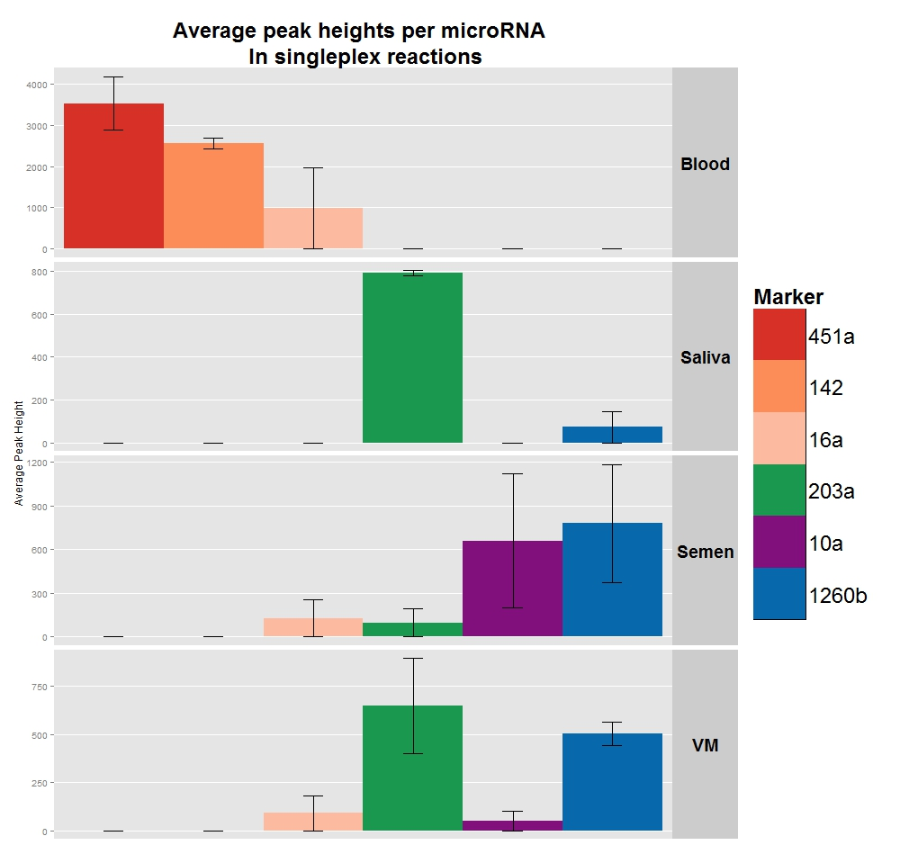
Figure 1 Average peak heights per body fluid. Error bars indicate standard error. Blood can be seen to have highly specific markers (miR-451a, 142 and 16a) and miR-10a is expressed almost exclusively in semen. Saliva and vaginal material (VM) can be seen to have much closer expression patterns, but careful inspection of the expresion levels of miR-203a and miR-1260b still allow accurate identification.

The blood specific markers miR-451a and -142 showed high specificity, being detected in all blood samples at consistent levels and in none of the other tissue types. The third blood maker miR-16a, showed a more ambiguous expression pattern, with varying peak heights detected in 4/5 blood samples and minor peaks detected in 1 semen and 1 vaginal material sample.
The semen specific marker miR-10a was detected at various peak heights in all semen samples and not in any blood or saliva samples. This marker was detected in a single vaginal material sample just above the detection threshold (103 RFU).
The saliva marker miR-203a was detected consistently at high levels in all saliva samples. However, it was also detected in all vaginal material samples and all but one semen samples. The peak heights in these other tissues were generally lower and much less consistent than in saliva samples.
The vaginal material marker miR-1260b is expressed at high levels in all vaginal material samples, but is also detected in all semen samples and in a single saliva sample.

Discussion
With these expression patterns, blood and semen are highly distinguishable from the other body fluids. Saliva and vaginal material have many expression markers in common and careful examination of the expression levels is therefore essential.
Overall, the results are consistent with qPCR data and CE does not only allow detection of absence/presence of a microRNA, but also an indication of expression level. Not only the highly expressed microRNAs can be detected in these small samples, but also the non-specific microRNA expression levels are consistent with qPCR data. For instance, the detection of miR-10a in vaginal material is consistent with qPCR data and potentially points at residual semen found in the vagina several days after unprotected sexual intercourse.

Conclusion
Despite the smaller dynamic range of a genetic analyser compared to qPCR, we have demonstrated here that it allows equally accurate BFID with microRNAs. This is mainly because the selected microRNAs show highly differentiated expression, combined with reaction optimisation allow accurate determination. This had been demonstrated for mRNA markers [9], and we have presented evidence that this holds for microRNAs as well. Li et al. [5] demonstrated this ability on a smaller scale, with a panel of 4 microRNAs. The extended novel panel here with 8 markers, provides more support for this strategy and its possibilities. While work continues on multiplexing the selected microRNA markers, these work is a strong continuation towards a single microRNA-based BFID test that can be performed on common DNA extracts.

Acknowledgements
The authors wish to thank Kimberley J. Bexon for her help in obtaining some of the samples and all volunteers for participating in this study.

Conflict of Interest Statement
None

Role of Funding
This study was internally funded by the University of Huddersfield. There was no involvement of the funding body in the realisation or submission of this manuscript.

References
[1] D. P. Bartel, MicroRNAs: target recognition and regulatory functions, Cell 136 (2009) 215–233.
[2] E. J. Omelia, M. L. Uchimoto, and G. Williams, Quantitative PCR analysis of blood- and saliva-specific microRNA markers following solid-phase DNA extraction, Anal. Biochem. 435 (2013) 120–122.
[3] D. van der Meer, M. L. Uchimoto, and G. Williams, Simultaneous Analysis of Micro-RNA and DNA for Determining the Body Fluid Origin of DNA Profiles, J. Forensic Sci. 58 (2013) 967–971.
[4] Z. Wang, J. Zhang, H. Luo, et al., Screening and confirmation of microRNA markers for forensic body fluid identification, Forensic Sci. Int. Genet. 7 (2013) 116–123.
[5] Y. Li, J. Zhang, W. Wei, et al. A strategy for co-analysis of microRNAs and DNA., Forensic Sci. Int. Genet. 12 (2014) 24–29
[6] C. Chen, D. a Ridzon, A. J. Broomer, et al., Real-time quantification of microRNAs by stem-loop RT-PCR, Nucleic Acids Res 33 (2005) e179.
[7] U. Jung, X. Jiang, S. H. E. Kaufmann, et al., A universal TaqMan-based RT-PCR protocol for cost-efficient detection of small noncoding RNA, RNA 19 (2013) 1864–1873.
[8] M. J. Brownstein, J. D. Carpten, and J. R. Smith, Modulation of non-templated nucleotide addition by Taq DNA polymerase: primer modifications that facilitate genotyping, Biotechniques 20 (1996) 1004–1010.
[9] A. Lindenbergh, M. de Pagter, G. Ramdayal, et al., A multiplex (m)RNA-profiling system for the forensic identification of body fluids and contact traces, Forensic Sci. Int. Genet. 6 (2012) 565–77.

