BREAKING THE RULES IN PATTERN CUTTING: AN INTERDISCIPLINARY APPROACH TO PROMOTE CREATIVITY IN PEDAGOGY

ABSTRACT
The aim of the research is to explore how the discipline of pattern cutting can be taught, investigated and practiced through innovative, interdisciplinary approaches. Interdisciplinarity involves the combining of two or more academic disciplines into one activity (for instance in this enquiry, pattern cutting is merged with disciplines such as health and engineering). The study discusses how interdiscipinarity can break rules, which involve going against a set of regulations that direct a practice or method within an area of activity. This mutinous concept can make pattern cutting appear more exciting and creative to the student and often leads to them exploring different concepts and approaches. The research was based on secondary sources gathered from a review of papers presented at, The Second International Conference for Creative Pattern Cutting, held at University of Huddersfield, 24 and 25 February 2016. This conference was purposively selected due to its discipline relevance and international representation and was unique to the authors because they organised and chaired what has, to date been the sole global platform to disseminate research in pattern cutting. It focuses on works that considered new approaches to pattern cutting by effectively implementing interdisciplinary activity into its practice. This is described as a methodology of conference organisation using content analysis as well as interviews with the individual authors of selected papers. The findings discuss how the disorderly methods impacted on the student’s experiences. This supports the development of new, novel and innovative, pedagogical approaches to pattern cutting practice and has the potential to enrich the fashion industry, encouraging pattern cutters to develop essential skills to cross discipline boundaries.

KEYWORDS pattern cutting; interdisciplinary; rules; skills; disrupt; pedagogy

INTRODUCTION
In higher education, the practice of pattern cutting is taught in a variety of ways. This ranges from introducing traditional methods of flat pattern cutting and tailoring, draping materials on the dress stand, to using complex 2D and 3D pattern development software. Pattern cutting combines knowledge of body measurements and body proportions to create a 3D form, which fits the human shape. It amalgamates empirical knowledge with theoretical approaches that utilize a combination of technical and creative skills. Research has shown that many clothing and fashion students find pattern cutting challenging because it is often presented as a methodical and mathematically complex discipline, divorced from creativity. Arguably it would have more appeal if presented as a creative craft, underpinned by technical skills that use a set of basic rules and procedures (Almond 2010; Bailey, Drew and Shreeve 2004; Sayer & Studd 2006). Once an understanding of the basic rules has been acquired, their manipulation using a variety of techniques should be encouraged. This enables fashion students to find methods that promote creativity and disrupt conventional approaches.

Globalization has changed the face of the clothing, fashion and textile industries in many developed and developing nations. In pattern cutting the advancement of digital software has increased at a tremendous pace. In the last two decades, there have been significant advances in computational power and hardware performance which has enabled the progression of 3D CAD systems specifically aimed at the clothing industry (Fang 2003; Sul and Kang 2006). However, it has been argued that digital software has not improved the effectiveness and innovation in pattern cutting and this should be considered in the context of pedagogy (Carr, McDaniel and Mehta 2016; Huang 2016). The clothing and fashion sector therefore needs to explore different mechanisms for engaging students by exposing them to different pattern cutting techniques and using new forms of pedagogies. These would encourage pioneering new ways to pattern cut and develop creative confidence and risk taking.

This paper considers how the discipline of pattern cutting can be taught, explored and practiced through innovative, interdisciplinary approaches. The research is based on evidence synthesized from a sample of secondary research, gathered from a review of papers that explored interdisiplinarity, presented at, The Second International Conference for Creative Pattern Cutting, held at University of Huddersfield, 24 and 25 February 2016. The investigation considers how the enhancement of student’s creativity can be instigated in pattern cutting through interdisciplinary working that challenges established rules. It provides a discussion on new forms of pattern cutting that blur the boundaries between different disciplines, mediums and techniques, introducing reflective practice to underpin learning by doing and encouraging the exploration of novel techniques and their benefits to learning.

THE DEVELOPMENT OF PATTERN CUTTING
The role of the pattern cutter is integral within the fashion industry. These skilled practitioners are responsible for interpreting 2D ideas into 3D garments. Historically pattern cutting evolved through the work of seamstresses and tailors who created clothes by hand. Their skills were passed on manually or by word of mouth. It wasn’t until school attendance became obligatory in the mid-eighteenth century that people began to read and write. This resulted in the first manuals published that documented pattern cutting techniques and began to record the basic rules, many of which are still followed today (Giles 1887; Hearn 1821). These rules have evolved into contemporary pattern cutting manuals that document technical instruction and are used by clothing and fashion students to learn basic techniques (Aldrich 2008; Joseph-Armstrong 2013). Within the clothing/fashion industry there are predominantly three methods of pattern making: traditional flat pattern making, modelling on the stand/creative pattern cutting and 2D and 3D, CAD pattern design/development.
- Flat pattern cutting - usually involves the manoeuvre of a basic block shape created to fit a standard body size such as a bodice block or a skirt block (Figure 1). The cutter manipulates the block shape through a variety of established techniques to create a pattern for a design. This is made up in a cheap fabric, known as a toile and fitted to a body. The final alterations are then made to the flat pattern before the finished garment is constructed.

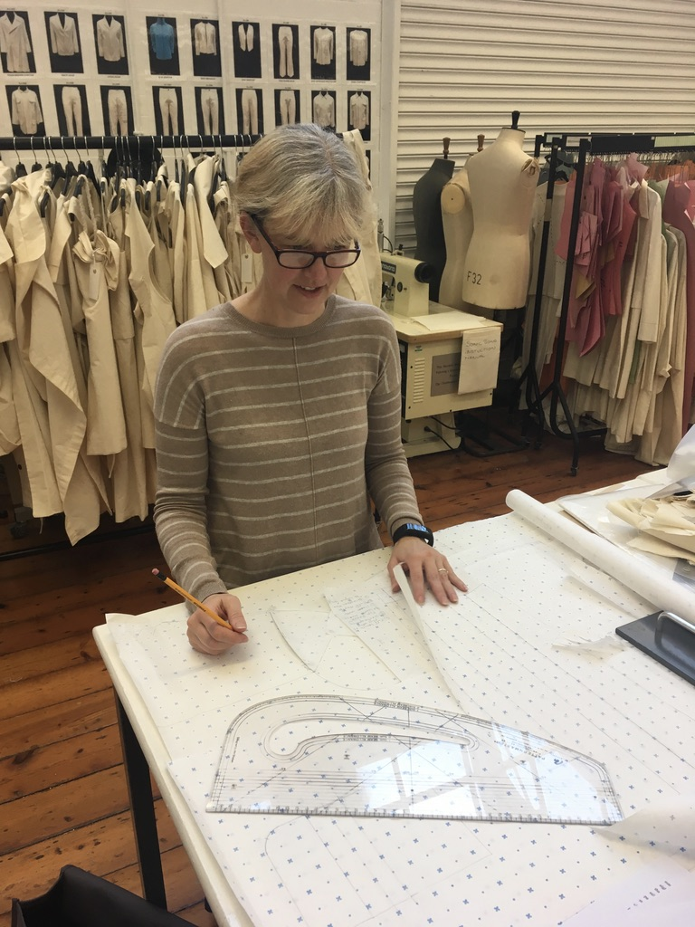
Figure 1: Flat pattern cutting in the fashion studio. Photograph courtesy of Kevin Almond.

- Modelling on the stand/creative pattern cutting - is a more sculptural approach to pattern making. It involves the cutter manipulating and sculpting fabric on a three-dimensional dress stand to achieve a shape (Figure 2). It allows for greater experiment and a breaking of the established rules of flat pattern cutting. The draped pieces are laid out on pattern paper and traced around to create a pattern. This is tested by producing a toile, which is fitted on the model before the final pattern is created. Many fashion designers have advocated this approach. For instance, the British designer, Betty Jackson said, ‘What you don’t want is someone pedantic who says this is how a jacket is cut and these are the rules and you can’t break these rules. What any designer needs is to work with a creative pattern cutter who will break those rules’ (Inspirational Pattern Cutting 2000).

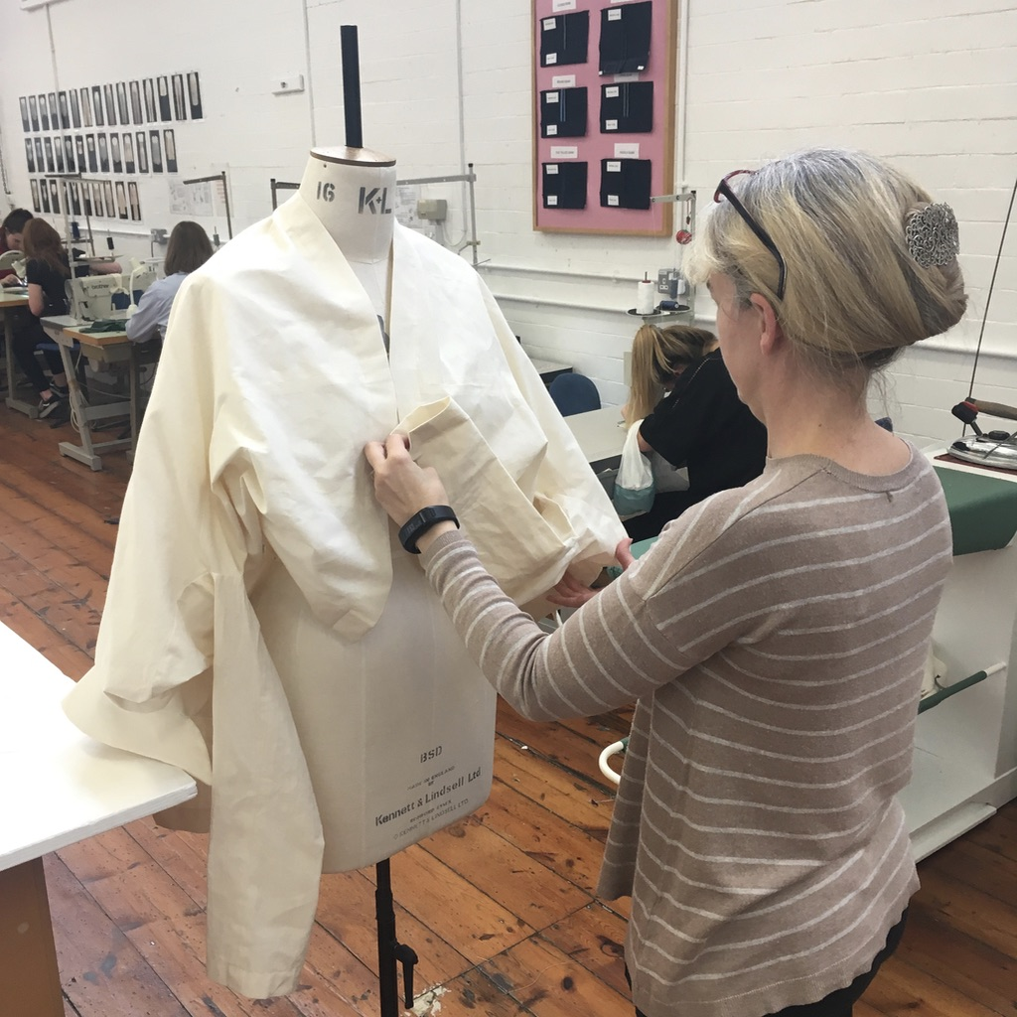
Figure 2: Modelling on the stand in the fashion studio. Photograph courtesy of Kevin Almond.

- 2D and 3D CAD pattern design/development - has been significantly advanced in the last two decades, which has enabled the progression of 3D CAD systems aimed at the fashion industry (Fang 2003; Sul and Kang 2006). The two major advantages of CAD within clothing and fashion design are in the saving of time and the ability to view and quickly manipulate design ideas (Hardaker and Fozzard 1998; Fang 2003; Power, Apeagyei, and Jefferson 2011; Jefferson, Power, and Rowe 2012). Previously constructed designs can be revisited, modified and enhanced to produce new designs in short time frames and these can be displayed on avatars in a variety of poses, with realistic drape (Figure 3).

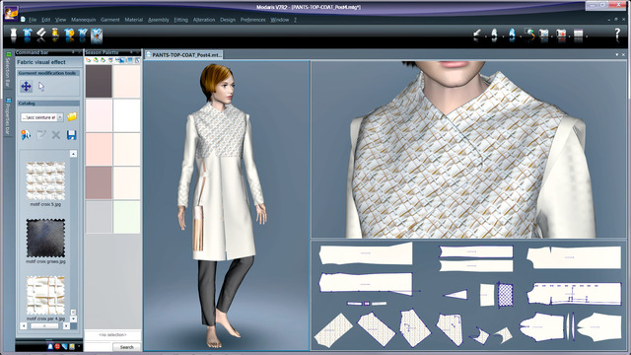

Figure 3: Designs displayed on avatars. Illustration by permission of Lectra.

BREAKING THE RULES
Contemporary research into creative pattern cutting is a new and emerging research area and has significance beyond clothing and fashion because it also promotes the value of tacit knowledge within a research context. In 2013, the first dedicated creative pattern cutting conference was held in the UK, established by the authors (Almond 2013; 2013a). This was followed by the Second International Conference for Creative Pattern Cutting in February 2016 (Almond and Power 2016; 2016a). Further to this, two special editions have been published in, The International Journal of Fashion Design, Technology and Education (Almond 2013; 2013a; Almond and Power 2016; 2016a). There have also been a series of creative pattern cutting workshops held by the British Fashion Council, Colleges Council in London (2014). These workshops, held by leading international pattern cutters (e.g. Julian Roberts and Shingo Sato, Figures 4 and 5), demonstrate different pattern cutting techniques to fashion students, encouraging them to think creatively and develop new ways to pattern cut.

Figure 4: Pattern Cutting Workshop by Julien Roberts. Photograph courtesy of The British Fashion Council.

Figure 5: Pattern workshop by Shingo Sato. Photograph courtesy of The British Fashion Council.

The overarching purpose of the 2013 and 2016 conferences was to provide a platform for pattern cutters, fashion designers, researchers, students, and educators to explore the impact and direction for creative pattern cutting. Research was presented from leading international experts describing new methods and techniques. One of the emerging themes from the 2016 conference was the growth of interdisciplinary working in pattern cutting that disrupted established technologies and broke traditional rules. In the findings section, some of the interdisciplinary approaches from the research presentations and the ways in which they have broken rules, are discussed and explored.

Research has shown that clothing and fashion necessitate innovative approaches to design, which require a complex skill set only achieved by creative teams that combine design and technical specialists (Power 2014; Power 2015). In the twenty first century clothes are no longer manufactured and retailed in specific local regions. Clothing and fashion have joined textiles in becoming a global operation (Power, Apeagyei and Jefferson 2011). However, garment design and realization remains a highly specialized domain which demands skills across a variety of disciplines. This has created a divide between the construction of design and apparel, which could be broken down using disruptive approaches that utilise interdisciplinary design teams. The Design Council advocates that design can address complex social issues and offers multidisciplinary as a solution, with design placed as the foundation of discipline integration (DC 2015). The Royal Academy of Engineering (RAE 2012) acknowledged that individuals who can work together in multidisciplinary teams are better equipped to deal with complex challenges (RAE 2012). As the fashion industry becomes increasingly competitive and technologically advanced, it is important that fashion and clothing graduates are equipped with the skills required to work and network beyond their immediate discipline.

Clothing and fashion are increasingly crossing the boundaries into other disciplines such as health/well-being and functional apparel, as consumers from all levels of the market, from the high street to couture, want garments manufactured from the latest technical materials as well as clothing with duel functions. It is therefore essential that graduates are prepared to take risks by combining or disrupting technology, using techniques borrowed from other academic disciplines, thus breaking the rules of established methods for pattern cutting. In the global fashion industry, it is acknowledged that pattern cutters who break these traditional rules pioneer new ways to cut and this leads to innovative clothing and fashion (Almond 2010). New technologies and interdisciplinary approaches have the potential to offer new, novel and innovative solutions to the fashion and clothing industry.

METHODOLOGY

The academic, Gjoko Muratovski (2016), who has significant experience in cross-disciplinary design and branding practice, identified that in design research, it is paramount that a balance is created between academic inquiry and practical application to ensure a successful outcome. In relation to these ideas an interpretive, constructionist philosophy was adopted in this research, as it endorsed data collection methods that were primarily qualitative. An interpretive methodology is particularly suitable for studies using a purposively selected sample of experts (Saunders 2016). The sample in this research consisted of papers, which investigated interdisciplinary approaches to pattern cutting from the, Second International Conference for Creative Pattern Cutting (2016). This allowed for a deeper understanding of impacting issues, through the synthesizing of a cross-section of expert views based predominantly on an in-depth analysis of literature, related to current practice and application within pattern cutting disciplines.

As well as the secondary sources gathered from the review of papers at the conference, research was also based on a wider literature review, which is referred to throughout the text. The authors recognised the potential limitations of focusing on the use of secondary sources. However as joint organisers and conference chairs for the event, they had identified a pedagogical and industrial need for a forum that allowed researchers to discuss and disseminate developments in pattern cutting, including interdisciplinarity. They also acquired an in-depth awareness of the quality and diversity of the papers submitted for peer review. This could be described as a methodology of conference organisation using content analysis, unique to the authors. The conference was also selected to form the initial sampling frame for literature due to its discipline relevance and international representation. Together with the first conference in 2013 (also organised and chaired by one of the authors), they have, to date been the only global platforms dedicated specifically to research into pattern cutting. Both events presented the works of over 80 individuals, from 20 countries, in four themes: pedagogy, sustainability, fashion and new technology. The events were thus considered to provide a rich source of data.

An extensive review of the 2016 conference papers was conducted to identify works that explored how pattern cutting can be practiced through innovative, interdisciplinary approaches and focussed on the pedagogy of creative pattern cutting. The criteria for selecting the papers fixated on works that considered new approaches that crossed discipline boundaries and disrupted pre-conceived ideas. The use of disorderly interdisciplinary forces, described in the selected papers, led to the development of new approaches for teaching and learning. Primary research was conducted through email interviews with some of the authors of the selected papers. The interviews were designed to be semi-structured and consisted of a set of open questions, which allowed the authors to freely expand on their understanding of how the interdisciplinary projects had impacted on their student’s experience of pattern cutting.

FINDINGS
This section discusses and interprets the finding from the selected papers presented in the creative pattern cutting conference (2016), as well as the additional information gained from interviewing the authors. Four main themes related to the interdisciplinary approaches to pattern cutting emerged, these were;
- Changing perspectives, through methods that combined the teaching of pattern cutting with teaching methods from other disciplines.
- Combining traditional approaches with digital technologies
- Use of different media
- Pattern cutting and science

The first approach considered ways in which interdisciplinary teaching methods could be combined. Greg Climer (Figure 5) from Parsons, The New School for Design in New York, discussed how the school introduced a new curriculum in 2013, ‘Which has cross-disciplinary work, creative making and reflective practice underpinned by research at the core’ (Almond, Power 2016: 17). The institution introduced a restructured Bauhaus approach. Traditional Bauhaus design education involves one foundation year, followed by three years in a selected discipline. Parsons has shifted to a four-year structure that updates the Bauhaus model. The case study presented focused on how the changes in the curriculum impacted on student experience, particularly how students approach pattern cutting and design as a symbiotic relationship that creatively depend upon each other. When interviewed, Climer said that, ‘Our first year teaches many of the same skills that are part of the Bauhaus model but always within a context. Projects always begin with a design problem to solve through the lens of the skill being practiced. Technical skills are treated as integral to conceptual thinking instead of tools which conceptual thinking can use’ (2017). Climer considered this improved the student’s creative experience because all making skills were placed in a creative context and there was no longer a first year of making block shapes with little or no creative thinking. Instead the foundations of pattern cutting (such as, dart manipulation, adding and subtracting fullness) were taught through combined creative design/pattern cutting projects, exhibiting elements of experimental learning.

The lecturer, Lee Harding, from Sheffield Hallam University UK, presented research about a series of workshops that focused on garment distortion techniques with second year undergraduate students. ‘The practical workshops encourage learners to forge a new perspective to three-dimensional thinking and understanding, not traditionally found through conventional flat pattern cutting methods’ (Almond, Power 2016:17). The research reflected on practical sessions that attempted to build the confidence of the learner by offering new methods to develop new approaches to 3D garment design. When interviewed, Harding considered that the workshops broke down pre-established concepts surrounding pattern cutting and challenged students to develop new ideas. Both methods offer a synergic slant to developing pattern cutting by uniting different ways of teaching, firmly embedding the principle of learning by doing. He said, ‘The over-arching feedback from learners was that the workshops contributed to overcoming boundaries and offer a far more spontaneous engagement with 3D design. Some learners would have applied the workshop techniques to their work to develop creative shapes, whilst others felt they were able to consider pattern cutting differently and build their confidence’ (2017). In contrast lecturer, Brianna Plummer from, Framlington State University USA, explored the potential benefits of introducing creative pattern cutting earlier in the curriculum. She considered how interdisciplinary approaches to pattern cutting could potentially present creative alternatives to traditional pattern cutting and questioned how much knowledge, ‘….is needed to provide the foundational skills required for successful creative pattern cutting’ (Almond, Power 2016: 28).

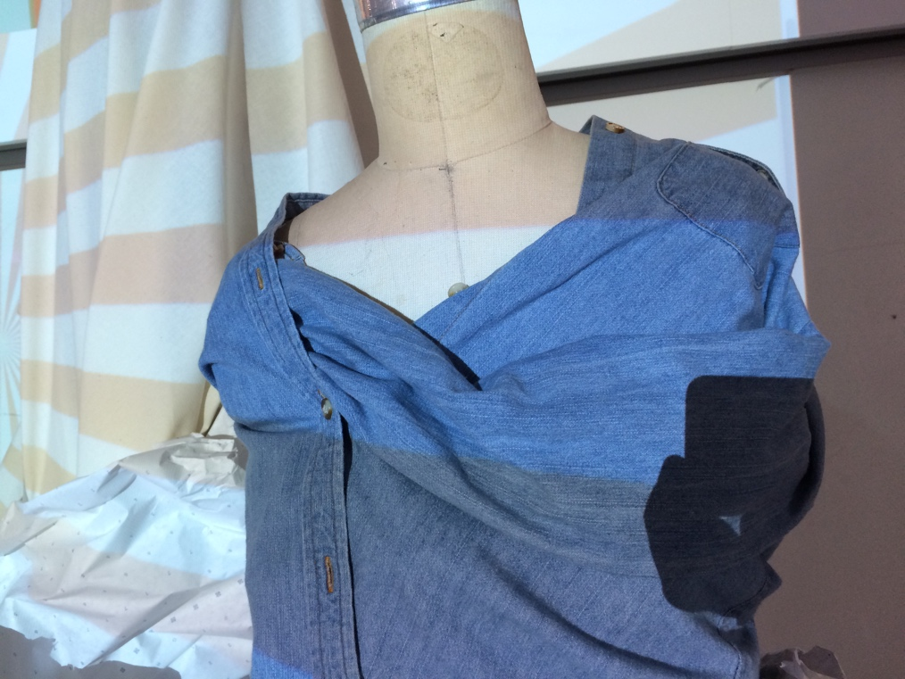

Figure 6: Garment produced during pattern cutting class from Parsons new curriculum. Photograph courtesy of Greg Climer.

Although numerous researchers are investigating and developing 3D CAD systems from the 3D to 2D concept, emerging companies are favouring the 2D to 3D. Early 3D CAD software systems, enabled the designer to construct a garment in 3D form on a virtual model, then flattening the 3D images created to produce 2D patterns. The second approach, 2D to 3D is more common within the garment industry because it simulates the traditional process of design, pattern construction and garment realization. 2D patterns are developed within a CAD software system, using the same rules and principles that apply to flat pattern cutting. These individual pattern pieces are then virtually sewn together to construct a 3D garment which can be displayed on a virtual model. The virtual image can be viewed from any zoom level and rotated 360°. Researchers have acknowledged its lack of practical application and adoption within the clothing/fashion industry (Power, Apeagyei, and Jefferson 2011). This is accredited to a variety of reasons including, setup costs, user expertise, technology limitations and fabric simulation.

The second approach investigated the use of 2 D and 3D digital tools in the pattern cutting classroom through an interdisciplinary method that considered exploring digital technology in more innovative ways. Lecturers, Elizabeth Carr, Linda Ohrn-McDaniel and Archana Mehta from Kent State University, USA, considered if using digital tools could change the student’s perspective. They created a demonstration, ‘Where the student is placed in the position of the expert through digital recordings placing the camera perspective from that of the instructor’ (Almond, Power 2016: 15). The idea was to allow the students to experience the demonstration through the eyes of the expert to gain a more convincing viewpoint. The tutors considered this approach to be successful because the student’s understanding improved through the new perspectives learnt from demonstrating pattern cutting techniques themselves. When interviewed, Linda Ohrn McDaniel commented, ‘One of the main successes we found is that with access to the videos, the student’s take ownership of their learning in a different and more successful way than when the instructor appeared to be the keeper of all information’ (2017).One of the conference keynote presentations from, Professor Shelley Fox and lecturer, Juliana Sissons, suggested that, ‘The fashion design process is an interactive one, dealing with the body as the primary site for investigation, where the designer and cutter work in collaboration to develop the designer’s initial concept’ (Almond, Power 2016: 11). It was about building a relationship between the designer and the cutter in which two different and often epistemological perspectives require unification. This illustrates ways in which creative individuals with different skillsets can unite through a creative design process, placing the body, different media, structure and form at its core.

The third theme, which explored the use of different media, described how clothing and fashion student’s pedagogical understanding of pattern making could be enhanced by introducing alternative approaches to the curriculum, utilizing different media. Lecturer, Laura Hardingham, from Robert Gordon University, UK described her introduction of flattened boxes as a substitute for pattern pieces (Figure 6). ‘Working in pair’s students were briefed how there was no right or wrong response, but rather to focus on creating interesting 3D form’ (Almond, Power 2016: 22). The students worked with a minimum of two boxes that were cut out in calico. They were encouraged to stich edges together and manipulate the shape on a dress stand until they felt a garment shape was beginning to manifest itself. This promoted greater creativity because it emphasised how alternative approaches to teaching pattern cutting can complement traditional approaches such as flat pattern cutting, which students often find particularly challenging.

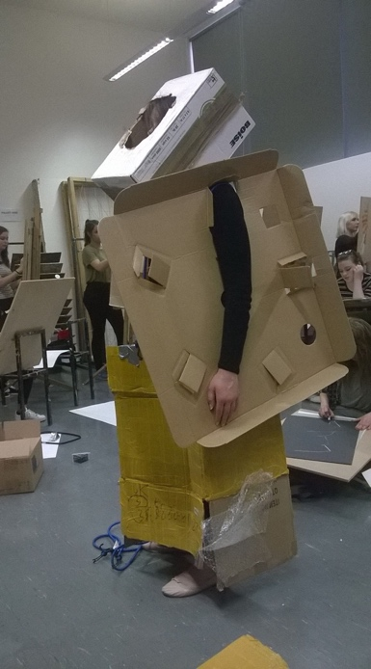

Figure 7: How Does a Box Become a Garment - Drawing silhouette analysis, interaction between the body and boxes photograph. Photograph courtesy of Laura Hardingham.

The fourth approach looked at ways in which pattern cutting could be combined with science. The lecturer, Rickard Lindqvist, from The Swedish School of Textiles, discussed experiments that involved cutting and draping fabrics on live models guided by Langer’s lines (Figure 7). The anatomist, Karl Langer (1819-1887) discovered that topological lines drawn onto the human body, that are parallel to the underlying muscle fibres, are helpful to surgeons when deciding where and in what direction to place an incision in the skin, before an operation. Incisions made parallel to Langer's lines may heal better and produce less scarring. Rickard’s research explores and defines possible, ‘Congruence’s between the shear forces of human skin and the anisotropic qualities of woven fabric’ (Almond, Power 2016: 25). This is suggested by discussing a number garments that illustrate how the utilization of fabric grain may shift across the body. Langer’s lines are a representation of the movements of the body and these lines and movements can inspire pattern cutting through the placement of seams and darts. This can also inform teaching as students can be encouraged to consider these lines when analysing flattering shape and proportion on the human body.

Figure 8: Visual analysis of hard shell jacket. Langer’s lines are marked with thin red lines on the torso and arm. Photograph courtesy of Daniel Grizel.

Lecturer, Holly McQuillan, from Massey University, New Zealand, discussed her multi-disciplinary research, exploring User Modifiable Zero Waste Fashion. It explored the interplay between textile mark making and garment form creation, through to, ‘The Development and testing of an embedded navigational system by which users can formulate an understanding of the form and construction of a garment and its opportunities for manipulation’ (Almond, Power 2016: 26). McQuillan discussed the facilitation of understanding and risk taking in the context of collaborative textile and fashion design and questioned how the encoding of navigational markers into a garment might aid its facility for creation and modification by the user (Figure 8). When questioned about how this approach could impact on student experiences of pattern cutting, McQillan advised that much was explained within the paper. The intent of the project, ‘Was to foster an open-ended collaboration between designer, maker/user and textile that empowered the maker/user to actively make design decisions, affording them creative agency’. (McQuillan; Archer-Martin; Bailey; Derwin; Kane; Menzies; 2018), This is also something which can be explored in pedagogy as the navigational markers can be used by the student to enhance the manipulation of pattern pieces and to inspire greater creativity. In the interview McQuillan further explained that, ‘It certainly makes understanding the fundamentals of this approach to zero waste cutting much easier. It facilitates an alternative understanding of the relationship between body and cloth. The printed system on fabric or paper is like a tool, aiding in student’s comprehension of how to manipulate form without wasting fabric. This allows them to progress to a more advanced template system, until finally being able to manipulate the approach to suit end goals. I look at it as a kind of scaffolding, it supports and builds until you don’t need it anymore.’ (2017).

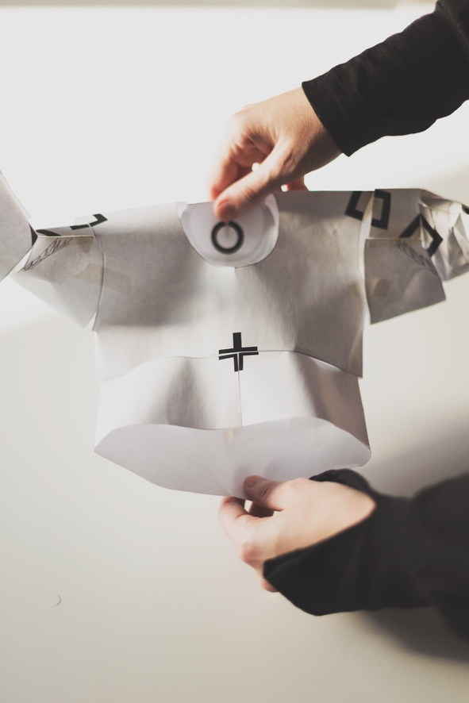

Figure 9: MakeUse: Encoded way finding system for the creation of garment form - Early test using paper prototype. Photograph courtesy of Holly McQuillan.

Each of the four interdisciplinary themes related to pattern cutting promoted creativity in different ways and in this context, it is challenging to identify which were more effective. Placing the selected papers loosely into one of the four themes allows a more focussed analysis and evaluation of the merits of each piece of research. This emphasises how interdisciplinarity can break some of the established rules in pattern cutting, making the discipline appear more exciting to the students and leading them to explore different concepts and approaches. The context of each theme differs in relation to cost effectiveness of delivery. For instance, combining the teaching of pattern cutting with teaching methods from other disciplines such as digital technology and science incur far greater financial investment as well as the contributions of highly skilled people. Approaches such as the use of card board boxes or combining creative design/pattern cutting projects with different teaching methods were simpler and incurred less cost. In relation to the scope and size limitations of this paper, a more in-depth evaluation of these approaches could be a potential area for further research.

ENHANCING THE PATTERN CUTTING CURRICULUM
The introduction emphasized how many clothing and fashion students find pattern cutting challenging and suggested that new forms and mechanisms for teaching pattern cutting beyond the traditional methods of flat pattern cutting, draping on the dress stand and using complex 2D and 3D-pattern development software, need to be considered and developed. As discussed, one of the emerging themes from the 2016 conference was the growth of interdisciplinary working that disrupts established technologies. This develops skills and techniques within pattern cutting as well as skills associated with team working, critical analysis and problem solving. The four interdisciplinary approaches discussed in the findings advocate different approaches to pedagogy which could be considered either as individual ways to enhance current curriculum or implemented collectively to pioneer new ways to pattern cut, using techniques and approaches from other disciplines. These are discussed below.
- Reflective analysis – is a key element of the learning process which develops confidence and re-in forces learning (learning by doing). In the case of Parsons, the move to experiential learning using a Bauhaus approach enhanced the student experience and enabled students to better reflect upon theory and practice within the confines of pattern cutting.
- Experimentation - is a key part of studio practice providing different opportunities linked to the diverse needs of learners. The work of Holly McQuillan, supported experimentation through interplay between the disciplines of textile marking and garment creation and suggested that incorporating creative techniques earlier in the pattern cutting curriculum had many benefits including the development of creative confidence. This is a controversial debate and it has been questioned how much traditional pattern making knowledge ‘Is needed to provide the foundational skills required for successful creative pattern cutting’ (Almond, Power 2016: 28).
- Effective and appropriate use of different technologies - enhances and supports the development of new pedagogies for learning. For instance, digital feedback/recording of the critiquing sessions has much benefit to knowledge building. In Carr, McDaniel and Mehta’s work they used a flipped learning approach, placing students outside their comfort zones by making them the expert. By cleverly designed demonstrations students were supported to become the instructor, aligning them with developing the commercial skills required for employment.
- Knowledge transfer – demonstrates how effectively simple principles can be transferred to the discipline of pattern cutting, such as those presented by Laura Hardingham, where flattened boxes were used in a collaborative context to support learning. Methods such as these offer a synergetic slant to developing pattern cutting through uniting different ways of teaching.

CONCLUSION
The research has demonstrated how pattern cutting is increasingly crossing boundaries into other disciplines such as teaching methods from contrasting fields or science. By combining techniques from different discipline boundaries, pre-conceived ideas are challenged and new epistemological perspectives are reached. It is widely accepted that innovative and sustainable solutions for many complex problems reach far beyond the boundaries of a single academic discipline or methodological approach (Stember 1991; Korhonen 2005; McLeish and Strang 2014) and therefore new approaches for embedding this into the pattern cutting curriculum are essential. Clothing and fashion necessitate innovative approaches to both design and pattern cutting and require a complex skill set that can only be achieved by team working (Power, 2014; Power, 2015). This is a view supported by Fox and Sissons (2016), who wholeheartedly support collaboration and innovation within pattern cutting. This is a final theme that can be drawn from the paper and explored further in future research. Ultimately, it could be argued that interdisciplinary working does not break rules in a traditional sense. As discussed it relates to the amalgamation of two ways of working within one pursuit however the results of this one pursuit have the potential to break established notions of the activity itself. This advances the pattern cutting curriculum by introducing students to a more enriched and wider vocabulary of techniques and ideas.

The study is predominantly based on secondary sources gathered from the review of papers, presented at The Second International Conference for Creative Pattern Cutting (2016). The authors of the papers were also interviewed to further identify ways that interdisciplinarity impacted on the student’s experience of creative pattern cutting. In relation to the scope and size limitations of the paper, a more in-depth evaluation of the interdisciplinary approaches to pattern cutting could be another potential avenue for research. This could take a more critical path by further exploring the student’s experiences alongside those of the lecturers. It could also evaluate if simpler approaches such as the use of card board boxes or the more costly approaches, such as the embedded navigational system, work better than others in terms of promoting creativity. Additional research could also explore a wider use of different methodologies, such as action based research in the pattern cutting studio or object based research studying the creative merits of fashion garments produced as results of the interdisciplinary approaches. This could also extend research into creative pattern cutting from a pedagogical context as well as exploring the development of creative, three dimensional ideas further within the fashion industry itself.

REFERENCES
Aldrich, Winifred (2008), Metric Pattern Cutting for Womenswear, 5th ed. Oxford: Blackwell.
Almond, Kevin (2010), 'Insufficient Allure: The Luxury and Cost of Creative Pattern Cutting', The International Journal of Fashion Design, Technology and Education, 3: 1, pp. 15-24.
Almond, Kevin (2013), ‘Raiding the Past, Designing for the Future’, Journal of Conference Proceedings Futurescan 2 Collective Voices, 2, pp, 112-123.
Almond, Kevin (2013). The First International Symposium for Creative Pattern Cutting. University of Huddersfield.
Almond, Kevin (ed.) (2013a), 'Guest Editorial, Creative Cut', special issue, The International Journal of Fashion Design, Technology and Education, 6: 2, pp, 71.
Almond, Kevin and Power, Jess (eds) (2016). 'Guest Editorial Creative Cut’, special issue, The International Journal of Fashion Design, Technology and Education, 9: 2, pp. 95-96.
Almond, Kevin and Power, Jess (eds) (2016a), The Second International Conference for Creative Pattern Cutting. Huddersfield: University of Huddersfield.
Bailey, Sue, Drew, Linda and Shreeve, Alison (2004), ‘Students’ approaches to the ‘research’ component in the fashion design project: Variation in students’ experience of the research process’, Art, Design and Communication in Higher Education 2: 3, pp. 113-120.
British Fashion Council (2014), ‘Creative Pattern Cutting Seminar’, http://www.britishfashioncouncil.co.uk/Education/Colleges-Council/Creative-Pattern-Cutting-Seminar. Accessed 8 June 2016.
British Fashion Council (2000), Inspirational Pattern Cutting, London: British Fashion Council.
Carr, Elizabeth, Ohrn-McDaniel, Linda and Mehta, Archana (2016), ‘Changing Perspectives in the Patternmaking and Draping Classroom’, in K. Almond and J. Power (eds), The Second International Conference for Creative Pattern Cutting, Huddersfield: University of Huddersfield, p. 15.
Climer, Greg. (2017), Enquiry about paper. [Email].
Climer, Greg (2016), ‘Parsons New Curriculum’, in K. Almond and J. Power (eds), The Second International Creative Pattern Cutting Conference, Huddersfield: University of Huddersfield, pp. 17.
Design Council (2015), ‘Design Council Celebrating 70 years’, http://www.designcouncil.org.uk/about-us/celebrating-70-years. Accessed 30 May 2016.
Fang, Jing-Jing (2003), ‘3D Collar Design Creation’, International Journal of Clothing Science and Technology, 15: 2, pp. 88-106.
Fox, Shelley and Sissons, Juliana (2016), ‘Cutter – Designer – Cutter: Cutting as Design’, in K. Almond and J. Power (eds), The Second International Conference for Creative Pattern Cutting, Huddersfield: University of Huddersfield, pp. 11.
Giles, Edward (1887), The History of the Art of Cutting in England, Preceded by a Sketch of the History of English Costumes, London: F. T. Prewett.
Hardaker, Caroline and Fozzard, Gary (1998), 'Towards the virtual garment', International Journal of Clothing Science and Technology, 10: 2, pp. 114-127.
Harding, Lee. (2017), Enquiry about paper. [Email].
Harding, Lee (2016), ‘Abstract Approaches to Creative Cutting’, in K. Almond and J. Power (eds), The Second International Conference for Creative Pattern Cutting, Huddersfield: University of Huddersfield, pp. 21-22.
Hardingham, Laura (2016), ‘How Can a Box Become a Garment’, in K. Almond and J. Power (eds), The Second International Conference for Creative Pattern Cutting, Huddersfield: University of Huddersfield, pp. 22.
Hearn, William (1821), Hearn’s Rudiments of Cutting Coats &c, London: Publisher Unknown.
Huang, Kiwi (2016), ‘Computational Fashion – The Digital Approach to Pattern Making’, in K. Almond and J. Power (eds), The Second International Conference for Creative Pattern Cutting, Huddersfield: University of Huddersfield, pp. 23.
Jefferson, A. M., Power, E. J. and Rowe, H., (2012), ‘Enhancing the employability of fashion students through the use of 3D CAD’, Journal of Conference Proceedings: Fashion Beyond Borders 14th Annual Conference for the International Foundation of Fashion Technology Institutes (IFFTI). 14.
Joseph-Armstrong, H (2013), Patternmaking for Fashion Design. 5th Edition, USA: Pearson New International.
Joseph-Armstrong, H (2013), Patternmaking for Fashion Design. 5th Edition, USA: Pearson New International.
Korhonen, Jouni (2005), ‘Symposium on Transdisciplinary Case Study Research for Sustainable Development’, 11th Annual International Sustainable Development Research Conference, Finlandia Hall, Helsinki, Finland, 6-8 June.
Lindqvist, R. (2017), Enquiry about paper. [Email].
Lindqvist, Rickard (2016), ‘On the Relationship Between the Shear Forces in Human Skin and the Grain Direction of Woven Fabric’, in K. Almond and J. Power (eds), The Second International Conference for Creative Pattern Cutting, Huddersfield: University of Huddersfield, pp. 25.
McLeish, Tom and Strang, Veronica (2014), Leading interdisciplinary research: transforming the academic landscape. Durham University: Leadership Foundation for Higher Education.
McQuillan, H. (2017), Enquiry about paper. [Email].
McQuillan, Hollie (2016), ‘Print as Encoded Way Finding a System for the Creation of Garment Form’, in K. Almond and J. Power (eds), The Second International Conference for Creative Pattern Cutting, Huddersfield: University of Huddersfield, pp. 26.
McQuillan, Hollie., Archer-Martin, Bailey, J., Derwin, E. Fox., Kane, K. and Menzies, G., (2018), ‘Make/Use: A System for Open Source, User Modifiable, Zero Waste Fashion Practice’, Fashion Practice: The Journal of Design, Creative Process and the Fashion Industry
Muratovski, Gjoko (2016), Research for Designers, London: Sage.
Ohrn-McDaniel, Linda. (2017), Enquiry about paper. [Email].
Plummer, Brianna (2016), ‘Scaffolding Creative Pattern Cutting throughout the Traditional Patternmaking Curriculum’, in K. Almond and J. Power (eds), The Second International Conference for Creative Pattern Cutting, Huddersfield: University of Huddersfield, pp. 28.
Power, Jess (2014), ‘A New Methodology for the Integration of Performance Materials into The Clothing Curriculum’, Proceedings of The 89th Textile Institute World Conference, pp. 614-618.
Power, Jess (2015), ‘Integration of Performance Materials into The Clothing Curriculum’, Global Textile Congress, Bangkok, Thailand, 13-15 February.
Power, Jess, Apeagyei, Phoebe and Jefferson, Aileen (2011), ‘Integrating 3D Scanning Data & Textile Parameters into Virtual Clothing’, 2nd International Conference on 3D Body Scanning Technologies. Lugano, Switzerland, 25-26 October.
RAE. (2012), ‘Educating Engineers to Drive the Innovation Economy’, http://www.raeng.org.uk/publications/reports/innovation-economy-2012. Accessed 10 July 2016.
Saunders, Mark, Lewis, Phillip and Thornhill, Adrian (2016). Research methods for business students, 7th Edition, UK: Pearson.
Sayer, Kate and Studd, Rachel (2006), ‘Matching Learning Style Preferences with suitable Delivery Methods on Textile Design Programmes’, International Journal of Technology and Design Education, 16, pp. 163-176.
Stember, Marilyn (1991), ‘Advancing the Social Sciences through the Interdisciplinary Enterprise’, The Social Science Journal, 28: 1, pp. 1-14.
Undressed in the Twentieth Century (1998, UK Channel Four).
Sul, In Han, and Kang, Tae Jin (2006), ‘Interactive Garment Pattern Design Using Virtual Scissoring Method’, International Journal of Clothing Science and Technology, 18: 1, pp. 31-42.

