A tale of two landscapes:
transferring landscape quality metrics from Wales to Iceland.

Abstract
The assessment of visual landscape quality remains a tantalizing goal for geographers. Methods to evaluate landscape views proliferate, with increasing use made of both quantitative and qualitative techniques. Reproducibility of these methods is often claimed by researchers but is rarely tested. Landscape quality assessment is so often tailored to a location that little thought is given to its potential portability. In response to this challenge, we have taken a visual landscape quality method previously developed for Wales, UK (Swetnam, et al., 2017) and tested its transferability to quite different landscapes in Iceland. We outline the methodological considerations required, demonstrate its successful application with a report on our pilot field investigations and provide a checklist for others wishing to transfer landscape quality metrics from one place to another.

Keywords: environmental change; Iceland; landscape aesthetics; visual assessment; Wales.
- Introduction
Current global environmental change is driven by socio-economic and bio-physical factors which are transforming the appearance and functioning of ecosystems worldwide (MEA, 2005). These drivers include: population growth, urbanisation, deforestation, nutrient enrichment and the spread of invasive species - all of which pose significant threats to the health of our planet and the natural capital on which we all depend (TEEB, 2010). Some of this natural capital is easy to valorise (such as the amount of timber harvested), but other elements are more challenging, especially within the arena of cultural ecosystem services (CES), which includes: spiritual nourishment, enjoyment of Nature, and access to green space (Costanza et al., 1997; Church et al., 2011). Visual landscape quality and the enjoyment that people derive from experiencing attractive landscapes is an example of such a CES (Daniel et al., 2012; Potschin & Haines-Young, 2016). It remains however, one of the most difficult services to quantify (Satz et al., 2013). What is it about a location, seen at a particular time that is valued? Are some of these aspects common across cultures? How will we know if our valued rural landscapes such as National Parks and Nature Reserves are suffering gradual erosion in their landscape beauty and coherence if we do not have the means to test it?
The value that people place on an attractive landscape view has a long history in geographical research. This is evident from the early sensory mapping work of Granö in the 1920s (Jones, 2007) to the landscape architectural work of Lynch (1960), contrasting with the component mapping undertaken in Wisconsin, USA by Lewis (1964, 1996); the preference matrix approaches of Kaplan and Kaplan (1989) and the holistic approaches proposed by Kellert & Wilson (1993). Later developments in the field of landscape ecology (Gobster et al., 2007) have led to many proposed theoretical frameworks (Tveit et al., 2006; Ode et al., 2008). There is also a distinction between landscape characterisation and landscape evaluation (Van Eetvelde & Antrop, 2009). The former uses holistic, fieldwork-based methods to define qualitative narratives without any specific attempt to value one landscape above another (Brabyn, 2009); examples include the influential UK Landscape Character Assessment method (Swanwick, 2003) which has been adapted and applied in several countries including Malaysia (Teh et al., 2017) and South Korea (Kim & Pautliebt, 2007). In contrast, landscape evaluation places a rating on or orders landscapes in terms of their landscape quality and frameworks exist for Denmark (Hanson et al., 2010) and Norway (Sala, 2014). Such quantitative, value-based approaches have received new momentum due to the rise of the ecosystem-services driven paradigm (Daily et al., 2009). Therefore, the development of effective means to assess aesthetic qualities of landscapes has received considerable attention (Clay & Daniel, 2000; Frank et al., 2013) as pressure on this cultural service provision intensifies.

  - Approaches to visual landscape quality assessment
Quantifying landscape quality is therefore important, as many people care passionately about their home landscapes and some have strong views on what they expect “their countryside” to look like. This need is heightened at present by the rapid pace of societal development and the urbanisation of the human species. Our landscapes are experiencing unprecedented rates of change due to direct human influence from land-use change, but more significantly, through indirect human impacts on climate, which in turn determines species and habitat composition over the longer term, as well as influencing land-forming processes. The appropriate approach to take to this challenge - whether this is quantitative and component-based with emphasis on measurement of biophysical features of a landscape or qualitative and perceptual-driven - has long been debated (Dakin, 2003; Price, 2012). There are many critiques of biophysical, component-based approaches to landscape evaluation (see Lothian, 1999), which partly explains the move towards more holistic responses in the form of character assessment (Selman & Swanwick, 2009). Such broad narratives are valuable, but time-consuming to construct and therefore alternatives are required for rapid assessments. Such needs are partially met by Geographic Information Systems (GIS) approaches to visual landscape quality assessment, whereby digital datasets offer opportunities for synoptic coverage and quantification (see Dramstad et al., 2006; Wu et al., 2006 and Tratalos et al., 2016).

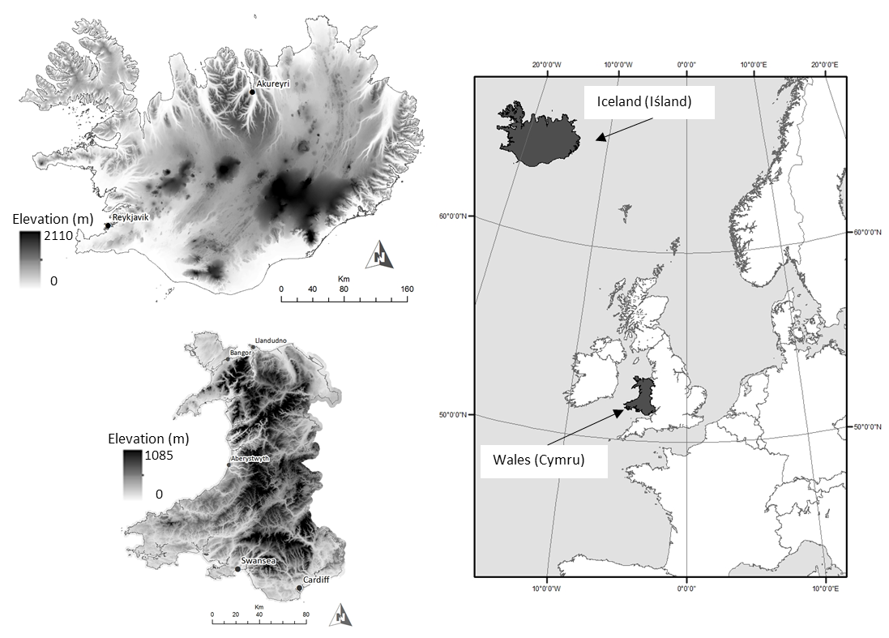
Figure 1: The location of the two study sites within Europe. Inserts show the elevation of Iceland (top left) as extracted from the National Land Survey of Iceland 20m x 20m elevation dataset and Wales (bottom left) as extracted from the UK Ordnance Survey 5m x 5m NEXTMAP dataset. Note that different scales are used to ensure clarity of the countries, but Iceland is approximately 5x the size of Wales.

Our own research has previously developed such a GIS-enabled method to quantify the visual landscape quality of Wales in the UK (Swetnam et al., 2017) (Figure 1). This work formed part of a monitoring programme, funded by the Welsh Government, to evaluate the landscape impact of the Glastir Agri-environmental scheme. The Visual Quality Index (VQI) was designed to quantify those components of the Welsh landscape that are quantifiable metrics of landscape quality. It has been successfully applied to a stratified sample of 300, 1km² sites across Wales, and has undergone public validation through an online Photographic Preference Survey (PPS), which confirmed that the correct components of the landscape were captured and that the VQI ordering of landscape quality matched that of the public assessment (Swetnam et al., 2015).
Iceland is a developed northern European country where the interplay of ice and volcanic activity has generated diverse and distinctive landscapes and many locations are renowned for their scenic beauty (Figure 1). The central highland plateau is the largest remaining terrestrial wilderness in western Europe and there are concerns about the pace of landscape change (Benediktsson, 2007; Landvernd, 2017). Many of the impacts of such change are due to i) the environmental effects of deglaciation and increased volcanic activity (e.g. Pagli & Sigmundsson, 2008; Tweed & Carrivick, 2015); ii) increased tourism (e.g. Sæþórsdóttir, 2010a); iii) energy resource development (Thórhallsdóttir, 2007) and iv) invasive plants, notably the Nootka lupin (e.g. Benediktsson, 2015). There is also undeniable tension between the forces of capitalism and the ideals of conservation and a very real sense of conflict and compromise in the context of landscape.
Consequently, there is an emerging body of work on landscape aesthetics and evaluation in Iceland (Jóhannesdóttir, 2015). Some of this work has investigated the culturally-embedded relationships between humans and nature and implications for conservation (e.g. Waage, 2013). Other research has concerned the evaluation of nature and wilderness (e.g. Ólafsdóttir & Runnström, 2011) often in the context of the highly-politicised nature of energy projects (e.g. Thórhallsdóttir; 2002; 2007; Benediktsson, 2007; Sæþórsdóttir, 2010b; Ostman, 2015). The Icelandic Landscape Project (ILP) in particular, sought to characterise major landscape types and investigate their regional distribution against the backdrop of the Icelandic Framework Plan for the Use of Hydropower and Geothermal Energy (Þórhallsdóttir et al., 2010). Landscape classification is still at an early stage in Iceland, although some research has begun to address the challenges of translating fieldwork methods into GIS-based approaches (e.g. Hoffritz et al., 2016). The initial landscape classification system developed by the ILP has recently been refined to develop a robust database for evaluating landscapes in relation to energy projects and work is ongoing (Hoffritz et al., 2016).

  - Testing the transferability of a visual quality assessment: from Wales to Iceland
Successful research methods are often bolstered by suggestions that the approach could be applied to other settings, thus extending its utility and providing greater justification for the work. Indeed, there has been renewed scientific interest in the importance of reproducibility, both of methods and results (McNutt, 2014; Baker, 2016) as surveys have shown that very few can be replicated. Many landscape researchers claim that their approaches are transferable to other locations, but this is rarely tested in earnest despite the potential efficiencies that this could offer (Hou et al., 2013). The Welsh VQI (Swetnam et al., 2017) represented a substantial political and financial investment by the Welsh Government and a commitment to an ecosystem services approach to monitoring the health of the Welsh landscape (Emmett et al., 2013). The spatial scale and longitudinal nature of the study is relatively rare and has provided a baseline and a means to monitor changes in those components of the landscape that contribute to overall visual quality. This work naturally led to questions regarding the transferability of the method to other environments.
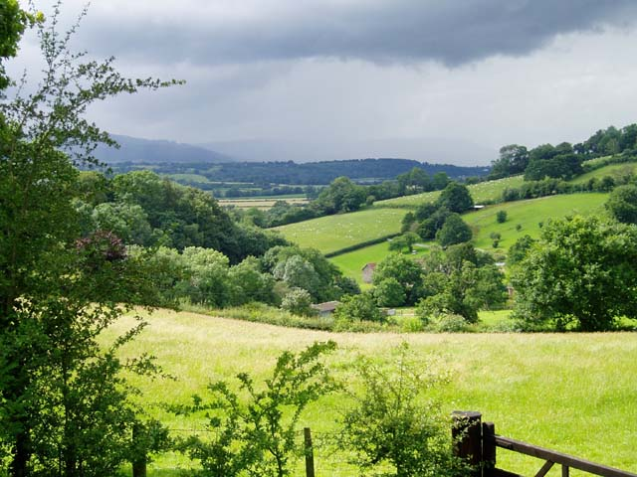
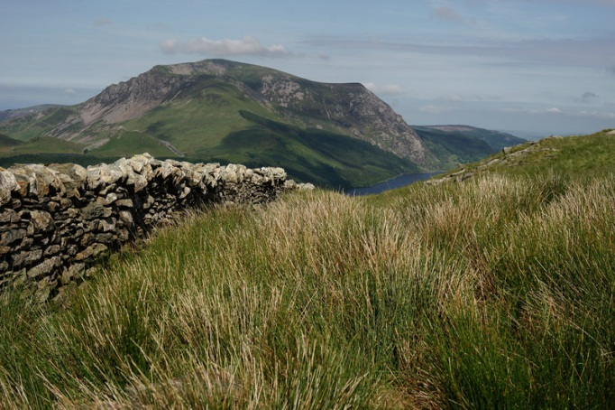
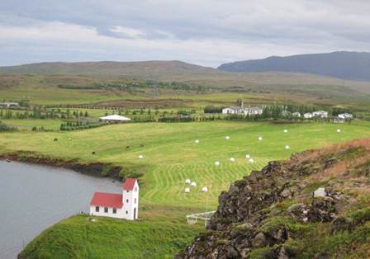
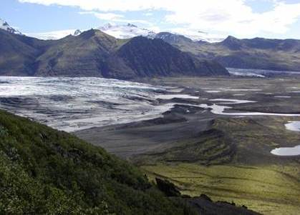
Intensive pasture
Hedgerows
Conifer plantations
Mixed deciduous woodlands
Large boundary trees
Intensive pasture
Sheep grazing
Farm
Dry stone walls
Conifer plantations
Rush pasture (wet)
Rough pasture
Exposed, bare mountain summits
Grazing horses
Few small trees
Farmed fields and silage bales
Farm
Ice cap
Flowering alpine vegetation
Valley glacier
Exposed mountain summits
Recently deglaciated bare surfaces
A
B
C
D

Figure 2: Indicative/characteristic landscapes of Iceland (A and B) and Wales (C and D). A and C compare and contrast lowland farmland scenes, whilst B and D compare and contrast upland landscapes. (A) Photo. 2011 © Fiona S. Tweed; (B) Photo. 2003 © Fiona S. Tweed; (C) Photo. 2007 © Claire Seyler (cc-by-sa/2.0); (D) Photo. 2014 ©Peter Trimming (cc-by-sa/2.0).

Iceland provides an interesting case study to test the transferability of the Welsh VQI. Although historically, socially and politically part of Europe, geographically it is unique and provides a challenging testbed for the landscape metrics used to assess visual quality in Wales. There are similarities between Icelandic and Welsh landscapes, but significant differences include: the relative absence of woodland, the openness of the view, the presence of ice caps, glaciers and active volcanoes and the nature of the built environment (see Figure 2). As explained previously, it is an environment experiencing rapid visual change with a pressing need to undertake visual assessment over very large areas; qualitative approaches requiring extensive fieldwork and public consultation are too time-consuming to meet this imperative (Hoffritz et al., 2016). An Icelandic VQI using a sampling framework derived from the ILP’s wider landscape characterisation work could offer Icelandic agencies and the research community a means to monitor and ameliorate landscape change.

  - Aims
Our aim therefore, was to adapt a visual assessment tool developed in the context of Welsh landscapes and apply it to Icelandic landscapes. In particular, we i) explore the methodological considerations inherent in adapting the visual assessment tool; ii) evaluate the transferability of the approach and iii) make recommendations for those wishing to undertake similar studies. In the following section, we summarise the landscape characteristics and agents of landscape change for Wales, where the VQI is part of an established programme of work, and for Iceland as the transferability test location.

- Study Sites
  - Wales: Landscape Characteristics and Drivers of Change
Wales is a relatively small country (20,761km²) with 3.1 million residents (ONS, 2013), the majority of whom live within the conurbations of south Wales (Cardiff, Swansea, Port Talbot) and along the north coast (Bangor, Llandudno). A remarkably diverse range of landscapes are found within its borders; from rocky and sandy coasts to open heather moorland, from rich pastoral farmland to heavily industrialised landscapes both past and present. Situated at latitude 51-54⁰ north, Wales has a largely maritime climate with significant diurnal and seasonal variations. It comprises significant areas of land above 300m with the highest peak Mount Snowdon rising to 1085m and a diverse range of important habitats including saltmarshes, woodlands, bogs and montane.
Geologically, Wales is characterised by ancient bedrock from the Lower Palaeozoic (430-540 million years ago) or Pre-Cambrian (540-750 million years ago) BGS (2017) and is geologically very stable with no active volcanoes or significant geothermal activity. The last glaciers retreated around 11,000 years ago (Hughes, 2009) and the landscape clearly shows their impact, with glaciated valleys, cirques and moraines in evidence. Geological variety has yielded significant mineral wealth, particularly in the form of slate and coal, but outcrops of copper, lead and silver have long been exploited (Humpage & Bide, 2010). Plentiful supplies of stone have resulted in dwellings constructed from long-lasting materials, leaving prehistoric monuments and 13th century castles such as Conwy and Beaumaris still standing. Farmhouses built over 400 years ago are still in use and the coherence of the rural Welsh vernacular is often striking to the visitor.
Land use in Wales is dominated by pastoral farming with 64.3% of land classed as grassland (Morton et al., 2011). Dairy and beef farming is concentrated on the richer soils of the valleys, whilst sheep farming dominates the uplands. The long history of livestock farming in this landscape has shaped its character and form significantly, with grazing keeping mountain sides free of scrub and woodland. In addition, enclosure of the farmed landscape by dry-stone walls to contain sheep has helped to define its character. Forests are another significant rural land use, with 15% of Wales under native deciduous woodland or plantation conifers (Forestry Commission, 2017). High annual rainfall, particularly in the mountains means that rivers, lakes and wetlands are also important landscape components.
Although Wales is part of the United Kingdom, it has devolved legislative powers from the main UK parliament in London. It has its own language - Welsh (Cymraeg), which is currently spoken by 21% of the population (Welsh Government, 2015). Although the language is no longer dominant within Wales, the country is officially bilingual and Welsh contributes to a strong sense of “place-based identity” even for non-Welsh speakers and the connections between the Welsh language, history, culture and physical environment remain.
Tourism has been an important part of the Welsh economy for over 150 years with infrastructure well-established and able to cope with the 100 million day visits and 6 million overnight trips made to Wales in 2013 (VisitBritain, 2015). Tourists are attracted by high quality landscapes, particularly the three national parks of Snowdonia, the Brecon Beacons and the Pembrokeshire Coast. The historic environment is also widely used in the promotion of Wales as a tourist destination. Within the Welsh Government, there is clear recognition of the contribution of the historic environment to the quality of life in Wales and the Historic Environment Strategy for Wales (Welsh Government, 2013) illustrates this policy focus.

  - Iceland: Landscape Characteristics and Drivers of Change
Iceland is an island of 100,000km², approximately five times the size of Wales. It is situated in the north Atlantic, just south of the Arctic Circle (Figure 1). Iceland’s population is approximately 329,100 (a tenth of the size of that of Wales) most of whom live in towns and villages relatively close to the coast (Statistics Iceland, 2016). Iceland’s origins are volcanic and, in contrast to Wales, it is geologically youthful with all of its rocks being formed within the last 25 million years (Thordarsson & Höskuldsson, 2014). Volcanic and tectonic processes are active and the landscape is scattered with volcanic peaks, geysers, geothermal springs and solidified lava flows. Glaciers have advanced and retreated for thousands of years, creating landforms and modifying those formed by other processes, but unlike Wales, glaciers are still active in Iceland. The landscape is dynamic; approximately a million cubic metres of land is removed from the island by erosion each year, but this removal is counterbalanced by sedimentation and volcanic processes (Thordarsson & Höskuldsson, 2014). Glaciers and lava flows each constitute approximately 10% of the country’s land surface and lakes and rivers cover approximately 6% (Thórhallsdóttir, 2007); coastal cliffs, black sandy beaches, waterfalls, meadows and lakes are also pervasive landscape features. Over half of Iceland is a central highland plateau which contains globally rare volcanic landforms (e.g. hyaloclastite mountain ridges and table mountains) and geologically diverse terrain (Thórhallsdóttir, 2002; Thordarsson & Höskuldsson, 2014).
Since the first settlers arrived in Iceland from Scandinavia in the ninth century, human activities have had significant impacts on the Icelandic landscape. Over-exploitation of the fragile natural capital ensued; forests were aggressively logged, which soon resulted in irreversible environmental changes. The grazing of domestic animals accelerated deforestation and initiated widespread soil erosion and desertification, which was also aided by a windy climate and the friable nature of the soils (Arnalds & Barkarson, 2003). Today, in stark contrast to Wales, vegetation covers barely 25% of Iceland and 50% of the soil cover has blown away resulting in swathes of comparatively barren land, especially in the interior of the country (Thórhallsdóttir, 2007). Unlike Wales, true forest is now rare, but there is dwarf birch woodland and re-forestation programmes exist, chiefly under the auspices of the Icelandic Forest Service, Skógrækt Ríkisins (Gunnarsson, 2012). The introduction of the Nootka lupin (Lupinus Nootkatensis) and its rapid spread, especially since 1945, has mitigated soil erosion and desertification processes in some locations, but is controversial (Benediktsson, 2015).
Volcanic processes continue to shape the landscape of Iceland, as do the actions of water and wind, but present-day deglaciation is having a marked impact (Tweed & Carrivick, 2015). Ice surface lowering and glacier retreat due to melting are substantially reducing the former prominence of ice in some vistas and large expanses of ice-free terrain characterised by basaltic moraines and outwash sands and gravels are becoming more widespread. Proglacial lakes are increasing in number and in size, occupying glacier forelands as valley glaciers retreat into over-deepened glacier troughs (Schomacker, 2010; Carrivick & Tweed, 2013). Glacier retreat liberates fine sands and silts (loess) which are carried by the wind and re-deposited, although large expanses of glacial outwash (sandar) and bare ground have now been colonised by the Nootka lupin, especially in the south of Iceland (Benediktsson, 2015).
Rapidly accelerating tourism presents a landscape pressure in Iceland. Tourism accounts for more foreign exchange income than the fisheries industry or aluminium production and has been a huge contributor to recovery from the banking collapse or ‘kreppa’ of October 2008. The total number of foreign visitors was 1.77 million in 2016, increasing by 39% on 2015, when foreign visitors totalled approximately 1.3 million (Icelandic Tourist Board, 2016). Tourist numbers have nearly quadrupled over the last ten years (Statistics Iceland, 2016) with the construction of hotels, apartments, campsites, cafes, gift stores, access roads, car parks and other associated infrastructure barely able to keep pace with demand. In 2013-14, over 60% of visitors cited ‘nature, scenery and landscape’ as Iceland’s main strength as a tourist destination (Icelandic Tourist Board, 2016). Unsurprisingly, Iceland invokes a sense of wilderness with snow, ice, mountains, volcanoes, glaciers, tundra, wild weather, and lengthy periods of darkness and cold. However, extended daylight, fine weather and vibrant vegetation in the summer present a different picture and underscore the seasonality of the landscape view. Iceland’s physical landscape is visually diverse and dynamic and the expansive nature or ‘openness’ of the views, as well as the exotic volcanic and icy terrain, is frequently absorbing for visitors.
Over the last twenty years, industrial and infrastructural developments have also played a more prominent and controversial role in Iceland’s landscape change. Iceland runs almost entirely on renewable energy from geothermal and hydro-electric power. Foreign companies have been attracted to Iceland with the promise of cheap energy and the central highland of Iceland, in particular, has been under increasing pressure from proposals to construct hydro-electric power plants to serve industry, accompanied by major roads, and power lines (Magnason, 2006; Benediktsson, 2007; Thórhallsdóttir, 2007). There are tensions here; environments with potential for geothermal and HEP development frequently have dramatic and interesting landscapes and high ecological value, which call for conservation. Such environments are also often popular with tourists (Sæþórsdóttir, 2010b; Sæþórsdóttir & Ólafsson, 2010). The high profile and contested Kárahnjúkar dam project, completed in 2009, dammed and diverted a glacial river 50km further east to an underground power station to provide power for a newly-constructed Alcoa aluminium smelter (see Benediktsson, 2007). There are proposals to turn the central highlands into a National Park in order to promote sustainable tourism and to limit energy development, particularly damming associated with HEP generation (Landvernd, 2017).

- Research questions
Having reviewed the key characteristics of Welsh and Icelandic landscapes and some of the drivers for landscape change, our research was guided by the following questions in seeking to adapt the VQI to the Icelandic landscape.
- What components of the Welsh VQI are transferable? Which components require revision?
- What Icelandic landscape components need adding?
- What weightings are applicable?
In the next section, we outline the methodology underpinning the development of the Welsh VQI before explaining how it was adapted for application in an Icelandic context.

- Methods
  - Establishing the Welsh VQI
The VQI is a measure of visual landscape quality developed specifically for the Welsh landscape and the methodology has been previously published in detail (see Swetnam et al., 2015; 2017) and so only a summary of the key characteristics will be provided here. It has five thematic components: physical, blue-space, green-space, historic and human with a final possible value ranging from 0 (worst) to 1 (best). Physical components of the VQI include a terrain roughness index (TRI) which has been adapted from an established geomorphological model originally published by Riley et al., (1999), which gives an indication of relative changes in height and is more useful than a simple elevation range as it considers the topographical complexity of landscape. Topography is known to have significant impact on the perceived visual quality of a location (Arriaza et al., 2004) with rugged mountain scenery rated highly by most people (Wu et al., 2006; García-Llorente et al., 2012) and therefore, the terrain component contributes positively to the overall VQI.
Blue-space focuses on water, which is known to have a positive impact on landscape quality ratings (Kaltenborn & Bjerke, 2002; Völker & Kistemann, 2011; Yang et al., 2014) with strongly positive ratings for coastal areas (White et al., 2010; Wheeler et al., 2012). The VQI measures water area (e.g. ponds), length (e.g. streams) and points (e.g. waterfalls) all of which contribute positively to the VQI. Vegetation heterogeneity plays a significant role in the visual evaluation of rural landscapes and the evidence to support this is extensive (Kaplan & Kaplan, 1989; Ode et al., 2008, Ode & Miller, 2011; Rechtman, 2013). Therefore, the green-space component of the Welsh VQI includes parameters that measure: habitat richness, species diversity, woodland area, presence of large single trees in fields and boundaries and total hedgerow length. Woodlands are rated positively in most landscape assessments (Herzog & Bosley 1992; Legge-Smith et al., 2012), although species type and management practices can influence this - for example, in Wales native deciduous woodland is rated positively, whilst plantation conifers often invoke some strongly negative responses. Hedgerows are vegetated linear features, 1-3m in height, typically comprising a mix of shrub and tree species such as blackthorn (Prunus spinosa), hawthorn (Crateaegus monogyna) and hazel (Corylus avellane) which are planted and managed to form dense field boundaries. Many are old and species-rich and provide an important habitat for birds, small mammals and insects (JNCC, 2012). They also contribute to the vertical green structure of a view and provide a strong visual pattern to large parts of the farmed landscape. Finally, Wales has many of Europe’s oldest trees which are ecologically valuable (Rackham, 2010) and due to their longevity and size these features are often significant cultural features of the British landscape (Lonsdale, 2013:13).
The presence of historic and cultural features such as stone crosses, standing stones, listed buildings, scheduled ancient monuments and dry-stone walls are all included within the Welsh VQI as positive components of landscape quality (Webley, 2004; Collier, 2013). Such assets can be important for tourism, education and sense of place (Ashworth, 2008). Finally, the human theme captures material encroachment on the natural landscape by people and their activities. Visual landscape quality reduces as human influence increases (Brush et al., 2000; Rechtman, 2013). Within this theme, the VQI calculates the length and area of roads, buildings, utilities and heavily managed or altered habitats, such as monoculture arable and coniferous plantations, and rates these negatively within the index. The totals for each of these five component groups were collated, scaled between 0 and 1, and then the five groups were weighted equally (x 0.2) and summed to derive the final Welsh VQI. These Welsh weightings reflected the emphasis given to the historic and cultural components of the landscape by the Welsh Government, even though they were sometimes less visually obvious to visitors. A sensitivity analysis was undertaken, which demonstrated the relative stability of the overall VQI as long as the weighting given to any one of the five did not exceed 0.5 (see Swetnam et al., 2017).
The Welsh VQI was designed from inception to be a GIS-enabled method due to the spatial scope of the survey; 300 sites across Wales to be resurveyed every four years. Detailed field evaluation of each 1km² survey site was not a tractable response to the scale of this challenge, which was primarily motivated by monitoring change in landscape quality over time. The method presented in Swetnam et al., (2017) was based on a thorough understanding of UK landscapes, extensive stakeholder consultation and thorough public testing through a PPS (Swetnam et al., 2015). In contrast, literature on aesthetic values attached to the Icelandic landscape is more limited due to the small local population and the relatively recent emergence of Iceland as a significant tourist destination for international visitors (Icelandic Tourist Board, 2016). Groundwork was therefore needed to establish the landscape parameters required for such a unique environment.

  - Iceland: adapting the VQI to a new setting
Several phases of research review, field testing and refinement were involved in adapting the VQI to the Icelandic landscape context (Figure 3). We began with the Welsh VQI, adding Iceland-specific content and then removing Welsh-specific content to develop a draft Icelandic VQI for field use in summertime. This VQI was field-tested with a small pilot in Iceland during summer 2015 and the content was then further adapted to the Icelandic landscape setting; glacial and geothermal features were included and some of the greenspace and historic parameters that are so prevalent in the Welsh landscape were removed. A subsequent winter pilot study led to further revisions following which the Icelandic VQI was applied to 32 sites by 4 assessors in a summer field campaign in 2016. Table 1 summarises the parameters used in the visual quality assessment in both Wales and Iceland, showing that a number are shared (for example, landscape ruggedness, the amount of water, presence of infrastructure). In developing the Icelandic VQI, each of the five themes contained within the Welsh VQI was considered in turn; these are explained below.

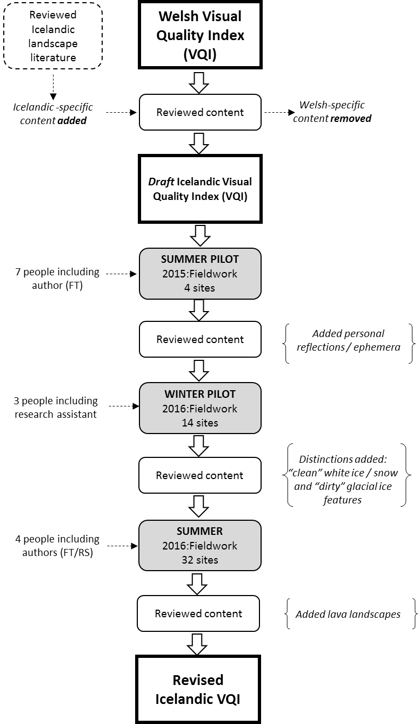
.

Figure 3: Key methodological stages used to transfer the Welsh VQI to the Icelandic landscape context

ICELAND SPECIFIC | SHARED | WALES SPECIFIC
(T)- Can you see any geysers, steam or bubbling mud?  (BS) – Can you see any ice?  (BS) What % of the landscape consists of white ice / snow / glaciers?  (BS)- What % of the landscape consists of dirty or black ice / snow / glaciers?  (GS) - Can you see or hear any birds?  (BT) - Can you see any buildings? | (T) - How rugged is most of the landscape view?  (BS)- What % of the view consists of liquid water?  (BS)- Can you see / hear the sea?  (BS) - Can you see any waterfalls or the spray from waterfalls?  (GS) - What % of the view is vegetated?  (GS) - Can you see any plants in flower?  (GS) - Can you see /hear any livestock?  (BT) - How many bits of infrastructure can you see (pylons, piping, masts, etc.)  (BT) – Can you see any roads?  (H) - Can you see any buildings of architectural or cultural interest or merit? | (GS) - What % of the view is wooded?  (GS) - How many large, individual trees can you see?  (GS)- Can you see any hedgerows? How long are they?  (BS) – How many point water features (wells, springs etc.) can you see?  (BT) - What % of the landscape in the view is urban / suburban?  (H) - How long are the stone / slate walls or fences  (H)- Can you see any ancient monuments?

Table 1: Landscape parameters for use in visual quality assessment in Iceland and Wales. The Welsh parameters are derived from a Visual Quality Index (Swetnam et al., 2017) developed as part of the Glastir Monitoring and Evaluation Programme (GMEP) which was field tested on 300 sites across Wales. These landscape parameters were then tailored and field-tested on 32 sites across south and western Iceland during 2016 / 2017. (T) = Terrain, (BS) = Blue Space, (GS) = Green Space, (BT) = Built, (H) = Historic

    - Terrain
The first theme attempts to capture how rugged and topographically varied the landscape view appears. Both countries are mountainous and the sense of scale, height and enclosure are all relevant to the aesthetic enjoyment of landscapes (Nepal & Chippenuik, 2005). Within the ILP (Þórhallsdóttir et al., 2010), eight topographical parameters were assessed: landscape shape (concave to convex); visible landscape depth; elevational range; landscape form (straight, rolling, angular, sinuous, diversity). This represented over a third of the total which gives some indication of the visual dominance of the physical landscape in Iceland and the significance attached to it by Icelanders. In Wales, this type of measure was captured by one metric, the Terrain Ruggedness Index adapted from Riley et al., (1999), which provided a systematic and objective way of capturing variability in the mountain topography. This was calculated at a 5m resolution scale for the whole of Wales and then extracted for each 1km survey site with the modal value taken as representative. For the purposes of testing, we opted for simplicity and asked field evaluators to assign a class (level / undulating / moderately rugged / highly rugged) that best represented the majority of the landscapes from where they stood. However, this question remained problematic in open landscapes fringed with mountains.
The “openness” and “expansiveness” of Iceland was much debated by the team as there is no doubt that the scale and textural complexity of the Welsh and Icelandic landscapes is markedly different (Figure 2). Under clear conditions, the visible horizon in Iceland can sometimes be 40-50km away. This would only occur at high elevations and under exceptionally good weather conditions in Wales. In the ILP, the researchers used “visible landscape depth” as a parameter, splitting the horizon into quarters and evaluating how far away it appeared to be (<3km, 3 - 10km, 11 - 20km, 21-40km, >40km). However, such distance can appear foreshortened to the human eye and is extremely difficult to assess accurately; in addition, it will be notably affected by weather conditions. This task could be undertaken more rigorously using GIS data from a DEM and calculating actual line-of-sight distances from a known observer point (Fisher-Gewirtzman, 2003).
For many visitors to Iceland, the existence of geysers, steaming rivers and bubbling mud pools provides tangible evidence of the island’s volcanic activity. Although a common sight to locals, these features can be visually exciting (geyser eruptions, for example) and can provide an overwhelming olfactory experience as hydrogen sulphide (H₂S) is often released. Therefore, we added this to our list of terrain factors as it is largely a geological phenomenon.

    - Blue space (water)
Water is the second theme in the VQI; registering this in the Welsh situation was relatively straightforward and involved recording the presence and scale of water features (lakes, rivers, waterfalls, springs etc.). These factors are still relevant to Iceland, but we needed to consider the fundamental difference between the visual appearance of liquid water and frozen water. The latter is hugely significant in the Icelandic landscape in all seasons. Ice caps, permanent snow cover and active glaciers remain a significant draw for most overseas visitors (Jóhannesdóttir, 2010; Olafsdóttir, 2013). One of the researchers (FST) is a glacial specialist who has extensive knowledge of the appearance of many of the Icelandic glaciers of Mýrdalsjökull and Vatnajökull, with photographs spanning 25 years. Reviewing these from an aesthetic viewpoint, it was clear that there is a distinction to be made between the white surfaces of the ice caps and the blackened, debris-rich ice present at the snouts of many of Iceland’s glaciers. Icelandic glaciers are retreating rapidly (e.g. Sigurdsson et al., 2007; Tweed & Carrivick, 2015) and the bare, debris-strewn landscapes that are left in their wake are going to become more common (Björnsson & Pálsson, 2008; Welling, 2013). We suggest that this may pose significant aesthetic challenges; most tourists come to see ice in Iceland and if sites such as Skaftafell, Sólheimajökull and Snæfellsnes continue to change rapidly, the view may not be quite so enthralling to those unfamiliar with deglaciating environments.
Waterfalls are also noteworthy in this blue-space theme. Wales has many small waterfalls which are visually attractive and valued features of the landscape. Pistyll Rhaeadr in Wales is the UK’s tallest single drop waterfall, at 80m high. In Iceland, waterfalls are common and visible features, rarely hidden by surrounding vegetation. Glymur is the highest accessible waterfall in Iceland with a 198m drop whilst the famous Gullfoss is a wide, tiered waterfall with 11m and 21 m drops. The relative discharge of these features is notable in Iceland; for example, Dettifoss is often considered to be the most powerful waterfall in Europe, its debris-charged water dropping 44m. In both countries, waterfalls are major tourist attractions and are valued aesthetically (Hudson, 2013).

    - Green space (vegetation)
Iceland’s landscape is dominated by bare rock; vertical green infrastructure in the form of mature trees is rare with only 1.5% of Iceland having any tree cover (Eysteinsson, 2013). Much of the country is treeless and this absence of vegetation is one of the most striking things to the visitor. Consequently, this theme was much compressed for the Icelandic situation. The Welsh indicators, designed to capture the amount of woodland, trees and linear hedgerows as well as overall plant and habitat diversity, were reduced to an assessment of the amount of vegetated land (most typically grassland or heathland). As the VQI was being tailored to the summer, flowering plants such as: stitchworts (Stellaria spp.), buttercups (Ranunculus spp.) and angelica (Angelica spp.) are evident (Kristinsson, 2010). In addition, swathes of invasive lupin (Nootka lupensis) with their purple flower spikes are a recent, but visually impactful addition (Benediktsson, 2015). Therefore, we retained a simple indicator recording the presence / absence of any flowering plants within the view.

    - Built/human
Most visitors that arrive in Iceland do so through Keflavík International Airport which serves the capital city of Reykjavík, 50km to the north-east. This city region of 211,282 people is home to 64% of the Icelandic population (Landshagir, 2015) and contains all of the built paraphernalia of any developed conurbation including houses, factories, transport, signage, utilities and recreational facilities. Once outside of its confines, the impact of the built environment on the landscape diminishes rapidly. Iceland has no motorways or railways and its road system is functional, but minimal. Settlements are small, mainly coastal, scattered and unobtrusive. Iceland lacks a long history of industrialisation and so the extensive land degradation seen in Wales (from hundreds of years of coal extraction, slate mining and heavy chemical industries) is absent. Energy infrastructure is present however, pipes and geothermal power infrastructure are found both at the energy source and around urban areas (Arnórsson et al., 2008). Three parameters relating to the built environment were retained within the Icelandic VQI: the presence of any sort of building; a count of the numbers of visible infrastructure seen (such as electricity pylons, mobile phone masts, pipes); whether there were any roads in the view and what type (track versus tarmacked). These parameters all impact negatively on the final VQI.

    - Historic
Within the Welsh VQI, the historic and cultural components of the landscape are explicitly considered in detail with five separate parameters evaluated (number of scheduled ancient monuments, number of listed buildings, overall length of stone walls / slate fences, presence of designated historic landscapes). Iceland’s rich cultural heritage, which is preserved in its famous saga literature, is of great national significance (Magnusson, 1987). However, this does not find a physical expression in built remains due to the lack of building stone as well as the need for frequent rebuilding because of physical damage caused by heavy snowfall, avalanches, debris flows, floods, eruptions and earthquakes (Bessason et al., 2012). It is somewhat ironic that although Iceland has the oldest parliament in the world, the Alþingi, which was founded at Þingvellir in 930 AD, no ancient building marks this location; the current Alþingishúsið in Reykjavík dates from only 1881. Aside from preserved turf houses, such as the example at Glaumbær (van Hoof & van Dijken, 2008), and a few wooden buildings dating back to the early 19th century, most buildings in Iceland are 20th century. Within the wider landscape, the only prominent historic buildings are Icelandic churches; these are mostly constructed of wood and painted white, with modern concrete examples found at Ólafsvík and Stykkísholmur. The only historic parameter that could easily be recorded was “Are there any buildings of architectural or cultural interest?” which was rated positively in the final index. The built / human theme and the historic theme were combined within the Icelandic VQI.

  - Weighting the Icelandic VQI
The issue of weighing within the VQI needed reconsidering in the Icelandic context. When tested with a range of Icelandic landscape photographs from the first ILP classification (Þórhallsdóttir et al., 2010), an equal-weighted VQI (Terrain = 0.25, Blue Space = 0.25, Green Space = 0.25, Built/Historic = 0.25) did not appear to distinguish between different landscapes particularly well. As previously discussed, the physical landscape of Iceland is visually dominant. We therefore, weighted our Icelandic VQI more unevenly (Terrain = 0.50, Blue Space = 0.20, Green Space = 0.20, Built/Historic = 0.10) with much greater emphasis placed on basic terrain and much less on human infrastructure. This partly mirrors decisions made in the second version of the ILP (Hoffritz, et al., 2016) where basic shape, vegetation cover, sea and glacier presence were determined to be dominant visual characteristics of the landscape and were given a weight of 0.5 in the clustering algorithm used to classify landscape types. As with the Welsh data, we undertook a sensitivity analysis that showed that the VQI remained stable, even when the Terrain weighting was quite extreme. Variations in the Green Space component were the most impactful because of the large amount of bare rock in Iceland. The weightings used seemed to deliver the most meaningful output and for the purposes of testing the method, they were deemed acceptable (See Supplementary Materials S1).

Group | Responses
Ephemera | - Are there any noticeable smells? If so please note  - Are there any noticeable sounds? If so please note
Personal Response | How would you describe this landscape, here and now?
 | Beautiful | +3 / +2 / +1 / 0 / -1 / -2 / -3 |  | Ugly
 | Natural | +3 / +2 / +1 / 0 / -1 / -2 / -3 |  | Managed
 | Exciting | +3 / +2 / +1 / 0 / -1 / -2 / -3 |  | Dull
 | Varied | +3 / +2 / +1 / 0 / -1 / -2 / -3 |  | Uniform
 | Safe | +3 / +2 / +1 / 0 / -1 / -2 / -3 |  | Dangerous
Weather | Cloud Cover | <5% (Clear) | 5–49% (Partial Cloud) | 50-70% (Cloudy) | >70% (Overcast)
 | Rain | None | Misty Rain | Constant Rain | Heavy Rain
 | Wind | Calm | Gentle Breeze | Moderately Windy | Very Windy
 | Visibility | Clear | Good | Average | Poor

Table 2: Ephemeral landscape conditions were assessed during the Icelandic field assessment using three groups of additional questions: Senses, Personal Response (Visual Appeal) and Weather.

  - The inclusion of ephemera and personal landscape appeal
As discussed earlier, there is a substantial body of research on the aesthetic appeal of landscapes (e.g. Nassauer 1995; Gobster et al., 2007; Yang et al., 2014). In contrast to the Welsh VQI field survey, we directed participants to record measures of personal landscape appeal as well as the ephemeral aspects in which a landscape was evaluated, for example, noticeable smells, sounds and weather conditions (Table 2). The inclusion of personal landscape appeal meant that the relatively objective VQI score could be compared against individual and highly personal responses to landscapes. This would enable us to determine whether individuals found landscapes that were accorded a high visual quality score to be more attractive (see for example, Ode et al., 2008).

- Results
The prime objective of this research was to test the transferability of a method to evaluate visual landscape quality from one location (Wales, UK) to another very different setting (Iceland). The final results presented here represent the combined views of only four people from the third field assessment undertaken at 32 sites during July 2016, and the results should be considered as “proof of concept” rather than a definitive assessment of visual landscape quality in these parts of Iceland. That said, the results are informative, appear geographically sensible and reasonably consistent and could move Icelandic mapping towards the potential goal of a complete, baseline visual quality assessment that does not require every km² to have been individually assessed by people - clearly an impossible task.
Figure 4 presents a summary of the key findings, both in terms of the VQI but also the separately assessed personal responses regarding the visual appeal / aesthetic of the sites. With both measures, it is important to stress that it is not the final score that is key; using one number to describe the beauty of a location is obviously meaningless. What matters is the ranking, the order that the index places sites in. Can it distinguish the high-quality sites from the less visually appealing? The pilot VQI appears to do a fairly good job of this, with iconic sites such as Skógafoss and Gullfoss appearing in the top 20% along with the unique glacial landscapes of the icecaps, glaciers and iceberg-filled lakes also clustered towards the top. The more typical farmed landscapes appear further down the ranking, whilst settlements and flat outwash plains received much lower scores. Selected sites are shown here to illustrate the variation, but the complete ordering of 32 sites is shown in Supplementary Materials S2.

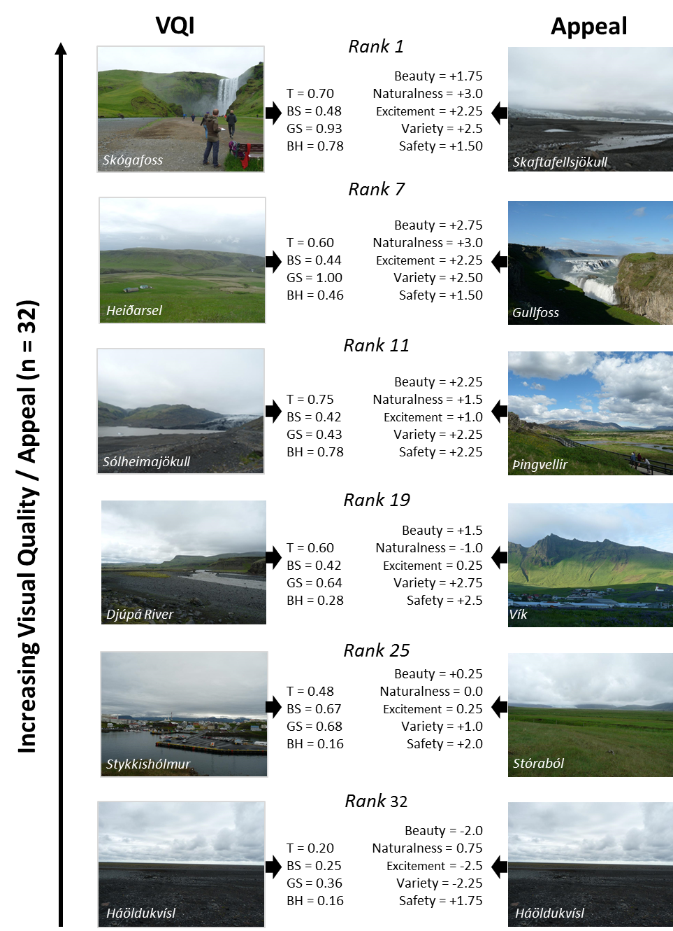
Figure 4: Comparison of the ranked VQI (left hand column) and the associated Appeal Scores (right hand column) where the VQI rank 1 = highest, rank 32 = lowest for the Icelandic test sites. The VQI scores range from 0 – 1.0 for each of the themes where T = Terrain, BS = Blue Space, GS = Green Space, BH = Built and Historic combined. Appeal scores could range from +3 to -3, see Table 3 for full description of the scale. In both cases, results = mean scores of the four field evaluators. Photographs all ©Fiona S. Tweed, 2016.

In contrast, the separately derived Appeal Scores (Table 2) also order the landscapes in a meaningful (but slightly different) manner with the waterfalls dominating the higher scores (Supplementary S2). Both evaluations agreed that the outwash plains at Háöldukvísl were visually unattractive. A positive relationship is shown between the qualitatively assessed Appeal Scores and the quantitatively described VQI (r² = 0.462). This is encouraging, as it demonstrates that the VQI is capturing something significant about the landscape appeal and aesthetic (Figure 5). The level of agreement between the four field surveyors is significantly higher with the VQI as opposed to the Appeal Ratings. For the 32 sites, (using the 17 parameters listed in Table 1) there was >70% agreement on 28 / 32 sites and >80% agreement on 13 / 32 sites. In contrast, the personal response data demonstrated wide levels of disagreement. On half of the sites (16 / 32) there was no agreement at all between the four surveyors using the 5 measures. Eleven sites had one question where all four agreed and there were only five sites where agreement was reached in two out of the five measures. This clearly shows that qualitative responses of this type do not lend themselves well to categorisation and the variability shown would need capturing differently. Other routes to engagement would need to be sought (as exemplified by Jóhannesdóttir, 2015 in her immersive, qualitative discussions with focus groups) and used alongside the more objective, component-based approach of the VQI.

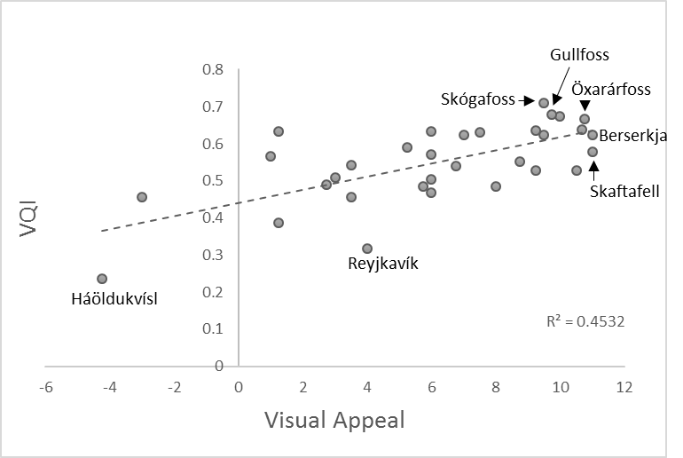
Figure 5: The relationship between the qualitatively assessed Appeal ratings and the quantitatively scored VQI index for the 32 sites surveyed in June 2016, mean value from 4 surveyors used.

- Discussion
The Welsh VQI was delivered using a quantifiable, GIS approach. This was a deliberate choice to side-step the problems raised by subjective, evaluative approaches which do not lend themselves to monitoring or comparison. Table 3 presents a recommended approach to implement these field-tested parameters within a GIS for Iceland. Perhaps the biggest challenge is to determine what spatial scale is most appropriate to calculate these indices, both in terms of tractability for processing for a country that is >100,000km² in area, but more importantly to capture the scale of the landscape. It is evident that the 1km² survey square scale used in the GMEP project for Wales is too restrictive. We suggest 2 – 5km² might be appropriate, but this would need testing to explore the impact on the indicators and the output of the VQI.
THEME | ICELAND VQI  FIELD EVALUATION (qualitative) | ICELANDIC VQI  PROPOSED GIS METHOD (quantitative)
Terrain | - How rugged is most of the view?  - Can you see geysers, steam, bubbling mud? | - Calculate Terrain Ruggedness Index (Riley et al., 1999). The landscape scale and openness could potentially be calculated using standardised line of sight methods as proposed by Fisher-Gewirtzman (2003).  - Count the number of mapped geothermal features within chosen grid cells.
Blue Space | - What % of the view consists of liquid water?  - Can you see or hear the sea?  - Can you see any waterfalls or the spray from waterfalls?  - What % of the landscape consists of white ice / snow / glaciers?  - What % of the landscape consists of dirty or black ice / snow / glaciers? | - Measure the area (km²) of all standing open water bodies. Measure the length of all mapped watercourses (km).  - Measure the distance from the site boundaries to the coastline. If within 5km assign as coastal.  - Record the number of all mapped waterfalls.  - Measure the area (km²) of all mapped permanent glaciers  - The distinction between white / black ice is not possible to determine from GIS datasets
Green Space | - What % of the view is vegetated?  - Can you see any plants in flower?  - Can you see or hear any birds?  - Can you see or hear any livestock? | - Measure the area (km²) of vegetated land. Calculate the habitat diversity within the site using land cover data.  - Calculate plant species diversity from species data.  - Not available as a quantitative measure.  - Official stocking data may be available – this was used in the Welsh VQI to confirm livestock presence.
Built | - Can you see any buildings?  - How many bits of infrastructure can you see (pylons, geothermal piping, masts, telegraph poles etc)  - Are there any roads in the view? | - Measure the area (m²) or count the number of individual buildings.  - Measure the area (m²) of any infrastructure plant. Count the number of masts / pylons / turbines mapped. Measure the length (m) of any visible piping.  - Measure the length of roads (km)
Historic | - Can you see any buildings of architectural or cultural interest or merit? | - Count the number of mapped churches / historic buildings

Table 3: A comparison between the field method used to assess visual landscape quality (QUALITATIVE) and a proposed GIS-enabled implementation of that method using available digital data for Iceland (QUANTITATIVE).

The field evaluations allowed us to consider in situ what parameters would be needed for a GIS implementation for Iceland. However, it does have other potential uses. It was quick and straightforward to implement, even by non-experts and could collect large numbers of responses from visitors at fixed points in key locations (e.g. Gullfoss, Skaftafell). Although, outside the scope of this paper, its value as an educational tool for locals and tourists alike could be considerable especially if results from many different sorts of visitors could be tracked over time.
We recognise that we are subject to socio-cultural bias (Chiesura & de Groot, 2003) and that, in seeking to transfer a method from Wales (which we know well as “natives” of the UK) to a landscape in which we are “outsiders”, we acknowledge that this bias will be present. Three of the four people employed in the main data collection phase in summer 2016 had not visited Iceland before; however, the fourth (FT) has conducted extensive field research in Iceland over the last 30 years and is very familiar with Iceland and its landscapes. In addition, we consulted with Icelandic landscape researchers who assisted us in thinking through various aspects of the Icelandic VQI. With the publication of the Icelandic Landscape Characterisation (Þórhallsdóttir et al., 2010; Hoffritz et al., 2016), there now exists a sampling framework which could be used to stratify sites for a GIS-derived landscape quality assessment. This would be similar to the approach taken in the UK, where GMEP and the long-established Countryside Surveys (Carey et al., 2009) use the UK Land Classification (Bunce et al., 1996) as a framework for efficient ecological sampling.

- Conclusions
We asked three fundamental questions about the portability of visual landscape quality metrics between different landscape settings: what components of the VQI were transferable between Wales and Iceland? (Q1); which components of the view were missing? (Q2) and finally how might the different themes of the VQI be weighted in these different settings? (Q3). Our results demonstrated that core metrics relating to the built environment and transport, basic topography, the presence of the coast, water features and vegetated habitats were common. In contrast, the glacial and volcanic landforms of Iceland are part of its distinctive visual character and required adding to the Icelandic version of the VQI, with the wooded and historic features of the Welsh version being removed. The weightings applied to each theme within the VQI also required adjustment, moving from an equally weighted index which worked well in the Welsh setting to an unequal weighting which emphasised the physical components of the landscape in Iceland. We believe that careful choice of location-specific parameters and evaluation of appropriate weightings, would allow our approach to be tailored to other landscapes. For those seeking to apply the VQI in other landscape settings, we suggest the following checklist as a starting point.

- Do you have access to individuals with a personal understanding of the landscape, based on experience?
- Can the general character of the landscape be described? e.g. topography, vegetation (wooded/forested) farmed (arable/pastoral, intensive/extensive), geology (e.g. terrain, ruggedness, obvious unique or unusual features), water features.
- Can the settlements and associated infrastructure be described? e.g. dispersed, clustered, presence of historic buildings, utilities etc.
- What transport infrastructure is present?
- How seasonal is the landscape and how is that reflected? e.g. differences in vegetation cover and nature, snow and ice cover etc.
- Do you need to weight elements to bring up your sites in the right ‘order’ of visual quality? How might you check this?
- Do you wish to include ephemera in your assessment? e.g. sounds, smells, weather conditions.
- Do you wish to include personal aesthetic evaluations? e.g. perceptions of beauty, safety, level of management of landscape etc.
- Can you test your adapted Visual Quality Index in the field? (Note - this is vital)

It is clear from this research, that fieldwork and in-situ experience of the landscape is essential to undertaking a successful transfer of such a method. The digital world, with its synoptic spatial datasets, offers many tempting short-cuts to landscape scientists, but side-stepping the fundamental fieldwork step is risky. There is great value in such an immersive experience and the only defence against the subjectivity inherent in all landscape aesthetic approaches is to pilot the work, evaluate it, consult on the findings and be transparent with potential users about which metrics are used and how they are weighted.

Acknowledgements
Our fieldwork in Iceland was funded by the Staffordshire University Vice-Chancellor’s Research Fund 2016. Thank you to Geological Society of America (GSA) ‘Dynamic Iceland 2015’ GeoVenture participants Tim Chowns, Rick Rogers, Tom McGuire, Cathy Carpenter, Wendy Van Norden and Amanda Ruhe for their assistance with a pilot study of the adapted VQI in Iceland. Edward Jones, Bruce Righton and Brenda Righton undertook the winter pilot study in Iceland and Jonathan Newbould assisted its development. We thank Dan Chambers and Gordon Walker for field data collection in 2016 and Karl Benediktsson, Edda Waage and Adam Hoffritz at the University of Iceland for useful discussion of Icelandic landscapes. Photographs in Figure 2C (Claire Seyler) and 2D (Peter Trimming) were sourced from https://www.geograph.org.uk/ and are used under a Creative Commons licence. The Welsh VQI was developed as part of the Glastir Monitoring and Evaluation Programme which was funded by the Welsh Government (Contract Ref: C147/2010/11). We acknowledge the GMEP project team for the provision of data on which the Welsh VQI was built and their suggestions during its inception. Finally, we thank our reviewers for their helpful comments.

References
- Arnalds, Ó. & Barkarson, B.H. 2003. Soil erosion and land use policy in Iceland in relation to sheep grazing and government subsidies. Environmental Science and Policy 6, 105-113.
- Arnórsson, S., Axelsson, G., Sæmundsson, K., 2008. Geothermal systems in Iceland. Jókull 58: 269–302
- Arriaza, M. Cañas-Ortega, J.F., Cañas-Madueñoet, J.A. & Ruiz-Aviles, P. 2004. Assessing the visual quality of rural landscapes. Landscape and Urban Planning 69, 115-125.
- Ashworth, G., 2008. In search of the place-identity dividend: using heritage landscapes to create place identity. Chapter 13 In: Eyles, J., Williams, A. (Eds.), Sense of Place, Health and Quality of Life. Ashgate Publishing Ltd., Aldershot, UK.
- Baker, M. 2016. Is there a Reproducibility Crisis? Nature 533, 452-454.
- BGS. 2017. Overview of Regional Geology of Wales. British Geological Survey available online at http://www.bgs.ac.uk/research/ukgeology/regionalGeology/home.html
- Brabyn, L. 2009. Classifying Landscape Character. Landscape Research 34, 299-321.
- Benediktsson K., 2007. "Scenophobia" geography and the aesthetic politics of landscape. Geografiska Annaler Series B, Human Geography 89, 203-217.
- Benediktsson, K. 2015. Floral hazards: Nootka lupin in Iceland and the complex politics of invasive life. Geografiska Annaler: Series B, Human Geography 97, 139-154.
- Bessason, B., Bjarnason, J.Ö., Guðmundsson, A., Sólnes, J. & Steedman, S., 2012. Comprehensive damage analysis of buildings affected by the 2008 South Iceland earthquake. In Proceedings of the 15th World Conference of Earthquake Engineering.
- Björnsson, H. & Pálsson, F. 2008. Icelandic glaciers. Jökull 58, 365-386.
- Brush, R., Chenoweth, R.E. & Barman, T. 2000. Group differences in the enjoyability of driving through rural landscapes. Landscape and Urban Planning 47, 39-45.
- Bunce, R.G.H., Barr, C. J., Gillespie, M.K., Howard, D. C., 1996. The ITE Land Classification: providing an environmental stratification of Great Britain. Environmental Monitoring and Assessment 39, 39-46.
- Carey, P. D., Wallis, S., Chamberlain, P.M., Cooper, A., Emmett, B.A., Maskell, L.C., McCann, T., Murphy, J.,
- Carrivick, J.L. & Tweed, F.S. 2013. Proglacial lakes: character, behaviour and geological importance. Quaternary Science Reviews 78, 34-52.
- Clay, G.R. & Daniel, T.C., 2000. Scenic landscape assessment: the effects of land management jurisdiction on public perception of scenic beauty. Landscape and Urban Planning 49, 1-13.
- Chiesura, A. de Groot, R. 2003. Critical natural capital: a socio-cultural perspective. Ecological Economics, 44: 219-231.
- Church, A., Burgess, J., Ravenscroft, N., Bird, W., et al., 2011. Cultural Services: UK National Ecosystem Assessment. UNEP-WCMC, Cambridge, 633-692.
- Collier, M. 2013. Field boundary stone walls as exemplars of 'novel' ecosystems. Landscape Research 38. 141-150.
- Costanza, R., d’Arge, R., de Groot, R., Farber, S., Grasso, M., Hannon, B., Limburg, K., Naeem, S., O’Neill, R. V., Paruelo, J., Raskin, R. G., Sutton, P., van den Belt, M., 1997. The value of the world’s ecosystem services and natural capital. Nature, 387: 253-260.
- Daily, G.C., Polasky, S., Goldstein, J., Kareiva, P.M., et al., 2009. Ecosystem services in decision making: time to deliver. Front. Ecol. Environ. 7, 21–28.
- Dakin, S., 2003. There’s more to landscape than meets the eye: towards inclusive landscape assessment in resource and environmental management. The Canadian Geographer/Le Geographe Canadien 47, 185–200.
- Daniel, T. C., Muhar, A., Arnberger, A., Anzar, O., et al., 2012. Contributions of cultural services to the ecosystem services agenda. PNAS 109, 8812-8819.
- Dramstad, W.E., Sundli Tveit, M., Fjellstad, W.J. & Fry, G.L.A. 2006. Relationships between visual landscape preferences and map-based indicators of landscape structure. Landscape and Urban Planning 78, 465-474.
- Emmett, B.A., 2013. An integrated ecological, social and physical approach to monitoring environmental change and land management effects: the Wales axis II monitoring and evaluation programme. Asp. Appl. Biol., 118.
- Eysteinsson, T., 2013. Forestry in a Treeless Land – 4th Edition. Iceland Forestry Service. Available online https://rafhladan.is/bitstream/handle/10802/7037/Treeless-land_netutgafa.pdf?sequence=1
- Fisher-Gewirtzman, D., 2013. Spatial openness as a practical metric for evaluating built-up environments. Planning and Design, 30: 37-49.
- Forestry Commission. 2017. Woodland Area, Planting and Publicly Funded Restocking. 2017 Edition 1st Release. Available online https://www.forestry.gov.uk/pdf/wapr2017.pdf/$FILE/wapr2017.pdf
- Frank, S., Fürst, C., Koschke, L., Witt, A., & Makeschin, F. 2013. Assessment of landscape aesthetics - Validation of a landscape metrics-based assessment by visual estimate of scenic beauty. Ecological Indicators 32, 222-231.
- García-Llorente, M. Martín-López, B., Iniesta-Arandia, I., López-Santiago, C.A., Aguilera, P.A. & Montes, C. 2012. The role of multi-functionality in social preferences toward semi-arid rural landscapes: An ecosystem service approach. Environmental Science & Policy 19-20, 136-146.
- Gobster, P.H., Nassauer, J. I., Daniel, T. C., & Fry, G., 2007. The shared landscape: what does aesthetics have to do with ecology? Landscape Ecology 22, 959-972.
- Gunnarsson, E. 2012. Skógræktarárið 2011 (Forestry in 2011). Icelandic Forestry 2012 2, 90-95.
- Hansen, S. S., Nellemann, V. W., & Willeberg-Nielsen, K. 2010. 97 Kommuneplanlægning for fremtidens landbrugsbyggeri. Byplan 62, 23-29. In Norwegian, summarised in English in Sala (2014).
- Herzog, T.R. & Bosley, P.J. 1992. Tranquility and preference as affective qualities of natural environments. Journal of Environmental Psychology 12, 115-127.
- Hoffritz, A., Ostman, D. & Arnason, Þ. 2016. Landslagsflokkun með Vettvangsgögnum og Stafrænum Aðferðum. Rannsóknasetur Háskóla Íslands á Hornafirði, 50pp.
- Hou, Y., Burkhard, B., & Müller, F. 2013. Uncertainties in landscape analysis and ecosystem service assessment. Journal of Environmental Management, 127(Supplement Sept 2013), 117-131.
- Hudson, B. 2013. Waterfalls, science and aesthetics. Journal of Cultural Geography 30, 356-379.
- Hughes, P.D. 2009. Loch Lomond Stadial (Younger Dryas) glaciers and climate in Wales. Geological Journal 44, 375-391.
- Humpage, A. J., & Bide, T. P. 2010. The Mineral Resource Maps of Wales. British Geological Survey Open Report OR/10/032. 49pp. Available online at https://www.bgs.ac.uk/downloads/start.cfm?id=1665
- Icelandic Tourist Board, 2016. https://www.ferdamalastofa.is/en
- JNCC, 2012. Joint Nature Conservation Committee and Defra: UK Post-2010 Biodiversity Framework, Available online: 〈http://jncc.defra.gov.uk/pdf/UK_Post2010_Bio-Fwork.pdf〉.
- Jóhannesdóttir, G.R., 2010. Landscape and Aesthetic Values: Not Only in the Eye of the Beholder, p 109-125 in Benediktsson & Lund, K. A.,(Eds.). Conversations with Landscape. Farnham UK: Ashgate Publishing.
- Jóhannesdóttir, G.R., 2015. Icelandic Landscapes: Beauty and the Aesthetic in Environmental Decision Making. PhD thesis, Faculty of History and Philosophy, University of Iceland pp.204.
- Jones, M., 2007. Seasonality and Landscape in Northern Europe: An Introductory Exploration. Chapter 2 in Palang et al., (Eds.) Seasonal Landscapes. Landscape Series Vol 7. Springer: Dordrecht. 257pp.
- Kaltenborn, B.P. & Bjerke, T. 2002. Associations between landscape preferences and place attachment: a study in Róros, Southern Norway, Landscape and Urban Planning, 133:67-77.
- Kaplan, R & Kaplan, S., 1989. The Experience of Nature. Cambridge University Press: Cambridge, UK.
- Kellert, S. R., & Wilson, E. O., 1993. The Biophilia Hypothesis. Island Press: Washington DC.
- Kim, K.H., & Pautleitb, S. 2007. Landscape character, biodiversity and land use planning: The Case of Kwangju City Region, South Korea, Land Use Policy 24, 264-274.
- Kristinsson, H., 2010 Flowering Plants and Ferns of Iceland. Mál og menning: Reykjavik. 368pp.
- Landshagir, 2015. Statistical Yearbook of Iceland, Volume 25. Statistics Iceland: Reykjavik. Available online https://www.statice.is/publications/yearbook/
- Landvernd (The Icelandic Environment Association) 2017. http://landvernd.is/en
- Legge-Smith, E., Bishop, I.D., Williams, K.J.H., & Ford, R.J. 2012. Scenario Chooser: An interactive approach to eliciting public landscape preferences. Landscape and Urban Planning 106, 230-243.
- Lewis, P.H., 1964. Quality corridors for Wisconsin. Landscape Architecture 54, 100-107.
- Lewis, P. H. 1996. Tomorrow by Design. A Regional Design Process for Sustainability. New York, NY: John Wiley & Sons.
- Lonsdale, D (Ed.)(2013) Ancient and other veteran trees: further guidance on management. Ancient Tree Forum. The Tree Council: London UK. Available online http://ancienttreeforum.co.uk/wp-content/uploads/2015/02/ATF_book.pdf
- Lothian, A. 1999. Landscape and the Philosophy of Aesthetics: Is Landscape Quality inherent in the landscape or in the eye of the beholder? Landscape and Urban Planning, 44: 177-198.
- Lynch, K. 1960. The Image of the City. Cambridge MA: The MIT Press.
- Magnason, A.S. 2006. Draumalandið. Mál og menning, Reykjavík.
- Magnusson, M. 1987. Iceland Saga. The Bodley Head: London, pp246.
- McNutt, M. 2014. Journals unite for reproducibility. Science 346 (6210), 679.
- MEA, 2005. Millennium Ecosystem Assessment Ecosystems and Human Well Being: Current State and Trends Assessment, Volume 1. Island Press: London.
- Morton, D., Rowland, C., Wood, C., Meek, L., Marston, C., Smith, G., Wadsworth, R., Simpson, I. C., 2011. Final report for LCM2007 – the new UK Land Cover Map. Countryside Survey Report No 11 / 07, Centre for Ecology & Hydrology. Available online
https://www.ceh.ac.uk/sites/default/files/LCM2007%20Final%20Report.pdf
- Nassauer, J. L., 1995. Messy ecosystems, orderly frames. Landscape Journal, 14: 161-170.
- Nepal, S. K., & Chipenuik, R. A., (2005) Mountain Tourism: Toward a Conceptual Framework. Tourism Geographies 7(3): 313-333.
- Norton, L.R., Reynolds, B., Scott, W.A., Simpson, I.C., Smart, S.M., Ullyett, J.M. 2009. Countryside Survey, UK Results from 2007. Final Report available from http://nora.nerc.ac.uk/5191/1/N005191CR%20UK%20Results.pdf
- Ode, Ä. Tveit, M. S., Fry, G., 2008. Capturing Landscape Visual Character Using Indicators: Touching Base with Landscape Aesthetic Theory. Landscape Research 33, 89-117.
- Ode, Ä., Miller, D., 2011. Analysing the Relationship between Indicators of Landscape Complexity and Preference. Environment & Planning, B., 38(1):24-40.
- Olafsdóttir, G., 2013 ‘… sometimes you’ve just got to get away’: On trekking holidays and their therapeutic effect. Tourist Studies 13, 209-231.
- Ólafsdóttir, R. & Runnström, M.C. 2011. How Wild is Iceland? Wilderness Quality with Respect to Nature-based Tourism. Tourism Geographies 13, 280-298.
- ONS 2013. Office for National Statistics, Annual Mid-year Population Estimates, 2013 Release. Available from http://www.ons.gov.uk/ons/dcp171778_367167.pdf Accessed February 2015.
- Ostman, D. 2015. A New Approach for Assessing Landscape Impacts of Geothermal Power Plants: A Case Study of Hellisheiði. Master’s thesis, Faculty of Life and Environmental Sciences, University of Iceland, pp.94.
- Pagli, C. & Sigmundsson, F. 2008. Will present day glacier retreat increase volcanic activity? Stress induced by recent glacier retreat and its effect on magmatism at the Vatnajökull ice cap, Iceland. Geophysical Research Letters 35, L09304.
- Þórhallsdóttir, Þ. E., Árnason, Þ., Bárðarson, H., & Pálsdóttir, K. (2010). Íslenskt landslag. Sjónræn einkenni, flokkun og mat á fjölbreytni. Reykjavík: Háskóli Íslands. http://www.ramma.is/media/gogn/Landslagskyrsla-jan2010.pdf
- Potschin, M., & Haines-Young, R., 2016. Defining and measuring ecosystem services. In Potschin, M., Haines-Young, R., Fish, R., & Turner R. K., (eds.) Routledge Handbook of Ecosystem Services. Routledge, London & NY: 25-44.
- Price, C., 2012. Subjectivity and objectivity in landscape evaluation. An old topic revisited. Pgs 53-76, in van der Heide & Heijman, W. J. M. (Eds.) The Economic Value of Landscapes. Routledge.
- Rechtman, O., 2013. Visual perception of agricultural cultivated landscapes: key components as predictors for landscape preferences. Landscape Research 38, 273-294.
- Rackham, O. (2010) Woodlands. The New Naturalist Library, 100. Collins: London
- Riley, S.J., et al., 1999. A terrain ruggedness index that quantifies topographic heterogeneity. Intermountain Journal of Sciences 5, 23–27.
- Sæþórsdóttir, A.D. 2010a. Planning Nature Tourism in Iceland based on Tourist Attitudes. Tourism Geographies 12, 25-52.
- Sæþórsdóttir, A.D. 2010b. Tourism Struggling as the Icelandic Wilderness is Developed. Scandinavian Journal of Hospitality and Tourism 10, 334-357.
- Sæþórsdóttir, A.D. & Ólafsson, 2010. Nature tourism assessment in the Icelandic Master Plan for geothermal and hydropower development. Part I: rapid evaluation of nature tourism resources. Journal of Heritage Tourism 5, 311-331.
- Sala, S. 2014. Perceived Landscape Qualities: A Case Study of Snæfellsjökull National Park. MSc thesis. Programme of Environment and Natural Sciences, University of Iceland, pp105.
- Satz, D., Gould, R. K., Chan, K.M.A., Gnerry, A., et al., 2013. The Challenges of Incorporating Cultural Ecosystem Services into Environmental Assessment. Ambio 42, 675-684.
- Schomacker, A., 2010. Expansion of ice-marginal lakes at the Vatnajökull ice cap, Iceland, from 1999 to 2009. Geomorphology 119, 232-236.
- Selman, P., & Swanwick, C. 2009. On the meaning of natural beauty in legislation. Landscape Research 35, 3-26.
- Sigurðsson, O., Jónsson T. & Jóhannesson, T. 2007. Relation between glacier-termini variations and summer temperature in Iceland since 1930. Annals of Glaciology 46, 170-176.
- Statistics Iceland 2016. The National Statistical Institute of Iceland. https://www.statice.is/
- Swanwick, C., 2003.The Assessment of Countryside and Landscape Character in England: An Overview. In “From Global to Local: Developing Comprehensive Approaches to Countryside and Nature Conservation”. Eds. Bishop, K. and Phillips, A. Earthscan, London. 109-124
- Swetnam, R. D., Smith, G. R., Prochorskaite, A., Scott, L., 2015. Socio-economic benefits of Glastir. Chapter 3 in Emmett et al., 2015. Glastir Monitoring and Evaluation Programme. Second year report to the Welsh Government, Cardiff, Wales.
- Swetnam, R. D., Harrison-Curran, S. K., Smith, G. R. 2017 Quantifying landscape quality in rural Wales: A GIS-enabled method for extensive monitoring. Ecosystem Services, 26(B): 451-464.
- TEEB, 2010. The economics of ecosystems and biodiversity. In: Kumar, Pashpam (Ed.) Ecological and Economic Foundations. Earthscan, London & $2 Washington, Available from www.teebweb.org
- Teh, M. Z., Pugi, N. A., & Rahman, N. A., 2017. Visual Landscape Assessment for Development Landscape Structure: Case Study at Teiping, Parak. 5th AMER Int. Conf. on Quality of Life, Bangkok, Feb 2017. Available online at www.eiph.co.uk
- Thordarsson, T. & Höskuldsson, A. 2014. Iceland: Classic Geology in Europe 3 (Second edition). Dunedin, Edinburgh.
- Thórhallsdóttir, T.E. 2002. Evaluating Nature and Wilderness in Iceland. In: Watson, A.E., Alessa, L. and Sproull, J. Eds. Wilderness in the Circumpolar North: searching for compatibility in ecological, traditional and ecotourism values. USDA Forest Service Proceedings RMRS-P-26, 96-104.
- Thórhallsdóttir, T.E. 2007. Environment and energy in Iceland: A comparative analysis of values and impacts. Environmental Impact Assessment Review 27, 522-544.
- Þórhallsdóttir, Þ. E., Árnason, Þ., Bárðarson, H., & Pálsdóttir, K. 2010. Íslenskt landslag. Sjónræn einkenni, flokkun og mat á fjölbreytni. Reykjavík: Háskóli Íslands.
- Tratalos, J.A., Haines-Young, R., Potschin, M., Fish, R. & Church, A. 2016. Cultural ecosystem services in the UK: lessons on designing indicators to inform management and policy. Ecological Indicators 61, 63-73.
- Tveit, M. S, Ode, Ä, & Fry, G., 2006. Key concepts in a framework for analysing visual landscape character. Landscape Research, 31, 229-255.
- Tweed, F.S. and Carrivick, J.L.2015. Deglaciation and proglacial lakes. Geology Today 31, 96-102
- Van Eetvelde, V. & Antrop, M. 2009. Indicators for assessing changing landscape character of cultural landscapes in Flanders (Belgium). Land Use Policy, 26(4): 901-910.
- Van Hoof, J. & van Dijken, F., 2008. The historical turf farms of Iceland: Architecture, building technology and the indoor environment. Building and Environment, 43, 1023-1030.
- Visit Britain 2015. Inbound visitor statistics for Wales. http://gov.wales/topics/tourism/researchmain/latest-stats/?lang=en Accessed February 2015.
- Völker, S. & Kistemann, T. 2011. The impact of blue space on human health and well-being - Salutogenetic health effects of inland surface waters: A review. International Journal of Hygiene and Environmental Health 214, 449-460.
- Waage, E.R.H. 2013. The Concept of Landslag: meanings and Value for Nature Conservation. PhD dissertation. Faculty of Life and Environmental Sciences. University of Iceland, 187pp.
- Webley, P., 2004. Dry Stone Walling Techniques and Traditions. Dry Stone Walling Association, Cumbria UK.
- Welsh Government., 2013 Welsh Assembly Government - Historic Environment Strategy for Wales http://adw.gov.wales/docs/cadw/publications/Hist_Env_Strat_Wales_John_Griffiths_EN.pdf
- Welsh Government., 2015. Welsh Language Use in Wales 2013 – 2015. Survey by the Welsh Government. Available online at http://gov.wales/statistics-and-research/Welsh-language-use-survey/?lang=en
- Welling, J. T., 2013. Tourism, Landscapes and Climate Change in Iceland. Report to Icelandic Tourism Research Centre, Borgum, Akureyri, Iceland. Available online: http://www.rmf.is/static/research/files/tourism_landscapes_and_climate_change_in_icelandpdf
- Wheeler, B.W., White, M., Stahl-Timmins, W., & Depledge, M.H., 2012. Does living by the coast improve health and wellbeing? Health Place 18, 1198-1201.
- White, M. et al., 2010. Blue space: The importance of water for preference, affect, and restorativeness ratings of natural and built scenes. Journal of Environmental Psychology, 30(4):482–493
- Wu, Y., Bishop, I., Hossain, H., & Sposito, V. 2006. Using GIS in landscape visual quality assessment. Applied GIS 2, 18.1–18.20.
- Yang, D., Luo, T., Lin, T., Qui, Q., & Luo, Y., 2014. Combining aesthetic with ecological values for landscape sustainability. PLoS One 9, e102437.

