Table S2: VQI scores, Appeal Scores and Rankings for all 32 sites from the Summer Iceland Fieldwork. Site names are indicative, grid references provided with Site Photographs shown in Figure S2 below. T = Terrain (0.5), BS = Blue Space (0.2), GS = Green Space (0.2), BH = Built / Historic (0.1) Weights applied in ().
ID | SITE NAME | TYPE | T | BS | GS | BH | VQI | VQI Rank | Appeal Score | Appeal Rank | Combined Rank
1 | Þingvallavatn | Water / Coast | 0.450 | 0.563 | 0.857 | 0.438 | 0.553 | 17 | 8.8 | 12 | 14
2 | Lögberg / Þingvellir | Other | 0.650 | 0.469 | 0.857 | 0.469 | 0.637 | 6 | 9.3 | 10 | 8
3 | Öxarárfoss | Waterfall | 0.800 | 0.516 | 0.393 | 0.844 | 0.666 | 4 | 10.8 | 3 | 1
4 | Geysir | Other | 0.500 | 0.406 | 0.857 | 0.063 | 0.509 | 22 | 3.0 | 26 | 26
5 | Gullfoss | Waterfall | 0.750 | 0.609 | 0.536 | 0.750 | 0.679 | 2 | 9.8 | 7 | 2
6 | Near road junction 30/35 | Farmed | 0.600 | 0.250 | 1.000 | 0.156 | 0.566 | 16 | 1.0 | 30 | 24
7 | Holt | Water / Coast | 0.650 | 0.484 | 0.714 | 0.250 | 0.590 | 13 | 5.3 | 21 | 17
8 | Skógafoss | Waterfall | 0.700 | 0.484 | 0.929 | 0.781 | 0.711 | 1 | 9.5 | 8 | 2
9 | Sólheimajökull | Glacial | 0.750 | 0.422 | 0.429 | 0.781 | 0.623 | 11 | 9.5 | 8 | 9
10 | Vík | Built | 0.600 | 0.313 | 0.857 | 0.375 | 0.571 | 15 | 6.0 | 17 | 16
11 | Hvammsá | Farmed | 0.300 | 0.422 | 1.000 | 0.344 | 0.469 | 27 | 6.0 | 17 | 23
12 | Dyrhólaey lighthouse | Glacial | 0.400 | 0.313 | 0.607 | 0.719 | 0.456 | 29 | -3.0 | 31 | 31
13 | Reykjavík cathedral | Built | 0.250 | 0.594 | 0.286 | 0.156 | 0.317 | 31 | 4.0 | 23 | 29
14 | Just off Reykjanesbraut | Water / Coast | 0.300 | 0.609 | 0.714 | 0.750 | 0.490 | 24 | 2.8 | 27 | 27
15 | Heiðarsel | Farmed | 0.600 | 0.438 | 1.000 | 0.458 | 0.633 | 7 | 6.0 | 17 | 11
16 | Skaftafellsjökull | Glacial | 0.700 | 0.453 | 0.250 | 0.875 | 0.578 | 14 | 11.0 | 1 | 7
17 | Stόraból | Farmed | 0.300 | 0.328 | 0.893 | 0.625 | 0.457 | 28 | 3.5 | 24 | 28
18 | Háöldukvísl picnic bench | Other | 0.200 | 0.250 | 0.357 | 0.156 | 0.237 | 32 | -4.3 | 32 | 32
19 | Banks of the Djúpá | Water / Coast | 0.600 | 0.422 | 0.643 | 0.281 | 0.541 | 19 | 6.8 | 16 | 18
20 | Stífla | Farmed | 0.200 | 0.250 | 1.000 | 0.375 | 0.388 | 30 | 1.3 | 28 | 30
21 | Hekla from Mið-Sel | Farmed | 0.400 | 0.328 | 1.000 | 0.625 | 0.528 | 20 | 9.3 | 10 | 15
22 | Hellisheiði power station | Other | 0.800 | 0.344 | 0.714 | 0.219 | 0.633 | 7 | 1.3 | 28 | 18
23 | Borganes | Built | 0.500 | 0.609 | 0.571 | 0.188 | 0.505 | 23 | 6.0 | 17 | 21
24 | Mast on road 507 | Farmed | 0.733 | 0.333 | 0.905 | 0.250 | 0.639 | 5 | 10.7 | 4 | 2
25 | Near Hvítárvellir | Other | 0.600 | 0.500 | 1.000 | 0.750 | 0.675 | 3 | 10.0 | 6 | 2
26 | Skjálg near Eldborg crater | Lava | 0.750 | 0.359 | 0.607 | 0.625 | 0.631 | 9 | 7.5 | 14 | 10
27 | Berserkjahraun | Lava | 0.700 | 0.438 | 0.500 | 0.875 | 0.625 | 10 | 11.0 | 1 | 6
28 | Ólafsvík | Built | 0.600 | 0.438 | 0.679 | 0.188 | 0.542 | 18 | 3.5 | 24 | 22
29 | Saxhóll crater | Lava | 0.650 | 0.375 | 0.679 | 0.875 | 0.623 | 11 | 7.0 | 15 | 13
30 | Lóndrangar | Water / Coast | 0.300 | 0.578 | 0.750 | 0.688 | 0.484 | 26 | 8.0 | 13 | 20
31 | Stykkishólmur | Built | 0.400 | 0.672 | 0.679 | 0.156 | 0.486 | 25 | 5.8 | 21 | 24
32 | Near Snæfellsjökull | Glacial | 0.600 | 0.453 | 0.357 | 0.656 | 0.528 | 20 | 10.5 | 5 | 12

Figure S2: Site photographs showing the 32 sites ordered from high to low based on VQI scores, Appeal Scores and Combined Scores from the Summer Iceland Fieldwork.
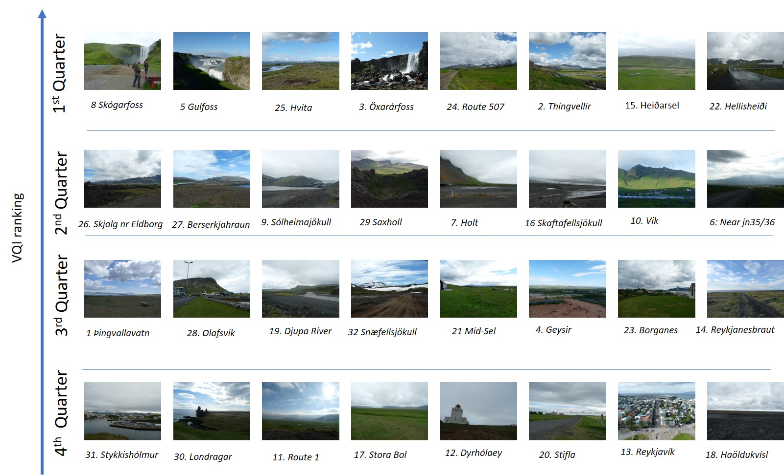
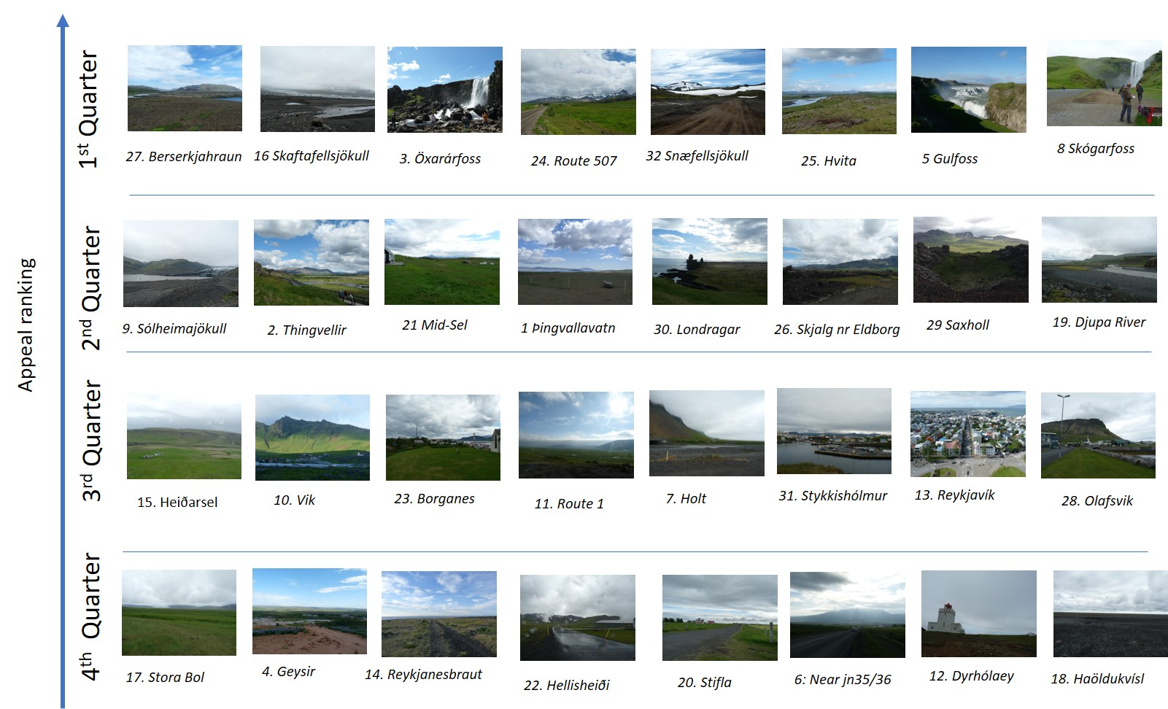
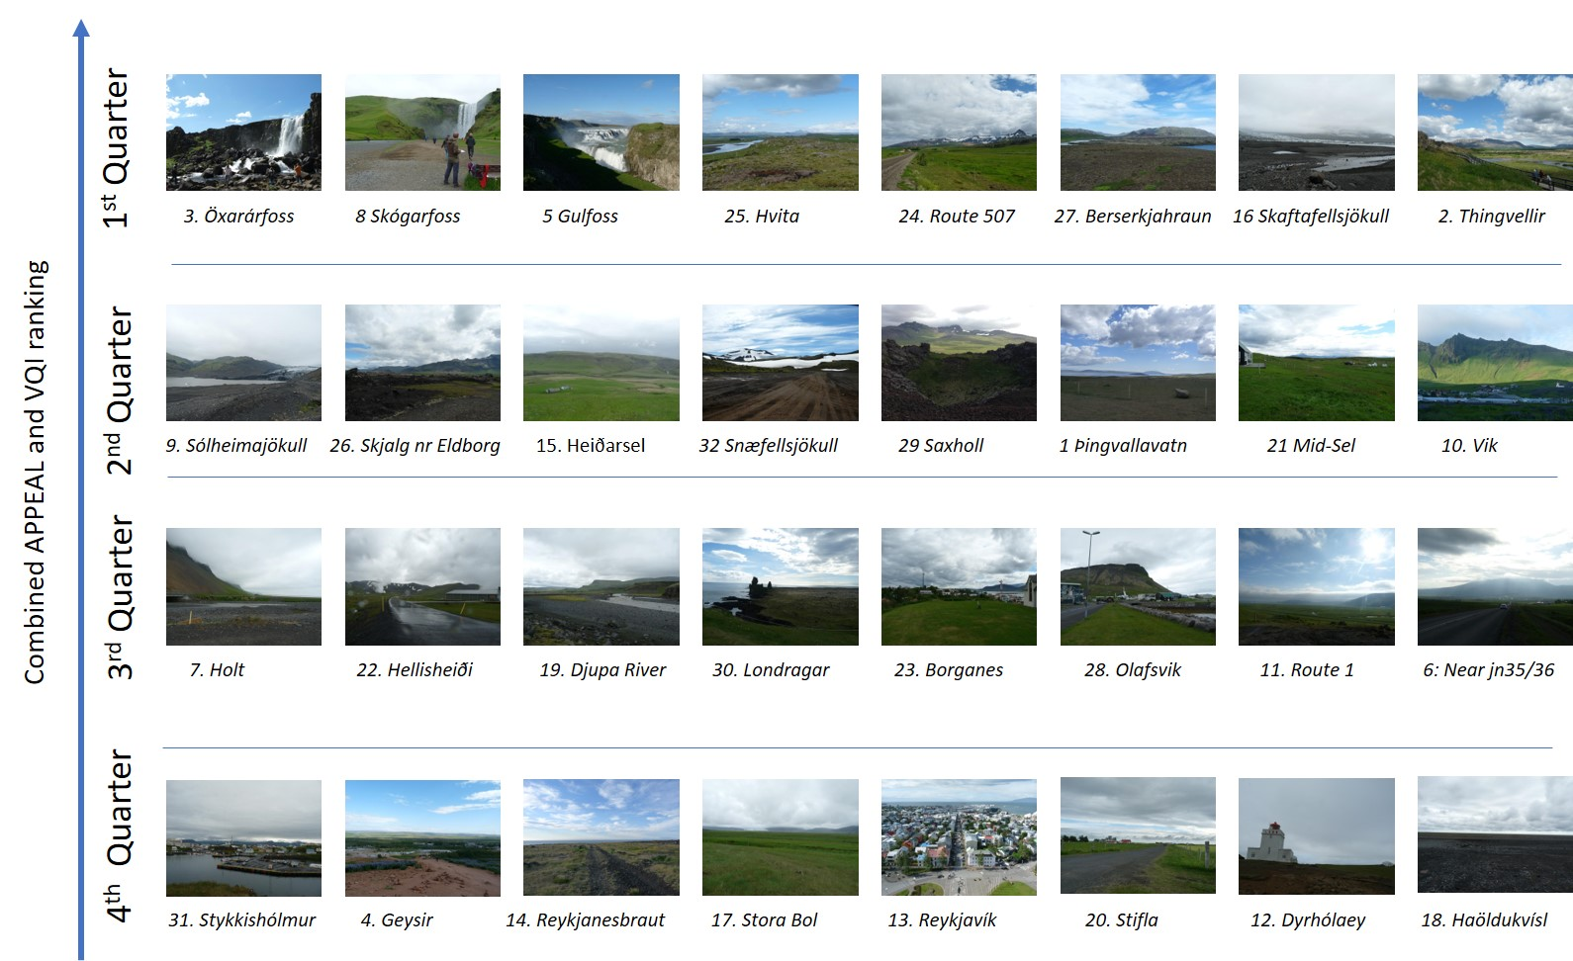

ID | SITE NAME | TYPE | Latitude | Longitude | Location note
1 | Þingvallavatn | Water / Coast | 64°12'39.67"N | 21°15'37.83"W | Taken from a layby about 2.9km beyond a small lake, looking south-east.
2 | Lögberg / Þingvellir | Other | 64°15'33.71"N | 21°07'21.54"W | Taken from stepped seating area at Logberg in Þingvellir, looking north-east.
3 | Öxarárfoss | Waterfall | 64°15'56.17"N | 21°07'01.25"W | Taken from boardwalk close to Öxarárfoss, looking west.
4 | Geysir | Other | 64°18'50.75"N | 20°18'12.91"W | Taken from a trig point above Geysir, looking south-east.
5 | Gullfoss | Waterfall | 64°19'34.21"N | 20°07'28.07"W | Taken from the top of the canyon trail at the lookout, looking north-east.
6 | Near road junction 30/35 | Farmed | 64°18'34.43"N | 20°13'54.25"W | Taken near junction of Route 35 and 30 from Gullfoss to Geysir, looking south-west.
7 | Holt | Water / Coast | 63°33'05.41"N | 19°46'47.24"W | Taken from a small track to Holt, off Route 1, near the bridge, looking east.
8 | Skógafoss | Waterfall | 63°31'46.24"N | 19°30'47.29"W | Taken from Skógafoss car park, looking north towards the waterfall.
9 | Sólheimajökull | Glacial | 63°31'53.46"N | 19°22'03.19"W | Taken from a moraine, left of the path to Sólheimajökull, looking north-east.
10 | Vík | Built | 63°24'55.02"N | 19°00'47.85"W | Taken from the road to Vík beach, athletics track to the right, looking north-east.
11 | Hvammsá | Farmed | 63°27'09.27"N | 19°03'42.54"W | Taken just of Route 1, looking towards Dyrhólaey, facing west.
12 | Dyrhólaey lighthouse | Glacial | 63°24'06.80"N | 19°07'50.92"W | Taken at Dyrhólaey Lighthouse looking north towards Mýrdalsjökull.
13 | Reykjavík cathedral | Built | 64°08'31.13"N | 21°55'37.93"W | Taken from the top of cathedral tower, looking north-west over the city.
14 | Just off Reykjanesbraut | Water / Coast | 64°00'47.78"N | 22°10'57.03"W | Taken from a small bay off Route 41, looking north-east.
15 | Heiðarsel | Farmed | 63°47'43.47"N | 18°10'59.42"W | Taken above Heiðarsel farmhouse, looking south-west.
16 | Skaftafellsjökull | Glacial | 64°01'33.76"N | 16°56'09.28"W | Taken from a moraine just further on from the information board, looking east.
17 | Stόraból | Farmed | 64°18'10.10"N | 15°24'40.68"W | Taken on Route 1 by Stora Bol sign before Brunnholi, looking north-west.
18 | Háöldukvísl picnic bench | Other | 63°57'40.06"N | 17°10'55.63"W | Taken on Route 1 at Skeiðarársandur, bench near track to Haöldukvísl, looking south.
19 | Banks of the Djúpá | Water / Coast | 63°56'52.53"N | 17°38'28.13"W | Taken on banks of the Djúpá on route 1, looking west over old bridge and Kalfafell.
20 | Stífla | Farmed | 63°41'57.26"N | 20°12'36.71"W | Taken on Route 1 by the sign to Ey-I-II, Berjanes, Stifla, looking south-west.
21 | Hekla from Mið-Sel | Farmed | 63°55'25.18"N | 20°16'24.74"W | Taken from the edge of Mið-Sel house, looking east towards Hekla volcano.
22 | Hellisheiði power station | Other | 64°02'14.85"N | 21°24'25.53"W | Taken on the visitor access road into Hellisheiði power station, looking east.
23 | Borganes | Built | 64°32'17.08"N | 21°55'20.55"W | Taken in the churchyard of Borganes church looking out east over the town.
24 | Mast on road 507 | Farmed | 64°32'31.18"N | 21°43'23.49"W | Taken on Route 507 next to a communications mast looking south-east.
25 | Near Hvítárvellir | Other | 64°36'20.67"N | 21°41'29.80"W | Taken on Route 510 to Reykholt (26km), Hvitárvellir on the left bank.
26 | Skjálg near Eldborg crater | Lava | 64°50'03.83"N | 22°17'19.85"W | Taken just off Route 54, past Eldborg crater in lava field just past Skjálg, looking east.
27 | Berserkjahraun | Lava | 64°56'42.84"N | 22°54'05.40"W | Taken off Route 54, Berserkjahraun lava flow layby, looking north-west.
28 | Ólafsvík | Built | 64°53'44.45"N | 23°42'20.31"W | Taken outside Ólafsvík police station alongside harbour looking west to the church.
29 | Saxhóll crater | Lava | 64°51'07.16"N | 23°55'38.21"W | Taken from the lip of the Saxhóll crater looking towards Snæfellsjökull.
30 | Lóndrangar | Water / Coast | 64°44'09.11"N | 23°46'28.08"W | Taken from roped area near car park off Route 574, Snaefellnes, looking south-west.
31 | Stykkishólmur | Built | 65°04'47.72"N | 22°43'36.42"W | Taken from western end of Súgandisey looking south at harbour, town and church.
32 | Near Snæfellsjökull | Glacial | 64°50'32.69"N | 23°44'16.40"W | Taken from Route 570 and F575 junction, by road sign looking south to Snæfellsjökull.

