Digital Play in Early Years
“Think about a gallery or a museum, which exhibits are you more drawn to: the paintings on blank walls, or, the interactive pieces?”

To become fascinated and immersed in onlooker or observant behaviour does not necessarily mean that sedentary behaviour equates to limited learning, development or growth. When appreciating a piece of art, reading a book, watching television, or, playing with your device, the mind (and sometimes heart) are still engaged. However, if we see an individual interacting with resources and equipment, we arguably make a judgment that indeed that individual is benefiting far more than the former. There is no right nor wrong here, and nor is there a correct answer to whether a child’s digital play is either healthy or unhealthy, as context, equipment, co-use, age and stage, and many more influential variables have an impact. With this in mind, let us explore why we should embrace digital play, and how we can do so practically.

Children’s access to play and recreational activities is recognised internationally as a fundamental human right. Article 31(1) of the United Nations Convention on the Rights of the Child (UNCRC):

States Parties recognise the right of the child to rest and leisure, to engage in play and recreational activities appropriate to the age of the child and to participate freely in cultural life and the arts.

How a child realises this right can be through any play type, and as their culture evolves digitally, then a right to digital play arguably should be cultivated and advocated. Lester and Russell (2008) identify two groups for functions of play;
- Instrumental – play is a mechanism for learning, and development.
- Autotelic / intrinsic – play is important for its own sake.
Moreover, Davy and Lundy (2009) argue that a rights-based approach to play, incorporates both Instrumental and Autotelic functions of play, rather than play being for either/or. It could be argued as a society we are searching for how digital play can support or inhibit mechanisms for learning, and we struggle appreciating digital play for its own sake. Perhaps if we can remind ourselves that digital literacy is a part of culture, we can value a child’s right to access digital play.

Naturally this can be very difficult when there are countless articles and headlines warning of screen time, however, this has unfortunately resulted in a misinterpretation for many professionals and parents who now only attribute digital play to screen time. Of course, screen time is one part of digital play, but it is possibly dangerous to overly associate screens with digital play, as our well-meaning intervention could potentially lead to play deprivation within a technological culture. Play Wales (2003) remind us that play deprivation comes in many forms, we immediately imagine an individual chronically play deprived from either no play, to brief erratic encounters of play, however, we can trigger a type of deprivation if we cause a ‘play bias’ - whereby play is loaded to a single or few types. Thus, by fearing and consequently inhibiting the use of screens and digital play, we can inadvertently exclude a child enjoying a total play experience.

The primary research of Huber et al (2018) into the executive functioning of pre-schoolers, showed interaction with educational content improved working memory comparative to viewing, their findings based upon work with 96 2 and 3 year olds emphasized that for executive functioning, interactivity and content were more important factors to consider than screen time alone. Eady et al (2013) claim that when technology is used in play it can increase and/or improve;
- Learner Motivation
- Learner Engagement
- Potential to cater for learning styles
- Learner Outcomes
To help us observe this for ourselves we can use Churches (2009) ‘Blooms Digital Taxonomy Verbs’ to narrate and describe the learning:
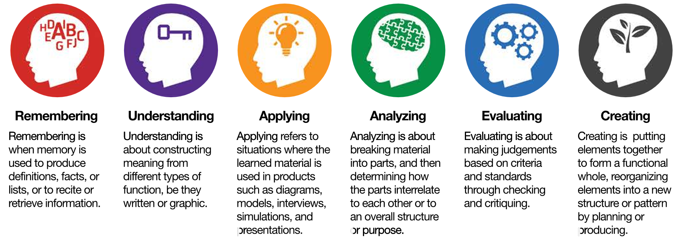These cognitive skills (or verbs) can be directly linked to Characteristics of Effective Learning in the EYFS, furthermore, can all be supported with or without a screen. Digital play can in fact be camera’s, telephones, cause an effect toys, radios, watches, programable toys, computerised toys, or, completely void of a plug or battery, as many professionals are now realising. For example; recently when exploring outdoor play, a cohort of my students suggested enjoyable activities for children in their early years, these included making dens, orienteering, land art and messy play, students then considered how these activities could be digitalised, or, how they can support computational thinking. Here are some more of their suggestions:
Nature Bags
Encourage children to collect natural resources such as twigs, flowers, stones, leaves and so forth, to create their own interest nature bag. Children could be given a camera to take photographs of natural environments to later recreate within their own art.
Treasure Hunt
Encourage children to find differing amounts of hidden items in the outdoor area, children will be encouraged to count and check they’re correct as they progress through finding each item. Children could use timers on watches or other devices to see how long it took each of them.
Hide and Seek
Children to play a teamed game of Hide and Seek whereby children can sneak from initial hiding spaces and move around. The team who are seeking can use walkie talkies to keep in contact to increase their chances of finding those hiding.
Measuring with Objects
Children could use natural items to measure different objects with e.g. ‘my wellington boot is 6 leaves long’, this can then be explored using an educational app or software e.g. Education City, to play measuring games.
Savage et al (2017) explicitly encourage Early Years professionals to associate the Characteristics of Effective Learning with digital play by providing us with reflections to support our digital play provision, and thus below questions enabled students to enhance traditional play with technology:
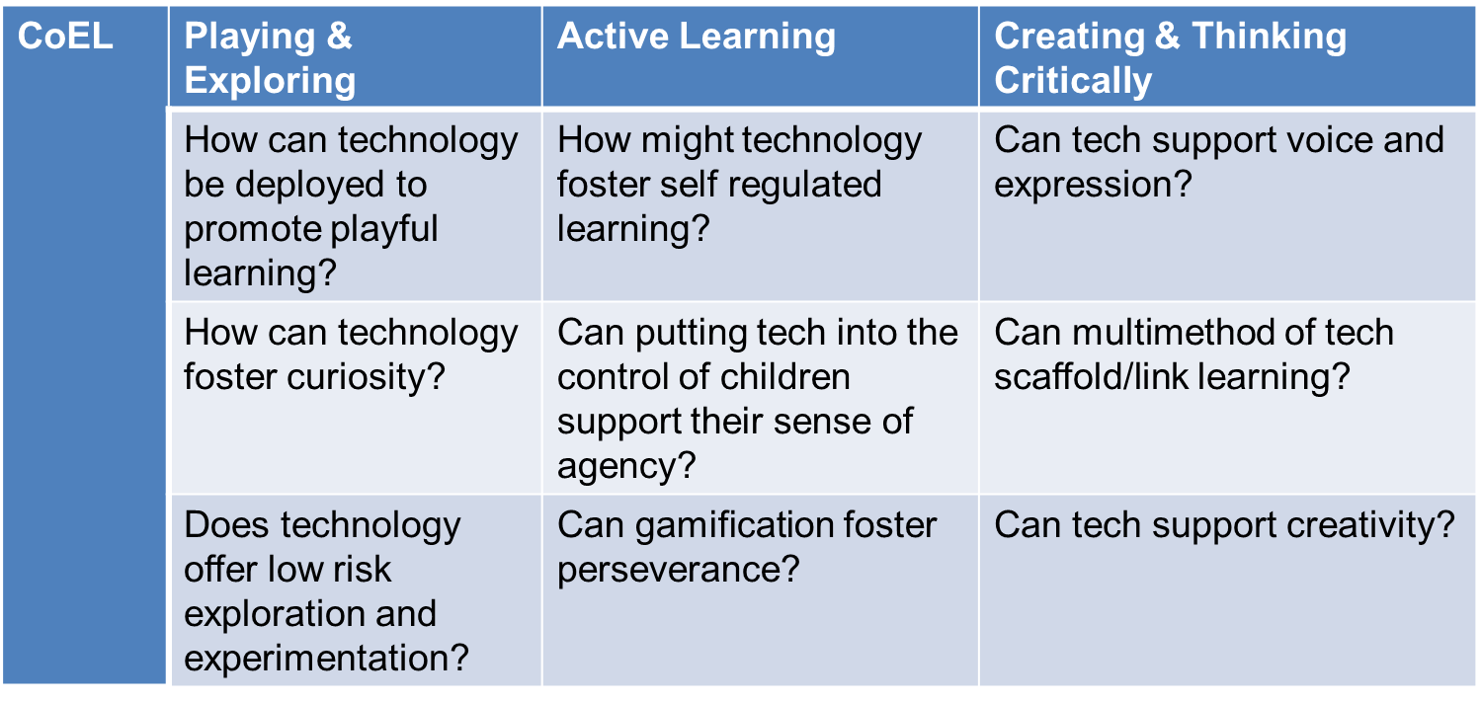
By reconceptualising familiar curricula perspectives such as the EYFS or CoEL’s with technology in mind, we can then support and increase skills and learning beyond the ELG’s within KUW, Fisher et al (2006) categorise additional technology related skills into 4 sets;
- Knowledge Building
- Distributed Cognition
- Community and Communication
- Engagement
Similarly, Barefoot (2014) explain the four cornerstones of computational thinking skills as Decomposition, Pattern Recognition, Abstraction and Algorithm. Here are my favourite activities to support this… and there’s not a screen in sight!
Algorithms are simply a set of instructions and rules, perhaps try back to back drawing whereby one child describes what to draw, and the other child must draw it. You can use easy read written rules, or, sequenced pictures depending on the stage of the children. The discussion can then develop on not only the character drawn, but the importance of effective communication of rules, and instruction (algorithms).
Abstraction is sieving the important information from the less important information, perhaps play Charades or Pictionary where you represent a familiar story, character or object for children to guess what it is, perhaps throw in some red herrings. Gifford (1997) suggests that playful behaviour on the part of the professional, for example, deliberately pretending not to know how to do something, pretending not to understand what the child is saying, ‘tricking’ children and using humour encourages playful challenge, thus allowing children to abstract and work out what is correct/incorrect or more important.
Decomposition of a whole class, group, or family project allows you to think about what you will do, and importantly produce a step by step plan on how you will achieve this project. This allows us to truly follow individual passions and collective interests, for example children may choose to develop a new environment, resource, display; and by planning together, talking about how we can achieve this in achievable chunks we decompose a seemingly large task.
Patterning, or, noticing patterns is much more than noticing a trend, children work out the Attribute (what it looks like) the Core (what repeats) and the Pattern Rule (describe in words), there are so many contexts that you could develop a patterning activity from, whether it be simply looking for patterns in illustrations, objects or the environment.

Perhaps then, as Marsh et al (2016) would advocate, digital play should not solely be seen as a play type in itself to fear or avoid, but as a means to enhance all play, in a way that is appropriate in a digital age. Thus, we can enhance children’s digital capability, computational thinking, and skill sets beyond those in the EYFS, whilst simultaneously preserving the benefits of the traditional play types and fulfilling their right to play.
Technology is progressing fast, who knows what new play type the future holds.
Francesca Cornwall HEA, PGCHPE, MA, BA (Hons), FdA
Staffordshire University Education Department Lecturer, Digital Champion and STEM Ambassador

References
Barefoot (2014) Teaching Activities, [Online] Available at https://barefootcas.org.uk/about-barefoot/ (Accessed June 2017)
Churches, A. (2009) Blooms Digital Taxonomy, [Online] Available at www.globalcitizen.org (accessed March 2018)

Eady, M. Lockyer, L. (2013) Tools for Learning: Technology and Teaching Strategies [Online] Available at www.ro.uow.edu.au/cgi/viewcontent.cgi?article=1413&content=asdpapers (accessed May 2017)

Fisher, T. Higgins, C. Loveless, A. (2006) Teachers Learning with Digital Technologies: A Review of Research and Projects [Online] www.nfer.ac.uk/publications/futl67/futl67.pdf (accessed May 2017)

Huber, B. et al (2018) The Effects of Screen Media Content on Young Children’s Executive Functioning, Journal of Experimental Child Psychology, vol.170, p.72-85

Lester S, Russell W. (2008) Play for a Change. Play Policy & Practice: A Review of Contemporary Perspectives. Play England⁄National Children’s Bureau: London.

Kilkelly U, Lundy L. (2006) Children’s Rights in action; using the UN Convention on the Rights of the Child as an auditing tool. Child and Family Law Quarterly 18: 331–350.

Kilkelly U, Kilpatrick R, Lundy L, Moore L, Scraton P, Davey C, McAlister A, Dwyer C. (2005). Children’s Rights in Northern Ireland. Northern Ireland Commissioner for Children and Young People: Belfast.

Marsh, J. et al (2016) Exploring Play and Creativity in Pre-schoolers Using Apps, [Online] Available at www.techandplay.org/tap-media-pack.pdf (accessed May 2017)

Play Wales (2003) Play Deprivation [Online] Available at www.playwales.org.uk (accessed November 2017)

Savage, M. Barnett, A. (2017) Technology-Enhanced Learning, Critical Publishing: Plymouth

