Biomimetic Pupils for Augmenting Eye Emulation in Humanoid Robots

Carl Strathearn 1† and Minhua Ma 2
School of Computing and Digital Technologies, Staffordshire University
Carl.Strathaern@research.staffs.ac.uk, M.Ma@staffs.ac.uk

Abstract.

Contemporary approaches in the development of humanoid robots continually neglect holistic nuances, particularly in ocular prosthetic design. The standard solid glass and acrylic eye construction techniques implemented in humanoid robot design present the observer with an inaccurate representation of the natural human eye by utilising hardened synthetic materials which prohibit pupillary dynamics. Precise eye emulation is an essential factor in the development of a greater realistic humanoid robot as misrepresentation in ocular form and function will appear distinctly prevalent during proximity face to face communication as eye contact is the primary form of interpersonal communicative processing. This paper explores a new material approach in the development of a more accurate humanoid robotic eye construction by employing natural compounds similar in structure to that found in the organic human eye to replace the traditional glass and acrylic modelling techniques. Furthermore, this paper identifies a gap in current ocular system design as no robotic eye model can accurately replicate all the natural operations of the human iris simultaneously in reaction to light and emotive responsivity. This paper offers a new system design approach to augment future humanoid robot eye construction towards achieving a greater accurate and naturalistic eye emulation.

Key Words: Humanoid Robotics, The Uncanny Valley, Artificial Muscle, Human / Computer Interaction.

1. Introduction

Aesthetical and functional accuracy are primary factors in humanoid robot design as optical precision reduces acute negative perceptual feedback stimulus when referenced against the natural human form [1]. The employment of dynamic pupillary modules in contemporary humanoid robot design will propagate the visual capacity to reify the perceptual organic credibility of humanoid robots towards achieving a more accurate emulation, due to our innate referencing of the human face [2]. Current humanoid robot eye dilation systems such as Sejima at al: Pupiloid [3], Prendergast & Reed: Animatronic Pupil [4] and Schnuckle: Robotic Eye [5], can express different emotional states using mechanical actuation. However, these models focus on emotive pupil expression without considering pupillary responses to alternating light sources, which is as a significant operational factor of the natural human eye [6]. Therefore, neglecting light responsivity as a systematic function in humanoid robotics will

result in an inaccurate emulation of the natural operations of the human eye. In contrast, Breedon & Lowrie: Dynamic Pupil, Smart Materials [7], Zeng, et al.: Light-Actuated Crystal Elastomer [8] and Lapointe: Next Generation Dynamic Iris [9], present artificial eyes that react to oscillating light frequencies. However, pupil dilation in response to an emotive stimulus is not portrayable through singular light sensing technologies. Aesthetical accuracy is also a key factor in replicating a human eye for humanoid robots. Traditional hand painted approaches in the aesthetical design approach of artificial eyes, lack the visual realism to reproduce the complexity of the iris accurately [10]. Contemporary techniques in digital print replication of the human iris recreate a more accurate iris image for use in the medical ocular prosthesis industry [11]. Paper-Based approaches restrict the dynamic pupil membrane observable in the human iris as the paper utilised in these models is a non-stretchable material. Therefore, to achieve an aesthetically correct iris that is flexible and actuated requires a new design approach. According to Mori’s (1970) Uncanny Valley hypothesis [12], the slightest inaccuracy in humanoid robot design and function outside of the natural human paradigm has the potential to question the observer’s acute recognition of a synthetic human’s authenticity. Thus, bio-mimetic pupils implemented in humanoid robots are required to simultaneously respond to alternating light frequencies and emit emotional responses to achieve an accurate emulation of the human eye, while retaining proximal aesthetical realism. This research will explore new material and design approaches in creating a gelatine printed iris membrane that can expand and contract in a manner proximal to that of the human iris while allowing light to pass through the artificial iris cell to regulate light responsivity and emit emotional pupil responses.

2. Human Eyes as a Key Referential Signifier
Perceptual ocular identification is the primary process of direct interpersonal contact, preceding other forms of primary commutative facial operations [13], [14]. Pupil size and dynamics are key components of the eye contact procedure as pupilar reflexivity acts as visual communicative signifier during face to face contact as pupils emit instances of emotion and attention. However, recognition of natural pupil dynamics during face to face contact is primarily a subconscious process and only visually prevalent if there are notable irregularities in the eye formations [15]. This process is an important design consideration as the human facial form is the most natural interface for a human to human communication due to our innate recognition of the human face and interpretation of its visual signals, which are instinctive behaviours from infancy [16].

Visual irregularities occur when the misinterpretation of facial expressions instigates a delay in the established optical communicative interchange, resulting in the diffusion of the natural flow of face to face interaction [17]. This misrepresentation is due to irregular intuitive cues between principal points of facial reference (most notably in the eye region), that disorientate the observer’s familiarity with human anatomy [18]. Thus, precise eye dilation emulation in humanoid robots will create a more naturalistic mode of human-robot interaction as irregularities in pupil replication will appear significant at close inspection as gaze attention plays a vital role in face to face communication.

2.1. Eye Aesthetics as a Significant Factor

Poor eye aesthetics are a condition of generating irregular perceptual feedback during face to face contact [19]. Without consideration of visual aesthetics, the pupilliary operations of the artificial eye would not precede the optical effect of the eye if it appears visually unnatural. Eye diseases and deformities such as glaucoma and congenital disabilities alter the natural visual state of the iris making the eye look abnormal. Eye deformities can have a negative impact on the daily life of the sufferer not just in a functional sense but also in a sociological mind as they feel visually malformed [20].

These rare instances have a distinct correlation with wearers of the traditional ocular prosthesis as the conventional method for replicating a lost human eye using hand-painted techniques lacks the detail and precision to accurately reproduce the fine details and dynamic pupillary functions of the natural human eye, resulting in apparent visual irregularities against the surviving eye. Unnatural ocular prosthetic appearance can have a severe impact on the general psychological welfare of the users, most notably at close inspection during face to face contact where visual dissonance is most notable to the observer [21]. Modern screen printing techniques [11] have recreated a more accurate iris image for use in the medical ocular prosthesis industry. However, printing an iris on a flat paper surface results in a flat image. The print process does not portray the translucent material depth of the iris. This irregularity will appear apparent under different light sources due to the reflective fibrous nature of the human iris membrane [21].
Furthermore, paper-based iris replication approaches restrict the dynamics of the human iris as paper is a non-stretchable and non-durable material. Therefore, applying a paper print approach is not an appropriate method for encapsulating the delicate transparent materiality and dynamic mechanisms of the human iris for use in humanoid robots. Thus, a new material approach that is proximal to the natural muscle fibres found in the human iris and sclera would increase the authenticity of artificial eye design. This method considers the natural compound Gelatine, which is a polypeptide derived from degraded collagen fibres. The primary compounds are dead muscular and connective tissue [22]. The organically derived material is highly flexible, transparent and robust and commonly used in the cinematic special effects industry to replicate human skin and muscular tissue. The material is available in different physical forms, density, colours and can be moulded and printed upon on using a conventional colourised ink printer [23].

2.2. Pupil Responsivity in Humanoid Robot Eyes

In a recent study, MacDorman & Chattopadhyay [24] determined the iris, eyelashes, eyelids, and lips as crucial facial features that contribute to increased levels of eeriness in humanoid robots. Thus, to minimalise the negative perceptual feedback outlined in Mori’s (1970) Uncanny Valley hypothesis particular attention to eye and mouth aesthetics and movement should be forefronted in contemporary humanoid robot development as these facial areas emit high rates of abnormal visual stimulus. The following review will explore and critically analyse a selection of robotic dilating eye models that have pupil dilation functionality.

Robotic engineer, Schnuckle [5] demonstrates a method for creating a dilating artificial eye. The system comprises of a triangular foam formation pressed against the inner surface of the internal eye shell, motor actuation compresses the point of the triangle back and forth against the interior surface, and thus, increasing and decreasing the diameter of the foam point creating a fluctuating pupil effect. However, a close review of the system poses potential issues concerning. 1. The offset of the natural pivot of the eye via an actuator. 2. The extensive space occupied via the forward linear actuation mechanism. 3. Intricate and complex mechanical components, which may lead to unstable and unreliable system procedure over time. 4. Abnormal eye dynamics of the pupil (opposed to the organic kinetics of the Iris).

Prendergast & Reed [4] patented a comparable dynamic ocular system using a mechanical shutter lens framework. However, on examination, the shutter mechanism may present issues concerning the abnormal functioning of the artificial iris at close inspection, due to the mechanical nature of the shutter mechanism. The iris actuation is an essential systematic consideration as the pupillary reflex in humans is continuously adapting to alternating light and emotional states. Therefore the engineering of the humanoid robotic eye system is required to operate continuously adjusting to different signal inputs from the light sensor and microcontroller. A mechanical shutter system would thus be under continuous strain, heightening the potentiality of mechanical failure. Heat generation due to the constant running of the motors is also an issue as this may cause overheating in the confined space of the eye area.

Yoshihiro et al. [3], developed Pupiloid, which exhibits the ability to contract and dilate using a 3D printed shutter system. However, the utilisation of an ABS plastic mechanical framework to emulate a fluidic retinal membrane presents numerous operational complications due to the overly mechanised nature of the shutter arrangement. Such complex structures are inherently susceptible to malfunction over time, due to the strain on the complex dynamic components of the system. Furthermore, there are accuracy issues when utilising a mechanical shutter framework, as the module requires the axial capability of various mechanical actuators. The space needed to install the mechanical apparatus of a servomechanism shutter module reduces the work area for other more significant systematic elements.

Unlike the previous humanoid robotic eye examples, Breedon & Lowrie [7] eye system demonstrates the autonomous capability to contract and expand the artificial iris in a fluidic motion under variable light levels using a photoresistor. However, the model appears distinctly mechanical and far withdrawn from natural human eye reference in form and aesthetical quality. The system further cannot respond or emit emotive signals, thus acting as a single photosensitive prosthetic module. The actuation system is a standard dielectric elastomer arrangement. This control framework can operate outside of the eye forms thus requiring minimal space to perform inside the eye. This set-up has a potential implementation in humanoid robot design as it permits integration with standard system control and sensor methods utilised in contemporary humanoid robotic control systems. Zeng et al. [8] present another light reactive eye model using smart materials, however like the previous example the eye only responds to alternating light frequencies thus neglecting emotional output. Furthermore, the materials utilised in this research are still in the early stages of development and require further testing to ensure precise actuation control and safe use.

Bunton et al. [25] demonstrate a dilating iris using heat activated memory materials. However, the transference of high temperatures is unsuitable for use in humanoid robot design as overheating can cause system malfunction and heat damage to electronics, materials and sensor elements. Other artificial eye systems using display screens such as Lapointe et al. [9] Living Pupil, Abramson et al. [26] Ocular Display Device, and Lapointe et al. [10] Next Generation Artificial Eye, will not be considered in this research. These systems cannot embed sensors to permit real-time iris functions that operate similarly to the natural human eye. Furthermore, all these examples declare issues involving the animation and definition of the micro LCD image. Visionary Effects Studio [27], demonstrate an animatronic ocular dilation module with a silicone membrane manipulated by a servomotor. On review, the system is overly mechanical as positioned in a single eye formation due to the high volume required for the eye to operate. There are no developmental updates on the adaptation of the framework into a binocular vision arrangement. Therefore, the model is incompatible with a humanoid robot stereoscopic eye format.

2.3. Discussion

The research studies and synthetic pupil dilation prototypes critically examined in this paper have identified gaps in current humanoid robot eye development. These gaps are 1. No humanoid robotic eye system can simultaneously respond to alternating light frequencies and emit emotional responses. 2. The current materials utilised in humanoid robotic eye design do not efficiently emulate the visual aesthetics and fluidic dynamics of the natural human eye. To address the practical issues highlighted in this paper the following methodology section will illustrate a new approach to humanoid robotic eye design.

3. Methodology
The process for creating a biomimetic iris membrane commences with a high-resolution computerised image of the eye form, Fig 1. This image is transformed into a stencil using 3D modelling software and extruded using a depth map and imprinted onto the blank eye form. The result of this procedure is a detailed 3D virtual approximation of the original organic iris. The colour image of the iris can then be projected onto the imprinted eye form to ensure exact positioning of the iris membrane. This process is an important design factor as the positioning of the iris image has to precisely match the gelatin depth map to create an accurate 3D iris representation.
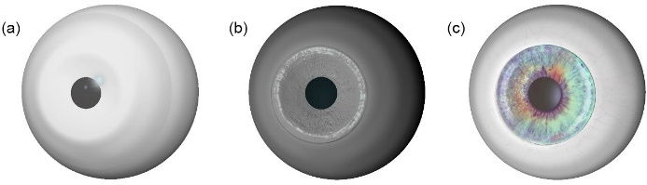

Fig. 1. A virtual modelling technique for developing a precision custom iris form. (a) Basic 3D eye form created in Maya (3D graphics software) using common biological eye parameters. (b) Eye form imported into Mudbox (3D sculpture software) and imprinted with customised stamp tool (iris). (c) Finished eye form with colourised iris.
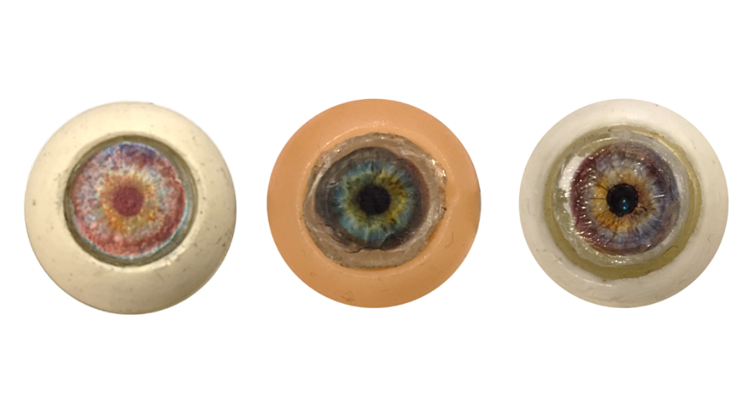
In Fig. 2, the imprinted eye configuration (a) is exported to a precision 3D printing system (20 microns = 0.02 mm) and printed using SLA resin (b) the material provides a detailed surficial area for the replicated iris print. Other materials tested in the 3D print process include PLA, TPU, and ABS. However, SLA provided a smoother and higher refined surface in comparison to these materials. A silicone mould taken from the 3D printed eye form (0.2mm); this process establishes an accurate negative for making gelatine positives of the iris. To accurately reproduce the human iris colour array, a physical copy of the original eye image is printed on gelatine/gel transfer paper using a high-resolution printer (min: 4,800 x 2,400dpi) and layered on the gelatine positive.
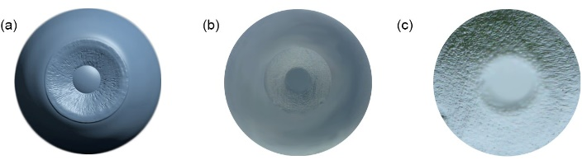

Fig. 2, 3D printing process for resin base form and production of a silicone mould for gelatine iris. (a) Eye base form in 3D printing software (b) 3D Printed SLA resin eye (c) Gelatine positive of iris from the silicone mould.

The gelatine print process provides depth, high definition imagery, and a reflective, translucent surface, in comparison to using paper print methods. Amalgamating the depth map with the digital image of the iris printed on gel transfer paper acts as a protective layer to the delicate iris foam membrane similarly to the sclera membrane in the human eye. As the gel transfer is of the same material as the gelatine iris map, the two layers when amalgamated together remain flexible and transform shape easily and fluidically under actuation methods. Furthermore, the gel print methodology allows the iris membrane to transfer light through the colourised cell into the back of the eye; this function is proximal to the operation of the human iris. This process allows a photosensor to gather data without having direct access to an external light source. Translucent materiality is a crucial factor as the membrane is required to measure light frequencies and hide the light sensor element to retain a naturalistic aesthetic accuracy. Fig .3 demonstrates the aesthetical comparisons between the ink-paper based print method and gelatine depth map model.

Fig. 3. A comparative example of paper printed iris form, gelatin print and gelatine depth map (left) paper printed iris image using gloss paper (middle) Gel iris without depth map (right) 3D mapped image of iris using gel paper embedded into 3D print iris membrane.

3.1. Dielectric Elastomer Pupil Dilation System

The internal dilation system of the artificial eye is Electro-Active Polymer (EAP) action equation:

$c=ε_{r}ε_{0} \frac{A}{D}$ Eq. (1)
Where capacitance equals 𝜀𝑟 to the relative permittivity of the foam membrane and 𝜀0 is the permittivity of space (aperture) in the diaphragm. A is the area of the foam membrane and D is the distance between the upper and lower surficial conductive carbon infused layers.

The dynamic capacity of the electro-active elastomer framework provides a fluidic transition, similar to the natural dilation function of the human iris and within a comparable operational range. This application provides an additional conductive surface layer for the EAP action, which results in a reduction of the required operational voltage into the EAP membrane. With an estimated pre-stretched (x3) membrane area of 10.2 mm, regulating the sequential voltage at approximately 6,000-15,000v. The diameter fluctuation of the elastomer eclipse area has the optimal operational capacity to alternate between 30% and 70% area strain under electrical conductivity and a maximum range of 70% - 140% at 15,000v-30,000v at a membrane width of 0.1mm (100 micrometres). Material stress over this percentage is possible but may incur material deterioration in prolonged usage in higher stress ratios outside of the optimal strain range. Fig. 4 demonstrates the dielectric elastomer design framework implemented in this research.
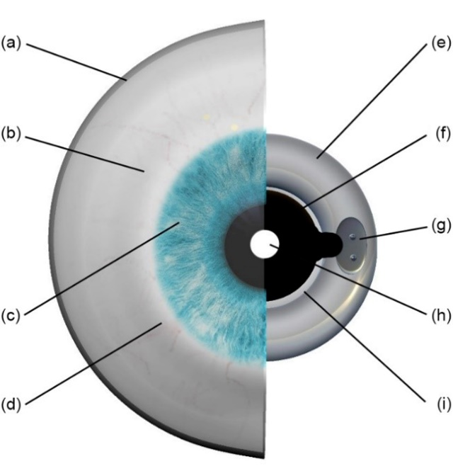
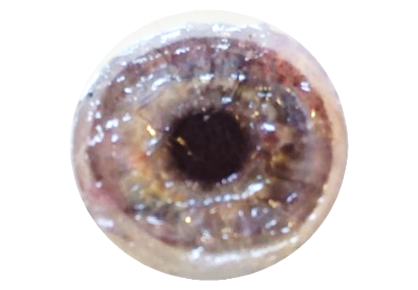
These calculations are pivotal in justifying the dialectic elastomer model for utilisation in humanoid robotic artificial eye modules as the maximum pupillary diameter responsivity ratio operates between a fluctuation range of 2mm and 8mm (average 3 – 6 mm) during natural pupil dilation responsivity [28].

Fig. 4. Frontal diagram of the humanoid robotic eye. (a) Clear cast resin outer shell (b) Silicone sclera skin (c) Gelatine iris (d) Airbrushed veining – silicone-based paint (e) Laser cut acrylic frame (f) Conductive graphite gel (g) Metal power coupler (h) Aperture (i) Electro-active polymer (EAP) foam diaphragm

The dielectric elastomer technique further provides a compact operational utility, as the systematic elements of the electrical input device may be controlled via a standard step-up converter peripheral. An issue identified with the standard carbon paste method utilised in dielectric elastomer actuation is that it the compound is actuated via positive and negative conduction lines of carbon paste. Black EAP pigmentation makes the layering of a transparent colourised gelatine transfer underlay appear unnatural [29]. A new dielectric elastomer approach regulating electrostatic energy at a higher voltage and using carbon grease paste surrounded in a transparent conductive silicone-based gel resolves this issue. Applying this method to the new eye model permits the iris cell to remain aesthetically correct as the clear conduction gel does not restrict the visual tonality of the iris membrane as with the formal EAP approach, Fig .5 demonstrates the clear electroactive polymer gel layer on top of the gelatine iris membrane.
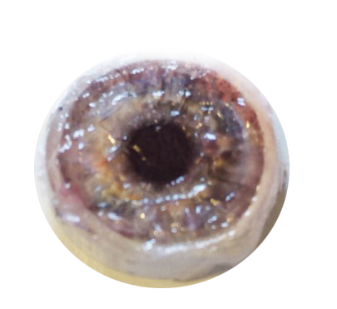

Fig. 5. Frontal image of the gelatine iris with clear conductive silicone gel suspension surrounding the EAP carbon grease paste.

3.2 Light / Emotive Dilation Eye System
In the photosensitive binocular design shown in Fig. 6 & 7, the left eye component controls the dynamic operation of the artificial iris for both left and right optical modules. Photo-data can then be inputted into an Arduino controller and used to regulate the angle of a micro servo in the left eye module. The photo-sensor thus acts as visual cortex mechanism in controlling the expressionism of the iris. The gel compound arrangement in the photo-sensor model permits light transference through the iris membrane via the transparency of the foam membrane into the photo-resistor.
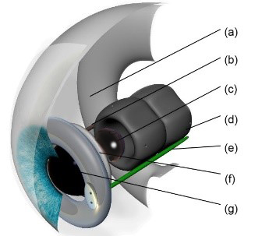
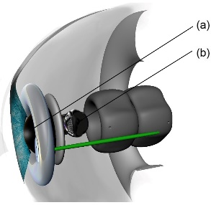

Fig. 6. digital eye representation; Right: (a) Resin eye form (b) Negative power cable (c) Colour Camera (d) Ball and socket bracket (e) Positive power cable (f) Sensor frame (g) One-way black-out acrylic sphere. Right: (a) 1080p infra-red camera (b) Aperture in EAP membrane and Gelatine iris
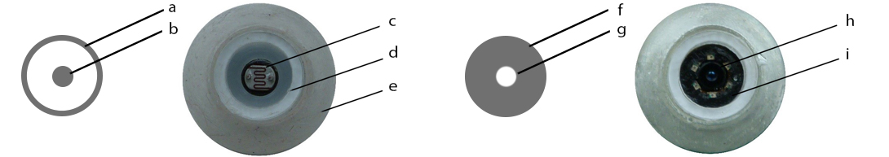

Fig. 7. Eye prototype: Dielectric elastomer (a) transparent membrane (b) graphite gel compound. Left Eye: (c) photo-resistor (d) dielectric elastomer frame (e) resin eye form. Dielectric elastomer (f) clear membrane (g) graphite gel compound. Right Eye: (h) 1080p infra-red camera and light (i) black silicone sheath.
Connecting the micro-servo horn to the step up converter allows the automated control of the system shown in Fig 8. Thus, the photo-sensor (input) measures alternating light frequencies, in response, the control system converts this information into positional servo data. This linear process modifies the flow of electricity into the left and right EAP membranes, increasing and decreasing the aperture according to the data gathered via the light dependent resistor. A manual resistor is situated on the power input in the right ocular module to ensure synchronicity of both pupils. A relay switch permits the system to transfigure between autonomous photo-reactive mode and high emotional dilation operation, managed via the systems integrated micro-controller framework. The dilation function reflecting emotional arousal over-rides the photo-sensitive device when trigged contiguously with the facial expression controls of the humanoid robot.

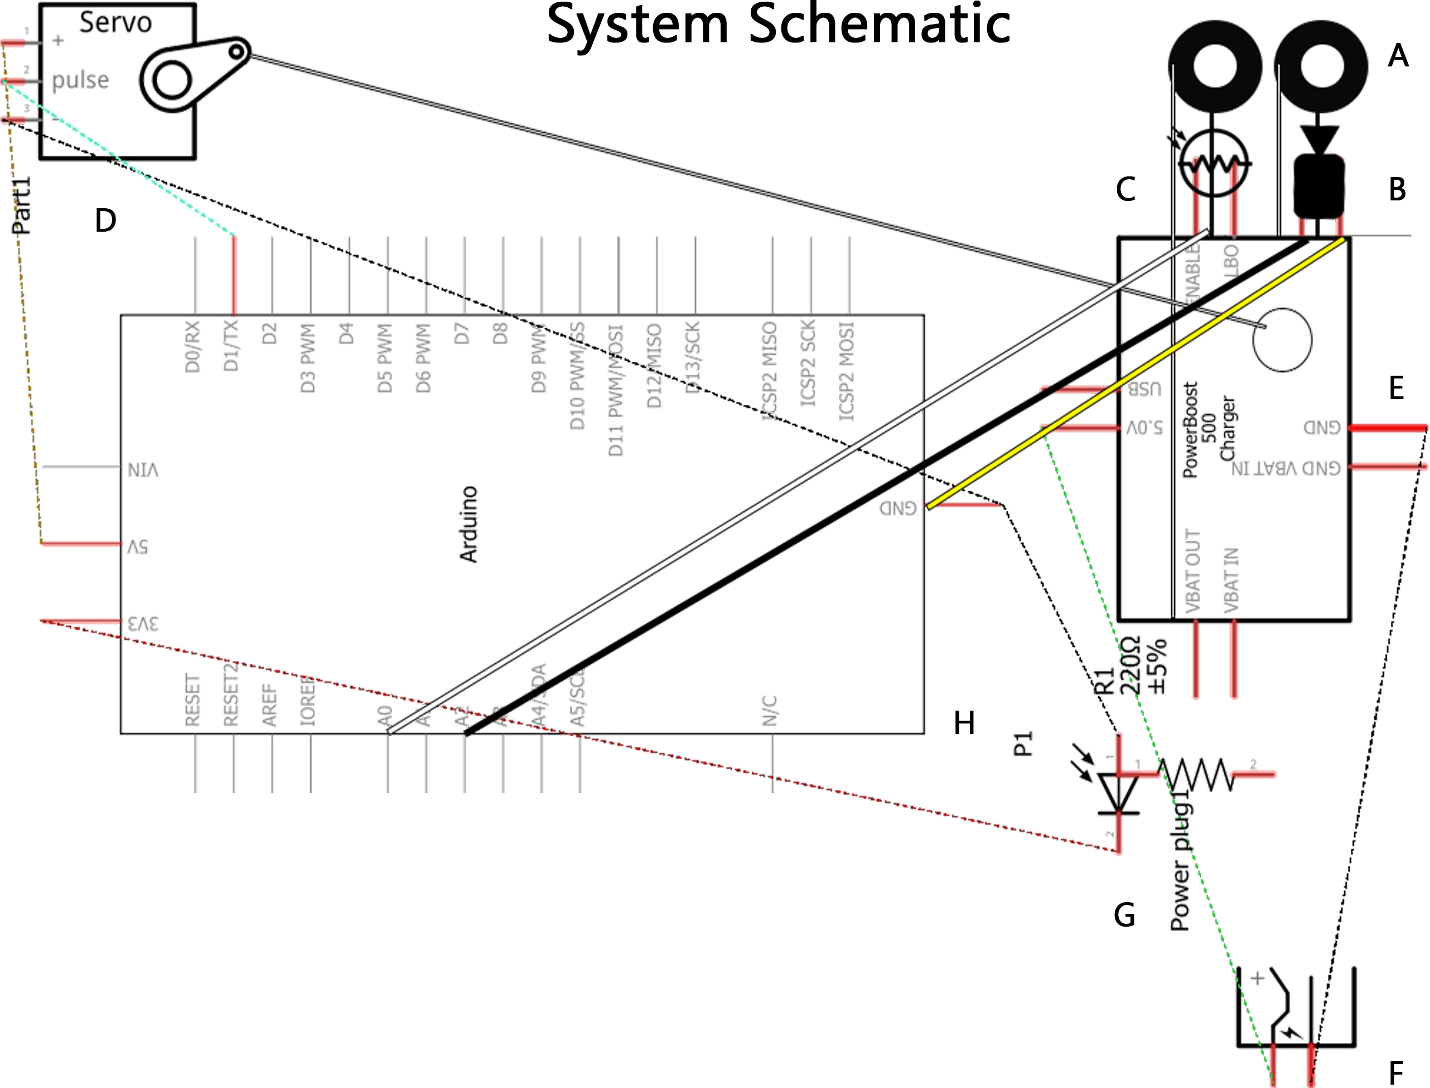

C++

Fig. 8. Novel emotive/light responsive system design, (A) Left / right dielectric elastomer membranes (B) Camera unit (C) photoresistor sensor (D) Micro servo (E) Step up / down converter (F) Step up converter PSU (G) Arduino PSU (H) Arduino microprocessor

4. Conclusion and Future Work
This paper identifies a gap in the current development of humanoid robot eye design suggesting contemporary eye construction techniques continue to neglect the capacity of expressive pupillary modules as a standardised approach to developing greater realistic humanoid robots for human/robot interaction. The outcome of this process results in a diffusion of the naturalistic bodily simulation of humanoid robots which is distinct upon initial observer inspection. Therefore, resulting in negative perceptual feedback proximal to the preternatural stimulus exemplified in the Uncanny Valley theorem. The outlined robotic ocular system presented in this research represents a potential step towards achieving a greater realistic eye module for augmenting holistic eye functioning and aesthetics in humanoid robots. According to the constraints exemplified in Masahiro Mori’s, Uncanny Valley theorem, aesthetical and operational factors are critical elements in preserving the realistic effect of humanoid robot eye prostheses to minimise the Uncanny Valley response. However, Mori explains that humanoid robotic developers should not seek progression past the threshold of the Uncanny Valley as they risk design failure and instead should develop humanoid robots that are less likely to cause adverse perceptual responses.
Nevertheless, without striving towards the highest peak in the Uncanny Valley by developing new systems founded on previous prototypes and design failures, the future humanoid robotic industry will not reach its real potential in developing the ultimate human simulacra. This research paper does not claim to traverse the Uncanny Valley effect. However, it does provide an innovative ocular modelling approach using new materials and system functions that may aid in the future progression of humanoid robotic design towards achieving a hyperrealistic emulation of the human eye.
References
1. Hanson, D (2005) Expanding the Aesthetic Possibilities for Humanoid Robots, Retrieved from http://citeseerx.ist.psu.ed u/viewdoc/download

2. Tondu .B, Bardou .N (2009) Aesthetics and Robotics: which form to give to the human-like robot, world academy of science, engineering and technology; International journal of humanities and social sciences. Vol 3 (10) pp.1936-1943

3. Sejima .Y, Egawa .S, Okamoto .D, Sato .Y, Wantanbe .T (2016) Pupiloid: Development of a pupil response robot for emotional expression, JSME robotics, pp.35-42,
4. Prendergast. K. W, Reed. T. J. (199) Simulator eye dilation device. Publication number. US5900923. Retrieved: Http: //www.google.co.uk/patents/US5900923. Accessed 09.04.17
5. Schnuckle, G. (2006) Expressive eye with dilating and constricting pupils. Publication Number US 7485025B2: Retrieved: https://www.google.com/patents/US7485025. Accessed 09.04.17
6. Mathot .S, Stigchel .V .S, (2015) New Light on the Mind’s Eye, Current Directions in Psychological Science, vol 24 (5) pp.374-378,

7. Breedon. J. P, Lowrie. P.J. (2013) Lifelike prosthetic eye: the call for smart materials, Expert Review of Ophthalmology, 8(04), pp. 135-137
8. Zeng .H, Wani .M, Wasylczyk .P, Kaczmarek .R, Priimagi A (2017) Self-Regulating Iris Based on Light-Actuated Liquid Crystal Elastomer, Journal of Advanced Materials, Vol 29 (3) pp.90-97
9. Lapointe .J, Boisvert .J, Kashyap .R (2016) Next Generation Artificial Eyes with Dynamic Iris, International Journal of Ophthalmology and Clinical Research, Vol 3 (3), pp.1-10. ISSN: 2378-346X
10. Lapointe. J, Durette. J.F, Shaat. A Boulos P.R, Kashyap. R. (2010) A ‘living’ prosthetic iris, Macmillan Publishers: Eye, 24, pp.1716-1723.

11. Shah, .M .R, Coutinho .I, Chitre .V, Aras .A .M (2013) The Ocular Prosthesis: A Novel Technique Using Digital Photography, The Journal of Indian Prosthodontic Society, vol 14

12. Mori. M (1970) The Uncanny Valley, Energy, 7 (4), pp.33-35 (1970) Trans: MacDorman K.F & Minato. T: IEE Robotics & Automation Magazine, 19(2) (2012):

13. Levy, J., Foulsham, T., Kingstone, A. (2013). Monsters are people too: Biology Matters, 9 (1), pp.01-04. DOI: 10.1098/rsbl.2012.0850

14. Gentile. F, Ales. J, Rossion. B. (2017). The Neural Dynamics of Face Perception. Journal of Human Brain Mapping, 38, (1), pp.120- 139. DOI: 10.1002/hbm.23348
15. Kret .E .M, The Role of Pupil Size in Communication: is there Room for Learning, Journal of cognition and emotion, pp.1-7, ISSN:0269-9931

16. Simion, .F, Giorgio, (2015) Face Perception and Processing in Early Infancy: Frontiers in Psychology, vol 6, pp.969-978

17. Naples. J. A, Wu. J, Mayes, C. L, McPartland, C. J (2017) Event-related Potentials Index Neural Response to Eye Contact, Journal of Biological Psychology. 127, pp.18-24,
18. Ashby, J. Roncero, C. Almeida, D. (2018) The Early Processing of Metaphors and Similes: Evidence from eye Movements and Integrations, Journal of Experimental Psychology, 71(1),
19. Chinnery, .H, Thompson .S, Noroozi .S, Dyer .B (2017) Scoping Review of the Development of Artificial Eyes throughout the Years, Edorium Journal of Disabilities and Rehabilitation, vol 3, pp.1-10.
20. Wilhelm. H (2011) Disorders of the Pupil, Handbook of Clinical Neurology, vol 102, pp.427-466

21. Gunaseelaraj .R, Karthikeyan .S, Kumar .N .M, Balamurugan .T, Jagadeeshwaran .A .R (2012) Custom-made Ocular Prosthesis, Journal of Pharmacy and Bio-Allied Sciences, Vol 4 (2) DOI:10.4103/0975-7406.100264

22. Binsi. K .P, Shamasundar .B .A, Dileep .O .A, Badii .F, Howell .N .K, (2009) Rheological and Functional Properties of Gelatin from the Skin of Bigeye Snapper Fish: Influence of Gelatin on the Gel-Forming ability of Fish Mince, International Journal of Food Hydrocolloids and Preservatives, Vol 23 (1) pp.132-145

23. Dabrowska .A,Rotaru .M, Spano .F, Affolter .C, Fortunato .G, Lehmann .S, Derler .S, Spencer .D, Rossi .R (2017) A water-responsive gelatin based human skin model, Journal of Tribology International, Vol 113, pp.316-322

24. MacDorman, .K, Chattopadhyay, .D (2016) Reducing Consistency in Human Realism Increases the Uncanny Valley Effect: Increasing Category Uncertainty Does Not, Journal of Cognition, Vol 146 (2016) pp.190-205.

25. Bunton .B, Faulkner .M .G, Wolfaardt .J (2005) Development of a shape memory alloy actuator for a robotic eye prosthesis, Journal of Smart Materials and Structures, Vol 14 (4) pp.43-67
26. Abramson .D, Bohle .C .G, Marr .P .B, Booth .P, Black .C .P Retrieved from: https://patents.g oogle.com/patent/ WO2014110190A2/en, Katze .B .A, Moore .G .J (2013), Ocular Prosthesis with Display Device, Accessed 20.03.18.

27. Visionary Effect Studio (2017) Here is an animatronic eye with dilating pupil that we designed a few years ago, Image. Retrieved:visionaryeffects.tumblr.com/post/160094398405/here-is-a-animatronic-eye-with-dilating-pupil-that, Accessed (01.02.18)

28. Walker. K, Hurst. J. W, Hall W. D, (1990). The pupils: Clinical Methods: The History, Physical, and Laboratory Examinations. 3RD Ed, Ch. 58, pp.300-304. ISBN: 9780409900774

29. Michel .S, Chu .B, Grimm .s, Nuesch .F, Borogschule, .A, Opris, .D (2012) Journal of Materials Chemistry, Vol 4 (28) pp.20736-20741

