Young People’s Experiences of being Assessed and Recommended for Dialectical Behaviour Therapy (DBT), by Child and Adolescent Mental Health Service (CAMHS) Clinicians

Alexandra Louise Olga Crawford

Thesis submitted in partial fulfilment of the requirements of Staffordshire University for the degree of Doctorate in Clinical Psychology

September 2018

Total word count: 18,615

THESIS PORTFOLIO: CANDIDATE DECLARATION
Title of degree programme | Professional Doctorate in Clinical Psychology
Candidate name | Alexandra Louise Olga Crawford
Registration number | 15027195
Initial date of registration | September 2015

Declaration and signature of candidate
I confirm that the thesis submitted is the outcome of work that I have undertaken during my programme of study, and except where explicitly stated, it is all my own work.
I confirm that the decision to submit this thesis is my own.
I confirm that except where explicitly stated, the work has not been submitted for another academic award.
I confirm that the work has been conducted ethically and that I have maintained the anonymity of research participants at all times within the thesis.

Signed: Date:

Acknowledgments

I would like to thank Dr Helena Priest, Dr Jo Heyes, Dr James Boardman and the CAMHS clinical team for their supervision and constant support during this thesis. To the young people who took part in the research study, thank you! Without you this thesis would not have been possible and I hope that the experiences you shared will support decision making at CAMHS.
Daddy-O, Matthew, Traci, Pete and Laura thank you for all of your support, love and encouragement throughout this process, I hope you enjoying reading this thesis for your Christmas presents, ha! To my friends – Jem, Andrea, ‘party-time’, Mely and Eloise, thank you for your support and allowing me to be a rubbish friend while I wrote this.
My Mumma … I could never, ever, thank you enough for everything you do for us. This thesis and completing this course literally would not have been possible without your help, your love, your support and your never ending belief in me. My greatest wish is to make you as proud to be my Mumma as I am to be your daughter … Butterflies and rainbows Mumma x x
Last, but by no means least - to my baby bear … You’ll never read this but I could never have got through the last 3 years and relocating without you. Thank you for your waging tail every-time I walk in the door, for sitting patiently by the side of my chair while I work and not minding the lack of walks when I’ve been busy typing. I love you Dakota x x
“When I needed a hand, I found your paw.”

Contents

Thesis Abstract ……………………………………………………… | 10

Paper One: A Review of the Literature

Abstract ……………………………………………………………… | 13
Introduction ………………………………………………………… | 15
Young People’s Voices and Research ………………………… | 15
Aim of the Review ………………………………………………… | 17
Method ……………………………………………………………… | 17
Search Strategy ……………………………………………………  . | 17
Search Criteria …………………………………………………… | 18
Screening Process ……………………………………………… | 19
Search Results …………………………………………………… | 20
Critical Appraisal Process ……………………………………… | 22
Quality Assessment of Qualitative Papers …………………… | 22
Summary of Qualitative Studies ………………………………… | 24
Synthesis of Qualitative Studies ……………………………… | 29
Results ……………………………………………………………… | 35
Theme One: Therapeutic Relationship ………………………… | 36
The clinician …………………………………………………… | 36
Engagement …………………………………………………… | 36
Developmental Appropriateness …………………………… | 37
Decision Making ………………………………………….… | 37
Theme Two: Young People’s Pre-conceived Views ………… | 38
Of Clinicians …………………………………………………… | 38
Of ‘Mental Health’ ……………………………………………… | 38
Theme Three: Information and Communication ……………… | 39
Lack of Information …………………………………………… | 39
Sharing of Information ………………………………………… | 39
Discussion …………………………………………………………… | 40
Conclusion …………………………………………………………… | 41
Clinical Implications ……………………………………………… | 41
Limitations of Literature Review ………………………………… | 43
Researchers Role in the Review ………..……………………… | 43
Future Research ……….………………………………………… | 43
Acknowledgements ………………………………………………… | 45
References …………………………………………………………… | 46

List of Appendices

Appendix A: Author Guidelines for the Child and Adolescent Mental Health Journal …………………………………………….. | 50
Appendix B: Inclusion and Exclusion Criteria ………………….. | 58
Appendix C: Description of Papers ………………………………. | 59
Appendix D: Initial Codes and Theme Maps ……………………. | 66

Paper Two: Empirical Paper

Abstract ……………………………………………………………… | 69
Introduction …………………………………………………………… | 71
Rationale for the Study……………………………………………. | 76
Aims and Objectives……………………………………………… | 78
Method ………………………………………………………………… | 79
Design …………….…………………………………………………  . | 79
Participants ………………………………………………………… | 80
Ethical Approval ….………………………………………………… | 84
Data Analysis ……………………………………………………… | 84
Results ………………………………………………………………… | 87
Super-Ordinate Theme 1: The Clinician as Important ………… | 88
Super-Ordinate Theme 2: Anxiety Before Assessment ………. | 91
Super-Ordinate Theme 3: Making Decisions & Being Offered Choice ……………………………………………………………. | 94
Super-Ordinate Theme 4: Interview Reflecting Assessment | 97
Discussion …………………………………………………………… | 99
The Emancipatory Research Paradigm ……..………………… | 101
Relevance to Clinical Psychology and Clinical Implications | 102
Strengths and Validity …………………………………………. | 104
Limitations and Future Research ………………………………….. | 106
Conclusion …………………………………………………………… | 108
Declaration of Conflicting Interests ………………………………. | 109
References …………………………………………………………… | 110

List of Appendices

Appendix E: Recruitment Poster ………………………………. | 116
Appendix F: Young Person’s Information Sheet ………………. | 117
Appendix G: Parent/Guardian Information Sheet ……………… | 121
Appendix H: Semi-structured Interview Guide …………………. | 125
Appendix I: IPR Approval | 126
Appendix J: Ethical Approval from Wales Research & Ethics Committee …………………………………………………………. | 127
Appendix K: HRA Approval ………………………………………. | 131
Appendix L: Local R&D Approval ………………………………… | 133
Appendix M: Example of Coding & Development of Emerging Themes for Participant 6 …………………………………………… | 137
Appendix N: Individual Participant Super-ordinate Themes in list Format for Group …………………………………………….. | 139
Appendix O= Example of how Participant 4 Super-ordinate Themes were Originated ………………………………………… | 140
Appendix P= Example of Super-ordinate & Sub-theme Analysis across Group and how Themes were linked …………………….. | 141
Appendix Q= Reflective & Exploratory Notebook Example ……. | 142
Appendix R= Clinical Child Psychology & Psychiatry Journal Guidelines …………………………………………………………… | 143

Paper Three: Executive Summaries

Executive Summary One: For Participants (Young People)
What was the study about? …………………………………………… | 151
What did the study hope to find out? ………………………………… | 152
What did we do? ……………………………………………………….. | 152
What was found out? ………………………………………………….. | 153
What does this mean for you? ……………………………………….. | 154
How will this be shared? ………………………………………………. | 155
References ……………………………………………………………… | 156

Executive Summary Two: For Parents/Guardians of Participants

Introduction to the study ………………………………………………….. | 160
Aims of the study ………………………………………………………….. | 161
Methods – How was it done? …………………………………………….. | 161
What were the findings? ………………………………………………….. | 162
Conclusion ………………………………………………………………….. | 164
Recommendations…………………………………………………………. | 165
Sharing the Study ………………………………………………………….. | 165
Limitations ………………………………………………………………….. | 165
References …………………………………………………………………. | 167

List of Abbreviations

BPD | Borderline Personality Disorder
CAMHS | Child and Adolescent Mental Health Service
CASP | Critical Appraisal Skills Programme
CHI-ESQ | The Commission for Health Improvement Experience of Service Questionnaire
CP | Clinical Psychologist
CQC | Care Quality Commission
DBT | Dialectical Behaviour Therapy
DoH | Department of Health
HRA | Health Research Authority
IPA | Interpretative Phenomenological Analysis
NHS | National Health Service
NICE | National Institute for Health and Care Excellence
TA | Thematic Analysis
UK | United Kingdom
USA | United States of America
YP | Young People

Thesis Abstract

The aim of this thesis is to provide the field of child and adolescent mental health with an understanding, from young people’s perspectives, of being assessed and having decisions made about their interventions by clinicians within the Child and Adolescent Mental Health Service (CAMHS). In order to obtain this understanding it is important to explore how young people experience both the CAMHS assessment process and being recommended interventions. Therefore, paper one consists of a literature review in which nine studies regarding young people’s experiences of being assessed in a mental health service were critically appraised and synthesised. Common themes were discovered across the papers around the therapeutic relationship, pre-conceived views and information and communication.
The literature review highlighted that young people’s experiences of being recommended interventions following a CAMHS assessment had not been considered within the literature. Furthermore, Government aims and the literature showed the importance of young people being included in decisions regarding their care. Therefore, paper two presents a qualitative study exploring young people’s experiences of being assessed and recommended Dialectical Behaviour Therapy (DBT) by CAMHS clinicians. Six young people from a CAMHS setting DBT group were interviewed. Transcripts were analysed using Interpretative Phenomenological Analysis (Smith, Flowers & Larkin, 2009) four super-ordinate themes and seven sub-themes were identified. Super-ordinate themes demonstrated the importance of the clinician in assessment and recommendation, that young people can experience anxiety before an assessment, young people value being part of decisions and being offered choice about treatment recommendations, and that the interviews reflected CAMHS experiences.
Paper three provides two executive summaries of paper two, for the purposes of sharing the study’s findings with the young people who took part and for their parents/guardians. Therefore, part one of paper three will be presented in an age appropriate and user friendly format for young people.

Word count: 300

Paper One: A Review of the Literature

Young People’s Experiences of Child and Adolescent Mental Health Services (CAMHS) Assessments

Target Journal: This paper has been written with the intention of submission for publication to The Child and Adolescent Mental Health Journal; author guidelines for manuscript submission can be found in appendix A.

Word count: 7,845

Abstract
Background: The review aims to explore young people’s experiences of child and adolescent mental health services (CAMHS) assessments.

Method: A systematic search of the literature was undertaken to identify relevant papers to be reviewed. Nine papers in total were shortlisted. The nine papers were critically reviewed and a thematic synthesis of the results was performed.

Results: Thematic analysis identified three common themes and eight sub-themes across the literature including: 1) Therapeutic relationship (1.The clinician; 2.Engagement; 3.Developmental appropriateness; 4.Decision making); 2) Young people’s pre conceived views (5.Of clinicians; 6.Of ‘mental health’) and 3) Information and communication (7.Lack of information; 8.Sharing of information).

Conclusions: There are numerous methodological concerns across the papers. However, the authors demonstrate that young people have valuable experiences and views about CAMHS assessments. For many of the young people the qualities of the clinician and how well they are engaged and involved in the assessment are key factors to a ‘good’ or ‘bad’ assessment experience. Negative views and opinions of CAMHS are held by many young people prior to attending their first assessment. It appears this could be exacerbated by a lack of information about the service when initially referred. It is important to continue the evidence base to explore young people’s experiences of being recommended treatment following an assessment.

Word Count: 213

Key Practitioner Message
- There is a growing recognition for further research exploring the voices of young people regarding their mental health.
- This article syntheses and reviews the available literature concerning young people’s experiences of being assessed in United Kingdom Child and Adolescent Mental Health Services.
- The article presents clinical implications for CAMHS services based on the reviewed literature, providing clinicians and decision makers alike with recommendations for clinical practise.

Key Words: Young People; Child and Adolescent Mental Health Services (CAMHS); Assessment

Introduction
Young People’s Voices and Research
There is recognition within child and adolescent mental health services that there is a need for increased research into how phenomena both occur and develop, alongside an increasing agenda for the voices of young people to be heard through the literature (Bone et al, 2015; Stafford et al, 2014). Young people are considered to have perspectives that are unique about their own experiences and the difficulties they face, which may be overlooked by the adults around them (National Children’s Bureau, 2015).
An initial brief scope of the literature using search terms ‘adolescents’ or ‘young people’ and ‘treatment decisions’ or ‘treatment recommendations’ on EBSCOhost yielded 512,399 results. When searching the literature specifically for studies around young people’s experiences of Child and Adolescent Mental Health Services (CAMHS) there were very few purely focused on young people’s experiences alone (Swift et al, 2013). Some papers found did focus on the experiences of the professionals, or the young people and professionals but there appears to be a lack of studies purely concerned with the voices of Young People and their experiences of CAMHS services (Bone, O’Reilly, Karim & Vostanis, 2014; Coyne et al, 2015; Funnell, 2014; Hinrichs, Owens, Dunn & Goodyear, 2012; Hovish, Weaver, Islam, Paul, Singh, 2012).
Therefore, given the lack of research available that looks directly into young people’s experiences of CAMHS, the literature around young people’s experiences of being assessed by clinicians in CAMHS will be reviewed. Although a search of the Cochrane library did not yield any results on the literature review topic a similar systematic review was found whilst conducting the search by Worrall-Davies and Marino-Francis (2008). However, Worrall-Davies and Marino-Francis (2008) looked more broadly at young people’s views of CAMHS services in an attempt to understand what methods are most effective in research for eliciting young people’s views and which of those methods are most likely to facilitate change. They were not concerned with ascertaining and reviewing the literature specifically around young people’s experiences of CAMHS or the assessment process, like this review of the literature.
Because CAMHS is a specific service to the United Kingdom (UK) with other countries having vastly different set ups of child and adolescent mental health services and indeed different names for these services, literature reviewed and presented will be limited to UK studies. The review will look specifically into CAMHS services for reasons twofold; the research will be conducted in a UK CAMHS service and therefore findings will be directly applicable and comparable to the current research, and other non NHS mental health services for young people go by a plethora of other names across the UK and it would be almost impossible to account for all of these different names when searching the literature. Therefore, potentially relevant literature could be lost and so for the purpose of this review the search will focus on CAMHS studies only.

Aim of the Review
This literature review aims to present a comprehensive and current synthesis of young people’s experiences of being assessed by clinicians in UK Child and Adolescent Mental Health Service (CAMHS) settings.

Method
Search Strategy
A systematic approach was employed utilising thematic analysis to conduct this literature review. An initial search of the Cochrane Library to assess if any previous published systematic reviews on young people’s experiences of being assessed by clinicians in CAMHS services was conducted. Following this an electronic literature search was conducted through EBSCOhost using the following selected databases:
- MEDLINE (Medical Literature Analysis and Retrieval System Online)
- CINAHL (Cumulative Index to Nursing and Allied Health
- SPORTDiscus
- PsycINFO,
- PsycARTICLES,
- PsycBOOKS

ProQuest was also accessed to search for grey literature and hand searching was also employed in order to ensure as much relevant literature was accessed as possible.
Careful consideration was given to the search terms used. Although the search intended to look directly at young people’s experiences of being assessed by clinicians in CAMHS, previous work experience allowed for knowledge that a number of different wording is used to describe ‘assessment’ such as choice, choice appointment, initial appointment, screening, to name a few. Therefore, to limit the likelihood of missing data the decision was made to not include any search terms relating directly to assessment and instead screening for the above mentioned terms further on in the process to assess whether the papers were relevant to this literature review was utilised. This included reading the abstracts for each paper at this initial stage to search for the specific terms related to a ‘CAMHS assessment’, although this added significant time to the process this allowed for the most systematic approach to reviewing the literature.
The search question used was: What is known about young people’s experiences of being assessed by CAMHS clinicians? The search terms used were:
- (young people* OR children* OR adolescent*)
- AND (experience* OR perspective* OR understanding
- OR perception OR view)
- AND (CAMHS OR child and adolescent mental health service*).

Search Criteria
Figure 1: Inclusion and Exclusion Criteria
Inclusion criteria applied:
I1 = Young people’s experiences of mainstream/general UK community CAMHS services – limiter
I2 = English language papers – limiter
I3 = Studies include or can be applied to young people’s experience of assessment in CAMHS
I4 = Over 5’s and under 19 – CAMHS criteria – limiter
I5 = Human study – limiter

Exclusion criteria applied:
E1 = Parent or professionals only as participants/subjects
E2 = Studies that did not look at the CAMHS assessment process – e.g. reviews of treatment models, diagnosis specific studies, transition studies
E3 = Researcher observed methodology (therefore not direct service users voice)
E4 = Specialist CAMHS service specific studies- such as LD CAMHS as they have a different assessment process to generic CAMHS

Please see Appendix B for Inclusion and Exclusion Criteria Checkbox.

Screening Process
A Cochrane library search did not yield any results for relevant systematic reviews in this research area using the reviews search terms. Therefore, to the researcher’s knowledge there are no other previous review papers that have focused on this topic.
Figure 2: Flowchart of the Screening Process

Search Terms
(young people* OR children* OR adolescent*)
(experience* OR perspective* OR understanding OR perception OR view)
(CAMHS OR child and adolescent mental health service*)
AND
AND
Total before exclusions =
1,603
Total after limiters applied = 132

Limited to:
English language
Human population
Over 5’s under 19
UK CAMHS research
EBSCO host
Total after title screening (-27) = 105

Total after abstract assessment (-91) = 14

Abstract revealed a limiter and was excluded at abstract
assessment

Total after inclusion and exclusion criteria assessment (-5) = 9

The literature search was initially conducted on Monday 19th June 2017 and produced 1,603 studies. A total of 132 studies were considered after limiters were applied to search.
Search Results
In total there were seven qualitative papers and two mixed methods papers shortlisted for review. The search produced mainly qualitative papers given the focus was on personal experience and therefore a qualitative methodology would be more suited to addressing this, which can indeed be seen through the available literature.
Once quality assessment of papers commenced it became clear that there were issues related to the two mixed methods papers as follows. Davison, Zamperoni and Stain (2017) outline that their study employs a mixed methodology approach. The researchers intended to explore The Commission for Health Improvement Experience of Service Questionnaire (CHI ESQ) acceptability as a routine experience measure using quantitative methodology. However, no formal quantitative methods were used to analyse the data. Instead, visual graphs were used to make comparisons and open ended questions from the CHI ESQ were analysed using Thematic Analysis (TA). Therefore, for the purpose of this literature review the study will be critically appraised as a qualitative study and not mixed methods.
Kapur, Hayes, Waddingham, Hillman, Deighton and Midgley (2014) provide a study of two parts. The first is an exploration of participants experiences through face to face interviews analysed using Interpretative Phenomenological Analysis (IPA) (Smith, Flowers & Larkin, 2009). The first part of the study meets all of the inclusion and exclusion criteria for the review. However, the second part of the study employs an online questionnaire which reaches out to participants in other countries such as USA, Canada and Brazil (to name a few). The second part of the study also recruits participants up to the ages of 29. Both the countries and ages of participants included in the second part violate the inclusion and exclusion criteria of this review.
However, given that the first part of the study meets all inclusion and exclusion criteria and provides valuable knowledge to address the aims of this review the two parts of the study will be treated separately and for the purpose of this review only the first part of the study will be assessed for quality and included in the analysis process. Total exclusion of the entire study cannot be justified.
Critical Appraisal Process
The evaluation of the appropriateness of the study design for the research question and assessing the key methodological features of the design are two important features of a successful and sound critical appraisal (Young & Solomon, 2009). Other important factors to consider when critically appraising studies include the suitability and interpretation of methods used the relevance of the research to practise and potential conflicts of interest within the study (Young & Solomon, 2009).
A descriptive overview of the studies reviewed is provided in Appendix 2 which includes details of paper numbers, data collection, participants sampling, and analysis and key findings for each along with brief descriptions of the strengths and limitations for each paper. The critique of each papers methodological quality will be presented individually, followed by a synthesis of the themes and general findings from the literature.
Quality Assessment of Qualitative Papers
To assess the quality of the seven qualitative papers the Critical Appraisal Skills Programme (CASP) Qualitative Research Checklist (2013) was used as a guideline. The CASP outlines ten questions to assist in appraising issues systematically. The CASP provides three options to answer the question of whether the studies have met criteria for each question, these are ‘yes’, ‘no’ and ‘can’t tell’. For the purpose of this review the category ‘can’t tell’ will be replaced with ‘partially met’ to allow to capture where a study has made attempts but not quite met criteria to warrant a ‘yes’. The three categories have been assigned a representative ‘traffic light’ colour of green for yes’, amber for ‘partially met’ and red for ‘no’ to allow for clear and quick visual inspection of the quality of the papers.
No | Criteria | Beck (2006) | Bone et al (2014) | Coyne et al (2015) | Davison et al (2017) | Evans (2017) | Jack et al (2015) | Kapur et al (2014) | O'Reilly et al (2016) | Rani et al (2009)
1 | Clear statement of aims? | Y | Y | Y | Y | Y | Y | Y | Y | Y
2 | Qualitative method appropriate? | Y | Y | Y | PM | Y | Y | Y | Y | Y
3 | Design appropriate to address aims? | N | PM | Y | N | N | PM | PM | PM | PM
4 | Recruitment strategy appropriate to aims? | Y | PM | PM | Y | PM | Y | Y | N | N
5 | Data collection addressed research? | N | PM | Y | N | N | N | N | N | N
6 | Role of the researcher considered? | N | N | PM | N | N | N | PM | PM | N
7 | Ethical issues considered? | N | PM | PM | N | Y | Y | PM | N | PM
8 | Data analysis rigorous? | N | PM | Y | N | N | Y | PM | PM | PM
9 | Clear statement of findings? | N | PM | Y | PM | N | PM | PM | N | PM
10 | Is the research valuable? | PM | Y | Y | N | N | Y | PM | Y | PM

Key
Yes
Partially met
No

Table 1: Traffic Light Visual of Quality of Papers

Summary of Qualitative Studies
Beck (2006) conducted a qualitative study using open ended descriptive questionnaires with 162 carers and 109 young people. The aim of the study was to gather the views of young people and their carers about: the young people’s mental health, their access to mental health services, and experience of the services. The young people were all under the care of Lambeth Local Authority (LA). Questionnaires were posted to and from participants posing methodological issues. It was unclear how the data was analysed, another methodological issue of this paper. Findings were presented in themes. Themes identified were 1) Young people identify internal emotional problems; 2) Carers focused on externally visible problems; 3) Young people valued social worker contact and 4) Both groups reported barriers to accessing mental health services.
Bone, O’Reilly, Karim and Vostanis (2014) conducted a qualitative study with the aim to contribute to the existing literature children and parents’ perceptions and experiences of CAMHS, with an objective to provide guidance for services to improve inclusivity and empowerment. Participants included fourteen parents and eleven young people aged 8-12 years old and consisted of young people and their parents who had been referred to any of the four participating CAMHS services. All families with children aged 8-12 were invited. Semi structured interviews were conducted and the data was analysed using Thematic Analysis (TA) (Braun & Clarke, 2006). Three themes were identified and discussed, these were; 1) Fear of the unknown; 2) Therapeutic engagement and 3) Making services more acceptable for families.
Coyne, McNamara, Healy, Gower, Sarkar and McNicholas (2015) produced a qualitative descriptive study which included nine focus groups and ten semi-structured interviews. Of the nine focus groups six were with parents and three were with young people, of the interviews four were with parents and six were with young people, giving a total of thirty-two parents and fifteen adolescents combined. Young people were aged between 11-17 years old. All participants were recruited from three CAMHS clinics in Ireland. All open cases were invited to participate (including those not seen regularly) in an attempt to make findings as representative as possible. The aim of the study was to explore adolescents’ and parents’ experiences of CAMHS in relation to accessibility, approachability and appropriateness. All of the data collected was analyses using TA (Braun & Clarke, 2006). Five themes emerged these were; 1) Getting help; 2) Having a voice; 3) Building a therapeutic alliance; 4) Stigma and 5)Meeting support needs.
Davison, Zamperoni and Stain (2017) produced a qualitative study into the experiences of vulnerable young people using a local CAMHS. All participants were recruited from a special needs secondary school with pupils who have been referred from CAMHS. Seventeen participants aged 12-18 years old took part in semi-structured interviews and thirty-four participants in the same age group completed the CHI ESQ. All participants were either currently or had previously been seen by CAMHS employing the use of purposive sampling. The semi-structured interviews and open-ended questions on the CHI ESQ were analysed using TA (Braun & Clarke, 2006).
For the CHI ESQ the most valued service aspects of CAMHS were ‘the opportunity to be listened to, and to talk with someone.’ Least valued was ‘nothing’ followed by ‘long wait time between appointments, not feeling listened to and changes in workers’. The ‘other’ category yielded a finding that young people viewed CAMHS as ‘unhelpful’. Three themes were identified through the analysis of the interviews these were; 1) Listening; 2) Cared for and supported and 3) Access and Continuity.
A qualitative study by Evans (2017) looked to explore the experience of children, young people and their families attending their first appointments in CAMHS. Semi- structured interviews were conducted in seventeen family group’s homes, which like Beck (2006) posed specific methodological issues regarding data collection. All of the families interviewed had been referred to and were recruited from, a CAMHS triage clinic. Interviews were analysed using a TA three stage approach as outlined by Miles and Huberman (1994). Through this approach four themes emerged, these were; 1) Telling traumatic events; 2) Feeling the stigma; 3) Unfamiliar territory and 4) Therapeutic connection.
Jack, Lanskey and Harvey (2015) produced a qualitative study exploring the relevance of young people’s experiences of mental health interventions with CAMHS before and during their time with youth offending services. Participants included fourteen young people who had offended aged between 14-17 years, five of their carers and five CAMHS professionals all from one Local Authority (LA). An open approach to sampling of young people was used; every fifth person on a list of identified young people in the Youth Offending Service (YOS) with experience of CAMHS, along with an opportunistic sampling of carers and purposive sampling of professionals. Semi-structured one to one interviews were conducted with all and analysed using a TA and iterative approach. Five relevant issues/themes were identified; 1) Initial anxieties and diverging expectations; 2) Understanding, recognition, respect and trust in the practitioner-young person relationship; 3) Challenges of access; 4) Mixed views about family and agency involvement and 5) The importance of perceived effectiveness.
As previously discussed Kapur, Hayes, Waddingham, Hillman, Deighton and Midgley (2014) produced a two stage mixed methodology study with the aim to gain an insight into the experiences and perspectives of young people, aged 11-18 years, who hear voices and their families who have engaged with mental health professionals, and to examine their views on such services. Two young people aged 11 and 17 years old were interviewed using a semi-structured approach, their mothers were also interviewed. Both young people had or currently were hearing voices and had contact with CAMHS services. The semi structured interviews were analysed using Interpretative Phenomenological analysis (IPA) (Smith, Flowers & Larkin, 2009). Four superordinate themes were identified; 1) The struggle to understand the hearing voices phenomenon; 2) Battling with the mental health services; 3) ’Stuck in a limbo’ and 4) Wish for a holistic approach.
A qualitative study by O’Reilly, Bowlay-Williams, Svirydzenka and Vostanis (2016) aimed to address two research questions; 1) how do adoptive carers and their children conceptualise and manage their difficulties? And 2) what are their perceptions of help-seeking, in particular of CAMHS? Purposive sampling was used to recruit twelve participants, of these, six were parents and six adopted young people who all had involvement with adoption groups within a CAMHS team. Semi-structured audio recorded interviews were conducted in the family home which much like Beck (2006) and Evans (2017) posed methodological issues regarding the collection of data. Interviews were analysed using TA (Braun & Clarke, 2006). Two broad issues were identified which were divided into six themes. The first issue ‘Constructing the problem’ had four themes; 1) Child’s construction of the problem; 2) Carer’s construction of the problem; 3) The problem within family life and 4) School influences on the problem. The second issue ‘Managing and coping with presented problems’ identified two key themes; 5) Managing internally within the family and 6) External sources of help.
Finally, Rani, Prosser, Worrall-Davies, Kiernan and Hewson (2009) present a qualitative study with the aim to obtain a descriptive account of users of a Bradford CAMHS and their parents, to obtain their views and experiences of the service. Convenience sampling was employed to recruit young people who were or had used the CAMHS home treatment service. Methodological issues arose through recruitment such as fifteen participant names were nominated by the service manager, of which staff then excluded names whom they deemed ‘too unwell’ or who had moved out of area. A total of nine young people and their parents were successfully recruited, of these seven young people and twelve parents had semi-structured interviews. It was unclear why two of the young people recruited did not, presumably their parents did and so they were included as ‘recruited’. Young people were aged between 13 and 17 years old.
Interviews were analysed using Framework Analysis (FA). Five broad-themes and sixteen sub-themes were identified; 1) Communication; ‘Someone always there for me’; ‘Being kept informed’; ‘Poor lines of communication’ and ‘Difficult to retain information’. 2) Lack of choice. 3) Support; ‘Good support’ and ‘Support but the wrong sort’. 4) Effects on families; ‘Good to keep the routine’; ‘Distress caused to other siblings’; ‘Family felt lonely and isolated’; ‘Family felt alienated’; ‘Risks posed by young person at home’ and ‘Home associated with bad memories of illness’. 5) Admission; ‘Stigma’; ‘Inappropriateness of place of admission’ and Loneliness away from home.
Synthesis of Qualitative Studies

Across the studies all researchers provided clear aims as to what they intended to achieve along with informed and well-argued rationales for the need of the studies. All studies employment of qualitative methodology to address the aims and, or, research questions were appropriate. However, there were a number of shared methodological limitations across the papers which reduced the validity, generalisability, reliability and overall quality of the papers. These have been summarised in the Descriptive Table of Papers (please see appendix 2) and Table 1: Traffic Light Visual of Quality of Papers. A more in depth synthesis of these findings are grouped into common issues found and discussed below.
The Role of Researchers
Yardley (2000) discusses the importance in qualitative research of considering how factors such as intentions, assumptions and indeed actions affect our experience of the world and therefore the equal importance for researchers using this methodology to openly reflect on how factors such as these may have affected the research they produce. This process is sometimes referred to as ‘reflexivity’ and would involve the researcher making relevant disclosures to enable as full transparency as possible (Yardley, 2000).

It can be clearly seen in Table 1, that none of the nine papers reviewed adequately explored the role of the researcher in the studies. Three of the papers reviewed met the ‘partially met’ requirement (Coyne et al, 2015; Kapur et al, 2015: O’Reilly et al, 2016), with Coyne et al (2015) addressing the issue of potential sample bias through the use of ‘gatekeepers’ in recruitment and outlining how enhanced trust worthiness of researcher analysis of the data was achieved through an independent review of the themes. However, they did not attempt to state their own positions or explore their own experiences or assumptions (Yardley, 2000).

In the study by Kapur et al (2014) the researchers state their role as dynamic and also discuss the use of double hermeneutics which are the researcher’s interpretations of the participant’s interpretations of their experience (Smith & Larkin, 2009). The researchers also check their interpretations by employing the use of respondent validation in the form of emailing the emergent themes to participants to check if they agree (Kapur et al, 2014). However, competing interests are highlighted at the end of the paper including that one of the researchers manages the group where all participants who took part in the study were recruited from but there is a failure to explore this any further. It could be assumed that being so heavily involved in the specific field of research and indeed potentially knowing many of the participants could have influenced the researcher (Greenhalgh & Taylor, 1997; Yardley, 2000), and yet the researchers fail to be transparent about this.

Indeed, O’Reilly et al (2016) also seem to make an attempt at addressing their roles but fall short of achieving this fully. The researchers state their theoretical position as social constructionist which does allow the reader somewhat of an insight into their possible assumptions about the world when taking on this research. However, this requires prior knowledge of this position which even if held could still result in a variety of interpretations by the reader and so further reflexivity by the researchers would have provided greater quality of the study allowing for a ‘yes’ scoring.

The other six studies seemingly made no attempts to address the issue of the role of the researcher, an important methodological issue for qualitative research and therefore not allowing the reader to appropriately interpret the results (Greenhalgh & Taylor, 1997).

Participant Recruitment and Selection
In qualitative research participants are selected to allow an in depth understanding of the experiences of particular groups or individuals, and participants are therefore deliberately sought out to best answer the research questions (Greenhalgh & Taylor, 1997). All of the papers seemed to make attempts to seek participants that could best address the research questions. However, whilst O’Reilly et al (2016) failed to provide adequate information to allow the reader to discern how and why participants were recruited, Rani et al (2009) employed some recruitment strategies that seriously questioned the validity and reliability of their findings. Rani et al (2009) document that a service manager where recruitment took place ‘nominated’ names of potential participants, other members of staff then went through the list excluding young people they deemed too ‘unwell’ to take part. This could have created serious bias in the recruitment and data produced, rather than focusing on recruiting those who can best answer the research questions. In contrast to this four of the papers were able to demonstrate successful and well thought out recruitment strategies (Beck, 2006; Davison et al, 2017; Jack et al, 2015; Kapur et al, 2014).
Data Collection
Data collection and selection of themes was a particular problem for this body of research, with seven of the nine papers receiving a no on the traffic lights system (Beck, 2006; Davison et al, 2017; Evans, 2017; Jack et al, 2015; Kapur et al, 2014; O’Reilly et al, 2016; Rani et al, 2009). As previously discussed Davison et al (2017) reported using a mixed methods approach but it was found that the use of the CHI-ESQ seemed unnecessary.
Beck (2006) employed the use of questionnaires that were posted to and then from the participants homes. This raises a variety of methodological concerns regarding reliability, validity and generalisability of their findings. The questionnaires could have been completed by the young people with help from their parent and therefore biased their answers. The social workers may have been present while the questionnaires were filled in, who were subjects of the questionnaires. Perhaps even more concerning there is no way that the researchers can say for certain that the questionnaires were even filled in by the names of the people on the forms. Any of these could make the studies entire findings invalid and unreliable.
Two of the studies conducted the semi-structured interviews within the participant’s homes (Evans, 2017; O’Reilly et al, 2016). Much akin to the study by Beck (2006) this raises serious questions in regards to reliability and validity of the study’s findings. The researchers have not explained how they attempted to control for influential factors such as; was anybody else present in the house, or indeed the room at the time of interviews? Who could potentially over hear the interviews and what may have been, or may not have been, said because of this? The thoroughness of data collection is as important in qualitative studies as it is for quantitative and any variables that may affect the data collected should be accounted for, or at the least discussed as a limitation (Yardley, 2000).
In contrast Coyne et al (2015) showed a thoughtful and more meticulous approach to data collection. The researchers considered and justified all aspects of collecting data including the setting and the methods used which included explicit details of how the semi-structured interviews were developed and the processes once data saturation was achieved was outlined (Coyne et al, 2015). The researchers also discussed and presented a clear justification for why they were using both focus groups and one to one interviews.
Ethics
Three papers received a no on the traffic light rating system for ethical considerations (Beck, 2006; Davison et al, 2017; O’Reilly et al, 2016). Davison et al (2017) state that they gained informed consent and checked for participant ‘willingness’ to take part. However, there was no explanation of how consent was obtained or indeed how they quantified or measured participant ‘willingness’. Furthermore, there was no discussion around confidentiality or anonymity for participants. O’Reilly et al (2016) did not provide adequate information around ethical considerations in order for the reader to assess whether standards were obtained.
In contrast Evans (2017) and Jack et al (2015) were able to fully demonstrate to the reader that ethical standards were maintained. Both papers detailed fully how information was shared with participants, confidentiality and anonymity considerations and both received full ethical approval. Jack et al (2015) also included some information about how participants were supported throughout the research process.
Data Analysis
It is important to note when critiquing the papers that six out of nine of the papers employed the use of Thematic Analysis (TA) methodology to analyse the data (Bone et al 2014; Coyne et al, 2015; Davison et al, 2017; Evans, 2017; Jack et al, 2015; O’Reilly et al, 2016). Indeed, this of course is not a criticism of the methodology but could be a consideration for future researchers, as employing different methods to analyse the data could produce undiscovered knowledge about the area.

Results
The studies were analysed using Thematic Analysis (TA) (Braun & Clarke, 2006). TA is a method that allows for the identification, analysis and reporting of themes (or patterns) within data (Braun & Clarke, 2006). TA is not theoretically bounded as some other methods are and therefore was chosen for this review (Braun & Clarke, 2006). Familiarisation with the data was achieved through reading and re reading of the papers, initial coding’s were recorded and frequently appearing or overlapping codes were combined to create three themes and eight sub-themes (Please see Table 2: Themes and sub-themes below). For a more detailed overview of the initial codes and how they were combined to create themes and sub-themes please see appendix D: Initial codes and theme maps.
Theme | Sub-themes
Theme 1: Therapeutic relationship | 1: The clinician  2: Engagement  3: Developmental appropriateness  4: Decision making
Theme 2: Young people’s pre conceived views | 5: of clinicians  6: of ‘mental health’
Theme 3: Information and communication | 7: Lack of information  8: Sharing of information

Table 2: Themes and Sub-Themes

Theme One: Therapeutic relationship
1: The clinician
Bone et al (2014) found that Young People (YP) valued having someone ‘new’ to talk to about their difficulties when being assessed. However, in contradiction to this finding Beck (2006) found that YP actually found it important to talk with someone they knew well. YP valued particular qualities in their clinician and these were seen as important to building a therapeutic relationship, these qualities included a clinician who; listens, cares, respects them, is trustworthy and non- judgemental (Beck, 2006; Bone et al, 2014; Coyne et al, 2015; Davison et al, 2017; Jack et al, 2015;Kapur et al, 2014). The data showed that although some of the YP valued having somebody new to talk to they were not happy about telling their story more than once, for example due to staff turnover or lack of multiagency communication (Bone et al, 2014;Coyne et al, 2015;Davison et al, 2017). YP viewed the clinician as an important part as to whether they had a positive or negative experience of CAMHS assessments (Beck, 2006; Bone et al, 2014; Coyne et al, 2015; Davison et al, 2017; Evans, 2017; Jack et al, 2015; Kapur et al, 2014; O’Reilly et al, 2016; Rani et al, 2009).
2: Engagement
The literature highlighted the importance of engagement in the assessment process and how this can help or hinder a therapeutic relationship (Beck, 2006; Bone et al, 2014; Coyne et al, 2015; Davison et al, 2017; Jack et al, 2015; Kapur et al, 2014). A link between YP who were not engaged in the assessment process and being bored became clear through analysis (Beck, 2006; Bone et al, 2014; Coyne et al, 2015). YP commented on this directly reporting that the sessions were often too long and there was too much talking between adults, which resulted in a lack of engagement (Bone et al, 2014; Coyne et al, 2015). It was interesting that the YP were also concerned with the practicalities of engagement such as the building and room appearance and timing of sessions. YP were not happy with sessions being scheduled in school time (Beck, 2006; Bone et al, 2014; Davison et al, 2017; Jack et al, 2015).
3: Developmental appropriateness
The initial codes showed that YP were concerned with the developmental appropriateness of the assessments and in particular how they were interacted with. YP did not value being talked to ‘like babies’ (O’Reilly et al, 2016) but in contrast valued rewards and motivation to take part such as certificates (Bone et al, 2014). Overlapping codes from the sub-theme of engagement such as the length of sessions, how much talking was included in assessment and the practicalities were also combined to develop the sub-theme of developmental appropriateness (Beck 2006; Bone et al, 2014; Coyne et al, 2015; Davison et al, 2017; Jack et al, 2015; Kapur et al, 2014; O’Reilly et al, 2016).
4: Decision making
An interesting finding from the data was just how important YP valued being involved in decision making and having their voices heard (Coyne et al, 2015; Davison et al, 2017; Jack et al, 2015). YP valued being part of the decision to attend the assessment and also being a part of any decisions that were made in the assessment about their care (Coyne et al, 2015; Jack et al, 2015). It became clear that YP did not feel their voice was a powerful one (Coyne et al, 2015; Davison et al, 2017). However, in contrast some young people found a power in their sharing of information (Jack et al, 2015). YP were aware that they held the most information about why they were being assessed and for some had discovered that they therefore had control over what they chose to share, giving them power.
Theme Two: Young people’s pre conceived views
Seven of the papers highlighted that YP held negative views of CAMHS before attending, most notably views about the clinicians and views about what ‘mental health’ is (Beck, 2006; Bone et al, 2014; Coyne et al, 2015; Davison et al, 2017; Evans, 2017; Jack et al, 2015; O’Reilly et al, 2014). These views often led to increased anxiety and fear that may have already been present. Encouragingly it was found that many of these pre conceived views were unfounded after the assessment had taken place (Bone et al, 2014; Jack et al, 2015).
5: Of clinicians
YP held some negative images of clinicians such as clinicians being ‘witches’ to views of clinicians wearing jackets and glasses (Bone et al, 2014; Evans, 2017; Jack et al, 2015).
6: Of ‘mental health’
YP hold some quite clear ‘if’ and ‘then’ statements about what mental health is and what it means to have mental health difficulties. The overall message from the YP in the data was that if you attend CAMHS you are ‘mad’ or ‘mental, and if you are ‘mad’ or ‘mental’ then you will be ‘locked up’ (Beck, 2006; Davison et al, 2017; Jack et al, 2015). This would understandably be a distressing story that could be played out when a YP attends a CAMHS assessment.
Theme 3: Information and communication
7: Lack of information
Strong links were found between YP not receiving adequate information about CAMHS and the assessment process prior to attending their appointment and increased levels of anxiety and even fear about being assessed (Beck, 2006; Bone et al, 2014; Davison et al, 2017; Jack et al, 2015; Rani et al, 2009). Indeed, it could be assumed that some of this lack of information could have contributed to, or not helped to alleviate, the development of some of the previously mentioned themes, such as young people’s pre conceived views of CAMHS.
8: Sharing of information
Some YP made a decision to keep the fact that they were attending CAMHS a secret from their peers and indeed other family members (Coyne et al, 2015; Davison et al, 2017; Evans, 2017). In light of the data shown around young people’s pre conceived negative views of mental health, it was not surprising that YP showed this reluctance for others to know they were being assessed.
As previously discussed YP found power in their own choices to share, or not to share personal information (Jack et al, 2015). In contrast YP reported that they valued multi agency communication about their assessment and treatment, which could be seen as taking this power away from them (Beck, 2006; Coyne et al, 2015; Rani et al, 2009). However, it was unclear from the data whether this value of multi-agency communication came with a caveat of YP making the decisions over which information is communicated to whom.
Despite parents/carers often attending CAMHS appointments with YP and indeed often being invited to do so by clinicians, YP value having time away from their parents/carers to speak with CAMHS clinicians in private when being assessed (Coyne et al, 2015; Jack et al, 2015).

Discussion

This review critically appraised and synthesised 9 studies which included the views and experiences of Young People (YP) who had attended or been involved in a CAMHS assessment. It is clear that YP are able to articulate and contribute to an understanding around what constitutes and contributes to a ‘good’ or ‘bad’ experience of CAMHS assessments. YP value the therapeutic relationship as a key part to a good experience during assessment. The clinician in particular is a focal point for facilitating a ‘good’ assessment and valued personal qualities in clinicians are shared by YP.
It is important however not to assume that a clinician who embodies the desired personal attributes will produce a good experience of assessment for YP. Other important factors around a therapeutic relationship were also highlighted in the data, such as engagement. It was not surprising to find that YP who did not feel engaged would become bored but it was however interesting to find that YP considered the timing of sessions to be important, most notably that they were not missing time out of school (Davison et al, 2017). It may be somewhat naïve of professionals therefore to assume that ‘all’ children enjoy ‘getting out of’ attending school.
YP valued assessments being developmentally appropriate with an emphasis on autonomy and being included in decision making at all levels and stages of the assessment. It is important for clinicians to consider whether the YP in front of them have chosen to be there, or whether they have been told to come by their parents/carers. Indeed, a lack of information prior to attending assessments was highlighted as a problem for YP and could be thought about in the consideration of YPs decisions to attend and what information they wish to share when in an appointment.

Conclusion
Clinical Implications

This review has highlighted that YP have a voice, they have valuable experiences to share about CAMHS assessments and contributions to make to the shaping of CAMHS practise and service delivery. Many of the themes highlighted in this review show that national guidance for CAMHS aims and objectives are not currently being met in many services such as young people being a part of decision making, information to be developmentally appropriate and considerations around the physical environment of CAMHS (NHS, 2015). Interestingly some of the themes have highlighted that YP actually seem to want assessments that are in line with the aims and objectives of CAMHS therefore the most important recommendation this review could make is to encourage clinicians to follow the guidelines laid out (NHS, 2015). The literature reviewed includes participants from a number of countries within the United Kingdom (UK), along with a variety of ages and social and cultural backgrounds and so the findings can be considered to be somewhat generalisable to other CAMHS services within the UK. Therefore, clinical implications should be considered at a national level.
Young people have clear and seemingly agreed ideas of what constitutes a ‘good’ clinician and the values attributed to them. Clinicians should take note of the qualities YP value and have experienced as positive, when being assessed and should attempt to embed these qualities into their practise. NHS (2015) guidelines for CAMHS include the use of outcome measures, included within this could be measures to assess the qualities of the clinician as rated by the YP allowing for clinicians to ascertain quantifiably whether they are employing the skills and qualities into their work that YP desire.
At a service delivery and commissioning level managers and commissioners could give thought to the practicalities of CAMHS services. In particular, the location and aesthetics of the buildings, accessibility, décor, privacy and working hours of staff to allow for out of hours appointments, were highlighted as important considerations for YP (Beck 2006; Bone et al, 2014; Coyne et al, 2015; Davison et al, 2017; Jack et al, 2015; Kapur et al, 2014; O’Reilly et al, 2016). Furthermore, one of the key findings of this review is that YP directly attribute a lack of information prior to their assessment with an increase in their anxiety, even in some cases leading to fear about their first appointment. CAMHS should therefore consider the need for better communication of information before assessments.
Limitations of Literature Review

Only 9 studies met the inclusion and exclusion criteria for this review and this was with some leniency over not excluding papers that contained parts which violated criteria. Furthermore, this review was conducted and is reported by a single researcher therefore all stages of the review process may have been influenced by researcher subjectivity. However, the researcher has attempted to address these issues by presenting the review with as much transparency as possible and with consideration for researcher reflexivity.
Researchers Role in the Review

The researcher has a background as a CAMHS clinician and it is important to be transparent about the potential biases this prior experience may have caused. However, the researcher has made attempts to limit these biases by being as transparent as possible as to why decisions have been made throughout the review.
Future Research

Despite the review highlighting that Young People (YP) are able to share their experiences and views about CAMHS assessment and the fact that it is the YP themselves who are being assessed, the research base is still failing to respect YPs experiences enough to conduct research with YP in isolation of their parents/carers. Only 1 of the 9 papers reviewed included the experiences of YP alone (Davison et al, 2017). YP have highlighted that they don’t want to be ‘treated like babies’, they want to be seen for assessments separate from their parents/carers and that they want to be involved in all decisions about their care (Beck 2006; Bone et al, 2014; Coyne et al, 2015; Davison et al, 2017; Jack et al, 2015; Kapur et al, 2014; O’Reilly et al, 2016). Future research could reflect this by focusing research into YPs experiences separately from those of their parents, carers and clinicians.
The review highlights a concern around the negative views YP hold about CAMHS prior to engaging with the service (Beck, 2006; Bone et al, 2014; Coyne et al, 2015; Davison et al, 2017; Evans, 2017; Jack et al, 2015; O’Reilly et al, 2014). Further research could endeavour to seek out these views specifically, with an intention to attempt to understand where they have come from, and whether they are socially constructed shared views of CAMHS or if they were specific to the YP included in the 9 papers reviewed.
The literature review focuses on YPs experiences of assessment at CAMHS and doesn’t follow their experiences of the outcome of these assessments, such as the treatments recommended. YP have expressed a desire to be included in these decisions and it would be of interest to the evidence base to begin to seek an understanding of YPs experiences of this next level of the assessment process, including YPs experiences of the recommendation of specific treatments.

Acknowledgements
Study Funding: No external funding was provided for this review article.
Conflicts of Interest: The author has declared that they have no competing or potential conflicts of interest.
Contributorships: There were no further contributors to this review article.

References

Beck, A. (2006). Users’ views of looked after children’s mental health
services. Adoption & Fostering, 30, 53-63.

Bone, C., O’Reilly, M., Karim, K., & Vostanis, P. (2014). ‘They’re not
witches ’Young children and their parents’ perceptions and
experiences of child and adolescent mental health services. Child
Care, Health and Development, 41(3), 450-458.

Braun, V., & Clarke, V. (2006). Using thematic analysis in
psychology. Qualitative Research in Psychology, 3, 77-101.

Coyne, I., Mcnamara, M., Healy, M., Gower, C., Sarkar, M., &
McNicholas, F. (2015). Adolescents’ and parents’ views of child
and adolescent mental health services (CAMHS) in ireland.
Journal of Psychiatric and Mental Health Nursing, 22, 561-569.

Davison, J., Zamperoni, V., & Stain, H. J. (2017). Vulnerable young
people’s experiences of child and adolescent mental health
services. Mental Health
Review Journal, 22, 95-110.

Evans, N. (2017). Experiences of a child and adolescent mental
health service. Nursing Children and Young People, 29, 41-45.

Funnell, F. (2014). Experiences and observations of a nurse
prescriber in CAMHS. British Journal of Mental Health Nursing,
3(6), 282-286.

Greenlagh, T., & Taylor, R. (1997). Papers that go beyond numbers
(qualitative research). British Medical Journal, 315, 740-743.

Hinrichs, S., Owens, M., Dunn, V., & Goodyer, I. (2012). General
practitioner experience and perception of child and adolescent
mental health services (CAMHS) care pathways: a multi method
research study. BMJ Open, 2, 1-12. doi:10.1136/bmjopen-2012-
001573

Hovish, K., Weaver, T., Islam, Z., Paul, M., & Singh, S. P. (2012).
Transition experiences of mental health service users, parents
and professionals in the united kingdom: a qualitative study.
Psychiatric Rehabilitation Journal, 35(3), 251-257.

Jack, A., Lanskey, C., & Harvey, J. (2015). Young offenders’ and
their families’ experiences of mental health interventions. Journal
of Children’s Services, 10, 353-364.

Kapur, P., Hayes, D., Waddingham, R., Hillman, S., Deighton, J., &
Midgley, N. (2014). The experience of engaging with mental
health services among young people who hear voices and their
families: a mixed methods exploratory study. BMC Health
Services Research, 14, 1-9.

National health Service. (2015). Model specification for child and
adolescent mental health services: Targeted and specialist levels
(tiers 2/3). Retrieved from
https://www.england.nhs.uk/wp-
content/uploads/2015/01/mod-camhs-tier-2-3-spec.pdf.

O’Reilly, M., Bowlay-Williams, J., Svirydzenka, N., & Vostanis, P.
(2016). A qualitative exploration of how adopted children and their
parents conceptualise mental health difficulties. Adoption &
Fostering, 40, 60-76.

Rani, J., Prosser, A., Worrall-Davies, A., Kiernan, K., & Hewson, L.
(2009). User and carer views of CAMHS intensive home
treatment service in Bradford. Practice Development in Health
Care, 8, 223-238.

Smith, J. A., Flowers, P., & Larkin, M. (2009). Interpretative
phenomenological analysis. London: Sage.

Stafford, V., Hutchby, I., Karim, K., O’Reilly, M. (2014). “Why are you
here?” Seeking children’s accounts of their presentation to
CAMHS. Clinical Child Psychology and Psychiatry, 19(4), 489-
505.

Swift, K. D., Hall, C. L., Marimuttu, V., Redstone, L., Sayal, K., &
Hollis, C. (2013).Transition to adult mental health services for
young people with attention defecit hyperactivity disorder (ADHD):
a qualitative analysis of their experiences. BMC Psychiatry, 13, 1-
11.

The National Children’s Bureau. (2015). Involving children and young
people in policy, practise and research. London: NCB.

Worrall-Davies, A., & Marion-Francis, F. (2008). Eliciting children’s
and young people’s views of child and adolescent mental health
services: A systematic review of best practise. Child and
Adolescent Mental Health, 13, 9-15.

Yardley, L. (2000). Dilemmas in qualitative health research.
Psychology and Health, 15, 215-228.

Young, J. M., & Solomon, M. J. (2009). How to critically appraise an
article. Nature Clinical Practice, 6,82-9.

Appendix A: Author Guidelines for the Child and Adolescent Mental Health Journal

Note: It was unclear from the guidelines what is specific to ‘Review articles’ and therefore general guidelines for ‘manuscripts’ have been followed, where able to whilst conforming to University guidelines for the thesis review.

Author Guidelines
Why submit to Child and Adolescent Mental Health?
- An international journal with a growing reputation for publishing work of clinical relevance to multidisciplinary practitioners in child and adolescent mental health
- Ranked in ISI: 2014: 73/119 (Psychology Clinical); 93/140 (Psychiatry (Social Science)); 63/119 (Pediatrics); 75/133 (Psychiatry)
- 4000+ institutions with access to current content, and a further 5000+ plus institutions in the developing world
- High international readership - accessed by institutions globally, including North America (36%), Europe (41%) and Asia-Pacific (15%)
- Excellent service provided by editorial and production offices
- Opportunities to communicate your research directly to practitioners
- Every manuscript is assigned to one of the Joint Editors as decision-making editor; rejection rate is around 84%
- Acceptance to Early View publication averages 45 days
- Simple and efficient online submission – visit http://mc.manuscriptcentral.com/camh_journal
- Early View – articles appear online before the paper version is published. Click here to see the articles currently available
- Authors receive access to their article once published as well as a 25% discount on virtually all Wiley books
- All articles published in CAMH are eligible for Panel A: Psychology, Psychiatry and Neuroscience in the Research Excellence Framework (REF)
1. Contributions from any discipline that further clinical knowledge of the mental life and behaviour of children are welcomed. Papers need to clearly draw out the clinical implications for mental health practitioners. Papers are published in English. As an international journal, submissions are welcomed from any country. Contributions should be of a standard that merits presentation before an international readership. Papers may assume any of the following forms: Original Articles; Review Articles; Measurement Issues; Innovations in Practice.
Original Articles: These papers should consist of original research findings.
Review Articles: These papers are usually commissioned; they should survey an important area of interest within the general field.
Measurement Issues: These are commissioned review papers that aim to evaluate evidence-based measurement issues in child mental health disorders and services.
Innovations in Practice: Submission to this section should conform to the specific guidelines, given in full below.
2. Submission of a paper to Child and Adolescent Mental Health will be held to imply that it represents an original article, not previously published; that it is not being considered for publication elsewhere; and that if accepted for publication it will not be published elsewhere without the consent of the Editors.
3. Manuscripts should be submitted online. For detailed instructions please go to: http://mc.manuscriptcentral.com/camh_journal and check for existing account if you have submitted to or reviewed for the journal before, or have forgotten your details. If you are new to the journal create a new account. Help with submitting online can be obtained from Prabha Choubina at ACAMH (e-mail prabha.choubina@acamh.org)
4. Authors’ professional and ethical responsibilities
Disclosure of interest form
All authors will be asked to download and sign a full Disclosure of Interests form and acknowledge this and sources of funding in the manuscript.
Ethics
Authors are reminded that the Journal adheres to the ethics of scientific publication as detailed in the Ethical principles of psychologists and code of conduct (American Psychological Association, 2010). These principles also imply that the piecemeal, or fragmented publication of small amounts of data from the same study is not acceptable. The Journal also generally conforms to the Uniform Requirements for Manuscripts of the International Committee of Medical Journal Editors (ICJME) and is also a member and subscribes to the principles of the Committee on Publication Ethics (COPE).
Informed consent and ethics approval
Authors must ensure that all research meets these ethical guidelines and affirm that the research has received permission from a stated Research Ethics Committee (REC) or Institutional Review Board (IRB), including adherence to the legal requirements of the study county. Within the Methods section, authors should indicate that ‘informed consent’ has been appropriately obtained and state the name of the REC, IRB or other body that provided ethical approval. When submitting a manuscript, the manuscript page number where these statements appear should be given.
Note to NIH Grantees
Pursuant to NIH mandate, Wiley-Blackwell will post the accetped version of contributions authored by NIH grant-holders to PubMed Central upon acceptance. This accepted version will be made publicaly available 12 months after publication. For further information, see www.wiley.com/go/nihmandate.
Recommended guidelines and standards
The Journal requires authors to conform to CONSORT 2010 (see CONSORT Statement) in relation to the reporting of randomised controlled clinical trials; also recommended is the Extensions of the CONSORT Statement with regard to cluster randomised controlled trials). In particular, authors must include in their paper a flow chart illustrating the progress of subjects through the trial (CONSORT diagram) and the CONSORT checklist. The flow diagram should appear in the main paper, the checklist in the online Appendix. Trial registry name, registration identification number, and the URL for the registry should also be included at the end of the methods section of the Abstract and again in the Methods section of the main text, and in the online manuscript submission. Trials should be registered in one of the ICJME-recognised trial registries:
Australian New Zealand Clinical Trials Registry
Clinical Trials
Nederlands Trial Register
The ISRCTN Register
UMIN Clinical Trials Registry
Manuscripts reporting systematic reviews or meta-analyses should conform to the PRISMA Statement.
The Equator Network is recommended as a resource on the above and other reporting guidelines for which the editors will expect studies of all methodologies to follow. Of particular note are the guidelines on qualitative work http://www.equator-network.org/reporting-guidelines/evolving-guidelines-for-publication-of-qualitative-research-studies-in-psychology-and-related-fields and on quasi-experimental http://www.equator-network.org/reporting-guidelines/the-quality-of-mixed-methods-studies-in-health-services-research and mixed method designs http://www.equator-network-or/reporting-guidelines/guidelines-for-conducting-and-reporting-mixed-research-in-the-field-of-counseling-and-beyond
CrossCheck
An initiative started by CrossRef to help its members actively engag in efforts to prevent scholarly and professional plagiarism. The journal to which you are submitting your manuscript employes a plagiarism detection system. By submitting your manuscripts to this journal you accept that your manuscript may be screened for plagiarism against previously published works.
5. Manuscripts should be double spaced and conform to the house style of CAMH. The first page of the manuscript should give the title, name(s) and address(es) of author(s), and an abbreviated title (running head) of up to 80 characters. Specify the author to whom correspondence should be addressed and provide their full mailing and email address.
Summary: Authors should include a structured Abstract not exceeding 250 words under the sub-headings: Background; Method; Results; Conclusions.
Keywords: Please provide 4-6 keywords (use MeSH Browser for suggestions).
Key Practitioner Message: (in the form of 3-6 bullet points) should be given below the Abstract, highlighting what's known, what's new and the direct relevance of the reported work to clinical practice in child and adolescent mental health.
6. Papers submitted should be concise and written in English in a readily understandable style, avoiding sexist and racist language. Original Articles should not exceed 5,500 words, including References and Tables. Occasionally, longer articles may be accepted after negotiation with the Editors. Authors should include a word count of their paper.
7. Authors who do not have English as a first language may choose to have their manuscript professionally edited prior to submission; a list of independent suppliers of editing services can be found at http://authorservices.wiley.com/bauthor/english_language.asp. All services are paid for and arranged by the author, and use of one of these services does not guarantee acceptance or preference for publication.
8. Headings: Original articles should be set out in the conventional format: Methods, Results, Discussion and Conclusion. Descriptions of techniques and methods should only be given in detail when they are unfamiliar. There should be no more than three (clearly marked) levels of subheadings used in the text.
9. All manuscripts should have an Acknowledgement section at the end of the main text, before the References. This should include statements on the following:
Study funding: Please provide information on any external or grant funding of the work (or for any of the authors); where there is no external funding, please state this explicitly.
Conflicts of interest: Please disclose any conflicts of interest of potential relevance to the work reported for each of the authors. If no conflicts of interest exist, please include an explicit declaration of the form: "The author(s) have declared that they have no competing or potential conflicts of interest".
Contributorships: Please state any elements of authorship for which particular authors are responsible, where contributionships differ between the author group. (All authors must share responsibility for the final version of the work submitted and published; if the study includes original data, at least one author must confirm that he or she had full access to all the data in the study, and takes responsibility for the integrity of the data and the accuracy of the data analysis). Contributions from others outside the author group should also be acknowledged (e.g. study assistance or statistical advice) and collaborators and study participants may also be thanked.
10. For referencing, CAMH follows a slightly adapted version of APA Style http:www.apastyle.org/. References in running text should be quoted showing author(s) and date. For up to three authors, all surnames should be given on first citation; for subsequent citations or where there are more than three authors, 'et al.' should be used. A full reference list should be given at the end of the article, in alphabetical order.
References to journal articles should include the authors' surnames and initials, the year of publication, the full title of the paper, the full name of the journal, the volume number, and inclusive page numbers. Titles of journals must not be abbreviated. References to chapters in books should include authors' surnames and initials, year of publication, full chapter title, editors' initials and surnames, full book title, page numbers, place of publication and publisher.
11. Tables: These should be kept to a minimum and not duplicate what is in the text; they should be clearly set out and numbered and should appear at the end of the main text, with their intended position clearly indicated in the manuscript.
12. Figures: Any figures, charts or diagrams should be originated in a drawing package and saved within the Word file or as an EPS or TIFF file. See http://authorservices.wiley.com/bauthor/illustration.asp for further guidelines on preparing and submitting artwork. Titles or captions should be clear and easy to read. These should appear at the end of the main text.
13. Footnotes should be avoided, but end notes may be used on a limited basis.
Data Sharing and Supporting Information
CAMH encourages authors to share the data and other artefacts supporting the results in the paper by archiving them by uploading it upon submission or in an appropriate public repository. Examples of possible supporting material include intervention manuals, statistical analysis syntax, and experimental materials and qualitative transcripts.
1. If uploading with your manuscript please call the file 'supporting information' and reference it in the manuscript.
2. Please note supporting files are uploaded with the final published manuscript as supplied, they are not typeset.
3. On publication your supporting information will be available alongside the final version of the manuscript online.
4. If uploading to a public repository please provide a link to supporting material and reference it in the manuscript. The materials must be original and not previously published. If previously published, please provide the necessary permissions. You may also display your supporting information on your own or institutional website. Such posting is not subject to the journal's embargo date as specified in the copyright agreement. Supporting information is made free to access on publication.
Full guidance on Supporting Information including file types, size and format is available on the Wiley Author Service website.
For information on Sharing and Citing your Research Data see the Author Services website here.
Review Articles
These papers are usually commissioned; they should survey an important area of interest within the general field of child and adolescent mental health disorders and services. Suggestions for topics and proposals (outline and/or draft abstract) may be sent to the CAMH Editorial Office camh@acamh.org
Measurement Issues
These are commissioned review papers that aim to evaluate evidence-based measurement issues in child mental health disorders and services: if you have a suggestion for a measurement-based overview article, please contact the CAMH Editorial Office camh@acamh.org with an outline proposal.
Manuscripts for Review Articles are Measurement Issues should follow the standard format for Original Articles but to a word limit agreed at the point of the proposal being agreed.
Innovations in Practice
Child and Adolescent Mental Health (CAMH) promotes evidence-based practice, intervention and service models. Innovations in practice, intervention and service provision may arise through careful and systematic planning, while others are responsive to need, evolution of existing services, or simply arise because of changing circumstances or technology. In this rapidly evolving field, the Editors of CAMH warmly welcome short Innovations in Practice papers which aim to allow authors to share with our wide international multidisciplinary readership knowledge and initial impact of new and interesting developments.
Manuscripts submitted as Innovations in Practice submissions should follow the standard format for Original Articles but be no more than 2500 words, including references and tables. They should briefly set out the aims and detail fo the innovation, including relevant mental health, service, social and cultural contextual factors; the evaluation methods used; relevant supporting evidence and data; and conclusions and implications. Submissions may describe formal pilot and feasibility studies or present findings based on other evaluative methods. Contributions outlining important innovations with potential significant impact may be considered even in the absence of evaluative data. Close attention should be paid in all submissions to a critical analysis of the innovation.
Manuscript Processing
Peer Review Process: All material submitted to CAMH is only accepted for publication after being subjected to external scholarly peer review, following initial evaluation by one of the Editors. Both original and review-type articles will usually be single-blind reviewed by a minimum of two external referees and only accepted by the decision Editor after satisfactory revision. Any appeal of an editorial decision will first be considered by the initial decision Editor, in consultation with other Editors. Editorials and commissioned editorial opinion articles will usually be subject to internal review only, but this will be clarified in the published Acknowledgement section. Editorial practices and decision making will conform to COPE http://publicationethics.org/resources/guidelines and ICMJE http://icmje.org/ best practice.
Proofs: Proofs will be sent to the designated author only. These will be sent via e-mail as a PDF file and therefore a current e-mail address must always be given to the journal office. Only typographical or factual errors may be changed at proof stage, and the publisher reserves the right to charge authors for correction of non-typographical errors.
Offprints: Free access to the final PDF offprint of your article will be available via Wiley's Author Services only. Please therefore sign up for Author Services if you would like to access your article PDF offprint and enjoy the many other benefits the service offers. Should you wish to purchase additional copies of your article, please visit http://offprint.cosprinters.com/cos/bw/ and follow the instructions provided. If you have queries about offprints please email:offprint@cosprinters.com.
Copyright: If your paper is accepted, the author identified as the corresponding author for the paper will receive an email prompting them to log into Author Services where, via the Wiley Author Licensing Service (WALS), they will be able to complete a license agreement on behalf of all co-authors of the paper.
For authors who do not chose OnlineOpen
If the OnlineOpen option is not selected, the corresponding author will be presented with the Copyright transfer Agreement (CTA) to sign. The terms and conditions of the CTA can be previewed in the Copyright FAQs here.
For authors choosing OnlineOpen
If the OnlineOpen option is selected, the corresponding author will have a choice of the following Creative Commons License Open Access Agreements (OAA):
Creative Commons Attribution License OAA
Creative Commons Attribution Non-Commercial License OAA
Creative Commons Attribution Non-Commercial-NoDerivs License OAA
To preview the terms and conditions of these Open Access Agreements please visit the Copyright FAQs here and click here for more information.
If you select the OnlineOpen option and your research is funded by certain Funders [e.g. The Wellcome Trust and members of the Research Councils UK (RCUK) or the Austrian Science Fund (FWF)] you will be given the opportunity to publish your article under a CC-BY license supporting you in complying with your Funders requirements.
For more information on this policy and the journal's compliant self-archiving policy please click here.
Liability
Whilst every effort is made by the publishers and editorial board to see that no inaccurate or misleading data, opinion or statement appears in this journal, they wish to make it clear that the data and opinions appearing in the articles and advertisements herein are the sole responsibility of the contributor or advertiser concerned. Accordingly, the publishers, the editorial board and editors, and their respective employees, officers and agents accept no responsibility or liability whatsoever for the consequences of any such inaccurate or misleading data, opinion or statement.

Appendix B: Inclusion and Exclusion Criteria
P = Paper | P 1 | P2 | P3 | P4 | P5 | P6 | P7 | P8 | P9 | P10 | P11 | P12 | P13 | P14
Include if all 5 checked
I1 | X | X |  | X | X | X | X | X |  | X | X | X | X | X
I2 | X | X | X | X | X | X | X | X | X | X | X | X | X | X
I3 | X | X | X | X | X |  | X | X |  | X | X | X | X
I4 | X | X |  | X | X | X | X | X |  | X | X | X | X
I5 | X | X | X | X | X | X | X | X | X | X | X | X | X | X
Exclude if any checked
E1
E2 |  |  |  |  |  | X |  |  | X |  |  |  |  | X
E3 |  |  |  |  |  |  |  |  | X |  |  |  | X
E4 |  |  |  |  |  | X |  |  | X
Include Yes/No | Yes | Yes | No | Yes | Yes | No | Yes | Yes | No | Yes | Yes | Yes | No | No

Appendix C: Description of Papers

Paper No | Author, Date and Title | Study Type | Study Aim | Participant Sample | Data Collection and Analysis | Study Findings | Strengths (+) and Limitations (-) to Study
1 | Beck (2006)  Users’ views of looked after children’s mental health services | Qualitative | To gather the views of young people and their carers about: the young people’s mental health, their access to mental health services, and experience of the services. | 162 carers and 109 young people.  Young people in the looked after system and their carers.  No further information. | Open ended descriptive questionnaires sent out in post. Questionnaire was a non-standardised tool.  Reported that a number of markers scanned responses for common themes and number of responses tallied. | Findings were separated into response tallies to each question and then a descriptive piece on young people’s views and then carers’ views.  Themes included:  1)Young people identify internal emotional problems  2)Carers focused on externally visible problems  3)Young people valued social worker contact  4)Both groups reported barriers to accessing mental health services. | + The aim of the study was clear, participants were chosen well to address the aims and a qualitative methodology was appropriate.  -Unclear what methodology was used to analyse data, potentially ethical issues re approval of study. Methodological issues with home filled in questionnaire. Researchers own role not examined. Discussion does not present clear argument for and against, some data not included in results because it was ‘specific to those individuals’ and ‘could not be catagorised’.  No exploration of researchers role.
2 | Bone, O’Reilly, Karim & Vostanis (2014) | Qualitative | Contribute children and parents’ perceptions and experiences of CAMHS, with objective to provide guidance for services to improve inclusivity and empowerment. | 12 mothers and 2 fathers + 11 children aged 8-12 years.  Young people and their parents who had been referred to any of the four participating CAMHS services. All families with children aged 8-12 were invited. | Semi- structured interviews.  Analysed using Thematic Analysis (TA). | Three themes were identified and discussed:  1)Fear of the unknown.  2)Therapeutic engagement.  3)Making services more acceptable for families. | +Clear aim and good rationale. Qualitative appropriate. Attempted to address triangulation or researchers. Contribution study makes neatly presented.  -6 themes found but only 3 deemed ‘pertinent to research question’ ignoring contradictory data? Bias in selection of themes to present?  Lots of ‘PM’ categories, researchers have attempted to address areas of the CASP but often fall short of fully achieving.
3 | Coyne, McNamara, Healy, Gower, Sarkar & McNicholas (2015) | Qualitative – descriptive | To explore adolescents’ and parents’ experiences of CAMHS in relation to accessibility, approachability and appropriateness. | 32 parents and 15 adolescents aged 11-17 years.  Participants recruited from three CAMHS clinics in Ireland. All open cases were invited to participate (including those not seen regularly) in an attempt to make findings as representative as possible. | X9 focus groups (x6 with parents & x3 with young people).  X10 semi-structured interviews (x4 with parents and x6 with young people).  Analysed using TA. | Five themes were identified and discussed:  1)Getting help.  2)Having a voice  3)Building a therapeutic alliance  4)Stigma  5)Meeting support needs. | +Clear aims, rationale and reason for chosen methodology. Data collection transparent. In depth description of analysis process clear how researchers came to their themes and reliability considered. It is clear what the researchers findings are and they have attempted to present evidence for and against their argument. Consideration of the contribution of the study and areas for future research.  -Recruitment sample bias was discussed and considered as was trust worthiness of researcher analysis of data. Researchers own role not examined.  Ethical considerations are good but missing information around support for participants pre, during and post participation.
4 | Davison, Zamperoni & Stain (2017) | Paper states mixed methods however no formal quantitative methodology employed in study. | To explore the experiences of vulnerable young people using a local CAMHS. | Interviews - Pupils from a special needs secondary school with pupils who have been referred from CAMHS. 17 participants aged 12-18 years.  CHI-ESQ measure – 34 participants aged 12-18 years.  All either currently or previously seen by CAMHS.  Purposive sampling. | TA used for x3 open ended CHI-ESQ questions and interviews.  Semi-structured interviews analysed using TA.  CHI-ESQ – comparison to CORC sample using single clustered bar chart. No formal statistical strategies or methods used. | CHI-ESQ – The most valued service aspects of CAMHS were ‘the opportunity to be listened to, and to talk with someone.’ Least valued was ‘nothing’ followed by ‘long wait time between appointments, not feeling listened to and changes in workers’. The ‘other’ category yielded a finding that young people viewed CAMHS as ‘unhelpful’.  Interviews – Three themes were identified:  1)Listening  2)Cared for and supported  3)Access and Continuity | +Participant recruitment was appropriate and aim of the study was clear, although this was not backed up by methodology. Researchers attempt to address some of the limitations mentioned below.  -The major quality issue is around ‘mixed methods’. States using this approach and using CHI-ESQ for quantitative. However, no formal quantitative methods actually used instead visually inspected graphs and used TA on open ended questions. Therefore, not a true mixed methodology and a full qualitative method would have been more suitable. Unable to evaluate quality of quantitative methods. No argument for why confusing methods chosen.  X2 pilot interviews, schedule then amended after for further interviews however data from first x2 kept in.  No examination of own role.  Explanation of ethical considerations poor and ethics of study questionable.  Findings are difficult to ‘unravel’ and claims made that findings do not fully evidence, such as the CHI-ESQ’s acceptability as a routine experience measure.
5 | Evans (2017) | Qualitative | To explore the experience of children, young people and their families attending their first appointments in CAMHS. | 17 family groups were interviewed using semi-structured interviews.  Families referred to a CAMHS triage clinic. | Semi- structured interviews conducted in the families homes.  Analysed using TA three stage approach as outlined by Miles and Huberman, 1994). | Four themes were identified and discussed:  1)Telling traumatic events.  2) Feeling the stigma.  3)Unfamiliar territory.  4)Therapeutic connection. | +Clear approach used to collecting themes.  -aim of study could lend self-more to an IPA methodology as looking at experiences?  Interviews conducted in participants homes ‘at a convenient time’ both child and parent(s) interviewed. No consideration or discussion around who was present in house at time, who could hear, who was in the room. Did child/parent listen to others interview and then do their own? Were things said/not said because of other people at home. Lots of methodological issues that have not been addressed by setting of interviews.  No exploration of researchers role.  Credibility of findings not discussed, no evidence against argument presented. No discussion of contribution of study to evidence base, transferability or relevance to policies and procedures.
6 | Jack, Lanskey & Harvey (2015) | Qualitative | To explore the relevance of young people’s experiences of mental health interventions with CAMHS before and during their time with youth offending services. | 14 young people who had offended aged between 14-17 years, five of their carers and five CAMHS professionals all from one Local Authority (LA).  Open approach to sampling young people – every fifth person on list of identified young people in the Youth Offending Service (YOS) with experience of CAMHS.  Opportunistic sampling of carers.  Purposive sampling of professionals. | Semi-structured one to one interviews.  Analysed using a TA and iterative approach. | Five relevant issues/themes were identified:  1)Initial anxieties and diverging expectations.  2)Understanding, recognition, respect and trust in the practitioner-young person relationship.  3)Challenges of access.  4)Mixed views about family and agency involvement.  5)The importance of perceived effectiveness. | +Careful considerations around recruitment. Thought about potential for selectivity and how this could be avoided. Good ethical considerations including support for participants. Contradictory data shared and discussed in results. Clear use of a n ‘implications for policy and practise’ box in discussion. Considered contribution to existing knowledge and transferability to other populations.  -Unclear where interviews took place or justification for choosing this method of data collection. No consideration of selves in research. A limitations section and discussion would have been useful.
7 | Kapur, Hayes, Waddingham, Hillman, Deighton & Midgley (2014) | Mixed methods – only first stage of study will be critiqued qualitative methodology as the second stage online questionnaires violates both inclusion and exclusion criteria for the review. | To gain an insight into the experiences and perspectives of young people (aged 11-18 years) who hear voices and their families who have engaged with mental health professionals, and to examine their views on such services. | Purposive sampling.  Two young people and their parents. | Semi-structured interviews.  Interpretative Phenomenological Analysis (IPA) used to analyse interviews. | Four superordinate themes identified:  1)The struggle to understand the hearing voices phenomenom.  2)Battling with the mental health services.  3)’Stuck in a limbo’.  4)Wish for a holistic approach. | +Clear aim and rationale for study. First stage of study justified use of IPA methodology. Participant recruitment is good.  Researcher attempts to address their role in research and gained participant validation of interpretations. Findings are clear.  -No contradictory data presented. No new areas of research suggested. Lack of discussion around evidence against arguments. Participant support not discussed.
8 | O’Reilly, Bowlay-Williams, Svirydzenka & Vostanis (2016) | Qualitative | Aim to address two research questions:  1)How do adoptive carers and their children conceptualise and manage their difficulties?  2)What are their perceptions of help-seeking, in particular of CAMHS? | Purposive sampling.  12 participants – six parents and their six adopted children. | Semi-structured audio recorded interviews conducted in the family home.  Interviews analysed using TA. | Two broad issues identified which were divided into six themes.  The first issue – ‘Constructing the problem’ had four themes:  1)Child’s construction of the problem.  2)Carer’s construction of the problem.  3)The problem within family life.  4)School influences on the problem.  The second issue – ‘Managing and coping with presented problems’ identified two key themes:  5)Managing internally within the family.  6)External sources of help. | +Aims clear and qualitative approach appropriate. Researcher attempts to address their role by stating their position as social constructionist, no further considerations. Researchers identify gaps for future studies and consider transferability to other populations. Study considered in relation to policies and procedures.  -Participants appropriate but recruitment strategy unclear, how many approached, how they were invited and potential bias in population sample, all white British.  Like Evans (2017) Interviews conducted in the home. No consideration or discussion around who was present in house at time, who could hear, who was in the room. Did child/parent listen to others interview and then do their own? Were things said/not said because of other people at home. Lots of methodological issues that have not been addressed by setting of interviews. Ethical considerations limited approval obtained and say informed consent obtained through ‘opt-in process’. No further ethical discussion cannot assess whether ethical standards were obtained.
9 | Rani, Prosser, Worrall-Davies, Kiernan & Hewson (2009) | Qualitative | To obtain a descriptive account of users of a Bradford CAMHS and their parents, to obtain their views and experiences of the service. | Convenience sampling.  Young people who were or had used the CAMHS home treatment service, names nominated by service manager. Staff excluded names from a list of 15 who they deemed ‘too unwell’ or had moved out of area.  9 young people and their parents successfully recruited. Of these 7 young people had interviews and 12 parents. 19 interviews in total. Young people participants aged 13-17 years. | Semi-structured interview.  Interviews analysed using Framework Analysis (FA). | Five broad-themes and sixteen sub-themes identified:  1)Communication  -Someone always there for me.  -Being kept informed.  -Poor lines of communication.  -Difficult to retain information.  2)Lack of choice  -Lack of choice.  3)Support  -Good support.  -Support but the wrong sort.  4)Effects on families  -Good to keep the routine.  -Distress caused to other siblings.  -Family felt lonely and isolated.  -Family felt alienated.  -Risks posed by young person at home.  -Home associated with bad memories of illness.  5)Admission  -Stigma.  -Inappropriateness of place of admission.  -Loneliness away from home. | +Clear aims and rationale and qualitative appropriate. Consent, confidentiality and anonymity have been well considered but unclear how research was explained/presented during recruitment. Good use of visual aids along with extracts from original data to show how themes were extracted and contradictory data shared and discussed. Findings are explicit and easy to follow. Considerations around contribution of study, relevance to policies and procedures considered and new areas of research identified.  -Worrying bias in participant recruitment which question findings, a service manager ‘nominated’ names of participants and then other staff excluded some of the names if they believed the young people to be ‘too unwell’. No explanation why 4 participants who were deemed appropriate chose not to take part. Participants interviewed in a variety of settings, not discussed as a limitation or methodological considerations of this. Role of researchers not considered.

Appendix D: Initial Codes and Theme Maps
Theme 2: Young People’s Preconceived Views
Sub-theme 5: of clinicians
That clinicians are ‘witches’
Wear jackets and glasses
Fear over professional backgrounds – social worker = take me away
Using CAMHS = mad
Secrecy about attending
Accessing CAMHS = mental = locked up
Theme 1: Therapeutic Relationship
Sub-theme 1: The clinician
Sub-theme 3: Developmental appropriateness
Sub-theme 4: Decision making
Sub-theme 2: Engagement
Value someone new – not teacher
Value clinician who –listens, respects, cares, is trustworthy and non-judgmental
Clinician on young person’s side
Same clinician – telling story once

Young person part of process
Not engaged = bored
Sessions too long
Too much talking
Practicalities: Location and timing of appointments; The building and room decoration
Being talked to like ‘babies’
Child-centred practise
Sessions too long
Too much talking
Practicalities: Location and timing of appointments; The building and room decoration
Reward and motivation – certificates

Young people involved in decision to attend
Young people involved in agreeing treatment
Feeling voice is not powerful

Power to decide what to share
Contradictory data
Sub-theme 6: of ‘mental health’
Sub-theme 7: Lack of information
Sub-theme 8: Sharing information
Theme 3: Information and Communication
Lack of pre information = raised anxiety
Arriving unprepared = fear
About what to expect
Multiagency communication is helpful
Information as power (young people)
Secrecy about attending
Private space to talk
Telling story once – same clinician

Paper Two: Empirical Paper

Young People’s Experiences of being Assessed and Recommended for Dialectical Behaviour Therapy (DBT), by Child and Adolescent Mental Health Service (CAMHS) Clinicians

Short Title: The CAMHS DBT Assessment and Decision Making Process

Target Journal: This paper has been written with the intention of submission for publication to The Clinical Child Psychology and Psychiatry Journal; author guidelines for manuscript submission can be found in appendix R.

Word count: 8,764

Abstract

Objective
Child and Adolescent Mental Health Services (CAMHS) are receiving increasing referrals across the UK and 1 in 10 young people are now believed to have a diagnosable mental health condition (Department of Health, 2017). Young people who present to CAMHS receive an assessment as the first line of care; following this, intervention recommendations are often made.
Dialectical Behaviour Therapy (DBT) is a group intervention that offers support to young people who present with vulnerable and risky behaviours. Despite the high number of assessments conducted in CAMHS and the regularity of intervention recommendations such as DBT, there is little evidence for young people’s experiences of this process in the literature. The purpose of this study is to attempt to provide CAMHS services with an understanding of how young people experience being assessed and recommended for DBT, in the hope that the findings will be used to influence local practice.

Methods
Semi-structured interviews were conducted with six young people. Participants were recruited from a West Midlands DBT group and the data collected were analysed using Interpretative Phenomenological Analysis methodology (Smith, Flowers & Larkin, 2012).

Results
Four super-ordinate themes were identified as important to the participants’ experiences: 1) The clinician as important; 2) Anxiety before the assessment; 3) Making decisions and being offered choice and 4) Interview reflecting assessment, where the young people experienced the research interview similar to the assessment.

Conclusion
The findings are discussed in relation to the current literature and relevant theories, and theoretical implications are considered.

Key Words: Young people; CAMHS; DBT; Qualitative; Interpretative Phenomenological Analysis.

Introduction
It is estimated that 75% of mental health problems in adults begin before the age of 18 (House of Commons, 2017). Statistics show that one in ten young people will have some sort of mental health difficulty, and that these young people will not have the same chances in life as their peers (DoH, 2017). However, this statistic was based on a 2004 survey which only included children aged 5-17, and therefore may not reflect the current prevalence of mental health difficulties in young people (Care Quality Commission, 2017). The DoH (2017) discusses how England is now seeing more investment than ever before into mental health, with an emphasis on transforming Child and Adolescent Mental Health Services (CAMHS). A baseline report showed that in 2014/15 England based CAMHS received approximately 270,000 referrals (NHS, 2016) and a significant increase in self-harm and suicidal ideation has been reported in children and young people, with suicide being one of the leading causes of death for young people (CQC, 2017).
There is national recognition within England that improvements in mental health services for young people need to be made, and that young people are too often not receiving the right care, or at the right time, which can sometimes result in an escalation of mental health difficulties (Department of Health & National Health Service, 2015). The Department of Health (DoH) and the National Health Service (NHS) combined efforts in 2015 creating a ‘taskforce’ to attempt to tackle this national issue by producing the ‘Future in Mind’ document. This document outlined a vision for change in young people’s mental health services and included findings of an increased rate in young people presenting to services emotionally dysregulated and having self-harmed, and an increase in referrals and wait times. The document also noted that young people should be involved in decisions and choices that affect their options regarding interventions (DoH & NHS, 2015).
Group interventions can be seen as being effective both at intervention and financial costing levels (DoH & NHS, 2015). Indeed, with the increasing rate of young people presenting at CAMHS as emotionally dysregulated which is the inability to regulate or control one’s emotional responses, coupled with guidelines recommending Dialectical Behaviour Therapy (DBT) as an intervention for this difficulty, some Child and Adolescent Mental Health Services (CAMHS) are now running DBT groups (National Institute for Health and Care Excellence, 2009). DBT was originally developed as an intervention for chronically suicidal individuals (Linehan, 1993). Rathus and Miller (2015) have adapted the DBT model for use with severely emotionally dysregulated adolescents presenting with serious and multiple problems, such as self-injury, suicidal behaviours and high risk sexual behaviours.
However, despite the ‘Future in Mind’ vision for young people to become more involved in the decisions that affect their interventions and the development of DBT groups in CAMHS across England, there is very little literature available on this topic. Furthermore, as the guidance by Rathus and Miller (2015) for using DBT with young people has only recently been published, there is little literature currently available around young people’s experiences of being assessed and recommended DBT as an intervention. Therefore, how does one know what the experiences are of young people who present to CAMHS services, specifically around the decisions made regarding their care?

The Importance of Young People’s Experiences of CAMHS Assessments

All young people who receive support from CAMHS receive a first or initial appointment with a clinician to complete an assessment. This assessment will then inform the team’s decision as to whether the young person will receive support or be signposted to a more appropriate service. This assessment will also support the clinician’s formulation of the young person’s difficulties, support any interventions subsequently provided and may also, in some cases, be the young person’s first experience of CAMHS and CAMHS clinicians.
The available literature shows that young people’s experiences of the CAMHS assessment can have a positive or negative affect on the future therapeutic relationship and whether the young person engages in CAMHS interventions (Beck, 2006; Bone et al, 2014; Coyne et al, 2015; Davison et al, 2017; Jack et al, 2015; Kapur et al, 2014), thus highlighting the importance of this initial first experience of CAMHS and the CAMHS assessment. Furthermore, this demonstrates the need for understanding the young people’s experiences given the potential positive or negative impact that these assessments can have on the subsequent interventions, in order for CAMHS services to ensure that assessments ‘go well’ and young people engage in interventions and begin to build therapeutic relationships with clinicians. One could argue that at an individual level, if we do not hear the voices and experiences of young people themselves about these assessments, how can clinicians know that they are providing young people with the best opportunities to engage in the interventions they may subsequently offer? Indeed, at a service level, understanding the experiences of young people can provide CAMHS with evidence of what is important and useful in the assessment and decision making process, evidence that can be implemented to maintain or improve good practice.
Furthermore, the researcher holds lived experience of being a CAMHS clinician and completing assessments with young people, who have then gone on to receive a CAMHS intervention. The researcher’s own experiences and views are in line with the available literature, that whether a young person has a ‘good’ experience at assessment can directly influence their engagement with interventions, and can also influence whether a good therapeutic relationship is subsequently formed.
The evidence base also highlights that young people value being involved in the decisions made about their care and having their voices heard in relation to these decisions. Young people value being part of decisions made regarding the interventions they are recommended following an assessment, which again the literature shows can positively influence engagement in said interventions (Coyne et al, 2015; Davison et al, 2017; Jack et al, 2015). However, despite a desire to have their voices heard around decisions about their care, and government initiatives to empower this, it has been found that young people did not feel their voices were powerful (Coyne et al, 2015; Davison et al, 2017).
When exploring the importance of young people’s experiences of CAMHS assessments further, the significance of this research can be seen at a service level. This research was requested by the host CAMHS through a service level aim and intended outcome to improve practice, in particular of the DBT group, by including young people’s experiences into CAMHS decision making and assessment practice. The CAMHS service were interested in exploring whether the decisions made for young people to be recommended DBT as an intervention following an assessment, were the most appropriate and helpful for those young people. Indeed, the service wished to understand what the experiences were of the young people, believing that they hold a unique and important perspective on these processes that should be considered into clinician practice.
Quantitative outcome measures are often employed to gather information in regards to experiences and satisfaction of services provided in CAMHS. However, it is the researcher’s own experience that completion of such measures is infrequent and data collected can be unreliable due to factor’s such as; the questionnaires being completed in the room with the clinician present, the questionnaires not being completed by the young person themselves and the questionnaires being rushed at the very end of an intervention, to name a few. Given this difficulty in gathering the views of young people the service concerned were interested in exploring how the experiences of young people who are assessed and recommended DBT could be captured more reliably.
Stafford et al (2014) highlight the growing recognition within the field of child and adolescent mental health for qualitative research that focuses on how and why phenomena occur and subsequently evolve. Bone et al. (2014) further this by pointing out an increased agenda for listening to the voices of young people, which qualitative research allows offering a holistic and rich focus on lived experience within its context (Tracy, 2012). This increased agenda is highlighted and supported by the National Children’s Bureau (NCB, 2015) indicating that young people have a unique perspective, and hold real life experiences of difficulties affecting them, which adults may overlook.
Aldridge (2017) highlights the importance of affording young people with an ‘opportunity to be heard’ arguing that policy and practice in health and social care are too often only paying ‘lip service’ to young people’s voices. The importance of young people being involved in decisions about their care and having their voices heard is highlighted within the literature. It is argued that for this to be achieved the Government and adults who work with young people need to continue to promote their participation in making decisions and indeed, must not only hear their views but act accordingly to their wishes (Aldridge, 2017). Qualitative methodologies in CAMHS provide an opportunity for young people to be heard. Furthermore, through the use of qualitative methods, researchers can attempt to understand young people’s experiences and wishes, and interpret these into meaningful recommendations of how CAMHS can embed these wishes into best practice.

Rationale for the Study
Initial intentions from the CAMHS involved were to conduct qualitative research with young people involved in DBT to explore the potential difficulties of Borderline Personality Disorder (BPD) as a contentious diagnosis for young people, and the problematic nature of the ‘medical model’ in CAMHS (DSM-V, 2013). However, after extensive ethical consideration it was decided that despite having already received an initial psychoeducation session as part of the DBT course around BPD and DBT, an assumption was being made that the young people would have understood that by being recommended DBT as an intervention they were potentially being considered as presenting with difficulties associated with BPD. This is an assumption, which if unfounded, could be potentially devastating. Furthermore, as a trainee Clinical Psychologist who does not ascribe to the ‘medical model’, the researcher also felt that this research aim was not appropriate given the problematic nature of such diagnostic terms (Greenfield et al, 2015).
With these ethical concerns in mind and the previously discussed importance of understanding young people’s experiences of CAMHS assessments, the individual and service level aims and outcomes for the study were to understand young people’s experiences of CAMHS assessments and decision making processes. Therefore, the current study, in line with DoH and NHS guidelines to tackle the paucity of quality information and evidence base on these topics, intends to investigate the experiences of young people who present to CAMHS and are assessed and recommended DBT.
A review of the literature was completed around young people’s experiences of mental health services assessments (Beck, 2006; Bone, O’Reilly, Karim & Vostanis, 2014; Coyne, McNamara, Healy, Gower, Sarkar & McNicholas, 2015; Davison, Zamperoni & Stain, 2017; Evans, 2017; Jack, Lanskey & Harvey, 2015; Kapur, Hayes, Waddingham, Hillman, Deighton & Midgley, 2014; O’Reilly, Bowlay-Williams, Svirydzenka & Vostanis, 2016; Rani, Prosser, Worrall-Davies, Kiernan & Hewson, 2009). However, at the time no literature could be found around the experiences of young people who are assessed and recommended DBT by CAMHS clinicians.
Therefore, given the lack of research available that looks directly into the current study topic and the recognised need for further qualitative research into the experiences of young people, alongside the growing demand for CAMHS support within the UK, the current study will attempt to add to the evidence base in an area where it is currently lacking. The study also intends to provide CAMHS services across the UK with valuable insight into young people’s experiences of being assessed and recommended DBT by clinicians, putting forward novel information that could potentially be used to inform practice. This information will be presented as clinical implications and should be considered as an opportunity for young people to begin to contribute to shaping the services they receive, in line with recent Government recommendations (NHS, 2015).

Aims and Objectives
This study aims to explore how young people experience the Child and Adolescent Mental Health Service (CAMHS) initial assessment process, and how they subsequently experience being recommended for DBT. The study also focuses on understanding how young people experience clinicians from CAMHS making decisions about their mental health and relevant interventions.
The study’s objectives are to explore the following questions:
- How do young people experience the Child and Adolescent Mental Health Service (CAMHS) initial assessment process?
- How do they subsequently experience being recommended for DBT?
- How do they experience clinicians from CAMHS making decisions about their mental health and recommending interventions?

Method
Design
Theoretical Background
Interpretative Phenomenological Analysis (IPA) has been chosen to try to understand lived experience and how participants themselves make sense of their experiences. IPA is an approach concerned with how people make sense of life experiences (Smith, Flowers & Larkin, 2012). IPA is phenomenological in that it entails exploration in great detail of participant’s social and personal worlds, whilst attempting to ascertain a participant’s personal account or perception of a particular event (Smith & Osborn, 2006). Therefore, IPA focuses on the individual experiences of participants in contrast to other methodologies which explore events, processes and activities, such as Grounded Theory and Ethnography which look to understand shared-cultural behaviour of both groups and individuals (Creswell, 2003).
IPA is informed by the theory of interpretation or hermeneutics; the data gathered through IPA is considered to be a participant’s attempt at making sense of their experience, or interpretation of this (Smith, Flowers & Larkin, 2012). It is recognised that the experiences gathered can be limited to what the participants share with the researcher and indeed, can be influenced by the researcher’s own conceptions and life experiences which will undoubtedly be employed when attempting to understand the participants account (Smith & Osborn, 2006). This process of the researcher attempting to understand or make sense of the participant’s attempt to understand and make sense of their experience, is known as a double hermeneutic (Smith, Flowers & Larkin, 2012).

Participants
Recruitment Rationale
IPA is ideographic in its methodology focusing on small purposive samples allowing for specific statement findings from individuals, rather than probability statements derived from analysis of groups, as in nomothetic methodologies (Smith & Osborn, 2006). Purposive sampling is employed in IPA in an attempt to recruit participants who are best able to offer insights into the particular phenomenon concerned by the study and to achieve homogeneity in the sample, as far as possible (Smith, Flowers & Larkin, 2012).
IPA holds no definitive guidelines on sample sizes. However, IPA recognises that small sample sizes are most often used to allow for in-depth analysis of transcripts with the intent to understand the participant’s individual experiences and interpretations of a phenomenon, rather than employing larger sample sizes to allow for more generalised findings (Smith & Osborn, 2006; Smith, Flowers & Larkin, 2012). In light of the guidance the researcher aimed to recruit 6-8 participants.
Inclusion and Exclusion Criteria for the Study
In order to take part in the study participants were required by the researcher and the ethical approval granted to be young people currently accessing a North Staffordshire CAMHS, and actively engaged in the DBT group within this service. Exclusion criteria from the study included that young people must not be:
- Non-English speakers, as the study unfortunately cannot fund interpreters.
- Discharged CAMHS DBT clients (as they would not be actively in the group).
- Unable to provide Parent/Guardian Consent (as required by the ethics committee approval).
In order for the young people to access the DBT group they were required to meet the below CAMHS DBT group inclusion criteria, as laid out by the service, young people will:
  - Be aged between 12 and 17 years old.
  - Have had at least one suicidal act and/or non-suicidal self-harm behaviour in the past 16 weeks or current suicidal ideation
  - Have had previous intervention within Children’s Services e.g. CBT/Psychoeducation/counselling/previous priority presentations (being seen quickly).
  - Have severe emotional and behavioural impairment impacting on every day functioning.
Participant Demographics
In line with purposive sampling young people were recruited from a small and specific DBT group in a West Midlands CAMHS, based on the inclusion and exclusion criteria for the study. Given the uniqueness and small recruitment population of this group only general demographic information will be given to ensure participant anonymity. All participants were assigned a participant number, of which only the researcher knows, and will be referred to by these numbers throughout the paper.
Demographic Information
Six young people aged between 14 and 17 were recruited between April and July 2018. There was an even split between genders of participants, with three identifying as female and three as male. Given that three males were recruited despite a high percentage of females in attendance at the recruited DBT group, and a mixture of ethnic and cultural backgrounds of the group, the sample showed a good level of diversity. IPA researchers typically recruit from a fairly homogeneous sample (Pietkiewicz & Smith, 2012). Despite the diversity in terms of gender and ethnic backgrounds of the participants, the sample is still fairly homogeneous in terms of the selected traits that are useful to the researcher:
- Participants are members of the DBT group from one CAMHS locality.
- Participants all meet the DBT group inclusion and exclusion criteria in terms of age .Etc.
Procedure
Members of the clinical team approached young people through the use of a recruitment poster (Appendix E) and via word of mouth. All young people were also given young person and parent/guardian information sheets (Appendices F and G). All participants and their parent/guardian were required to give signed consent.
Consent Process
The National Health Service (NHS) Health Research Authority (HRA) (2014) state that any child considered to have ‘Gillick competence’ is able to give consent to taking part in research without the need for parental consent. However, the guidance recommends that it is good practice to involve parents and carers in the decision making process, therefore this study gained signed assent from the young person and signed consent from a parent/guardian (HRA, 2014).
Semi-Structured Interview Guide
In line with IPA literature, semi-structured interviews were implemented to allow for flexible data collection (Appendix H) (Smith & Osborn, 2003; Smith, Flowers & Larkin, 2012). The semi-structured interview guide was flexibly designed to facilitate exploration of the young people’s individual experiences of a CAMHS assessment and of being recommended for DBT (Smith, Flowers & Larkin, 2012). The semi-structured interview questions were constructed to allow the research aims to be answered and addressed, whilst also allowing for flexibility and exploration of personal experience. Given that IPA is concerned with individual experiences of a phenomenon, it is felt that a fully structured interview is too rigid for IPA methods (Creswell, 2003; Smith & Osborn, 2006; Smith, Flowers & Larkin, 2012).

Ethical Approval
Ethical approval for this study was granted by the Wales NHS Research Ethics Committee 4 in the form of a favourable opinion on 11th April 2018, subsequent local Trust and Health Research Authority (HRA) permissions were also received (Appendices I-L).

Data Analysis
Data collection and analysis followed the guidelines of Smith, Flowers and Larkin (2012). The first step involved the researcher immersing themselves in the data, which involved reading the transcripts whilst listening to the audio tape to allow for a deeper understanding. Initial thoughts were noted throughout to ensure the researcher was beginning to enter the participant’s world. Initial noting/coding was then carried out on each transcript one by one to include an examination of the language and semantic content at an exploratory level. Following this, emergent themes were developed for each participant, demonstrating the first part of the hermeneutic circle where the part is interpreted in relation to the whole (Appendix M) (Smith, Flowers & Larkin, 2012).
Transcripts were then studied for patterns and interrelationships across emergent themes at an individual level utilising methods of abstraction, subsumption, polarization, contextualisation and numeration (Smith, Flowers & Larkin, 2012) and individual super-ordinate themes were recorded together in list format (Appendix N). An example of how one participant’s super-ordinate themes were developed can be found in Appendix O.
The next step involved looking for patterns across cases. This is a creative task and in particular the researcher looked at a more theoretical level recognising which individual themes and super-ordinate themes represent shared higher order concepts across participants (Appendix P). This was then collated and represented in a master table of themes for the group (Table 4).
Analysis Credibility
In attempts to ensure rigour the researcher utilised a peer IPA group in an attempt to validate analysis. Recurrence of sub-themes and super-ordinate themes were also measured to enhance validity of analysis, please see Table 3 below. It can be seen that one sub-theme was removed during this process because it was not shared by half, or more, of the participants.

Theme | P1 | P2 | P3 | P4 | P5 | P6 | Present in half and include? Yes / No
The Clinician as Important | Yes | Yes | Yes | Yes | Yes | Yes | Yes
Personal Qualities & Relationship | Yes | Yes | Yes | Yes | Yes | Yes | Yes
Status, Power & Roles | Yes | No | Yes | Yes | No | Yes | Yes
Anxiety before Assessment | Yes | Yes | Yes | Yes | Yes | No | Yes
Information or lack of | Yes | No | No | Yes | Yes | No | Yes
Preconceived Views & Prior Experiences | Yes | Yes | Yes | Yes | Yes | No | Yes
Making Decisions and Offered Choice | Yes | Yes | Yes | Yes | Yes | Yes | Yes
Make own Decisions | Yes | Yes | Yes | Yes | Yes | Yes | Yes
Influence from Others | No | No | Yes | No | No | Yes | No
Motivation: ‘A Clean Slate’ | Yes | Yes | Yes | Yes | No | No | Yes
Parents: Helpful & Unhelpful | Yes | No | Yes | Yes | Yes | No | Yes
Interview Reflecting Assessment | Yes | No | Yes | Yes | Yes | Yes | Yes

Table 3: Identification of Recurrent Themes

Researcher’s Epistemological Position and Reflexivity
IPA recognises the researcher’s role in the interpretation of the participants’ experiences and acknowledges that the researcher’s own experiences cannot be bracketed entirely from this process (Creswell, 2003; Smith & Osborn, 2006; Smith, Flowers & Larkin, 2012).
The researcher is a 31 year old female and had worked for a number of years in CAMHS services prior to commencing the Professional Doctorate in Clinical Psychology. Indeed, the researcher has held a constant and growing concern for how young people experience the assessment and decision making process of the CAMHS ‘choice’ (initial) appointment. This of course influenced the researcher’s interest in this particular study topic. In light of this the researcher utilised supervision opportunities in an attempt to ensure that the interpretation remained grounded in the data in hand and kept a reflective and exploratory notebook in an attempt at bracketing, or separating off the researcher’s own thoughts and experiences from the participant’s (Appendix Q).

Results
Through analysis of the data four super-ordinate themes and seven sub-themes were identified. Themes were interlinked (Appendix P) but are discussed individually to provide clarity. The fourth super-ordinate theme emerged in regards to the interview process itself. This theme was not seen to be directly related to the research aims or questions but was of importance to the young people’s experiences in the room and is felt to be of importance to the consideration of further studies involving young people. The fourth theme also interlinked with all of the other three super-ordinate themes and so it was felt this could not be ignored (Appendix P).

Super-Ordinate Theme | Sub-Theme | Theme Present in Participants
1) The Clinician as Important | 1. A) Personal Qualities & Relationship | P1, P2, P3, P4, P5, P6
 | 1. B) Status, Power & Roles | P1, P3, P4, P6
2) Anxiety before Assessment | 2. A) Information or lack of | P1, P4, P5,
 | 2. B) Preconceived Views & Prior Experiences | P1, P2, P3, P4, P5,
3) Making Decisions & Offered Choice | 3. A) Making own Decisions about DBT | P1, P2, P3, P4, P5, P6
 | 3. B) Motivation; ‘A Clean Slate’ | P1, P2, P3, P4,
 | 3. C) Parents: Helpful & Unhelpful | P1, P3, P4, P5
4) Interview Reflecting Assessment |  | P1, P3, P4, P5, P6

Table 4: Master Table of Super-Ordinate and Sub Themes

Super-Ordinate Theme 1: The Clinician as Important
A range of experiences were identified across all participants in relation to the importance of the CAMHS clinician in both the assessment and being recommended DBT. Two sub-themes were identified in relation to the clinician: 1. A) Personal Qualities & Relationship and 1. B) Status, Power & Roles. The main interpretation of this theme was that young people’s experiences of CAMHS can be shaped by their experience of their clinician.
- A) Personal Qualities & Relationship
All participants experienced clinician personal qualities and relationship as important to whether they had a good experience of being assessed and recommended DBT. Particular qualities of importance were a clinician whom they could trust and who understands without judgement. Being able to trust a clinician was experienced as important to many participants. In particular, a sense of knowing that the clinician will not tell other people what is discussed at assessment was important. Experiences of concern for how peers, parents and indeed society may view their problems left participants with a desire to ensure things they shared ‘stayed in the room’:
“It’s all about being in that safe space when you’re talking about stuff in a confidential room – in a confidential manner … that you should have a counsellor who – you can feel – you can trust.” Participant 5: lines 306-308.
Judgement was also experienced as a concern for participants and to have a clinician who was not judgemental was important. A queried sense of insecure self ran through this sub-theme for many participants and a somewhat consuming concern for how others view and judge the participants, particularly in relation to their mental health was apparent:
“Like, if I said something to them … like if they were … Ermmm … gonna, like … like look at … like think of me badly for it.” Participant 3: lines 33-34.
Participant 3 then discusses how they experienced their clinician as not judgemental and the effect this had on their narrative around their problems:
“Yeah, a bit, coz I started to see that, like, they were just, like, trying to help me and things like that” lines 63-64.
“Mmm – and how did you experience having, feeling like someone was trying to help you?” Interviewer: lines 65-66.
“Ermmm … it just like, kinda, felt like, a bit, like, it felt like I might get better.” Participant 3: lines 67-68.
The clinician qualities also affected the relationship or ‘bond’ developed between clinicians and young people and this relationship was seen as important in having a good experience at CAMHS and how actively a young person will engage in their assessment:
“I think the best way for therapy is you need a good bond to, to have a good therapist and like a therapeutic experience if you want to fix yourself cause if you have someone who you thinks s**t you’re not going to work with them well and you’re not going to wanna be there and you’re not gonna wanna listen.” Participant 2: lines 216-220.
- B) Status, Power & Roles
An important theme running across participants emerged about the clinician’s professional status, the roles adopted between young people and clinicians during assessment and being recommended therapy, and how this concern with status and playing out of roles can at times create a power imbalance. In turn these experiences could become positively or indeed negatively influential in young people’s decision making from whether to engage fully in the assessment, to decisions around recommendation right through to whether they took part in the study. Interlinking with sub-theme 1. A) professional status seemed to represent someone young people can trust and could be demonstrated through visual cues such as a name badge:
“Ummm, just, like, well this sounds weird but like you’ve got your name badge on you’re just someone that’s got a higher status than me, so, someone that, not like, they’re obviously running the place and just someone that I know I could trust.” Participant 1: lines 110-113.
This extract from the data also highlights how the study interviews began to demonstrate a reflection of the assessment experience and how the researcher was being brought into this, when participant 1 changes from discussing the researcher’s name badge to ‘they’re’ referring to clinicians.
Power imbalances in relation to the clinician and the participants also emerged from the data. Participant 4 experienced a struggle between wanting to correct a clinician’s interpretation of their feelings but holding an underlying worry about offending the professional. The participant shares how they responded by not challenging them:
“Ermmm … I think it’s quite an awkward situation, because it’s, like, I feel … mean, I feel horrible if I’m, like, ‘No’ … because it’s kinda like disregarding their profession if I’m like, ‘No, you’re wrong’ … but then I also know that it’s … it’s what we’re talking about … well me”. Participant 4: lines 230-234.
When sharing how they responded:
“But – Ermmm … usually I just go ‘Mmm’.” Participant 4: line 238.

Super-Ordinate Theme 2: Anxiety before Assessment
All but one of the participants shared an experience of anxiety before they went to their CAMHS assessment. This could be interpreted as being influenced, for better or worse, by two sub-themes: 2. A) Information or lack of and 2. B) Pre-Conceived views & Prior Experiences. A lack of information about the CAMHS assessment and what this would entail was experienced by participants as a ‘fear of the unknown’:
“Eh, it was nerve-wracking. Like I obviously I didn’t know, what, what I was doing I didn’t know why I was there really, I just thought obviously coz I didn’t have any diagnosis or anything. I just walked in sort of thinking like ‘oh god what’s gonna happen here?’”. Participant 1: lines 51-54.
Participant 1 talks of not knowing why they were at CAMHS for the assessment. The increase in emotive language and the use of the phrase ‘oh god’ can be interpreted as reflecting an increase in anxiety when they walked into this first appointment. There is a sense of complete fear of not knowing why they are there or what would happen which could negatively impact on this young person’s experience of the CAMHS assessment and indeed their ability to engage in this process.
In polarization within the sub-theme, preparation and information about the assessment and indeed the clinician can aid in relieving young people’s anxieties about the assessment process:
“So … Them going into more depth about, basically, their job and their role and …ermmm … and just talking through what we’re going to be doing and Ermmm … planning it as well.” …(Interviewer: “Mmm”) … “So it’s more structured” …(Interviewer: “Mmm”) … “ and you don’t feel as, like, over-whelmed” Participant 4: lines 82-88.
In relation to how participants experienced being recommended DBT a number of them found being given an information video about DBT to watch was significant in assisting their understanding:
“Like making me watch a video and it made me understand a bit more about DBT.” Participant 3: lines 83-84.
“… with that video – it just cleared up basically what it is … and what it does [DBT] and Ermmm.” Participant 4: lines 124-129.
A desire for further information, particularly around DBT can be conceptualised at a societal level with forward thinking and concern for generations to come who aren’t informed about therapies:
“and that it’s sad that not a lot of people know what that is … what DBT is. And I think they should – because if some day our generation when we get older, we all have kids – we need to know a lot more about … what counselling is.” Participant 5: lines 501-504.
2. B) Pre-Conceived Views & Prior Experiences
Participants experienced pre-conceived views about CAMHS and their own prior experiences, mostly, as unhelpful and at times anxiety provoking or off putting when attending the assessment and being recommended DBT. There was a sense of apprehension building based on others’ warnings or experiences of CAMHS and subsequently participants became vulnerable to building their own pre-conceived negative views, which in turn then directly increased anxiety before assessment.
“Ermmm … I felt quite nervous, as such, Ermmm, I’ll be honest, my, I, I’ve heard people before, saying … that it’s not great here [CAMHS].” … (Interviewer: “Okay”) … “And that, and … I was, like quite nervous, so people saying that.” Participant 5: lines 156-161.
Previous negative experiences in services can create a view of others as potentially harmful and at an exploratory level could be interpreted as even invoking a threat brain mind-set before the assessment, which can cause the thinking brain to disengage and the emotional brain to take over (De-Thierry, 2015). Furthermore, in a first assessment when a clinician is attempting to gain information this experience would be really unhelpful, even detrimental to the young person’s wellbeing.
“Ermmm … it was … ermmm … because … I’ve had some bad experiences in the past, so … Ermmm … I’m a bit suspicious of people, just … in case they … could say hateful things or stuff like that.” Participant 3: lines 56-59.

Super-Ordinate Theme 3: Making decisions & Being Offered Choice
All of the participants experienced being able to make their own decisions, and being offered choice, as important in relation to their experience of the assessment and recommendation process. Three sub-themes emerged in regards to this experience: 3. A) Making own decisions about DBT; 3. B) Motivation: ‘A Clean Slate’ and 3. C) Parents: Helpful & Unhelpful.
3. A) Making own Decisions about DBT
It could be interpreted from the data that participants value making their own decisions. Notably for these participants this was particularly true when exploring their experience of being recommended DBT and what was important about this. There seemed to be a mixed experience of clinicians suggesting DBT, dependent on whether the participants felt they were truly being given a choice.
“I went to a normal session and [clinician name] was like ‘we’re doing DBT’ but it was my decision, I could have said no or yes.” Participant 2: lines 381-383.
Participant 1 shared how they experienced the recommendation of DBT from a clinician as forceful, which evoked a conceptual questioning around whether young people would feel able to challenge suggestions from clinicians, interlinking with sub-theme 1. B) Status, Power & Roles:
“no one said to me right you’ve got to do DBT this is what you’re doing that’s it you’ve got to go through it. I, it was just like, it was very forcefully said that … that, not forcefully, it was just … like not, I don’t know the word.” … (Interviewer: “Take your time.”) … “Like it was … agreed no that’s not the word [laughs]. It was recommended …” Participant 1: lines 284-290.
It was felt that participant 1 was struggling to find the words without appearing critical of the clinician. The use of the word ‘forcefully’ and the emphasis in tone of ‘recommended’ suggested that this young person did in fact experience that they were being told they had to do DBT.
3. B) Motivation: ‘A Clean Slate’
Participants showed a motivation for change and an appreciation for DBT being something new, fostering a sense of optimism through being recommended DBT as a therapy. This can perhaps be linked back to sub-theme 2. B) and the change DBT may have offered participants who have had negative experiences of CAMHS and other therapies is the past.
“Think … I’m a bit more … like, I need to sort myself out – like, I’ve realised.” Participant 6: lines 198-199.
“It was … a whole different … area for me [DBT] that I hadn’t been involved in, at all, so … Ermmm … I think that was good, that they recommended something fresh and something new, that could help me.” Participant 4: lines 500-504.
“And it’s like, like starting, like, a new, like, like, clean slate.” … (Interviewer: “What do you mean by a clean slate?”) … “Like, Ermmm … like it’s just, like, because I didn’t have, like, have good experiences with therapies in the past, it’s got kinda, like, a new, like, start for me … having, like, a new therapy.” Participant 3: lines 279-283.
3. C) Parents: Helpful & Unhelpful
The experience of parents was mixed in regards to them being helpful or unhelpful, or both. This was interpreted as though the assessment and recommendation of DBT were a story which had a beginning, middle and an ending, with each part being either helpful or unhelpful to have parent involvement. Some participants found parents helpful initially in easing anxieties at the ‘beginning’ of the assessment:
“I think the first time that I went, I think it was with my Mum … at the time as well, so that gave me some confidence as well … Some people don’t bring families … don’t bring their family members along to it but it does help if you do.” Participant 5: lines 219-224.
Moving to the ‘middle’ participants expressed a difficulty in being able to talk about their problems with parents in the room during the assessment:
“cuz I can’t, I feel like I can’t say something, like, to my parents … than …what I would say to a professional.” Participant 6: lines 65-67.
“I don’t really get on well with me Dad, so it was kinda at that time as well, I wasn’t really getting along with him so it’s more that was a bit … like, making me angry that he was there, so … just talking about what was going on with him there, was a bit hard.” Participant 1: lines 76-80.
Finally, the ‘ending’ when being recommended DBT some participants expressed valuing their parent’s opinions:
“… obviously I respect my Mum’s opinions as well, so Ermmm … and she knows what’s best for me.” Participant 4: lines 270-273.

Super-Ordinate Theme 4: Interview Reflecting the Assessment
Although not directly related to participants’ experiences of being assessed by clinicians and recommended DBT, it became clear in 5 of the 6 interviews that the interview process seemed to be reflecting the participant’s experiences of the assessment. Furthermore, upon data analysis it could be seen how this reflection interlinked with all three of the other superordinate-themes. The participants were experiencing the researcher as a clinician:
“like you wouldn’t, you wouldn’t be rude or, you wouldn’t, you wouldn’t like disrespect anyone” Participant 1: lines 121-122.
Participant 1 had just finished discussing the researcher’s name badge and lanyard, bringing them directly into the conversation. Participant 1 then repeatedly used ‘you’ when sharing with the researcher what makes a clinician someone you can trust. The participant combined the use of ‘you’ with elaborate hand gestures/pointing, eye contact and head movements towards the researcher to indicate they were actually discussing the researcher as someone who wouldn’t be rude .Etc. and that they viewed the researcher as, or the same as, a clinician.
The participants experienced anxiety before and at the start of the interview likened to the anxiety experienced before the assessment:
“Like, I’m nervous now, that’s why I’m stuttering a lot, but …” Participant 6: line 90.
Finally, through higher level analysis and interpretation it was questioned whether participants had felt they had made the decision to take part in the study autonomously. In particular a participant had commented at consent taking that her Dad had told her to come that day and to sign and that she did not know what the study was for. Please note, the study was thoroughly explained and the participant was given time after this to digest this before then giving assent.

Discussion
The aim of this research was to gain an in-depth understanding of young people’s experiences of being assessed by CAMHS clinicians and of being recommended DBT. The data was interpreted to highlight three super-ordinate themes: The clinician as important; anxiety before the assessment; making decisions & being offered choice, which may all interact in a complex manner in regards to whether young people have a good experience in a CAMHS assessment and how they experience being recommended for DBT. A fourth super-ordinate theme was also found that, although it did not directly answer the research aim, it was still felt to be of important significance to the study’s process and findings.
There are few studies of this kind available in the literature. Indeed, this is the first study, to the researcher’s knowledge, that has employed qualitative methodology in a UK based sample of young people only (not parents and/ or clinicians also) exploring assessment and recommendation specifically related to DBT, providing a novel insight into young people’s experience of being recommended this specific therapy.
Worrall-Davies & Marino-Francis (2008) highlight through a systematic review of 13 studies, the need for an understanding and evidence about what young people would like from CAMHS, in order to inform service development. The current study offers three distinct ideas of what young people might want in order to experience a good assessment at CAMHS and of being recommended DBT. Furthermore, the study offers seven further detailed areas to be considered when assessing young people and when recommending DBT as a therapeutic choice.
In line with findings from the available literature, participants in this study found the clinician to be of significant importance to their experience at CAMHS (Beck, 2006; Bone et al, 2014; Coyne et al, 2015; Davison et al, 2017; Jack et al, 2015;Kapur et al, 2014). Of particular note, young people felt being able to trust their clinician and for them to be non-judgemental were two of the most important qualities a clinician can have.
Indeed, the current study’s findings could be interpreted to show that young people are at an increased risk of experiencing raised anxiety levels prior to an assessment if they feel they have not received sufficient information about what to expect, especially if they hold pre-conceived negative views and have had previous negative experiences with services and therapies. These findings are also in line with the available literature that found young people who hold negative views of CAMHS and who did not receive adequate information about the assessment process prior to their appointment experienced higher levels of anxiety (Beck, 2006; Bone et al, 2014; Coyne et al, 2015; Davison et al, 2017; Evans, 2017; Jack et al, 2015; O’Reilly et al, 2016; Rani et al, 2009).
It can be interpreted from the findings that young people value being a part of the decisions made about their care. In particular, young people value being part of the decisions made when clinicians recommend interventions, such as DBT. Despite government documents encouraging young people’s active role in decisions about services, there is little relevant research available to allow policy and decision makers to successfully incorporate young people’s views into decisions (Edbrooke-Childs, Jacob, Argent, Patalay, Deighton & Wolpert, 2016). This study offers a unique perspective into the experiences of young people being assessed and recommended DBT by CAMHS clinicians, and a novel understanding of the importance for young people to make their own decisions about choice of therapy, such as DBT.

The Emancipatory Research Paradigm
Emancipatory research is a type of research that looks to empower the subjects of social enquiry through recognition of the imbalances of power (Noel, 2016). Noel (2016) states that women, the disabled, the non-Caucasian, the non-English speaking and the non-heterosexual have all been disenfranchised within research over time, and that all of these ‘reasons’ for why they were deprived have become the foci of emancipatory research. However, one could take this further and argue that young people have been, and in fact still are being marginalised within research. Indeed, through the consent and ethics process alone, of young people over the age of 16 having to have parental consent to take part in this study, young people can fall victim of paternalism and can begin their engagement with a study that intends to empower their voice with a narrative of ‘adults know best’.
Power imbalances within any child-adult relationship leave researchers vulnerable to exacting power over young people within the research process, and indeed the same can be said of clinicians working with young people as highlighted by sub-theme 1. B) (Irwin, 2006). It is important to consider emancipatory research understandings and the power imbalance within child-adult relationships when considering this study’s findings. Furthermore, these are the reasons for why the researcher felt it particularly important to include super-ordinate theme 4 in the findings with an intention to strengthen the message and highlight the concern around empowering young people in research and indeed, within CAMHS services.
It became clear to the researcher during all interviews and during analysis of five out six of the participants’ data, that young people were not only viewing the researcher as a clinician, they were, it was felt, withholding from critiquing clinicians or the service too ‘harshly’. Furthermore, in the extreme, participants seemed to want to please the researcher to a point where through higher level analysis it was conceptualised that the participants may have been saying what they thought the researcher ‘wanted to hear’. Interlinking with sub-theme 1. B). It could be conceptualised that status, power and roles were being enacted within the interviews as they had been at assessment.
Not only does this provide limitations to the current study but it also presents considerations for further studies involving young people around: in whose interest is it for young people to agree to take part? Who is asking them to be a participant and is there a potential power imbalance? Furthermore, do young people feel empowered enough to say no?

Relevance to Clinical Psychology and Clinical Implications
This study offers potentially new knowledge and understanding to the field of Clinical Psychology within a CAMHS setting and child psychology settings alike. Clinical Psychologists (CPs) working within CAMHS will complete assessments and make recommendations around interventions routinely. However, despite regularity in CPs’ conducting assessments and recommending interventions, evidence based formulations remain imperative to CP practice, which are informed by the psychological assessment. Indeed, formulations based on assessments are then utilised to inform intervention recommendations.
Therefore, this study offers an understanding to CPs around action they could be taking to ensure young people receive a ‘good’ experience of assessments and recommendations. Clinicians can continue to ensure through following relevant guidelines that they maintain confidentiality, ensuring trust with young people. CPs should continue to adopt non-judgemental approaches to working with young people and pay particular attention to perceived issues of power and status, in line with clinical guidelines.
CAMHS could address young people’s anxieties around assessments through rethinking invitation to assessment practice. Indeed, through the researcher’s own experiences, initial assessments are often organised through invitation via letter or through contacting a young person’s parent or guardian. More thought could be given to how CAMHS make this first contact and whether this should be done directly with the young person (where appropriate). Furthermore, better communication of information could be explored through multi-media platforms - from leaflets through to a social media presence, such as Facebook and Twitter. This presence may also begin to address some of the preconceived negative views young people hold about CAMHS, although it is recognised by the researcher that this may be a wider societal issue.
Young people value making decisions and being offered choice and this can readily be incorporated into practice, such as young people being actively involved in intervention decisions and having a choice about who is present in their assessment. Utilising this study’s findings is a way in which the studies local CAMHS can begin to incorporate their young people’s views into practise around assessment and decision making with some small, meaningful changes as previously discussed.
CAMHS can consider the importance of incorporating young people’s experiences of assessment and decision making, as highlighted in this study, into practice. However, it is important to utilise appropriate caution when basing any policies, and or, when generalising the study’s qualitative research findings into practice, whilst considering the potential limitations and validity of this study’s type. These considerations are explored further in the validity and limitations sections of this paper.

Strengths and Validity
When considering young people’s involvement in decision making and indeed in research one can consider Roger Hart’s Ladder of Youth Participation (United Nations Children’s Fund, 1992) and Shier’s (2001) Pathway’s to Participation. When considering the Ladder of Youth Participation this study can be considered to be at a ‘Consulted and Informed level’. The young people understand the process and their opinions are treated seriously but the study has been designed and run by adults (UNICEF, 1992). The researcher believes that this study attempts to employ level 4 of the Pathways to Participation Model as the researcher is attempting to involve young people in decision making processes, of course whether this will be achieved will depend on services taking into account the findings from participants (Shier, 2001).
Quality and credibility of the study is explored using Yardley’s (2000) core principles for assessing qualitative research below:
Sensitivity to Context
This principle was adhered to through recognition of the current CAMHS climate in light of increasing referrals (National Health Service, 2016). A heterogeneous sample was achieved through purposive sampling. Although the research question is specific to the characteristics of a DBT group, the group members do not share the same characteristics in terms of age, gender, ethnic backgrounds. Therefore, a homogeneous sample would not truly reflect the diversity of DBT groups and would limit the findings transferability (Smith, Flowers & Larkin, 2012).
Commitment and Rigour
In an attempt at triangulation a peer IPA group and academic supervision were utilised to ensure consistency with the methodology.
Transparency and Coherence
Transparency has been demonstrated through the use of photographs of the actual analysis that took place rather than typed versions of the process created afterwards. Extracts are presented from all six participants to demonstrate breadth and depth of analysis.
Impact and Importance
The findings have been discussed in relation to CAMHS practice and in direct relation to the field of Clinical Psychology.

Limitations and Future Research
Given the increased disengagement experienced by local clinicians of young people within the DBT group, recruitment was at times problematic. Ethical approvals stipulating parent/guardian consent even if a young person was over the age of 16 also proved to be a limitation with recruitment for this study. Because of these factors only six participants were recruited. However, IPA guidelines state that for student projects where the researcher is not familiar with the methodology a sample size of up to six would be sufficient for a good study (Smith, Flowers & Larkin, 2012).
Limitations in terms of power and the emancipatory research paradigm have previously been discussed. However, further research may look to address these issues through conducting interviews away from CAMHS bases. A number of participants commented on being in the same room for their assessment as where the interview was held. The interviewer made best attempts to not ‘appear’ to be a clinician, such as dressing more casually than clinicians might. However this may be addressed better in the future by researchers not wearing ‘professional name badges/lanyards’ and making it explicitly clear that they do not work for the service, or indeed the Trust(s), where appropriate.
Triangulation has been briefly explored in ‘transparency and coherence’. However, it is recognised that this could have been further attempted through engaging the participants in checking the themes and data analysis process. Indeed, the researcher had intended to share the superordinate themes generated with all members of the DBT group, not just those who participated, and ask them to create a visual representation of each theme. It was the belief of the researcher that if the young people were unable to visually represent any of the themes, then it could have been thought that the theme did not resonate with them. However, due to time constraints the researcher was unable to complete this form of participant checking. Furthermore, the researcher could have attempted to validate the study’s findings through triangulation by contacting other stakeholders, such as clinicians from the CAMHS service, and requested that they peer check the data analysis and themes found from the study. It would be recommended if the study was to be replicated in other CAMHS localities, that these forms of data validation should be explored.
Participants were keen to share their experiences of the DBT programme. The researcher is aware of a lack of literature in this area and so future research may wish to continue on from this study, providing an understanding of how young people experience DBT after being assessed and recommended it.
Conclusion
This study explored young people’s experiences of being assessed by CAMHS clinicians and recommended DBT. Semi-structured interviews were conducted with a sample of six young people all enrolled on a local DBT CAMHS group. Consistent with the literature young people experience clinicians as important throughout the process, increased levels of anxiety before assessment were experienced and young people valued being a part of decisions about their care (Beck, 2006; Bone et al, 2014; Coyne et al, 2015; Davison et al, 2017; Evans, 2017; Jack et al, 2015; Kapur et al, 2014; O’Reilly et al, 2014; Rani et al, 2009). The findings suggest clinicians can attempt to provide young people with a good experience of the assessment process by being trustworthy and non-judgemental and providing young people with choice and autonomy to make decisions about their care.
Furthermore, decision makers from the studies CAMHS could look to improve the views held by young people of CAMHS, in an attempt to reduce young people’s negative experiences and anxieties. This could be attempted by the local CAMHS through improving their social media presence, such as employing the use of media platforms like Facebook and twitter. Furthermore, these media platforms allow for ways in which CAMHS can communicate with and better inform young people about CAMHS assessments and the decision making process.
Generalisability and validity of the study’s findings should be considered alongside the limitations and methodological considerations discussed, particularly when considering any potential changes to policy and practice.
Declaration of Conflicting Interests
The Author declares that there is no conflict of interest.

References

Aldridge, J. (2017). Introduction to the issue: “promoting children’s
participation in research, policy and practice”. Social Inclusion, 5, 89-92.

American Psychiatric Association. (2013). Diagnostic and statistical manual
of mental disorders (5th ed.). Arlington, VA: American Psychiatric Publishing.

Beck, A. (2006). Users’ views of looked after children’s mental health services. Adoption & Fostering, 30, 53-63.

Bone, C., O’Reilly, M., Karim, K., & Vostanis, P. (2014). ‘They’re not witches ….’ Young children and their parents’ perceptions and experiences of child and adolescent mental health services. Child Care, Health and Development, 41(3), 450-458.

Care Quality Commission. (2017). Review of Children and Young People’s Mental Health Services. Newcastle Upon Tyne: CQC.

Coyne, I., Mcnamara, M., Healy, M., Gower, C., Sarkar, M., & McNicholas, F. (2015). Adolescents’ and parents’ views of child and adolescent mental health services (CAMHS) in ireland. Journal of Psychiatric and Mental Health Nursing, 22, 561-569.

Creswell, J. W. (2003). Research design: Qualitative, quantitative and mixed methods approaches. Thousand Oaks, CA: Sage Publications.

Davison, J., Zamperoni, V., & Stain, H. J. (2017). Vulnerable young people’s
experiences of child and adolescent mental health services. Mental Health Review Journal, 22, 95-110.

Department of Health. (2017). Transforming Children and Young People’s Mental Health provision: a Green Paper (Cm 9523). London: The Stationery Office.

Department of Health & National Health Service. (2015). Future in Mind: Promoting, Protecting and improving our Children and Young People’s Mental Health and Wellbeing (No 02939). London: Williams Lea.

De-Thierry, B. (2015). Teaching the Child on the Trauma Continuum. Surrey: Grosvenor House Publishing.

Edbrooke-Childs, J., Jacob, J., Argent, R., Patalay, P., Deighton, J., & Wolpert, M. (2016). The relationship between child-and parent- reported shared decision making and child-, parent-, and clinician- reported treatment outcome in routinely collected child mental health services data. Clinical Child Psychology and Psychiatry, 21(2), 324- 338.

Evans, N. (2017). Experiences of a child and adolescent mental health service. Nursing Children and Young People, 29, 41-45.

Greenfield, B., Henry, M., Lis, E., Slatkoff, J., Guile, J. M., Dougherty, G., Zhang, X., Raz, A., Arnold, L. E., Daniel, L., Mishara, B. L., Koenekoop, R. K., & De Castro, F. (2015). Correlates, stability and predictors of borderline personality disorder among previously suicidal youth. Child and Adolescent Psychiatry, 24, 397-406.

House of Commons. (2017). Children and Young People’s Mental Health – Policy, Services, Funding and Education (No 07196). London: The Stationery Office.

Irwin, L. G. (2006). The potential contribution of emancipatory research methodologies to the field of child health. Nursing Inquiry, 13(2), 94- 102.

Jack, A., Lanskey, C., & Harvey, J. (2015). Young offenders’ and their families’ experiences of mental health interventions. Journal of Children’s Services, 10, 353-364.

Kapur, P., Hayes, D., Waddingham, R., Hillman, S., Deighton, J., & Midgley, N. (2014). The experience of engaging with mental health services among young people who hear voices and their families: a mixed methods exploratory study. BMC Health Services Research, 14, 1-9.

Linehan, M. M. (1993). Cognitive behavioural treatment of borderline personality disorder. New York: Guilford Press.

National Health Service Health Research Authority. (2014). Principal of consent children and young people(England, Wales and Northern Ireland). Retrieved July 24, 2018, from http://www.hra- decisiontools.org.uk/consent/principles-children-EngWalesNI.html

National Health Service (2015). NHS England Update on Progress with Future in Mind. London: The Stationery office.

National Health Service. (2016). Children and Young People’s Mental Health Services Baselining Report (No 04894). London: The Stationery Office.

National Institute for Health and Care Excellence. (2009). Borderline personality disorder: recognition and management. Manchester: NICE.

Noel, L. A. (2016). Promoting an emancipatory research paradigm in design education and practice. Paper presented at the 2016 design research society 50th anniversary conference, Brighton.

O’Reilly, M., Bowlay-Williams, J., Svirydzenka, N., & Vostanis, P. (2016). A
qualitative exploration of how adopted children and their parents conceptualise mental health difficulties. Adoption & Fostering, 40, 60- 76.

Pietkiewicz, I., & Smith, J. (2012). A practical guide to using interpretative phenomenological analysis in qualitative research psychology. Czasopismo Psychologiczne, 18(2), 361-369.

Rani, J., Prosser, A., Worrall-Davies, A., Kiernan, K., & Hewson, L. (2009). User and carer views of CAMHS intensive home treatment service in Bradford. Practice Development in Health Care, 8, 223-238.

Rathus, J. H., & Miller, A. L. (2015). DBT skills manual for adolescents. New York: Guildford Press.

Shier, H. (2001). Pathways to participation: Openings, opportunities and obligations. Young people and Society, 15, 107-117.

Smith, J. A., Flowers, P., & Larkin, M. (2012). Interpretative phenomenological analysis. London: Sage.

Smith, J. A., & Osborn, M. (2003). Qualitative Psychology. London: Sage

Stafford, V., Hutchby, I., Karim, K., O’Reilly, M. (2014). “Why are you here?” Seeking children’s accounts of their presentation to CAMHS. Clinical Child Psychology and Psychiatry, 19(4), 489-505.

The National Children’s Bureau. (2015). Involving children and young people in policy, practise and research. London: NCB.

Tracy, S. J. (2012). Qualitative research methods: collecting evidence,
crafting analysis, communicating impact. Oxford: Wiley & Sons.

United Nations Children’s Fund. (1992). Children’s participation from tokenism to citizenship. Italy: International Child Development Centre.

Worral-Davies & Mario-Francis (2008).Eliciting children and young people’s views of child and adolescent mental health services: A systematic review of best practice. Child and Adolescent Mental Health, 13, 9-15.

Yardley L (2000) Dilemmas in qualitative health research. Psychol Health, 15:215- 228. doi:10.1080/08870440008400302

Appendices

Appendix E: Recruitment Poster
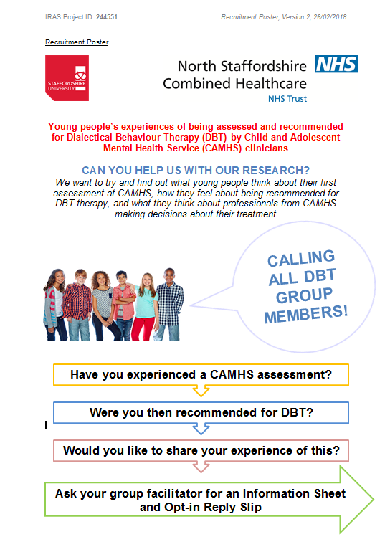

Appendix F: Young Person’s Information Sheet
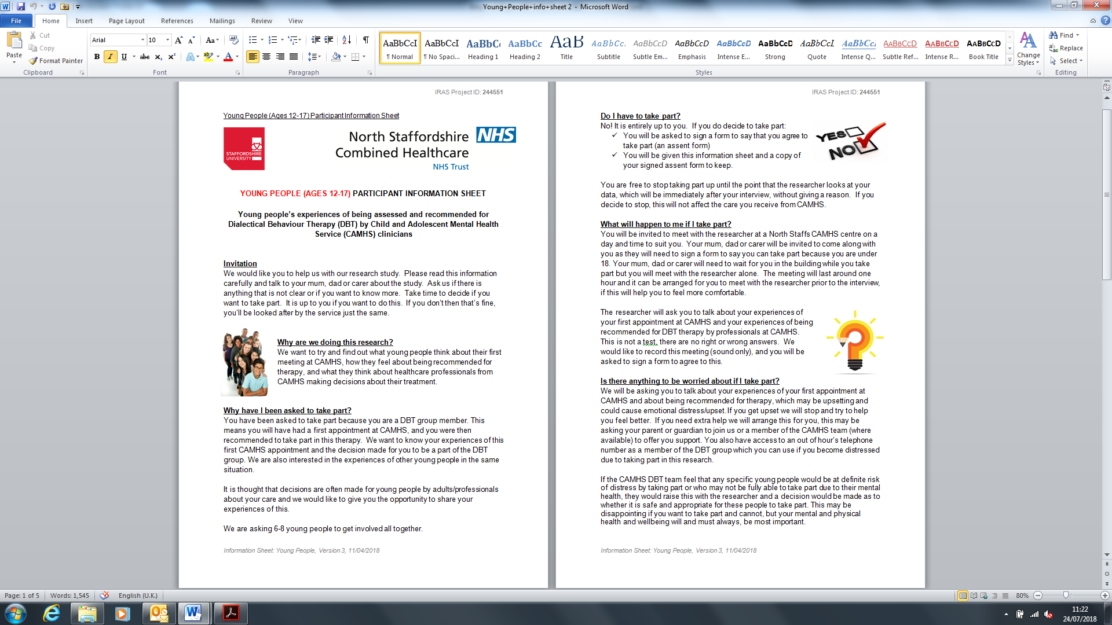
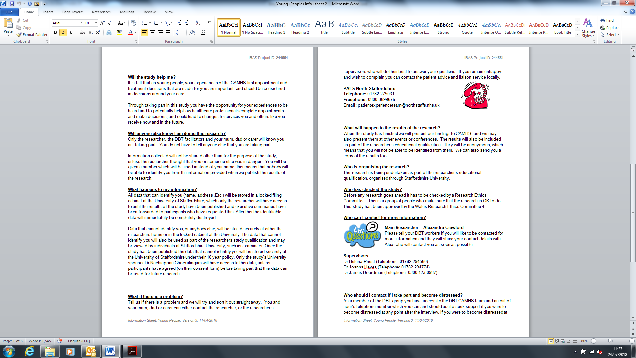

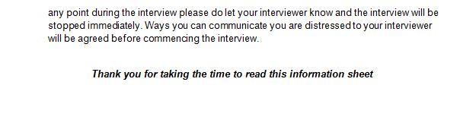
Appendix G: Parent/Guardian Information Sheet
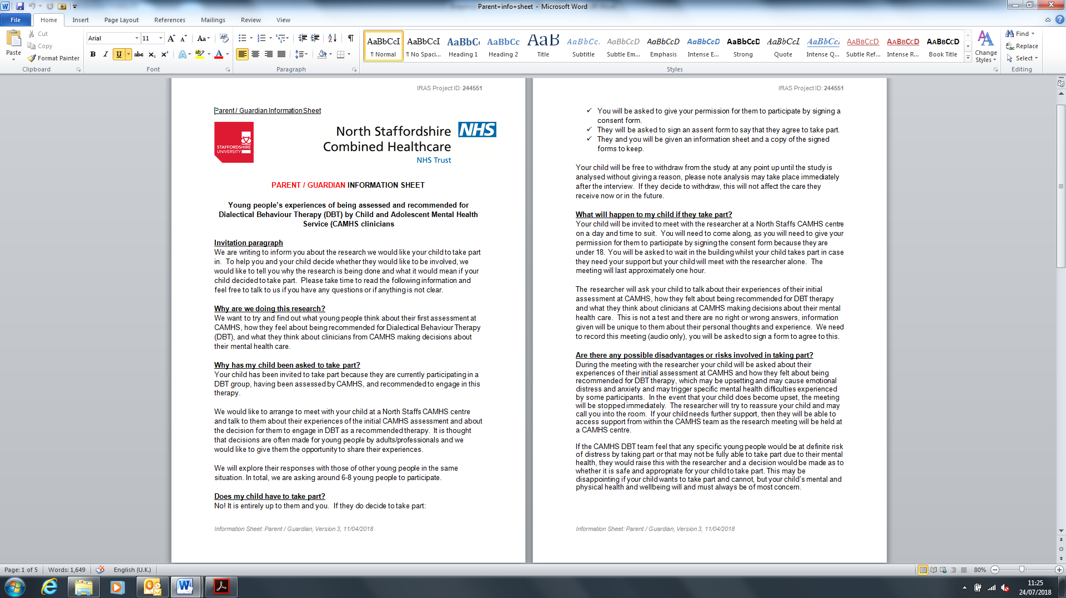
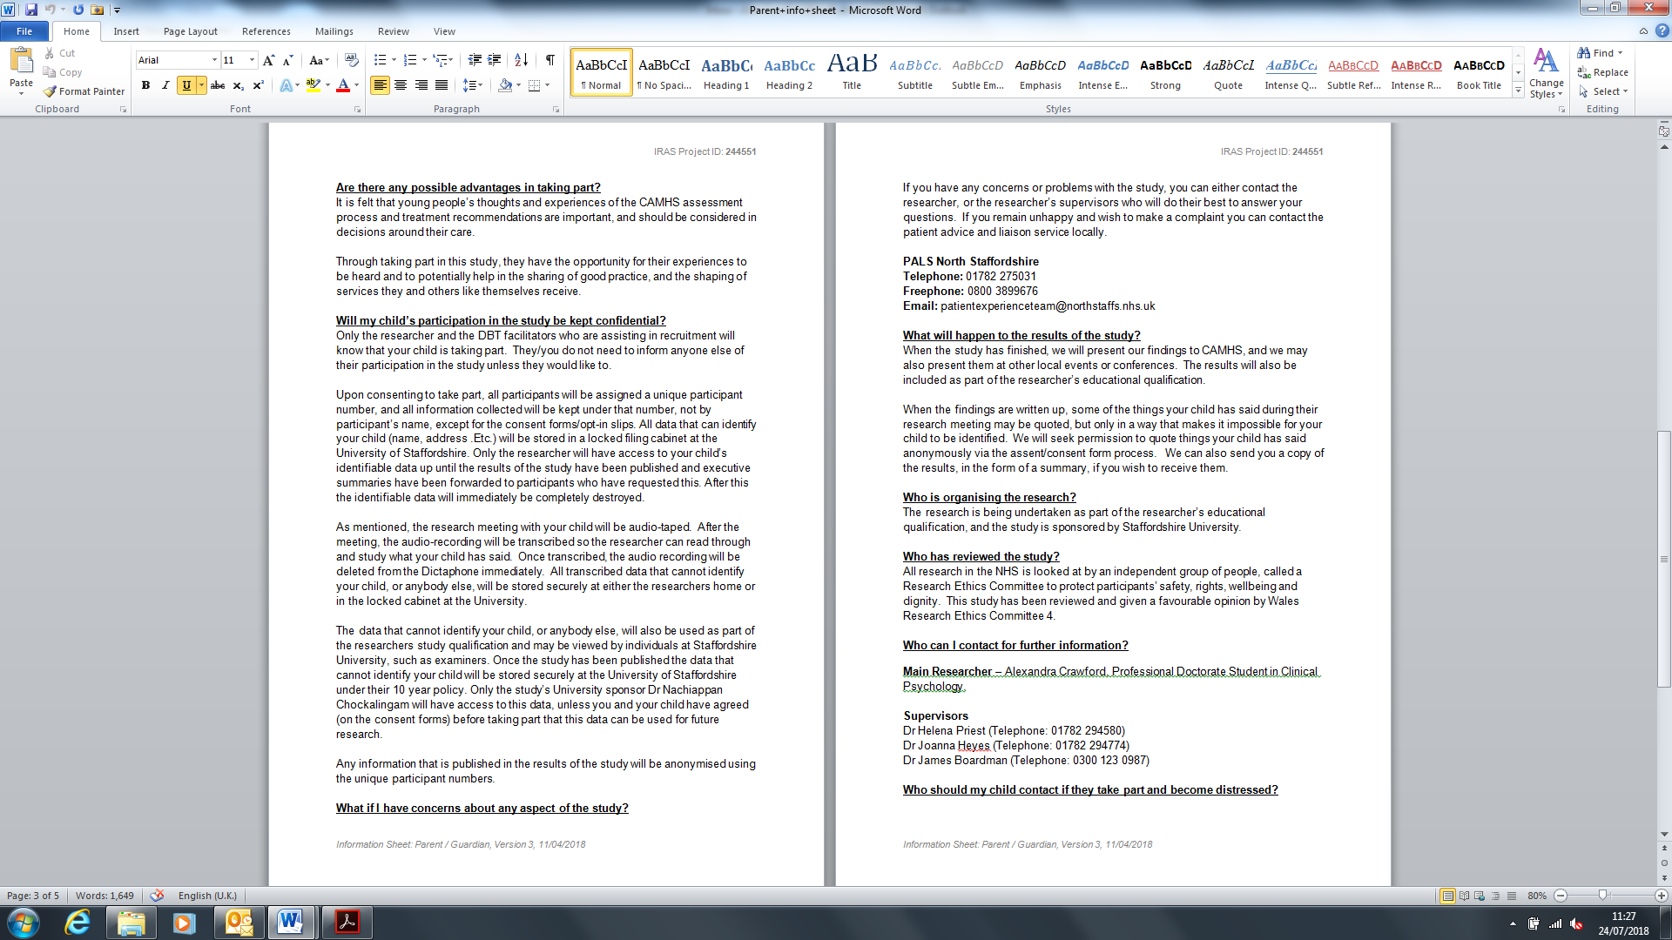

Appendix H: Semi-Structured Interview Guide
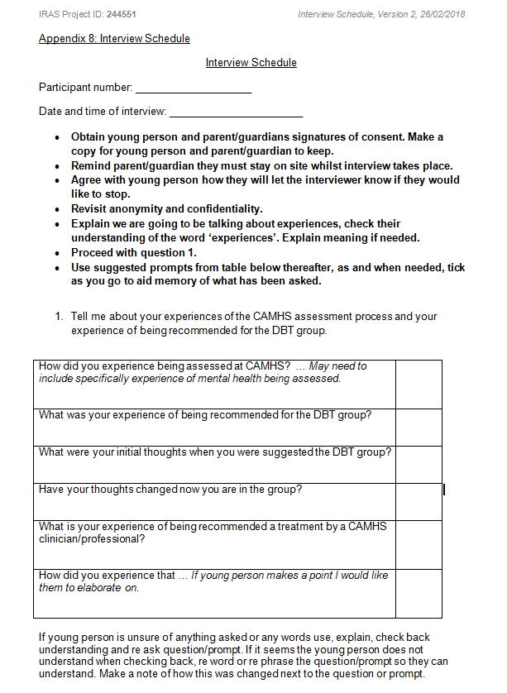

Appendix I: IPR Approval
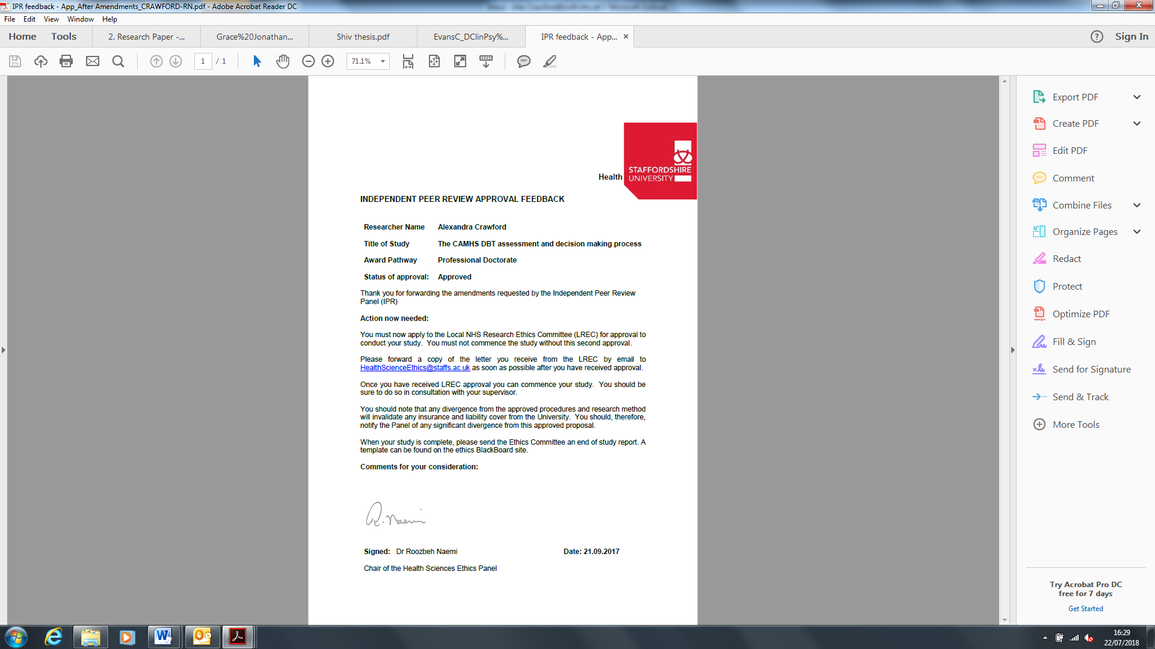

Appendix J: Ethical Approval from Wales Research and Ethics Committee
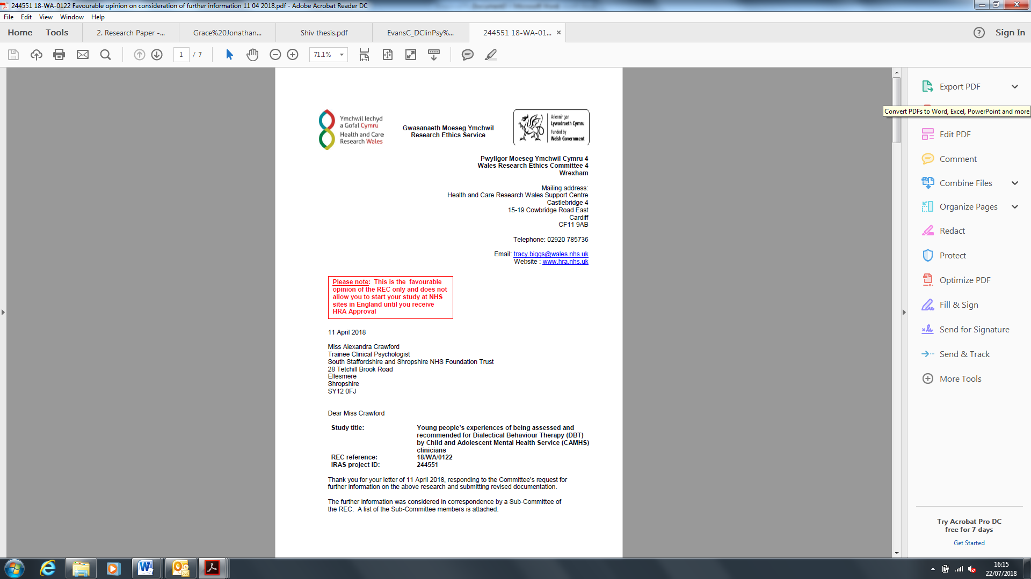

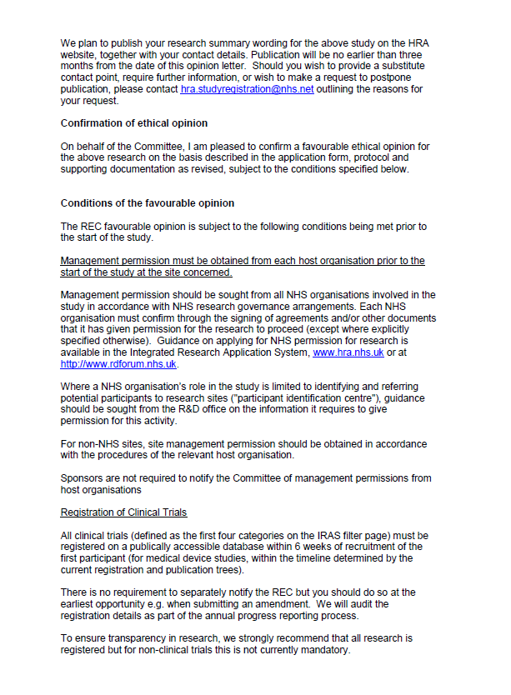

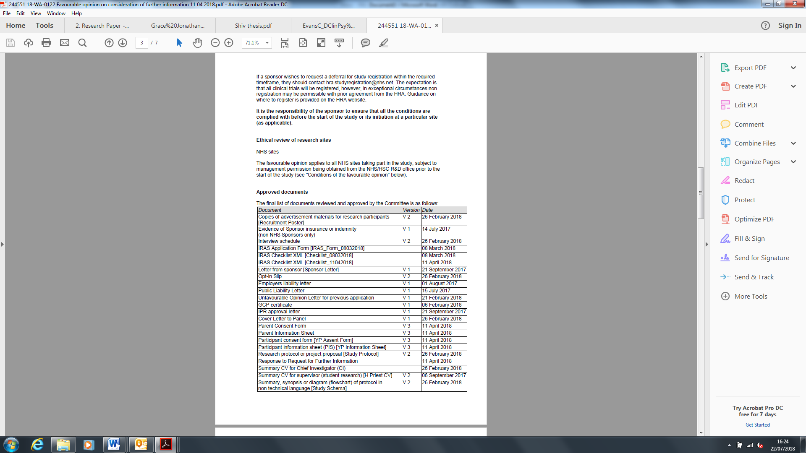

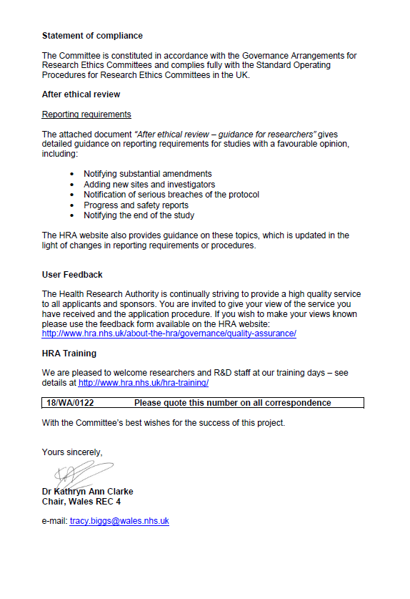

Appendix K: HRA Approval
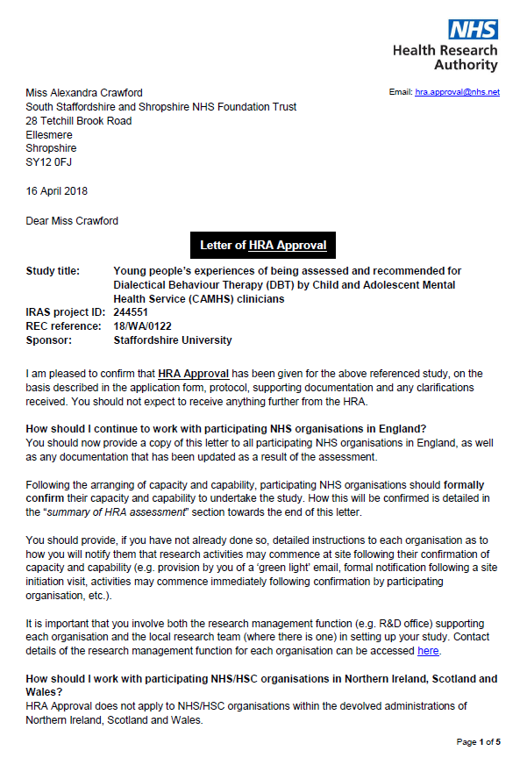

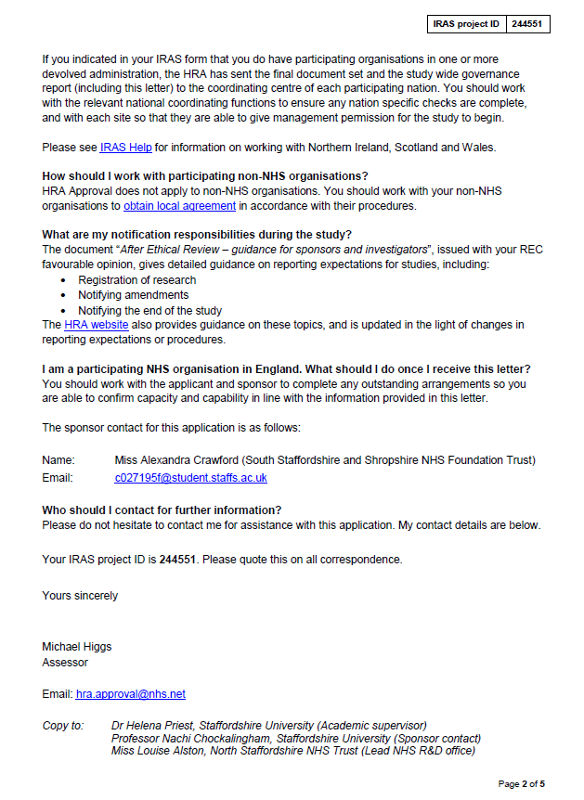

Appendix L: Local R & D Approval
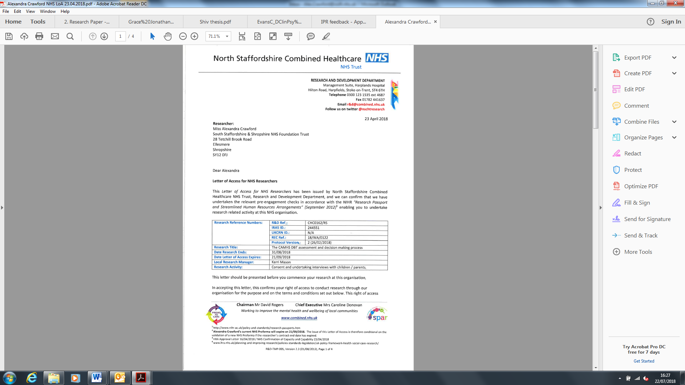

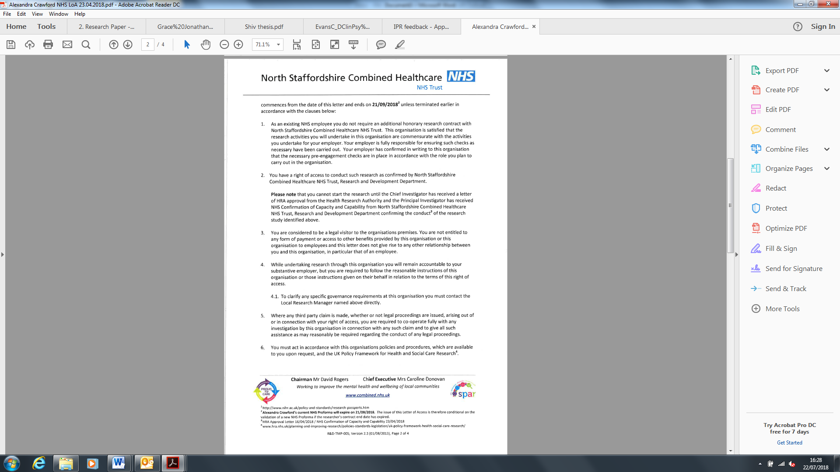

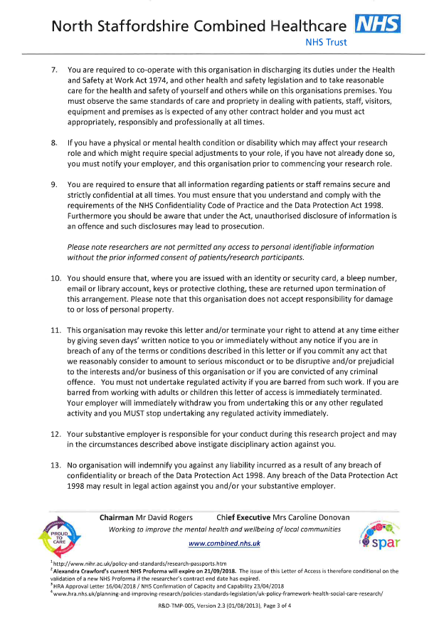

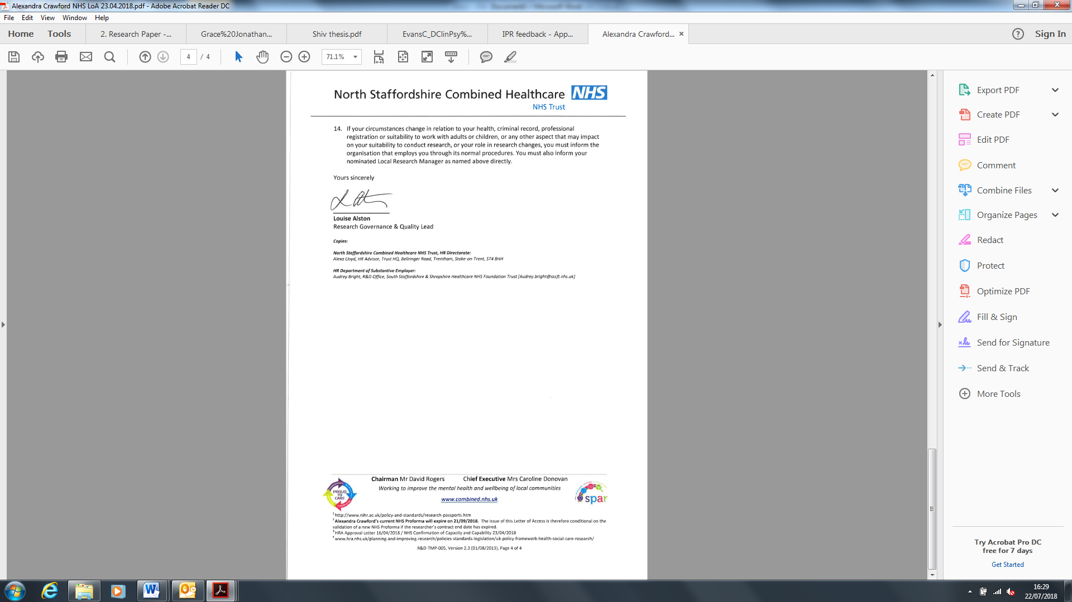
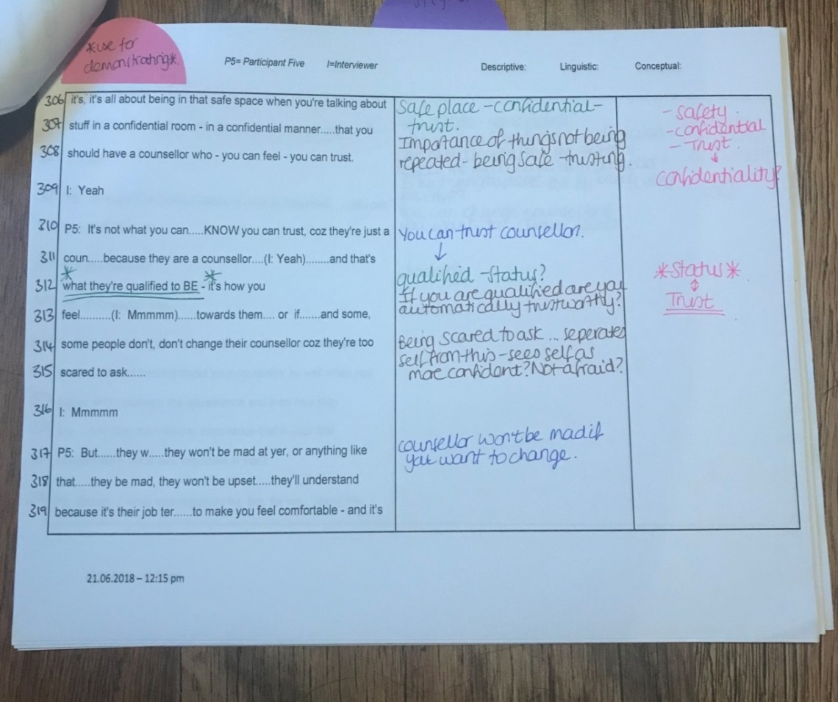
Appendix M: Example of Coding and Development of Emergent Themes for Participant 5

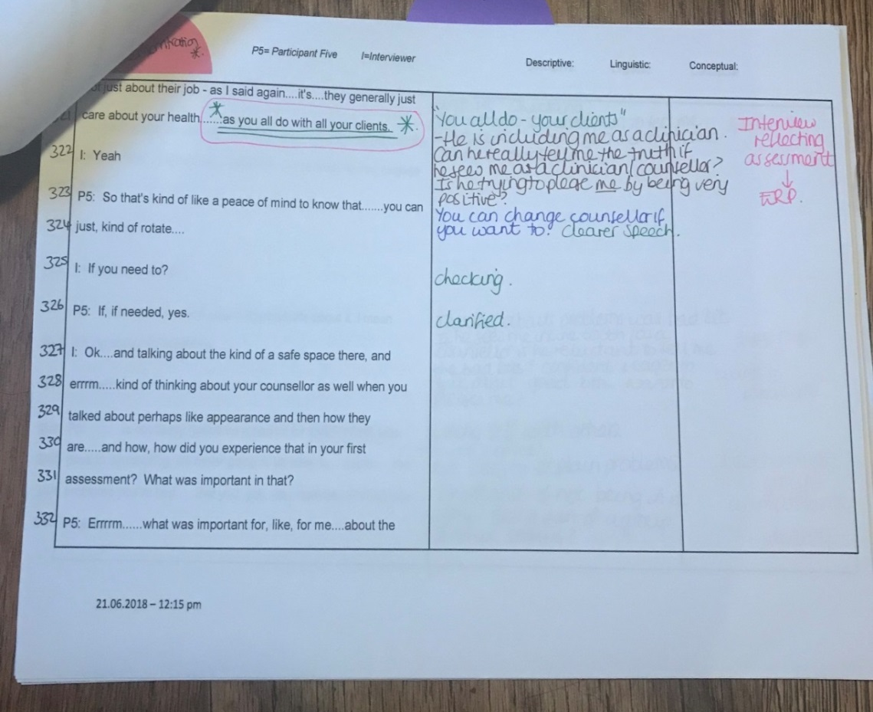

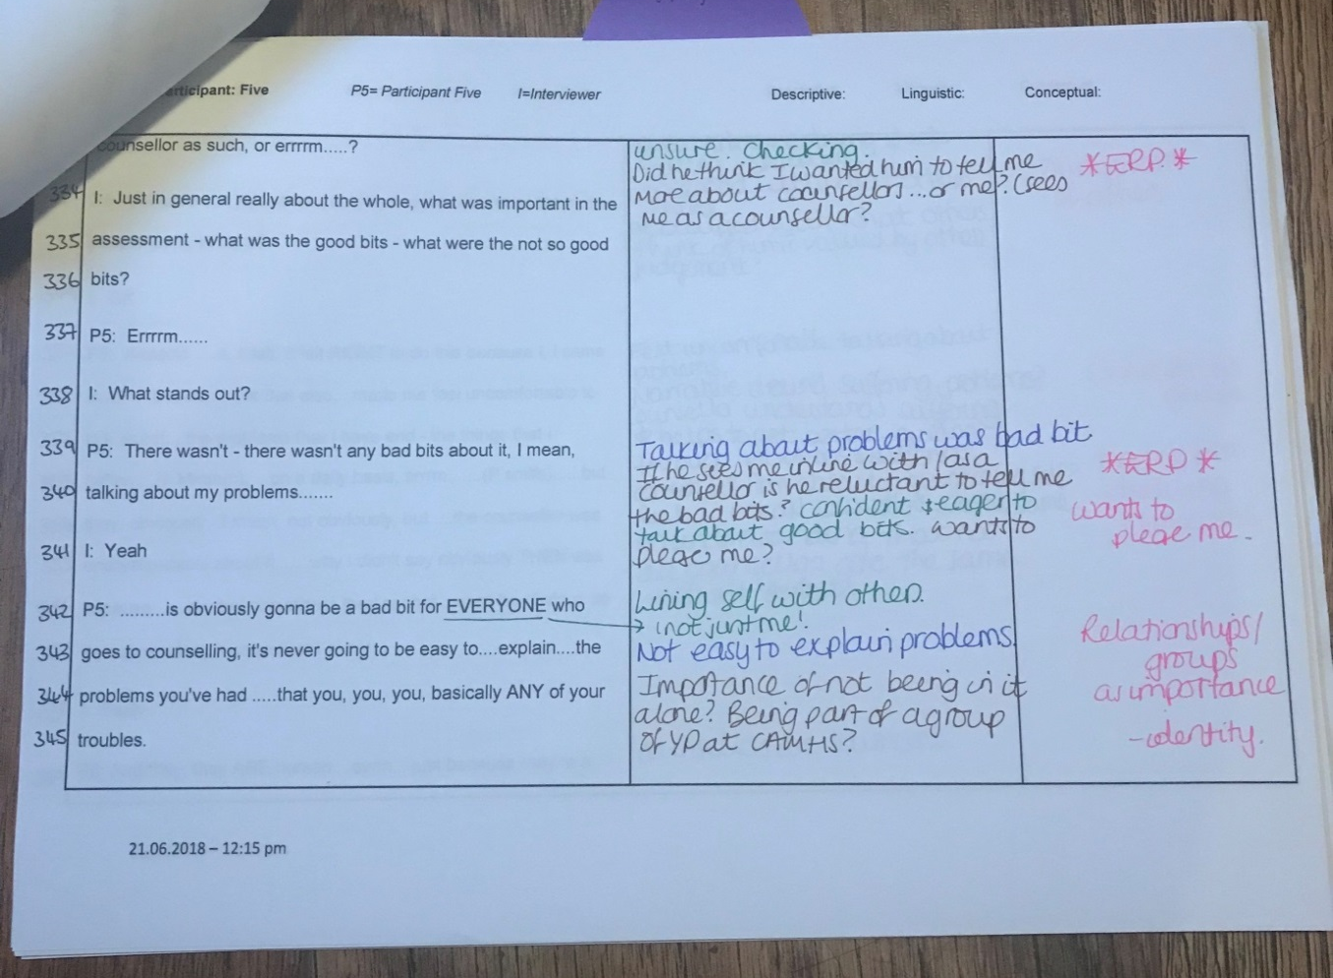

Appendix N: Individual Participant Super-Ordinate Themes in List Format for Group
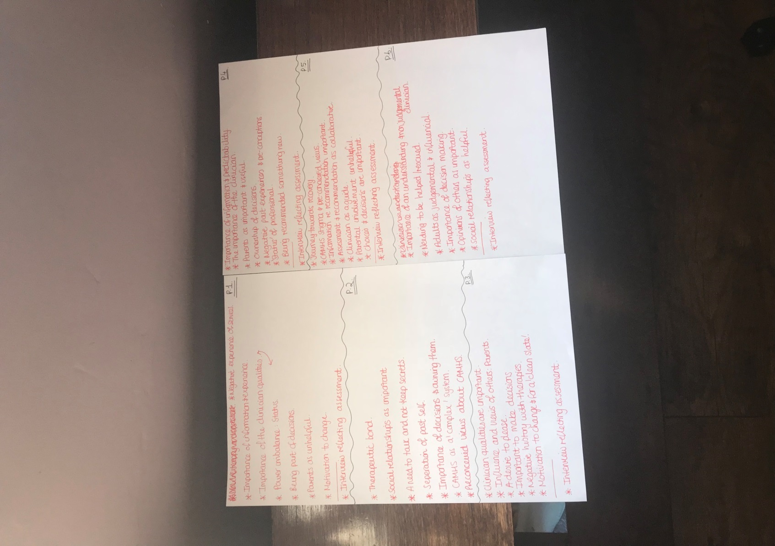

Appendix O: Example of how Participant 4 Super-Ordinate Themes were originated
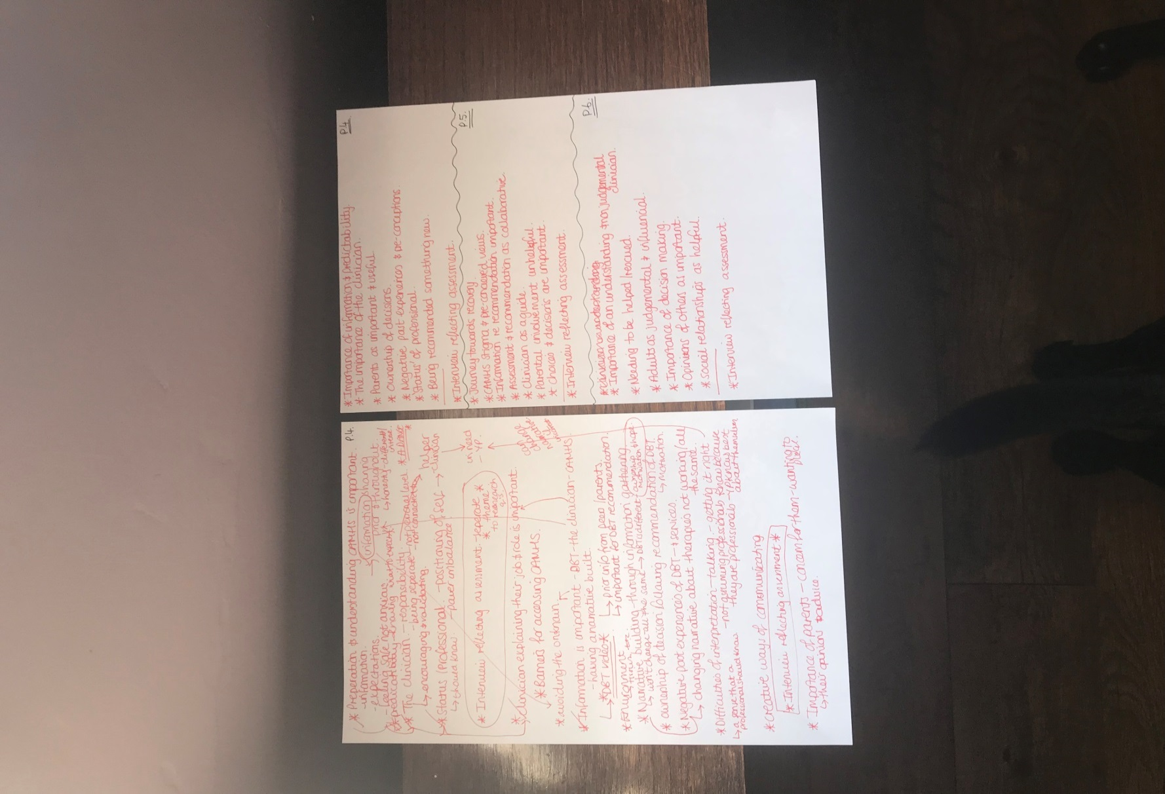

Appendix P: Example of Super-Ordinate and Sub-Theme Analysis across Group and how Themes were linked
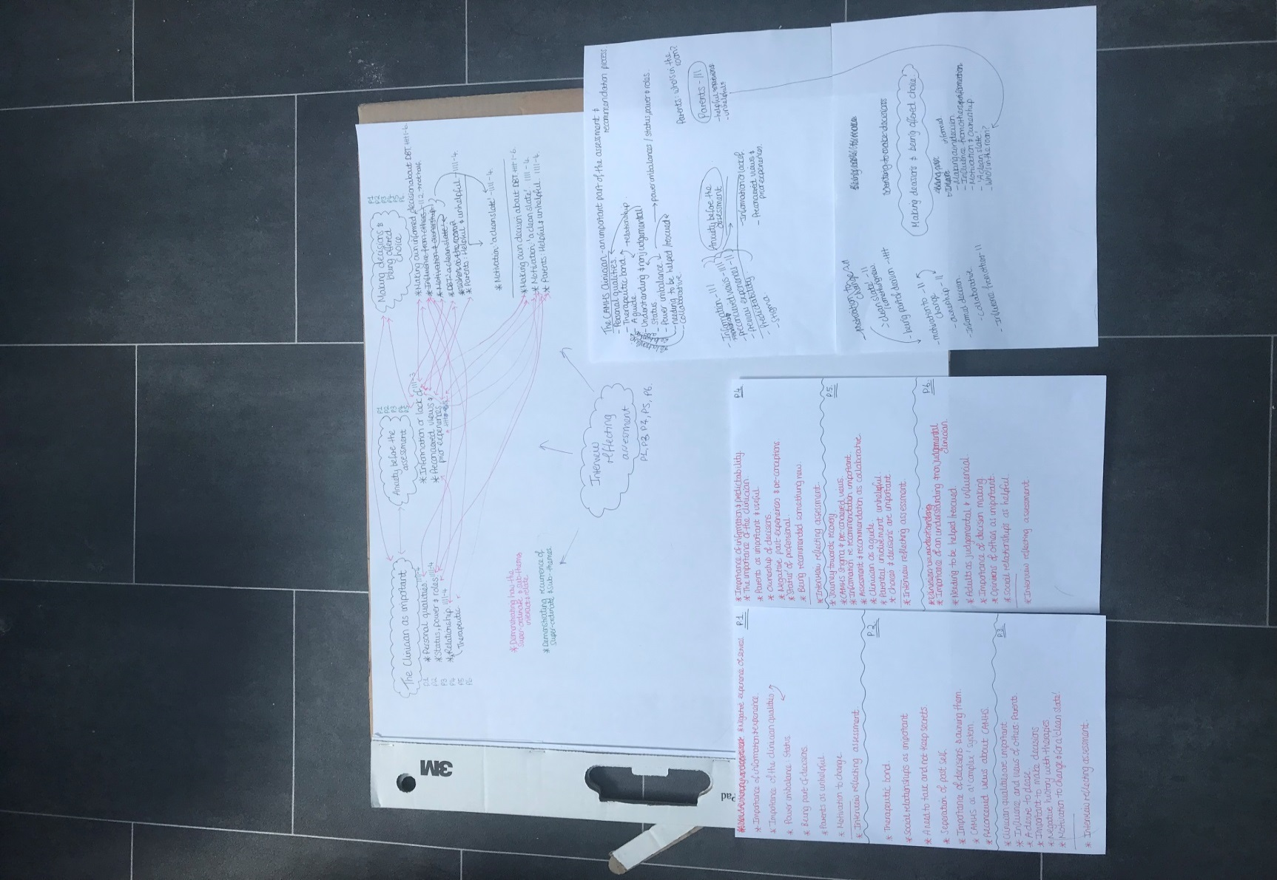

Appendix Q: Reflective & Exploratory Notebook Example
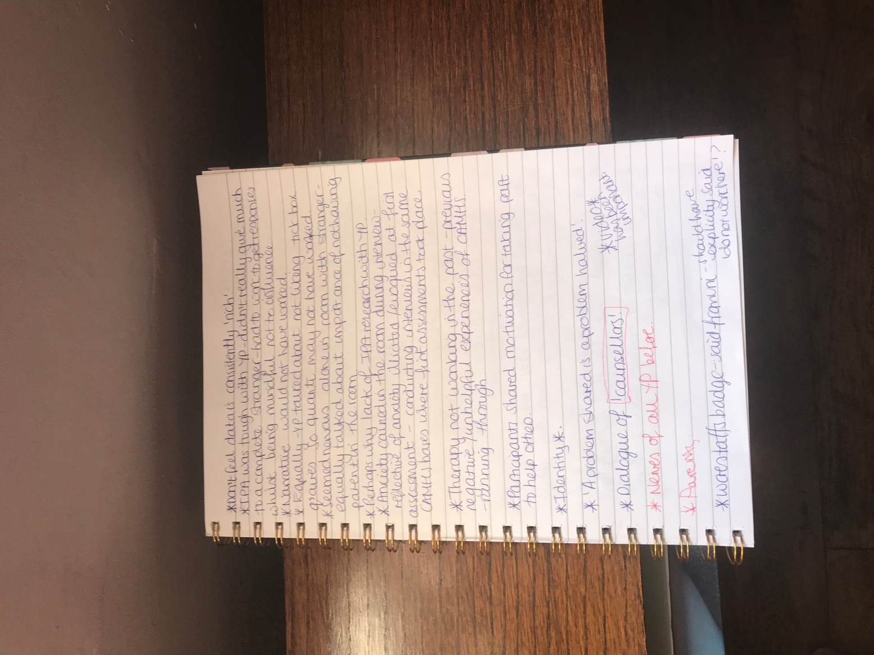

Appendix R: Clinical Child Psychology and Psychiatry Journal Guidelines
1. What do we publish?
1.1 Aims & Scope
Before submitting your manuscript to Clinical Child Psychology and Psychiatry, please ensure you have read the Aims & Scope.
1.2 Article Types
Clinical Child Psychology and Psychiatry is interested in advancing theory, practice and clinical research in the realm of child and adolescent psychology and psychiatry and related disciplines. Articles should not usually exceed 7,500 words and be clearly organized, with a clear hierarchy of headings and subheadings (3 weights maximum). Authors wishing to submit an article longer than 7,500 words should discuss this in advance with the journal editor.
1.3 Writing your paper
The SAGE Author Gateway has some general advice and on how to get published, plus links to further resources.
1.3.1 Make your article discoverable
When writing up your paper, think about how you can make it discoverable. The title, keywords and abstract are key to ensuring readers find your article through search engines such as Google. For information and guidance on how best to title your article, write your abstract and select your keywords, have a look at this page on the Gateway: How to Help Readers Find Your Article Online.
Back to top
2. Editorial policies
2.1 Peer review policy
The Editor will screen manuscripts for their overall fit with the aims and scope of the journal, especially in terms of having clear relevance for clinicians. Those that fit will be further reviewed by two or more independent reviewers in terms of merit, readability and interest.
As part of the submission process you will be asked to provide the names of [X no.] peers who could be called upon to review your manuscript. Recommended reviewers should be experts in their fields and should be able to provide an objective assessment of the manuscript. Please be aware of any conflicts of interest when recommending reviewers. Examples of conflicts of interest include (but are not limited to) the below:
• The reviewer should have no prior knowledge of your submission
• The reviewer should not have recently collaborated with any of the authors
• Reviewer nominees from the same institution as any of the authors are not permitted
Please note that the Editors are not obliged to invite/reject any recommended/opposed reviewers to assess your manuscript.
2.2 Authorship
All parties who have made a substantive contribution to the article should be listed as authors. Principal authorship, authorship order, and other publication credits should be based on the relative scientific or professional contributions of the individuals involved, regardless of their status. A student is usually listed as principal author on any multiple-authored publication that substantially derives from the student’s dissertation or thesis.
2.3 Acknowledgements
All contributors who do not meet the criteria for authorship should be listed in an Acknowledgements section. Examples of those who might be acknowledged include a person who provided purely technical help, or a department chair who provided only general support.
Any acknowledgements should appear first at the end of your article prior to your Declaration of Conflicting Interests (if applicable), any notes and your References.
2.4 Funding
It is the policy of Clinical Child Psychology and Psychiatry to require a declaration of conflicting interests from all authors enabling a statement to be carried within the paginated pages of all published articles.
Please ensure that a ‘Declaration of Conflicting Interests’ statement is included at the end of your manuscript, after any acknowledgements and prior to the references. If no conflict exists, please state that ‘The Author(s) declare(s) that there is no conflict of interest’. For guidance on conflict of interest statements, please see the ICMJE recommendations here.
2.5 Declaration of conflicting interests
Clinical Child Psychology and Psychiatry encourages authors to include a declaration of any conflicting interests and recommends you review the good practice guidelines on the SAGE Journal Author Gateway.
It is the policy of Clinical Child Psychology and Psychiatry to require a declaration of conflicting interests from all authors enabling a statement to be carried within the paginated pages of all published articles.
Please ensure that a ‘Declaration of Conflicting Interests’ statement is included at the end of your manuscript, after any acknowledgements and prior to the references. If no conflict exists, please state that ‘The Author(s) declare(s) that there is no conflict of interest’. For guidance on conflict of interest statements, please see the ICMJE recommendations here
2.6 Research ethics and patient consent
Medical research involving human subjects must be conducted according to the World Medical Association Declaration of Helsinki.
Submitted manuscripts should conform to the ICMJE Recommendations for the Conduct, Reporting, Editing, and Publication of Scholarly Work in Medical Journals, and all papers reporting animal and/or human studies must state in the methods section that the relevant Ethics Committee or Institutional Review Board provided (or waived) approval. Please ensure that you have provided the full name and institution of the review committee, in addition to the approval number.
For research articles, authors are also required to state in the methods section whether participants provided informed consent and whether the consent was written or verbal.
Information on informed consent to report individual cases or case series should be included in the manuscript text. A statement is required regarding whether written informed consent for patient information and images to be published was provided by the patient(s) or a legally authorized representative.
Please also refer to the ICMJE Recommendations for the Protection of Research Participants
Back to top
3. Publishing Policies
3.1 Publication ethics
Clinical Child Psychology and Psychiatry and SAGE take issues of copyright infringement, plagiarism or other breaches of best practice in publication very seriously. We seek to protect the rights of our authors and we always investigate claims of plagiarism or misuse of published articles. Equally, we seek to protect the reputation of the journal against malpractice. Submitted articles may be checked with duplication-checking software. Where an article, for example, is found to have plagiarised other work or included third-party copyright material without permission or with insufficient acknowledgement, or where the authorship of the article is contested, we reserve the right to take action including, but not limited to: publishing an erratum or corrigendum (correction); retracting the article; taking up the matter with the head of department or dean of the author's institution and/or relevant academic bodies or societies; or taking appropriate legal action.
3.1.1 Plagiarism
If material has been previously published it is not generally acceptable for publication in a SAGE journal. However, there are certain circumstances where previously published material can be considered for publication. Please refer to the guidance on the SAGE Author Gateway or if in doubt, contact the Editor at the address given below.
3.1.2 Prior publication
Before publication, SAGE requires the author as the rights holder to sign a Journal Contributor’s Publishing Agreement. SAGE’s Journal Contributor’s Publishing Agreement is an exclusive licence agreement which means that the author retains copyright in the work but grants SAGE the sole and exclusive right and licence to publish for the full legal term of copyright. Exceptions may exist where an assignment of copyright is required or preferred by a proprietor other than SAGE. In this case copyright in the work will be assigned from the author to the society. For more information please visit the SAGE Author Gateway.
3.2 Contributor's publishing agreement
Clinical Child Psychology and Psychiatry offers optional open access publishing via the SAGE Choice programme. For more information please visit the SAGE Choice website. For information on funding body compliance, and depositing your article in repositories, please visit SAGE Publishing Policies on our Journal Author Gateway.
3.3 Open access and author archiving
The preferred format for your manuscript is Word. LaTeX files are also accepted. Word and (La)Tex templates are available on the Manuscript Submission Guidelines page of our Author Gateway.
Back to top
4. Preparing your manuscript for submission
4.1 Formatting
The preferred format for your manuscript is Word. LaTeX files are also accepted. Word and (La)Tex templates are available on the Manuscript Submission Guidelines page of our Author Gateway
4.2 Artwork, figures and other graphics
For guidance on the preparation of illustrations, pictures and graphs in electronic format, please visit SAGE’s Manuscript Submission Guidelines.
Figures supplied in colour will appear in colour online regardless of whether or not these illustrations are reproduced in colour in the printed version. For specifically requested colour reproduction in print, you will receive information regarding the costs from SAGE after receipt of your accepted article.
4.3 Supplementary material
This journal is able to host additional materials online (e.g. datasets, podcasts, videos, images etc) alongside the full-text of the article. For more information please refer to our guidelines on submitting supplementary files.
4.4 Reference style
Clinical Child Psychology and Psychiatry adheres to the APA reference style. View the APA guidelines to ensure your manuscript conforms to this reference style.
4.5 English language editing services
Authors seeking assistance with English language editing, translation, or figure and manuscript formatting to fit the journal’s specifications should consider using SAGE Language Services. Visit SAGE Language Services on our Journal Author Gateway for further information.
Back to top
5. Submitting your manuscript
Clinical Child Psychology and Psychiatry is hosted on SAGE Track, a web based online submission and peer review system powered by ScholarOne™ Manuscripts. Visit http://mc.manuscriptcentral.com/ccpp to login and submit your article online.
IMPORTANT: Please check whether you already have an account in the system before trying to create a new one. If you have reviewed or authored for the journal in the past year it is likely that you will have had an account created. For further guidance on submitting your manuscript online please visit ScholarOne Online Help.
If you would like to discuss your paper prior to submission, please refer to the contact details below
5.1 ORCID
As part of our commitment to ensuring an ethical, transparent and fair peer review process SAGE is a supporting member of ORCID, the Open Researcher and Contributor ID. ORCID provides a persistent digital identifier that distinguishes researchers from every other researcher and, through integration in key research workflows such as manuscript and grant submission, supports automated linkages between researchers and their professional activities ensuring that their work is recognised.
We encourage all authors to add their ORCIDs to their SAGE Track accounts and include their ORCIDs as part of the submission process. If you don’t already have one you can create one here
5.2 Information required for completing your submission
You will be asked to provide contact details and academic affiliations for all co-authors via the submission system and identify who is to be the corresponding author. These details must match what appears on your manuscript. At this stage please ensure you have included all the required statements and declarations and uploaded any additional supplementary files (including reporting guidelines where relevant).
5.3 Permissions
Please also ensure that you have obtained any necessary permission from copyright holders for reproducing any illustrations, tables, figures or lengthy quotations previously published elsewhere. For further information including guidance on fair dealing for criticism and review, please see the Copyright and Permissions page on the SAGE Author Gateway.
Back to top
6. On acceptance and publication
6.1 SAGE Production
Your SAGE Production Editor will keep you informed as to your article’s progress throughout the production process. Proofs will be sent by PDF to the corresponding author and should be returned promptly. Authors are reminded to check their proofs carefully to confirm that all author information, including names, affiliations, sequence and contact details are correct, and that Funding and Conflict of Interest statements, if any, are accurate. Please note that if there are any changes to the author list at this stage all authors will be required to complete and sign a form authorising the change.
6.2 Online First publication
Online First allows final articles (completed and approved articles awaiting assignment to a future issue) to be published online prior to their inclusion in a journal issue, which significantly reduces the lead time between submission and publication. Visit the SAGE Journals help page for more details, including how to cite Online First articles
6.3 Access to your published article
SAGE provides authors with online access to their final article.
6.4 Promoting your article
Publication is not the end of the process! You can help disseminate your paper and ensure it is as widely read and cited as possible. The SAGE Author Gateway has numerous resources to help you promote your work. Visit the Promote Your Article page on the Gateway for tips and advice. In addition, SAGE is partnered with Kudos, a free service that allows authors to explain, enrich, share, and measure the impact of their article. Find out how to maximise your article’s impact with Kudos.
Back to top
7. Further information
Any correspondence, queries or additional requests for information on the manuscript submission process should be sent to the Clinical Child Psychology and Psychiatry editorial office as follows:
Alex Bollag, Editorial Assistant, email: ccpp.ed.assistant@gmail.com
Prof. Deborah Christie, Co-Editor, email: deborah.christie2@nhs.net
Dr. Eilis Kennedy, Co-Editor, email: EKennedy@tavi-port.nhs.uk
Books for review should be sent to: Ramon Karamat Ali,
Dr R Karamat Ali
Associate Editor/ Book review
13 Aigburth Drive
Liverpool
L17 4JG
Email: dr.rkaramatali@gmail.com

Paper Three: Executive Summaries for the Purpose of Sharing the Findings of Paper Two

Executive Summary One: For Participants (Young People)

Executive Summary Two: For Parents/Guardians of Participants

Total word count for summary one and two: 2,005

Executive Summary One: For Participants (Young People)

Young People’s Experiences of being Assessed and Recommended for Dialectical Behaviour Therapy (DBT), by Child and Adolescent Mental Health Service (CAMHS) Clinicians

Word Count: 549

Contents
What was the study about? | 151
What did the study hope to find out? | 152
What did we do? | 152
What was found out? | 153
What does this mean for you? | 154
How will this be shared? | 155
References | 156

What was the study about?

- It is recognised that changes need to be made to mental health services for young people.

- Young people have important views and lived experiences of the difficulties that affect them, which adults may overlook.



- Dialectical Behaviour Therapy (DBT) has been adapted for adolescents who present with a variety of specific difficulties.

- Many Child and Adolescent Mental Health Services (CAMHS) are now offering DBT as an intervention for young people.
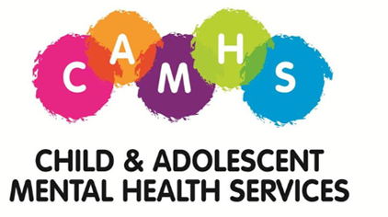

- There is little information about the views and experiences of young people who are assessed and recommended DBT in CAMHS.

- So how do we know what young people experience, and what they want and need when they are being assessed and recommended interventions, like DBT?

What did the study hope to find out?

The study wanted to explore the following questions:
- How do young people experience the Child and Adolescent Mental Health Service (CAMHS) initial assessment process?
- How do young people experience being recommended for DBT?

- How do young people experience clinicians from CAMHS making decisions about their mental health and recommending interventions?

What did we do?

- Six young people were interviewed in total.

- The interviews were then looked at in detail for patterns and relationships across what the participants had said.

- The patterns and relationships were then grouped into ‘themes’.

- Four ‘Major’ or ‘Super-ordinate’ and Seven ‘Sub’ themes were found. The diagram below shows what these were:

Theme 1: The Clinician as Important
- Personal Qualities & Relationship
- Status, Power & Roles
Theme 2: Anxiety before Assessment
- Information or Lack of
- Preconceived views & Prior Experiences
Theme 3: Making Decisions & Offered Choice
- Making own Decisions about DBT
- Motivation; ‘A Clean Slate’
- Parents: Helpful & Unhelpful
Theme 4: Interview Reflecting Assessment – Participants feeling that the research interview was like the CAMHS assessment

What was found out?

- The clinician is an important part of the assessment and recommendation process. Most importantly that a clinician is trustworthy and does not judge.

- It can be nerve wracking before an assessment, especially if you haven’t received much information about what to expect and if you have had previous bad experiences with mental health services.

- Being included in decision making and being offered choice is important.



- Being interviewed for the study felt a bit like being assessed and recommended DBT at CAMHS.

What does this mean for you?

It is recommended that:

- Clinicians can provide young people with a good experience of the assessment and decision making process by being trustworthy and non-judgemental.

- Clinicians should give young people choice about their care.

- CAMHS can attempt to improve their ‘image’ to reduce negative views.

- Young people can be better informed about what to expect at CAMHS through multimedia platforms like Facebook and twitter.




How will this be shared?

- The full research project will be submitted for publication to The Clinical Child Psychology and Psychiatry Journal.

- Participants who took part in the study and requested a copy of the executive summary will be sent a copy in the post.

References

Beck, A. (2006). Users’ views of looked after children’s mental health services. Adoption & Fostering, 30, 53-63.

Bone, C., O’Reilly, M., Karim, K., & Vostanis, P. (2014). ‘They’re not witches ….’ Young children and their parents’ perceptions and experiences of child and adolescent mental health services. Child Care, Health and Development, 41(3), 450-458.

Coyne, I., Mcnamara, M., Healy, M., Gower, C., Sarkar, M., & McNicholas, F. (2015). Adolescents’ and parents’ views of child and adolescent mental health services (CAMHS) in ireland. Journal of Psychiatric and Mental Health Nursing, 22, 561-569.

Davison, J., Zamperoni, V., & Stain, H. J. (2017). Vulnerable young people’s
experiences of child and adolescent mental health services. Mental Health Review Journal, 22, 95-110.

Department of Health & National Health Service. (2015). Future in Mind: Promoting, Protecting and improving our Children and Young People’s Mental Health and Wellbeing (No 02939). London: Williams Lea.

Evans, N. (2017). Experiences of a child and adolescent mental health service. Nursing Children and Young People, 29, 41-45.
Jack, A., Lanskey, C., & Harvey, J. (2015). Young offenders’ and their families’ experiences of mental health interventions. Journal of Children’s Services, 10, 353-364.

Kapur, P., Hayes, D., Waddingham, R., Hillman, S., Deighton, J., & Midgley, N. (2014). The experience of engaging with mental health services among young people who hear voices and their families: a mixed methods exploratory study. BMC Health Services Research, 14, 1-9.

Linehan, M. M. (1993). Cognitive behavioural treatment of borderline personality disorder. New York: Guilford Press.

National Institute for Health and Care Excellence. (2009). Borderline personality disorder: recognition and management. Manchester: NICE.

O’Reilly, M., Bowlay-Williams, J., Svirydzenka, N., & Vostanis, P. (2016). A
qualitative exploration of how adopted children and their parents conceptualise mental health difficulties. Adoption & Fostering, 40, 60- 76.

Rani, J., Prosser, A., Worrall-Davies, A., Kiernan, K., & Hewson, L. (2009). User and carer views of CAMHS intensive home treatment service in Bradford. Practice Development in Health Care, 8, 223-238.

Rathus, J. H., & Miller, A. L. (2015). DBT skills manual for adolescents. New York: Guildford Press.

Smith, J. A., Flowers, P., & Larkin, M. (2012). Interpretative phenomenological analysis. London: Sage.

Executive Summary Two: For Parents/Guardians of Participants

Young People’s Experiences of being Assessed and Recommended for Dialectical Behaviour Therapy (DBT), by Child and Adolescent Mental Health Service (CAMHS) Clinicians

Word Count: 1,207

Contents
Introduction to the study | 160
Aims of the study | 161
Methods – How was it done? | 161
What were the findings? | 162
Conclusion | 164
Recommendations | 165
Sharing the Study | 165
Limitations | 165
References | 167

Introduction to the Study
It is recognised nationally that improvements need to be made in mental health services for young people within England, with statistics showing that 1 in 10 young people will have some sort of mental health difficulty. Group therapeutic interventions are believed to be effective in terms of intervention effectiveness and costing to the National Health Service (NHS).

There is a rise in young people presenting with emotional difficulties and risky behaviours at Child and Adolescent Mental Health Services (CAMHS). Dialectical Behaviour Therapy (DBT) is recommended as a chosen intervention for these difficulties, and some CAMHS in England are now offering DBT groups for young people.

The ‘Future in Mind’ document encourages young people being involved in the decisions that affect their interventions. However, despite this Government document and the development of DBT groups across England in CAMHS, there was only a small amount of research available on this topic to help clinicians and decision makers understand what it is young people want and need.

This begs the question, how do we know what young people who present to CAMHS experience when decisions are made about their care, such as being assessed and recommended DBT?
This study intended to add to the small amount of research that was available by investigating the experiences of young people who present to CAMHS and were assessed and recommended DBT. It is hoped that any findings from this study will be considered in CAMHS decisions, in regards to young people’s treatment and care.

Aims of the Study
The study intended to explore the following questions:
- How do young people experience the Child and Adolescent Mental Health Service (CAMHS) initial assessment process?
- How do they subsequently experience being recommended for DBT?
- How do they experience clinicians from CAMHS making decisions about their mental health and recommending interventions?

Methods – How was it done?
Interpretative Phenomenological Analysis (IPA) is a research approach that explores how people make sense of life experiences. Following IPA guidelines, six participants were recruited from a select group who could best answer the studies questions, as outlined in the study aims.

Participants were three females and three males aged 14-17 and were all members of a local DBT group. Individual interviews were recorded, transcribed and then analysed to look for patterns and relationships across the participants. Four super-ordinate themes and seven sub-themes were identified. The diagram below outlines these:

Theme 1: The Clinician as Important
- Personal Qualities & Relationship
- Status, Power & Roles
Theme 2: Anxiety before Assessment
- Information or Lack of
- Preconceived views & Prior Experiences
Theme 3: Making Decisions & Offered Choice
- Making own Decisions about DBT
- Motivation; ‘A Clean Slate’
- Parents: Helpful & Unhelpful
Theme 4: Interview Reflecting Assessment - Participants feeling that the research interview was like the CAMHS assessment

What were the findings?
The study found three distinct ideas about what young people might want in order to experience a good assessment at CAMHS and of being recommended DBT. Additionally, the study found seven further areas to be considered when assessing young people and when recommending DBT as a therapeutic choice.

Participants in this study found the clinician to be of significant importance to their experience at CAMHS. Of particular note, young people felt being able to trust their clinician and for them to be non-judgemental were two of the most important qualities a clinician can have:
“It’s all about being in that safe space when you’re talking about stuff in a confidential room – in a confidential manner … that you should have a counsellor who – you can feel – you can trust.” Participant 5: lines 306-308.

The study found that it could be thought that, young people are at a high risk of experiencing anxiety prior to an assessment if they feel they have not received sufficient information. This is especially so if they already had negative views about CAMHS, and had previous negative experiences with services and therapies.

Young people valued being part of the decisions made about their care. In particular, young people want to be part of the decisions made when clinicians recommend interventions, such as DBT:
“I went to a normal session and [clinician name] was like ‘we’re doing DBT’ but it was my decision, I could have said no or yes.” Participant 2: lines 381-383.

Conclusion
The study explored young people’s experiences of being assessed by CAMHS clinicians and recommended DBT. In line with the limited available research, young people experienced clinicians as important throughout the process, increased levels of anxiety before assessment were experienced and young people valued being part of decisions about their care.

The study highlighted how young people can experience power-imbalances with adults. It was also found that the young people experienced the study interviews as similar to the CAMHS assessment and decision making process. It is therefore important to consider, in whose interest is it for the young people to take part in studies like this one?
Recommendations
Clinicians can provide young people with a good experience of the assessment and decision making process by being trustworthy and non-judgemental and providing young people with choice about their care. Decision makers from CAMHS services could look to improve the view held by young people of CAMHS, in an attempt to reduce young people’s negative experiences and anxieties around CAMHS.

CAMHS can better inform young people about what to expect through attempting to contact the young person themselves in regards to assessments, where appropriate. CAMHS could also improve their multimedia ‘presence’ on platforms such as Facebook and Twitter, to share information about CAMHS.

Sharing the Study
The full research project will be submitted for publication to The Clinical Child Psychology and Psychiatry Journal. The journal is interested in advancing theory, practice and clinical research in the field of child and adolescent psychology and psychiatry and related disciplines. Participants who took part in the study and requested a copy of the executive summary will be sent a copy in the post.

Limitations
Recruitment and the ethical processes were problematic, with a study involving vulnerable young people this was to be somewhat expected. To address the perceived ‘power imbalance’ and reflection of assessment in the interviews future research could be held separate from CAMHS bases. Researchers could ensure they do not wear ‘official’ name badges and make it clear to participants they are not employed by the NHS trust.

Participants seemed keen to discuss their experiences of the DBT group, and therefore a future research recommendation would be to explore this further.

References
Beck, A. (2006). Users’ views of looked after children’s mental health services. Adoption & Fostering, 30, 53-63.

Bone, C., O’Reilly, M., Karim, K., & Vostanis, P. (2014). ‘They’re not witches ….’ Young children and their parents’ perceptions and experiences of child and adolescent mental health services. Child Care, Health and Development, 41(3), 450-458.

Coyne, I., Mcnamara, M., Healy, M., Gower, C., Sarkar, M., & McNicholas, F. (2015). Adolescents’ and parents’ views of child and adolescent mental health services (CAMHS) in ireland. Journal of Psychiatric and Mental Health Nursing, 22, 561-569.

Davison, J., Zamperoni, V., & Stain, H. J. (2017). Vulnerable young people’s
experiences of child and adolescent mental health services. Mental Health Review Journal, 22, 95-110.

Department of Health & National Health Service. (2015). Future in Mind: Promoting, Protecting and improving our Children and Young People’s Mental Health and Wellbeing (No 02939). London: Williams Lea.

Evans, N. (2017). Experiences of a child and adolescent mental health service. Nursing Children and Young People, 29, 41-45.
Jack, A., Lanskey, C., & Harvey, J. (2015). Young offenders’ and their families’ experiences of mental health interventions. Journal of Children’s Services, 10, 353-364.

Kapur, P., Hayes, D., Waddingham, R., Hillman, S., Deighton, J., & Midgley, N. (2014). The experience of engaging with mental health services among young people who hear voices and their families: a mixed methods exploratory study. BMC Health Services Research, 14, 1-9.

Linehan, M. M. (1993). Cognitive behavioural treatment of borderline personality disorder. New York: Guilford Press.

National Institute for Health and Care Excellence. (2009). Borderline personality disorder: recognition and management. Manchester: NICE.

O’Reilly, M., Bowlay-Williams, J., Svirydzenka, N., & Vostanis, P. (2016). A
qualitative exploration of how adopted children and their parents conceptualise mental health difficulties. Adoption & Fostering, 40, 60- 76.

Rani, J., Prosser, A., Worrall-Davies, A., Kiernan, K., & Hewson, L. (2009). User and carer views of CAMHS intensive home treatment service in Bradford. Practice Development in Health Care, 8, 223-238.

Rathus, J. H., & Miller, A. L. (2015). DBT skills manual for adolescents. New York: Guildford Press.

Smith, J. A., Flowers, P., & Larkin, M. (2012). Interpretative phenomenological analysis. London: Sage.

