Wildlife Crime: The application of forensic geoscience to assist with criminal investigations

Kristopher D. Wisniewski,^{1*}, Jamie K. Pringle¹, Daniel Allen¹ and Gary E. Wilson²

¹School of Geography, Geology and Environment, Keele University, Keele, Staffs, ST5 5BG, U.K.
²Wildlife and Rural Crime Team, Staffordshire Police, Staffordshire, U.K.
Emails: k.d.wisniewski@keele.ac.uk ; j.k.pringle@keele.ac.uk ; d.allen@keele.ac.uk ;
gary.wilson@staffordshire.pnn.police.uk
*Corresponding author: K.D Wisniewski [k.d.wisniewski@keele.ac.uk]
Abstract
Wildlife crime is a growing problem in many rural areas. However, it can often be difficult to determine exactly what had happened and provide evidential Court material, especially where evidence is ephemeral. This paper presents a case study where a badger sett had been illegally filled and evidence was rapidly required to support a prosecution before it was either destroyed by the suspect/further badger activities or eroded by weather/time. A topographic surface survey was undertaken, quantifying the number and spatial position of sett entrances, as well as which had been filled by a slurry material. A ground penetrating radar survey was also undertaken to quantify how much tunnels were filled. Study results evidenced five sett tunnels were filled out of twelve observed. The slurry fill material was not being observed elsewhere on the surface. GPR survey data evidenced ~1m -5 m of slurry fill in tunnels. A subsequent report was forwarded to the CPS as evidential material. Study implications suggest the importance of rapid geoscience surveys to assist Police Forces to both gain scientific evidence for prosecutions and to deter future wildlife crime.
1. Introduction
Wildlife crime is a growing problem in rural UK, with badger persecution identified as one of the key areas for police and other agencies to prioritise and address [1]. European badgers (Meles meles) are a protected species both in Europe and in the UK. Under the Protection of Badgers Act (1992), it is illegal to: ‘wilfully kill, injure or take a badger (or attempt to do so); cruelly ill-treat a badger; dig for a badger; intentionally or recklessly damage or destroy a badger sett, or obstruct access to it; cause a dog to enter a badger sett; disturb a badger when it is occupying a sett’ [2]. Despite such legal protection, many cases of wildlife crime continue to be reported against them, varying from being shot, poisoned, baited and badger sett interference [3]. Between 2011 and 2016 inclusive, there were 3,399 recorded incidents of badger persecution across Great Britain, with most cases occurring in England and Wales [1]. Badger persecution accounted for 18% (298) of all intelligence submitted to the National Wildlife Crime Unit (NWCU) between 1/10/16 and 31/03/17, and 10% (113) from 01/04/17 to 30/09/17. An additional 45 intelligence logs were submitted from Police Scotland during this time [4 - 5]. The most reported criminal act to the Badger Persecution Delivery Group is sett disturbance, accounting for 249 (41% of the total) of badger incidents in the UK in 2016 [6].
UK Home Office Counting rules [7] (the recording of crime) do not currently require that all wildlife crime be recorded, meaning many incidents are often classified as a miscellaneous offence. Consequently, police forces and other Governmental organisations are unable to extract the necessary data to provide a true reflection of wildlife crime, raising concerns of under reporting and inaccurate recording. Both the Wildlife and Countryside and Wales Environment Links also discuss this; in their [1] report (p5) that ‘It is currently impossible to obtain accurate data on wildlife crime levels in England and Wales, whilst in Scotland reports of recorded crimes are collated monthly and published annually.’
There is also the current ‘good-bad badger paradox’ [8-9], where the species is seen as either a ‘victim’ or a ‘culprit’. The Government permit the licensed control of badgers to prevent the spread of bovine tuberculosis (TB), therefore they are regarded as the ‘culprit’ of disease transmission between wild and farmed animals. This led to 10,886 badgers being legally killed in England in 2016 and 19,274 in 2017. According to Dominic Dyer, CEO of the Badger Trust: ‘There is a correlation between the cull and wildlife crime in general’ and ‘people feel that they can use the badger cull as a legitimate excuse to commit wildlife crimes and take the law into their own hands’ [10]. If this is the case, DEFRA’s May 2018 announcement that there will be an expansion of the culling programme to TB low risk areas could have implications on future illegal badger persecution.
Badgers generally live as a small social group (‘clan’), which share a territory including one or more sleeping quarters (‘setts’) and feeding grounds. Family groups average four to eight adults but have been known to range from two to 23 [11]. [12], who used genotyping hair samples collected at 120 main setts in England and Wales, estimated that the mean social group size of 6.74 (±0.63) badgers, and a total population of ~485,000 badgers (95% confidence), although densities were estimate to vary, both in the UK and in other European countries (see [13]). The interconnected system of tunnels and chambers known as a sett can be generally categorised into four (Table 1). [14] define a badger sett as ‘any structure or place which shows signs indicating it’s currently being used by a badger’. The size of a sett has been show to be generally influenced by soil type rather than the number of badgers living within it [15].
Badger Sett Classification | Characteristics
Main Sett | - - Large number of entrance holes with large spoil heap  - - Well used paths to and from the sett, and between sett entrances  - Normally the breeding sett and active throughout the year
Annexe Sett | - Always close to a main sett  - Usually connected to the main sett by one or more well-worn paths  - Consist of several holes, not necessarily in use all the time
Subsidiary Sett | - Often only have a few holes  - Usually at least 50 m from main sett, not continuously active
Outlying Sett | - Usually only have one or two holes with little spoil outside  - No obvious path connecting them with another sett, sporadic use
Table 1. Badger Sett Classification (adapted from [16])
Previous research has found badgers roam between the main and other setts (Table 1), co-habit or use other setts [17], with broad correlations between badger numbers that could be estimated by the numbers of sett entrances, tunnels and chambers [18]. However, [19] performed a full sett excavation in Switzerland which with numerous sett chambers, tunnels and entrance, not all of which were linked to each other.
The use of forensic geoscientific methods are being increasingly utilized to assist in both criminal (e.g. see [20-25]) and wildlife crime investigations, commonly for trace evidence to identify material provenance or link perpetrators to crime(s) (see [26-29]). Geoscientific site investigation methods for search vary depending upon the specific case, site, and numerous other factors that are reviewed elsewhere [30-31].
Ground Penetrating Radar (GPR) has been evidenced to be able to both detect and map animal burrows, from gophers [32-33], European rabbits [34], moles [35], wombats [36] to badgers [37] and even termites [38]. Water penetrating radar (WPR) had also been successfully deployed within a water-filled ditch in a rural area to locate illegally-dumped badger remains [31]. Electrical resistivity methods have been successfully used to detect badger tunnels [39], but suffer from relatively poorer resolution and soil moisture content variations that affect the resulting data [40].
Staffordshire Police had received reports from a concerned member of the public that an active badger sett entrances had been interfered with, namely the deliberate blocking of various entrances bordering a farmer’s field. Initial site inspection by Staffordshire’s wildlife and rural crime officers found evidence that the site was still active, namely fresh badger droppings and bedding material, and that several of the sett entrances had been infilled by a slurry material via use of a pressurised tanker hose. They therefore requested rapid geoscience assistance to quantify the specific site, survey the filled badger sett entrances and, if possible, quantify the amount of infill to supply evidence for prosecution. There was concern that evidence would be lost without a rapid response, and that evidence gathered needed to be done so with minimal disturbance of the site (which was still active), and without the necessity for excessive digging.
The aims of this paper are to therefore; firstly to document the geoscience surveys that were undertaken on an illegal badger sett infill and secondly, discuss how such scientific investigations can aid Police Service wildlife crime investigations and provide evidence for prosecutions.

2. Methods
2.1 Desk study
An initial desk study, following standard practice [30-31], evidenced that the rural study site contained a relatively small sett, albeit with numerous entrances that were mostly covered with vegetation bordering two fields (Fig. 1). Historical maps showed the site had had little change since 1900, except for some changing field boundaries to the east outside of the study site. Data from the British Geological Survey had identified the soil to be Devensian glacial till sandy-clay soil and Carboniferous Etruria Formation mudstones, sandstones and conglomerates bedrock beneath this, with the water table at ~4 m below ground level.
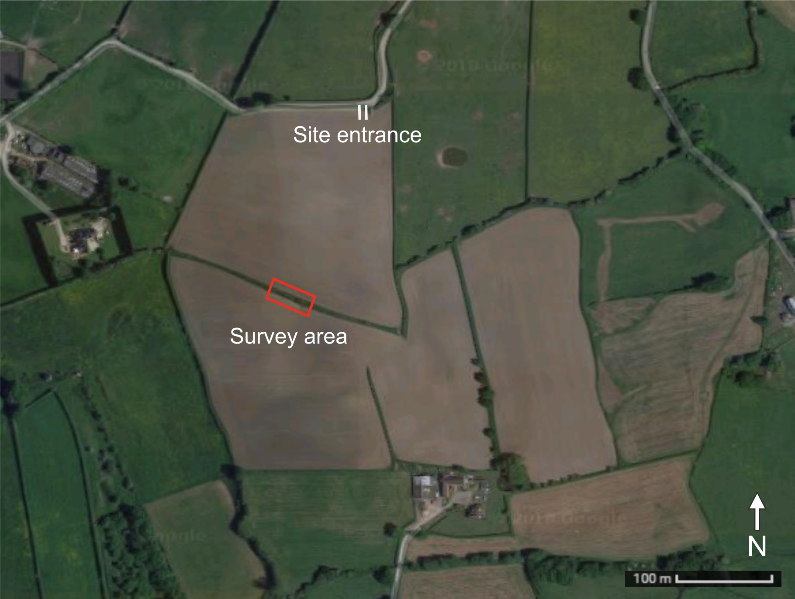
Fig. 1. GoogleEarth™ image of the study site (boxed) bordering two fields in a rural area in Staffordshire, UK.

2.2 Site reconnaissance
A site reconnaissance, for orientation purposes, was conducted 12 days after the initial wildlife and rural crime officer visit, with them in attendance for this visit. A soil auger was used to extract 0.75 m of top soil close to the survey area which determined the soil to be a sandy loam, oxidised and dry, which has been proven to be optimal for GPR surveys (see [40]). Initial police reports suggest that some badger sett entrances were deliberately filled with, most probably, agricultural slurry (animal waste and other unusable organic matter i.e. hay/straw) via a pressurised tanker hose. Police confirmed the material to be slurry, but it was deemed not necessary to collect samples for analysis, as the act of filling a sett entrance with any substance would be enough to commit the offence. The wildlife officers evidenced that there was no change to the site from their initial visit, except for a new badger tunnel entrance with fresh bedding being present on site (See Fig 2).
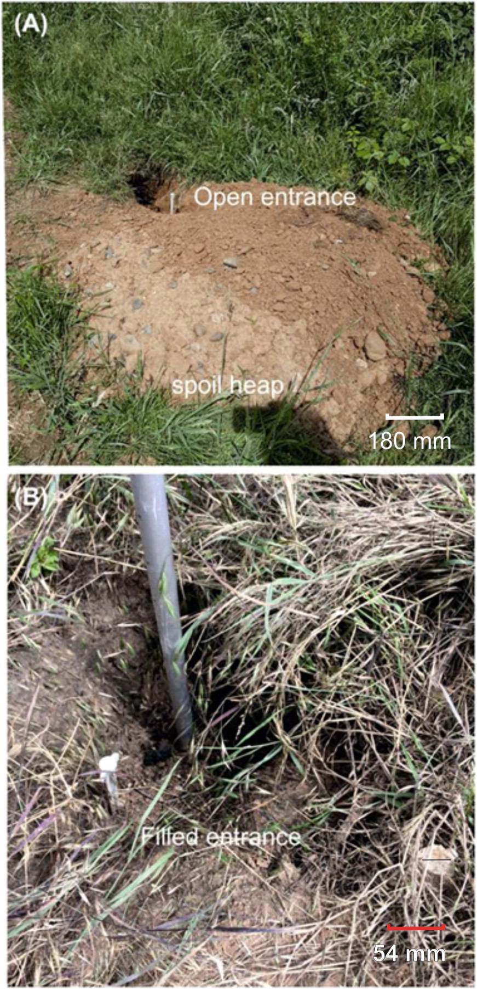
Fig. 2. Site photographs of (a) open sett tunnel entrance (E12) dug between initial and survey visits and (b) slurry-filled sett entrance (E1), with 15 cm long tent pegs for scale (see text).
Visual inspection of the site determined there to be 12 badger sett entrances present within the specified survey area. This non-invasive survey was required to be completed under strict time-constraints, with concern that evidence would be lost without a rapid response - with the suspected perpetrator still having land access, plus further badger activities and weather could potentially destroy evidence. Data gathering also needed to be done with minimal disturbance of the site (which was deemed to be a still active badger sett, with one new entrance being observed onsite since the first visit, with observations of fresh litter/droppings), and without the necessity for invasive investigations.
2.3 Site surveys
After some initial surface vegetation had been cleared either side of the central hedge in the middle of the survey area. The hedge line was approximately 1 m in width and 2 m in height, with a ~4.5 m clearing, allowing the fence line to be seen. A raised section of ground, with a steep topographic gradient, was present to the south of the hedge line (Fig. 5), whilst a drainage ditch (~0.7 m in depth) ran parallel to the hedge line north of the hedge line.

A Leica™ total station theodolite and 360° prism (Fig. 3) was used to survey 12 separate badger sett entrances, six open and a further six filled with a slurry type material (Fig. 2). Field posts and the field entrance to the north were also surveyed to map results into real-world coordinates if required. Average positional errors of survey points acquired were 0.002 m. Surface survey data were imported into Leica GeoOffice™ software and then converted to a mapview image before being annotated in Coreldraw™ 2017 graphics software.
2.4 GPR surveys
From previously published research on badger sett and entrance surveys (see [37]) and on similar forensic cases [21,23,24], mid-range GPR antennae frequency were deemed optimal. Therefore 250 MHz central frequency shielded antennae using Sensors & Software PulseEkko™ PRO equipment (Fig. 3) was used. 18, 2D profiles were collected, where possible due to the site constraints, that bisected the filled badger sett entrances, with Profile 1 collected away from the entrances to act as control (Fig. 5). The presence of the hedge and associated field border vegetation, steep gradient surface sections, surface brick rubble, field crops and significant time constraints (see section 2.2) did not allow a full radar grid to be collected on both sides of the hedge, as recommended by standard practice (see Reynolds, 2011). Four open entrance on the south side of the hedge were also not surveyed as they were not infilled. A fixed GPR transmitter/receiver antennae spacing, of 0.38 m, with a constant 0.05 m radar trace spacing and repeat 32 ‘stacks’ was used throughout the survey with an odometer used for trace positioning.
2D GPR profiles were processed using Reflexw™ v.8.5 software. Each profile underwent a series of standard sequential data processing steps (see [41]): (1) correct for maximum phase; (2) move start time; (3) dynamic correction; (4) bandpass Butterworth 1D filter; (5) background removal 2D filter; (6) Gain function, which boosts deeper reflections within the profiles, following standard practices (see [25,41]). Time slices were not generated due to the widely-spaced 2D profiles and non-grid nature of the survey..
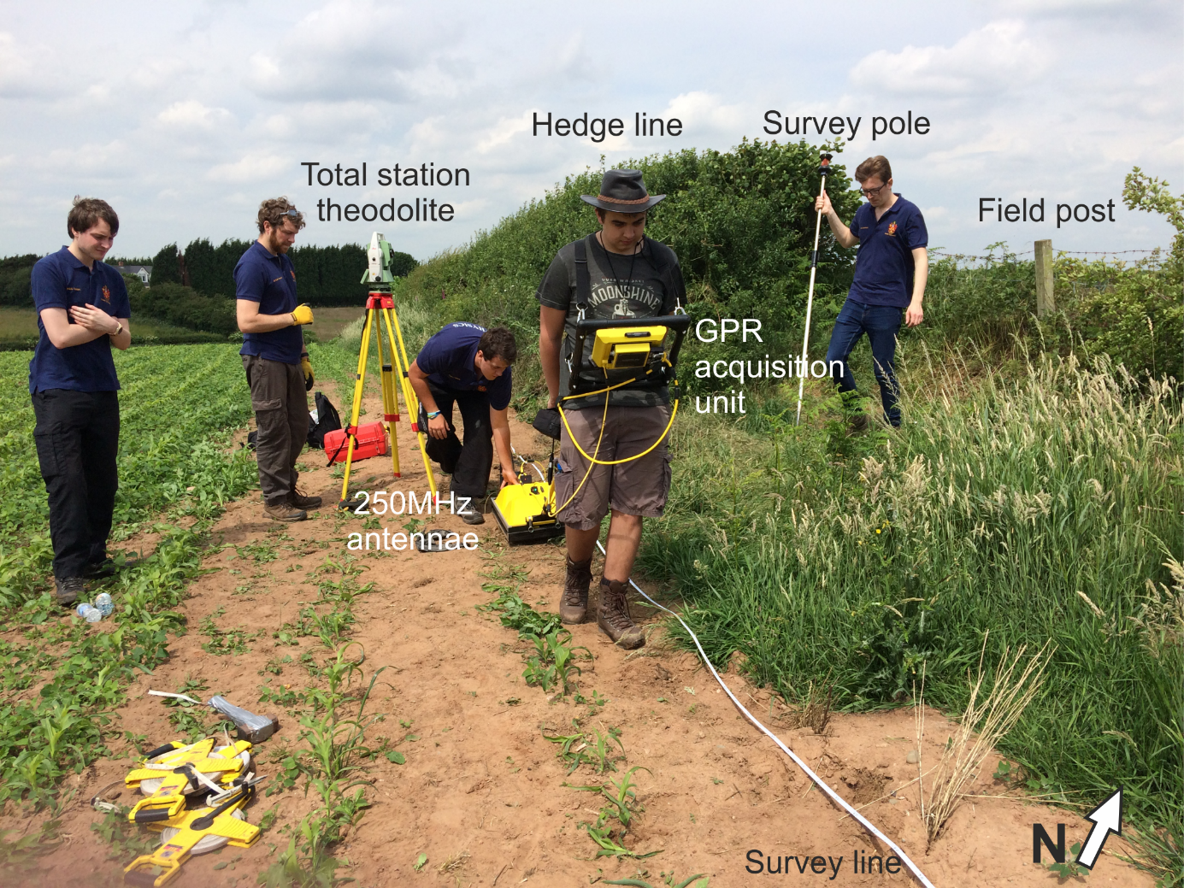
Fig. 3. Annotated site photograph (taken south of the hedge) of the Leica™ 1200 total station theodolite and pole survey system and the PulseEKKO™ Pro 250 MHz GPR system on 2D profile L1.

3. Results
Seven open (E4-7 and E9-12) and five filled (E1-3, E8 and E13) badger sett entrances were identified and topographically surveyed (Fig. 4). For the filled sett entrances, one (E8) in the field was filled with soil/brick rubble (also why it was not possible to have a GPR profile there – see Fig. 5), the others by the hedge were filled with soft, slurry-type material (Fig. 3b). The maximum horizontal distance between the filled entrances was 10 m from E1 – E8 (Fig. 4), with no slurry material observed elsewhere on the surface apart from in the badger sett entrances.
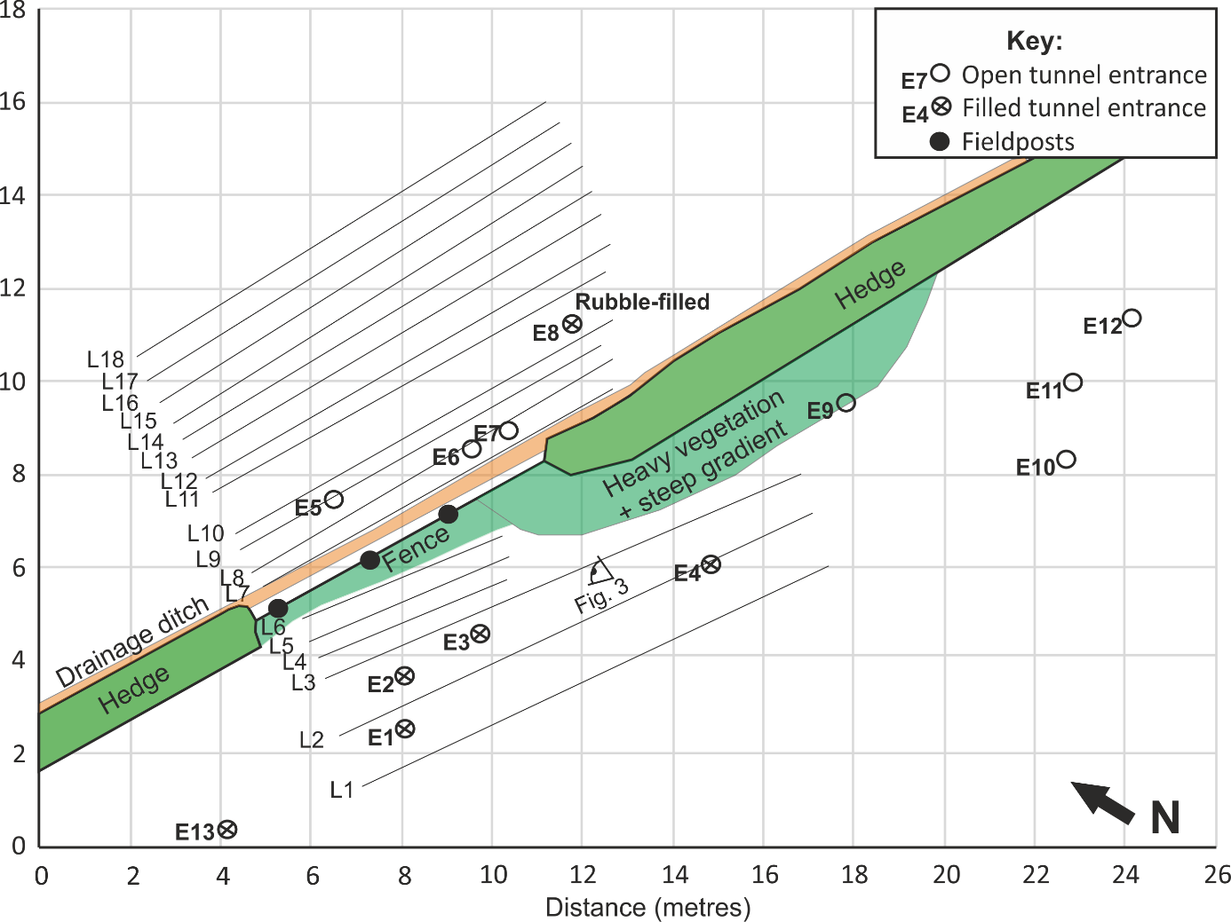
Fig. 4. Study site (mapview) showing the surveyed open (circle) and filled (crossed circle) badger sett tunnel entrances, hedge line and field posts (see key). The badger sett entrances were filled with slurry material unless otherwise stated. Fig. 1 taken position/orientation also shown.
The 2D GPR processed profiles L2-L14 showed isolated half-hyperbolic reflection anomalies in the near surface (Fig. 5); in contrast there were no significant half-hyperbolic reflection events in Profiles 1 and 15-18 which were situated away from the badger sett entrances (cf. Figs. 4-6) that thus gave confidence that significant sized radar anomalies were associated with badger tunnels. Small, relatively narrow anomalies, very close to the surface and positioned near to the hedge were, most probably, hedge roots (see Fig. 3).
Using the known surveyed open/slurry-filled badger tunnel entrance positions (Fig. 3), it was possible to visually evidence what these two tunnel fill types looked like on proximal GPR profiles (see Fig. 5). For the slurry-filled badger sett entrances (E1-E3), the associated GPR L2-9 profiles anomaly amplitudes were generally small and had rapid signal attenuation below the tunnel tops (Fig. 6). In contrast, for the open badger sett entrances (E5, E6 and E7), the associated GPR L10-14 profiles anomaly amplitudes were generally large and had less signal attenuation below the tunnel tops (Fig. 6). Therefore, excellent radar signal amplitude anomalies were interpreted to be open tunnels, and relatively poor radar signal amplitude anomalies were interpreted to be filled tunnels. Note that unfortunately the rubble-filled entrance (E8) could not be geophysically surveyed due to the rough ground. This criteria was then used to interpret radar anomalies through the rest of the GPR dataset.
Finally, the surveyed badger sett entrance, open and filled tunnel positions were then mapped onto the study site plan (Fig. 7).

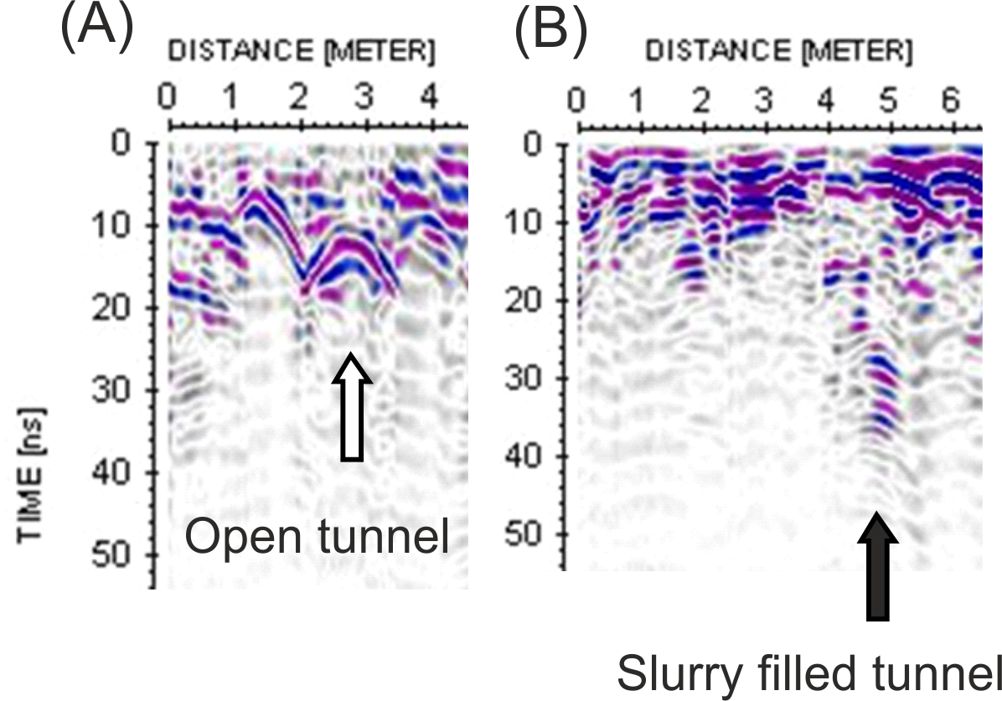
Fig. 5. Graphically shows GPR profiles adjacent to: (A) an open badger sett entrance and, (B) a slurry-filled badger sett entrance. Also note the comparably higher radar signal amplitudes of the open badger tunnel in a.
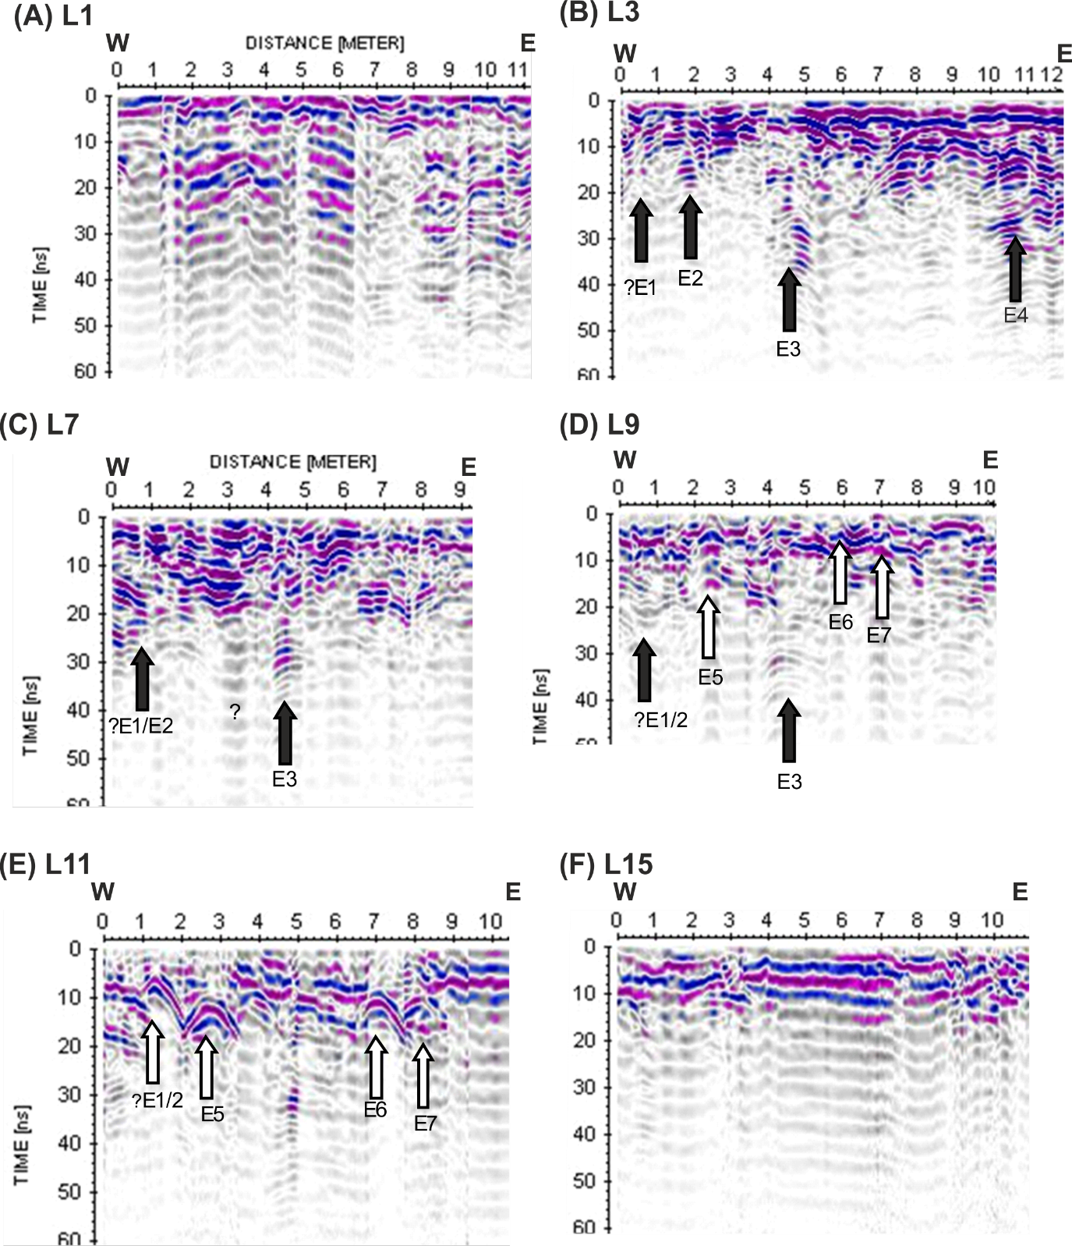
Fig. 6. GPR 2D 250 MHz processed selected profiles showing interpreted filled (black arrows) and open (white arrows) badger sett tunnel respective positions (see Fig. 3 for site map and text for details).

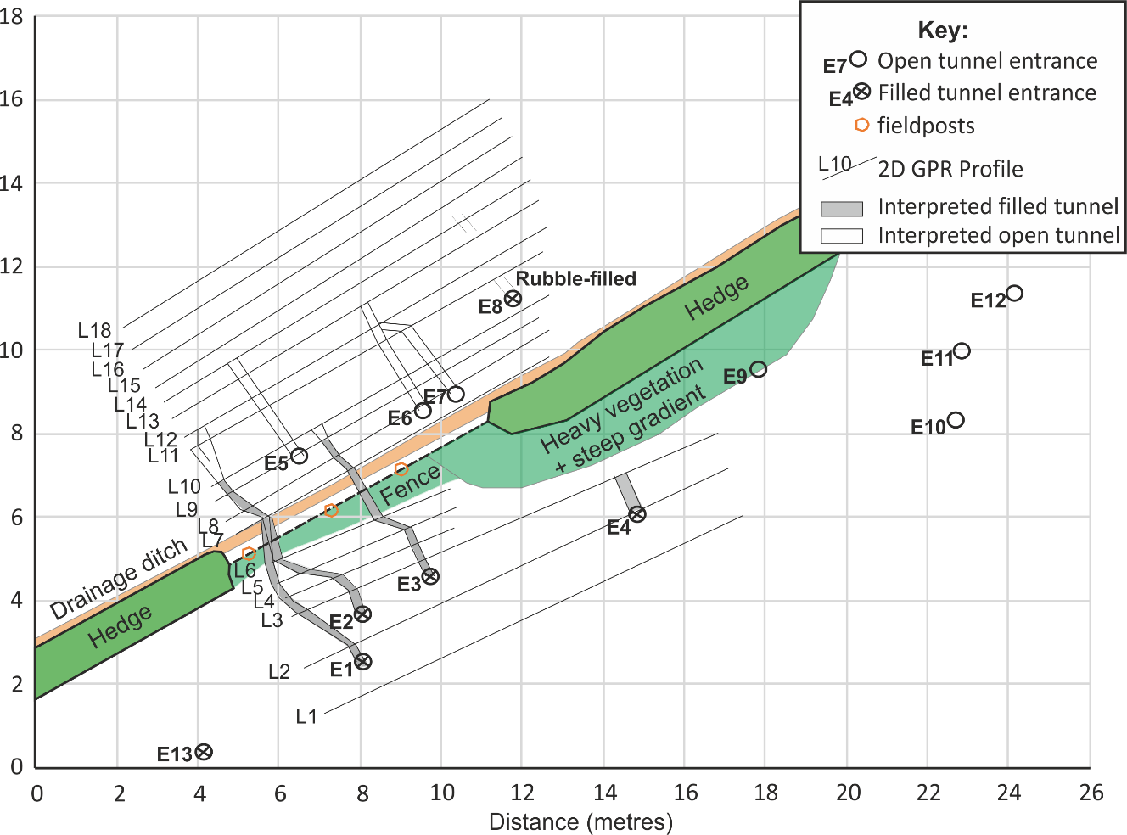
Fig. 7. Summary of study site findings, integrating the surveyed (mapview) badger sett entrances and the GPR interpreted sett tunnel positions. The interpreted filled and open badger sett tunnels are also shown (see key and text).

4. Discussion
Although every case study will be unique as discussed by others (see [30-31]), the research presented here has important implications for the use of geoscience techniques to assist forensic practitioners with wildlife crime investigations as [29] suggests. Wildlife crime is presently under-reported [1] and not prioritised, in comparison to other criminal activities, but it could be forensically investigated and prosecutions scientifically supported by the use of forensic geoscience techniques.
This study has demonstrated that rapid deployment of geoscience surveying equipment, namely surface topographic surveying and GPR 250 MHz near-surface geophysics, can result in a scientific analysis of wildlife crime, in this case the quantification of illegal filling of badger sett tunnels. Other authors have shown that GPR can both identify and characterise animal burrows (see [32-34,37]), with others showing both similar frequencies [37] and up to 900 MHz frequency antenna to be deployed [42], but here, the combination of the two different techniques also importantly allowed the quantification of the spatial location of filled entrances and the amount of tunnel infill. This geoscientific information, combined with the lack of slurry elsewhere on the surface, made the alternative hypothesis of an accidental deposition of slurry on the surface by a perpetrator(s) extremely unlikely.
Further work on this site should, if possible, collect more GPR 2D profiles, ideally in a grid orientation as per best practice [40]; horizontal time-slices could then be generated which could give more confidence in tunnel positions as [35] demonstrate. Targeted tunnels should also be intrusively investigated to confirm the radar interpretations that would be allowed under present UK License Laws. It would also be recommended that any similar future investigations should collect the slurry sample and, if possible, analyse to determine if it can be definitively linked to the offenders slurry tanker/source material.
A caveat that readers should note is that this study site was in dry sandy soil, other authors have noted that GPR may not be useful to map animal burrows in study sites with wet clay-rich soil (see [34]) or pebbly soil, with others noting different burrowing methods in different soil types [36]. Also, note that some badger tunnels may not be able to be geophysically detected if they are small and relatively deeply buried. Higher-populated burrows commonly result in more sett entrances and corresponding tunnels [17] although these have found to differ in different soil types [13], which may make correlating between tunnels much more difficult. Finally, surface vegetation may be a factor to consider when looking to deploy such geoscience techniques; in this study there was little to interfere with the survey, but within dense woodland where it may be difficult to differentiate between animal burrows and tree roots.
Rapid forensic geoscience assistance is currently under-utilised by both wildlife crime officers, other government (e.g. Historic England, Environment Agency) and indeed non-governmental organisation (NGO) investigators (e.g. RSPCA) in the UK and around the world. This paper demonstrates that such methods can be used to identify and characterise badger-sett disturbance, providing both police forces and NGOs with forensic evidence of wildlife crime. The widespread adoption and routine use of forensic geoscience support methods could, and should, have significant implications on future criminal investigations relating to protected burrowing species and their protected habitats at local, national and international levels.

5. Conclusions
This study has importantly evidenced how the rapid deployment of geoscience survey techniques can aid wildlife and rural crime officers with investigating wildlife crime, in this case the illegal sett interference of a protected badger species. Having a geoscience survey team rapidly collect evidence meant that the potential ephemeral badger sett tunnel fill was able to be quantified and provided evidence for a subsequent prosecution. A report was subsequently forwarded to the Crown Prosecution Service, but the CPS were not sufficiently confident that the badger sett was active (despite the fresh entrance dug between site visits) so a prosecution was not advanced in this case. Study implications suggest that forensic geoscience surveys should be commonly utilised by investigators of wildlife crime.

6. Acknowledgements
PC 0931 J. Moore is acknowledged for logistical and site assistance. J. Ainsworth, N. Cooper, J. Francis and Lewis Moore are thanked for fieldwork assistance. A Keele University Faculty of Natural Science grant has funded the GPR field equipment used in this study.
7. References
[1] J. Gosling, The recording of wildlife crime in England and Wales. Reviewing the effectiveness of current practices, (2017) Wildlife and Countryside Link and Wales Environment Link, London. Accessible online: https://www.wcl.org.uk/docs/Link_Recording_Wildlife_Crime_in_England%20_and%20_Wales_full_November_2017.pdf Last viewed: 15/06/2018
[2] RSPCA, 2018. Badgers and the Law. Available at: https://www.rspca.org.uk/adviceandwelfare/wildlife/inthewild/badgers/law Last Accessed: 06/06/2018
[3] Badger Trust, 2018. Stop Badger Crime. Available at: https://www.badgertrust.org.uk/crime Last Accessed: 06/06/2018
[4] National Wildlife Crime Unit (NWCU) Tactical Assessment, May 2017a. Available at: http://www.nwcu.police.uk/wp-content/uploads/2013/03/NWCU-Tactical-Assessment-May-2017-sanitised-version.pdf Last accessed 06/06/2018
[5] National Wildlife Crime Unit (NWCU) Tactical Assessment, Nov. 2017b. Available at: http://www.nwcu.police.uk/wp-content/uploads/2013/03/NWCU-Tactical-Assessment-Nov-2017-sanitised-version.pdf Last accessed 06/06/2018
[6] Naturewatch, 2018. Facts about badger baiting. Available at: https://naturewatch.org/campaign/badger-baiting-in-the-uk/facts-about-badger-baiting Last Accessed: 06/06/2018
[7] Home Office (2017) Accessible online: https://data.gov.uk/dataset/695f6775-3e51-4dd4-911a-19575638384c/home-office-counting-rules-for-recorded-crime last Accessed: 15/06/2018
[8] A. Cassidy, Vermin, Victims and Disease: UK Framings of badgers in and beyond the bovine TB Controversy, Sociologia ruralis 52 (2012) 192-214.
[9] R. Naylor, W. Manley, D. Maye, G. Enticott, B. Ilbery, A. Hamilton‐Webb, The framing of public knowledge controversies in the media: a comparative analysis of the portrayal of badger vaccination in the English National, Regional and Farming Press, Sociologia ruralis 57 (2017) 3-22.
[10] J. Phillips, Badger cull fuelling illegal wildlife crimes, charities claim, The Telegraph, April 16 2018. Available at: https://www.telegraph.co.uk/news/2018/04/16/badger-cull-fueling-illegal-wildlife-crimes-charities-claim/ Last Accessed: 06/06/2018
[11] J. Lowen, RSPB Spotlight: Badgers. London, Bloomsbury, 2016.
[12] J. Judge, G.J. Wilson, R. Macarthur, R.A. McDonald, R.J. Delahay, Abundance of badgers (Meles meles) in England and Wales, Sci. Rep. 7 (2017) 276.
[13] P. Acevedo, P. González-Quirós, J.M. Prieto, T.R. Etherington, C. Gortázar, A. Balseiro, Generalizing and transferring spatial models: A case study to predict Eurasian badger abundance in Atlantic Spain, Ecol. Model. 275 (2014) 1-8.
[14] Natural England, 2015. Badgers: surveys and mitigation for development projects. Available at: https://www.gov.uk/guidance/badgers-surveys-and-mitigation-for-development-projects Last Accessed: 08/06/2018
[15] Department of Agriculture, Environment and Rural Affairs (DAERA), 2018. Advice on badgers. Available at: https://www.daera-ni.gov.uk/articles/advice-badgers Last Accessed: 08/06/2018
[16] Natural England, 2011. Badgers and development. A Guide to Best Practice and Licensing. Available at: http://www.wildlifeco.co.uk/wp-content/uploads/2014/03/badgers-and-development.pdf
[17] T.J. Roper, The structure and function of badger setts, J. Zool., Lond. (1992) 227, 691-698.
[18] T.J. Roper, A.I. Tait, D. Fee, S.F. Christian. Internal structure and contents of three badger (Meles meles) setts, J. Zool., Lond. (1991) 225, 115-124.
[19] C. Fischer, F. Dunand, 3D topography and structure analysis of three European badger (Meles meles) setts from Western Switzerland, Wildl. Biol. Pract. 12 (2016) (3) 26-35.
[20] D.C. Nobes, The search for “Yvonne”: A case example of the delineation of a grave using near-surface geophysical methods, J. For. Sci. 45 (2000) 715–721.
[21] J. Schultz, Using GPR to locate clandestine graves of homicide victims: forming forensic archaeology partnerships with law enforcement, Homicide Stud. 11 (2007) 15–29.
[22] J.K Pringle, J.R. Jervis, Electrical resistivity survey to search for a recent clandestine burial of a homicide victim, UK, For. Sci. Int. 202 (2010) e1-e7.
[23] A. Novo, H. Lorenzo, F. Ria, M. Solla, 3D GPR in forensics: finding a clandestine grave in a mountainous environment, Forensic Sci. Int. 204 (2011) 134–138.
[24] J-P Fernandez-Alvarez, D. Rubio-Melendi, A. Martinez-Velasco, J.K. Pringle, D. Aguilera, Discovery of a mass grave from the Spanish Civil War using GPR and forensic archaeology, Forensic Sci. Int. 267 (2016) e10-e17.
[25] H.C. Dick, J.K. Pringle, B. Sloane, J. Carver, K.D. Wisniewski, A. Haffenden, S. Porter, et al. Detection and characterisation of Black Death burials by multi-proxy geophysical methods, J. Arch. Sci. 59 (2015) 132–141.
[26] K. Pye, S. Blott, D.J. Croft, J.F. Carter, Forensic comparison of soil samples: assessment of small-scale spatial variability in elemental composition, carbon and nitrogen isotope ratios, colour, and particle size distribution, J. For. Sci. 163 (2005) 59-80.
[27] A. Ruffell, J. McKinley, Forensic Geoscience: applications of geology, geomorphology and geophysics to criminal investigations, Earth Sci. Rev. 69 (2005) 235-247.
[28] A. Ruffell, J. McKinley, Geoforensics. Chichester, U.K.: Wiley Pubs, 2008.
[29] R. Morgan, P. Wiltshire, A. Parker, P.A. Bull, The role of forensic geoscience in wildlife crime detection, For. Sci. Int. 162 (2006) 152-162.
[30] J.K. Pringle, A. Ruffell, J.R. Jervis, L. Donnelly, J. McKinley, J. Hansen, et al., The use of geoscience methods for terrestrial forensic searches, Earth Sci. Rev. 114 (2012) 108-123.
[31] A. Ruffell, J.K. Pringle, J.P. Cassella, R. Morgan, M. Ferguson, V.G. Heaton, C. Hope, The use of geoscience methods for aquatic forensic searches, Earth Sci. Rev. 171 (2017) 323-337.
[32] A.E. Kinlaw, L.B. Conyers, W. Zajac, Use of GPR to image burrows of the Gopher tortoise. Herpetological Review, 38 (2007), 50-56.
[33] J.D. Cortez, S.E. Henke, T.E. Fulbright, R. Riddle, J. Young, Demonstration of GPR as a useful tool for assessing pocket gopher tunnels. Wildlife Soc. Bull. (2013) 37, 428-432.
[34] P. Stott, GPR: a technique for investigating the burrow structure of fossorial vertebrates, Wildlife Res. 23 (1996) 519-530.
[35] T. Saey, M. van Meirvenne, J. de Pue, E. van der Vijver, S. Delefortrie, Reconstructing mole tunnels using frequency-domain GPR, App. Soil. Ecol. 80 (2014) 77-83.
[36] M.J. Swinbourne, D.A. Taggart, E. Sparrow, M. Hatch, B. Ostendorf, GPR as a non-invasive tool to better understand the population dynamics of a fossorial species: mapping the warrens of southern hairy-nosed wombats (Lasiorhinus latifrons), Wildlife Res. 42 (2016) 678-688.
[37] D. Nichol, J.W. Lenham, J.M. Reynolds, Application of GPR to investigate the effects of badger setts on slope stability at St. Asaph Bypass, North Wales. Q J. Eng. Geol. 36 (2003) 143-154.
[38] X. Xu, Q. Zeng, D. Li, J. Wu, X. Wu, J. Shen, GPR detection of several common subsurface voids inside dikes and dams, Eng. Geol. 111 (2010) 31–42.
[39] J. Butler, T.J. Roper, A.J. Clark, Investigation of Badger (Meles meles) setts using soil resistivity measurements, J. Zool. Lond. (1994) 232, 409-418.
[40] J.R. Jervis, J.K. Pringle, G. Tuckwell, Time-lapse resistivity surveys over simulated clandestine graves, Forensic Sci. Int. 192 (2009) 7–13.
[41] J. Milsom, A. Eriksen, Field Geophysics, fourth ed., John Wiley & Sons, Chichester, UK, 2011. p. 283.
[42] H.K. Chlaib, H. Mahdi, H. Al-Shukri, M.M. Su, A. Catalki, N. Abd, Using GPR in levee assessment to detect small scale animal burrows, J. App. Geophys. 103 (2014) 121-131.

