Study of Brain Signal Extraction, Processing and Implementation
Proceedings of the 24th International Conference on Automation & Computing, Newcastle University, Newcastle upon Tyne, UK, 6-7 September 2018

Majid Ali
School of Creative Arts & Engineering
Staffordshire University
Stoke-on-Trent, England
mmajidali88@yahoo.com

Alison Griffiths
School of Creative Arts & Engineering
Staffordshire University
Stoke-on-Trent, England
a.l.griffiths@staffs.ac.uk

Mohammad S. Hasan
School of Computing and Digital Technologies
Staffordshire University
Stoke-on-Trent, England
m.s.hasan@staffs.ac.uk

Abstract—Machine to Machine (M2M) and Device to Device (D2D) communication paradigms make fast, effective autonomous communication possible which is beneficial for devices, people, machines and objects. However, some applications still require an actuation/control signal from a human, more specifically applications in a Home Area Network (HAN). People with a disability may have certain constraints in terms of providing an actuation signal for Internet of Things (IoT) based home appliances. This paper investigates human brain signal extraction using Emotive Epoch headset [reference], processing and controlling a computing mouse. The mouse operations include clicking, cursor movement etc. This study has an option for further enhancement to control more devices and home appliances and to manage energy consumption by suitable scheduling of appliances with improved decisions for a resource constrained disable person’s comfort in smart home based on HAN.
Keywords- Neurons, EEG Signals, PC-mouse, Console, EMOTIV EPOC headset.

Introduction
The human body has five senses to connect with the surroundings and all these senses are directly connected to brain. The main function of these brain related activities e.g. (some examples) are common in every human being. The human body is made up of trillions of neuron cells and all bodily functions are controlled by this electrical system. Information transfer in the central and autonomous nervous system, operation of the brain and spinal cord, operation of the muscle functions, operation of the body organs to control and maintain system billions of electrical signals must be generated in the human nervous system. The source of the electrical signals are electrochemical potentials in the nerve cells [1].
The objective of this paper is to investigate an operation of a computer mouse using human head movement and facial expressions such as (wink, smile etc.). According to the initial introduction of human neural network, the brain can produce electrical signals which can be extracted and processed into digital form as a command to computer. To investigate the extraction process of brain signals it is important to know more about the functions that create electric pulse inside the human body.

Neurons producing current

Neurons pass on data by transmitting messages to different neurons or different sorts of cells, for example, muscles. Neurons utilise electrical signs to hand-off data starting with one part of the neuron then onto the next.. Neural network consists of three different types of neurons out of which sensory neurons are responsible for muscle movements. Process of muscle movement is explained in Fig 1.
Figure 1: Neuron circuit representing muscle movement[2]
Point 1 representing the hammer which tap on the knee to initiate sensory receptors in leg extensor muscles. 2a sensory neuron synapses with and excites motor neuron in the spinal cord 2b showing that sensory neuron also excited the spinal interneuron 2c point exhibits the interneurons synapse to flexor muscle. 3a is the motor neuron which conducts action on extensor muscle fibers 3b is flexor muscle relaxes because the activity of its motor neurons has been inhibited , 4 shows the movement of leg caused by the hammer tap [2].
The above explanation can be used as reference to explain the signal generation caused by muscle movement. Brain electrical current consists mostly of Na+, K+, Ca++, and Cl- ions that are pumped through channels in neuron membranes in the direction governed by membrane potential [3]. The signal is in the form of electric pulse which can be extracted using the EEG headset.
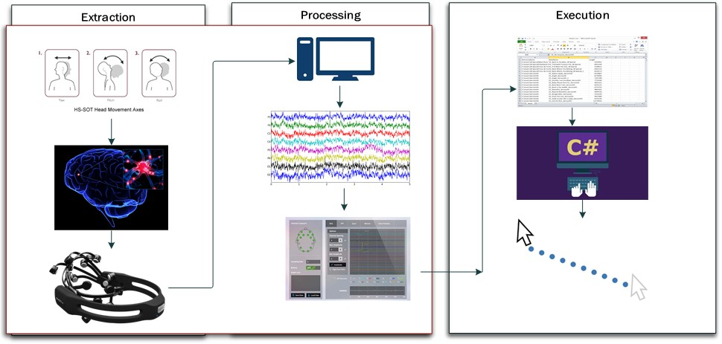
Figure 2: Block Diagram of the Brain Computer Interface

Mind-processor interface
The Brain Computer Interface (BCI) is a technique that allows to control a computer by brain activity only, without the need for muscle control [4]. Whist there are different kinds of BCI that either rely on motor imagery or the detection of P300 [5]. The P300 Event Related Potential was elicited with auditory stimuli when eyes are open/closed in the same subjects [6] BCI systems are based on visual evoked potentials are currently the fastest method to establish non-invasive BCI control. BCI is one of the fastest growing fields of interdisciplinary research, involving disciplines such as neuroscience, computer science, engineering and clinical rehabilitation [7]. Two types of BCI are implemented 1. Invasive which requires surgery to transplant electrodes inside the brain and 2. Non-invasive in which electrodes are placed on the scalp [8].
Electroencephalography(EEG) was discovered by Richard Canton in 1875 from the uncovered brains of monkeys and rabbits [9]. It can be described as a test used to record the electrical activities in the brain of animals. The process tracks the brain wave pattern by using tiny metal discs with electrodes attached with the scalp and then being recorded as waves.
There are several modern machines available to measure the EEG from brain with the help of electrodes as sensors and can give result more precisely. Different devices use different technique and logics to design headsets that can record brain waves.
For this study an EEG detection device known as EPOCTM Headset from EMOTIVTM [10] is used to extract brain signals and then being processed in a firmware provided by EMOTIV. The data collected from the files where the brain waves are stored and then processed to execute a program using C# language. Execution of the program results in the control procedure of a Personal Computer (PC) mouse. A block diagram for this technique is shown in Fig 2.
To develop a BCI system three main steps are required to perform which are as follows and can be seen in Fig 3:
- Signal Acquisition – To extract brain signal in the electrical form
- Processing – Extracted signal is then processed using filtering strategies and interpretation calculations to deciphers according to the required sign
- Execution – The classified signal is the output which can be seen through oscilloscope and can be used as an input for the desired electronic device controller.
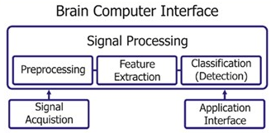
Figure 3 Procedure of Brain computer Interface[11]

Material and Methods

EEG Signal Extraction and Processing
Emotiv EPOC headset is being used to extract EEG signals. It consists of 14 channels and the sampling frequency is 128Hz. It has an inbuilt sinc filter (which neglects frequencies above cut-off and has linear phase response) whose bandwidth is from 0.2 to 45 Hz, and it is connected through Bluetooth with the PC using a receiver of 2.4 GHz band [12]. The 14 electrodes location on the scalp is shown in Fig 4.
Figure 4: Scalp connect points on the EMOTIV device with 14 channels

EPOC Emotiv uses specialized software to display information about EEG signals and is categorized in three different Suites 1. Expressiv (to analyse facial expressions) 2. Affectiv (to display emotional state of user) and 3. Cognitiv (to control intentions of movement). The display formats are shown in Fig 5.

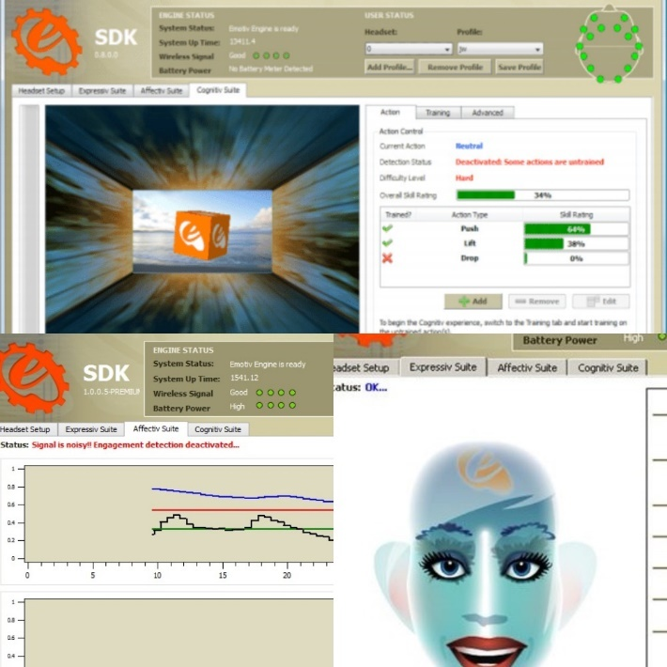
Figure 5: Three Suites to study various forms of results
The control panel (as shown in Fig 5) is installed in windows system which gives the overview of the electrodes attached and strength of the connections between scalp and sensors, moreover, it shows the above defined suites and the values which is directly being transmitted from the brain as displayed in Fig 6.
Figure 6:Emotiv Control panel (Status for signal strength of electrodes)
EPOC Device is being used to generate results from head movements and eye blinks. The signals are processed, and data is recorded in .csv format which can be opened in MS-excel program. The data is then extracted as a source file in the C# program.
As a result of program written in C# language, a console box appears on the screen of the PC as seen in Fig 5, on which the pre-recorded mouse pointer is induced, and the pointer moves along with the console shown in Fig 7.
Figure 7: Console developed for testing
The program can be written and executed in MATLAB, but it will be more expensive and complex. The reasons for choosing C language are provided in Table 1.
Table 1: Why C language is preferred for this research
C Language | MATLAB
Can declare variable and their types | Particular declaration is not possible
new functions can be defined as per requirement | Pre-defined function has to be used
C is open source and easy to share data | Software require licence and is expensive

The written program performs two major tasks for mouse control, Movement of cursor and opening a specific file using a double click operation.
The algorithm and coding create a ‘mouseeventargs’ whose button is set to the mousebuttons.right value. Call function is initiated using onmouseclick using same function as an argument. There are other ways to simulate mouse input. For example, it can be programmatically set a control property that represents a state that is typically set through mouse input (such as the Checked property of the Checkbox control), or can directly call the delegate that is attached to the event wanted to be simulated.

Result
The study gives successful result working in a non-real time simulation. Adding header files with specified functions from EMOTIV can make this project work in real time environment. The recorded signals converted into .csv file format as a data and extracted as a source in C#. Signals recorded during head movement are shown in Fig 8,9,10,11.
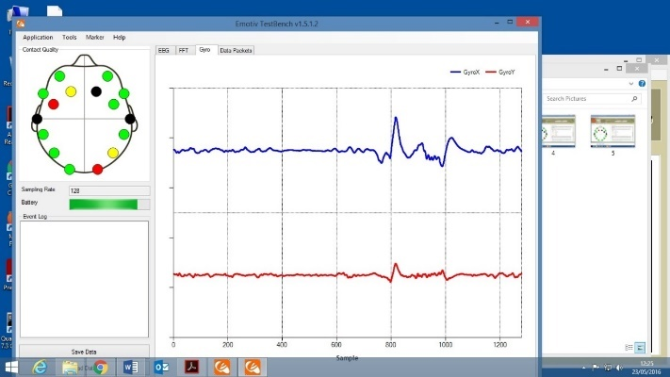
Figure 8:Signal Recorded while turning head towards right
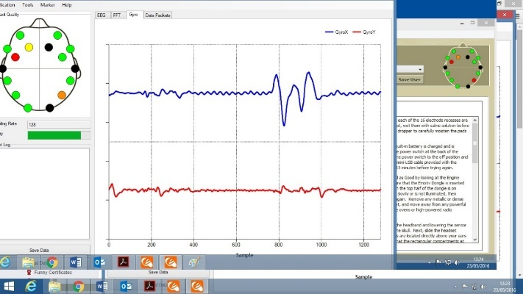
Figure 9: Signal Recorded while turning head towards Left
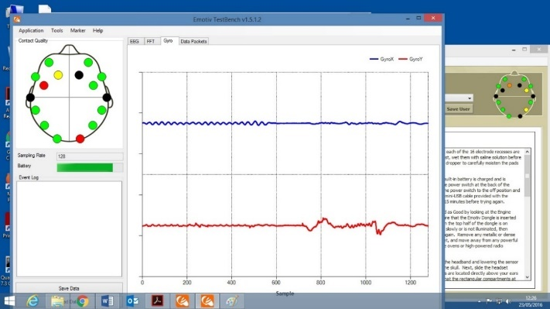
Figure 10: Signal Recorded while moving head to Up
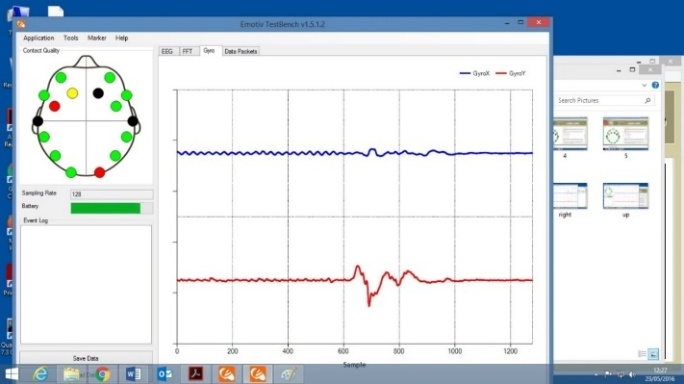
Figure 11:Signal Recorded while moving head towards Down
During the research some issues has been observed as well. EEG signals are noisy and variable from time to time. Noise emerges from slight movements in the position of electrodes and changes in the conductance through skin and hair impedance. Most BCI tests bargain just with order and have overlooked the location issue of distinguishing when a subject has delivered a BCI charge and is not performing some other mental movement. Following are the links to experimental videos.
1. Checking signal strength and variations
https://www.dropbox.com/s/6ww2tlh2pq46ikz/EEG%20signal%20Strength.MOV?dl=0
2. Mouse movement using gyro function of EPOC
https://www.dropbox.com/s/qz8gd7itebl2zew/Testing.mp4?dl=0

Conclusion
After studying the brain anatomy and the electrical signals present in the brain and by comparing the EEG signals, it can be concluded that brain signals can be programmed using a programming language and can be used to control and operate a mouse. A mouse is being used fully with using brain signals and movement of hands, eyes, lips or any other particular function, which can be defined, using functions in the C #language, can define the brain signals produced. Instead of using keyboard controls, the signals can be used as the input to perform the movements or opening a specific file. The readings of the movement recorded through the EMO workbench and saved in csv file mode, which is, then being extracted it into the module, which can further be modified to use as the same procedure in real time mode. This study can further be used to develop multi device controlling setups with increase in accuracy and can be used to monitor brain activities of patients.

Risk analysis
A few number of risks has been observed while this study, as using frequently this device can cause deficiency in brain cells and could be hazardous for different body functions due to the extraction of the signals from the brain and to operate this device less or no hair is required on the scalp to get better signal radiations through the neuroheads.

Forthcoming Possibilities
The Future of BCI is not limited just to control electronic devices and smart homes. This technology has emerging as relief for patients and comfort in people’s daily life. The use of BCI has open many possibilities such as Brain Controlled Vehicles and Drones. The invasive type of BCI can be used to heal damages in brain cells and can be transplanted into the damaged part of the brain. Brain-Chips is a concept which is already in research process now a day, in which memories can be inserted in human brains and can make brain to brain communication possible.
There are countless visions and ideas which can be implemented through BCI and will benefit human and environment.

Acknowledgment
The paper is completed under the guidance and expert advices form Dr. Alison Griffiths and Dr. Mohammed S. Hasan.

References

[1] Staff, “Physics of the nervous system.” pp. 1–19, 2003.
[2] D. Purves et al., Neuroscience, vol. 3. 2004.
[3] M. Teplan, “Fundamentals of EEG measurement,” Meas. Sci. Rev., vol. 2, no. 2, pp. 1–11, 2002.
[4] J. R. Wolpaw, N. Birbaumer, D. J. McFarland, G. Pfurtscheller, and T. M. Vaughan, “Brain Computer Interfaces for communication and control,” Front. Neurosci., vol. 4, no. 113, pp. 767–791, 2002.
[5] L. A. Farwell and E. Donchin, “Talking off the top of your head: toward a mental prosthesis utilizing event-related brain potentials,” Electroencephalogr. Clin. Neurophysiol., vol. 70, no. 6, pp. 510–523, 1988.
[6] J. Intriligator and J. Polich, “On the relationship between background EEG and the P300 event-related potential,” Biol. Psychol., vol. 37, no. 3, pp. 207–218, Jul. 1994.
[7] B. Šumak, M. Špindler, and M. Pušnik, “Design and development of contactless interaction with computers based on the Emotiv EPOC+ device,” 2017 40th Int. Conv. Inf. Commun. Technol. Electron. Microelectron. MIPRO 2017 - Proc., pp. 576–581, 2017.
[8] E. G. M. Kanaga, M. K. R, M. Hema, R. G. Manohari, and T. A. Thomas, “An Experimental Investigations on Classifiers for Brain Computer Interface ( BCI ) based Authentication.”
[9] F. H. Lopes da Silva, S. I. Gonçalves, and J. C. De Munck, “Electroencephalography (EEG),” Encyclopedia of Neuroscience. pp. 849–855, 2010.
[10] EMOTIV, “EMOTIV Epoc - 14 Channel Wireless EEG Headset,” EMOTIV Inc. 2013.
[11] V. Kaiser, A. Kreilinger, G. R. Müller-Putz, and C. Neuper, “First steps toward a motor imagery based stroke BCI: New strategy to set up a classifier,” Front. Neurosci., vol. 5, no. JUL, pp. 1–10, 2011.
[12] W. T. Lee, H. Nisar, A. S. Malik, and K. H. Yeap, “A brain computer interface for smart home control,” Proc. Int. Symp. Consum. Electron. ISCE, pp. 35–36, 2013.

.

