**Distance Learning in Engineering and Technology**

**Professor Moofik Al-Tai Dr Alison Griffiths**

Staffordshire University (UK) Staffordshire University (UK)  
m.al-tai@staffs.ac.uk a.l.griffiths@staffs.ac.uk

**ABSTRACT:** In the field of distance learning, presentation and interaction with materials must be approached in an alternative way to when students are regularly attending the campus, and on site at teaching locations. When a student is on campus, they are learning in direct contact with the Higher Education (HE) institution and academically trained members of staff that can facilitate their learning with their direct knowledge and supporting materials. However, a student who is off campus, and receives the course programme through means of distance learning, learns through another channel, and must therefore have materials that cater to the fact they are in a remote location.

Distance learning does not always meet the requirements of Engineering and Technology courses where the physical classroom attendance is mandatory to complete the course.

This paper discusses the important issues related to the distance learning in Engineering and Technology courses which are required to fulfil the professional institution requirements for accreditation.

**Keywords:** learning, distance

**1. INTRODUCTION**

Distance Learning is a modern way of studying for an undergraduate, Master or PhD degree courses without actually being on site at the students chosen university by using new technology in the delivery of modules associated with these courses, including the use the Virtual Learning Environment (VLE) through the Internet.

Instead of attending lectures, students study online, attending ‘virtual’ tutorials and submit their assignments over the Internet. They can be in the same country as the university, or overseas.

Distance Learning gives the students the opportunity to study through a university that they would not necessarily be able to attend due to their physical location, or to fit study around work or other commitments.

The Engineering and Technology programme aims to equip the students with knowledge, understanding and skills to analyse deliver and manage technology in a variety of design related settings and environments providing the students with:

* An understanding of technology principles.
* An understanding of the management of technology and change.
* The skills to apply analyse and evaluate information technology systems.
* The ability to undertake design work
* The ability to use mathematical and computer models to understand technological solutions
* The ability to solve technology problems
* The ability to undertake practical work
* The awareness of leading edge knowledge
* A range of transferable skills including team-working and communication skills
* An intellectually demanding and stimulating programme of study
* A life-long commitment to learning

Therefore delivering Engineering and Technology programme of study by entirely VLE methods will not satisfy some the aims listed above which require face-to-face teaching.

However, VLE is well suited to distance learning and flexible learning, but can also be used in conjunction with face-to-face learning, in which case the term Blended learning is commonly used.

**2. LEARNING MATERIALS**

There are four means in which materials work in the distance learning environment:

(a) Material-Based Learning

This is where learning resource materials made available to the students by the course programme for the sole basis for their understanding of the course content.

b) Direct Communication

Materials may also be provided in the situation where learning is supported from the HE institution remotely from the student.

(c) Lecturer Delivery in the Students Place of Work

Another option would be for the HE institution to physically send relevant staff to the employer at regular intervals to deliver the materials.

(d) Virtual Learning Environment

The Virtual Learning Environment (VLE) is a system which changes the way materials are delivered. The VLE is designed to facilitate the delivery of course programmes to students, through providing a means in which the students can learn without having to be in the classroom.

**3. SPECIFIC LEARNING OUTCOMES IN ENGINEERING AND TECHNOLOGY PROGRAMME**

In the UK, the Engineering and related technology programme provides opportunities to develop the Engineering benchmark’s knowledge and understanding, intellectual abilities, practical skills and general transferable skills.

Learning outcomes can also be explicitly linked to the UK Standard for Professional Engineering Competence (UK-SPEC) statements [1] included within the UK Quality Assurance Agency for Higher Education (QAA) engineering benchmark statement [2] under the headings of:

(a) Underpinning science, mathematics and associated engineering disciplines

(b) Engineering Analysis

(c) Design

(d) Economic, social, and environmental context

(e) Engineering Practice

In order to fulfil the professional institution requirements for accreditation, satisfactory evidence of the achievement of all the above learning outcomes, at an appropriate level, and should be demonstrated in the programme.

**4. MSc BY DISTANCE LEARNING**

An example of an MSc course delivered by distance learning is Staffordshire University MSc in Professional Engineering [3]. This is a work-based learning postgraduate award designed for students who are currently in employment and for a variety of reasons can-not attend university but can study at their place of work, and be educated to Masters level through a programme involving collaboration between the university, a Professional Engineering Institution and an industrial partner. Within this programme, academic challenges at MSc level, together with competencies required by the Professional Engineering Institution are clearly addressed.

One of the many advantages of this system is that students registered on this programme do not have to attend university apart from seminar and assessment days (an alternative arrangement may be possible for students not resident in the UK) thus reducing the costs of staff development for employers. An excellent feature of this programme is the final project which can be designed to correlate with the work that the student is doing for their employer.

The course of study undertaken, by the very design of the course, is derived through negotiation with the award team and the supervisor. This will start with an audit of the student’s current position in terms of knowledge, experience and qualifications. With a study plan approved that commences the studies in areas of engineering that are supported by the University.

**5. PHD BY DISTANCE LEARNING**

The regulations at Staffordshire University award a PhD to candidates who:

* Have critically investigated an approved topic resulting in an independent and original contribution to knowledge and demonstrated an understanding of research methods appropriate to the chosen field, and
* Have presented and defended a thesis by oral examination to the satisfaction of examiners

A research degree by distance learning is not suitable for everyone. The right students, supervisors, research topics and resources are required to be in place prior to study.

The advent of broadband and telecommunication systems such as Skype and MSN allow for elementary but effective video conferencing, usually free, between individuals anywhere in the world. It is recognised that such communication is not as easy as proper video conferencing facilities which in turn are less effective than actual face-to-face meetings.

The PhD students must be in regular contact with their supervisors by mail, email, fax and telephone. A record of each contact shall be kept. Students are also required to meet face-to-face with their supervisors at least once a year.

## 6. WORK BASED LEARNING

Work Based Learning is a modern way of creating Higher Education (HE) level learning in the workplace [4]. Its special work-linked features enable learning to be centred and take place throughout the working environment. By using an actual working role and an organisation’s objectives as the focus for academic enquiry, Work Based Learning is uniquely structured to benefit both the individual employee and the employing organisation.

Work-based learning can help **students/employees** [5]:

* Make career decisions
* Develop job skills relevant to future employment
* Enhance their academic knowledge
* Improve their personal and professional development
* Achieve a recognised academic qualification
* Relate their programme of study directly to the activities of their employment
* Incorporate a project which will enhance their performance and that of the organisation
* Develop skills which will give them the confidence to learn and improve their personal effectiveness

Work-based learning can help **employers** [5]:

* Identify employees to fill specialist roles
* Become a learning organisation able adapt to changes in the market place
* Retain employees
* Make contact with experts from HE institutions
* Improve organisational project performance
* To be involved in the HE course curriculum development process
* Reduce the costs of recruitment

**7. BLENDED LEARNING**

Blended Learning is a combination of face-to-face learning, online assessment and feedback, mediated instruction (E-Learning) and traditional study methods, as illustrated in Figure 1.

Because of the face-to-face learning sessions, blended learning can be applied to engineering and technology related degree courses which require a significant amount of laboratory based work in order to satisfy the accreditation requirements by professional bodies.



Figure 1: Blended Learning Model

**8. ONLINE COURSE INFORMATION – BLACKBOARD**

Blackboard plays an important role in the students studies, when they become a University Online Distance Learning students.

A Virtual Learning Environment (VLE) used by top-ranking universities globally, Blackboard provides online access to course materials and learning resources.

Using the Blackboard software, students can complete and submit coursework, check their progress, communicate with their lecturers and participate in lively, active debate with other students from around the world regarding the central issues of their learning.

**8.1 Benefits of Blackboard**

The benefits of Blackboard include:

* Access to important reference material, handouts, reading lists and web links
* Talking to other students and tutors through online discussion boards and forums
* Attending ‘virtual’ presentations and tutorials
* Discussing ideas, exchanging information and joining in lively debates
* Completing and submitting your assignments with the support of online marking and feedback
* Keeping up-to-date with course deadlines and announcements

**8.2 An Example of Blackboard VLE Module Information**

An example illustration of the type of module information given within the Blackboard VLE is given in Figure 2. Within the table there are electronic links to the module descriptor, module handbook, lecturer’s contact details and module study materials.

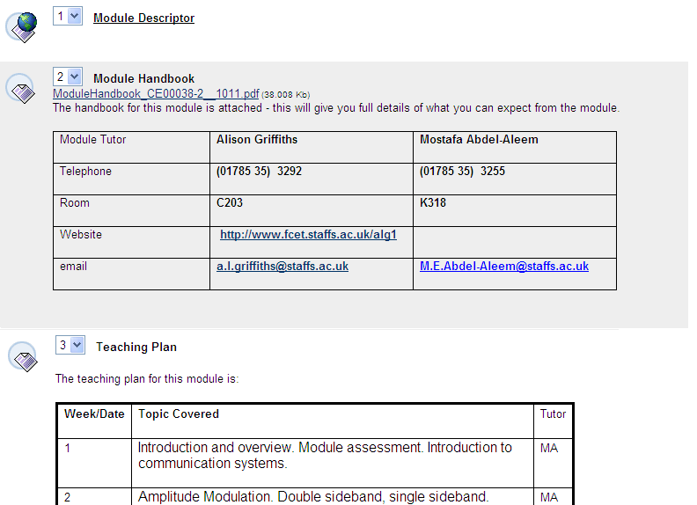

Figure 2: An Example of Blackboard VLE Module Information

**8.3 Blackboard Grade Centre**

The Blackboard Grade Centre provides an area within the universities Blackboard courses to store results data. Student scores from Blackboard tests and surveys are stored in the grade centre automatically. Lecturers may also manually add scores and information that are not automatically added by Blackboard.

By using Blackboard Grade Centre, lecturing staff can:

* Enter grades, exemptions, and comments all in one place.
* Directly communicate with a student.
* Create a calculated column and even drop grades

An example illustration of the use of Grad Centre from a lecturer’s point of view is illustrated in Figure 3. The student however, will only be able to see their own grades and feedback.

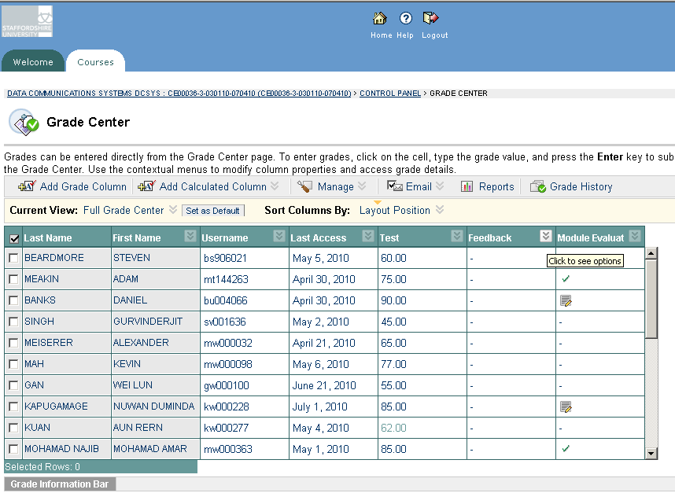

Figure 3: Blackboard Grade Centre

**9. CONCLUSION**

This paper presented various delivery methods of undergraduate and postgraduate courses, namely entirely distance learning, work-based learning and blended learning.

Delivering of materials using entirely distance learning methods is well suited to non-technical subjects, however it is difficult to implement for technical subjects such as engineering which require a significant amount of practical work at a HE Institution campus. For some Maters by Research (MRes) and PhD learners it is possible to use this method of delivery if the study is simulation based and the learners can communicate with their supervisor via multi-media methods.

Work-based learning is important for vocational courses which require the delivery of some materials within the workplace. For industry-based part-time students, this is feasible to implement, however it has proven difficult to find a work placements for full-time students to carry out their work-based learning materials and therefore there is an issue about practical work is not going to be resolved.

Blended learning is the most suitable delivery method presented as this suits all types of learners on all courses.

**REFERENCES**

[1] UK Standard for Professional Engineering Competence (UK-SPEC).

<http://www.engc.org.uk/professional-qualifications/standards/uk-spec>

[2] UK Quality Assurance Agency for Higher Education (QAA) Subject benchmark statement: Engineering.

<http://www.qaa.ac.uk/Publications/InformationAndGuidance/Pages/Subject-benchmark-statement-Engineering-.aspx>

[3] Staffordshire University MSc Professional Engineering

<http://www.staffs.ac.uk/courses_and_study/courses/professional-engineering-tcm4212777.jsp>

[4] Al-Tai, M ‘Work Based Learning’, Professors and Head of Electrical Engineering (PHEE) Conference, January 2009, London, UK.

[www.phee.org/Conf2009/AlTai.pdf](http://www.phee.org/Conf2009/AlTai.pdf)

[5] Staffordshire University Projects, UK.

[www.staffs.ac.uk/about_us/projects/](http://www.staffs.ac.uk/about_us/projects/)