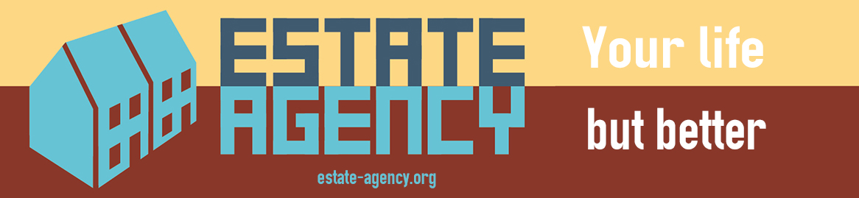
Estate Agency
a project by Anna Francis
Friday 28th April to Saturday 6th May, 2017
Opening Night : Friday 28th April 6pm-9pm
Campbell Works, 27 Belfast Road, London N16 6UN

Estate Agency is a project, designed and delivered by UK artist Anna Francis, exploring systems of culture led regeneration, via exhibitions in Stoke-on-Trent and London, plus a series of discussion events. It asks 'If councils and governments now recognise the value of arts and culture in developing places, what happens to these places, their communities and the cultural protagonists involved in the process, post-development?'

For many London based artists and arts organisations, the places and spaces they have been involved in developing for many years, are no longer viable and sustainable places to remain, due to rising costs and the want of ring fencing of cultural space within development contexts. Estate Agency aims to explore a sense that this commercial development activity and associated rise in land and property values is pricing artists out of London, while also engaging with the impacts of development on wider local communities.

Following the recent ‘SHUT UP’ of Campbell Works , the gallery will re-open as a high street Estate Agency. Instead of showing properties, and development opportunities local to Stoke Newington, all of the properties for sale or to let will be in Stoke-on-Trent, a Midlands city with abundant empty spaces and vacant properties and relatively low sale and rental values. Each property advertised is real life and real time and includes residential, commercial and artist studio provision.

From the opening night on 28th April and throughout the week, as well as the advertised properties, there will also be a series of creative 'shifts', undertaken by a team of Estate Agents, covering a variety of associated concerns - What happens to London if all the creative practitioners leave? If this is happening to artists, what are the effects for the other communities in these places? What responsibility do artists and arts organisations have in this process? Are artists complicit in the developers’ plans, or are they as much of a victim as the communities that are being forced out? How can artists use our collective creative agency to do things differently? As art organisations see the neighbourhoods around them change, do they need to change the way they work to reflect those changes? What can we learn from places, like Margate, where the processes of change are now well underway?

The Campbell Works Estate Agency looks to these two cities, London and Stoke-on-Trent, with their vastly different circumstances and fortunes, and will frame activity around the question of what happens to London in the context of rising costs of living and advocating for relocation to achieve a better quality of life.

Estate Agency is designed and delivered by Anna Francis, funded by Arts Council England, Staffordshire University and Artcity, and with support from AirSpace Gallery, Campbell Works and Butters John Bee.

For more information about Estate Agency, including the full programme of the week’s activities please visit the website at www.estate-agency.org or contact AirSpace Gallery at www.airspacegallery.org , Campbell Works at www.campbellworks.org or Anna Francis at amf@airspacegallery.org

Notes to the editor :

Estate Agents:

Anna Francis is an artist and researcher whose practice aims to rethink city resources, through participatory art interventions. She creates situations for herself, the public and other artists to explore places differently: often experimenting with leading and instruction by creating manuals, kits or leading guided tours. In recent years the interventions which Anna has worked on focus on the city of Stoke-on-Trent, and use an action research process to recognise untapped resources, plan a response to site, take action to change the way the site is viewed, and potentially, make changes, which can be temporary and sometimes permanent. Through this, Anna aims to gain an understanding of the role of artists and arts organisations in the development of places. Anna is a Director at AirSpace Gallery, Stoke-on-Trent's contemporary, artist led exhibiting space, where she has been leading on projects which engage with city and location since 2007. Anna is Associate Professor of Fine Art and Social Practice at Staffordshire University.

Rebecca Davies is an artist working within a participatory practice through illustration, performance and event. Rebecca graduated Royal College of Art in 2010 with an MA in Communication Art and Design, where she received the Sheila Robinson Prize for Drawing and was short listed for the Helen Hamlyn Design Award. She is an Associate Artist at Artsadmin, receiving their ‘Interference’ award in 2012 to create the Beau Belles Ice Cream Van. Rebecca is from Elephant and Castle, where she has made work for over 8 years. She co-created Peoples Bureau with artist Eva Sajovic, a project which is now an associate of Tate Exchange. She has run the Whitechapel Community Workshops for three years, and was lead artist of The Art Already Made, a programme of work made in collaboration with City Gateway. She represented London in the 2015 Mons European Capital of Culture with her project The Oasis Social Club, which then toured to Stoke On Trent, Preston and Hull seeing her collaborate with a range of UK wide partners. Her film, The Landlady, made in response to the tour, was screened at South London Gallery as part of The London Festival of Architecture in 2016.

Nicola Winstanley is a socially engaged artist who seeks to explore the relationship between participatory arts, perceptions of place and community action. By forging new relationships between art, people and place, Nicola believes that art practice can have a lasting effect on communities. She is particularly interested in engaging people who have no arts background and finding ways for art practice to improve their quality of life.
With a background in 2D and 3D public art, Nicola has collaborated internationally with artists, makers and members of the public to make work that engages the public at large in art practices, for this she often works in partnership with artist Sarah Nadin as Winstanley & Nadin. She has most recently been working solo alongside academic researchers to evaluate the impact of 'place' on individuals and communities. Nicola has 7 years workshop and public consultation experience, as well as having designed and managed large scale public art projects.

Penny Vincent is a Senior Lecturer at Staffordshire University and previously worked at a senior level in the public and voluntary sector. She is actively involved in community organising, supporting communities to get their voices heard, and has led on a number of projects in Stoke-on-Trent which have led to lasting change. She has extensive experience in community development, regeneration and public service improvement. She is a regular volunteer, musician/singer and photographer.

Supporters:

AirSpace Gallery is a collaborative, artist led project in Stoke-on-Trent, providing professional development opportunities, studio and exhibiting space and support for artists. Through a dynamic and evolving programme of exhibitions, events and activities AirSpace Gallery brings critical, high quality contemporary art to the region and provides opportunities for a broad range of artists. AirSpace Gallery was started in 2006 and since then the gallery has worked with a number of nationally and internationally acclaimed artists. As an artist-led space, the Gallery's current research interests mirror those of its directors and is particularly concerned with issues surrounding collaboration and partnership working and a relational relevance with its location and the socio-political landscape.

Campbell Works is the creative partnership of artists Neil Taylor & Harriet Murray. Their studio practice extends to running an artist led gallery space, initiating and curating art projects, and undertaking a wide range of public realm interventions. By developing the collaboration and curation of new ventures with artists working across a wide spectrum of disciplines, Campbell Works acts as a meeting point for ideas and aims to explore contextual relationships between art, spaces and people. Campbell Works collaborate with artists and organizations internationally, as well as with a diverse range of professionals, commissioning bodies, the public, schools, and local authorities in the UK.



