Can computer game landscapes target new audiences for landscape quality assessment?
Swetnam, R. D^{1*} & Korenko, J.²
¹ – Geography, Humanities & Performing Arts, Staffordshire University, College Road, Stoke-on-Trent, ST4 2DF, UK. Email = r.d.swetnam@staffs.ac.uk, Tel: +44 (0) 1782 295934
² – Visual Effects and Concept Design, Computing and Digital Technology, Staffordshire University, College Road, ST4 2DF, UK. Email = j.korenko@staffs.ac.uk Tel: +44 (0) 1782 294935

Graphical Abstract
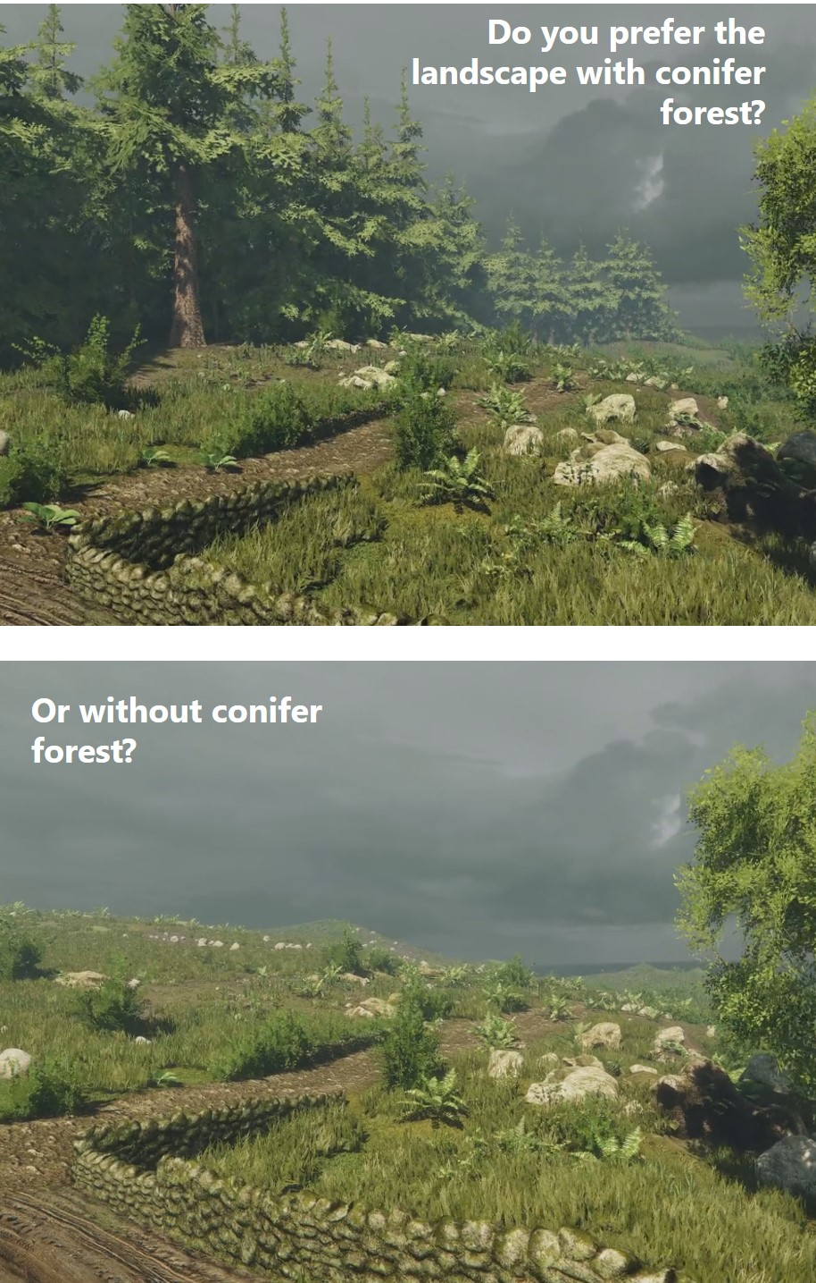
Abstract
This paper investigates and reflects upon the use of digital game landscapes as tools for visual quality assessment. It explores three distinct but related questions. First, can game landscapes engage the missing “young-voice” in landscape evaluations? Second, is it possible to represent the reality of typical landscape vistas? Third, does familiarity with such virtual reality environments impact on overall landscape ratings? This research draws on empirical work undertaken for the Welsh Government to evaluate the impact of their agri-environmental scheme Glastir on the rural landscapes of Wales. This project employed a new, GIS-enabled method to evaluate visual landscape quality, tested using an online photographic preference survey. Whilst the survey was successful, receiving over 2200 responses, young people (<25 years) were significantly underrepresented in the self-selecting sample.
To address this gap, we stepped out of the real-world landscapes that most geographers are comfortable with, into the virtual landscapes of gaming. Our response was to create a virtual Welsh landscape which could be navigated in games software and manipulated to mimic landscape changes. A second survey incorporating images of this virtual landscape was first targeted at computer games design students and then secondly to the wider public, with both groups undertaking the same assessment. Overall >70% of respondents were highly satisfied with the quality of the landscape visualisations. Of those who had visited rural Wales before, 64% gave a rating of at least 7 out of 10 for its representativeness. No significant differences in overall landscape ratings were observed between the two groups which is helpful as it indicates that gaming familiarity would not preclude the use of such landscape visualisations in public consultation exercises. This paper considers results from this pilot study and discusses the visual accuracy of the Welsh landscape created. Wider methodological issues are outlined alongside some of the interdisciplinary challenges involved in the construction of the landscape visualisation.
Keywords: Aesthetics; Games Design; Landscapes; Young People; Visual Quality; Wales
1.0 Introduction
Landscape science is an interdisciplinary endeavour drawing upon geography, ecology, architecture and planning. It necessarily merges ideas relating to physical form, aesthetics and purpose to further understanding of the relationships between people and place. These culturally embedded relationships have received recent scrutiny due to their inclusion within the theoretical framework of ecosystem service assessment (MEA, 2005). A beautiful landscape view can be identified as a ‘cultural ecosystem service’ alongside other intangible benefits such as spiritual nourishment or enjoyment of nature (Costanza, et al., 1997; Church, et al., 2011; Daniel, et al., 2012). Assessing the visual quality of a landscape is an exercise in quantifying our qualitative responses to these views (Swetnam, et al., 2017). Such assessments are important to answer fundamental questions such as ‘what do we want our landscapes to look like? and ‘who decides?’
The sensory nature of this evaluation means that visual technologies are often employed in data gathering as well as the presentation of results. Traditionally, this started with fieldwork which is place-based, time-stamped and multi-sensory (Riesco-Chueca & Gomez-Zotano, 2013). Visual impressions of landscapes were originally recorded through narratives, sketches and paintings and this is still important in geographical research (Turkington, 2010). Site photographs represented a major step forward with respect to capturing the view and they remain important in visual landscape assessment (Arriaza, et al., 2004; Pardo-Garcia & Merida-Rodriguez, 2017; Swetnam & Tweed, 2018). However, the 3D nature of the landscape is still constrained by the 2D capacity of such recording devices. With the development of computer-based technologies, the 3D aspects could be represented more effectively within Geographic Information Systems (GIS) and Virtual Reality (VR) environments (Paar, 2006; Kuliga, et al., 2015). This potential has recently been fully realised for wind farm assessments by Rafiee et al., (2017) and in land management in the GeoGame platform developed by Ahlqvist et al., (2018). In both these cases, the spatial data handling capabilities of GIS have been fully integrated within game engine software.
1.1 Assessing public views on landscape
Traditional methods to gather information about public views on the management of shared rural environments include: town meetings, focus groups, phone surveys, public consultations and community planning exercises (Fletcher, et al., 2014; Gyllin & Grahn, 2015). These sorts of data-gathering exercises seem archaic to the internet-enabled. The voice of the young (<25 years) therefore, is often marginalized in the landscape quality / landscape management debate. It may have been hoped that the rise of internet-enabled phones and the ubiquity of wi-fi access in many places would have helped fill this gap. Online surveys are easy to distribute via social media but issues concerning validity, ethics and uptake remain (McInroy, 2016). However, despite the apparent ubiquity of the internet, engaging this cohort in scientific research remains difficult as users have many other entertainments and virtual activities in which to engage. Our own studies in Wales, UK (Swetnam, et al., 2015) mirrored this finding; a self-administered, online photographic preference survey collected 2263 responses from across the UK but only had 93 (= 4.1%) from people under the age of 25. All other age groups broadly matched that of the wider population in terms of proportion.
1.2 Young People in Landscape Evaluations
The missing voice of young people in landscape assessment is therefore a concern, particularly considering the challenges that this generation will undoubtedly face in managing the impacts of rapid environmental change on their lives. It is crucial that we do understand the landscape preferences of our younger citizens. Thankfully, much groundwork has been done in this area. In particular the literature on younger children’s place preferences is vast with notable contributions offered by Hart (1979), van Andel (1990) and seminal work by Matthews (1992) and Matthews & Limb (1999). Often the emphasis is developmental, exploring how younger children play and explore their local natural environment. Work with adolescents is less common and often has a social focus in an attempt to understand how young adults use shared public spaces. Owens & McKinnon’s (2009) study of 53 teenagers in California identified both formal and informal green spaces used by young adults in their locale (such as sports fields, parks and beaches) and concluded that they were important for three key activities: recreation, restoration and socializing with friends. Safe spaces were valued but so were areas where teenagers could meet and interact without constant adult supervision. Some more recent studies are beginning to explore teenagers’ specific preferences for greenery and vegetation (Luckmann, et al., 2013; van den Bogerd, et al., 2018). Whilst Eder & Arnberger’s (2016) landscape preference work with adolescents in riverine landscapes demonstrated that the associated recreational infrastructure (benches etc.) were important to this age group and their social dynamics.
Young people are often reliant on adults to facilitate their access to natural environments. This often happens through supervised visits which are dependent on transport provision whereby the parents drive or take the children to the countryside as a recreational activity. Much has been written in increasingly anxious tones about the growing disconnect between children in urban areas and wild nature which Louv (2005) influentially termed “Nature Deficit-Disorder”. As there is increasing evidence showing the link between time spent outdoors in greenspaces and our physical and mental health (Kahn & Kellert, 2002; Bird, 2007; van den Berg, et al., 2016) this lack of real engagement with reality is worrying. Even though later writers have offered critiques of the message Louv’s book espoused (e.g. Dickinson, 2013), it remains influential; for example, the UK’s National Trust charity heavily promotes a range of outdoor play activities for children (Percival, 2016), with similar schemes developed by the US Forest Service (Kimbell, et al., 2009). It is certainly true that in highly urbanised developed countries such as Japan and the UK, the size of children’s home range and unsupervised engagement in outdoor play has plummeted within a single generation (Witten, et al., 2013; Woolley & Griffin, 2015). Reasons for this are complex and multifaceted but fears associated with high levels of road traffic, stranger-danger and risk-averse societies have been postulated by social scientists (O'Brien, et al., 2000).
At the same time as this sharp decline in youth’s outdoor activity (Pergams & Zaradic, 2008; Pergams & Zaradic, 2006) there has been a concomitant rise in time spent on technology-enabled play – particularly using computers, tablets and internet-enabled mobile phones. This ‘gamification’ is discussed within the context of conservation science by Fletcher (2017), Sandbrook et al., (2015) and Büscher (2013) who provide useful contributions to the theoretical debate underlying this field. Some researchers believe that this disconnect between people and Nature is creating a generation which is less aware of its intimate dependence on the natural world and the vital ecosystem services it provides to support their existence (Kareiva, 2008; Soga & Gaston, 2016). This in turn, may lead to disinterest and disengagement from pressing environmental problems such as pollution, biodiversity loss and degradation of the physical environment for all species on the planet, not just our own (Sandbrook, et al., 2015).
1.3 Landscapes and Computer Games
Computer gaming offers digital landscape experiences where young people are right at the forefront. Many young adults spend a large part of their free time immersed within these highly-technologized and idealised game-worlds (McGonigal, 2011; Rideout, et al., 2010). These virtual landscapes are designed to be inhabited and traversed by those virtual characters playing the game (Martin, 2011). Indeed, (Aarseth, 2000, p. 163) argues that computer games are “preoccupied with space” and that one of the defining elements in computer games is spatiality. A significant number of these games are rooted firmly in fantasy and story-telling with imaginary lands recreated for artistic effect.
It is sometimes a shock for older generations, who do not have frequent contact with young people, to grasp the cultural significance of computer games in their daily lives. Computer gaming is the fastest growing cultural industry in the industrialized world and an established part of everyday life for many (Aarseth, 2000; Quandt, et al., 2015; McGonigal, 2011). It has been recently estimated that between 2.2 – 2.6 billion people play computer games globally with a market worth over $100 billion per annum (UKIE, 2017). In the mature markets of the Europe, US, Japan and China, the figures are startling; for example, in the US 64% of the population aged 13+ play computer games (UKIE, 2017). It is not however, an activity confined to just young people (Williams, et al., 2008; Pearce, 2008), in the US the average age of gamers is currently 35, whilst in the UK, of those who play at least once a month, 22% are over the age of 50. Once seen as an alternative activity for socially awkward teenagers (Griffiths, et al., 2003), it is now as mainstream as television viewing for many.
1.4 Overall Aim and Research Questions
It is clear, that for many young people their exploration of landscape takes place within the digital world rather than through first-hand experience. This creates challenges for landscape researchers whose task is to evaluate the reality of the here and now. For some young people, the time spent playing computer games far outweighs the time spent exploring the reality of their local outdoor environments. A recent survey of children in the UK aged between 8 – 15, found that on average they spent less than 16 minutes per day in outdoor locations such as parks or the countryside (ONS, 2018). This emerging disconnect between young people and their physical environments needs to be recognized by policymakers and land managers to avoid disenfranchisement of a key societal group. Young peoples’ views are valid, important and need to be captured. Therefore, our research response was to create a ‘games-designed’ version of a representative 1km² of the Welsh landscape and use it to assess whether this virtual world could target these under-represented audiences for landscape quality assessment. We explored three questions:
- Can game landscapes engage the missing “young-voice” in landscape evaluations?
- Is it possible to represent the reality of generic landscape vistas using the Welsh landscape as a case study?
- Does familiarity with virtual reality environments impact on overall landscape ratings?
2.0 Methodology
There were two distinct but linked methodological components to the work – (1) the creation of the 3D game landscapes and (2) the evaluation of these landscapes with gamers and the public; these will be discussed in turn.
2.1 Creation of the virtual game landscapes
Our work is an example of games software being applied to a landscape research task, rather than a landscape game per se (Bishop, 2011). The superlative graphics available were harnessed to create a believable, recognisably-Welsh, rural landscape which could be traversed in order to provide several different vistas. These capabilities were recognised early by Herwig & Paar (2002) who questioned why the high standards of visualisation in games software were not being exploited in landscape planning applications. However, it was not just a programming task; the final landscape was the output of an iterative, interdisciplinary “research conversation” between the landscape geographer (RS) and the games design specialist (JK). The process is summarised in Figure 1 and consisted of four main stages: (1) preparation of a landscape design brief by RS; (2) collation of a photographic archive by RS; (3) game landscape construction (JK) and finally (4) a review and final revision (RS and JK).
2.1.1 Stage 1: The Landscape Design Brief
A design brief was provided based on a GIS-derived 3D landscape model. This simplified terrain represents one example of the topography of rural Wales with a land use layer showing the layout of tracks, roads, water features, woodland, agriculture and settlement (Figure Supplementary S1). It was a composite, drawn from knowledge of 300, 1 x 1km² sites from across Wales which were surveyed as part of the Glastir Monitoring and Evaluation Programme (GMEP). This wide-ranging ecosystem service assessment of the Welsh landscape was funded by the Welsh Government and included detailed land use mapping and vegetation assessment (Emmett, 2013; Swetnam, et al., 2017).
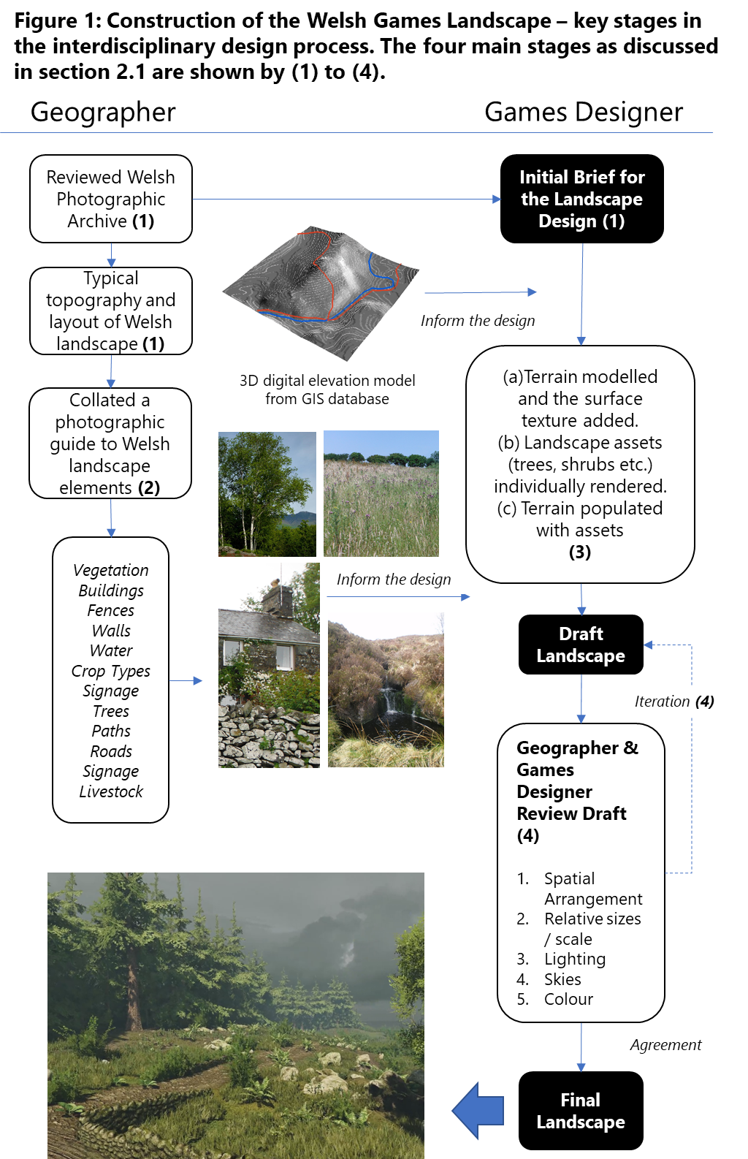2.1.2 Stage 2: Collation of a photographic archive
As part of the GMEP field mapping, thousands of representative landscape images were taken. Examples of key landscape features were extracted from this photographic collection, to create a gallery of representative images which contained: common tree types, wall constructions, vegetation types, buildings, water features and livestock. These are referred to as “assets” in the technical language of games software. The photographic archive was essential, enabling the game designer (JK) to match the colour, texture and form of real landscape features in Wales.
2.1.3 Stage 3: Game Landscape Construction
The final Welsh landscape was compiled using the software ©CryEngine v3.2 which is a leading package used in the games design and architecture market. However, a range of software tools were involved in creating the final landscape including: ©Photoshop (used for manipulating the appearance of images), ©Flora3D (for the creation of vegetation) and ©WorldMachine (to render the 3D landscapes). This approach is more common in games design where programmers link a changing array of software together in “Workflows” which aim to achieve the very best current effect, rather than being wedded to one piece of software such as a GIS. Two key stages were involved, firstly, the creation of the landscape terrain and secondly, the population of this terrain by the landscape assets such as trees and walls.
The terrain was initially created within the software ©WorldMachine. The “heightmap” method was first used to create a detailed, scaled elevation grid (Golubev, et al., 2016). Many aerial photographs of the Welsh landscape were then stitched and draped over this terrain surface and subjected to weathering and erosion functions to achieve the desired visual effect. This 3D surface was then imported into the visualisation software ©CryEngine which tessellated this terrain for further manipulation.
Trees were some of the most important landscape assets as they play a significant role in the visual structure of the Welsh landscape and their presence and type were embedded in the original Welsh visual quality assessment. Over 50 individual models of eight different tree species were created using ©Flora3D. Each of these required individual tree trunks, foliage and bark to be rendered. The photographic archive created by the geographer was used as a starting point and these images were incorporated into the fine detail. A similar approach was taken with bushes, shrubs, crops, fields, flowers and grass patches to create an authentic look. The individual assets were “painted” onto the terrain using a 3D brush which allowed large numbers of trees to be distributed. Along paths and around other features such as walls the vegetation assets were individually placed as woodland is not random within a managed landscape such as Wales. Finally, the built assets in the landscape – most notably the dry-stone walls which are so important in the visual appearance of these upland areas of the UK were sculpted using ©Zbrush which mimics digital clay and allows stones to be individually crafted and then the surface was rendered using a mixture of photographs and hand-painted techniques.
This time-consuming approach to asset-creation, had many benefits once the landscape was available to be used for scenario testing. As these assets existed as separate entities within the 3D model, it was then relatively easy to turn them on and off within the landscape to mimic landscape change without disrupting the completeness and visual integrity of the whole.
2.1.4 Stage 4: Review and Revise
There followed an iterative series of reviews, where issues concerning the spatial arrangement, scale and lighting were refined. As the games designer (JK) had limited personal experience of Welsh landscapes, these discussions were essential to correct perceptual errors, especially with respect to the relative sizes of components and their appearance. Constraining the innate desire to fantasise and beautify the output was a challenge, as the aim was to create something that was recognisably Welsh, rather than artistic. We were not aiming for photo-realism; this exercise was designed to test the potential of these landscapes to be usable and attractive tools to undertake visual assessments of components in the landscape. Indeed, some game design experts warn against trying to copy Nature too closely as humans are optimized for visual stimuli and when these representations become too life-like it wakens our hard-wired “wardens of reality” which then cause us to focus on these incongruities (Wages, et al., 2004), rather than the task at hand. A screenshot of part of the landscape is shown in Figure 1, other detailed examples are given in Supplementary S2 where links to dynamic video fly-throughs used in the survey are also provided.
2.2 Evaluation of the virtual game landscapes
One of the key aims of this study was to evaluate the use of virtual landscapes created with gaming software for the purposes of visual landscape quality assessment. Therefore, the effectiveness of the test landscape was evaluated using an online photographic preference survey (PPS) created and administered within the survey software $©$Qualtrics using links to the video hosting website ©Vimeo to deliver the video content. PPS are a commonly used tool for visual landscape assessments; see examples from Kienast et al., (2012) Wherett (2000) and Taylor (2018). Previously, such assessments of public preference for landscape views would have been undertaken in person, using printed or projected images of landscapes for evaluation. Such assessments can now be delivered online to larger sample groups, without incurring additional costs, and their validity has been evaluated empirically (Roth, 2006).
2.2.1 Test population
Engaging groups of younger people (<25 years), who do not frequently venture into the wider outdoors was one of the key goals of this research. Staffordshire University is nationally recognised for its courses in computer game design and programming and has one of the largest student cohorts in these disciplines in the UK with approximately 1000 gaming students in 2017-18. We therefore, had a relatively large and unique population from which to sample. A clear majority of these adults fall within our target age range and have wide ranging experience of both playing and creating detailed computer games. The games survey was specifically targeted at undergraduate Games Design (GD) students at Staffordshire University. Advertising was tailored to this group, both through course leaders emailing the links to their students and through poster-based information which was tagged with the phrase “Are you a Games Design student? – we need your specific expertise to assist our research”. The survey was distributed to this group in January 2018 via departmental emails and tutorials with promotion by the departmental staff. It was live for six weeks throughout the early part of 2018.
A separate (but identical) copy of the survey was also released to the wider public (P) via social media, landscape forums and geographical associations as well as through the normal channels of research contacts used for the first phase of the Welsh survey (Swetnam et al., 2015). It was also promoted as a research activity on several University Open Days at Staffordshire University during 2018. This phase of the data collection was opportunistic in nature. Due to the prevalence of computer gaming as a recreational activity across a wide range of society, it was likely that many respondents in this second comparative phase would also have experience of playing computer games though it was also possible that there would be a cohort of respondents here who are not as familiar with the visual aesthetics of these virtual worlds. By keeping these two groups separate, we were able to specifically identify the computer gaming experts without having to insert further questions into the online survey.
The survey consisted of 15 questions with associated video clips and still images and contained eight key components: (1) demographics; (2) gaming experience; (3) moving video evaluations; (4) still image evaluations; (5) comparison of (3 & 4); (6) detailed feature evaluation; (7) word descriptions and finally (8) declaration of familiarity with the Welsh countryside and overall evaluation. Summary details of the questionnaire structure are given in Table 1, with full details of the possible responses and question types as well as extracts of the survey provided in Supplementary Materials
Table 1: Online survey structure with all 15 questions detailed. Those questions with an ID in bold were answered by ALL respondents, the remaining 3 questions were hidden from respondents when not relevant. The survey was constructed in ©Qualtrics software and took approximately 7 minutes to complete.
Component | ID | Question
Demographics | 1 | What is your gender?
 | 2 | What is your age group?
Previous computer gaming experience | 3 | Have you any experience of playing computer games?
 | 4 | Approximately how long have you been playing computer games?
 | 5 | In a typical week, how much time in hours, would you spend playing computer games? (Use the last 3 -4 weeks to help you estimate)
Moving video clip evaluations | 6 | (Having first watched a 40 second video flythrough) How much do you like the visual appearance of the landscape?
 | 7 | Having first watched 2 x 5 second video clips: one with conifer forest, the second with the forest removed. (Close Up)  Do you prefer the look of landscape A or B?
 | 8 | Having first watched 2 x 5 second video clips: one with conifer forest, the second with the forest removed. (Forest on distant horizon)  Do you prefer the look of landscape C or D?
Still image evaluation | 9 | Presented with a static image from the video clip one with some sheep, one without.  Do you prefer the look of landscape E or F?
Comparison of still vs moving | 10 | Which format did you find easiest to evaluate?
Detailed evaluation of individual components | 11 | Presented with a static image with components outlined by boxes. Users asked to choose whether they like, dislike or are neutral.  How visually accurate do you find each of the following components: signpost, conifer forest, dry stone wall, wire fencing, sheep flock, large deciduous tree, muddy farm track.
Qualitative descriptions of the respondents view of the content | 12 | What words would you use to describe these virtual Welsh landscapes? – please choose as many as you wish.
 | 13 | Please add any other words you would like to contribute to describe your response.
Familiarity with the appearance of real Welsh rural landscapes | 14 | Have you ever visited the Welsh countryside in person before?
 | 15 | If you have visited the Welsh countryside before, do you think that the images looked like the landscape you remember?

3.0 Results
3.1 Survey Demographics
In this pilot, 70 complete responses were received from the GD survey of which nine (12.9%) were female. This represents a response rate of 7% which although relatively low is similar to other studies which used self-selecting, online surveys. For example, Guin-Downes Le, et al., (2012) received an 8% response from a survey of over 12,200. As hoped, the age profile of the GD group was tight (Figure 2a) with 83% falling into the difficult to reach 18-24 group. There were no GD students over the age of 44 reflecting the youthful nature of this emerging industry. The gender split was also notable, with 87% of the GD respondents identifying as male; this GD gender split partly reflects the overall 2018 GD student cohort at Staffordshire University which has approximately 1000 students of which only 6-8% are female (small variations present between years). Of the 59 completed responses in the Public (P) group, 32 (54%) were female (Figure 2b). The age profile of the P group was bimodal, containing a distinct peak in the 18-24 group of 25 respondents (42%) with a second smaller peak in the 45-54 group of 13 respondents (22%) which clearly reflects the nature of the event. University Open-Days are typically populated by aspiring young applicants in the 18-24 age range accompanied by their parents and occasional younger siblings. There is some evidence to suggest that women are much more likely to engage in voluntary online surveys than men (Smith, 2008; Aerny-Perreten, et al., 2015) which may explain the relative over-representation of women in both the GD and the P group.
Past and current gaming experience in the GD cohort conformed to expected trends. All the GD respondents (n=70) had been gaming for over 6 years, with the majority (94%) having more than 10 years of experience (Figure 2d). Considering most of the cohort were under 24, it is clear, that this group are early adopters playing from a young age. They are also committed gamers with 61% of the GDs confirming that they spent more than 11 hours per week playing (P group = 22%), with 40% of the respondents spending more than 20 hours per week gaming (P group = 7%) see Figure 2c and 2d.
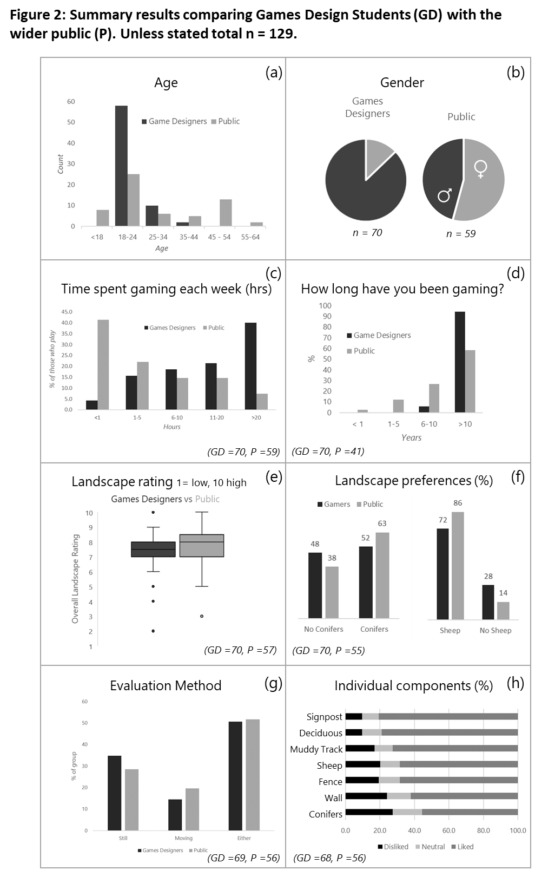
3.2 Games Landscape Assessments
Both sets of respondents were then shown a 40-second fly-through of a game derived “Welsh” landscape which incorporated a variety of landscape features typically found in rural landscapes in Wales. The video is available here: https://player.vimeo.com/video/148001699?loop=1 They were asked to rate how much they liked the appearance of the landscape using a 1 (disliked) to 10 (really liked) sliding scale (Figure 2e). The GD group gave it a lower mean score of 7.21 ± 1.58, compared to 7.67 ±1.62 from the P group, though these differences were not statistically significant (Mann Whitney U = 1745, p = 0.213). Figure 2c indicates that within the P group, there are also a significant number of respondents who spend time gaming each week. To evaluate the impact of this on overall landscape ratings, the GD and P group data were combined and split purely on weekly gaming activity (Table 2). The mean rating for all respondents irrespective of grouping was 7.48 ± 1.56. There were no statistically significant differences between any groups. When asked to choose between the same clip with specific landscape features added or removed, a clear majority (63%) of the P group preferred the landscape with conifers present rather than absent (Figure 2f); the GD group were balanced between the two options with 52% preferring the conifers. Both groups preferred the scene with sheep present, with 86% of the P group favouring this option compared to 72% of the GD group.
Table 2: Counts of overall landscape rating for the combined sample (GD and P). Data split purely on the time spent gaming in a typical week (Hrs). Note that n = 127.
Hours | Overall landscape rating (1 – 10) |  |  |  |  |  |  |  |  | Summary Statistics
 | 2 | 3 | 4 | 5 | 6 | 7 | 8 | 9 | 10 | n | Mean ± Stdev
0 |  | 2 |  | 1 |  | 3 | 5 | 3 | 2 | 16 | 7.44 ±2.06
< 1 |  |  |  |  | 3 | 5 | 9 | 1 | 2 | 21 | 7.70 ±1.1
1 - 5 | 1 |  |  | 4 | 3 | 2 | 3 | 4 | 3 | 19 | 7.20 ±2.11
6 - 10 |  |  | 1 |  | 1 | 9 | 6 | 2 |  | 19 | 7.32 ±1.08
11 – 20 |  |  |  | 1 | 3 | 3 | 11 |  | 3 | 21 | 7.71 ±1.28
20+ | 1 |  |  | 1 | 2 | 12 | 7 | 7 | 1 | 33 | 7.48 ±1.48
Total | 2 | 2 | 1 | 7 | 12 | 34 | 41 | 17 | 11 | 127 | 7.48 ±1.56

Specific evaluations of the visual accuracy of components of the landscapes did indicate that overall, respondents were quite satisfied (Table 3). When the two groups were combined, the signpost and the large deciduous tree were the most liked features (Figure 2h). The signpost had been copied very carefully from photographs and its built structure allowed the games programmer to mirror its features very accurately. Welsh footpath signs have a specific design and are recognisable to many British people (see top right panel in Figure 3), therefore the high public preference for this feature (liked by 85.7% of the P group) may reflect this familiarity. Its “uniqueness” may have helped respondents feel confident in the visualisation of this landscape. The muddy tracks, sheep and fences were similarly liked, with the wall and the conifer forest regarded as least visually accurate. However, there were some subtle differences in preference between the two groups which we suggest may reflect the GD group’s experience of constructing such landscapes (Figure 3).
Table 3: Evaluations of component visual accuracy in the virtual Welsh landscape. The seven individual components were highlighted by boxes on the image and the respondent asked for their view (see Supplementary Figure 2 for detail).
Landscape Feature | GAMES DESIGNERS  (n= 68) |  |  | PUBLIC  (n=56) |  |  | COMBINED  (n=124)
 | % |  |  | % |  |  | %
 | Disliked | Neutral | Liked | Disliked | Neutral | Liked | Disliked | Neutral | Liked
Signpost | 13.2 | 10.3 | 76.5 | 5.4 | 8.9 | 85.7 | 9.7 | 9.7 | 80.6
Deciduous Tree | 8.8 | 13.2 | 77.9 | 10.7 | 8.9 | 80.4 | 9.7 | 11.3 | 79.0
Muddy Track | 16.2 | 11.8 | 72.1 | 17.9 | 8.9 | 73.2 | 16.9 | 10.5 | 72.6
Sheep | 23.5 | 14.7 | 61.8 | 16.1 | 7.1 | 76.8 | 20.2 | 11.3 | 68.5
Fence | 25.0 | 11.8 | 63.2 | 12.5 | 12.5 | 75.0 | 19.4 | 12.1 | 68.5
Wall | 26.5 | 13.2 | 60.3 | 21.4 | 14.3 | 64.3 | 24.2 | 13.7 | 62.1
Conifer Trees | 23.5 | 20.6 | 55.9 | 32.1 | 12.5 | 55.4 | 27.4 | 16.9 | 55.6
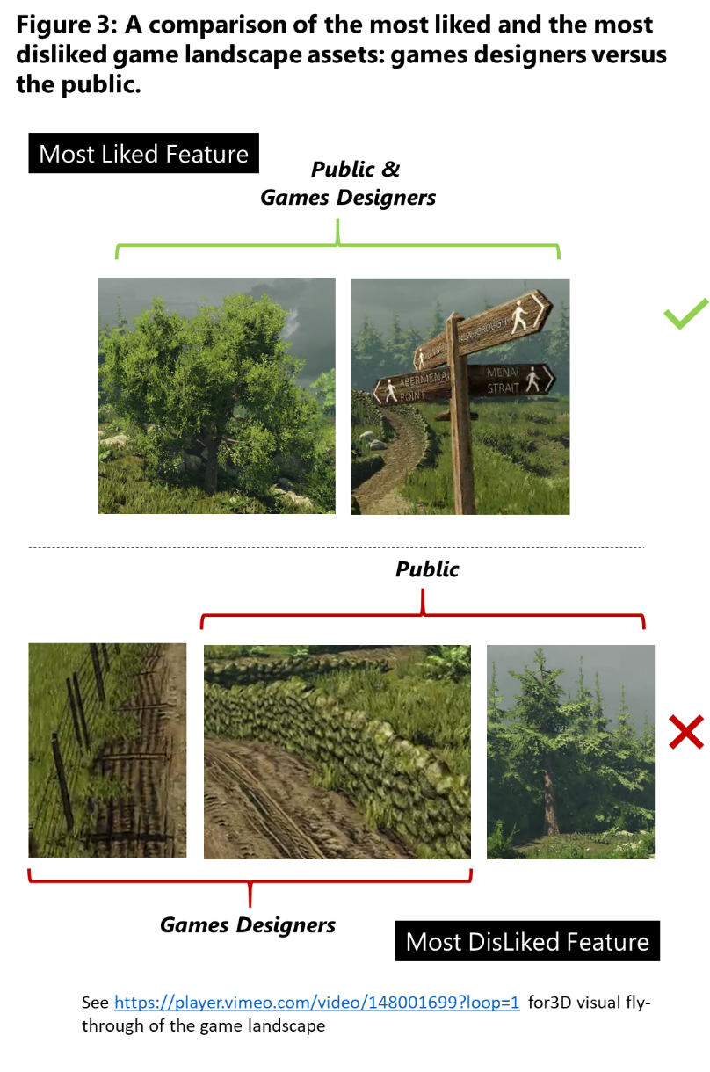

It is notable that the public liked the sheep, which the researchers felt were the most artificial component of the scene. Similarly, the public disliked the conifer trees in the landscapes; this mirrored findings from the wider Welsh GMEP survey (Swetnam et al., 2015), where conifers were actively disliked by 31% of the public (n = 2263). There is some apparent contradiction shown here as when the public group were asked to choose between a landscape with conifer forest and one without, there was a strong preference for the forested landscape (63% preferred it). There are evident differences between asking respondents to consider a whole landscape rather than compartmentalizing it into sections.
The short survey did contain a mix of video fly-throughs and still image comparisons and the respondents were asked which they preferred for evaluation (Figure 2g). A significant minority (32%) of both the P and GD groups expressed a preference for the still image comparisons which mirrored other research findings (Lovett, et al., 2015; Berry & Higgs, 2010). However, a clear majority (68%) of both groups of respondents were happy with either the moving video fly-throughs or the photographs to evaluate landscape quality which mirrors earlier comparisons made by other studies (Reichhart, et al., 2007; Cartwright, 2006).
Table 4: Number of times listed words were selected by respondents (GD and P combined). Words were presented in three columns and the positive and negative were mixed – visual grouping of pairs (such as Natural / Artificial) were avoided to ensure each was considered. Respondents could select none or as many as they wanted. A separate question then invited the respondent to suggest any other words they would like to have picked, user-suggested words are shown below.
Word | Count | +ve | -ve | Most popular combinations of words (>2) | Count
Natural | 70 | X |  | Accurate, Familiar, Engaging, Interesting, Natural | 8
Interesting | 64 | X |  | Accurate, Familiar, Natural | 8
Familiar | 63 | X |  | Accurate, Familiar, Fun, Engaging, Interesting, Natural | 4
Accurate | 58 | X |  | Accurate, Natural | 4
Engaging | 43 | X |  | Familiar, Interesting, Artificial | 4
Artificial | 30 |  | X | Familiar, Interesting, Natural | 4
Fun | 18 | X |  | Accurate, Engaging, Interesting, Natural | 3
Strange | 11 |  | X | Familiar, Artificial | 3
Boring | 8 |  | X
Alienating | 3 |  | X
False | 2 |  | X
Confusing | 2 |  | X
Totals |  | 361 | 56
User-suggested words: Games Designers
Adventuring, Bright, Dim, Dry, Plausible, Peaceful (x2), Rural, Serene
User-suggested words: Public
Appealing, Beautiful, Calming, Computer-generated, Countryside, Cartoony, Different, Enjoyable, Green, Happy, Immersive, Intriguing, Limited view, Mountainous, Mysterious, Realistic (x2), Relaxing, Space

One of the most revealing areas of the survey results was the descriptive text responses (Table 4). Respondents were invited to choose which words best captured their feelings about the landscapes examined. Twelve words were offered, six which were deemed to have positive connotations (natural, familiar, interesting, accurate, engaging, fun) and six with negative connotations (artificial, boring, strange, alienating, false, confusing). We recognise that these distinctions are somewhat subjective, but such word-connotations are recognised in semantics and in sentiment analysis (Liu, 2012). An earlier pilot of the survey had these 12 paired into positive-negative groups such as ‘natural OR artificial’, ‘accurate OR false’ and respondents were forced to make a choice between them. Although this structured approach yielded data that was potentially easier to analyse due to the binary choice on offer, it was felt on reflection that it was rather didactic. By giving the respondent the opportunity to combine whichever words they wished to, some of the complexity of their response to the landscape could be captured.
These data show overwhelmingly positive responses to the game landscape with 361 positive-word choices versus only 56 negative-word choices (Table 3). Interestingly, the most common word chosen was ‘Natural’, chosen 70 times, more than twice as frequently as its opposite ‘Artificial’ (30). This was by far the most commonly chosen negative-connotation word however, which does indicate some of the conflicted views held. ‘Familiar’ was also a common choice (63) which indicates that the games software rendering was not visually distracting to most. Interestingly, all eight of those respondents who chose ‘Boring’ as one of their words were from the GD group. Volunteered word choice was also interesting – even though there were twice as many GD respondents, they were far less likely to suggest words. The words they chose, such as ‘Adventuring’ also hint at their interests and engagement with this landscape. The public group were much more forthcoming, offering up eighteen additional descriptors most of which would have positive aesthetic associations such as ‘Beautiful’, ‘Serene’, ‘Immersive’ and ‘Relaxing’.
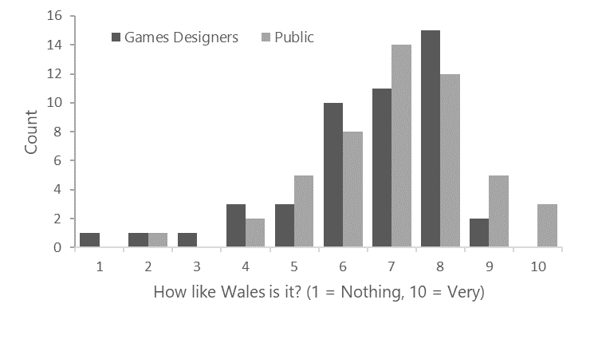
Figure 4: For those respondents who had visited the Welsh rural landscape before (GD = 46/70, P = 49 /59) - ratings response to the question "How much like Wales is it?“ where (1 = Low, 10 = High).
Finally, those respondents who stated that they had visited the rural landscape of Wales were asked to evaluate how similar the game-derived landscape visualisations were to the rural vistas they had previously seen (Figure 4). It is notable that P group were much more likely to have visited rural Wales with 49 out of 59 confirming their personal experience of this type of landscape (83%) compared to 46 out of 70 (66%) of the GD group. Most respondents were happy with the visual accuracy of the Welsh landscapes with 69% (P) and 61% (GD) rating it as 7/10 or higher though there were some differences between the two groups (Figure 4). The mean value for the GD group was lower at 6.522± 1.81, whilst the P group was 7.04 ± 1.63 though once again, these differences were not statistically significant (Mann Whitney U = 981, p = 0.266). With any Likert Scale response like this, there is a tendency for users to choose more central values whilst avoiding the extremes (Carifio & Perla, 2007), but both groups show a positive skew to their responses indicating higher levels of satisfaction. When combined with the positive self-volunteered descriptors detailed in Table 4, the overall message is one of user-satisfaction.

4.0 Discussion
Our impetus for this work was realising that we had a serious gap in our responses to an important public consultation on visual landscape quality monitoring for Wales (Swetnam, et al., 2015). The most recent census in Wales recorded 30.4% of the population being <25 years old (Office for National Statistics, 2011), whilst our online survey only had 4.1% of respondents in this age group. We attempted to bridge this gap to the “young voice”, not by expecting these young people to suddenly choose to spend their leisure time in the outdoors, but by stepping into the virtual worlds they choose to interact with. By changing the medium of engagement to a virtual Welsh landscape we were able to tap into a favoured recreational practice of this cohort, namely computer gaming (Quandt, et al., 2015). The games landscapes that they spend time in are familiar to them and therefore offer potential to be used in this manner. With respect to our first research question regarding the ability of game landscapes to engage younger people in formal landscape evaluation, our pilot study indicates that this is indeed possible. Our findings showed good engagement from even our committed games designers i.e. those spending more than 20 hours a week gaming. The fact that a significant minority of this group had never even been to Wales, even though Staffordshire University is in the city of Stoke-on-Trent and only situated an hour from the border with Wales shows that we could connect with a young urban population.
Our second research question related to the technical and visual challenge of representing the Welsh landscape. Was it possible to create a virtual landscape that was sufficiently like Wales that it could be used in similar ways to manipulated photographs to assess landscape visual quality? Our data indicate that this is indeed possible with such high-quality graphics. Some components were more successfully realised than others; in particular the vegetation and the built structures such as the footpath signs were well liked and felt to be accurate by the majority of respondents from either group The value of an interdisciplinary approach was exemplified here – the landscape geographer ensured that the output of the virtual design process was sufficiently realistic to enable sensible landscape interventions to be evaluated. This was tested in our pilot survey with satisfaction levels of >70% recorded by both groups of respondents (P) and (GD).
Thirdly, we were interested to explore whether familiarity with such technologized environments would impact on overall landscape ratings? Would the GD group have completely different responses to the wider public when considering the visual appeal of a landscape? Our data does not provide evidence to support this either in terms of differences in overall appeal of the landscape nor its visual accuracy with respect to the real Welsh countryside. This consistency of response is helpful as it indicates that gaming familiarity would not preclude the use of such landscape visualisations in public consultation exercises. Certainly, the GD group were less likely to have visited the Welsh countryside than the public group, only 67% as compared to 88%, but this may well have more to do with their relatively young ages than with a recreational preference. Our data may simply indicate that the older respondents in the P group were more likely to have had time and greater opportunities to explore Wales than the GD students. The reasons for that are outside the scope of this study.
4.1 Caveats
We acknowledge that part of this pilot survey used a self-selecting sample which was accessed via an online questionnaire and photographic preference survey. The benefits of such an approach are obvious: it is relatively cheap and quick to administer; it can give access to marginalized or hard-to-reach populations and makes data collection and processing simple. Evidence does exist, that the quality of such datasets is as good as more traditional paper-based methods (Gosling, et al., 2004). However, we acknowledge that our pilot survey will potentially be prone to two types of error: coverage bias and self-selection bias. The first occurs when respondents have unequal access to the survey, or knowledge about the survey’s existence. This survey was delivered within a wifi-enabled University campus, to highly IT-literate games design students with universal access to the online survey. In addition, every student was given equal notification to the survey through a course-wide email from the subject lead and poster information was available in many visible locations around their department. We therefore are confident that coverage bias was not an issue.
The second source of error is much more problematic. Self-selection bias is a feature of most internet-based surveys with survey participation linked to greater personal involvement and interest in the topic (Khazaal, et al., 2014). Such bias is particularly noticeable in surveys with relatively low response rates such as ours (Bethelehem, 2010). As previously discussed, one of the reasons why this survey was targeted at University Game Design students was to engage with a “hard-to-reach” population cohort, it was deliberately biased in its design as the group we wished to access are marginalized or disinterested in the topic of landscape management and evaluation. We believe therefore, that in this pilot study the self-selection bias should not devalue the results, which are proof of concept rather than definitive with respect to the visual landscape results. We acknowledge that the self-selecting nature of the online survey and the relatively small sample size does limit the external validity of the results and a much larger response would be required to ensure the general applicability of the findings.
There is also the possibility that the novelty factor of using the medium of computer gaming landscapes in this fashion could quickly fade. With any technology-mediated task, engagement may quickly decline (de-Marcos, et al., 2016), particularly in a visual medium which develops as rapidly as computer gaming. Users may also come to resent the intrusion of serious-gaming type approaches within their recreational sphere.
5.0 Conclusion
Landscape scientists have long been interested in Virtual Reality (Foo, et al., 2015) and in using this technology to scenario-test landscape planning options (Lovett, et al., 2015; Paar, 2006; Dockerty, et al., 2005). However, much cutting-edge technological development in the representation of landscapes in virtual worlds has occurred well outside the disciplinary boundaries of geography, ecology or environmental science. The economic importance of the games industry (UKIE, 2017) means that the money spent on research, design and technical innovation dwarfs anything available to the physical sciences. Instead of trying to re-invent the wheel, we do need to actively collaborate across disciplines. This is much more efficient in terms of programming effort and means bespoke landscape games are not always necessary. If we program our real-world concerns and requirements into games software, the decision-making, and scenario evaluation can be implicit in an existing virtual landscape.
With respect to the challenge of engaging the young in landscape evaluation, our work is promising. Virtual landscapes which may appear abstract to older generations without access or familiarity with such technology (Smith, 2013, p. 19), are familiar to the ‘digital natives’ of the younger generations (Prenksy, 2001). Perhaps we, as geographers, scientists and planners need to step into this virtual world to engage with our youth in a landscape setting they are comfortable navigating. Key to success is an interdisciplinary approach, combining the technical flair of the visual effects experts with the geographical grounding provided by the landscape scientist.
Acknowledgements
The development of the digital landscape, was funded by the Welsh Government and the European Commission via the Axis II component of the Rural Development Plan for Wales 2007–2013 (Contract reference: C147/2010/11) and formed part of the wider Glastir Monitoring and Evaluation Programme (GMEP) which was led at the NERC Centre for Ecology and Hydrology by Professor Bridget Emmett and managed by Bronwen Williams (CEH Project: NEC04780) and James Skates (Welsh Government). The subsequent survey work presented in this paper was funded by Staffordshire University research time granted to RS. We thank our reviewers for taking the time to provide us with their constructive reviews. We are also grateful to our University colleagues, Dr Paul Barratt and Professor Fiona Tweed for helpful discussion and advice. In addition, we thank Dr Samantha Harrison-Curran for her contribution to the early development of the landscape brief, Andrew Pillinger for conducting pilot survey work during his undergraduate degree and to all the survey participants who gave their time and opinions freely.

References

Aarseth, E., 2000. Allegories of Space: The Question of Spatiality in Computer Games. . In: M. Eskelinen & R. Koskimaa, eds. Cybertext Yearbook 2000. s.l.:University of Jyvaskyla, pp. 152-171.
- Aerny-Perreten, N., Dominguez-Berjon, M. F., Esteban-Vasallo, M. D. & Barcia-Riolobos, C., 2015. Participation and factors associated with late or non-response to an online survey in primary care.. Journal of Evaluation in Clinical Practice, Volume 21, pp. 688-693.
- Ahlqvist, O., Khodke, N. & Ramnath, R., 2018. GeoGame analytics - A cyber-enabled petri dish for geographical modeling and simulation. Computers, Environment and Urban Systems, 67, pp. 1-8.
- Arriaza, M., Canas-Ortega, J. F., Canas-Madueno, J. A. & Ruiz-Aviles, P., 2004. Assessing the visual quality of rural landscapes. Landscape and Urban Planning, 69(1), pp. 115-125.
- Berry, R. & Higgs, G., 2010. An Evaluation of Online GIS-based Landscape and Visual Impact Assessment Tools and Their Potential for Enhancing Public Participation in the UK. Como, Italy, ISPRS Working Group IV/5.
- Bethelehem, J., 2010. Selection bias in web surveys. International Statistical Review, 78(2), pp. 161-188.
- Bird, W., 2007. Natural Thinking, Sandy, UK: RSPB.
- Bishop, I. D., 2011. Landscape planning is not a game: Should it be? Landscape and Urban Planning, pp. 390-392.
- Büscher, B., 2013. Nature 2.0. Geoforum, 44(1), pp. 1-3.
- Cartwright, W., 2006. Exploring Games and Gameplay as a Means of Accessing and Using Geographical Information.. HUMAN IT, Volume 8.3, pp. 28-67.
- Church, A. et al., 2011. Cultural Services: UK National Ecosystem Assessment, Cambridge: UNEP-WCMC.
- Costanza, R. et al., 1997. The value of the world's ecosystem services and natural capital. Nature, Volume 387, pp. 253-260.
- Daniel, T. C. et al., 2012. Contributions of cultural services to the ecosystem services agenda. PNAS, Volume 109, pp. 8812-8819.
- de-Marcos, L., Garcia-Lopez, E. & Garcia-Cabot, C., 2016. On the effectiveness of game-like and social approaches in learning: Comparing educational gaming, gamification and social networking. Computers and Education, Volume 95, pp. 99-113.
- Dickinson, E., 2013. The Misdiagnosis: Rethinking "Nature-deficit Disorder". Environmental Communication, Volume 7(3), pp. 315-335.
- Dockerty, T. et al., 2005. Visualising the potential impacts of climate change on rural landscapes.. Computers, Environment and Urban Systems, Volume 29, pp. 297-320.
- Eder, R. & Arnberger, A., 2016. How heterogeneous are adolescents' preferences for natural and semi-natural riverscapes as recreational settings?. Landscape Research, Volume 41(5), pp. 555-568.
- Emmett, B. A. e. a., 2013. An integrated ecological, social and physical approach to monitoring environmental change and land management effects: the Wales Axis II Monitoring and Evaluation Programme. Aspects of Applied Biology, Volume 118, pp. 1-10.
- Fletcher, R., 2017. Gaming conservation: Nature 2.0 confornts nature-deficit disorder. Geoforum, Volume 79, pp. 153-162.
- Fletcher, R., Baulcomb, C., Hall, C. & Hussain, S., 2014. Revealing marine cultural ecosystem services in the Black Sea. Marine Policy, Volume 50(A), pp. 151-161.
- Foo, K., Gallagher, E., Bishop, I. & Kim, A., 2015. Critical landscape visualization to LAND SI "Critical Approaches to Landscape Visualization". Landscape and Urban Planning, Volume 142, pp. 80-84.
- Golubev, K., Zagarskikh, A. & Karsakov, A., 2016. Dijkstra-based Terrain Generation Using Advanced Weight Functions. Procedia Computer Science, Volume 101, pp. 152-160.
- Gosling, S. D., Vazire, S., Srivastava, S. & John, O. P., 2004. Should we trust web-based studies? A comparative analysis of six preconceptions about internet questionnaires. American Psychology, Volume 59(2), pp. 93-104.
- Griffiths, M. D., Davies, M. N. O. & Chappell, D., 2003. Breaking the stereotype: The case of online gaming. CyberPsychology & Behavior, Volume 6(1), pp. 81-91.
- Guin-Downes Le, T., Baker, R., Mechling, J., Ruyle, E., 2012. Myths and realities of respondent engagement in online surveys. International Journal of Market Research, Volume 54(5): 1-12.
- Gyllin, M. & Grahn, P., 2015. Semantic assessments of experienced biodversity from photographs and on-site observations – a comparison. Environmental Natural Resources Research, Volume 5(4), pp. 46-62.
- Hart, R., 1979. Children's experience of place.. New York: Irvington.
- Herwig, A. & Paar, P., 2002. Game engines: tools for landscape visualization and planning.. Trends in GIS and Virtualization in Environmental Planning and Design, Volume 161, p. 172.
- Kahn, P. H. & Kellert, S. R., 2002. Children and nature: Psychological, sociocultural, and evolutionary investigations. Cambridge, MA: MIT Press.
- Kareiva, P., 2008. Ominous trends in nature recreation. PNAS, Volume 105(8), pp. 2757-2758.
- Khazaal, Y. et al., 2014. Does Self-Selection Affect Samples' Representativeness in Online Surveys? An Investigation in ONline Video Game Research. Journal of Medical Internet Research, Volume 16(7), p. e164.
- Kienast, F. et al., 2012. GIS-assisted mapping of landscape suitability for nearby recreation.. Landscape and Urban Planning, Volume 105(4), pp. 385-399.
- Kimbell, A. R., Schuhmann, A. & Brown, H., 2009. More kids in the woods: Reconnecting Americans with nature. Journal of Forestry, Volume 107(7), pp. 373-377.
- Kuliga, S. F., Thrash, T., Dalton, R. C. & Holscher, C., 2015. Virtual reality as an empirical research tool - Exploring user experience in a real building and a corresponding virtual model. Computers, Environment and Urban Systems, Volume 54, pp. 363-375.
- Liu, B., 2012. Sentiment analysis and opinion mining. Synthesis lectures on human language technologies, Volume 5(1), pp. 1-167.
- Louv, R., 2005. Last child in the woods: saving our children from nature-deficit disorder. Chapel HIll, NC: Algonquin Books.
- Lovett, A., Appleton, K., Warren-Kretzschmar, B. & Von Haaren, C., 2015. Using 3D visualization methods in landscape planning: An evaluation of options and practical issues. Landscape and Urban Planning, Volume 142, pp. 85-94.
- Luckmann, K., Lagemann, V. & Menzel, S., 2013. Landscape assessment and evaluation of young people: Comparing nature-orientated habitat and engineered habitat preferences.. Environment and Behaviour, Volume 45, pp. 86-112.
- Martin, P., 2011. The Pastoral and the Sublime in Elder Scrolls IV: Oblivion. Game Studies [online], 11(3).
- Matthews, H., 1999. Defining an agenda for the geography of children: review and prospect.. Progress in Human Geography, Volume 23(1), pp. 61-90.
- Matthews, M. H., 1992. Making sense of place: children's understanding of large-scale environments. Hemel Hempstead: Harvester Wheatsheaf.
- McGonigal, 2011. Reality is Broken: Why Games Make Us Better and How They can Save the World. New York: Penguin.
- McInroy, L. B., 2016. Pitfalls, Potentials, and Ethics of Online Survey Research: LGBTQ and Other Marginalized and Hard-to-Access Youths. Social Work Research, Volume 40(2), pp. 83-93.
- MEA, 2005. Millennium Ecosystem Assessment: 1 Ecosystems and Human Well Being: Current State and Trends Assessment. London: Island Press.
- O'Brien, M., Jones, D., Sloan, D. & M, R., 2000. Children's Independent Spatial Mobility in the Urban Public Realm. Childhood, Volume 7(3), pp. 257-277.
- Office for National Statistics, 2011. [Online]
Available at: https://statswales.gov.wales/Catalogue/Census/2011/UsualResidentPopulation-by-BroadAgeGroup-LocalAuthority
[Accessed August 2018].
- Owens, P. E. & McKinnon, I., 2009. In Pursuit of Nature: The Role of Nature in Adolescents' Lives. Journal of Developmental Processes, 4(1), pp. 43-58.
- Paar, P., 2006. Landscape visualizations: Applications and requirements of 3D visualization software for environmental planning. Computers, Environment and Urban Systems, pp. 815-839.
- Pardo-Garcia, S. & Merida-Rodriguez, M., 2017. Measurement of visual parameters of landscape using projections of photographs in GIS. Computers, Environment and Urban Systems, Volume 61, pp. 56-65.
- Pearce, C., 2008. The truth about baby boomer gamers: A study of over-forty computer game players.. Games and Culture, 3(2), pp. 142-174.
- Percival, T., 2016. 50 Things To Do Before You Are 11 3/4. London: Nosy Crow.
- Pergams, O. R. W. & Zaradic, P. A., 2006. Is love of nature in the US becoming love of electronic media? 16-year downtrend in national park visits explained by watching movies, playing video games, internet use, and oil prices. Journal of Environmental Management, Volume 80, pp. 387-393.
- Pergams, O. & Zaradic, P., 2008. Evidence for a fundamental and pervasive shift away from nature-based recreation. PNAS, Volume 105, pp. 2295-2300.
- Prenksy, M., 2001. Computer games and learning: Digital game-based learning.. In: J. Raessens & J. Goldstein, eds. Handbook of Computer Game Studies. Cambridge, MA: The MIT Press, pp. 97-123.
- Quandt, T. et al., 2015. Digital Games Research: A Survey Study on an Emerging Field and Its Prevalent Debates. Journal of Communication, Volume 65, pp. 975-996.
- Rafiee, A., Van der Male, P., Dias, E. & Scholten, H., 2017. Developing a wind turbine planning platform: Integration of "sound-propogation model-GIS-game engine" triplet. Environmental Modelling and Software, Volume 95, pp. 326-343.
- Reichhart, T., Arnberger, A. & Muhar, A., 2007. A comparison of still images and 3D animations for assessing social trail use conditions.. Forest Snow Landscape Research, Volume 81, pp. 77-88.
- Rideout, V. J., Foehr, U. G. & Roberts, D. F., 2010. Generation M2: Media in the lives of 8 to 18 year olds, Menlo Park, California: Henry J. Kaiser Family Foundation.
- Riesco-Chueca, P. & Gomez-Zotano, J., 2013. Landscape Fieldwork: Scientific, Educational and Awareness-Raising Requirements in the Context of the European Landscape Convention. Landscape Research, Volume 38(6), pp. 695-706.
- Sandbrook, C., W, A. & Monteferri, B., 2015. Digital games and biodversity conservation. Conservation Letters, Volume 8, pp. 118-124.
- Smith, G., 2008. Does Gender Influence Online Survey Participation? A Record-Linkage Analysis of University Faculty Online Survey Response Behavior., San Jose: SJSU Scholar Works.
- Smith, K., 2013. Digital Outcasts: Moving Technology Forward without Leaving People Behind. Oxford: Elsevier.
- Soga, M. & Gaston, K. J., 2016. Extinction of experience: evidence, consequences and challenges of loss of human-nature interactions. Frontiers in Ecology and the Environment, Volume 14(2), pp. 94-101.
- Swetnam, R. D., Harrison-Curran, S. K. & Smith, G. R., 2017. Quantifying visual landscape quality in rural Wales: A GIS-enabled method for extensive monitoring of a valued cultural ecosystem service. Ecosystem Services, Volume 26(B), pp. 451-464.
- Swetnam, R. D., Prochorskaite, A., Harrison, S. K. & Smith, G. R., 2015. Landscape and Historic, Glastir Monitoring and Evaluation Programme report to the Welsh Government, Cardiff.
- Swetnam, R. D. & Tweed, F. S., 2018. A tale of two landscapes: Transferring landscape quality metrics from Wales. Land Use Policy, Volume 76, pp. 565-576.
- Taylor, D. E., 2018. Racial and Ethnic Differences in Connectedness to Nature and Landscape Preferences Among College Students. Environmental Justice. Volume 11 (3), [online]
- Turkington, A., 2010. Making Observations in the Field. In: N. Clifford, S. French & G. Valentine, eds. Key Methods in Geography. 2nd ed. London: SAGE, pp. 220-229.
- Tweed, F. S. & Boast, R., 2011. Reviewing the 'Research Placement' as a Means of Enhancing Student Learning and Stimulating Research Activity. Journal of Geography in Higher Education, Volume 35(4), pp. 599-615.
- UKIE, 2017. UK Video Games Fact Sheet: Association of UK Interative Entertainment. [Online]
Available at: https://ukie.org.uk [Accessed December 2017].
- van Andel, J., 1990. Places children like, dislike and fear. Children's Environment Quarterly, Volume 7(4), pp. 24-31.
- van den Berg, M. et al., 2016. Visiting green space is associated with mental health and vitality: A cross-sectional study in four european cities. Health and Place, Volume 38, pp. 8-15.
- van den Bogerd, N., Dijkstra, S. C., Seidell, J. C. & Maas, J., 2018. Greenery in the University environment: Students' preferences and perceived restoration likelihood. PLOS one, February. Volume February 15, 2018. [online]
- Wages, R., Grunvogel, S. M. & Grutzmacher, B., 2004. How Realistic is Realism?. Eindhoven, Springer-Verlag, pp. 216-225.
- Wherett, J. R., 2000. Creating Landscape Preference Models Using Internet Survey Techniques. Landscape Research, Volume 25, pp. 79-96.
- Williams, D., Yee, N. & Caplan, S. E., 2008. Who plays? How much, and why? Debunking the stereotypical gamer profile. Journal of Computer Mediated Communication, Volume 13(4), pp. 993-1018.
- Witten, K. et al., 2013. New Zealand parents' understandings of the intergenerational decline in children's independent outdoor play and active travel. Children's Geographies, Volume 11(2), pp. 215-229.
- Woolley, H. E. & Griffin, E., 2015. Decreasing experiences of home range, outdoor spaces, activities and companions: changes across three generations in Sheffield north England. Children’s Geographies, Volume 3(6), pp. 677-691.

Supplementary Table 1: Online survey structure with all 15 questions detailed, possible responses listed, and research purpose of each question outlined. Note that those questions with an ID in bold were answered by ALL respondents, the remaining 3 questions were hidden from respondents when not relevant. The survey was constructed in ©Qualtrics software and used links to video clips uploaded onto the ©Vimeo web hosting site. On average the survey took 7 minutes to complete and was mobile phone compliant.
Component | ID | Question | Possible Responses | Format | Purpose
Demographics | 1 | What is your gender? | Male / Female / Prefer not to say | Single choice | To evaluate the impact of age / gender.
 | 2 | What is your age group? | <18 / 18 – 24 / 25 – 34 / … up to/ > 85 | Single choice
Previous computer gaming experience | 3 | Have you any experience of playing computer games? | Yes (answer Q4 & Q5) / No (go to Q6) | Single choice | To identify computer gaming experience
 | 4 | Approximately how long have you been playing computer games? | < 1 year / 1 -5 yrs. / 6 – 10 yrs. / >10 years | Single choice | To determine the respondent’s experience of computer game visuals.
 | 5 | In a typical week, how much time in hours, would you spend playing computer games? (Use the last 3 -4 weeks to help you estimate) | < 1 hour / 1 -5 / 6 – 10 /11 – 20 / > 20 hours | Single choice | To identify the occasional versus committed computer gamer.
Moving video clip evaluations | 6 | (Having first watched a 40 second video flythrough) How much do you like the visual appearance of the landscape? | Dislike -> Neither Like / Dislike -> Like | Likert Scale | To establish the overall appeal of the Welsh 3D game landscapes.
 | 7 | Having first watched 2 x 5 second video clips: one with conifer forest, the second with the forest removed. (Close Up)  Do you prefer the look of landscape A or B? | Landscape A or Landscape B | Single Choice | To undertake a test landscape evaluation using both moving / still images from the games landscape.  To compare against previous results from traditional photographs for the Welsh study sites.
 | 8 | Having first watched 2 x 5 second video clips: one with conifer forest, the second with the forest removed. (Forest on distant horizon)  Do you prefer the look of landscape C or D? | Landscape C or Landscape D | Single Choice
Still image evaluation | 9 | Presented with a static image from the video clip one with some sheep, one without.  Do you prefer the look of landscape E or F? | Landscape E or Landscape F | Single Choice
Comparison of still vs moving | 10 | Which format did you find easiest to evaluate? | Moving video / Still images from video / No problem with either | Single Choice | To assess ease of use of different types of media.
Detailed evaluation of individual components | 11 | How visually accurate do you find each of the following components: signpost, conifer forest, dry stone wall, wire fencing, sheep flock, large deciduous tree, muddy farm track. | Select for each outlined component: Accurate () / Inaccurate () / Neutral ( ) | Self-selected response from three options | To evaluate the success of the detailed landscape construction based on the original photographs used in the game landscape creation.
Qualitative descriptions of the respondents view of the content | 12 | What words would you use to describe these virtual Welsh landscapes – please choose as many as you wish. | Available options: accurate, alienating, artificial, boring, confusing, engaging, false, familiar, fun, interesting, natural, strange | Multiple choice | To elicit a narrative response – with some prompts provided as a starting point. Will different groups choose different descriptions?
 | 13 | Please add any other words you would like to contribute to describe your response. | Free text box to enter any additional words | Optional free text contribution | To encourage deeper engagement and to allow non-standard responses to the landscapes by the respondent.
Familiarity with the appearance of real Welsh rural landscapes | 14 | Have you ever visited the Welsh countryside in person before? | No (End of Survey), all others to Q15  Yes, I have lived or still live there  Yes, I have visited frequently  Yes, I have visited a few times  Yes, but only once | Single Choice | To determine physical / real familiarity with the real Welsh countryside outside of towns and the built-up coast.
 | 15 | If you have visited the Welsh countryside before, do you think that the images looked like the landscape you remember? | Nothing like it -> Not bad -> Very like it | Likert Scale | To evaluate how successful the representation of the Welsh countryside is for visual landscape quality assessments.

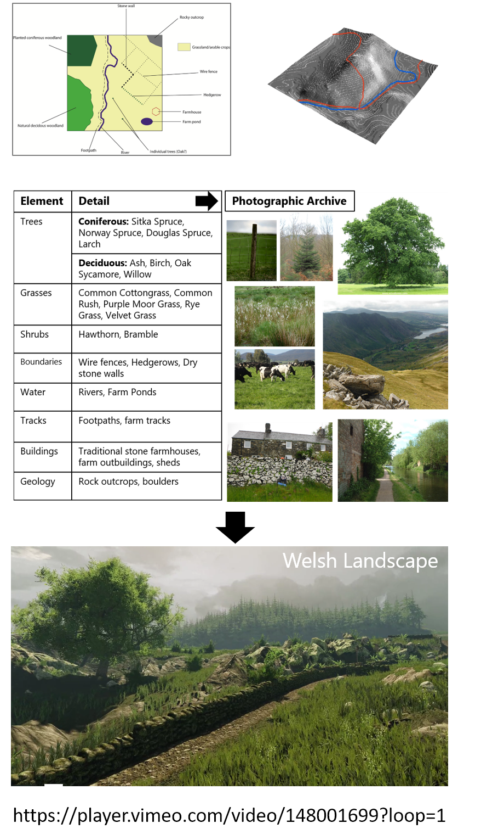
Supplementary Figure 1: The original GIS outline and elevation image shared with the Games Designer as part of the project brief (top) with examples of the photographic archive used to aid construction (middle) and the final Welsh landscape (bottom). Hyperlink to the video flythrough also provided.

Supplementary Figure 2: Individual game landscape features for assessment of visual accuracy. Survey respondents were presented with the image. The component areas are highlighted by a box on screen in which the user clicks once to turn green to like, twice to turn red to dislike, once again to return it to a neutral state. The individual responses are shown in Figure 2h and Table 2 of the main text.
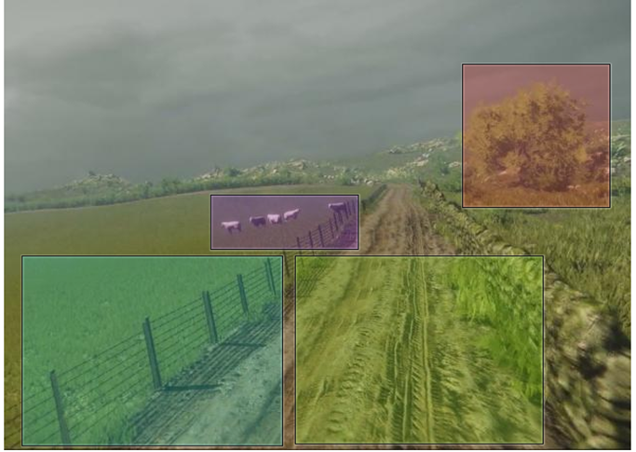
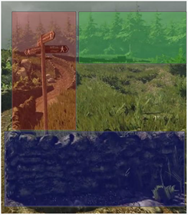
Fence
Muddy Track
Sheep
Deciduous Tree
Conifers
Wall
Signpost

