Presentation to the United Nations Expert Group on Creative Economy
Geneva, Monday October 28th
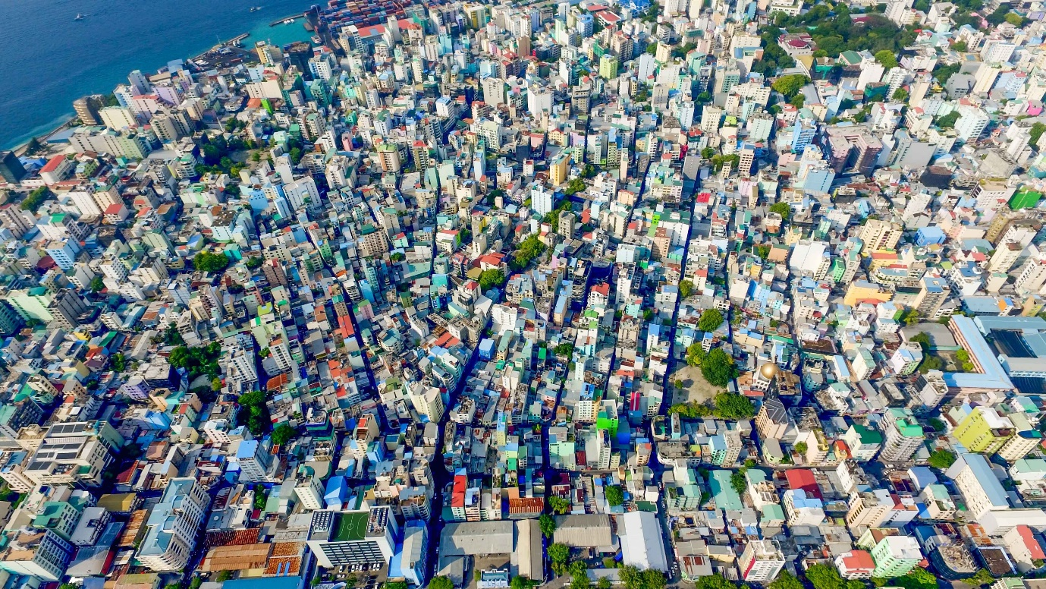
Building Creative Economies
In Small Island Developing States

Peter Rudge
Associate Professor, Staffordshire University
Beyond the Blue Economy
Much of my recent work has been focussed on the development of creative clusters in challenged and developing regions and how those clusters can work to build creative entrepreneurship and innovation. I’ve also been working on how creative and cultural industries can be an important part of how SIDS can look beyond the blue economy, engage a more diverse population and strengthen their economies in the face of increasing political, economic and climate challenges. This work has been done over the last ten years in the Eastern Caribbean region and in the Indian Ocean.
As a creative entrepreneur, an academic and chair of a creative cluster in the UK, I see the opportunities and challenges of the creative economy from a number of different perspectives. The impact and value of the creative economy has exploded in the last 10 years but that growth has been uneven, and no more noticeable than in small island developing states.

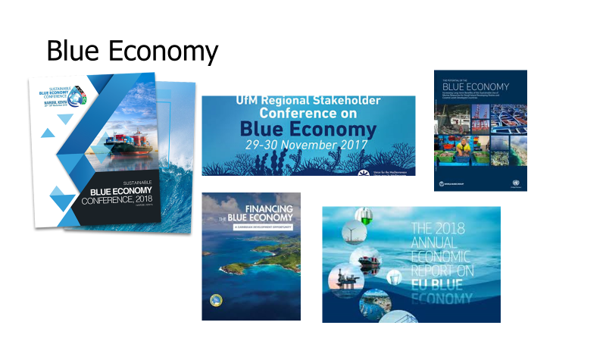
The Blue Economy is the dominant economic model that drives SIDS. Based around the Oceans and the sustainability of tourism and fishing, the majority of research, strategic development and international focus has been on this sector.
That’s because the oceans are its key natural resource. However, a reliance on a vertical model like this makes these small island states vulnerable to shocks - whether that’s economic, political or environmental.
With the pace of economic and environmental change continuing to accelerate it is more important than ever that these island governments develop broader, more resilient and crucially, more innovative, digital-creative economies.
We know that the creative economy has substantial positive impacts on social cohesion, on educational aspiration and achievement, but it is also critical to building a vibrant and sustainable culture of innovation and entrepreneurship.
The impact of digital technology on the creative industries has meant that SIDS now have the opportunity to develop something that seemed impossible just a few years ago.

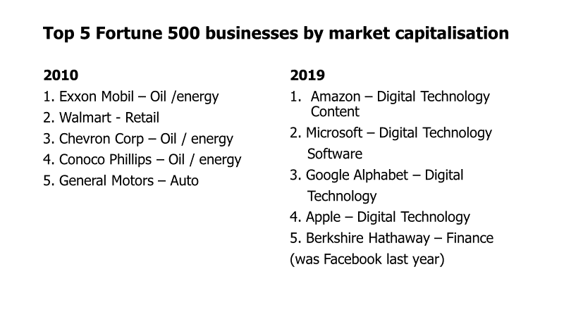

People, knowledge and creativity are replacing physical resources as the dominant driver of economic growth and trade. This is where SIDS can really benefit because if physical resources are no longer a prerequisite for building a globally successful company then these island states can look to their human resource as well as their oceans.
The development of digital creative industries in SIDS regions is largely untapped and small scale but the capabilities of the small nations to grow broader economic bases can really be enhanced by these creative technologies.
It is vitally important that when we look at research, funding, policy and strategic development in SIDS, the creative economy must be central to that process and we have to recognise that the blue economy can only be a part of achieving the SDG’s for these regions.
There is much work to be done around increasing inward investment, educational aspiration and achievement, physical and digital infrastructure and suitable regulatory frameworks in place around IPR.
In SIDS, creative and entrepreneurial education, infrastructure, networks and investment all lag significantly behind more traditional sectors. But if you want to innovate in clean energy, healthcare, education and environmental solutions then build a strong creative economy and capitalise on the substantial creative spillovers into every sector and every part of culture and society.
With the capabilities of digital technology solutions and the platforms and access to market that this offers, there is no reason with young entrepreneurs in SIDS can’t develop innovative solutions, creative content and high value businesses.
The question is how we support that and make it happen.

Access to Finance is linked to entrepreneurial activity
We often talk about the importance of creative SME’s having access to finance, but this access does not automatically solve the problem.
More broadly, and not just restricted to SIDS, there are limited understandings of creative value chains and markets on the part of many business angels, private equity funds and other SME finance providers. Alongside this, there is a lack of understanding from creative entrepreneurs of becoming finance ready and the various stages and options of capital investment.
So education then is needed on both sides.
Understanding of investment and business models on the part of the industry itself. For example, a variety of local TV stations across the region often screen copyrighted material without the correct licenses or payments to producers. This demonstrates an example of insufficient or unenforced Government policy. If local channels can screen copyrighted work with impunity then there is no commercial reason to reinvest back into their own industry and the sector will never grow or become truly sustainable. The ability to move from start-up angel finance to VC or commercial debt scale up then is compromised, as will FDI, if suitable regulatory frameworks are not implemented and enforced around IPR.

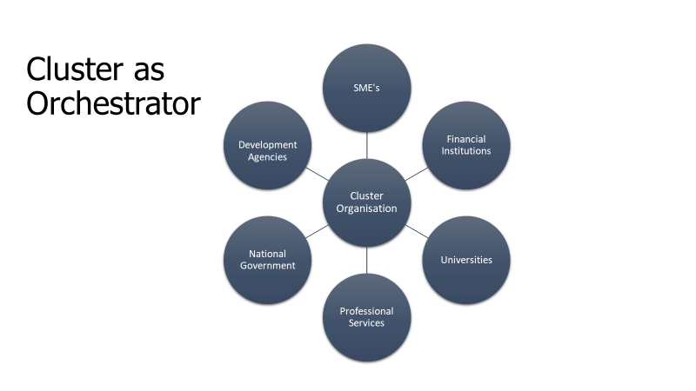
The answer is to return to the idea of clusters. It’s well understood the creative and innovative enterprises thrive best in each others company and much has been written about creative hubs, networks and clusters in cities and major urban centres.
The difficulty for many developing regions and SIDS in particular is often the lack of these networks and hubs, primarily due to dispersed populations and smaller urban centres. Because of this, creative economies have lacked the scale and investment required to become a key part of the economy.
Cluster initiatives can play a central role in making this happen.
Connecting polycentric, small island states and regions such as the Eastern Caribbean, the Indian Ocean and Pacific Islands through the development of cluster initiatives is a way in which creative entrepreneurship can be nurtured and grown.
However, these mechanisms are dominated by the belief that major cities are the natural home of creative clusters and little has been researched or proposed around using clusters as drivers and orchestrators of digital-creative ecosystems in other types of geographies.
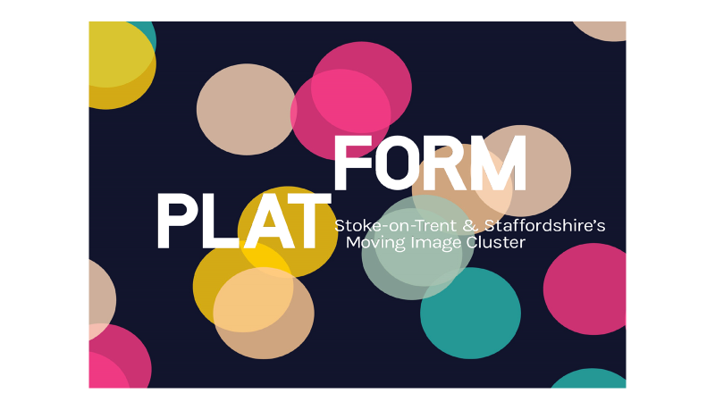
The research and development of Platform, a moving image cluster in the UK that provides a valuable case study for a similar approach for cluster development in SIDS regions.
Platform is based in a small, polycentric city in the North of England, Stoke-on-Trent is made up of six towns, stretched along a linear route in a largely rural region – everything that a cluster should not be.
For Stoke, Platform has provided the vital connectivity and support that creative entrepreneurs need. In two years its seen creative sector employment grow by 34%, company formations grow by 18% and turnover increase by 26%. So it can be done.
What Platform set out to do though was to not just be a network for creative entrepreneurs. For it to be truly successful and effective in its region, it had to be an advocate, a facilitator and crucially a leader of digital creative growth.
So, clusters themselves need to recognise that their activities can no longer just be connecting SME’s through networking events and running a few workshops.
Clusters need to be orchestrating and leading the development of complete ecosystems.
In major cities these ecosystems often work best as organic, self-regulating systems, but in developing regions and small dispersed populations, orchestration and leadership is essential.
Clusters can orchestrate ecosystems of entrepreneurship, start-up, scale up and financial support. They can be the vital link between education, private sector, government and finance.
They do however, need to sector led – so that it is a bottom up and top down approach, not just a top down.

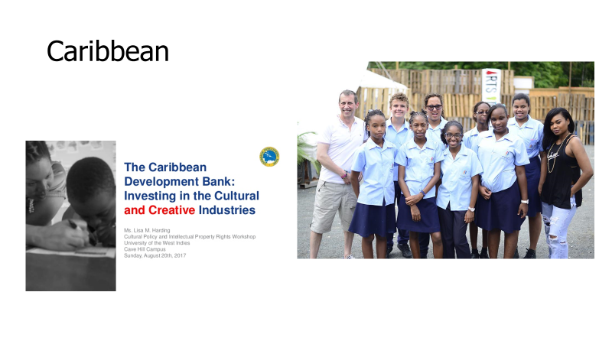
Since 2014 I’ve worked in the Eastern Caribbean developing a screen industry sector and working with the OECS to look at how creative clusters can play a central role in bringing creative entrepreneurs together in the region.
This work is forming the basis of my forthcoming book Beyond the Blue Economy: Clusters, Creative Economies and Sustainable Development in Small Island Developing States to be published by Routledge in 2020.
There is significant potential for developing a strong screen sector – Film, TV, Games Design, VFX, Animation, Immersive Technology. There is considerable but as yet largely untapped talent across the region, but as with the situation globally, development is uneven with considerable differences in capacity.
The step from hobbyist/part time to making a sustainable living is a big one but with investment in moving what is largely an amateur/hobbyist network towards a professional sector. Lack of widely accessible tertiary level education in digital media production at a professional level as well as a lack of professional development opportunities
Networks are fragmented and infrastructure across the value chain is very limited – studios/kit houses/post houses etc
For the Eastern Caribbean, as for developing regions globally, establishing a creative cluster offers a real opportunity to build a strong collaborative voice to balance the more developed, economically stronger islands in the region. The cluster can then orchestrate the connection between education, industry, government and finance to deliver a platform that can foster information and communication exchange across sectors as well as within the cluster, and alongside the sector specific SME’s that will directly benefit from this cluster, there will be a wider impact across the whole regional economy.
It can help attract and retain talent in the region, in partnership with education and business support networks. It can be a driver for innovation in its widest sense and it can deliver a global message that the Caribbean and all the other regions where SIDS exist, can be destinations for innovation, entrepreneurship, investment and creative talent.

