Optical and thermal performance analysis of a micro parabolic trough collector for building integration
Moucun Yangª, M.A. Moghimi^{b}, Yuezhao Zhuª, Runpeng Qiaoª
Yinfeng Wangª, Robert A Taylor^{c,} ∗
a) School of Mechanical and Power Engineering, Nanjing Tech University, Nanjing, China, 30 Puzhu South Rd, Pukou, Nanjing, China, 211816
b) Department of Design and Engineering, Staffordshire University, Stoke-On-Trent ST4 2DE, UK.
c) School of Mechanical and Manufacturing Engineering / School of Photovoltaic and Renewable Energy Engineering, University of New South Wales, Sydney, NSW, Australia, Gate 14, Barker St., Kensington, Sydney, NSW, 2052

Abstract: Medium temperature thermal energy (100-400ºC) is widely used in industrial processes and in large buildings. The presented work investigated the feasibility of a new solar collector which was designed to harvest solar energy from factory rooftops for industrial process heat applications. The proposed solar collector was comprised of parallel micro-parabolic troughs, vacuum tube receivers, and an internal tracking mechanical contained in a glazed box which can be easily mounted on large buildings. The system does not require external rotational tracking and achieves a concentration ratio of ~4.2 in a ~150 mm height, so it can be easily integrated with buildings. The optical performance of the presented collector is analysed and modelled theoretically and numerically, considering the effect of shading, inclination, and orientation. Furthermore, a transient thermodynamic model is developed to calculate its thermal efficiency and stagnation temperature, along with the effect of vacuum pressure, beam radiation, and emissivity of selective coatings. The theoretical analysis, verified by TRNSYS simulations and an outdoor experiment, revealed that the annual optical efficiency of the system was about 66.7% and the thermal efficiency was about 59.3% at 200 ºC, if the collector was inclined to local latitude angle. These results reveal that the proposed design is competitive with evacuated flat plates (i.e., the TVP collector which has a thermal efficiency of ~36% at a normalized temperature difference of 0.2). Further, if the collector were to be installed on the vertical façade of a building, the theoretical model estimated that the optical and thermal efficiencies would be 44.1% and 37.5%, respectively. An economic analysis indicated that a levelized cost of heat energy of 0.51 $/kWh can be obtained. Overall, since the proposed collector has a simple structure and a low-profile, this study indicates it is promising for medium temperature solar thermal heat production for industrial processes and/or for multi-effect absorption chillers.

Keywords: solar energy; micro parabolic trough collector (MPTC); medium temperature; TRNSYS modeling

Nomenclature
A | Area (m²) | B | aperture width of a single trough (mm)
b | interaction coefficient | C | specific heat capacity (J/kg.ºC)
d₀ | distance between two adjacent receivers (mm) | d₁ | distance between side receiver and  frame (mm)
$$d_{gi}$$ | outer absorber diameter (mm) | $$d_{to}$$ | inner glass envelope diameter (mm)
f | Coverage factor | h | convective heat transfer coefficient (W/m².K)
H₁ | collector height (mm) | H₂ | center height of receiver (mm)
I | total solar radiation (W/m²) | I_{b} | solar beam radiation (W/m²)
k | thermal conductivity of air (W/m²K) | K | incident angle modifier
L | length of the troughs (mm) | M | Mass (kg)
n | number of micro parabolic troughs | P | vacuum pressure (Pa)
Pr | Prandtl number | q | radiation energy density (W/m²)
R | concentrating ratio | $$Ra$$ | Rayleigh number
S | Slope of solar collector (º) | T | Temperature (ºC)
t | time (s) | T₀ | Initial temperature (ºC)
U | Expanded uncertainty | u | standard uncertainty
$$\overset{⃑}{v_{in}}$$ | =(x_{in}, y_{in}, z_{in}), normalized incident beam vector | $$\overset{⃑}{v_{c}}$$ | =(x_{c}, y_{c}, z_{c}), normalized collector’s normal vector
x₁ | shading width induced by side of frame (mm) | x₂ | shading width induced by adjacent trough (mm)
x₃ | unshading length (mm)
Greek letters
𝛼 | absorptivity | 𝛽 | tracking angle (or rotary angle) (º)
𝛾 | transmissivity of glass cover | $$ε$$ | emissivity
$$η_{a}$$ | annual optical efficiency | $$η_{d}$$ | daily optical efficiency
$$η_{op}$$ | optical efficiency | η_{t} | transmission efficiency
$$η_{th}$$ | thermal efficiency | 𝜃 | incident angle (º)
𝜃_{l} | longitudinal incident angle (º) | 𝜃_{t} | transversal incident angle (º)
𝜃_{z} | zenith angle (º) | 𝜅_{b} | shading loss factor
$$λ$$ | mean-free-path of a molecule (cm) | 𝜌 | the reflectivity of parabolic mirrors
𝜎 | Stefan-Boltzmann constant (W/m²⋅K⁴)
Subscripts
a | air in the chamber | g | glass cover
g,i | between glass cover and chamber air | g,o | between glass cover and outer air
in | inlet | m | at average temperature
out | outlet | r,g | between receiver and glass cover
s | air out of frame | std | at standard status
t | receiver tubes | t,g | between receiver and glass cover
t,i | between receiver and chamber air | t,w | between receiver and working fluids
w | working fluids

1. Introduction
The thermal energy used in buildings and industry represents about half of the world’s total primary energy consumption [1]. Moreover, more than half of the energy demand for industry is for medium temperature (100-400ºC) thermal energy [2]. Solar energy has become a global priority to replace conventional fossil fuel-based energy conversion technologies in response to worldwide energy and environmental concerns [3, 4]. In sunny locations, a significant fraction of this thermal energy demand could potentially be met with solar energy [5]—energy that is already freely available on factory rooftops. In order to achieve >100ºC temperature in a solar thermal collector, some amount of concentration of the incoming sunlight is typically required [6, 7]. Due to the high energy requirement per square meter of the building’s footprint, rooftop systems must be as space efficient as possible, which limits the use of traditional single and dual access concentrators [8]. Additionally, dynamic wind loading restrictions and installation/operational complexity also preclude the use of parabolic troughs (the dominant technology for providing medium temperature heat) in rooftop-mounted applications [9].
Thus, there is a growing interest to develop rooftop-friendly (e.g. low profile) technologies which can push towards higher temperatures for industrial process heating and for thermal-driven air-conditioning applications to displace fossil fuel inputs [6, 10, 11]. ‘Micro-concentrator’ designs have been proposed in recent years to achieve this aim. These are typically based on: 1) Relatively low concentration parabolic trough collectors (i.e. the design from Rehan et al. [12] and the Polytrough 1200 [1]); or 2) Linear Fresnel reflectors (i.e. the micro-concentrating collector (MCT) [8]); or 3) Compound parabolic concentrators, which can have either symmetrical [13-17] or unsymmetrical [18-20] reflectors to concentrate light from a range of incident angles, up to a critical acceptance angle. As one example, SolarFocus GmbH have commercialized a solar panel with compound parabolic concentrator (CPC) technology for industrial or domestic application [21]. In general, the drawbacks of CPC collectors are: a) the effective operational time during a day is limited by acceptance angle, b) the concentration ratio is limited (and related to the acceptance angle), and c) their concentrating precision is also limited. Furthermore, although some collectors above are referred to as small-scale, they are difficult to integrate with buildings, and can be considered as relatively ‘large’ compared to conventional solar collectors.
As an alternative design, Li [6, 22] and Zheng [23] designed a low-profile solar concentrator with a double lens and CPC reflectors, shown in Fig. 1. Its thickness was only about 130 mm and it could achieve a maximum thermal efficiency of about 47% at 200 ºC. However, its optical efficiency is low at large incident angles.
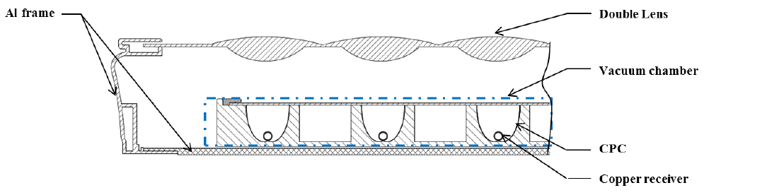
Fig. 1 A low-profile solar concentrating collector designed by Li [22]
A free-tracking, ultra-flat, compact concentrator was presented by Chaves [24]. This design was based on a combination of two stages: upper optics which contain many small CPC structures placed side by side and lower optics which bounce light between a flat mirror and a parabola. Although the final design was indeed very compact, the optical losses might be large due to the number of reflections, depending on the geometry and mirror reflectivity. Karp et al [25] presented an approach to solar concentration where sunlight is collected by lens in a two-dimensional lens array. The light is coupled into a shared, planar waveguide utilizing localized features placed at each individual lens focus. In optimized designs of this type, the optical efficiency can achieve 90% and 82% at 73x and 300x concentration, respectively, in a thickness of less than 10mm. Dhakal et al [26] combined a microlens with a curved light guide and presented a flat solar concentrator design with >39x concentrating ratio.
Biomimetic technology also provides some inspiration for the design of solar concentrators [26, 27]. Inspired by the structure and optical functionality of the ommatidium in the compound eye of insects [26], the ‘moth’s eye’ design had an acceptance angle of up to ±15° and a thickness of only 11 mm. Moreover, the optical concentration ratio can be further increased to 81x through tapering of the geometry, but this will come at the cost of reduced optical efficiency.
In addition, beam steering has been proposed for use with low-concentrator systems to alleviate the need for rotational tracking [28-31]. In these concentrators, solar rays are ‘steered’ (reflected or refracted) from a range of incident angles to the concentration elements. Although this type of concentrator normally has no complicated tracking system, it would require some physical changes in the beam steering component over time to ‘track’ the sun. As such, some technical issues still exist, such as limited tracking time, concentrating precision, and the optical losses of adding yet another component to the collection system.
Overall, it is critical for concentrating solar thermal collectors to integrate with buildings since heat is difficult to transport. In order to do this, the design must strike a balance between the structure, tracking mechanism, and high temperature/efficiency requirements without adding too much cost. Low profile, relatively low concentration ratio solar collectors represent an emerging, and—potentially—cost-effective approach to achieve this balance. Motivated by the authors’ previous attempts to solve these issues, the proposed design combines a simple pinion-rack transmission mechanism and several parallel micro-parabolic troughs. The pinion-rack transmission mechanism enables a large cost savings in terms of materials and assembly as well as precisely tracking, and it should allow a wider acceptance angle than most CPC based designs. Compared with other low-profile solar collectors, the main innovation of the presented collector is that a quite compact parabolic trough collector is designed, in which the focal line of parabolic trough, the pinion axis and the rotary center of parabolic trough are designed to be coincident. With this design, parabolic trough can be driven by rack (or gear) while the tube receiver could be fixed, which leads to a quite simple pipe design and connection (no flexible pipes required) as well as tracking system. Due to that it is an internal tracking system and compact design, it is easy to be integrated with rooftop and façade of buildings. Thus, the main objective of the current study is to numerically investigate such a design for its optical and thermal performance as well as cost analysis with respect to buildings and industrial heat applications.
2. Modelling of the micro, trough-based solar collector
To produce medium-temperature heat while ensuring that the solar collector can integrate with buildings, it is important to achieve concentration in a low-profile. As shown in Fig. 2, the proposed design includes micro-parabolic troughs (labelled ‘1’); a tracking mechanism (consisting of a rack ‘2’ and pinions ‘3’) to track the sun, evacuated tube receivers (labelled ‘4’) to collect solar energy and reduce the heat losses, an outer frame including insulation ‘5’ to support mirrors and tracking mechanism, and a 4-millimeter glass cover ‘6’ to protect mirrors and reduce the heat losses. In fact, a gear mechanism, a parallelogram mechanism, a sprocket mechanism, and a synchronous belt mechanism were also considered for the tracking system. However, it was determined that, of these, the parallelogram mechanism and pinion-and-rack mechanism represent the most robust and compact designs. In choosing between these two choices, a pinion-and-rack design was selected because all components are readily available online suppliers, allowing nearly any design to be constructed without the need for any customized (read: expensive) manufacturing.
In the MPTC, only the tube receivers are evacuated (noting that the corresponding manufacturing technology for evacuated tube receivers is quite mature). The chamber is not evacuated because it is difficult to maintain the vacuum in a non-circular chamber. Therefore, all the moving parts (PTCs, pinion, etc.) in the chamber are accessible for repair and maintenance. Importantly, to simplify the proposed concept, all the focal line, the pinion axis, and the rotary center of parabolic trough are considered coincident. Thus, the parabolic trough is connected to a pinion which rotates around the evacuated tube receivers, driven by a sliding rack. This fixed receiver design represents a significant departure from large-scale parabolic trough tracking, which requires both the trough and the receiver to rotate about an intermediary. It also saves space when integrated onto rooftops.

a)
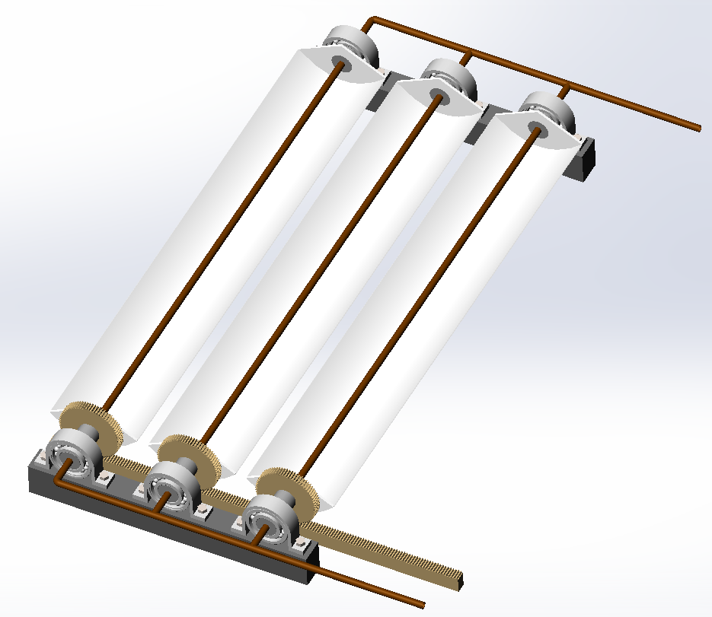
1
2
3
4
b)
Fig. 2 Schematic of the proposed MPTC
a) Section view of the proposed MPTC and b) axonometric view (excluding glass cover and frame)1- Micro-parabolic troughs; 2- Rack; 3- Pinion; 4 - Receivers; 5 – Frame and insulation; 6 - Glass cover
2.1 Optical modelling
Optical performance is of primary importance, particularly in a concentrating solar collector. Some assumptions were made to in the optical model to simplify the analysis. These were similar to those made in similar studies in the literature. For example, Li used a uniform solar flux to modeling optical and thermal performances [32]; Multiple reflections among the absorber, glass tube and reflector, glass thickness were ignored and the change of the reflectivity, transmissivity, and absorptivity were also neglected by Sultana and Liang [33, 34]; Li, Hongn and Yang neglected the geometric, tracking and alignment/installation errors of LFR collector [35-37]. The sun shape also was neglected in other studies [36, 37]. Based on these literatures, the theoretical model can be simplified using the following assumptions:
(1) The parabolic troughs and glass cover are considered as ideal optical components. In other words, those elements assumed to be perfectly manufactured (no geometric errors) with constant optical properties which are independent of operational conditions as well as solar spectrum.
(2) Alignment/installation errors are neglected.
(3) Only the direct normal irradiance (DNI), that is, solar beam radiation is considered (noting that this is conservative since it is possible for some near normal angle diffuse light to make it to the receiver in low concentration systems).
(4) Optical trough-receiver end losses are neglected due to short focal distance with respect to collector length.
With these assumptions, the optical performance of the presented collector is dictated by transmission losses, shading losses, and cosine losses. Therefore, the instantaneous optical efficiency 𝜂_{op} can be expressed as follows.
$η_{op}=η_{t}{(1-κ}_{b})\cos{θ}$ (1)
During transmitting, solar rays pass through glass cover, impinge on parabolic mirrors, and are reflected back from facets and concentrated onto receivers. Since very little of the energy could be internally bounced back and forth between components in such a system, only the direct ray path was considered (e.g. multi-interaction with optical components was neglected). Therefore, transmission efficiency η_{t} can be simply expressed as follows.
η_{t}=𝛾𝜌𝛼_{t} (2)
Shading losses of the collector are generated by either side frame or/and adjacent parabolic troughs (depending on the tracking angle $β$(=𝜃_{t})). Fig. 3a displays a schematic of the collector at ~30 degrees tracking angle. Based on the geometry of the collector, the shading width can be expressed as follows.
a) Front view | b) Axonometric view
Fig. 3 Shading losses of the collector

$x_{1}=(H_{1}-H_{2}+d_{1}tanβ)sinβ+B/2-d_{1}/cosβ$ (3)
$x_{2}=B{-d}_{0}cosβ$ (4)
Note that the shading length is not equal to trough length due to a changing solar altitude angle (see Fig. 3b). In this situation, the unshaded length, x₃, can be calculated by the following equation:
$x_{3}=d_{0}sinβtanθ_{l}$ (5)
The implications of equations (3) and (4) are such that there nearly always exists some shading on the troughs if x₁ or/and x₂ are more than 0. However, if 𝛽 is close to zero, x₁ and x₂ will be zero or even negative, which means no shading but gap between troughs takes place in the collector. Therefore, the shading factor of the presented collector, with several micro-troughs, can be expressed as the following:
$κ_{b}=\frac{x_{1}L+\left(n-1\right)x_{2}(L-x_{3})}{nBL} for x_{1},x_{2}>0$ (6)
We can set x₁ or x₂ to be zero during the calculations if x₁ or x₂ is less than zero in equations (3) and (4). Therefore, $κ_{b}$ could be zero (no shading and no blocking) at noon and the instantaneous optical efficiency at noon could be less than the efficiencies at other time due to the gap between neighbouring troughs.
If the collector is installed on a horizontal rooftop (or the ground), aligned with a north-south axis orientation, the parameters 𝜃, $θ_{l},$ $θ_{t}$ and 𝛽 can be defined as follows:

$cosθ={\overset{⃑}{v_{in}}*\overset{⃑}{v_{c}}=x}_{in}x_{c}+y_{in}y_{c}+z_{in}z_{c}$ (7)
$tanθ_{l}={z_{in}}/{y_{in}}$ (8)
$tanβ=tanθ_{t}={x_{in}}/{y_{in}}$ (9)
where $\overset{⃑}{v_{in}}$=( x_{in}, y_{in}, z_{in}) and $\overset{⃑}{v_{c}}$=( x_{c}, y_{c}, z_{c}) are the normalized incident beam vector and collector’s normal vector, which can be determined according to Yang et al. [37].
Non-tracking collectors are normally installed with a tilt angle, S, facing towards the equator to minimize cosine losses throughout the year. In this condition, according to relative-motion rules, tilting the collector is equivalent to mounting the collector at the equator. Since the proposed collector has a self-contained tracking system, it is possible to tilt it similar to a non-concentration collector, whereby the new solar incident vector can be obtained by modifying the values in equations (7) ~ (9) [37].
The daily and annual average optical efficiency of the proposed MPTC can be calculated, as follows, once the instantaneous optical efficiency 𝜂_{op} has been calculated.
$η_{d,i}=\frac{\int_{t_{1}}^{t_{2}}{η_{op}(t,i)I_{b}(t,i)dt}}{\int_{t_{1}}^{t_{2}}{I_{b}(t,i)dt}}$ (10)
$η_{a}=\frac{\sum_{i=1}^{n_{d}}{{(η}_{d,i}\int_{t_{1}}^{t_{2}}{I_{b}(t,i)dt)}}}{\sum_{i=1}^{n_{d}}{(\int_{t_{1}}^{t_{2}}{I_{b}(t,i)dt)}}}$ (11)
where t is solar time; t₁ and t₂ are the start-up and shut-down times, respectively; n_{d} is day number; and η_{d,i} and η_{a} are the i^{th} daily and annual average optical efficiency, respectively; $I_{b}$(t,i) is the instant direct radiation on the i^{th} day and could be calculated by the equation I_{b}=1367exp(-0.19/cos(θ_{z})) [38].
2.2 Thermal modelling
In solar thermal applications, the overriding design objective is to absorb as much solar energy as possible while minimizing heat loss. Therefore, the thermal losses play an almost equal role to the optical losses, with the combination of the allowing us to determine operation temperatures and overall efficiency of the collector.
A schematic of energy transition flow of one unit of the proposed MPTC is shown in Fig. 4. The incident solar rays (including diffuse radiation) heat up the glass cover, the air in the chamber, the receiver tubes, and the working fluid. As soon as the temperatures of these components reach a higher value than environment, they start to dissipate energy via radiation and convection to the environment.
According to the first law of thermodynamics, the absorbed net energy gain of the glass cover is equal to the sum of the absorbed incident energy and the convective and thermal radiation heat losses. For our situation, the formula can be expressed as follows:
$M_{g}C_{g}\frac{dT_{g}}{dt}=A_{g}Iα_{g}+{A_{t}q}_{r,g}+{A_{g}h}_{g,i}\left(T_{a}-T_{g}\right)-A_{g}σε_{g}\left(T_{g}^{4}-T_{s}^{4}\right)-{A_{g}h}_{g,o}\left(T_{g}-T_{s}\right)$ (12)
Fig. 4 Heat transfer mechanisms in the collector

According to Kalogirou et al. [39], q_{r,g}, radiation energy from receiver tubes can be expressed with the following formula:
$$q_{t,g}=\frac{σ(T_{t}^{4}-T_{g}^{4})}{1/ε_{t}+(1/ε_{g}-1)R}$$
Following the same logic, similar equations can be written for the receiver tube, the air in the non-evacuated chamber, and the working fluid.
$M_{t}C_{t}\frac{dT_{t}}{dt}=η_{op}A_{g}I_{b}-{A_{t}q}_{t,g}-{A_{t}h}_{t,w}(T_{t}-T_{w})-{A_{t}h}_{t,i}(T_{t}-T_{a})$ (13)
$M_{a}C_{a}\frac{dT_{a}}{dt}=A_{g}Iγα_{a}+{A_{t}h}_{t,i}\left(T_{t}-T_{a}\right)-{A_{g}h}_{g,i}\left(T_{a}-T_{g}\right)$ (14)
$M_{w}C_{w}\frac{dT_{w}}{dt}={A_{t}h}_{t,w}(T_{t}-T_{w})$ (15)
Since the chamber is not evacuated, the convective heat transfer coefficient between glass cover and chamber air, h_{g,i}, can be determined according to Raúl Zimmerman [40]. The convective heat transfer coefficient between receiver tube and working fluids h_{t,w} can be determined according to Li et al. [22] and the convective heat transfer coefficient between receiver tube and air in the chamber h_{t,i} depends on the vacuum pressure between receiver tube and glass envelope, which is normally estimated by the following equations[39, 41]:
$h_{t,i}=\frac{k_{std}}{\frac{d_{to}}{2ln⁡({d_{gi}}/{d_{to}})}+bλ\left({d_{to}}/{d_{gi}}+1\right)} for P<0.013Pa$ (16)
$h_{t,i}=\frac{2.425k_{m}{[Pr{Ra}_{d_{to}}/(0.861+Pr)]}^{0.25}}{{[1+{(d_{to}/d_{gi})}^{0.6}]}^{1.25}} for P>0.013Pa$ (17)
In total, there are 4 unknown variables (T_{r}, T_{w}, T_{a}, T_{g}) and 4 differential equations (Eqs. 10-13). Thereby, once all the parameters, such as 𝛼_{a}, I_{b}, h_{t,w}, h_{t,i}, are given, the temperatures can be calculated. Using these, the thermal efficiency can be calculated by the following formula:
$η_{th}=\frac{{\dot{M}}_{w}C_{w}(T_{out}-T_{in})}{A_{g}I_{b}}$ (18)
3. Results and discussion
3.1 Optical analysis
A ray tracing simulation (using NREL’s Soltrace software [42]) was employed in this study to verify the theoretical model. The proposed concentrator was located in Nanjing, China (with a latitude of 31°N) and it is envisioned that a full-scale module would consist of 6 micro parallel parabolic troughs, each of 0.6 meters in length and a width of 0.106 meters. All structural and optical parameters are listed in the Table 1. The collector frame was also included in the SolTrace model to simulate the shading from side frame on troughs.
Table 1 Structural and optical thermodynamic parameters of the collector
Symbol | Value | Unit | Symbol | Value | Unit
B | 0.106 | m | L | 0.6 | m
d₀ | 0.120 | m | n | 6 | -
d₁ | 0.127 | m | 𝛾 | 0.92 | -
H₁ | 0.180 | m | 𝜌 | 0.94 | -
H₂ | 0.105 | m | 𝛼_{t} | 0.92 | -
d_{to} | 0.008 | m | d_{gi} | 0.02 | m
I | 1000 | W/m² | I_{b} | 850 | W/m²
R | 4.2 | -

A sample of the Soltrace simulation results are displayed in Fig. 5, where only a small subset of rays is displayed for clarity. The ray-independence study shows that at >1,000,000 rays, the results are independent of the number of rays. The absorbed power on the receiver tubes is obtained through “power of plotted rays” where the total input power is calculated through total mirror area multiplied by the assumed DNI. Thus, the optical efficiency can be calculated.
Fig. 6 shows the theoretical and simulated optical efficiency results of the collector installed on a flat horizontal ground or rooftop. As indicated, the daily average optical efficiency reaches about 68.7% during summer solstice for DNI while it is about 54.8% at spring or autumn equinox. For the winter solstice, however, it is only about 34.6%, although the collector could be tilted seasonally (rather than a constant tilt) to improve upon these values. Overall, the annual optical efficiency is ~57.1% in the case of mounting the collector on a flat horizontal surface.
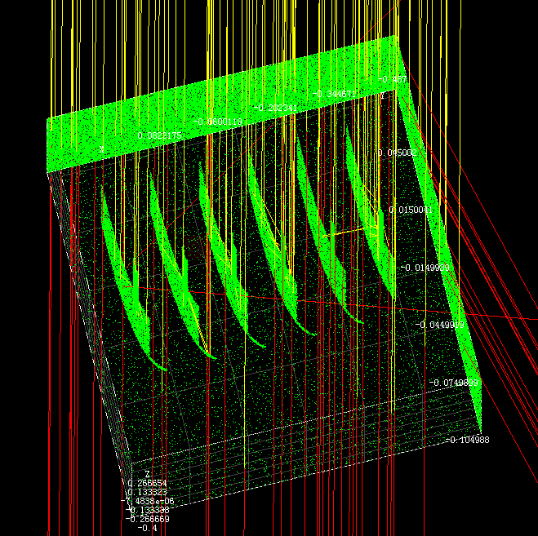
Fig. 5 Soltrace model of the collector (9:00 at spring equinox, only a part of rays are plotted here to make the figure clear)
a) Installed on a horizontal surface | b) Installed on 31º tilting surface
Fig. 6 Theoretical and simulated optical efficiency of the collector

As displayed in Fig. 6a), the theoretical and simulated optical efficiency results are in good agreement. The instantaneous difference between the results are much larger during early morning or winter solstice than any other time and goes up to ~5%. Overall, the difference is small and acceptable, and hence the theoretical model is reliable, but the difference can be attributed to the following:
1) The shading shape caused by an adjacent trough was simplified to a square in the theoretical model, when it should be a trapezoid (see Fig. 3b). In addition, in the early morning and late afternoon (lower sun elevation angles), the angle of the trapezoidal shape becomes more acute, so the difference will be more pronounced.
2) End losses on receiver tubes are neglected in the theoretical analysis, but they are accounted for in the ray tracing simulation.
3) The curve of optical efficiency is not convex but slightly concave during midday. This is caused by the gap between two adjacent mirrors. As the sun rises, the shading width x₂ between two adjacent mirrors will gradually decrease to zero and then a gap between the two adjacent mirrors will form and increase from 0 to maximum (=d₀-B) at noon. It is symmetrical in the afternoon. The gap causes a lower optical efficiency near noon. Therefore, shading (during early morning/late evening) and missing rays (during midday) both reduce the optical efficiency. In comparison, the optical efficiency during midday is much higher than early morning because cosine loss is lower at midday.
As mentioned above, it is normal to improve optical efficiency by tilting a solar collector. As a nominal rule, the best annual performance can be obtained by tilting the collector to an angle equal to the local latitude. Fig. 6 b) shows the optical efficiency at 31º tilting angle (the latitude of the location of interest). This technique clearly improves the optical efficiency of the collector (please compare Fig. 6 a) and b). As observed, this approach boosts the winter solstice optical efficiency and annual optical efficiency is improved about ~26.8% and about 9.6%. Therefore, annual optical efficiency reaches about 66.7%, although the summer solstice optical efficiency drops about 7.8%.
The other advantage of the proposed collector is that it could be implemented on the building façade for harvesting solar energy in the verticals orientation (particularly at higher latitude locations) [43, 44]. To quantify the optical performance of the proposed collector installed on the façade of buildings, cos$(θ)$ is replaced by sin$(θ)$ in equation (1). This was adopted because sin$(θ)$ is the effective component of incident solar beams on façade of buildings in this case. In addition, the direction of receiver tubes is oriented west-east to improve optical efficiency. The theoretical analysis shows that the annual optical efficiency is about 44.1% at latitude of 31°N. It is also interesting that the annual optical efficiency ranges from 40~50% for higher latitude ranges, up to 80°N, which indicates that this type of collector can also be applied on building façade in these locations.
To depict the trend of optical efficiency as a function of solar incident angle, the incident angle modifier (IAM), including the longitudinal and the transversal incident angle modifier, referred as K(𝜃_{t},0) and K(0,𝜃_{l}), is introduced and fitted below and shown in Fig. 7. As can be seen, the longitudinal incident angle modifier K(0,𝜃_{l}) presents a decreasing trend with increasing 𝜃_{l}, while the transversal incident angle modifier K(𝜃_{t},0) increases quickly with smaller 𝜃_{t} (neglecting its sign). This result can be explained by the tracking mechanism which tries to follow the sun position in the transversal direction.
$\left\{\begin{aligned}\begin{aligned}η\left(θ_{t},θ_{l}\right)=η\left(0,0\right)K\left(θ_{t},0\right)K\left(0,θ_{l}\right) \\ η\left(0,0\right)=0.796 \\ K\left(θ_{t},0\right)=1-4.016\cos\left(θ_{t}\right)+5.828\cos^{2}\left(θ_{t}\right)-2.513\cos^{3}\left(θ_{t}\right)\end{aligned} \\ K\left(0,θ_{l}\right)=1+0.406\cos\left(θ_{l}\right)+3.265\cos^{2}\left(θ_{l}\right)-1.398\cos^{3}\left(θ_{l}\right)\end{aligned}\right.$ (19)
Fig. 7 IAM of the presented collector
3.2 Thermal analysis
To demonstrate the thermal characteristics of the proposed MPTC, the differential equations (12) ~ (15) were solved numerically with Matlab, according to the given parameters and initial values in Tables 1 and 2. Note that the mass of working fluid was initially set to 5kg but was changed to obtain different temperature rise rates. Figs. 8 and 9, respectively, show the temperature rise curve versus time and the thermal efficiency versus normalized temperature difference ((T_{out}+T_{in})/2-T₀)/I_{b} for the 31º tilt angle installation as an example. It can be seen that the temperature of air in the chamber and glass cover rises very little while the temperature of receiver tubes and working fluid rises significantly and rapidly and can even exceed 200ºC. That is, the presented solar collector can be applied for harvesting medium-temperature heat. Furthermore, the thermal efficiencies in case of a flat installation and a façade installation were calculated. The results show that at (for a 31º latitude location), a tilt angle of 31º maximizes instantaneous efficiency (up to 59.3%). A horizontal installation (no tilt) was found to provide an efficiency of 50.0% and a façade installation (an equatorial facing 90º tilt) was found to achieve an efficiency of 37.5%. Note that all of these were calculated under the corresponding annual average optical efficiency for outlet temperatures of ~200 ºC (e.g. when the normalized temperature difference is 0.21 and DNI is 850W/m²). In addition, it was assumed that the tube receiver’s selective emissivity was 0.05, which represents a TiNO_{x} selective surface [16]. This result indicates that the proposed design is quite competitive in comparison of the commercialized TVP solar collector which has a ~40% thermal efficiency at 200 ºC [45].
To further explore the potential performance of this collector, a sensitivity analysis of several critical parameters was carried out for the 31º tilt angle installation. The absorptance at short wavelength and emissivity at long wavelength of the receiver’s selective surface are two of the most critical parameters for the collector. Thus, the effect of the emissivity and absorptivity on thermal efficiency was investigated, which is shown in Fig. 9. It is obvious that thermal efficiency, as well as the stagnation temperature, drops quickly with increasing emissivity. For example, the stagnation temperature is 563 ºC and the thermal efficiency is 59.3% at 200 ºC when ε_{t}=0.05, while the stagnation temperature is only 343 ºC and the thermal efficiency is 52.3% at 200 ºC when ε_{t}=0.25. Comparatively, the absorptivity of the receiver affects thermal efficiency almost linearly and the ratio of thermal efficiency equals to the ratio of absorptivity.
The effect of incident angle and tilt angle also was investigated. According to references [46-48], the Nusselt number for heat transfer of the air in the cavity varies very little for low tilt angles (e.g. 0 to 30 degrees) when the Reynolds number is low. In this case, the Nusselt number is less than 10, if Ra<10⁶. Further, even outside this range, if the Nusselt number were to change by more than 50%, its fluctuation will have a negligible effect on thermal efficiency. As evidence of this, Fig. 10 (below) compares the thermal efficiency for different gas heat transfer coefficients, h_{g,i}=1, 3, and 5. It can be observed that the effect of h_{g,i} on thermal efficiency is weak since a 5X change results in only 1-2% change in thermal efficiency. The reason is that receiver tube heat is dominated by radiation and the evacuated tube ensures that only a limited amount of heat is lost from the receiver into the cavity. Based on this reasoning, h_{g,i} was considered as a constant (3 W/m²K) in this study.
Fig. 8 Temperature rise of the collector  (ε_{t}=0.05, 𝛼_{t}=0.92, T₀=20ºC, I=1000, I_{b}=850, P=1.33, η_{op}=66.7%) | Fig. 9 Thermal efficiency with various receiver emissivity and absorptivity  (for different ε_{t}, 𝛼_{t} values, keeping all other parameters identical with Fig. 8)
Fig. 10 Comparison the effect of different h_{g,i} on thermal efficiency
(All parameters are identical with Fig. 8 except h_{g,i})
Table 2. Thermodynamic parameters of the collector
Symbol | Value | Unit | Symbol | Value | Unit
M_{g} | 4.2 | kg | C_{g} | 750 | J/kg.K
M_{a} | 0.08 | kg | C_{a} | 1005 | J/kg.K
M_{t} | 0.33 | kg | C_{t} | 390 | J/kg.K
A_{g} | 0.43 | m² | C_{W} | 2100 | J/kg.K
A_{t} | 0.13 | m² | $$α_{g}$$ | 0.06 | -
$$ε_{g}$$ | 0.85 | - | $$α_{a}$$ | 0.01 | -
$$ε_{t}$$ | 0.05 | - | $$σ$$ | $$5.67×{10}^{-8}$$ | W/m².K⁴
$$h_{g,o}$$ | 11.8 | W/m².K | $$h_{g,i}$$ | 3 | W/m².K
$$k_{std}$$ | 0.0255 | W/m².K | $$h_{t,w}$$ | 70 | W/m².K
T₀ | 20 | ºC | $$k_{m}$$ | 0.0466 | W/m².K

Solar radiation always varies due to stochastic weather conditions and other factors. Such changes could significantly influence the performance of trough solar collectors since only beam radiation (DNI) is utilized in those system. Figs. 11 and 12, respectively, show the effect of beam radiation on thermal efficiency and stagnation temperature. It is obvious that the stagnation temperature drops off quickly with reduced beam radiation while the thermal efficiency increases slightly. Low beam radiation leads to low solar energy density for a given concentration ratio and hence a low collecting temperature. Lower temperature induces less heat loss, which leads to slightly higher thermal efficiency. The total solar radiation has negligible effect on stagnation temperature as well as thermal efficiency if the beam radiation is constant.
Evacuated tubes utilize a high vacuum (i.e. pressures below 100 Pa), which leads to low convective heat transfer coefficient and thus low energy losses. Figs. 11 and 12 also show the effect of vacuum pressure on stagnation temperature and thermal efficiency. As displayed, both the stagnation temperature and thermal efficiency drop with the increasing vacuum pressure. In general, it is easy to keep vacuum pressure in the range of 0.1~1Pa for a standard evacuated tube [49, 50], and therefore thermal efficiency can be kept at a high level.
To depict the trend of thermal efficiency with all the above with an explicit formula, the overall annual thermal efficiency of the proposed collector is fitted to a polynomial below.
$η_{th}= η\left(0,0\right)K\left(θ_{t},0\right)K\left(0,θ_{l}\right)-0.2403T^{*}-0.4048{\left(T^{*}\right)}^{2}$ (20)
where $T^{*}$ is the normalized temperature difference defined by ((T_{out}+T_{in})/2-T₀)/I_{b}.
Fig.11 The effect of beam radiation and vacuum pressure on thermal efficiency  (All parameters are identical with Fig.8 except I_{b} and P) | Fig.12 The effect of beam radiation and vacuum pressure on stagnation temperature (All parameters are identical with Fig.11)
Fig. 13 Comparison of thermal efficiency among several solar collectors

Fig. 13 and Table 3 compares the thermal efficiencies of five solar collectors, including the double lens solar concentrator designed by Li [32], along with CPC-T1 solar collector designed by Tripanagnostopoulos [18] and solar flat plate developed by a Swiss company, TVP Solar SA [45] and the MCT collector [34]. As can be seen in Fig.13, our proposed MPTC achieves higher efficiency at high temperature than any of these collectors. At a normalized temperature difference of 0.2, the efficiency of the proposed collector has a 60.3% efficiency. This compares favourably with Li’s design, which was 47.0% and the TVP collector, which has an efficiency of about 36.7% at this operation condition. Thus, our design represents a relatively more efficient design for medium temperature applications.

Table 3 Comparison of several compact concentrators
Collectors | Collector size | Optical performance | Thermal performance
Double Lens[32] | Thickness:130mm,  Concentrating Ratio:4.8 | η_{op}=77.0% | η_{th}=47.0%  (ΔT/G=0.2)
TVP solar [45] | Thickness:51mm,  Concentrating Ratio:1 | η_{op}=71.2% | η_{th}=36.7%  (ΔT/G=0.2)
CPC-T1 [18] | depth:250mm,  Concentrating Ratio:1.25 | η_{op}=70.7% | η_{th}=32.5%  (ΔT/G=0.1)
MCT [34] | Thickness:316mm,  Concentrating Ratio:20 | η_{op}=62% | η_{th}=44.0%  (ΔT/G=0.2)
Micro-trough | Thickness:150mm,  Concentrating Ratio:4.2 | η_{op}=66.7% | η_{th}=60.3%  (ΔT/G=0.2)
3.3 Validation of the model and annual performance analysis
3.3.1 Experimental performance test
To evaluate the performance of the presented MPTC, a prototype was manufactured according to the structural parameters in Table 1. An outdoor, on-sun, testing platform, as shown in Fig. 14a), was used. This rig included the MPTC, a pump, a flowmeter, valves and an oil tank. As a heat transfer fluid, a synthetic organic oil, Diphyl DT, was used, purchased from Lanxess Deutschland GmbH [51]. Thermocouple (type K) wires were inserted to the inlet and outlet of the collector and connected to a thermocouple module, an AT4508 produced by Changzhou Applent Instruments Ltd., to record the temperature change. The solar irradiation, environmental temperature and wind speed were measured with a meteorological station, a Solys 2 produced by Kipp & Zonen Company. Data was only taken at steady state conditions, according to the standard ISO 9806:2017 [52]. All measured variables and the instruments used in the tests are listed in Table 4. Table 4 also provides the corresponding expanded uncertainties, according to their precision and the standard ISO/IEC Guide 98-3:2008 [53].
Table 4 Measured Variables and Instruments Used
Parameters |  | Instruments | Values |  | Precision | Uncertainty
$${\dot{M}}_{w}$$ |  | Metal tube rotameter  (LZDN15) | 32kg/L |  | 2.5% | U=0.8, k=3
C_{w} |  | - | 2.1kJ/kg.K |  | 1% | U=0.002, k=3
T_{out} |  | Thermocouple  (K-type, φ3mm) | 25℃ |  | ±1% | U=0.25℃, k=3
T_{in} |  | Thermocouple  (K-type, φ3mm) | 20℃ |  | ±1% | U=0.2℃, k=3
I_{b} |  | Meteorological station, Solys 2 | 700W/m² |  | 0.05% | U=0.35, k=3
A_{g} | width | Flexible Ruler | 0.7m |  | 0.001m | U=0.0005, k=3
A_{g} | length | Flexible Ruler | 0.6m |  | 0.001m | U=0.0005, k=3
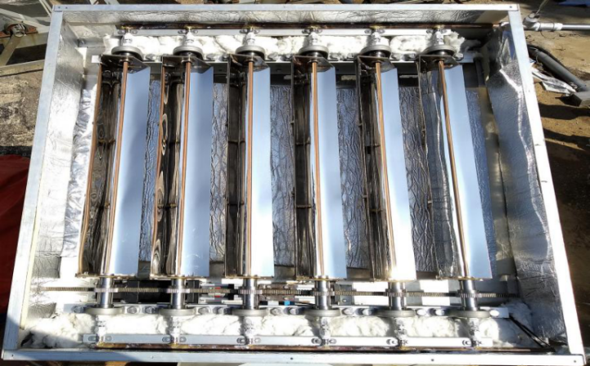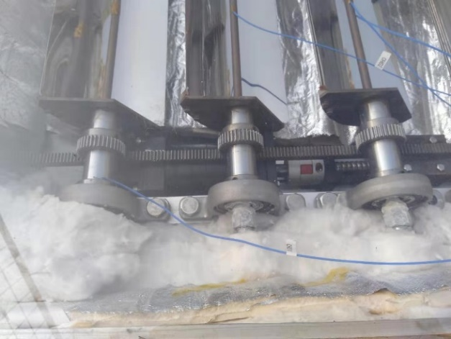
Step motor
Gear reducer
Shaft coupling
Ball screw
Rack
Pinion
Trough
Receiver
a) b)
c) |  |  |  | d)
Fig.14 Test rig and Comparison of thermal efficiencies
a) Image of the micro parabolic trough collector prototype b) Zoomed in view of the tracking components c) Flowchart layout of the MPTC test system d) thermal efficiency comparison (among theoretical, simulated and experimental results).
Note that the vacuum tube receivers were replaced by copper tube due to lack of the commercial vacuum tube with a receiver diameter of 8mm as per the design. In this case, the convective heat transfer coefficient between receiver tube and air in the chamber h_{t,i} is about 22 W/m².K and its emissivity is about 0.15. Thus, Eq. 20 should be replaced by the Eq. 21.
$η_{th}= η\left(0,0\right)K\left(θ_{t},0\right)K\left(0,θ_{l}\right)-1.2407T^{*}-0.5626{\left(T^{*}\right)}^{2}$ (21)
The tests were carried on from 9am to 15pm on 17th April to 10th May and the collector was installed facing south and tilted 31 degrees. According to the collected data, the thermal efficiency can be calculated and fitted by a linear polynomial and also plotted in Fig.14d) based on the standard ISO 9806:2017 [52]. As shown, the theoretical, simulated and experimental results are in good agreement, which validates the proposed theoretical and simulated models.
The average error between the theoretical and simulated results is 7.1% and between the theoretical and exponential results is 8.2%. The error is mainly caused by: 1) the fluctuation of IAM, since a nominal IAM was used in the model, but IAMs in the experiment vary due to the fact that the incidence angle ranged from 0 to 5 degrees; 2) fluctuation of the working conditions, such as change of the solar irradiation (e.g. small changes in the ambient temperature and beam radiation, albeit less than ±50W/m² during each sampling period); 3) the heat losses from frame are not included in the theoretical model while in practice some heat will be lost from frame in spite of the thermal insulation; 4) the precision of thermocouple, optical and thermal properties of the experiments (reflectivity of mirrors, the absorptivity of receiver) have some uncertainty; 5) other uncertainties such as the thermal properties of air in models, which could affect the real value of the convective heat transfer coefficient.
To evaluate the uncertainty of the calculated thermal efficiency, the underlying of each variable important parameter was needed (listed in last Table 4). With these, the uncertainty of the thermal efficiency can be evaluated by using the following propagation of uncertainty equation [53]:
$u\left(η\right)=\sqrt{\sum{{\left(\frac{∂η}{∂x_{i} }u\left(x_{i}\right)\right)}^{2}}}$ (22)
where x_{i} represents the main parameters, ${\dot{M}}_{w}$, C_{w}, T_{out}, T_{in}, I_{b} and A_{g}, and $∂η/∂x_{i}$ represents the sensitivity of each parameter on the overall uncertainty. $x_{i}$ and can be calculated through Eq. 18 and u(x_{i}) represents the standard uncertainty of each variable. Thus, the expanded uncertainty of the thermal efficiency is:
U($η$)=f$u\left(η\right)$=0.02 (23)
where f=2 and the corresponding confidence probability is 95%. This means that, for example, if the calculated thermal efficiency was 31.7%, we have 95% confidence that the efficiency is in the range from 29.7% to 33.7%. According to this evaluated uncertainty of thermal efficiency, the decentrality is quite small, which indicated that the calculated thermal efficiency is reliable.
3.3.2 Annual TRNSYS simulations
According to the optical and the validated thermal performance model determined above, a TRNSYS model was developed to analyse the annual average efficiency of the presented MPTC at a 31º tilt angle (i.e. approximately the same as Nanjing, China and Port Macquarie, Australia). In this TRNSYS model (see Fig.15), the main components included the collector (Type 536), a pump (Type 3b), tanks (Type 4c), daily working hours (Type 14h), temperature monitor (Type 2b), weather data (TMY2), data display (Type 65c). All settings of the TRNSYS model were identical with the above optical and thermal analysis. In order to fix the mass flow and inlet temperature, an open loop system was implemented. Additionally, the mass flow and inlet temperature can be controlled independently in different simulations and the MPTC was compared for a vacuum and a non-vacuum receiver tube (a copper tube). The annual simulation results also are shown in Fig.14b). These simulations revealed that annual efficiency of the presented MPTC with vacuum receiver tube is about 51% at the normalized temperature of 0.2 while it is only 35% with non-vacuum receiver tube (a copper tube). Thus, the vacuum receiver, although it may introduce some extra cost and optical loss is necessary to reduce the heat loss at these temperatures. In addition, the simulated results were compared with the theoretical results and it was found that the difference was quite small, with an average different of about 5.8% and 1.0% with two different receivers.
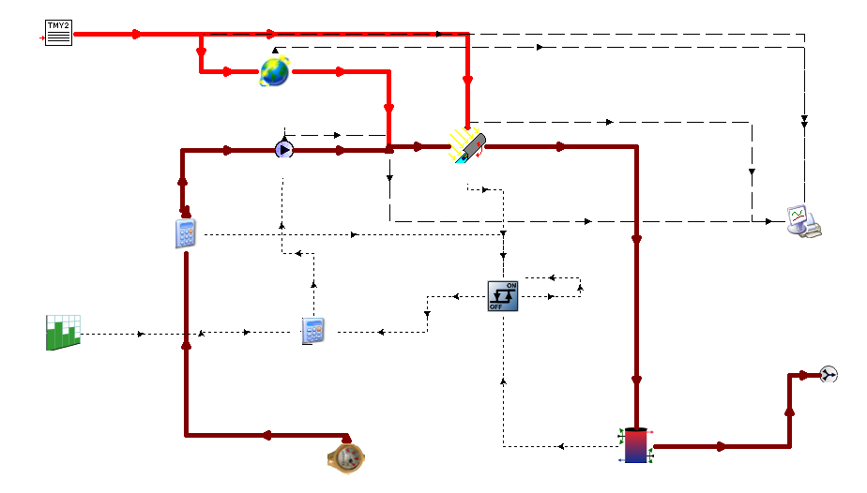
Weather data
Daily working hours
Radiation processor
Oil-in
Oil tank
Oil-out
Data display
Temperature monitor
Trough solar collector
Hydraulic pump start and stop
Flow controller
Pump
a) TRNSYS model of MPTC
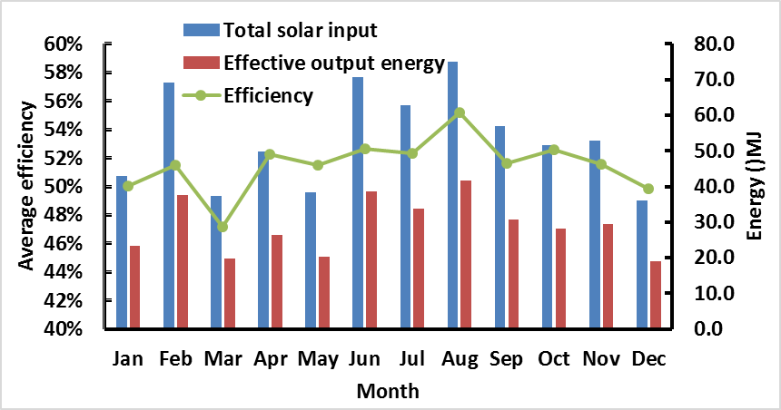
b) Annual analysis
Fig. 15 TRNSYS simulation and annual analysis of MPTC
3.4 Economic analysis
An economic analysis was carried out to further evaluate the feasibility of the presented MPTC. First, the cost of the MPTC test system was estimated according to the cost of each component. It should be noted that the cost is based on single-piece production and material cost. As such, Table 5 lists the estimated cost of each component, the total cost of a 0.43 m² MPTC prototype (i.e. 506.2 US dollars) and the entire system, including the MPTC module, pipes, pump, controller and driver and so on, is about 615.6 US dollars. If trough length is extended to 1.4m, the collecting area of a MPTC module is about 0.86m² and the cost of entire system with 0.86 m² MPTC was estimated to be 726.0 US dollars.
Table 5 Capital cost of the MPTC prototype
Component Cost | Unit | Value | Justifications or notes
Solar tracking module | $/set | 117.1 | Including ball screw [55], motor reducer [56], drive and controller [57, 58]
Collector tubes | $ | 15.6 | Copper pipes (∅8mm) [59]
Collector troughs | $ | 175.3 | Using mirror steel with a thickness of 0.35mm, including the cost of relevant attachments [60]
Frame structure | $ | 98.2 | Aluminum product [61]
Bearings | $ | 12.6 | [62]
Gears | $ | 29.3 | Custom gears, including rack structure [63]
Thermal insulation | $ | 28.1 | Using heating preservation cotton [64]
Auxiliary component | $ | 30.0 | Including bolts, etc. [65]
MPTC cost | $ | 506.2 | Single MPTC module
Pump and controllers | $ | 42.1 | Adjustable flow pump, including valves[66]
Oil tank | $ | 47.7 | 304 stainless steel material (0.25 tonne) [67]
Piping cost |  | 19.6 | 304 stainless steel pipe [68]
System capital cost | $ | 615.6 | The entire system with 0.43m² MPTC
Annual interest rate | - | 4.2% | The benchmark interest rate of the People's Bank of China
Annual maintenance cost | % | 10 | of capital cost
Electricity price | $/kWh | 0.2 | Average industrial electricity price
Annual fuel cost | $ | 2.9 | According to the actual power of this system (6W)
Annual operating cost | $ | 64.5 | Maintenance and fuel costs
Annual energy output | kWh | 210 | 4500MJ/m².a, assumes η_{th_a} ~40%
System lifetime | Year | 20 | General design requirement

Based on the 0.43 m² MPTC cost, a detailed levelized cost of heat energy (LCOH) formula was applied in this system analysis, as given by Eq. 24, which takes into account the capital cost (CC) of the entire system, the annual operating cost (AOC, including maintenance and fuel costs), and the heat energy produced (E_{H}). In this system, the MPTC mainly converts solar energy into heat energy of water, and E_{H} denotes the output of heat energy in kWh.
$LCOH=\frac{CC*CRF+AOC}{E_{H}}$ (24)
The capital recovery factor (CRF) is defined in Eq. (23).
$CRF=\frac{{\left(1+i\right)}^{N}*i}{{\left(1+i\right)}^{N}-1}$ (25)
where i is the average annual interest rate and N represents the lifetime, in number of years, of the system.
According to the data in Table 5, the LCOH can be calculated to be 0.51 $/kWh. This is relatively high compared to natural gas prices (which range from 0.01-0.1 $/kWh around the world [54]). While there is scope to lower the LCOH considerably through mass production, it is comparable to other rooftop concentrators presented in literature (e.g. a double lens collector [6]).
4. Conclusions
In this paper, a new low-profile solar collector design was proposed which uses an array of parallel micro-parabolic troughs mounted in a common collector box. A simple gear mechanism was introduced to track the sun by using a pinion centered at the rotational axis of the parabolic troughs. With this design, the absorber tube is stationary while the parabolic troughs track sun around them inside the box. To analyse the design, optical and thermal models were developed which consider all critical factors, such as geometry, optical properties, tilt angle, and vacuum pressure. In addition, a prototype was built and tested to validate the model. The results show that the presented collector is suitable for medium process heat operation temperatures (>200ºC), while maintaining a high thermal efficiency by using (off-the-shelf) evacuated tubes and selective coatings. By inputting the validated model into TRNSYS, it was found that this design can provide an annual optical efficiency of ~66.7% and a thermal efficiency of 59.3% at 200ºC, if tilted to the latitude (31º in this case). Further, it was found that this design might also be suitable for façade integration on a commercial building since the annual optical and thermal efficiencies of 44.1% and 37.5% were possible if this design is mounted vertically. An economic analysis was also conducted, which determined that a LCOH of 0.51 $/kWh can be obtained with the prototype system. This might be reduced significantly, however, upon mass production. Overall, this low profile collector, with is robust internal tracking mechanism and relatively high efficiency at high temperature, represents a promising alternative to parabolic troughs and evacuated flat plates for building integration (i.e. to drive industrial processes or multi-effect absorption chillers).
Acknowledgments
The project was supported by six talent peaks project in Jiangsu, China (XNY-028), National Key Research and Development Program of China (2018YFB1502905), the National Natural Science Foundation of China (Grant No. 51105192), China Postdoctoral Science Foundation (Grant No.2018M632294), Major projects of natural science research in Jiangsu higher education institutions (Grant No.17KJA470004). R.A.T. would like to acknowledge support from the Australian Research Council (DE1601000131).
References
[1] NEP Solar. NEP Solar PolyTrough 1200: High Efficiency Solar Hear for Process Applications and Solar Cooling. 2011. [cited 2018 August 29th]; Available from: http://www.nep-solar.com/wp-content/uploads/2013/11/NEPSOLAR_PolyTrough1200_Sept2011.pdf
[2] Werner S. Ecoheatcool 2005-2006, work package 4: Possibilities with more district heating in Europe. Brussels: Euroheat and Power; 2006. [cited 2018 August 29th]; Available from: https://www.euroheat. org/wp-content/uploads/2016/02/Ecoheatcool_WP4_Web.pdf
[3] Mostafavi TSS, Taylor RA. Off-design simulation and performance of molten salt cavity receivers in solar tower plants under realistic operational modes and control strategies. Applied Energy, 2016. 179: p. 698-715
[4] Otanicar TP, Theisen S, Norman T, Tyagi H, Taylor R.A. Envisioning advanced solar electricity generation: Parametric studies of CPV/T systems with spectral filtering and high temperature PV. Appl Energy 2015; 140: 224-33. https://doi.org/10.1016/j.apenergy.2014.11.073
[5] Wang YF, Yang L, Wang XY, Chen HJ, Fan HT, Taylor R.A, Zhu YZ. CFD simulation of an intermediate temperature, two-phase loop thermosiphon for use as a linear solar receiver. Appl Energy 2017; 207: 36-44. https://doi.org/10.1016/ j.apenergy.2017.05.168
[6] Li QY, Zheng C, Shirazi A, Mousa O.B, Moscia F, Scott J.A, Taylor R.A. Design and analysis of a medium-temperature, concentrated solar thermal collector for air-conditioning applications. Applied Energy, 2017. 190: p. 1159-1173
[7] Belgasim B, Aldali Y, Abdunnabi MJR, Hashem G, Hossin K. The potential of concentrating solar power (CSP) for electricity generation in Libya. Renew. Sustain. Energy Rev 2018; 90:1-15. https://doi.org/10.1016/ j.rser.2018.03.045
[8] Sultana T, Morrison GL, Rosengarten G. Thermal performance of a novel rooftop solar micro-concentrating collector. Solar Energy 2012; 86(7): 1992-2000. https://doi.org/10.1016/j.solener. 2012.04.002
[9] Fernández-García A, Zarza E, Valenzuela L, Pérez M. Parabolic-trough solar collectors and their applications. Renewable and Sustainable Energy Reviews 2010; 14(7): 1695-1721. https://doi.org/10.1016/j.rser. 2010.03.012
[10] Kalogirou S. The potential of solar industrial process heat applications. Appl Energy 2003; 76(4):337-61. https://doi.org/10.1016/S0306-2619(02)00176-9
[11] Al-Mulali U, Solarin SA, Sheau-Ting L, Ozturk I.. Does moving towards renewable energy causes water and land inefficiency? An empirical investigation. Energy Policy 2016; 93: 303-14. https://doi.org/ 10.1016/j.enpol.2016.03.023
[12] Rehan MA, Ali M, Sheikh NA, Khalil M.S, Chaudhary GQ, Rashid TU, Shehryar M. Experimental performance analysis of low concentration ratio solar parabolic trough collectors with nanofluids in winter conditions. Renewable Energy 2018; 118: 742-51. https://doi.org/10.1016/j.renene.2017.11.062
[13] Rönnelid M, Perers B, Karlsson B. Construction and testing of a large-area CPC-collector and comparison with a flat plate collector. Solar Energy 1996; 57(3):177-84. https://doi.org/10.1016/ S0038-092X(96)00062-X
[14] Buttinger F, Beikircher T, Pröll M, Schölkopf W. Development of a new flat stationary evacuated CPC-collector for process heat applications. Solar Energy 2010; 84(7): 1166-74. https://doi.org/10.1016/ j.solener.2010.03.022
[15] Wang YF, Zhu YZ, Chen HJ, Zhang X, Yang L, Liao CH. Performance analysis of a novel sun-tracking CPC heat pipe evacuated tubular collector. Appl Therm Eng 2015; 87:381-8. https://doi.org/10.1016/j.applthermaleng. 2015.04.045
[16] Gu XG, Taylor R.A, Li QY, Scott J.A, Rosengarten G. Thermal analysis of a micro solar thermal collector designed for methanol reforming. Solar Energy 2015; 113: 189-98. https://doi.org/10.1016/j.solener.2014.12.030
[17] Osório T, Horta P, Collares-Pereiraa M. Method for customized design of a quasi-stationary CPC-type solar collector to minimize the energy cost. Renewable Energy 2019; 133: 1086-98. https://doi.org/10.1016/j.renene.2018.10.110
[18] Tripanagnostopoulos Y, Yianoulis P, Papaefthimiou S. CPC Solar Collectors With Flat Bifacial Absorbers. Solar Energy 2000; 69(3): 191-203. https://doi.org/10.1016/S0038-092X(00)00061-X
[19] Adsten M, Helgesson A, Karlsson B. Evaluation of CPC-collector designs for stand-alone, roof- or wall installation. Solar Energy 2005; 79(6):638-47. https://doi.org/10.1016/j.solener.2005.04.023
[20] Souliotis M, Quinlan P, Smyth M, Tripanagnostopoulos Y, Zacharopoulos A, Ramirez M, Yianoulis P. Heat retaining integrated collector storage solar water heater with asymmetric CPC reflector. Solar Energy 2011; 85(10):2474-87. https://doi.org/10.1016/j.solener. 2011.07.005
[21] SolarFocus. CPC and sunny line collector. [cited 2018 August 29th]; Available from: https://www.solarfocus.com/prospekte/solaranlagen/en/solartechnik-cpc-sunnyline_en_-tedoc_04-02-2016_ansicht.pdf
[22] Li Q, Zheng C, Gu X, Woffenden A, Rosengarten G, Hawkes E. Design and analysis of a low-profile, concentrating solar thermal collector. Conference design and analysis of a low-profile, concentrating solar thermal collector. https://doi.org/ 10.1615/IHTC15.sol.008611
[23] Zheng C, Li Q, Rosengarten G, Hawkes E, Taylor RA. Design and analysis of compact optical concentrators for roof-integrated solar thermal applications. Optics for Solar Energy: Optical Society of America; 2014. p. RTu3B. 2. https://doi.org/10.1364/OSE.2014.RTu3B.2
[24] Chaves J, Collares-Pereira M. Ultra flat ideal concentrators of high concentration. Solar Energy 2000; 69(4):269-81. https://doi.org/10.1016/S0038-092X(00)00106-7
[25] Karp JH, Tremblay EJ, Ford JE. Planar micro-optic solar concentrator. Optic Express 2010; 18:1122-33.https://doi.org/10.1364/OE.18.001122
[26] Dhakal R, Lee J, Kim J. Bio-inspired thin and flat solar concentrator for efficient, wide acceptance angle light collection. Appl Optic 2014; 53(2):306-15. https://doi.org/10.1364/AO.53.000306
[27] Motamedi M, Warkiani ME, Taylor RA. Transparent Surfaces Inspired by Nature. Advanced Optical Materials 2018; 6(14): 1800091. https://doi.org/10.1002/adom.201800091
[28] Liu C, Li L, Wang QH. Liquid prism for beam tracking and steering. Optical Engineering 2012, 114002. https://doi.org/10.1117/1.OE.51.11.114002
[29] Tsai M, Whang A, Lee T, Chen Y. Adjustable Planar Light guide Solar Concentrators with Liquid-prism Structure. In Proceedings of SPIE - The International Society for Optical Engineering 8620, 2013. 12. https://doi.org/10.1117/12.2004017
[30] León N, García H, Ramírez C. Semi-passive Solar Tracking Concentrator. Energy Procedia 2014; 57: 275-284. https://doi.org/10.1016/j.egypro.2014.10.032
[31] Narasimhan V, Jiang D, Park SY. Design and optical analyses of an arrayed microfluidic tunable prism panel for enhancing solar energy collection. Applied Energy 2016; 162: 450-459. https://doi.org/10.1016/j.apenergy.2015.10.051
[32] Li QY, Zheng C, Mesgari S, Hewkuruppu Y.L, Hjerrild N, Crisostomo F, Rosengarten G, Scott J.A, Taylor R.A. Experimental and numerical investigation of volumetric versus surface solar absorbers for a concentrated solar thermal collector. Solar Energy 2016; 136: 349-364. https://doi.org/ 10.1016/j.solener.2016.07.015
[33] Sultana, T. Morrison GL, Taylor R.A, Rosengarten G. TRNSYS Modeling of a Linear Fresnel Concentrating Collector for Solar Cooling and Hot Water Applications. Journal of Solar Energy Engineering, 2015. 137
[34] Liang HB, You SJ, Zhang H. Comparison of three optical models and analysis of geometric parameters for parabolic trough solar collectors. Energy, 2016. 96: p. 37-47
[35] Li M, Xu CM, Ji X, Zhang P, Yu QF. A new study on the end loss effect for parabolic trough solar collectors. Energy, 2015. 82: p. 382-394
[36] Marcos H, Silvana FL, Marcelo G, Martin A. Least square based method for the estimation of the optical end loss of linear Fresnel concentrators. Solar Energy, 2015. 111: p. 264-276
[37] Yang MC, Zhu YZ, Taylor R.A. End losses minimization of linear Fresnel reflectors with a simple, two-axis mechanical tracking system. Energy Convers. Manage 2018; 161: 284-93. https://doi.org/ 10.1016/j.enconman.2018.01.082
[38] Bellos E, Tzivanidis C, Papadopoulos A. Daily, monthly and yearly performance of a linear Fresnel reflector. Solar Energy, 2018. 173: p. 517-529
[39] Kalogirou SA. A detailed thermal model of a parabolic trough collector receiver. Energy 2012; 48(1): 298-306. https://doi.org/10.1016/j.energy.2012.06.023
[40] Zimmerman R, Morrison G, Rosengarten G. A Microsolar Collector for Hydrogen Production by Methanol Reforming. Journal of Solar Energy Engineering-Transactions of the Asme, 2010. 132(1): p. 5.
[41] Forristall R. Heat Transfer Analysis and Modeling of a Parabolic Trough Solar Receiver Implemented in Engineering Equation Solver. 2003. https://doi.org/10.2172/15004820
[42] SolTrace Version 2012.3.28 Help Contents. National Renewable Energy Laboratory. 2012.
[43] Matuska T, Sourek B. Façade solar collectors. Solar Energy 2006; 80(11): 1443-52. https://doi.org/ 10.1016/j.solener.2006.04.006
[44] Visa I, Moldovan M, Comsit M, Neagoe M, Duta A. Facades Integrated Solar-thermal Collectors – Challenges and Solutions. Energy Procedia 2017; 112: 176-85. https://doi.org/10.1016/j.egypro. 2017.03.1080
[45] TVPSolar. MT-Power: Thermal Applications 100°C To 180°C. [cited 2018 August 29th]; Available from: http://www.tvpsolar.com/attach/MT-Power%20Datasheet%20(v4%20SK).pdf
[46] Baïri A. Nusselt–Rayleigh correlations for design of industrial elements: Experimental and numerical investigation of natural convection in tilted square air filled enclosures. Energy Conversion and Management, 2008. 49(4): p. 771-782
[47] Beikircher T, Berger V, Möckl M. Real-Size Experiments on Reverse Natural Air Convection between Inclined Parallel Plates for New Insulation Methods in Solar Flat-Plate Collectors. Journal of Solar Energy Engineering, 2016. 139
[48] Bilgen E, Oztop H. Natural convection heat transfer in partially open inclined square cavities. International Journal of Heat and Mass Transfer, 2005. 48(8): p. 1470-1479
[49] Wang J, Huang XY, Gong GJ, Hao M, Yin F. A systematic study of the residual gas effect on vacuum solar receiver. Energy Convers. Manage 2011; 52(6): 2367-72. https://doi.org/10.1016/j.enconman. 2010.12.043
[50] Espinosa-Rueda G, Navarro Hermoso J.L, Martinez-Sanz N, Gallas-Torreira M. Vacuum evaluation of parabolic trough receiver tubes in a 50 MW concentrated solar power plant. Solar Energy 2016; 139: 36-46. https://doi.org/10.1016/j.solener.2016.09.017
[51] Lanxess Deutschland GmbH. DIPHYL® - heat transfer fluids. [cited 2019 May 8]; Available from: http://advancedindustrialintermediates.com/en/products-applications/applications-aii-brands/diphylr/
[52] ISO, Solar energy — Solar thermal collectors — Test methods. 2017, International Standardization Organization.
[53] ISO/IEC, ISO/IEC Guide 98-3:2008, Uncertainty of measurement-Part 3: Guide to the expression of uncertainty in measurement, MOD. 2008
[54] Natural Gas Price. [cited 2019 17th Oct.]; Available from: https://www.energy.gov.au/sites/default/files/gas-price-trends-review-report-revision2-mar-2017_pdf_5913_kb.pdf.
[55] Ball screw. [cited 2019 30 Sept]; Available from: https://item.taobao.com/item.htm?spm=a230r.1.14.1.119d2031ASiW5T&id=600583775909&ns=1&abbucket=12#detail
[56] Gear reducer. [cited 2019 30, Sept.]; Available from: https://item.taobao.com/item.htm?spm=a230r.1.14.29.7c5251afgb43Qn&id=545530239503&ns=1&abbucket=12#detail
[57] Step motor. [cited 2019 30, Sept]; Available from: https://item.taobao.com/item.htm?spm=a230r. 1.14.1.15b977eakcklQw&id=44311541641&ns=1&abbucket=12#detail
[58] Driver and Controller. [cited 2019 30, Sept]; Available from: https://item.taobao.com/item.htm?spm=a230r.1.14.196.144e69f3OMem8v&id=533749071599&ns=1&abbucket=12#detail
[59] Tube. [cited 2019 30, Sept]; Available from: https://detail.tmall.com/item.htm?spm=a230r.1.14.36.712a1b02JJQc90&id=538782231805&ns=1&abbucket=12&skuId=3220096493316
[60] Mirror. [cited 2019 30, Sept]; Available from: https://item.taobao.com/item.htm?spm=a230r.1.14.16.56a16c39y8qaow&id=527779520844&ns=1&abbucket=12#detail
[61] Frame. [cited 2019 30, Sept]; Available from: https://detail.tmall.com/item.htm?spm=a230r.1.14.1.5cbe7d07VYvB7w&id=43973179466&ns=1&abbucket=12
[62] Bearings. [cited 2019 30, Sept]; Available from: https://item.taobao.com/item.htm?spm=a230r.1.14.21.2c0d2741cbnRCY&id=583681729446&ns=1&abbucket=12#detail
[63] Gears. [cited 2019 30, Sept]; Available from: https://shop110174811.taobao.com/?spm=2013.1.1000126.3.4a283803uOMZao.
[64] Insulation. [cited 2019 30, Sept]; Available from: https://item.taobao.com/item.htm?spm=a230r.1.14.62.518e6f4ce9gKBY&id=596451514771&ns=1&abbucket=12#detail
[65] Auxiliary component. [cited 2019 30, Sept]; Available from: https://item.taobao.com/item.htm?spm=a230r.1.14.1.1508592coMrJiu&id=20136894403&ns=1&abbucket=12#detail.
[66] Pump. [cited 2019 30, Sept]; Available from: https://item.taobao.com/item.htm?spm=a230r.1.14.1.770220d5diT7fQ&id=558071981605&ns=1&abbucket=12#detail.
[67] Oil tank. [cited 2019 30, Sept]; Available from: https://item.taobao.com/item.htm?spm=a230r.1.14.163.804439d59g0bTa&id=564075751975&ns=1&abbucket=12#detail.
[68] Piping. [cited 2019 30, Sept]; Available from: https://detail.tmall.com/item.htm?spm=a230r.1.14.6.2754d46dADVUMA&id=564851303533&cm_id=140105335569ed55e27b&abbucket=12

∗ Corresponding author, Email: robert.taylor@unsw.edu.au

