**Design and Implementation of Myoelectric Controlled Arm**

Tariq M. Younes1, Mohammad A. AlKhedher2, Abdel-Hamid Soliman3, Aiman Al Alawin4

1Al Balqa Applied University, Faculty of Engineering Technology, Mechatronics Engineering Department, [tariqmog@bau.edu.jo](mailto:tariqmog@bau.edu.jo);

2Abu Dhabi University, Mechanical Engineering, [mohammad.alkhedher@adu.ac.ae](mailto:mohammad.alkhedher@adu.ac.ae)

3Staffordshire University, School of Creative Arts and Engineering (Electrical & Electronic Engineering), [a.soliman@staffs.ac.uk](mailto:a.soliman@staffs.ac.uk),

4Al Balqa Applied University, Faculty of Engineering Technology, Mechanical Engineering Department, [t a.alawin@bau.edu.jo](mailto:tariqmog@bau.edu.jo)

**Abstract:** In this paper, a discrimination system, using a neural network for electromyogram (EMG) externally controlled Arm is proposed. In this system, the Artificial Neural Network (ANN) is used to learn the relation between the power spectrum of EMG signal analysed by Fast Fourier Transform (FFT) and the performance desired by handicapped people. The Neural Network can discriminate 4 performances of the EMG signals simultaneously. The digital signal processing was realized using MATLAB and LabVIEW software.

**Keywords:** Electromyogram, Neural network, biosignal, gripping and rotating

**Introduction**

Worldwide, disability is one of the most acute medical and social problems. Recently more than 1.9 million people are living in America without one or more limbs. Thirty percent of these amputees suffer from arm loss. The causes leading to amputation of the arms include military conflicts, road accidents, and industrial injuries, natural disasters and technological disasters, as well as diseases such as obliterating vascular lesions, atherosclerosis, and diabetes. Besides that, there are 50,000 new amputations each year [1]. The loss of an arm means a drastic reduction of live quality for affected people. Almost until the end of the 20th century, all inventions in the field of the prosthetics were mechanical, in some cases, the flexion was manually adjusted. The main problems of mechanical prostheses were the lack of any connection with the body, rigidity, and fragility. The prostheses that replaced the arm or leg could not function as a full-fledged prototype - this is just a surrogate that replaces the active parts of the body but is unable to get closer to the natural counterpart in capabilities. This is the main disadvantage of dentures - their "external" nature and low functionality. All that remains to be done by their owner to use them as an element of the wardrobe, which eventually wears out and becomes unsuitable for further operation. In recent years, in the field of prosthetics, such a direction as "biomechatronics" has appeared, which is a combination of robotics and human nerve cells. To compensate for the lost live quality myoelectric hand prostheses have been developed, that can be controlled by muscle contractions in the patient's stump. Surface Myoelectric signal is still considered as an aid in various aspects of medical and biomedical applications. For example, they are used in the diagnosis of muscle disorders and the study of muscle function as well used to control prosthesis manipulators [2]. Myoelectric control prostheses have received widespread use as devices for individuals with amputations or congenitally deficient upper limbs and many systems are now available commercially to control a single device such as a hand, elbow, and wrist. There have been numerous approaches to interface humans with machines over the last century. Humans emit a variety of complex signals that today's technology can capture, process, and decipher to varying degrees of success [3]. Advances in bioengineering have led to increasingly sophisticated prosthetic devices for the amputees and the paralyzed individuals. The control of such devices requires real-time classification of biosignals, for example, B. electromyographic signals (EMG signals) recorded by intact muscles [4]. It was shown that not only EMG electrodes (that measure the biopotentials of contracting muscles), but also electroencephalography electrodes (EEG) that record the brain activity of the operator can be used as devices that record driving signals from a biological object (prosthesis operator). The choice of method for controlling the prosthesis of the upper limb is largely determined by the sources of useful signals used. For example, mechanical movement of segments of the arm, bioelectric signals of contracting muscles, and also varying impedance (impedance) to the alternating current of contracting muscles can be used as such signals. With the development of computer technology, fundamentally new technologies have appeared that are used in the management of upper limb prostheses: pattern recognition technology, neural networks, Fuzzy logic, and machine learning. The work presents a design and implementation of a prosthetic arm that can be controlled naturally, provide sensory feedback and allows two movement actions. In addition to that, it also focuses on extracting electromyogram (EMG) signals generated during contraction of the biceps. The proposed partial-prosthesis mechanism is controlled by a program.

**Literature review**

In work [5], the author presents an alternative approach in which you can intuitively control four different handles with the MPR and open/close grips and open/close in a multifunctional prosthetic hand. The system was used for five days by a one-sided person with dysmelia, whose arm never developed and yet learned to create patterns of myoelectric activity that are reported to be intuitive to multi-functionally control the prosthetics. The authors collect data for further real-time processing.

The authors in work [6] present prostheses are monitored using surface electromyogram (sEMG) signals obtained from residual muscle tissue on the residual limb of an amputee. In their work, the intuitive control of the multifunctional upper-limb prosthesis achieved using pattern recognition (PR) sEMG.

The article [7], introduces an anthropomorphic hand prosthesis with flexure joints that are controlled by surface electromyography (sEMG) by only 2 electrodes. The myoelectric control system, which can classify 8 gripping hand movements, is being built. The pattern recognition is used when the mean absolute value (MAV), the variance (VAR), the fourth-order autoregressive coefficient (AR), and the sample entropy (SE) are selected as the optimal feature set and the linear discriminant analysis (LDA) is used for the reduction Dimension.

In their article [8], the authors introduce a fully integrated preinstalled artificial arm equipped with a human-machine feedback system. The artificial arm consists of five fingers. Hand driven by six DC motors, one per finger and one thumb. The motor is in the hand area and the sensors are distributed over the whole housing. The integrated control system is a subsystem and a sensory subsystem. The motion control subsystem is a critical factor as a sensory subsystem for the patient. The controllability is achieved by using several types of sensors.

The aim of work [9] is to design and construct a prosthesis that is strong and reliable and at the same time provides control over the exerted force. The design had to take into account the reliability and size of the mechanical and electrical design These objectives were achieved through the use of EMG in the electrical control system and a linear motion approach in Mechanics.

The literature review shows that the developed system characterized by the complexity of design and implementation. On the other hand, the literature review emphasizes that the problem of controlling prostheses is still one of the most important issues.

**Theoretical background**

Over the centuries, the design of upper limb prostheses has changed depending on the level of existing technology. The first wooden and iron prostheses appeared before our era. Over time, prostheses began to include mechanical elements: ratchet mechanisms, systems of levers, rods, joints, springs, and gears appeared. This led to the ability to control the grip and opening of the hand, as well as the use of working prostheses (auxiliary tools that enable operators to engage in physical labor). However, despite significant advances, in the mechanics of such prostheses had some fundamental shortcomings. The grip force depended solely on the spring force, which was very limited. Another drawback was that the effort being made in the prosthesis was too small [10].

In the middle of the XX century. upper limb prostheses with an external energy source appeared. During this period, pneumatic actuators were widely used as executive engines, but several years later electric motors took their place. With the development of microcontroller technology, a new element base has arisen, and prostheses have become an electromechanical control system, which includes master devices and controllers that implement algorithms and methods of control [11]. The idea of one of the first bioelectrically controlled prostheses working with an external energy source in case of amputation at the brush level was to control the electromechanical brush using biopotentials removed from the skin in the area of the projection of the abdomen of the contracting muscle. The signals are picked up by surface electromyography (EMG) electrodes from two groups of stump muscles (flexors and extensors) and are fed through amplifiers to the control system of the electromechanical brush [12]. Not only EMG electrodes that measure the biopotentials of contracting muscles, but also electroencephalography electrodes (EEG) that record the brain activity of the operator can be used as devices that record driving signals from a biological object (prosthesis operator). The methods used to control prostheses are based on common fundamental principles: open control (without feedback); feedback (closed-loop); compensation method. The choice of method for controlling the prosthesis of the upper limb is largely determined by the sources of useful signals used. For example, mechanical movement of arm segments, bioelectric signals of contracting muscles, as well as a variable impedance (impedance) to the alternating current of the contracting muscle [13].

In humans, the system of movements consists of the systems of the brain, nervous system, and muscle units. To create movement, the brain releases pulse signals. The signal is then sent through the nervous system. The muscle unit that is stimulated by the impulse of the nervous system, then squeezed and causes movement. When using a prosthesis, an electromyographic signal (EMG) is used to send a command to develop two types of actions: rotation or capture.

A transformation of the scanned signal into a certain amount of grip or rotating types for prosthesis requires the same amount of unique signal patterns. The major problem using myoelectric signal patterns is the patients' deficiency to contract more than two muscles independently. Additionally, the EMG-signal is no pure signal of one specific muscle but contains information about all contracted muscle fibers in the range of the sensor. Thus, signal quality is reduced drastically and the success of discrimination of different signal patterns decreases. Several groups made promising attempts to increase the corresponding classification rate via preprocessing or sophisticated classification algorithms [14, 15], however, no control using more than two to three movements is commercially available. In this work, two states of movement are considered: rotating and gripping. Starting in a neutral state (prosthesis opened, and no rotation action is applied) the user may generate two switching signals depending on the intensity of the muscle contraction and the time of activation.

**Methodology**

When the fibers extend along the length of the muscle, the extracellular field potential is evoked. The typical amplitude of EMG ranges from 20-2000μV, depending on the size of the motor unit and the position of the electrode. The EMG signals generated from a contracting muscle for and detected by EMG electrodes are first to send to the instrumentation amplifier, the bandpass filter, and the rectifier circuits. Following amplification, filtering, and rectification the resulting signals are used for extracting features and consequently providing a control signal to control the movement of the prosthetic arm. The block diagram of the system is shown in Fig 1.

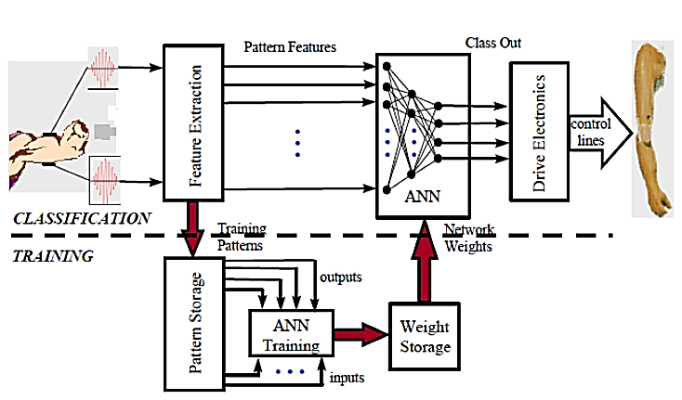

Fig 1. Block diagram illustrates the main stages of myoelectric arm

Several signs of progress in biomechatronics technology bring a lot of benefits to increase the mobility of the amputee in their daily life activities. A prosthetic arm, for example, is used to compensate for the lost functions of the amputee's absent arm. The importance of this project stems from the local.

The development of such products is required high levels of controllability and signal conditioning and processing in the local market. The project will be accomplished such as to minimize the discrepancy between the amputee's expectations and reality. This will be achieved by designing a prosthetic arm that has a sufficient number of degrees of freedom that result in a natural human-like arm motion while performing a daily life task.

The goal of this article is to design and develop a prototype of prosthetic arm that can be controlled naturally, provide sensory feedback and allows some degrees of freedom.

The prosthetic arm is to be perceived as an incentive that would encourage learning and to help advance current technology, with these specific goals:

1. To develop a fully integrated prosthetic arm that can be used to compensate for the lost functions of the amputee's absent arm. The project offers a task that requires controllability and high level of signal conditioning and processing.

2. Getting involved in building integrated systems such as a prosthetic arm. Developing a prosthetic arm offers a unique educational exercise that provides experience in physics, mechanics, hardware, .and, teamwork.

**T**he human body contains 650 muscles which represent 40% of the total weight of the body. Small electrical currents are generated by muscle fibers before the production of muscle force. These currents are generated by the exchange of ions across muscle fiber membranes, a part of the signaling process for the muscle fibers to contract. The signal is called the electromyogram (EMG) and can be measured by applying electrodes to the skin surface, or invasively within the muscle. Figure2. shows an EMG signal obtained by placing surface EMG electrodes on normal person skin.

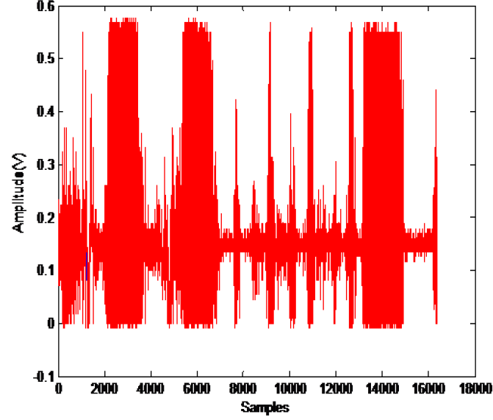

Fig 2. EMG signal obtained from muscle

The EMG signal in a fiber muscle is stochastic. Normally, it shows the intensity of muscle contraction and the time of activation.

The main characteristics of the EMG signal are:

• Frequency is between 0 to 2000Hz, but the dominant energy is concentrated in the range of 50 to 500Hz.

• Amplitude is between 0 and 10 mV.

• Noise Affectation is a common problem.

There are several types of electrodes used for the collection of EMG data, including wire needle, and surface electrodes. Wire needle electrodes are useful for accessing individual motor units and muscles that are in deeper layers under the skin. Surface electrodes, on the other hand, are extremely low risk to the subject and require a little training to use properly also are the most suitable for assessing the time force relationship of EMG signals and interfacing an individual with a biomechanical device.

To minimize the impedance between the electrode-skin contacts it is recommended that the skin surface be shaved of any hair and dead skin cells at the target location. Dry shaving works well for removing the dead skin cells. Once shaved, the skin should be cleaned with alcohol and allowed to dry before the electrode is placed [2].

After reading the electrical signals from the contracting muscles (EMG signals) using the surface EMG electrodes shown in Figure (2), the signal has an amplitude of about (0-10 mV) and contains noise from the AC supplies (50-60Hz), this means processing is a must before the control phase. Many steps should be done to prepare the EMG signal; amplification using instrumentation amplifier, filtering by a pass-band filter (50-500Hz), and rectification.

**System design and development**

*Development of the preprocessing phase and Data acquisition system*

The preprocessing phase is given in Figure (3). This schematic diagram consists of amplification, filtration and rectification elements that are used to filter the EMG signal from the noises affecting it.

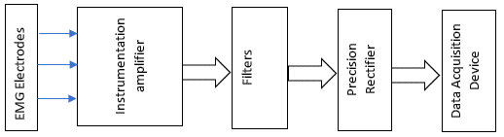

Fig. 3. the block diagram of the preprocessing phase of the EMG signal and data acquisition system

Because of the sensitivity of EMG signal to the surrounding effects, it is very important to use PCB processing circuit, this shown in following Fig.4.



Fig 4. PCB processing circuit

The experimental setup of the developed arm is shown in figure 5**.**



Fig. 5. The experimental setup

*Development of Mechanical system*

The mechanical implementation was concerned locating the motors in the right position in the myoelectric arm. There are two motors (servo and Stepper) control the gripping and rotating of Myoelectric arm, where the gripping motor has been calibrated to give a fully opening action and optimum closed action through the mechanical design of the gripper, it has been located after about 20 cm from the wrist and connected with ring gear and shaft to pull up the cable that connected with gripper where the shaft will rotate about 160 degrees while the total stroke for the cable is about 5.1 cm to achieve fully open gripper.

Rotating motor has been putting in the shaft of a myoelectric arm and calibrated to rotate 90-degree CCW using time principle, and then it will be reverse its direction to return to the initial position. Figure (6) shows the final mechanical design system of a myoelectric arm.

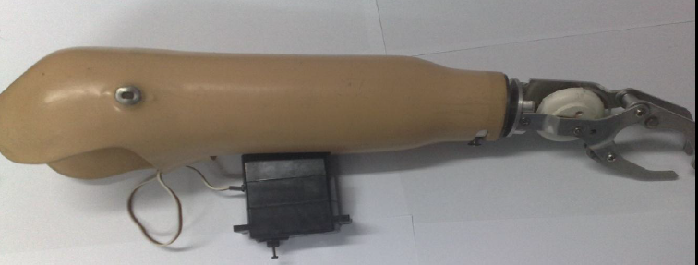

Fig. 6 final mechanical system of myoelectric arm

**5.EMG FEATURE EXTRACTION AND CLASSIFICATION**

*EMG Signal Classifications for Human-Computer Interaction*

With the increasing role of computerized machines in society, the Human-Computer Interaction (HCI) system is becoming an increasingly important part of our daily lives. HCI defines the effective use of the accessible information flow of computing, communication and display technologies. In recent years, there has been a huge interest in introducing intuitive interfaces that can recognize the movements of the user's body and translate them into machine instructions. For neural communication with computers, various biomedical signals (biosignals) can be used, which can be obtained from specialized tissue, organ, or cellular systems, such as the nervous system. For example, an electromyogram (EMG) signal.

With the EMG feature extraction process, you can highlight the main features of the signal to distinguish more than one degree of freedom from a muscle, such as a muscle. B. detection and rotation. The feature extraction reduces the dimension of the EMG signal suitable for the control system. The feature extraction can be applied both in the time domain and in the frequency domain. Time-domain objects are usually calculated quickly because they do not need to be converted. For example, mean (MAV), wavelength (WL), Willison amplitude (WAMP), and variance (VAR), which are discussed later.

A function in the frequency domain contains more useful information than a function in the time domain, which requires a transformation that slows down the system [16].

The first task is to detect the beginning of the movement. Due to the stochastic properties of the surface electromyogram, detecting the onset is a difficult task, especially when the surface response of the EMG is weak [17].

The algorithm we used for this task is the segmentation of the EMG signal. Each segment contains 40 readings (48.88 ms) of 0.001222 seconds for each EMG reading. Calculate Willison's amplitude for this segment and compare it with a predefined

Willison amplitude: If the amplitude of the Willison segment is greater than the predetermined amplitude of Willison, an EMG signal will be detected, otherwise it will be noise. The next section explains the Willison amplitude criteria [18].

**T**he value of the threshold is determined using the following equation

Threshold=mean (noise) +3*std (noise) (1)

Where:

std: standard deviation of the EMG signal.

Mean: mean absolute value of the noise 100 reading.

In the feature extraction, we take windows of the EMG signal each window contains 1440 readings when the signal is detected.

The Mean Absolute Value (MAV), as the name suggests, is calculated by taking the average of the absolute value of all-time samples. The equation is given here

(2)



Where N is the number of readings in each window.

Fig. 7. shows the mean absolute value of the EMG signal where the signal is parting to windows each part contains 40 readings, and the mean absolute value is calculated for each part.

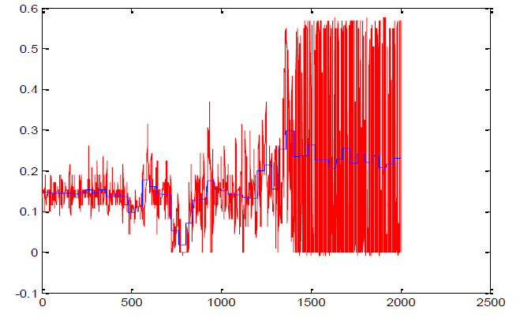

Fig 7. EMG signal and the mean absolute value of each window

The number of counts for each change of the EMG signal amplitude that exceeds a predefined threshold is called Willison Amplitude [19]. It is given by

(3)



With f (x) = 1 if x > threshold, 0 otherwise. This unit is an indicator of the firing of motor unit Action potentials (MUAP) and, therefore, an indication of muscle contraction level [9].

The EMG signal was modeled as amplitude modulated Gaussian noise whose variance is related to the force developed by the muscle, a variance (or second-order moment) of the EMG is a measure of its power, and it is given by

(4)



The waveform is the cumulative length of the waveform over the time segment. It is defined as

(5)



Where ΔXk= Xk - Xk-1. , is parameter gives a measure of waveform amplitude, frequency, and duration all in one.

There are several possible classification techniques [17-19]. Among them; the most used are artificial neural networks. Recently, some authors have tried to use a fuzzy classifier, but other authors reported that with the appropriate representation of the signal, a linear classifier performs better than a nonlinear one.

The classification task includes linear discriminant analysis (LDA) classifier and multilayer perceptron (MLP) classifier. LDA and the MLP are easy to implement and are representatives of statistical and neural classifiers respectively, which were well understood [20].

Pattern classifiers with adaptability are desired in this application because of the nature of EMG signals. As we introduced in the feature extraction part there are many factors influencing the acquisition of the EMG signals: Mean absolute value, Wilson amplitude, waveform length, and variances features are expected for different individuals. Similarly, there can be differences in EMG signals of a single person measured at different times. The patterns might be completely altered for different individuals, while for one individual the changes upon a time might be some "shifting", "increasing" or "growing" of the patterns. The classifiers need to be able to deal with these differences and variances while maintaining a certain level of stability.

The recognition system of EMG patterns consists of three stages, all these stages are explained Firstly, time-series data for EMG is measured by electrodes in the input part and then processed by filtration, amplification and amplitude rectification. The second stage is the EMG feature identification based on MLP-NN. The input data to the ANN are taken to have a dimension (P×I). The length of I represents the number of inputs to NN, which denotes the number of features that used for moving the human arm. The length of P represents the number of samples used in training the NN. The NN training algorithm, which is used in this stage, is MLP-NN (Fig. 8).

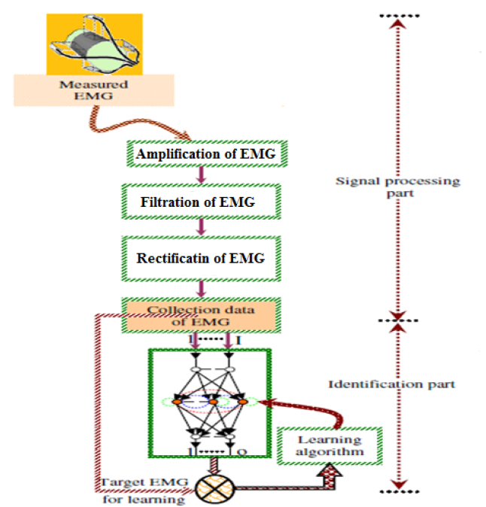

Fig. 8. Flow chart for Processing EMG Signal and Identification of NN.

The identification system depends on the reliability of the measured signal. If the obtained signal from the muscle by using directly surface electrode as a measurement source is unknown data, it must be classified as an EMG signal for the human. This purpose is fulfilled by taking many different EMG signal lengths from different muscles of the human arm. The third stage is the movement's recognition system. At this stage, an EMG signal features will be considered and processed in the same way of the first stage. The NN, which is used in this stage, is considered from the learned NN in the second stage. The processed features of EMG signal in this stage are taken as the input to NN in the forward path only and the output of this NN is compared by a microcontroller to decide about human arm movement as shown in Fig. 9.

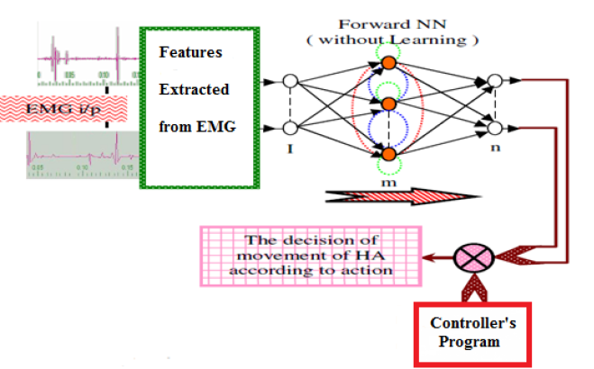

Fig 9. Block Diagram of testing Recognition Processing

*Training procedure*

The training process was implemented offline by taking many examples of the EMG signal which the user trained to produce. The user generates a long signal when he wants to rotate the arm, and generates a short signal when he want to gripe something by his arm as shown in the fig. 10 below.

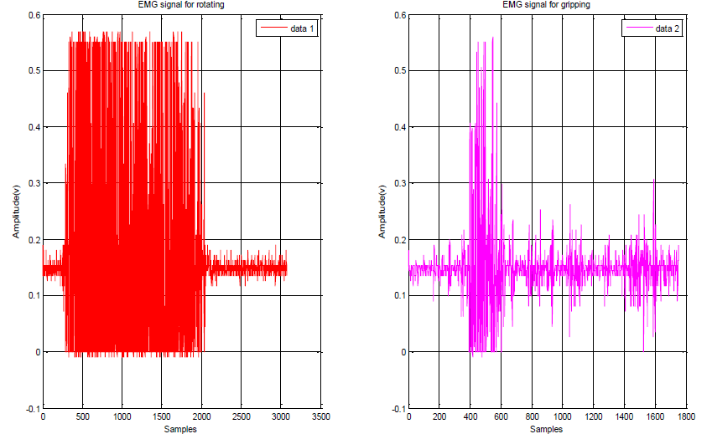

Fig. 10. the left figure showing the signal produced by the user for rotating and the right figure showing the signal produced for gripping

The feature vector of each window of the EMG signal represents the input vector of the neural network feature vector (Mean Willison Amplitude Variance Waveform Length). Table I shows the minimum and maximum values of each feature.

Table 1. Features Values

|  |  |  |
| --- | --- | --- |
| feature | Min value | Max value |
| Mean absolute value | 0.1499 | 0.2067 |
| Waveform length | 15.4581 | 175.552 |
| Willison amplitude | 26.000 | 568 |
| Variance | 0.0032 | 0.0476 |

The target vector is built by calculating the Willison amplitude of each window if the Willison amplitude is greater than 5 and less than 200 then the target=1 “gripping” and if the Willison is greater than 200 then the target=2 “rotating”.

the neural network will generate the output vector "Y" and its values [1, 2]

the error is calculated using the following equation

(6)



Where:

T- target vector

Y- the output of the neural network

**Conclusion**

In this paper, the design and implementation of a myoelectric arm is presented. Feature extraction of EMG signal is developed using a neural network. According to the peak detection the extracted feature is used to control the motion of the arm.

**Acknowledgement**

This work has been carried out during the academic year 2018-201. I’d like to thank Al-Balqa Applied University Abu Dhabi University for their support and Staffordshire University for their logistic aid.

**Author’s Contributions**

Dr. Tariq Younes participated in all experiments, coordinated the circuit design and data acquisition system via Labview , Dr. Mohammad A. AlKhedher designed the research plan and organized the study. Dr. Abdel-Hamid Soliman provided data-analysis and contributed to the writing of the manuscript, Dr. Aiman Al-Alawin designed the mechanical system of myoelectric arm.

**Ethics**

This article is original. Authors declare that are not ethical issues that may arise after the publication of this manuscript.

***REFERENCES***

1. Kulley, Marlow. Hand Prosthesis Statistics‖ Apr 03 http://biomed.brown.edu/Courses/BI108/BI108_2003_Groups/Hand_Prosthetics/stats.html Accessed Mar 1, 2008

2. Silcox, D.H., Rooks, M.D. et. al., “Myoelectric Prostheses”, The Journal of Joint and Bone Surgery 75A(12), 1781-1791, 1993.

3. B. Hudgins, K. Englehart, P. Parker, and R. Scott, "A microprocessor-based multifunction Myoelectric control system, "23rd Canadian Medical and Biological Engineering Society

Conference, Toronto, May 1997.

4. Mohammad A. Al-Khedher, Tariq M. Younes and Mohammad A.K. Alia, Thermo-Acoustic Water Analyzer in Hydrocarbon Emulsions with Kalman Filter, *American Journal of Applied Sciences,* Volume 9, Issue 5, Pages 717-723

5. Enzo Mastinu, Johan Ahlberg, Eva Lendaro, Liselotte Hermansson, Bo Håkansson, Max Ortiz-Catalan, An Alternative Myoelectric Pattern Recognition Approach for the Control of Hand Prostheses: A Case Study of Use in Daily Life by a Dysmelia Subject IEEE J Transl Eng Health Med. 2018; 6: 2600112. Published online 2018 Mar 12. doi: 10.1109/JTEHM.2018.2811458 PMCID:  PMC5881457

6. Nisheena V. Iqbal,Kamalraj Subramaniam,Shaniba Asmi P., Review Article A Review on Upper-Limb Myoelectric Prosthetic Control, Journal IETE Journal of Research,Volume 64, 2018 - Issue 6

7. Nianfeng Wang, Kunyi Lao, Xianmin Zhang, Design and Myoelectric Control of an Anthropomorphic Prosthetic Hand, Journal of Bionic Engineering Volume 14, Issue 1, January 2017, Pages 47-59

8. Tariq M. Younes, Computer-Based Acoustic Detector for Determining the Type and Concentration of a Solution, Journal of Applied Research and Technology, Vol. 10, December 2012

9. Chandrashekhar P. Shinde, DESIGN OF MYOELECTRIC PROSTHETIC ARM, International Journal of Advanced Science, Engineering and Technology, Vol 1, Issue 1, 2012, pp 21-25

10. González-Fernández M, Development of upper limb prostheses: current progress and areas for growth, Arch Phys Med Rehabil. 2014 Jun;95(6):1013-4. doi: 10.1016/j.apmr.2013.11.021. Epub 2013 11. Lake C, Dodson R.,Progressive upper limb prosthetics,Phys Med Rehabil Clin N Am. 2006 Feb;17(1):49-72. Dec 18.

12. Paul F. Pasquina, and others, Recent advances in bioelectric prostheses,Neurol Clin Pract. 2015 Apr; 5(2): 164–170, doi: 10.1212/CPJ.0000000000000132

13. Aimee Cloutier,James Yang ,CONTROL OF HAND PROSTHESES- A LITERATURE REVIEW, Proceedings of the ASME 2013 International Design Engineering Technical Conferences and Computers and Information in Engineering Conference IDETC/CIE 2013 August 4-7, 2013, Portland, Oregon, USA

14. Jingzhou Yang, Karim Abdel-Malek, Jason Potratz, (2005) "Design and prototyping of an active hand prosthetic device", Industrial Robot: An International Journal, Vol. 32 Iss: 1, pp.71 – 78.

15. Davalli, A., Sacchetti R., and Schmidl H., “Multifunctional Prosthetic-Robotics Systems. When?” Proc. of the IEEE Int. Conf. on Sys., Man and Cybernetics, Vol. 3, pp. 531-533, 1993.

16. Nishikawa, D., Yu, W., Yokoi, H. & Kakazu, Y., “Analyzing and discriminating EMG signals using wavelet transform and real-time learning method”, C. H. Dagli, et al. (Eds.), vol. 9, 281-286, ASME Press, 1999.

17. De Luca, Carlo; William J. Forrest (December 1972). "Some Properties of Motor Unit Action Potential Trains Recorded during Constant Force Isometric Contractions in Man". Kybernetik 12: 160–168. doi:10.1007/bf00289169

18. Reza Boostani and Mohammad Hassan Moradi, Evaluation of the forearm EMG signal features for the control of a prosthetic hand,Physiol. Meas. 24 (2003) 309–319

19. Orderly Recruitment of Muscle Action Potentials Motor Unit Threshold and EMG Amplitude Camille B. Olson, PhD; David O. Carpenter, MD; Elwood Henneman, MD Arch Neurol. 1968;19(6):591-597. doi:10.1001/archneur.1968.00480060061008.

20. Shebel Alsabbah; Tariq Mughrabi ,Neural network-based waveguide acoustic gas detector, 2008 5th International Symposium on Mechatronics and Its Applications,IEEE Xplore: 14 October 2008,DOI: 10.1109/ISMA.2008.4648867