Testing application of GIS, forensic geomorphology and electrical resistivity tomography to investigate suspected clandestine grave sites in Colombia, South America

Carlos Martin Molina^{a,b} (PhD), Kristopher D. Wisniewski^{c,d} (PhD), Jonathan Drake^{e} (MSc), Alejandra Baenaª (PhD), Ana Guatame^{f} (MSc), Jamie K. Pringle^{d} (PhD).
ªUniversidad Antonio Nariño. Facultad de Ingeniería Ambiental and Facultad de Ciencias, Bogotá, Colombia.
^{b}Instituto Nacional de Medicina Legal y Ciencias Forenses. Laboratorio de Evidencia Traza. Bogotá, Colombia
^{c}Department of Criminal Justice and Forensics, School of Law, Policing & Forensics, Science Centre, Staffordshire University, Leek Road, Stoke on Trent, ST4 2DF, UK.
^{d}School of Geography, Geology and Environment, Keele University, Keele, Staffs, ST5 5BG,UK.
^{e}American Association for the Advancement of Science, 1200 New York Ave NW, Washington D.C., USA.
^{f}Equipo Colombiano Interdisciplinario de Trabajo Forense y Asistencia Psicosocial. EQUITAS.

Emails: marmolgal@gmail.com; kristopher.wisniewski@staffs.ac.uk; jdrake@aaas.org; alejandra.baena@uan.edu.co; acguataname@equitas.org.co; j.k.pringle@keele.ac.uk.
*Corresponding author: Carlos Martin Molina (martin.molina@uan.edu.co)

Acknowledgements

To relatives of the victims, who gave information and helped to search. EQUITAS are acknowledged who organized this study. Thanks to Subsuelo 3d Ltd. who loaded the geophysical equipment. Both the Instituto Nacional de Medicina Legal y Ciencias Forenses and the Universidad Antonio Nariño are thanked for allowing authors the time to undertake the study and the American Association for the Advancement of Science who provided funding for Jonathan Drake to be involved in the study.

Abstract

Colombian forensic investigators required assistance locating clandestine burials of missing persons related to human right atrocities from 14 years ago. Geoscientific search methods were trialled, including a predictive spatial statistical model, using various input and database information, to select the most likely grave locations in difficult mountainous terrain. Ground work using forensic geomorphology, near-surface geophysics (ERT) and subsequent probing identified suspect burial positions. One site was in mountainous terrain and the other in former school grounds, both difficult to access and in poor weather conditions. In the mountainous area, a negative resistivity anomaly area was identified and intrusively investigated, found to be a buried rock. In school grounds, after MESP and intelligence was used to identify a burial site, surface depressions were identified, and ERT datasets collected over the highest priority depression; intrusive investigations discovered a hand-dug pit containing animal bones. This approach is suggested for Latin American searches.

Keywords: Mass burials; geoscience; missing persons; human rights; GIS; resistivity

In many South American countries there are significant numbers of people both missing and those who have been subjected to forced disappearances (1). In Colombia there are currently ~85,000 missing individuals, estimated ~25,000 being forced disappearances (2). Discovered clandestine grave victims in South America have been isolated (3,4), co-mingled and mass burial styles (5), at different burial depths and in a variety of depositional environments (3-5). Other published case studies of atrocity victims have been reported, for example, 19th Century Irish mass burials (6), USA race riot victims (7), Spanish Civil War mass burials (8-10), World War Two burials (11,12), in post-WW2 Polish repression mass burials (13), the Northern Ireland ‘Troubles’ albeit mostly isolated burials (14), 1990s Balkan wars mass burials (15,16), and current civil wars with both isolated and mass burials (17).

In Colombia, armed conflict by paramilitary and armed gangs is considered the main driver behind kidnappings (18). The Self Defense Forces of Casanare (AUC, by its Spanish abbreviation), was a powerful paramilitary group operating within Eastern Cordillera and Casanare provinces. Between 2002 – 2003, the AUC kidnapped ~150 people from Chameza and Recetor towns alone (19); following accusations that they were ‘guerrilleros’ [guerrillas]. Both Chameza and Recetor are in the southwest of Casanare province (Fig. 1), a region known for illegal group/gang operations, particularly during the 1980’s, due to the rugged and remote terrain which allowed smuggling routes to be established. Small towns (<3,000 people) is often considered an important factor when setting up illegal activities within these regions (20). In the last 15 years, authorities have found 14 missing people that were positively identified and remains returned to their families from these two towns, all of which were buried in small mass graves. However, the lack of communication between Government organizations and poorly-established search techniques has meant that the successful location and recovery of missing persons in these areas remains low (21).
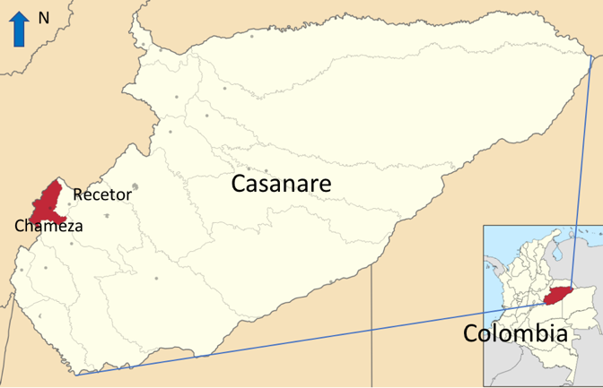Fig. 1: Map showing the locations of the towns of Chameza and Recetor, within the Casanare Province, Colombia, South America.

There has been an increased use in geoscientific methods by search teams to detect and locate clandestine buried materials of forensic interest. It is often found that depth of buried objects is normally shallow, typically less than 3 m below ground level (bgl), whilst clandestine graves are often around 0.5 m (22). Searches for clandestine burials often start with large-scale methods, such as remote sensing (23,24), aerial and ultraviolet photography (25,26), thermal imaging (27), or even visual observations of vegetation changes at ground-level (28), surface geomorphology changes (29), soil type (30) and depositional environment(s) (31), near-surface geophysics (32), diggability surveys (30) and probing of anomalous areas (33,34) before removing topsoil (28) and ultimately performing controlled excavation and recovery of remains (25).

In order for near-surface geophysical methods to be successful, there must be a detectable physical contrast between the target and background (or host) medium (see (35)). Ground penetrating radar (GPR) is the most common geophysical method for forensic search (32), although a multi-method phased approach is suggested as best practice [see (22) for review]. For example, anomalous areas can be quickly identified using Electro-Magnetics (EM) (36) and its reciprocal electrical resistivity (37) techniques before further investigation using higher resolution methods. Passive field techniques, such as magnetics, measure variations in the Earth’s magnetic field due to nearby objects (35,38). In contrast, active EM methods, such as metal detectors, depend on metallic objects being good conductors and transmitting their own secondary EM field in response to the instruments’ primary EM field (39, 40), However, controlled research (41) and forensic cases have had limited success using EM methods, typically owing to interference from both above- and below-ground non-target objects (35). In contrast, electrical resistivity has been widely used in environmental forensics (22, 35), detection of clandestine graves (42), ancient burials (43, 44, 45) and controlled experiments (46, 47). However, major environment variables can affect target detection including soil moisture (22). GPR search also has limitations in wooded environments (36) and soil type, for example: water-logged (47), saline-rich (32), clay-rich (42) or heterogeneous (48) soils can all significantly attenuate radar signal amplitudes.
Search methods differ worldwide, for example, in the UK a search strategist is employed at an early stage to decide upon the highest probability of search success (30, 22, 49). However, not all countries utilize such a methodical and standardised approach (50); Colombian searches often rely on witness testimony to identify an area(s) of interest, followed by deployment of small search teams to visually assess, probe and dig trial pits. Geophysical methods are sometimes used, but there has been little published studies in Colombia, other than control experiments (51, 52, 53, 54).

Geographical Information Systems (GIS) can be used to link geospatial (location) and other data (topography, vegetation cover, land use and transport networks) to other descriptive information (26), such as: noise pollution (55); animal conservation (56) and recording crimes (57). GIS-technology is already assisting intelligence-led policing to predict future crime (58). There has also been success in using GIS to determine the location of clandestine burials (59, 60).

The aim of this paper is to detail a Colombian missing persons case study to assist South American forensic search investigators to improve their efficiency and recovery rates of locating missing individuals. This was achieved by adopting a more standardized approach to search procedures, informed by ‘Predictive Spatial and Statistical Modelling’ (MESP, by its Spanish abbreviation), to identify two mass burial search areas in difficult terrain and weather conditions. Ground investigations then identified surface depressions forensic geomorphology techniques, before near-surface geophysical methods were used on targeted areas before subsequent probing and intrusive investigations.

Material and Methods

Predictive Spatial and Statistical Modeling (MESP)

Predictive Spatial and Statistical Modelling (MESP) utilizes Maximum Entropy Modeling (MaxEnt) software, a machine-learning technique, which is often used to predict species distribution in certain grid cells, according to user-specified inputs (61). Here it was used to predict the probable locations of missing people, based on information gained from a GIS-database (Quantum GIS software, version 2.10.2 (Pisa) (6)).

GIS has been applied in forensic cases to track and analyse crime data which can reveal patterns, including repeat offenses (58). For example, the “Shankill butchers” were an Ulster loyalist gang operating in Northern Ireland (1970s – 1980s) and were responsible for the deaths of at least 23 people (31). Using GIS analysis, it was possible to establish the spatial relationship between the location of abductions, at the zones of intersection between public transport routes and territorial gang areas, and body deposition sites (26).

MESP modeling steps used in this study were: (A) used the existing Colombian database (19) to centralise, compile and triangulate relevant information on missing persons, known criminal and para-military activities/locations, military base locations, police reports, and past search and exhumation information (e.g. burial style, soil type, surrounding vegetation, location, etc. see (2,4,13,14)). (B) Parallel activity to collate information from the respective victim’s family, chiefly; (1) the missing persons disappearance location where known, (2) witness testimonies where available and (3) missing individual’s social activities with available spatial location(s). These two steps were then used to process, classify, analyze and visualize two predicted locations for further ground investigation.

Diggability surveys

Diggability surveys often form part of pre-search reconnaissance visits to crime scenes or search areas (62). Surveys are conducted with probes or by digging to measure the ease in which soil can be excavated and re-filled. Trial pits can also identify soil type and its structure. A RAG (red-amber-green) coding system is often used to determine the most likely location for a clandestine burial; as soil types that allow for easy and quick digging (coded green) will be preferred to soil which requires a lot of effort and time to dig (coded red) – see (62, 63).

Study site investigations

Chameza area search

Using the MESP modeling method, based on witness testimony and social cartography, a potential burial site was identified in the Chameza area, west of Casanare province. The site was at an altitude of 2,018 m above sea level, on a north-facing slope of the Cerro San José Mountain (Fig. 2). Due to the steep and narrow wooded terrain, it was only possible to access the search area via horseback, carrying the necessary ground investigative geoscientific equipment (Fig. 3). There are no historical photographs of the site available; however, the isolated location and well-established mature vegetation suggested little change from when the burial was thought to have been occurred ~14 years ago.

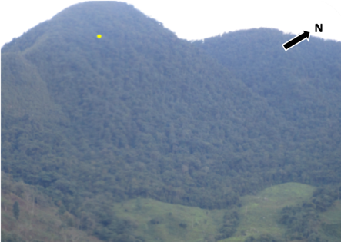

Fig. 2. A photograph of the proposed search (yellow dot) area in San Jose Mountain, near the town of Chameza, at an altitude of 2,018 m above sea level (masl). This remote and rugged location was identified by MESP spatial predictive modeling (see text).

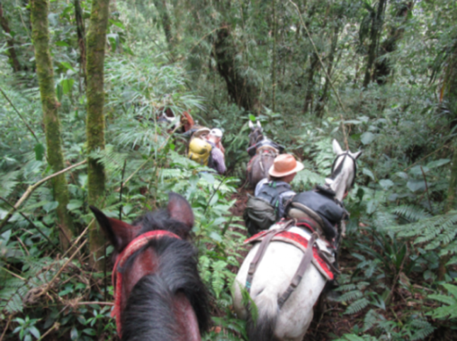

Fig 3. Access to the proposed survey site (Fig. 2) was only accessible via dense woodland and rugged terrain. Horses were needed to carry geoscientific equipment.

Chameza site reconnaissance

Initial trial pits showed the site to have clay soil with rock fragments; undulating surface topography and dense vegetation in a humid tropical forest (see Figs. 2-3). Visual soil profiling revealed three horizons: an ‘A’ horizon to be 0.10 m thick and black, indicating the presence of organic matter, an underlying ‘B’ horizon to be 0.10 m – 0.20 m thick and composed of grey clay, 0.20 m - 0.5 m was yellow clay.

Once the priority area was identified, it was cleared of leaf litter (0.10 m – 0.15 m thick) and other surface non-forensic items. A diggability survey, consisting of probing and trial pits, was also conducted, in order to determine if any areas of disturbance were visible which may arise from differences in soil compaction following best practice (see (22)). 35 surface topographic depressions, that were human-sized within the search area, were identified and then carefully probed with a steel metal pole, as can be indicative of a potential grave site (see (22) and Fig. 4).

Due to the clay-rich soil and numerous trees onsite, it was decide that GPR would not be suitable as a geophysics survey technique, as best practice suggests relatively poor signal penetration in clay-rich soils and numerous non-target anomalies from tree roots (see (22)). A series of 2D ERT profiles were collected on east-west orientations (see (15) and Fig. 4 for location). ERT 2D profile separation was 1 m with a 0.5 m electrode probe spacing for all profiles, as judged sufficient here (see (64)). It would be best practice to obtain these profiles in north-south orientation but due to time constraints with the local judiciary this was not possible.

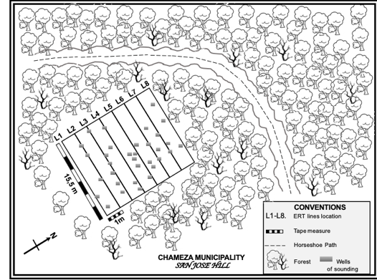

Fig. 4. Schematic survey area map in San Jose´s Mountain, near Chameza, showing the locations of surface depressions, and ERT profile positions (L1 to L8).

Recetor area search

Using the MESP modelling software results, a potential burial site was also identified near to Teguita Alta, in the municipality of Receptor, west of Casanare province. This location was located around a now-disused school (1,658 masl), which was a paramilitary camp during the 1980s-1990s (Fig. 5). Testimonies from survivors and families of victims, who had been held there, assisted to identify a survey area for more detailed investigations.

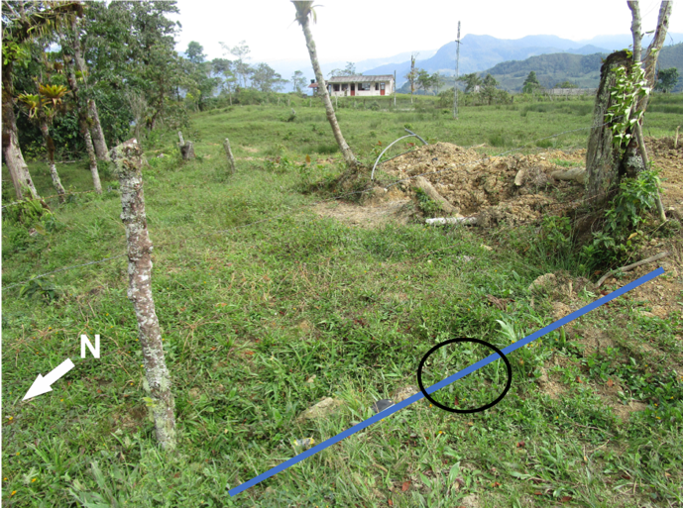

Fig. 5. Photograph of the proposed clandestine grave site located at a disused school (one building in background) near Recetor, previously occupied by paramilitary groups in the 1980s-1990s. Line marks the position of the ERT and circle area was intrusively investigated.

Receptor site reconnaissance

The identified survey area had an undulating topographic surface with little vegetation. Visual soil profiling of a trial pit revealed the ‘A’ horizon to be 0.10 m thick and black indicating the presence of organic matter, the ‘B’ horizon to be 0.10 m – 0.40 m thick yellow clay without a grey layer unlike site 1.

An initial visual topographic survey of the site was undertaken to note any surface depressions, with one being identified (see Fig. 6). As per site 1, the clay-rich soil precluded GPR to be optimal as a geophysical survey technique at this site, so an ERT 2D profile was collected over the single depression, which was located ~15 m from the road/track (Fig. 6).

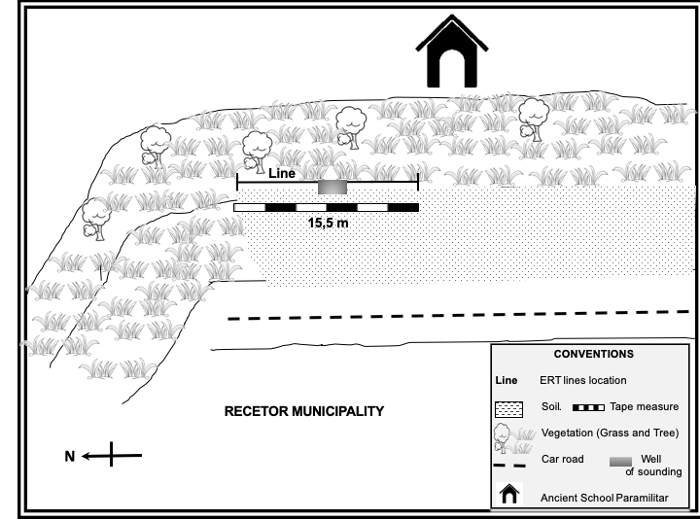

Fig. 6. Schematic survey area map of the ex-school near Receptor, showing the location of the identified surface depression and the ERT 2D profile (15,5 m long).

ERT collection and processing

ERT 2D profiles were acquired at both sites (see Figs. 8 and 10 for respective locations), using a GeoAmp 303 system, which comprised 32 electrodes at 0.5 m probe spacings on 2D profile lines and using a Wenner array configuration following standard practices (see (38)). The spatial distance between each profile was 1 m.
Raw ERT profiles were then individually processed and inverted utilising a least-squares inversion approach using Geotomo™ Res2Dinv v.355 software in accordance with (65) resistivity surveying recommendations. Half-cell spacing was utilized during the inversion process to remove potential edge effects and reduce any near-surface electrical resistivity variations respectively.

Results

Chámeza site

A forensic geomorphology site survey identified 35 surface topographic depressions (see Fig. 4 for locations). This was the main area that eight 2D ERT profiles were then collected over (Fig. 4) and processed the same as the Receptor site data.

The eight 2D ERT profile inversion results showed mostly relatively high resistivities, albeit with widely varying measured apparent resistivity values ~ 20 ohm.m to 20,000 ohm.m (Fig. 7). RMS errors of inversion, when compared to the input raw/model data, averaged 15% which was higher than optimal (see (65)), most probably due to the difficult terrain and near-surface variations.

An isolated relative low resistive anomaly, with respect to background values, was identified on profile L1 that could be correlated to one of the 35 topographic depression (Fig.7). This was subsequently intrusively investigated and was found to be a large buried rock boulder approximately 0.25 m x 0.10 m x 0.10 m at a depth of 0.75 m below the ground surface (Fig. 8). The other 34 topographic depressions were also intrusively investigated and found to contain smaller rock fragments.

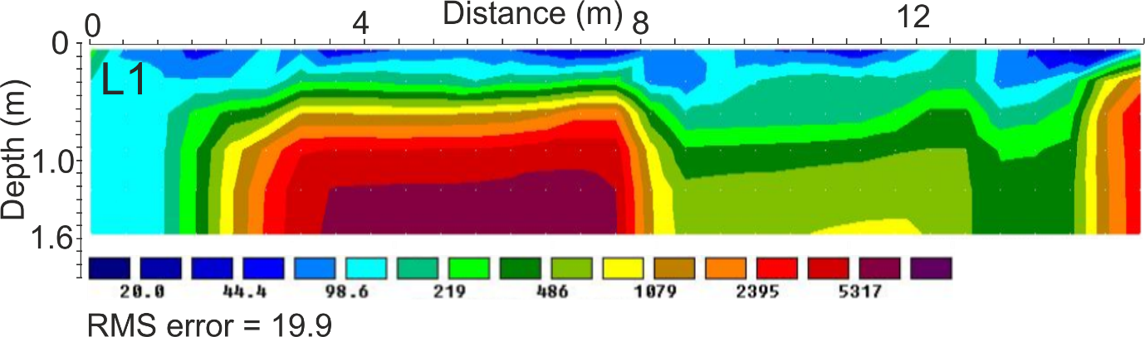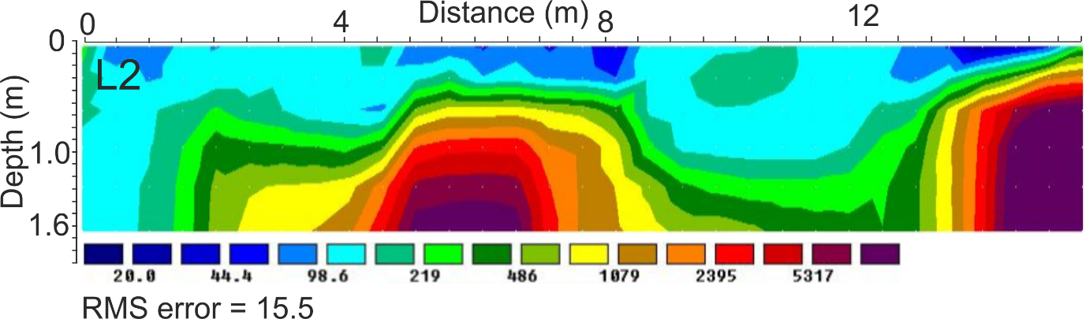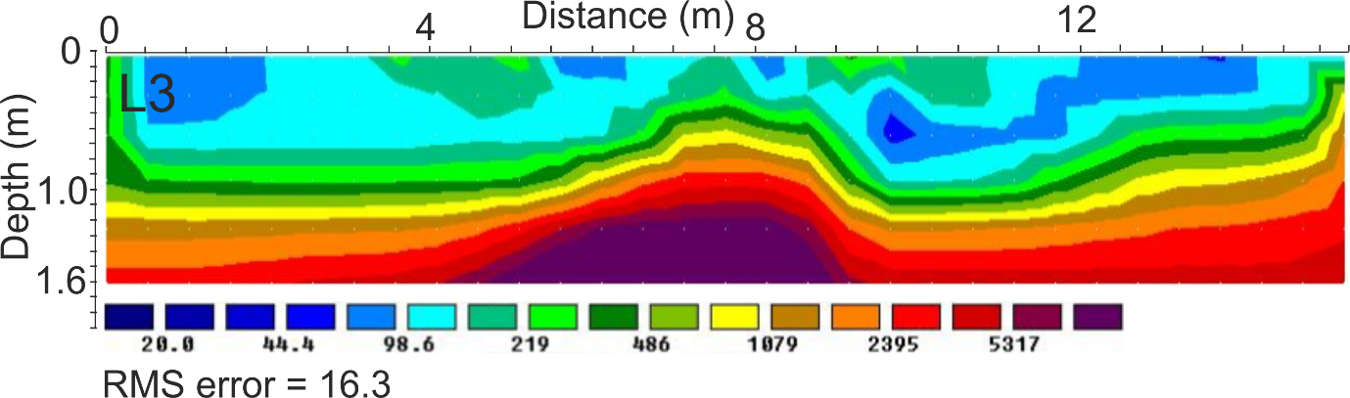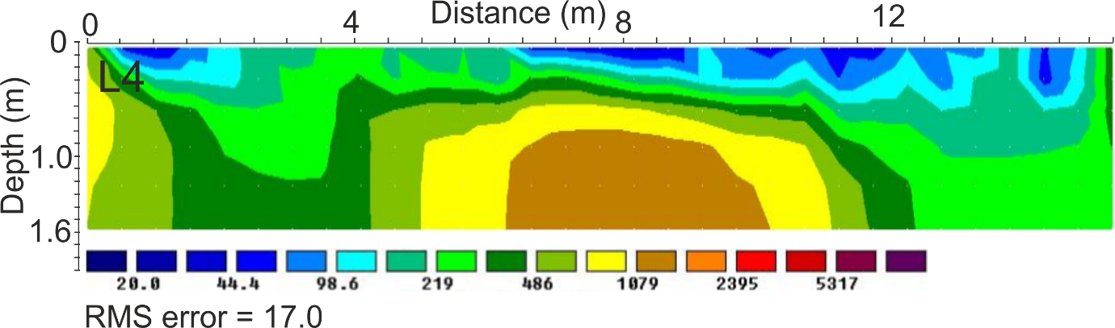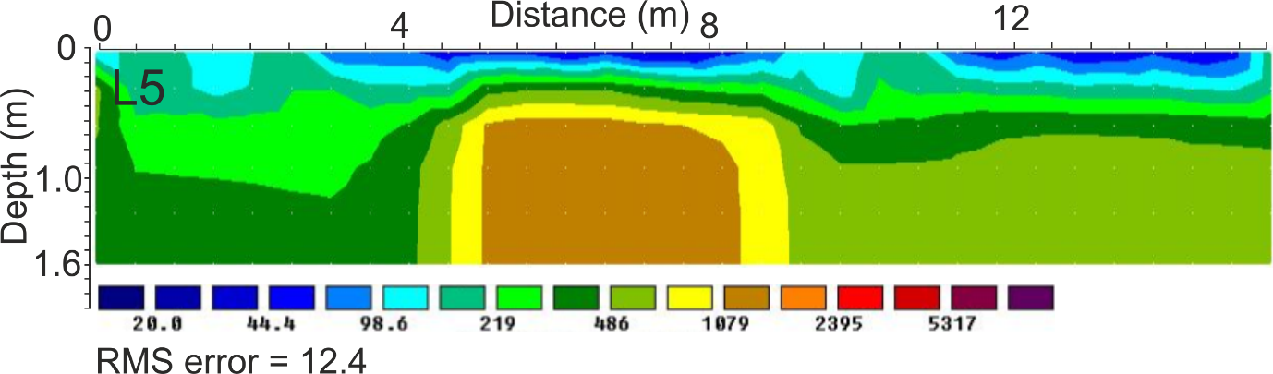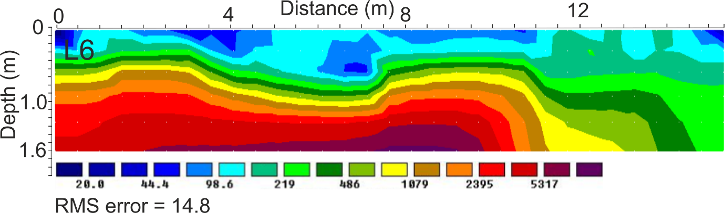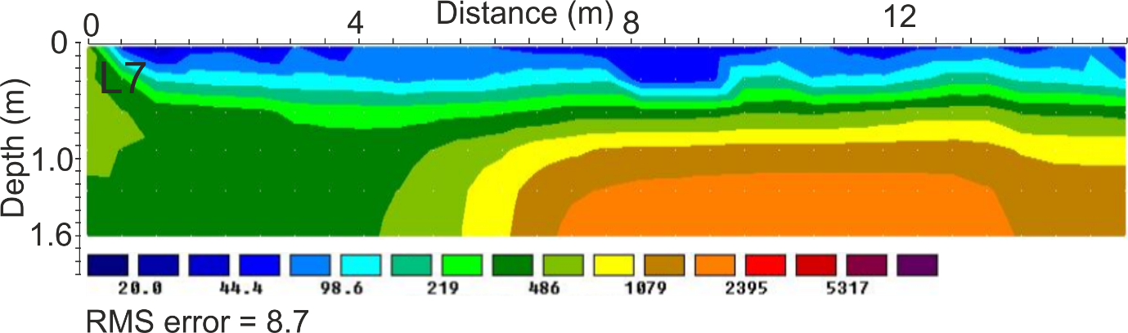
Fig. 7. ERT 2D profiles L1-L7 (see Fig. 4 for respective locations) inversions at the Chameza mountainous terrain site. L8 profile data was corrupted.
Fig. 8. Photograph of a large rock boulder (0.25 m x 0.10 m x 0.10 m) found at a depth of 0.75 m during intrusive investigation of the resistive anomaly identified on ERT profile L1. 1 m scale survey pole for scale.

Recetor site

Using the same methodology as for the Chameza site, on initial inspection in the ex-school grounds, a forensic geomorphology site survey identified only one surface topographic depression (see Fig. 6). One 15.5 m long 2D ERT profile was collected over this, with the surface depression being located in the profile center (Fig. 6).

The ERT 2D profile results (Fig. 9) showed two isolated high anomalies, when compared to background values. The central anomaly was intrusively investigated by hand, with a disturbed earth pit with dimensions of 0.5 m x 0.6. m x 1.5 m deep. This was approximately the same size as the resistivity anomaly (See Fig. 9). Bone fragments were discovered at the base (Fig. 10), but subsequently found to be bovine in origin. The larger anomaly was not investigated as this was decided to be too large to be manmade.
Fig. 9. ERT 2D profile inversion at the Recetor site (see Fig. 6 for location). Red areas indicate relative anomalous resistivities, with the smaller one intrusively investigated (Fig. 10).
Fig. 10. Photograph showing the discovered burial pit at site 2 (Recetor) in the middle of the surface depression and ERT profile (Fig. 4 for location). Grey bone fragments clearly visible at the burial pit base.

Discussion

Although there have been controlled experiments using electrical resistivity over simulated graves (51-54), this is the first published case study that has used forensic geoscience methods (spatial modeling, forensic geomorphology and near-surface geophysics) to try to locate clandestine graves in Colombia, noting the GPR study in Brazil (66) and the electrical resistivity and GPR study in Argentina (67). The discussion will now sequentially comment on the study aims and relate to others.

Research aims were “to detail a Colombian search case study to assist South American forensic search investigators to improve their efficiency and recovery rates of locating missing individuals”. In fact, two case studies were presented in quite different depositional environments, each with their own challenges.

The first Chameza study area was probably the most difficult logistically, being in hilly mountainous and wooded terrain. The surveys and subsequent intrusive investigations were not successful, but that is not unusual in such cases. Other forensic search investigators have searched for clandestine graves in such environments, some successfully (e.g. in Spain (10) and in Bosnia (15)), and others not (e.g. in Spain (68)), albeit mostly using GPR methods. (37) used EM and GPR methods successfully in wooded terrain in New Zealand looking for a similar-aged clandestine burial.

The second Receptor study area in the grounds of the ex-school was successful, in that a surface topographic depression was identified, geophysical data collected over it which identified a resistivity anomaly, intrusively investigated and found to be a burial pit, albeit containing animal (bovine) remains. Many discovered clandestine graves are found either near or within built structures (see (22,48)), and therefore are well worth prioritizing and investigating.

It is suggested that initial areas be the subject of further search techniques using the Red-Amber-Green methods detailed by others (see 62,63)), but this was not used here.

It is known that ground depressions become more pronounced when underlying cadaver chest cavities collapses (69), with corresponding depressions in the ground surface (70) and so surface depressions became important during visual inspections. Simulated (54, 71) and graveyard geophysical surveys (72) have shown that older graves are progressively more difficult to locate, using near-surface geophysical methods, as the measurable geophysical contrast between ‘grave targets’ and background levels decreases. In both survey locations, the age of the suspected graves (~14 years old) meant that there would be a reduced geophysical response, when compared to those relatively freshly buried graves.

This paper also demonstrates how using ‘Predictive Spatial and Statistical Modelling’ methods, using relevant input data, can be critical to narrowing down the potential search area(s). Other authors have had some success using these methods, such as (60) when searching for a simulated isolated grave in mountainous terrain in Italy. (60) also detailed how specific GIS case technology and case notes could help with narrowing down a specific search area and (31) details how to use database information to inform crime clustering patterns.

For specific site searches, forensic geomorphology, such as (29) documents, can also rapidly identify suspect areas for subsequent investigation, geophysics in this case. Near-surface geophysical methods have been shown to be invaluable in targeting a sub-area for subsequent intrusive investigations (see (2, 3, 5, 66)), which is evidenced in this case study, albeit for an animal grave to be located. Although ERT surveys are relatively slow to set out and collect data, when compared to EM methods for example (see (36)), they are effective to identify anomalous areas, especially in this difficult depositional clay-rich soil in wooded environments that may preclude the more commonly-utilized GPR to be effective.

Conclusions

This study aimed to test methodologies and equipment to locate the Columbian remains of suspected victims from atrocities 14 years ago. Researchers used spatial modeling using a variety of input data, including witness statements, survivor’s testimonies and known areas of activity, to narrow down two sites to be investigated, one in remote mountainous wooded terrain near Chameza, and the other in the ground of an ex-school near Recetor. After reconnaissance trial pits evidenced clay-rich soil, surface geomorphology analysis was then undertaken, identifying a series of topographic surface depressions. Near surface geophysical data, in this case ERT 2D profiles, were collected, with a series of isolated resistivity anomalous areas identified in both sites. Subsequent intrusive investigations of targeted areas did locate one burial pit, albeit containing animal not human remains

A combined geoscientific approach is thus suggested for other investigations, once suspected sites have been located (in this case using MESP spatial modeling), initial ground reconnaissance included control grave for investigating soil type(s) and to identify surface topography depression styles. Thereafter forensic geomorphology analysis should be undertaken to identify shallow depressions at both sites. Subsequent near-surface geophysical surveys are then recommended, in this case using ERT due to the clay-rich soil type onsite and wooded terrain precluding GPR. Subsequent intrusive investigations of geophysical anomalies should then be undertaken.

Further work should investigate other sites in Colombia, and indeed in other Latin American countries, to investigate this strategy in burial target detection, which can only improve as more information is collected and used to better define the search methods detailed.

References
1. Missing Project. For Memory, Truth and Justice. Available online at http://www.desaparecidos.org. Last accessed: 13th Feb 2019.
2. National Institute of Legal Medicine and Forensic Sciences, Colombia. Available online at www.medicinalegal.gov.co. Last accessed: 13th Feb 2019.
3. Solla HE, Işcan MY. Skeletal remains of Dr. Eugenio Berríos Sagredo. Forensic Sci Int 2001;116:201-11.
4. Işcan MY, Solla HE, McCabe BQ. Victim of a dictatorial regime: identification of Mr. Roberto Gomensoro Josman. Forensic Sci Int 2005;151(2-3):213-20.
5. Varas CG, Leiva MI. Managing comingled remains from mass graves: considerations, implications and recommendations from a human rights case in Chile. Forensic Sci Int 2012; 219:19-24.
6. Ruffell A, McCabe A, Donnelly C, Sloan B. Location and assessment of an historic (150-160 years old) mass grave using geographic and ground penetrating radar investigation, NW Ireland. J Forensic Sci 2009;54(2):382-94.
7. Witten A, Brooks R, Fenner T. The Tulsa race riot of 1921: a geophysical study to locate a mass grave. The Leading Edge 2000;20(6):655-60.
8. Ríos L, Ovejero JI, Prieto JP. Identification process in mass graves from the Spanish Civil War I. Forensic Sci Int 2010;199(1-3):e27-36.
9. Ríos L, García-Rubio A, Martínez B, Alonso A, Puente J. Identification process in mass graves from the Spanish Civil War II. Forensic Sci Int 2012;219(1-3):e4-9.
10. Fernández-Álvarez JP, Rubio-Melendi D, Martínez-Velasco A, Pringle JK, Aguilera D. Discovery of a mass grave from the Spanish Civil War using GPR and forensic archaeology. Forensic Sci Int 2016;267:e10-17.
11. Fiedler S, Berger J, Stahr K, Graw M. Localisation of a Mass Grave from the Nazi Era: A Case Study. In: Ritz K, Dawson L, Miller D, Editors. Criminal and Environmental Soil Forensics. Springer, Dordrecht, 2009;303-14.
12. Ossowski A, Kuś M, Brzeziński P, Prüffer J, Piątek J, Zielińska G, et al. Example of human individual identification from World War II gravesite. Forensic Sci Int 2013; 233(1-3):179-92.
13. Szleszkowski L, Thannhäuser A, Szwagrzyk K, Konczewski P, Kawecki J, Swiątek B. Exhumation research concerning the victims of political repressions in 1945-1956 in Poland: a new direction in forensic medicine. Forensic Sci Int 2014;235:103.e1-6.
14. Independent Commission for the Location of Victims Remains, Accessible online at: http://www.iclvr.ie/. Last Accessed: 13th Feb 2019.
15. Brown AG. The use of forensic botany and geology in war crimes investigations in NE Bosnia. Forensic Sci Int 2006;163(3):204-10.
16. Djuric M, Dunjic D, Djonic D, Skinner M. Identification of victims from two mass-graves in Serbia: a critical evaluation of classical markers of identity. Forensic Sci Int 2007;172(2-3):125-9.
17. Syrian Observatory for Human Rights, Available online at www.syriahr.com. Last accessed: 13th Feb 2019.
18. National Center of Historical Memory. Available online at www.centrodememoriahistorica.gov.co. Last accessed: 13th Feb 2019.
19. EQUITAS “A radar to find them”. Available online at www.equitas.org.co/. Last accessed 13th Feb 2019.
20. Attorney General of the Nation. Available online at: www.fiscalia.gov.co/colombia/. Last accessed 13th 2019.
21. Colombia: Advances in the search for missing persons are necessary. International Committee of the Red Cross. 1; 2017. Available at: https://www.icrc.org. Last accessed 13th Feb 2019.
22. Pringle JK, Ruffell A, Jervis JR, Donnelly JD, McKinley J, Hansen JD, et al. The use of geoscience methods for terrestrial forensic searches, Earth Sci Rev 2012;114(1-2):108-23.
23. Brilis GM, van Waasbergen RJ, Stokely PM, Gerlach CL. Remote sensing tools assist in environmental forensics: Part II digital tools, Environ Forensics. 2001;2(3):223-9.
24. Grip WM, Grip RW, Morrison RD. Application of aerial photography and photogrammetry in environmental forensic investigations. Environ Forensics. 2000;1(3):121-9.
25. Hunter J, Cox M, (Eds). Forensic archaeology: advances in theory and practice. Abingdon, UK: Routledge; 2005.
26. Ruffell, A, McKinley J, Robinson M, Bristow C. Ground Penetrating Radar: Geomorphological Techniques. J History of Childhood and Youth 2013; ISSN 2047-0371:1-26.
27. Dickinson DJ. The aerial use of an infrared camera in a police search for the body of a missing person in New Zealand. J Forensic Sci Soc 1976;16(3):205-11.
28. Killam EW. The detection of human remains. Springfield, IL, USA: Charles C Thomas; 2004.
29. Ruffell A, McKinley J. Forensic geomorphology. Geomorphology 2014;206:14-22.
30. Harrison M, Donnelly LJ. Locating concealed homicide victims: developing the role of geoforensics. In: Ritz K, Dawson L, Miller D, Editors. Criminal and Environmental Soil Forensics. The Netherlands: Springer Publishers; 2009: 197-219.
31. Ruffell A, McKinley J, Geoforensics, Chichester: Wiley Blackwell; 2008.
32. Pringle JK, Holland C, Szkornik K, Harrison M. Establishing forensic search methodologies and geophysical surveying for the detection of clandestine graves in coastal beach environments. Forensic Sci Int 2012;219(1-3):e29-36.
33. Owsley DW. Techniques for locating burials with emphasis on the probe. J Forensic Sci 1995;40(5):735-40.
34. Ruffell A. Burial location using cheap and reliable quantitative probe measurements. Forensic Sci Int 2005;151(2-3):207-11.
35. Reynolds JM. An introduction to applied and environmental geophysics, 2nd ed. Wiley; 2011.
36. Nobes DC. The search for ‘‘Yvonne’’: a case example of the delineation of a grave using near-surface geophysical methods, J Forensic Sci 2000;45(3): 715-21.
37. Powell K. Detecting buried human remains using near-surface geophysical instruments. Exploration Geophys 2004;35(1);88-92.
38. Milsom J, Eriksen A. Field Geophysics, 4th ed. Chichester, UK: John Wiley & Sons; 2011.
39. Rezos MM, Schultz JJ, Murdock RA, Smith SA. Controlled research utilizing a basic all-metal detector in the search for buried firearms and miscellaneous weapons. Forensic Sci Int 2010;195(1-3):121-7.
40. Dionne CA, Schultz JJ, Murdock RA, Smith SA. Detecting buried metallic weapons in a controlled setting using a conductivity meter. Forensic Sci Int 2011:208(1-3);18-24.
41. Juerges A, Pringle JK, Jervis J, Masters P. Comparisons of magnetic and electrical resistivity surveys over simulated clandestine graves in contrasting burial environments. Near Surf Geophys 2010;8:529-39.
42. Pringle JK, Jervis JR. Electrical resistivity survey to search for a recent clandestine burial of a homicide victim, UK. Forensic Sci Int 2010;202(1-3):e1-7.
43. Dick HC, Pringle JK, Sloane B, Carver J, Haffenden A, Porter S, et al. Detection and characterisation of Black Death burials by multi-proxy geophysical methods. J Arch Sci 2015;59:132-41.
44. Ellwood BB. Electrical resistivity surveys in two historical cemeteries in Northeast Texas: a method for delineating unidentified burial shafts. Hist Arch 1990;24(3):91-98.
45. Matias HC, Monteiro Santos FA, Rodrigues Ferreira FE, Machado C, Luzio R. Detection of graves using the micro-resistivity method. Annals of Geophys 2006;49:1235-44.
46. France DL, Griffin TJ, Swanburg JG, Lindemann JW, Davenport GC, Trammell V, et al. A multidisciplinary approach to the detection of clandestine graves. J Forensic Sci 1992;37:1445-58.
47. Cheetham P, Forensic geophysical survey, In: Hunter J, Cox M, Editors. Forensic archaeology: advances in theory and practice. London: Routledge Publishers; 2005.
48. Pringle JK, Jervis J, Cassella JP, Cassidy NJ. Time-lapse geophysical investigations over a simulated urban clandestine grave, J Forensic Sci 2008;53(6):1405-16.
49. Ruffell A, Pringle JK, Cassella JP, Morgan RM, Ferguson M, Heaton VG, et al. The use of geoscience methods for aquatic forensic searches. Earth Sci Rev 2017;171;323-37.
50. Larson DO, Vass AA, Wise M. Advanced Scientific Methods and Procedures in the Forensic Investigation of Clandestine Graves. J Contemp Crim Justice 2011;27(2):149–82.
51. Molina CM, Hernandez O, Pringle JK. Experiments to detect clandestine graves from interpreted high resolution geophysical anomalies. Proc Meeting of Americas, AGU, Cancun, México, 14-17th May 2013.
52. Molina CM, Pringle JK, Saumett M, Hernandez O. Preliminary results of sequential monitoring of simulated clandestine graves in Colombia, South America, using ground penetrating radar and botany. Forensic Sci Int 2015;248:61-70.
53. Molina CM. Pringle, JK. Saumett, M. Evans GT. Geophysical and botanical monitoring of simulated graves in a tropical rainforest, Colombia, South America. J Environ App Geophys 2016b;135:232-42.
54. Molina CM. Pringle JK. Saumett, M. Evans GT. Geophysical monitoring of simulated graves with resistivity, magnetic susceptibility, conductivity and GPR in Colombia, South America. J Forensic Int 2016;261:106-15.
55. Bilaşco S, Govor C, Roşca S, Vescan I, Fillip S, Fodorean I. GIS model for identifying urban areas vulnerable to noise pollution: case study. Frontiers Earth Sci 2017;11(2):214-28.
56. Perkl RM. Geodesigning landscape linkages: Coupling GIS with wildlife corridor design in conservation planning. Landscape and Urban Planning 2016;156:44-58.
57. Balogun TF, Okeke, H, Chukwukere CI. Crime mapping in Nigeria Using GIS. J Geog Info System 2014;6(5):453-66.
58. Fitterer J, Nelson T, Nathoo F. Predictive crime mapping. Police Pract Research 2015;16(2):121-35.
59. Bunch A, Kim M, Brunelli R. Under our nose: the use of GIS technology and case notes to focus search efforts. J Forensic Sci 2016;62(1):92-8.
60. Somma R, Cascio M, Silvestro M, Torre E. A GIS-based quantitative approach for the search of clandestine graves, Italy. J Forensic Sci 2018;63(3):882-98.62.
61. Merow C, Smith MJ, Silander JA Jr. A practical guide to MaxEnt for modeling species’ distributions: what it does, and why inputs and settings matter. Ecography. 2013;36(10):1058-69.
62. Donnelly LJ, Harrison M. Geomorphological and geoforensic interpretation of maps, aerial imagery, conditions of diggability and the colour-coded RAG prioritization system in searches for criminal burials. In: Pirrie D, Ruffell A, Dawson L, Editors. Environmental and Criminal Geoforensics. London, Geol Soc Spec Pub 384 2013;173-194.
63. Ruffell A, McAllister S. A RAG system for the management of forensic and archaeological searches for burial grounds. Int J Arch 2015;3:1-8.
64. Rubio-Melendi D, Gonzalez-Quiros A, Roberts D, Garcia M, Dominguez AC, Pringle JK, Fernandez-Alvarez J-P, GPR and electrical resistivity surveys to detect & characterise a Spanish Civil War mass burial, Northern Spain. Forensic Sci Int 2018;287:e1-e9.
65. Loke MH, Barker R. Rapid least-squares inversion of apparent resistivity pseudosections by a quasi-Newton method. Geophys Prospect 1996;44(1):131-52.
66. De Oliveira LA, Lima Fliho FP, Da Silva DN, Andrade Dos Reis JJ, De Medeiros SA. GPR 3D Profile of the Adequateness of underground dams in a sub-watershed of the Brazilian semiarid. Revista Caatinga 2018;31(2):523-31.
67. Sagripanti GL, Villalba D, Aguilera D, Giaccardi A. Advances in forensic geology in Argentina: search with non-invasive methods of people victims of enforced disappearance. Geology Mag 2017;39(3):55-69.
68. Novo A, Lorenzo H, Ria F, Solla M. 3D GPR in forensics: finding a clandestine grave in a mountainous environment. Forensic Sci Int 2011;204:134–8.
69. Rodriguez WC, Bass WM. Decomposition of buried bodies and methods that may aid in their location. J Forensic Sci 1985;30:836–52.
70. Corcoran KA, Mundorff AZ, White DA, Emch WL. A novel application of terrestrial LIDAR to characterize elevation change at human grave surfaces in support of narrowing down possible unmarked grave locations. Forensic Sci Int 2018;289:320-28.
71. Pringle JK, Jervis JR, Roberts D, Dick HC, Wisniewski KD, Cassidy NJ, Cassella JP. Geophysical monitoring of simulated clandestine graves using electrical and ground penetrating radar methods: 4-6 years. J Forensic Sci 2016;61:309-21.
72. Dick HC, Pringle JK, Sloane B, Carver J, Wisniewski KD, Haffenden A, Porter S, et al. Detection and characterisation of Black Death burials by multiproxy
geophysical methods. J Arch Sci 2015;59:132–41.

