Abstract

Animal cruelty cases can involve a variety of mistreatments to domestic animals. A common source of abuse is the use of heat sources, such as ovens, hot surfaces and microwaves. Analysis of damage to skin by a veterinarian is a key aspect of these investigations but additional information can be provided by observing the hair of the animal, including heat source type and exposure time.
This study developed an objective grading system for the analysis of heat damage in hairs which can be used to quantify different damage characteristics including bubbling, discolouration, expansion of hair, fractures, changes to the medulla and scales and scale removal/melting. This grading scheme was applied to the investigation of dog (Canis familiaris) skin samples with full pelage and loose hairs exposed to microwaves and a heated environment in order to identify any distinguishing damage characteristics from the two different heated environments.
Samples were exposed to a furnace for 1 minute at different temperature ranges (50-350°C with 50°C intervals) and also a microwave at maximum power for different time periods (15, 30, 45, 60, 120, 180, 240 and 300 seconds). Hairs were extracted for examination using high powered light microscopy and scanning electron microscopy.
Overall, it can be determined that the type of damage observed is influenced by the nature of heat applied and the context and substrate in which the hair is situated at the time of exposure. Using Principal Component Analysis (PCA) it was concluded that as temperature increases in a furnace so does the severity of each of the damage characteristics observed. It can be noted that with furnace exposure, any one of the characteristics could be used to indicate the temperature to which it has been exposed. For furnace exposed samples there was no significant difference between loose or embedded hairs.
PCA analysis determined that there are two independent forms of damage that occur when hairs are exposed to microwave radiation, these are: increased bubbling and discolouration in the root and increased bubbling and discolouration of the shaft and tip. Exposure time is correlated with both the root and shaft/tip observations.
The results indicated some clear distinctions between heat source and exposure useful for the objective interpretation of such evidence. This standardised approach for the observation of heat damage characteristics in animal hair provides investigators with a tool to differentiate between methods of abuse, providing a greater understanding of the crime committed.

Keywords

- Forensic animal hair analysis
- Canine hair
- Heat damage
- Microscopy
- Grading scheme
- Animal abuse cases

1.0 Introduction
Hair evidence is a common type of trace evidence encountered at crime scenes, due to their ability to shed easily. The ubiquitous nature of hairs and the intelligence information that may be gathered from analysing this form of evidence means they can be valuable in crimes against animals, such as animal abuse and wildlife persecution. Hairs can readily shed from the skin of both humans and animals, transferring to objects and individuals during the commission of a crime[1]. This transfer may link individuals to scenes, victims and objects. In addition to this, hair evidence may be used to provide intelligence, including details pertaining to the donor’s appearance and any damage incurred to the hair through deliberate actions or otherwise. The latter is particularly useful when ascertaining the nature of abuse that may have been subjected to an animal.
Both human and animal hairs consist of three regions: the root (proximal end), the shaft and the tip (distal end), also known as the shield region in animal hairs, and three structural layers. The cuticle is the outermost layer, which comprises of overlapping scales and normally do not contain pigment [2]. The medulla is the central core of air-filled cells and vacuoles whose structure can vary dramatically in animal hair. The cortex, which consists of spindle shaped cells, makes up the main component of the hair [3]. Each of these three layers contain characteristics which can be used to compare one hair to another and provide information as to whether the hair has been exposed to any environmental conditions, such as heat. In animal hairs, the characteristics that can be observed include, but are not limited to; the scale pattern, scale count (cuticle characteristics); medulla type and medulla ratio (medulla characteristics); and pigment granule size/distribution and presence of ovoid bodies (cortex characteristics).
Keratin makes up more than 90% of the dry weight of hair, with the outer cuticle being rich in cystine and the cortex containing low-sulphur proteins interspersed within a medium of high-sulphur and glycine/tyrosine-rich proteins [4]. The structure of keratin offers protection to heat and chemicals due to the large amount of disulphide bonds and three-dimensional structure. The keratin fibre structure, as its currently understood, is described in Kadir et al’s 2017 study [5].
Hair is generally believed to be stable and able to withstand external conditions; this is in part due to its outer cuticle layer which acts as protection to the internal cortex. Although hair withstands degradation much better than other biological samples, over time the outer cuticle will gradually erode [6]. The cuticle often shows weathering and damage before other internal areas of the hair which may involve the wearing down of the cuticle scales making it noticeably irregular and damaged. Abrasion damage is generally seen nearer the tip due to this area being exposed to external day-to-day damage, such as grooming [7]. When damage becomes more extreme, the cuticle may start to crack, lift off or be lost completely exposing the internal cortex, this can lead to frayed ends and split tips. Hairs will also still be affected by extreme conditions, including high temperatures [8]. If the outer cuticle layer of the hair is damaged in some manner, this can allow access to the cortex and therefore degradation may be accelerated.
The microscopic analysis of the morphological features within animal hairs has been studied in a forensic context for use in both crimes against humans and animals for many years [9 - 17]. While the analysis of morphological characteristics of animal hairs alone may not be able to individualise, it can contribute to an investigation by providing information such as species and associating links to other individuals, where animal hair has transferred from the animal to suspect and subsequently persisted. [9, 10]. Although the microscopical examination of animal hairs has been studied in terms of identification, including the use of DNA, [11, 17, 18], no studies have been carried out upon damage incurred to hairs during different criminal activities, including the abuse of animals and the subsequent intelligence information it might yield.
Abuse of animals is frequently described as “socially unacceptable behaviour that intentionally causes unnecessary pain, suffering, or distress to and/or death of an animal” [19]. The abuse of domestic animals has been widely studied in terms of its links to interpersonal violence, including violence to intimate partners [20, 21]. Ascione et al [22], noted that dogs and cats are the main target of family violence as they form strong bonds with people. Studies into methods of animal abuse have identified burning as an abuse type, along with shooting, kicking/hitting, drowning, stabbing, strangling/smothering, poisoning, dismembering, being thrown against a wall/ground and sexual intercourse [23 - 27]. Hensley and Tallichet [27] noted from a study of 261 inmates in a US prison, that one in seven admitted to having either burned, drowned or had sex with an animal. Miller and Knutson’s [24] study of 314 inmates showed of the 151 instances of killing of an animal, five of those used burning as the method. The causes of animal abuse and subsequent link to interpersonal violence are not covered here, but for a review of these studies, please see Monsalve et al [28] and Lockwood and Arkow [29].
Veterinary forensics is an emerging specialism of veterinary medicine, which has increased in its use over the last few decades due to improved legislation in the protection of animals amongst other factors. Veterinary forensic practitioners may be involved in the investigation of animal abuse, including gross neglect, torture, organized abuse and sexual abuse [30]. Munro and Thrusfield [31] identified common types of non-accidental injury (NAI) occurring in 182 cases in cats and 243 cases in dogs after interviewing UK based veterinarians. Fourteen incidents of heat related injuries were recorded in cats and 29 in dogs. The use of ovens and microwaves for the abuse of animals has been seen by veterinarians in the UK and understanding which of these an animal has been exposed to is important for reconstructing the events of a case. Other such sources of heat to inflict NAIs may include, cigarettes, cigarette lighters, heated cooking pans, hair straighteners/styling tools and clothing irons [32]. An issue raised by Munro and Thrusfield [31] was that veterinarians found it particularly difficult to determine whether an injury was caused by an accidental or non-accidental injury. Although the veterinary examination of animals may yield information about the cause of abuse, the exact nature of activities may not be able to be identified from wound pathologies. It is acknowledged by Parry and Stoll [30] that there are significant knowledge gaps and a lack of resources for those involved in veterinary forensics that would aid in the investigation of animal crimes and determining whether an injury is non-accidental. Due to this, an objective method to help discriminate between different heat mechanisms would be desirable and would aid interpretation of these types of abuse cases for individuals working in animal crime investigations, including RSPCA officers and veterinarians.
When hairs are exposed to different forms of either mechanical, chemical or heat damage, changes can occur on the outer surface or internally within the hair. In terms of heat damage, it is believed that these changes are dependent on the source of heat, temperature, exposure time and heating rate [8]. The investigation into the analysis of damage and environmental changes to hairs has been conducted for fungal tunnelling [33] and post-mortem root banding [34, 35], both of which utilised microscopic indicators of damage to allow these forms of environmental exposure to be identified. These indicators included the presence of holes within the hair (fungal tunnelling) and the gradual darkening in the form of a band at the proximal end (post-mortem root banding). Factors such as the growth stage of hair and temperature were investigated for post-mortem root banding which indicated that this only occurs in hairs that are in the anagen and catagen stages of growth and that the presence of this phenomena will increase over time and with increased temperatures [34].
There are limited studies in the damage caused to hair that has been exposed to heat. A study by Ayres [36] in 1985, investigated two case studies that relied heavily on human hair evidence that had been exposed to high temperatures. Hairs exposed to a hot plate for four minutes exhibited a colour change (from light brown to a dark red/brown), some bubbling in the area of the medulla and slight expansion of the hair. Hair exposed to an open flame exhibited charring and bubbling but no colour change. In 2015, Igowsky and Pangerl [8] investigated the effect of two different heat sources on human hair. Hairs were exposed to either a furnace, ranging in temperatures between 100-400°C or a hot plate (150-250°C). Findings were consistent with the study by Ayres [36], where it was observed that hairs exposed to heat sources will exhibit colour changes, bubbling and expansion. Further characterisation of hairs exposed to heat was attempted in the later study by Igowsky and Pangerl [8], including noting brittleness of the hair.
The approaches used in these studies were qualitative observations only. The results provided useful general descriptions of heat damage characteristics but did not quantify the amount or locations of damage seen, making it difficult to glean any link between temperature, time or heat source and damage characteristics. These previous studies utilised human hair only and although both human and animal hair share the same three structural layers, the differences within these structures vary considerably between species. Using approaches for animal hair interpretation that have been derived from human hair analysis are generally not advised [37]. In addition, only loose hairs (detached from the skin) were observed in these studies which potentially does not give a realistic account of the changes that would occur in hairs still in situ. This is important if we are to interpret hair taken from the skin of animals rather than found loose.
Studies into the thermal behaviour of animal textile fibres has been conducted on speciality animal fibres within the textile industry [38, 39]. These studies focussed upon animal fibre quality for textiles rather than the interpretation of heat source. These studies also used differential scanning calorimetry (DSC) to provide thermal behaviours of the animal hairs rather than observing the presence of any damage characteristics with transmitted light microscopy, which is the preferred approach for animal hair analysis [37].
Although some qualitative information about heat damage characteristics from furnace and hot-plate exposure is available for the forensic scientist in human hair, a quantitative, more objective method of observing heat damage has not previously been proposed. The effect of exposure to microwaves upon hair has not been previously examined and no observations of heat damage have been investigated in animal hair. A method for objectively quantifying damage allows for easier comparison between variables and comparison between studies to further aid interpretation of heat source. The problems of subjectivity in hair analysis has been previously acknowledged [40, 41] with attempts at developing methods that create more objective data being seen [42, 43]. This study aims to produce a more objective approach, via the development of a grading scheme, for the analysis of heat damage in animal hairs, which complements traditional microscopical observations.
A standardised approach for the observation of heat damage characteristics in animal hair could provide investigators with a technique to differentiate between methods of abuse, ergo allowing intelligence to be ascertained and providing a greater understanding of the offence.
This study developed an objective grading system for the analysis of heat damage in hairs which can be used to quantify different damage characteristics including bubbling, discolouration, expansion of hair, fractures, changes to the medulla and scales and scale removal/melting. This grading scheme was applied to the investigation of dog (Canis familiaris) skin samples with full pelage and loose hairs exposed to microwaves and a furnace for different time periods (microwave only) and temperatures (furnace only) in order to identify any distinguishing damage characteristics from the two different heated environments. Microwave and furnace were chosen as the heat sources in this initial study as they represent two very different mechanisms of heat transfer; this allowed the study to capture the variety of different heat damage characteristics formed from these two heat sources leading to a more robust grading system. These two sources chosen can also be grouped such that the activity by the offender is similar; both include fully exposing an animal to a household cooking device (furnace as a proxy for an oven and microwave); this commonly leads to the death of the animal and thus why these two sources were prioritised.

2.0 Materials and Methods

2.1 Hair Sample Source
Canine skin (Canis familiaris) was sourced from a ‘Pitbull-type’ dog as defined by the UK Dangerous Dogs Act 1991 [44] after it had been euthanised by a veterinary surgeon upon receipt of a destruction order. This UK legislation prohibits the possession or custody of dogs belonging to types bred for fighting which includes the dog breed known as a pitbull terrier. The courts may order for the destruction of an animal under certain circumstances. For more information about this legislation and destruction orders, please see section 4 of the Dangerous Dogs Act 1991 [44]. Full ethical consideration was carried out and approved via the University’s Research Ethics Regulations taking into account the UK Dangerous Dogs Act 1991. The skin was dissected from the animal by a qualified veterinary surgeon, which included the epidermis, dermis and hypodermis layers. The thickness of the dissected skin was kept as consistent as possible during dissection. This sample was labelled as DS2. An unexposed skin sample can be seen in Figure 1. Care was taken not to damage the hair or skin upon removal. The skin and hair were healthy and displayed no observable damage upon collection.
Samples were taken from the back region of the dog, centrally running down the spine (dorsal median line) and extending into the pectoral regions. Samples were macroscopically homogenous in terms of the colour, coarseness and length of the hairs on the pelage.
Samples were stored in a freezer packaged in plastic evidence bags with additional layers of plastic between skin layers to prevent skin from adhering together and potential damage from ‘freezer burn’.
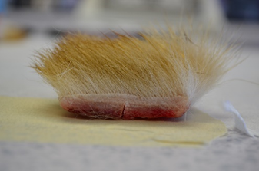
Figure 1: Side elevation image of the 2cm by 2cm cut canine skin sample (DS2).

2.2 Heat Sources
The two heat sources used in this study was a Stanton Furnace with a Stafford Instruments Ltd. temperature controller (maximum temperature 1000°C) and a Panasonic microwave (17 litres, 800 watts). These sources of heat were chosen for this stage based on previous literature and the authors experience in animal abuse types. Both forms of heated environment have been reported to have been used to inflict injuries to animals by Munro and Thrusfield [31].

2.3 Sample Preparation
Prior to exposure, samples were removed from the freezer to defrost overnight. The skin samples were cut into 2cm x 2cm squares using a scalpel. This size of skin and hair allowed for a sufficient area to be exposed so as to allow multiple hairs to be removed for analysis and for the samples to exhibit any insulating properties as would be seen if the hair was in situ on an animal. This allows for a more realistic reconstruction of what may be seen if an animal was subjected to these two forms of heat in abuse cases. These samples will be referred to as ‘embedded’ hairs in this study. Loose hairs were collected by gently removing them from unexposed skin samples prior to testing. Bundles of 20-30 loose hairs were exposed in the same manner as the hair and skin samples; these samples will be referred to as ‘individual hairs’ in this study. Loose hair samples were included to identify whether the same damage characteristics and extent of damage can be seen in loose hairs compared to those remaining in the skin. This aids in the interpretation of detached hairs found at crime scenes vs analysis of hairs taken from the animal when being examined by a veterinarian. This also aids future research in this area as it determines whether complete skin with hair samples is required for testing or whether the more easily sourced loose hair samples are an adequate alternative. Three control hair samples were taken from each skin sample (2cm x 2cm piece) prior to exposure and analysed using transmitted light microscopy and scanning electron microscopy, as described in section 2.5, to ascertain any prior damage and original hair morphology.

2.4 Heat Exposure

2.4.1 Furnace
Unexposed samples (both embedded and individual hairs) were placed separately into porcelain cups and then into the centre of the furnace, this ensured that no one area of the skin or certain hairs were more exposed than other areas; this was a limitation seen in one of the initial studies of Igowsky and Pangerl [8]. The door was then closed and secured using the locking mechanism to ensure safety. The samples were then exposed for 1 minute at the given temperature, using the in-built furnace timer to control exposure time. Temperatures analysed were 50-350°C with 50°C intervals. The furnace was then allowed to cool to room temperature and the samples were removed using heat resistant clips. A maximum of 350°C was chosen as beyond this temperature the sample was completely thermally degraded (cremated). Exposure time was not able to be a testable variable when using the furnace due to the risk assessment requirements that limited contact with the furnace when hot, thus making time difficult to change accurately.

2.4.2 Microwave
Unexposed samples (both embedded and individual hairs) were placed separately into a Pyrex 1 litre bowl and then into a Panasonic microwave. Exposure occurred on separate samples at full power (800 watts) for time periods of 15, 30, 45, 60, 120, 180, 240 and 300 seconds. After exposure, samples were allowed to cool prior to further analysis. Temperature was not a variable that could be changed and investigated in this heat source method. Microwave wattage was set at the maximum setting for all of the repeats and different timeframes. Three hundred seconds was chosen as the maximum time as after this, hairs were thermally degraded such they were unanalysable for the chosen characteristics.
For both microwave and furnace heat sources, only one piece of skin was exposed for each exposure setting, due to the limited availability of the dog skin.

2.5 Examination of Heat Damage Characteristics
From each exposed hair and skin (embedded) sample, three hairs, including root, were carefully removed with metal tweezers. For each loose (individual) sample, three hairs were randomly chosen from the 20-30 which had been exposed. These were then individually mounted onto a microscope slide using DPX (Refractive Index =1.52) and allowed to dry for 24-hours. A Nikon Eclipse E200 high powered microscope with Nikon DS-FI1 camera attachment was used to examine the internal morphology of the hairs at x400 magnification.
One hair from each sample set was mounted onto a carbon tab and then fixed onto an aluminium stub. These stubs were then placed into the sample holder for the JSM-6610LV Scanning Electron Microscope (SEM) and inserted into the instrument. The exterior of the samples were then examined using the following conditions; secondary scanning electron imaging, 1mm protruding height, 40 pascals, 21mm working distance, 20mm actual distance, 7Kv, spot size 52 and x400 magnification as standard, however when necessary, other magnifications were applied and noted on any images. Scanning electron microscopy was only used to identify if this technique may add any value to the grading system when observing the surface of the hair for damage. Possible damage characteristics that may be observed (seen in the grey highlighted rows in Table 1) were noted and assessed in terms of how easy they were to grade. As only one hair per sample was analysed using this technique, no quantitative analysis was conducted on the SEM observations.
To objectively assess the level of heat damage to hairs, a grading system was created based on the characteristics observed from the analysis of the hairs exposed to furnace and microwave heating and characteristics noted in previous studies [8,36]. The following damage characteristics were observed using transmitted light microscopy; bubbling (appearance of air bubbles), discolouration (changes in colour of the hair from light to dark), expansion (whether the hair has expanded or not), expansion type (expansion of the whole width of the hair, node (localised expansion and expansion in root area only), fractures in the hair and medulla disintegration (medullary cells appearing to shrink and disperse until they completely disappear). The following damage characteristics were observed using SEM as these focussed upon the outer cuticle morphology; scale pattern identification (ability to still be able to identify the scale pattern), thermal degradation by melting and scale removal (the lifting, breakage, displacement and complete removal of individual and multiple scales). A separate grade (0-5) was given for each of the SEM observations. Table 1 shows the region of the hair (root, shaft and tip) in which each of the damage characteristics were observed. All three regions of the hair were observed for all characteristics being analysed using light microscopy, apart from medulla disintegration, where only the root and shaft were observed as there was generally no medulla present in the tip region. A separate grade (0-5) was given for each region for bubbling, discolouration and medulla disintegration. Only one grade was given to represent the whole hair for the features of expansion and fractures due to the nature of these two characteristics and their grading categories, for example, grade 5 for fractures is complete fragmentation of the hair, thus the whole hair must be incorporated in this observation. Only the shaft region was utilised for the SEM analysis due to the time-consuming nature of the technique.
Apart from expansion, expansion type and fractures in the hair shaft, which were categorical, 0 was used to indicate no changes to hair and 5 was used to indicate a significant change to the hair with the grades in-between reflecting the progressive changes. Fractures in the hair shaft was an ordinal variable and contained four categories; 0, 1, 3 and 5 were used to grade the extent of fracturing, which increased with an increase of grade score. An image for each grade point for each of the characteristics was identified to act as an example to assist in the consistent use of the grading system. These images were sourced from the large pool of images gathered of damaged hairs during this study. The 0 grades were sourced from the collection of images taken of the control samples. A description of each grade point supplemented the image to also aid use. The grading scheme descriptions and example images can be seen for light microscopy and SEM in Figures 2 and 3 respectively. The sum of these scores was then used to provide a total damage score. A total damage score allowed for easier comparison between temperature and time parameters. As only one sample was analysed per sample using SEM, the grading results for the damage characteristics analysed using the SEM were not included in the total damage scores. The SEM results were interpreted only qualitatively in terms of the ease of analysis and perceived usefulness in heat source identification.
This system was then used to grade the level of damage displayed in the hairs exposed to the furnace and microwave conditions for both embedded and individual samples. The effectiveness of the damage characteristics chosen were also qualitatively assessed whilst using the grading scheme to identify recommendations in its use and areas for improvement.

Table 1: Region of hair observed for each damage characteristic. Characteristics with an asterisk denote features which provided a score that incorporated all three regions (root, shaft and tip). Characteristics highlighted in grey were observed using SEM.
Damage Characteristic | Region of Hair Observed
 | Root | Shaft | Tip
Bubbling
Discolouration
Expansion (incl. type of expansion)*
Fractures*
Medulla Disintegration |  |  | -
Scale pattern identification | - |  | -
Thermal degradation by melting | - |  | -
Scale removal/displacement | - |  | -

Statistical testing was conducted using both Statistical Package for Social Sciences (SPSS) version 23 and R, an open source programming language and software environment.
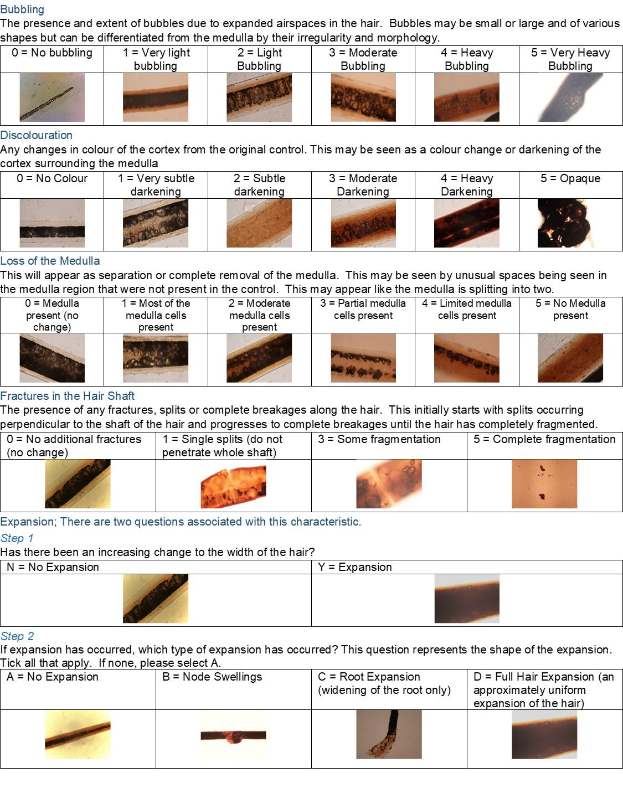
Figure 2: Grading scheme descriptions and example images for light microscopy analysis. All images taken at x400 magnification.

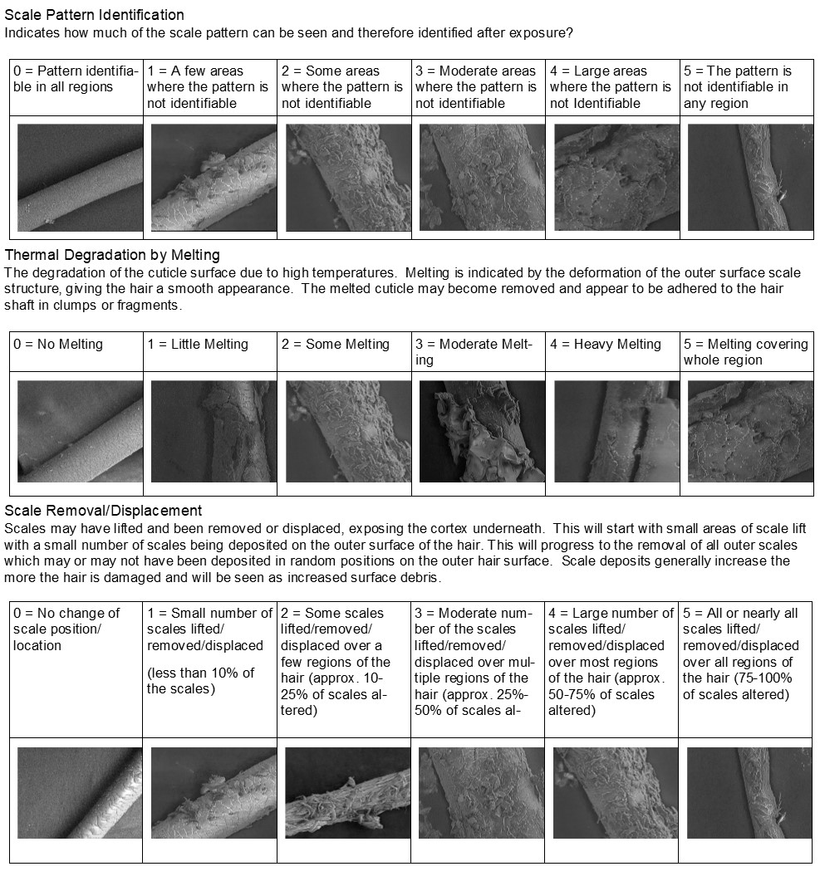
Figure 3: Grading scheme descriptions and example images for SEM analysis. All images taken at x400 magnification.

3.0 Results and Discussion

3.1 Unexposed Samples (controls)
The control samples were examined using both transmitted light microscopy and SEM to ascertain the generic morphological characteristics of the hair for comparison with the exposed samples. Photos of the controls were used to create the 0 scores for the grading scheme and provided a range of images of different control hairs so as to account for some of the variation seen in the hairs. The control images used were chosen based on their ability to appropriately represent the hairs from DS2. These images can be seen in Figures 2 and 3 as the 0 scores for the grades. Macroscopic observations identified that the control hairs were pale at the proximal end and were light brown at the distal end, approximately 2.5 cm in length and had a straight profile. Internally, the medulla consisted of a continuous multicellular medulla with none to light pigment extending from the root to mid-shaft and then light to medium pigment from mid-shaft to the tip. The cuticle consisted mainly of wave shaped scales with flat edges. Intra-variation between hairs from samples cut from DS2 was low. Negligible amounts of damage were present on the cuticle due to prior exposure to the environment, this was seen as minimal scale debris present on the surface of the hairs. No fractures, bubbling, sudden changes in hair width or unusual discolouration and medulla morphology were seen in the control samples. Some minimal damage to the hairs is expected as hairs incur naturally occurring mechanical damage through wear over time [7]. The level of damage was so minimal as to be deemed of no issue for the purposes of this study, although this cannot be said for casework samples indicating that cuticle features may not be the most appropriate area to observe for specific heat damage. Although the source of DS2 was deemed healthy and no significant damage was seen in the control samples, the history of any heat exposure of this dog is unknown, as it generally would be in casework. To ensure appropriate examination of any damage to hairs on an animal, an adequate control sample from an area that has not been exposed to heat (if possible) is required. Of the characteristics observed in this study, discoloration, expansion and the scale observations particularly require a good quality control sample to provide a representative description of the hair in its unexposed state so as to be able to identify any changes and quantify any existing damage caused through wear. This is because there is likely to be variation in the colour and width of hair across the pelage of an animal. In the authors experience, bubbling and changes in the medulla as seen in the ‘medulla disintegration’ feature do not occur from general wear and are therefore more likely to be due to another form of damage, heat being one cause, although due to the scope of this study, it cannot be stated that this is exclusive to heat.

3.2 Exposed Samples (Embedded and Individual)
Sections 3.2.1 to 3.2.3 will focus upon the qualitative and quantitative use of light microscopy for the analysis of damage incurred to both loose (individual) and embedded hairs from two sources of heat. Section 3.3 will provide a qualitative overview of the use of SEM in the analysis of heat damage on animal hair and compare that to light microscopy.

3.2.1 Effect of Exposure to a Heated Environment using a Furnace
As both the embedded and individual hairs were exposed to the furnace it was possible to visually see both macroscopic and microscopic changes occurring in the hair. A set of images depicting the main heat damage characteristics occurring in the hairs when exposed to a furnace at temperatures ranging from 50°C up to 350°C can be seen in Figures 4 and 5 (embedded and individual hairs using transmitted light microscopy respectively) and Figures 6 and 7 (embedded and individual hairs analysed using SEM respectively).
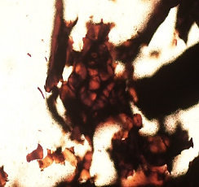
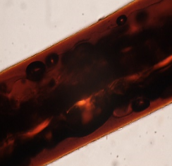
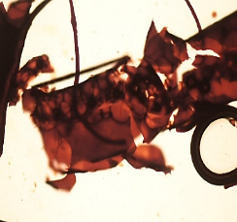
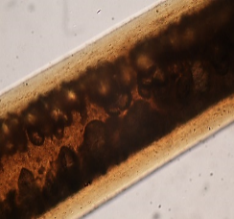
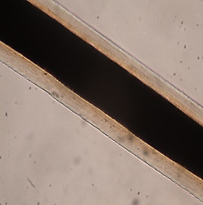
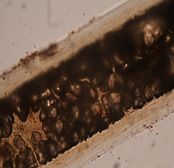
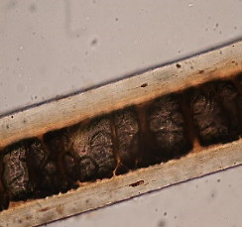
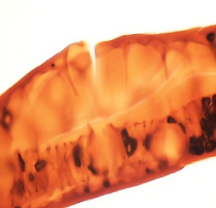
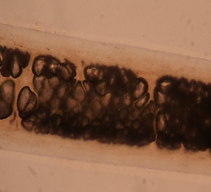
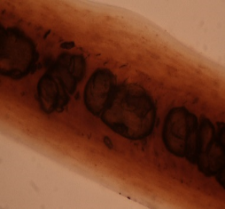
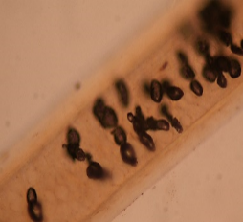
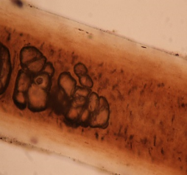
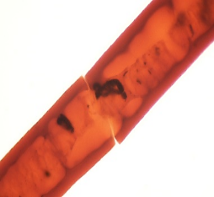
Figure 4: Images taken under a transmitted light microscope at x400 of embedded hairs when exposed to a furnace at temperatures (left to right): 50°C, 100°C, 150°C, 200°C, 250°C, 300°C and 350°C.
Figure 5: Images taken under a transmitted light microscope at x400 of the individual hairs exposed to a furnace at temperatures (left to right): 50°C, 100°C, 150°C, 200°C, 250°C, 300°C and 350°C.

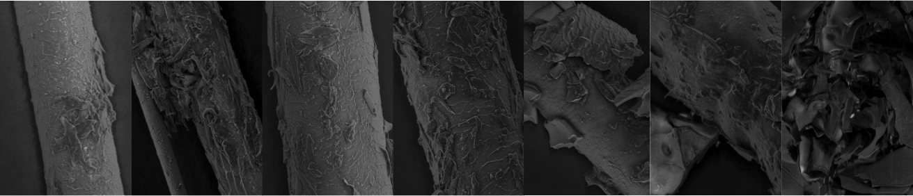
Figure 6: Images taken using a scanning electron microscope at x400 of the embedded hairs when exposed to a furnace at temperatures (left to right): 50°C, 100°C, 150°C, 200°C, 250°C, 300°C and 350°C. 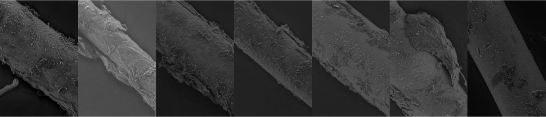
Figure 7: Images taken using a scanning electron microscope at x400 of the individual hairs exposed to a furnace at temperatures (left to right): 50°C, 100°C, 150°C, 200°C, 250°C, 300°C and 350°C.

To quantify these changes both light microscopy and SEM damage grading schemes were applied to the hairs and the mean and standard deviation (SD) calculated for each quantitative characteristic and the mode for qualitative characteristic for the embedded and individual hair samples; these can be seen in tables 2 and 3 respectively. For completeness, tables 2 and 3 also include the grades for the characteristics observed using the SEM, although no further statistical analysis has been conducted due to the small sample size.

Table 2: The mean grades for each quantitative damage characteristic, the standard deviation and the mode of the qualitative observations for embedded hairs exposed to a furnace.
Damage Characteristic - location on hair (for light microscopy only) |  |  | Temperature
 | Unexposed control |  | 50°C |  | 100°C |  | 150°C |  | 200°C |  | 250°C |  | 300°C |  | 350°C
 | Mean | SD | Mean | SD | Mean | SD | Mean | SD | Mean | SD | Mean | SD | Mean | SD | Mean | SD
Light Microscopy Damage Grading (n=3)
Bubbling – Root | 0.00 | 0.00 | 0.00 | 0.00 | 0.00 | 0.00 | 0.67 | 1.15 | 0.00 | 0.00 | 3.33 | 2.08 | 5.00 | 0.00 | 5.00 | 0.00
Bubbling – Shaft | 0.00 | 0.00 | 0.67* | 1.15 | 0.00 | 0.00 | 2.00 | 1.73 | 2.00 | 0.00 | 2.67* | 2.31 | 5.00 | 0.00 | 5.00 | 0.00
Bubbling – Tip | 0.00 | 0.00 | 0.00 | 0.00 | 0.00 | 0.00 | 0.33 | 0.58 | 0.00 | 0.00 | 1.67 | 1.53 | 5.00 | 0.00 | 5.00 | 0.00
Discolouration – Root | 0.00 | 0.00 | 0.00 | 0.00 | 0.00 | 0.00 | 1.00 | 1.00 | 0.67 | 0.58 | 3.33 | 1.15 | 4.33 | 0.58 | 4.67 | 0.58
Discolouration – Shaft | 0.00 | 0.00 | 0.00 | 0.00 | 0.00 | 0.00 | 1.67 | 1.53 | 2.67 | 0.58 | 4.33 | 0.58 | 4.67 | 0.58 | 5.00 | 0.00
Discolouration – Tip | 0.00 | 0.00 | 0.00 | 0.00 | 0.00 | 0.00 | 0.67 | 1.15 | 0.67 | 0.58 | 3.00 | 1.73 | 4.33 | 0.58 | 5.00 | 0.00
Medulla Disintegration - Root | 0.00 | 0.00 | 0.00 | 0.00 | 0.00 | 0.00 | 0.33 | 0.58 | 0.00 | 0.00 | ** | 0.00 | ** | 0.00 | ** | 0.00
Medulla Disintegration – Shaft | 0.00 | 0.00 | 0.33 | 0.58 | 0.00 | 0.00 | 2.33 | 2.08 | 2.67 | 1.53 | ** | 0.00 | ** | 0.00 | ** | 0.00
Fractures | 0.00 | 0.00 | 0.00 | 0.00 | 0.00 | 0.00 | 0.00 | 0.00 | 0.00 | 0.00 | ** | 0.00 | 5.00 | 0.00 | 5.00 | 0.00
Presence of Expansion | No |  | No |  | No |  | No |  | No |  | Yes |  | Yes |  | Yes
Expansion Shape | A |  | A |  | A |  | A |  | A |  | D |  | BD |  | BD
SEM Damage Grading (n=1)
Scale Pattern Identification | 1.00 | 0.00 | 3.00 | 0.00 | 2.00 | 0.00 | 1.00 | 0.00 | 2.00 | 0.00 | 3.00 | 0.00 | 4.00 | 0.00 | 4.00 | 0.00
Thermal Degradation by Melting | 0.00 | 0.00 | 1.00 | 0.00 | 2.00 | 0.00 | 1.00 | 0.00 | 1.00 | 0.00 | 3.00 | 0.00 | 4.00 | 0.00 | 5.00 | 0.00
Thermal Degradation by Scale Removal | 1.00 | 0.00 | 1.00 | 0.00 | 1.00 | 0.00 | 2.00 | 0.00 | 3.00 | 0.00 | 2.00 | 0.00 | 1.00 | 0.00 | 5.00 | 0.00
Expansion shapes; A = No expansion, B = Node swellings, C = Root expansion and D = Full hair expansion
*indicates where the observation was not possible in all samples (i.e. due to being obscured in one or two of the samples). **indicates where no observations were possible due to the characteristic being obscured in all samples.

Table 3: The mean grades for each quantitative damage characteristic, the standard deviation and the mode of the qualitative observations for individual hairs exposed to a furnace.
Damage Characteristic - location on hair (for light microscopy only) | Temperature
 | Unexposed control |  | 50°C |  | 100°C |  | 150°C |  | 200°C |  | 250°C |  | 300°C |  | 350°C
 | Mean | SD | Mean | SD | Mean | SD | Mean | SD | Mean | SD | Mean | SD | Mean | SD | Mean | SD
Light Microscopy Damage Grading (n=3)
Bubbling – Root | 0.00 | 0.00 | 0.33 | 0.58 | 1.00 | 0.00 | 1.33 | 0.58 | 0.67 | 0.58 | 4.67 | 0.58 | 4.67 | 0.58 | 5.00 | 0.00
Bubbling – Shaft | 0.00 | 0.00 | 1.00 | 1.73 | 1.33 | 1.53 | 2.00 | 1.00 | 1.67 | 2.08 | 4.33 | 1.15 | 4.67 | 0.58 | 5.00 | 0.00
Bubbling – Tip | 0.00 | 0.00 | 0.67 | 1.15 | 0.00 | 0.00 | 0.67 | 0.58 | 0.33 | 0.58 | 3.33 | 2.89 | 4.00 | 1.00 | 5.00 | 0.00
Discolouration – Root | 0.00 | 0.00 | 0.33 | 0.58 | 0.67 | 0.58 | 0.67 | 0.58 | 0.33 | 0.58 | 3.67 | 0.58 | 3.33 | 0.58 | 4.00 | 0.00
Discolouration – Shaft | 0.00 | 0.00 | 0.00 | 0.00 | 2.00 | 0.00 | 1.33 | 0.58 | 2.33 | 0.58 | 4.00 | 0.00 | 3.67 | 0.58 | 4.00 | 0.00
Discolouration – Tip | 0.00 | 0.00 | 0.00 | 0.00 | 0.00 | 0.00 | 0.33 | 0.58 | 0.33 | 0.58 | 2.67 | 2.31 | 3.00 | 1.00 | 4.00 | 0.00
Medulla Disintegration - Root | 0.00 | 0.00 | 0.00 | 0.00 | 0.00 | 0.00 | 0.33 | 0.58 | 0.67 | 0.58 | ** | 0.00 | ** | 0.00 | ** | 0.00
Medulla Disintegration – Shaft | 0.00 | 0.00 | 1.33 | 2.31 | 1.00 | 1.00 | 1.33 | 1.15 | 2.00 | 2.00 | ** | 0.00 | ** | 0.58 | ** | 0.00
Fractures | 0.00 | 0.00 | 0.00 | 0.00 | 0.00 | 0.00 | 0.00 | 0.00 | 0.00 | 0.00 | 4.33 | 1.15 | 4.33 | 1.15 | 5.00 | 0.00
Presence of Expansion | No |  | No |  | No |  | No |  | No |  | Yes |  | Yes |  | Yes
Expansion Shape | A |  | A |  | A |  | A |  | A |  | D |  | BD |  | D
SEM Damage Grading (n=1)
Scale Pattern Identification | 1.00 | 0.00 | 1.00 | 0.00 | 3.00 | 0.00 | 2.00 | 0.00 | 3.00 | 0.00 | 3.00 | 0.00 | 2.00 | 0.00 | 1.00 | 0.00
Thermal Degradation by Melting | 0.00 | 0.00 | 1.00 | 0.00 | 3.00 | 0.00 | 2.00 | 0.00 | 1.00 | 0.00 | 1.00 | 0.00 | 2.00 | 0.00 | 1.00 | 0.00
Thermal Degradation by Scale Removal | 1.00 | 0.00 | 2.00 | 0.00 | 1.00 | 0.00 | 2.00 | 0.00 | 2.00 | 0.00 | 3.00 | 0.00 | 3.00 | 0.00 | 2.00 | 0.00

It can be seen from tables 2 and 3 that as temperature increases, bubbling, discolouration and fractures increase in both embedded and individual hairs, with a particular increase above 250°C. Hairs that exhibited greater discolouration tended to obscure observations of the internal cortex and therefore medulla disintegration may not be a suitable characteristic to analyse in hairs believed to have been exposed to temperatures above 250°C. Individual hair samples began to show discoloration around the root region at 50°C. In contrast, the embedded hairs generally started to discolour at higher temperatures (≥ 150°C). The medulla started to appear to separate and bubbles started to appear at 50°C, particularly in the main shaft of the hair for both embedded and individual but was at a greater extent in the individual hairs, where this extended to both root and tip regions at the lower temperatures (≥ 100°C). Like the embedded hairs, the individual hairs became extremely brittle and started to fragment after 250°C, progressing to an ash like consistency at 350°C. This progression in fragmentation can be seen in Figure 4 to 6.
Further differences were seen between the embedded and individual hairs including the location of the damage. In the embedded hairs, damage was most apparent in the root to midshaft regions with the tips showing little to no damage. In a living sample, moisture is deposited to the proximal end of the hair from the sebaceous glands [33]. In the dissected skin samples, moisture from the thawed tissue could create a similar effect as with living skin, causing differences in heat conductivity along the length of the hair. The additional moisture from the skin at the root end of the hair may increase heat conductivity in that region, which would explain why more damage was present at the root. The presence and amount of melanin in hair has been noted to affect the thermal degradation of hair, with thermal diffusivity (rate at which heat may spread through the hair) being 40-50% higher in white hairs compared to brown hairs [5]. The hairs used in this study were consistently lighter in colour at the root than the shaft and tip which could also explain the increased damage in this region. Further study of the thermal diffusivity and thermal conductivity of canine hairs using the transient electro-thermal (TET) technique may aid in the interpretation of heat damage.
In individual hairs, the shaft displayed more damage compared to embedded hairs. A suggestion as to why this occurred is that the individual samples did not have the protection from the insulating layer of surrounding hairs that the hairs embedded in the skin were afforded thus leaving the shaft region more exposed to the heat. This variation in the extent of damage seen along the length of the hairs, indicates that the hairs may not be uniformly subjected to the heat source and/or different regions of the hair are more susceptible to damage than others. These inconsistencies in damage have previously been noted in human hair exposed to an oven [31].
The results from the furnace exposure in this study support further findings concluded by Igowsky and Pangerl’s [8] study on the effects of heat on human hair. Although the degree of damage was not quantified, Igowsky and Pangerl noted that when hair has been exposed to a furnace, bubbling and discolouration will occur, which was also seen in the present study. However, dissimilar results were seen in regard to the minimum exposure temperature required to cause damage. In the present study, damage was identified at 50°C whereas no damage was seen in hairs exposed to temperatures lower than 190°C in human hair. Other damage characteristics were identified in this study that had previously not been noted, including the disintegration of the medulla. Differences in sample type (canine vs human) and method may help explain these disparate findings. It has been noted in studies investigating the thermal degradation of keratin waste, that the wt% of certain elements can differ between human and cattle hair, e.g. nitrogen [45]. These differences may be extended to other mammalian species such as canines and thus effect the thermal properties of the hair.
To observe any overall trends in damage due to sample type (embedded vs individual) and exposure temperature, mean total damage scores were calculated; this included the sum of each damage score for every hair region (where applicable) for bubbling, discolouration, medulla disintegration and fractures, with a maximum possible total score of 45. The SEM observations and expansion were not included in the total damage score. The mean total damage scores for the furnace results can be seen in Figure 8. Histograms showing the distributions of scores for damage characteristics for both embedded and individual hairs are shown in Figure 9.

Figure 8: Mean total damage scores for both embedded and individual hair samples exposed to a heated environment via a furnace.
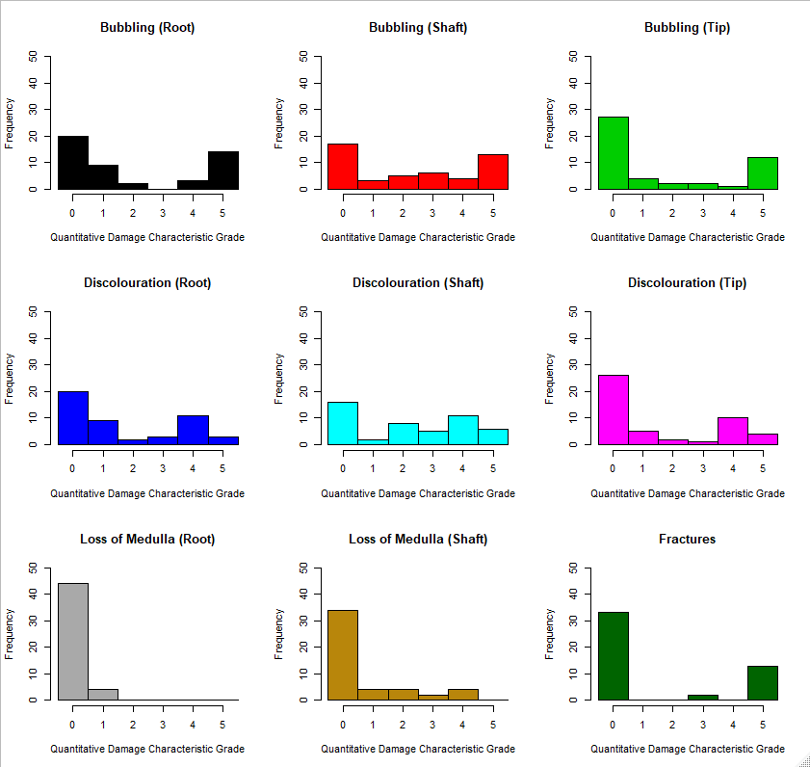
Figure 9: Histograms of damage characteristic grades for samples exposed to furnace damage.

The general trend is that as temperature is increased, the total damage is increased for both embedded and individual hairs. Studies investigating the thermal degradation of keratin have noted that thermal degradation occurs in multiple successive and overlapping stages [4]. Degradation starts slowly with initial decomposition due to the loss of adsorbed water in the sample, which has shown to occur in wool samples at approximately 180°C [4]. This slow increase in damage can be seen at the lower temperatures in Figure 8. The second stage is the start of the keratin decomposition (which occurs between 150°C to 600°). A sharp increase in keratin degradation at around 300°C has been noted previously and coincides with the generation of inorganic gases, such as ammonia and carbon dioxide. This rapid increase in damage can be seen in the overall damage scores at 250°C. Advanced degradation of the keratin structure occurs at higher temperatures (above 450°C) which was seen in initial pilot studies where samples exposed to temperatures above 350°C became completely cremated. It can be seen from Figure 9, over the range of temperatures used, scores for loss of medulla in the root vary little. Distributions for the remaining characteristics show that for the most part, the full range of grading scores are used, with the exception of shaft medulla loss.
Individual hairs exhibited greater damage than embedded hairs at all temperatures apart from 50°C, 300°C and 350°C. This may indicate that the protection that multiple hairs in a pelage provide each other is only exhibited at temperatures less than 300°C and beyond this temperature, the hairs and air between the hairs are sufficiently increased in temperature to cause damage.
Due to the large number of characteristics being observed, it is beneficial to attempt to determine if there are latent variables which might explain variance across the dataset and identify redundant measures in the analysis of hairs that are believed to have been subjected to heat. Additionally, the relationship between such latent variables and independent variables such as exposure time or temperature may help inform future grading schemes of this type. The light microscopy damage grading data was therefore subjected to principal component analysis (PCA) for the purposes of dimensionality reduction. Before subjecting the data to PCA, the KMO measure of sampling adequacy (MSA) was computed. The MSA of the dataset was 0.72. This indicates that overall, the data collected may be suitable for PCA. However, the measures of sampling accuracy for loss of medulla in the root (0.54) and shaft (0.43) indicate that the distribution of these scores are not suitable for inclusion into a PCA. This may be related to the fact that in the case of furnace exposed hairs, observations of medulla loss were not possible at temperatures of 250°C and above due to obfuscation of the internal structure. However, it was found that at temperatures of 200°C and below, loss of medulla in both root and shaft were correlated with bubbling in the same region (Root: R² = 0.48, p = 1.3 x 10⁻⁵; shaft: R² = 0.6, p = 2.25 x 10⁻⁷), as such it was determined that it was valid to omit these measures from the PCA in order to analyse all observations across the full range of temperatures.
Figure 10 shows the loadings for the extracted features. The point of inflection and proportion of variance given by the eigenvalue attributed to component 1 strongly suggests a one-dimensional solution. It was found that the first component (Dim 1) accounted for 86.5% of the variation in the data, with all of the damage characteristics heavily loaded onto this dimension.
Figure 11 shows a PCA vector map with temperature included as a supplementary variable and mapped onto the extracted feature space. The loading of temperature on to the first dimension of the PCA suggests that temperature is correlated with all damage features, indicating that as temperature increases so does the severity of each of the damage characteristics (R² = 0.84, p< 2.2x10⁻¹⁶). It can be noted that with furnace exposure, any one of the characteristics could be used to indicate the temperature to which it has been exposed. Therefore, not all the characteristics may need to be observed, reducing the analysis time.
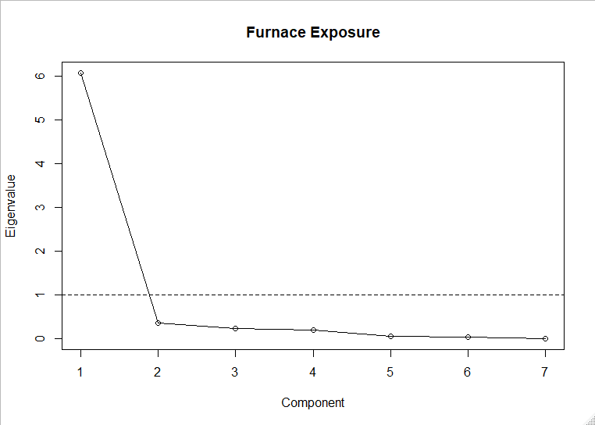
Figure 10: Scree plot showing the eigenvalues of the components extracted from ratings of furnace exposed hairs.

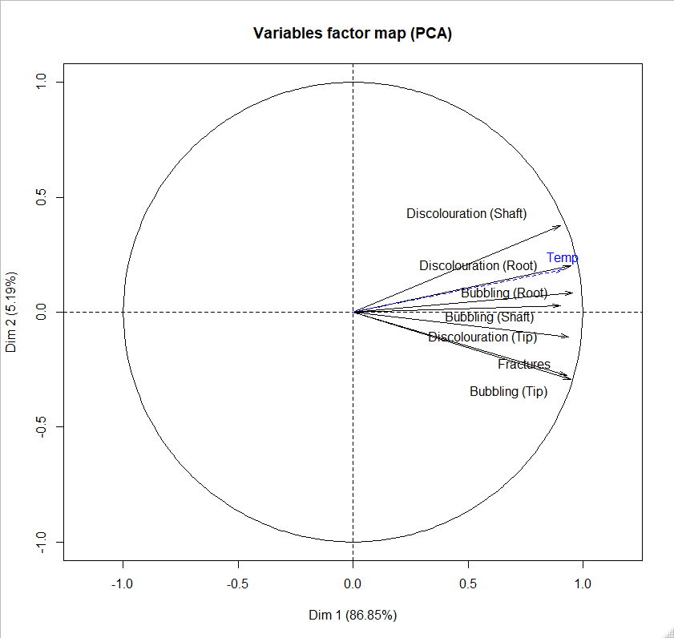
Figure 11: PCA Vector map for light microscopy damage characteristics of hairs exposed to a furnace.

Individual data points for PCA scores on dimensions 1 and 2 were plotted with 95% confidence interval ellipses for sub-setting the data by whether the hairs were embedded or loose (Figure 12), whether they expanded or not (Figure 13) and if expansion was present, the type of expansion seen (Figure 14).
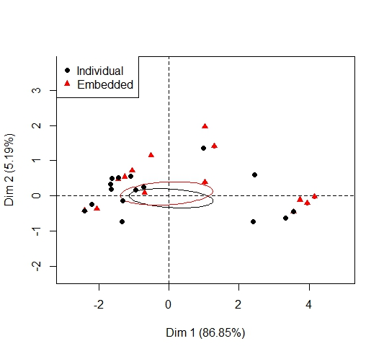
Figure 12: PCA individuals plot to compare embedded and individual hairs
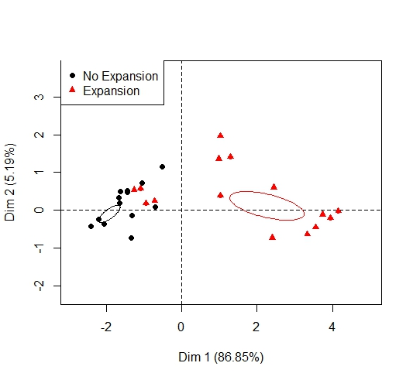
Figure 13: PCA individuals plot to compare hairs that showed expansion

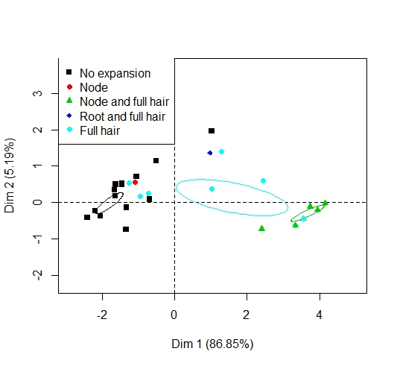
Figure 14: PCA individuals plot to compare expansion type
Although the descriptive statistics initially indicate there is some variation in the damage characteristics between embedded and individual hairs, Figure 12 shows there is no significant difference between these groups. This means that in future studies of hairs exposed to furnaces, it is possible to just use the more easily sourced loose hairs. Care must be taken though as this applies to the canine hairs used in this study and further analysis is needed to identify if this is more generalizable. Figure 13 shows that expansion of the hair is associated with the amount of damage (dimension 1) as is temperature, as discussed above. Therefore, as the exposure temperature is increased, the more likely the hair is to expand.
Expansion type (Figure 14) appears to have three distinct groups; those that show lower levels of damage and therefore no expansion, full hair expansion as the temperature is increased (and therefore an increase in other damage scores also) and hairs exposed to the highest temperatures which have both full hair expansion and nodes. This indicates that generally as the temperature is increased the hair will firstly expand in its width along the whole shaft and then as it reaches the higher temperature range, nodes start to appear. This expansion may be due to the increase in temperature of the air gaps inside the cortex, pushing on the outer cuticle. Once the threshold of expansion is reached, further expansion occurs at weaker, more localised points along the shaft causing nodes. These nodes may occur where there are breaches in the cuticle layer or where the cuticle is thinner, but further analysis of the cuticle at these points is required to confirm this.

3.2.2 Effect of Exposure to Microwave Radiation
Both the embedded and individual hairs showed macroscopic and microscopic changes as exposure time in the microwave was increased. A set of images depicting the main heat damage characteristics occurring in the hairs when exposed to microwave radiation at exposure times of 15, 30, 45, 60, 120, 180, 240 and 300 seconds can be seen in figures 15 and 16 (embedded and individual hairs using transmitted light microscopy respectively) and figures 17 and 18 (embedded and individual hairs analysed using SEM respectively).

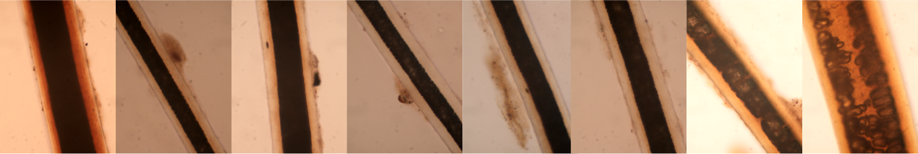
Figure 15: Images taken using a transmitted light microscope at x400 of hairs embedded in skin when exposed to microwave radiation for exposure times (left to right): 15 seconds, 30 seconds, 45 seconds, 60 seconds, 120 seconds, 180 seconds, 240 seconds and 300 seconds.
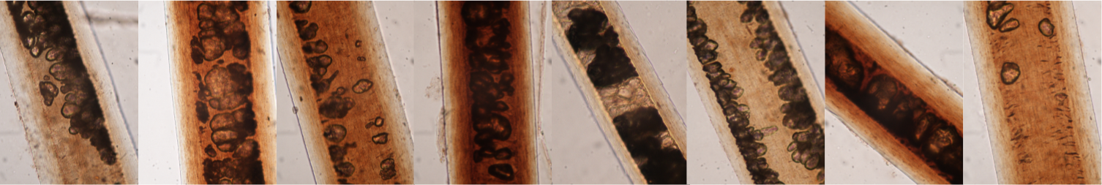
Figure 16: Images taken using a transmitted light microscope at x400 of the individual hairs exposed to microwave radiation for exposure times (left to right): 15 seconds, 30 seconds, 45 seconds, 60 seconds, 120 seconds, 180 seconds, 240 seconds and 300 seconds.
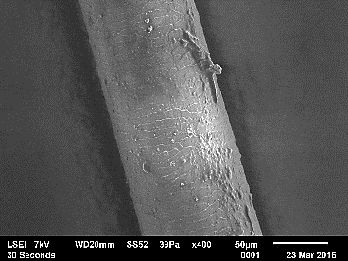
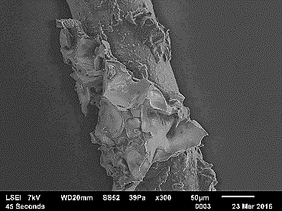
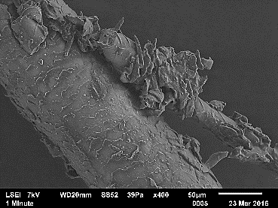
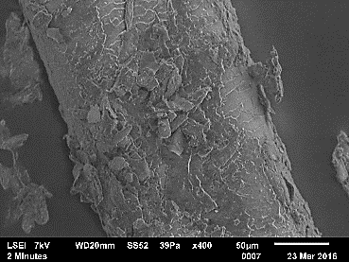
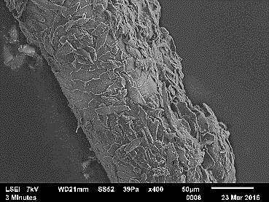
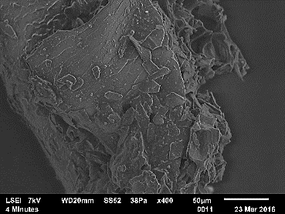
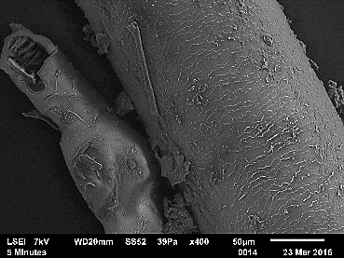
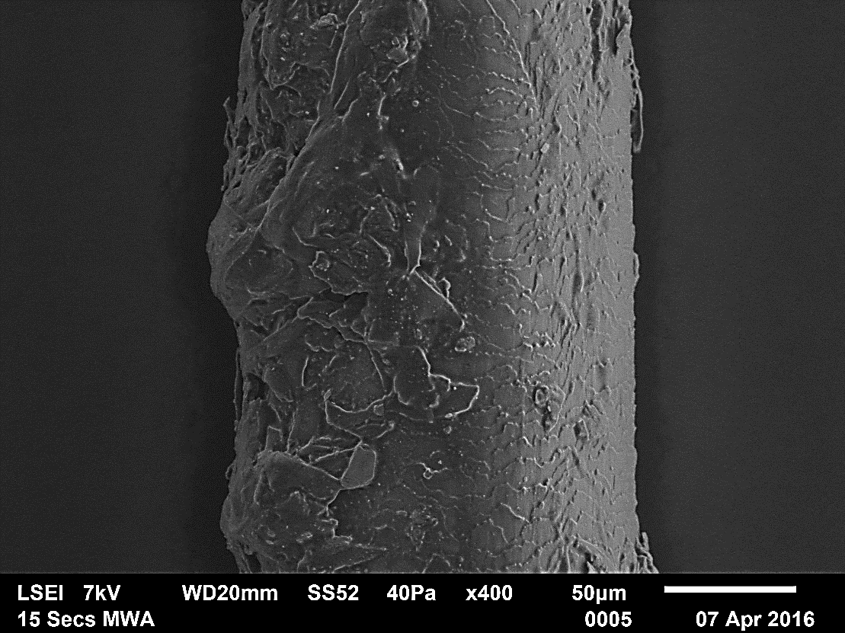
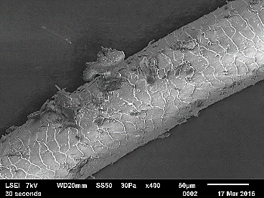
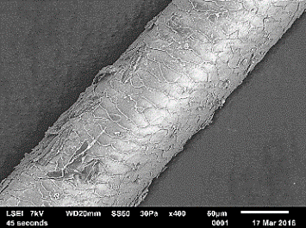
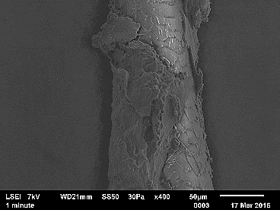
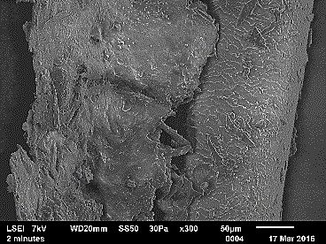
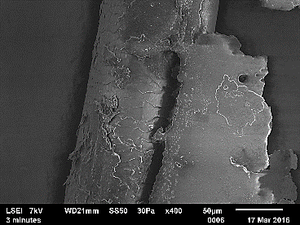
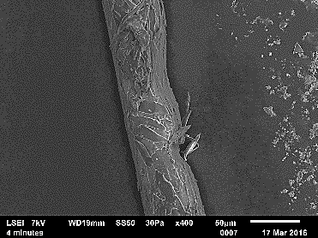
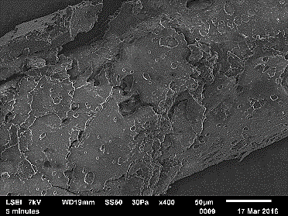
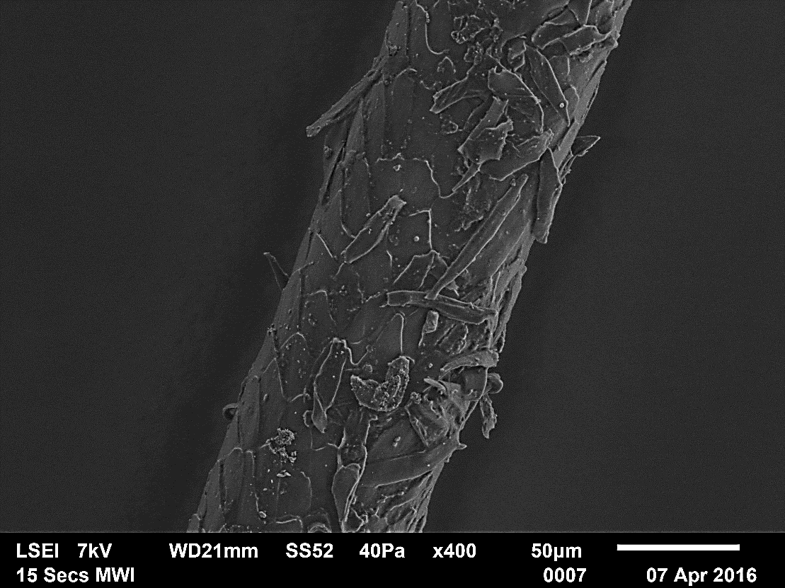
Figure 17: Images taken using a scanning electron microscope at x400 of the embedded hairs when exposed to microwave radiation for exposure times (left to right): 15 seconds, 30 seconds, 45 seconds, 60 seconds, 120 seconds, 180 seconds, 240 seconds and 300 seconds.
Figure 18: Images taken using a scanning electron microscope at x400 of the individual hairs exposed to microwave radiation for the exposure times (left to right): 15 seconds, 30 seconds, 45 seconds, 60 seconds, 120 seconds, 180 seconds, 240 seconds and 300 seconds.

Tables 4 and 5 provide the mean grades for each quantitative damage characteristic, the standard deviation and the mode of the qualitative observations (n=3) for both embedded and individual hairs exposed to microwave radiation respectively. For completeness, Tables 4 and 5 also include
the grades for the characteristics observed using the SEM; these will be discussed further in section 3.3.

Table 4: The mean grades for each quantitative damage characteristic, the standard deviation and the mode of the qualitative observations for embedded hairs exposed to microwave radiation.
Damage Characteristic - location on hair (for light microscopy only) | Exposure Time
 | Unexposed control |  | 15 seconds |  | 30 seconds |  | 45 seconds |  | 60 seconds |  | 120 seconds |  | 180 seconds |  | 240 seconds |  | 300 seconds
 | Mean | SD | Mean | SD | Mean | SD | Mean | SD | Mean | SD | Mean | SD | Mean | SD | Mean | SD | Mean | SD
Light Microscopy Damage Grading (n=3)
Bubbling – Root | 0.00 | 0.00 | 5.00 | 0.00 | 0.67 | 1.15 | 1.67 | 0.58 | 1.33 | 0.58 | 5.00 | 0.00 | 0.33 | 0.58 | 4.00 | 1.73 | 5.00 | 0.00
Bubbling – Shaft | 0.00 | 0.00 | 0.00 | 0.00 | 0.67 | 0.58 | 0.33 | 0.58 | 0.33 | 0.58 | 0.00 | 0.00 | 0.00 | 0.00 | 1.00 | 1.00 | 2.33 | 2.08
Bubbling – Tip | 0.00 | 0.00 | 0.00 | 0.00 | 0.00 | 0.00 | 0.00 | 0.00 | 0.00 | 0.00 | 0.00 | 0.00 | 0.00 | 0.00 | 0.00 | 0.00 | 0.33 | 0.58
Discolouration – Root | 0.00 | 0.00 | 2.67 | 0.58 | 1.00 | 0.00 | 2.67 | 1.15 | 0.00 | 0.00 | 3.00 | 0.00 | 0.67 | 0.58 | 2.67 | 0.58 | 3.00 | 0.00
Discolouration – Shaft | 0.00 | 0.00 | 0.33 | 0.58 | 1.33 | 0.58 | 1.33 | 0.58 | 1.00 | 0.00 | 1.00 | 0.00 | 1.00 | 1.00 | 1.33 | 0.58 | 2.67 | 1.15
Discolouration – Tip | 0.00 | 0.00 | 0.00 | 0.00 | 0.00 | 0.00 | 0.00 | 0.00 | 0.33 | 0.58 | 0.00 | 0.00 | 0.00 | 0.00 | 0.00 | 0.00 | 0.00 | 0.00
Medulla Disintegration - Root | 0.00 | 0.00 | 0.00 | 0.00 | 0.00 | 0.00 | 0.33 | 0.58 | 0.00 | 0.00 | 0.00 | 0.00 | 0.00 | 0.00 | 0.00 | 0.00 | 0.00 | 0.00
Medulla Disintegration – Shaft | 0.00 | 0.00 | 0.00 | 0.00 | 0.00 | 0.00 | 0.00 | 0.00 | 0.33 | 0.58 | 0.00 | 0.00 | 0.00 | 0.00 | 0.00 | 0.00 | 0.67 | 1.15
Fractures | 0.00 | 0.00 | 0.00 | 0.00 | 1.00 | 1.73 | 0.00 | 0.00 | 0.00 | 0.00 | 1.00 | 1.73 | 0.00 | 0.00 | 1.00 | 1.73 | 2.00 | 1.73
Presence of Expansion | No |  | Yes |  | No |  | Yes |  | No |  | Yes |  | No |  | Yes |  | Yes
Expansion Shape | A |  | C |  | A |  | C |  | A |  | C |  | A |  | C |  | BC
SEM Damage Grading (n=1)
Scale Pattern Identification | 1.00 | 0.00 | 1.00 | 0.00 | 1.00 | 0.00 | 3.00 | 0.00 | 2.00 | 0.00 | 3.00 | 0.00 | 2.00 | 0.00 | 2.00 | 0.00 | 1.00 | 0.00
Thermal Degradation by Melting | 0.00 | 0.00 | 1.00 | 0.00 | 1.00 | 0.00 | 3.00 | 0.00 | 1.00 | 0.00 | 2.00 | 0.00 | 2.00 | 0.00 | 3.00 | 0.00 | 3.00 | 0.00
Thermal Degradation by Scale Removal | 1.00 | 0.00 | 2.00 | 0.00 | 0.00 | 0.00 | 1.00 | 0.00 | 3.00 | 0.00 | 3.00 | 0.00 | 4.00 | 0.00 | 4.00 | 0.00 | 3.00 | 0.00
Expansion shapes; A = No expansion, B = Node swellings, C = Root expansion and D = Full hair expansion

Table 5: The mean grades for each quantitative damage characteristic, the standard deviation and the mode of the qualitative observations for individual hairs exposed to microwave radiation.
Damage Characteristic - location on hair (for light microscopy only) | Exposure Time
 | Unexposed control |  | 15 seconds |  | 30 seconds |  | 45 seconds |  | 60 seconds |  | 120 seconds |  | 180 seconds |  | 240 seconds |  | 300 seconds
 | Mean | SD | Mean | SD | Mean | SD | Mean | SD | Mean | SD | Mean | SD | Mean | SD | Mean | SD | Mean | SD
Light Microscopy Damage Grading (n=3)
Bubbling – Root | 0.00 | 0.00 | 1.00 | 0.00 | 0.67 | 0.58 | 1.00 | 1.00 | 1.67 | 0.58 | 2.00 | 0.00 | 2.33 | 0.58 | 1.67 | 1.15 | 2.67 | 0.58
Bubbling – Shaft | 0.00 | 0.00 | 1.67 | 1.53 | 3.33 | 0.58 | 3.33 | 0.58 | 2.33 | 2.08 | 1.00 | 1.73 | 2.67 | 0.58 | 1.33 | 2.31 | 3.67 | 0.58
Bubbling – Tip | 0.00 | 0.00 | 0.00 | 0.00 | 0.33 | 0.58 | 0.00 | 0.00 | 0.33 | 0.58 | 0.33 | 0.58 | 1.00 | 1.00 | 1.00 | 1.00 | 0.67 | 0.58
Discolouration – Root | 0.00 | 0.00 | 0.33 | 0.58 | 0.33 | 0.58 | 0.67 | 0.58 | 0.33 | 0.58 | 0.00 | 0.00 | 1.67 | 1.15 | 0.33 | 0.58 | 0.67 | 0.58
Discolouration – Shaft | 0.00 | 0.00 | 1.00 | 0.00 | 1.67 | 0.58 | 1.67 | 0.58 | 3.00 | 0.00 | 1.33 | 0.58 | 2.00 | 0.00 | 2.00 | 0.00 | 1.67 | 0.58
Discolouration – Tip | 0.00 | 0.00 | 0.00 | 0.00 | 0.00 | 0.00 | 0.67 | 1.15 | 0.33 | 0.58 | 0.33 | 0.58 | 0.33 | 0.58 | 0.00 | 0.00 | 0.00 | 0.00
Medulla Disintegration - Root | 0.00 | 0.00 | 0.00 | 0.00 | 0.00 | 0.00 | 0.00 | 0.00 | 0.00 | 0.00 | 0.33 | 0.58 | 0.33 | 0.58 | 0.00 | 0.00 | 0.00 | 0.00
Medulla Disintegration – Shaft | 0.00 | 0.00 | 2.00 | 1.73 | 2.67 | 0.58 | 2.67 | 1.53 | 2.00 | 1.73 | 0.33 | 0.58 | 1.00 | 1.73 | 0.33 | 0.58 | 2.33 | 1.53
Fractures | 0.00 | 0.00 | 0.00 | 0.00 | 0.00 | 0.00 | 0.00 | 0.00 | 0.00 | 0.00 | 0.00 | 0.00 | 1.00 | 1.73 | 0.00 | 0.00 | 0.00 | 0.00
Presence of Expansion | No |  | No |  | No |  | No |  | No |  | No |  | No |  | No |  | No
Expansion Shape | A |  | A |  | A |  | A |  | A |  | A |  | A |  | A |  | A
SEM Damage Grading (n=1)
Scale Pattern Identification | 1.00 | 0.00 | 1.00 | 0.00 | 1.00 | 0.00 | 1.00 | 0.00 | 2.00 | 0.00 | 2.00 | 0.00 | 3.00 | 0.00 | 5.00 | 0.00 | 4.00 | 0.00
Thermal Degradation by Melting | 0.00 | 0.00 | 0.00 | 0.00 | 1.00 | 0.00 | 0.00 | 0.00 | 1.00 | 0.00 | 3.00 | 0.00 | 4.00 | 0.00 | 2.00 | 0.00 | 5.00 | 0.00
Thermal Degradation by Scale Removal | 1.00 | 0.00 | 1.00 | 0.00 | 1.00 | 0.00 | 1.00 | 0.00 | 1.00 | 0.00 | 1.00 | 0.00 | 1.00 | 0.00 | 5.00 | 0.00 | 1.00 | 0.00
Expansion shapes; A = No expansion, B = Node swellings, C = Root expansion and D = Full hair expansion

Tables 4 and 5 show that the damage characteristics that can be associated with embedded hairs that have been exposed to microwave radiation are disintegration of the medulla in the shaft, bubbling and discolouration, particularly in the root region, and expansion of the root. For individual hairs, disintegration of the medulla in the shaft, bubbling in the root and shaft and discolouration, particularly in the shaft was seen.
The presence of these characteristics may be attributed to the method at which a microwave produces heat in a material. Radio waves are projected onto the sample which excites water molecules. Vibration starts to occur as the excitation level increases which consequently generates heat. As the heating process occurs internally, it is likely the medulla and cortex will hold the most heat hence more damage occurring in these structures.
As with the furnace exposed hairs, differences were initially seen when observing the descriptive statistics between embedded and loose (individual) hairs. Individual hairs did not fracture (only one instance seen at 180 seconds), even after the maximum exposure time, whereas some fracturing was seen in the embedded hairs after just 30 seconds with an increase in fracturing seen at 300 seconds. The embedded hairs began to show damage macroscopically after 240 seconds and by 300 seconds, the hairs had discoloured to a dark brown. In individual hairs, this discolouration was less pronounced than in the embedded hairs with an increase in discolouration seen at 60 seconds and longer exposure times. This discolouration was seen in both the root and shaft for embedded hairs but predominantly in the shaft for individual hairs. Less bubbling and discolouration in the root were seen in individual hairs compared to embedded and as with the furnace exposed samples, the root to midshaft area displayed greater damage in the embedded hairs which may be also be attributed to the reasoning discussed in section 3.2.1.
Using the same approach as in section 3.2.2, to observe any overall trends in damage due to sample type (embedded vs individual) and exposure time, the mean total damage scores were calculated; this can be seen in figure 19. Histograms showing the distributions of scores for damage characteristics for both embedded and individual hairs are shown in Figure 20.

Figure 19: Mean total damage scores of both embedded and individual hair samples exposed to microwave radiation
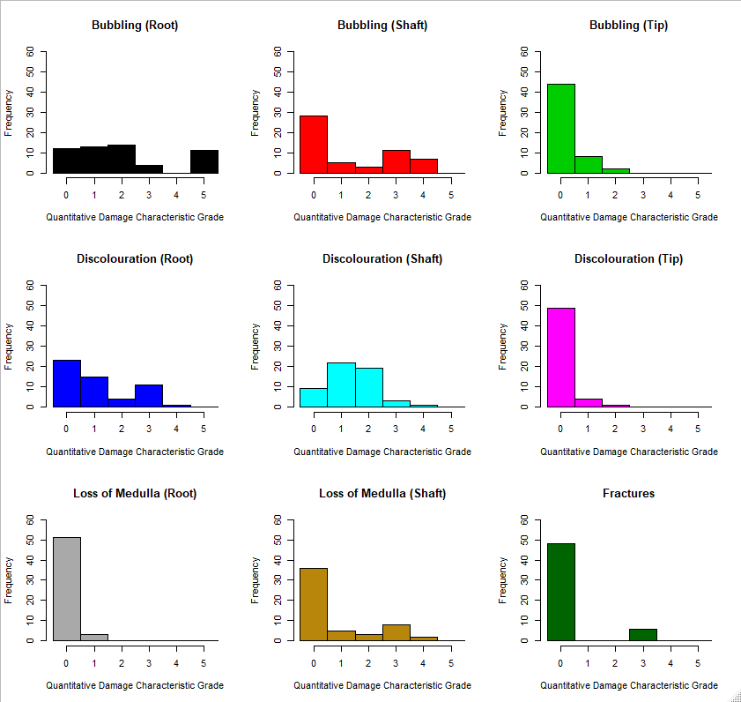Figure 20: Histograms of damage characteristic grades for samples exposed to microwave damage.

Overall, there is a slight trend between exposure time and total damage score; as exposure time increases, the level of damage increases, although this link is not as prominent as compared to the one seen between damage and temperature in the furnace results. This relationship is less apparent in the embedded samples compared to the individual samples, possibly due to the individual hairs having greater exposure to the microwave radiation as they do not have the protection of the insulating layer of the pelage that the embedded hairs do. It appears that damage is incurred after only 15 seconds of exposure but then remains relatively stable when exposed to microwave radiation for up to 180 and 300 seconds, whereupon damage scores increase again for individual and embedded hairs respectively. As with furnace results, loss of medulla in the root has little variance in scores within the sample (Figure 20). Additionally, the distributions of bubbling in the tip and discolouration of the tip do not vary greatly. In general, scores occupy a narrower range than samples exposed to furnace damage.
As with the furnace results, these two stages of increasing damage may be due to the two main stages of mass loss seen in keratin when exposed to high temperatures. These two stages are not particularly prominent in the microwave exposed samples compared to the furnace, which may be due to the heating rate of the samples in the microwave and lower overall heat exposure. Although the temperature of the samples is unknown, it may be expected that the loose individual hairs take up to 180 seconds for the samples to reach a high enough temperature for the keratin to start to decompose and up to 300 seconds for the embedded hairs to reach this decomposition stage.
When exposed to a microwave, water molecules in the hair absorb the microwave radiation likely causing an increase in temperature of the surrounding material. This may cause the samples to lose water and quickly start the degradation process; this could explain the short time required for the first stage of degradation to occur (15 seconds). The variation in amount of water on and in the hair samples may partly contribute to the differences in damage score seen between the embedded and individual hairs. Although samples were clean and dry before exposure, slight differences in water content could affect the amount the hair was heated up and its subsequent damage features. This is particularly relevant for the hairs remaining in the skin which may have absorbed water from the thawed tissue to different degrees. To understand the stages of thermal degradation further for hair exposed to microwaves, analysis of the rate of temperature increase of the samples during microwaving is required.
KMO testing was performed on the dataset. It was found that MSA for the data was not sufficient for PCA (0.54). However, this was due to the contributions of medulla loss in the root (0.33), discolouration of the tip (0.27) and loss of medulla in the shaft (0.49). Removing these variables increased the MSA of the dataset to 0.7, indicating suitability for PCA. PCA was performed on the damage characteristic scores and exposure time was included as a supplementary variable and mapped onto the extracted feature space. The scree plot suggests two dimensions accounting for 65.34% of the total variance. The loadings for which can be seen in Figure 21.
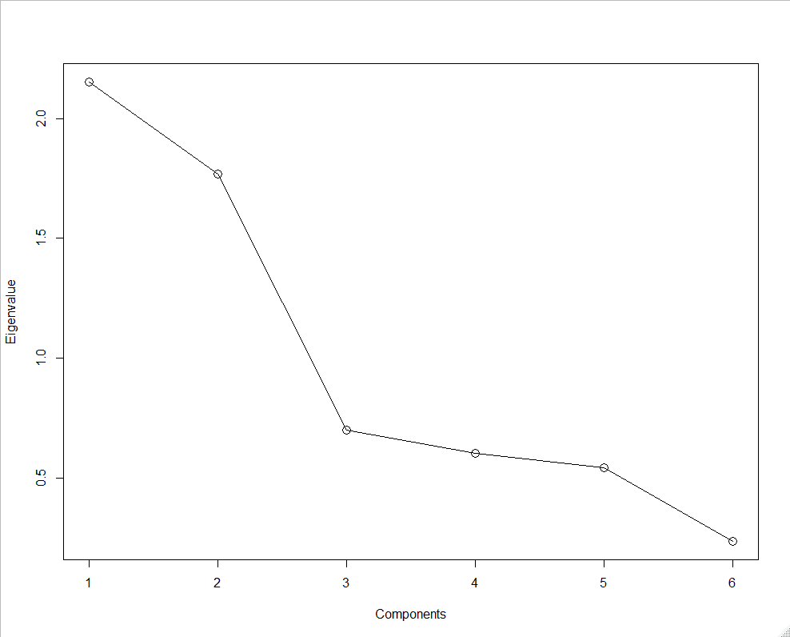
Figure 21. Scree plot for PCA of damage rating for microwave damage

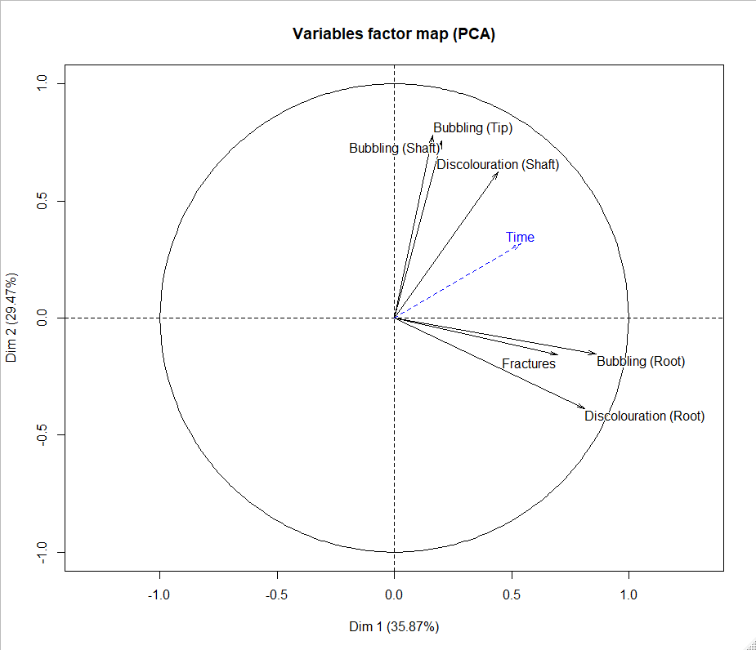
Figure 22: PCA Vector map for light microscopy damage characteristics of hairs exposed to a microwave.

The results suggest that there are two independent forms of damage that occur when hairs are exposed to microwave radiation. Dimension 1 is associated with increased bubbling and discolouration in the root. Dimension 2 is associated with bubbling and discolouration of the shaft and tip. Time is correlated with both dimension 1 and 2 indicating that although exposure time is a factor in damage observed in microwave exposed hairs, it influences two groups of damage characteristics which do not co-vary. Figure 23 shows that there is significant difference between embedded and individual hairs on both dimensions 1 and 2, with individual hairs showing damage characteristics which are consistent with lower equivalent exposure time compared to embedded hairs. For embedded hairs, increased exposure time is associated with higher scores on dimension 1 (root damage) with little effect of exposure time on dimension 2 features (shaft damage). Conversely, increased exposure time for individual hairs results in greater shaft and tip damage, with little change to root damage scores. Figure 24 shows comparisons of data dependent on whether hairs showed expansion. There is significant difference between the groups only on dimension 2, suggesting that expansion is associated with greater exposure time. However, the grouping observed in figure 23 suggests that expansion is also dependent on whether hairs are embedded. It appears that for at least this one source of heat, results are dependent upon whether hairs were embedded in skin or loose when exposed; this highlights a potential barrier in further research in this area as ethically obtaining healthy dog skin is limited only to countries which have legislation, such as the Dangerous Dogs Act 1991 [44], for obtaining hair samples from animals that were euthanised due to court order not for experimental purposes. Further investigation into the extent of variation in results seen between individual and embedded may potentially allow modelling of the data so as to account for hairs that have been tested in their loose form.
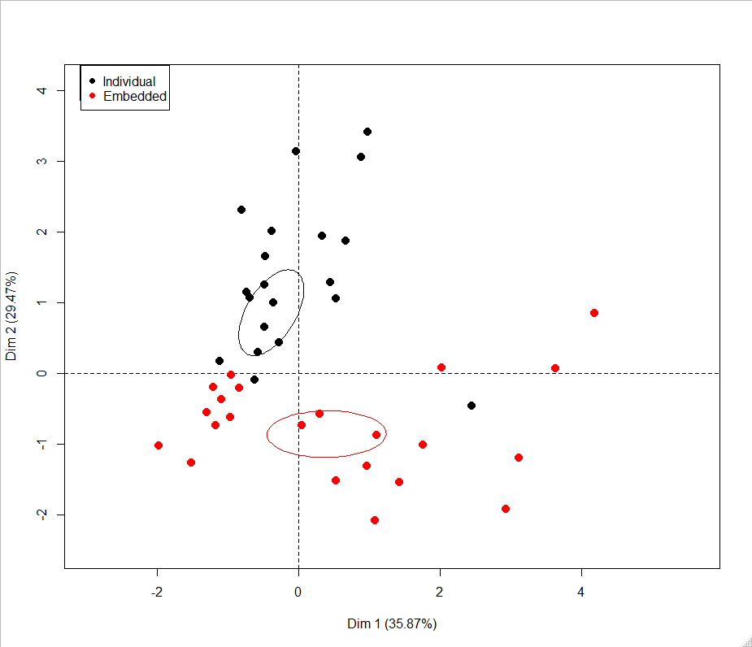
Figure 23: Individuals plot to compare embedded and individual hairs

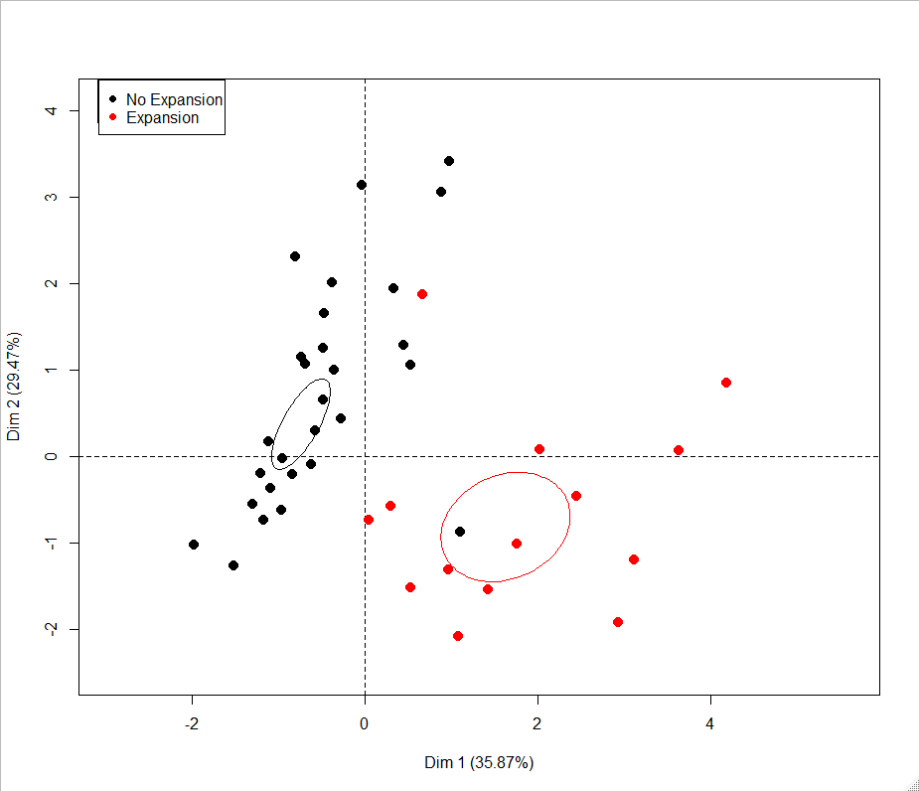
Figure 24: Individuals plot to compare hairs that showed expansion

3.2.3 Identifying Heat Source from Damage Characteristics
The heat sources investigated in this report cannot be directly compared against one another due to different independent variables being measured. However, it can be determined that the type of damage observed is influenced by the type of heat applied and the context and substrate in which the hair is situated at the time of exposure. As discussed above, exposure to heat causes damage characteristics to co-vary uniformly and displays a nonlinear relationship to exposure temperature. Exposure to microwave radiation results in a damage profile which is dependent on whether hairs are loose or embedded within skin as they are in vitro. As such, this result suggests that total damage grading may obscure information which may indicate microwave exposure. The comparison between recovered individual loose hairs and those recovered from skin may be a useful method for determining whether exposure to microwave radiation has occurred.

3.3 Use of SEM for Grading Heat Damage in Hairs
The use of scanning electron microscopy (SEM) for the examination of damage characteristics present on the cuticle was limited to only 1 hair per variable. This was due to time and availability of the equipment. This method could be repeated to provide a comprehensive set of characteristics for cuticle damage where more repeats would be examined to identify variation seen in these characteristics.
Less emphasis was placed on the SEM variables due to its limited use in casework by forensic hair examiners. A study by Wilkinson and Gwinnett [41] investigated the methods used in hair examinations and found that SEM was only used by 2 out of 45 participants in casework and 3 out of 11 in research. As this technique is not commonly used in casework, more value should be placed on characteristics that can be observed using transmitted light microscopy methods where 36 participants used this in casework and 8 in research [41].
Originally, four characteristics were chosen to describe thermal damage to the cuticle: scale pattern identification, thermal degradation by melting, scale removal/displacement and scale edge damage. The first of which was chosen to represent the overall change in scale pattern and the difficulty this posed in terms of identifying scale pattern type; identifying scale pattern type is important in animal hair analysis and why it was included here. Thermal damage seen by melting and scale removal/displacement were chosen to attempt to quantify the deformation of the scales and identify why the scale pattern might not be identifiable. Scale edge damage was originally included to quantify any damage to the scale edges, but this was difficult to categorise and, in most instances, where melting or scale removal/displacement had occurred, it was not possible to give a grade to at all. Due to this, only the three remaining characteristics were seen as useful for characterisation via SEM of the cuticle and utilised in this study. A limitation of SEM for damage analysis is the time for sample preparation and imaging. This time-consuming process meant that only the shaft of one sample per condition was able to be analysed. Access to an SEM and the time to analyse hairs may mean that this is not a realistic or useful method for investigating the presence of heat damage in hairs. The traditional approach of producing scale casts of the cuticle using a suitable medium such as gelatine or clear nail varnish, would normally be an alternative approach to SEM to visualise the outer surface of hair samples; this technique is both quicker and more accessible. There are disadvantages of using scale casts in this type of investigation as adhering the hair to a sticky surface to create a cast could add further damage to hair or in the case of brittle hairs, could destroy samples.
Although only a small sample size was tested, some initial observations can be made on heat damage to the cuticle using SEM. Embedded hairs exposed to a furnace appeared to show some increase in damage in terms of scale pattern identification and melting when exposed to higher temperatures, for example melting scores increased when exposed to 250°C, 300°C and 350°C. This increase in damage linked to temperature increase was less obvious for individual hairs. Scale removal showed no link to temperature in the furnace, with scores appearing independent to temperature or any other feature. Embedded hairs exposed to a microwave showed some increase in damage in terms of scale removal at 60 seconds and above exposure times and an increase in melting and scale pattern identification scores at 45 seconds and above. Individual hairs appear to be affected slightly differently than embedded with damage scores only increasing after longer exposure times, e.g. melting scores become higher at 120 seconds and above and scale pattern identification scores are greater at 180 seconds and above. Scale removal appears minimal regardless of exposure time. Care must be taken with these results as it is unclear due to sample size as to the variation that would be seen in hairs exposed to these heat sources. Overall, the authors noted that cuticle observations were far more difficult to quantify than the damage features in the cortex and medulla. This mainly was due to the subjective nature of providing a grade for a characteristic that could vary dramatically even across one hair. However, the use of SEM to identify damage in hairs has previously been proven successful in a number of studies which have investigated the effect of treatment to human hairs. Dias dos Santos, Edwards and Cappa de Oliveira [46] found that thermal treatments, straightening and bleaching of hairs all produced different patterns of damage on the cuticle of human hairs. Kaliyadan et.al. [47] compared hair samples from a control group who had never used specific hair treatments and a target group who regularly bleach, dye, and/or straighten their hair. From this study it was found that using normal clinical examinations and light microscopy, no significant differences were seen between the two groups however SEM identified that the target group displayed more damage to the hairs. Mahrle, Sterry and Orfanos [48] also found that SEM can be used to differentiate between mechanical and chemical damage in human hair samples. The subtle differences seen in heat damage may be such that SEM should be used as a supplementary approach to light microscopy and therefore is worthy of further study. A suggestion for future work in damage analysis using SEM could be to investigate the use of categorical type observations only, e.g. the presence or absence of scale removal, and remove the ordinal grade scale.

3.4 The Use of Grading Schemes in Heat Damage Interpretation
The use of objective methods to aid the interpretation of hair examinations has been discussed by Wilkinson and Gwinnett [41]. Past criticisms of hair evidence [49] have meant that more objective methods for hair characterisation would be preferable. Previous attempts at using quantitative measurements or observations to reduce subjectivity in hair characterisation have been conducted mainly on colour [1, 42, 43, 50]. As far as the authors know, no quantitative grading scheme has been attempted to characterise heat damage features seen in hair. A study to create a grading system to note damage in hair due to pathological medical conditions, e.g. alopecia, was developed for the medical sector previously but the features notes were not forensically relevant and did not allow environmental exposure to heat to be investigated. [51]. Attributing a value to a characteristic that can be depicted by a continuous scale can be beneficial in forensic science research as it allows standardisation in methods and comparison between studies. This is something that has been utilised in fingerprint quality assessment for some years [52 - 54]. Creating appropriate grading schemes that can be used in casework can be problematic as certain characteristics are not exclusive to one another and hard to show an increasing scale that can be supported by images for users to refer to. The characteristics chosen for a grading scheme should be easy to define and understood by users; this is a particular challenge when creating a grading scheme for heat damage analysis as many observations have previously not been published and may not have been observed by analysts before. The characteristics chosen for the grading schemes in this study were based on both published work conducted on human hair [8] and also the authors observations whilst exposing hair to these two distinctive heat sources.

3.5 Limitations of Study
The main limitation of this study is that only one source of dog hair and skin was tested. The use of one sample source was beneficial to test heat source types and exposure time/temperature but it is unknown as to whether all animal hair, or even other breeds of dog, would exhibit the same thermal damage characteristics. To ascertain whether this grading scheme could be more generally applied, different breeds of dog and other species of animal that may be subjected to domestic abuse need to be analysed and any additional damage characteristics observed integrated into the grading scheme. In particular it would be useful to identify whether this grading scheme could be easily adapted for human hair analysis. A further limitation is that only one piece of dog skin was exposed per condition; this was due to the limited source of dog skin available for study. Hairs embedded in skin from different locations on a dog’s body other than the back was not investigated and therefore differences in damage levels may been seen on areas that may have a higher abundance of under hairs than the locations tested in this study. The authors recognise that the methods used to expose the samples may have had some influence on the results. A porcelain cup was used to hold the sample in the furnace; something that is unlikely to happen when animals are placed in heated environments such as ovens. Although, care was taken to ensure that the hair was not in contact with the cup surface, the tissue layer was in contact and would have been subjected to contact heat from the cup as this increased in temperature. This may have artificially seen an increase in tissue temperature beyond what would be expected if this was skin in situ on an animal. Although the purpose of a grading scheme is to increase objectivity, the choosing between different grades for each characteristic still represents a subjective decision by the analyst. To understand how this subjectivity may differ between analysts, a study comparing results from forensic hair analysts observing the same sample (akin to a proficiency test approach) would be beneficial. Finally, other sources of heat such as open flame (for example via cigarette lighters or smouldering end of a cigarette) and hot surfaces (for example via heated metal surfaces such as hair straighteners) are used in animal abuse cases yet have not been included in this initial study. It is important to identify if further heat damage characteristics are seen due to exposure to these two other forms of heat transfer. It is likely that open flame will cause rapid thermal degradation leading to sample disintegration quickly; any studies investigating this may need to change exposure times accordingly. It is recommended that any additional heat damage features identified during testing these other sources of heat be integrated into the grading scheme presented in this study to create a universal heat damage grading system.

4.0 Conclusion
Animal abuse may occur in a variety of manners including exposing animals to heat sources such as ovens and microwaves. These non-accidental injuries can be problematic to identify and further evidence to support reconstruction of the incident is preferential. The aims of this study were to examine the effects of applying two forms of heat to animal hair in order to assess the damage characteristics using microscopic methods and to create a grading scheme to objectively assess the level of damage. The two forms of heat (furnace and microwave) were chosen to represent methods of animal abuse seen by veterinarians.
When exposed to a furnace, hairs will exhibit bubbling, discolouration, fragmentation and scale removal and displacement. All of the damage characteristics seen in furnace exposed hairs are correlated with temperature, indicating that as temperature increases so does the severity of each of the damage features. It can be noted that with furnace exposure, any one of the characteristics could be used to indicate the temperature to which it has been exposed. Medulla disintegration is not a recommended characteristic to observe in hairs suspected to be exposed to a furnace as this is difficult to visualise at higher temperatures due to discolouration of the sample. Although there are similarities between heat damage from an oven in human hair (as noted in the Igowsky and Pangerl [8] study) and animal hair, differences in minimum exposure temperature required to cause damage was seen. Although the descriptive statistics indicate there is a small amount of variation in the damage characteristics between embedded and individual hairs, there is no significant difference between these groups, meaning that more easily accessible loose hairs can be used in studies involving heat damage caused by furnaces.
There are two independent forms of damage that occur when hairs are exposed to microwave radiation, these are; increased bubbling and discolouration in the root and increased bubbling and discolouration of the shaft and tip. Time is correlated with both the root and shaft/tip observations although these two groups of damage characteristics do not co-vary. Exposure to microwave radiation results in a damage profile which is dependent on whether hairs are loose or embedded within skin as they are in vitro concluding that studies conducted on heat damage incurred by exposure to microwaves should investigate both loose and embedded hairs. This may also be true for other heat damage types not investigated in this study, such as open flame and contact with a hot surface.
Overall, it can be determined that the type of damage observed is influenced by the type of heat applied and the context and substrate in which the hair is situated at the time of exposure.
The grading system is a novel method in the analysis of heat damage to hair and has provided a method of quantifying the level of damage with the total scores generally reflecting that as the independent variable is increased, the level of damage increases.
This study has developed a grading scheme to provide an objective approach to quantifying damage characteristics in hair to provide intelligence in criminal cases. Although this grading scheme focussed upon heat damage, the same approach may be utilised for the development of further grading schemes.

Reference List
[1] BIRNGRUBER, C., RAMSTHALER, F. and VERHOFF, M.A., 2009. The color(s) of human hair--Forensic hair analysis with SpectraCube ®. Forensic Science International (Online). 185(1). Pp. e19 - e23.
[2] PARTIN, K.D. (2004) A microscopical study of exotic animal hair: part 1. Modern Microscopy Journal.
[3] DEEDRICK, D.W. & KOCH, S.L. (2004) Microscopy of Hair Part 1: A Practical Guide and Manual for Human Hairs. Forensic Science Communications. [Online] 6. (1, January) Available from:https://archives.fbi.gov/archives/about-us/lab/forensic-science-communications/fsc/jan2004/research/2004_01_research01b.htm. [Accessed: 04/02/20].
[4] BREBU, M., SPIRIDON, I. (2011) Thermal Degradation of Keratin Waste. Journal of Analytical and Applied Pyrolysis. 91.(2). Pp. 288 – 295. DOI: 10.1016/j.jaap.2011.03.003.
[5] KADIR, M., WANG, X., ZHU, B., LIU, J., HARLAND, D., POPESCU, C. The Structure of the “Amorphous” Matrix of Keratins. Journal of Structural Biology. 198.(2). Pp. 116 – 123.
[6] WILTSHIRE, P. (2006) Hair as a source of forensic evidence in murder investigations. Forensic Science International. 163.(3). Pp. 241 – 248.
[7] Deedrick, D. W. and Koch, S. L. (2004) Microscopy of hair part II: A practical guide and manual for animal hairs. Forensic Science Communications [Online].6.(3). Available from: https://www.researchgate.net/publication/318753108_Microscopy_of_Hair_Part_II_A_Practical_Guide_and_Manual_for_Animal_Hairs. [Accessed: 04/02/20].
[8] IGOWSKY, K., PANGERL, E. (2015) Changes observed in human head hairs exposed to heat. Journal of the American Society of Trace Evidence Examiners. 6.Pp. 17 – 26.
[9] ANDREA, F.D., FRIDEZ, F. (1998) Preliminary experiments on the transfer of animal hair during simulated criminal behaviour. Journal of Forensic Sciences. 43.(6). Pp. 1257 – 1258.
[10] BOEHME, A., BROOKS, E., MCNAUGHT, I., ROBERTSON, J. (2009) The persistence of animal hairs in a forensic context. Australian Journal of Forensic Sciences. 41. Pp. 99 – 112. doi:10.1080/00450610902936054.
[11] SAVOLAINEN, P., ROSÉN, B., HOLMBERG, A., LEITNER, T., UHLÉN, M., LUNDEBERG, J. (1997) Sequence analysis of domestic dog mitochondrial DNA for forensic use. Journal of Forensic Sciences. 42. Pp. 593 – 600.
[12] MOORE, J.E. (1988) A key for the identification of animal hairs. Journal of the Forensic Science Society. 23. Pp. 335 – 339.
[13] PEABODY, A.J., OXBOROUGH, R.J., CAGE, P.E., EVETT, J.W. (1983) The Discrimination of Cat and Dog Hairs. Journal of the Forensic Science Society. 23. Pp. 121 – 129.
[14] SUZANSKI, T.W. (1988) Dog hair comparison: a preliminary study. Canadian Society of Forensic Science Journal. 21. Pp. 19 – 28.
[15] WILDMAN, A. B. (1961) The Identification of Animal Fibres. Journal of the Forensic Science Society. 1. Pp. 115 –119.
[16] ROSEN, S.I. (1974) Identification of Primate Hair. Journal of Forensic Sciences. 19 (1). Pp. 109 – 112.
[17] YATE, B., ESPINOZA, E.O., BAKER, B.W. (2010) Forensic Species Identification of Elephant (Elephantidai) and Giraffe (Giraffidae) using Light Microscopy. Forensic Science, Medicine and Pathology. 6. Pp. 165 – 171.
[18] SAVOLAINEN, P., LUNDEBERG, J. (1999) Forensic evidence based on mtDNA from dog and wolf hairs. Journal of Forensic Sciences. 44.(1). Pp. 77 – 81. doi:10.1016/S1353-1131(99)90078-0.
[19] ASCIONE, F.R. (1993) Children who are cruel to animals: A review of research and implications for developmental psychopathology. Anthrozoös. 6.(4). Pp. 226 – 247.
[20] ALLEN, M., GALLAGHER, B. JONES, B. (2006) Domestic violence and the abuse of pets: researching the link and its implications in Ireland. Practice. 18. Pp. 167 – 181.
[21] HARTMAN, C.A., HAGEMAN, T., WILLAIMS, J.H., ASCIONE, F.R. (2015) Intimate partner violence and animal abuse in an immigrant-rich sample of mother-child dyads recruited from domestic violence programs. Journal of Interpersonal Violence. 33.(6). Pp. 1030 – 1047.
[22] ASCIONE, F.R. WEBER, C.V. THOMPSON, T.M. HEATH, J., MARUYAMA, M., HAYASHI, K. (2007) Battered pets and domestic violence: animal abuse reported by women experiencing intimate violence and by non-abused women. Violence Against Women. 13.(4). Pp. 354 – 373. DOI: 10.1177/1077801207299201
[23] FELTHOUS, A.R. (1980) Aggression against cats, dogs, and people. Child Psychiatry and Human Development. 10. Pp. 169 – 177.
[24] MILLER, K. S., & KNUTSON, J. F. (1997) Reports of severe physical punishment and exposure to animal cruelty by inmates convicted of felonies and by university students. Child Abuse and Neglect. 21.(1). Pp. 59 - 82.
[25] MERZ-PEREZ, L., HEIDE, K. M., & SILVERMAN, I. J. (2001) Childhood cruelty to animals and subsequent violence against humans. International Journal of Offender Therapy and Comparative Criminology. 45.(5). Pp. 556 - 573.
[26] TALLICHET, S. E., HENSLEY, C., & SINGER, S. D. (2005) Unravelling the methods of childhood and adolescent cruelty to nonhuman animals. Society & Animals. 13.(2). Pp. 91 - 107.
[27] HENSLEY, C., TALLICHET, S. E. (2009) Childhood and adolescent animal cruelty methods and their possible link to adult violent crimes. Journal of Interpersonal Violence. 24.(1). Pp. 147 - 158.
[28] Monsalve, S., Ferreira, F., Garcia, R. (2017) The connection between animal abuse and interpersonal violence: A review from the veterinary perspective. Research in Veterinary Science. 114. Pp. 18-26. DOI: 10.1016/j.rvsc.2017.02.025.
[29] LOCKWOOD, R., ARKOW, P. (2016) Animal abuse and interpersonal violence. The cruelty connection and its implications for veterinary pathology. Veterinary Pathology. 53. Pp. 910 – 918. doi:10.1177/0300985815626575.
[30] PARRY, N.M.A., STOLL, A. (2020) The rise of veterinary forensics. Forensic Science International. 306. Doi: 10.1016/j.forsciint.2019.110069.
[31] MUNRO, H.M.C., THRUSFIELD, M. (2001) Battered pets: non-accidental physical injuries found in dogs and cats. Journal of Small Animal Practice. 43. Pp. 279 – 290.
[32] MERCKE, M. (2014) Forensic Veterinary Investigation of a Cat Torture Case. Paper presented at International Forensic Veterinary Conference, UNESP, Botocatu, Brazil.
[33] DEGAETANO, D.H., KEMPTON, J.B., ROWE, W.F. (1992) Fungal tunnelling of hair from a buried body. Journal of Forensic Sciences. 37. Pp. 1048 – 1054.
[34] KOCH, S.L., MICHAUD, A.L., MIKELL, C.E. (2013) Taphonomy of hair – a study of postmortem root banding. Journal of Forensic Sciences. 58. Pp. 52 – 59. doi:10.1111/j.1556-4029.2012.02271.x.
[35] LINCH, C.A., PRAHLOW, J.A. (2001) Postmortem Microscopic Changes Observed at the Human Head Hair Proximal End. Journal of Forensic Sciences. 46. Pp. 15 – 20.
[36] AYRES, L. (1985) Misleading colour changes in hair that has been heated but not exposed to flame, in: Int. Proc. Forensic Hair Comp., Virginia, 1985: p. 187.
[37] TRIDICO, R., HOUCK, M.M., KIRKBRIDE, K.P., SMITH, M.E., YATES, B.C. (2014) Morphological Identification of Animal Hairs: Myths and Misconceptions, Possibilities and Pitfalls. Forensic Science International. 238. Pp. 101 – 107. DOI: 10.1016/j.forsciint.2014.02.023.
[38] VINEIS, C., ALUIGI, A., TONIN, C. (2008) Morphology and thermal behaviour of textile fibres from the hair of domestic and wild goat species. Autex Research Journal. 8. Pp. 68 – 71.
[39] VINEIS, C., ALUIGI, A., TONIN, C. (2010) Outstanding traits and thermal behaviour for the identification of speciality animal fibres. Textile Research Journal. 81. Pp. 264 – 272. doi:10.1177/0040517510380779.
[40] TAUPIN, J.M. (2004) Forensic Hair Morphology Comparison – a Dying Art or Junk Science. Science & Justice. 44. (2). P.95-100.
[41] WILKINSON, L., GWINNETT, C. (2020) An international survey into the analysis and interpretation of microscopic hair evidence by forensic hair examiners. Forensic Science International. 308. Doi:10.1016/j.forsciint.2020.110158
[42] VERMA, M.S., PRATT, L., GANESH, C., MEDINA, C. (2002) Hair-MAP: A Prototype Automated System for Forensic Comparison and Analysis. Forensic Science International. 129. (3, October). P.168-186.
[43] BROOKS, E., COMBER, B., MCNAUGHT, I., ROBERTSON, J. (2011) Digital imaging and image analysis applied to numerical applications in forensic hair examination. Science and Justice. 51.(1). Pp. 28 – 37. Doi:10.1016/j.scijus.2010.06.008.
[44] Dangerous Dogs Act 1991, c.65. Available at http://www.legislation.gov.uk/ukpga/1991/65/contents [Accessed on 17-3-20).
[45] WASHBURN, R.G., GILMORE, L.O., FECHHEIMER, N.S. (1958) The chemical composition of cattle hair. I. The fat, ash and nitrogen content. The Ohio Journal of Science. 58. Pp. 150 – 152.
[46] DIAS DOS SANTOS, J., EDWARDS, H.G.M., CAPPA DE OLIVEIRA, L.F. (2019) Raman spectroscopy and electronic microscopy structural studies of Caucasian and Afro human hair. Heliyon. 5. (5). e01582.
[47] KALIYADAN, F., GOSAI, B., AL MELHIM, W.N., FEROZE, K., QURESHI, H.A., IBRAHIM, S., KURUVILLA, J. (2016) Scanning electron microscopy study of hair shaft damage secondary to cosmetic treatments of the hair. International Journal of Trichology. 8. (2). Pp. 94 – 98.
[48] MAHRLE, G., STERRY, W., ORFANOS, C.E. (1981) The use of scanning-electron microscopy to assess damage of hair. In: Orfanos C.E., Montagna, W., Stüttgen, G. (eds) Hair Research, Springer, Berlin.
[49] FBI, FBI Testimony on Microscopic Hair Analysis Contained Errors in at Least 90 Percent of Cases in Ongoing Review. [Online]. Available From: https://www.fbi.gov/news/pressrel/press-releases/fbi-testimony-on-microscopic-hair-analysis-contained-errors-in-at-least-90-percent-of-cases-in-ongoing-review. [Accessed: 12/02/20], (2015).
[50] VAUGHN, M.R., OORSCHOT, R.A.H. & BAINDUR-HUDSON, S. (2009) A Comparison of Hair Colour Measurement by Digital Image Analysis with Reflective Spectrophotometry. Forensic Science International. 183. (1-3, January). Pp.97-101. doi: 10.1016/j.forsciint.2008.11.002.
[51] KIM, Y.D., JEON, S.Y., JI, J.H., LEE, W.S. (2010) Development of a classification system for extrinsic hair damage: standard grading of electron microscopic findings of damaged hairs. American Journal of Dermatopathology. 32. (5). Pp. 432 – 438.
[52] SEARS, V.G., BLEAY, S.M., BANDEY, H.L., BOWMAN, V.J. (2012) A methodology for finger mark research. Science & Justice. 52. (3). Pp. 145 – 160.
[53] DAWKINS, J., GAUTAM, L., BANDET, H., ARMITAGE, R., FERGUSON, L. (2020) The Effect of Paint Type on the Development of Latent Fingermarks on Walls. Forensic Science International.
[54] FIELDHOUSE, S., GWINNETT, C. (2016) The design and implementation of a proficiency test for assessors of Fingermark quality, to facilitate collaborative practise in Fingermark research. Science & Justice. 56. (4). Pp. 231 – 240.

