**Numerical study of circular-elliptical double-pipe thermal energy storage systems**

Hassan Bazaia, M.A. Moghimib,c,d, Hayder I. Mohammede, Roohollah Babaei-Mahanif,

Pouyan Talebizadehsardarig,h,⁎

a *Clean Energy Research Group, Department of Mechanical and Aeronautical Engineering, University of Pretoria, Pretoria, South Africa*

b *Institute of Research and Development, Duy Tan University, Da Nang 550000,Vietnam*

c *Faculty of Electrical – Electronic Engineering, Duy Tan University, Da Nang 550000, Vietnam*

d *Department of Design and Engineering, Staffordshire University, Stoke-on-Trent, ST4 2DE, UK*

e *Department of Physics, College of Education, University of Garmian, Kurdistan, Iraq*

f *Belmore Energy Ltd., London, United Kingdom*

g *Department for Management of Science and Technology Development, Ton Duc Thang University, Ho Chi Minh City, Vietnam*

h *Faculty of Applied Sciences, Ton Duc Thang University, Ho Chi Minh City, Vietnam*

**Abstract:**

Solar energy is one of the unlimited sustainable energy resources that can be stored for different applications by using latent heat thermal energy storage systems. These systems utilize the phase change process (melting/solidification) of a phase change material (PCM) for the store and release energy. In the present study, an annulus with an inner ellipse as a thermal energy storage system was numerically investigated. This study investigated the effects of various aspect ratios of the inner ellipse diameters (1, ¾, ½ and 1/3) as well as the angular position of the inner ellipse (90°, 60°, 45°, 30° and 0°) during both melting and solidification processes. The results show that the lowest aspect ratio (W=1/3H) has the best performance during charging (minimum melting time); however, the aspect ratio has no considerable effect on the solidification process. On the study of the ellipse angle, the results reveal that lower melting time is achieved for a higher angle while the solidification time is not varied significantly. The melting time reduces by almost 61% and the efficiency enhances by 26 % for the case of W=1/3H with the angle of 90º compared with the case of aspect ratio=1 (circular case).

**Keywords:** Thermal energy Storage; Circular-Elliptical Double-pipe; Phase change materials; Melting; Solidification.

**Nomenclature:**

|  |  |  |
| --- | --- | --- |
| A | Mushy zone constant | kg/m3s |
| C* | Dimensionless Darcy coefficient, |  |
| Cp | Specific heat | J/kgK |
| D | Hydraulic diameter | m |
|  | Liquid fraction |  |
| Fo | Fourier number, |  |
| g | Gravitational acceleration constant | m/s2 |
| h | Sensible enthalpy | J/kg |
| H | Total enthalpy | J/kg |
| H* | Non-dimensional enthalpy, |  |
| k | Thermal conductivity | W/mK |
| L | Latent heat | J/kg |
| P | Pressure | Pa |
| P* | Non-dimensional pressure, |  |
| Pr | Prandtl number, |  |
| R | Radius | m |
| Ra | Rayleigh number, |  |
| r | Radial eccentricity |  |
| r* | Non-dimensional radial eccentricity, |  |
| S | Source term | kg/m2s2 |
| Ste | Stefan number, |  |
| t | Time | s |
| T | Temperature | K |
| T* | Non-dimensional temperature, |  |
|  | Velocity | m/s |
|  | Non-dimensional velocity, |  |
| T0 | Initial Temperature | K |
|  | Heat flux | W/m2 |
| H | Height | m |
| W | Width | m |
| **Greek** | | |
|  | Density | kg/m3 |
|  | Initial Density | kg/m3 |
|  | Non-dimensional density, |  |
|  | Thermal diffusivity | m2/s |
|  | Dynamic viscosity | Pa.s |
|  | Small number |  |
|  | Angle | rad |
|  | Volumetric expansion coefficient | 1/K |
| **Subscripts** | | |
| in | Inner |  |
| mush | Mushy zone |  |
| out | Outer |  |
| ref | Reference |  |
| s | surface |  |
| **List of abbreviations** | | |
| CFD | Computational fluid dynamics |  |
| Exp. | Experimental study |  |
| Err. | Error |  |
| HTF | Heat-transfer fluid |  |
| PCM | Phase change material |  |
| TES | Thermal energy storage |  |
| LHTES | Latent heat thermal energy storage |  |
| SHS | Sensible heat storage |  |

1. **Introduction:**

The global energy demand is rising significantly day by day due to population growth and industrial demands. In addition, the most critical human-being problem is global warming recently. According to the growing global energy demand and detrimental impacts of conventional energy resources e.g. CO2 emission, the anticipated increase in global temperature growth by the end of the 21st century ranges between 1.1°C and 6.4°C [1]. Governments and scientists are looking into alternative renewable energy resources especially solar energy to avoid this problem [2, 3].  The chase of the materials with the ability of energy storage has pointed to a class of materials denominated phase change materials (PCMs), in which heat can be stored due to the process of phase changing or fusion of latent heat [4]. PCMs are elected to support solid-liquid, solid-gas, liquid-gas, and solid-solid phase transmutations, and commonly most PCMs operate between solid-liquid phase transformation in the applications of thermal engineering, which is understood as melting-solidification or charging-discharging cycle [5]. The use of PCM collecting energy can manage the mismatch of the relation between the power supply and power demand [6, 7]. Solar energy provides people with an available renewable source of energy all over the world that can be introduced as an alternative for fossil fuels [8]. For this purpose, Thermal Energy Storage (TES) systems can store the harvested solar energy during days for further usage on cloudy days, at nights and/or even during the day when a higher amount of heat is required. They can make it possible to store excess energy which otherwise can be lost [9]. Generally, TES is classified into latent heat thermal energy storage (LHTES), sensible heat storage (SHS) and thermochemical energy storage. Efficient TES systems as the environmental-friendly unit for renewable energy resources can be employed on a large scale to compensate for the growing rate of energy demand [2, 10, 11].

Of several TES methods, LHTES is one of the most approved forms by utilizing phase change materials (PCM) because of its high storage density and small temperature deviation from storage to retrieval [12]. Several organic and inorganic PCMs and their mixtures with different melting points have been studied as LHTES materials by researchers [13-16]. Solid-solid, liquid-gas, and solid-liquid are three categories which depending on the experienced phase change can house different types of PCMs. The solid-liquid PCMs are the most famous type that has been utilized in different applications, but solid-solid PCMs have not been employed frequently by researchers. Although liquid-gas PCMs usually show high heats of transformation, the large density ratio between the two phases makes them rather ineffective for thermal storage [17, 18].

There are different studies in the literature working on the enhancement of TES performance by geometry modification [19, 20] or adding additive including nanoparticles and metal foams [21, 22]. Among the studies of annulus systems, some investigations have focused on the configuration of the inner tube, in the presence and absence of fins, or nanoparticles to enhance the thermal conductivity of PCMs [23-29]. Longeon and et al. [27] conducted an experimental and numerical study on horizontal and vertical annuli in presence of HTF side injection. The results showed that the location of the injection point depends on charging and discharging nature. As recommended, top and bottom injections are suitable for charging and discharging, respectively. Darzi et al. [30] conducted a numerical investigation on the melting and solidification of PCM in the presence of radial conductive fins. The results showed that either adding nanoparticles or considering radial fins to the PCM intensify the phase change (Solidification and Melting) rate. Nevertheless, the stable heat transfer at the bottom section of the annulus was not reduced. Implanting fins lead to the notable enhancement of the melting and solidification rates. It is more suitable during the solidification process due to the destruction of the natural convection effect during the melting.

This study focuses on the effects of aspect ratio of the elliptical inner tube and also the impact of the angular position of the inner ellipse on the performance of a circular elliptical double-pipe TES during both charging (melting) and discharging (solidification) processes, to offer the best configuration, to which no attention has been paid so far, to the best of authors’ knowledge. The detailed explanations of the model, methods, and results are presented and discussed in the subsequent sections.

1. **Computational Method:**
   1. *TES Design*

In the present study, as the base case, the concentric double-pipe TES system with internal and external diameters of 20 and 40 mm, respectively employed in the experimental study of Darzi et al.[31] is considered for further investigations. However, to investigate the effect of the inner elliptical tube, the aspect ratio of the inner pipe in Darzi’s study has changed to generate an inner ellipse. In the first step, the effect of the aspect ratio of the ellipse's diagonals as the inner tube was investigated. Four aspect ratios (AR) were chosen as demonstrated in Fig. 1 In the second step, the effects of the angular position of the inner ellipse on melting and solidifications of PCM are investigated. All the information about the various angles is available in Fig.2. It’s noteworthy that in both of these cases the stored amount of PCM in all the proposed geometries are similar.

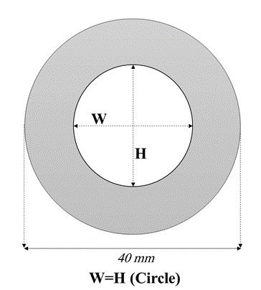 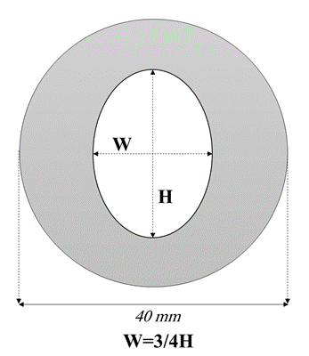

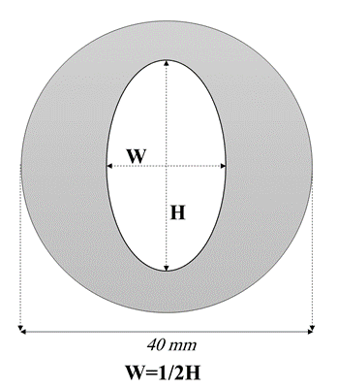 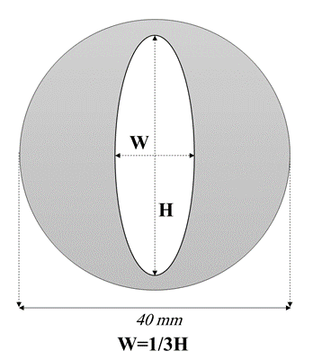

Fig. 1. The different Aspect Ratio (AR) of the inner tube

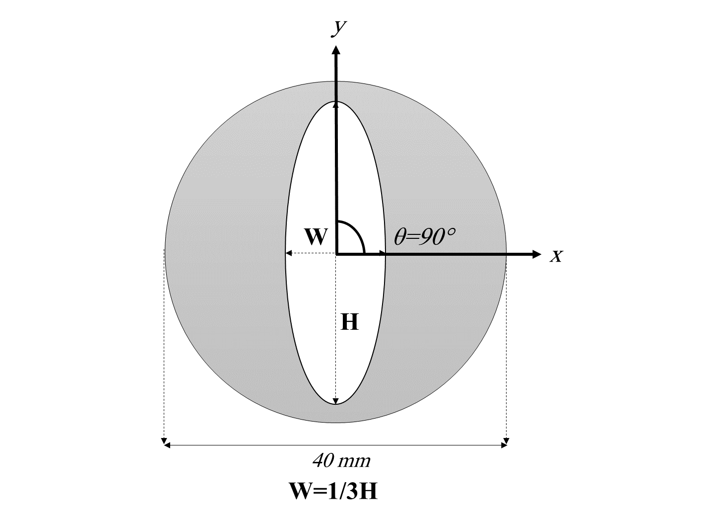 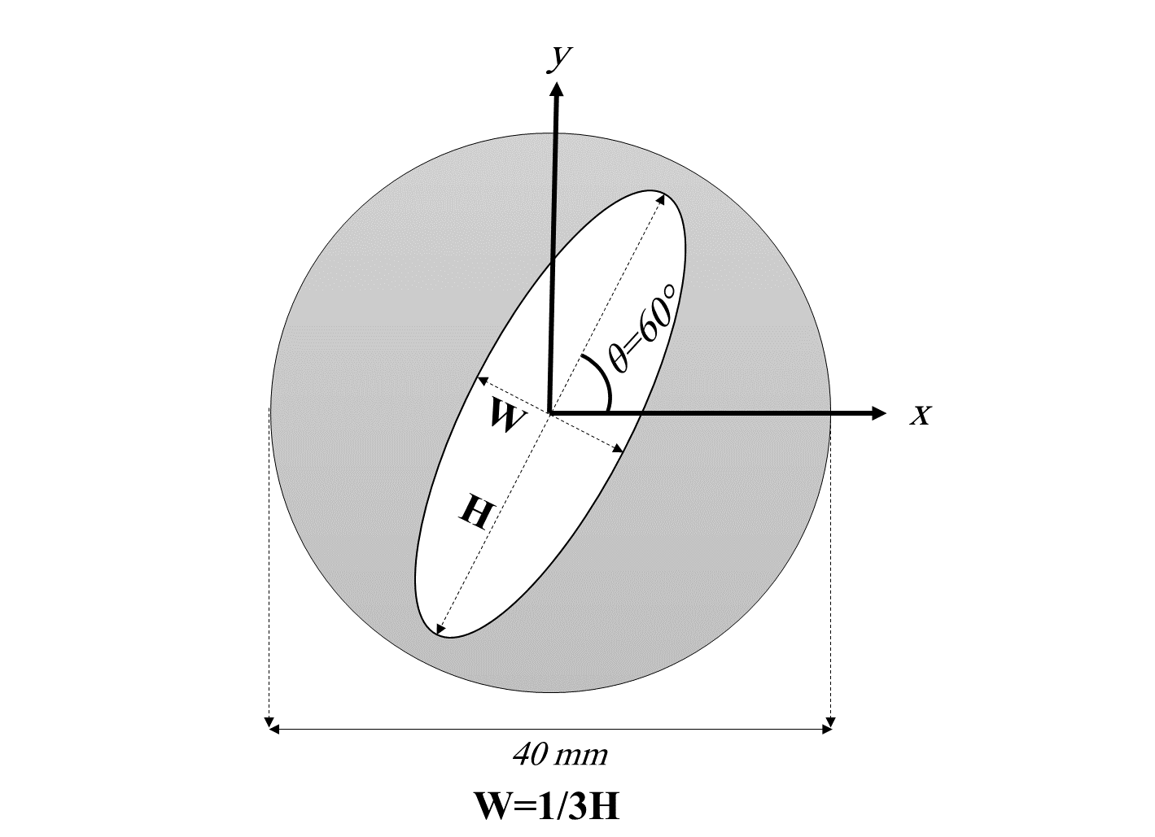

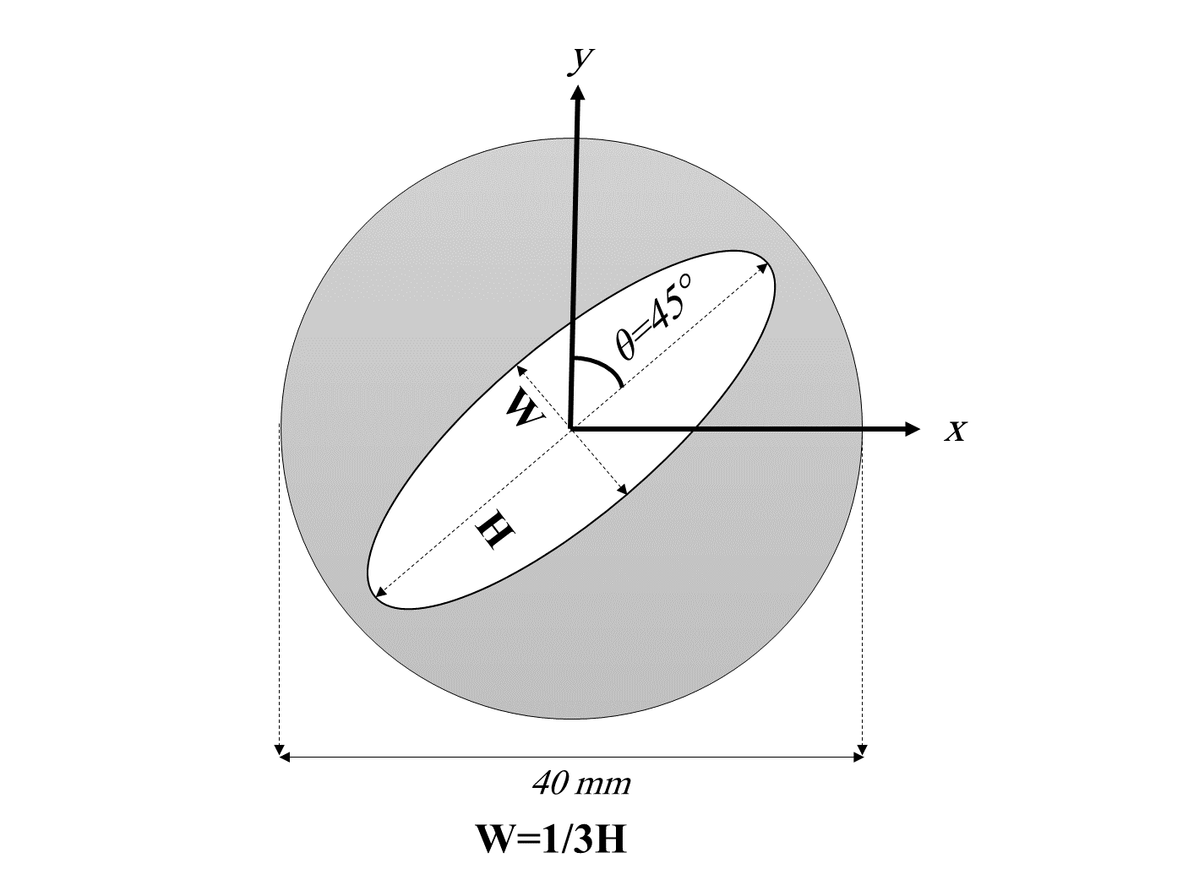 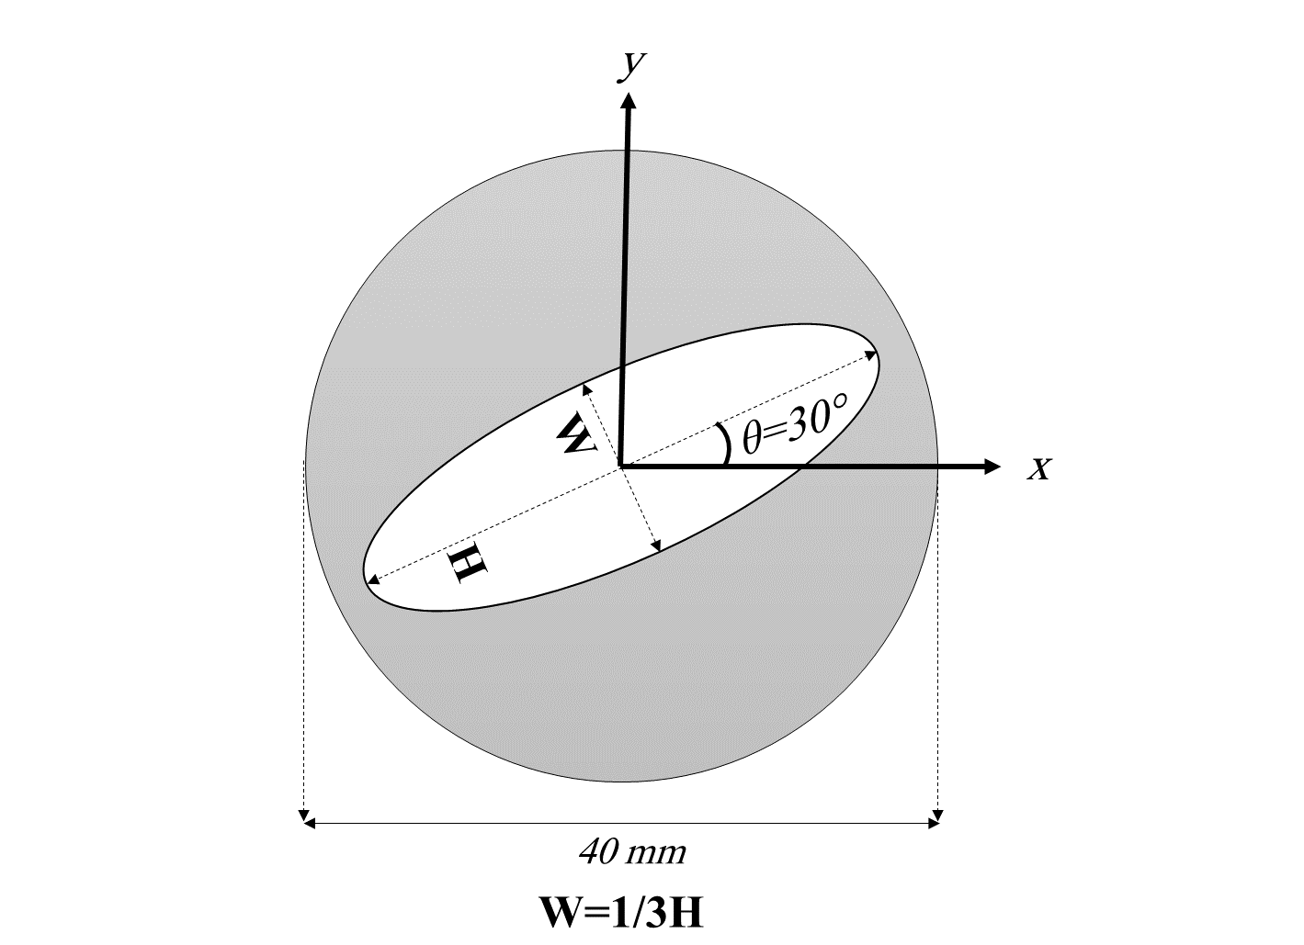

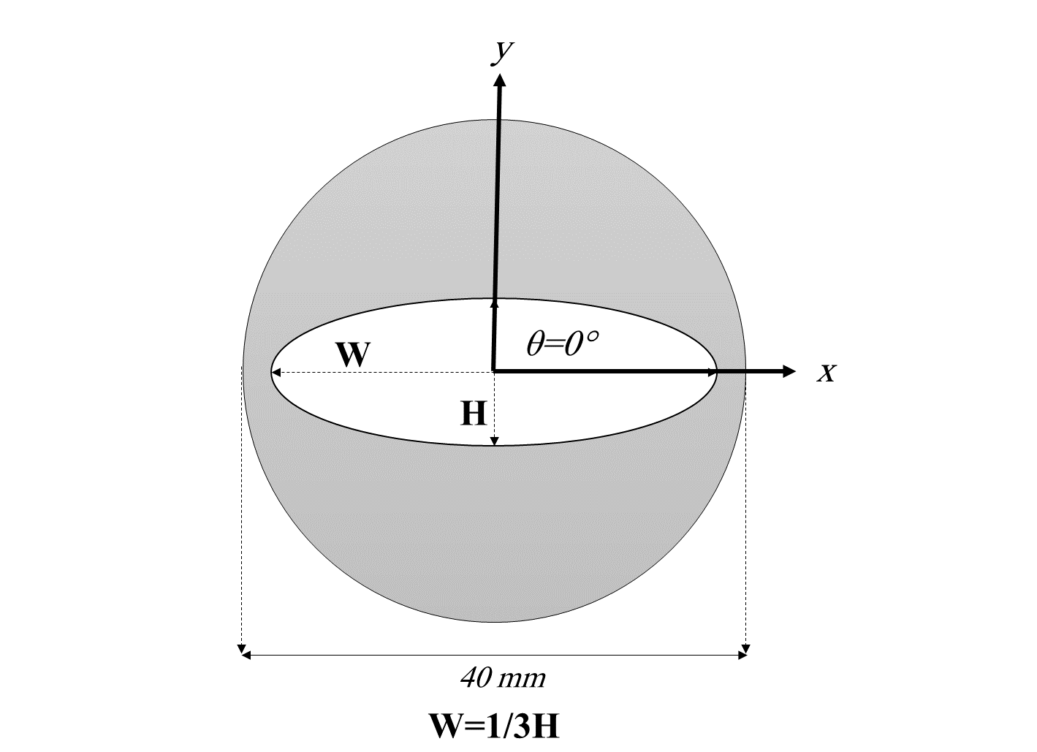

Fig. 2. Different angles of the selected aspect ratio of the inner tube

* 1. *Computational Fluid Dynamics (CFD) Modeling*

To model a phase change phenomenon, the enthalpy-porosity approach is employed. Based on the approach, three discrete zones have to be considered: a solid zone, a liquid zone, and a mushy zone of the liquid scattered among the solid fields [9]. Then, the basic conservation equations such as continuity, momentum, and energy have to be solved throughout the computational domain. The reason for using the approach are [32]:

• Achieving the same results of the governing equations of single-phase flow instead of two-phase.

• The enthalpy-porosity formulation is solved alternatively of explicit tracking of the liquid-solid interface.

• This approach gives an easy implementation of phase-change problems.

* + 1. Assumptions

The following assumptions decrease the computational expenses with minimum error generation [33]:

* The Boussinesq approximation is employed for density and buoyant force predictions.
* 2-D, laminar, incompressible, transient and Newtonian flow.
* The gravity acceleration is considered along the negative y-axis.
* Viscous dissipation is neglected due to the absence of large velocities.
* Heat loss to the ambient environment is ignored due to the well-insulated assumption of the outer surface of the TES.
  + 1. Conservation equations

The governing equations of momentum and energy for PCM are described by the Navier-Stokes. For solidification and melting process, the energy equation is [33]:

 , (1)

where H is the total volumetric enthalpy, which is the sum of sensible enthalpy, h, and the latent heat, L:

 , (2)

 , (3)

In Eq. (3),  refer to the liquid fraction of the PCM in melting and solidification process, and is calculated by Eq. (4):

 , (4)

To estimate the effect of natural convection, the momentum equation has been written as,

, (5)

where, S, is the momentum source term to the reduced porosity in the mushy zone based on the enthalpy-porosity approach, which takes the following form:

 , (6)

where the term  is a constant reflecting the mushy zone morphology that illustrates how the velocity is reduced when the PCM solidifies. The constant  is a small number to prevent division by zero. The following parameters were utilized in the present study [33-35].

 .

The continuity equation has been written as:

 , (7)

The new form of momentum equation, with Boussinesq approximation (Eq. (8)) consideration, is presented at Eq. (9) [33].

 , (8)

, (9)

To eliminate from the buoyancy term in the momentum equation, the Boussinesq approximation is accurate as long as changes in actual density are small; specifically, the Boussinesq approximation is valid when .

The non-dimensional forms of Continuity, Momentum, and Energy obtain by considering the following non-dimensional parameters, are shown in Eq. (10), (11), and (12), respectively.

 ,

where  is the hydraulic diameter of the Annulus.

, (10)

, (11)

, (12)

Where  , ,  ,  , and  are Fourier Number, Prandtl Number, Rayleigh Number, Stefan Number, and Dimensionless Darcy coefficient, respectively.

* + 1. Mesh Generation

The unstructured quadrilateral mesh was generated in ANSYS-Meshing 19. According to Fig. 3 Different grid sizes were analyzed to guarantee the solution independency from mesh topology by comparing the temporal variations in the liquid fraction over selected element sizes of 0.25 (mm), 0.5 (mm), 1 (mm) and 2 (mm). The results showed that the size of 0.5 (mm) is more accurate and has less computational expense than other sizes in comparison with experimental. For all the element sizes, the minimum orthogonal quality, maximum skewness, and maximum aspect ratio are calculated about 0.9, 0.15, and 1.2, respectively.

* + 1. PCM thermo-physical properties

To validate the obtained results, the experimental study of Darzi et al [36] were considered for verification. The N-eicosane PCM was employed to store the thermal energy. The thermophysical properties of the N-eicosane PCM used also in this numerical study are given in Table 1.

Table 1. Thermo-physical properties of N-eicosane PCM[34]

|  |  |
| --- | --- |
| *Property* | N-eicosane |
| *Solidus Temperature (K)* | 308.15 |
| *Liquidus Temperature (K)* | 310.15 |
| *Liquid Density (Kg/m3)* | 770 |
| *Specific Heat Capacity (J/Kg.K)* | 2460 |
| *Latent Heat of Fusion (J/Kg)* | 247600 |
| *Thermal Conductivity (W/m.K)* | 0.1505 |
| *Thermal Expansion Coefficient (1/K)* | 0.0009 |
| *Dynamic Viscosity (Kg/m.s)* | 0.00385 |

* + 1. Boundary conditions

To solve the governing equations Table 2 provides the necessitated boundary conditions and initial conditions.

Table 2. Boundary and initial conditions

|  |  |
| --- | --- |
| ***Charging (Melting)*** | |
| ***Parameters*** | ***Type*** |
| , | *B.C* |
|  | *B.C* |
|  | *I.C* |
| ***Discharging (Solidification)*** | |
| ***Parameters*** | ***Type*** |
|  | *B.C* |
|  | *B.C* |
|  | *I.C* |

* + 1. CFD model settings

In this numerical model, the mentioned partial differential equations are solved by utilizing a CFD code (ANSYS FLUENT 2019-R1). To determine the assortment of coupled partial differential governing equations, based on the control volume method, the PISO algorithm is used for addressing the pressure-velocity coupling. The discretization of momentum and energy equations is conducted by the QUICK scheme, while the PRESTO scheme is assumed for the pressure correction equation [37]. A first-order implicit time advancing method is utilized and at each time step with constant size of 0.15 (s), a course of 60 iterations are found satisfactory to fulfil the convergence criteria of less than 10-6 for all equations. Furthermore, to reach a permanent solution through the process of solving, the under-relaxation factors for the velocity components, pressure correction and liquid fraction are fixed to 0.4, 0.3, and 0.9, respectively, and the under-relaxation factors of the rest of equations are fixed to a value of 1.

1. **Results and discussions**
   1. *Validation and Mesh independency*

To guarantee the independence of the results from the element size and mesh topology, mesh independency analysis was conducted by the comparison of the area-weighted average liquid fraction of the PCM area for five grids with the specific element size of 0.25, 0.5, 1.0, and 2.0 (mm). The results obtained that the element size of 0.5 mm was reliable whereas the smaller size of cells brought about similar results, with the expense of more computational time (due to the significant number of elements). The outcomes of mesh independency from the size of cells were presented in Fig. 3.

To verify the accuracy of the numerical results, the present study is compared with the experimental results (or numerical results) of Darzi et al. [36]. In that esteem, a horizontal concentric double-tube TES was simulated including Aluminum tubes with an inner diameter and outer diameter of 20 (mm) and 40 (mm), respectively. The suggested TES was filled with pure N-eicosane as the PCM which was initially subcooled by 289.15 K. The thermos-physical properties of the mentioned PCM are available in Table 1. The agreement between the experimental results of Darzi et al. and conducted numerical results of Darzi’s work by authors (presented in Fig. 4) showed great accuracy with 5.78 % error based on Eq. (13).

 , (13)

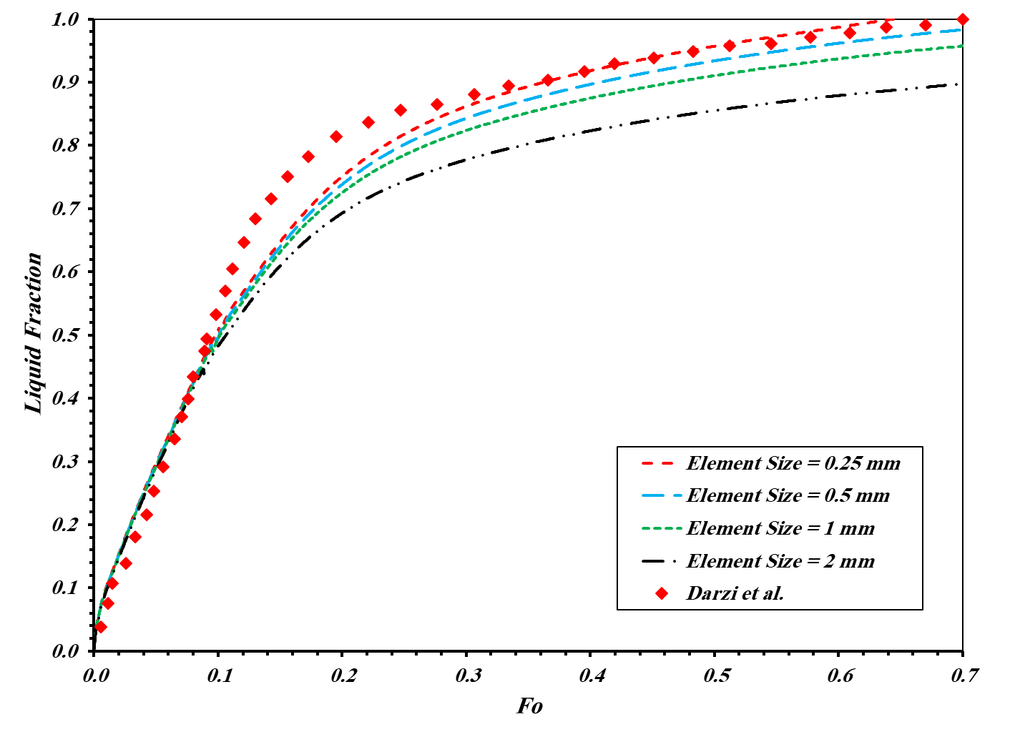

Fig. 3. The results of mesh independency

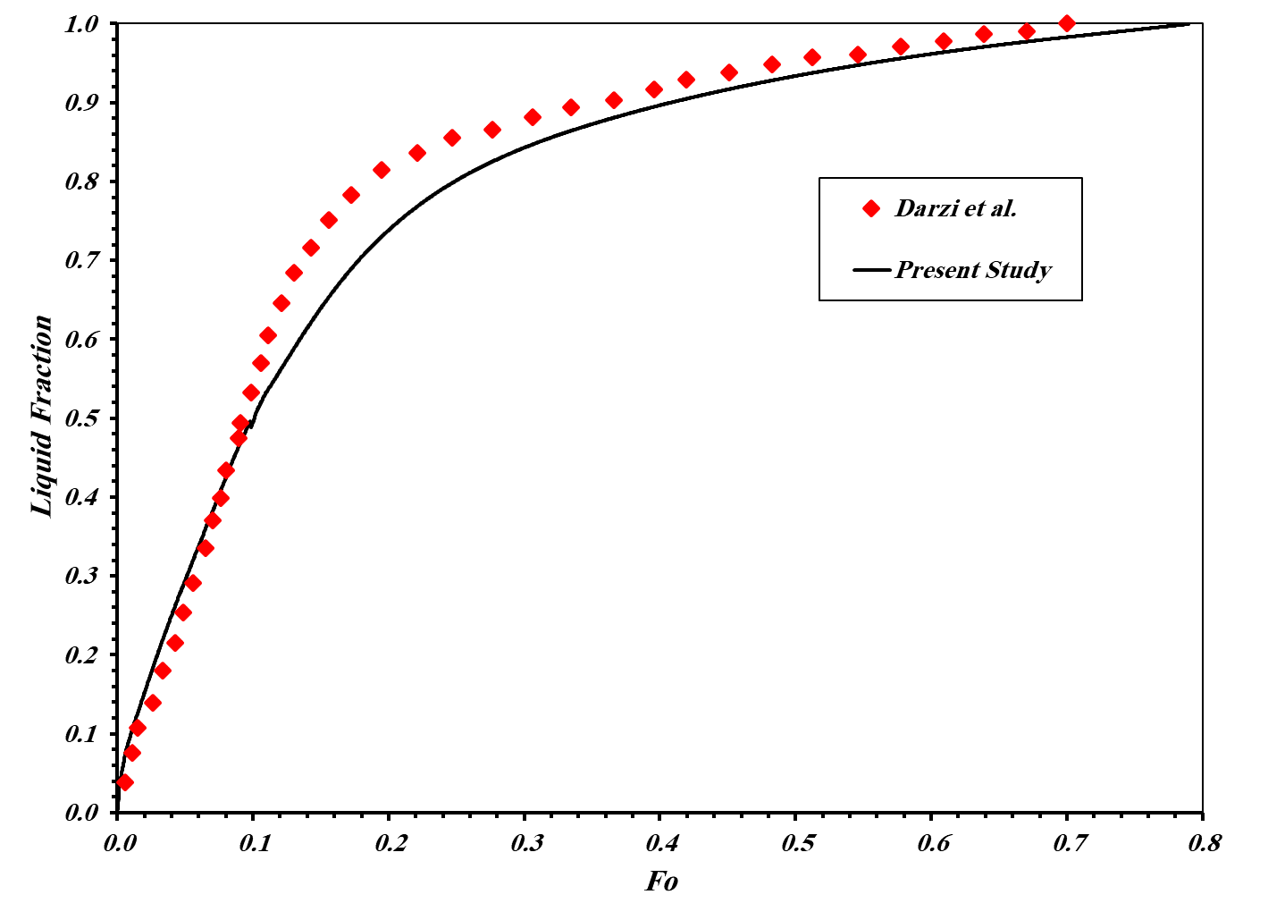

Fig. 4. Comparison of the captured liquid fraction in the present study with the Darzi et al[36].

* 1. *Charging and discharging processes with n-eicosane for different Aspect Ratios (AR) of the ellipse*

In this section, the behaviour of the proposed energy storages supplied with N-eicosane during the charging (melting) and discharging (solidification) processes is studied. Fig. 5 demonstrates a comparison of charging and discharging processes in different aspect ratios of the system. From Fig. 5, it is clear, as the aspect ratio of the inner ellipse increases, the overall time of charging and discharging processes are declined. The minimum value of the Fourier Number (Fo) belongs to W=1/3H, it means that the case needs less time than others for charging, while for W=H case (circular case) the overall Fo number is maximized that means the system needs more time than other cases for charging process.

|  |
| --- |
|  |
| Fig. 5. Comparison of Charging and Discharging of the inner tube with different aspect ratios |

Fig. 6 displays the variations of liquid fraction in the discharging process starting from zero Fo. From Fig. 6. the discharging process for all cases are approximately similar and the maximum Fo number belongs to W=1/3H. The Fo number for the charging process for the cases of W=H, W=3/4H, W=1/2H, and W=1/3H are 0.79, 0.67, 0.55, and 0.31, respectively. The discharging Fo number for W=H, W=3/4H, W=1/2H, and W=1/3H are 1.1, 0.99, 1.05, and 1.13, respectively.

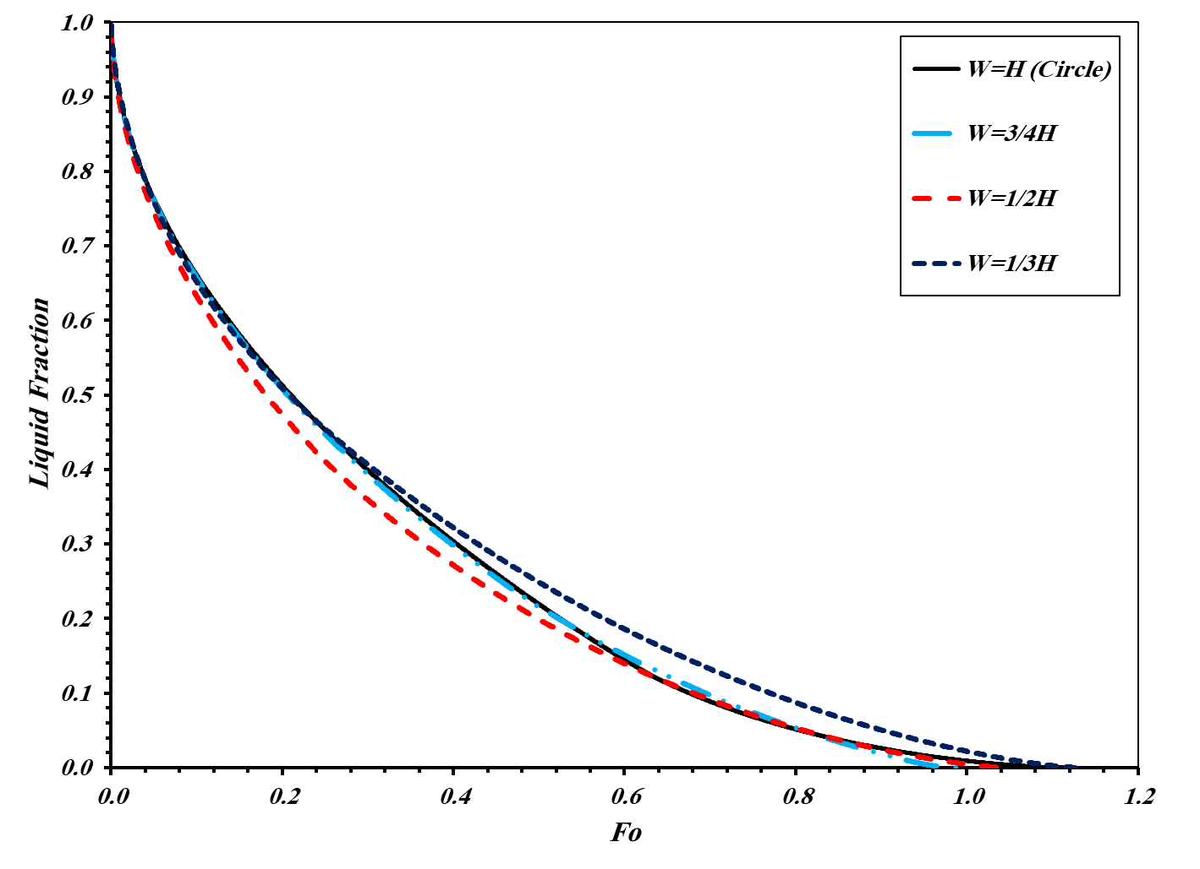

Fig. 6. Liquid fraction comparison of discharging of the inner tube with different aspect ratios

Fig. 7 indicates the velocity contours in the charging process for different aspect ratios at Fo number of 0.238. As shown in this figure with a higher aspect ratio of ellipse increases along the y-direction, the velocity increases along the TES and it can promote the buoyant force (increase heat transfer mechanism) and consequently lead to quicker charging.

|  |  |  |
| --- | --- | --- |
|  | | |
| (a) | (b) | |
| (c) | | (d) |
| Fig. 7. Velocity counters of the aspect ratios (a) W=H, (b) W=3/4H and, (c) W=1/2H (d) W=1/3H in the charging process at the Fo=0.238 | | |

Fig. 8. Shows the liquid fraction contours of the cases with different aspect ratios at three Fo number (0.119, 0.238, 0.477) during the charging process. The PCM melting enhancement for a lower aspect ratio of the ellipse can be concluded due to the prompter melting as time passes. The area of the molten PCM is growing to the point that the PCM melts completely. Overall, at the first stages of the melting process, the liquid PCM is in direct touch with the hot surfaces of the internal tube and a thin layer of the molten PCM is made on the surface of the hot tube and it becomes thicker during the time. In the beginning, the heat is transferred from the inner tube via the condition to the PCM and PCM starts melting. As time passes, natural convection is generated inside the liquid PCM which helps the melting process by transferring heat to all the PCM domain results in more liquid PCM. Thicker molten layer induces a bigger thermal resistance and the melting (charging) abates temporally. The area for conduction heat transfer is almost similar for all the cases. Therefore, the reason for the advantages of the lower aspect ratio of the ellipse is the dominance of natural convection which can better be explained according to the presented PCM temperature contours.

|  |  |  |  |
| --- | --- | --- | --- |
|  | | | |
| Cases | Fo = 0.119 (600 s) | Fo = 0.238 (1200 s) | Fo = 0.477 (2400 s) |
| W=H (Circle) |  |  |  |
| W=3/4H |  |  |  |
| W=1/2H |  |  |  |
| W=1/3H |  |  |  |

Fig. 8. Liquid Fraction contours of the inner tube with different aspect ratios at three Fourier numbers (Fo) during the charging process

Fig. 9. Indicates the temperature contours of the TES with different aspect ratios at different Fo numbers. According to this Fig., the temperature for the case of W=1/3H became uniform faster than other cases. The reason is when the aspect ratio of the ellipse increases in direction of the gravity acceleration, it promotes natural convection inside the molten PCM because of the area of the inner tube that can prevent the motion of molten PCM in direction of gravity acceleration will decrease. As shown in this Fig., the W=H (Circle) case requires more time than the other cases to reach uniform temperature distribution.

|  |  |  |  |
| --- | --- | --- | --- |
|  | | | |
| Cases | Fo = 0.119 (600 s) | Fo = 0.238 (1200 s) | Fo = 0.477 (2400 s) |
| W=H (Circle) |  |  |  |
| W=3/4H |  |  |  |
| W=1/2H |  |  |  |
| W=1/3H |  |  |  |

Fig. 9. Temperature contours of the inner tube with different aspect ratios at three Fourier numbers (Fo) during the charging process

Fig. 10 describes the velocity contour when the natural convection is taking place in the discharging process for different aspect ratios (W=H, W=3/4H, W=1/2H, and W=1/3H) at Fo number of 0.238. As displayed, since almost the average of velocity distribution across the TESs are similar during the discharging process, therefore, all the cases almost require equal times for discharging.

|  |  |  |
| --- | --- | --- |
|  | | |
| (a) | (b) | |
| (c) | | **(d)** |
| Fig. 10. Velocity counters of the aspect ratios (a) W=H, (b) W=3/4H and, (c) W=1/2H (d) W=1/3H in the discharging process at the time of 1200 s | | |

Fig. 11 presents the liquid fraction contours of the ellipse with different aspect ratios at three Fo number (0.119, 0.238, 0.477) during the discharging process. At the first stage of the discharging processes, the liquid PCM is in direct contact with the cold surfaces of the internal tube and a thin layer of the molten PCM is formed on the surface of the cold tube and it thickens as time passes. During the solidification process, in contrast to the melting process, the aspect ratio of the ellipse does not have a significant effect on the discharging process. Indeed, when the natural convection forms around the inner tube, and due to the fact that the molten PCM starts to solidify in the adjacency of the inner tube therefore molten PCM will be accumulated near the outer tube, so, the aspect ratio of the ellipse does not have a significant impact on the discharging process. Furthermore, through the time, due to the solidification of PCM, the amount of available liquid PCM decreases which reduces the effect of natural convection during the discharging process against the charging process.

|  |  |  |  |
| --- | --- | --- | --- |
|  | | | |
| Cases | Fo = 0.119 (600 s) | Fo = 0.238 (1200 s) | Fo = 0.477 (2400 s) |
| W=H (Circle) |  |  |  |
| W=3/4H |  |  |  |
| W=1/2H |  |  |  |
| W=1/3H |  |  |  |

Fig. 11. Liquid fraction contours inner tube with different aspect ratios at three Fourier numbers (Fo) during the charging process

Fig. 12. demonstrates the temperature contours of the TES at different Fo numbers during the discharging process. According to this Fig., the temperatures for all cases are almost similar during the solidification process. Thus, as concluded earlier, in the discharging process, the shape of the inner tube of the TES does not significantly impact on the process.

|  |  |  |  |
| --- | --- | --- | --- |
|  | | | |
| Cases | Fo = 0.119 (600 s) | Fo = 0.238 (1200 s) | Fo = 0.477 (2400 s) |
| W=H (Circle) |  |  |  |
| W=3/4H |  |  |  |
| W=1/2H |  |  |  |
| W=1/3H |  |  |  |

Fig. 12. Temperature contours of the inner tube with different aspect ratios at three Fourier numbers (Fo) during the discharging process

Table 3 lists the charging and discharging times as well as the efficiency of the TES unit for different aspect ratios of the inner tube. The calculated efficiency of this table has been defined as:

, (14)

As presented, the system with the lowest aspect ratio of the ellipse has the maximum efficiency which motivates authors to choose this geometry for further investigation.

Table 3. The value of the Time (s) and Fo number at the end of Charging and Discharging processes

|  |  |  |  |  |  |
| --- | --- | --- | --- | --- | --- |
| ***Case*** | ***Charging***  ***(Melting)*** | | ***Discharging (Solidification)*** | | ***Efficiency***  ***Eq. (14)*** |
| ***Fo*** | ***Time (s)*** | ***Fo*** | ***Time (s)*** |
| ***W=H*** | 0.79 | 3976 | 1.11 | 5603 | 0.58 |
| ***W=3/4H*** | 0.67 | 3363 | 0.99 | 4978 | 0.60 |
| ***W=1/2H*** | 0.55 | 2770 | 1.05 | 5293 | 0.66 |
| ***W=1/3H*** | 0.31 | 1555 | 1.13 | 5702 | 0.79 |

* 1. *Charging and Discharging process for the different angular position of the inner ellipse*

As presented in Fig. 2, five different angular positions of 90°, 60°, 45°, 30°, and 0° for the inner ellipse are examined for the case with W=1/3H.

Fig. 13 expresses a comparison of overall charging and discharging processes for different angles of the proposed ellipse. As shown, the effect of different angles of the ellipse has an inverse relationship on the overall charging and discharging time. As the angle of ellipse increases, relative to the gravity direction, the Fo number of charging and discharging processes (according to Fig. 13) increases and decreases, respectively. Thus, according to Eq. (14), the efficiency diminishes. The minimum value of the Fourier Number (Fo) in the charging process refers to the angle of 90º, and the angle of 0º has the greatest overall Fo number that means the system needs more time than other cases to complete the charging process. The Fo number for the cases with ellipse angles of 90º, 60º, 45º, 30º, and 0º in the charging process are 0.3, 0.45, 0.61, 0.81, and 1.18, respectively.

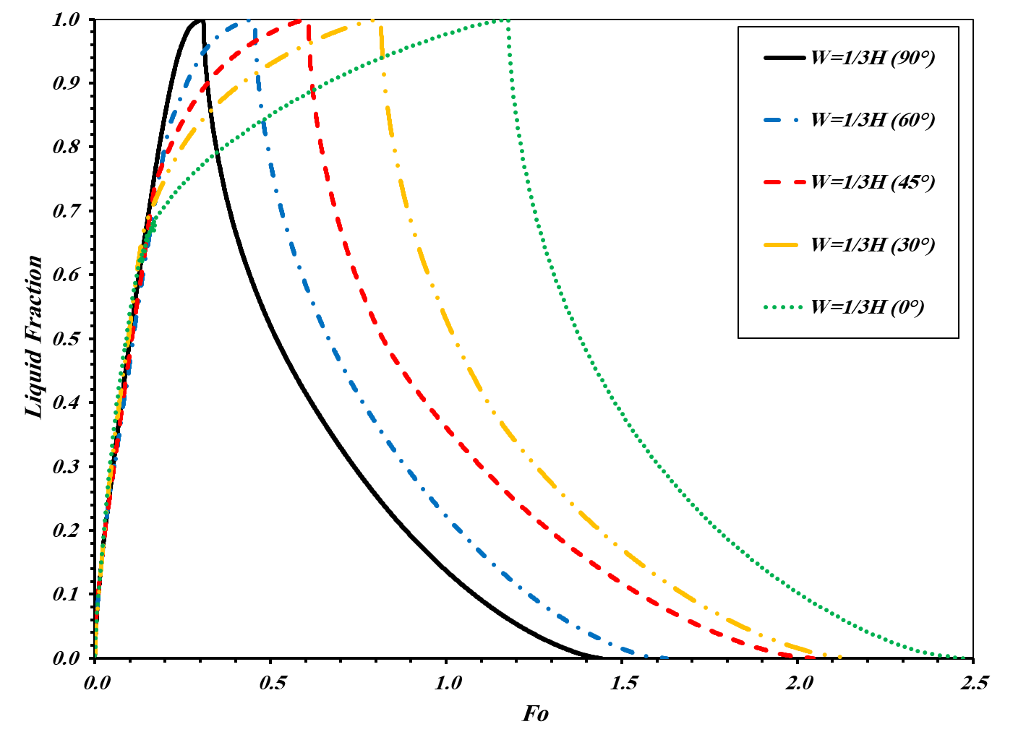

Fig. 13. Comparison of the inner tube with different angular positions during consecutive charging and discharging

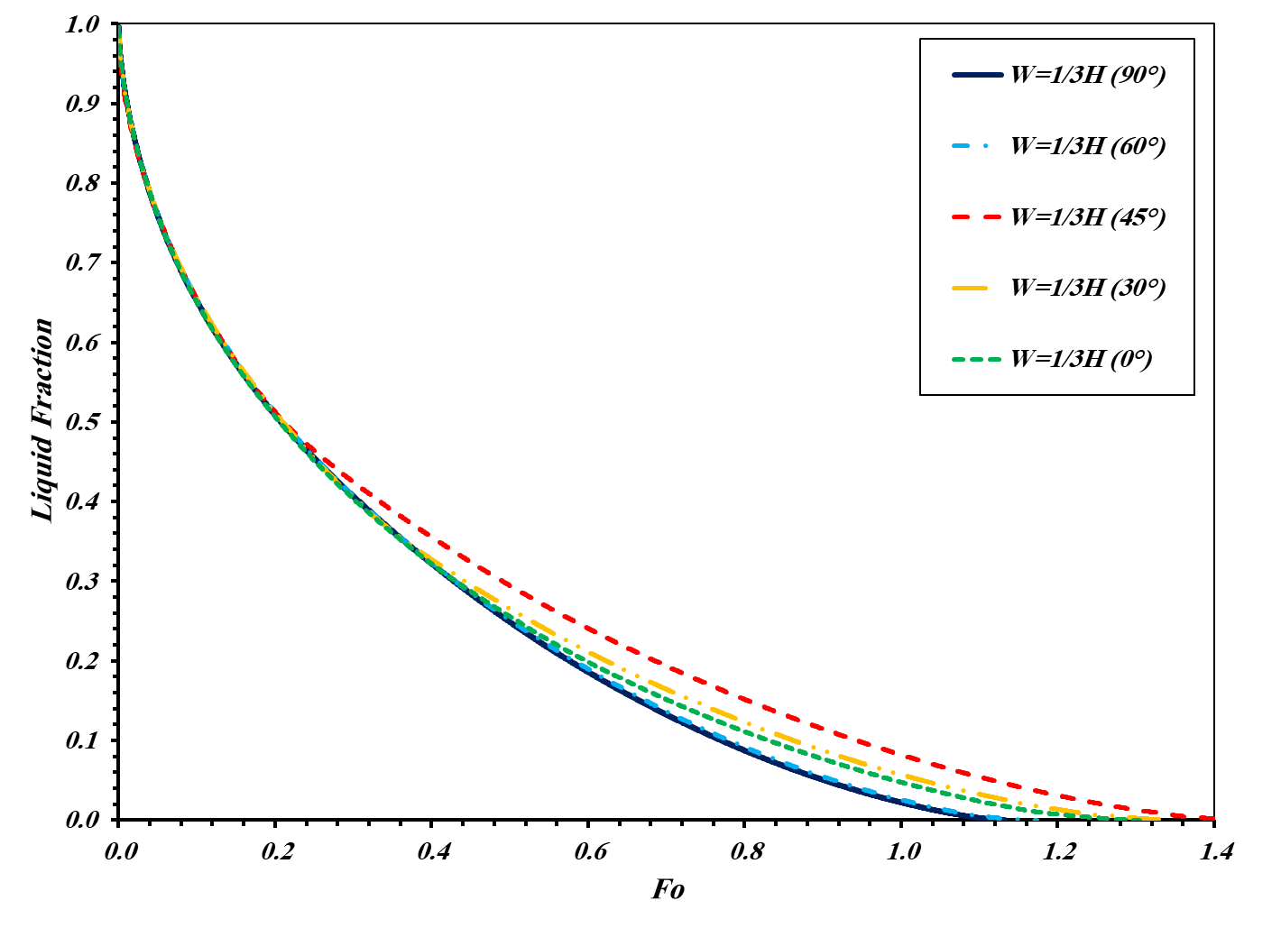

Fig. 14. Liquid fraction comparison for discharging process of inner with different angular positions

The efficiencies of all angular position cases are listed in Table. 4. According to this Table, the best configuration belongs to the case of W=1/3H which the longer diameter is in line with gravity acceleration direction.

Table 4. The value of the Time (s) and Fo number at the end of Charging and Discharging processes for different angles of the ellipse

|  |  |  |  |  |  |
| --- | --- | --- | --- | --- | --- |
| ***Case*** | ***Charging (Melting)*** | | ***Discharging (Solidification)*** | | ***Efficiency*** |
| ***Fo*** | ***Time (s)*** | ***Fo*** | ***Time (s)*** |
| ***W=1/3H (0°)*** | 1.18 | 5924 | 1.30 | 6567 | 0.53 |
| ***W=1/3H (30°)*** | 0.81 | 4100 | 1.35 | 6794 | 0.62 |
| ***W=1/3H (45°)*** | 0.61 | 3063 | 1.13 | 5702 | 0.65 |
| ***W=1/3H (60°)*** | 0.45 | 2290 | 1.17 | 5907 | 0.72 |
| ***W=1/3H (90°)*** | 0.31 | 1555 | 1.13 | 5702 | 0.79 |

Fig. 15 indicates the contours of velocity during the natural convection in the charging process for different angles at Fo number of 0.238. As shown, the case (d) requires the most time to complete the charging process in comparison with the others because of low velocity and non-uniform velocity distribution, especially at the lower half. Thus, when the inner ellipse rotates from vertical to horizontal (90° to 0°) the charging performance of the TES will be drastically affected.

|  |  |  |
| --- | --- | --- |
|  | | |
| (a) | (b) | |
| (c) | | **(d)** |

Fig. 15. Velocity counters of the different angles of the ellipse with W=1/3H, (a) 60º, (b) 45º, (c) 30º, and (d) 0º in the charging process at the Fo=0.238

Liquid fraction contours of the proposed ellipse with different angular positions for three Fo numbers (0.119, 0.238, 0.477) during the charging process are displayed in Fig. 14. As shown for different Fo numbers, when the angle is 90º, the quickest charging process takes place (more molten PCM are generated in a shorter time) compared with the other angles, while at 0 º angle the charging process is the slowest. thus, the results proved the importance of the relation between the direction of gravity acceleration and configuration of the inner tube which was mentioned in the previous section.

|  |  |  |  |
| --- | --- | --- | --- |
|  | | | |
| Cases of W=1/3H | Fo = 0.119 (600 s) | Fo = 0.238 (1200 s) | Fo = 0.477 (2400 s) |
| Θ = 90° |  |  |  |
| Θ = 60° |  |  |  |
| Θ = 45° |  |  |  |
| Θ = 30° |  |  |  |
| Θ = 0° |  |  |  |

Fig. 16. Liquid fraction contours of the inner tube with different angular positions at three Fourier numbers (Fo) during the charging process

Fig. 17 shows the contours of temperature for different angles of the inner ellipse. As shown, the temperature of the case with the ellipse angle of 90º is higher and more uniform compared with the other cases at identical instants.

|  |  |  |  |
| --- | --- | --- | --- |
|  | | | |
| Cases of W=1/3H | Fo = 0.119 (600 s) | Fo = 0.238 (1200 s) | Fo = 0.477 (2400 s) |
| Θ = 90° |  |  |  |
| Θ = 60° |  |  |  |
| Θ = 45° |  |  |  |
| Θ = 30° |  |  |  |
| Θ = 0° |  |  |  |

Fig. 17. Temperature contours of the inner tube with different angular positions at three Fourier numbers (Fo) during the charging process

Fig. 18. indicates the contours of velocity during the discharging process for various orientation of inner tube (angles of 60º, 45º, 30º, and 0º) at the Fo number of 0.238. As displayed in this figure, the case (d) needs the most time to complete the discharging process in comparison with the others because of the lower velocity. therefore, when the angle of inner ellipse changes from 90° to 0° the discharging process takes shorter (in other words the thermal battery drains quicker), Therefore, one can conclude that a 90° ellipse can be represented as both a fast-charge and slow-discharge thermal battery since it has the least Fo number for charging and most Fo number for discharging.

|  |  |  |
| --- | --- | --- |
|  | | |
| (a) | (b) | |
| (c) | | **(d)** |
| Fig. 18. Velocity counters of the different angles of the ellipse with W=1/3H, (a) 60º, (b) 45º, (c) 30º, and (d) 0º in the discharging process at the Fo=0.238 | | |

Figs. 19 and 20 expose the graphical results of liquid fraction and temperature at the discharging process for the cases with various ellipse angles at different Fo number. The results prove that there is no significant discrepancy between the various cases with different angles during the discharging process. As the graphical results revealed, the distribution of temperatures and solidified PCM approximately equal for different cases with different angular positions of the ellipse.

|  |  |  |  |
| --- | --- | --- | --- |
|  | | | |
| Cases of W=1/3H | Fo = 0.119 (600 s) | Fo = 0.238 (1200 s) | Fo = 0.477 (2400 s) |
| Θ = 90° |  |  |  |
| Θ = 60° |  |  |  |
| Θ = 45° |  |  |  |
| Θ = 30° |  |  |  |
| Θ = 0° |  |  |  |

Fig. 19. Liquid fraction contours of the inner tube with different angles at three Fourier numbers (Fo) during the discharging process

|  |  |  |  |
| --- | --- | --- | --- |
|  | | | |
| Cases of W=1/3H | Fo = 0.119 (600 s) | Fo = 0.238 (1200 s) | Fo = 0.477 (2400 s) |
| Θ = 90° |  |  |  |
| Θ = 60° |  |  |  |
| Θ = 45° |  |  |  |
| Θ = 30° |  |  |  |
| Θ = 0° |  |  |  |

Fig. 20. Temperature contours of the inner tube with different angles at three Fourier numbers (Fo) during the discharging process

* 1. **Summary**

Based on Eq. (14), a case with minimum Fo number during the charging process and maximum Fo number during the discharging process is the best case for having the maximum efficiency which respectively represents fast charging TES and last longing TES. According to Fig. 21, the highest value of Fo number for the discharging process and the least Fo number for charging process belongs to the case of W=1/3H with the angles of 30°, and 90°, respectively., Fig. 21 provide a wide picture of all efficiencies of all the proposed cases in this study. According to this Fig., the best configuration of the inner tube belongs to W=1/3H with the angle of 90°. The charging efficiency of the case W=1/3H at 90° is 26% higher than the conventional configuration in double-pipe LHS systems (circular inner tube or W=H case) with almost similar discharging efficiency.

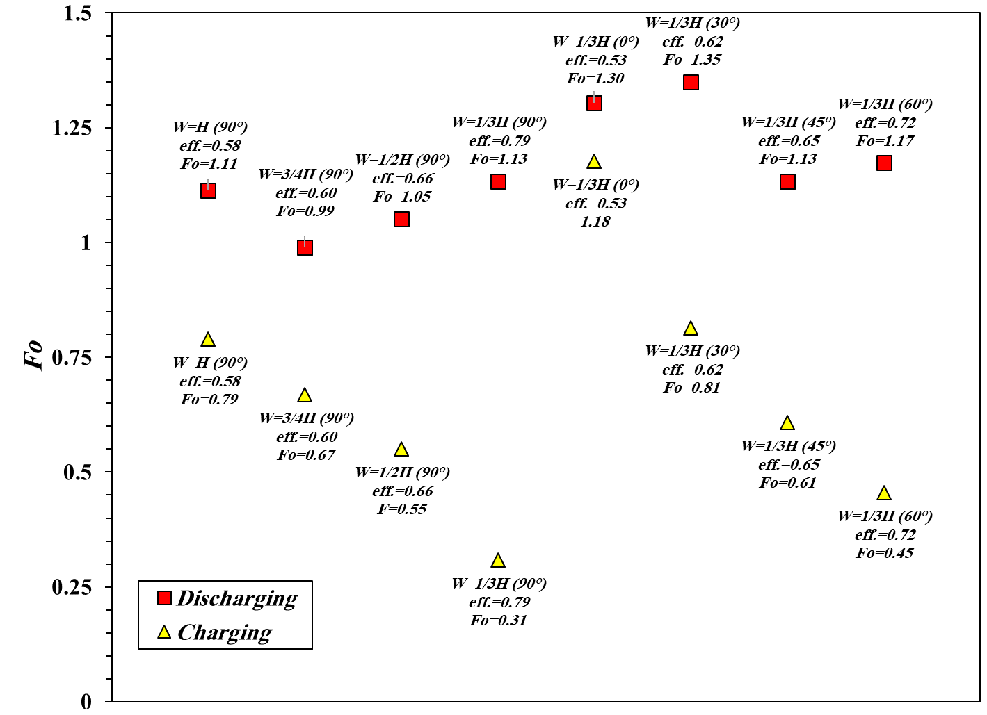

Fig. 21. Comparison of Charging and Discharging ending time (Fo) of the inner tube with different aspect ratios and angles

1. **Conclusion**

The Double-pipe are manipulated as thermal energy storage systems using PCMs that can be used for different applications and therefore increasing the efficiency of double-tubes TES has significant importance which was performed in this study by modifying the geometry of the inner tube. In this study, the PCM charging and discharging processes were modelled numerically in a double-tube thermal energy storage system where the cross-section of the inner tube is an ellipse. The influences of the different aspect ratios of the ellipse as an inner tube, and also the various angle of the ellipse in the best aspect ratio were examined to increase the performance of the TES and reach to the best efficiency. The results exhibited that the best performance of different aspect ratios belongs to the case with W=1/3H which reduces the required time for the melting process compared to the other aspect ratios and has no noticeable effect on the solidification process. On the study of ellipse angular position, the results reveal that the melting time reduces for a higher angle and the solidification time does not vary significantly. The melting time reduces by 60% for the case of W=1/3H with 90º angle compared with the conventional double pipe case (W=H/ inner circular tube). The efficiency of the case of W=1/3H with 90º was about 0.79 which is 26% higher than the conventional double pipe TES.

**References**

[1] U. Mikolajewicz, M. Vizcaino, J. Jungclaus, G. Schurgers, Effect of ice sheet interactions in anthropogenic climate change simulations, Geophysical Research Letters, 34 (18) (2007).

[2] A. Pandey, M. Hossain, V. Tyagi, N.A. Rahim, A. Jeyraj, L. Selvaraj, A. Sari, Novel approaches and recent developments on potential applications of phase change materials in solar energy, Renewable and Sustainable Energy Reviews, 82 (2018) 281-323.

[3] B. Xu, P. Li, C. Chan, Application of phase change materials for thermal energy storage in concentrated solar thermal power plants: a review to recent developments, Applied Energy, 160 (2015) 286-307.

[4] A. Shahsavar, J. Khosravi, H.I. Mohammed, P. Talebizadehsardari, Performance evaluation of melting/solidification mechanism in a variable wave-length wavy channel double-tube latent heat storage system, Journal of Energy Storage, 27 (2020) 101063.

[5] N. Kumar, D. Banerjee, Phase Change Materials, Handbook of Thermal Science and Engineering, (2018) 2213-2275.

[6] M. Kenisarin, K. Mahkamov, Solar energy storage using phase change materials, Renewable and sustainable energy reviews, 11 (9) (2007) 1913-1965.

[7] P.T. Sardari, D. Grant, D. Giddings, G.S. Walker, M. Gillott, Composite metal foam/PCM energy store design for dwelling space air heating, Energy Conversion and Management, 201 (2019) 112151.

[8] M. Moghimi Ardekani, Optical thermal and economic optimisation of a linear Fresnel collector, University of Pretoria, 2017.

[9] M. Kadivar, M. Moghimi, P. Sapin, C. Markides, Annulus eccentricity optimisation of a phase-change material (PCM) horizontal double-pipe thermal energy store, Journal of Energy Storage, 26 (2019) 101030.

[10] N.I. Ibrahim, F.A. Al-Sulaiman, S. Rahman, B.S. Yilbas, A.Z. Sahin, Heat transfer enhancement of phase change materials for thermal energy storage applications: A critical review, Renewable and Sustainable Energy Reviews, 74 (2017) 26-50.

[11] R. Sharma, P. Ganesan, V. Tyagi, H. Metselaar, S. Sandaran, Developments in organic solid–liquid phase change materials and their applications in thermal energy storage, Energy Conversion and Management, 95 (2015) 193-228.

[12] P.T. Sardari, D. Giddings, D. Grant, M. Gillott, G.S. Walker, Discharge of a composite metal foam/phase change material to air heat exchanger for a domestic thermal storage unit, Renewable Energy, (2019).

[13] A. Sarı, A. Karaipekli, Thermal conductivity and latent heat thermal energy storage characteristics of paraffin/expanded graphite composite as phase change material, Applied Thermal Engineering, 27 (8-9) (2007) 1271-1277.

[14] A. Abhat, Low temperature latent heat thermal energy storage: Heat storage materials, Solar Energy, 30 (4) (1983) 313-332.

[15] K. Kaygusuz, The viability of thermal energy storage, Energy Sources, 21 (8) (1999) 745-755.

[16] S.D. Sharma, K. Sagara, Latent heat storage materials and systems: a review, International Journal of Green Energy, 2 (1) (2005) 1-56.

[17] S. Hasnain, Review on sustainable thermal energy storage technologies, Part I: heat storage materials and techniques, Energy conversion and management, 39 (11) (1998) 1127-1138.

[18] S. Seddegh, X. Wang, A.D. Henderson, Z. Xing, Solar domestic hot water systems using latent heat energy storage medium: a review, Renewable and Sustainable energy reviews, 49 (2015) 517-533.

[19] A. Shahsavar, A. Shaham, P. Talebizadehsardari, Wavy channels triple-tube LHS unit with sinusoidal variable wavelength in charging/discharging mechanism, International Communications in Heat and Mass Transfer, 107 (2019) 93-105.

[20] M.R. Kadivar, M.A. Moghimi, P. Sapin, C.N. Markides, Annulus eccentricity optimisation of a phase-change material (PCM) horizontal double-pipe thermal energy store, Journal of Energy Storage, 26 (2019) 101030.

[21] A. Shahsavar, A.A. Al-Rashed, S. Entezari, P.T. Sardari, Melting and Solidification Characteristics of a Double-Pipe Latent Heat Storage System with Sinusoidal Wavy Channels Embedded in a Porous Medium, Energy, 171 (2019) 751-769.

[22] Z. Li, A. Shahsavar, A.A.A.A. Al-Rashed, P. Talebizadehsardari, Effect of porous medium and nanoparticles presences in a counter-current triple-tube composite porous/nano-PCM system, Applied Thermal Engineering, (2019) 114777.

[23] D.B. Khillarkar, Z.X. Gong, A.S. Mujumdar, Melting of a phase change material in concentric horizontal annuli of arbitrary cross-section, Applied Thermal Engineering, 20 (10) (2000) 893-912.

[24] S. Mat, A.A. Al-Abidi, K. Sopian, M.Y. Sulaiman, A.T. Mohammad, Enhance heat transfer for PCM melting in triplex tube with internal–external fins, Energy Conversion and Management, 74 (2013) 223-236.

[25] R. Velraj, R. Seeniraj, Heat transfer studies during solidification of PCM inside an internally finned tube, Journal of heat transfer, 121 (2) (1999) 493-497.

[26] A.A. Al-abidi, S. Bin Mat, K. Sopian, M.Y. Sulaiman, A.T. Mohammed, CFD applications for latent heat thermal energy storage: a review, Renewable and Sustainable Energy Reviews, 20 (2013) 353-363.

[27] M. Longeon, A. Soupart, J.-F. Fourmigué, A. Bruch, P. Marty, Experimental and numerical study of annular PCM storage in the presence of natural convection, Applied Energy, 112 (2013) 175-184.

[28] T. Tabassum, M. Hasan, L. Begum, 2-D numerical investigation of melting of an impure PCM in the arbitrary-shaped annuli, International Journal of Thermal Sciences, 114 (2017) 296-319.

[29] J.M. Mahdi, H.I. Mohammed, E.T. Hashim, P. Talebizadehsardari, E.C. Nsofor, Solidification enhancement with multiple PCMs, cascaded metal foam and nanoparticles in the shell-and-tube energy storage system, Applied Energy, 257 (2020) 113993.

[30] A.A. Rabienataj Darzi, M. Jourabian, M. Farhadi, Melting and solidification of PCM enhanced by radial conductive fins and nanoparticles in cylindrical annulus, Energy Conversion and Management, 118 (2016) 253-263.

[31] A.R. Darzi, M. Farhadi, K. Sedighi, Numerical study of melting inside concentric and eccentric horizontal annulus, Applied Mathematical Modelling, 36 (9) (2012) 4080-4086.

[32] A. Brent, V.R. Voller, K. Reid, Enthalpy-porosity technique for modeling convection-diffusion phase change: application to the melting of a pure metal, Numerical Heat Transfer, Part A Applications, 13 (3) (1988) 297-318.

[33] P. Talebizadeh Sardari, G.S. Walker, M. Gillott, D. Grant, D. Giddings, Numerical modelling of phase change material melting process embedded in porous media: Effect of heat storage size, Proceedings of the Institution of Mechanical Engineers, Part A: Journal of Power and Energy, (2019) 0957650919862974.

[34] S. Seddegh, X. Wang, A.D. Henderson, Numerical investigation of heat transfer mechanism in a vertical shell and tube latent heat energy storage system, Applied thermal engineering, 87 (2015) 698-706.

[35] S. Seddegh, X. Wang, M.M. Joybari, F. Haghighat, Investigation of the effect of geometric and operating parameters on thermal behavior of vertical shell-and-tube latent heat energy storage systems, Energy, 137 (2017) 69-82.

[36] A.A.R. Darzi, M. Jourabian, M. Farhadi, Melting and solidification of PCM enhanced by radial conductive fins and nanoparticles in cylindrical annulus, Energy conversion and management, 118 (2016) 253-263.

[37] A.A. Al-Abidi, S.B. Mat, K. Sopian, M. Sulaiman, A.T. Mohammed, CFD applications for latent heat thermal energy storage: a review, Renewable and sustainable energy reviews, 20 (2013) 353-363.