Towards a grounded theory of the psychological impact of experiencing systemic barriers when attempting to overcome poverty. A qualitative study.

Sophie Natasha Horton

Thesis submitted in partial fulfilment of the requirements of Staffordshire University for the degree of Doctorate in Clinical Psychology
School of Life Sciences and Education

April 2020

Total word count: 19,806 (including thesis abstract and acknowledgments, excluding main titles, cover pages, references and appendices)
Chapter One – Literature Review: 7,866
Chapter Two – Research Study 8,000
Chapter Three – Executive Summary 2,466
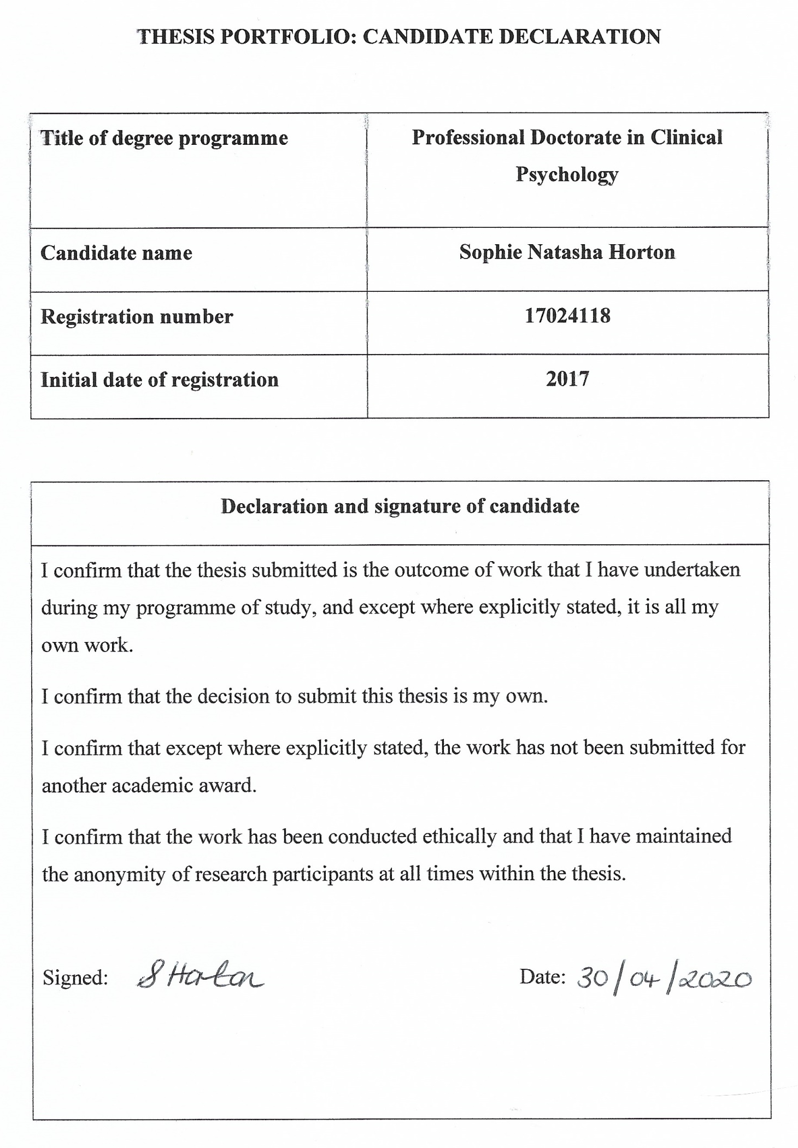

Acknowledgements
First and foremost, I would like to say a huge thank you to all the service users who gave up their time to support this research, initially in the development of the specific focus and participant forms, expressing interest in participating, sharing your stories and providing feedback following the study. Without you all, this would not have been possible. I hope that sharing your stories was beneficial and that this research goes some way to inform services and improve things for you all. I was honoured to hear your stories.

To the project workers, I couldn’t have undertaken this research without your dedication, care and support. How much you dedicate your lives to those you work with is inspiring. You really do all deserve an award as one of the participants suggested!

I would like to thank my supervisors in this project, Dr Joanna Heyes and Dr Peter Oakes. Thank you both for always making time for my questions and providing me with the guidance needed to complete this work. Your thoughtful feedback and encouragement has been invaluable.

I am so thankful to have shared these last three years with my cohort. Your dry humour has kept me going through what has been a challenging time to be completing our training. I never expected to have to complete this thesis whilst we are having to social distance. A special shout out to Ami and Jenni who have, at various times, shared your homes with me so that I didn’t leave my sanity somewhere on the painfully long commute down the dreaded M60 and M6!

Thank you to my supportive friends, family and husband, Patrick, for helping me to maintain a work-life balance and always supporting me in whatever I do. Patrick, thank you for quietly listening to my monologues which made zero sense to you! I couldn’t have done this without you. And last but not least, thank you to Penny the cat for keeping me company whilst working from home and making cameos in my video calls.

Contents
Journal Submission Details 9
Thesis Abstract 9
Chapter One: Literature Review - What impact has serious financial difficulty, since the 2008 UK recession, had on individuals’ psychological wellbeing? 11
Abstract 11
Introduction 11
Method 13
Inclusion and Exclusion Criteria 13
Selection of articles 17
Quality of Articles 20
Findings 20
Location of Studies 21
Measure of Psychological Wellbeing 21
Measure of Economic Deprivation 22
Sampling Methods 22
Cross-sectional Studies 23
Qualitative Studies 27
Overall Trends in Findings 28
Strengths and Weaknesses 28
Discussion 32
Summary of Findings 32
Limitations 33
Review Process. 33
Quality of Evidence. 33
Directions for Future Research 34
Conclusion 35
References 37
Appendices 43
Appendix 1.1: Summary table of included papers. 43
Appendix 1.2: Example of CASP used to determine quality ratings. 75
Appendix 1.3: Quality Hierarchy. 79
Appendix 1.4: Journal Impact Factors. 80
Chapter Two: Research Study - Towards a grounded theory of the psychological impact of experiencing systemic barriers when attempting to overcome poverty. A qualitative study. 81
Abstract 81
Introduction 81
Poverty in the UK 81
Poverty in The Area 82
Poverty and Mental Health 83
Barriers to Accessing Support 83
Aims 84
Method 85
Epistemological Position 85
Ethical Considerations 85
Service User Involvement 85
Eligibility Criteria 86
Participant Characteristics 86
Procedure 87
Analysis Strategy 87
Rigor/Quality Control 88
Findings 89
‘Accessibility’ 89
‘Changes to the system’ 90
‘Pressure from the system’ 90
‘Lack of resources’ 91
“I realise I was set up for failure” (P6, 169) 92
Pre-existing psychological experiences 93
Receiving Appropriate Support 93
‘Discrimination’ 94
Pre-existing psychological experiences 94
Being discriminated against 95
Services being untrustworthy 96
‘Dehumanised’ 96
‘Being Dehumanised’ 97
‘Being Valued’ 98
‘Resilient not Resigned’ 99
‘Resilience and motivation’ 99
Hope 99
‘Personal support networks’ 100
Triangulation of Data 100
Discussion 103
Limitations 105
Clinical and Ethical Implications 105
Directions for Future Research 106
Reflections 107
Conclusion 108
References 109
Appendices 117
Appendix 1.1: Ethical Approval 117
Appendix 1.2: Member check text sent 118
Appendix 1.3: Participant Information Sheet 118
Appendix 1.4: Demographic Information Sheet 127
Appendix 1.5: Consent Form 130
Appendix 1.6: Initial Interview Schedule 132
Appendix 1.7: Initial Themes 133
Appendix 1.8: Example of initial coding 136
Appendix 1.9: Example of focused coding 136
Appendix 2.1: Comparing focused codes across transcripts 138
Appendix 2.2: Examples of memos 153
Appendix 2.3: Triangulation of data-Information held by Emerald 154
Appendix 2.4: List of systemic barriers found across transcripts 156
Chapter Three: Executive Summary 158
Contents 160
Study Title 160
Key Words 160
Why this research topic? 160
Aims 160
How the study was done 160
Key Findings 160
Sharing the Findings 160
Recommendations 160
Limitations 160
References 160
Study Title 161
Key Words 161
Poverty 161
Systemic barriers 161
Qualitative research 161
Grounded theory [GT] 161
Why this research topic? 161
Aims 163
How the study was done 163
Key Findings 166
Summary of findings 166
The Project 166
Systemic barriers 168
Main Themes 170
The Model 174
Sharing the Findings 176
Recommendations 176
Limitations 177
References 177
Thesis Appendices 179
Appendix 1.1: Author guidelines for Journal of Poverty and Social Justice 179

Journal Submission Details
Style and referencing conform to Journal of Poverty and Social Justice guidelines (appendix 1.1) for Chapter One and Chapter Two. Figures and tables would need removing to a separate document for journal submission.

Thesis Abstract
Research has long demonstrated the negative impact of living in poverty upon mental health. However, poverty remains a feature of people’s lives in the United Kingdom [UK] and the latest UK economic recession in 2008 added to the financial challenges of the country. As a result, the UK government introduced austerity measures attempting to stabilise the UK’s economy which included funding cuts to the welfare system and statutory services. This thesis aimed to investigate the impact of living in poverty upon psychological wellbeing. Chapter One presents a narrative literature review of quantitative and qualitative research reporting the psychological impact of poverty in the UK, since its latest recession in 2008. Thirteen of the fourteen reviewed papers demonstrated that there is a significant correlation between living in poverty and psychological distress. Chapter One also suggests that austerity measures are negatively impacting upon psychological wellbeing, especially for people living in existing poverty and those with mental health difficulties. Due to the levels of poverty in the area this research was conducted, voluntary services have developed projects to attempt to support people out of financial difficulty. However, individuals can face numerous barriers to accessing services such as these, and other services they need to access to overcome poverty. Therefore, Chapter Two presents an empirical Grounded Theory [GT] study investigating the psychological impact of experiencing systemic barriers when attempting to overcome poverty. A qualitative GT method was chosen to provide in-depth, rich data on the topic of interest given the lack of research on the impact of systemic barriers. Systemic barriers are barriers which are created, either directly or indirectly, through the way services are funded, set up and delivered. GT was also chosen to enable a theory to be developed from the data rather than existing theory guiding the research. The GT model which emerged found that there were four conceptual categories capturing participants experiences; ‘Accessibility, ‘Discrimination’, ‘Dehumanisation’ and ‘Resilient not Resigned’. Systemic barriers negatively impacted upon psychological wellbeing, triggering initial reactions of anger, anxiety, low mood and worthlessness. Participants described how these initial feelings could lead to secondary psychological reactions. Sometimes, they described secondary psychological reactions that, based on psychological theory, stemmed from initial psychological reactions without specifically mentioning the initial feeling. The secondary psychological reactions were: feelings of blame, shame, hopelessness, a loss of motivation, avoidance, a loss of trust in services, negatively impacting relationships, putting up barriers with others, a loss of confidence and a fear of future discrimination. Resilience and motivation were important for protecting participants from psychological harm and influenced levels of hope. Personal support networks provided external motivation for participants. It is unknown at which point these protective factors become salient for individuals. It may be that some participants were naturally more resilient and motivated, or these characteristics may have developed as coping strategies. There were also positive stories of experiencing positive feelings and prosocial behaviour following receiving appropriate support. There seems to be a vicious cycle in which poverty and mental health are linked, with mental health being both a vulnerability factor for poverty and poverty negatively affecting mental health. In addition, people can then face systemic barriers when attempting to access services to overcome poverty which further impacts upon their psychological wellbeing. Clinical implications are discussed in terms of reducing or eliminating systemic barriers to improve psychological wellbeing. Chapter Three is an executive summary of the empirical paper and was written for the participants and the project they were recruited from. Their feedback was sought via email.

Chapter One: Literature Review - What impact has serious financial difficulty, since the 2008 UK recession, had on individuals’ psychological wellbeing?

Abstract
This systematic literature review considers the impact of living in financial deprivation upon adult mental health, since the United Kingdom’s 2008 recession. Four databases, hand-searching and searching for grey literature occurred. Fourteen articles met the inclusion criteria. The majority of these were cross-sectional. Thirteen of the articles found a significant association between living in financial deprivation and poorer mental health. Several studies also found mental health has deteriorated since the recession. There was also evidence that austerity measures are disproportionately negatively impacting upon those living in the most deprived areas, and upon those with existing mental health difficulties.
Keywords: poverty, deprivation, socioeconomic deprivation, mental health, psychological wellbeing.

Introduction
This review evaluates literature on the psychological impact of living in financial deprivation, since the 2008 recession in the United Kingdom [UK]. Although there has been a literature review recently published on the impact of recessions upon mental health (Frasquilho et al. 2016), this did not focus upon the UK. Furthermore, included studies were published from 2004 and the UK did not enter a ‘technical’ recession until quarter three of 2008 (Allen 2010). The current review offers only evidence published since this time.
Although the UK recession lasted for fifteen months (Allen 2010), there were significant austerity measures for several years either side, attempting to stabilise the UK’s financial position. These were unique to the UK, hence the focus of this review. Austerity measures implemented in the UK include significant, permanent cuts to the welfare system (Cummins 2018). Flynn (2015) claims that austerity measures with the greatest impact were introduced in 2010. Two examples of austerity measures are the Work Capability Assessment [WCA] in 2008 and Universal Credit [UC] in 2013. The WCA has been criticised for not accounting for mental health difficulties (Cummins 2018) whilst both have been criticised for increasing psychological distress (Barr et al. 2016, Trussell Trust 2018). UC may also have a serious negative impact upon people with disabilities and their families (The Children’s Society 2012). There has been an increase in rent arrears (National Housing Federation cited in Raynor 2018) and the use of food banks (Trussell Trust no date) in areas where UC has been introduced. These are just two examples of how austerity measures may be disproportionately impacting the vulnerable and impacting upon psychological wellbeing. Austerity measures remain in place and many people continue to live in poverty (Joseph Rowntree Foundation [JRF] 2018), despite the UK since the final quarter of 2009 no longer being in recession (Allen 2010).
Although there is much research documenting the link between poverty and poorer mental health (e.g. Burns 2015), there is no known recent review of the literature focussing on this specifically in the UK since the recession and associated austerity measures. There are several studies documenting the link between the recession and/or poverty on suicide rates (e.g. Coope et al. 2014). This review focuses on how individuals experience poverty rather than prevalence or incidence rates to provide insight into the personal impact of poverty rather than broader societal measures.
For the purpose of this review, lower socioeconomic status [SES], poverty, deprivation and financial difficulties will be considered as synonymous indicators of living in financial hardship for the purposes of this review. SES is most commonly measured using indicators of education level, income and occupation and refers to an individual’s position in society (APA 2007). Thus, lower SES indicates a lower position in society characterised by lower income, a lower educational level and less-skilled occupation. There are multiple ways poverty is measured and defined so there is debate over whether it is even measurable (Habitat for Humanity 2017). However, for this review poverty is characterised by significant difficulties affording essentials such as utilities, food and rent (JRF no date) whereas financial difficulties may involve some difficulties affording these essentials but to a lesser extent. This review is interested in samples where there is a significant experience of financial difficulty; be this objectively or subjectively. Deprivation refers to a lack of something, and for this review the lack of financial or economic stability is considered. Although there are differences between the definitions of these phrases, they are all characterised by significant financial difficulty and are considered similar concepts for the purpose of this review.

Method
This literature review was conducted systematically. It critically appraises twelve quantitative and two qualitative research articles based on their methods, quality and findings in relation to the research question.

Inclusion and Exclusion Criteria
This review is interested in research which adds to our understanding of the psychological impact upon individuals of living in poverty, since the 2008 recession in the UK. Tables one and two describe inclusion and exclusion criteria. Where the date of data collection was not evident within articles, authors were contacted. If they could not be reached, or no response was received by 12 May 2019, articles were excluded as it could not be confirmed that they met the inclusion criteria. The PRISMA diagram (Figure 1) provides the references of these.

Table One. Inclusion criteria.
Inclusion Criteria | Justification
Empirical paper | Adds to our understanding by providing evidence based upon “the application of observation and experience to a research question rather than being grounded in theory alone.” (Gaskell 2000 pp. 349)
Peer-reviewed | Quality evidence
Data collection conducted from 2008 onwards | The latest recession in the UK started in 2008 (Allen, 2010). This review is interested in the impact since then
Data collection spanned pre and post 2008 but compared pre-recession to post-recession | Impact since the 2008 recession could be ascertained
Qualitative or quantitative | Increase scope
Quantitative research must use a recognised measure of psychological impact | Increase precision (Carlson and Morrison, 2009)
Participants must be adults | Population of interest
Written in English | Translation services unavailable. Unlikely that any articles would be written in languages other than English
UK sample OR sample includes UK participants and reports psychological measure of UK participants separately | Focus of the review
Poverty* reported as hypothesised predecessor of psychological outcome | Focus of the review question is interested in this directional association
Articles reporting the link between poverty* and psychological outcome where there were mediators (e.g. allostatic load) | These still capture the essence of the review question and give further clues as to the mechanism of such an association
Participants must be experiencing significant financial difficulties which is made clear in the description of their economic position | This review is interested in the impact of living in serious financial difficulty upon psychological wellbeing
Articles must report on the individuals experience of the impact of financial hardship upon their psychological wellbeing, qualitatively or quantitatively | Focus of the review
NOTE: poverty* and its related definitions used in this review.

Table Two. Exclusion criteria.
Exclusion Criteria | Justification
Does not report empirical research e.g. editorial, commentary or similar | Must add to our understanding by providing empirical evidence which adds to the evidence base
Non-peer reviewed | Avoids lower quality evidence
Data was collected pre-2008 | The latest recession in the UK started in 2008 (Allen, 2010) and as this review is interested in the impact since this
Date of data collection was not reported and remained unclear despite attempts to contact authors | Not possible to confirm data collection date meets the inclusion criteria
Articles reporting on the longitudinal impact of poverty* in childhood on adult psychological outcomes | Does not answer review question
Poverty* reported as a moderator or mediator | Does not answer review question
Participants are on low incomes or unemployed with no clear indication that this significantly impacted their ability to afford essentials | No clear indication that sample are experiencing significant financial difficulties which impact upon their ability to afford essential items
Studies reporting on: mortality rates, incidence rates of psychological disorders, suicide rates, access to services, impact upon service delivery or provision, referral rates for psychological distress, cognitive functioning, social deprivation, medication prescribing for psychological difficulties in areas of poverty* | Do not provide an indication of the individual’s experience of the impact of poverty* upon their psychological wellbeing
NOTE: poverty* and its related definitions used in this review.

Selection of articles
Following an initial scoping of the literature, CINAHL, PsycARTICLES, PsycINFO and Scopus were searched. Grey literature was searched via; STORE [Staffordshire University Online Research Repository] and Google Scholar. Hand searching references of relevant articles was employed.
Searches were carried out between 31/01/19 and 24/04/19. The following search terms were used: Poverty words: poverty, “socioeconomic status”, “financial hardship”, “economic hardship” and deprivation AND psychological impact words: “mental health”, “mental wellbeing”, “mental well-being”, “mental illness” and psycho* AND geographical limiter: (England OR Scotland OR Wales OR “Northern Ireland” OR "United Kingdom"). Every combination of the poverty and psychological impact terms were used separately, each with the geographical limiter string. The latter was used because it is not possible to use place as a limiter on all databases. Other limiters were: adults (all ages eighteen+), humans and published 2007-2019 due to initial scoping identifying 2007 as the start of the recession. Initial scoping was in the form of a crude internet search which later transpired to refer to the beginning of the events which led to the technical recession. Given more credible evidence that the recession in the UK officially began in July 2008 (Allen 2010) the date of data collection inclusion was hand applied as 2008 onwards. For continuity and replicability purposes all searches maintained 2007-2019 as a limiter. For the STORE and Google Scholar searches, all limiters were applied by hand. Google Scholar searches were limited to reviewing titles.
A total of 3, 452 results were identified through database searching, with 126 duplicates removed. Hand and grey literature searching supplemented this which resulted in a total of 3,388 titles and abstracts being reviewed for inclusion. 3,286 records were excluded at this stage, leaving 102 for full-text review. Eighty-seven records were excluded at this stage due to: unknown date of data collection (three), pre-2008 data collection (thirty-six), incorrect geographical area (twelve) or failing to meet other inclusion criteria/meeting exclusion criteria (thirty-six). A total of fourteen articles are included in this review (see Figure 1 for Prisma diagram; appendix 1.1. for summary table of included articles).
Results via database searching
(n = 3,452)
Results from other sources:
Grey Literature (STORE n = 662, Google Scholar n = 259)
Hand searching (n = 29)
Identification
Abstracts reviewed for eligibility
(n = 3, 388)
Screening
Duplicates removed
(n = 126)
Records excluded
(n = 3,286)
Full-text articles assessed for eligibility
(n = 102)
Eligibility
Full-text articles excluded: (n = 87)
Data collection time frame unknown (n = 3)*
Data collection date did not meet inclusion criteria (n = 36)
Sample not UK/did not report UK participants separately (n = 12)
Paper met other exclusion criteria/did not meet other inclusion criteria (n = 36)
Non-empirical (n = 4)

Studies included
(n = 14)
Included
*Papers excluded due to being unable to ascertain data collection time frame:
1. Richardson, T., Elliott, P., Waller, G. and Bell, L. (2015) ‘Longitudinal relationships between financial difficulties and eating attitudes in undergraduate students’, International Journal of Eating Disorders, 48(5): 517-521.
2. Stack, R. J. and Meredith, A. (2018) ‘The Impact of Financial Hardship on Single Parents: An Exploration of the Journey From Social Distress to Seeking Help’, Journal of family and economic issues, 39(2): 233-242.
3. Anderson, F. and Freeman, D. (2013) ‘Socioeconomic status and paranoia: the role of life hassles, self-mastery, and striving to avoid inferiority’, The Journal of nervous and mental disease, 201(8): 698-702.
Records excluded based on titles
(n = 1, 014)
Figure 1. Prisma diagram indicating the selection and inclusion of articles.

Quality of Articles
Study design is a significant component in considering quality, with Randomised Controlled Trials [RCT’s] generally considered of a ‘high’ quality, observational studies considered ‘low’ quality and all other designs considered ‘very low’ quality (Oxman and Group 2004). There were no RCT’s identified. This is not surprising given the nature of living in poverty is such that controlled intervention studies would raise ethical challenges. Most studies were cross-sectional (n = ten), with one prospective cohort study, one service evaluation and two qualitative studies. Critical Appraisal Skills Programme [CASP] checklists were used to consider quality in relation to design (Critical Appraisal Skills Programme [CASP] 2018a, 2018b, 2018c) by selecting the most appropriate checklist for each study. Although the CASP checklists are not scoring tools, they have options of yes, can’t tell and no for each question. Therefore, scores were assigned to these as two, one and zero respectively. ‘Can’t tell’ was judged as the paper going some way towards meeting that question. Due to the lack of manipulation in many of the articles given the nature of living in poverty, occasionally questions were marked as not applicable. This was the case for seven of the articles in which questions surrounding controls (Bellis et al. 2012, Poots et al. 2014, Cientanni et al. 2017, de Gelder et al. 2017, French and McKillop 2017, Prior et al. 2018) or follow-up (Mattheys et al. 2016) were not applicable. No questions were omitted from CASPS for the other articles. Additional quality considerations were included according to Oxman and Group (2004), with scores applied for the overall study design; three for RCT’s, two for observational studies and one for other designs. Percentages were then calculated as a quality measure due to the different total points available for different checklists (see appendix 1.2 for an example CASP and appendix 1.3 for quality ratings). Quality ratings ranged from 61-85 percent, with higher percentages indicating higher quality. Scores greater than 75% were considered of high quality for this review. Less than 50% would have been considered of low quality.

Findings
The findings of this review will consider the similarities and differences between the articles and some of their strengths and limitations.

Location of Studies
Although all the UK (and Northern Ireland) experienced the 2008 recession, there are differences in political policies across the countries which make up the UK. These have the potential to impact upon people’s psychological wellbeing differently. Thus, the location of studies is important for considering generalisability. The specific geographical locations of the included articles varied; two were conducted across England (Katikireddi, Niedzwiedz and Popham 2012, Thomson, Niedzwiedz and Katikireddi 2018), one across Scotland (Cientanni et al. 2017), one in a specific area of the UK (Barnes et al., 2015), one in Great Britain (Prior, Manley and Jones, 2018), four in specific areas of England (Bellis et al. 2012, Poots et al. 2014, Mattheys et al. 2016, Mattheys, Warren and Bambra 2018), three in specific areas of Scotland (Landy, Walsh and Ramsay 2012, Curl and Kearns 2015, Curl and Kearns 2017), one in Europe, including the UK, (de Gelder et al. 2017) and one in Northern Ireland (French and McKillop 2017).

Measure of Psychological Wellbeing
Studies used a range of psychological wellbeing measures. This can make comparisons challenging as different measures potentially measure different concepts. Furthermore, some measures have greater reliability and validity. Given the breadth of psychological wellbeing as a concept, a range of measures is expected, and all have their merits in providing insight into psychological wellbeing. Barnes et al. (2015) and Mattheys et al. (2018) were qualitative studies and therefore did not use a validated measure of psychological wellbeing, instead collecting in-depth personal accounts of experiences. Five studies employed the General Health Questionnaire [GHQ-12] (Katikireddi et al. 2012, Landy et al. 2012, de Gelder et al. 2017, French and McKillop 2017; Thomson et al. 2018); with French and McKillop (2017) also employing the EuroQol-5D [EQ-5D] and Landy, Walsh and Ramsay (2012) also employing the Warwick and Edinburgh Mental Wellbeing Scale [WEMWBS] and the Clinical Interview Schedule [CIS]. Three used the Short Form Health Survey [SF-12] (Curl and Kearns 2015, 2017 and Prior et al. 2018). One study used the mental component scale of the Short Form-8 [SF-8 MCS] (Mattheys et al. 2016). An additional study also employed the WEMWBS (Mattheys et al. 2016) and one employed the Short WEMWBS [SWEMWBS] (Bellis et al. 2012). One study used the Clinical Outcomes in Routine Evaluation Outcome Measure [CORE-OM] (Cientanni et al. 2017) and one used the Patient Health Questionnaire [PHQ-9] (Poots et al. 2014).

Measure of Economic Deprivation
Studies varied in their definition and measure of economic deprivation. This may impact on the ability to make direct comparisons due to different definitions and measures. However, if just one measure or definition was used, the range and breadth of articles would be seriously limited. The definitions are considered similar enough to enable synthesis. Some studies characterised this as living in deprived areas (n = 9; Bellis et al. 2012, Katikireddi et al. 2012, Landy et al. 2012, Poots et al. 2014, Mattheys et al. 2016, Cientanni et al. 2017, Mattheys et al. 2018, Prior et al. 2018 and Thomson et al. 2018). All these studies used various Indices of Multiple Deprivation [IMD] appropriate for the years and areas of study. Thomson, Niedzwiedz and Katikireddi (2018) also used socioeconomic position measured via self-report and highest educational level in addition to the IMD. Four studies characterised it as participants experiencing financial or economic difficulties/hardship (Barnes et al. 2015, Curl and Kearns 2015, 2017 and French and McKillop 2017); with Curl and Kearns (2017) specifically looking at fuel affordability. These studies used participant self-report to measure financial difficulty, with French and McKillop (2017) also using objective levels of debt. Four studies conceptualised different levels of economic hardship in relation to SES (Katikireddi et al. 2012, Landy et al. 2012, de Gelder et al. 2017 and Thomson et al. 2018). These studies included highest educational attainment as an indicator of SES. de Gelder et al. (2017) also conceptualised SES to include employment status and self-reported financial strain. Landy et al. (2012) also measured income-related benefits, National Statistics Socio-economic Classification, economic activity, housing tenure and marital status.

Sampling Methods
Various sampling methods are used in empirical studies. Each has their relative benefits, limitations and appropriateness to methodology (Marshall 1996). Some sampling techniques reduce the chance of bias in the selection of participants, whereas others are more suited to qualitative research. Barnes et al. (2015) and French and McKillop (2017) utilised purposive sampling. This involves selecting participants based upon characteristics of interest (Etikan, Musa and Alkassim 2016). Eight studies employed different random sampling methods (Bellis et al., 2012 utilised clustered random sampling; Katikireddi et al. 2012, Landy et al. 2012, Curl and Kearns 2015, Mattheys et al. 2016, Curl and Kearns 2017, de Gelder et al. 2017 and Thomson et al. 2018 utilised stratified random sampling). Random sampling is when each member of the target population has an equal chance of being selected (Marshall 1996). Clustered random sampling involves taking a random sample of naturally occurring groups, i.e. clusters, e.g. based upon location. Stratified random sampling involves taking a random sample from homogenous ‘strata’. One study employed theoretical sampling (Mattheys et al. 2018) which is when participants are recruited based on emerging theories from the data (Marshall 1996). The remaining study did not make their sampling strategy clear and the original survey methodology was not available to review (Prior et al. 2018).

Cross-sectional Studies
Bellis et al. (2012) surveyed a cross-sectional sample in North West England (n = 18, 560) regarding life satisfaction and mental wellbeing (measured by the WEMWBS). Due to the focus of this review, only the findings in relation to mental wellbeing are discussed here. They found that living in more deprived areas was associated with significantly lower mental wellbeing. They did not find that living in deprived areas was associated with lower mental wellbeing for 18-24-year olds, those in full time education, those of South Asian ethnicity, those in the highest exercise group, those with poor physical health, current or ex-smokers and those classed as drinking risky amounts of alcohol. This study provides evidence that those who live in deprived areas are more at risk of poor mental wellbeing than those in less deprived areas. However, there are exceptions.
Cientanni et al. (2017) used existing data to investigate the effect of socioeconomic deprivation and identifications with social groups on psychological distress (measured using the CORE-OM). They found greater socioeconomic deprivation was associated with significantly increased psychological distress. They also found a significant mediation effect of identifying with social groups on this relationship: belonging to more social groups was protective against distress. This provides important directions for future interventions to increase social group identifications for those living in deprived areas, with a view to improve psychological wellbeing.
Curl and Kearns (2015) is a cross-sectional analysis of survey data from a longitudinal cohort looking at financial difficulty and its association with mental health. Only findings from 2008 to 2011 are considered due to exclusion criteria. They found that mental health difficulties (measured by the SF-12) have increased from 2008-2011, i.e. since the recession. They also found that those reporting financial difficulties were more likely to report mental health difficulties. This study provides an indication that mental health difficulties have increased since the recession; an important finding for policy making and service providers. The fact that worse mental health was more likely in those experiencing financial difficulties provides information about where to target services.
Curl and Kearns (2017) uses the same data as above but looks in more detail at the relationship between fuel affordability and mental health, controlling for more confounders than the earlier study. Fuel affordability in this study refers to participants being able to comfortably afford their utility bills. The inability to do so represents a significant financial difficulty. They found there has been an increase in people having difficulty affording fuel since the recession and this was associated with worse mental health. This association was present when controlling for housing type, age and employment status. This study provides further evidence of increasing financial difficulties following the recession in the UK, which are associated with poorer mental health.
de Gelder et al. (2017) conducted a cross-sectional analysis of existing survey data from the European Urban Health Indicator System Part 2 project. This included survey data from nine European countries, including the UK. They found higher financial strain was associated with poorer mental health (as measured by the GHQ-12), with SES explaining differences in psychological distress. However, these findings relate to the sample as a whole and it is unknown whether these patterns would have been present if the UK data was analysed alone.
French and McKillop (2017) using a face-to-face interview analysed survey data, collected by a market research company with participants identified through credit unions in Northern Ireland whom were in debt. They found that those reporting financial stress were more likely to report greater symptoms of psychological distress (as measured by EQ-5D). This study provides evidence that subjective stress in relation to finances is associated with psychological distress.
Katikireddi et al. (2012) report the findings of a repeated cross-sectional analysis of data from the Health Survey for England. Only findings since the recession have been considered for this review. Overall, they found that mental health, as measured by GHQ-12 caseness, has deteriorated since 2008. However, they found that this deterioration was only significant for men and not for women. They also found that inequalities in SES have increased over time. This study did not find SES explained the differences in mental health. Nor could it be explained by differences in employment, educational level or income. This study supports evidence that mental health may have worsened since the recession. However, it suggests this is not the case for both genders and contradicts other studies by finding no differences in mental health across SES’s. They do not provide any alternative explanations for their findings that men’s mental health deteriorated or the increase in SES inequalities.
Thomson et al. (2018) is a repeated cross-sectional analysis following on from Katikireddi et al. (2012), also using data from the Health Survey for England. They found that although socioeconomic inequalities in mental health reduced after the recession in 2008, the gap has increased since austerity measures have been introduced. This may explain the contradictory evidence of Katikireddi et al. (2012) as Thomson et al. (2018) which suggests the mediational effect of austerity policies on the relationship between economic changes in the UK and mental health. Thomson et al. (2018) found that differences in GHQ-12 caseness for males was back to the pre-recession level by 2012. However, for women the caseness did not significantly change from 2009-2010 but did significantly increase from 2010-2012, after the implementation of major austerity measures (according to Flynn, 2015). Katikireddi et al. (2012) may not have found a difference in mental health by SES due to the austerity policies not having yet been fully implemented. Thomson et al. (2018) supports evidence that mental health has been significantly impacted since the recession, specifically since the introduction of austerity measures. It also hints that these negative impacts may actually be more detrimental for women’s mental health.
Landy et al. (2012) analysed data from the 2008-9 Scottish Health Survey investigating whether biological, behavioural and socioeconomic factors explain the lower levels of health in Glasgow. Only the findings in relation to mental health and socioeconomic factors are considered for this review. This study found that Glasgow had poorer mental health (as measured by GHQ-12, WEMWBS and CIS) compared with the rest of Scotland, and most of these differences were explained by socioeconomic factors (both individual and area deprivation). However, there were still significantly higher rates of anxiety in Glasgow compared with the rest of Scotland when socioeconomic factors were controlled. This suggests that while some aspects of mental health can be explained by SES, there may be additional factors present impacting upon anxiety for residents of Glasgow. The authors suggest future research to ascertain what these additional factors, and hypothesise, based on existing research, that it is likely a multitude of factors, adding the historical, political and economic to biological, behavioural and socioeconomic factors.
Mattheys et al. (2016) conducted a prospective cohort study in Stockton-on-Tees, England to investigate differences in mental health between areas of high and low deprivation. They found a significant association between living in the least deprived areas and reporting better mental health (measured by the WEMWBS and SF8), which was explained by material and psychosocial factors such as social isolation. They found that those living in the most deprived areas reported greater isolation and reduced friendships which they note has previously been found to be linked with poorer mental health. Again, this study provides additional evidence of inequalities in mental health when living in differing areas of deprivation.
Poots et al. (2014) conducted a retrospective service evaluation about the impact of an increasing access initiative in a London psychological therapy service. Only findings relevant to the question of this review are discussed. They found that those living in areas of higher deprivation had significantly worse levels of depression on service entry (measured by the PHQ-9). However, deprivation had no impact upon recovery rates or meaningful change. This study is helpful as it suggests targets for psychological intervention may include areas of deprivation. The findings are encouraging as they provide evidence that those living in deprived areas have the same chance of recovery from mental health difficulties as those living in more affluent areas.
Prior et al.’s (2018) cross-sectional analysis of existing data aimed to determine whether allostatic load (a biological marker for chronic stress) mediated the relationship between deprivation and poor mental health (measured by the SF-12). They found that allostatic load was higher for those living in deprived areas, suggesting increased levels of chronic stress. Poorer mental health was also found for those living in more deprived neighbourhoods (measured by the IMD), even when controlling for individual socioeconomic factors. They also found a significant mediating effect of higher allostatic load on the relationship between higher deprivation and poor mental health. This study further supports that there is an association between living in deprivation and experiencing poorer mental health and it suggests a biosocial mediator for this in the form of the impact of the chronic stress of living in deprivation, i.e. allostatic load.

Qualitative Studies
Barnes et al. (2015) conducted a qualitative study with those who had attended hospital following an episode of self-harm and cited economic difficulties as a factor in their self-harm. Sixteen of their nineteen participants were in debt and had difficulty affording day-to-day essentials and paying utility bills, which was distressing for them. Many of the participants experienced anxiety in relation to the benefits process due to; uncertainty about changes, the difficulties of the process, and about new assessments. They also found that difficulty finding a job, or losing jobs, negatively impacted upon people’s self-esteem and in some cases had led to people engaging in self-harm as a coping strategy. Barnes et al. (2015) found that when participants were experiencing significant financial difficulties, historical factors that may have made them vulnerable to self-harm came more to the fore. They concluded that there was a cumulative impact of financial difficulties increasing over time, with a final event (such as the threat of debt collectors) sometimes making these unmanageable and leading to self-harm. Many of their participants reported other known current and historical risk factors for suicide and self-harm, such as childhood abuse and bullying, which were intertwined with current financial difficulties. This suggests the cumulative impact of historical and current risk factors, combined with current financial difficulties, on self-harm. This highlights the importance of future interventions considering someone’s historical and current risk factors and the potential for financial difficulties to add to these and trigger to using self-harm as a way of coping with the psychological impact of these experiences.
Mattheys et al. (2018) extended Mattheys et al.’s (2016) study by recruiting participants who reported mental health difficulties and conducting a qualitative study to investigate the impact of austerity on those people. They also interviewed stakeholders and those accessing the Citizens Advice Bureau. The data suggested a relationship between poverty, experiencing financial difficulties and poorer mental health. Financial security was found to have reduced since 2010 when the most severe austerity measures were enforced (Flynn, 2015). These measures affected those living in deprived areas and those with existing mental health difficulties significantly more than those living in affluent areas. Financial security was a protective factor as it afforded people the opportunity to escape situations which may negatively impact upon their mental health which was not available to those living in deprivation. This study provides valuable insights into the detrimental effect of austerity as participants reported that these made mental health difficulties worse. People also said they felt unheard and powerless.

Overall Trends in Findings
All the studies included in this review, except for Katikireddi et al. (2012), found a significant association between economic deprivation and poorer mental health. This was across qualitative and cross-sectional studies, providing converging evidence (Jick 1979). However, Katikireddi et al. (2012) found that there was no significant difference in mental health between those of differing SES’s. This study was rated in the middle range for quality when compared with other studies included in this review (77 percent, joint fifth position) so its findings should not be ignored because they contradict other evidence, but its quality should be considered as it is still considered relatively high quality. Five studies found that mental health, or inequalities in mental health, deteriorated since the recession or austerity (Katikireddi et al. 2012, Curl and Kearns 2015, 2017, Mattheys et al. 2018 and Thomson et al. 2018). This finding is significant as these studies are the only ones included in this review which report on changes since the recession, the other studies did not find that there has been no decline in mental health but they did not have the ability to report on trends. So, although Katikireddi et al. (2012) did not find that mental health differed by SES, they did find that mental health deteriorated since the recession among their participants. It is possible that this study did not find a link between mental health and SES for methodological reasons. For example, they do not mention matching participants across study waves which may have confounded the results.

Strengths and Weaknesses
It is important to consider the relative value of the above findings by considering the strengths and limitations of the articles, whilst remembering their overall quality.

Sample Size.
Nine articles had large sample sizes (n = 1,426 – n = 106, 985) (Bellis et al. 2012, Katikireddi et al. 2012, Landy et al. 2012, Poots et al. 2014, Curl and Kearns 2015, 2017, de Gelder et al. 2017, Prior et al. 2018, Thomson et al. 2018) which arguably increases their power (Martin, Bateson and Bateson 1993), generalisability and representativeness (Biau, Kernéis and Porcher 2008). However, the increased risk of making a Type 1 should be considered due to the increased risk of determining there is a significant association when this is due to chance in large samples (Tabachnick and Fidell 2013).

Sampling Method.
Eight studies employed forms of random sampling (Bellis et al. 2012, Katikireddi et al. 2012, Landy et al. 2012, Curl and Kearns 2015, Mattheys et al. 2016, de Gelder et al. 2017, Curl and Kearns 2017, Thomson et al. 2018) which decreases the chance of bias (Hedt and Pagano 2011). The studies by Barnes et al. (2015) and French and McKillop (2017) employed purposive sampling which increases the risk of bias in selecting the sample. However, this is a suitable sampling method for qualitative research (Barnes et al. 2015) as it ensures the sample has experienced the phenomenon of interest (Oppong 2013). Barnes et al. (2015) also used purposive sampling to attempt to recruit a representative sample. The use of purposive sampling by French and McKillop (2017) in a quantitative study is a little unusual, but they were specifically interested in those experiencing debt. Potential bias in sampling methods impacts upon generalisability and representativeness. de Gelder et al. (2017) fail to describe their sampling method which reduces confidence in the objectivity of their sampling method.

Generalisability and Representativeness.
The generalisability of the findings of Bellis et al. (2012), Landy et al. (2012), Poots et al. (2014), Barnes et al. (2015), Curl and Kearns (2015, 2017), Mattheys et al. (2016, 2018), Cientanni et al. (2017), de Gelder et al. (2017), French and McKillop (2017), and Prior et al. (2018) to the general population of the UK is questioned due to being conducted in specific areas or not solely focussing on the UK. However, given the similar findings across different areas, there is a strong case for generalisability. Bellis et al. (2012) used postcodes as the sampling frame meaning that representativeness of the sample cannot be judged. The representativeness of Poots et al. (2014) and Cientanni et al. (2017) is questioned due to their samples all being clinical samples. Therefore, they must have already been experiencing psychological distress and may not be representative of the general population, making it difficult to generalise the findings. The representativeness of Prior et al. (2018) is questioned as they do not report the characteristics of their sample nor how they were recruited which also increases the chance of bias. Describing the sample is important to judge the generalisability of the findings (Pickering 2017). Mattheys et al. (2016) only sampled those living in the twenty most and twenty least deprived areas of Stockton-on-Tees which questions whether the sample was representative and whether the findings can be generalised to people living in areas across the complete range of deprivation. Barnes et al. (2015) and Mattheys et al. (2018) are qualitative and therefore have smaller samples. Usually, this reduces generalisability (Biau et al. 2008) but qualitative research does not intend to provide generalisable findings; they provide in-depth, personal accounts of people’s experiences. Therefore, smaller samples are suitable. It is difficult to determine whether the overall findings of de Gelder et al. (2017) would also be found if the UK sample was separately analysed as although they report GHQ-12 scores by country, their analysis and discussion is for the nine included countries together. Two studies are felt to have strengths in representativeness and generalisability (Katikireddi et al. 2012, Thomson et al. 2018) due to their sampling methods and characteristics.

Validity.
A strength of the qualitative studies is their ability to provide rich, in-depth data that arguably increases their validity (Goodwin and Horowitz 2002). Barnes et al. (2015) continued their sampling until they reached the point of data saturation, i.e. where they were finding no new data, increasing validity (Ness 2015). Mattheys et al. (2018) fail to discuss saturation. Neither of the qualitative studies discusses contradictory findings, reducing their quality (Drisko 1997). However, they both use quotes to illustrate their findings, improving validity (Sandelowski 1994). The quantitative studies rely on self-report measures of psychological wellbeing which potentially reduces validity due to the potential for biases such as social desirability (Fisher 1993). This limitation is offset by using validated measures which have been tested for their ability to measure what they intend to. However, the validity of the SWEMWBS used in Bellis et al. (2012) is further limited as it has not been widely used in similar samples. This may explain in part their number of exceptions in the association found. There are also concerns about the validity of the SF8 (Mattheys et al. 2018).

Relevance to Review Question.
Many of the articles included a large portion devoted to the focus of this review. However, the relevance of some is questioned due to their focus not being solely upon the psychological impact of living in poverty (Poots et al. 2014, Curl and Kearns 2017, de Gelder et al. 2017, French and McKillop 2017). There is a question of whether Curl and Kearns (2017) further adds to our understanding in addition to Curl and Kearns (2015) given that the relevant findings are from the same data.

Reliability.
All studies, except Barnes et al. (2015), Curl and Kearns (2015, 2017) and French and McKillop (2017) used objective measures of deprivation, increasing the reliability of this measure and reducing the chance of bias. The reliability of qualitative research is judged on its trustworthiness (Golafshani 2003). Neither Barnes et al. (2015) nor Mattheys et al. (2018) reflect upon their own position as researchers which decreases the trustworthiness due to a lack of transparency (Macbeth 2001, Cutcliffe 2003, Reid, Flowers and Larkin 2005). However, they both employ triangulation which goes some way towards increasing their reflexivity (Reid et al. 2005, Berger 2015), hence increasing the quality.

Study Design.

Cause and effect.
Cross-sectional designs are unable to detect cause and effect due to their lack of manipulation (Mann 2003, Booth, Sutton and Papaioannou 2016) so naturally many of the studies included have this as a limitation. However, three analysed data from longitudinal cohorts (Curl and Kearns 2015, 2017, Thomson et al. 2018) which have a greater ability to hypothesise cause and effect (Taris and Kompier 2014).

Control.
The quality of cross-sectional designs is increased through greater control, and acknowledgement, of confounding variables (CASP 2018a). Five articles are noted to acknowledge, or control for these, relatively well (Bellis et al. 2012, Katikireddi et al. 2012, Landy et al. 2012, Mattheys et al. 2016, French and McKillop 2017). Curl and Kearns (2015) utilise retrospective matching which increases their ability to control for confounding variables by analysing each person’s data against their following data.

Risk of error, statistical significance and power.
The risk of making a Type 1 error, i.e. declaring there is a significant effect/association when this is down to chance, is increased when conducting many statistical tests (Pallant 2010). This is a potential issue for Curl and Kearns (2015), Landy et al. (2012) and Prior et al. (2018) and therefore their findings should be treated with caution. The findings of Prior et al. (2018) should be further treated with caution as the mediation effect of the association between deprivation and mental health only just reached statistical significance. The risk of this being due to chance is further increased by the large sample. Power calculations are used to determine the sample size needed to detect an effect of the desired level (Pallant 2010) and can reduce the chance of error (Jones, Carley and Harrison 2003). Mattheys et al. (2016) and de Gelder et al. (2017) are the only two articles which specified the use of a power calculation and reached the sample size required, reducing the chance of error.

Replicability.
A detailed description of methodology, data collection and analysis are key to replication and most of the studies reviewed provide this. However, there are some questions around the sampling method in de Gelder et al. (2017). Prior et al. (2018) also fail to describe the recruitment strategy or characteristics of their sample. A limitation of Mattheys et al. (2018) is that they do not provide detailed information of their analysis.

Discussion

Summary of Findings
Thirteen of the fourteen articles indicate a link between living in poverty and poorer mental health. In addition, the exceptions of certain groups, found in Bellis et al. (2012), should be considered when making conclusions about this association. The methodological strengths and limitations should also be considered. Although one article did not find this association, it did find that mental health has worsened since the recession in the UK. Its contradictory findings are also somewhat superseded by Thomson et al. (2018) extending their study with data from subsequent years. Five studies found evidence indicating that mental health has deteriorated since the recession. There is also evidence that austerity measures are disproportionately, negatively impacting upon those living in the poorest areas and those with existing mental health difficulties.

Limitations

Review Process.
Only one reviewer judged eligibility for inclusion and quality of included articles. Therefore, there is a possibility of bias in the inclusion and quality judgements, reducing reliability. However, due to the nature of this review being a part fulfilment of the doctorate in clinical psychology, it was not possible to validate decisions with a peer. Using the CASP checklists and other guidance in the quality judgement, and remaining transparent in review processes, reduces bias. However, judging quality remains subjective, reducing validity and reliability. This review only included peer-reviewed articles which are subject to publication bias, introducing the potential that the findings of this review are skewed towards studies which found confirmatory results (Easterbrook et al. 1991). Searching grey literature attempted to counteract this. Only articles published in English were included in this review which may have led to relevant articles being excluded. However, due to the focus being on the UK it is felt that articles are highly unlikely to have been conducted in the UK and not subsequently published in English.

Quality of Evidence.
A further limitation concerns the quality of included evidence. One way evidence can be appraised is by considering the impact factors of the journal in which articles have been published. Impact factors give a figure corresponding to citations of articles from that journal, with higher impact factors indicating greater citations (Amin and Mabe 2000). These are sometimes used as a measure of quality. Appendix 1.4 shows the articles included and the impact factors of the journals they were published in. Most impact factors were found using the Journal Citation Report (Clarivate Analytics 2017). Included articles come from journals with ranging impact factors. It should be noted that the International Journal of Housing Policy is yet to be indexed. Most academic journals have impact factors greater than, or equal to one. All the journals for this review have impact factors over this, so could be considered of equal quality to most journals. Five of the journals (eight articles) have impact factors over two. This may indicate that they are of a higher quality than articles from journals with impact factors less than this. However, it should be noted that higher impact factors do not necessarily correspond with higher quality individual studies (Seglen 1997, Amin and Mabe 2000). There are differences in quality ratings (appendix 1.3) when compared to impact factors (appendix 1.4). Although most articles scored a high percentage according to the values assigned to the CASP checklists, they still all fall within what is considered ‘low’ or ‘very low’ quality evidence (Oxman and Group 2004). Therefore, the confidence in the findings of the articles is questioned. Their findings should be considered in relation to their overall quality (Appendices 1.1-1.4). All articles are peer-reviewed and have therefore gone through a rigorous review process to ensure quality. The cross-sectional nature of most of the studies means that cause and effect cannot be determined (Mann 2003, Booth et al. 2016). Therefore, the findings of this review need to be treated with caution in relation to further decisions. Confounders are inevitable in these designs (Mann 2003) and thus is it not possible to determine that deprivation causes poor mental health. The findings of this review indicate a definite association between higher deprivation and poorer mental health. The confidence in this is increased due to numerous cross-sectional studies having similar conclusions (CASP 2018a), in addition to the qualitative findings further converging with these (Jick 1979). Due to the nature of this research area, it is not possible to conduct more controlled studies. Therefore, such designs provide the best available methodologies to investigate this topic. Given the variety of definitions used for the factors investigated in this review, it is possible that they measure different concepts. This makes it challenging to make comparisons. However, given the high level of convergence it is likely that they are measuring the same or highly related concepts. This, coupled with the lack of evidence available, justifies including various definitions.

Directions for Future Research
Poverty is a complex phenomenon which is challenging to conduct controlled studies on, but which nonetheless has a profound impact upon people. Future studies may want to employ longitudinal designs to have a greater ability to determine cause and effect (Taris and Kompier 2014). This review indicated that the recession and austerity are having a disproportionately negative impact upon those already living in poverty and with existing mental health difficulties (e.g. Mattheys et al. 2018). This indicates future research should pilot, implement and evaluate the impact of prevention and intervention strategies to limit the impact of these measures upon the most vulnerable. Poots et al. (2014) found that although those living in deprivation entered the service with greater levels of depression, recovery rates were equitable. These suggest a need for targeted psychological services within deprived areas that also offer practical assistance (Barnes et al. 2015). This will require staff knowledgeable in working with people therapeutically but also in the services and systems available in the area. They should monitor for events which have the potential to push people over the edge (e.g. Mattheys et al. 2018) and increase protective factors as a means of prevention (e.g. social groups (Cientanni et al. 2017)). This may include encouraging social groups for people experiencing financial difficulty. These would need to be subsidised to ensure people could travel to access them. Future research should also investigate other protective factors. There is also a need for current social policies to be challenged given the serious impact they have had upon people’s psychological wellbeing as demonstrated in this review. Although austerity measures were introduced for economical reasons, they appear to have had a counter-productive effect in increasing the demand for psychological services.

Conclusion
This review found a consistent, significant association between living in deprivation and poorer mental health. This confirms the well-documented link between these factors from previous research (e.g. Burns 2015, Frasquilho et al. 2016) and suggests that despite the progression and advances in society, this is not changing. In contrast, there is evidence that inequalities are increasing, and mental health is deteriorating (Katikireddi et al. 2012, Curl and Kearns 2015, 2017, Mattheys et al. 2018, Thomson et al. 2018). This is especially important as there are predictions that the UK will enter another recession imminently due to uncertainty around the impact of withdrawing from the European Union (Eaton 2019). It will be important to consider how this could further negatively impact upon the mental health of the UK population, but especially those in the most deprived areas. This review also suggests that austerity measures are affecting those living in the most deprived areas and those with existing mental health difficulties greater (Mattheys et al. 2018). This is important as it provides avenues for prevention and intervention strategies to improve lives and decrease suffering. Future policy should consider these findings when implementing further austerity measures to counteract the potential detrimental impact. Future research should employ more longitudinal designs and determine the impact of any prevention and intervention strategies.

References
Allen, G. (2010) Recession and recovery. Key issues for the new parliament 2010, https://www.parliament.uk/documents/commons/lib/research/key_issues/Key-Issues-Recession-and-recovery.pdf
American Psychological Association (APA) (2007) Report of the APA taskforce on socioeconomic status, https://www.apa.org/pi/ses/resources/publications/task-force-2006.pdf
Amin, M. and Mabe, M. (2000) ‘Impact factors: use and abuse’, International Journal of Environment Science and Technology, 1(1): 1-6.
Barnes, M.C., Gunnell, D., Davies, R., Hawton, K., Kapur, N., Potokar, J. and Donovan, J.L. (2016) ‘Understanding vulnerability to self-harm in times of economic hardship and austerity: a qualitative study’, BMJ Open. 6(2): 1-8. doi:10.1136/bmjopen-2015-010131.
Biau, D.J., Kernéis, S. and Porcher, R. (2008) ‘Statistics in brief: the importance of sample size in the planning and interpretation of medical research’, Clinical Orthopaedics and Related Research, 466(9): 2282-2288.
Barr, B., Taylor-Robinson, D., Stuckler, D., Loopstra, R., Reeves, A. and Whitehead, M. (2016) ‘‘First, do no harm’: are disability assessments associated with adverse trends in mental health? A longitudinal ecological study’, Journal of Epidemiology and Community Health, 70(4): 339-345.
Bellis, M.A., Lowey, H., Hughes, K., Deacon, L., Stansfield, J. and Perkins, C. (2012) ‘Variations in risk and protective factors for life satisfaction and mental wellbeing with deprivation: a cross-sectional study’, BMC Public Health, 12(1): 492-479. doi:10.1186/1471-2458-12-492
Berger, R. (2015) ‘Now I see it, now I don’t: Researcher’s position and reflexivity in qualitative research’, Qualitative research, 15(2): 219-234.
Booth, A., Sutton, A. and Papaioannou, D. (2016) Systematic approaches to a successful literature review. London: Sage.
Burns, J. K. (2015) ‘Poverty, inequality and a political economy of mental health’, Epidemiology and psychiatric sciences, 24(2): 107-113.
Carlson, M. D. and Morrison, R. S. (2009) ‘Study design, precision, and validity in observational studies’, Journal of palliative medicine, 12(1): 77-82.
Children’s Society (The) Holes in the safety net: The impact of universal credit on disabled people, https://www.citizensadvice.org.uk/Global/Migrated_Documents/corporate/holes-in-the-safety-net-final-copy.pdf
Cientanni, F., Power, K., Sani, F., Wright, C., Baty, F., Hustings, K. and Tanner, G. (2017) ‘Comparing social group identifications and socioeconomic deprivation as predictors of psychological distress: Evidence from a Scottish primary care sample’, British Journal of Social Psychology, 56(4): 705-722.
Clarivate Analytics (2017) Journal Citation Report (2017), https://clarivate.com/products/journal-citation-reports/
Critical Appraisal Skills Programme [CASP] (2018a) CASP Case Control Study Checklist, https://casp-uk.net/wp-content/uploads/2018/01/CASP-Case-Control-Study-Checklist-2018.pdf
Critical Appraisal Skills Programme [CASP] (2018b) CASP Cohort Study Checklist, https://casp-uk.net/wp-content/uploads/2018/01/CASP-Cohort-Study-Checklist_2018.pdf
Critical Appraisal Skills Programme [CASP] (2018c) CASP Qualitative Study Checklist, https://casp-uk.net/wp-content/uploads/2018/01/CASP-Qualitative-Checklist-2018.pdf
Cummins, I. (2018) ‘The impact of austerity on mental health service provision: a UK perspective’, International journal of environmental research and public health, 15(6): 1145-1156.
Curl, A. and Kearns, A. (2015) ‘Financial difficulty and mental wellbeing in an age of austerity: the experience in deprived communities’, Social Policy and Society, 14(2): 217-240.
Curl, A. and Kearns, A. (2017) ‘Housing improvements, fuel payment difficulties and mental health in deprived communities’, International Journal of Housing Policy, 17(3): 417-443.
Cutcliffe, J. R. (2003) ‘Reconsidering reflexivity: Introducing the case for intellectual entrepreneurship’, Qualitative health research, 13(1): 136-148.
de Gelder, R., Koster, E. M., van Buren, L. P., van Ameijden, E. J., Harrison, A., Birt, C. A. and Verma, A. (2016) ‘Differences in adults’ health and health behaviour between 16 European urban areas and the associations with socio-economic status and physical and social environment’, The European Journal of Public Health, 27(suppl_2): 93-99.
Drisko, J. W. (1997) ‘Strengthening qualitative studies and reports: Standards to promote academic integrity’, Journal of social work education, 33(1): 185-197.
Easterbrook, P. J., Gopalan, R., Berlin, J. A. and Matthews, D. R. (1991) ‘Publication bias in clinical research’, The Lancet, 337(8746): 867-872.
Eaton, G., (2019) ‘The threat of a new recession is rising and the UK is dangerously unprepared’, New Statesman, https://www.newstatesman.com/politics/economy/2019/02/threat-new-recession-rising-and-uk-dangerously-unprepared
Etikan, I., Musa, S. A. and Alkassim, R. S. (2016) ‘Comparison of convenience sampling and purposive sampling’, American journal of theoretical and applied statistics, 5(1): 1-4.
Elsevier (2017) CiteScore, https://www.elsevier.com/editors-update/story/journal-metrics/citescore-a-new-metric-to-help-you-choose-the-right-journal
Fisher, R. J. (1993) ‘Social desirability bias and the validity of indirect questioning. Journal of consumer research’, 20(2): 303-315.
Flynn, P. M., (2015) Austerity in Northern Ireland. Where are we and where are we going?, https://www.nerinstitute.net/blog/2015/05/06/austerity-in-northern-ireland-where-are-we-and-whe/
French, D. and McKillop, D. (2017) ‘The impact of debt and financial stress on health in Northern Irish households’, Journal of European Social Policy, 27(5): 458-473.
Gaskell, T. (2000) ‘The Process of Empirical Research: a learning experience?’, Research in Post-Compulsory Education, 5(3): 349-360.
Golafshani, N. (2003) ‘Understanding reliability and validity in qualitative research. The qualitative report’, 8(4): 597-606.
Goodwin, J. and Horowitz, R. (2002) ‘Introduction: The methodological strengths and dilemmas of qualitative sociology’, Qualitative sociology, 25(1): 33-47.
Habitat for Humanity (2017). Relative vs absolute poverty. Defining different types of poverty, https://www.habitatforhumanity.org.uk/blog/2018/09/relative-absolute-poverty/?gclid=EAIaIQobChMIrvfe3_y-5gIVTbDtCh33KQ1qEAAYAiAAEgI3tPD_BwE
Hedt, B. L. and Pagano, M. (2011) ‘Health indicators: eliminating bias from convenience sampling estimators’, Statistics in medicine, 30(5): 560-568.
Jick, T. D. (1979) ‘Mixing qualitative and quantitative methods: Triangulation in action’, Administrative science quarterly, 24(4): 602-611.
Jones, S. R., Carley, S. and Harrison, M. (2003) ‘An introduction to power and sample size estimation’, Emergency Medicine Journal, 20(5): 453-458.
Joseph Rowntree Foundation (2018) UK poverty 2018, https://www.jrf.org.uk/people/child-poverty?gclid=EAIaIQobChMItsD81c3k4wIVArDtCh0cbQPXEAAYASAAEgKlYfD_BwE
Katikireddi, S. V., Niedzwiedz, C. L. and Popham, F. (2012) ‘Trends in population mental health before and after the 2008 recession: a repeat cross-sectional analysis of the 1991–2010 Health Surveys of England’, BMJ Open, 2(5): 1-9. doi:10.1136/bmjopen-2012-001790
Landy, R., Walsh, D. and Ramsay, J. (2012) ‘Do socio-economic, behavioural and biological risk factors explain the poor health profile of the UK's sickest city?’, Journal of Public Health, 34(4): 591-598.
Macbeth, D. (2001) ‘On “reflexivity” in qualitative research: Two readings, and a third’, Qualitative Inquiry, 7(1): 35-68.
Mann, C. J. (2003) ‘Observational research methods. Research design II: cohort, cross sectional, and case-control studies’, Emergency Medicine Journal, 20(1): 54-60.
Marshall, M. N. (1996) ‘Sampling for qualitative research’, Family practice, 13(6): 522-526.
Martin, P., Bateson, P. P. G. and Bateson, P. (1993) Measuring behaviour: an introductory guide. Cambridge: Cambridge University Press.
Mattheys, K., Bambra, C., Warren, J., Kasim, A. and Akhter, N. (2016) ‘Inequalities in mental health and well-being in a time of austerity: Baseline findings from the Stockton-on-Tees cohort study’, SSM-Population Health, 2: 350-359.
Mattheys, K., Warren, J. and Bambra, C. (2018) ‘“Treading in sand”: A qualitative study of the impact of austerity on inequalities in mental health’, Social Policy and Administration, 52(7): 1275-1289.
Ness, L. R. (2015) ‘Are we there yet? Data saturation in qualitative research’, The Qualitative Report, 20(9): 1408-1416.
Oppong, S. H. (2013) ‘The problem of sampling in qualitative research’, Asian Journal of Management Sciences and Education, 2(2): 202-210.
Oxford Academic (no date). International Journal for Quality in Healthcare, https://academic.oup.com/intqhc
Oxman, A. D. and Group, G. W. (2004) ‘Grading quality of evidence and strength of recommendations’, BMJ, 328(19): 1490-1494.
Pallant, J., (2010) SPSS Survival Manual. 4th edition. Maidenhead: Open University Press.
Pickering, R. M. (2017) ‘Describing the participants in a study’, Age and Ageing, 46(4): 576-581.
Poots, A. J., Green, S. A., Honeybourne, E., Green, J., Woodcock, T., Barnes, R. and Bell, D. (2014) ‘Improving mental health outcomes: achieving equity through quality improvement’, International Journal for Quality in Health Care, 26(2): 198-204.
Prior, L., Manley, D. and Jones, K. (2018) ‘Stressed out? An investigation of whether allostatic load mediates associations between neighbourhood deprivation and health’, Health and Place, 52: 25-33.
Raynor, T., (2018). ‘This is the impact of universal credit’, Sky News, https://news.sky.com/story/what-impact-is-universal-credit-having-11343838
Reid, K., Flowers, P. and Larkin, M. (2005) ‘Exploring lived experience’, Psychologist, 18(1): 20-23.
Sandelowski, M. (1994) ‘Focus on qualitative methods. The use of quotes in qualitative research’, Research in Nursing and Health, 17(6): 479-482.
Seglen, P. O. (1997) ‘Citations and journal impact factors: questionable indicators of research quality’, Allergy, 52(11): 1050-1056.
Tabachnick, B. G. and Fidell, L. S. (2013) Using multivariate statistics (sixth edition), Boston, MA: Pearson.
Taris, T. W. and Kompier, M. A. J. (2014) ‘Cause and effect: Optimizing the designs of longitudinal studies in occupational health psychology’, Work and Stress, 28: 1-8.
Thomson, R. M., Niedzwiedz, C. L. and Katikireddi, S. V. (2018) ‘Trends in gender and socioeconomic inequalities in mental health following the Great Recession and subsequent austerity policies: a repeat cross-sectional analysis of the Health Surveys for England’, BMJ Open, 8(8): 1-9. doi:10.1136/bmjopen-2018-022924
Trussell Trust (The) (no date). The next stage of universal credit. Moving onto the new benefit system and foodbank use, https://www.trusselltrust.org/wp-content/uploads/sites/2/2018/10/The-next-stage-of-Universal-Credit-Report-Final.pdf
Trussell Trust (The) (2018). Left behind. Is universal credit truly universal?, https://s3-eu-west-1.amazonaws.com/trusselltrust-documents/Trussell-Trust-Left-Behind-2018.pdf

Appendices

Appendix 1.1: Summary table of included papers.
Reference | Setting | Study Design | Year of data collection | Participant Characteristics (n), Sampling Method | Psychological Outcome Measure | Economic difficulty Definition and Measure | Relevant Key Findings | Strengths | Limitations | Quality Rating (%)
Barnes et al. (2015) | 2 UK cities | Qualitative: semi-structured, in-depth interviews | 2012-2014 | Those who attended hospital following self-harm, reporting economic hardship as a factor (n = 19; 9 men; 10 women, 19-56 years).  Purposive sampling | Qualitative, Beck Suicide Scale | Economic hardship, self-reported demographics | Economic hardship added to pressure and led to self-harm in context of other risk factors | In-depth, rich detail  Clear, focussed objective  Purposive sampling to try and recruit representative sample  Clear description of the procedure, method and analysis = replicability  Reached saturation  Triangulation increases credibility  Use of quotes = credibility and trustworthiness | Purposive sampling increases chance of bias and reduces transferability  Small sample size = low transferability  Lack of reflection on own position as researchers decreases trustworthiness  No discussion about contradictory findings reduces transferability  No validated measure of psychological wellbeing | 70
Bellis et al. (2012) | North West England | Cross-sectional | 2009 | Clustered random sampling to gather population sample (n = 18, 560) | Short Warwick and Edinburgh Mental Wellbeing Scale [SWEWBS] | Deprivation characterised by LOSA’s using IMD | Deprivation associated with poorer mental wellbeing and life satisfaction | Large sample size = generalisability and representativeness  Validated measure of psychological wellbeing increases validity  Objective measure of deprivation reduces chance of bias, increases reliability  Clear, focussed objective  Convergent findings  Controlled for confounders  Random sampling reduces the risk of bias | Postcodes as sampling unit = unable to determine the representativeness  SWEWBS limited validation in similar samples. Self-report reduces validity  Cross-sectional = cannot determine cause and effect | 70
Cientanni et al. (2017) | Scotland | Cross-sectional analysis of data | 2014-2016 | Those referred to a computerised Cognitive Behavioural Therapy programme (n = 976; 68.2% female; M age = 39.85 years).  No sampling | Clinical Outcomes in Routine Evaluation Outcome Measure [CORE-OM], clinician opinion | Deprivation measured by Scottish IMD | Greater psychological distress found with greater socioeconomic deprivation | Self-reported measure of psychological distress supplemented by clinician opinion = increases validity  Large sample = increased reliability and generalisability  Objective measure of deprivation  Clear objective  Convergent findings  Controlled for other common predictors of psychological distress  Validated measure of psychological wellbeing | Cross-sectional = cannot determine cause and effect  Self-report measure of psychological distress limits validity  Limited generalisability and representativeness due to being those referred to a psychological therapy = already high psychological distress  No discussion of the potential impact of confounders/limitations of the design | 74
Curl and Kearns (2015) | Glasgow, Scotland | Repeated cross-sectional design with nested longitudinal cohort | 2006 (wave 1-not considered for this review), 2008 (wave 2), 2011 (wave 3) | Stratified random sampling (2008: n = 3, 922; 2011: n = 3, 340) | Self-reported mental health difficulties and SF-12 Mental Health Component Scale [SF-12v2] | Financial difficulty measured by a self-report question about how often people struggle to meet costs of various essentials | Mental health difficulties increased from 2008-2011. Those reporting financial difficulties more likely to report mental health difficulties | Large, representative sample = increased reliability and generalisability  Clear, focussed objective  Randomised, stratified sampling reduces chance of bias, increases representativeness  Retrospective matching helps control for confounders  Validated measure of mental health increases validity  Convergent findings  Longitudinal design increases ability to hypothesise about cause and effect | Cannot determine direction of effect  Subjective, categorical measure of financial difficulty measured by one self-report question reduces validity and precision  Conducted in Glasgow only = reduced generalisability  Mental health measure self-report = subject to biases  Large number of statistical tests = increased risk of type 1 error | 80
Curl and Kearns (2017)  Reporting on same data as Curl and Kearns (2015) but controlling for other variables within analysis of relationship between fuel poverty and mental health | Glasgow, Scotland | Repeated cross-sectional analysis of longitudinal survey data | 2006 (wave 1-not considered for this review), 2008 (wave 2), 2011 (wave 3) | Longitudinal cases who completed the survey at least twice and who lived in areas of the Glasgow Housing partnership group (n = 1933; n = 575 central heating improvement group (control group n = 599); n = 374 fabric works improvement group (control group n = 1090)).  Random sampling | SF-12v2 | Fuel affordability measured by the self-report question in the survey about how often people struggle to meet costs of various essentials, including fuel bills | Between waves 2 and 3, difficulty in affording to heat homes was associated with poorer mental health when controlling for housing type, age and employment status | Longitudinal data = can see change in trends over time, increases the ability to determine cause and effect  Clear, focussed objective  Validated measure of mental health increases validity  Controlled for some variables in analysis  Convergent findings  Randomised, stratified sampling = reduced bias, increased representativeness  Large, representative sample so increased reliability and generalisability | Small aspect of the paper answering the question, same data as Curl and Kearns (2015) so does it add to the evidence?  Potential extraneous variables, cannot conclude relationship direction  Self-report = risk of biases = reduced validity  Financial difficulty measured by one, self-report question = reduced validity  Other variables not controlled for may influence bill affordability  Conducted only in Glasgow so generalisability questioned  No mention of matching of participants | 77
de Gelder et al. (2017) | Europe | Cross-sectional analysis of existing survey data | 2010-2011 | Those living in urban areas in 9 countries (UK: n = 14, 022; M age = 57.5; 48% male).  Stratified, random sampling in original survey | General Health Questionnaire [GHQ-12] | Socioeconomic status [SES] measured by highest education level, employment status and self-reported financial strain | Psychological distress linked with higher financial strain, SES explained differences in psychological distress | Large sample increases reliability and generalisability  Random sampling used in the original surveys increases representativeness and reduces chance of bias  Clear, focussed objective  Power calculation conducted  Validated measure of psychological distress increases validity  Multiple socioeconomic measures, many objective = increased reliability | Although psychological distress and SES measures are separately for the UK, difficult to determine whether overall findings apply specifically to the UK = confidence in findings and generalisability to the UK questioned  Sampling method for original survey not mentioned in this paper  UK sample only from 3 cities = limited generalisability  Measure of psychological distress self-report = reduced validity | 78
French and McKillop (2017) | Northern Ireland | Cross-sectional | 2014 | Participants approached through five credit unions with loan arrears or rescheduled loans (n = 499; 28% aged 25-34, 34% 35-49, 31% over 50; 58% female)  Purposive sampling | EuroQol five dimensions [EQ-5D] anxiety/depression aspect and GHQ-12 | Financial hardship measured by self-reported questions regarding financial wellbeing, financial stress and levels of debt | Subjective financial stress linked to poorer psychological health | Relatively large sample = reliability and generalisability increased  Clear, focussed objective  Validated GHQ increases validity  Used modelling and controlled for some potential confounders  Convergent findings | No objective measure of financial wellbeing = validity reduced  Generalisability to other areas of the UK questioned due to the impact of the recession on Northern Ireland and different policies  Impact on mental health relatively small aspect of the study so relevance limited  Potential bias in selection of participants  EuroQol only small aspect relating to mental health so utility of this for current review is limited  All outcome measures self-report so validity reduced  Cross-sectional = cannot determine cause and effect/direction of effect  Validated GHQ not used in analysis | 65
Katikireddi, Niedzwiedz and Popham (2012) | England | Repeated cross-sectional analysis of survey data | 1991-2010 (only considering findings since 2008) | Population sample of completers of the Health Survey for England (n = 106, 985; 25-64 years only)  Stratified random sampling | GHQ-12 | SES measured by education level (self-reported) and area-level deprivation using the Index of Multiple Deprivation [IMD] | Overall increase in caseness on the GHQ since 2008. Men’s mental health declined since the recession, but this pattern was not seen for women. Changes not due to employment levels or income. No differences in SES in terms of explaining differences in mental health | Large, representative sample = generalisability is increased  Random sampling reduces risk of bias, increases reliability  Multiple waves of data collection allowed for comparison pre and post-recession/over time  Validated measure of mental health increases validity  Objective measure of deprivation increases reliability  Clear, focussed objective  Acknowledge confounders  Adjusted for some potential confounders | Cause and effect cannot be determined  Potential framing effects for GHQ-12 reduces validity, social desirability, self-report  Data only collected up to 2010  No evidence of matching participants  Aspect of findings differ from other evidence | 77
Landy, Walsh and Ramsay (2012) | Glasgow, Scotland | Use of data from cross-sectional studies using face-to-face interviews plus additional blood samples (not of interest to this review) | 2008 and 2009 | Population sample of Glasgow compared to the rest of Scotland (Scotland sample n = 13, 996, Glasgow n = 3242). Scottish health survey  Multi-stage stratified sampling | GHQ-12, WEMWBS, Clinical Interview Schedule | Area-level deprivation (IMD) and individual-level socioeconomic factors | Glasgow has significantly higher rates of poor psychological health than the rest of Scotland. These differences remained after controlling for SES | Large sample = increased reliability and generalisability  Stratified sampling reduces risk of bias  Clear, focussed objective  Validated measures of mental health = increased validity  Adjusted for a number of potential confounders  Convergent findings  Objective measure of deprivation increases reliability | Self-report measures = reduced validity  Large number of analyses increases risk of Type 1 error  Representativeness to other areas of the UK questioned | 81
Mattheys, Bambra, Warren, Kasim and Akhter (2016) | Stockton-on-Tees, England | Prospective cohort study | 2014 | Stratified random sampling of adults from 20 of the most and 20 of the least deprived LOSA’s in Stockton (n = 836) | WEMWBS and SF8-MCS | IMD | Those living in the least deprived areas have greater mental health and wellbeing | Power calculation completed, sample size double this = increases power  Many aspects of SES considered and measured = increased validity  Sampling reduces risk of bias  Two validated measures of psychological functioning = increased confidence in findings, increased validity  Clear, focussed objective  Objective measure of deprivation, including range of socioeconomic indicators  Modelling used to control for some confounders  Convergent findings | Robustness of SF8-MCS questioned, reducing validity  Cannot determine direction of effect  Measures are self-report = less objective, reduced validity  Respondents older than general population = representativeness reduced  Conducted in one specific area = representativeness questioned  Sample size moderate = reliability and generalisability reduced  Participants only recruited from 20 least and 20 most deprived areas = reduced representativeness | 85
Mattheys, Warren and Bambra (2018) | Stockton-on-Tees, England | Qualitative (Narrative Thematic Analysis) | 2015 and 2016 | Theoretical sampling of participants in wider cross-sectional survey (Mattheys et al., 2016) and purposive sampling of stakeholders (n = 28; 27-62 years; 17 reporting mental health difficulties; 10 femle, 7 male; 5 from most deprived areas and 7 from least + 11 stakeholders) | Qualitative | Living in a deprived area as measured by the English indices of deprivation (2010) | Those living in more deprived areas are negatively impacted by cuts to welfare in terms of psychological wellbeing | Rich, in-depth data  Findings triangulated = credibility increased  Clear, focussed objective  Quotes =, increased validity  Objective measure of deprivation = increased reliability | One area of the UK = reduced transferability  No validated measure of psychological wellbeing  Small sample size due to design reduced transferability  Purposive sampling increases chance of bias  No discussion of researchers position reduces trustworthiness  Analysis strategy not discussed thoroughly  No discussion of limitations  No discussion of divergent cases or verification with participants reduces quality  No discussion of saturation | 65
Poots et al. (2014) | London, UK | Retrospective service evaluation | 2009-2012 | Those attending a psychological therapy service in London (total n = 6, 062; 1426 (24%) had both pre and post PHQ-9 scores).  No sampling | Patient Health Questionnaire [PHQ-9) | Living in a deprived area as measured by Lower Super Output Area [LSOA] of IMD | Those from more deprived areas entered the service experiencing higher depression. Deprivation did not impact on recovery rates or the level of meaningful change achieved as this was not statistically different for low, medium and high deprivation | Validated measure of mental health = validity increased  High ecological validity  Clear, focussed objective  Large sample increases reliability  Objective measure of deprivation increases reliability, reduces bias  Convergent findings | Self-report measure of mental health = potential biases, lowers validity  Paper not focussed upon question of this review  No manipulation of data = lower control, cannot determine cause, confounders  High drop-out rates = representativeness questioned  No discussion of potential confounders  Sample is service users = generalisability reduced  Conducted in one service in London = reduced generalisability | 61
Prior, Manley and Jones (2018) | Great Britain | Cross-sectional survey data plus blood samples | 2010-2012 | Population sample (n = 11, 387 from 6, 629 neighbourhoods; M age = 51.97, 55.36% female).  Sampling method unclear | Short Form Health Survey [SF-12] mental health component score | IMD | Chronic stress (allostatic load) mediates the relationship between deprivation and poorer mental health | Large, representative sample = increased generalisability  Clear, focussed objective  Objective measure of deprivation increases reliability  Validated measure of mental health increases validity  Convergent findings | Cannot determine cause and effect  Indirect relationship between allostatic load and mental health only just reached statistical significance = confidence in the findings reduced  No discussion of sampling = potential bias  No discussion of the sample characteristics apart from age and gender = difficult to determine representativeness  Self-selecting sample for blood samples = potential bias, reduces representativeness | 76
Thomson, Niedzwiedz and Katikireddi (2018)  Follow-up from Katikireddi et al. (2012) | England | Repeated cross-sectional analysis of survey data | 1991-2014 (only considering findings since 2008) | Population sample of completers of the Health Survey for England ((n = 67, 778; 25-64 years only)  Stratified random sampling | GHQ-12 | Socioeconomic position [SEP] (self-reported) and area-level deprivation using the Index of Multiple Deprivation [IMD] and highest educational attainment) | Socioeconomic inequalities in mental health reduced immediately after the recession but have increased during austerity | Large, representative sample = generalisability increased  Multiple waves of data collection allowed for comparison between pre and post-recession/over time  Longitudinal increases ability to determine cause and effect  Validated measure of mental health increases validity  Multiple measures of SEP increases validity, including some objective = bias reduced  Clear, focussed objective  Sampling reduces chance of bias, increases representativeness  Controlled for some confounders  Some convergent findings  Objective measure of deprivation | Cause and effect cannot be fully determined  Did not collect data on who was subject to austerity measures which could have added to explanation  No mention of matching participants | 80

Appendix 1.2: Example of CASP used to determine quality ratings.

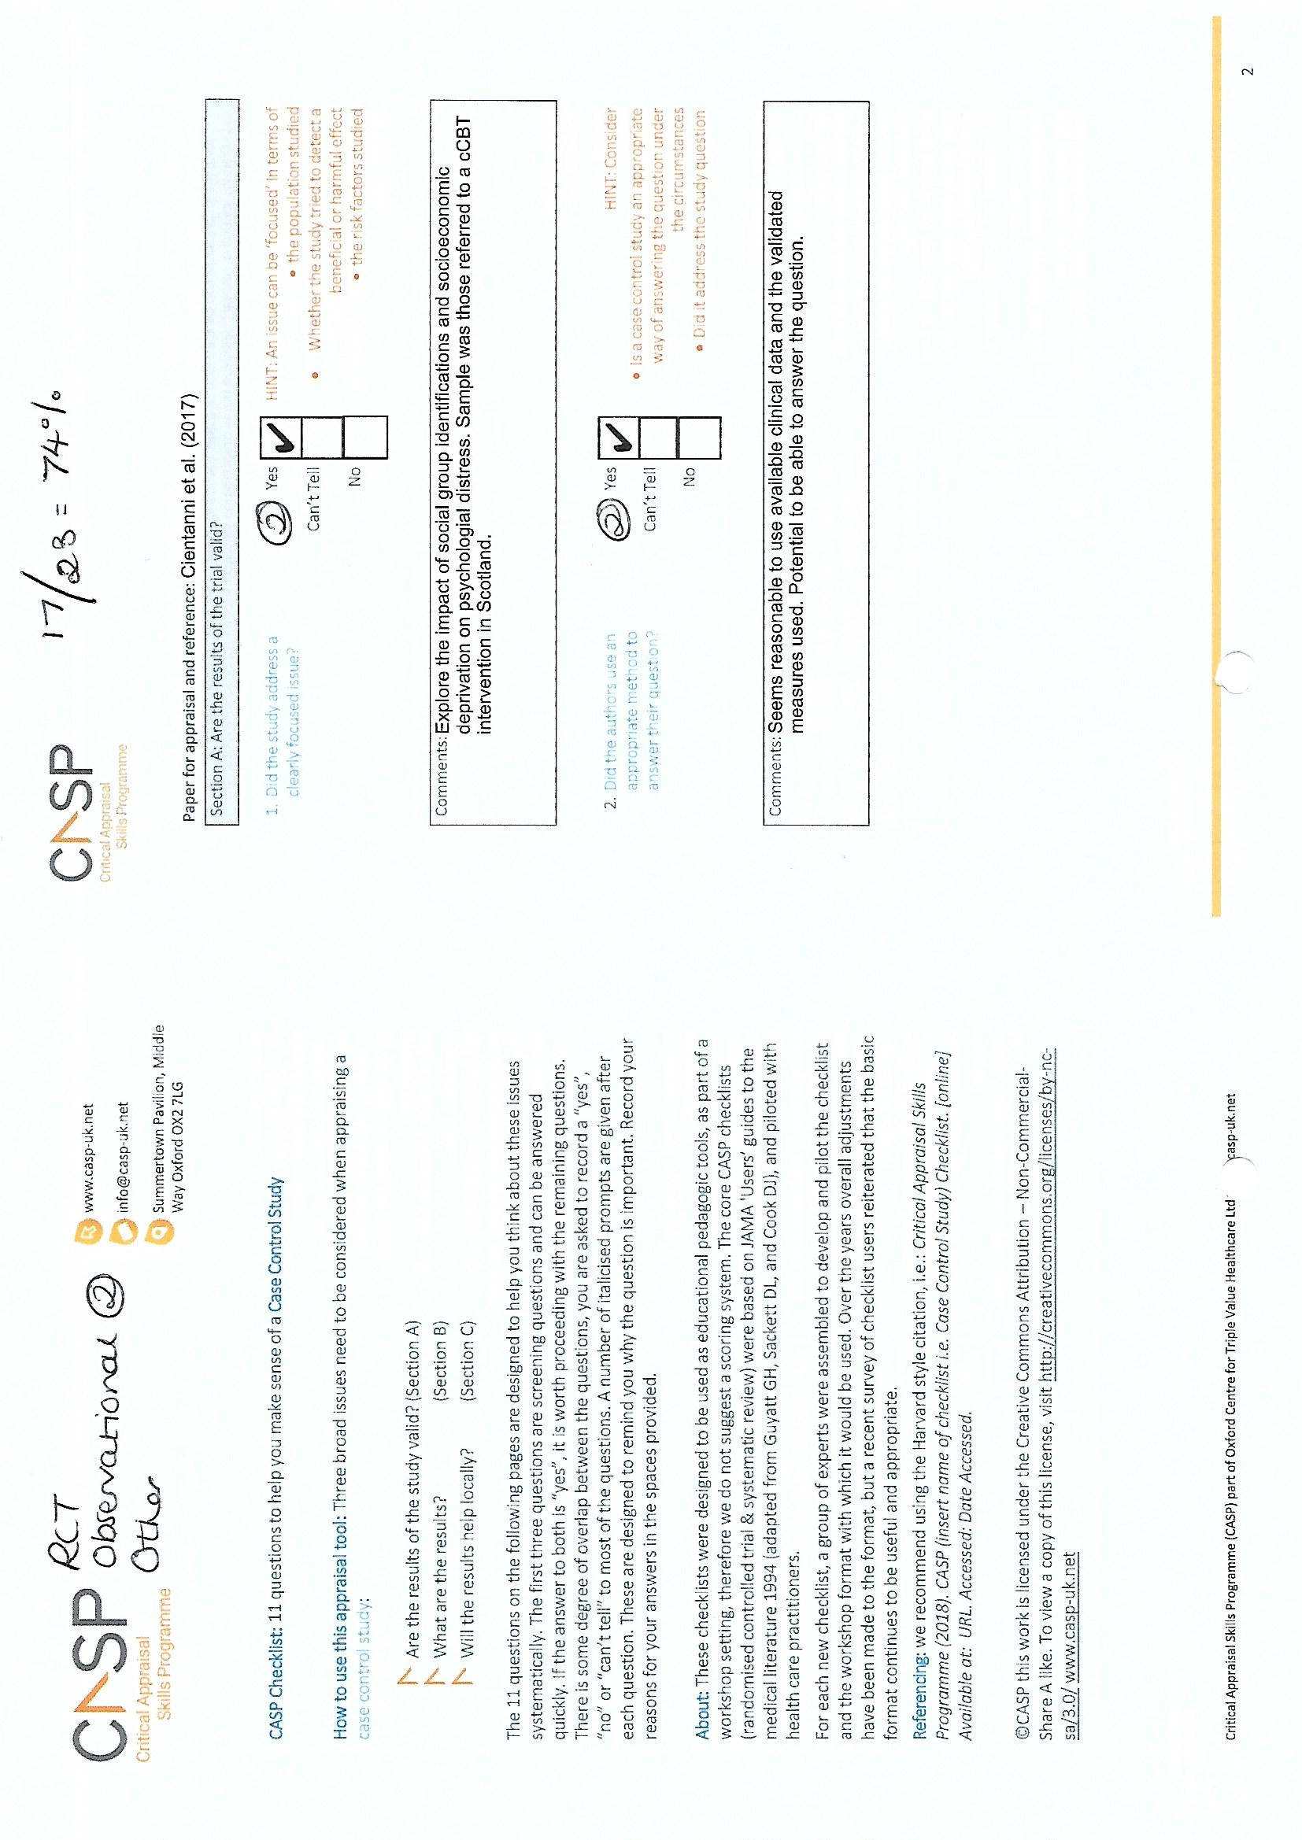
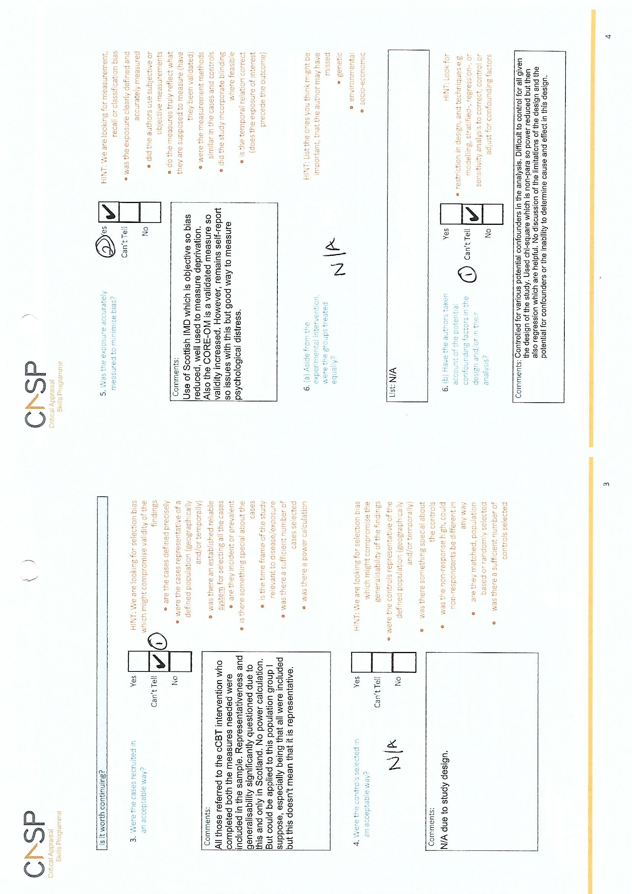

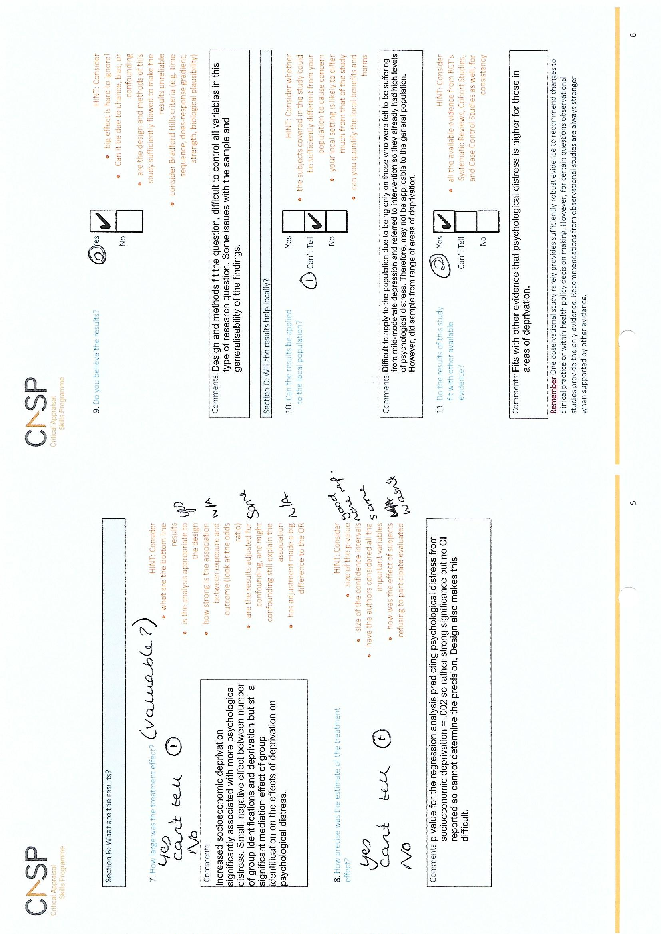

Appendix 1.3: Quality Hierarchy.
Quality Hierarchy
Decreasing quality
- Mattheys, Bambra, Warren, Kasim and Akhter (2016)
(85 per cent)
- Landy, Walsh and Ramsay (2012)
(81 per cent)
- Curl and Kearns (2015) and Thomson, Niedzwiedz and Katikireddi (2018)
(80 per cent)
- de Gelder et al. (2017)
(78 per cent)
- Curl and Kearns (2017) and Katikireddi, Niedzwiedz and Popham (2012)
(77 per cent)
- Prior, Manley and Jones (2018)
(76 per cent)
- Cientanni et al. (2017)
(74 per cent)
- Barnes et al. (2015) and Bellis et al. (2012)
(70 per cent)
- French and McKillop (2017) and Mattheys, Warren and Bambra (2018)
(65 per cent)
- Poots et al. (2014)
(61 per cent)

Impact factors retrieved from:
Clarivate Analytics (2017) Journal Citation Report (2017), https://clarivate.com/products/journal-citation-reports/
Elsevier (2017) CiteScore, https://www.elsevier.com/editors-update/story/journal-metrics/citescore-a-new-metric-to-help-you-choose-the-right-journal
Oxford Academic (no date). International Journal for Quality in Healthcare, https://academic.oup.com/intqhc

Appendix 1.4: Journal Impact Factors.
Article | Journal | Journal Impact Factor
Prior et al. (2018) | Health and Place | 3.000
de Gelder et al. (2017) | European Journal of Public Health | 2.782
Poots et al. (2014) | International Journal for Quality in Healthcare | 2.554 (Oxford Academic, no date)
Bellis et al. (2012) | BMC Public Health | 2.420
Barnes et al. (2015)  Katikireddi et al. (2012)  Thomson et al. (2018) | BMJ Open | 2.413
Cientanni et al. (2017) | British Journal of Social Psychology | 1.775
Landy et al. (2012) | Journal of Public Health | 1.670
French and McKillop (2017) | Journal of European Social Policy | 1.542
Mattheys et al. (2018) | Social Policy and Administration | 1.418
Mattheys et al. (2016) | SSM-Population Health | 1.15 (CiteScore, 2017)
Curl and Kearns (2017) | International Journal of Housing Policy | Not yet indexed
Curl and Kearns (2015) | Journal of Social Policy and Society | Not yet indexed

Chapter Two: Research Study - Towards a grounded theory of the psychological impact of experiencing systemic barriers when attempting to overcome poverty. A qualitative study.

Abstract
This social constructivist Grounded Theory [GT] study interviewed eight individuals in an inner-city area of North West England about the psychological impact of systemic barriers to overcoming poverty. Four conceptual categories: ‘Accessibility’, ‘Discrimination’, ‘Dehumanisation’ and ‘Resilient not Resigned’ explained the essence of the data. Systemic barriers led to anger, anxiety, low mood/depression and worthlessness and secondary psychological consequences. ‘Resilient not Resigned’ was protective, leading to hopefulness. Positive consequences of accessing appropriate support were evident. Member checks and triangulation of data suggested the model explained the data.
Keywords: Grounded Theory, poverty, social constructivist, qualitative, systemic barriers.

Introduction
This study investigated the psychological impact of experiencing barriers when accessing services to overcome poverty. There is no single, widely accepted definition of poverty (Full Fact 2019, United Nations Educational, Scientific and Cultural Organisation [UNESCO] 2017) but definitions tend to focus on absolute versus relative poverty. Absolute poverty is an inability to afford essentials such as food, shelter and clothing. Relative poverty takes quality of life, compared to population norms, into account. These have been criticised for ignoring the social aspects of poverty such as loneliness and isolation (UNESCO 2017). For this study, poverty is defined as facing immediate financial crisis and seeking support from voluntary services.

Poverty in the UK
Although the United Kingdom [UK] is considered well-developed in some sources (US News 2019), poverty remains (Social Metrics Commission [SMC] 2019). Moreover, its existence can be ignored, and attitudes exist that people have brought poverty upon themselves, thus ignoring the systemic context (Joseph Rowntree Foundation [JRF 2018]). This is potentially one reason why those living in poverty experience blame and shame (Jo 2013).

Poverty in The Area
There has been an increase in the number of UK neighbourhoods falling within the 10% most deprived areas since 2015 (Department for Communities and Local Government [DCLG] 2019). This includes where this study was conducted which for confidentiality purposes is given the pseudonym Rosewood. Rosewood has seen an increase of 33% in homelessness or temporary accommodation since June 2016 (Smithers 2017). Rough sleeping also increased from two people in 2018 to four people in 2019 (Ministry of Housing, Communities and Local Government [MHCLG] 2019). The number of people living in poverty in Rosewood is likely greater than official statistics which do not account for the hidden homeless (Crisis, 2011) or those experiencing poverty despite having homes (JRF, 2013).
Austerity measures attempting to stabilise the UK’s economic position (Allen 2010) were introduced in response to the latest recession in 2008. There is evidence such measures negatively impact upon psychological wellbeing (Barr et al. 2016, Trussell Trust 2018, Chapter One), especially for those with disabilities (The Children’s Society 2012), mental health difficulties and those living in deprivation (Mattheys, Warren and Bambra 2018). Universal Credit [UC] is an austerity measure and redesign of welfare benefits in Great Britain, combining several benefits into one payment (Department for Work and Pension [DWP] 2015). UC was introduced gradually from April 2013, with Rosewood being one of the first places it was introduced (DWP 2013, 2015). UC has been reported to be subject to delays (BBC News 2019) and to have impacted upon people’s ability to afford essentials, such as food (Trussell Trust no date) and rent (National Housing Federation [NHF] cited in Raynor 2018). There is evidence that information about a gap in benefits has been lacking (HM Revenue and Customs [HMRC] 2017). It is possible Rosewood has experienced a disproportionately negative impact of austerity measures due to existing deprivation (Mattheys et al. 2018) as it falls within the bottom ten local areas by Gross Domestic Product per head (£18, 285, ONS 2020).

Poverty and Mental Health
Poverty can detrimentally impact upon psychological wellbeing (Burns 2015, Coope et al. 2014, Chapter One). Those living in poverty report a lack of closeness to and mistrust of others (SMC 2019), higher anxiety and reduced happiness and life satisfaction (ONS 2017). Poverty can also lead to learned helplessness (Peterson, Maier and Seligman 1993). It is both a result and determinant of mental health inequalities (Bostock 2004, Das et al. 2007, Murali and Oyebode 2004, Ngui et al. 2010, Wagstaff 2002).

Barriers to Accessing Support
Accessing support can be difficult due to existing psychological distress (Lin 2002, Andrews, Issakidis and Carter 2001, Hinson and Swanson 1993, Wills 1992) and internalised stigma (Murphy and Busuttil 2014). Organisations and systems can also unintentionally create barriers, irrespective of mental health difficulties (Hoge et al. 2004) i.e. systemic barriers. Systemic barriers found in previous research include; structural inequalities (Peacock-Brennan, Zlotowitz and Gomm 2018), lack of transport, and stigma (Santiago, Kaltman and Miranda 2013, Hoge et al. 2004). A hypothesised barrier is the need for a certain level of education to navigate the systems inherent in accessing support. Those living in poverty, particularly the homeless, are more likely to be from a lower educational background (ONS 2017) which may make it more challenging to navigate.
Poverty is increasing (DCLG 2019, MHCLG 2019, NHF cited in Raynor 2018, Smithers 2017, Trussell Trust no date) and has a detrimental psychological impact (Chapter One, SMC 2019, ONS 2017, Burns 2015, Coope et al. 2014, Peterson et al. 1993). Poverty and mental health difficulties seem to create a vicious cycle, as hypothesised in Figure 1.

Vulnerability factors to experiencing poverty
e.g. trauma and poor mental health (Fitzsimons et al. 2017); living in a deprived area (Mooney and Scott 2011); psychological difficulties impacting people’s ability to maintain a secure financial position (Ngui et al. 2010, Das et al. 2007, Marmot 2005, Bostock 2004, Murali and Oyebode 2004)

Experience of poverty

Barriers to overcoming poverty e.g. Peacock-Brennan et al. 2018, ONS 2017, Murphy and Busuttil 2014, Santiago et al. 2013, Hoge et al. 2004, Andrews et al. 2001, Lin 2001, Hinson and Swanson 1993, Wills 1992
Psychological distress (Chapter One, SMC 2019, ONS 2017, Burns 2015, Coope et al. 2014, Peterson et al. 1993)

Figure 1. Hypothesised cycle of the relationship between poverty, mental health and barriers to overcoming poverty.

Despite this knowledge, research investigating the impact of systemic barriers upon mental health is lacking. Systemic barriers are defined as barriers created directly, or indirectly, through the way services are funded, set up and delivered and they may include physical, interpersonal and political barriers. There is a need to understand their impact to demonstrate the importance of reducing or eliminating them to improve psychological wellbeing.

Aims
The aim of this study is to gather in-depth accounts of people’s experiences of barriers when accessing services to overcome poverty. It aims to create a Grounded Theory [GT] to explain the psychological impact of experiencing systemic barriers, which will add to our understanding of how service provision impacts upon psychological wellbeing, potentially influencing service development and helping address mental health inequalities.

Method
This study uses a social constructivist GT approach, recognising the role of the researcher; both in data collection and analysis, with reality being socially constructed (Charmaz 2014).

Epistemological Position
The researcher took a social constructivist, phenomenological approach, stating there is no one truth (Hugly and Sayward 1987) in exploring individual experiences. The findings are a product of the interaction between the researcher and each participant, subjectively interpreted (Charmaz 2014). Data collection and analysis is a dual process and it is impossible to be completely objective (Charmaz 2014).
The researcher lives in Rosewood and found the number of people using foodbanks surprising, leading to believing the high levels of poverty in Rosewood need addressing. The researcher is a White British female with gender equality views. The higher educational level and more affluent financial position of the researcher has the potential to create a power imbalance with participants. The researcher believes that everyone is valuable and should have access to support, and we have a duty of care to the vulnerable. In addition, the researcher conducted a literature review prior to this study, further instilling the belief that poverty has a detrimental effect upon psychological wellbeing.

Ethical Considerations
Ethical approval from Staffordshire University Research Ethics Committee was received (appendix 1.1). All procedures were followed to ensure the minimisation of harm and maintain participant anonymity.

Service User Involvement
Service users of the participating project were consulted regarding the topic and accessibility of paperwork prior to ethical approval. These service users did become participants. Those asked confirmed the topic was of interest and importance. Changes to the paperwork were: making the study title shorter and ensuring the potential disadvantages were clearer by presenting as bullet points. The project is referred to as Emerald to maintain anonymity. Emerald staff were consulted at all stages.

Eligibility Criteria
Participants must have accessed Emerald to assist them to overcome poverty. Their involvement with Emerald could be in any capacity and for any length of time. Emerald was set up in 2016, with five years Big Lottery funding. It is a non-profit, multi-agency initiative aiming to help people out of financial crisis. Emerald runs various hubs where people can access advice, support, signposting, counselling, and life skills and social groups. Emerald accept referrals from anyone, including self-referrals, for any adult resident in Rosewood experiencing financial hardship. Financial hardship is subjectively measured by service users and/or those who refer them. Participants needed to be English-speaking due to the unavailability of translation services. They also needed to be able to provide informed consent and to attend one of the Emerald hubs for the interview.

Participant Characteristics
Participants were aged between thirty-one and sixty, with an equal male to female ratio. No participants were educated beyond A-Level. All participants were from a White British/Irish background except one who was Black African. Half the participants reported having a disability. Most were unemployed (n = 6), with one employed full-time and one on a zero-hour contract. Participants housing situations varied; homeless (n = 2), homeowner (n = 1), renting (council or private; n = 3) and temporary accommodation or sofa surfing (n = 2). Table 1 presents the demographics.

Table 1. Demographics of participants.
Demographic |  | Frequency
 | 31-35 | 2
 | 36-40 | 1
 | 41-50 | 2
 | 51-60 | 3
Gender | Male | 4
 | Female | 4
Occupation | Full-time employed | 1
 | Unemployed | 6
 | Zero-hour contract | 1
Highest level of education | No formal qualifications | 3
 | Entry-level qualifications | 2
 | GCSE’s or equivalent | 1
 | A-levels or equivalent | 2
Disabilities | Yes | 4
 | No | 4
Ethnicity | Any White British/Irish | 7
 | Any Black/African/Caribbean/Black British | 1
 | Homeowner | 1
 | Council renting | 2
 | Temporary accommodation/sofa surfing | 2
 | Homeless | 2
 | Housing association renting | 1

Procedure
Purposive sampling identified participants likely to provide in-depth, rich data on experiencing systemic barriers (Charmaz 2014). Fourteen potential participants were identified either directly by the researcher attending hubs or via project workers. Participants consented to their contact information being passed on to and/or held by the researcher. Reminders were sent if requested by text. A total of eight took part in semi-structured, intensive interviews. These ranged from twenty-two minutes and forty-five seconds to one hour, twenty-four minutes and forty-three seconds. They took place between 13 September 2019 and 11 December 2019. Participants were provided with the information sheet (appendix 1.3) and given the opportunity to ask questions. If they agreed to participate, they completed the demographic information sheet (appendix 1.4) and consent form (appendix 1.5). They were reminded of their right to withdraw and take breaks. Once consent was documented, the Dictaphone was turned on and the semi-structured, intensive interview (Charmaz 2014) began (see appendix 1.6 for initial interview schedule).
Follow-up questions were asked to gather information along the topics, avoid restriction (Corbin and Morse 2003), increase attunement and remain flexible (Birks and Mills 2015). This ensures data emerges rather than being influenced by pre-existing theories (Corbin and Strauss 2015). Interviews were adjusted according to GT methodology, based upon emerging themes, for example ‘Discrimination’, where from P3 onwards, participants were asked how they had been treated by services. Theoretical sampling was utilised to review emerging categories and ensure rich, saturated data (Draucker et al. 2007). Given the emerging themes of discrimination and hope/hopelessness, participants were sought who had experience of or displayed these. Participants were offered refreshments and travel costs were reimbursed. Interviews took place in a private room at one hub. All participants had the participant information sheet with links to support should they need it. None required support following interviews. Sampling continued until saturation was reached, i.e. when no new significant themes emerged (Charmaz 2014).

Analysis Strategy
Interviews were audio-recorded and transcribed by the researcher. Identifiable information was removed to ensure anonymity. Constant comparison occurred where data collection and analysis occur simultaneously, allowing the interview schedule to be adapted dependent on emerging themes (Corbin and Strauss 1990). Initial impressions were written down following interviews and during transcription (appendix 1.7). Once transcribed, interviews were analysed more closely. Firstly, each line of each transcript was coded (appendix 1.8). Every effort was made to remain immersed in the data by coding these as actions to maintain participants narratives in the findings (Charmaz 2014, Mills, Bonner and Francis 2006). Analysis then moved onto focussed coding where initial codes were inspected for patterns and codes that fitted the data most accurately. Codes were colour coded or added to the transcript (appendix 1.9). Due to differences in conversation styles, frequency counting lines for each focused code was employed to enable comparison across transcripts (appendix 2.1, Charmaz 2014). This allowed for the development of conceptual categories explaining larger chunks, capturing the essence of the data.
Member checks suggested the model explained participants experiences (Lincoln and Guba 1985). These were conducted over the telephone or text (appendix 1.2) dependent upon participant preferences and availability. Participants are referred to using P followed by their corresponding number in the sequence of interviews. It was not possible to contact P1 and P4 as when they consented to their details being held, they did not have mobile numbers. P5 said: “…what you have put in the text totally sums it all up.”. P6 replied: “That’s perfect”. P7 stated the model “sounds good” in a telephone call and they did not feel there was anything the researcher had misrepresented. They highlighted how positive help experiences increase motivation and that they were pursuing volunteering, confirming findings. No further feedback was received. An executive summary was written for Emerald staff and participants. Feedback was sought by email.

Rigor/Quality Control
Researcher ideas were documented through memos (Charmaz 2014, appendix 2.2) and a transparent, detailed description of methodology and analysis have been employed to increase dependability (Gasson 2004). The aim was to produce a substantive theory based upon the context studied (Strauss and Corbin 1990). Not every aspect of the model needs be relevant to all participants, but general concepts should resonate (Strauss and Corbin 1998), which member checks suggested they did. Triangulation of data increases trustworthiness (Flick 2004). This involved supplementing interview data with electronic data held on each participant by Emerald. Their database was accessed on 10 February 2020 and notes entered by project workers about support they provided to each participant was written down (appendix 2.3) to enable comparison to interview data.

Findings
There were four conceptual categories explaining the essence of the data. These were ‘Accessibility, ‘Discrimination’, ‘Dehumanisation’ and ‘Resilient not Resigned’. ‘Accessibility’ captures how systemic barriers impacted the accessibility of services. It encompasses stories of challenges and successes related to accessing services. ‘Discrimination’ represents the experience of explicit or implicit self-directed, other-directed or discrimination from others. These experiences were intertwined with experiences of service accessibility and being dehumanised. ‘Dehumanised’ captures the detrimental impact of being dehumanised by services and the importance of being valued for psychological wellbeing. These three conceptual categories embody the systemic nature of attempting to access services, particularly those to overcome poverty. ‘Resilient not Resigned’ represents motivation and resilience as protective factors, resulting in hopefulness. This includes personal support networks providing external sources of motivation and hope. Although participants were asked about experiences of accessing services to overcome poverty, they spoke about a range of services.

‘Accessibility’
‘Accessibility’ was the most common conceptual category and seen across all transcripts. This is not surprising given the focus of interviews. As ‘Accessibility’ was most commonly coded, a significant portion of the findings are dedicated to discussing it. This does not mean it is more important than the others as many of the points are closely related to other categories. Links between categories and codes are made throughout. ‘Accessibility’ represents a range of systemic barriers which affected the accessibility of services and led to initial feelings of anger, anxiety and low mood/depression. These led to secondary psychological consequences including thoughts of self-harm and suicide, feelings of blame, hopelessness and putting up barriers with others. It also represents positive stories of when services were accessible.

‘Changes to the system’
‘Changes to the system’ reduced service accessibility. Participants discussed the impact of government policies e.g. services closing, reductions in service provision, processes moving online and UC. Participants discussed UC payment delays and struggling changing from weekly to monthly payments which required budgeting skills. Participants spoke of the many being punished for the minority abusing the system previously and not feeling cared about by the system (cf. ‘Dehumanisation). They said UC did not cover living costs and large amounts being taken to cover existing debts, further reducing payments. These experiences led to anxiety and low mood. The anxiety and uncertainty around how much UC would be received each month resulted in relationship strain for P8. The job centre having security guards was mentioned. Due to ‘changes to the system’, statutory and voluntary services are under pressure (JRF 2015), which participants were understanding of, but the decreased accessibility of services and detrimental psychological impact of this remained. There was a sense of anger when services were unable to help, leading to believing they had been let down, and sometimes suicide attempts.
Figure 2. ‘Changes to the system’.

‘Pressure from the system’
Participants felt under ‘pressure from the system’ to meet certain requirements to access support. Participants spoke about needing to prove themselves, complete inaccessible paperwork and worrying about bills or appointment letters. These reduced the accessibility of services. P2’s quote below demonstrates their belief that people may avoid dealing with letters they receive. Motivation helped participants overcome the pull to avoid (cf. ‘Resilient not Resigned’). Participants discussed having to prove they are looking for a certain number of jobs a day. They spoke of not possessing identification to set up a bank account, hindering them receiving UC, and not having a stable address which hinders employment and vice versa. Participants felt discriminated against based on their circumstances (cf. ‘Discrimination’). Service pressures and processes delayed support and reduced ‘Accessibility’, leading to a loss of motivation.
Figure 3. ‘Pressures from the system’.

‘Lack of resources’
Participants spoke about a lack of (quality) services impacted by the reduced funding (‘changes to the system’). This resulted in a paucity of staff, or of staff being too busy and reduced service accessibility for participants. A lack of opportunity in Rosewood made it difficult for participants to gain employment. P1’s quote below demonstrates feeling under pressure to apply for jobs is complicated by lack of opportunity which impacted mood and confidence. Participants spoke of a lack of funds, and not having a computer. The latter created difficulties as processes have increasingly moved online (‘changes to the system’) and thus they could not access key services. This made people feel socially isolated and negatively impacted mood. Not having enough money to cover living costs, and to engage with social events, led to anger, sadness and shame. Given that social isolation is a risk factor for mental health difficulties (Leigh-Hunt et al. 2017), it is important that benefits facilitate social engagement.

Figure 4. ‘Lack of resources’.

“I realise I was set up for failure” (P6, 169)
Some participants said they were set up to fail. For example, due to services making mistakes, a lack of wrap around support and support being contingent on being in a certain place. These experiences were coded within ‘Accessibility’ as they represent services failing to be accessible and suitable for all. Participants spoke about services being inflexible to individual circumstances or mental health needs and therefore they felt dehumanised (cf. ‘Dehumanised’). There was an undercurrent of feeling to blame. Inflexibility and believing they had been set up to fail led to a loss of faith in services. These were linked to losing motivation to access support in the future, a fear of future discrimination and putting up barriers with others. This suggests a snowball effect of systemic ‘Accessibility’ barriers leading to initial psychological feelings and various psychological reactions, which further reduce accessibility. Participants described how buildings can be unwelcoming, how locations can trigger mental health difficulties, and negative staff attitudes (cf. ’Discrimination’).
Figure 5. “I realise I was set up for failure” (P6, 169).

Pre-existing psychological experiences
Existing mental health difficulties, trauma, relationship difficulties, pride and embarrassment impacted upon an individual’s ability to seek help. This included struggling to trust services which could be a result of the cyclical nature of poverty, mental health and systemic barriers (e.g. Figure 1). Existing psychological experiences were closely related to the experience of ‘Discrimination’.

Receiving Appropriate Support
In contrast to difficulties accessing services, participants shared stories where services were accessible, leading to feeling valued (cf. ‘Dehumanised), grateful and motivated to help others.

‘Gratitude’
Participants spoke highly of Emerald. They described being supported, listened to, and valuing having someone to talk to (cf. ‘Dehumanised’).
Figure 6. ‘Gratitude’.

‘Helping others’
This was a significant code for P1, P3 and P5-7 and a less frequent code for P2 and P8. Participants spoke of wanting to help others, volunteer and pass on information when services were accessible, and they received appropriate support. This suggests participants valued help they had received and wanted others to experience this.
Figure 7. ‘Helping others’.

‘Discrimination’
The conceptual category of ‘Discrimination’ captures systemic judgement, be it explicit or implicit from others, towards others and themselves. Participants shared stories of experiencing discrimination when accessing a range of services. ‘Discrimination’ was strong across transcripts (except P4 and P8) and sometimes subtle. For example, P1 stated “…you’re not illiterate like that.” (93). This was interpreted as P1 believing they had been discriminated against. ‘Discrimination’ includes stories such as this where participants described discrimination without explicitly labelling it as such. ‘Discrimination’ ran across ‘Accessibility’, making services less accessible, and ‘Dehumanised’, making participants feel dehumanised. Resilience seemed to help participants cope with discrimination (cf. ‘Resilient not Resigned’). ‘Discrimination’ led to initial psychological reactions of anger, anxiety, low mood/depression and worthlessness. Secondary psychological reactions were fearing future discrimination, which contributed to feelings of shame, avoidance and a loss of motivation. It also negatively impacted confidence, led to hopelessness and feelings of blame.

Pre-existing psychological experiences
There was a sense that participants feared discrimination based upon existing psychological experiences. This increased pre-existing anxiety and low mood. Those experiencing psychological difficulties, including childhood trauma, report high levels of shame and blame (Kealy et al. 2018, Jo 2013) which may predispose them to fear discrimination. Participants spoke of being embarrassed to seek support which seemed related to fearing discrimination. Pride seemed to be a self-judgement that seeking help is shameful. Being discriminated against can lead to shame and self-blame (Zavaleta 2007). Some participants blamed themselves for the situation they found themselves in, which influenced embarrassment at seeking support. Experiencing ‘Discrimination’ further increased existing psychological difficulties.
Figure 8. ‘Pre-existing psychological experiences.

Discrimination
As discussed earlier, some participants said they had been set up to fail. This was related to ‘Discrimination’ as some participants believed this was due to stigma. Participants suggested a lack of wrap around services, insufficient support to maintain help received, and inappropriate support or housing were intertwined with being discriminated against. Protective factors from the detrimental psychological impact of discrimination were motivation, resilience and hopefulness (cf. ‘Resilient not Resigned’). Experiencing explicit or implicit discrimination led to anger. Participants believed it was unfair and unjust. Not being believed led to one interviewee saying they felt angry and demeaned. In ‘lack of resources’, the quote from P1 is linked to them being discriminated against based on their age and physical characteristics. It demonstrates how ‘Discrimination’ can lead to a loss of confidence and hopelessness. Being discriminated against previously, led to fearing future discrimination which led to a reluctance to seek support, related to pride and embarrassment. Fearing discrimination led to avoidance and social isolation for some participants.
Figure 9. Discrimination.

Services being untrustworthy
Some participants spoke of ‘negative staff attitudes’ and services being untrustworthy leading to anger, low mood and worthlessness. For example, being judged on how they were spending their benefits and not being believed about being homeless. These made services less accessible (cf. ‘Accessibility’) and impacted help seeking. ‘Negative staff attitudes’ seemed to stem from discrimination, perceived as from staff and participants predicting negative staff responses. Services being untrustworthy was often due to previous negative experiences with services or in relationships, including previous discrimination.

Figure 10. Services being untrustworthy.

‘Dehumanised’
This category captures how important it was for participants wellbeing to feel valued and treated as an individual. ‘Dehumanised’ encompasses not being listened to, cared about, understood or valued and was seen across all transcripts. There was a strong sense that participants had not been listened to before and that they needed to be. Discrimination made participants feel dehumanised and vice versa. Participants discussed having to tell their story multiple times (e.g. due to high staff turnover), not being fully informed about changes (‘changes to the system’), the homeless being ignored and a lack of compassion (‘negative staff attitudes’), foodbanks not accounting for allergies, not being believed (‘Discrimination’), lack of feedback and zero-hour contracts (‘changes to the system’). The initial psychological consequences of being ‘Dehumanised’ were anger, anxiety, low mood/depression and worthlessness. The secondary consequences were putting up barriers with others, thoughts of self-harm/suicide, hopelessness, shame and losing motivation. In contrast, positive stories of being valued, cared about and listened to when accessing services were vital for experiencing positive psychological states and overcoming negative experiences.

‘Being Dehumanised’
High staff turnover made participants feel dehumanised and caused them to put barriers up with others. Being ‘Dehumanised’ was related to thoughts of self-harm and suicide, worthlessness and feeling invisible. These are hypothesised to stem from low mood and hopelessness. Not being listened to was demeaning. The quote below demonstrates the interaction between existing psychological experiences and ‘Dehumanised’ as they discuss not listened to being demeaning and adding to pride. Participants spoke about not receiving feedback leading to a loss of motivation. It is hypothesised that not receiving feedback makes people feel dehumanised in that services cannot take the time to feedback. One participant spoke about being sanctioned by the benefit system (‘changes to the system’) leading to anger and sadness, believing the system did not care or listen to their circumstances and being forced to share personal experiences (inflexibility).
Figure 11. Being Dehumanised.

‘Being Valued’
In contrast, being valued was a focused code in all transcripts except P4 and P7 and coded within the overall conceptual category of ‘Dehumanised’ capturing the reverse of being dehumanised. Participants spoke of being valued when accessing Emerald and conveyed being listened to during the interview. These experiences elicited positive feelings of worthiness and happiness. They valued sharing their experiences in interviews (P5-7), potentially related to being listened to. Most transcripts conveyed a desire to be listened to/valued as most started by sharing their journey into poverty, suggesting they have not been listened to in this way before. Many used verbalisations such as ‘you know what I mean’, demonstrating a wish to be understood. Alternatively, it may represent regional colloquialism. Many said they had been listened to following interviews, suggesting this experience was rare.
Figure 12. Being valued.

‘Resilient not Resigned’
This category was developed by combining the codes of ‘hope/hopelessness’, ‘personal support networks’ and ‘resilience/motivation’ as it transpired these represented a personal quality of being resilient but not resigned to situations. Resilience/motivation protected against the detrimental psychological impacts of systemic barriers and instilled hope.

‘Resilience and motivation’
‘Resilience/motivation’ was a significant code for P1, P2, P6 and P7 and a less frequent code for P3 and P4. Participants who expressed more resilience/motivation had more hopeful outlooks. These qualities helped participants to keep going despite challenges, protecting psychological wellbeing.
Figure 13. ‘Resilience/motivation’.

Hope
Hope arose from ‘resilience/motivation’. Hope/hopelessness was a significant focussed code for P1-4. Hope was conveyed by P6 but coded within ‘resilience/motivation’ and was a minor code for P5. Overall, P4’s transcript conveys a more hopeless outlook and seemed resigned to the situation. Participants with a more hopeful outlook believed their mental health had been affected to a lesser extent by systemic barriers. P6’s transcript was the most hopeful and conveyed a sense that they wanted the researcher to see their ‘resilience/motivation’. Family was a factor in their motivation.
Figure 14. ‘Hope’.

‘Personal support networks’
‘Personal support networks’ was a focused code for P1, P2 and P5 and a less frequent code for P3 and P8. It is hypothesised that having personal support instils hope (Simmons et al. 2009, Morgante 2000) and compensates for low internal motivation (Menges et al. 2017). Children were a common source of motivation and hope. Having a support network was associated with positive feelings, motivation/resilience and hope.
Figure 15. ‘Personal support networks’.

Triangulation of Data
Triangulation (appendix 2.3) stated that Emerald liaised with other services on behalf of P2, P3, P5-7 and signposted P1, P3, P5 and P8. The provision of food (for all except P7), fuel (P3, P5 and P8) and bus vouchers (P1, P3, P5 and P8), and records reporting low benefits (P5 and P8) fit with participants comments. Records stated they supported P1-3 and P5 to complete benefit forms and P2 with legal processes. Emerald stated it provided P1, P3 and P4 with mobile phones (‘lack of resources’). Records suggested debt being a factor for P2, P5 and P6 which was discussed by participants. Triangulation of data suggested pride/embarrassment and no recourse to public funds as barriers for P6. Records suggest social isolation for P1 and P5 which was not extensively mentioned. This may reflect embarrassment about discussing this, or the interview not facilitating sharing this.
Figure 16 shows the model developed from the emerging data. It shows which primary psychological consequences of anger, anxiety, low mood/depression and worthlessness followed from systemic barriers within each conceptual category. Not all participants reported each psychological consequence for each category, the model is substantive. The model depicts secondary psychological reactions as implications of experiencing systemic barriers. These appeared to follow from primary feelings, occur later than the immediate feeling or based upon existing knowledge to stem from initial feelings. Arrows depict how secondary psychological reactions were linked to each other and initial feelings. The model acknowledges the importance of protective factors in ‘Resilient not Resigned’. These do not completely protect from negative psychological consequences but play a role in maintaining hope. This helped participants manage the psychological impact of systemic barriers. It is not known whether these were present prior to experiencing systemic barriers or whether they developed as coping mechanisms. The model acknowledges consequences of accessible support: feeling valued, helping others and gratitude.

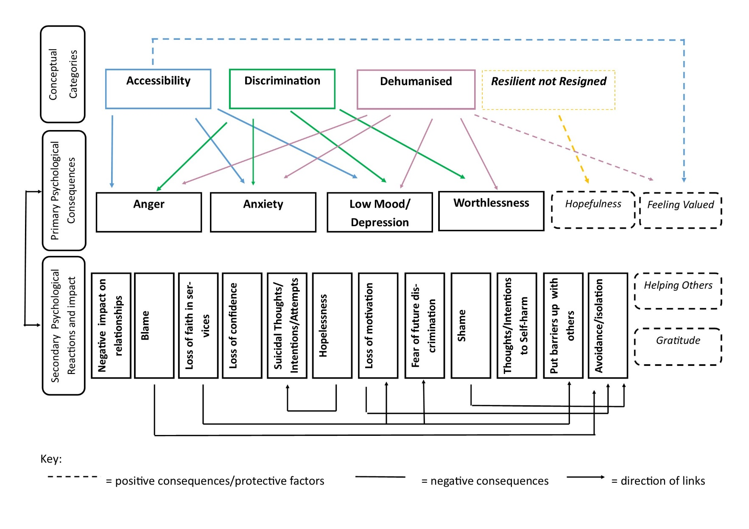

Figure 16. GT Model of the psychological impact of experiencing systemic barriers to overcoming poverty.

Discussion
This GT study presents an emerging substantive model to explain participants experiences of how systemic barriers to accessing services to overcome poverty affected their psychological wellbeing. Although this study was regarding accessing services to overcome poverty, this encompasses a range of services and the findings are relevant to services more generally. This study supports previous research that systemic barriers have a detrimental impact upon psychological wellbeing (SMC 2019, ONS 2017, Burns 2015, Coope et al. 2014, Jo 2013, Peterson et al. 1993). It confirms previous barriers (National Housing Federation cited in Raynor 2018, Peacock-Brennan et al. 2018, HMRC 2017, Santiago et al. 2013, Trussell Trust no date) and identifies additional ones (appendix 2.4).
The main themes are explained by four closely linked conceptual categories: ‘Accessibility’, ‘Discrimination’, ‘Dehumanisation’ and ‘Resilient not Resigned’. Systemic barriers led to anger, anxiety, low mood/depression and worthlessness. There were secondary psychological consequences stemming from these which can also feedback into initial feelings. Links between conceptual categories and psychological consequences may be mediated by additional factors such as trauma and attachment. Those who have experienced trauma, be it from Adverse Childhood Experience’s or later in life (including fleeing fear and oppression), are more likely to have less secure attachments, hence no ‘stable base’ (Hughes 2011). Without a stable base, people are more susceptible to psychological distress (Hughes 2011) which may predispose them to experiencing poverty and therefore systemic barriers. In turn, they may have reduced resources to cope with the psychological impact of systemic barriers.
Difficulties understanding letters and completing forms supports the hypothesis that there is a need for a certain educational level to navigate the system and how this is difficult for many living in poverty who may have lower education levels (ONS 2017). ‘Accessibility’ leading to anxiety and low mood is not surprising given that uncertainty leads to anxiety (Grupe and Nitschke 2013) and not having access to support is related to increased anxiety and depression (Mayer et al. 2016). ‘Accessibility’ also led to thoughts of self-harm and suicide, feelings of blame, hopelessness and putting up barriers with others. These are hypothesised to stem from low mood given participants stories and previous research (Hedley et al. 2018, Yates, Cohan and Goharian 2017, NICE 2009, Beck 1986).
Previous research has found stigma a barrier to accessing services (Hoge et al. 2004) and a fear of judgement to be correlated with avoidance of seeking support (Montgomery et al. 2006, Ackerson 2003). Furthermore, judgement can lead to shame and blame (Zavaleta 2007). This supports the model depicting that a fear of future discrimination, shame, avoidance and a loss of motivation to seeking help stem from ‘Discrimination’. Previous research suggests avoidance can exacerbate initial psychological reactions (Montgomery et al. 2006), supporting the cyclical nature of the model.
Not being listened to leads to powerlessness and humiliation (van den Hooff and Goossensen 2014) and poverty impacts relationships and trust (SMC 2019). Findings discussed in ‘Dehumanisation’ support these in that being dehumanised led to anger, anxiety, low mood/depression and worthlessness. These could lead to putting up barriers with others, thoughts of self-harm/suicide, hopelessness, shame and losing motivation.
Resilience predicts hope and hope positively predicts psychological wellbeing (Satici 2016). ‘Resilient not Resigned’ supports this in highlighting how greater resilience/motivation led to a more hopeful outlook. Personal support networks provided external motivation. It is not clear if protective factors are innate qualities or if they are developed to cope.
The model shows how secondary psychological consequences were linked; a loss of faith in services led to a loss of motivation to seek help, a fear of future discrimination and putting barriers up with others. Hopelessness led to feelings of self-harm/suicide, supported by previous research (e.g. NICE 2009, Beck 1986). A loss of motivation and feelings of blame and shame led to avoidance/isolation which seems logical. People appear to become stuck in a cycle of experiencing systemic barriers to overcoming poverty which negatively impacts upon their psychological wellbeing, then reducing motivation to seek support.
The model acknowledges how experiences of accessible support can lead to positive feelings and prosocial behaviour. This study adds to our understanding of the psychological impact of systemic barriers, demonstrating how these can have long-term, multi-faceted effects. It has found a negative cycle in which psychological distress or existing poverty make people vulnerable to experiencing systemic barriers and these further negatively impact wellbeing. Reduced wellbeing then makes services less accessible. It adds to our understanding of barriers which can be reduced or eliminated and protective and positive factors which can be increased.

Limitations
Traditional GT does not conduct literature searches prior to the empirical study to protect the emerging theory from the influence of previous ideas (Glaser and Strauss 1967). This was impossible to avoid, and it is not achievable to be naïve to existing ideas (Walls, Parahoo and Fleming 2010) but these may have impacted the findings (Thornberg 2012).
The researcher is a GT novice so the method may not have been conducted to an experienced level. Every effort has been made to be clear about processes. Only one researcher transcribed and analysed, ensuring reliability but making coding unique to this researcher’s interpretation.
Generalisability is limited due to the research being conducted in one area, with participants all accessing one project. Purposive and theoretical sampling were used to recruit a sample representative of Rosewood. However, an underrepresentation of ethnic minorities remained, consistent with their underrepresentation in research (Heiat, Gross and Krumholz 2002). Qualitative research aims to provide an in-depth account of individuals’ experiences as opposed to generalisability, so this is reasonable.

Clinical and Ethical Implications
The association between poverty and mental health is a systemic issue and policy makers and services should work to reduce barriers and their psychological impact. A community approach integrating practical and psychological support would enable wrap around support, targeted in areas of poverty. This would address the systemic barrier of a lack of signposting as this would not be required. A variety of statutory and charitable services that can be accessed in the same venue, at the same time would offer multi-agency support to address the multi-faceted nature of poverty and eliminate several systemic barriers discussed in this research (e.g. having to tell your story to multiple staff members). This would involve training to enable staff to provide both psychological and practical support. Training should also focus on reducing discrimination, increasing compassion, addressing negative attitudes and the ability to respond flexibly to individual needs and circumstances. A satellite model with various centres across areas, considering their placement, would increase accessibility, reduce travel burden and the chance of locations triggering mental health difficulties. These should be well advertised to increase accessibility. This approach should empower individuals, fostering the protective factors of resilience and motivation which were found to lead to increased hopefulness in this study. Engaging with the community through outreach and developing relationships would enable those most at risk of the detrimental psychological effects of experiencing systemic barriers to be identified. Many of the systemic barriers are a result of the wider economic context placing pressure on services. This in turn, is felt by individuals. Policy makers need to consider the long-term impact of austerity and cuts upon psychological wellbeing and address these. By making the investments suggested here, services will be more accessible and less discriminatory and dehumanising.
Given the conceptual categories appear to apply beyond services involved in overcoming poverty, services more generally should consider ways to reduce psychological suffering by increasing accessibility, reducing discrimination, treating people as individuals and responding to their unique needs.
This study was conducted before the Coronavirus crisis, which has increased the strain on services and led to increases in the number of people struggling financially due job losses (France 24 2020), a lack of access to free school meals and vital services being reduced or closed due to social distancing (BBC News 2020a). This research is arguably even more important during these circumstances to inform service provision given the potential increase in poverty across the world (BBC News 2020b).

Directions for Future Research
It may be that systemic barriers are playing a part in ethnic minorities underrepresentation in research which should be investigated. Future intervention studies investigating the impact of increasing the protective factors (personal support network, resilience, motivation and resulting hopefulness) upon psychological wellbeing would provide insights into the mechanism through which these operate. It would be beneficial to determine whether they are innate or developed to cope. Quantitative intervention studies taking pre and post measures of psychological wellbeing whilst providing an intervention to increase one of the protective factors e.g. a weekly, subsidised peer support group in an area of existing poverty due to those living in poverty being at a greater risk of poor mental health (e.g. Burns 2015, Coope et al. 2014, Chapter One) would provide insight into this. Future research should also focus on evaluating the impact of the recommended community-based services offering wrap around support.

Reflections
It is possible that participants spoke highly of Emerald due to a sense of obligation. However, they were assured their data was anonymous and the researcher was not affiliated with Emerald. Some participants needed to speak about the events leading to poverty to a greater extent than the impact of systemic barriers. This potentially reflects not being listened to previously. Having a similar accent and awareness of services and places discussed aided rapport. However, being from the same area potentially biased the researcher towards ensuring the detrimental impact of systemic barriers are heard. It is possible the researcher was biased towards confirming existing beliefs around this. To reduce the chance of this, memos were used (appendix 2.2) and positive and protective factors included. P6 provides contradictory evidence, with a positive, hopeful outlook and the motto “…homeless not hopeless…” (323). Despite this, P6 mentions similar barriers. They mention psychological consequences but place a lesser emphasis on these. The researcher may have more easily identified with female participants given the sharing of this characteristic. This was considered in a memo (appendix 2.2) so as not to give more weight to any one participant. Power imbalances were evident in relation to educational level and economic status. The findings have been analysed from these perspectives, potentially intellectualising the findings. Member checks suggest this is not the case. The imbalance in economic status potentially added to feelings of shame and discrimination. The researcher felt P1 was vulnerable and needed scaffolding due to beliefs about protecting the vulnerable, resulting in more summarising and questioning. A conscious effort was made to minimise the researcher speaking so as not to influence subsequent interviews. The researcher was aware of the cultural differences to P6, potentially impacting the interpretation of their story. The researcher noticed that some stories instilled anger and a sense of injustice, likely reflecting the researcher’s socialist leanings. It is possible that these views influenced the topic and interpretation of the findings.

Conclusion
This study provides a GT of the psychological impact of experiencing systemic barriers when attempting to overcome poverty. The model indicates that although there were idiosyncratic differences, the most common systemic barriers were around inaccessible services (c.f. ‘Accessibility’), ‘Discrimination’ and being ‘Dehumanised’. These led to anger, anxiety, low mood/depression and worthlessness. Barriers, and their initial psychological consequences, led to secondary psychological consequences, some of which appeared linked. Experiencing systemic barriers impacts upon psychological wellbeing, so future research is essential. The fourth conceptual category of ‘Resilient not Resigned’ captures the importance of being resilient/motivated leading to hopefulness. This is protective from detrimental psychological consequences of systemic barriers. Positive experiences led to prosocial behaviour and positive feelings. Future research should investigate protective factors with a view to increase these to reduce psychological suffering. Policy makers should consider the long-term impact of short-term savings achieved by cuts and austerity. Given that systemic barriers impact upon psychological wellbeing, it is possible that people experiencing barriers influenced by such measures will later require psychological and other support. Prevention and promotion strategies are likely to benefit the individual and wider system longer-term.

References
Ackerson, B. J. (2003) ‘Coping with the dual demands of severe mental illness and parenting: the parents' perspective’, Families in Society, 84(1): 109-118.
Allen, G. (2010) Recession and recovery. Key issues for the new parliament 2010, https://www.parliament.uk/documents/commons/lib/research/key_issues/Key-Issues-Recession-and-recovery.pdf
Andrews, G., Issakidis, C. and Carter, G. (2001) ‘Shortfall in mental health service utilisation’, The British Journal of Psychiatry, 179(5): 417-425.
Barr, B., Taylor-Robinson, D., Stuckler, D., Loopstra, R., Reeves, A. and Whitehead, M. (2016) ‘‘First, do no harm’: are disability assessments associated with adverse trends in mental health? A longitudinal ecological study’, Journal of Epidemiology and Community Health, 70(4): 339-345.
BBC News (2019) Universal credit: Tenants to be 'ploughed into debt', https://www.bbc.co.uk/news/uk-wales-50361604
BBC News (2020a) Coronavirus: Fighting food poverty in a lockdown, https://www.bbc.co.uk/news/uk-england-manchester-52228080
BBC News (2020b) Virus could plunge half a billion people into poverty, https://www.bbc.co.uk/news/business-52211206
Beck, A. T. (1986) ‘Hopelessness as a predictor of eventual suicide’, Annals of the New York Academy of Sciences, 487(1): 90-96.
Birks, M. and Mills, J. (2015) Grounded Theory. A practical guide (2nd Ed.), London: Sage.
Bostock, J. (2004) ‘The high price of poverty. Poverty and debt are major risk factors for mental ill health in deprived communities and groups’, Mental health today, 27-29.
Burns, J. K. (2015) ‘Poverty, inequality and a political economy of mental health’, Epidemiology and psychiatric sciences, 24(2): 107-113.
Charmaz, K. (2014) Constructing grounded theory (2nd Ed.), London: Sage.
Children’s Society (The) Holes in the safety net: The impact of universal credit on disabled people, https://www.citizensadvice.org.uk/Global/Migrated_Documents/corporate/holes-in-the-safety-net-final-copy.pdf
Coope, C., Donovan, J., Wilson, C., Barnes, M., Metcalfe, C., Hollingworth, W. and Gunnell, D. (2015) ‘Characteristics of people dying by suicide after job loss, financial difficulties and other economic stressors during a period of recession (2010–2011): A review of coroners׳ records’, Journal of affective disorders, 183: 98-105.
Corbin, J. and Morse, J. M. (2003) ‘The unstructured interactive interview: Issues of reciprocity and risks when dealing with sensitive topics’, Qualitative inquiry, 9(3): 335-354.
Corbin, J. M. and Strauss, A. (1990) ‘Grounded theory research: Procedures, canons, and evaluative criteria’, Qualitative sociology, 13(1): 3-21.
Corbin, J. and Strauss, A. (2015) ‘Basics of Qualitative Research: Techniques and Procedures for Developing Grounded Theory’ (4th Ed.), Thousand Oaks, CA: Sage Publications.
Crisis (2011) The hidden truth about homelessness. Experiences of single homelessness in England, https://www.crisis.org.uk/media/236816/the_hidden_truth_about_homelessness_es.pdf
Das, J., Do, Q. T., Friedman, J., McKenzie, D. and Scott, K. (2007) ‘Mental health and poverty in developing countries: Revisiting the relationship’, Social Science & Medicine, 65(3): 467-480.
Department for Communities and Local Government (2019) The English indices of deprivation 2015, https://assets.publishing.service.gov.uk/government/uploads/system/uploads/attachment_data/file/835115/IoD2019_Statistical_Release.pdf
Department for Work and Pensions (2013) Universal credit comes to Oldham and Warrington, https://www.gov.uk/government/news/universal-credit-comes-to-oldham-and-warrington
Department for Work and Pensions (2015) Policy paper. 2010 to 2015 government policy: welfare reform, https://www.gov.uk/government/publications/2010-to-2015-government-policy-welfare-reform/2010-to-2015-government-policy-welfare-reform
Draucker, C. B., Martsolf, D. S., Ross, R. and Rusk, T. B. (2007) ‘Theoretical sampling and category development in grounded theory’, Qualitative health research, 17(8): 1137-1148.
Fitzsimons, E., Goodman, A., Kelly, E. and Smith, J. P. (2017) ‘Poverty dynamics and parental mental health: Determinants of childhood mental health in the UK.’, Social Science & Medicine, 175: 43-51.
Flick, U. (2004) ‘Triangulation in qualitative research’, A companion to qualitative research, 3: 178-183.
France 24 (2020) Coronavirus pandemic ‘amplifying’ poverty in the UK, https://www.france24.com/en/20200405-coronavirus-pandemic-amplifying-poverty-in-uk
Full Fact (2019) Poverty in the UK: a guide to the facts and figures, https://fullfact.org/economy/poverty-uk-guide-facts-and-figures/
Gasson, S. (2004) ‘Rigor in grounded theory research: An interpretive perspective on generating theory from qualitative field studies,’ in M. E. Whitman and A. B. Woszczynski (eds), The handbook of information systems research, Hershey, PA: Idea Group. pp. 79-102
Glaser, B.G and Strauss, A. L. (1967) The Discovery of Grounded Theory: Strategies for
Qualitative Research, Aldine: Chicago.
Grupe, D. W. and Nitschke, J. B. (2013) ‘Uncertainty and anticipation in anxiety: an integrated neurobiological and psychological perspective’, Nature Reviews Neuroscience, 14(7): 488-501.
Hedley, D., Uljarević, M., Wilmot, M., Richdale, A. and Dissanayake, C. (2018) ‘Understanding depression and thoughts of self-harm in autism: a potential mechanism involving loneliness’, Research in Autism Spectrum Disorders, 46: 1-7.
Heiat, A., Gross, C. P. and Krumholz, H. M. (2002) ‘Representation of the elderly, women, and minorities in heart failure clinical trials’, Archives of internal medicine, 161: 996-1002.
Hinson, J. A. and Swanson, J. L. (1993) ‘Willingness to seek help as a function of self‐disclosure and problem severity’, Journal of Counseling & Development, 71(4): 465-470.
HM Revenue and Customs (2017) The transition from tax credits to universal credit: qualitative and quantitative research with claimants, https://assets.publishing.service.gov.uk/government/uploads/system/uploads/attachment_data/file/792426/The_transition_from_tax_credits_to_Universal_Credit_-_qualitative_and_quantitative_research_with_claimants.pdf
Hoge, C. W., Castro, C. A., Messer, S. C., McGurk, D., Cotting, D. I. and Koffman, R. L. (2004) ‘Combat duty in Iraq and Afghanistan, mental health problems, and barriers to care’, New England Journal of Medicine, 351(1): 13-22.
Hughes, D. (2011) Attachment-focused family therapy, New York: W. W. Norton and Company.
Hugly, P. and Sayward, C. (1987) ‘Relativism and ontology’, The Philosophical Quarterly, 37(148): 278-290.
Jo, Y. N. (2013) ‘Psycho-social dimensions of poverty: When poverty becomes shameful’, Critical Social Policy, 33(3): 514-531.
Joseph Rowntree Foundation (2013) The links between housing and poverty: an evidence review, https://www.jrf.org.uk/report/links-between-housing-and-poverty
Joseph Rowntree Foundation (2015) The cost of cuts: The impact on local government and poorer communities, https://www.jrf.org.uk/sites/default/files/jrf/migrated/files/Summary-Final.pdf
Joseph Rowntree Foundation (2018) How to build lasting support to solve UK poverty, https://www.jrf.org.uk/report/how-build-lasting-support-solve-uk-poverty?gclid=EAIaIQobChMIx4Pq7Y_a5AIVC1PTCh0iXABmEAAYAiAAEgKrSvD_BwE
Kealy, D., Rice, S. M., Ogrodniczuk, J. S. and Spidel, A. (2018) ‘Childhood trauma and somatic symptoms among psychiatric outpatients: investigating the role of shame and guilt’, Psychiatry research, 268: 169-174.
Leigh-Hunt, N., Bagguley, D., Bash, K., Turner, V., Turnbull, S., Valtorta, N. and Caan, W. (2017) ‘An overview of systematic reviews on the public health consequences of social isolation and loneliness’, Public Health, 152: 157-171.
Lin, Y. N. (2001) ‘Taiwanese university students' conceptions of counselling’, Journal of Contemporary Psychotherapy, 31(3): 199-211.
Lincoln, Y. and Guba, E. (1985) Naturalistic Inquiry, Beverly Hills, CA: Sage.
Marmot, M. (2005) ‘Social determinants of health inequalities’, The lancet, 365(9464): 1099-1104.
Mattheys, K., Warren, J. and Bambra, C. (2018) ‘“Treading in sand”: A qualitative study of the impact of austerity on inequalities in mental health’, Social Policy and Administration, 52(7): 1275-1289.
Mayer, F. B., Santos, I. S., Silveira, P. S., Lopes, M. H. I., de Souza, A. R. N. D., Campos, E. P. and Almeida, R. (2016) ‘Factors associated to depression and anxiety in medical students: a multicenter study’, BMC medical education, 16(1): 282-291.
Menges, J. I., Tussing, D. V., Wihler, A. and Grant, A. M. (2017) ‘When job performance is all relative: How family motivation energizes effort and compensates for intrinsic motivation’, Academy of Management Journal, 60(2): 695-719.
Mills, J., Bonner, A. and Francis, K. (2006) ‘The development of constructivist grounded theory’, International journal of qualitative methods, 5(1): 25-35.
Ministry of Housing, Communities and Local Government (2019) Rough sleeping snapshot in England: autumn 2019- tables, https://www.gov.uk/government/statistics/rough-sleeping-snapshot-in-england-autumn-2019
Montgomery, P., Tompkins, C., Forchuk, C. and French, S. (2006) ‘Keeping close: Mothering with serious mental illness’, Journal of Advanced Nursing, 54: 20-28.
Mooney, G. and Scott, G. (2011) ‘Social justice, social welfare and devolution: Nationalism and social policy making in Scotland’, Poverty & Public Policy, 3(4): 1-21.
Morgante, L. (2000) ‘Hope in multiple sclerosis: a nursing perspective’, International Journal of MS Care, 2(2): 9-15.
Murali, V. and Oyebode, F. (2004) ‘Poverty, social inequality and mental health’, Advances in psychiatric treatment, 10(3): 216-224.
Murphy, D. and Busuttil, W. (2014) ‘PTSD, stigma and barriers to help-seeking within the UK Armed Forces’, Journal of the Royal Army Medical Corps, 161(4): 322-326.
Ngui, E. M., Khasakhala, L., Ndetei, D. and Roberts, L. W. (2010) ‘Mental disorders, health inequalities and ethics: A global perspective’, International Review of Psychiatry, 22(3): 235-244.
National Institute for Clinical Excellence (NICE) (2009) Depression in adults: recognition and management (NICE Clinical Guideline CG90), https://www.nice.org.uk/guidance/cg90
Office for National Statistics (2017) Persistent poverty in the UK and EU: 2015. Rates of persistent relative income poverty for the UK are compared with other EU countries, https://www.ons.gov.uk/peoplepopulationandcommunity/personalandhouseholdfinances/incomeandwealth/articles/persistentpovertyintheukandeu/2015
Office for National Statistics (2020) Regional economic activity by gross domestic product, UK: 1998 to 2018, https://www.ons.gov.uk/economy/grossdomesticproductgdp/bulletins/regionaleconomicactivitybygrossdomesticproductuk/1998to2018#gross-domestic-product-by-uk-constituent-country-and-region
Peacock-Brennan, S, Zlotowitz, S. and Gomm, R. (2018) A British Psychological Society community psychology section response to ‘The origins of happiness’, https://www.researchgate.net/publication/324058774_A_British_Psychological_Society_Community_Psychology_Section_Response_to_%27The_Origins_of_Happiness%27?enrichId=rgreq-1b1a8b186781195223b467663013a06d-XXX&enrichSource=Y292ZXJQYWdlOzMyNDA1ODc3NDtBUzo2MDkxMTc5ODcxNzIzNTlAMTUyMjIzNjQ1MzU5Mg%3D%3D&el=1_x_3&_esc=publicationCoverPdf
Peterson, C., Maier, S. F. and Seligman, M. E. (1993) ‘Learned helplessness: A theory for the age of personal control’, Theory for the Age of Personal.
Raynor, T., (2018) This is the impact of universal credit, https://news.sky.com/story/what-impact-is-universal-credit-having-11343838
Santiago, C. D., Kaltman, S. and Miranda, J. (2013) ‘Poverty and Mental Health: How Do Low‐Income Adults and Children Fare in Psychotherapy?’, Journal of clinical psychology, 69(2): 115-126.
Satici, S. A. (2016) ‘Psychological vulnerability, resilience, and subjective well-being: The mediating role of hope’, Personality and Individual Differences, 102: 68-73.
Simmons, B. L., Gooty, J., Nelson, D. L. and Little, L. M. (2009) ‘Secure attachment: Implications for hope, trust, burnout, and performance’, Journal of Organizational Behavior, 30(2): 233-247.
Smithers (2017) Revealed- the shocking scale of the rise of homelessness across Greater Manchester, https://www.manchestereveningnews.co.uk/news/greater-manchester-news/homelessness-rise-manchester-oldham-shelter-13044554
Social Metrics Commission (2019) Measuring poverty 2019. A report of the Social Metrics Commission, https://li.com/reports/measuring-poverty-2019-a-report-of-the-social-metrics-commission/
Strauss, A. and Corbin, J. M. (1990) Basics of qualitative research: Grounded theory procedures and techniques, Thousand Oaks, CA: Sage.
Strauss, A. and Corbin, J. (1998) Basics of Qualitative Research (2nd Ed.), London: Sage.
Thornberg, R. (2012) ‘Informed grounded theory’, Scandinavian Journal of Educational Research, 56(3): 243-259.
Trussell Trust (The) (no date). The next stage of universal credit. Moving onto the new benefit system and foodbank use, https://www.trusselltrust.org/wp-content/uploads/sites/2/2018/10/The-next-stage-of-Universal-Credit-Report-Final.pdf
Trussell Trust (The) (2018). Left behind. Is universal credit truly universal?, https://s3-eu-west-1.amazonaws.com/trusselltrust-documents/Trussell-Trust-Left-Behind-2018.pdf
United Nations Educational, Scientific and Cultural Organisation (2019) Poverty, http://www.unesco.org/new/en/social-and-human-sciences/themes/international-migration/glossary/poverty/
US News (2019) Overview of the United Kingdom, https://www.usnews.com/news/best-countries/united-kingdom
van den Hooff, S. and Goossensen, A. (2014) ‘How to increase quality of care during coercive admission? A review of literature’, Scandinavian journal of caring sciences, 28(3): 425-434.
Walls, P., Parahoo, K. and Fleming, P. (2010) ‘The role and place of knowledge and literature in grounded theory’, Nurse researcher, 17(4): 8-17.
Wagstaff, A. (2002) ‘Poverty and health sector inequalities’, Bulletin of the world health organization, 80: 97-105.
Wills, T. A. (1992) ‘The helping process in the context of personal relationships’, in S. Spacapan and S. Oskamp (eds), Helping and being helped, Newbury Park, CA, Sage. pp. 17– 48.
Yates, A., Cohan, A. and Goharian, N. (2017) Depression and self-harm risk assessment in online forums, Conference of Empirical Methods in Natural Language Processing, Copenhagen: Denmark, 2958-2968, https://arxiv.org/pdf/1709.01848.pdf
Zavaleta Reyles, D. (2007) ‘The Ability to go About without Shame: A proposal for internationally comparable indicators of shame and humiliation’, Oxford Development Studies, 35(4): 405-430.

Appendices

Appendix 1.1: Ethical Approval

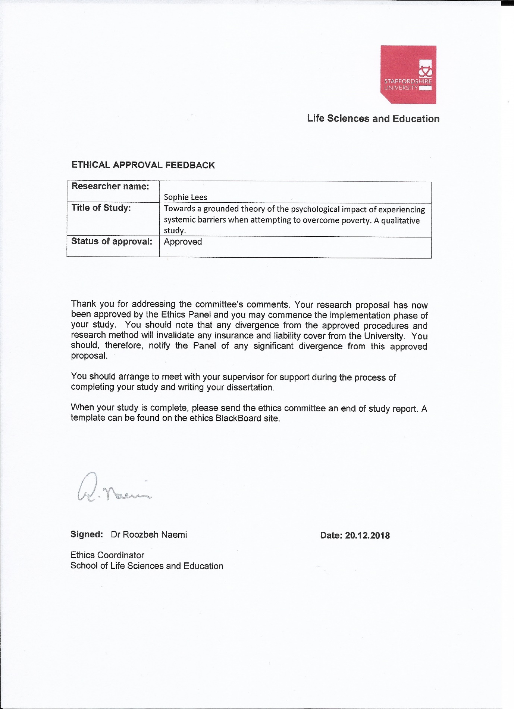

Appendix 1.2: Member check text sent
“Hi [participant name], it’s Sophie here, you took part in an interview with me at foodbank. I’m now writing up the study! I’m seeing if participants agree with my understanding/if it fits with their experiences. Obviously it might not all fit. I’ve found barriers people face seem to be around ‘Getting Help’, ‘Judgement’ and feeling not listened to/devalued/not cared about when accessing services. These seem to lead to feelings of anger, anxiety, depression and worthlessness. These then can have other consequences. Having hope, being motivated or resilient and having support seem to protect people from negative psychological effects. Positives were wanting to help others, feeling valued and valuing Emerald. Happy to hear feedback!”

Appendix 1.3: Participant Information Sheet
Participant Information Sheet

This sheet has information about a study you are invited to take part in.

Study Title

Towards a grounded theory of the psychological impact of experiencing systemic barriers when attempting to overcome poverty. A qualitative study.

Brief Summary

This study wants to know about difficulties you have faced when trying to get support to overcome a period of poverty or financial hardship. We are particularly interested in how these have made you feel. You will be asked some questions about your experiences. To do this, you will be asked to come to one of the buildings that Emerald use. We may also contact you later to ask some more questions.

What is it all about?

Lots of people in the UK live in financial difficulty which can affect their mental health. There are services that aim to help people out of financial difficulty, but people can find it hard to get help because of how services are set up.

Some reasons people might find it hard to get the help they need are:
- Having to tell their story to lots of different people
- Not knowing how to get in touch with services
- Finding it hard to fill out forms
- Worrying how people will treat them when asking for help

We still don’t know much about how the way services are set up affect people’s mental health. This study wants to add to our understanding of this. We hope that it will inform how services are set up in the future.

This study hopes to ask 8-10 people about their experiences.

This study is being done as part of the Doctorate in Clinical Psychology at Staffordshire University.

What would I have to do?

You would be asked some questions about your experiences of seeking help to try and get out of financial difficulty. It will ask you how these experiences have made you feel. This will be audio recorded. This will take place in one of the Emerald buildings. We will try and make sure it is somewhere close to you and at a time that suits you. We will pay for your travel. You will be able to take breaks when we meet.

After this, you will be asked whether it would be ok to contact you at a later date. This is so we can check things out with you and ask more questions if we need to. This would take place over the phone.

We will also ask you if you are happy for us to see any information about you that Emerald keep on their system.

You must be able to speak and understand English. These sheets can be read to you.

What might be good about taking part?

- A chance to share your experiences

- As there is not a lot of information on this topic, your views will be valuable. They will help us to understand how services affect people’s mental health better

- This could help us make services better

What might be the disadvantages of taking part?

- We will be asking about what might have been a difficult time of your life which might be upsetting or make you feel sad or worried.
  - You do not have to take part.
  - You can also ask to stop the questions if you wish. At this point, you can take a break or stop being part of the study altogether.
  - We can have as many breaks as you like.
  - You can ask for your data (what you have said) to be taken out of the study at any time until we start to analyse the data. We expect this to be in Summer 2019. This is because once we start this, your information will not be able to be separated from other people’s.

- If taking part in this study has made you feel upset, sad or worried and you feel that you need some extra support:
  - You can contact the Samaritans on 116 123 or email them at jo@samaritans.org
  - You can visit your local GP who will be able to tell you about local services that are available
  - https://www.mind.org.uk/?gclid=EAIaIQobChMI26urpryf3wIVZpPtCh2TLg8aEAAYASAAEgIudvD_BwE&gclsrc=aw.ds have information freely available about lots of mental health difficulties and links to extra support

- This study is only with people who have used Emerald. This means there is a small chance you could be identified if you talk about something very specific. However, anything you speak about that could identify you will not be included when writing up the study.

- The researcher also lives in the Rosewood. Therefore, there is a small chance that you might see them outside of the study.
  - If you take part, you can discuss how to manage this unlikely event with the researcher.
  - They will not share anything about you outside of the study.
  - The researcher will not be available in a professional way outside of the study.

Do I have to take part?

You do not have to take part. If you choose not to take part, it will not make any difference to the support you get from Emerald.

If you want to take part, we will go over this information again. If you still wish to take part, you will be asked to read, initial and sign the consent form. You will be offered a chance to ask any questions before this.

Keeping your data safe

This study will involve you sharing some personal information. It is important to us that we keep your information private and safe. To do this, we will follow data protection procedures. These procedures are known as GDPR-see below.

The researcher will look after your information and only use it for the study. Once you have taken part, your answers will be stored electronically and securely with a unique code instead of your personal details. This will make sure no one will be able to tell the information is about you. All your personal information will be deleted once analysis begins to make sure you cannot be identified. We estimate that this will start in Summer 2019. This means you can ask for your data to be taken out of the study up to this point. Unfortunately, after the analysis starts, your data will not be able to be taken out as we will not be able tell which yours. The anonymous data will be kept for 9 years to follow Staffordshire University’s regulations.

You will be asked to sign a consent form if you wish to take part in this study. Once you have signed this, it will be kept in a locked cabinet at Staffordshire University.

GDPR (General Data Protection Regulations)
Your data will be processed in accordance with the General Data Protection Regulation 2016 (GDPR).

The data controller for this project will be Staffordshire University. The University will process your personal data for the purpose of the research outlined above. The legal basis for processing your personal data for research purposes under GDPR is a ‘task in the public interest’ You can provide your consent for the use of your personal data in this study by completing the consent form that has been provided to you.

You have the right to access information held about you. Your right of access can be exercised in accordance with the General Data Protection Regulation. You also have other rights including rights of correction, erasure, objection, and data portability. Questions, comments and requests about your personal data can also be sent to the Staffordshire University Data Protection Officer. If you wish to lodge a complaint with the Information Commissioner’s Office, please visit www.ico.org.uk

Further information

This study is part of a course at Staffordshire University. This means it is not being done for profit. The findings of the study will be handed into Staffordshire University as part of this course. Staff at the university, and external examiners will review the write up of the study. It is will then be sent to a peer reviewed journal for potential publication.

This study has been given ethical approval by the Staffordshire University Research Ethics Panel. This means that it has been decided that all steps have been taken to protect those who take part from any harm and the study is thought to have the chance of being worthwhile.

In thinking about this study, those who have used Emerald were asked about their thoughts on the question, this information sheet and the consent form. Changes were made based on their feedback.

For further information please contact Sophie Lees on L024118h@student.staffs.ac.uk if you have access to email or speak to an Emerald project worker.

Version 1.9

Appendix 1.4: Demographic Information Sheet
Participant Identification Number:
Demographic Information

Please circle your answers

Gender
Male
Female
Prefer not to say

Age
18-24
25-30
31-35
36-40
41-50
51-60
61+
Prefer not to say

Occupation
Full-time employed
Part-time employed
Casual/cash in hand worker
Unemployed
Other, please state _________________________
Highest level of education
No formal qualifications
Entry level qualifications
GCSE’s or equivalent (e.g. BTEC’s, CSE’s, Level 2 NVQ’s, O levels)
A levels or equivalent (e.g. Level 3 NVQ’s,
Level 4 NVQ, higher apprenticeship or equivalent
Level 5 NVQ, foundation degree or equivalent)
Undergraduate bachelors degree or equivalent
Masters degree or equivalent
Doctorate
Other, please state __________________________________________

Do you have any disabilities (physical, learning or neurodevelopmental)?
Yes
No
Prefer not to say

Ethnicity
- White:
White English/Northern Irish/Scottish/Welsh/British
Irish
Gypsy or Irish traveller
Any other white British

- Mixed/Multiple ethnic backgrounds
White and Black Caribbean
White and Black African
White and Asian
Any other mixed/multiple ethnic background

- Asian/Asian British
Indian
Pakistani
Bangladeshi
Chinese
Any other Asian/Asian British

- Black/African/Caribbean/Black British
African
Caribbean
Any other Black/African/Caribbean/Black British

- Any other ethnic group
Arab
Any other ethnic group

Housing situation
Private renting
Homeowner
Council renting
Sofa surfing/temporary accommodation
Homeless
Other, please state ________________________________________________

Appendix 1.5: Consent Form
(University logo and address here)
Participant Identification Number:

CONSENT FORM
Title of Study: Towards a grounded theory of the psychological impact of experiencing systemic barriers when attempting to overcome poverty. A qualitative study.

Name of Researcher: Sophie Lees

Please read the following statements. If you agree to them, please initial each box.

- I have read the information sheet. I have had chance to think about taking part. I have had the chance to ask any questions.

- I understand that I do not have to take part. I understand that I can ask for my data to be taken out until analysis starts. I understand that this will not affect any support I get from Emerald.

- I understand that the information collected about me may be used to support other research in the future. It may be shared anonymously with other researchers.

- I agree that the researcher can access information that Emerald hold about me.

- The anonymous findings of this study may be shared widely. For example, they will be submitted for publication in a peer reviewed journal and may be used at research conferences and for teaching purposes.

- I agree to take part in the above study.

If you would like to take part, please print your name, date and sign below.

Print Name Date Signature

Name of Person Date Signature
taking consent

Appendix 1.6: Initial Interview Schedule
Preamble:
- Housekeeping
- Explain the purpose of the study and re-read the participant information sheet with participant
- Allow opportunity for further questions
- Read and ask participant to sign the consent form

(Turn audio recorder on)

Interview Questions:

- What difficulties or barriers have you faced when accessing services to overcome poverty?
E.G.
- Having to tell story multiple times
- Resources to access services
- Multiple agencies
- Complicated systems
- Racism
- Discrimination
- What have services done/not done that has made it hard for you to get help to overcome poverty?

- What is your understanding of the impact of these experiences on your psychological wellbeing?
Example of expected questions relating to this overarching question:
- How did [experience] make you feel?
- How long did/has this feeling last[ed]?
- Do you think that experience caused this feeling for you?
- What do you think it would have been like for you if you didn’t experience [particular barrier]?
- Do you think you would still feel [emotion/psychological concept]?

Ending:
- Thank for time
- Check still happy to participate
- Check they’re happy to be contacted over the telephone to check emerging themes

Appendix 1.7: Initial Themes
Participant Identification Number | Initial Themes
123819 | Getting help (the right help/information/knowing where to go/not wanting to ask/not having access to computer)
 | Feeling judged (based on appearance/age)
 | Not feeling listened to
2130919 | Mental health as a predecessor and a consequence of poverty
 | Feeling judged
 | Unclear communication (letters not explaining what they are for)
3041019 | Changes to benefit system (universal credit)
 | Getting help (not knowing about the services available/services not signposting/not being helped)
 | Positives of receiving help (connecting with people/wanting to give something back)
 | Shame impacting on mental and physical health
 | Lack of compassion from services (feeling they don’t care/not being helped/not signposting)
4041019 | Changes to benefit system (universal credit, access to technology, politics, lack of communication, not enough to cover costs)
 | Hopelessness/powerlessness
 | Feeling devalued/not cared for/marginalised/not listened to
 | Mental health as a predecessor and a consequence of poverty
5111019 | Getting help (lack of information/lack of communication/mixed messages)
 | Lack of compassion/understanding (including complex forms)
 | Lack of resources (staffing/funding/buildings)
 | Changes to the benefit system (universal credit)
6231019 | Judgement/Stigma and prejudice (racial and homelessness)
 | Positives of being determined and being motivated
 | Lack of resources (feeling set up to fail/government policies/lack of support)
 | Getting help (lack of services/lack of organisation/coordination/passed between services)
7141119 | Getting help (Pride/embarrassment/finding information)
 | Judgement/Stigma
 | Being set up to fail (Not having a fixed address = can’t get employment)
 | Lack of resources (services overrun/having to wait a long time/lack of feedback/communication)
 | Feeling more lively when have money; bored when no money?
 | Putting a strain on relationships
 | Impacting motivation
 | Feeling devalued
8111219 | Getting help (not knowing where to go/how to get there/embarrassment/lack of accessible information)
 | Changes to the benefit system (universal credit changing payments from weekly to monthly/benefit amounts reducing/not knowing how much will get month to month/not being enough to live off)
 | Feeling devalued (zero-hour contracts)
 | Strain on relationships

Appendix 1.8: Example of initial coding
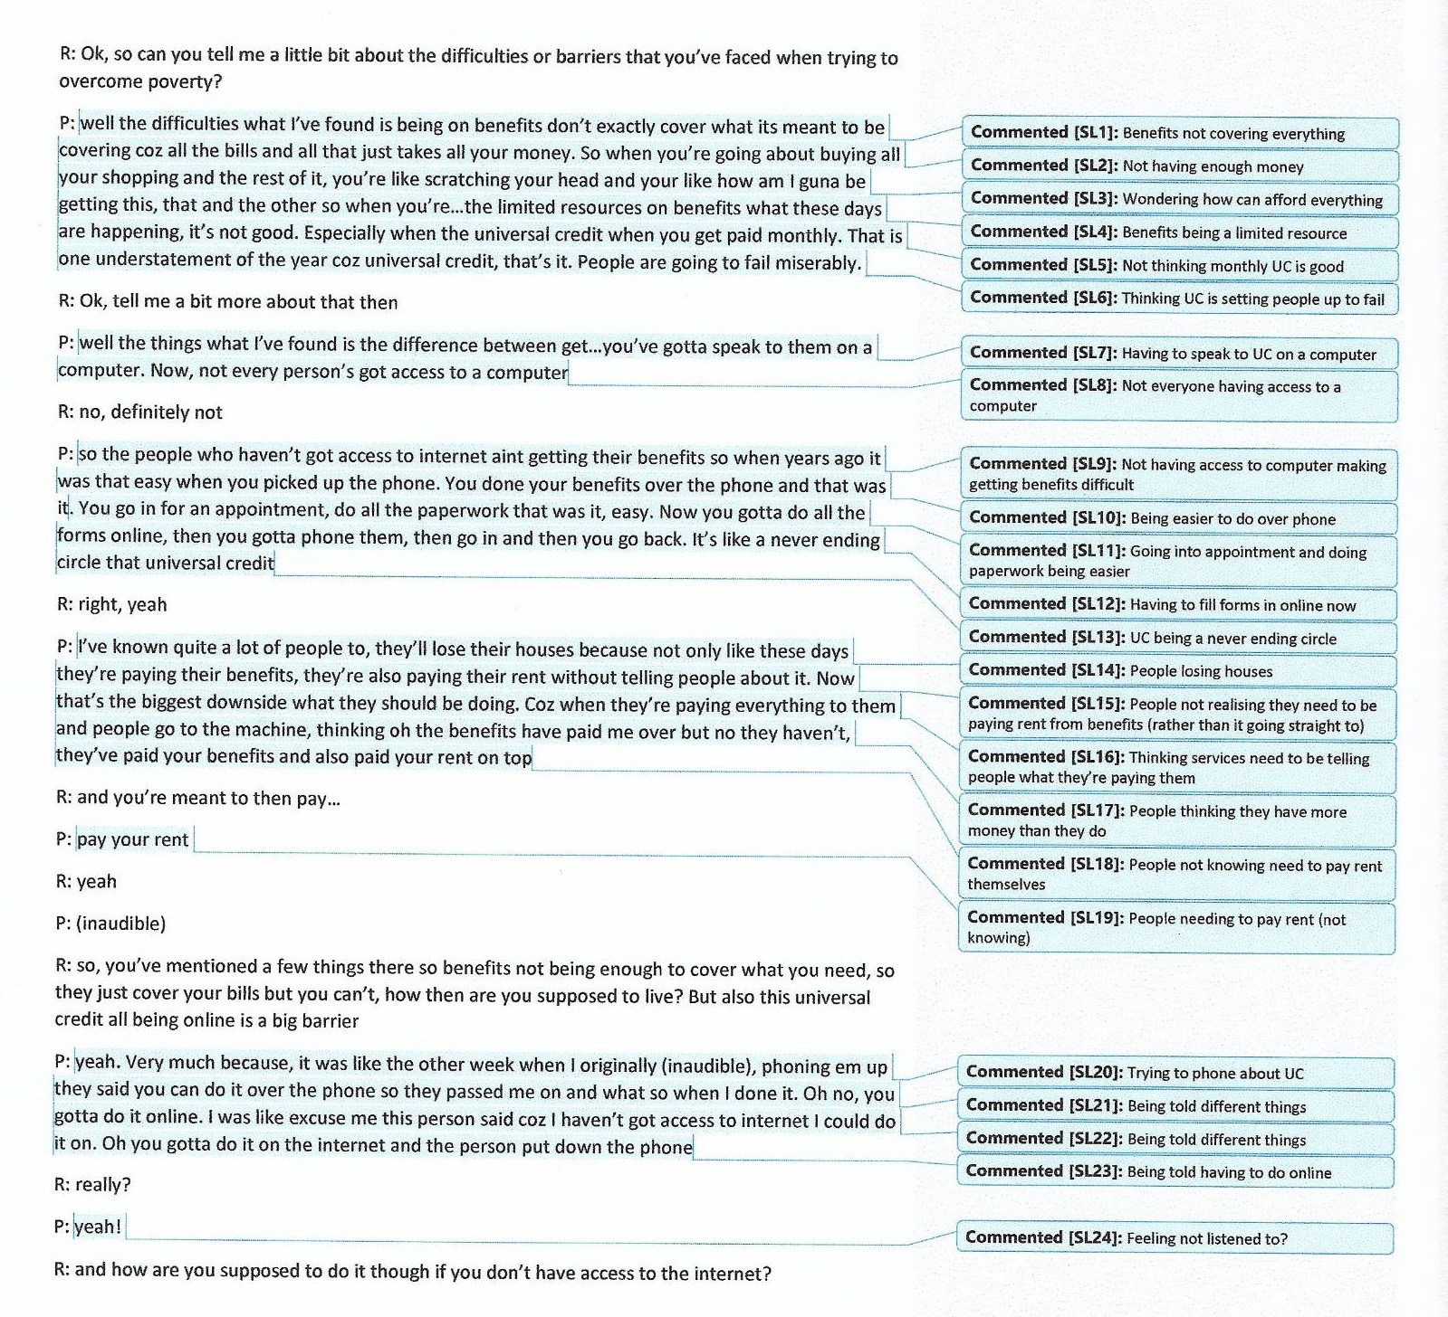

Appendix 1.9: Example of focused coding

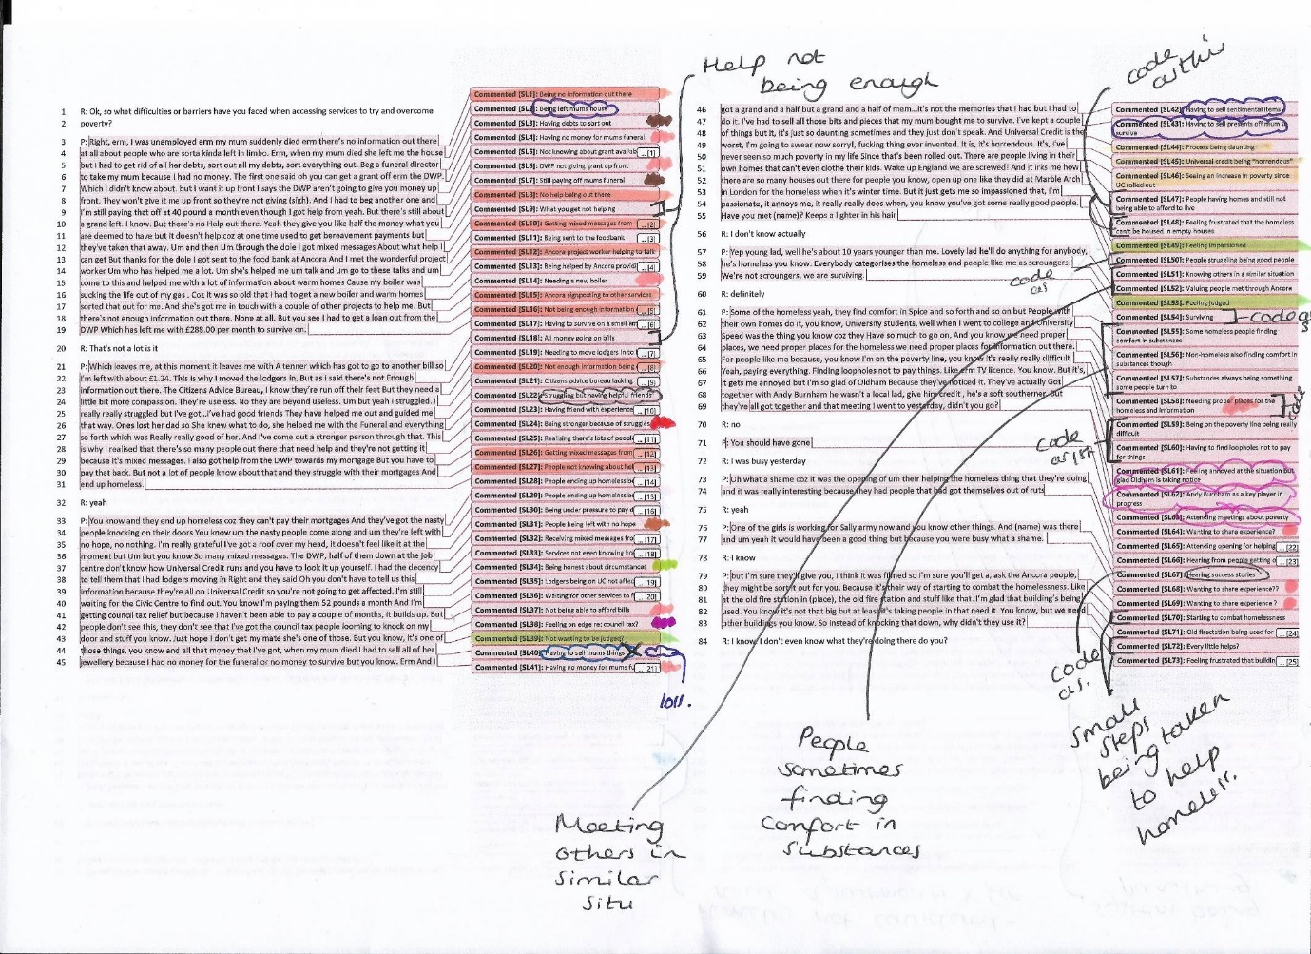

Appendix 2.1: Comparing focused codes across transcripts
Code | Frequency
Getting Help (including sub-codes) | 75 (187) (Accessibility)
Changes to the system | 42
Pressures from the system | 22
Lack of resources | 36
System failures | 12
Judgement | 95 (Discrimination)
Resilience/motivation | 61 (Resilient not Resigned)
Hope/hopelessness | 37 (Resilient not Resigned)
Mental health | 35
Feeling devalued including conveying a need to be listened to | 35 (Dehumanised)
Personal traits/characteristics/circumstances | 27
Pride/embarrassment | 21
Helping others | 14 Positives of good accessibility
Personal support network | 11 (Resilient not Resigned)
Feeling different | 9 (Discrimination)
Lack of opportunities | 6 (Accessibility)
Physical health | 6
Developing a relationship/wanting to connect with interviewer | 5 (Dehumanised)
Understanding the challenges faced by system | 4 (Accessibility)
Financial security | 3
Self-esteem | 2
Feeling listened to/cared about/valued | 2 (Dehumanised)
Disappointment | 2
Being informed | 1

Code | Frequency
Trauma (pre-financial difficulty, impact of this upon ability to manage finances, work, MH) | 115
Getting Help (including sub-codes) | 22 (106) (Accessibility)
Lack of resources | 42
Pressures from the system | 30
Changes to the system | 10
System failures | 2
Loss (of possessions, mum, ex-gf, relationships) | 59
Relationships (loss of key relationships due to death/MH, avoiding new due to previous experiences) | 40
Mental Health (pre-existing as a barrier to accessing help, services not flexible to MH needs; impact of barriers on MH) | 39 (Accessibility-lack of flexibility)
Judgement (people in general, not specifically services but idea that is implicit) | 32 (Discrimination)
Feeling devalued including conveying a need to be listened to | 24 (Dehumanised)
Personal Support Network | 20 (Resilient not Resigned)
Pride/embarrassment | 16
Resilience/motivation | 16 (Resilient not Resigned)
Debt | 13
Employment | 12
Hope/Hopelessness | 11 (Resilient not Resigned)
Not trusting services/others | 10 (Discrimination)
Eviction | 9 (Dehumanised)
Feeling listened to/cared about/valued | 9 (Dehumanised)
Personal traits/characteristics/circumstances | 7
Putting on a brave face | 5
Wanting to escape Rosewood | 5
Helping Others | 5 Positives of good accessibility
Gender | 5
Having to move | 4
Security guards at Job Centre | 3 (Accessibility)/(Discrimination)
Understanding the challenges faced by system | 3 (Accessibility)
Not wanting to let people down | 3
Drug use | 2
It’s okay to cry | 2
Abuse of the system | 2 (Discrimination)
Feeling a lack of control | 1
Avoidance | 1
Feeling not good enough | 1 (Dehumanised)

Code | Frequency
Getting Help (including sub-codes) | 89 (163) (Accessibility)
Changes to the system | 27
Lack of resources | 32
System failures inc. feeling let down by services | 6
Admiring Emerald | 7
Feeling grateful for help | 2
Feeling devalued including conveying a need to be listened to/understood | 60 (Dehumanised)
Physical Health | 36
Not wanting to relapse/regretting drug use (drugs) | 31
Pride/Embarrassment/Humiliation | 23
Developing a relationship/wanting to connect with interviewer | 23 (Dehumanised)
Mental Health | 23
Wanting to help others/give something back | 22 Positives of accessibility
Feeling listened to/cared about/valued | 16 (Dehumanised, positives)
Hope/Hopelessness | 10 (Resilient not Resigned)
Debt | 9
Waiting for benefits/looking forward to | 9
Needing to budget (inc. learning to do) | 8 (Accessibility)
Not wanting to let people down/feeling need to prove self | 8
Trauma | 8
Relationships | 7
Abuses of the system | 7 (Discrimination)
Worrying about being alone at shelter with male security | 7
Resorting to shoplifting | 7
Wanting someone to be there for you | 6 (Dehumanised)
Valuing taking part in interview/talking about being helpful | 6 (Dehumainsed-positives)
Not having a place to call home/having nothing | 5
Finding it difficult to talk about/manage emotions | 5
Feeling Alone | 4
High level of poverty in Rosewood | 4
Feeling good = motivating | 3
Resilience/Motivation | 3 (Resilient not Resigned)
Personal Support Network | 3 (Resilient not Resigned)
Being aware of other services | 3
Blame/Self-blame | 3
Understanding pressures of the system | 2 (Accessibility)
Judgement | 2 (Discrimination)
Having to follow rules of shelter | 2
Not knowing who offers services | 1 (Accessibility)
Going without food | 1
Foodbank boss hard faced but brilliant | 1
People not realising lots of staff behind scenes | 1
Walking around the streets all day | 1
Feeling scared | 1

Code | Frequency
Getting Help (including sub-codes) | 9 (55) (Accessibility)
Lack of resources | 10
Pressures from the system | 3
Changes to the system (inc. people not being fully informed of changes and impact) | 15
System failures (inc. feeling set up to fail) | 15
Lack of flexibility from services | 3
Mental Health | 23
Society being unfair | 21 (Discrimination)
Not trusting services/others | 19 (Discrimination)
Feeling devalued including conveying a need to be listened to/understood | 17 (Dehumanised)
Hope/Hopelessness | 15 (Resilient not Resigned)
Being homeless being not nice/dangerous | 9
Blaming government policy | 6 (Accessibility)
Uncertainty due to Brexit | 4
Not wanting to talk about things | 4
Having been through a lot | 4
Anger/annoyance | 4
Legalities and paperwork a barriers | 4 (Accessibility)
Learning from mistakes | 3
Making light of situation | 2
Turning to crime | 1
Feeling blamed | 1
Valuing the law | 1
Feeling services have a responsibility to look after people | 1
Resilience/Motivation | 1 (Resilient not Resigned)
Relationships | 1
Feeling lack of control | 1

Code | Frequency
Getting Help (including sub codes) | 52 (145) (Accessibility)
Lack of resources | 63
Pressures from the system | 16
Changes to the system (inc. people not being fully informed of changes and impact) | 11
System failures (inc. feeling set up to fail) | 3
Help not being enough | 1
Buildings not being welcoming | 2
Feeling devalued including conveying a need to be listened to/understood | 57 (Dehumanised)
Mental Health | 39
Personal Support Network | 21 (Resilient not Resigned)
Government/services/funders not having priorities right | 23 (Accessibility)
Helping others | 20 Positives of accessibility
Needing more LGBT support | 12
System as punishing | 10 (Accessibility/Discrimination)
Comparing England to Switzerland where they do more for the homeless | 10
Judgement | 9 (Discrimination)
Feeling listened to/cared about/valued | 9 (Dehumanised, positives)
Having a safe place to go/this being important | 9
Being aware of services | 8 (Accessibility)
Employment | 8
Staff lacking compassion/personability | 8 (Dehumanised)
Homeless being ignored/not considered | 7 (Discrimination)
Lack of a sense of community | 7
Needing more funding for university | 7
Not trusting services/others | 6 (Discrimination)
Not wanting new homes built-focus should be on current residents | 5
Needing proper support for drug use | 5
Loss | 4
Debt | 4
Positives of taking part in interview/talking about experiences | 4 (Dehumanised, positives)
Abuses of system | 4 (Discrimination)
Lack of opportunity | 4 (Accessibility)
Need for a more structured system | 4 (Accessibility)
People sometimes finding comfort in substances | 3
Job centre needs to change its approach | 3
Feeling grateful for support received | 3 Positives of accessibility
Feeling that people are being exploited by current working conditions | 3
People not being aware of how much others are struggling | 3 (Dehumanised)
Pride/embarrassment | 3
Comparing self to others in worse position/putting self in others shoes | 3
Action needs to be taken | 3
Those at the bottom not being a new thing | 3
Small steps being taken to tackle homelessness | 2
Meeting others in a similar situation | 2
Being on the poverty line being difficult | 2
Difficult life events | 2
Other countries getting living wage | 2
People turning to crime | 2
Disappointment | 2
Learning from experience | 2
Finding the interview difficult | 2
Physical Health | 2
Cigarettes being one pleasure in the world | 2
Wanting to government to make a decision on Brexit | 2
Hope/Hopelessness | 1 (Resilient not Resigned)
Personal traits/characteristics/circumstances | 1
Recognising differences to interviewer | 1
Surviving | 1
People struggling being good people | 1
Hearing success stories | 1
Not being entitled to PIP | 1
Taking drugs in the past | 1
Not wanting to be patronised | 1
Battling with companies | 1
Relationships | 1
Struggling to budget | 1
Feeling lack of control | 1
Worrying for others | 1
University not being like the real world | 1
“My England is not my England anymore” | 1
Feeling worse off than during WW2 rations | 1

Code | Frequency
Getting Help (including sub codes) | 43 (106) (Accessibility)
Lack of resources | 14
System failures inc. being set up to fail | 9
Pressures from the system | 10
Negative attitudes from staff when accessing services. This leading to avoiding accessing help (link to judgement) | 28
Staff lacking skills to deal with people using foodbank | 1
Being shocked that people know services in Rosewood aren’t good | 1
Relationships | 26
Feeling judged/stigmatised/persecuted (inc. negative staff attitudes ) | 22 (50) (Discrimination)
Feeling like services/agencies/ex-partner are against/setting up | 21 (Dehumanised)
Resilience/Motivation | 21 (Resilient not Resigned)
Helping others | 19 Positives of accessibility
Physical health | 18
Feeling devalued including conveying a need to be listened to/understood | 16 (Dehumanised)
Feeling falsely accused | 14 (Discrimination)
Mental Health | 14
Finding it difficult to talk about experiences | 12
Having no legal representation, having to complete application to reinstate leave to remain self and application being rejected | 11
People turning to substances to mask difficulties, not solving/when nothing to do | 10
Refusing to be moved to different detention centre | 8
Pride/embarrassment | 8
Being offered, and declining, nefarious help | 8
Having to go to court for different things inc. immigration, family court, arrears | 7
Strong connection to daughter-wanting to fight for custody | 7 (Resilient not Resigned)
Hope/hopelessness (“homeless not hopeless”) | 7 (Resilient not Resigned)
People needing support to move into homes after being homeless | 7 (Accessibility-lack of wrap around support)
Ex-partner not telling where moved with daughter | 7
Information being shared between services without consent | 7
Being impressed when attending Men’s club | 7
Having a home not necessarily solving all problems | 6 (Accessibility-lack of wrap around support)
Being discharged from detention centre and signing on at immigration centre | 6
Comparing situation to others = motivating | 6
Even children being affected by homelessness | 6
Employment | 6
Thinking drugs/drink would only worsen situation, dabbling in the past | 6
Being assaulted | 6
Not retaliating to assault for daughters sake | 5 (Resilient not Resigned)
Choosing to leave flat to eliminate one problem | 5
People using the foodbank having needs beyond food | 5
Wanting to share the positives of going through what have | 5
Personal support network | 5 (Resilient not Resigned)
Thinking the environment needs changing, need for greater level of holistic support | 5
Being daughters main caregiver for 5 years | 5
Still trying to overcome barriers | 4
Maintaining personal hygiene despite being homeless | 4
Having a friend in a similar situation | 4
Debt | 4
Wanting to share story/positives of taking part | 4 (Dehumanised)
Having leave to remain granted based on daughter being here/human rights basis | 4
Not being directly about poverty for me/not always about financial difficulties | 3
Doing off the books work | 3
Being homeless | 3
Wanting contact with daughter overriding other difficulties | 3 (Resilient not Resigned)
Daughter staying with until shifts changed to nights | 3
Not believing them then told would be going home from detention centre | 3
Wanting to set a good example to daughter | 3 (Resilient not Resigned)
Having grown up daughters in Africa | 3
Being detained when told immigration centre was homeless | 3
Having a lot of things to deal with | 2
Being difficult to get a job when homeless | 2
Having no criminal record | 2
Emerald being beside Trussell Trust at the foodbank but not being the same | 2
Abuse of the system | 2 (Discrimination)
Emerald holding information about your situation | 2
Not trusting services/others | 2 (Discrimination)
Family as a reason not to end life | 2 (Resilient not Resigned)
Being asked questions by a researcher | 2
Needing passport from home office to volunteer | 2 (Accessibility)
Happiness and health being as important as wealth | 2
Learning from experiences | 2
Worrying not talking about the right things | 2
Stealing could lead to prison where substances are accessible | 2
Not being able to get legal aid | 2
Being given notice to leave flat | 1
Involvement with court affecting immigration status | 1
Feeling listened to/cared about/valued | 1 (Dehumanised, positives)
Getting information from daughter about something father in law said | 1
Moving house after relationship breakdown | 1
Requesting to take belongings if deported | 1
Ticket being booked to deport | 1
Not feeling that financial difficulties have impacted mental health | 1
Telling others your story | 1 (Dehumanised, positives)
Financial situation not improving | 1
Putting on a brave face | 1 (Resilient not Resigned)
Promising self not to be depressed | 1 (Resilient not Resigned)
Wanting to right wrongs | 1 (Resilient not Resigned)
Being homeless not being normal | 1
Satisfying to know done what you could | 1 (Resilient not Resigned)
Hearing about plans for services in Rosewood | 1
Not being able to face another court case | 1
Worrying about what’s coming through letterbox | 1
Having a daughter in England | 1

Code | Frequency
Getting Help (including sub codes) | 51 (65) (Accessibility)
Lack of resources | 1
Pressures from the system | 5
Feeling no one is helping/everyone is against you | 3
Poor services | 5
Delays in procedures/processes | 12 (Accessibility)
Judgement | 11 (Discrimination)
Helping Others | 8 Positives of accessibility
Mental Health | 8
Resilience/Motivation | 7 (Resilient not Resigned)
Feeling devalued including conveying a need to be listened to/understood | 7 (Dehumanised)
Wanting personal touch from services | 7 (Dehumanised)
Struggling to express self/not having anything else to add/finding it difficult to think of everything | 6
Feeling treated well by Emerald | 6 Positives of accessibility
Pride/Embarrassment | 6
Employment | 4
Sometimes being able to disregard fear of/actual judgement | 4 (Resilient not Resigned)
Needing an address to gain employment and vice versa | 4 (Accessibility)
Physical Health | 4
Not trusting services | 4 (Discrimination)
Being easier to talk to someone you don’t know | 3 (Discrimination)
Happy with what shared | 3
Having money = can do things = feel up | 3
Relationships | 3
One thing stopping progress in a lot of things | 2
All having good and bad days | 2
Realising need for help for self | 2
Comparing self to those worse off | 2
People thinking their problems are worse than yours | 2
Predicting will face more barriers | 2
Everyone’s problems being personal to them | 2
Sometimes wanting to give up | 1
Loss | 1
Not wanting to sound like moaning | 1
Knowing others are struggling financially | 1
Wanting to share | 1 (Dehumanised, positives)
Not needing to use the foodbank | 1
Recognising others might need greater level of support | 1

Code | Frequency
Getting Help (inc sub codes) | 45 (11) (Accessibility)
Changes to the system | 26
Lack of resources | 40
Employment | 24
Pride/Embarrassment | 14
Relationships | 13
Putting children first, them being motivation | 12 (Resilient not Resigned)
Feeling Devalued (conveyed through wanting to connect with researcher) | 10 (Dehumanised)
Uncertainty around work due to being on a zero-hour contract | 10 (Accessibility)
Having to make sacrifices | 8
Children not fully understanding situation | 8
Feeling guilt at being able to provide for family in the past/not being able to give them as much now | 6
Struggling to meet additional needs of child | 4
Mental health | 4
Feeling said all wanted to | 4 (Dehumanised, positives)
Feeling listened to/cared about/valued | 3 (Dehumanised, positives)
Not having many people to turn to for financial support | 2 (Resilient not Resigned)
Things getting worse/being in a bad way | 2
Finding it difficult to talk about experiences | 2
Poor services | 2 (Accessibility)
Helping others | 2 Positives of accessibility
Personal support network | 2 (Resilient not Resigned)
Debt | 2
Hearing about service from friend | 1 (Accessibility)
Being surprised by how many people need help | 1
Not understanding question | 1
Losing UC and not getting any help/extra money | 1 (Accessibility)
Being billed for housing repairs | 1
Just getting through the day | 1
Cost of living increasing | 1
Making best of the situation | 1

*Red indicates collapsing codes into conceptual categories.

Appendix 2.2: Examples of memos
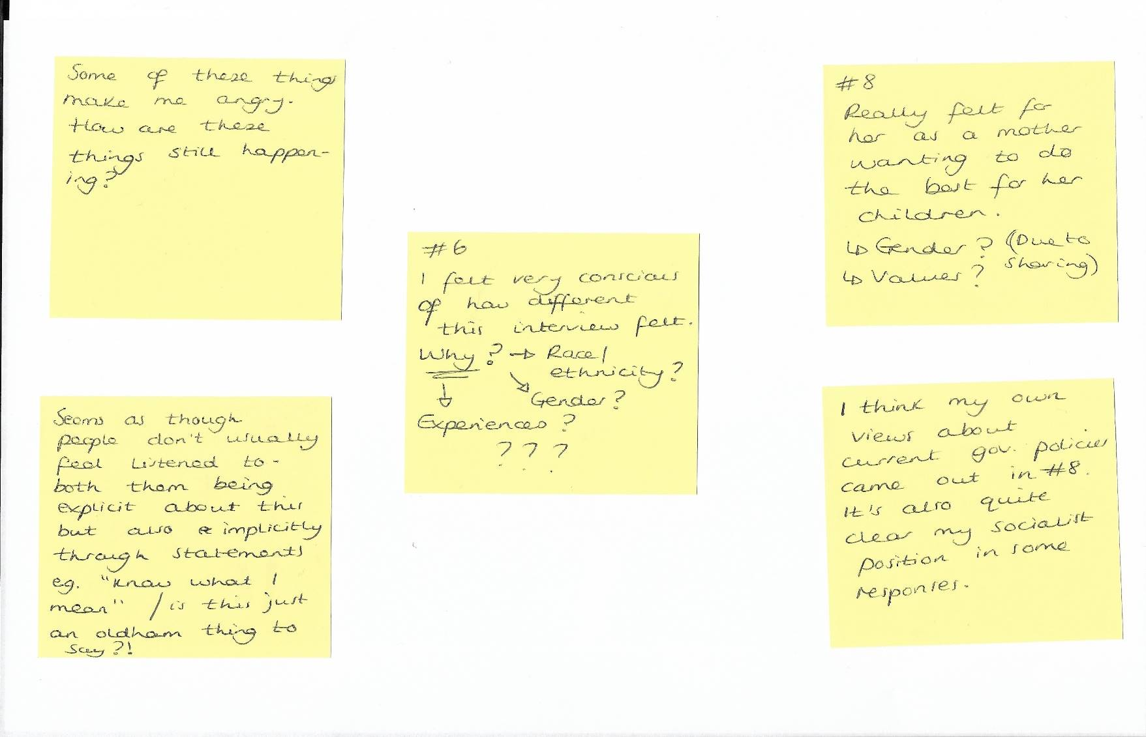

Appendix 2.3: Triangulation of data-Information held by Emerald
Emerald information (most recent support first for each participant)
#123819
- Help completing benefit forms
- Free bus pass(es) provided
- Phone and sim provided
- Food voucher(s) provided
- Socially isolated
- Referred for counselling
- Attends ‘That Thursday Thing’ hub (form relationships, social interaction)
#2130919
- Help with understanding forms
- Help with understanding and dealing with legal letter
- Attends ‘That Thursday Thing’ hub (form relationships, social interaction)
- Helping filling out PIP form, support with gathering the evidence for this
- Food voucher(s) provided
- Debt issues
- Fine received from non-payment of TV license, helped to arrange a repayment scheme
#3041019
- Supported with securing accommodation
- Phone given
- Supported with assessment for accommodation
- Able to come and ask for help with the assessment for accommodation
- Free bus travel provided
- Helping to fill out forms
- Bed for night temporary accommodation secured
- Warm clothing from foodbank given
- Attends ‘That Thursday Thing’ hub (form relationships, social interaction)
- Food voucher(s) provided
- Help completing benefit forms
- Fuel voucher(s) provided (when previously housed, left due to DV)
#4041019
- Food voucher(s) provided
- Provided with a phone
#5111019
- Quote from project worker note: “UC payments are so low that she can barely afford to keep a roof above her head from week to week”
- Needs acts application as washing machine broken down- supported to complete this
- Bus travel provided to attend ‘That Thursday Thing’ hub (form relationships, social interaction)
- Signing up for course to help with securing volunteering
- Warm clothes (coat) provided
- Help completing benefit claims (enhanced ESA through UC, then apply for PiP if successful)
- Taking part in Making every adult matter (lived experience, involved in coproduction)- feeling empowered due to this
- Food voucher(s) provided
- Referred to CAP (Christians Against Poverty) re: debt
- Bus ticket to get to interview with get Rosewood working provided
- Fuel voucher(s) provided
- Advice and guidance given
- Referred to warm homes
- Referred to Inspire Women (relationships support, re: isolation, “keen to socialise as she is feeling isolated”)
#6231019
- Supported to set up a budgeting plan with Great Places (rent debt)
- Reference given for volunteering
- Will not accept support regarding tenancy and legal issues
- Needed bus ticket to get to court (unsure if given)
- Food voucher provided
- Advice and guidance given
- Liaising with other organisations on behalf of (Great Places re: rent arrears)
- No recourse to public funds
- CAB supporting re: access to daughter
- Calls to benefit office made on behalf of
- Housing and tenancy advice given
#7141119
- Helped to secure accommodation
- Volunteering with Emerald soon
- Completed full homeless assessment
- Attended homeless appointment
#8111219
- Food voucher(s) provided
- Toy donations for children for Christmas given
- Advice and guidance provided
- Referred to fair share (food from church)
- Fuel voucher provided
- Advice on other food suppliers given
- Bus ticket provided
- Benefit cap = reason for struggling financially so much

Appendix 2.4: List of systemic barriers found across transcripts
- Finding the right help/not knowing about services/not knowing how to contact
- ‘Being passed from pillar to post’/not being given the right or enough information
- Changes to benefits i.e. Universal Credit (not covering living costs = debt, difficulty changing from weekly to monthly, large amounts taken to cover debts, uncertainty around payments, not being fully informed of the impact of the changes)
- Processes moving online and not having access to a computer/the skills to use
- Judgement (including stigma and marginalisation)
- Having to prove you’re looking for/applying for a certain amount of jobs each day/feeling pressured to work when you do not feel mentally ready
- Lack of jobs in the area
- Services changing premises, not being informed and not knowing where to go
- Having to tell a stranger about your situation/being asked personal questions/question you cannot answer
- Lack of funding = staff too busy/services closing/lack of services/lack of quality services/services being unable to provide what you need/services being overrun
- Receiving letters/bills (including these not being accessible)
- System failures e.g. lack of wrap around support, feeling set up to fail, mistakes being made
- Not being listened to/cared about by services
- Lack of flexibility from services (including not accounting for personal circumstances/mental health)
- Needing to physically attend services to access help (including not having the funds to do this)
- Placement of services e.g. difficult to get to/triggering for mental health
- Physical security guards at the job centre
- Waiting times
- Not having a bank account/identification/fixed address impacting ability to access services and receive support/better situation
- High staff turnover
- Lack of signposting and communication between services
- High levels of poverty in the area
- Support being contingent on being in a certain area/services not equitable across areas
- Limited resources for assistance e.g. number of food vouchers
- Government policy (impacting funding and services = vital services taken away)
- Paperwork and delays with this
- Lack of feedback from services
- Zero-hour contracts not being a secure source of income

Chapter Three: Executive Summary

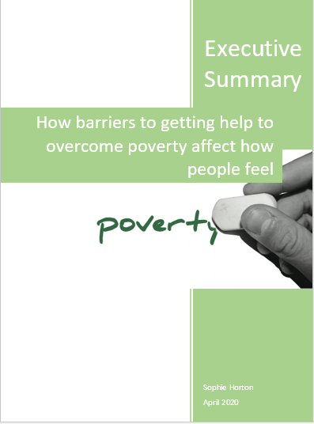

Contents
Study Title………………………………………………………………..160
Key Words………………………………………………………………..160
Why this research topic?...........................................................................160
Aims……………………………………………………………………….162
How the study was done…………………………………………………162
Key Findings……………………………………………………………...165
Summary of Findings……………………………………………...165
The Project………………………………………………………...165
Systemic barriers…………………………………………………..167
Main Themes……………………………………………………….169
The Model………………………………………………………….173
Sharing the Findings……………………………………………………..175
Recommendations………………………………………………………..175
Limitations………………………………………………………………..176
References………………………………………………………………...176

Study Title: Towards a grounded theory of the psychological impact of experiencing systemic barriers when attempting to overcome poverty. A qualitative study.

This is a summary of the above research study. It has been written for those who took part and the project they were identified through. This summary was sent to project workers and those who took part, who wanted to see it, for their feedback. One participant replied with positive feedback. No other feedback was received. This may be because of the Coronavirus crisis meaning people’s priorities were elsewhere. I would like to thank the project workers for all their help with the study. Your dedication is a credit to you. And of course, without those who took part in the interviews, this study would not have been possible. It was a pleasure to meet you all and hear your stories.

Key Words
Poverty: for this study, poverty was defined as facing immediate financial difficulty to a point where the person asked for help from services.
Systemic barriers: systemic barriers are defined as barriers created, either directly or indirectly, by services and organisations due to the way they are funded, set up and delivered.
Qualitative research: a set of ways to collect information about people’s experiences which do not focus on numbers or statistics. They collect in-depth information about a person’s experiences from their own perspective.
Grounded theory [GT]: a specific way of collecting information about people’s experiences. It develops a theory from this information that explains the themes common to their experiences.

Why this research topic?
Poverty appears to be increasing (Department for Communities and Local Government [DCLG] 2019; Ministry of Housing, Communities and Local Government [MHCLG] 2019; Smithers 2017). It also has a negative effect on people’s mental health (Social Metrics Commission [SMC] 2019, Office for National Statistics [ONS] 2017, Burns 2015, Coope et al. 2014, Peterson et al. 1993). Therefore, it is important to study topics around the link between poverty and mental health.
The UK recession in 2008 put financial pressure on the country. The government put measures into place, called austerity measures, to try to help the country’s financial position (Allen 2010). Austerity measures introduced include Universal Credit [UC], Work Capability Assessments [WCA’s], cuts to funding and changes to services. There is evidence that these measures have negatively affected people’s mental health (Barr et al. 2016, Trussell Trust 2018). Some sources also say that austerity measures have made it difficult for people to afford essentials such as food (Trussell Trust, no date) and rent (National Housing Federation [NHF], cited in Raynor 2018).
Our deep-rooted beliefs are important to how we see the world, others and ourselves. These beliefs shape how we act and understand what happens to us. There are some patterns in the British public’s beliefs about poverty. One is that we are ‘over poverty’ in the UK (Joseph Rowntree Foundation [JRF] 2018). Our brains can automatically ‘gloss over’ information that doesn’t fit with our beliefs to protect us from the distress of our beliefs being challenged. If someone holds this belief, stories of poverty may be ‘glossed over’ and its existence ignored. Another pattern of thought around poverty is that those who experience it do so due to their own choices. This belief blames the person and places the responsibility on them to change things. This ignores the wider systemic context (JRF 2018). The systemic context includes things such as the area someone lives, social circumstances, housing situation, services available, government policy and funding, family, work, leisure activities etc.
From visiting the project before deciding on the specific focus of the research, it was clear that people faced many barriers to overcoming poverty. It struck the researcher how the processes involved in accessing help were difficult for people to navigate, especially without someone to support them and point them in the right direction. It was also surprising to discover just how many people were relying on the Foodbank in the area.
Therefore, the researcher was interested in looking at the systemic barriers people have faced when attempting to access services to overcome poverty and their impact on psychological wellbeing.
This study was completed before the Coronavirus crisis, which has put greater strain on services. The pandemic has led to an increase in people struggling financially. This is due to job losses (France 24 2020), a lack of access to free school meals due to school closures and vital services that people rely on (e.g. foodbanks and other charities) having to reduce or close their services due to social distancing rules (BBC 2020). This research is arguably even more important given the current situation to help us to understand how to protect wellbeing by reducing systemic barriers and how to respond to the likely increase in poverty.

Aims
- To gather in-depth data about people’s experiences of difficulties they have faced when attempting to access services to overcome poverty (i.e. the barriers).
- Discover how systemic barriers affect psychological wellbeing.
- Gather evidence on how service provision impacts psychological wellbeing, with a view to inform how services are funded, set up and delivered.
- Develop a theory of the psychological impact of experiencing systemic barriers to accessing services when trying to overcome poverty. This theory needed to be based on what people discussed in interviews.

How the study was done
The study received ethical approval from Staffordshire University Research Ethics Committee. This means experts felt the research was taking steps to protect those who would take part from harm, and it had the potential to be useful. Service users were asked before the study if they thought the topic was relevant. They also looked at the forms and checked these made sense. Those who took part were asked after the study if the findings fit their experiences. Those who replied said they did. Project staff were kept up to date throughout.
Eight people took part who had been to the project. Taking part was either discussed with potential participants by the researcher visiting different hubs of the project, or by project workers who passed contact details on with permission. The table below shows information about participants and the interviews:

Dates of interviews | 13/09/2019 - 11/12/2019
Length of interviews | 22 minutes – 1 hour 24 minutes
Place of interviews | Private room at the foodbank
Age range | 31-60
Ethnicity | 7 White British/Irish, 1 Black African
Gender | 4 Male, 4 Female
Disability status | 4 Yes, 4 No
Employment status | 6 unemployed, 1 employed full-time, 1 zero-hour contract
Housing situation | 2 homeless, 1 homeowner, 3 renting (either private or council), 2 temporary accommodation/sofa surfing
Highest level of education | 3 no formal qualifications, 2 entry-level qualifications, 1 GCSE’s (or equivalent), 2 A-Level’s (or equivalent)

The interviews were audio recorded. The researcher listened to the recordings and typed them up word for word. This process is called transcribing, creating transcripts of each interview. The transcripts were then analysed using GT methods. This involved looking at each line of speech within each transcript and devising ‘codes’ i.e. action statements which captured the essence of the line. For example (fictional data):
1 “I mean, it’s just really difficult to decide whether to buy the branded pasta or the
2 non-branded pasta. I know it sounds silly.”
Line 1 might be coded as: having difficulty deciding which pasta to buy
Line 2 might be coded as: feeling silly

Initial codes are then looked at for patterns within and between each interview. This is to see which codes come up a lot, suggesting which things are common experiences. This allows for conceptual categories to develop which explain larger chunks of information across interviews. The categories must explain enough of the data that they ring true for everyone who takes part. If we return to the example above, this would mean comparing that participant’s data throughout their interview and to other participants to see if those codes came up a lot e.g.:
Interview 1
1 “I mean, it’s just really difficult to decide whether to buy the branded pasta or the
having difficulty deciding which pasta to buy
2 non-branded pasta. I know it sounds silly.”
feeling silly
Interview 2
1 “I stand there for ages you know, just constantly comparing which pasta is the right
spending a long time deciding which pasta is right
2 one to get. I sound so ridiculous saying that I know.”
feeling ridiculous
Interview 3
1 “I think I know which one I want before I go. But I get there, and I just don’t
thinking decided but not sure when there
2 I think to myself, gosh you are so silly you know.”
feeling silly

Here you can see that the three fictional interviews are saying similar things about struggling to decide which pasta to buy and feeling silly about struggling to make this decision. The initial codes are in red. There is a pattern across these interviews which means, there may be conceptual categories explaining the main themes. For this fictional information, these may be: “Difficulty deciding” and “Feeling Silly”.
Once the conceptual categories for this study were developed, a model then came out explaining people’s experiences of the psychological impact of facing systemic barriers when trying to access services to get out of poverty.

Key Findings

Summary of findings
- Those who took part valued the project and support they received. This may be due to them being recruited from the project, but they were told what they said would not be shared as coming from them. The researcher was also separate from the project.
- It seemed that participants had not been listened to very much before.
- People wanted to share their journeys to their current situation.
- They spoke about lots of barriers that made it difficult for them to get help.
- Pride/embarrassment, existing mental health difficulties/previous traumatic experiences and relationship difficulties made it hard for people to want to get help.
- There were a lot of systemic barriers that people described which added to the challenges of getting help.
- Systemic barriers negatively impacted people’s feelings and actions.
- There were four conceptual categories which explained the main themes of the interviews: ‘Accessibility’, ‘Discrimination’, ‘Dehumanisation’ and ‘Resilient not Resigned’.

The Project
This word cloud shows key words from what participants said about their experiences and support received from the project.
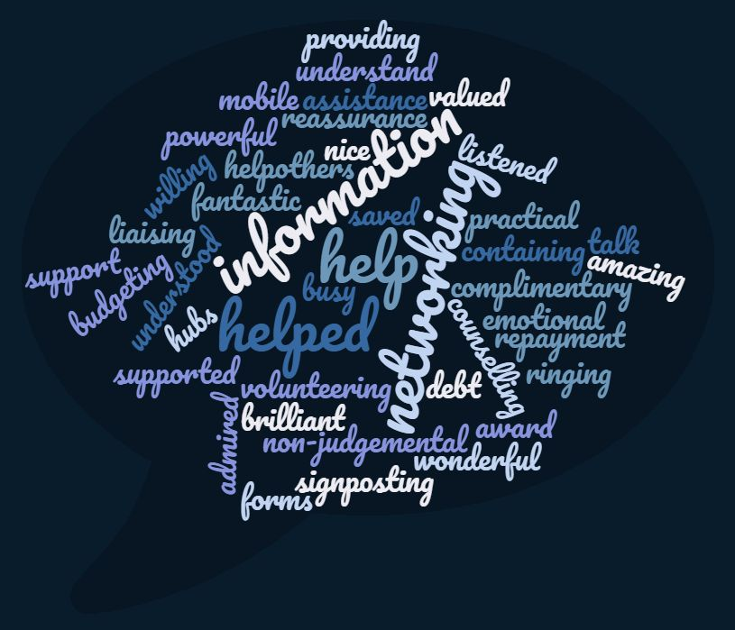

Systemic barriers
The table below shows the systemic barriers people spoke about facing.
Changes to the system
Universal Credit (not covering living costs = debt, difficulty changing from weekly to monthly payments, large amounts taken to cover debts, uncertainty about how much you will be paid, not being fully informed of the changes)

Government policy = reduced funding and services = vital services taken away

Lack of funding = staff too busy/services closing/lack of services/lack of quality services/services unable to provide what you need/services being overrun

Zero-hour contracts = not secure source of income

Services moving without being told, not knowing where to go

Processes moving online
Lack of resources
Limited resources for help e.g. number of food vouchers you can have within certain time period

Not having a bank account/identification/fixed address impacting ability to access services, get help/better situation/get a job

Not having access to a computer/the skills to use one
Pressures from the system
Paperwork and delays with this

Needing to physically go somewhere including struggling to afford to do this

Receiving letters/bills (including these not being accessible)

Having to prove you’re looking for/applying for a certain amount of jobs each day/feeling pressured to work when you do not feel mentally ready
Local issues
High levels of poverty in the area

Having to live in a certain area to get the help you need/services not the same across areas

Lack of jobs in the area
Service level barriers
Lack of signposting and communication between services

High staff turnover

Lack of feedback from services

Security guards at the job centre

Waiting times

Where services are (difficult to get to, triggering for mental health)

Lack of flexibility from services (including not accounting for personal circumstances/mental health)

System failures e.g. lack of wrap around support, feeling set up to fail, mistakes being made

“Being passed from pillar to post”/not being given the right or enough information

Finding the right help/not knowing about services/not knowing how to contact them
Interpersonal barriers
Not being listened to/cared about/understood by services

Having to tell a stranger about your situation/being asked personal questions/questions you cannot answer

Judgement (including stigma and feeling marginalised)

Main Themes
The main themes are called conceptual categories in GT terms. The main themes found in this study were: ‘Accessibility’, ‘Discrimination’, ‘Dehumanisation’ and ‘Resilient not Resigned’. These themes are explained in the diagrams below, showing the types of experiences within these that people spoke about, and the feelings and actions these experiences led to.

Services being inaccessible
‘Accessibility’

Being able to access services

Due to changes to the system
The system failing people
Due to a lack of resources
Services placing pressure on people
Being able to access appropriate support led to…
Wanting to help others
Feeling grateful for the help received
Feeling valued (related to the theme ‘Dehumanised’)
Services being inaccessible led to…
Feeling angry, worried and low in mood/depressed

These feelings led to…
Thoughts, intentions and attempts of self-harm and suicide
Feelings of blame
Feeling hopeless
Negatively affected relationships
Putting up barriers with other people

‘Discrimination’
Being discriminated against
Towards others
Towards yourself

Negative staff attitudes = not trusting services
Based on age/personal characteristics
Feeling set up to fail (related to ‘Accessibility) due to discrimination

Being discriminated against led to…
Feeling angry
Feeling worried
Low mood/depression
Feeling worthless

These feelings led to…
Fearing being discriminated against in the future e.g. when trying to get help next time
Feelings of shame
Avoidance e.g. of seeking help
Losing motivation in general/to try and get help
Losing confidence
Feeling hopeless
Feeling to blame
Feeling dehumanised (linked to the next theme)

Being discriminated against
‘Dehumanised’

Being Dehumanised = not feeling listened to/cared about/valued/understood when trying to access services
Being Valued = feeling listened to/cared about/valued/understood when accessing services

Being Dehumanised led to…
Feeling angry
Feeling worried
Low mood/depression
Feeling worthless
Being Valued led to…
Feeling worthy
Happiness
Feeling grateful

These feelings led to…
Wanting to help others
These feelings led to…
Putting up barriers with other people
Thoughts of self-harm/suicide
Feeling hopeless
Feelings of shame
Losing motivation e.g. To seek help

‘Resilient not Resigned’= protective against negative psychological impact of barriers

Resilience/motivation
Resilience could be an existing characteristic for some people or developed to cope with barriers
Personal Support Network
Helpful to provide people with external source of motivation e.g. children as a motivator to keep going

These led to hope = protected people from potentially more damaging psychological effect of experiencing barriers/helped people to cope better.
Greater resilience/motivation = greater hope = less negative psychological effects

The Model
Below is a simplified version of the model that was developed to explain the experiences of how systemic barriers affected those who took part.

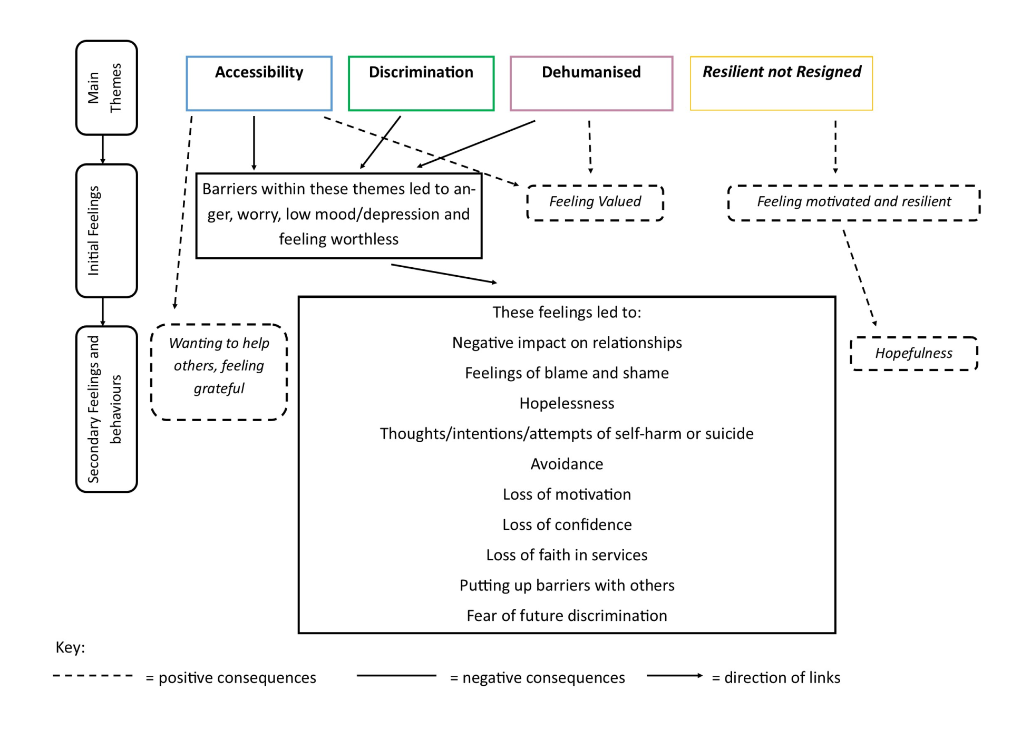

Sharing the Findings
The full research paper is being handed in to Staffordshire University as part of the doctorate in Clinical Psychology. Attempts will also be made to submit to a peer-reviewed journal so the findings can be shared more widely. The full research paper, literature review and this summary have been (or will be) shared with the project. People who took part, and project workers, were asked for their feedback on this summary. One participant replied with positive feedback. No further feedback was received.

Recommendations
- Projects which support people to navigate the system of getting help to overcome poverty should be funded and accessible.
- Policy makers and services should aim to reduce the known systemic barriers due to their negative impact on psychological wellbeing.
- Policy makers should consider the long-term impact of austerity and budget cuts for short-term gain. This study suggests that budget cuts play a significant role in increasing psychological distress which in turn will likely cost services in the future.
- Increase advertising of services.
- Increase signposting.
- Staff training in responding to individual’s needs, particularly mental health needs would be beneficial.
- Additional funding and flexibility is needed for services to respond to individual’s needs. Services would benefit from additional funding to increase staffing levels.
- Forms need to be more accessible and staff available to help with completing these.
- Increase multi-agency communication.
- Support should be ‘wrap around’. For example, being provided with the keys to a flat without the skills and resources to maintain this home is not enough. Packages of support are likely to be more effective.
- Changes to processes should be clearly explained, in accessible language.
- Where services are should be considered in terms of ease of travel, familiarity and their sense of welcoming.
- Those most at risk of the negative psychological consequences of facing systemic barriers to overcome poverty need to be identified.
- Efforts should be made to increase protective factors, namely resilience/motivation, personal support networks and the resulting more hopeful outlook.

Limitations
There is a potential that the findings were influenced by pre-existing ideas due searching the literature before the study, which is not normally done for traditional GT. The researcher was new to GT. However, guidance was followed, and the full paper provides detailed information about exactly what was done. All analysis was completed by one researcher and therefore the findings have been developed through the researcher’s own interpretation. This includes the researcher being a White British female from the same area as participants and having views that everyone in society is valuable and should be treated fairly. Applying the findings to other areas is limited due to the study being conducted in one area.

References
Allen, G. (2010) Recession and recovery. Key issues for the new parliament 2010, https://www.parliament.uk/documents/commons/lib/research/key_issues/Key-Issues-Recession-and-recovery.pdf
Barr, B., Taylor-Robinson, D., Stuckler, D., Loopstra, R., Reeves, A. and Whitehead, M. (2016) ‘‘First, do no harm’: are disability assessments associated with adverse trends in mental health? A longitudinal ecological study’, Journal of Epidemiology and Community Health, 70(4): 339-345.
BBC (2020) Coronavirus: Fighting food poverty in a lockdown, https://www.bbc.co.uk/news/uk-england-manchester-52228080
Burns, J. K. (2015) ‘Poverty, inequality and a political economy of mental health’, Epidemiology and psychiatric sciences, 24(2): 107-113.
Coope, C., Donovan, J., Wilson, C., Barnes, M., Metcalfe, C., Hollingworth, W. and Gunnell, D. (2015) ‘Characteristics of people dying by suicide after job loss, financial difficulties and other economic stressors during a period of recession (2010–2011): A review of coroners׳ records’, Journal of affective disorders, 183: 98-105.
Department for Communities and Local Government (2019) The English indices of deprivation 2015, https://assets.publishing.service.gov.uk/government/uploads/system/uploads/attachment_data/file/835115/IoD2019_Statistical_Release.pdf
France 24 (2020) Coronavirus pandemic ‘amplifying’ poverty in the UK, https://www.france24.com/en/20200405-coronavirus-pandemic-amplifying-poverty-in-uk
Joseph Rowntree Foundation (2018) How to build lasting support to solve UK poverty, https://www.jrf.org.uk/report/how-build-lasting-support-solve-uk-poverty?gclid=EAIaIQobChMIx4Pq7Y_a5AIVC1PTCh0iXABmEAAYAiAAEgKrSvD_BwE
Ministry of Housing, Communities and Local Government (2019). Rough sleeping snapshot in England: autumn 2019- tables. Retrieved from https://www.gov.uk/government/statistics/rough-sleeping-snapshot-in-england-autumn-2019
Office for National Statistics (2017) Persistent poverty in the UK and EU: 2015. Rates of persistent relative income poverty for the UK are compared with other EU countries, https://www.ons.gov.uk/peoplepopulationandcommunity/personalandhouseholdfinances/incomeandwealth/articles/persistentpovertyintheukandeu/2015
Peterson, C., Maier, S. F. and Seligman, M. E. (1993) ‘Learned helplessness: A theory for the age of personal control’, Theory for the Age of Personal.
Raynor, T., (2018)‘This is the impact of universal credit’, https://news.sky.com/story/what-impact-is-universal-credit-having-11343838
Smithers (2017) ‘Revealed- the shocking scale of the rise of homelessness across Greater Manchester’, https://www.manchestereveningnews.co.uk/news/greater-manchester-news/homelessness-rise-manchester-oldham-shelter-13044554
Social Metrics Commission (2019) Measuring poverty 2019. A report of the Social Metrics Commission, https://li.com/reports/measuring-poverty-2019-a-report-of-the-social-metrics-commission/
Trussell Trust (The) (no date). The next stage of universal credit. Moving onto the new benefit system and foodbank use, https://www.trusselltrust.org/wp-content/uploads/sites/2/2018/10/The-next-stage-of-Universal-Credit-Report-Final.pdf
Trussell Trust (The) (2018). Left behind. Is universal credit truly universal?, https://s3-eu-west-1.amazonaws.com/trusselltrust-documents/Trussell-Trust-Left-Behind-2018.pdf

Thesis Appendices

Appendix 1.1: Author guidelines for Journal of Poverty and Social Justice

What are we looking for?
- Research Articles should be up to 8000 words (including references) in length (or longer by agreement with the editor). Authors should make clear the policy context, reference only directly relevant literature, adopt an intelligible structure and a lucid style, use rigorous argument and reach strong conclusions. Technical and statistical material is best omitted or presented as an appendix. An abstract of not more than 100 words should be included.
- Policy and Practice is concerned with policy ideas and themes emanating from pressure groups and think tanks, and also provides updates on new developments, issues, legislation and reviews especially with reference to welfare rights. Contributions should be no longer than 3000 words (including references).
- Book reviews: for information on how to submit a book review please contact the Book Review Editor, Rod Dacombe: rod.dacombe@kcl.ac.uk

How to submit an article
All submissions should be made online at the Journal of Poverty and Social Justice Editorial Manager website: http://www.editorialmanager.com/jpsj/default.aspx, in Word or Rich Text Format (not pdf). New users should first create an account, specify their areas of interest and provide full contact details. .
In the course of your online submission you will be asked to provide a plain language summary of the paper (optional) which will be transmitted to Kudos on article acceptance. Kudos is an online platform dedicated to helping authors maximise the impact of their research. You can find out more about how it works in our guide to Kudos.
Preparing your anonymised manuscript
Your initial submission must consist of the following separate files:
  - A cover page including: the article title, author name(s) and affiliations, the article abstract (up to 100 words), up to 5 key words/short phrases and the article word count including references. A cover page template is available to download here.
  - A fully anonymized manuscript which does not include any of the information included in the cover page. It should not include any author or study names, acknowledgments, funding details, or conflicts of interest that would identify the author(s). References to the authors' own work should be anonymised as follows: "Author's own, [year]". Please note that submissions that have not been sufficiently anonymised will be returned.
  - If you have any Figures and Tables please upload them as separate files at the end of the manuscript. Please indicate where these should be placed in the text by inserting: ‘Figure X here’ and provide numbers, titles and sources where appropriate.
All authors should comply with the Bristol University Press/ Policy Press ethical guidelines.
For help submitting an article via Editorial Manager, please view our online tutorial.
Once a submission has been conditionally accepted, you will be invited to submit a final, non-anonymised version.
Checklist: what to include in your final, accepted non-anonymised manuscript
  - A cover page including: the article title, author name(s) and affiliations, the article abstract (up to 100 words), up to 5 key words and the word count.
A non-anonymised manuscript including:
  - Funding details: list any funding including the grant numbers you have received for the research covered in your article as follows: "This work was supported by the [Funding Agency] under Grant [number xxxx]."
  - Conflict of interest statement: please declare any possible conflicts of interest, or state "The Author(s) declare(s) that there is no conflict of interest" if there are none. Find out more about declaring conflicts of interest in the Bristol Universty Press/ Policy Press Ethical Guidelines.
  - Acknowledgements: acknowledge those who have provided you with any substantial assistance or advice with collecting data, developing your ideas, editing or any other comments to develop your argument or text.
  - Figures and Tables: should be included as separate files at the end of the manuscript. Please indicate where these should be placed in the text by inserting: ‘Figure X here’ and provide numbers, titles and sources where appropriate. For advice about less common file formats please contact dave.j.worth@bristol.ac.uk.
  - Supplemental data: We recommend that any supplemental data are hosted in a data repository (such as figshare) for maximum exposure, and are cited as a reference in the article.
Editorial Review Process
All submissions will be subject to double blind peer-review processes (unless stated otherwise) by referees currently working in the appropriate field.
The editors aim to provide quick decisions and to ensure that submission to publication takes the minimum possible time. Please note: submissions that, in the opinion of the editors, have not been anonymised for review will be returned to authors. The final decision on publication rests with the managing editors.
*Taken from the Journal of Poverty and Social Justice website: https://policy.bristoluniversitypress.co.uk/journals/journal-of-poverty-and-social-justice/instructions-for-authors

