Parental Experiences of Self-Harm in Young People with Autism: An Interpretive Phenomenological Analysis

Katie Louise Vandewalle

Thesis submitted in partial fulfilment of the requirements of Staffordshire University for the degree of Doctorate in Clinical Psychology

May 2020

Total word count: 18,018

THESIS PORTFOLIO: CANDIDATE DECLARATION
Title of degree programme | Professional Doctorate in Clinical Psychology
Candidate name | Katie Vandewalle
Registration number | 17024120
Initial date of registration | September 2017

Declaration and signature of candidate
I confirm that the thesis submitted is the outcome of work that I have undertaken during my programme of study, and except where explicitly stated, it is all my own work.
I confirm that the decision to submit this thesis is my own.
I confirm that except where explicitly stated, the work has not been submitted for another academic award.
I confirm that the work has been conducted ethically and that I have maintained the anonymity of research participants at all times within the thesis.

Signed: Date:

Preface

This thesis has been written in line with submission guidelines for the Journal of Research in Autism Spectrum Disorders (RASD). Submission Guidelines can be found in Paper 2, Appendix Q.

Table to show Total Word Counts

Document Name | Word Count
Acknowledgements | 226
Thesis Abstract | 228
Paper One: Literature Review | 7,875
Paper Two: Empirical Paper | 7,975
Paper Three: Executive Summary | 1,714
Total Word Count | 18,018

Acknowledgements

I would like to share my sincerest thanks to all the parents who took part in this research. Thank you for your time, your honesty, and your openness in sharing your experiences with me. I want you to know that I think you all do an amazing job as parents. Many thanks also to the organisations and groups who supported this research by advertising the study.

I would like to thank my academic supervisor, Dr Yvonne Melia, for all her guidance during this project and for her valuable feedback. My thanks go to my personal tutor, Dr Helen Scott, for always being available during the stressful times.

To my friends who have been on this journey with me since starting my undergraduate degree in psychology, (or even before), I appreciate you all so much. You have celebrated my achievements with me, sympathised with my struggles, and kept encouraging me all the way. Thanks also to my cohort who have provided the best peer support that anyone could ask for.

I owe a huge thanks to my fiancé for being there whenever I needed him, irrespective of my mood, and for helping me to manage my work-life balance. Finally, I want to thank my family for their unconditional support, especially to my parents who taught me that I can achieve whatever I put my mind to.

Contents Page

Acknowledgements: ……………………………………………………………….4
Thesis Abstract: ……………………………………………………………………6
Paper 1: Literature Review: ………………………………………………………7
Abstract: ……………………………………………………………………………..8
Introduction: …………………………………………………………………………9
Methodology: ………………………………………………………………………14
Results: ………………………………………………………………………….…18
Discussion: …………………………………………………………………………39
Conclusion: ………………………………………………………………………...44
References: ……………………………………………………………………..…45
Appendices: ………………………………………………………………………..54
Paper 2: Empirical Report: ………………………………………………………60
Abstract: ……………………………………………………………………………61
Introduction: ………………………………………………………………………..62
Methodology: ………………………………………………………………………65
Results: …………………………………………………………………………….72
Discussion: …………………………………………………………………………84
Conclusion: ..………………………………………………………….……………91
References: ………………………………………………………………………..92
Appendices: ………………………………………………………………………103
Paper 3 Executive Summary: …………………………………………………145
Executive Summary Contents Page: …………………………………………….146
Background: ………………………………………………………………………147
Aims: ………………………………………………………………………….…..148
Method: …………………………………………………………………………...148
Findings: ………………………………………………………………………….149
Discussion: ..…………………………………………………………………...…152
References: ………………………………………………………………………155

THESIS ABSTRACT

Paper 1 is a systematic literature review of 15 published studies which explore the associated factors between self-injurious behaviour (SIB) and autism spectrum disorders (ASD). Findings indicated that SIB is associated with lower adaptive ability, communicative ability, IQ and increased impulsivity/ over-activity. There are mixed findings suggesting a possible link between SIB and severity of autism symptomology. These findings call for a multidisciplinary approach to provide robust assessment. Current research is limited by reliance on secondary data and poor transparency in methodology.

Paper 2 is an empirical study which used an interpretive phenomenological analysis to explore how parents understand and experience adolescent self-harm in the context of their child having ASD. Findings suggest that the functions of self-harm are similar to those conceptualised in non-ASD literature, but that core traits associated with ASD may underpin the triggers and maintenance of self-harm. Self-harm impacts parental wellbeing and quality of life, although parents habituate to self-harm over time. Parents take practical approaches to support their child and value positive aspects of life.

Paper 3 is an executive summary written as an accessible account of the research for the participants who took part in this research, although it can be disseminated to the general public as well as clinicians in Child and Adolescent Mental Health Services. The rationale, method, findings, implications and limitations of the empirical research are summarised.

Paper 1: Psychosocial and Behavioural Factors Associated with Self Injurious Behaviour in Individuals with Autism Spectrum Disorders

ABSTRACT

Background: Self-injurious behaviour (SIB) is a persistent and distressing difficulty which may be more prevalent for individuals with an Autism Spectrum Disorder (ASD). Despite exploration of factors associated with self-injury and ASD, the present understanding of the aetiology of SIB remains limited. A review was conducted to compile evidence and guide current understanding of this difficulty.

Method: 6 databases were systematically searched for research exploring factors relating specifically to SIB limited to ASD populations. Studies were critically appraised using a tool developed for the purpose of this review, adapted from the CASP, AXIS and STROBE quality appraisal tools.

Results: 15 studies met the eligibility criteria. SIB was found to be associated with lower adaptive ability, communicative ability, IQ, and increased impulsivity/ over-activity. There were mixed findings supporting an association between autism severity and self-injury.

Conclusions: The development of SIB in ASD populations is complex. The range of factors associated with SIB and ASD imply a clinical need for a robust assessment and a multi-disciplinary approach to intervention. Theoretical perspectives regarding the role of impaired behavioural inhibition, communication, and sensory processing difficulties are considered. Limitations and future research are discussed.

Keywords: Autism, ASD, Self-injurious Behaviour, Associations, Review

INTRODUCTION

Self-injurious behaviour (SIB) refers to self-directed behaviours which result in physical harm to the individual without showing apparent intent of harm (Fee & Matson, 1992). Such behaviours include head banging, biting, hitting, and eye gouging. SIB can range from ‘mild’ to ‘severe’ and as such are concerning to those who work with the individuals presenting with these behaviours (Durand & Crimmins, 1988). Self-directed injurious behaviours occur in typically developing populations as part of normal development (Berkson & Tupa, 2000; Berkson, Tupa & Sherman, 2001), however these ‘proto-injurious’ behaviours usually diminish between the ages of 3-5 years, and differ from SIB as they do not cause tissue damage (Roane et al, 2007; Tate & Baroff, 1966). The aetiology of SIB is yet to be fully comprehended, although it is understood that self-injury is driven by biological processes and emotional regulation, and is developed and maintained by reinforcement and resulting influences in the social and physical environment (Carr, 1977; Guess & Carr, 1991; Iwata et al., 1994; Hastings & Brown, 2000; Kurtz et al 2003).

Individuals with Autism Spectrum Disorders (ASD) often present with SIB. ASD is an umbrella term used to describe diagnoses of autistic disorder, childhood disintegrative disorder, Asperger Syndrome and pervasive developmental disorder not otherwise specified (PDD-NOS). Autism spectrum disorders, along with Rett Syndrome are described as Pervasive Developmental Disorders, which are neurodevelopmental disorders characterised by deficits in social interaction, communication, and restricted and repetitive behaviours or interests (American Psychiatric Association, 2000). Individuals with autism often present with SIB, although this is not part of the diagnostic criteria, possibly because it is not endemic to ASD (Minshawi et al, 2014). Indeed, SIB can also be observed in those with Learning Disabilities (LD) and in individuals without autism who present with mental health difficulties such as borderline personality disorder (Crowell & Kaufman, 2016).

It has been argued that self-injurious behaviour referring to individuals with ASD is distinguished by being repetitive and stereotypic in nature as opposed to compulsive SIB (relating to impulse control disorders e.g. hair pulling, nail biting), or impulsive, episodic SIB (relating to tension release and mood elevation e.g. cutting, burning) (Yates, 2004). SIB in ASD is therefore distinguished as being stereotypic in nature and without intent of causing harm; such conceptualisations are considered in this review. This is not to say that individuals with ASD never present with impulsive, episodic self-injury, which will be distinguished as ‘self-harm’ in this paper (see Maddox, Trubanova & White, 2016; Hannon & Taylor, 2013).

SIB has been extensively researched across different fields. Neurobiological factors have contributed significantly to an understanding about the aetiology of SIB, where a number of factors have been suggested to associate with SIB, including pain reactivity and alterations in the somatosensory system, among other things. Exploration of this research base is beyond the scope of the present review; for further discussion see Deurden et al (2014), Tordjman et al (2018), Shirley et al (2016), Christenson et al (2009), Kolevzon et al (2014), Devine et al, (2014), and Wolff et al (2013).

Additionally, SIB has been conceptualised as part of different constructs of behaviour. First it is conceptualised as a challenging behaviour - a behaviour of intense frequency, duration, or intensity which restricts community access, or places that person or other persons in jeopardy (Emerson, 1995; Emerson, 2001). Such behaviours might include aggression, property destruction, disruptive behaviours and SIB (Horner et al, 2002). Second, it is conceptualised as a repetitive and restricted behaviour (RRB), which includes stereotypy, repetitive manipulation of objects, repetitive language, restricted interests, and SIB (Stratis & Lecavalier, 2013). Factors associated with challenging behaviours and RRB have been explored in previous research (Matson et al, 2010; Cohen et al, 2018; Rattaz et al, 2018; McTiernan et al, 2011; Stratis & Lecavalier, 2013; Antezana et al, 2019), however there has been an emphasis on conducting research into SIB as an individual difficulty.

A primary reason for this emphasis centres around the prevalence of SIB both for individuals with intellectual disabilities and autism (Oliver, Licence & Richards, 2017; McClintock, Hall and Oliver, 2003), with prevalence rates reported in up to 52% of individuals with autism (Duerden et al, 2012). Accurate prevalence rates are difficult to determine due to methodological differences across studies, definitions of SIB, and participant characteristics (Summers et al, 2017).

Although accurate rates are difficult to establish, it has been long established that people with autism may be at particular risk of developing SIB: Research has found that individuals with ASD and intellectual disability (IDD) display significantly less SIB compared to individuals with autism and without IDD (Ando & Yoshimura, 1979). Richards et al (2012) compared rates of SIB and autistic behaviour across groups of individuals with autism, Fragile X syndrome and Downs syndromes. Findings indicated that those with higher rates of autistic behaviours displayed significantly more SIB. Furthermore, researchers have been cautioned not to assume that SIB in ASD and IDD populations arise from the same motivations, and that research into SIB in ASD specific populations is warranted (Weiss, 2002).

SIB has also been shown to be a persistent difficulty. While the onset of SIB often emerges during developmental years (Berkson & Tupa, 2000; Furniss & Biswass, 2012), longitudinal and follow up studies have evidenced that SIB can endure and can present in adolescence and adulthood for those with ASD (Richards et al, 2016; Baghdadli et al, 2008; Rattaz et al, 2015; Taylor et al, 2011). This is not to say that SIB is a life-long disorder. Interventions for SIB such as medication and behavioural interventions are shown to be efficacious in reducing SIB behaviours (Schroeder et al, 1978; Eurtuk, Machalicek & Drew, 2018). However, these interventions are not always successful, and SIB can persist after therapeutic intervention (Baghdadli et al, 2008).

Besides the high prevalence and persistence of SIB in ASD populations, it is an important area to research due to the associated outcomes. Individuals with ASD displaying SIB are more likely to cause long term damage or injury to themselves, including concussions, contusions, bleeding, lacerations, fractures, loss of sensory function and infections which cumulatively present as one of the primary reasons for adolescents with ASD accessing hospital emergency departments (Ianuzzi et al, 2012; Soke et al, 2018; Minshawi et al, 2015). The chance of placement in residential facilities or inpatient hospital settings increases for ASD populations with the presentation of SIB, where the length of inpatient hospital stays for individuals with ASD are up to four times longer than the national average for neurotypical populations (Siegal et al 2012; Minshawi et al, 2015; Mandell, 2008). SIB also impacts significantly on carers such as teachers and parents, where SIB is considered to relate to increased caregiver stress and lower parental reported quality of life (Konstantareas & Homatidis, 1989; Lecavaller, Leone & Wiltz, 2006; Rattaz, Michelon & Baghdadli, 2015; South, Ozonoff, & McMahon, 2005).

Rationale

The association between SIB and ASD is an important area of research due to the prevalence of SIB in this population and that individuals with ASD may be more at risk of SIB. SIB is also a persistent difficulty for individuals with ASD, which not only impacts on the individual and places them at risk of harm, but impacts more widely on parents, carers and teachers. In addition, there remain numerous questions regarding the aetiology of the behaviour. It has been proposed that interventions should be based on hypotheses about the cause of a problem (Matson, 1988), implying that a better understanding of the factors associated with SIB may lead to increasingly targeted interventions. Furthermore, behavioural outcomes are improved by early identification and treatment of emerging SIB (Lance et al, 2014; Richman, 2008).

Research Question

What are the associated psychosocial and behavioural factors and predictors for self-injurious behaviour in individuals with autism spectrum disorders?
Terminology

Self-Injurious Behaviour (SIB)
Throughout this review, SIB is the term used to describe repetitive and stereotypic self-directed behaviours which results in physical harm to the individual without showing apparent intent of harm (Fee & Matson, 1992; Yates, 2004). This is distinguished from deliberate self-harm (DSH) which is episodic and with intent of harm.

Autism
Since the release of the Diagnostic and Statistical Manual 5th Edition (DSM-5; American Psychiatric Association, 2013) there has been a change in diagnostic terminology associated with autism. Recent diagnostic terminology reflects the conceptualisation of autism as a spectrum, thus the diagnostic term is ‘Autism Spectrum Disorder’. Previously this would have included terms such as ‘autism spectrum condition’, ‘high functioning autism’ and pervasive developmental disorders such as Asperger’s syndrome. For the purpose of this review, the term ‘autism’ is used to incorporate these previous diagnostic terminologies.

Psychosocial
Different definitions of ‘psychosocial’ differ predominantly in their breadth of inclusivity. For the purpose of this review, psychosocial factors refer to the convergence of two categories of variables. This includes psychological attributes which exist at an individual level, such as hostility, and secondly includes variables which refer to environmental structures, for example, work conditions (Singh-Manoux, MacLeod and Smith, 2003).

Behavioural
The Australian Institute of Health and Welfare define behavioural risk factors as behaviours which individuals have the most ability to modify, which holds associations to a chronic health disease (AIHW, 2016). An example of this might be a person smoking which could be associated with onset of lung cancer. This description was utilised in this review.
METHOD

Scoping Searches

An initial unlimited search of Google Scholar, the Cochrane Library and Staffordshire University Library collection (Summon) was conducted to identify whether there was an existing systematic review on this topic. Scoping searches identified that reviews had been undertaken by Minshawi et al (2014) and Weiss (2002). These studies were narrative in nature and considered a broad range of topics including the epidemiology and aetiology of SIB, as well as factors associated with SIB and treatment options. As these narrative overviews were not systematic reviews focusing uniquely on psychosocial and behavioural factors associated with SIB, the current review proceeded.

Search Strategy

Systematic searches of online databases were carried out during April 2019. Studies were identified through searches of the following databases: PsycINFO, PsycArticles, Scopus, Medline, CINAHL, and Research Autism. Search terms were established through consultation with Staffordshire University Librarians and through use of the ‘Thesaurus’ in applicable databases. The search terms were used as follows: (Autis* OR “autism spectrum disorder” OR “autism spectrum condition” OR Asperger* OR ASD OR ASC) AND (“self-injurious behaviours” OR “self-injurious behaviour” OR “self-injury”) AND (Predictors OR “risk factors” OR “associated factors” OR associat* OR predisposition OR correlation). Each database was searched separately. Limiters of English language and peer reviewed studies were set to ensure quality of the review. A limiter of publication after 1987 was set as this was the release date of the Diagnostic and Statistical Manual III-R, when people with autism were considered to potentially present with self-injury, such as head banging, as a form of RRB. The eligibility criteria are outlined in Table 1. Citations from eligible studies identified in the main search were then reviewed to identify additional relevant studies. No additional studies were identified through this citation review. The search strategy followed the Preferred Reporting Items for Systematic Review and Meta-Analyses (PRISMA, Moher et al, 2009) and is illustrated in Figure 1.

Table 1.
Eligibility criteria for inclusion in review
Criteria | Inclusion | Exclusion
Participants | Research with a primary focus on people with an Autism Spectrum Diagnosis | Research focusing on people with learning disabilities or genetic disorders, due to the clinical distinctions between these populations.
Study Design | Peer reviewed, empirical research which reports qualitative, quantitative or mixed method results. | Book chapters,  Overviews,  Summaries,  Discussion papers.
Topic | Research exploring psychosocial and behavioural factors associated with self-injury | Research on interventions,  Genetic, physical, neurobiological research, research on deliberate self-harm, research into general challenging or repetitive behaviour.
Publication Year | 1987 onwards | Pre-1987, before the release of the DSM-III-R which references repetitive and restricted behaviours (e.g. head banging)
Language | Written in the English Language  Research conducted in any country.
Figure 1.
PRISMA Flowchart Demonstrating Search Strategy for Article Inclusion (Moher et al, 2009)
Full text records excluded, with reasons:
Article was a commentary (n=2)
Article was a data correction (n=1)
Article was an overview (n=1)
People with an ASD diagnosis were not the focus of the article (n=3)
Focus of the article was not SIB (n=1)
Article was a Single Case Experimental Design intervention (n=2)

Records identified through database searching:
PsycINFO (n=287)
PsycArticles (n=5)
Scopus (n=372)
CINAHL (n=114)
MEDLINE (n=134)
Research Autism (n=201)
Total (n= 1113)
Records screened by title and abstract
(n= 1040)
Records excluded, with reasons (n=1015)
Focus of the article was not SIB
Focus of the article was on treatment
People with ASD were not the focus of the article
Article used non-human subjects
Article was not written in English
Focus was genetic/ neuro-biological/ physical factors

Full text studies read and assessed for eligibility
(n=25)

Studies meeting inclusion criteria
(n=15)

Additional records identified through citation tracking and grey literature (n=0)
Records after duplicates removed
(n= 1040)
Identification
Screening
Eligibility
Included

Publication Bias

A search of the grey literature was conducted to minimise publication bias. This refers to the bias in publishing research based on the significance and direction of effects found and confirmation of hypotheses (Dickersin, 1990). This search included Google Scholar, the Ethos Database for unpublished dissertations, and searches of charitable organisations including the National Autistic Society and the Interactive Autism Network. No additional empirical studies were identified, and no relevant unpublished theses were identified. Any sources of relevant information found during these searches reflected themes presented in the eligible research. As no new or additional information was identified it could be assumed that effects of publication bias were minimal. Potential publication bias is identified in limiting eligibility to papers written in the English language.

Quality Assessment

Eligible studies were all quantitative observational studies using cross sectional and cohort designs. An 18-item critical appraisal checklist was developed from evaluation tools for cohort studies and cross-sectional studies, and from quality guidance for observational studies (Appendix 1). This informed the development of a data extraction tool which was applied to eligible studies (Appendix 2). Specifically, the tools used to develop the critical appraisal checklist were:

- The Critical Appraisal Skills Programme (CASP) checklist for cohort studies. This tool comprises of 12 questions under sections relating to the validity of the study, what the results are, and the generalisability of the study. Responses are presented as ‘yes’, ‘no’, ‘can’t tell’. 8 items from the CASP tool were used in the development of the current appraisal tool, which are questions 4, 6, 7, 8, 9, 12, 14, 17.
- The Appraisal of Cross Sectional Studies (AXIS) tool. This tool consists of 20 questions which relate to the introduction, method, results, and discussion of an article, as well as ‘other’ queries. Responses are presented as ‘yes’, ‘no’, ‘don’t know/comment’. 9 items from the AXIS tool were used in the development of the current tool, which are questions 1, 3, 5, 10, 11, 13, 15, 16, 18.
- The Strengthening the Reporting of Observational Studies in Epidemiology (STROBE) statement. This tool consists of 22 items to guide an author completing an observational study. This guidance may therefore be drawn on in appraising observational studies. 1 item in the current tool, question 2, was taken from the STROBE statement.

All items were scored in the same way and given equal weighting. Items which were answered ‘yes’ received 1 point, and items which were answered as either ‘no’ or ‘can’t tell/ don’t know’ did not receive a point. Points were totalled and a score was calculated as a percentage of the total score possible.

RESULTS

Search Results

The initial search produced 1113 results from the combined database searches. Citations were transferred to RefWorks ProQuest. Duplicates were removed, limiting the results to 1040. Studies were then screened by title and abstract which resulted in 25 studies. These were read in full to assess for relevance, where 10 studies were removed. Of these 10, two studies were excluded only after discussion with a supervisor and independent reviewer. Overall a total of 15 studies were retained for inclusion.

Study Characteristics

The main characteristics of the eligible studies are outlined in Table 2. All studies included in this review utilised quantitative methods. Of the design of studies included, five were cross sectional observational studies (Gulsrud et al, 2018; Handen et al, 2018; Richard, Davies & Oliver, 2017; Duerden et al, 2012; Poustka & Lisch, 1993), and three were cross sectional observational studies which utilised existing data (Baghdadli et al, 2003; Soke et al 2018; Lance et al, 2014). Four studies were observational studies based on information obtained from databases and data repositories (Richman et al, 2013; Soke et al, 2017; Dempsey et al, 2016; Soke et al, 2019). One was a prospective cohort study (Richards et al, 2016), two were a longitudinal follow up of data reported in previously existing studies (Bagdadli et al, 2008; Rattaz, Michelon & Baghdadli, 2015). 8 studies originated from the USA, 1 from Canada, 1 from Germany, 2 from the UK and 3 from France.

Table 2.
Summary of studies included in the review.
Author, Year of Publication,  Aims | Sample | Method | Analysis | Findings | Limitations | Appraisal Rating (%)
Richman et al, 2013  Aims to replicate and extend previous research on risk factors associated with SIB using items from the Aberrant Behaviour Checklist | Sample originated from the USA:  N=617 individuals with ASD.  (Average age = 11.2 years old.  83% were male). | Cross sectional observation study  Analysis of information from a database. | Structural equation modelling | SIB predicted by impulsivity, stereotypy and low IQ.  Unanticipated positive correlation between IQ and Autism Severity but no relation between Autism severity and SIB. | Use of database – more up to date information may have been available  Error through measurement and use of indirect measures (use of secondary data). | 65
Rattaz, Michelon & Baghdadli, 2015  Aims to identify the risk factors for SIB among adolescents with ASD, to describe the prevalence of SIB and the relationship between SIB and clinical or environmental factors. | Sample originated from France:  N= 152 adolescents with ASD, recruited from 46 autism-specialist clinics.  (Average age = 15 years old. 82% were male).  (A subset of participants from the French ‘EpiTED’ cohort, see Baghdadli et al, 2012). | Cross sectional observation study  A longitudinal follow up of data reported previously. | Kruskal-Wallis  Bonferroni post hoc  Two polytomic logistic regressions | Factors associated with SIB: increased aberrant behaviours, autism symptom severity, drug use, lower adaptive skills, person and object cognition, functional language, growth trajectory.  Risk factors: autism symptom severity. Protective factors: IQ, communicative ability | Subset of data – bias as the observations were not random | 67
Duerden et al 2012  Aims to assess incidents of SIB in ASD in a large sample of children and adolescents with ASD with previously defined risk factors. | Sample originated from Canada.  N=250 children and adolescents with ASD.  (Mean age = 7.4 years old. 85% were male) | Cross sectional (cohort) observation study | Hierarchical regression analysis  Multivariate linear model | Factors predicting SIB: atypical sensory processing, IQ, social communication ability, and sameness (resistance to change). | Significant predictors did not account for much overall variance  Participants had a high rate of autism severity - may not be representative | 78
Dempsey et al, 2016  Aims to update the model of Deurden et al (2012) by re-running in a large sample, including anxiety as a factor, exploring the impact of IQ, and using a dichotomous and clinically relevant definition of SIB. | Sample originated from USA  N=2341 children with ASD  (Mean age = 9 years old. 85% were male). | Cross sectional observation study.  Analysis of information from databases | Multivariate linear regression  Multivariate logistic regression | Factors associated with SIB: lower non-verbal IQ and social communication, increased anxiety, insistence on sameness, atypical sensory seeking | Significant predictors did not account for much overall variance  Function of SIB not analysed | 71
Richards, Davies & Oliver,  2017  Aims to describe the prevalence, topography and severity of SIB and self-restraint within and between children and adults with ASD. | Sample originated from the UK  N=424 individuals attending NAS adult services or schools.  (Mean age = 24.10 years. 78% were male) | Cross sectional observation study | Chi Square tests  Relative Risk statistics  Binary logistic regressions | Associations with SIB: lower ability, increased restrictive/repetitive behaviours and overactive/ impulsive behaviours. Health problems (skin and digestive problems) also associated with SIB in child sample.  SIB predicted by: overactivity/ impulsivity for child and adult samples. SIB in child sample also predicted by increased repetitive/restricted behaviour, health problems, lower ability. | Possible sampling bias  Use of screening tool rather than in depth instrument  Studied limited number of factors previously identified in literature | 82
Baghdadli et al, 2003  Aims to identify risk factors for SIB among children with ASD with respect to age, ID, medical condition, degree of autism and parental social class | Sample originated from France:  N=222 children with ASD  (Mean age = 5 years. 80% were males).  A subset of participants from a cohort study identifying prognosis factors in children with autistic disorders (Ausilloux et al, 2001) | Cross sectional observation study.  Data already existing from previous study.  A subset of data collected during a cohort study. | Mann-Whitney test and Chi-Square tests used to compare groups (no SIB, SIB)  Logistic regression | Significant relationships between SIB and presence of perinatal condition, higher speech delay, higher adaptive delays, autism severity, lower speech level.  Risk factors: higher degree of autism, daily living skills delay, perinatal condition, low chronological age. | Limitations are not discussed. | 47
Baghdadli et al, 2008  A follow up study of Baghdadli et al, 2003.  Aims to describe the changes in children’s SIB and determine whether childhood risk factors are related to a negative outcome of SIB | Sample originated from France:  N=185 children with ASD  (Mean age = 8 years old. 80% were males.) | Observation study  A longitudinal follow up of a subset of data previously reported in an existing study. | Mann-Whitney test and Chi-Square tests used to compare groups (no SIB, SIB)  Logistic regression | Significant relationships between SIB (persistent from Bagdadli et al, 2003, and newly emerged) and higher adaptive delays, cognitive deficits, lower speech level, autism severity, psychoactive drug use.  Risk factors for persistent or new SIB: greater autism severity, lower speech level. | Sample may not be representative: Psychiatric clinics- may be lower functioning  SIB rating obtained by caregivers so maybe not reliable.  SIB questionnaire had not been validated  SIB between time 1 and 2 not analysed. | 61
Handen et al 2018  Aims to explore whether individuals who present with SIB at home and in hospital show more irritability and hyperactivity, and to explore predictors of SIB for an inpatient population | Sample originated from the USA:  N=302 children and adolescents with ASD in hospital inpatient units  (Mean age = 12.9 years, 79% were males) | Cross sectional naturalistic observation | ANOVA tests  Chi-square and Fisher’s exact tests  Tree structure classification | SIB is associated with lower IQ and non-verbal IQ, higher externalising behaviours.  ASD severity and age not associated with SIB. | Naturalistic study – differences between recruitment sites e.g. length of stay, level of observation.  Inpatient setting -onset of interventions and medications. | 82
Richards et al, 2016  Aims to compare SIB over time and establish persistence, to investigate variables associated with SIB at Time 2, to evaluate variables at Time 1 to assess presence of SIB at Time 2. | Sample originated from the UK:  N=67 carers of individuals with ASD  (Median age = 13.5 years old.  85% were males) | Prospective cohort  Follow up time was 36.4 months | McNemar and Wilcoxen signed ranks tests  Chi-square, relative risks statistics and Mann-Whitney U tests.  Kruskall Wallis tests | SIB is persistent and stable over time.  SIB associated with non-verbal communication, lower ability, mood, social interactions. Higher levels of stereotyped behaviour, compulsive behaviour, over-activity, sameness, repetitive behaviour.  SIB risk markers: lower social interaction and higher impulsivity | Relatively small sample prevented some data analysis  Under-representation of individuals with self-injury at T2 may limit external validity.  Did not collect data on pharmaceutical and behavioural treatments for SIB. | 83
Soke et al, 2018  Aims to enhance our knowledge of factors influencing SIB, and to evaluate the concordance between parental report of SIB and clinical observations of SIB. | Sample originated from the USA:  N=692 children with ASD  (Mean age = 4.7 years old. 82% males) | Cross sectional observation study  Using data from the Study to Explore Early Development (SEED) | Log-binominal regression | Current/ Ever SIB factors: lower adaptive skills, sleep and behavioural difficulties, gastrointestinal problems, younger maternal age.  Current SIB factors: genetic conditions, higher IQ, caesarean delivery. | Large sample but SEED network only included 6 sites – not generalizable.  Parent reports – possible over reporting due to stress or ‘proto’ SIB. | 59
Soke et al, 2019  Aims to explore associations between SIB and perinatal, prenatal and neonatal factors, and to validate associations between SIB and developmental, medical and behavioural factors. | Sample originated from the USA:  N=4343 children from the Autism and Developmental Disabilities Monitoring Network surveillance.  (Average age = 8 years old. 83% were males) | Cross sectional observation study | Non-linear mixed models. | SIB associated with: developmental regression, IQ, sleep and sensory problems, aggression and argumentative behaviours, temper tantrums, co-occurring developmental and psychiatric diagnoses.  SIB associated with maternal smoking and education, and electronic fetal monitoring during labour. | Did not consider severity of SIB  Missing data  ‘Ever’ SIB may include ‘proto’ SIB.  Information may have been under/over reported.  Sample not representative  Possible type II errors | 65
Lance et al, 2014  Aims to examine the associations between types of SIBs and a history of regression in a group of hospitalised patients with neuro-behavioural disorders. | Sample originated from the USA:  N=125adolescent inpatients with ASD  (Mean age = 10.9 years old. 75% were male) | Observational retrospective review | Logistic regression | No significant differences in SIB observed between individuals with or without social, language, and behavioural regression. | Selection bias  Small samples  Limited generalisability  Non-standardised definitions | 71
Soke et al, 2017  Aims to assess factors associated with SIB in two large and distinct national samples, and to determine if any associations found are moderated by gender, IQ, or maternal education. | Sample originated from the USA:  N=13,167 children with ASD  (ADDM database Mean age = 8 years old. 82% were male. AS-ATN database Mean age=5.7 years old. 83% were males) | Cross sectional observation study.  Analysis of information from the ADDM and AS-ATN databases | Non-linear mixed method model, multiple imputation | Across datasets, SIB associated with: impaired adaptive behaviour, developmental regression, maladaptive behaviours, problems with sleep and sensory processing. | Retrospective data – not all desired data available.  Selection bias  Different methods of data collection  Possible type II errors | 71
Gulsrud et al, 2018  Aims to utilise a sample of individuals with ASD across a wide range of variables to provide characteristics of markers associated with SIB | Sample originated from the USA:  N=144 individuals with ASD  (Mean age = 9.3 years old. 81% were males) | Cross sectional observation study | ANOVA  Likelihood Ratio Chi-square | Medium-large effect sizes found for factors associated with SIB: lower birth weight, premature birth, delayed crawling and bladder and bowel control. Impairments in verbal and non-verbal IQ, cognition, awareness and social communication. | Sample size  No direct observation of SIB  Unable to collect desired data e.g. SIB persistence, onset.  Large number of statistical tests may have obscured findings. | 53
Poustka & Lisch, 1993  Aims to find out if self-injury in ASD is significantly correlated with autistic phenomena and/or degree of intellectual functioning. | Sample originated from Germany:  N=61 individuals diagnosed with ASD  (Median age = 15.3years, mean age not reported.  80% were males) | Cross sectional observation study | Statistical methods not outlined, but reference given to chi-square correlations and multivariate analyses | Association between lower IQ and increased SIB was visibly observed, but statistical analyses did not reveal significant correlation.  No correlation between SIB and severity of communication difficulties, social interaction difficulties, and repetitive stereotyped behaviours. | Limitations are not discussed | 41%

Overview of Methodological Quality of Studies

Sample
Sample sizes ranged from 61 (Richards & Poustka, 1993) to 13,167 participants (Soke et al, 2017). The age of participants ranged between 2 years (Baghdadli et al, 2003; Soke et al, 2017; Soke et al, 2018) to 61 years (Richards, Davis & Oliver, 2017). Twelve studies focused exclusively on child and adolescent populations (Baghdadli et al, 2003; Soke et al, 2017; Soke et al, 2018; Duerden et al, 2012; Rattaz et al, 2013; Handen et al, 2018; Soke et al, 2019; Richards et al, 2016; Richman et al, 2013; Baghdadli et al, 2008; Lance et al, 2014; Dempsey et al, 2016), while three studies also included adult populations (Richards, Davis & Oliver, 2017; Gulsrud et al 2018; Poustka & Lisch, 1993).

Participants were recruited from different settings. This included clinic-based populations (Soke et al, 2017; Baghdadli et al, 2003; 2008, Soke et al, 2018; Rattaz et al, 2015) hospital based clinics (Gulsrud et al, 2018), community populations (Richards e al, 2016; Richards, Davies & Oliver, 2017; Soke et al, 2019; Dempsey et al, 2016) and inpatient hospital settings (Lance et al, 2014; Handen et al, 2018). In three studies, the setting from which individuals were recruited from was not stated (Richman et al, 2013; Poustka & Lisch, 1993; Duerden et al, 2012).

Of the studies reviewed, four involved the active recruitment of participants (Richards et al, 2016; Richards, Davis & Oliver, 2017; Poustka & Lisch, 1993; Gulsrud et al, 2018). Of these, two studies utilised a volunteer sampling method and recruitment via questionnaire packs (Richards et al, 2016; Richards, Davis & Oliver, 2017). One study involved a mixture of self-referral and referral by primary care physician or school for a neurodevelopmental evaluation. The method of advertising the neurodevelopmental evaluation was not specified (Gulsrud et al, 2018). The means of recruitment were not outlined by Poustka and Lisch (1993).

Eleven studies did not directly recruit a sample of participants, but instead used samples from other studies, subsets of existing study data, database repositories, or reviews of information pertaining to specific existing samples. Samples were extracted from: the Autism Inpatient Collection (Handen et al, 2018), the admission database for the Maryland Neurobehavioural Unit (Lance et al, 2014), the Autism and Developmental Disabilities Monitoring Network (Soke et al, 2019; 2017), the Autism Speaks- Autism Treatment Network (Soke et al, 2017), the Simon’s Simplex Collection (Dempsey et al, 2016), the National Database for Autism Research (Richman et al, 2013), Genetic studies at the Offord Centre or the Autism Research Unit in Canada (Duerden et al, 2012), the Study to Explore Early Development (Soke et al, 2018), and the EpiTED cohort in France (Rattaz, Michelon & Baghdadli, 2015). Baghdadli et al (2003; 2008) used data collected in another study by Aussilloux et al (2001). From the majority of these studies it was difficult to determine if a representative sample was obtained due to the nature of their recruitment. A limitation is the selection bias and potentially poor sample representativeness associated with this method of sampling and recruitment.

Procedure
Studies collected data from a variety of sources. Soke et al (2019) collected information through reviewing summary files comprising health and education records as well as birth certificates. Data from health or school records were also accessed by Rattaz et al (2015). Lance et al (2014) collected data from inpatient admission medical records. Data collection through this method may be less reliable as it relies on non-standardised definitions of self-injury and other variables.

Most studies, with the exceptions of Soke et al (2019) and Poustka and Lisch (1993) involved the use of questionnaires. The sole use of questionnaires to collect data was implemented by Richards, Davis and Oliver (2017) and Richards et al (2016). While this method reduces interviewer bias, questionnaire designs are more prone to social desirability, potential sampling bias, and may not provide ‘rich’ data (Pattern, 2016). This method of data collection may also be limited by missing data and the under/over reporting of data, which could affect the reliability and validity of the study.

The majority of studies involved standardised assessments (Deurden et al, 2012; Rattaz et al, 2015; Richman et al, 2013; Baghdadli et al, 2008; Soke et al, 2019; Dempsey et al, 2016; Handen et al, 2018; Soke et al, 2017; Gulsrud et al, 2018; Poustka & Lisch, 1993). The use of standardised assessments increases the validity and reliability of the studies. Four studies also conducted semi-structured interviews (Baghdadli et al, 2003; Baghdadli et al, 2008; Dempsey et al, 2016; Poustka & Lisch, 1993) or clinician observations (Rattaz et al, 2015; Baghdadli et al, 2003; Baghdadli et al, 2008).

Measures
SIB
Different measures were used to measure self-injury. Three studies (Handen et al, 2018; Richman et al, 2013; and Rattaz, 2015) used the Aberrant Behaviour Checklist (ABC), which assesses problem behaviour in children and adults with developmental disabilities. This includes subscales of hyperactivity, irritability, impulsivity, stereotypy, and lethargy, where SIB can be derived from items on the subscales. Handen et al (2018) report the measure to be reliable in ASD populations.
SIB was also measured by items on the Challenging Behaviour Questionnaire (Richards et al, 2016; Richards, Davies & Oliver, 2017) by the self-injurious subscale of the Repetitive Behaviour Scale-Revised (Handen et al, 2018; Deurden et al, 2012), and in three studies, item 83 of the Autism Diagnostic Interview-Revised was used as a measure of SIB (Dempsey et al, 2016; Soke et al, 2018; Duerden et al, 2012). SIB was also coded ‘yes/no’ from observational data and records (Soke et al, 2019; Soke et al, 2019; Lance et al, 2014), and rated by clinical judgement (Baghdadli et al, 2008; Baghdadli et al, 2003; Poustka & Lisch, 1993).

Autism
A range of measures were used to confirm the diagnosis of autism. Five studies used the Autism Diagnostic Interview – Revised (ADI-R) measure, which assesses the presence of the core domains of autism (Gulsrud et al, 2018; Poustka & Lisch, 1993; Soke et al, 2018; Rattaz et al, 2015; Deurden et al, 2012). The properties of the ADI-R were reported in one study (Gulsrud et al, 2018) as having good inter-rater reliability for the three core domains, between 0.62 and 0.89, and good internal consistency with domains ranging between 0.69 and 0.95. Use of such a measure suggests increased validity in the participants’ ASD diagnosis. Baghdadli et al, (2003) also used the ADI-R, but as a measure of expressive speech.
Two studies referred to confirmation of diagnosis using the Autism Diagnostic Observation Schedule (ADOS) (Handen et al, 2018; Soke et al, 2017), which is an assessment tool that is used to examine the core components of autism. Neither study included information about the reliability or validity of the assessment. Eight studies did not use standardised measures to explicitly confirm a diagnosis of autism (Richards et al, 2016; Richards, Davies & Oliver, 2017; Soke et al, 2019; Lance et al, 2014; Richman et al, 2013; Baghdadli et al, 2003; Baghdadli et al, 2008; Dempsey et al, 2016).
However, most studies conducted an assessment of autism severity. Seven studies used the Autism Diagnostic Observation Schedule (ADOS) to assess the presence and severity of autism (Duerden et al, 2012; Richman et al, 2013; Soke et al, 2017; Soke et al, 2018; Gulsrud et al, 2018; Handen et al, 2018; Poustka & Lisch, 1993). Autism severity was also assessed using the Childhood Autism Rating Scale (CARS) which measures autism between 1 (normal) and 4 (maximum severity). Three studies used this measure whereby after a 20 minute video recording of the participant and an adult, the participant’s autism severity was observed and rated by two independent clinicians (Baghdadli et al, 2003; Baghdadli et al, 2008; Rattaz et al, 2015).

Associated Variables
The Vineland Adaptive Behaviour Scales (VABS) was used in eight studies as a measure of adaptive functioning (Soke et al, 2017; Gulsrud et al, 2018; Handen et al, 2018; Soke et al, 2018; Duerden et al, 2012; Rattaz et al, 2015; Baghdadli et al, 2003; Baghdadli et al, 2008). The VABS is used across age groups, typically completed in a semi-structured interview with parents, and is comprised of communication, daily living skills, and socialisation domains. Gulsrud et al (2018) reported internal consistency as 0.86 to 0.98, and test-retest reliability ranging from 0.83 to 0.96, suggesting this is a reliable measure.

Ten studies completed a measure of intelligence (IQ), which varied depending upon the age and ability of the participant (Handen et al, 2018; Richman et al, 2013; Duerden et al 2012, Gulsrud et al, 2018; Soke et al, 2017; Dempsey et al, 2016; Soke et al, 2018; Baghdadli et al, 2008; Rattaz et al, 2015; Poustka & Lisch, 1993). Measures used across these studies were the Leiter International Performance Scale, the Mullen Scales of Early Learning (MSEL), the Wechsler Preschool and Primary Scale of Intelligence 4th edition (WPPSI-IV), the Wechsler Intelligence Scale for Children Third Edition (WISC-III) the Wechsler Intelligence Scale for Children Fourth Edition (WISC-IV), the Wechsler Intelligence Scale for Children Fifth Edition (WISC-V), the Stanford-Binet Intelligence Scales, Fifth Edition, Wechsler Abbreviated Scales of Intelligence- Second Edition (WASI-II), the Wechsler Adult Intelligence Scale Fourth Edition (WAIS-IV), the Differential Ability Scales-II, the Peabody Picture Vocabulary Test, and the Brunet-Lezine Test. Poustka and Lisch (1993) used German translated versions of the WISC and WAIS. The range of tools used to measure IQ makes it difficult to compare findings across studies.

Particular hypotheses were tested in individual studies, for example, exploration of the role of executive functioning, or affect. Relevant measures were utilised to assess such hypotheses, namely the Behaviour Rating Inventory of Executive Function (BRIEF) and the Mood Interest and Pleasure Questionnaire- Short (MIPQ-S) respectively. A full list of additional questionnaires is listed in Appendix 3. Richards et al (2016) and Richards, Davies & Oliver (2017) generally report good reliability of their measures. However, limited information is provided about measures in a number of other studies, which calls into question the robustness of findings based on these measures.

Quality Appraisal

Studies were appraised based on the information reported in individual studies. All studies reported clear aims and objectives of the research and provided a sufficient rationale for the study, and designed a study appropriate to the aims.

The majority of studies sought ethics approval or consent from participants or parents, although this was not explicitly achieved by Lance et al (2014), Richman et al (2013), or Deurden et al (2012), however there was no evidence of ethical misconduct. Limitations and theoretical or practical implications were discussed in all studies except two which were Poustka and Lisch (1993) and Baghdadli et al (2003). This may not be reported in the latter case because the study was continued and findings published in a separate article (Baghdadli et al, 2008) which did report such details.

There were a number of issues with study methodology. Richards et al (2017), Richards, Davies & Oliver (2016) and Handen et al (2018) appeared to recruit a representative sample and collected data in a way that would minimise bias. However, for the majority of studies there was generally a lack of explanation or transparency about methodology, particularly regarding sampling, recruitment and data collection methods. A number of studies utilised secondary data and stated that sampling and data collection methods were reported in a primary data source. The means of approaching participants were generally not reported and purposive sampling was generally used rather than random sampling which has implications for selection bias and representativeness. A wide range of subjective and standardised measures were used, some of which were not accurate measures of variables.

Sample size was justified only in one study (Deurden e al, 2012). A number of samples were limited by small or modest sample sizes (Lance et al, 2014; Richards et al, 2016; Gulsrud et al, 2018; and Rattaz et al, 2015; Poustka & Lisch, 1993) and studies reported various comorbidities. With the exception of Poustka and Lisch (1993), all studies reported on statistical analysis methods, although four studies lacked clear justification for the data analysis method carried out (Soke et al, 2019; Lance et al, 2014; Soke et al, 2018; Gulsrud et al, 2018). Four studies did not report confidence intervals to support precision of results (Deurden et al, 2012; Poustka & Lisch, 1993; Richman et al, 2013; and Gulsrud et al, 2018), although Gulsrud et al (2018) did report high effect sizes. All studies except Poustka and Lisch (1993) reported statistical significance levels. Six studies reported methods sufficiently to allow for replication (Handen et al, 2018; Richard, Davies & Oliver, 2017; Richman et al, 2013; Deurden et al, 2012; Richards et al, 2016; Soke et al, 2017).

Three studies reported conflicts of interest which could affect the interpretation of results, either due to the support that authors received or due to funding arrangements and participant recruitment (Handen et al, 2018; Soke et al, 2018; Dempsey et al, 2016). Five studies reported no conflicts of interest (Soke et al, 2019; Richards et al, 2016; Gulsrud et al, 2018; Deurden et al, 2012, Richards, Davies & Oliver, 2016). The remaining seven studies did not report this information.

Using the critical appraisal tool the lowest scoring study was appraised at 41% (Poustka & Lisch, 1993) and the highest scoring article was appraised at 83% (Richards et al, 2016). Studies by Baghdadli and colleagues (Baghdadli et al, 2003; Baghdadli et al, 2008; Rattaz et al, 2015) received similar critiques largely focused around their methodology and lack of transparency. Upon reading the full text it becomes apparent to the reader that each study uses a subset of data from primary publications (Ausilloux et al, 2001; Baghdadli et al, 2007). Whilst authors direct readers to primary sources for full explanations of their sampling and participants, readers are left without clarity as to information regarding population, sampling method, sample size calculation, justification for eligibility criteria, definitions of variables, and use of standardised measures. Similar concerns can be reported regarding the study by Poustka and Lisch (1993), which lacks clarity and transparency both around the methodology and the statistical analyses undertaken and reported on. For these reasons, results and conclusions from these studies might be viewed with particular caution.
Synthesis of Main Findings

Autism Severity
Mixed findings were reported regarding the association between autism severity and SIB. Four studies found that severity of ASD or increased ASD phenomenology was associated with SIB (Richards et al, 2016) and that it is a risk factor for SIB (Baghdadli et al, 2003; Baghdadli et al, 2008; Rattaz et al, 2015). On the other hand, no associations were found between ASD severity and SIB in five studies (Handen et al, 2018; Gulsrud et al, 2018; Soke et al, 2017; Deurden et al, 2012; Richman et al, 2013). It has been suggested that this discrepancy could be due to sampling differences, measurement variables, data analysis procedures and the characterisation of autism severity (Duerden et al, 2012; Handen et al, 2018).

Characteristics of ASD
A number of studies explored core characteristics of ASD as factors associated with SIB. Lower levels of social communication and social interactions were found to be related to, or predictive of, increased SIB (Gulsrud et al, 2018; Richards et al, 2016; Deurden et al, 2012). An association between SIB and insistence on sameness was found in two studies, (Richards et al, 2016; Deurden et al, 2012). An increased level of RRB was identified as a factor increasing SIB in two papers (Richards, Davies & Oliver, 2017; Richards et al, 2016). However, Deurden et al (2012) and Gulsrud et al (2018) contradicted this, reporting that RRB was not a significant predictor of SIB. Poustka and Lisch (1993) reported no associations between SIB and the core features of ASD.

IQ
Results generally suggested a negative association between IQ and increased levels of SIB. Studies reported a fairly consistent finding that lower IQ is associated with SIB (Handen et al, 2018; Gulsrud et al, 2018; Baghdadli et al, 2008; Soke et al, 2019; Rattaz et al, 2015; Duerden et al, 2012; Dempsey et al, 2016) and is a risk factor for SIB (Rattaz et al, 2015; Richman et al, 2013). Soke et al (2017) reported a negative association between IQ and SIB, however this did not reach statistical significance. Unlike other studies, Soke et al (2018) conversely reported a positive relationship between IQ and SIB. Authors suggested that decreased IQ might affect functional ability to engage in SIB. No association was found between SIB and IQ by Poustka and Lisch (1993).

Adaptive Behaviour
Findings were generally consistent for adaptive behaviour. Five studies found an association between low adaptive ability and increased SIB (Baghdadli et al, 2003; Soke et al, 2018; Baghdadli et al, 2008; Soke et al, 2017; Rattaz et al 2015). Two studies (Richards, Davies, & Oliver, 2017; Richards et al, 2016) did not explore adaptive behaviour per se, but explored ability levels; they reported an association between lower ability and increased SIB. Although findings were generally consistent, no association was found between adaptive behaviour delay and higher levels of SIB in Gulsrud et al. (2018). Authors suggested that this finding may be due to small sample size. Findings for the role of adaptive behaviour were not explicitly reported in one study exploring this variable (Handen et al, 2018).

Impulsivity and Over-activity
Consistent findings in four studies reported an association between SIB and increased impulsivity and aberrant behaviours such as over-activity and stereotypy (Richman et al, 2013; Richards et al 2016; Rattaz et al 2015; Richards, Davies & Oliver, 2017). Over-activity, which appears to be conceptualised in the same way as hyperactivity, and Impulsiveness was found to be predictive of SIB in both child and adult populations.

Language/ Lower Speech ability
Lower speech level, lower levels of functional language, and non-verbal communication is found to be a risk factor associated with increased levels of SIB, whereas higher levels of communicative ability is found to be a protective factor against SIB (Baghdadli et al, 2003; Baghdadli et al, 2008; Richards et al 2016; Rattaz et al, 2015). These findings were not supported by Deurden et al (2012), where functional communication was not significantly predictive of SIB.
Atypical Sensory Processing
A further factor associated with increased SIB was atypical sensory processing, where individuals with ASD can present with a number of abnormalities in processing sensory stimuli which could cause stress (Soke et al 2017; Dempsey et al, 2016; Soke et al, 2019; Deurden et al, 2012). In two studies (Deurden et al, 2012; Dempsey et al, 2016) atypical sensory processing was the single biggest predictor of SIB. However, in both studies this only accounted for a small proportion of the overall variance, suggesting other relevant factors may be unaccounted for.

A number of other factors were found to be associated with SIB which includes sleep (Soke et al, 2017; Soke et al, 2018; Soke et al, 2019), externalising behaviours such as aggression and behavioural difficulties (Handen et al, 2018; Soke et al, 2018; Soke et al, 2019), and mood (Richards et al, 2016). Mixed findings were found for the role of regression (reverting back to ‘younger’ behaviours) where one study reported no association (Lance et al, 2014) and others identified a role for developmental regression and SIB (Soke et al, 2017; Soke et al, 2019).

DISCUSSION

The purpose of this review was to determine what psychosocial and behavioural factors are associated with self-injurious behaviour for individuals with autism spectrum diagnoses. 15 studies were systematically identified, reviewed and critically appraised. The quality of the studies was generally good overall, although the methodology was poor across a number of them, potentially influencing the validity of the results due to bias. Studies frequently identified a number of factors associated with, or predictive of, increased levels of SIB in individuals with ASD. These factors include lower levels of IQ, adaptive ability, speech and language skills, and higher levels of impulsivity and overactivity. Mixed findings were reported regarding the association between increased levels of SIB and autism severity and phenomenology.

While the finding of an association between factors does not elucidate the function of the behaviour, the results of the studies can offer insights into theoretical perspectives regarding SIB. The finding that impulsivity and over-activity has been consistently found to be associated with increased SIB lends support to a theory that SIB is underpinned by an impaired behavioural inhibition (Richards et al, 2016). This theory is in line with previous research in the Attention Deficit Hyperactivity Disorder (ADHD) literature, where individuals with ADHD display similar impulsive and over-active behaviours. Here, individuals experience deficits in response inhibition, which are considered a primary form of executive dysfunction contributing to such impulsive behaviours (Barkley, 1997; Scheres et al, 2004). Thus, it could be intuitively argued that if SIB is associated with impulsivity in individuals with ASD, there could be a similar link to deficits in response inhibition (Richman et al, 2013).

Research indicating that SIB is associated with lower speech abilities may support a theory that SIB is used as a way of communicating. This converges with previous research indicating that deficits in communicative ability is associated with more behavioural problems in individuals with developmental difficulties (Sigafoos, 2000) and learning disabilities (Chamberlain, Chung & Jenner, 1993). It has also been demonstrated that interventions to increase functional communication reduce ‘maladaptive behaviours’ in individuals displaying behaviours such as self-injury and aggression (Carr & Durand, 1985). The association between communication and behaviour is embedded in wider research. For example, literature on self-harm suggests that a function of the behaviour may be to communicate distress (Nock, 2008).

Consideration that SIB is a means of communication opens wider channels of theoretical exploration. Literature highlights that lower communicative ability is related to adaptive functioning, severity of autism symptomology, and IQ (Klin et al, 2007; Kjellmer et al, 2012). A relationship has also been identified between lower communicative ability and increased abnormalities in sensory processing (Patten, 2013). This complex association between SIB and deficits in communication, IQ, sensory processing and adaptive ability may relate to information processing and how individuals with ASD make sense of the world around them.

Limitations of Included Studies

Although the studies were generally appraised as being of good quality, several limitations need to be considered before drawing conclusions from the research. First, definitions used to refer to SIB are inconsistent and research continues in its struggle to distinguish SIB and self-harm in a way which might be meaningful to readers and participant groups. This is of particular importance considering that research has relied predominantly on parent report, and that data has largely been collected through questionnaires, where researchers may not have chance to qualify terms, meaning that parents may report higher levels of SIB or be referring to self-harm or proto-SIB.

Second, the majority of studies used secondary data, most of which relied on databases or case files/ chart reviews. Acknowledged by most authors, there remain limitations associated with this around recruiting a representative sample, differing definitions of variables, and only analysing data which is readily available. Several studies were insufficiently transparent with their methodology to allow replication of results, calling into question the scientific value of the research.

Third, studies which explored variance reported that significant factors predicting SIB accounted for a small proportion of the overall variance. Findings from Deurden et al (2012) and Dempsey et al (2016) identified a number of significant variables predicting SIB. However, overall there is still up to 71% variance unaccounted for by these models, which has led to criticism regarding the extent to which we can draw conclusions about factors influencing SIB (Forgeot D’Arc et al, 2012). Thus, even significant and precise findings regarding factors associated with SIB may only give us limited understanding of aetiology.

Limitations of Current Review

The critique and analysis tool presented in this review has been undertaken by an individual researcher. This introduces potential subjectivity and bias, and the appraisal tool lacks validity and reliability. Items on the new appraisal tool were taken directly from valid appraisal tools and were verified by a supervisor to reduce subjectivity. It should be noted that in using the current appraisal tool a number of studies may have achieved an inflated numeric rating. An example of this may be awarding a point for ‘sufficient background and rationale’, when a sufficient general background is outlined before a brief rationale is provided, stating simply that the area is yet unexplored and may be relevant.

Furthermore, researchers should be cautious in drawing concrete conclusions based solely on this review due to its strict inclusion criteria. Here, SIB has been studied as a single entity presenting in ASD populations. Although the reasons for this are understandable due to its prevalence, persistence, and association with negative outcomes, it limits and possibly simplifies the presentations observed across the literature for this population. Beyond the scope of this review, SIB is also classified as a challenging behaviour, and as a repetitive and restricted behaviour in wider areas of research. Readers are therefore directed to consult literature in these domains which may reveal further insights to factors associated with SIB.

Clinical Implications

This review has highlighted the complexity of presentations of SIB in ASD populations and has indicated a broad range of factors which could be significant to consider. Assessments in clinical practice need to be mindful of this and be sufficiently comprehensive to explore behavioural, social and psychological factors which could relate to the behaviour. Assessments should endeavour to include direct interview with parents to offer clarity of terms and explore SIB thoroughly, as questionnaires may offer limited information. Furthermore, parental involvement is necessary for more effective treatments for children with ASD (Burrell & Borrego, 2012).

These findings have also supported the view that assessments should be offered as early as possible so proactive early interventions could be targeted for individuals identified as ‘at risk’ of SIB (Richards et al, 2016; Soke et al, 2017; Gulsrud et al, 2018). It has been suggested that intervention and prevention of SIB could begin before diagnosis, as similar factors associated with SIB have been identified in very young children pre-diagnosis, at risk of autism (Dimian et al, 2012).

Clinical practice should focus on the development of targeted treatment protocols and differential treatments (Dempsey et al, 2016; Richman et al, 2013). Results have emphasised the need for specific treatments aiming to develop interventions to focus on factors including communicative abilities, sensory processing, and the need for sameness (Rattaz et al, 2015; Baghdadli et al, 2008; Deurden et al, 2012). With this is mind, there are implications for formulation from Clinical Psychologists to make sense of such complex assessments and offer insights to guide treatment plans.

The various factors highlighted in influencing SIB and the identification of target areas for intervention give rise to the need for multi-disciplinary working in autism services. Difficulties with behaviour and affect suggest the need for psychologists to implement psychological and behavioural approaches, while factors associated with SIB such as communication, adaptive ability, and sensory processing difficulties suggest that Speech and Language Therapists and Occupational Therapists could have a significant role in providing intervention for individuals presenting with SIB.

Lastly, there are clinical implications around the wider impact that the development of such interventions may have. Namely, early intervention to reduce SIB could significantly reduce hospital admissions for this population and improve their quality of life through minimising the long term negative physical effects of self-injury. Reduction in SIB through awareness of risks and early intervention may also have a distinct positive impact on parents, carers, and teachers, who experience a person’s self-injury as distressing. In other words, targeting a reduction in SIB holds implications not just for individuals with SIB, but for their carers, support systems, and for health services.

Future Research

Future research should attempt to address the limitations outlined in this review. The inconsistent definitions of SIB make comparisons across studies difficult, and definitions may be compounded with descriptions of self-harm. Clarity is needed not only in terms, but in methodology. A need for more studies employing methodologies to investigate associations with SIB which collect primary data is called for.

It is noted that the majority of research included in this review predominantly collected data from parental reports. This may be natural given that parents are generally the primary caregiver and may hold the most insight to a child, indeed often acting as an advocate or ‘voice’ for a child with ASD during health appointments (Boshoff, Gibbs, Phillips, Wiles, & Porter, 2016). However, considering that autism presentations are persistent across different settings, perspectives from other carers, respite workers, teachers, and the individuals themselves is lacking. Wider insights may impact on perceptions of important factors associated with SIB.

The majority of research was also cross sectional in design. To explore risk markers for SIB and factors predicting SIB it is suggested that an emphasis be placed on longitudinal research to further explore the variables highlighted by current research. To achieve this successfully, researchers would be encouraged to recruit sufficiently sized samples.

Furthermore, it is recommended that research explore a wider population base beyond the emphasis on children. This focus potentially limits our understanding of the course of SIB since different factors have shown to be associated with SIB in children and adults (Richards, Davies & Oliver, 2017). Autism is a lifelong disorder, and presentations of SIB are also observed in older adult populations (Kats et al, 2015). Research is therefore encouraged to be more age inclusive in their samples to make findings more generalizable.

CONCLUSION

This review aimed to establish the current understanding of factors associated with SIB in ASD populations. Current research lacks robustness due to methodological issues and a reliance on secondary data. Findings demonstrated that a number of factors are associated with or predictive of SIB, including levels of adaptive functioning, communicative ability, IQ, and impulsivity and over-activity. Mixed findings were revealed as to the role of severity of autism phenomenology with SIB. There is evidence that SIB may be associated with different factors during different stages of life, although it would be recommended that future research explore this further through longitudinal designs. Multidisciplinary teams could be utilised to provide early assessment, develop and provide differential targeted treatments given the wide range of factors associated with SIB in this population, although further research is needed to inform such treatments.

REFERENCES

Australian Institute of Health and Welfare (2016). Evidence for chronic disease risk factors. Retrieved from: https://www.aihw.gov.au/reports/chronic-disease/evidence-for-chronic-disease-risk-factors/behavioural-and-biomedical-risk-factors.

American Psychiatric Association (2000). Diagnostic and statistical manual of mental disorders (4th ed., Text Revision). Washington, DC: Author

American Psychiatric Association. (2013). Diagnostic and statistical manual of mental disorders (5th ed.). Washington, DC: Author.

Ando, H., & Yoshimura, I. (1979). Effects of age on communication skill levels and prevalence of maladaptive behaviors in autistic and mentally retarded children. Journal of Autism and Developmental Disorders, 9(1), 83-93.

Antezana, L., Factor, R. S., Condy, E. E., Strege, M. V., Scarpa, A., & Richey, J. A. (2019). Gender differences in restricted and repetitive behaviors and interests in youth with autism. Autism Research, 12(2), 274-283.

Baghdadli, A., Pascal, C., Grisi, S., & Aussilloux, C. (2003). Risk factors for self-injurious behaviours among 222 young children with autistic disorders. Journal of Intellectual Disability Research, 47(8), 622-627.

Baghdadli, A., Picot, M. C., Pry, R., Michelon, C., Burzstejn, C., Lazartigues, A., & Aussilloux, C. (2008). What factors are related to a negative outcome of self-injurious behaviour during childhood in pervasive developmental disorders? Journal of Applied Research in Intellectual Disabilities, 21(2), 142-149.

Barkley, R. A. (1997). Behavioral inhibition, sustained attention, and executive functions: constructing a unifying theory of ADHD. Psychological bulletin, 121(1), 65-94.

Berkson, G., & Tupa, M. (2000). Early development of stereotyped and self-injurious behaviors. Journal of Early Intervention, 23 (1), 1–19.

Berkson, G., Tupa, M., & Sherman, L. (2001). Early development of stereotyped and self-injurious behaviors: I. Incidence. American Journal on Mental Retardation, 106(6), 539-547.

Boshoff, K., Gibbs, D., Phillips, R., Wiles, L., & Porter, L. (2016). Parent’s voices: ‘why and how we advocate’. A meta-synthesis of parents’ experiences of advocating for their child with autism spectrum disorder. Child: care, health and development, 42 (6), 784-797.

Burrell, L. & Borrego, J. (2012). Parent’s involvement in ASD treatment: What is their role? Cognitive and Behavioural Practice, 19 (3), 423-432.

Carr, E. G. (1977). The motivation of self-injurious behavior: a review of some hypotheses. Psychological bulletin, 84 (4), 800-816.

Carr, E. G., & Durand, V. M. (1985). Reducing behavior problems through functional communication training. Journal of applied behavior analysis, 18 (2), 111-126.

Chamberlain, L., Cheung Chung, M., & Jenner, L. (1993). Preliminary findings on communication and challenging behaviour in learning difficulty. The British Journal of Development Disabilities, 39 (77), 118-125.

Christensen, T. J., Ringdahl, J. E., Bosch, J. J., Falcomata, T. S., Luke, J. R., & Andelman, M. S. (2009). Constipation associated with self-injurious and aggressive behavior exhibited by a child diagnosed with autism. Education & Treatment of Children, 32 (1), 89-103. doi:10.1353/etc.0.0041

Cohen, S., Fulcher, B. D., Rajaratnam, S. M. W., Conduit, R., Sullivan, J. P., St Hilaire, M.,A., & Lockley, S. W. (2018). Sleep patterns predictive of daytime challenging behavior in individuals with low-functioning autism. Autism Research: Official Journal of the International Society for Autism Research, 11 (2), 391-403.

Dempsey, J., Dempsey, A. G., Guffey, D., Minard, C. G., & Goin-Kochel, R. (2016). Brief report: Further examination of self-injurious behaviors in children and adolescents with autism spectrum disorders. Journal of Autism and Developmental Disorders, 46 (5), 1872-1879. doi:10.1007/s10803-016-2704-x

Devine, D. P. (2014). Self-injurious behaviour in autistic children: A neuro-developmental theory of social and environmental isolation. Psychopharmacology, 231 (6), 979-997. doi:10.1007/s00213-013-3279-2.

Dickersin, K. (1990). The existence of publication bias and risk factors for its occurrence. Journal of the American Medical Association, 263 (10), 1385-1389.

Dimian, A. F., Botteron, K. N., Dager, S. R., Elison, J. T., Estes, A. M., Pruett, J. R. J., & Wolff, J. J. (2017). Potential risk factors for the development of self-injurious behavior among infants at risk for autism spectrum disorder. Journal of Autism and Developmental Disorders, 47 (5), 1403-1415.

Duerden, E., Oatley, H., Mak-Fan, K., McGrath, P., Taylor, M., Szatmari, P., & Roberts, S. (2012). Risk factors associated with self-injurious behaviors in children and adolescents with autism spectrum disorders. Journal of Autism & Developmental Disorders, 42 (11), 2460-2470.

Duerden, E. G., Card, D., Roberts, S. W., Mak-Fan, K., Chakravarty, M. M., Lerch, J. P., & Taylor, M. J. (2014). Self-injurious behaviours are associated with alterations in the somatosensory system in children with autism spectrum disorder. Brain Structure & Function, 219 (4), 1251-1261.

Durand, V. M., & Crimmins, D. B. (1988). Identifying the variables maintaining self-injurious behavior. Journal of Autism and Developmental Disorders, 18 (1), 99-117.

Emerson, E. (1995). Challenging behaviour: Analysis and intervention in people with learning disabilities. New York: Cambridge University Press

Emerson, E. (2001). Challenging behaviour: Analysis and intervention in people with severe intellectual disabilities. New York: Cambridge University Press.

Erturk, B., Machalicek, W., & Drew, C. (2018). Self-injurious behavior in children with developmental disabilities: A systematic review of behavioral intervention literature. Behavior modification, 42 (4), 498-542.

Fee, V. E., & Matson, J. L. (1992). Definition, classification, and taxonomy. In J. K. Luiselli, J. L. Matson, & N. N. Singh (Eds.), Self-injurious behavior: Analysis, assessment, and treatment (pp. 3 - 20). New York: Springer-Verlag.

Forgeot d'Arc, B., Dawson, M., Soulières, I., & Mottron, L. (2012). Self-injury in autism is largely unexplained: Now what? Journal of Autism and Developmental Disorders, 42 (11), 2513-2514.

Furniss, F., & Biswas, A. B. (2012). Recent research on aetiology, development and phenomenology of self‐injurious behaviour in people with intellectual disabilities: a systematic review and implications for treatment. Journal of Intellectual Disability Research, 56 (5), 453-475.

Gulsrud, A., Lin, C. E., Park, M. N., Hellemann, G., & McCracken, J. (2018). Self‐injurious behaviours in children and adults with autism spectrum disorder (ASD). Journal of Intellectual Disability Research, 62 (12), 1030-1042.

Handen, B. L., Mazefsky, C. A., Gabriels, R. L., Pedersen, K. A., Wallace, M., Siegel, M., & The Autism and Developmental Disorders Inpatient, Research Collaborative. (2018). Risk factors for self-injurious behavior in an inpatient psychiatric sample of children with autism spectrum disorder: A naturalistic observation study. Journal of Autism & Developmental Disorders, 48 (11), 3678-3688.

Hannon, G., & Taylor, E. P. (2013). Suicidal behaviour in adolescents and young adults with ASD: Findings from a systematic review. Clinical psychology review, 33 (8), 1197-1204.

Hastings, R. P., & Brown, T. (2000). Functional assessment and challenging behaviors: Some future directions. Journal of the Association for Persons with Severe Handicaps, 25 (4), 229-240.

Horner, R. H., Carr, E. G., Strain, P. S., Todd, A. W., & Reed, H. K. (2002). Problem behavior interventions for young children with autism: A research synthesis. Journal of autism and developmental disorders, 32 (5), 423-446.

Ianuzzi, D. A., Cheng, E. R., Broder-Fingert, S., & Bauman, M. L. (2015). Brief report: Emergency department utilization by individuals with autism. Journal of Autism and Developmental Disorders, 45 (4), 1096-1102.

Iwata, B. A., Dorsey, M. F., Slifer, K. J., Bauman, K. E., & Richman, G. S. (1994). Toward a functional analysis of self‐injury. Journal of applied behavior analysis, 27 (2), 197-209.

Kats, D., Payne, L., Parlier, M., & Piven, J. (2013). Prevalence of selected clinical problems in older adults with autism and intellectual disability. Journal of neurodevelopmental disorders, 5 (1), 27, https://doi.org/10.1186/1866-1955-5-27

Kjellmer, L., Hedvall, Å., Fernell, E., Gillberg, C., & Norrelgen, F. (2012). Language and communication skills in preschool children with autism spectrum disorders: Contribution of cognition, severity of autism symptoms, and adaptive functioning to the variability. Research in developmental disabilities, 33 (1), 172-180.

Klin, A., Saulnier, C. A., Sparrow, S. S., Cicchetti, D. V., Volkmar, F. R., & Lord, C. (2007). Social and communication abilities and disabilities in higher functioning individuals with autism spectrum disorders: The Vineland and the ADOS. Journal of autism and developmental disorders, 37 (4), 748-759.

Kolevzon, A., Lim, T., Schmeidler, J., Martello, T., Cook, E. H. J., & Silverman, J. M. (2014). Self-injury in autism spectrum disorder: An effect of serotonin transporter gene promoter variants. Psychiatry Research, 220 (3), 987-990.

Konstantareas, M., & Homatidis, S. (1989). Assessing child symptom severity and stress in parents of autistic children. The Journal of Child Psychology and Psychiatry, 30 (3), 459-470.

Kurtz, P. F., Chin, M. D., Huete, J. M., Tarbox, R. S., O'Connor, J. T., Paclawskyj, T. R., & Rush, K. S. (2003). Functional analysis and treatment of self‐injurious behavior in young children: A summary of 30 cases. Journal of applied behavior analysis, 36 (2), 205-219.

Lance, E. I., York, J. M., Lee, L., & Zimmerman, A. W. (2014). Association between regression and self injury among children with autism. Research in Developmental Disabilities, 35 (2), 408-413.

Lecavalier, L., Leone, S., & Wiltz, J. (2006). The impact of behaviour problems on caregiver stress in young people with autism spectrum disorders. Journal of Intellectual Disability Research, 50 (3), 172-183.

Maddox, B. B., Trubanova, A., & White, S. W. (2017). Untended wounds: Non-suicidal self-injury in adults with autism spectrum disorder. Autism, 21(4), 412-422.

Mandell, D. S. (2008). Psychiatric hospitalization among children with autism spectrum disorders. Journal of autism and developmental disorders, 38 (6), 1059-1065.

Matson, J. L., Neal, D., Fodstad, J. C., & Hess, J. A. (2010). The relation of social behaviours and challenging behaviours in infants and toddlers with autism spectrum disorders. Developmental Neurorehabilitation, 13 (3), 164-169.

McClintock, K., Hall, S., & Oliver, C. (2003). Risk markers associated with challenging behaviours in people with intellectual disabilities: a meta‐analytic study. Journal of Intellectual Disability Research, 47 (6), 405-416.

McTiernan, A., Leader, G., Healy, O., & Mannion, A. (2011). Analysis of risk factors and early predictors of challenging behavior for children with autism spectrum disorder. Research in Autism Spectrum Disorders, 5 (3), 1215-1222.

Minshawi, N. F., Hurwitz, S., Fodstad, J. C., Biebl, S., Morriss, D. H., & McDougle, C. J. (2014). The association between self-injurious behaviors and autism spectrum disorders. Psychology Research and Behavior Management, 7, 125-136.

Minshawi, N. F., Hurwitz, S., Morriss, D., & McDougle, C. J. (2015). Multidisciplinary assessment and treatment of self-injurious behavior in autism spectrum disorder and intellectual disability: integration of psychological and biological theory and approach. Journal of autism and developmental disorders, 45 (6), 1541-1568.

Moher, D., Liberati, A., Tetzlaff, J., & Altman, D. G. (2009). Preferred reporting items for systematic reviews and meta-analyses: the PRISMA statement. Annals of internal medicine, 151 (4), 264-269.

Nock, M. K. (2009). Why do people hurt themselves? New insights into the nature and functions of self-injury. Current directions in psychological science, 18 (2), 78-83.

Nock, M. K. (2010). Self-injury. Annual review of clinical psychology, 6, 339-363.

Oliver, C., Licence, L., & Richards, C. (2017). Self-injurious behaviour in people with intellectual disability and autism spectrum disorder. Current opinion in psychiatry, 30 (2), 97-101.

Patten, E., Ausderau, K. K., Watson, L. R., & Baranek, G. T. (2013). Sensory response patterns in nonverbal children with ASD. Autism research and treatment, 2013, 436286, https://doi.org/10.1155/2013/436286

Patten, M. L. (2016). Questionnaire research: A practical guide. New York: Routledge.

Poustka, F., & Lisch, S. (1993). Autistic behaviour domains and their relation to self-injurious behaviour. Acta Paedopsychiatrica, 56(2), 69-73.

Rattaz, C., Michelon, C., & Baghdadli, A. (2015). Symptom severity as a risk factor for self-injurious behaviours in adolescents with autism spectrum disorders. Journal of Intellectual Disability Research, 59 (8), 730-740.

Rattaz, C., Michelon, C., Munir, K., & Baghdadli, A. (2018). Challenging behaviours at early adulthood in autism spectrum disorders: Topography, risk factors and evolution. Journal of Intellectual Disability Research, 62 (7), 637-649.

Richards, C., Moss, J., Nelson, L., & Oliver, C. (2016). Persistence of self-injurious behaviour in autism spectrum disorder over 3 years: A prospective cohort study of risk markers. Journal of Neurodevelopmental Disorders, 8 (1), 21 -33.

Richards, C., Davies, L., & Oliver, C. (2017). Predictors of self-injurious behavior and self-restraint in autism spectrum disorder: Towards a hypothesis of impaired behavioral control. Journal of Autism and Developmental Disorders, 47 (3), 701-713.

Richman, D.M. (2008). Annotation: Early intervention and prevention of self injurious behaviour exhibited by young children with developmental disabilities. Journal of Intellectual Disability Research, 52 (1), 3-17.

Richman, D. M., Barnard-Brak, L., Bosch, A., Thompson, S., Grubb, L., & Abby, L. (2013). Predictors of self-injurious behaviour exhibited by individuals with autism spectrum disorder. Journal of Intellectual Disability Research, 57 (5), 429-439.

Roane, H. S., Ringdahl, J. E., Vollmer, T. R., Whitmarsh, E. L., & Marcus, B. A. (2007). A preliminary description of the occurrence of proto-injurious behavior in typically developing children. Journal of Early and Intensive Behavior Intervention, 4 (1), 334-347.

Scheres, A., Oosterlaan, J., Geurts, H., Morein-Zamir, S., Meiran, N., Schut, H., & Sergeant, J. A. (2004). Executive functioning in boys with ADHD: primarily an inhibition deficit? Archives of Clinical Neuropsychology, 19 (4), 569-594.

Schroeder, S. R., Schroeder, C. S., Smith, B., & Dalldorf, J. (1978). Prevalence of self-injurious behaviors in a large state facility for the retarded: A three-year follow-up study. Journal of Autism and Childhood Schizophrenia, 8 (3), 261-269.

Shirley, M. D., Frelin, L., López, J. S., Jedlicka, A., Dziedzic, A., Frank-Crawford, M., & Pevsner, J. (2016). Copy number variants associated with 14 cases of self-injurious behavior. PLoS ONE, 11 (3), https://doi.org/e0149646.

Siegel, M., Doyle, K., Chemelski, B., Payne, D., Ellsworth, B., Harmon, J., & Lubetsky, M. (2012). Specialized inpatient psychiatry units for children with autism and developmental disorders: a United States survey. Journal of Autism and Developmental Disorders, 42 (9), 1863-1869.

Sigafoos, J. (2000). Communication development and aberrant behavior in children with developmental disabilities. Education and Training in Mental Retardation and Developmental Disabilities, 35 (2), 168-176.

Singh-Manoux, A., MacLeod, J., & Davey Smith, G. (2003). Psychosocial factors and public health. Journal of Epidemiology & Community Health, 57, 553-556.

Soke, G. N., Rosenberg, S. A., Hamman, R. F., Fingerlin, T., Rosenberg, C. R., Carpenter, L., & DiGuiseppi, C. (2017). Factors associated with self-injurious behaviors in children with autism spectrum disorder: Findings from two large national samples. Journal of Autism & Developmental Disorders, 47(2), 285-296.

Soke, G. N., Rosenberg, S. A., Rosenberg, C. R., Vasa, R. A., Lee, L., & DiGuiseppi, C. (2018). Self-injurious behaviors in children with autism spectrum disorder enrolled in the study to explore early development. Autism: The International Journal of Research & Practice, 22 (5), 625-635.

Soke, G. N., Rosenberg, S. A., Hamman, R. F., Fingerlin, T. E., Rosenberg, C. R., Carpenter, L., & DiGuiseppi, C. (2019). Prenatal, perinatal, and neonatal factors associated with self-injurious behaviors in children with autism spectrum disorder. Research in Autism Spectrum Disorders, 61, 1-9.

South, M., Ozonoff, S., & McMahon, W. M. (2005). Repetitive behavior profiles in Asperger syndrome and high-functioning autism. Journal of autism and developmental disorders, 35 (2), 145-158.

Stratis, E. A., & Lecavalier, L. (2013). Restricted and repetitive behaviors and psychiatric symptoms in youth with autism spectrum disorders. Research in Autism Spectrum Disorders, 7 (6), 757-766.

Summers, J., Shahrami, A., Cali, S., D’Mello, C., Kako, M., Palikucin-Reljin, A.,Savage, M., Shaw, O., & Lunsky, Y. (2017). Self-injury in autism spectrum disorder and intellectual disability: exploring the role of reactivity to pain and sensory input. Brain sciences, 7 (11), 140, https://doi.org/10.3390/brainsci7110140

Tate, B. G., & Baroff, G. S. (1966). Aversive control of self-injurious behavior in a psychotic boy. Behaviour Research and Therapy, 4 (4), 281-287

Taylor L, Oliver C, & Murphy G. (2011). The chronicity of self-injurious behaviour: A long-term follow-up of a total population study. Journal of Applied Research in Intellectual Disabilities, 24 (2), 105–117.

Tordjman, S., Anderson, G. M., Charrier, A., Oriol, C., Kermarrec, S., Canitano, R. &, Mottron, L. (2018). Relationships between self-injurious behaviors, pain reactivity, and ß-endorphin in children and adolescents with autism. Journal of Clinical Psychiatry, 79 (2), https://doi.org/10.4088/jcp.16m10889

Weiss, J. A. (2002). Self-injurious behaviours in autism: A literature review. Journal on Developmental Disabilities, 9, 129-143.

Wolff, J. J., Hazlett, H. C., Lightbody, A. A., Reiss, A. L., & Piven, J. (2013). Repetitive and self-injurious behaviors: Associations with caudate volume in autism and fragile X syndrome. Journal of Neurodevelopmental Disorders, 5 (1), 1-9.

Yates, T. M. (2004). The developmental psychopathology of self-injurious behavior: Compensatory regulation in posttraumatic adaptation. Clinical Psychology Review, 24 (1), 35-74.

Appendix 1. Quality Assessment Tool

- Were the aims/objectives of the study clear?
- Was a sufficient background and rationale for the study provided?
- Was the study design appropriate for the aims?
- Was the cohort recruited in an acceptable way?
- Was the sample size justified?
- Were variables accurately measured to minimise bias?
- Have the authors identified all important confounding factors?
- Was the follow up of subjects long enough?
- Was the follow up of subjects complete enough?
- Were the methods (including statistical methods) sufficiently described to enable them to be repeated?
- Was ethical approval or consent of participants attained?
- What are the results and do you believe the results?
- Were the results presented for all the analyses described in the methods?
- Are the results precise? (What are the confidence intervals?)
- Were the authors’ discussions and conclusions justified by the results?
- Were the limitations of the study discussed?
- Are there implications of this study for practice, theory or future research?
- Were there any funding sources or conflicts of interest which may affect the authors’ interpretation of the results?
Appendix 2. Data Extraction Sheet

Title
Author
Year
Aims
Setting
Sample/ Recruitment
Eligibility Criteria
Ethical Approval
Procedure/ Measures
Design
Duration of Study
Analysis
Main Findings
Missing Data
Strengths
Limitations
Clinical Implications

Appendix 3. Table to show additional measures used across included studies

Name of measure | Authors who utilised measure |  | Description of measure
The Repetitive Behaviour Scale- Revised (RBS-R) | Deurden et al (2012), Dempsey et al (2016), Handen et al (2018). |  | A 44-item parent-completed questionnaire that measures repetitive behaviours in children and adolescents with ASD.
The Child Behaviour Checklist (CBCL) | Gulsrud et al (2018), Dempsey et al (2016) | A parent-report questionnaire assessing social, emotional and behavioural functioning. Dempsey et al (2016) used this questionnaire as a measure of anxiety.
The Adult Behaviour Checklist | Gulsrud et al (2018) |  | A parent-report questionnaire assessing social, emotional and behavioural functioning.
The Behaviour Rating Inventory of Executive Functioning (BRIEF), | Gulsrud et al (2018) |  | Used to measure executive functioning in real life situations
The Social Responsiveness Scale, second edition | Gulsrud et al (2018) |  | A parent report used to assess the level of ASD related impairment
The Parental Concerns Questionnaire | Soke et al (2017) |  | A screening tool for identifying problem behaviour for young children at risk of developmental delays
The Mood Interest and Pleasure Questionnaire-Short | Richards et al (2016) |  | Comprises of 12 items to assess affect across mood and interest and pleasure.
The Activity Questionnaire | Richards et al (2016) |  | An invalidated measure to assess overactivity, impulsivity and impulsive speech across 18 items
The Repetitive Behaviour Questionnaire | Richards et al (2016) |  | A measure to assess stereotyped behaviour, compulsive behaviour, insistence on sameness, restricted preferences and repetitive speech.
The Social Communication Questionnaire | Richards et al (2016) |  | Based on the Autism Diagnostic Interview, this 40 item measure screens for ASD
The Wessex Scale | Richards et al (2016) |  | An invalidated measure of ability in children and adults with intellectual disabilities
The Child Sleep Habit Questionnaire | Soke et al (2018) |  | A standardised instrument for assessing sleep across 5 domains.
The Gastrointestional Symptom Inventory | Soke et al (2018) |  | No description provided.
Seibert and Hogan’s Scale | Baghdadli et al (2008) |  | A measure of person-related cognition consisting of subscales for social interaction, joint attention and behaviour adjustment.
The Early Social Communication Scale | Rattaz et al (2015) |  | Items were taken from this scale to assess person-related cognitive functioning including theory of mind, symbolic play, imitation and joint attention
The Parental-developmental-disorders-Quality of Life (PAR-DD-QoL) | Rattaz et al (2015) |  | A questionnaire to measure parental quality of life.
The Oral and Written Language Scales (OWLS) | Duerden et al (2012) |  | A measure to assess expressive and receptive language skills.
The Self-Restraint Checklist | Richards, Davies & Oliver (2017) |  | Describes seven topographies of self-restraint, caregivers are asked to endorse whether the behaviour is present.
Self-Injury Aggression and Destruction Screening Questionnaire | Richards, Davies & Oliver (2017) |  | Developed as a screening measure to assess putative risk markers for challenging behaviour

Paper 2: Parental Experiences of Self-Harm in Young People with ASD: An Interpretive Phenomenological Analysis

ABSTRACT

Background: Adolescent self-harm is a growing public health concern which has a significant impact on parents. Although recent research has indicated that individuals with an autism spectrum disorder (ASD) may be more vulnerable to engaging in self-harm, little research has been carried out into adolescents with ASD who self-harm. The present study explored parental experiences of this phenomenon.

Method: Semi-structured interviews were conducted with 7 parents of children aged between 12-18 years with an ASD diagnosis and who self-harmed by cutting, either currently or within the last year. Data was analysed using Interpretive Phenomenological Analysis (IPA).

Results: 6 main themes and 13 subordinate themes were identified. Main themes found were: ‘An uncontrollable thing’, ‘Try and figure it out’, ‘Keep calm and carry on’, ‘I go into practical mode’, ‘Quality of life’ and ‘Hope’. Self-harm has a significant impact both on family life and parents individually. Parents struggle to understand self-harm and describe experiences of managing risk, parenting, and accessing support. Parents hold onto cautious hope for the future.

Conclusion: Parents make sense of self-harm in a similar way to parents of neurotypical children, although self-harm is largely attributed to autism. This could help parents cope with self-harm; however, due to ongoing emotional distress parents may be at risk of compassion fatigue. Clinical implications around support for parents, assessment and intervention are outlined. Further research is required on this topic, both with parents and with adolescents themselves.

Keywords: Autism, Self-harm, parental perspective, IPA, qualitative

INTRODUCTION

It has been established that adolescent self-harm has a profound impact on parents and families, where parents have reported feeling ‘devastated’, and ‘helpless’ upon discovering their child’s self-harm (Hughes et al, 2017).

Self-harm is a growing public health concern with one study reporting prevalence rates increasing by 22% between 2005-2016, (Griffin et al, 2018). For the purpose of this paper, ‘self-harm’ is the term used to describe impulsive, episodic self-injury where an individual holds intent of causing themselves harm (Yates, 2004), although a number of other terms are used interchangeably in the literature (e.g. non-suicidal self-injury (NSSI), deliberate self-harm, see Nock, 2010). Common forms of self-harm include cutting, burning, skin picking, or ingesting harmful substances (Klonsky, 2011; National Health Service, 2019). Although self-harm is commonly a coping strategy, it is a concerning behaviour as around half of those who complete suicide have a history of self-harm (HM Government, 2019; Klonsky, May & Glenn, 2013; Moseley, Gregory, Smith, Allison & Baron-Cohen, 2020). With this risk, it is perhaps not surprising that parents typically report distress responses to their child’s self-harm.

Yet family dynamics and family support are considered significant factors relating to the onset, maintenance, and cessation of self-harm in adolescents (see Brophy & Holmstrom, 2006; Tatnell et al, 2014). Indeed, Dialectical Behaviour Therapy (DBT), which is effective in treating adolescent self-harm, directly involves parents and carers (see Cook & Gorraiz, 2016; Miller & Smith, 2008; Miller et al, 2007). Furthermore, parental reactions to children’s distress may significantly influence outcomes, where parental responsiveness to children’s distress predicts better negative affect regulation in children as young as 6 years old (Davidov & Grusec, 2006). Concerning self-harm, a recent theory termed the ‘NSSI Family Distress Cascade Theory’ (Waals et al, 2018) has been proposed which relates directly to such systemic factors. Here, the authors suggest that parental distress and increases in parental controlling behaviours following onset of self-harm can threaten adolescent autonomy, thus increasing the likelihood of further self-harm. This highlights the inseparable and complex systemic link between parents and children.

In the neurotypical population it is established that self-harm has a considerable impact on parents. Parents report increased levels of stress and anxiety as well as withdrawal from social networks (Ferrey et al, 2016). Indeed, caregivers who experience serious threat or harm to their children may be at risk of ‘secondary traumatic stress’, where self-harm is frequently experienced as a traumatic event (Figley, 1995; Whitlock et al, 2018). Research also suggests that parents might struggle to understand self-harm and cope with the issue without support or input from services (Byrne et al, 2008; Oldershaw, Richards, Simic & Schmidt, 2008). At the same time, parental perspectives are important in this field of research as their responses may contribute to continued self-harm in young people, according to the NSSI Family Distress Cascade Theory.

Research on self-harm to date has predominately focused on neurotypical populations; there is limited research investigating self-harm in populations of people with an Autism Spectrum Disorder (ASD). ASD is a lifelong disorder characterised by deficits in social interaction, communication and restricted and repetitive behaviours or interest. This term encompasses previous subcategories of autism (e.g. Asperger’s Syndrome) (American Psychiatric Association, 2013). In some instances, having a diagnosis of ASD has itself been an exclusion criterion in self-harm research (Dickstein et al, 2015). It has been suggested that this view relates to diagnostic overshadowing, where clinicians attribute these as associate symptoms to ASD rather than a separate difficulty (Hannon & Taylor, 2013).

Yet this limited research is perhaps surprising as recent research indicates that there may be a higher incidence of self-harm in individuals with ASD compared to neurotypical populations. Maddox, Trubanova and White (2016) found that 50% of adults with an ASD diagnosis endorsed self-harming. Prevalence rates for self-harm in an age-inclusive ASD sample were reported at 24.1%, still approximately 10% higher than neurotypical prevalence rates (Licence, Oliver, Moss & Richards, 2019). Additionally, in the UK, the majority of people who self-harm are between the ages of 11-25 years, with higher risk of onset being observed between the ages of 12-15 years (Camelot Foundation & Mental Health Foundation, 2006; Hawton, Saunders & O’Conner, 2012; Mage et al., 2008). As rates of self-harm in ASD populations is higher, more research on self-harm in adolescents with ASD appears warranted. It is also noted that risk factors for self-harm such as experiencing negative thoughts, depression, and anxiety (Fleige, Lee, Grimm & Klapp, 2009) are frequently observed in individuals with ASD (Hollocks et al, 2019; Strang et al, 2012).

There may be particular relevance to considering the experiences of parents of adolescents with ASD who self-harm. First, there may be differences in the parent-child interrelationship; parents of children with ASD show differences in parenting strategies compared to parents of neurotypical children (Boonen et al, 2015), and adolescents with ASD typically present with less autonomy than neurotypical peers (Hume et al, 2014). Second, parents of children with ASD may have a different relationship with healthcare services due to increased involvement. Parents have a key role in ASD diagnosis and assessment processes, where the National Institute for Health and Care Excellence (NICE) Guidelines highlight that every assessment should include detailed questions about a parent’s or carer’s concerns (NICE, 2017). Furthermore, many parents act as advocates for their child with ASD, acting as their ‘voice’ for practitioners (Boshoff, Gibbs, Phillips, Wiles, & Porter, 2016). Third, parental experiences of self-harm may differ according to the meaning that they associate with the behaviour and how this is viewed in the context of an individual having ASD, who may be more prone to rigid and repetitive behaviours. It is therefore relevant to gain parental insight.

Rationale and Aims

Whilst understanding of the impact on parents of having a child who self-harms is well established in neurotypical populations this is an under-researched area in respect to adolescents with ASD who self-harm, a population where higher rates of self-harm are observed. Parenting an adolescent with ASD is recognised to differ from experiences with neurotypical children. Therefore, how self-harm is made sense of and experienced in the context of the diagnosis is important to understand.

Therefore, this research first aims to explore parents’ experiences of trying to understand self-harm in the context of their child having an ASD, and second, to explore how parents experience the impact of self-harm. This is explored using an IPA methodology which examines personal lived experiences and is particularly useful for researching under-researched topics (Smith & Osborn, 2015).

Research Question

How do parents of children who self-harm and who have an ASD diagnosis experience sense-making of their child’s self-harm, and how do they experience the impact of this?

METHOD

Ethics

Full ethical approval was obtained from the Staffordshire University Ethics Committee Board (See Appendix A). Participants were informed about the potentially distressing nature of this research and all participants were debriefed and signposted to other agencies offering support. Informed consent to take part in this research was given by all participants; adolescents’ assent was not gained as they were not directly involved in the research. Both the participants and their children were given pseudonyms to ensure anonymity.

Design and Approach

This is a qualitative, observational study using an IPA approach. IPA is an approach which focuses first on individual human experiences of a particular phenomenon, and second on the interpretation and sense-making of that experience, referred to as hermeneutics. The third focus centres around the idiographic principle, which refers to a commitment of depth and detail to particular instances (Smith, Flowers & Larkin, 2009). Given the need for an in-depth exploration of self-harm in ASD as an under-researched phenomenon, IPA was the chosen approach.

Recruitment

Participants were recruited online via social media sites and specific forums and websites associated with either Autism or Self-harm (See Appendix B). A poster was placed on these websites outlining the aims of the study, the eligibility criteria, and the contact details for the lead researcher (See Appendix C). Potential participants could elect to contact the lead researcher either through Online Messaging or through private email. The lead researcher then sent the participant an information sheet giving further details about the study (See Appendix D), a document signposting to other relevant sources of information and support (See Appendix E), and participants were given the opportunity to ask questions about the study. Participants wanting to take part then signed a consent form (electronically) (See Appendix F). Verbal consent was given at the beginning of the interview. Interviews were arranged at a time and date convenient to participants.

Sampling and Participants

Following the principle of idiography (the individual), Interpretive Phenomenological Analysis (IPA) is concerned with depth of the particular. In commitment to this, researchers in IPA utilise purposive sampling from a fairly homogenous sample (Smith, Flowers & Larkin, 2009). There is therefore no rule regarding sample size, although this research was conducted within the scope of a doctoral project, where samples of up to 8 participants have been recommended (Turpin et al, 1997; Smith, 2015).

In total, 7 participants were recruited to take part in this study. Participant eligibility was defined using the criteria outlined in Table 1. The exclusion of participants of children who do not cut themselves improves the research credibility in investigating deliberate self-harm rather than investigating self-injurious behaviours, which are stereotypic/repetitive self-directed behaviours resulting in physical harm to the individual, although there is no apparent intent of harm (Fee & Matson, 1992). Each participant was asked to discuss their experiences of their child(ren) engaging in self-harm. Participants were aged between 32-56 years. Six participants were White British and living in England, one participant was White German and living in Scotland. Children’s ages ranged between 13-17 years, with age of onset of self-harm ranging between 9-14 years. Each child was diagnosed with ASD, with one participant identifying their child with the diagnosis of Pathological Demand Avoidance syndrome. Participant characteristics are outlined in Figure 1.

Table 1.
Participant eligibility criteria

Inclusion Criteria (Parents with…) | Exclusion Criteria (Parents with…)
Adolescents aged 12-18 years with a diagnosed Autism Spectrum Disorder. | Young children or adult children with ASD. Adolescents suspected of having ASD without formal diagnosis.
Adolescents self-harm by cutting anytime in the last year. | Adolescents who self-harm solely through other means than cutting.
Adolescents with comorbid mental health difficulties e.g. anxiety, depression. | Adolescents with comorbid learning disabilities.
Parents reside in the UK and can speak and understand English Language. | Non-English-speaking parents and those residing in other countries.

Anna is a 50-year-old Mother who moved to Scotland from Germany and has three children. Her 16-year-old son, Scott, was diagnosed with autism at age 7 years and first cut himself aged 12 years. He is also diagnosed with dyslexia.

Beth is a 48-year-old Mother who has three children. Her 13-year-old daughter, Brooke, began to self-harm at age 11 years and was later diagnosed with autism when she was 13 years old.

Cathy is a 55-year-old Mother who has two children. Her 14-year-old daughter, Amy, began to self-harm at age 12 years and was later diagnosed with autism when she was 13 years old. She was also diagnosed with anxiety and depression.

Dan is a 56-year-old Father who has four children. His 17-year-old daughter, Lilly, began to self-harm at age 14 years and was later diagnosed with Autism/ PDA when she was 15 years old. Lilly also has diagnoses of depression and an emerging personality disorder.

Elsie is a 38-year-old Mother who has two children. Her 15-year-old daughter, Sandra, was diagnosed with autism at age 13 years and began to self-harm at age 14 years. Sandra has been diagnosed with anxiety and depression and has recovered from Anorexia Nervosa.

Fran is a 36-year-old Mother who has 5 children. Her 14-year-old son, Adam, began to cut himself when he was aged 9 years. He was diagnosed with autism at age 10 years.

Greg is a 32-year-old Father who has three children. His 13-year-old daughter, Kira, was diagnosed with autism at age 7 years. She began to cut herself at age 12 years and has also been diagnosed with anxiety and depression.

Figure 1. Participant Characteristics

Procedure

A semi-structured interview schedule was developed in accordance with IPA guidelines and through consultation with academic supervisors (See Appendix G). Participants were initially given the option of taking part via face-to-face interviews (to be conducted at Staffordshire University) or video-call interviews, where Skype has been argued to be equal to face-to-face interviewing (Deakin & Wakefield, 2014; Hanna, 2012; Sullivan, 2012). However, telephone was later included as an interview medium due to participants’ preferences and lack of internet access. Data was collected for 5 participants via video-calling, and 2 participants via telephone.

Interviews were recorded on a Dictaphone so they could be later transcribed; participants gave explicit consent for this. Interviews lasted between 51 and 69 minutes (average duration 62 minutes). At the beginning of each interview the researcher asked questions from a demographic questionnaire (See Appendix H) to which participants gave verbal responses. Participants were given the opportunity to share any further information or ask questions at the end of the interview. Time was spent concluding the interview with a verbal ‘debrief’ to ensure that participants had not experienced any negative effects from taking part. A debrief form was sent to all individuals following their participation (See Appendix I). No negative effects were reported by participants.

Analysis

After interviews were transcribed, IPA analysis followed the steps outlined in Smith, Flowers and Larkin (2009). For each participant, this consisted of reading the transcript several times and listening to the audio recording to become immersed in the data. The researcher then wrote initial notes on the transcript, with focus on descriptive comments, linguistic comments, and contextual comments. From this, emergent themes were developed and written next to the transcript and initial notes (See Appendix J). Connections were sought across emergent themes (See Appendix K) resulting in the development of superordinate themes for each participant (See Appendix L). After this process had been completed on a case-by-case basis, the researcher looked for patterns across cases, noticing convergence and divergence between participants at group level (See Appendix M). From this, higher order ‘main theme’ titles were generated. Group level ‘superordinate themes’ were renamed ‘subordinate themes’ to reflect their position under higher order main theme titles (See Appendix N). This was then written in table format (See Appendix O). Relevant quotes were identified from the tables for inclusion in the report. See Appendix P for a flow diagram of the analysis process.

Reflexivity and Epistemology

Reflexivity is important to consider in the interpretation of phenomenological research. This refers to a researcher’s self-awareness of how their personal experiences might influence data collection and analysis (Clansy, 2013; Shaw, 2010). Such reflexivity is relevant to the double hermeneutic process. This refers to a researcher making sense of a participant’s sense-making. In other words, if a researcher makes sense of a participant’s sense-making, it is important that they be self-aware as to why they might be making such interpretations.

Researchers must also be aware of their epistemological approach. Here the researcher was led by a personal constructivist approach. Broadly, constructivism considers that multiple meanings are constructed from our interactions with the world, rather than knowledge holding empirical truth (Hugly & Sayward, 1987; Kwan and Tsang, 2001). Personal constructivism acknowledges that individuals may have existing knowledge around a topic, but knowledge bases can be reconstructed to accommodate new understanding (Piaget, 1972). This is an appropriate approach as IPA assumes that no single certain conclusion can be made about an experience, and through working in healthcare services, the researcher already held an existing knowledge base about self-harm. From this the researcher developed an opinion that self-harm should not be viewed in a wholly negative light and can be a beneficial coping strategy. The researcher thus approached the interpretation with a self-awareness of these preconceptions and made use of research supervision and bracketing initial thoughts off in a reflective diary to make biases more apparent (Smith, Flowers & Larkin, 2009). This was particularly pertinent when interpreting the participant’s experiences of sense-making around self-harm.

RESULTS

This study used an IPA approach to explore how parents of children with ASD experience their child’s self-harm. Analysis of transcriptions revealed 6 main themes and 12 subordinate themes. Main themes were ‘An Uncontrollable Thing’, ‘Try and Figure It Out’, Keep Calm and Carry On, ‘I Go Into Practical Mode’, Quality of Life, and Hope (See Table 3 below).

Table 3.
Themes

Main Themes | Subordinate Themes
1) “An Uncontrollable Thing”
2) “Try and Figure It Out” | “I still don’t get it”
 | “A Coping Strategy”
 | “Any Trigger”
 | “I suppose that’s the ASD”
3) Keep Calm and Carry On | “It Came as a Ton of Bricks”
 | “Take a Breath”
 | “You Get Used To It”
4) “I Go into Practical Mode” | “Walking on Eggshells”
 | “Professionals Know What They’re Doing”
 | “The Risk that Comes with Harming”
5) Quality of Life | “It Affects Everyone”
 | Societal Taboo
6) Hope

Theme 1: “An Uncontrollable Thing”

All participants experienced a process of conceptualising their child’s self-harm, where participants made-sense of self-harm as a powerful and uncontrollable force, something which can’t be stopped despite parents’ best efforts to prevent the self-harm or encourage alternative coping strategies.

“It’s like an uncontrollable thing that she has to do, but she’s trying.” – Beth

“Everyone does everything they can. But that everything is never good enough, it’s never enough because at the end of the day she’ll still self-harm.” – Greg
Elsie, Dan and Anna likened self-harm to an addiction or a drug, which gives the impression that parents believe their children are dependent upon self-harm. This suggests that parents try to draw on existing knowledge bases to hook an understanding of self-harm to, which perhaps feels a helpful way to share their understanding with others. At the same time, participants view self-harm as a compulsion rather than a choice, which may bring parents comfort.

“The fact that she can have had a fantastic day but find one and still use it makes me think it’s more, almost more of an addiction, the cutting. I think she gets the same highs and lows that a heroin addict would get.” - Elsie

Theme 2: “Try and Figure it Out”

In this theme, participants instinctively engaged in a process of sense-making around their child’s self-harm.

- “I Still Don’t Get It”

Six parents seemed to express a continuum from knowing about their child’s self-harm and what might be happening for them, to understanding their child’s self-harm. General knowledge about self-harm was insufficient to understand it. Instead, parents seemed to experience confusion, and embarked on a challenging journey of trying to piece together their child’s personal experiences, aiming to gain better understanding of it.

“I still for the life of me don’t understand why, not just Kira, why anyone self-harms to feel, I know people do it because they could be stressed or worried or even attention seeking in some people, but I still don’t get it why anyone would do that.” - Greg

“and you know we’ve just been trying to put together puzzle pieces over time.” – Fran
- “A Coping Strategy”

All participants discussed what they believed their child gained from self-harm. Parents generally interpreted their child’s self-harm as a means of affect regulation, a way to ‘feel something’, or a means of communication. These are reflective of coping strategies, which suggest that parents try and see self-harm as something which is helpful for their child, or done for good reason. Parents may need to focus on benefits and justifications to cope with or accept this phenomenon.

“A release, I think. There’s moments of relief, I think it almost just distracts from her feeling low.” - Elsie

“Yeah, the sensation of feeling something. And it might be pain. But something. Because she says she feels numb most of the time.” - Beth

“And he used to like the blood and he used to smear the blood, and he used to see those wounds there as if he was releasing something and he could explain some of the pain he was feeling because there was [sic] physical cuts”. – Fran

- “Any Trigger”

All participants discussed what might cause their child’s self-harm. Beth, Cathy, Dan and Greg identified puberty and hormones as a biological factor underpinning their child’s self-harming behaviours. Beth and Fran considered rejection and loss as specific triggers. Beth, Greg and Fran considered that these triggers may have been difficult for their children due to their autism and difficulties adapting to change. This suggests that parents feel that significant triggers are ‘out of their hands’, leaving them at a loss of what to do. However, making sense of triggers in relation to their child’s autism seems to help parents experience empathy for their children trying to cope with navigating a confusing world.
“for someone who already doesn’t understand the world, it’s that, you know, growing up. I think that it’s got a lot to answer for to be honest, the cycle of hormones.” – Greg

“his circle of people or beings that he communicates with is fairly small, so whenever he loses something or someone’s not there his sense of loss is huge, and he can’t figure out how to deal with it” - Fran

Triggers also centred around day-to-day activities, where triggers could be broad and non-specific. This means they become difficult to identify and anticipate, which seems to leave parents feeling overwhelmed or defeated.

“Um, there is no real trigger for Lilly. She can, I mean, obviously if we have an argument then that can be a trigger for her, but sometimes she just gets herself into a state and she does it then… It can be any sort of day to day activities, any trigger.” – Dan

- “I Suppose That’s The ASD”

Six participants considered that core traits of autism, or sensory needs, related to their child’s engagement with self-harm. Participants also discussed how self-harm may itself be maintained by autism as it becomes a repetitive behaviour, or that rigid thinking and difficulties in communication limits alternative coping strategies. Furthermore, Beth and Fran expressed that their children were aware of being ‘different’ to peers. Such sense-making suggests that parents may feel a need to attribute their child’s behaviour to something. Locating the self-harm as something associated with their child’s autism may help parents remove blame from their child, or may help parents feel ‘better’ in the sense that the self-harm is associated with a neurodevelopmental disorder and thus unavoidable.

“he didn’t understand the social rules and wasn’t able to understand the comments in their context. …I think the problem’s that he’s not very flexible in his thinking and when he is thinking something sometimes he is obsessing over it, even though everyone else moved on, he is still on that detail. And that causes conflict.” – Anna

“I don’t know if the autism plays a part in this, but I think now it’s a learned habit, or a, she knows it… And I guess there’s that, with autism, there’s that lack of being able to communicate or struggle with communicating sometimes, and I wonder that, if she could communicate better in different ways would she feel a need to do that [self-harm]?” - Elsie

“She’s looking at the girls around her and not understanding why she’s not like them… and that, she sort of beats herself up about that.” – Beth

Theme 3: Keep Calm and Carry On

Participants conveyed that they had to learn to contain their initial distress on discovering their child’s self-harm. Most participants desensitised to self-harm over time.

- “It Came as a Ton of Bricks”

Six participants discussed a strong emotional response after initially finding out about their child’s self-harm. Most experienced feelings of shock and panic. While the shock quickly passed, parents were left living with continuous worry and anxiety which had a significant impact on their own emotional wellbeing.

“So the first time he did it was ‘Oh my God, Oh my God!” [laughs] – Anna

“I’d go into her bedroom panicking and thinking, has she taken it too far? So living a life where you’re constantly going in blood everywhere, erm, so it started to have a real impact on me.” – Beth

Elsie, Cathy, Dan and Anna all expressed a sense of disappointment, shame, or guilt relating to self-blame and a sense that they had not kept their child safe, or that they had let them down as a parent.

“sleepless nights with my wife in tears trying to figure it out. Blaming herself. So yeah, it was pretty horrible as a, as a parent a horrible situation, because obviously you feel guilty like you’ve done something wrong, you’ve let them down somehow.” - Dan

“I felt ashamed I think, because you feel like, you’re a failure as a parent, because something you’ve done or haven’t done has caused that.” - Cathy

- “Take a Breath”

All parents saw the benefits of managing their emotional reactions to self-harm in front of their child. Parents generally moved from a position of responding emotionally to a position of responding calmly, although Dan and Fran were able to regulate their emotions from the onset of self-harm. Parents found that their children responded better to calmer responses.

“So… when I stopped being the frantic parent and started just being the matter of fact one, I felt Brooke responded to that very well, because, I found being calmer, and with her ASD, she copes with that better.” – Beth

“Now the kind of response is, oh come here love, let’s get this cleaned, um, how did you feel, like what made, you know, is there any reason why.” - Greg

- “You Get Used to It”

Six participants discussed a process of habituating to self-harm as part of life, particularly if the cutting is frequent and enduring. Unable to prevent the self-harm or cope with experiencing such strong emotions so often, parents appear to learn to tune out from their emotional response and adjust to self-harm as something which is ‘normal’. This desensitising is important for coping and carrying on with daily life, but may indicate potential compassion fatigue.

“it’s just what’s happening right now and it’s getting on with it in a way.” – Elsie

“It doesn’t raise an eyebrow now. You know we’ll just say, oh I’m sorry, is there anything you want to talk to us about? ... Now it’s been going on several years you know. It’s like anything, you get used to it.” – Dan

“So we had to go into sort of, what I’ve always referred to as auto-pilot mode.” - Fran

Theme 4: “I go into Practical Mode”

In this theme parents grappled with practical issues such as parenting approach, managing risky behaviour and seeking service involvement.

- Walking on Eggshells”

Five participants expressed a difficulty in balancing typical parenting, such as implementing boundaries, with caution due to the worry about triggering their child to self-harm. Parents reported making more exceptions for their child and going out of their way to make their child happy. This suggests that parents feel compelled to do all they can to support their child; parents are protective and prioritise their childs’ wants to keep them safe.

“ when you’ve got a child who can self-harm at will, you know, they have that capacity to try and control situations with well if you don’t do this, I’m going to do this, or there will be a knock on effect if you’ve told them off for something.” – Fran

“No-one in this house likes cats, none of us, only Kira. One night… we’d sat with her for nearly 3 hours, and I just, put my head in my hands and said, do you want a kitten? And she stopped instantly.” – Greg

- “Professionals Know What They’re Doing”

All the participants sought help from mental health services for their child, and several made personal referrals to services to support their own emotional wellbeing, where healthcare professionals were ‘experts’. However, services were generally viewed as limited or insufficient, leading participants to seek support from other sources such as private organisations or self-harm groups. Finding peer support was difficult. Parents appear disappointed and frustrated around a lack of access to resources and support. They feel help exists, but they are left feeling rejected or isolated, stirring potential abrasive feeling towards services.

“So it’s just nice knowing that there is someone who not only understands it but has got the skills to be able to help her and advise her.” – Elsie

“They don’t have the resources to help children who have different circumstances and difficulties with communication. So we’ve just got to get on with this, because no-one else is going to hold your hand and come do anything” – Fran

“I would love more than anything to be able to go and talk to other parents who are going or have been through the same thing.” – Cathy

- “The Risks that Come with Harming”

Each of the participants discussed assessing and making decisions based on perceived risks. Participants reported mixed methods of trying to keep their children safe, such as locking away razors or providing a ‘self-harm kit’ with clean equipment to protect against sepsis and infection. Parents appear uncertain as to the most appropriate way to keep their children safe but experience a strong sense of responsibility to try and do so.

“she self-harmed that week a lot of times. We’ve had to contact the school and tell Kira as well and say look you can’t go. But she, she self-harmed again in the night-time because she then can’t go to Germany.” - Greg

“I mean there’s certain things that we put in place, like um, we don’t have any, we locked away razor blades and um medication and stuff like that, that’s all locked away.” – Cathy

“Erm we did put together a cutting kit, when she was cutting regularly, just to make sure she had clean blades and antiseptic wipes.” – Beth

Theme 5: Quality of Life

Participants explored the impact of self-harm on their family life and how this, coupled with societal stigma, could result in social withdrawal and more reserved outlooks on the future.

- “It Affects Everyone”

Having a child struggling with mental health difficulties and engaging with self-harm was expressed by Anna, Fran and Greg as having significant impact on other siblings in the family through exposure to their sibling’s difficulties and behaviours. There were also implications for a family’s ability to engage in family activities such as trips out and holidays, giving a sense that ‘normal’ family life is restricted.

“that’s what they’re growing up with, this is what I explained to them, professionals around Kira. What she’s doing it’s not just her, it’s everyone around her it’s affecting, everybody around. It affects everyone’s mental health.” Greg
“we don’t go out very often as a family, not very often going different places. So it does make it very difficult to have um, a standard family life.” – Fran

Beth considered that having a child who self-harms can make it difficult for her to engage in new personal relationships.

“I’m sort of thinking about dating, but I have to be, I can’t introduce anyone to Brooke. I’d have to be absolutely 100%, and that person, he, he’s going to have to accept what Brooke, and who Brooke is.” - Beth

- Taboo

Beth, Greg, Anna and Dan conveyed self-harm as either something typically undiscussed in society, something which makes others uncomfortable, or something which other people have considerable negative responses to. Together this suggested that parents manage taboo and society’s negative response to self-harm.

“Well people are afraid of kids who self-harm. Like when someone dies, people would rather cross the street than say to you, how are you feeling because your mother’s died? You know, self-harm is the same.” – Beth

Theme 6: Hope

Each participant identified something positive which they were grateful for despite all the surrounding difficulties, such as friendships or improvement in parent-child communication. This focus on protective factors suggests that parents look for signs of hope for their child’s recovery, which seems to aid parental coping.

“Her friends are lovely girls. They’ve stuck with her. I think that, that’s something I’m so grateful for really because it kept her rooted in the real world rather than the mental health and suicidal world.” – Dan
“She’s able to come and say, Mum I need this. Rather than showing me and then saying Mum I need help. And it’s a big thing for her and it’s a good thing.” – Beth

This said, Anna, Greg and Dan expressed caution in their hopefulness, conveying a sense of preparedness that self-harm may resurface in the future, or that scars are permanent, thus preventing total recovery. This moderated hope may help parents to protect themselves against potential emotional distress arising at a later date.

“She’s coming out of it. Maybe she’ll always have that tendency to go back into a depression and self-harming”. - Dan

“how is she ever going to go out in a nice dress and go out to town when she’s old enough with all these cuts on her arms and her face?” - Greg

Illustrative Summary

The themes explored in the current research are outlined in Figure 2. Adjusting to a young person’s self-harm is viewed as continual process, suggesting that aspects of experiencing adolescent self-harm are changeable over time. The experiences of parents and themes explored reflect cognitive, interpersonal, emotional, and practical responses associated with experiencing their child’s self-harm.

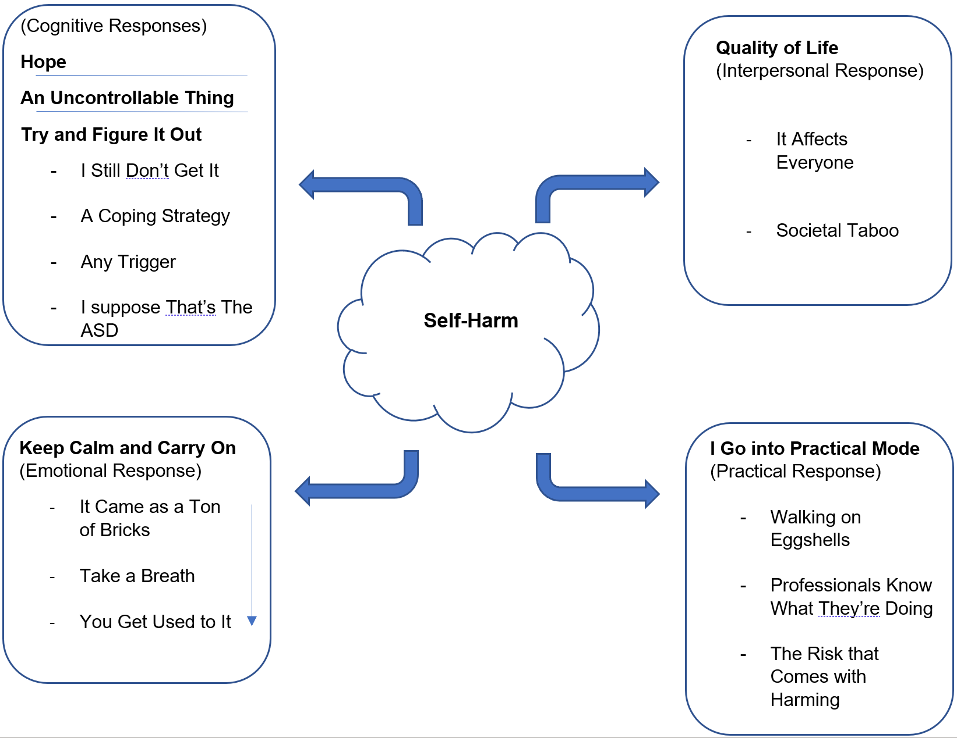

Figure 2.
Illustrative Summary of Findings

DISCUSSION

Qualitative research has previously been conducted into parental experience and sense-making of adolescent self-harm in neurotypical populations, but no research to date has wholly applied this approach to an ASD population. An IPA approach was used to explore this phenomenon.

The first aim of this study was to explore parental sense-making of their child’s self-harm within the context of them having an ASD diagnosis. The main themes found were around parents feeling confused, experiencing a process of conceptualising self-harm, and attempting to attribute reason for the self-harm to help them cope with the behaviour. The second aim was to explore how parents experience the impact of self-harm. The main themes found were around parents managing their emotional reaction and taking a pragmatic approach to managing difficulties. Participants described how the experience had negatively affected their quality of life, although participants drew on positives and tentative hopefulness to aid their sense of coping.

Participants were confused by their child’s self-harm and strived to make sense of the behaviour. Self-harm was viewed as something which was compulsive and was conceptualised by some parents as being like an addiction. This suggests that parents try to use existing frameworks of knowledge and try to make sense of something seemingly incomprehensible. This relates to constructivism as an approach to making sense of self-harm, where individuals actively construct meaning, built on previous knowledge (Phillips, 1995). Interestingly, parental experiences reflected similar themes to those identified in adolescent addiction literature (Choate, 2011; Choate, 2015; see Blasco-Fontecilla et al, 2016).

In the process of sense-making, parents tried to understand the functions, triggers and underlying causes to the self-harm. Here, triggers were viewed as being outside their child’s control, such as puberty or transitions/change in life. Autism was attributed as an underlying cause, which is similarly uncontrollable. Making sense of self-harm in this way removes blame from the child. The Attribution-Affect-Action model of helping behaviour (Weiner, 1980; Schmidt & Weiner, 1988) proposes that the way in which individuals attribute cause influences the way they feel, which subsequently influences the action they take. Here, attributing self-harm to an uncontrollable cause may elicit empathy, which would generate help-giving behaviours and support from parents. Indeed, findings also indicated that parents engaged with practical, help-orientated behaviours regarding risk management and seeking support from services. However, like prior research, parents who accessed professional help felt largely unsupported (Kelada, Whitlock, Hasking & Melvin, 2016). Reports that services were not sufficiently helpful appears associated with parental perception of risk, and services having insufficient ‘resources’ to support children with autism.
Parents’ views of the triggers and functions of self-harm were the same as what neurotypical children themselves report, such as affect regulation (see Taylor et al, 2018). At the same time, parents considered how autism symptomology may influence self-harm or how issues such as feeling ‘different’ to peers may be triggering, in line with previous research that a perception of social exclusion is a risk factor for self-harm (Brunner et al, 2014; Lereya et al, 2013). This perhaps suggests that parents try and grasp this complex behaviour through converging understandings of autism and self-harm.

Self-harm was found to have a significant emotional impact on parents, where several participants sought therapy for their own wellbeing. This fits with previous research suggesting that discovering a child’s self-harm is a traumatic experience, where parents may experience ‘secondary traumatic stress’ as they are exposed to their child’s distress (Figley, 1995; Raphael, Clarke & Kumar, 2006; Whitlock et al, 2018). Findings indicated that strong emotional responses diminished over time as parents de-sensitised to self-harm and became more distant to it, which may perhaps be indicative of compassion fatigue and burnout (Figley, 1997). Indeed, higher levels of personal distress is associated with higher secondary traumatic stress (Thomas, 2013). Parents also recognised that their strong emotional responses were not helpful for their child, in line with previous research that parental distress has an adverse effect on children (Wagner et al, 2003; Chow, Otis & Simons, 2016).

Participants in this study reported that self-harm impacted on their parenting regarding managing boundaries, where parents were ‘walking on eggshells’ to avoid triggering self-harm. Previous research shows mixed findings around this (Beatens et al, 2015; Byrne et al, 2008). This is interesting considering that parents of children with autism have been found to be less authoritative compared to parents of neurotypical children (Rutgers et al, 2007). Changes in parenting strategies are considered as part of the NSSI Family Distress Cascade Theory (Waals et al, 2018). However, this theory proposes that as parents become distressed by the self-harm, parents implement more controlling behaviours and tighter boundaries, which escalates self-harm as adolescents perceive a threat to their autonomy. Current findings therefore suggest that this theory may be limited at least for ASD populations.

Participants reported experiencing a significant disruption to their quality of life regarding the impact on siblings and family functioning as well as an impact on social life, which was partially associated with negative societal attitudes towards self-harm. Ferrey et al (2016) reported similar parental concerns for siblings, social isolation and stigma, where stigma is established as a prominent issue facing those who self-harm (Haskin & Boyes, 2018; Law, Rostill-Brookes & Goodman, 2009). Participants expressed cautious hope for the future and focused on positive factors including friendships and improvements in the parent-child relationship. This may be significant as prior research has indicated parental support as a protective factor (Tatnell, Kelada, Hasking, & Martin, 2014; Jiang, You, Zheng & Lin, 2017).

Findings from the present study were largely comparable to previous research on self-harm involving parents of a neurotypical adolescent population with regards to the purpose of self-harm and the impact it has on parents and families (Arbuthnott & Lewis, 2015; Byrne et al, 2008; Oldershaw, Richards, Simic & Schmidt, 2008; Raphael, Clarke & Kumar, 2006).This suggests that parents conceptualise self-harm in an ASD population in a similar way to current understanding of self-harm, although children having an ASD diagnosis perhaps aided parents in externalising and empathising with the behaviour.

Clinical Implications

The findings from this study illustrate the significant impact that adolescent self-harm can have on parents, as well as parents’ instinctive response to trying to gain knowledge and understanding about their child’s behaviours. Parent support groups would offer an appropriate space to share experiences, understanding, advice and information about self-harm (Rissanen, Kylma & Laukkanen, 2009). They would also offer relief from social isolation and feeling alone in their difficulties (Bryne et al, 2008; Nixon et al, 2004), and help parents with some of the emotional consequences of adolescent self-harm, such as self-blame and risk of compassion fatigue (James et al, 2020). Social inclusion is a significant merit of face-to-face support groups, although online groups (Clifford & Minnes, 2013; Solomon, Pistranf & Barker, 2001), and telephone support groups (Ritchie et al, 2000) have merit. Parents may benefit from telephone helplines (Shor & Birnbaum, 2012) which offer 1:1 confidential support. Services should be aware of the extent that adolescent self-harm can impact parents; it would be appropriate to monitor secondary traumatic stress responses and parental burnout (see Roskam, Raes & Mikolajczak, 2017), and actively promote such support groups and helplines.

Information packs, websites, and leaflets should be routinely provided to parents to support their understanding of this behaviour. In one study, patient information leaflets were the second most frequently used information source for parents seeking information about their child’s healthcare, which was deemed as more reliable than nurses (Holappa et al, 2012). In the UK, ‘Coping with Self-Harm: A Guide for Parents and Carers’ (Self Injury Support, 2016) has recently been produced, however it appears that this is not yet being widely received by parents. Psychoeducation groups are also found to be beneficial in aiding parental understanding, which can itself be an intervention (McCleary & Ridley, 1999; Holtkamp et al, 2005; Miller & Smith, 2008).

The impact that self-harm can have on family functioning should be addressed. A notable treatment for self-harm, DBT, generally includes family therapy (Miller & Smith, 2008). Although not evidenced in an ASD population, research suggests that family-based interventions for self-harm may offer more favourable outcomes than routine care, showing improvements for family functioning as well as reduced self-harm (Pineda & Dadds, 2013). For parents concerned about the impact on siblings, groups which support siblings of children with autism could be tailored to include support around self-harm (Sibs, 2020; Smith & Perry, 2005). Interventions could also target traits of autism such as assisting with understanding social interaction and communication, as parents attributed self-harm to difficulties associated with autism.

The young people in this study had a different presentation to the neurotypical population because of their differences associated with autism. This was reported by parents as a barrier to getting support, as their children struggled to engage with typical treatments offered to neurotypical children. It would be beneficial for CAMHS services in the UK to have more robust training in autism conditions to be able to offer tailored interventions.

Clinicians in CAMHS may need to work more closely with families regarding risk. Research suggests it is important to include parental concerns in risk assessments, where a pilot study found that parental concern about self-harm was predictive of risk, while clinician assessment of risk did not predict further behaviours (Cassidy et al, 2009). Participants reported a sense that services did not meet their needs particularly when they felt that their child was engaging with risky behaviour.

Strengths and Limitations

This is a clinically relevant and original study investigating self-harm in adolescents with autism from a parental perspective. While the experience of parents can be interpreted, there remains a need to gain an understanding about self-harm in an ASD adolescent population from the young people themselves.

Participants were recruited from online parent support groups and websites. Individuals often use such groups for seeking and sharing information, seeking emotional support, or to feel a sense of ‘friendship’ and social connectedness (Perron, 2002). This selection bias may have influenced findings.

Due to available timeframes, service-users were not consulted in the development of the semi-structured interview schedule. Such involvement is important; research benefits from gaining a service-user focus, and service-users can improve their knowledge and sense of wellbeing-being (Minogue et al, 2005). Although this lack of service-user focus could lead to bias, IPA emphasises an idiographic approach, focussing on depth of individuals’ experiences, meaning the research arguably retains service-user focus.

While research supervision and a reflective journal was used to bracket personal biases for confirmability, it would have been beneficial to have had an independent clinician review the transcripts and comment upon the interpretations. This would improve the dependability and credibility of the research, although this is challenging in IPA research due to the significance of the double hermeneutic in interpretation.

Future Research

Future research should expand on the current research by considering the views of young people themselves, where it is ethically appropriate to do so. Such research would likely need adapting to make it appropriate for individuals with autism.

Longitudinal research following parents of children with ASD who self-harm would offer further insights into their experience of managing the impact of self-harm and how parents come to habituate to self-harm over time. Further research is needed around parental experience of attributing cause and how this impacts on their experience of the phenomenon.

Research should also consider investigating alternative treatment options, such as family-based interventions, and how these may need to be adapted to include siblings and the adolescent with ASD. Interventions should aim to include goals around improving family functioning and communication as well as reducing self-harm behaviours. There is a need to explore parental experiences of accessing support and evaluating the impact of parent support groups and use of helplines to give better indication as what support is most beneficial to parents. Research should also evaluate the role of psychoeducation materials in helping these parents, where there may be a need to adapt existing self-harm materials to be more relevant to parents of young people who also have autism.

CONCLUSION

This research aimed to explore how parents experience sense-making and the impact of self-harm when their child also has autism. Parents actively engaged with constructing meaning to their child’s behaviour, which some viewed as conceptually similar to an addiction. Understanding of self-harm developed over time and was attributed to autism and triggers outside of their child’s control, which appears to help parents cope with the behaviour. Parents experience significant emotional distress after discovering self-harm, but they habituate to this over time, and may experience a sense of compassion fatigue. Self-harm had a notable impact on family life and parenting approach. This said, participants were able to express hopefulness. Further research is needed exploring this phenomenon with adolescents themselves, and research should explore the process by which parents adjust to self-harm. There is a need for parental support groups, psychoeducation, and family-based interventions.

REFERENCES

American Psychiatric Association. (2013). Diagnostic and statistical manual of mental disorders (5th ed.). Washington, DC: Author.

Arbuthnott, A. E., & Lewis, S. P. (2015). Parents of youth who self-injure: a review of the literature and implications for mental health professionals. Child and adolescent psychiatry and mental health, 9(1), 35. https://doi.org/10.1186/s13034-015-0066-3

Baetens, I., Claes, L., Onghena, P., Grietens, H., Van Leeuwen, K., Pieters, C., Wiersema, J.R., & Griffith, J. W. (2015). The effects of nonsuicidal self-injury on parenting behaviors: a longitudinal analyses of the perspective of the parent. Child and adolescent psychiatry and mental health, 9(1), 24. https://doi.org/10.1186/s13034-015-0059-2

Blasco-Fontecilla, H., Fernández-Fernández, R., Colino, L., Fajardo, L., Perteguer-Barrio, R., & De Leon, J. (2016). The addictive model of self-harming (non-suicidal and suicidal) behavior. Frontiers in Psychiatry, 7, 8. https://doi.org/10.3389/fpsyt.2016.00008

Boonen, H., van Esch, L., Lambrechts, G., Maljaars, J., Zink, I., Van Leeuwen, K., & Noens, I. (2015). Mothers’ parenting behaviors in families of school-aged children with autism spectrum disorder: An observational and questionnaire study. Journal of autism and developmental disorders, 45(11), 3580-3593. https://doi.org/10.1007/s10803-015-2506-6

Boshoff, K., Gibbs, D., Phillips, R., Wiles, L., & Porter, L. (2016). Parent’s voices: ‘why and how we advocate’. A meta-synthesis of parents’ experiences of advocating for their child with autism spectrum disorder. Child: care, health and development, 42, 6, 784-797. https://doi.org/10.1111/cch.12383

Brophy M, & Holmstrom R. (2006). Truth hurts: report of the national inquiry into self-harm among young people. London: Mental Health Foundation.

Brunner, R., Kaess, M., Parzer, P., Fischer, G., Carli, V., Hoven, C. W., Wasserman, M., Sarchiapone, F., Resch, A., Apter, J., Balazs, S., Barzilay, J., Bobes, P., Corcoran, D., Cosmanm, C., Haring, M., Ioseuc, J.P., Kahn, H., Keeley, G., & Balazs, J. (2014). Life‐time prevalence and psychosocial correlates of adolescent direct self‐injurious behavior: A comparative study of findings in 11 European countries. Journal of Child Psychology and Psychiatry, 55(4), 337-348. https://doi.org/10.1111/jcpp.12166

Byrne, S., Morgan, S., Fitzpatrick, C., Boylan, C., Crowley, S., Gahan, H., Howley, J., Staunton, D., & Guerin, S. (2008). Deliberate self-harm in children and adolescents: a qualitative study exploring the needs of parents and carers. Clinical child psychology and psychiatry, 13(4), 493-504. https://doi.org/10.1177/135910408096765

Camelot Foundation & Mental Health Foundation. (2006). Truth Hurts: National Inquiry into Self-Harm Among Young People. https://www.mentalhealth.org.uk/sites/default/files/truth_hurts.pdf

Cassidy, C., McNicholas, F., Lennon, R., Tobin, B., Doherty, M., & Adamson, N. (2009). Deliberate self-harm (DSH): a follow-up study of Irish children. Ir Med J, 102(4). Retrieved from: https://d1wqtxts1xzle7.cloudfront.net/49552153/Deliberate_Self-Harm_DSH_a_follow-up_s20161012-9664-1h6nvun.pdf?1476295912=&response-content-disposition=inline%3B+filename%3DDeliberate_Self_Harm_DSH_a_follow_up_stu.pdf&Expires=1598564757&Signature=KIWYhv5MFs2ImTAAW2VCf99lsiOJkg-h7fUxoACt1J97QnL77m7iewoibuQxiCpAQwL4xTFxdCqsfd4Qcr4mtg0GdnLdD4Az507mXisqnw4tfYrXr3lxXpCq9i5TyZu1f2tpw4NClRr0hLMd3G3~bbpmAqh-zKbuaPEapIBt8KSwQibuhlvZ1q7lZw7H-KrJWraMUdAipCfe1mckxbi21weXNqn2fMle-gmg0Jy3TPNeFgtwab1CWHV-mQQU~vS7mDD9Bl8CLBgPUXpoo4Q9cjNpE6TmSU4yTqg7I0CRLU~VDJuLjoQb~-APWH-QMHLXCnQxPk431CfvspfPeqevbA__&Key-Pair-Id=APKAJLOHF5GGSLRBV4ZA

Choate, P. W. (2011). Adolescent addiction: What parents need? Procedia-Social and Behavioral Sciences, 30, 1359-1364. https://doi.org/10.1016/j.sbspro.2011.10.263

Choate, P. W. (2015). Adolescent alcoholism and drug addiction: The experience of parents. Behavioral sciences, 5(4), 461-476. https://doi.org/10.3390/bs5040461

Chow, E. T., Otis, J. D., & Simons, L. E. (2016). The longitudinal impact of parent distress and behavior on functional outcomes among youth with chronic pain. The Journal of Pain, 17(6), 729-738. https://www.ncbi.nlm.nih.gov/pmc/articles/PMC4885759/

Clancy, M. (2013). Is reflexivity the key to minimising problems of interpretation in phenomenological research? Nurse researcher, 20(6), 12-16. https://doi.org/10.7748/nr2013.07.6.12.c1209

Clifford, T., & Minnes, P. (2013). Logging on: Evaluating an online support group for parents of children with autism spectrum disorders. Journal of autism and developmental disorders, 43(7), 1662-1675. https://link.springer.com/article/10.1007/s10803-012-1714-6

Cook, N. E., & Gorraiz, M. (2016). Dialectical behavior therapy for nonsuicidal self‐injury and depression among adolescents: Preliminary meta‐analytic evidence. Child and Adolescent Mental Health, 21(2), 81-89. https://doi.org/10.1111/camh.12112

Davidov, M., & Grusec, J. E. (2006). Untangling the links of parental responsiveness to distress and warmth to child outcomes. Child development, 77(1), 44-58. https://doi.org/10.1111/j.1467-8624.2006.00855.x

Deakin, H., & Wakefield, K. (2014). Skype interviewing: Reflections of two PhD researchers. Qualitative research, 14(5), 603-616. https://doi.org/10.1177/1468794113488126

Dickstein, D. P., Puzia, M. E., Cushman, G. K., Weissman, A. B., Wegbreit, E., Kim, K. L., Nock, M.K., & Spirito, A. (2015). Self‐injurious implicit attitudes among adolescent suicide attempters versus those engaged in nonsuicidal self‐injury. Journal of child psychology and psychiatry, 56(10), 1127-1136. https://doi.org/10.1111/jcpp.12385

Fee, V. E., & Matson, J. L. (1992). Definition, classification, and taxonomy. In J. K. Luiselli, J. L. Matson, & N. N. Singh (Eds.), Self-injurious behavior: Analysis, assessment, and treatment (pp. 3 - 20). New York: Springer-Verlag.

Ferrey, A. E., Hughes, N. D., Simkin, S., Locock, L., Stewart, A., Kapur, N., Gunnell, D., & Hawton, K. (2016). The impact of self-harm by young people on parents and families: a qualitative study. BMJ open, 6(1), 1-7. http://dx.doi.org/10.1136/bmjopen-2015-009631

Figley, C. R. (1995). Compassion Fatigue: Coping with secondary traumatic stress disorder in those who treat the traumatised. New York: Routledge.
https://www.amazon.co.uk/Compassion-Fatigue-Secondary-Traumatized-Psychosocial/dp/0876307594

Figley, C. R. (1997). Burnout in families: The systemic costs of caring. Florida: CRC Press.
https://www.amazon.co.uk/Burnout-Families-Systemic-Innovations-Psychology/dp/1574440470/ref=sr_1_1?dchild=1&keywords=Burnout+in+families%3A+The+systemic+costs+of+caring.&qid=1598219319&s=books&sr=1-1

Fliege, H., Lee, J. R., Grimm, A., & Klapp, B. F. (2009). Risk factors and correlates of deliberate self-harm behavior: A systematic review. Journal of psychosomatic research, 66(6), 477-493. https://doi.org/10.1016/j.jpsychores.2008.10.013

Griffin, E., McMahon, E., McNicholas, F., Corcoran, P., Perry, I. J., & Arensman, E. (2018). Increasing rates of self-harm among children, adolescents and young adults: a 10-year national registry study 2007–2016. Social psychiatry and psychiatric epidemiology, 53(7), 663-671. https://doi.org/10.1007/s00127-018-1522-1

Hanna, P. (2012). Using internet technologies (such as Skype) as a research medium: A research note. Qualitative Research, 12(2), 239-242. https://doi.org/10.1177/1468794111426607

Hannon, G., & Taylor, E. (2013). Suicidal behaviour in adolescents and young adults with ASD: Findings from a systematic review. Clinical Psychology Review, 33, 8, 1197-1204. https://doi.org/10.1016/j.cpr.2013.10.003

Hasking, P., & Boyes, M. (2018). Cutting words: a commentary on language and stigma in the context of nonsuicidal self-injury. The Journal of nervous and mental disease, 206(11), 829-833. https://doi.org/10.1097/NMD.0000000000000899

Hawton, K., Saunders, K., & O’Conner, R. (2012). Self-harm and suicide in adolescents. The Lancet, 379, 9834, 2373-2382. https://dio.org/10.1016/S0140-6736(12)60322-5

HM Government (2019). Preventing suicide in England: Fourth Progress report of the cross-government outcomes strategy to save lives. Retrieved from: https://assets.publishing.service.gov.uk/government/uploads/system/uploads/attachment_data/file/772184/national-suicide-prevention-strategy-4th-progress-report.pdf

Holappa, M., Ahonen, R., Vainio, K., & Hämeen-Anttila, K. (2012). Information sources used by parents to learn about medications they are giving their children. Research in Social and Administrative Pharmacy, 8(6), 579-584. https://doi.org/10.1016/j.sapharm.2012.01.003

Hollocks, M. J., Lerh, J. W., Magiati, I., Meiser-Stedman, R., & Brugha, T. S. (2019). Anxiety and depression in adults with autism spectrum disorder: a systematic review and meta-analysis. Psychological medicine, 49(4), 559-572. https://doi.org/10.1017/S0033291718002283

Holtkamp, K., Herpertz-Dahlmann, B., Vloet, T., & Hagenah, U. (2005). Group psychoeducation for parents of adolescents with eating disorders: the Aachen program. Eating Disorders, 13(4), 381-390. https://doi.org/10.1080/10640260591005263

Hughes, N. D., Locock, L., Simkin, S., Stewart, A., Ferrey, A. E., Gunnell, D., Kapur, N., & Hawton, K. (2017). Making sense of an unknown terrain: how parents understand self-harm in young people. Qualitative health research, 27(2), 215-225. https://doi.org/10.1177/1049732315603032

Hugly, P., & Sayward, C. (1987). Relativism and Ontology. The Philosophical Quarterly, 37(148), 278 - 290. https://doi.org/10.2307/2220398

Hume, K., Boyd, B. A., Hamm, J. V., & Kucharczyk, S. (2014). Supporting independence in adolescents on the autism spectrum. Remedial and Special Education, 35(2), 102-113. https://doi.org/10.1177/0741932513514617

James, M. E. B. I. R., Kapala, J., Gerard, A. F. F., & Mikolajczak, M. (2020). Treating parental burnout: Impact of two treatment modalities on burnout symptoms, emotions, hair cortisol, and parental neglect and violence. Balance, 28(70.31), 0-91. https:// DOI.org/ 10.1159/000506354

Jiang, Y., You, J., Zheng, X., & Lin, M. P. (2017). The qualities of attachment with significant others and self-compassion protect adolescents from non suicidal self-injury. School psychology quarterly, 32(2), 143. https://doi.org/10/1037/spq0000187

Kelada, L., Whitlock, J., Hasking, P., & Melvin, G. (2016). Parents’ experiences of nonsuicidal self-injury among adolescents and young adults. Journal of child and family studies, 25(11), 3403-3416. https://doi.org/10.1007/s10826-016-0496-4

Klonsky, E. D. (2011). Non-suicidal self-injury in United States adults: prevalence, sociodemographics, topography and functions. Psychological medicine, 41(9), 1981-1986. https://doi.org/10.1017/S0033291710002497

Klonsky, E. D., May, A. M., & Glenn, C. R. (2013). The relationship between nonsuicidal self-injury and attempted suicide: Converging evidence from four samples. Journal of abnormal psychology, 122(1), 231-237. https://doi.org/10.1037/a0030278.

Kwan, K., & Tsang, E.W.K., (2001). Realism and Constructivism in Strategy Research: A Critical Realist Response to Mir and Watson, Strategic Management Journal, 22(12), 1163-1168. https://doi.org/10.1002/smj.199

Law, G. U., Rostill-Brookes, H., & Goodman, D. (2009). Public stigma in health and non-healthcare students: Attributions, emotions and willingness to help with adolescent self-harm. International journal of nursing studies, 46(1), 108-119. https://doi.org/10.1016/j.ijnurstu.2008.08.014

Lereya, S. T., Winsper, C., Heron, J., Lewis, G., Gunnell, D., Fisher, H. L., & Wolke, D. (2013). Being bullied during childhood and the prospective pathways to self-harm in late adolescence. Journal of the American Academy of Child & Adolescent Psychiatry, 52(6), 608-618. https://doi.org/10.1016/j.jaac.2013.03.012

Licence, L., Oliver, C., Moss, J., & Richards, C. (2019). Prevalence and risk-markers of self-harm in autistic children and adults. Journal of autism and developmental disorders, 1-14. https://doi.org/10.1007/s10803-019-04260-1

Maddox, B., Trubanova, A., & White, S. (2016). Untended Wounds: Non-suicidal self-injury in adults with autism spectrum disorder. Autism, 21 (4), 412-422. https://doi.org/10.1177/1362361316644731

Mage, N., Hewitt, A., Hawton, K., Jan de Wilde, E., Corcoran, P., Fekete, S., van Heeringen, K., De Leo, D., & Ystgaard, M. (2008). Deliberate self-harm within an international community sample of young people: comparative findings from the Child and Adolescent Self-harm in Europe (CASE) Study. Journal of Child Psychology and Psychiatry, 49, (6), 667-677. https://doi.org/10.1111/j.1469-7610.2009.01879.x

McCleary, L., & Ridley, T. (1999). Parenting adolescents with ADHD: Evaluation of a psychoeducation group. Patient Education and Counseling, 38(1), 3-10. https://doi.org/10.1016/S0738-3991(98)00110-4

Miller, A. L., Rathus, J. H., DuBose, A. P., Dexter-Mazza, E. T., & Goldklang, A. R. (2007). Dialectical behavior therapy for adolescents. In Dimeff, L.A. & Koerner, K. (Eds), Dialectical behavior therapy in clinical practice: Applications across disorders and settings (245-263). https://www.amazon.co.uk/Dialectical-Behavior-Therapy-Clinical-Practice/dp/1572309741

Miller, A. L. & Smith, H. L. (2008). Adolescent non-suicidal self-injurious behaviour: The latest epidemic to assess and treat. Applied and Preventive Psychology, 12, 178–188. https://doi.org/10.1016/j.appsy.2008.05.003

Minogue, V., Boness, J., Brown, A., & Girdlestone, J. (2005). The impact of service user involvement in research. International Journal of Health Care Quality Assurance, 18(2), 103-112. https://doi.org/10.1108/09526860510588133

Moseley, R. L., Gregory, N. J., Smith, P., Allison, C., & Baron-Cohen, S. (2020). Links between self-injury and suicidality in autism. Molecular autism, 11(1), 1-15. https://doi.org/10.1186/s13229-020-0319-8

National Health Service. (2019). Self-Harm. NHS Inform. Retrieved from https://www.nhsinform.scot/illnesses-and-conditions/mental-health/self-harm.

National Institute for Health and Care Excellence. (2017). Autism Spectrum Disorder in Under 19s: recognition, referral and diagnosis. Retrieved from https://www.nice.org.uk/guidance/cg128/chapter/Recommendations#recognising-children-and-young-people-with-possible-autism

Nixon, M. K., McLagan, L., Landell, S., Carter, A., & Deshaw, M. (2004). Developing and piloting community-based self-injury treatment groups for adolescents and their parents. The Canadian child and adolescent psychiatry review, 13(3), 62-67. https://www.ncbi.nlm.nih.gov/pmc/articles/PMC2538736/?tool=pmcentrez&report=abstract

Nock, M. K. (2010). Self-injury. Annual review of clinical psychology, 6, 339-363.

Oldershaw, A., Richards, C., Simic, M., & Schmidt, U. (2008). Parents' perspectives on adolescent self-harm: Qualitative study. The British Journal of Psychiatry, 193(2), 140-144. https://doi.org/10/1192/bjp/bp/107.045930

Perron, B. (2002). Online support for caregivers of people with a mental illness. Psychiatric Rehabilitation Journal, 26(1), 70. https://doi.org/10.2975/26.2002.70.77
Piaget, J., (1972). The principles of genetic epistemology, London: Routledge and Kegan Paul Books. https://www.amazon.co.uk/Principles-Genetic-Epistemology-Selected-Piaget/dp/0415168902

Pietkiewicz, I., & Smith, J. A. (2014). A practical guide to using interpretative phenomenological analysis in qualitative research psychology. Psychological journal, 20(1), 7-14. https://doi.org/10.14691/CPPJ.20.1.7

Pineda, J., & Dadds, M. R. (2013). Family intervention for adolescents with suicidal behavior: a randomized controlled trial and mediation analysis. Journal of the American Academy of Child & Adolescent Psychiatry, 52(8), 851-862. https://doi.org/10.1016/j.jaac.2013.05.015

Raphael, H., Clarke, G., & Kumar, S. (2006). Exploring parents' responses to their child's deliberate self‐harm. Health Education, 106 (1), 9-20. https://doi.org/10.1108/09654280610637166

Rissanen, M. L., Kylmä, J., & Laukkanen, E. (2009). Helping adolescents who self‐mutilate: Parental descriptions. Journal of Clinical Nursing, 18(12), 1711-1721. https://doi.org/10.1111/j.1365-2702.2008.02672.x

Ritchie, J., Stewart, M., Ellerton, M. L., Thompson, D., Meade, D., & Viscount, P. W. (2000). Parents’ perceptions of the impact of a telephone support group intervention. Journal of Family Nursing, 6(1), 25-45. https://doi.org/10.1177/107484070000600103

Roskam, I., Raes, M. E., & Mikolajczak, M. (2017). Exhausted parents: development and preliminary validation of the parental burnout inventory. Frontiers in psychology, 8, 163. https://doi.org/10.3389/fpsyg.2017.00163

Rutgers, A. H., van IJzendoorn, M. H., Bakersman-Karnenburg, M. J., Swinkels, S. H. N., van Daalen, E., & Dietz, C. (2007). Autism, attachment and parenting: a comparison of children with Autism Spectrum Disorder, Mental Retardation, Language Disorder and non-clinical children. Journal of Abnormal Child Psychology, 35, 859–870. https://doi.org/10.1007/s10802-007-9139-y.

Schmidt, G., & Weiner, B. (1988). An attribution-affect-action theory of behavior: Replications of judgments of help-giving. Personality and Social Psychology Bulletin, 14(3), 610-621. https://doi.org/10.1177/0146167288143021

Shaw, R.L. (2010). Embedding reflexivity within experiential qualitative psychology. Qualitative Research in Psychology, 7(3), 233-243. https://doi.org/10.1080/14780880802699092

Shor, R., & Birnbaum, M. (2012). Meeting unmet needs of families of persons with mental illness: evaluation of a family peer support helpline. Community mental health journal, 48(4), 482-488. DOI 10.1007/s10597-012-9504-3

Sibs. (2020). Siblings Group Leaders. https://www.sibs.org.uk/supporting-young-siblings/siblings-group-leaders/

Smith, J.A., Flowers, P., & Larkin, M. (2009) Interpretive Phenomenological Analysis: Theory, Method and Research. London: Sage.

Smith, J.A. & Osborn, M. (2015). Interpretive phenomenological analysis. In Smith, J.A. (Ed.), Qualitative Psychology: A Practical Guide to Research Methods (3rd ed.). London: Sage.

Smith, T., & Perry, A. (2005). A sibling support group for brothers and sisters of children with autism. Journal on Developmental Disabilities, 11(1), 77-88. https://oadd.org/wp-content/uploads/2016/12/smithperry.pdf

Solomon, M., Pistrang, N., & Barker, C. (2001). The benefits of mutual support groups for parents of children with disabilities. American journal of community psychology, 29(1), 113-132. https://doi.org/10.1023/A:1005253514140

Strang, J. F., Kenworthy, L., Daniolos, P., Case, L., Wills, M. C., Martin, A., & Wallace, G. L. (2012). Depression and anxiety symptoms in children and adolescents with autism spectrum disorders without intellectual disability. Research in Autism Spectrum Disorders, 6(1), 406-412. https://doi.org/10.1016/j.rasd.2011.06.015

Sullivan, J. R. (2012). Skype: an appropriate method of data collection for qualitative interviews? The Hilltop Review, 6(1), 10, 53-60. https://scholarworks.wmich.edu/hilltopreview/vol6/iss1/10/

Tatnell, R., Kelada, L., Hasking, P., & Martin, G. (2014). Longitudinal analysis of adolescent NSSI: The role of intrapersonal and interpersonal factors. Journal of abnormal child psychology, 42(6), 885-896. https://doi.org/10.1007/s10802-013-9837-6

Taylor, P. J., Jomar, K., Dhingra, K., Forrester, R., Shahmalak, U., & Dickson, J. M. (2018). A meta-analysis of the prevalence of different functions of non-suicidal self-injury. Journal of Affective Disorders, 227, 759-769. https://doi.org/10.1016/j.jad.2017.11.073

Thomas, J. (2013). Association of personal distress with burnout, compassion fatigue, and compassion satisfaction among clinical social workers. Journal of Social Service Research, 39(3), 365-379. https://doi.org/10.1080/01488376.2013.771596

Turpin, G., Barley, V., Beail, N., Scaife, J., Slade, P., Smith, J.A., & Walsh, S. (1997). Standards for research projects and theses involving qualitative methods: suggested guidelines for trainees and courses. Clinical Psychology Forum, 108, 3-7. https://shop.bps.org.uk/publications/publication-by-series/clinical-psychology-forum/clinical-psychology-forum-no-108-october-1997.html

Self Injury Support. (2016). Coping with Self-Harm: A Guide for Parents and Carers [Guide]. The University of Oxford. https://www.selfinjurysupport.org.uk/Handlers/Download.ashx?IDMF=6005501b-15f0-4189-80db-a70a4b9f162a

Waals, L., Baetens, I., Rober, P., Lewis, S., Van Parys, H., Goethals, E. R., & Whitlock, J. (2018). The NSSI family distress cascade theory. Child and adolescent psychiatry and mental health, 12(1), 52. https://doi.org/10.1186/s13034-018-0259-7

Wagner, J. L., Chaney, J. M., Hommel, K. A., Page, M. C., Mullins, L. L., White, M. M., & Jarvis, J. N. (2003). The influence of parental distress on child depressive symptoms in juvenile rheumatic diseases: the moderating effect of illness intrusiveness. Journal of pediatric psychology, 28(7), 453-462. https://doi.org/10.1093/jpepsy/jsg036

Weiner, B. (1980). A cognitive (attribution)-emotion-action model of motivated behavior: An analysis of judgments of help-giving. Journal of Personality and Social psychology, 39(2), 186-200. https://doi.org/10.1037/0022-3514.39.2.186

Whitlock, J., Lloyd‐Richardson, E., Fisseha, F., & Bates, T. (2018). Parental Secondary Stress: The Often Hidden Consequences of Nonsuicidal Self‐Injury in Youth. Journal of clinical psychology, 74(1), 178-196. https://doi.org/10.1002/jclp.22488

Yates, T. M. (2004). The developmental psychopathology of self-injurious behavior: Compensatory regulation in posttraumatic adaptation. Clinical Psychology Review, 24 (1), 35-74. https://doi.org/10.1016/j.cpr.2003.10.001

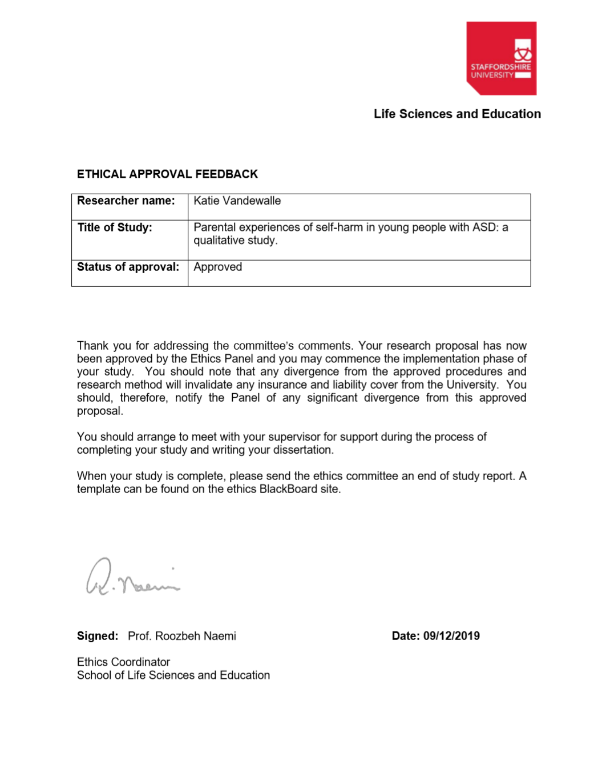
Appendix A. Ethical Approval
Appendix B. List of Websites and Organisations used for Advertising and Recruitment

- Parent Support Page – Children/ Teens who Self Harm (Facebook Support Group). https://www.facebook.com/groups/selfharmparentsupport/
- Self-Harm – Parents (Facebook Support Group). https://www.facebook.com/groups/339257352865468/
- Autism Support and Discussion Group (Facebook Support Group). https://www.facebook.com/groups/autismsupportanddiscussion/learning_content/
- Mumsnet. https://www.mumsnet.com/
- Simply Misunderstood. http://www.simplymisunderstood.co.uk/
- National Self-Harm Network Forum. http://www.nshn.co.uk/forum/
- PDA North West
- Twitter

Appendix C. Advertisement Poster

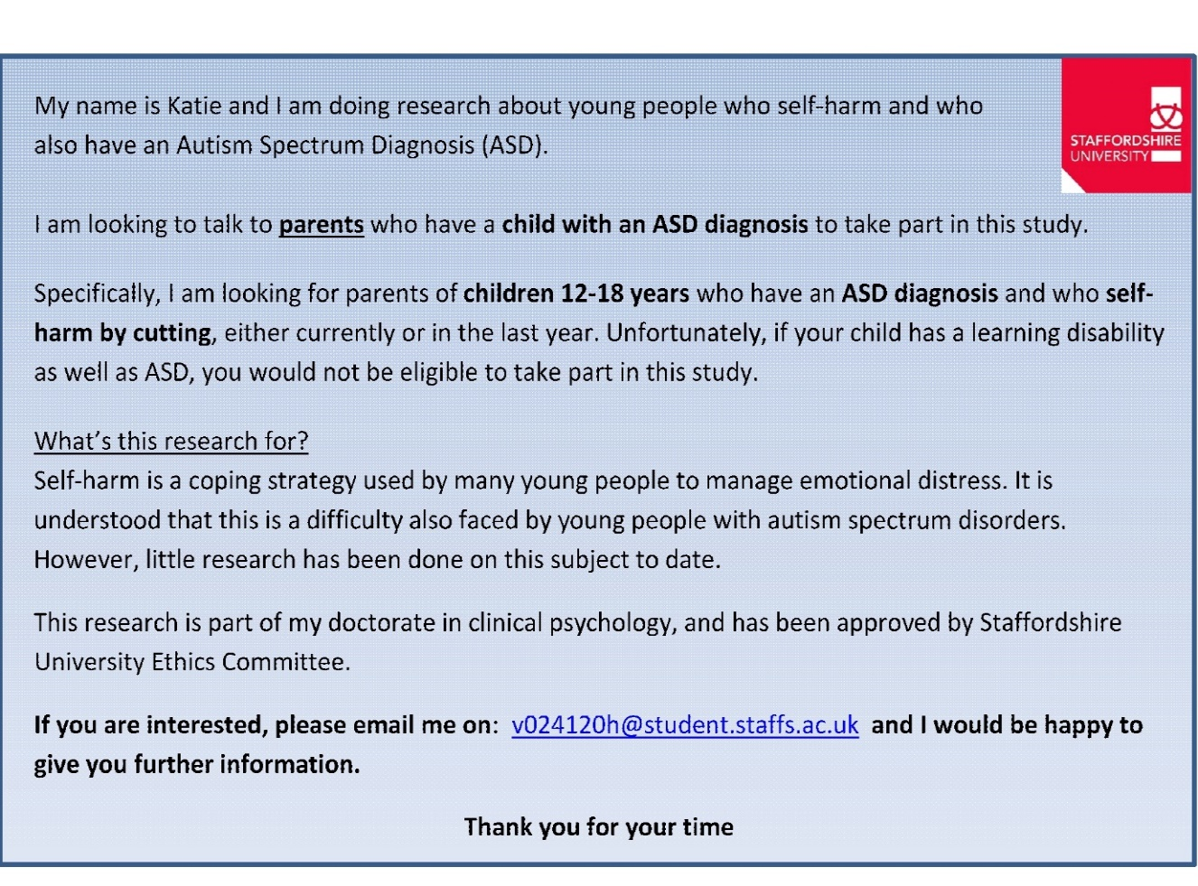

Appendix D. Participant Information Sheet
INFORMATION SHEET FOR PARTICIPANTS

Parental experiences of self-harm in young people with ASD: a qualitative study.

Invitation

My name is Katie Vandewalle. I am a trainee clinical psychologist, undertaking doctoral research on self-harm in children and adolescents with a diagnosis of ASD. Before you decide whether you want to take part, it is important for you to understand why the research is being done and what your participation will involve. Please take time to read the following information carefully and discuss it with others if you wish. Ask me if there is anything that is not clear or if you would like more information.

What is the Purpose of the Study?

Self-harm is a coping strategy used by many young people to manage emotional distress. It is understood that this is a difficulty also faced by young people with autism spectrum disorders, however little research has been done on this subject to date. This study seeks to interview parents of children with autism who self-harm and aims to explore what parents understand by their child’s behaviour, and what impact this has on them as parents.

Can I take part?

You are welcome to take part in this study if the following applies to you:
- You are a parent of a child aged between 12-18years who has a diagnosed Autism Spectrum Disorder.
- Your child has self-harmed by cutting themselves at any time in the last year.
- Your child may/ may not have difficulties with anxiety and/or depression.
- Your child does not have a learning disability or other diagnosed mental health disorder besides anxiety and/or depression.
- You can speak and understand English language and reside in the UK.

What will happen if I take part?

To take part in this study, you would be either required to participate in a face-to-face interview at Staffordshire University, Stoke-on-Trent site, or you can participate via a Skype call. Here, you would be asked to take part in an interview lasting approximately 1 hour. The interviewer will ask questions around your understanding of your child’s behaviour, and how this has impacted on you. The interview will be conducted in a single session to be least disruptive to your time. With your consent to take part in the study, interviews would be tape recorded on a Dictaphone, so a transcript from the interview can be produced, analysed, and discussed in a research paper and thesis. Transcripts will be anonymised so you will not be identifiable in any report of the research that is written up and shared with others. Taking part in the study will not impact on the service or care currently offered to your child.

Do I have to take part?

Participation is completely voluntary. You should only take part if you want to and choosing not to take part will not disadvantage you in anyway. Once you have read the information sheet, please contact us if you have any questions that will help you make a decision about taking part. If you decide to take part we will ask you to sign a consent form and you will be given a copy of this consent form to keep.

What are the possible benefits of taking part?

Although this study cannot offer any immediate assessment or treatment benefits to yourself or your child, this research hopes to generate wider benefits for children and families across the country who experience similar difficulties and concerns. Outcomes of this study may have implications for the way that young people with autism are assessed and treated for their self-harm, as well as generating an awareness about the emotional impact that parents face, and the support that they might need. Other outcomes of this study may include an increased awareness of this presentation in young people, which promotes further research in the area to provide the best care and service.

What are the possible disadvantages or risks of taking part?

This research should not impact upon your physical health and wellbeing in any way. For some individuals, in completing this study there is risk of emotional distress and anxiety in discussing your child’s self-harm. This can be a sensitive and difficult subject to address, and your child’s self-harm may have had an impact on your own emotional wellbeing. Should you require further support around this topic after our interview, information is provided on a separate document about different services available to you which can provide information, support, advice and advocacy.

Data Handling and Confidentiality

Your personal information (eg consent forms, contact details) will be kept in a secure filed location within Staffordshire University, and this will be destroyed as soon as the study is finished and after you have received a summary of the research paper produced. Audio recorded data from your interview will be deleted after it has been transcribed. All other non-identifiable data will be kept and filed away securely for a period of 10 years in line with university regulations, after which time all information will be destroyed. It is the responsibility of the researcher to ensure that all data is safely secured for this 10 year period until data can be disposed of.
Confidentiality will only be breached in the event of disclosure of information which may raise concerns regarding the welfare of your child. Where significant concerns are raised, the lead researcher would contact emergency services to initiate suitable support.

Your data will be processed in accordance with the General Data Protection Regulation 2016 (GDPR).

Dissemination

The research may be written up for publication in a journal and thesis, however any personal data or quotes reported in the research paper will be kept confidential by giving you and your child a pseudonym to ensure that you remain anonymous. This method of ensuring your confidentiality will similarly be applied should the study be shared with other persons. For example, this study may be shared with healthcare and academic staff at conferences or training presentations, or it may be distributed to other parents of children with ASD for discussion in support groups etc.

Data Protection Statement

The data controller for this project will be Staffordshire University. The University will process your personal data for the purpose of the research outlined above. The legal basis for processing your personal data for research purposes under GDPR is a ‘task in the public interest’. You can provide your consent for the use of your personal data in this study by completing the consent form that has been provided to you.

You have the right to access information held about you. Your right of access can be exercised in accordance with the General Data Protection Regulation. You also have other rights including rights of correction, erasure, objection, and data portability. Questions, comments and requests about your personal data can also be sent to the Staffordshire University Data Protection Officer at dataprotection@staffs.ac.uk. If you wish to lodge a complaint with the Information Commissioner’s Office, please visit www.ico.org.uk

What to expect during the consent process

The consent process will include giving full information for you to be able to take part in the study. You will be given a consent form which outlines the conditions of taking part in the study, including your right to withdraw, your right to remain anonymous, and that you have been given sufficient information about the study to knowingly consent to take part. Consent forms will be signed and kept securely. You will also be asked to give verbal consent which will be recorded at the beginning of your interview.

What if I change my mind about taking part?

You have a right to withdraw from the study without reason or explanation. Should you withdraw from the study, your personal data will be destroyed along with any information that had been recorded from the interview session. Withdrawing from the study will not impact on the current treatment or service provided to your child. It is possible to withdraw from the study by contacting the lead researcher by email or telephone, provided at the end of this information sheet. You are free to withdraw at any point until the data has been analysed, which will be up to 2 weeks of the interview taking place. This is because the information will no longer be identifiable to you personally to be destroyed. If you choose to withdraw from the study we will not retain any information that you have provided to us as a part of this study.

Who has reviewed this study?

This study has received ethical approval from the Ethics Committee at Staffordshire University.

What if I have further questions, or if something goes wrong?

If this study has harmed you in any way or if you wish to make a complaint about the conduct of the study you can contact the researcher, their supervisor, or the Chair of the Staffordshire University Ethics Committee for further advice and information. These details are provided below. If this study causes any negative impact on your psychological wellbeing and you wish to seek support, contact details of a number of organisations which can provide information, advice, support groups and advocacy can be found in the attached document ‘Support Groups, Information and Advice’.

Further information/Contact details

Lead Researcher: Katie Vandewalle
Contact Telephone Number: 07495 502516
Email Address: v024120h@student.staffs.ac.uk

Academic Supervisor: Dr Yvonne Melia
Email Address: Yvonne.Melia@staffs.ac.uk

Chair of University Ethics Committee: Dr Roozbeh Naemi
Contact telephone number: +44 (0)1782 295879
Email Address: r.naemi@staffs.ac.uk

Thank you for reading this information sheet and for considering taking part in this research.
Appendix E. Support Groups, Information and Advice

North Staffs Autism/ Asperger Association.
Provides help, support and advice to individuals with ASD, parents and carers.
Address: 14A King Street, Newcastle, ST5 1EJ
Tel: 01782 627002
Email: info@nsaaa.co.uk

ADD-vance (ADD-vance ADHD and Autism Trust Hertfordshire)
Supports families affected by ASD, ADHD, and related conditions
Tel: 01727 833963
Email: herts@add-vance.org

Autism East Midlands
Provides support to adults, children and families affected by ASD
Tel: 01909 506 678
Email: enquiries@autismeastmidlands.org.uk

Lincolnshire Autistic Society
Tel: 01775 821213
Email: enquiries@lincolnshireautisticsociety.org.uk
Provides information and support about ASD

Child Autism UK
Tel: 01344 882248
Email: info@childautism.org.uk
Provides support and advice and services for children with ASD

National Autistic Society
Provides services and support to those affected by ASD
Helpline number: 0808 800 4104

LifeSIGNS
Provides support and guidance to those who self-harm
Email: www.lifesigns.org.uk

The Samaritans Helpline
A service which provides support to those in emotional distress
Tel: 116 123

Advocacy

ASIST
Address: Winton House, Stoke road, Stoke on Trent, ST4 2RW
Tel: 01782 845584
Email: enquires@asist.co.uk

Wigan Family Welfare
Address: St Catherine’s House, Catherine Terrace, Scholes, Wigan, WN1 3JW
Tel: 01942 867888
Email: admin@wiganfamilywelfare.co.uk
Appendix F:
CONSENT FORM

Title of Project: Parental experiences of self-harm in young people with ASD: a qualitative study
Initials

Name of Researcher: Katie Vandewalle
- I confirm that I have read and understood the information sheet for the
above study. I have had the opportunity to consider the information, ask questions and have had these answered satisfactorily.

- I understand that my participation is voluntary and that I am free to withdraw without giving any reason, without my medical care or legal rights being affected. I understand that I have up to two weeks after the interview has taken place to withdraw my data, after which time my data will be anonymised and no longer be personally identifiable.

- I understand that my interview will be audio recorded

- I understand that my personal information will be confidential and stored securely until such a time that it is deleted/ destroyed. Identifiable and personal data will be destroyed as soon as the study is completed. Audio data will be destroyed as soon as transcription has been completed and initial analysis has taken place. I understand that all other non-identifiable information and data will be kept securely until it is destroyed after 10 years, in line with University regulations.

- I understand that my confidentiality will be breached should I raise any serious issues which would call my child’s welfare into question.

- I understand that the information I provide will be anonymised so neither myself nor my child will be identifiable when the research is disseminated. This includes anonymity when quotes or excerpts are used in the research report.

- I understand that the data will be transcribed, analysed, discussed and will be disseminated in a number of ways (e.g. thesis, journal, research conferences, training).

- I am entitled to receive feedback and information about the findings of the study

- I agree to take part in the above study.

Name of Participant Date Signature

Name of Researcher Date Signature

Appendix G. Semi-Structured Interview Schedule

Icebreakers:
Tell me a bit about yourself?
Tell me a bit about your family? (prompt: what can you tell me about your child?)

Can you think back to the time when you first found out that your child was self-harming? What was going on in their life at that time?

How do you think it came about that your child started self-harming?
(prompt: how did they find out about the concept of self-harm?)
(prompt: what might have made them first choose to self-harm?)
(prompt: can you describe what they did?)
(prompt: how did you make sense of this at the time?)

What might have been happening directly before an incident of self-harming?
(prompt: what might cause it at a certain time specifically?)
(prompt: can you think back to a particular example of an incident, and how you make sense of this now?)

How do you think your child experiences self-harm?
(prompt: How do you think your child feels after an incident of self-harm?)

When you first found out that your child was self-harming, what did you personally experience?
(prompt: thoughts, feelings, behaviour, relationship changes).

What did you do in response to the self-harm, and how might this be different now?

Has your understanding of the meaning of self-harm for your child changed over time?
(prompt: how do you feel when you think about it now? – thoughts, feelings, behaviour, relationship changes)

Is there anything else you would like to add that seems important about your experience of your child’s self-harm?

Appendix H:
Demographics Questionnaire

Relating to the participant (parent)
- What is the participant’s age?
- What is the participant’s gender?
- What is the participant’s ethnicity?
- What is the participant’s geographical location in the UK?

Relating to the adolescent with ASD who self-harms
- What is the age of the young person?
- What is the gender of the young person?
- What age did they receive their ASD diagnosis?
- Do they have any additional diagnoses?
- At what age did they start to self-harm by cutting?

Appendix I. Participant Debrief Form

Participant Debrief Form

Study Title: Parental experiences of self-harm in young people with ASD: a qualitative study

Thank you for participating in this research. This research aimed to explore how parents understand their child self-harming in the context of them having an autism spectrum disorder (ASD). The research also aimed to explore what impact this experience has had on you.

No research has been done on this topic to date, so we conducted exploratory interviews to gain more insight into this area. This insight will inform the way that assessments and interventions may be offered to you people with ASD who self-harm. It will also help to inform us about what support parents might need and what services need to consider offering moving forwards.

If you wish to withdraw from this study, please contact the researcher within the next two weeks. Your data will be treated in accordance with GDPR guidance and any data disseminated will be anonymised to keep your identity confidential. Once the research is completed, you will receive an Executive Summary outlining information and findings of the research.

If you have any questions or complaints associated with your participation in this research, please contact the lead researcher on the contact details provided below. For further support or advice, please refer to the details provided in the ‘Support Groups, Information and Advice’ document.

Again, thank you for your participation in this research.

Lead Researcher: Katie Vandewalle
Contact Telephone Number: 07945 502516
Email Address: v024120h@student.staffs.ac.uk

Academic Supervisor: Dr Yvonne Melia
Email Address: Yvonne.Melia@staffs.ac.uk

Appendix J. Initial Notes and Emergent Themes (Extract from ‘Elsie’)
Emergent Themes
Initial Notes
Transcript
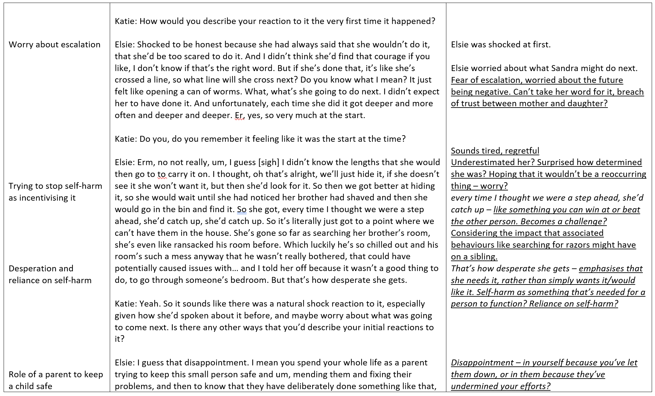

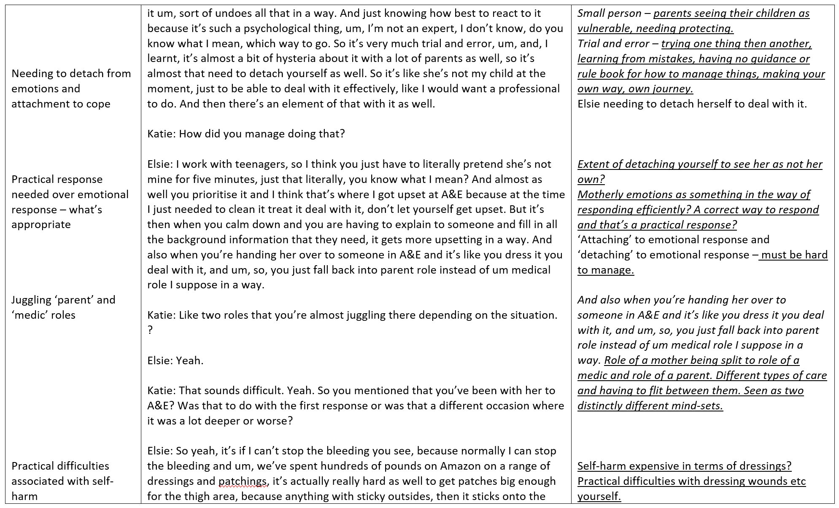
Transcript
Emergent Themes
Initial Notes

Initial Notes
Transcript
Emergent Themes
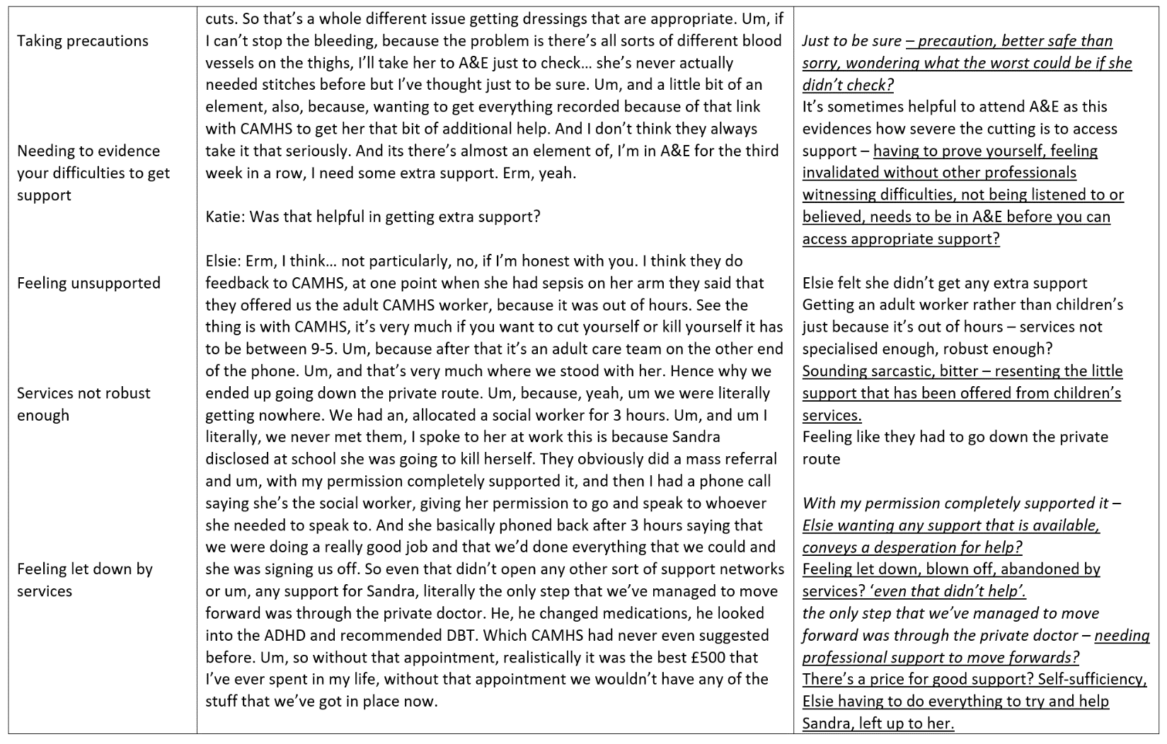

Appendix K. Reviewing Emergent Themes (for ‘Elsie’)

It’s a complicated presentation, difficult to understand

Unremarkable background, couldn’t have predicted from significant life events

History of anxiety and skin picking

Medication increasing suicidal ideation – help being unhelpful

Sudden escalation overwhelming

Desperate for an efficient release

Repetitive habit that’s become addictive

Noticing positives

Secrecy

Rigid thinking around purpose of razors

Identifying what’s autism and what’s mental health

Self-harm prevalent as a social norm

Self-harm as a natural escalation when seeking regulation

Uncertainty where the desire stems from in people

Self-harm as sensory input

Self-harm as satisfying

Trying to work things out

Impact of change and transition for young people with ASD
How to manage/ cope with anxiety

Impact on schools and teachers

Lack of early intervention and support

Needing to validate why support is needed

Separation anxiety

Seeking meaning, asking ‘why’

Expectations on children to adjust to change

Misinterpreting expressions and non-verbal information

Needing more individual support at school

Coping with anxieties about friendship groups
Parents taking responsibility

Finding different ways of managing

Benefits of flexible approaches

Parental concern and self-doubt

Difficult relationships with support networks/ schools

Doors being shut

Parental effort, fighting for child

Limited coping strategies, findings ways to manage

Purpose of self-harm changing over time

Trying to stop a child self-harming

Parental acceptance that you can’t fix everything

Triggered by depression and stress

Self-harm as distraction from emotional distress

Panic and infection – drawbacks of self-harm

Guilt for self-harming, aware of impact on others

Visual pleasure to self-harm

Talking about self-harm with others

Emotional initial reaction, upset, shock

Worry about escalation

Trying to stop self-harm as incentivising it

Desperation and reliance on self-harm

Role of a parent to keep a child safe

Needing to detach from emotions and attachment to cope

Practical response needed over emotional response – what’s appropriate

Juggling ‘parent’ and ‘medic’ roles

Practical difficulties associated with self-harm

Taking precautions

Needing to evidence your difficulties to get support

Feeling unsupported

Services not robust enough

Feeling let down by services

Rejection from services having a negative impact on children’s wellbeing

Parents having to take the initiative

Using resources and needing to be resourceful

Having to be vigilant

Fear about suicide

Normalising the experience as part of day to day life

Comorbidity complicating the understanding

‘Part of life’, ‘just what we need to do’

External representation of internal state
Cognitive processing

Worry how normalising will be judged by others

Seeking advice from professionals

Professionals as experts

Value professionals experience and advice

Learning ways to manage together, collaborative

Valuing communication

Knowing vs understanding

Response and approach change over time

Meaning from spotting patterns and triggers over time

Addiction as framework for understanding self-harm

Rigid thinking and behaviours

Developing a routine around self-harm itself

Self-harm as communication and expressing feelings

Doubting self, uncertainty

Difficulties with social interaction and forming relationships
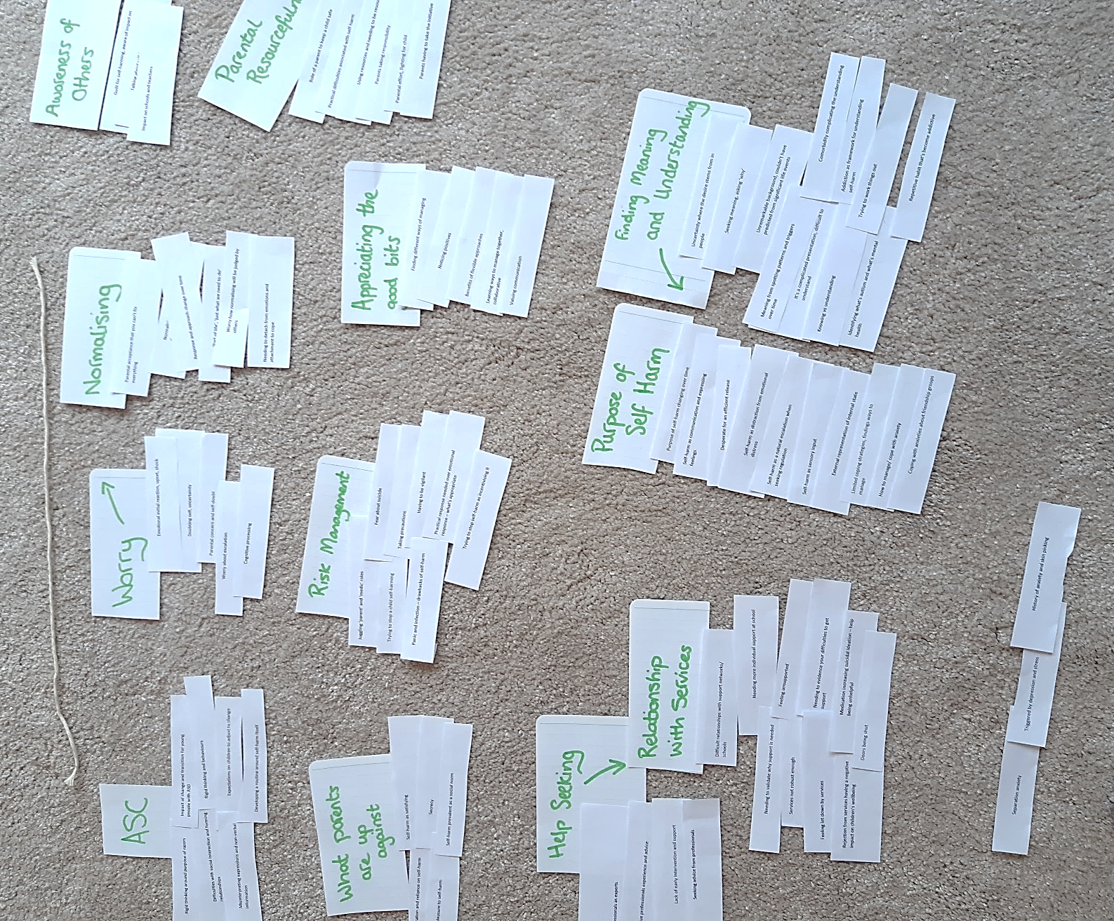
Appendix L. Generating Superordinate Themes from Emergent Themes (Example from Elsie)

Appendix M. Looking for Themes Across Cases (Where different colours represent individual participants’ superordinate themes)
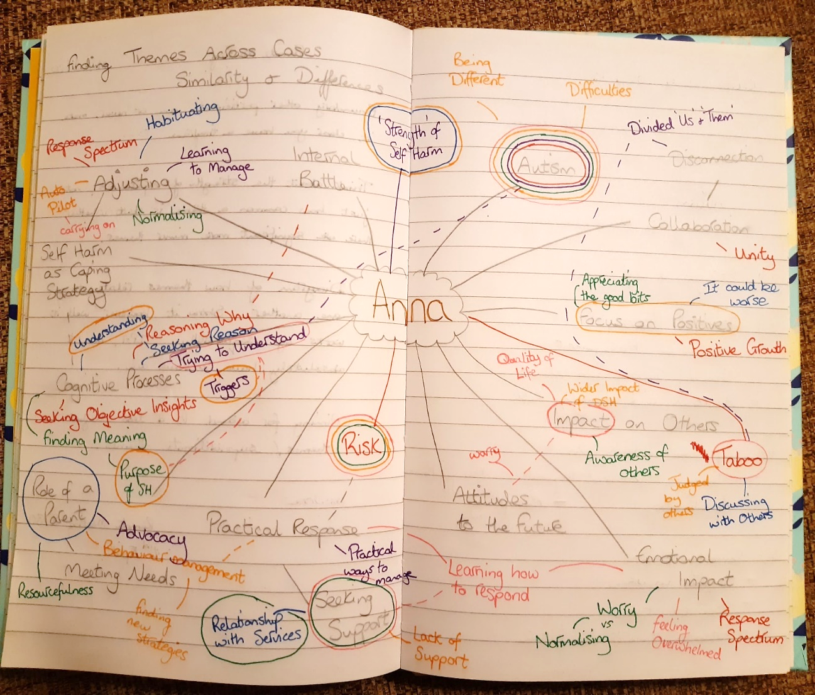

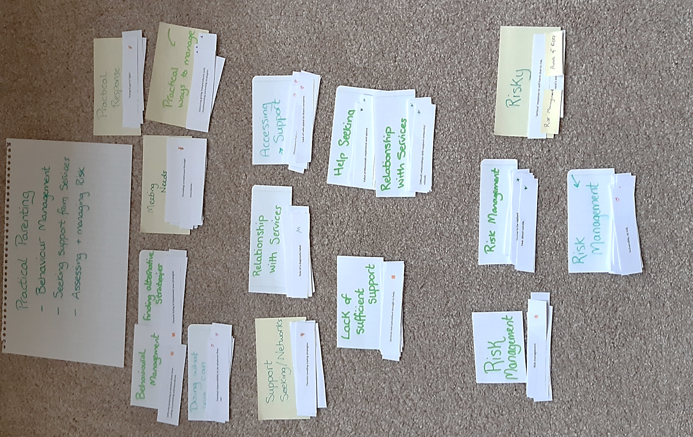
Appendix N. Grouping Higher Order Main Themes and Subordinate Themes from Case-by-Case Superordinate and Emergent themes. Data from ‘I Go into Practical Mode’.

Appendix O: Table to show data for Main Theme ‘I Go Into Practical Mode’ with Subordinate Themes

Main Theme: I Go Into Practical Mode
(Subordinate Themes: Behaviour Management, Seeking Support, Assessing and Managing Risk)

- Behaviour Management

Participant Pseudonym | Super-ordinate Theme | Emergent Theme | Quote | Transcript Lines
Anna | Meeting Needs/ Practical Response | Difficulty balancing parenting with protecting and preventing escalation | I think for a while, for a while I was walking on eggshells trying not to escalate situations, and not confront him. Yeah. So then, but then he became really rude [laughs] I think he took advantage of that a little bit. | 240-242
 |  | Practical approach to support | At some point I fished three knives out of his school bag, he took knives to school, and a guy in another academy just hurt another person, so school was really strict on that and actually they searched his bag a week later so he was really lucky that I had searched his bag that day. And then I did it quite regularly for a while. | 223-226
Cathy | Practical ways to manage | Balancing independence with implementing parenting strategies | She doesn’t have her phone in her bedroom at night the phone stays downstairs at night-time. She does take her phone upstairs but most of the time we say use the phone downstairs. I’ve not mentioned this actually, at one point um, when she was cutting, she was filming it and putting it, pictures of cuts on Instagram. | 308-312
Dan |  | Changing parenting style due to caution | well, we, we [sighs] we found ourselves walking on eggshells, making a lot of allowances, trying not to upset her. Yeah, I think, walking on eggshells is quite an apt phrase. | 195-196
Fran | Behavioural Management | Fight for power, behaviour management | Er, so I think a lot of the processes around it were, well how do I manage this situation, how do I keep this under some sort of control where he doesn’t manipulate the situation with, oh if you don’t do this I’m going to cut myself | 397-399
 |  | Difficulty balancing protecting them from cutting vs parenting and boundaries | but it’s been, it’s been a rough, rough ride, because when you’ve got a child who can self-harm at will, you know, they have that capacity to try and control situations with well if you don’t do this, I’m going to do this, or there will be a knock on effect if you’ve told them off for something. | 419-422
 |  | Trying to encourage and incentivise alternative coping strategies | I can’t just say, oh I’m going to give you this to encourage you not to hurt yourself, more a case of, oh you’ve not hurt yourself this week, would you like something. Or you’ve had a really good week, well done you’ve not hurt yourself. It’s kind of trying to fit that around saying that, and not bribing him to say don’t do that this week. Um, it’s a very, very fine line | 428-431
Greg | Doing what you can | Difficult to know how to respond, behaviour needing punishing? | We can’t, we can’t like punish her for it, say take her mobile phone or go on the xbox or nothing because that’s just, then it just escalates. | 73-75
 |  | Parents at their last resort trying everything | having this cat in this house is the most ridiculous thing ever, that’s just one thing that I can think of recently. She’s known for a long time that no-one in this house likes cats, not Kira’s brothers not Kira’s Mum not me, none of us, only Kira. Now she was really testing the boundaries of you know, how much, how far we will go to please her by going on about this kitten and erm, one night she was absolutely suicidal in her bedroom and nothing would shift, and we’d sat with her for nearly 3 or 4 hours, and I just, put my head in my hands and said do you want a kitten? And she stopped instantly. | 249-254

- Seeking Support

Participant Pseudonym | Super-ordinate Theme | Emergent Theme | Quote | Transcript Lines
Anna | Support Seeking/ Networks | Seeking support | I am having NHS counselling free, so I tried that but I didn’t feel it helped me. I joined support groups on facebook so at least, I mean I knew I wasn’t alone, but when I read what other people went through, you know I saw the same patterns, and um, once I actually wrote my own post and got a few responses. So that helped a little bit. | 361-364
 |  | Seeking personal support | But even the mental health nurse he is there for Scott, and Scott is now 16. I mean I can call him for advice, but it would be really helpful if someone could, you know, someone who has almost gone through it themselves, and they can give me some, you know a knowledgeable fellow parent or something. | 378-381
 |  | Support from services | And then I felt like I was the only advocate so it was always nice to have Steve there. You know, so I was always strongly encouraging Scott to keep, if nothing else but for liaising for school you know | 277-279
Beth | Under-standing | Trying to understand | But we’re getting support, we’re doing some reading about how to manage it. | 361-362
 |  | Getting Help | It’s like camhs but we don’t have camhs here anymore, we call it ELCAS. Erm, so we were referred into them, and it was like hit and miss | 95-96
Cathy | Practical ways to manage | Help seeking response | Then we went to the GP, the GP referred us to CAMHS... CAMHS did an assessment but at that stage we were told that she wouldn’t be taken on by CAMHS because she um, she wasn’t serious enough basically. And she got to another agency, things rolled on a bit, and round about, it was almost exactly this time two years ago erm, then it got a lot more serious. She told a friend at school that she made a plan to take her own life. Um so, at that stage all the bells and whistles went off and we got accepted by CAMHS very quickly then. She went straight into counselling, started having weekly counselling there | 49-55
 |  | Practical ways of managing | I, the way I deal with things I go into practical mode. I went very much into you know, we’re going to ring the GP, we’re going to look on this website, that’s my way of coping | 203-205
 |  | Seeking guidance | I would love more than anything to be able to go and talk to other parents who are going or have been through the same thing. And I haven’t been able to find anything in the local area. I don’t know, as a parent, not so much now, I think I’m better, but probably 18 months ago I was desperate to find someone else who I could talk to, who understood it more, had been through the same thing, and that’s been really hard. | 404-408
Dan | Relation-ship with Services | Diagnosis as means of accessing support | the diagnosis was only really a means to an end. The end was getting the psychiatrist to talk to her and she gets access to CBT, which didn’t really work for her, and then she went on to DBT which worked well. I wouldn’t say it really bothered us either way what letters they give her, but as a diagnosis, she got the help she needs | 431-434
 |  | Implicit trust in professionals | we did rely on them a lot. Because of course, we were totally inexperienced and out of our depth. So we did rely on them. If they said this, and we thought, this is a stupid idea but… you know. They’re the professionals so we’ll trust them, they know what they’re doing | 136-138
 |  | Misplaced trust in services | but er, you know, we talked it through and said, well look, we’re asking them for help, and even thought it doesn’t sound like something we’d want to do, they’re the experts we’re not, and we’ll trust them. It didn’t stop her you know. | 142-144
Elsie | Help Seeking | Value professionals experience and advice | It’s such a nice feeling to know that there’s another, um, there’s an expert involved basically. There’s someone that, um, I mean we’ve only got one Sandra, her brother couldn’t be more different, um, whereas they’ve probably got, I don’t think they’ve met another Sandra, but they’ve met girls that age with similar issues, they’ve done the research, they’ve got their, and I mean sometimes not being emotionally involved I think you can have a clearer picture. So it’s just nice knowing that there is someone who not only understands it but has got the skills to be able to help her and advise her. | 582-588
 |  | Lack of early intervention and support | we had already tried to get a referral to CAMHS through our GP because we knew things weren’t going well. That had been turned down, so then school did another referral basically saying that she wasn’t able to attend the school. And she’d written some quite dark stories in an English lesson, which we weren’t concerned about but they used that as evidence for CAMHS, and she got given a CAMHS appointment but that wasn’t until April time, and with her not going back to school in January between that time she just got worse and worse | 195-200
 |  | Seeking advice from professionals | I mean she’s only just finished off the pre-therapy, now she’s actually in therapy, so my plan is to try and contact them so anything coming up that I think might cause scratching or low moods, I’m able to say this is coming up, what do you advise, and the family worker can then speak to Sandra’s therapist and say, this is coming up, and then Sandra’s therapist can contact Sandra if she thinks it’s appropriate. So it’s like a big, like a bigger team now, whereas it has pretty much just been us, now we’ve got experts involved as well regularly | 571-576
 | Relation-ship with services | Services not robust enough | See the thing is with CAMHS, it’s very much if you want to cut yourself or kill yourself it has to be between 9-5. Um, because after that it’s an adult care team on the other end of the phone. Um, and that’s very much where we stood with her. Hence why we ended up going down the private route. | 467-470
Fran | Lack of Sufficient support | Having to be self-sufficient | Um… not got a huge amount of support outside of the household, um, certainly from services there’s nothing that anyone seems to be able to find that helps us as a family, a large extent can’t intervene or help in any way, other than one grandparent. And that’s it | 61-63
 |  | No-one is going to come hold your hand | So it’s then all referred back to mental health services who are not very, forward thinking, they don’t have the resources to help children who have different circumstances and difficulties with communication. So we always get stuck in loopholes, and we’ve just got to get on with this, because no-one else is going to hold your hand and come do anything and that has really been, quite a struggle | 522-527
 |  | Mainstream schools being unequipped to manage and support difference | he was excluded from school numerous times because of self-harming. Um, he spent a year and a half on temporary timetables in school because of his self-harming, because they couldn’t find support for him. Um, he left mainstream because he had been bullied by teachers and not supported in school, um to the point that he would just break down and couldn’t cope any longer | 72-75
 |  | Services inflexible and not person-centred | erm, and then when CAMHS realised that they can’t fix things in a generic way they kinda just seemed to give up and not really offer much in the way of consistent help, other than, well let’s just medicate this child. | 122-124
Greg | Accessing support | Being prevented from accessing better support | But, ideally I’d like her, I’d love her to be on a ward for a while you know, a reasonable time, for her to have these professionals around her every minute of the day for a month. So they can see and work out how she thinks and what she can do, what they can do to help | 333-336
 |  | Seeking more support | because we felt that she needed more psychiatric help but she couldn’t get that in the community. | 131-132
 |  | Diagnosis as means of accessing support | She was labelled naughty, and we started to believe it because professionals was telling us that she’s just naughty. She started to believe that. And her Mum’s cried many a night and said I can’t believe that we used to say she’s just a naughty kid in the end. And it’s sad because she could have been diagnosed, she could have been diagnosed at 5 in my opinion. And I would have saved her two years of mainstream school, and Kira used to speak to us about how upset she was in them classes. So yeh, definitely early intervention helps, early diagnosis certainly | 630-635

- Assessing and Managing Risk

Participant Pseudonym | Super-ordinate Theme | Emergent Theme | Quote | Transcript Lines
Anna | Cognitive processes | ‘Body Checking’ for truth | I couldn’t see any evidence of that, no scars or any blood or. And you know I don’t see him naked that often but he works out and, he um, takes everything off other than his shorts so I see him, and the other day I saw him and didn’t see any older scars | 187-190
Beth | Risky | Risks | You know, it’s a coping strategy, so I’ve, what we’re doing now is trying to find alternative coping strategies, which are maybe safer. And I do talk about the risks that come with harming, which, such as sepsis, infection, she got a nasty infection in her breast and she was very very close to sepsis. | 338-341
 |  | Risk management | Erm we did put together a cutting kit, when she was cutting regularly, just to make sure she had clean blades and antiseptic wipes etc, erm, I think, it was described to me, | 268-270
 |  | ‘serious’ response to self-harm due to risk | But we carried on going to see her counsellors and then she started to self-harm in one of her sessions. So we were referred quite quickly, well we were taken the same day to regional general hospital where Brooke had an immediate meeting with a psychiatrist | 103-106
Cathy | ‘Strength’ of Self-Harm | Can’t be controlled | I mean there’s certain things that we put in place, like um, we don’t have any, we locked away razor blades and um medication and stuff like that, that’s all locked away. But I have knives in the kitchen still, she can always pick up a pencil sharpener at school or anywhere. | 154-157
Elsie | Risk manage-ment | Practical response needed over emotional response | I think you just have to literally pretend she’s not mine for five minutes, just that literally, you know what I mean? And almost as well you prioritise it and I think that’s where I got upset at A&E because at the time I just needed to clean it treat it deal with it, don’t let yourself get upset. | 437-440
 |  | Trying to stop a child self-harming | With the cutting it’s just if she can get her hands on a razor. So we don’t have them in the house or if they are in house they are locked away, so that’s what stops her is the fact that she cannot access a razor | 311-313
 |  | Having to be vigilant | Yeah and just not leaving her unsupervised because we didn’t know if she was going to try and use anything | 522-523
 |  | Taking precautions | Um, if I can’t stop the bleeding, because the problem is there’s all sorts of different blood vessels on the thighs, I’ll take her to A&E just to check… she’s never actually needed stitches before but I’ve thought just to be sure. | 456-458
Fran | Risk manage-ment | Risk management | We, we hide away things, we’ve got a safe to keep a lot of sharp things in. But people can be quite condescending, Um. I’ve had professionals come and tell me that they can come and help me hide knives as if that is some major issue. But my son will use anything with an edge to cut himself. I mean, so, I’ve caught him trying to do it with Lego bricks. You can’t possible baronise every environment | 108-112
Greg | Risk manage-ment | Worry about suicide | what, what are we waiting for? What are we waiting for? Because, my worry is that one day accidentally she is going to kill herself. By going too far with this self-harm. | 319-321
 |  | Having to assess risk | but this was before this, she self-harmed that week a lot of times. We’ve had to contact the school and tell Kira as well and say look you can’t go. But she, she self-harmed again in the night time because she then can’t go to Germany. So how, how, what are we meant to do, | 440-442
 |  | Weighing up risks | Kira’s got a kind of copying behaviour, and they said if she was to go on a ward with other people who do really dangerous stuff to themselves then she could potentially copy them at that level and it takes it up a level, that’s what they don’t want to do, which I understood | 134-136
 |  | Parental instinct to protect, reduce risks | I’m not giving her a self-harming kit, I couldn’t live with me, I’m not, I couldn’t… I couldn’t do that. I know that might be the right way but at point blank I cannot do that, to any child let alone my own. She’s not getting razor blades off me to go cut herself. If anything I’ll be hiding everything in the house. | 392-395

Appendix P. Flow chart to show process of analysis

Higher order ‘main theme’ titles generated
Looking across cases to compare superordinate themes across the whole dataset (group level)
Generating superordinate themes for a single case
Writing initial notes for a single case
Generating emergent themes for a single case
Transcription of recordings. Re-reading and listening to audio recording to immerse in the data.

Group level ‘superordinate themes’ renamed ‘subordinate themes’ to reflect their position under higher order ‘main themes’.

Appendix Q.
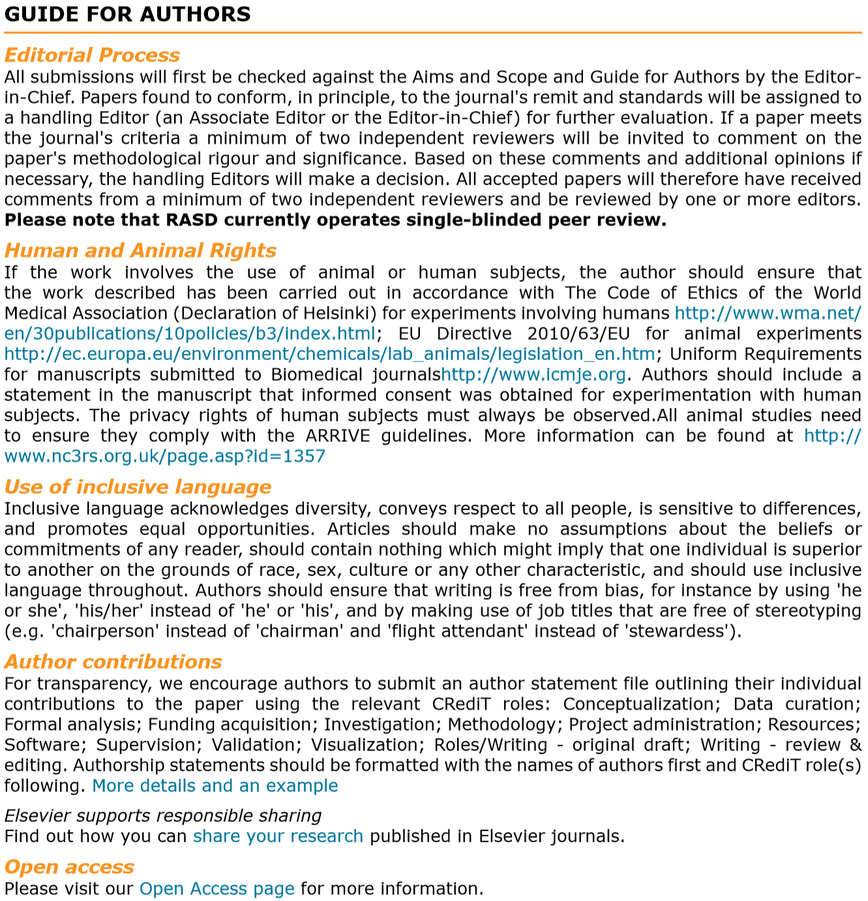
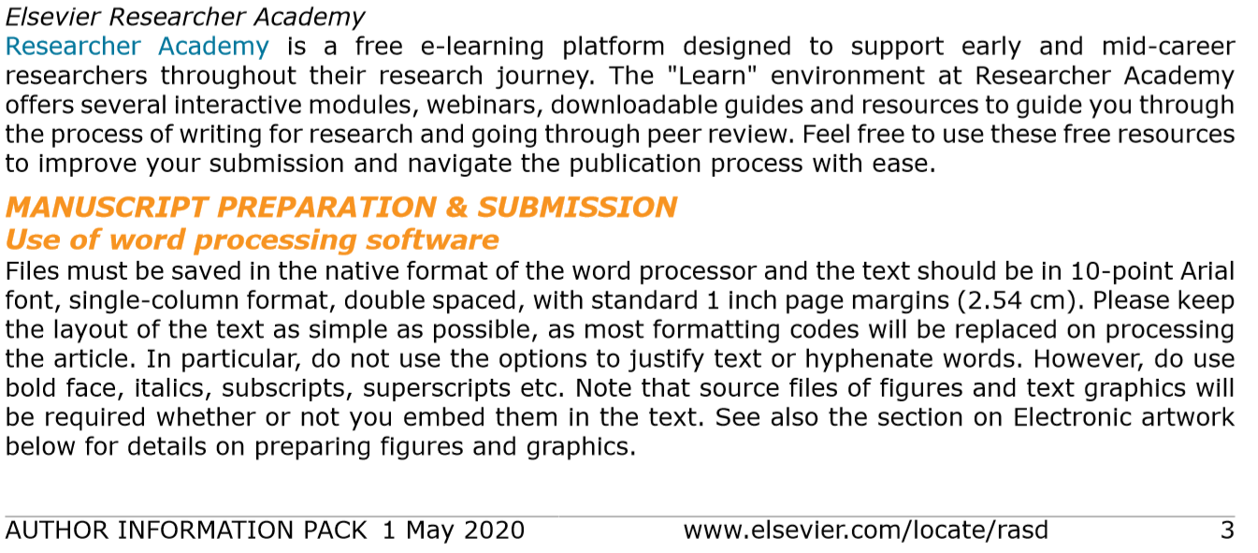

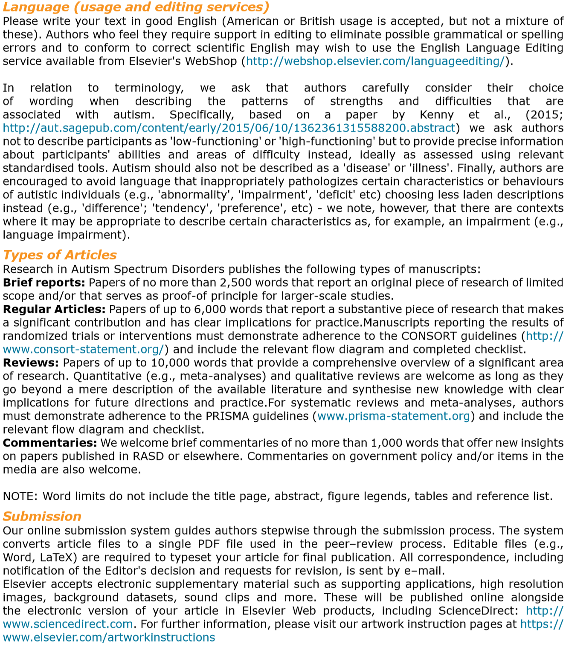
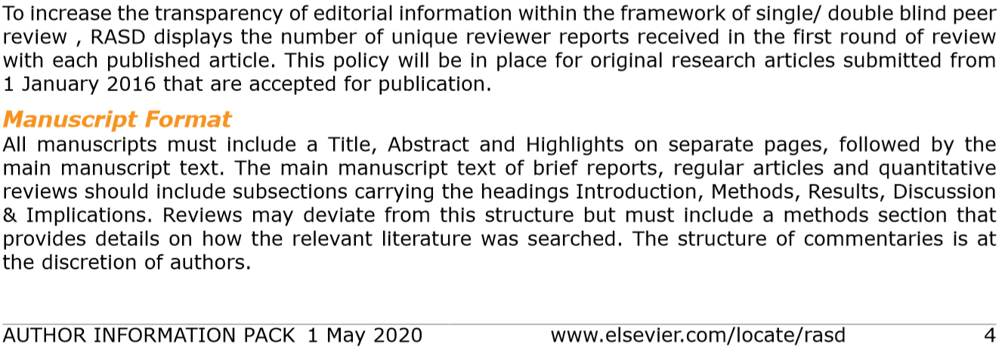

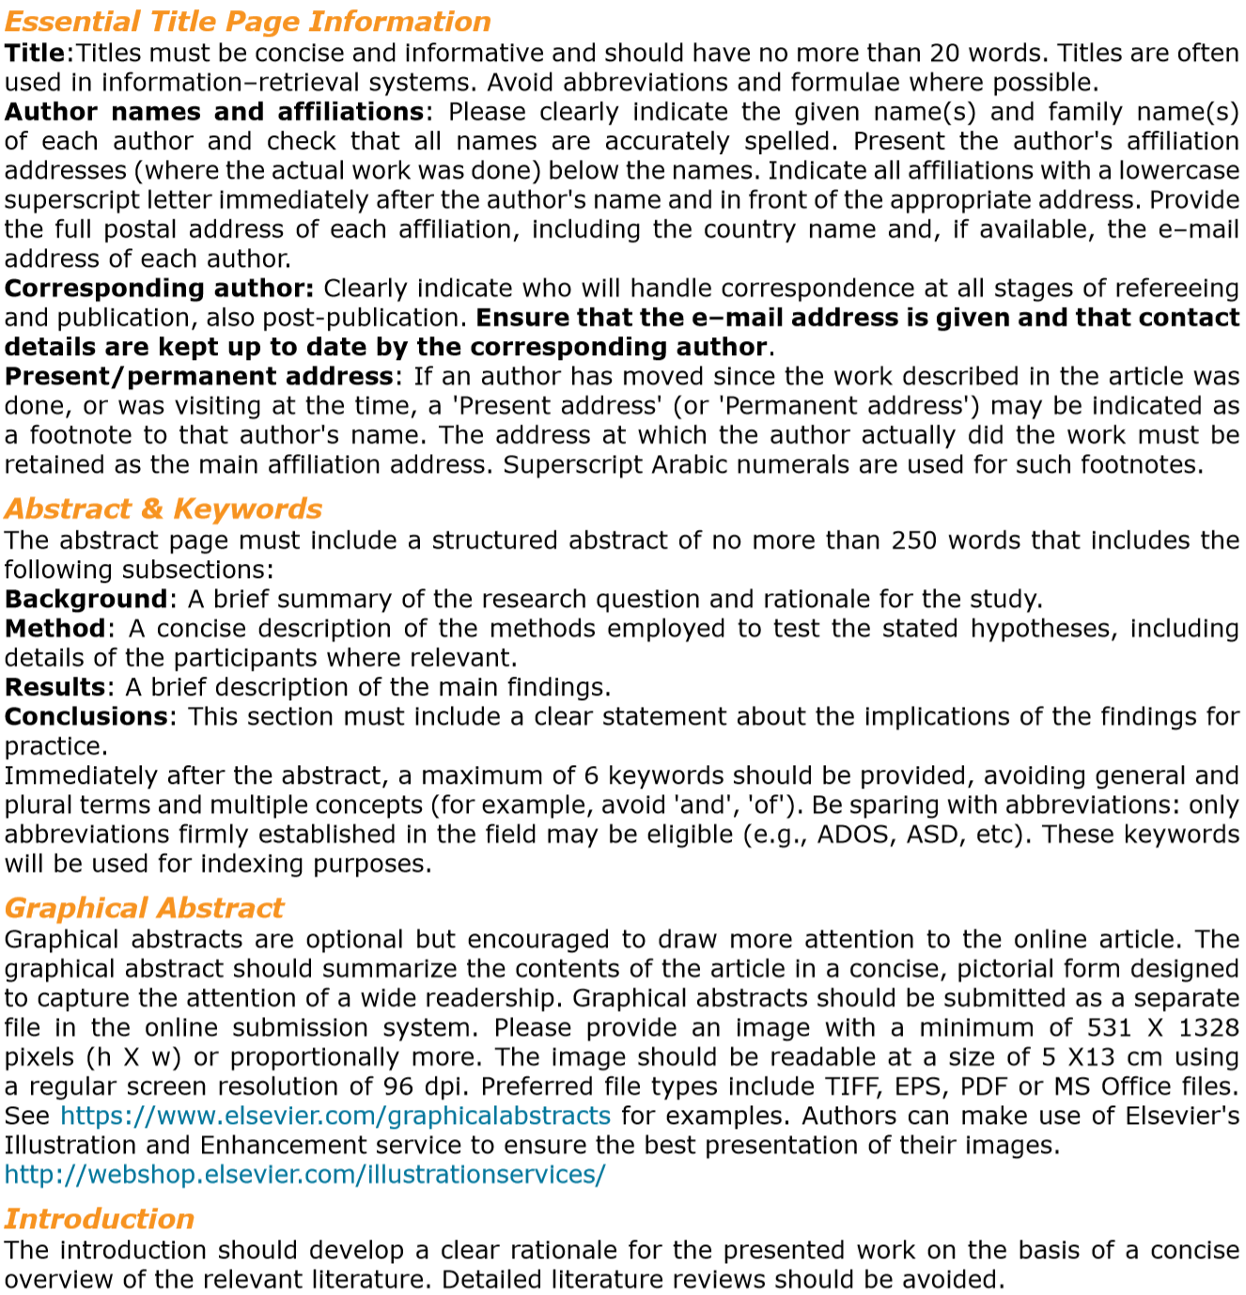
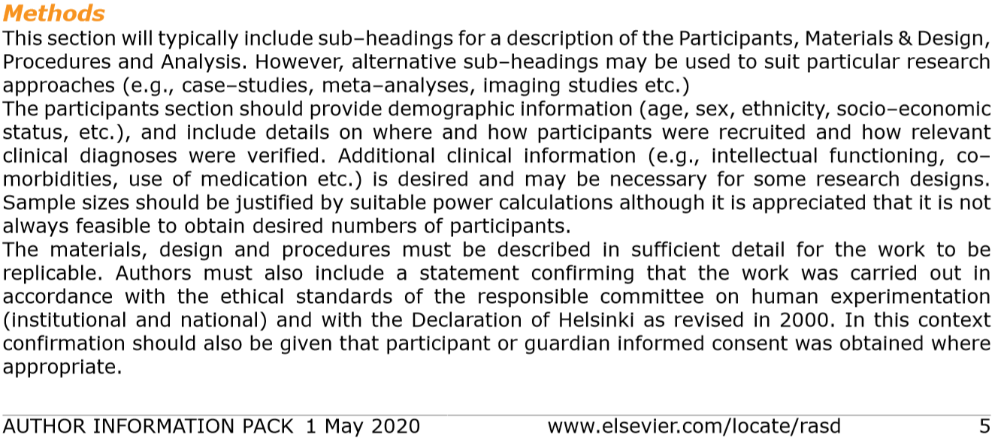

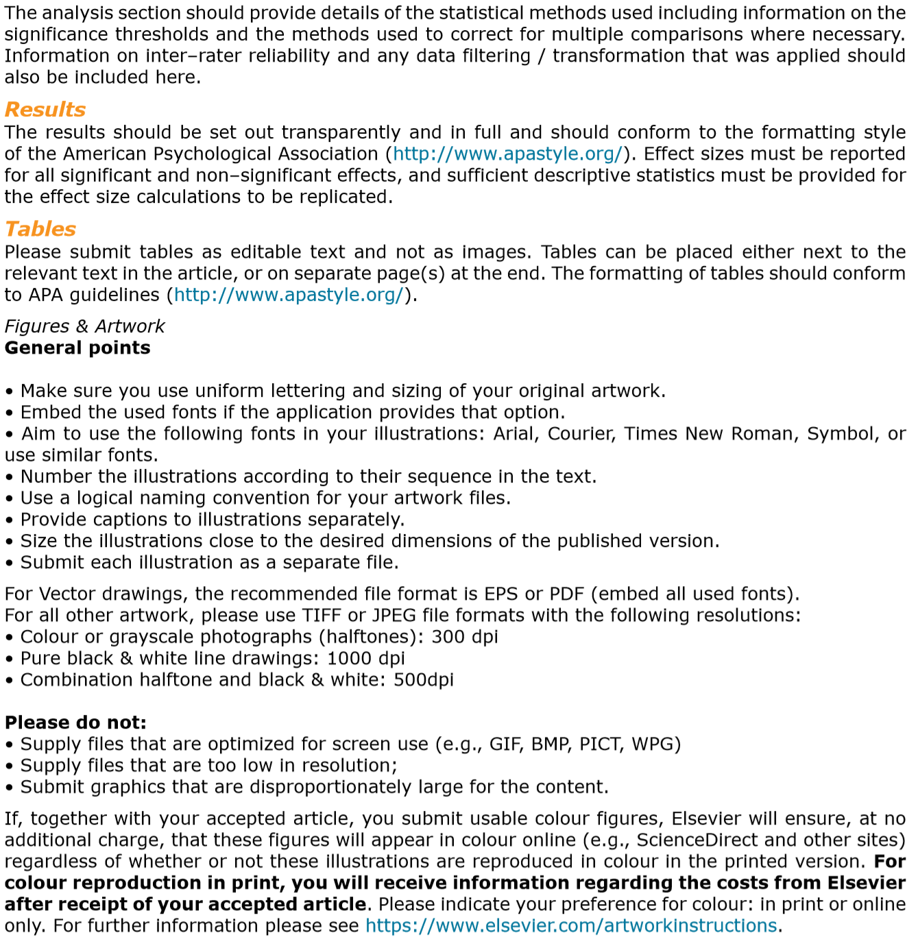

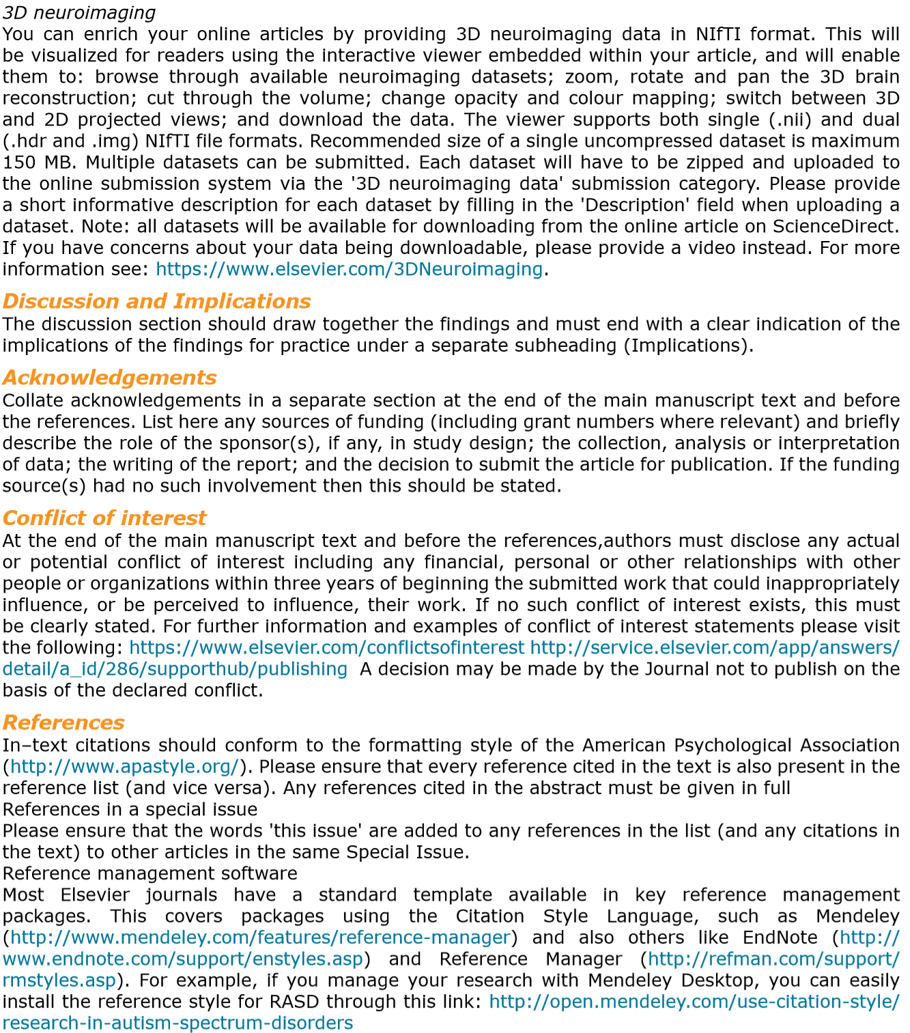
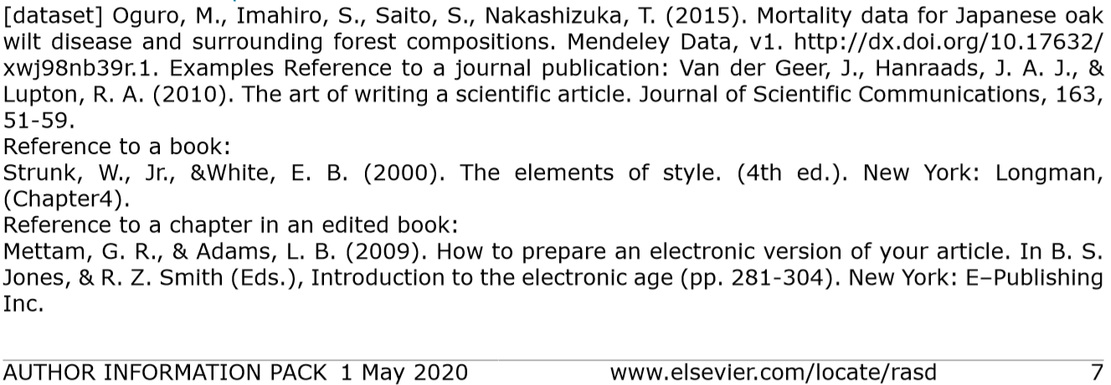

Parental Experiences of Self-Harm in Young People with ASD: An Interpretive Phenomenological Approach

Executive Summary

Contents Page

Background……………………………….……………………………….……147

Aims……….…………………...…………………………….…………….……148

Method……….……………………………………………………………….…148

Results……………………………………………………………………….….149

Discussion……..……………………………………………………………..…152

Limitations…………………………………………………………………….…153

Future Research………………………………………………………………..154

References…...……………………………………………………………....…155

WHY WAS IT IMPORTANT TO DO THIS RESEARCH?

Self-harm is a serious public health concern and the number of people who self-harm is increasing. Self-harm is typically used as a coping mechanism, but it can be particularly worrying because it is linked to suicide. It is most common in children and young people. When children self-harm it has a significant impact on parents. Self-harm is difficult for parents to understand and causes strong emotional responses and distress (Ferrey et al, 2016).

People with Autism Spectrum Disorders (autism) have difficulties with communication, social interaction, and repetitive thinking and behaviours. Research has shown that more people with autism self-harm compared to adults who self-harm and don’t have autism, meaning people with autism might be more vulnerable to self-harming (Maddox, Trubanova & White, 2016; License, Oliver, Moss & Richards, 2019).
Why Do Research with Parents?

- Guidelines for healthcare professionals say that every assessment should include parent’s concerns (NICE Guidelines, 2017). Parents also advocate for the children with ASD and act as their ‘voice’ at appointments (Boshoff et al, 2016).

- Parents’ views are important, and they might have a different relationship with services than parents of neurotypical children.

- The relationship between a parent and child can affect self-harm in people who do not have autism. Parents have a different relationship with their child if their child has autism.

- Parents might experience self-harm differently if the relationship with their child is a bit different.

- No research has been done with parents of a child who self-harms and who also has ASD.

- Parents might experience self-harm differently in the context of autism.

WHAT WAS DONE AND WHY?
AIMS
- To explore how parents make sense of self-harm in the context of their child having autism
- To explore how parents experience this self-harm

Staffordshire University Ethics Committee Board confirmed this research is ethical. Participants and their children were all given false names to protect their identity.

Posters were placed on social media websites, online forums, and specific webpages which supported parents or individuals coping with autism or self-harm.
Who could take part?
- Parents who had a child who cut themselves currently or in the last year
- Their child had a diagnosed Autism Spectrum Disorder
- Their child was aged between 12-18 years
- Their child did NOT have a learning disability
- Parents who spoke English and lived in the United Kingdom

And who DID take part?
- 7 participants across the UK
- 5 mothers and 2 fathers, aged between 32-56 years
- Their children were aged between 13-17 years
- 5 of their children were girls and 2 were boys

What’s ipa?

Ipa is a method for analysing words. it is used when researchers are interested in detailed descriptions of peoples’ experiences of a certain occurrence. It can be good to use when there isn’t much known about a topic.

Participants who consented to take part were interviewed by the researcher by telephone or Skype. Interviews were recorded on a Dictaphone so they could be transcribed.
Transcripts were then analysed using ‘Interpretive Phenomenological Analysis’ (IPA). The researcher interpreted meaning from the data and looked for key themes that were particularly meaningful or common across participants.

WHAT WAS FOUND?

6 main themes were found, with 13 sub-themes in total. The 6 main themes are ‘An Uncontrollable Thing’, ‘Step Back and Figure It Out’, ‘Keep Calm and Carry On’, ‘I Go Into Practical Mode’, ‘Quality of Life’, and ‘End the Day on a Positive’. A description of these themes is given below. Quotes are given to provide examples of things that were said by participants about those themes.

“An Uncontrollable Thing”: Self-harm was viewed as a profound and powerful force, something which is difficult to control or stop. 3 participants directly related self-harm to an addiction.
“Everyone does everything they can. But that everything is never enough, it’s never enough because at the end of the day she’ll still self-harm.” - Greg

“Try and Figure It Out’: Participants tried to make sense of their child’s self-harm. Participants discussed the purpose of their child’s self-harm (such as relief from emotional tension). Participants also identified triggers to help understand why their child self-harmed. Common triggers related to their child’s autism, such as difficulties with communicating or managing change/transition. Feeling ‘different’ to peers was also thought to relate to difficulties with self-harm. Thinking that self-harm is to do with autism might help parents to not blame their child and to empathise with them more.
“he didn’t understand the social rules and wasn’t able to understand the comments in their context… I think the problem’s that he’s not very flexible in his thinking… even though everyone else has moved on, he is still on that detail. And that causes conflict.” - Anna
“and you know, we’ve just been trying to put together puzzle pieces over time” - Fran

‘Keep Calm and Carry On’: Participants spoke about the initial worry, anger, or self-blame they felt when they found out about their child’s self-harm. Parents often had a panicked initial response, but parents learnt how to adapt and manage their reaction. As time passed and self-harm continued, parents found that they were able to normalise it.
“So, when I stopped being the frantic parent and started just being the matter of fact on, I felt Brooke responded to that very well, because, I found being calmer, and with her ASD, she copes with that better.” - Beth
“It doesn’t raise an eyebrow now…Now it’s been going on several years you know, it’s like anything, you get used to it.” - Dan
“I Go Into Practical Mode”: After finding out about their child’s self-harm, participants felt a need to ‘do’ something. Largely this involved finding out more information about self-harm and seeking professional help from healthcare services. Parents were faced with managing the risk associated with self-harm (such as by locking away sharp objects or providing a sterilised self-harm kit). Parents also found that they were careful not to trigger their child’s self-harm, which could lead to difficulties with managing behaviour.
“I think for a while I was walking on eggshells trying not to escalate situations, and not confront him.” - Anna
“I mean there’s certain things that we put in place, like um, we don’t have any, we locked away razor blades and um medication and stuff like that, that’s all locked away.” - Cathy

‘Quality of Life’: Participants discussed how their child’s self-harm had affected the wider family, particularly siblings, and the family’s ability to enjoy pleasurable activities such as days out and holidays. Participants also considered the impact that their child’s self-harm had had on their relationships with other people - many felt a social rejection due to stigma or reported becoming more isolated from others.
“Well people are afraid of kids who self-harm. Like when someone dies, people would rather cross the street than say to you, how are you feeling because your mother has died? You know, self-harm is the same.” - Beth
“We don’t go out very often as a family, not very often going different places. So it makes it very difficult to have um, a standard family life.” - Fran

“Hope”: Despite the difficulties, all participants were able to identify things which they were grateful for. This included valuing their child’s friendships or noticing that they had a better relationship with their child because of better communication since talking about self-harm. Parents also described a cautious hopefulness for the future.
“Her friends are lovely girls. They’ve stuck with her. I think that, that’s something I’m so grateful for really because it kept her rooted in the real world rather than the mental health and suicidal world.” - Dan

SO WHAT DOES THIS MEAN? HOW DO PARENTS MAKE SENSE OF THEIR CHILD’S SELF-HARM?

- Self-harm is difficult to make sense of. Self-harm is seen as having a strong and addictive nature. Many difficulties may be underpinned by characteristics associated with autism.
- Self-harm feels out of the parents’ and child’s control. This makes it easier to empathise and want to help them.
WHAT COULD THIS MEAN FOR SERVICES AND FAMILIES?
- Clinicians should provide leaflets and direct parents to sources of information to help them understand autism and self-harm.
- Parent support groups should be organised to allow parents to meet and share experiences and their understanding. Face-to-face groups will help parents feel more socially connected.
- Clinicians in CAMHS healthcare services need more robust training in autism to be able to offer tailored care and consider how autism might affect a young person’s mental health.

HOW DO PARENTS EXPERIENCE THEIR CHILD’S SELF-HARM?

- Parents experience a strong emotional impact when their child starts to self-harm. Parents could experience ‘secondary traumatic stress’.
- This impact reduces over time as parents become used to it. This could potentially indicate parental burnout.
- Parents consider how best to get support for their child – if risk is higher, then parents will strive for help more.
- Although parents can identify positives, self-harm has an overall major impact on the wider functioning and wellbeing of the family.
WHAT COULD THIS MEAN FOR SERVICES AND FAMILIES?

- Parental support groups would also be useful to help parents struggling with the emotional impact of self-harm.
- Clear and consistent advice needs to be given from professionals for parents in terms of managing risk and behaviour.
- Interventions should include parents and siblings rather than just being aimed at the young person self-harming.
- Concerns of parents should be taken particularly seriously when it comes to risk assessments

WHAT COULD THIS STUDY HAVE DONE BETTER?

Participants were all recruited from online support groups, so it is perhaps not surprising that the results showed that parents are practical in seeking advice and support.
This research explores why young people with autism self-harm. Parent views are important, but it would be great to hear from the young people themselves as well.

WHAT DOES THIS MEAN FOR FUTURE RESEARCH?

- Research should follow parents coping with self-harm over a number of years to help us understand more about adjusting to self-harm.
- Research should consider investigating different treatment options with a focus on family-based interventions to help support siblings and family functioning as well as helping the young person with their self-harm.
- Research should gain the perspective of the young people themselves.

REFERENCES

Boshoff, K., Gibbs, D., Phillips, R., Wiles, L., & Porter, L. (2016). Parent’s voices: ‘why and how we advocate’. A meta-synthesis of parents’ experiences of advocating for their child with autism spectrum disorder. Child: care, health and development, 42, 6, 784-797. https://doi.org/10.1111/cch.12383

Ferrey, A. E., Hughes, N. D., Simkin, S., Locock, L., Stewart, A., Kapur, N., Gunnell, D., & Hawton, K. (2016). The impact of self-harm by young people on parents and families: a qualitative study. BMJ open, 6(1), 1-7. http://dx.doi.org/10.1136/bmjopen-2015-009631

Licence, L., Oliver, C., Moss, J., & Richards, C. (2019). Prevalence and risk-markers of self-harm in autistic children and adults. Journal of autism and developmental disorders, 1-14.

Maddox, B., Trubanova, A., & White, S. (2016). Untended Wounds: Non-suicidal self-injury in adults with autism spectrum disorder. Autism, 21, 4, 412-422.

National Institute for Health and Care Excellence. (2017). Autism Spectrum Disorder in Under 19s: recognition, referral and diagnosis. Retrieved from https://www.nice.org.uk/guidance/cg128/chapter/Recommendations#recognising-children-and-young-people-with-possible-autism

Additional search terms including ‘vulnerability’ and ‘relationship’ were considered but disregarded following discussion with the University Librarian as these terms were not used in the relevant respect in the literature. For example, ‘vulnerability’ instead was used to refer to vulnerable populations.
Any item which was not applicable was not scored. Item 8 which enquired about the length of participant follow up was not applicable to cross sectional studies. Percentages were calculated based on responses / total number of applicable items x 100.
With sincere thanks to Anna* for reviewing a draft of this paper and providing valuable feedback.

