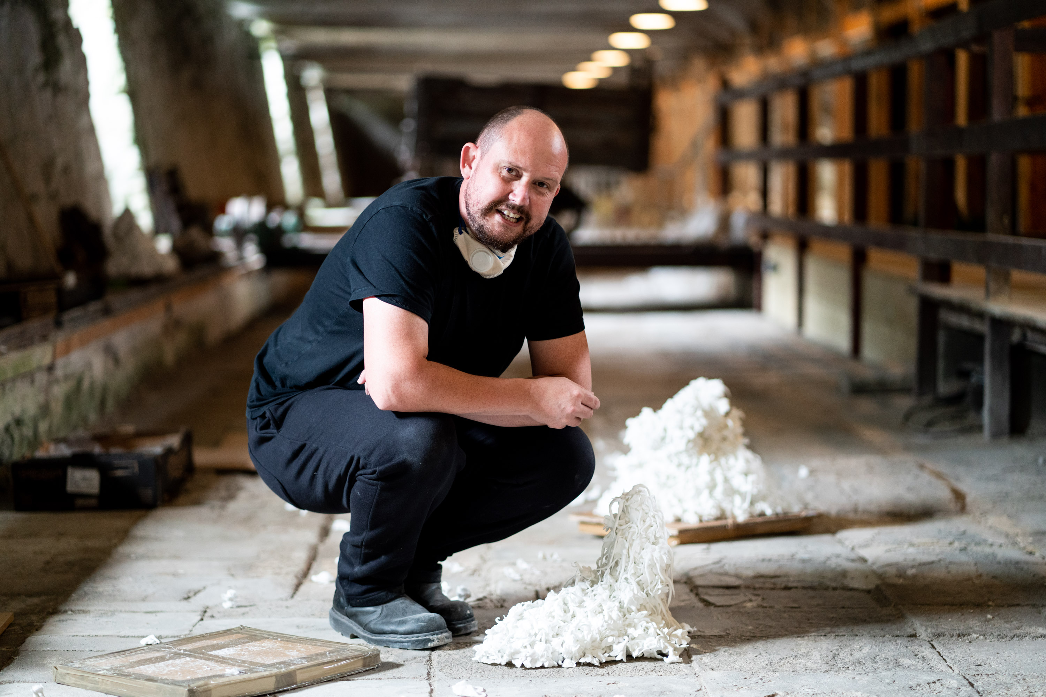

PRESS RELEASE
FOR IMMEDIATE RELEASE: 04.09.20

NEIL BROWNSWORD QUARTZ AWARD WINNER, WHITEGOLD INTERNATIONAL CERAMIC PRIZE 2019 EXHIBITS NEW WORK IN ST AUSTELL

A creative clay revolution in St Austell is underway with some of the best makers in the
UK and the world, exhibiting artworks in the town famous for its international china clay connections.

Professor Neil Brownsword was awarded Whitegold’s Quartz prize in 2019 and has created two inter-related artworks for the town that will be launched at the Whitegold Festival on the 19th September. ‘Relic’ consists of fragments of porcelain flowers carefully arranged on the surface of the old pan kiln at Wheal Martyn Clay Works and ‘Taskscape’ is a film and object installation on show at White River Place, the main retail centre in St Austell.

Through these two artworks Neil explores the entangled histories of St Austell
and the Potteries of North Staffordshire, bound together by the mining of china
clay and its transformation into ceramics.

Relic Wheal Martyn Clay Works, St Austell
‘Relic’ is the culmination of five-years of research during which Neil has archived the incredible hand skills of Stoke-on-Trent china flower maker Rita Floyd. He has captured every stage of the hand modelling involved in mass producing the many types of flower
that Rita has in her repertoire, and enshrined them in a series of porcelain fragments.
These abstracted individual elements are carefully arranged across the pan tiles of
Wheal Martyn’s china clay drying shed - petals, leaves and mounds of discarded flowers, reminiscent of local sky-tips, can be seen as metaphors for the loss of skills and the
need for safeguarding endangered craft practices for the future.

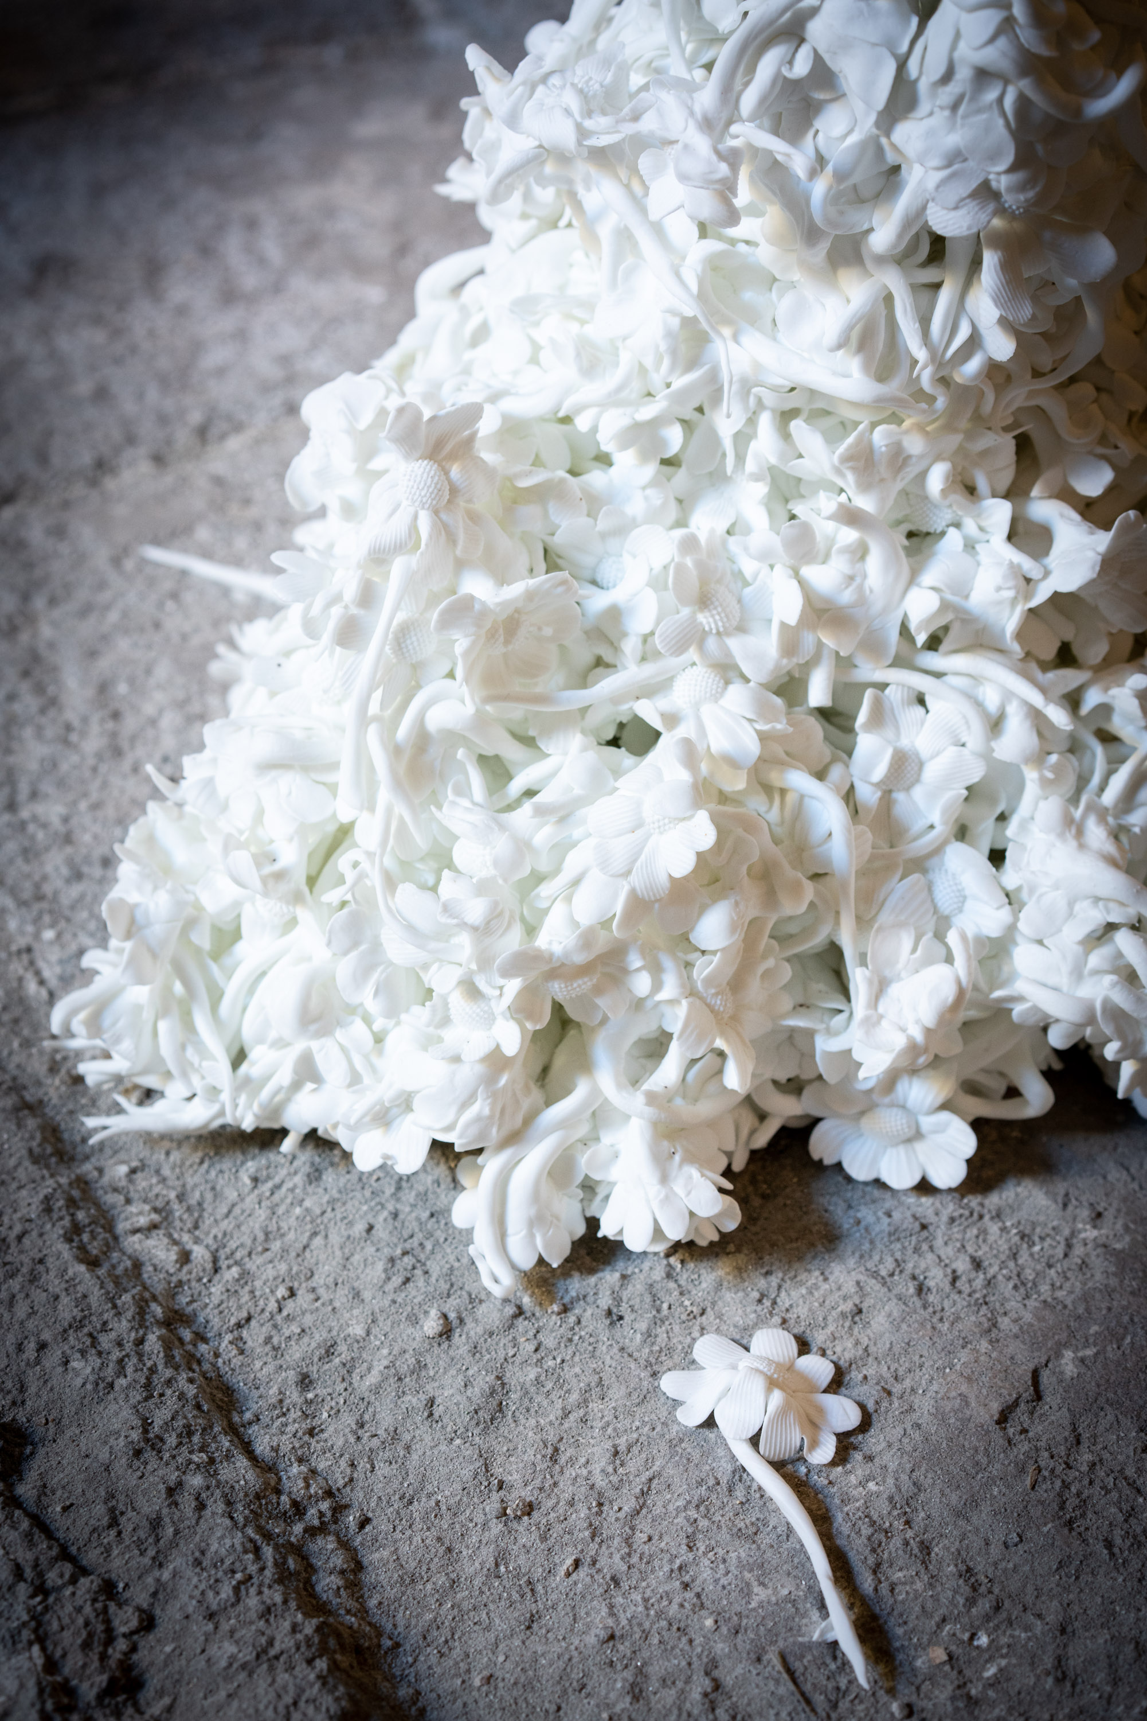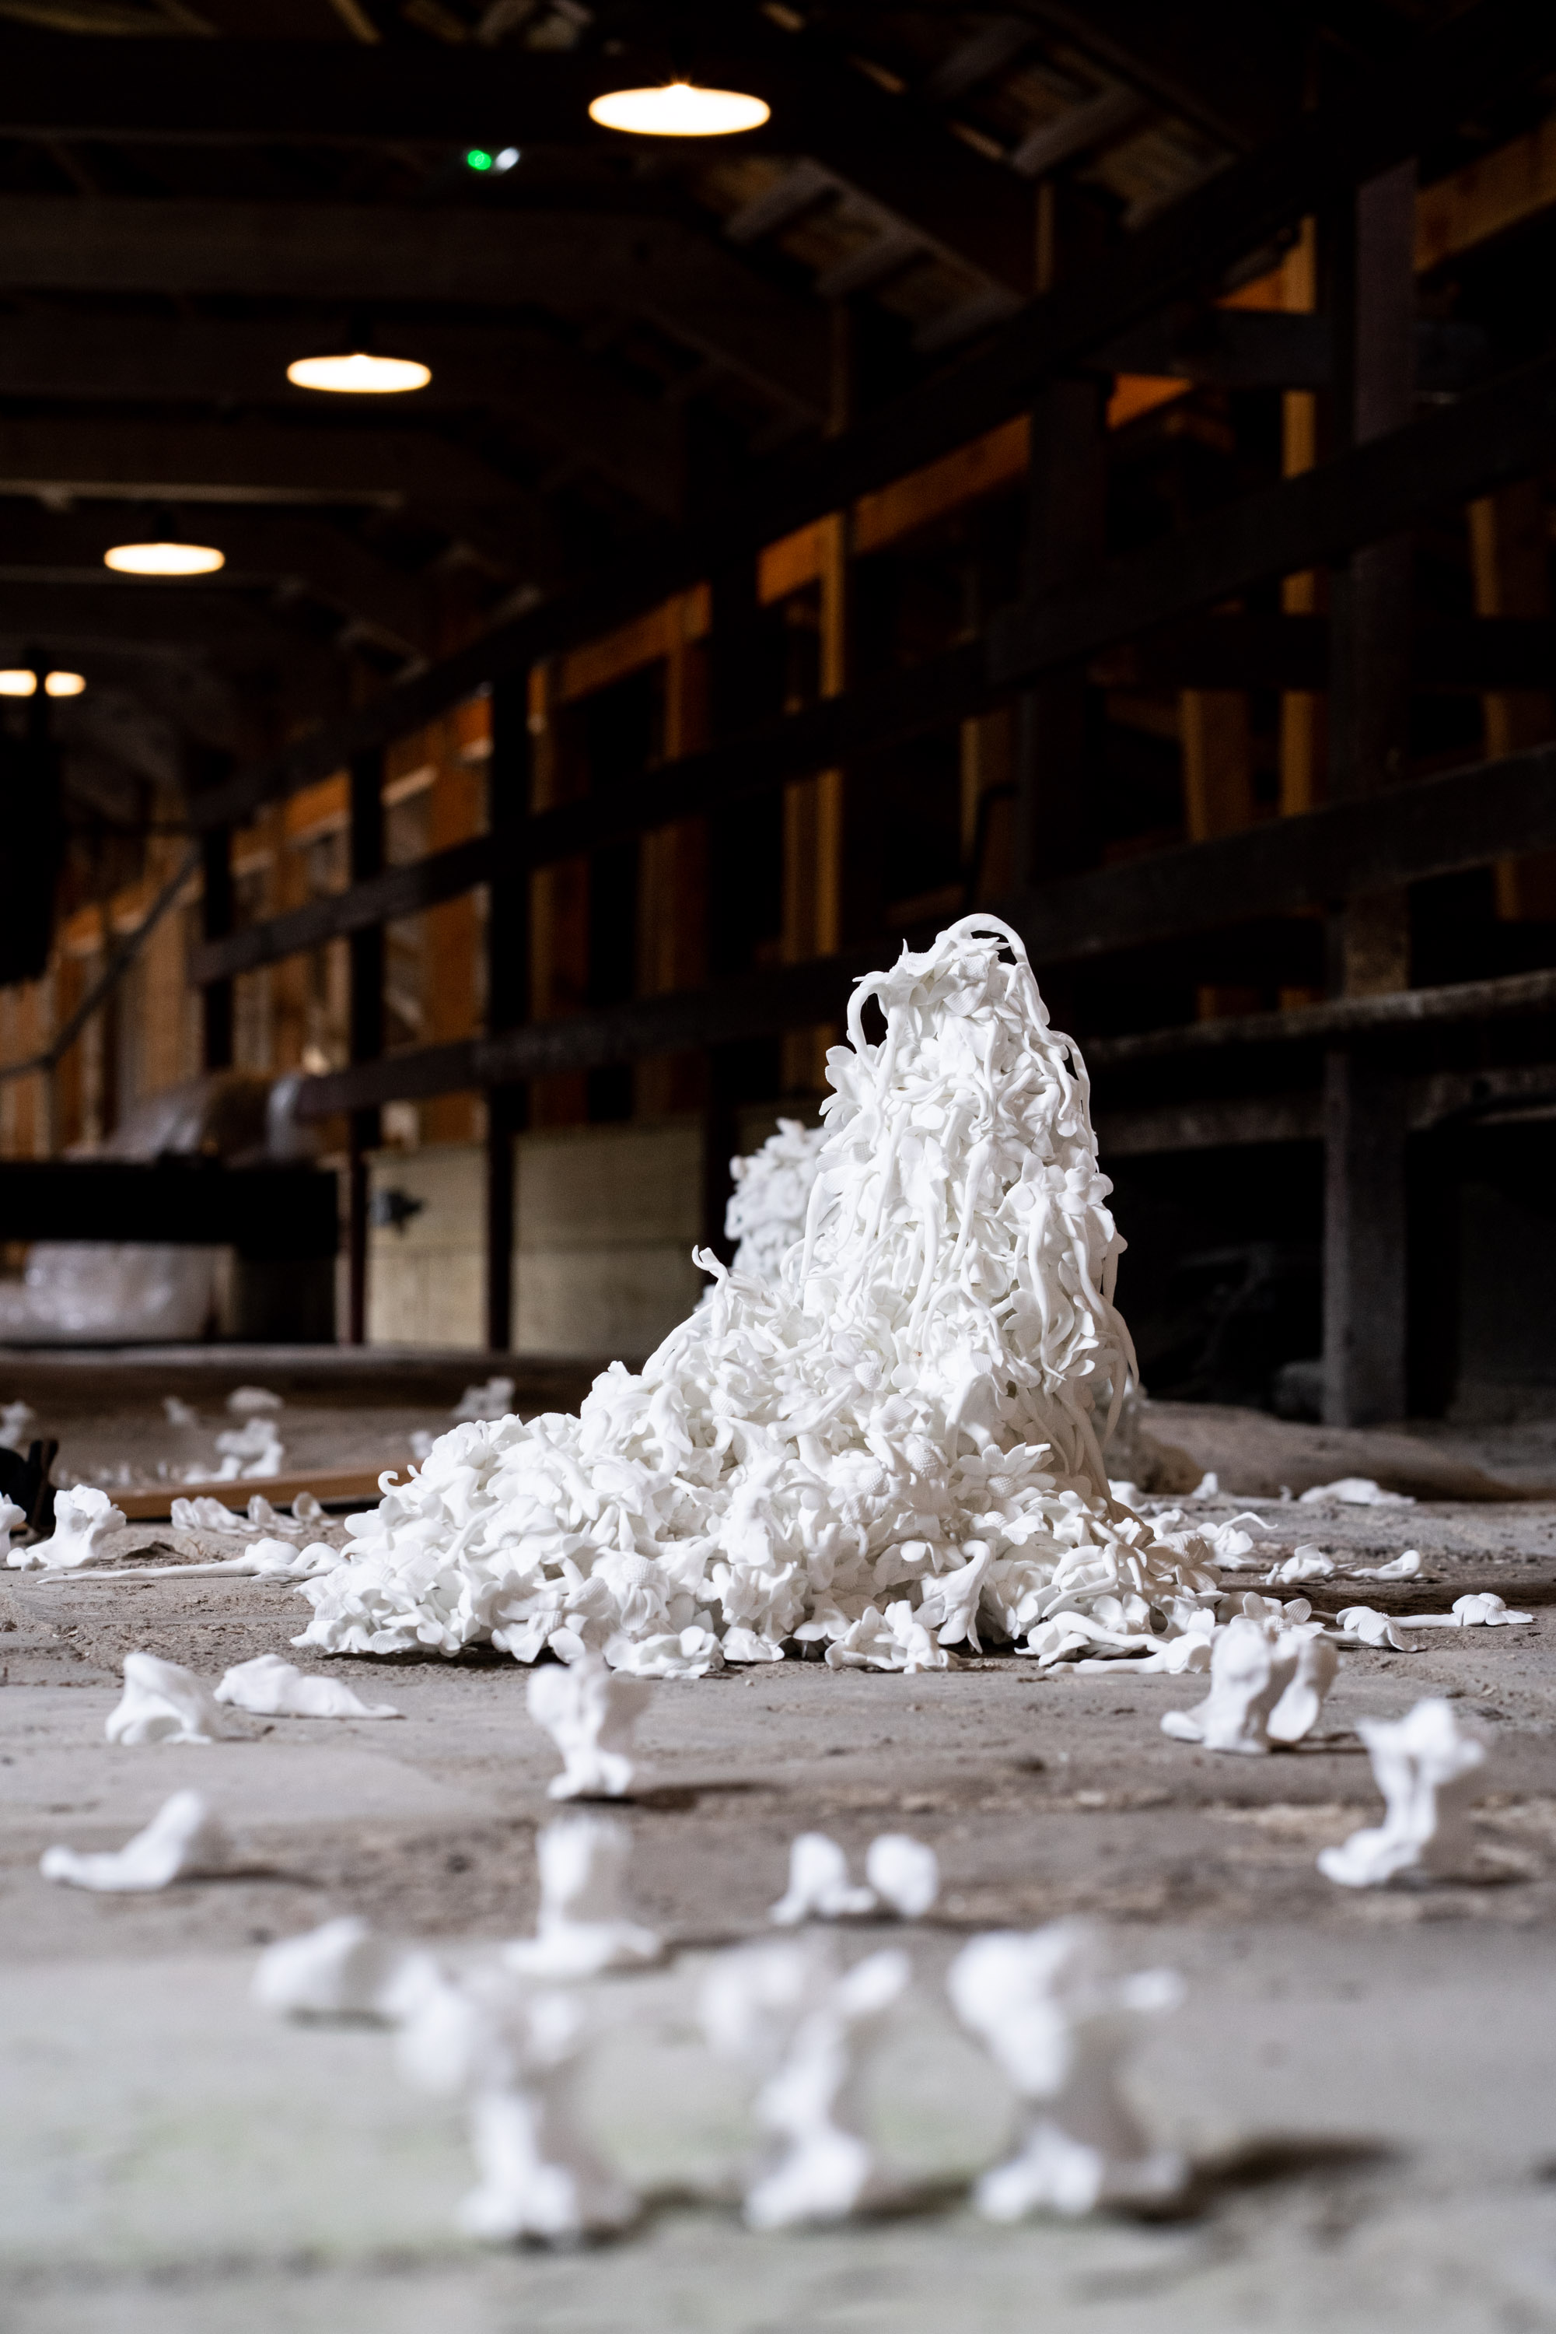

Taskscape, White River Place, St Austell
In ‘Taskscape’, Neil focusses attention on moments of china clay transformation coordinated by human hand, showing us processes seldom seen. Incidental elements, the flowing, bubbling, accumulation of materials and turquoise waters that occur in extracting, separating and settling the clay are framed aesthetically and offered up for poetic contemplation.

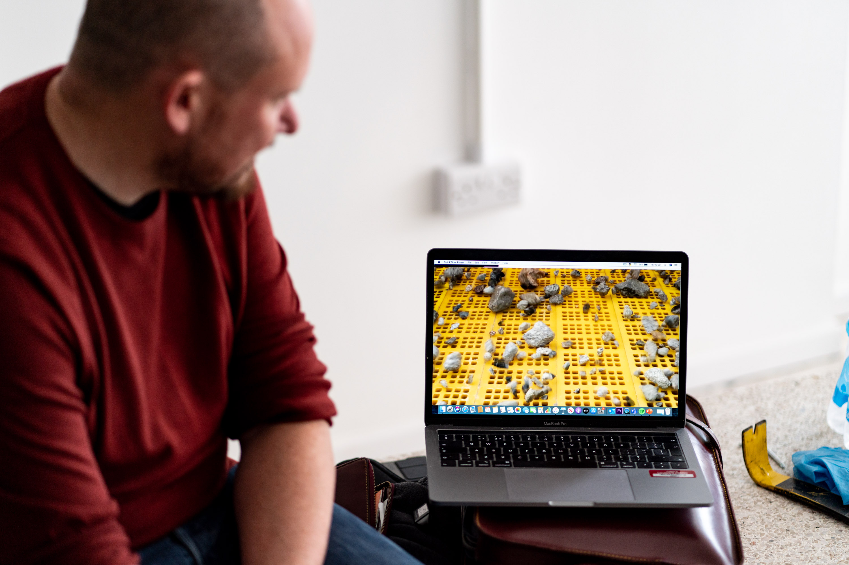

Neil’s work highlights the human ingenuity embedded within objects and practices that have shaped the identity of industrial regions such as St Austell and Stoke-on-Trent. He draws our attention to the relationships between human actions and the behaviours of raw materials as they are processed and refined to create china clay, and crafted into ceramic objects.

Neil says, “Whitegold offered me the opportunity to draw together interests in place and practices. I am very interested in industrial regions, the industry of China clay production in St Austell and ceramic production in North Staffordshire. For over two hundred years these industries have been intertwined and so I wanted to find a way of connecting them in my work”

Jo Moore, Curator of Wheal Martyn Clay Works says,
“I’m really excited to see the site used in different ways. Neil’s installation is an
extra-ordinary juxtaposition of the pure whiteness of the clay against the very mottled grey tiles of the old pan kiln. As the light changes the pieces are lit from the spaces where the liquid clay would have poured through from the settling tanks. It’s magical!”

Neil is Professor of Ceramics at Staffordshire University and University of Bergen, Norway. This commission for Whitegold has been kindly supported by Imerys, Staffordshire University, Spode Museum Trust and Valentine Clays.

Background
The Whitegold International Ceramic Prize is an Austell Project initiative curated by Dr. Katie Bunnell, and designed to bring ceramic artists from around the world to
St Austell’s clay country. It invites proposals for new artworks for St Austell, drawing on the history and culture of the region and its global china clay connections. Neil Brownsword’s work was selected for the 2019 Quartz Award by an experienced team of jurors as an outstanding proposal exploring clay in relationship with people, culture and place.

The Whitegold Project is the vision of a group of dedicated local people bringing together businesses, councils, artists, gardeners and the people living and working in the area. With a belief that art in public spaces and greening projects which are socially aware can play a vital role in helping to generate pride in the area, increase a sense of ownership and contribute to a better quality of life.

The project has been funded by the Coastal Communities Fund and was initiated by the St Austell Bay Economic Forum.

Contact: Press contact: Dr Katie Bunnell, Co-Curator on 07976583536 @whitegoldproject
Austell Project - https://austellproject.co.uk/

Photo credits James Darling Photography - https://jamesdarlingphotography.com/

Notes to Editors:
- St Austell Bay Economic Forum (SABEF) is a group of local businesses, public bodies and community organisations – united in the aspiration to better St Austell Bay and the hinterlands.
- The Coastal Communities Fund is run by the Ministry for Housing, Communities and Local Government (MHCLG). MHCLG say: The Great British Coast has enormous Economic Potential and this government is determined to see it thrive all year round. That’s why by 2020 the government will have invested £250 million in our much-loved seaside areas through dedicated programmes like the Coastal Communities Fund to help in generating jobs and boosting businesses. So far, MHCLG analysis shows that this has been money well spent; with every pound invested having the potential to create up to an £8 boost to our coastal economies. To find out more visit the Coastal Communities fund website. St Austell was awarded a £1million contribution to transform the St Austell area as a visitor destination. The funding will support St Austell becoming a Green and Ceramic Cultural Centre including a programme of public realm cultural initiatives and events and skills training, to attract more visitors and extend the tourist season.

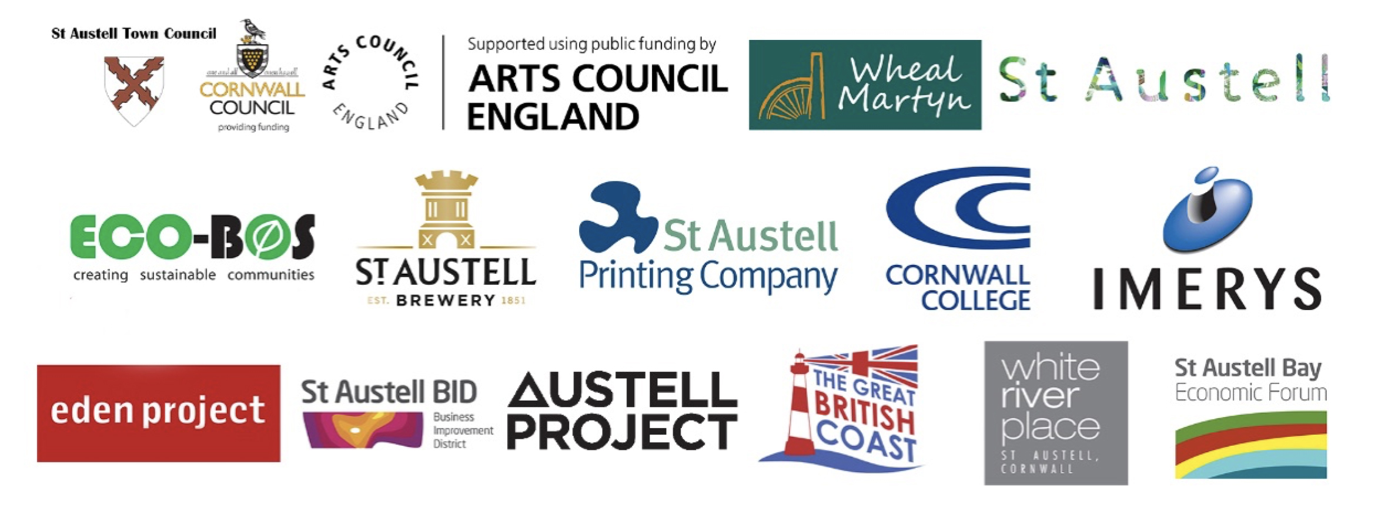

Ends

