Are We Contaminating Our Samples? A Preliminary Study to Investigate Procedural Contamination During Field Sampling and Processing for Microplastic and Anthropogenic Microparticles.
C Gwinnett¹, RZ Miller²
¹ Staffordshire University, Microplastic and Forensic Fibres Research Group, UK
² Rozalia Project for a Clean Ocean, USA
Abstract:
Methods for sampling, analysis and interpretation of fresh and saltwater microplastics and anthropogenic microfibers have improved since 2004, but techniques for reducing and monitoring procedural contamination are still limited. Quantifying the amount of procedural contamination introduced to samples improves the robustness of counts of microplastics and anthropogenic microfibers in the environment. This pilot study investigates procedural contamination introduced into water samples when rigorous QA/QC anti-contamination protocols are used and removed. Procedural contamination accounted for 33.8% of the total microfibers and microplastics found in samples when protocols were used (n=81), but 70.7% when they were not (n=8). With the use of extensive control sampling and full characterization of samples (morphological, optical and chemical) it was possible to identify the predominant sources of contamination (crew clothing) and make recommendations for anti-contamination and procedural contamination identification/reduction protocols for shoreline and small/medium sized vessel sampling for microplastics and anthropogenic microfibers.
Keywords: Microfiber; Microplastic; Contamination control; QA/QC; Anti-contamination; Field sampling

1. Introduction
Microplastics (MPs) are acknowledged as a global problem that are present in all environments including water, air and soil (Cole, et al, 2011). The study of anthropogenic material, including anthropogenic microfibers (AMFs) from naturally derived materials as well as microplastics (described as polymers smaller than 5 mm in size), collectively referred to in this paper as ‘microparticles’, has increased dramatically since some of the first studies in the early 2000’s (e.g. Thompson et al, 2004). With this increase in studies has come improved methods for sampling and analyzing these microparticles. Knowledge of how the integrity of the sample may be threatened by the addition of procedural contamination during sampling, recovery and analysis has also improved (Miller et al, 2021; Prata et al, 2021; Woodall et al, 2015) although as of yet, methods to prevent procedural contamination have not been standardized. Early studies in microplastic and AMF abundance either did not incorporate rigorous protocols for the prevention of contamination entering the sample or did not report them, e.g. as seen in Ng and Obbard (2006).
Now, there is an expectation for precautions to be taken to limit contamination of samples at all stages of the study (Cowger et al., 2020; Prata et al, 2021; Koelmans et al, 2019; Miller et al, 2021;), yet there are challenges in doing so (Duarte, 2020). The need for improved procedural contamination prevention procedures has been exacerbated by the changes in field sampling since early studies. With greater use of grab sampling (using containers or pumps) rather than volume reduction methods (such as Manta trawls), the ability to capture and analyze smaller sized microparticles has increased (Tamminga et al, 2019). This means that smaller fibers and fragments are now of interest from a pollution point of view, but it is smaller particulates that are likely to be contamination seen in procedural blanks (Frei et al, 2019). To prevent procedural contamination from being included in the end MP and AMF pollutant count, microfibers shed from textiles (e.g. analysts clothing) that are in the proximity to the environmental samples, during sampling and processing, must be reduced and monitored using strict protocols.
For the purpose of clarity, this study defines the following terms as;
Procedural contamination to refer to any anthropogenic microparticles that have entered the sample during sampling and processing that was not part of the original sample taken from the environment (e.g. water, sediment, air).
Ambient Contamination: a sub-category of ‘Procedural Contamination’ which has originated from airborne sources, as identified through analysis of the atmospheric deposition blanks. Also described as ‘air contamination’ in other studies (Prata et al, 2021).
Pollutant to refer to any anthropogenic microparticles that are present in the sample that are truly from the environment and are not procedural contamination.
Procedural contamination procedures attempt to control contaminants entering samples from analysts’ clothing, from airborne sources, from surfaces in the laboratory and from the equipment and consumables being used. Protocols used in the forensic science industry for fibers and other particulate analysis have influenced how microplastic/microfiber studies are conducted and specific protocols for contamination prevention have been developed [Woodall et al, 2015). Although more widely used in more recent studies, a review by Prata et al (2021) of 50 works published in 2019, showed that only 4 out of 10 contamination control measures were being employed when processing samples in a laboratory.
The extent and type of methods used to reduce procedural contamination of samples can differ between field and laboratory activities with the latter generally having more comprehensive protocols in place. Common methods employed in the laboratory to reduce procedural contamination include;
- The wearing of non-synthetic polymer clothing, e.g, cotton and /or the use of cotton lab coats (Dodsen et al, 2020)
- Cleaning of all equipment and surfaces prior to use, for example with filtered wash water or chemicals/wipes such as Clorox® wipes, (Dodsen, 2020)
- The avoidance of plastic equipment, including sample containers, e.g. glass jars (Plee and Pomory, 2020)
- Controlled air environments including conducting processing within laminar flow hoods (Bordos et al, 2019) or secluded rooms with controlled air flow (Jensen et al, 2019).
Other protocols utilized in laboratory settings are described and assessed in terms of their frequency of use by Prata et al (2021).
Methods utilized in the field to minimize procedural contamination whilst collecting samples are very limited, with many studies not reporting any protocols at all. For some examples of studies and their procedural contamination protocols used during field sampling, please see Table 1 (ST1) in the Supplementary Materials.

Procedural contamination prevention activities such as avoiding the use of plastic (Miller et al (2017); Kedzierski et al, 2019; Kuklinski et al, 2019; Schonlau et al, 2020; Suaria et al, 2020; Zayen et al, 2020), using distinctive plastic when plastic is unavoidable during sampling (Kuklinski et al, 2019), choosing particular items of clothing to be worn (Miller et al, 2017; Lindeque et al, 2020; Russell and Webster, 2021), securing samples upon recovery (Miller et al, 2017; Suaria et al, 2020; Lindeque et al, 2020), cleaning equipment prior to use (Isobe et al, 2017; Miller et al, 2017; Schonlau et al, 2020; Lindeque et al, 2020; Russell and Webster,2021), covering samples during processing with the likes of aluminum foil (Miller et al, 2017; Schonlau et al, 2020), or specifically attempting to reduce the time the sample is in contact with plastic objects are noted in some studies (Miller et al, 2017; Lindeque et al, 2020), albeit rarely. It appears that the most common measure used during field sampling is avoiding plastic items and cleaning of equipment before use. The latter is a commonly seen approach used in the laboratory (64% of 50 studies as noted by Prata et al (2021)). Prata et al’s review (2021) did not separately assess the use of contamination prevention controls in the field but did note the importance of avoiding plastic at the sampling stage.
Fewer studies note the taking of controls and blanks during the sampling stage. Studies may run a series of positive and negative blanks alongside the environmental samples, the first to test methods and the second to ascertain levels of contamination (Plee and Pomory, 2020). The latter may be classed as a procedural contamination monitoring method. Unfortunately obtaining a true clean sample is very difficult as they are rarely free from microparticles if including small size fractions (e.g. down to 1µm in size), thus can lead to an overestimation of MP/AMF contamination and/or unnecessary removal of MPs/AMFs from the end count.
It is acknowledged that atmospheric deposition is a source of MPs and AMFs (ambient contamination), yet many protocols used in the field, do not reduce exposure to this source of contaminant and only a few studies have stated they have monitored for this form of contamination, e.g Schonlau et al, 2020). The re-evaluation of procedures for sampling MPs/AMFs in light of the prevalence of airborne microfibers has been called for (Liu et al, 2019). More recently, in laboratory settings, airborne contaminants are being monitored by leaving a substrate, such as filter papers, exposed during sampling; the use of this in the field is rare, but has been noted in some studies (Russell and Webster, 2021; Miller et al, 2017). In the Russell and Webster (2021) study, only microplastics found on the ambient control that were >300 μm were to be subtracted from the end count, but as only particles <300 μm were found, there was no need to discount these. This highlights the need for studies investigating particles <300 μm to monitor ambient contamination.
The taking of ‘control’ samples of possible sources of MPs and AMFs contamination has been included in some studies, but this is generally limited to any plastic equipment that could not be avoided (Miller et al, 2017; Kedzierski et al, 2019; Kuklinski et al, 2019; Schonlau et al, 2020; Suaria et al, 2020; Zayen et al, 2020). Controls from the clothes being worn by the scientists are rarely either taken or noted, with many lab-based studies circumnavigating this need by wearing cotton lab-coats over clothes. The wearing of lab-coats is not always possible in field studies where the safety and comfort of the scientists whilst onboard boats requires the wearing of appropriate sports type clothing in response to the elements (heat, cold, precipitation). To address the needs for suitable clothing in the field, some studies ask all samplers to wear a distinctive colored fabric type that is then eliminated from end counts by their color (Miller et al, 2017; Huntington et al 2020). Only one other study has investigated the contamination of samples from clothing during sampling, where red cotton overalls were worn (Scopetani et al, 2020). This study concludes that up to 15% of MPs can originate from sampling attire highlighting the need to take adequate controls of clothing worn when sampling.
Although there have been considerable improvements in trying to reduce and monitor procedural contamination in MP/AMF studies, the significant amount of microparticles being transferred location to location, particularly fibers, means that the potential for these entering samples is still high. This is particularly true during the field sampling/processing part of these studies. Currently the amount of possible procedural contamination in MP/AMF studies is unknown, particularly at the field sampling stage. This pilot study aims to provide the first quantification of this procedural contamination when strict anti-contamination protocols are used and not used.
This study aimed to 1) quantify the amount of procedural contamination found in water samples when full QA/QC anti-contamination protocols were used during the sampling and initial processing stages for microplastics/anthropogenic microfibers in the water from a small-medium size vessel, 2) quantify the amount of procedural microplastic/microfiber contamination found in water samples when poor QA/QC protocols are in place, 3) compare the effect that full QA/QC anti-contamination protocols have when implemented during sampling on the deck versus during processing in the boat’s lab and 4) make recommendations for anticontamination and procedural microplastic/microfiber contamination identification protocols to be used for shoreline, and small and medium sized vessel sampling for microplastics and anthropogenic microfibers.
2.Materials and Methods
This study was conducted during the Hudson River Mountains to the Sea, Seafloor to the Sky Microplastic Sampling and Technology Expedition conducted in 2019. This broad expedition analyzed water, air and soil samples from the whole length of the Hudson River from the headwaters at Lake Tear of the Clouds (44.17°N, 73.96°W) to the Atlantic Ocean marked by Ambrose Light (40.74°N, 73.96°W); a total of 507 km (315 miles), with samples taken every 4.8 km (3 miles) and included additional studies such as this study and a high-resolution Wastewater Treatment Plant effluent study.
To address aims 1-3 of this study, the amount and source of procedural contaminants that were incorporated into water samples during sampling and extraction processes were investigated using a 2-part field study environment. Part 1 was sampling using full QA/QC anti-contamination protocols (referred to as ‘full QA/QC’ for brevity), which acted as the control. Part 2 was a ‘procedural contamination study’ which featured behaviors that go against the full QA/QC protocols used in Part 1 of this study; this will be referred to as ‘poor QA/QC’ for brevity. Controls were taken from the equipment on the vessel and the crew’s clothing to identify exact sources of procedural contamination in both parts of this study. Both Part 1 and 2 were conducted aboard American Promise (Cutter-rigged sloop. LOA: 60’, Beam: 17’, Draft: 11’, weight: 35 tons, mast height: 87’). Part 1 was conducted on July 7th (Hudson), 10th (Yonkers), 12th (Brooklyn), 2019 and part 2 was conducted on July 9th (Cornwall-on-Hudson), 2019.
2.1 Sampling, Processing and Analysis Methods used for both Parts 1 and 2
For both Part 1 (full QA/QC) and Part 2 (poor QA/QC), the basic methods for the sampling, processing and analysis of anthropogenic material from water samples were the same, only QA/QC procedures differed. For both parts of the study, ambient contamination was monitored (see section 2.1.4) and control samples taken for reference from all plastic items and clothing worn by the crew.
2.1.1 Sampling of Water
Surface water samples were taken using a grab sample technique with a 4.73 Liter galvanized steel bucket decanted into 1 L glass jars. Water from the mid-water column and 1 meter above sediment were taken using a 5L General Oceanics Niskin bottle with a 4.39 mm aperture opening. These samples were also decanted into 1 L glass jars. Further details of the sampling methods used can be found in section 1 of the Supplementary Materials.
2.1.2 Processing of Water Samples
Each water sample was filtered under vacuum (using a portable vacuum pump) using a ceramic Buchner funnel (available from Fisher scientific catalogue number 10771752) and a Whatman 3 cellulose filter paper (available from Sigma-Aldrich, catalogue number WHA 1003070) in the galley of American Promise. Directly after each filtration had been completed, and whilst the filter was still damp, the filter paper was removed to a clean ceramic plate and covered with a clean ceramic ramekin. The inside of the funnel was then tape lifted in the region where the filter paper’s edges had previously been located. This was done with a single piece of Easylift® by gently contacting its adhesive side with the area in question. This same piece of tape was then directly used to tape lift the uppermost surface of the filter paper in question. This was done by bringing the adhesive side of the Easylift® into repeated contact with the filter such that the whole surface of that filter was tape lifted. On occasion, for samples that contained larger amounts of debris, the taping of the filter was repeated twice using the same tape. The Easylift® tape concerned was then adhered to a microscope slide without delay, the tape being held in place by its adhesive. The sample was then labelled using an indelible marker on one of the Easylift® tape’s two blue handles. For a full description of the recovery of anthropogenic material from filter papers using Easylift®, see Gwinnett, Osborne and Jackson (2021).
Further detail of the processing of samples can be found in section 2 of the Supplementary Materials.
2.1.3 Monitoring for Ambient Contamination
To monitor ambient contamination, upturned pieces of Easylift® tape (so that the adhesive side was facing upwards) were secured to the surfaces used for filtering and taping in the galley and settee area. These were left exposed for the duration of processing and then recovered and secured onto microscope slides for analysis. The Easylift® tape is 75mm by 25mm in area. Two tapes were used in the galley; one next to the filtration system and one next to the searching area. These tapes were left exposed during sampling/processing session, which normally lasted between 5 and 10 hours, and then recovered for analysis. New tapes were used for every sampling/processing session.
2.1.4 Comprehensive Control Sampling
The taking of extensive controls other than blanks of water and airborne contamination is uncommon in MP/AMF studies. In both parts of this study, controls were taken of any potential source of contaminant from the vessel, its equipment and rigging as well as from the crew themselves. This included;
1. All types of rope or line that remained on deck and/or upwind of sampling stations (halyards, mainsheet, sail cover tiedowns, cockpit cover rigging), or were directly part of sampling (the bucket line, retrieval and safety lines on the Niskin bottle, control and hoisting lines for the air sampler).
2. All types of canvas or other textiles related to the vessel that remained on deck: sail cover, cockpit cover and sail bag.
3. Samples from all clothing worn by the crew during sampling and processing for the duration of the expedition. This included provided shirts and hats plus crew supplied shorts/pants/skirts and shoes.
Control samples were taken from textiles by gently removing a minimum of 20-30 fibers using tweezers from an area that is less likely to have contamination, for example a seam, and then placing them in a paper wrap/envelope and then labelling with textile type, textile description and other pertinent details such as name of crew member (if clothing). If the textile was difficult to recover fibers from, Easylift® tape was used to recover control fibers by adhering to the surface of the textile multiple times until enough fibers from the garment were recovered. The tape was then secured on a microscope slide ready for analysis. Where no textile items were sampled, small pieces were cut either using scissors or a scalpel from the item and stored in the same manner as the fibers. For example, approx. 1 cm of line was cut using scissors from unavoidable lines used in the sampling stage. In total, control samples were taken from 53 items with 5 fibers examined from each textile/rope-based item.
2.1.5 Analysis of Recovered Anthropogenic Material
All samples recovered from the filter papers using Easylift® tape, the control samples of items, along with control samples taken from wash water and ambient contaminants were then analyzed for their morphological, optical and chemical properties using a sequential workflow inspired by forensic fiber examinations. This involved the techniques and characteristics seen in Figure 1. Please note that the size range of anthropogenic material of interest in this study was 6 µm (due to pore size of filter papers used) to 5mm (4.39mm for samples taken using the niskin bottle due to that being the aperture opening size). Polarized Light Microscopy (PLM) was the first stage of analysis (after initial searching of Easylift® tapes for microparticles. PLM is a valuable tool for polymer/particulate analysis as it makes use of the optical properties of microfibers, namely its birefringence and sign of elongation, to provide a polymer identification. For detail about the use of PLM for polymer identification, please see Gwinnett, Osborne and Jackson (2021) and Robertson, Roux, and Wiggins (2018). All analysis was conducted within the Easylift® tape unless the sample required dissection from the tape for Fourier Transform Infrared Spectroscopy (FTIR). For MP/AMFs which required FTIR analysis, these were dissected from the tape by cutting a small ‘V’ shape around the item of interest and adding one drop of TissueClear® solvent to remove the adhesive from the item. These were then analyzed using a Thermo Nicolet, Avatar 370 spectrometer with microscope attachment, which runs with OMNIC software. This was set up to average over 32 scans with a resolution of 4 cm-1. Where samples were analyzed using Raman Spectroscopy, spectra were collected using a Renishaw inVia Raman Microscope with Leica microscope; a ×20 objective lens was used for simultaneous illumination and data collection. A range of settings were used on each potential microplastic in order to ensure the best spectra was generated. The excitation wavelength used was 514 nm with the laser intensity used including 1%, 5%, 10% and 50% and integration time ranged from 4-10 seconds.
Once fully characterized, any MP/AMFs found in the water samples were then compared to the samples found in the water and air samples taken during the sampling events to identify if their source could be attributable to any onboard sources of microplastic or from ambient contamination. The comparison of control samples to unknown samples in this manner is a fundamental part of any forensic examination and conclusions in this study were arrived at using this same forensic process. In MP/AMF studies, many of these techniques noted in Figure 1 are used in isolation and therefore do not fully characterize the MP/AMF samples. Utilizing the approach in this study allowed more reliable screening and characterization beyond polymer or material type. Characterization of the morphological, optical and chemical properties as commonly seen in forensic work can allow MPs that fall within the same polymer type to be sub-categorized. This allows the analyst to fully understand the extent of possible sources of these contaminants; something which is currently rarely attempted. This study used this approach to identify the sources of the contaminants to specific garments or items.
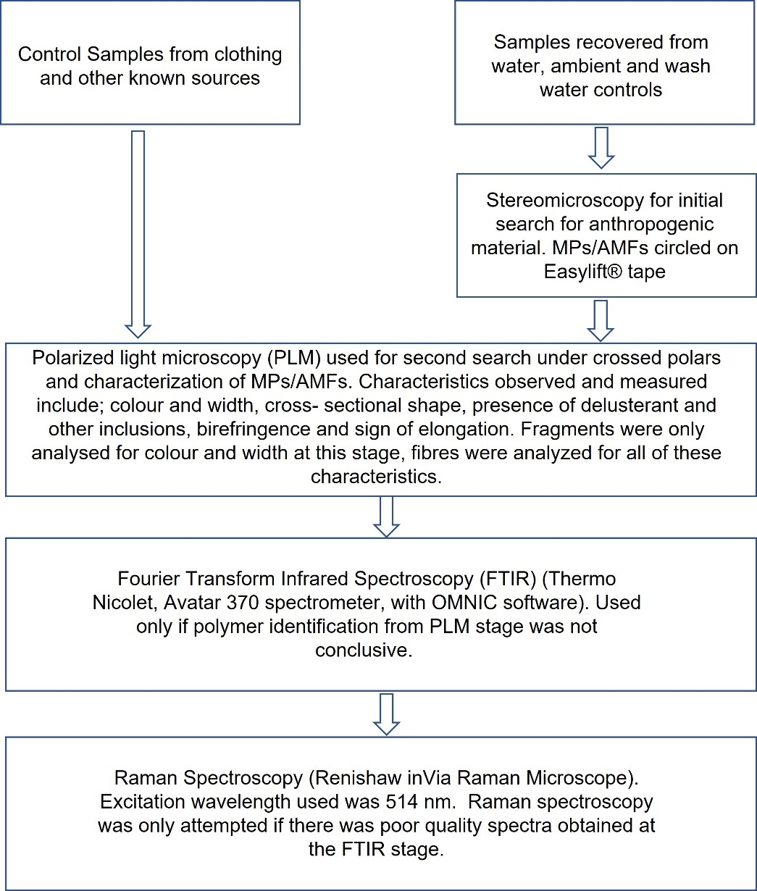
Figure 1: Workflow used to analyze microparticles
2.2 Part 1: Full QA/QC
As part of the expedition, a Wastewater Treatment Plant (WWTP) study was conducted to investigate the abundance and types of microplastics and anthropogenic microfibers present in water from the river surface, mid - column and 1 meter above the sediment at 4 locations, 0.5 miles apart both upriver and downriver from three WWTPs (Hudson, Yonkers and East River, plus at the outflow location as marked on navigation charts (9 sample sites with 3 samples each per WWTP). This study used the same full QA/QC protocols as the main expedition study and as such makes up Part 1 of this paper. For the purposes of this study, Part 1 was used to identify the levels of procedural contamination when fully utilizing the anti-contamination protocols in place over three different locations. The high resolution of sampling for Part 1 of the study along with the strict timeframes needed (to ensure parity in river conditions/current) meant that a large number of samples were recovered (27 water samples) over a short-time period (3 hours) at each of 3 WWTPs (n=81). This provided an excellent comparison to Part 2 of the study (Poor QA/QC) (section 2.4).

2.2.1 QA/QC Procedures
The procedures used to minimize contamination can be categorized into; preparation of vessel (section 2.2.1), preparation of crew (section 2.2.2), sampling protocols (section 2.2.3) and sample extraction protocols (section 2.2.4).

2.2.1 Preparation of Vessel
The deck was cleared of any potential sources of procedural contamination not essential to the running of the vessel or conducting the study, including extra line, sail bags, sails, spare equipment, tools, tarps, and flags and the deck was scrubbed with boat soap (West Marine biodegradable boat soap). If the general public or guests were permitted on deck, the deck was scrubbed before sampling recommenced.
When a sail bag, other textiles or piece of equipment could not be removed from the deck, it was moved aft and/or downwind of all sampling stations. Comprehensive control samples were taken from these materials as described in 2.3.
Where possible, for unavoidable synthetic lines and ropes that were used for sampling (attached to the surface sampling bucket or to raise and lower the air pump), bright orange; a color less often found in samples and one that would be readily identifiable, thus reducing the time taken for detecting procedural contamination, was used.
The crew maintained clean and uncluttered processing areas. These areas were below deck; in the galley and settee area, an open area approximately in the middle of the vessel’s interior. All textiles (specifically dish towels and cloths) were removed, all food and food containers were put in cabinets and all surfaces including counters and walls were given a deep clean with natural sponges (Twist plant-based sponge) and counter spray (Mrs. Meyers). Standard paper towels were replaced with plastic-free paper towels (Seventh Generation 100% recycled). This cleaning procedure occurred before every processing session (whether the space was used for meals, meetings or not at all).
2.2.2 Preparation of Crew
All crew who handled samples wore 100% cotton short-sleeved t-shirts of the same color (an unusual gray/blue) and the same baseball style hat (shirts and hats provided to crew). The crew wore the same 1-2 pairs of shorts/shoes (not provided) for the sampling part of the expedition. 100% cotton or low-shed polyester weaves were encouraged. In addition, all crew who handled samples removed all plastic or textile bracelets, rings and watches prior to sampling or processing. Metal jewelry/watches were permitted. Comprehensive control samples were taken from all textiles and items as described in section 2.3.

2.2.3 Sampling
When preparing equipment to be used as part of sample collection, all potential sources for microplastic fragment or fiber contamination were removed and replaced with non-plastic alternatives. This included using glass, metal and ceramic materials wherever possible, for example, glass mason jars, ceramic plates, metal buckets, metal Petri dishes and a metal tray for small items needed on deck. Where plastic was unavoidable, only inspected and intact (not photo-degraded or cracked/broken) items were used. Control samples of these unavoidable plastics were taken as described in section 2.1.4.
If a crew member was wearing clothing or equipment other than the expedition shirt/hat (or an approved garment), they stayed aft of all sampling stations, again control samples were taken from these items as noted in section 2.1.4.
The Niskin bottle was dropped to the desired depth as quickly as possible while still maintaining control in order to prevent microparticles from higher up in the water column from adhering to inner surface of the bottle
Prior to transferring the sample water from the surface bucket or the Niskin bottle, samplers ensured that they were downwind of the water being transferred and their hands and arms plus the glass sample jar were triple rinsed with the sample water. For the surface samples this required two bucket-loads of water, whereas the Niskin bottle was large enough to complete this pre-washing step before transferring the sample.
The sample jar lids were kept facing down during the triple rinse and the final sample transfer to prevent ambient contamination.
If any lines, garments or other pieces of equipment fell into the sample bucket or came into contact with the glass sample jar during transfer of the sample, that sample was thrown out and the process started again with a triple rinse.

2.2.4 Processing of Samples
All sample extraction occurred in the galley and settee area below deck. While processing was in progress or any samples were being handled, the hatches were closed and fans were turned off to minimize airflow and reduce ambient contamination.
During extraction, only crew members involved/engaged in processing were permitted to be in the galley/settee area. All others were prohibited to linger in or transit through this space.
All extraction equipment including the Buchner ceramic filter funnel (Fisher Scientific, catalogue number 10771752), ceramic plate (available from IKEA) for placing filter paper before recovery of particulates using Easylift® tape (available from Staffordshire University, UK), were triple rinsed with filtered wash water. One-liter blank samples of wash water were taken and analyzed for any procedural contaminants.
The Whatman number 3 filter paper boxes (Whatman catalogue number 1003 070, pore size of 6 µm) and microscope slide boxes were kept closed and secure and only opened when a new filter paper was quickly removed to prevent contamination of the box. The Buchner ceramic funnel was covered with a clean ceramic plate at all times during filtration to reduce ambient contamination and when the filter paper was transferred to a new clean ceramic plate for tape lifting, it was covered at all times with a ceramic bowl. Tape lifting using Easylift® allowed the fast recovery of any particulates reducing exposure of the filter paper to the environment. Samples, once recovered onto the tape, were secured onto a clean microscope slide, protecting the sample from any further procedural contamination onboard the boat. Further discussion about the use and benefits of using Easylift® tape for the recovery of microplastics and reduction of contamination is discussed in Gwinnett, Osborne and Jackson (2021).

2.4 Part 2: Poor QA/QC
This study was conducted aboard American Promise whilst at anchor. Two water samples (surface and mid-water) were taken and processed for each of 4 sampling events (described in Table 1), methods for these can be found in section 2.4.1. The same equipment was used for sampling as in the Part 1 (full QA/QC) of the study yet anti-contamination procedures were removed strategically as seen in Table 1. By using poor QA/QC protocols during the sampling methods but retaining full QA/QC protocols in the processing methods (and vice versa) we were able to isolate where and at what time procedural contamination may be taking place.
Table 1: Description of sampling events with poor/full QA/QC protocols
Sample Code | Sampling methods (on deck) | Processing methods (in galley)
DC1 | Poor QA/QC (see below) | Full QA/QC
DC2 | Poor QA/QC (see below) | Full QA/QC
GC1 | Full QA/QC | Poor QA/QC (see below)
GC2 | Full QA/QC | Poor QA/QC (see below)

2.4.1 Surface and Mid-column Water Samples
To investigate the potential behaviors that might increase contamination while taking water samples, Table 1 was followed. Where full QA/QC protocols were used, the highest standard of QA/QC was employed (section 2.2). Where poor QA/QC was employed, the following behaviors occurred: the deck was not prepared/cleaned prior to sampling, sampling team wore fleece high shed garments, the sample jars were not triple rinsed with water from the river, samplers did not triple wash their hands before taking the sample, the rope used to control the bucket was allowed to sit in the bucket and the control rope used for the Niskin bottle was allowed to interrupt the flow of water out of the Niskin bottle and sampling bucket.
2.4.2 Processing of Water Samples
To investigate the potential behaviors that might increase contamination while sampling/processing water samples, table 1 was followed. Where full QA/QC protocols were used, the highest standard of QA/QC was employed (section 2.2). Where poor QA/QC was employed, the following behaviors occurred: the galley was not fully prepared/cleaned prior to sampling, fans and hatches were left on in processing space (promoting air flow), flasks and Petri dishes were left uncovered during processing and people not involved with processing were permitted to both walk through and congregate in the processing area.
2.5 Statistical Analysis
Statistical analysis was performed using Pearson’s χ² test of association. A contingency table tabulating the counts of fragments found while processing water samples by contamination type (procedural/environmental contaminant) and the type of QA/QC protocols observed (full QA/QC and poor QA/QC on deck during sampling and poor QA/QC in the galley during processing) was constructed for this analysis. Poor QA/QC data were obtained on the sampling events described in Table 1 and Full QA/QC data was obtained by aggregating fragment counts from the WWTP part of the expedition in order to produce a mean ‘representative’ sampling event count to provide a control to compare against the reduced QA/QC protocol conditions.
3. Results and discussion
When full QA/QC was used, contamination accounted for a total of 33.8% (n=81; 206 of 610 particulates) of the total microplastics and anthropogenic microfibers found in the samples. When poor QA/QC was used, contamination accounted for a total of 70.7% (53 of 75 particulates); 71.4% (40 of 56 particulates) with poor QA/QC during sampling on deck and 68.4% (13 of 19 particulates) with poor QA/QC during processing in the galley lab (Figure 2). The mean number of procedural contamination and pollutant microparticles per sample and associated standard deviations (SD) can be seen in Table 2. This shows that having full QA/QC both on deck during sampling and in the galley during processing are equally important.
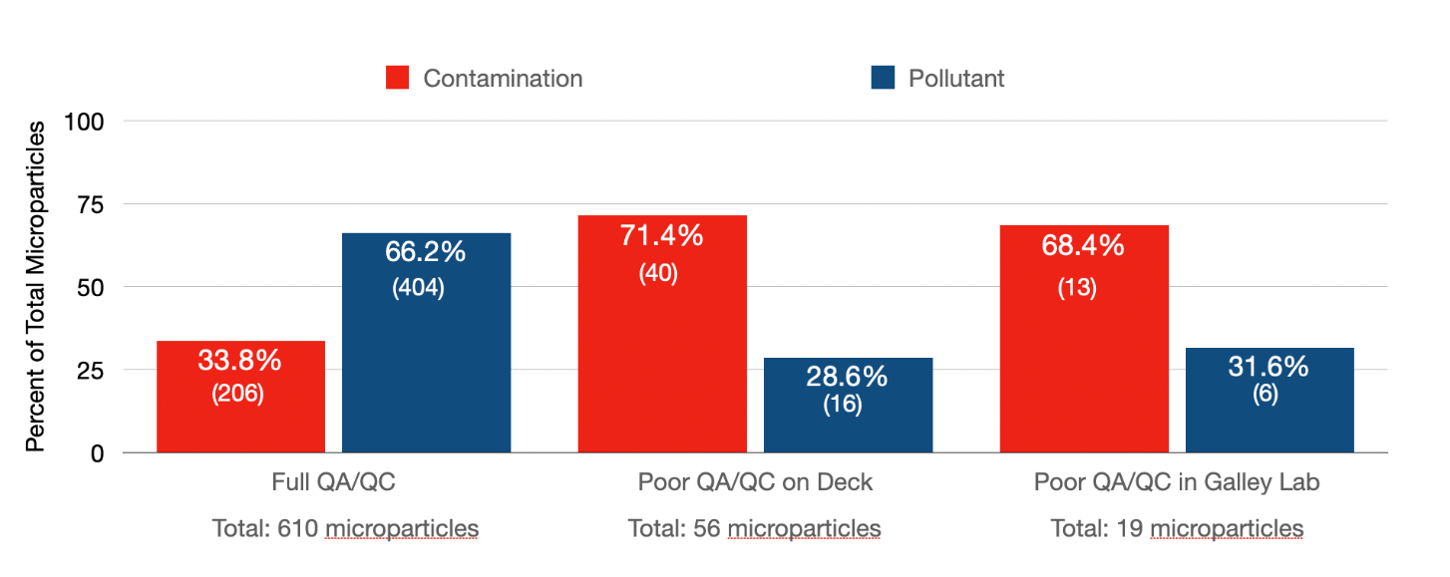

Figure 2: Percentage of microparticles found in surface water samples from environmental pollution and from procedural contamination
Table 2: Mean number of procedural contamination and pollutant microparticles per sample and associated standard deviations (SD)
 | Procedural Contamination |  | Pollutant
 | Mean number of microparticles per sample | SD | Mean number of microparticles per sample | SD
Full QA/QC (n=81) | 7.6 | 3.5 | 15.0 | 5.8
Poor QA/QC on Deck (n=4) | 10.0 | 5.7 | 4.0 | 2.4
Poor QA/QC in Galley (n=4) | 3.3 | 2.2 | 1.5 | 1.7

Of the contamination found during the use of poor QA/QC, a total of 84.9% (45 microparticles) was from known sources; 35 microparticles when there was poor QA/QC on deck and 10 with poor QA/QC in the galley lab. These were predominantly from clothing worn by both the science and the deck crews ; while a total of 15.09% (8 particulates; 5 with poor QA/QC on deck protocols and 3 with poor QA/QC in the galley) of the contamination came from ambient air in the space used for sample processing. Of the known sources, the 100% cotton t-shirts worn by the crew (8 people) accounted for 68.6% (24 fibers) with poor QA/QC on deck and 70.0% (7 fibers) with poor QA/QC in the galley. Fibers from other garments worn by the crew (both sampling and deck teams) accounted for 28.6% (13 fibers) with poor QA/QC on deck and 30.0% (3 fibers) with poor QA/QC in the galley. These included 3 pairs of shorts, 2 skorts, a fleece top, trousers and a sun shirt. Finally, 1.9% (1 fiber) came from equipment used in taking samples (the Niskin bottle control line) while sampling with poor QA/QC on deck (Figure 3). Of particular note, some of the fibers that were identified as contamination from crew clothing, were from garments not worn on the day of sampling but worn on the days prior. This demonstrates the transfer, persistence and subsequent redistribution of fibers from sources that have been previously been used, to environmental samples, even when strict cleaning protocols are used. This highlights the need to take control samples from all possible sources of microplastics (and anthropogenic microfiber depending on the scope of the study) when onboard a small-medium vessel, not just those present on sampling days.

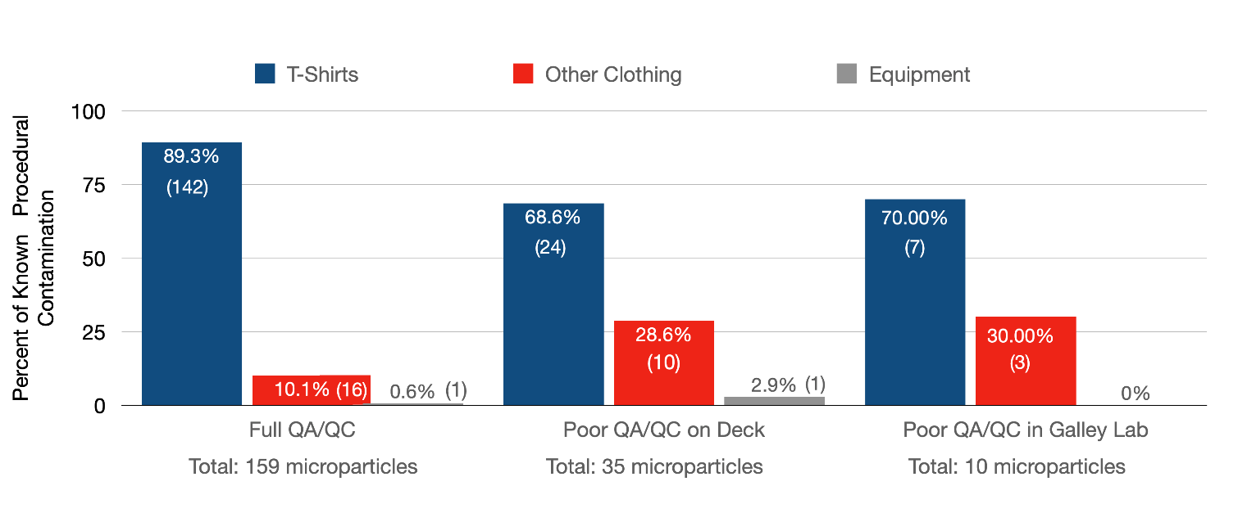
Figure 3: Percentage of procedural contamination by known source
Counts of microparticles found while sampling with poor QA/QC on deck or in the galley were tabulated for analysis. Counts of microparticles found while sampling with full QA/QC were also included in the analysis; these data were obtained from the large-scale sampling activities as part of the WWTP study during the expedition. As such, they were considered representative values for per sampling event concentrations of microparticles under full QA/QC conditions. For this analysis, mean sampling event counts for ‘full QA/QC’ conditions were scaled to be proportional to the two poor QA/QC conditions (poor QA/QC on deck and poor QA/QC in the galley lab) (N=4). Table 3 shows the number of microparticles found under each sampling condition.
Table 3: Counts of microparticles found using full QA/QC, poor QA/QC on deck and poor QA/QC in the galley
Totals | Procedural Contamination | Pollutant
Full QA/QC | 10.2* | 20.0*
Poor QA/QC on deck | 40 | 16
Poor QA/QC in the galley lab | 13 | 6
* Representative data derived from other sampling events (N=81)

These count data were subjected to Pearson’s χ² test of association to determine if utilizing full QA/QC contamination prevention protocols had a statistically significant effect on the amount of anthropogenic material recovered from water sampling events. It was found that using full QA/QC anti-contamination protocols were shown to significantly reduce the number of fibers and fragments resulting from contamination found in samples taken on deck and processed in the interior of a small-medium sized vessel (p = 0.001, χ² = 12.25, df = 2).
A further aim of this study was to make recommendations that assist field researchers to produce more accurate and robust microplastic and microfiber data while saving time and money, particularly those working from a small-medium sized vessel. To do that, in addition to calculating the above, the process of identification and source attribution of anthropogenic materials found in the samples was tracked and assessed.
It is well known, although not often discussed in published studies, that determining polymer type of MPs and material type of microfibers (i.e. polymer type or natural fiber type) can be difficult. This may be due to multiple reasons including sample size, presence of debris and the presence of biofilms. For the purposes of identifying polymer/material type, we categorized results based on whether polarized light microscopy (PLM), Raman spectroscopy or FTIR were required/effective, or if none of those methods could produce a robust identification (figure 4). For part 2 (poor QA/QC) of the study, 75 individual pieces of microfiber or microplastic were recovered from the samples. Of those 75 pieces, 34 were synthetic and 41 were anthropogenic cotton. We confidently identified 76.0% using only the PLM; this included 100% of the anthropogenic cotton. For 17.3% of the microparticles, we required spectral analysis to confirm a good, but not definitive, PLM result; 1.3% had an inadequate PLM result, but spectral analyses gave us a confirmed identification. Neither the PLM nor Raman/FTIR were able to correctly identify the polymer for 5.3% of the pieces. However, we were able to confirm that these were synthetic.
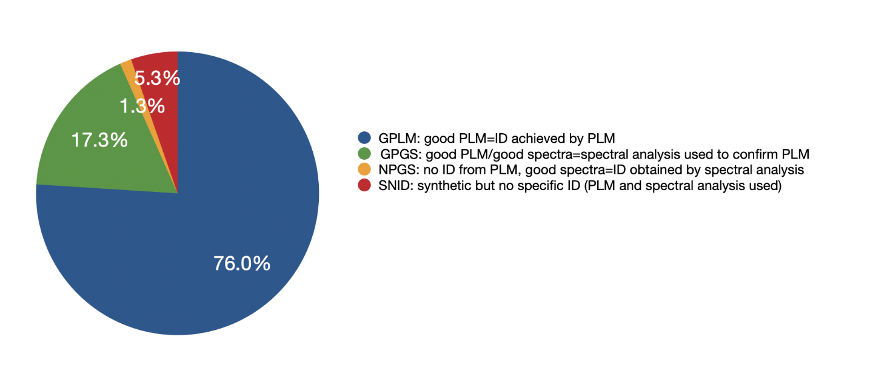
Figure 4: Methods used to achieve a polymer/material ID (or no ID). Please note: per the workflow in Figure 1, the process always started with the polarizing light microscope. If the ID was low confidence or no polymer ID could be achieved, spectroscopy was used.

Our recommendation, therefore, is to start the identification process using a PLM. The benefits are two-fold. First is a cost-savings benefit. The equipment itself is less expensive than either a Raman or FTIR to buy outright (for example, it is currently possible to obtain a PLM for <$4,000). For research groups planning to send samples to private labs for identification and paying per fiber or fragment analyzed, there could be a cost saving by owning a PLM and only sending a percentage of the samples out for spectroscopy services. Secondly, for those who have access to both a PLM and spectroscopy, there is a significant time saving utilizing a PLM as the first step. We estimate the following average times required for each method of polymer identification (per fiber, includes sample preparation):

- PLM: 4 minutes;
- Raman: 15 minutes
- FTIR: 35 minutes.

This saves 11-41 minutes per individual piece of anthropogenic fiber over using spectroscopy only. For the contamination study alone (94 microparticles of interest), we saved 12.8– 47.8 hours due to being able to make polymer identifications with the PLM alone and not use spectroscopy for every item. It must be noted that polymer identification using PLM is only possible if you encase any items of interest in a medium that is transparent to polarized light and is itself not birefringent (so as not to interfere with analysis). This means that MPs/AMFs need to be removed from the filter paper prior to analysis. The use of Easylift® tape facilitates this analysis by encasing items of interest between a non-birefringent layer and a glass microscope slide; this allows light to transmit through the sample and the polymer’s birefringence and sign of elongation (which allow polymer identification) to be measured (Gwinnett, Osborne and Jackson, 2021).

It is clear from this study that the major form of procedural contamination is fibers. Given that it is now accepted that fibers are also often the predominant form of MP found in the environment (Akanyange et al, 2021), unless procedural contamination is monitored and appropriately excluded from final counts, differentiating between fibers that are attributable to the environment and fibers that are the result of procedural contamination is imperative because not doing so has the potential to reduce accuracy by a significant amount. Even while following full QA/QC anti-contamination protocols, we still see that 33.8% (206 particulates) is contamination and 68.9% (142) of that, from this study, is coming directly from fibers from our team’s 100% cotton t-shirts. While the fibers being shed from these crew shirts may not be synthetic, they still may be classed as a form of pollution and are certainly procedural contamination with the power to put significant pressure on the time it takes to analyze results and ensure the accuracy of the results themselves.
One other study has investigated the potential effect of researchers’ clothing on microplastic sampling; Scopetani et al (2020) found that red, cotton overalls worn by all of the field scientists contributed 25%, 20% and 8% to sediment, snow and ice samples respectively while using full QA/QC. When looking solely at fibers from the cotton t-shirts during the full QA/QC sampling, the numbers in this study are very similar to those in Scopetani et al 2020. In our case, t-shirt fibers from crew shirts made up 23% of the total microparticles found.
These data suggest that studies investigating physical, anthropogenic pollution under 5mm should consider strategies that:
1) reduce the total amount of fibers likely to end up in the samples by considering outerwear made from low shed materials and/or low shed textile construction.
2) reduce the time needed to identify and source fibers in the samples by considering outerwear made from fibers that are distinct and easily identifiable, such as a rare color and morphology, e.g. unusual cross-sectional shape. By utilizing a sequential analysis approach that characterizes the fibers fully, only fibers from that source will be eliminated from end counts (Gwinnett, Osborne and Jackson, 2021). This team does not recommend garments mde with blue, red, white, colorless or black fiber as these are the colors most frequently found in environmental samples as pollution rather than contamination. In this study the 22 fibers from environmental pollution were: blue (40.9%), colorless (clear) (31.8%), red (13.6%) and black (13.6%). The primary benefit of this recommendation is potential time-saving in that the unusual fibers are flagged as potential contamination early, most likely only requiring PLM to confirm their source.
While both strategies will assist with streamlining research, the authors believe it is preferable to use low shed garments in the first instance. Considering that 76.7% of the total contamination came from crew clothing in part 2 of this study (full QA/QC), there are significant benefits both for research studies and the environment itself for researchers to choose low-shed garments that also provide the temperature control/protection from the elements required by field teams. Furthermore, we recommend that the garments designated for field and lab teams are tested prior to sampling to confirm that they truly are low-shed, however, currently there are no standardized methods to achieve this quantification.
Beyond controlling the material of textiles worn by the sampling/processing crew, it is our recommendation that the same is done for all members of the team, not just those in direct contact with the samples. Fibers from the captain’s clothing were part of the contamination found in this study, yet the captain was never in direct contact with samples at any time. Since that was the case, if any member of the team requires the use or wearing of textiles other than those issued to the sampling and processing team (such as foul-weather or UV protective gear), we recommend that controls are taken of all of those additional textiles as well as controls taken from any fiber-producing pieces of equipment including boat gear, backpacks/bags, lines/ropes, tarps, covers, and the like. Though gear other than clothing accounted for just 1.9% when using poor QA/QC and 0.5% in full QA/QC conditions (1 fiber from the line that controls the Niskin Bottle in each), other field situations may see greater contributions of contaminant fibers from equipment, for example, field work happening from tents or where sample-takers need to have gear bags in close proximity to the samples themselves (glaciers, mountainous/steep areas). This ability to highly differentiate between known sources of contaminant MPs or AMFs prevents the analysts having to eliminate microplastics and/or fibers found in samples based solely on color and/or polymer type; this provides a more accurate count on the abundance of the pollutant in the sample.

4. Limitations and further research
A limitation is the unbalanced design of part 2 (poor QA/QC) compared to part 1 (full QA/QC). This was due to the limited time available onboard the American Promise that could be dedicated to something other than sampling for MPs/AMFs with full QA/QC protocols in place.
This study grouped together multiple behaviors that would cause contamination for each sampling event with poor QA/QC protocols. It would be beneficial to isolate specific behaviors and test for how much they specifically contribute to procedural contamination to further ensure robust counts. Behaviors of particular interest for further investigation include; on deck: dropping a line in the sample bucket, positioning the sample jar downwind of collectors, wearing textile watch straps/bracelets, etc., and not triple washing hands; and below deck: leaving fans on, allowing people to walk through sampling area, and leaving sample jars uncovered during filtration. Investigating other potentially contaminating behaviors would also be useful for future studies.
The poor QA/QC sampling events were taken on a day with very little wind and while at anchor, whilst the full QA/QC sampling events were taken over 3 days with 3 different amounts of wind (light, medium and one day with relatively strong breeze) and with the vessel holding position with the engine. A study investigating how air flow across the boat affects the amount of procedural contamination in the samples and whether being anchored and/or wind strength (and direction relative to the boat) influences contamination would further help teams reduce procedural contamination at the planning and operational levels.
In part 2 (poor QA/QC), 73.6% of the contaminant fibers were cotton and 26.4% were synthetic fibers. 100% of the 8 crew each wore the same 100% cotton t-shirt whilst there was a mixture of different types of lower garments (e.g shorts/skirts) being worn. 24.5% of the contaminant fibers not from crew-issued t-shirts came from 8 different garments worn by 4 different crew members. While we can extrapolate the relative amount each type of garment contributed, a useful future study would be to investigate the likelihood of each of a range of appropriate garments (per the weather, elements, etc.) contributing contaminant fibers to samples. This kind of understanding of shed rates based on fiber type, textile construction and garment use would also be a valuable contribution to our overall understanding of this problem and our collective ability to develop and implement effective preventative solutions upstream of consumers.
Finally, all of the samples that were part of this study were taken and processed on one particular vessel. Repeating this study on other vessels and with various combinations of shoreside collection and different non-traditional lab arrangements (tents, for example) would further help future research teams design field studies that provide the most effective reduction in procedural contamination protocols which save on time and costs.

5. Conclusions
It is evident from this study that even with the strictest of QA/QC protocols, procedural contamination is inevitable when sampling for microplastics and/or anthropogenic microfibers from small vessels due to the dynamic environment, the inability to control airflow and the shed rates of our clothing. Using strict, consistent and team-wide full QA/QC anti-contamination protocols during field sampling and processing can reduce sample contamination by 36.9%. This study shows that even when full QA/QC anti-contamination protocols are in place, 33.8% of procedural contamination could remain. Techniques to ensure robust results that properly attribute microplastics and anthropogenic microfibers to the environment include: making deliberate choices concerning the clothing worn by all members of a sampling team (including those not directly in contact with the samples such as captain, first mate, guide, etc.) such as wearing either low shed or identifiable textiles and sampling these for control fibers. In addition, beginning the identification process by using a polarizing light microscope to fully characterize the optical and morphological properties of microparticles and then using FTIR and/or Raman spectroscopy as secondary confirmation can further reduce time and save on associated costs. This full characterization of samples beyond polymer type and color allows the source of the procedural contamination to be identified and leads to more robust counts of environmental pollution. These recommendations will benefit both the research teams engaged in water research as well as the very waters they are looking to understand.
Acknowledgements
Our first acknowledgment is to Amy Osborne for her tireless work onboard during sample collection and processing and for the number of tough hours doing sample analysis all the way through the pandemic.
Additionally, we would like to thank: the expedition’s lead organization, Rozalia Project for a Clean Ocean; scientific partner Staffordshire University and funders: National Geographic Society, Kilroy Realty Corporation and Schmidt Marine Technology Partners. In addition, thank you to all of the crew members and guest scientists onboard that made collecting samples and implementing this study’s protocols possible: Brooke Winslow, Captain Mark Waddington and First Mate Adam Steckley; Claudia Richardson (Patagonia), Eleanor Harrison (Staffordshire University), Ethan Edson (Ocean Diagnostics), Gregory Zarus (CDC), Mauricio Gonzales (NY Harbor School), onboard reporters: Annie Tuthill, Adam Steckley, Brooke Winslow and Alex Levin; delivery crew: Ashley Sullivan, Collin Schmidt, Brian Toche, Leanne Torrie, Heather Martin, Annie Tuthill and Blaze Jones-Yellin; education and delivery crew: Tina Mullen, Laura Migliacio, Jane O’Connor, Jessica Servis, and Elizabeth Hogan. We’d also like to acknowledge: Allan and Barbara Miller, The Tuthill Family, Shirley and Paul Waterfield, Alicia Martorella and the Hudson River Maritime Museum. We would also like to thank Dr. William Bailey for his help with data quality checking and statistical analysis. Thanks are also given to the technical team at Staffordshire University who have helped facilitate the analysis of the samples, in particular, Sarah Appelbee.
Funding
Rozalia Project was funded by National Geographic Society, Kilroy Realty Corporation and Schmidt Marine Technology Partners.
References
Akanyange, S.N., Lyu, X., Zhao, X., Li, X., Zhang, Y., Crittenden, J.C., Anning, C., Chen, T., Jiang, T., Zhao, H., (2021) Does microplastic really represent a threat? A review of the atmospheric contamination sources and potential impacts, Science of The Total Environment, 777.
Bordós, G., Urbányi, B., Micsinai, A., Kriszt, B., Palotai, Z., Szabó, I., Hantosi, Z., Szoboszlay. S., (2019) Identification of microplastics in fish ponds and natural freshwater environments of the Carpathian basin, Europe, Chemosphere, 216, pp 110-116.
Cole, M, Lindeque, P, Halsband, C, Galloway T.S (2011) Microplastics as contaminants in the marine environment: a review, Mar. Pollution Bulletin, 62, pp. 2588-2597
Cowger, W., Booth, A. M., Hamilton, B. M., Thaysen, C., Primpke, S., Munno, K., ... & Nel, H. (2020). Reporting guidelines to increase the reproducibility and comparability of research on microplastics. Applied spectroscopy, 74(9), 1066-1077
Dodson. G.Z, Shotorban. A.K, Hatcher. Derek. P.G, Waggoner. C, Ghosal. S, Noffke. N (2020) Microplastic fragment and fiber contamination of beach sediments from selected sites in Virginia and North Carolina, USA, Marine Pollution Bulletin, 151.
Duarte, A.C., (2020) Specialty grand challenges in environmental analytical methods, Frontiers in Environmental Chemistry, 1.
Frei, S., Piehl, S., Gilfedder, B. S., Löder, M. G. J., Krutzke, J., Wilhelm,L., Laforsch, C (2019) Occurrence of Microplastics in the hyporheic zone of rivers, Scientific Reports, 9.
Frias,J.P.G.L. Sobral, P., Ferreira,A.M (2010) Organic pollutants in microplastics from two beaches of the Portuguese coast, Marine Pollution Bulletin, 60, (11), pp1988-1992.
Gwinnett, C.M.B., Osborne, A.O., Jackson, A.R.W (2021) The application of tape lifting for microplastic pollution monitoring, Environmental Advances, 5.
Huntington, A., Corcoran, P.L., Jantunen, L., Thaysen, C., Bernstein, S., Stern, G.A., Rochman, C.M, (2019) A first assessment of microplastics and other anthropogenic particles in Hudson Bay and the surrounding eastern Canadian Arctic waters of Nunavut. FACETS. 5, (1), pp432-454.
Isobe.A., Uchiyama-Matsumoto, K., Uchida, K., Tokai, T (2017) Microplastics in the Southern Ocean, Marine Pollution Bulletin, 114, pp 623-626.
Jensen, L.H., Motti, C.A., Garm, A.L., Tonin, H., Kroon, F.J., (2019) Sources, distribution and fate of microfibres on the Great Barrier Reef, Australia, Scientific Reports, 9.
Kedzierski, M., Falcou-Prefol, M., Kerros, M.E., Henry, M., Pedrotti, M.L., Bruzaud, S. (2019) A machine learning algorithm for high throughput identification of FTIR spectra: Application on microplastics collected in the Mediterranean Sea, Chemosphere, 234, pp 242-251.
Koelmans, A.A., Nor, N.H.M., Hermsen, E., Kooi, M., Mintenig, S.M., De France, J., (2019) Microplastics in freshwaters and drinking water: Critical review and assessment of data quality, Water Research, 155, pp 410-422,
Kuklinskia, P., Wicikowskid, L., Koperc, M., Gralac, T., Leniec-Koperc, H., Barasińskic, M.,Talarc, M., Kamińskic, I., Kibartc, R., Małecki, W. (2019) Offshore surface waters of Antarctica are free of microplastics, as revealed by a circum-Antarctic study, Marine Pollution Bulletin, 149.
Lindeque, P.K., Cole. M., Coppock, R.L., Lewis, C.N., Miller, R., Watts, A.J.R., Wilson-McNeal, A., Wright, S.L., Galloway, T.S, (2020) Are we underestimating microplastic abundance in the marine environment? A comparison of microplastic capture with nets of different mesh-size, Environmental Pollution, Volume 265, Part A.
Liu, K., Wang, X., Fang, T., Xu, P., Zhu, L., Li, D. (2019) Source and potential risk assessment of suspended atmospheric microplastics in Shanghai, Science of The Total Environment, 675, pp 462-471.
Miller, E., Sedlak, M., Lin, D., Box, C., Holleman, C., Rochman, C.M., Sutton, R. (2021) Recommended best practices for collecting, analyzing, and reporting microplastics in environmental media: Lessons learned from comprehensive monitoring of San Francisco Bay, Journal of Hazardous Materials, 409.
Miller RZ, Watts AJR, Winslow BO, Galloway TS, Barrows APW (2017) Mountains to the sea: River study of plastic and non-plastic microfiber pollution in the northeast USA, Mar Pollution Bulletin, 124.
Ng, K.L., Obbard. J.P, (2006) Prevalence of microplastics in Singapore’s coastal marine environment, Marine Pollution Bulletin, 52, (7), pp 761-767.
Palenik, C. S., Beckert, J. C. and Palenik, S. (2016). Microspectrophotometry of fibers: Advances in analysis and interpretation. National Criminal Justice Reference Service, U. S. Department of Justice.
Plee, T.A., Pomory, C.M, (2020) Microplastics in sandy environments in the Florida Keys and the panhandle of Florida, and the ingestion by sea cucumbers (Echinodermata: Holothuroidea) and sand dollars (Echinodermata: Echinoidea), Marine Pollution Bulletin, 158.
Prata, J.C., Reis, V., Da Costa, J.P., Mouneyrac, C., Duarte, A.C., Rocha-Santos, T. (2021) Contamination issues as a challenge in quality control and quality assurance in microplastics analytics, Journal of Hazardous Materials, 403.
Qin F, Du J, Gao J, Liu G, Song Y, Yang A, Wang H, Ding Y, Wang Q. (2020) Bibliometric Profile of Global Microplastics Research from 2004 to 2019. International Journal of Environmental Research and Public Health, 17 (16) 5639
Robertson, J., Roux, C. and Wiggins, K. (eds). (2018). Forensic Examination of Fibres. 3rd edn. Boca Raton: CRC Press.
Russell, M., Webster, L. (2021) Microplastics in sea surface waters around Scotland, Marine Pollution Bulletin, 166.
Schönlau, C., Karlsson, T.M., Rotander, A., Nilsson, H., Engwall, M., Van Bavel, B., Kärrman, A (2020) Microplastics in sea-surface waters surrounding Sweden sampled by manta trawl and in-situ pump, Marine Pollution Bulletin, 153.
Scopetani, C., Esterhuizen-Londt, M., Chelazzi, D.,Cincinelli, A., Setälä, H., Pflugmacher, S. (2020) Self-contamination from clothing in microplastics research, Ecotoxicology and Environmental Safety, 189.
Suaria, G., Perold, V., Lee, J.R., Lebouard, F., Aliani, S., Ryan, P.G., (2020) Floating macro-and microplastics around the Southern Ocean: Results from the Antarctic Circumnavigation Expedition, Environment International, 136.
Tamminga, M., Stoewer, S-C., Fischer, E.K., (2019), On the representativeness of pump water samples versus manta sampling in microplastic analysis, Environmental Pollution, 254, Part A.
Thompson R.C., Olsen Y., Mitchell R.P., Davis A., Rowland S.J., John A.W.G., Mcgonigle D., Russell A.E. (2004) Lost at sea: Where is all the plastic? Science, pp304:838.
Woodall, L. C., Gwinnett, C., Packer, M. P., Thompson, R. C., Robinson, L. F. & Paterson, G. L. J. (2015). Using a forensic science approach to minimize environmental contamination and to identify microfibres in marine sediments. Marine Pollution Bulletin. 95 (1). pp. 40-46.
Zayen, A., Sayadi, S., Chevalier, C., Boukthir, M., Ismail, S.B., Tedetti, M (2020) Microplastics in surface waters of the Gulf of Gabes, southern Mediterranean Sea: Distribution, composition and influence of hydrodynamics, Estuarine, Coastal and Shelf Science.

