TEACHING AND LEARNING CASE STUDY ON SOCIAL MEDIA ANALYTICS FOR SMALL AND MEDIUM-SIZED ENTERPRISES
M. Willetts, A.S. Atkins, C. Stanier
Staffordshire University (UNITED KINGDOM)

Abstract
There is a shortage of case studies to support the teaching of Big Data Analytics, particularly in the area of business applications to SMEs to achieve competitive advantage. The literature indicates there is lack of adoption to Big Data Analytics in SMEs citing insufficient case studies success, expertise, and financial cost as barriers to adoption. The paper outlines the application of a proposed holistic Big Data Analytics framework for UK SMEs to a case study for the purpose of demonstrating how a business can overcome the barriers to adoption. SMEs comprise 99% of all businesses in the UK (6 million), employ 61% of the country’s workforce and generates over half of the turnover of the UK’s private sector (£2.2 trillion) assisting them to gain competitive advantage by the adoption of technology is important. SMEs represent 99% of all businesses in Europe and 90% of all businesses worldwide. The paper presents Big Data Analytics tool based on the proposed holistic framework and shows how a small business using web technology in recruitment software marketing can adopt Social Media Analytics. The paper presents the scores of the framework tool across three stages of the business development: pre-Business Intelligence, Business Intelligence and Big Data Analytics. The second and third stages of the case study show how measurable improvements are gained and how the company can benchmark itself against competitors together with an indication of the software selection either using free (trial) or commercial software, expertise, and the financial costs of the respective stages. The application of Big Data Analytics tool is transferrable to other SME sectors such as manufacturing, logistics and service industry. The development of this case study provides an approach which could be utilised by other educators to develop their own case studies to support teaching.
Keywords: Big Data Analytics, Case Study, SMEs, Competitive Advantage, Social Media Analytics

INTRODUCTION
Big Data Analytics has been widely adopted by large businesses but not to the same extent by SMEs [1]–[3]. Big Data is defined as: ‘an umbrella term used to describe a wide range of technologies that capture, store, transform and analyse complex data sets which can be of a high volume, generated at a high velocity in a variety of formats’ [4, p. 3034]. Big Data Analytics refers to the variety of software tools and techniques which are used to extract insights from Big Data sources. Mikalef et al. [5, p. 1] state that a widely used definition of Big Data Analytics is: ‘a new generation of technologies and architectures, designed to economically extract value from very large volumes of a wide variety of data, by enabling high velocity capture, discovery and/or analysis’. One form of Big Data Analytics is social media analytics. Social media analytics refers to the analysis of structured and unstructured data generated by social media which can include social networks, blogs, microblogs, social news, social bookmarking, media sharing, question-and-answer sites and review sites [6]. There are a variety of techniques for analysing social media data which include: modelling, sentiment analysis, social network analysis and text mining [7].
As part of this research, 21 barriers to the adoption of Big Data Analytics by SME were identified and a framework has been developed [4], [8], which has been validated through quantitative [9] and qualitative studies. A software tool has been developed to allow SMEs to assess their current level of Big Data Analytics readiness on a scale of between a score of 1 (very low: business is not ready for the adoption of Big Data Analytics) to 5 (very high - business has adopted Big Data Analytics and is achieving significant benefits from the technology). The readiness framework shown in Fig 1.has been derived from an extensive literature review which identified 69 barriers to adoption from 14 publications [6]. The barriers were validated using both a quantitative approach through an online questionnaire fully completed by 102 SMEs and a qualitative analysis of 8 focus group interviews with SME practitioners. The barriers to adoption were grouped into four categories, referred to as pillars. The framework was revised to reflect the comments received during validation and the final version of the framework is shown in Fig. 1. This version of the framework includes weightings to represent the importance of the barrier and the weightings are used in a scoring tool. The weightings were developed using the number of citations in the literature and the feedback from the SME practitioners in the focus group interviews, as they provided a richer vocabulary which cannot be acquired through a questionnaire. A significant barrier to SME’s adoption of Big Data Analytics, suggested in the literature is the lack successful business case studies in this sector [1], [2]. The weightings were tested on a positioning and experimentation study before the application to this case study described in this paper. Case studies of businesses operating under similar limitations to themselves would be very helpful in convincing SMEs why they should adopt Big Data Analytics and provide a blueprint of how to achieve the same benefits. This paper outlines the approach used to develop a Big Data adoption case study for use with the Big Data Analytics Strategic Framework. The case study development approach discussed in this paper could be adapted to develop case studies for use in other contexts.
Figure 1 - Big Data Analytics Strategic Framework with the weightings allocated

METHODOLOGY
Validation of the Big Data Analytics framework was achieved by applying the framework to case studies, utilising the scoring tool. The scoring tool has been designed to be intuitive to use, allowing SMEs to rank themselves to support the investment in Big Data Analytics and to identify where improvements are required. To achieve this, case studies have been developed with SMEs, showing the application of Big Data Analytics. Each case study shows three stages of Big Data Analytics adoption: the first stage when the business does not utilise data analytics, the second phase when the business is using Business Intelligence to analyse Big Data and a third stage when Big Data Analytics could be utilised. This paper describes a case study based on a small recruitment company, Company A. In the scenario presented here, Company A is currently utilising social media analytics and are actively attempting to improve their usage of this software through the form of sentiment analysis.
The case study was developed in a focus group with SME practitioners, similarly to a Community of Practice (CoP). A CoP is defined as: ‘groups of people who share a concern or a passion for something they do and learn how to do it better as they interact regularly’ [10, p. 1]. It has been suggested that smaller numbers of participants result in greater interaction amongst the members of the focus group. Nielsen [11] recommended that five participants is the ideal number for conducting interviews whereas a focus group should consist of six to nine participants.
The stages performed to document the case studies were:
1) A standard presentation was made to the representative of the SME assisting with the case study. The presentation documented the framework and the tool to show the SME how to apply this.
2) A workshop was held with the SME representative. They provided information about each phase of their business’ analytics maturity journey including background information about the company, the data captured and the software utilised.
3) The SME scored themselves using the tool and the guidance provided.
4) The output of the session was documented for each stage of the case study.

Selection of Data and Software
The development of the case study required access to data. Social media data is publicly available for anyone with an internet connection to view. This is highly advantageous for businesses as they can view posts relating to themselves, their competitors and the industry in which they operate. Social media analytics software allows the user to select the social media accounts which they wish to monitor, therefore they can see any posts which are publicly available which relate to them. There are many social media analytics or social media management packages which contain social media analytics functionality. Free tools or free tiers of commercial packages are available such as Talkwalker [12], Social Searcher [13] and Mention [14]. There are limitations with the free software packages available, however they may satisfy the needs of an SME or demonstrate how social media analytics can assist their business. Similarly, free or open-source software may be sufficient for academic studies. The majority of social media analytics solutions reviewed for this research offered a free trial, which is useful for academic studies as it allows staff and students to sign up for trials whilst they undertake their research. It also allows businesses to review the different packages whilst they establish which one they prefer. Many of the social media packages reviewed have other features such as the ability to schedule social media posting to different social media platforms. A sample of the social media analytics software available is shown in Table 1.

Table 1 - Sample of Social Media Analytics Software Available
 |  | Awario [15] | Brand24 [16] | Hootsuite [17] | Mention [14] | Social-Searcher [13] | Talkwalker [12]
Features | Description | Social media suite for posting and analytics across multiple social media networks | Social media monitoring tool | Social media suite for posting and analytics across multiple social media networks | Social media suite for posting and analytics across multiple social media networks | Social media search engine and monitoring service with alerts | Limited to searching for keywords and hashtags over a 7 day period
Features | Social media platforms | Facebook  Twitter  Instagram  YouTube | Facebook  Twitter | Facebook  Twitter  Instagram  LinkedIn  YouTube  Pinterest | Facebook  Twitter  Instagram  YouTube | Facebook  Twitter  Instagram  YouTube | Twitter  YouTube  Pinterest
Training/Support | Online tutorials, videos or resources | Yes | Yes | Yes | Yes | Limited | No
Training/Support | Support | Account Manager with Enterprise tier | Live help with Premium tier | Business tier only | Email support Account management with Company tier | No | No
Training/Support | Training courses | Online videos but support is available | Training resources available - consultant available in $199 per month tier | On-demand | Live online training | No | No
Finance | Cost | From $24 per month | From $49 per month | From £39.99 per month | From $83.99 per month with sentiment analysis | From free to €19.49 per month | Free – premium tiers are available but pricing must be requested
Finance | Free trial | Yes | Yes | Yes | Yes | Yes | N/A
Finance | Free tier | No | No | Yes | No | Yes | Yes

RESULTS - Scenario

Pre-Data Analytics Stage
The first stage in developing the case study was to create the scenario. In the scenario presented here, Company A is a small Recruitment company based in the UK, founded in the late 1990s. The business provides a range of recruitment services to businesses including traditional end-to-end recruitment through advertising job vacancies, heading hunting candidates to shortlist for businesses. The business utilises a Software as a Service (SaaS) recruitment software solution, which was customised to the business’ requirements. The software was developed by another company who undertakes and maintains the software and develops new functionality at the request of Company A. The business has utilised the software vendor for over 10 years. The recruitment software provides the facility to post job advertisements to job boards, receive applications, shortlist candidates and arrange job interviews. The software also allows candidates to be stored in a database so that they can be considered for future positions when suitable jobs become available. Company A’s client base consists of businesses in a wide range of sectors. Company A’s clients have access to view candidates in their own instance of the recruitment software. Similarly, Company A also resell their software to other recruiters to post their own jobs and have their own independent instance of the software. The size of the clients ranges from SMEs to large, multinational companies. The recruitment agencies who utilise the software can range from sole traders to SMEs. Prior to the adoption of social media analytics, the business primarily advertised its services through its website which was developed and maintained by a third party. Company A had social media accounts for Facebook and Twitter but did not actively use them. The business utilised LinkedIn to for recruitment of candidates. The business promoted itself at trade shows and print media.
The business employed 20 staff, primarily recruitment staff, supported by finance, business development and sales staff. The business is privately owned by a family who also ran the business; therefore, the decisions were predominantly driven by them and funds were only allocated to investments which they believed would provide a return on investment. The business maintained a sustainable volume of work from their client base. The business captured a range of data such as sales and marketing data, in addition to CVs stored by the business and their customers in the recruitment software (both structured and unstructured data including images and text documents). The business utilised Microsoft Excel for ad-hoc financial and sales reporting but did not utilise any traditional Business Intelligence or Big Data Analytics applications.
The company outsourced its IT support to a third party; however, in the scenario, several members of staff have a high level of IT literacy. As the business resells SaaS software and processes sensitive data, they ensure they are compliant with legislation such as the General Data Protection Regulation (GDPR) and are aware of ethical concerns of using personal data. The business occasionally utilised consultancy services. The information in the scenario was applied to the framework and weightings shown in Table 2 and the score for this stage of the case study was calculated as 2.30 which indicates a low level of readiness for the adoption of Big Data Analytics but some of the foundations are in place.
Table 2 - Results from Stage 1 of the Scenario
Overall Score | 2.30
Stage | - Stage 1 – Basic Analytics
Software | - Microsoft Excel
Cost | - £7 per month per user (Office 365) or £249 for a Office Home & Business 2019 licence [18]
Expertise | - Basic spreadsheet skills  - Many written tutorials are available online or videos such as on YouTube  - Training courses are available

Business Intelligence Stage
The second stage of the case study describes changes that take place in the company, specifically that changes to personnel in Company A led to the appointment of a new Operations Director who had been recruited into the business externally. The new Operations Director wanted to increase the market share of the business by focusing on new markets and offering new services, with the number of staff increasing to 35 to expand the business. The Operations Director believed this could be achieved by improving Company A’s usage of social media and online advertising such as Google Ads. The Operations Director was aware of how social media analytics software could benefit the business such as simplifying posting to multiple social media networks and reporting the impact their social media posts were making, such as the number of likes and interactions. This allowed the business to identify which posts were well received to allow them to tailor their marketing to increase the sales enquiries and ultimately the number of sales. Company A’s competitors were also utilising social media to interact with customers and advertise the business.
The senior management team therefore decided to invest in a basic social media analytics software package. The software allowed the business to obtain descriptive reports on the social media activity of Company A to identify how effective their usage of social media was to improve their usage of social media. Applying the framework factors and weightings to the information in the Business Intelligence stage, created a score of 3.40 as shown in Table 3 which indicates an awareness of the benefits of Big Data Analytics but they are limited in the type of analysis which they can conduct using historical data.
Table 3 - Results from Stage 2 of the Scenario
Overall Score | 3.40
Stage | - Stage 2 – Business Intelligence
Software | - Social Media Analytics Software - Mention
Cost | - £30 per month (free one month trial available)
Expertise | - Online tutorials and user guides are available for most social media analytics tools  - Some software providers offer online training  - Most solutions reviewed offer support  - Consultants available from £500-£1,000 per day

Big Data Analytics Stage
In the final stage of the case study, the scenario shows Company A deciding to invest further time and resources into Social Media Analytics. The company decided to hire a full-time Digital Marketing Executive to manage their social media including posting, interacting with customers and reporting on both Company A’s use of social media and its competitors. In this stage of the scenario, Company A uses Big Data Analytics in the form of sentiment analysis of social media. Sentiment analysis analyses the content of social media posts to identify whether they contain positive or negative sentiment. By utilising sentiment analysis, the business analyses social media data which is freely available in the public domain for a number of purposes.
Social media posts relating to competitors and the wider industry can also be analysed for sentiment. There are many applications available which are suitable for SMEs including Hootsuite [17] and Mention [14]. For the purposes of this Case Study, a trial of Mention was utilised to demonstrate how sentiment analysis can be utilised. All of the data utilised was taken from social media and is freely available, however the screenshots are anonymised to protect the identities of the businesses.
In the scenario, Company A uses Mention and utilise sentiment analysis for multiple purposes. Firstly, the sentiment of the responses to posts made by the business or its competitors can be analysed for sentiment, for example whether it was received positively or negatively. Similarly, posts which mention the business or its competitors can be analysed to identify whether it is being discussed positively or negatively. Fig 2. shows an example of how social media analytics can compare the sentiment of posts of a business and its competitors.
Figure 2 - Comparison of posts made by Recruitment businesses within one week analysed by sentiment using Mention
Dashboards or alerts can be configured to monitor the sentiment of the business or its competitors. This may be useful to identify events, for example if there is a problem with the business’ recruitment software platform, there may be a number of negative posts on social media which mention the business. By detecting this, the business can intervene by engaging with the customers but can also report the technical problem to their developers. Fig. 3 shows an example of how this may appear.
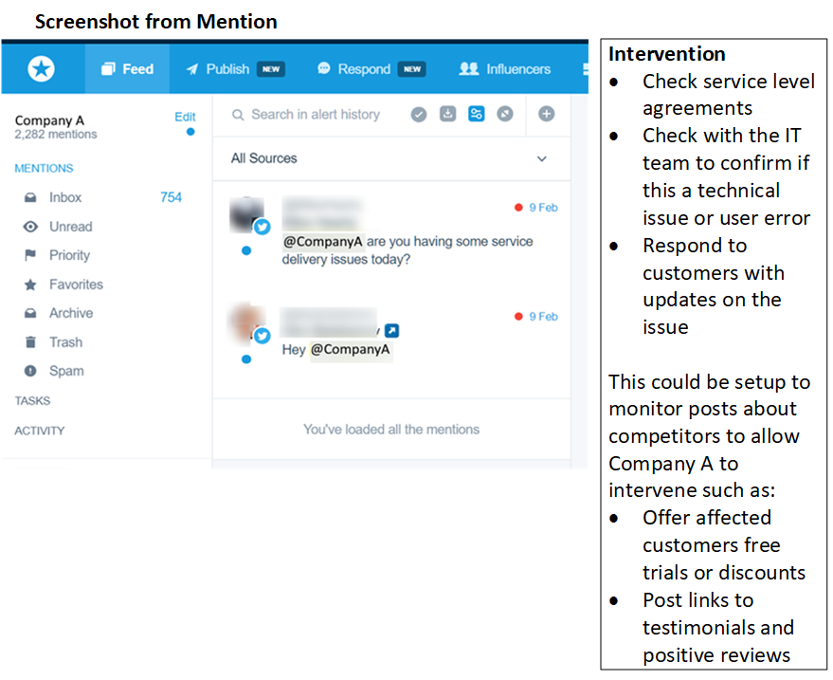
Figure 3 – Dashboard showing negative posts identified as negative sentiment of a Recruitment company using publicly available social media data in Mention
Sentiment Analysis can also be utilised to identify Influencers such as businesses or individuals who are positively or negatively discussing Company A, its competitors or topics in the industry. Influencers could be contacted to promote Company A or their feedback could be utilised to make changes to its offerings. One consideration when performing social media analytics is ethics. Individuals and businesses can be identified from their social media posts. Fig 3. shows a social media post relating to a cloud-based software package which appears to be offline. If the name of the developer of this software was published as part of this anonymised case study, this could cause reputational damage. Potentially, this may not have been a system error and it could have been user error, therefore extreme caution needs to be considered when publishing sensitive social media posts. For the purposes of the development of the case study outlined in this paper, business and individuals have been anonymised to protect their identities. Similarly, businesses which are being discussed negatively could be targeted in marketing.
Social Media Analytics software can also identify trending topics with both positive and negative sentiment. Company A can use these to tailor its marketing, for example adding keywords which people will engage with or how to overcome negative issues. For example, Company A may want to utilise keywords or hashtags such as ‘#futureofwork’, ‘#wellbeing’ and ‘#diversity’.
The location of positive and negative social media messages mentioning Company A can be identified using Mention or an alternative package, as shown in in Fig 4.
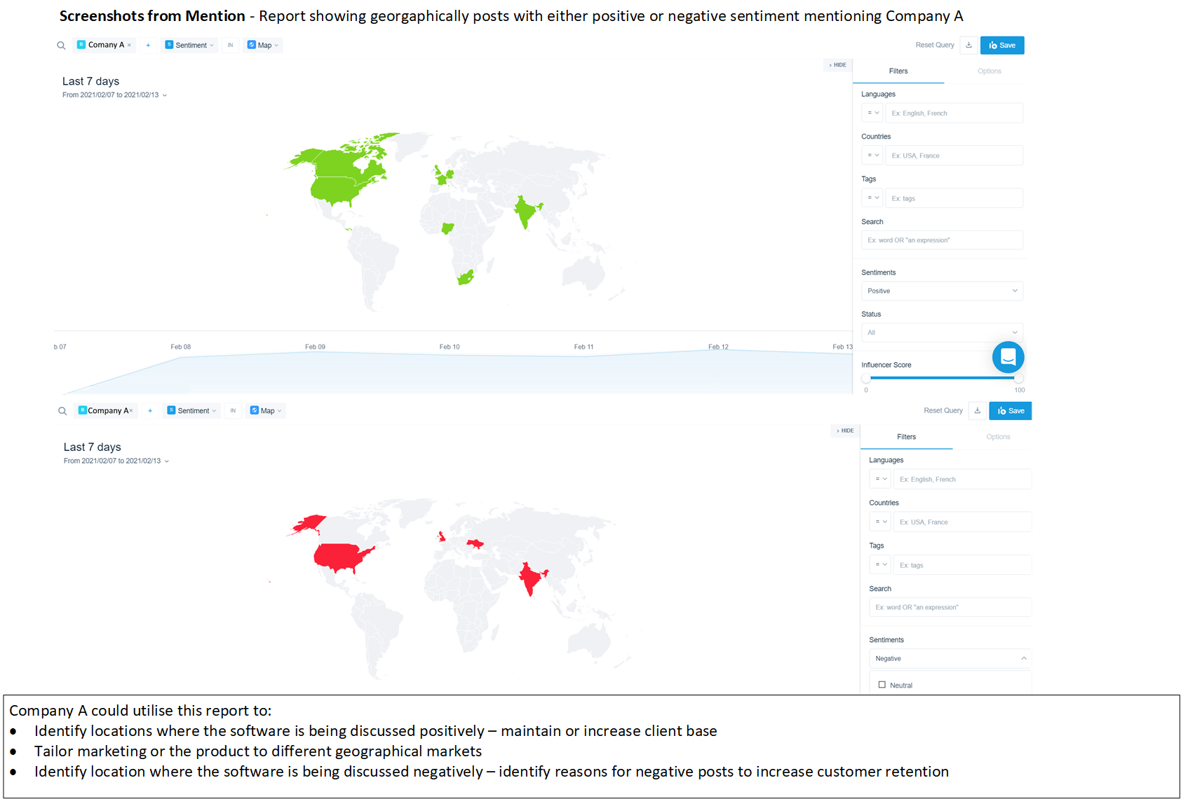
Figure 4 - Sentiment by location
The information in the scenario was applied to the framework and weightings shown in Fig. 1 and the score for this stage of the case study was calculated as 4.0 as shown in Table 4, which indicates a high level of expertise in Big Data Analytics with scope to expand further. For the purposes of the case study, it is assumed that Company A is only interested in Big Data Analytics in relation to sentiment analysis. In a real world scenario, other data such as web site traffic and customer management data would also be relevant.
Table 4 - Results from Stage 3 of the Scenario

Overall Score | 4.0
Stage | - Stage 3 – Big Data Analytics - Sentiment Analysis
Software | - Social Media Analytics – Mention  - A sample of 6 suitable packages with sentiment analysis capability have been identified in Table 1
Cost | - Free tools are available such as TalkWalker  - Most providers reviewed offer free trials  - Paid software ranges from $24 per month – some software has limitations on the number of posts but there are higher tiers available
Expertise | - Online tutorials and user guides are available for most social media analytics tools  - Some software providers offer online training  - Most solutions reviewed offer support  - Consultants available from £500-£1,000 per day  - A full time member of staff could be hired such as a Digital Marketing Assistant (£25,000 per annum) [19] or Social Media Manager (£37,500 per annum) [20]

CONCLUSIONS
This paper has described the process of developing a case study for use with a framework designed to support the adoption of Big Data Analytics by SMEs. The case study is based on the use of Big Data Analytics applied to social media. The process of developing the case study included the selection of software and data, and consideration of the ethical issues of social media analytics. Social media data is freely available, therefore the advantage to utilising this data to develop a case study is that datasets do not need to be created, and that real world data and real world data volumes can be used. The approach used in the case study was to show the evolution of the use of Big Data Analytics with social media by presenting the analysis in three stages: pre-Business Intelligence, Business Intelligence and Big Data Analytics. The development of further case studies will follow this approach.
Future publications will document the further development of the scoring tool and its application to further case studies showing the use of Big Data Analytics with SMEs in different sectors such as logistics.
REFERENCES
[1] S. Coleman, R. Göb, G. Manco, A. Pievatolo, X. Tort-Martorell, and M. S. Reis, “How Can SMEs Benefit from Big Data? Challenges and a Path Forward,” Qual. Reliab. Eng. Int., vol. 32, no. 6, pp. 2151–2164, Oct. 2016, doi: 10.1002/qre.2008.
[2] M. Iqbal, S. H. A. Kazmi, A. Manzoor, A. R. Soomrani, S. H. Butt, and K. A. Shaikh, “A study of big data for business growth in SMEs: Opportunities & challenges,” in 2018 International Conference on Computing, Mathematics and Engineering Technologies: Invent, Innovate and Integrate for Socioeconomic Development, iCoMET 2018 - Proceedings, Mar. 2018, vol. 2018-Janua, pp. 1–7, doi: 10.1109/ICOMET.2018.8346368.
[3] M. Bianchini and V. Michalkova, “OECD SME and Entrepreneurship Papers No. 15 Data Analytics in SMEs: Trends and Policies,” 2019. doi: 10.1787/1de6c6a7-en.
[4] M. Willetts, A. S. Atkins, and C. Stanier, “A Strategic Big Data Analytics Framework To Provide Opportunities for SMEs,” in INTED2020 Proceedings, 2020, vol. 1, pp. 3033–3042, doi: 10.21125/inted.2020.0893.
[5] P. Mikalef, M. Boura, G. Lekakos, and J. Krogstie, “Big data analytics and firm performance: Findings from a mixed-method approach,” J. Bus. Res., vol. 98, pp. 261–276, 2019, doi: https://doi.org/10.1016/j.jbusres.2019.01.044.
[6] A. Gandomi and M. Haider, “Beyond the hype: Big data concepts, methods, and analytics,” Int. J. Inf. Manage., vol. 35, no. 2, pp. 137–144, Apr. 2015, doi: 10.1016/j.ijinfomgt.2014.10.007.
[7] N. A. Ghani, S. Hamid, I. A. Targio Hashem, and E. Ahmed, “Social media big data analytics: A survey,” Comput. Human Behav., Aug. 2018, doi: 10.1016/j.chb.2018.08.039.
[8] M. Willetts, A. S. Atkins, and C. Stanier, “Barriers to SMEs Adoption of Big Data Analytics for Competitive Advantage,” in 4th International Conference on Intelligent Computing in Data Sciences, ICDS 2020, Oct. 2020, pp. 1–8, doi: 10.1109/ICDS50568.2020.9268687.
[9] M. Willetts, A. S. Atkins, and C. Stanier, “Quantitative Study on Barriers of Adopting Big Data Analytics for UK and Eire SMEs,” in Data Management, Analytics and Innovation, 2022, pp. 349–373.
[10] E. Wenger-Trayner and B. Wenger-Trayner, “Communities of practice 1 A brief introduction-V Communities of practice a brief introduction,” 2015.
[11] J. Nielsen, Usability Engineering. San Diego: Morgan Kaufmann, 1993.
[12] Talkwalker, “Best Free Social Media Search Tool - Talkwalker,” 2021. https://www.talkwalker.com/social-media-analytics-search (accessed Sep. 04, 2021).
[13] Social Searcher, “Social Searcher - Free Social Media Search Engine,” 2021. https://www.social-searcher.com/ (accessed Sep. 04, 2021).
[14] Mention, “Monitoring and Social Media Management | Manage your Brand Online,” 2021. https://mention.com/en/ (accessed Aug. 29, 2021).
[15] Awario, “Brand monitoring tool to analyze all brand mentions on the web | Awario,” 2021. https://awario.com/ (accessed Sep. 04, 2021).
[16] Brand24, “Brand24 - Media Monitoring Tool,” 2021. https://brand24.com/ (accessed Sep. 04, 2021).
[17] Hootsuite, “Social Media Management Dashboard - Hootsuite,” 2021. https://hootsuite.com/en-gb/ (accessed Jan. 02, 2021).
[18] Microsoft, “Microsoft Office 2019 for Business | Microsoft 365,” 2021. https://www.microsoft.com/en-GB/microsoft-365/get-started-with-office-2019 (accessed Jul. 19, 2021).
[19] Totaljobs, “What is the average salary for Digital Marketing Assistant jobs?,” 2021. https://www.totaljobs.com/salary-checker/average-digital-marketing-assistant-salary.
[20] Totaljobs, “What is the average salary for Social Media Manager jobs?,” 2021. https://www.totaljobs.com/salary-checker/average-social-media-manager-salary.

