Evaluating seasonal change in the landscape of Downs Banks, Barlaston: a visual quality approach.

Dissertation submitted in partial fulfilment of the requirements for the degree of Master of Philosophy, MPhil

“This copy has been supplied on the understanding that it is copyright material and that no quotation from the thesis may be published without proper acknowledgement.”

Anne Elizabeth May Brown

School of Life Sciences and Education Department: Biological Sciences
July 2021
Supervisors
Ruth D Swetnam & Fiona S Tweed

Staffordshire University
July 2021

Contents
Abstract iii
Acknowledgements v
1 Introduction 1
1.1 The evolution of landscape assessment 6
1.2 Conceptual framework for approaches to landscape assessment. 8
1.2.1 Landscape – the difficulty of definition. 8
1.2.2 Perception theory and influences on visual perception and preference. 10
1.3 Approaches to landscape assessment. 13
1.4 Seasonal approaches to landscape assessment 15
1.5 Aims, objectives and research questions 18
2 Methods 19
2.1 Methodological context 19
2.1.1 Pathways to enquiry 20
2.2 The Downs Banks site 22
2.3 Study site selection 31
2.4 Survey point selection 32
2.5 Taking the seasonal photographs 34
2.6 The Visual Quality Index (VQI) 35
2.7 Adapting the Survey Assessment to Downs Banks 37
2.7.1 Terrain 38
2.7.2 Blue Space 43
2.7.3 Green Space 43
2.7.4 Human/Built 48
2.8 Winter study on site 51
2.8.1 Selection of surveyors 52
2.9 Assessing seasonal photographs and confirmation of VQI 52
2.9.1 Use of photographs 53
2.9.2 Weighting the VQI and Sensitivity Test 54
2.10 Testing appeal of the Downs Banks landscape – the online survey 56
2.10.1 Selection of photographs 56
2.10.2 Designing the online survey 57
2.10.3 Administering the online survey 58
2.11 Statistical analyses 59
3 Results and Discussion 60
3.1 Winter field study 61
3.2 Testing the Appeal from the public preference online survey 70
3.2.1 Agreement with the Winter field study Appeal score 73
3.3 The participant profiles 76
3.3.1 Testing the Appeal - Age group 79
3.3.2 Testing the Appeal - Gender 81
3.4 Landscape Parameter Appeal 85
3.5 Limitations 88
4 Conclusions and recommendations 90
APPENDICES 109
Appendix 1 Comparisons of VQI adaptations 110
Appendix 2 Overview of component metrics and supporting literature. (Adapted Downs Banks metric in bold). 112
Appendix 3 VQI field survey assessment 114
Appendix 4 The VQI calculation, weighting and sensitivity analysis. 115
Appendix 5 The 11 photographs used for the online survey (with VQI scores) 117
Appendix 6 Landscape Parameter photographs for online survey 119
Appendix 7 Online survey examples. 120
Appendix 8 Significant differences in appeal between the 11 survey photographs 121
Appendix 9 Appeal ratings of seasonal photographs – 122
Age groups and Gender groups compared to total appeal. 122
Appendix 10 Inter-group comparison of Appeal ratings for Age group and 123
Gender group 123
Appendix 11 Comparison of Appeal ratings by frequency of visits compared to 124
total appeal 124
Appendix 12 Inter-group comparison of Appeal ratings for frequency of visits. 125

Abstract
Assessing visual quality and aesthetic preferences for landscapes using both quantitative and qualitative methods remains a challenge for landscape research, but it is vitally important for conservation and management. This study adapts and tests a published landscape evaluation method, the Visual Quality Index or VQI (Swetnam et al., 2017), in a typical British lowland rural landscape. The study was conducted in Downs Banks, a nature reserve close to the city of Stoke on Trent in Staffordshire, UK. The site is in a semi-rural area and it is owned and managed by the National Trust. In this study, specific focus is given to seasonal changes in perceived visual quality. Emphasis on temporal changes in visual quality, where landscape ‘space’ is kept constant, but landscape ‘time’ is manipulated remains under-researched in the field and has not been evaluated in this type of rural setting in England.
Visual quality parameters were chosen to assess specific landscape features across the site with additional seasonal parameters included to capture key differences in visual quality over the space of a calendar year. Sites were photographed and images selected for an online survey to gauge public responses. Respondents were asked to rate the appeal of the photographs on a 10-point scale and were also asked to indicate preferences for specific landscape features. Additional data about age, gender, frequency of visits and activities pursued in rural areas was also collected from the 162 respondents.
Sites with higher VQI scores calculated using a range of specific landscape indicators did not always appeal aesthetically to the survey respondents, but views with minimal human intervention were preferred. Seasonally, landscape views in summer and autumn were preferred and overall ratings differed significantly from the same sites in winter. Specifically, seasonal visual characteristics including the range of colours in autumn and summer, the presence of seasonal fruits and berries and the dense tree canopies in summer were positively perceived. The brown winter colours exhibited by some of the of the vegetation, the muddy ground and ploughed fields were negatively perceived. Age and gender of respondents showed no significant association with appeal ratings however, frequency of visits to the site revealed some significant relationships with appeal ratings. Respondents found autumn most appealing
This study confirms the need for further refinement of seasonal visual quality parameters when undertaking detailed work of this type. Recommendations for the effective management of small natural areas are presented; these are particularly important against the backdrop of climate change and the anticipated importance of a future in which we are encouraged to account for our natural capital.
Key Words:
visual quality, seasonal appeal, landscape features, lowland, semi-rural

Acknowledgements
I would like to thank the following people, without whom I would not have been able to complete this research.
My supervisors, Professor Ruth Swetnam and Professor Fiona Tweed whose insight and knowledge into the subject matter steered me through this research. Thankyou both for your faith in me, generous contributions, patience and constant encouragement.
My research colleague Daniela Jovanovska whose support as part of her PhD allowed me to develop my ideas.
Dr Andrew Lothian for inspiration in the beginning.
My fieldwork work colleagues, Dr Sharon Matthews and Jan Davies for braving the wintry conditions on location and looking through endless photographs.
The Barlaston Community Group, Staffordshire University Geography Department and Graduate School for helping with survey distribution.
My husband Mark for his support and unfailing patience.

1 Introduction
When landscape is mentioned most people think of mountains, lakes and great plains. They think of vast panoramic views of dramatic scenery, of isolated and natural places that are undisturbed and timeless, yet many of them ever get to witness these landscapes. Closer to home the landscape can take on a different spatial and temporal meaning. For some, the landscape can be urban and for others, rural, but most would say that landscapes in their ordinary lives meant the outdoors and the countryside nearby (Howard 2011).
People in the UK spend a good deal of their leisure time in the open air. Although not as popular a pastime these days, statistics reveal that 20% still prefer to visit the countryside, rural villages and reserves. Between 2007-2019 38% liked walking in the countryside (Visit Britain, 2021) and in 2019, 358 million people took day trips to rural locations (Statista, 2021). The temperate climate in Britain with distinct seasons provides year-round interest. Coupled with the rolling countryside crossed by streams and marked by scattered villages, the countryside is perceived as a special place. Many people value these features in the landscape and fiercely defend “their patch” from visual change. We know that landscapes appeal and do hold meaning for people, and for geographers, this poses some interesting questions. What do people like to see in a landscape? Which specific part of a view do they notice and find appealing? Along with some consideration for seasonal changes in the landscape this research attempts to address these questions.
The Downs Banks (Figure1) near Barlaston in Mid-Staffordshire is a typical lowland British rural landscape. It is a small National Trust site set in the countryside beyond the city limits of Stoke on Trent in Staffordshire where numerous walking trails on the hilltops and along a stream provide for countryside views and recreation. It is a popular retreat for both city and local village residents which offers a sense of rural seclusion and the opportunity to be in a natural setting.

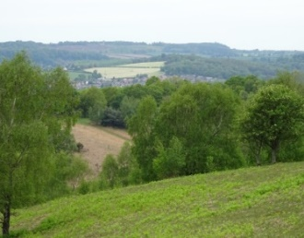
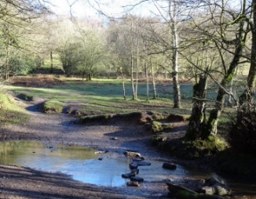

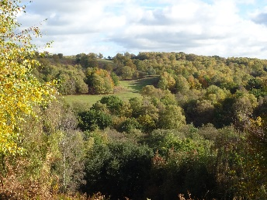

Figure 1. Views from the hilltop trails across the valley to distant countryside and trails down to the stream edge characterise the Downs Banks landscape (A Brown photographs).
It is at least 25 years since I went for my first walk to Downs Banks. As a new arrival from Australia where the landscape was so vast and harsh, the lush English countryside with civilisation close at hand was an intriguing and welcome change. I had come from a landscape in a wide, brown land where a distant line of hills on the horizon would melt into a bluish shimmer and water mirages appeared in the foreground. A landscape that was almost an enemy, that meant toil, survival and respect. The gentle green English countryside was in direct contrast to the empty, flat spaces, harsh glare, dry grass and dust that I knew so well. Each time I went to Downs Banks I knew that I liked to see views of the fertile and productive countryside filled with trees and hedgerows, the stream and the colours of the seasons. I also looked at Downs Banks through a geographer’s eye knowing that the visual cues which underpinned natural and human processes and brought both tangible and intangible meaning to my local area could not only be described but measured as well.
Geographical research into visual quality of landscapes can be traced back to the Finnish geographer Granö, whose work in the 1920s with sensory representation of summer and winter pioneered ideas about landscape as a visual phenomenon (Jones, 2007). But it has been in the last 70 years that much has been written about the visual value of landscape. Early attempts by Lowenthal and Prince (1964) and architectural work by Lynch (1960) in the USA went beyond mere landscape descriptions to apply a more rigorous analysis by identifying key visual qualities. Visual features of the landscape were considered important and researchers like Fines (1968) and Linton (1968) in the UK began to develop methods to measure and assess the quality of these spaces. Measurement was largely quantitative and focussed on evaluating the ecological value of an area using expert opinion (Daniel and Vining, 1983; Daniel 2001).
Qualitative visual landscape assessment was not widely recognised as a potentially useful assessment tool until the 1970s when Appleton (1975) and Robinson et al., (1976) developed techniques to assess and evaluate the visual quality of landscapes and to quantify outcomes statistically. However, much this work was not pursued and fell into disrepute (Lothian, 2017). Research conducted throughout the 1980s with work on preference matrices by Kaplan and Kaplan (1989) and the more holistic approaches of Kellert and Wilson (1995) in the 1990s began to draw increasingly on aesthetic theory to understand how visual qualities in a landscape were perceived. The debate about the use of qualitative methods for visual landscape assessment was renewed when developments in landscape ecology developed by Gobster et al., (2007) led to the work on landscape component assessments by (Tveit, et al., 2006; Ode et al., 2009) which have served as the basis for subsequent theoretical frameworks. Selman and Swanwick (2010) suggest that there has been an evolution from landscape evaluation to assessment to character assessment in which the roles have developed for both objective and subjective assessment of landscape.
The visual appearance of much of the natural landscape in Britain is changing particularly in response to shifts in climate which is hastening the loss of natural capital like water, soils and biodiversity. This combined with growing pressures of urbanisation and the development of commercial and industrial land has led social scientists to realise the importance of the relationship between ecosystem and society (Costanza et al.,1997; Daniel et al., 2012; Stanik et al., 2018). There is an increasing realisation that the non-material components of an ecosystem like access to green space, cultural heritage, sense of place, spiritual gains (Costanza,et al., 1997) and appreciation of visual aesthetics can afford a more holistic view and are important connectors of people to landscapes. Despite the difficulties in defining and measuring non-material cultural ecosystem components (Bryce et al., 2016; Swetnam et al., 2017) such as visual quality it is recognised that they should be included as part of cultural landscape assessment programmes (Daniel et al., 2012; Stanik et al., 2018).
Visual landscape capital as a cultural ecosystem component at national and local policy level is gaining traction. In 2018 the UK Government released its environmental plan ‘A Green Future; Our 25-year Plan to Improve the Environment’ (HM Government, 2018) seeking to improve the environment within a generation. By amalgamating all Areas of Outstanding Natural Beauty, National Parks, National walking trails and National Park partnerships (as detailed by Glover, 2019) a new landscape service could be established. Such a service would enable standardised assessment and monitoring to prioritise and inform management. In addition to ecological monitoring, perceptions of landscape, features prominently and should form part of a new natural capital assets register. Perhaps the most progressive visual quality research to date is the enquiry into the visual impact of electrical transmission infrastructure (Visual Impact Provision – VIP) commissioned by Ofgem with The National Grid UK who, in 2014, assessed the visual landscape to produce recommendations for preservation of views in nationally protected landscapes.
At a more local scale many county councils and smaller charitable organisations across the country have structural plans and policies in place which acknowledge the aesthetic value of their green and open spaces. The 2014 Staffordshire Green infrastructure Strategy (Holinzer and Everard, 2014) recognises aesthetic values and sense of place with a focus on mental health as part of their cultural ecosystem service provision. At present only monetary value of the services offered is considered with no further definition or attempt at assessment of aesthetic qualities like visual quality. Although not administered by the council, the site for this research comes under the jurisdiction of Staffordshire Borough Council and is broadly included in this plan. Other charities in the UK like the Woodland Trust, Wildlife Trusts and RSPB also recognise the value of restoring and preserving landscapes for health and well-being and enabling people to enjoy and appreciate outdoor spaces. Despite no formal assessment of aesthetics in these policies there is the implication that visual along with other qualities in the landscape are important and worth preserving (RSPB, 2019; The Wildlife Trust, 2020; The Woodland Trust, 2020).
As one of the UK’s largest landowners and a charity focused on “protecting special places”, The National Trust (who own and manage Downs Banks) is committed to using cultural strategies alongside its existing ecosystem services framework. The ‘Nature, Beauty and History - For everyone, for ever: our strategy 2025’ (National Trust Annual Report, 2019-2020) outlines plans and on-going commitments to restoring and preserving the cultural landscape alongside the natural landscape. This will involve highlighting the importance of the natural environment and outdoor experience, finding new solutions to managing space, and promoting place awareness.
From these few examples it is clear to see that aesthetic considerations are important to landscape managers at every level and efforts have been made to account for their provision at policy level. Implicit are the ideas that the visual landscape is important, but it is not always a clearly defined component of ecosystem service policies and there appears to be little formal assessment of it. Perhaps this is because these authorities have no means of measuring or qualifying it.
This research presents a simple quantitative method for visual landscape assessment with a unique focus on quantifying seasonal ephemera. The study is small scale but demonstrates a tool that could be used for the assessment of visual parameters in the landscape for inclusion in landscape registers and monitoring plans.

1.1 The evolution of landscape assessment
Despite being a relatively recent field of research, landscape visual quality assessment and contemporary ideas about landscape perception cannot be considered without looking at the history of aesthetics and cultural attitudes towards the landscape (Dakin, 2003). Landscape appreciation is rooted in the philosophy of aesthetics and rose out of classical thought where attempts were made to attach beauty to what was observed. Images of landscape were based on scenes from the legendary Golden Age (Lothian, 2017) and later, the landscapes of Arcadia, a mountainous area in the Peloponnese, which was said to be an ideal, rustic paradise.
Elsewhere in the ancient world, the Babylonians and Persians also viewed nature with a discerning eye. The Hanging Gardens of Babylon (about 500-600BC) were allegedly constructed to allow the Sumerians to worship their gods in a sumptuous setting. The Persians adopted these ideas to construct idealised micro-landscapes in the form of parks and gardens with designs and features reflecting the ideals of a perfect paradise. The term paradise is Persian - ‘pairidiaeza’ meaning an enclosed park-like area (Thacker, 1985). These quests to identify beauty and the nature of the aesthetic experience laid the foundation for aesthetic thought that survives today.
Classical Greek and Roman aesthetic ideals rose again in the Renaissance with the early Dutch, Flemish and Venetian artists discovering landscapes as a subject and not merely a background in a painting. The landscape now became visual and a way of seeing the natural world (Olwig, 1996). Aesthetics began to flourish in Western Europe during the 17th and 18th centuries where English aesthetic philosophers like John Locke (1632-1704) and David Hume (1711-1776) regarded beauty as having a subjective quality. German philosopher Alexander Baumgarten (1714-1762), first used the term aesthetics to recognise that sensitive cognition was a precondition for beauty and that beauty was an intellectual category (Gross, 2002). It was in this era that some of the famous Arcadian landscapes of the 17th and 18th centuries were re-created in parks and gardens of English stately homes to express cultural ideas about nature. Landscape designers like Lancelot ‘Capability’ Brown (1716-1783) designed over 200 parks with his trademark sweeping lawns, clumps of trees through which distant vistas could be seen, lakes and streams, all influenced by the fashionable Grand Tours to Italy.
This new movement spearheaded by influential thinker Jean-Jacques Rousseau (1712-1778) led to a surge in alpine tourism to locations like Chamonix and Mont Blanc which promoted the idea of the tourist gaze over glorious landscape and later forged the foundations of the conservation movement. There was an expectation that people would not only enjoy nature but learn from it (Lothian, 2017). Aesthetic pleasure of the natural world and the new ways in which Europeans saw the landscape was fully realised in the Romantic Movement. The Sublime, coined by the most important aesthetician of this time, Edmund Burke (1729-1797), paved the way for new expression in literature and the arts, and landscapes provided the perfect subject.
The English School of artists and the Lakeland poets used Burke’s ideas about beauty and the sublime to instil the notion of the picturesque. Landscapes became pictorial with interesting features like rivers, woodlands, ruins high up on steep valley sides and interesting sharp angles all set in pastoral scenes (Selman and Swanwick, 2010; Howard, 2011; Lothian, 2017). Artists like JWM Turner (1775-1851) captured the sublime in large, dramatic landscapes and seascapes and Gainsborough (1727-88) and Constable (1776-1837) were well known for their depictions of ordinary, rustic landscapes that were timeless, well-ordered and rural. Most inspired were the English romantic poets. The Lake Poets – Wordsworth, Coleridge and Southey and later, Blake, Byron, Shelley and Keats, were inspired by nature and explored new territory both literally and metaphorically. Ideas about the aesthetics of beauty and nature as an aesthetic object became less important towards the end of the 19th century and into the 20th century.
Since 1960s the application of aesthetic thought to landscape perception and ideas for assessment has been taken up by several disciplines all offering different theoretical perspectives, methods and philosophical orientations (Dakin, 2003). Behavioural geography has been the most influential on developing methods for landscape assessment. Based on landscape architectural design principles and resource analysis, experimental measurement to observer responses to landscape have been extensively researched. Debate about the limitations of these methods and the rise and fall of metrics to assess landscapes has led to the categorisation of different conceptual approaches to landscape assessment according to theoretical, methodological and philosophical orientations.

1.2 Conceptual framework for approaches to landscape assessment.

1.2.1 Landscape – the difficulty of definition.
Before addressing the conceptual frameworks of landscape aesthetics and the ideas behind the approaches to visual quality and landscape assessment it is important to be clear about what landscape means.
The English term ‘landscape’ is not easy to define because it is trans-disciplinary and the meaning changes with application across several subjects (Kaymaz, 2012). The traditional ideas about physical land characteristics and scenic beauty that took root in the Renaissance and Romantic art and literary movements have moved on to reflect cultural processes that shape landscapes and the meanings that society attach to them. Consequently, this shifting by context has added to the complexity of the meaning (Antrop, 2005). The literature is extensive, and this is by no means an exhaustive analysis, but gives a few different perspectives to highlight the difficulties in defining the term.
The traditional definitions refer to a limited area of the land’s surface with a broad reference to the view that may be seen; ‘a view or picture of natural inland scenery, landforms in a region, and portion of territory that the eye can comprehend in a single view’ (Daniel, 2001 p. 269). Such physical landscape definitions are reminiscent of times when the early geographers like Alwin Oppel took up the challenge and introduced the term ‘landschaftskunde’ in 1884 (Olwig, 2003; Troll, 1950, in Antrop, 2005) to mean landscape science. Granö defined landscape in sensory terms, making the distinction between the surroundings that can be experienced by all senses and the part of the landscape that is mainly perceived visibly, but could be described (Antrop, 2005). French geographer Paul Vidal de la Blache (1845-1918) used more literary and historical terms to define landscape and sought to recognise the importance of the local society and lifestyle, the ‘genre de vie’, in organising landscapes. Zube (1984), Gobster (1999), and Daniel (2001) argue that these older definitions emphasising just an area of the land’s surface are quite restrictive and have diminishing relevance as a stand-alone definition.
Landscape as a concept can involve much more than physical landforms and scenery (Kaymaz, 2012). Researchers like Tuan (1974) and Lowenthal (1975) took more of a philosophical and humanistic approach in that they emphasised the importance of landscape perception and landscape as a social construct with narratives and symbolic meanings (Antrop, 2005). Furthermore, Tuan (1978) asserts that landscape has a diaphoric meaning by combining two dissimilar ideas: ‘domain – a place or region and scenery – aesthetics and space’ (Olwig, 2007 p. 586). Lowenthal (1962) turned the meaning of landscape on end and claimed that there was no fixed meaning of landscape (Olwig, 1996) and recognised that people saw landscapes in a multitude of ways. Developing the ideas of the perception of the landscape added a new layer of meaning to the term which was then contested by human geographers, Cosgrove and Daniels (1988) who emphasised the cultural image of landscape to give a more holistic idea of landscape and to include the ideas of perception and aesthetic qualities (Antrop, 2005).
The older definitions have not proved popular with the landscape practitioners and researchers, Hartig (1993), Zube (1984), Nassaeur (1992) and Gobster (1999) who prefer to extend the meaning to make it synonymous with the environment and ecosystem. They claim that landscape must include not only landforms, but the biological and ecological processes and that the socio-cultural aesthetics have influenced a more passive approach to looking at landscapes (Gobster, 1999) rather than objectively and scientifically.
Driving forces transforming the landscape like urbanisation and industrialisation made clear the many issues to do with landscape and society and highlighted the need for the public to be recognised as stakeholders and for landscapes to be sustainable (Haines-Young, 2000). The European Landscape Convention 2000 challenged traditional landscape terminology – in particular the term ‘scenic’, and geomorphic flora and fauna references, to give it some cultural meaning and recognise physical and human interactions as perceived by people (Déjeant-Pons, 2006; Olwig, 2007).
New and more formalised definitions adopted by UNESCO and the European Landscape Convention 2000 define landscape as ‘an area as perceived by people whose character is the result of the action and interaction of natural and/or human features’ (Déjeant-Pons, 2007 p. 369). These definitions cement ideas for a more progressive trans-disciplinary approach where emphasis is placed on policy and the importance of the public’s aspirations and perceptions of landscapes (Antrop, 2005). This more holistic view that perception and meaning of landscape are determined by people’s interaction with it underpins the focus of this research. Although landscape remains a difficult term to define its meaning does appear to have shifted from more academic and philosophical terms to one which is applicable in a variety of contexts in both physical and human settings.

1.2.2 Perception theory and influences on visual perception and preference.
It is clear from discussion about aesthetics that landscapes do not have intrinsic perceptual qualities, but rather the perceiving of landscapes comes from people ascribing quality and value to them (van Heijgen, 2013; Lothian 2017). Perception is about information processing (cognitive), emotions (affective) and people’s preferences (evaluative), and clarifies how people appreciate landscapes, respond to them and choose between them. Although perception science may only seem vaguely relevant to landscape assessment there is a need to understand the fundamentals to develop efficient and valid approaches towards evaluating landscapes (Kaymaz, 2012). Theories for explaining landscape aesthetic perception and preference broadly fall into two categories, evolutionary and cultural (Tveit et al., 2006; Hafner et al., 2018).
Evolution theories are based on the idea that all humans evolved with the same need to thrive and survive in a landscape (Appleton, 1975; Zube, 1984) and that this explains how landscapes are perceived and how preferences in them are made. Appleton’s ‘Prospect Refuge’ theory (1983) realises the human need to observe an environment to see if it is safe and take refuge when under threat (Kaymaz, 2012) and that responses to landscape will be based on a set of perceived positive and negative features essential to survival (Orians, 1980). Such ideas were born out of evolutionary ideas about survival and the innate instincts by our ancestors in savanna-like conditions where a tree-covered landscape would provide hiding places and a sense of safety. Conversely open space offered hunting opportunities to enable sustenance for survival. Similar concepts about perception are also supported by Orians’s Habitat Theory (Orians,1980) and Ulrich’s Affective Theory (1983).
Perhaps the most well-known evolutionary theory on landscape preferences is the information processing theory presented by Kaplan and Kaplan (1989) which is also centred on an innate need to survive by understanding and making sense of an environment through the visual senses. Their research showed that people were discomforted by obstructed views where they did not know what to expect and could not see route ways. Understanding legibility, coherence, mystery, complexity in an environment was key to making preferences about landscapes (Kaplan and Kaplan, 1989; Tveit et al., 2006; Lothian, 2017).
Other major approaches built on early evolutionary theories and tended to focus on perception and experience of a landscape as being dependent on cultural background and observer attributes. Rather than concentrating on the biological affective responses these ideas concentrate more on function and social conventions and using preferential studies to indicate perception of landscape. These are derived from environmental psychology and are based on complex personal, behavioural and cultural aspects that influence perception of landscape and aesthetic experience (Bourassa, 1990; Tempestra, 2010).
Tuan (1974) established the idea that an affective bond between people and setting driven by personal experience was possible. Through the repeated occurrence of ordinary events one can accumulate a strong sentiment for a place which is termed ‘topophilia’ and that perception and preference for landscape is influenced by personal attributes like gender and age, familiarity and occupation. More recently these socio-demographic characteristics have been recognised as important predictors of aesthetic perception (Dearden, 1983; Strumse, 1996; Svobdova et al., 2012). As research into these is extensive only those characteristics relevant to visual perception in this study is considered.

Age has been found to influence perceptions of the surrounding landscape. Balling and Falk (1982) considered differences in perception of landscape between adults and children and found that there were preferential differences between these groups. Zube et al. (1983) found that that children, middle aged and older all rated landscape photographs differently while Lyons (1983) found that generally children registered higher landscape preference ratings than elderly adults. Filova et al. (2015) found that middle aged people awarded higher preferential ratings for a range of landscape than younger and older people. Other studies have shown that it is gender that can influence how people perceive the landscape. While only marginal differences between adolescent gender preferences were found by Lyons (1983) other studies showed significant differences between men’s and women’s preferences (Lyons, 1983; Strumse, 1996; Svobodova et al., 2014) for landscapes.
More frequently visited landscapes are thought to be perceived differently from those less frequented (Wellman and Buhyoff, 1980; Nieman, 1980) and cannot be easily separated from the idea of increased familiarity which may partially account for high visual quality preferences (Penning-Rowsell, 1982; Burgess et al., 1988). Grounded in Kaplan’s ideas about understanding a landscape and the level of complexity and engagement that a landscape offers (Kaplan and Kaplan, 1989), research confirms that there is a positive relationship between familiarity and visual landscape preference (Zube et al., 1974; Lyons, 1983; Dearden, 1984; Burgess 1988; Svobodova et al., 2014; Strumse, 1996; Hammitt, 1979; Dramstad et al., 2006; Jovanovska, 2021). Tapsell (1995) maintains that the most valued landscapes are those that play a part in our daily lives. These are often the landscapes that are easily accessed and that we can visit frequently and are therefore familiar.

1.3 Approaches to landscape assessment.
Divergent philosophies in many disciplines have resulted in numerous approaches to landscape assessment and experimental design (Porteous, 1982; Zube et al., 1982, Daniel and Vining, 1983; Dakin, 2003; 2005; Wherrett and Tan, 2005). Depending on the notion of landscape and the viewpoint of individuals, these typologies can be placed along a continuum. According to the typology of Dakin (2003) there are three broad approaches: expert, experimental and experiential (Figure 2). These move from the objective judgement of visual attributes in the landscape through to more subjective evaluation based on emotions and expectations of landscape (Daniel, 2001; de la Fuente de Val et al., 2006; Vouligny, 2009).

Expert |  | Experimental |  | Experiential
Objective |  | Objective/Subjective |  | Subjective
Biophysical  Landscape quality  Formal aesthetic |  | Psychophysical  Psychological cognitive  Landscape perception |  | Phenomenological  Sociological  Experiential  Landscape interpretation
Quantitative  Ecological surveying, GIS mapping, Field surveying |  | Quantitative/Qualitative  Field surveying, scaling of perceived landscapes, photograph perception surveys |  | Qualitative  Interviews, focus groups, photograph surveys
Figure 2. Three approaches to landscape assessment based on Dakin’s (2003) typology. Terminology in the typology draws on terms used by Zube et al.,(1982) expert, psychological cognitive, experiential and Daniel and Vining (1993) formal aesthetic, psychophysical, phenomenological. The experimental combines both approaches from both expert and experiential approaches.
The expert or formal aesthetic approach requires trained observers to identify and measure visible biophysical landscape features and relationships which are assumed to be indicators of landscape quality (Daniel, 2001; Dakin, 2003). These range from topography to assessment of water and vegetation (whose properties are translated into formal parameters with form, line and variety with relationships between these features) (Daniel, 2001; de la Fuente de Val et al., 2006). The outcomes of these assessments are that landscape features are ranked in order of quality following prescribed rules and assessment guidelines. This is an objective approach whereby landscape is assumed to be an aesthetic object (Daniel, 2001). More recent studies have termed this approach as biophysical (Swetnam et al., 2017), top-down or expert-led, (Tveit et al., 2006 Lothian, 2017). Lothian, critical of this approach in the belief that more subjective measure of visual landscape perception should be included, suggests that more holistic approaches are useful (Lothian, 2017).
The experiential approach favours clarification of understanding of the landscape rather than identifying physical landscape features and observer ratings (Dakin, 2003). Such methods tend to focus on aesthetics as well as the less tangible aspects of human-environment interactions, and why these landscapes are important to participants (Daniel and Vining, 1993). Research involves examining sensory and emotional experiences, sense of place and social interaction, and meanings in these landscapes. This approach has received less attention in environmental management as it is idiosyncratic and subjective with its broad and intangible methods of assessment (Chenoweth and Gobster, 1990).
The experimental approach, which is placed in the middle of the continuum and is the method used in this research, emphasises the interaction of both subjective viewer evaluation and the more objective biophysical evaluation. Both the physical and the cognitive are evaluated by the public preference and emphasise the viewer side of landscape (Dakin, 2003). Survey research and psychological scaling methods are applied to give quantitative measures of perceived landscape aesthetic quality (Zube et al., 1982; Daniel, 2001). Physical landscape features are measured and rated by subjects and the ratings are correlated with the cognitive measures like appeal and other affective measures which function as the independent variable.
In the past these correlations have provided the basis for predictive models for estimating landscape preference and have generally indicated high levels of reliability (Daniel, 2001). Use of sampling of public opinion, either random or representative, rather than using experts has also been acknowledged as an effective planning and management tool (Kaplan and Kaplan, 1989). A review of literature by Daniel (2001) found there to be a high degree of reliability in studies using this method. Photographic representation, as surrogates based on colour photograph representation, has been widely used with this method. However, there has been on-going debate about the use of photographs since the 1970s (see also section 2.8.1). A comprehensive analysis by Sevenant and Antrop (2011) highlighted that while there is confidence in the use of photographs as representations (Shuttleworth, 1980; Zube et al.,1987; Arriaza et al., 2004; Roth, 2006; Walker and Ryan, 2008), nevertheless others (Palmer and Hoffmann, 2001; Scott, 2002) contest that the use of photograph surrogates is too limited and context cannot be fully appreciated. Photographs however, as a tool to generate judgements about visual environment, have been far less contested and require more investigation (Sevenant and Antrop, 2011).

1.4 Seasonal approaches to landscape assessment
Dry bracken, ploughed fields, trees in autumn leaf, fruits and flowering hedgerows can have a major impact on the appearance of the landscape. Throughout the course of the year these features change in colour and texture with the most marked differences seen at the thresholds of the seasons. These temporal changes to the landscape feature in temperate climates of Northern Europe and the UK where ephemeral conditions change rapidly, and seasons are pronounced.
Brassley (1998) first coined the term ephemera to refer to often-overlooked conditions in the landscape. He defined ephemera as the short-lived phenomena like the changing colours of vegetation, weather conditions, the growth cycle of plants and agricultural crops, and the passing of the seasons. Jones (2003) makes a further distinction between ephemeral landscapes and seasonal landscapes. While ephemeral refers to the transient, non-permanent features of the landscape that change spatially and temporally and come and go with irregularity, Palang et al., (2005), and Boyd and Gardener, (2005) claim that seasonal landscapes which are ephemeral are also transitory and short, and are recurring and cyclical. Seasonal changes occur on a regular, even annual basis showing the natural rhythms and oscillations in a landscape. For this research the term seasonal will be used in the ephemeral sense that shows a cyclical change in visual quality of the landscape. Seasons in this context will be examined at fixed points in in the landscape over the change of time.
The visual effects of the ephemerality of the seasons in landscapes is not new and owes its origins to the historical and philosophical notions of the great masters. The Flemish artists depicted seasonal rural scenes and the British romantic artists JMW Turner (1775-1851), Thomas Gainsborough (1727-88) and John Constable (1776-1837) measured the moods of nature by combining natural ephemera such as sunlight, storm and rain to capture the sublime and the picturesque. In the 19th century the new ‘en plein air’ fashion sought to widen the range of vision by capturing ephemeral reflections of life in the natural world to create a subjective experience. Early geographers like Granö understood that landscape existed in space and time. Ephemera, in addition to permanence, in the landscape was illustrated in his early sensory cartographic works (Palang,et al., 2005). The UK landscape writers Fines (1968) and Litton (1972) also recognised that various forms of ephemera such as seasons could change the appearance of a landscape. They identified ephemerality as a product of the variability of time that showed contrasts and was episodic.
The changes in appearance of the landscape like variation in leaf colour, defoliation of trees, and forest and agricultural land use changes created by seasons can go un-noticed and, as Brassley (1998) argues, are considered unimportant compared to the permanent landscape fixtures in planning legislation. He contends that the more subtle changes in landscape appearance during the seasons are worthy of consideration particularly if it can be demonstrated that changes in ephemera such as seasonal change affect perception and evaluation in the same way as permanent components. If these ephemera do affect visual quality and evaluation, should they be considered in land use planning? Can changes in the ephemeral landscape be identified and could they be managed? The existence of seasonal ephemera makes reliable evaluation of a landscape at a single point in time very difficult, and while this research does not seek to answer all these questions, the aim is to see which seasonal features appeal and are perceived to be of visual value in the landscape.

Research into the effects of seasonal ephemera on visual preference studies have been largely overlooked (Brassley, 1998; Palang et al., 2005; Jones, 2007; Schüpbach et al., 2016). However, those who have investigated these characteristics in the landscape maintain that assessment of them can bring out a richer image of an area (Stobbelaar and Hendriks, 2007) and can be used together with accepted indicators of visual assessment to enhance appreciation of the visual landscape for maintaining landscape quality (Schüpbach et al., 2016). In the search for robust visual indicators, Tveit et al., (2006) sought to include ephemera, particularly seasonal change as landscape characteristic for landscape analysis.
A small number of studies have focussed on the visual effects of seasonal change for agricultural landscape management in Northern Europe (van Mansveldt and van der Lubbe, 1999; Hendriks et al., 2000) where methods for assessing perception of the landscape on a cyclical, temporal and place identity basis were based on Kaplan’s ideas of coherence. Stobbelaar et al.,(2004) used seasonal colours and shapes in agricultural settings to measure and assess phenological aspects of the Dutch and Belgian landscape while Schüpbach et al.,(2016) focussed on using seasonality in aesthetic valuation as a substitute for quality in a diversity index designed for agricultural areas in Switzerland.
Other studies have included seasonal elements as part of larger investigations into landscape visual preference. Hands and Brown (2002) and Schloss et al. (2017) considered how colour changes in vegetation affected visual preference and Kuper (2015) examined the appeal of colour and vegetation appearance throughout an annual growth cycle. The contribution to the appeal of vegetation heterogeneity by seasonal vegetation change was also investigated by (Dronova, 2017).
Older techniques like scenic beauty estimation have been used to assess preferences in seasonal variation in Northern European coniferous forests (Tahvanainen et al., 2001), public park settings in Iran (Aminzadeh and Ghoreyshi, 2007) and spring and winter comparisons on a university campus setting in Turkey (Eren and Düzenli, 2017).

More recent work with visual landscape indices has included some specific seasonal indicators like presence of flowers and fruits (Swetnam et al., 2017; Swetnam and Tweed, 2018) and colour variation and colour contrast (Arriaza et al., 2004; Wang et al., 2016; zu Ermgassen et al., 2018), but to date no studies of visual landscape quality have focused specifically on preference ratings of seasonal landscapes in typical British lowland rural areas on a local scale.

1.5 Aims, objectives and research questions
The aim of this project is to develop a tractable method to undertaking a seasonal visual landscape assessment for use at the local scale in the British landscape.
The objectives are twofold; firstly, to adapt an existing visual quality method (the VQI: Swetnam et al., 2017; Swetnam and Tweed, 2018) by incorporating explicit seasonal components. Secondly, to test this method on a typical lowland rural landscape in Mid-Staffordshire UK that is locally valued rather than nationally outstanding in terms of landscape beauty. In doing so, to answer the following research questions;
RQ 1) What are the existing public preferences for the landscape views at Downs Banks, Staffordshire?
RQ 2) What specific physical and /or cultural characteristics are valued in this landscape?
RQ 3) How do seasonal aspects of this landscape affect appeal ratings and landscape preference?
RQ 4) Does the VQI method, as adapted in this research, provide credible results in this local area?

2 Methods

2.1 Methodological context
Despite advances in assessment of landscape visual quality, techniques to merge the applications of both biophysical and human assessment (Daniel, 2001) remain a challenge (Gobster et al., 2007; Selman and Swanwick, 2010; Lothian, 2017; Swetnam and Tweed, 2018). As with much geographical research of this type the interrelated questions of human and physical processes on both spatial and temporal scales are important and demand a pragmatic approach (Yardley and Bishop, 2008; Cope and Elwood, 2009) to combine both quantitative and qualitative techniques.
Much of what is known about appeal in the landscape has been validated by use of this mixed method approach (Arriaza et al., 2004; Tempesta , 2010; Frank et al., 2013; Kuper, 2013, 2015; Junge et al., 2015; Wang et al., 2016; Lothian, 2017; Swetnam and Tweed, 2018; zu Ermgassen et al., 2018; Jovanovska, 2020). To provide a holistic idea of what is in the Downs Banks landscape and how people feel about it, a similar pragmatic approach to enquiry is adopted in this research. The quantitative measurements are designed to assess landscape parameters, establish the VQI and to measure public perception of the landscape features. Statistical testing confirms validity. In accordance with similar methods (Kuper, 2013, 2015; Frank et al., 2013; Wang et al., 2016; zu Ermgassen et al., 2018; Jovanovska, 2020) data from an online survey also provides a qualitative platform for interpretation. Determining meaning and making inferences about appeal in the Downs Banks landscape is supported by what is known from the literature about appeal in landscapes but also from the demographic profiles and comments from survey participants.

2.1.1 Pathways to enquiry
Having established the research questions the following methods were designed to measure and assess the visual quality of the Downs Banks landscape in each season. The research process was conducted in several stages and the methodology can be divided into four distinct parts.
1. Fifteen sites were chosen and photographed in summer, winter, autumn and spring. A quantitative visual quality index was adapted to measure the landscape parameters at each site in each season.
2. A winter site visit was conducted by three surveyors to check the suitability of the amendments to the visual quality index assessment.
3. Suitable photographs for each site in each season were chosen and the final visual quality assessment confirmed by the three surveyors. The assessment details were entered into an MS Excel® spreadsheet where numerical values were assigned and weighted. Several weighting trials and a sensitivity test were conducted to establish the final visual quality index scores.
4. Appeal of the visual landscape was tested by an online public preference survey where a systematic selection of 11 seasonal images were presented and respondents asked to rate the images. A further six images highlighting specific landscape features were also presented where respondents were required to indicate preference.
Statistical analysis of results was undertaken to address the relationship between the VQI and public appeal and to establish which sites appealed visually in which season. A secondary analysis of demographic questions to establish appeal between age groups, gender and frequency of visits was also conducted.
All methods were conducted by the author unless stated. Figure 3 shows the stages and components of the Downs Banks visual quality assessment process. Details of each stage are discussed in the following sections

Review of Visual Landscape literature and seasonal literature

And seasonal
15 sites selected

Summer photographs taken at 15 sites. (August 2018)

VQI parameter assessment criteria adapted for Downs Banks and refined again in autumn.
Autumn photographs taken at 15 sites. (November 2018)

Downs Banks VQI parameter assessment adaptations tested in the field.

Winter photographs taken. Field survey conducted at 15 sites (February 2019) (3 surveyors)

Spring photographs taken at 15 sites ( April 2019)

Final VQI parameter assessment adaptations.

Assessment of winter, summer, autumn and spring photographs to establish VQI. (3 surveyors)

VQI confirmed
Sensitivity and final weighting trials.

Qualtrics Public preference Survey (11 systematically selected images, 6 landscape parameter images)
Review of online survey methods and design Qualtrics survey.

Statistical analysis

Landscape preferences Downs Banks

Figure 3. Methodological stages used to establish and test the Seasonal VQI for Downs Banks. All methods conducted by author unless stated.

2.2 The Downs Banks site
Downs Banks comprises 67 hectares of land situated in Mid-Staffordshire 8.5 kilometres south-east of the city of Stoke-on-Trent and 13.5 kilometres north of the Staffordshire borough town, Stafford (Figure 4). It is an area of open countryside surrounded by privately owned agricultural land and the nearby rural villages of Stone, 3.5 kilometres to the south, Barlaston, 2 kilometres north-west and Oulton, 1.5 kilometres to the east.

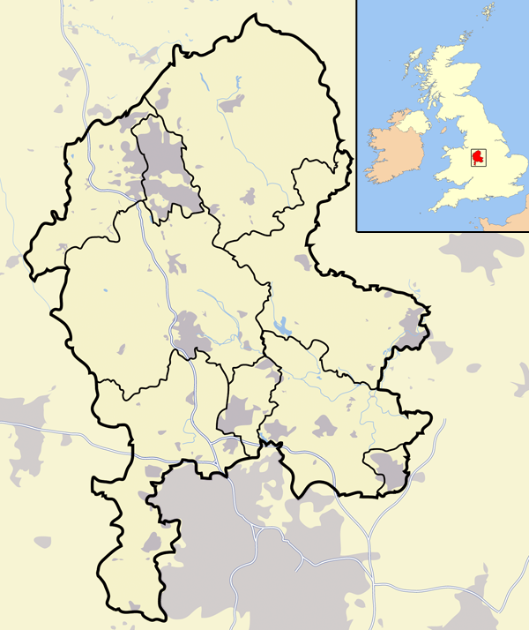
Stone and Oulton
Downs Banks
Barlaston
South Staffordshire
Stafford
North Staffordshire

Stoke on Trent

Mid-Staffordshire
Newcastle-under-Lyme



Scale 1cm = 19 kms

Figure 4. National and regional location of Downs Banks, Barlaston, Staffordshire UK. (Wikimedia maps).
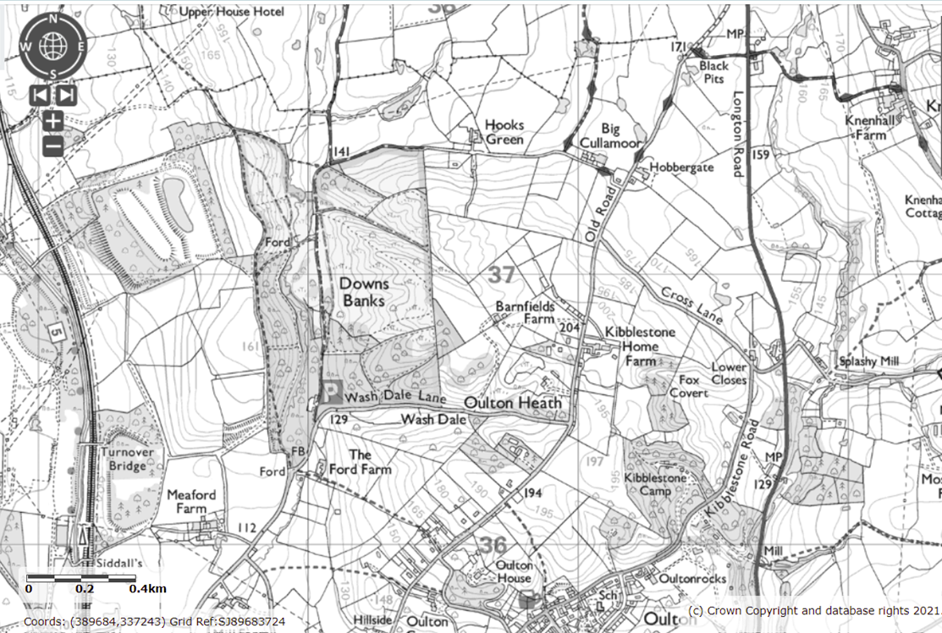
Figure 5 Downs Banks shown in the centre surrounded by agricultural land and scattered villages. The Trent & Mersey Canal and main west-coast railway line between London, Birmingham and Manchester can be seen to the West of the boundary. (Defra magic maps)
Although not visible from the property it is closely flanked on the western side by the Trent & Mersey Canal, the main west coast railway line and 2 kilometres beyond to the M6 Motorway (Figure 5).
Downs Banks is currently owned and maintained by the National Trust and is designated an open access property granted to the public under the Countryside Right of Way Act 1949. Its status is different from other protected British countryside areas like National Parks, AONBs and Country Parks. The need to create open spaces for public use stemmed from post-industrial urban Britain in the 1830s. The National Trust as part of the open space movement since its inception in 1895, was one of the first organisations to promote permanent preservation of landscapes, natural and cultural, for the benefit of the nation, covering land, agricultural tenements, buildings of beauty and historic interest and scenic natural landscapes.

The notion of giving public access to natural places was established after the Town and Country Act 1932 which gave local councils the power to preserve scenic amenity (Lothian, 2017; Selman and Swanwick, 2010). Further legislation for high quality ecological landscapes by way of the 1949 Countryside Act saw the creation of national parks for the preservation and conservation of natural beauty, wildlife and heritage, and for public enjoyment. Similarly, Areas of Outstanding Natural Beauty, also allowing public access, were designated for the protection and conservation because of their distinctive character. Sites of Special Scientific Interest were created under the same legislation and granted formal conservation designation for the protection and conservation of rare flora, fauna species and unique geological formation. Public access is not automatic, and landowners are obliged to manage these sites accordingly (The Woodland Trust, 2020). Country parks were created in the 1950s on the edge of urban areas as informal semi -rural settings that were to be publicly accessible (Census 2011; Natural England - Defra, 2012).
Downs Banks is a typical lowland British rural landscape and, other than being a protected rural space, is not a remarkable landscape. It is a popular local destination with the public, offering easy walks and picnic spots. On a clear day the views from the toposcope at the highest point (185m) reach as far as 64 kilometres west to the Clee Hills, the Long Mynd and the Wrekin in Shropshire, and 25 kilometres to the north to Mow Cop in the Staffordshire Moorlands. Mid-distance views extend over well-managed farmland with crops and livestock to south and west to the Trent Valley, and east to Meir Edge. Views were partly obscured to the west by the Meaford Power Station until its demolition in 1991.
The many paths that cross the area are well-used. Waymarked bridleways and paths permit open access for walkers, and cyclists and horse riders. It is well used by the public for a variety of activities particularly on weekends and holidays. There is ample free parking and 24-hour access. Since the 1950s it has been home to the local orienteering club, the Potteries Club (formerly the Walton Chasers) and is frequently used by schools in the district for educational field trips. More recently it has been the venue for the annual Barlaston New Year’s Eve Wassail.

The Old Packhorse bridleway runs close to northern boundary to Hooks Green linking a network of bridleways beyond the valley and is also a designated access route for farmers and services. The stream (known locally as Downs Banks Brook) that rises in the nearby Hartwell Hills, runs north-south through the valley and is a focal point for recreation with two fording points and two other crossing points mid-way along the stream at the stepping stones and a foot bridge. Downs Banks is flanked by Meaford power station ash tips to the west which, because of contamination, have remained undeveloped, and have been left to regenerate into deciduous woodland. Farms with arable and grazing land border the eastern and southern boundaries and a visitors’ car park is located at southern end on Wash Dale Lane (Figure 6).

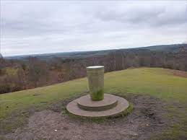
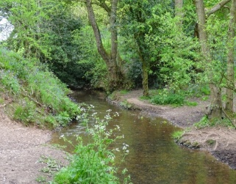
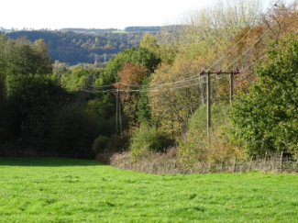

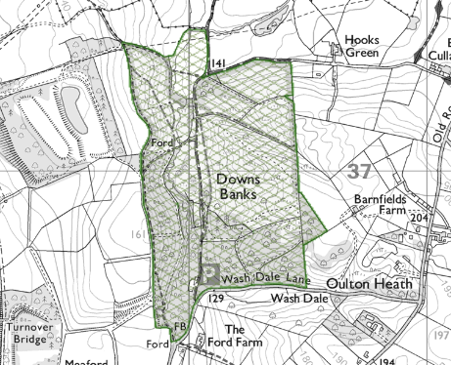
Revegetated ash tips Stream Toposcope
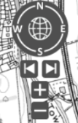

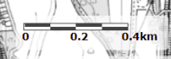

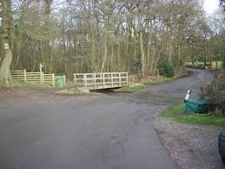
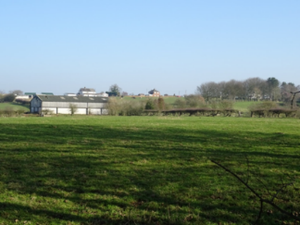

Visitors’ car park and ford Barnfields Farm

Figure 6. Downs Banks as defined by the green hatching on the map is part of the Environmental Stewardship agreement UK (Defra Magic Maps - Environmental Stewardship; A Brown photographs).

Downs Banks lies in a north-south fluvial valley with eastern and western slopes rising to 180m. Bedrock formation in the area includes Carboniferous Halesowen sedimentary formations comprising millstones and siltstones on the northern and southern boundaries and Jurassic conglomerate Chester formation in the central area. Quaternary alluvial silts clays and gravels lie on the valley floor. Subaerial formations of Quaternary clay and silt deposits and sedimentary ice melt water detrital material cover the valley slopes (British Geological Survey, 2021).
While not a diverse landscape or rich in species, the area contains several small habitats worthy of preservation, and is designated nationally as a woodland priority habitat. As shown in Figure 7, most of the area is covered by woodland interspersed with open herbaceous areas. Broad-leafed forest dominates with large stands of native deciduous species of Oak (Quercus robur), Sessile Oak (Quercus petraea) and Field Maple (Acer campestre). There are also some introduced species such as Turkey Oak (Quercus cerris), Silver Birch (Betula pendula) and European Ash (Fraxinus excelsior). Smaller trees like Rowan (Sorbus aucuparia), Hawthorn (Cretagus monogyna), Blackthorn (Prunus spinosa) and Holly (Ilex aquifolium) create a secondary canopy, and there is a small stand of conifer (Pinus spp.). Recent management has seen some clearing of birch scrub and bracken which has opened the paths and many of the views (National Trust, 2018).

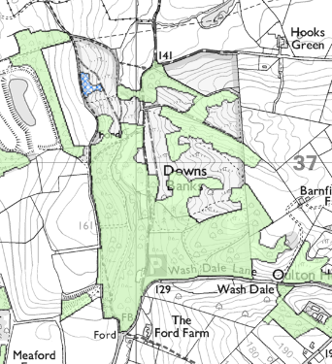

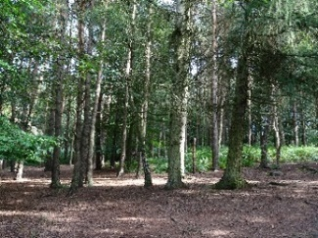
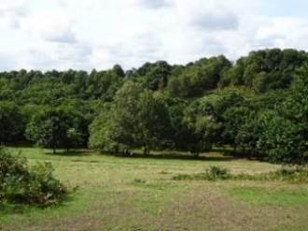
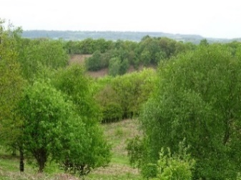

Deciduous woodland Open grassland Coniferous forest

Figure 7. Downs Banks is a designated Woodland priority habitat and defined as a broadleaved woodland by the National Forest Inventory, UK. as shown by the green shaded area on the map. A small patch of shrub shown in blue hatching exists on the north eastern boundary of the site (Defra Magic Maps- Woodland Habitats; A Brown photographs).

The open habitats on the site are predominantly lowland acid grassland (Figure 8). These habitats are typically found in pastoral landscapes like Downs Banks on relatively nutrient poor gravelly soils with a history of grazing and regular cutting.
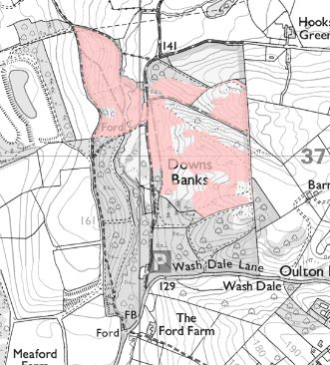

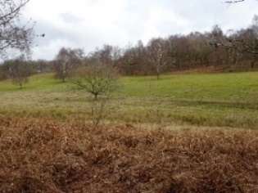
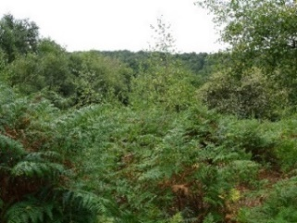
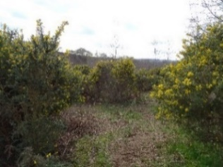

Gorse (Ulex europaeus) Bracken (Pteridium aquilinum) Lowland acid grassland

Figure 8. The pink shading on the map show the open areas of Downs Banks covered with grassland and low herbaceous flora. It is officially classified as a Lowland dry acid grassland under the priority habitat inventory designated by the National Forest Inventory, UK (Defra Magic Maps – Grassland Habitats; A Brown photographs).
Grasses like Sheep’s Fescue (Festuca ovina) and Common Bent (Agrostis capillaris) grow in cleared areas along with a low growing herbaceous layer containing species like Sheep’s Sorrel, (Rumex acetosella), Heath Bedstraw (Gallium saxatile), Catchfly species (Lychnis spp.), Hawkweed species (Pilosella spp.) and Tormentil (Potentilla erecta). There are remnants of original heathland, with a small mosaic of Heather (Calluna vulgaris) and Bilberry (Vaccinium myrtillus) on the hills, and two sites of spring-fed bog/wetland in the valley with swards of Tussock Grass (Poa spp.). Gorse (Ulex europaeus) and Broom (Genistea spp.) and Common Bracken (Pteridium aquilinum) cover much of the open upland area. A rotating programme of clearing and grazing by cattle has been practised since 2005 to keep these invasive species under control. A small patch of Wood Anemone (Anemone nemorosa) has been recently discovered on the stream banks.
Downs Banks also hosts a number of bird, insect and reptile species. In the last five years, recording of butterfly and viviparous lizard populations in these areas have shown an increase in numbers (Natural England, 2014). Birds typical of arable and farmland areas like the Tree Sparrow (Passer montanus), Yellow Wagtail (Motacilla flava) and the Lapwing (Vanellus vanellus) (which is in decline and facing challenges), frequent the area (British Trust for Ornithology; bto.org). In the patches of dense vegetation along the stream the occasional Common Kingfisher (Alcedo atthis) can be seen. The stream was heavily polluted from a diesel oil spill in 2008 upstream beyond the reserve. It has since recovered and now supports a healthy population of European Bullhead (Cottus gobio) and Brown Trout (Salmo trutta).
As with most rural landscapes in lowland Britain, Downs Banks has quite a long history as a managed landscape. The few details available suggest that the land was part of a larger estate owned by Viscount Sidmouth and was probably used as open grazing land by tenant farmers. The flat land on the valley floor was used by the nearby tenants at Bluebarn Farm (since demolished), located at the northern end of the valley, to grow hops for the Joules Brewery in Stone from 1904-1907. Downs Banks was acquired freehold from Viscount Sidmouth on 12 December 1946 by John Joule of Joules Brewery.

Early maps and photographs from 1910-1920 (Staffordshire Past Track) reveal an open moorland-like environment, with bracken and a few scattered deciduous trees covering the hills. The area looks quite different today as the view across the valley is now largely obscured by woodland. Hops were grown and cattle were grazed on Downs Banks until it was given to the National Trust in 1950 by John Joule as ‘an offering for victory in the 1939-45 War and as a memorial to those who died’ (National Trust, 2018). Because Downs Banks had been common land despite being a hop farm, Joule thought that it should be open to the public once more (National Trust, 2018). After the 1950s, lack of grazing led to birch and bracken invasion which has from time to time been cleared.

2.3 Study site selection
Unique to this study is the appeal of the small, local, everyday landscapes in which people spend most of their time. Downs Banks was chosen because it is a landscape that comprises features typical of the British rural lowland landscape (as outlined in section 2.2) and is representative of the small ‘on-the-doorstep’ locations that people use and enjoy every day.
In contrast, much of the literature highlights studies that are conducted in larger scale landscapes where parameters are numerous and more varied. The two studies on which this VQI method is based covered much larger areas. The survey area for the Iceland visual quality study covered an area of 100,000 km² (Swetnam and Tweed, 2018) while the Welsh study sampled 300 sites across the country (Swetnam et al., 2017). Other visual quality studies for agricultural policy planning purposes in European lowland settings were also conducted over extensive regional areas (Coeterier, 2000; Hendriks et al, 2000; Rogge et al, 2007) with some covering the entire Swiss lowland region (Junge et al., 2015; Schüpbach et al., 2016), the northern part of the Provence of Cordoba in Andalusia, Spain (Arriaza et al., 2004) and larger scale lowland forest sites in Finnish rural areas (Tahvanainen et al.,1996; Tahvanainen et al., 2001).
Unique also, to this research are methods designed to be conducted over the course of a year in contrast to the larger seasonal studies (Junge et al., 2015; Schüpbach et al., 2016) which were undertaken over the course of several years. Such an undertaking in a single year requires concentrated field work particularly when each site must be photographed from the same aspect in each season at the most opportune time. For these reasons, Downs Banks provided a practical study location with easy access for the principal researcher to conduct relatively quick survey and photographic coverage.

2.4 Survey point selection
It is common for large scale visual assessment studies to use objective site selection methods based on GIS-enabled mapping exercises where stratified sites of equal size can be sampled (de la Fuente de Val et al., 2006; Rechtman, 2013; Filova et al., 2015; Junge et al., 2015; Schübach et al., 2016; Swetnam et al., 2017). A subjective and more practical approach was used to select survey points for this research. Given the small area and relatively uniform landscape of Downs Banks which could be surveyed on location, mapping the area to select sites was considered inappropriate. Instead a more convenient and opportunistic approach was adopted: (1) to select sites that showed some micro-variation in landscape features (the shallow parts of the stream that could be forded and the walk through the small conifer wood) that may otherwise not be evident in a mapping exercise; (2) to select sites that would potentially show seasonal variation; and (3) to select sites that characterised the views of Downs Banks to be used as photographs in the online public preference survey.
Despite the limitations of non-probability sampling like opportunistic sampling, it is commonly used (Mugo, 2002) and in the case of this research where time was limited in each season, this technique was deemed appropriate on the understanding that the variability and bias could not be controlled and that only cautious generalisations beyond the sample could be made (Mugo, 2002; Acharya et al., 2013).
Good coverage of the area could be achieved by selecting 15 sites (Figure 9) chosen from points along the walking trails to represent the four VQI themes; terrain, blue space, green space and human/built. Four sites (2,4,8,13) were selected on the two highest ridges which overlook the Downs Banks valley and beyond over a mosaic of farmland dotted with farmhouses, villages, woods and infrastructure. These sites were located along the most popular walking trails, offering attractive scenes typical of rural lowlands. In accordance with evidence that far reaching views over wide-open spaces rated highly for visual quality (Arriaza et al., 2004; de la Fuente de Val et al., 2006), these sites were also chosen in the hope that a degree of seasonal variation could be seen at a distance particularly over the stands of deciduous woodland and surrounding farmland.
Another three sites (5,6,15) were chosen on the lower paths on the inner valley slopes leading down to the valley floor. These sites were selected to show the shorter views across the valley floor where micro features in topography could be seen and where the fern, grass and low shrub understorey provided contrast to the tall stands of deciduous trees seen from the hilltop sites. These mid-distance sites also enabled views of the Bracken and Rowan trees covering the valley slopes which would potentially provide contrasting seasonal interest.
Three sites (9,10,14) were located along the stream at the stepping stones, the wooden bridge and smaller fording point. These popular recreation sites were selected more to test the appeal of water, as it is known to be an attractive visual feature in a landscape (Herzog and Brosely, 1992; Kaltenborn and Bjerke, 2002; Bulut and Yilmaz, 2009; Arriaza et al., 2004; Lothian, 2017; zu Ermgassen et al., 2018), than for potential seasonal interest.
While the literature supports the lack of appeal of conifer woods (Lothian 2017; Swetnam et al., 2017), the small stand of conifer was chosen at Site 1 to see whether seasonal variation in surroundings would affect the overall appeal of a stand of evergreen trees. Similarly, another less frequently visited, densely wooded (Silver Birch) site, at site 11 was chosen to see if the conditions of limited legibility (Kaplan and Kaplan, 1989; Misgav, 2000; Junge et al., 2015; zu Ermgassen et al., 2018) would hold any appeal. The final three sites (7,9,12) were selected from the boundary trails with mid-distance views into Downs Banks and over farmland which typified the surrounding managed lowland countryside.
In addition to being representative of the landscape it was essential to select sites that would potentially show some seasonal variation. Unlike other seasonal studies which have been conducted over longer time periods where the passage of seasons at individual sites could be observed before choice of site was finalised (Hendriks et al., 2000; Junge et al., 2015; Schübach et al., 2016), a shorter, more efficient approach had to be exercised for this research to be completed in a shorter time frame over one year.
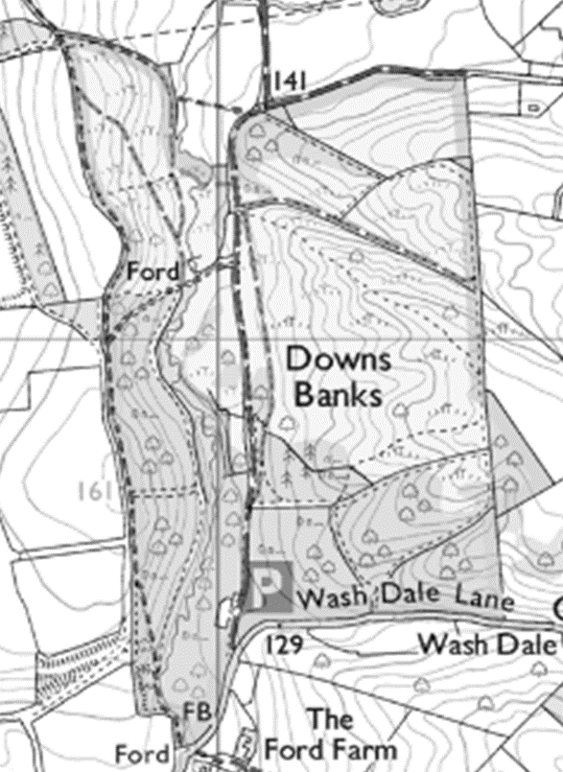

















Figure 9. Fifteen sites were chosen from points along the walking trails (Defra Magic Maps).

2.5 Taking the seasonal photographs
After the survey locations were finalised colour photographs were taken at each of the 15 sites in late summer (August) and repeated in mid-autumn (November), late winter (February) and mid-spring (late April) (see Figure 3 for chronological details) along with survey site notes detailing aspect, direction, altitude, and general topographical observations. Photographic details about focal length and position were also noted on the first visit so that these positions could be reproduced on each visit.
Few studies provide guidance for taking photographs for this type of research, but it is considered advisable as far as practical to standardise the process (Lothian, 2017). Colour photographs were taken with a Sony Cyber-shot HX60 digital still camera and, in line with accepted research (Lothian, 2008; zu Ermgassen et al., 2018), from a standing height of 1.6m. To ensure that the top third of the image was sky and that the mid ground and fore ground were clearly visible, images were taken horizontally rather than vertically (Nassseur,1993; Svobodova et al., 2014) and between 10:00 and 14:00 to avoid long shadows which have been shown to detract from preference ratings (Lothian, 2017). Aspect and direction were determined by the most dominant view and in the cases on higher ground, the most obvious vantage point. No people were included in any of the photographs to avoid potential bias and impact on landscape ratings. In contrast to research where images have been enhanced and standardised for clarity (Filova et al., 2015; Junge et al., 2015) or to exclude infrastructure (zu Ermgassen et al., 2018), photographs for this research were not digitally manipulated.

2.6 The Visual Quality Index (VQI)
Originally developed for Welsh landscapes by Swetnam et al., 2017, the Visual Quality Index (VQI) was designed as an objective measure of visual landscape quality which was applied through a stratified random sample to 300, 1km² squares across Wales. It was GIS-enabled and was designed to be used as a monitoring tool to evaluate change in landscape quality. It has been further adapted by Swetnam and Tweed (2018) for a visual quality study in Iceland and by Jovanovska et al. (2020) for use in the Shar Planina mountains, North Macedonia. This approach assumes that biophysical components of the physical landscape such as bodies of water, vegetation, terrain, and human elements like the presence of buildings and infrastructure can be measured and assigned numeric values. Some are positive visual features (native woodlands), others negative (roads, industry, housing). Recent research (Arriaza, et al., 2004; Wang, et al., 2016; Swetnam, et al., 2017; zu Ermgassen et al., 2018; Swetnam and Tweed, 2018; Jovanovska, et al., 2020) show that these visual indicators can be measured objectively by scaling and weighting the scores to distinguish high or low visual quality in the landscape.
The original Welsh Visual Quality Index (VQI) reflected a temporal snapshot, being confined to considering the landscape during summer months when vegetation was at full growth. This study extends and develops this work by focusing on a systematic sample across 15 sites over the course of a complete year. The switching from a narrow to a wider temporal extent and from a wide to a narrower spatial extent makes this research unique and brings a new dimension to this methodology
The original VQI recognises five visual themes for assessment: Terrain, Blue Space, Green Space, Human/Built, and Historic/Cultural. Figure 10 shows the themes and the visual parameters within these themes which can be measured and later scored and assigned values according to their negative or positive influence on visual landscape quality. Weightings are applied to each broad theme to give the overall visual quality score with values ranging from the lowest visual quality 0 to the highest visual quality 1. The order in which sites are placed rather than the number is the key.



Blue Space
Waterfall, Coast, % Water

Terrain
Ruggedness,Bare Rock

^{Naturalness}
^{Visual Scale}



VQI
Human
Roads/Transport, No. utilities, % Built,
Green Space
% vegetation, % woodland, Hedgerows, Flowers, Birds, Livestock


^{Naturalness}
^{Stewardship}
Cultural
Ancient monuments, Stone walls, Buildings of merit

^{Historicity}

Figure 10. The five visual themes (Terrain, Blue Space, Green Space, Human/Built and Historic/Cultural) in the VQI developed by Swetnam et al., 2017. The main landscape parameters for consideration are listed under each theme. The five themes were originally derived from a theoretical framework of landscape characteristics including to Naturalness, Stewardship, Visual scale and Historicity devised by Tveit et al., 2006.

2.7 Adapting the Survey Assessment to Downs Banks
After initial visits to the study site it was decided that only four of the visual themes would be used; Terrain, Blue Space, Green Space and Human/Built theme. This last was not well represented at the study site except in the views seen from the paths beyond the property boundary and as there were no significant cultural representations in the landscape, the decision to omit the historic/cultural theme seemed practical. This simplified approach was also adopted in the later work of Jovanovska et al., (2020) in North Macedonia. The parameters for each theme were refined to suit the spatial scale of the Downs Banks landscape. The landscape parameters were designed to be evaluated in the field and by photograph observation and were not mapped or defined from desk-based modelling exercises unlike the Welsh study which was calculated from a detailed spatial geodatabase supported by extensive habitat surveying. A comparative list of VQI parameters used for both Downs Banks and the Welsh study are outlined in Appendix 1 and an overview of the metric and supporting literature is summarised in Appendix 2.

2.7.1 Terrain
The first theme in the VQI provides a measure of the shape of the landscape. Four parameters were assessed; topographical variation, distance of view and openness of view and unvegetated bare ground. Based on a geomorphological model originally developed by Riley et al.,(1999) and subsequently used in Wales by Swetnam et al. (2017) and in Iceland by Swetnam and Tweed (2018), topographical variation was considered to be a useful indicator for measuring landform variation quickly from a vantage point and a simple way to assess the landscape shape best represented in the view. Unlike the Welsh study (Swetnam et al., 2017) where a digital elevation model was used to calculate terrain values the estimations in this study are more subjective and relied on simple field observations. As the Downs Banks site is not rugged, some adaptations had to be made to this assessment parameter to suit a small, undulating area with little variation in terrain. Rather than including categories for ruggedness, classes of terrain describing more local variations were designed to include flat, almost flat, and sloping to hilly topography. The parameter was weighted positively in accordance with research to suggest that higher elevations are associated with higher visual quality with rolling hills rated moderately high and flat land rated low (Brush, 1981;Shuttleworth, 1983; Lothian, 2017).

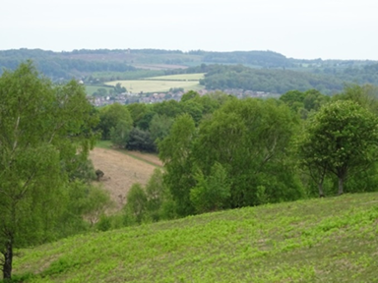
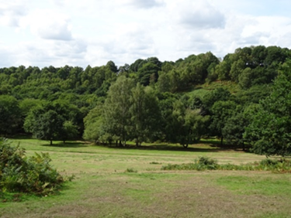

Terrain:
1 . Terrain:
1. How hilly is most of the landscape in the view? Flat (0) Almost flat (1) Sloping (2) Hilly (3)
How hilly is most of the landscape in the view? Flat (0) Almost flat (1) Sloping (2) Hilly (3)

Terrain:
1. How hilly is most of the landscape in the view? Flat (0) Almost flat (1) Sloping (2) Hilly (3)

Predominantly hilly
Predominantly flat

Figure 11. Examples of two sites showing terrain variations. Assessment categories are positively weighted 0 – 3 ( A Brown photographs). Questions are as used in the survey – see appendix 1

Downs Banks landscapes that would be classified as flat and hilly are shown in Figure 11. Similar flat, sloping and hilly categories were used by Wang et al., (2016) to assess shape of the land. Slope was considered important because from some sites in the more enclosed areas of Downs Banks only sloping land could be seen in the valley where view distance was short.

Presence of bare, unvegetated ground was also added to the Terrain theme. Unlike the bare ground measures in the Welsh Study (Swetnam et al., 2017) and the Iceland study (Swetnam and Tweed, 2018) where ruggedness with bare rock faces and extensive glacial outwash plains were a feature, bare ground was re-named unvegetated ground in this context with a twofold purpose; to account for the bare muddy patches around the stream as seen in Figure 12 and well-worn paths on the valley floor of Downs Banks, and to try to capture the emergence of seasonally muddy and bare ground in winter. The question was negatively weighted as visual preference studies show that ground cover contributes to visual quality (Schroeder and Brown, 1983) and that bare, unvegetated ground is not considered appealing (Nassauer,1995; Misgav, 2000; Hands and Brown, 2002; Howley et al., 2012).
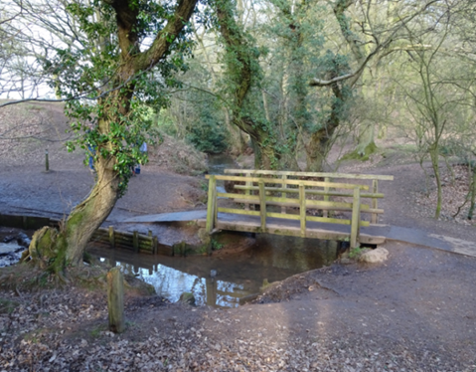

Can you see unvegetated bare ground? Yes (0) No (1)
Figure 12. Unvegetated ground at one of the study sites. This characteristic is negatively weighted 0-1 (A Brown photograph). Question is as used in the survey – see appendix 1

Some of the Downs Banks sites offer vantage points with views up to 64 kilometres to the Long Mynd and The Wrekin in Shropshire in contrast to other views of less than 100 metres in the valley. To capture the wide range of scales, the view distance parameter needed to assess both view distance and horizon. Adaptations to these parameters in this study were based on ideas from Arriaza et al.(2004) and zu Ermgassen et al.(2018) where horizon was included as a parameter. To overcome the problems of observing scale the view was given a measurable depth by dividing the categories into quarters as seen in Figure 13 to ensure simplicity and more accuracy for the surveyors. Distances were measured from ArcGIS before the field work commenced to aid the surveyors’ estimations. In line with work conducted in Swiss alpine regions (Schirpke et al., 2013) which showed that short views on valley floors rated low and most preferred views were from the higher alpine sites and by Arriaza et al., (2004) where distant views rated highly, this parameter was weighted positively.

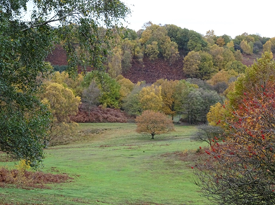
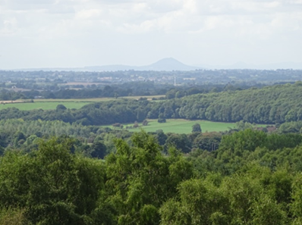

>2000m
101-500m

View/Horizon)
How far can you see? <100m (0) 101-500m (1) 501-2km (2) >2000m (3)

Figure 13. Two examples of sites to illustrate the variation in horizon and view distance. Positive weighting from 0-3 for 4 visual assessment categories (A Brown photographs). Question is as used in the survey – see appendix 1

The final terrain parameter deals with the concept of openness. Adapted from Wang et al. (2016), this parameter was designed to account for the scales of expanse of the view at each site which range from far reaching hilltop vistas to enclosed space on the valley slopes and floor. Classes of closed, semi-open to open sites were assessed and positively rated. Openness as a landscape parameter has been debated (Ruddell et al., 1989; Dunn, 1976; Tveit et al., 2006; Schirpke et al., 2012) and generally open and semi-open landscapes are preferred. Based on these findings, Figure 14 shows the positive weightings for the degrees of openness and seasonal differences in openness.

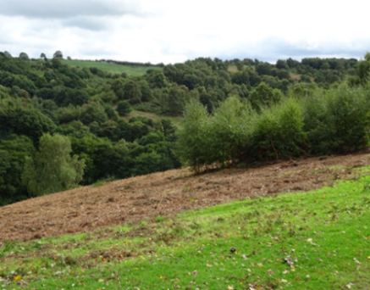
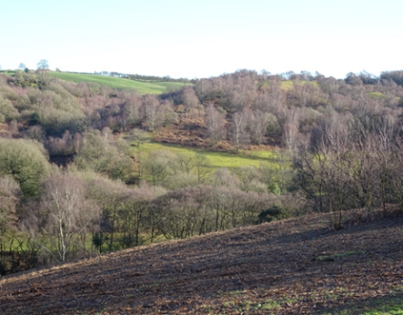

Summer (semi-open) and winter (open) contrasts in openness

4.How open is the view? (Can you see through the trees?) Closed (0) Semi- open (1) Open (2)
Figure 14. Examples of two of the sites with views with seasonal woodland variation. The positive weighting for openness of 0-2 for the parameter is shown ( A Brown photographs). Question is as used in the survey – see appendix 1.

This question was later modified to capture some seasonal cues as it became apparent that with seasonal change, openness of sites changed appearance (Figure 14). Research suggests that particularly in temperate regions where bare trees characterise winter, views are enhanced because a longer range of vision provides a sense of way finding and an ability to pass through the landscape (Misgav, 2000).

2.7.2 Blue Space
The second theme of Blue Space in the VQI is not particularly well represented at Downs Banks with only a small stream flowing through the valley. However, given that the stream provides popular recreation spots for visitors and that there is research to suggest that the presence of water contributes significantly to positive visual quality ratings (Herzog and Brosely, 1992; Kaltenborn and Bjerke, 2002; Bulut and Yilmaz 2009; Arriaza et al., 2004; Lothian, 2017; zu Ermgassen et al., 2018), it was decided that the blue space theme should be included. Further categories like running water were not deemed relevant at Downs Banks as the stream flows intermittently. There are two small, low lying bog areas on the property which are botanically significant. The question arose as to whether this landscape feature should be considered as a blue space or green space theme as the presence of water was not obvious and only the trained eye could spot the vegetation that indicated water below the surface. While research shows that wetland areas provide visual contrast to landscapes (Ode et al., 2009; Ode and Miller, 2011) and are associated with higher landscape preference (Dramstad et al., 2006) the vegetation was considered the dominant feature that would appeal (Jovanovska et al., 2020) so, it was included in green space.
The presence of snow, ice and frost was included in anticipation of possible presence in the winter. Downs Banks is at a higher altitude than the surrounding landscape and is often frostier, and the first place to receive snow. Although infrequent, when it does snow, visitor numbers increase greatly. Despite research (Misgav, 2000) indicating that snow is not preferred, a positive weighting was given to this parameter for this reason. Research in the Iceland study (Swetnam and Tweed, 2018) showed that periglacial snow cover rated highly as did snow cover in the Lake District where, despite heavy cloud cover, snow lifted landscape preferences by an average of 6% (Lothian, 2017).

2.7.3 Green Space
The Green Space theme was the key theme in the design of a seasonal VQI because Downs Banks comprises several different floral habitats that exhibit changes over the course of a year. Seven visual parameters in this theme were designed to capture temporal cues in the landscape.
Percentage of vegetation cover estimates for the first parameter were adapted from Arriaza et al. (2004), Wang et al. ( 2016), Swetnam and Tweed (2018) and zu Ermgassen et al. (2018). Scales with a quarter category (Figure 15) were estimated and positively weighted on a 1-4 scale. Research from public preference surveys confirms that the presence of vegetation appeals and is preferred (Herzog et al., 2000; Arriaza et al., 2004; Kaplan et al., 2006; Rogge et al., 2007; Filova et al., 2014; Wang et al., 2016; Lothian, 2017).
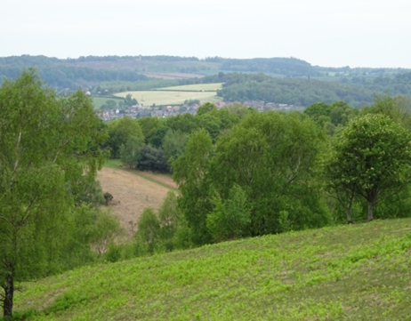
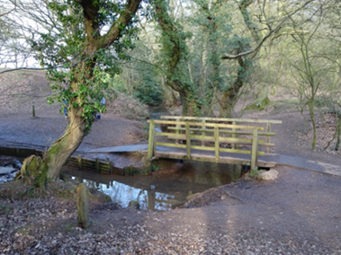

0-25%
76-100%

Green Space (Vegetation)
What % of the landscape in view is vegetated? 0-25% (1) 26-50% (2) 51-75% (3) 76-100% (4)

Figure 15. Site examples of two of the four visual categories for % of vegetation coverage. Four categories available for estimation with a positive weighting from 1-4 ( A Brown photographs). Question is as in survey – see appendix 1.

The second Green Space parameter considers tree coverage. Wooded areas account for much of the visual character of Downs Banks and, particularly in temperate areas, after water, trees are the most preferred features in landscapes (Purcell and Lamb, 1984; Kaplan and Kaplan,1989; Misgav, 2000; Lothian, 2017). Woodland especially has been found to attract positive visual quality ratings and a number of studies have shown that trees, scattered or in copses as they are on the Downs Banks site, rate highly (Herzog and Bosley,1992; Nassaeur,1995; Lindeman-Matthies et al., 2010; Legge–Smith et al., 2012; Lothian 2017; zu Ermgassen et al., 2018) while dense stands of non-native conifer are seen as visually unattractive (Vining et al., 1984; Lothian, 2017). A positively weighted scale with estimated quarter categories adapted from the Welsh VQI Swetnam et al. (2017) was used to measure the percentage of wooded cover.
Logically, the third parameter about the presence of livestock could have been categorised in the Human theme but was placed in the Green Space assessment as grazing animals play a vital role in the management of the vegetation diversity in the grassland areas of Downs Banks. Also, part of the character of Downs Banks trails are the views of livestock in the fields beyond the property perimeter. Livestock have been noted to influence positive visual preference ratings (van Zanten et al., 2014; Howley et al., 2012; Junge, et al., 2015) so a positively weighted parameter in favour of the presence of livestock was included in the VQI assessment.
Field observations confirmed that there were three broad assemblages of vegetation on site: grassland and low herbaceous, taller herbaceous (like Bracken) and shrub, and stands of taller woodland. The fourth parameter question, modelled on Wang et al., (2016) was designed to account for these categories. Work by Nassauer (1995), Arriaza et al. (2004), Rechtman (2013) and Wang et al. (2016) reveal that the degree of vegetation heterogeneity is seen as a positive element in the visual landscape and the decision to positively weight the categories (Figure 16) as the vegetation changes from low grassland forms to taller tree form was supported by research to show that that trees are preferred over shrubs and grasses (Nassauer, 1995; Wang et al., 2016).

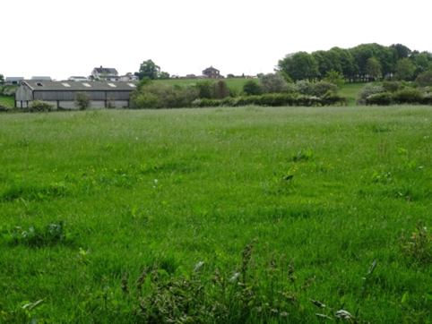
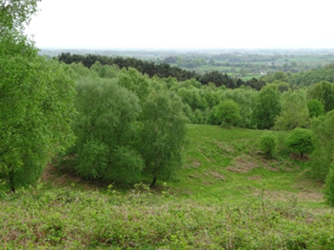

Grass/low herbaceous
Predominantly trees
What types of vegetation can you see that dominate the view?
Grass/low herbaceous (1) Tall herbaceous/Shrub (2) Trees (3)
Figure 16. Examples of two sites showing categories of vegetation assemblages. Visual quality weighting increases from 1 to 3 as the views change from grassland to trees ( A Brown photographs). Question is as in survey – see appendix 1.

Britain has a long history of farming landscapes and for centuries the land has been tilled, cropped and grazed. It is this pattern of activity and ownership that has given rise to the long lines of hedgerows that so characterise lowland rural landscapes in Britain. There is only one hedgerow on the eastern boundary of Downs Banks and none within the confines of the property. However, distant hedgerows can be seen from several of the higher vantage points forming linear patterns and boundaries in the distance and surveyors thought that these views were an integral part of the Downs Banks landscape and should be included as the fifth visual parameter. A five-part scale to account for the variety of hedgerow lengths seen in Figure 17 was devised and positively weighted on a scale of 0 – 4 in accordance with research that indicates that hedgerows are considered visually appealing in the landscape (Howley et al., 2012; Swetnam et al., 2017).
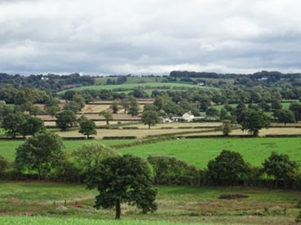

Can you see any hedgerows? How long are they? 0 (0) < 50m (1) 51-100m (2) 101-500m (3) >500m (4)

Figure 17. The view over hedgerows on the Eastern boundary and to lowland rural landscape beyond Downs Banks. Visual quality weighting scores are shown with positive weightings with increased hedgerow length ( A Brown photograph). Question is as in survey – see appendix 1.

In order to show seasonal change, parameters indicating the changes in vegetation were considered important and make up the final two green space categories. The most obvious indication that seasons are changing is in the colour and the growth cycles of vegetation. While seasonal aspects are considered important components of temperate landscape perception and aesthetic evaluation, overall outcomes are often not always significant (Brassley, 1998; Stobbelaar and Hendriks, 2007; Kuper, 2013; Junge et al., 2015). However, preferences for individual seasonal elements like berries (Misgav, 2000) and flowers (Junge et al., 2015) and colour contrasts have been found to positively correlate with visual quality and are preferred visual cues in landscapes (Arriaza et al., 2004; Junge et al., 2015; Kuper, 2015).
Two seasonal indicators were included in the VQI assessment: the presence of fruits, berries and flowers, and foliage colour changes. A positively weighted parameter indicating absence or presence (1-2) of fruits, berries and flowers was included in the VQI assessment. The final visual quality parameter was designed to assess preferences for both colour saturation and number of colours. The scale was devised to account for the colour changes throughout the year like the monotones with few colours in winter through to striking colour contrasts with multiple colours in autumn, spring and summer. Adaptations were made to scales used by Arriaza et al. (2004) and Wang et al. (2014) for numbers of colours and a scale of contrasts of colours from zu Ermgassen et al. (2018). As monotone colours and low colour diversity in a landscape are the least preferred (Hands and Brown, 2002) compared to a variety of colours (Junge et al., 2015; Kuper, 2015; Schloss et al., 2017) the scale of monotone colours <3 colours with some contrast to >3 colours and striking contrasts were positively weighted for the Downs Bank landscape with a scale 1-3 (Figure 18).

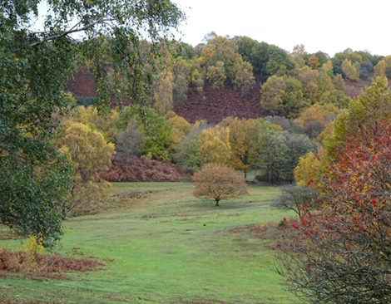
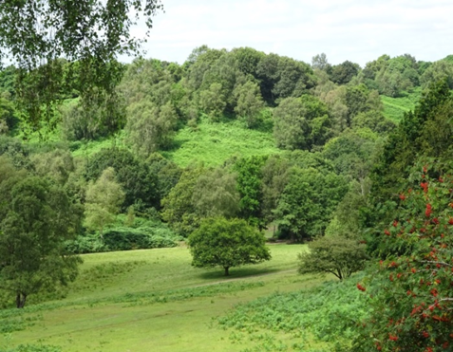

>3 colours and striking contrasts
Monotone vegetation colours

What colours can you see in the vegetation?
Monotone shades (1) <3 colours and some contrast (2) > 3 colours and striking contrast (3)

Figure 18. Vegetation colour variation: monotone greens to striking autumnal contrasts showing positive weightings for more colours and contrast (A Brown photographs). Question is as in survey - see appendix 1

2.7.4 Human/Built
While the impact of farming and grazing practices over the years has been extensive, the area has not been built on and apart from two wooden bridges over the stream there are no identifiable cultural additions to the landscape. However, distant infrastructure like pylons, housing and farm buildings were included as part of the VQI because they could be seen from the walking trails and formed part of the collective landscape. The final four VQI assessment parameters were adapted from Arriaza et al. (2004), Swetnam et al. (2017), and Swetnam and Tweed (2018).
Research shows that there is generally a negative relationship between built and infrastructure features and visual quality (Zube et al., 1975; Daniel and Vining, 1983; Arriaza et al., 2004 ; Bulut and Yilmaz, 2008; Lothian, 2008; Rechtman, 2013; Filova et al., 2015) therefore each of the four human parameters was negatively weighted. A five-part negatively weighted scale for percent of urban/built cover (0%, <10%, 10-25%, 26-50%,51-100%) was devised for the first of the parameters because built up areas could be seen from the highest vantage points.

An assessment of the number of infrastructure installations like transmission poles and pylons and larger masts and turbines was also included as they were visible over a wide area beyond Downs Banks (Figure 19). Tall intrusions like powerlines (Arriaza et al., 2004; Bulut and Ylimaz, 2008), transmission poles and towers (Filova et al., 2015), and turbines (Lothian, 2008; de Vries et al., 2012) are known to affect the rating of a view and detract from the visual quality of a landscape. The M6 motorway and numerous rural tracks can also be seen from several sites and were included in the assessment as these too, detract from the visual quality of the landscape (Filova et al., 2014).
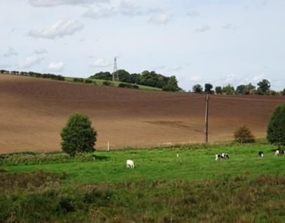
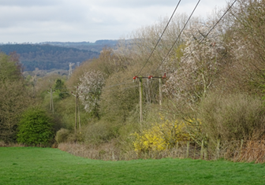

How many poles, pylons, masts or turbines can you see? 0 (2) 1-5 (1) >6 (0)

Figure 19. Views of infrastructure from within and beyond Downs Banks. Visual quality weighting scores are shown with negative weightings with increasing number of infrastructure installations (A Brown photographs). Question is as in survey – see appendix 1

A final addition in this theme was an assessment of the visual impact of livestock fences which have been constructed around the stream and on the property perimeters. This was an experimental question based on ideas from research conducted by Kuper (2015) in the USA who found that in times of vegetation senescence (defoliation), previously concealed structures like fences were exposed and were less appealing. The aim here was to see if the appeal of these visual features would change seasonally (Figure 20). A 5-part scoring scale like the hedgerow assessment was designed and negatively weighted.

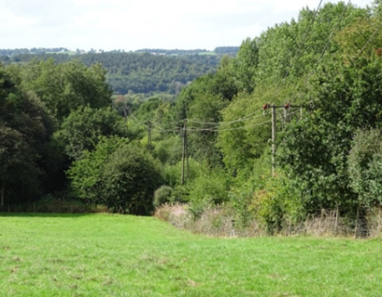
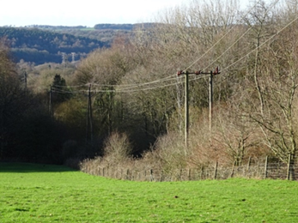
Fence and pole hidden in summer <50m
Fence and pole exposure in winter 50-100m

Are there any livestock fences in view? How long are they?
0 (4) <50m (3) 51-100m (2) 101-500m(1) >500m (0)

Figure 20. Examples of two sites where stock fences can be seen. Negatively weighted Visual quality shows a decrease with the increasing fence length (A Brown photographs). Question is as in survey – see appendix 1

2.8 Winter study on site
To gauge whether the adaptations to the VQI assessment made on the previous summer and autumn visits were feasible, three surveyors conducted the VQI assessment in the field (late February) – one with knowledge of the area and the VQI and two non-experts. Rather than establishing an order of VQI, (which it is designed to do) the aim in this instance was to use it as a metric to see if the sites with the highest VQI were the most appealing. Winter was the earliest convenient time to test the adjustments which had been made to VQI questions throughout the previous summer and autumn. The VQI assessment was conducted at the 15 survey points taking care to limit peripheral views to that of the camera angles (120° degrees). The mean score for all three observations was calculated to give a result for each landscape parameter (See Appendix 3 for MS Excel® spreadsheet examples). Photographs were also taken at this time for use as the winter set in the online survey. Surveyors also conducted an appeal assessment at each site to provide a dependent variable against which VQI scores could be tested to see if the sites with the highest VQI would also be the most appealing. The appeal scoring system (see Table 1) was first used by Swetnam et al. (2017) and Swetnam and Tweed (2018) which involves using a semantic differentiation technique as an objective measure for assessing appeal. Observers react to visual stimuli and assess broad categories of beauty, naturalness, excitement, variety and safety, using bipolar terms with a 7-point table. The mean scores for each response and the overall mean were calculated for the three surveyors’ scores to provide an appeal score for each site. Following extensive research, Lothian (2017) confirmed that this technique has been successfully used in qualitative landscape descriptions.
Your Personal Responses How do you feel about this landscape?
Beautiful | 3 | 2 | 1 | 0 | -1 | -2 | -3 | Ugly
Natural | 3 | 2 | 1 | 0 | -1 | -2 | -3 | Managed
Varied | 3 | 2 | 1 | 0 | -1 | -2 | -3 | Uniform
Exciting | 3 | 2 | 1 | 0 | -1 | -2 | -3 | Dull
Safe | 3 | 2 | 1 | 0 | -1 | -2 | -3 | Dangerous

Table 1. The 7-point semantic differentiation rating table used by surveyors on location for the winter on-site study.

2.8.1 Selection of surveyors
Prior to winter on-site assessment the principal surveyor (also the principal researcher for this study) had surveyed and begun work on adapting the list of landscape parameters for each of the 15 Downs Banks sites.
Two additional surveyors were selected to assist with the field testing of the VQI adaptations as it was considered that they might look at the landscape with ‘fresh eyes’. In contrast to research of this type which uses experts (Arriaza et al., 2004; zu Ermgassen et al., 2018) and trained individuals like students (Wang et al., 2016; Eren and Düzenli, 2017; Jovanovska, 2021) these were lay people. They (both female) were specifically selected because they had no previous experience of landscape observation, were not local and were qualified in unrelated academic fields unlike the principal surveyor who was a qualified geographer and familiar with the Downs Banks landscape.
Debate continues about the rating of landscapes on location and in photographs by experts and lay people (Kaplan and Kaplan 1989; Kuper, 2015; Lothian 2017) claiming that experts, by virtue of training and appreciation of formal visual criteria (Vouligny, 2009), may understand and interpret the environment differently from lay people (Rogge et al., 2009; Dupont et al., 2015) who tend to interpret landscapes more from factors beyond the formal such as experience and proximity (Vouligny et al, 2009). Despite the limitations that such decisions might place on this research the choice was also largely pragmatic because the surveyors were known to the principal surveyor and willing to help.

2.9 Assessing seasonal photographs and confirmation of VQI
Once the final set of spring photographs was taken the final assessment could commence and the VQI for each site in each season could be confirmed. The three surveyors (who had also conducted the winter study) assessed 60 of the most suitable photographs (4 seasons at 15 sites using the confirmed VQI assessment). The surveyors were set up with the images on laptops to replicate an A5 sized photograph equivalent to a Qualtrics survey image. The latter was an important consideration so that images were clear enough for the public to see on a range of devices.
A brief comparative assessment exercise was conducted to see if the winter photographs differed much from the winter field observations. The VQI photograph scores were between 2-5% lower than the field observation VQI scores and despite some discrepancy were deemed to be sufficiently representative for online application.
Assessing 60 photographs was time consuming and in order to minimise viewer fatigue the session was divided into photograph observation slots with rest breaks after 10 photographs. The photographs were also presented in random order to prevent practice effect (Roth, 2006) and to save time a verbal consensus was reached before noting the score for each parameter of the VQI assessment for each photograph. Average scores were calculated from the three surveyor’s assessment scores and entered as the final VQI score for the landscape parameters for each image in each season (See Appendix 3 for examples of VQI assessment MS Excel® spreadsheet). No Appeal scores were given for the photographs as the aim was to test appeal via the public preference survey.

2.9.1 Use of photographs
There has been some debate over whether photographs provide a suitable substitute for on-site assessment. While some research suggests that the use of single photographs as representations of landscape are too limited (Palmer and Hoffman, 2001), the method has also been found to be simple and effective with no significant difference between on-site observations and photographs (Shuttleworth, 1980; Stamps, 1990). A high degree of correlation between landscape evaluation in the field and from photographs was found in Southern Mediterranean studies (Arriaza et al., 2004) and in Canadian studies (Walker and Ryan, 2008). This method has been used and validated in numerous studies (Coeterier,1996; Lothian, 2008; Rogge et al., 2006; Arriaza et al., 2004; Filova et al., 2015; Rechtman, 2013; Wang et al., 2016; zu Ermgassen et al., 2018) and a number of seasonal photographic surveys (Kuper, 2013, 2015; Junge et al., 2015; Schüpbach et al., 2016; Eren and Düzenli, 2017).

2.9.2 Weighting the VQI and Sensitivity Test
Following the assessment of the 60 seasonal photographs by the three surveyors the final VQI score had to be calculated as a weighted sum of four contributing themes: Physical, Blue space, Green Space and Human/Built (Swetnam et al., 2017; Swetnam and Tweed, 2018). Weighting needed to achieve proportionate representation of each theme in the VQI, to show enough differentiation between sites based on the idea that sites with higher VQI will be the most visually appealing, and uniquely to this study, to allow for seasonal differentiation.
The 18 visual parameters in the four landscape themes were quantified to calculate the VQI. As the themes did not have the same number of parameters the raw data values were scaled to ensure parity and then weighted to show an index for each site between 0 and 1. This dealt with moving raw data to a visual quality index score. As a starting point, equal weightings of 0.25 were initially applied to the Terrain, Blue Space, Green Space and Human/Built components on the assumption that all four landscape themes contribute equally to overall landscape quality.
Initial weightings failed to differentiate sites because of the narrow range of VQI scores, therefore, further weighting trials were necessary, and values adapted to maximise the visual differences. Finally, a sensitivity analysis was completed to assess the impact of the entire weighting range on the final value of the VQI. The sensitivity analysis served as a semi-quantitative measure to evaluate the robustness of the VQI measure. It was possible to assess at which point heavier weightings to one theme would cause extreme variability to the remaining themes which would ultimately result in disproportionate representation of each theme in the landscape evaluation. A degree of intuition and locational knowledge also guided the weighting process. Field observations confirmed Green Space to be dominant followed by Terrain. Neither the Blue Space nor Human/Built themes are well represented at Downs Banks. Any weighting that dramatically altered these proportions would not be representative of the Downs Banks landscape.
Systematic weightings from 0 to 1 in increments of 10% were applied for each theme in turn while maintaining equal weighting to the remaining themes. To decide final weighting values the maximum, median and minimum scores were plotted graphically and the point where the maximum and minimum deviated least from the median score as shown on Figure 21 was the point where weighting was considered to have least impact on the other themes.

Figure 21. An example of two of 16 plots (4 themes over 4 seasons) showing how weightings were derived. The circled parts of the graphs show the least divergence (between 0.1- 0.2) for Winter Blue Space and (0.2-0.3) for Summer Terrain. See Appendix 4 for full table)

This process was repeated for the 16 graphs (four landscape themes in all four seasons). Final weightings were derived from choosing the commonly occurring weightings across each theme in each season along with some subjective licence based on knowledge of how each theme should be represented at Downs Banks. The VQI for Downs Banks is highly impacted if any of the themes is removed or increased to a weighting of over 50%. The Final VQI weights: Terrain (0.3) + Blue Space (0.1) + Green Space (0.5) + Human/Built (0.1) were set for each theme. Beyond the range of 0.1 - 0.5 respective scores for each theme were impacted and found not to be representative of the Downs Banks landscape. (See Appendix 4: for tables and further explanation).

2.10 Testing appeal of the Downs Banks landscape – the online survey
Once the final VQI scores had been assigned to the photographs a selection was put into a Qualtrics-enabled survey to seek online public appeal preferences. Allowing for considerable methodological control by embedding graphics and determining preference scales, this survey method offers an effective way to reach a wide audience and large sample of people in a relatively short time frame (Evans and Mathur, 2005) suitable for this type of study

2.10.1 Selection of photographs
The selection of photographs had to fulfil three objectives:
1. To include a selection of winter photographs to see if the public agreed with the surveyors’ on-site preferences.
2. To select photographs from the other three seasons to test public appeal.
Given that these variables had to be accounted for, selecting photographs at random (Filova et al., 2015) or deliberately to show clearly defined seasons as in some research (Junge et al., 2015; Schüpbach et al., 2016) would not have been appropriate. Instead the inter-quartile range was calculated for the winter VQI and photographs of five sites (minimum, first quartile, median, third quartile, and maximum) were systematically selected. A second selection of the autumn and summer photographs from three of these five sites was made to make up 11 photographs (see Appendix 5).
3. To test preferences for specific landscape parameters in each season.
Repeats of six of the previously selected photographs which showed specific landscape and seasonal parameters were chosen (see Appendix 6). After establishing the VQI it became apparent that there was not as much difference between the VQIs for each season as initially expected. The VQI range for the spring photographs was very narrow and they looked identical to the summer photographs on a screen. For this reason, and at the risk making a long survey which could result in participant fatigue and low survey completion rates (Dillman, 1991; van Selm et al., 2006), the spring photographs were not included in the online survey.

2.10.2 Designing the online survey
To ensure that the data set had the capability of offering normally distributed data for statistical analysis (Chyung et al.,2018) a continuous rating scale from 0-10 was assigned to each of the 11 survey photographs. Respondents were asked to indicate an overall appeal of the landscape. The photographs were placed on separate pages to avoid any comparative judgment and in random order, in accordance with research (Arriaza et al., 2004; Frank et al., 2013; Kuper, 2013; Filova et al., 2015; Junge et al., 2015; Wang et al., 2016; zu Ermgassen et al., 2018) which confirms that this helps prevent viewer fatigue and reduces bias induced by order. Photographs were labelled with the season. There is some evidence to suggest that labels can affect ratings (Lothian, 2017) but they were used to avoid confusion given that some of the images were repeated in the second part of the survey.
In order to see which specific landscape parameters appealed, six of the photographs were used again in a second part to the survey (see Appendix 6). Those which showed a range of features in each season from the four VQI themes were selected. Landscape parameters such as shape of terrain, vegetation colour and contrasts and the presence of infrastructure were framed in the photographs. Respondents indicated whether they liked, disliked or felt neutral about each of the parameters. (see Appendix 7 for examples of online survey pages).
To enable a mixed method pragmatic approach to enquiry and to facilitate further extrapolation of results, demographic details about age, gender, frequency of visits and activities undertaken in rural areas were collected and respondents were also given the opportunity to make informal comments at the end of the survey. The inclusion of demographic questions in landscape assessment research, based on the idea that there could be affective bonds between people and physical settings Tuan (1974), is recognised as potentially important methodology for predicting aesthetic perception (Dearden, 1983; Strumse, 1996; Svobdova et al., 2012).
While personal and demographic factors have not always been found to influence results to a great degree (Kaplan and Kaplan, 1989; Zube et al., 1982; de Groot and van den Born, 2003; Rogge et al., 2007),others have found age (Balling and Falk, 1982), gender (Lyons, 1983; Strumse, 1996; Svobodova et al., 2014) and frequency of visit (Wellman and Buhyoff, 1980; Nieman, 1980) to be significant and useful adjuncts for qualitative landscape interpretation (Frank et al., 2013). In accordance with these findings similar demographic indicators have been used in the qualitative interpretation of this research.

2.10.3 Administering the online survey
Gauging the appeal of the Downs Banks landscape was administered by an online survey. As confirmed by extensive research (de Groot and van den Born, 2003; Roth, 2006; Filova et al., 2015; Kuper, 2013, 2015; zu Ermgassen et al., 2018; Swetnam et al., 2017; Jovanovska, 2020), the internet as a survey instrument has proved to be an objective and reliable instrument for gathering data on landscape perception and visual landscape assessment. However, factors such as computer use and on-line patronage (which will inevitably affect the recruitment of participants) (Roth, 2006), and the influence of demographic factors such as age, gender, class and cultural background on outcomes should be considered (Frank et al., 2013; McGuirk and O’Neill, 2016) in final analysis.
Selection of this type of survey method and online distribution avoids the constraints of cost, time and organisational problems of finding focus groups and conducting interviews (Roth, 2006; Scott, 2012), and ensures high voluntary participation because of ease of access for most people. For these reasons and the physical constraints imposed by the coronavirus pandemic, online delivery and distribution was considered the most practical option for this research.
Equally important is the consideration of targeting survey respondents. The choice to target local groups is a widely recognised method (McGuirk and O’Neill, 2016) and is the one used in this research. Much significant visual quality research conducted in European and UK farming regions (Coeterier, 2000; de Groot and van den Born, 2003; Rogge et al., 2007; Stobbelaar and Hendriks, 2007; Howley et al., 2012; Scott, 2012; Junge et al., 2015; Schübach et al., 2016) and forest settings (de la Fuente de Val et al., 2005; Tyrväinen et al., 2017; zu Ermgassen et al., 2018) target local groups and interested stakeholders with knowledge of their landscapes. Other studies confirming significant results chose to target respondents based on expert judgement conveniently using university campus students (Wang et al., 2016; Eren and Düzenli, 2017) and local professional groups interested in landscape. (Arriaza et al., 2004; Kuper, 2013, 2015; Rechtman, 2013). In accordance with the aims to test local perception of a nearby landscape, while acknowledging the limitations that such choice imposes on outcomes with this type of sampling (McGuirk and O’Neill, 2016), local groups were targeted for this research. Geography undergraduates and the post graduate community from Staffordshire University, local geographical association members and local Barlaston residents via their community website were invited to participate.

2.11 Statistical analyses
All data sets used for comparison were first tested using a Kolmogorov-Smirnov (KS) test (McCarroll, 2017). All data were non-normal; therefore, the non-parametric Mann Whitney U-test was applied throughout to test for significant differences between groups. All analyses were conducted using MS Excel® and calculators available on the Social Sciences Statistics website.

3 Results and Discussion
The aim of this research was to see if a more holistic measure of landscape quality could be derived by adapting an existing VQI to assess the Downs Banks landscape in different seasons. Previous studies have assessed visual quality at single points in time (Arriaza et al., 2004; de la Fuente de Val et al., 2006; Filova et al., 2015; Rechtman, 2013; Wang et al., 2016; Swetnam et al., 2017; Swetnam and Tweed, 2018; zu Ermgassen et al., 2018; Jovanovska et al, 2020), but the aim here was to see if additional seasonal VQI parameters could capture key differences in visual quality over the space of a year. Landscape ‘space’ was therefore kept constant, but landscape ‘time’ was manipulated to see if a seasonal index of visual quality could be created. Which sites, at which time of the year, were appealing? Unlike the previous studies this investigation was tested in a typical British rural setting, on a much smaller scale and over a single year capturing all four seasons
The results for the two components of the investigation are presented. Firstly, the results of the winter study (see section 2.8 for details of methods) with emphasis on the evaluation of the VQI parameters and field appeal scores. Secondly, the results of the online questionnaire in which the public were asked to rate their preferences for seasonal landscape images and specific landscape parameters (see section 2.10 for details of methods). Participant profiles are presented and results for appeal ratings for age, gender and frequency rural visits are extrapolated.

3.1 Winter field study
The winter field study results were initially evaluated to see if there was a correlation between the derived VQI and the field assessed Appeal ratings. Rather than establishing an order of VQI, (which it is designed to do) the aim was to use it as a metric to see if the sites with the highest VQI were the most appealing.
The Mean VQI and Mean Appeal results from the three field surveyors’ results were ranked and plotted (Figure 22 and see Table 2 for survey sites). A weak positive correlation was confirmed by a Spearman rank coefficient test (r_{s} = 0.57386 >0.05). Although not statistically significant, there is an indication that those sites with a higher VQI do tend to appeal more to the viewer in the field. The sites with a variety of landscape parameters that score highly on the VQI are generally the more appealing to the viewer (for example sites 2,5,8 and 13). There are several sites in the mid-range of the VQI that have lesser appeal. The landscape features at these sites vary quite considerably and presence or absence of individual features might account for the varying ranges of appeal. There are also some sites with a low VQI that are the least appealing. A summary giving details of the sites and field surveyors’ decisions for appeal ratings is detailed below

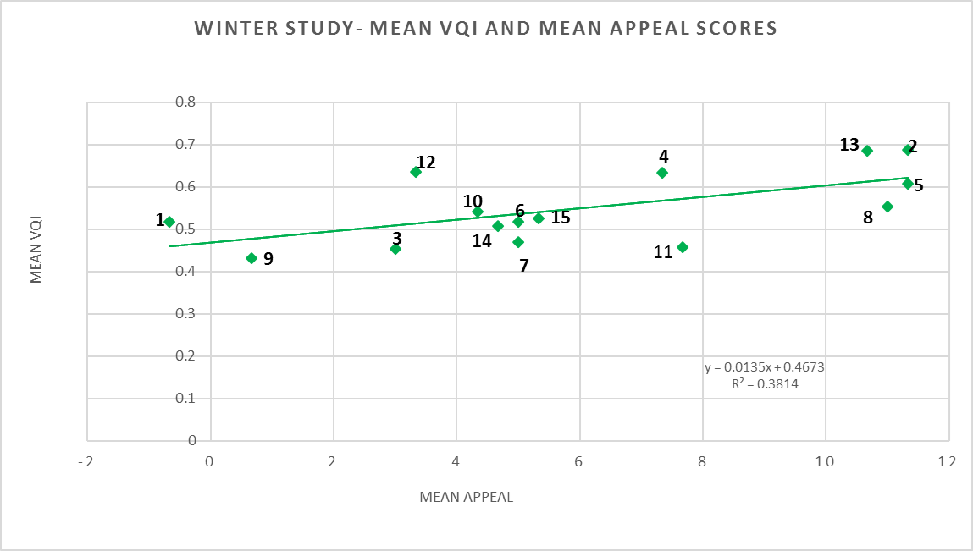

Figure 22. Winter field study Mean VQI (range 0 – 1.0) and Mean Appeal. Site numbers are indicated on the graph.

Table 2. The 15 field site and reference code names as shown on Figure 22 above.

Site | Code
1 | Conifers
2 | Wrekin View
3 | Back Farm
4 | Tittensor Hill
5 | East Side
6 | Hop field
7 | Farmland
8 | Hartwell
9 | Bridge
10 | Steeping stones
11 | Birch Valley
12 | Ash Tips
13 | White House Farm
14 | Stream
15 | Valley View

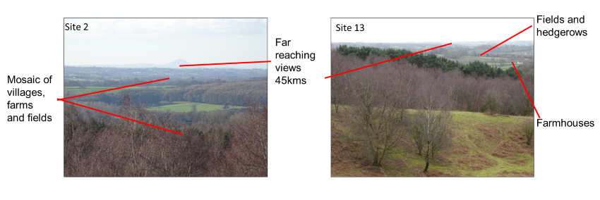
Figure 22 shows that sites 2 (Wrekin View) and 13 (White House Farm) with the highest scoring VQI scores are the most appealing. Both sites are located on the eastern ridges above Downs Banks valley with views to the West as far as Shropshire to the Wrekin and the Clee Hills as shown in Figure 23. A wide variety of high scoring VQI landscape features like the mosaic of fields and deciduous wooded areas marked by hedgerows, and a far-reaching horizon with the outlines of high hills accounts for the higher visual quality and appeal ratings.

Figure 23. Site 2 Wrekin View and Site 13 White House Farm (A Brown photographs).
This accords with work by Arriaza et al. (2004) and de la Fuente de Val et al. (2006) who showed that far reaching views to a horizon and wide-open spaces providing a full view rated highly for visual quality.
The foreground offers variation in terrain and variety of vegetation types which are attractive. Contrary to studies which confirm that in general conifers are unappealing (Lothian, 2017; Swetnam et al., 2017), the field surveyors agreed that in this study the conifers provided an evergreen variation in an otherwise bare winter landscape and were on a sufficiently small scale as not to detract from the attractiveness of the view from Site 13. Similarly, it was agreed that human features like village housing and farmhouses, and the pylons and wind turbines visible at a distance from both sites, did not detract from overall appeal, as they were a familiar sight, despite being negatively weighted in the VQI. Generally, these types of human features in the landscape do not appeal.

Despite housing being classed as a positive feature in Southern Spanish landscapes where rural architecture is regarded as culturally significant and pleasing (Arriaza et al., 2004), visual quality scores were low. Infrastructure like power lines and poles, wind turbines and transmission towers have been found to be unappealing and consistently attract low scores for visual quality in numerous studies (Arriaza et al., 2004; Bulut and Yilmaz, 2008; Lothian, 2008; de Vries et al., 2012; Filova et al., 2015). However, when viewed from a distance these parameters seem not to have so much impact. In extensive studies in the Netherlands, de Vries et al. (2012) found that the negative appeal ratings for both building heights and presence of large vertical structures like transmission towers and turbines decreased by 25% with increasing distance up to 2000m.
Site 5 (East Side) and Site 8 (Hartwell) shown in Figure 24 also scored highly for visual quality, offering open views across grazing and arable land from Site 8 and across the Downs Banks valley from Site 5. In contrast to the previous two highest scoring sites, the shorter views with a closer horizon, resulting in less depth of view over a less varied rolling rural landscape at these two sites could account for slightly lower VQI scores.
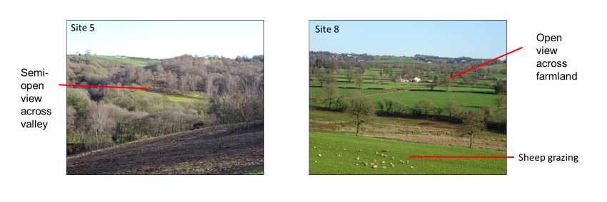

Figure 24. Site 5 East Side and Site 8 Hartwell (A Brown photographs).

Work by Shuttleworth (1983) in the UK showed that while hilly relief rated highly, rolling hills scored mid-value ratings for visual quality. The closer views detailing a variety of landscape features like hedgerows, fields and farmhouses from Site 8 appealed more than the distant views of similar features at the Site13 (White House Farm). The appeal of crisp edges, bold patterns, and orderliness first detailed in research by Nassauer (1995) also appealed to the surveyors. Site 8 did not appeal as much as the view across the Downs Banks valley at site 5 where no human intervention could be seen. The field surveyors felt that although the site 8 view was interesting and typical of a British farming landscape, Site 5 was a more natural, uninterrupted view and was therefore more appealing. Research suggests that landscapes with a few woodland patches, together with no obvious human intervention (Nassauer, 1995; Deaden, 1983) are perceived to have more appeal.
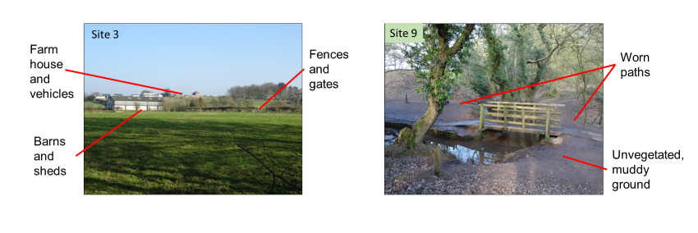

Figure 25 Site 3 back farm and Site 9 Bridge. (A Brown photographs)

The sites with lowest VQI, Site 3 and Site 9 shown in Figure 25 were the least appealing. The presence of buildings, vehicles and stock fences in the foreground did not score highly for visual quality nor did they present a particularly scenic view. Discussion between surveyors concluded that despite an open view the farm looked untidy. Site 9 at the bridge over the stream in the Downs Banks valley with a foreshortened view, unvegetated and muddy ground, and worn paths held little appeal. Generally, bare ground scores low for visual quality and is regarded as unattractive (Nassaeur, 1995; Misgav, 2000; Hands and Brown, 2002). Brown stream water is also unattractive (Pflüger et al., 2010) and surveyors agreed that, despite the wooden bridge and presence of water it was not an appealing view and that there were very few landscape parameters that contributed to visual quality.

The least appealing site was the conifer wood at Site1 (Figure 26) with dense tree cover, dark conditions and sparse understorey beneath the canopy. Despite rating higher on the VQI than sites 3 and 9 sites the surveyors considered the site unappealing. This is in line with previous research by Lothian (2017), who concluded from a comprehensive literature search that generally broad-leaved trees were preferred to conifers and that conifers were viewed negatively in countries where they were not native. Swetnam et al. (2017) also confirmed that large blocks of conifers planted on an industrial scale in rural Wales were considered unattractive and unappealing in comparison to stands of native trees.
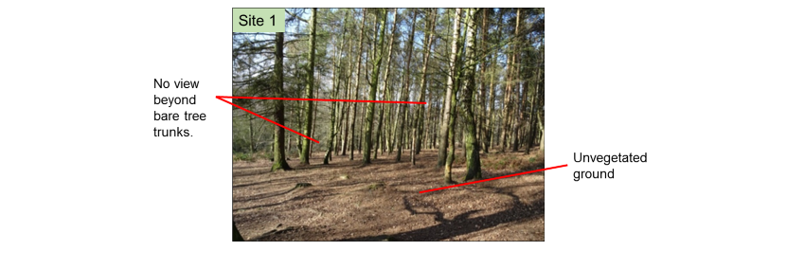

Figure 26 Site 1 conifers. (A Brown photograph).
The sites in the mid-ranges for VQI and Appeal (Figure 27 and 28) did not have any outstanding positive or negative visual quality parameters or any extremes of appeal. Surveyors agreed that Site 15 and Site 6 were very similar. All sites are semi open with mid-distance views overlooking local topography and showing close-range variations in vegetation. Site 7 overlooks agricultural fields with livestock and a tussock bog, and despite having more of a variety of visual parameters, it did not score as highly on the VQI as the other two sites. Swampy areas (Herzog, 1985) and bogs covered with rushes and tussock grass (Howley et al., 2001) have been confirmed as lacking in visual appeal. Infrastructure such as pylons and fences were noted by field surveyors as unattractive, but typical for this type of landscape. The shorter, semi-open views of up to 200m from Sites 6 and 15 show fewer landscape parameters but appealed because they were free of human influence.
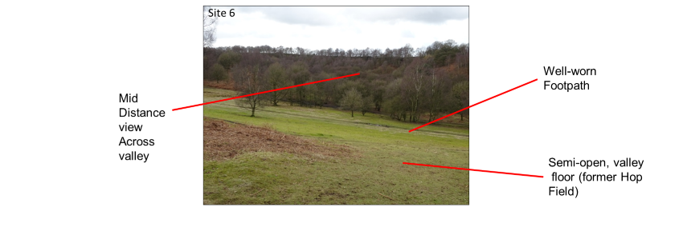
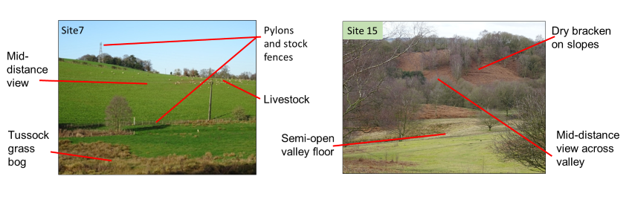

Figure 27 Site 7 Farmland and Site 15 Valley View, and site 6 Hop Field (A Brown photographs)

Surprisingly, the sites along the stream at Site 10 (Stepping Stones) and Site 14 (Stream) seen in Figure 28 also scored only mid-range scores for VQI and appeal. Together with few visual parameters the views were short and closed in by trees, which made them dark and unattractive. Despite the presence of water at both sites and the stepping stones at Site 10, which is a popular site for visitors, the muddy banks and unvegetated ground was considered a contributing factor in awarding lower visual scores and appeal scores. Surveyors felt that the limited visibility detracted from the appeal of both sites and although the type and scale of sites are different, studies in American forests (Daniel and Bolster,1976) confirm that short range of vision created by tree cover was found to be unappealing and connected to people’s perceived inability to pass through the landscape.

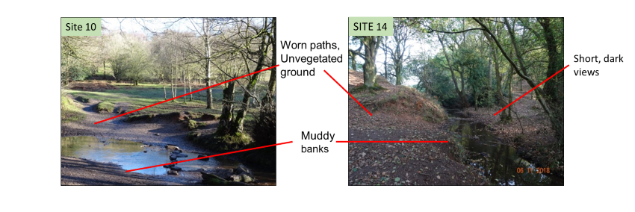
Figure 28 Site 10 Stepping Stones and Site 14 Stream. (A Brown photographs)

Site 4 and Site 11 appear as outliers. Despite the highly appealing open and far reaching views offered at Site 4, (Figure 29), the field surveyors felt that the motorway, which is not apparent in the photograph, together with the lack of variation in landscape parameters in the foreground, detracted from the appeal. By the time this site was surveyed, the haze had increased and partly obscured the view so appeal could not be fully appreciated. Mist and haze were found to compromise views in visual quality studies in by Lothian (2017) in South Australia where cloud cover reduced ratings by up to 20%.
By contrast, Site 11, with a mid-VQI score, held some appeal. Located on the steepest of the valley slopes, the site offered a relatively featureless and foreshortened view of woodland that was not particularly species rich. While unremarkable, the view up the slope through the trees was considered to have some appeal as surveyors could see through the relatively thin canopies of the birch trees to the top of the slope.

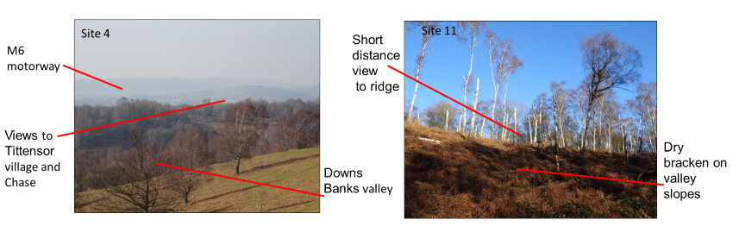
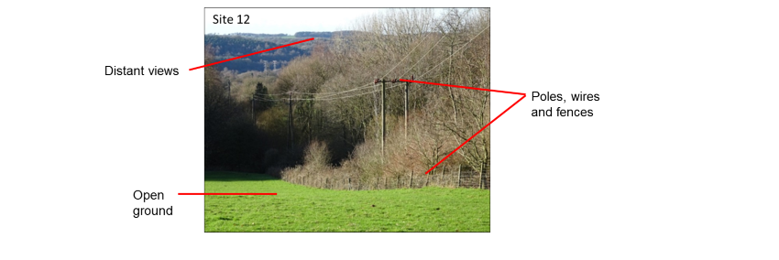

Figure 29 Site 4 Tittensor Hill and Site 11 Birch Valley, Site 12 Ash Tips (A Brown photographs)

Site 12 shown in Figure 29 looks down over the revegetated ash tips from the former Barlaston power station. A variety of parameters both topographical and human did contribute to a mid-range visual quality score. However, infrastructure like poles, pylons and stock fences detracted from the view despite a more appealing vista beyond the trees into the distance.

3.2 Testing the Appeal from the public preference online survey
Following the results of the winter field study, the assessment parameters were set and weightings for the VQI finalised by conducting a sensitivity test (see Section 2.9.2). The photographs for the online survey were selected (see Section 2.10 1 for details of methods) and distributed. The following results represent a summary of the key findings from the online public preference questionnaire.
Table 3 shows the Mean Appeal scores from the questionnaire with the VQI scores for each site. The values for the VQI range from 0.404 to 0.687 with a mean value of 0.543, and a median value of 0.534. The Appeal values range from 5.79 to 8.21 with a mean value of 6.74 and a median value of 6.44.
Season | Site ID, Name | VQI (0-1.0) | Mean Appeal (0-10)
Winter | 2. Wrekin View | 0.687 | 5.91
 | 5. East Side | 0.608 | 6.45
 | 15. Valley View | 0.525 | 5.79
 | 7. Farmland | 0.469 | 6.38
 | 9. Bridge | 0.432 | 6.44
Summer | 2. Wrekin | 0.651 | 7.60
 | 15. Valley View | 0.534 | 8.09
 | 7. Farmland | 0.404 | 6.15
Autumn | 2, Wrekin View | 0.621 | 7.30
 | 15. Valley View | 0.617 | 8.21
 | 7. Farmland | 0.435 | 5.91
Min |  | 0.404 | 5.79
Max |  | 0.687 | 8.21
Median |  | 0.534 | 6.44
Mean |  | 0.543 | 6.74

Table 3. VQI and Mean Appeal scores from the public preference questionnaire for three seasons.

The VQI scores in Table 3 were ranked from highest to lowest for each season. There is no indication that sites with the higher VQI scores are consistently the most appealing. However, there are some sites with a higher VQI in some seasons that do have more appeal. Because the summer and autumn data sets are smaller than winter, a comparison of mean scores for VQI and Appeal for the seasons is not useful. Therefore, it is only possible to look at some broad patterns. The Appeal scores overall are highest in summer ranging from 0.6 - 0.8 followed by autumn ranging from 0.5 - 0.8 while the winter appeal scores range from 0.5 - 0.6. In this instance the summer and autumn photographs were preferred to winter, despite winter having some of the highest VQI scores. Winter scenes in Northern Europe without snow have also been found to score low on visual quality scales in contrast to snowscapes which score highly in locations where snow cover hides deforestation and provides for wide uninterrupted vistas (Tyrväinen et al., 2017; Tahvanainen and Tyrväinen, 1996).
Further analysis to establish a pattern was conducted by plotting the VQI and mean Appeal data shown in Figure 30. Tests for normal distribution indicated that despite skewness indicating near normal negative distribution for both VQI and Appeal (-0.075 and -.0609), kurtosis for both VQI and Appeal (1.567 and 1.397) indicated a non-normal distribution. Because the data set was small and the range narrow, the data were transformed logarithmically, and as the data are not normally distributed, a Spearman’s correlation coefficient test was conducted r (9) = 0.40, p = 0.22. The correlation is not significant but does shows a weak positive trend indicating that summer and autumn views were preferred to winter.

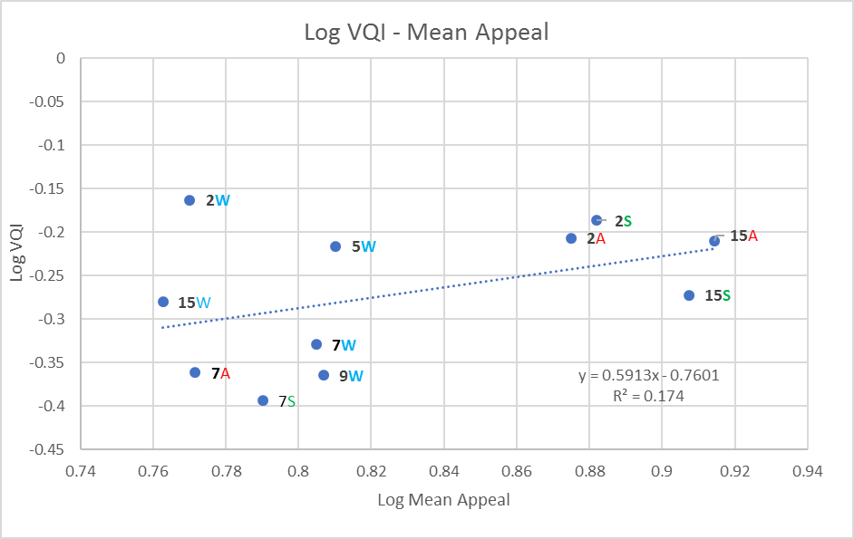
Figure 30. VQI and Mean Appeal from public questionnaire. 2 = site number. W= winter, S= summer, A=autumn. Spring data not included.
The sites with medium to long distance views in summer and autumn like Site 2 (2S and 2A Summer and Autumn - Wrekin view) and Site 15 (15S and 15A Summer and Autumn - Valley view) were preferred, which accords with the surveyors’ findings and is confirmed in the literature (Arriaza et al., 2004; de la Fuente de Val et al.,2006). Results from the comparative matrix ( see Appendix 8) confirm that Autumn and Summer at these sites did differ significantly from other sites. The lush green tones of the summer vegetation at both sites appealed to respondents who indicated that they liked the range of shades of green. Visual ratings for foliated vegetation exhibiting signs of green were rated significantly higher than defoliation in winter in studies conducted by Kuper (2015) in the USA. Nevertheless, research in the Netherlands reveals that too much monotone green in agricultural areas is did not attract high visual scores (Stobbelaar and Hendriks, 2004).
As indicated in Figure 30, Autumn appealed at Site 2 and Site 15. Both scenes showed contrasts of colours of three or more and striking colours. Red berries and a variety of yellow to orange leaf colours particularly at Site 15 appealed and survey respondents noted that they liked the colours. Schloss et al.(2016) found that people liked the reds and oranges of the fall colours in North America and similarly Junge et al. (2015) found that Swiss preferences for tree and shrub colour change in autumn received high preference ratings. Interestingly, despite Site 2 being higher on the VQI, it was Site 15 that appealed more. This might be because the vegetation at Site 15 is more diverse than other sites and could be seen at closer proximity in the photographs. The summer and autumn colour changes in leaves and fruits added to the colour saturation which scores highly (Junge et al., 2015) and were easy to see in the photographs. The dense foliage in summer and autumn also meant that the less appealing landscape parameters like distant poles and masts were not as obvious from Site 2 in summer and autumn.
Site 7 (Farmland) did not appeal in any season. Research shows that wetland areas like the tussock bog and intensively tilled fields seen in summer have little visual appeal (Bulut and Yilmaz, 2009; Howley et al, 2012; Rechtman, 2013). Extensive investigation also confirms that open fields where monoculture practices are evident are the least visually preferred forms of agriculture (Hendriks et al., 2000; Kaltenborn and Bjerke, 2002; Rogge, 2007; Howley et al., 2012; Rechtman, 2013). The autumn and winter photographs of Site 7 show little colour diversity and few in indications that the seasons have changed unlike Sites 2 and 15 where seasonal change is clearly defined.
The Winter scenes indicated in Figure 30 were perceived to be the least appealing. Respondents indicated that they did not like the winter monotone colours of muddy ground and brown vegetation as much as the summer and autumn contrasts. Supported by work on vegetation senescence in the USA (Kuper 2015) and work in temperate regions of Israel (Misgav 2000), winter colours and bare trees have been shown to be less visually appealing.
A comparative analysis of the 11 photographs revealed that there were significant seasonal differences in appeal between the photographs (see Appendix 8 for comparative matrix table) and confirm the pattern seen in Figure 30. Results show that Autumn held the most appeal, followed by Summer, and specifically at Sites 2 and 15 which showed significant differences in appeal from other sites. The Winter photographs did not differ significantly from each other at any sites. No significant differences in appeal were noted between sites 5, 7 and 9 despite the landscape parameters like bridges, pylons and the stream varying quite considerably. Winter by contrast with Summer and Autumn at the more scenic sites at 2 and 15 also seemed to hold little appeal. The farmland at site 7 did not appeal in any season

3.2.1 Agreement with the Winter field study Appeal score
As the winter part of the study had been conducted in the field it was necessary to see if the public preferences for the winter landscape images agreed with the surveyors’ on-site preferences.
In addition to gauging public preferences for the landscapes in each season it was important to see if they agreed with the surveyors’ preferences on location in the winter. The mean appeal scores shown Table 4 show a large difference between the winter field study and the online questionnaire. While the winter field study results confirm that sites with higher VQI are the more appealing, results for public preferences bear no relation to the on-site results nor do they indicate any pattern other than confirming that the winter views were generally found to be unappealing.
Site | Site Code | VQI | Winter Field Study Mean Appeal | Winter Public Mean Appeal
2 | Wrekin view | 0.687 | 11.33 | 5.89
5 | East Side | 0.608 | 11.33 | 6.46
15 | Valley view | 0.525 | 5.33 | 5.79
7 | Farmland | 0.469 | 5 | 6.38
9 | Bridge | 0.432 | 0.66 | 6.41

Table 4. Mean Appeal score differences between the Winter Field Study conducted on location and the public preferences questionnaire.

Several methodological limitations could account for these differences. The Appeal ratings for the five Winter photographs in the online survey were based on the semantic differential scale used in the Swetnam and Tweed (2018) Iceland study for testing the VQI. The scale used bipolar -3 to +3 ratings for five visual and emotional responses and an average score was derived (see Section 2.7 for details of method). For ease of use and to ensure full responses, a sliding scale (from 0-10) to score preference was used in the online questionnaire. Respondents had the opportunity to comment on their visual and emotional responses in a separate comments section. The use of different appeal scales has resulted in two different sets of scores which makes comparison difficult, but it also raises questions about the validity of the use of photographs as an alternative to on-site field work and the influence of ephemeral weather conditions on location.
Detail in the long view of fields and hedgerows from Site 2 and the rolling hills giving the impression of an open landscape from Site 5 could be seen with the naked eye and clearly appealed on location. The surveyors at both sites could appreciate the scale of these views. Less detail and a lack of sense of scale, and of not “being out there in a big landscape” in the photographs could have influenced public preferences. The idea of being out-in-the-field is well documented and supports the idea that the immersive experience enables a more holistic approach to landscape description (Howard, 2011; Henry and Murray, 2018) Online survey respondents indicated that long, wide views were what they generally preferred to see and experience and several indicated that this was difficult to capture in photographs.
While neither Sites 15 nor 7 appealed to surveyors or to the public, infrastructure like fences, poles and pylons at Site 7 and the wooden bridge at Site 9 may have appealed more to the public than on location as they seem at a distance and less intrusive in the photographs. Public online responses indicated that while infrastructure features were less appealing, they were not the sole unattractive feature at Site 7. Similarly, at Site 9 although not regarded as appealing by the public, the photographs did not capture the uncomfortable, cold, wet and muddy conditions felt by the field surveyors standing near the bridge.
The weather conditions and timing of photography on location must also be considered. Being on location in winter probably set the mood from the outset. This combined with surveying an attractive site first could have rendered every other preference decision for the day relative, and therefore artificially low. During the course of the day, the on-site weather conditions ranged from morning haze seen at Site 2 to sunnier conditions by midday at Site 5 which deteriorated to dull, overcast weather by the time surveyors assessed the last sites, 9 and 15 and it has been acknowledged in previous discussion that cloud cover can influence visual preference (Lothian, 2017). This, combined with surveyor fatigue, might account for differences between on-site and online preferences. The online survey respondents were asked to give preferences for summer and autumn photographs at the same locations as well as winter. Despite having separate photographs in random order in the online survey, respondents could have read the time of the year (Coeterier, 2000) as their least favourite (as results show) and cast lower appeal preferences for the winter scenes. The colour diversity and contrast in the winter photographs is low and could have influenced preferences. Surveyors agreed that the winter colour was more appealing on location than in the photographs, which highlights the value of an immersive experience where spatial and temporal aspects of the landscape can be fully appreciated.

3.3 The participant profiles
100 females, 61 males and 1 non-binary person completed the questionnaire (Figure 31). As is commonly the case with opportunistic sampling and surveys of this nature there were more female participants than male which resulted in an uneven distribution of data for gender (de Groot and van den Born, 2003; Frank et al., 2013; Filova et al., 2015).

Figure 31. Gender of online survey participants. (n=162)

Respondents were also asked about their age. Figure 32 reveals that the best represented age group was the 45-54-year olds who made up 22.8% of respondents. The poorest represented group was the young with no respondents under 18 years and only 8.0% in the 18-24 group. The older group, 55 and over, represented 33.9% of the total respondents with 15.4% of them over 65 years. 58% of respondents were young adults to middle aged, i.e. in the 25-54 age group.

Figure 32. Age distribution of survey participants. (n=162)

Finding out how often the public visit rural areas ( Figure 33) was useful to see if the level of engagement with the outdoors and landscapes influenced appeal ratings. Figure 33 indicates that 67% of people visit frequently, either daily, 2-3 times a week or once a week. Given that the profile of the survey community were geographers and associated researchers, and locals who live near Downs Banks it is not surprising that the level of engagement with a landscape is high. 30% visit less frequently, 2-3 times a month or once a month and only 3% never go at all.
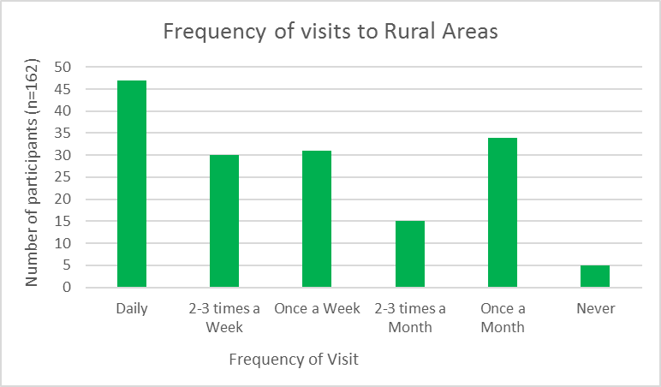

Figure 33. Frequency of visits to rural areas.

Preferences for types of activity taken in rural areas required respondents to choose one or more activities, so the results indicate popularity by referring to the total number of times an activity was chosen. (Figure 34). Clearly, relaxation and seeking peace and quiet was the most popular with 85% of people stating this reason for their visit. Health and exercise were also considered an important reason with 70% exercising for health reasons and 36% pursuing more active exercise like cycling and running. Observing wildlife in rural settings was important for 52%, and for 22% rural settings offered the opportunity to pursue artistic hobbies like photography. 41% of people met up with family and friends and 22% chose to walk their dogs in a rural area. 6% worked in rural locations and 7% stated reasons ranging from already living in a rural area, passing through on the way to work and to visit family or to go to their allotment. One respondent went deliberately to connect with nature and another to forage for food, and one spent a lot of time in rural areas assessing them to counter housing proposals. Only one respondent had never visited rural areas.

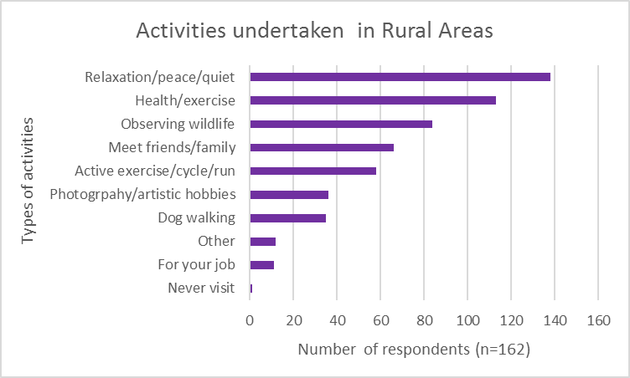

Figure 34. Activities undertaken in rural areas.

3.3.1 Testing the Appeal - Age group

 |  |  | Age Group
SEASON | Site ID, Name | Overall Mean Rating ± SD (range) | 18 -34 (n = 43)  ± SD (range) | 35-54 (n = 64) ± SD (range) | 55+ (n = 55) ± SD (range)
WINTER | 5. East Side | 6.45±1.74 (0-10) NS | 6.38±1.69 (0-9) NS | 6.32±1.84 (2-10) NS | 6.77±1.66 (4-10) NS
WINTER | 9. Bridge | 6.44±1.99 (1-10) NS | 5.97±2.13 (1-10) NS | 6.55±1.89(1-10) NS | 6.75±1.98 (2-10) NS
WINTER | 7. Farmland | 6.38±1.89 (0-10) NS | 6.33±2.09 (0-10) NS | 6.53±1.89 (1-10) NS | 6.8±1.77 (2-10) NS
WINTER | 2. Wrekin View | 5.91±1.86 (1-10) NS | 5.78±1.76 (2-8) NS | 5.88±2.12 (1-10) NS | 6.07±1.63 (2-10) NS
WINTER | 15. Valley View | 5.79±1.73 (1-10) NS | 5.38±1.80 (1-8) NS | 5.79±1.70 (2-10) NS | 6.20±1.58 (3-10) NS
SUMMER | 15 Valley View | 8.09±1.35 (4-10) NS | 8.02±1.21 (6-10) NS | 8.36±1.32 (5-10) NS | 7.83±1.47 (4-10) NS
SUMMER | 2. Wrekin View | 7.60±1.58 (2-10) NS | 7.64±1.57 (2-10) NS | 7.90±1.61 (2-10) NS | 7.27±1.52(2-10) NS
SUMMER | 7. Farmland | 6.15±1.76 (0-10) NS | 5.66±2.04 (0-10) NS | 6.23±1,60 (1-10) NS | 6.45±1.62 (1-10) NS
AUTUMN | 15 Valley View | 8.21±1.37 (4-10) NS | 8.04±1.41 (4-10) NS | 8.30± 1.39 (4-10) NS | 8.25±1.36 (5-10) NS
AUTUMN | 2. Wrekin View | 7.30±1.49 (3-10) NS | 7.59±1.32 (5-10) NS | 7.50±1.79 (2-10) NS | 7.44±1.50 (4-10) NS
AUTUMN | 7. Farmland | 5.91±1.65 (1-10) NS | 5.90±1.26 (4-9) NS | 6.00±1.88 (1-10) NS | 5.87±1.67 (1-10) NS

Table 5. Appeal ratings of seasonal photographs at Downs Banks, Barlaston (n = 162) summarised by age group. Mean Appeal values (0 low to 10 high) are given with associated standard deviations (SD) and ranges. Significant differences in ratings for age group compared to the total were calculated using non-parametric Mann Whitney U tests and are indicated by NS =Not Significant, * p < 0.05; ** p <0.01; *** p<0.001. Full statistical data are given in Appendix 9.

None of the age group mean appeal scores shown in Table 5 differs significantly from the overall mean ratings. Autumn and summer at all sites, except for the farmland at site 7, appealed to all age groups. No rating below 4 was awarded for any site in autumn. Higher mean appeal scores indicate that the middle-aged group found autumn more appealing than the younger and older age groups. Both middle aged and younger group scores also show that they rated summer more highly than the older group. The lowest mean appeal scores were given for winter and no winter scene scored above a mean of 6.8 whereas summer and autumn scored higher, between 7 and 8.3.
The range of ratings for the younger group indicate that they gave no higher rating than 8 in any category. The older group tended to give slightly higher ratings for winter overall and the winter range of ratings indicate that no rating below 2 was awarded. This group tended to be a little more forgiving in their winter ratings. Although they may not have preferred winter over other seasons, there is some indication that perhaps they had an appreciation of it or perhaps intuitively tended to avoid extremes on the scale. Documentation suggests that central tendency is an on-going issue when dealing with sliding scale responses and that analysis must take this into account in interpretation of results (Douven, 2018).
Visual quality ratings in less appealing mining settings in European studies suggests a degree of consensus and conservatism among older age groups (Svobodova et al., 2014). Many of the older group lived locally and were very familiar with Downs Banks. Site 2, Wrekin View and Site 15, Valley View appealed to all age groups in the autumn and summer. By contrast the lowest mean scores given by all age groups is for the Farmland at Site 7.
Data for each age group were compared (see Appendix 10).and most results were non-significant. The only significant comparisons were as follows:
- The older age group rated the summer photograph at site 2 (Wrekin View) significantly lower than middle aged group (U = 1362.5, z= 2.11602, p = .034).
- The older age group rated the summer photograph at site 15 ( Valley View) significantly lower than middle aged group (U =1371.5, z = 2.06805, p = 0.03846).
- The younger age group rated the summer photograph at site 7 (Farmland) significantly lower than the older age group (U = 1338.5, z = 2.20359, p = .0278).
Significant differences are indicated only in summer photographs. The numerous features in the photograph at Site 2 (Wrekin View) may have been more difficult for the older group (55+) to distinguish because they appeared at a vastly reduced scale in the online image. It was the middle aged (35-54) respondents who indicated in the survey that summer photographs appealed more because they liked the summer greens and dense tree canopies. Respondents in middle-aged groups generally were found by Filova et al., (2015) to rate scenes more highly than the older age groups. The older group also indicated that they did not mind the summer farmland view. Cautious ratings might account for this but also familiarity with the landscape. Strumse (1996) found in Northern European studies that preferences were often higher when the biome was familiar, particularly for the older age groups who had been associated with the landscape for longer. Lindemann-Mathies et al. (2010) found that older people tended to rate arable land and farm scenes more than younger age groups.

3.3.2 Testing the Appeal - Gender
In accordance with other research (de Groot and van den Born, 2003; Svobodova et al., 2014) gender had little influence on the results and some research suggests that gender characteristics do not indicate landscape preferences (Penning-Rowsell, 1982; Dearden, 1983). However, some trends from these results can be extrapolated. Compared to the overall mean appeal both men and women show few differences in mean ratings of the photographs (see table 6) and generally, men’s mean appeal scores are lower than women. The highest mean score was indicated for autumn (8.34) by women which accords with research that suggests that women generally rate scenes higher than men (Frank et al., 2013; Filova et al., 2015). Both genders had higher mean appeal scores for all sites in autumn and summer except for the farmland at site 7. The rating ranges for Site 15 summer and autumn for both genders start higher at 4 or 5 indicating strong preference for those scenes. Interestingly men did not rate summer Site 2 Wrekin View higher than 8.
Other winter site mean scores did not differ significantly between genders and were rated mid-range. The lowest mean scores were for the farmland at Site 7 for both genders, yet the most significant difference in appeal was in autumn at this site where men rated the autumn photograph at Site 7 (Farmland) significantly lower than women (U = 2499.5, z = 2.06753, p = .03846) (see Appendix 10). The pylons and stock fences were exposed in this photograph and clearly did not appeal. In European mining landscapes where pylons and associated infrastructure was visible, Svobodova et al, (2014) found men to be more critical and rated these scenes lower than women

 | Gender
Season | Site ID, Name | Overall mean rating SD± (range) | Men + Non-Binary (n= 61) SD ± (range) | Women (n=100) SD± (range)
WINTER | 5. East Side | 6.45±1.74 (0-10)NS | 6.36±1.62 (2-10) NS | 6.51±1.82 (0-10) NS
WINTER | 9. Bridge | 6.44±1.99 (1-10)NS | 6.09±1.94 (1-10) NS | 6.68±2.00 (1-10) NS
WINTER | 7. Farmland | 6.38±1.89 (0-10) NS | 6.16±1.67 (1-10) NS | 6.51±2.01 (0-10) NS
WINTER | 2. Wrekin view | 5.91±1.86 (1-10) NS | 5.75±1.90 (2-10) NS | 6.03±1.83 (1-10) NS
WINTER | 15. Valley View | 5.79±1.73 (1-10) NS | 5.90±1.56 (2-10) NS | 5.72±184 (1-10) NS
SUMMER | 15. Valley View | 8.09±1.35 (4-10) NS | 7.83±1.39 (4-10) NS | 8.25±1.31 (5-10) NS
SUMMER | 2. Wrekin View | 7.60±1.58 (2-10) NS | 7.36±1.58 (2-8) NS | 7.76±1.57 (2-10) NS
SUMMER | 7. Farmland | 6.15±1.76 (0-10) NS | 5.83±1.54 (2-9) NS | 6.38±1,85 (0-10) NS
AUTUMN | 15. Valley view | 8.21±1.37 (4-10) NS | 8.01±1.41 (4-10) NS | 8.34±1.34 (4-10) NS
AUTUMN | 2. Wrekin View | 7.30±1.49 (3-10) NS | 7.30±1.49 (3-10) NS | 7.62±1.60 (2-10) NS
AUTUMN | 7. Farmland view | 5.91±1.65 (1-10) NS | 5.57±1.44 (1-8) NS | 6.14±1.74 (1-10)NS

Table 6: Appeal ratings of seasonal photographs at Downs Banks, Barlaston (n = 162) summarised by Gender. Mean Appeal values (0 low to 10 high) are given with associated standard deviations (SD) and ranges. Significant differences in ratings for each gender compared to the total were calculated using non-parametric Mann Whitney U tests and are indicated by NS =Not Significant, * p < 0.05; ** p <0.01; *** p<0.001. Full statistical data are given in Appendix 9 .
3.3.3 Testing the Appeal - Frequency of Visits
The total mean appeal scores and mean appeal scores given by people who visit either daily, weekly or monthly as shown in Table 7. A small number of respondents indicated that they never visited rural area. These results have not been included as the data set was too small to provide statistically meaningful results. The highest appeal mean scores were given by respondents who visited site 15, Valley View, daily in the autumn followed by weekly and monthly visits in the summer. Both Site 2, Wrekin View and Site 15, Valley View appealed at all visiting times in autumn and summer. The lowest mean scores were given in winter and for weekly visits to Site 2, Wrekin View in winter. The Farmland at Site 7 was the least appealing for all visits in all seasons.

Season | Site ID, Name | Overall mean rating SD± (range) | Daily  (n=42) SD±  (range) | Weekly  (n=61) SD±  (range) | Monthly  (n=49) SD±  (range)
WINTER | 5. East Side | 6.45±1.74 (0-10) NS | 6.76±1.65 (3-10) NS | 6.11±1.68 (2-9) NS | 6.54±1.73 (0-10) NS
WINTER | 9. Bridge | 6.44±1.99 (1-10) NS | 6.80±1.78 (4-10) NS | 6.21±2.15 (1-10) NS | 6.43±1.88 (2-10) NS
WINTER | 7. Farmland | 6.38±1.89 (0-10) NS | 6.52±2.07 (1-10) NS | 6.33±1.72 (2-10) NS | 6.18±1.93 (0-10) NS
WINTER | 2. Wrekin View | 5.91±1.86 (1-10) NS | 6.26 ±1.95 (2-10) NS | 5.66±1.72 (1-9) NS | 5.91±1.79 (2-10) NS
WINTER | 15. Valley View | 5.79±1.73(1-10) NS | 6.17±1.72 (3-10) NS | 5.50±1.82 (1-9) NS | 5.85±1.52 (1-9) NS
SUMMER | 15. Valley View | 8.09±1.35 (4-10) NS | 8.39±1.29 (6-10) NS | 7.70±1.46 (4-10) NS | 8.20±1.16 (5-10) NS
SUMMER | 2. Wrekin View | 7.60±1.58 (2-10) NS | 8.06±1.40 (3-10) NS | 7.28±1.77 (2-10) NS | 7.54±1.39 (5-10) NS
SUMMER | 7. Farmland | 6.15±1,76 (0-10) NS | 6.19±1.66 (2-10) NS | 6.01±1.74 (1-9) NS | 6.14±1.95 (0-10) NS
AUTUMN | 15. Valley View | 8.21±1.37 (4-10) NS | 8.58±1.34 (5-10) NS | 8.06±1.28 (4-10) NS | 7.97±1.45 (4-10) NS
AUTUMN | 2. Wrekin View | 7.30±1.49 (3-10) NS | 7.82±1.48 (5-10) NS | 7.28±1.85 (2-10) NS | 7.41±1.23 (5-10) NS
AUTUMN | 7. Farmland | 5.91±1.65 (1-10) NS | 5.95±1.71 (3-10) NS | 5.68±1.71 (1-10) NS | 6.20±1.33 (3-9) NS
Table 7: Appeal ratings of seasonal photographs at Downs Banks, Barlaston (n = 162) summarised by frequency of visit to rural areas. Mean Appeal values (0 low to 10 high) are given with associated standard deviations (SD) and ranges. Significant differences in ratings for frequency of visit compared to the total were calculated using non-parametric Mann Whitney U tests and are indicated by NS =Not Significant, * p < 0.05; ** p <0.01; *** p<0.001. Full statistical data are given in Appendix 11.

Appeal ratings tend to increase when the visits are more frequent and in autumn and summer. Respondents who visited daily also tended to award higher appeal ratings (5-6). Appeal ratings categorised by frequency of visit were compared and confirm that daily visits (see Appendix 12) have an influence on appeal.;
- Appeal ratings for the summer photograph at Site 2 (Wrekin View) for weekly visits rated significantly lower than daily visits (U = 1073,
z = -2.23083, p = .02574).
- Appeal ratings for the autumn photograph at Site 15 ( Valley View) for weekly visits rated significantly lower than daily visits (U = 1095.5,
z = -2.0914, p = .03662).
- Appeal ratings for the summer photograph at Site15 (Valley View) for weekly visits rated significantly lower than daily visits (U = 1050.5,
z = -2.37335, p = .01778).
- Appeal ratings for the summer photograph at Site 2 (Wrekin View) for monthly visits rated significantly lower than daily visits (U = 867.5,
z = -2.07783, p = .03752).
- Appeal for the autumn photograph at Site 15 (Valley View) for monthly visits rated significantly lower than daily visits (U= 871.5, z = -2.04852,
p = .04036)
In summer and autumn, views at Site 2 and Site 15 were preferred over the Farmland at Site 7 and other winter views even by the regular visitors. These seasons may have appealed more because it is more difficult and less comfortable to walk at these sites in the winter indicating that perhaps the level of engagement offered by a landscape influences how people perceive it (Kaplan and Kaplan, 1989). It is likely that familiarity with the sites may have influenced these appeal scores. Several of the respondents were local and noted informally that they never tire of their regular visits. Familiarity in landscapes has been researched extensively and raises complex discussion about attachment to place which is not within the brief of this study. However, in this context familiarity probably has an influence on how people, particularly local residents, respond to the Downs Banks landscape and research confirms that familiarity with landscapes does influence visual preference (Dearden, 1984; Kaltenborn and Bjerke, 2002; Dramstad et al., 2006; Gobster, 2007; Walker and Ryan, 2008; Voluligny et al., 2009; Svobodova et al., 2014; Lothian, 2017).

3.4 Landscape Parameter Appeal
Coloured boxes as indicated on the example in Figure 35 to show specific landscape features were superimposed on six photographs which were repeats of some of the 11 images presented in the first part of the survey (see Appendix 6 for images). Landscape parameters from all four VQI themes and in each season were chosen to see which specific features held appeal and to confirm that their presence probably influenced overall preferences for the scenes.
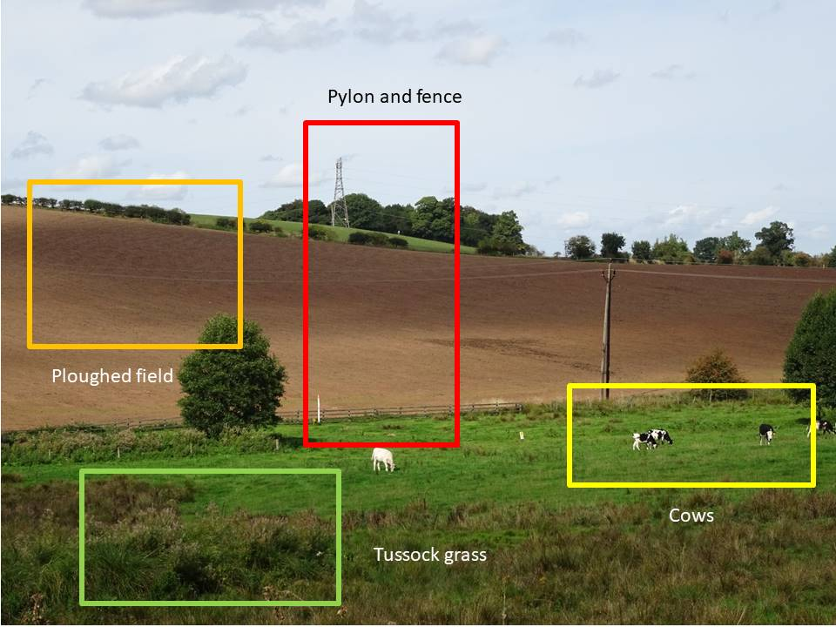

Figure 35. Coloured boxes showing specific landscape parameters superimposed on online survey image. Respondents were asked to rate each parameter: like/neutral/dislike
(A Brown photograph).

Several of the green space parameters were chosen from the VQI assessment questions which were designed to assess the seasonal shifts in vegetation colour and cover. All positively weighted, they included assessments of colour scale from monotones through to three or more contrasting colours, density of tree canopy in summer and winter and presence of seasonal fruits. Results in Table 8 show that the appearance of the vegetation appealed more to respondents than other parameters and that overall, the autumn and summer parameters in this theme appealed more than the winter. Vegetation dominated most of the scenes and seasonal colour changes could be easily recognised. Autumn vegetation colours showing a high degree of contrast were preferred over summer and winter colours. High colour saturation has been found to be key to perceiving a landscape as attractive (Junge et al., 2015; Hands and Brown, 2002). On the other hand, and in line with other seasonal colour perception studies (Hands and Brown, 2002; Junge et al., 2015; Kuper, 2015), the brown winter monotone colours of dry bracken and bare tree trunks were not as appealing. Although not rating them highly, a surprising number of respondents registered neutral responses rather than outright dislike to the winter colours.

VQI Theme | +/- Impact on VQI | Landscape Component | Like | Dislike | Neutral
GS | Positive | Contrasting Autumn Vegetation | 155 | 1 | 4
GS | Positive | Green summer vegetation colours | 151 | 0 | 9
GS | Positive | Red autumn berries | 151 | 0 | 9
GS | Positive | Dense green tree canopy | 139 | 1 | 20
GS | Positive | Hedgerows | 139 | 3 | 18
GS | Positive | Livestock-cows | 134 | 2 | 24
BS | Positive | Stream | 130 | 8 | 22
T | Positive | Hills views | 123 | 3 | 34
T/GS | Positive | View through trees | 121 | 4 | 35
GS | Positive | Tussock grass | 86 | 9 | 65
GS | Positive | Brown winter vegetation | 78 | 19 | 63
GS | Positive | Dry winter bracken | 56 | 24 | 80
T | Negative | Ploughed field bare ground | 55 | 26 | 79
H | Negative | Pylons/fences | 14 | 81 | 65
T | Negative | Muddy ground | 13 | 67 | 80

Table 8: Evaluation of individual landscape components/parameters. Respondents were asked to indicate whether they liked, disliked or felt neutral about each parameter. The table indicates the most liked to disliked. VQI Themes – T = Terrain, BS = Blue Space, GS = Green Space, H = Human. Questionnaire photographs are shown in Appendix 6

Other seasonal green space parameters scored highly with all respondents liking the presence of autumnal fruits and berries and the dense green tree canopies and hedgerows in full leaf in the summer. Despite the monotone colours of the dense tree canopy and hedgerows their presence in the landscape held appeal possibly because these features offer distinctive edges and structural landmarks in the landscape (Nassauer, 1995). In contrast, respondents were also asked to consider the appeal of being able to see through the trees in winter. A surprisingly large number of respondents rated this surprisingly highly, but still preferred the dense tree cover in summer with no view. It is well documented that trees enhance the visual landscape and that there is an optimal threshold of tree cover (Kaplan and Kaplan, 1989; Misgav, 2000; Lothian, 2017). Mature stands with medium density canopies with a view through them are found to appeal more than dense stands of trees (zu Ermgassen et al., 2018) yet in temperate regions of Israel, bare trees were not preferred over densely leaved trees in summer (Misgav, 2000). The tussock grass at the Farmland site was present in all seasons but did not display much seasonal variation. However, it appealed more than expected with a surprising number of respondents also registering neutral preferences despite the literature supporting its lack of appeal (Howley et al., 2001). Bare ground in the form of winter mud and summer ploughed field were also chosen to indicate seasonal variations. The literature supports lack of appeal of muddy ground and bare, tilled earth (Howley et al., 2012; Rechtman, 2013) and it is conceivable that these features could well have been the main detractors from these scenes. Even the ploughed field, a summer image, did not appeal, confirming that this type of bare ground is not liked in any season.
Non seasonal parameters from the Terrain, Blue Space and Human/Built themes were chosen to test appeal of well-known visual quality indicators and to provide an idea of what people specifically liked in the overall Downs Banks landscape. All positively weighted features like distant views and views over hedgerows, the stream and the presence of livestock appealed to people and probably led them to rate these scenes favourably. As expected, the presence of infrastructure was disliked, and was the likely influence on low appeal ratings for the farmland scene at Site 7 with its poles, fences and pylons. The high number of neutral ratings for infrastructure (especially by men) and muddy ground is interesting and could possibly indicate that while these features are not favoured, they are an accepted part of the landscape.

3.5 Limitations
Although the methodology shows promise towards helping to determine relationships between seasonal changes in the landscape and appeal it has certain limitations which might be improved in subsequent work.
The small scale of the study site reduced the reliability of the results by limiting choice of survey sites that were sufficiently different from each other and sufficiently different in different seasons. Therefore, VQI parameter scores were similar and the range of both the VQI and Appeal scores reduced. While smaller sites can be used (Kuper, 2013; Wang et al., 2016; Eren an Düzenli, 2017) it is essential to appreciate that sample sizes may be limited which makes mitigation of margins of error and extrapolation of results more difficult to achieve (de la Fuente de Val et al., 2006).
The lack of differentiation also resulted in the spring photographs being excluded from the study which not only highlighted the alarming lack of botanical diversity in the area (with few visual spring cues like flowers and blossom), but meant that a full seasonal analysis could not be conducted in accordance with the original aim of the study. Unlike previous research where the final set of photographs had been drawn from a wide selection (de la Fuente de Val et al., 2006; Rechtman, 2013; Filova et al., 2015; Junge et al., 2015; Schüpbach et al., 2016; Jovanovska, 2020) and in the case of seasonal work over the course of several years (Junge et al., 2015; Schüpbach et al., 2016), the photographs for this research were fewer in number and taken on the same day in each season. More photographs to focus on the smaller scale complexities in the landscape (Lothian, 2017) taken over the course of perhaps a week, so that variation and daily nuances can be captured as suggested by Palmer (2000) might help to resolve the problems. Ideally seasonal studies of this nature should be conducted over several years to offer a representative seasonal collection of images.
Viewer fatigue and the ‘practice effect’ (Roth, 2006 p. 185) may have accounted for both narrow VQI ratings by the field surveyors and online appeal scores by survey respondents. Surveyors had many images to rate for establishing the VQI and online survey respondents viewed repeats of photographs in different seasons. Despite no effects reported in a similar study where the same photographs were presented in each season (Kuper, 2013), monotony may have resulted in faster and less observant viewing and decision making.
In addition to using the semantic differentiation scoring system to derive appeal scores in the winter field study, surveyors ideally should have given the sites a 1-10 appeal rating to allow for a direct comparison with online appeal scores. As with most 10 point scales there will be a tendency to opt for the middle rating rather than the extremes (Chyung et al., 2017), and often in cases where the respondent is undecided, or in the case of this study, perhaps unmoved by the landscape, but felt that they had to make some type of decision, the mid-point was the easiest. Also, the scale for appeal ranged from 0-10. Perhaps it should have begun at 1 as all landscapes have a visual impact and therefore should have a rating (Lothian, 2017). Many responses given were mid-scale ratings and considering the limitations of lack of photograph differentiation it is difficult to confirm whether the choice of scale was adequate or could have been a limiting factor. Previous landscape photograph rating studies have shown that use of both 7-point scales (Rogge et al., 2007; Junge et al., 2015; Wang et al., 2016) and 10-point scale scales (Lothian, 2017) produce valid results.
The online survey was targeted at local groups. While results indicate more appeal with frequency of visits and informal comments hint at familiarity, without knowing where respondents came from there was no opportunity to verify that familiarity and local experience with the Downs Banks landscape might have played in determining the appeal of survey images. Extensive work does confirm that preference for landscapes is not solely visual, but determined by familiarity and experience (Dearden, 1984; Kaltenborn and Bjerke, 2002; Alumäe et al., 2003; Dramstad et al., 2006; Gobster et al., 2007; Vouligny et al., 2009 Svobodova et al., 2014) particularly those landscapes nearby (Vouligny, 2009). In the case of this study the inclusion of additional survey question asking respondents where they came from would have enabled a more detailed extrapolation and determination of the possible reasons for the appeal of Downs Banks.

4 Conclusions and recommendations
The aim of this project was to develop a tractable method to undertaking a seasonal visual landscape assessment for use at the local scale in the British landscape. Specific objectives were to adapt and test a visual quality method which included seasonal components.
Adapting the Visual Quality Index was straightforward enough. Despite the lack of cultural features four of the five VQI themes could be adapted for assessment. The flexibility of the VQI allowed for the inclusion of enough assessment categories in each of the Terrain, Blue Space, Green Space and Human/Built themes to cover all features of the site and additional seasonal parameters which were designed to measure differentiation between seasons. Field surveyors found the VQI assessment easy to use on-location and to apply to the seasonal set of photographs.
It is debatable as to whether the narrow range of VQI scores is a result of not enough adequate adaptations to the VQI to allow for differentiation or whether it is due to the limitations of the study site. The latter seems much more likely and further testing on small sites might verify this. Several trials for weighting the VQI had to be conducted and although adjusted towards the upper limits, particularly for Green Space, differentiation between sites in each season was achieved.
The adapted VQI was tested by correlating appeal scores to the VQI to see if the highest scoring VQI sites were the most appealing. While results from the winter field study indicated a weaker correlation, they did indicate that, in winter, the highest scoring sites appealed the most. Results from further testing of public appeal via the online survey were not statistically significant but did indicate that aspects of lowland areas like Downs Banks do appeal. The results also indicate that the higher scoring VQI sites with views appeal as do sites with the most seasonal colour contrasts. The colour contrast parameter was key to differentiating seasonal aspects of the landscape and confirm that the colourful autumnal and summer contrasts in vegetation are preferred.
The first two research questions were designed specifically to gauge public preferences in the Downs Banks landscape and which physical and /or cultural features were valued. The parts of the landscape that offer panoramic views over the wide, open countryside were the most appealing and are what people like to see. Features which are typical of British lowland rural landscapes such as the presence of livestock, the hedgerows, scattered trees and woods, and the stream all attracted higher visual appeal scores and were indicated as preferred parameters. Informal comments from the survey confirm that views over the countryside were appreciated because they offered a sense of space and were familiar. People liked to see the distant villages, the patterns of fields, hedgerows and woods that epitomise the British countryside. The results also confirm that the visual features associated with human influences like pylons and fences and built structures were less appealing and not preferred in the landscape. Similarly, neither the agricultural landscape with bare fallow ground, the nearby tussock bog nor the muddy ground around the stream held much appeal. Interestingly, although least preferred, the number of neutral preferences for these negatively perceived features indicate that they seem to be viewed as an accepted, almost expected and familiar part of the rural landscape and, in some instances, went largely un-noticed.
Age and gender did not influence visual appeal scores, but frequency of visit did support the idea that familiarity with a landscape has an influence on how people perceive their environment. Visiting frequently, particularly daily, enables close monitoring of a place and heightens awareness of surroundings. People can remember the subtle shifts in the landscape if they see them often. Equally, of course, it is possible that people who appreciate the landscape tend to visit more frequently – is it cause or effect? Appeal ratings and comments from the younger age groups were not forthcoming in this study. Investigation into their perceptions of landscape is worthy of future consideration.
The third research question focuses on how seasonal aspects of the Downs Banks landscape affect appeal ratings and landscape preference. Results indicate that seasonal changes in the landscape were noticed and appreciated and did indicate a significant shift in preference over the seasons. Autumn, and to a lesser extent summer, held significantly more visual appeal than winter. In the case of Downs Banks, it was the vegetation that signalled the visual cues. The autumnal leaf colours and contrasts, and lush summer green foliage with berries and fruits scored highly for visual appeal in preference to the winter defoliation and dull, brown colours. Informal comments by respondents revealed that people preferred the summer and autumn views over winter. Winter was perceived as a depressing, dull time. In direct contrast, autumn was viewed as a sublime and colourful season.
Spatially, seasonal change was more appreciated at a closer range than in the long-distance views, which was unexpected. Appeal scores showed a shift from favouring autumnal and summer long distance views to the autumn and summer views at closer range in the Downs Banks valley where the nuances in vegetation change could be more easily seen. Winter did not appeal at any site.
The final research question addresses the validity of the VQI method as adapted in this research to provide credible results in a local area. While not significant the results do indicate that the VQI has some transferability and that it is possible to adapt the VQI parameters to smaller local areas. However, caution must be exercised in site selection to allow for enough differentiation of landscape features to give a larger range of VQI and Appeal scores. While not the brief of this study, the resulting narrow range of VQI and Appeal scores would have made construction of a VQI and Appeal index difficult. Additionally, with more differentiation in landscape features, weighting the VQI would have required less manipulation. The nature of the overall area meant that there were few specifically unappealing features, which if present, would have allowed for more differentiation.
The inclusion of seasonal parameters in the VQI was possible. The results show that seasonal changes in the visual landscape are subtle and often only detected at close quarters. This highlights the need for careful parameter assessment design to include smaller scale VQI parameters perhaps like leaf fall, colour changes in the stream (in particular increased turbidity in higher winter flow) and the more subtle spring changes that were not apparent in the wider landscape photographs of Downs Banks. The part of this study in which parameters were defined in order to show seasonal change through foliated and defoliated scenes (seeing through trees and revealing infrastructure) were not tested thoroughly and have the potential for further investigation.
Despite being deemed suitable as surrogates for visual assessment (Shuttleworth, 1980; Stamps, 1990), it is debatable as to whether the use of photographs for seasonal assessment can be successful, The use of photographs in this study largely failed in providing the nuances of seasonal change as evidenced by the decision to exclude the spring series of photographs because spring features were not visible. However, the winter field study confirms that using the VQI on location in a small site, and for detecting seasonal nuances, has the potential to work. In support of Scott (2002) who claims that photographs cannot pick up context and saliency in a landscape, the temporal, spatial and emotive measurement of seasonal nuances can only be achieved by “being in this landscape”. Perhaps in future studies the possibilities of a “virtual reality” approach could be explored.
The following specific methodology recommendations are made for future use of the VQI for seasonal visual quality research:
1. Ensure enough landscape variation on the site.
2. Conduct the VQI assessment on location if investment in time is possible.
3. If seasonal photographs are to be used, then presenting them as a comparative set over four seasons in a preference survey rather than individual images would allow for more analysis of shifts in appeal and preference.
4. Ensure an adequate selection of photographs by taking multiple images at each site and over extended time periods in each season.
5. Semantic questions and interviews focusing on why people like to see the changes in seasonal landscapes would aid exploration of the more subjective aspects of seasonal appeal. The affective domain in seasonal preference has not been widely researched and would be a useful adjunct to VQI assessment in enquiries of this nature.
6. As both familiarity and experience serve as important predictors of appeal (Kaplan and Kaplan, 1989; Dearden, 1984; Dakin, 2003) in landscapes, a focus on the targeting of specific groups to respond to the survey and the design of measures to include experience and familiarity would enable further extrapolation of the appeal in this landscape.
It is a reality that even the small local landscapes like Downs Banks do not escape the forces of development that will inevitably change the visual landscape and ‘without our little places our natural environment would be even poorer than it is now’ (Glover, 2019 p 28). Consent was granted in 2016 for a new gas turbine power station (National Infrastructure Planning, 2016) and for 1.2 million square feet of industrial park floorspace (Staffordshire County Council, 2020) on the former Meaford Power station site on the western boundary of Downs Banks. An application for a solar farm (DECC, 2015) on the north western boundary has also been submitted. All of these will affect the views from Downs Banks. More distant views have already been altered by large scale timber felling on Tittensor Chase to the west as part of the Forestry England North Staffordshire 2019-2028 plan (part of the national commercial conifer felling plan) (Forestry England 2019). Nearby high-density housing developments and more recently the ‘Stay Local’ Covid-19 pandemic restrictions have contributed to heavier visitor loads at Downs Banks. By further reducing biodiversity through severe vegetation trampling and footpath erosion it could be argued that this has also contributed to a reduction in visual capital of the area.
By using the VQI to assess the visual condition of the local landscape, managers of small tracts of land may consider the following planning recommendations:
- Specific landscape features that have value such as long-distance views, bodies of water and wooded areas should be identified and protected and maintained.
- Management practices like controlled and selective scrub clearance should be considered to preserve views.
- Consideration should be given to fore and mid ground planting (consistent with recommendations for screening set out in The National Grid Visual Impact Provision statement, 2014), on the boundaries where development is imminent.
- Selective maintenance by rotating temporary restricted access should be considered to ensure biodiversity restoration. The recent heavy visitor load at Downs Banks has highlighted trampling and erosion problems which have contributed to worn, unappealing areas and further reduced biodiversity.
- For sites like Downs Banks where botanical diversity is low, a selective planting regime to restore a variety of flora with seasonal interest is advised. Where herbaceous cover may be more difficult to establish and monitor, spring and summer flowering native trees, which also provide autumn fruits and leaf colour, could be considered. Species such as Rowan (Sorbus aucuparia), Blackthorn (Prunus spinosa), and Wild Cherry (Prunus avium) would provide year-round interest. Winter interest could be established by planting native evergreens like Juniper (Juniperus communis) along with the larger deciduous trees such as Oak (Quercus spp.) and Beech (Fagus spp.), which would provide an interesting variety of bare wood vistas in winter.

There is little doubt about the urgency of protecting our landscapes and accounting for our natural capital on both national scales in our large landscapes (Glover, 2019; HM Government, 2018) and on local scales in our small landscapes. Gaining momentum too, is the realisation by public and private stakeholders that ecosystem service provision must not only encompass ecological landscapes but also cultural landscapes to include the aesthetic capital. If assigning value to visual landscapes is to be a part of monitoring schemes then some form of measurement for assessment of existing visual capital and prediction of what could be valuable is required.

The Visual Quality Index (the VQI) presented in this research demonstrates a simple scoping tool to measure visual quality in the landscape. By enabling quantitative assessment of spatial and temporal landscape parameters either through data collection on site or by photograph substitutes, landscapes with high visual importance can be identified. The assessment data derived from the VQI can be a useful addition to landscape registers and provide a useful platform for predicting and monitoring the impacts of increasingly rapid visual change in our landscapes.

5 References

ALUMÄE, H., PRINTSMANN, A. and PALANG, H., 2003. Cultural and historical values in landscape planning: locals’ perception. In Landscape Interfaces (pp. 125-145). Springer, Dordrecht.
ACHARYA, A.S., PRAKASH, A., SAXENA, P. and NIGAM, A., 2013. Sampling: Why and how of it. Indian Journal of Medical Specialties,4(2), pp.330-333.
AMINZADEH, B. and GHOREYSHI, S., 2007. Scenic landscape quality and recreational activities in natural forest parks, Iran.
ANTROP, M., 2013. A brief history of landscape research. The Routledge companion to landscape studies, 1, pp. 12-22.
AOKI, Y., 1999. Trends in the study of the psychological evaluation of landscape. Landscape Research, 24(1), pp. 85-94.
APPLETON, J., 1984. Prospects and refuges re-visited. Landscape journal, 3(2), pp.91-103.
ARCGIS online. Available at https://www.arcgis.com/. Accessed [6th July 2020].
ARRIAZA, M., CAÑAS-ORTEGA, J.F., CAÑAS-MADUEÑO, J.A. and RUIZ-AVILES, P., 2004. Assessing the visual quality of rural landscapes. Landscape and Urban Planning, 69(1), pp. 115-125.
BALLING, J.D. and FALK, J.H., 1982. Development of visual preference for natural environments. Environment and Behaviour, 14(1), pp. 5-28.
BOURASSA, S.C., 1990. A paradigm for landscape aesthetics. Environment and Behaviour 22(6), pp. 787-812.
BOYD, W.E. and GARDINER, J.E., 2005. Stooking the peanuts: historical agriculture and the management of a dying seasonal landscape, north-east New South Wales, Australia. Landscape Research, 30(2), pp. 193-220.
BRASSLEY, P., 1998. On the unrecognized significance of the ephemeral landscape. Landscape Research, 23(2), pp. 119-132.
BRITISH GEOLOGICAL SOCIETY Available at ]. https://www.bgs.ac.uk/map-viewers/geology-of-britain-viewer Accessed [13th April 2021].
BRITISH TRUST FOR ORNITHOLOGY. Available at https://app.bto.org/birdfacts/results/bob4930.htm. Accessed [13th May 2021].
BRUSH, R.O., 1981. Landform and scenic preference: A research note. Landscape planning, 8(3), pp. 301-306.
BRYCE, R., IRVINE, K.N., CHURCH, A., FISH, R., RANGER, S. and KENTER, J.O., 2016. Subjective well-being indicators for large-scale assessment of cultural ecosystem services.
BULUT, Z. and YILMAZ, H., 2008. Determination of landscape beauties through visual quality assessment method: a case study for Kemaliye (Erzincan/Turkey). Environmental monitoring and assessment, 141(1), pp. 121-129.
BURGESS, J., LIMB, M. and HARRISON, C.M., 1988. Exploring environmental values through the medium of small groups: 2. Illustrations of a group at work. Environment and Planning A, 20(4), pp. 457-476.
CENSUS 2011 Available at: https://www.ons.gov.uk/census/2011census. Accessed [29th June 2020].
CHENOWETH, R.E. AND GOBSTER, P.H., 1990. The nature and ecology of aesthetic experiences in the landscape. Landscape journal, 9(1), pp.1-8.
CHYUNG, S.Y., ROBERTS, K., SWANSON, I. and HANKINSON, A., 2017. Evidence‐based survey design: The use of a midpoint on the Likert scale. Performance Improvement, 56(10), pp. 15-23.
CHYUNG, S.Y., SWANSON, I., ROBERTS, K. and HANKINSON, A., 2018. Evidence‐based survey design: The use of continuous rating scales in surveys. Performance Improvement, 57(5), pp. 38-48.
COETERIER, J.F., 2000. Landscape perception: application of a measurement method landscape perception in four areas in the Netherlands. Alterra-rapport (Netherlands).
COPE, M. and ELWOOD, S. eds., 2009. Qualitative GIS: A mixed methods approach. Sage.
COSGROVE, D. and DANIELS, S., 1988. The iconography of landscape: essays on the symbolic representation, design and use of past environments. Cambridge University Press.
COSTANZA, R., D'ARGE, R., DE GROOT, R., FARBER, S., GRASSO, M., HANNON, B., LIMBURG, K., NAEEM, S., O'NEILL, R.V. and PARUELO, J., 1997. The value of the world's ecosystem services and natural capital. Nature, 387(6630), pp. 253-260.
DAKIN, S., 2003. There's more to landscape than meets the eye: towards inclusive landscape assessment in resource and environmental management. Canadian Geographer/Le Géographe Canadien, 47(2), pp. 185-200.
DANIEL, T.C., 2001. Whither scenic beauty? Visual landscape quality assessment in the 21st century. Landscape and Urban Planning, 54(1-4), pp. 267-281.DANIEL, T.C., MUHAR, A., ARNBERGER, A., AZNAR, O., BOYD, J.W., CHAN, K.M., COSTANZA, R., ELMQVIST, T., FLINT, C.G. and GOBSTER, P.H., 2012. Contributions of cultural services to the ecosystem services agenda. Proceedings of the National Academy of Sciences, 109(23), pp. 8812-8819.
DANIEL, T.C. and Bolster, R.S., 1976. Measuring landscape aesthetic: the scenic beauty estimation method. USDA Forest Service, research paper RM-167.
DANIEL, T.C. and VINING, J., 1983. Methodological issues in the assessment of landscape quality. Behaviour and the natural environment. Springer, pp. 39-84.
DEFRA magic maps. Available at https://magic.defra.gov.uk/.Accessed [25th February 2021].
DE GROOT, W.T. and VAN DEN BORN, RIYAN JG, 2003. Visions of nature and landscape type preferences: an exploration in The Netherlands. Landscape and Urban Planning, 63(3), pp. 127-138.
DE VAL, GONZALO DE LA FUENTE, ATAURI, J.A. and DE LUCIO, J.V., 2006. Relationship between landscape visual attributes and spatial pattern indices: a test study in Mediterranean-climate landscapes. Landscape and Urban Planning, 77(4), pp. 393-407.
DE VRIES, S., DE GROOT, M. and BOERS, J., 2012. Eyesores in sight: Quantifying the impact of man-made elements on the scenic beauty of Dutch landscapes. Landscape and Urban Planning, 105(1-2), pp. 118-127.
DEARDEN, P., 1983. Forest harvesting and landscape assessment techniques in British Columbia, Canada. Landscape Planning, 10(3), pp. 239-253.
DEARDEN, P., 1984. Factors influencing landscape preferences: an empirical investigation. Landscape planning, 11(4), pp.293-306.
DECC, 2015. Department of Energy and Climate Change REPD (Renewable Energy Planning Database) / RESTATS. Available at http://www.renewables-map.co.uk/deccpop.asp?deccrefid=5728. Accessed [5th January 2022].
DÉJEANT-PONS, M., 2006. The European landscape convention. Landscape Research, 31(4), pp. 363-384.
DILLMAN, D.A., 1991. The design and administration of mail surveys. Annual review of sociology, 17(1), pp. 225-249.
DOUVEN, I., 2018. A Bayesian perspective on Likert scales and central tendency. Psychonomic bulletin & review, 25(3), pp.1203-1211.
DRAMSTAD, W.E., TVEIT, M.S., FJELLSTAD, W.J. and FRY, G.L., 2006. Relationships between visual landscape preferences and map-based indicators of landscape structure. Landscape and Urban Planning, 78(4), pp. 465-474.
DRONOVA, I., 2017. Environmental heterogeneity as a bridge between ecosystem service and visual quality objectives in management, planning and design. Landscape and Urban Planning, 163, pp. 90-106.
DUNN, R., 1976. Landscape with photographs: Testing the preference approach to landscape evaluation. Journal of Environmental, Management
DUPONT, L., ANTROP, M. and VAN EETVELDE, V., 2015. Does landscape related expertise influence the visual perception of landscape photographs? Implications for participatory landscape planning and management. Landscape and Urban Planning, 141, pp.68-77., 4, pp. 15-26.
EREN, E.T. and DÜZENLI, T., 2017. Assessment of Seasonal Views Based on Landscape Perception: the Case of Ktu Kanuni Campus. Current World Environment, 12(2), pp. 188.
EVANS, J.R. AND MATHUR, A., 2005. The value of online surveys. Internet research.
FINES, K.D., 1968. Landscape evaluation: a research project in East Sussex. Regional Studies, 2(1), pp. 41-55.
FILOVA, L., VOJAR, J., SVOBODOVA, K. and SKLENICKA, P., 2015. The effect of landscape type and landscape elements on public visual preferences: ways to use knowledge in the context of landscape planning. Journal of Environmental Planning and Management, 58(11), pp.2037-2055.
FORESTRY ENGLAND. Forest Plan 2019-2028. North Staffordshire Forest Plan [pdf] Available at https://www.forestryengland.uk/sites/default/files/documents/North%20Staffs%20FP%202019%20to%202028. Accessed [26th January,2022].
FRANK, S., FÜRST, C., KOSCHKE, L., WITT, A. and MAKESCHIN, F., 2013. Assessment of landscape aesthetics—Validation of a landscape metrics-based assessment by visual estimation of the scenic beauty. Ecological Indicators, 32, pp. 222-231.
GLOVER, J., 2019. Landscapes Review. Final Report. [pdf]. Available at https://assets.publishing.service.gov.uk/government/uploads/system/uploads/attachment_data/file/833726/landscapes-review-final-report.pdf. Accessed [20th January 2022]
GOBSTER, P.H., 1999. An ecological aesthetic for forest landscape management. Landscape journal, 18(1), pp. 54-64.
GOBSTER, P.H., NASSAUER, J.I., DANIEL, T.C. and FRY, G., 2007. The shared landscape: what does aesthetics have to do with ecology? Landscape Ecology, 22(7), pp. 959-972.
HM GOVERNMENT A Green Future: Our 25 Year Plan to Improve the Environment, 2018. [pdf] Available at https://www.gov.uk/government/publications/25-year-environment-plan. Accessed [20th January 2022]
GROSS, S.W., 2002. The neglected programme of aesthetics. The British Journal of Aesthetics, 42(4), pp.403-414.
HÄFNER, K., ZASADA, I., VAN ZANTEN, B.T., UNGARO, F., KOETSE, M. and PIORR, A., 2018. Assessing landscape preferences: a visual choice experiment in the agricultural region of Märkische Schweiz, Germany. Landscape Research, 43(6), pp. 846-861.
HAINES-YOUNG, R., 2000. Sustainable development and sustainable landscapes: Defining a new paradigm for landscape ecology. Fennia, 178(1), pp. 7-14.
HAMMITT, W.E., 1979. Measuring familiarity for natural environments through visual images, Proceedings of Our National Landscape: A Conference on Applied Techniques for Analysis and Management of The Visual Resource 1979, pp. 217-226.
HANDS, D.E. and BROWN, R.D., 2002. Enhancing visual preference of ecological rehabilitation sites. Landscape and Urban Planning, 58(1), pp. 57-70.
HARTIG, T., 1993. Nature experience in transactional perspective. Landscape and Urban Planning, 25(1-2), pp. 17-36.
HENDRIKS, K., STOBBELAAR, D.J. and VAN MANSVELT, J.D., 2000. The appearance of agriculture: An assessment of the quality of landscape of both organic and conventional horticultural farms in West Friesland. Agriculture, ecosystems & environment, 77(1-2), pp.157-175.
HENRY, T. and MURRAY, J., 2018. How does it feel? The affective domain and undergraduate student perception of fieldwork set in a broad pedagogical perspective. Tuning Journal for Higher Education, 5(2), pp. 45-74.
HERZOG, T.R., 1985. A cognitive analysis of preference for waterscapes. Journal of Environmental Psychology, 5(3), pp. 225-241.
HERZOG, T.R. and BOSLEY, P.J., 1992. Tranquillity and preference as affective qualities of natural environments. Journal of Environmental Psychology, 12(2), pp. 115-127.
HERZOG, T.R., HERBERT, E.J., KAPLAN, R. and CROOKS, C.L., 2000. Cultural and developmental comparisons of landscape perceptions and preferences. Environment and
HÖLZINGER, O. and EVERARD, M., 2014. Staffordshire Ecosystem Assessment. Staffordshire County Council.
HOWARD, P., 2011. An introduction to landscape. Ashgate Publishing, Ltd.
HOWLEY, P., DONOGHUE, C.O. and HYNES, S., 2012. Exploring public preferences for traditional farming landscapes. Landscape and Urban Planning, 104(1), pp. 66-74.
JONES, M., 2003. Human geographical landscapes: JG Granö's approach to landscapes as scientist and artist. Origin of Landscape Science.JG Granö an A New Pure Geography for a New State.The Turku University Foundation, Turku, pp. 71-98.
JONES, M., 2007. Seasonality and Landscape Exploration in Northern Europe: An Introductory. In Seasonal Landscapes (pp. 17-60). Springer, Dordrecht. In PALANG, H., FRY, G., JAUHIAINEN, J.S., JONES, M. and SOOVÃLI, H., 2005. No title. Landscape and seasonality and seasonal landscapes.
JOVANOVSKA, D., SWETNAM, R.D., TWEED, F.S. and MELOVSKI, L., 2020. Assessing the landscape visual quality of Shar Planina, North Macedonia. Landscape Ecology, 35(12), pp. 2805-2823.
JOVANOVSKA. D., 2021. Valued landscapes facing rapid environmental change: Integrating cross-cultural views in a visual quality assessment of Shar Planina, North Macedonia. Unpublished PhD Thesis. Staffordshire University.
JUNGE, X., SCHÜPBACH, B., WALTER, T., SCHMID, B. and LINDEMANN-MATTHIES, P., 2015. Aesthetic quality of agricultural landscape elements in different seasonal stages in Switzerland. Landscape and Urban Planning, 133, pp. 67-77.
KALTENBORN, B.P. AND BJERKE, T., 2002. Associations between environmental value orientations and landscape preferences. Landscape and urban planning, 59(1), pp.1-11.
KAPLAN, R. and KAPLAN, S., 1989. The experience of nature: A psychological perspective. CUP Archive.
KAYMAZ, I.C., 2012. Landscape perception. Landscape planning, pp. 251-276.
KELLERT, S.R. and WILSON, E.O., 1995. The biophilia hypothesis. Island Press.
KUPER, R., 2013. Here and Gone The Visual Effects of Seasonal Changes in Plant and Vegetative Characteristics on Landscape Preference Criteria. Landscape Journal, 32(1), pp. 65-78.
KUPER, R., 2015. Examining the Visual Effects of Plant Foliation and Vegetative Winter Dormancy on Preference and Mystery. Landscape Journal, 34(2), pp. 139-159.
LINDEMANN-MATTHIES, P., JUNGE, X. and MATTHIES, D., 2010. The influence of plant diversity on people’s perception and aesthetic appreciation of grassland vegetation.
LINTON, D.L., 1968. The assessment of scenery as a natural resource. Scottish Geographical Magazine, 84(3), pp. 219-238.
LOTHIAN, A., 2008. Scenic perceptions of the visual effects of wind farms on South Australian landscapes. Geographical Research, 46(2), pp. 196-207.
LOTHIAN, D.A., 2017. The science of scenery: how we see scenic beauty, what it is, why we love it, and how to measure and map it. CreateSpace Independent Publishing Platform.
LYONS, E., 1983. Demographic correlates of landscape preference. Environment and Behaviour, 15(4), pp. 487-511.
MCCARROLL, D (2017) Simple Statistical Tests for Geography. CRC Press: Baton Rouge, FL, USA.
MCGUIRK, P.M. and O'NEILL, P., 2016. Using questionnaires in qualitative human geography.
MISGAV, A., 2000. Visual preference of the public for vegetation groups in Israel. Landscape and Urban Planning, 48(3-4), pp.143-159.
MUGO, F.W., 2002. Sampling in research.[pdf].
NASSAUER, J.I., 1992. The appearance of ecological systems as a matter of policy. Landscape Ecology, 6(4), pp. 239-250.
NASSAUER, J.I., 1995. Messy ecosystems, orderly frames. Landscape journal, 14(2), pp. 161-170.
NATIONAL GRID Visual Impact Provision.[pdf] Available at https://www.nationalgrid.com/uk/electricity-transmission/document/120581/download.pdf, [Accessed 20th January, 2022].
NATIONAL INFRASTRUCTURE PLANNING. Meaford Energy Centre. Available at https://infrastructure.planninginspectorate.gov.uk/projects/west-midlands/meaford-energy-centre/. Accessed [5th January 2022].
NATIONAL TRUST RESEARCH STRATEGY 2017-2021.[pdf] Available at: https://www.nationaltrust.org.uk/documents/national-trust-research-strategy.pdf. Accessed [29th July 2018].
NATIONAL TRUST 2019-2020 ANNUAL REPORT. Available at https://www.nationaltrust.org.uk/features/annual-reports. Accessed [20th May 2021].
NATURAL ENGLAND - Defra -Country Parks Available at https://naturalengland-defra.opendata.arcgis.com/datasets. Accessed [3rd February 2021].
NIEMAN, T.J., 1980. The visual environment of the New York coastal zone: user preferences and perceptions. Coastal Management, 8(1), pp. 45-61. In AOKI, Y., 1999. Trends in the study of the psychological evaluation of landscape. Landscape Research, 24(1), pp. 85-94.
ODE, Å, FRY, G., TVEIT, M.S., MESSAGER, P. and MILLER, D., 2009. Indicators of perceived naturalness as drivers of landscape preference. Journal of environmental management, 90(1), pp. 375-383.
ODE, Å and MILLER, D., 2011. Analysing the relationship between indicators of landscape complexity and preference. Environment and Planning B: Planning and Design, 38(1), pp. 24-40.
ODE, Å, TVEIT, M.S. and FRY, G., 2008. Capturing landscape visual character using indicators: touching base with landscape aesthetic theory. Landscape Research, 33(1), pp. 89-117.
OLWIG, K., 2003. Landscape: the Lowenthal legacy. Annals of the Association of American Geographers, 93(4), pp. 871-877.
OLWIG, K.R., 2007. The practice of landscape ‘conventions’ and the just landscape: the case of the European Landscape Convention. Landscape Research, 32(5), pp. 579-594.
OLWIG, K.R., 1996. Recovering the substantive nature of landscape. Annals of the Association of American Geographers, 86(4), pp. 630-653.
ORIANS, G.H., 1980. Habitat selection: General theory and applications to human behaviour. The evolution of human social behaviour.
PALANG, H., FRY, G., JAUHIAINEN, J.S., JONES, M. and SOOVÃLI, H., 2005. No title. Landscape and seasonality and ”seasonal landscapes, .
PALMER, J.F., 2000. Reliability of rating visible landscape qualities. Landscape Journal, 19(1-2), pp. 166-178.
PALMER, J.F. and HOFFMAN, R.E., 2001. Rating reliability and representation validity in scenic landscape assessments. Landscape and Urban Planning, 54(1-4), pp. 149-161.
PENNING-ROWSELL, E.C., 1982. A public preference evaluation of landscape quality. Regional Studies, 16(2), pp. 97-112.
PFLÜGER, Y., RACKHAM, A. and LARNED, S., 2010. The aesthetic value of river flows: An assessment of flow preferences for large and small rivers. Landscape and Urban Planning, 95(1-2), pp. 68-78.
PORTEOUS, D., 1982. Approaches to environmental aesthetics. Journal of Environmental Psychology, 2(1), pp.53-66.
PURCELL, A.T. and LAMB, R.J., 1984. Landscape perception: An examination and empirical investigation of two central issues in the area. Journal of environmental management, 19(1), pp. 31-63.
RECHTMAN, O., 2013. Visual perception of agricultural cultivated landscapes: key components as predictors for landscape preferences. Landscape Research, 38(3), pp. 273-294.
RILEY, S.J., DEGLORIA, S.D. and ELLIOT, R., 1999. Index that quantifies topographic heterogeneity. intermountain Journal of sciences, 5(1-4), pp. 23-27.
ROBINSON, D.G., 1976. Landscape Evaluation: The Landscape Evaluation Research Project 1970-75. University of Manchester, Centre for Urban & Regional Research.
ROGGE, E., NEVENS, F. and GULINCK, H., 2007. Perception of rural landscapes in Flanders: Looking beyond aesthetics. Landscape and Urban Planning, 82(4), pp. 159-174.
ROTH, M., 2006. Validating the use of Internet survey techniques in visual landscape assessment—An empirical study from Germany. Landscape and Urban Planning, 78(3), pp. 179-192.
RUDDELL, E.J., GRAMANN, J.H., RUDIS, V.A. and WESTPHAL, J.M., 1989. The psychological utility of visual penetration in near-view forest scenic-beauty models. Environment and Behaviour, 21(4), pp. 393-412.
SCHIRPKE, U., TASSER, E. and TAPPEINER, U., 2013. Predicting scenic beauty of mountain regions. Landscape and Urban Planning, 111, pp. 1-12.
SCHLOSS, K.B., NELSON, R., PARKER, L., HECK, I.A. and PALMER, S.E., 2017. Seasonal variations in colour preference. Cognitive Science, 41(6), pp. 1589-1612.
SCHROEDER, H.W. and BROWN, T.C., 1983. Alternative functional forms for an inventory-based landscape perception model. Journal of Leisure Research, 15(2), pp. 156-163.
SCHÜPBACH, B., JUNGE, X., LINDEMANN-MATTHIES, P. and WALTER, T., 2016. Seasonality, diversity and aesthetic valuation of landscape plots: An integrative approach to assess landscape quality on different scales. Land Use Policy, 53, pp. 27-35.
SCOTT, A., 2002. Assessing public perception of landscape: the LANDMAP experience. Landscape Research, 27(3), pp.271-295.
SELMAN, P. and SWANWICK, C., 2010. On the meaning of natural beauty in landscape legislation. Landscape Research, 35(1), pp. 3-26.
SEVENANT, M. and ANTROP, M., 2011. Landscape representation validity: a comparison between on-site observations and photographs with different angles of view. Landscape Research, 36(3), pp.363-385.
SHUTTLEWORTH, S., 1983. Upland landscapes and the landscape image. Landscape Research, 8(3), pp. 7-14.
SHUTTLEWORTH, S., 1980. The use of photographs as an environmental presentation medium in landscape studies. Environmental Management, 11, pp. 61-76.
SMITH, E.L., BISHOP, I.D., WILLIAMS, K.J. and FORD, R.M., 2012. Scenario Chooser: An interactive approach to eliciting public landscape preferences. Landscape and Urban Planning, 106(3), pp. 230-243.
SOCIAL SCIENCES STATISTICS. Available at https://www.socscistatistics.com/.
STAFFORDSHIRE PAST TRACK Available at: http://www.staffspasttrack.org.uk/ Accessed [13th January 2020].
STAFFORSHIRE COUNTY COUNCIL. Meaford Business Park. Available at https://www.staffordshire.gov.uk/Business/Investment/Meaford-Business-Park.aspx. Accessed [20th January 2022].
STAMPS III, A.E., 1990. Use of photographs to simulate environments: A meta-analysis. Perceptual and Motor Skills, 71(3), pp.907-913.
STANIK, N., AALDERS, I. and MILLER, D., 2018. Towards an indicator-based assessment of cultural heritage as a cultural ecosystem service–A case study of Scottish landscapes. Ecological Indicators, 95, pp.288-297.
STATISTA. Available at https://www.statista.com/.org. Accessed [3rd June 2021].
STOBBELAAR, D.J. and HENDRIKS, K., 2007. Seasonality of agricultural landscapes: reading time and place by colours and shapes. Seasonal landscapes. Springer, pp. 103-126.
STOBBELAAR, D.J., HENDRIKS, K. and STORTELDER, A., 2004. Phenology of the landscape: the role of organic agriculture. Landscape Research, 29(2), pp. 153-179.
STRUMSE, E., 1996. Demographic differences in the visual preferences for agrarian landscapes in western Norway. Journal of Environmental Psychology, 16(1), pp. 17-31.
SVOBODOVA, K., SKLENICKA, P. and VOJAR, J., 2014. Dominance Level of Significant Features in Post-mining Landscapes as a Predictor of Perceived Scenic Beauty. Mine Planning and Equipment Selection. Springer, pp. 843-853.
SWETNAM, R.D., HARRISON-CURRAN, S.K. and SMITH, G.R., 2017. Quantifying visual landscape quality in rural Wales: A GIS-enabled method for extensive monitoring of a valued cultural ecosystem service. Ecosystem Services, 26, pp. 451-464.
SWETNAM, R.D. and TWEED, F.S., 2018. A tale of two landscapes: Transferring landscape quality metrics from Wales to Iceland. Land Use Policy, 76, pp. 565-576.
TAHVANAINEN, L., TYRVÄINEN, L. and NOUSIAINEN, I., 1996. Effect of afforestation on the scenic value of rural landscape. Scandinavian Journal of Forest Research, 11(1-4), pp.397-405.
TAHVANAINEN, L., TYRVÄINEN, L., IHALAINEN, M., VUORELA, N. and KOLEHMAINEN, O., 2001. Forest management and public perceptions—visual versus verbal information. Landscape and urban planning, 53(1-4), pp.53-70.
TAPSELL, S.M., 1995. River restoration: what are we restoring to? A case study of the Ravensbourne River, London. Landscape Research, 20(3), pp. 98-111.
TEMPESTA, T., 2010. The perception of agrarian historical landscapes: A study of the Veneto plain in Italy. Landscape and Urban Planning, 97(4), pp.258-272.
THAKER, C., 1985. The History of Gardens. Croom Helm, Sydney
THE NATIONAL ASSOCIATION ANOB Available at: https://landscapesforlife.org.uk/. Accessed [13th April 2021].
THE RSPB WILDLIFE CHARITY. Available at https://www.rspb.org.uk/. Accessed [20th January 2020].
THE WILDLIFE TRUSTS, 2020 Available at https://www.wildlifetrusts.org/ Accessed [20th January, 2020].
THE WOODLAND TRUST, 2020 Available at: https://www.woodlandtrust.org.uk/ Accessed [13th April 2021].
TROLL, C., 1950. Die geographische Landschaft und ihre Erforschung. Studium generale. Springer, pp. 163-181.in ANTROP, M., 2013. A brief history of landscape research. The Routledge companion to landscape studies, 1, pp. 12-22.
TVEIT, M., ODE, Å and FRY, G., 2006. Key concepts in a framework for analysing visual landscape character. Landscape Research, 31(3), pp. 229-255.
TYRVÄINEN, L., SILVENNOINEN, H. and HALLIKAINEN, V., 2017. Effect of the season and forest management on the visual quality of the nature-based tourism environment: a case from Finnish Lapland. Scandinavian Journal of Forest Research, 32(4), pp. 349-359.
ULRICH, R.S., 1983. Aesthetic and affective response to natural environment. In Behavior and the natural environment (pp. 85-125). Springer, Boston, MA.
VAN HEIJGEN, 2013. Human landscape Perception. A report on understanding human landscape perception and how to integrate and implement this in current policy strategies. ANOB High Weald Unit, UK.
VAN MANSVELT, J.D. and VAN DER LUBBE, M J, 1999. Checklist for Sustainable Landscape Management, Department of Ecological Agriculture, Wageningen Agricultural University.
VAN SELM, M. and JANKOWSKI, N.W., 2006. Conducting online surveys. Quality and quantity, 40(3), pp. 435-456.
VAN ZANTEN, B.T., VERBURG, P.H., KOETSE, M.J. and VAN BEUKERING, P.J., 2014. Preferences for European agrarian landscapes: A meta-analysis of case studies. Landscape and Urban Planning, 132, pp. 89-101.
VINING, J., DANIEL, T.C. and SCHROEDER, H.W., 1984. Predicting scenic values in forested residential landscapes. Journal of Leisure Research, 16(2), pp. 124-135.
VISIT BRITAIN .Available at https://www.visitbritain.com/gb/en. Accessed [3rd June 2021].
VOULIGNY, É, DOMON, G. and RUIZ, J., 2009. An assessment of ordinary landscapes by an expert and by its residents: Landscape values in areas of intensive agricultural use. Land Use Policy, 26(4), pp. 890-900.
WALKER, A.J. and RYAN, R.L., 2008. Place attachment and landscape preservation in rural New England: A Maine case study. Landscape and Urban Planning, 86(2), pp. 141-152.
WANG, R., ZHAO, J. and LIU, Z., 2016. Consensus in visual preferences: The effects of aesthetic quality and landscape types. Urban Forestry & Urban Greening,20, pp.210-217.
WELLMAN, J.D. and BUHYOFF, G.J., 1980. Effects of regional familiarity on landscape preferences. Journal of environmental management, 11(2), pp. 105-110.
WHERRETT, J.R. and Tan B.H., 2005. Review of existing methods of landscape assessment and evaluation. The Macaulay Institute, Aberdeen. https://macaulay.webarchive.hutton.ac.uk/. Accessed [7th February 2019].
WIKIMEDIA MAPS . Available at https://commons.wikimedia.org/wiki/File:Staffordshire_outline_map_with_UK.png. Accessed [3rd February 2021].
YARDLEY, L. and BISHOP, F., 2008. Mixing qualitative and quantitative methods: A pragmatic approach. The Sage handbook of qualitative research in psychology, pp.352-370.

ZU ERMGASSEN, S.O., MCKENNA, T., GORDON, J. and WILLCOCK, S., 2018. Ecosystem service responses to rewilding: first-order estimates from 27 years of rewilding in the Scottish Highlands. International Journal of Biodiversity Science, Ecosystem Services & Management, 14(1), pp. 165-178.
ZUBE, E.H., 1984. Themes in landscape assessment theory. Landscape Journal, 3(2), pp. 104-110.
ZUBE, E.H., 1974. Cross-disciplinary and intermode agreement on the description and evaluation of landscape resources. Environment and Behaviour, 6(1), pp. 69.
ZUBE, E.H., PITT, D.G. and ANDERSON, T.W., 1975. Perception and prediction of scenic resource values of the Northeast: Values, Perceptions and Resources. Landscape assessment: Values, perceptions and resource. Dowden, Hutchinson and Ross, pp. 151-167.
ZUBE, E.H., PITT, D.G. and EVANS, G.W., 1983. A lifespan developmental study of landscape assessment. Journal of Environmental Psychology, 3(2), pp. 115-128.
ZUBE, E.H., SELL, J.L. and TAYLOR, J.G., 1982. Landscape perception: research, application and theory. Landscape planning 9(1), pp. 1-33.

APPENDICES

Appendix 1 Comparisons of VQI adaptations
Details of metrics of components and assessment applied in the field for assessment of the Visual Quality index (VQI). Field visual quality assessment parameters shared for Wales (Swetnam et al., 2017) and Iceland (Swetnam and Tweed, 2018) and Downs Banks.
Date:………………….. Time:………………………… Location:……………………………
Direction:……………………. Name:……………………………..

TERRAIN  Q1 | How hilly is most of the landscape in the view?
 | Flat  (0) |  |  |  | Almost Flat  (1) |  |  |  |  |  | Sloping  (2) |  |  |  |  |  |  | Hilly  (3) |  |  |  | Adapted for Downs Banks
Q2 | Can you see unvegetated ground?
Q2 | Yes  (0) |  |  |  |  |  |  |  |  |  | No  (1) |  |  |  |  |  |  |  |  |  |  | Adapted for Downs Banks
Q3 | How far can you see?
Q3 | <100m  (0) |  |  |  | 101-500m  (1) |  |  |  |  |  | 500-2000m  (2) |  |  |  |  |  |  | >2000  (3) |  |  |  | Adapted for Downs Banks
Q4 | How open is the view? (Can you see through the trees?)
Q4 | Closed  (0) |  |  |  |  | Semi-Open  (1) |  |  |  |  |  |  |  |  |  | Open  (2) |  |  |  |  |  | Adapted for Downs Banks
  WATER  Q5 | Can you see water?
 | No  (0) |  |  |  |  |  |  |  |  |  | Yes  (1) |  |  |  |  |  |  |  |  |  |  | Shared for Wales, Iceland and Downs Banks
Q6 | Can you see snow/frost/ice?
Q6 | No (0) |  |  |  |  |  |  |  |  |  | Yes (1) |  |  |  |  |  |  |  |  |  |  | Adapted for Downs Banks
VEGETATION  Q7 | What % of the landscape in view is vegetated?
 | 0-25%  (1) |  |  |  | 26-50%  (2) |  |  |  |  |  | 51-75%  (3) |  |  |  |  |  |  | 76-100%  (4) |  |  |  | Shared for Wales, Iceland and Downs Banks
Q8 | How much of the view is wooded?
Q8 | 0-25%  (1) |  |  |  | 26-50%  (2) |  |  |  |  |  | 51-75%  (3) |  |  |  |  |  |  | 76-100%  (4) |  |  |  | Shared for Wales and Downs Banks
Q9 | Are there livestock in view?
Q9 | No  (0) |  |  |  |  |  |  |  |  |  | Yes (1)  (Type: ) |  |  |  |  |  |  |  |  |  |  | Shared for Wales, Iceland and Downs Banks
Q10 | What types of vegetation dominate the view?
Q10 | Grass/Low herbaceous  (1) |  |  |  |  |  | Tall herbaceous/Shrub  (2) |  |  |  |  |  |  |  |  |  | Trees  (3) |  |  |  |  | Adapted for Downs Banks
Q11 | Can you see any hedgerows? How long are they?
Q11 | 0  (0) |  | <50m  (1) |  |  |  |  |  | 51-100m  (2) |  |  |  |  |  | 101-500m  (3) |  |  |  |  |  | >500m  (4) | Shared for Wales and Downs Banks
Q12 | Can you see any plants/crops in flower or fruit?
Q12 | No  (0) |  |  |  |  |  |  |  |  |  | Yes  (1) (Type: ) |  |  |  |  |  |  |  |  |  |  | Adapted for Downs Banks
Q13 | What colours can you see in the vegetation?
Q13 | Monotone Shades  (1) |  |  |  | <3colours/some contrasts  (2) |  |  |  |  |  |  |  |  | >3 colours/striking contrasts  (3) |  |  |  |  |  |  |  | Adapted for Downs Banks
HUMAN/BUILT  Q14 | What % of the landscape in the view is built on? |  |  |  |  |  |  |  |  |  |  |  |  |  |  |  |  |  |  |  |  | Shared for Wales and Downs Banks
 | 0%  (4) | <10%  (3) |  |  |  |  |  | 11-25%  (2) |  |  |  | 26-50%  (1) |  |  |  |  |  |  | 51-100%  (0) |  |  | Shared for Wales. Iceland and Downs Banks
Q15 | How many poles, pylons, masts or turbines can you see? |  |  |  |  |  |  |  |  |  |  |  |  |  |  |  |  |  |  |  |  | Shared for Wales, Iceland and Downs Banks
Q15 | 0  (2) |  |  |  | 1-5  (1) |  |  |  |  |  | >6  (0)
Q16 | Can you see roads in the view? |  |  |  |  |  |  |  |  |  |  |  |  |  |  |  |  |  |  |  |  | Shared for Wales, Iceland and Downs Banks
 | None  (3) |  |  |  | Rural Tracks  (2) |  |  |  |  |  | Main Roads  (1) |  |  |  |  |  |  | Motorways  (0)
Q17 | Are there any livestock fences in view? How long are they? |  |  |  |  |  |  |  |  |  |  |  |  |  |  |  |  |  |  |  |  | Adapted for Downs Banks
Q17 | None  (4) |  |  | <50m  (3) |  |  |  |  |  | 51-100m  (2) |  |  | 101-500m  (1) |  |  |  |  |  |  | >500m  (0)

SMELL | Are there any noticeable smells?
 | Yes (note: ) | No | Shared for Wales, Iceland and Downs Banks
SOUND | Are there any noticeable sounds? |  | Shared for Wales, Iceland and Downs Banks
 | Yes (note: ) | No | Shared for Wales, Iceland and Downs Banks

Cloud Cover | Clear (<5%) | Partial Cloud (5-49% | Overcast (50-70%) | Heavy Cloud (>70%)
Wind | Calm | Gentle Breeze | Moderately windy | Very windy
Rain | None | Misty rain | Gentle rain | Heavy rain
Visibility | Clear | Good | Hazy | Poor
Weather Conditions Shared with Wales, Iceland and Downs Banks

Your Personal Responses How do you feel about this landscape? Shared with Wales, Iceland and Downs Banks
Beautiful | 3 | 2 | 1 | 0 | -1 | -2 | -3 | Ugly
Natural | 3 | 2 | 1 | 0 | -1 | -2 | -3 | Managed
Varied | 3 | 2 | 1 | 0 | -1 | -2 | -3 | Uniform
Exciting | 3 | 2 | 1 | 0 | -1 | -2 | -3 | Dull
Safe | 3 | 2 | 1 | 0 | -1 | -2 | -3 | Dangerous

Other observations: _________________________________________________________________

Appendix 2 Overview of component metrics and supporting literature. (Adapted Downs Banks metric in bold).
Theme | VQI Component metric | Metric description | Score (metric) | Downs Banks evidence and supporting literature
Terrain | Q1. How hilly is the landscape? | Flat | 0 | Higher elevations are associated with higher visual quality. Rolling hills rated moderately high and flat land rated low. (Brush,1981; Shuttleworth, 1983; Lothian, 2017). Designed in accordance with Wang et al. (2016), Swetnam et al. (2017); Swetnam and Tweed (2018) using Riley et al. (1999).
Terrain | Q1. How hilly is the landscape? | Almost flat | 1
Terrain | Q1. How hilly is the landscape? | Sloping | 2
Terrain | Q1. How hilly is the landscape? | Hilly | 3
Terrain | Q2. Can you see bare ground/no vegetation? | Yes | 0 | Adapted from bare rock face from Swetnam and Tweed (2018). to bare ground in Downs Banks context. Bare ground associated with low visual ratings (Nassauer, 1995; Misgav, 2000; Hands and Brown, 2002; Howley et al., 2012).
Terrain | Q2. Can you see bare ground/no vegetation? | No | 1
Terrain | Q3. How far can you see? | >100m | 0 | Long distance views are considered to influence visual quality and overall scenic beauty with longer view towards mountains rating highly (Arriaza et al., 2004; Schirpke et al., 2013; zu Ermgassen et al., 2018). Downs banks adaptation based on views towards the Shropshire Hills and The Wrekin.
Terrain | Q3. How far can you see? | 101-500m | 1
Terrain | Q3. How far can you see? | 501-2000m | 2
Terrain | Q3. How far can you see? | <2000m | 3
Terrain | Q4. How open is the view? (see through trees) | Closed | 0 | Open landscapes are associated with higher visual quality. Visual penetration is greater (Ruddell et al.,1989) and preferred ( Daniel and Bolster, 1976). Open to semi open areas preferred (Schirpke et al., 2013; Dunn, 1976).
Terrain |  | Semi-open | 1
Terrain |  | open | 2
Blue Space | Q5. Can you see water? | No | 0 | Water has universal appeal in landscapes. (Herzog and Brosely 1982; Lothian 2000; Kaltenborn and Bjerke, 2002; Bulut and Yilmaz 2009; Arriaza et al., 2004; zu Ermgassen et al., 2018; Dramsatd et al., 2006).
Blue Space | Q5. Can you see water? | Yes | 1
Blue Space | Q6. Can you see frost/ice/snow? | No | 0 | Snow in UK setting rates positively (Lothian., 2017). Literature supports the notion that associated forms of ice and snow can contribute to visual quality (Swetnam and Tweed, 2018; Jovanovska et al., 2020).
Blue Space | Q6. Can you see frost/ice/snow? | Yes | 1
Green Space | Q7. What % of the landscape is vegetated? | 0-25% | 1 | The presence of vegetation appeals and is preferred.(Herzog et al., 2000; Lothian, 2000; Arriaza et al., 2004; Kaplan et al., 2006; Rogge, 2007; Filova et al., 2014; Wang et al., 2016).
Green Space | Q7. What % of the landscape is vegetated? | 26-50% | 2
Green Space | Q7. What % of the landscape is vegetated? | 51-75% | 3
Green Space | Q7. What % of the landscape is vegetated? | 76-100% | 4
Green Space | Q8. How much of the view is wooded? | 0-25% | 1 | Woodland is commonly associated with visual appeal in landscapes (Daniel and Bolster,1976; Purcell et al., 1984; Kaplan and Kaplan, 1989; Lothian, 2017; Misgav, 2000). Trees are preferred over shrubs and grasses (Nassauer, 1995; Wang et al., 2016). Optimal tree cover studies confirm that moderate stands/density is preferable (Misgav, 2000).
Green Space | Q8. How much of the view is wooded? | 26-50% | 2
Green Space | Q8. How much of the view is wooded? | 51-75% | 3
Green Space | Q8. How much of the view is wooded? | 76-100% | 4
Green Space | Q9. Are there livestock in view? | No | 0 | Cattle are grazed as part of the Downs Banks management programme. Livestock are visible in neighbouring fields from the paths. Generally, Presence of livestock, particularly cows (Junge, et al., 2015) add to the visual appeal in UK landscapes and influence positive ratings. ratings (van Zanten et al., 2006; Howley et al., 2012).
Green Space |  | Yes | 1
Green Space | Q10. What types of vegetation dominate the view? | Grass/herbaceous | 1 | Trees rate highly in visual quality studies. (Herzog and Bosley, 1982; Nassauer, 1995; Lothian 2000; Lindeman-Matthies, et al., 2010; Legge-Smith et al., 2012; zu Ermgassen et al., 2018). Grassland rates lower (Rechtman, 2012; Nassauer, 1995).
Green Space | Q10. What types of vegetation dominate the view? | Tall herbaceous/shrub | 2
Green Space | Q10. What types of vegetation dominate the view? | Trees | 3
Green Space | Q11. Can you see any hedgerows? | No | 0 | Hedgerows are associated with high visual ratings in UK landscapes (Howley et al., 2012; Swetnam et al., 2017) European research yielded similar results; Junge et al., 2015).
Green Space | Q11. Can you see any hedgerows? | Yes | 1
Green Space | Q.12 can you see plants/crops in flower/fruit? | No | 0 | Seasonal elements like berries, fruits (Misgav, 2000) and flowers (Junge et al., 2015) are associated with high visual preference in landscapes.
Green Space | Q.12 can you see plants/crops in flower/fruit? | Yes | 1
Green Space | Q13. What colours can you see in the vegetation? | Monotone shades |  | Seasonal studies confirm that colour in the landscape is a positive visual cue and rates highly. Variety of colours (Junge et al., 2015; Kuper, 2015; Schloss et al., 2017) rate highly in USA and European studies. High colour contrasts score high visual ratings (Hands and Brown, 2002). Monotone colours and low colour diversity in a landscape are the least preferred (Hands and Brown, 2002).
Green Space | Q13. What colours can you see in the vegetation? | <3 colours and some contrast
Green Space | Q13. What colours can you see in the vegetation? | >3 colours and striking contrast
Human/Built | Q.14 What % of landscape is urban/built? | 0 | 4 | A negative relationship between built and infrastructure features and visual quality has been confirmed by (Zube et al., 1975; Daniel and Vinning, 1983; Lothan 2000; Arriaza et al., 2004 ; Bulut and Yilmaz 2008; Rechtman, 2012; Filova et al., 2014). More traditional types of settlements like villages often rate highly (Arriaza et al., 2004; Brush et al., 2000).
Human/Built | Q.14 What % of landscape is urban/built? | <10% | 3
Human/Built | Q.14 What % of landscape is urban/built? | 11-25% | 2
Human/Built | Q.14 What % of landscape is urban/built? | 26-50% | 1
Human/Built | Q.14 What % of landscape is urban/built? | 51-100% | 0
Human/Built | Q15.How many poles/ pylons/turbines can you see? | 0 | 2 | Tall intrusions like power lines (Arriaza et al., 2004; Bulut and Ylimaz, 2008) and transmission poles and towers (Filova et al., 2014), and turbines (Lothian, 2008; de Vries et al., 2012) are known to influence negative rating of a view.
Human/Built | Q15.How many poles/ pylons/turbines can you see? | 1-5 | 1
Human/Built | Q15.How many poles/ pylons/turbines can you see? | >6 | 0
Human/Built | Q16. Can you see any routeways/roads/motorways? | 0 | 3 | Research by Filova et al. (2014), Arriaza et al. ( 2004) and Junge et al. (2015) associates larger roadways with negative visual quality ratings.
Human/Built | Q16. Can you see any routeways/roads/motorways? | Rural tracks/paths | 2
Human/Built | Q16. Can you see any routeways/roads/motorways? | Main roads | 1
Human/Built | Q16. Can you see any routeways/roads/motorways? | Motorways | 0
Human/Built | Q17. Are there livestock fences in view? How long? | 0 | 4 | Ideas for this parameter drawn from research based on legibility (Kaplan and Kaplan, 1989) and studies conducted by Kuper (2015).
Human/Built | Q17. Are there livestock fences in view? How long? | <50m | 3
Human/Built | Q17. Are there livestock fences in view? How long? | 51-100m | 2
Human/Built | Q17. Are there livestock fences in view? How long? | 101-500m | 1
Human/Built | Q17. Are there livestock fences in view? How long? | <500m | 0

Appendix 3 VQI field survey assessment
MS Excel® spreadsheets formulated to calculate the following for each Downs Banks site in each season (examples only).
Field assessment recording sheet used for Winter study and 60 seasonal photographs. Questions and scoring system in Appendix 2.

Final weighted VQI ratings (mean score for three surveyors) for each theme and final Site VQI. Weightings can be adjusted.

Summary (for Site1) indicating average values (from 3 surveyors) for each theme/each season and final weighting outcome for each season

Appendix 4 The VQI calculation, weighting and sensitivity analysis.
The VQI and theme weighting are in accordance with the calculation first presented in Swetnam et al. (2017) and Swetnam and Tweed (2018). The VQI score is calculated as a weighted sum of the four landscape themes: Terrain, Blue Space, Green Space and Human/Built. To confirm the approach, the winter field trial was conducted (r^{s} = 0.05).
The number of parameters in each of the four VQI themes (only Green Space is shown ) is different so each theme was scaled to a value to between 0 and 1 (sum of assigned values given by observer in each theme divided by the maximum value of each theme to give the scaled value in each theme) and then weighted to equate the contribution of each to the final VQI. The increments of 10% were applied for each theme in turn while maintaining equal weighting to the remaining themes.
The maximum, median and minimum scores for each theme in each season were plotted graphically (Green Space example below) (some detail on graphs reduced in reproduction).
Four seasons for Green Space

The point on each graph (see circled values) where there was the least divergence of the maximum and minimum from the median was noted as the most suitable weighting point . For example, the weightings for Green Space range from 0.3 to 4.5. The table below summarises the possible weightings (after having looked at each graph for each theme in each season).
Summer |  | Terrain |  | Water | Green | Built
 |  | 0.2 |  | 0.15/0.2 | 0.4/0.45 | 0.1
Spring |  | Terrain |  | water | Green | Built
 |  | 0.2 |  | 0.1 | 0.4 | 0.1
Winter |  | Terrain |  | water | Green | Built
 |  | 0.3 |  | 0.2 | 0.4 | 0.1
Autumn |  | Terrain |  | Water | Green | Built
 |  | 0.2 |  | 0.1 | 0.3-0.4 | 0.2

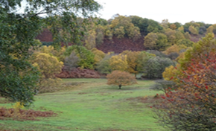
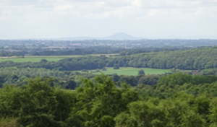

VQI: 0.65 T (0.16), BS (0), GS(0.40, H/B (0.08)
VQI: 0.61 T(0.20), BS(0), GS(0.32), H/B(0.09)

The most commonly occurring weightings were chosen as the final weightings for each theme. Some intuitive license was also required in choosing the final weightings by taking into consideration the influence of the theme in the landscape.
As Green Space followed by Terrain were considered the most dominant themes in the landscape,(as seen in the photographs of two higher rating VQI sites in summer and autumn), upper limits of weighting were chosen for both themes. Green Space was also considered to be an important seasonal component in this landscape. As Blue Space and Human/Built themes were not well represented in the landscape weighting was kept to lower limits. The least impact on each theme was found when weights ranges from between 0.1-0.5
Final VQI weights = Terrain (0.3) + BS (0.1) + GS (0.5) + H/B (0.1)

Appendix 5 The 11 photographs used for the online survey (with VQI scores)
VQI scores from visual quality assessments are indicated for each site. Each theme with in the final VQI score is indicated: Physical terrain (T), Blue Space (BS), Green Space (GS) and Human/Built(H/B) scores are indicated in brackets. Winter field study on-location appeal scores for trial purposes are not included.
Five quartiles from the VQIs of the 15 sites (winter photographs) were calculated: maximum (Site 2 Wrekin View), quartile 1 (Site 9 Bridge), median (Site 15 Valley View), quartile 3 (Site 5 East Side) and minimum (Site 7 Farmland).
The summer and autumn photographs were selected from the maximum (Site 2), minimum (Site 7), median (Site 15) quartile photographs. These were put into the online public preference survey.
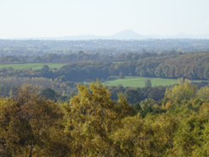
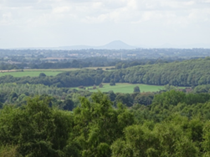
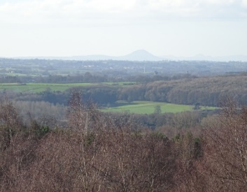
Winter Summer Autumn

VQI:0.62 T(0.16), BS(0), GS(0.40), H/B(0.05)

VQI: 0.65 T (0.16), BS (0), GS(0.40, H/B (0.08)
VQI: 0.68.T(0.23),BS(0),GS(0.40), H/B(0.05) Site 2 Wrekin View (Max..Quartile)
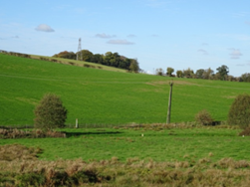
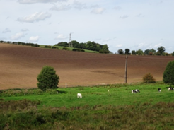
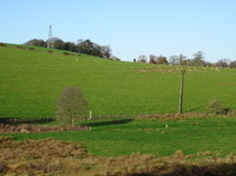

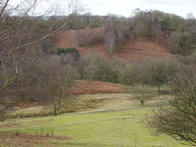
VQI: 0.43 T(0.13), BS(0),GS(0.22), H/B(0.07)
VQI: 0.40 T(0.10, BS(0), GS(0.25), H/B(0.05)
VQI: 0.46. T(0.16), BS(0), GS(0.22), H/B(0.07) Site 7 Farmland (Min Quartile)
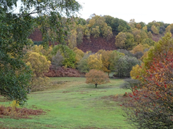
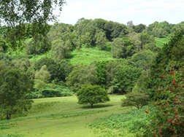
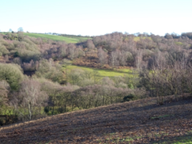
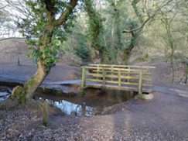
VQI: 0.53 T(0.16), BS(0),GS(0.27), H/B(0.09)
VQI: 0.61 T(0.20), BS(0), GS(0.32), H/B(0.09)
VQI:0.60 T(0.23), BS(0), GS(0.27), H/B(0.10) Site 5 East Side (Quartile 3)
VQI: 0.43 T(0.10), BS(0.10), GS(0.14), H/B(0.09) Site 9 Bridge (Quartile 1)
VQI:0.52 T(0.20), BS(0), GS(0.17),H/B(0.10) Site 15 Valley View (Med quartile)

Appendix 6 Landscape Parameter photographs for online survey
Photograph 4 shown in section 3.4 of main text.
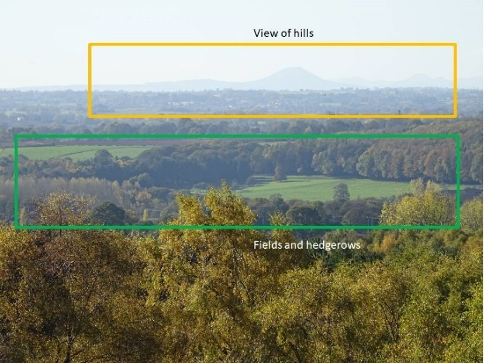
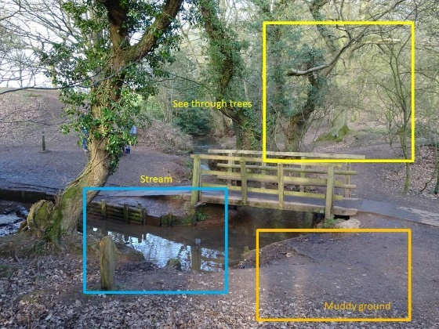

Photograph 2

Photograph 1
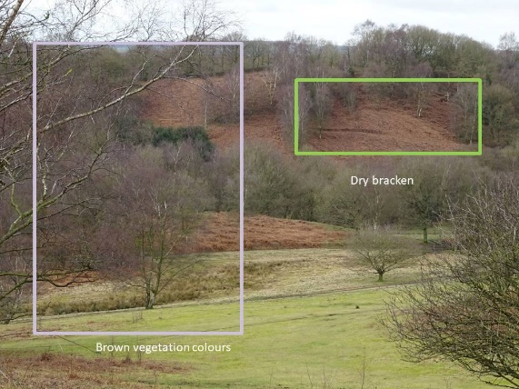
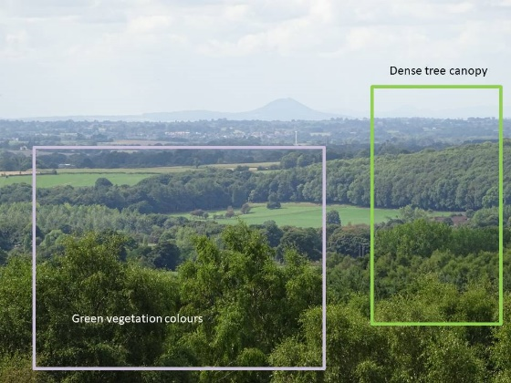
Photograph 3
Photograph 5

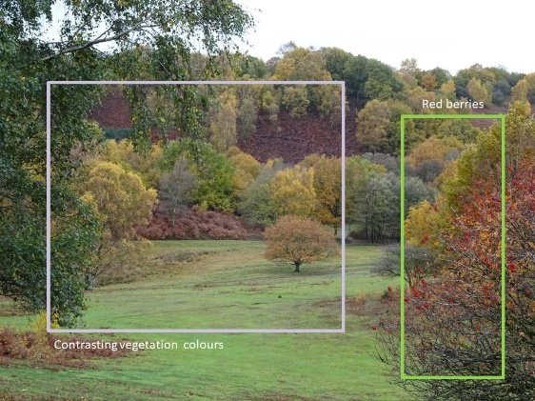

Photograph 6

Colour Code for frames
Orange – Terrain, Blue – Blue Space, Green – Green space, Purple –Seasonal/colour
Red – Built/Human, Yellow - Miscellaneous

Appendix 7 Online survey examples.
Rating of 11 seasonal photographs on 10-point sliding scale.
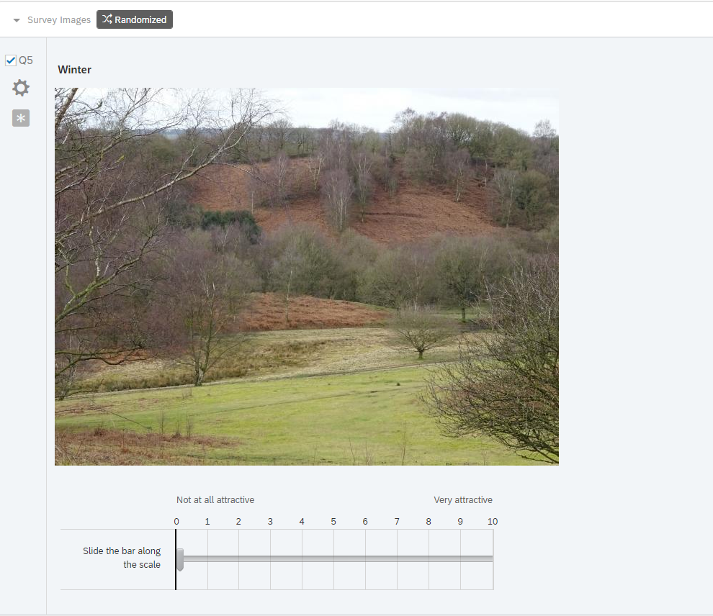

Preference rating Like/Neither/Dislike radio buttons for specific landscape parameters for six photographs.
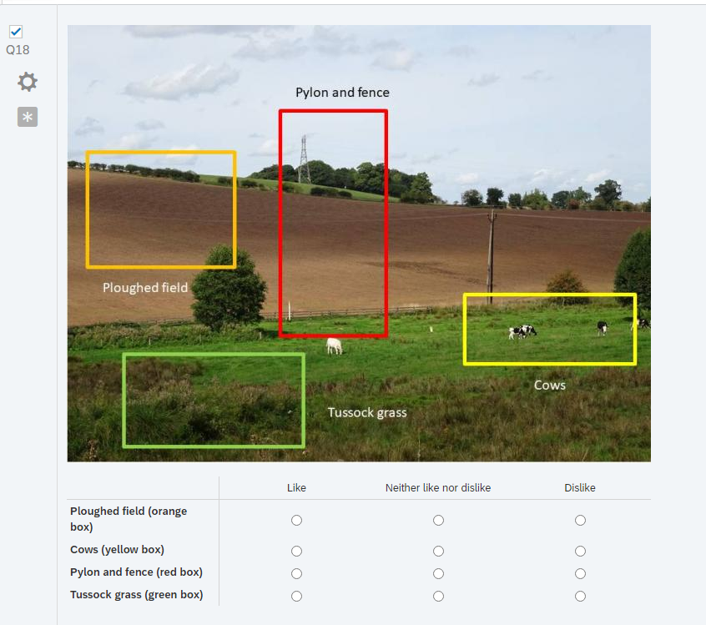

Appendix 8 Significant differences in appeal between the 11 survey photographs

Comparative matrix table showing the significant differences in ratings for the 11 photographs in the questionnaire were calculated using non-parametric Mann Whitney U tests and are indicated by NS =Not Significant, * p < 0.05; ** p <0.01; *** p<0.001

Appendix 9 Appeal ratings of seasonal photographs –

Age groups and Gender groups compared to total appeal.

Site ID, Season | Age Groups |  |  | Gender
 | Young (18-34)/ All | Middle (35-54) /All | Older (55+)/ All | Men + Non-Binary/ All | Gender
15. Valley View, WINTER | U =3065.5, Z= 1.20587,  p = .22628 NS | U = 5148, z = -0.08016,  p = .93624 NS | U =4073.5, z = -0.947,  p = .34212 NS | U = 4919.5, z = -0.23504,  p = .81034 NS | U = 7997.5, z = 0.17118,  p = .86502 NS
2. Wrekin View, AUTUMN | U= 3474, z = 0.02458,  p = .98404, NS | U= 5088.5, z = -0.21451,  p = .83366 NS | U = 4368.5, z = 0.21376,  p = .83366, NS | U = 4661, z = - 0.83071  , p = .40654 NS | U = 7839, z = -0.43718, p = .65994 NS
7. Farmland,  SUMMER | U =2961, z=1.50806,  p = .13104 NS | U = 5105.5, z = -0.17613,  p = .85716 NS | U =6011.5, z= -1.20972,  p = .22628 NS | U= 4391, z = 1.45288,  p = .14706 NS | U = 7469, z = -1.05813,  p = .28914 NS
5. East Side,  WINTER | U = 3459.5, z = 0.06651,  p = .9442, NS | U = 4777.5, z= 0.91676  , p =.35758 NS | U =4025, z = -1.06755,  p = .28462, NS | U = 4790, z = 0.5323,  p = .59612 NS | U = 7865.5, z = -0.38767,  p = .69654 NS
2. Wrekin View, SUMMER | U = 3477, z = -0.0159,  p = .98404 NS | U = 4643, z= -1.22047,  p = .22246 NS | U = 3908, z = 1.35836,  p = .17384, NS | U = 4462, z =1.28928,  p = .19706 NS | U = 7540, z = -0.93898,  p = .34722 NS
15. Valley View, AUTUMN | U = 3250, z = 0.67234  , p = .50286 NS | U = 4968.5, z= -0.48548,  p = .62414, NS | U = 4437.5, z= -0.04225,  p = .9681 NS | U = 4647.5, z= 0.86182,  p = .38978 NS | U = 7725.5, z =-0.62766,  p = .5287 NS
9. Bridge,  WINTER | U = 3020, z = 1.33745,  p = .18024, NS | U = 5071, z = -0.25403,  p = .80258 NS | U = 4105, z = -0.8687,  p = .3843 NS | U = 4452, z=1.31232,  p = .1902 NS | U = 7530, z= -0.95576,  p =.33706 NS
7. Farmland,  WINTER | U = 3459.5, z= -0.06651,  p =.9442,NS | U = 4886.5, z=-0.67064,  p = .50286 NS | U = 4134, z = 0.79662,  p = .42372, NS | U = 4622, z= 0.92058,  p = .35758 NS | U = 7700, z = -0.67046,  p = .50286 NS
15. Valley View, SUMMER | U = 3287.5, z = 0.5639,  p = .57548,NS | U = 4539.5, z= -1.45417  , p = .14706, NS | U = 4006, z=1.11477,  p = .267 NS | U = 4485, z = 1.23628,  p = .21498 NS | U = 7563, z =-0.90038,  p =.36812 NS
2. Wrekin View  WINTER | U = 3366, z = 0.33689,  p = .72786 NS | U =5172, z= -0.02597,  p = .97606 NS | U = 4350, z = -0.25974,  p = .79486 NS | U =4811.5, z=0.48391  , p = .63122 NS | U =7889.5, z = -0.35243,  p =.72634 NS
7. Farmland  AUTUMN | U = 3349, z = 0.38605,  p = .69654 NS | U = 4887, z = -0.66951,  p = .50286 NS | U = 4292, z = 0.4039,  p = .68916 NS | U =4421.5, z = 1.3826,  p = .16758 NS | U = 7499.5, z=-1.00695,  p = .3125 NS

Full statistical data for Appeal ratings of seasonal photographs at Downs Banks, Barlaston (n = 162) summarised by Age group and Gender. Significant differences in ratings between age groups and between gender compared to the total were calculated using non-parametric Mann Whitney U tests and are indicated by NS =Not Significant, * p < 0.05; ** p <0.01; *** p<0.001.

Appendix 10 Inter-group comparison of Appeal ratings for Age group and

Gender group
 | Gender comparison and Age Group comparison
Site ID, Season | Gender (Men vs Women) | Young (18-34)vs Middle Aged (35-54) | Middle Aged (35-54) vs Older (55+) | Young (18-34) vs Older (55+)
15. Valley View WINTER | U = 2997.5, z = -0.35148,  p = 0.72634, NS | U = 1196.5, z = 1.13739,  p = 0.25438 NS | U = 1616.5, z = -0.76219,  p = 0.4472 NS | U = 944.5, z = 1.70028,  p = 0.0891 NS
2. Wrekin View, AUTUMN | U = 2739, z = 1.24224,  p = 0.21496 NS | U =1343,z = 0.20651,  p= 0.83366 NS | U = 1697.5, z = 0.33046,  p = 0.7141 NS | U= 1158.5, z = -0.1682,  p = 0.86502 NS
7. Farmland, SUMMER | U = 2469, z = 2.17263,  p = .03, NS | U= 1143.5, z = 1.47415,  p = .14156 NS | U = 2404, z= 0.8657,  p = 0.384 NS | U = 1338.5, z = 2.20359,  p = .0278, Sig *young<older
5. East Side,  WINTER | U = 2868.5, z = 0.796,  p = .42372 NS | U = 1266, z = -o.69577,  p = .48392 NS | U = 2463.5, z= -1.57769,  p = .1141 NS | U = 1049, z = 0.95216,  p = .34212, NS
2. Wrekin View, SUMMER | U = 2540, z = 1.92797,  p = .0536 NS | U = 1232.5, z = 0.90864,  p = 0.36282 NS | U = 1362.5, z= 2.11602,  p = .034, Sig * older <mid | U = 1033, z = -1.0667  , p = 0.28462 NS
15 Valley View, AUTUMN | U = 2725.5, z = 1.28876,  p = 0.19706 NS | U = 1225. z = 0.95629,  p = 0.33706 NS | U = 1695.5. z = 0.34112,  p = .72786 NS | U = 1100.5, z = 0.58347,  p = .56192 NS
9. Bridge,  WINTER | U = 2530, z = 1.96243,  p = 0.05 NS | U = 1155.5, z= 1.3979,  p = .16152 NS | U = 1652.5, z = -0.57031,  p = 0.56868 NS | U = 940, z = 1.7325,  p = 0.08364 NS
7. Farmland,  WINTER | U = 2700, z = 1.37663,  p = 0.16758 NS | U = 1317, z = 0.37172  , p = .71138 NS | U = 1521.5, z = 1.26854,  p = .20408 NS | U = 1100, z = -0.58704,  p = .5552 NS
15. Valley View, SUMMER | U = 2563, z = 1.84872,  p = 0.06432 NS | U = 1120, z = 1.62347,  p = .010524, NS | U =1371.5, z = 2.06805,  p = 0.03846, Sig * older< mid | U = 1122, z = -0.42955,  p = 0.6672 NS
2. Wrekin View, WINTER | U = 2889.5, z = 0.72364,  p = .4715 , NS | U = 1329, z = 0.29547,  p = 0.76418 NS | U = 1725, z = -0.18389,  p = 0.85716 NS | U = 1112.5, z = 0.49756,  p = 0.61708 NS
7. Farmland, AUTUMN | U = 2499.5, z = 2.06753,  p = .03846, Sig * men <women | U = 1237.5, z = 087687,  p = 0.37886 NS | U = 1601, z = 0.84214,  p = .4009 NS | U = 1178, z = -0.02864,  p = 0.97606 NS

Full statistical data for comparison of Appeal ratings of seasonal photographs at Downs Banks, Barlaston (n = 162) summarised by Age group and Gender. Significant differences in ratings for age group comparison and gender comparison were calculated using non-parametric Mann Whitney U tests and are indicated by NS =Not Significant, * p < 0.05; ** p <0.01; *** p<0.001.

Appendix 11 Comparison of Appeal ratings by frequency of visits compared to

total appeal

Site ID, Season | Daily/All | Weekly/All | Monthly/All | Never/all
15. Valley View, WINTER | U =3353.5, z = -1.241, p = .21498 NS | U= 4441, z = 1.163, p = .24604 NS | U = 3881, z = -0.23366, p = .8181 NS | U = 363.5, z = 0.38501, p = .69654 NS
2. Wrekin View, AUTUMN | U =3420, z = -1.05882, p = .28914 NS | U = 4911,5, z = 0.30035, p = .76418 NS | U =3680.5, z = 0.76906, p = .4413 NS | U = 374, z= -0.28641, p = .77182
7. Farmland, SUMMER | U = 3766.5, z = 0.10958, p = .9124 NS | U = 4732.5, z = 0.48429 p = .63122 NS | U =3899.5, z = -0.18425, p = .85716 NS | U = 225.5, z = -1.68092, p = .09296 NS
5. East Side, WINTER | U = 3450.5, z= -0.97527, p = .32708 NS | U= 4431, z= 1.18628 p = .23404 NS | U = 3862, z = -0.28439, p = .77948 NS | U = 358.5, z = -0.43197, p = .6672 NS
2. Wrekin View, SUMMER | U =3143.5, z =-1.8163, p = .06876 NS | U= 4551.5, z = 0.90572, p = .36282 NS | U= 3689, z = 0.74636, p = .45326 NS | U = 399, z = -0.05165, p = .96012 NS
15. Valley View, AUTUMN | U = 3219, z = -1.60947, p =.1074 NS | U = 4570.5, z = 0.86148, p = .38978 NS | U = 3593, z = 1.00271, p = .31732 NS | U = 246.5, z = -1.48372, p = .13888 NS
9. Bridge, WINTER | U = 3470, z =-0.92185, p = .35758 NS | U = 4688.5, z = 0.58674, p = .5552 NS | U = 3904, z = 0.17224, p = .86502 NS | U = 385.5, z = 0.17842, p = .85716 NS
7. Farmland, WINTER | U= 3551.5, z = -0.69858, p = .48392 NS | U = 4758, z = 0.42492, p = .67448 NS | U =3763.5, z = 0.54742, p = .58232 NS | U = 272, z = -1.24425, p = .21498 NS
15. Valley View, SUMMER | U=3350.5, z = -1.24922, p = .2113 NS | U = 4200.5, z = 1.72296, p = .08544 NS | U = 3821.5, z = -0.39254, p = .69654 NS | U = 268.5, z = -1.27712, p = .20054 NS
2. Wrekin View WINTER | U= 3341, z = -1.27525, p = .20054 NS | U = 4575, z = 0.851, p = .39532 NS | U = 3954, z = 0.06275, p = .95216 NS | U= 329, z = 0.70899, p = .4777 NS
7. Farmland AUTUMN | U= 3792.5, z = 0.03835, p = .9681 NS | U =4592.5, z = 0.81026, p =.41794 NS | U = 3605, z = -0.97067, p =.33204 NS | U = 404, z = 0.0047, p = 1 NS

Full statistical data for Appeal ratings of seasonal photographs at Downs Banks, Barlaston (n = 162) summarised by Frequency of visit to rural areas. Significant differences in ratings depending on frequency of visit compared to the total were calculated using non-parametric Mann Whitney U tests and are indicated by NS =Not Significant, * p < 0.05; ** p <0.01; *** p<0.001.

Appendix 12 Inter-group comparison of Appeal ratings for frequency of visits.

Site ID, Season | Daily vs Weekly | Weekly vs Monthly | Daily vs Monthly
15. Valley View WINTER | U = 1128.5, z = -1.88691, p = .05876 NS | U = 1302.5, z = -1.15169, p = .25014 NS | U = 1030.5, z = -1.15169, p = .25014 NS
2. Wrekin View, AUTUMN | U = 1246, z = -1.15879, p =.24604 NS | U = 1422, z = 0.43301, p = .6672 NS | U = 954, z = -1.44019, p = .14986 NS
7. Farmland, SUMMER | U = 1383.5, z =-0.30674, p =.75656 NS | U = 1407.5, z =-0.52021, p = .60306 NS | U = 1116, z=0.25652, p = .79486 NS
5. East Side, WINTER | U = 1153.5, z = -1.73199, p = .08364 NS | U = 1294, z = -1.20281, p = .23014 NS | U =1071, z= -0.58634, p = .5552 NS
2. Wrekin View, SUMMER | U =1073, z=-2.23083, p = .02574 Sig* weekly< daily | U =1479.5, z=-0.0872, p = .92828 NS | U =867.5, z= -2.07783, p = .03752 Sig * monthly< daily
15 Valley View, AUTUMN | U =1095.5, z= -2.0914, p = .03662 Sig * weekly< daily | U = 1454, z=0.24056, p = .81034 NS | U = 871.5, z =-2.04852, p = .04036 Sig * monthly< daily
9. Bridge, WINTER | U =1240, z = -1.19597, p = .23014 NS | U =1441, z =-0.31874, p = .74896 NS | U =1024.5, z =-0.92715, p = .35238 NS
7. Farmland, WINTER | U =1297.5, z = -0.83966, p = .4009 NS | U =1483.5, z = 0.06315, p = .95216 NS | U =1001.5, z = -1.09572, p = .27134 NS
15. Valley View, SUMMER | U =1050.5, z = -2.37335, p = .01778 Sig * weekly < daily | U =1207.5, z = -1.72302, p = .08544 NS | U =1054.5, z = -0.70727, p = .4777 NS
2. Wrekin View, WINTER | U =1139.5, z = -1.82184, p = .06876 NS | U =1399.5, z = -0.56833, p = .56868 NS | U =1011.5, z = -1.02243, p =.30772 NS
7. Farmland, AUTUMN | U =1339.5, z= -0.5794, p =.56192 NS | U =1250, z= -1.46743, p = .14156 NS | U =1037.5, z = 0.83187, p = .40654 NS

Full statistical data for comparison of Appeal ratings of seasonal photographs at Downs Banks, Barlaston (n = 162) summarised by frequency of visit. Significant differences in ratings for frequency of visit comparisons were calculated using non-parametric Mann Whitney U tests and are indicated by NS =Not Significant, * p < 0.05; ** p <0.01; *** p<0.001.

