Novel Forward/Backward Signal Space for Coherent Signals DoA Estimation and its Real-time Experimental Validation
Ahmed A Hussain,  Dept. of Electrical Engineering  Prince Mohammad University, KSA  ahussain1@pmu.edu.sa | Nizar Tayem  Dept. of Engineering & Technology Texas A & M Univ., Commerce, USA  Nizar.Tayem@tamuc.edu | Abdel-Hamid Soliman  School of Engineering,  Staffordshire University, UK  A.Soliman@staffs.ac.uk
Redha M. Radaydeh
Dept. of Engineering & Technology Texas A & M Univ., Commerce, USA
Redha.Radaydeh@tamuc.edu

Abstract— The direction of arrival (DoA) angles estimation of several narrowband RF sources in multipath environments is crucial in real-time applications. In this paper, a new DoA algorithm is presented to reduce the computational complexity of estimating the DoA’s of highly correlated signals in pairs while maintaining estimation accuracy. The method proposed employs Cholesky decomposition in conjunction with a novel forward/backward operation (FBO) applied to the signal subspace matrix to de-correlate the incident coherent sources while most of the existing methods employ conventional pre-processing techniques to the covariance matrix. Employing FBO to the signal space matrix along with Cholesky decomposition results in significant reduction in the computation time and the complexity of hardware implementation. These advantages make the method proposed well-suited for applications such as in massive-MIMO systems as well as in enabling next generation wireless communication networks (beyond 5G and 6G). Simulation results using Root Mean Square Error (RMSE) and results from real-time implementation on a Software Defined Radio (SDR) testbed are used to validate the efficacy of the proposed method. Results show that the performance of the method proposed compares favorably with the Root-MUSIC method.
Keywords—correlated/coherent sources, spatial smoothing, DoA estimation, uniform linear array, beyond 5G (B5G) and 6G networks, software defined radio

Introduction
Next generation wireless communication systems 5G and 6G are envisioned to not only provide users communication services but also computing, localization, and sensing services [1]. Since the DoA of the anticipated signal is required to be known beforehand to provide some of these services, DoA estimation along with beamforming are vital to the implementation of these communication networks as well as other civilian and military applications [2]-[5]. However, since hundreds of antennas are required for enabling these technologies, there are immense challenges for DoA estimation such as in processing very large-scale array matrices constructed from the signals received from hundreds of antennas. DoA estimation is also confronted with handling multiple RF signals in multipath environments, complex spatial-temporal signal sampling, and the effects of mutual coupling [6]. Our immediate focus in this paper is the DoA estimation of highly correlated signals which occur when a signal travels through multipath environments.
There have been a wide variety of DoA estimation methods reported in the literature such as maximum likelihood (ML) method, ESPRIT and MUSIC, and their variations [7]-[10]. The shortcomings of these methods are the degradation in accuracy when estimating highly correlated or coherent signals [11]-[12] besides the higher computational complexity required for subspace search for the peaks.
The estimation of DoA angles of highly correlated signals invariably requires a spatial smoothing operation as a preprocessing step for preparing the data signals for accurate estimation. The purpose of the spatial smoothing operations is to improve the rank of the covariance matrix to the same number of incident sources, since the correlated signals will affect the number of detected sources [11]-[12]. This operation further rises the computational cost of the DoA estimation algorithms making them unsuitable for hardware implementation.
Since they were first introduced by Evans et al. [13] and later by Shan et al. [14], spatial smoothing methods have been widely used for improving the estimation accuracy of coherent sources. While forward/backward spatial smoothing (FBSS) methods were used by various authors as reported in [15]-[17], the method proposed by S. N. Shahi et al. [18] combines Beamspace MUSIC and Barlett method [19] to reduce computational complexity. The method proposed by W. Zhang et al. [20] can find DoA estimates of coherent sources using multiple-Toeplitz matrix construction technique while a components separation algorithm is proposed by A. M. Molaei et al. in [21] which can estimate the DoA of RF signals in multipath environments. Another method that uses a combination of the orthogonal matching pursuit technique and the maximum likelihood estimator has been reported by M. Rahmani et al. in [22]. The method reported in [20] has been shown to be effective in multipath environments. However, its drawback is its high processing time since it uses an iterative one-dimensional search method to estimate the DoA’s in multiple directions. All the methods proposed in [13]-[23] and related preprocessing techniques have varying performance and computational complexity.
This paper proposes a novel algorithm for accurate DoA estimation of coherent sources using forward/backward operation (FBO) as a pre-processing step. This operation is applied to the signal subspace matrix whereas existing methods apply it to the covariance matrix. A unique feature of this novel FBO is that it does not require any matrix operations other than a matrix multiplication operation of the signal subspace matrix with a left-right-flipped identity matrix. This lead to the reduction of computational complexity of the proposed algorithm. The signal subspace matrix is extracted from the decomposition of the covariance matrix into its noise and signal space. This results in significantly reduced computational complexity due to the fact of the size of the covariance matrix is M x M whereas the size of the signal subspace matrix is M x K, where M is the number of antenna elements or sensors and K is the number of sources. Since M >> K usually the case in 5G applications, the complexity in the existing methods will be significantly higher. Another advantage of the proposed method in applying FBO to the signal space matrix is that it is free from noise and results in better estimation accuracy, unlike the covariance matrix which contains both the signal and noise spaces. In addition, the method proposed obviates the need for computationally complex eigen-value decomposition (EVD) operations of O(${2M}^{3}$) including in the extraction of the signal and noise subspaces unlike the existing methods [13]-[23]. In the method proposed, the signal subspace matrix is obtained from the Cholesky factorization of the covariance matrix into its noise and signal subspaces. Matrix decomposition using Cholesky factorization of the covariance matrix R_{x} is$Chol\left(R_{x}\right)={LL}^{H}$, L being a lower triangular matrix [11]. The advantage of using Cholesky factorization method [24] is that it requires only calculating the lower triangular matrix which requires O($M^{3}/3$) operations.
The method proposed in this paper is similar to the one reported in [25] in that it applies a spatial smoothing operation to the signal subspace matrix but the spatial smoothing operation applied is the conventional forward backward averaging (FBA) operation. Another difference is that the method in [25] uses QR decomposition for extracting the signal space from the covariance matrix whereas the proposed method applies computationally less complex Cholesky decomposition method [24]. In light of these advantages of the method proposed in this paper, it can be considered to be highly suitable for real-time applications and hardware implementation since operating on the signal space reduces computation cost and resource consumption due to reduction in the number of required operations. The main advantages of the proposed method are: 1) reduction in the computational time and hardware implementation, and 2) improved accuracy in estimating highly correlated signals.
In addition, the experimental validation of a direction of arrival estimation method in real-time is very crucial in establishing the efficacy of the algorithm and expediting its implementation in real-world systems and applications. Very few works [26]-[31] in the literature have reported experimental validation and hardware implementation. Hence, the novel DoA estimation algorithm for accurate estimation of highly correlated signals presented here has been validated experimentally on an SDR platform using National Instruments (NI) USRP-2901 [32] units and through MATLAB simulations. Performance of the method proposed has been compared with Root-MUSIC [23].

SYTEM MODEL AND PROPOSED METHOD
Fig. 1 below shows K narrowband radio frequency (RF) source signals which are located in the far-field region of the ULA. The ULA has M omni-directional antenna elements which equally spaced by a distance with being the wavelength of the signal. The narrowband signals are considered to be impinging on the ULA at an azimuth angle θ_{k} for the k^{th} source.
The observation data from the received signals at any time instant (t) at the ULA are given by
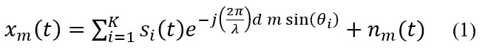
$x_{m}\left(t\right)=\sum_{i=1}^{K}{s_{i}\left(t\right)e^{-j\left(\frac{2π}{λ}\right)d m\cos\left(θ_{i}\right)}+n_{m}(t)}$where is the i-th source and n_{m}(t) is the noise at the m-th element.
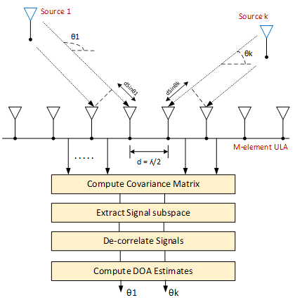
Fig. 1. DOA estimation of K signals employing a ULA
Equation (1) in matrix form is given by
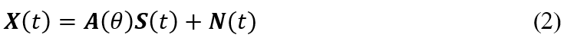
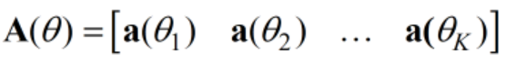 | (3)
is the (M x K) array response matrix, and is the array steering vector given by
$a\left(θ_{K}\right)={\left[\begin{matrix}1 & ⋯ & u_{K}^{M}\end{matrix}\right]}^{T}$, where $u_{k}=e^{(-\frac{j2πsin\left(θ_{k}\right)}{λ})}$ (4)
where S(t) is the (K x 1) vector of the received signals, and N(t) is the (M x 1) additive white Gaussian noise vector.
There are six main steps in the proposed method. First, the covariance matrix R_{x} is determined from the collected date received from multiple RF sources as follows
$R_{x}=\frac{1}{N}\sum_{t=1}^{N}{x_{i}\left(t\right){x_{i}\left(t\right)}^{H}}$ (5)
where $x_{i}\left(t\right)$represents the i^{th} antenna column vector of the ULA and ( )^{H} represents the operation for conjugate transpose of a matrix.
Second, the signal subspace is extracted from the covariance matrix R_{x} using Cholesky decomposition method. Cholesky decomposition of R_{x} can be found as follows
$Chol\left(R_{x}\right)={LL}^{H}=\left[\begin{matrix}L_{s} & L_{n}\end{matrix}\right]{\left[\begin{matrix}L_{s} & L_{n}\end{matrix}\right]}^{H}$ (6)
where L_{s} is the signal subspace matrix of size (M x K) and L_{n} is the noise subspace matrix of size (M x (K-M)).
Next, the direction of arrival information, which is contained in the first K columns of the signal space data matrix L_{s,}, is extracted as shown below
$Ls =\left[\begin{matrix}l_{11} & ⋯ & 0 \\ ⋮ & ⋱ & ⋮ \\ l_{M1} & ⋯ & l_{MK}\end{matrix}\right]$ (7)
In the third step of the method proposed, the signal space matrix $Ls \left(1 to M rows,1 to K columns\right)$ will be utilized to in the angles of arrival estimation of coherent sources (s₁, and s₂=αs₁) in pairs, where (0 < α ≤ 1) is the correlation coefficient. When α = 1, the two signals are considered fully coherent.
In the fourth step of the method proposed, the signal space contained in $Ls$ is decorrelated by applying the novel FBO on the signal subspace matrix in (7), as shown below
${ R}_{fb}=\left[L_{s}^{*}\left(1 to M,1 to K\right) J_{M}(L_{s}\left(1 to M,1 to K\right)\right]$ (8)
where $\left(*\right)$ represents a conjugate operation and J_{M} is shown below
$J_{M} =\left[\begin{matrix}0 & ⋯ & 1 \\ ⋮ & 1 & ⋮ \\ 1 & ⋯ & 0\end{matrix}\right]$ (9)
The dimension of the data matrix $R_{fb}$ in the proposed method is directly proportional to K sources to be estimated, whereas in the existing methods it is proportional to M antenna elements since the spatial smoothing operation is performed on the covariance matrix in the existing methods. This difference becomes significant in practical applications where M >> K. For example, a massive MIMO system in beyond 5G and 6G applications [6].
In the fifth step of the method proposed, the $R_{fb}$ data matrix is partitioned into two sub-matrices $R_{fb1} and R_{fb2}$ given by
$$R_{fb1}=R_{fb}(1:M-1, :)$$
$R_{fb2}=R_{fb}(2:M,:)$ (10)
Since $range \left\{R_{fb1}\right\}=range \{R_{fb2}\}$, the matrices $R_{fb1} and R_{fb2}$ are related by a non-singular transform $Ψ$$Ψ$ given by
$R_{fb2}=R_{fb1}Ψ$ $R_{fb2}=R_{fb1}Ψ$ (11)
$Ψ$ in (11) is due to the phase shift between $R_{fb1} and R_{fb2}$, and it can be written as
$Ψ=T^{-1}Φ\left(θ\right)T$ (12)$Ψ=T^{-1}Φ\left(θ\right)T$
where T is a non-singular matrix, and is a $(KxK)$ diagonal matrix which contains information about the directions of arrival of incident sources.
$Φ\left(θ\right)=\left[\begin{matrix}e^{(-j2πdsin\left(θ_{1}\right))/λ} & ⋯ & e^{(-j2πdsin\left(θ_{K}\right))/λ}\end{matrix}\right]$ (13)
The diagonal entries of $Φ\left(θ\right)$ can be obtained by calculating the eigenvalues of $Ψ$$Ψ$ . The eigenvalues are used to calculate the DoA’s of the RF sources.
In the sixth step, the least squares (LS) solution similar to (LS-ESPRIT) of (11) can be found as
$Ψ={\left[R_{fb1}^{H}R_{fb1}\right]}^{-1}R_{fb1}^{H}R_{fb2}$ (14)
The eigenvalues of $Ψ$ are$Ψ$ computed from the LS solution in (14) as the roots of the polynomial obtained from the equation |$Ψ-$ $Ψ$I| = 0. Finally, the eigenvalues, thus obtained, are used in estimating the directions of arrival as given by the following formula
$θ_{K}=\sin^{-1}\left[\frac{angle(Ψ_{K})}{2πd}\right]$ (15)
where $Ψ_{K}$ refers to the k^{th} eigenvalue.

Complexity Analysis
The proposed DOA estimation method for highly correlated signals is analyzed here in terms of complex-valued multiply and accumulate (MAC) operations as shown in Table I. The comparison is limited to the novel (FBO) which is applied to the signal subspace matrix $Ls$ as in (8) and the conventional forward/backward averaging operation applied on $R_{x}$ as in (16). We consider K signal sources, M antenna elements, and N snapshots for the calculations.
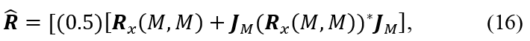
where the size of each matrix in (16) is M x M.
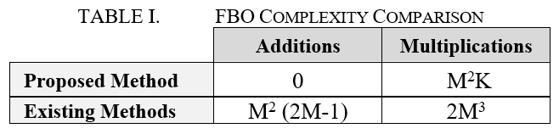
Table II presents numerically the overall computational cost of the FBO operation for the case of K = 4 signal sources with varying antenna elements M.
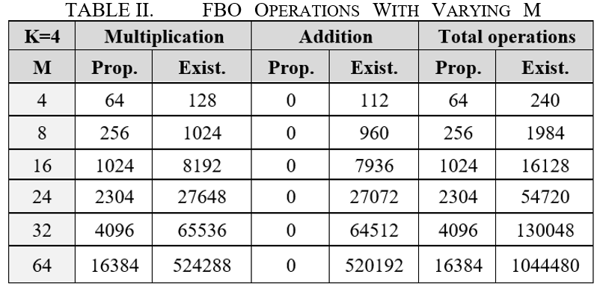
The “total operations” columns in the above table show numerically why the existing methods have a much higher computational cost in comparison with the method proposed. With increasing antenna elements, there is a significantly higher increase in the computational cost for the existing methods. For instance, for M=64 antenna elements at the receiver, the total number of operations with existing methods is about 64 times more than the proposed method. This aspect of the method proposed presents a substantial improvement over existing methods, making it highly suitable for deployment in areas such as massive MIMO systems.
As mentioned earlier, the method proposed further reduces the computational cost by employing Cholesky decomposition to extract the signal subspace from the covariance matrix by decomposing it into its noise and signal subspaces. Conventional methods, instead, use either SVD or EVD which require O(${2M}^{3}$) operations whereas Cholesky requires O($M^{3}/3$) operations [11], [24]. Calculations for the computation cost of the major operations in the DoA estimation using the method proposed are listed in Table III while Table IV shows the calculations for Root-MUSIC. For a numerical comparison, assuming number of snapshots N=100, antenna elements M=32, and signal sources K=4, the method proposed requires only about 30% of the operations that are required in computing the DoA estimates using Root-MUSIC method.
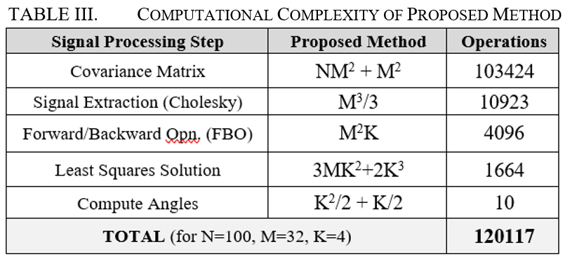
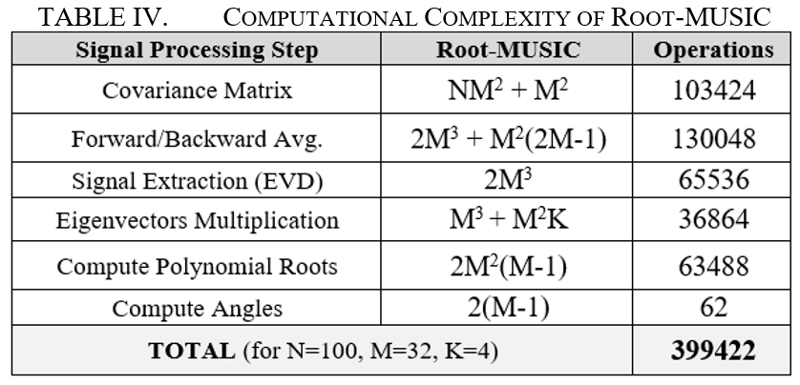

MATLAB Simulation Results
The estimation accuracy of the method proposed in computing the DoA estimates has been validated using MATLAB under different simulation scenarios. Results of MATLAB simulations are shown in the RMSE vs SNR charts in Fig. 2 through to Fig. 4, with the RMSE values plotted in degrees. Up to two pairs of coherent sources (α = 1) are considered for estimation. It can be clearly observed in these charts that the method proposed has low RMSE values demonstrating its efficacy. We observe from Fig. 3 and Fig. that the proposed method provide better DOA estimation in comparison to Root-MUSIC method.
Fig. 2 shows the RMSE values plotted against SNR for the DoA estimation of two pairs of coherent sources. Simulation parameters considered are: M=16, SNR=0:5:35 dB, N = 500, and source signals DoA1 to DoA4 are located at [50º 70º 100º 110º], respectively. RMSE values steadily decrease as SNR increases, indicating high estimation accuracy.
Fig. 2. RMSE plot with SNR for DoA estimation of twoppairs ofccoherent sources
Fig. 3 shows the estimation performance of the method proposed and the Root-MUSIC method in the DoA estimation of a pair of coherent sources. RMSE values are plotted against SNR. Simulation parameters are: M=16, SNR=0:5:35 dB, N = 500, and source signals are located at [50º 70º]. It can be clearly observed that the estimation accuracy of the method proposed is comparable with that of the Root-MUSIC method with the latter only slightly better.
Fig. 3. RMSE plot with SNR for DoA estimation of a pair of coherent signals versus Root-MUSIC with FBA applied
It is worth noting here that a spatial smoothing operation is also applied in computing the DoA estimates using the Root-MUSIC method for the sake of a fair comparison. The conventional spatial smoothing operation of forward/backward averaging (FBA) as indicated in the second row of Table IV is applied to $R_{x}$. For this reason, Root-MUSIC provides slightly better estimation accuracy as shown in Fig. 3 but at a much higher computational cost as discussed in section III above.
Fig. 4 below shows the performance comparison of the proposed method with that of Root-MUSIC without FBA applied in computing the DoA estimates using the Root-MUSIC method. Simulation parameters are: M=16, SNR=0:5:35 dB, N = 500, and source signals are located at [50º 70º]. we observe that proposed has much higher estimation accuracy while Root-MUSIC method suffers from degradation in accuracy when estimating highly correlated or coherent signals without spatial smoothing applied.
Fig. 4. RMSE plot with SNR for DoA estimation of a pair of coherent signals versus Root-MUSIC without FBA applied

Experimental Validation on SDR Testbed
The method proposed in this paper has been validated on an experimental setup built using the software defined radio platform from National Instruments (NI). This testbed consists of an 8-element ULA receiver connected to four NI USRP-2901 units for signal acquisition as shown in Fig. 5. The sources will not be received at the same time. Hence, time and phase synchronization must be performed for each USRP unit in the testbed before estimating the DoA’s. The details of the testbed construction as well as how time and phase synchronization is accomplished are described in [31].
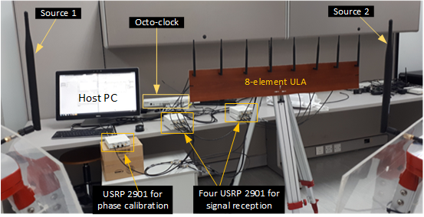
Fig. 5. USRP testbed using an 8-element ULA for real-time experimental validation
Two transmitter antennae connected to a single source using a two-way splitter are used to generate a pair of coherent signals (freq.: 1 GHz, gain: 10 dB, α = 1). The signals received at the ULA are processed by the proposed DoA estimation algorithm as well as Root-MUSIC (for comparison) running on a host processor (PC). The algorithm is implemented in LabVIEW and the DoA estimates are displayed on a user interface, as shown in Fig. 6.
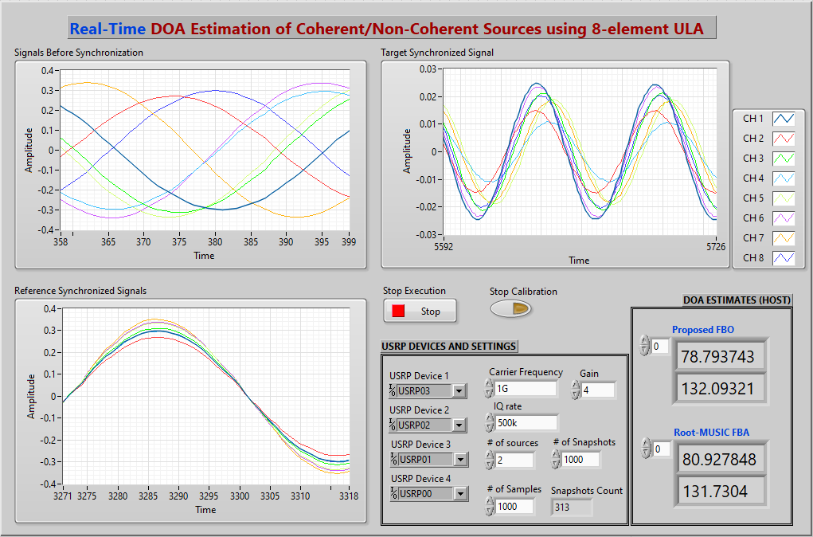
Fig. 6. LabVIEW User Interface displaying DoA estimates from real-time experiments for a pair of coherent sources located at 80º and 130º.
Fig. 7 below shows the placement of two RF signals at 80º and 130º, respectively in real time.
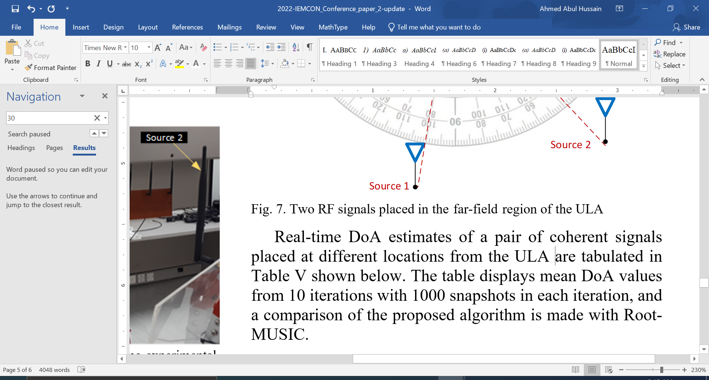
Real-time DoA estimates of a pair of coherent signals placed at different locations from the ULA are tabulated in Table V shown below. The table displays mean DoA values from 10 iterations with 1000 snapshots in each iteration, and a comparison of the proposed algorithm is made with Root-MUSIC.
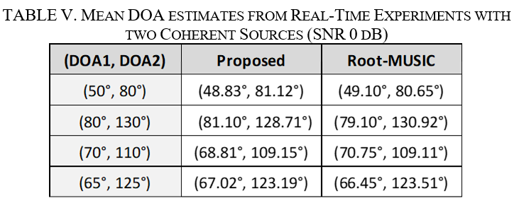
Fig. 8 shows the RMSE vs SNR chart plotted in MS Excel (with SNR values in dB on the x-axis) for the DoA estimates from real-time experiments for the method proposed and Root-MUSIC method for two coherent signals placed at 80° and 130°, respectively, from the ULA.
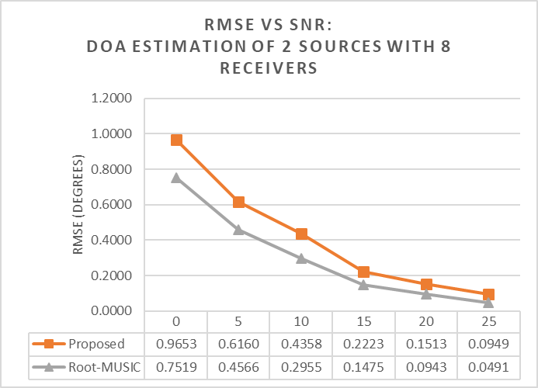
Fig. 8. RMSE vs SNR chart for real-time experiments
The above table and the chart show clearly that the method proposed estimates the DoA’s fairly accurately even at low SNR with the Root-MUSIC method doing marginally better. However, this slight edge in performance of the Root-MUSIC method comes at a much higher computation cost (as discussed in Section III above).

Conclusions
A novel DOA method for highly correlated signals based on FBO was proposed in this paper. This FBO operation is applied to the signal subspace matrix instead of the covariance matrix resulting in significantly lower computational cost in de-correlating the data signals for the method proposed when compared with the existing methods. Results from MATLAB simulation and real-time experiments validated the estimation accuracy of the method proposed and its performance was compared with Root-MUSIC as a benchmark. The significantly reduced computational complexity of the method proposed yields a high-performance system with faster computation time and lower resources consumption making it highly suited to practical applications for massive MIMO systems as well as next generation wireless communications networks.

References
- Saad, W.; Bennis, M.; Chen, M., “A vision of 6G wireless systems: Applications, trends, technologies, and open research problems,”. IEEE Network, Vol. 34, pp.134–142, May 2020.
- Y.H. Ko, et al., “2-D DoA estimation with cell searching for a mobile relay station with uniform circular array,” IEEE Transactions on Communications, vol. 58, no. 10, pp. 2805–2809, 2010.
- Mukhopadhyay, M., B. K. Sarkar, and A. Chakrabarty, “Augmentation of anti-jam GPS system using smart antenna with a simple DOA estimation algorithm,” PIER 67, 231–249, 2007.
- X. Yuan, J. Wan, Z. Cheng, H. Liu, G. Li, A novel GNSS interference suppression and DOA estimation processing system,” Proceedings 2011 International Conference on Transportation, Mechanical, and Electrical Engineering (TMEE), Changchun, 2011.
- H. Zhang, Z. Gao, H. Fu, “A high resolution random linear sonar array-based MUSIC method for underwater DOA estimation,” Proceedings of the 32nd Chinese Control Conference, Xi’an, 2013.
- Ruan N, Wang H, Wen F, Shi J, “DOA Estimation in B5G/6G:Trends and Challenges,” Sensors 2022, no. 14:5125, https://doi.org/10.3390/s22145125
- R. Schmidt, “Multiple Emitter Location and Signal Parameter Estimation,” IEEE Trans. Antennas and Propagation, Vol. 34, No. 2, March, 1986, pp. 276–280.
- Roy, R. and T. Kailath, “Esprit-estimation of signal parameters via rotational invariance techniques,” IEEE Transactions on Acoustics, Speech and Signal Processing, Vol. 32, No. 7, 984–995, July 1989.
- H. Krim and M. Viberg, “Two decades of array signal processing research: the parametric approach,” IEEE Signal Processing Magazine, vol. 13, no. 4, pp. 67–94, 1996.
- Z. M. Liu, et al., “An efficient maximum likelihood method for direction-of-arrival estimation via sparse Bayesian learning,” IEEE Transactions on Wireless Communications, vol. 11, no. 10, 2012.
- G.H. Golub, C.F. Van Loan, Matrix Computations, third ed., John Hopkins University Press, Baltimore, 1996.
- Balanis, C. A. and P. I. Ioannides, Introduction to Smart Antennas. San Rafael: Morgan & Claypool, 2007.
- J.E. Evans, et al., “Application of advanced signal processing techniques to angle of arrival estimation in ATC navigation and surveillance systems,” Technical Report, MIT Lincoln Lab, June 1982.
- T. Shan, M. Wax, and T. Kailath, “On Spatial Smoothing for Direction-of-Arrival Estimation of Coherent Signals,” IEEE Trans. Acoustics, Speech, and Signal Processing, Vol. 33, No. 4, 1985.
- S. U. Pillai and B. H. Kwon, “Forward/backward spatial smoothing techniques for coherent signal identification,” IEEE Transactions on Acoustics, Speech, and Signal Processing, vol. 37, no. 1, 1989.
- Y. H. Choi, “ESPRIT-based coherent source localization with forward and backward vectors,” IEEE Transactions on Signal Processing, vol. 58, no. 12, pp. 6416–6420, 2010.
- J. Pan, M. et al., "An Enhanced Spatial Smoothing Technique With ESPRIT Algorithm for Direction of Arrival Estimation in Coherent Scenarios," in IEEE Transactions on Signal Processing, vol. 68, pp. 3635-3643, 2020, doi: 10.1109/TSP.2020.2994514.
- S. N. Shahi, M. Emadi, and K. Sadeghi “High Resolution DOA Estimation In Fully Coherent Environments”, Progress In Electromagnetics Research C, Vol. 5, 135–148, 2008.
- Zoltowski, M. D., et al., “Beamspace root-MUSIC,” IEEE Transactions on Signal Processing, Vol. 41, No. 1, 344–364, Jan. 1993.
- W. Zhang, Y. Han, M. Jin and X. Qiao, "Multiple-Toeplitz Matrices Reconstruction Algorithm for DOA Estimation of Coherent Signals," in IEEE Access, vol. 7, pp. 49504-49512, 2019, doi: 10.1109/ACCESS.2019.2909783.
- A. M. Molaei, B. Zakeri and S. M. Hosseini Andargoli, "Components Separation Algorithm for Localization and Classification of Mixed Near-Field and Far-Field Sources in Multipath Propagation," in IEEE Transactions on Signal Processing, vol. 68, pp. 404-419, 2020, doi: 10.1109/TSP.2019.2961226.
- M. Rahmani, M. H. Bastani and S. Shahraeeni, "A computationally efficient direction-of-arrival estimation algorithm, robust against coherent sources and small sample size," 2013 21st Iranian Conference on Electrical Engineering (ICEE), 2013, pp. 1-4, doi: 10.1109/IranianCEE.2013.6599522.
- Shu Changgan and Liu Yumin, "An improved forward/backward spatial smoothing root-MUSIC algorithm based on signal decorrelation," 2014 IEEE Workshop on Advanced Research and Technology in Industry Applications (WARTIA), 2014, pp. 1252-1255, doi: 10.1109/WARTIA.2014.6976509.
- Ahmed A. Hussain, N. Tayem, A. Soliman, “Matrix Decomposition Methods for Efficient Hardware Implementation of DOA Estimation Algorithms: A Performance Comparison,” ICRAIE 2019, Nov. 27-29 2019, Penang, Malaysia.
- Ahmed A. Hussain, N. Tayem, A. Soliman, "Computationally Efficient Forward/backward Averaged DOA Estimation of Coherent Sources in Pairs," in 94th IEEE VTC Fall 2021, 27 – 30 September 2021.
- Unlersen, Fahri M., Yaldiz, Ercan; Imeci, Sehabeddin T., “FPGA Based Fast Bartlett DoA Estimator for ULA Antenna Using Parallel Computing,” Applied Computational Electromagnetics Society Journal, April 2018, Vol. 33 Issue 4, p450-459. 10p.
- M. Devendra and K. Manjunathachari, “Direction of arrival estimation using MUSIC algorithm in FPGA: Hardware software co-design,” International Journal of Applied Engineering Research, vol. 11, 2016.
- J. Yan, Y. Huang, H. Xu, G. A. E. Vandenbosch, “Hardware acceleration of MUSIC based DoA estimator in MUBTS,” in the 8th European Conference on Antennas and Propagation, 2014.
- Abdulrahman Alhamed, Nizar Tayem, Tariq Alshawi, Saleh Alshebeili, Abdullah Alsuwailem, Ahmed Hussain, “FPGA-based Real Time Implementation for Direction-of-Arrival Estimation,” The Journal of Engineering, 2017, 13 pp., doi: 10.1049/joe.2017.0165
- A. A. Hussain, N. Tayem, M. O. Butt, A. H. Soliman, A. Alhamed and S. Alshebeili, “FPGA Hardware Implementation of DOA Estimation Algorithm Employing LU Decomposition,” in IEEE Access, vol. 6, pp. 17666-17680, 2018. doi: 10.1109/ACCESS.2018.2820122
- A. A. Hussain, N. Tayem, A. Soliman and R. M. Radaydeh, "FPGA-Based Hardware Implementation of Computationally Efficient Multi-Source DOA Estimation Algorithms," in IEEE Access, vol. 7, pp. 88845-88858, 2019, doi: 10.1109/ACCESS.2019.2926335.
- National Instruments SDR USRP-2901: http://www.ni.com/en-lb/support/model.usrp-2901.html

