Exploring some challenges of prison life; a review of hunger strikes, and an exploration of transitions into adult prisons

Angelique Marcou

Thesis submitted in partial fulfilment of the requirements of Staffordshire University for the degree of Doctorate in Clinical Psychology

April 2022

Total word count: 18,839

Acknowledgements

I would like to thank my academic supervisor, Susan Ledwith for all your support, encouragement and words of wisdom throughout both this research and doctorate. I would also like to thank Dr Michelle Rydon-Grange, my supervisor, for her invaluable support and guidance. I would also like to thank Dr Helen Scott and Dr Kim Gordon for their valued input into this project and guidance during analysis.

I am grateful to be part of a big loving family, who have given me unconditional love, support and belief in me over the last few years. A special thanks to the relentless force that is my mum for her unwavering love, acceptance and support. Thankyou to Ben for his constant encouragement and reminders to stop watching TV when doing work. Thankyou also to Matt and Alix, I’m truly lucky to have such supportive and loyal friends with great proofreading skills.

The biggest thanks go to my participants, for being part of this process, giving your time and allowing me to have an insight into your working lives. I am grateful to have heard your stories and reflections. I hope this work has accurately represented your experiences.

Table of Contents

Thesis Abstract -------------------------------------------------------------------------------- 7
Paper 1: Literature Review ----------------------------------------------------------------- 8
Abstract -------------------------------------------------------------------------------------------- 9
Introduction --------------------------------------------------------------------------------------- 10
Mental Health in Prisons ------------------------------------------------------------- 10
Eating Disorders in Prisons --------------------------------------------------------- 10
Hunger Strikes -------------------------------------------------------------------------- 12
Rationale of the Literature Review ---------------------------------------------------------- 12
Method --------------------------------------------------------------------------------------------- 13
Inclusion / Exclusion Criteria -------------------------------------------------------- 14
Search Outcome ----------------------------------------------------------------------- 14
Critical Appraisal Tool --------------------------------------------------------------- 16
Results - Overview of Included Studies --------------------------------------------------- 16
Critical appraisal -------------------------------------------------------------------------------- 24
Sample and Recruitment ------------------------------------------------------------ 24
Measures -------------------------------------------------------------------------------- 25
Data Analysis --------------------------------------------------------------------------- 26
Ethical Considerations ---------------------------------------------------------------- 26
Main Findings --------------------------------------------------------------------------- 27
Discussion ---------------------------------------------------------------------------------------- 29
Limitations of Review -------------------------------------------------------------------------- 32
Clinical Implications and Future Directions ----------------------------------------------- 33
Conclusions -------------------------------------------------------------------------------------- 36
References --------------------------------------------------------------------------------------- 37
Appendix A: A Visual representation of the MMAT appraisal tool ------------------ 42

Paper 2: Empirical Paper ------------------------------------------------------------------- 44
Abstract -------------------------------------------------------------------------------------------- 45
Introduction --------------------------------------------------------------------------------------- 46
Rationale ------------------------------------------------------------------------------------------ 49
Aims and Research Question ---------------------------------------------------------------- 49
Method --------------------------------------------------------------------------------------------- 51
Ethics ------------------------------------------------------------------------------------- 51
Design ------------------------------------------------------------------------------------ 51
Recruitment ----------------------------------------------------------------------------- 52
Inclusion / Exclusion Criteria -------------------------------------------------------- 52
Procedure -------------------------------------------------------------------------------- 53
Participants ------------------------------------------------------------------------------ 54 Epistemological Stance -------------------------------------------------------------- 55
Reflexivity -------------------------------------------------------------------------------- 55
Analysis ---------------------------------------------------------------------------------- 56
Results --------------------------------------------------------------------------------------------- 58
Being unprepared --------------------------------------------------------------------- 59
Maturity and Independence --------------------------------------------------------- 62
Inconsistencies ------------------------------------------------------------------------ 63
Relationships and attachments ----------------------------------------------------- 64
Discussion ---------------------------------------------------------------------------------------- 66
Strengths and Limitations --------------------------------------------------------------------- 69
Clinical Implications ---------------------------------------------------------------------------- 70
Future directions -------------------------------------------------------------------------------- 72
Conclusion ---------------------------------------------------------------------------------------- 74
References --------------------------------------------------------------------------------------- 75

Appendices
Appendix B: Journal of Forensic Practice Key Author Guidelines ------------------ 82
Appendix C: Participant Interview Schedule --------------------------------------------- 83
Appendix D: Participant Recruitment Advert --------------------------------------------- 84
Appendix E: Staffordshire Universities Ethics Board Approval ---------------------- 85
Appendix F: Participant Information Sheet ----------------------------------------------- 86
Appendix G: Participant Consent Form --------------------------------------------------- 89
Appendix H: Audit trail of study design decisions -------------------------------------- 90
Appendix I: Visual Example of Manual Thematic Analysis process --------------- 91
Appendix J: Examples of exerts of data initial coding --------------------------------- 92
Appendix K: Master table of themes and subthemes --------------------------------- 95

Paper 3: Executive Summary -------------------------------------------------------------- 97
Key points summary --------------------------------------------------------------------------- 98
Study Aims --------------------------------------------------------------------------------------- 99
Rationale ------------------------------------------------------------------------------------------ 99
Background --------------------------------------------------------------------------------------- 99
Methods ------------------------------------------------------------------------------------------- 101
Participants ------------------------------------------------------------------------------ 101
Analysis ----------------------------------------------------------------------------------- 102
Strengths & Limitations ------------------------------------------------------------------------ 105
Clinical Implications ---------------------------------------------------------------------------- 105
Conclusion ---------------------------------------------------------------------------------------- 106
Dissemination ------------------------------------------------------------------------------------ 107
References --------------------------------------------------------------------------------------- 108

Thesis Abstract
This research thesis focuses on prison experiences and phenomena either through the offending individuals or through the staff that work with them.

Paper one is a narrative literature review, examining nine papers, investigating current research about prevalence, gender differences, mental health for eating disorders and hunger striking within prisons, as well as the known rationales for hunger striking. Mental health difficulties were commonly reported across the studies and the impact of the environment on mental health is considered. The majority of the research on eating disorders focused on females, while hunger strike research focused mainly on male offenders. The literature was challenging to synthesize due to a lack of similarity in methodological design.

Paper two is an empirical study exploring prison staff’s experiences of transitions of young adult offenders from youth offending institutions to adult prisons. Seven prison staff were interviewed on their experiences of young offenders’ transition. Reflexive thematic analysis identified four core themes; ‘Being unprepared’, ‘inconsistencies’, ‘maturity and independence’, ‘relationships and attachments’. The results highlighted poor coordination across various organisational systems and a lack of staff support meaning staff felt unprepared for the transition. Clinical implications, limitations of the study and directions for future research are discussed.

Paper 3 is an executive summary of the empirical research, in a style accessible for prison, NHS and managerial staff working within prisons. The paper consists of an overview of the research background, methodology, results, key discussion points and clinical implications that derive from the research.

Paper 1: Literature Review

What is known about eating disorders and hunger strikes in prisons? A Review of the Literature

This paper has been prepared with the intention of publication in the Journal of forensic practice, including Harvard referencing style. Further editing and modifications will be made before submitting to the journal.
Author Guidelines for publication in this journal can be found in Appendix B.

Word Count: 7470

Abstract
Prisons and offenders are an under researched population as is eating disorders and hunger striking in these establishments (Erkul, 2020). Harmful eating refers to behaviours such as restricting intake, purging, and binging, whilst hunger strike refers to fasting only. Although a regular occurrence within prisons (Scanlan et.al, 2008), very little research has been undertaken to psychologically understand such behaviours (Erkul, 2020; Gulati, et.al, 2018). Given the paucity of research on hunger strikes and harmful eating in prisons, this review aims to summarise what is known currently about prevalence, gender differences, mental health across eating disorders and hunger striking within prisons, as well as the known rationale for hunger striking. Nine mixed method articles were critically reviewed and synthesised after systematic searches of several databases. Most of the research on eating disorders focused on females, whereas hunger strike research focused mainly on male offenders. Mental health difficulties were commonly reported across the studies and the impact of the prison environment on mental health is considered. Overall, this literature was challenging to compare and synthesize due to a lack of similarity in design and measures, as well as the number of methodological issues across the studies. Nevertheless, this literature offers a platform for future research to extend upon in terms of understanding the psychological processes, possible causes, and influencing factors on eating disorders and hunger striking in prisons. A greater understanding could then inform clinical practice to improve both the treatment and management of hunger strikes and harmful eating in prisons.

Introduction
Mental Health in prisons
Recent reports have identified that there are 78, 037 people in the UK prison system, and this figure has risen by 74% over the last 30 years (Prison Reform Trust, 2021a). There is a consensus across the literature that the prevalence rates of mental health problems in prisons is higher than the general population (Tyler et.al., 2019; Rebbapragada, Furtado and Hawker-Bond, 2001). The Penal Reform international report (2015) documented that 90% of offenders have mental health or substance abuse difficulties.

Gender differences were noted in the mental health of people in prison. 71% of women currently in prison reported that they had mental health difficulties compared to 47% of men (Prison Reform Trust, 2021b). However, it is also suggested that not only do offenders experience mental health difficulties prior to prison (Prison Reform Trust, 2021b) but that incarceration itself can precipitate and increase the risk of mental health difficulties (Edgemon and Clay-Warner, 2019). Prison based mental health risk factors that have been identified include overcrowding, violence, isolation, lack of privacy and meaningful activity, as well as inadequate access to health and mental health services and support (Penal Reform International, 2015).

The UK government prison health report (House of Commons, 2018) notes that both the NHS and the prison service are missing opportunities to identify, intervene, and manage the health care needs of the prison population. The wider impact of the current poor screening procedures (Prison Reform Trust, 2021a) is that mental health needs such as eating disorders may be missed and thus can deteriorate for the individual as well as impacting on the prison service provisions.

Eating Disorders in prisons

Eating disorders are stated to be a mental health condition where food control is used as a way of coping with negative emotions and thoughts (BEAT, 2020). Eating disorders often incorporate unhealthy eating behaviours that may include eating too little or too much food, or getting rid of food through fasting, purging or laxative use, and there is often a preoccupation with food, weight and body dissatisfaction (NHS England, 2020; DSM-5; American Psychiatric Association, 2013).

Tyler et.al (2019) examined the prevalence of mental health difficulties in prisons and noted that eating disorders were present in 19.6% of the prison population compared to the 10.1% of the general population, with incarcerated women being 2.5 times more at risk of an eating disorder. Gender was found to be a significant factor in eating disorder presentation in UK prisons, with female offenders significantly more likely to report previously receiving an eating disorder diagnosis (31.3%) than males (15.1%) (Tyler et.al, 2019). Tyler et.al (2019) also suggest that men were significantly more likely to have unmet needs in relation to possible eating disorders. They considered whether males felt unable to ask for support or whether masculine stereotypes in prison would impact on help seeking.

Many factors have been hypothesised to cause or exacerbate the development of eating disorders, one of which is locus of control. Previous literature has discussed the key role of perceived control in relation to the cause, variability and treatment of anorexia nervosa (Surgenor, Horn and Hudson, 2003). A survey of 156 USA college students found that both locus of and desired control were predictive factors in the development of harmful eating (Sarra and Abar, 2020). Furthermore, a sense of lack of control and the reliance on behaviours to gain more control were associated with severe eating disorder (Surgenor, Horn and Hudson, 2003). The relevance of control in relation to the researched population is that prisons by nature are restrictive where liberties are removed, and individual control is reduced.

Farber (2013) discusses the lack of control that is often experienced by offenders, and how in these restrictive institutions, eating disorders may be more prevalent. Within Farber’s review (2013) she notes that the literature suggests an unreported high rate of eating disorders particularly in US women’s prisons, which often developed during their first period of custody. As a result of the perceived and actual lack of control that is experienced in prisons, Farber (2013) suggests that these eating behaviours may act as a way of expressing a sense of control, despair and anger, which offenders may not be able to express in a non-harmful manner. It was further discussed whether such eating behaviours are a means of exerting some power over prison staff.

Hunger Strikes

Individual hunger strikes within prisons are under-researched (Scanlan et.al, 2008), whilst collective and political hunger strikes are more documented and researched (Morse, 2016). There are several definitions of hunger striking used in research, which may reflect the different policies in place across prisons. The World Medical Association (WMA) defines a hunger striker as a mentally competent person who has decided to refuse foods and/or fluids for a period of time (WMA, 2006), until another party agrees or concedes to their demands (Oguz and Miles, 2005). Sharp (1973) adds that hunger striking is a non-violent method of protesting or resistance in order to produce social or political change. The WMA goes further to state that hunger strikers usually have no intention of dying and therefore it is not equivalent to suicide.

Historically, collective hunger strikes have been linked to a political protest, for example, the 1980 hunger strike of Irish republicans (O’Hearn, 2009) following the revocation of special prison status of paramilitary offenders. There have also been widely publicised political protesting hunger strikes in Turkey, Guantanamo Bay, and Pelican Bay (Morse, 2016). Little research has focused on individual hunger strikes (Scanlan et.al, 2008).

Rationale of the literature review
This literature review focuses on research on harmful eating in prisons with the specific review question: ‘What is known about eating disorders and hunger strikes within prisons?’ Currently, the majority of the literature on unhealthy eating behaviours in prison focus mainly on obesity, overlooking other eating difficulties such as anorexia, bulimia, harmful eating behaviours, as well as hunger strikes. Eating disorders are understood as a mental health difficulty, however as hunger striking is not, the psychological factors underpinning this may perhaps be overlooked from research. Furthermore, hunger striking can have a significantly detrimental impact on a person’s physical health, however, is not seen as a form of self-harm regardless of the awareness of the damaging physical consequences. Previous literature on hunger strikes focuses mainly on the political and ethical perspectives of collective hunger strikes rather than on the individual incidents, which this literature review aims to do. The rationale for combining the two harmful eating behaviours found in prisons is to consider whether there are any similarities or overlap in presentation and precipitating and maintaining factors for future research to focus on. No existing literature reviews on this topic have been found by the author.

Aim of the review
The aim of this review is to provide an overview of the current literature in the hope of providing a clearer insight into eating disorders and hunger striking within prisons on factors such as prevalence, gender differences, mental health and the known rationale for hunger striking. A better understanding of eating disorders and hunger strikes within prison settings could lead to insights regarding required preventative measures, interventions and support within secure settings. For clarity, although eating disorders and hunger strikes are researched as separate phenomena and may not be linked, where this literature review discusses overall eating difficulties, regardless of diagnosis they will be referred to as harmful eating behaviours.

Method
A systematic strategy was implemented for this literature review. The literature search was undertaken on the 2nd June 2021 without a date limiter. The electronic database searches were carried out using the EBSCOhost to search the following databases: Cumulative Index to Nursing and Allied Health Literature (CINAHL), Medline, PsycInfo, PsycArticles and Scopus. The Cochrane library was searched for any similar literature reviews. The reference lists of included articles were also searched. Google Scholar was also searched to identify any grey literature or omitted articles in order to attempt to counter any publication bias, however, nothing was returned. The key terms used to conduct this search were “Eating disorder” or “hunger strike” and “prison”. A thesaurus was used to identify related terms. The full search terms used are shown in Box 1.

Box 1: Literature review search terms.
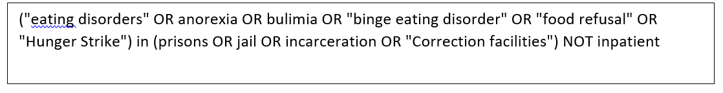

Inclusion criteria
Studies must meet the following criteria to be included within this literature review:
- Published in English due to the lack of translation resources.
- Peer reviewed.
- Focus of the study must be on adults (i.e., 16 years and above) of any gender and in prison.
- Papers must also have a direct focus on eating disorders and/or individual hunger striking.

Exclusion Criteria
- The paper focuses only on obesity rather than including hunger striking or eating disorders as well.
- Paper is a summary or an opinion piece

Search Outcome
After screening articles in accordance with the inclusion and exclusion criteria, duplicates were also removed leaving 90 articles to be reviewed by abstract and title. Sixty-eight irrelevant articles were removed prior to full text review, two more articles were included following a review of reference lists. Finally, the full-text of 24 articles were reviewed leading to the final nine papers included in this review. Figure I is a flow chart depicting the literature search process and reasons for exclusion.

Figure I: Literature review search strategy flow cart
Records identified through database searching
(N=176)

EBSCO host:
CINAHL (n=25)
MEDLINE (n=64)
PsychINFO (n=84)
PsychARTICLES (n=0)
SPORTDiscus (n=3)
Limiters:
Peer reviewed – 29 removed
English Language – 18 removed
n=129 remaining records

39 duplicates removed
68 articles excluded due to lack of relevance to the review topic
90 articles screened by title and abstract
15 full text articles excluded with reasons;
Review articles (n=2)
Political and Ethical focus (n=3)
Not enough of a focus on eating disorders in prisons (n=5)
Not enough of a focus on prison population (n=1)
Medical management focus (n=4)
24 full text articles assessed for eligibility
Hand searching of article citATIONS (USING Google Scholar), reference lists (n=2)
Articles meeting inclusion criteria (n=9)

Critical Appraisal Tool
The Mixed Method Appraisal Tool (MMAT; Hong et.al., 2018; Appendix A) was deemed most appropriate to critically appraise the papers included in the review as it was specifically designed to report on the methodological quality of mixed methods studies. The MMAT has two initial screening questions regarding whether each study has clear research aims (1) and if the data collected addresses these (2). These questions must be applied to all studies to ensure the studies were appropriate to be assessed by the MMAT. Following this, the MMAT has five categories of study types, of which the ‘quantitative descriptive studies’ category was the most appropriate to appraise all nine studies included in this review. Under this category, there are five appraisal questions in addition to the two screening questions.

The MMAT scores each item as either ‘yes’, ‘no’, or ‘cannot tell’. The scores of the MMAT are presented visually in a table (Appendix A) using a tick for ‘yes’. The more ticks evident the higher quality of study.

Results

Overview of Included Studies

Nine studies were identified and included in this review and an overview of the included studies is described below. For further study characteristics for each study see Table I.

Five of the studies utilised a mixed method approach of both qualitative and quantitative data collection (Reeves et al., 2017; Garcia-Guerrero et.al, 2015; Larkin, 1991; Milligan et.al, 2002; Drach et.al, 2016). Three studies utilised a quantitative approach (Chen, 2018; Lagarrigue et.al, 2017), one of which implemented a between-group comparison of bulimia scores between self-harming and non self-harming individuals (Matsumoto et.al, 2005). One study used an unspecified qualitative method where they completed a critical reading of prisoners’ diary entries and prison files (Erkul, 2020).

The studies were conducted in a variety of countries including the USA (n=2), UK (n=2), Belgium (n=1), Israel (n=1), Japan (n=1), Spain (n=1) and France (n=1). Participant numbers across all the studies ranged from 29 - 796. One study recruited from two prisons (Erkul, 2020). Garcia-Guerrero et.al, (2015) recruited from 28 prisons across Spain, whilst the remaining seven studies recruited from one prison. In relation to gender, three studies focused on only female offenders (Milligan et.al, 2002; Chen, 2018; Drach et.al, 2016), one focused on only male offenders (Matsumoto et.al, 2005), and three studies did not discriminate for gender (Erkul, 2020, Lagarrigue et.al, 2017, Reeves et al., 2017), and two did not document the gender of their participants (Larkin, 1991; Garcia-Guerrero et.al, 2015).

Of the studies using quantitative methods, six developed their own unstandardised surveys to measure demographic data, reasons for fasting, mental health difficulties and physical examination data. Four of these studies also used standardised measures alongside the unstandardised measures (Milligan et.al; Chen, 2018; Matsumoto et.al, 2005; Lagarrigue et.al, 2017). The standardised measures used were the ‘State trait Anger Expression Inventory (STAXI; Spielberger, 1996); The SCOFF (Sick, Control, One, Fat, Food) questionnaire (Morgan, Reid and Lacey, 1999); The Childhood Trauma Questionnaire (Bernstein et al., 1998); Eating disorder Inventory (Garner, 1991); Adolescent Dissociative Experience Scale (A-DES; Armstrong et.al, 1997); Bulimia Investigatory Test, Edinburgh (BITE; Henderson and Freeman, 1987); Becks Depression inventory (BDI; Beck, Steer & Brown, 1996), Spielberg State-Trait Anxiety Inventory Spielberger, 2010), Trauma History questionnaire (Green, 1996); Questionnaire on Eating and Weight Patterns (QEWP; Spitzer et.al, 1993) and Dutch Eating Behaviour Questionnaire (DEBQ; Wardle, 1987). Three studies utilised a retrospective review of the available prison clinical files. However, the method of qualitative analysis was not specified and is therefore unclear.

Table I: Characteristics of the nine studies included within the literature review
Author, Date & Country | Aims and Objectives | Sample and Settings | Methodology and Measures | Main Findings
Chen (2018)  Israel | To examine the association between eating disorders and child abuse and neglect (CAN), substance abuse and mental health among female offenders. | One female prison  N=62  Mean age – 39.2 years | Cross sectional study  Self-report surveys;  Socio-demographic questionnaire, The Childhood Trauma Questionnaire; Eating disorder Inventory.  Correlation and regression analysis | 84% of participants reported CAN  High prevalence of eating disorders and a high co-occurrence with CAN.  ‘Ineffectiveness’ (eating disorder inventory subset) was significantly associated with emotional abuse, emotional neglect, and sexual abuse.  Links between bulimia, ineffectiveness and low impulse regulation with mental health.
Drach et al., (2016)  USA | To assess the prevalence of harmful eating behaviours and weight gain among female offenders. | One female USA prison  134 women, (89% response rate)  Mean age -39 years | The study was part of a wider 3-year initiative.  Self-administered surveys, demographic data via records.  pearsons X² , independent t-tests and bivariate correlations. | 24% of participants utilised unhealthy strategies to lose weight in the past 6 months, 17% fasted, 9% used laxatives and 5% self-induced vomited.  55% of women ate to try and forget problems when stressed, 24% went on uncontrollable eating binges in the last 6 months.
Erkul  (2020)  Belgium | To study the motivations of offenders to hunger strike and the reactions of the prison authorities. | Focus on Interwar period 1910 -1923  2 French prisons  N=42 (3 female, 39 male)  Age ranged between 23 -48 years | Retrospective prisoner and clinical file review | They report that hunger striking was sufficient evidence to label offenders as mentally ill.  The end of hunger strikes was often due to force-feeding.  Of the little motivations documented they were demanding transfer, sooner release, and protesting innocence.
Garcia-Guerrero et.al (2015) Spain | To study the incidence of voluntary fasting, and related factors. | 28 prisons across Spain  180 offenders (gender not disclosed)  Mean age 38.7 years  Study spans a year 2013-2014 | Mixed methods for data collection  (direct observations, daily clinical assessments, reasons for fasting)  Parametric and non-parametric T-Tests to compare data at the start and end of fasting.  Duration of fasting was categorised into 3 groups (2-7 days, 8-14 days and over 14 days) and compared by Chi-Square test. Anova or Kruskal-wallis test was used to compare means of duration categories. | 354 fasting episodes reported across 22 prisons  31.7% (n=57) fasted due to treatment decision disagreements  Most common duration 2-7 days (40.6%). 12.2% reported duration over 14 days  Older age was linked to longer fasting.
Larkin (1991)  UK | To determine the prevalence of mental disorder among offenders who refused food during the period 1978-1986 | One UK prison  49 incidents of food refusal (n=39 offenders, however only 29 prison files were accessible)  Mean age – 32 years  Gender was not disclosed. | Prisoner file review (Demographic data, reasons for food refusal and psychiatric opinion).  no statistical analysis documented | Average length of refusal = 24 days (range 2-193 days)  Rationale for food refusal; protest (n=24); unable to give a reason (n=5)  Mental health diagnosis was present in 14 of the 25 cases where a diagnosis was recorded  All 5 offenders that were unable to give a reason for fasting had mental health difficulties.
Lagarrigue et.al. (2017)  French | To explore gender differences in eating behaviour and emotional vulnerability as possible determinates of obesity in incarcerated individuals. | One French prison  33 Females  18 males  Systematic recruitment to match the participants.  Mean age - 41 years | Self-report questionnaires, Becks Depression inventory, Spielberg State-Trait Anxiety inventory, Trauma History questionnaire,  Questionnaire on Eating and Weight Patterns (QEWP),  Dutch Eating Behaviour Questionnaire (DEBQ).  Mann Whitney Wilcoxon statistical test, Chi-Square, spearman’s correlation, logistic regression | The QEWP revealed non-significant trend (0.08) for higher eating disorder in women compared to men.  Binge eating disorder score >8 was present in 27.3% of women and 11% of men, which significantly higher than general population.  On the DEBQ women scored higher than men  QEWP scores were positively correlated with DEBQ emotional and external eating scores  Men lost more weight (33%) than women (21.2%)
Matsumoto et.al. (2005)  Japan | The study examined whether bulimia and dissociation are common in men who self-harm. | One juvenile prison  N= 796 offenders (98% response rate)  Age range 17-36 years. | Self-report questionnaire designed for the study, Adolescent Dissociative Experience Scale, and the Bulimia Investigatory Test, Edinburgh.  Chi-square and T-Tests for within and between group comparisons. Logistic regression to identify clinical features of those who self-harm. | Two groups 117 in the self-cutters group, 679 in the non-cutters.  Self-cutters showed significantly higher scores on the dissociative and bulimia scales  More self-cutters scored above the cut offs of both scales than non-cutters.
Milligan, Waller & Andrews (2002)  UK | To explore harmful eating behaviours in female offenders and links between facets of anger (e.g., state anger, anger suppression, trait anger). | One UK prison  N= 91 (53% of prison population)  Mean age - 31.7 years | Self-report questionnaires:  State trait Anger Expression Inventory (STAXI); SCOFF questionnaire  Correlations (Spearman’s p) to analyse relationship between SCOFF and STAXI scores  Comparisons across SCOFF questions and STAXI facets analysed using Mann-Whitney. | Positive correlations found between overall SCOFF score and state and suppressed anger on the STAXI.  3 or more positive responses on the SCOFF were linked to state anger, anger suppression, and trait anger (high trait reaction to criticism).
Reeves et al. (2017).  USA | To explore the characteristics of offenders who hunger strike. | 231 individuals accounted for the 292 hunger strikes recorded from 2005 – 2015  229; males and 2 females.  Age range 19-80 years (median = 35 years)  One New Jersey prison | Retrospective review of electronic medical records across a 10-year period (2005-2015).  Collected demographic data, psychiatric diagnosis and reasons for initiating and ending the strike  Linear regression and Chi square test were used to establish statistically significant trends over the years. | 45% of hunger strikers were on the mental health caseload compared to 15% of the general prison population.  Personality difficulties were significantly more prevalent in hunger strikers (48%, n=111)  Protesting the disciplinary process, accommodation, and conflicts with staff were the common reasons for striking

Critical Appraisal

Aims and Objectives
Of the nine papers, seven clearly stated their rationale and aims for their studies (Reeves et.al, 2017; Garcia-Guerrero et.al, 2015; Milligan et.al, 2002; Chen, 2018; Matsumoto et.al, 2005; Drach et.al, 2016; Lagarrigue et.al, 2017). Larkin (1991) clearly stated the aims for the main focus of the study, however, the study later explores and discusses the prisoner’s reasoning for hunger striking, which was not included as an initial study aim. Erkul (2020) aimed to understand motivations of hunger striking during the Belgium interwar period. However, it is unclear whether the study was able to fully meet its aims due to the lack of documentation available in the retrospective notes regarding the reasoning and motivations for striking.
One of the main limitations of the qualitative studies, except for Garcia-Guerrero et.al, (2015), is that the findings lack generalisability to any other prison establishment other than the one in which the study was conducted, in addition to the small sample sizes. However, this is typically not the case for qualitative studies where the aim is not to generalise findings but to gain contextual depth regarding specific phenomena.

Sample and Recruitment
Only one study (Chen, 2018) of the quantitative studies reported the inclusion of power analysis in order to justify the use of 62 participants. It was also noted how this sample only represented 34.4% of the female offenders in Israel and thus perhaps was not a representative sample. For the remaining studies that completed statistical analysis, it is unclear if their sample sizes were adequate or not as they did not complete or did not report a power analysis.

The impact of their small sample size on the generalizability of findings and power of analysis was acknowledged as a limitation in two of the studies (Lagarrigue et.al, 2017; Drach et.al, 2016). This transparency of offering possible reasons for the low recruitment numbers can aid future or replication studies improving upon the current studies. It is acknowledged, however, that research within secure settings can often be difficult to undertake due to a number of strict ethical, security, and political reasons, which could have also impacted the recruitment process and thus the research base overall.

In terms of recruitment, three studies did not require recruitment as they obtained retrospective prisoner files (Reeves et.al, 2017; Larkin, 1991; Erkul, 2020). Milligan et.al (2002) utilised a voluntary recruitment method through posters, whilst Drach et.al (2016) and Garcia-Guerrero et.al (2015) approached eligible participants and asked for their consent to partake. Matsumoto et.al (2005) utilised the prison entry screening procedure to recruit and implement the measures. One study (Lagarrigue et.al, 2017) utilised a voluntary recruitment method for females but utilised a stratified approach when recruiting the male participants in order to match the females in regard to important characteristics related to the study aims so that group comparisons could be made. For one study (Chen, 2018), the Israeli Prison Service (IPS) where the study was conducted, had regulations that hindered the research team from being involved in prisoner recruitment, the identification of eligible participants was a duty held by the prison social workers.

In terms of recruitment, the studies all varied in their approach, which may be due to the different prison policies and procedures that vary significantly within and between countries. Whilst it is important and vital that any research within prisons follow the policies of the local prison and ministry of justice, this can become a barrier to ethical or gold standard research. For example, regarding Chen’s study (2018) where the social workers identified eligible participants, this regulation increases the risk of inappropriate participants or missed individuals. On the contrary, this researcher’s impartiality during recruitment could reduce possible researcher and selection bias. However, it is unclear whether any of these issues and biases are impacting the study’s validity.

Measures
The unstandardised measures used in three studies (Garcia-Guerrero et.al, 2015; Drach et.al, 2016; Larkin, 1991) were perhaps not the most appropriate to address the research question. The difficulty with using solely non-standardised measures for quantitative research is that their internal validity has not been examined to explore whether they are effective in measuring what they intend to. The variation in measures used, although reflecting similarities in the areas addressed, does not allow for easy comparison and synthesis of the research. The research currently available is broad and focuses on different facets of eating disorders and hunger striking in prisons.

For those studies that included file reviews, several of files were not available. For example, one study (Larkin, 1991) refers to 10 files being missing which would have accounted for nearly a third of the files, whilst other studies were not clear about the missing data. This limitation questions the appropriateness of the methodology in addressing the research question if a high volume of data is missing. This ultimately impacts the study’s reliability as conclusions were made with partial data and without any documentation of how the missing data were addressed during analysis.

Data Analysis
The statistical analysis for the quantitative data appeared appropriate as appraised on the MMAT (Reeves et.al, 2017; Milligan et.al, 2002; Chen, 2018; Matsumoto et.al, 2005; Drach et.al, 2016; Lagarrigue et.al, 2017; Garcia-Guerrero et.al, 2015). Although appropriate given the study aims, Larkin (1991) did not utilise any statistical analysis. However, future studies may benefit from gathering more than demographic data and further statistical analysis across the variables exploring links and influencing factors. Erkul (2020) used a qualitative method referring to it as a critical reading of prisoner diary entries and files, without stating what specific analysis method was used. The lack of clarity regarding the analysis was present across all the qualitative elements within the mixed method studies. Such information is required for qualitative research in order to address any biases created by the researcher’s own beliefs, epistemological stance or preconceptions of offenders, eating difficulties or hunger striking for example.

Ethical Considerations
Seven of the papers stated that they received ethical approval and received informed consent from their participants, however much detail is not documented which may not be adequate for the qualitative studies, where sensitive topics may have been discussed or confidential clinical files reviewed. Larkin (1991) did not report ethical approval, their justification was noted, that consent from these individuals was not needed to be sought as the methodology was a retrospective review of prisoner files. Although this may be accurate, it is difficult to discern and it is expected to be dependent on the current policies in place.

Main Findings
Gender
In relation to gender, the four papers focusing on hunger striking identified a higher prevalence of men carrying out such behaviours. Conversely, the prevalence of eating disorders was found to be higher in females than males. However, these findings should be interpreted with caution as two studies did not report the gender of their sample, and a further five studies chose to research either male or female participants, therefore no direct gender comparisons could be made. These findings may not be representative of all individuals with eating difficulties, as some individuals may not feel able or supported enough to disclose any harmful eating thoughts or behaviours whilst in prison. Prisons may not be the most therapeutic environments, thus preventing such disclosures and help-seeking, particularly for men (Tyler et.al, 2019). As such, harmful eating patterns may be underreported in this setting.

Mental health
The occurrence of mental health was evident and common across the studies that explored this relationship. Reeves et.al (2017) reported that mental health difficulties were significantly more prevalent in offenders who hunger strike than in the general prison population (45% vs 15%). Larkin’s (1991) results identified the presence of mental health difficulties in over 50% of the hunger striking sample. Larkin also suggests that the presence of a mental health difficulty may be a risk factor in hunger striking as all of those who could not give a reason for the hunger strike had a mental health difficulty. Erkul (2020) suggested that being on a hunger strike was sufficient evidence to label someone as having a mental health problem. Although being a 2020 study, this conclusion was drawn from reviewed diary entries between 1910 and 1923, suggesting that hunger striking has been present for many years rather than being a recent phenomenon. These subjective statements may reflect the perspective and understanding of mental illness during this period. However, this possible inconsistency with current understandings of mental health difficulties was not acknowledged by Erkul.

More specific mental health difficulties were found to be related to harmful eating, such as ‘personality disorders’ being the most common psychiatric diagnosis in those that hunger strike, and more prevalent than in the general prison population (Reeves et al. 2017). Self-harm was also linked to bulimia and dissociative difficulties. Matsumoto et.al (2005) concluded that offenders who engaged in self-harm were more likely to develop bulimia as a harmful eating behaviour compared with those who do not self-harm.

Childhood emotional and sexual abuse, and neglect, were also linked to a higher prevalence of eating disorder. Chen (2008) found positive relationships between childhood abuse and neglect. Research suggests that childhood abuse and neglect can impact a person’s ability to self-regulate in a non-harmful way and therefore individuals may use harmful eating behaviours to self-regulate (Kolk and Fisler,1994). These behaviours could block or be a distraction to painful emotions or memories, offering a sense of relief (Svaldi et.al, 2012).

Bulimia was also found in the same study to be related to eating disorder subscales of low impulse regulation and ‘ineffectiveness’ relating to a sense of inadequacy, worthlessness, and uncontrollability over one’s life. Ineffectiveness which involves a sense of inadequacy or worthlessness, has been noted to be a difficulty found in those with eating disorders (Nokleby, 2012). Groleau (2012) stated some eating disorder behaviours may alleviate some feelings of inadequacy and increase feelings of self-worth.

Milligan et.al, (2002), reported a positive relationship between eating disorder scores (SCOFF scores) and state anger and anger suppression. Higher scores of eating difficulties, defined as 3 or more positive responses on the SCOFF, was linked to reactivity to criticism. They also found that loss of control overeating was linked to trait anger and externally directed anger. Milligan et.al (2002) hypothesised that the prison environment can lead to heightened feelings of anger and loss of control, possibly explaining why harmful eating is more prevalent in the prison population. Milligan et.al (2002) found that suppressed and externalised anger were both linked to potentially developing an eating disorder. It is possible that these aspects of anger could be present or heightened by the prison environment due to possible anger through a sense of injustice or loss of control, which are also factors and reasons that lead to a hunger strike.

Rationale for hunger strikes
The papers exploring hunger strikes reported similar findings to each other, in that the offenders’ rationales were documented to be mostly out of protest. The studies have reported that offenders would protest the disciplinary process, housing or conflicts with staff, disagreement with treatment decisions, demanding transfer or early release, and protesting their innocence. It is possible that these reasons could elicit some feelings of anger, loss of control and injustice, which could offer support to the previous hypothesis around the role of anger in harmful eating behaviours (Milligan et.al, 2002). However, the comments made by authors regarding the striking reasons were drawn from file reviews, which could be assumed were written by the professionals working in the prison and may not reflect the offenders’ views themselves. There is no documentation within the studies of completing an in-depth interview with the offenders regarding the reasoning for their hunger strike. Although, Garcia-Guerrero et.al, (2015) conducted interviews, the details and questions were not reported, therefore it is unclear as to whose opinion the reasons for hunger striking were.

Discussion
The focus of this review was to summarise the current research on hunger strikes and eating disorders in prisons, regarding the prevalence, gender differences, mental health and the known rationale for hunger striking. Although, the occurrence of hunger striking and eating disorders in prisons may not be as common as other mental health difficulties (Tyler et.al., 2019) they do occur as evidenced by the research. However, the lack of research does not reflect their occurrence. As some of the samples within this review were not representative of the prison population, the number of individuals with harmful eating behaviours could be much greater than reported. The prevalence rates across the studies cannot be directly compared due to variations in study duration, the number of prisons recruited from, and how each study measured harmful eating behaviours. Overall, due to sample size, geography, gender split and recruitment, the findings are not generalisable outside of the individual prison in which each study was conducted and as the studies differ methodologically and in focus, they may not be directly comparable.

Although various countries were included, which could allow for a better understanding of hunger strikes and eating disorders across different countries, the majority of the studies were based in western societies, European countries, and the USA, and therefore study results are likely to reflect the culture of the country they were conducted in. It is also worth noting that most of the studies were undertaken in wealthier countries, where research funding, services and support for such difficulties and mental health support may be more accessible.

The recruitment and methodology procedures were not explicitly explained across all the studies. A clearer methodology could benefit the reader and further research in understanding the process and ethics of their recruitment and procedure, particularly when working with a vulnerable, under-researched group where recruitment alongside strict security regulations may be difficult. There were specific issues with the recording of the qualitative analysis methods used across all of the studies, impacting clarity and opportunities for replication. There were methodological issues pertaining to the internal validity and reliability of the findings in relation to how, although the methodology and measures were appropriate, were they the most effective in addressing the research question.

Although the gender distribution of the samples may appear unbalanced and unrepresentative, this may highlight gender as a possible risk factor for hunger striking. Three studies recruited only female offenders (Milligan et.al, 2002; Chen, 2018; Drach et.al, 2016), this conscious recruitment of females only, may reflect the higher prevalence of harmful eating in women than in men (Hudson et.al., 2007). However, this female dominated research does not address the issue of male eating disorders being under-researched (Greenberg and Schoen, 2008).

These gender differences suggest that men hunger strike more than women, and women report more eating disorders than men, which may reflect different underlying psychological processes. For example, it is possible that in custody, women chose to refuse food and begin engaging in harmful eating behaviours, which may be associated with gaining more control in their lives (Surgenor, Horn and Hudson, 2003; Sarra and Abar, 2020), to lose weight, or to manage distressing emotions, and that this is then labelled as an eating disorder. Conversely, it is possible that when in custody, men who choose to refuse food are labelled as being on hunger strike. Although also having a controlling or perhaps rebellious element, it is possible that due to gender stereotypes, similar psychological processes relating to control (Farber, 2013) may underpin both presentations. Current research has not thus far explored any similarities in the possible underlying psychological processes across eating disorders and hunger striking in the prison population.

Milligan et.al (2002) hypothesised how the feelings of anger and loss of control experienced in prisons may be linked to the higher prevalence of harmful eating in the prison population. This also supports previous research that has hypothesised on the role of perceived control in relation to eating disorders (Surgenor, Horn and Hudson, 2003). One theory suggests that anorexia nervosa results from an unhealthy defence strategy, a search for personal control (Williams, Chamove, and Millar, 1990) and feelings of ineffectiveness (Hood et al, 1982). Waller and Hodgson (1996) added that the desire for control was also a factor in the maintenance of an eating disorder.

Farber (2013) also suggested that harmful eating behaviours are a method of expressing control within an environment where individuals with eating difficulties may experience a lack of control. Eating disorder research reports how individuals with greater eating difficulty symptomology also have higher scores on external locus of control measures (Harding and Lachenmeyer, 1986). External locus of control refers to the degree to which a person attributes both successes and failures to external factors in their lives beyond their control (Rotter, 1954). The desire for greater control would lead a person to attempt to compensate for this lack of external control by having control over their body, in what is referred to as displaced reactance (Slade, 1982). Rezek and Leary (1991) extended this theory of control, suggesting that individuals with anorexia react to threatened or lost freedom by restricting their eating. This research may relate to eating disorders in prisons, where individuals have less external control and a loss of freedom.

Limitations of Review

This literature review, although reviewing research into an under-reported phenomena within a vulnerable population, has several limitations. The number of papers included is small due to the lack of research within this field, therefore limiting any firm conclusions that can be drawn. The limited research that is available varies in methodology and research topic. This lack of similarity and homogeneity caused difficulties in synthesising study outcomes and drawing conclusions.

Regarding the search strategy, including non-peer reviewed journal articles may have identified additional papers as well as countering publication bias. Due to the vulnerability of the population and security restrictions, it could be hypothesised that a number of research papers may not have been published, increasing said publication bias. The fact that only one person selected and reviewed the papers is also a limitation. The objectivity of the review could have been hindered due to the influence of the researcher’s values, opinions and perspectives that have not been questioned or challenged by another, thus leading to possible selection bias in the selection and review of the papers.

All the included studies were cross-sectional, which does not allow causation to be determined. The papers were all descriptive studies with very little statistical data, particularly the hunger striking focused studies. However, as the studies’ aims were to explore harmful eating in this population, all studies scored reasonably well on the MMAT appraisal tool and cannot be overly criticised for not including more statistical data. A couple studies scored either ‘not applicable’ or ‘can’t tell’ on some of the MMAT questions. This inability to definitively score can lead to higher scores being given which may mean the studies appear to be of higher quality than they actually are. This may question whether the MMAT was the most appropriate quality checking tool, and whether the questions were too broad for the studies reviewed.

Another critique is that the MMAT is brief and only has a small number of questions focusing on the core methodological criteria, not considering ethics for example. Therefore, this review could have considered using another quality checking tool or developed additional appraisal questions, for instance around ethics which could be used in conjunction with a standardised tool in order to counter any critique regarding appraisal methodology.

Clinical Implications and Future Directions
Overall, literature within prisons is limited, often due to the number of restrictions in place from either ethics boards, prison policies, or the Ministry of Justice. Due to this, the research on harmful eating and hunger striking in prisons is very limited. More knowledge and theory regarding the function of such behaviours, as well as maintaining or predisposing factors, could lead to improved support, thus reducing the overall prevalence rates, need for medical assessment, or hospital admission, which can be costly. Whilst future research on risk factors such as adverse childhood experiences or perceived level of control, comorbid mental health difficulties and influencing factors could support and improve the management and treatment in prisons, it could also most importantly reduce the levels of distress for that individual. Furthermore, with more knowledge of the risk factors, the ability to prevent or be aware of the possible development of difficulties is greater. In particular, the mental health screening when a person enters prison could be amended to incorporate some of the knowledge learnt about eating difficulties and hunger striking and their risk factors to identify those who are at a higher risk of developing such difficulties.

This review acknowledges the mental health difficulties individuals present with whilst in prison, eating difficulties in particular as well as the relationships with trauma, child abuse and neglect (Chen, 2008). However, Wainwright and Decodts (2020) reported that many offenders felt there was inadequate help and support available for their mental health needs, with one in five of those diagnosed not receiving any care from a mental health professional whilst in prison (Prison Reform Trust, 2021b). Therefore, an important clinical implication of this review can be to recognise the need for training and education to be given to prison staff. Currently, the literature on managing those who hunger strike focuses purely on medical and physical management. There is yet to be a paper that supports the prison officers in managing and working alongside either an offender on hunger strike or with an individual who has an eating disorder. It could be argued that supporting and working with people who show harmful eating within a prison setting will be challenging, and therefore a better understanding may increase staff empathy, warmth, and resilience, thus overall having a more positive impact on the individual they are supporting.

Future research could also expand to explore more of the psychological processes involved in hunger striking and harmful eating such as the role of perceived control or facets of anger as well as considering the psychological impact of experiencing these difficulties whilst incarcerated. One possibility could be to explore the role of control and an individual’s attempts at gaining control in both eating disorders and hunger striking in prisons. Regarding methodology, future research could improve the reliability of their results by utilising standardised measures as opposed to tools that have not had their validity analysed.

Across the papers reviewed, the definition of hunger striking was clear, however, definitions can vary across prisons and clinicians and therefore there may not be a consensus across the literature. There is also a lack of clarity and distinction between eating disorder behaviours and hunger striking behaviours, or when these may overlap or develop into the other. Starving oneself is present in both hunger strikers and individuals with an eating disorder such as anorexia. However, no previous research has explored whether these individuals share the same psychological processes. Furthermore, longitudinal studies would improve the literature by offering insight into the long-term impact or progression of these difficulties in prison. In terms of systemic and clinical relevance, increased understanding of long-term negative impacts could encourage organisations and clinical funding services to invest greater resources into preventative and support services to address the difficulties at an earlier stage, thus reducing the long-term impact on health services and the individual.

Conclusions

Overall, this review pulls together literature that has not previously been synthesised or considered together. It also highlights an area of research and a population that may not have been considered previously in relation to eating disorders and hunger striking in prisons. Although it has been challenging to compare and synthesise the papers due to the broad variations and lack of literature, this review recognises the need for future research in this area, which may lead to developments in clinical practice, as well as improving the support for individuals presenting with harmful eating behaviours in prisons.
REFERENCES
American Psychiatric Association, D.S. and American Psychiatric Association, 2013. Diagnostic and statistical manual of mental disorders: DSM-5.
Armstrong, J.G., Putnam, F.W., Carlson, E.B., Libero, D.Z. and Smith, S.R., 1997. Development and validation of a measure of adolescent dissociation: The Adolescent Dissociative Experiences Scale. The Journal of nervous and mental disease, 185(8), pp.491-497.
BEAT eating disorder., 2020. Types of Eating disorders. Accessed online 09.07.21. https://www.beateatingdisorders.org.uk/types
Beck, A.T., Steer, R.A. and Brown, G.K., 1996. Beck depression inventory (BDI-II) (Vol. 10, p. s15327752jpa6703_13). Pearson.
Bernstein, D.P., Fink, L., Handelsman, L. and Foote, J., 1998. Childhood trauma questionnaire. Assessment of family violence: A handbook for researchers and practitioners.
Chen, G., 2018. Eating Disorders in an Israeli Women’s Prison: Correlates of the Risk. Journal of Child and Family Studies, 27(8), pp.2574-2583.
Drach, L.L., Maher, J.E., Braun, M.J., Murray, S.L. and Sazie, E., 2016. Substance use, disordered eating, and weight gain: describing the prevention and treatment needs of incarcerated women. Journal of Correctional Health Care, 22(2), pp.139-145.
Edgemon, T.G. and Clay-Warner, J., 2019. Inmate mental health and the pains of imprisonment. Society and Mental Health, 9(1), pp.33-50.
Erkul, A., 2020. Food refusal as a protest tool. Hunger strikes in Belgian prisons during the interwar period. Appetite, 144, p.104448.
Farber, S.K., 2013. Eating disorders in women's prisons: an under-reported phenomenon?. Advances in Eating Disorders, 1(1), pp.39-50.
García-Guerrero, J., Vera-Remartínez, E.J., Alia, C., Antolín, J.M., Antón, J.J., Casado-Hoces, S.V., Castellanos, J.C., Davoodzadhe, G., de Andrés, B., de Juan, J. and Escribano, M., 2015. Episodes of voluntary total fasting (hunger strike) in Spanish prisons: a descriptive analysis. Journal of forensic and legal medicine, 34, pp.182-186.
Garner, D.M., 1991. Eating Disorder Inventory-2; Pro-fessional Manual. Psychological assessment resources.
Green, B.L., 1996. Trauma history questionnaire. Measurement of stress, self-report trauma, and adaptation, pp.366-369.
Greenberg, S.T. and Schoen, E.G., 2008. Males and eating disorders: Gender-based therapy for eating disorder recovery. Professional Psychology: Research and Practice, 39(4), p.464.
Groleau, P., Steiger, H., Bruce, K., Israel, M., Sycz, L., Ouellette, A.S. and Badawi, G., 2012. Childhood emotional abuse and eating symptoms in bulimic disorders: An examination of possible mediating variables. International Journal of Eating Disorders, 45(3), pp.326-332.
Gulati, G., Kelly, B.D., Meagher, D., Kennedy, H. and Dunne, C.P., 2018. Hunger strikes in prisons: a narrative systematic review of ethical considerations from a physician’s perspective. Irish journal of psychological medicine, 35(2), pp.135-142.
Harding, T.P. and Lachenmeyer, J.R., 1986. Family interaction patterns and locus of control as predictors of the presence and severity of anorexia nervosa. Journal of Clinical Psychology, 42(3), pp.440-448.
Henderson, M. and Freeman, C.P.L., 1987. A self-rating scale for bulimia the ‘BITE’. The British Journal of Psychiatry, 150(1), pp.18-24.
Hood, J., Moore, T.E. and Garner, D.M., 1982. Locus of control as a measure of ineffectiveness in anorexia nervosa. Journal of Consulting and Clinical Psychology, 50(1), p.3.
Hong, Q.N., Fàbregues, S., Bartlett, G., Boardman, F., Cargo, M., Dagenais, P., Gagnon, M.P., Griffiths, F., Nicolau, B., O’Cathain, A. and Rousseau, M.C., 2018. The Mixed Methods Appraisal Tool (MMAT) version 2018 for information professionals and researchers. Education for Information, 34(4), pp.285-291.
House of commons., 2018. Prison health. Twelfth report of session 2017-19. Health and social care committee. House of commons. Accessed online. 21.06.21 https://publications.parliament.uk/pa/cm201719/cmselect/cmhealth/963/963.pdf
Howard League for Penal reform., 2018. Howard League for Penal Reform response to the Health and Social Care Committee’s inquiry on prison healthcare. Accessed online. 21.06.21 https://howardleague.org/wp-content/uploads/2018/06/Response-to-the-Health-and-Social-Care-Committee%E2%80%99s-inquiry-on-prison-healthcare.pdf
Hudson, J.I., Hiripi, E., Pope Jr, H.G. and Kessler, R.C., 2007. The prevalence and correlates of eating disorders in the National Comorbidity Survey Replication. Biological psychiatry, 61(3), pp.348-358.
Kolk, B.A. and Fisler, R.E., 1994. Childhood abuse and neglect and loss of self-regulation. Bulletin of the Menninger Clinic, 58(2), p.145.
Lagarrigue, A., Ajana, S., Capuron, L., Féart, C. and Moisan, M.P., 2017. Obesity in French inmates: gender differences and relationship with mood, eating behavior and physical activity. PLoS One, 12(1), p.e0170413.
Larkin, E.P., 1991. Food refusal in prison. Medicine, Science and the Law, 31(1), pp.41-44.
Matsumoto, T., Yamaguchi, A., Asami, T., Okada, T., Yoshikawa, K. and Hirayasu, Y., 2005. Characteristics of self‐cutters among male inmates: Association with bulimia and dissociation. Psychiatry and Clinical Neurosciences, 59(3), pp.319-326.
Milligan, R.J., Waller, G. and Andrews, B., 2002. Eating disturbances in female prisoners: The role of anger. Eating Behaviors, 3(2), pp.123-132.
Morgan, J.F., Reid, F. and Lacey, J.H., 1999. The SCOFF questionnaire: assessment of a new screening tool for eating disorders. Bmj, 319(7223), pp.1467-1468.
Morse, A.C., 2016. From Guantanamo Bay to Pelican Bay: Hunger striking and the biopolitical geographies of resistance (Doctoral dissertation, University of Oregon).
NHS England., 2020. Overview of Eating Disorders. Accessed online 09.07.21. https://www.nhs.uk/mental-health/feelings-symptoms-behaviours/behaviours/eating-disorders/overview/
Nøkleby, H., 2012. Comorbid drug use disorders and eating disorders—A review of prevalence studies. Nordic Studies on Alcohol and Drugs, 29(3), pp.303-314.
Oguz, N.Y. and Miles, S.H., 2005. The physician and prison hunger strikes: reflecting on the experience in Turkey. Journal of Medical Ethics, 31(3), pp.169-172.
O’Hearn, Denis. "Repression and solidary cultures of resistance: Irish political prisoners on protest." American Journal of Sociology 115, no. 2 (2009): 491-526.
Penal Reform International., 2015. Global Prison Trends 2015. Penal Reform International, London. Accessed online 07.07.21 https://cdn.penalreform.org/wp-content/uploads/2015/04/PRI-Prisons-global-trends-report-LR.pdf
Prison reform trust., 2021a. Prison the facts. Bromley briefings summer 2021. Accessed online 07.07.21 http://www.prisonreformtrust.org.uk/Portals/0/Documents/Bromley%20Briefings/Summer%202021%20briefing%20web%20FINAL.pdf
Prison Reform Trust., 2021b. Mental Health care in prisons. Accessed online 07.07.21 http://www.prisonreformtrust.org.uk/WhatWeDo/Projectsresearch/Mentalhealth
Rebbapragada, N., Furtado, V. and Hawker-Bond, G.W., 2021. Prevalence of mental disorders in prisons in the UK: a systematic review and meta-analysis. BJPsych Open, 7(S1), pp.S283-S284.
Reeves, R., Tamburello, A.C., Platt, J., Tepper, D. and Edelman, K., 2017. Characteristics of inmates who initiate hunger strikes. J Am Acad Psychiatry Law, 45(3), pp.302-10.
Rezek, P.J. and Leary, M.R., 1991. Perceived control, drive for thinness, and food consumption: Anorexic tendencies as displaced reactance. Journal of Personality, 59(1), pp.129-142.
Rotter, J.B., 1954. Social learning and clinical psychology. Englewood Cliffs, NJ: Prentice Hall.
Sarra, S.R. and Abar, C.C., 2020. Perceptions of control and disordered eating behaviors during college transitions. Journal of American College Health, pp.1-8.
Scanlan, S.J., Stoll, L.C. and Lumm, K., 2008. Starving for change: The hunger strike and nonviolent action, 1906–2004. In Research in social movements, conflicts and change. Emerald Group Publishing Limited.
Sharp, G., 1973. The politics of nonviolent action, 3 vols. Boston: Porter Sargent, 2.
Spielberger, C. D. (1996). State-Trait Anger Expression Inventory: Professional manual. Odessa, FL:Psychological Assessment Resources, Inc.
Spielberger, C.D., 2010. State‐Trait anger expression inventory. The Corsini Encyclopedia of Psychology, pp.1-1.
Spitzer, R.L., Yanovski, S.Z. and Marcus, M.D., 1993. The questionnaire on eating and weight patterns-revised (QEWP-R). New York: New York State Psychiatric Institute.
Slade, P., 1982. Towards a functional analysis of anorexia nervosa and bulimia nervosa. British Journal of Clinical Psychology, 21(3), pp.167-179.
Surgenor, L.J., Horn, J. and Hudson, S.M., 2003. Empirical scrutiny of a familiar narrative: Sense of control in anorexia nervosa. European Eating Disorders Review: The Professional Journal of the Eating Disorders Association, 11(4), pp.291-305.
Svaldi, J., Griepenstroh, J., Tuschen-Caffier, B. and Ehring, T., 2012. Emotion regulation deficits in eating disorders: a marker of eating pathology or general psychopathology?. Psychiatry research, 197(1-2), pp.103-111
Tyler, N., Miles, H.L., Karadag, B. and Rogers, G., 2019. An updated picture of the mental health needs of male and female prisoners in the UK: prevalence, comorbidity, and gender differences. Social psychiatry and psychiatric epidemiology, 54(9), pp.1143-1152.
Wainwright.l and Decodts.F., 2020. Who cares: Exploring distress in prison from the perspective of people in prison. Prison reform trust. Accessed online 07.07.21. http://www.prisonreformtrust.org.uk/Portals/0/Documents/Who%20Cares%20-%20PPN%20Distress%20report.pdf
Wardle, J., 1987. Eating style: a validation study of the Dutch Eating Behaviour Questionnaire in normal subjects and women with eating disorders. Journal of psychosomatic research, 31(2), pp.161-169.
Waller, G. and Hodgson, S., 1996. Body image distortion in anorexia and bulimia nervosa: the role of perceived and actual control. The Journal of nervous and mental disease, 184(4), pp.213-219.
Williams, G.J., Chamove, A.S. and Millar, H.R., 1990. Eating disorders, perceived control, assertiveness and hostility. British Journal of Clinical Psychology, 29(3), pp.327-335.
World Medical Association., 2006. WMA Declaration of Malta: a back-ground paper on the ethical management of hunger strikes. World medical journal 52: 36-43

APPENDIX A - A Visual representation of the MMAT (Hong et. al., 2018) appraisal tool

 | MMAT Methodological quality criteria
Study Author and date | S1. Are there clear research questions? | S2. Do the collected data allow to address the research questions? | 4.1 Is the sampling strategy relevant to address the research questions? | 4.2 Is the sample representative of the target population? | 4.3 Are the measures appropriate? | 4.4 Is the risk of nonresponse bias low? | 4.5 Is the statistical analysis appropriate to answer the research question? | Comments
Reeves et al. (2017). |  |  |  |  |  |  |  | no standardised measures used  retrospective- some individuals may have been missed
Larkin (1991) |  |  |  |  |  |  | N/A | didn’t offer aim for exploring reasons to strike  not enough data gathered  retrospective- some individuals may have been missed
Garcia-Guerrero et.al (2015) |  |  |  |  |  |  |  | around half of possible participants
Erkul  (2020) |  |  |  |  | N/A | N/A | N/A
Milligan, Waller & Andrews (2002)
Chen (2018)
Matsumoto et.al. (2005)

Drach et al., (2016)

Lagarrigue et.al. (2017)

Key : YES NO CAN’T T

Paper 2: Empirical Paper

“I don't feel like they're supported enough”
– Prison staff’s experiences and perceptions of transitions of young adults to adult prisons

.

Angelique Marcou

This paper has been prepared with the intention of publication in the Journal of forensic practice, including Harvard referencing style. Further editing and modifications will be made before submitting to the journal.
Author Guidelines for publication in this journal can be found in Appendix B

Word count: 7969

Abstract
The Howard League emphasises the need to support young adults who transfer to adult prisons (Howard league, 2019) as this had been identified as one of the broad difficulties young offenders face (Prison Reform Trust, 2012). The purpose of the current study was to explore prison staff’s experience of transitions of young adults in youth offending institutions transitioning to adult prisons. This study used a qualitative reflexive thematic analysis approach to analyse semi-structured interviews with seven prison staff. The results identified four core themes; ‘Being unprepared’, ‘inconsistencies’, ‘maturity and independence’, ‘relationships and attachments’ with subthemes within each. Prison staff voiced a sense of being unprepared and a lack of consensus in relation to the prison systems in place. The results highlighted the prison staff’s sense of compassion and concern for the young adults as they transitioned to adult prisons. Better support for staff, as key attachment figures for these individuals, was recommended as a result of the prison staff’s experiences. Prison staff may also benefit from supervision and additional training to counter their sense of feeling unprepared, to allow them to feel both more supported and to feel more effective during the transition period for young adult prisoners.

Key words: prison; youth offenders, adult prison; prison staff; transition; transfer

Introduction

Young adults in prison aged between 18-25 years, account for 15.2% of the UK prison population (Sturge, 2021). There is a projected rise in the population of young adult prisoners as well as an increase in the custody length served by young adults (Ministry of Justice, 2021). These estimated increases alongside the likelihood of recidivism (HM Inspectorate of Prisons, 2021) imply that some individuals will transfer into adult prisons during their custodial sentence. The statistics for the number of individuals transferring are unclear. However, poor transition to adult services was identified as one of the broad difficulties young adult offenders face (Prison Reform Trust, 2012). This paper aims to explore what prison staff perceive as contributing to this difficulty.

Within an offending context, children are defined as aged 18 and under as specified by section 105 of the Children Act 1989 (Department of Education, 2021). Once these individuals reach 18 the law changes, which can affect sentencing and parole, while many services provided by youth offending teams are no longer available. ‘Young adults’ is another definition used within secure settings, which describes a prisoner aged between 18 to 21 years. There is a lack of consensus across the prison system, legal system and social services regarding when the transition to adulthood occurs (Fossi, 2006) and their approach (Webster, 2021).

The Howard League for Penal Reform and the Transition to Adulthood alliance (T2A) argue that the term ‘young adults’ should be inclusive of individuals up to the age of 25 years (Emanuel, Mawer and Janes., 2021) due to individuals still maturing emotionally, socially and neurologically (Webster, 2021; Prison reform trust, 2012). However, the criminal justice system does not often account for these issues, treating young adult offenders as fully mature when this may not be the case (The Parole Board, 2021).

Transitions

Young offenders are often accommodated in Youth Offender Institutions (YOIs) that either house 15-17 year olds or 18-21 years, however, there are no distinct cut-offs. In the UK, an 18 year old from children’s secure estates can be transferred to a young adult or adult estate prison, whilst a prisoner turning 21, will transfer to an adult prison if remaining in custody (The Parole Board, 2021). It has been reported that young adults were placed haphazardly across different types of establishments without considering their needs (HM Inspectorate of Prisons, 2021) or psychological impact. There does not seem to be a single strategy document for young adults (HMI report, 2021).

There is no reported benefit of merely decanting young adults into an adult population prison (HM Inspectorate of Prisons, 2021). However, there was no rationale for why many young adults were placed in predominantly adult prisons, with no evidence to suggest that these decisions were based on prisoner needs. Therefore, the instability in the transition system could exacerbate this population’s pre-existing psychological vulnerabilities and lead to long-term poor outcomes (Mercer, 2020). Furthermore, with little provision or resources, most prisons inadequately recognise and provide support to meet the complex needs and challenges of young prisoners as they mature into adulthood. (HMI report, 2021). Webster (2021) concluded that when there is specific dedicated and well-resourced young adult provision, outcomes improve for young adults, including wellbeing.

It is documented that 70% of offenders will have some form of mental health difficulty at any given time, with 10% of the prison population receiving treatment for their mental health difficulties (House of Commons, 2021). Many young adult prisoners have complex psychological needs such as a history of childhood abuse (Goddard & Pooley, 2019), difficult family dynamics and insecure attachments. Therefore, attachment theory is particularly important to consider in relation to the impact on their custodial journey and transition. Without awareness, staff members may remodel or re-enact the offenders’ early relationship experiences by being punitive, rejecting or over-involved (Moore, 2012). The internal working model (Bowlby, 1979) would further suggest that should the staff not have a secure attachment relationship themselves, they may be unable to adjust or be responsive to prisoners’ needs (Pietromonaco & Barrett, 2000). For young people in secure settings their attachment figures may often be prison staff, which may have been the only consistent, sustained, and caring relationships some young individuals have experienced (Kane, 2008). Prison-based relationships between offenders and prison staff are recognised as a key aspect of offender welfare (Bullock and Bunce, 2020), thus offering rationale for the importance of this research.

Transition support

Young offenders may already have experienced a number of transitions, where early planning, assessment, and involvement of key staff from both the transferring and receiving establishments is needed to ensure safe and positive resettlements into adult establishments (Prison Reform Trust, 2012). Lack of support for young people moving from the youth to the adult justice system was seen as a concern by an independent panel (Prison Reform Trust, 2012). The transition process has been reported to be negatively impacted by the lack of preparation (Livanou, Furtado & Singh, 2017). Hart (2009) highlighted that transitions within and between justice systems were poorly managed due to being rarely pre-planned and often on short notice. However, the factors that reduce support being offered or how these moves are experienced by the supporting staff have not been explored further.

Abrupt, poorly managed transitions as previously identified could negatively impact the young person’s attachments and potentially lead to trauma or re-trauma due to the loss of stable and positive staff relationships (Kane, 2008). Some have reported that the prison environment itself can be further traumatising for some (Marriott & Houghton, 2011). More recently, trauma-informed care approaches have begun to be implemented in some UK prisons (Levenson, 2014; Jewkes et.al., 2019). The drive to deliver trauma-informed care in UK prisons is underpinned by empirical evidence that suggests that those who receive custodial sentences typically report historical psychological trauma (Goddard & Pooley, 2019).

Offering care has been identified as a central aspect of the prison service and prison staff role (Pilling, 1992). The staff-prisoner relationship (National Offender Management Service, 2008) and their approach (Walker et.al., 2018) are a key part of the rehabilitation process. However, prison staff are reported to be insufficiently trained to manage the complex needs of prisoners and the staff are also not offered adequate support in their stressful roles (Smith, 2000).

Rationale

Prisons, prisoners and prison staff have historically been seldom researched, as they can be a vulnerable and hard to reach population. The majority of the research and opinions presented have been completed as policy reviews and government reports, without considering the experiences or psychological impact of those affected. Most of these studies utilise a quantitative methodology, whilst a qualitative approach would offer a more in-depth understanding of the perceptions and experiences of the participants. Overall, there is little research within the UK focusing on experiences of transitions from YOI into adult prisons from the stance of those involved, staff or prisoner. There is no current research focusing on prison staff’s experiences of the transition process for young adults, identifying a gap within forensic literature.

As prisoner-staff relationships and developed attachments are recognised as key to offender psychological wellbeing and rehabilitation, this offers a further rationale for the importance of this study’s focus on the prison staff’s perceptions of young adult prison transitions. As prison practices in relation to young adults vary significantly within and between countries, this initial study focused its research within the UK. The unique insights of the prison staff could generate valid recommendations that could benefit procedures such as transitions and subsequent prisoner and staff experience and wellbeing.

Aims
The current research aims to explore and represent the participants’ (prison staff) experiences and perceptions of prisoner transitions from YOIs to adult prison, by using reflexive thematic analysis. The specific objectives are:

- To qualitatively explore staff perceptions and experiences of transitions from a youth offenders institute to an adult prison.

- To analyse the qualitative data gathered using thematic analysis in order to identify themes relating to participants’ experiences and views of transition.

To note, the prison staff experiences include actively supporting the young adults during these transitions or being directly involved in the process. However, it can also include experiences of observations, witnessing their colleagues’ involvement and talking to the prisoners about the process.

Research Question

What are prison staff’s experiences of working with young offenders during their transition from YOIs to adult prisons?
Method

Ethics

The study received approval from Staffordshire Universities Research Ethics Committee (Appendix E). Informed consent was obtained from all participants, and they were allocated a pseudonym name to anonymise their data. The participants were aware they had the opportunity to withdraw their data during the two weeks following the interview. The audio data was transcribed with all identifiable information deleted to ensure anonymity.

Design

A qualitative approach was applied in order to explore and provide deeper insights into this phenomenon, gathering data on participants’ experiences and perceptions. The study utilised a semi-structured interview method followed by a reflexive thematic analysis of the data. In comparison to other qualitative methodologies, reflexive thematic analysis is more independent in terms of its epistemological and theoretical stance, allowing the researcher more flexibility during analysis to be responsive to the data, whilst acknowledging their own position (Braun & Clarke, 2022). Reflexive thematic analysis was selected as the most appropriate analysis over Interpretative Phenomenological approach (IPA) as a possible alternative. The rationale is that this research did not intend to have an idiographic focus but rather to analyse patterns across the data set, which is better suited to a reflexive thematic analysis method (Clarke & Braun, 2017). Furthermore, in regard to influencing the prison service, thematic analysis has been reported to be suited to informing local policy development (Braun & Clarke, 2006). The interview schedule (Appendix C) was developed by the researcher with support from a volunteer prison staff member, the pilot of the interview schedule lasted around 30 minutes.

Current context

The study was proposed and conducted during an unprecedented global pandemic, which subsequently impacted the NHS and prison systems as well as research procedures, thus affecting this research and the process in which this is conducted including recruitment and procedure.

Recruitment

Participants were recruited through an opportunistic and voluntary sampling method. Direct recruitment from prisons was initially attempted, however, due to prison pandemic regulations that limited external individuals entering, this was not possible. Therefore, online recruitment was more appropriate within this context. The research study was advertised via social media platforms such as Facebook and Instagram (Appendix D), utilising their prison staff forums and groups, e.g. ‘HMPS serving or Ex-staff chat group’ with 3500 members. Prison staff within this study refers to any role or discipline where the individual works with offenders in a prison. Prison staff were required to meet the following inclusion criteria to participate in the study;

Inclusion Criteria:

- Participants must be any staff working in a UK prison who have experienced or are involved in youth offenders transferring into the adult prison.
- Participants must be 18 years or over and deemed to have capacity to give informed consent by the research team.
- All participants should be deemed to be in a state physically and mentally where they are able to participate and give informed consent on the day of interview, this was asked by the lead researcher on the day of interview.

Exclusion Criteria:

If the person is unable to recall the transition or is not in a fit state to complete the interview on the day.

The advert was posted on social media, where people commented on the original post expressing their interest or tagging others whom they thought might be interested. The post was also shared 30 times by other users, however as the researcher did not have access to these secondary shares the subsequent interactions are unknown. No inappropriate individuals contacted as a result of the secondary shares. A number of individuals got in contact with the researcher, whilst the researcher sent a follow-up message to others who expressed their interest, see figure II for detailed numbers.

Procedure

Seven prison staff participated in semi-structured interviews ranging from 27 to 46 minutes (mean = 35). All of the interviews were conducted online using video conferencing platforms such as Microsoft Teams and audio recorded. All participants were sent an information sheet (Appendix F) and consent form (Appendix G) to read and sign prior to the interview to ensure they understood what was asked of them before giving consent. They had an opportunity to ask questions and verbally confirm their consent at the start of the interview. The audio recordings were manually transcribed into a word document and then exported into an excel spreadsheet during the coding process.

Figure II. An illustration of the recruitment procedure

Participants

All seven participants (Table II) have experiences of transitions and worked within prison settings. The mean age of the participants is 40.7 years.

Table II. Participant Demographics
Pseudonym | Current Job Role | Previous prison experience | Gender | Age
Andrew | Operations manager - Adults | YOI | M | 58
Ben | Psychosocial substance misuse caseload holder - Adults | Youth & young adults 11-25 | M | 51
Claire | Prison general nurse - YOI | Adults | F | 36
David | Prison Custodial manager - Adults | YOI | M | 29
Elaine | Clinical psychologist - Adults | YOI & Mixed prison | F | 48
Fran | Prison officer- n/a | Mixed YOI & Adults | F | 36
Georgia | Prison Custody officer - Adult | n/a | F | 27

Epistemological stance

It is important to consider the role of the researcher in relation to the research before the analysis process begins. The researcher took a critical realist epistemological position. With a critical realist ontology, it assumes that reality exists independently but also how this is mediated by our different perspectives and methods (Willig, 2001) imposed on that reality (epistemologically relativist) which can be impacted by our social world (Braun & Clarke, 2022). A critical realist position aligns well with this research in that prisons are social structures (Morton, 2006) with their own culture and guidelines that develop shared realities, however, the prison staff will have their own realities in relation to how these are negotiated (Bhaskar, 1998). Hearing these realities can bring alight areas for transformation and service change. The researcher has experience with secure services and therefore the analysis of the data occurred through a lens of understanding of the possible prison cultures.

This study reflects prison staff’s experiences whilst the analysis is also an interpretation made by the researcher who cannot impose true objectivity, as critical realism recognises how the researcher is also within the world they are researching (Pilgram, 2014). RTA suits the epistemological stance of the researcher in that RTA can allow the researcher epistemological and theoretical flexibility during analysis to be responsive to the data (Braun & Clarke, 2006). The critical aspect of this epistemological stance can look toward change and as such the research rationale and question allow for a critical perspective to be taken in regard to the youth transition experiences of the prison staff. An inductive approach was taken as the analysis was driven by the data and the perception each participant brings, rather than through the lens of a theoretical framework (Braun & Clarke, 2022).

Reflexivity

Reflexivity is fundamental to TA where a critical view regarding the researcher’s embedded values and experiences that shape their perspective, and the influences this has on shaping the research and analysis is required. Reflexivity is an active process which can aid and influence interpretations, gaining insights into the research (Birks and Mills, 2015). A reflective journal was kept in order to record initial ideas, thoughts and feelings to aid the reflexivity process, deepening interpretations (Braun & Clarke, 2022).

Theoretical sensitivity refers to the process where the identification and meaning making of the data is influenced by the researcher’s ability to use their own experiences (Charmaz, 2006). The researcher had previously experienced a young adult transition within a secure setting, which they interpreted as poor and uncompassionate. These personal experiences had a significant impact on the researcher and informs the researcher’s perspective. RTA values the experiences of the researcher in how they can enhance the analysis. The reflective journal and attendance to TA peer groups allowed the researcher to hold this in mind so that the analysis could stay aligned with the participants and represent their voices and experiences.

Analysis

Reflexive thematic analysis was implemented as it values the subjective researcher and critically reflects on their role, the process of their interpretation and the influences on the research. The analysis followed the 6 phases set out by Braun & Clarke (2022), a snapshot of the process can be seen in Appendix I. Firstly, the researcher immersed and familiarised themselves with the dataset by rereading the transcripts before systematically coding interesting data with meaningful descriptions (Appendix J). The coding was done manually by the researcher alone without the use of a computer programme. The codes were printed out in order to colour code and group codes that shared a central concept, generating initial themes of broader shared meanings. The fourth phase reviewed the themes to ensure they were viable in relation to the research question and across the dataset, a visual board aid was utilised. The revision consisted of changing, collapsing together or discarding themes in order to tell the story of the data. Once the themes were refined, they were named and clearly defined. The final phase was the process of writing up the analysis, including data extracts and reflections. The developed themes were shared with a prison staff member to ensure the themes correctly reflected their experiences, they later read the executive summary; paper 3.

Results

Analysis of the data identified four core themes, with subthemes within each. These are; ‘Being unprepared’, ‘inconsistencies’, ‘maturity and independence’, ‘relationships and attachments’. The subthemes are depicted below (figure III) as smaller circles colour coded to match their main theme. The lines illustrate possible relationships and links between the themes.

Figure III. A diagram to illustrate the themes identified and their relationships 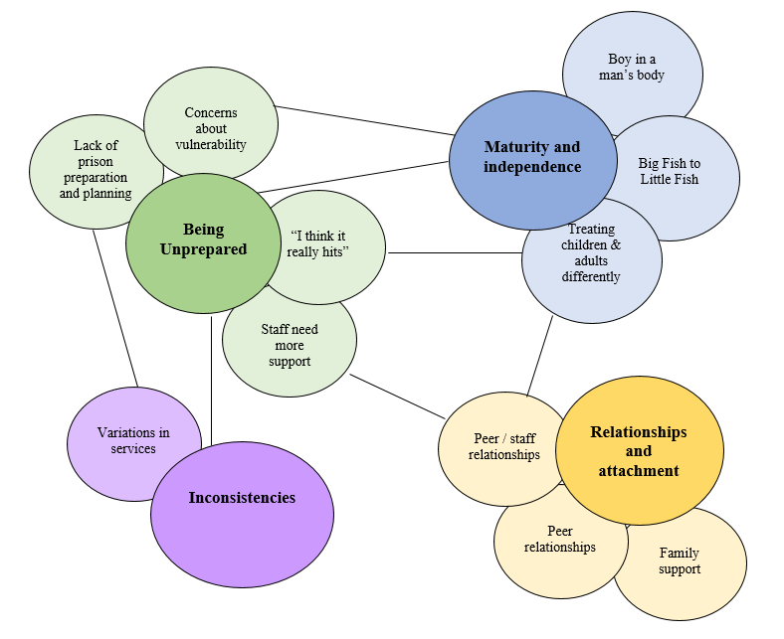
‘Being unprepared’, encompasses how the prison staff experienced a lack of procedural preparation in relation to the transition process and the prisoner’s expectations. Although separate, this theme may be related to the inconsistencies the prison staff experienced across the systems they work within. The prison staff experienced how the lack of readiness and deficit in emotional maturity and independence may disadvantage young adults in managing adult prison life. This increased emphasis on independence and reduction in staff support as described by the prison staff adds to the ‘reality that hits’ when they move to the adult prison environment and culture.

1. Being unprepared
This theme was supported by all participants and incorporates four subthemes; 1) lack of prison preparation and planning, 2) I think it really hits, 3) concerns about vulnerability and 4) staff need more support. This theme identified a pattern of how the prison staff experienced unpreparedness in regard to the prison’s process of transition, but also the expectations and vulnerabilities of prisoners facing a change in culture when moving to an adult prison.

1a. Lack of prison preparation and planning
“I don’t feel like they’re supported enough […] I don’t think there’s anything from what I know specifically targeted at the YOI transition” – DAVID
“I think once you’re in adult services, you’re in adult services and I think there’s no easing you in” –ELAINE
“they've been bundled on a bus and their medications not come with them” - ANDREW
Prison staff experienced how prisons offered limited opportunities to prepare and support the young adults in relation to what to expect and the process of transition. The staff also spoke about their lack of preparation in terms of procedures and systems around transitions such as medication transfer and timings.

“you know a rabbit in the headlights, they just you know, they just don’t know what to expect” – FRAN
“They need to be more informed about what adult prison is like” – DAVID
“when they came to us we didn't know anything about what kind of support they had […it] would have helped because it would have made us understand what they were going through.” – GEORGIA

It is the prison staffs’ experience that prisoners were not prepared for what to expect about adult prison life, which the prison staff believed is different from YOIs. The staff believe that something should be implemented to better inform the young adults. The lack of information sharing and preparation has led to prison staff feeling unable to adequately support prisoners to reduce any shock or anxiety they may feel when they transition. There is a felt sense that the prison staff may feel powerless to implement such support around the transition process that they believe is required.

1b. “I think it really hits” – DAVID
“its seen too often as part of prison life so it’s a big shock to your system, so you are gonna struggle.” – BEN
“they are completely different culture, to be fair yeah it’s a massive culture shock”– DAVID
The prison staff observe the effect of the transition on the young person in relation to the magnitude of the change, perceiving this as a real challenge for them. The prison staff experience this impact of transitions to be related to an unprepared culture shock from what they may have come to expect in youth offending services.

1c. Concerns about vulnerability
“I have concerns then because are they at risk of being exploited, bullied” – BEN
“I think those risks don’t then immediately go when you turn 18 […] risks you may be being exposed to and far less support to intervene”. – ELAINE
The prison staff experienced a sense of concern about the possible risks the young adults may be exposed to in moving to an adult prison environment, including new peers. The prison staff experienced how the risks for the young adults do not change at the point of becoming legal adults, whilst their concerns are founded on experiences of how these risks are managed with less intensive support available once they transition to adult prison compared to YOIs.

1d. Staff need more support
“I think all managers need to recognize the skill set of their staff. Invest in their staff” - ANDREW
“There needs to be some, sort of, like shake up in regards to how colleagues and staff communicate and work together because it really does impact on how they support the people that they're working with” – FRAN
“We’ve got a job to deliver. But they definitely need to do something put more effort into the staff [...] morale goes down they start thinking actually can I make a difference in this job”- DAVID
When discussing their transition experiences, the prison staff noted a sense of being expected to ‘just get on with it’, which ultimately impacts their morale. Furthermore, should they require it, the support is not there for their challenging roles and the expectation of supporting transitions and the prisoners more widely. The prison staff experienced that the lack of effort in staff support and investment impacts how they support the young adults during their transition.

“We were trying our best but we were short staffed and they just weren't getting the help they needed to just reach – to do what they wanted to do” –GEORGIA
“I wasn’t gonna really make a difference because I didn't get enough time to spend with people as a personal officer” – FRAN

The staff experienced how staffing levels and the lack of resources or protected time with the prisoners hinders their ability to adequately work with the young adults and prepare them for the transition to the extent they wanted to. The prison staffs’ experiences have led to them feeling more like a helpless bystander and powerless rather than being an active support during the young adult transition.
2. Maturity and independence
This theme was supported by the majority of participants (5/7) and includes subthemes of “boy in a man’s body”, “treating adults and children differently” and “big fish to little fish”. It draws together the prison staff’s experiences of working with individuals as they progress through natural life cycle transitions, finding their identity as they develop into adulthood and how this affects their transitions through the system.
“I think there’s really clear differences both in terms of what’s expected of you in terms of your kind of developing your identity, developing your skills, developing independence, but also the whole kind of neuro side of it.” -ELAINE

2a. “boy in a man’s body”
“he was still to me a boy in a man’s body. He even though he was a grown man in his own right, emotionally he was still 16 years of age.” BEN
“just all the neuro developments in there, that goes on to mid 20’s” - ELAINE
The participants considered the neurological developments that continue beyond the age of 18 years, when they become legal adults. They also experienced dissonance between the young person’s physical age that they are expected to transition and the perceived age of emotional maturity at this stage, which may impact their readiness for adult prison.
“its also about managing a life stage development and how they might move from a position of increased dependency to increased independence” –CLAIRE
Prison staff considered how the prisoners move away from being staff and service dependent as they transition to adult prisons and experienced how prisoners may sense the transition as a maturing life event.

2b. Big fish to little fish
“you’ve got a lot of young kids that will be top dog in in the young offender but they’ll go into an adult establishment and they’ll become nothing”. –CLAIRE
“but they’re transitions from the big fish to little fish. Sometimes there’s a bit of a tricky journey for the” –ANDREW
The prison staff experiences were that they observed a possible difficult transition for the young adults as they move away from an already established identity in YOIs as they move into new adult environments.

2c. Treating children and adults differently
“that huge difference, that huge sort of wrapped in cotton wool we’ll look to see what we can do to help you, to almost being lifted out and put into a big prison and crack on”. – BEN
“you go from an establishment where you’re very […], very supported and your very sort of treated as a child or young adult and all of a sudden they’ve got to become a man really and stand on their own two feet”. – DAVID
The prison staff also reported experiences of how differently the individuals were treated once marked as an adult. Particularly transitioning away from an environment they believed is more intensive and supportive compared to adult prisons without any support or scaffolding between.

3. Inconsistencies
This theme was supported by most participants (5/7) and reflects prison staff’s experiences of inconsistencies that occur during the transition period that are present for both the prison staff and prisoners. It relates to the wider systemic and organisational frameworks in place regarding transitions that differ across services and the patterns of how services treated children differently from adults.

3a. Variations in services
“caught between a rock and a hard place because they'd be a young person for one service and an adult in another service”. – BEN
“just frustration with being told one thing by one person, something completely the opposite by somebody else” [regarding prisoners]- FRAN
“There’s a big change in the ethos of services [...] there’s a change in your legal rights and there’s a change in what support systems are there.” – ELAINE
“so you have the NHS staff and the prison staff have a very different outlook shall we say on how to look after the person […] so that they will bang heads sometimes” – BEN
The prison staff experienced inconsistencies in the approaches used by the prison and the NHS systems, as well as other services that are involved during a young person’s transition. These inconsistencies can cause conflicts and difficulties when working with young adults during the transition process. Inconsistencies were also experienced in regard to the changes in a person’s legal rights as they become an adult, and how this influences how they are managed through the criminal justice system. There is a sense of frustration regarding working within these inconsistencies and the staff believed the prisoners also shared such frustrations.

4. Relationships and Attachment
This theme focuses on the relationships that the prison staff experience with the prisoners and their experiences of the prisoner peer relationships they witness. All but one participant supported this theme.

4a. Prisoner / staff relationship
“They [prison staff] are the foundation sometimes for me that can make the remainder of their [young adults] journey in a prison either good or bad” - ANDREW
“but then I think the older staff also helped because it was like them having a father or a mom figure” – GEORGIA
“a personal officer who would obviously get to know them as a person […] ease them into the transition of prison life”- FRAN

The prison staff recognise the importance of a positive rapport in order to support the prisoners during what can be a difficult transition period, some staff implied a possible parental style relationship that develops with young adults perhaps still seeing them as children even after the transition.

4b. Peer relationships
“there was pros and cons with mixing different ages because there was a lot of obviously maternal figures within the setting who wanted to look out for the younger ones” – FRAN
“We literally have a rep for everything […] whereas if they're being told it by sort of an insider that's lived on that wing for 5-10 years, then they feel more comfortable accepting that” - DAVID
Prison staff perceived peer relationships to be influential in how young adults manage both the transition and their custodial journey. They recognise the positive impact of mixing young adults with older individuals as well as previously commenting on the risks this may create.

4c. Family support
“they don’t get time to tell their family where they are where they’ve gone to […]if there’s better family contact, it would improve that transition period” – ANDREW
“limits their ability to mix and contact their family […] restricts them from having any sort of emotional support and so that transitions may be a bit smoother” - BEN
Prison staff recognise the positive impact family contact has during these challenging transitions, and express sensitivity toward staff being an inadequate attachment figure that could abandon them at 18, when they are expected to move to adult services.

Discussion

In summary of the key themes, the participants discussed the ‘inconsistencies’ they experienced across the various agencies involved as well as how the legal age of adulthood may not match the readiness and emotional maturity one may need when moving to an adult prison. The prison staff recognised the importance of ‘relationships and attachments’ during transitions whilst balancing the boundaries and processes set out within their roles. In relation to the experience of ‘being unprepared’, there was a sense of empathy from the participants in acknowledging how the transition could be difficult for the young adults, and a felt sense of concern regards their vulnerabilities and complex needs.

The researcher previously worked within secure services and had experiences of transitions and working with young adults who moved into adult settings. These personal experiences must be acknowledged in how they interplay with the analysis as the results have been interpreted through the lens of the researcher’s experiences and understandings. It was expected by the researcher that the prison staff would predominantly share experiences of supporting and working with the young adults. However, the prison staff were more prisoner focused than expected, also sharing experiences and perceptions of observing the prisoner’s journey through the transition and its possible impact.

The prison staff shared experiences of feeling unprepared, which they felt affected both the staff and the prisoners by not knowing what to expect. These findings validate previous research, in that transitions are negatively impacted by the lack of preparation (Livanou, Furtado & Singh, 2017), and how there are concerns regarding the lack of support for young people moving to adult prisons (Prison Reform Trust’s, 2012). Previous research has also questioned the disregard for additional factors that may impact transitions, such as self-independence, maturity, and readiness to transition (Singh et al., 2010). There was a sense of compassion from the prison staff in their acknowledgement of how difficult the transition can be for the young adults, but also an experience that morale was impacted which may be a result of the lack of support for staffs’ stressful roles (Arnold, 2005). The implication of low staff morale is that it could lead to possible compassion fatigue due to a feeling of a lack of staff support, whilst appropriate staff support can reduce levels of burnout and compassion fatigue (Alkema, Linton and Randall, 2008). Research has suggested that staff burnout and frustrations can result in developing unfavourable views toward prisoners, possibly projecting their frustrations towards the prisoners increasing punitive responses and reducing their support for treatments (Lambert, Barton-Bellessa & Hogan, 2015). Consequently, this could negatively affect the staff-prisoner relationship, thus highlighting the importance of exploring the impact of staff support and how the prison system mitigates this.

Although it was not the focus of this study, prison staffs’ more recent experiences of transition may have been magnified by the impact of the covid restrictions that were in place during the time of the study. The prison staff reported how transitions can be hasty, unprepared and without closure, for many reasons including risk. Although at times justified, the staff empathised with the negative impact these service decisions can have on the prisoners. This corroborates with Kane’s findings (2008), on how poorly managed transitions can negatively impact the young person’s attachments and potentially lead to trauma or re-trauma due to the loss of stable and positive staff relationships. From the interviews, there was a sense of acknowledgement and perhaps disappointment in being unable to work towards an ending, perhaps supporting the previous reflection regarding a sense of parental attachment and parental loss but without the ability to influence or make changes.

In regard to mental health, endings can be a poignant stage of recovery, representing a point of change in an individual’s life (Webb, Schröder and Gresswell, 2021) which can often be challenging, eliciting complex emotive responses (Wachtel, 2002). Therefore, with a lack of considered endings, it is possible that the prison staff are re-enacting previous rejecting and unhealthy early attachment experiences (Moore, 2012). In regard to attachment development, many prisoners may have experienced trauma (Goddard & Pooley, 2019), and have a history of avoidant attachments. Attachment theory (Ainsworth, 1989) suggests some individuals may experience such abrupt endings and transitions as abandoning and thus reinforcing negative self-beliefs and uncertainty in relationships. As a result, their needs and vulnerabilities may be missed or exacerbated, increasing the risk of mental health crisis and reoffending (Saunders, 2014).
The varied agency processes around transition were identified as a challenge in relation to the inconsistencies and conflicts they create. The inconsistencies regarding the management of transitions appeared across all levels of the systems. This included the wider socio-political and legal frameworks regarding the age and rights of an adult, as well as how staff treated the individuals once they transitioned to adult services. Prisons are generally founded on rules and predictability and therefore working alongside a number of inconsistencies may be difficult for both staff and prisoners to navigate during the transition period.

There was an overall sense from the staff of having very limited influence across the systems they work within (Dixey & Woodall, 2011) in relation to wanting to do more than they are currently able, which lead the staff to feel powerless to make any meaningful change. Similar to previous research the prison staff empathise and want to make a change (Warr, 2008), by acknowledging a need for more support and better processes. However, as they are in fact unable to implement any of the changes they want to, they could be left feeling undervalued and powerless (Arnold, Liebling and Tait, 2007) as bystanders rather than effective supporters (Crewe, 2011) during these transitions. It could be speculated that although prison staff may feel they have a lack of systemic power during transitions, the prisoners may perceive the staff to have more power, which could cause potential tension in their relationships.

The issue of power within the prison environment and its impact on the culture has been a complex topic discussed within the research (Warr, 2008; Bennett, Creww & Wahidin, 2012). It is reported that many prisoners felt helpless regarding their predicament in relation to the power imbalance within the prisons (Crewe, 2012). This may also ring true for the prison staff. Within Regan’s (2009) study, prison staff indicated that they were never informed or consulted about organisational policies and decisions, which can increase job dissatisfaction and frustration with co-workers and prisoners (Clarke, 2014). Being mindful of the staff-prisoner relationship and such factors that may rupture or impede their strength is important because these relationships and their approach (Walker et.al., 2018) are key during rehabilitation (Bullock and Bunce, 2020; National Offender Management Service, 2008). Building positive relationships in complex environments such as prisons where there is a power imbalance and possible lack of trust can be difficult (Bullock and Bunce, 2020; Tait, 2011), therefore, staff wellbeing and empowerment are particularly important in relation to maintaining positive prisoner-staff relationships. There was a feeling of compassion from the prison staff and a sense of parental concern, fearing the transition for the prisoners with an absence of resources and support for vulnerabilities that do not disappear as soon as they become legal adults.

Strengths and Limitations

The current study contributes to the knowledge base in that it offers a unique insight into a seldom researched area by reporting the experiences of staff regarding transitions. Although the participant response may appear small, the context in which the study recruited must be considered. Direct access to prisons was not possible due to covid restrictions, thus relying solely on online recruitment, which although reaching a wider audience, the level of engagement online can be inconsistent. This study was able to meet the recommendations on sample size, made by Braun and Clarke (2013) regarding doctoral research to aim to recruit between 6-15 participants. With hindsight on the recruitment difficulties and sample size, IPA analysis could have been applied. However, as there was a breadth of data from the interviews and the themes were similar across the participants it justifies the methodology and adequacy of the sample size for this research.

A factor to consider is the sensitive nature of prison settings and the robust confidentiality policies in place affecting the recruitment process and what participants disclosed. During recruitment, one potential participant stated that they would need the governor’s permission to participate. Another person, had reservations regarding whether the study flouted the Official Secrets Act (Everett, Maer and Bartlett, 2015), this was checked, and the individual was reassured. This offers a possible insight into why there is limited qualitative prison focused research and the challenges of recruitment.

The complex nature of prison work (Arnold, 2005) may have also influenced what prison staff felt comfortable sharing and may have underreported their experiences. Previous research has discussed a code of silence seen to be present in prisons which can deter prison staff from speaking out about misconduct or areas for improvement as a result of subculture loyalty (Dennehy & Nantel, 2006). This study may have been impacted by such a code that negative themes or unhelpful patterns may not have been shared, ultimately hindering our full understanding of the prison staff experience. Longer time for recruitment in order to build trust, offering face-to-face prison access alongside online platforms could benefit future studies.

The credibility of this qualitative data does not require a second researcher during analysis, as this would impose a second and possibly different epistemological stance. However, the researcher kept a reflexive journal and regularly attended a peer thematic analysis group where themes and interpretations were discussed in order to ensure their suitability, whilst also referring to the 15-point checklist presented by Braun & Clarke (2006).

Clinical Implications

Although research on transitions through the criminal justice system is limited, looking at the experience of those who are tasked with facilitating this is an important addition to understanding how to improve the experience for both staff and prisoners. As prison staff shared a feeling of being unsupported, regular supervision could be improved across all disciplines within the adult prison workforce to offer support to the staff and on the personal impact of their role. Supervision can be helpful in managing staffs’ own well-being (Stewart and Terry, 2014), but also how it might affect their relationships with prisoners. In order to increase the prison staff’s sense of empowerment, prison management should welcome their suggestions and involvement in wider prison systems discussions and procedural or policy changes.

In response to staff reporting feeling unprepared to support the young adults, additional training focusing on how to foster better prisoner-staff relationships could be implemented for all staff to increase their understanding of the positive impact and the importance of these relationships on a prisoner’s transition. Another focus of the training could be on a specific approach or protocol around transitions based on the skills and approach required for working with young adults in relation to their specific needs. This may include areas such as attachments and childhood trauma, neurodevelopment, identity, vulnerabilities, mental health and care planning and areas that could improve both the prisoners’ and staff’s experiences. These efforts could increase staff’s confidence and compassion when working with transitioning young adults, feeling better supported and prepared to deliver effective care, which in turn could lead to the young adults also feeling better prepared and contained. The prison staff could also benefit from regular (fortnightly) reflective practice groups run by suitably qualified psychologists/therapists. These reflective spaces could offer the opportunity for prison staff to acknowledge the impact of systemic limitations, whilst supporting the management of their own well-being, but also the impact on their relationships with prisoners (Fitzalan and Wakeling, 2019).

This research has highlighted the complex staff-prisoner relationship, where poorly managed transitions, without considering the impact of endings on young adults, could result in potential trauma or re-trauma due to the loss of stable and positive staff relationships (Kane, 2008). These factors could increase mental health difficulties within prisons, which their current provisions may not be able to effectively support, whilst the disengagement and lack of positive relationships with prison staff could encourage an anti-establishment ethos, impacting prisoners’ rehabilitation and recidivism rates. Transitions can significantly impact the development and well-being of the young person (Phoenix, 2019) as well as their successful integration back into the community, as during transitions there is a risk of losing any progress made in the youth justice system (House of Commons. 2017). With poorer transition management, some individuals may not receive the support they require, subsequently developing severe and enduring mental health problems (Richards & Vostanis, 2004).

The prison staff’s experiences do not reflect a holistic, individualised journey to transition, but rather focus more on service processes, as also acknowledged by Kirk (2008). Therefore, a more person-centred approach which also supports young adults to take an active and empowered role in their transition could mitigate distress and benefit their rehabilitation and wellbeing (Hart, 2009).

Future directions

Insights from different experiences would benefit the literature base, particularly the young adult prisoners’ voices regarding their own transition experiences. Specifically exploring how their experiences of the support they receive during their transition affect their well-being and further explorations could focus on their attachments during these transitions. A study involving a range of prison contexts would allow a deeper understanding of how contexts may affect the transition process differently. Furthermore, although the findings cannot be replicated, the research would benefit from more analyses from diverse researchers, across different geographical areas and countries to explore whether similar themes are found.

Although, there is a vast amount of research into criminality and recidivism (Fazel & Wolf, 2015), the knowledge base may benefit from research exploring the link between the important yet complex staff-prisoner relationships, and the impact on recidivism. They could further consider attachment theory in terms of prison staffs’ attachment styles, and the impact this may have on supporting young adults’ transitions through the system, mental health, rehabilitation and recidivism. Perhaps with a greater understanding and a focus on proactive involvement, recidivism may reduce, thus the number of youths requiring an adult prison transition may also reduce.

This research has flagged the complexity of this phenomenon in relation to the interplay the prison staff perceive between organisational fragmentation and the prisoners’ experiences as well as their complex relationship dynamics with the young adults. As this study is only able to offer an extract of understanding into these phenomena, it identifies the potential to understand a great deal more. For instance, future analysis of the personal and professional impact on both staff and prisoners could be valuable. Furthermore, research could expand on these findings and explore the impact of prison staff’s experiences of feeling helpless on their wellbeing and relationships with prisoners. Whilst clinical service evaluations could be designed to evaluate the effectiveness of any intervention or service change implemented to address the experience of lack of support, such as staff attachment and transition support training or prison staff supervision and the impact on their wellbeing and experiences of support.

Conclusion

This paper has explored prison staff’s experiences of prisoners transitioning from youth offending establishments to adult prisons. The study found that prison staff experienced being unprepared to support the prisoners for such transitions due to a lack of clear guidance; working within multiple contradictory systems regarding young adult management, whilst they perceived prisons were inadequately preparing the young adults. Their experience of inconsistencies adds to the challenges of working within complex environments where power dynamics are balanced with the ability to make changes and be influential. There was also a theme of concern regarding the prisoners’ vulnerability when moving to adult prisons, that prison staff did not feel they were able to address in their roles. The context in which the study was completed increased the obstacles to recruitment, whilst the prison staff culture is considered as a possible influencing factor. A better understanding of how all individuals in YOI settings experience transitions could contribute to improving services and procedures to facilitate prepared and more positive experiences.

References

Ainsworth, M.S., 1989. Attachments beyond infancy. American psychologist, 44(4), p.709.
Ali, S. and Phipps, J., 2020. Evaluating a mental health service in a young offender’s institution: a thematic analysis of prison officer experiences. The Journal of Forensic Practice. , 22(3), 149-160.
Alkema, K., Linton, J.M. and Davies, R., 2008. A study of the relationship between self-care, compassion satisfaction, compassion fatigue, and burnout among hospice professionals. Journal of Social Work in End-of-Life & Palliative Care, 4(2), pp.101-119.
Arnold, H., 2005. The effects of prison work. The effects of imprisonment, pp.391-420.
Arnold, H., Liebling, A. and Tait, S., 2007. Prison officers and prison culture. In Jewkes, Y., eds. Handbook on prisons. Devon. (pp. 471-495).
Barrow Cadbury Trust. 2005. Lost in Transition; A Report of the Barrow Cadbury Commission on Young Adults and the Criminal Justice System. [online]. https://barrowcadbury.org.uk/wp-content/uploads/2011/09/Lost-in-Transition.pdf [accessed 11.06.2021]
Bennett, J., Crewe, B. and Wahidin, A. eds., 2012. Understanding prison staff. Cullompton. Willan
Bhaskar, R., The Possibility of Naturalism, London: Routledge, 1998a.
Birks, M. and Mills, J., 2015. Grounded theory: A practical guide. Sage. Los Angeles
Bowlby, J., 1979. The Making and Breaking of Affectional Bonds. London; Tavistock
Braun, V. and Clarke, V., 2006. Using thematic analysis in psychology. Qualitative research in psychology, 3(2), pp.77-101.
Braun, V. and Clarke, V., 2013. Successful qualitative research: A practical guide for beginners. Sage. London
Braun, V. and Clarke, V., 2022. Thematic analysis, a practical guide. Sage. London
Bullock, K. and Bunce, A., 2020. ‘The prison don’t talk to you about getting out of prison’: On why prisons in England and Wales fail to rehabilitate prisoners. Criminology & Criminal Justice, 20(1), pp.111-127.
Charmaz, K., 2006. Constructing grounded theory: A practical guide through qualitative analysis. Sage. London
Clarke, J., 2014. Irish Prison Officers’ Perception of Job Burnout (Doctoral dissertation, Dublin, National College of Ireland).
Clarke, V. and Braun, V., 2017. Commentary: Thematic analysis. Journal of Positive Psychology, 12(3), pp.297-298.
Crewe, B., 2011. Soft power in prison: Implications for staff–prisoner relationships, liberty and legitimacy. European Journal of Criminology, 8(6), pp.455-468.
Crewe, B., 2007. The sociology of imprisonment. Handbook on prisons, pp.123-151.
Collins WA, Steinberg L., 2006. Adolescent development in interpersonal context. Social, emotional, and personality development. In: Damon W, Lerner R, editors. Handbook of Child Psychology. New York: Wiley. pp. 551–592.
Cullen, E., 1994. Grendon: The therapeutic prison that works. Therapeutic Communities: International Journal for Therapeutic and Supportive Organizations. 15, 4, 301-311
Department of Education (2021). Children Act 1989, (2021). Guidance and Regulations, Vol. 2 Care Planning, placement and care review. London: [online]. The Children Act 1989 guidance and regulations (publishing.service.gov.uk). [accessed 11.06.2021]
Dennehy, K.M. and Nantel, K.A., 2006. Improving prison safety: Breaking the code of silence. Washington University journal of law and policy, 22, p.175.
Dixey, R. and Woodall, J., 2011. Prison staff and the health promoting prison. International journal of prisoner health.
Eggleston, A., 2007. Perceptual punishment: The consequences of adult convictions for youth. Washington, DC: Campaign for Youth Justice.
Emanuel, D., Mawer, C. and Janes, L. 2021. ‘The sentencing of young adults: a distinct group requiring a distinct approach’, Criminal Law Review 3, 203-217
Equal Justice Initiative, 2022. Children in adult prison. [online]. https://eji.org/issues/children-in-prison/. [accessed 22.04.2022]
Everett, M., Maer, L. and Bartlett, G., 2015. The Official Secrets Acts and Official Secrecy. House of Commons Library, Briefing Paper Number CBPO7422, 17. [online] CBP-7422 (002).pdf [accessed 20.04.2021].
Fazel, S. and Wolf, A., 2015. A systematic review of criminal recidivism rates worldwide: Current difficulties and recommendations for best practice. PloS one, 10(6), p.e0130390.
Fitzalan Howard, F. and Wakeling, H., 2019. Prisoner and staff perceptions of Procedural Justice in English and Welsh prisons. Analytical Summary 2019. HM Prison & Probation Service. [Online]. 19.04.2021. https://assets.publishing.service.gov.uk/government/uploads/system/uploads/attachment_data/file/771324/prisoner-staff-perceptions-procedural-justice-research.pdf [accessed 24.01.2022]
Fossi, J., (2006), Young adult male prisoners: A short thematic report. HM Inspectorate of Prisons. [online]. https://www.justiceinspectorates.gov.uk/hmiprisons/wp-content/uploads/sites/4/2014/06/Young_adult_male_prisoners.pdf [accessed 24.01.2022]
Goddard, T. and Pooley, J.A., 2019. The impact of childhood abuse on adult male prisoners: a systematic review. Journal of police and criminal psychology, 34(2), pp.215-230.
Griffin, M.L., Hogan, N.L., Lambert, E.G., Tucker-Gail, K.A. and Baker, D.N., 2010. Job involvement, job stress, job satisfaction, and organizational commitment and the burnout of correctional staff. Criminal Justice and behavior, 37(2), pp.239-255.
Griffin, P., Addie, S., Adams, B. and Firestine, K., 2011. Trying juveniles as adults: An analysis of state transfer laws and reporting. Washington, DC: US Department of Justice, Office of Justice Programs, Office of Juvenile Justice and Delinquency Prevention.
Hart, D., 2009. Managing transitions from secure settings. London: NCB.
HM Inspectorate of Prisons, (2021). Outcomes for young adults in custody. A thematic review. [online]. https://www.justiceinspectorates.gov.uk/hmiprisons/wp-content/uploads/sites/4/2021/01/Young-adults-thematic-final-web-2021.pdf [accessed 01.04.2021]
House of Commons., 2017. The treatment of young adults in the criminal justice system. [online].https://publications.parliament.uk/pa/cm201617/cmselect/cmjust/169/169.pdf.[accessed 01.12.2021]
House of Commons., 2021. Mental Health in prisons. [online]. https://committees.parliament.uk/publications/7455/documents/78054/default/ .[accessed 11.07.2022]
Howard league., 2019. Howard League for Penal Reform’s response to HMPPS consultation on transition of young people from youth to adult custody policy framework. [online]. https://howardleague.org/wp-content/uploads/2019/02/HL-response-on-transition-from-youth-to-adult-services_2019_02_26-final.pdf [accessed 01.12.2021]
Jewkes, Y., Jordan, M., Wright, S. and Bendelow, G., 2019. Designing ‘healthy’prisons for women: Incorporating trauma-informed care and practice (TICP) into prison planning and design. International journal of environmental research and public health, 16(20), p.3818.
Kane, S., 2008. Managing the transitions from adolescent psychiatric in-patient care: toolkit. Journal of the Canadian Academy of Child and Adolescent Psychiatry, 27(4), pp.228-235.
Kirk, S., 2008. Transitions in the lives of young people with complex healthcare needs. Child: care, health and development, 34(5), pp.567-575.
Lambert, E.G., Barton-Bellessa, S.M., & Hogan, N.L., 2015. The Consequences of Emotional Burnout Among Correctional Staff. Sage Open, 2, 1-5.
Levenson, J., 2014. Incorporating trauma-informed care into evidence-based sex offender treatment. Journal of Sexual Aggression, 20(1), pp.9-22.
Livanou, M.I., Furtado, V. and Singh, S.P., 2017. Mentally disordered young offenders in transition from child and adolescent to adult mental health services across England and Wales. Journal of forensic practice. 19(4), pp.301-308.
Marriott, P. and Houghton, E., 2011. Transition and trauma: Somatic experiencing in a prison therapeutic community. [online]. http://www.seaustralia.com.au/downloads/TransitionTrauma-Marriott.pdf [accessed 07.02.2022]
Mercer,T., 2020. Young adult men in prison: a case for a dedicated approach. Penal reform international. [online]. https://www.penalreform.org/blog/young-adult-men-in-prison-the-case-for/#_ftnref2 [accessed 03.01.2022]
Moore, E., 2012. Personality disorder: its impact on staff and the role of supervision. Advances in psychiatric treatment, 18(1), pp.44-55.
Morton, P. (2006). Using critical realism to explain strategic information systems planning. Journal of Information Technology Theory and Application (JITTA), 8(1), 3.
Ministry of Justice., 2010. Breaking the cycle: Effective punishment, rehabilitation and sentencing of offenders. Stationery Office.
Ministry of Justice., 2021. Prison Population Projections 2021 to 2026, England and Wales. [online].https://assets.publishing.service.gov.uk/government/uploads/system/uploads/attachment_data/file/1035682/Prison_Population_Projections_2021_to_2026.pdf [accessed 07.02.2022]
National Offender Management Service (NOMS)., 2008. Race Review 2008: Implementing Race Equality in Prisons – Five Years On. London: Ministry of Justice.
National Offender management Service, 2015. Better outcomes for young adult men; evidence based commissioning principles. [online]. https://assets.publishing.service.gov.uk/government/uploads/system/uploads/attachment_data/file/462169/Better_Outcomes_for_Young_Adult_Men__P1_1_.pdf [accessed 30.11.2021]
Pietromonaco, P.R. and Barrett, L.F., 2000. The internal working models concept: What do we really know about the self in relation to others? Review of general psychology, 4(2), pp.155-175.
Phoenix, J., 2019. Youth in transition or young people in the community?: Alternative conceptions of the relevance of age in shaping responses to young people in trouble with the law. In Justice Alternatives (pp. 358-371). Routledge.
Pilgrim, D., 2014. Some implications of critical realism for mental health research. Social Theory & Health, 12(1), pp.1-21.
Pilling, J., 1992. Back to basics: Relationships in the prison service. Eve Saville Memorial Lecture. London, England: Institute for the Study and Treatment of Delinquency.
Prison Reform Trust., 2012. Old Enough To Know Better? A briefing on young adults in the criminal justice system in England & Wales. London: Prison Reform Trust. [online]. http://www.prisonreformtrust.org.uk/portals/0/documents/oldenoughtoknowbetter.pdf [accessed 24.11.2021]
Regan, S., 2009. Occupational stress amongst prison officers. The Journal of Social Criminology, 1(1), pp.23-54.
Richards, M. and Vostanis, P., 2004. Interprofessional perspectives on transitional mental health services for young people aged 16–19 years. Journal of Interprofessional Care, 18(2), pp.115-128.
Saunders, A., 2014. Briefing paper 2. The Bradley Commission; Young adults (18-24) in transition, mental health and criminal justice. Centre for Mental health. [online]. https://www.centreformentalhealth.org.uk/sites/default/files/2018-09/briefing_Bradley_youngadults.pdf. [accessed 13.02.21].
Scott, E.S. and Steinberg, L., 2008. Adolescent development and the regulation of youth crime. The Future of Children, pp.15-33.
Singh, S.P. et.al. 2010. Process, outcome and experience of transition from child to adult mental healthcare: multiperspective study. The British Journal of Psychiatry, 197(4), pp.305-312.
Smith, C., 2000. ‘Healthy prisons’: a contradiction in terms?. The Howard Journal of Criminal Justice, 39(4), pp.339-353.
Stevens, A., 2012. Offender rehabilitation and therapeutic communities: Enabling change the TC way. Routledge. Oxford
Stewart, W. and Terry, L., 2014. Reducing burnout in nurses and care workers in secure settings. Nursing Standard, 28(34).
Sturge, G. (2021). UK Prison Population Statistics. Houses of Commons Library. [online]. https://researchbriefings.files.parliament.uk/documents/SN04334/SN04334.pdf [accessed 13.02.2022]
Swift, K.D. et.al. 2013. Transition to adult mental health services for young people with Attention Deficit/Hyperactivity Disorder (ADHD): a qualitative analysis of their experiences. BMC psychiatry, 13(1), pp.1-11.
Tait, S., 2011. A typology of prison officer approaches to care. European journal of criminology, 8(6), pp.440-454.
The Parole Board. 2021. Young Adults member guidance. [online]. https://assets.publishing.service.gov.uk/government/uploads/system/uploads/attachment_data/file/1013867/Guidance_on_Young_Adults_V1.0_FINAL_WEB.pdf [accessed: 02.01.2022].
The Scottish Government., 2022. Keeping the promise to our children, young people and families. [online]. https://www.gov.scot/publications/keeping-promise-implementation-plan/documents/. [accessed: 17.03.2022].
Tweed, A. and Charmaz, K., 2012. Grounded theory methods for mental health practitioners. Qualitative research methods in mental health and psychotherapy: A guide for students and practitioners, pp.131-146.
Walker, E.J. et.al. 2018. Work–life and well-being in UK Therapeutic Prison Officers: A thematic analysis. International journal of offender therapy and comparative criminology, 62(14), pp.4528-4544.
Warr, J., 2008. Personal reflections on prison staff. Understanding prison staff, pp.17-29.
Wachtel, P.L., 2002. Termination of therapy: An effort at integration. Journal of Psychotherapy Integration, 12(3), p.373.
Webb, K., Schröder, T. and Gresswell, D.M., 2021. Grounding clinical guidelines in service users’ experiences of endings. Mental Health Review Journal. 27(1), pp.48-64
Webster,R. (2021). Prisons failing young adult offenders. [online] https://www.russellwebster.com/prisons-failing-young-adult-offenders/. [accessed 03.01.2022]
Webster,R. (2021). Working with young adults; Community Rehabilitation Company Evaluation Series. [online] https://ingeus.co.uk/INGEUS/media/Documents/Justice/ingeus-justice-evaluation_approaches-to-working-with-young-adults.pdf. [accessed 21.06.2022]
Willig, C., 2001. Introducing qualitative research in psychology; adventures in theory and method. Open university press. Buckingham.
Williams, S., 2018. A Critical Realist informed Thematic Analysis: Families’ experience of the process of adjustment when a family member is in a forensic mental health hospital (Doctoral dissertation, University of East London).

Appendix B –Author guidelines for publication - Journal of Forensic Practice

For full author guidelines, see follow the link below , included is some key guidelines

https://www.emeraldgrouppublishing.com/journal/jfp#author-guidelines

Article length / word count | Articles should be between 6000 and 8000 words in length. This includes all text, for example, the structured abstract, references, all text in tables, and figures and appendices. Please allow 350 words for each figure or table.
References | All references in your manuscript must be formatted using one of the recognised Harvard styles. You are welcome to use the Harvard style Emerald has adopted – we’ve provided a detailed guide below. Want to use a different Harvard style. That’s fine, our typesetters will make any necessary changes to your manuscript if it is accepted. Please ensure you check all your citations for completeness, accuracy and consistency.  - When referring to pages in a publication, use ‘p.(page number)’ for a single page or ‘pp.(page numbers)’ to indicate a page range.  - Page numbers should always be written out in full, e.g. 175-179, not 175-9.  At the end of your paper, please supply a reference list in alphabetical order using the style guidelines below. Where a DOI is available, this should be included at the end of the reference.

Appendix C - The interview schedule

As stated in the participant information sheet, everything you say in this interview will
be kept confidential unless you share anything which suggests there is a risk of harm to yourself or others. Your interview data will be anonymised by removing your name and anything else which could identify you, any prisoners or prisons. You can take a break or end the interview at any stage just let me know. Any questions?

- What is your role in the prison - What does your role entail?

- Could you tell me a bit about what you know about youth to adult prison transfers/ transitions? - What is your role during youth to adult prison transfers?

- Tell me about your experiences of youth to adult prison transitions?

- Are there any factors that impact these transitions? Are there any negative factors – are there any positive factors? Are there any factors that make these run smoother? Why do you think this might be?

- Is there anything you would change about the transitions? - What do you think would positively impact on these transition to make them more of a positive experience for all those involved?

- Is there anything in your experience that would make the transition better? (if not already answered) For staff, for prisoners

- How have you been affected by working with youth to adult prison transitions?

- Do you ever feel you need extra support working with youth to adult prisons transitions – what does this support look like, What kind of support is available? Do you know where to access this support? What would you need to be further supported in your role? Is there anything that could help you? What support is helpful/unhelpful?

- Is there anything else that you would like to share in regards to your role during the transition process?

Closing statements
That is the end of the interview, thank you for participating. If you require any additional support, please refer to the contact details listed on the debrief sheet as well as on the participant information sheet. You can withdraw your data for up to two weeks following the interview.

It is hoped that the results will assist the service and organisation to understand and support both custodial staff in your roles as well as the transition experience for the prisoners. The results will be submitted to an academic journal and shared with the local prisons and prison in reach teams as part of the multidisciplinary team.

Appendix D – Participant Recruitment Advert

Are you a Prison Staff Member?
Have you worked with offenders who have transitioned to an adult prison from a Youth Offender Institution?
We are looking for prison staff who have supported and worked with offenders who have transitioned/ transferred from a YOI to an adult prison or offenders who have just completed this transition, to take part in a research project.

This research is focusing on prison staff experiences and perspectives of this custody transition

What is the purpose of the study?
We want to hear the voice of people who work within a custodial service. The hope is that with a better understanding of these transfer experiences, the findings could inform prison practice, improving the experience for both staff and prisoners.

What does the study involve?
An interview, which will last around 30-minutes, this can either be face to face or via online video conference call.

To take part in the study you must be: 18+ years of age and be able to recall your experiences of supporting offender transfers either before, prior or after their transfer.

How do I take part or find out more information?

If you want to take part in the study, express an interest or would like further information, please contact

Angelique Marcou (Trainee Clinical Psychologist).
l024074h@student.staffs.ac.uk - Staffordshire University, Department of Psychology

Appendix E – Research Ethics Committee Approval

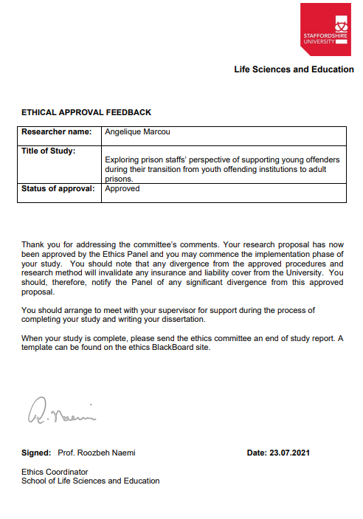

Appendix F –Participant Information sheet

INFORMATION SHEET FOR PARTICIPANTS

Project Title: Exploring prison staffs’ experiences of young offender transitions from youth offending institutions to adult prisons

I would like to invite you to participate in this research project which is part of my Clinical Psychology Doctorate training. Before you decide whether you want to take part, it is important for you to understand why the research is being done and what your participation will involve. Please read the following information carefully, feel free to ask any questions, for more information or if anything is not clear.

What is the purpose of the study?
The research hopes to hear the voice of people who work within a custodial service, to hear their experiences and perspectives of supporting offenders during their transfers from a Youth Offenders Institution to an adult prison. The hope is that with a better understanding of these supporting experiences, the aids and barriers, the findings could go toward informing prison practise and to understand the experiences of transferring prisoners.

Why have I been invited to take part?
As you are a staff member within a prison who has supported offenders during their transition process.

What will happen if I take part?
If you agree to take part, you will be invited to a short interview, this will either be face to face at Staffordshire University, telephone or online video interview depending on social distancing measures and your preference. You will be asked questions around the offender transition journey, your opinion about supporting prisoners during this time. I will ask for your thoughts on that works well and what may make things more difficult. I will also ask questions regarding your job role, your age, gender and ethnicity. I would like you to answer honestly about how you found the experience and any thoughts you had about the process. The interview will last up to 30 minutes at a pace that suits you and we can take short break if needed.
The interview will be audio recorded for the purpose of analysis. The recording will be transcribed and then deleted, leaving only a written transcript of your responses titled with an anonymous code and not your name.

Do I have to take part?
Participation is completely voluntary and if you want to, choosing not to take part will not disadvantage you in anyway.
Once you have read the information sheet, please let the research team know if you have any questions, I can also answer any questions you have on the interview day.
If you decide you would like to take part, please contact the research team and we can discuss the project further and should you still wish to participate I would request that you sign a consent form and return it to the research team via email or post. I will ask for your consent again at the interview meeting and give you a chance to withdraw if you no longer wish to take part.

What are the possible risks of taking part?
These questions are not intended to cause you any stress, however if they do cause you any stress, discomfort or upset, please let the researcher know straight away. We can then pause for a break or even end the interview if you wish. If you feel upset or distressed following the interview, again please let staff know and support from either one of the research team is available as someone to talk to.
Some of things you might say could make you identifiable so I would ask you don’t name yourself, the prison, your wing or the names of any other staff or prisoners, if you do however, I will remove identifiable data when writing up the transcript.

What are the possible benefits of taking part?
By taking part it gives us the chance to understand transfers between secure institutions from a different perspective, learning what is helpful and possibly unhelpful during the transition process in relation to the staff supporting them. The findings from this study could, we hope, positively impact on future transfers by improving the experience of transfers and the wellbeing of staff supporting.

Data handling and confidentiality
The information you provide will remain anonymous and your interview will be given a code rather than using your personal information. As you are aware, as a crown servant you cannot disclose information that has been identified as sensitive by the prison service. Therefore, during the interview to ensure confidentiality, please try not to disclose your name, those of other staff or prisoners.
Your information and the data will only be shared with the research team. The audio recording will be saved on a password protected memory stick, once it is transcribed the audio file will be disposed of and the transcription will be also kept on a separate password protected file. This anonymous data will be kept for 10 years as per policy before being disposed of. Your consent forms and audio recordings will be retained by Staffordshire University.

General Data Protection Statement
Your data will be processed in accordance with the General Data Protection Regulation 2016 (GDPR). The data controller for this project will be Staffordshire University. The university will process your personal data for the purpose of the research outlined above. The legal basis for processing your personal data for research purposes under the GDPR is a ‘task in the public interest’. You can provide your consent for the use of your personal data in this study by completing the consent form that has been provided to you.
You have the right to access information held about you. Your right of access can be exercised in accordance with the GDPR. You also have other rights including rights of correction, erasure, objection, and data portability. Questions, comments and requests about your personal data can also be sent to the Staffordshire University Data Protection Officer. If you wish to lodge a complaint with the Information Commissioner’s Office, please visit www.ico.org.uk.
What if I change my mind about taking part?
You are able to withdraw at any point of the interview, without having to give a reason, we will not retain any information that you have provided us as a part of this study. After the interview day you will have 2 weeks to withdraw from the study, after this time you will not be able to withdraw.

What will happen to the results of the study?
At the end of the study the findings will be published as Doctoral research through Staffordshire University with the hope of being published in peer reviewed journal articles. The anonymised findings will also be shared with all participants.

Who should I contact for further information?
If you have any questions or require more information about this study, please contact any of the research team below and we will answer any questions you may have.

Angelique Marcou
Trainee Clinical Psychologist & Lead researcher
l024074h@student.staffs.ac.uk

Susan Ledwith Dr Michelle Rydon-Grange
Senior Lecturer Prison Clinical Psychologist
Study Supervisor: 01782 294774 Study Supervisor (01902) 533465
Susan.ledwith@staffs.ac.uk Michelle.Rydon.Grange@mpft.nhs.uk

What if I have further questions, or if something goes wrong?
If this study has harmed you in any way or if you wish to make a complaint about the conduct of the study you can contact the study supervisor or the Chair of the Staffordshire University Ethics Committee for further advice and information:

Staffordshire University Ethics Chair: Dr Tim Horne
Research, Innovation and impact services
Cadman building, Satffordshire University
College Road, Stoke on Trent, ST4 2DF
Time.horne@staffs.ac.uk
+441782295722

Thank you for reading this information sheet and for considering taking part in this research.
Appendix G –Participant Consent Form

Project Title: Exploring prison staffs’ experiences of young offender transitions from youth offending institutions to adult prisons

Researcher: Angelique Marcou Initial Box
I have read and understood the Participant Information Sheet for the above study.

I have had time to think and ask questions about the study and have had my questions answered satisfactorily.

I understand that my participation in the study is voluntary, and I can withdraw 2 weeks after the interview, I do not have to give a reason for withdrawing.

I am over 18 years old.

I give permission for my interview to be audio recorded.

I give permission for demographic information to be recorded for analysis purposes

I understand that the anonymised information collected about me will be used in research publications.

I understand anonymised quotes from my interview will be used in the publication

I understand that the anonymised information collected about me will be stored in the University Clinical Psychology archives for up to ten years.
I would like to receive a report of the findings when the study is complete.

I agree to take part in this study.

………………………………………………… ……………………… …………………………………...
(Name of participant) (Date) (Signature)

………………………………………………. ………………………… ………………………………..
(Name of person taking consent) (Date) (Signature)

Appendix H – Audit trail of study design decisions

1. Initially, the researcher discussed their epistemological position with their supervisor and peers. At first, the supervisor thought their position was from a social constructionist position.

2. However, following further reading, discussions and attempts to explain the position, the researcher realised that this position was incorrect. Due to their previous experiences of transition and their intention for research, the researcher recognised their epistemological position was critical realist.

3. Following this the research question was developed and a qualitative approach was decided upon.

4. In regards to Methodology and analysis, both Interpretive Phenomenological Analysis and reflexive thematic analysis (RTA) were considered, the rationale for why RTA was chosen is explained in the main text. However, RTA values the researcher’s experiences in relation to the interpretation of the data.

5. Once RTA was chosen as the analysis, the procedure for gathering the data was finalised, for example completing semi-structured interviews online with prison staff. Who will be recruited through online platforms.

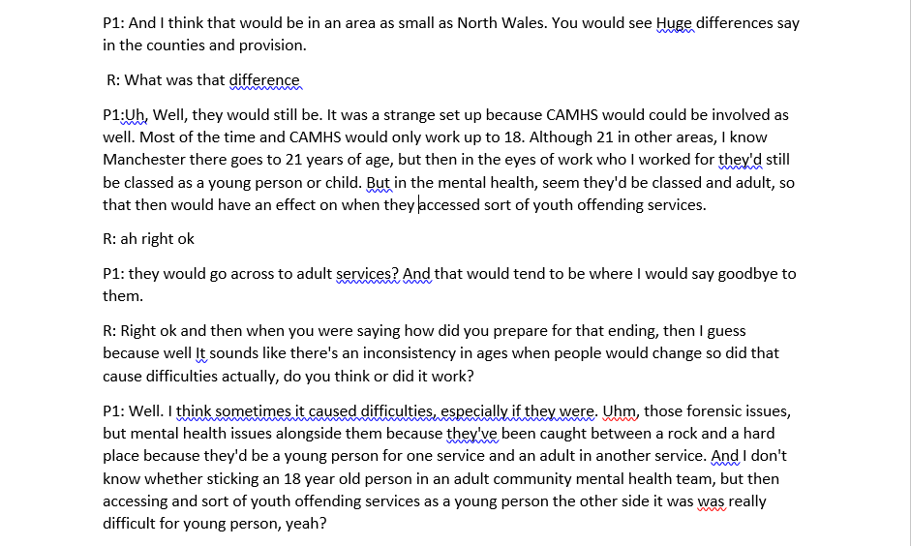

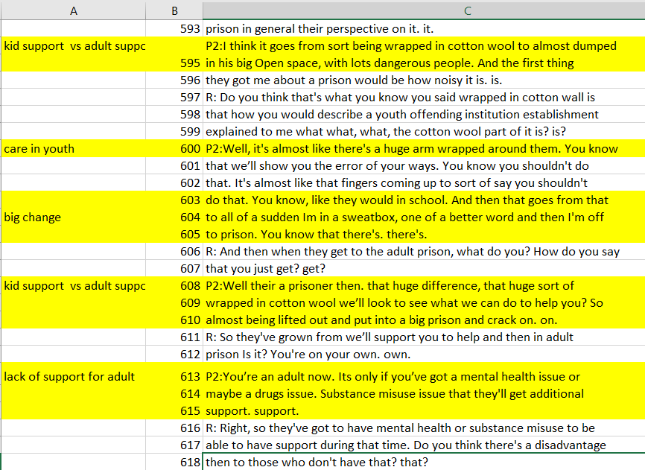
Appendix I – Visual Example of Manual Thematic Analysis process
Example of transcribed participant interview exert
Example of initial coding

Example process of reviewing and revising themes for consistency and clarity including
Example of manual process of grouping codes and developing initial themes
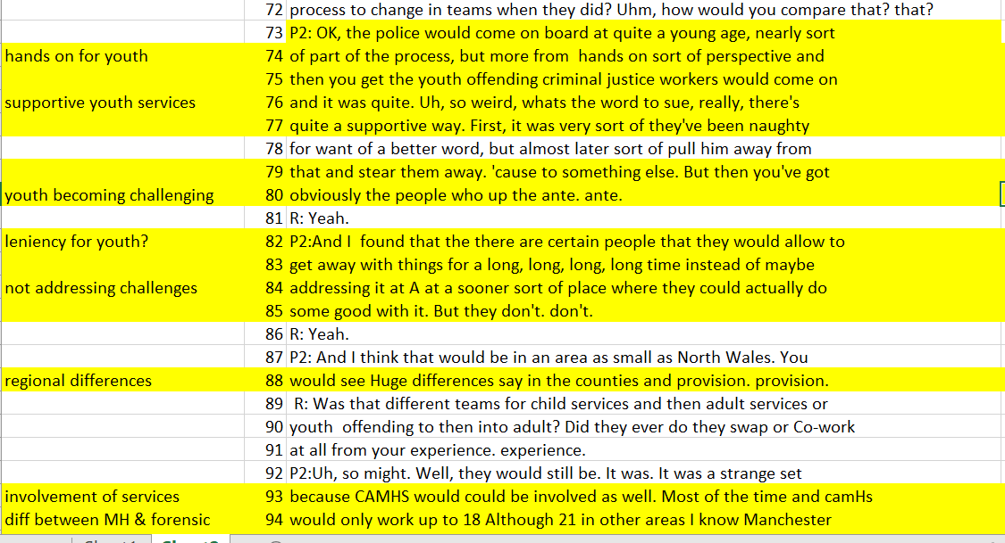
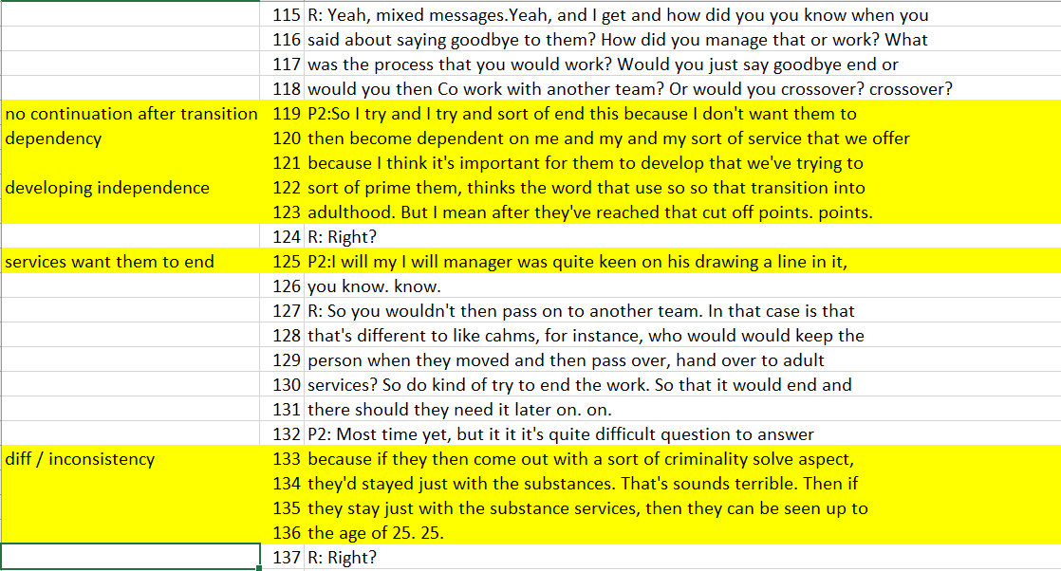
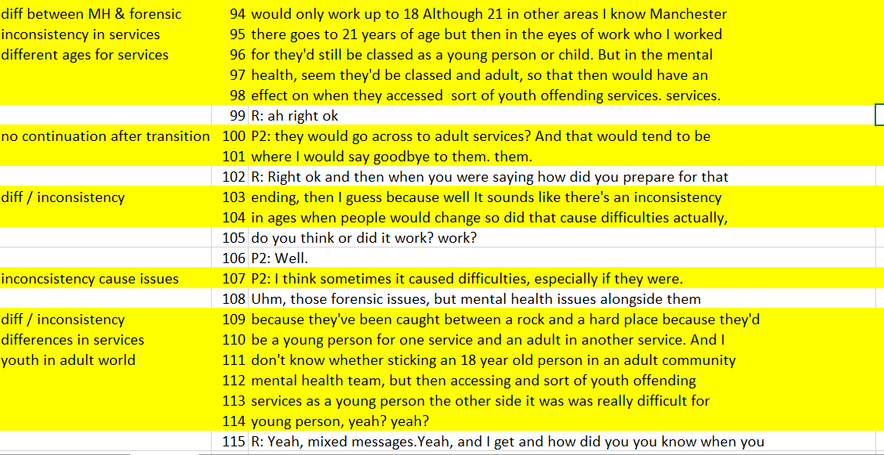
Appendix J – Examples of exerts of data initial coding
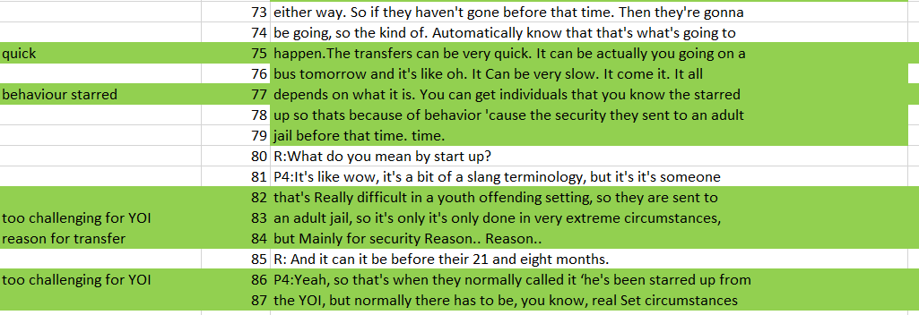
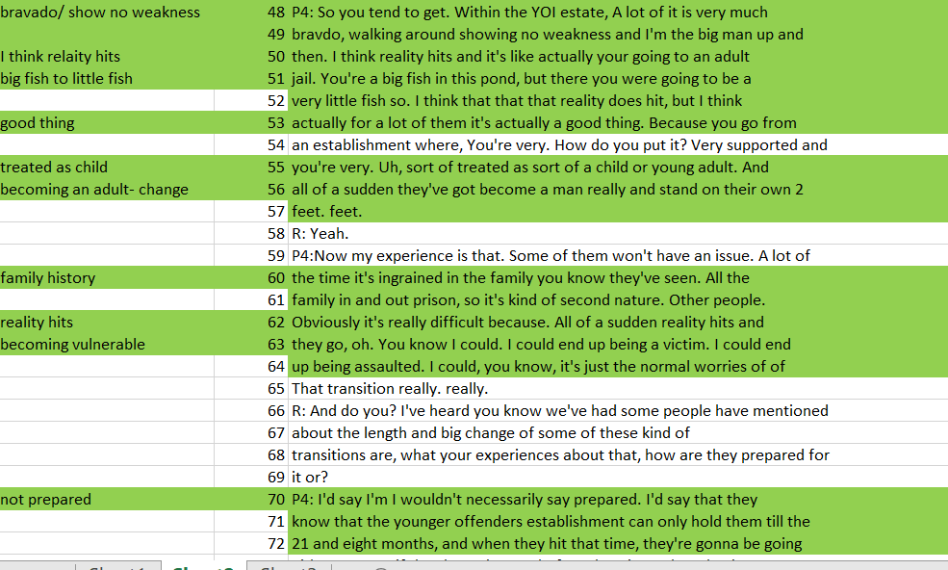
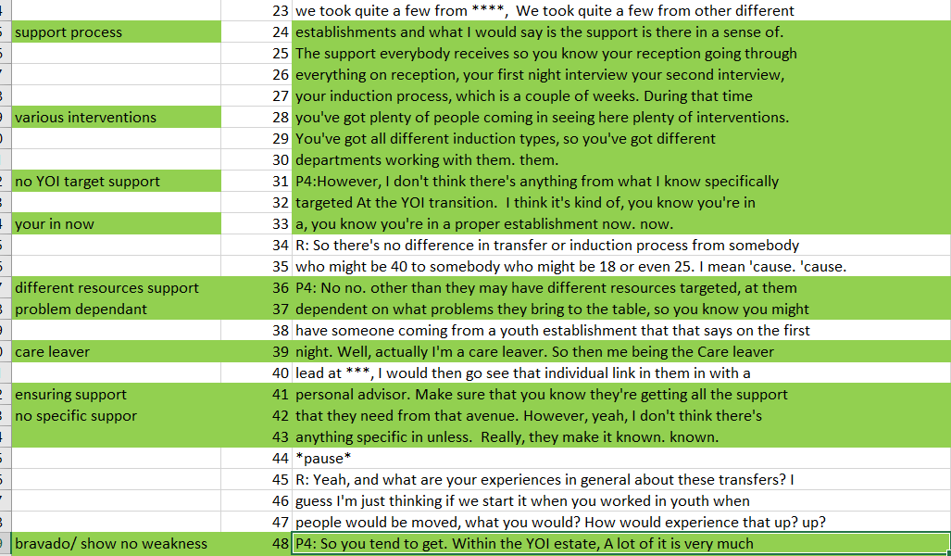
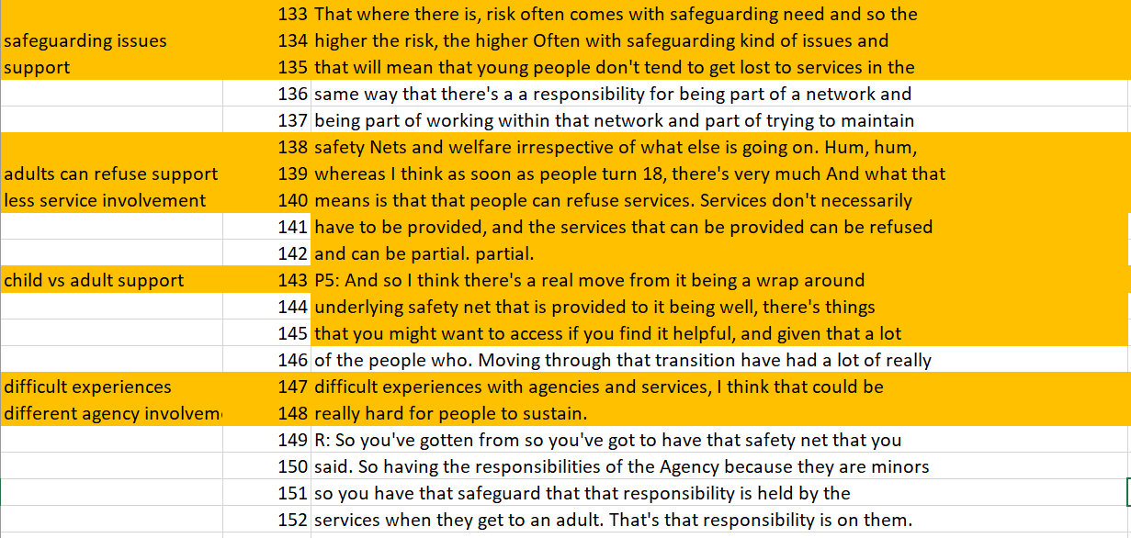
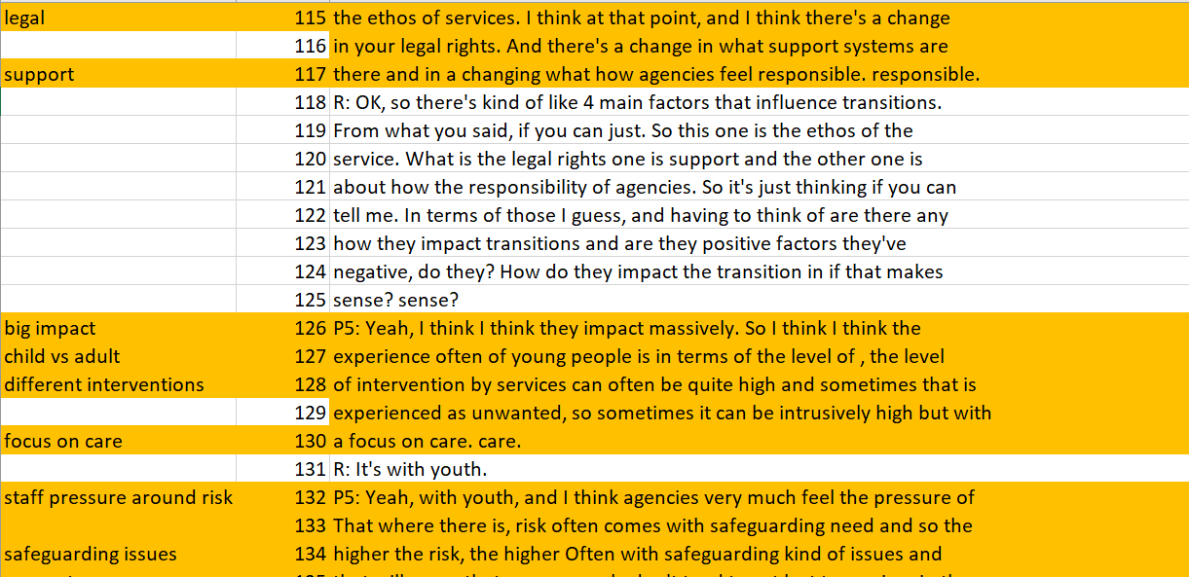
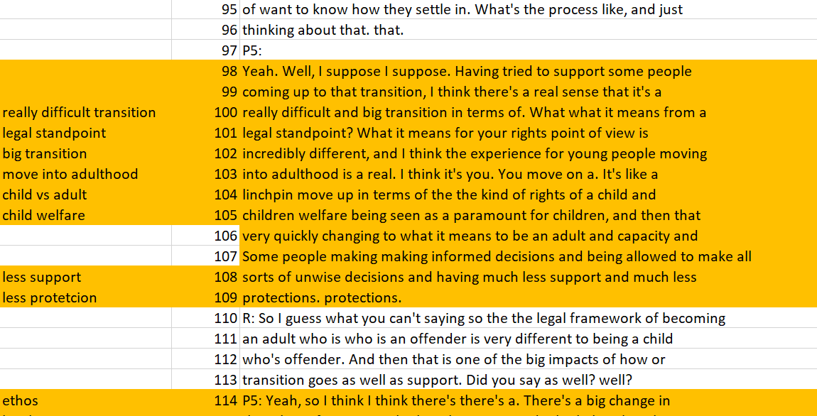

Appendix K – Master Table of themes and subthemes Participant Key: A- Andrew, B- Ben, C-Claire,
D- David, E- Elaine, F-Fran, G- Georgia

Theme | Subthemes | Example quotes | Number of participants supported the theme N/7
Being unprepared |  |  | 7/7
1a. | Lack of prison preparation and planning | “I don’t feel like they’re supported enough […] I don’t think there’s anything from what I know specifically targeted at the YOI transition” – DAVID | 6/7 A, B, D, E, F,G
1b. | “I think it really hits” | “its seen too often as part of prison life so it’s a big shock to your system, so you are gonna struggle.” – BEN | 4/7 A, B, C, D, G
1c. | Concerns about vulnerability | “I think those risks don’t then immediately go when you turn 18 […] risks you may be being exposed to and far less support to intervene”. – ELAINE | 5/7 A, B, C, D, E
1d. | Staff need more support | “I wasn’t gonna really make a difference because I didn't get enough time to spend with people as a personal officer” – FRAN | 6/7 A, B, D, E, F, G
Maturity and independence |  |  | 5/7
2a. | “boy in a man’s body” | he was still to me a boy in a man’s body. He even though he was a grown man in his own right, emotionally he was still 16 years of age.” BEN | 4/7 A, B, C, E
2b. | Big fish to little fish | young kids that will be top dog in in the young offender but they’ll go into an adult establishment and they’ll become nothing”. –CLAIRE | 4/7 A, B, C, G
2c. | Treating children and adults differently | […], very supported and your very sort of treated as a child or young adult and all of a sudden they’ve got to become a man really and stand on their own two feet”. – DAVID | 4/7 B, C, D, E
Inconsistencies |  |  | 5/7
3a | Variations in services | “caught between a rock and a hard place because they'd be a young person for one service and an adult in another service”. – BEN | 5/7 A, B, C, E, F
Relationships and Attachments |  |  | 6/7
4a. | Prisoner / staff relationship | “They [prison staff] are the foundation sometimes for me that can make the remainder of their [young adults] journey in a prison either good or bad” - ANDREW | 4/7 A, B, F, G
4b. | Peer relationships | “there was pros and cons with mixing different ages because there was a lot of obviously maternal figures within the setting who wanted to look out for the younger ones” – FRAN | 3/7 D, F, G
4c. | Family support | “they don’t get time to tell their family where they are where they’ve gone to […]if there’s better family contact, it would improve that transition period” – ANDREW | 5/7 A, B, D, E, G

Paper Three: Executive Summary

“I don't feel like they're supported enough”
– prison staff’s experiences and perceptions of transitions of young adults to adult prisons.

Word count: 2428

Target audience: UK prison staff and managers, services working with young adult prisoners, as well as young adult prisoners.
This summary has been read by members of this audience, feedback was taken to enhance its accessibility to this population.

Key Points:
Findings:
- The results found four themes; ‘Being unprepared’, ‘inconsistencies’, ‘maturity and independence’, ‘relationships and attachments’.
- Staff felt unprepared to support prisoners during transitions because of a lack of clear guidance – they also felt the prisoners were poorly prepared for this big change.
- They experienced inconsistencies, this may have added to an already complex environment and may have been an addition factor as to why staff felt unable to make real changes within the prison system.
- They noted a disconnect between a person’s legal age Vs their maturity and readiness.
- The prison staff shared a sense of compassion and parental concern about prisoners’ vulnerabilities that do not disappear as soon as they turn 18
- Prison staff also empathised with how quick, poorly organised transitions can negatively affect the young adults.

Recommendations:
- Better support for staff as key attachment figures.
- Additional supervision and training on effectively working with young adults, their risks and needs.
- More preparation in place before the transition to ready and resource the staff and prisoners.
- Prisons should welcome prison staff suggestions and involve them in prison procedures or policy improvements.

Study Aim
To explore prison staffs’ experiences and perceptions of prisoner transitions from Youth Offending Institutions (YOIs) to adult prisons.

Rationale
It is difficult to do research in prisons because involving prisoners and prison staff have to be carefully carried out, so that prison procedures and security are upheld, and the research is not exploiting vulnerable people. Much of what we know about young people and transitions have been completed as policy reviews in government documents rather than individual research exploring an issue at a deeper level. They also do not explore transitions from the point of view of the people involved. Due to the important prison-based relationships between prisoners and staff, research where the views of prison staff can be heard, could lead to important recommendations for policy and procedure improvements and more positive outcomes. It is hoped that the findings can make an impact on the prison service.

Background

Young adults in prison

Young adults aged between 18-25 years, account for 15.2% of the UK prison population (Sturge, 2021). The number of young adults in prison is estimated to increase from 3,431 (July 2021) to 5,100 by 2026 (Ministry of Justice, 2021). Due to this likely population increase, rise in custody length and the likelihood of reoffending, some young adults will transition into adult prisons during their sentence.
Sturge, 2021

The Howard League for Penal Reform argue that the term ‘young adults’ should be inclusive of individuals up to the age of 25 years (Emanuel, Mawer and Janes, 2021) due to still maturing emotionally, socially and neurologically beyond the age of 18 (Webster, 2021). However, the criminal justice system can treat young adult offenders as fully mature when this may not be the case (The Parole Bard, 2021).

Transitions
Currently, there is no clear agreement as to when the transition to adult prisons should happen (Fossi, 2006). Young adults can be placed across different types of placements without thinking about their needs (HM Inspectorate of Prisons, 2021), these could be mixed child and young adults or solely adult prisons. Poorly managed moves to adult prison services were reported as one of a number of difficulties young adult offenders face (Prison Reform Trust, 2012). Unstable transitions can worsen any pre-existing mental health difficulties and could lead to poor long-term outcomes for young adult offenders and reoffending (Mercer, 2020).

Prison staff and Prisoner relationship
Researching prisoners’ well-being support and the working relationship with staff is important, because, for some young people, relationships with prison staff may have been the only stable and caring relationships they have had. (Kane, 2008).
If change is abrupt and poorly managed, young people could feel let down or betrayed by the service and staff, potentially leading to them becoming traumatised because of the loss of these stable and positive staff relationships (Kane, 2008).
However, staff training and guidance for working with young adults has been reported as insufficient (MHI prison report, 2006) as well as not having good enough support for staff (Smith, 2000).

Why interview Prison staff?
There is very little research that explores youth offender prison staff views. By listening to the unique thoughts and opinions of these staff members, the smooth running of prison procedures such a transitions could be improved, overall improving prisoner experience and staff wellbeing support.

Methods
7 prison staff were recruited through adverts on Facebook groups, feeds and Instagram. See figure below for details on the recruitment process.

- Online Interviews were audio-recorded, on average they lasted 35 minutes
- The interviews were transcribed and anonymised.
- The transcripts were analysed using a reflexive thematic analysis method, which was seen as the best approach to explore prison staff’s experiences whilst acknowledging the position of the researcher.
Participants
Table 1. Participant Demographics
Pseudonym | Current Job Role | Previous prison experience | Gender | Age
Andrew | Operations manager - Adults | YOI | M | 58
Ben | Psychosocial substance misuse caseload holder - Adults | Youth & young adults 11-25 | M | 51
Claire | Prison general nurse - YOI | Adults | F | 36
David | Prison Custodial manager - Adults | YOI | M | 29
Elaine | Clinical psychologist - Adults | YOI & Mixed prison | F | 48
Fran | Prison officer- n/a | Mixed YOI & Adults | F | 36
Georgia | Prison Custody officer - Adult | n/a | F | 27
During the interviews, the participants were asked about their experiences of young adult transitions from youth services to adult prisons. They were asked about any positive and negative factors that may impact these transitions as well as the support they received as staff helping facilitate these moves.

Analysis
Four core themes were identified as patterns across participants’ experiences;
1. ‘Being unprepared’ 2. ‘Inconsistencies’
3. ‘Maturity and independence’, 4. ‘Relationships and attachments’.

The subthemes that are linked to the four main themes are shown below as the smaller circles colour coded to match the main theme. The lines illustrate possible relationships and links between the themes.

Figure 2. A diagram to illustrate the themes identified and their relationships

Being unprepared

“I don’t feel like they’re supported enough […] I don’t think there’s anything from what I know specifically targeted at the YOI transition” -David.
Subthemes: 1a – lack of prison preparation and planning; 1b – I think it really hits;
1c - Concerns about vulnerability; 1d. Staff need more support

The prison staff experienced feeling unprepared and a sense of not knowing what to expect, which they felt affected both the staff and the prisoners. This supports past research that also claimed that a lack of preparation negatively affects transitions (Livanou, Furtado & Singh, 2017). The prison staff had a shared sense of concern about the possible risks the young adults may be exposed to in moving to an adult prison environment, including other prisoners and less intensive support than in child services.
“I think those risks don’t then immediately go when you turn 18”- Elaine

they are completely different culture, to be fair yeah it’s a massive culture shock” - David

This may have been linked to how the prison staff also felt unsupported and unprepared to adequately support prisoners to reduce any shock or anxiety they may feel when they transition.
“I think they definitely need to do something put more effort into the staff”- Andrew

“He even though he was a grown man in his own right emotionally he was still 16 years of age.”- Ben

Maturity and independence
Subthemes: 2a. “boy in a man’s body”; 2b. Big fish to little fish; 2c. Treating children and adults differently

Prison staff spoke about experiences of working with individuals as they progress through natural life cycle changes, finding their identity as they develop into adulthood and how this impacts their transitions through the criminal justice system. The prison staff experienced a difference between a person’s physical age which influences when they move to adult prison and their perceived age of emotional maturity, acknowledging that their brain is also still developing beyond the age of 18 years.
“ that huge sort of wrapped in cotton wool we’ll look to see what we can do to help you, so almost being lifted out and put into a big prison and crack on”.-Ben

Inconsistencies
Subthemes: 3a. Variations in services

The prison staff discussed the ‘inconsistencies’ they experienced across the various agencies involved during these transitions. These include wider political and legal frameworks such as the legal age of an adult and their rights, which may not match the level of readiness and emotional maturity a person may need when moving to an adult prison. These inconsistencies could add to the challenges of what can already be a complex environment. There was a felt sense that the prison staff are aware that more needs to be done to support the young adults but may feel powerless against the prison process. The perceived lack of influence in the systems they work within to do anything different, appears to have a negative impact on their morale and how they view their ability to support the prisoners.
“NHS staff and the prison staff have a very different outlook shall we say on how to look after the person”- Ben
““just frustration with being told one thing by one person, something completely the opposite by somebody else” - Fran

“they don’t get time to tell their family […]if there’s better family contact, it would improve that transition period” - Andrew

Relationships and Attachment
Subthemes: 4a. Prisoner / staff relationship; 4b. Peer relationships; 4c. Family support

The prison staff recognised the importance and need for a positive rapport to support the prisoners during what can be a difficult time. From the prison staffs’ experience, they perceive peer relationships to be influential in how a young person manages their transition period and overall prison journey. The prison staff spoke about the positive impact of mixing the young adults with older individuals, whilst also noting that this may create a new risk.

“ I think the older staff also helped because it was like them having a father or a mom figure”- Georgia

Overall, there was a feeling of compassion from the prison staff and a sense of parental concern. They acknowledged how there is often less support after the young adults’ transition even though their vulnerabilities do not disappear as soon as they become legal adults. Although they understood the reasons for sometimes needing quick transitions, the prison staff also empathised with how this can negatively affect the young adults. The prison staff acknowledged and perhaps felt disappointment in sometimes not being able to have a proper ending or say goodbye. This may link back to the sense of parental attachment or parental loss from prison staff but without the ability to influence or make changes.

Strengths & Limitations

This study explores the experiences and opinions of prison staff regarding their supporting role and a topic that is not often researched. Although there are only seven participants and may seem small, this number of participants is deemed adequate as it meets the recommendations on sample size, made by Braun and Clarke (2013) regarding doctoral research. Due to the nature of prisons, they need to uphold firm security and confidentiality. However, this may have been one of the challenges during the recruitment process, in that direct access to prisons was not possible and that prison staff may not have felt able to be fully honest in their responses, affecting the study’s overall understanding. Having a longer time for recruitment, could help build staffs’ trust, whilst having face-to-face prison access alongside online methods could benefit recruitment for future studies.

Clinical Implications
This study hears the experiences of the prison staff that are tasked with supporting adults during their transition, therefore this understanding can help improve the experience for both staff and prisoners. This research highlights that poorer transition management, which doesn’t consider the important staff-prisoner relationship, could result in potential trauma due to the loss of these stable and positive staff relationships (Kane, 2008). In turn this could negatively impact on the development of prisoner mental health problems (Richards & Vostanis, 2004) and increase reoffending rates.

Therefore, the following suggestions could be considered;
- Regular supervision or reflective practise spaces could be encouraged more across all the different types of staff that work within the prisons. This could then offer better staff support around the personal impact of their role.
- By recognising and reflecting on some of the challenges of working within the wider prison systems, it can be helpful in managing staffs’ own well-being as well as their relationships with prisoners.
- In order to increase the prison staffs’ sense of empowerment, prison management should welcome their suggestions and involvement in wider prison systems discussions and procedural or policy changes.
- To consider additional training for all members of staff to increase their understanding of the staff-prisoner relationship. They could also focus on the skills and approach needed to work effectively with young adults in relation to their specific needs, attachments, identity, vulnerabilities and care planning.

Conclusion

This study heard the experiences of prison staff regarding prisoners transitioning from youth offending establishments to adult prisons. The prison staff experienced being unprepared to support the prisoners during their transition because of a lack of clear guidance across the different systems, they also felt that prisons poorly prepared the young adults for this change. Being a prison-focused research may have made things more difficult for the study and may have impacted what the participants felt comfortable sharing. However, a better understanding of how people experience transitions can work towards improving services and procedures, overall being better prepared and creating more positive experiences. Future studies should focus on gaining insights of the prisoners who have experienced these transitions.

Dissemination
The findings will be published in an academic journal. The study will also be shared with the prison staff that participated and the charity ‘Transition to Adulthood’ alliance (T2A), a voluntary sector organisation working with young adults in the criminal justice system. It is hoped that the findings will encourage further research into transitions in particular hearing about the experiences of the young adult prisoners. Furthermore, this study as well as future research can contribute to professionals’ knowledge, working towards better supporting the staff who work closely with the young adult prisoners in order to improve the experience of transition for the young adults.

References

Braun, V. and Clarke, V., 2013. Successful qualitative research: A practical guide for beginners. Sage.
Fossi, J., (2006), Young adult male prisoners: A short thematic report. HM Inspectorate of Prisons. Accessed online. 24.01.2021. https://www.justiceinspectorates.gov.uk/hmiprisons/wp-content/uploads/sites/4/2014/06/Young_adult_male_prisoners.pdf
HM Inspectorate of Prisons, (2021). Outcomes for young adults in custody. A thematic review. Accessed online. https://www.justiceinspectorates.gov.uk/hmiprisons/wp-content/uploads/sites/4/2021/01/Young-adults-thematic-final-web-2021.pdf
Kane, S., 2008. Managing the transitions from adolescent psychiatric in-patient care: toolkit. Journal of the Canadian Academy of Child and Adolescent Psychiatry, 27(4), pp.228-235.
Livanou, M.I., Furtado, V. and Singh, S.P., 2017. Mentally disordered young offenders in transition from child and adolescent to adult mental health services across England and Wales. Journal of forensic practice. 19(4), pp.301-308.
Mercer,T., 2020. Young adult men in prison: a case for a dedicated approach. Penal reform international. Accessed online. https://www.penalreform.org/blog/young-adult-men-in-prison-the-case-for/#_ftnref2
Ministry of Justice., 2021. Prison Population Projections 2021 to 2026, England and Wales. Accessed online. https://assets.publishing.service.gov.uk/government/uploads/system/uploads/attachment_data/file/1035682/Prison_Population_Projections_2021_to_2026.pdf
Prison Reform Trust., 2012. Old Enough To Know Better? A briefing on young adults in the criminal justice system in England & Wales. London: Prison Reform Trust. Accessed online. http://www.prisonreformtrust.org.uk/portals/0/documents/oldenoughtoknowbetter.pdf
Richards, M. and Vostanis, P., 2004. Interprofessional perspectives on transitional mental health services for young people aged 16–19 years. Journal of Interprofessional Care, 18(2), pp.115-128.
Smith, C., 2000. ‘Healthy prisons’: a contradiction in terms?. The Howard Journal of Criminal Justice, 39(4), pp.339-353.
Sturge, G. (2021). UK Prison Population Statistics. Houses of Commons Library. Accessed online. https://researchbriefings.files.parliament.uk/documents/SN04334/SN04334.pdf
The Parole Board. 2021. Young Adults member guidance. Accessed online. https://assets.publishing.service.gov.uk/government/uploads/system/uploads/attachment_data/file/1013867/Guidance_on_Young_Adults_V1.0_FINAL_WEB.pdf

