A civic and sustainable 15-minute campus? Universities should embrace the 15-minute city concept to help create vibrant sustainable communities.
Dr Paul Barratt, Senior Lecturer in Human and Environmental Geography, Staffordshire University. P.Barratt@Staffs.ac.uk
Dr Ruth Swetnam, Carbon and Research Manager, Royal Society of Wildlife Trusts. rswetnam@wildlifetrusts.org
This perspective article, based on research conducted at Staffordshire University, looks at the value of applying the 15-minute city concept to city-based university campuses. We argue that attention to the public realm within and beyond university campuses has the potential to reduce carbon emissions, enhance civic engagement and status, and improve the vibrancy and liveability of university cities. In addition to this, the 15-minute approach addresses aspects of poverty and inequality through the relative affordability of sustainable travel and access to affordable good and services. To realise these benefits Universities must focus on three key areas;
- Establishing porous campus boundaries where services and functions can be shared with the local community and vice versa.
- Playing an active role in evaluating and improving the sustainability and liveability of the urban area surrounding the university campus.
- Becoming a travel hub – promoting, enhancing and enabling high quality public transport and active travel networks to reduce reliance on private vehicles.
The 15-minute campus approach marks a distinct change from the idea of a ‘sticky campus’ where the university is seen as an enclosed one-stop resource for staff and students – an environment often set apart and secured from its host city. Our notion of a 15-minute campus is a more civic minded conception that promotes an awareness of what lies both within and beyond the confines of the campus, challenging the definition of what the university is, and who it is for.
Keywords 15-minute cities, cost-of-living, sustainability, civic universities.
Introduction
15-minute cities strive to provide everything that householders need within a few minutes of their homes with the aim of creating vibrant, accessible and sustainable communities (Moreno et al. 2023). They represent a model for sustainable living reducing travel requirements and the multiple environmental issues associated with automobile dependence. However, proximal living initiatives have the potential to provide so much more, including opportunities relating to health, well-being, inequality, and historical and contemporary cost-of-living pressures.
Universities could rightly be perceived as forerunners of the 15-minute model, with sticky one-stop campuses providing totalising environments for students, catering for all the academic, social and practical necessities of student living (Berman et al. 2022). Some city-based universities already seemingly intertwine with the urban fabric of their locales (Hebbert 2018). These universities demonstrate the best elements of mixed used urban planning essential to local living initiatives (TCPA 2021). 15-minute city thinking could help these universities integrate further through civic engagement and represent a step change to those that are not presently embedded in their local communities, enabling them to (re)insert themselves into the locality and realise the multiple interrelated benefits that this can provide (Sangupta et al. 2020). As this perspective paper highlights, this is particularly relevant for post-industrial cities like Stoke-on-Trent, cities which are high on indices of deprivation and are struggling in the wake of the COVID-19 pandemic as well as the challenges wrought and intensified by the current cost of living crisis (Etherington et al. 2022). Disadvantaged people are particularly impacted by this as are students who are “among the 42% of fuel-poor households who suffer from a long-term lack of adequate energy services in the home” (Petrova 2018: 20). As such, the 15-minute campus could help to alleviate student finance challenges around transport, budget shopping and other local services.
The 15-minute city is a model for urban sustainability and resilience which universities could employ as they face the challenge of becoming zero carbon-entities. Engagement with the model could help make university estates work at a higher capacity, reduce transport emissions, promote health and well-being, and help tackle the cost-of-living crisis as experienced by students, staff and local residents (Moreno et al. 2021). This perspective article argues that opportunities exist for all universities to map and evaluate how university campuses blend with the surrounding physical, cultural and socio-economic geographies of their localities, and that a wider awareness and appreciation of 15-minute campuses should become the norm.
Evidence and reflections in this perspective article are presented from research undertaken by staff and students at Staffordshire University, situated within the city of Stoke-on-Trent, UK. This research mapped and evaluated the 15-minute offer in and beyond the University Quarter of Stoke-on-Trent from the student perspective. The civic realm within and surrounding the University was evaluated in terms of services available, well-being, walkability and cyclability. This article summarises the main findings from the project and suggests how other city-based universities could benefit by engaging with 15-minute city thinking.
Re-aligning and re-defining universities through 15-minute thinking
The 15-minute city approach requires universities to redefine their relationship with the area in which they are based. To do this, and for a university to realise the aforementioned benefits of 15-minute living they must focus upon the following three areas.
- Establishing porous campus boundaries where services and functions can be shared with the local community and vice versa.
- Playing an active role in evaluating and improving the sustainability and liveability of the urban area surrounding the university campus.
- Becoming a travel hub - Promoting, enhancing and enabling a high-quality public transport and active travel networks to reduce reliance on private vehicles.
Each of these interrelated elements are discussed in turn below before discussing the methods, findings, reflections and actions, from Staffordshire University’s own application of the 15-minute concept to its campus and locality.
Blurring boundaries
Berman et al. (2022) saw the future of campus design involving the creation of more collaborative third spaces amongst the formal educational spaces of the university. Whilst this trend is evident, we propose going further, by opening-up the university to the city and its inhabitants. We propose the idea of the sticky campus and the third spaces that it encourages are reconceptualised - ‘private’ or ‘quasi-private’ campus spaces could and should be opened up in a more collaborative way, with thought to the wider needs of city dwellers in addition to those of staff and students.
The idea of a 15-minute campus marks a distinct change from notion of the one-stop university, towards a more civic minded conception that promotes an awareness of what lies both within, and beyond, the confines of the campus. However, the blurring of campus boundaries may provide a challenge to traditional university estate conventions, particularly those around campus security and access to facilities. There is a need to rethink universities for civic and sustainability purposes and 15-minute thinking is an ideal holistic community centred perspective to do this from. Those wishing to adopt what Gratton and Jones (2023) term a ‘more than civic’ role in their cities and regions must resolve these operational challenges. For Gratton (2020) this involves embedding civic engagement into the strategic vision and operation of the university.
Evaluating and promoting the area
Taking the blurred boundaries of the campus as read, universities should engage in evaluating and mapping what the university and the wider area both offer and lack. This includes the ranges of service provision across the 15-minute area as well as other urban features such as parks and greenway sites for leisure, recreation and urban-well-being (see section 3.10 TCPA 2021). Once the features are mapped and evaluated a vision can be established for the area that plays to its strengths. Then a strategy can be devised which mitigates problems and makes local living happen. Guidance around the principle for success of such schemes are provided from case studies and policy guidance documents (see TCPA 2021).
People tend to have a mental map of their hometowns or cities, developed through experience, exploration and local knowledge – for those attending university in an unfamiliar place that type of place based knowledge can be hard to acquire especially for international students (Oh, Butler and Lee 2014). Students can progress through a three-year degree programme without obtaining a knowledge of the city far beyond the campus boundary. There is also a tendency for student to ‘self-segregate’ from non-student populations (Holton 2015). Universities have a responsibility to help fill these spatial knowledge gaps and reduce cultural divides to make students aware of what is on offer down the road and around the corner. In doing this they can improve the vitality, vibrancy and sustainability of both the university and the wider city in which it is situated.
Becoming a sustainable travel hub
Accessible active and public travel infrastructure has the power to challenge spatial manifestations of non-inclusiveness (Pozoukidou and Chatziyiannaki 2021). Active travel is the cornerstone for carbon net-zero strategies and one that is challenging for universities regarding staff and student commuting (Brand et al 2021). Active travel is an accessible and cost-effective means of urban transit, is can also be a vehicle for relieving health inequalities with walking and cycling highly beneficial to disadvantaged people (Sustrans 2008). For 15-minute living to be achievable there needs to be high quality civic spaces for transit that are accessible, safe and direct (Abdelfattah et al. 2022). Through mapping and evaluation of the active travel network infrastructure gaps in provision, connectivity issues, accessibility issues and safety concerns are highlighted (see for example TFL 2020). To facilitate progress universities must work with local councils and pressure groups to lobby for change and an enhancement of current provision.
Staffordshire University’s 15-minute campus project
The idea for Staffordshire University’s 15-minute campus project emerged as the UK was in its second pandemic lockdown. Local living had become the norm in an attempt to stall the spread of COVID-19. People had become attuned to their immediate surroundings often discovering places within minutes of on their doorsteps that they had never seen or appreciated before. The pandemic altered our narrative for living and studying providing a disruptive moment in which to act with added impetus and insight - a springboard for 15-minute neighbourhoods to emerge (Pozoukidou and Chatziyiannaki 2021).
Staffordshire University is based within the Shelton area of Stoke-on-Trent, a polycentric city made up of six interconnected towns. The structure of the city lends itself well to the 15-minute city model with functions replicated across the polycentric urban nodes. In the past this replication has been regarded problematic, however, with the help of academics and local advocates the City Council are beginning to appreciate that engaging with the 15-minute city concept could be a vehicle for reimaging and revitalising the city. Areas of Stoke-on-Trent rank high on deprivation indices and have issues of air-pollution and traffic congestion partly due to its polycentric layout, features that incentivise the application sustainable city living techniques. Staffordshire University recognises its important role in regard to these issues and is advocating a ‘more-than-civic’ approach to aid in the (re)development of the city and wider regions (Gratton & Jones 2023) with recognition of deeply embedded inequalities that the political narrative of ‘levelling-up’ has so far failed to address (Hudson 2022).
Mapping and evaluating the 15-minute campus
The are multiple ways to map a university using digitall data Datashine (datashine.org) is one such tool which maps detailed census data into a spatial format (datashine.org). However, there is no getting away from the fact that cities are experienced by people as tangible embodied experiences, shaping where we go and how we interact with the places which we inhabit in the course of our daily lives (Nast and Pile 1998). Therefore, the mapping and evaluation of Staffordshire University’s 15-minute campus focused on the perspective of students and involved walking and cycling as participatory research (O’Neil and Roberts 2019). An undergraduate team, recruited for the duration of the project, evaluated walking and cycling facilities and infrastructure from the heart of the campus to its 15-minute perimeter. Ten cycle and walking routes were traversed, photographed, mapped and scored – warts and all! Figures one and two illustrate the 15-minute areas for cycling and walking respectively.
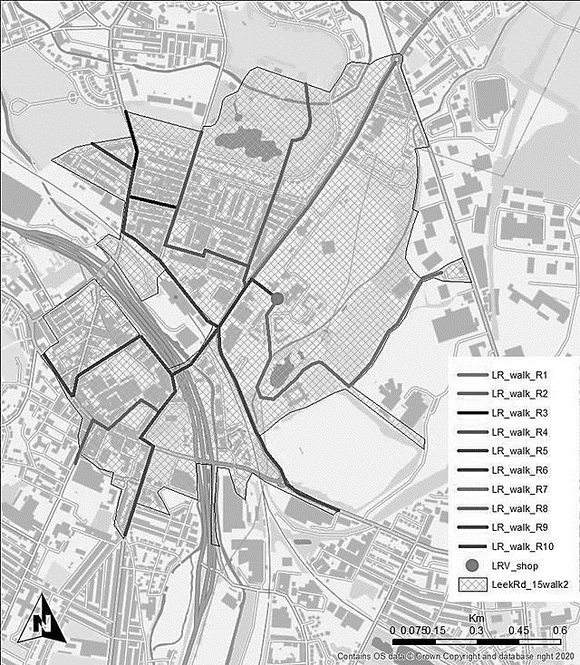
Figure 1. Staffordshire University 15-Minute walkability map (Source Barratt et al. 2022)

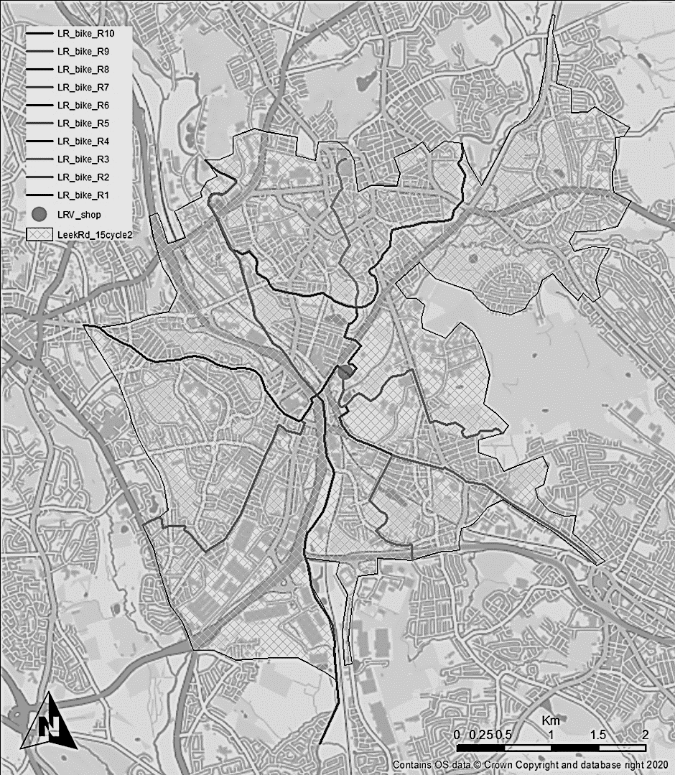
Figure 2. Staffordshire University 15-minute cyclability map (Source Barratt et al. 2022)
Each route was also scored using an adapted version of Transport for London’s Pedestrian Network Design Principles, from their ‘Planning for Walking Toolkit’ (Transport for London 2020) The design principle was developed to give planners and policy makers a strong steer on what needs to be done to improve routes and increase pedestrian (and for this project cyclist) footfall. We found the criteria worked well to articulate what a route does well or less well.
Pedestrian/Cyclist Network Design Principles
- Safe – The public realm should be safe to use at all times of day and for people to feel safe to spend time in.
- Inclusive – All walking (and cycling) environments should adhere to the principles of inclusive design by ensuring that they are accessible to, and usable by, as many people as reasonably possible without the need for special adaption or specialised design.
- Comfortable – Designated walking/cycling areas should allow unhindered movement by providing sufficient space.
- Direct – Facilities should be positioned to provide convenient links between major walking/cycling trip attractions.
- Legible - Features should be consistent and easy to understand for all pedestrians/cyclists to know intuitively how to navigate within a space.
- Connected – Walking/cycling networks should have a high density of route options to suit pedestrians’/cyclists’ needs.
- Attractive – Walking/cycling environments should be inviting for pedestirans/cyclists to pass through or spend time in.
(Source adapted from TFL Walking Toolkit 2020)
The mixed methodology produced a student-centred warts-and-all account of the 15-minute campus area. The qualitative and quantitative data produced from the methodology was in the form of photos, narrative descriptions, scoring and mapping. A detailed account of the methodology, results and outcomes of the project including are range of maps and analysis are available in the project report (see Barratt et al. 2022).

15-minute campus outcomes
The 15-minute campus project highlighted positive aspects about how the campus connects to and is serviced by the surrounding city, as well as opportunities. Walkability and cyclability were both good, although awareness of the infrastructure that facilitates this and what could be found beyond the campus was less good. Issues such as secure cycle parking and the legibility and connectivity of the cycling infrastructure was flagged up and has subsequently fed directly into consultation on the City Council’s 2023 Transport Strategy.
Findings from the report were shared via emails, meetings and through Stoke-on-Trent’s Collaborative Network. This is a community of organisations and individuals from the public sector, private sector and third sector who, collectively, have a passion for delivering systems and services differently to better serve the communities of Stoke-on-Trent and North Staffordshire. The research was presented internally to Staffordshire University’s Sustainability Reporting Group headed up by the University’s Chief Financial Officer. Likewise, issues with safety and security on more isolated routes around the university have been directed to the police commissioner to prioritise spending in the area surrounding the university.
The project has provided the university and other city stakeholders with some valuable baseline data from a city dwellers perspective. It has stimulated wider discussions and action within and beyond the university. Some changes require awareness raising whilst others will rely on behaviour and culture change as well as city wide policy and planning responses.
The project team firmly believe that 15-minute thinking is an essential tool for university sustainability and city regeneration in and beyond educational settings. As a bottom-up approach, it allows the priorities of the student voice to be articulated clearly. At the institutional level it has led to the establishment of a ‘bike users group’ and investment in on campus cycling infrastructure and facilities. Whilst beyond the campus it is feeding into wider public transport and active travel plans for the city – including enhancing the connectivity of the present network, pedestrianised zones and low-traffic areas surrounding the campus.
The Student Union (NUS) at Staffordshire University has also engaged with the project and its civic agenda to promote community cohesion, pride and responsibility and is organising student clean-ups and litter picks around in the Shelton. Whilst the police are using the information to improve safety and security – a particular challenge that needs to be tackled regarding the gendered profile of active travel participation (Loukaitou-Sideris 2020). Steps are heading in the right direction but the emissions from transport remain a greater challenge for the university and city, once the insights from our report begin to permeate local policy alongside the impetus of national carbon reduction commitment, we believe there will be enhanced participation in active travel and public transport use leading to a reduction in private car use in the area.
What can other universities learn from Staffordshire University’s 15-minute campus project?
Reflecting on the success of the project and returning to our three interrelated elements of 15-minute campus thinking, we believe that other universities and large organisations can learn from our experience, and benefit from our approach.
- Establishing a porous campus boundary where services and functions can be shared with the local community and vice versa.
To fully embrace the 15-minute city concept and its potential, universities need their boundaries to become more permeable, from the inside out, but also importantly from the outside in. Away from campus street audits to map and raise awareness of local shops, services and resources give a wider range of choices and empower students to make better use of the city. It is important to think from the perspective of students and include greenspaces as well as other urban well-being features. Similarly, institutions need to question whether the services align to the needs of students and local residents, if not consider whether the university needs to add to this service offer or support relevant business start-ups in the area.
It is also important to consider how the university can intensify the use of the campus and its buildings beyond traditional teaching hours – this could include gymnasiums, sports fields, cafeterias alongside teaching spaces. The university may want to consider hosting other activities and community groups maximising usage balanced against increased resource use from heating and lighting. Reflecting wider societal concerns some areas of the campus could become designated warm spaces, a repose for those under pressure from the cost-of-living crisis.
- Play and active role in evaluating and improving the sustainability and liveability of the campus and the area surrounding the university.
We believe it is critical to promote sustainable student living on and beyond the campus. Research illustrates that high density neighbourhoods tend to be responsible for fewer GHG emissions than those in more rural or sprawling communities (Lehmann 2016). This is because residents in these areas will typically drive less far as study, jobs and services are located nearby making transit on foot, bike or public transport more appealing. High density student halls on campus with small rooms and communal facilities and heating systems could be a model of sustainability through the development of zero-carbon student halls.
Beyond the campus Universities should work with student landlords to improve the sustainability credentials of student housing. Energy efficiency, renewable energy sources, secure cycle storage at all properties where practical should be a minimum commitment in return for accreditation and access for rental clients.
Taking the civic role further, training could be provided relating to sustainability and low-carbon living. Environmental and Carbon Literacy training is one example where engagement with the learning materials can both mitigate climate change, help with cost-of-living and empower local communities enhancing social capacity and cohesion (Fifield 2020).
- Embedding themselves within a network of high-quality public and active travel networks to reduce reliance on private vehicles.
City traffic systems are often discriminatory to those who do not want to drive (Attard 2021) making it problematic to encourage sustainable transport despite the clear cost savings, and benefits to the health and well-being of staff and students. Staff and student travel surveys are a vital pathway for understanding commuting. They indicate travel mode and distance as well as gauging opinion as to why more sustainable forms of transit are not used.
As a first stage, it is key to map and evaluate existing active routes from the user perspective rather than relying upon maps and other data sources. Promoting awareness of active travel infrastructure amongst campus users and how it links to local services and attractions is essential. In tandem with this, the university should examine local public transport routes to ensure frequency and directness of services. If not in the proximity of the rail network for example, ensuring connectivity between different public transport types should be a goal. As anchor economic institutions in cities, universities can then lobby to improve these services both for their own constituents but also for their neighbourhoods.
Finally, it is important to engage with the civic authorities – actively seeking opportunities to present these findings to local transport planning teams and to lobby for change and interventions. Low traffic neighbourhoods, rapid transit bus routes, park-and-ride to reduce congestion, as well as vehicle emissions and pollution are all options that should be explored.
These are some of the steps that are now being undertaken or considered by Staffordshire University. Actions and proposals that are enhanced by a deeper understanding and consideration of the university as an integral part of a its wider community – a 15-minute campus. This approach can and should be part of a strategic visions for all universities as they consider campus developments in relation to a broader more engaged civic role and responsibility.
Conclusion 15-minute campuses of sustainable civic universities.
There is no doubt that universities face multiple challenges around inclusivity and the environment and are turning attention to their civic role in place leadership to address this (Liddle et al. 2022; Gratton and Jones 2023). The cost-of-living crisis is exacerbating existing problems for disadvantaged communities (Etherington et al. 2022; Fellows 2022). Student finance, debt and anxiety problems are making in part-time work a necessity and often this has a negative effect on attainment and wellbeing (Callender 2008; Thompson and Ivinson 2020). With an increased recognition of these challenges we believe that a serious engagement with proximal living initiatives will allow universities to begin to tackle these issues with bottom-up experiential data.
Drawing on the mantra ‘what gets measured gets managed’ our experience demonstrates that applying 15-minute thinking allows deeper consideration of the University’s role in local regeneration, sustainability, social cohesion, liveability and inclusion. Even if a university is well embedded in an area, improvements can be made, and questions should be asked about the quality of civic linkages, the level of engagement and inclusivity. 15-minute thinking, informed from the bottom-up through the student, staff and community voice, should form a integral element of all universities’ strategic thinking and development plans. New buildings and spaces should be considered from a community perspective – questioning what benefits they bring to the city and community as well as for the institution.
It is time for British universities to up their civic game through their own investments and strategies alongside using their sway to influence local planning and policy interventions to make liveable and sustainable university cities a reality (Sengupta et al. 2020). For this ‘more-than-civic’ shift to occur there needs to be change in how we define what universities are and who universities are for (Gratton and Jones 2023) – and as universities mitigate climate change, they can also mitigate against poverty and exclusion amongst the student body and wider community in which they are located and who they serve.
Acknowledgements
Thanks go to the student researchers employed to undertake various activities in relation to this topic to ensure that the student voice was heard loud and clearly. Thanks also to Human Nature Escapes CIC who worked with us to train students to identify the multitude of urban well-being resources within our 15-minute campus area, and to our informal steering group members who helped focus the research during its early stages.
References
Abdelfattah L, Deponte D, and Fossa D (2022) The 15-minute city: interpreting the model to bring out urban resiliencies, Transportation Research Procedia, Volume 60, Pages 330-337, ISSN 2352-1465, https://doi.org/10.1016/j.trpro.2021.12.043.
Attard M, Cañas C and Maas S (2021) Determinants for walking and cycling to a university campus: insights from a participatory Active Travel workshop in Malta, Transportation Research Procedia, Volume 52, Pages 501-508, ISSN 2352-1465, https://doi.org/10.1016/j.trpro.2021.01.059.
Barratt P, Banks A, Causer A, Legge L, Tunney A, and Swetnam R (2022) The 15 Minute Campus. Final Report to Staffordshire University Sustainability Challenge Fund. Geography, Staffordshire University.
Berman M, Mehta D and Matsuo A (2022) The sticky campus in Japan: re-evaluating campus spaces, Globalisation, Societies and Education, DOI: 10.1080/14767724.2022.2121689
Brand C, Götschi T, Dons E, Gerike R, Anaya-Boig E, Avila-Palencia I, Nazelle A, Gascon, Gaupp-Berghausen M, Iacorossi F, Kahlmeier S, Panis L, Racioppi F, Rojas-Rueda D, Standaert A, Stigell E, Sulikova S, Wegener S and Nieuwenhuijsen M (2021) The climate change mitigation impacts of active travel: Evidence from a longitudinal panel study in seven European cities, Global Environmental Change, Volume 67, 102224, ISSN 0959-3780, https://doi.org/10.1016/j.gloenvcha.2021.102224
Callender C (2008) The impact of term‐time employment on higher education students’ academic attainment and achievement, Journal of Education Policy, 23:4, 359-377, DOI: 10.1080/02680930801924490
Etherington D, Telford L, Jones M, Harris S, and Hubbard S (2022) The Pending Poverty Catastrophe in Stoke on Trent: How benefit cuts and the cost of living crisis impacts on the poor. Staffordshire University/Citizens Advice Staffordshire North and Stoke on Trent. Available at: https://eprints.staffs.ac.uk/7270/3/The_Pending_Poverty_Catastrophe_in_Stoke-on-Trent.pdf
Fifield S (2020) The urban politics of greenspace: exploring community empowerment for greenspace aspirations, justice and resilience. A participatory action research project in Glasgow (Doctoral dissertation, University of Glasgow).
Gratton N (2020) "From Engagement to Strategy: The Journey Towards a Civic University", Sengupta E, Blessinger, and Mahoney C (Ed.) University–Community Partnerships for Promoting Social Responsibility in Higher Education (Innovations in Higher Education Teaching and Learning, Vol. 23), Emerald Publishing Limited, Bingley, pp. 105-120. https://doi.org/10.1108/S2055-364120200000023008
Gratton N and Jones M (2023) More-Than-Civic: Higher Education and Civil Society in Post-Industrial Localities. In: Dobson J and Ferrari E, (eds) Reframing the Civic University. Rethinking University-Community Policy Connections. Palgrave Macmillan, Cham. https://doi.org/10.1007/978-3-031-17686-9_7
Hebbert M (2018) The campus and the city: a design revolution explained, Journal of Urban Design, 23:6, 883-897, DOI: 10.1080/13574809.2018.1518710
Holton M (2015) ‘I Already Know the City, I Don’t Have to Explore it’: Adjustments to ‘Sense of Place’ for ‘Local’ UK University Students. Space Place, 21: 820– 831. Doi: 10.1002/psp.1866.
Hudson R (2022) ‘Levelling up’ in post-Brexit United Kingdom: Economic realism or political opportunism? Local Economy, 37(1–2), 50–65. https://doi.org/10.1177/02690942221099480
Lehmann S (2016) Sustainable urbanism: towards a framework for quality and optimal density? Fut Cit & Env 2, 8. https://doi.org/10.1186/s40984-016-0021-3
Liddle J and Addidle G D (2022) Two North-East of England Case Studies—Northumbria and Teesside. The Role of Universities and HEIs in the Vulnerability Agenda, pp.77-95.
Loukaitou-Sideris A (2020) A gendered view of mobility and transport: Next steps and future directions. In Engendering Cities (pp. 19-37). Routledge.
Moreno C, Allam Z, Chabaud, D, Gall C, Pratlong F, (2021) Introducing the “15-Minute City”: Sustainability, Resilience and Place Identity in Future Post-Pandemic Cities. Smart Cities. 4, 93-111. https://doi.org/10.3390/smartcities4010006
Nast H J and Pile S eds., 1998. Places through the body. Psychology Press.
Oh C Y, Butler BS and Lee M (2014) Information behavior of international students settling in an unfamiliar geo-spatial environment. Proc. Am. Soc. Info. Sci. Tech., 51: 1-11. https://doi.org/10.1002/meet.2014.14505101068
O'Neill M and Roberts B (2019) Walking methods: Research on the move. Routledge.
Petrova S (1018) Encountering energy precarity: geographies of fuel poverty among young adults in the UK. Trans Inst Br Geogr. 43: 17– 30. https://doi.org/10.1111/tran.12196
Pozoukidou G and Chatziyiannaki Z (2021) 15-Minute City: Decomposing the New Urban Planning Eutopia. Sustainability 13(2), 928.
Sengupta E, Blessinger P and Mahoney C (2020) "Introduction to Civil Society and Social Responsibility in Higher: International Perspectives on University–Community Partnerships", Sengupta E, Blessinger P and Mahoney C (Ed.) University–Community Partnerships for Promoting Social Responsibility in Higher Education (Innovations in Higher Education Teaching and Learning, Vol. 23), Emerald Publishing Limited, Bingley, pp. 3-14. https://doi.org/10.1108/S2055-364120200000023001
Sustrans. (2008) Active travel and health inequalities. How walking and cycling can benefit the health of the most disadvantaged people. https://backend.orlis.difu.de/server/api/core/bitstreams/74d458ee-0c00-43b7-b3bc-5a966bbc00de/content
Thompson I and Ivinson G ed. (2020) Poverty in education across the UK: A comparative analysis of policy and place. Policy Press.
Town and Country Planning Association (TCPA) (2021) 20-Minute Neighbourhoods – Creating Healthier, Active, Prosperous Communities: An Introduction for Council Planners in England https://tcpa.org.uk/wp-content/uploads/2021/11/final_20mnguide-compressed.pdf
Transport for London (2020) The planning for walking toolkit https://content.tfl.gov.uk/the-planning-for-walking-toolkit.pdf

