More-Than-Civic:

Higher Education and Civil Society in Post-Industrial Localities

Nicola Gratton
Staffordshire University
n.gratton@staffs.ac.uk

&

Martin Jones
Staffordshire University
martin.jones@staffs.ac.uk

More-Than-Civic:

Higher Education and Civil Society in Post-Industrial Localities

Introduction
The economic impact of civic universities is often easy to imagine in the mind’s eye and popular discourse—they are frequently large employers of local people, with strategic relationships with local authorities, businesses, business associations, and partnerships. These institutions in turn bring investment through campus developments or research and innovation and, of course, contribute skilled graduates to the local labour market (see Frontier Economics, 2019).
The economic contribution universities make to their civic regions, however, is often much broader than the direct impact measured by jobs created, business relationships, student spend and graduate jobs (Goddard, 2009). In some cities, where wages are low and multiple deprivation is high, studying or working at a university is still out of reach for some local residents. Universities’ positive economic impacts may not be easily felt by people affected by multiple disadvantages.
In this chapter we suggest debates and dialogues on the civic nature of higher education would benefit greatly from reflecting on and examining the wider responsibilities of universities in relation to economic impact. We will reflect on how building strong relationships with civil society and creating a civic strategy based on participatory and asset-based community development principles led our institution – Staffordshire University – to support community action to directly challenge issues of hardship and poverty within its ‘civic region’. We deploy the notion of a ‘civic region’ to capture the networked interventions made by Staffordshire University, primarily the territorially-bounded Stoke-on-Trent region (see below). By bringing into the equation civil society—defined as ‘the sphere in which social movements are active, and where the popular challenges that sustain democracy’s vibrancy are located; […] also the space within which the political power of unequal wealth is wielded’ (Crouch, 2020: 20–21; cf. HM Government, 2018)—we encourage participants in these debates to think about what we would term ‘being more-than-civic’.
The chapter starts with an overview of the economic impacts of universities situated in the context of the civic university narrative. We then introduce a case study of Staffordshire University, exploring how the development of a civic strategy and building partnerships with civil society in the region has ensured an approach to economic prosperity, which provides an obvious economic footprint, but also creates wider opportunities for sustainable change within communities. In concluding, we raise wider implications of these arguments for policy, strategy, and academic exchanges.

The economic impact of universities
Universities are typically well connected to their place. Modern universities are particularly well connected by virtue of having large proportions of their students from the locality. In turn, this contributes directly to the government’s ‘Levelling Up’ agenda (see HM Government, 2022) by providing opportunities to acquire knowledges and skills and also social capital, collectively feeding directly into economic growth, rising productivity, and over time seeking to rebalance regional inequalities (see MillionPlus, 2022). There is evidence, for instance, that ‘increases in university presence’, either through the expansion of higher education and/or capturing this within cities, are positively associated with faster subsequent economic growth (Valero and Van Reneen, 2019: 66). The MillionPlus (2022) report Staying Local to go Far points to the critical economic importance of universities in both larger cities and smaller towns across the UK, through scale of employment, relatively high wages, supply chains and visitor and student spend. A report by Frontier Economics for Universities UK (2021) estimated that the higher education sector in England directly employs 360,000 people and supports an additional 455,000 jobs within universities’ localities, generating above £95 billion of gross output to the economy each year. There is the important question though of how much of this output lands and stays in local areas.

Universities build human capital by generating skills, knowledge and competencies, through teaching and learning, and research, enterprise and innovation partnerships within their region, producing skilled graduates for the local labour market (Valero and Van Reenen, 2019) and driving up skills more broadly in their geographical areas. Place-based civic universities with close ties to local business and institutions can be more responsive to, and faster to address, the labour needs of their localities than traditional universities (MillionPlus, 2022). Universities also contribute to the physical capital of a place through campus developments. Where developments are funded to foster enterprise opportunities, this can have a positive impact on engaging communities and strengthening democratic dialogue at the local level, as well increasing the capacity for local innovation through partnerships between universities and businesses (Valero and Van Reenen, 2019: 54). The social value of universities can also be seen in their support for public sector skills development, widening participation and finding solutions to complex societal challenges.

Understanding the economic contribution of universities to their regions, then, needs to consider all these factors as well as the plurality of their missions and activities. Economic impact ‘straddles different components and missions [which are] hard to fully untangle from one another’ (MillionPlus, 2022: 17). MillionPlus further attempts to map out the relationship between economic and social value of higher education institutions. It identified a number of partners, including local small and medium sized enterprises (SMEs), larger businesses, local councils, NHS trusts, schools and multi-academy trusts and FE Colleges. Economic and social impacts emerge from relationships with all stakeholders, although there is a tendency to minimise this potential by assuming relationships with one partner will result in only one type of impact, for example, economic impact from work in partnership with SMEs (ibid, 2022). The counter-narrative to this is that in helping SMEs with innovation, while levering procurement with companies to ensure social value (environmental standards, local labour, etc.), helps to provide the conditions for a more virtuous economic development environment.

Universities’ social capital contributions to their regions are often overlooked, though, in measuring the value of universities to their place, possibly because it is difficult to measure them accurately. This is despite increased emphasis on the civic impact of universities in recent years. The Truly Civic report (UPP Foundation, 2019) raised several important questions. The first asked whether the public were aware of the impact their local university had in their place, and whether they felt ownership or pride in their local university. The second asked how responsive institutions were to the needs of the place. The third was whether there were strategic internal and external approaches and visions for the institution’s civic agenda. Finally, the report asked whether universities were able to achieve and measure the impact of their civic work. It challenged higher education institutions to think more strategically and holistically about their economic impact, calling on them to negotiate ‘Civic University Agreements’ with local civic partners to ensure activity and impact is mutually beneficial to regions and universities. While, as ‘anchor institutions’ (Goddard et al, 2014), universities will benefit local economies by employing people from the area, there may be less analysis of who is being recruited, to what types of role, and which grades they are being recruited to. As the civic framework outlined in chapter 1 highlights, a civic university needs to address issues of economic inequality and not rest on the fact that it brings income into the region without considering who benefits.

So while universities have demonstrable economic impacts, many of these may not be recognised by those in the greatest financial need, or may remain unrecognised by the communities they serve (UPP Foundation, 2019). With the emphasis often on those outcomes that can be most easily quantified, social impacts can be overlooked in favour of more tangible economic impacts. Focusing on the economic impact of a university in isolation from its social, cultural, environmental or wellbeing impacts not only risks undermining its social value (Brink, 2018) but also risks alienating communities most affected by economic inequalities.

The remainder of this chapter focuses on Staffordshire University, based in Stoke-on-Trent (Staffordshire), which has adopted a holistic place-based approach to the economic prosperity of its locality. The first stage is the development of an approach to civic engagement and impact called ‘Connected Communities’, built on participatory principles in an attempt to span the economic and social value of its interventions. This is a conscious effort to ensure the university’s strategy and intervention projects are formed by people with lived experience of the economic challenges of the region. The second step is to work with and through civil society to build capacity for social and economic transformation.

Stoke-on-Trent’s economic context
The city of Stoke-on-Trent is an important industrial conurbation in the midlands of England with a population of around 260,000 people. The city was created in 1910 as a polycentric city-regional federation of six industrial towns. Its name is taken from Stoke-upon-Trent—the centre of governance and focus of road and rail transport links, with the other towns being Hanley (the commercial centre of the conurbation), Burslem, Tunstall, Longton and Fenton. In recent years, Stoke-on-Trent has been coined ‘Capital of Brexit’ in light of its status as the city with the largest proportion of voters opting for ‘Leave’ in the 2016 referendum (see MacLeod and Jones, 2018). Stoke-on-Trent is a ‘left-behind’ textbook study, where a historical dependency on ceramics and traditional manufacturing industries has led to a cocktail of interlocking social and economic disadvantages. It regularly features in the bottom 10 UK cities for business start-up rates; number of businesses; gross value added per worker; residents with high qualifications; weekly earnings and low property values (see House of Commons, 2020). Job creation remains concentrated in low skill sectors such as logistics and warehousing, though there are exciting ‘Silicon Stoke’ (Stoke-on-Trent City Council, 2021) jobs growth developments around digital skills and the creative economy.

Stoke-on-Trent, then, possesses the characteristics of a deindustrialised ‘low pay low skills’ economy, where the proportion of residents qualified to higher levels is below average, with skill gaps identified by local employers at both higher and basic employability levels. The local authority ranks 14th (out of 317 districts) in the 2019 Indices of Multiple Deprivation, and Stoke-on-Trent North, Central and South constituencies saw child poverty stand at 44.5%, 44.9% and 41% respectively (End Child Poverty Coalition, 2020). There are concentrations of worklessness, particularly among people with disabilities, while youth unemployment is a challenge in some deprived areas. Jobs growth within the local economy is dominated by insecure employment (including zero-hour contracts, underemployment and temporary contract working. Low levels of aspiration compound the challenge, engendered by generational unemployment and the failure of employers and successive governments to invest in skills and training (see Jones, 2019).

Layered over this, local institutional capacity remains hindered by the legacies of local government reorganisation in the 1970s, experimentation with the model of the directly-elected mayor and council manager, the collapse of the traditional working class Labour vote, and the rise of far-right populism. Austerity also cuts deep into this narrative: Stoke is in the top six local authorities in England in terms of spending cuts. Between 2010/11 and 2017/18 the council reduced its influence and spending power in cash terms by £193 million, impacting on public sector contributions to growth. Leadership and collaboration often depend on the external imposition of formal requirements for partnership working by central government or, in the past, the European Union. Where external frameworks are absent, a ‘parochial localism’, due in part to the polycentric nature of the urban morphology, tends to prevail, hampering partnership working across the city (Griggs et al, 2020: 16).

At the time of writing (July 2022), the UK faces increasing inflation and rising food and fuel prices, with around three quarters of the population worried about the cost of living. Adults living with a dependant child, people aged 30 to 49, people with disabilities and women feel most concerned about their financial futures (see Office for National Statistics, 2022; Etherington et al., 2022). Staffordshire University’s main campus is in Stoke-on-Trent, with smaller campuses in Stafford, Lichfield, and London. The Covid 19 pandemic of 2020, removal of universal credit uplift and global and domestic factors affecting food and fuel costs have only exacerbated the situation for Stoke-on-Trent residents. During the pandemic one third of the working age population claimed Universal Credit and legacy benefits (Etherington et al., 2020), with the impact evident in enquiries to Citizens Advice, which saw increased demand since 2020 for services such as advice on debt, benefits and tax credits and financial services (Etherington et al., 2021). Over 17,000 people in the city received food aid between 2020 and 2021, with one charity alone seeing a 500% increase in food aid between 2018 and 2021 (see Etherington, 2021).

The Staffordshire University approach to civic impact
Staffordshire University has a long history of civic engagement and impact. In 2019, it worked with independent consultants to assess its economic impact. It was found to be a significant economic driver in its local area, supporting 2750 full-time equivalent jobs and contributing £120 million gross value added to Stoke on Trent and Staffordshire in 2019 (Hatch Regeneris, 2020). Around £11.5 million was spent on local suppliers in 2018-19 and 72% of graduates were employed in the Staffordshire region. The report indicated that beyond employment, suppliers and attracting students and visitors to the area, the university’s commitment to social mobility, skills attainment, research, innovation and enterprise as a local community asset contribute to its economic footprint.

It was relatively easy to identify the economic impacts of being a significant regional employer, recruiting high numbers of local and commuter students, developing graduates’ skills to meet industry needs and developing strong strategic relationships with local employers, and to attribute these to specific areas of university activity. While the economic impact report (Hatch Regeneris, 2020) drew on several areas of work with clear social impacts, these were generally presented as isolated case studies, which stood starkly against the quantifiable numbers, charts and infographics of the economic impacts presented. Therefore, while conducting an economic impact assessment was helpful to understand some areas of impact across Stoke-on-Trent and Staffordshire, it also raised a series of questions for the institution.

Firstly, the logistical effort required to gather the data for the assessment was extensive, as much of the activity was uncoordinated and data gathering was inconsistent, particularly in relation to the role of community engagement in civic impact. It highlighted a lack of focus on ‘civic work’; there was a danger that ‘civic’ was becoming synonymous with everything Staffordshire University did. The broad and disparate activity associated with civic was confusing for staff, with many unable to pin down the specificities of what civic meant for them, particularly when limited to large-scale local government institutions. Furthermore, reporting on some areas of civic activity was clear, while others had no clear reporting process, making a full and meaningful assessment of civic impact difficult. The report implied a distinction between community and civic engagement and more formal business and civic sector partners with clear, measurable economic implications. This not only made coordination of our broad civic work challenging but also devalued the social impact of the institution to the communities it serves. As one of the universities committed to developing a Civic University Agreement, coherence, coordination and accessibility were essential to lay a clearer foundation for Staffordshire University’s civic mission.

The separation of economic and social activities and impacts was concerning. While Staffordshire University clearly had an economic impact in its civic region it was unclear how much local communities, especially those most affected by financial challenges within the city, were engaged in or benefiting from the work. The questions raised by the economic impact assessment process, therefore, resulted an in extended period of reflection prior to developing a negotiated Civic University Agreement with civic partners. Clarification was needed to support staff engagement with a university-wide approach to civic impact, and to enable external partners to navigate university systems and processes smoothly. Work was also needed to align and coordinate activity that produced both economic and social value, and to assess how impact that was less easily measured contributed to the wider picture of civic impact through collaborative work with Staffordshire University. As a result, the university set out a clear vision for civic impact and outlined its implications across seven themes to support all staff in understanding how their practice informed the university’s civic impact. A clear brand, Connected Communities, further clarified the issues for staff and external partners. Staff, students, partners and communities were consulted in the development of Connected Communities. The rest of this section outlines the process of developing a civic strategy that pulls together activity for intentional economic and social impact that cannot be untangled, that also gives local people a say in the economic changes they want to see locally. The strategy uses participatory principles, placing people at the centre and ensuring a wide reach across university activity.

From a place of abundance, not deficit
Given current economic challenges in the UK, it is tempting to understand a university’s role as addressing the problems faced by people in their civic region. However, in early conversations with civic society partners in Stoke-on-Trent and Staffordshire, it became clear that such a deficit approach would be unhelpful, and indeed contradictory, to the asset-based approaches that underpinned much of the civil society activity in the city. Any civic strategy therefore needed to start from a place of strengths, not weaknesses of a place. These values reflect an approach to participatory action research (PAR), Get Talking, that has been developed and embedded into Staffordshire University’s work with communities since 2004 (see Emadi-Coffin, 2008). Get Talking has engaged over 100 community researchers to involve over 2,000 community members in research and consultation exercises focused on addressing issues of social justice within community spaces or organisations (Gratton and Reynolds, 2022). The ‘co-production’ (see Bell and Pahl, 2018) approach encourages active participation by community members and partners as community researchers, through which the academic researchers adopt a facilitation role, challenging power differences between researchers and those often considered subjects of research. Bringing together a range of stakeholders also ensures the issues at the heart of the research process are viewed from many different lenses, offering rich insights and analysis and finding solutions based on a collective understanding of the issues being researched.

While Get Talking often focuses on issues of social justice, the process itself also aims to address issues of inclusion, identifying gaps and actively reaching out to communities ‘who are typically excluded from the research process, or those frequently identified as research subjects, by engaging people most affected by the subject in question at the centre of the research process’ (Gratton and Reynolds, 2022: 4). The emphasis on forming long term relationships with community partners and adopting flexible approaches to research keeps the process inclusive. Finally, the approach is focused on action, motivated by collectively identified needs for change. Between 2002 and 2019 Get Talking, which was originally developed as a short course for a public sector partner, evolved into a community based participatory action research methodology which formed the foundation for community-university partnerships and identified and addressed shared research priorities. The model was often commissioned by community, voluntary, charity and public sector partners for short term, localised projects.

Given the growing reputation of the Get Talking approach with local community organisations and members of the public it felt appropriate that any attempt to grow a university wide civic strategy should be built on its participatory and inclusive principles. Gratton (2020a, 2020b) outlines how Staffordshire University used principles derived from youth work practice, asset-based community development and Get Talking to inform the early iterations of Connected Communities. Several factors were important in embedding the core principles underpinning Get Talking into a civic strategy, including grassroots expertise within the institution and coordinated and supportive strategic leadership. The resulting approach not only encapsulated the university’s civic activity and intentions but also attempted to place stakeholders’ participation centre stage.

Staffordshire University engages with a range of stakeholders in its civic work, including past and present students, staff, members of the public, community sector partners and private and public civic partners. The relationships with local councils across Stoke-on-Trent and Staffordshire are important, not least to enable both parties to align long-term plans for placemaking and attract potential regeneration and redevelopment income (MillionPlus, 2022). However, the university also places equal emphasis on its relationship with civil society.

For Staffordshire University, civil society encompasses community and voluntary sector organisations and charities as well as residents and members of a broad range of geographical, interest and identity-based communities. Get Taking projects over a number of years have helped the university to build a long-term relationship with a network of community researchers, with extensive knowledge of their region and an intricate understanding of the issues affecting them. Members of the community are often unattached to community sector partners and so bring a range of independent perspectives. A strong relationship with civil society provides a unique insight into the realities of living, working or studying in a region. Within Stoke-on-Trent and Staffordshire civil society is knowledgeable, well connected and, in many cases, experienced at living with the challenges impacting communities. Using a participatory action research and asset-based lens it is clear that this collective understanding is a strength through which action can be taken.

Get Talking, then, has illustrated how pulling together a range of community perspectives around a single issue can result in unexpected insights and meaningful solutions. A network of stakeholders with differing but relevant perspectives are involved in the governance of the Connected Communities approach via a Staffordshire Civic Advisory Network, or ‘Staffs CAN’. This network both informs practice and monitors progress. At the time of writing, Staffs CAN was made up of informal networks, operating through a series of ‘Big Conversations’ with stakeholders, feeding into existing community networks and groups, such as Get Talking community researchers, Stoke-on-Trent Collaborative Network and Stoke-on-Trent’s Hardship Commission. Although the informality of this approach works well for the stakeholders involved it is intended that the group will be organised in a more formal way to aid coordination, monitoring and evaluation, while retaining the flexibility of engagement that is so well received by the groups involved. This group sits at the heart of the Connected Communities approach illustrated in Figure 1.

Figure 1. The Connected Communities model

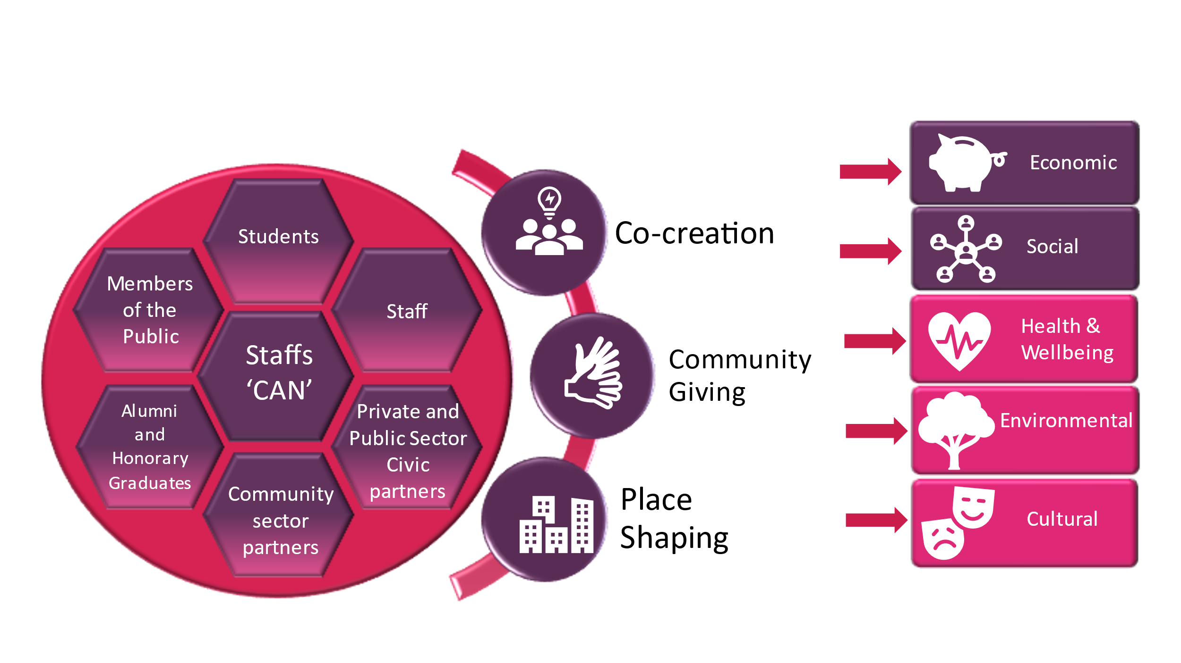

Reflecting values through priorities
To aid clarification of Staffordshire University’s vision for Connected Communities, the plethora of activity that was considered under the civic engagement and impact banner was condensed into three priorities: co-creation, community giving and place-shaping placemaking.

Co-creation
Co-creation recognises that solutions to societal challenges faced by communities require creative and collaborative thinking, and change is only achievable through partnership and co-ownership of solutions. The participatory and inclusive principles of Get Talking can be observed here. Universities could be criticised for over-emphasising their own expertise over those with more practical or real-world experience. Embedding co-creation into the strategy has challenged Staffordshire University to resist leading initiatives and dominating how knowledge is developed and shared, and instead use its own power to elevate the voices of others. The case study of the Hardship Commission below is a prime example of this.

Community giving
While the financial challenges facing universities in 2022 cannot be ignored, universities are often relatively well resourced compared to their civil society partners. They are in an excellent place to share resources, knowledge and facilities to benefits their civic regions. Staffordshire University’s commitment to community giving as a priority area was the aspect of the model that was most welcomed in consultations with community partners, who saw it as a commitment to acknowledge and address inequalities within the region.

Place-shaping
Universities’ contribution to placemaking is often reduced to buildings, facilities and their role in regeneration projects. The deliberative shift towards Staffordshire University’s role as a place shaper illustrates its commitment to a more holistic approach to shaping communities through economic, social, cultural health and wellbeing and environmental interventions (see also Chapter 8). While this might include access to facilities, retaining skilled graduates and supporting business start-ups, it may also involve supporting communities to enact and campaign for the changes they want to see within their place. The term place making comes with connotations of top-down change, whereas being a place shaper gives space for Staffordshire University to work in more collaborative ways, influencing and supporting change but not always leading it.

Plurality of impacts
MillionPlus (2022: 17) highlights the plurality of university missions and the implications this has for clearly identifying and articulating economic impact. They argue ‘there is considerable overlap between different parts of a university and … the economic value of the constituent parts is interconnected’. It can also be argued that the economic value of an intervention is interwoven with social interventions and impacts. Staffordshire University’s relationship with civil society and the value it places on asset-based development, social connections and collective action means disparate approaches to impacts could potentially isolate a significant proportion of the stakeholders who are vital to a civic mission. So while Staffordshire University aspires to generate economic, social, health and wellbeing, environment and cultural impacts, it encourages all initiatives to maximise their impacts across all five areas by collaborative working both across the institution and externally with civic and civil partners, recognising social benefits may result in economic impacts and vice versa. To aid this, the approach needed to be embedded across all parts of the university, and a clear framework for monitoring and evaluation introduced.

Embedding the approach
As mentioned above, a significant challenge for Staffordshire University staff was understanding what ‘civic’ meant for their own practice. Therefore, once a clear vision and brand was established, this was mapped against seven different priorities of the university strategy as outlined in Figure 2.

Figure 2. Embedding Connected Communities
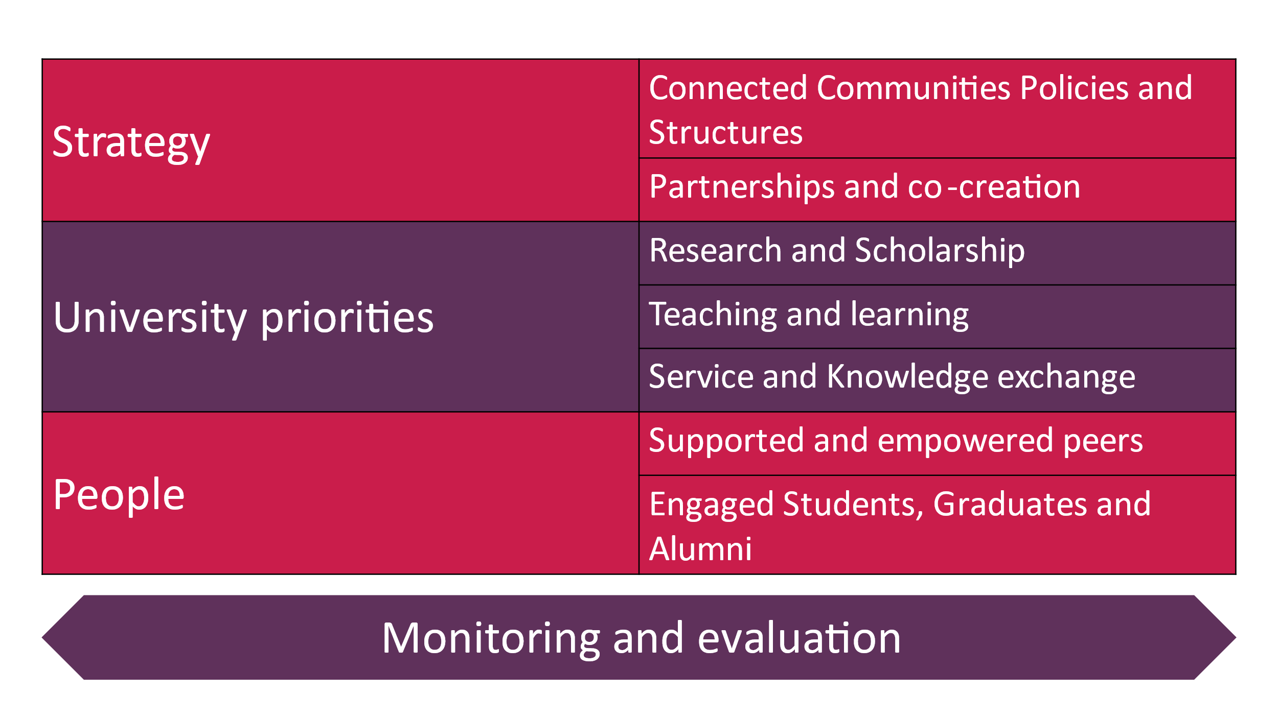
While embedding the approach across the seven themes will take some time to implement, the introduction of this framework has made it easier to understand how the broad Connected Communities strategy translates into practice.
Work at a strategic level includes a review of policies and structures to ensure the experience of community partners working directly with us was streamlined and seamless, to provide a positive and consistent experience. In addition, ways were outlined to strengthen partnerships with civil, civic and internal stakeholders around the civic agenda, and identify how co-creation can feed into both our Connected Communities activity at a strategic level through the Staffs CAN, and at service and school level. The framework also outlined clear priorities for Connected Communities within three of the university priorities of teaching and learning, research and service and knowledge exchange, with a range of opportunities, training and mentoring to support staff and student engagement. Indeed, the university’s academic strategy recognises the value of creating and securing these connections for the benefits of student recruitment, reputations, and undertaking applied research with impact.

Understanding the impact
The challenges of measuring the true value of civic work have been noted (MillionPlus, 2022) as well as the implications for softer outcomes for civic engagement. Given the participatory foundations of the Connected Communities approach it was important that any evaluation framework reflected these principles and enhanced Staffordshire University’s aspiration to embed co-creation throughout its civic work. The framework (Figure 3) embeds participation in its methodology, while recognising the plurality of missions and impacts as well as the need for Connected Communities to be informed by learning and collective input of stakeholders. Participatory dialogue is an essential stage of the process and therefore links well to the introduction of a Civic Advisory Network model, ensuring members of the public, civic partners, civil society and students and alumni are core to how we understand our progress.

Figure 3. Evaluating Connected Communities
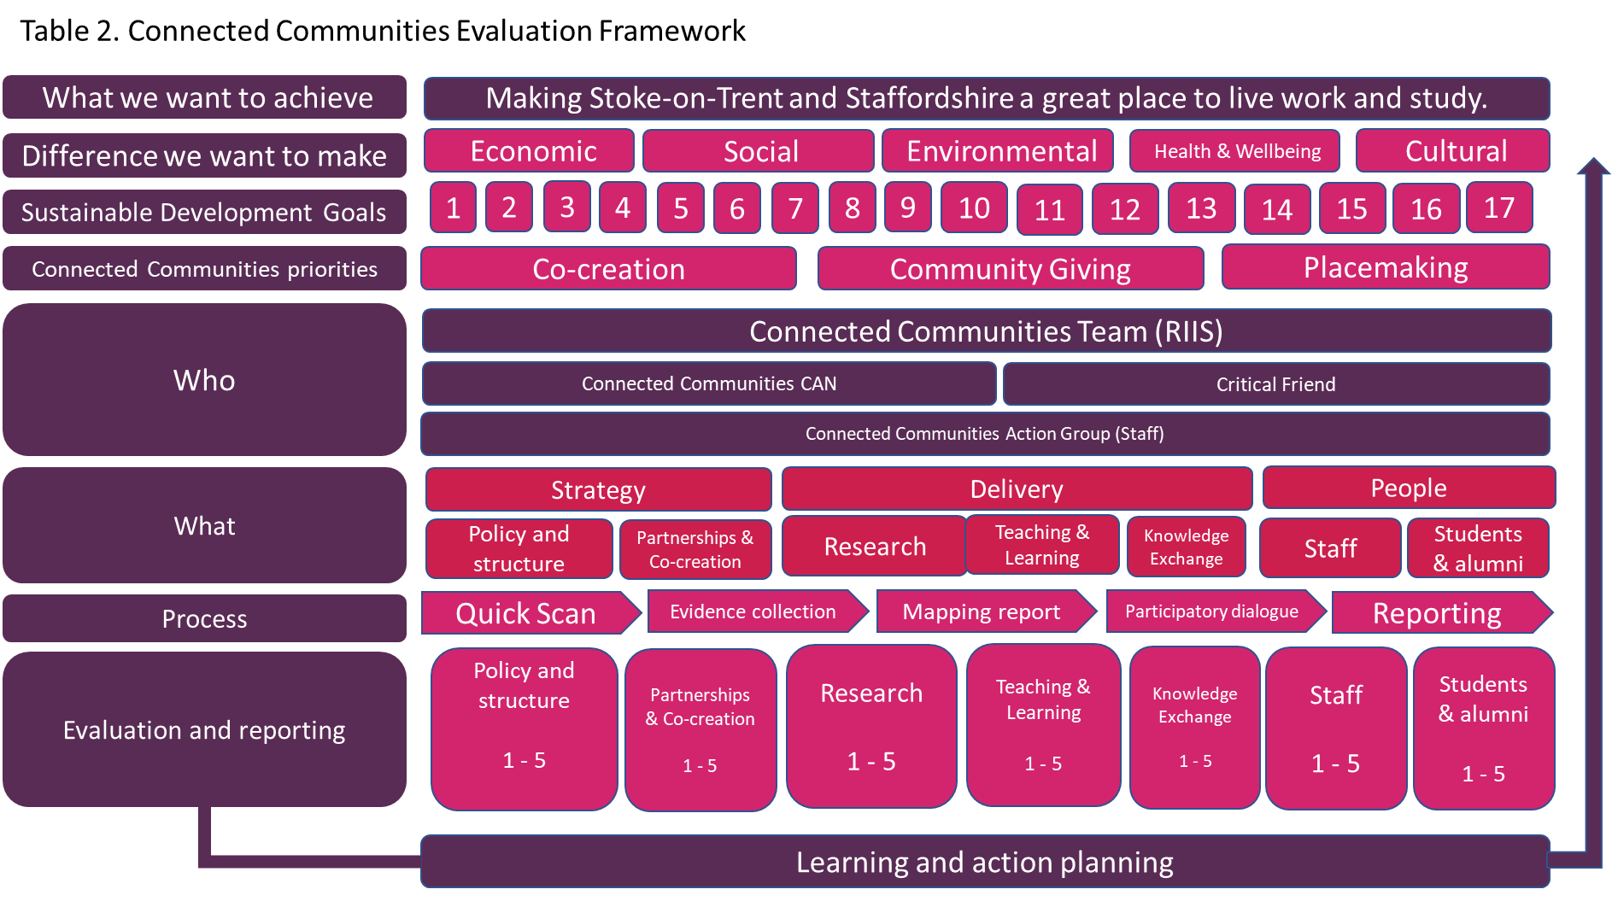

Taking Connected Communities beyond the civic
The Connected Communities approach to civic engagement and impact recognises that universities’ social and economic impacts cannot be easily separated into neat piles of data. The impacts within civic regions may be long term, and therefore reporting impact immediately after a project may not capture the full picture. Equally it recognises the challenges of understanding causality, especially where collaborative and co-created projects result in impacts. While some impacts can be neatly presented in an infographic, others will be softer and need a different methodology to effectively measure and demonstrate. Finally, it recognises that impact cannot, and should not, be understood in isolation from those most affected by the outcomes of university civic work, and places stakeholders, in particular those with less economic power in the city, at the centre of the approach and evaluation methodology. By setting firm participatory foundations for Connected Communities, Staffordshire University has been able to build on both the strengths of university engagement and the strengths of its place.

Valero and Van Reneen (2019) argue that universities can strengthen local institutions by creating spaces for democratic dialogue. The inclusion of civil society partners within Staffs CAN and specific projects as part of its civic engagement and impact activity enables the university to facilitate meaningful conversations from the partners’ perspective, drawing on collective understanding to shape locally relevant solutions. The need to bring several voices into this dialogue has been highlighted by a recent case study, outlined below, through which Staffordshire University has played a significant role in challenging economic hardship in Stoke-on-Trent by supporting and galvanising civil society, including community and voluntary sector partners, to raise awareness and connect with civic actors to create change.

As the case study (see Gratton, 2020a, 2020b) illustrates, Staffordshire University’s work on hardship with civil and community partners extends the realm of social and economic impacts as envisioned by MillionPlus (2022). It uses socially engaged and participatory methods to work directly with people with lived experience of hardship and poverty, and the civil society partners working with them, to directly challenge economic inequalities and demand action.

Addressing hardship and poverty work through lived experience
The Hardship Commission in Stoke-on-Trent has members from third sector organisations, education providers and local authority representatives. Staffordshire University has been represented on the commission since 2015.
In 2019, the commission asked Staffordshire University to conduct a participatory action research project, underpinned by Get Talking, to help it understand people’s lived experiences of hardship and poverty. The Hardship Commission recognised it had an abundance of statistics highlighting the levels of hardship and poverty in Stoke-on-Trent but little evidence of how the statistics translated to the real-world impacts on people’s lives.
Get Talking Hardship attracted 43 community researchers to help understand hardship from the perspective of over 240 people. The community researchers were from a range of backgrounds, including people who had current or past experience of extreme poverty or homelessness. The community research team included several civil society partners who helped the Get Talking Hardship team reach people with lived experience of hardship, as well as contributing their own unique experience and perspectives of supporting others to the research findings. Over the course of six months, the community research team collected stories from each other and reached out to their community networks to ensure the voices of a broad range of communities were included. They also defined the research questions for the project, conducted interviews and analysed findings as a team. The data collection included world café style focus groups and semi-structured interviews using consultation tools, though which people could share their own anonymous stories with the groups.
Because 43 local people were involved in delivering Get Talking Hardship, the research caught the attention of the local newspaper which partnered with the university to produce a week of reports on hardship and poverty in the city. This included some of the community researchers’ stories and interviews with the three Stoke-on-Trent MPs. The project report highlighted experiences of people claiming Universal Credit, and the impact of delays in receiving this on people’s financial stability, mental health and wellbeing. As a result, the MP for Stoke Central raised the report in the House of Commons during Prime Minister’s Questions, firmly highlighting the issues of hardship in the city at a national level. Locally, the Hardship Commission rewrote its terms of reference to ensure people with lived experience of hardship were represented on the steering group. It also extended the invitation for the Staffordshire University civic lead, who led the Get Talking Hardship research, to sit on the Commission. This was the start of a more strategic link between Staffordshire University and the Hardship Commission.
When the global Covid-19 pandemic broke out a couple of months after the end of Get Talking Hardship, commission members had to pause this work to respond to the immediate affects of the national lockdown and wellbeing needs of service users. However, in December 2021, Staffordshire University was asked to conduct a follow-up project with local people to build a campaign and create better connections between the Hardship Commission and local communities. The Hardship Commission recognised that its work was not common knowledge in the city, and communities most affected by hardship were generally unaware of its role or, in some case, existence. To solidify their commitment to working more closely with people with lived experience of poverty, the commission agreed a new tag line: Raising Voices, Changing Minds, Ending Poverty, and this was adopted as the title of the new campaign project. Raising Voices was delivered over four months and included two civil society partners, Expert Citizen CIC and All the Small Things CIC, with a steering group of community researchers from Get Talking Hardship, Expert Citizen volunteers and community organisers supported by All the Small Things.
The project used creative methods to tell the story of hardship in Stoke-on-Trent, building on findings from Get Talking Hardship and using the interests of the steering group, including photography, poetry and podcasting, to gather stories from people in the city. These were assembled into a physical and online exhibition and accompanied by a Manifesto for Change which outlined how the Hardship Commission and Raising Voices steering group would work together and their priorities for action. The Hardship Commission and the Raising Voices steering group negotiated its content and members from each group signed the manifesto at the exhibition event in March 2022.
Staffordshire University, in reality, led both Get Talking Hardship and Raising Voices but was guided by the Connected Communities participatory principles to elevate the voices of the community researchers, the steering group and the civil partners involved above its own. Staffordshire University has challenged its own power base and opened the conversation for others to do so. Equally, it has challenged the power base of the Hardship Commission to extend its membership to those with lived experience of hardship, making the forum more inclusive and encouraging an asset-based approach. Crucially, the university has made connections between civil and civic sector partners and brought community partners with experience of hardship into discussions with civic leaders about how to develop an anti-poverty strategy for the city.
The relationship between Staffordshire University and the Hardship Commission and Raising Voices is a long term one that will continue to build on the social connections and capital of people most affected by poverty to change the economic landscape in Stoke-on-Trent.

Conclusions
John Goddard (2009: 5) describes the civic university as:
‘…one which provides opportunities for the society of which it forms part. It engages as a whole with its surroundings, not piecemeal; it partners with other universities and colleges; and is managed in a way that ensures it participates fully in the region of which it forms part. While it operates on a global scale, it realises that its location helps to form its identity and provide opportunities for it to grow and help others, including individual learners, business and public institutions, to do so too’.
This chapter has sought to draw out these parameters and we would add that achieving such a process on the ground in Staffordshire University is an iterative and developmental activity. We have suggested that notions of being ‘more-than-civic’ could capture these academic and policy concerns more accurately. This gives a heavy nod to the importance of engagements with and the dynamics of civil society, as well as more formalised civic interrelationships. Long-term relationships though are vital to anchor and deliver all this. The UKRI-funded project, undertaken by Gratton (2020b), on ‘Keep Talking’ highlights the need for sustained involvement by community researchers, based on a ‘community connector’ principle of clear communication, defined and understood purpose, and inbuilt flexibility where and when needed.

Notions of being more-than-civic are not without contradictions. When universities seek to influence the field known as the ‘foundational economy’, i.e. health services, education, and other services areas that support ‘everyday life’ (MillionPlus, 2022; Russell et al, 2022), there is the obvious complexity of being embroiled in local politics and policy-failure that forms the ‘new contradictions’ (Lefebvre, 1976) of local state intervention through higher education. This is despite the foundational economy’s importance in developing a pipeline of students to support the local and regional economy. But this is where the civic and civil responsibilities of Staffordshire University matter and where there is potential to transform people, places, and society. We would advocate future research in these spaces and places and returning to previous debates on the ‘local state’ (see Duncan and Goodwin 1989) to understand the rich tapestry of civic and civil society.

References
Bell, M. and Pahl, K. (2018) Co-production: towards a utopian approach, International Journal of Social Research Methodology, 21(1), 105-117.
Brink, c. (2018) The Soul of a University: Why excellence is not enough. Bristol: Bristol University Press.
Crouch, C. (2020) Post-Democracy After the Crisis. Cambridge: Polity.
Duncan, S. and Goodwin, M. (1988) the local state and uneven development: Behind the local government crisis. Cambridge, Polity.
Emadi-Coffin (2008) Get Talking: community participation and neighbourhood learning. Widening Participation and Lifelong Learning. 10 (3), 30-34.
End Child Poverty (2020) Child Poverty in your area 2014/15 – 2019/20. Available at: https://endchildpoverty.org.uk/local-child-poverty-data-2014-15-2019-20/. (Accessed 19.6.22)
Etherington D, Jones M, Harris, S & Hubbard, S (2020) A Disappearing Safety Net: Post Covid-19 Crisis and its Impact on Poverty and Disadvantage in Stoke-on-Trent – Report to the Stoke Hardship Commission. Stoke-on-Trent: Staffordshire University. https://eprints.staffs.ac.uk/6403/
Etherington, D., Jones, M. Harris, S. And Hubbard, S. (2021) ‘Powering Up’ or reducing inequalities? Assessing the impact of benefit cuts and withdrawal of employment support (Furlough) on Stoke-on-Trent. Stoke-on-Trent: Staffordshire University. https://eprints.staffs.ac.uk/7031/
Etherington, D Telford, L & Jones, M (2022) The Pending Poverty Catastrophe in Stoke-on-Trent: How benefit cuts and the cost-of-living crisis impacts on the poor. Stoke-on-Trent: Staffordshire University. https://eprints.staffs.ac.uk/7270/3/The_Pending_Poverty_Catastrophe_in_Stoke-on-Trent.pdf
Frontier Economics (2019) The economic contributions of the higher education sector in England. Summary report prepared for Universities UK. London, UUK.
Goddard (2009) Re-inventing the Civic University. London: NESTA.
Goddard, J., Coombes, M., Kempton, L., & Vallance, P. (2014). Universities as anchor institutions in cities in a turbulent funding environment: vulnerable institutions and vulnerable places in England. Cambridge Journal of Regions, Economy and Society, 7(2), 307–325.
Gratton, N. (2020a) From engagement to strategy: the journey towards a civic university. In Sengupta, E., Blessinger, P., and Mahony, C. (eds) (2020) University-Community Partnerships for Promoting Social Responsibility in Higher Education. Innovations in Higher Education Teaching and Learning. Volume 23. Bingley, Emerald Publishing. pp 105 – 120.
Gratton, N. (2020b) Keep Talking: Impact and Recommendations. Stoke-on-Trent: Staffordshire University. https://blogs.staffs.ac.uk/connections/previous-work/keep-talking/keep-talking-impact-and-recommendations/
Gratton, N. and Reynolds, J. (2022) Participatory evaluation for large-scale arts programmes: challenges, adaptations and unexpected shifts in culture. Research for All Journal, 6(1) 1-14.
Griggs S., Hall, S. & Jones, M. (2020) ‘Levelling up or pushing down?’ Municipal Journal. Available at: https://www.themj.co.uk/Levelling-up-or-pushing-down/218943# (Accessed 21.6.22).
Hatch Regeneris (2020) Civic Report: Economic and social impact assessment of Staffordshire University. Manchester, Hatch.
HM Government (2018) Civic Society Strategy: Building a future that works for everyone. HM Government: London.
HM Government (2022) Levelling Up the United Kingdom. CP 604. London, HMSO.
Jones, M. (2019) Cities and regions in crisis: The political economy of subnational economic Development. Cheltenham: Edward Elgar.
Lefebvre, H. (1976), The survival of capitalism: Reproduction of the relations of production. London: Allison & Busby.
MacLeod, G. & Jones, M (2018) ‘Explaining “Brexit Capital”: uneven development and the austerity state’. Space and Polity. 22: 111-136.
MillionPlus (2022) Staying Local to go Far: Modern Universities as Placemakers. MillionPlus: London.
Office for National Statistics (2022). UK Economy Latest, June. London: ONS. https://www.ons.gov.uk/economy/economicoutputandproductivity/output/articles/ukeconomylatest/2021-01-25
Russell, B. Beel, D., Jones, I.R. and Jones, M. (2022) Placing the foundational economy: an emerging discourse for post-neoliberal economic development. Environment and Planning A DOI: 10.1177/0308518X22109874
Stoke-on-Trent City Council (2021a) Silicon Stoke Prospectus: Establishing Stoke-on-Trent’s plan for a gigabit connected city. Stoke: Stoke-on-Trent City Council. https://www.stoke.gov.uk/info/20012/business/445/silicon_stoke
UPP Foundation (2019) Truly Civic: Strengthening the Connection Between Universities and their Places. London: UPP Foundation.
Valero, A. and Van Reenen, J. (2019) The economic impact of universities: Evidence from across the globe. Economics of Education Review, 68, 53-67.

