Determining the effect and magnitude of neoteric shoes on female distance running performance.

Word Count: 5379

Determining the effect and magnitude of advanced footwear technology on female distance running performance.

Abstract
There is limited work, to date, in which the potential performance-enhancing effects of Advanced Footwear Technology (AFT) in the female elite athlete has been considered. This study aimed to retrospectively explore publicly available race data for a marathon, half-marathon, and 10-km elite events to analyse the effect of AFT, along with athlete and event characteristics, to determine the effect on female running performance. Race performance times for the top 20 female athletes within the world were extracted from 1990-2020 (n=1722), along with athlete and event characteristics from 2010-2020 (n=660). Data for race shoes were available for 655 of the 660 performances. The changes in grouped mean performance times over the years that AFT had been adopted were compared with the grouped mean of the corresponding number of years immediately prior show marathon, half-marathon, and 10-km performance times were 1.7%, 1.72%, and 1.75% (p < 0.001, pη² > 0.220) faster during the AFT period. Repeated performance analysis comparing the improvement in race times between the control group and athletes who adopted AFT showed athletes who adopted AFT improved significantly more over the marathon (2.64%, p < 0.001) and half-marathon (1.67%, p < 0.002). Advanced Footwear Technology correlated (r >.50) with improvements in the marathon and half-marathon, but not the 10-km. Based on multiple regression modelling, it can be suggested that wearing AFT improves marathon race time by 78 s (.93%), and half-marathon race time by 28 s (.71%). Based on these results, we observe a small but meaningful performance-enhancing effect of AFT within elite female athletes.

Key words: carbon fibre plate; performance-enhancing; ergogenic; marathon; half-marathon; 10-km.

Introduction
The pioneering ‘Nike Vaporfly 4%’ combined the theoretical principles of the ideal running shoes utilising a highly compliant (Kerdok et al., 2002), resilient (Worobets et al., 2014), lightweight midsole foam (Frederick et al., 1984), >10-mm cushioning under the midfoot and forefoot (Franz et al., 2012; Tung et al., 2014), and embedding a curved carbon-fibre plate tuned to the athlete’s mass to increase the midsole longitudinal bending stiffness (Roy & Stefanyshyn, 2006). Subsequently, numerous shoe companies have adopted these performance-enhancing principles, this advanced footwear technology (AFT) combines an embedded rigid moderator inserted between a lightweight, resilient midsole foam and a rocker profile (Frederick, 2022). Despite analysis of data trends suggesting the upper limits of human performance are being reached (Berthelot et al., 2010; Marck et al., 2017), all male and female long-distance world records from 5-k to the marathon, on both the road and track, have been broken by athletes wearing AFT shoes or spikes (Muniz-Pardos et al., 2021). Technological advancements offer a means to elicit performance gains exceeding the limits of physiology (Marck et al., 2017). Subsequently, the recent advancement of numerous long-distance world records has stimulated critiques that the improvements are due to technological not physiological developments (Muniz-Pardos et al., 2021).

Laboratory testing demonstrated, that, on average, athletes running in the Nike Vaporfly shoe improved running economy by 4% in comparison with other leading racing shoes at the time of testing (Barnes & Kilding, 2018; Hoogkamer et al., 2017a). However, a significant limitation of this Hoogkamer et al. (2017a) study was that all participants were male. Although, in the Barnes and Kilding (2018) study, the effects of the Nike Vaporfly 4% on running economy were investigated among 12 females, the velocities of 14 and 16 km.h⁻¹ are considerably slower than velocities sustained by elite females over the marathon duration. Consequently, there are very limited data within elite females and we cannot assume the mean improvement of 4% on running economy directly translates to this population. Furthermore, not all AFT are created equally and the mean improvement of 4% in running economy cannot be extrapolated beyond the Nike Vaporfly 4%. Joubert and Jones (2022) compared 7 AFT to a traditional race shoe demonstrating no significant improvement in running economy in two pairs (Hoka Rocket X (-0.08%), Brookes Hyperion Elite 2 (-0.53%)), two pairs enhanced running economy between 1-2% (New Balance Fuel Cell RC Elite (-1.37%), Saucony Endorphin Pro (-1.48%)), and three pairs improved running economy >2.5% (Asics Metaspeed Sky (-2.52%), Nike Zoom X Vaporfly Next % (-2.72%), Nike Air Zoom Alphafly Next % (-3.03%).

Equations predicting the oxygen uptake-velocity relationship were utilised by Kipp et al. (2019) to quantify how an improved running economy translates into faster running performance. Utilising Kipp et al.’s (2019) calculations, an improvement of 4% in running economy is predicted to increase running velocity by 2.74% when running at the current women’s marathon world record pace of 5.246 m/s. However, it is worth noting that since the advent of AFT the female marathon world record has fallen only by 1.00%. One of the limitations of Kipp et al.’s (2019) mathematical model is that it does not account for how the energetic cost of running increases with race duration (Lacour & Bourdin, 2015), due to slow component increases in oxygen uptake kinetics (Burnley & Jones, 2007) and muscular damage (Hikida et al., 1983). Furthermore, distances shorter than the marathon, such as the half-marathon and 10-km race speeds, are usually run at an intensity above the lactate threshold where the running economy cannot be determined due to the non-oxidative energy contribution (Kipp et al., 2019). Consequently, Kipp et al.’s (2019) calculations may overestimate the performance benefit attributed to an improvement of running economy and thus the effect of AFT.

Currently two studies have investigated the effects of AFT on race performance (Bermon et al., 2021; Senefeld et al., 2021). Senefeld et al. (2021) analysed race data utilising the top 50 finishers across four of the World Marathon Majors (Berlin, Chicago, London and New York). Males’ marathon finish times were shown to be significantly faster by 2% or 2.8 min and females’ race times were faster by 2.6% or 4.3 min when running in AFT (Senefeld et al., 2021). In the same study, based on within-participant repeated measures analysis, males’ marathon times improved by 0.8% or 1.2 min, whereas females experienced a significantly greater improvement by 1.6% or 3.7 min when running in AFT when compared with their last marathon in traditional shoes (Senefeld et al., 2021). The results from this study are limited, however, to Nike shoes utilising AFT with little known regarding the effects of AFT within other brands on race performance. The impact of AFT for both sexes was explored by Bermon et al. (2021) across road races events including the 10-km, half-marathon, and marathon. The magnitude of improvement in race times associated with performance times in the years of mass utilisation of AFT was greater for females compared with males and also larger the longer the race duration (Bermon et al., 2021). Female race times improved by 1.9%, 1.7%, and 2.0% in the 10-km, half-marathon, and marathon, in contrast male performance times improved by 1.1%, 0.7% and 1.2% between 2016 and 2019 (Bermon et al., 2021). Across the half-marathon and marathon, a repeated samples analysis of performers within the period of 2016-2019 with and without AFT demonstrated all athletes except male half-marathon runners significantly improved their performance times. However, this analysis is limited due to a small number of athletes with repeated performances with and without AFT and no control group was used to compare the magnitude of effect.

Improvements in running economy are likely to elicit a larger impact over longer race distances where glycogen stores are challenged (Jeukendrup, 2011). Whilst, modifications to shoe weight leading to enhanced running economy have been demonstrated to improve performance times over a short race distances of 3000m (Hoogkamer et al., 2016), the improvements in running economy over longer race distance is currently unknown. We cannot assume the change in running economy measured at submaximal paces effects the metabolic rate independent of running velocity (Hoogkamer et al., 2016). The half-marathon and 10-km have witnessed new world records being achieved by athletes wearing AFT in both males and females’ events (Muniz-Pardos et al., 2021). Currently, only one study to date has been undertaken to investigate the effect of AFT over race distances shorter than the marathon despite the half-marathon and 10-km witnessing new world records. This study aims to conduct a retrospective, observational analysis using real-world data to explore trends in females’ race performances in road events over 10-km, half-marathon, and marathon and evaluate if mass adoption of AFT influences race times. It is acknowledged that marathon performance is multi-factorial and so, a further aim of the study is to develop a multiple-regression model to determine the magnitude of the effect of AFT, along with other determinants available within the public domain including age, race experience, and course, to identify key determinants and their influence on the progression of female running performance over the last decade (2010–2020).

Method:
Ethics:
All procedures involved retrospective analysis utilising publicly accessible information approved by the Institute’s Ethics Board in accordance with the Declaration of Helsinki.

Participants:
Female marathon (n=620), half-marathon (n=594) and 10-km (n=508) road running performance times for the top 20 athletes within the world in each year from 1990-2020 were extracted from World Athletics (2021), a publicly accessible database (https://www.worldathletics.org), providing a total sample of n=1722. Individual athletes who ranked in the top 20 performances in multiple years will have multiple performances across the data set.

Data Extraction:
Performance times, race year, course, the athlete’s name, age, number of previous races completed corresponding to the specific race distance, and 5-k personal best times were extracted via the World Athletics (2021) database for each race distance (n=220) over the years between 2010-2020 (total sample n = 660).

A reference table identifying all known shoes utilising AFT available before 1st January 2021 was constructed (see supplementary material). Advanced Footwear Technology (AFT) were defined as: footwear containing an embedded rigid moderator (e.g. A full or partial carbon-fibre plate or rods) sandwiched between a lightweight, resilient midsole foam and a rocker profile in accordance with Frederick (2022). Table 4 details technical characteristics and images of the shoes, including the carbon-fibre plate disposition, midsole material, weight for a size 8 UK (g), max heel height (mm), drop (mm), and date of known availability or date first used in competition. The reference table was externally validated by two independent experts, a footwear industry expert and a clinical running lead and podiatrist. The reference table (Table 4, Appendix 1) was utilised to identify and cross-reference AFT worn by the athletes. Footwear were identified from available photographs posted on publicly accessible websites (e.g. https://www.marathonfoto.com/), race footage available on publicly accessible websites (e.g. https://www.youtube.com/) or social media pages following the same method as Senefeld et al. (2021). Shoes were then coded AFT or other. Of the 660 potential data points, 655 had identifiable shoes and were included within the analyses.

Data Analysis:
All statistical analyses were undertaken using an IBM SPSS Statistics 27 software package. Initially, the mean and standard deviation of performance times over the marathon, half-marathon and 10-km for the top 20 females were calculated. Analysis of both change in percentage (%) and absolute time (s) were calculated from year to year in chronological order from 1990-2020. Subset analysis comparing the changes in grouped mean (percentage (%) and absolute time (s)) and standard deviation over the years that AFT had been adopted were compared with the grouped mean and standard deviation of the corresponding number of years immediately prior to the utilisation of AFT (AFT group 2017-2020 for the marathon vs. traditional shoe group 2013-2016). Normal distribution ranges were set for skewness between -2 and +2 and kurtosis range of -10 to +10 (Field, 2009). Once parametric assumptions were met, performance times across groups were compared using a one-way analysis of variance (ANOVA) (p .05). Effect sizes were estimated via partial eta square (pη²) and were interpreted as follows: small 0.01-0.05, medium 0.06-0.13 and large ≥ .14 (Bakeman, 2005). Multiple comparisons assessing year-on-year differences were performed applying the Bonferroni method (Field, 2009). Priori analysis was conducted using G*Power to determine the statistical power and sample required, with ANOVA alpha level set at p < 0.05, β = 0.95 for 2 groups and 8 factors, which required a sample size of 118 participants for power 0.95 (Cohen, 1988).

A subset case-control analysis of female athletes with repeated performances over the marathon and half-marathon was conducted determining a within-athlete change in finish time (s) between the athletes’ fastest time (s) in AFT and traditional shoes and in the control group the improvement from their previous personal best time (s) to their current personal best time (s). Athletes with a previous best time <5 years prior and <5 min slower than their current best time were excluded from the analysis due to improvements in time likely attributed to additional factors beyond utilisation of AFT. Data were available for 88 performances over the marathon (AFT group performances, n = 20; traditional shoe group performances n = 68), and 97 performances over the half-marathon (AFT group performances, n = 25; traditional shoe group performances 72). A two-way independent t-test was conducted (p < 0.05) to assess the difference between the change in performance times of those assigned to the AFT group and those assigned to the control group. Effect sizes were calculated using Cohen’s d and were interpreted as follows: small 0.2-0.49, medium 0.5-0.79 and large ≥ 0.8 (Field, 2009).

Pearson’s correlation was conducted, analysing the relationship between performance time over the marathon, half-marathon, or 10-km (r > 0.50) (Field, 2015) and race year (n = 660), course (n = 660), the individual athlete (n = 660), age (n = 658), number of previous races completed corresponding to the specific race distance (n = 660), and 5-k personal best time (n = 545). A point-biserial correlation (r_{pb} >0.50) (Field, 2015) was conducted, analysing the relationship between performance time and AFT shoes (n = 655). Power calculations for the Pearson’s correlation coefficient, applying a correlation of r > 0.50, p < 0.05, and β = 0.95, required a sample of 38 for a power of 0.95 (Cohen, 1988). Lastly, determinants correlating (r > 0.50) with performance time were inputted into a step-wise multiple linear regression analysis to assess how much the determinants explained change within race performance over the top 20 performances each year from 2010-2020 (n = 220) for each race distance. Power calculations of the multiple linear regression, applying an effect size partial eta squared (pη²) of 0.14, p < 0.05, β = 0.95, using 7 predictors required a sample size of 164 for a power of 0.95.

Results
Evaluating performance over time
Marathon performance times significantly (p < 0.001) improved on average by 143s (1.7%) during the AFT period (2017-2020, 8405 ± 90s, n = 80) compared with the traditional shoe period (2013-2016, 8547 ± 81s n = 80) where a distinct plateau in performance had occurred (Figure 1). The improvement in marathon performance times during the AFT (2017-2020) period were associated with a large effect size (pη² = 0.41). Mean marathon performance times increased by 25 ± 8 s (0.30%) each year from 2013-2016 (n = 80) compared with an improvement of 37 ± 41 s (0.44%) each year from 2017-2020 (n = 80). Post-hoc analysis revealed no significant difference in the marathon performance times between the years 2013-2016 (p > 0.05), however, the years from 2018-2020 were all significantly (p < 0.001) quicker than the marathon times from 2013-2016. Marathon performance times were significantly faster in 2017 (p < 0.01) than in 2013, 2014, and 2016, but not significantly (p= 0.106) faster than in 2015.
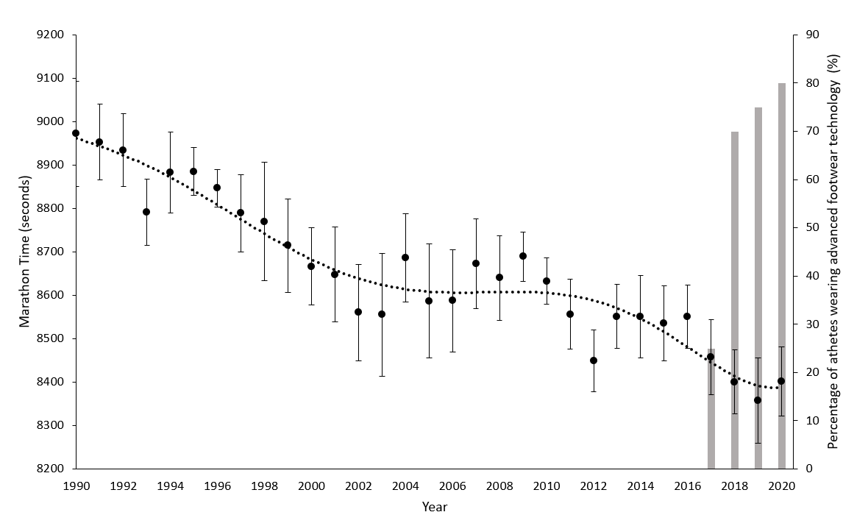
Figure 1. Female top 20 mean (± standard deviation shown in error bars) marathon times from 1990-2020 (n = 620) (circles) with a polynomial trend line (dashed line) displaying the rolling average over 6 years. Columns represent the prevalence of AFT each year reported as a total percentage (%).
Table 1. Female world top 20 mean (s) and standard deviation marathon times from 2015-2020 with the change in marathon race performance compared with the previous year expressed in absolute time (s) and percentage change (%) corresponding with AFT prevalence expressed in absolute number (n) and percentage (%).
Year | Mean & standard deviation marathon performance times (s) | Change in race performance compared with the previous year |  | Prevalence of advanced footwear technology
Year | Mean & standard deviation marathon performance times (s) | Time (s) | Percentage (%) | Number (n) | Percentage (%)
2015 | 8535 ± 87 | -16 | -0.18 | 0 | 0
2016 | 8551 ± 72 | 15 | 0.18 | 0 | 0
2017 | 8457 ± 86 | -93 | -1.10 | 5 | 25
2018 | 8400 ± 74 | -57 | -0.68 | 14 | 70
2019 | 8358 ± 98 | -42 | -0.50 | 15 | 75
2020 | 8402 ± 79 | 44 | 0.52 | 16 | 80

Mean half-marathon running times significantly (p < 0.001) improved by 68 s (1.72%) during the AFT period between 2018-2020 (3960 ± 38 s, n = 60), compared with the 3 years prior 2015-2017 (4028 ± 61s, n = 60), ran in traditional shoes (Figure 2). Improvements in half-marathon race times were associated with a large effect size (pη² = 0.312). Post-hoc analysis revealed the AFT period years (2018-2020, n = 60) to be significantly (p < 0.001) faster than years 2015 and 2016. However, no significant difference (p > 0.05) in half-marathon times were reported between the year 2017 and the AFT period years (2018-2020, n = 60).
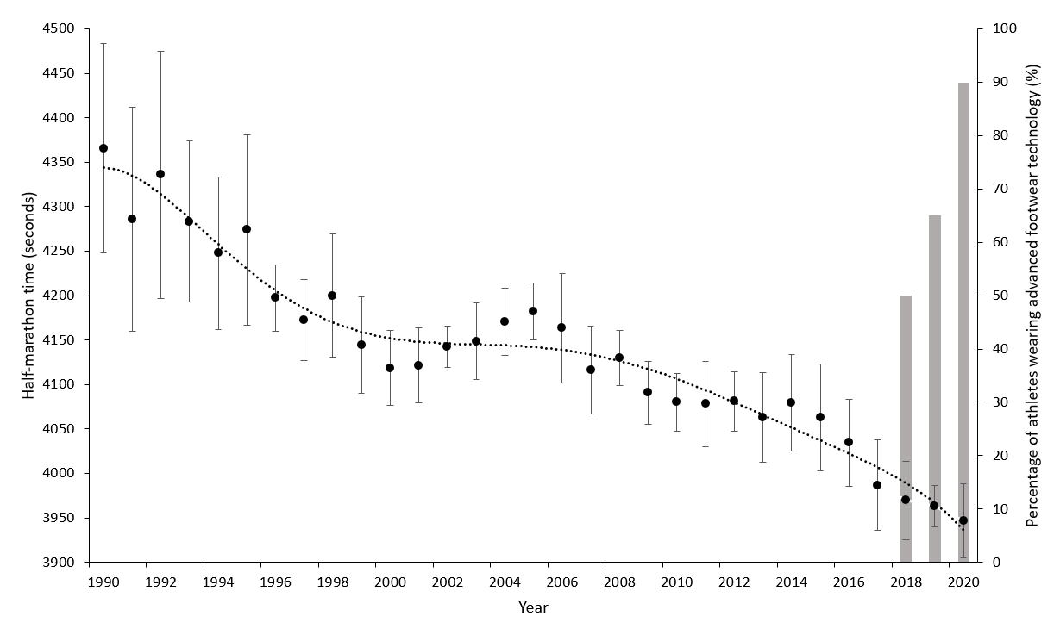
Figure 2. Female top 20 mean (± standard deviation) half-marathon times from 1990-2020 (n = 594) (circles) with a polynomial trend line (dashed line) displaying the rolling average over 6 years. Columns represent the prevalence of AFT each year reported as total percentage (%). *Only half-marathon performances sub 75 minutes are recorded. Subsequently, for years 1990-1994, mean performance times have been calculated from samples ranging from 10-19 athletes.

Table 2. Female world top 20 mean (s) and standard deviation half-marathon times from 2015-2020 with the change in half-marathon race performance compared with the previous year expressed in absolute time (s) and percentage change (%) corresponding with AFT prevalence expressed in absolute number (n) and percentage (%).
Year | Mean & standard deviation marathon performance times (s) | Change in race performance compared with the previous year |  | Prevalence of advanced footwear technology
Year | Mean & standard deviation marathon performance times (s) | Time (s) | Percentage (%) | Number (n) | Percentage (%)
2015 | 4063 ± 60 | -17 | -0.41 | 0 | 0
2016 | 4035 ± 49 | -28 | -0.69 | 0 | 0
2017 | 3987 ± 51 | -48 | -1.20 | 0 | 0
2018 | 3970 ± 44 | -17 | -0.44 | 10 | 50
2019 | 8963 ± 23 | -6 | -0.16 | 13 | 65
2020 | 3947 ± 42 | -17 | -0.42 | 18 | 90

Race performance times over the 10-km from 2011-2015 (n = 100) ran in traditional shoes (1897 ± 29s) were significantly (p < 0.001) slower compared to race times during 2016-2020 (n = 100) the AFT period (1864 ± 33s) associated with a large effect size (pη² = 0.220). During the AFT period (2016-2020, n = 100) mean 10-km race times improved by 33s (1.75%) compared with the 5-year period prior (2011-2015, n = 100). Over the period 2011-2015, where races were run in traditional shoes the mean change in time, was 0 s (-0.01%) per year, in comparison times improved by 4 s (-0.21%) per year during the AFT period (2016-2020). Post-hoc analysis demonstrates only times for the year 2019 were significantly (p < 0.001) quicker than times in all other years within the traditional shoe period (Table 3). The Pearson correlation coefficient revealed only the individual athlete (r = 0.58) correlated with 10-km performance. The point-biserial correlation coefficient revealed AFT (r_{pb} = 0.20) did not correlate with faster running times.
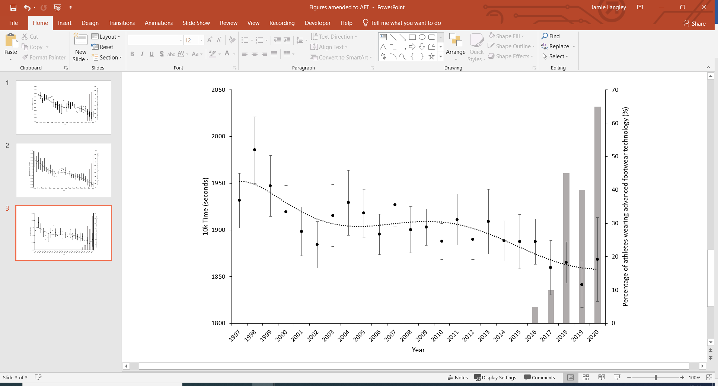
Figure 3. Female top 20 mean (± standard deviation) 10-km times from 1997-2020 (n = 480) (circles) with a polynomial trend line (dashed line) displaying the rolling average over 6 years. Columns represent the prevalence of AFT each year reported as total percentage (%). *years 1990-96 were excluded due to lack of data only 38 data points out of 120 available.

Table 3. 10-km ANOVA Bonferroni Post-hoc results comparing the race performance times between the years 2011-2020, traditional shoe period from 2011-2015, AFT period from 2016-2020. Prevalence of AFT shoes each year expressed in both absolute values (n) and percentages (%).
Year | Traditional shoe years significantly different from 2011 – 2015 (p < .05) | Prevalence of advanced footwear technology
Year |  | Number (n) | Percentage (%)
2016 | None | 1 | 5
2017 | 2011, 2013 | 2 | 10
2018 | 2011, 2013 | 9 | 45
2019 | 2011, 2012, 2013, 2014, 2015 | 8 | 40
2020 | 2011, 2013 | 13 | 65
Case-Control Analysis of Repeated Performances:
Performance improvement was strongly moderated by racing shoe for both the marathon (p <0.001) and half-marathon (p =0.002) with a larger effect size for the marathon (d = -1.17) than the half-marathon (d = -0.72). The marathon AFT group improved their performance time by 331 ± 312 s (3.79%, n = 20) compared with the traditional shoe group, who improved their performance by 123 ± 116 s (1.15%, n =68) a difference of 207 s (2.64%). Over the half-marathon the AFT group improved their performance time by 142 s ± 140s (3.58%, n = 25) compared with 77 ± 64 s (1.91%, n =72) for the traditional shoe group, which was a difference of 65 s (1.67%).

Multiple Regression Analysis
Based on the Pearson correlation coefficient the individual athlete (r =0.61, p <0.001), the year the marathon was ran (r =0.58, p =0.245), and AFT (r_{pb} =0.54, p <0.001) correlated with marathon performance, whereas there were low correlations for the course (r = 0.31), country the athlete represented (r = 0.27), age on race day (r = -0.03), number of prior races including races the athlete did not finish (DNF) (r = .04), and /5-k personal best times (r = 0.19) with marathon performance. Based on stepwise multiple linear regression analysis, a combination of athlete and AFT significantly (p < 0.001) predicted marathon times, accounting for 42% of the variance (R² = 0.424). The regression equation is detailed in equation 1. Details of the athlete and AFT codes can be found in the supplementary material.

Eq 1. $Marathon time \left(seconds\right)=8273.65+athlete*1.695+advanced footwear technology*78.348$

Based on predictive regression analysis, athlete 1 (supplementary material) would complete the marathon 78 s faster wearing AFT (8353s) in comparison with traditional shoes (8431s).
Advanced footwear technology marathon time prediction:
$8273.65+1*1.695+1*78.348=8353s$.

Traditional shoes marathon time prediction:
$8273.65+1*1.695+1*78.348=8431s$.

Based on the Pearson correlation coefficient the individual athlete (r = 0.72, p <.001), the year the half-marathon was ran (r =0 .70, p =0.09), the course (r = 0.50, p < 0.001) and AFT (r_{pb} = 0.50, p =0.04) correlated with half-marathon performance. The country the athlete represented (r =0 .10), age on race day (r = 0.07), number of prior races including DNF’s (r = 0.04), and 5000m/5k personal best times did not correlate (r = 0.14) with half-marathon times. Stepwise multiple linear regression reported a combination of athlete, course and AFT significantly (p < 0.003) predicted half-marathon times, accounting for 57% of the variance (R² = 0.572). The regression equation is detailed in equation 2. Details of athlete, AFT and course codes can be found in the supplementary material.

Eq 2. $Half Marathon Time \left(seconds\right)=3906.346+athlete*1.112+course*1.378+advanced footwear technoloy*27.521$

Predictive regression analysis shows athlete 1 (supplementary material) on the same course would complete the half-marathon 28s faster wearing AFT (3936s) compared with traditional shoes (3964s).

Advanced footwear technology half-marathon time prediction:
$3906.346+1*1.112+1*1.378+1*27.521=3936s.$
Traditional shoes half-marathon time prediction:
$$3906.346+1*1.112+1*1.378+2*27.521=3964s.$$

Discussion
Based on the findings, there was a performance-enhancing effect of AFT compared with traditional shoes with AFT eliciting a greater magnitude of effect, the longer the race duration. Based on the results from this study, footwear technological advancements contributed to the improvements in the marathon and half-marathon race times within elite female athletes. However, AFT are unlikely to have a significant effect on 10-km running times and are unlikely to have contributed to the recent progression of 10-km running times.

In agreement with Bermon et al. (2021) we demonstrated AFT elicited a larger performance enhancing effect the greater the race duration. The performance improvements are likely attributed to the enhanced elastic properties of shoes utilising AFT, which improve running economy (Barnes & Kilding, 2019; Hoogkamer et al., 2019). The primary physiological determinants of the marathon and half-marathon race performance are regarded as V̇O₂max, lactate threshold, and running economy (Joyner, 1991; Midgley et al., 2007). Running economy is the only determinant which can be directly modified by biomechanical improvements (Hoogkamer et al., 2017b). Improvements in running economy increase the maximal sustainable running velocity, thus reducing marathon and half-marathon performance time (Poole et al., 2016; Smith and Jones, 2001). According to Hoogkamer et al. (2017b), with AFT reducing the energetic cost of running, athletes can sustain a faster velocity while consuming metabolic energy at the same rate. The magnitude of improvement in half-marathon race times attributed to AFT appears less than the improvement for the marathon, possibly due to the lower contribution of running economy on half-marathon performance (Alvero-Cruz et al., 2020).

Although a similar magnitude of improvement in road race times over the 10-km were observed between our results 1.75% and Bermon et al. (2021) 1.9% our results demonstrated no correlation between faster 10-km performance times and AFT race shoes. Similar to the marathon determinants of performance, V̇O₂max (Evans et al., 1995), velocity at V̇O₂max (vV̇O₂max) (Morgan et al., 1989) and lactate threshold (Fay et al., 1989), are fundamentally associated with shorter race distances such as the 10-km. However, running economy is more influential in determining marathon race performance in comparison to 10-km road running performance (Midgley et al., 2007; Morgan et al., 1989). Muniz-Pardos et al. (2021) reported that 10-km road race times improved by 2.3% when adopting AFT race shoes over traditional shoes, which does not support the findings of the current study. Based on results from this study AFT have a reduced impact on race performance where running economy is less significant to performance (Alvero-Cruz et al., 2020; Midgley et al., 2007). The half-marathon and 10-km are competed at velocities above lactate threshold where it is not possible to measure running economy, therefore it is not fully understood how both oxidative and non-oxidative metabolic demands change at higher intensities (Kipp et al., 2019). More research needs to be undertaken to determine how AFT might affect running economy, vV̇O₂max, and lactate threshold over 10-km and half-marathon race velocities.

The ergogenic effect of AFT on the marathon and half-marathon was further explored through the development of a multivariate regression model. The magnitude of improvement predicted for both the marathon (0.93%) and the half-marathon (0.71%) were considerably smaller than the predicted improvements applying the calculations recommended by Kipp et al. (2019) of 2.74% and 2.67% over the marathon and half-marathon, respectively. Applying Kipp et al.’s (2019) equation factoring in height, weight, and percentage improvement in running economy of 4% from AFT for the female marathon world-record (2:14:04) velocity of 5.246 m.s⁻¹ attributes a 2.74%, improvement in time to AFT. Likewise, applying Kipp et al.’s (2019) equation for the half-marathon world-record (1:04:02) velocity 5.491 m.s⁻¹ attributes a 2.67% improvement in time attributed to AFT. Whilst this study did not independently investigate the effect of AFT Nike shoes on race performance 90.2% and 87.8% of the AFT identified in the marathon and half-marathon were Nike models. However, the predicted benefit of 0.93% over the marathon is strikingly similar to the degree of advancement of the female marathon world record of 1% ran in AFT (Joyner et al., 2020). Differences may be explained by individual athlete variation in the energetic savings provided by AFT with improvements in running economy ranging from -1.59 to -6.26% in Hoogkamer et al.’s (2017a) study and -1.72 to -7.15% in Barnes and Kilding’s (2018) study. Furthermore, Kipp et al.’s (2019) equation does not account for individual variability in the V̇O₂-velocity relationship (Saunders et al., 2004). Running economy is likely to decline over the marathon duration resulting from the race distance and fast speeds that incur muscle damage (Millet et al., 2011) or substrate utilisation shifts (Vernillo et al., 2017), causing Kipp et al.’s (2019) equation to overpredict the performance benefits. A larger difference in the predicted benefit of AFT is observed over the half-marathon between our results and Kipp et al.’s (2019) predictive equation, which may be attributed to a lower impact of running economy on shorter race distances (e.g. the half-marathon and 10-km) where velocities exceed lactate threshold (Alvero-Cruz et al., 2020; Midgley, et al., 2007).

Both the between-measures (1.7%) and the within-measures (2.64%) analysis demonstrated a similar magnitude of improvement associated with AFT utilisation compared with Senefeld et al. (2020) results (2.6% between-measures and 1.6% within-measure). However, the magnitude of improvement predicted by the multiple linear regression model for the marathon (78s, 0.93%) was significantly smaller than the 2.6% (258s) and the 1.6% (222s) reported by Senefeld et al. (2020), suggesting Senefeld et al. (2020) results may overestimate the magnitude of effect of AFT on female marathon race performance. Furthermore, differences in performance times may be observed between our findings which investigated the effects of numerous models of AFT on race performance times where improvements in running economy have varied from 0.08-3.03% (Joubert & Jones, 2022), in contrast Senefeld et al. (2020) results only looked at AFT in Nike shoes where reported improvements in running economy ranged from 2.72-3.03% (Joubert & Jones, 2022). The marathon performance is multi-factorial (Joyner et al., 2020), however, Senefeld et al. (2020) infers direct correlation between the adoption of AFT and improved marathon performances. Based on the results of the current study, it can be suggested that improvements in race performance times since the adoption of AFT are not perfectly correlated with other factors beyond the shoes contributing to faster race times. Based on the regression modelling for both the marathon and the half-marathon suggest changes within the athlete population to attribute the largest change within performance time not AFT (Equation 1 & Equation 2).

The findings of this study and any conclusions drawn must be interpreted with respect to the limitations of the work. Firstly, the study is theoretical, applying a retrospective analysis of performance times specifically using the last 11 years to develop a regression model to predict the influence of AFT on race performance. Therefore, the true cause and effect relationship cannot be identified between improvements within performances and the ergogenic effect of AFT. Thus, further investigation is warranted evaluating the direct relationship between AFT and race performance. Marathon performance is multi-factorial and likely influenced by numerous factors not evaluated within this study. This point is exemplified by the marathon and half-marathon regression models explaining only 42% and 57% of the variance in performance times, respectively. Additional factors beyond the remit of this study, which may explain further variance within long-distance running performance times include: anthropometrics (Foster & Lucia, 2007; Sano et al., 2013), biomechanics (Gomez-Molina et al., 2017), training history (Foster et al., 1977), pacing strategies and race tactics (Renfree & Gibson, 2013; Hanley, 2015), drafting techniques (Hoogkamer et al., 2018), weather (El Helou et al., 2012), altitude (Hamlin et al., 2015), pollution (Marr & Ely, 2010) and nutrition (Burke et al., 2007). A pragmatic decision was made to limit the number of factors included within the model due to the availability of data within the public domain. Finally, the regression model assumes a linear and homogenous response to AFT based upon the group response when wearing these running shoes.

Not all AFT are created equally. There are significant differences in the 3D shape, longitudinal bending stiffness, and location of the imbedded moderator between AFT (Muniz-Pardos et al. 2020). Not all AFT utilise a full-length carbon fibre plate to act as a stiff moderator, moderators may be split into multiple plates imbedded within the midsole and may not adopt carbon fibre as the moderator, for example, Adidas Adizero Adios Pro utilise an array of plastic rods (Muniz-Pardos et al. 2020). Furthermore, different AFT models utilise different midsole foams and thicknesses with differing levels of compliance and resilience, which in turn return different rates of energy to the runner (Hoogkamer et al. 2017). Consequently, differences in AFT design has led to varied degrees of improvement within running economy measured in the laboratory with Joubert and Jones (2022) reporting considerable variation with improvements ranging from -0.08% to -3.03% when running in different AFT shoe models. We are in a dynamic state of AFT development, with numerous running shoe companies competing in an arms race to produce new and improved models. Consequently, the magnitude of performance enhancement attributed to AFT is in a state of flux, new AFT models may offer further ergogenic benefits associated with a larger magnitude of performance enhancement. This point is exemplified by Joubert and Jones (2022) who demonstrated Nikes third-generation of AFT (Nike Air Zoom Alphafly Next %) elicited a larger improvement in running economy 3.03% compared to 2.72% associated with their second-generation AFT (Nike Zoom X Vaporfly Next %), an improvement of 0.31%. Additionally, Hoogkamer et al. (2017a) and Barnes and Kilding (2018) reported considerable inter-individual variation in the energetic saving provided by the Nike Vaporfly 4% ranging from -1.59 to -7.15%, therefore it is likely that the magnitude of improvement attributed to the footwear will vary accordingly. The significant inter-individual variation in running economy whilst running in AFT demonstrates changes in performance times may be largely influenced by outliers in the sample size utilised of 20 athletes from each year, in light mean results should be interpreted with caution.

In conclusion, female marathon, half-marathon, and 10-km performance times were found to have significantly improved since the introduction of AFT. The utilisation of AFT elicits a greater ergogenic effect the greater the race distance associated with improvements in the marathon and half-marathon, but not the 10-km. Although, the magnitude of effect appears smaller than previously reported, the benefits of wearing AFT provide a significant competitive advantage with the potential to determine race finishing positions. The women’s marathon medal positions have been separated by 60s or less over last 5 Olympiads (Athens 2004- Tokyo 2021), a time differential which is smaller than the calculated performance benefit of AFT on female marathon race performance.

Declaration of Interests
The authors report no conflict of interest.

Reference List
Alvero-Cruz, J. R., Carnero, E. A., García, M. A. G., Alacid, F., Correas-Gómez, L., Rosemann, T., Nikolaidis, P.T., & Knechtle, B. (2020). Predictive performance models in long-distance runners: A narrative review. International Journal of Environmental Research and Public Health, 17(21), 8289. https://doi.org/10.3390/ijerph17218289
Bakeman, R. (2005). Recommended effect size statistics for repeated measures designs. Behavior research methods, 37(3), 379-384. https://doi.org/10.3758/BF03192707
Barnes, K.R., & Kilding, A.E. (2018). A randomised crossover study investigating the running economy of highly-trained male and female distance runners in marathon racing shoes verses track spikes. Sports Medicine. 1-12. https://link.springer.com/article/10.1007/s40279-018-1012-3
Berthelot, G., Tafflet, M., El Helou, N., Len, S., Escolano, S., Guillaume, M., Nassif, H., Tolaini, J., Thibault, V., Desgorces, F.D., Hermine, O., & Toussaint, J. F. (2010). Athlete atypicity on the edge of human achievement: performances stagnate after the last peak, in 1988. PloS one, 5(1), e8800. https://doi.org/10.1371/journal.pone.0008800
Bermon, S., Garrandes, F., Szabo, A., Berkovics, I., & Adami, P. E. (2021). Effect of advanced shoe technology on the evolution of road race times in male and female elite runners. Frontiers in Sports and Active Living, 3, 653173. https://doi.org/10.3389/fspor.2021.653173
Burnley, M., & Jones, A. M. (2007). Oxygen uptake kinetics as a determinant of sports performance. European Journal of Sport Science, 7(2), 63-79. https://doi.org/10.1080/17461390701456148
Burke, L.M., Millet, G., & Tarnopolsky, M.A., (2007). Nutrition for distance events. Journal of Sports Sciences, 25(1), 29-38. https://doi.org/10.1080/02640410701607239
Cohen, J. (1988). Statistical power analysis for the behavioral sciences 2nd ed Hillsdale NJ Erlbaum.
El Helou, N., Tafflet, M., Berthelot, G., Tolaini, J., Marc, A., Guillaume, M., Hausswirth, C., & Toussaint, J.F. (2012). Impact of environmental parameters on marathon running performance. PloS one, 7(5), e37407. https://doi.org/10.1371/journal.pone.0037407
Evans, S. L., Davy, K. P., Stevenson, E. T., & Seals, D. R. (1995). Physiological determinants of 10-km performance in highly trained female runners of different ages. Journal of applied physiology, 78(5), 1931-1941. https://doi.org/10.1152/jappl.1995.78.5.1931
Fay, L., Londeree, B. R., LaFontaine, T. P., & Volek, M. R. (1989). Physiological parameters related to distance running performance in female athletes. Medicine and Science in Sports and Exercise, 21(3), 319-324. https://doi.org/2733582
Field, A. (2015). Discovering statistics using IMB SPSS statistics. London: SAGE.
Foster, C., Daniels, J.T., & Yarbrough, R.A. (1977). Physiological and training correlates of marathon running performance. Australian Journal of Science & Medicine in Sport, 9, 58-61. https://doi.org/286751587
Foster, C., & Lucia, A. (2007). Running economy. Sports medicine, 37(4-5), 316-319. https://doi.org/10.2165/00007256-200737040-00011
Franz, J. R., Wierzbinski, C. M., & Kram, R. (2012). Metabolic cost of running barefoot versus shod: is lighter better?. Medicine & Science in Sports & Exercise, 44(8), 1519-1525. https://doi.org/10.1249/MSS.0b013e3182514a88
Frederick, E. C. (2022). Let’s just call it advanced footwear technology (AFT). Footwear Science, 14(3), 131-131. https://doi.org/10.1080/19424280.2022.2127526
Frederick, E. C., Daniels, J. R., & Hayes, J. W. (1984). The effect of shoe weight on the aerobic demands of running. na. In Hoogkamer, W., Kipp, S., Frank, J.H., Farina, E.M., Luo, G., and Kram, R. (2017). A Comparison of the Energetic Cost of Running in Marathon Racing Shoes, Sports Medicine. 48, 1009-19. https://doi.org/10.1007/s40279-017-0811-2
Hamlin, M.J., Hopkins, W.G. and Hollings, S.C. (2015). Effects of altitude on performance of elite track-and-field athletes. International journal of sports physiology and performance, 10(7), 881-887. https://doi.org/10.1123/ijspp.2014-0261
Hanley, B., (2015). Pacing profiles and pack running at the IAAF World Half Marathon Championships. Journal of sports sciences, 33(11), 1189-1195. https://doi.org/10.1080/02640414.2014.988742
Hikida, R. S., Staron, R. S., Hagerman, F. C., Sherman, W. M., & Costill, D. L. (1983). Muscle fiber necrosis associated with human marathon runners. Journal of the neurological sciences, 59(2), 185-203. https://doi.org/10.1016/0022-510X(83)90037-0
Hoogkamer, W., Kipp, S., Frank, J.H., Farina, E.M., Luo, G., and Kram, R. (2017a). A Comparison of the Energetic Cost of Running in Marathon Racing Shoes, Sports Medicine. 48, 1009-19. https://doi.org/10.1007/s40279-017-0811-2
Hoogkamer, W., Kipp, S., & Kram, R. (2019). The biomechanics of competitive male runners in three marathon racing shoes: a randomized crossover study. Sports Medicine, 49(1), 133-143. https://doi.org/10.1007/s40279-018-1024-z
Hoogkamer, W., Kipp, S., Spiering, B. A., & Kram, R. (2016). Altered running economy directly translates to altered distance-running performance. Med Sci Sports Exerc, 48(11), 2175-80. https://doi.org/10.1249/mss.0000000000001012
Hoogkamer, W., Kram, R., & Arellano, C. J. (2017b). How biomechanical improvements in running economy could break the 2-hour marathon barrier. Sports Medicine, 47(9), 1739-1750. https://doi.org/10.1007/s40279-017-0708-0
Hoogkamer, W., Snyder, K. L., & Arellano, C. J. (2018a). Modelling the benefits of cooperative drafting: is there an optimal strategy to facilitate a sub-2-hour marathon performance?. Sports Medicine, 48(12), 2859-2867. https://doi.org/10.1007/s40279-018-0991-4
Jeukendrup, A. E. (2011). Nutrition for endurance sports: marathon, triathlon, and road cycling. Journal of sports sciences, 29(1), 91-99. https://doi.org/10.1080/02640414.2011.610348
Joubert, D. P., & Jones, G. P. (2022). A comparison of running economy across seven highly cushioned racing shoes with carbon-fibre plates. Footwear Science, 1-13. https://doi.org/10.1080/19424280.2022.2038691
Joyner, M. J. (1991). Modeling: optimal marathon performance on the basis of physiological factors. Journal of applied physiology, 70(2), 683-687. https://doi.org/10.1152/jappl.1991.70.2.683
Joyner, M. J., Hunter, S. K., Lucia, A., & Jones, A. M. (2020). Physiology and fast marathons. Journal of Applied Physiology, 128(4), 1065-1068. https://doi.org/10.1152/japplphysiol.00793.2019
Kerdok, A. E., Biewener, A. A., McMahon, T. A., Weyand, P. G., & Herr, H. M. (2002). Energetics and mechanics of human running on surfaces of different stiffnesses. Journal of applied physiology 92, 469-478. https:doi.org/10.1152/japplphysiol.01164.2000
Kipp, S., Kram, R., & Hoogkamer, W. (2019). Extrapolating metabolic savings in running: implications for performance predictions. Frontiers in physiology, 10, 79. https://doi.org/10.3389/fphys.2019.00079
Marck, A., Antero, J., Berthelot, G., Saulière, G., Jancovici, J.M., Masson-Delmotte, V., Boeuf, G., Spedding, M., Le Bourg, É. and Toussaint, J.F. (2017). Are we reaching the limits of homo sapiens? Frontiers in physiology, 8, 812. https://doi.org/10.3389/fphys.2017.00812
Marr, L. C., & Ely, M. R. (2010). Effect of air pollution on marathon running performance. Medicine and science in sports and exercise, 42(3), 585-591. https:/doi.org/10.1249/mss.0b013e3181b84a85
Midgley, A. W., McNaughton, L. R., & Jones, A. M. (2007). Training to enhance the physiological determinants of long-distance running performance. Sports Medicine, 37(10), 857-880.
Millet, G. Y., Tomazin, K., Verges, S., Vincent, C., Bonnefoy, R., Boisson, R. C., Gergele, L., Feasson, L., & Martin, V. (2011). Neuromuscular consequences of an extreme mountain ultra-marathon. PloS one, 6(2), e17059. https://doi.org/10.1371/journal.pone.0017059
Morgan, D. W., Baldini, F. D., Martin, P. E., & Kohrt, W. M. (1989). Ten kilometer performance and predicted velocity at VO2max among well-trained male runners. Medicine and science in sports and exercise, 21(1), 78-83. https://doi.org/10.1249/00005768-198902000-00014
Muniz-Pardos, B., Sutehall, S., Angeloudis, K., Guppy, F., Bosch, A., and Pitsiladis, Y. (2021). Recent Improvements in Marathon Run Times Are Likely Technological, Not Physiological. Sports Medicine. https://doi.org/10.1007/s40279-020-01420-7
Poole, D. C., Burnley, M., Vanhatalo, A., Rossiter, H. B., & Jones, A. M. (2016). Critical power: an important fatigue threshold in exercise physiology. Medicine and science in sports and exercise, 48(11), 2320. https://doi.org/10.1249/MSS.0000000000000939
Renfree, A., & Gibson, A.S.C. (2013). Influence of different performance levels on pacing strategy during the Women’s World Championship marathon race. International journal of sports physiology and performance, 8(3), 279-285. https://doi.org/10.1123/ijspp.8.3.279
Roy, J. P. R., & Stefanyshyn, D. J. (2006). Shoe midsole longitudinal bending stiffness and running economy, joint energy, and EMG. Medicine & Science in Sports & Exercise, 38(3), 562-569. https://doi.org/10.1249/01.mss.0000193562.22001.e8
Sano, K., Ishikawa, M., Nobue, A., Danno, Y., Akiyama, M., Oda, T., Ito, A., Hoffrén, M., Nicol, C., Locatelli, E. & Komi, P. V. (2013). Muscle–tendon interaction and EMG profiles of world class endurance runners during hopping. European journal of applied physiology, 113(6), 1395-1403. https://doi.org/10.1007/s00421-012-2559-6
Saunders, P. U., Pyne, D. B., Telford, R. D., & Hawley, J. A. (2004). Factors affecting running economy in trained distance runners. Sports medicine, 34(7), 465-485. https://doi.org/10.2165/00007256-200434070-00005
Senefeld, J. W., Haischer, M. H., Jones, A. M., Wiggins, C. C., Beilfuss, R., Joyner, M. J., & Hunter, S. K. (2021). Technological advances in elite marathon performance. Journal of Applied Physiology. https://doi.org/10.1152/japplphysiol.00002.2021
Smith, C. G., & Jones, A. M. (2001). The relationship between critical velocity, maximal lactate steady-state velocity and lactate turn point velocity in runners. European journal of applied physiology, 85(1), 19-26. https://doi.org/10.1007/s004210100384
Tung, K. D., Franz, J. R., & Kram, R. (2014). A test of the metabolic cost of cushioning hypothesis during unshod and shod running. Med Sci Sports Exerc, 46(2), 324-9. https://doi.org/10.1249/MSS.0b013e3182a63b81
Vernillo, G., Millet, G. P., & Millet, G. Y. (2017). Does the running economy really increase after ultra-marathons? Frontiers in physiology, 8, 783. https://doi.org/10.3389/fphys.2017.00783
World Athletics. (2021). All-time top lists: Marathon Women. Retrieved from https://www.worldathletics.org/records/all-time-toplists/road-running/marathon/outdoor/women/senior?regionType=world&drop=regular&fiftyPercentRule=regular&page=1&bestResultsOnly=true&firstDay=1900-01-01&lastDay=2021-03-23
Worobets, J., Wannop, J. W., Tomaras, E., & Stefanyshyn, D. (2014). Softer and more resilient running shoe cushioning properties enhance running economy. Footwear Science, 6(3), 147-153. https://doi.org/10.1080/19424280.2014.918184

