INVESTIGATION INTO THE
MEASUREMENT OF PARTICULATE EMISSIONS
FROM STATIONARY SOURCES

A thesis submitted in partial fulfilment of the requirement
of Staffordshire University for the degree of
Doctor of Philosophy

Daniel Nicklin

Under the supervision of
Professor Hamidreza Gohari Darabkhani (Primary Supervisor)
Professor Torfeh Sadat-Shafai (Secondary Supervisor)
In collaboration with DRM Technic Ltd, Stafford – UK
and the Smart Energy Network Demonstrator, Keele University – UK

March 2023

Abstract
This PhD research project has an industrial focus investigating the measurement of particulate emissions from stationary sources. The requirement for accurate measurement is imperative for the understanding and therefore reduction of harmful particulate emissions. Requirements for cleaner air has now been driven by regulators who are imposing more stringent restrictions on emitters and processes who contribute to harmful emissions. This puts the regulatory burden of proving compliance with the operators of these processes and therefore introduces the need for accurate monitoring and reporting techniques. To present accurate data, reliable and repeatable techniques to measure particulate emissions is required.
This research presents an overview of the particulate emissions measurement industry through a literature review, industrial survey, and multi criteria decision analysis. The purpose of an in-depth industry review was to realise the current position of the industry with a view to seeking areas for improvement and development. The literature review analysed the available measurement equipment, categories for particulate measurement, particulate emissions sources, legislation, and methods of multi criteria decision analysis. The industrial survey analysed the views and opinions of experts working within the field of particulate emissions monitoring. Issues associated within the industry and the current methodologies to measure particulate emissions were highlighted. Multi criteria decision analysis was used as a strategy to select suitable equipment, dependent upon the application, as the best available technology. There is currently no equipment available to measure the mass of particulate directly and continuously in a gas stream, for all applications.
Following the in-depth review of the industry the development of a method to measure the mass of particulate on a filter directly and continuously was developed with a focus on the geometry design for highest sensitivity. A U-shaped glass tube was developed with a filter fitted at the anti-nodal point as a method of analysing the particulate in a sampled gas stream.
Following the development of a method to measure mass directly and online in a gas stream, the process of extracting a representative sample was investigated. An analysis was made of data taken from 21 United Kingdom (UK) processes that have a regulatory responsibility to measure particulate emissions. In processes with particulate emissions <5 mg/m³, 80.7% of the total sample was collected in the rinse, and for processes >5 mg/m³, 56.4% of the sample was collected in the rinse. The data doesn’t suggest any correlation between any of the measured parameters and the percentage of particulate in the rinse, including the stack velocity, isokinetic percentage, sample volume, and the total mass concentration. This highlighted further areas for improvement and development within the particulate emissions measurement industry.

Contents
Abstract ii
Contents iv
List of Figures viii
List of Tables xii
Declaration xiii
About the Author xiv
Dedication xvi
Acknowledgements xvii
Publications xix
Nomenclature xx
1 Chapter 1 – Introduction 24
1.1 Background 24
1.2 Motivation 26
1.3 Aims and objectives of the research 28
1.4 Scope and limitations of the research 29
1.5 Research methodology 30
1.6 Overview and structure 35
2 Chapter 2 – Overview of particulate emissions monitoring methods 38
2.1 Introduction 38
2.2 Categories for measurement 40
2.2.1 Continuous or periodic sample 40
2.2.2 In-situ or extractive 40
2.2.3 In-stack or out-stack 41
2.2.4 Direct or in-direct 41
2.2.5 Measurement principals 41
2.3 Legislation 42
2.4 Measurement techniques 44
2.4.1 Isokinetic sampling, gravimetric analysis – Standard Reference Method (SRM) 46
2.4.2 Probe electrification 52
2.4.3 Opacity 55
2.4.4 Loaded oscillator 59
2.4.5 Beta attenuation 61
2.4.6 Laser (Light Scatter) 64
2.4.7 Measurement techniques comparisons 69
2.5 Conclusion 71
3 Chapter 3 – Selection of particulate monitoring equipment 73
3.1 Introduction 73
3.2 Methodology 74
3.2.1 Literature review 75
3.2.2 Industrial survey 75
3.2.3 Multi criteria decision analysis 76
3.3 Survey 77
3.4 Multi criteria decision analysis (MCDA) 82
3.5 Results 88
3.5.1 Complete Ranking and GAIA web graphs 88
3.5.2 Best available measurement technique selection 99
3.6 Conclusion 102
4 Chapter 4 – Development of a particulate emissions measurement method 104
4.1 Introduction 104
4.2 Theory 106
4.3 Methodology 112
4.3.1 Development methodology 112
4.3.2 Experimental methodology 115
4.3.3 Application methodology 120
4.3.4 Analysis methodology 121
4.4 Results and discussion 123
4.4.1 Simulation and experimental results analysis 124
4.4.2 Experimental results analysis 130
4.4.3 Tube parameter analysis 134
4.4.4 Application analysis 137
4.4.5 Sensitivity analysis 139
4.4.6 Discussion 140
4.5 Conclusion 141
5 Chapter 5 – Representative sampling from stationary sources 144
5.1 Introduction 144
5.2 SRM regulatory influence 146
5.3 Process and methodology 148
5.3.1 Research methodology 148
5.3.2 Experimental methodology 150
5.3.3 Survey methodology 151
5.3.4 Analysis methodology 151
5.4 Results and discussion 153
5.4.1 Isokinetic percentage analysis 153
5.4.2 Isokinetic percentage and stack velocity 154
5.4.3 Sample volume analysis 156
5.4.4 Filter loss analysis 157
5.4.5 Concentrations analysis 159
5.4.6 Survey results 160
5.4.7 Discussion 161
5.5 Conclusions 162
6 Chapter 6 – Conclusions and suggestions for further work 165
6.1 Introduction 165
6.2 Conclusions 167
6.2.1 Overview of particulate emissions monitoring methods 167
6.2.2 Selection of particulate emissions monitoring equipment 168
6.2.3 Development of particulate emissions measurement 171
6.2.4 Representative sampling from stationary sources 173
6.2.5 Summary of research outcomes 175
6.3 Further suggested work 177
References 180
Appendix 1 Journal of Environmental Management 190
Appendix 2 Atmosphere 2022, 13, 1585 211
Appendix 3 Atmosphere 2023, 14, 915 225
Appendix 4 Industrial Survey 246
Appendix 5 Multi Criteria Decision Analysis GAIA Web Graphs 251

List of Figures
Figure 0-1 Postcard of photograph showing the air pollution in Stoke-on-Trent [1] xv
Figure 1-1 Research plan – topics of interest 32
Figure 1-2 Process steps for descriptive study [40] 33
Figure 1-3 Life cycle of a product, reproduced from [41] 34
Figure 2-1 Mass concentration measurement techniques 39
Figure 2-2 Typical isokinetic sampling equipment [76] 47
Figure 2-3 Clean Air isokinetic sample train equipment [77] 48
Figure 2-4 Effects of over and under isokinetic conditions for five nozzles (6 mm,
15 mm, 20 mm, 25 mm, and 32 mm) [55] 51
Figure 2-5 Probe electrification system [24] 52
Figure 2-6 Triboelectric probe by Auburn Systems LLC 55
Figure 2-7 Opacity technology light source transmission 57
Figure 2-8 Dynamic opacity curves from PCME Ltd Stack 602 [92] 59
Figure 2-9 TEOM element [78] 60
Figure 2-10 Beta attenuation process [101] 62
Figure 2-11 Beta gauge monitor [103] 63
Figure 2-12 Rayleigh and Mie scattering [35] 65
Figure 2-13 PCME Ltd QAL 181 – Principal of operation [51] 66
Figure 2-14 PCME Ltd QAL 360 – Principal of operation [112] 67
Figure 2-15 PCME Ltd QAL 181 WS – Principal of operation [52] 68
Figure 3-1 Participant role within the particulate emissions measurement industry 78
Figure 3-2 Preferred particulate emission measurement technique 80
Figure 3-3 Technique to measure low concentration of particulate 81
Figure 3-4 Multi criteria decision analysis process 84
Figure 3-5 MCDA complete ranking and GAIA results showing the best available
techniques for a stack diameter of 0.3 m – 3 m non-isokinetic 90
Figure 3-6 MCDA complete ranking and GAIA results showing the best available
techniques for a stack diameter of 3 m – 8 m non-isokinetic 91
Figure 3-7 MCDA complete ranking and GAIA results showing the best available
techniques for a stack diameter of 8 m – 18 m non-isokinetic 92
Figure 3-8 MCDA complete ranking and GAIA results showing the best available
techniques for a concentration of 0 mg/m³ – 200 mg/m³ 93
Figure 3-9 MCDA complete ranking and GAIA results showing the best available
techniques for a concentration of 200 mg/m³ – 1,000 mg/m³ 94
Figure 3-10 MCDA complete ranking and GAIA results showing the best available techniques for a concentration of 1,000 mg/m³ – 10,000 mg/m³ 95
Figure 3-11 MCDA complete ranking and GAIA results showing the best available techniques for use in changing conditions 96
Figure 3-12 MCDA complete ranking and GAIA results showing the best available techniques for use in changing velocity 97
Figure 3-13 MCDA complete ranking and GAIA results showing the best available techniques for use where chemical analysis is required 98
Figure 4-1 Idealised mechanical model for a glass tube cantilever 106
Figure 4-2 (a) U-Tube geometry and (b) total displacement of glass tube 111
Figure 4-3 Initial geometry design 113
Figure 4-4 System geometry support with piezo exciter and sensor 114
Figure 4-5 Experimental design 117
Figure 4-6 Experimental schematic 119
Figure 4-7 Experimental setup 119
Figure 4-8 Glass U-tube with filter 121
Figure 4-9 Simulation and experimental results comparison 129
Figure 4-10 Cumulative distribution of simulation and experimental data 130
Figure 4-11 Standard deviation of experimental results for all tube geometries 131
Figure 4-12 Maximum percentage difference between test sets 133
Figure 4-13 Bend radius vs. the percentage change in resonant frequency 134
Figure 4-14 Tube length vs. the percentage change in resonant frequency 135
Figure 4-15 Tube external diameter vs. the percentage change in resonant frequency 136
Figure 4-16 Tube mass vs. the percentage change in resonant frequency 137
Figure 4-17 Calculated expected mass vs. measured mass to calculate
percentage error 138
Figure 4-18 Calibration curve and measured values for 6 mm diameter tube 139
Figure 5-1 Typical isokinetic sampling equipment schematic [76] 149
Figure 5-2 Isokinetic percentage for each sample 153
Figure 5-3 Isokinetic percentage of each process detailing the percentage of
particulate in the rinse 155
Figure 5-4 Sample volume vs. percentage of particulate in rinse 156
Figure 5-5 Comparison of an average of testing parameters for samples with and
without filter losses 159
Figure 5-6 Percentage of mass in rinse (%) and concentration (mg/m³) 160
Figure A 5-1 Multi Criteria Decision Analysis GAIA web graph for stack diameters of
0.3 m – 3 m 251
Figure A 5-2 Multi Criteria Decision Analysis GAIA web graph for stack diameters of
3 m – 8 m 252
Figure A 5-3 Multi Criteria Decision Analysis GAIA web graph for stack diameters of
8 m – 18 m 253
Figure A 5-4 Multi Criteria Decision Analysis GAIA web graph for concentrations of
0 mg/m³ – 200 mg/m³ 254
Figure A 5-5 Multi Criteria Decision Analysis GAIA web graph for concentrations of
200 mg/m³ – 1,000 mg/m³ 255
Figure A 5-6 Multi Criteria Decision Analysis GAIA web graph for concentrations of
1,000 mg/m³ – 10,000 mg/m³ 256
Figure A 5-7 Multi Criteria Decision Analysis GAIA web graph for processes with
changing conditions 257
Figure A 5-8 Multi Criteria Decision Analysis GAIA web graph for processes with
changing velocity 258
Figure A 5-9 Multi Criteria Decision Analysis GAIA web graph for processes where
chemical analysis is required 259

List of Tables
Table 2-1 Comparison of particulate measurement techniques 70
Table 3-1 Criteria requirements, scale, and range and weighting factor for MCDA 85
Table 3-2 Application criteria and justification 87
Table 3-3 Application criteria selection 88
Table 3-4 Best available techniques 99
Table 3-5 Suitable technologies to meet two application criteria 101
Table 4-1 Ansys DesignXplorer optimised geometry results 115
Table 4-2 Test 1, simulation, and experimental results 125
Table 4-3 Test 2, simulation, and experimental results 126
Table 4-4 Test 3, simulation, and experimental results 127

Declaration
I, Daniel Nicklin, hereby certify that the work contained in this thesis document titled “Investigation into the measurement of the mass concentration of particulate emissions from stationary sources” was carried out by myself under the supervision and guidance of the listed supervisory team members:
Research Project Supervisory Team Members:
- Professor Hamidreza Gohari Darabkhani – Primary Supervisor, Staffordshire University
- Professor Torfeh Sadat-Shafai – Secondary Supervisor, Staffordshire University
- Martin McGraw (Managing Director) – Industry Supervisor, DRM Technic Ltd
- Lee Bloor (Technical Manager) – Industry Supervisor, DRM Technic Ltd
This research is to form part of the Smart Energy Network Demonstrator (SEND) project of Keele University (ref.32R16P00706) and is part-funded through the European Regional Development Fund (ERDF) as part of the England 2014 to 2020 European Structural and Investment Funds (ESIF) Growth Programme. The project is also receiving funds from the Department for Business, Energy and Industrial Strategy (BEIS).
Research Project Funding Support Team:
- Julian Reed – SEND Business Engagement Manager – Keele University
- Anna Mawson – Project Funding Manager – Staffordshire University

“This copy has been supplied on the understanding that it is copyright material and that no quotation from the thesis may be published without proper acknowledgement.”

About the Author
The author graduated from Staffordshire University in 2010 with a Bachelor of Science (B.Sc.) honours degree in Aeronautical Technology and Electronics. He spent time in industry working on a graduate scheme for Balfour Beatty Utility Solutions, working on the project design of High Voltage (HV) and Extra High Voltage (EHV) cable systems. Following this period, the author completed a Master of Science (M.Sc.) degree at Liverpool John Moores University in Commercial Building Surveying. Following completion of the M.Sc he spent time working in the Renewable Energy Industry developing control strategy and systems for biomass heating and district heating plants.
He was awarded a fully funded Ph.D research scholarship in 2019 as part of the SEND project at Keele University, (ref.32R16P00706) and is part-funded through the European Regional Development Fund (ERDF) as part of the England 2014 to 2020 European Structural and Investment Funds (ESIF) Growth Programme. The project also received funds from the Department for Business, Energy and Industrial Strategy (BEIS).
The research study is a collaborative project with Staffordshire University (Academic), Keele University (Funding) and DRM Technic Ltd (Industrial).
The research presented is directly related to current problems faced within the emissions monitoring industry. A full technical review, empirical studies and primary research were used to investigate the issues surrounding the measurement of particulate emissions from stationary sources, with a view to finding and suggesting new and alternative methods to overcome the issues currently faced.
Figure 0-1 Postcard of photograph showing the air pollution in Stoke-on-Trent [1]

The author’s great-grandfather, William Evans, spent his whole working life in the pottery industry in conditions that have been compared to the emissions from Etna and Vesuvius. It is said that conditions in the potteries influenced the government’s decision to introduce the Clean Air Act 1956 [2] which prohibited the occupier of a building from emitting dark smoke from a chimney, similar to that shown in Figure 0-1.
It is the authors privilege to contribute to the development of the measurement, and therefore control of harmful emissions to create a cleaner environment for generations to come.

Dedication

Dedicated
To my dad, Trevor,
who raised me to believe that anything is possible.
To my mum, Ann,
who helped me make everything possible.
To my sister, Rachel,
who supported me through the impossible.
And, to God,
in whom all things are possible.

I love you all, and wouldn’t be where I am today
without your tireless support and encouragement.

Acknowledgements
“The heart of man plans his way, but the Lord establishes his steps.” Proverbs 16:9. Holy Bible. English Standard Version.

First and foremost, I give thanks to God for His leading and directing. His ways are perfect.

Furthermore, I would like to express my sincere thanks and deepest gratitude to my supervisor and mentor, Professor Hamidreza Gohari Darabkhani, who had the faith to believe that I could accomplish the task set before me. His guidance, patience, advice, and gentle encouragement have been my mainstay throughout this project. I will always admire his qualities, character, and integrity. “Thank you, Sir.”

Additionally, I would like to thank Esther. Your prayerful support, enduring patience, and belief in me during the past few years has seen me through this project.

I also extend my thanks to my dear friends, Manilka and Ernest for their encouragement, guidance, and support. Their friendship has been greatly valued over the course of my journey and I have no doubt that it will continue.

A special thanks to Martin and his team at DRM Technic Ltd for giving me the opportunity to undertake this research project. The financial, industrial, and moral support will always be truly appreciated.

The Ph.D scholarship awarded by Staffordshire University is greatly acknowledged and I would like to recognise the academic and support staff of the Department of Engineering of Staffordshire University for their assistance.

This research project forms part of Keele University’s SEND scheme (ref.32R16P00706) and is part-funded through the European Regional Development Fund (ERDF) as part of the England 2014 to 2020 European Structural and Investment Funds (ESIF) Growth Programme. The project is also receiving funds from the Department for Business, Energy and Industrial Strategy (BEIS).
Rather, as servants of God we commend ourselves in every way: in great endurance; in troubles, hardships and distresses; in beatings, imprisonments and riots; in hard work, sleepless nights and hunger; in purity, understanding, patience and kindness; in the Holy Spirit and in sincere love; in truthful speech and in the power of God; with weapons of righteousness in the right hand and in the left; through glory and dishonour, bad report and good report; genuine, yet regarded as impostors; known, yet regarded as unknown; dying,
and yet we live on; beaten, and yet not killed; sorrowful, yet always rejoicing; poor,
yet making many rich; having nothing, and yet possessing everything. 2 Corinthians 6:4-10

Publications
Journal Publications
- Techniques to measure particulate matter emissions from stationary sources: A critical technology review using Multi Criteria Decision Analysis (MCDA). Daniel Nicklin and Hamidreza Gohari Darabkhani. ‘Journal of Environmental Management Volume 296, 15th October 2021, 113167’.
- Feasibility of Using Isokinetic Sampling Techniques to Extract a Representative Sample from Processes in the United Kingdom. Daniel Nicklin and Hamidreza Gohari Darabkhani. ‘Atmosphere 2022, 13, 1585’.
- Design, modelling, and experimental validation of a glass U-tube mass sensing cantilever for particulate direct-on-line emissions measurement. Daniel Nicklin and Hamidreza Gohari Darabkhani. ‘Atmosphere 2023, 14, 915’.
Poster Presentation
- Development of Method for Measuring Particulate Emissions from Small Combustion Plant Processes. Daniel Nicklin and Hamidreza Gohari Darabkhani. ‘Smart Energy Network Demonstrator (SEND) Research Development & Innovation Conference’ Keele University UK April 2019.

Nomenclature
Abbreviations
AC Alternating Current
AST Annual Surveillance Test
BA Beta attenuation
BAT Best Available Techniques
BS British Standard
BS EN British Standard European Norm
BSI British Standards Institution
BSL Back scatter laser
CEMS Continuous Emissions Monitoring Systems
CEN European Committee for Standardisation
DC Direct Current
DRM Design Research Methodology
EA Environmental Agency
ELV Emission Limit Value
EN Europäische Norm (European Norm)
EP Electrodynamic probe
EPA Environmental Protection Agency
FEA Finite Element Analysis
FSL Front scatter laser
GAIA Graphical Analysis for Interactive Aid
IEC International Electrotechnical Commission
IED Industrial Emissions Directive
ISO International Organisation for Standardisation
LOD Limit of Detection for Standardisation
MCERTS Monitoring Certification Scheme
MCDA Multi Criteria Decision Analysis
MCPD Medium Combustion Plant Directive
NPL National Physical Laboratory
PM Particulate matter
PM₁₀ Particulate matter with a diameter <10 microns
PM_{2.5} Particulate matter with a diameter <2.5 microns
PROMETHEE Preference ranking organisation method for enrichment evaluation
QAL1 Quality Assurance Level 1
QAL2 Quality Assurance Level 2
QAL3 Quality Assurance Level 3
RO Ratiometric opacity
SEND Smart Energy Network Demonstrator
SO Standard opacity
SRM Standard Reference Method
TEOM Tapered Element Oscillating Microbalance
TP Triboelectric probe
TUV Technischer Überwachungsverein (Technical Inspection
Association)
UK United Kingdom
US United States
US EPA United States Environmental Protection Agency

Symbols
mg Milligram
m³ Cubic meter
mg/m³ Milligrams per cubic meter
m/s Meters per second
% Percentage
kg Kilogram
< Less than
> Greater than
≤ Less than or equal to
≥ Greater than or equal to
µ Micro
π Pi, a mathematical constant
MWth Megawatt thermal
Pa Pascal
GPa Gigapascal
K Kelvin
g/cm³ Grams per cubic centimetre
ºC Degrees Celsius
d Particle size in µm
µm Micrometre
e Error, expressed as a percentage
m Meter
mm Millimetre
nm Nanometre
Phi+ Positive preference flow
Phi- Negative preference flow
φ+ Phi+
φ- Phi-
f Resonant frequency
ms Effective mass of sensor
k Spring constant
I Moment of inertia
r Radius of geometry
K Bending stiffness
E Elastic modulus
L Length
w Uniform load per unit length
g Gravitational constant
r_{e} External radius of tube
r_{i} Internal radius of tube
P1 Input design parameter 1
P2 Input design parameter 2
V Voltage
Hz Hertz
σ Population standard deviation
$x_{i}$ Individual valve from the population
$μ$ The population mean
N Total number of values
r Correlation coefficient
$x_{i}$ Values of the x-variable in a sample
$\overline{x}$ Mean of the values of the x-variable
$y_{i}$ Values of the y-variable in a sample
$\overline{y}$ Mean of the values of the y-variable
R² Linear regression, goodness of fit
O₂ Chemical formula for oxygen
CO₂ Chemical formula for carbon dioxide
V_{n} Gas velocity in the entry nozzle
V_{d} Gas velocity in the duct

Chapter 1 – Introduction

Background
Maintaining a good level of air quality is one of the foremost environmental problems facing our society today. The current discharge of large amounts of particulate matter (PM) into the atmosphere poses a threat to quality of life, raises various public health issues, and requires urgent attention [3]. PM is an atmospheric pollutant and has proven to be a challenge to control in a variety of environments across the world [4]. The current legislation [5] to regulate emissions from stationary sources has gone a long way in highlighting and controlling the recognised problems, however, accurate particulate emission measurement is imperative to understanding and therefore reducing air pollution. As legislation is continually driving down concentration levels of particulate emissions from stationary sources, the requirement for reliable and repeatable measurements increases [6]. Factors which can inhibit the reliability and negatively influence results include variable gas moisture content, variable temperature, variable gas velocity, variable particle size-distribution and a variation in characteristics of the particulate [7]. The complex nature of particulate emissions gives rise to the difficulties in accurate measurement. Legislative measures are in place to control, limit and reduce particulate emissions. Lee [8] reports that public perceptions and anxiety regarding harmful emissions are influenced by mainstream media. This highlights the importance of not only accurate measurement but accurate reporting.
PM affects more people than any other pollutant [9] negatively impacting health [10–12]. PM is known to be associated with adverse effects on the health of humans, particularly affecting those suffering with any kind of respiratory diseases [13]. Cardiovascular and respiratory diseases have been linked to the exposure of PM, with high exposure increasing the risk of lung cancer [9,14,15]. According to the Environmental Agency (EA) [14,16] it is the fine particles formed by combustion that are the main cause of the harmful effects.
Particles can be classified by size [17]. Course particulate known as PM₁₀ includes all particles less than 10 micrometres (microns), whilst fine particles known as PM_{2.5} includes all particles less than 2.5 micrometres (microns) [18,19]. A study undertaken by Díaz-Robles [20] in two of Chile’s cities with the highest particulate air pollution, shows that PM₁₀ had a significant association with daily mortality in both the elderly and younger populations. These age groups were linked with the greatest risk. When related to health reports, it is the particle size that is of most importance due to smaller particles (PM_{2.5}) having the greater impact on health [12,21].
The EA list the most common sources of particulate as the combustion of coal, oil, petrol/diesel, wood, and biomass. They are made up of sulphates, nitrates, hydrogen ions, ammonium, elemental carbon, silica, alumina organic compounds, trace elements, trace metals and particle bound water [14]. Particulate emissions in flue gasses are produced by combustion of fuel or waste, whilst the characteristics and quantity of the particulate depends upon the type of fuel and design of the process.
The requirements for installing and operating a particulate mass concentration measurement equipment can vary. These requirements include ensuring compliance with legislation, and optimising, monitoring, or controlling combustion processes. The application will influence the approach to monitoring particulate emissions, which could either be a periodic measurement and/or continuous emissions monitoring. Periodic measurements usually have a representative sample taken from the process to a laboratory for analysis. Continuous Emissions Monitoring Systems (CEMS) generally measures the emissions from a process giving an output in real time, usually in mg/m³. Continuous measurement equipment requires calibration against the Standard Reference Method (SRM) to give reliable and representative results. Due to the development of particulate monitoring over the last 30 – 40 years there are now a large range of products available using a variety of technologies to measure particulate emissions [22]. Amaral [23] lists the techniques to measure particulate emissions as gravimetric, optical, microbalance, and Yan [24] adds electrostatic sensing. CEMS operate on the principal of measuring a parameter of the particulate which can be correlated to a mass concentration level. This method therefore requires calibration via a manual gravimetric method to ensure reliable results [25,26].
Averdieck [22] explains that the performance and suitability of any particulate equipment is application dependent, and that the fundamental issue with obtaining good results is to ensure that the instrument is fit for the intended purpose. Meyer [27] states that difficulties surrounding accurate particulate capture include particulate being the only air pollutant not defined by its molecular composition, particulate containing water droplets can make up a large fraction of particulate, and some particulate can volatise at ambient temperature. Fraser [28] completed a study of fine particulate emissions taken from heavy-duty vehicles. He explains that significant variation was found in its composition, with the fraction of elemental carbon emitted ranging from 19 % to 94 %. Woollatt [29] completed research estimating measurement uncertainty of particulate emissions from stationary sources. He states that a reason for the difference in results was attributed to the high-water vapour content in the sample and confirms that there may be differences in the composition of the particulate in waste gasses. Hering [30] made the comparison between using a polytetrafluoroethylene filter and a nylon filter for the capture of particulate and found large discrepancies. Herring’s comparison found that the losses can be as much as 9 % to 21 % of the gravimetric mass of the total particulate in a sample. Chow [31] found that particulate nitrates are volatilized during sampling with polytetrafluoroethylene filters. Nitrates are a major component of particulate matter and therefore can cause losses and difficulty in obtaining accurate results.

Motivation
Many sources are now detailing the urgent requirement to control and reduce emissions to support plans on the path to reaching net zero by the year 2050. The National Physical Laboratory (NPL) state that accurate measurement can assist in the plan to net zero by quantifying and analysing emissions [32]. There is currently more research than ever before being carried out on emissions as detailed in a study undertaken by Shi [33]. The United States (US) Environmental Protection Agency (EPA) state that their research on emissions measurement is advancing the ability to determine the composition of sources of air pollution, conduct exposure assessments, improve monitoring capabilities, and support public health research. The tightening of legislation and introduction of the Medium Combustion Plant Directive (MCPD), highlights the requirement for accurate mass concentration measurement of particulate emissions from stationary sources. Difficulties are now becoming apparent in the particulate emissions industry as the limit of detection (LOD) of monitoring equipment are in some cases higher than Emission Limit Values (ELV). The guidance set out in BS EN 13284-1 “Stationary source emissions — Determination of low range mass concentration of dust. Manual gravimetric method” states that the SRM is only validated for particulate concentrations of >5 mg/m³ [34]. Given that the SRM is used for the calibration of all CEMS, the industry is now reaching the limits of available equipment to achieve accurate, reliable, and repeatable measurements. Manufactures of CEMS equipment state that technology is available to measure low concentrations of particulate emissions, but calibration of this equipment at concentrations <10 mg/m³ is difficult. Measurements from continuous equipment below this range can only be indicative and not a reliable quantitative representation of the emissions. This research is not only driven by increased legislative requirements and issues within the industry, but also addresses the requirement to measure and understand particulate emissions from stationary sources. This seeks to assist in the development of control strategies as part of the wider emissions reduction plan for a cleaner, healthier environment.
This research:
- Presents an overview of the particulate emissions measurement industry through a literature review, industrial survey, and multi criteria decision analysis (MCDA) to highlight areas for development to improve measurement techniques.
- Highlights the analysis requirement for accurate particulate measurement to improve current measurement methodology.
- Analyses the feasibility of extracting a representative sample using the isokinetic techniques currently used in the calibration of CEMS.

Aims and objectives of the research
This research aims to provide a comprehensive investigation into the mass concentration measurement of particulate emissions from stationary sources. Determining which technology, technique, and procedure are most suitable to provide accurate, reliable, and repeatable results to overcome some of the issues faced within the particulate emissions monitoring industry.
The objectives of this research are:
- Undertake a thorough review of the current state of the particulate emissions monitoring industry. Analysing current technologies, techniques, and procedures used to measure the mass concentration of particulate.
- Undertake a full critical evaluation implementing empirical studies including an industrial survey, and multi criteria decision analysis with a view to fully realising the issues currently faced and to provide requirements for improvement.
- Provide a possible measurement methodology solution to overcome the issues currently faced within the industry by considering the outcome of the literature review, industrial survey, and multi criteria decision analysis.
- Review the proposed measurement solution with a view to industry application and how the method would integrate with available sampling techniques.
The focus of this research project is to review the current state of the industry and develop a method to measure particulate emissions to improve current techniques. It is expected that the research undertaken in this project will make progress into improving the current state of the industry and addressing some of the issues faced by operators of equipment.

Scope and limitations of the research
As stated by Castellani [35], particulate emission monitoring is a particularly challenging and technical field due to the accuracy and performance required by particulate monitors and the harsh environment in which they operate. This is confirmed by Yan [36] who writes that the measurement and monitoring of particles in a gas stream is seen to be technically challenging by anyone who has researched or been involved in the subject area. Additionally, Nathalie [37] states that measurement of particulate emissions at low concentration poses even further challenges.
There are limited commercially available measurement techniques to accurately measure low concentration <5 mg/m³ of particulate emissions to give reliable, repeatable, and quantifiable results. Manufacturers state that technology is available to measure at these low concentrations but there is no method to accurately calibrate instruments at this concentration, which consequently provides only an indicative measurement rather than a quantifiable result which is required for emissions monitoring purposes. The technical difficulty of solving the problem was part of the expected challenge in this research.
The process for a product to become commercially viable and accepted in the industry is both timely and costly as well as being technically challenging. Consultation with regulatory bodies and rigorous testing is required. This research project focusses on improving the current state of the industry through the development of measurement methodologies by addressing issues currently faced during the measurement of particulate emissions. The development of a commercially available product to address the issues is beyond the scope of this research but is a consideration throughout, and therefore influences decisions and direction of the research. The approval process to gain industry acceptance is a major challenge and although this process may be beyond the scope of this project, it should not be ignored.
The field of particulate emissions measurement has been in development since the early 1970’s and therefore considerable research has been completed in this area. However, even with the research carried out there are still issues associated with the accuracy and reliability of measurement. This research project seeks to examine the current state of the industry with a view improving the methodology and process of measurement.
While this is a challenging field and a difficult industrial problem, this research project is both academically and practically valuable, maintaining a realistic goal that can be achieved within the scope of the project with the guidance of strong academic and industrial support.
Following a review of the current technologies available to measure mass concentration of particulate emissions, an industrial survey to discover the perceptions of professionals working within the sector, in addition to meetings with consultants, highlighted that there are currently no methods available commercially to accurately measure and calibrate CEMS at low concentrations. Great uncertainty surrounds the use of the SRM for calibration purposes, as the lower the concentration the greater the possibility of errors on the measurement. The accuracy of the calibration procedure which is usually undertaken in challenging conditions is dependent on manual techniques, which reduces the accuracy of a highly precise process. A case study included in BS EN 13284-1 [34] stated that four teams following the procedure set out in the BS used the SRM on the same plant, and under the same conditions, returned results of between 3 – 19 mg/m³. Therefore, highlighting the need for development in the measurement and calibration of particulate emission equipment.

Research methodology
This project is based around Design Research Methodology (DRM). It is a systematic methodology for completing engineering research that has been developed due to limited publications focusing on research methodology in engineering design [38]. This is also confirmed by Tomiyama [39] who explains that due to the lack of methodologies for development research, many industries develop their own techniques to overcome this problem. Although the DRM framework will be used throughout this research project, it is adapted where required. This will help to fully realise the potential of the study by taking influence from other publications, described, and detailed throughout this work. Blessing [40] comments on a study which observed researchers who tried to follow a design methodology step by step in a rigid fashion, producing output of a lesser quality than those following a goal-directed but flexible approach.
The first stage of the project is the research clarification stage, during which evidence will be sought to support any assumptions made to formulate a realistic and worthwhile research goal. The research clarification stage can be seen as the preliminary planning stage of the research, setting out the foundations of the project. This will detail the goals, the focus areas – detailed through Figure 1-1, research problems, research questions, relevant disciplines, and the research plan.
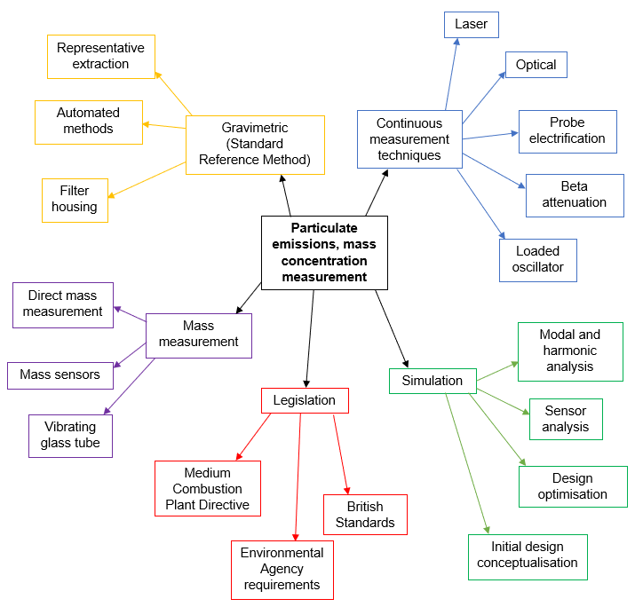
Figure 1-1 Research plan – topics of interest

The second stage of the project is the descriptive study stage. This stage will seek to complete a reference model for the project and to investigate the current state of the industry using both a literature review and empirical studies with the process detailed in Figure 1-2. As stated by Blessing [40], a descriptive study is required for research design projects to complete the reference model in order to identify and clarify the factors that affect the research and project criteria. Through the descriptive stage of the project, problems associated with the current state of the industry will be highlighted. This will determine the relevance of the research and the contribution through which the project will realise whilst highlighting factors that require addressing.
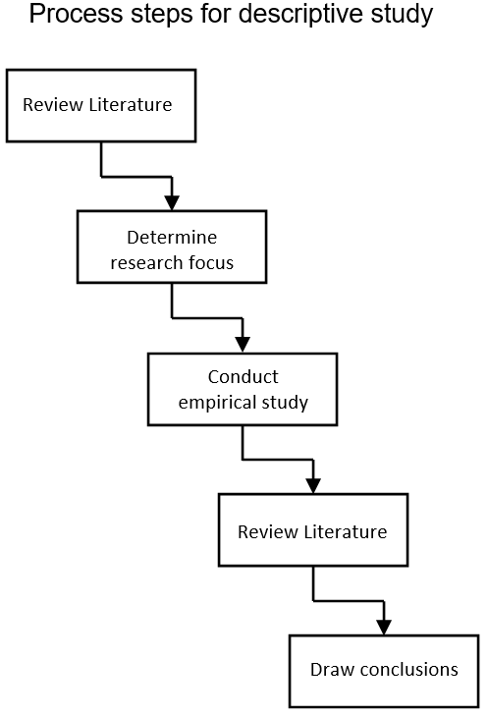
Figure 1-2 Process steps for descriptive study [40]

The two parts of the descriptive phase consist of a review-based stage which will include an initial overview of the literature, both directly and in-directly related to the subject, developing into a more detailed literature review and empirical study. The process involved in the descriptive stage is detailed through Figure 1-2, although this is detailed as a step process the steps may run concurrently.
The third stage of the project is the conceptualisation stage. This will draw on the information gathered through review and empirical study to develop a strong solution to the research problem. Solution principals will be sought during this stage of the project and generally applicable methods will be developed. New concepts and ideas will be critically challenged to identify faults and possible short comings that will be part of the refining and continued development process. This stage will involve exploring novel paths which may seem irrelevant and unconventional, but these ideas should not be dismissed. Through this stage of the project, the lifecycle of the product will be considered, as well as the proposed use, installation, and maintenance.
Every product has a ‘product life cycle’ and is usually commercially designed with this in mind. Kamm [41] explains the typical life cycle of the product. Figure 1-3 details the various stages in the life of a product and all stages should be considered throughout the project process. In conclusion of the conceptualisation stage, the proposed solution should lead to a positive result, with the solution being both academically and practically worthwhile whilst being achievable in the project specification.
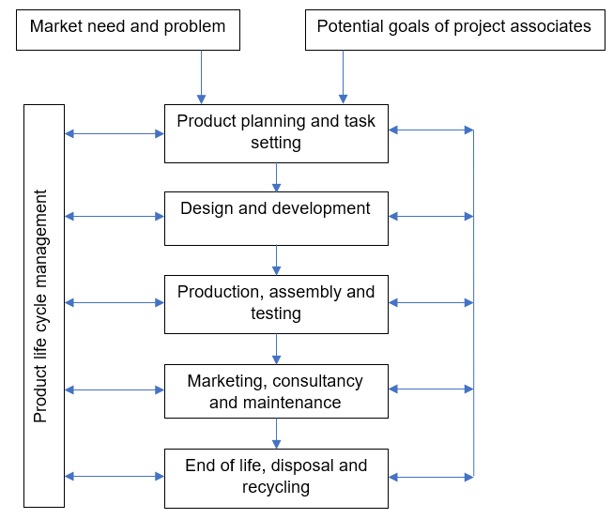
Figure 1-3 Life cycle of a product, reproduced from [41]

The next stage will be the embodying stage where the ideas generated in the conceptualisation stage will be developed into a physical prototype. This will include further review to find the best platforms and technologies for the development process. At this stage it is documented how the solution addresses the problem through simulation and testing. In addition, it will define the elements and components, its principal of function, concepts involved, and how it will operate.
The final stage of the project will be an application evaluation to analyse the design support. The methods that will be used for evaluation are developed through the earlier stages of the research project and recorded as certain test and evaluation criteria are identified. This will determine whether the solution is able to support the problem as intended in application and address any further issues in the measurement of particulate emissions. Areas for further research will be identified and directed at this stage of the research. A continual evaluation will take place for the duration of the project, starting at the conceptualisation stage.
Due to the nature of the project, several research methods will be used. Blessing [40] states that studies of multi-dimensional problems, such as design activities, require multi-level and multi-method approaches. These include:
- Literature review – a literature review is undertaken, covering all aspects of the measurement of particulate emissions.
- Simulation – specialist software is used for the design and development process.
- Experimental testing – a physical model of the designed methodology is used to verify the proposed technique.
- Industrial survey – a survey is used for further industry review.

Overview and structure
As legislation is driving processes to become cleaner, operators are required to be able to prove their emissions levels at low concentrations. There is a great need to accurately measure particulate emissions, and to calibrate CEMS operating on processes where emissions are less than the limit of detection of the equipment. This research project therefore aims to investigate the methodology of particulate emissions measurement. Consideration is made for new and alternative techniques not currently used in the industry to accurately measure particulate emissions to give reliable and repeatable results, with a focus on calibration and the SRM.
This thesis consists of 6 Chapters with a contents table, list of figures, list of tables, declaration, acknowledgements and nomenclature before Chapter 1 and the appendices following Chapter 6. Most of the work presented in this thesis has been published in peer-reviewed journals, as detailed in the appendices.
Chapter 1 introduces the research project. Detailing the research background, the motivation behind the research, the main aims and objectives, the scope and limitations of the research, the research methodology and the structure of the thesis.
Chapter 2 is the initial literature review. This Chapter gives an overview of the particulate emissions measurement industry. Reviewing the current categories for measurement, legislation, and commercially available measurement techniques with a view to highlighting areas in the industry requiring improvement and to realise the contribution of this research project. The results from the literature review are detailed throughout all published journal papers, predominantly published in the Journal of Environmental Management Volume 296, 15th October 2021, 113167.
Chapter 3 details the methodology and requirements for selection of the most suitable particulate monitoring equipment. There is currently no equipment available suitable to cover the full range of applications and therefore careful consideration is required to select appropriate measurement equipment for the relevant application. This Chapter takes information gathered from the literature review in Chapter 2, an industrial survey and multi criteria decision analysis to determine the best selection strategy. The results of the industrial survey and MCDA are published in the Journal of Environmental Management Volume 296, 15th October 2021, 113167.
Chapter 4 details the development of a methodology to measure the mass of particulate directly in a gas stream. Designed with the capability to overcome some of the issues found within the measurement of particulate emissions from stationary sources. Chapters 2 and 3 influence the requirements for the proposed technique as well as highlighting industrial problems that require addressing. Initial geometry designs are presented with modal analysis used to verify the design principal. Following initial verification of the design, geometry optimisation is undertaken to achieve highest sensitivity. Experimental validation is undertaken to verify the simulation results. The results from the geometry design, optimisation, development, and experimental verification are published in Atmosphere 2023, 14, 915.
Chapter 5 details an experimental investigation into using isokinetic sampling to extract a representative sample. This section focusses on the application of alternative methods of analysis, such as that developed through Chapter 4. To accurately obtain reliable results using extractive measurement techniques, the sample extracted from the process must be representative of the total emissions present in the stack. The SRM currently uses an isokinetic measurement process with guidance detailed in relevant legislation and industry guidance. This Chapter investigates the reliability of using the isokinetic measurement technique with the results published in Atmosphere 2022, 13, 1585.
Chapter 6 details the conclusions drawn from the research and makes recommendations for further work in the development and improvement of the particulate emissions industry.
Appendices 1, 2 and 3 detail the published work. Appendix 4 details the industrial survey and Appendix 5 contains figures taken from Section 3.5 in larger format for clarity.

Chapter 2 – Overview of particulate emissions monitoring methods

Introduction
This Chapter presents an overview of the commercially available methods to measure particulate emissions from stationary sources. It focuses on techniques to measure mass concentration. Mass concentration, usually presented in mg/m³, is the measurement requirement to satisfy emissions reporting for the majority of current regulations not only in the UK and Europe but also Worldwide. The process of particulate emissions monitoring has been used and developed over the last 30 years because of increasing demands of legislation development and clean air initiatives. Maintaining a good level of air quality is one of the foremost environmental problems facing our society today. The current discharge of large amounts of particulate matter into the atmosphere poses a threat to quality of life [42], raises various public health issues, and requires urgent attention [3]. Particulate matter affects more people than any other pollutant [9], negatively impacting health [10–12]. Particulate matter is known to be associated with adverse effects on the health of humans, particularly affecting those suffering with any kind of respiratory diseases [13]. Cardiovascular and respiratory diseases have been linked to the exposure of particulate matter with high exposure to particulate increasing the risk of lung cancer [9,14,15,43]. According to the UK EA [16] it is the fine particles formed by combustion that are the main cause of the harmful effects [44]. The EA describe the main sources of particulate as the combustion of coal, oil, petrol, diesel, wood and biomass and made up of sulphates, nitrates, hydrogen ions, ammonium, elemental carbon, silica, alumina organic compounds, trace elements, trace metals and particle bound water [14]. Particulate emissions in flue gasses are produced by combustion of fuel or waste, whilst the characteristics and quantity of the particulate depends upon the type of fuel and the design of the process.
This Chapter reviews the mass concentration measurement of particulate emissions from stationary sources. Detailing the ways that equipment is categorised, the relevant legislation, and measurement techniques as detailed in Figure 2-1. When deciding upon the measurement technique, the operator must consider the range of device, portability, usability, installation requirements, expected concentration, purpose of measurement, particle characteristics, cost, and diameter of stack. All measurement techniques have their own set of working parameters and pros and cons for selection. There is currently no suitable method available to measure mass both directly and continuously. This results in using either the SRM or CEMS which then requires calibration to its application using the SRM to obtain meaningful results. There is currently no single continuous particulate monitor available suitable for all applications. The SRM has a number of issues surrounding its accuracy, specifically at low concentrations <10 mg/m³. This calls into question the accuracy of CEMS equipment which relies on a calibration procedure using the SRM.
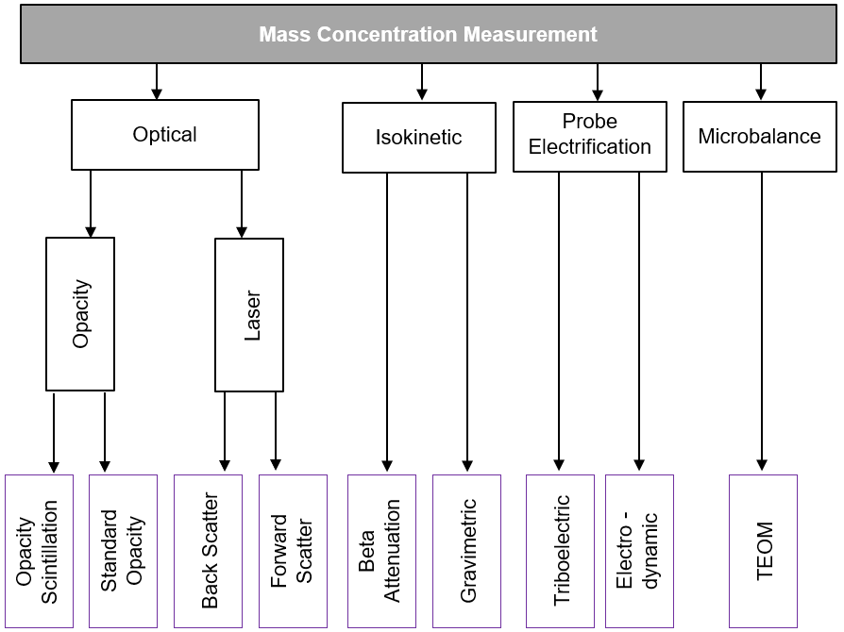
Figure 2-1 Mass concentration measurement techniques

Categories for measurement
Particulate emissions measurement equipment that is designed for use on stationary sources can be categorised into a number of groups depending upon their operating characteristics. An operator should be aware of the categories and how they are relevant to the device application to help with the correct instrument selection process. Irrespective of the category that the equipment falls into, operators of industrial plants have to monitor and maintain their emissions monitoring equipment through a series of tests detailed in EN standards. These tests are a series of Quality Assurance Level (QAL) tests and an Annual Surveillance Test (AST) detailed further in Section 2.3.
Particulate is either classified as filterable or condensable [45]. Filterable particulate can be captured on a filter. Yang [46] defines condensable particulate as material that is a gas at the stack temperature at the sampling point. The semi-volatile particulate can condense into a liquid or solid upon leaving the stack [45,47]. Condensable particulate is always PM_{2.5} or less [47].

Continuous or periodic sample
The principal of CEMS equipment is to measure a parameter of particulate that changes depending upon the concentration in a gas stream. In application, CEMS can be used to measure particulate concentration and also to monitor processes by giving a qualitative analysis of emissions [48,49]. Whereas, for a periodic measurement, a sample is taken over a period of time and will only give a mass concentration measurement result for a certain point in time, rather than continuous real-time monitoring [18].

In-situ or extractive
In-situ measurements are taken on the stack itself using an instrument usually attached to the stack via flanges. Extractive measurements take a representative sample from the stack and analyse the sample externally [50]. Some devices used for in-situ measurements can be adapted and applied to extractive sampling by applying the same measurement techniques to an extracted sample. As an example, PCME Ltd manufacture two products that operate using the same forward scatter laser technology. One is designed for in-situ and the other extractive measurement allowing for measurements to be taken on wet stacks where water droplets may be present [51,52].

In-stack or out-stack
This category of measurement refers to isokinetic sampling and the location of the filter in the sampling system. In-stack sampling locates the filter housing and filter inside the stack whereas out-stack sampling locates the filter outside of the stack [53] and is used when there may be water droplets present in the sample.

Direct or in-direct
Direct measurements respond to changes in the mass of collected particles using the laws of physics whereas indirect measurements respond to changes of particle characteristics rather than mass [27]. Generally, CEMS equipment are in-direct measurements and the SRM is a direct measurement.

Measurement principals
Generally, there are three core principals currently used for monitoring particulate. These three primary approaches for determining the particulate content of gas emissions include [7]:
- The direct measurement of particulate contained in a known volume of gas is captured on a filter and weighed before and after sampling.
- The measurement of certain physical characteristics of the particulate, such as electric charge, can be related to the mass of the particles in a known volume of gas.
- The attenuation of an energy source, such as light or radiation passing through the aerosol or mass of particulate, can be related to the concentration.

Legislation
Operators of stationary source processes have a legislative burden to measure emissions and ensure compliance. In addition to applying good technical judgement in the selection of particulate monitoring equipment, operators are required to comply with relevant legislation. These standards should always be consulted before any particulate monitoring equipment is designed, purchased, or installed to ensure compliance with the relevant legislation. All stationary source processes should operate to the current editions of all relevant standards and in line with any local requirements of the EA in the UK. The area of emissions monitoring is highly regulated with the purpose of measurement for most operators is being due to the increased legislative requirements to meet clean air targets.
The SRM procedure is vital for the calibration of CEMS equipment and is the internationally recognised method. The procedure is detailed throughout the European Standard BS EN 13284-1 which covers the method for measurement of low particulate mass concentration <50 mg/m³ although higher concentrations can be measured with this method. Field tests have been conducted and detailed in the standard, but are only verified down to concentration levels of >5 mg/m³ [34].
Irrespective of the category that the equipment falls into, it is a requirement that CEMS have approvals to determine and maintain suitability. BS EN 14181 “Stationary source emissions – Quality assurance of automated measuring systems” [54], details the requirements for quality assurance of CEMS. These are divided into four Quality Assurance Levels QAL1, QAL2, QAL3 and AST. The requirements specific to particulate CEMS are detailed in BS EN 13284-2 “Stationary source emissions – Determination of low range mass concentration of dust. Quality assurance of automated measuring systems” [55] which details the QAL2 and QAL3 requirements. QAL1 is a requirement that the instrument is suitable for purposes, based upon the procedures set out in BS EN 15267 “Certification of Automated Measuring Systems” [56–58]. The QAL1 is issued by an official test laboratory known as Monitoring Certification Scheme (MCERTS) in the UK and Technischer Überwachungsverein (TUV) in Germany. A Type Approval is issued following several highly controlled tests to prove the reliability of the test equipment and determines if the equipment is suitable to meet the legislative requirements for the particular application and includes the sampling and analytical equipment as a whole. QAL2 is a requirement to regularly inspect the equipment to check that is still able to operate correctly in its environment [37]. This process covers the calibration of the CEMS equipment to a recognised standard and accredited to BS EN ISO/IEC 17025 “General requirements for the competence of testing and calibration laboratories” [59] in addition to MCERTS in the UK. The QAL2 ensures that the equipment is correctly installed, calibrated, and verified by an independent body. Most of the process is undertaken by an accredited laboratory, also known as a test house. QAL3 is the ongoing day to day requirement to ensure equipment is operating as expected. This is an interim check undertaken in between the QAL2 requirement. It is expected that operators of processes record data from emissions monitoring equipment as soon as the equipment is commissioned into service. Irregularities in the pattern of measurements can be observed and dealt with appropriately when continuous data is recorded. The AST is the annual surveillance test and is similar in principle to the QAL2 and is used to analyse the performance of the measurement equipment, to analyse and verify the validity of calibration.
In addition to these requirements there are additional legislation that operators should be aware of. BS EN 15259 “Measurement of Stationary Source Emissions – Requirements for measurement sections and sites and for the measurement objective, plan and report” [60], is a European Standard that covers the requirements for measurement sections and sites regarding emissions measurements. It details the requirements for the measurement objective, plan, and report of measurements of air pollutants, and reference quantities carried out in industrial plants. EN ISO 16911 “Stationary source emissions – Manual and automatic determination of velocity and volumetric flow in ducts” [61,62] is split into two parts. Part 1 specifies a method for periodic determination of velocity and volume flow rate of gas within emissions ducts and stacks, required for determining mass concentration for particulate. Part 2 details the specific requirements for automated measuring system flow monitoring and is closely related to BS EN 14181 [54]. It specifies the criteria for the choice, mounting, commissioning, and calibration of automated measurement systems for determining the volume flow rate. It is developed for monitoring emissions from waste incinerators and large combustion plants. The MCPD [63] applies to medium combustion plants in the thermal size input range of ≥ 1 to < 50 MWth and is relevant to around 143,000 plants across Europe [64]. The majority of combustion plants in the scope of the MCPD includes boilers, engines, and turbines, and excludes large combustion plants that are regulated under the Industrial Emissions Directive (IED) [5]. The directive fills the regulatory gap between large combustion plants covered in the IED and smaller appliances which are covered by the Ecodesign Directive [63] and sets out emissions limits for these processes. The IED establishes the main principal for permitting and controlling of large industrial installations, focussing on providing the best available techniques to achieve a high level of environmental protection considering both costs and benefits [65].
It is critical that suitable equipment is selected to meet the requirements set out in legislation. In the UK, the EA provide additional guidance to the operators of plant and equipment to aid the selection and operational requirements. The methodology required for certain techniques used for the monitoring of particulate emissions are available in legislation, including the SRM procedure.

Measurement techniques
The question may arise as to why there are so many techniques to measure particulate emissions. As Engdahl [7] states, it would be a formidable task to develop an instrument which will instantaneously and accurately record the concentration of particulate in a stack over a wide range of operating conditions. Issues arise with monitoring instruments when the limitations are not fully understood, highlighting the importance of knowing the requirements of the application when choosing a suitable device. A study by Oetari [66] found that plants using the same fuel had different emissions profiles depending upon the design of the treatment process, highlighting the need to fully consider the application and find a measurement device to suit. Jahnke [6] explains that there is currently no best fit solution to particulate monitoring, stating that one of the main issues is that there are no methods available to measure mass both directly and continuously. Meyer [27] states that in order to measure particulate emissions mass concentration directly, particulate needs to be collected and weighed, and that the elimination of mass calibration uncertainty is only possible when using sensors based upon first principal physical laws (direct mass measurement).
An article by Mills [67] details the issues surrounding CEMS, stating that they suffer from potential inaccuracies as they do not directly weigh particulate and must be periodically calibrated using the SRM. Despite its status as the reference method, using the SRM can be laborious, time consuming and not always repeatable. Chung [68] explains that using traditional filter based methods to measure particulate has a disadvantage as they do not offer information in real time as the process requires long sample times. These problems are relevant when using filter-based sampling in both stationary and ambient particulate monitoring.
Averdieck [69] reports of two particular cases where the wrong test instruments were fitted to industrial applications causing cost implications. The first being a vehicle catalyst plant in the UK where the minimum detection level of the fitted opacity measurement instrument was 100 mg/m³ and the prescribed emission limit value was 1 mg/m³. This was using an opacity meter that could not detect low enough values to be of practical use for the application, resulting in the need to replace and re-calibrate a new instrument. The second case was a pharmaceutical company’s clinical waste incinerator in the UK where an optical measurement device was installed to measure emissions but due to the low emissions value of 2 mg/m³ and a small optical path length, the instrument had no response to the low values and was unable to be calibrated. These given examples highlight the need to align application and measurement technique.

Isokinetic sampling, gravimetric analysis – Standard Reference Method (SRM)
The process of using isokinetic sampling with gravimetric analysis is referred to as the standard reference method. It is the industry standard used to calibrate CEMS which applies internationally, although other variations in name may be used including reference method, standard reference method (SRM), and correlation method. The SRM testing procedure is detailed in BS EN 13284-1 and US EPA Method 5 [34,70] and explained throughout Section 5.3.2.
SRM results do not give any real time indication on the performance or control of the combustion process, as it is usually performed annually or biannually depending upon legislative requirements [6,71]. As the name suggests, this is a sample method and therefore for the results to be meaningful the tested sample must be representative of the total emissions [72]. This does however allow for the filter to be taken to a laboratory for elemental analysis of the sample, something that can be difficult with other techniques. Ge [73] successfully carried out a study of stack gas emissions where the mass of the sample on a filter was weighted and then taken to a laboratory for elemental analysis, showing that both a mass concentration and sample analysis can be undertaken on particulate captured on a filter.
Test results taken from CEMS particulate measurement equipment are only indicative of the emissions without calibration of the system in its operating conditions, against a reference method. With gas analysis, a known calibration gas can be used for this process, whereas with particulate, no viable, independent, particle mass concentration standard exists. The SRM is the industry standard for calibration [6,22,74] and has been used in studies to measure particulate emissions as detailed by [75]. Therefore, the accuracy of isokinetic sampling and gravimetric analysis has to be accurate, reliable, and repeatable for the results recorded from the system in service to have credibility.
Due to increased legislation, particulate emission sources are becoming cleaner and are controlled to a much lower concentration level than ever required before. In some cases down to <5 mg/m³ [9]. However, manual test methods such as the SRM are difficult to obtain accurate results in low concentrations <10 mg/m³ of particulate. In a report issued by GDF Suez, Laborelec [37] they state that at low concentrations of <10 mg/m³, calibrating particulate monitors is becoming increasingly challenging.
The manual gravimetric analysis test method was first introduced in around 1970 and as Jahnke [6] explains, there can be an expectation that, as this is a manual reference test method, the results must be accurate. This is not always the case and some of the main issues are the inability to accurately measure low particulate concentrations, poor experimental technique leading to inaccurate results, and extracting a representative sample from the process. Engdahl [7] reported that isokinetic sampling with gravimetric analysis is a tedious task and is of uncertain accuracy due to so many areas where losses can influence the process. Figure 2-2 and Figure 2-3 show the detail of typical isokinetic sampling equipment, the weight of this equipment can typically be up to 100 kg.
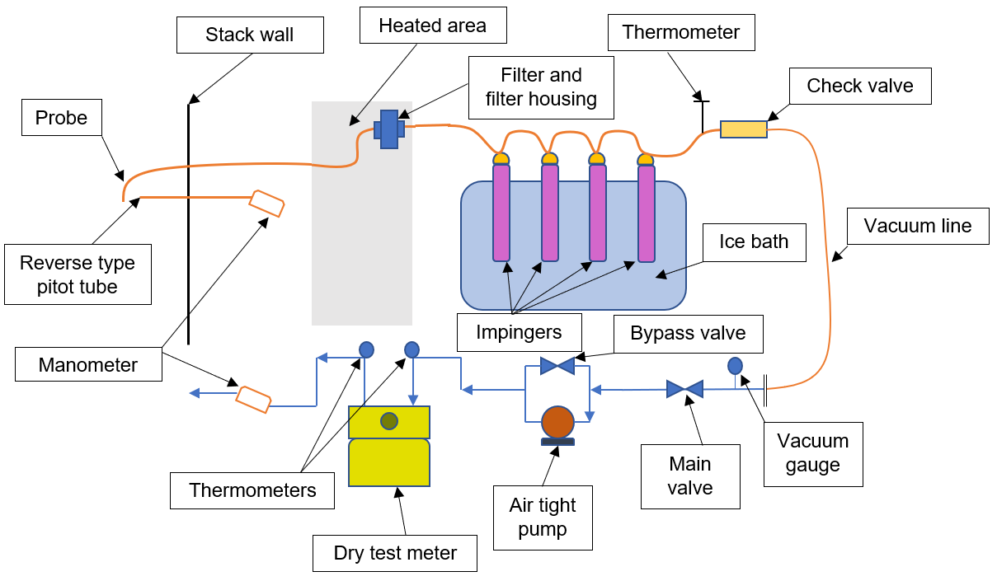
Figure 2-2 Typical isokinetic sampling equipment [76]
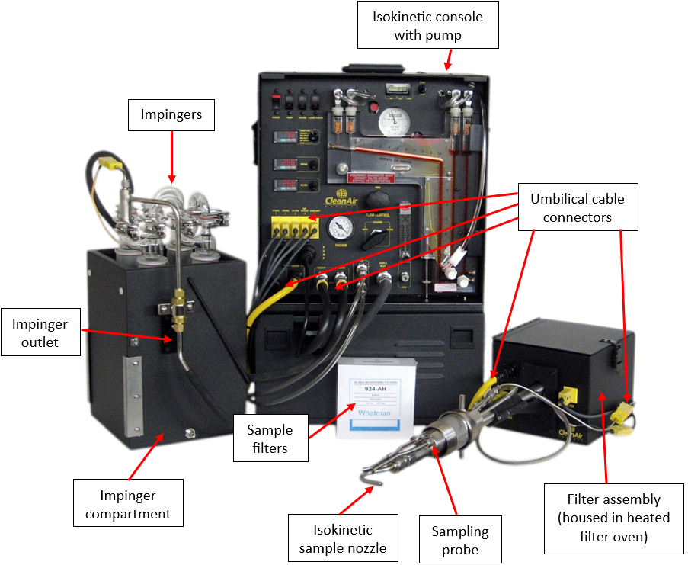
Figure 2-3 Clean Air isokinetic sample train equipment [77]

Results from the SRM are reported in standard conditions although measurements are not taken in standard temperature and pressure conditions, therefore a conversion is required [53,78]. As temperature and pressure change, the volume of the gas also changes, even though it still contains the same amount of particulate. The standard conditions of a dry gas for reporting are 101.325 Pa and 273.15 K [55,76]. There are four considerations to accurately report results in standard conditions these include temperature, pressure, moisture content, and excess oxygen. The industry requirements detailed in BS EN ISO 16911-1 [61] and industry guidance notes detail the following conversations. The dry volume flow rate under standard conditions of temperature and pressure is given by:
 | $$q_{V,0d}= q_{V,w}* \frac{p_{c}}{101.325}*\frac{273.15}{T_{c}}* \frac{100-φ_{H_{2}O}}{100}$$ | (1)
Where:
- $q_{V,0d}$ = the dry volume flow rate under standard conditions of temperature and pressure
- $q_{V,w}$ = the volume flow rate under the conditions of temperature and pressure of the duct, on wet gas, in m3/s
- $p_{c}$ = the absolute pressure in the duct, on the measurement section in kPa
- $T_{c}$ = the temperature of gas, in the measurement section, in K
- $φ_{H_{2}O}$ = the water vapour content of gas in the duct, expressed as a percentage volume fraction.
The dry volume flow rate, under standard conditions and on reference oxygen concentration, in m³/s is given by:
 | $$q_{V,0d,O_{2}ref}=q_{V,0d,O_{2}}* \frac{21-φ_{O_{2},d}}{21- φ_{O_{2},ref}}$$ | (2)
Where:
- $q_{V,0d,O_{2}ref}$ = the dry volume, under standard conditions and on reference oxygen concentration, in m³/s.
- $q_{V,0d,O_{2}}$ = the dry volume flow rate, under standard conditions and on actualoxygen concentration, in m³/s.
- $φ_{O_{2},d}$ = the reference oxygen concentration, expressed as a percentage volume fraction.
- $φ_{O_{2},ref}$ = the oxygen concentration measured in the duct during the exploration of the duct on dry gas expressed as a percentage volume fraction.
The principal of isokinetic sampling is that a nozzle which is designed to offer minimum resistance and disturbance is installed parallel to the gas flow. During sampling, the sample flow rate is adjusted so that the velocity at the nozzle is equal to the velocity in the duct [79]. A process known as isokinetic sampling. The gas containing the particulate is drawn through a filter which captures the particulate [80]. The volume of gas that is drawn through the filter is measured. These values are used to calculate a mass concentration reading, reported in mg/m³ [76].
The measurement of particulate where moisture is present using any measurement technique can be particularly challenging. In this instance when using the SRM, changes to the procedure can help to achieve accurate results. Out-stack filtration is best suited to wet samples where the filter and sample can be heated to vaporise any droplets present. BS EN 13284-1 [34] states that the filter must be conditioned, which is confirmed in a study by Kuo [81]. The filter should be dried for at least one hour before sampling at a temperature of at least 20 °C above the maximum temperature reached during sampling. The filters are to then be cooled to ambient temperature in a desiccator located in the weighing room for at least four hours.
Losses must be kept to a minimum to obtain a representative sample and to maintain high accuracy in particulate measurement systems. A study completed by Zhu [82] detailed the many factors that can affect the loss of particles in the sampling lines of emission monitors. Two of the main factors are, the temperature difference between the hot sampling gas and the pipe wall, and the surface roughness from the pipe itself. Combining all possible factors, losses in the sampling lines of a particulate monitor can reach 69 % after 0.2 seconds for PM₁₀. Smaller particles generally have lower percentage losses.
The current standard BS EN 13284-2 [55] states that the sampling velocity should be within -5 % to +15 % of the isokinetic velocity but should be as close as possible to minimise losses. Figure 2-4 taken from work completed in BS EN 13284-2 [55] indicates the influence of particle size, nozzle diameter, and their combined effect on the error due to non-isokinetic sampling with constant flow rate. The first graph indicates the influence of particle size ‘d’ and the nozzle diameter between 6 mm and 32 mm and their combined effect on the error ‘e’ at 20 % under-isokinetic sampling. The second graph indicates the influence of particle size ‘d’ and nozzle diameter between 6 mm and 32 mm and their combined effect on the error ‘e’ at 20 % over-isokinetic sampling.
Figure 2-4 Effects of over and under isokinetic conditions for five nozzles
(6 mm, 15 mm, 20 mm, 25 mm, and 32 mm) [55]

Permission to reproduce extracts from British Standards is granted by BSI Standards Limited (BSI). No other use of this material is permitted. British Standards can be obtained in PDF or hard copy formats from the BSI online shop: www.bsigroup.com/Shop

Probe electrification
Probe electrification systems utilise a probe installed inside a section of a stack that is in such a position to measure the most representative profile of particulate emissions. Figure 2-5 details how a probe would be inserted into a stack to achieve a representative sample. As explained by Averdieck [83], the working principal of probe electrification technology is based on the measurement of electrical signals derived from the interaction of the particles and the probe installed in the stack.
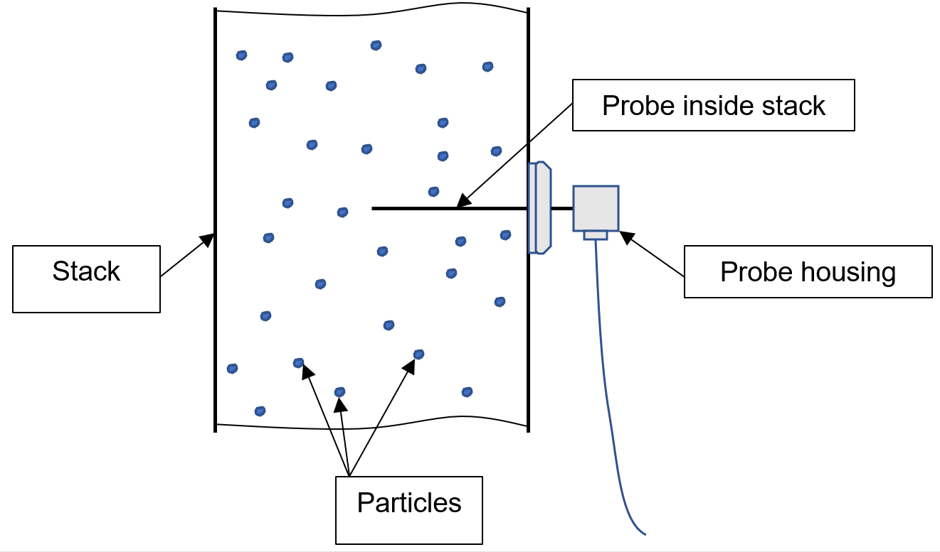
Figure 2-5 Probe electrification system [24]

There are two common methods of measurement available [24] but both methods have very different measurement characteristics. The signal in electrodynamic measurement uses the induced frequency response from variations in the distribution of particulate passing the probe, whereas with triboelectric, the signal comes from the total number of particles impacting the probe. Averdieck [83] explains that triboelectric systems measure and amplify the magnitude of the Direct Current (DC) signal produced when particles collide with or rub against the grounded sensor inserted into the stack. This DC signal can be dependent upon many factors with the most important being the concentration of particulate, but other factors that can affect results are the amount of charge transfer, the particle impact energy, probe material, and the type and characteristics of particles. Electrodynamic particulate emissions monitors measure Alternating Current (AC) current as a result of a charge induction. As the charged particles pass the grounded sensor, the measured AC current is directly related to particulate concentration. The term electrodynamic generally emphasises the fact that the charge is generated from movement of particulate, whereas the term triboelectric suggests that the particulate is charged due to friction or direct contact with the electrode [24].
There are probe electrification products available to measure mass concentration limits as low as 0.1 mg/m³ [24,48] making this method of measurement very appealing to certain applications where low concentrations are expected. Sensitivity is generally higher than that of any opacity monitors, and an important consideration is that accurate calibration of a system at such low concentrations <10 mg/m³ is extremely challenging. Care should be taken when determining the reliability and accuracy of such low readings if an accurate calibration process is not possible. Nevertheless, Yan [24] explains that probe based electrostatic particle monitors are suitable for installations on stack sizes of 50 mm – 6 m, making them a versatile device.
The movement of particles in an industrial plant generates an electric charge. As described by Yan [24,36], the electrification of particles is expected when they come into contact with other surfaces. The electrostatic charge is due to collisions between particles, the surface of the stack, and friction between particles and the air stream. The amount of charge is dependent upon physical and chemical properties of the particles as well as external influences such as humidity and temperature.
Measurement issues with triboelectric and electrodynamic devices are that they can be affected by changes in particle size distribution, changing particle type, changes in particle characteristics or changes in charge on the particulate [84]. If the application is subjected to any of these changing conditions then probe electrification may not be the best method of measurement [24]. An example application could be an incinerator where fuel type is subjected to change and electrostatic precipitators are used. This is confirmed by Yan [24] who explains that a limitation of both methods of probe electrification is that they are sensitive to changes in physical and chemical characteristics of particulate as well as to changes in humidity and temperature of the source.

Electrodynamic
Probe electrification is a measurement of contact charge transfer, measuring charge transferred to a probe inserted into a stack. When two materials make contact, due to the flow of particles in a stack there is a net transfer of electrons from one material to another [6,36]. Electrodynamic particulate monitors measure AC. The AC current produced is directly related to the particulate concentration. Two types of interaction take place to produce the charge. Direct collision with the probe, and charge induction where charge on the particle repels charge in the probe as it passes in close proximity. [85]. The AC signal is measured and analysed by the measurement device to give an output in mg/m³ which can then be calibrated against the SRM to give meaningful results. This signal can be amplified to higher levels than with the triboelectric method. Electrodynamic systems are not affected by build-up of particulate matter on the probe unlike the use of triboelectric measurement. In electrodynamic measurements, triboelectric current is also produced but is filtered out [83].

Triboelectric
In triboelectric systems the magnitude of DC triboelectric current, produced by particles colliding and rubbing against a grounded sensor inserted in a stack, is measured and amplified [83]. Triboelectric instruments detect three separate effects when particles impact or pass close to the probe. Castellani [35] describes the three effects as:
- A particle striking the conductor causes a charge transfer to take place between the particle and conductor.
- A particle striking the conductor rubbing on the surface causing a frictional charge.
- Charged particles passing close to the conductor inducing a charge of equal and opposite magnitude.
The charge generated by 1 and 2 are dependent upon velocity, mass, and charge history and 3 is an inductive charge.
Triboelectric systems can be affected by a build-up of particulate on and around the probe in the stack, and have limited sensitivity to submicron particles which do not contribute proportionately to mass [86]. This then creates unreliability with readings and requires a regular maintenance program to minimise inaccuracies due to contamination of the probe [87]. The amount of DC current measured is related to the particulate concentration, although other parameters can affect the charge transfer. Averdieck [83] explains that the factors affecting measurements are the type of particulate which is dependent upon the fuel source, the energy of the particle, the material of the probe, stack gas velocity, and contamination that may build up on the probe surface. A typical triboelectric probe is shown in Figure 2-6.
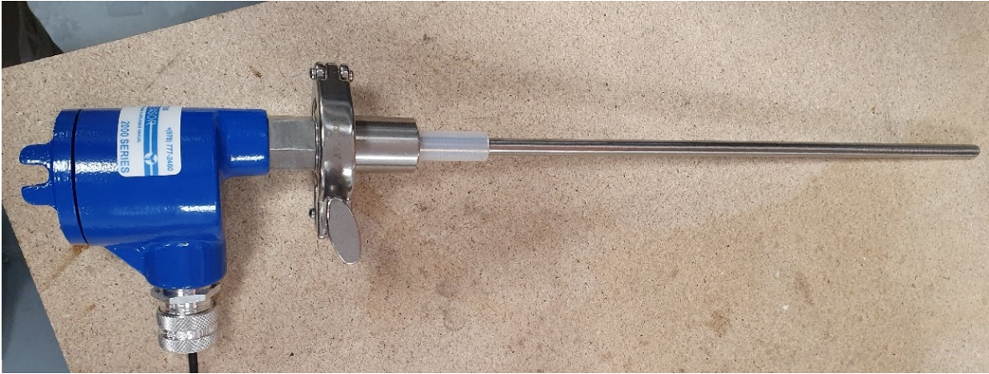
Figure 2-6 Triboelectric probe by Auburn Systems LLC

Opacity
As a beam of light hits a particle, it is either scattered by reradiating in all directions or absorbed by transforming it into other forms of energy [71,88]. This characteristic of particulate can therefore be used as a technique to measure mass concentration. The size, shape, and colour of particles as well as the type of light and receiver will determine how this light behaves in opacity measurement. Using optical techniques to measure the mass concentration of the particulate is not a direct measurement [13,89], and therefore, a calibration procedure is required for all optical measurements. The principal of operation is that opacity measurement instruments measure the reduction in light passing through the stack due to the concentration of particulate present.
As explained by PCME Ltd [87], laser scatter systems are now replacing standard opacity instruments due to increased performance and ease of installation as they can be installed in single point configuration. Manufacturers state that they can be used to measure low concentrations at levels of particulate <10 mg/m³, however, this would still have to be confirmed with calibration via the SRM as with all methods of continuous emissions monitors. This brings into question the reliability of instruments at these levels due to problems associated with the SRM at low concentrations.
Opacity and light scatter techniques are sensitive where water droplets may be present and therefore care should be taken when selecting a measurement technique for use in these applications. It can be possible to use optical techniques to measure particulate matter in wet stacks where moisture droplets are present, but different techniques are required, most commonly extractive techniques. In this instance the sample is usually heated to remove the water droplets by keeping the sample above the dew point. However, the additional process increases losses in the sampling equipment and therefore an important design consideration here is to ensure that the sample remains representative.
There are two methods of opacity measurement used in stack emissions testing. Both use similar methodology but interpret measurements in different ways to output a mass concentration reading. The two methods are traditional opacity and ratio-metric opacity [90].

Traditional opacity
Traditional opacity measures the attenuation of energy of an optical light source transmitted through a flue gas [90]. The EA [91] state that opacity meters are not suitable for concentrations less than 10 mg/m³ measurements, although manufactures are now stating capability to measure lower concentrations. The light from an opacity device can pass through the stack by transmission, be scattered by particles, be absorbed by particles, or be reflected by particles. As the concentration of particulate increases the light energy attenuated is also increased. Figure 2-7 details how opacity can be measured according to the concentration of particulate in a stack.
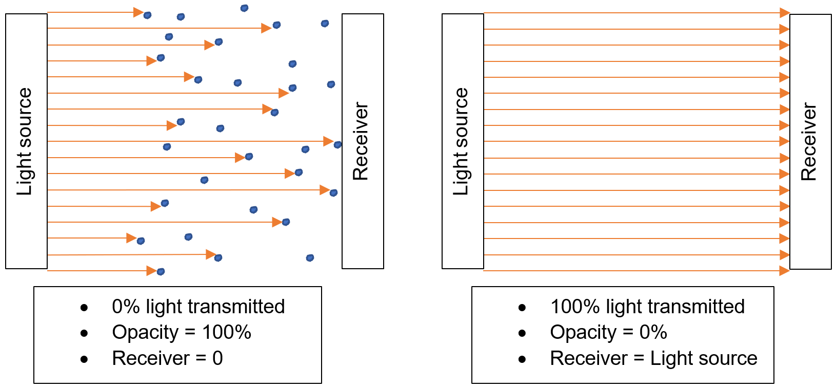
Figure 2-7 Opacity technology light source transmission

As explained by Castellani [35], the receiver in an opacity meter measures the decrease in light intensity due to absorption and scattering as the beam crosses the stack through the particulate laden gas emissions. The reduction in light is proportional to the mass concentration of particulate inside the stack, outputting results in mg/m³.
There are two configurations of opacity monitors, single pass, and double pass. Single pass devices have a light source and detector on opposite sides of the stack. Double pass devices use a reflector on the opposite side of the stack to the light source. Benefits of double pass include having no electronics on the reflector side of the stack, resulting in an easier maintenance procedure. Castellani [35] confirms that opacity meters used to measure particulate matter should use a red or near infrared light source and that opacity measurements are dependent on particle size, composition, shape, colour, and refractive index. These characteristics will change depending upon fuel type and application, and therefore requires the need for accurate and regular calibration.

Ratiometric opacity
Traditional methods of opacity measure the intensity of light received, whereas ratio-metric methods measure the ratio of signal scintillation to absolute light intensity [22,50]. Ratiometric opacity devices do not measure the light beam intensity but the temporal variation, or light scintillation in its intensity [90]. Castellani [35] explains that the main advantage of this method over traditional opacity methods is that it is unaffected by lens contamination, therefore reducing maintenance of the unit. The reduction in light intensity and the reduction in intensity caused by lens contamination are affected by the same proportion. The device is therefore unaffected by contamination up to approximately 90 %. The solution to contamination issues is confirmed by PCME Ltd [92]. They explain that their ratio-metric method has significant advantages in terms of reliability and resolution over traditional opacity measurement techniques as it avoids problems associated with the contamination of the lens in a traditional device.
The principal of operation in ratio-metric instruments is that they measure the ratio of temporal variation in intensity of the light, this is known as optical scintillation. Optical scintillation is caused by variations in the atmosphere that the light passes though. These irregularities produce optical effects on a light source [92,93]. The higher the concentration of particles in the stack, and therefore in the light path, the greater the range in variation of light. Averdieck [94] explains that ratio-metric opacity also known as dynamic opacity, is only capable of resolving particulate concentrations as low as 2.5 mg/m³ but calibration makes this difficult to calibrate at <10 mg/m³. This technology has the capability to be applied to a large concentration range as it is suitable for concentrations up to 1,000 mg/m³. Figure 2-8 taken from PCME Ltd Stack 602 datasheet shows that light intensity and the variation in intensity are affected by the same proportion [35].
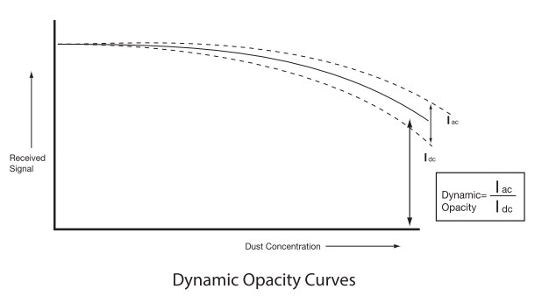
Figure 2-8 Dynamic opacity curves from PCME Ltd Stack 602 [92]

Loaded oscillator
The loaded oscillator also known as a Tapered Element Oscillating Microbalance (TEOM), is an electromechanical device that has been developed on the principal that the frequency of a vibrating oscillator will reduce as the mass of the element increases [6]. Aside from the direct gravimetric measurement technique, a loaded oscillator is one of the most direct means of measuring particle mass. Janke [6] explains that although this technology has been used for a long time, there are a few problems relating to cleaning and recalibrating the vibrating element.
The principal of operation is that a representative sample is isokinetically taken from the stack and sampled through a filter located on top of a hollow tube which oscillates in a temperature-controlled housing [95]. A carefully controlled vacuum is applied to the opposite end of the hollow tube and as the gas flows through the tube, the particulate is captured on the quartz filter [96]. The change in frequency of the oscillating tube is measured with the reduction being proportional to the mass of particulate [89,97].
A TEOM monitor detailed in Figure 2-9, provides a continuous measurement of collected particulate mass. The filter collects the particulate from the sample and, as in alternative filter-based measurement techniques, can suffer from the same losses [98]. Soysol [26] explains that heating the system is necessary for the accuracy of the sensor due to its sensitivity to temperature, however, this does increase the losses in semi-volatile material.
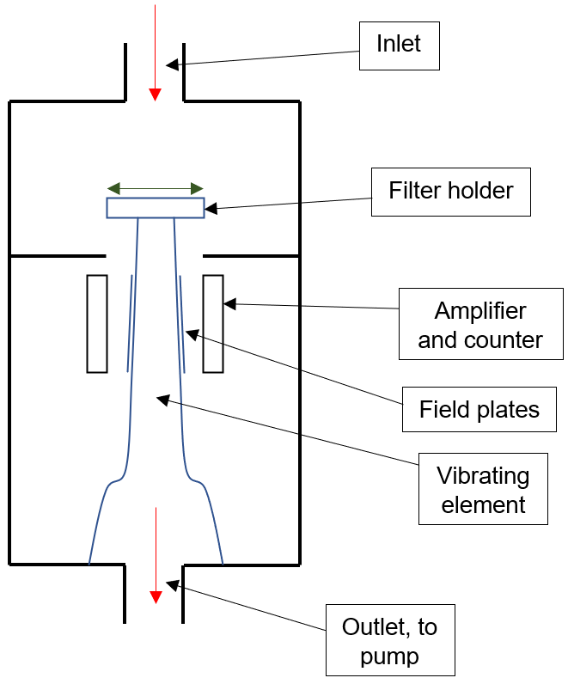
Figure 2-9 TEOM element [78]

A TEOM monitor requires a sample to be collected from a stack or duct while automatically maintaining isokinetic sampling conditions. A filter is attached to one end of the mass transducer allowing the collected particles to be weighed continuously, resulting in a real-time measurement of the mass concentration. Gonnet [95] describes the principal as tracking the frequency of the oscillator to provide the mass rate and combining it with the sample flow rate through the filter. Mass concentration can then be directly calculated.
The TEOM is specific to mass measurement loading, and even though the oscillating frequency is directly proportional to mass, there can be significant systematic errors. To reduce the errors, the oscillating element is maintained at a temperature of 50 °C [99]. This temperature is high enough to evaporate volatiles from some particulates reducing the mass, and therefore reducing the accuracy. Additional pre-treatment of the sample can reduce some volatilisation errors [78].

Beta attenuation
Beta radiation devices are commercially available equipment [100] and use an isokinetic technique to extract a sample from the flue or duct, with the sample deposited on a glass fibre filter tape. The filter tape is wound on a roll moving sequentially so that a small spot of particulate matter is collected and analysed [6]. Figure 2-10 shows how the particulate is collected on the filter tape before moving to the beta attenuation analysis. The filter media is tested as a reference before any particulate is deposited and used as a base line. The initial and final measurements are then subtracted to calculate the difference between the two measurements to give a beta attenuation reading with the captured particulate. A typical beta attenuation monitor is detailed in Figure 2-11.
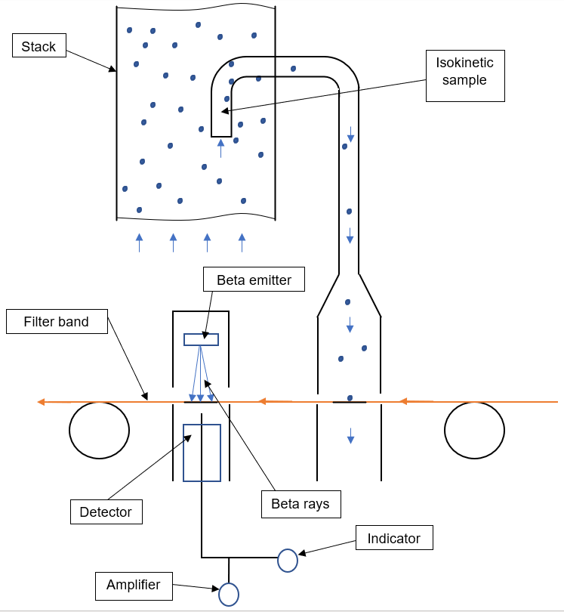
Figure 2-10 Beta attenuation process [101]

Beta attenuation systems are based upon the correlation between the intensity of the Beta radiation and the concentration of particulate on a filter paper [86]. Beta gauge samplers continually measure particulate by extraction. The sampling duration is usually programmable [102] and will determine the mass concentration detection limit. At high concentrations the duration is kept low [37] to avoid sampling excessive particulate concentration [100].
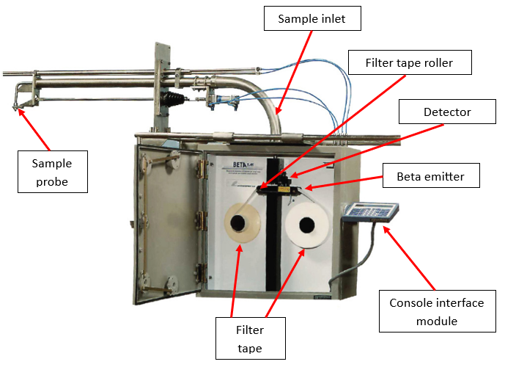
Figure 2-11 Beta gauge monitor [103]

Castellani [35] explains that the challenges associated with using Beta gauge measurement devices are the high maintenance requirements, although they do benefit by not being affected by size, colour changes, and size distribution differences [102,104]. Further difficulties are explained in a presentation by Cemtek [101] who states that the installation process is difficult, the devices are expensive, and the operating costs are high.
The radiation absorbed and scattered by the particulate collected for analysis is dependent upon its composition. The absorption of beta rays depends upon the exchange of energy with the electric field of electrons in the particulate. Jahnke [6] explains that the exchange is only slightly dependent upon the atomic number for most of the particulate found in stationary source emissions. This is due to the electron density being similar, where the electron density is equal to the ratio of the atomic number to the atomic weight. If the atomic number is relatively constant the attenuation of the radiation can be successfully used to provide a measure of the mass of the material collected.
Jahnke [6] explains that the advantage of using beta attenuation is that this method can be used to measure wet gas streams containing water droplets due to its heated sample probe. Soysal [26] states that its radioactive source limits its acceptance in industrial applications. Chung [68] explains that while the heated sample line will reduce the effects of water content in the sample, it may bias results where large amounts of volatile particulate is present. Any source of natural or artificial radioactivity can modify the beta count and therefore influence the accuracy of the results. The main components of a beta radiation device are the beta source and the detector, shown in Figure 2-10.
The beta gauge does not measure mass directly and therefore must be calibrated against the SRM. Following calibration, a mass concentration reading can be given, usually ranging between 2 mg/m³ – 2,000 mg/m³ [91]. Although beta radiation devices are automated and sample continuously, the devices cannot be considered continuous in line with MCERTS requirements [37] due to the systematic sampling process and are therefore known as batch samplers [7,105].

Laser (Light Scatter)
When a laser beam is directed into the path of particulate it is reflected, refracted, absorbed, and scattered in all directions. Light scatter instruments measure the amount of light that is scattered in a particular direction and will output a signal that is proportional to the amount of particulate matter in the light path [35]. It is this principal that light scatter technology uses to determine the concentration of particulate in a stack or duct [106]. The amount of light scattered is based upon the concentration and properties of the particles in the path of the light [107]. The properties include size, composition, shape, colour, and refractive index, which can all change depending upon the fuel type [35]. This makes optical sensors strongly dependent upon these changing properties and can affect accuracy in processes where conditions are subject to change [108,109]. Automatic laser measuring devices can either be forward, backwards, or side scatter, which describes the way in which the scattered light is measured and is dependent upon the position of the detector in relation to the path of the light source [37]. Different angles of detection are used by manufactures for various reasons including minimising dependence on the particle size distribution and particle refractive index, or for instrument design purposes. The forward scattering technique is less sensitive to particle size and refractive index changes. Side scatter is most sensitive to refractive index but allows for easier design of equipment for in-stack measurements. Back scattering is least sensitive to particle size changes. The consideration when using any light scatter instrument when measuring particulate mass concentration is that they must be calibrated using the SRM [107], which should the conditions change render the measurement inaccurate.
There are two different types of scattering effects that are observed when the light hits the particle. These are Rayleigh and Mie scattering. Bivins [107] explains that when the wavelength of the incident light is much larger than the radius of the particle, 'Rayleigh' scattering is observed, and when the wavelength of the incident light is the same size, 'Mie' scattering will occur [35] as detailed in Figure 2-12.
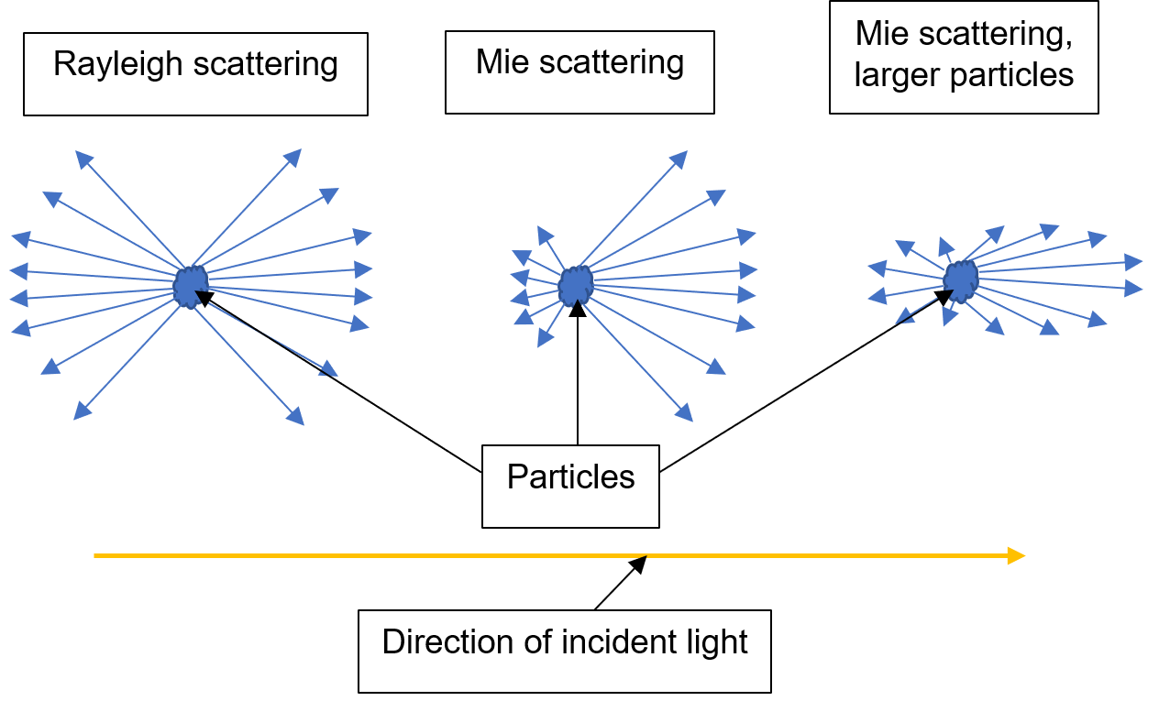
Figure 2-12 Rayleigh and Mie scattering [35]

Forward scatter
PCME Ltd [51] explain that as particles travel through a beam of light causing them to scatter light in all directions, light scattered forward will be the strongest. The beam of light is transmitted by a laser, through the particulate, reflecting off the concave mirror into the beam dump. The concave mirror is focussed onto a quartz rod where scattered light only is transmitted to a light detector. The amount of light received is proportional to the particulate concentration, as shown in Figure 2-13.
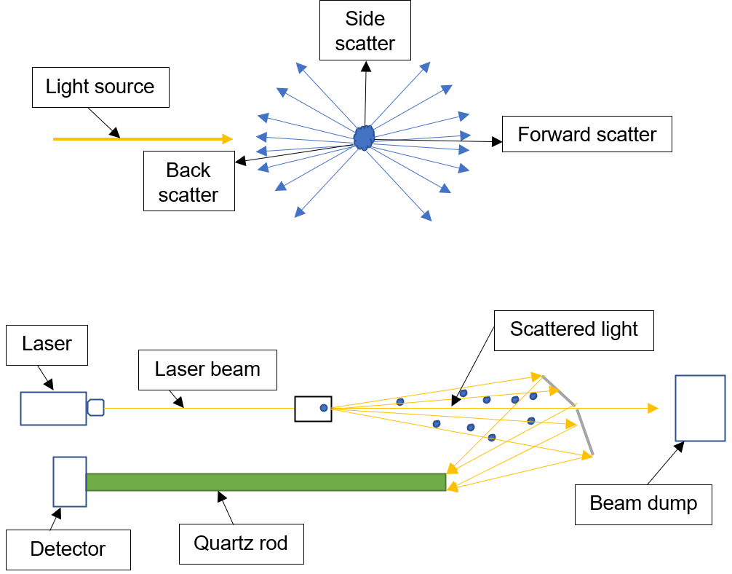
Figure 2-13 PCME Ltd QAL 181 – Principal of operation [51]

A study completed by Chen [110] concluded that forward scattering and especially small angle scattering at around 25 ° is most suitable for low concentrations of around 10 mg/m³ as this increases sensitivity.

Back scatter
Back scattering devices are best suited to measure particles that are less than 10 µm in diameter or PM₁₀. Using a wavelength of 900 nm, the instrument response is proportional to the cube of the particle radius, giving a direct relationship between particle volume and therefore mass, which following calibration against the SRM can give a mass concentration value.
PCME Ltd [111] state that in their back scatter devices the sensor measures the amount of light scattered back from the particles in the stack illuminated by a modulated laser. This operation is shown in Figure 2-14. Application of this technology requires calibration against the SRM to give a mass concentration result in mg/m³ [111]. Some back scatter instruments do not operate well in high temperatures due to instability issues [106]. Back scatter technology is dependent upon the refractive index of the particulate, which can cause issues if the particle characteristics are prone to change [6].
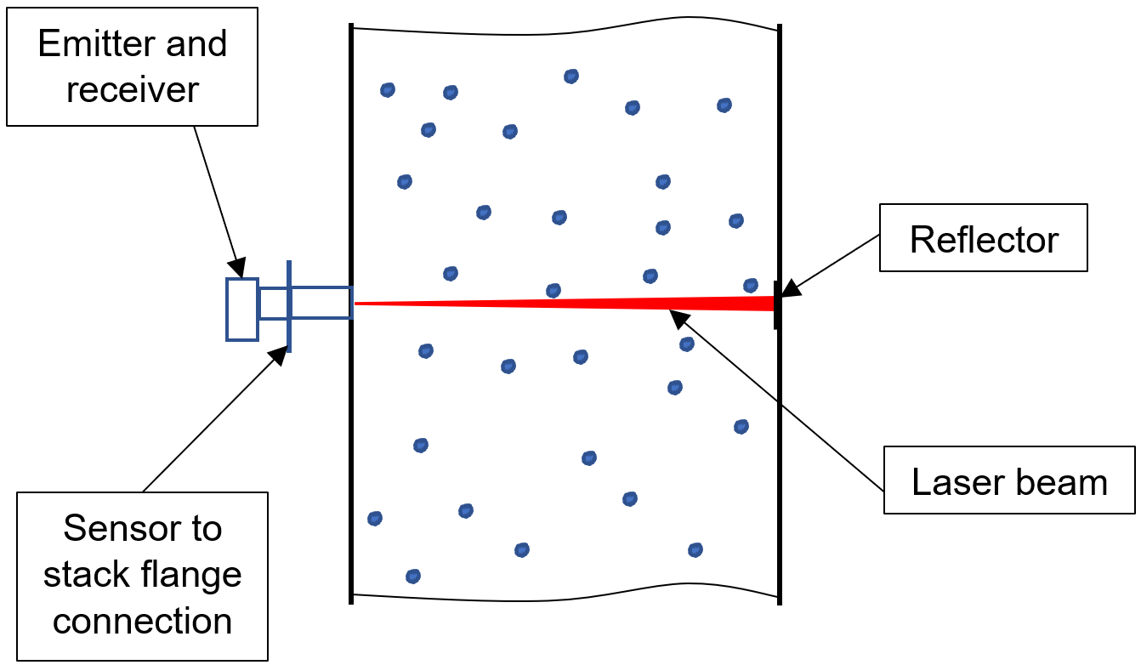
Figure 2-14 PCME Ltd QAL 360 – Principal of operation [112]

Side scatter
Side scatter devices are capable of measuring medium range concentrations >200 mg/m³ of particulate but as with back scatter instruments they are dependent upon the refractive index of the particles, and also the particle size distribution [6]. Changes in the properties of the particulate can affect the calibration line of the instrument, therefore making them unsuitable where processes are prone to changes in the particulate emissions profile.

Scatter technology in wet stacks
Although the application of laser technology is affected by water droplets, it is possible to install these devices in wet stacks using the same technology but using different extractive techniques to sample the gas stream before analysis. Several manufacturers currently produce laser products capable of measurement in wet stack applications. PCME Ltd state that their QAL 181 WS model, shown in Figure 2-15, is suitable for stacks below the dew point and with water droplets present [52].
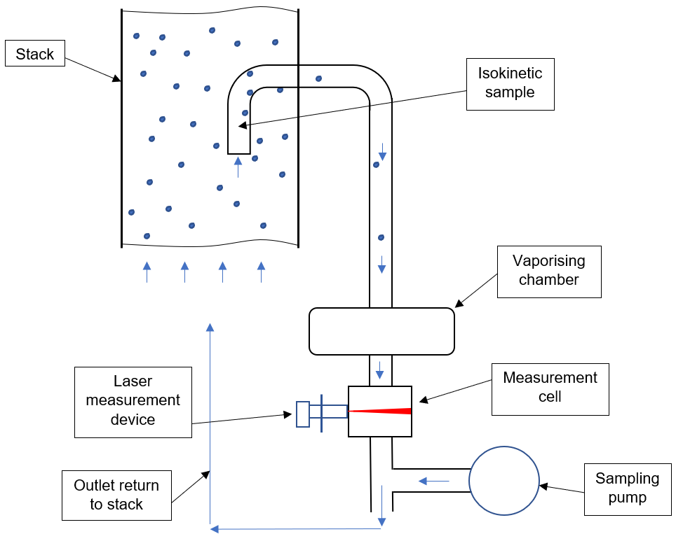
Figure 2-15 PCME Ltd QAL 181 WS – Principal of operation [52]

In a wet stack, a continuous sample is taken from the stack under controlled isokinetic conditions and is heated to remain above the dew point. The measurement section of the system uses the same laser technology as in-stack testing [52]. In certain cases, depending upon the technology used to measure particulate, a mathematical correction calculation may be used to account for the moisture in a stack to improve accuracy. This is only possible where consistent emissions are being recorded and where change in moisture content is minimal.

Measurement techniques comparisons
A summary of the technologies available to measure particulate emissions from stationary sources is detailed in Table 2-1. The summary details the vast range of detection limits, measurement range and advantages and disadvantages.
Technology  Table 2-1 Comparison of particulate measurement techniques | General Principals | Detection Limits | Measurement Range (mg/m³) | Advantages | Disadvantages
Gravimetric Analysis (Standard Reference Method) | Requires isokinetic sampling to obtain representative sample. Sample is collected on a filter, taken to a laboratory for weighing before and after sampling to determine particulate in stack. Sampled volume of gas is measured to output mass/volume | Analysis is difficult where emissions are less than  10 mg/m³ | >10,000 | Suitable for processes with changing conditions. Reference method for calibration of alternative measurement methods. Guidance on process methodology available in legislation | Labour intensive. Manual process. Heavy equipment. Not capable of continuous measurement. No feedback on process.
Opacity Scintillation | Measures temporal variation or light scintillation in its intensity, they do not measure mass of particulate directly and require calibration which is dependent upon particle size, composition, shape, colour, and refractive index | Generally, not used in applications where  emissions are less than  10 mg/m³ | >1,000 | Suitable over a wide range of stack diameters from  0.3 - 18 m. Generally unaffected by particulate contamination | If process or emissions conditions change,  re-calibration is required. Requires regular calibration. Chemical analysis not possible.
Standard Opacity | Measures attenuation of energy of an optical light source transmitted through a flue gas, with the attenuation being proportional to the particulate in the stack. Does not measure mass of particulate directly and requires calibration which is dependent upon particle size, composition, shape, colour, and refractive index | Generally, not used in applications where  emissions are less than  10 mg/m³ | >10,000 | Suitable over a wide range of stack diameters from  0.3 - 18 m. Generally unaffected by particulate contamination. | If process or emissions conditions change,  re-calibration is required. Requires regular calibration. Chemical analysis not possible.
Back  Scatter | Measures amount of light scattered back from particulate in the stack and does not measure mass of particulates directly, requiring calibration with the SRM | 10 mg/m³ and above | >1,000 | Suitable for stack diameters up to 8 m. | Not suitable where process conditions are subject to change. Requires calibration
Forward  Scatter | Measures amount of light scattered forward from the particles in the stack and does not measure mass of particulates directly, this therefore requires calibration with the SRM | 10 mg/m³ and above | >200 | Suitable for stack diameters up to 8 m. | Not suitable where process conditions are subject to change. Requires calibration.
Beta  Attenuation | Undertaken under isokinetic conditions. Representative sample is extracted from stack and deposited onto filter tape which moves sequentially on a roll. Cannot be removed for chemical analysis | 2 mg/m³, but calibration at this  level is unachievable with the standard reference method | >10,000 | Can measure  <10 mg/m³.  Suitable in changing process conditions. Suitable for stack diameters up to  18 m. | Calibration is required. Chemical analysis not possible. High cost. High maintenance requirements.
Tribo-electric | Measures magnitude of DC current produced by particles colliding and rubbing against the sensor in stack. Can be affected by a build-up of particulate on probe. Amount of DC current produced is proportional to particulate concentration in the stack | Measurements below 10 mg/m³ are possible  but calibration  at this level is not possible | >1,000 | Low initial cost. Ideal for indicative monitoring. | Highly sensitive to changes in process and particulate characteristics. Calibration required. Suited to smaller diameter stacks.
Electro-  dynamic | Measures contact charge transfer to a probe in the stack. Measures the AC current produced which is directly related to the concentration of particulate in the stack. The AC signal is measured, analysed and an output given in mg/m³ | Measurements below 10 mg/m³ are possible  but calibration  at this level is not possible | >1,000 | Low initial cost. Ideal for indicative monitoring. Less affected by particle build up on probe than triboelectric. | Highly sensitive to changes in process and particulate characteristics. Calibration required. Suited to smaller diameter stacks.
TEOM | A loaded oscillator and electromechanical device. Measures a change in frequency of a vibrating oscillator which reduces as mass of particulate builds up on a filter located at the end of the oscillator | Measurements below 10 mg/m³ are possible  but calibration  at this level is not possible | >200 | Not affected by changing conditions. Filter can be removed for chemical analysis. | Requires an intensive maintenance program. High cost. Requires calibration.

Conclusion
The question may arise as to why there are so many techniques to measure particulate emissions. The task of designing, manufacturing, installing, and maintaining particulate emissions monitoring equipment in the harsh environments that it is expected to operate is a challenging task. The harsh environments coupled with the vast range of changing characteristics of processes results in unstable particulate emissions profiles, and therefore measurement challenges. Manufactures of equipment have reacted by developing equipment capable of overcoming some of the application-based challenges that have arisen.
All current CEMS equipment for particulate emissions monitoring is required to be calibrated against the SRM for accurate reporting purposes. Without calibration, results can only be defined as indicative and not accurate quantitative results that are now required as legislation is driving process to emit less particulate. This in turn puts a heavy burden on the SRM process which in itself is a manual, labour intensive, and costly process. The accuracy of the SRM is questionable especially at concentrations <10 mg/m³. Careful consideration of the accuracy of results when calibrating CEMS equipment on processes with these low particulate mass concentrations is therefore required.
CEMS equipment all suffer from the same potential inaccuracies as they do not weigh particulate directly but measure a characteristic of the particulate. They allow for a continuous measurement to be taken from processes, something that is not possible with the SRM. Although this process measures the mass of particulate directly, it does not allow for any real time measurement. CEMS equipment is now being used for the monitoring of plant health as well as for emissions reporting purposes due to the lower costs of manufacturing equipment.
There is currently no measurement technology available to measure the mass concentration of particulate directly online to give real time measurements. It is suggested that to measure particulate emissions mass concentration, a direct mass measurement is required. The SRM currently uses a direct mass measurement approach but is not capable of measuring directly and online. Further investigation into the current state of the particulate emissions measurement industry is required to further realise the requirements for future development. Further investigation is undertaken throughout Chapter 3 through an industrial survey and MCDA.

Chapter 3 – Selection of particulate monitoring equipment

Introduction
This Chapter aims to investigate the current state of the particulate emissions measurement industry. The intention is to realise the perceptions of industrial experts working within the field and to develop a methodology for the selection of appropriate equipment considering application characteristics. Consideration will be made to Chapter 2 of this thesis report, an industrial survey, and MCDA for comprehensive analysis of the measurement techniques operating in a full range of applications. This Chapter highlights the importance of matching a suitable device with the intended application. Requirements for installing and operating particulate mass concentration measurement equipment can vary for reasons including ensuring compliance with legislation, and to optimise, monitor or control combustion processes. The intended application influences the approach to monitoring stack emissions. The options available are either periodic measurements and/or continuous emissions monitoring. Periodic measurements take a representative sample from the stack before being transferred to a laboratory for analysis. Continuous monitoring undertakes measurement on site, in real time, either in the stack or on an extracted sample. For credibility of results with particulate emissions reporting, continuous methods require calibration against the SRM [25,26].
The performance and suitability of any particulate monitor is application dependent and the fundamental issue with obtaining good results is to ensure that the instrument is fit for the intended purpose. Meyer [27] states that difficulties surrounding accurate particulate capture include:
- Particulate being the only air pollutant not defined by its molecular composition.
- Particulate laden emissions can contain water droplets.
- Some particulates can volatise at ambient temperature.
There is currently no single continuous particulate monitor available which is suitable for all applications, therefore the selection of appropriate equipment is vitally important to the accuracy of continuous particulate monitoring. This Chapter details methodology for selecting the Best Available Techniques (BAT) when considering the measurement of particulate emissions. There is a vast range of application characteristics that influence the selection of suitable equipment, the influence of these characteristics is investigated through MCDA. Through an industrial survey the perceptions of industrial experts are considered when investigating improvements to current measurement techniques and procedures. When considering the development and improvement of the industry, a full review is required. This is through a literature review, industrial survey, and MCDA.

Methodology
This Chapter used three analysis methods to complete a full review of techniques to measure particulate matter emissions from stationary sources including:
- Literature review
- Industrial survey
- MCDA
The analysis presented in this Chapter is driven by the fact that particulate emissions profiles from stationary sources vary significantly from process to process. Operators have different motivation to measure particulate, including satisfying legislation and industrial requirements, and process control and monitoring which influences the selection of equipment. This section will give an overview the research methodology used throughout this Chapter.

Literature review
A comprehensive literature review was undertaken to give an understanding of the commercially available techniques to measure particulate matter from combustion processes.
The literature review was conducted in stages by searching carefully considered key terms including:
- All available measurement techniques, ‘opacity scintillation’, ‘standard opacity’, ‘back scatter’, ‘forward scatter’, ‘beta attenuation’, ‘gravimetric’, ‘triboelectric’, ‘electrodynamic’ and ‘tapered element oscillating microbalance (TEOM)’.
- Categories for particulate measurement, ‘continuous and periodic particulate measurement’, ‘in-situ and extractive measurement’, ‘in-stack and out-stack sampling’ and ‘direct and indirect particulate measurement’.
- ‘Particulate formation from stationary sources’.
- Legislation for particulate measurement, ‘stationary source emissions legislation’, ‘particulate emissions measurement legislation’, ‘emissions legislation’ and ‘emissions directive’.
- ‘Multi criteria decision analysis’ and ‘preference ranking organisation method for enrichment evaluation (PROMETHEE)’.
The literature review seeks to give an overview of the current state of the commercially available measurement techniques for particulate emissions.

Industrial survey
An industrial survey, detailed in Appendix 4, was undertaken as a systematic method of calculating the weighting for each criteria to be assessed in the MCDA. It was also used for gaining information on the current state of the industry with a view to providing suggestions for improvement for further research.
Ostovare [113] successfully used a survey of an expert team to develop criteria and weight for use with the PROMETHEE MCDA methodology. This research seeks to successfully implement a similar model, using a carefully designed industrial survey and the PROMETHEE method to successfully determine the best approach to particulate emissions measurement from stationary sources.

Multi criteria decision analysis
The decision process in selecting the most suitable particulate emissions monitor is complex due to its multivariate nature with poor decisions having costly implications. It is not acceptable to select a device simply because it is a suitable match to just one of the many criteria, therefore a more detailed approach should be taken through the methodology developed through this research. MCDA is a formal approach whose purpose is to aid a decision making process by considering the decision makers in the development of structured thinking about the selection problem at hand [114].
In this research, an industrial survey, and literature review were used to derive:
- Criteria for each evaluation (measurement technology) to be analysed against.
- Weighting for each evaluation.
- Application based criteria to analyse the use of the available measurement technologies in a range of applications.
- Appropriate methodology for MCDA framework.
The PROMETHEE method of decision analysis was chosen for this research as the method is well adapted to a problem where a finite number of alternative actions are to be ranked considering several criteria [115] that is suited to smaller data sets [116]. Ishizaka [117] completed a study to select the best statistical distribution and introduced the use of PROMETHEE method stating that it allows for the preferences of the decision maker to be fully considered rather than imposing a set of parameters. In this research the preferences of the decision maker (industry expert) are to be fully considered due to the significant cost and operational implications caused by poor selection of equipment.

Survey
A survey was conducted as a systematic method of gathering information from industry experts regarding the measurement of particulate emissions, specifically the technologies and methodologies currently used. The survey aimed to gain a deeper understanding of the application and use of the various technologies available from the perceptions of industry experts working within the particulate emissions monitoring industry.
Jones [118] explains that to obtain a representative sample it is important to consider who will be targeted. Therefore, during the design of the survey, it was decided that researchers, national regulators, operators, stack testers, independent and in-company test houses, and industry specialists including consultants would be approached. The assumption was made that participants understand the industry of particulate emissions measurement, which was confirmed in Figure 3-1 which details participant current job role. 100 % of participants also confirmed that they understand the health risks associated with particulate emissions and 94 % have had hands-on practical experience of particulate emissions measurement.

Figure 3-1 Participant role within the particulate emissions measurement industry

The survey combines the perceptions and views of experts using, designing, maintaining, and installing particulate emissions measurement equipment. The results from the literature review will be analysed alongside the results from the industrial survey for a comprehensive analysis of the current state of the industry. The focus of this section is to build an understanding of the industry and to highlight issues and challenges that require addressing to improve the quality of particulate emissions measurement. Ponto [119] explains that surveys are used for the collection of information from a sample of individuals through their responses to questions. In this review an online research tool was used, similar to that used by Sherman [120] to collect data from participants. The total number of responses for the survey was 732. The survey was designed with 20 questions for all participants and included both open and closed format questions. Topics covered include the perceptions of the industry, the roles and experience of participants within the industry, details of the measurement of particulate emissions, requirements for monitoring, and issues and improvements with monitoring equipment.
Participants were asked if in their opinion enough is being done to monitor and understand emissions from stationary sources, and if adequate technology is available to measure particulate emissions. The responses to this question were noticeably split with 50 % of participants stating that they thought enough is being done to monitor emissions and 61 % thought that adequate technology is available. Nearly all those who stated that enough was being done to monitor emissions also felt that adequate technology is available. Therefore, the majority of those who do not feel enough is being done also do not feel that adequate technology is available, with a small proportion unsure and unable to comment.
Results show that a range of measurement technologies are currently in use including standard opacity, opacity scintillation, laser, beta attenuation, SRM, triboelectric, electrodynamic, and oscillating microbalance. The SRM is the most popular measurement technique being used by 83 % of participants with 30 % using laser and an even split of all other techniques. 75 % stated that their single favoured technique would be the SRM. Figure 3-2 details the preferred measurement techniques to measure particulate emissions. This question does not address the application complications which have to be considered when selecting suitable equipment. Application requirements are addressed in the MCDA section of this Chapter.

Figure 3-2 Preferred particulate emission measurement technique

Legislation is now requiring applications to measure and report emissions where levels are lower than ever seen before. Participants were asked what the preferred measurement technique for applications with low concentrations would be. Figure 3-3 shows that the SRM with gravimetric analysis would also be the preferred choice for lower concentrations although 34 % could not confirm that their equipment is capable of measuring low concentrations.

Figure 3-3 Technique to measure low concentration of particulate

Participants were given opportunity to openly comment on any problems associated with particulate emissions monitoring equipment and to discuss any improvements that could be made. There are common themes that have been analysed from the data highlighting the issues and possible improvements to equipment. Firstly, the difficulty of accurate measurement of particulate <10 mg/m³ is highlighted throughout the survey results, confirming the findings of the literature review. This problem is now becoming increasingly significant as emissions limit values are driven lower as processes become cleaner. Several experts highlighted and encouraged the need for research into new technologies or methodologies to find suitable approaches to measure at low emission values. Secondly, those working with the equipment on a daily basis emphasised the need for the equipment to be more ‘useable’ including a reduction in the size and weight of the equipment, easier maintenance procedures, better connectivity and interface, and increased protection from the elements, specifically referring to the SRM. Thirdly, there were two points raised regarding the measurement of the devices. The first is that available equipment is not able to efficiently handle any change in the characteristics of particulate emissions. Should a process continually burn the same fuel, at the same rate, producing the same emissions, the monitoring equipment can provide reasonably accurate results. When changes in the process occur, the reliability of results is questionable. The second is regarding calibration of CEMS equipment, especially <10 mg/m³, where accurate calibration is difficult.

Multi criteria decision analysis (MCDA)
The process of selecting the most suitable particulate emissions monitor is complex due to its multivariate nature; poor decisions can have costly and timely implications. These decisions are rarely a matter of choosing a solution based on the optimisation of a single well defined criteria [121]. It is not appropriate to select equipment simply because it is a suitable match to just one of many criteria, therefore a more detailed approach should be taken. MCDA is a suitable option to analysing both quantitative and qualitative data for engineers when faced with making a choice between various options [122]. Therefore, making it ideally suited for comparison of varying technologies against several criteria. The PROMETHEE MCDA methodology was used for this research. The specific details of the algorithms for the PROMETHEE technique are published in readily available literature [113,115]. PROMETHEE facilitates the ranking and ordering of complex matters [116,123], which in this review is particulate emissions measurement techniques for stationary sources. Mathematically the problem is defined by [113,124]:
 | $$max\left\{f_{1}(a),f_{2}(a),...f_{j}(a)...,f_{k}(a)\left|α∈A\right.\right\}$$ | (3)
Where:
- $A$ is a finite set of n actions
- $f_{1}$ to $f_{k}$ are k criteria
- $f_{j}(a)$ is the evaluation of action a on the criteria $f_{j}$
Assuming that criteria is to be maximised.
PROMETHEE is an outranking method that does not eliminate any alternatives in a pairwise comparison but instead ranks the alternatives according to the criteria and preferences applied by the user. The main advantages are its simplicity, clearness, and stability [113,125]. The process involves assigning preference and weighting conditions, pre-selected by the user, and applying them to the variables [116]. Weighting is completed separately, this allowed the use of the industrial survey and literature review to strengthen the weighting process, a method explained by Fülöp [126]. Weighting of criteria is an important part of the PROMETHEE MCDA methodology [113] and the industrial survey used in this research seeks to strengthen the process. The use of dedicated software helped with the implementation of the of the PROMETHEE methodology, [117] and in this research ‘Visual PROMETHEE Educational Software’ was used. Each criteria requires a preference function which defines differences in pairwise evaluations. These are translated into degrees of function and are a reflection of the perception of the criteria scale by the decision maker [127]. The integrated preference function assistant in the Visual PROMETHEE Educational Software was utilised to determine the preference function for each criteria. The MCDA process which was used in this research is detailed in Figure 3-4, showing how the criteria, weighting, and data is selected. Also, the influence and application of the literature review and industrial survey to obtain the strongest outcome.
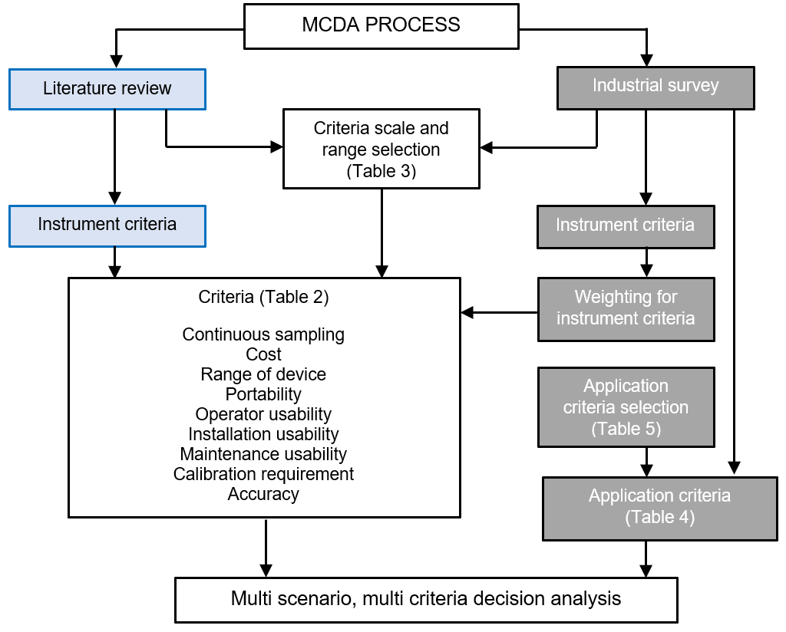
Figure 3-4 Multi criteria decision analysis process

The industrial survey was undertaken as a systematic method of calculating the weighting for each criteria in this research. The criteria subjects were derived from responses to participants considerations for selection of particulate emissions measurement. Participants in the survey were given a list of carefully selected suggestions derived from the literature review, as well as an open opportunity to submit their own. The results for the weighting of criteria were taken as a percentage. The correct weighting of criteria is essential to accurately represent the priorities of the decision maker. The requirements for each criteria, scale, range, and the weighting factor given as a percentage, are detailed in Table 3-1. The Visual PROMETHEE software requires the preference for each range to be set to maximum or a minimum depending upon the preferred outcome for each scenario and application-based criteria.
Table 3-1 Criteria requirements, scale, and range and weighting factor for MCDA
Criteria | Requirement | Scale | Range | Weighting Factor (%)
Continuous sampling | Based upon the instrument’s capability for continuous measurement according to the MCERTS requirement. | Qualitative | Yes / No | 5.8
Cost | Based upon the capital cost of the product, not including costs of  maintenance requirements. | Currency (£) | 5,000 – 70,000 | 8.9
Range of device | Based upon the operating range of  the product. | Qualitative | Very high, high,  medium, low, very low | 7.1
Portable | Based upon whether the instrument is designed to be transported between applications rather than assigned to one site as a fixed installation. | Qualitative | Yes / No | 11.4
Operator usability | Based upon the ability for the end user to operate the instrument  including operating basic functionality. | Qualitative | Difficult, moderate, simple | 16.1
Installation usability | Based upon the ease of installation for the qualified installation engineer.  It should be noted that this is product and not application based. | Qualitative | Difficult, moderate, simple | 10.3
Maintenance usability | Based upon the requirements for maintenance taking into consideration maintenance frequency, work required at each interval, and therefore costs incurred for the maintenance. | Qualitative | Difficult, moderate, simple | 10.5
Calibration requirement | Based upon the requirement for calibration of the intended device to  function in its operating conditions. | Qualitative | Yes / No | 11.0
Accuracy | Based upon the accuracy of the device  as a percentage. | Numerical | 5 % – 30 % | 18.8

MCDA results can be expressed in different ways. Partial ranking is a comparison of the leaving flow (Phi+) and the entering flow (Phi-). Where Phi+ represents the technology with most positive criteria, and Phi- represents the technology with least negative criteria [127]. Long [124] explains that MCDA results are presented by means of the total function value obtained for each action. This means that actions are prioritised from the highest and lowest Phi value. Phi +1 = best solution whereas Phi -1 = worst solution. Complete ranking is based upon the net preference flow by combining the other preference flows in a single score. This means that all actions are compared and that the ranking will not include any incomparability.
Phi+ ($φ^{+})$can be expressed as:
 | $$φ^{+}(a)=\frac{1}{n-1}\sum_{b≠a}{π}(a,b)$$ | (4)
Where $φ^{+}$ measures how much an action a, is preferred to the other n-1 actions, being a global measurement of the strength of action a.
Phi- ($φ^{-})$can be expressed as:
 | $$φ^{-}(a)=\frac{1}{n-1}\sum_{b≠a}{π}(b,a)$$ | (5)
Where $φ^{-}$ measures how much the other n-1 actions are preferred to action a, being a global measurement of the weakness of action a.
Phi ($φ$) can be expressed as:
 | $$φ(a)=φ^{+}(a)-φ^{-}(a)$$ | (6)
Where $φ$ considers both the strengths and weaknesses of the action into a single output.
Scenarios were used to assess the decision process from the viewpoint of different decision makers by modifying the selection of criteria to suit the requirements of the intended application. Decision makers, for the purpose of this research, are those who are selecting suitable equipment including researchers and operators of plant who require the most suitable equipment to measure particulate emissions. Scenarios, for the purposes of this research, are application-based criteria detailed in Table 3-2 which represent the requirements of the different decision makers. Nine carefully selected applications are analysed in this research to cover a comprehensive range of applications for stationary source particulate emissions measurement. The stack diameter and concentration criteria were arranged into range categories at set points where the parameters of measuring equipment characteristics change.
Table 3-2 Application criteria and justification
 | Categories |  | Justification
 | Application Criteria | Range
1 | Stack diameter for continuous monitoring  (non-isokinetic) | 0.3 – 3 m | Stack diameters for stationary sources can range from 0.3m to 18m. Measurement devices have operating ranges which impacts selection. This includes continuous monitoring devices as isokinetic sampling can be undertaken over the full range of stack diameters, but addition sampling points may be required for accuracy.
2 |  | 3 – 6 m
3 |  | 6 – 18 m
4 | Concentration | 0 – 200 mg/m³ | Particulate emissions measurement devices have detection limits and a concentration operating range, the measurement device must be selected to  fit this criteria.
5 |  | 200 – 1,000  mg/m³
6 |  | 1,000 – 10,000 mg/m³
7 | Changing conditions | n.a. | If the process is subject to changing fuel characteristics, the PM emissions will be subject to change as a result, including particle size, composition, shape, colour,  and refractive index. It is difficult to undertake  accurate measurements using continuous  monitoring due to the requirement of recalibration.
8 | Changing velocity | n.a. | Continuous monitoring in changing emissions characteristics can be difficult but some devices operate better than others.
9 | Chemical analysis required | n.a. | Sample analysis can only be undertaken following the collection of a sample either on a filter or similar method.

The comparison of selected technologies is excluded in instances where the technology was not appropriate for that particular application as detailed in Table 3-3. The information in Table 3-3 is derived from both the literature review, industrial survey, and data taken from Table 2-1. Beta Attenuation, SRM and TEOM are not included for any selection of stack diameter in the application criteria as all are carried out under isokinetic conditions and this application criteria relates only to non-isokinetic sampling for continuous methods, represented in Table 3-3 as n.a. Where a technology is suitable for the application criteria it is represented by ✓, whereas a technology is not suitable for the application criteria it is represented by ✗.
Table 3-3 Application criteria selection
Application Criteria | Range | Ratiometric opacity | Standard opacity | Back scatter laser | Forward scatter laser | Beta attenuation | Standard reference method | Triboelectric probe | Electrodynamic probe | TEOM
Stack diameter for continuous monitoring (non-isokinetic) | 0.3 – 3 m | ✓ | ✓ | ✓ | ✓ | n.a. | n.a. | ✓ | ✓ | n.a.
 | 3 – 8 m | ✓ | ✓ | ✓ | ✓ | n.a. | n.a. | ✗ | ✗ | n.a.
 | 8 – 18 m | ✓ | ✓ | ✗ | ✗ | n.a. | n.a. | ✗ | ✗ | n.a.
Concentration | 0 – 200  mg/m³ | ✓ | ✓ | ✓ | ✓ | ✓ | ✓ | ✓ | ✓ | ✓
 | 200 – 1,000 mg/m³ | ✓ | ✓ | ✓ | ✗ | ✓ | ✓ | ✓ | ✓ | ✗
 | 1,000 – 10,000 mg/m³ | ✗ | ✓ | ✗ | ✗ | ✓ | ✓ | ✗ | ✗ | ✗
Changing conditions | n.a. | ✗ | ✗ | ✗ | ✗ | ✓ | ✓ | ✗ | ✗ | ✓
Changing velocity | n.a. | ✓ | ✓ | ✓ | ✓ | ✓ | ✓ | ✗ | ✗ | ✓
Chemical analysis required | n.a. | ✗ | ✗ | ✗ | ✗ | ✗ | ✓ | ✗ | ✗ | ✓

Results
The MCDA results are displayed visually in complete ranking form in Figures 3-5 – 3-13. Each application criteria represented individually is visually displayed in a Graphical Analysis for Interactive Aid (GAIA) web form graph in Appendix 5, Figures A 5-1 – 5-9. The results are also consolidated in Table 3-4, which details the best available technology to measure particulate emissions mass concentration where a single application criteria applies. Table 3-5 expands on this, and details results for two applications.

Complete Ranking and GAIA web graphs
The GAIA webs show a graphical representation of the unicriterion net flow scores for the selected technology, showing the compatibility of each technology for the application for each criteria. Conventional spiderweb graphs display the variables equally spaced around the centre of the display, with the shape being dependent upon the arbitrary order of the criteria. The GAIA web expresses similar preferences close to each other giving more meaningful visual analysis. For each dimension, the radial distance corresponds to the net flow score with -1 values drawn at the centre of the web with +1 values at the outer circle, with a polygon connecting the criteria. The further from the centre of the web, the higher the compatibility of the device for that criteria. The complete ranking chart visually displays the suitability of the available technologies for the application criteria. The closer the outcome is to +1, the better suited it is to operate as the best available technology for the application. Only technologies capable of measurement for the application criteria are visually displayed. For the purposes of Figures 3-5 – 3-13 the following abbreviations are used.
- RO – Ratiometric opacity
- SO – Standard opacity
- EP – Electrodynamic probe
- TP – Triboelectric probe
- BSL – Back scatter laser
- FSL – Forward scatter laser
- TEOM – Tapered element oscillating microbalance
- SRM – Standard reference method
- BA – Beta attenuation

Techniques for stack diameters of 0.3m – 3m

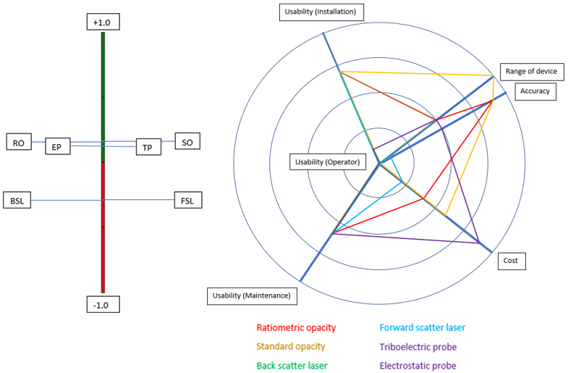
Figure 3-5 MCDA complete ranking and GAIA results showing the best available techniques for a stack diameter of 0.3 m – 3 m non-isokinetic

Figure 3-5 details the complete ranking results for measurement technologies on stack diameters of 0.3 m – 3 m. The complete ranking chart shows that RO and SO are the most suitable technologies when selected against the range of measurement criteria. EP and TP are also suitable options, although a weaker fit compared to RO and SO. For clarity, the GAIA web graph showing the suitability of each technology, for each instrument criteria, for stack diameters of 0.3 m – 3 m, is also detailed in Appendix 5, Figure A 5-1. The criteria that are strongly correlated are grouped close to each other and negative values are drawn at the centre of the web. The GAIA web graph details how each technology performs against each criteria.

Techniques for stack diameters of 3m – 8m

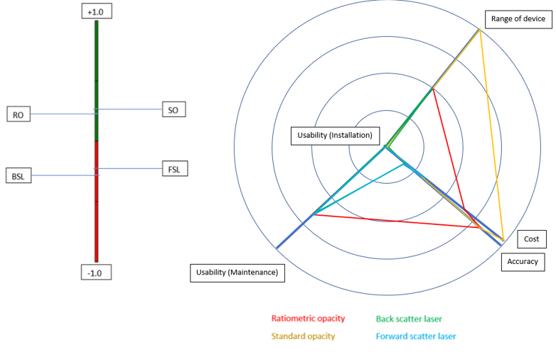
Figure 3-6 MCDA complete ranking and GAIA results showing the best available techniques for a stack diameter of 3 m – 8 m non-isokinetic

Figure 3-6 details the complete ranking results for measurement technologies on stack diameters of 3 m – 8 m. The complete ranking chart shows that SO is the most suitable technology when selected against the range of measurement criteria. RO is also a suitable option, although a slightly weaker fit compared to SO. For clarity, the GAIA web graph showing the suitability of each technology, for each instrument criteria, for stack diameters of 3 m – 8 m, is also detailed in Appendix 5, Figure A 5-2. The criteria that are strongly correlated are grouped close to each other and negative values are drawn at the centre of the web. The GAIA web graph details how each technology performs against each criteria.

Techniques for stack diameters of 8m – 18m

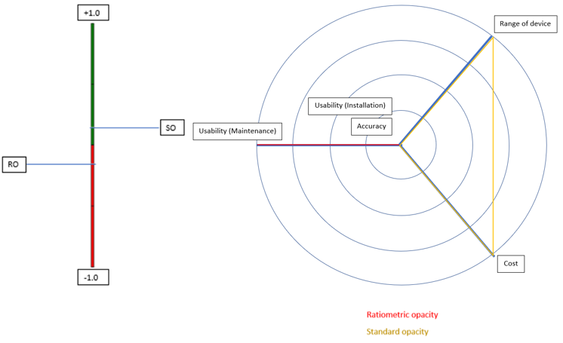
Figure 3-7 MCDA complete ranking and GAIA results showing the best available techniques for a stack diameter of 8 m – 18 m non-isokinetic

Figure 3-7 details the complete ranking results for measurement technologies on stack diameters of 8 m – 18 m. The complete ranking chart shows that SO is the most suitable technology when selected against the range of measurement criteria. For clarity, the GAIA web graph showing the suitability of each technology, for each instrument criteria, for stack diameters of 8 m – 18 m, is also detailed in Appendix 5, Figure A 5-3. The criteria that are strongly correlated are grouped close to each other and negative values are drawn at the centre of the web. The GAIA web graph details how each technology performs against each criteria.

Techniques for concentrations of 0mg/m³ – 200 mg/m³

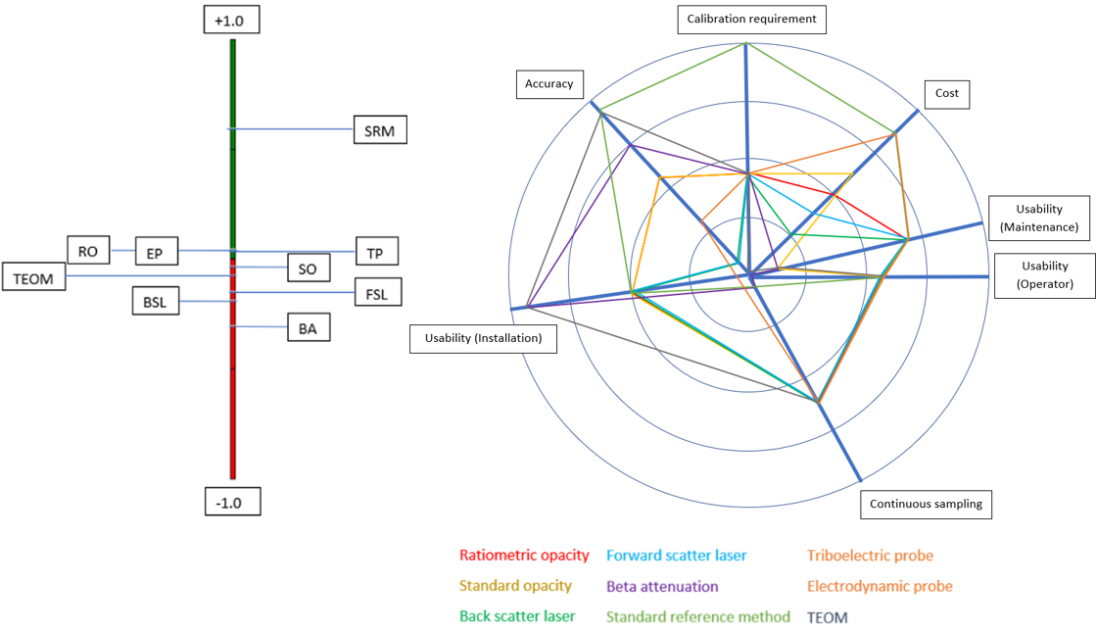
Figure 3-8 MCDA complete ranking and GAIA results showing the best available techniques for a concentration of 0 mg/m³ – 200 mg/m³

Figure 3-8 details the complete ranking results for measurement technologies for concentrations from 0 mg/m³ – 200 mg/m³. The complete ranking chart shows that the SRM is the most suitable technology when selected against the range of measurement criteria. For clarity, the GAIA web graph showing the suitability of each technology, for each instrument criteria, for concentrations of 0 mg/m³ – 200 mg/m³, is also detailed in Appendix 5, Figure A 5-4. The criteria that are strongly correlated are grouped close to each other and negative values are drawn at the centre of the web. The GAIA web graph details how each technology performs against each criteria.

Techniques for concentrations of 200 mg/m³ – 1,000 mg/m³

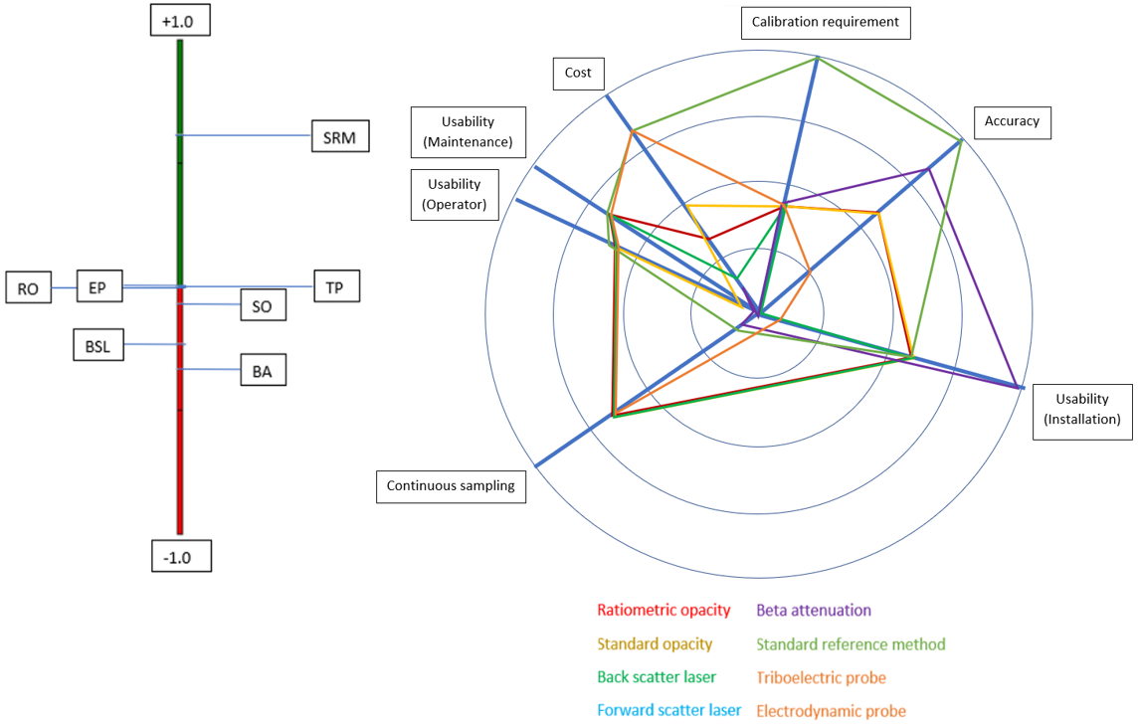
Figure 3-9 MCDA complete ranking and GAIA results showing the best available techniques for a concentration of 200 mg/m³ – 1,000 mg/m³

Figure 3-9 details the complete ranking results for measurement technologies for concentrations from 200 mg/m³ – 1,000 mg/m³. The complete ranking chart shows that the SRM is the most suitable technology when selected against the range of measurement criteria. For clarity, the GAIA web graph showing the suitability of each technology, for each instrument criteria, for concentrations of 200 mg/m³ – 1,000 mg/m³, is also detailed in Appendix 5, Figure A 5-5. The criteria that are strongly correlated are grouped close to each other and negative values are drawn at the centre of the web. The GAIA web graph details how each technology performs against each criteria.

Techniques for concentrations of 1,000 mg/m³ – 10,000 mg/m³

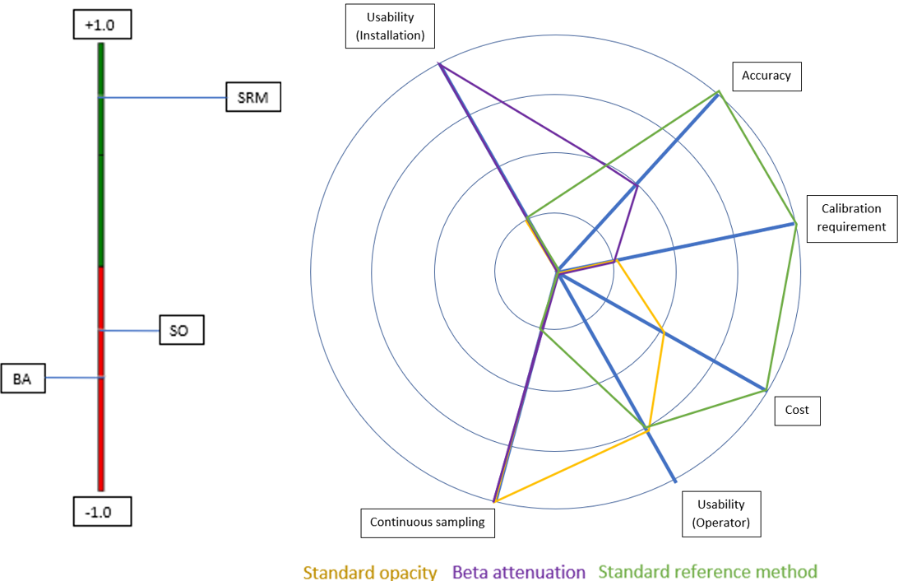
Figure 3-10 MCDA complete ranking and GAIA results showing the best available techniques for a concentration of 1,000 mg/m³ – 10,000 mg/m³

Figure 3-10 details the complete ranking results for measurement technologies for concentrations from 1,000 mg/m³ – 10,000 mg/m³. The complete ranking chart shows that the SRM is the most suitable technology when selected against the range of measurement criteria. For clarity, the GAIA web graph showing the suitability of each technology, for each instrument criteria, for concentrations of 1,000 mg/m³ – 10,000 mg/m³, is also detailed in Appendix 5, Figure A 5-6. The criteria that are strongly correlated are grouped close to each other and negative values are drawn at the centre of the web. The GAIA web graph details how each technology performs against each criteria.

Techniques for changing conditions

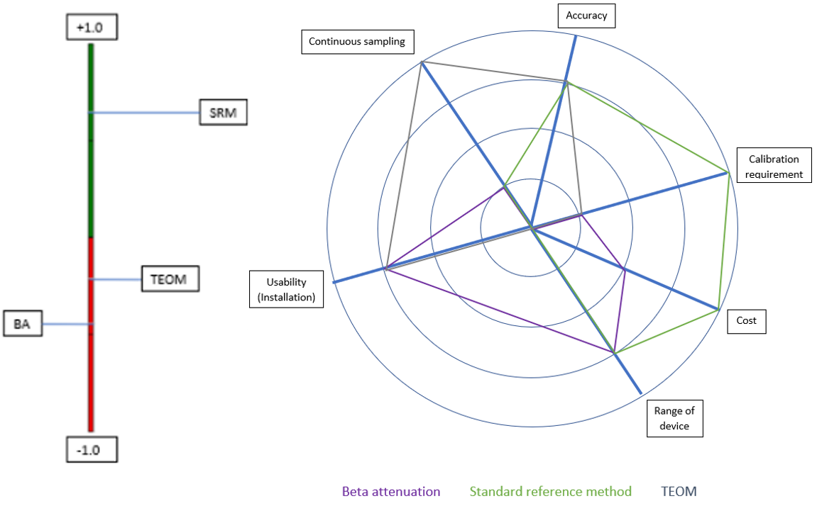
Figure 3-11 MCDA complete ranking and GAIA results showing the best available techniques for use
in changing conditions

Figure 3-11 details the complete ranking results for measurement technologies on processes with changing conditions. The complete ranking chart shows that the SRM is the most suitable technology when selected against the range of measurement criteria. For clarity, the GAIA web graph showing the suitability of each technology, for each instrument criteria, for processes with changing conditions, is also detailed in Appendix 5, Figure A 5-7. The criteria that are strongly correlated are grouped close to each other and negative values are drawn at the centre of the web. The GAIA web graph details how each technology performs against each criteria

Techniques for changing velocity

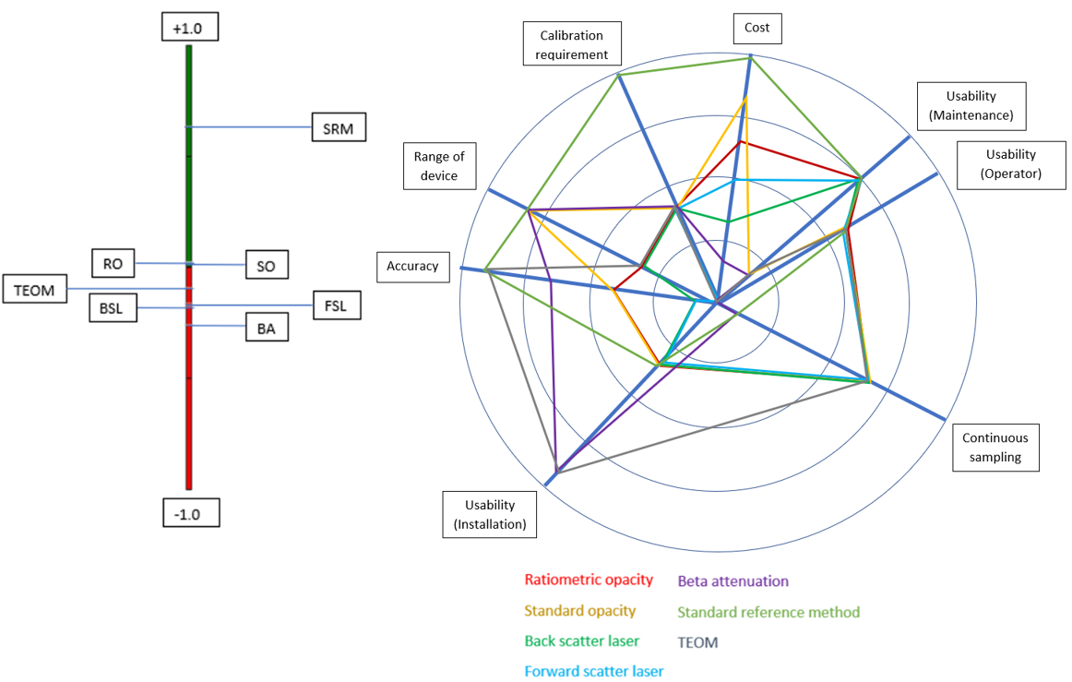
Figure 3-12 MCDA complete ranking and GAIA results showing the best available techniques for use
in changing velocity

Figure 3-12 details the complete ranking results for measurement technologies on processes with changing velocity. The complete ranking chart shows that the SRM is the most suitable technology when selected against the range of measurement criteria. For clarity, the GAIA web graph showing the suitability of each technology, for each instrument criteria, for processes with changing velocity, is also detailed in Appendix 5, Figure A 5-8. The criteria that are strongly correlated are grouped close to each other and negative values are drawn at the centre of the web. The GAIA web graph details how each technology performs against each criteria.

Techniques for chemical analysis

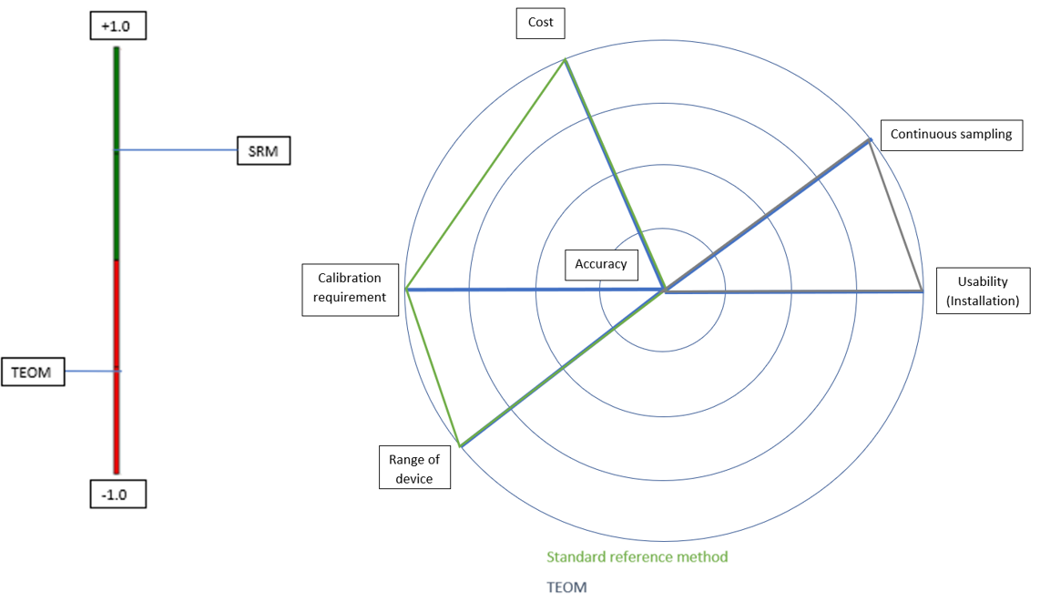
Figure 3-13 MCDA complete ranking and GAIA results showing the best available techniques for use
where chemical analysis is required

Figure 3-13 details the complete ranking results for measurement technologies on processes where chemical analysis is required. The complete ranking chart shows that the SRM is the most suitable technology when selected against the range of measurement criteria. For clarity, the GAIA web graph showing the suitability of each technology, for each instrument criteria, for processes where chemical analysis is required, is also detailed in Appendix 5, Figure A 5-9. The criteria that are strongly correlated are grouped close to each other and negative values are drawn at the centre of the web. The GAIA web graph details how each technology performs against each criteria.

Best available measurement technique selection
Table 3-4 Best available techniques
Categories |  | Best available measurement technology
Application criteria | Range
Stack diameter for continuous monitoring  (non-isokinetic) | 0.3 – 3 m | Standard opacity, ratiometric opacity, electrodynamic probe, and triboelectric probe
 | 3 – 8 m | Standard opacity and ratiometric opacity
 | 8 – 18 m | Standard opacity
Concentration | 0 – 200  mg/m³ | Standard reference method  (ratiometric opacity, electrodynamic probe, triboelectric probe for continuous monitoring)
 | 200 – 1,000  mg/m³ | Standard reference method  (ratiometric opacity and electrodynamic probe  for continuous monitoring)
 | 1,000 – 10,000 mg/m³ | Standard reference method  (standard opacity for continuous monitoring)
Changing conditions | n.a. | Standard reference method  (TEOM for continuous monitoring)
Changing  velocity | n.a. | Standard reference method  (ratiometric opacity and standard opacity  for continuous monitoring)
Chemical analysis required | n.a. | Standard reference method  (TEOM for continuous monitoring)

Table 3-4 details the best technologies available to meet one application criteria. In practise, measurement technologies can be required to meet two of the application criteria. Table 3-5 has therefore been developed to detail available measurement techniques to match more than one application criteria. For applications where isokinetic sampling is suitable, the SRM is seen to be the best technique regardless of the application criteria. For this reason, other techniques have been included to show the best available technique where continuous monitoring is required. Where there is little difference between technologies, all options that are suitable have been included in the best available measurement technology. The weakness for the SRM is its lack of suitability where continuous monitoring is required. If there is a requirement for continuous monitoring to comply with legislation where no suitable measurement technology is available, the relevant governing body for example the EA or Local Authority in the UK should be consulted to discuss potential solutions that satisfy legislative requirements.
There is no solution to meet all criteria and it is therefore it is critical to match the measurement technology to the application that it is intended to avoid potential costly errors and inaccurate results. An article written by PCME Ltd [87] emphasises the importance of choosing the best available technology and methodology for the application of intended use. Where there are multiple options of suitable equipment, the decision maker should refer to Table 3-5 and any organisational criteria which may also influence choice. Where no specific organisational requirements are available, the methodology detailed in this Chapter provides guidance to select the best available technique for a range of applications.

Table 3-5 Suitable technologies to meet two application criteria
 |  | Stack diameter for continuous monitoring (non-isokinetic) |  |  | Concentration |  |  | Changing conditions | Changing  velocity | Chemical analysis required
 |  | 0.3 –  3 m | 3 –  8 m | 8 –  18 m | 0 –  200 mg/m³ | 200 – 1,000 mg/m³ | 1,000 – 10,000 mg/m³
Stack diameter for continuous monitoring (non-isokinetic) | 0.3 –  3 m | - | - | - | Ratiometric Opacity, Electro-dynamic Probe  and  Triboelectric Probe | Ratiometric Opacity  and  Electro-dynamic Probe | Standard Opacity | Not Available | Standard Opacity  and  Ratiometric Opacity | Not Available
 | 3 –  8 m | - | - | - | Ratiometric Opacity | Ratiometric Opacity | Standard Opacity | Not Available | Standard Opacity  and  Ratiometric Opacity | Not Available
 | 8 –  18 m | - | - | - | Not Available | Not Available | Standard Opacity | Not Available | Standard Opacity | Not Available
Concentration | 0 –  200 mg/m³ | Ratiometric Opacity, Electro-dynamic  Probe  and  Triboelectric Probe | Ratiometric Opacity | Not Available | - | - | - | Standard reference method | Ratiometric Opacity | Standard reference method
 | 200 – 1,000 mg/m³ | Ratiometric Opacity  and  Electro- dynamic Probe | Ratiometric Opacity | Not Available | - | - | - | Standard reference method | Ratiometric Opacity | Standard reference method
 | 1,000 – 10,000 mg/m³ | Standard Opacity | Standard  Opacity | Standard Opacity | - | - | - | Standard reference method | Standard Opacity | Standard reference method
Changing conditions |  | Not  Available | Not Available | Not Available | Standard reference method | Standard reference method | Standard reference method | - | Standard reference method | Standard reference method
Changing velocity |  | Standard Opacity  and  Ratiometric Opacity | Standard Opacity  and  Ratiometric Opacity | Standard Opacity | Ratiometric Opacity | Ratiometric Opacity | Standard Opacity | Standard reference method | - | Standard reference method
Chemical analysis required |  | Not  Available | Not Available | Not Available | Standard reference method | Standard reference method | Standard reference method | Standard reference method | Standard reference method | -

Conclusion
Due to the heightened requirements of legislation and the lower cost of particulate monitoring equipment, there is a trend towards using these measurement techniques not only for particulate measurement but also process monitoring. The problem with the calibration of automatic devices at concentrations <10 mg/m³ remains unsolved.
Selecting an unsuitable measurement technique can have significant cost implications. This can be due to a lack of understanding regarding requirements from regulators, resulting in the selection of inappropriate techniques, or a lack of understanding of the application and suitable measurement equipment.
Most continuous particulate emissions monitors are sensitive to changes in particle characteristics. CEMS equipment is calibrated to its environment and a change in particulate emissions in terms of particle characteristics could render the instrument response inaccurate. There are many changing process conditions such as velocity, particle size and composition that can also affect the calibration of a device. Therefore, the difficulty is not obtaining calibration, but maintaining calibration.
Technology is available to measure low concentrations of particulate but verification against a reference method is difficult with no method available capable of measuring mass directly and continuously. The question is to be asked how CEMS equipment can be verified when calibration at low concentration levels is not possible.
MCDA analysis was used to evaluate the most suitable technique to measure particulate mass concentration in mg/m³. The results show that there is no solution currently available that is suitable across the whole range of criteria. In applications where continuous sampling is not required the SRM is the best technique. The methodology developed through this Chapter, as well as results from the survey and MCDA can be used to aid selection of equipment for a range of applications where CEMS equipment is a requirement.
There is potential for further research into the development of technologies used to measure particulate emissions. This is confirmed by 1/3 of the participants in the survey who felt that adequate technology is not yet available to measure particulate emissions, and 81 % detailed various problems with current equipment and the methodology of particulate emissions measurement. Only 50 % of participants felt that enough is being done to monitor particulate emissions. It can therefore be assumed that there is scope for improvement and development throughout the industry.
Further research should include the development of a method to measure particulate emissions from combustion processes accurately and reliably at low concentration down to <5 mg/m³. The measurement process should aim to measure the mass of particulate emissions directly to avoid the requirement for process calibration. Investigated further in Chapter 4 of this thesis.
The SRM is the most commonly used method to measure particulate; currently being used by 83 % of experts in the industry. There is a requirement to use the SRM to calibrate all continuous methods of measurement to give representative results, which suggests why this technique is most popular. The sampling process used for the SRM requires further investigation into achieving a representative sample with isokinetic sampling. Detailed in Chapter 5 of this thesis.
The measurement of particulate mass concentration is a technically challenging field, with so many variables affecting the methodology and technology. There is no product currently available that is suitable for all applications. With careful consideration, good technical judgement, and the application of the methodology developed throughout this Chapter, the best available technique can be chosen for a range of applications.

Chapter 4 – Development of a particulate emissions measurement method

Introduction
The requirement to monitor and control industrial processes has increased over recent years, therefore innovative techniques are required to meet the demand for alternative methods of particulate measurement. Accurately measuring particulate emissions is imperative to the understanding, and therefore, the control and reduction of particulate emissions. There are serious health and economic effects of particulate emissions as detailed in a study completed by Zhang [128]. Nicklin and Darabkhani [129] explain the issues surrounding particulate emissions measurement, in particular the calibration of CEMS with the SRM. Innovative research to develop the SRM procedure is required for the accurate calibration of continuous monitoring devices. The representativeness of continuous particulate measurement is dependent upon accurate calibration using a repeatable and reliable calibration procedure. Measurement with the SRM according to BS EN 13284-1 [34] is difficult at mass concentration levels of <10 mg/m³ and the methodology is only validated for processes >5 mg/m³.
Resonant mass sensors are now strong candidates for accurate mass measurement and are frequently used in many diverse fields of science and engineering. This Chapter presents the design, modelling, and optimal geometry selection for sensitivity improvement of a U-shaped glass tube as a resonant mass sensing cantilever for the purposes of particulate measurement. The design provides possible solutions to some of the issues currently seen with particulate measurement from stationary sources. The experimental and simulation results confirm that the highest sensitivity is achieved when the geometry dimensions, and therefore the vacant mass of the tube, is reduced.
When a U-shaped glass tube cantilever is set to resonance at its natural frequency, the frequency of the tube will vary depending upon the characteristics and properties of the tube [130]. The natural frequency is inversely proportional to the combined mass of the body of the tube and any additional unknown mass. General considerations that can affect the resonant frequency are shape, size, elasticity of the tube’s material, induced stress, mass, mass distribution inside the body and damping. Good system design is critical to achieving repeatable and reliable results. The vibrating U-tube design is based on the principal that a measured change in resonant frequency can be used to determine an unknown mass applied to the vibrating tube. The resonant frequency will have the greatest change when the mass is at the antinode point, meaning that the effect of the mass will have a different effect on the frequency depending upon its position in the glass tube.
A range of glass tubes has been chosen for analysis in this research from 6 mm – 10 mm external diameter. The tube is manufactured from a straight glass tube bent into a U-shape and is made from borosilicate glass with a density of 2.23 g/cm³ and Young’s modulus of 63 GPa. The glass tube is a component that forms part of a wider system, which, in its most basic form, includes supports for the glass tube, counter mass, exciter, frequency sensor, temperature control, and process control. Anton Parr use this principal for the measurement of density in lab-based instruments [131].
Finite Element Analysis (FEA) was used to develop the system which was validated experimentally using a physical model. Modal and harmonic analysis were undertaken across a range of commercially available glass tube sizes to determine the optimal geometry selection, validated with practical experimental data. The measured experimental results show strong linearity, suggesting strong potential for implementation of the methodology in its intended application. This Chapter therefore seeks to develop a system and propose methods to improve the process of particulate mass concentration measurement.

Theory
The idealised mechanical system model that is commonly used to describe the system behaviour of the proposed design is a spring mass system, oscillating under a forced displacement [132,133] as detailed in Figure 4-1.
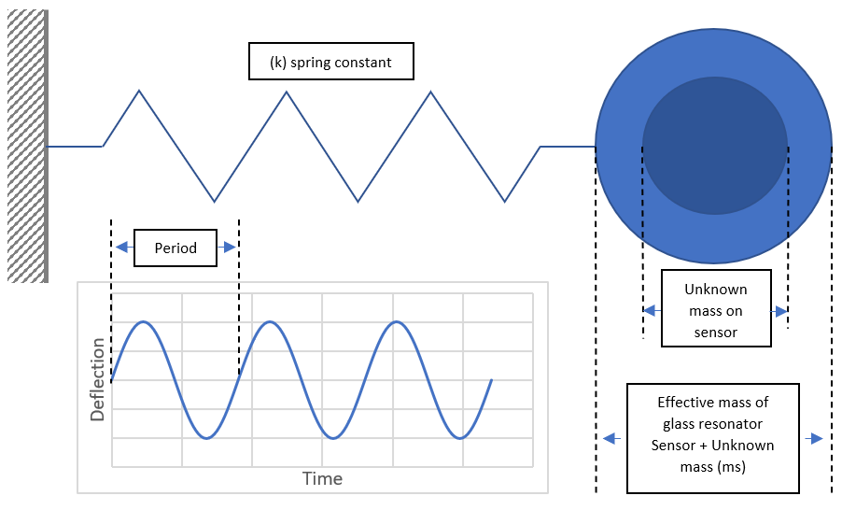
Figure 4-1 Idealised mechanical model for a glass tube cantilever

The total mass of a vibrating glass U-tube system consists of a combination of the tube and any additional unknown masses. The resonant frequency of a vibrating sensor is determined by [134–137]:
 | $$f=\frac{1}{2π}\sqrt{\left(\frac{k}{ms}\right)}$$ | (7)
Where:
- $f$ = resonant frequency
- $ms$ = effective mass of the sensor
- $k$ = spring constant of the sensor
The resonant frequency of a vibrating sensor is inversely proportional to the effective mass of the sensor. Any mass added to the tube increases the effective mass of the sensor (ms), resulting in a measurable reduction in the resonant frequency of the U-tube. The use of this principal is currently used in resonating cantilevers to measure the density of fluids [138–140]. In this research, the concept was developed for the accurate measurement of mass concentration of particulate from industrial processes.
In work conducted by Ansari [141] which investigates deflection, frequency, and stress characteristics in microcantilevers, sensitivity is increased when the deflection and resonant frequency are increased. Reducing the moment of inertia, reduces the bending stiffness, which in turn results in higher deflection.
Where:
- The moment of inertia is the structure’s ability to resist bending.
- The bending stiffness (K) is a function of, the Young’s modulus, the moment of inertia, the cross-sectional area, and the length of the beam.
The moment of inertia (I) of a round structure can be determined by:
 | $$I=(π{(r}^{4}))/4$$ | (8)
Where:
- $I$ = moment of inertia
- $r$ = radius of geometry
The bending stiffness (K) can be determined by:
 | $$K=3EI/(L^{3})$$ | (9)
Where:
- $K$ = bending stiffness
- $E$ = elastic modulus
- $I$ = moment of inertia
- $L$ = length of tube
Therefore, to achieve the desired effect of an increase in deflection, a longer glass tube with the smallest radius would be the most suitable option. A tube with a smaller radius has a lower moment of inertia, and a smaller moment of inertia results in a smaller bending stiffness, but a longer tube also has a smaller bending stiffness.
The design objective of this Chapter is to achieve the greatest measured change in resonant frequency for the smallest change in additional mass to achieve the highest sensitivity. Where the smallest change in additional point load mass gives the greatest change in resonant frequency, the highest sensitivity will be observed. Therefore, the highest sensitivity will be seen when the ratio between the additional point load mass and the change in resonant frequency, is smallest.
The fundamental resonant frequency of a cantilever beam can be calculated by:
 | $$f=\frac{1}{2π}\sqrt{\frac{EIg}{wl^{4}}}$$ | (10)
Where:
- $f$ = resonant frequency
- $E$ = elastic modulus
- $I$ = moment of inertia
- $l$ = beam length
- $w$ = uniform load per unit length
- $g$ = gravitational constant
As stated by Sanmamed [142], the spring constant of a hollow mass sensor can be determined by:
 | $$k=\frac{3E}{L^{3}}\frac{π}{4}\left(r_{e}^{4}-r_{i}^{4}\right)$$ | (11)
Where:
- $k$ = spring constant
- $E$ = Young’s modulus of sensor tube material
- $L$ = total length of sensor tube
- $r_{e}$= external radius of sensor tube
- $r_{i}$ = internal radius of sensor tube
Throughout this Chapter, commercially available components were selected for the development of the mass measurement system. Values for $r_{e}$ and $r_{i}$ are determined by manufacturing tolerances and availability.
To achieve the desired effect of increasing resonant frequency, a shorter length glass tube with a larger radius would be the most suitable option. The reduction in length increases resonant frequency and a higher moment of inertia also increases resonant frequency caused by an increase in the tube’s radius. Therefore, when designing a system to increase the resonant frequency and the deflection of the glass tube, several design conflicts are observed. DesignXplorer of Ansys Workbench was used to determine the optimal geometry sizes for a glass tube resonant mass sensor, which was designed for the greatest change in resonant frequency for the smallest addition of mass. This research has a particular industrial application focus and is therefore influenced by commercially available components and manufactures tolerances when considering component selection. The expected effects of damping are present during oscillation but, in a well-designed system, the effects are minimised. The system is excited via forced vibration and the exciter will operate to keep the system, for any change in additional mass (ms), at its resonant frequency; overcoming damping effects as seen in work undertaken by Hermiyanty [143].
As explained by Rechberger [139], glass flexural resonators are established as being one of the standard methods for the measurement of density of liquids in a laboratory. The core component of the system is the U-shaped glass tube measuring cell detailed in Figure 4-2 (a), whose oscillator’s resonance frequency changes with the mass of the fluid within the tube.
Figure 4-2 (b) details the meshed tube geometry. A mesh independence check was undertaken on each geometry before simulating the model, where an investigation into the independence of the mesh sizing from the simulation results is undertaken. This is performed by running simulations with differing mesh sizes to determine the impact on the change in results. Small geometry diamensions in this project allowed for a mesh sensitivity study also known as a mesh independence study to be undertaken on the whole geometry. The process included selecting the whole geometry to be analysed, refining the mesh sizing on the geometry, selecting the result to analysed, which in this project was the resonant frequency of the glass tube and analysing how the number of nodes in the mesh affects the resonant frequency. Generally, where there is an increase in mesh density, the accuracy of the structural behaviour of the geometry will improve, although simulation time increases. Ideal conditions are achieved where any further change in mesh design does not improve the accuracy of simulation results. The simulation results must be independent of the mesh size for accurate analysis. The displacement of the tube is also detailed in Figure 4-2 (b), where the hotter, red colours indicate areas of higher displacement and the cooler, blue colours indicate areas of lower displacement. During the initial analysis of the geometry, the end faces of the tube were used as a fixed support, it is therefore expected that the highest displacement is seen at the opposing end of the cantilever.
The mass of the tube support should ideally be infinitely higher than the mass of the tube to avoid interference from external sources. This assumption is made throughout the initial analysis by applying an infinite fixed support to the tube to allow sensitivity analysis to be carried out on the size and geometry of the tube with external influence. In practise this is not possible but good design should make considerations for best tube supports.
Figure 4-2 (a) U-Tube geometry and (b) total displacement of glass tube

Methodology
This section details the development, experimental, application, and analysis methodology.

Development methodology
The requirement to measure the mass of particulate in an emissions gas stream from stationary sources both online and directly, was identified by Nicklin and Darabkhani Generally, continuous particulate emissions monitors measure a characteristic of particulate, which could include, the diameter, size distribution, colour, shape, and chemical composition. These continuous instruments measure particulate characteristics as a function of the mass concentration and give an output in mg/m³ for emissions reporting purposes after applying a calibration factor. The issue surrounding the use of continuous particulate monitors is that the SRM used for calibration is difficult <10mg/m³. The accuracy is also questionable due to the influence of errors in the process [144], and the process is labour intensive and therefore costly.
Anton Parr [131] have developed lab-based equipment capable of measuring the density of fluids using the vibrating glass tube method. When a glass U-tube is free to move as a cantilever and forced to vibrate at its natural frequency, a measured change in frequency is proportional to a change in density of the fluid inside the tube. This principal is adapted through this research as a method to accurately measure an unknown mass of particulate from an industrial process, online, and in real time.
Preliminary geometry designs of a glass U-tube, similar to those used in commercially available lab-based densitometers, were drawn for initial development detailed in Figure 4-3. Ansys Mechanical software was chosen as the tool for simulating the system. The measurement system requirements included the capability to support the glass U-tube, mechanically excite the tube, and accurately measure any changes to the tubes resonant frequency as a result of the addition of any mass. Conditions for simulation through Ansys Mechanical included a fixed ambient temperature of 22 °C, borosilicate glass tubing with a density of 2.23 g/cm³ and Young’s modulus of 63 GPa, and point loads of 130 mg and 260 mg in addition to the vacant tube. Two input design parameters for the glass tube were defined as detailed in Figure 4-3. These include P1, the straight length of the two shafts of the U-tube, and P2, the radius of the U-bend in the tube. The limits of the manufacturing process were taken into consideration through the development process and only the minimum and maximum tolerances were used for simulation. As external diameters of the tube increase, the minimum limit of parameter P2 also increases due to manufacturing limits. The selection of tube geometries with an external diameter of 6 mm – 10 mm were chosen to determine the effect of tube sizes on the sensitivity of the design and were influenced by the manufacturing limitations and availability.
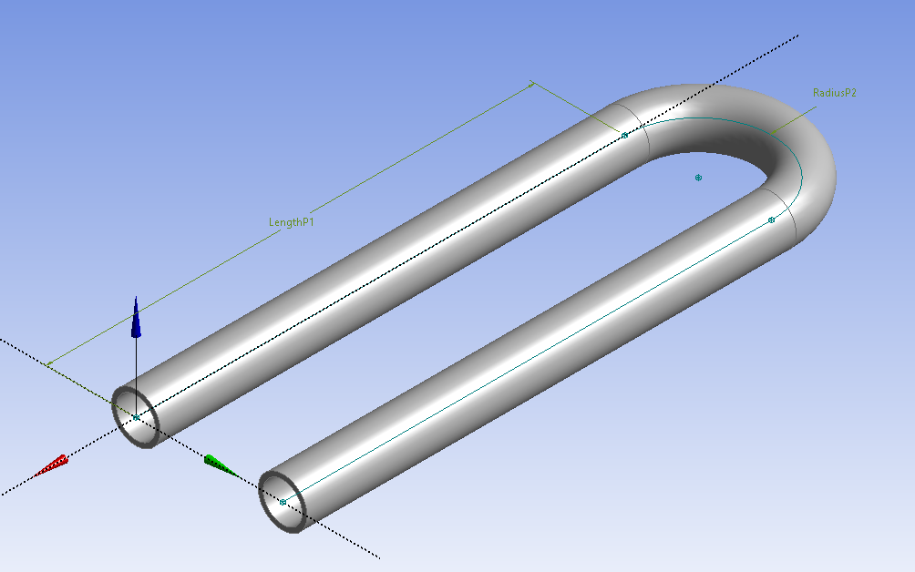
Length P1
Radius P2
Figure 4-3 Initial geometry design

The full support system was designed to hold the glass tube and comprises of two adjustable tube supports to allow for testing of all tube variations as detailed in Figure 4-4. Support inserts were designed to house the piezo chips which are used for the forced excitation and measurement of the tube’s frequency. The inserts are size specific to suit the external diameter of the tubes. The piezo chips are held in place up to, and along the surface of the tube, with the connecting wires for termination passing through the body of the support.
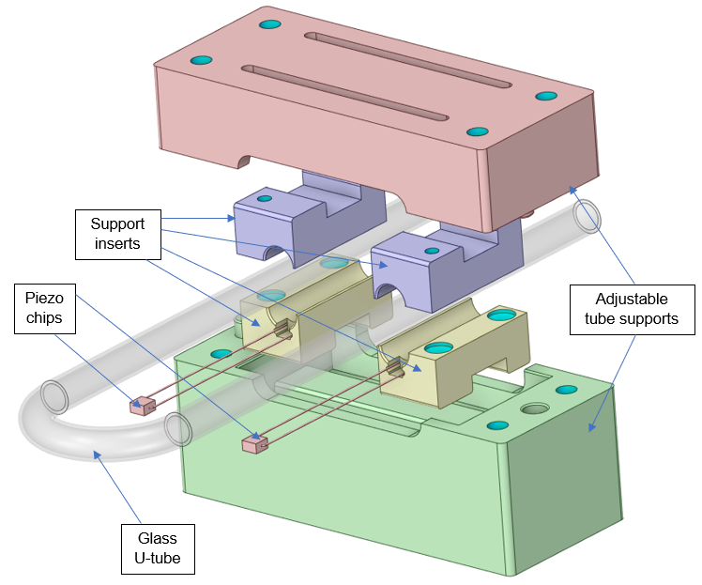
Figure 4-4 System geometry support with piezo exciter and sensor

Ansys DesignXplorer was used to analyse the system geometry to maximise sensitivity, giving the greatest change in frequency for the smallest addition of mass for optimum performance. DesignXplorer is a post processing tool, allowing the realisation of how the output parameters are driven by input parameters, and how changes to model geometry affects performance to meet the design deliverables. The optimisation process was undertaken for each tube diameter from 6 mm – 10 mm, with the minimum and maximum bend radius, and tube length determined by the manufacturing tolerances. Following the optimisation analysis, the three most sensitive designs for each tube were selected for further evaluation and experimental validation as detailed in Table 4-1. Variations in the manufactured components resulted in differences between the required optimised geometry sizes and the actual measured sizes. To allow for accurate validation of the results, the measured values were used for harmonic analysis which was undertaken to determine the natural response of the system.
Table 4-1 Ansys DesignXplorer optimised geometry results
Tube size, external diameter (mm) | P1 – length  (mm) | P2 – radius  (mm) | Resonant frequency  (Hz)
10 | 50.01 | 13.00 | 1921.62
 | 61.35 | 22.88 | 993.42
 | 78.48 | 22.40 | 740.35
9 | 50.01 | 9.00 | 2037.13
 | 61.38 | 18.85 | 1004.87
 | 78.46 | 18.72 | 732.52
8 | 50.01 | 7.00 | 1972.42
 | 61.38 | 16.88 | 945.45
 | 78.64 | 16.21 | 687.52
7 | 50.01 | 7.00 | 1710.11
 | 61.31 | 17.00 | 816.05
 | 78.57 | 16.41 | 591.96
6 | 50.01 | 6.00 | 1513.31
 | 61.38 | 15.88 | 725.27
 | 78.31 | 15.16 | 543.85

Experimental methodology
Experimental work was undertaken for validation purposes to determine the degree to which the simulation is an accurate representation of the real-world physical model, and to confirm the measurement concept. Geometry optimisation for highest sensitivity is the design objective through modal analysis, design optimisation, harmonic analysis, and result validation.
Using the optimised geometry results detailed in Table 4-1, the 15 tubes were manufactured from borosilicate glass tubing with a density of 2.23 g/cm³, and Young’s modulus of 63 GPa. Each of the 15 tube geometries were tested at no load (0mg), 130 mg, and 260 mg, resulting in a total of 45 combinations as detailed in Figure 4-5. For reliability of results, all combinations were repeated three times, tested at a constant temperature of 22 °C which was monitored by a climatic chamber as shown in the system schematic Figure 4-6 and equipment setup in Figure 4-7.
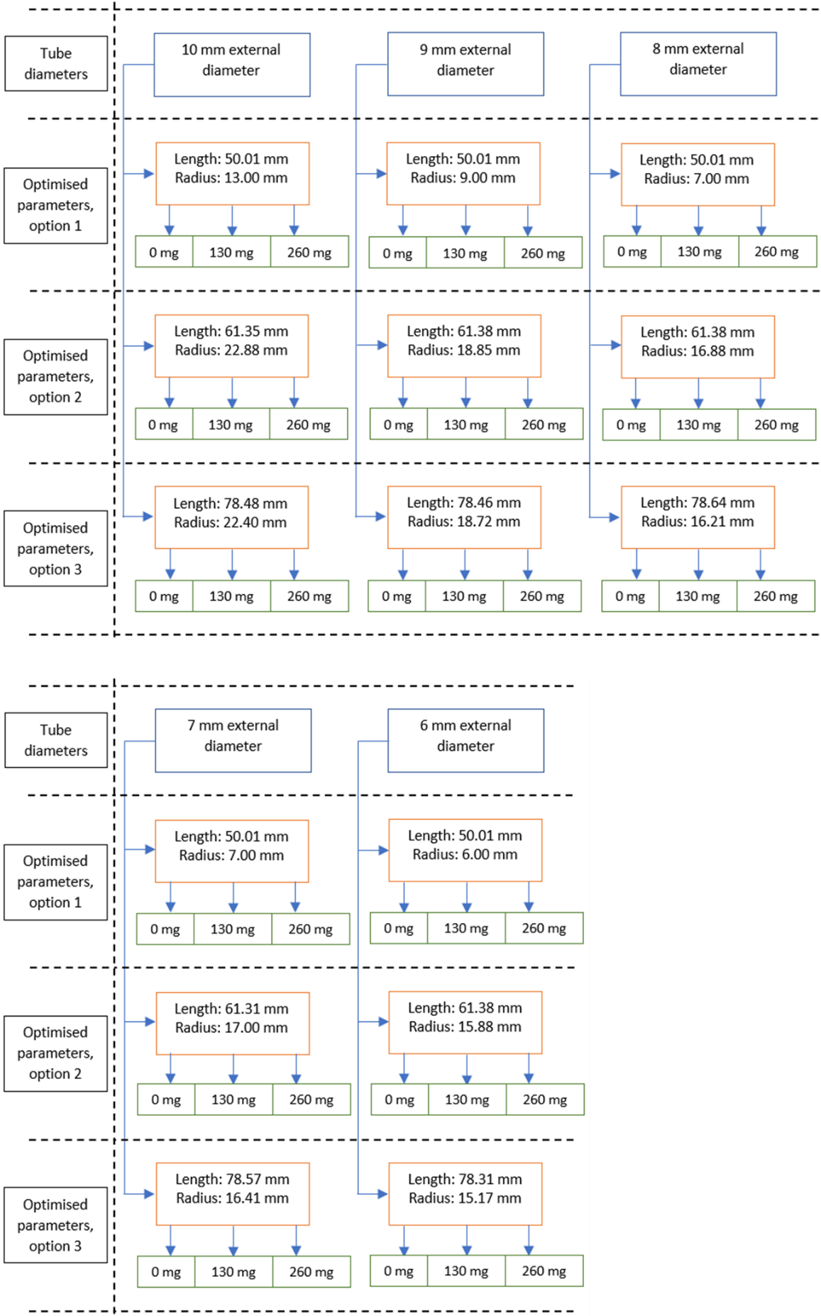
Figure 4-5 Experimental design

LabVIEW software was used on a laptop to measure and control the system. A National Instruments USB X Series Data Acquisition Device was used as the interface between the physical model and the laptop. The tube was excited to its resonant frequency by a piezo chip located in the tube insert, adjacent to the face of the tube at the end of the support. The resonant frequency was measured using a piezo transducer located in the same manner as the piezo exciter, allowing accurate measurement and feedback control for the system. A feedback control loop was developed in LabVIEW to excite the glass U-tube at its resonant frequency using a similar methodology to that developed by Ruff [145]. The approach automated the process of tracking and plotting the tubes frequency, whilst maintaining a resonant state. The temperature of the climatic chamber was controlled through the LabVIEW software and monitored via a thermocouple connected directly to the Data Acquisition Device. The vibrating tube system was left in the climatic chamber for 15 minutes to stabilise before the experimental work commenced. During each test, the following information was recorded:
- The measured internal and external radius of the glass tubes
- The measured bend radius
- The climatic chamber temperature
- The resonant frequency
- The mass of the tube
Figure 4-6 details the experimental schematic diagram and connectivity of the setup, and Figure 4-7 is a photograph of the system during testing.

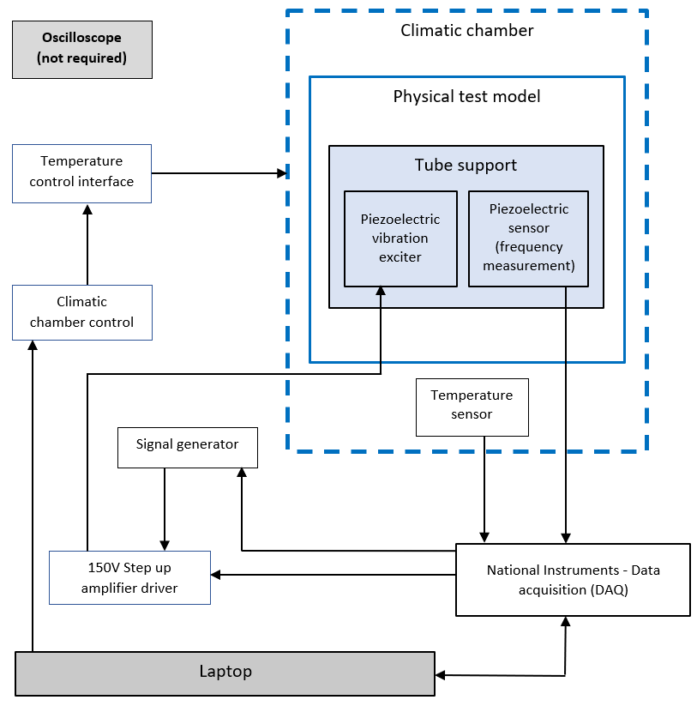
Figure 4-6 Experimental schematic

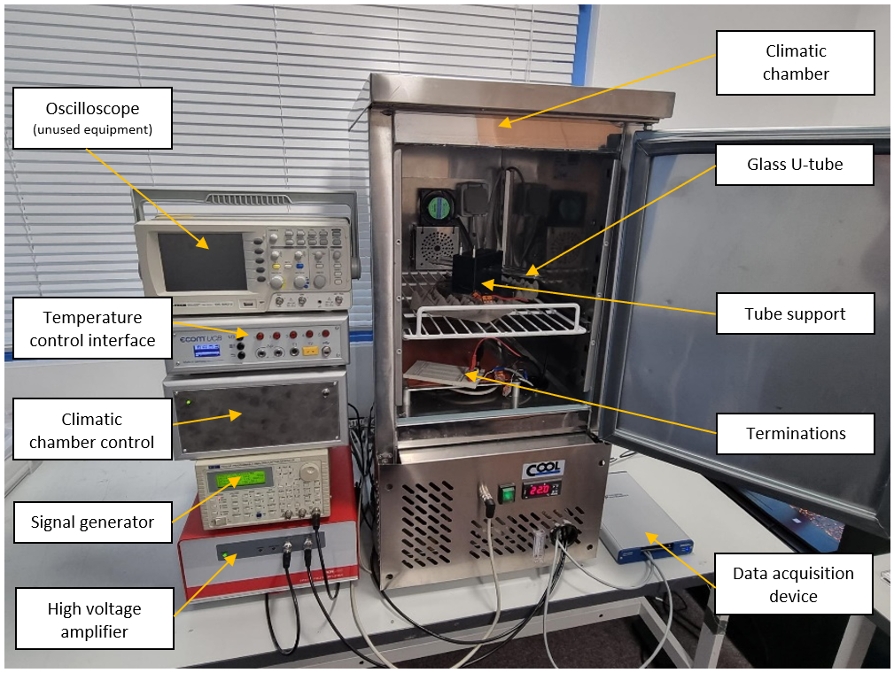
Figure 4-7 Experimental setup

Application methodology
The development of an accurate mass measurement device in this research has an industrial application focus to accurately measure particulate emissions from stationary sources. The design objective is to optimise the geometry for the highest sensitivity and to prove the concept through a measured change in resonant frequency as a result of the addition of mass to the tube. The physical properties of the system components and the fluid contained in the system will be affected by changes in temperature; in commercial densitometers this is commonly controlled using Peltier elements.
The general principal of measurement using the SRM is to sample a known volume of flue gas through a filter. The sampling must be undertaken isokinetically, where the suction at the nozzle is at the same velocity as the flue gasses in the duct or stack. By weighing the filter before and after sampling, the total particulate per volume of gas can be determined [37]. To take an online, direct, mass concentration measurement from a stationary source, there is a requirement to measure the mass of particulate directly in a gas flow [129].
When a particle flows through a glass U-tube sensor as detailed in this Chapter, the resonant frequency of the tube is dependent upon the position of the particulate. The greatest change in frequency will be seen when the particle is at the anti-nodal point. For an isolated mass travelling through the tube, the mass can be calculated accurately following a calibration and set-up procedure of the tube by measuring the resonant frequency change when the mass is greatest in the tube. For the intended application of industrial stationary source emissions measurement, particulate will not be in isolation; will be of different colour, shape, and concentration. The proposed solution uses a filter fitted at the anti-nodal point in the U-tube shown in Figure 4-8 to measure the accumulated mass concentration. In the intended application, a measured volume of particulate laden gas from a stationary source is to be passed through the glass U-tube from the inlet to the outlet with the filter capturing the particulate. The mass of the filter will subsequently increase due to the mass of the captured particulate reducing the resonant frequency and therefore allowing the glass U-tube to be used to accurately measure the accumulation of particulate. By measuring the volume of gas passed through the glass tube and the mass of particulate captured on the filter in the tube, a mass concentration in mg/m³ can be given. This method addresses issues associated with the handling and processing of filters during the SRM measurement process, reduces the time required to undertake a full test procedure, reduces high costs associated with annual surveillance testing, increases accuracy, and gives potential to achieve stack profiling to determine optimum positioning for continuous monitoring.
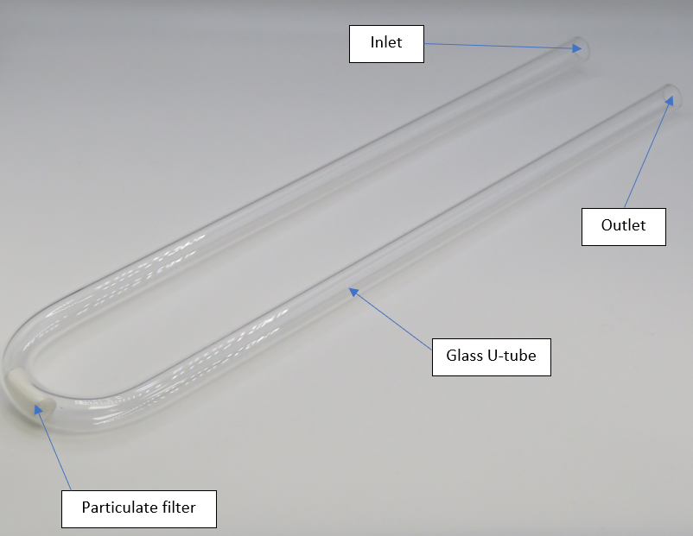
Figure 4-8 Glass U-tube with filter

Analysis methodology
This section details the methods used for analysing the data collected in this Chapter through simulation and experimental work.
The three sets of data from the experimental work were compared to determine the consistency of results and the reliability of each of the experimental setups. The procedure included an analysis of the standard deviation between the data sets with a visual representation to aid evaluation and to determine patterns in the consistency of results. The standard deviation was calculated using the following formula:
$$σ= \sqrt{\frac{\sum{{(x_{i}- μ)}^{2}}}{N}}$$ | (12)
Where:
- $σ=$ population standard deviation
- $x_{i}=$ each individual value
- $μ=$ the total mean value
- $N=$ the total number of values
A visual aid was used as an initial comparison of the simulation and experimental data to verify the results and therefore the design principal and was also used to show the percentage difference between the sets of data. To determine if the two sets of data follow the same distribution, a Kolmogorov-Smirnov test was undertaken. This test statistically determines if the sets of data follow the same pattern by quantifying the distance between the distributions of the two samples.
The effects of the bend radius, length, tube mass, and size of tube on the change in frequency was analysed by calculating the Pearson correlation coefficient to measure the strength of the relationship between the two variables. Using the value calculated for r (correlation coefficient), the correlation strength can be assessed to determine the influence of parameters on the change in frequency and therefore the sensitivity of the tube, calculated using the following formula:
$$r=\frac{Σ\left(x_{i}-\overline{x}\right)(y_{i}-\overline{y})}{\sqrt{{Σ{\left(x_{i}-\overline{x}\right)}^{2} Σ\left(y_{i}-\overline{y}\right)}^{2}}}$$ | (13)
Where:
- $r$ = correlation coefficient
- $x_{i}$ = values of the x-variable in a sample
- $\overline{x}$ = mean of the values of the x-variable
- $y_{i}$ = values of the y-variable in a sample
- $\overline{y}$ = mean of the values of the y-variable
A linearity check was undertaken on the measured resonant frequency for the tube showing greatest sensitivity by using the linear calibration curve and the linear regression equation. Using the linear regression equation, any unknown mass can be calculated from any measured resonant frequency. The R² value was used to determine the linearity of the measured results.

Results and discussion
This section details the results of both the simulation and experimental work undertaken as part of this Chapter for the best geometry design selection. The design was also used to propose new methodology for particulate measurement.
There are currently many issues surrounding the use of the SRM procedure as detailed in BS EN 13284-1 [34]. This Chapter seeks to detail the optimum geometry selection of the proposed method to overcome some relevant industry issues. In a study completed by Nicklin and Darabkhani [144], significant errors are introduced when following the SRM procedure. The methodology detailed in this Chapter seeks to overcome some of these issues including difficulties in the rinse and clean procedure, external influences affecting results (where high levels of ambient particulate is present), and the handling and processing of delicate filters. The development of an online direct mass measurement system with the ability to give accurate mass concentration values of particulate from stationary sources would see a significant improvement on current methods. There is also the possibility to introduce new applications to the emissions measurement industry, which could include providing a stack profile to determine the optimum location for continuous particulate monitoring. This is a process undertaken when installing gas emissions monitors, but with current technologies, is not available for particulate monitoring. Through the development of optimal geometry selection, this Chapter seeks to provide an alternative, improved measurement technique.

Simulation and experimental results analysis
The result from each test includes the internal and external diameter of the glass tubes, length of the tube (parameter P1), radius of the bend (parameter P2), measured radius, point load mass, measured frequency, temperature, measured external and internal diameter of the glass tubes and the simulated resonant frequency. The simulation results presented in Tables 4-2, 4-3, and 4-4 are obtained through harmonic analysis using Ansys Mechanical software. The geometry values and boundary conditions used for harmonic analysis were the measured values taken from the physical model to allow for accurate comparison of simulation and experimental results. The recorded results in Tables 4-2, 4-3, and 4-4 are also visually displayed through this section for a comprehensive analysis.
Table 4-2 Test 1, simulation, and experimental results
External Diameter (mm) | Internal Diameter (mm) | Length P1  (mm) | Radius P2  (mm) | Radius measured (mm) | Point  load  mass  (mg) | Measured frequency (Hz) | Temp (°C) | Measured External Diameter (mm) | Measured Internal Diameter (mm) | Simulation frequency  (Hz)
10 | 8 | 50.01 | 13.00 | 12.5 | 0 | 1891.193 | 22.0 | 10.021 | 7.93 | 1956.4110290
 |  |  |  |  | 130 | 1852.623 | 22.0 |  |  | 1915.5906470
 |  |  |  |  | 260 | 1815.139 | 22.0 |  |  | 1876.8734350
 |  | 61.35 | 22.88 | 27.64 | 0 | 881.814 | 22.0 | 9.973 | 7.94 | 911.9312391
 |  |  |  |  | 130 | 869.158 | 22.0 |  |  | 899.1509160
 |  |  |  |  | 260 | 857.461 | 22.0 |  |  | 886.8608600
 |  | 78.48 | 22.40 | 26.67 | 0 | 658.459 | 22.0 | 9.978 | 7.93 | 681.1085183
 |  |  |  |  | 130 | 649.971 | 22.0 |  |  | 672.5700134
 |  |  |  |  | 260 | 642.183 | 22.0 |  |  | 664.3282249
9 | 7 | 50.01 | 9.00 | 8.825 | 0 | 1992.343 | 22.0 | 9.259 | 6.93 | 2080.8821080
 |  |  |  |  | 130 | 1944.121 | 22.0 |  |  | 2030.2764570
 |  |  |  |  | 260 | 1899.718 | 22.0 |  |  | 1982.7361470
 |  | 61.38 | 18.85 | 23.11 | 0 | 889.424 | 22.0 | 9.003 | 6.91 | 924.7244616
 |  |  |  |  | 130 | 875.109 | 22.0 |  |  | 909.3065067
 |  |  |  |  | 260 | 859.524 | 22.0 |  |  | 894.5946580
 |  | 78.46 | 18.72 | 21.9 | 0 | 653.849 | 22.0 | 9.018 | 6.92 | 684.4345993
 |  |  |  |  | 130 | 643.631 | 22.0 |  |  | 674.0943019
 |  |  |  |  | 260 | 633.856 | 22.0 |  |  | 664.1904599
8 | 6 | 50.01 | 7.00 | 6.985 | 0 | 1908.017 | 22.0 | 8.044 | 5.99 | 1979.2033190
 |  |  |  |  | 130 | 1842.684 | 22.0 |  |  | 1913.7147920
 |  |  |  |  | 260 | 1786.168 | 22.0 |  |  | 1853.7699510
 |  | 61.38 | 16.88 | 20.5 | 0 | 848.168 | 22.0 | 8.018 | 5.95 | 882.2484451
 |  |  |  |  | 130 | 831.865 | 22.0 |  |  | 864.3686588
 |  |  |  |  | 260 | 815.068 | 22.0 |  |  | 847.4838398
 |  | 78.64 | 16.21 | 19.805 | 0 | 607.044 | 22.0 | 8.011 | 5.93 | 632.8606340
 |  |  |  |  | 130 | 595.742 | 22.0 |  |  | 621.5179677
 |  |  |  |  | 260 | 582.029 | 22.0 |  |  | 610.7432698
7 | 5 | 50.01 | 7.00 | 6.83 | 0 | 1649.685 | 22.0 | 7.003 | 4.97 | 1720.9172120
 |  |  |  |  | 130 | 1584.284 | 22.0 |  |  | 1652.2413660
 |  |  |  |  | 260 | 1525.684 | 22.0 |  |  | 1590.7614900
 |  | 61.31 | 17.00 | 20.25 | 0 | 739.972 | 22.0 | 7.000 | 4.99 | 769.4069017
 |  |  |  |  | 130 | 722.079 | 22.0 |  |  | 750.5753339
 |  |  |  |  | 260 | 705.380 | 22.0 |  |  | 733.0109383
 |  | 78.57 | 16.41 | 19.14 | 0 | 537.781 | 22.0 | 7.018 | 5.00 | 558.8510286
 |  |  |  |  | 130 | 526.218 | 22.0 |  |  | 546.7969748
 |  |  |  |  | 260 | 515.350 | 22.0 |  |  | 535.4680947
6 | 4 | 50.01 | 6.00 | 5.765 | 0 | 1471.684 | 22.0 | 6.014 | 3.98 | 1531.7088460
 |  |  |  |  | 130 | 1399.168 | 22.0 |  |  | 1455.8388680
 |  |  |  |  | 260 | 1334.745 | 22.0 |  |  | 1389.7957030
 |  | 61.38 | 15.88 | 26.13 | 0 | 526.844 | 22.0 | 6.019 | 3.97 | 545.7014000
 |  |  |  |  | 130 | 513.741 | 22.0 |  |  | 531.9492375
 |  |  |  |  | 260 | 501.681 | 22.0 |  |  | 519.1570976
 |  | 78.31 | 15.17 | 25.34 | 0 | 387.524 | 22.0 | 6.011 | 3.94 | 401.6232990
 |  |  |  |  | 130 | 378.851 | 22.0 |  |  | 392.5772624
 |  |  |  |  | 260 | 370.568 | 22.0 |  |  | 384.1011814

Table 4-3 Test 2, simulation, and experimental results
External Diameter (mm) | Internal Diameter (mm) | Length P1  (mm) | Radius P2  (mm) | Radius measured (mm) | Point  load  mass  (mg) | Measured frequency (Hz) | Temp (°C) | Measured External Diameter (mm) | Measured Internal Diameter (mm) | Simulation frequency  (Hz)
10 | 8 | 50.01 | 13.00 | 12.50 | 0 | 1892.135 | 22.0 | 10.021 | 7.93 | 1956.4110290
 |  |  |  |  | 130 | 1853.843 | 22.0 |  |  | 1915.5906470
 |  |  |  |  | 260 | 1815.985 | 22.0 |  |  | 1876.8734350
 |  | 61.35 | 22.88 | 27.64 | 0 | 880.945 | 22.0 | 9.973 | 7.94 | 911.9312391
 |  |  |  |  | 130 | 869.021 | 22.0 |  |  | 899.1509160
 |  |  |  |  | 260 | 856.893 | 22.0 |  |  | 886.8608600
 |  | 78.48 | 22.40 | 26.67 | 0 | 657.945 | 22.0 | 9.978 | 7.93 | 681.1085183
 |  |  |  |  | 130 | 649.654 | 22.0 |  |  | 672.5700134
 |  |  |  |  | 260 | 641.918 | 22.0 |  |  | 664.3282249
9 | 7 | 50.01 | 9.00 | 8.825 | 0 | 1993.156 | 22.0 | 9.259 | 6.93 | 2080.8821080
 |  |  |  |  | 130 | 1944.985 | 22.0 |  |  | 2030.2764570
 |  |  |  |  | 260 | 1899.105 | 22.0 |  |  | 1982.7361470
 |  | 61.38 | 18.85 | 23.11 | 0 | 888.156 | 22.0 | 9.003 | 6.91 | 924.7244616
 |  |  |  |  | 130 | 874.565 | 22.0 |  |  | 909.3065067
 |  |  |  |  | 260 | 858.599 | 22.0 |  |  | 894.5946580
 |  | 78.46 | 18.72 | 21.90 | 0 | 655.156 | 22.0 | 9.018 | 6.92 | 684.4345993
 |  |  |  |  | 130 | 646.002 | 22.0 |  |  | 674.0943019
 |  |  |  |  | 260 | 636.063 | 22.0 |  |  | 664.1904599
8 | 6 | 50.01 | 7.00 | 6.985 | 0 | 1902.817 | 22.0 | 8.044 | 5.99 | 1979.2033190
 |  |  |  |  | 130 | 1839.114 | 22.0 |  |  | 1913.7147920
 |  |  |  |  | 260 | 1782.987 | 22.0 |  |  | 1853.7699510
 |  | 61.38 | 16.88 | 20.50 | 0 | 845.165 | 22.0 | 8.018 | 5.95 | 882.2484451
 |  |  |  |  | 130 | 828.168 | 22.0 |  |  | 864.3686588
 |  |  |  |  | 260 | 811.651 | 22.0 |  |  | 847.4838398
 |  | 78.64 | 16.21 | 19.805 | 0 | 606.358 | 22.0 | 8.011 | 5.93 | 632.8606340
 |  |  |  |  | 130 | 595.159 | 22.0 |  |  | 621.5179677
 |  |  |  |  | 260 | 585.429 | 22.0 |  |  | 610.7432698
7 | 5 | 50.01 | 7.00 | 6.83 | 0 | 1656.684 | 22.0 | 7.003 | 4.97 | 1720.9172120
 |  |  |  |  | 130 | 1590.652 | 22.0 |  |  | 1652.2413660
 |  |  |  |  | 260 | 1532.844 | 22.0 |  |  | 1590.7614900
 |  | 61.31 | 17.00 | 20.25 | 0 | 746.455 | 22.0 | 7.000 | 4.99 | 769.4069017
 |  |  |  |  | 130 | 728.365 | 22.0 |  |  | 750.5753339
 |  |  |  |  | 260 | 711.526 | 22.0 |  |  | 733.0109383
 |  | 78.57 | 16.41 | 19.14 | 0 | 542.244 | 22.0 | 7.018 | 5.00 | 558.8510286
 |  |  |  |  | 130 | 530.559 | 22.0 |  |  | 546.7969748
 |  |  |  |  | 260 | 519.597 | 22.0 |  |  | 535.4680947
6 | 4 | 50.01 | 6.00 | 5.765 | 0 | 1473.479 | 22.0 | 6.014 | 3.98 | 1531.7088460
 |  |  |  |  | 130 | 1401.220 | 22.0 |  |  | 1455.8388680
 |  |  |  |  | 260 | 1338.290 | 22.0 |  |  | 1389.7957030
 |  | 61.38 | 15.88 | 26.13 | 0 | 525.125 | 22.0 | 6.019 | 3.97 | 545.7014000
 |  |  |  |  | 130 | 511.996 | 22.0 |  |  | 531.9492375
 |  |  |  |  | 260 | 499.488 | 22.0 |  |  | 519.1570976
 |  | 78.31 | 15.17 | 25.34 | 0 | 385.854 | 22.0 | 6.011 | 3.94 | 401.6232990
 |  |  |  |  | 130 | 377.544 | 22.0 |  |  | 392.5772624
 |  |  |  |  | 260 | 369.255 | 22.0 |  |  | 384.1011814

Table 4-4 Test 3, simulation, and experimental results
External Diameter (mm) | Internal Diameter (mm) | Length P1  (mm) | Radius P2  (mm) | Radius measured (mm) | Point  load  mass  (mg) | Measured frequency (Hz) | Temp (°C) | Measured External Diameter (mm) | Measured Internal Diameter (mm) | Simulation frequency  (Hz)
10 | 8 | 50.01 | 13.00 | 12.50 | 0 | 1892.125 | 22.0 | 10.021 | 7.93 | 1956.4110290
 |  |  |  |  | 130 | 1853.216 | 22.0 |  |  | 1915.5906470
 |  |  |  |  | 260 | 1814.587 | 22.0 |  |  | 1876.8734350
 |  | 61.35 | 22.88 | 27.64 | 0 | 881.153 | 22.0 | 9.973 | 7.94 | 911.9312391
 |  |  |  |  | 130 | 869.795 | 22.0 |  |  | 899.1509160
 |  |  |  |  | 260 | 858.002 | 22.0 |  |  | 886.8608600
 |  | 78.48 | 22.40 | 26.67 | 0 | 657.524 | 22.0 | 9.978 | 7.93 | 681.1085183
 |  |  |  |  | 130 | 649.255 | 22.0 |  |  | 672.5700134
 |  |  |  |  | 260 | 641.856 | 22.0 |  |  | 664.3282249
9 | 7 | 50.01 | 9.00 | 8.825 | 0 | 1999.489 | 22.0 | 9.259 | 6.93 | 2080.8821080
 |  |  |  |  | 130 | 1948.921 | 22.0 |  |  | 2030.2764570
 |  |  |  |  | 260 | 1902.946 | 22.0 |  |  | 1982.7361470
 |  | 61.38 | 18.85 | 23.11 | 0 | 891.424 | 22.0 | 9.003 | 6.91 | 924.7244616
 |  |  |  |  | 130 | 876.854 | 22.0 |  |  | 909.3065067
 |  |  |  |  | 260 | 861.524 | 22.0 |  |  | 894.5946580
 |  | 78.46 | 18.72 | 21.90 | 0 | 658.157 | 22.0 | 9.018 | 6.92 | 684.4345993
 |  |  |  |  | 130 | 647.684 | 22.0 |  |  | 674.0943019
 |  |  |  |  | 260 | 638.052 | 22.0 |  |  | 664.1904599
8 | 6 | 50.01 | 7.00 | 6.985 | 0 | 1892.618 | 22.0 | 8.044 | 5.99 | 1979.2033190
 |  |  |  |  | 130 | 1831.237 | 22.0 |  |  | 1913.7147920
 |  |  |  |  | 260 | 1774.169 | 22.0 |  |  | 1853.7699510
 |  | 61.38 | 16.88 | 20.50 | 0 | 847.912 | 22.0 | 8.018 | 5.95 | 882.2484451
 |  |  |  |  | 130 | 831.265 | 22.0 |  |  | 864.3686588
 |  |  |  |  | 260 | 814.835 | 22.0 |  |  | 847.4838398
 |  | 78.64 | 16.21 | 19.805 | 0 | 611.654 | 22.0 | 8.011 | 5.93 | 632.8606340
 |  |  |  |  | 130 | 595.684 | 22.0 |  |  | 621.5179677
 |  |  |  |  | 260 | 584.835 | 22.0 |  |  | 610.7432698
7 | 5 | 50.01 | 7.00 | 6.83 | 0 | 1665.698 | 22.0 | 7.003 | 4.97 | 1720.9172120
 |  |  |  |  | 130 | 1599.685 | 22.0 |  |  | 1652.2413660
 |  |  |  |  | 260 | 1540.197 | 22.0 |  |  | 1590.7614900
 |  | 61.31 | 17.00 | 20.25 | 0 | 745.654 | 22.0 | 7.000 | 4.99 | 769.4069017
 |  |  |  |  | 130 | 727.602 | 22.0 |  |  | 750.5753339
 |  |  |  |  | 260 | 710.780 | 22.0 |  |  | 733.0109383
 |  | 78.57 | 16.41 | 19.14 | 0 | 541.206 | 22.0 | 7.018 | 5.00 | 558.8510286
 |  |  |  |  | 130 | 529.547 | 22.0 |  |  | 546.7969748
 |  |  |  |  | 260 | 518.603 | 22.0 |  |  | 535.4680947
6 | 4 | 50.01 | 6.00 | 5.765 | 0 | 1470.898 | 22.0 | 6.014 | 3.98 | 1531.7088460
 |  |  |  |  | 130 | 1398.454 | 22.0 |  |  | 1455.8388680
 |  |  |  |  | 260 | 1333.832 | 22.0 |  |  | 1389.7957030
 |  | 61.38 | 15.88 | 26.13 | 0 | 524.875 | 22.0 | 6.019 | 3.97 | 545.7014000
 |  |  |  |  | 130 | 511.846 | 22.0 |  |  | 531.9492375
 |  |  |  |  | 260 | 499.751 | 22.0 |  |  | 519.1570976
 |  | 78.31 | 15.17 | 25.34 | 0 | 388.288 | 22.0 | 6.011 | 3.94 | 401.6232990
 |  |  |  |  | 130 | 379.745 | 22.0 |  |  | 392.5772624
 |  |  |  |  | 260 | 371.592 | 22.0 |  |  | 384.1011814

The design process of this research was undertaken through simulation in Ansys Mechanical software. The results were used for the development of a physical model to undertake experimental validation. A bar chart was used for a visual comparison of the simulation and experimental results, with a line graph showing the maximum percentage difference between the two sets of results, as detailed in Figure 4-9. It can be noted for all tests that the measured resonant frequency is always lower than the simulated resonant frequency and in all cases is between 3 % and 5 % difference. As expected, as the tube length increases the resonant frequency decreases, as the point load mass increases the resonant frequency decreases, and as the tube diameter decreases the resonant frequency decreases. A Kolmogorov-Smirnov test was undertaken on the two sets of data, with a significance level of 5 % to determine if they follow the same distribution. The cumulative distributions are visually detailed showing similar distributions in Figure 4-10. The Kolmogorov-Smirnov d-value is 0.133 and the p-value is 0.825. The d-value denotes the maximum absolute difference between the two distributions with the low value indicating that the data sets closely follow the same distribution. A high p-value suggests that a small deviation has a high probability value and therefore we can conclude that the data sets follow the same distribution and we cannot reject the null hypothesis, which is that the samples follow the same distribution. The consistently small differences between the simulation and experimental data show a slightly lower result for the measured values in each test and can be attributed to tolerances in material specification, manufacturing processes, and the assembly setup process.
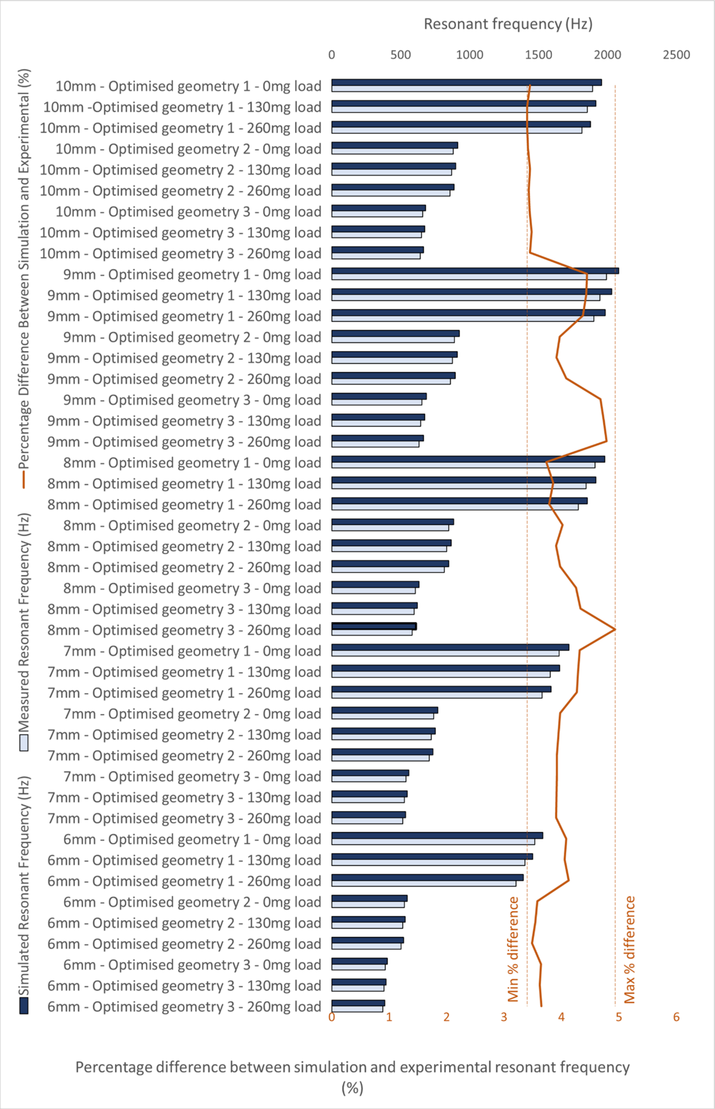
Figure 4-9 Simulation and experimental results comparison
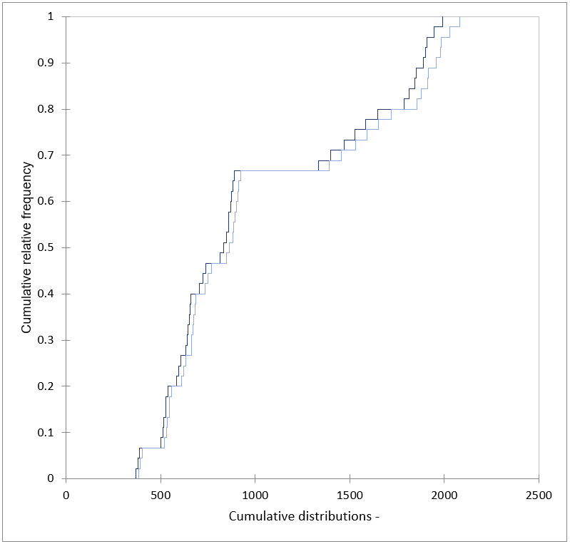
Figure 4-10 Cumulative distribution of simulation and experimental data

Experimental results analysis
The standard deviation for each tube size is visually displayed in Figure 4-11 on the same axis bounds for clarity of comparison. In ideal conditions, all results would be identical with no deviation in results. Small inconsistencies with the experimental setup results in differences between the sets of results. The Pearson correlation coefficient was calculated to determine the effect of the tube diameter on the standard deviation of results, which was undertaken to determine the reliability of each tube diameters setup on the consistency of results. The Pearson correlation coefficient gave an r-value of -0.4007 which is a negative and weak correlation. This is not strong enough to determine any reliable correlation in this study. The series of tests for each tube diameter were carried out consecutively, meaning that the setup process for each tube was undertaken for each test.
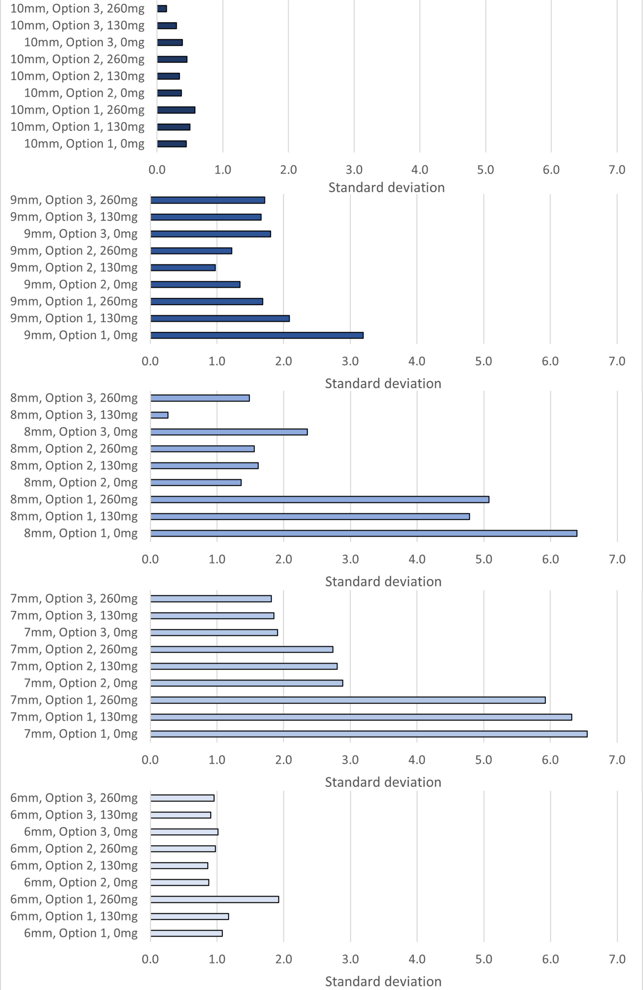
Figure 4-11 Standard deviation of experimental results for all tube geometries
Although no strong correlation between the tube diameters and standard deviation of the three test sets can be determined, Figure 4-12 details the maximum percentage difference between the results for each test set. All results have <1 % difference between the minimum and maximum measured resonant frequency with an average of 0.44 %. The deviation can be attributed to the manual process required for the setup of the tube into the support. In practical application, the slight differences would be accounted for in a calibration factor applied specifically to the tube, as installed in the support system. Therefore, the difference in results is due to the inconsistency of the setup process, and is not a measure of accuracy of the measurement system.
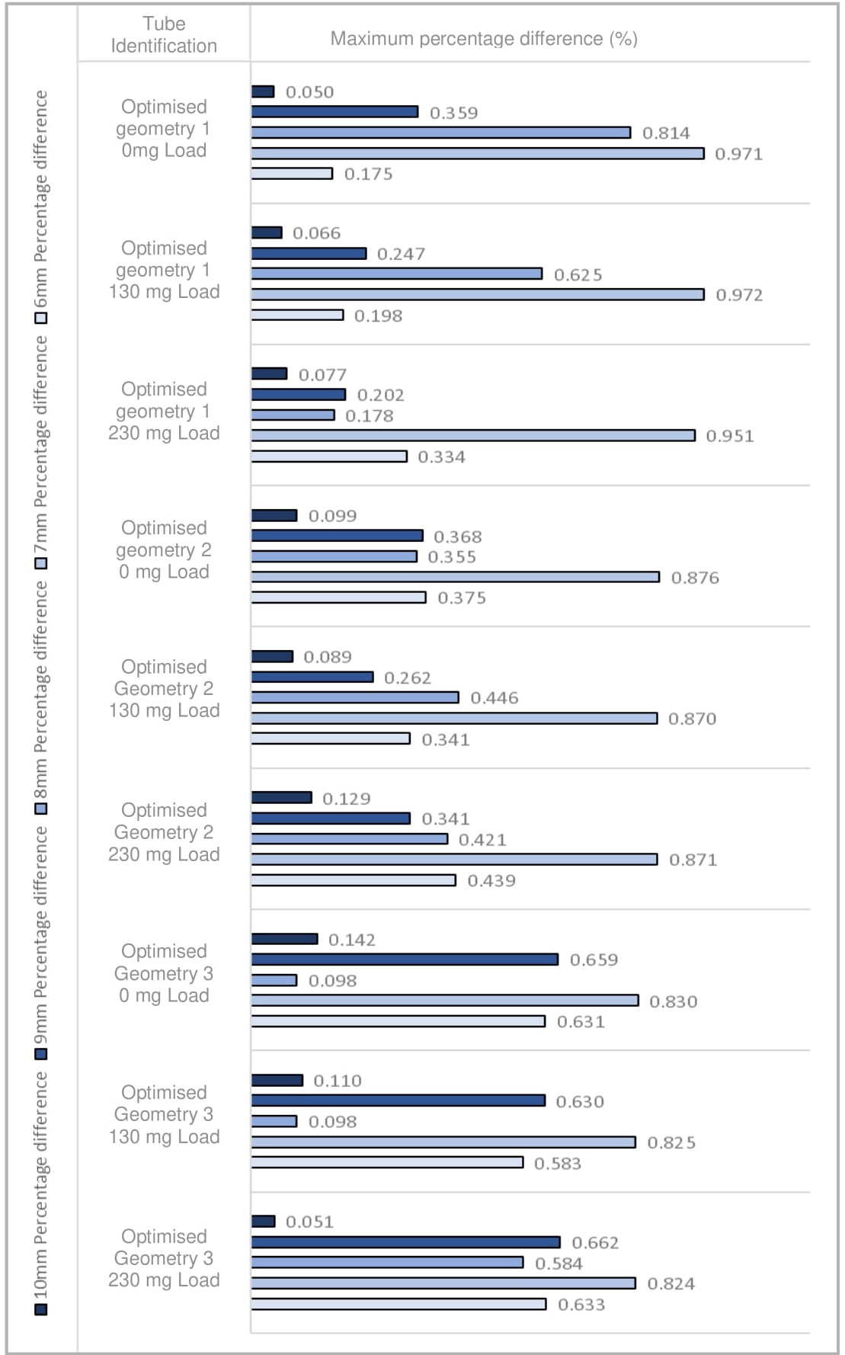
Figure 4-12 Maximum percentage difference between test sets

Tube parameter analysis
Analysis was undertaken on the effects of each of the design parameters including the bend radius, tube length, tube mass, and diameter of the tube on the percentage change in resonant frequency for both 130 mg and 260 mg point load mass. This analysis was undertaken to determine the importance of each of the parameters on the sensitivity of the tube to establish the most appropriate design for the relevant application. The Pearson correlation coefficient was used to determine the strength of relationship between the parameters and the change in resonant frequency. All results were actual measured values that were experimentally tested and not data collected through simulation. The four comparisons are detailed in Figures 4-13 – 4-16.
The relationship between the bend radius and the percentage change is detailed in Figure 4-13. The analysis using the Pearson correlation coefficient returns an r-value of -0.7917 for the 130 mg test, and -0.7924 for the 260 mg test. This shows a strong and negative correlation and confirms that the relative effect on the frequency is consistent with the changing load, concluding that a larger bend radius results in a smaller change to the measured resonant frequency.
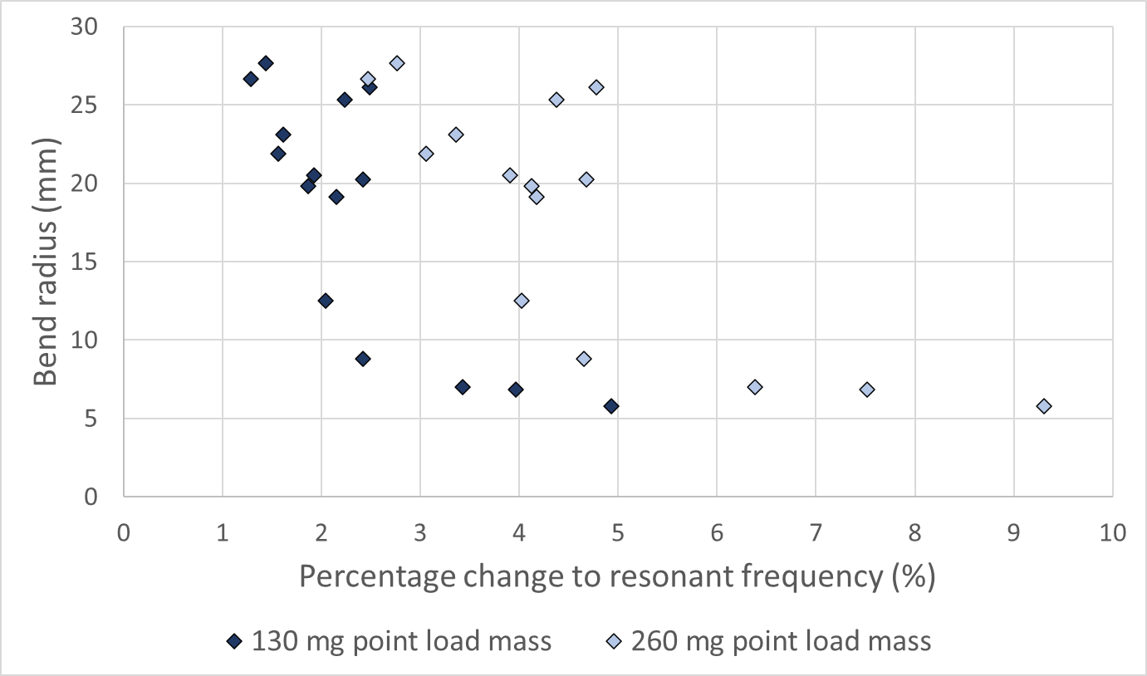
Figure 4-13 Bend radius vs. the percentage change in resonant frequency
The relationship between the tube length and the percentage change in resonant frequency is detailed in Figure 4-14. The analysis using the Pearson correlation coefficient returns an r-value of -0.6071 for the 130 mg test, and -0.5926 for the 260 mg test. This shows a moderate negative correlation and confirms that the relative effect on the frequency is consistent with the changing load, concluding that a longer tube results in a smaller change to the measured resonant frequency.
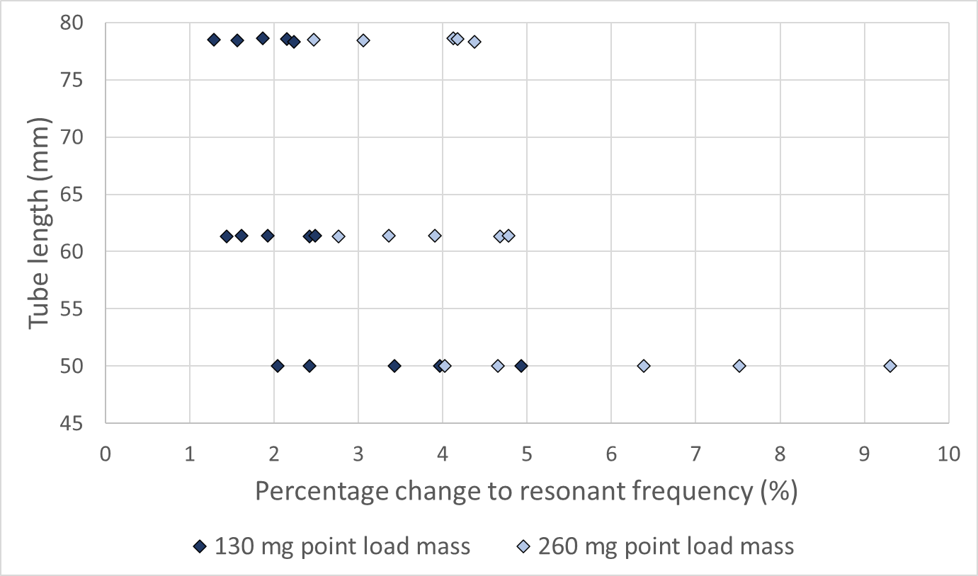
Figure 4-14 Tube length vs. the percentage change in resonant frequency

The relationship between the tube diameter and percentage change in resonant frequency is detailed in Figure 4-15. The analysis using the Pearson correlation coefficient returns an r-value of -0.61 for the 130 mg test, and -0.6234 for the 260 mg test. This again shows a moderate negative correlation and confirms that the relative effect on the frequency is consistent with the changing load, concluding that a larger diameter tube results in a smaller change to the measured resonant frequency.
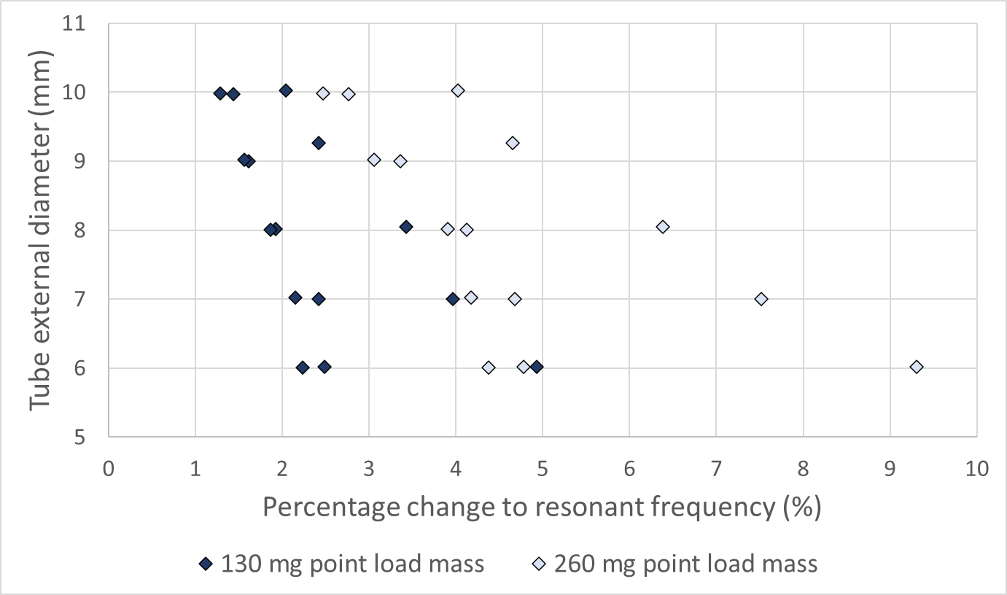
Figure 4-15 Tube external diameter vs. the percentage change in resonant frequency

The relationship between the tube mass and the percentage change in resonant frequency is detailed in Figure 4-16. The analysis using the Pearson correlation coefficient returns an r-value of -0.8996 for the 130 mg test, and -0.9048 for the 260 mg test. This shows strong negative correlation and confirms that the relative effect on the frequency is consistent with the changing load, concluding that the heavier the tube, the lower the change to the measured resonant frequency.
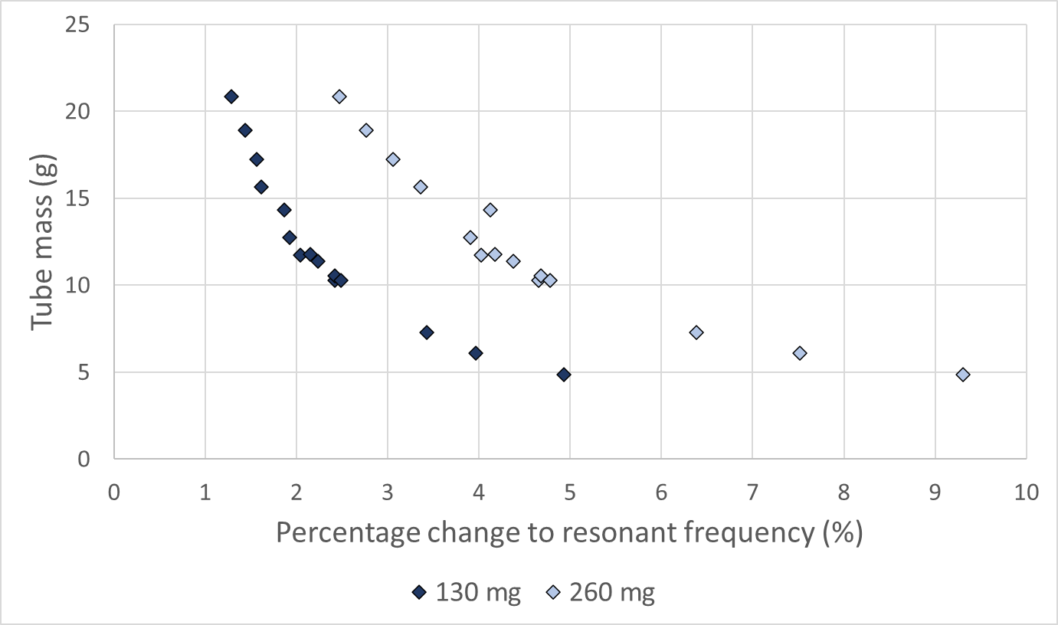
Figure 4-16 Tube mass vs. the percentage change in resonant frequency

Application analysis
The U-tube measurement system was designed through simulation and experimentally tested at known masses, the first being a vacant empty tube, the second at 130 mg, and the third at 260 mg. The objective of this Chapter is to apply an unknown mass in the form of particulate extracted from a stationary source to give an accurate representative measurement. The measurement concept was tested using the measured resonant frequency at a known mass of 130 mg and 260 mg and calculating the expected resonant frequency for the respective mass. The calculated value can then be compared to the measured value to determine the error in the system and to prove the concept of the measurement of the unknown mass in the tube. The percentage error of the measured and calculated resonant frequency values were calculated and are visually displayed in Figure 4-17, which also shows the measured and expected values for resonant frequency. The average percentage error for the measurement system is 3.8 %, showing strong potential of the proposed design for the measurement of an unknown mass. There are a small number of samples with a higher percentage error than the average suggesting inconsistencies with the measurement process, which can be attributed to the manual setup. In application these errors could be reduced as manual interference required for experimental testing would be reduced, and once calibrated, would not affect results.
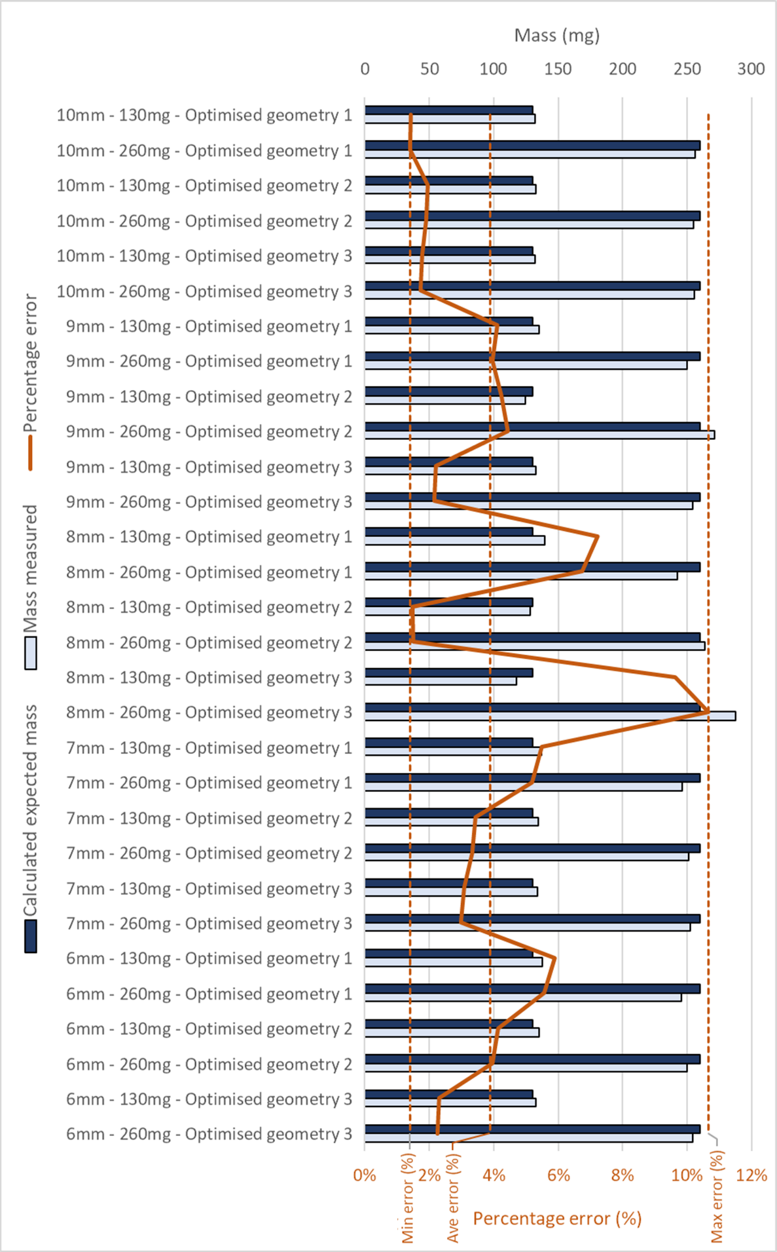
Figure 4-17 Calculated expected mass vs. measured mass to calculate percentage error
The linear calibration curve has been visually plotted against the measured data for the optimised geometry 1, for the 6 mm tube detailed in Figure 4-18. The linear regression equation used to plot the calibration curve can be used to calculate the unknown mass applied to the tube from the resonant frequency and is shown in Figure 4-18. The R² value is 0.9984. This high value shows that the measured data follows the linear calibration curve and therefore indicates strong linearity in the measurements.
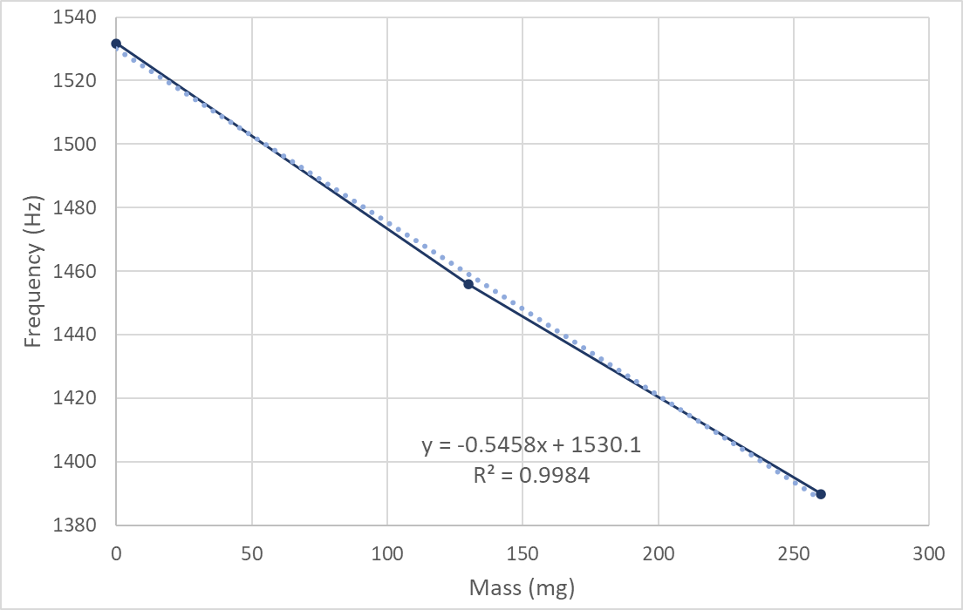
Figure 4-18 Calibration curve and measured values for 6 mm diameter tube

Sensitivity analysis
This Chapter focuses on the geometry and system development of a method of measurement of particulate for the highest sensitivity. The greatest change in measured resonant frequency is noted for the 6 mm diameter tube at 50 mm length with 6 mm bend radius, suggesting that this tube is most sensitive for mass measurement. The sensitivity of the 6mm tube is given by:
 | $$Sensitivity= \frac{Δ frequency}{Δ point load mass}$$ |  | (14)
Where:
- $Δ frequency$ = change in measured resonant frequency (Hz)
- $Δ point load mass$ = change in additional point load mass (mg)
This results in a measurement sensitivity of 0.53 Hz/mg. A LOD of 9.21 mg was calculated using the three sets of data collected experimentally. Further experimental work would allow for additional data to be collected for analysis to realise the full potential and capabilities of the vibrating glass tube as a mass measurement system. The LOD was determined with the following formula taken from “Guidance for Industry, Validation of Analytical Procedures, Methodology” document, produced by ICH [146]:
 | $$LOD= \frac{3.3 σ}{S}$$ |  | (15)
Where:
- $LOD$ = detection limit
- $σ$ = standard deviation of the response
- $S$ = slope of the calibration curve

Discussion
This Chapter focuses on the development of using a U-shaped glass tube for accurate mass measurement with a view to exploring the design for highest sensitivity. By using a known point load mass across the design geometry selections, the highest percentage change in resonant frequency will show the tube with highest sensitivity. All analysis of the effects of geometry parameters on the percentage change in resonant frequency show that reducing the size and weight of the glass tube, increases the measured change in resonant frequency when a load is applied to the tube.
The experimental setup was assembled to be representative of the system design which was developed through the optimisation process in Ansys. A comparative analysis of the experimental data was undertaken through the standard deviation of results. The analysis was carried out across the three sets of data, for each tube diameter, at each optimised geometry, with the mass remaining constant for direct comparison.

Conclusion
The purpose of this Chapter is to design, simulate, and validate experimentally, a glass U-tube mass sensor designed for highest sensitivity. The intended application of the methodology is to measure the mass concentration of particulate emissions from stationary sources with a view to using the methodology to overcome some known issues associated with the SRM method detailed in BS EN 13284-1 [34]. The research process involved initial geometry design of the U-tube sensor, modal analysis, system design, geometry optimisation, component manufacture, system assembly, experimental testing, and harmonic analysis. Throughout this structured process, a system capable of mass measurement using a vibrating glass U-tube was designed and developed.
Emissions monitoring is a technically challenging field. The measurement of particulate emissions from stationary sources is difficult due to the high level of accuracy required and the harsh environment in which equipment operates. Techniques currently available for continuous particulate monitoring rely on the measurement of the characteristics of particulate and not the mass directly. The method presented in this work seeks to overcome many of the parameter driven measurement issues by measuring mass directly online, capable of giving real time mass concentration measurements. As well as overcoming current issues faced within the particulate measurement industry, the proposed methodology opens further application opportunities. The ability to perform stack profiling is a now a possibility. This is a process that is currently undertaken to determine the most suitable location for continuous gas emissions monitors and is currently not feasible with particulate measurement equipment. The ability to take a stack profile from a stationary source would allow for better placement of continuous monitoring equipment and would improve the representativeness of the measurements currently being taken.
Analysis was undertaken on glass tubes with external diameters of 6 mm – 10 mm. Geometry optimisation was undertaken to develop a measurement system for the highest sensitivity. The data collected through simulation and experimental work suggests that the most sensitive system is designed when the tube mass is smallest by reducing the length, bend radius, and external diameter. The 6 mm tube with smallest length and smallest bend radius gives the greatest percentage change in resonant frequency for the smallest addition of mass, with a measurement sensitivity of 0.53 Hz/mg.
The distribution of the simulation and experimental data shows strong correlation, resulting in a maximum difference of between 3 % to 5 %. The strong linearity shown in a high R² value of the linear regression equation confirms that the natural resonant frequency is inversely proportional to the combined mass of the body of the tube and any additional unknown mass. The average percentage error for the measurement system is 3.8 %, showing strong potential of the proposed design for the measurement of an unknown mass. All experimental results have <1 % difference between the minimum and maximum measured resonant frequency with an average of 0.44 %.
This Chapter delivers the development of the most suitable geometry for highest sensitivity measurement and details the process to aid selection of the most appropriate tube. The proposed application for the glass U-tube developed in this research is for the measurement of the mass concentration of particulate emissions from stationary sources. Whilst this research has detailed the geometry, system design, and evidence of the measurement concept, it is suggested that further research should be undertaken. This should include the integration of the measurement system with existing extractive techniques, address the issues associated with the harsh environment where equipment operates (including temperature regulation), and integrate the measurement technique with the measurement of gas volume to generate mass/volume concentration measurements (required for emission measurement reporting).

Chapter 5 – Representative sampling from stationary sources

Introduction
The impact of particulate matter emissions cannot be ignored; there are serious health [147,148] and economic effects to be considered . Understanding particulate emissions accurately is imperative to implementing appropriate control and reduction measures to create a cleaner environment [149], as well as ensuring compliance with emissions limits imposed on plants and processes. As explained by Nicklin and Darabkhani [129], there is an immediate requirement for innovative development in the measurement of particulate emissions. As tougher legislation is introduced and stringent ELVs are imposed on emissions processes in the UK, the calibration of CEMS is increasingly more difficult due to the reliability of the SRM at low concentrations. The accuracy of results from the SRM and therefore CEMS equipment must be questioned when the uncertainty of measurement is higher than process ELVs.
As explained by Jahnke [6], particulate CEMS equipment is calibrated against the SRM and a calibration factor is applied to equipment, whereas with gas CEMS, calibration gases can be used as a reference to ensure calibration of equipment. The calibration gas should be traceable to recognised international standards and is used to establish a known analyser response to a certified gas component concentration. This methodology is not possible when considering the calibration of particulate CEMS, as no viable particulate mass concentration standard exists due to the complex nature of particulate emissions [129]. When processes are in operation, the characteristics of fuel can change. These small changes in fuel can cause the particulate emissions profile to differ significantly as detailed in a study by Kasurinen [150].
To accurately measure the mass concentration of particulate emissions from a combustion process using the SRM, the extracted sample must be representative of the emissions present. The general measurement concept of the SRM is to pump a known volume of the flue gas through a filter and weigh the filter in controlled conditions before and after sampling. The flue gas is sampled isokinetically, that is, at the same velocity as the gas in the stack or duct. The total mass of particulate collected on the filter, and therefore per m³ of gas, can then be calculated to give meaningful results in mg/m³ format. In research presented by Antonsson [151], the performance characteristics of the SRM are investigated, detailing two contributions for underreporting in isokinetic sampling. The first being the widespread practise of 5 % super-isokinetic suction velocity and the second being the geometry design of nozzles used. These two factors can account for a 13 % underestimation of particulate emissions. Research conducted by the NPL [152] suggests that significant losses from filters can be seen, potentially up to 50 %, making this a major consideration when investigating the accuracy of the SRM. Developments have been made to create alternative techniques for determination of particulate on filter media, detailed in a study by Garland [153], and losses associated with the probe itself, detailed in a study by Sreenath [154]. This research investigates the distribution of particulate in the rinse procedure by analysing parameters collected during testing in accordance with BS EN 13284-1 [34] to determine the feasibility of isokinetic sampling to obtain a representative sample. Similar methods to the European SRM are used throughout the world, including ISO 9096:2017 “Stationary source emissions – Manual determination of mass concentration of particulate matter”, and the United States (US) Environmental Protection Agency (EPA) Method 5 [70]. All standards use a very similar process, of which the findings of this study are relevant for the development and improvement of the methodology.
This Chapter investigates the reliability of isokinetic sampling when used as a method to extract a representative sample from a stack process, in conjunction with innovative, alternative methods of sample analysis. The investigation considers the accuracy and reliability of isokinetic sampling and gravimetric analysis of particulate emissions – a process known as the standard reference method. An analysis of particulate emissions data from 21 UK sites was undertaken. In processes with particulate emissions <5 mg/m³, 80.7 % of the total sample was collected in the rinse, and for processes >5 mg/m³, 56.4 % of the sample was collected in the rinse. The data does not suggest any correlation between any of the measured parameters and the percentage of particulate in the rinse, including the stack velocity, isokinetic percentage, sample volume, and total mass concentration. The analysis assessed the filter and rinse data to identify the distribution of particulate in the filter and sample train to determine possible areas of improvement to minimise losses and increase accuracy for operators and designers of the SRM process. Rinse data refers to the particulate captured within the sample train that is collected through the rinse procedure.
The information presented in this research would aid the application of the SRM for stack emissions testers to help increase accuracy and understand where improvements can be made, whilst highlighting areas for the development of the methodology through further research. Only a sample of the total emissions is extracted from the stack when using the SRM technique; therefore, it is imperative that the extracted sample is representative of the emissions as a whole.

SRM regulatory influence
The field of emissions monitoring is highly regulated. The objective for accurate measurement for most operators and processes is to ensure compliance with increased legislative requirements. As technologies become available and CEMS are developed, process control can also be monitored. Emissions legislation is putting tighter restrictions on plant processes to reduce harmful emissions, as detailed in a study by Paola [155]. These low levels of particulate emissions are observed in the 21 sites tested in this project, with 62 % of sites reporting a result <5 mg/m³. It should be noted that in BS EN 13284-1 [34], the SRM is only validated for particulate concentrations of >5 mg/m³.
The legislation that is relevant to an application is generally determined by the size and operation of the process. In the UK, the EA are the governing body responsible for not only ensuring compliance with legislation, but also guidance and advice to maintain compliance. Whilst the legislation gives general guidance and emissions limits, in the UK, the EA are responsible for issuing permits detailing the application specific ELVs. Emissions from combustion processes are highly dependent upon the characteristics of the fuel used, particularly particulate emissions [150]. There are European Standards for emissions covering the requirements for particulate monitoring and measurement including the requirements of measuring points in a stack, requirements for the SRM to determine particulate concentration, the calibration of CEMS, the characteristics of measurement equipment, the QAL requirements to ensure equipment performs during its lifetime, and the handling of environmental data. This research project focusses on the SRM as a reliable method to extract a representative sample from a process, as per the methodology detailed in BS EN 13284-1 [34].
In the UK and Europe, BS EN 13284-1 [34] details the SRM for particulate measurement in ducted gaseous streams <50 mg/m³, although this technique can be, and is, used at higher concentrations. BS EN 13284-2 [55] derived from BS EN 14181 [54], details the quality assurance procedures related to CEMS for the measurement of particulate in order to meet the uncertainty requirements on measured values detailed in relevant regulations.
In addition to the above-mentioned legislation, the most relevant European Standards relating to particulate can be categorised into three sections including monitoring methods, instrument performance and test specifications, and quality assurance. Monitoring methods are covered in BS EN 13284-1, EN ISO 16911 [34,61,62], and BS EN 15259 [60]. Instrument performance and test specifications are covered in BS EN 15267 parts one, two, and three [56–58] and these regulations cover all requirements for certification of CEMS. Quality assurance is covered in BS EN 14181 [54] and BS EN ISO/IEC 17025 [59]. The MCPD [63], applies to medium combustion plants in a thermal size input range of ≥1 to <50 MWth and applies to around 143,000 plants across Europe [64]. The majority of combustion plants are in the scope of the MCPD, including boilers, engines, and turbines excluding large combustion plants regulated under the IED [5]. The IED [65] establishes the main principal for the permitting and control of large industrial installations, focusing on providing the best available techniques to achieve a high level of environmental protection considering both costs and benefits. There is considerable legislation covering all aspects of emissions monitoring, but all legislation influencing the measurement of particulate emissions references the SRM detailed in BS EN 13284-1 [34]. This research investigates the feasibility of using isokinetic sampling to obtain a representative sample, therefore specifically focusing on the methodology detailed in BS EN 13284-1 [34].
In European Legislation, ELVs are expressed in mg/m³ (mass/volume) of particulate in a flow of gas, generally given on a dry basis at a reference O₂ concentration. The reference O₂ level is specified in the authorisation, permit, or process guidance specific to each plant process. The conversion details are referenced in Section 2.4.1. For this reason, CEMS report an output in this format. As detailed in work covered by Nicklin and Darabkhani [129], CEMS use measuring principals that do not directly measure the particulate in a gas stream, but instead measure a function of a parameter of the particulate emissions in the flow of gas. The output in mg/m³ must be determined for each system for each application, due to changes in the characteristics of the particulate emissions; therefore, it is imperative that the SRM is representative of the actual emissions.

Process and methodology
This section will detail the research and project methodology, and the process of the isokinetic sampling for the SRM to the requirements of BS EN 13284-1 [34].

Research methodology
Further to research undertaken by Antonsson [151] detailing the effect of nozzle design and placement on the representativeness of the sample, it is the sample train that is of particular interest to the development of integrating alternative methods of analysis. This Chapter analyses data collected through isokinetic testing on 21 sites in the UK across a range of processes including incineration, energy recovery, spray booths, energy production, and manufacturing. The fuel types include clinical waste, dried sewage, non-recyclable waste, natural gas, biomass/limestone, oil and pharmaceutical waste. Stack diameters range from 0.3 – 6 meters, with an average of 1.6 meters. All testing was undertaken on industrial processes operating as expected with no known errors, such as any abatement failure, nor during any cleaning process which may have influenced results. The expected emissions values were not known before commencing any testing, and the characteristics of the particulate was not known. No additional analyses other than those completed under the SRM was undertaken throughout this research. All presented results are corrected for standard conditions and are representative of those used for the purposes of emissions reporting. The sample train is designed to be the transport system for the emissions sample and is therefore imperative to the accuracy of the final particulate measured. The typical equipment used for the isokinetic sampling and particulate capture is detailed in Figure 5-1.
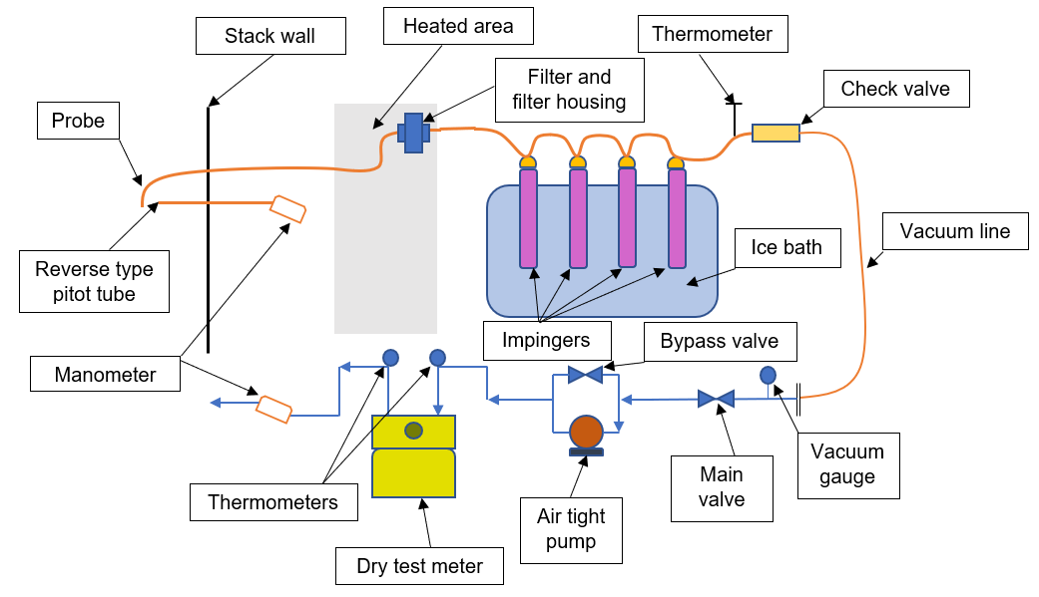
Figure 5-1 Typical isokinetic sampling equipment schematic [76]

The process of emissions monitoring is a sampling exercise with the fundamental requirement to ensure that the sampled gas is representative of the actual emissions of the bulk gas stream. An accredited laboratory or test facility to BS EN ISO/IEC 17025 [59] is required to undertake isokinetic sampling to BS EN 13284-1 [34] for the purposes of particulate CEMS calibration. The general principal of measurement using the SRM is to sample a known volume of flue gas through a filter. The sampling must be undertaken isokinetically, where the suction at the nozzle is at the same velocity as the flue gasses in the duct or stack. By weighing the filter before and after sampling, the total particulate per volume of gas can be determined [37]. By undertaking the SRM in accordance with the process detailed in BS EN 13284-1 [34], the results were analysed to determine the feasibility of achieving a representative sample from a plant process. A total of 21 sites were selected for testing across a range processes, all of which require annual validation of particulate CEMS via the SRM. All tests undertaken in this research are to the same standard of that required for the calibration of CEMS and samples were taken from existing sample ports suitably sited for extractive surveillance testing. The data obtained and recorded for the purposes of analysis include the stack velocity, percentage isokinetic, sample volume, particulate concentration, filter mass, and rinse mass.

Experimental methodology
An overview of the SRM procedure detailed in BS EN 13284-1 [34] and followed through this research is detailed in this section. The process begins with the preparation of equipment and pre-site tasks. This includes the handling of filters, which can be a major source of uncertainty, especially in low concentration measurements where only a small quantity of particulate will be collected on the filter. Filters are installed into their own housing for transportation to the test laboratory. To select the most suitable nozzle diameter, a number of tests are required. These ‘pre-measurements’ include determining the waste gas concentration of O₂, CO₂, and water vapor; the density of the waste gas; the number and location of measurement points in accordance with BS EN 15259 [60]; the temperature and velocity of gas at the measurement points; and a check for deviations of gas flow regarding duct axis. Leak testing of the equipment is required before any testing begins to ensure no external source will influence the results. The sample train is preheated to the selected temperature depending upon the stack temperature and inserted into the duct. The nozzle must face directly into the gas flow, avoiding contact with any part of the duct. A minimum of 30 minutes sample time is required. The probe is relocated during testing to cover each section required without pause in sampling. Isokinetic conditions must be maintained throughout the entire process. During sampling, the temperature and volume of gas at each point must be recorded, and during post sampling a visual inspection of the filter is undertaken. All components to be weighed are enclosed in an electrostatic free container for transportation. In addition to the particulate component captured on the filter, there may be particulate deposits in the sample train. BS EN 13284-1 [34] states that the deposits found can often be 10 – 30 % of the total particulate when sampling from waste incinerators at around 5 mg/m³. There is currently no known way to keep this negligible and therefore the system requires to be rinsed down to collect these deposits. The particulate collected from the system rinse is added to the particulate collected on the filter for a total particulate value. The total mass of particulate/volume of gas can be calculated via the known volume of gas and known total mass of particulate.

Survey methodology
For additional analysis and understanding in this project, the survey was conducted as a systematic method to obtain perspective from users and operators of SRM equipment. The focus of the analysis of the survey results was to target personnel who work to the methodology set out in BS EN 13284-1 [34] to obtain greater insight of the process involved in the SRM. Jones [118] explains that in order to obtain a representative sample, it is important to consider who will be targeted and therefore the participants’ industry statuses were confirmed for all participants. Detailed in Chapter 3.4.

Analysis methodology
Data collection for analysis was through the SRM and included recording of the stack velocity, percentage isokinetic, sample volume, particulate concentration, filter mass, and rinse mass. The objective of this Chapter is to determine the feasibility of extracting a representative sample using the SRM. The behaviour and influence of the measured parameters were analysed to determine and define any correlation affecting the representativeness of an extracted sample. Analysis procedures in this Chapter include a visual examination of data patterns with graphs and visual aids. Through scatter graphs an inspection of the distribution of the percentage isokinetic, stack velocity, and sample volume against the percentage of particulate in the rinse was carried out for an inspection of data patterns. Using the same data set, the Pearson correlation coefficient was calculated to measure the strength of the relationship between the two variables, using the following formula:
$$r=\frac{Σ\left(x_{i}-\overline{x}\right)(y_{i}-\overline{y})}{\sqrt{{Σ{\left(x_{i}-\overline{x}\right)}^{2} Σ\left(y_{i}-\overline{y}\right)}^{2}}}$$ | (16)
Where:
- $r$ = correlation coefficient
- $x_{i}$ = values of the x-variable in a sample
- $\overline{x}$ = mean of the values of the x-variable
- $y_{i}$ = values of the y-variable in a sample
- $\overline{y}$ = mean of the values of the y-variable
Using the value calculated for r, the correlation strength can be assessed to determine the influence of parameters. A comparison was made through a visual scatter graph and the Pearson correlation coefficient methods were used to compare the effects of the total mass concentration of particulate, and the percentage of the particulate found in the rinse. A mean average for all results with and without filter losses were calculated for stack velocity, percent isokinetic, sample volume, percentage of particulate in rinse and the total mass concentration. This allowed for analysis of samples recorded with and without filter material losses. Survey analysis was undertaken to determine the perceptions of operators of SRM equipment, looking for trends in results using NVivo software to aid organisation of the data. Thematic analysis was then undertaken on the data by coding topic areas and identifying prevalent themes.

Results and discussion
This section will detail results from 21 UK sites, shown in Figure 5-2, using the SRM referenced in BS EN 13284-1 [34] to measure particulate emissions mass concentration with a view to analysing the data on the feasibility of extracting a representative sample. With legislation driving levels of particulate emissions lower than ever before, the reliability of equipment is questionable at these low levels, especially at levels <10 mg/m³.

Isokinetic percentage analysis

Figure 5-2 Isokinetic percentage for each sample

It is confirmed that all results are within the isokinetic rate of 95 – 110 % Figure 5-2, as required by BS EN 13284-1 [34]. The isokinetic rate is the relationship between the ratio of gas velocity in the entry nozzle to the gas velocity in the duct, determined by the following expression, shown as a percentage:
 | $${V_{n}}/{V_{d}}$$ |  | (17)
Where:
- $V_{n}$ = gas velocity in the entry nozzle
- $V_{d}$ = gas velocity in the duct
BS EN 13284-1 [34] specifies a generous acceptable tolerance of between 95 – 110 % isokinetic rate. While all results in this study are within these parameters, a study completed by Antonsson [151] states that any deviations from the ideal isokinetic condition will have an impact on the accuracy of results. The BS EN 13284-1 standard [34], references work completed by Belyaev and Levin [156] to justify claims that the SRM can be used to obtain a representative sample. Antonsson [151] highlights critical differences between the work presented by Belyaev and Levin [156] and the procedure stated in the BS EN 13284-1 standard [34], including the limits for ratio of suction velocity at the nozzle to the free gas flow. A super-isokinetic sample will have a negative impact on the result and render the process in accurate.

Isokinetic percentage and stack velocity
The effects of both the isokinetic percentage of the sample and the stack velocity to the percentage of particulate in the rinse are shown in Figure 5-3. The horizontal axis corresponds to the percentage of particulate in the rinse and is expressed as a percentage (%). BS EN 13284-1 [34] states directly that when the isokinetic percentage rate of the sample and the isokinetic rate are one, the stack gas and gas entering the nozzle are at the same velocity and a representative sample can be taken. However, Antonsson [151] has found that any probe inserted into a particulate laden flow of gas, influences the representativeness of the sample even at ideal isokinetic conditions. When using the SRM, the isokinetic percentage measurement is required to confirm that the velocity of the stack gas and gas entering the sample nozzle are within the stated required parameters to reduce any influence of flow velocity. Calculating the Pearson correlation coefficient gives an r value of 0.081, which is a positive but very weak correlation between the data. This weak relationship suggests that the isokinetic percentage of the sample has no influence on the percentage of particulate in the rinse. The stack velocity is measured as part of the process to monitor the percentage of the sample isokinetic and ensure that the velocity of the gas in the stack and entering the probe are as close as practically possible, on site, during testing. The effects of the stack velocity expressed in m/s on the percentage of particulate in the rinse, and therefore on the distribution in the sampling equipment is shown in Figure 5-3. The calculated Pearson correlation coefficient gives an r value of −0.248, which shows no correlation. From the 21 sites tested, there is no evidence to suggest that there is any correlation between the velocity of the gas in the stack and the distribution of particulate between the filter and rinse.
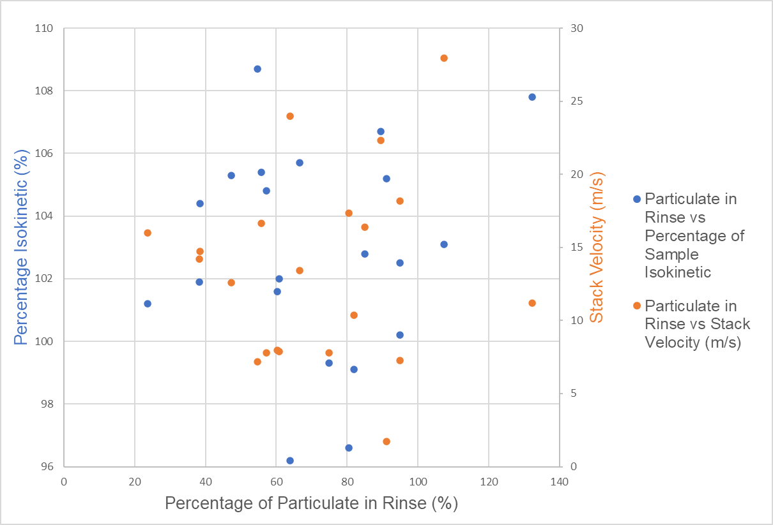
Figure 5-3 Isokinetic percentage of each process detailing the percentage of particulate in the rinse

Sample volume analysis
The sample volume is a required measured parameter used to determine the mass concentration to output in reportable format of mg/m³. As expected, the 21 sites analysed through this Chapter have varying emissions profiles, including particulate emissions, with a sample volume range between 0.35 m³ and 1.416 m³. Any variation in the measured volume of gas will have significant impact on the accuracy and reported particulate emissions value. The relationship of sample volume, expressed in m³ and percentage of particulate in the rinse, is detailed in Figure 5-4. Analysis undertaken using the Pearson correlation coefficient gives an r value of 0.0248, showing a positive but very weak relationship. There is no evidence to suggest any relationship between the sample volume of gas analysed and the percentage of particulate found in the rinse. For the purposes of accurate analysis when referencing the percentage of particulate in the rinse, some data represents >100 % of the sample captured in the rinse, which can be attributed to particulate filter losses. When reporting for legislative purposes, the negative value of filter mass is not considered. In this research, the losses of the filter are added to the mass of the rinse, creating a negative recorded mass for the filter when compared to the pre-weighed mass so that the influence of filter losses can be considered.
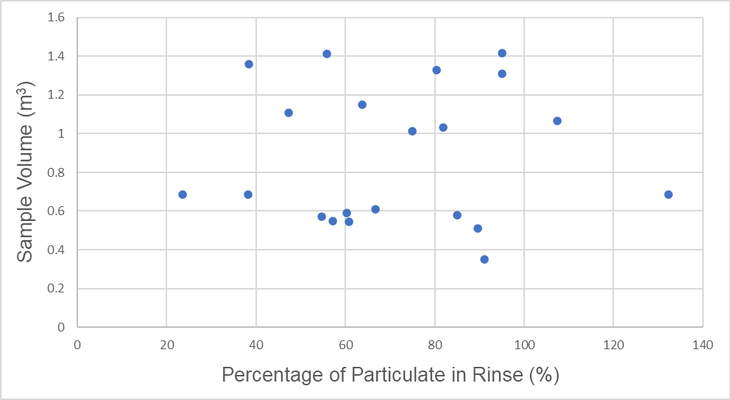
Figure 5-4 Sample volume vs. percentage of particulate in rinse

Filter loss analysis
Throughout the testing of the 21 sites, analysis shows that losses are experienced during the ‘pre’ and ‘post’ sampling filter measurement; therefore, losses of filter media are experienced. A study completed by the NPL [152] details that losses on filters specifically for BS EN 13284-1 [34] can potentially be up to 50 % of the mass of particulate collected when sampling. Careful handling of filters is required at all stages of testing with the design of filters having little impact on losses experienced. Figure 5-5 shows a comparison of tested parameters from samples with and without filter losses to determine how these factors influence the losses in the filter and therefore the reliability of the sampling equipment. The data was split into two categories, those with negative mass readings suggesting filter losses, and those without showing a positive mass reading. A mean average for the tested parameters in each category was used for analysis and comparison. The average stack velocity across all results is 16.2 m/s, whilst the average for sites with filter losses is 19.6 m/s and the average for sites without filter losses is 12.8 m/s. Whilst the data from the sites tested show that an increase in velocity increases filter losses, further specific research on filter losses is recommended for reliable analysis. The mean average for the percentage of the sample that is isokinetic is 104.05 %, whilst that for sites with filter losses is 105.5 % and that for sites without losses is 102.6 %. The sample volume taken shows no influence on the losses in the filter as the average with and without filter losses is 0.9 m³. In a study by the NPL [152], they found that the flow rate has little influence on the losses in filters and that the greatest losses are due to the handling and measuring processes. As previously mentioned, the presented results will show >100 % of particulate in some instances where there are filter losses. Therefore, as expected, the average of particulate in the rinse where filter losses are present is 119.9 % and the average where there are no filter losses is
65 %. This shows that the >100 % results are due to negative filter mass results and exaggerated rinse mass results. The mass concentration is lower for samples where there are filter losses, with the average being 1.9 mg/m³. Where there are no filter losses the average measurement is 30.6 mg/m³. As there is no data to suggest any strong influence from the stack velocity, isokinetic percentage, and sample volume on the filter loss, the results suggest that these losses could be present in all samples, where the higher concentration found on the filter is higher than the losses experienced, which maintains a positive value for the filter mass. In a study by Elder [157], the efficiency of glass-fibre filters, similar to those used in the SRM procedure in this study, are around 99.9 % effective with particle size having little influence. For processes with particulate emissions <5 mg/m³
80.7 % of the sample was collected in the rinse, and for processes >5 mg/m³ 56.4 % of the sample was collected in the rinse. Whilst the delicate handling of the filter and accurate processing and measurement is vital to achieving good quality results, there is a significant percentage of particulate collected within the rinse that cannot be neglected.
The flow of gas emissions through a duct or similar is not constant, as detailed in a study by Malet [158]. Particulate generally follows the path of least resistance, with the greatest concentration generally found where velocity is highest and not near the stack walls [159]. Emissions from plant processes can vary significantly. For combustion processes fuel has great influence on the emissions profile [150]. Conditions can be hot, wet, and corrosive, adding to challenges in accurate sampling. The range of particulate collected within the rinse across the 21 sites is from 23.6 % to 132.3 % with an average of 71.4 %; therefore, consideration for the accurate collection of particulate in the rinse is imperative for accurate implementation of the SRM. In Elders [157] study on the deposition of particulate in the sample train, the highest quantities of particulate were found on the leading edge of the probe liner and at the bends. With such high quantities of particulate found in the sample train, and therefore the rinse, confirmation of careful implementation of the rinse procedure is required.

Figure 5-5 Comparison of an average of testing parameters for samples with and without filter losses

Concentrations analysis
The concentration of particulate for results greater than, and less than, 5 mg/m³ are shown plotted against the percentage of the mass in the rinse on the horizontal axis in Figure 5-6. For sites with a mass concentration >5 mg/m³ the r value is −0.078, showing a negative but weak relationship. For sites with a mass concentration of <5 mg/m³ the r value is −0.1073, again showing a negative but weak relationship. The higher the concentration, the less percentage of particulate is captured in the rinse. Although this correlation is weak, as with earlier findings, it still suggests that the losses on the filter are due to the handling and measurement process. When a lower concentration of particulate is seen on the filter, the losses due to handling have a greater impact on the ratio of particulate on the filter to the rinse. More data on the losses associated with the handling of filters is required for statistical reliability.

Figure 5-6 Percentage of mass in rinse (%) and concentration (mg/m³)

Survey results
An industrial survey detailed in Appendix 4 was undertaken to analyse opinions of professionals working within the industry. All participants currently work within the emissions monitoring industry and use SRM equipment. The survey was used to determine the current position of the industry regarding the use of the SRM, taking the perspectives of experienced users to determine the feasibility of using the SRM to extract a representative sample. The survey was designed with 20 questions for all participants and included both open and closed format questions. A total of 732 responses to the questions were recorded. The topics covered include the perceptions of the industry, the roles and experience of participants within the industry, details of the measurement of particulate emissions, requirements for monitoring, and issues/improvements with monitoring equipment. The analysis of results focuses upon the perceptions of participants regarding issues relating to monitoring equipment and thoughts regarding improvement. Current technology is not capable of the measurement of emission limits, with participants stating that the practical limit of detection for the SRM is around 5 mg/m³. Many processes are operating at lower mass concentrations than 5 mg/m³, with 62 % of processes analysed in this project reporting these low values. Poor application of equipment is observed in the field, which is said to result is low quality data. Contamination of the sample is highlighted as an issue with poor application, with better cleaning procedures suggested as a method to improve contamination issues. Performing the rinse procedure on site in harsh conditions can significantly influence the accuracy of results. When dealing with such low mass concentrations, the inconsistencies with the measurement technique can have considerable effects on accurately reporting results. It was noted that where there are high levels of ambient particulate, the accuracy of results is negatively affected, suggesting that ambient particulate contaminates the measured sample at the measurement stage. Using sealed filters was suggested as a methodology to overcome issues relating to damaged filters and filter losses. Whilst sealing a filter would reduce losses, the contamination issue still exists regarding the rinse procedure. It was suggested that sampling flow rates should be increased to increase the sample volume, although this would involve a change in design of the probe.

Discussion
There is a requirement to measure the mass of particulate emissions in a gas stream directly, eliminating the issues surrounding particulate parameter driven measurements encountered with continuous monitoring. Methodologies including triboelectric, electrodynamic, laser, and optical measurements require site calibration due to the vast inconsistencies in particulate characteristics. It is not possible to create a standard ‘calibrated particulate’ due to the variations in particle size, composition, shape, colour, and refractive index. Using the SRM as a technique to take a sample of particulate for a given period, the purposes of calibration of CEMS is well used in the emissions monitoring industry and is the best available technique for processes emitting >10 mg/m³. There is a particular focus in this Chapter to determine the feasibility of using the isokinetic sampling methodology to achieve a representative sample for the purposes of integration of alternative analysis methods such as that detailed in Chapter 4. When the methodology is used as a complete system and a rinse is part of the procedure, the losses associated with particulate deposits collected in the sample train can be minimised. When the isokinetic sampling system is used with a view to analyse the sample for use with alternative methods, the losses of particulate in the sample train must be considered.
As highlighted by Antonsson [151], the influence of any interruption of flow within the stack influences results up to 13 %, and larger probes would only worsen these effects. BS EN 13284-1 [34] is written as a guide to perform SRM measurements from stack processes. The equipment used to undertake these measurements is bulky and difficult to navigate the harsh conditions called upon by stack emitting processes. Regardless of the quality of implementation, there are limitations to the SRM. The key point being its inability to accurately measure processes with emissions levels <5 mg/m³. The process of employing the SRM introduces errors, influencing the quality and accuracy of results. Alternative methods of analysis are available, but the process of extracting a representative sample limits the reliability and potential of these new technologies. The SRM is a critical process to accurately measure particulate emissions from a plant process. The characteristics of particulate emissions, including the diameter, size distribution, colour, shape, and chemical composition make the selection of equipment challenging. For instruments that measure a parameter of particulate in such unstable conditions, it is not possible for manufactures to calibrate instruments that can be installed on any process and give accurate representative results. The requirement of the SRM is to provide an unbiased, representative measurement of the particulate concentration in the stack.

Conclusions
This Chapter analysed data from an industrial survey and 21 UK sites with data obtained by implementing methodology available through BS EN 13284-1, known as the SRM for the measurement of particulate for the purposes of calibrating CEMS. There are several issues surrounding the SRM including the validation of measurements <5 mg/m³, introduction of losses through the harsh measurement environment, environmental influences (especially where high levels of ambient particulate are present), the influence of the probe inside the stack (which can contribute to up to 13 % overreporting), and difficulties with the rinse and clean procedure to obtain accurate results.
The data collected in this research shows very weak relationships between any of the measured parameters required for SRM testing, and the percentage of particulate in the rinse including the stack velocity, isokinetic percentage, sample volume, and the total mass concentration. The issue with particulate deposits collected in the sample train, limits the use of isokinetic sampling to obtain a representative sample for use with alternative analysis methods. Using alternative and new methods of measurement, especially when developing systems to be considered as a reference method, takes considerable collaboration and integration with policies and standards. This research has highlighted that there are potential problems with achieving a representative sample using the isokinetic process in its current form for use with new technologies to analyse an extracted sample.
There are possible applications where the procedure detailed in BS EN 13284-1 can be used with alternative measurement techniques. Where continuous analysis techniques are being developed to integrate with extractive isokinetic sampling techniques, the possibility of a full stack profile can be undertaken to output the percentage of particulate found at each point in the stack. The problem with particulate captured within the sample train is still present but by giving a percentage profile across a stack, valuable data can be obtained. When installing gas analysers for the purposes of emissions measurement, a stack profile can be obtained to identify the best location for CEMS to be installed. This is currently not possible with the SRM and is difficult with any other available techniques. Using this method would allow a full profile to be supplied for the purposes of accurate CEMS location; although this would not provide any quantitative data for particulate emissions as the issues with sample train capture are still present. This research shows that there are difficulties with the SRM in achieving a representative sample, but further research opportunities are highlighted for the future integration of these processes. Automating the filter measurement process to produce an online, real-time measurement would assist the users of measurement equipment, knowing when sufficient sample has been measured to achieve reliable results. This would not completely solve problems associated with the SRM procedure; however, some errors associated with the handling of filters could be eliminated. The process of the rinse procedure was highlighted in the survey as being difficult. Significant improvement is suggested to automate the manual technique currently used. Through the automation of a rinse procedure, many of these issues could be overcome, including the ability to use the isokinetic sampling method integrated with an automated rinse as a system for extracting an accurate representative sample.

Chapter 6 – Conclusions and suggestions for further work

Introduction
This research project has an industrial focus investigating the measurement of particulate emissions from stationary sources. The requirement for accurate measurement is imperative for the understanding and therefore reduction of harmful particulate emissions. Requirements for cleaner air has now been driven by regulators who are imposing more stringent restrictions on emitters and processes who contribute to harmful emissions. This puts the regulatory burden of proving compliance with the operators of these processes and therefore introduces the need for accurate monitoring and reporting techniques.
The impact of harmful emissions can be seen on health, climate, and the economy with the media regularly reporting issues associated with the impacts of harmful emissions to raise public awareness. To present accurate data, reliable, and repeatable techniques to measure particulate emissions are required. The primary source of particulate emissions is from the combustion of coal, oil, fuel, and biomass for the purposes of energy generation and are composed of sulphates, nitrates, hydrogen ions, ammonium, elemental carbon, silica, alumina organic compounds, trace elements, trace metals and particle bound water. The characteristics of the emissions profile is dependent upon the fuel, combustion, and abatement process.
The development of the particulate emissions measurement industry has changed the way in which technology is applied and used within the industry. Requirements for installing and operating measurement equipment can vary, these include ensuring compliance with legislation, and optimising, monitoring, and controlling combustion processes.
Particulate measurement emissions equipment operates either continuously by measuring a parameter of the particulate itself; which is a function of the mass concentration, or by sample measurements; where a representative sample is extracted from the process and the particulate captured is analysed. Generally, the sample method is used to calibrate continuous emission monitors. Emissions reporting requires results to be given in mg/m³ format, known as mass concentration.
This research is not only driven by increased legislative requirements and issues within the industry but addresses the requirement to measure and understand particulate emissions from stationary sources to aid control strategies as part of the wider emissions reduction plan for a cleaner and healthier environment.
This research presents an overview of the particulate emissions measurement industry through a literature review, industrial survey, and MCDA. The purpose of an in-depth industry review was to realise the current position of the industry with a view to seeking areas for improvement and development. The literature review analysed the available measurement equipment, categories for particulate measurement, particulate emissions sources, legislation, and methods of MCDA. The industrial survey analysed the views and opinions of experts working within the field of particulate emissions monitoring. Issues associated with the industry and the current methodologies to measure particulate emissions were highlighted. MCDA was used as a strategy to select suitable equipment dependent upon the application as the BAT.
Following the in-depth review of the industry the development of a method to measure the mass of particulate on a filter directly and continuously was developed with a focus on the geometry design for highest sensitivity. A U-shaped glass tube was developed with a filter fitted at the anti-nodal point as a method of analysing the particulate in a sampled gas stream.
Following the development of a method to measure mass directly and online in a gas stream, the process of extracting a representative sample was investigated. An analysis was made of data taken from UK processes that have a regulatory responsibility to measure particulate emissions. This highlighted further areas for improvement and development within the particulate emissions measurement industry.

Conclusions
The following section details the conclusions for each section of this thesis report.

Overview of particulate emissions monitoring methods
- The task of designing, manufacturing, installing, and maintaining particulate emissions monitoring equipment in the harsh environments that it is expected to operate is a challenging task.
- A comprehensive literature review was undertaken to give an understanding of the commercially available techniques to measure particulate matter from combustion processes. The literature review was conducted in stages by searching carefully considered key terms. The literature review seeks to give an overview of the current state of the commercially available measurement techniques for particulate emissions.
- The harsh environments coupled with the vast range of changing characteristics of processes results in unstable particulate emissions profiles and therefore measurement challenges.
- Manufactures of equipment have developed techniques capable of overcoming some of the application-based challenges that have arisen, although a ‘one fits all’ solution to particulate monitoring is not available.
- Particulate emission monitoring equipment can be classified into many different categories to describe their operating characteristics and principals. These include continuous or periodic sampling, in-situ or extractive, in-stack or out-stack, and direct or in-direct.
- All current CEMS equipment for particulate emissions monitoring requires regular calibration against the SRM for accurate reporting purposes. Without calibration, results can only be defined as indicative and not accurate and quantitative, which is now required with legislation driving process to emit less particulate.
- Calibration must be carried out on all equipment for its intended application. As process characteristics change, the calibration curve is also affected requiring regular calibration intervals to maintain accurate measurements.
- A heavy operational and regulatory burden is placed on the SRM procedure which is a manual, labour intensive, and costly process. The accuracy of the SRM is questionable especially at concentrations <10 mg/m³. Careful consideration of the accuracy of results when calibrating CEMS equipment on processes with these low particulate mass concentrations is required.
- CEMS equipment all suffer from the same potential inaccuracies as they do not weigh particulate mass directly, but rather measure a characteristic of particulate. Scatter instruments measure the intensity of light scattered from particulate, opacity instruments measure the ability of a flue gas to transmit light, beta attenuation instruments measure the transmissions of electrons through a concentration of particulate, and triboelectric instruments measure charge transfer to a probe. This equipment allows for a continuous measurement to be taken from processes, something that is not possible with the SRM which measures the mass of particulate directly.
- CEMS equipment is now being used for monitoring of plant health as well as for emissions reporting purposes due to the lower costs of manufacturing equipment.
- Legislation and guidance regarding the measurement of particulate emissions is available. This details the requirements to measure emissions, the limits required to ensure compliance, and the procedures that should be followed.

Selection of particulate emissions monitoring equipment
- A MCDA methodology has been developed to aid the technical selection of particulate emissions measurement equipment.
- An industrial survey was undertaken as a systematic method of calculating the weighting for each criteria to be assessed in the MCDA, and for gaining information on the current state of the industry with a view to providing suggestions for improvement for further research.
- The decision process of selecting the most suitable particulate emissions monitor is complex due to its multivariate nature with poor decisions having costly implications. It is not acceptable to select a device simply because it is a suitable match to one of the many criteria, therefore a more detailed approach should be taken through the methodology developed through this research in addition to good technical judgement.
- An industrial survey, and literature review were used to derive criteria and weighting for each evaluation (measurement technology) to be analysed against, and the application-based criteria to analyse the use of the available measurement technologies in a range of applications to develop appropriate methodology for MCDA framework.
- There is now a trend towards using CEMS equipment not only for particulate measurement but also process monitoring.
- Calibration of CEMS at concentrations <10mg/m³ is difficult. Technology is available to continuously measure low concentrations of particulate but verification against a reference method is difficult. There is no technique available capable of measuring mass directly and continuously.
- The selection of suitable equipment is imperative to obtaining accurate results. The characteristics of the application must be taken into consideration with good technical judgement required to select the BAT.
- Most continuous particulate emissions monitors are sensitive to changes in particle characteristics which becomes a problem if the application has changing emissions profiles. CEMS equipment is calibrated to its environment, and a change in particulate emissions in terms of particle characteristics could render the instrument response inaccurate. There are many changing process conditions such as velocity, particle size, and composition that can also affect the calibration of a device, therefore the difficulty is not obtaining calibration but maintaining calibration.
- Factors that can affect the accuracy of isokinetic sampling include temperature difference between hot sampling gas and the pipe wall, and the surface roughness from the pipe itself or the particles. Combining all the possible factors, losses in the sampling lines of SRM equipment can reach 69 % after 0.2 seconds for PM₁₀, although smaller particles have lower percentage losses.
- There are very few technologies available to measure mass concentration continuously at low levels. The difficulty is not the measurement but verification against a reference method at these low levels.
- The MCDA results show that there is no solution currently available that is suitable to measure in all applications. Where continuous sampling is not required, the SRM is the BAT.
- Methodology has been developed through a literature review, industrial survey, and MCDA to aid the technical decision-making process when selecting the BAT to measure particulate emissions.
- Emissions profiles from stationary sources vary significantly from process to process, this explains the requirement for good technical judgement when selecting equipment.
- Operators have different motivation for measuring particulate emissions including satisfying legislation and industrial requirements, and process control and monitoring which influences the selection of equipment.
- There is a requirement to use the SRM to calibrate all continuous methods of measurement to give representative results, which suggests why this technique is most popular. The sampling process used for the SRM requires further investigation into achieving a representative sample.
- The measurement of particulate mass concentration is a technically challenging field with so many variables affecting the methodology and technology selection. There is no product currently available that is suitable for all applications, but with careful consideration, the BAT can be selected.
- The importance of the physical and chemical particulate characteristics on the selection of the BAT cannot be overemphasised. Should these characteristics change, instrument response can be significantly affected.
- Experts in the industry of particulate emissions monitoring feel that more needs to be done to develop instruments and techniques due to the limitations of current technology.

Development of particulate emissions measurement
- A glass U-tube mass sensor was designed, simulated, and validated experimentally with a view to measuring the mass of particulate in a gas stream. The intended application of the methodology is to measure the mass concentration of particulate emissions from stationary sources with a view to using the methodology to overcome some known issues associated with the SRM method detailed in BS EN 13284-1.
- The research involved initial geometry design of the U-tube sensor, modal analysis, system design, geometry optimisation, component manufacture, system assembly, experimental testing, and harmonic analysis. Throughout this structured process, a system capable of mass measurement using a vibrating U-tube was designed and developed.
- Emissions monitoring is a technically challenging field. The measurement of particulate emissions from stationary sources is difficult due to the high level of accuracy required and the harsh environment in which equipment operates.
- Techniques currently available for continuous particulate monitoring rely on the measurement of the characteristics of particulate and not the mass directly leading to the development of this research.
- The method presented in this work seeks to overcome many of the parameter driven measurement issues by measuring mass directly online, that is capable of giving real time mass concentration measurements.
- Analysis was undertaken on the geometry parameters to develop a measurement system for the highest sensitivity, which is the largest change in resonant frequency for the smallest addition of mass. The data collected through simulation and experimental work suggests that the most sensitive system is designed when the tube mass is smallest. This was confirmed through experimental analysis where the 6 mm tube with smallest length and smallest bend radius gives the greatest percentage change in resonant frequency for the smallest addition of mass. As the tube length increases the resonant frequency decreases, as the point load mass increases the resonant frequency decreases, and as the tube diameter decreases the resonant frequency decreases.
- The distribution of the simulation and experimental data shows strong correlation resulting in a maximum difference of between 3 % and 5 %. The strong linearity shown in a high R² value of the linear regression equation confirms that the natural resonant frequency is inversely proportional to the combined mass of the body of the tube and any additional unknown mass.
- This research delivers the development of the most suitable geometry for highest sensitivity measurement and details the process to aid selection of the most appropriate tube.
- The proposed application for the glass U-tube developed in this research is for the measurement of the mass concentration of particulate emissions from stationary sources. Measuring a change in resonant frequency of a glass U-tube containing a filter would capture particulate allowing accurate mass measurement.
- Analysis of the effects of geometry parameters on the percentage change in resonant frequency show that reducing the size and weight of the glass tube increases the measured change in resonant frequency when a load is applied to the tube.
- The U-tube measurement system was designed through simulation and experimentally tested at known masses. The first being a vacant empty tube, the second at 130 mg, and the third at 260 mg. The objective is to apply an unknown mass in the form of particulate extracted from a stationary source to give an accurate representative measurement. The measurement concept was tested and confirmed using the measured resonant frequency at a known mass (130 mg and 260 mg) and then calculating the expected resonant frequency for the respective mass.

Representative sampling from stationary sources
- This research analysed data from an industrial survey and 21 UK sites. Data was obtained by implementing methodology available through BS EN 13284-1, known as the SRM for the measurement of particulate used for the purposes of calibrating CEMS.
- There are several issues surrounding the SRM. These include the validation of measurements <5 mg/m³, introduction of losses through the harsh measurement environment, environmental influences (especially where high levels of ambient particulate are present), the influence of the probe inside the stack (which can contribute to up to 13 % overreporting), and difficulties with the rinse and clean procedure to obtain accurate results.
- The data shows weak relationships between any of the measured parameters required for SRM testing, and the percentage of particulate in the rinse. These include the stack velocity, isokinetic percentage, sample volume, and the total mass concentration.
- The issue with particulate deposits collected in the sample train limits the use of isokinetic sampling to obtain a representative sample for use with alternative analysis methods.
- Using alternative and new methods of measurement, especially when developing systems to be considered as a reference method takes considerable collaboration and integration with policies and standards. This research has highlighted that there are potential problems with achieving a representative sample using the isokinetic process in its current form for use with new technologies to analyse an extracted sample.
- There are possible applications where the procedure detailed in BS EN 13284-1 can be used with alternative measurement techniques. Where continuous analysis techniques are being developed to integrate with extractive isokinetic sampling techniques, the possibility of a full stack profile can be undertaken to output the percentage of particulate found at each point in the stack. The problem with particulate captured within the sample train is still present but by giving a percentage profile across a stack, valuable data can be obtained. When installing gas analysers for the purposes of emissions measurement, a stack profile can be obtained to identify the best location for CEMS to be installed. This is currently not possible with the SRM and is difficult with any other available techniques. Using this method would allow a full profile to be supplied for the purposes of accurate CEMS location; although this would not provide any quantitative data for particulate emissions as the issues with sample train capture are still present.
- The guidance set out in BS EN 13284-1 states that the SRM is only validated for particulate emissions concentrations of >5 mg/m³. Given that the SRM is used for the calibration of all CEMS, the industry is now reaching the limits of available equipment to achieve accurate, reliable, and repeatable measurements.
- Manufactures of current CEMS state that technology is available to measure low concentrations of particulate emissions but calibration of this equipment at concentrations <10 mg/m³ is difficult. It could be said that measurements from continuous equipment below this range can only be indicative and not a reliable quantitative representation of the particulate emissions.
- Whilst the data from the 21 UK sites tested show that an increase in velocity increases filter losses, further specific research on filter losses is recommended for reliable analysis.

Summary of research outcomes
This research project aimed to provide an investigation into the measurement of particulate emissions from stationary sources. Determining which technology, technique, and procedure are most suitable to provide accurate, reliable, and repeatable results with to overcome some of the issues currently faced within the particulate emissions monitoring industry.
The objectives of this research are:
- Undertake a thorough review of the current state of the particulate emissions monitoring industry. Analysing current technologies, techniques, and procedures used to measure the mass concentration of particulate.
This objective has been realised through an industrial literature review detailed in Chapter 2. This included a review of literature, and industrial documentation consisting of legislation, industrial guidance and manufactures data. The analysis of the literature review led to the requirement to undertake further evaluation in the form of an industrial survey and multi criteria decision analysis.
- Undertake a full critical evaluation implementing empirical studies including an industrial survey, and multi criteria decision analysis with a view to fully realising the issues currently faced and to provide requirements for improvement.
This objective has been realised through an industrial survey and MCDA detailed in Chapter 3. The industrial survey was undertaken as a systematic method of calculating the weighting for each criteria to be assessed in the MCDA. Also, for gaining information on the current state of the industry with a view to providing suggestions for improvement for further research. This led to an investigation into the measurement of the mass of particulate emissions directly in a gas stream. A potential method was identified, designed, and developed with a view to measuring the mass of particulate directly from a stationary source.
- Provide a possible measurement methodology solution to overcome the issues currently faced within the industry by considering the outcome of the literature review, industrial survey, and multi criteria decision analysis.
This objective has been realised through the development of a glass U-tube mass sensor, designed for highest sensitivity for the application of particulate mass measurement. The design, modelling, and optimal geometry selection for sensitivity improvement of a glass U-shaped tube as a resonant mass sensing cantilever for the purposes of particulate measurement was undertaken. The proof of concept was realised through simulation and experimental validation. For extractive analysis methods to be used, the industry standard isokinetic sampling techniques are required to extract a representative sample; this led to a review of the feasibility of using isokinetic sampling to obtain a representative sample.
- Review the proposed measurement solution with a view to industry application and how the method would integrate with available sampling techniques.
This objective has been realised through a study on 21 UK processes to determine the feasibility of using isokinetic sampling techniques to extract a representative sample from a stationary source, detailed in Chapter 5. This Chapter analyses data taken from an industrial survey and 21 UK processes where the SRM, in accordance with the procedure in BS EN 13284-1 has been used for particulate measurement. An investigation was undertaken on the reliability of isokinetic sampling when used as a method to extract a representative sample from a stack process in conjunction with innovative, alternative methods of sample analysis.
This is an industrial focused research project with a goal to improve the measurement of particulate emissions. The ultimate goal within the industry would be to design, build, manufacture, and obtain industrial approval for a product capable of measuring particulate continuously and directly. Valuable information and direction have developed throughout this project to aid and assist in future research to collaboratively achieve continuous industry improvement. The following section details suggestions for further work, some of which the researcher seeks to undertake to continue industry development.

Further suggested work
This section will detail suggestions for future research in the continuation of improvement in the measurement of particulate emissions from stationary sources.
- There is potential for further research into the development of technologies used to measure particulate emissions, as confirmed by 1/3 of the participants in the industrial survey who felt that adequate technology is not yet available to measure particulate emissions. 81 % of participants detailed various problems with current equipment and the methodology of particulate emissions measurement. Only 50 % of participants felt that enough is being done to monitor particulate emissions. It can therefore be assumed that there is scope for improvement and development throughout the industry.
- There is currently no measurement technology available to measure the mass concentration of particulate directly online to give real time measurements. It is suggested that to measure particulate emissions mass concentration, a direct mass measurement is required. The SRM currently uses direct mass measurement approach but is not capable of measuring directly and online. It is suggested that methods to measure the mass of particulate directly and continuously in a gas stream should be investigated.
- Factors that can affect the accuracy of isokinetic sampling include temperature difference between hot sampling gas and the pipe wall, and the surface roughness from the pipe itself or the particles. Combining all the possible factors, losses in the sampling lines of a SRM equipment can reach 69 % after 0.2 seconds for PM₁₀. It is suggested that further work to investigate losses in the isokinetic sampling system should be examined this should include how the components interact to reduce and minimise inaccuracies.
- It is suggested that further research should include the development of a method to measure particulate emissions from combustion processes accurately and reliably at low concentration down to <5 mg/m³.
- The proposed methodology detailed in Chapter 4 seeks to overcome some issues faced within the particulate measurement industry. It also opens further industrial application opportunities. The ability to perform stack profiling is a now a possibility. This is a process that is currently undertaken to determine the most suitable location for continuous gas emissions monitors and is currently not feasible with particulate measurement equipment. The ability to take a stack profile from a stationary source would allow for better placement of continuous monitoring equipment and would improve the representativeness of the measurements currently being taken. It is suggested that further research into the feasibility of conducting accurate stack profiling should be considered.
- This research has detailed the geometry, system design, and evidence of an alternative measurement concept. It is suggested that further research should be undertaken on the development of the particulate measurement technique. This should include the integration of the measurement system with existing extractive techniques, address the issues associated with the harsh environment where equipment operates (including temperature regulation), and integrate the measurement technique with the measurement of gas volume to generate mass/volume concentration measurement which is required for emissions measurement reporting.
- This research shows that there are difficulties with the SRM in achieving a representative sample, but further research opportunities are highlighted for the development of this methodology. Automating the filter measurement process to produce an online, real-time measurement would assist the users of measurement equipment, knowing when sufficient sample has been captured to achieve reliable results. This would not completely solve problems associated with the SRM procedure; however, some errors associated with the handling of filters could be eliminated.
- The problems associated with the rinse procedure were highlighted in the industrial survey. Through the automation of a rinse procedure, many of these issues could be overcome. This would include the ability to use the isokinetic sampling method integrated with an automated rinse as a system for extracting an accurate representative sample.

References
[1] Diane Baker. The Staffordshire Potteries (CIBSE Heritage Group Collection) 1991. https://doi.org/10.1093/nq/s1-VIII.201.220-f.
[2] Her Majesty’s stationery office. The Clean Air Act, 1956. Nature 1956;Ch52. https://doi.org/10.1038/179615e0.
[3] Favez O, Ne Cachier H, Sciare J, Le Moullec Y. Characterization and contribution to PM 2.5 of semi-volatile aerosols in Paris (France). Atmos Environ 2007;41. https://doi.org/10.1016/j.atmosenv.2007.09.031.
[4] Grange SK, Fischer A, Zellweger C, Alastuey A, Querol X, Jaffrezo JL, et al. Switzerland’s PM10 and PM2.5 environmental increments show the importance of non-exhaust emissions. Atmos Environ X 2021;12. https://doi.org/10.1016/j.aeaoa.2021.100145.
[5] Graham SG and D. The European Union’s Medium Combustion Plant Directive. Envirotech-Online 2018.
[6] Jahnke JA. Continuous Emission Monitoring. 2000.
[7] Engdahl RIM& RB. A Survey for Improved Methods for the Measurement of Particulate Concentraion in Flowing Gas Streams. J Air Pollut Control Assoc 2012. https://doi.org/10.1080/00022470.1963.10468220.
[8] Lee KH, Bae MS. Discrepancy between scientific measurement and public anxiety about particulate matter concentrations. Sci Total Environ 2021;760. https://doi.org/10.1016/j.scitotenv.2020.143980.
[9] World Health Organization. Ambient (Outdoor) Air Quality and Health. World Heal Organ 2015.
[10] Djoumi L, Blondeau-Patissier V, Vanotti M, Appert-Collin J-C, Thomas D, Fertier L. Surface Acoustic Wave Sensors for PM2.5 and PM10 Concentration. Procedia Eng 2016;168. https://doi.org/10.1016/J.PROENG.2016.11.250.
[11] Koehler KA, Peters TM. New Methods for Personal Exposure Monitoring for Airborne Particles. Curr Environ Heal Reports 2015;2. https://doi.org/10.1007/s40572-015-0070-z.
[12] Kamiya H, Hada K, Sekizawa T, Yamada M, Tsukada M, Lenggoro W, et al. Measurement and Analysis of Fine Particulate Matters (PM10/PM2.5) and Condensable Nanoparticles Emission from Stationary Sources. WIT Trans Ecol Environ 2011;154. https://doi.org/10.2495/CHEM110081.
[13] Time R, Impactor C, On B, Measurement C. Real Time Cascade Impactor Based On Surface Acoustic Wave Delay Lines for PM10 and PM2.5 Mass Concentration Measurement 2018. https://doi.org/10.3390/s18010255.
[14] Environment Agency. Technical Guidance Note M15 - Monitoring PM 10 and PM 2.5 Environment Agency 2012.
[15] Sanju Thomas, Farah H. Villa-López, Jan Theunis, Jan Peters, Marina Cole and JWG. Particle Sensor Using Solidly Mounted Resonators. IEEE Sens J 2015. https://doi.org/10.1109/JSEN.2015.2512303.
[16] Environment Agency. Technical Guidance note - M1 Sampling Requirements for Stack Emission Monitoring. 2017.
[17] Obaidullah M, Bram S, Verma VK, De Ruyck J. A Review on Particle Emissions from Small Scale Biomass Combustion. Int J Renew ENERGY Res 2012;2.
[18] Nussbaumer T, Czasch C, Klippel N, Johansson L, Tullin C. Particulate Emissions from Biomass Combustion in IEA Countries Survey on Measurements and Emission Factors. 2008.
[19] Pilling M. Particulate Matter in the United Kingdom. Air Qual Expert Gr 2018.
[20] Díaz-Robles L, Díaz-Robles L, Cortés S, Carlos Ortega J, Vergara-Fernández A. Short Term Health Effects of Particulate Matter: A Comparison Between Wood Smoke and Multi-Source Polluted Urban Areas in Chile. Aerosol Air Qual Res 2015;15. https://doi.org/10.4209/aaqr.2013.10.0316.
[21] Dockery DW, Pope III CA. Acute Respiratory Effects Of Particulate Air Pollution. vol. 15. 1994.
[22] Averdieck W. Selection of Particulate Monitors - Technical Paper 4. 2011.
[23] Amaral SS, de Carvalho JA, Costa MAM, Pinheiro C. An Overview of Particulate Matter Measurement Instruments. Atmosphere (Basel) 2015;6:1327–45. https://doi.org/10.3390/atmos6091327.
[24] Yan Y. Continuous Measurement of Particulate Emissions. IEEE Instrum Meas Mag 2005;8. https://doi.org/10.1109/mim.2005.1518620.
[25] Green D, Fuller GW. The Implications of Tapered Element Oscillating Microbalance (TEOM) Software Configuration on Particulate Matter Measurements in the UK and Europe. Atmos Environ 2006;40. https://doi.org/10.1016/j.atmosenv.2006.04.052.
[26] Soysal U, Géhin E, Algré E, Berthelot B, Da G, Robine E. Aerosol Mass Concentration Measurements: Recent Advancements of Real-Time Nano/Micro Systems. J Aerosol Sci 2017;114. https://doi.org/10.1016/j.jaerosci.2017.09.008.
[27] Meyer MB. Sampling, Real-time Monitoring and Conditioning of Air Samples for Determination of Particle Mass. 2004.
[28] Fraser MP, Lakshmanan K, Fritz SG, Ubanwa B. Variation In Composition of Fine Particulate Emissions from Heavy-Duty Diesel Vehicles. J Geophys Res Atmos 2002;107. https://doi.org/10.1029/2001JD000558.
[29] G.B Woollatt. Estimating Measurement Uncertainty for Particulate Emissions from Stationary Sources. Clean Air J 2017;27.
[30] Hering S, Cass G. The Magnitude of Bias in the Measurement of PM25 Arising from Volatilization of Particulate Nitrate from Teflon Filters. J Air Waste Manag Assoc 1999;49. https://doi.org/10.1080/10473289.1999.10463843.
[31] Chow JC, Watson JG, Lowenthal DH, Magliano KL. Loss of PM2.5 Nitrate from Filter Samples in Central California. J Air Waste Manag Assoc 2005;55. https://doi.org/10.1080/10473289.2005.10464704.
[32] National Physical Laboratory. https://www.npl.co.uk/measurement-for-our-planet/greenhouse-gas-emissions 2020.
[33] Shi S, Yin J. Global research on carbon footprint: A scientometric review. Environ Impact Assess Rev 2021;89. https://doi.org/10.1016/j.eiar.2021.106571.
[34] BSI Standards. BS EN 13284-1 : 2017 BSI Standards Publication Stationary Source Emissions – Determination of Low Range Mass Concentration of Dust 2017.
[35] Castellani B, Morini E, Filipponi M, Nicolini A, Palombo M, Cotana F, et al. Comparative Analysis of Monitoring Devices for Particulate Content in Exhaust Gases. Sustain 2014. https://doi.org/10.3390/su6074287.
[36] Yan Y, Ma J. Measurement of Particulate Velocity Under Stack-Flow Conditions. Meas Sci Technol 2000;11. https://doi.org/10.1088/0957-0233/11/1/309.
[37] Nathalie F. Literature Review and Practical Experiences on Continuous Dust Monitoring at Low Concentrations. Laborelec - Brussels. 2015.
[38] Blessing L, Chakrabarti A. DRM: A Design Research Methodology. Les Sci. la Concept., 2002.
[39] Tomiyama T, Gu P, Jin Y, Lutters D, Kind C, Kimura F. Design methodologies: Industrial and educational applications. Manuf Technol 2009. https://doi.org/10.1016/j.cirp.2009.09.003.
[40] T.M.Blessing L. Design Research Methodology. vol. 2. 2001.
[41] Kamm LJ. Engineering Design. 2015. https://doi.org/10.1109/9780470546338.ch33.
[42] Corrigan AE, Becker MM, Neas LM, Cascio WE, Rappold AG. Fine particulate matters: The impact of air quality standards on cardiovascular mortality. Environ Res 2018;161. https://doi.org/10.1016/j.envres.2017.11.025.
[43] Pope CA, Coleman N, Pond ZA, Burnett RT. Fine particulate air pollution and human mortality: 25+ years of cohort studies. Environ Res 2020;183. https://doi.org/10.1016/j.envres.2019.108924.
[44] Brodny J, Tutak M. Analysis of the diversity in emissions of selected gaseous and particulate pollutants in the European Union countries. J Environ Manage 2019. https://doi.org/10.1016/j.jenvman.2018.10.045.
[45] Corio LA, Sherwell J. In-Stack Condensible Particulate Matter Measurements and Issues. J Air Waste Manage Assoc 2000;50. https://doi.org/10.1080/10473289.2000.10464002.
[46] Yang H-H, Lee K-T, Hsieh Y-S, Luo S-W, Li M-S. Filterable and Condensable Fine Particulate Emissions from Stationary Sources. Aerosol Air Qual Res 2014;14.
[47] Kuenen J, Jozwicka M, Visschedijk A, Hulskotte J, Denier Van Der Gon H. Condensable Particulate Matter. 2018.
[48] Averdieck W. Air Pollution ; Choosing the Right Analysis Technology. Control Instrum 1994;10.
[49] Buonanno G, Ficco G, Stabile L. Size Distribution and Number Concentration of Particles at the Stack of a Municipal Waste Incinerator. Waste Manag 2009. https://doi.org/10.1016/j.wasman.2008.06.029.
[50] Kanchan SK. Particulate Matter CEMS. 2018.
[51] PCME Ltd. PCME QAL 181 Datasheet 2019. https://www.optyl.be/info Yves/PCME pdf/PCME QAL 181.pdf (accessed March 20, 2019).
[52] PCME Ltd. PCME QAL 181 WS Datasheet. 2019.
[53] Volker Lenz, Daniela Thrän DP. Methods for Measuring Emissions of Particulate Matter from Solid Biomass Combustion Biomass Energy Use. 2018.
[54] BSI Standards. BS EN 14181 BSI Standards Publication Stationary Source Emissions — Quality Assurance of Automated Measuring Systems 2014.
[55] BSI Standards. BS EN 13284-2 : 2017 BSI Standards Publication Stationary Source Emissions — Determination of Low Range Mass Concentration of Dust 2017.
[56] BSI Standards. BS EN 15267 - 1 Air quality — Certification of Automated Measuring Systems 2007;3.
[57] BSI Standards. BS EN 15267 - 2 Air quality — Certification of Automated Measuring Systems 2007;3.
[58] BSI Standards. BS EN 15267 - 3 Air quality — Certification of Automated Measuring Systems 2007;3.
[59] BSI Standards. BS EN ISO-IEC 17025 General requirements for the competence of testing and calibration laboratories 2017.
[60] CEN - European Committee for Standardization. BS EN 15259 Air quality - Measurement of stationary source emissions Requirements for measurement sections and sites and for the measurement objective, plan and report 2007.
[61] BSI Standards. BS EN ISO 16911-1 Stationary source emissions — Manual and automatic determination of velocity and volume flow rate in ducts Part 1: Manual reference method 2013.
[62] BSI Standards. BS EN ISO 16911-2 Stationary source emissions — Manual and automatic determination of velocity and volume flow rate in ducts Part 2: Automated measuring systems 2013.
[63] European Commission. Medium Combustion Plant (MCP) Directive - Environment - European Commission 2019. http://ec.europa.eu/environment/industry/stationary/mcp.htm (accessed January 4, 2020).
[64] Vojáček O, Sobotka L, Macháč J, Žilka M. Impact Assessment of Proposal for a Directive on the Limitation of Emissions from Medium Combustion Plants – National Impact Assessment Compared to the European Impact Estimate. Renew Sustain Energy Rev 2018;82. https://doi.org/10.1016/j.rser.2017.06.119.
[65] European Commission. Industrial Emissions - Environment - European Commission 2019. http://ec.europa.eu/environment/industry/stationary/index.htm (accessed January 9, 2020).
[66] Oetari PS, Hadi SP, Huboyo HS. Trace elements in fine and coarse particles emitted from coal-fired power plants with different air pollution control systems. J Environ Manage 2019;250. https://doi.org/10.1016/j.jenvman.2019.109497.
[67] Mills J. Development Of A Real-Time Stack Particulate Mass Monitor. 1999.
[68] Chung A, Chang DPY, Kleeman MJ, Perry KD, Cahill TA, Dutcher D, et al. Comparison of Real-Time Instruments Used to Monitor Airborne Particulate Matter. J Air Waste Manag Assoc 2001;51. https://doi.org/10.1080/10473289.2001.10464254.
[69] William Averdieck. Improvements in Continuous Particulate Emission Monitoring as a Result of the Independent Verification Schemes UBA, TUV AND MCERTS. 2015.
[70] US - EPA. EPA Method 5 2017.
[71] Beutner HP. Measurement of Opacity and Particulate Emissions with an On-Stack Transmissometer. J Air Pollut Control Assoc 1974. https://doi.org/10.1080/00022470.1974.10469984.
[72] Vallero DA. Fundamentals of Air Pollution Fourth Edition. 2008.
[73] Ge S, Bai Z, Liu W, Zhu T, Wang T, Qing S, et al. Boiler Briquette Coal Versus Raw Coal: Part I - Stack Gas Emissions. J Air Waste Manag Assoc 2001;51. https://doi.org/10.1080/10473289.2001.10464293.
[74] Apex Instruments. Isokinetic Source Sampler Method 5. 2008.
[75] Lee YY, Park H, Seo Y, Yun J, Kwon J, Park KW, et al. Emission characteristics of particulate matter, odors, and volatile organic compounds from the grilling of pork. Environ Res 2020;183. https://doi.org/10.1016/j.envres.2020.109162.
[76] O’Brien P. Isokinetic Sampling Part 2: Isokinetic Sampling In Accordance with NEMAQA Sampling. 2019.
[77] Clean Air Instrument Rental. Method 5 Isokinetic Sample Train. 2015.
[78] Tiwary A, Colls J. Air pollution: Measurement, Modelling and Mitigation. 2010.
[79] Arouca FO, Feitosa NR, Coury JR. Effect of Sampling in the Evaluation of Particle Size Distribution in Nanoaerosols. Powder Technol 2010;200. https://doi.org/10.1016/j.powtec.2010.02.007.
[80] Lim MT, Phan A, Roddy D, Harvey A. Technologies for Measurement and Mitigation of Particulate Emissions from Domestic Combustion of Biomass: A Review. Renew Sustain Energy Rev 2015;49. https://doi.org/10.1016/j.rser.2015.04.090.
[81] Kuo Y-M, Hsu C-W, Chen J-Y, Huang S-H, Lee L-H, Chen C-C. Development of a Reliable and Cost-Effective Weighing Chamber for Aerosol Sample Analyses 2015;15. https://doi.org/10.4209/aaqr.2014.10.0260.
[82] Zhu R, Zhang Y, Yuan Y, Li S. Deposition Loss of Particles in the Sampling Lines of Continuous Emission Monitoring System (CEMS) in Coal-Fired Power Plants. Aerosol Air Qual Res 2018;18. https://doi.org/10.4209/aaqr.2017.11.0523.
[83] William Averdieck. Electrodynamic Technology for Particulate Monitoring. 2014.
[84] Rahmat MF ad, Tajdari T. Particles Mass Flow Rate and Concentration Measurement using Electrostatic Sensor. Int J Smart Sens Intell Syst 2011;4. https://doi.org/10.21307/ijssis-2017-441.
[85] William Averdieck. Electrodynamic Technology Monitors Emissions with Precision. 1997.
[86] Nader JS. Current Technology for Continuous Monitoring of Particulate Emissions. J Air Pollut Control Assoc 1975;25. https://doi.org/10.1080/00022470.1975.10470141.
[87] PCME Ltd. Total Solution: Gas and Particulate Analysis in Cement Industry. Tech Rep 2016.
[88] Giechaskiel B, Maricq M, Ntziachristos L, Dardiotis C, Wang X, Axmann H, et al. Review of Motor Vehicle Particulate Emissions Sampling and Measurement: From Smoke and Filter Mass to Particle Number. J Aerosol Sci 2014;67. https://doi.org/10.1016/j.jaerosci.2013.09.003.
[89] Patashnick H, Rupprecht EG. Continuous PM-10 Measurements Ssing the Tapered Element Oscillating Microbalance. J Air Waste Manag Assoc 1991;41. https://doi.org/10.1080/10473289.1991.10466903.
[90] Chen A, Zu J, Wei P, Miao Y. Study on Particulate Emission Monitoring by Means of Scintillation. IEEE Instrum Meas Technol Conf 1998. https://doi.org/10.1109/imtc.1998.676877.
[91] Environment Agency. Technical Guidance Note - M2 Monitoring of Stack Emissions to Air. 2017.
[92] PCME Ltd. PCME STACK 602 Datasheet. 2019.
[93] Rary LTR, Bldg NW, Meyer-Arendt JR, Emmanuel CB. Optical Scintillation; A Survey of the Literature. 1965.
[94] Averdieck W. Dynamic Opacity – A New Proven Technique for Continuous Dust 2000.
[95] Gonnet G, Forges F-BS. Real Time Measurement Of Particulate At Low Concentration From The Emission Of Stationary Source In The Steel And Power Industries Using a TEOMTM based Emissions Monitor. 2004.
[96] Wang JCF, Kee BF, Linkins DW, Lynch RW. Real-Time Total Mass Analysis of Particulate in the Stack of an Industrial Power Plant. J Air Pollut Control Assoc 1983;33. https://doi.org/10.1080/00022470.1983.10465708.
[97] Wang JCF, Patashnick H, Rupprecht G. A New Real-Time Isokinetic Dust Mass Monitoring System. J Air Pollut Control Assoc 1980;30. https://doi.org/10.1080/00022470.1980.10465140.
[98] Thermofisher Scientific. TEOM Technology for Particulate Matter Measurement - UK 2019. https://www.thermofisher.com/uk/en/home/industrial/environmental/environmental-learning-center/air-quality-analysis-information/teom-technology-particulate-matter-measurement.html (accessed August 9, 2019).
[99] Elmes M, Gasparon M. Sampling and single particle analysis for the chemical characterisation of fine atmospheric particulates: A review. J Environ Manage 2017;202. https://doi.org/10.1016/j.jenvman.2017.06.067.
[100] Eiseman E. Monitoring for Fine Particulate Matter. 1998.
[101] Cemtek Environmental. Cemtek Environmental, Inc. Particulate Matter Monitoring Technologies and Detection Principles CEMTEK Environmental 2011. https://slideplayer.com/slide/5264610/ (accessed October 2, 2019).
[102] Richards JR. Air Pollution Training Institute (APTI) - Control of Particulate Matter Emissions. 2000.
[103] ENVEA. Stack Particulate Monitor ENVEA - BETA Attenuation 2019. http://www.environnement-sa.com/products-page/en/stack-particulates-beta-5m-2/ (accessed October 9, 2019).
[104] Altech Environment U.S.A. BETA 5M - Beta Attenuation Particulate Monitor. Tech Data Rep 2018.
[105] Calcagno JA. Data Analysis and Correlations for the Particulate Matter Continuous Emission Monitoring System Test Program at the TSCA Incinerator 2001.
[106] Teledyne Instruments. Particulate Matter Monitor Model 360. 2003.
[107] Bivins D. Current Knowledge of Particulate Matter (PM) - US EPA. Off Air Qual Plan Stand 2000.
[108] Liu D, Zhang Q, Jiang J, Chen DR. Performance Calibration of Low-Cost and Portable Particular Matter (PM) Sensors. J Aerosol Sci 2017;112. https://doi.org/10.1016/j.jaerosci.2017.05.011.
[109] Liu J, Hao W, Liu M, Liang Y, He S, Liu J, et al. A Novel Particulate Matter 2.5 Sensor Based on Surface Acoustic Wave Technology. Appl Sci 2018;8. https://doi.org/10.3390/app8010082.
[110] Chen D, Liu X, Han J, Jiang M, Xu Y, Xu M. Measurements of Particulate Matter Concentration by the Light Scattering Method: Optimization of the Detection Angle. Fuel Process Technol 2018. https://doi.org/10.1016/j.fuproc.2018.06.016.
[111] PCME Ltd. ProScatterTM Backscatter | PCME 2019. https://www.pcme.com/technologies/proscatter-backscatter (accessed September 10, 2019).
[112] PCME Ltd. PCME QAL 360 Datasheet 2019.
[113] Ostovare M, Shahraki MR. Evaluation of hotel websites using the multicriteria analysis of PROMETHEE and GAIA: Evidence from the five-star hotels of Mashhad. Tour Manag Perspect 2019;30. https://doi.org/10.1016/j.tmp.2019.02.013.
[114] Keller HR, Massart DL, Brans JP. Multicriteria decision making: A case study. Chemom Intell Lab Syst 1991;11. https://doi.org/10.1016/0169-7439(91)80064-W.
[115] Machrafi H. Green Energy and Technology. 2012. https://doi.org/10.2174/97816080528511120101.
[116] Gunawardena J, Egodawatta P, Ayoko GA, Goonetilleke A. Atmospheric deposition as a source of heavy metals in urban stormwater. Atmos Environ 2013;68. https://doi.org/10.1016/j.atmosenv.2012.11.062.
[117] Ishizaka A, Nemery P. Selecting the best statistical distribution with PROMETHEE and GAIA. Comput Ind Eng 2011;61. https://doi.org/10.1016/j.cie.2011.06.008.
[118] Jones TL, Baxter MAJ, Khanduja V. A Quick Guide to Survey Research. Ann R Coll Surg Engl 2013;95. https://doi.org/10.1308/003588413X13511609956372.
[119] Ponto J. Understanding and Evaluating Survey Research. J Adv Pract Oncol 2015;6.
[120] Sherman L, Cantor A, Milman A, Kiparsky M. Examining the complex relationship between innovation and regulation through a survey of wastewater utility managers. J Environ Manage 2020;260. https://doi.org/10.1016/j.jenvman.2019.110025.
[121] Hermans C, Erickson J, Noordewier T, Sheldon A, Kline M. Collaborative environmental planning in river management: An application of multicriteria decision analysis in the White River Watershed in Vermont. J Environ Manage 2007;84. https://doi.org/10.1016/j.jenvman.2006.07.013.
[122] Fontane DG. Multi-Criteria Decision Analysis Software Guide. 2014.
[123] Lim MCH, Ayoko GA, Morawska L, Ristovski ZD, Jayaratne ER, Kokot S. A comparative study of the elemental composition of the exhaust emissions of cars powered by liquefied petroleum gas and unleaded petrol. Atmos Environ 2006;40. https://doi.org/10.1016/j.atmosenv.2006.01.007.
[124] Long G. Coordination and Support Action (Coordinating Action) Report on the Multi-criteria Methodology, the Process and the Results of the Decision Making. 2016.
[125] Sabaei D, Erkoyuncu J, Roy R. A review of multi-criteria decision making methods for enhanced maintenance delivery. Procedia CIRP 2015;37. https://doi.org/10.1016/j.procir.2015.08.086.
[126] Fülöp J. Introduction to Decision Making Methods. Oper Res 2001. https://doi.org/10.1.1.86.6292.
[127] VPSolutions. Visual PROMETHEE Operator Manual. 2013.
[128] Zhang M, Song Y, Cai X, Zhou J. Economic assessment of the health effects related to particulate matter pollution in 111 Chinese cities by using economic burden of disease analysis. J Environ Manage 2008;88. https://doi.org/10.1016/j.jenvman.2007.04.019.
[129] Nicklin D, Gohari Darabkhani H. Techniques to measure particulate matter emissions from stationary sources: A critical technology review using Multi Criteria Decision Analysis (MCDA). J Environ Manage 2021;296. https://doi.org/10.1016/j.jenvman.2021.113167.
[130] Herbin H, Dubuisson P. Measurement, Instrumentation and Sensors Handbook. 2015. https://doi.org/10.1002/9781119018490.ch2.
[131] Krasser E, Senn H. Simultaneous measurements at U-tube density sensors in fundamental and harmonic oscillation. EUROCON 2007 - Int Conf Comput as a Tool 2007. https://doi.org/10.1109/EURCON.2007.4400268.
[132] Fox H, Bolton W. Mathematics for Engineers and Technologists. 2002. https://doi.org/10.1016/b978-0-7506-5544-6.x5000-0.
[133] Letcher EW and T. Volume Properties: Liquids, Solutions and Vapours. vol. 37. 2015. https://doi.org/10.1515/ci-2015-0322.
[134] Coĺou CM, Dryden P, Harrison C. A microfluidic oscillating tube densitometer. Rev Sci Instrum 2009;Volume 80. https://doi.org/10.1063/1.3226668.
[135] Oskui SM, Bhakta HC, Diamante G, Liu H, Schlenk D, Grover WH. Measuring the mass, volume, and density of microgram-sized objects in fluid. PLoS One 2017;12. https://doi.org/10.1371/journal.pone.0174068.
[136] Lampreia IMS, Nieto De Castro CA. A new and reliable calibration method for vibrating tube densimeters over wide ranges of temperature and pressure. J Chem Thermodyn 2011;43. https://doi.org/10.1016/j.jct.2010.11.002.
[137] Furtado A, Batista E, Spohr I, Filipe E. Measurement of density using oscillation-type DENSITY meters calibration , traceability and uncertainties. Conf 14ème Congrès Int Métrologie 2014;Volume 4.
[138] Paige Presler-Jur A, Doraiswamy P, Weber FX, Hammond O, Greene LC, Jayanty RKM. Performance of a Robotic Weighing System and Quality Practices for Gravimetric Mass Measurements. Aerosol Air Qual Res 2016;16. https://doi.org/10.4209/aaqr.2015.12.0670.
[139] Rechberger A, Amsüss R, Rossegger S, Breidler R, Steiner G. High precision vibration-type densitometers based on pulsed excitation measurements. Sensors (Switzerland) 2019;19. https://doi.org/10.3390/s19071627.
[140] Vielma T, Hnedkovsky L, Hefter G. Chemical speciation effects on the volumetric properties of aqueous sulfuric acid solutions. J Chem Thermodyn 2021;158. https://doi.org/10.1016/j.jct.2021.106408.
[141] Ansari MZ, Cho C. Deflection, frequency, and stress characteristics of rectangular, triangular, and step profile microcantilevers for biosensors. Sensors 2009;Volume 9. https://doi.org/10.3390/s90806046.
[142] Sanmamed YA, González-Salgado D, Troncoso J, Romani L, Baylaucq A, Boned C. Experimental methodology for precise determination of density of RTILs as a function of temperature and pressure using vibrating tube densimeters. J Chem Thermodyn 2010;42. https://doi.org/10.1016/j.jct.2009.11.014.
[143] Hermiyanty, Wandira Ayu Bertin DS. Process Measurement and Analysis. J Chem Inf Model 2017;8. https://doi.org/10.1017/CBO9781107415324.004.
[144] Nicklin D, Gohari Darabkhani H. Feasibility of Using Isokinetic Sampling Techniques to Extract a Representative Sample from Processes in the United Kingdom 2022.
[145] Ruff GS, Z.Wang A, D.Hunt W. Design and Development of Resonance Frequency Tracking Software Using LabVIEW. J Young Investig 2008;March.
[146] ICH. Guidance for Industry Q2B Validation of Analytical Procedures: Methodology 1996:301–827.
[147] Harrison RM. Key pollutants - Airborne particles. Sci Total Environ 2004;335. https://doi.org/10.1016/j.scitotenv.2004.04.059.
[148] Russell AG, Brunekreef B. A focus on particulate matter and health. Environ Sci Technol 2009;43. https://doi.org/10.1021/es9005459.
[149] Henneman LRF, Liu C, Mulholland JA, Russell AG. Evaluating the effectiveness of air quality regulations: A review of accountability studies and frameworks. J Air Waste Manag Assoc 2017. https://doi.org/10.1080/10962247.2016.1242518.
[150] Kasurinen S, Jalava PI, Tapanainen M, Uski O, Happo MS, Mäki-Paakkanen J, et al. Toxicological effects of particulate emissions - A comparison of oil and wood fuels in small and medium scale heating systems. Atmos Environ 2015;103. https://doi.org/10.1016/j.atmosenv.2014.12.055.
[151] Antonsson E, Cordes J, Stoffels B, Wildanger D. The European Standard Reference Method systematically underestimates particulate matter in stack emissions. Atmos Environ X 2021. https://doi.org/10.1016/j.aeaoa.2021.100133.
[152] Robinson RA, Whiteside K, Elliott R, Clack M, Curtis D. Study into the loss of material from filters used for collecting particulate matter during stack emissions monitoring. Nation Phys Lab (Technical Report) 2007.
[153] Garland C, Delapena S, Pennise D. An Alternative Technique for Determining Gravimetric Particle Mass Deposition on Filter Substrate: The Particle Extraction Method. Open J Air Pollut 2018;07. https://doi.org/10.4236/ojap.2018.74016.
[154] Sreenath A, Ramachandran G, Vincent JH. Experimental study of particle losses close to the entry of thin-walled sampling probes at varying angles to the wind. Aerosol Sci Technol 2001;35. https://doi.org/10.1080/02786820152546815.
[155] PaolaVilloria-Sáez, Tam VWY, Merino M del R, Arrebola CV, Arrebola CV. Effectiveness of greenhouse-gas Emission Trading Schemes implementation: a review on legislations. J Clean Prod 2016;127.
[156] S.P.Belyaev, L.M.Levin. Techniques for collection of representative aerosol samples. J Aerosol Sci 1974;5.
[157] Elder JC, Tillery MI, Ettinger HJ. Evaluation of epa method 5 probe deposition and filter media efficiency. J Air Pollut Control Assoc 1981;31. https://doi.org/10.1080/00022470.1981.10465190.
[158] Malet J, Radosavljevic M, Mbaye M, Costa D, Wiese J, Gehin E. Flow characterization of various singularities in a real-scale ventilation network with rectangular ducts. Build Environ 2022;222. https://doi.org/10.1016/j.buildenv.2022.109223.
[159] Kaushal DR, Seshadri V, Singh SN. Prediction of concentration and particle size distribution in the flow of multi-sized particulate slurry through rectangular duct. Appl Math Model 2002;26. https://doi.org/10.1016/S0307-904X(02)00054-9.

Appendix 1 Journal of Environmental Management
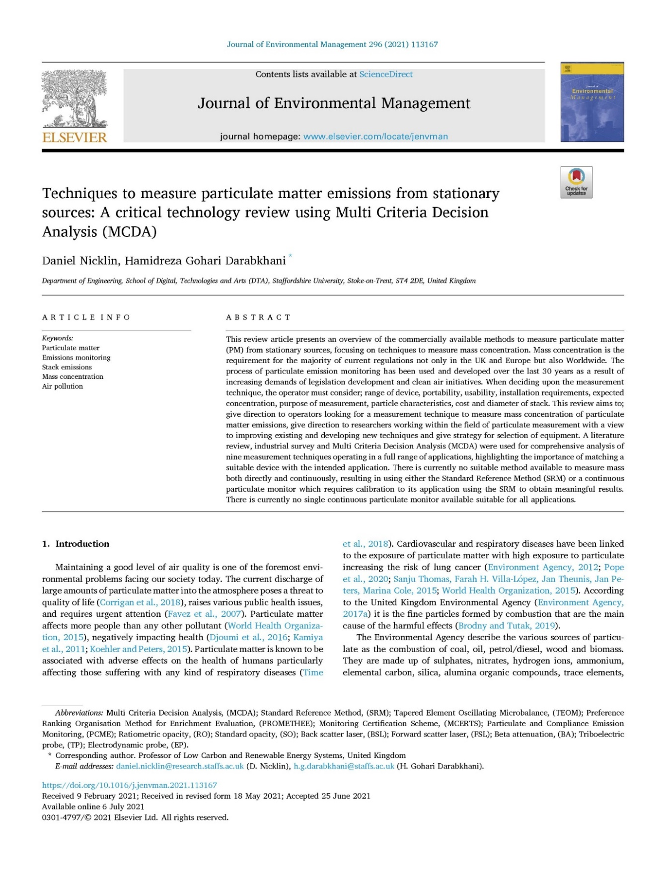
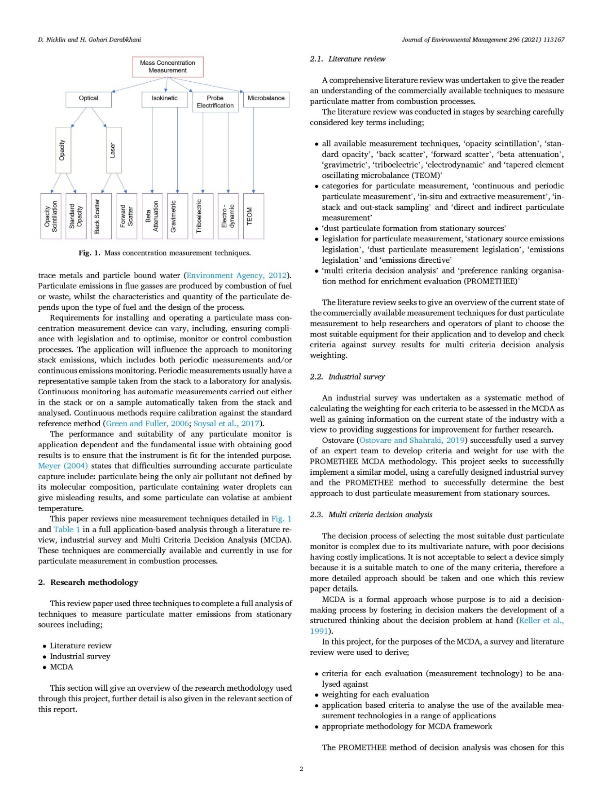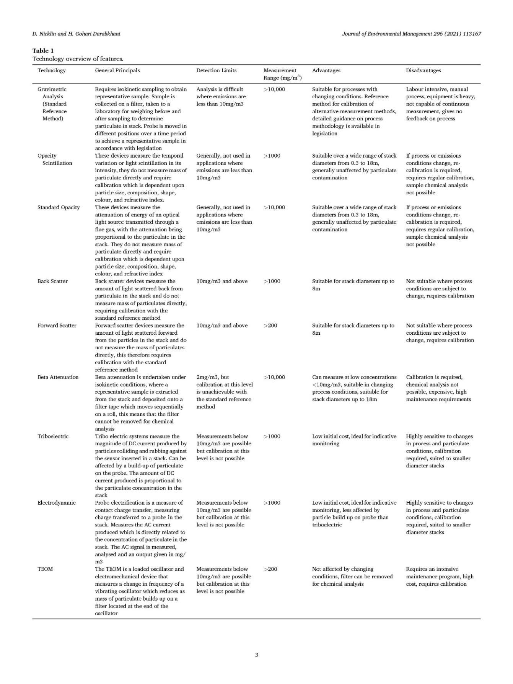
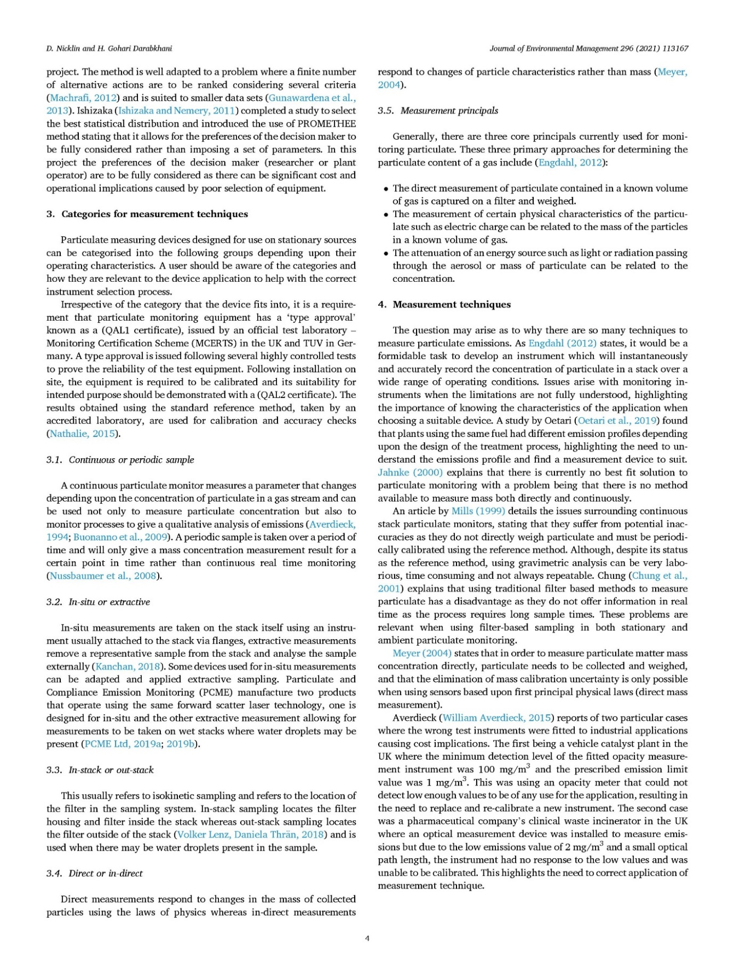
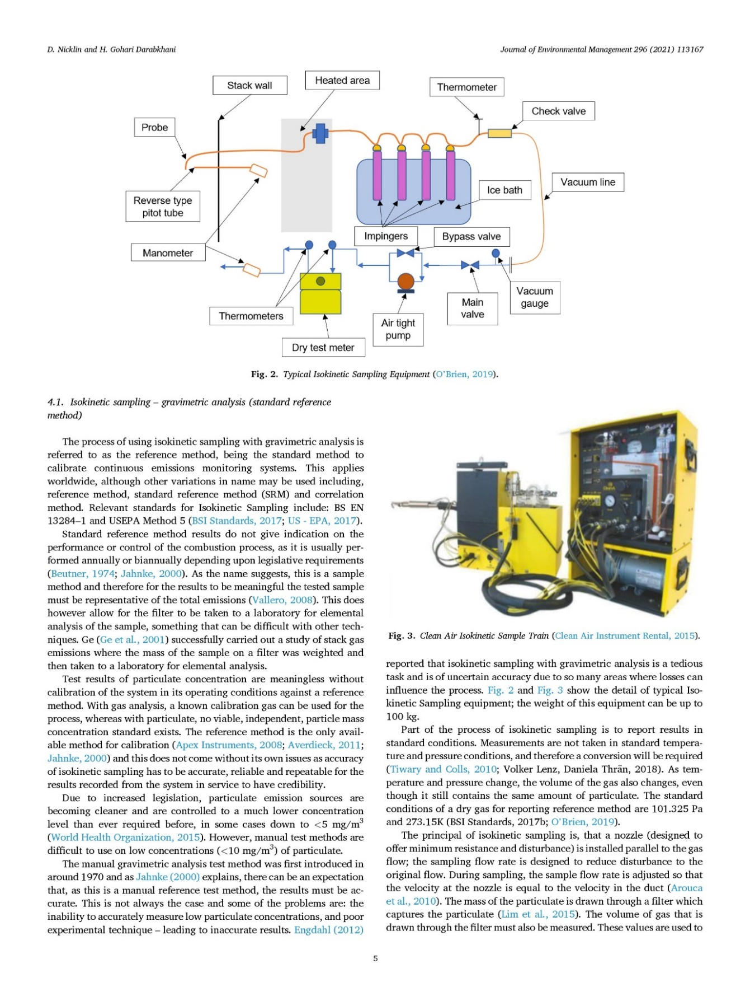
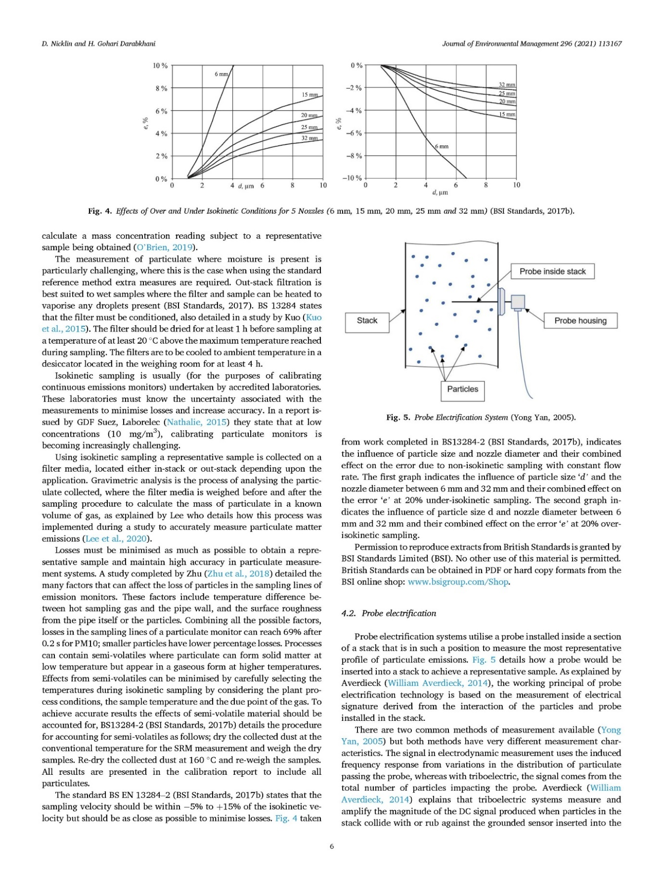
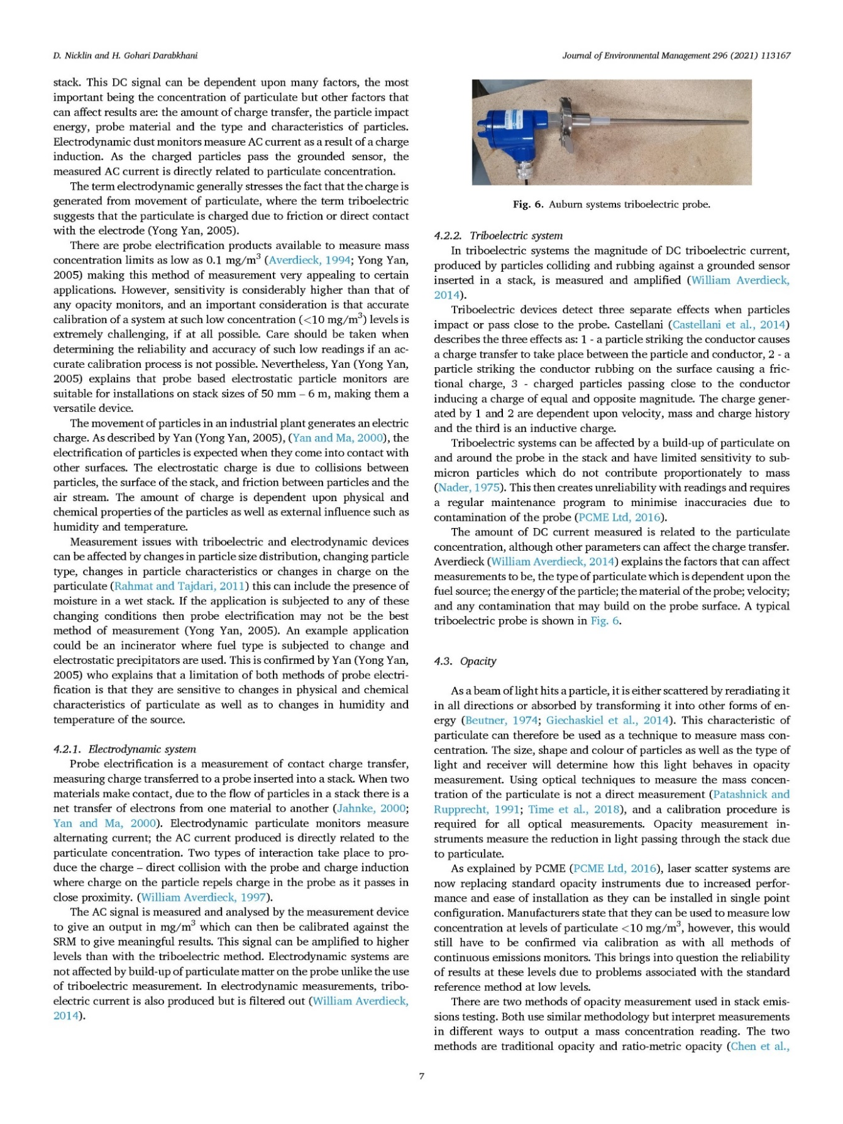
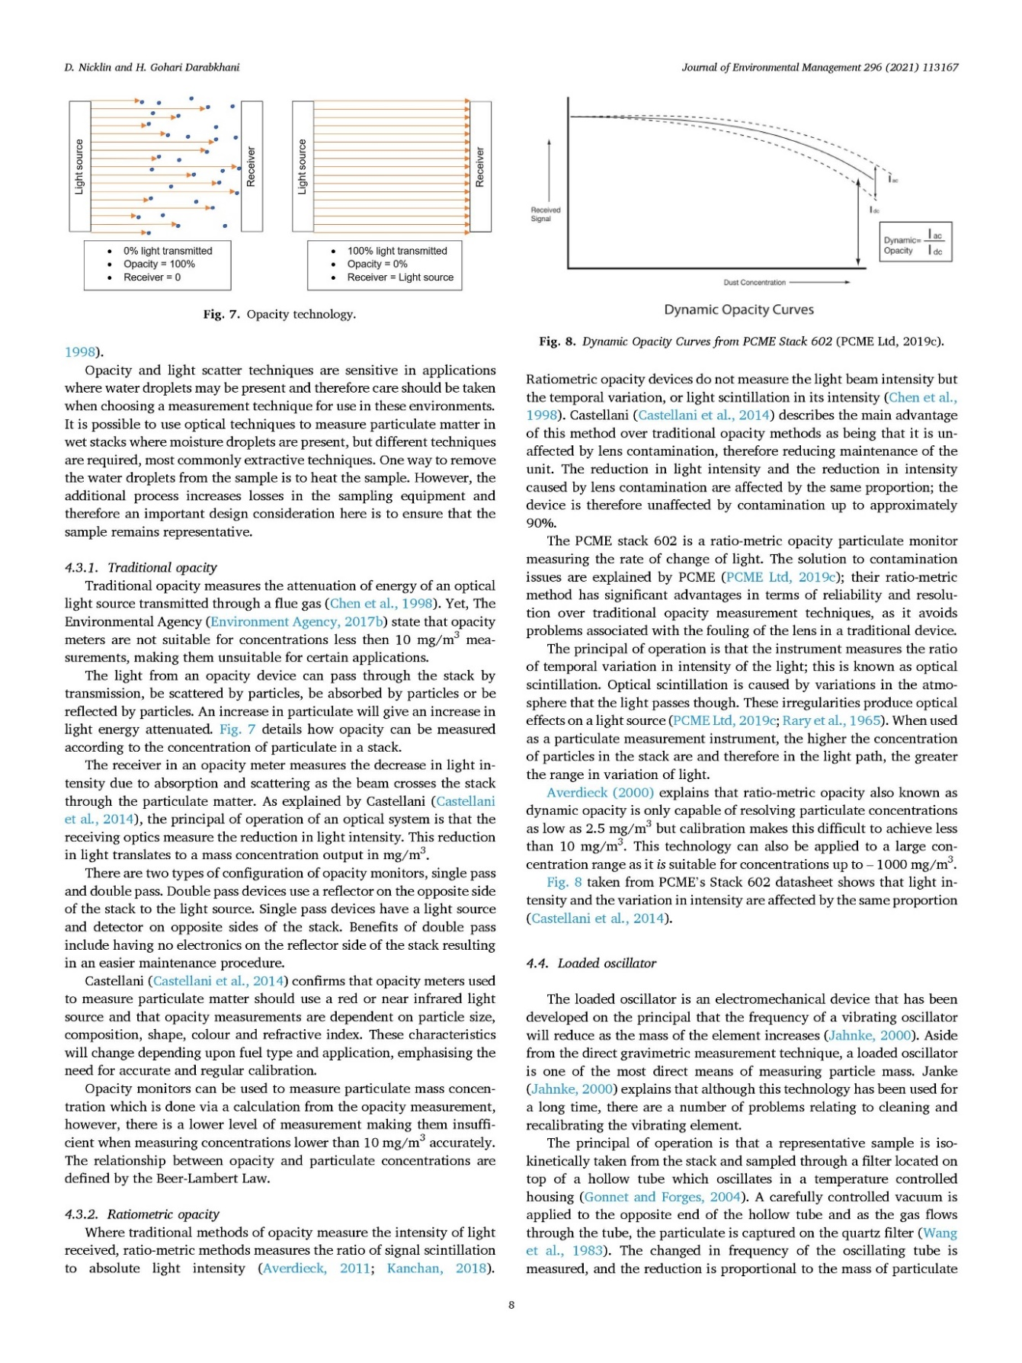
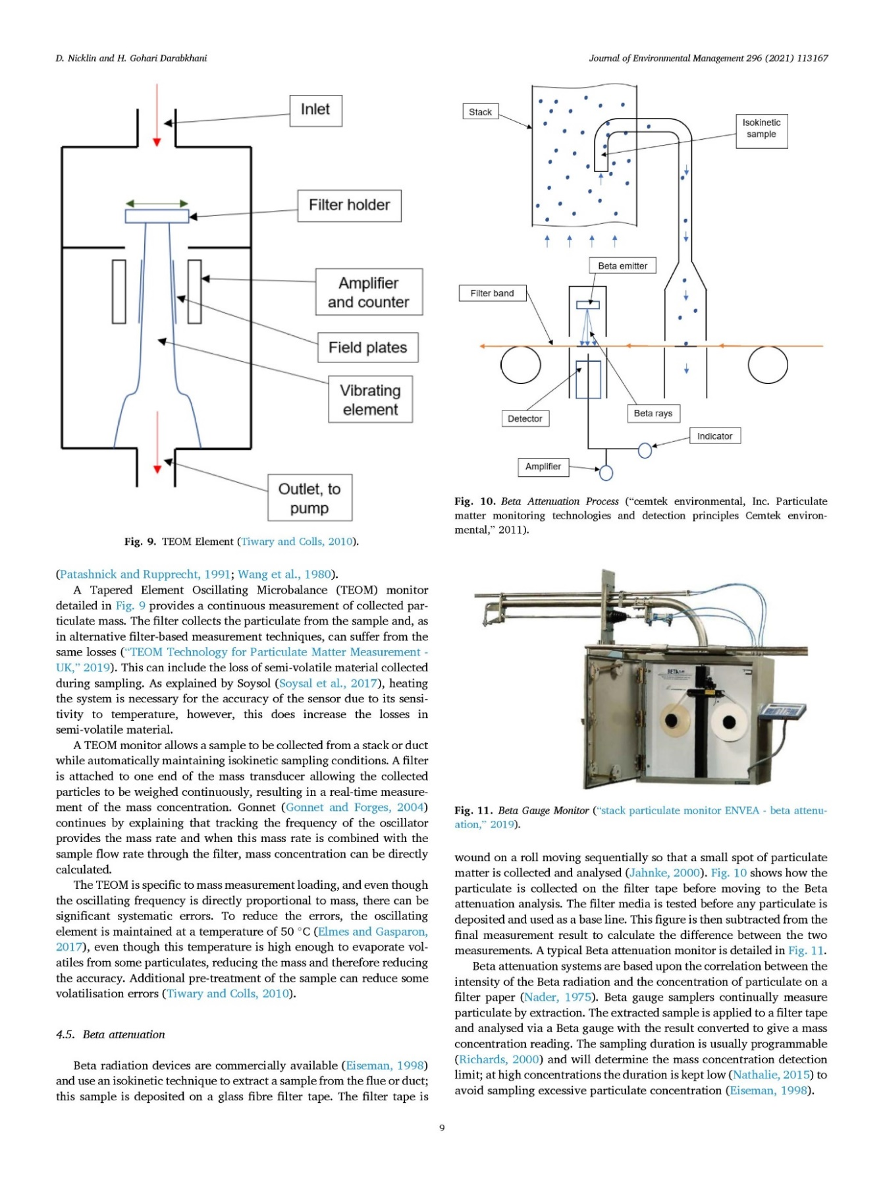
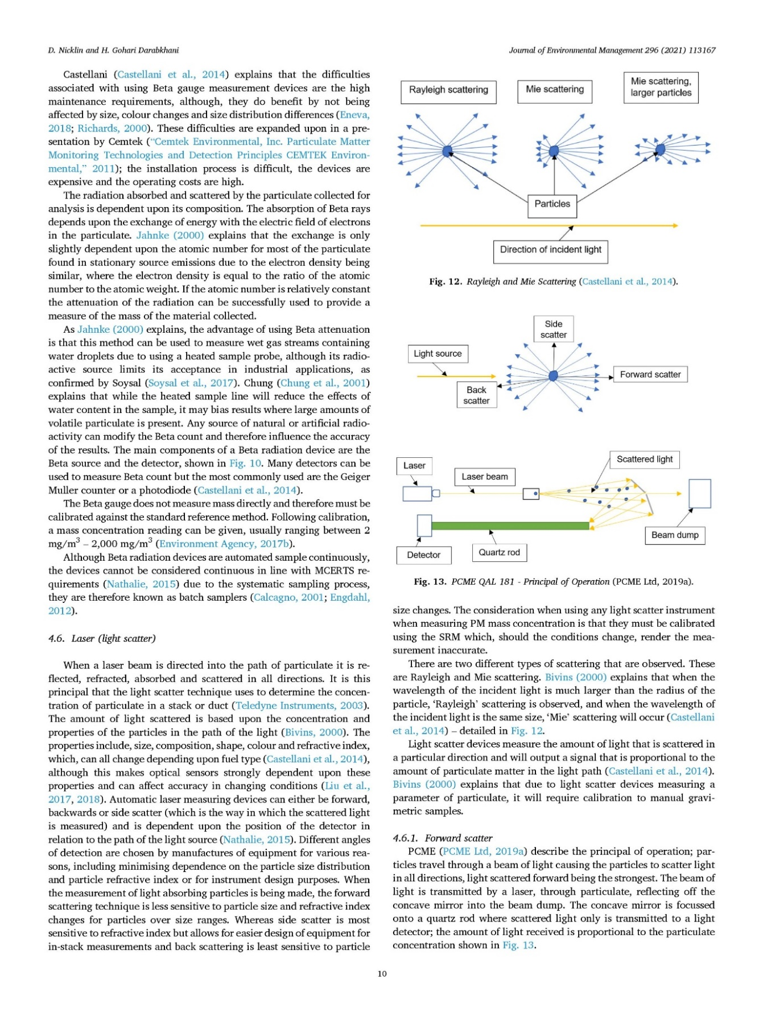
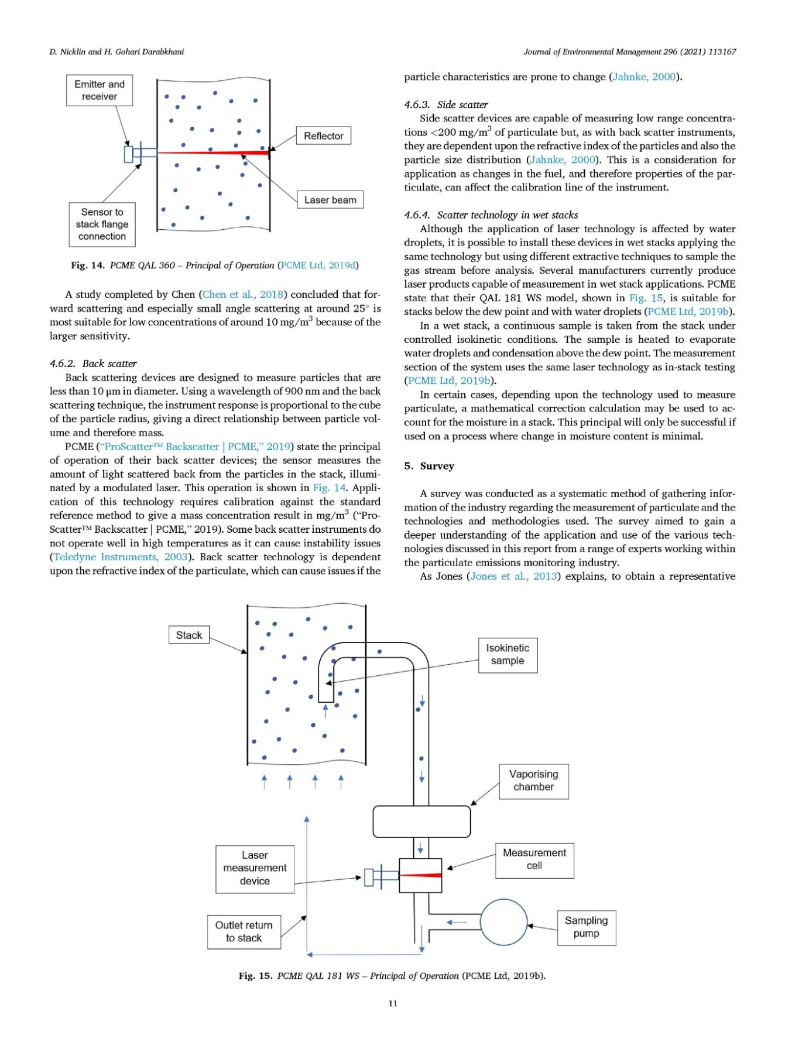
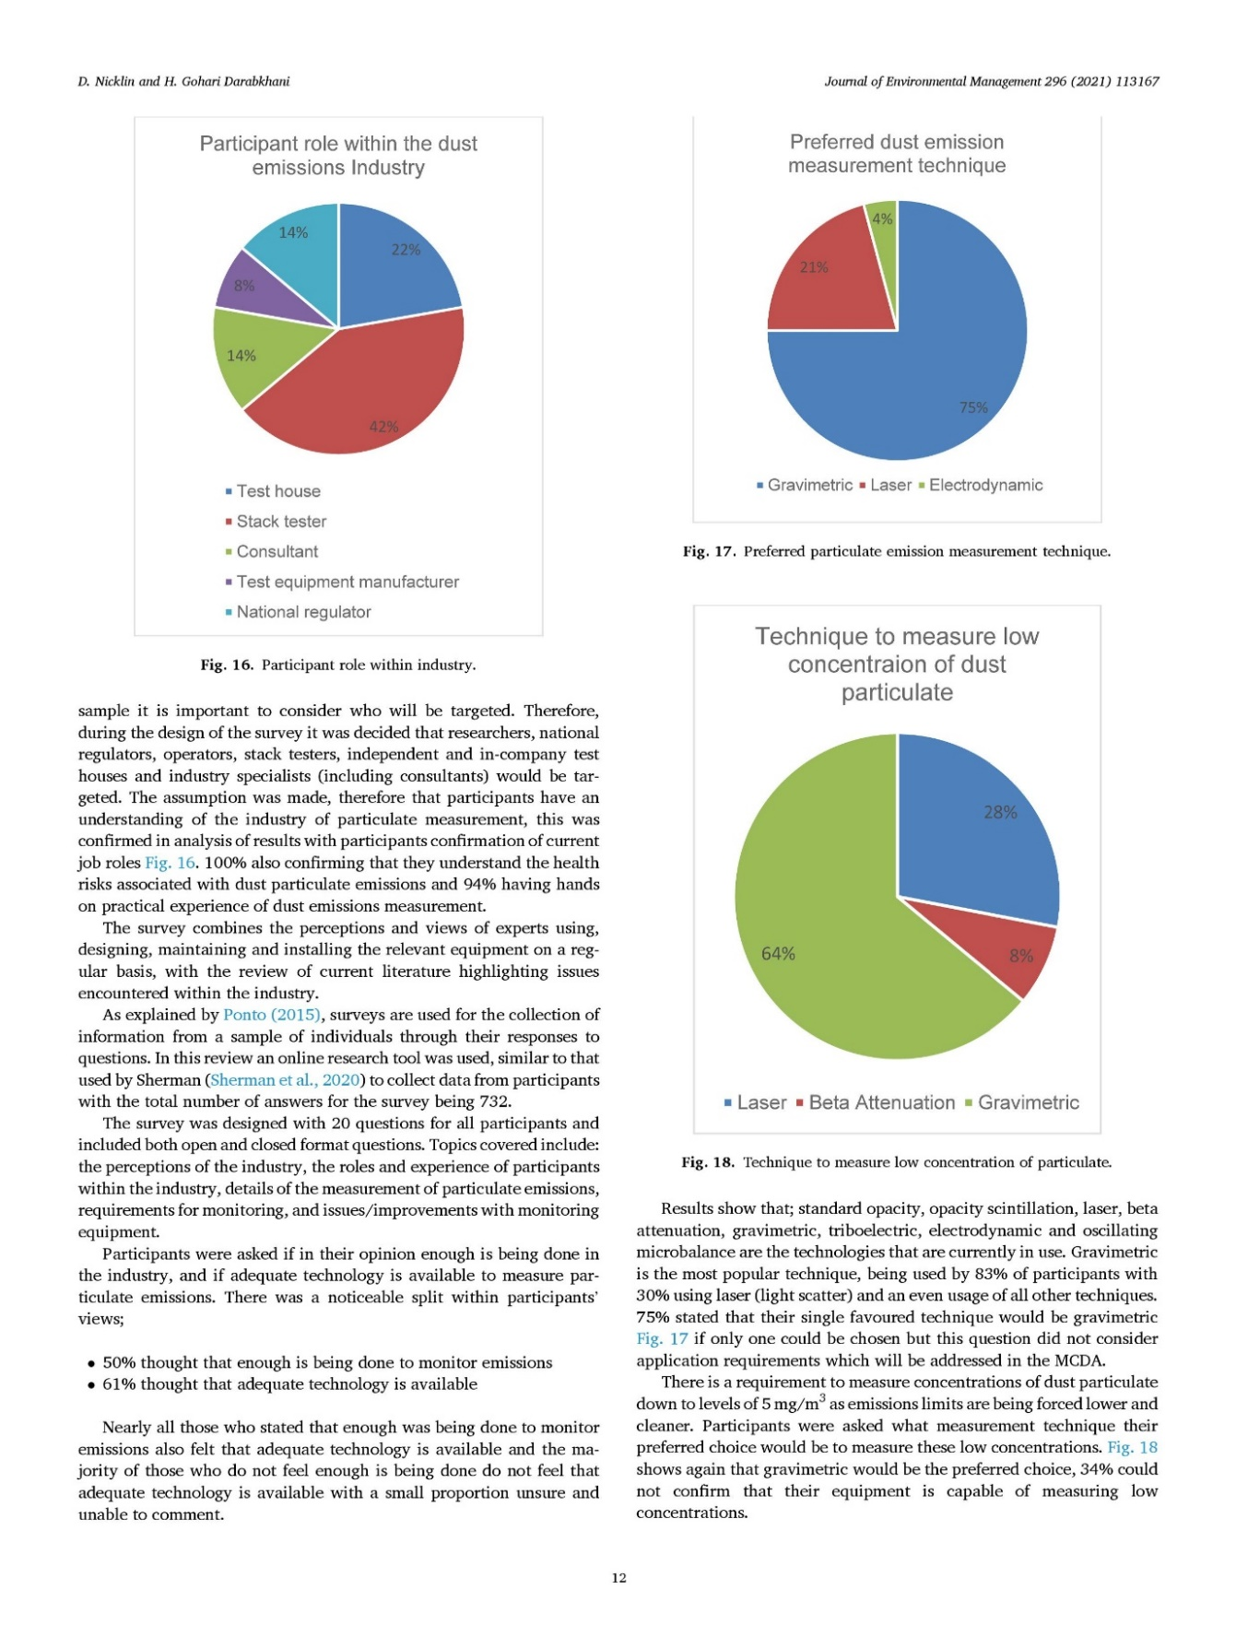
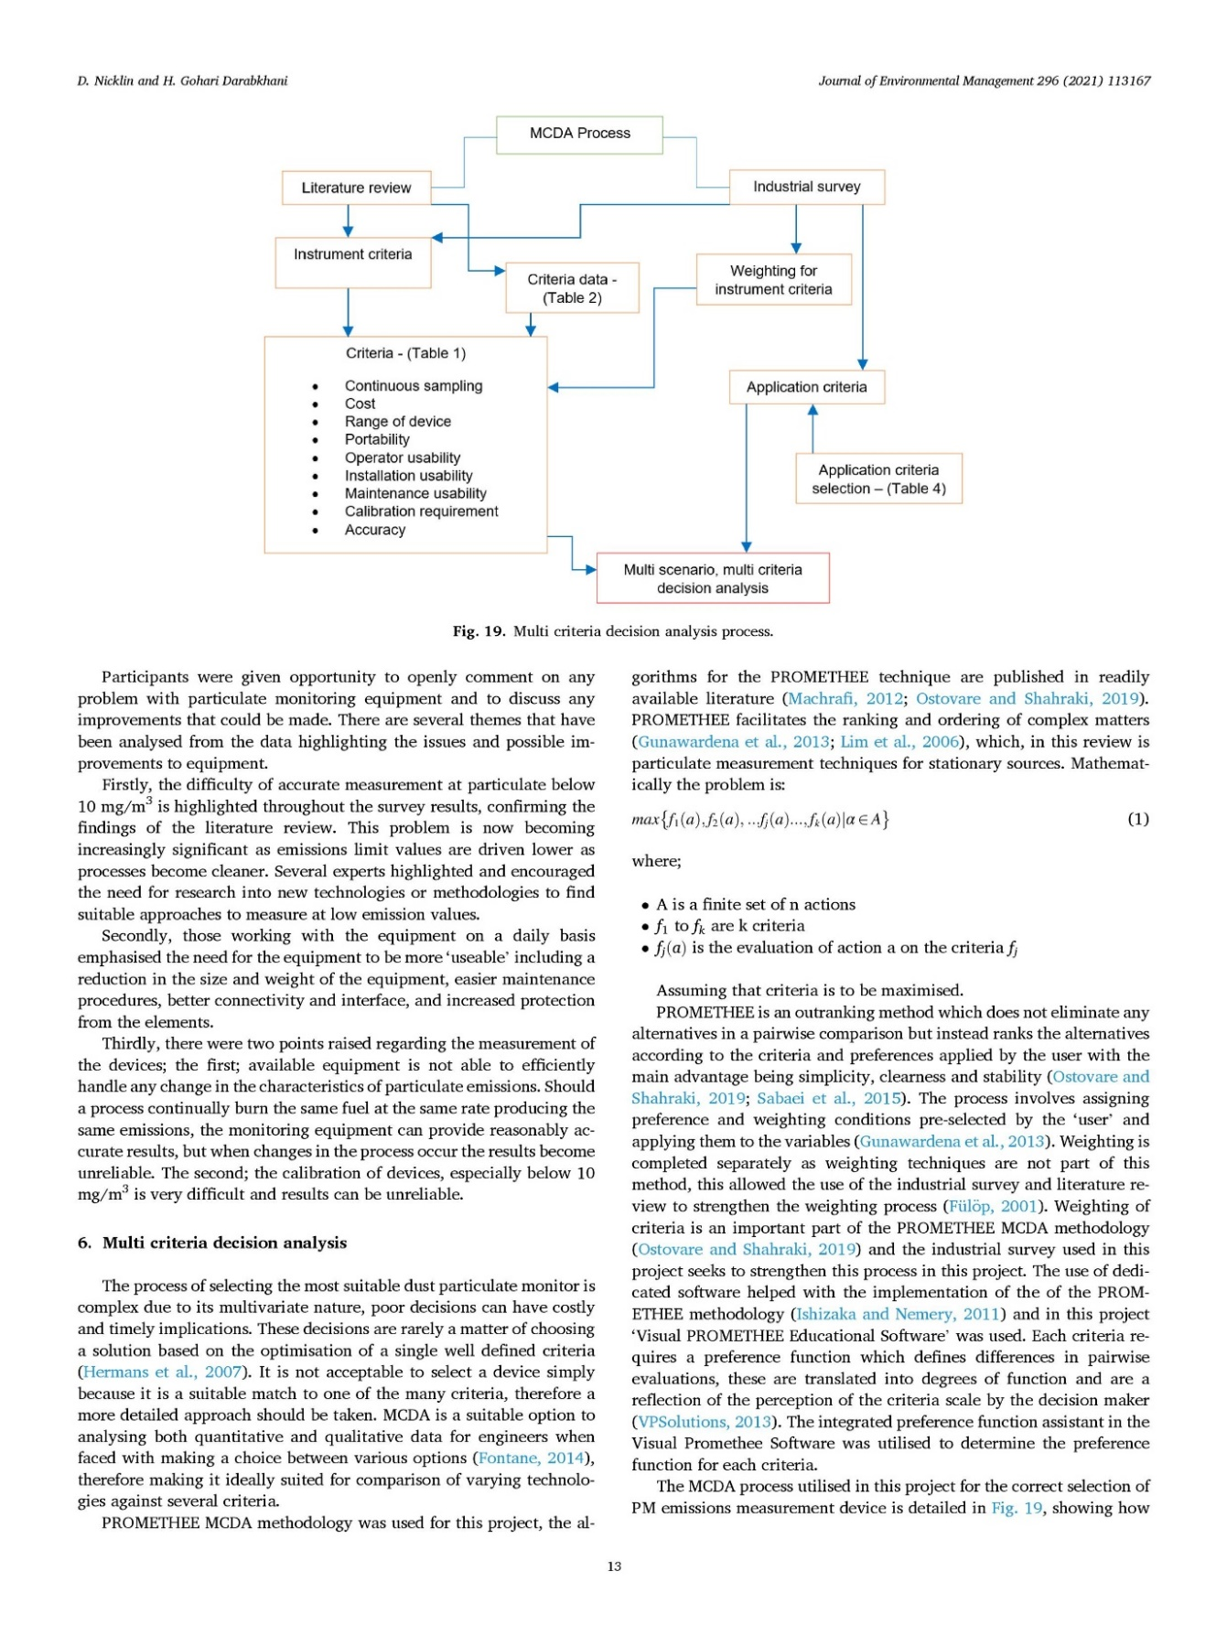
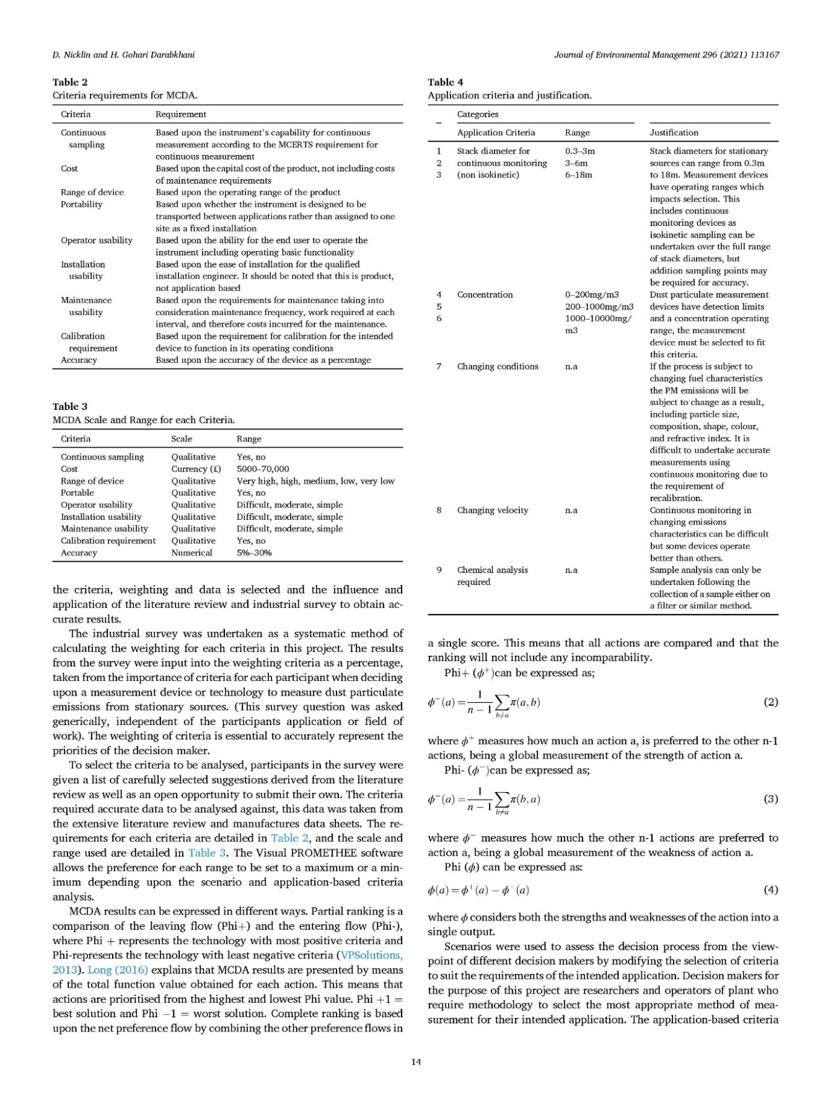
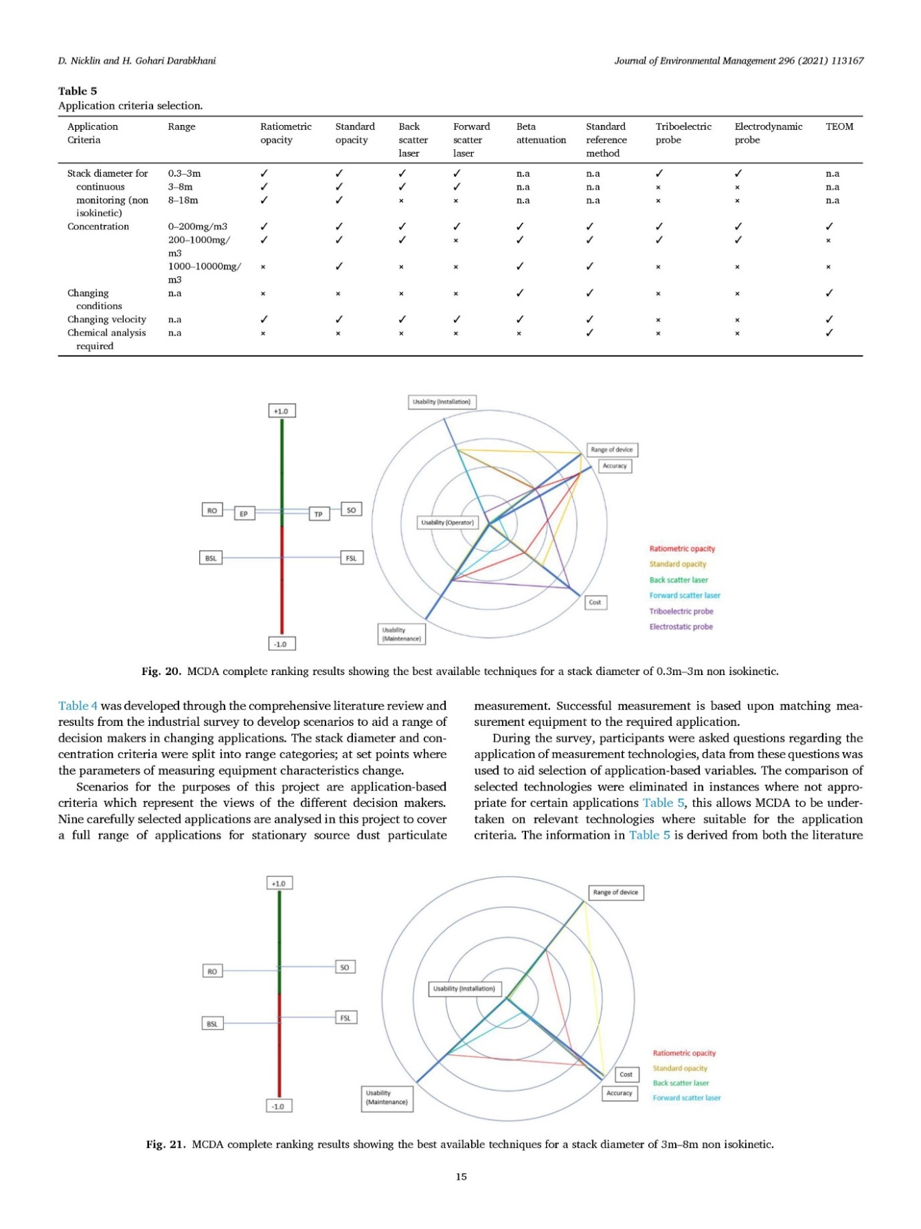
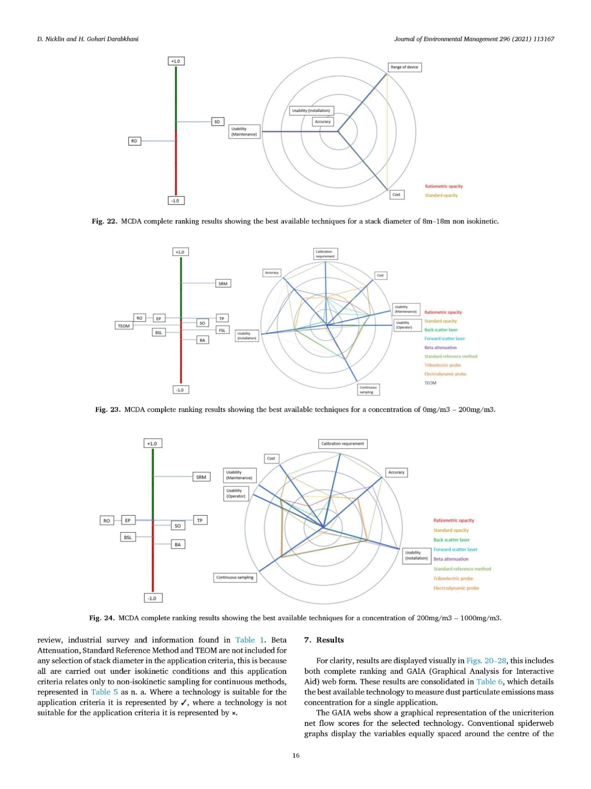
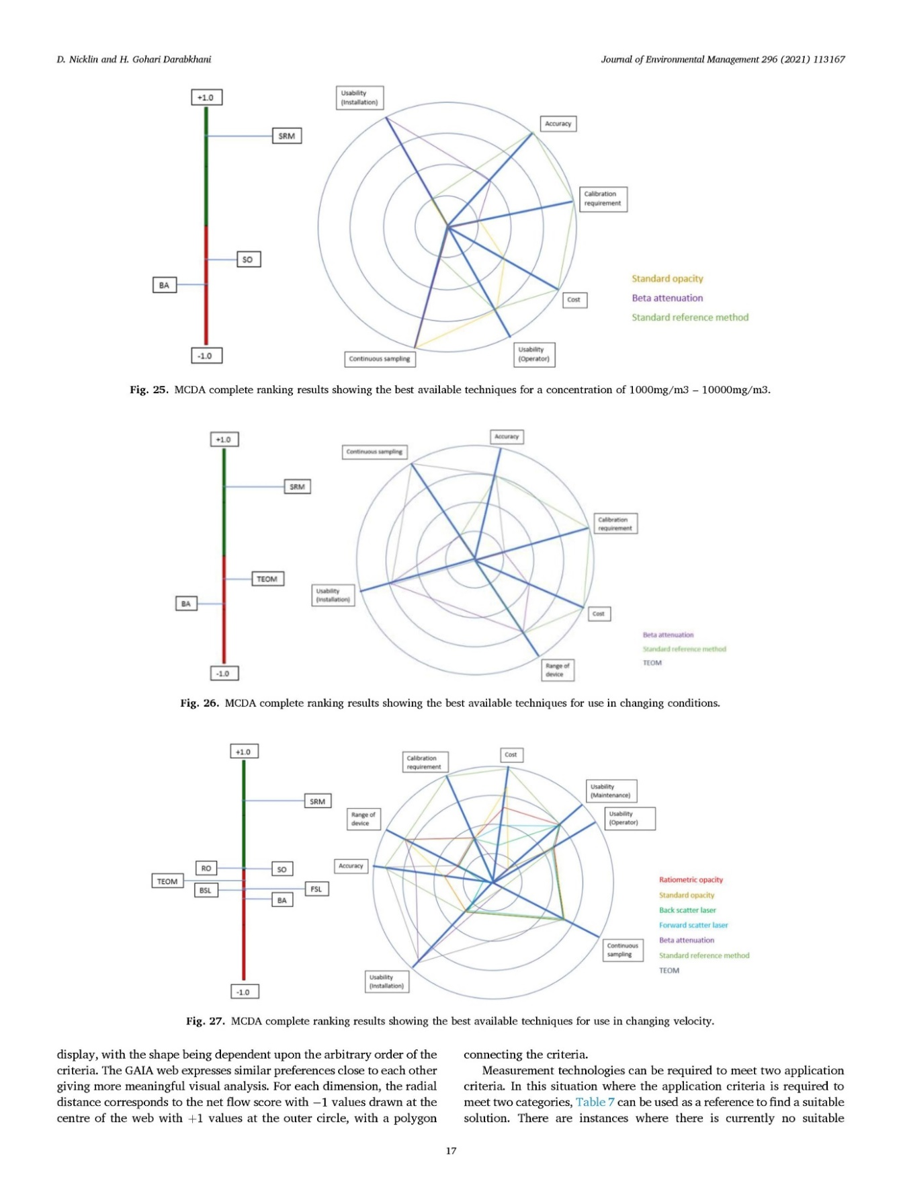
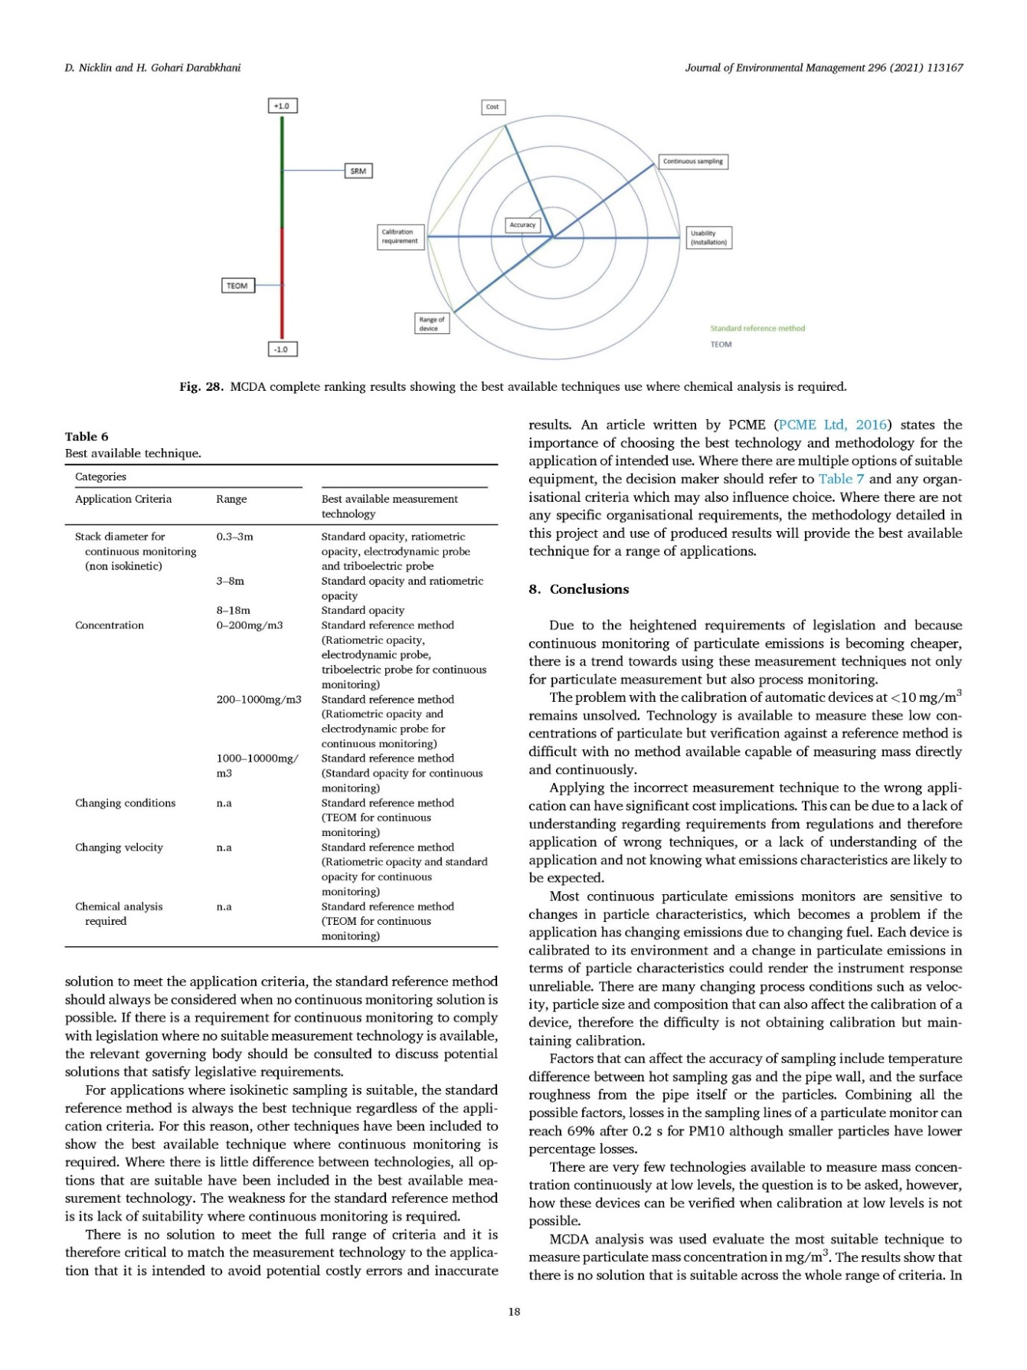
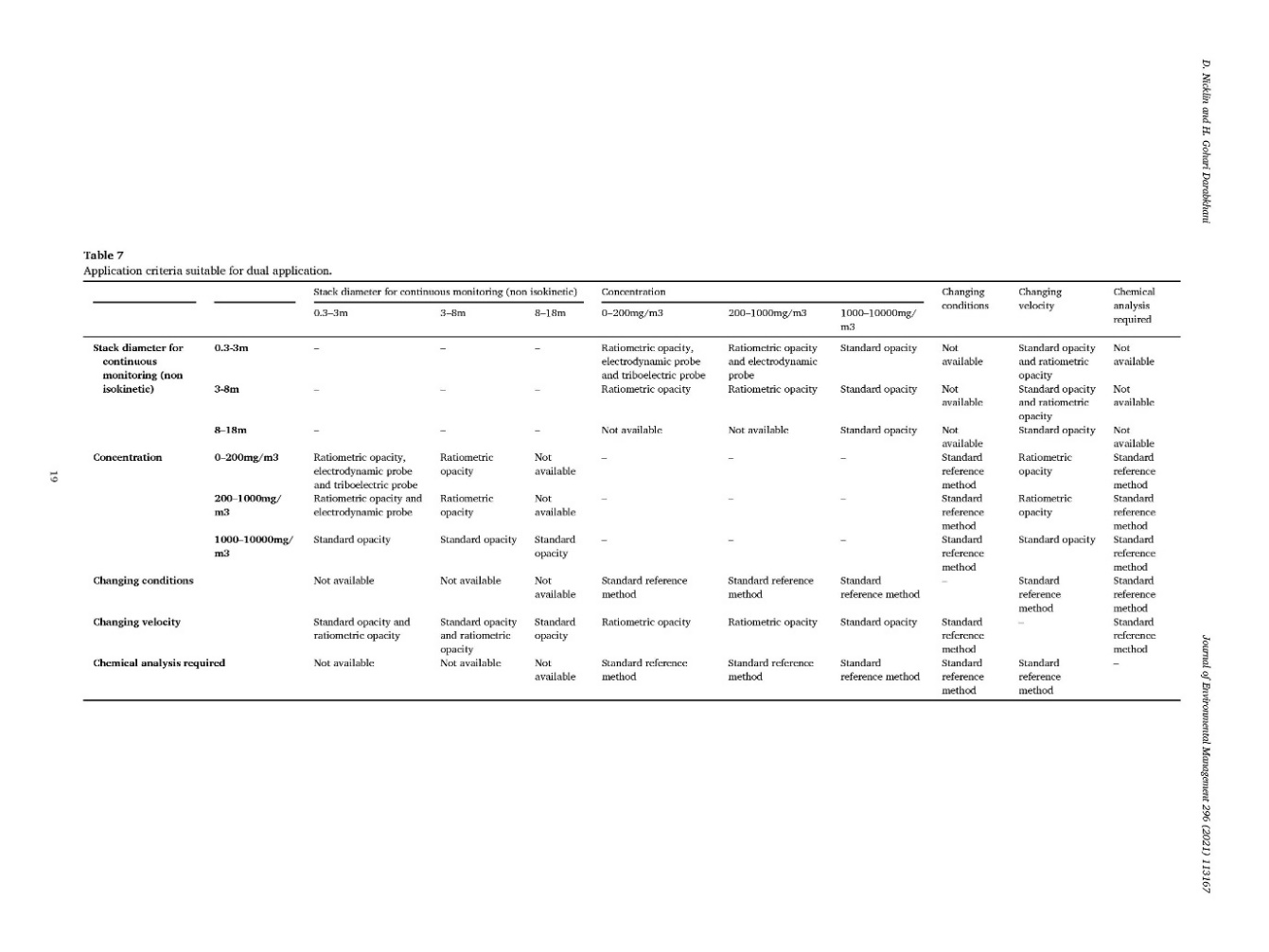
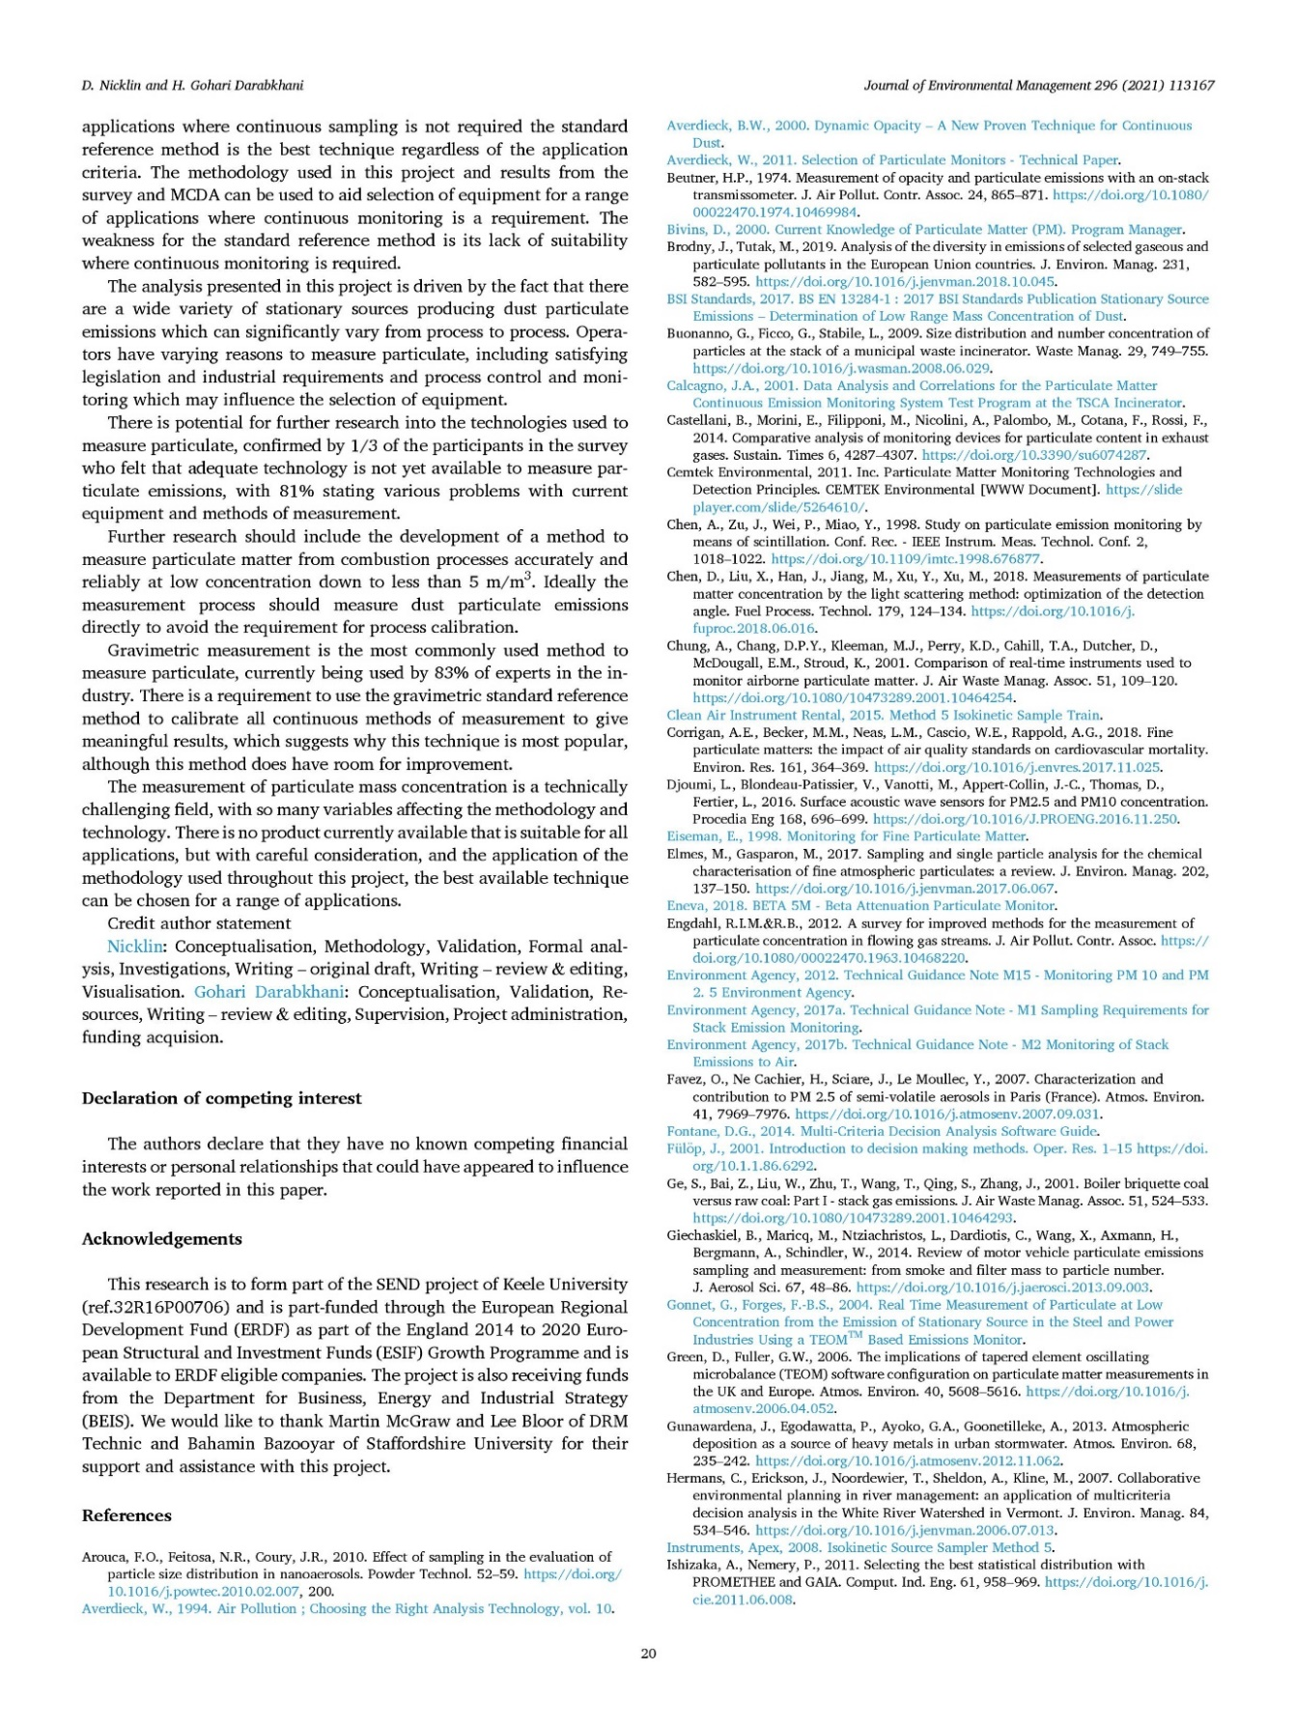

Appendix 2 Atmosphere 2022, 13, 1585
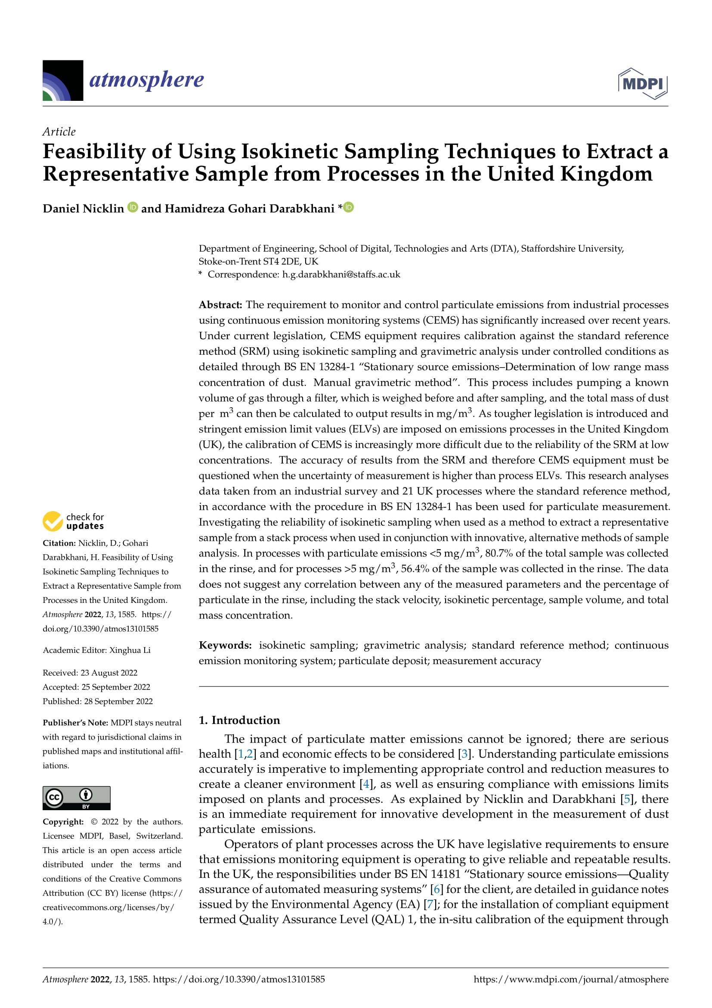
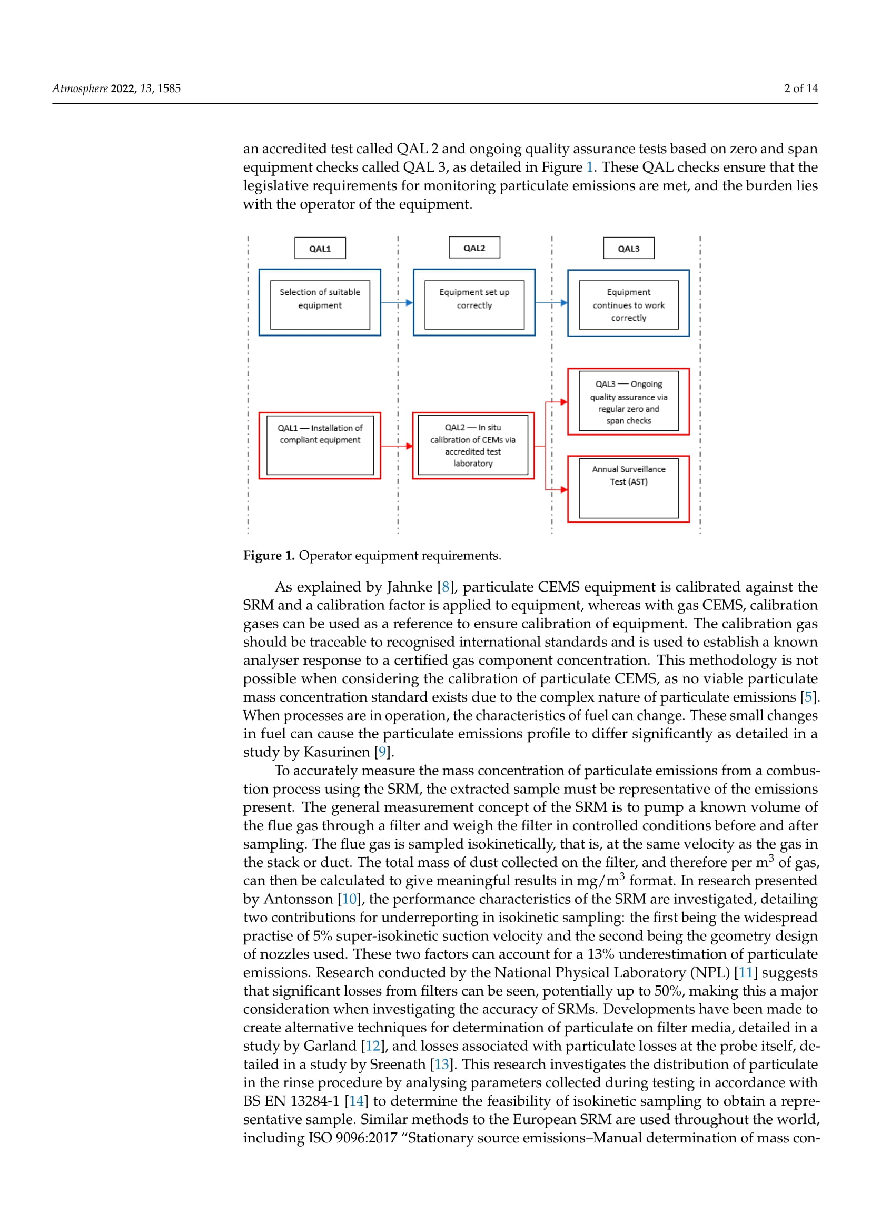
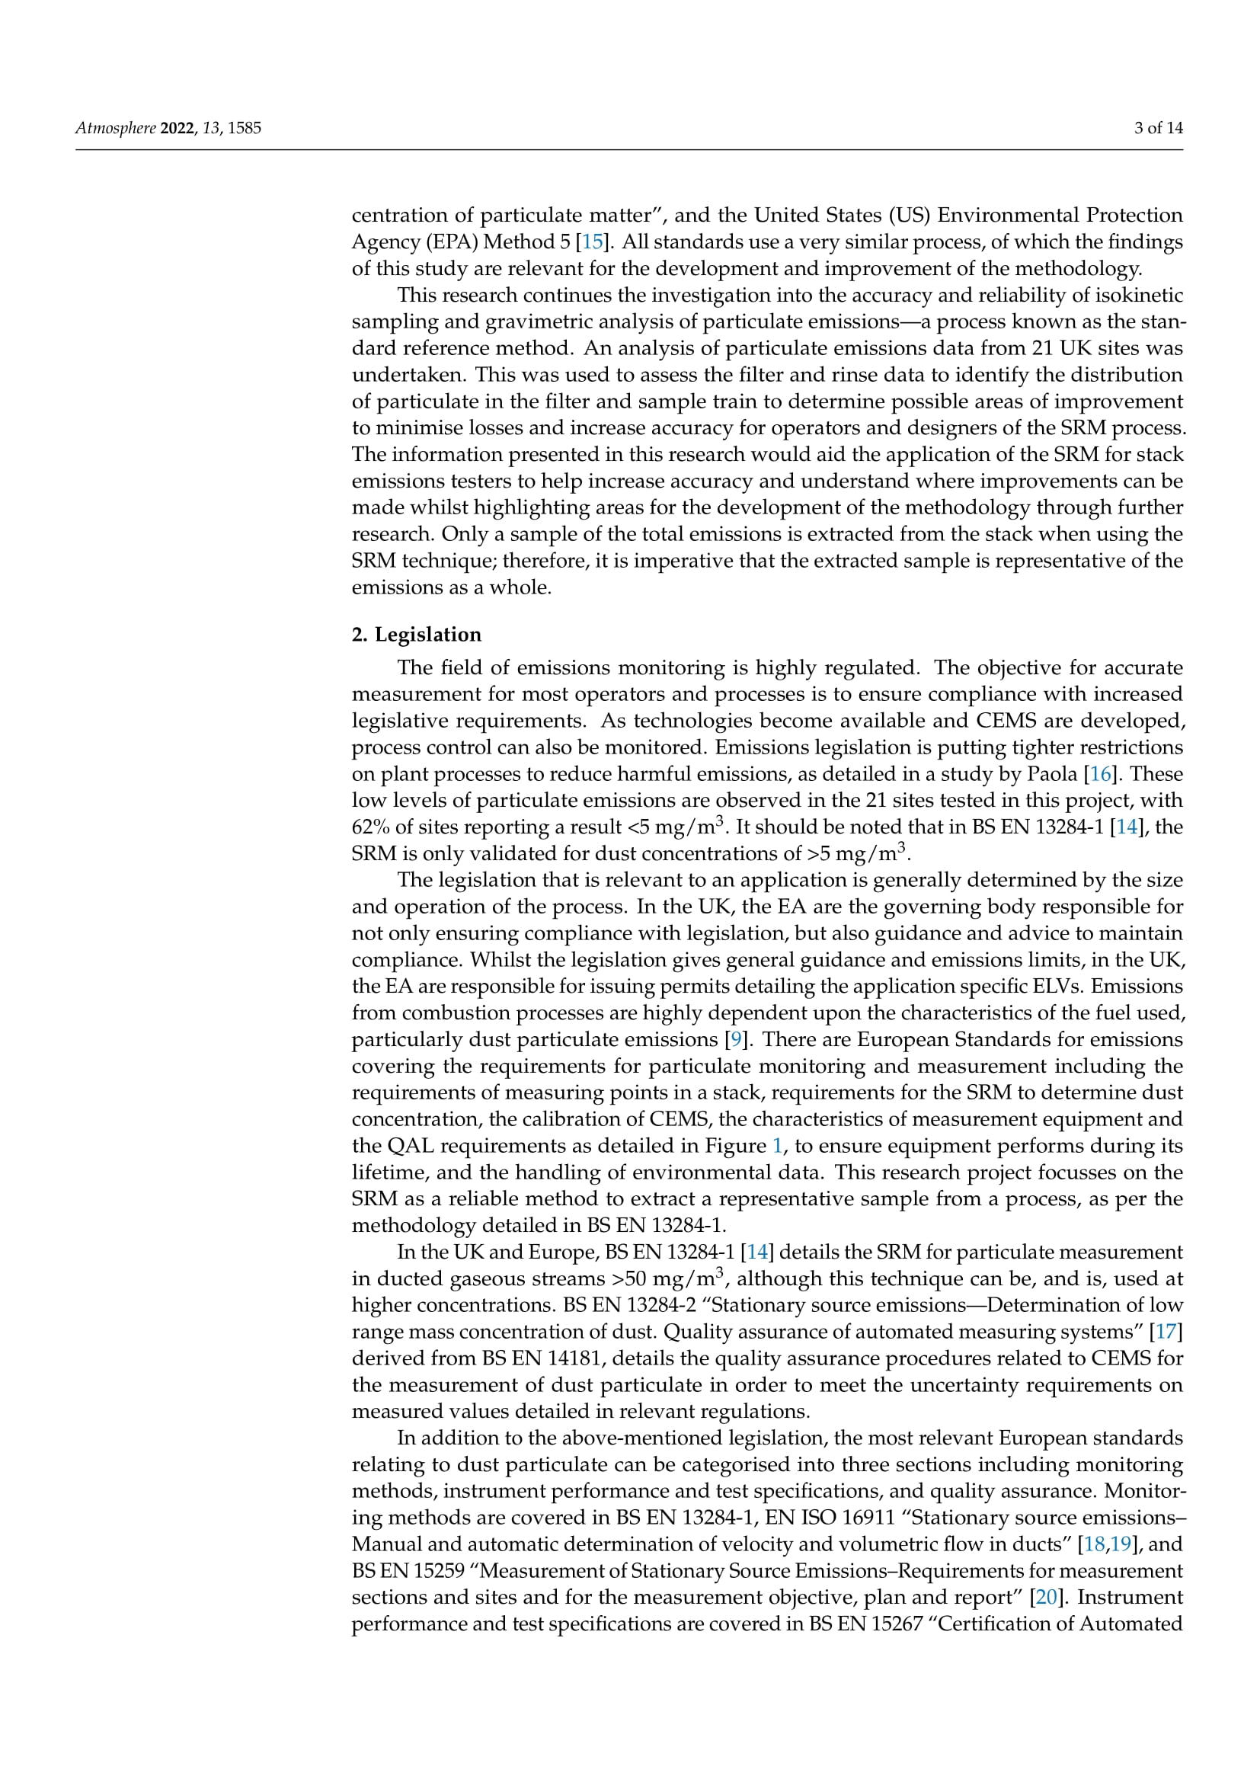
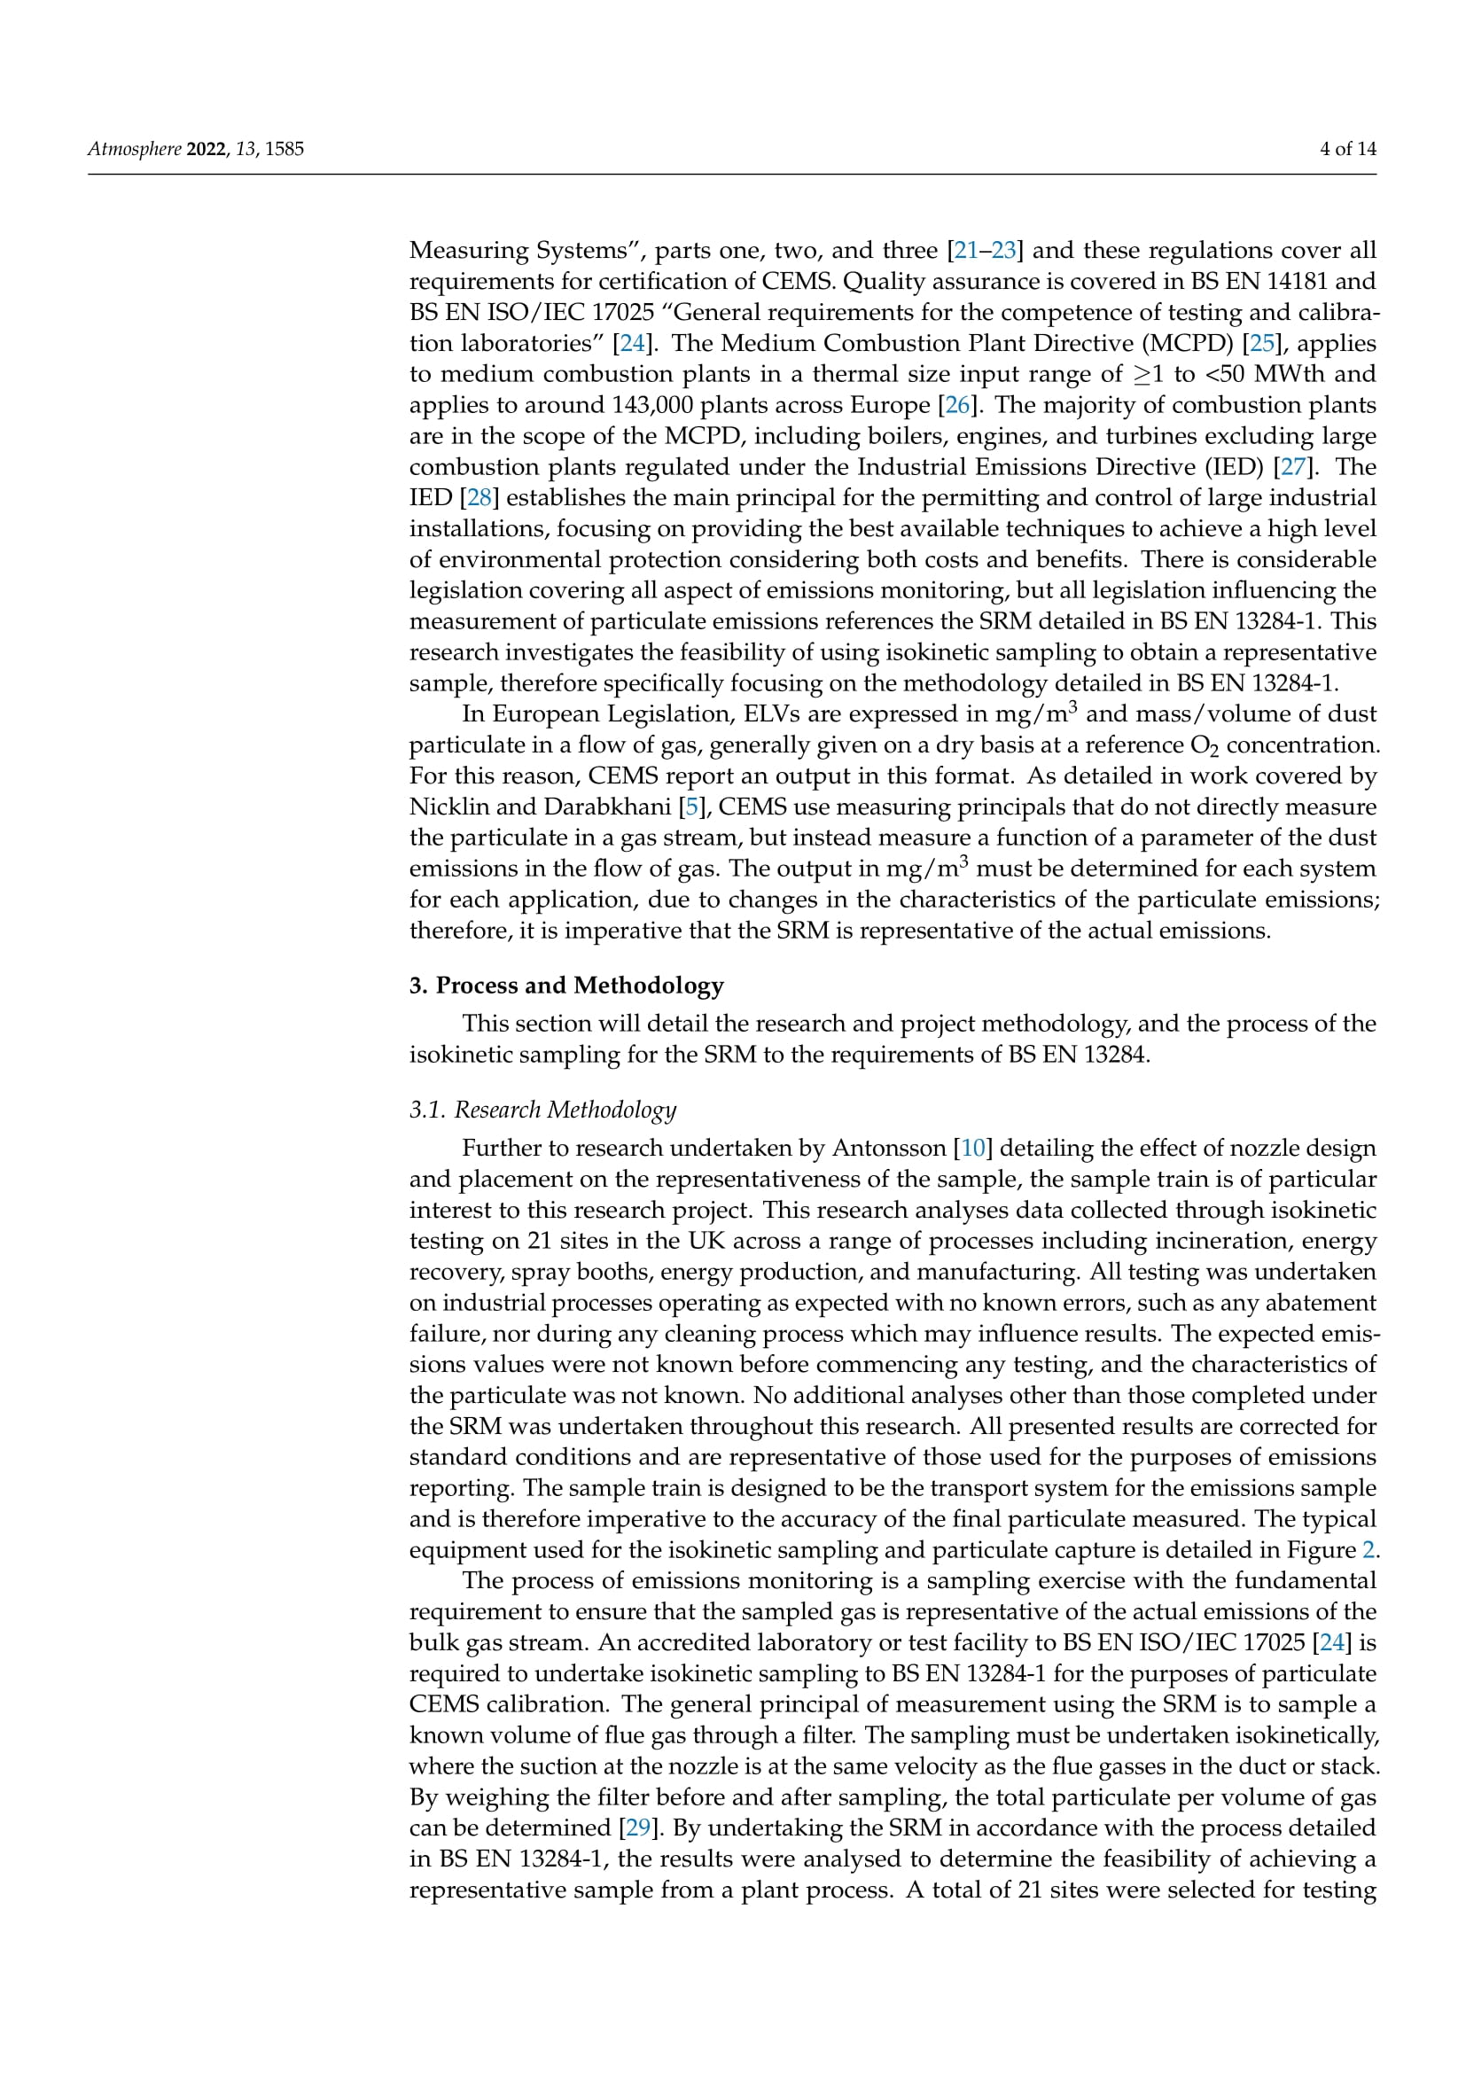
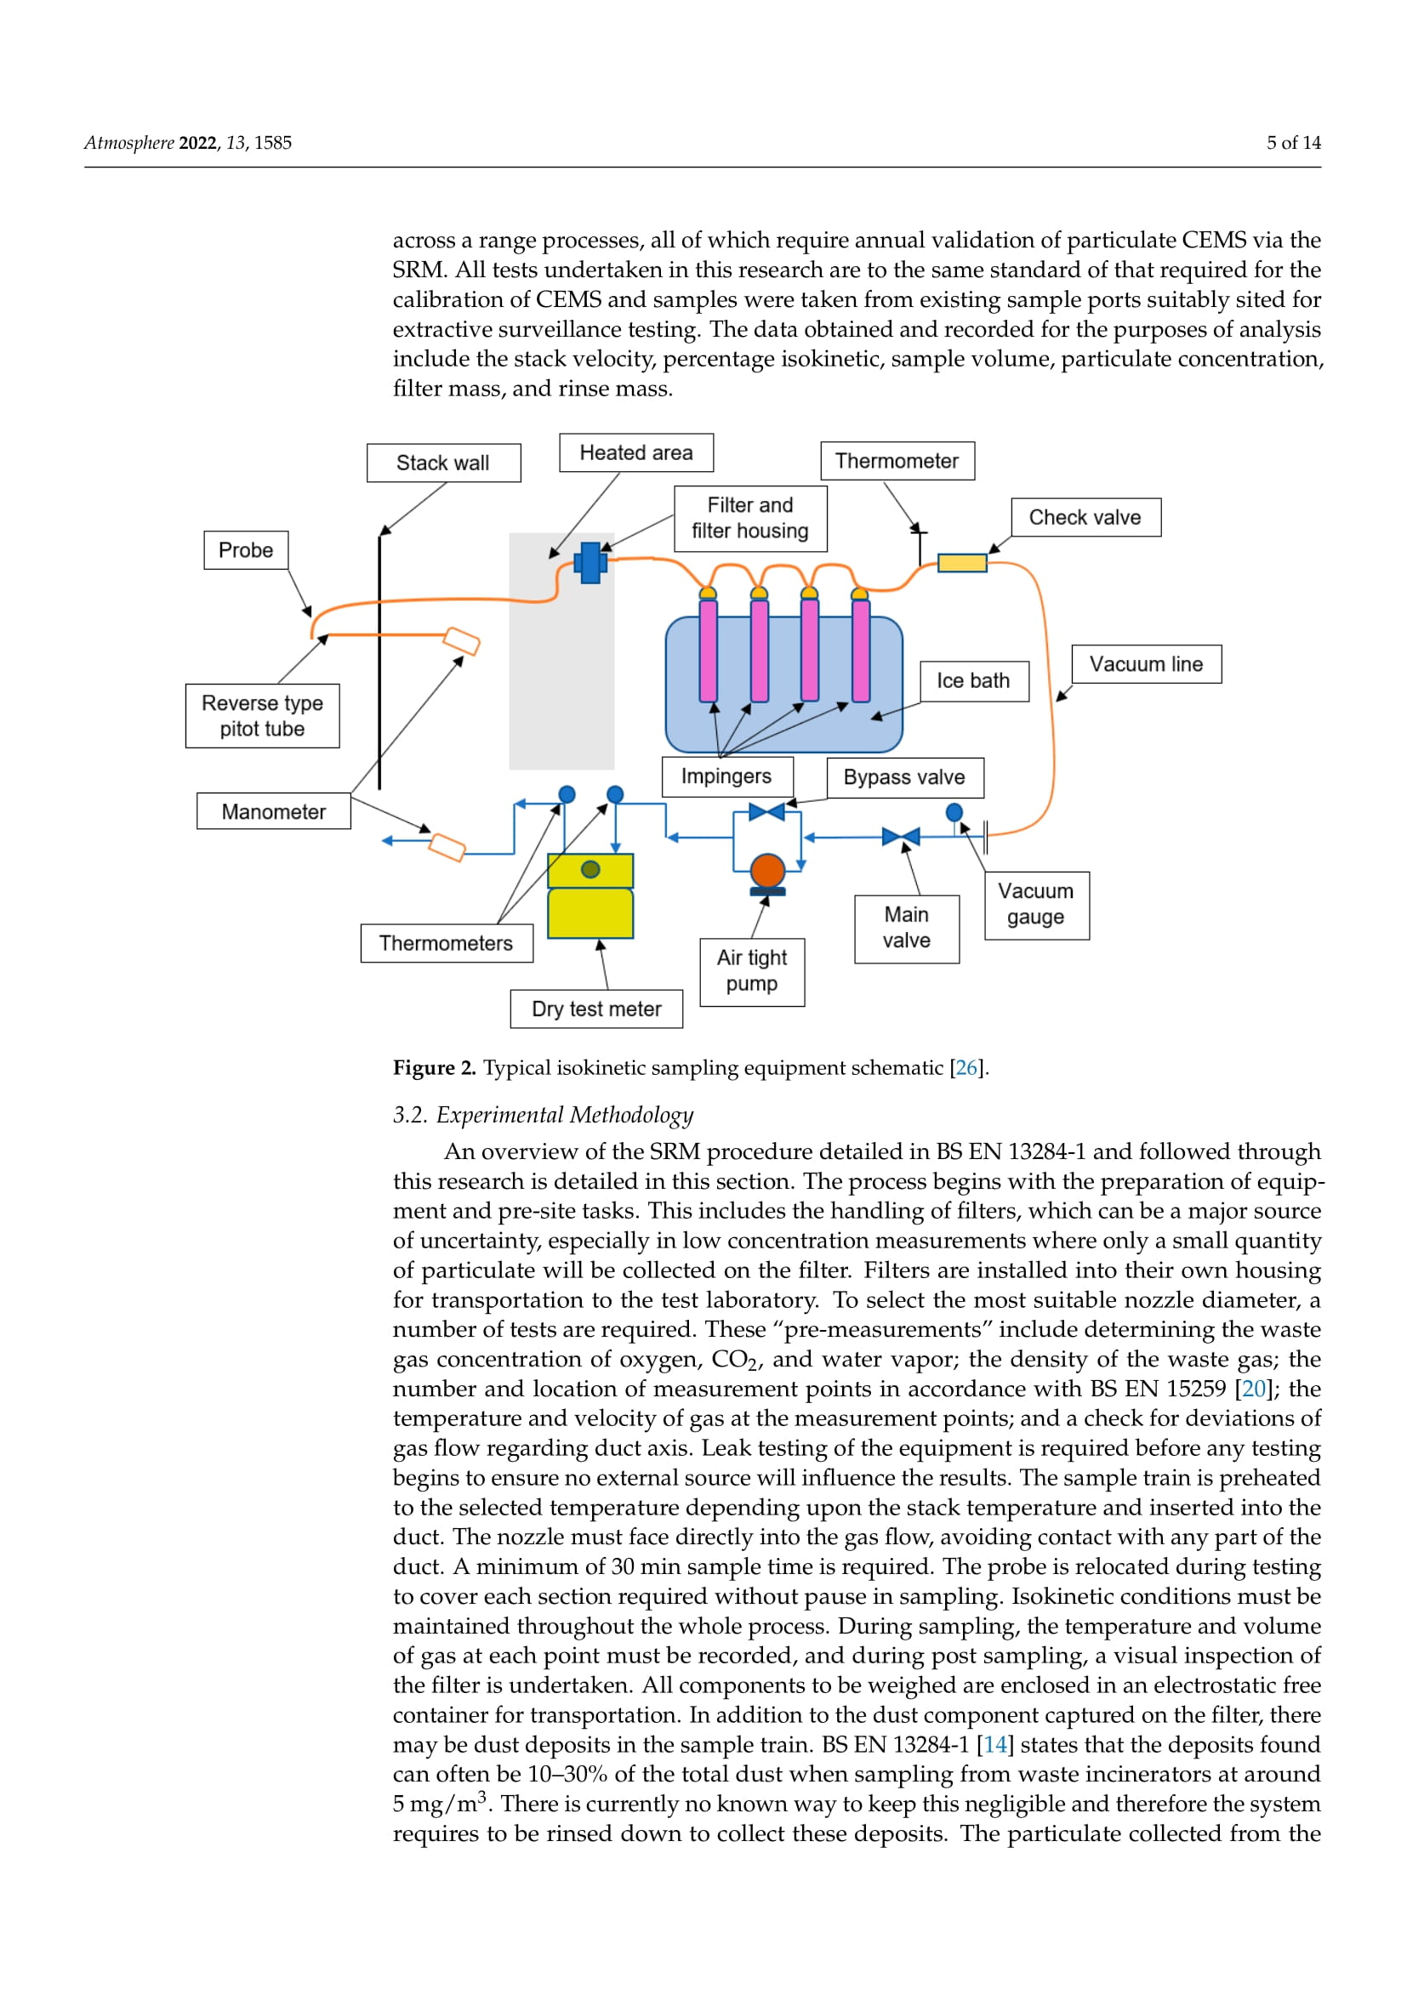
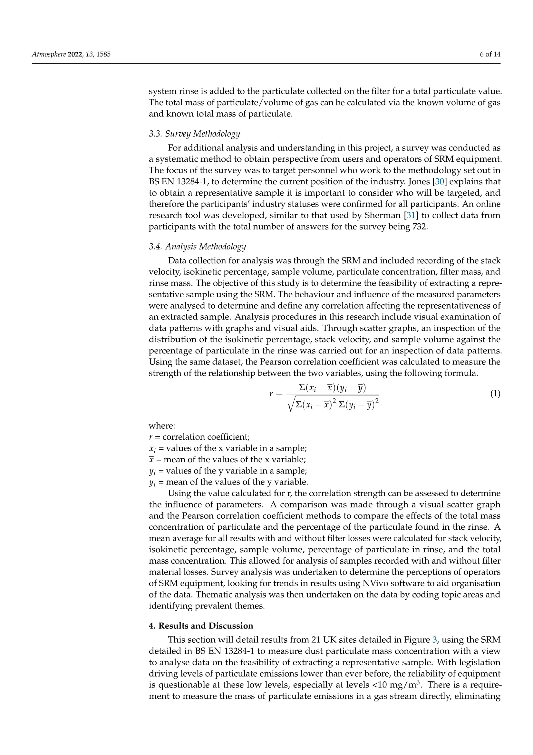
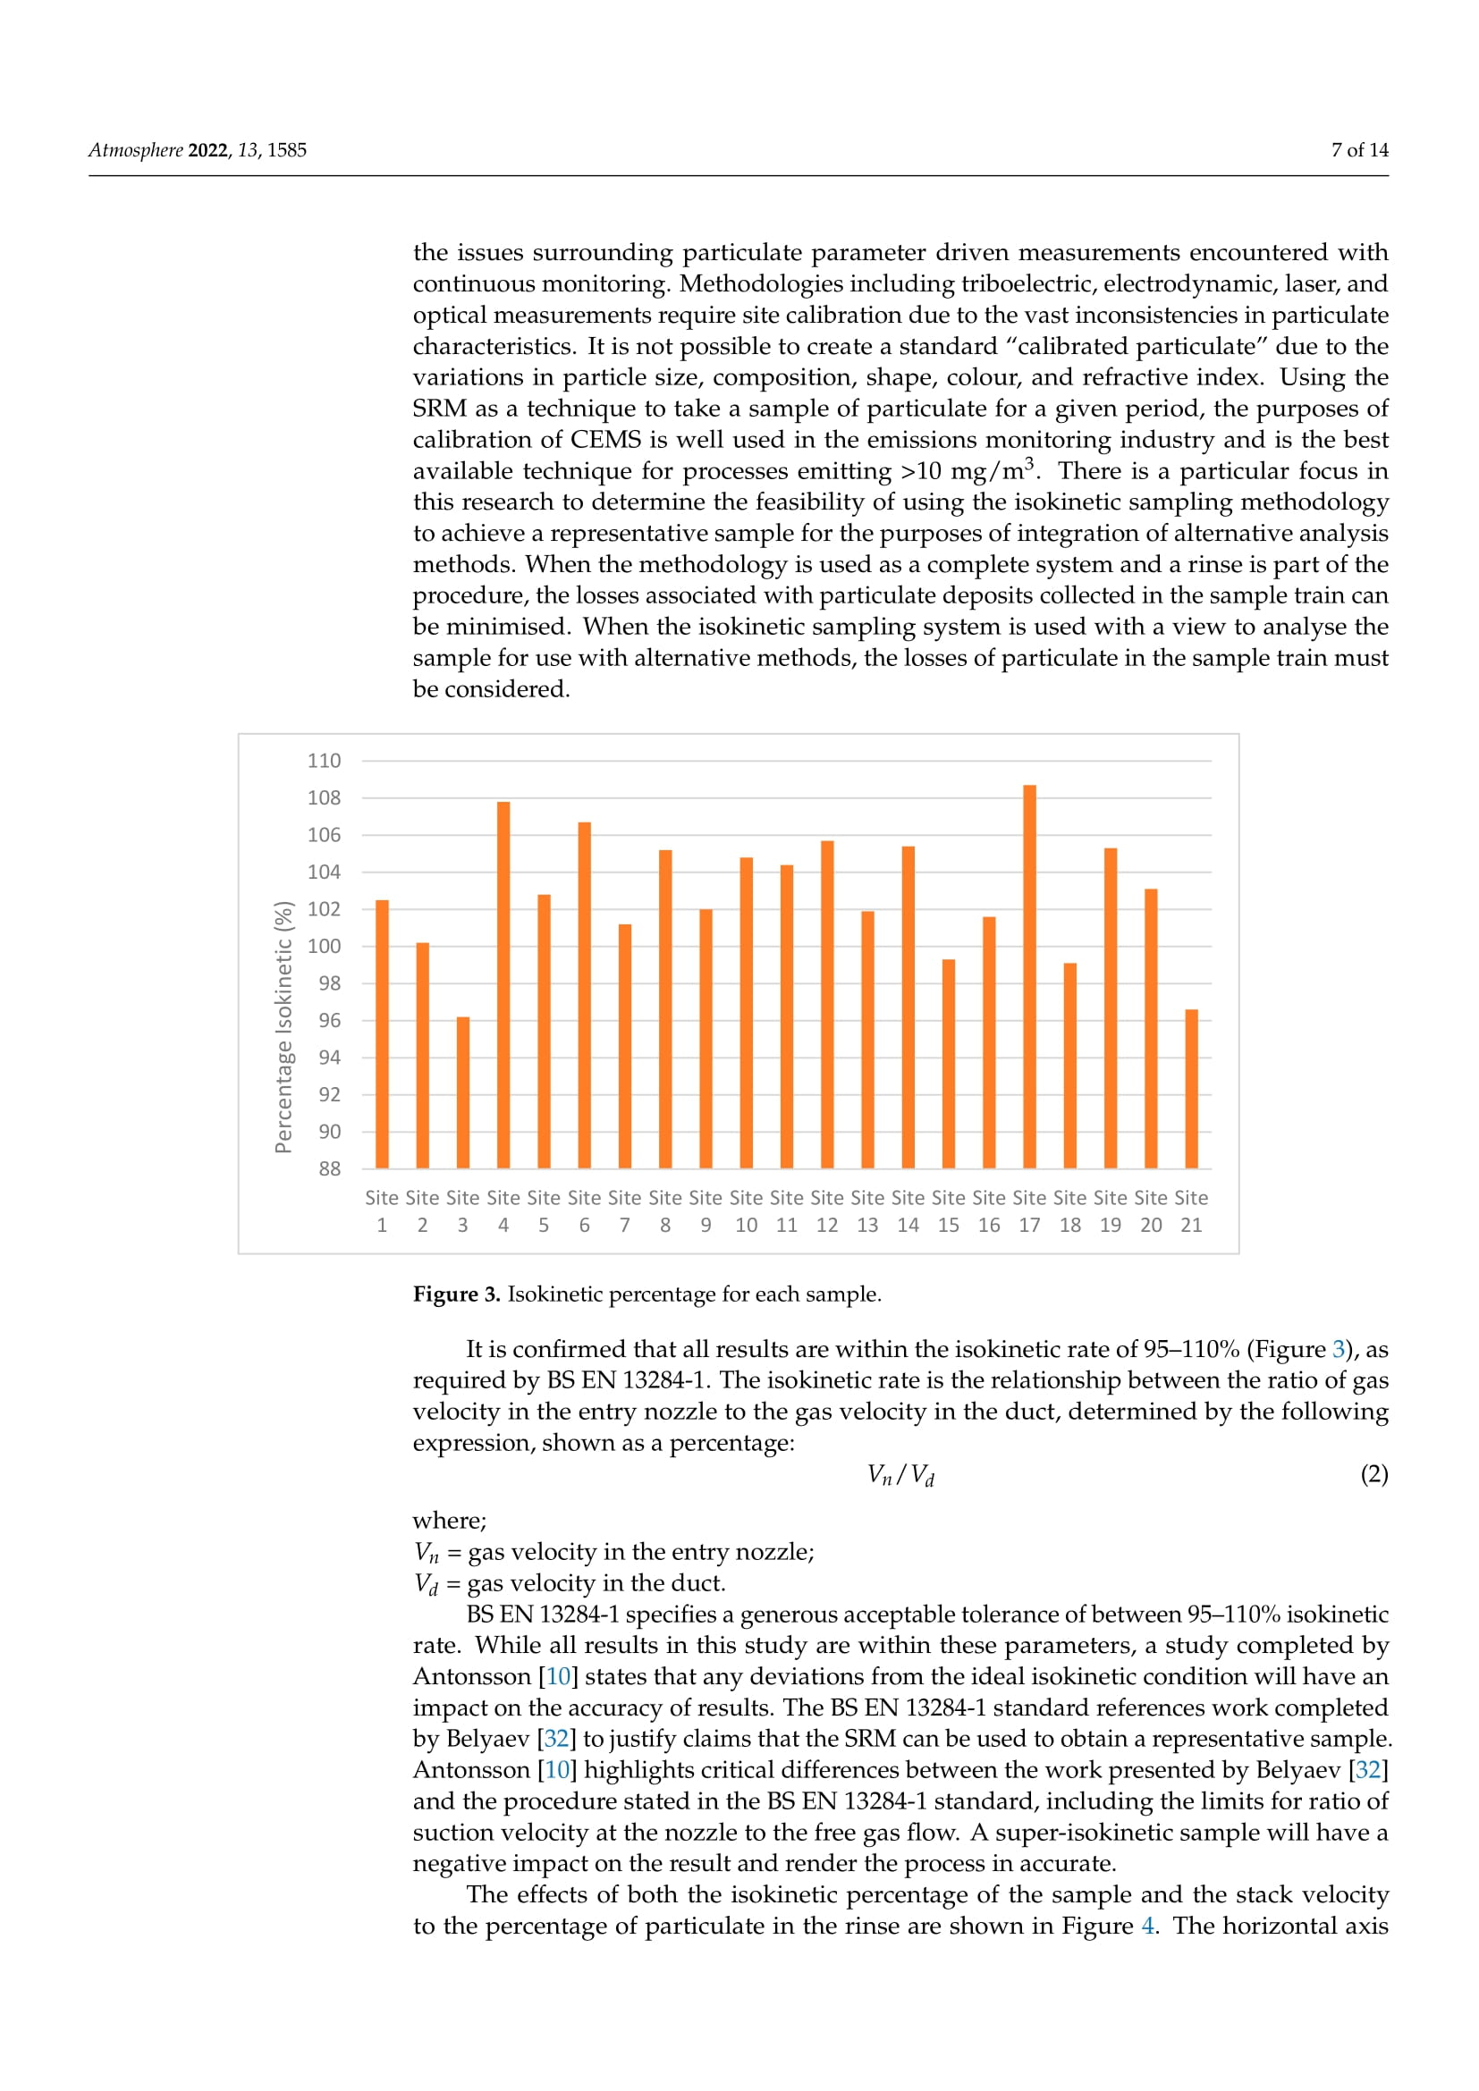
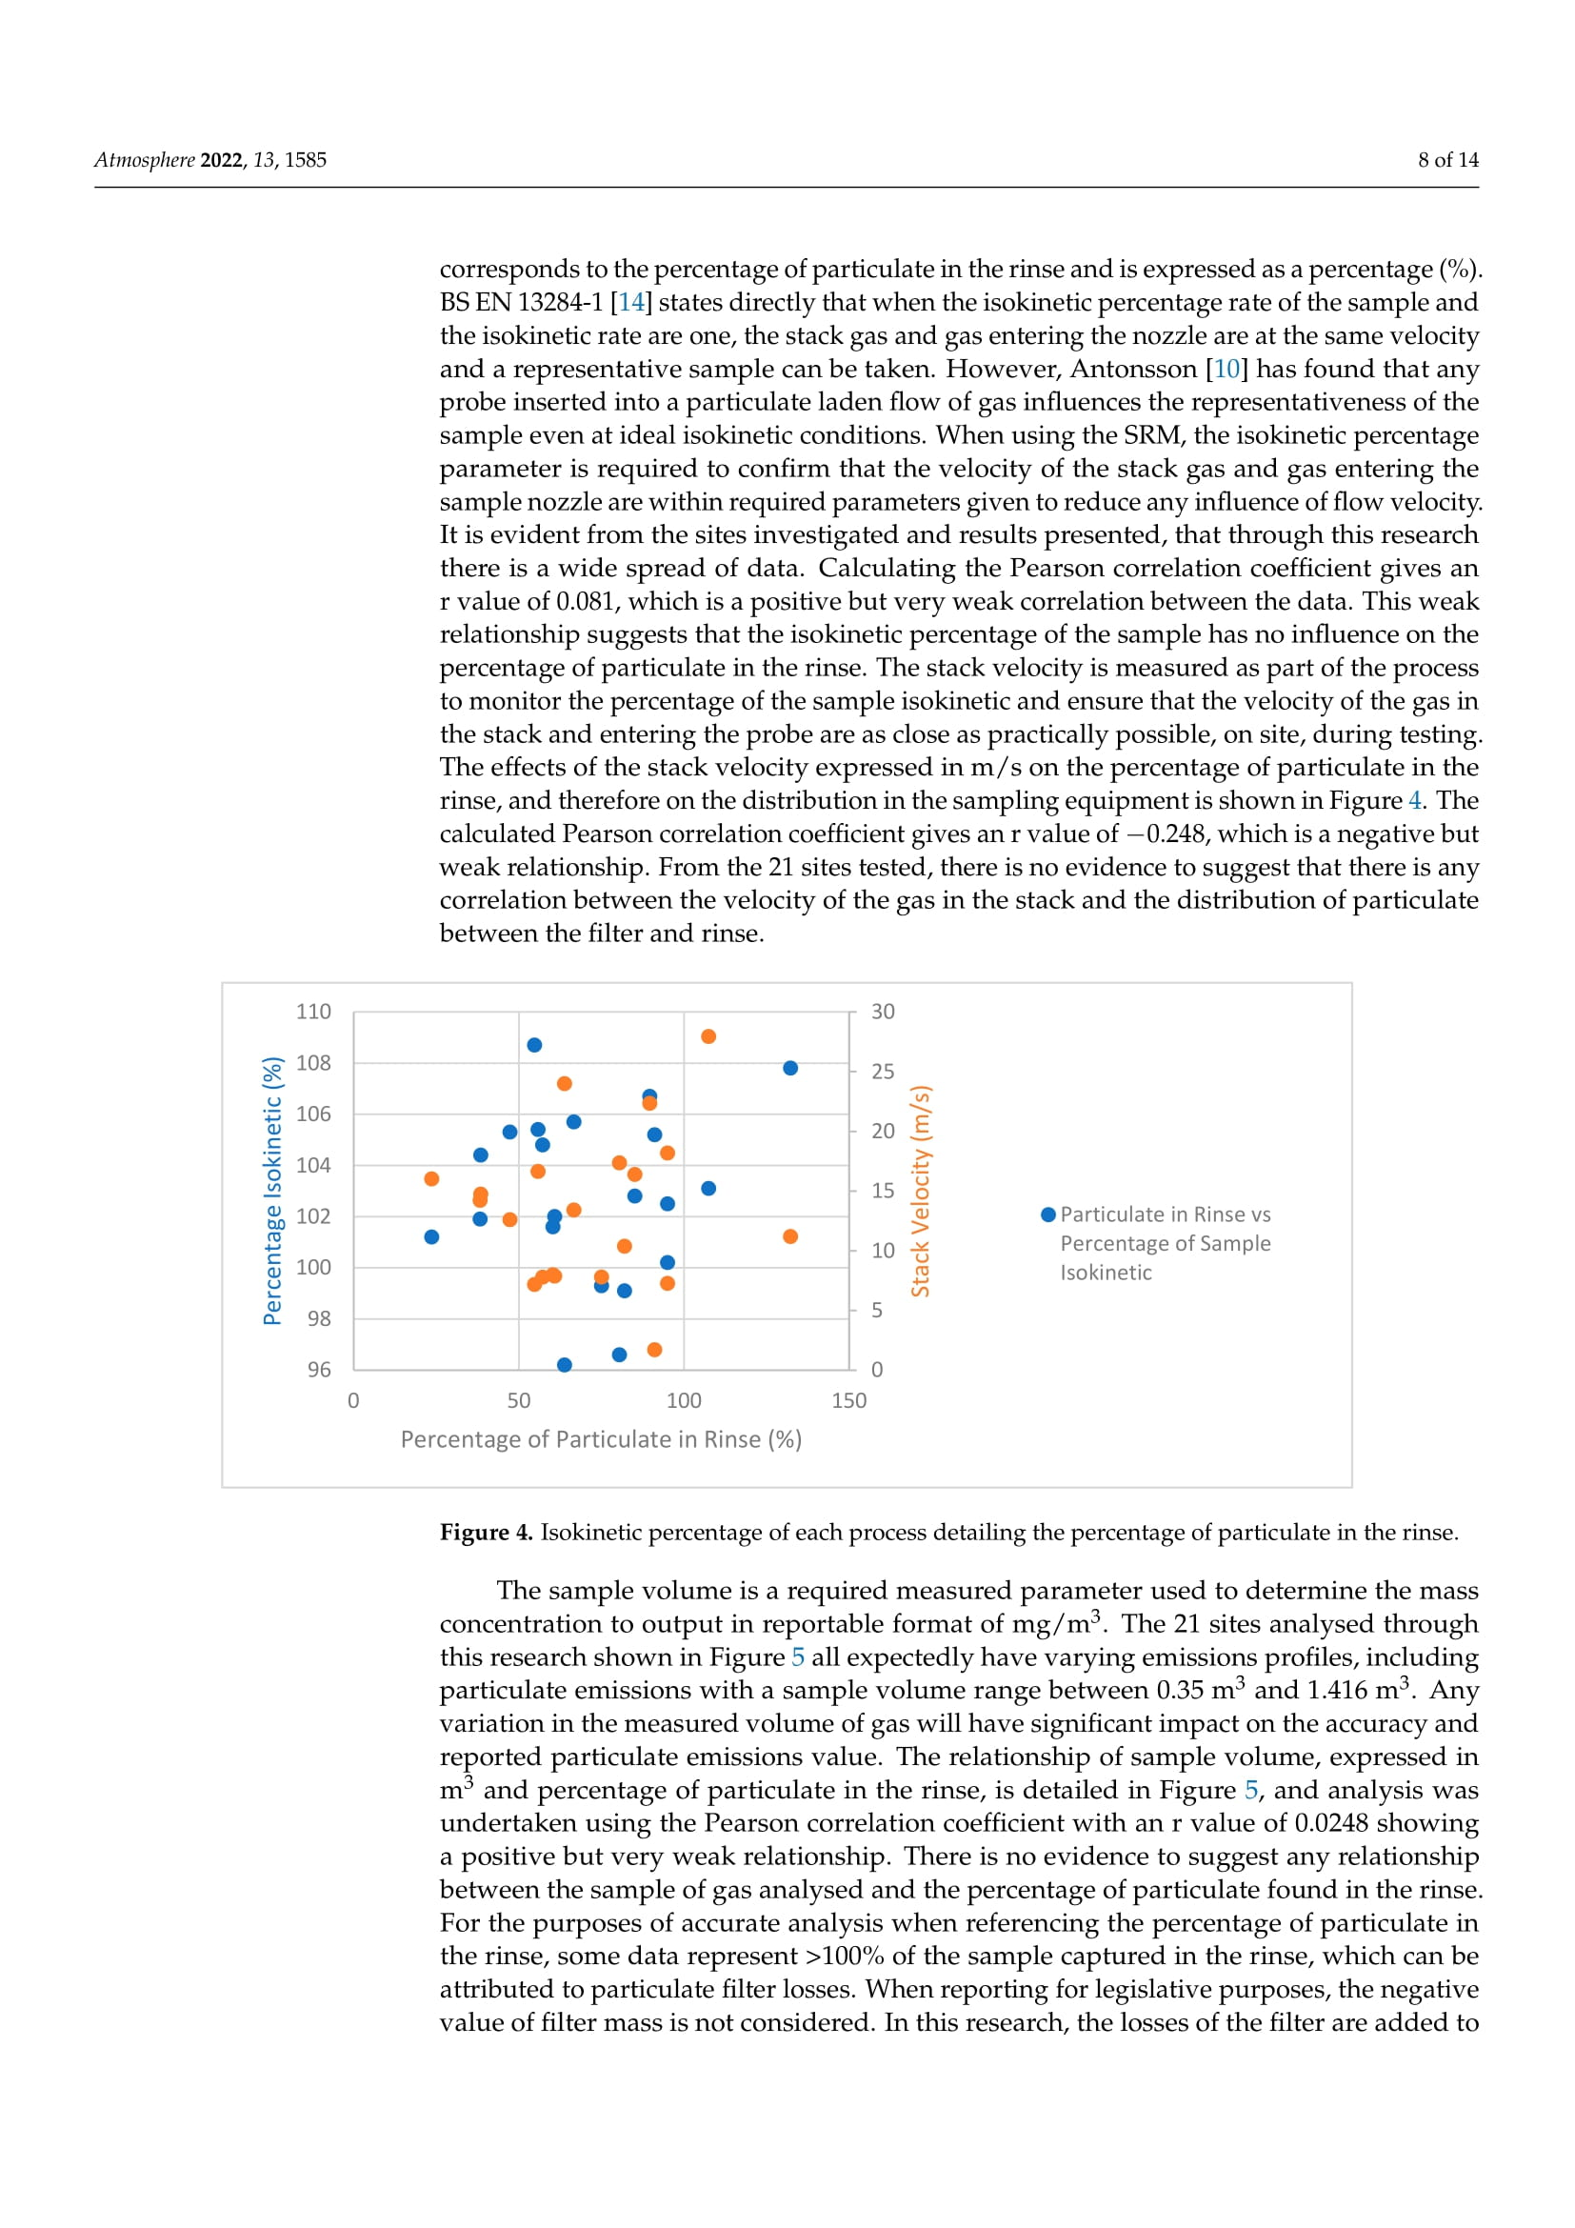
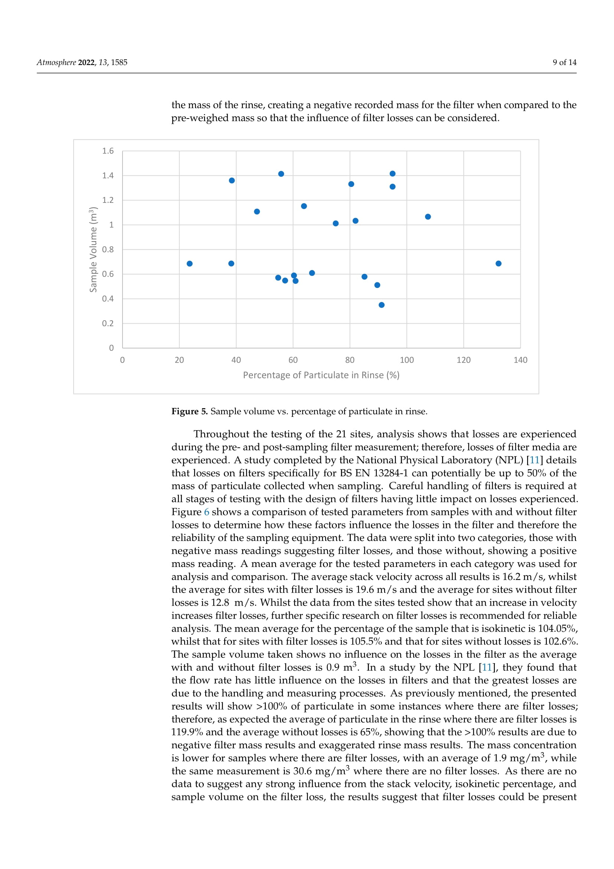
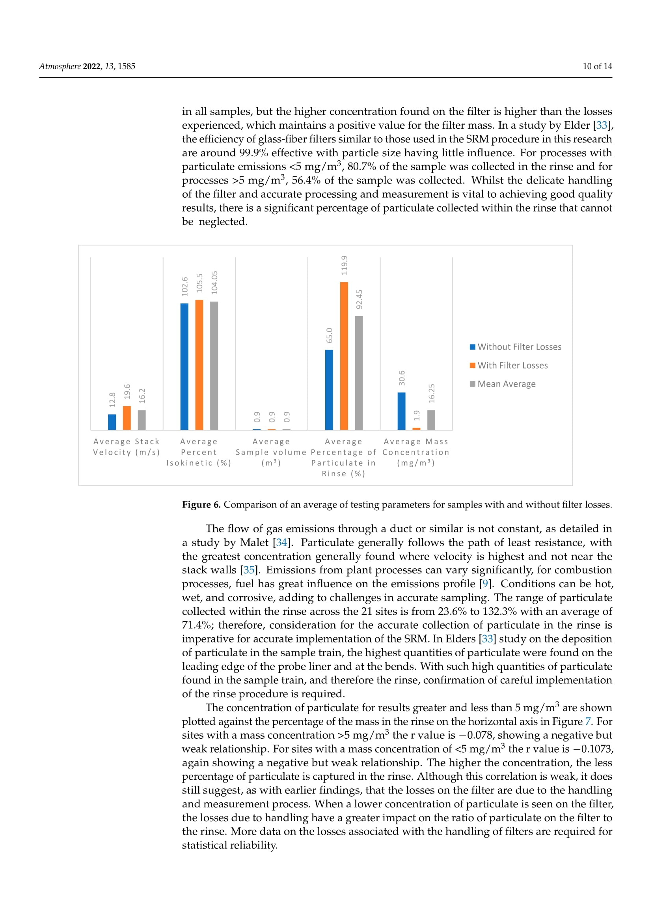
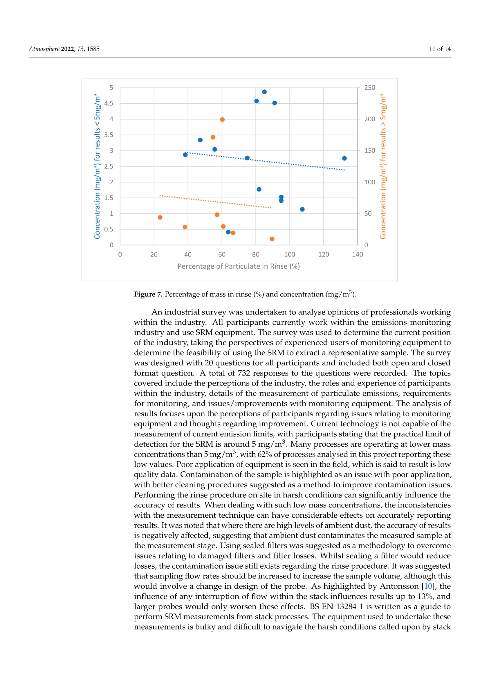
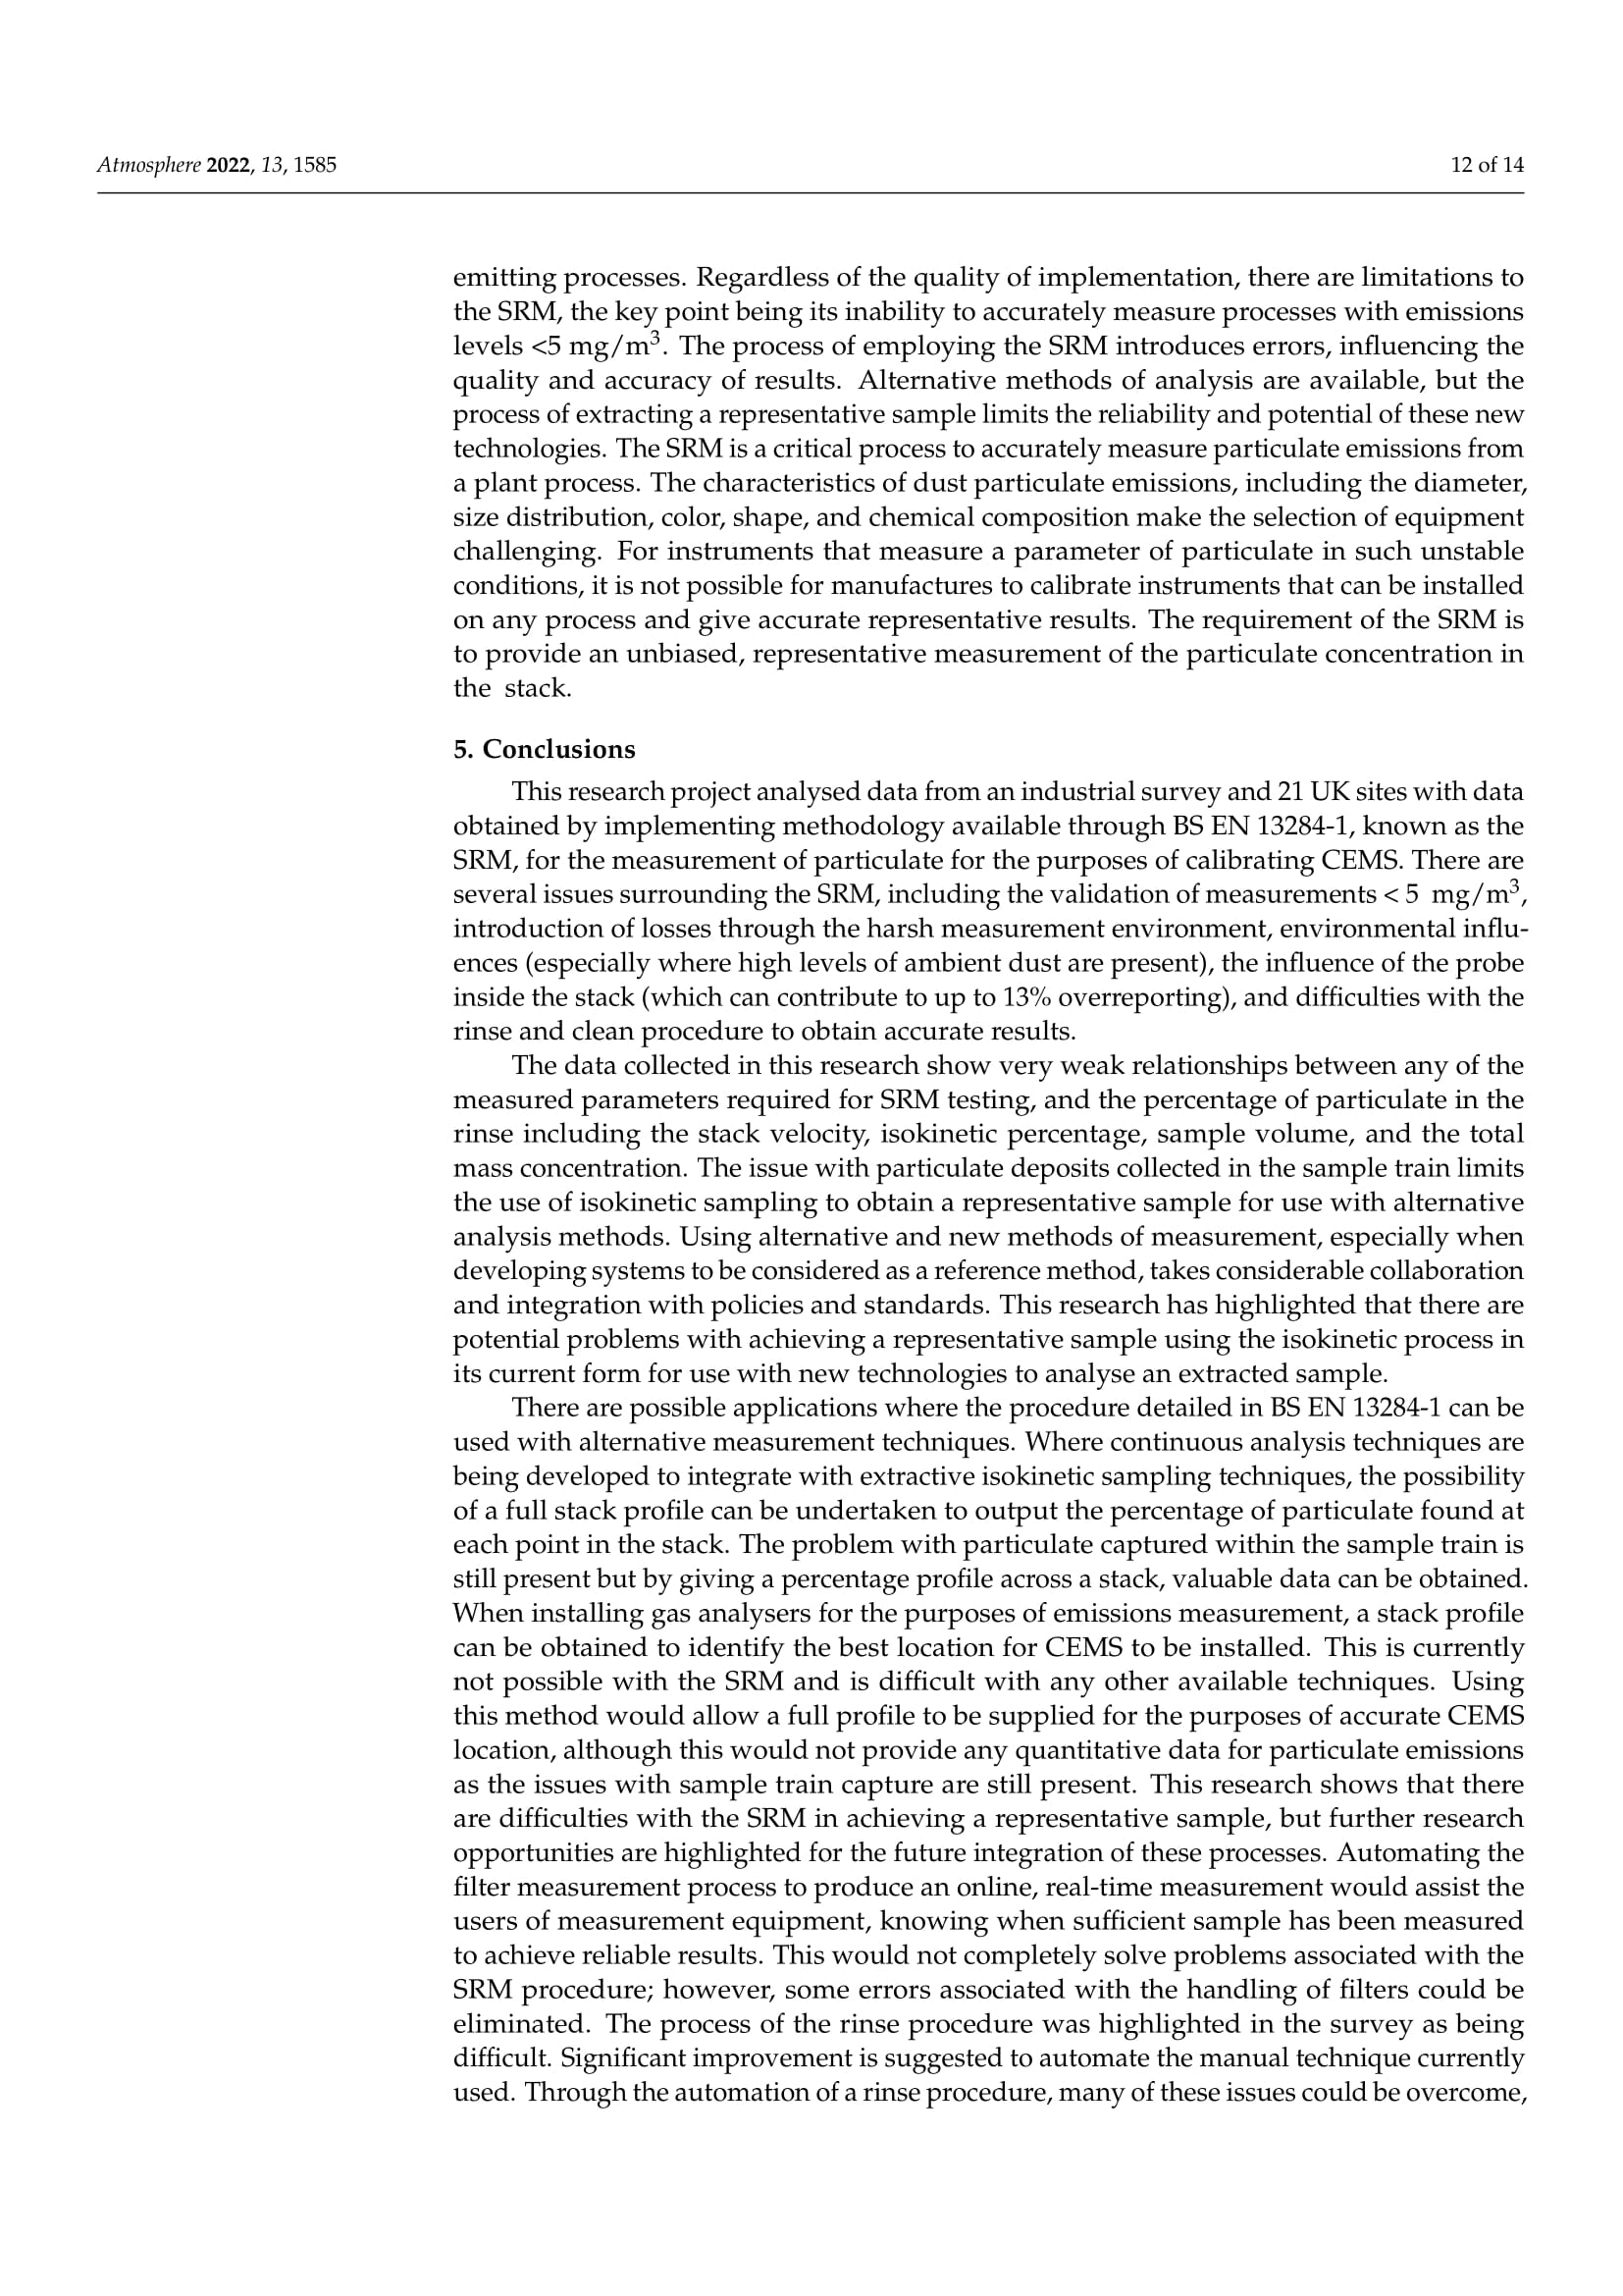
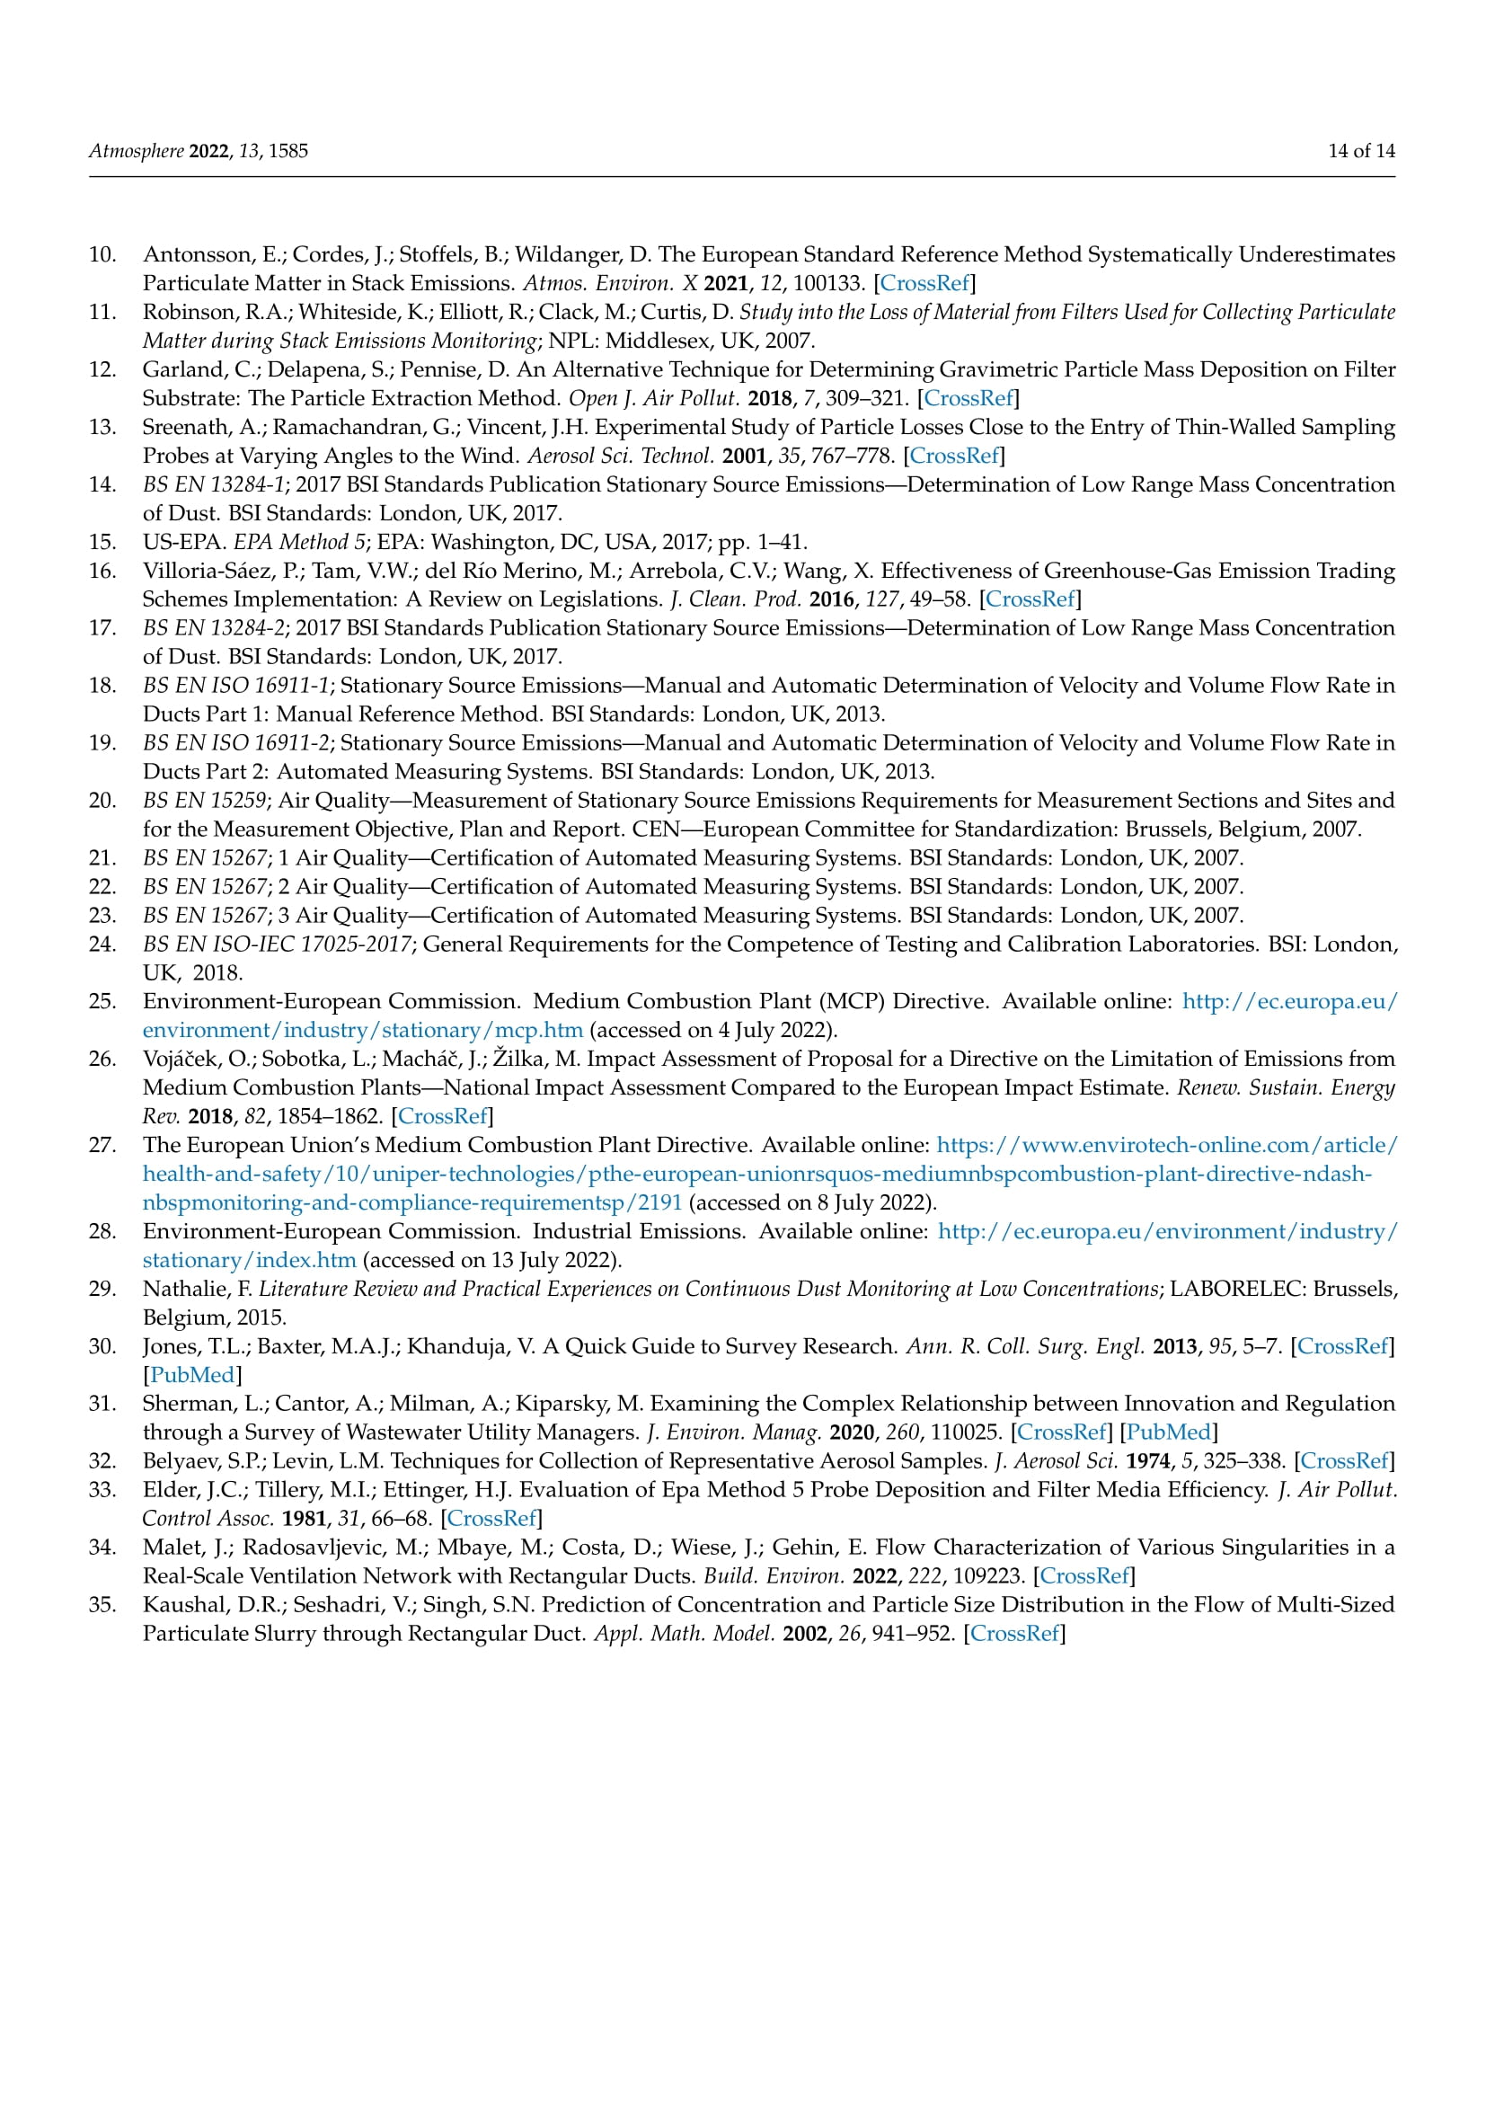

Appendix 3 Atmosphere 2023, 14, 915
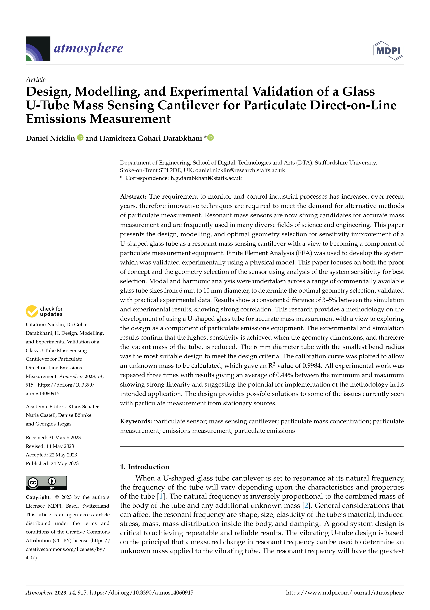

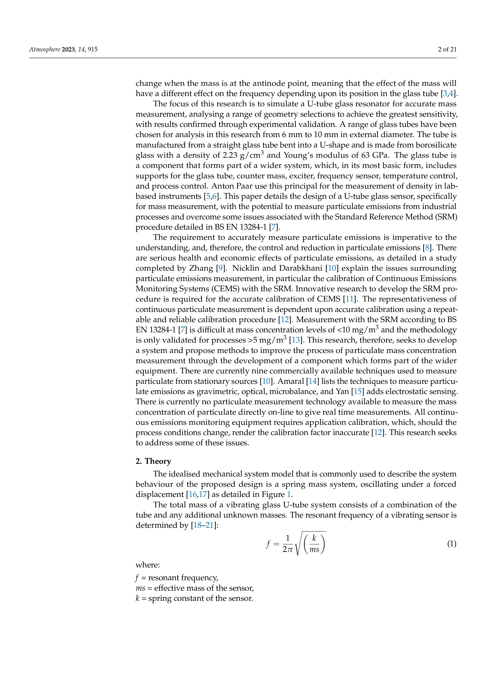

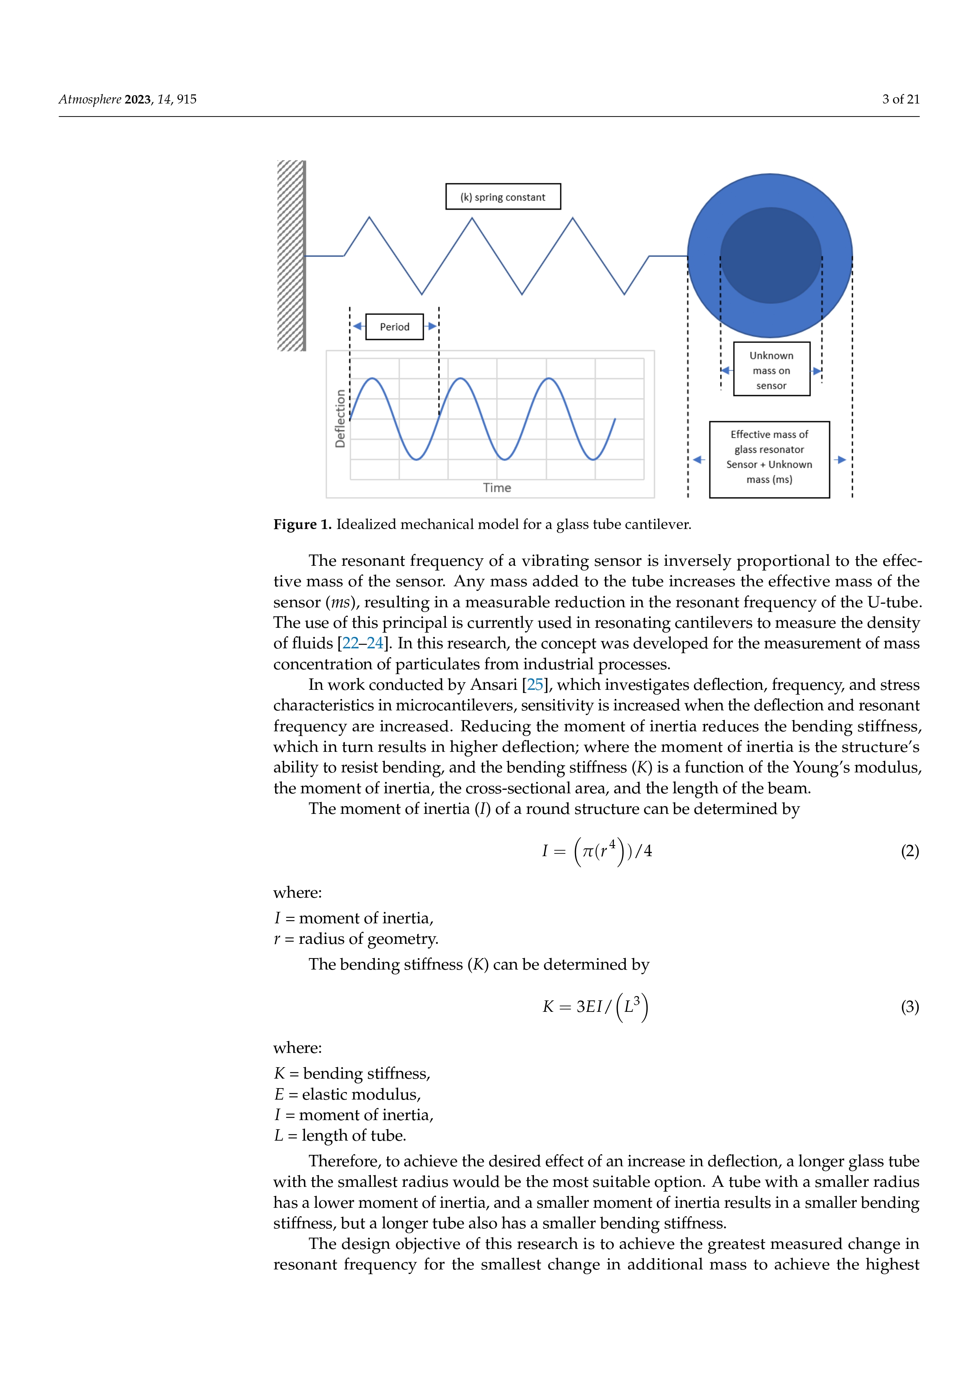

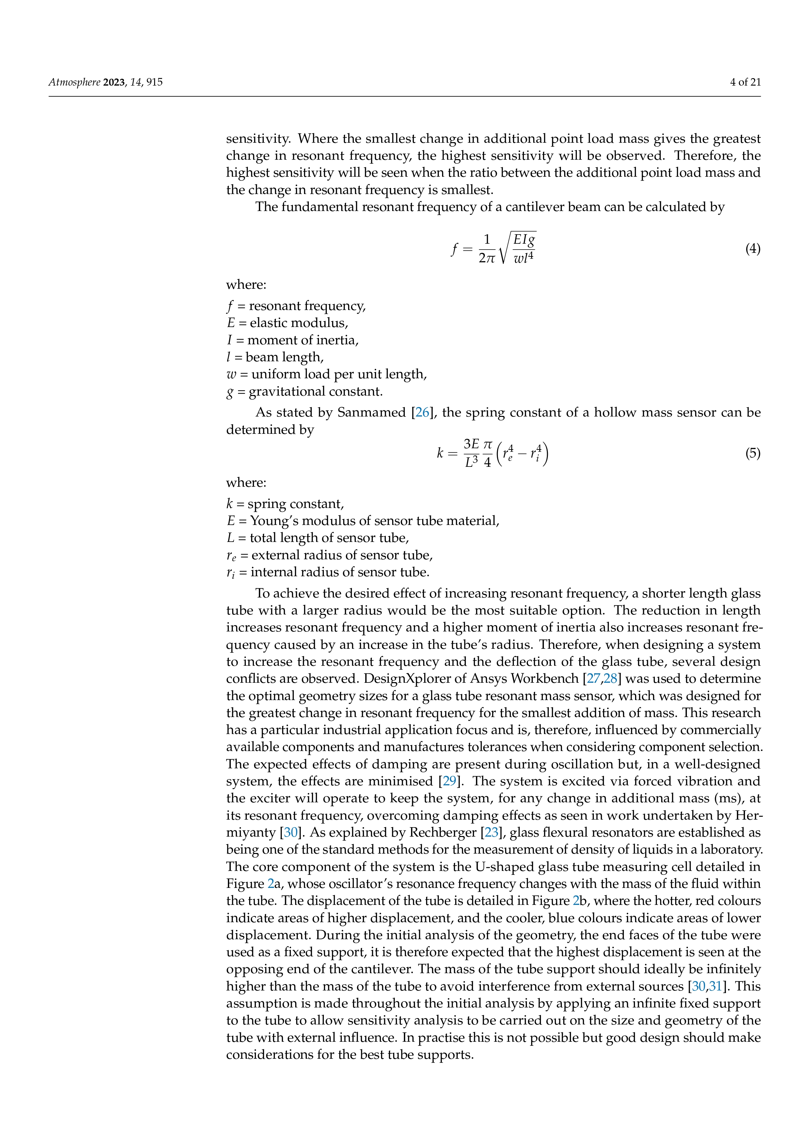

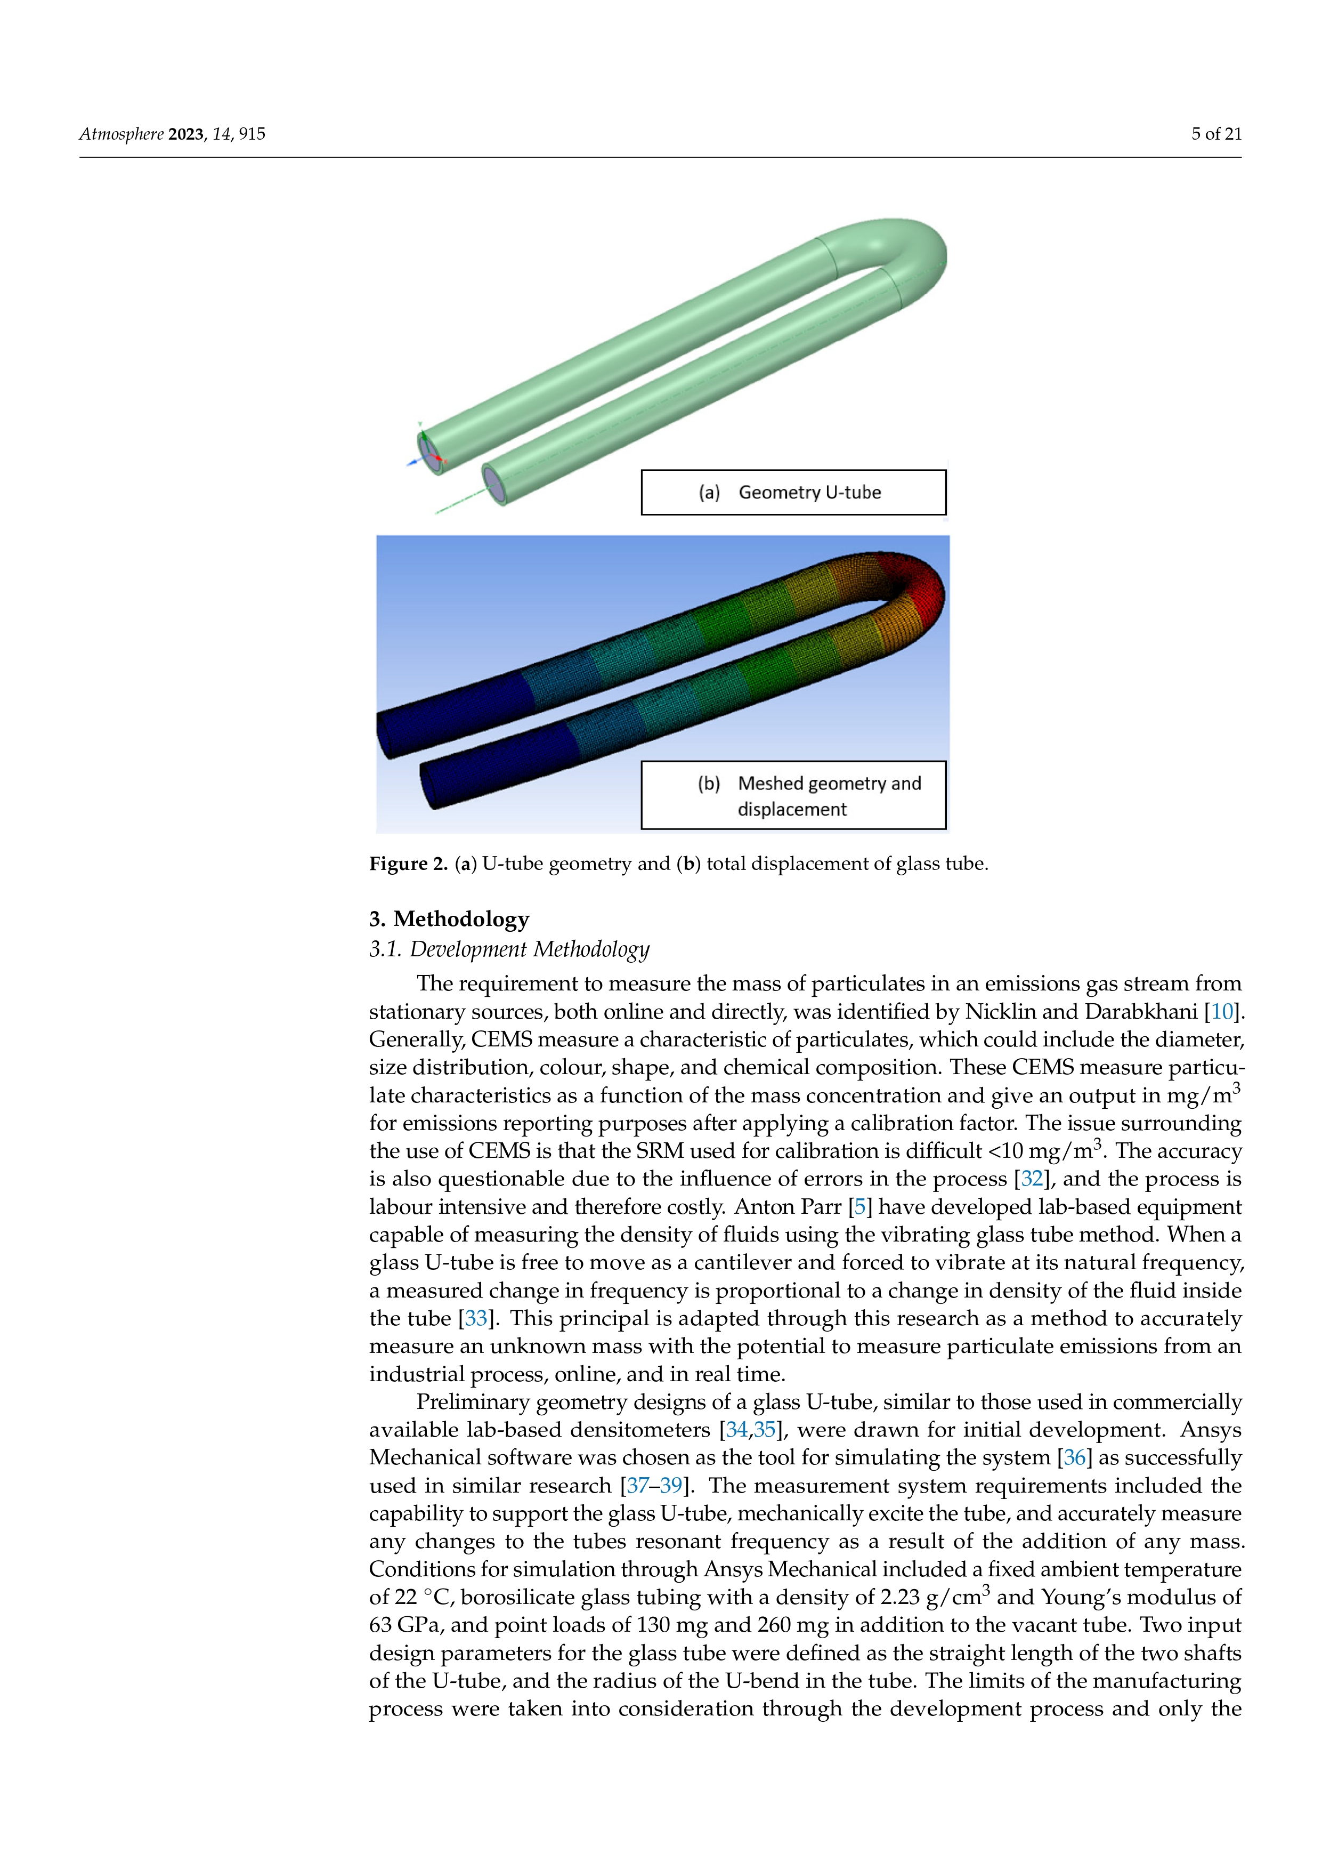

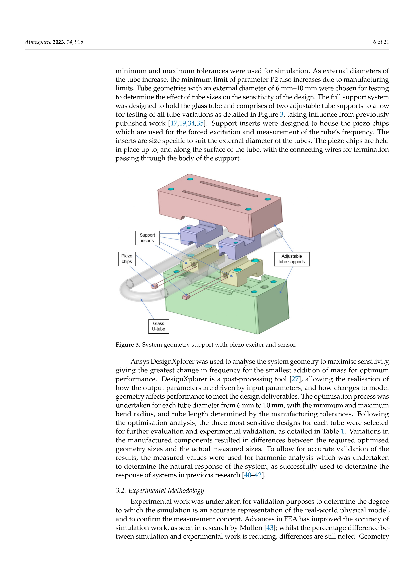

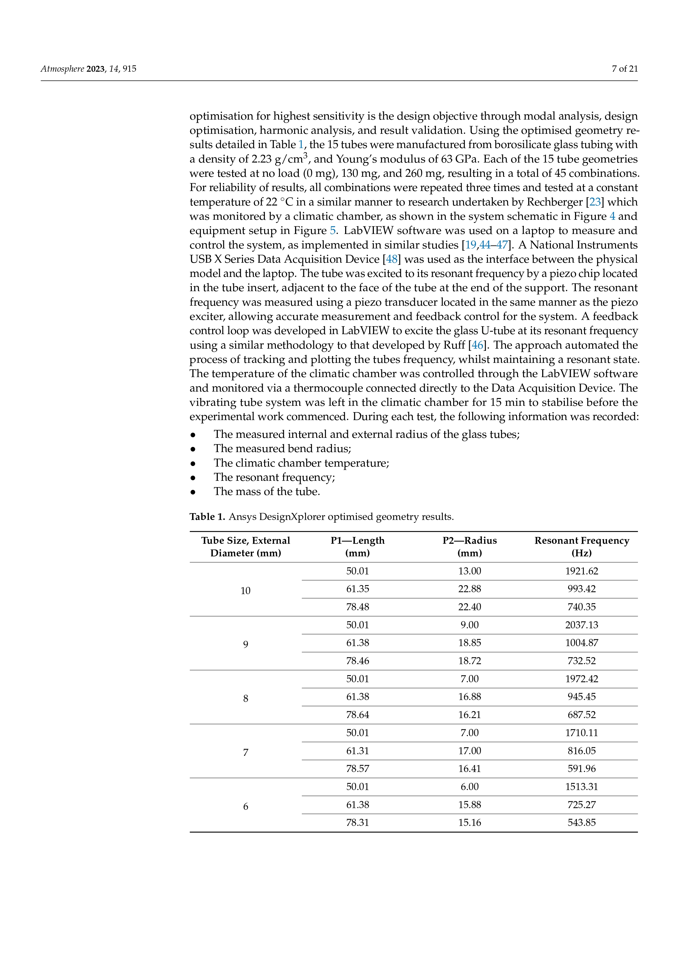

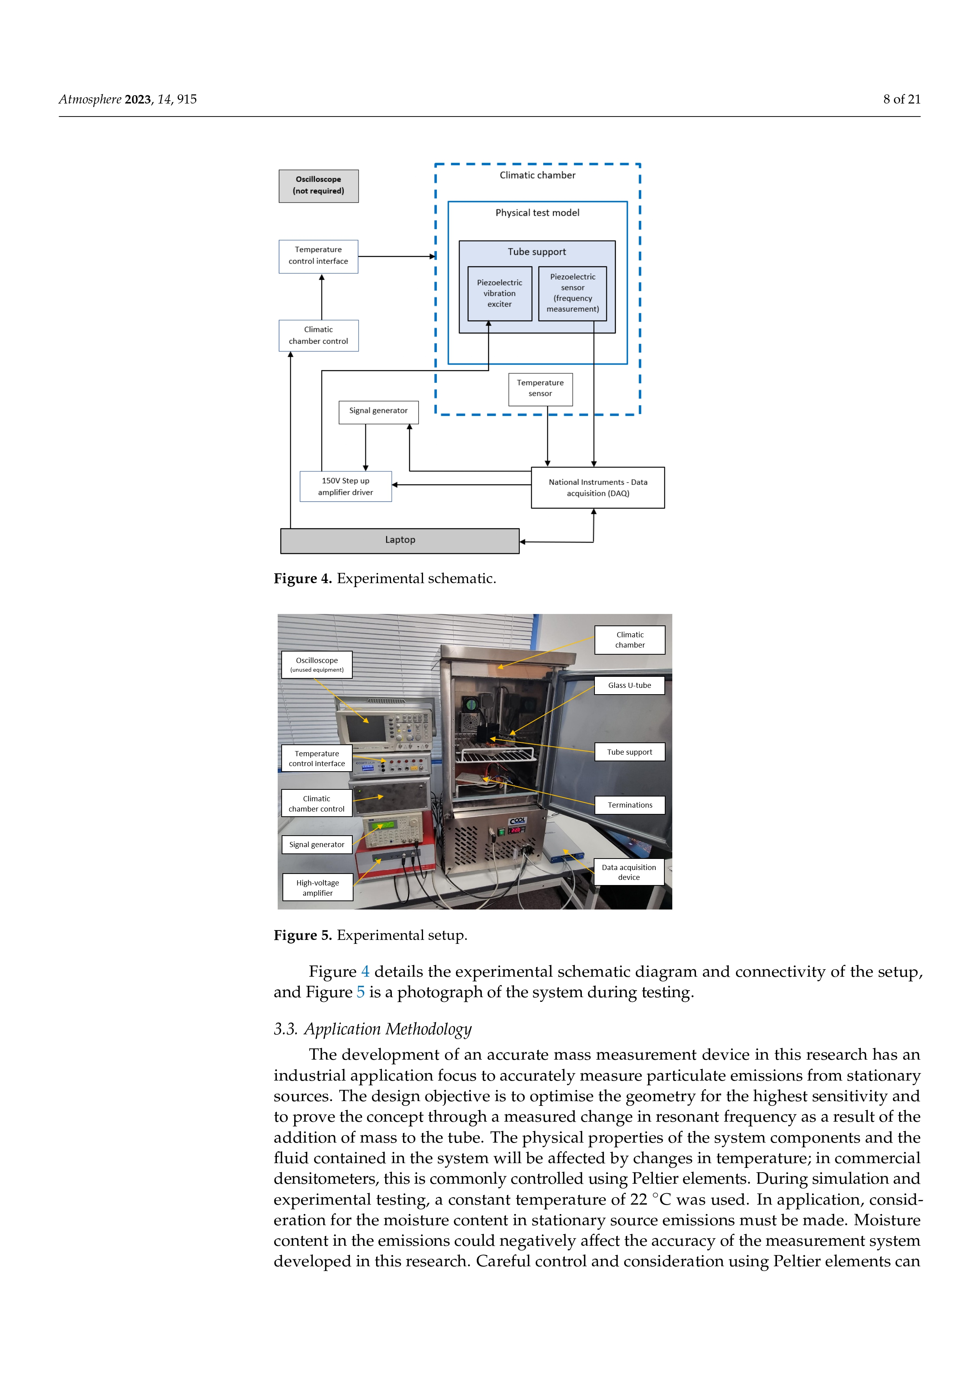

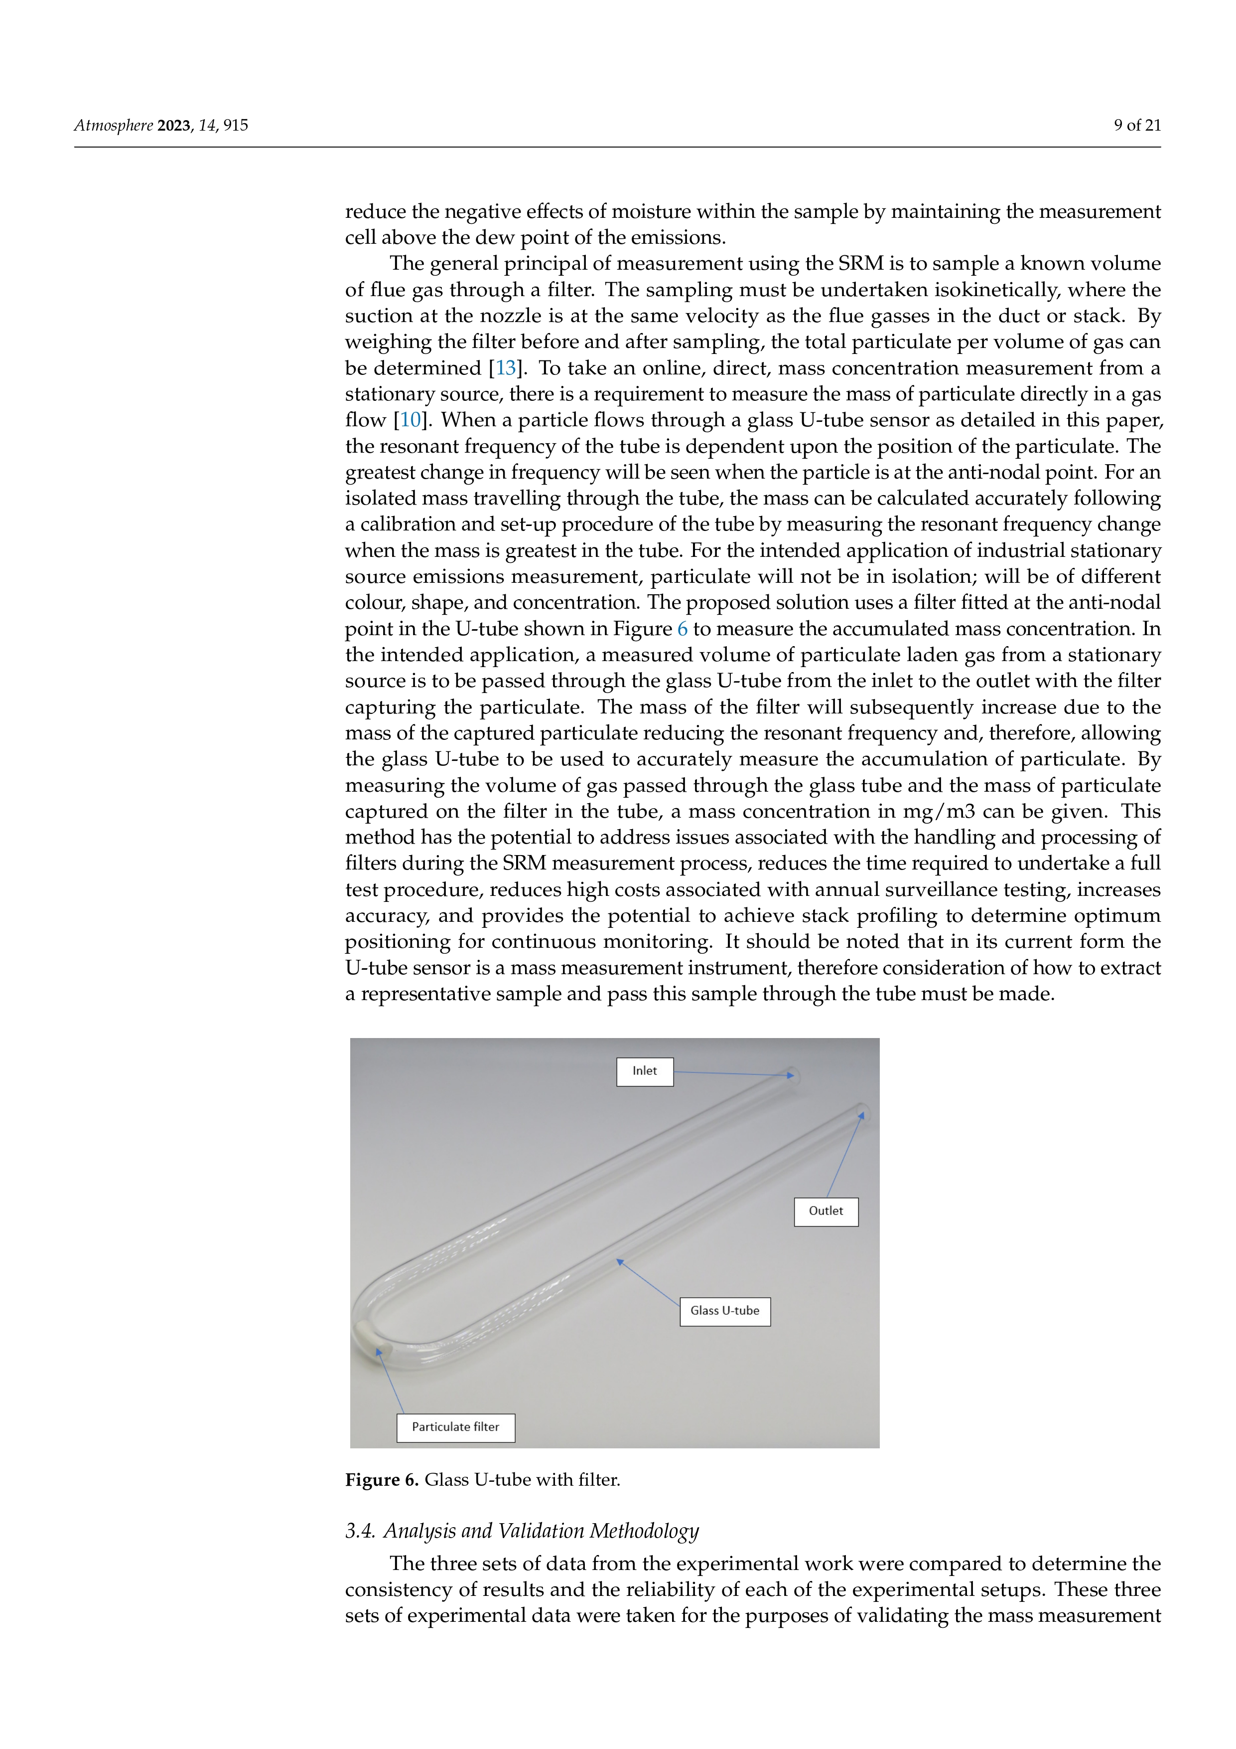

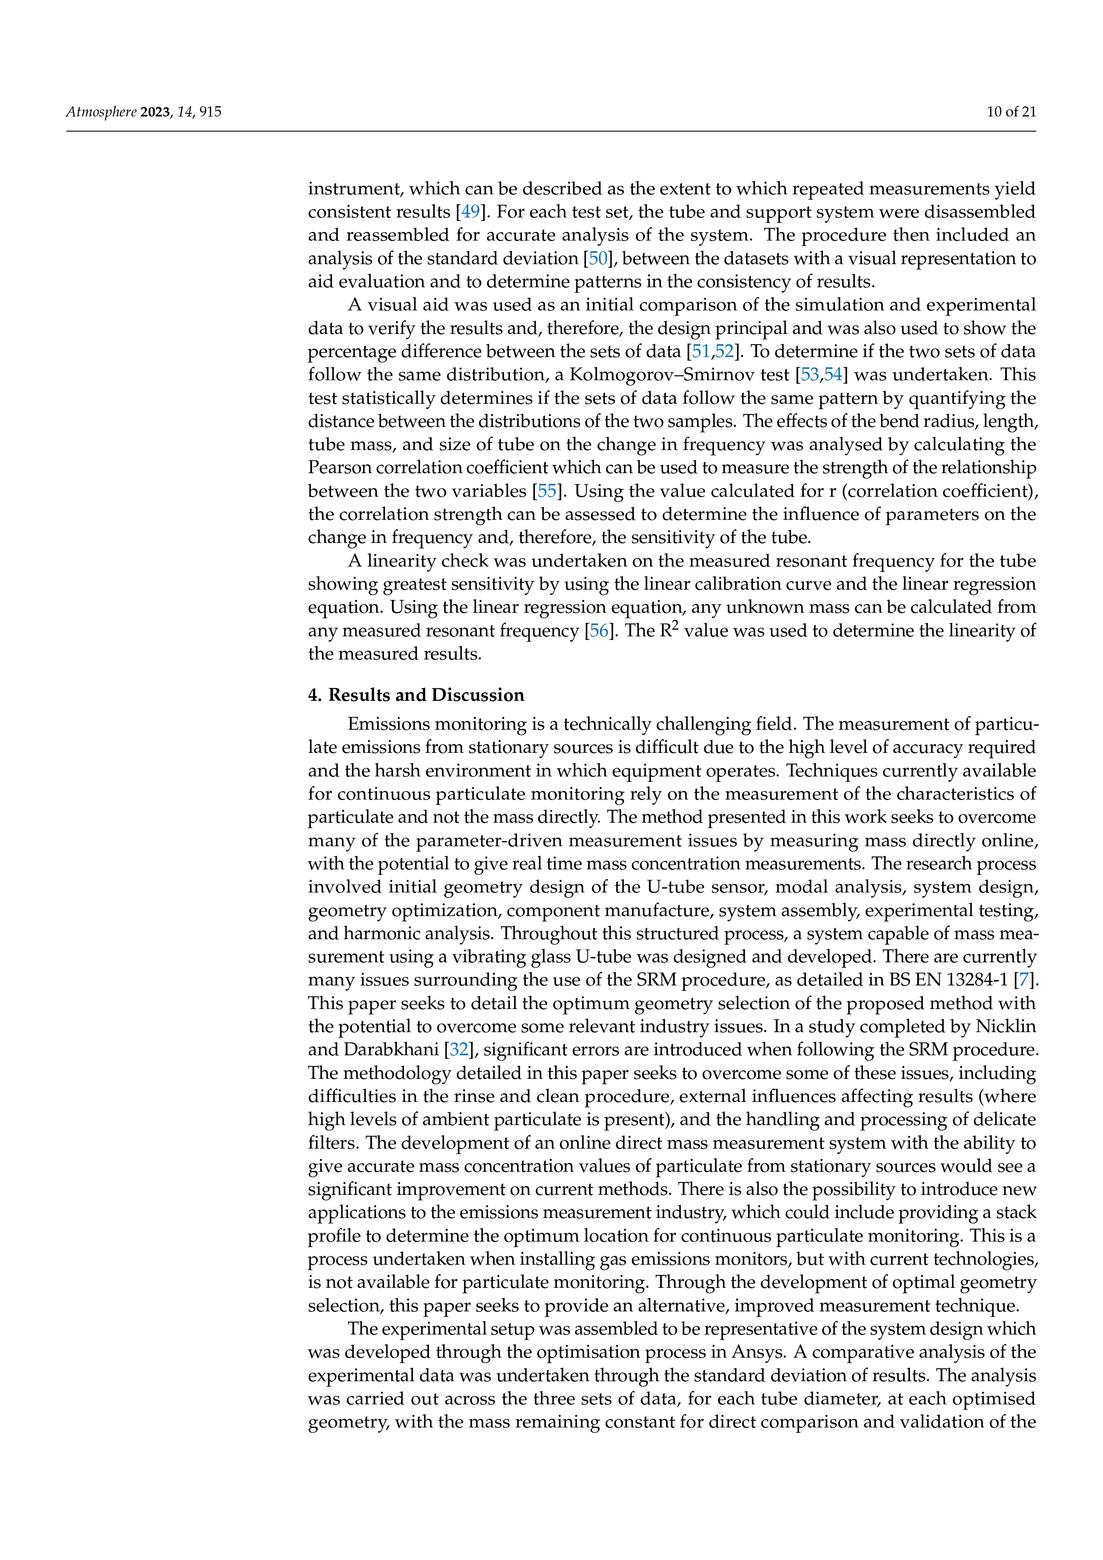

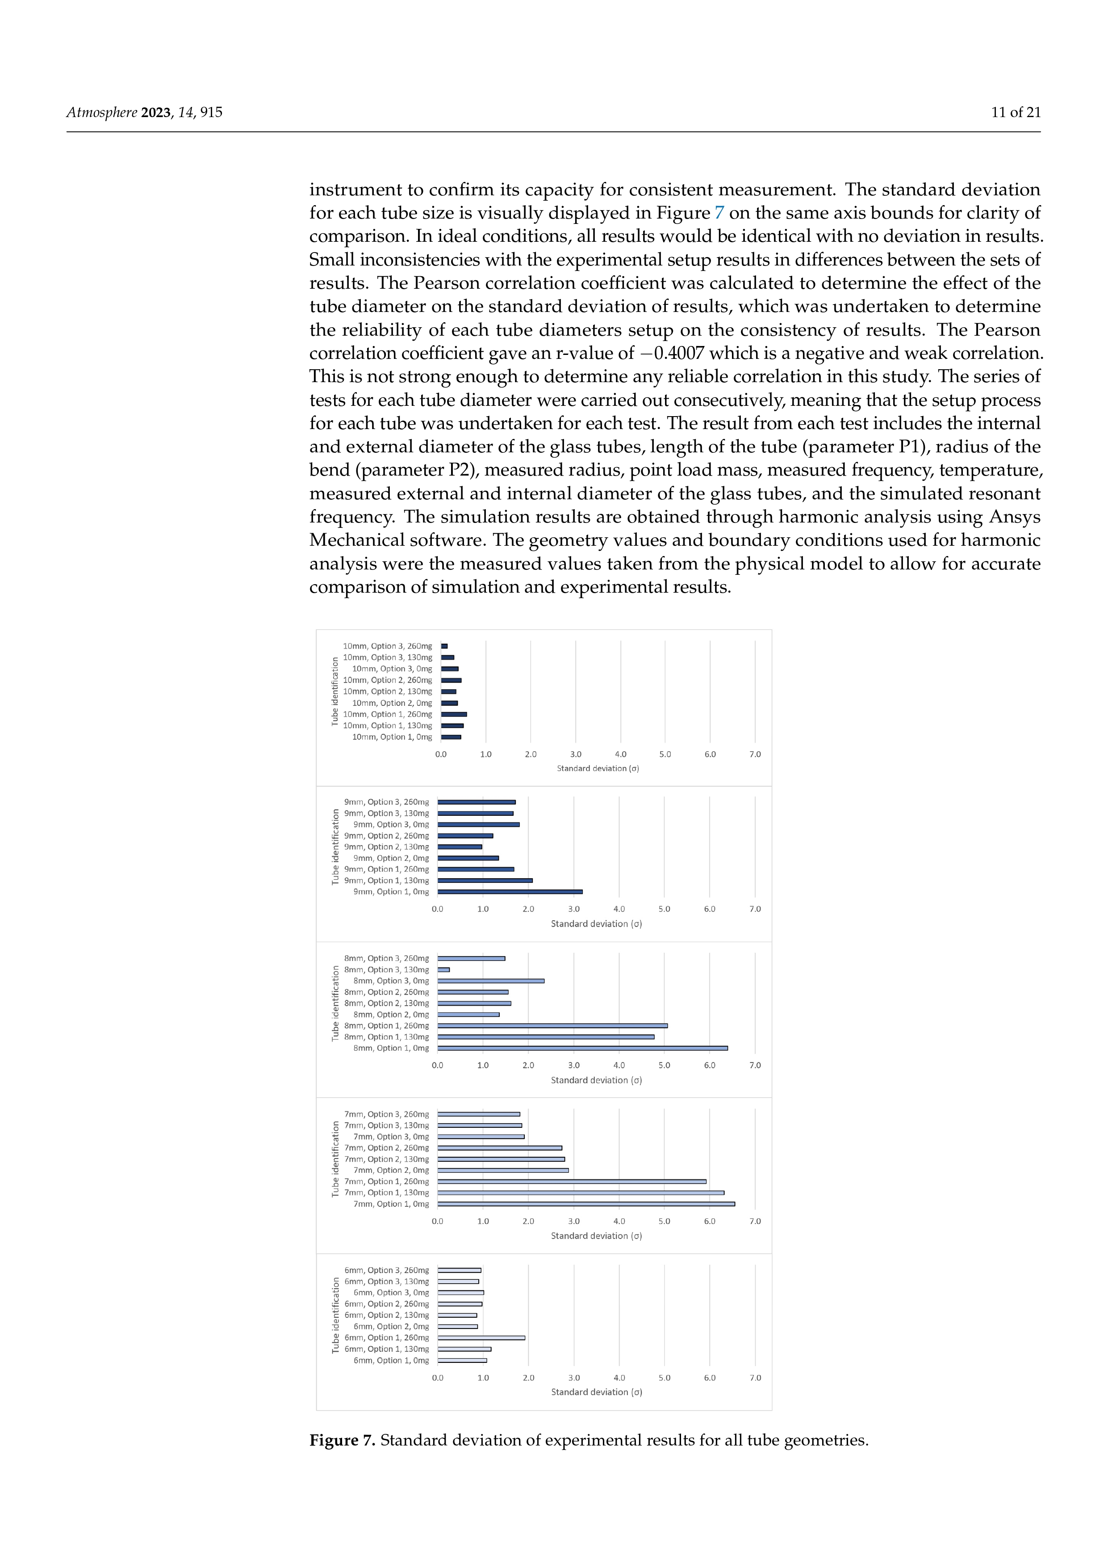

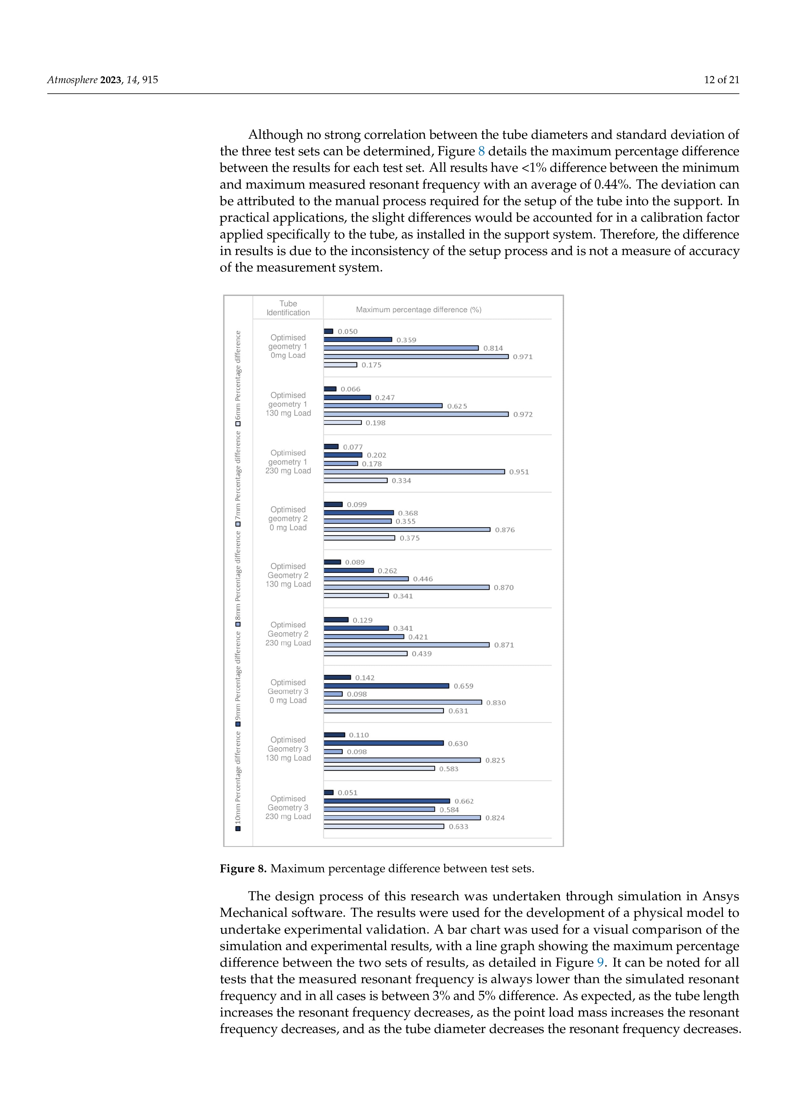

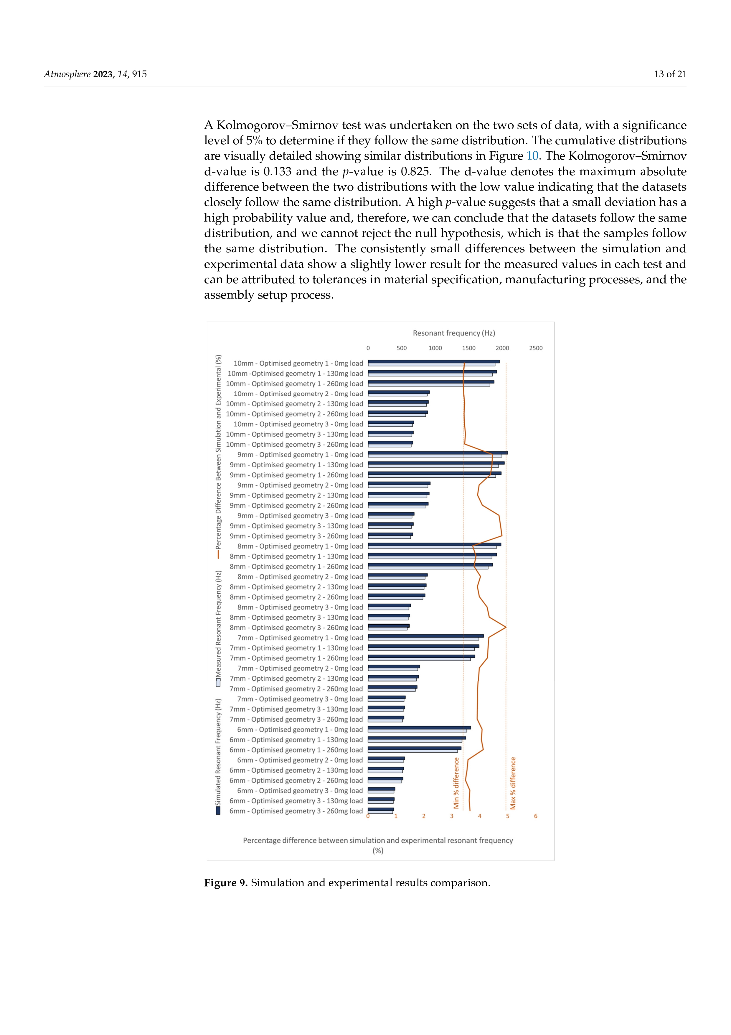

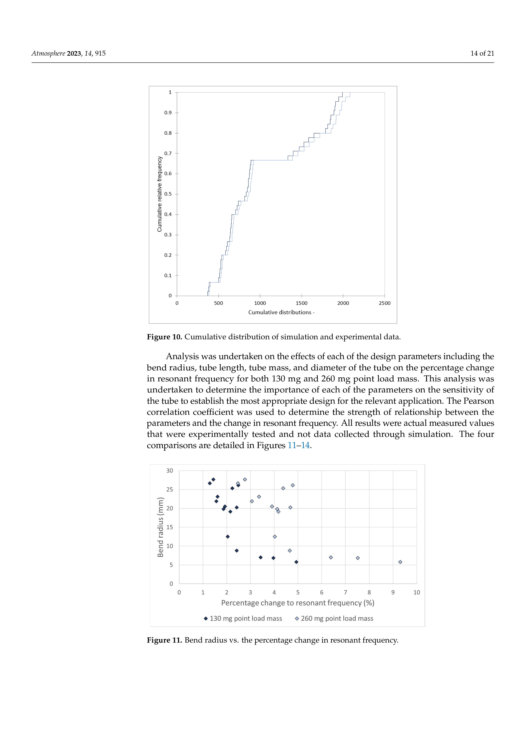

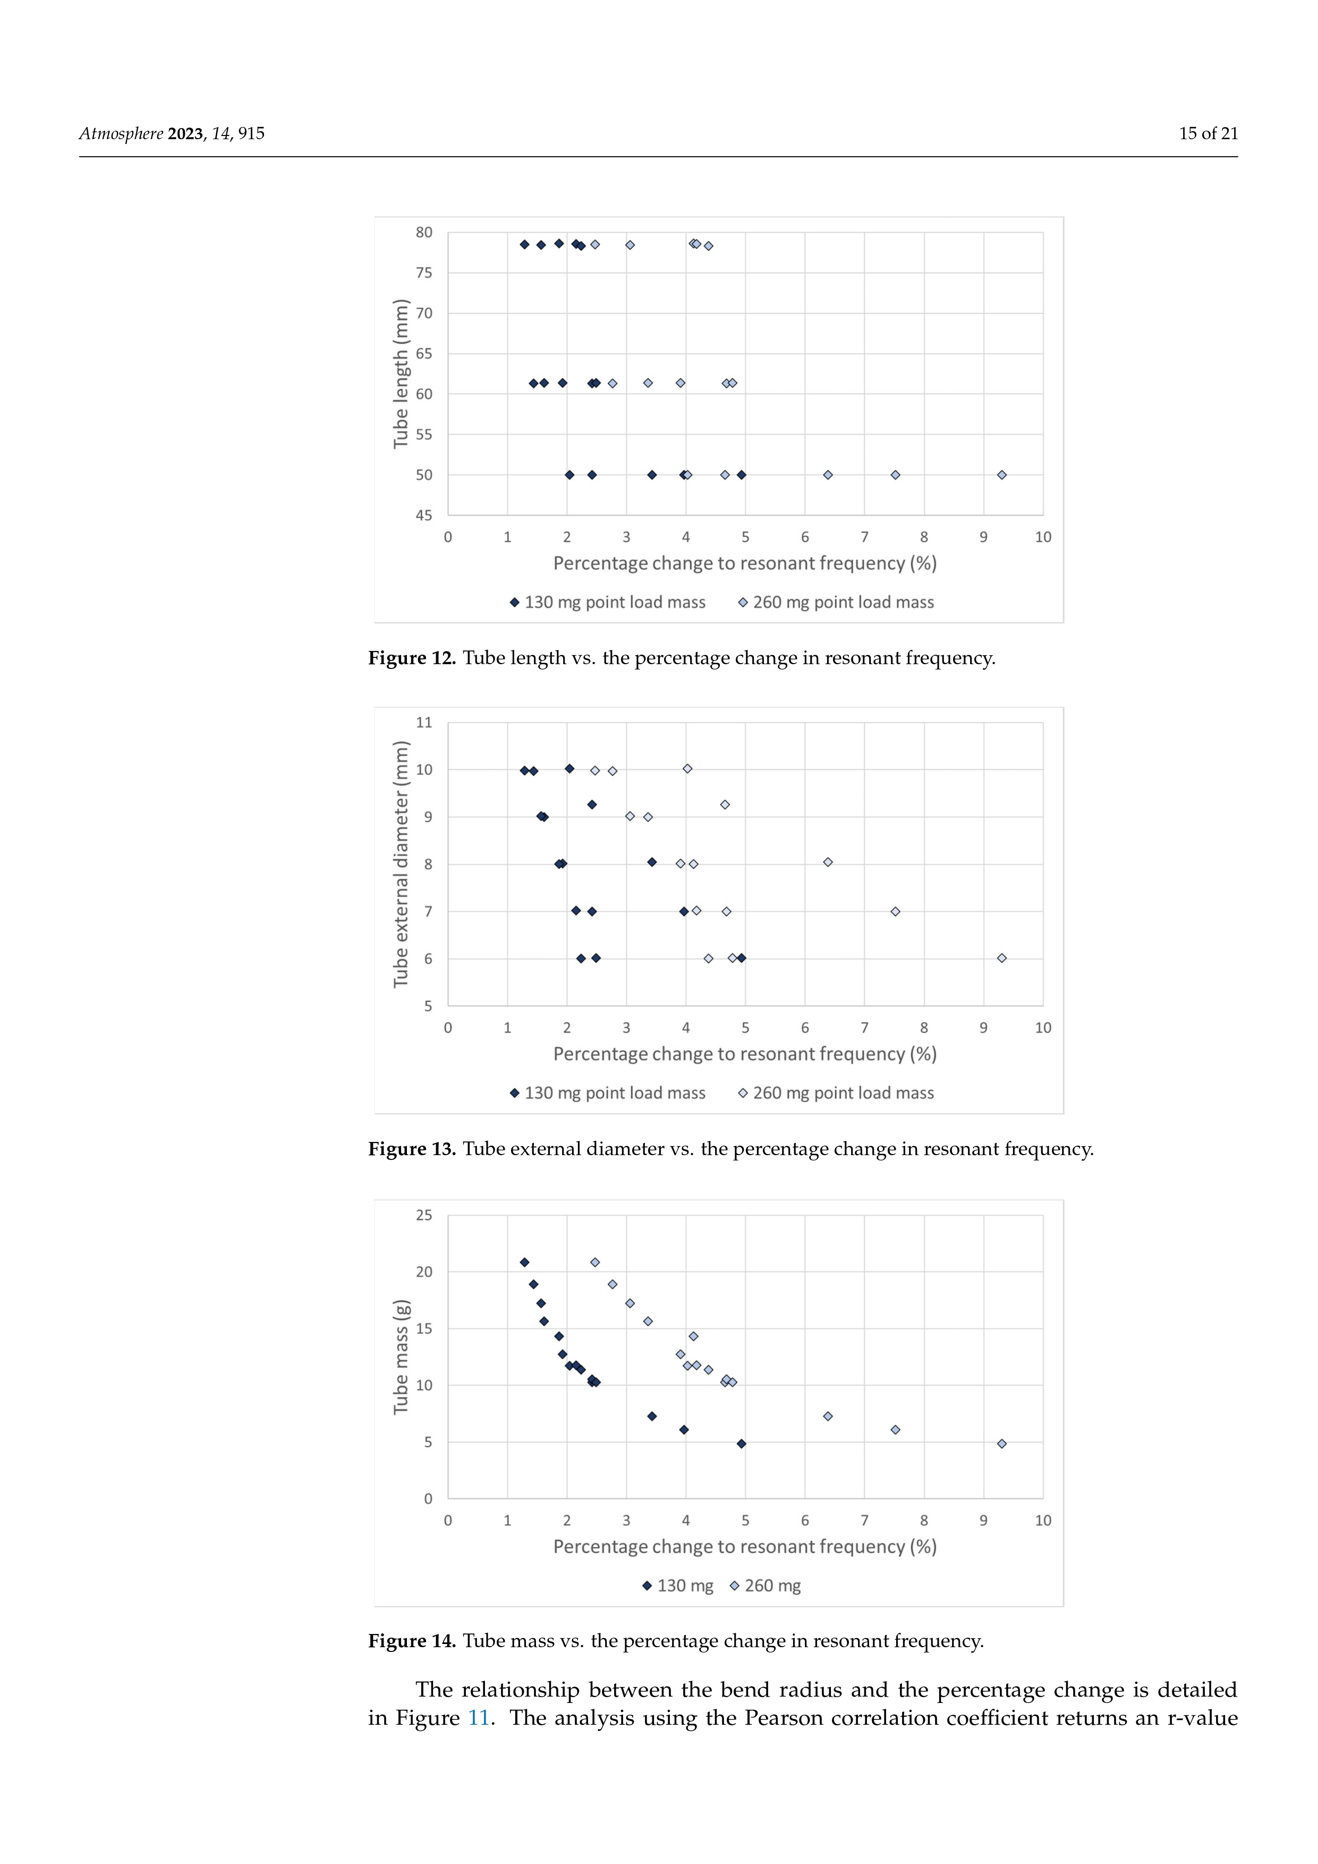

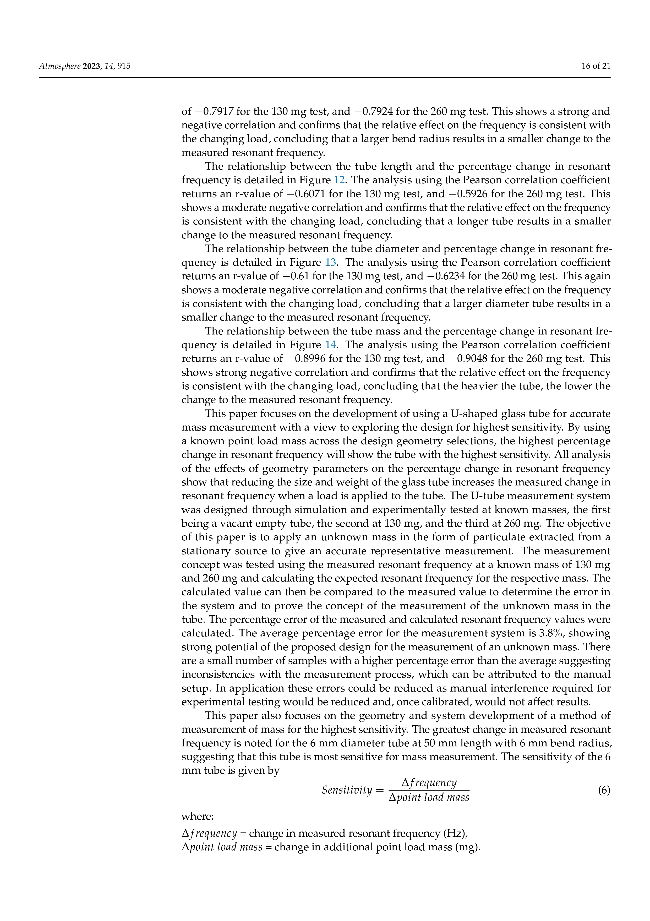

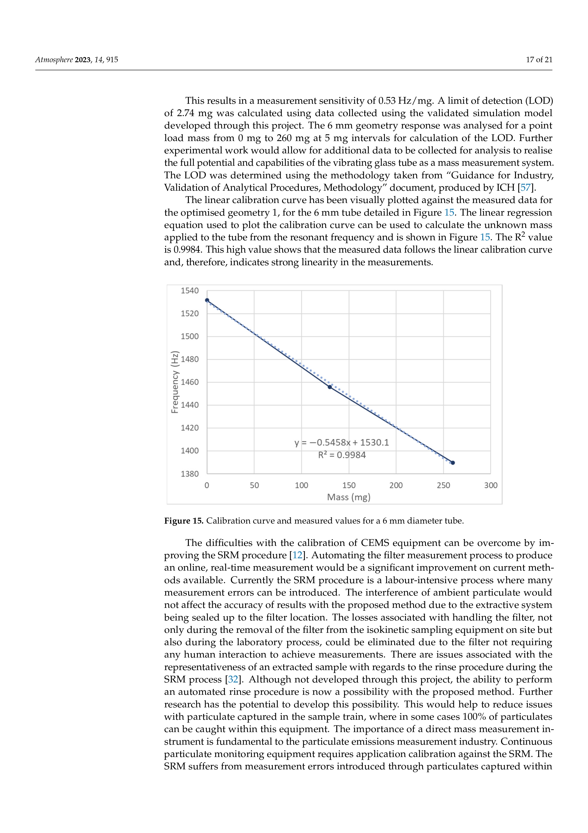

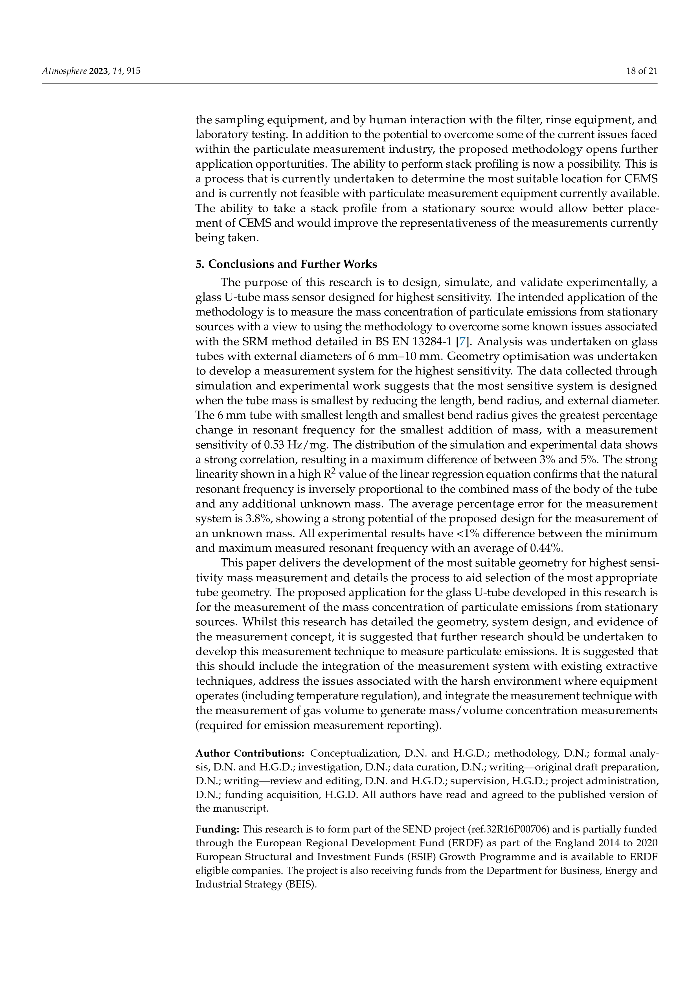

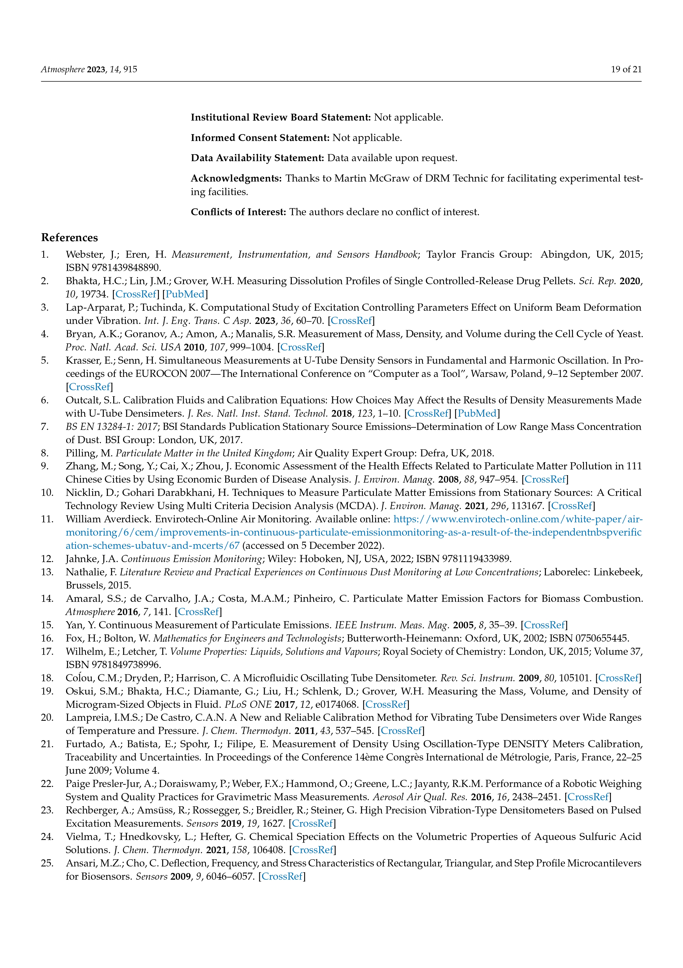

Appendix 4 Industrial Survey

Appendix 5 Multi Criteria Decision Analysis GAIA Web Graphs
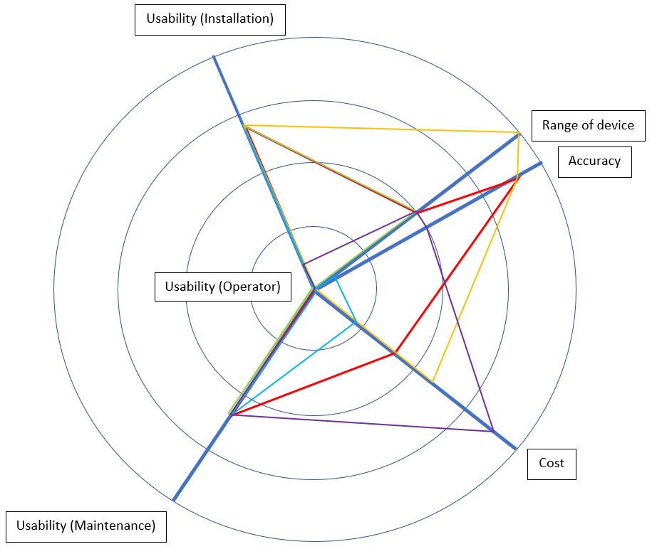
Ratiometric opacity
Standard opacity
Back scatter laser
Forward scatter laser
Triboelectric probe
Electrostatic probe
Figure A 5-1 Multi Criteria Decision Analysis GAIA web graph for stack diameters of
0.3 m – 3 m
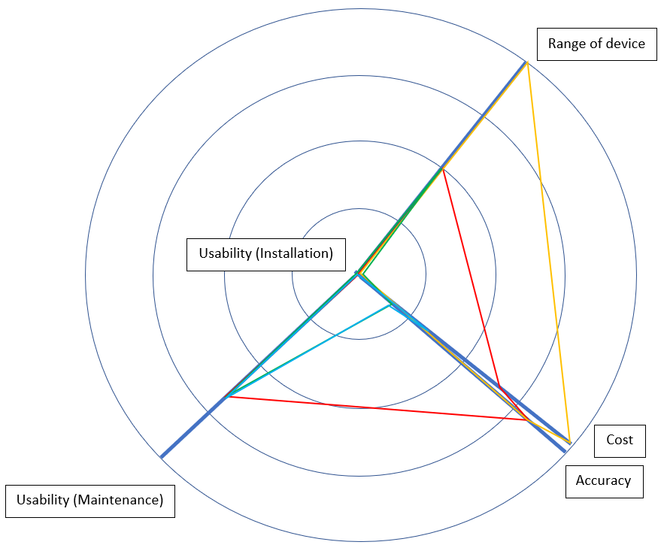
Ratiometric opacity
Standard opacity
Back scatter laser
Forward scatter laser
Figure A 5-2 Multi Criteria Decision Analysis GAIA web graph for stack diameters of
3 m – 8 m
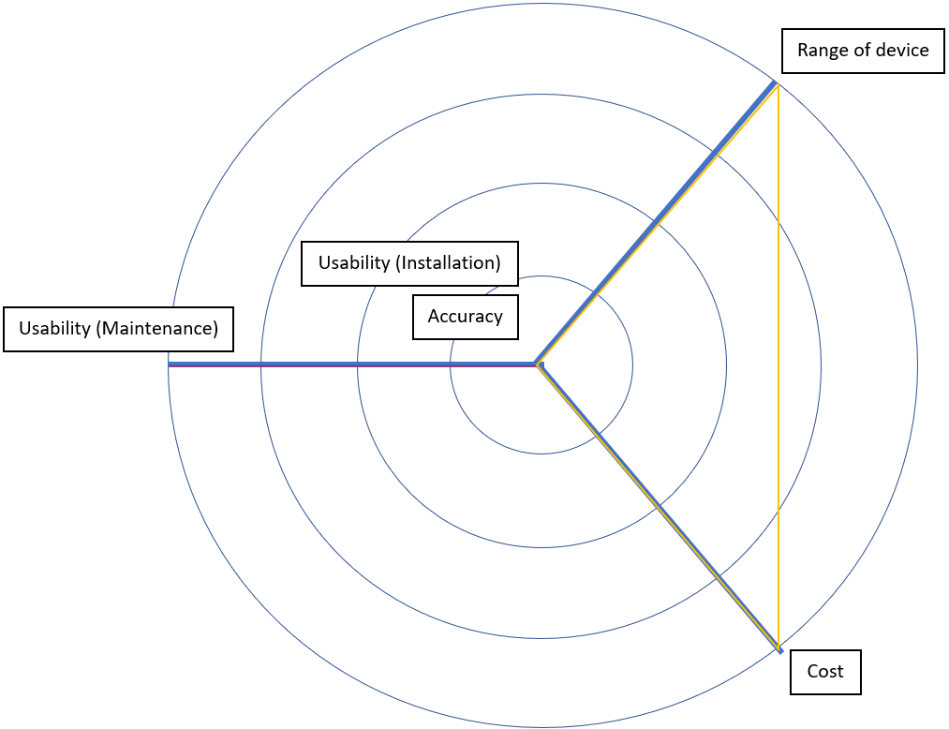
Ratiometric opacity
Standard opacity
Figure A 5-3 Multi Criteria Decision Analysis GAIA web graph for stack diameters of
8 m – 18 m
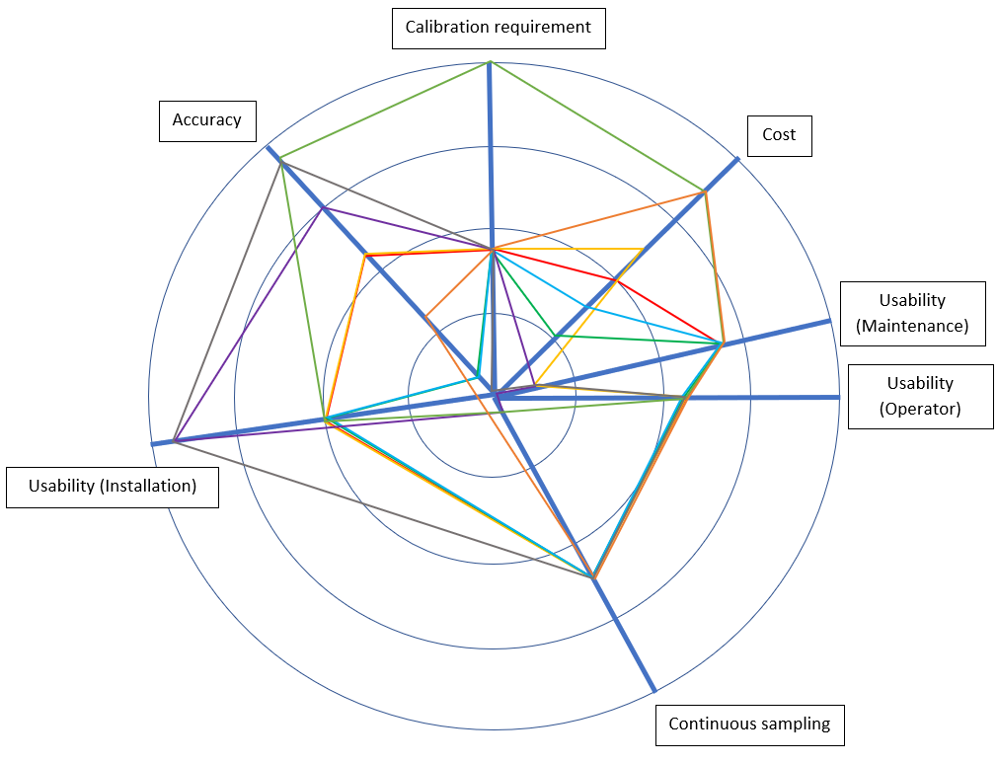
Ratiometric opacity
Standard opacity
Back scatter laser
Forward scatter laser
Beta attenuation
Standard reference method
Triboelectric probe
Electrodynamic probe
TEOM
Figure A 5-4 Multi Criteria Decision Analysis GAIA web graph for concentrations of
0 mg/m³ – 200 mg/m³
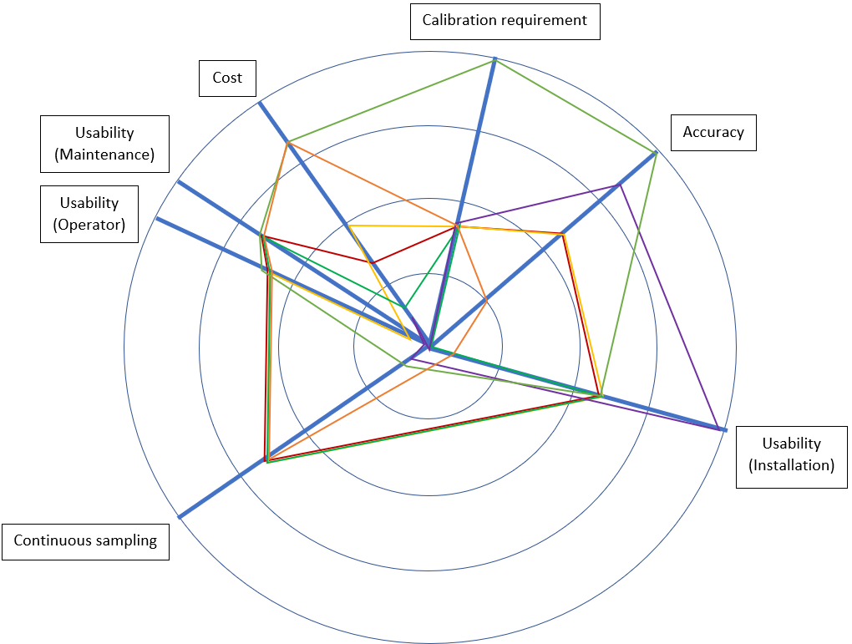
Ratiometric opacity
Standard opacity
Back scatter laser
Forward scatter laser
Beta attenuation
Standard reference method
Triboelectric probe
Electrodynamic probe
Figure A 5-5 Multi Criteria Decision Analysis GAIA web graph for concentrations of
200 mg/m³ – 1,000 mg/m³
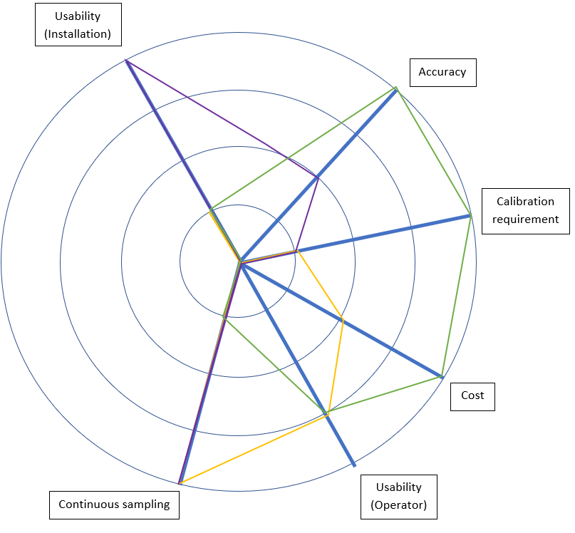
Standard opacity
Beta attenuation
Standard reference method
Figure A 5-6 Multi Criteria Decision Analysis GAIA web graph for concentrations of
1,000 mg/m³ – 10,000 mg/m³
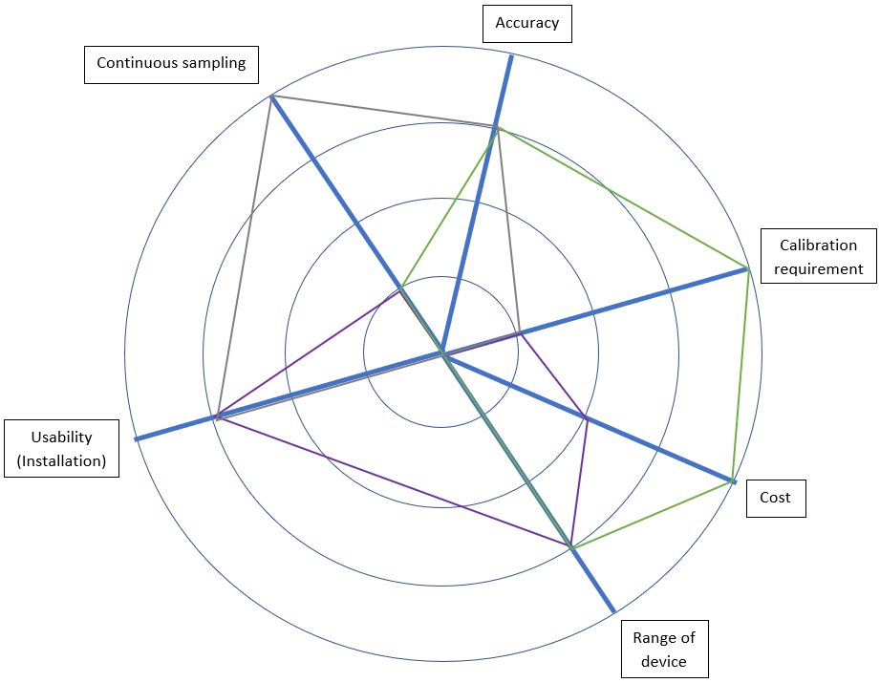
Beta attenuation
Standard reference method
TEOM
Figure A 5-7 Multi Criteria Decision Analysis GAIA web graph for processes with changing conditions
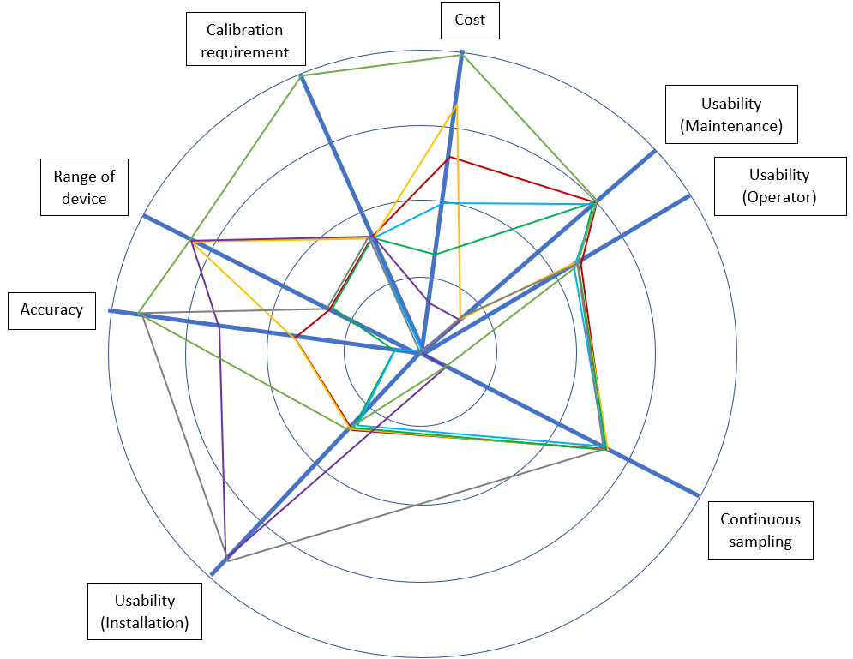
Ratiometric opacity
Standard opacity
Back scatter laser
Forward scatter laser
Beta attenuation
Standard reference method
TEOM
Figure A 5-8 Multi Criteria Decision Analysis GAIA web graph for processes with changing velocity
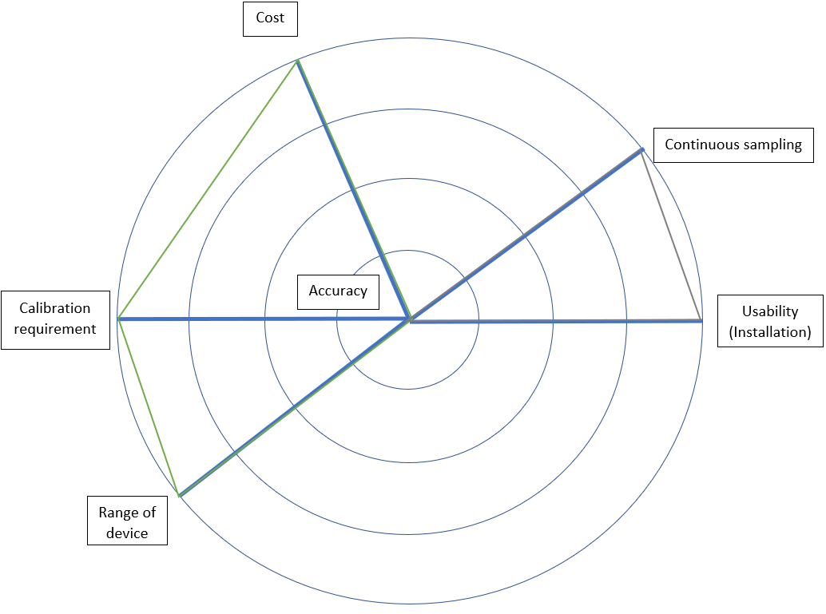
Standard reference method
TEOM
Figure A 5-9 Multi Criteria Decision Analysis GAIA web graph for processes where
chemical analysis is required

