The design, development and pilot study of a marine ecological simulation for education of environmental changes on marine life
David White¹[0000-0002-7095-8658], Robert Stone² [0000-0001-8871-2309] and Deborah Cracknell³[0000-0002-9794-8564]
¹ Staffordshire University, UK
² University of Birmingham, UK
³ University of Plymouth, UK
Abstract. A “serious game” simulating examples of marine life found at the artificial reef ex-HMS Scylla has been developed to demonstrate the impact of environmental changes. The game has been adapted from prior research into agent-based models of marine ecologies. The design of the game considers the abstraction and presentation of marine life, and the effect of environmental changes. Two simulations are performed: one exposing the ecology to the effects of climate change, and another which simulates the introduction of microplastics. A pilot study measured knowledge-recall for simulations with open and closed-ended questions, user awareness of environmental issues and future game design preferences. This research contributes by both demonstrating the conversion of a complex marine simulation to a game format, and also emphasises the potential of the simulation journey to learning and engagement.
Keywords: Serious Game, Agent-Based Model, Educational Simulation, Marine Ecology.
- Introduction
“Serious games”[1] offer unique insights into teaching and communicating the impacts of environmental change [2]. When deriving serious games from simulations, they provide not only the opportunity for users to understand the outcomes or result of a simulation, but also to experience firsthand the impacts of their choices within the simulation. Here, we will highlight the importance of the user’s journey and the learning process.

This pilot study develops a serious game, simulating a marine ecology scenario using an agent-based model. The game is adapted from prior research into complex simulations derived from peer-reviewed marine biology research.. We have collected data which measures how participants recalled simulation events, participant exposure to environmental issues, and preferences for future game design.

Agent-based modelling (ABM) is a method for simulating complex models which has been growing in popularity [3]. A serious game using an ABM framework can enable users to see how, during a game, changes to agents and their environment can alter the balance of species populations. Further, ABMs are particularly suited to modelling and understanding marine ecologies and the environmental changes which affect these. Earlier work by Stone [4] examined the potential for serious games to raise awareness of an artificial reef project “launched” in 2004 with the ex-Royal Navy vessel HMS Scylla; the Scylla reef is a context for this work. Serious games have the potential to permit the exploration of complex systems that would be impractical or unsafe in the real-world [5]. A serious game with an environmental message can also engage with the public at a lower cost than traditional marketing campaigns [6].

There is much prior work in games of marine ecologies. Ameerbakhsh [5] designed a serious game relating to fishery stock management. Their research concludes that, while students enjoyed the experience of using the game, the expert demonstration was more effective for learning effectiveness. Rossanno, in a pilot study [7][8], demonstrates a cartoon-style game to promote environmental attitudes to children to promote more sustainable behaviour. Rossanno focusses on feedback from primary school-aged children and examines whether participants liked the look and feel of the game as well as learning outcomes. Similarly, Panagiotopoulou [9] discusses the design of a serious game for children, specifically to raise awareness of plastics pollution.

Although such serious games have been increasingly used as educational tools, their use has mostly been restricted to relatively simple games. Although informative, they often overlook marine ecologies' complexity. Addressing this gap, this pilot project aims to incorporate complex simulations into a game, allowing users to see for themselves how environmental changes can cause population shifts.

Converting an existing ecosystem simulation into a game comes with the advantage that much of the groundwork has been done, making the process of creating accurate, yet understandable educational games a feasible goal. As Narayanasamy [10] discusses, both simulation games and serious games are engaging, challenging, and enjoyable to play, which suggests that converting simulations into games is a rational case for action.

The marine ecology simulations used to develop the game originate from research into artificial life models in which it was studied how complexity affects the outcome of simulations [4, 11, 12].
To evaluate the goals of this study, the following questions will be considered:
- What are the challenges when abstracting a complex marine ecosystem to an educational game?
- What are the challenges when developing complex models to measure various environmental effects?
- As a pilot study, what can we learn from participant feedback?
  - Is there a difference between the recall quality between open and closed questions, and what implications does this have for the future design of this game?
  - Does participant recall differ for different environmental scenarios? What opportunities does this present for future work?
  - What would participants like to see in future iterations of the game?
- Methodology
The research leading to the analysis of collected data was carried out in two stages: the modification of the simulation code to a game, and the pilot study where the data was collected. The simulation code is the result of prior research [11, 12] which examined how complexity influences the outcomes of simulations of marine ecosystems found at the Scylla reef [13]. Details of the marine life found at the Scylla reef were taken from a variety of sources but mainly from the MarLIN database [14]. A limitation at this stage is that the game, other than moving the camera and navigating the scenes, has little user interaction, which will be addressed in future work.

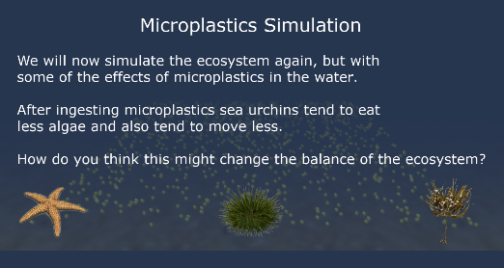
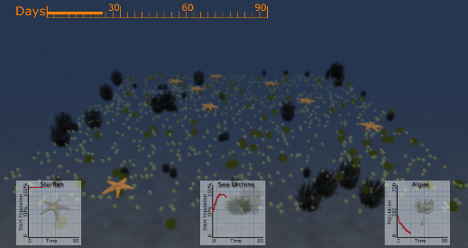
The game in this study has been developed over two iterations. The first iteration was developed in collaboration with the National Marine Aquarium as a demonstration for school children to show how artificial life can simulate climate change, and how this affects the balance of marine ecologies. The second was to introduce a further environmental effect to collect data for the pilot study.
Fig. 1. The Scylla Game – a pre-simulation tutorial, and the simulation in progress
The game takes the player through a series of steps in three scenarios: a baseline simulation, one with warmer sea temperatures representing climate change, and finally a simulation in which species ingest microplastics [15]. Three species are modelled: starfish, sea urchins and algae. The interactions between the species can be summarised as: starfish predate sea urchins, sea urchins graze on algae, algae grow. Too many starfish and the sea urchin population would be removed, resulting in growth of algae but the eventual demise of a starving starfish population. Too many sea urchins would lead to overgrazing of algae, a healthy population of starfish, but the eventual collapse of the sea urchins through lack of food source. Fig. 1 illustrates two screenshots from the game.

The player sees first-hand how an imbalance can lead to the collapse of the system. Climate change brings warmer temperatures resulting in increased predation and algae growth; microplastics discourage sea urchins from consuming algae, resulting in starvation. Both scenarios cause changes to population mixes - the educational message is that ecosystems evolve to balance, irregular environmental changes result in unpredictable and complex outcomes.

The pilot study measures how participants recalled information for both simulations, as well as recording prior exposure to these topics in the media. Data was collected at the free-to-attend Potteries Museum in Stoke-On-Trent, UK. All participants were aged 18 and over. 22 participants viewed the game demonstration and recorded their observations. The journey of a participant was as follows:
- The researcher would explain how the game simulates marine life at the Scylla Reef, and that three simulations would be presented.
- The game screen would detail the three species: sea urchins, starfish and algae.
- The baseline simulation would run, the researcher would point out the species, their interactions, and graphs showing species populations.
- To avoid recall bias, environmental change scenarios would run in random order.
- In each case the researcher would discuss the scenario behaviour and outcomes.
- After the game ends participants are asked to complete the questionnaire.
Table 1. Questionnaire completed by participants following demonstration of the game.
Q 1: Can you remember what happened to the sea urchins and the algae during the simulation which considered climate change? (open text)
Q 2: Can you remember what happened to the sea urchins and the algae during the simulation which considered the impact of microplastics? (open text)
Q 3: Can you remember what happened in the first simulation? (multi-choice)
Q 4: Can you remember what happened in the simulation which considered climate change? (multi-choice)
Q 5: Can you remember what happened in the simulation which considered microplastics? (multi-choice)
Q 6: How often do you remember hearing about climate change in the news and in media such as the internet and TV? (Likert scale options)
Q 7: How often do you remember hearing about microplastics in the news and in media such as the internet and TV? (Likert scale options)
Q 8: Do you think an individual in the UK can help to prevent further environmental changes due to climate change in the UK? (Likert scale options)
Q 9: Do you think an individual in the UK can help to prevent further environmental changes due to microplastics in the UK? (Likert scale options)
Q 10: How would you prefer the game to be developed further? (multi-choice)
- Results
Questions 1 and 2 were marked out of two, for two correct observations, incorrect observations were not penalised. Questions 3 to 5 required two specific correct answers, and although participants were not told how many were correct, all participants ticked either one or two answers, whether they were correct or not.

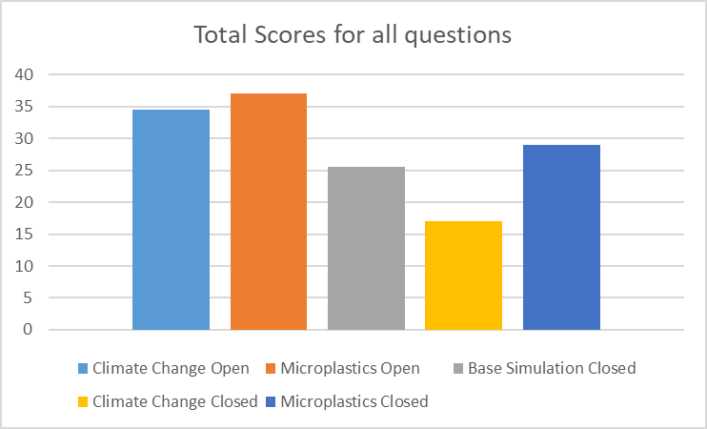
Fig. 2. Total Scores for all questions for all 22 participants (scores out of 44)
Fig. 2 shows the total scores for all questions. Questions were out of two, therefore with 22 participants the total score for each question was out of 44. Both open questions scored higher than their closed equivalents, and the climate change questions scored less well than the microplastics questions.

Unsurprisingly, with climate change being a broader subject with global implications, participants reported hearing about it more frequently than microplastics. Over 50% of the participants recalled hearing about climate change several times per week, compared to under 25% for microplastics. This contrast suggests that prior knowledge of environmental issues doesn't necessarily impact recall after a demonstration.

Participants’ views on their perceived agency to affect climate change and microplastics were perhaps surprising considering the disparity in the exposure to hearing about the issues in the news. Only two participants responded as having no influence over climate change and microplastics, whereas twelve and seven participants felt that they had some, or a lot of, influence, respectively.

Finally, when asked about potential improvements to the game, participants' views were divided into two distinct categories. Five participants felt the game was adequate as is or could benefit from more media-based instruction. Most participants (15 out of 22) expressed a desire for more complexity and suggested adding more simulations or user-controllable parameters to explore various outcomes.
- Conclusions and Further Work
This study provides insights into two key areas: the challenges inherent in converting simulations into games, and insights derived from participant questionnaires.

One key challenge is that the complexity of the model used in this study remains largely hidden from the observer. A great deal of behavioural interaction between agents remains obscured from the user and demonstrates the difficulties in demonstrating complex interactions and behaviour. Another challenge is avoiding catastrophic collapses in species populations and maintaining a balance between species. User feedback indicates they desire greater control over the game, but more user agency may lead to a feeling that balancing a system is too difficult. However, this may improve learning outcomes and engagement. Another challenge we encountered during the research leading up to this study was the interpretation of marine biology papers for conversion into ABMs. Papers sometimes tend to discuss the aggregated effects on a system, but not the individual, although there are papers which do this.

The method and benefit of open and closed questions in questionnaires is well documented topic [16]. Farrell [17] writes that open questions allow the user to project their ‘own’ answer. This raises the question: how do we know what a user is learning? This may be more uncertain when users have more control over a game.

Results demonstrated greater recall for participants when asked questions on microplastics compared to climate change. This could be a case of being introduced to a new, novel, concept [18]. It might also be the case however that microplastics are a factor that participants can control – one can immediately stop using microbeads but influencing climate change is a far loftier goal. This may indicate greater user motivation for issues they can easily control.

The goal of this pilot study was to demonstrate that the prior model could be used to simulate multiple environmental effects in a game-like format. This, in the context of the research questions, was a success, and may in turn motivate other developers of complex models into serious games.

Future work could consider the following:
- The additional development of the program in this study to allow users to modify environmental parameters, species ratios and species behaviour.
- What are user preferences when given greater command over a game, versus a variety of scenarios developed with ecosystem stability in mind?
- What value is there for such a simulation to be acquired by marine biologists for their work? Could policymakers benefit? Can it drive user behavioural change? This would build on work by Westera [19]

Ethics Statement
The study in this work was subjected to an approved ethics review by Staffordshire University, reference number SU_22_066.

References
1. Susi T, Johannesson M, Backlund P (2007) Serious games: An overview
2. Flood S, Cradock-Henry NA, Blackett P, Edwards P (2018) Adaptive and interactive climate futures: systematic review of ‘serious games’ for engagement and decision-making. Environmental Research Letters 13:63005
3. Sun Z, Lorscheid I, Millington JD, et al (2016) Simple or complicated agent-based models? A complicated issue. Environmental Modelling & Software 86:56–67. https://doi.org/https://doi.org/10.1016/j.envsoft.2016.09.006
4. Stone R, White D, Guest R, Francis B (2009) The Virtual Scylla: an exploration of “serious games”, artificial life and simulation complexity. Virtual Real 13:13–25. https://doi.org/10.1007/s10055-008-0111-0
5. Ameerbakhsh O, Maharaj S, Hussain A, McAdam B (2019) A comparison of two methods of using a serious game for teaching marine ecology in a university setting. Int J Hum Comput Stud 127:181–189. https://doi.org/https://doi.org/10.1016/j.ijhcs.2018.07.004
6. Trybus J (2015) Game-based learning: What it is, why it works, and where it’s going. New Media Institute 6:
7. Veronica R, Calvano G (2020) Promoting Sustainable Behavior Using Serious Games: SeAdventure for Ocean Literacy. IEEE Access 8:196931–196939. https://doi.org/10.1109/ACCESS.2020.3034438
8. Rossano V, Roselli T, Calvano G (2018) A Serious Game to Promote Environmental Attitude. In: Uskov VL, Howlett RJ, Jain LC (eds) Smart Education and e-Learning 2017. Springer International Publishing, Cham, pp 48–55
9. Panagiotopoulou L, Gayarre NC, Scurati GW, et al (2021) Design of a Serious Game for Children to Raise Awareness on Plastic Pollution and Promoting Pro-Environmental Behaviors. J Comput Inf Sci Eng 21:
10. Narayanasamy V, Wong KW, Fung CC, Rai S (2006) Distinguishing Games and Simulation Games from Simulators. Comput Entertain 4:9–es. https://doi.org/10.1145/1129006.1129021
11. White D (2008) Developing Artificial Life Simulations of Marine Biology and Exploring Measures of Complexity. In: 2008 Second UKSIM European Symposium on Computer Modeling and Simulation. pp 232–235
12. White D (2007) Variance in Water Temperature as a Factor in the Modelling of Starfish and Mussel Population Density and Diversity. In: Almeida e Costa F, Rocha LM, Costa E, et al (eds) Advances in Artificial Life. Springer Berlin Heidelberg, Berlin, Heidelberg, pp 153–162
13. Hiscock K, Sharrock S, Highfield J, Snelling D (2010) Colonization of an artificial reef in south-west England—ex-HMS ‘Scylla.’ Journal of the Marine Biological Association of the United Kingdom 90:69–94
14. Hiscock K, Tyler-Walters H (2006) Assessing the sensitivity of seabed species and biotopes–the Marine Life Information Network (MarLIN). Hydrobiologia 555:309–320
15. Wright SL, Thompson RC, Galloway TS (2013) The physical impacts of microplastics on marine organisms: A review. Environmental Pollution 178:483–492. https://doi.org/https://doi.org/10.1016/j.envpol.2013.02.031
16. Schuman H, Presser S (1979) The Open and Closed Question. Am Sociol Rev 44:692–712. https://doi.org/10.2307/2094521
17. Farrall S, Bannister J, Ditton J, Gilchrist E (1997) Open and closed question. Interpretation 3:2–9
18. Schomaker J, van Bronkhorst ML v, Meeter M (2014) Exploring a novel environment improves motivation and promotes recall of words. Front Psychol 5:918
19. Westera W (2017) How people learn while playing serious games: A computational modelling approach. J Comput Sci 18:32–45. https://doi.org/https://doi.org/10.1016/j.jocs.2016.12.002

Here ‘marine biology’ research refers to both biology and ecologies by experts in the field.

