Raising Voices: Sharing Stories Through Lived Experience

Ryan Fox, Phil Parkes, Lynne Ball, Simon Bamford, Stacey Hancock, Steve Harding, Justina Heffton, Tracy Knight, Steve Porter, Rebecca Smith, Jennifer Spice

Introduction
The impact of poverty and hardship is felt by many across the world. The issue too is felt by the people of Stoke-on-Trent, which Etherington, Jones, Telford, Harris, and Hubbard, (2023) explain sits in the 20% most deprived areas in England and around 12,660 children live in low-income families. Austerity is the main driver towards long-term cuts to public services and health, with the life expectancy for both men and women being lower than the England average. Figures such as these are important to provide an overview of the situation impacting a community but may fail to dive into the significant and complex trade-offs that come with lives impacted by inequality- the story behind the figures.
This chapter will explore the story of the Stoke-on-Trent-based Raising Voices, Changing Minds, Ending Poverty project, and its steering group, which combined community lived and learnt experiences with creativity, empowering others to share stories and experiences of poverty and hardship. Additionally, the chapter will outline the importance of co-creation and creative choice in project design and output.
This chapter has been written in collaboration with The Raising Voices Steering Group.

What was Raising Voices
Raising Voices, Changing Minds, Ending Poverty (simply known as Raising Voices) ran from October 2021 to March 2022, to shed light on the issue of poverty and hardship in Stoke-on-Trent, by amplifying the lived experiences of local people. It aimed to add meaning and ‘face’ to statistics as well as increase awareness of the day-to-day trade-offs of hardship, which face local people. Funded by the National Lottery Community Fund and commissioned by VOICES on behalf of the Hardship Commission, the project involved three main project partners: All the Small Things Community Interest Company (CIC), Expert Citizens CIC, and Staffordshire University.
Importantly to this was the Raising Voices Steering Group which was made up of people living locally, that had a lived experience or perspective of hardship and poverty. The steering group informed decisions and choices made throughout the project.
Although not focused on research, the heart of the project drew on principles of participatory action research (PAR) to enable the voices of local people to be heard effectively, as well as maximising the power held within the steering group. This allows projects to be done with, by and for people with lived experiences of a topic (Lenette, 2022). Brydon-Miller Et Al (2003, p.14) argue that PAR can:
“provide people with the support and resources to do things in ways that will fit their own cultural context […] The people, we knew, not the experts should be the ones to determine the nature and operation of the things”
The project aimed to achieve this through three key aspects of its delivery and output.
- The Raising Voices Steering Group
- Creative Sessions
- Manifesto for Change
These were reinforced by a social media campaign that ran through The Hardship Commission’s social media pages. In total it reached 5,817 people on Facebook and received 29,300 reactions on Twitter (The Raising Voices Steering Group et al., 2022).

A history of working in participatory ways
The project delivery teams from All the Small Things CIC, Expert Citizens CIC, and Staffordshire University have their own expertise in working with communities in participatory ways and previous collaborations between these project partners paved the way for the Raising Voices Steering Group to make decisions on the project.
In 2019, Staffordshire University led the research project ‘Get Talking Hardship’, which investigated poverty and hardship in Stoke-on-Trent by recruiting a team of community researchers, which were trained in Staffordshire University’s approach to PAR, ‘Get Talking’, that instils creative tools in its methodology for community consultation. Results from the project included raising awareness of hardship and poverty in the local area, as well as changing the terms of reference for the Hardship Commission (Gratton et al., 2019).
In 2020, ‘Keep Talking’ (Gratton, 2020; Gratton, Fox, Elder, 2020) worked with members of the Get Talking Hardship community research team and Expert Citizens CIC as partners to explore how universities and community partners can create structures for sustainable long-term place-based research. From this, a partnership agreement for future work between Staffordshire University and Expert Citizens CIC offered:
“a more sustainable and far-reaching model for placed based research in Stoke-on-Trent and provides opportunities for connections between the work of the Hardship Commission and others” (Gratton, 2020)
The resulting action from this was the commencement of the Raising Voices, Changing Minds, Ending Poverty project in 2022.

The Raising Voices Steering Group
The Raising Voices Steering Group brought together lived and learnt experiences of hardship and poverty in a collaborative partnership, totalling twelve people. All of which were paid for their time throughout. The strength of the project came from the approach taken in the make-up of the steering group, ensuring collaboration amongst parties who are dedicated to the same fight. The reality of working in unison between community and academic knowledge allowed things to be explored in a non-linear way, aiming towards a shared goal by combining lived experience with academic know-how.
The steering group were a necessity to enable this to happen, bringing lived and learnt experience centre stage and informing project decisions and sessions.
At steering group meetings, it was clear that there was a powerful dynamic, bringing together experience, familiarity, and freshness of perspective and opinion. Sometimes, projects involving universities can alienate communities due to a perceived ‘ownership’ which is tied to ‘knowledge’. However, the strength of taking a participatory approach, as seen in the steering group, enables a challenge to ‘elitist’ academics by increasing community members' and partners' ownership of project processes, findings, and outputs. These are legitimised by their community grounding, which is not reliant on academic prowess (Oliver et al., 2019). For some members of the community, academia can seem like a ‘cloud castle’, especially if they have previously not had a great experience with education. This means that it is even more important for universities to apply their ‘power’ appropriately, with communities enabling this to happen, as described in conversation with steering group members:
“The university was perhaps the battering ram, but it needed people with community knowledge to be able to push that along to make the impact and smash the doors down”.
The powerful insight of a lived experience perspective allowed the project to remain grounded in reality but also allowed steering group members' expertise and interests to be explored in an asset-based way. This focused on what could be done, rather than what couldn’t.
The base of assets available throughout the steering group enabled the diversity of options to be present in community settings. Barret (2013) highlights the value of being asset-based in approaches to participatory work, adding that areas experiencing multiple deprivations, like Stoke-on-Trent, may easily slip into focusing on what is lacking as a community rather than focusing on the ‘hidden’ skills, talents, and resources apparent in communities.
The free nature of the steering group environment let ideas grow, resulting in different ways of gathering stories from the local community, including poetry, postcards, photographs, a podcast, a wellness session, video interviews and storytelling through clay. Adopting an asset-based approach to consultation and story collection, empowered steering group members by building on their skills and interests, enabling community voices to be heard.
The nature of the group was described as an ‘informal form of social prescribing’ by some members, providing and meeting the practical, social, and emotional needs of the group. Thomas, Lynch and Haf Spencer (2021) outline that an environment of co-production and co-design goes hand in hand with social prescribing and fosters a culture of involved engagement rather than passive usership. Additionally, the creation of equal relationships, supported by non-traditional models, is essential. These processes provide a ‘transformative process’ due to the removal of barriers like hierarchy and distrust. This is echoed by a quote from a steering group member:
“It was open, honest, transparent, and an enthusiastic way of sharing information. It’s beautiful, to be part of the osmosis of information, free-flowing both ways and beyond. […] Literally, we are weaving the fabric of community together organically with empathy and kindness to pass the word on”
However, at times the project could have benefitted from more ‘steer’ from the project delivery teams. This critique is based on the amount of time that project development took, negatively impacting the period that could be spent on the delivery of sessions and the collection of community stories. With this in mind, it is still important to outline that the steering group experience was a positive one, which empowered individuals, enabled asset-based avenues to creativity and storytelling to be explored and allowed lived and learnt experiences to sit centre stage in action coming out of the steering group.
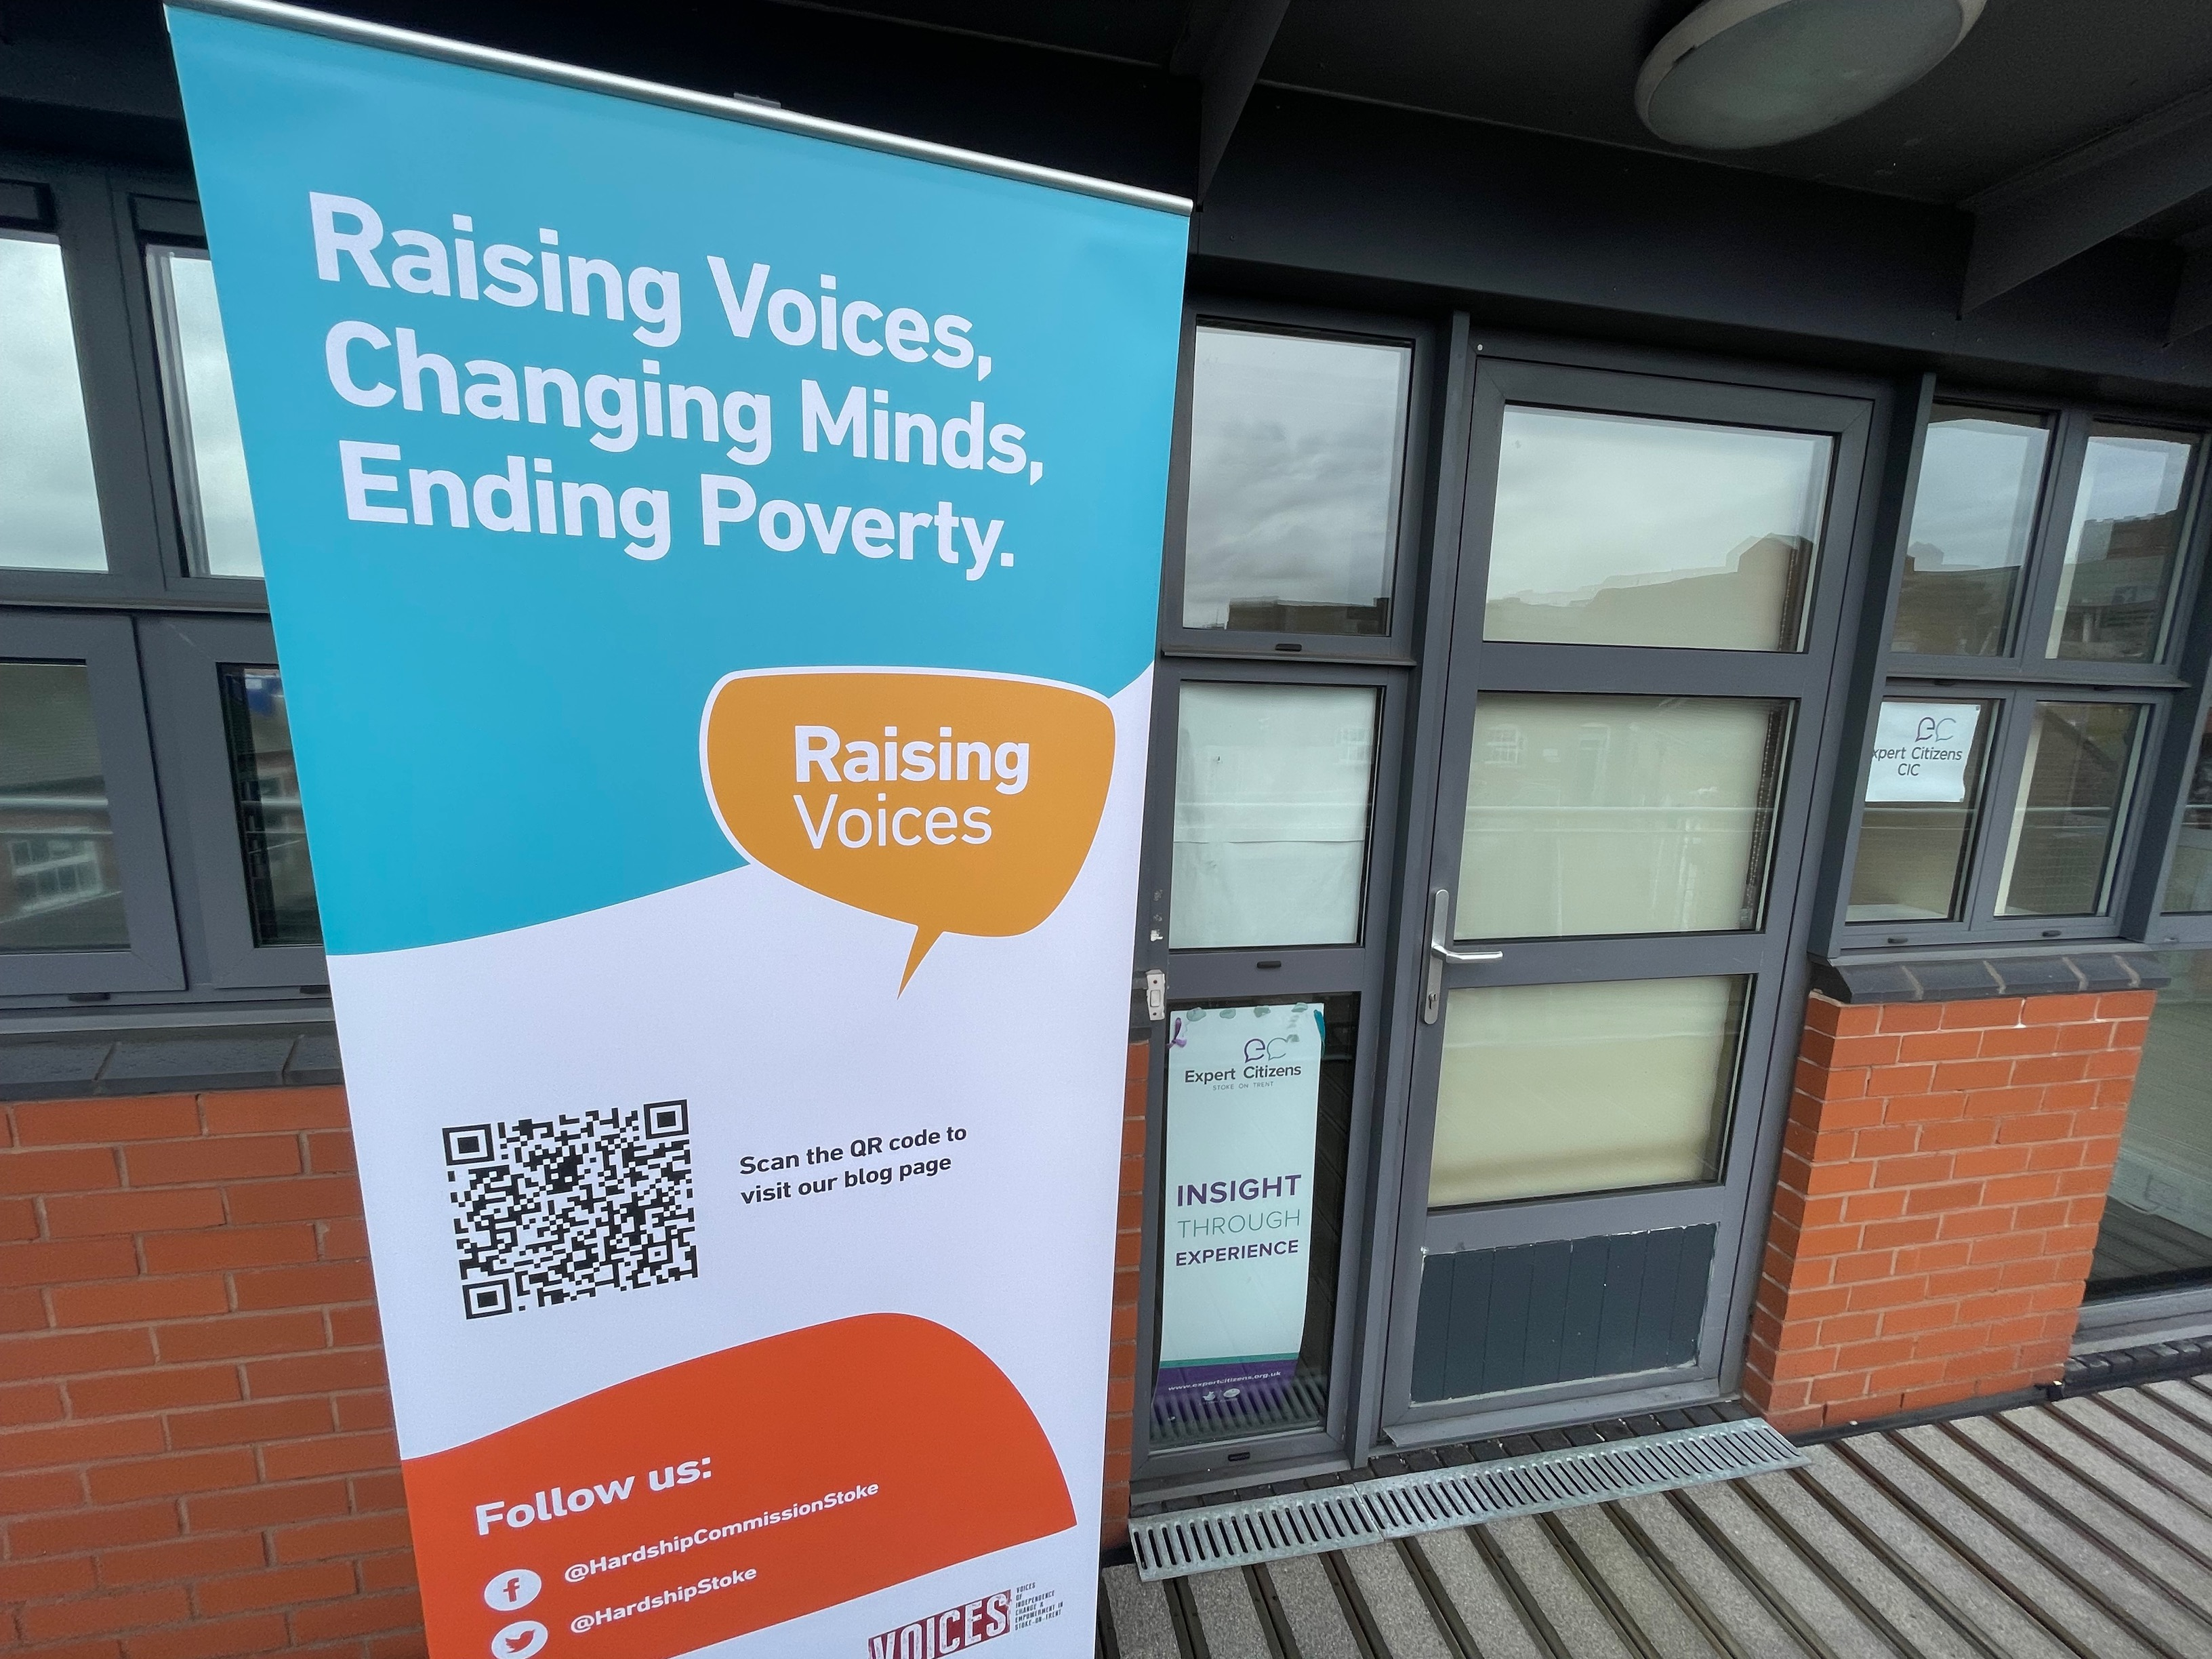
A picture from a Raising voices Steering Group meeting in February 2022, at Expert Citizens CIC (2022).

Creativity
Creativity was used to explore the narrative of community voices, enabled by the skills and expertise held in the steering group. Narratives were explored during creative sessions and activities, which drew on expertise held in the steering group. The purpose of the creative sessions was to allow multiple ways for community voices to be shared and amplified through the project’s social media campaign and exhibition. In total 211 community members took part in these during the project (Gratton, 2020).
The value of the stories did not hinge on creativity but instead gained value through open opportunities for discussion, facilitated by creative sessions. Rather than creativity being the main methodology, it was an avenue to assist discussion. People could still tell their stories in a conversational way, as well as share experiences with others during project activities, such as how a steering group member described the co-delivery of the wellness session:
“I could sort of relate to people and talk about my own struggles with addiction and health but then also channel my studies through into that as well”

Overview of creative sessions and activities

Wellness Session

The session focussed on wellness and staying well whilst experiencing hardship, by drawing on the lived experiences, and academic studies, of two steering group members. Here, an open community platform was created for people to share their barriers to staying well and identify and share what people had done to support themselves whilst experiencing hardship, to make a positive difference in their circumstances.
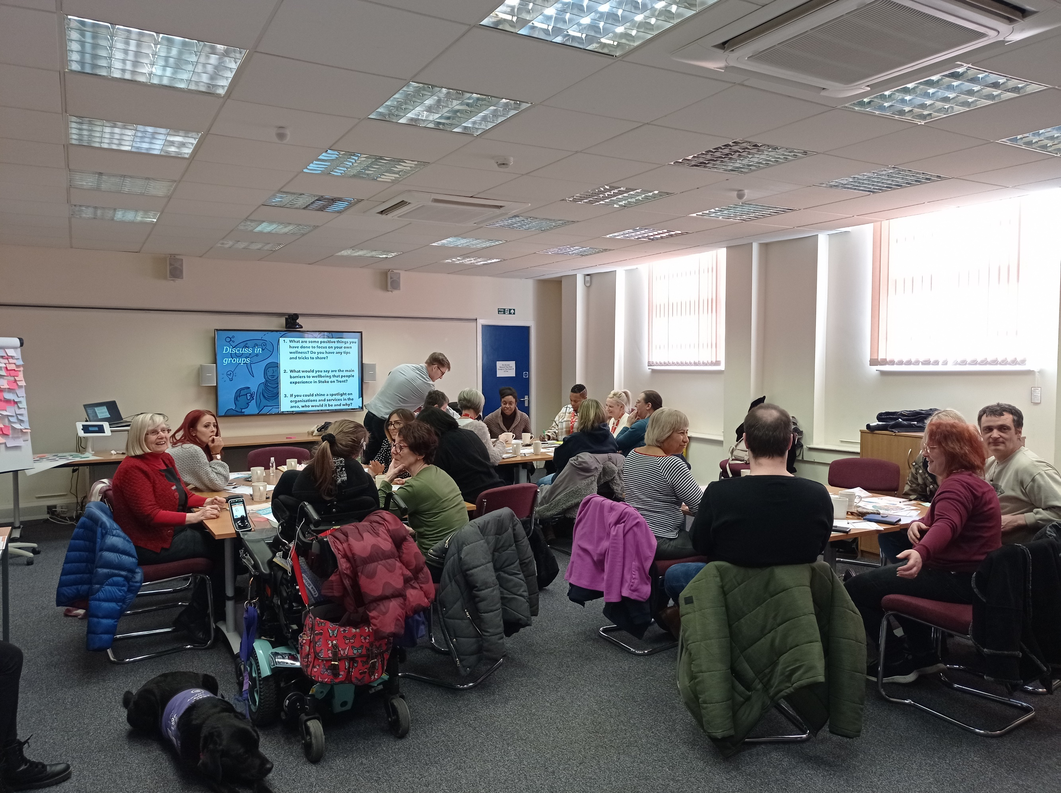
A picture from the Wellness session held in March 2022 at The Duson Centre, Stoke-on-Trent (2022).

Video Interviews
Organised by Expert Citizens CIC, the video interviews captured the experiences and feelings towards hardship, from the Raising Voices Steering Group and project delivery team. This video was then shared for the first time at the end of project exhibition and on social media following this. Although this did not capture an external community voice, it captured the voices of people working on the project and reflected their intent to act against poverty and hardship.

Postcard
The postcard was co-designed alongside the steering group. It was a remote way of gathering stories from community members, posing the question ‘What does hardship mean to you?’. For effective use in the community, a kit was created, containing the postcard, instructions on how to complete and return it, envelopes, stamps and creative materials. 70 postcards were collected as part of the project and displayed at the end of the project exhibition.
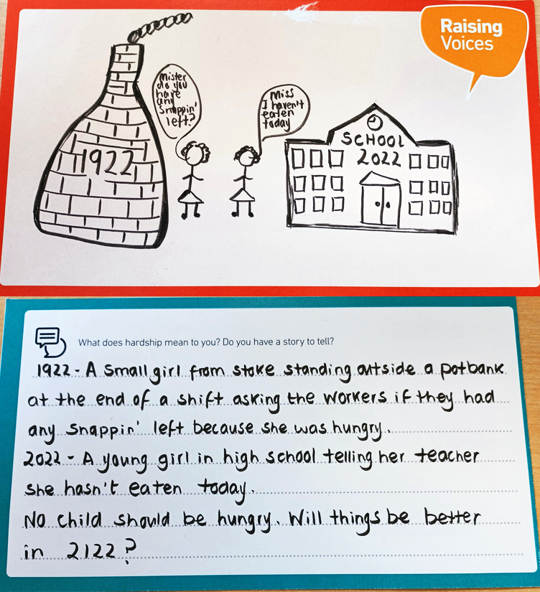
Image 1: “Mister do you have any snappin' left?” (2022)

Photography
Drawing on the expertise held by a steering group member, a photography tips and tricks session was held online. Here attendees could pick up skills for taking images in community settings. These skills were then implemented to highlight hardship in a local community setting during a guided ‘photo walk’ through Shelton, Stoke-on-Trent. 9 ‘photo stories’ were produced from these activities with over 50 photos contributing to the project. The photos and narratives were all displayed at the exhibition.
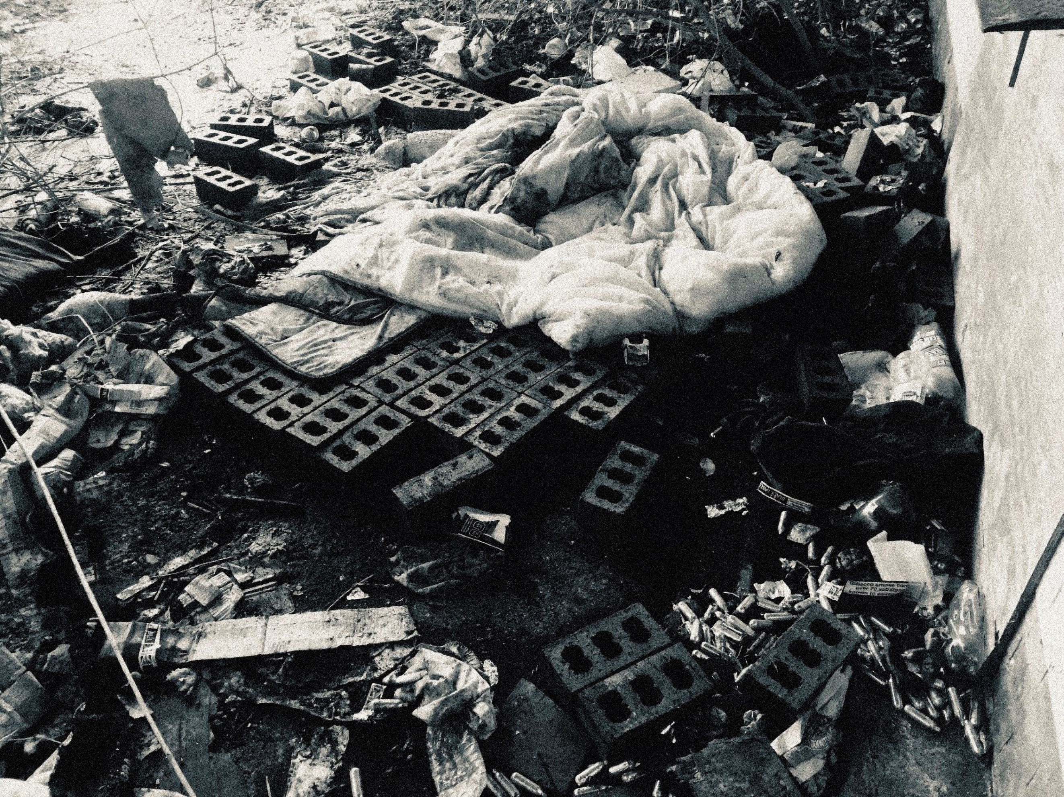
Image 2: “Dereliction”- (Bamford, 2022)

Image 3: “Abandoned”- (Heffton, 2022)

Clay storytelling
Clay’s ability to draw on life-world knowledge to tell stories (Henderson and Zipin, 2010) allowed views of hardship to be explored. Delivered by All the Small Things CIC, this session asked the question ‘What does hardship mean to you?’ allowing people to illustrate their thoughts on a ceramic piece and tell their stories alongside it. A total of 8 storytelling tiles were produced and displayed at the Raising Voices Exhibition.
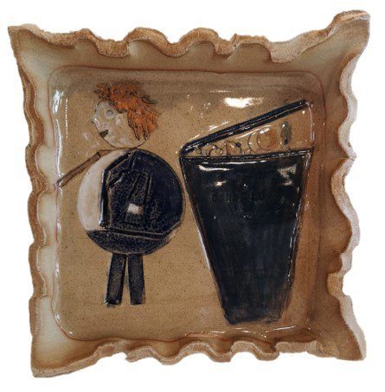
Image 4: “They think its trash”- (Porter, 2022)

Podcasting
The Raising Voices Podcast started from an initial conversation at the first steering group meeting in November 2021. Co-created between members of the steering group and local organisation, The Community Cast, this podcast connected with local people and organisations to talk about addiction and food insecurity in Stoke-on-Trent. The Community Cast supported members of the steering group with the recording and editing processes of the podcast, equipping them with the skills to create more in the future. The first episode was launched at the Raising Voices Exhibition in March 2022.

Poetry
From the expertise of a steering group member, this session combined community voices to create poems based on lived experiences and views of hardship. The session resulted in multiple poems and created the ‘Patchwork poem part 1’ from the collaborative voice of the people that attended the community session, this was presented at the exhibition:
Thrifty tips or 'mentality to survive', mere existence; financial squeeze; constant strain; stick odds and sods of soap together; cut off mould, ok to eat; attack tube for dregs of toothpaste, yet again.
Mask empty desolation; 'cheese only matures, it doesn't go off. One struggles to believe that manifestation; kicks and fun for free is high on implementation; 'googly eyes intent to vandalise', a bit of creative fun; bin at least smiles back at you, in absence of anyone;
Scrimp and save day to day; painful; abrasive to the soul; Raw, raw feeling; hard to reach elusive goal; feel opportunities lacking;
'feel useless and crushed like a smashed cup, duct-taped together, all out of luck;
'poverty? what is that anyway?' many things; 'relate relative' almost hard to say; social mobility; funding (or none) for Communities; people care and share; action creates unity;
No need to be bitter or bland; look to give a helping hand; the game of life is long; the one once; then we're gone; listening; care; voice and share; treat with empathy; implement fair.
(Spice Et Al., 2022)

Assets and Choice
Like Barret mentioned above, for the Raising Voices project, adopting an asset-based approach enabled lived and learnt experiences of hardship and poverty to shine through stories but also emphasise the value of the skills, talents and experiences held in the steering group:
“Sharing my ideas and experience of what helped me to write poetry meant that it could be meaningful and worthwhile for people [who wanted to share their story]”
Engaging in multiple open ways meant that people could find a way of expressing themselves that they were comfortable with. This also ensured that people felt in control of the stories that they were sharing, they had the choice of what to engage with and whether they wanted to engage at all.
On reflection, it is clear to see the importance of choice and the role that it played in allowing conversations to take place, especially considering that uncertainty surrounding personal, social, and economic situations can limit choice (Hansford et al, 2022). Therefore, people with a direct lived experience of hardship and poverty may be limited in the choices available to them to express themselves but also use that expression to influence change. Providing multiple open opportunities to choose from a wide variety of options to tell your story is a valuable asset for allowing people's voices to be heard.
Additionally, the context gained from the lived experience held in the steering group allowed potential issues surrounding the use of creative means of facilitation to be navigated. It was noted that creativity if forced on someone that has experienced, or is experiencing, hardship, can potentially have negative consequences. For some people exploring things in only a creative way may dismiss a story or lived experience as unimportant. Having multiple open choices in how to tell a story avoided a situation of “Poverty is bad, now paint me a picture”.

Image 5: ‘Good’ Life’ (Harding, 2022)

The Raising Voices Exhibition
The stories and creative outputs were displayed at an end-of-project exhibition at Staffordshire University on the 24th and 25th of March 2022. The first date was a launch event for the exhibition where discussions were had with leaders of local community organisations and charities, as well as members of the public. Although an impactful two days, the irony of exhibiting outputs from a poverty and hardship project in a £40 million building was not lost on members of the steering group.
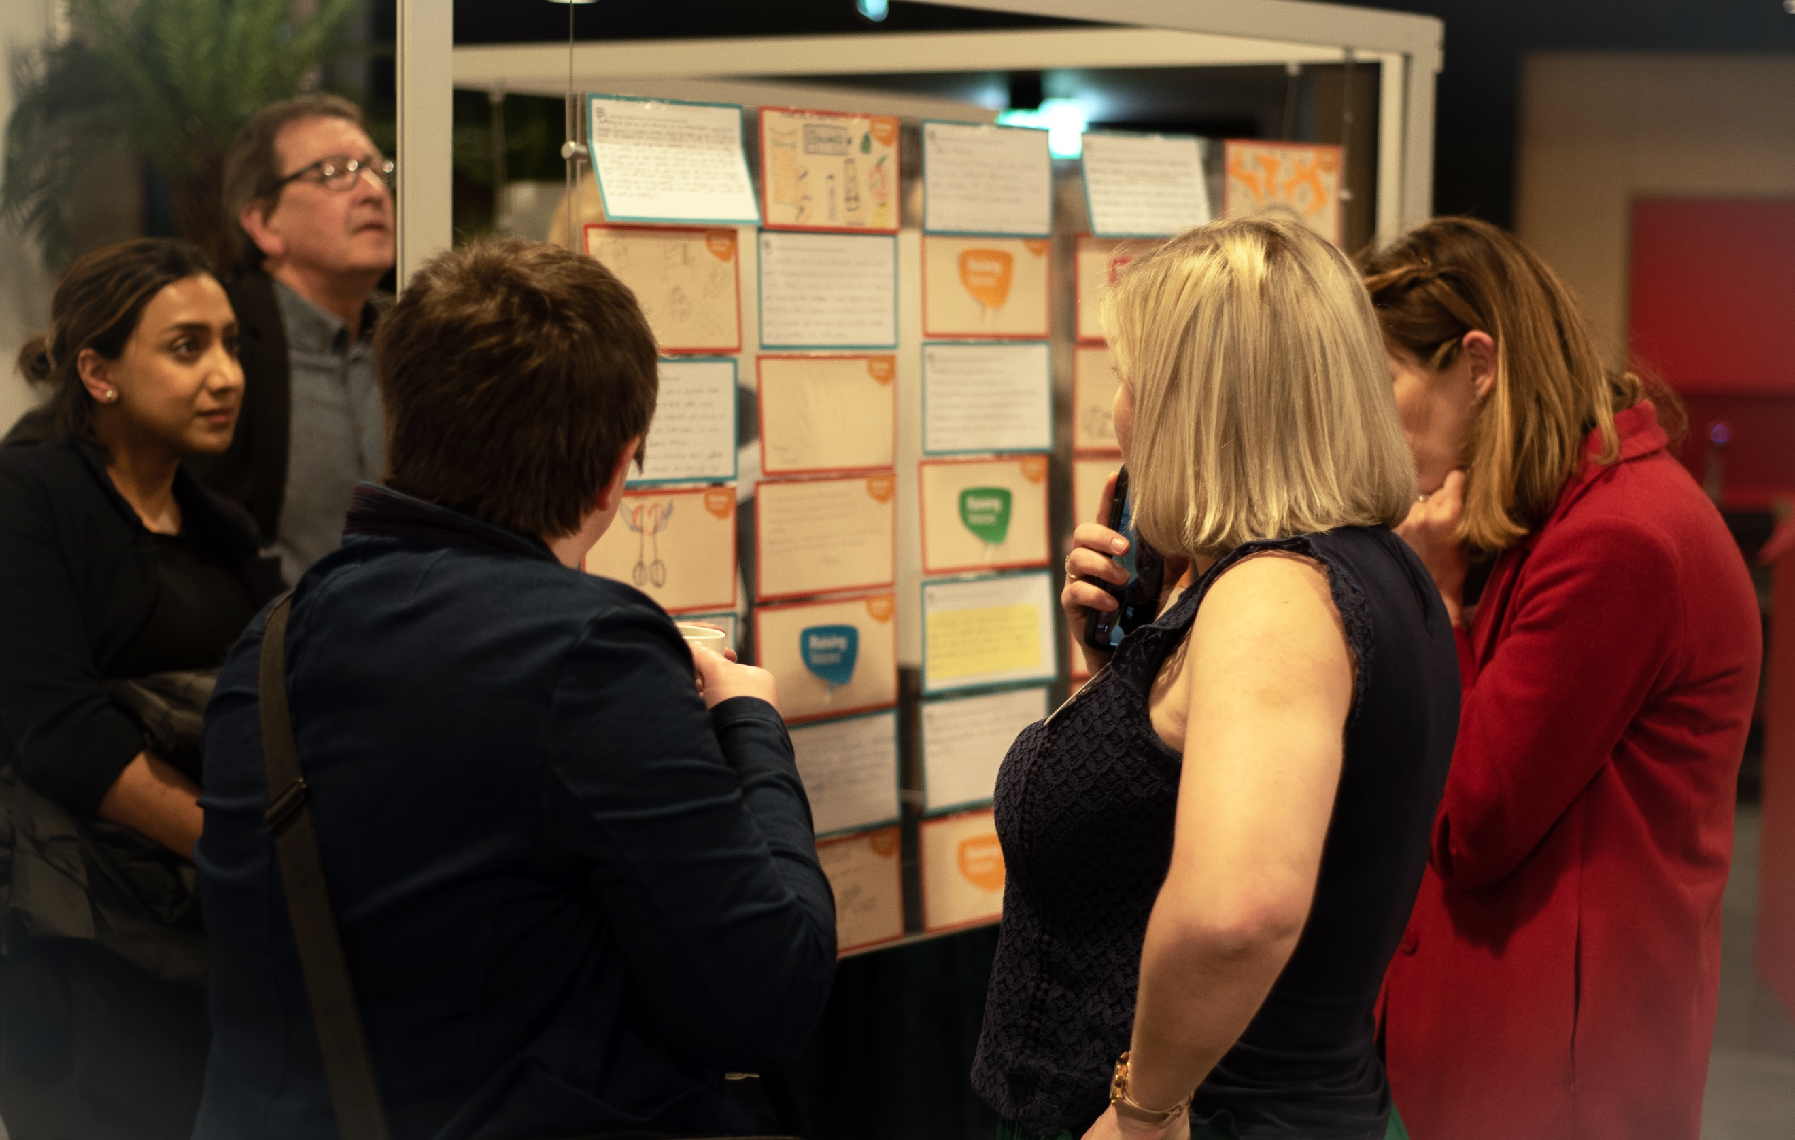
People viewing the postcards and stories at the Raising Voices Exhibition Launch (2022).

In addition to the critique of the location, was the amount of time that the exhibition was able to be on display at the university. Two days in the week meant that it was not viewed by as many people as could have potentially seen it, limiting the impact of the stories to those that were able to attend the exhibition launch on those days. Although the social media campaign that went alongside the project shared outputs and stories from the project, and an online exhibition was formed, this would mean that those unable to access digital formats weren’t able to see the outputs from the project, unless they attended the two-day event.
Although ironic, the ‘prestigious’ setting that the university offered had its benefits. Some members of the community may never have had an opportunity to share their story before, never mind having it contribute to an exhibition. Now someone could say “I’ve had a photo at an exhibition”, That was powerful. Once you put something in a place or a frame it becomes something completely different, it starts to have a life of its own, as well as what that picture or story originally meant to the person who shared it.
Creative outputs and stories, amplified through public settings can be seen as a platform for social change (Ortiz, 2020). The exhibition provided a public platform for discussions about poverty and hardship to take place, whilst recognising the value and impact that lived experience perspectives make in the overall understanding of social issues. The significance of having conversations was clear to see.
In addition, the value of having a story amplified in a public setting, even in most cases anonymously, had a huge impact on members of the community that attended to see their stories on a public stage. This was especially true for one steering group member that was able to share their own story and session overview at the exhibition:
“You were listened to you know; you've been given the space to express your own hardship as well as contribute to the creative side of what good can come out of it. […] I enjoyed it, I wanted to be public, because coming from being in addiction for so long, in the darkness, I have nothing to put on my CV. From doing this project, I was able to make my LinkedIn look quite professional, and it shows my engagement and something that's meaningful in the community. […] It helps me build my professional character”.
The exhibition launch concluded with the signing of the Manifesto for Change document, which had been co-created by the Raising Voices Steering Group before the event. The public signing signified the formation of the alliance between The Hardship Commission for Stoke-on-Trent and The Raising Voices Steering Group, notifying the need for continued allied work and action against poverty and hardship in Stoke-on-Trent.

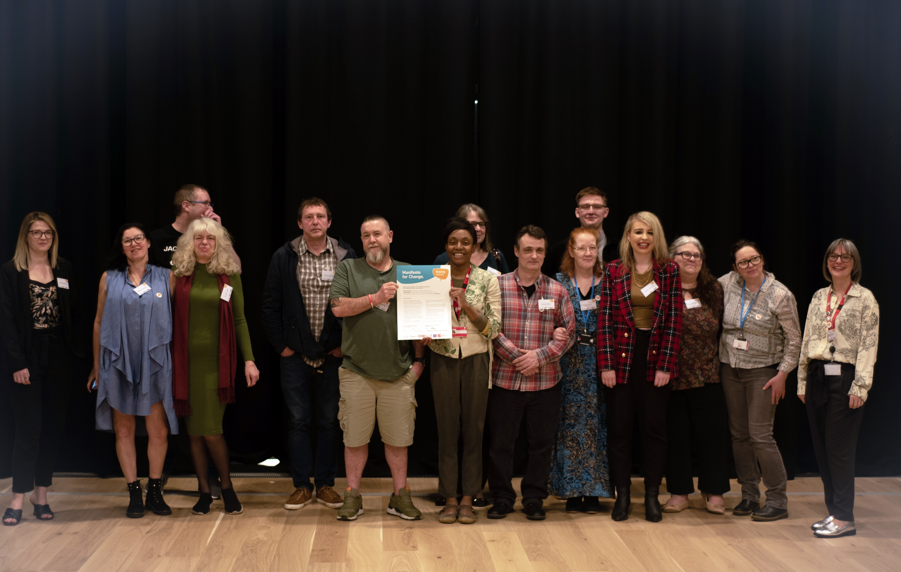
Members of the Raising Voices Steering Group and project delivery team at the Raising Voices Exhibition launch night (2022).

Manifesto for change
The manifesto for change was created by the Raising Voices Steering Group, after the collection of stories from community experiences of hardship in Stoke-on-Trent. The steering group analysed written, audio and visual information to pull together ideas of what should go into the manifesto, which aimed to form an alliance between the Hardship Commission for Stoke-on-Trent and the Raising Voices Steering Group.
The alliance commits to:
- Raise the Voices of people experiencing hardship and poverty.
- Change Minds about hardship and reduce the stigma attached to it, and
- Work closely with decision-makers to create the changes needed to End Poverty.
(The Raising Voices Steering Group & The Hardship Commission for Stoke-on-Trent, 2022)
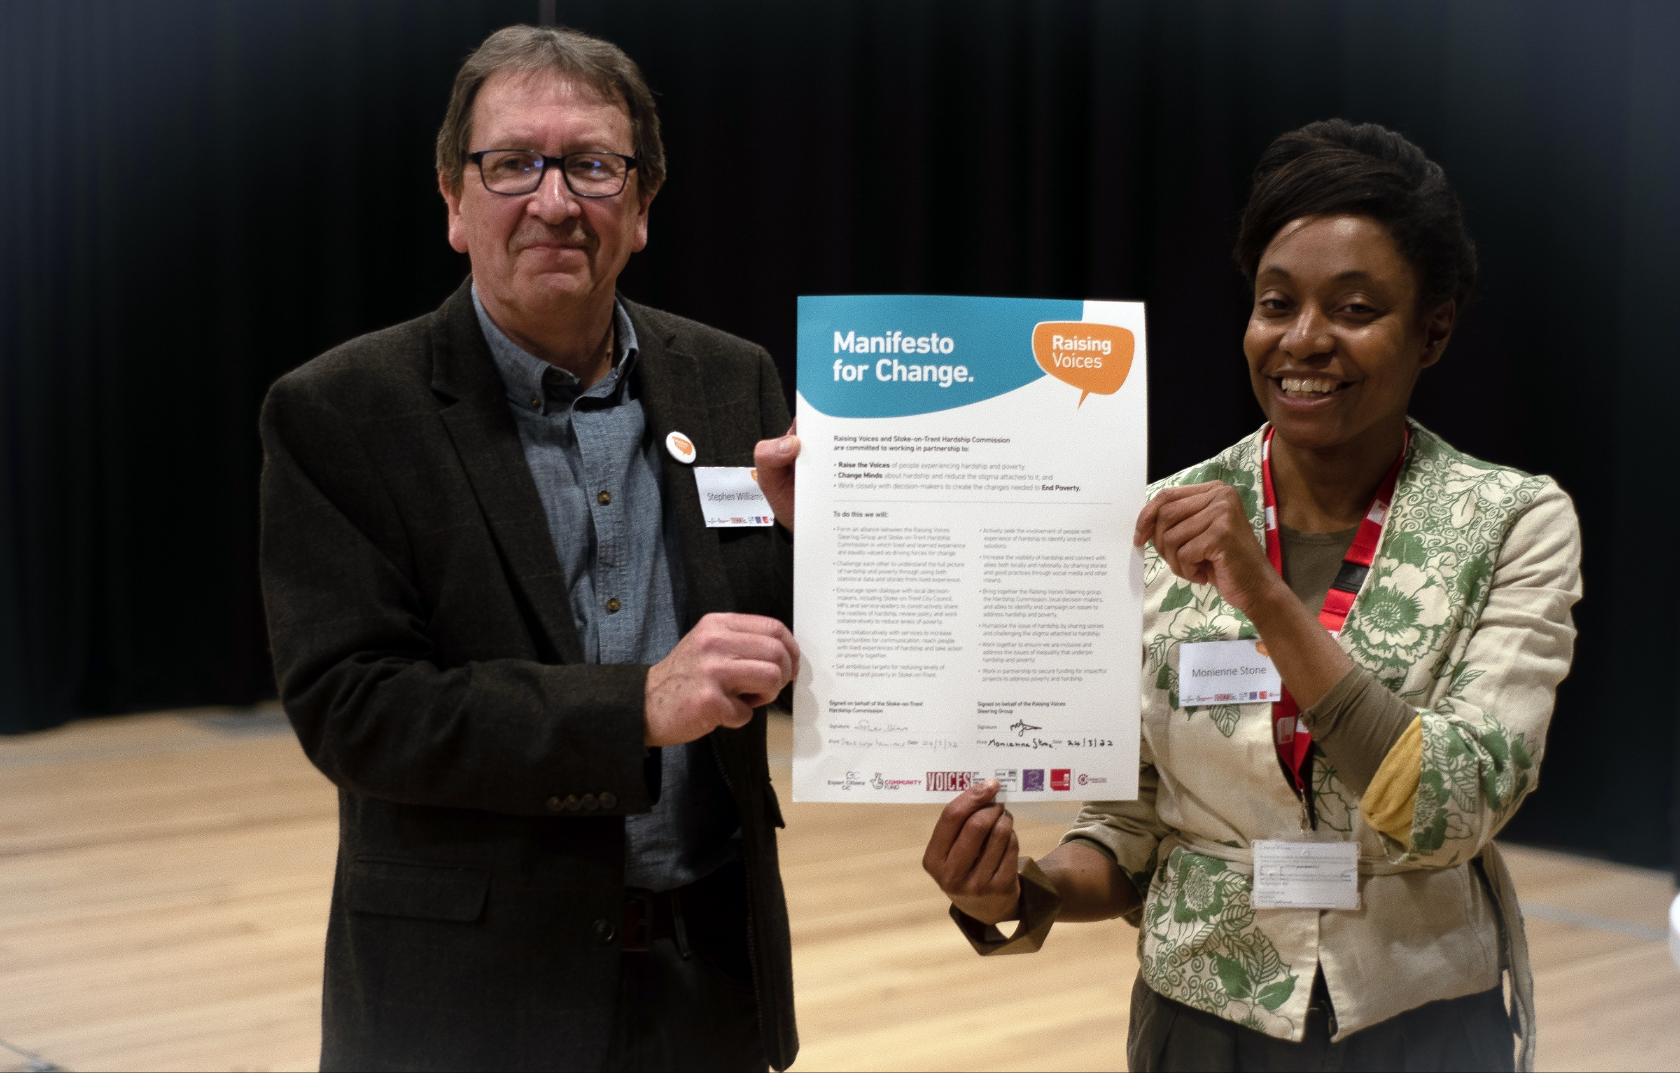
The signed manifesto for change held by a member of the Raising Voices Steering Group and Chair of The Hardship Commission for Stoke-on-Trent (2022).

The document also outlines the intent for lived and learnt experiences to be equally valued as forces for change in the City of Stoke-on-Trent, through future work between the Raising Voices Steering Group and the Hardship Commission. The alliance will continue to involve people with experiences of hardship, to identify and enact solutions to issues impacting local people. The further intent of the document clearly states the need to humanise the issue of hardship, by challenging stigma and mistruths attached to understandings of poverty and hardship. It has been set out to tackle this issue through the continued amplification of people’s stories related to the topic.

Since the signing of the Manifesto for Change, the Hardship Commission has responded to the need for lived and learnt experiences to be equally valued by acknowledging the steering group as members of the hardship commission, with steering group members attending meetings since the end of the project. This signifies an important step in acknowledging the value of lived and learnt experiences working together.
However, due to Hardship Commission partners having already stretched capacities when delivering their organisation's work in communities, there have been few opportunities for work to continue immediately after the project. Additionally, buy-in for the manifesto for change was limited to allies already in support, limited due to the challenges facing the project from its initial development outlined below.
Nevertheless, work towards another Raising Voices style project is in the works, with steering group members co-developing a funding bid alongside The Hardship Commission, All the Small Things CIC and Expert Citizens CIC.

Challenges
Like any project, it was not all smooth sailing and had to navigate challenges across the project. Notably, the challenges revolved around time, COVID-19, community reach, and the ability to continue in the current climate.

Time
The project set out to run over six months. However, the time dedicated to collecting stories from community settings lasted only two months, due to the time lost to university ethics processes, the long-time investment needed to work in safe participatory ways, and the time lost to enforced remote working. University ethical approval is required for work conducted between communities and academics to ensure the safety of all parties involved. Due to the nature of the topic, the required ethical approval process of Staffordshire University’s ethics committee delayed the beginning of the project, meaning that the ‘investigation’ side of the project could not begin until November. This, coupled with the impact of COVID-19, meant that there was little to no groundwork possible to create further reach into communities in Stoke-on-Trent. Unfortunately, the physical reach of the project was therefore restricted to, and reliant on, direct networks of partner organisations and the steering group. However, although smaller reaching, this meant that project activities involving community members were built on existing trusted relationships, rather than going into places ‘cold’ which may have posed ethical concerns for the project. Instead, sessions had an air of familiarity to them which created comfortable environments for people to share their stories. Future project work would benefit hugely from more time to focus on the groundwork and relationships, which are needed to create a wider reach in the local community, as well as reignite previous community relationships lost during COVID lockdowns.

COVID-19
COVID impacted the time that could be dedicated to the delivery of physical activities. This meant that of the six-month project, only half of the project was able to be run in a face-to-face capacity. Although interventions were made, this took away from the fast-paced progress that could be achieved when working together in a face-to-face group setting. During December, January, and parts of February the project operated by remote means to ensure the safety and health of all people involved in the project, whilst COVID infections were high over the winter months.

Continuation in the current climate
Given the worsening situations relating to the cost of living in the United Kingdom, there has been no more important time to raise the voices of local people experiencing hardship and poverty. However, as mentioned earlier in the chapter, the strain and squeeze felt by local organisations, charities, and groups such as the Hardship Commission mean they are finding it harder to operate on a day-to-day basis. This is due to high increases in demand and precarious funding situations. This puts work, like Raising Voices, on the back burner, behind the day-to-day realities of running organisations and working in these climates. The increases in service demand can also be seen to be one of the contributing factors to little action being taken on the Manifesto for Change, so far.

Conclusion
The Raising Voices project demonstrates the undeniable ability to bring lived and learnt experiences together to work towards action. Although the project’s reach and scale were limited, the value and impact gained from the steering group embedded lived and learnt experience in the heart of the project. The significance of this cannot be underestimated. The ability to draw on the strengths and assets of the group, and to engage with the public in creative and conversational ways, enabled multiple outlets and opportunities for local people that may have never had an opportunity to have their voices heard. At the time of writing, a bid for a new round of funding to raise the voices of local people has been submitted. This signifies the continued intent for the Raising Voices Steering Group to continue to work in alliance with The Hardship Commission for Stoke-on-Trent, to act on poverty.
Can poverty be banished?
Solved, righted, expelled, or fixed?
It’s everybody’s responsibility
To change the minds of judgments mixed
We can learn a lot by listening
To lived experience, who have survived
Collaborate with all of our services
To help our vulnerable to thrive
(Smith, 2022)
Image 6: “It’s Never Too Late”- (Knight, 2022)

Bibliography:
Barrett, A., (2013). Asset-Based Community Development: A Theological Reflection. Birmingham: Birmingham Vicar of Hodge Hill Church. Available at: https://togethermc.org.uk/uploads/togetherMiddlesbroughAndCleveland/ABCD_Theological_Reflection_2013.pdf. [Accessed January 27, 2023].
Brydon-Miller, M., Greenwood, D. and Maguire, P. (2003) “Why action research?” Action Research, 1(1), pp. 9–28. Available at: https://doi.org/10.1177/14767503030011002. [Accessed: January 20, 2023].
Etherington, D., Jones, M., Telford, L., Harris, S. and Hubbard, S (2023) Families on the Brink in Stoke-on-Trent: How austerity and the cost-of-living is driving poverty and destitution. Project Report. Staffordshire University. Available at: https://eprints.staffs.ac.uk/7621/ [Accessed January 27, 2023].
Gratton, N. (2020) Keep talking: Impact and recommendations, blogs.staffs.ac.uk. Staffordshire University. Available at: https://blogs.staffs.ac.uk/connections/files/2021/01/Gratton-2020-Keep-Talking-Final-Report-General.pdf [Accessed: January 20, 2023].
Gratton, N., Fox, R. and Elder, T. (2020) Keep Talking: Messy Research in Times of Lockdown. In Kara, H. and Khoo, S. (Eds) Researching in the Age of Covid-19. Volume II: Resilience and Care. Policy Press. Pg. 101 – 110. doi: https://doi.org/10.2307/j.ctv18dvt4f.14
Gratton, N., Vincent, P., Singha, L., Beddows, R., Ball, A., and Get Talking Hardship Community Researchers (2019) Get Talking Hardship. Available from: https://www.staffs.ac.uk/research/pdf/get-talking-hardship-report-2019.pdf [Accessed 20 January 2023].
Hansford, L., Thomas, F. and Wyatt, K., 2022. Poverty, choice and dying in the UK: a call to examine whether public health approaches to palliative care address the needs of low-income communities. Mortality, pp.1-17. Available at: https://doi.org/10.1080/13576275.2022.2044299 [Accessed January 26, 2023].
Henderson, D. and Zipin, L., 2010. Bringing clay to life: Developing student literacy through clay animation artwork to tell life-based stories. Connecting lives and learning: Renewing pedagogy in the middle years, pp.20-39. Available at: https://books.google.co.uk/books?hl=en&lr=&id=vHzZSLzmOh4C&oi=fnd&pg=PA20&dq=Telling+stories+through+clay&ots=HGsJxW5M66&sig=8LnRrgRSk--oGl44Z8UA13GhWyk&redir_esc=y#v=onepage&q=stories&f=false [Accessed January 31, 2023].
Lenette, C. (2022) Participatory Action Research: Ethics and decolonization. New York: Oxford University Press.
Oliver, K., Kothari, A. and Mays, N. (2019) “The dark side of coproduction: Do the costs outweigh the benefits for health research?” Health Research Policy and Systems, 17(1). Available at: https://doi.org/10.1186/s12961-019-0432-3. [Accessed: January 26, 2023].
Oriz, M.A. (2020) “Amplifying community voices through public art,” Community Literacy Journal, 14(2). Available at: https://doi.org/10.25148/14.2.009034. [Accessed January 27, 2023].
Smith, R. (2022) What is poverty? Raising Voices Online Exhibition. Hardship Commission for Stoke-on-Trent. Available at: http://bit.ly/3RmJyJi [Accessed: January 31, 2023].
Spice, J. et al. (2022) Patchwork poem part 1., Raising Voices Online Exhibition. The Hardship Commission for Stoke-on-Trent. Available at: http://bit.ly/3jk8ogA [Accessed: January 31, 2023].
The Raising Voices Steering Group and The Hardship Commission for Stoke-on-Trent (2022) Manifesto for Change: Raising Voices Online Exhibition, Raising Voices Online Exhibition. The Hardship Commission for Stoke-on-Trent. Available at: https://bit.ly/3UrZlH2 [Accessed: February 6, 2023].
The Raising Voices Steering Group et al. (2022) The Raising Voices Online Exhibition . rep. The Hardship Commission for Stoke-on-Trent. Available at: https://7ee8ecac-8297-45ff-bf5f-2f4b005cefd3.filesusr.com/ugd/5c51dc_d3ebc9ac5cf84b02b5ee3566d68fa4b3.pdf [Accessed: February 6, 2023].
Thomas, G., Lynch, M. and Spencer, L.H., 2021. A systematic review to examine the evidence in developing social prescribing interventions that apply a Co-Productive, Co-Designed approach to improve well-being outcomes in a community setting. International Journal of Environmental Research and Public Health, 18(8), p.3896. Available at: https://www.proquest.com/docview/2520862340/C4017781A5FA4B0APQ/1?accountid=17254 [Accessed January 27, 2023].

Picture Bibliography
Image 1: “‘Mister do you have any snappin' left?"” (2022) The Raising Voices Online Exhibition. The Hardship Commission for Stoke-on-Trent. Available at: http://bit.ly/3RkBdWM [Accessed: February 1, 2023].
Image 2: Bamford , S. (2022) Dereliction, The Raising Voices Online Exhibition . Stoke-on-Trent: The Hardship Commission for Stoke-on-Trent. Available at: http://bit.ly/40bHyYu [Accessed: February 1, 2023].
Image 3: Heffton, J. (2022) Abandoned, The Raising Voices Online Exhibition. Stoke-on-Trent: The Hardship Commission for Stoke-on-Trent. Available at: http://bit.ly/3jkhGZU [Accessed: February 1, 2023].
Image 4: Porter, S. (2022) “They think its trash,” The Raising Voices Online Exhibition. The Hardship Commission for Stoke-on-Trent. Available at: http://bit.ly/3WTEDAW [Accessed: February 1, 2023].
Image 5: Harding, S. (2022) 'Good' Life, Raising Voices Online Exhibition . Stoke-on-Trent: The Hardship Commission for Stoke-on-Trent. Available at: http://bit.ly/3YfLuG0 [Accessed: February 1, 2023].
Image 6: Knight, T. (2022) It's Never Too Late, The Raising Voices Online Exhibition. Stoke-on-Trent: The Hardship Commission for Stoke-on-Trent. Available at: http://bit.ly/3XZCYLt [Accessed: February 1, 2023].

