MASTERFUL DEFENSE VS. ROOKIE FUMBLES: HOW DO EXPERT AIR HOCKEY CHAMPS ON MOBILE REVEAL THEIR SKILLS THROUGH POSTURE & TOUCH?
Pooya Soltani¹, Antoine H. P. Morice²

¹School of Digital, Technology, Innovation and Business, Staffordshire University, Stoke-on-Trent, United Kingdom
²Aix-Marseille Université, CNRS, Institute of Movement Sciences (ISM), Marseille, France

We explored the relationships between expertise, in-game performance, posture, and screen interactions in mobile sports games. Twenty participants (10 experienced) played Disc-O, a turn-based air hockey game. Posture, phone holding style, play style, and screen metrics (displacement, velocity, touch size, pressure, and time to action) were compared. No significant associations were found between experience or performance and handedness, posture, holding style, or play style (p > 0.05). Experienced players performed better (p = 0.02) but showed no significant screen interaction differences compared to novices (p > 0.05). They reacted faster, with victors having smaller touch points, suggesting more precise motor control and efficient decision-making. The lack of posture and holding style differences suggests adaptability and potential for training interventions.
KEYWORDS: esports, athletic performance, touch screen
INTRODUCTION: Picture the air hockey puck whizzing across your phone screen. Mobile sports games refer to video games designed for mobile devices, including smartphones and tablets, where players can simulate or engage in sport-related activities. Some of these games are part of the broader esports landscape and include organized, competitive, and structured leagues and tournaments (McCutcheon, Hitchens, and Drachen, 2017).
Different players may have their own unique style when performing touch operations. These personal characteristics are reflected in their preferred posture, rhythm, strength, and angle preferences of touch interaction. As more governing bodies recognize esports as sports, understanding player differences, anticipation speed, and visual tracking strategies could be valuable for talent identification and decision-making (Mann et al., 2007; Valls-Serrano et al., 2022) as demonstrated in virtual reality for traditional sports players (Soltani and Morice, 2023). Understanding the physical interactions with esports platforms are also crucial as they may affect user performance, fatigue, and injuries (Chourasia et al., 2013, Wobbrock, Myers, and Aung, 2008).
Delving into the nexus of expertise, performance, and physical engagement, this study investigates whether players' posture and screen interaction techniques reveal their skill level in mobile esports. Beyond optimizing training and fostering talent development, understanding these physical expressions of gameplay could draw parallels to traditional sports analysis and inform the ergonomic design of esports games, ultimately mitigating discomfort from prolonged screen use.

METHODS: Twenty participants (Age: 25.45±4.84 years; Sex: 12 M, 8 F; Handedness: 12 R, 8 L; Experience level: 10 experienced, 10 novice) played bouts of Disc-O, a skill and strategy turn-based mobile sports game (PlatoApp, San Jose, USA; Figure 1). The goal of the game was to flick discs into the target area to score points or to knock opponents’ discs out. Each player could launch eight discs of three sizes (large, medium, and small) in alternating turns. Larger discs had higher impact and smaller discs had higher velocity. Players were considered as “experienced” if their win ratio within the game (% games won/games played) was above 70%. Posture was categorized as seated, standing, or other; holding style was categorized as right, left, both hands, or on the table; and playing style was categorized as left thumb, right thumb, left and right thumbs, left index, right index, and left and right index fingers (Figure 1).
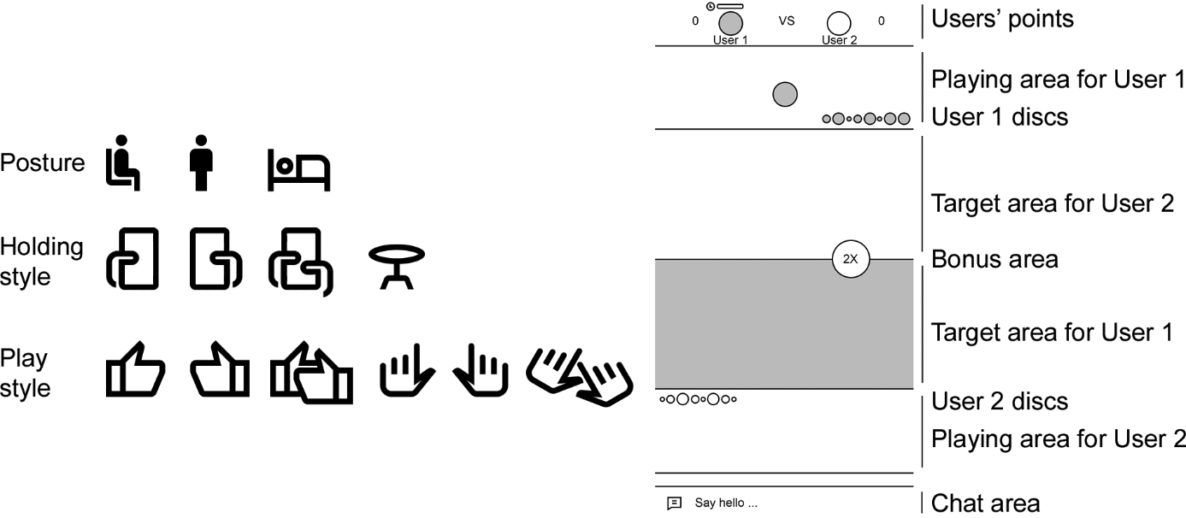
Figure 1: Posture (seated, standing, other), holding style (left hand, right hand, both hands, table), and play style (left thumb, right thumb, both thumbs, left index, right index, both index fingers), and a screenshot of the Disc-O game.

All the players used the same smartphone in portrait mode (Pixel 3, Google, USA). To explore screen interactions metrics, we used the Pointer Location app under the developer options for Android 12 (Google, USA). The statistics shown include: 1) The displacement between the finger's initial touch point and its final release point on the screen, calculated as the combined delta values in the X and Y directions (dX and dY in pixels – px); 2) The velocity of the touch point as a delta in X and Y directions (Xv and Yv in inch/s); 3) The normalized pressure value (Prs) ranging from 0 (no pressure) to 1 (normal pressure) describes the pressure applied to the device; (4) The normalized value representing the touch area (Siz) relative to the device's maximum detectable size, scaled from 0 to 1 based on device-specific ranges; and 5) Time to Action as the duration between the commencement of players’ turns to the moment they flicked the disc in seconds.
To examine the effects of independent variables (experience – experienced vs. novice, and performance – win vs. lose) on dependent variables (dX, dY, Xv, Yv, Prs, Siz, and Time to Action), as well as their interaction effects, we used a Multivariate Analysis of Variance (MANOVA). To evaluate the correlations between experience levels and performance, and handedness, posture, holding style, and playing style, we used Pearson Chi-Square test and used Cramer’s V to test the strength of the association. Prior checks were conducted to assess multivariate normality, homogeneity of variance-covariance matrices, and independence of observations. We utilized IBM SPSS Statistics (version 28, Chicago, USA) and set the statistical significance level to 0.05.

RESULTS: There was a statistically significant association between experience level and performance (χ(1) = 5.50, p = 0.02, Phi and Cramer’s V = 0.52) but no statistically significant association between either experience or performance, and handedness, hand posture, holding style, and play style (p > 0.05). However, 50% of the experienced players were right-handed; 70% of them chose to be seated while playing; 50% of them were using both hands to hold the phone; and 60% of them were using their right index to interact with the phone. In addition, 54% of those who won were right-handed; 61.5% of them chose to be seated; 38.5% of them were either holding the phone with both hands, or with their left hands; and 76.9% of them were interacting with the screen using their right index. Figure 2 shows the effects of experience and performance on screen interaction metrics. Although experienced players had statistically significantly lower time to action compared to novice players (F (1, 16) = 6.69, p = 0.02), other screen interaction metrics were not statistically significantly different compared to novice players (p > 0.05). In addition, victorious players had smaller touch point on the screen compared to those who lost (F (1, 16) = 9.31, p = 0.01).

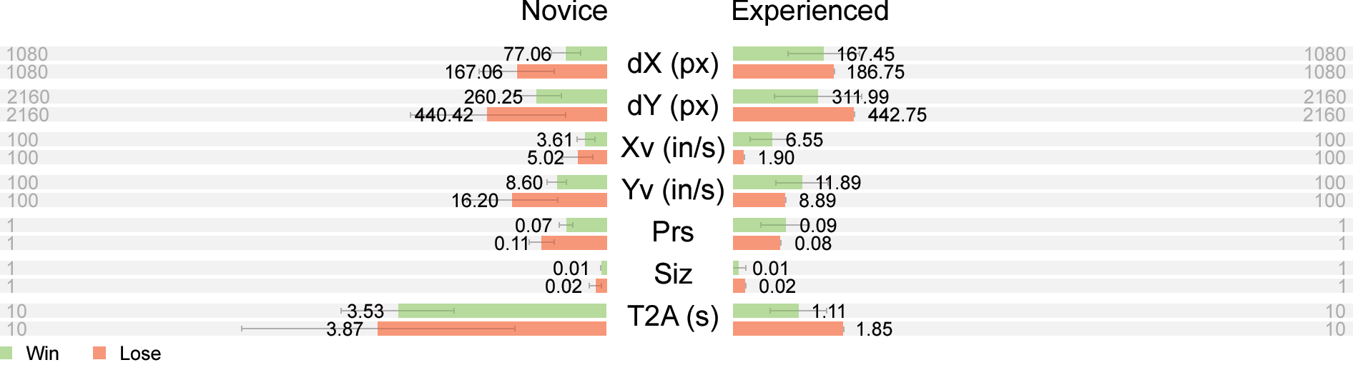
Figure 2: Mean±SD screen interaction metrices relative to their maximum value according to experience level and performance; dX and dY: Total displacement between entry and exit points in pixels; Xv and Yv: Velocity of touch points in inches/s; Prs: Normalized pressure value ranging from 0 to 1; Siz: Normalized touch area size from 0 to 1 based on device ranges; T2A: Time to action in seconds.

DISCUSSION: Our research dives into how posture, touch interaction, and even finger choice reveal the secrets of skill in mobile esports. While players had different posture options, most of the experienced players chose to be seated while playing. Possible reasons for this preference could be further elbow and forearm support while playing. This support was also reflected in holding the phone with one hand and playing with index finger. We also showed that experienced players’ screen interaction parameters were not different than their novice counterparts. It appears, however, that experienced players aspects of perceptual-cognitive skills, namely decision-making were reflected in lower amount of time to action.
Similar to the previous research, we showed that posture may not affect performance (Chourasia et al., 2013). However, our results were contrary to the previous research where lower performance was observed while standing and operating screen devices with one hand (Vahedi et al., 2020). It is possible that the nature of the task and the size and distribution of visual elements on the screen could affect performance (Schedlbauer, Pastel, and Heines, 2006). Contrary to the previous research suggesting higher error rates when using thumbs for mobile interactions (Gustafsson et al., 2011; Trudeau et al., 2012), our study with Disc-O demonstrated no significant association between playing style and performance. Studies suggest an optimal finger position for performing tasks on touchscreens, where neither full flexion nor extension offers the best performance (Trudeau et al., 2012; Dennerlein, 2015). Notably, using the index finger, which naturally rests in a slightly bent position, has been linked to improved speed and accuracy, possibly due to better control and tactile feedback. Those who performed better also had smaller touch points on the screen. This suggests that they were mostly interacting with their index fingers compared to their thumbs. It has been shown that using the thumb for both holding and flicking on a device can compromise performance due to conflicting functional demands (Trudeau et al., 2016). Additionally, single-handed grips may constrain thumb movement and require sub-optimal postures (Trudeau et al., 2016).
Coaches can emphasize the importance of providing support, either through holding the phone with one hand and interacting with the other hand, or through sitting, which could intuitively improve performance during mobile games. Additionally, coaches can focus on optimizing touch interaction techniques, particularly the preference for using the index finger, as identified in our study. Training drills can be designed to specifically target index finger dexterity and precision, allowing players to develop and refine their touch interaction skills. Furthermore, coaches should pay attention to decision-making aspects, as highlighted by the shorter time to action among experienced players. While this aspect was observed indirectly through gameplay metrics rather than direct monitoring of cognitive processes, coaches can integrate strategies to enhance players' decision-making abilities into their training programs. This could involve incorporating scenario-based simulations, analyzing gameplay footage to identify areas for improvement, and providing feedback to help players make more effective decisions in high-pressure situations.

CONCLUSION: This study investigated the relationship between expertise, performance, posture, and screen interactions in mobile esports. As expected, experienced players outperformed novices. They also reacted faster, potentially due to more efficient interaction strategies evidenced by smaller touch points. While posture and holding style did not significantly impact performance, future research could explore the underlying cognitive and perceptual-motor mechanisms driving these associations. Additionally, personalized interventions focused on efficient play style and finger choice could be explored to enhance mobile esports performance.

REFERENCES
Chourasia, A. O., Wiegmann, D. A., Chen, K. B., Irwin, C. B., & Sesto, M. E. (2013). Effect of sitting or standing on touch screen performance and touch characteristics. Human Factors, 55(4), 789-802. https://doi.org/10.1177/0018720812470843
Dennerlein, J. T. (2015). The state of ergonomics for mobile computing technology. Work, 52(2), 269-277. https://doi.org/10.3233/WOR-152159
Gustafsson, E., Johnson, P. W., Lindegård, A., & Hagberg, M. (2011). Technique, muscle activity and kinematic differences in young adults texting on mobile phones. Ergonomics, 54(5), 477-487. https://doi.org/10.1080/00140139.2011.568634
McCutcheon, C., Hitchens, M., & Drachen, A. (2017, December). eSport vs irlSport. In International Conference on Advances in Computer Entertainment (pp. 531-542). Cham: Springer International Publishing. https://doi.org/10.1007/978-3-319-76270-8_36
Mann, D. T., Williams, A. M., Ward, P., & Janelle, C. M. (2007). Perceptual-cognitive expertise in sport: A meta-analysis. Journal of Sport and Exercise Psychology, 29(4), 457-478. https://doi.org/10.1123/jsep.29.4.457
Schedlbauer, M. J., Pastel, R. L., & Heines, J. M. (2006, June). Effect of posture on target acquisition with a trackball and touch screen. In 28th International Conference on Information Technology Interfaces, 2006. (pp. 257-262). IEEE. https://doi.org/10.1109/ITI.2006.1708488
Soltani, P., & Morice, A. H. P. (2023). A multi‐scale analysis of basketball throw in virtual reality for tracking perceptual‐motor expertise. Scandinavian Journal of Medicine & Science in Sports, 33(2), 178-188. https://doi.org/10.1111/sms.14250
Trudeau, M. B., Young, J. G., Jindrich, D. L., & Dennerlein, J. T. (2012). Thumb motor performance varies with thumb and wrist posture during single-handed mobile phone use. Journal of biomechanics, 45(14), 2349-2354. https://doi.org/10.1016/j.jbiomech.2012.07.012
Trudeau, M. B., Asakawa, D. S., Jindrich, D. L., & Dennerlein, J. T. (2016). Two-handed grip on a mobile phone affords greater thumb motor performance, decreased variability, and a more extended thumb posture than a one-handed grip. Applied Ergonomics, 52, 24-28. https://doi.org/10.1016/j.apergo.2015.06.025
Vahedi, Z., Mazloumi, A., Sharifnezhad, A., Kazemi, Z., & Garosi, E. (2020). Head forward flexion, lateral bending and viewing distance in smartphone users: A comparison between sitting and standing postures. Work, 67(4), 837-846. https://doi.org/10.3233/WOR-203303
Valls-Serrano, C., de Francisco, C., Caballero-López, E., & Caracuel, A. (2022). Cognitive flexibility and decision making predicts expertise in the MOBA esport, League of Legends. SAGE Open, 12(4), 1-13. https://doi.org/10.1177/21582440221142728
Wobbrock, J. O., Myers, B. A., & Aung, H. H. (2008). The performance of hand postures in front-and back-of-device interaction for mobile computing. International Journal of Human-Computer Studies, 66(12), 857-875. https://doi.org/10.1016/j.ijhcs.2008.03.004

