The Relationship between Shame and Guilt Proneness, Moral Injury, Professional Role, Self-compassion and Post-Traumatic Stress Symptoms in Critical Care Healthcare Professionals During Covid-19.

Anja Steiner

Thesis submitted in partial fulfilment of the requirements of Staffordshire University for the degree of Doctorate in Clinical Psychology

April 2023

Total word count: 18,565

THESIS PORTFOLIO: CANDIDATE DECLARATION
Title of degree programme | Professional Doctorate in Clinical Psychology
Candidate name | Anja Steiner
Registration number | xxxxxxx
Initial date of registration | September 2020

Declaration and signature of candidate
I confirm that the thesis submitted is the outcome of work that I have undertaken during my programme of study, and except where explicitly stated, it is all my own work.
I confirm that the decision to submit this thesis is my own.
I confirm that except where explicitly stated, the work has not been submitted for another academic award.
I confirm that the work has been conducted ethically and that I have maintained the anonymity of research participants at all times within the thesis.

Signed: Date: 26.04.23

Acknowledgments
First and foremost, I would like to thank each participant for the time they took to take part in this research, and for bravely sharing their experiences. I am incredibly thankful to those who provided their expertise and feedback along the way.
I would like to extend my gratitude to my personal tutor and academic research supervisor, Dr Helen Scott, for her knowledge, words of encouragement and guidance throughout this research project.
To my friends and family, thank you for your unwavering support, patience, and ability to keep me smiling throughout.
And finally, I would like to thank the 2020 cohort. We have shared a unique rollercoaster of a ride over the past three years throughout which, your support and laughter has kept me going.

Contents
Thesis Abstract 8
Paper 1: Literature Review 9
Abstract 10
Introduction 11
Rationale 13
Method 14
Search strategy 14
Search strategy terms 14
Table 1 15
Eligibility criteria 15
Inclusion criteria 15
Exclusion criteria 15
Publication bias 16
Paper selection and data extraction 16
Figure 1 17
Results 18
Table 2 19
Quality assessment 26
Recruitment and sample 26
Methodology 28
Analysis 29
Thematic Synthesis 30
Table 3 31
Theme 1: Safety Compromised 31
1.1 PPE. 31
1.2. Us and Them. 32
1.3. Disparities in Risk. 33
Theme 2: Trauma Experiences 34
2.1. On the Verge. 34
2.2. Finding Ways to Cope. 35
Theme 3: Professional Identity 36
3.1. A Sense of Duty. 36
3.2. Changing Roles and Responsibility. 37
Theme 4: Compromised Care 37
4.1. An Inability to Provide Best Care. 37
4.2. Lost Aspects of Care. 38
Discussion 39
Clinical Implications 42
Strengths and Limitations 42
Areas for future research 43
Conclusion 43
References 45
Appendices 55
Appendix A 55
Appendix B 56
Appendix C 57
Paper 2: Empirical Paper 61
Abstract 62
Introduction 63
Post-Traumatic Stress Symptoms in Healthcare Professionals During Covid-19 63
Models of PTSD 65
Guilt and Shame in PTSD 66
Moral Injury in Covid-19 67
Self-Compassion 68
The current study 69
Aims and Hypotheses 69
Method 70
Design 70
Recruitment 70
Participants 71
Table 1 73
Table 2 74
Measures 75
Demographic Information 75
Exposure to Moral Injury 75
Self-Compassion 75
Shame Proneness and Guilt Proneness 76
Power Analysis 77
Data Analysis 77
Statistical Assumptions 78
Method of Analysis 78
Results 79
Descriptive Statistics 79
Table 3 79
Table 4 81
Multiple Regression Analysis 81
Table 5 83
Table 6 86
Mediation Analysis 87
Figure 1 88
Discussion 89
Limitations 91
Clinical Implications 92
Directions For Future Research 93
Conclusion 94
References 95
Appendices 107
Appendix A 107
Appendix B 108
Appendix C 109
Appendix D 111
Appendix E 114
Appendix F 115
Appendix G 121
Appendix H 122
Appendix I 123
Appendix J 131
Appendix K 134
Appendix L 137
Appendix M 141
Appendix N 144
Appendix O 147
Appendix P 150
Paper 3: Executive Summary 153
Bibliography 167

Thesis Abstract
Paper one is a literature review that explores the experiences of UK healthcare professionals who provided direct care to Covid-19 patients. Twelve papers were identified following a systematic search of the literature. The papers were thematically synthesised and identified four main themes: ‘Safety Compromised’, ‘Trauma Experiences’, ‘Professional Identity’ and ‘Compromised Care’. The review highlighted factors which increased levels of distress including experiencing high death rates, fears for safety, poor leadership, uncertainty, moral dilemmas, and challenges in providing adequate patient care. Professional commitment and strong team cohesion were highlighted as key to coping during Covid-19. Methodological quality varied, however most studies were found to be of high quality. Clinical implications and recommendations for further research are discussed. The second paper describes a cross-sectional study which explored the relationship between exposure to moral injury, self-compassion, professional role, shame and guilt proneness and post-traumatic stress symptoms (PTSD) in healthcare professionals who provided direct care during Covid-19. Fifty-six healthcare professionals were recruited for the study. Multiple regression analyses and a mediation analysis were conducted. The results suggest that lower levels of self-compassion predict higher levels of PTSD, none of the other predictors were significant. Self-compassion was found to mediate the relationship between exposure to moral injury and PTSD symptoms. Therefore, exposure to moral injury increases PTSD symptoms, through lower levels of self-compassion. The findings suggest that self-compassion-based interventions may be beneficial for individuals and organisations to manage experiences of PTSD symptoms. Clinical implications and recommendations for future research are discussed. Paper three is an executive summary of the research study carried out in this thesis and is written for healthcare professionals in critical care as well as senior leaders and professionals who may provide psychological support to healthcare professionals. This paper was created in consultation with individuals from critical care who provided care during Covid-19.

Paper 1: Literature Review

What do we know about the experiences of UK healthcare professionals providing direct care to Covid-19 patients? A review of the literature.

Word count: 7765 (excluding the title page, references and appendices)

This paper is intended for publication in the ‘Journal of Traumatic Stress’. The referencing style of this paper is APA 7th edition, in line with the journal requirements. Author Guidelines for the journal can be found in Appendix A. Further modifications may be made prior to submission to the journal, in line with to journal requirements.

Abstract
In the UK, National Health Service (NHS) staff have faced extraordinary pressures during the Covid-19 pandemic. This review aimed to explore, and critically evaluate research investigating the experiences of healthcare professionals who provided direct care to Covid-19 patients in the UK during the Covid-19 pandemic. A systematic search of literature was conducted utilising eight electronic databases, resulting in twelve papers being included in this review. These were critically appraised and thematically synthesised. Four main themes were generated: ‘Safety Compromised’, ‘Trauma Experiences’, ‘Professional Identity’ and ‘Compromised Care’. Healthcare professionals shared the elevated levels of distress associated with providing care during Covid-19. Contributing factors including shortages in personal protective equipment (PPE), poor leadership, ongoing uncertainty, moral dilemmas, a perceived poor ability to provide best care, changes in professional roles and high rates of death. A strong sense of team cohesion and professional commitment were found to be ways of coping. The reviewed studies varied in methodological quality; however most demonstrated to be of high quality. This review highlights the challenges and factors that impacted the experiences of healthcare professionals. It is hoped these findings may contribute to the understanding of evolving experiences through the pandemic and the development of future policy to support the recovery of organisations and healthcare professionals. Future research is recommended.

Introduction
The World Health Organisation (WHO) declared Covid-19 as a pandemic on the 11th of March 2020, after the first cases were identified in Wuhan, China in December 2019 (World Health Organisation, 2020). Attempts to control rapid transmission of the virus resulted in governments across the world and in the United Kingdom (UK) imposing restrictive measures such as mandated lockdowns (Davies et al., 2020). In the UK, National Health Service (NHS) staff have faced unprecedented demands during the Covid-19 pandemic. Covid-19 had a substantial impact on healthcare provisions in the UK, as resources were pulled to manage a significant increase in patients admitted to hospitals with Covid-19 (Shah et al., 2022). Frontline healthcare professionals providing direct patient care continued to work throughout the pandemic and faced increased risks of exposure and infection (Mutambudzi et al., 2020), often working in hospitals operating beyond safe occupancy for prolonged periods of time (Mateen et al., 2021).
Worldwide countries faced successive pandemic phases, although this varied in timescale. Phases of the pandemic in the UK were conceptualised in this paper as defined by Borek et al. (2022) with phase 1 (winter-spring 2020), phase 2 (summer-autumn 2020) and phase 3 (autumn 2020-winter 2021). By May 2020, the UK was one the worst affected countries in Europe, reporting high mortality rates (May et al., 2021). Significant challenges arose in the UK during the early phases of the Covid-19 pandemic such as: providing adequate levels of personal protective equipment (PPE) for healthcare professionals, rapidly changing guidance from the National Institute for Health and Care Excellence (NICE), Public Health England (PHE) and recommendations from the UK government (Caroll et al., 2020, May et al., 2021). With an already strained NHS, the pressures described during the second phase of Covid-19 saw further increases in the demand placed on organisations and healthcare professionals (Royal College of Physicians, 2021). Considering these differing demands in the continuing phases, healthcare professionals’ experiences may have also changed over time (Roberts et al., 2021), although there is limited longitudinal evidence currently.
An increased risk of infection meant frontline healthcare professionals were at increased risk of experiencing severe and prolonged psychological distress comparative to the general population (Billings et al., 2020, Greenberg et al., 2021). Pappa et al. (2020) found high rates of anxiety, depression, and insomnia in a quantitative systematic review of frontline healthcare professionals during Covid-19 globally, and Li et al. (2021) further identified a high prevalence of posttraumatic stress disorder (PTSD). This mirrors findings from previous public health disasters and biological threats such as the 2003 severe acute respiratory syndrome (SARS) outbreak, the H1N1 influenza outbreak in 2009, and the 2014 Ebola outbreak (Mak et al., 2009; Hossain et al., 2020). Research exploring the social and occupational factors associated with poorer psychological outcomes during these previous pandemics suggested risk factors such as: a lack of preparedness, working in high risk or high infection environments, perceptions of disease related personal risk, poor organisational and social support (Brooks et al., 2018). Similarly, Nyashanu et al. (2022) explored the triggers of mental health difficulties amongst healthcare professionals in various contexts during the initial phase of Covid-19, and identified concerns about the risks to themselves and others because of insufficient PPE, lack of clear evidence-based guidance, increased workloads and changing occupational demands which impacted levels of distress. These risk factors are likely to have impacted the experiences of healthcare professionals in the UK but there may be nuances in the differing contexts in which they provided care.
Various guidelines were issued during the beginning of the pandemic, which included recommendations on how to support healthcare professionals’ wellbeing during Covid-19 (Billings et al., 2020); however, these were developed rapidly when limited research existed to understand the experiences of those working on the frontline (Daniels et al., 2021). Emerging research from the second and third phases of the pandemic have shown that healthcare professionals’ experiences may continue to change (Roberts et al., 2021; Borek et al., 2022), thus it is important to continue to understand experiences to effectively support healthcare professionals.

Rationale
The impact of Covid-19 on healthcare professionals has been explored with a focus predominantly on quantifiable mental health outcomes and include studies largely from the first phase of the pandemic. Little research has examined the experiences of healthcare professionals who provided direct care for Covid-19 patients qualitatively and even fewer more specifically in the UK. It is important to capture the experiences of healthcare professionals in the NHS, with evolving phases of the pandemic, to inform future policies and guidance.
The objective of this paper is to explore the experiences of healthcare professionals providing care to patients with Covid-19 in the NHS. The review question therefore is: ‘what do we know about the experiences of UK healthcare professionals providing direct care to Covid-19 patients?’

Method

Search strategy
A systematic search of the following databases was undertaken on the 15th of March 2022 using the EBSCO database host: CINAHL, Medline, PsychInfo, PsychArticles and Scopus. Further searches were conducted in Google Scholar, Open Grey, and Ethos. The search strategy terms reported below were used to search titles, abstracts, and key terms. Titles and abstracts were screened, and the full text retrieved if the inclusion criteria (detailed below) was met. Reference lists within these studies were also screened to ensure all relevant papers were included. The literature search was restricted from January 2020 onwards as the first cases of Covid-19 were reported during this time (Lillie et al., 2020). The search was also restricted geographically to the UK, as the focus of this review is on the experiences of healthcare professionals in the NHS.

Search strategy terms
Due to the emphasis on understanding experiences in this literature review, search terms were developed using the PCC mnemonic framework (participant, concept, and context) (Table 1) (Peters, 2016). This framework is frequently used in emerging areas of healthcare research to provide direction and coherence (Pollock et al., 2021).

Table 1
Search Terms
PCC Framework | Search Terms
Participants | ("healthcare worker*" OR "healthcare professional*" OR "frontline worker*” OR nurse* OR doctor* OR allied healthcare* OR “healthcare assistant”)
Concept | (experience* OR “experiences of patient management” “experiences of delivery of care”)
Context | ("Covid-19" OR “Coronavirus-19”)

Eligibility criteria
Following the PCC framework, the inclusion criteria is outlined below.

Inclusion criteria
- Participants: healthcare professionals who provided direct care to patients with Covid-19 in NHS hospital settings during the Covid-19 pandemic, including all grades of doctors, nurses, allied health professionals and healthcare workers.
- Concept: research concerned with healthcare professionals experience of providing care including but not limited to their perceptions, challenges, and positive aspects.
- Context: research from January 2020 onwards following the first cases of Covid-19 in the UK.

Exclusion criteria
- Full text not available in English or German as resources for translation were not available.
- Studies that did not focus on experiences of providing care such as management or interventions for staff, or use of telehealth.
- Meta-analyses or systematic reviews

Publication bias
Unpublished literature was searched through Open Grey and Ethos to reduce publication bias, which is often due to the increased likelihood of favourable findings being published (DeVito & Goldacre, 2019). No further studies were identified for inclusion.

Paper selection and data extraction
The search yielded 404 results, 76 duplicates were removed and a further 286 papers were removed by screening the titles and abstracts based on the inclusion and exclusion criteria. Forty-one papers were then assessed for eligibility of which twelve articles met the inclusion criteria and were included in the review (Figure 1). A data extraction table was then created to collate relevant data from the suitable papers. During extraction it was identified that several studies were reporting findings as part of larger studies (Grailey et al.,2021; Harris et al., 2021). In particular, Vindrola-Padros et al. (2020) was noted to be a parent study with further papers published utilising the same methodology and participant pool (Dowrick et al.,2021; Hoernke et al., 2021; Regenold & Vindrola-Padros., 2021). Due to the differing research questions and reported findings, these were deemed to be suitable to be in included in the review as individual studies and thus appraised separately.

Figure 1
PRISMA Flow Chart of Study Inclusion Process (Page et al., 2021).
Identification of studies via databases and registers

Records removed before screening:

Duplicate records removed (n = 76)

Records identified from:
EBSCO host: Medline (N=105), CINAHL (N=97), PsychArticles (N=1), PsychInfo (N=13), Scopus (N=188), Ethos (N=0), Google Scholar (N=3)

Identification

Records screened
(n = 331)
Records excluded
(n =290)

Screening

Reports sought for retrieval
(n =41)
Reports not retrieved
(n = 0)

Reports excluded:
Not specific to care of patients with Covid-19 (n=14)
Not qualified (n=1)
No experience reported (n=7)
Not original study (n=6)
Not able to extract UK data (n=1)

Reports assessed for eligibility
(n =41)

Included
Studies included in review
(n=12)

Results
Twelve studies met the inclusion for review (Table 2). The findings of the studies will be reported in this section, including information regarding the quality appraisal of those studies. Following this, the thematic synthesis will be reported which will show the themes and subthemes across the studies.

Table 2
Table of Study Characteristics
 | Author, Date and Phase of Pandemic |  | Aims |  | Setting |  | Sample |  | Analysis |  | Methodology |  | Main Themes
 | Montgomery et al., 2021  Phase 2 |  | To understand NHS staff experiences of working in critical care during the first wave of the Covid-19 pandemic in the UK |  | Critical care across four NHS sites |  | N=40  21=nurses  10=doctors  4=AHP  3=operating department practitioners  2=ward clerks  19=redeployed |  | Rapid analysis |  | Semi-structured telephone interviews. |  | - Danger recognition  - Moral density  - Trial  - Closure  - Material and organisation resources  - Axis of convergence  - Social rituals
Bennet et al., 2020  Phase 1/2 |  | To understand the experiences and concerns of front-line NHS workers while caring for patients with Covid-19 |  | NHS |  | N=44  27=doctors  13=nurses  2=physiotherapists  1=radiographer  1=healthcare assistant  10=other |  | Inductive thematic analysis |  | Single-open question online, participants were able to submit written or video responses. |  | - Experience of trauma  - The ‘shock’ of the virus  - Staff sacrifice and dedication  - Collateral damage  - Hierarchy of power and inequality
Baldwin & George., 2021  Phase 2 |  | To develop an understanding of health professionals’ experiences of working at the point of care during the Covid-19 pandemic |  | Three NHS hospital sites in London |  | N=19  6=doctors  8=nurses  5=AHP |  | Framework analysis |  | Semi-structured interviews |  | - Working in a ‘war zone’  - Going into a war zone without a weapon  - Patients come first  - Impact of Covid-19  - Leadership and management  - Support systems  - Health professionals’ support needs  - Camaraderie and pride
Saleem et al., 2021  Phase 1/2 |  | To explore the lived experiences, beliefs, feelings, and challenges faced by Pakistani migrant physicians working in the UK during the Covid-19 pandemic |  | Covid-19 wards across the UK |  | N=10 doctors |  | Exploratory phenomenological approach |  | Semi-structured telephone interviews. |  | - Working across border and cultures  - Role of belief as a coping strategy  - The application of passion and professionalism  - Scaffolding the Pakistani system
Harris et al., 2021  Phase 3 |  | To gain an insight into the most difficult aspects of working as a frontline doctor in the UK and Ireland |  | Emergency, anaesthetic and intensive care NHS across the UK and Ireland |  | N=1379 doctors |  | Mixed Methods – data collected as part of Emergency Response Assessment (CERA)  Content analysis |  | Single-open question collected as part of a longitudinal survey.  Participants completed GHQ-12, IES-R which were not reported in this paper. |  | - I’m not a Covid hero, I’m Covid fodder  - The relentless and pervasiveness of Covid  - The ugly truths of the frontline  - Overwhelmed systems exacerbated by Covid
Grailey et al., 2021  Phase 2 |  | Investigate the presence of perceived stressors, psychological safety and teamwork in healthcare professionals. |  | Emergency and critical care across three NHS hospitals in London |  | N=49  26=nurses  17=doctors  6=physiotherapists |  | Thematic analysis |  | Semi-structured virtual interviews. |  | - Psychological effects  - Changes in team dynamics  - Changes in psychological safety  - Impact of PPE  - Changes in workplace stressors
Vindrola-Padros et al., 2020  Phase 1 |  | To explore the perceptions and experiences of healthcare workers (HCW) in relation to Covid-19 |  | Emergency and intensive care across three NHS hospitals in London |  | N= 30  25=doctors  2=nurses  2=AHP |  | Framework analysis |  | Rapid appraisal which collected three streams of data from semi-structured telephone interviews, media, and policies. |  | - Concerns about changing and inconsistent guidelines  - Lack of training  - Lack of streamlined and inconsistent testing of staff  - Difficulties using PPE  - Good wellbeing-support  - Solidarity among colleagues  - Quick changes are possible
Hoernke et al., 2021  Phase 1/2 |  | To report frontline healthcare workers experiences with personal protective equipment during the Covid-19 pandemic in the UK. |  | Emergency, critical care and respiratory departments |  | N=46  28=doctors  8=nurses  4=medical associates  2=pharmacists  1=dietician  2=SLT  1=clinical support staff  1=management  23 redeployed |  | Qualitative - data collected as part of parent study (Vindrola-Padros et al., 2020)  Framework analysis |  | Rapid appraisal which collected three streams of data from semi-structured telephone interviews, media, and policies. |  | - Division of labour  - Redeployment  - Burden on nurses  - PPE  - Mental health support  - Leadership and decision-making  - Beliefs and values  - Gender and sexism  - Caring responsibilities  - Pregnant healthcare workers
Regenold & Vindrola-Padrros, 2021  Phase 1/2 |  | Examine the experiences of HCWs during the first peak of the Covid-19 pandemic in England through a gender lens. |  | Emergency and intensive care across three NHS hospitals in London |  | N=41  17=doctors  13=AHP  10=nurses  1=pharmacist |  | Qualitative - data collected as part of parent study (Vindrola-Padros et al., 2020)  Thematic analysis |  | Rapid appraisal using semi-structured telephone interviews. |  | - PPE guidance and training  - PPE supply  - Challenges of delivering care in PPE
Warren et al., 2021  Phase 2 |  | To understand the experiences of trainees working in a large intensive care unit during the first surge of covid-19 |  | Intensive care unit, West Midlands UK |  | N= 40 trainee doctors |  | Thematic analysis |  | Semi-structured interviews virtual and face to face. |  | - Feeling safe ad supported  - Physical demands  - Emotional burden  - Sense of fulfilment, value and personal development
Dowrick et al., 2021  Phase 1/2 |  | To explore the work of emotion management that HCWs reported during the first way of the Covid-19 pandemic in the UK. |  | Two London NHS hospital sites |  | N=69  24=anaesthetists  15=nurses  12=doctors  5=surgeons  5=physiotherapists  3=service managers  2=speech therapists  2=dieticians  1=occupational therapist |  | Qualitative - data collected as part of parent study (Vindrola-Padros et al., 2020)  Interview data analysed using framework analysis, media analysed using sentiment analysis. |  | In-depth telephone interviews and review of media. |  | - Interacting with patients  - Interaction with families  - Caring for each other
Sugg et al., 2021  Phase 2 |  | Identify views and experiences of nursing staff on necessary nursing care for inpatients with SARS-CoV-2 |  | Acute General NHS hospital, tertiary/specialist hospital and private healthcare |  | N= 1062 nurses  139 redeployed |  | Mixed Methods  Framework analysis |  | Survey with free text comments. |  | - Missed physical care  - Missed relational care  - Missed psychosocial care  - Barriers to physical care  - Barriers to relational care  - Barriers to psychosocial care

Quality assessment
The studies selected for review were critically appraised using the Critical Appraisal Skills programme (Critical Appraisal Skills Programme, 2018) (CASP) for qualitative research. The tool comprises ten questions (Appendix B) to consider the validity and the quality of the study being appraised. The CASP is a commonly used tool for quality appraisal within health and social care-related systemic reviews (Dalton et al., 2017) and was selected as the included studies were qualitative in design and thus this appraisal tool was deemed suitable. One study (Harris et al., 2021) used a mixed-methods design, but as the quantitative aspect of this study did not investigate the health care professional’s experience of providing care to Covid-19 patients this element was not included. The researcher devised a scoring system whereby items were scored 0 (no), 1 (can’t tell) and 2 (yes). Although it is not recommended to provide a scoring system for the qualitative CASP (CASP, 2018), it was utilised to provide the reader with an overall measure of the quality of papers included in this review and thus provides a way of comparing and nuancing the quality of included studies. The summary score is calculated by totalling the scores across the relevant items and dividing this by the total possible score to report these as percentages (Appendix C). The scores on the CASP range from 75%-100%, demonstrating that the included studies were of high quality which increases the rigour of this paper.

Recruitment and sample
Eight studies recruited participants through convenience sampling directly from NHS sites: six of these were London based (Vindrola-Padros et al., 2020; Baldwin & George; 2021; Dowrick et al., 2021; Grailey et al., 2021; Hoernke et al., 2021; Regenold & Vindrola-Padrros, 2021), one in the West Midlands (Warren et al., 2021) and one did not specify (Montgomery et al., 2021). Three studies utilised purposive sampling through social media (Bennett et al., 2020; Harris et al., 2021; Sugg et al., 2021) and one through snow-ball sampling (Saleem et al., 2021). Four studies (Dowrick et al., 2021; Hoernke et al., 2021; Saleem et al., 2021; Regenold & Vindrola-Padros, 2021) provided insufficient information about the recruitment of participants which limits the capacity to assess for bias and the representativeness of the sample, reducing the internal validity of findings.
It is noted that three studies (Dowrick et al., 2021; Hoernke et al., 2021; Regenold & Vindrola-Padros, 2021) formed part of a larger study (Vindrola-Padros et al., 2020) and reported different aspects from the same study. It is therefore likely that data from the same participant pool was used in the analysis which raises concerns of sampling and confirmation bias, reducing rigour overall.
The twelve studies employed a total of 2829 participants, with samples ranging from 10 (Saleem et al., 2021) to 1379 participants (Harris et al., 2021). The amount of participant demographic information provided varied significantly between studies, therefore direct comparisons could not be made. Gender was reported in nine studies, in which most participants were female except in one study whereby the majority were male doctors (Saleem et al., 2021). Nurses and doctors were the most frequently represented healthcare professionals in studies. Only three studies included frequency of redeployed healthcare professionals to the frontline (Hoernke et al., 2021; Montgomery et al., 2021; Sugg et al., 2021) and three on the levels of seniority (Grailey et al., 2021; Vindrola-Padros., 2021; Warren et al., 2021). Ethnicity is reported in only three studies, in which the majority are white participants (Baldwin & George et al., 2021; Hoernke et al., 2021; Regenolf & Vindrola-Padros., 2021) except for Saleem et al. (2021) who focused on Pakistani doctors. Minority groups are therefore underrepresented and thus may not be representative of their experiences. Whereby research has identified risk factors for increased psychological distress in certain occupational groups such as nursing, females, and redeployed staff (Williamson et al., 2022), the variance in the reported demographics may impact the credibility of the findings whereby these may be confounding factors.
Nine studies reported on the specific context in which participants cared for patients such as critical care and emergency medicine, however three did not collect this data (Bennet et al., 2020; Baldwin & George., 2021; Sugg et al., 2021). Interestingly no studies report on the frequency or longevity of contact with Covid-19 patients; it may be plausible that people with increased exposure to providing care for Covid-19 patients may report differing experiences to those with less exposure.

Methodology
Six studies employed semi-structured interviews both over the telephone and virtually (Baldwin & George.,2021; Grailey et al., 2021; Montgomery et al., 2021; Regenold & Vindrola-Padros., 2021; Saleem et al., 2021 and Warren et al., 2021). Three studies employed a rapid appraisal design (Vindrola-Padros et al., 2020; Dowrick et al., 2021; Hoernke et al., 2021,). Two of the studies included in this review used open-ended questions on a survey (Harris et al., 2021; Sugg et al., 2021) and one study allowed for anonymous answers from an open-ended question to be submitted via video or written format (Bennet et al., 2020). Anonymous data collection was purposely chosen in these studies due to reduce stigma or fear of organisational repercussions allowing healthcare professionals to share the less desirable aspects of working (Hassan et al., 2009). The differing data collection methods may result in varying depths of experiences whereby methods such as rapid appraisals may allow for quick data collection, they can lack a richness of information comparative to other methodologies such as interviews (Vindrola-Padros & Johnson, 2020). However rapid appraisals allow for additional ‘streams’ of data to be collected such as social media reports which may provide more ‘real time’ data to be distributed quickly in the face of the rapidly changing context around Covid-19 (Beebe, 1995).

Analysis
Methodologies varied with five studies utilising framework analysis (Vindrola-Padros et al., 2020; Baldwin & George., 2021; Dowrick et al., 2021; Hoernke et al., 2021; Sugg et al., 2021) and four utilising thematic analysis (Bennet et al., 2020; Grailey et al., 2021; Regenold & Vindrola-Padrros, 2021; Warren et al., 2021). The remaining studies used content analysis (Harris et al., 2021), rapid analysis (Montgomery et al., 2021) and an exploratory phenomenological approach (Saleem et al., 2021). The variance in the analysis may impact the credibility of reported findings whereby methods such as framework analysis may take a more structured approach to analysis (Gale et al., 2013) comparative to more flexible approaches such as thematic analysis (Nowell et al., 2017). All studies except one (Saleem et al., 2021) sufficiently described their analytic methods and provided evidence of rigorous data analysis.
Only three studies outlined reflexivity and consideration of the relationship between researchers and participants (Baldwin & George, 2021; Grailey et al., 2021; Harris et al., 2021). Reflexivity is the process in which the researcher examines how their own positioning and beliefs may impact the research (Berger, 2013). This is a significant limitation and impacts the rigour of the research whereby researchers may have introduced possible biases due to a lack of reflexivity (Johnson et al., 2020). This a limitation frequently reported in the appraisal of qualitative research (Newton et al., 2011).

Thematic Synthesis
An inductive thematic synthesis (Thomas & Harden, 2008) was utilised to analyse the findings in this review. As most of the data about healthcare professionals’ experiences was qualitative, a thematic synthesis was considered to be the most appropriate method of analysis. Synthesising data in this way allows for findings to be considered in relation to the review question going beyond the description of the studies to produce a novel interpretation (Thorne et al., 2004). This method applies techniques from thematic analysis to code data to further identify and develop themes across the included research (Thomas & Harden, 2008). This included three stages of analysis following the extraction of direct quotes from participants across all studies. This included data from media analysis from four studies (Vindrola-Padros et al., 2020; Dowrick et al., 2021; Hoernke et al., 2021; Regenold & Vindrola-Padrros, 2021). The first stage entailed line-by-line opening coding of the data, these codes were then subsequently organised into descriptive themes during the second stage and analytical themes formed in the third stage (Thomas & Harden, 2008).
Four themes were identified across the 12 papers: 1. ‘Safety Compromised’, 2. ‘Trauma Experiences, 3. ‘Professional Identity’, 4. ‘Compromised Care’, and nine sub-themes (Table 3).

Table 3
Themes and Subthemes
Theme | Subthemes
Safety Compromised | PPE
 | Us and Them
 | Disparities in Risk
Trauma Experiences | On the Verge
 | Finding Ways to Cope
Professional Identity | A Sense of Duty
 | Changing Roles and Responsibility
Compromised Care | An Inability to Provide Best Care
 | Lost Aspects of Care

Theme 1: Safety Compromised
This theme describes how healthcare workers’ sense of safety was compromised whilst providing care to patients with Covid-19. This includes the subthemes: ‘PPE’, ‘Us and Them’, and ‘Disparities in Risk’.
1.1 PPE. Shortages in PPE increased anxiety of infection and transmission (Grailey et al., 2021), and healthcare professionals felt that PPE was ‘a basic right to be protected’ (Baldwin & George., 2021). Healthcare professionals reported that their safety was compromised whilst providing care for Covid-19 patients and as result expressed not being adequately protected which created an ‘impending sense of doom’ (Dowrick et al., 2021; Montgomery et al., 2021). Limited and inconsistent guidance on the use of PPE led to feelings of confusion, distrust, and anger which left healthcare professionals feeling insufficiently protected in their roles (Baldwin & George., 2020; Bennett et al., 2020; Harris et al., 2021).
Long hours spent in PPE was physically demanding, uncomfortable and some felt ‘suffocated’ (Harris et al., 2021). Healthcare professionals reported severe discomfort and physical distress which impacted their physical health (Vindrola-Padros et al., 2020; Grailey et al., 2021; Harris et al., 2021; Hoernke et al., 2021; Sugg et al., 2021). Barriers to taking breaks from PPE such as shortages of PPE and an increased guilt of wasting PPE resulted in less frequent breaks which may have prevented relief from these physical demands (Vindrola-Padros et al., 2020; Warren et al., 2021).
‘Police officers don’t go out without stab vests, firemen don’t go out without wearing the full protective gear [..] why are healthcare staff any different? Why are we not provided with the appropriate PPE?’ (Baldwin & George, 2021).
1.2. Us and Them. Healthcare professionals reported feelings of abandonment from management and lack of ‘credible leadership’ by government (Bennett et al., 2021). With ‘not much physical presence’ from higher management and poor communication (Baldwin & George., 2021), healthcare professionals reported the actions of the NHS trusts, and government being detached from the frontline. Healthcare professionals’ senior leadership and government had ‘no place’ in understanding the risks faced by staff, which resulted in feelings of betrayal and as though they were ‘left to fight alone’ (Harris et al., 2021). The death of colleagues was felt with strong anger where it was perceived to be as a direct result of poor leadership and risk management (Bennett et al., 2020). Poor leadership and the reorganisation of services and staff was felt to result in poor decision making, which impacted patient care and therefore increased distress of healthcare professionals (Bennett et al., 2020; Harris et al., 2021). With the increased demands of providing care to Covid-19 patients, existing challenges of understaffing, high workloads and a lack of resources were not felt to have been addressed adequately by management and highlighted existing strains within organisations (Bennett et al., 2021; Harris et al., 2021). The perceived lack of support and already increased psychological distress, resulted in feelings of disillusionment about professional roles and some wanting to leave employment following the pandemic (Bennett et al., 2021). Healthcare professionals wanted to feel valued by management, however, felt that they were ‘treated like numbers’ (Baldwin & George., 2021) leaving professionals feeling expendable.
‘Knowing the government was failing us in so many ways to support us [..] set a poor example. We as healthcare providers were alone and utterly unsupported’. (Harris et al., 2021)
1.3. Disparities in Risk. Where increased risk of infection and transmission was seen as inevitable, healthcare professionals continued to report concerns and anger about risk being disproportionality assigned to colleagues who were seen as more clinically vulnerable, including Black, Asian and minority ethnic (BAME) colleagues (Bennett et al., 2020; Vindrola-Padros et al., 2020; Hoernke et al., 2021; Montgomery et al., 2021, Saleem et al., 2021, Regenold & Vindrola-Padros, 2021). Nurses were perceived both by other nurses and healthcare professions to be amongst the ‘hardest hit’, and this was felt even more so for redeployed nurses who were ‘terrified’ (Warren et al., 2021; Regenold & Vindrola-Padros, 2021). Differences between junior and senior healthcare professionals were frequently stated in the literature with junior staff reporting senior staff being less visible and being less involved with patient care and as a result less exposed to the physical and emotional risks (Regenold & Vindrola-Padros, 2021). This left healthcare professionals feeling a lack of team cohesion and exhaustion, particularly during the second phase (Grailey et al., 2021).

Theme 2: Trauma Experiences
This theme describes trauma experiences as a result of providing care to Covid-19 patients and includes the subthemes ‘On the Verge’ and ‘Finding Ways to Cope’.
2.1. On the Verge. A continuous sense of uncertainty, the unknown nature of Covid-19 and subsequent limited information on care caused significant distress particularly whereby protocols and guidance changed rapidly which added to the feeling of unpreparedness and lack of control (Montgomery et al., 2020; Vindrola-Padros et al., 2020; Harris et al., 2021; Grailey et al., 2021). Feelings of shock were reported (Bennett et al., 2020) with the volume of severely ill patients and high mortality rates being particularly distressing (Bennett et al., 2020; Montgomery et al., 2020; Dowrick et al., 2021; Grailey et al., 2021, Harris et al., 2021). This was felt to be particularly challenging for healthcare professionals redeployed to the frontline, who may have had limited experience of patient death (Montgomery et al., 2021). Those with previous experiences of working during a pandemic, felt better prepared for the scale of events (Montgomery et al., 2020; Saleem et al., 2021). Witnessing the distress of colleagues was challenging (Grailey et al., 2021; Warren et al., 2021) and resulted in ‘moral distress’ (Harris et al., 2021) as healthcare professionals worried about the wellbeing of their colleagues. The second wave of the pandemic felt more challenging to some with the continuing deaths, relentless demands in providing care and the younger age of patients (Harris et al., 2021) and increased feelings of exhaustion (Grailey et al., 2021). Healthcare professionals frequently reported trauma related symptoms such as sleep disturbances, nightmares, emotional numbing, intrusive thoughts about work, emotional distress, feeling detached from family and friends, guilt, and shame (Bennet et al., 2020; Vindrola-Padros et al., 2020; Baldwin & George., 2021; Harris et al., 2021; Grailey et al., 2021; Montgomery et al., 2021, Saleem et al., 2021; Warren et al., 2021; Regenold & Vindrola-Padros, 2021). These symptoms were reported as impacting their quality of life and ability to provide care for patients. Healthcare professionals felt a pressure to be seen to be coping (Dowrick et al., 2021) or moving ‘straight back into automatic pilot’ (Grailey et al., 2021) to continue working. Healthcare professionals found themselves in an ‘unsustainable position of emotional loading with no outlet’ (Harris et al., 2021) compounded by the ongoing lockdown restrictions and limited social contact, increasing feelings of isolation.
2.2. Finding Ways to Cope. Healthcare professionals reported an increased availability of psychological support (Vindrola-Padros et al., 2020; Baldwin & George, 2021; Regenold & Vindrola-Padros, 2021) although this varied amongst studies. Some healthcare professionals reporting accessing support (Montgomery et al., 2020; Baldwin & George, 2021) but several barriers were reported for others such as working patterns not being conducive to the support available, a lack of protected time (Vindrola-Padros et al., 2020; Baldwin & George, 2021) and perceptions that voicing concerns may be viewed negatively (Grailey et al., 2021). Informal debriefing opportunities were felt to be missed, particularly due to frequent changes in teams (Warren et al., 2021). Healthcare professionals wanted basic needs such as increased time for breaks to be met comparative to psychological needs (Warren et al., 2021). Healthcare professionals seemed more likely to seek support through colleagues, friends and family, with a “close team” being essential to manage the emotional impact and to provide a sense of camaraderie (Montgomery et al., 2020; Baldwin & George, 2021; Dowrick et al., 2021; Regenold & Vindrola-Padros, 2021). Some healthcare professionals reported increased team cohesion during the second phase of the pandemic (Harris et al., 2021) however some reported fractures in teams due to exhaustion (Grailey et al., 2021) which may have reduced the ability to utilise teams as a source of support.
‘Teamwork was one of the things where, actually, humanity, certainly in hospital, really pulled together’. (Montgomery et al., 2021)

Theme 3: Professional Identity
This theme describes how Covid-19 impacted their professional identity and includes subthemes ‘A Sense of Duty’ and ‘Changing Roles’.
3.1. A Sense of Duty. Healthcare professionals reported a strong sense of duty to working through the Covid-19 (Montgomery et al., 2020, Vindrola-Padros et al., 2020) with some placing the needs of patients before their own (Baldwin & George, 2021; Saleem et al., 2021). Continuing to provide care to Covid-19 patients increased anxiety in healthcare professionals’ families due to the increased risk of infection (Bennett et al., 2020; Baldwin & George, 2021). Changes in childcare provisions placed additional demands on healthcare professionals and their partners (Dowrick et al., 2021; Harris et al., 2021). A sense of shared professional commitment and pride in their contributions to providing care was reported with admiration for colleagues and their continuing efforts (Bennett et al., 2020). Paradoxical to the sense of achievement and pride was the emotional distress this caused, particularly where care was perceived not to be optimal (Bennet et al., 2020). Healthcare professionals felt ‘embarrassed’ when called heroes for simply fulfilling their duties and that it glorified the sacrifices made rather than attributing responsibility to employers for inadequate responses (Baldwin & George, 2021). In turn, others found this to boost their confidence (Saleem et al., 2021).
‘As health professionals I think it’s something we’re good at. People have a sense of duty; they want to help. That’s why they’re there’. (Baldwin & George., 2021).
3.2. Changing Roles and Responsibility. With increased and changing demands, healthcare professionals had to take on multiple roles for their patients (Baldwin & George, 2021), both as care providers and to provide support due to lost family connections (Dowrick et al., 2021). Trainee doctors felt ‘underutilised’ and stripped of their autonomy which impacted their sense of value (Warren et al., 2021). Some reported a rapid increased in responsibilities such as providing training for redeployed staff (Montgomery et al., 2020; Grailey et al., 2021; Regenold & Vindrola-Padros, 2021). This coincided with higher levels of autonomy and decision making, increasing levels of stress (Grailey et al., 2021). Switching between providing care to critically ill patients and end of life care pushed staff to their limits and required them to rapidly shift between work roles (Montgomery et al., 2020; Dowrick et al., 2021).
‘To be a carer, they had to be a comforter; they had to be an advisor, a counsellor to the families. At the same time, to be a nurse’. (Baldwin & George., 2021, p).

Theme 4: Compromised Care
This theme describes the challenges healthcare professionals faced whilst providing care to Covid-19 patients, it includes the subthemes ‘An Inability to Provide Best Care’ and ‘Lost Aspects of Care’.
4.1. An Inability to Provide Best Care. A lack of evidence-base in providing treatment for patients increased the uncertainty around best practice and increased the fear of consequences because of perceived poor care (Montgomery et al., 2020). Increased numbers of patients meant patient to staff ratios were seen as unsafe (Montgomery et al., 2020; Regenold & Vindrola-Padros, 2021). This further impacted the ability to provide best care and left healthcare professionals feeling they had continually ‘failed again’ (Grailey et al., 2021) and were ‘inadequate’ (Harris et al., 2021). The increased demands and PPE placed constraints on healthcare professionals’ ability to provide emotional and psychological support to patients (Sugg et al., 2021). Complex decisions regarding care were made challenging due to limited guidance, which further added to distress and perceptions that decisions made were poor (Bennett et al., 2021). This was felt particularly whereby decisions were not explained well to other healthcare professionals (Warren et al., 2021). Treatments were seen as ‘inhumane’ and ‘brutal’ (Harris et al., 2021) due to the uncertainty of the progression of Covid-19, and therefore an inability to effectively elevate the suffering of patients (Dowrick et al., 2021; Sugg et al., 2021). Healthcare professionals felt unable to facilitate patients with comfortable deaths (Dowrick et al., 2021; Harris et al., 2021) which raised ethical issues and moral emotions of guilt and shame (Harris et al., 2021).
‘I feel guilty all the time now, as I don’t feel I can be the doctor I would like to be or the doctor I wish would look after my loved ones’. (Harris et al., 2021)
4.2. Lost Aspects of Care. Certain aspects of providing care were felt to be lost during the pandemic. PPE was seen to make providing care challenging and healthcare professionals (Harris et al., 2021). Due to a loss of sensory, visual and auditory information, examinations and care was seen as less effective (Montgomery et al., 2021). A loss of touch was reported as significant loss which removed the ability to hold ‘a patient’s hand to console them’ (Dowrick et al., 2021) and was seen as losing the human aspects of care (Sugg et al., 2021) which was particularly challenging. Healthcare professionals reported being ‘unable to comfort emotionally distressed patients’ due to PPE (Sugg et al., 2021). Furthermore, PPE impacted communication with colleagues whereby staff were unable to recognise each other which was a barrier to effective teamwork (Grailey et al., 2021; Montgomery et al., 2021) and felt ‘dehumanising’ (Hoernke et al., 2021).
Visitation restrictions and the subsequent loss of proximity between patients and families were frequently reported as an integral part of patient care and therefore a significant loss (Montgomery et al., 2020; Harris et al., 2021; Dowrick et al., 2021; Sugg et al., 2021; Warren et al., 2021). This was particularly evident whereby health professionals ‘made sure no one died alone’ (Dowrick et al., 2021) and expressed a deep sadness at witnessing the death of patients without family members present (Montgomery et al., 2020).

Discussion
This review provided a thematic synthesis on what is currently known about the experiences of healthcare professionals providing direct care to Covid-19 patients in the UK.
The psychological distress experienced by healthcare professionals in this review supports findings in previous research during Covid-19 (Pappa et al., 2020; Chirico et al., 2021). Greenberg et al. (2021) further found that 40% of healthcare professionals working in intensive care units during Covid-19 in the UK, met the threshold for a probable diagnosis of post-traumatic stress disorder (PTSD). Literature suggests that providing care to Covid-19 patients increased the risk of PTSD in this population (Braquehais et al., 2020; Johnson et al, 2020; Lai et al., 2020). Healthcare professionals in this review similarly reported experiencing a sequelae of traumatic stress symptoms. This appeared to be impacted by numerous factors including the high acuity and death of patients which was shown as a potential risk factor for increased psychological distress (Braquehais et al., 2020). The themes found in this review of compromised safety, disparities between professional roles and an inability to provide best care have been suggested as factors likely to have exacerbated symptoms of distress in literature (Braquehais et al., 2020; Walton et al., 2020). Traumatic stress symptoms in healthcare professionals have been linked to overall lower quality of care and medication errors (Karanikola., 2015) which in turn may further exacerbate and maintain traumatic stress.
Research from previous pandemics such as the SARS outbreak, found that PTSD symptoms continued long after the initial outbreak (Wu et al., 2009). Borek et al. (2022) found shifts in healthcare professionals’ experiences and concerns throughout the first year of the Covid-19 pandemic in the UK, which are echoed in the findings of this review pertaining to changes in team cohesion. Feingold et al. (2022) found that healthcare professionals in the USA experienced posttraumatic growth following the second phase of the pandemic although this does not appear to be reflected in the findings of this review. Whereby limited longitudinal studies exist, it is difficult to understand how the levels of distress reported may continue to impact this population in the UK.
Healthcare professionals faced continuing moral dilemmas such as conflicts between their duty to care and, safeguarding themselves and their families. A perceived inability to provide adequate care resulted in feelings of sadness, guilt, and shame. Healthcare professionals experienced anger and betrayal due to perceptions of poor leadership and the subsequent impact this had on their safety. These experiences may be conceptualised as potentially morally injurious events (PMIEs) which may have resulted in moral injury. Moral injury is defined as the psychological distress which results from actions, or the lack of, which violate an individual’s moral or ethical codes (Litz et al, 2009, Drescher et al., 2011). Moral injury may also occur following a betrayal by a leader or a trusted authority (Shay, 2014). The exposure to PMIEs may lead to moral injury whereby an individual experiences a significant dissonance between their experiences and their moral beliefs (Griffin et al., 2019). This may be pertinent to consider in this context where exposure to PMIEs has been significantly associated with PTSD across a range of professions (Williamson et al., 2018). Much of the research in moral injury has been carried out in military contexts, however emerging research has found MI in healthcare professionals during the Covid-19 pandemic (Mantri et al., 2020; Selman et al., 2020; Williamson et al., 2020).
Understanding the changing experiences of healthcare professionals through the continuing pandemic is essential to effectively provide support and to prevent misalignment between guidance and lived experiences (Vera San Juan et al., 2020). This review highlighted numerous factors which impacted healthcare professionals’ experiences, but it is also understood that needs are likely to change over time with the evolving nature of the pandemic (Borek et al., 2022). Understanding the experiences of healthcare professionals as moral injury implies the need to address the systemic stressors rather than solely focusing on the individual’s distress (Guy et al., 2022). The experiences of fractured relationships with management and government resulted in feelings of abandonment and dishonesty may further indicate betrayal-based moral injury (Shale, 2020). Research suggests there may be a significant impact on staff retention in organisations whereby moral injury relating to work environments and compromised care were significant factors in healthcare professionals’ intent on leaving their positions during Covid-19 (Sheppard et al., 2022).

Clinical Implications
Interventions are required to be multifaceted to meet the needs of healthcare professionals to correspond with the complex and nuanced experiences found in this review. An increase in availability of psychological support was reported but so were barriers to access (Walton et al., 2020). Whereby some healthcare professionals reported a need to appear to cope, this was also seen in literature where professionals adopt a ‘get on with it’ attitude during Covid-19 (Billings et al., 2021). Gailbraith et al. (2020) found that barriers such as stigma and experiences of guilt and shame can prevent access to support or disclosing difficulties, which may maintain distress as healthcare professionals often do not recognise or subjugate their own needs (Billings et al., 2021). Research also suggests interventions should aim to support physiological needs such as adequate breaks (Cai et al., 2020), social support (Liu et al., 2020) and moral repair within organisations (French et al., 2021) to manage distress. Moral repair following systemic betrayal might be particularly pertinent to consider whereby individual trauma focused interventions may be limited in efficacy without systemic repair (Shale, 2020).

Strengths and Limitations
A systematic approach was utilised in this review which allows for replication, however there were no secondary researchers to further validate findings, possibly reducing rigour. The studies included in this review were deemed to be of good quality and rigour, which increases overall the quality of the findings reported in the synthesis. Although widely used in the appraisal of qualitative studies, the CASP is reported to be less sensitive than comparative measures such as the Joana Briggs Institute tool (JBI) in aspects of validity and may be subject to interpretation bias (Hannes et al., 2021) and therefore the quality of studies may be inflated. A significant limitation of studies included in this review is the limited reporting on reflexivity of the researcher, which can significantly impact the rigour of the included research and overall impact the analysis within this review (Johnson et al., 2020). The differing methodologies of papers included highlighted a noticeable difference in the depth and understanding of experiences presented. Rapid appraisals can provide a quick synthesis of information but may lack the depth of information and analysis comparative to other methodologies (Vindrola-Padros & Johnson, 2020), this may limit the quality of reported findings. Sampling papers only from the UK allowed for homogeneity, increasing the value of findings as healthcare professionals may be more likely to have experienced similar healthcare provisions and responses to Covid-19 within the NHS (Carroll et al., 2020).

Areas for future research
Ongoing research is needed to explore the changing experiences of healthcare professionals of providing care in the context of the ongoing Covid-19 pandemic. This is particularly relevant to consider as although literature from previous pandemics may replicate findings during the initial wave of the pandemic, Covid-19 is unique with regards to scale, duration, and wider contextual impact comparative to previous pandemics. Further longitudinal research may be beneficial to consider the long-term effects of reported psychological distress and to identify suitable individual and systemic interventions in this context. Future research could further explore individual factors which impact the development of distress following the exposure to traumatic events.

Conclusion
This paper reviewed and synthesised research investigating healthcare professionals’ experiences of providing direct care to Covid-19 patients during the ongoing pandemic in the UK. The key themes in this review highlighted the complex experiences of healthcare professionals providing care to Covid-19 patients and the impact this had on their levels of distress. Findings indicate there are many factors that influence levels of distress stemming from an occupational and organisational level. These included lack of PPE, poor leadership, ongoing uncertainty, and longevity of COVID-19. It is also noted that healthcare professionals faced moral dilemmas, which may offer an alternative lens of which to understand experiences of trauma during Covid-19 and inform future interventions. Future research is recommended to explore the psychological distress longitudinally and to further consider individual factors which might pertain to the levels of distress experienced by healthcare professionals during Covid-19.

References
Baldwin, S., & George, J. (2021). Qualitative study of UK health professionals’ experiences of working at the point of care during the COVID-19 pandemic. BMJ Open, 11(9), e054377. https://doi.org/10.1136/bmjopen-2021-054377
Beebe, J. (1995). Basic Concepts and Techniques of Rapid Appraisal. Human Organization, 54(1), 42–51. https://doi.org/10.17730/humo.54.1.k84tv883mr2756l3
Bennett, P., Noble, S., Johnston, S., Jones, D., & Hunter, R. (2020). COVID-19 confessions: a qualitative exploration of healthcare workers experiences of working with COVID-19. BMJ Open, 10(12), e043949. https://doi.org/10.1136/bmjopen-2020-043949
Berger, R. (2013). Now I see it, now I don’t: Researcher’s position and reflexivity in qualitative research. Qualitative Research, 15(2), 219–234. https://doi.org/10.1177/1468794112468475
Billings, J., Ching, B. C. F., Gkofa, V., Greene, T., & Bloomfield, M. (2020). Healthcare workers experiences of working on the frontline and views about support during COVID-19 and comparable pandemics: A rapid review and meta-synthesis. BMC Health Services Research, 21(932). https://doi.org/10.1101/2020.06.21.20136705
Borek, A. J., Pilbeam, C., Mableson, H., Wanat, M., Atkinson, P., Sheard, S., Martindale, A.-M., Solomon, T., Butler, C. C., Gobat, N., & Tonkin-Crine, S. (2022). Experiences and concerns of health workers throughout the first year of the COVID-19 pandemic in the UK: A longitudinal qualitative interview study. PLOS ONE, 17(3), e0264906. https://doi.org/10.1371/journal.pone.0264906
Braquehais, M. D., Vargas-Cáceres, S., Gómez-Durán, E., Nieva, G., Valero, S., Casas, M., & Bruguera, E. (2020). The impact of the COVID-19 pandemic on the mental health of healthcare professionals. QJM: An International Journal of Medicine, 113(9). https://doi.org/10.1093/qjmed/hcaa207
Brooks, S. K., Dunn, R., Amlôt, R., Rubin, G. J., & Greenberg, N. (2018). A Systematic, Thematic Review of Social and Occupational Factors Associated With Psychological Outcomes in Healthcare Employees During an Infectious Disease Outbreak. Journal of Occupational and Environmental Medicine, 60(3), 248–257. https://doi.org/10.1097/jom.0000000000001235
Cai, H., Tu, B., Ma, J., Chen, L., Fu, L., Jiang, Y., & Zhuang, Q. (2020). Psychological impacts and coping strategies of front-line medical staff during COVID-19 outbreak in Hunan, China. Medical Science Monitor, 26. https://doi.org/10.12659/msm.924171
Carroll, W. D., Strenger, V., Eber, E., Porcaro, F., Cutrera, R., Fitzgerald, D. A., & Balfour-Lynn, I. M. (2020). European and United Kingdom COVID-19 pandemic experience: The same but different. Paediatric Respiratory Reviews, 35, 50–56. https://doi.org/10.1016/j.prrv.2020.06.012
Chirico, F., Ferrari, G., Nucera, G., Szarpak, L., Cresczeno, P., & Ilesamni, O. (2021). Prevalence of anxiety, depression, burnout syndrome, and mental health disorders among healthcare workers during the COVID-19 pandemic: A rapid umbrella review of systematic reviews. Journal of Health and Social Sciences, 6(2).
Critical Appraisal Skills Programme. (2018). CASP - Critical Appraisal Skills Programme. Critical Appraisal Skills Programme. https://casp-uk.net/
Dalton, J., Booth, A., Noyes, J., & Sowden, A. J. (2017). Potential value of systematic reviews of qualitative evidence in informing user-centered health and social care: findings from a descriptive overview. Journal of Clinical Epidemiology, 88, 37–46. https://doi.org/10.1016/j.jclinepi.2017.04.020
Daniels, K., Watson, D., Nayani, R., Tregaskis, O., Hogg, M., Etuknwa, A., & Semkina, A. (2021). Implementing practices focused on workplace health and psychological wellbeing: A systematic review. Social Science & Medicine, 277, 113888. https://doi.org/10.1016/j.socscimed.2021.113888
Davies, N. G., Barnard, R. C., Jarvis, C. I., Russell, T. W., Semple, M. G., Jit, M., & Edmunds, W. J. (2020). Association of tiered restrictions and a second lockdown with COVID-19 deaths and hospital admissions in England: a modelling study. The Lancet Infectious Diseases. https://doi.org/10.1016/s1473-3099(20)30984-1
DeVito, N. J., & Goldacre, B. (2018). Catalogue of bias: publication bias. BMJ Evidence-Based Medicine, 24(2), 53–54. https://doi.org/10.1136/bmjebm-2018-111107
Dowrick, A., Mitchinson, L., Hoernke, K., Mulachy Symmons, S., Cooper, S., Martin, S., Vanderslott, S., Vera San Juan, N., & Vindrola‐Padros, C. (2021). Re‐ordering connections: UK healthcare workers’ experiences of emotion management during the COVID‐19 pandemic. Sociology of Health & Illness. https://doi.org/10.1111/1467-9566.13390
Drescher, K. D., Foy, D. W., Kelly, C., Leshner, A., Schutz, K., & Litz, B. (2011). An exploration of the viability and usefulness of the construct of moral injury in war veterans. Traumatology, 17(1), 8–13. https://doi.org/10.1177/1534765610395615
Feingold, J. H., Hurtado, A., Feder, A., Peccoralo, L., Southwick, S. M., Ripp, J., & Pietrzak, R. H. (2022). Posttraumatic growth among health care workers on the frontlines of the COVID-19 pandemic. Journal of Affective Disorders, 296, 35–40. https://doi.org/10.1016/j.jad.2021.09.032
French, L., Hanna, P., & Huckle, C. (2021). “If I die, they do not care”: U.K. National Health Service staff experiences of betrayal-based moral injury during COVID-19.. Psychological Trauma: Theory, Research, Practice, and Policy, 14(3). https://doi.org/10.1037/tra0001134
Galbraith, N., Boyda, D., McFeeters, D., & Hassan, T. (2020). The mental health of doctors during the Covid-19 pandemic. BJPsych Bulletin, 45(2), 1–7. https://doi.org/10.1192/bjb.2020.44
Gale, N. K., Heath, G., Cameron, E., Rashid, S., & Redwood, S. (2013). Using the framework method for the analysis of qualitative data in multi-disciplinary health research. BMC Medical Research Methodology, 13(1), 1–8.
Grailey, K., Lound, A., & Brett, S. (2021). Lived experiences of healthcare workers on the front line during the COVID-19 pandemic: a qualitative interview study. BMJ Open, 11(12), e053680. https://doi.org/10.1136/bmjopen-2021-053680
Greenberg, N., Weston, D., Hall, C., Caulfield, T., Williamson, V., & Fong, K. (2021). Mental health of staff working in intensive care during COVID-19. Occupational Medicine, 71(2). https://doi.org/10.1093/occmed/kqaa220
Griffin, B. J., Purcell, N., Burkman, K., Litz, B. T., Bryan, C. J., Schmitz, M., Villierme, C., Walsh, J., & Maguen, S. (2019). Moral Injury: An Integrative Review. Journal of Traumatic Stress, 32(3), 350–362. https://doi.org/10.1002/jts.22362
Guy, C., Kunonga, E., Kennedy, A., & Patel, P. (2022). Moral injury and well-being in essential workers during the COVID-19 pandemic: local survey findings. BMJ Leader, leader-2021-000518. https://doi.org/10.1136/leader-2021-000518
Hannes, K., Lockwood, C., & Pearson, A. (2010). A Comparative Analysis of Three Online Appraisal Instruments’ Ability to Assess Validity in Qualitative Research. Qualitative Health Research, 20(12), 1736–1743. https://doi.org/10.1177/1049732310378656
Harris, S., Jenkinson, E., Carlton, E., Roberts, T., & Daniels, J. (2021). “It’s Been Ugly”: A Large-Scale Qualitative Study into the Difficulties Frontline Doctors Faced across Two Waves of the COVID-19 Pandemic. International Journal of Environmental Research and Public Health, 18(24), 13067. https://doi.org/10.3390/ijerph182413067
Hoernke, K., Djellouli, N., Andrews, L., Lewis-Jackson, S., Manby, L., Martin, S., Vanderslott, S., & Vindrola-Padros, C. (2021). Frontline healthcare workers’ experiences with personal protective equipment during the COVID-19 pandemic in the UK: a rapid qualitative appraisal. BMJ Open, 11(1), e046199. https://doi.org/10.1136/bmjopen-2020-046199
Hossain, M. M., Sultana, A., & Purohit, N. (2020). Mental health outcomes of quarantine and isolation for infection prevention: A systematic umbrella review of the global evidence. Epidemiology and Health, 42, e2020038. https://doi.org/10.4178/epih.e2020038
Johnson, J. L., Adkins, D., & Chauvin, S. (2020). A Review of the Quality Indicators of Rigor in Qualitative Research. American Journal of Pharmaceutical Education, 84(1), 7120. https://doi.org/10.5688/ajpe7120
Karanikola, M., Giannakopoulou, M., Mpouzika, M., Kaite, C. P., Tsiaousis, G. Z., & Papathanassoglou, E. D. E. (2015). Dysfunctional psychological responses among Intensive Care Unit nurses: a systematic review of the literature. Revista Da Escola de Enfermagem Da USP, 49(5), 847–857. https://doi.org/10.1590/s0080-623420150000500020
Lai, J., Ma, S., Wang, Y., Cai, Z., Hu, J., Wei, N., Wu, J., Du, H., Chen, T., Li, R., Tan, H., Kang, L., Yao, L., Huang, M., Wang, H., Wang, G., Liu, Z., & Hu, S. (2020). Factors Associated With Mental Health Outcomes Among Health Care Workers Exposed to Coronavirus Disease 2019. JAMA Network Open, 3(3), e203976–e203976. https://doi.org/10.1001/jamanetworkopen.2020.3976
Li, Y., Scherer, N., Felix, L., & Kuper, H. (2021). Prevalence of depression, anxiety and post-traumatic stress disorder in health care workers during the COVID-19 pandemic: A systematic review and meta-analysis. PLOS ONE, 16(3), e0246454. https://doi.org/10.1371/journal.pone.0246454
Lillie, P. J., Samson, A., Li, A., Adams, K., Capstick, R., Barlow, G. D., Easom, N., Hamilton, E., Moss, P. J., Evans, A., Ivan, M., PHE Incident Team, Taha, Y., Duncan, C. J. A., Schmid, M. L., & the Airborne HCID Network. (2020). Novel coronavirus disease (Covid-19): The first two patients in the UK with person to person transmission. Journal of Infection, 80(5). https://doi.org/10.1016/j.jinf.2020.02.020
Litz, B. T., Stein, N., Delaney, E., Lebowitz, L., Nash, W. P., Silva, C., & Maguen, S. (2009). Moral injury and moral repair in war veterans: a preliminary model and intervention strategy. Clinical Psychology Review, 29(8), 695–706. https://doi.org/10.1016/j.cpr.2009.07.003
Liu, X., Shao, L., Zhang, R., Wei, Y., Li, J., Wang, C., Hong, X., & Zhou, F. (2020, February 19). Perceived Social Support and Its Impact on Psychological Status and Quality of Life of Medical Staffs After Outbreak of SARS-CoV-2 Pneumonia: A Cross-Sectional Study. Papers.ssrn.com. https://papers.ssrn.com/sol3/papers.cfm?abstract_id=3541127
Mak, I. W. C., Chu, C. M., Pan, P. C., Yiu, M. G. C., & Chan, V. L. (2009). Long-term psychiatric morbidities among SARS survivors. General Hospital Psychiatry, 31(4), 318–326. https://doi.org/10.1016/j.genhosppsych.2009.03.001
Mantri, S., Lawson, J. M., Wang, Z., & Koenig, H. G. (2020). Prevalence and Predictors of Moral Injury Symptoms in Health Care Professionals. Journal of Nervous & Mental Disease, 209(3), 174–180. https://doi.org/10.1097/nmd.0000000000001277
Mateen, B. A., Wilde, H., Dennis, J. M., Duncan, A., Thomas, N., McGovern, A., Denaxas, S., Keeling, M., & Vollmer, S. (2021). Hospital bed capacity and usage across secondary healthcare providers in England during the first wave of the COVID-19 pandemic: a descriptive analysis. BMJ Open, 11(1), e042945. https://doi.org/10.1136/bmjopen-2020-042945
May, T., Aughterson, H., Fancourt, D., & Burton, A. (2021). “Stressed, uncomfortable, vulnerable, neglected”: a qualitative study of the psychological and social impact of the COVID-19 pandemic on UK frontline keyworkers. BMJ Open, 11(11), e050945. https://doi.org/10.1136/bmjopen-2021-050945
Montgomery, C. M., Humphreys, S., McCulloch, C., Docherty, A. B., Sturdy, S., & Pattison, N. (2021). Critical care work during COVID-19: a qualitative study of staff experiences in the UK. BMJ Open, 11(5), e048124. https://doi.org/10.1136/bmjopen-2020-048124
Mutambudzi, M., Niedwiedz, C., Macdonald, E. B., Leyland, A., Mair, F., Anderson, J., Celis-Morales, C., Cleland, J., Forbes, J., Gill, J., Hastie, C., Ho, F., Jani, B., Mackay, D. F., Nicholl, B., O’Donnell, C., Sattar, N., Welsh, P., Pell, J. P., & Katikireddi, S. V. (2020). Occupation and risk of severe COVID-19: prospective cohort study of 120 075 UK Biobank participants. Occupational and Environmental Medicine, oemed-2020-106731. https://doi.org/10.1136/oemed-2020-106731
Newton, B. J., Rothlingova, Z., Gutteridge, R., LeMarchand, K., & Raphael, J. H. (2011). No room for reflexivity? Critical reflections following a systematic review of qualitative research. Journal of Health Psychology, 17(6), 866–885. https://doi.org/10.1177/1359105311427615
Nowell, L. S., Norris, J. M., White, D. E., & Moules, N. J. (2017). Thematic analysis: striving to meet the trustworthiness criteria. International Journal of Qualitative Methods, 16(1), 1–13. SagePub. https://doi.org/10.1177/1609406917733847
Nyashanu, M., Pfende, F., & Ekpenyong, M. (2020a). Exploring the challenges faced by frontline workers in health and social care amid the COVID-19 pandemic: experiences of frontline workers in the English Midlands region, UK. Journal of Interprofessional Care, 34(5), 1–7. https://doi.org/10.1080/13561820.2020.1792425
Nyashanu, M., Pfende, F., & Ekpenyong, M. S. (2020b). Triggers of mental health problems among frontline healthcare workers during the COVID‐19 pandemic in private care homes and domiciliary care agencies: Lived experiences of care workers in the Midlands region, UK. Health & Social Care in the Community. https://doi.org/10.1111/hsc.13204
Page, M. J., McKenzie, J. E., Bossuyt, P. M., Boutron, I., Hoffmann, T. C., Mulrow, C. D., Shamseer, L., Tetzlaff, J. M., Akl, E. A., Brennan, S. E., Chou, R., Glanville, J., Grimshaw, J. M., Hróbjartsson, A., Lalu, M. M., Li, T., Loder, E. W., Mayo-Wilson, E., McDonald, S., & McGuinness, L. A. (2021). The PRISMA 2020 statement: An updated guideline for reporting systematic reviews. British Medical Journal, 372(71). https://doi.org/10.1136/bmj.n71
Pappa, S., Ntella, V., Giannakas, T., Giannakoulis, V. G., Papoutsi, E., & Katsaounou, P. (2020). Prevalence of depression, anxiety, and insomnia among healthcare workers during the COVID-19 pandemic: A systematic review and meta-analysis. Brain, Behavior, and Immunity, 88. https://doi.org/10.1016/j.bbi.2020.05.026
Peters, M., Godfrey, C., McInerney, P., Munn, Z., Trico, A., & Khalil, H. (2020). Chapter 11: Scoping Reviews. JBI Manual for Evidence Synthesis. https://doi.org/10.46658/jbimes-20-12
Pollock, D., Davies, E. L., Peters, M. D. J., Tricco, A. C., Alexander, L., McInerney, P., Godfrey, C. M., Khalil, H., & Munn, Z. (2021). Undertaking a scoping review: A practical guide for nursing and midwifery students, clinicians, researchers, and academics. Journal of Advanced Nursing, 77(4), 2102–2113. https://doi.org/10.1111/jan.14743
Public Health England. (2020, April 2). COVID-19 personal protective equipment (PPE). GOV.UK. https://www.gov.uk/government/publications/wuhan-novel-coronavirus-infection-prevention-and-control/covid-19-personal-protective-equipment-ppe
Regenold, N., & Vindrola-Padros, C. (2021). Gender Matters: A Gender Analysis of Healthcare Workers’ Experiences during the First COVID-19 Pandemic Peak in England. Social Sciences, 10(2), 43. https://doi.org/10.3390/socsci10020043
Roberts, T., Hirst, R., Sammut-Powell, C., Reynard, C., Daniels, J., Horner, D., Lyttle, M. D., Samuel, K., Graham, B., Barrett, M. J., Foley, J., Cronin, J., Umana, E., Vinagre, J., Carlton, E., Kane, L., Mackenzie, L., Sharma Hajela, S., Phizacklea, J., & Malik, K. (2021). Psychological distress and trauma during the COVID-19 pandemic: survey of doctors practising anaesthesia, intensive care medicine, and emergency medicine in the United Kingdom and Republic of Ireland. British Journal of Anaesthesia, 127(2), e78–e80. https://doi.org/10.1016/j.bja.2021.05.017
Royal College of Physicians. (2020). Ethical guidance published for frontline staff dealing with pandemic. RCP London. https://www.rcplondon.ac.uk/news/ethical-guidance-published-frontline-staff-dealing-pandemic
Saleem, J., Ishaq, M., Zakar, R., Suddahazai, I. H. K., & Fischer, F. (2021). Experiences of frontline Pakistani emigrant physicians combating COVID-19 in the United Kingdom: a qualitative phenomenological analysis. BMC Health Services Research, 21(1). https://doi.org/10.1186/s12913-021-06308-4
Selman, L. E., Chao, D., Sowden, R., Marshall, S., Chamberlain, C., & Koffman, J. (2020). Bereavement Support on the Frontline of COVID-19: Recommendations for Hospital Clinicians. Journal of Pain and Symptom Management, 60(2), e81–e86. https://doi.org/10.1016/j.jpainsymman.2020.04.024
Shah, S. A., Brophy, S., Kennedy, J., Fisher, L., Walker, A., Mackenna, B., Curtis, H., Inglesby, P., Davy, S., Bacon, S., Goldacre, B., Agrawal, U., Moore, E., Simpson, C. R., Macleod, J., Cooksey, R., Sheikh, A., & Katikireddi, S. V. (2022). Impact of first UK COVID-19 lockdown on hospital admissions: Interrupted time series study of 32 million people. EClinicalMedicine, 49. https://doi.org/10.1016/j.eclinm.2022.101462
Shale, S. (2020). Moral injury and the COVID-19 pandemic: reframing what it is, who it affects and how care leaders can manage it. BMJ Leader, 4(4), leader-2020-000295. https://doi.org/10.1136/leader-2020-000295
Shay, J. (2014). Moral injury. Psychoanalytic Psychology, 31(2), 182–191. https://doi.org/10.1037/a0036090
Sheppard, K. N., Runk, B. G., Maduro, R. S., Fancher, M., Mayo, A. N., Wilmoth, D. D., Morgan, M. K., & Zimbro, K. S. (2021). Nursing Moral Distress and Intent to Leave Employment During the COVID-19 Pandemic. Journal of Nursing Care Quality, 37(1), 28–34. https://doi.org/10.1097/ncq.0000000000000596
Sugg, H. V. R., Russell, A.-M., Morgan, L. M., Iles-Smith, H., Richards, D. A., Morley, N., Burnett, S., Cockcroft, E. J., Thompson Coon, J., Cruickshank, S., Doris, F. E., Hunt, H. A., Kent, M., Logan, P. A., Rafferty, A. M., Shepherd, M. H., Singh, S. J., Tooze, S. J., & Whear, R. (2021). Fundamental nursing care in patients with the SARS-CoV-2 virus: results from the “COVID-NURSE” mixed methods survey into nurses’ experiences of missed care and barriers to care. BMC Nursing, 20(1). https://doi.org/10.1186/s12912-021-00746-5
Thomas, J., & Harden, A. (2008). Methods for the thematic synthesis of qualitative research in systematic reviews. BMC Medical Research Methodology, 8(1), 1–10. Biomedcentral. https://doi.org/10.1186/1471-2288-8-45
Thorne, S., Jensen, L., Kearney, M. H., Noblit, G., & Sandelowski, M. (2004). Qualitative Metasynthesis: Reflections on Methodological Orientation and Ideological Agenda. Qualitative Health Research, 14(10), 1342–1365. https://doi.org/10.1177/1049732304269888
Vera San Juan, N., Clark, S. E., Camilleri, M., Jeans, J. P., Monkhouse, A., Chisnall, G., & Vindrola-Padros, C. (2022). Training and redeployment of healthcare workers to intensive care units (ICUs) during the COVID-19 pandemic: a systematic review. BMJ Open, 12(1), e050038. https://doi.org/10.1136/bmjopen-2021-050038
Vindrola-Padros, C., Andrews, L., Dowrick, A., Djellouli, N., Fillmore, H., Bautista Gonzalez, E., Javadi, D., Lewis-Jackson, S., Manby, L., Mitchinson, L., Mulcahy Symmons, S., Martin, S., Regenold, N., Robinson, H., Sumray, K., Singleton, G., Syversen, A., Vanderslott, S., & Johnson, G. (2020). Perceptions and experiences of healthcare workers during the COVID-19 pandemic in the UK. BMJ Open, 10(11), e040503. https://doi.org/10.1136/bmjopen-2020-040503
Vindrola-Padros, C., & Johnson, G. A. (2020). Rapid Techniques in Qualitative Research: A Critical Review of the Literature. Qualitative Health Research, 30(10), 1596–1604. https://doi.org/10.1177/1049732320921835
Walton, M., Murray, E., & Christian, M. D. (2020). Mental health care for medical staff and affiliated healthcare workers during the COVID-19 pandemic. European Heart Journal: Acute Cardiovascular Care, 9(3), 204887262092279. https://doi.org/10.1177/2048872620922795
Wanigasooriya, K., Palimar, P., Naumann, D. N., Ismail, K., Fellows, J. L., Logan, P., Thompson, C. V., Bermingham, H., Beggs, A. D., & Ismail, T. (2020). Mental health symptoms in a cohort of hospital healthcare workers following the first peak of the COVID-19 pandemic in the UK. BJPsych Open, 7(1). https://doi.org/10.1192/bjo.2020.150
Warren, J., Plunkett, E., Rudge, J., Stamoulis, C., Torlinski, T., Tarrant, C., & Mullhi, R. (2021). Trainee doctors’ experiences of learning and well-being while working in intensive care during the COVID-19 pandemic: a qualitative study using appreciative inquiry. BMJ Open, 11(5), e049437. https://doi.org/10.1136/bmjopen-2021-049437
Williamson, V., Murphy, D., & Greenberg, N. (2020). COVID-19 and experiences of moral injury in front-line key workers. Occupational Medicine, 70(5). https://doi.org/10.1093/occmed/kqaa052
Williamson, V., Stevelink, S. A. M., & Greenberg, N. (2018). Occupational moral injury and mental health: systematic review and meta-analysis. The British Journal of Psychiatry, 212(6), 339–346. https://doi.org/10.1192/bjp.2018.55
World Health Organisation. (2020). WHO Director-general’s opening remarks at the media briefing on COVID-19. World Health Organisation. https://www.who.int/director-general/speeches/detail/who-director-general-s-opening-remarks-at-the-media-briefing-on-covid-19-11-march-2020
Wu, P., Fang, Y., Guan, Z., Fan, B., Kong, J., Yao, Z., Liu, X., Fuller, C. J., Susser, E., Lu, J., & Hoven, C. W. (2009). The Psychological Impact of the SARS Epidemic on Hospital Employees in China: Exposure, Risk Perception, and Altruistic Acceptance of Risk. The Canadian Journal of Psychiatry, 54(5), 302–311. https://doi.org/10.1177/070674370905400504

Appendices

Appendix A
Journal Guidelines

Please refer to the Journal of Traumatic Stress webpage for the author submission guidelines:
https://onlinelibrary.wiley.com/page/journal/15736598/homepage/forauthors.html

- Referencing style APA 7th edition is used in the current paper, as per the journal guidelines
- The word count for the current paper will be reduced prior to submission to the journal, as the journal word limit is 7,500

Appendix B
CASP Qualitative Questions
- Is there a clear statement of the aims of the research?
- Is a qualitative methodology appropriate?
- Was the research design appropriate to address the aims of the research?
- Was the recruitment strategy appropriate to the aims of the research?
- Was the data collected in a way that addressed the research question?
- Has the relationship between researcher and participants been adequately considered?
- Have ethical issues been taken into consideration?
- Was the data analysis sufficiently rigorous?
- Is there a clear statement of findings?
- How valuable is the research?

Appendix C
Critical Appraisal of Studies (CASP Qualitative)

Critical Appraisal of Studies (CASP Qualitative)
Question | (Montgomery et al., 2021) | (Bennett et al., 2020) | (Baldwin & George, 2021) | (Saleem et al., 2021) | (Harris et al., 2021) | (Grailey et al., 2021) | (Vindrola-Padros et al., 2020) | (Hoernke et al., 2021) | (Regenold & Vindrola-Padros, 2021) | (Warren et al., 2021) | (Dowrick et al., 2021) | (Sugg et al., 2021)
Is there a clear statement of the aims of the research? | YES (2) | YES (2) | YES (2) | YES (2) | YES (2) | YES (2) | YES (2) | YES (2) | YES (2) | YES (2) | YES (2) | YES (2)
Is a qualitative methodology appropriate? | YES (2) | YES (2) | YES (2) | YES (2) | YES (2) | YES (2) | YES (2) | YES (2) | YES (2) | YES (2) | YES (2) | YES (2)
Was the research design appropriate to address the aims of the research? | YES (2) | YES (2) | YES (2) | YES (2) | YES (2) | YES (2) | YES (2) | YES (2) | YES (2) | YES (2) | YES (2) | YES (2)
Was the recruitment strategy appropriate to the aims of the research? | YES (2) | YES (2) | YES (2) | CAN’T TELL (1) | YES (2) | YES (2) | YES (2) | CAN’T TELL (1) | CAN’T TELL (1) | YES (2) | CAN’T TELL (1) | YES (2)
Was the data collected in a way that addressed the research question? | YES (2) | YES (2) | YES (2) | YES (2) | YES (2) | YES (2) | YES (2) | CAN’T TELL (1) | CAN’T TELL (1) | YES (2) | CAN’T TELL (1) | YES (2)
Has the relationship between researcher and participants been adequately considered? | NO (0) | CAN’T TELL (1) | YES (2) | NO (0) | YES (2) | YES (2) | NO (0) | NO (0) | NO (0) | NO (0) | NO (0) | NO (0)
Have ethical issues been taken into consideration? | YES (2) | YES (2) | YES (2) | CAN’T TELL (1) | YES (2) | YES (2) | YES (2) | YES (2) | YES (2) | YES (2) | YES (2) | YES (2)
Was the data analysis sufficiently rigorous? | YES (2) | YES (2) | YES (2) | CAN’T TELL (1) | YES (2) | YES (2) | YES (2) | YES (2) | YES (2) | YES (2) | YES (2) | YES (2)
Is there a clear statement of findings? | YES (2) | YES (2) | YES (2) | YES (2) | YES (2) | YES (2) | YES (2) | YES (2) | YES (2) | YES (2) | YES (2) | YES (2)
How valuable is the research? | YES (2) | YES (2) | YES (2) | YES (2) | YES (2) | YES (2) | YES (2) | YES (2) | YES (2) | YES (2) | YES (2) | YES (2)
Total Score/Percentage | 18 (90%) | 19 (95%) | 20 (100%) | 15 (75%) | 20 (100%) | 20 (100%) | 18 (90%) | 16 (80%) | 16 (80%) | 18 (90%) | 16 (80%) | 18 (90%)

Appraisal Scoring System
- Yes: paper fully meets CASP criteria. 2 points are allocated
- Can’t tell: unable to fully meet CASP criteria. 1 point is allocated
- No: paper does not meet CASP criteria. 0 points are allocated
- The maximum number of points allocated is 20 points

Paper 2: Empirical Paper

The Relationship between Shame and Guilt Proneness, Moral Injury, Professional Role, Self-compassion and Post-Traumatic Stress Symptoms in Critical Care Healthcare Professionals During Covid-19.

Word count: 7888 (excluding the title page, references and appendices)

This paper is intended for publication in the Journal of Traumatic Stress (Appendix A). Supplementary information presented with within this paper is included to aid overall cohesion for the thesis submission, this will be removed prior to journal submission. Further modifications will be made before submitting to the journal to meet journal requirements.

Abstract
Healthcare professionals on the frontline during the Covid-19 pandemic experienced elevated rates of post-traumatic stress symptoms (PTSD). Research indicates individual and organisational factors increased the risk for PTSD in this population. The current study aimed to explore the relationship between exposure to moral injury, self-compassion, professional role, shame proneness and guilt proneness and PTSD in healthcare professionals in critical care who provided direct care during Covid-19. A cross-sectional, multiple regression and mediation quantitative design was utilised. In total, 56 healthcare professionals were recruited for the study. Participants completed a demographic questionnaire alongside four questionnaires measuring exposure to moral injury, self-compassion, shame proneness and guilt proneness and PTSD. The findings suggest that lower levels of self-compassion predict higher levels of PTSD, whereas exposure to moral injury, professional role, shame proneness and guilt proneness did not predict PTSD. Self-compassion was found to mediate the relationship between exposure to moral injury and PTSD suggesting exposure to moral injury increases PTSD symptoms, through lower levels of self-compassion. Self-compassion-based interventions may be useful in supporting healthcare professionals to reduce PTSD symptoms and reported exposure to moral injury. Further research is recommended.

Introduction
The World Health Organisation (WHO) declared Covid-19 as a pandemic on the 11th of March 2020. Global restrictions were implemented to control the rapid transmission of COVID-19, for example, the United Kingdom government imposed restrictive mandated lockdowns (Davies et al., 2020). Healthcare professionals have been at the frontline of rapidly increasing demands and pressures due to significant increases in patient admissions to hospital with Covid-19 (Shah et al., 2022). As the National Health Service (NHS) was already under strain with difficulties in under staffing and a lack of resources (Bennet et al., 2021), the pandemic saw further increases in demands placed on healthcare professionals (Royal College of Physicians, 2021). Amongst those directly impacted were intensive care (ICU) and critical care teams where most Covid-19 patients were admitted (Greenberg et al., 2021).

Post-Traumatic Stress Symptoms in Healthcare Professionals During Covid-19
Healthcare professionals providing care at the frontline were identified as high risk for experiencing severe and prolonged psychological distress comparative to the general population (Billings et al., 2020, Greenberg et al., 2020). Research from previous pandemics such as the 2003 severe acute respiratory syndrome (SARS) outbreak, the H1N1 influenza outbreak in 2009 and the 2014 Ebola outbreak (Hossain, Sultana, & Purohit, 2020; Mak et al., 2009) highlighted the psychological impact on healthcare professionals such as increased levels of post-traumatic stress disorder (PTSD), depression and anxiety which were prolonged even after the initial outbreak. Occupational factors associated with increased psychological distress relating to previous pandemics included: a lack of preparedness, higher exposure to infected patients, higher perceptions of threat and risk of virus, lower levels of organisational support, social isolation, and those in specific occupational groups such as nursing (Brooks et al., 2018; Serrano-Ripoll et al., 2020).
The Covid-19 pandemic is similarly characterised by factors that are likely to have increased the risk of psychological distress amongst healthcare professionals. Carmassi et al. (2020) highlighted that healthcare professionals are at elevated risk for PTSD due to the unprecedented amount of patient acuity and death, continuing threat to self, and lack of effective treatments and guidelines. PTSD may occur following the witnessing or direct experience of trauma-related incidents, such as actual or threatened death, serious injury or sexual violence (American Psychiatric Association, 2022). PTSD is characterised by symptoms which persist for more than one month after the event, including: intrusion (re-experiencing distress after exposure to trauma stimuli, nightmares or flashbacks), avoidance (avoiding trauma-related stimuli, feeling emotionally or physically numb), hyperarousal (hypervigilance, irritability), negative alterations in cognitions and mood (feeling isolated, negative thoughts about self or others). However, not all people who are exposed to traumatic events will develop PTSD. Specifically, the difficulties faced by healthcare professionals during Covid-19 may be perceived as transient and a normal response given the challenging circumstances faced and that for most these PTSD symptoms are likely to subside over time (Greenberg et al., 2020). However, given the evidence from previous pandemics, little is currently known how these difficulties may continue to impact healthcare professionals longitudinally.
Studies suggest that PTSD in healthcare professionals during initial phases of Covid-19 in the UK varied between 22%-40% (Greene et al., 2021; Greenberg et al., 2021, Lamb et al., 2021; Wanigasooriya et al., 2021), which remained prevalent in later phases of the pandemic at 25% (Williamson et al., 2023). Healthcare professionals in the UK experienced a myriad of psychological stressors which may have increased the rates of PTSD found during Covid-19. Pre-pandemic, some of these stressors are likely to have been present in critical care settings due to the highly stressful working environment (Machado et al., 2018). However, Covid-19 added additional complexities including disproportionate risks of infection and transmission (Mutambudzi et al., 2020), insufficient personal protective equipment (PPE; Williamson et al., 2020; May et al., 2021), and patient death on a large scale (Montgomery et al, 2020), which many healthcare professionals felt unprepared for (Harris et al., 2021). The increased demands placed on organisations resulted in healthcare professions working for prolonged periods in hospitals operating beyond safe occupancy (Mateen et al., 2021), which resulted in distress relating to providing suboptimal treatments due to insufficient resources and staffing (Williamson et al, 2020). Healthcare professionals reported fractured relationships through a lack of credible leadership from the government (Bennett et al., 2020) and poor communication from management (Baldwin & George, 2021) which resulted in feelings of abandonment and dishonesty (French et al., 2021). Differences in experienced distress are also noted, for example, nursing staff report higher levels of PTSD comparative to other professions (Greenberg et al., 2021), and female healthcare professionals reported higher levels of psychological distress than men during Covid-19 (Braquehais et al., 2020).
Given the high levels of self-reported psychological distress during Covid-19, it is of concern that approximately only 9% of healthcare professionals accessed psychological services (Petrella et al., 2021). Barriers for critical care staff seeking during Covid-19 may include stigma and a need to be seen as coping (Sutton & Norton, 2022). This is pertinent to consider whereby healthcare professionals who report higher levels of distress, are more likely to leave employment (Jung et al., 2020).

Models of PTSD
There are various models of how PTSD develops, one of these is derived from a cognitive model proposed by Ehlers and Clark (2000), whereby the processing of an event is significant as the appraisal of a traumatic event and/or its sequelae produce a sense of serious and current threat. In response to the current threat, individuals with PTSD may utilise a range of behavioural and cognitive processing strategies to control the threat such as: thought suppression, avoidance, and emotional numbing. These strategies maintain PTSD as it prevents change in the negative appraisals and prevents integration of the memory (Ehlers & Clark, 2000). In critical care settings, healthcare professionals may favour avoidant coping strategies (Colville et al., 2014) and may have consciously suppressed difficult emotions for sustained periods of time during Covid-19 (Sutton & Norton, 2022), further maintaining PTSD symptoms.
Healthcare professionals providing direct care to Covid-19 patients reported significantly higher PTSD symptoms than those in other contexts (Johnson et al., 2020). Providing care during Covid-19 presented a unique situation whereby trauma exposure not only derived from fear relating to one own’s safety and high mortality rates, but also due to healthcare professionals being confronted with ongoing ethical and moral challenges surrounding patient care (Williamson et al., 2020). Furthermore, mandated lockdowns resulted in limited social contact which compounded feelings of isolation and feeling detached from family and friends (Harris et al., 2021).

Guilt and Shame in PTSD
The predominant emotional responses in PTSD depend on the appraisal of the event (Beck, 1976). Moral emotions, such as shame and guilt, are common responses following exposure to traumatic events, however it has been argued that individuals prone to higher levels of shame and guilt are at increased risk of developing further difficulties including PTSD, suicidal ideation, and poorer psychosocial functioning (Delima-Tokarz, 2016). Although frequently conflated, shame and guilt are conceptually and empirically different emotions (Lewis, 1971).
Guilt is identified as the negative evaluation of one’s behaviour or actions and is associated with remorse and regret (Lewis, 1971; Tangey, Stuewig & Mashek, 2007). Individuals may be motivated to make amends (Tangey et al., 1992), therefore, in many cases, guilt can be adaptive as it may prompt proactive actions such as apologising for one’s behaviour. However, guilt may become maladaptive whereby individuals develop an exaggerated sense of responsibility for events that occur out of their control or no reparable actions are possible (Leary & Tangney, 2011). Therefore, guilt relating to a traumatic event has been associated with PTSD due to appraisals such as it was my fault (Griffin et al., 2019). An experience of guilt in healthcare professionals might be the transmission of Covid-19 to family (Bennett et al., 2020) coupling an exaggerated sense of responsibility to protect loved ones with an inability to prevent increased exposure to Covid-19.
Shame involves a negative evaluation of the self as bad due to a violation of one’s important internal standards (Lewis, 1971) and may be accompanied by feelings of worthlessness and incompetence (Saraiya & Lopez-Castro, 2016). Shame is critical in the relation between exposure to traumatic events and development of PTSD due to the negative appraisal of self which can impact a person’s self-identity (López‐Castro et al., 2019). For example, perceptions of compromised-care during Covid-19 (Bennett et al., 2020) and an inability to facilitate comfortable deaths for patients (Harris et al., 2021) may lead to shame whereby the individual may have perceived themselves to be a failure or inadequate.
Guilt and shame were identified as common emotions in healthcare professionals during Covid-19 (Harris et al., 2021). Shame proneness was recognised as a strong predictor of PTSD in military populations (Leskela et al., 2002), however is not widely explored in healthcare professionals. It is important to understand how guilt and shame proneness may impact PTSD outcomes in healthcare professionals and how this may be targeted in psychological interventions.

Moral Injury in Covid-19
Moral injury is a relatively new concept in healthcare professionals and emerged in military contexts following experiences of distress during combat in which soldiers betrayed moral codes, acting outside of their own moral beliefs (Tick, 2005). It is defined as psychological distress resulting from perpetrating, failing to prevent, bearing witness to, or learning about acts that transgress deeply held moral beliefs or assumptions (Litz et al., 2009). Moral injury may also follow events such as betrayal by a leader or trusted authority, thus considers distress resulting from both an individual experience and institutional lens to examine the influence of social and political context (Shay, 2014; Wiinikka-Lydon, 2017).
Litz et al’s (2009) working conceptual model of moral injury describes how cognitive dissonance occurs due to the discrepancy between the event and the individual’s moral beliefs, which can lead to negative thoughts about self and others, deep feelings of guilt and shame, and an inability to self-forgive (Williamson et al., 2020). The events in which individuals may experience moral injury are described as potentially morally injurious events (PMIEs; Litz et al, 2009). Exposure to PMIEs does not inevitably lead to moral injury, rather it is determined by how the individual interprets this and whether appraisal generates significant cognitive dissonance (Barnes et al., 2019).
Although primarily research focuses on military populations, it has also been found that other occupational groups may be at a higher risk of work-related PMIEs including healthcare professionals (Williamson et al., 2018). Research exploring healthcare professionals’ experiences of providing care during Covid-19 highlighted a continuing exposure to ethical and moral dilemmas, conceptualised as PMIEs which may have resulted in moral injury (French et al., 2021; Greenberg et al., 2021), such as feeling betrayed by government and NHS leaders (Hergarty et al., 2022) and feelings of shame and guilt due to a perceived inability to provide optimal care (Bennett et al., 2020).

Exposure to PMIEs is reported to have a causal relationship and to be a predictor of PTSD with a moderate to strong effect in various occupations, including healthcare professionals (Williamson et al., 2018). PTSD and moral injury may occur in similar contexts which raises difficulty in understanding these associations (Stein et al., 2012). However, moral injury appears to differ from life-threat based PTSD with differing symptoms (Bryan et al., 2018) and mechanisms of distress (Jordan et al., 2017) which may be particularly relevant to consider in healthcare professionals during Covid-19 due to complex range of stressors. Research indicates significant relationships between healthcare professionals who reported high exposure to PMIEs during Covid-19 and PTSD (Lamb et al., 2021; Williamson et al., 2023), emphasising the importance of further research to understand this relationship.

Self-Compassion
Self-compassion may be an important factor in the development of PTSD (Winders et al., 2019). Neff (2003a) conceptualised self-compassion as three interacting components that emerge in the face of emotional distress: self-kindness (acknowledging inevitability of failure and approaching with sympathy instead of self-judgement or criticism), mindfulness (receptive to emotions and holding these with balanced perspective without avoidance or suppression), and a sense of common humanity (recognition that suffering and failure are inevitable human experiences rather than an isolating experience). Self-compassion therefore is relevant to consider in contexts with challenging moral implications which typically involve self-criticism, shame, and guilt (Tangey et al., 2007).
Winders et al. (2020) reported that higher levels of self-compassion were consistently found to be associated with lower PTSD symptoms, with some evidence of self-compassion as a direct and indirect mediator of PTSD symptoms. Therefore, a self-compassionate perspective may prevent negative appraisals following trauma exposure from being internalised (Forkus et al., 2019) and may reduce cognitive strategies, such as rumination, and suppression of unwanted thoughts (Neff, 2003a) which maintain PTSD symptoms (Ehlers & Clarke, 2000).
Limited studies have directly explored the relationship between self-compassion and PTSD in healthcare professionals, although findings have highlighted significant correlations between lower levels of self-compassion and higher PTSD scores in US emergency staff during Covid-19 (Shahsavarinia et al., 2022). Furthermore, McDonald et al. (2021) found higher levels of self-compassion to be a significant predictor of lower levels of PTSD symptoms in US first responders. Self-compassion has been identified as modifiable factor which may be targeted through therapeutic interventions (Neff & Germer, 2013), although the evidence for the efficacy of therapy has been mixed but tentatively promising (Winders et al., 2020).

The current study
Healthcare professionals are at risk of experiencing elevated PTSD symptoms during the Covid-19 pandemic and thereafter, due to a myriad of psychological stressors. Further research is needed to understand factors which might elevate these outcomes, such as shame and guilt proneness, exposure to PMIEs, and specific professional roles. Additionally, there is limited research exploring the relationship between self-compassion and PTSD in healthcare professionals, however research suggests that self-compassion may be a significant factor in reducing PTSD symptoms and may buffer the impact of PTSD (Winders et al., 2020). Developing an understanding of the development of PTSD in healthcare professionals is crucial to inform interventions and recommendations at both the individual and systemic level.

Aims and Hypotheses
This study aimed, firstly, to investigate whether reported exposure to PMIEs, self-compassion, professional role, shame proneness and guilt proneness, predict PTSD symptoms in healthcare professionals in critical care who provided direct care during Covid-19. Secondly, the study aimed to investigate whether self-compassion, guilt proneness and shame proneness mediates the relationship between exposure to PMIEs and PTSD.
The following hypotheses were tested:
- Higher levels of exposure to PMIEs, lower levels of self-compassion, higher levels of shame and guilt proneness, and nursing roles comparative to other professions, will predict hight levels of PTSD symptoms.
- Self-compassion, guilt and shame proneness will mediate the relationship between PMIEs and PTSD symptoms. Lower levels of self-compassion, higher levels of guilt proneness and shame proneness will be associated with higher levels of exposure to PMIEs and PTSD symptoms. In turn, exposure to PMIEs will be associated with higher levels of PTSD symptoms through lower levels of self-compassion and higher levels of guilt proneness and shame proneness.

Method

Design
The research was a cross-sectional online quantitative study using a multiple regression to investigate the relationship between exposure to PMIEs, shame proneness and guilt proneness, self-compassion, and professional role in predicting PTSD symptoms. A further mediation analysis was undertaken to explore this further.
This study was reviewed and approved by Staffordshire University Ethics Committee (Appendix B) and the Health Research Authority (HRA) (Appendix C). The NHS site supporting recruitment also confirmed their capacity and capability for the research to be carried out (Appendix D). All participants provided informed consent before participating.
The researcher adopted a positivist epistemological stance, to objectively investigate the proposed variables in predicting PTSD symptoms. Statistical methodology is inherent to positivist research to achieve reliable, generalisable and scientific research results using structured research techniques (Tuli, 2010).

Recruitment
To be eligible for this study, participants needed to be aged 18 or over, currently employed as a healthcare professional in the NHS including medical doctors, nurses, allied health professionals (e.g., physiotherapists, occupational therapists) and other healthcare professionals who are involved in direct patient care (e.g., health care support workers). Participants needed to have been employed and providing direct care to patients in critical care during the Covid-19 pandemic (March 2020 onwards), although no limitations were placed on the length of time worked during the pandemic. Individuals were asked to self-exclude if they were unable to understand written English, as there were no resources for translation. Healthcare professionals who were redeployed from other NHS healthcare settings due to the Covid-19 pandemic were not eligible as they may have been at higher risk of experiencing moral injury due to additional factors not explored in this research (Williamson et al., 2023). Those in student roles due to the limited patient care and nature of their roles.
Recruitment took place between December 2022 and March 2023. Potential participants were recruited via snowball sampling and alerted to the study in one of two ways. Firstly, an online research advertisement (Appendix E) was posted on open access social media forums and Facebook groups aimed at healthcare professionals, as well as on the researcher’s social media accounts (Facebook, Twitter and Instagram). Sharing was enabled on social media posts to allow individuals to share the advert and hashtags, such as ‘#criticalcare’, were used to reach wider audiences. Individuals were encouraged to share the research with those whom they thought may be eligible and interested in participating.
Secondly, participants were recruited through a local NHS trust through a variety of communication channels facilitated by the Research and Development Team. Study advertisements were disseminated through emails, research events, team meetings and study advertisements were placed on critical wards at the hospital. All the above advertisement methods included a direct hyperlink or QR code to direct interest individuals to the study website.
The study was hosted on Qualtrics (www.qualtrics.com). Participants who accessed the Qualtrics site were presented with a study information sheet (Appendix F) and if after reading this they wished to participate, were then directed to the online consent form (Appendix G). It was not possible to access the study without completing the consent form. Participants were informed their data would be anonymised and that they would be provided with a participant ID code at the end of the study. Participants were then asked to complete an initial demographic survey to collect age, gender, ethnicity, professional role, and length of time in critical care to describe the sample (Appendix H) before proceeding to the four study questionnaires (Appendix I). Participants were provided with information for organisations to seek support, in the event they experienced any distress due to taking part in the study (Appendix F).

Participants
In total, 75 individuals accessed the participant information sheet via the study URL link. Of these, 11 (14.6%) did not progress past the information sheet and eight (10.6%) began participation but withdrew before completion by exiting the web browser, and as per the withdrawal of consent information provided in the participant information sheet, their data were deleted and thus not included in the analysis, leaving 56 participants.
The fifty-six healthcare professionals were aged 22-60 (M = 37.52, SD = 10.9). Most were female (85.7%), from a nursing profession (73.2%) and White British (78.6%). Participants had worked in critical care between six months and 37 years (M= 9.09 SD = 8.4). Participants demographic data is presented in Table 1 and details within professional groups is presented in Table 2.

Table 1
Sample Characteristics (N = 56)
Demographic Characteristic | N (%) | M (SD) Range
Age (years) |  | 37.5 (10.9) 22-60
Gender
Female | 48 (85.7%)
Male | 8 (14.3%)
Ethnicity
White British | 44 (78.6%)
White Irish | 1 (1.8%)
White Other | 4 (7.1%)
Asian Indian | 4 (7.1%)
Asian Filipino | 2 (3.6%)
Rather Not Say | 1 (1.8%)
Professional Group
Medical Doctor | 3 (5.4%)
Nursing | 41 (73.2%)
Allied Health Professional | 6 (10.7%)
Other | 6 (10.7%)
Time in Critical Care (years and months) |  | 9.09 (8.4) 0.6-37.0

Table 2
Detail of Professional Groups (N = 56)
Professional Group | N
Medical Doctor | 3
Anaesthetist | 1
Intensive Care Consultant | 2
Nursing
Staff Nurse | 27
Senior Staff Nurse | 9
Critical Care Outreach | 2
Junior Sister | 1
Advanced Critical Care Practitioner | 2
Allied Health Professional
Psychology | 2
Physiotherapist | 1
Occupational Therapist | 1
Therapy Technician | 2
Other
Healthcare Support Worker | 4
Nursing Assistant | 2

Measures

Demographic Information
Demographic information was collected using a questionnaire (Appendix G). For the analysis, participants provided their professional role.

Exposure to Moral Injury
The Moral Injury Events Scale (MIES, Nash et al, 2013) is a nine-item questionnaire measuring exposure to potentially morally injurious events (PMIEs) by assessing perceptions of perceived transgressions (e.g., perpetrating acts of commission or acts of omission) and perceived betrayals (e.g., perceived betrayal by leaders, self, and trusted others). Participants were asked to respond to these questions in relation to their experiences of working in critical care during Covid-19. Questions include ‘I saw things that were morally wrong’, and ‘I feel betrayed by leaders who I once trusted’. Respondents are asked to rate items on a 6-point Likert scale, by how much they agree with the statements from strongly agree (6) to strongly disagree (1). A composite score can be obtained by summing all items, with higher scores reflecting a perception of higher exposure to PMIEs. Scores range from nine to 54. The scale has shown good internal reliability (Cronbach’s α=.90) in military populations (Nash et al.,2013) and in a study (Litam & Balkin, 2020) of healthcare workers (Cronbach’s α=.86). In the current study, internal consistency was excellent (Cronbach’s α=.93).

Self-Compassion
The Self Compassion Scale (SCS, Neff, 2003b) is a self-report questionnaire with 26 items assessing individuals in six areas: self-kindness, self-judgement, common humanity, isolation, mindfulness and over identification. Responses are provided on a 5-point Likert scale ranging from 1 (almost never) to 5 (almost always), with scores ranging from 26-130. Questions include ‘I try to be loving towards myself when I am in emotional pain’ and ‘I’m tolerant of my own flaws and inadequacies’. A total sum is calculated with higher scores indicating more self-compassion. The SCS has been shown to have convergent and discriminant validity, and excellent internal reliability (Cronbach’s α=.92) (Neff, 2003b). Internal consistency was also excellent in the current study (Cronbach’s α=.93).

Shame Proneness and Guilt Proneness
The Test of Self-Conscious Affect (TOSCA, Tangney et al, 2000) is an 11-item questionnaire which measures guilt proneness and shame proneness across three areas of shame self-talk, guilt self-talk and blaming others which relate to how individuals might respond to everyday situations. Respondents are provided with scenarios of situations which they are likely to encounter in everyday life, for example ‘you break something at work and then hide it’. Respondents are then given three possible responses to each scenario, so in the example above this would be: a) you would think ‘this is making me anxious, I need to either fix it or get someone else to’, b) you would think about quitting, c) you would think: ‘a lot of things aren’t made very well these days’ and asked to rate how likely they would respond in each of these ways. Respondents rate this on a 5-point Likert scale from ‘not likely’ (1) to very likely (5). Higher scores denote a greater propensity towards the individual experiencing guilt and shame. Scores range from 11-55.
The TOSCA has been widely used across a variety of settings including research with healthcare workers (Zabari & Southern, 2018). This study will focus on solely on the guilt and shame subscales as this is referenced as a risk factor for PTSD (Delima-Tokarz, 2016). More broadly, these subscales have specifically used in PTSD research with military populations (Leskela et al., 2002) and in further research exploring the relationship between moral injury, guilt, and shame proneness in military (Aldridge et al, 2019). In healthcare professionals the TOSCA has been used to research the relationship between shame and guilt proneness and medical error reporting (Zabari & Southern, 2018).
Internal consistency scores for shame and guilt have been identified (α=0.76 and α=0.66) respectively (Tangey et al., 1992) and acceptable in further studies (α=0.71 and α=0.75) (Aldridge, 2019). Internal consistency was good in the current study (Cronbach’s α=.84). Furthermore, item analysis and confirmatory factor analyses of the TOSCA have supported the interpretation of the TOSCA as a measure of guilt and negative self-evaluation (Fontaine et al., 2001).
Post-Traumatic Stress Symptoms
The Impact of Events Scale Revised (IES-R, Weiss, 2007) is a 22-item questionnaire measuring post-traumatic stress disorder (PTSD) symptoms. It is a widely used measure of subjective distress to traumatic events (Bardhoshi et al., 2016), namely in this study working in critical care during Covid-19. Respondents were asked to consider each item in the context of their time working in critical care during Covid-19 and asked to rate their symptom severity over the past seven days. The measure comprises a total subjective stress scale and three subscales with items measuring intrusion (‘I had trouble staying asleep’), avoidance (‘I stayed away from reminders of it’) and hyperarousal (‘I felt irritable and angry’). Respondents are asked to rate how applicable the statements are to them from 0 (not at all) to 4 (extremely). Scores range from 0-88 and an overall composite score is calculated, with higher scores denoting greater severity of PTSD symptoms. Existing research suggests that a score of 33 or above may be indicative of a probable PTSD diagnosis (Creamer et al, 2003).
The IES-R has been shown to have good internal reliability in previous studies in healthcare populations (Cronbachs α=0.89-0.94; Demartini et al., 2020; Chatzittofis et al., 2021). In the current study, internal consistency was excellent (Cronbach’s α=.96).

Power Analysis
A power calculation was undertaken based on a previous similar study in relation to effect size (Williamson et al., 2018). To predict PTSD using a multiple regression and seven predictors (exposure to moral injury, self-compassion, professional role [medical doctor, nursing, allied health professional and other], shame proneness and guilt proneness), with a medium effect size (0.15), power set at 0.80 (Cohen, 1992) and an alpha value of 0.05, 103 participants were required (Soper, 2021).

Data Analysis
Online responses were transferred from Qualtrics to SPPS. Statistical analysis was completed using SPSS Statistics Version 28. There was no missing data and, therefore, all 56 participants’ data were used in the initial analyses. The final regression included five predictors as professional role was collapsed into two categories of ‘nursing’ and all other professions in ‘other’. This was done to allow comparison of other professional groups to nursing in the analysis, due to the high number of nursing staff.

Statistical Assumptions
Data checks were completed to see if the data significantly violated the assumptions for a multiple regression analysis, including absence of outliers, normality, homoscedasticity, linearity, absence of multicollinearity, and independence of residuals (Field, 2017).
Guilt proneness (TOSCA) and PTSD symptoms (IES-R) violated the assumption of normality as identified by the Kolmogorov-Smirnov test, suggesting the distribution differed significantly from a normal distribution (Appendix J). Guilt proneness was moderately negatively skewed with one outlier. Two further outliers were identified in the TOSCA shame from visual inspection of the box plots. The regression model was conducted with (Appendix L) and without the outliers to determine the effect that the outliers had on the overall model (Appendix K), a significant difference was not observed and therefore these were retained in the sample.
A multivariate outlier was identified from a visual inspection of the partial regression plot of MIES and IES-R. The outlier was further investigated using Cooke’s Distance and Mahalanobis Distance (Appendix L) to test the influence over the parameters of the model (Field, 2017), these did not highlight any concerns and were within acceptable parameters (Field, 2017). Despite these not being of concern, the regression model was conducted with and without this outlier to determine the effect this had on the overall model. The outlier was observed to have a significant impact on the significance of MIES as a predictor for IES-R. The case was therefore removed from the analysis as it was deemed to exerted undue influence on the regression model (Field, 2017; Appendix M).
Bootstrapping was used to address the normality violation and is reported alongside both regressions. Bootstrapping is a re-sampling method used when the sample differs from normality, it estimates confidence intervals and properties of the sampling distribution using the study data (Field, 2017).

Method of Analysis
Correlations between the study variables were assessed as part of the multiple regression and mediation analysis. A multiple regression was carried out to explore the relationship between the predictor variables (exposure to PMIEs, self-compassion, professional role, shame proneness and guilt proneness) and the criterion variable (PTSD symptoms). Process version 4.2 for SPSS (Hayes, 2022) was used to carry out a mediation analysis, to further investigate the direct effect of exposure to PMIEs on PTSD symptoms and the indirect effect of exposure to PMIEs on PTSD symptoms through self-compassion, shame proneness and guilt proneness.

Results

Descriptive Statistics
The mean, standard deviations and range for the analysis variables of PTSD symptoms, exposure to morally injurious events, self-compassion, shame proneness and guilt proneness are presented in Table 3.

Table 3
Descriptive statistic for the regression variables (n=55).
 | M | SD | Range
PTSD Symptoms (IES-R) | 28.15 | 20.3 | 0-69
Exposure to Morally Injurious Events (MIES) | 26.7 | 12.3 | 9-51
Self-Compassion (SCS) | 77.3 | 18.7 | 34-127
Shame Proneness (TOSCA) | 34.1 | 7.4 | 15-51
Guilt Proneness (TOSCA) | 45.4 | 5.7 | 28-54

Correlations
The correlations between the study variable are present in Table 4. A significant strong negative correlation was found between PTSD symptoms and levels of self-compassion, with greater levels of PTSD symptoms associated with lower levels of self-compassion (r=-.619, p < .01). A significant moderate negative correlation was found between exposure to PMIEs, with higher levels of exposure associated with lower levels of self-compassion (r=-.482, p < .01). A significant moderate association was found between exposure to PMIEs and shame proneness (r=-0.348, p < .05 indicating higher levels of shame proneness were associated with higher exposure to PMIEs. A significant moderate negative correlation was found for shame proneness (r=-.411, p < .01) and a significant weak negative correlation was found for guilt proneness (r=-.281, p < 0.05), indicating higher levels of shame and guilt proneness are associated with lower levels of self-compassion. Higher levels of PTSD symptoms correlated significantly to higher exposure to PMIEs with a moderate positive correlation (r=.398, p < .01). A significant strong correlation was also found between shame and guilt proneness (r=.628, p < .01) indicating higher levels of shame proneness are associated with higher levels of guilt proneness, though this correlation is not surprising as they are subscales from the same measure. Professional role was not significantly correlated to any of the variables.

Table 4
Pearon’s r correlations for the regression variables (n=55).
Variable | 1 | 2 | 3 | 4 | 5 | 6
- PTSD Symptoms (IES-R) | -
- Exposure to Morally Injurious Events (MIES) | 0.398** | -
- Self-Compassion (SCS) | -.619** | -.482** | -
- Shame Proneness (TOSCA) | 0.187 | 0.348* | .411** | -
- Guilt Proneness (TOSCA) | 0.035 | 0.204 | -.281* | 0.628** | -
- Professional Role | -.29 | -.161 | -.94 | -.01 | -.11 | -
Note. *p < 0.05; *p < 0.01

Multiple Regression Analysis
A multiple regression analysis was conducted with exposure to PMIEs, self-compassion, professional role (nursing comparative to all others), shame proneness and guilt proneness as predictor variables, and PTSD symptoms as the criterion variable (Table 5). Predictors were entered into the model at the same time using the enter method.
The regression model was significant (F (5,49) = 7.32, p < .001), accounting for 42.7% of the total variance in PTSD symptoms (36.9% when adjusted). The hypothesis was partially met, as self-compassion (β = -0.62, p < .001) was a significant predictor of PTSD symptoms, however exposure to PMIEs (β = 0.12, p = 0.35), shame proneness (β = -0.003, p = 0.98), guilt proneness (β = -0.17, p = 0.23) and professional role (β = -0.09, p = 0.45) were not significant predictors. Due to the violation to normality in the guilt proneness predictor and PTSD symptoms criterion variable, the model was rerun using bootstrapping (Appendix M). The bootstrap confidence intervals did not differ significantly to those in the original model, suggesting that the degree of violation was not too significant for the model.

Table 5
Multiple regression analysis of exposure to morally injurious events, self-compassion, professional role, shame proneness and guilt proneness as predictors of PTSD symptoms (n = 55)
 | Multiple Regression |  |  |  |  |  | Bootstrapping
 | B | SE B | β | Sig. | 95% CI |  |  |  |  | 95% BCa CI
 |  |  |  |  | Lower | Upper | Bias | SE | Sig. | Lower | Upper
Constant (PTSD) | 103.62 | 25.60 |  | <0.001 | 52.17 | 155.07 | 1.26 | 23.70 | <0.001 | 59.41 | 161.22
Exposure to Morally Injurious Events (MIES) | 0.20 | 0.21 | 0.12 | 0.35 | -0.23 | 0.63 | 0.003 | 0.22 | 0.35 | 0.27 | 0.62
Self-Compassion (SCS) | -0.67 | 0.14 | -0.62 | <0.001 | -0.96 | -0.38 | -0.002 | 0.14 | <0.001 | -0.92 | -0.41
Shame Proneness (TOSCA) | -0.01 | 0.42 | -.003 | 0.98 | -0.83 | 0.81 | -0.039 | 0.45 | 0.98 | -1.04 | 0.72
Guilt Proneness (TOSCA) | -0.61 | 0.50 | -0.17 | 0.23 | -1.61 | 0.40 | -0.002 | 0.50 | 0.21 | -1.75 | 0.36
Professional Role | -3.88 | 5.12 | -0.09 | 0.45 | -14.16 | 6.40 | 0.176 | 4.87 | 0.40 | -14.0 | 7.33
Note. R ² = 42.7%; Adjusted R ² = 36.9%. Unstandardised coefficient, standard error, standardised coefficient, significance values and confidence intervals are presented, along with the bootstrapped comparison including bias-corrected accelerated confidence intervals. Bootstrap results are based on 1000 bootstrapped samples.

To improve precision of the model, the analysis was rerun with only the significant predictor (self-compassion). This model was significant (F (1,53) = 32.98, p < .001), explaining 38.4% of the total variance in PTSD symptoms (37.2% when adjusted) (Appendix N). Self-compassion remained a strong predictor (β = -0.62, p = 0.001). (Table 6).

Table 6
Multiple regression analysis of self-compassion as a predictor for PTSD symptoms (n = 55)
 | Multiple Regression |  |  |  |  |  | Bootstrapping
 | B | SE B | β | Sig. | 95% CI |  |  |  |  | 95% BCa CI
 |  |  |  |  | Lower | Upper | Bias | SE | Sig. | Lower | Upper
Constant (PTSD) | 80.12 | 9.32 |  | <0.001 | 61.44 | 98.77 | 80.12 | 8.97 | <0.001 | 60.90 | 97.33
Self-Compassion (SCS) | -0.67 | 0.12 | 0.62 | <0.001 | -0.92 | -0.44 | 0.00 | 0.12 | <0.001 | -0.88 | -0.46
Note. R ² ⁼ 38.4%; Adjusted R ² = 37.2%. Unstandardised coefficient, standard error, standardised coefficient, significance values and confidence intervals are presented, along with the bootstrapped comparison including bias-corrected accelerated confidence intervals. Bootstrap results are based on 1000 bootstrapped samples.

Mediation Analysis
A mediation analysis was deemed suitable despite exposure to PMIEs not being a significant predictor for PTSD symptoms. A significant relationship between the predictor and outcome variable does not need to be present whereby there are significant indirect effects (Hayes, 2009; Aguinis et al., 2016). A mediation analysis was used to therefore test the indirect effect of exposure to PMIES on PTSD symptoms through self-compassion. Shame proneness and guilt proneness were removed from the mediation analysis as no significant effects were found with exposure to PMIES and PTSD (Appendix O).
PROCESS (Hayes, 2022) was used to test the mediation model utilising 5000 bootstrap samples and 95% percentile bootstrap confidence intervals. A significant mediation effect is shown whereby the confidence interval does not contain zero (Hayes, 2022).
As shown in Figure 1, higher exposure to PMIEs is associated with lower levels of self-compassion (a= -0.73), and lower levels of self-compassion are associated with higher levels of PTSD symptoms (b=-0.60). Therefore, exposure to PMIEs increases PTSD symptoms, through lower levels of self-compassion. The bootstrap 95% confidence interval for the indirect effect (ab = 0.44) did not cross zero [0.21, 0.68] indicating an indirect effect of exposure to PMIEs on PTSD symptoms through self-compassion (Table 7; Appendix P). The mediation presents an inconsistent mediation due to the differing signs between the mediated effects and the direct effect (MacKinnon, Fairchild & Fritz, 2007). This partially supports the hypothesis that self-compassion mediates the relationship between exposure to PMIEs, guilt proneness and shame proneness and PTSD symptoms in healthcare professionals.

Figure 1
A mediation model showing the relationships between exposure to PMIEs, self-compassion and PTSD symptoms (n=55).
C’ = 0.21, p = 0.30
b = -0.60, p = 0.001
a = -0.73, p = 0.002
Self-Compassion
Exposure to PMIEs
PTSD Symptoms

Note. Values next to the arrows represent the unstandardised coefficients and the p values.

Table 7
The total, direct and indirect effects in the model, with the predictor (exposure to PMIEs), mediator (self-compassion) and outcome variable (PTSD symptoms) (n=55).
 | B | SE | P | 95% CI
 |  |  |  | Lower | Upper
Total Effect | 0.66 | 0.21 | 0.0026 | 0.24 | 1.07
Direct Effect | 0.21 | 0.20 | 0.3 | -0.19 | 0.62
Indirect Effect | 0.44 | 0.12 | - | 0.21 | 0.68
Note. This table present the unstandardised coefficient, standard errors, P values and 95% percentile bootstrapped confidence intervals.

Discussion
This study aimed to investigate the relationship between exposure to PMIEs, self-compassion, shame and guilt proneness, professional role and PTSD symptoms in healthcare professionals who provided care during Covid-19. The results of the two hypotheses will be discussed in turn.
The first hypothesis, that higher levels of exposure to morally injurious events, lower levels of self-compassion, higher levels of shame and guilt proneness, and being from a nursing profession will predict hight levels of PTSD symptoms, was partially supported. The results indicated that lower levels of self-compassion significantly predicted higher levels of PTSD symptoms in healthcare professionals, however none of the other predictors were significant.
Self-compassion was a strong predictor of PTSD symptoms as the final regression model accounted for 37% of the variance. This is the first study to explore the relationship between self-compassion and PTSD symptoms in critical care healthcare professionals in the UK during Covid-19. The findings mirror those found in US first responders (McDonald et al., 2021) and emergency staff (Shahsavarinia et al., 2022) during Covid-19.
This study identified that 41.8% of the sample met the cut off for probable diagnosis of PTSD (Creamer et al., 2003). It is difficult to directly compare this to other studies due to the variation in PTSD measures, however previous studies indicate rates of probable PTSD diagnosis range between 22%-40% during the initial waves of Covid-19 in the UK (Greene et al., 2021; Greenberg et al., 2021, Lamb et al., 2021; Wanigasooriya et al., 2021), and 25% in more recent studies (Williamson et al., 2023). It is unclear why PTSD rates remain so high post-pandemic, especially without baseline measures prior to Covid-19 as to whether this represents a change. However, this further reflects ongoing difficulties faced by healthcare professionals who provided care during Covid-19. These findings are concerning whereby stress and traumatic experiences have been found as a significant factor in healthcare professionals leaving employment in critical care (Khan et al, 2018) and may be pertinent to consider in ongoing challenges with staff retention in the NHS (Horsfield, 2020).
Exposure to PMIEs was not a significant predictor of PTSD symptoms, however had a moderate correlation with PTSD symptoms. The non-significant prediction is inconsistent with previous literature which identified a relationship between higher levels of exposure to PMIEs and higher levels of PTSD in healthcare professionals during Covid-19 in the UK (Lamb et al., 2021; Wanigasooriya et al.2021; Williamson et al., 2023). Interestingly, in the current study the average score on the MIES was 26.7 which is comparatively higher to Williamson et al. (2023) and Lamb et al. (2021). However, the current study has a small sample size relative to the aforementioned research which may indicate the current sample was too small to identify the extent of the relationship. Furthermore, the mediation analysis showed an inconsistent mediation which may suggest that in this model, self-compassion may have acted as a suppressor variable (MacKinnon, Fairchild & Fritz, 2007) which may have reduced the effect of exposure to moral injury on PTSD symptoms.
Professional role was not a significant predictor of PTSD which is surprising given that differences amongst professional groups were frequently found in previous studies (Greene et al., 2021, Greenberg et al., 2021, Lamb et al., 2021). Findings from the current study infer that PTSD symptoms were experienced across various professional groups; however, the professional groupings were too small to be included as separate comparison groups and were collapsed into heterogeneous groups for ‘nursing’ and all other professions. The small sample size therefore may have resulted in insufficient power to detect differences between professional groups.
Shame and guilt proneness were not found to be significant predictors of PTSD, which is surprising given qualitative findings report that healthcare professionals reported feelings of guilt, shame, and failure due to factors such as perceived inability to provide adequate care to Covid-19 patients (Grailey et al., 2021; Harris et al., 2021). Giner-Sorolla (2011) found that the TOSCA guilt did not show a significant relationship with feelings of guilt, but rather predicted reparative action, whereas TOSCA shame was a better predictor of self-critical feelings. Therefore, the TOSCA may not have been an adequate measure of experiences of feeling guilt and shame in healthcare professionals during Covid-19.
The second hypothesis, that self-compassion, shame, and guilt proneness will mediate the relationship between exposure to PMIEs and PTSD symptoms was partially met. Here, lower levels of self-compassion were associated with higher levels of reported exposure to PMIEs, and higher levels of PTSD. Therefore, exposure to PMIEs increases PTSD symptoms, through lower levels of self-compassion. This is the first study to explore self-compassion as a mediator between exposure to PMIEs and PTSD in healthcare professionals in the UK during Covid-19. These novel findings suggest that self-compassion, therefore, may be a potential mechanism through which exposure to PMIEs influences PTSD symptoms in healthcare professionals. The context in which PTSD and moral injury may occur are often similar (Stein et al., 2021), although moral injury differs from life-threat based PTSD (Bryan et al., 2017) in that the events relate to those which transgress deeply held moral beliefs or assumptions (Litz et al., 2009). With Litz et al.’s (2009) and Ehler and Clark’s (2000) model of PTSD in mind, it may be that healthcare professionals who report lower levels of self-compassion are more likely to engage in negative appraisals of their actions or themselves (Barnes et al., 2019). This may result in further distress and exacerbate PTSD symptoms through engagement in avoidant coping strategies (Sutton & Norton, 2022).

Limitations
Participants were recruited both online and directly through one NHS Trust site. Despite significant efforts, the study did not recruit a sample size required to detect a medium sized effect in a regression model with seven predictors as proposed, and therefore this was an underpowered sample. This was despite the number of variables being reduced to five predictors as professional role was collapsed. Although the final regression model accounted for 37% of the variance, this may have significantly impacted the power of the study to accurately determine the effect of predictors on PTSD. A common barrier in recruiting healthcare professionals is a lack of time for individuals to participate (Marjanovic et al., 2019), it may be that given the context of overstretched organisations (Bennett et al., 2020), healthcare professionals struggled to access this study. Furthermore, utilising one NHS site may have introduced bias and therefore raises concerns about the generalisability of the findings as it is not possible to confirm how participants accessed the study (Selm & Jankowski, 2006).
This study was reliant on participants self-identifying that they correctly met the inclusion criteria. Anyone with access to the study link could have completed the questionnaire, meaning there was little control over the recruitment sample and participants are thus unverified. Possible response bias may also be present in that those healthcare professionals with higher levels of distress may have been more motivated to take part (Greenberg et al., 2021).
The current study utilised a cross-sectional design and therefore the findings cannot infer causality. It is a limitation of the study and existing literature, as it is not possible to determine whether symptoms of PTSD symptoms existed prior to Covid-19. Furthermore, participants were asked to reflect on their experience of providing care retrospectively which may have introduced recall bias (Sedgwick, 2014).

Clinical Implications
The findings of this research support the notion that PTSD symptoms continue to be prevalent in healthcare professionals in critical care and that levels of self-compassion may have a significant impact on the severity of PTSD symptoms reported and levels of reported exposure to PMIEs. Clinicians therefore may find it helpful to also assess for levels of self-compassion when working with healthcare professionals who report PTSD symptoms.
The application of these findings should be tentative, and further consideration should be given to the acceptability of current PTSD interventions in healthcare professionals. The National Institute for Health and Care Excellence (NICE) Guidance (2018) recommends trauma-focused cognitive behavioural therapy as an intervention for PTSD, therefore interventions targeting self-compassion, such as Compassion Focused therapy (CFT; Gilbert, 2009) should be considered for implementation. This may support individuals to develop self-compassion in the face of traumatic experiences by growing an understanding of the suffering they experience, and finding ways to manage self-criticism, isolation, and self-blame (Gilbert, 2010). Evidence for self-compassion in PTSD treatments has been mixed, but tentatively promising (Winders et al., 2020).
As healthcare professionals are more likely to access practical and social support over professional psychological support (Muller et al., 2020), it is pertinent to provide a range of accessible information and support for healthcare professionals through individual and group modalities. For example, Neff et al. (2020) highlighted that a self-compassion group-based intervention in healthcare professionals was efficacious in increasing self-compassion and enhanced wellbeing. Access to information regarding common reactions follow trauma exposure (NICE, 2018) may be helpful to reduce stigma and increase knowledge of psychological distress (Riley et al., 2021).
It is important to consider wider contextual factors, such as fractured relationships within organisations (Baldwin & George, 2021; Bennett et al., 2020; French et al., 2021) and organisational cultures such as stigma around mental health difficulties (Riley et al., 2021), which may impact on healthcare professionals’ experiences of PTSD. Thus, it is pertinent to consider these factors whereby the efficacy of individual trauma-focused interventions may be limited as they do not address systemic factors (Shale, 2020). Self-compassion may be fostered further through models of compassionate leadership which promote a strong sense of shared purpose, values, and common humanity (Zulueta, 2021). For example, active monitoring and check-ins may support a proactive mental health culture (Sutton & Norton, 2022).

Directions For Future Research
To improve the generalisability and reliability of these findings, future research may replicate this study with a larger sample across varying NHS sites. While this study proposes potential relationships between self-compassion and PTSD symptoms, future research should explore these relationships in longitudinal studies to better understand this relationship, particularly the mediating role of self-compassion following exposure to PMIEs. As 63% of the variance is not explained by this model, additional variables not explored in the current study are likely to be involved. Previous research exploring PTSD in UK healthcare professionals during Covid-19 found significant variables such as historical mental health difficulties (Wanigasooriya et al., 2021) and a lack of social support in work (Greene et al., 2021) to be related to higher PTSD levels. Future research may consider the impact of these variables on PTSD symptoms in healthcare professionals.
Conversely, where previous research has focused on challenges of Covid-19, there may be experiences of posttraumatic growth (PTG) following the pandemic (Feingold et al., 2022). PTG is defined as the positive psychological changes which may develop following exposure to traumatic events such as increased awareness of one’s personal strength, and the development of deeper interpersonal relationships (Tedeschi & Calhoun, 2004). Factors such as social connection have been shown to predict higher levels of PTG, therefore future research could explore additional factors which may facilitate PTG to promote growth and mental wellbeing following the pandemic (Matos et al., 2021).
Although self-compassion was included in this study, individual components were not explored. Future research should explore the use of self-compassion interventions with healthcare professionals using measures of PTSD pre and post intervention to contribute to the limited evidence base. Research should also consider how subscales of the SCS might impact symptoms to further understand the specific mechanisms within the self-compassion construct, such as the self-judgement and isolation subscale as predictors of PTSD (Shahsavarinia et al., 2022).

Conclusion
This study contributes to the limited evidence base of self-compassion research with PTSD in healthcare professionals during Covid-19. It has provided preliminary evidence for self-compassion as a significant predictor of PTSD symptoms, and for the association between lower levels of self-compassion and higher levels of reported exposure to PMIEs. Furthermore, self-compassion has been proposed as a potential mediator in the exposure to PMIEs and PTSD symptoms relationship. This offers a potential target for intervention for healthcare professionals reporting higher levels of PTSD symptoms. Further research is needed to further understand the relationships between these variable and possible interventions.

References
Aguinis, H., Edwards, J. R., & Bradley, K. J. (2016). Improving Our Understanding of Moderation and Mediation in Strategic Management Research. Organizational Research Methods, 20(4), 665–685. https://doi.org/10.1177/1094428115627498
Aldridge, V., Scott, H., & Paskell, R. (2019). Investigating the Relationship Between Guilt and Shame Proneness and Moral Injury in Veterans That Have Experienced Active Deployment. Military Behavioral Health, 1–9. https://doi.org/10.1080/21635781.2019.1580641
American Psychiatric Association. (2022). Diagnostic and statistical manual of mental disorders. Diagnostic and Statistical Manual of Mental Disorders, Fifth Edition, Text Revision (DSM-5-TR), 5(5). https://doi.org/10.1176/appi.books.9780890425787
Baldwin, S., & George, J. (2021). Qualitative study of UK health professionals’ experiences of working at the point of care during the COVID-19 pandemic. BMJ Open, 11(9), e054377. https://doi.org/10.1136/bmjopen-2021-054377
Bardhoshi, G., Erford, B. T., Duncan, K., Dummett, B., Falco, M., Deferio, K., & Kraft, J. (2016). Choosing Assessment Instruments for Posttraumatic Stress Disorder Screening and Outcome Research. Journal of Counseling & Development, 94(2), 184–194. https://doi.org/10.1002/jcad.12075
Barnes, H. A., Hurley, R. A., & Taber, K. H. (2019). Moral Injury and PTSD: Often Co-Occurring Yet Mechanistically Different. The Journal of Neuropsychiatry and Clinical Neurosciences, 31(2), A4-103. https://doi.org/10.1176/appi.neuropsych.19020036
Beck, A. T. (1976). Cognitive therapy and the emotional disorders. International Universities Press.
Bennett, P., Noble, S., Johnston, S., Jones, D., & Hunter, R. (2020). COVID-19 confessions: a qualitative exploration of healthcare workers experiences of working with COVID-19. BMJ Open, 10(12), e043949. https://doi.org/10.1136/bmjopen-2020-043949
Billings, J., Ching, B. C. F., Gkofa, V., Greene, T., & Bloomfield, M. (2020). Healthcare workers experiences of working on the frontline and views about support during COVID-19 and comparable pandemics: A rapid review and meta-synthesis. BMC Health Services Research, 21(932). https://doi.org/10.1101/2020.06.21.20136705
Braquehais, M. D., Vargas-Cáceres, S., Gómez-Durán, E., Nieva, G., Valero, S., Casas, M., & Bruguera, E. (2020). The impact of the COVID-19 pandemic on the mental health of healthcare professionals. QJM: An International Journal of Medicine, 113(9). https://doi.org/10.1093/qjmed/hcaa207
Brooks, S. K., Dunn, R., Amlôt, R., Rubin, G. J., & Greenberg, N. (2018). A Systematic, Thematic Review of Social and Occupational Factors Associated With Psychological Outcomes in Healthcare Employees During an Infectious Disease Outbreak. Journal of Occupational and Environmental Medicine, 60(3), 248–257. https://doi.org/10.1097/jom.0000000000001235
Bryan, C. J., Bryan, A. O., Roberge, E., Leifker, F. R., & Rozek, D. C. (2018). Moral injury, posttraumatic stress disorder, and suicidal behavior among National Guard personnel. Psychological Trauma: Theory, Research, Practice, and Policy, 10(1), 36–45. https://doi.org/10.1037/tra0000290
Carmassi, C., Foghi, C., Dell’Oste, V., Cordone, A., Bertelloni, C. A., Bui, E., & Dell’Osso, L. (2020). PTSD symptoms in healthcare workers facing the three coronavirus outbreaks: What can we expect after the COVID-19 pandemic. Psychiatry Research, 292(113312), 113312. https://doi.org/10.1016/j.psychres.2020.113312
Chatzittofis, A., Karanikola, M., Michailidou, K., & Constantinidou, A. (2021). Impact of the COVID-19 Pandemic on the Mental Health of Healthcare Workers. International Journal of Environmental Research and Public Health, 18(4), 1435. https://doi.org/10.3390/ijerph18041435
Cohen, J. (1992). A power primer. Psychological Bulletin, 112(1), 155–159. https://doi.org/10.1037/0033-2909.112.1.155
Colville, G., Dalia, C., Brierley, J., Abbas, K., Morgan, H., & Perkins-Porras, L. (2014). Burnout and traumatic stress in staff working in paediatric intensive care: associations with resilience and coping strategies. Intensive Care Medicine, 41(2), 364–365. https://doi.org/10.1007/s00134-014-3559-2
Creamer, M., Bell, R., & Failla, S. (2003). Psychometric properties of the Impact of Event Scale—Revised. Behaviour Research and Therapy, 41(12), 1489–1496. https://doi.org/10.1016/j.brat.2003.07.010
d’Ettorre, G., Ceccarelli, G., Santinelli, L., Vassalini, P., Innocenti, G. P., Alessandri, F., Koukopoulos, A. E., Russo, A., d’Ettorre, G., & Tarsitani, L. (2021). Post-Traumatic Stress Symptoms in Healthcare Workers Dealing with the COVID-19 Pandemic: A Systematic Review. International Journal of Environmental Research and Public Health, 18(2), 601. https://doi.org/10.3390/ijerph18020601
Davies, N. G., Barnard, R. C., Jarvis, C. I., Russell, T. W., Semple, M. G., Jit, M., & Edmunds, W. J. (2020). Association of tiered restrictions and a second lockdown with COVID-19 deaths and hospital admissions in England: a modelling study. The Lancet Infectious Diseases, 21(4). https://doi.org/10.1016/s1473-3099(20)30984-1
Delima-Tokarz, T. (2016). The Psychiatric Ramifications of Moral Injury Among Veterans. American Journal of Psychiatry Residents’ Journal, 11(5), 10–12. https://doi.org/10.1176/appi.ajp-rj.2016.110505
Demartini, B., Nisticò, V., D’Agostino, A., Priori, A., & Gambini, O. (2020). Early Psychiatric Impact of COVID-19 Pandemic on the General Population and Healthcare Workers in Italy: A Preliminary Study. Frontiers in Psychiatry, 11. https://doi.org/10.3389/fpsyt.2020.561345
Drescher, K. D., Foy, D. W., Kelly, C., Leshner, A., Schutz, K., & Litz, B. (2011). An exploration of the viability and usefulness of the construct of moral injury in war veterans. Traumatology, 17(1), 8–13. https://doi.org/10.1177/1534765610395615
Ehlers, A., & Clark, D. M. (2000). A cognitive model of posttraumatic stress disorder. Behaviour Research and Therapy, 38(4), 319–345. https://doi.org/10.1016/s0005-7967(99)00123-0
Feingold, J. H., Hurtado, A., Feder, A., Peccoralo, L., Southwick, S. M., Ripp, J., & Pietrzak, R. H. (2022). Posttraumatic growth among health care workers on the frontlines of the COVID-19 pandemic. Journal of Affective Disorders, 296, 35–40. https://doi.org/10.1016/j.jad.2021.09.032
Field, A. (2017). Discovering Statistics Using IBM SPSS Statistics (5th ed.). Sage Publications.
Fontaine, J. R. J., Luyten, P., De Boeck, P., & Corveleyn, J. (2001). The test of self‐conscious affect: internal structure, differential scales and relationships with long‐term affects. European Journal of Personality, 15(6), 449–463. https://doi.org/10.1002/per.428
Forkus, S. R., Breines, J. G., & Weiss, N. H. (2019). Morally injurious experiences and mental health: The moderating role of self-compassion. Psychological Trauma: Theory, Research, Practice, and Policy, 11(6), 630–638. https://doi.org/10.1037/tra0000446
French, L., Hanna, P., & Huckle, C. (2021a). “If I die, they do not care”: U.K. National Health Service staff experiences of betrayal-based moral injury during COVID-19.. Psychological Trauma: Theory, Research, Practice, and Policy, 14(3). https://doi.org/10.1037/tra0001134
French, L., Hanna, P., & Huckle, C. (2021b). “If I die, they do not care”: U.K. National Health Service staff experiences of betrayal-based moral injury during COVID-19.. Psychological Trauma: Theory, Research, Practice, and Policy, 14(3). https://doi.org/10.1037/tra0001134
Gilbert, P. (2009). Introducing compassion-focused therapy. Advances in Psychiatric Treatment, 15(3), 199–208. https://doi.org/10.1192/apt.bp.107.005264
Gilbert, P. (2010). Compassion Focused Therapy. Routledge. https://doi.org/10.4324/9780203851197
Gilbert, P., McEwan, K., Matos, M., & Rivis, A. (2011). Fears of compassion: Development of three self-report measures. Psychology and Psychotherapy: Theory, Research and Practice, 84(3), 239–255. https://doi.org/10.1348/147608310x526511
Giner-Sorolla, R., Piazza, J., & Espinosa, P. (2011). What do the TOSCA guilt and shame scales really measure: Affect or action? Personality and Individual Differences, 51(4), 445–450. https://doi.org/10.1016/j.paid.2011.04.010
Grailey, K., Lound, A., & Brett, S. (2021). Lived experiences of healthcare workers on the front line during the COVID-19 pandemic: a qualitative interview study. BMJ Open, 11(12), e053680. https://doi.org/10.1136/bmjopen-2021-053680
Greenberg, N., Weston, D., Hall, C., Caulfield, T., Williamson, V., & Fong, K. (2021). Mental health of staff working in intensive care during COVID-19. Occupational Medicine, 71(2). https://doi.org/10.1093/occmed/kqaa220
Greene, T., Harju-Seppänen, J., Adeniji, M., Steel, C., Grey, N., Brewin, C. R., Bloomfield, M. A., & Billings, J. (2021). Predictors and rates of PTSD, depression and anxiety in UK frontline health and social care workers during COVID-19. European Journal of Psychotraumatology, 12(1), 1882781. https://doi.org/10.1080/20008198.2021.1882781
Griffin, B. J., Purcell, N., Burkman, K., Litz, B. T., Bryan, C. J., Schmitz, M., Villierme, C., Walsh, J., & Maguen, S. (2019). Moral Injury: An Integrative Review. Journal of Traumatic Stress, 32(3), 350–362. https://doi.org/10.1002/jts.22362
Harris, S., Jenkinson, E., Carlton, E., Roberts, T., & Daniels, J. (2021). “It’s Been Ugly”: A Large-Scale Qualitative Study into the Difficulties Frontline Doctors Faced across Two Waves of the COVID-19 Pandemic. International Journal of Environmental Research and Public Health, 18(24), 13067. https://doi.org/10.3390/ijerph182413067
Hayes, A. F. (2009). Beyond Baron and Kenny: Statistical Mediation Analysis in the New Millennium. Communication Monographs, 76(4), 408–420. https://doi.org/10.1080/03637750903310360
Hayes, A. F. (2022). Introduction to Mediation, Moderation, and Conditional Process Analysis: A Regression-Based Approach. (3rd ed.). Guilford Publications.
Hegarty, S., Lamb, D., Stevelink, S. A. M., Bhundia, R., Raine, R., Doherty, M. J., Scott, H. R., Marie Rafferty, A., Williamson, V., Dorrington, S., Hotopf, M., Razavi, R., Greenberg, N., & Wessely, S. (2022). “It hurts your heart”: frontline healthcare worker experiences of moral injury during the COVID-19 pandemic. European Journal of Psychotraumatology, 13(2), 2128028. https://doi.org/10.1080/20008066.2022.2128028
Horsfield, C. (2020). National Critical Care Nursing Workforce Survey Overview Report. Critical Care Networks - National Nurse Leads (CC3N). https://www.cc3n.org.uk/uploads/9/8/4/2/98425184/national_critical_care_nursing_workforce_survey_report_july_2020_final_v.._.pdf
Hossain, M. M., Sultana, A., & Purohit, N. (2020). Mental health outcomes of quarantine and isolation for infection prevention: A systematic umbrella review of the global evidence. Epidemiology and Health, 42, e2020038. https://doi.org/10.4178/epih.e2020038
Johnson, S., Dalton-Locke, C., Vera San Juan, N., Foye, U., Oram, S., Papamichail, A., Landau, S., Rowan Olive, R., Jeynes, T., Shah, P., Sheridan Rains, L., Lloyd-Evans, B., Carr, S., Killaspy, H., Gillard, S., & Simpson, A. (2020). Impact on mental health care and on mental health service users of the COVID-19 pandemic: a mixed methods survey of UK mental health care staff. Social Psychiatry and Psychiatric Epidemiology, 56(1), 1–13. https://doi.org/10.1007/s00127-020-01927-4
Khan, N., Jackson, D., Stayt, L., & Walthall, H. (2018). Factors influencing nurses’ intentions to leave adult critical care settings. Nursing in Critical Care, 24(1), 24–32. https://doi.org/10.1111/nicc.12348
Lai, J., Ma, S., Wang, Y., Cai, Z., Hu, J., Wei, N., Wu, J., Du, H., Chen, T., Li, R., Tan, H., Kang, L., Yao, L., Huang, M., Wang, H., Wang, G., Liu, Z., & Hu, S. (2020). Factors Associated With Mental Health Outcomes Among Health Care Workers Exposed to Coronavirus Disease 2019. JAMA Network Open, 3(3), e203976–e203976. https://doi.org/10.1001/jamanetworkopen.2020.3976
Lamb, D., Gnanapragasam, S., Greenberg, N., Bhundia, R., Carr, E., Hotopf, M., Razavi, R., Raine, R., Cross, S., Dewar, A., Docherty, M., Dorrington, S., Hatch, S., Wilson-Jones, C., Leightley, D., Madan, I., Marlow, S., McMullen, I., Rafferty, A.-M., & Parsons, M. (2021). Psychosocial impact of the COVID-19 pandemic on 4378 UK healthcare workers and ancillary staff: initial baseline data from a cohort study collected during the first wave of the pandemic. Occupational and Environmental Medicine, 78(11), oemed-2020-107276. https://doi.org/10.1136/oemed-2020-107276
Leary, M. R., & Tangey, J. P. (2011). The self as an organizing construct in the behavioral and social sciences. The Guilford Press.
Leskela, J., Dieperink, M., & Thuras, P. (2002). Shame and posttraumatic stress disorder. Journal of Traumatic Stress, 15(3), 223–226. https://doi.org/10.1023/a:1015255311837
Lewis, H. B. (1971). Shame and guilt in neurosis. Psychoanalytic Review, 58(3), 419–438. https://pubmed.ncbi.nlm.nih.gov/5150685/
Litz, B. T., Stein, N., Delaney, E., Lebowitz, L., Nash, W. P., Silva, C., & Maguen, S. (2009). Moral injury and moral repair in war veterans: a preliminary model and intervention strategy. Clinical Psychology Review, 29(8), 695–706. https://doi.org/10.1016/j.cpr.2009.07.003
López‐Castro, T., Saraiya, T., Zumberg‐Smith, K., & Dambreville, N. (2019). Association Between Shame and Posttraumatic Stress Disorder: A Meta‐Analysis. Journal of Traumatic Stress, 32(4), 484–495. https://doi.org/10.1002/jts.22411
Machado, D. A., Figueiredo, N. M. A. de, Velasques, L. de S., Bento, C. A. de M., Machado, W. C. A., & Vianna, L. A. M. (2018). Cognitive changes in nurses working in intensive care units. Revista Brasileira de Enfermagem, 71(1), 73–79. https://doi.org/10.1590/0034-7167-2016-0513
MacKinnon, D. P., Fairchild, A. J., & Fritz, M. S. (2007). Mediation Analysis. Annual Review of Psychology, 58(1), 593–614. https://doi.org/10.1146/annurev.psych.58.110405.085542
Marjanovic, S., Ball, S., Harshfield, A., Dimova, S., Prideaux, R., Carpenter, A., Punch , D., & Simmons, R. K. (2019). Involving NHS Staff in Research. Www.thisinstitute.cam.ac.uk; The Healthcare Studies Improvement Institute. https://www.thisinstitute.cam.ac.uk/wp-content/uploads/2019/02/Involving-NHS-Staff-In-Research-1.pdf
Mateen, B. A., Wilde, H., Dennis, J. M., Duncan, A., Thomas, N., McGovern, A., Denaxas, S., Keeling, M., & Vollmer, S. (2021). Hospital bed capacity and usage across secondary healthcare providers in England during the first wave of the COVID-19 pandemic: a descriptive analysis. BMJ Open, 11(1), e042945. https://doi.org/10.1136/bmjopen-2020-042945
Matos, M., McEwan, K., Kanovský, M., Halamová, J., Steindl, S. R., Ferreira, N., Linharelhos, M., Rijo, D., Asano, K., Vilas, S. P., Márquez, M. G., Gregório, S., Brito-Pons, G., Lucena-Santos, P., Oliveira, M. da S., Souza, E. L. de, Llobenes, L., Gumiy, N., Costa, M. I., & Habib, N. (2021). The role of social connection on the experience of COVID-19 related post-traumatic growth and stress. PLOS ONE, 16(12), e0261384. https://doi.org/10.1371/journal.pone.0261384
May, T., Aughterson, H., Fancourt, D., & Burton, A. (2021). “Stressed, uncomfortable, vulnerable, neglected”: a qualitative study of the psychological and social impact of the COVID-19 pandemic on UK frontline keyworkers. BMJ Open, 11(11), e050945. https://doi.org/10.1136/bmjopen-2021-050945
McDonald, M. A., Meckes, S. J., & Lancaster, C. L. (2020). Compassion for Oneself and Others Protects the Mental Health of First Responders. Mindfulness, 12(3720). https://doi.org/10.1007/s12671-020-01527-y
Montgomery, C. M., Humphreys, S., McCulloch, C., Docherty, A. B., Sturdy, S., & Pattison, N. (2021). Critical care work during COVID-19: a qualitative study of staff experiences in the UK. BMJ Open, 11(5), e048124. https://doi.org/10.1136/bmjopen-2020-048124
Muller, A. E., Hafstad, E. V., Himmels, J. P. W., Smedslund, G., Flottorp, S., Stensland, S. Ø., Stroobants, S., Van de Velde, S., & Vist, G. E. (2020). The mental health impact of the covid-19 pandemic on healthcare workers, and interventions to help them: A rapid systematic review. Psychiatry Research, 293, 113441. https://doi.org/10.1016/j.psychres.2020.113441
Mutambudzi, M., Niedwiedz, C., Macdonald, E. B., Leyland, A., Mair, F., Anderson, J., Celis-Morales, C., Cleland, J., Forbes, J., Gill, J., Hastie, C., Ho, F., Jani, B., Mackay, D. F., Nicholl, B., O’Donnell, C., Sattar, N., Welsh, P., Pell, J. P., & Katikireddi, S. V. (2020). Occupation and risk of severe COVID-19: prospective cohort study of 120 075 UK Biobank participants. Occupational and Environmental Medicine, 78(5), oemed-2020-106731. https://doi.org/10.1136/oemed-2020-106731
Nash, W. P., Marino Carper, T. L., Mills, M. A., Au, T., Goldsmith, A., & Litz, B. T. (2013). Psychometric Evaluation of the Moral Injury Events Scale. Military Medicine, 178(6), 646–652. https://doi.org/10.7205/milmed-d-13-00017
National Institute for Health And Care Excellence. (2018). Overview | Post-traumatic stress disorder | Guidance | NICE. Nice.org.uk; NICE. https://www.nice.org.uk/guidance/ng116
Neff, K. (2003a). Self-Compassion: An Alternative Conceptualization of a Healthy Attitude Toward Oneself. Self and Identity, 2(2), 85–101. https://doi.org/10.1080/15298860309032
Neff, K. (2003b). The Development and Validation of a Scale to Measure Self-Compassion. Self and Identity, 2(3), 223–250. https://doi.org/10.1080/15298860309027
Neff, K. D., & Germer, C. K. (2013). A Pilot Study and Randomized Controlled Trial of the Mindful Self-Compassion Program. Journal of Clinical Psychology, 69(1), 28–44. https://doi.org/10.1002/jclp.21923
Neff, K. D., Knox, M. C., Long, P., & Gregory, K. (2020). Caring for others without losing yourself: An adaptation of the Mindful Self‐Compassion Program for Healthcare Communities. Journal of Clinical Psychology, 76(9), 1543–1562. https://doi.org/10.1002/jclp.23007
Øktedalen, T., Hoffart, A., & Langkaas, T. F. (2014). Trauma-related shame and guilt as time-varying predictors of posttraumatic stress disorder symptoms during imagery exposure and imagery rescripting—A randomized controlled trial. Psychotherapy Research, 25(5), 518–532. https://doi.org/10.1080/10503307.2014.917217
Petrella, A. R., Hughes, L., Fern, L. A., Monaghan, L., Hannon, B., Waters, A., & Taylor, R. M. (2021). Healthcare staff well-being and use of support services during COVID-19: a UK perspective. General Psychiatry, 34(3), e100458. https://doi.org/10.1136/gpsych-2020-100458
Riley, R., Buszewicz, M., Kokab, F., Teoh, K., Gopfert, A., Taylor, A. K., Hove, M. V., Martin, J., Appleby, L., & Chew-Graham, C. (2021). Sources of work-related psychological distress experienced by UK-wide foundation and junior doctors: a qualitative study. BMJ Open, 11(6), e043521. https://doi.org/10.1136/bmjopen-2020-043521
Royal College of Physicians. (2020). Ethical guidance published for frontline staff dealing with pandemic. RCP London. https://www.rcplondon.ac.uk/news/ethical-guidance-published-frontline-staff-dealing-pandemic
Saiz, J., Ausín, B., González-Sanguino, C., Castellanos, M. Á., Salazar, M., Marin, C., López-Gómez, A., Ugidos, C., & Muñoz, M. (2021). Self-Compassion and Social Connectedness as Predictors of “Peace and Meaning” during Spain’s Initial COVID-19 Lockdown. Religions, 12(9), 683. https://doi.org/10.3390/rel12090683
Saraiya, T., & Lopez-Castro, T. (2016). Ashamed and Afraid: A Scoping Review of the Role of Shame in Post-Traumatic Stress Disorder (PTSD). Journal of Clinical Medicine, 5(11), 94. https://doi.org/10.3390/jcm5110094
Sedgwick, P. (2014a). Retrospective cohort studies: advantages and disadvantages. BMJ, 348(jan24 1), g1072–g1072. https://doi.org/10.1136/bmj.g1072
Sedgwick, P. (2014b). Cross sectional studies: advantages and disadvantages. BMJ, 348(mar26 2), g2276–g2276. Researchgate. https://doi.org/10.1136/bmj.g2276
Serrano-Ripoll, M. J., Meneses-Echavez, J. F., Ricci-Cabello, I., Fraile-Navarro, D., Fiol-deRoque, M. A., Moreno, G. P., Castro, A., Ruiz-Pérez, I., Campos, R. Z., & Gonçalves-Bradley, D. (2020). Impact of viral epidemic outbreaks on mental health of healthcare workers: a rapid systematic review and meta-analysis. Journal of Affective Disorders, 277. https://doi.org/10.1016/j.jad.2020.08.034
Shah, S. A., Brophy, S., Kennedy, J., Fisher, L., Walker, A., Mackenna, B., Curtis, H., Inglesby, P., Davy, S., Bacon, S., Goldacre, B., Agrawal, U., Moore, E., Simpson, C. R., Macleod, J., Cooksey, R., Sheikh, A., & Katikireddi, S. V. (2022). Impact of first UK COVID-19 lockdown on hospital admissions: Interrupted time series study of 32 million people. EClinicalMedicine, 49(101462). https://doi.org/10.1016/j.eclinm.2022.101462
Shahsavarinia, K., Amiri, P., Mousavi, Z., Gilani, N., Saadati, M., & Soleimanpour, H. (2022). Prediction of PTSD related to COVID-19 in emergency staff based on the components of self-compassion and perceived social support. BMC Psychiatry, 22(1). https://doi.org/10.1186/s12888-022-04017-8
Shale, S. (2020). Moral injury and the COVID-19 pandemic: reframing what it is, who it affects and how care leaders can manage it. BMJ Leader, 4(4), leader-2020-000295. https://doi.org/10.1136/leader-2020-000295
Shay, J. (2014). Moral injury. Psychoanalytic Psychology, 31(2), 182–191. https://doi.org/10.1037/a0036090
Soper, D. D. (2021). Free A-priori Sample Size Calculator for Multiple Regression - Free Statistics Calculators. Www.danielsoper.com. https://www.danielsoper.com/statcalc/calculator.aspx?id=1
Stein, N. R., Mills, M. A., Arditte, K., Mendoza, C., Borah, A. M., Resick, P. A., Litz, B. T., Belinfante, K., Borah, E. V., Cooney, J. A., Foa, E. B., Hembree, E. A., Kippie, A., Lester, K., Malach, S. L., McClure, J., Peterson, A. L., Vargas, V., & Wright, E. (2012). A Scheme for Categorizing Traumatic Military Events. Behavior Modification, 36(6), 787–807. https://doi.org/10.1177/0145445512446945
Sutton, O. R., & Norton, E. A. (2022). Psychological Needs of Critical Care Staff and Barriers to Accessing Support: A Qualitative Study. Nursing & Health Sciences. https://doi.org/10.1111/nhs.12958
Tangney, J. P., Dearing, R. L., Wagner, P. E., & Gramzow, R. (2000). Test of Self-Conscious Affect–3. PsycTESTS Dataset. https://doi.org/10.1037/t06464-000
Tangney, J. P., Stuewig, J., & Mashek, D. J. (2007). Moral Emotions and Moral Behavior. Annual Review of Psychology, 58(1), 345–372. https://doi.org/10.1146/annurev.psych.56.091103.070145
Tangney, J. P., Wagner, P., & Gramzow, R. (1992). Proneness to shame, proneness to guilt, and psychopathology. Journal of Abnormal Psychology, 101(3), 469–478. https://doi.org/10.1037/0021-843x.101.3.469
Tedeschi, R. G., & Calhoun, L. G. (2004). Posttraumatic growth: Conceptual foundations and empirical evidence. Psychological Inquiry, 15(1), 1–18. https://doi.org/10.1207/s15327965pli1501_01
Tick, E. (2005). War and the soul : healing our nation’s veterans and our nation from post-traumatic stress disorder. Quest Books.
Tuli, F. (2010). The Basis of Distinction between Qualitative and Quantitative Research in Social Science: Reflection on Ontological, Epistemological and Methodological Perspectives. Ethiopian Journal of Education and Sciences, 6(1). https://doi.org/10.4314/ejesc.v6i1.65384
Van Selm, M., & Jankowski, N. W. (2006). Conducting Online Surveys. Quality and Quantity, 40(3), 435–456. https://doi.org/10.1007/s11135-005-8081-8
Wanigasooriya, K., Palimar, P., Naumann, D. N., Ismail, K., Fellows, J. L., Logan, P., Thompson, C. V., Bermingham, H., Beggs, A. D., & Ismail, T. (2020). Mental health symptoms in a cohort of hospital healthcare workers following the first peak of the COVID-19 pandemic in the UK. BJPsych Open, 7(1). https://doi.org/10.1192/bjo.2020.150
Weiss, D. S. (2007). The Impact of Event Scale: Revised. Cross-Cultural Assessment of Psychological Trauma and PTSD, 219–238. https://doi.org/10.1007/978-0-387-70990-1_10
Wiinikka-Lydon, J. (2017). Moral Injury and the Promise of Virtue. In Springer eBooks. Springer Nature. https://doi.org/10.1007/978-3-030-32934-1
Williamson, V., Lamb, D., Hotopf, M., Raine, R., Stevelink, S., Wessely, S., Docherty, M., Madan, I., Murphy, D., & Greenberg, N. (2023). Moral injury and psychological wellbeing in UK healthcare staff. Journal of Mental Health, 1–9. https://doi.org/10.1080/09638237.2023.2182414
Williamson, V., Murphy, D., & Greenberg, N. (2020). COVID-19 and experiences of moral injury in front-line key workers. Occupational Medicine, 70(5). https://doi.org/10.1093/occmed/kqaa052
Williamson, V., Stevelink, S. A. M., & Greenberg, N. (2018). Occupational moral injury and mental health: systematic review and meta-analysis. The British Journal of Psychiatry, 212(6), 339–346. https://doi.org/10.1192/bjp.2018.55
Winders, S., Murphy, O., Looney, K., & O’Reilly, G. (2020). Self‐compassion, trauma, and posttraumatic stress disorder: A systematic review. Clinical Psychology & Psychotherapy, 27(3), 300–329. https://doi.org/10.1002/cpp.2429
World Health Organisation. (2020). WHO Director-general’s opening remarks at the media briefing on COVID-19. World Health Organisation. https://www.who.int/director-general/speeches/detail/who-director-general-s-opening-remarks-at-the-media-briefing-on-covid-19-11-march-2020
Zabari, M. L., & Southern, N. (2018). Effects of Shame and Guilt on Error Reporting Among Obstetric Clinicians. Journal of Obstetric, Gynecologic & Neonatal Nursing, 47(4), 468–478. https://doi.org/10.1016/j.jogn.2018.03.002
Zulueta, P. de. (2021). How do we sustain compassionate healthcare? Compassionate leadership in the time of the COVID-19 pandemic. Clinics in Integrated Care, 8, 100071. https://doi.org/10.1016/j.intcar.2021.100071

Appendices

Appendix A
Journal Guidelines

Please refer to the Journal of Traumatic Stress webpage for the author submission guidelines:
https://onlinelibrary.wiley.com/page/journal/15736598/homepage/forauthors.html

- Referencing style APA 7th edition is used in the current paper, as per the journal guidelines
- The word count for the current paper will be reduced prior to submission to the journal, as the journal word limit is 7,500

Appendix B
Ethical Approval from Staffordshire University

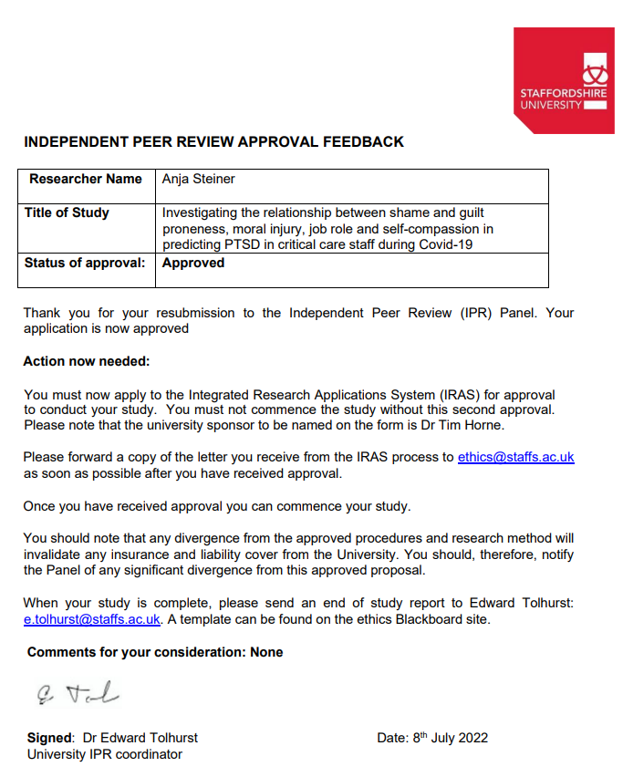

Appendix C
Ethical Approval from HRA
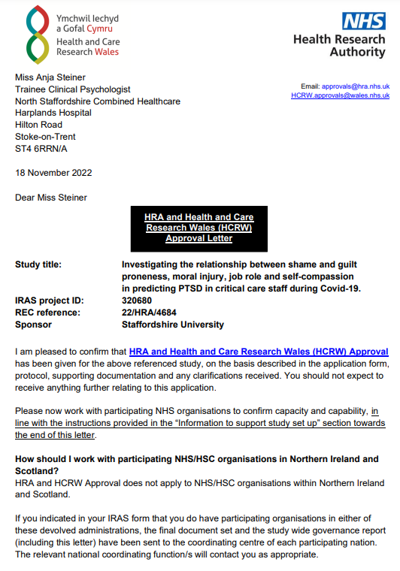

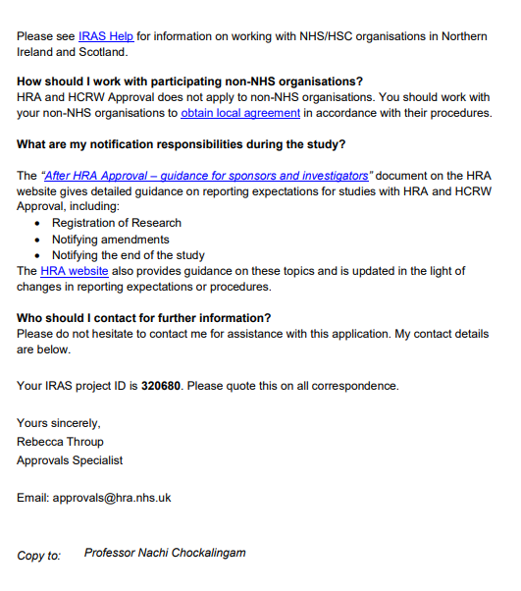

Appendix D
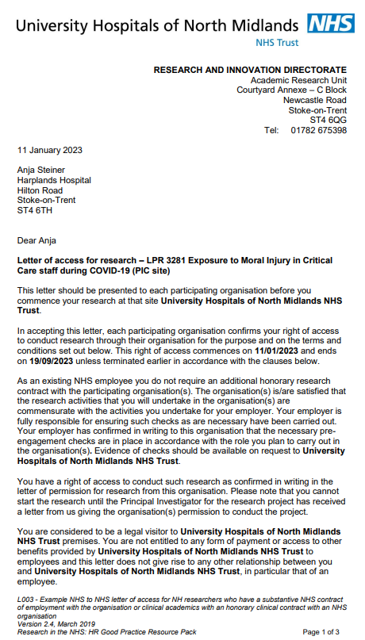
Letter of Access for Research
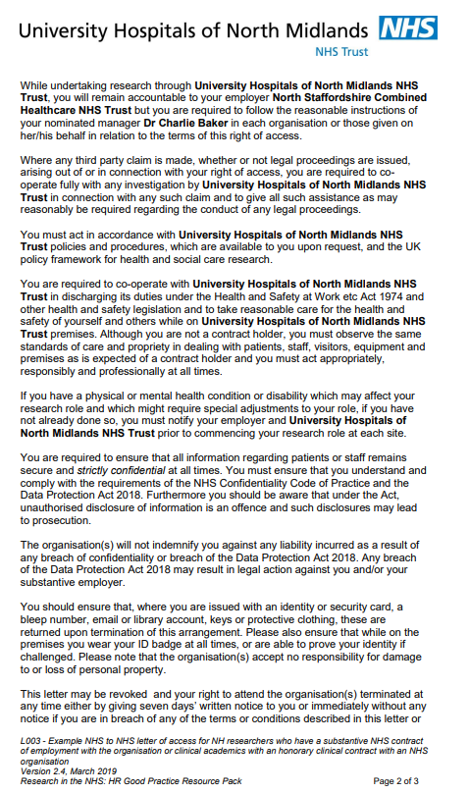
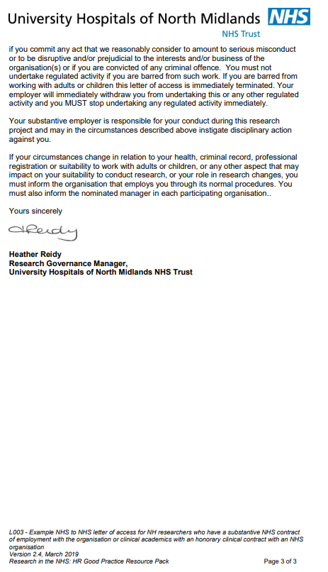

Appendix E
Research Advertisement

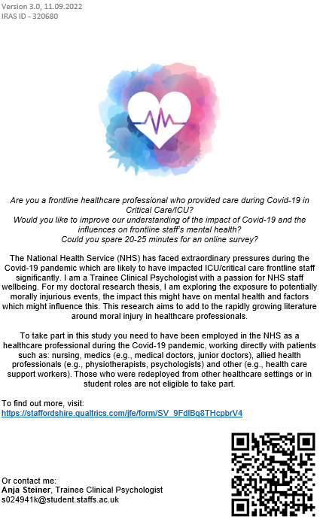

Appendix F
Participant Information Sheet
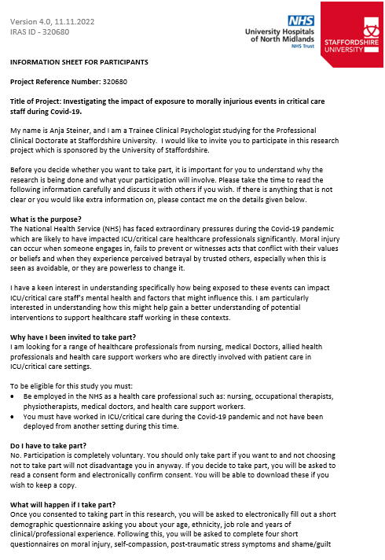
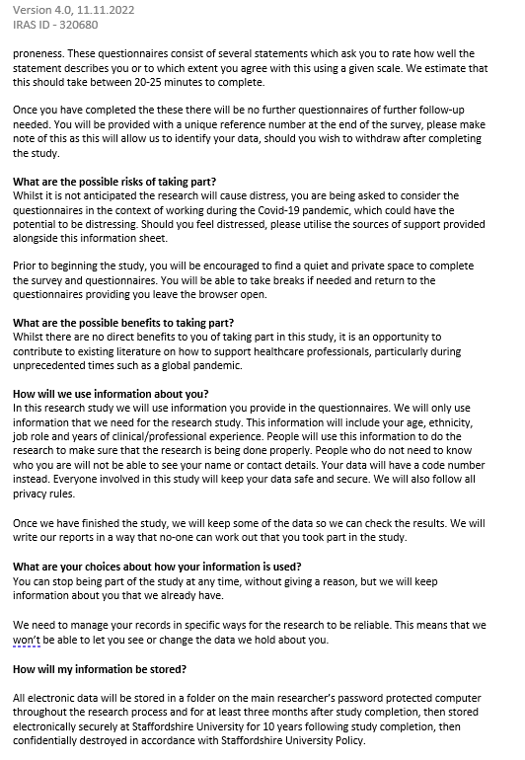
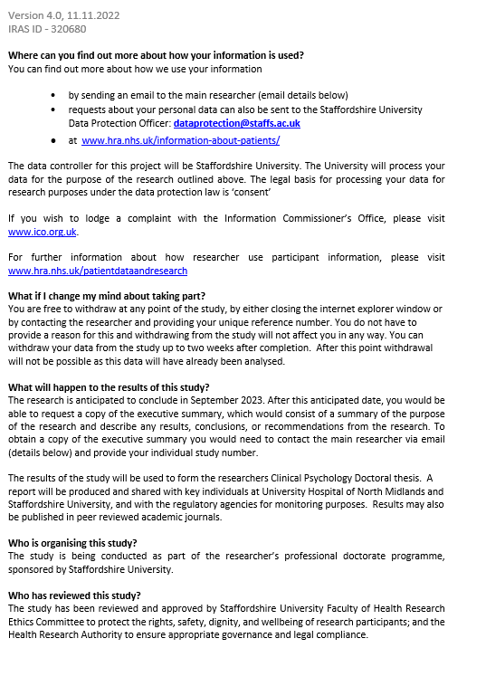

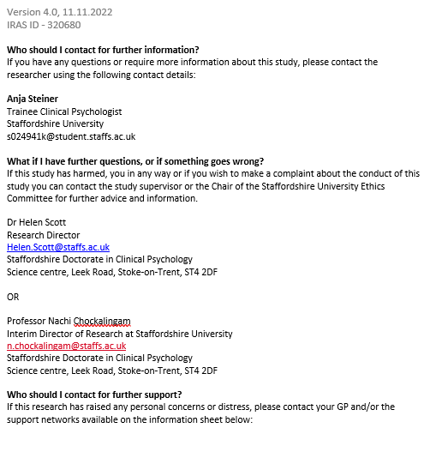

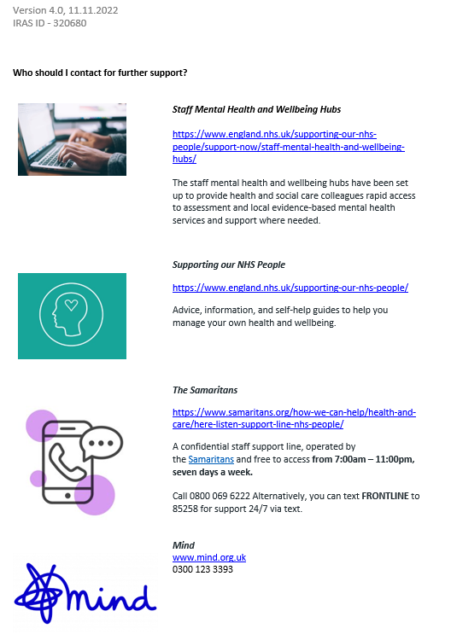

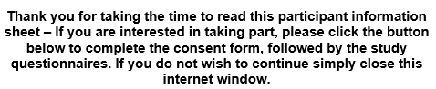

Appendix G
Participant Consent Form
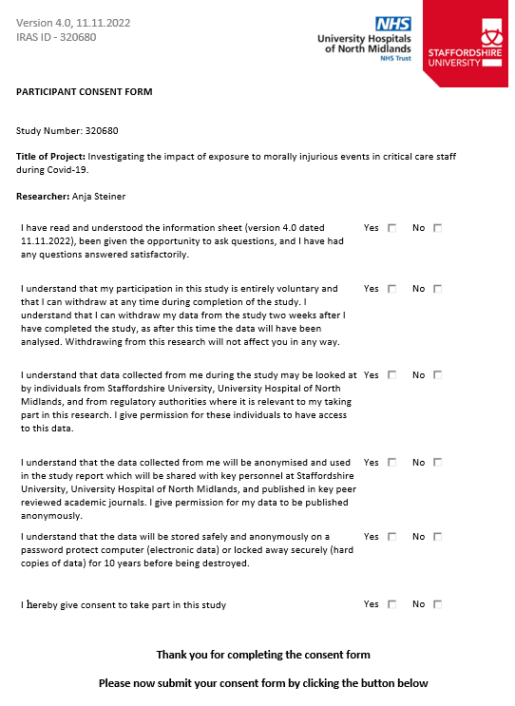

Appendix H
Demographic Questionnaire
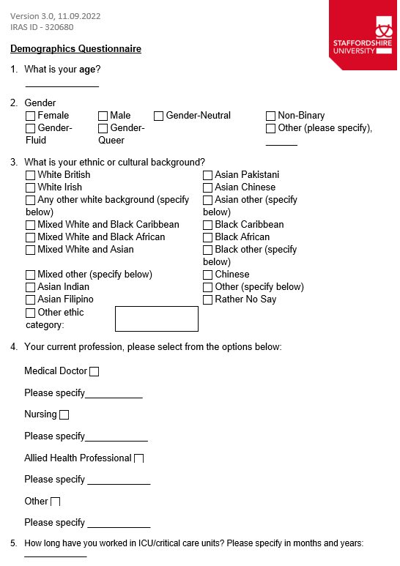

Appendix I
Measures
The Impact of Events Scale Revised (IES-R)
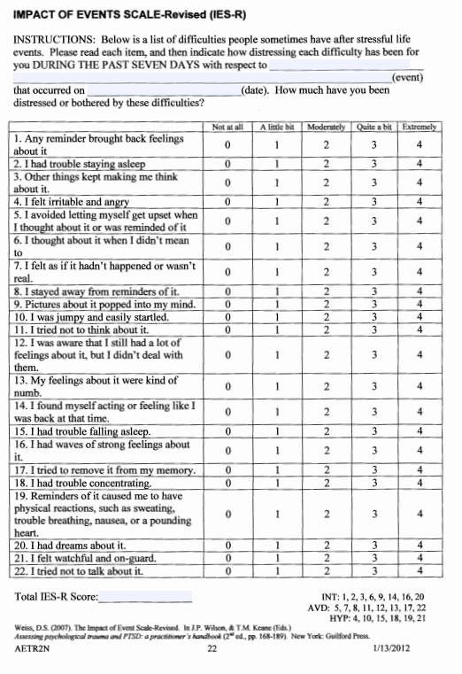
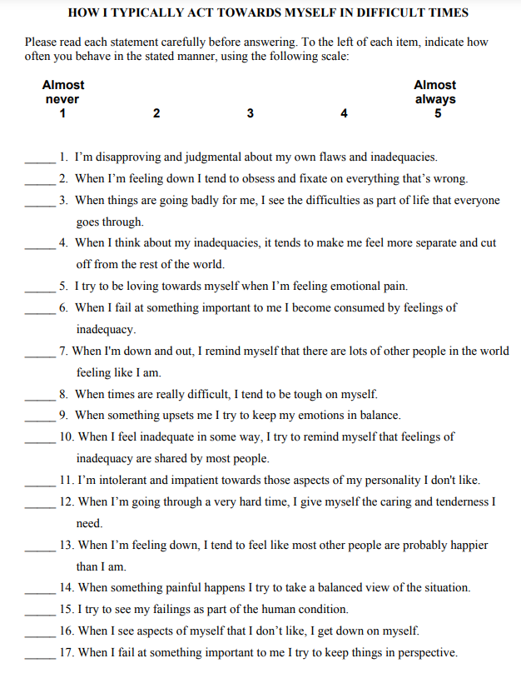
Self-Compassion Scale (SCS)

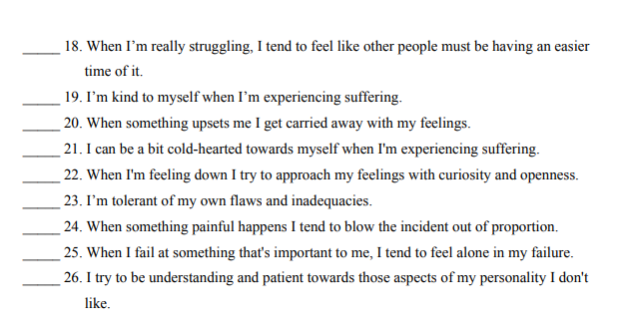

Test of Self-Conscious Affect, Version 3 (TOSCA)
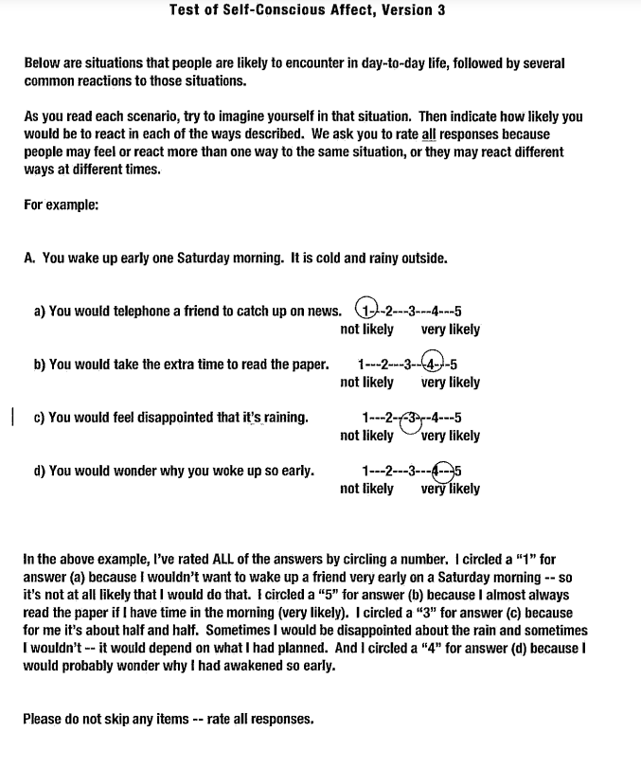

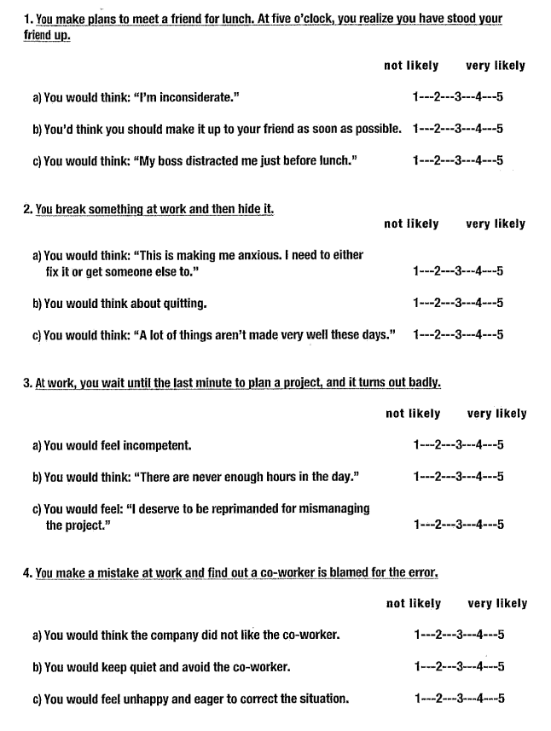

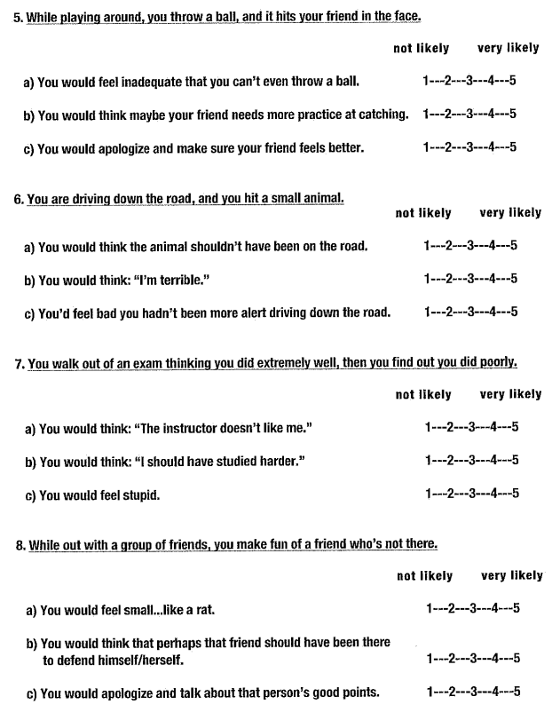

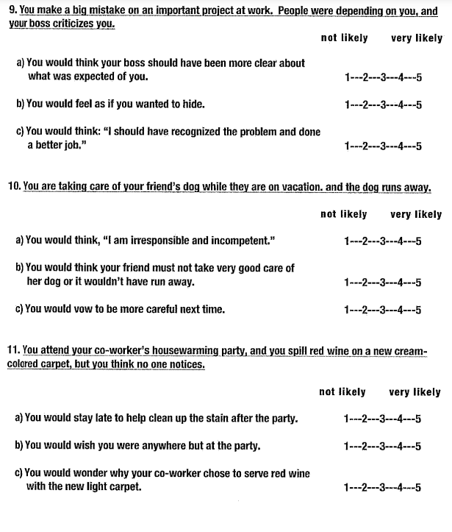

Moral Injury Events Scale (MIES)
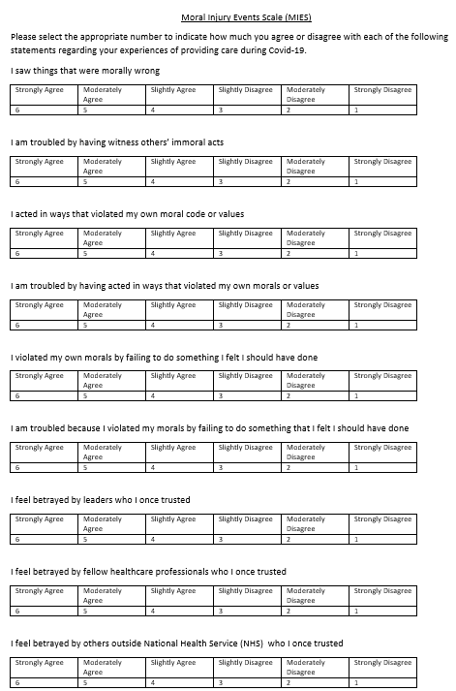

Appendix J
SPSS Output – Normality Checks
Normality checks showing violations to normality for PTSD symptoms (IES-R) and guilt proneness (TOSCA total guilt) (N = 56)
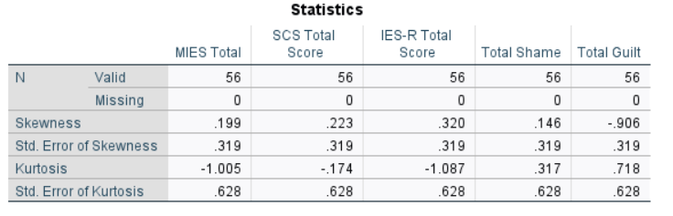
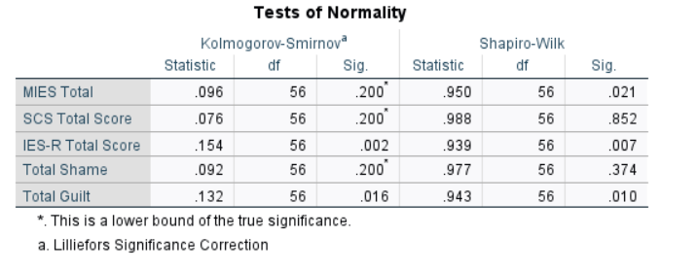

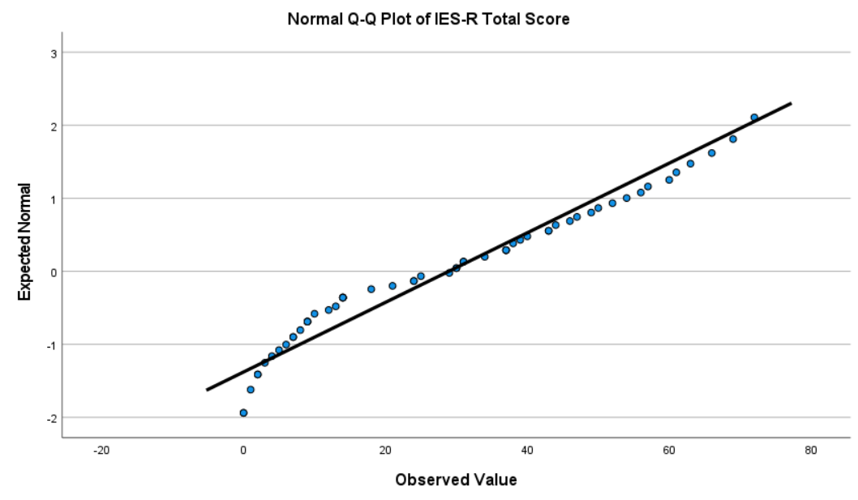

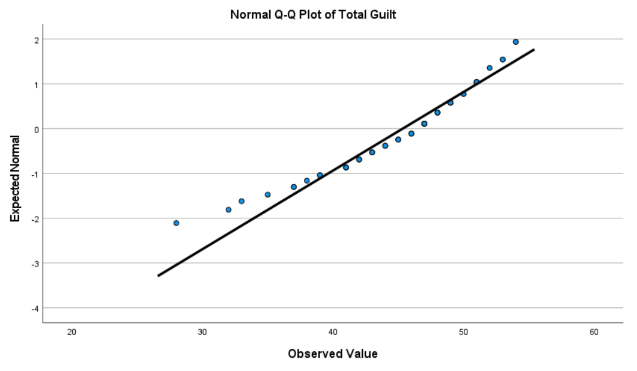

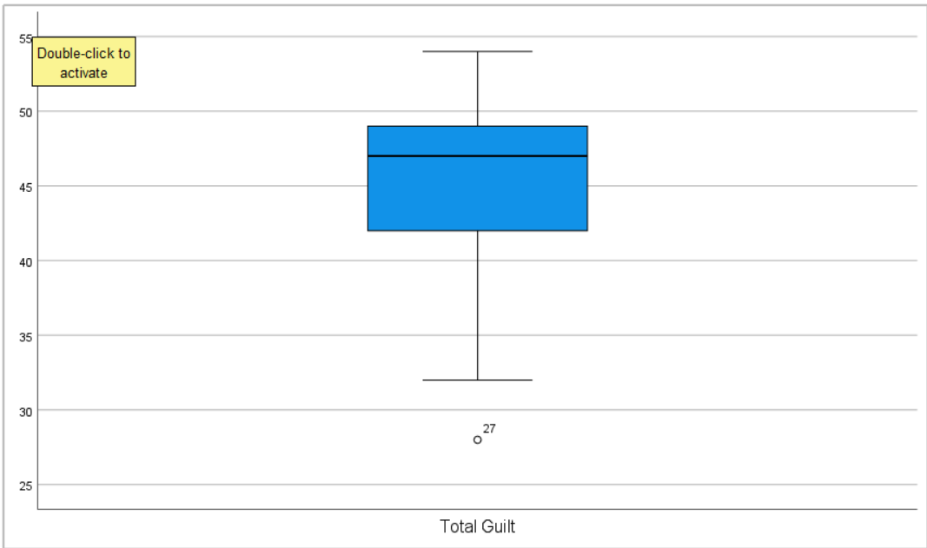
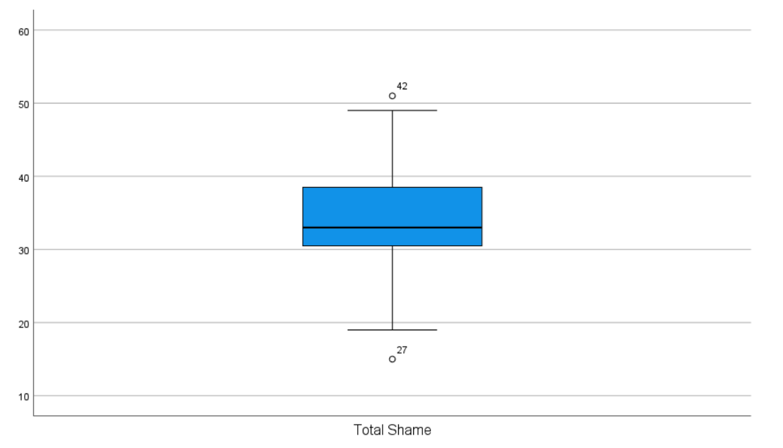

Appendix K
SPSS Analysis Output
Shame and Guilt Outliers Removed (N = 54)
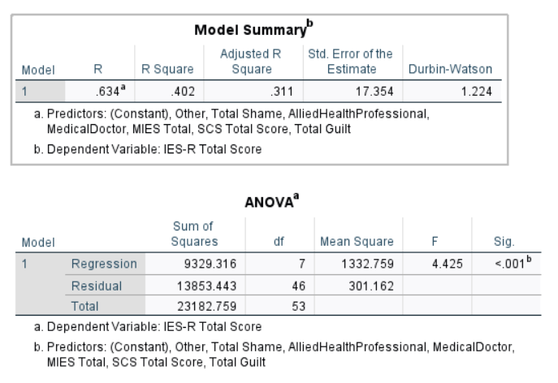

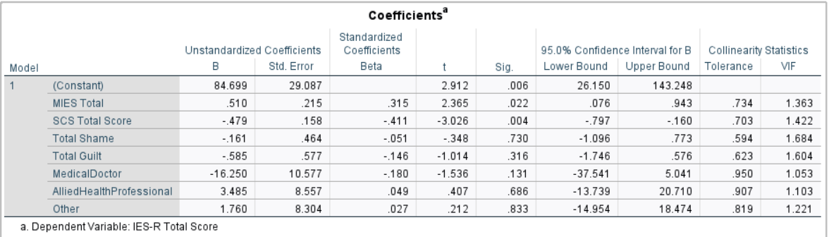
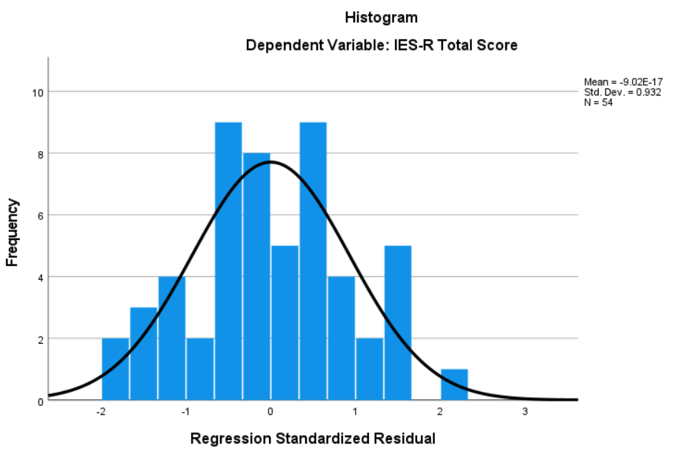
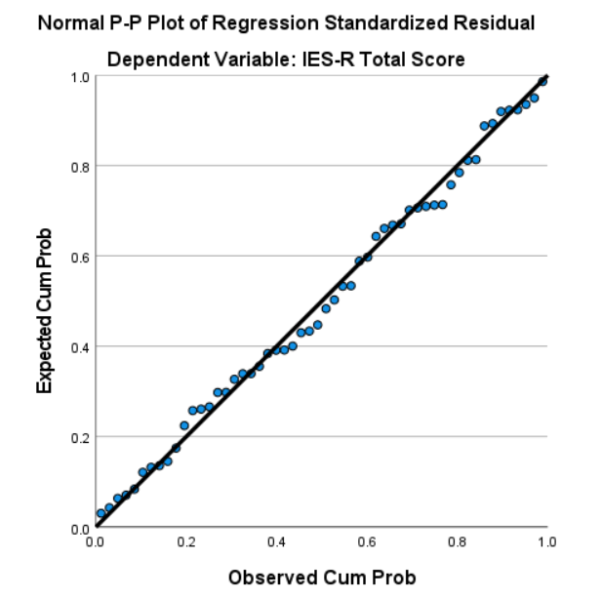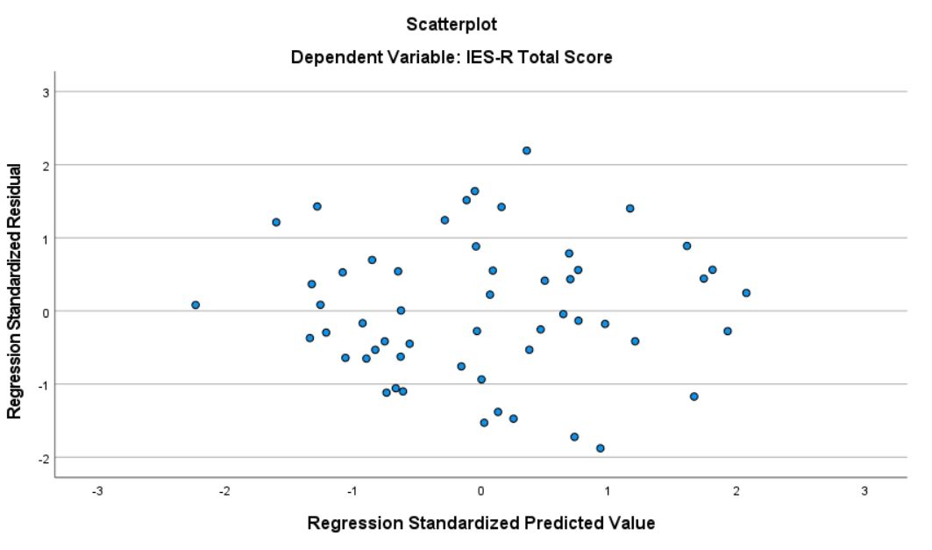

Appendix L
SPSS Analysis Output
Regression with predictors (MIES, SCS, TOSCA Shame, TOSCA Guilt, Professional Role) and identified outlier on partial regression plot and Bootstrap Regression (N = 56)
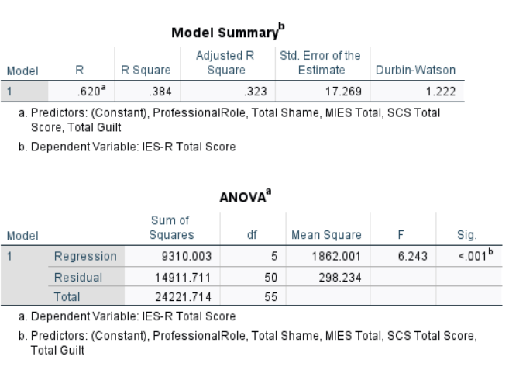

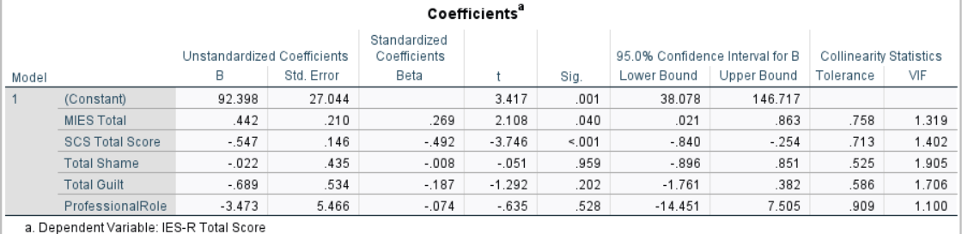

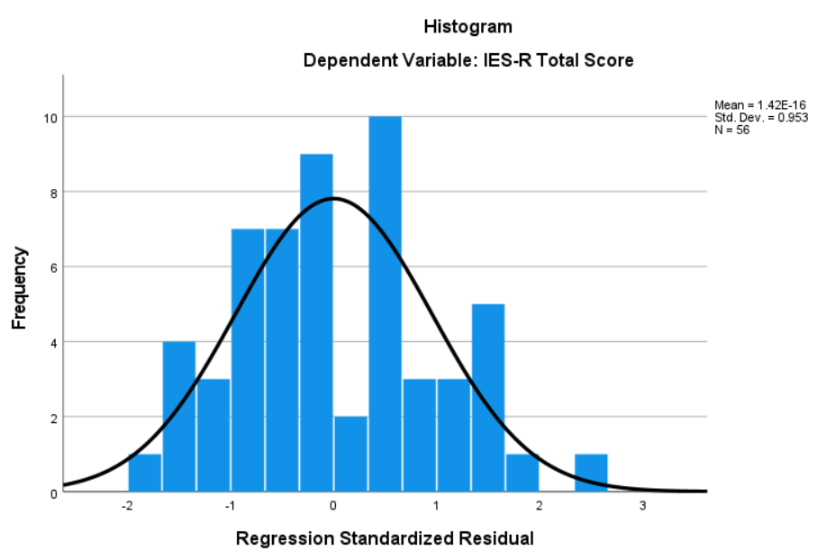

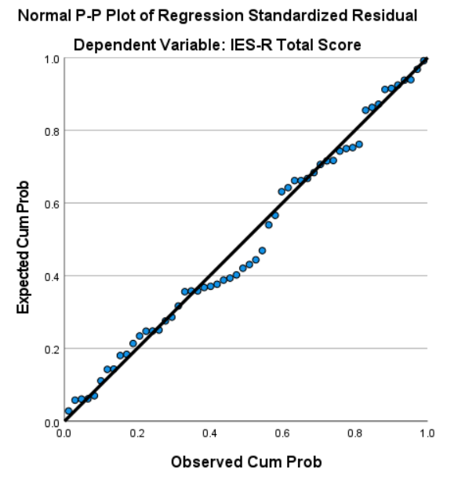

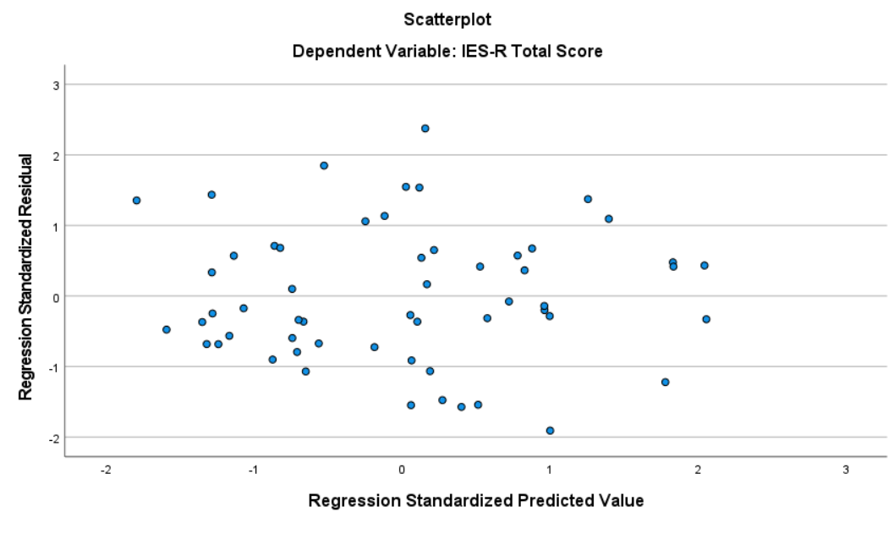

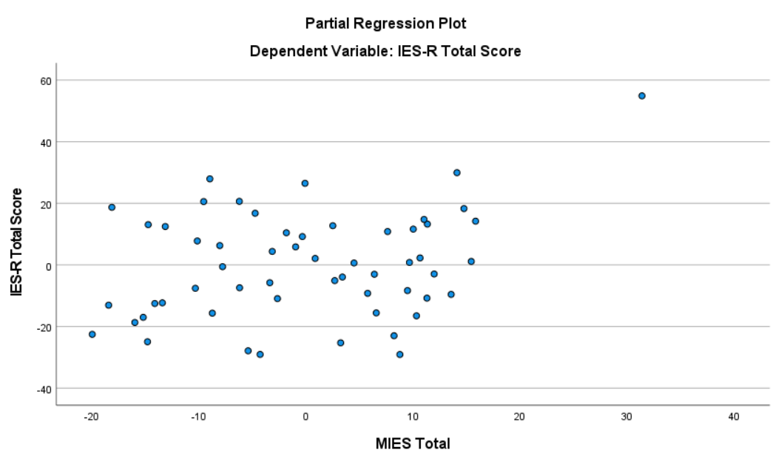

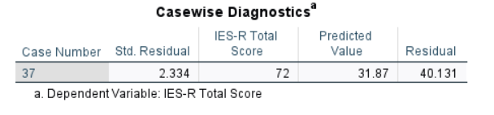

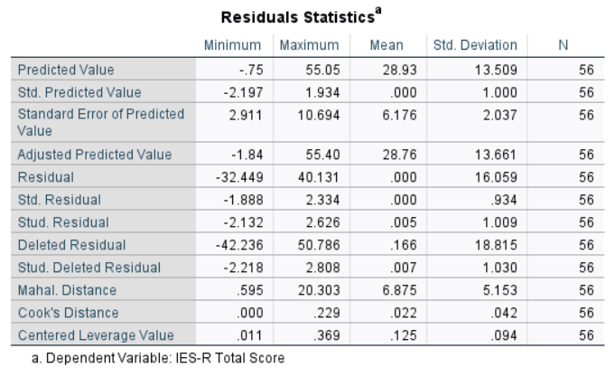

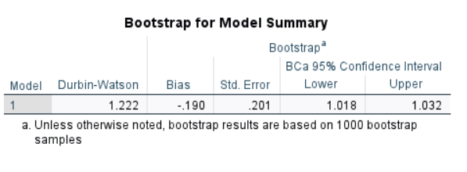
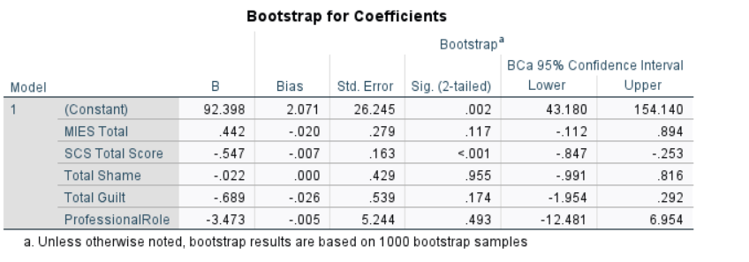

Appendix M
SPSS Analysis Output
Regression with Outlier Removed and Bootstrap Regression (N = 55)

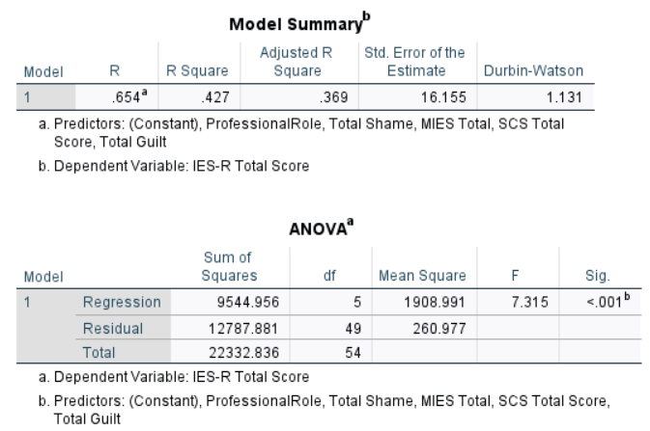

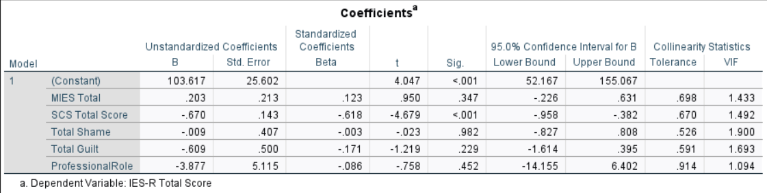
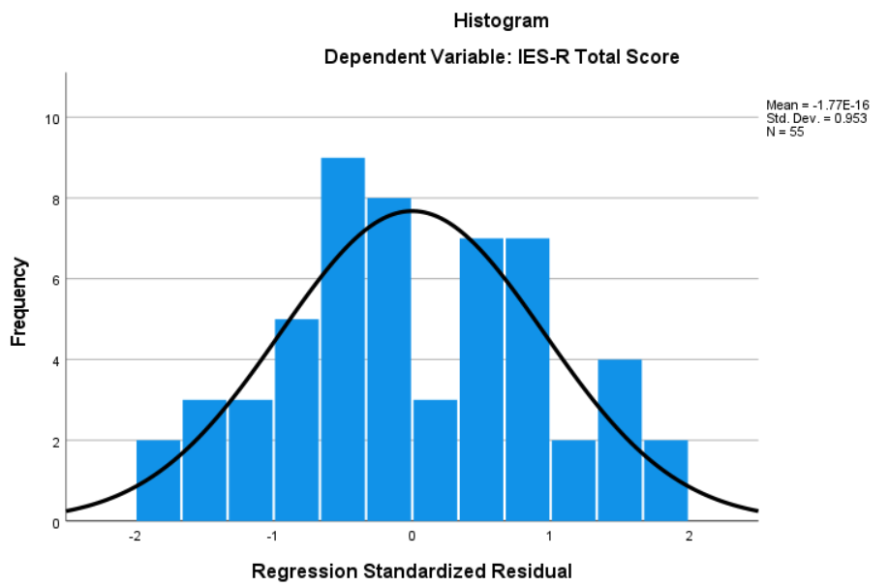
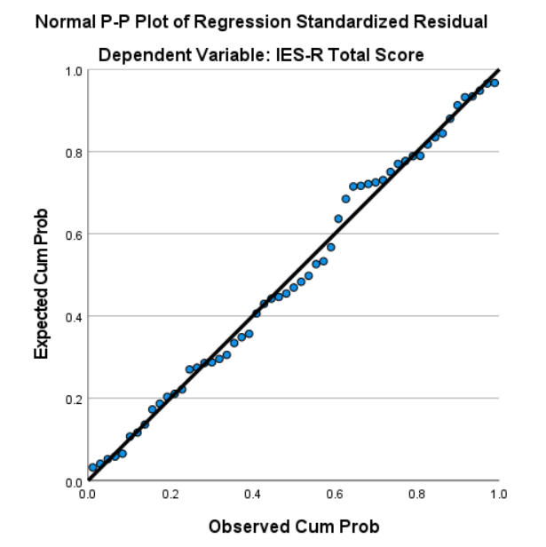

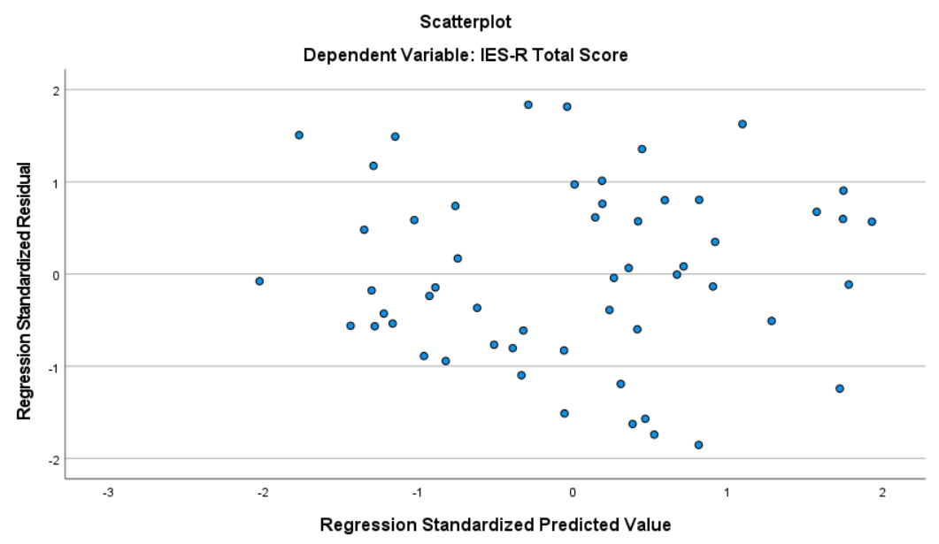

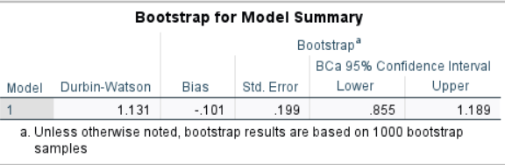

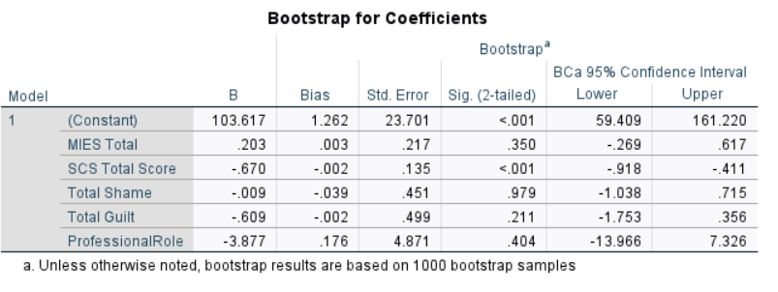

Appendix N
SPSS Analysis Output
Regression Model with One Predictor (Self-Compassion) (N = 55)
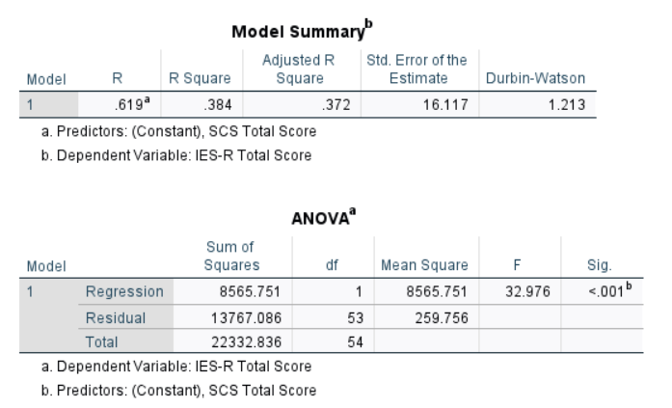

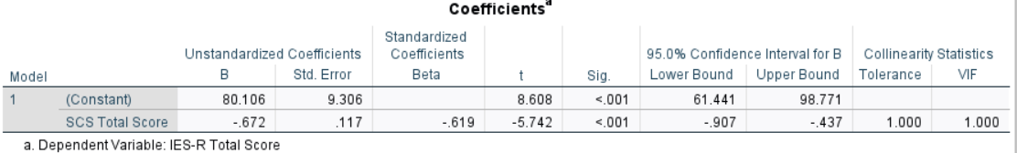

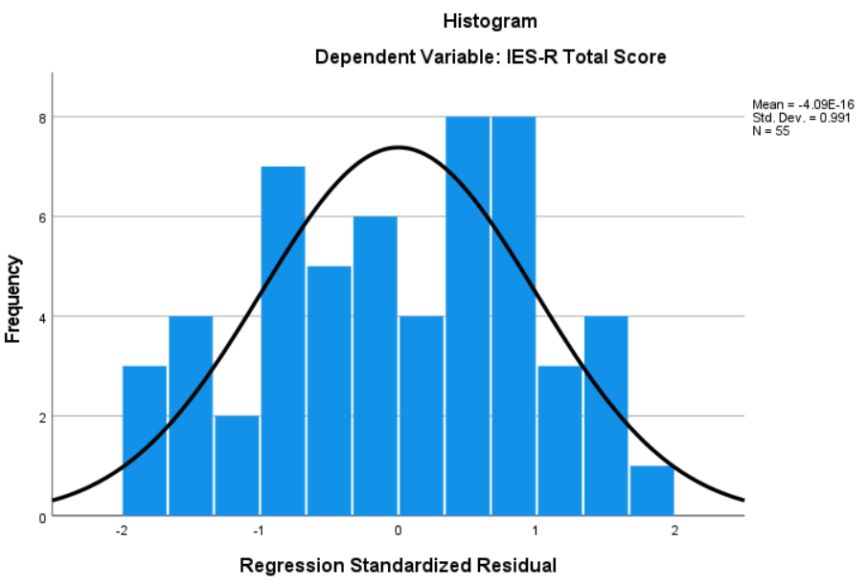

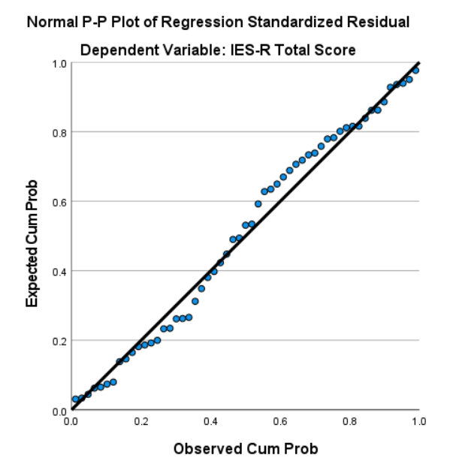

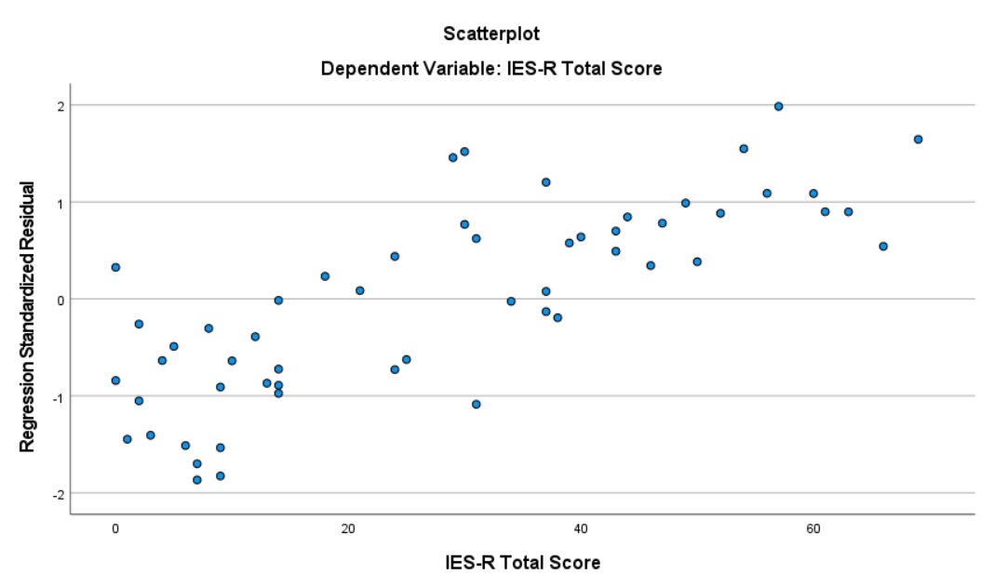

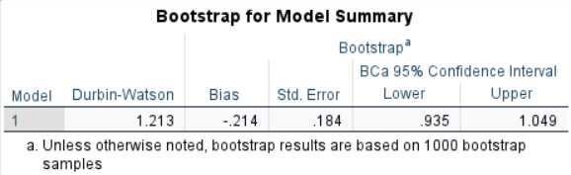

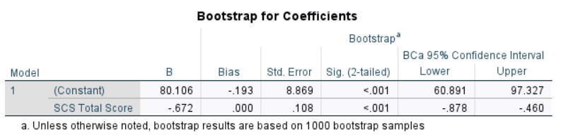

Appendix O
SPSS Analysis Output
Mediation Analysis with shame proneness, guilt proneness and self-compassion (n= 55)

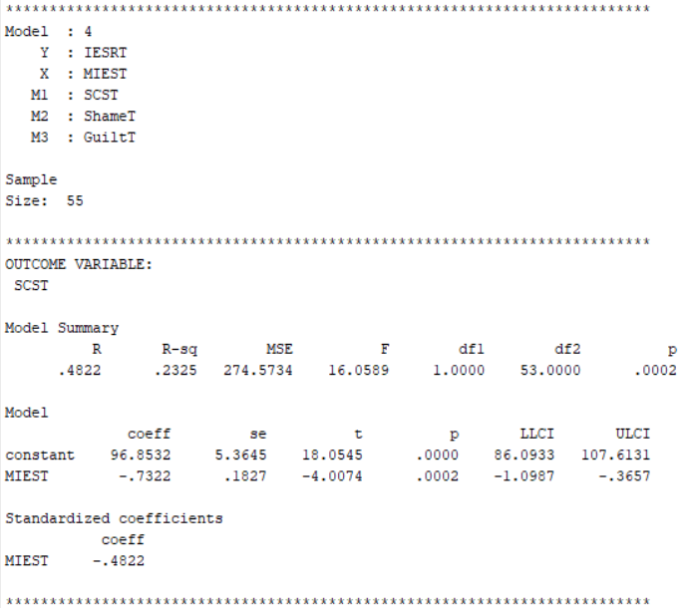

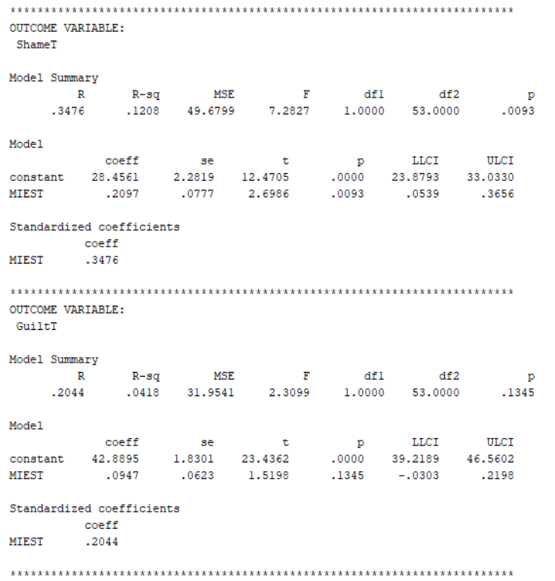

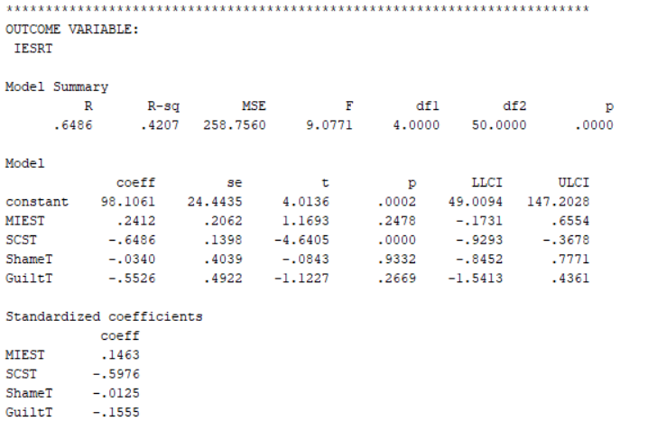

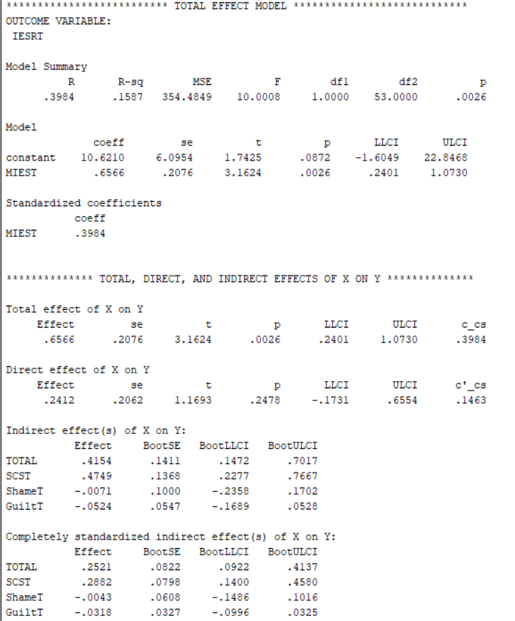

Appendix P

SPSS Analysis Output
Mediation Analysis with Self-Compassion (N= 55)
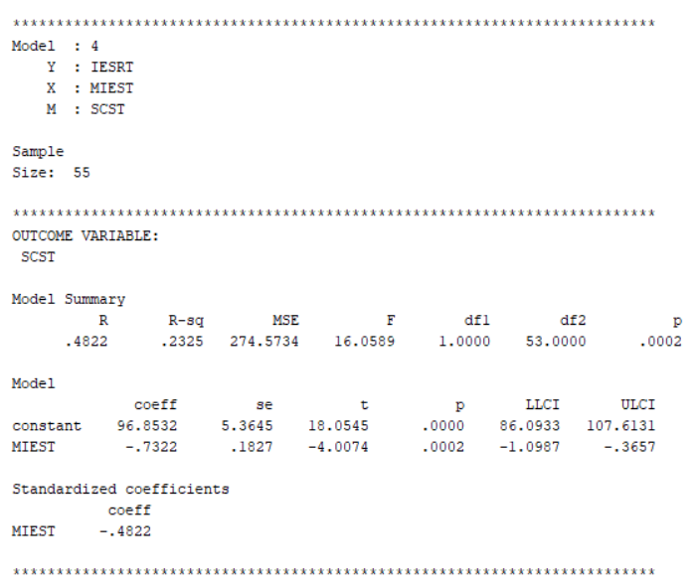

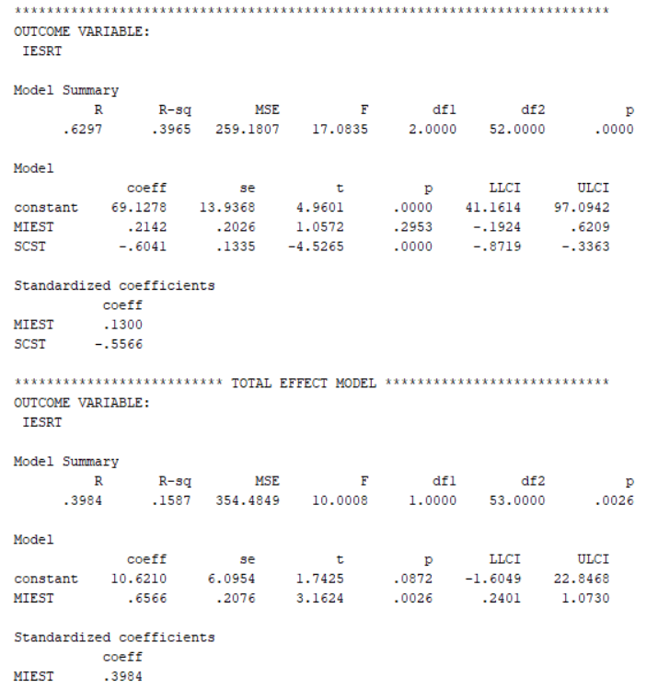

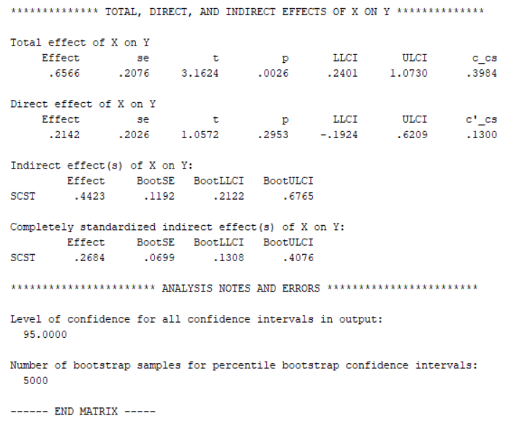

Paper 3: Executive Summary

Investigating Shame and Guilt Proneness, Moral Injury, Professional Role, Self-Compassion and Post-Traumatic Stress in Critical Care Staff During Covid-19: An Executive Summary

Word count: 2497 (Excluding title page and references)

Investigating Shame and Guilt Proneness, Moral Injury, Professional Role, Self-Compassion and Post-Traumatic Stress in Critical Care Staff During Covid-19
This report is a summary of a research project undertaken with healthcare professionals in critical care, who provided direct patient care during Covid-19. The research investigated factors which impact levels of post-traumatic stress disorder (PTSD) and included exposure to morally injurious events, shame and guilt proneness, professional role, and self-compassion.
This summary has been written for healthcare professionals in critical care; it may also be of interest to senior leadership within critical care and professionals who provide psychological support to healthcare professionals. This report has been developed in consultation with healthcare professionals from critical care who reviewed the report and provided feedback on the content and presentation.
Background to the Research
Covid-19 was declared a pandemic on the 11th of March 2020¹. Prior to Covid-19, the National Health Service (NHS) faced challenges such as understaffing and a lack of resources.² Covid-19 resulted in rapid increases in demand due to high patient admissions to hospital with Covid-19³ which further added pressure to an already strained NHS. Critical care teams were directly impacted as this is where most Covid-19 patients in the UK were admitted.
There were many factors during Covid-19 which meant that healthcare professionals were identified as being at high risk of experiencing high levels of distress. Some of these factors included:
- Caring for very sick patients and witnessing the death of many
- Being at increased risk of infection from Covid-19 and a lack of personal protective equipment (PPE)
- Covid-19 being an unknown disease which meant healthcare professionals had a lack of treatment guidelines.
What is PTSD?
Some of these factors meant that healthcare professionals were at an increased risk of experiencing PTSD. PTSD is a mental health difficulty that can occur after being exposed to a traumatic event such as exposure to death or witnessing the suffering of others.⁴ The table below shows the specific types of symptoms people with PTSD might experience and examples of these:

Type of PTSD Symptom | Examples of Symptoms
- Reliving aspects of what happened | - Vivid flashbacks  - Nightmares  - Intense distress from being exposed to reminders of the event
- Avoiding feelings or memories | - Avoiding anything that reminds them of the event  - Feeling emotionally or physically numb
- Difficult thoughts or feelings | - Blaming themselves or others for the event  - Overwhelming feelings of guilt, shame, or anger  - Feeling like they can’t trust others
- Alertness or feeling on edge | - Extreme alertness known as ‘hypervigilance’  - Being easily upset or irritable

It is estimated that up to 40% of healthcare professionals in the UK experienced PTSD during Covid-19.⁵ Research during Covid-19 found that nursing staff in particular were at higher risk of developing PTSD compared to other professionals.⁶
What factors might impact levels of PTSD?
Not everyone exposed to traumatic events will develop PTSD, research suggests there are key factors as to how someone interprets the event, how they think of themselves and the emotions they experience as a result.⁷
Shame Proneness and Guilt Proneness
Shame and guilt are emotions people might experience following exposure to a traumatic event. Guilt describes a sense of regret or responsibility that relates to feeling you have done something wrong. Shame describes feelings of embarrassment and incompetence that relate to feeling there is something wrong or bad about themselves. Past research suggests that individuals who are more prone to experiencing shame and guilt are at a higher risk of developing PTSD because they are more likely to have negative thoughts about themselves⁸ (the figure below shows this).

Guilt ‘It was my fault’
Shame ‘I am a terrible person’

Moral Injury
Moral injury describes the distress which can occur when someone acts in ways, fails to stop, or witnesses acts that conflict with their values or beliefs.⁹ It can also occur when someone feels betrayed by a leader or trusted authority.¹⁰ This can lead to difficulties such as intense feelings of guilt and shame, negative thoughts about themselves or others which relates to PTSD symptoms. ¹¹Examples in which healthcare professionals may have been exposed to morally injurious events are noted in the box below:
- Conflicting values between a duty of care, safeguarding themselves and their families
- Feeling that they were unable to provide optimal patient care, due to limited guidance around Covid-19 and lack of resources
- Feeling let down and angry at the UK Government and NHS leaders handling of the pandemic

Research during Covid-19 found that healthcare professionals who reported higher exposure to morally injurious events, reported higher levels of PTSD.¹²

Self-Compassion
Self-compassion has been defined as a self-attitude in the face of emotional distress which involves three components.¹³ These are shown in the figure below:
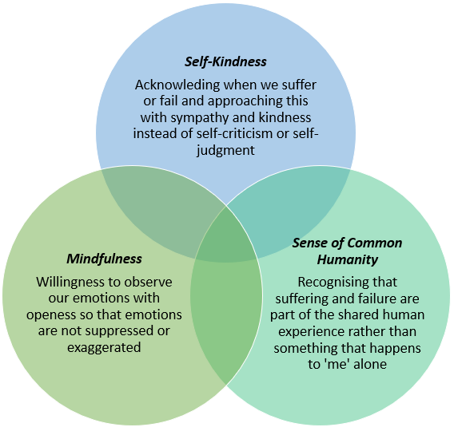

Lower levels of self-compassion are related to higher levels of PTSD in healthcare professionals.¹⁴ Lower levels of self-compassion might mean that individuals are more likely to be self-critical and therefore might experience higher levels of shame and guilt. Self-compassion may help individuals following exposure to traumatic events or morally injurious events by managing feelings of guilt and shame, reducing avoidance of difficult feelings and unwanted thoughts, reducing self-criticism and self-judgment which have been shown to increase the risk of PTSD.¹³

Why carry out this study?
Research during Covid-19 suggests that many healthcare professionals experienced PTSD, and potential factors related to this may be lower levels of self-compassion, higher reported exposure to morally injurious events, higher shame and guilt proneness and being from a nursing profession. However, these factors have not been investigated together to see if they predict PTSD in healthcare professionals.
It has been suggested that interventions that increase self-compassion may lead to a reduction in PTSD symptoms.¹⁵ It is important to understand the relationship between these factors to help develop interventions to support healthcare professionals.¹⁶

Aims of the Study
- To investigate whether reported exposure to morally injurious events, shame and guilt proneness, professional role, and self-compassion, predict PTSD in healthcare professionals who worked in critical care during Covid-19.
- To investigate whether lower levels of self-compassion, higher levels of guilt and shame proneness impact the relationship between reported exposure to morally injurious events and PTSD.
Predicted Outcomes
- Higher levels of reported exposure to morally injurious events, lower levels of self-compassion, higher levels of shame and guilt proneness and being from a nursing profession compared to other professions, will predict higher levels of PTSD symptoms.
- Participants with lower levels of self-compassion, higher levels of guilt and shame proneness will report higher levels of exposure to morally injurious events. In turn, lower levels of self-compassion and higher levels of guilt and shame proneness will be associated with higher levels of PTSD symptoms.

Method
This study was reviewed and approved by Staffordshire University Ethics Committee and the NHS Health Research Authority (HRA).
Who could take part?
Healthcare professionals had to meet the following criteria to take part:
To take part, healthcare professionals must be: | Healthcare professionals could not take part if:
- Aged 18 or over  - Employed as a healthcare professional in the NHS (UK) including medical doctors, nurses, allied health professionals and other roles such as healthcare support workers, nursing assistants etc  - Involved in direct patient care during the Covid-19 pandemic (March 2020 onwards) | - Unable to understand written English (as there were no resources for translation)  - Redeployed from another healthcare setting during Covid-19  - They did not have contact with patients or a role involving patient care  - Nursing or medical students

How were participants recruited?
Participants were recruited between December 2022 and March 2023. A research advertisement was posted on social media and online groups aimed at healthcare professionals. The study was also advertised at critical wards through a local trust.
What did taking part involve?
This research was a cross-sectional design, meaning that data was collected at one point in time. Participants completed the study online which they accessed through a link in the advertisement, and this took participants to a webpage detailing information about the study. From here participants could make an informed decision about taking part, if they decided to proceed, participants were asked to complete a consent form before they could access the study.
Participants were asked to complete several questions about themselves, this included their:
- Age
- Gender
- Ethnicity
- Professional role
- Length of time working in critical care

Participants were then asked to complete four questionnaires:

- The Impact of Events Scale Revised ¹⁷ is a 22-item questionnaire measuring PTSD symptoms relating to participants experiences of working in critical care during Covid-19. These scores can be categorised to show whether the severity of PTSD symptoms is high enough to suggest a probable diagnosis of PTSD, high enough that they might be of clinical concern or lower than a cut-off score suggesting the severity does not likely indicate PTSD.

- The Moral Injury Events Scale ¹⁸ is a nine-item questionnaire measuring perceptions of exposure to morally injurious events by asking participants relating to their experiences of working in critical care during Covid-19.

- The Self-Compassion Scale¹⁹ is a 26-item questionnaire that measures levels of self-compassion.

- The Test of Self-Conscious Affect²⁰ is a 11-item questionnaire that measures shame proneness and guilt proneness.

Who took part?
Fifty-six participants were recruited for this study. Most participants were female (86%) and white British (79%). The age of participants ranged from 22-60. The time length of time working in critical care ranged from 6 months to 37 years. Details about the different professional roles are presented in the diagram below. One participant’s information was removed from the analysis as their scores differed significantly from others; therefore, 55 participants were included in the analysis.

How did we obtain the results?
Two types of statistical analysis were used. The first was a multiple regression analysis. This analysis shows whether there is a relationship between two or more factors such as self-compassion and PTSD. More specifically, the analysis shows whether one factor significantly impacts another factor. If the regression analysis identifies there is a significant impact, it is known as a predictor of the other factor. This study looked to investigate if shame and guilt proneness, professional role, exposure to moral injury and self-compassion would predict PTSD symptoms.
The second was a mediation analysis. This analysis investigates why or how one factor might predict another. It investigates whether a factor in between the predictor and the outcome variable might indirectly influence the relationship (as shown in the figure below). The factor in between is known as mediator factor and is thought to explain how the predictor factor might influence the outcome factor, through the mediator.

Key Findings
Prediction One: Higher levels of reported exposure to morally injurious events, lower levels of self-compassion, higher levels of shame and guilt proneness and being from a nursing profession compared to other professions, will predict hight levels of PTSD symptoms.

Using the multiple regression analysis, lower levels of self-compassion were found to be significant predictor of higher PTSD symptoms (the figure below shows this). Exposure to moral injury, shame proneness, guilt proneness and professional role were not significant predictors of PTSD.

=

Higher levels of
PTSD symptoms
Lower levels of
self-compassion

These results indicate the prediction one was partly correct; lower levels of self-compassion were related to higher levels of PTSD symptoms in healthcare professionals; however, the other factors were not.

Results also show that 42% of participants reported levels of PTSD symptoms high enough to be categorised as showing a probable diagnosis of PTSD (the chart below shows this)

Prediction Two: Healthcare professionals with lower levels of self-compassion, higher levels of guilt proneness and shame proneness will report higher levels of exposure to morally injurious events. In turn, lower levels of self-compassion and higher levels of guilt and shame proneness will be associated with higher levels of PTSD symptoms.

The results suggest that lower levels of self-compassion are associated with higher levels of reported exposure to morally injurious events, and lower levels of self-compassion are associated with higher levels of PTSD. This suggests that reported exposure to morally injurious events increases PTSD symptoms, through lower levels of self-compassion. Therefore, prediction two was partially supported.

Conclusions and Recommendations
The findings of this study suggest that lower levels of self-compassion significantly predict higher levels of PTSD in healthcare professionals in critical care, who provided care during Covid-19. The findings also suggest that healthcare professionals with higher reported exposure to morally injurious events, had lower levels of self-compassion and in turn, higher levels of PTSD.
Clinical Recommendations
These findings have important implications for healthcare professionals and those supporting healthcare professionals. Self-compassion may be a key mechanism to support the reduction of PTSD symptoms and reported exposure to morally injurious events.
Healthcare professionals may prefer to have access to a range of information and support. Some ideas to help put this into practice include:
- Using an intervention to increase self-compassion individual or group based, such as Compassion Focused Therapy.²¹ This type of intervention encourages individuals to recognise difficult emotions and build strategies to reduce shame, guilt, and self-criticism.²²
- Healthcare professionals should have access to information regarding PTSD and common reactions following exposure to trauma to increase knowledge and understanding.
- Organisations should consider how to support self-compassion in the workplace. Compassionate leadership is a model which promotes a strong sense of shared purpose, values and common humanity which may support individuals to be more self-compassionate.²³
Limitations
- The study had a relatively small sample size compared to similar studies, therefore there may have not been enough participants to accurately measure the impact of all factors.
- As the study only collected data relating to experiences during Covid-19, it is difficult to say if the levels of PTSD participants reported in this study were caused due to Covid-19 or whether these difficulties existed prior to Covid-19.
- Participants were recruited both online and through a local NHS trust, therefore the findings may not be generalisable to all critical care settings.
Recommendations for researchers
It is important to remember that this is only one study, so caution should be applied when interpreting the results. Further research should be done to help verify these findings. Examples of future research could include:
- Measuring levels of PTSD, self-compassion, and exposure to morally injurious events over time. This would enable researchers to explore this relationship further and how it might change over time.
- Investigating if other factors are relevant to the relationship between the variables, for example, do lower levels of organisational support influence levels of PTSD?
- Most of the research has focused on challenges faced by healthcare professionals during Covid-19, future research might consider what factors may have promoted positive outcomes for healthcare professionals following the pandemic.
- A comparison study could be used to compare participants PTSD scores before and after receiving a self-compassion intervention to see if the intervention reduces levels of PTSD.
Who will this research be shared with?
Participants were advised they could contact the research to request a copy of this reported once the research was complete. This research will also be submitted for publication to a scientific journal, “Journal of Traumatic Stress”.

Bibliography
1.World Health Organisation. WHO Director-general’s opening remarks at the media briefing on COVID-19. [Internet]. World Health Organisation. 2020. Available from: https://www.who.int/director-general/speeches/detail/who-director-general-s-opening-remarks-at-the-media-briefing-on-covid-19-11-march-2020

2.Bennett P, Noble S, Johnston S, Jones D, Hunter R. COVID-19 confessions: a qualitative exploration of healthcare workers experiences of working with COVID-19. BMJ Open. 2020 Dec;10(12):e043949.

3.Shah SA, Brophy S, Kennedy J, Fisher L, Walker A, Mackenna B, et al. Impact of first UK COVID-19 lockdown on hospital admissions: Interrupted time series study of 32 million people. eClinicalMedicine [Internet]. 2022 Jul 1;49(101462). Available from: https://www.thelancet.com/journals/eclinm/article/PIIS2589-5370(22)00192-4/fulltext

4.American Psychiatric Association. Diagnostic and statistical manual of mental disorders. Diagnostic and Statistical Manual of Mental Disorders, Fifth Edition, Text Revision (DSM-5-TR) [Internet]. 2022 Mar 18;5(5). Available from: https://dsm.psychiatryonline.org/doi/book/10.1176/appi.books.9780890425787

5.Greenberg N, Weston D, Hall C, Caulfield T, Williamson V, Fong K. Mental health of staff working in intensive care during COVID-19. Occupational Medicine. 2021 Jan 13;71(2).

6.Greene T, Harju-Seppänen J, Adeniji M, Steel C, Grey N, Brewin CR, et al. Predictors and rates of PTSD, depression and anxiety in UK frontline health and social care workers during COVID-19. European Journal of Psychotraumatology [Internet]. 2021 Jan 1;12(1):1882781. Available from: https://www.tandfonline.com/doi/abs/10.1080/20008198.2021.1882781

7.Ehlers A, Clark DM. A cognitive model of posttraumatic stress disorder. Behaviour Research and Therapy [Internet]. 2000 Apr;38(4):319–45. Available from: https://www.sciencedirect.com/science/article/pii/S0005796799001230

8.Delima-Tokarz T. The Psychiatric Ramifications of Moral Injury Among Veterans. American Journal of Psychiatry Residents’ Journal. 2016 May;11(5):10–2.

9.Litz BT, Stein N, Delaney E, Lebowitz L, Nash WP, Silva C, et al. Moral injury and moral repair in war veterans: a preliminary model and intervention strategy. Clinical psychology review [Internet]. 2009 [cited 2019 Oct 16];29(8):695–706. Available from: https://www.ncbi.nlm.nih.gov/pubmed/19683376

10.Shay J. Moral injury. Psychoanalytic Psychology. 2014 Apr;31(2):182–91.

11.Williamson V, Murphy D, Greenberg N. COVID-19 and experiences of moral injury in front-line key workers. Occupational Medicine. 2020 Apr 2;70(5).

12.Williamson V, Lamb D, Hotopf M, Raine R, Stevelink S, Wessely S, et al. Moral injury and psychological wellbeing in UK healthcare staff. Journal of Mental Health. 2023 Mar 8;1–9.

13.Neff K. Self-Compassion: An Alternative Conceptualization of a Healthy Attitude Toward Oneself. Self and Identity [Internet]. 2003 Apr;2(2):85–101. Available from: https://www.tandfonline.com/doi/abs/10.1080/15298860309032

14.McDonald MA, Meckes SJ, Lancaster CL. Compassion for Oneself and Others Protects the Mental Health of First Responders. Mindfulness. 2020 Nov 13;

15.Winders S, Murphy O, Looney K, O’Reilly G. Self‐compassion, trauma, and posttraumatic stress disorder: A systematic review. Clinical Psychology & Psychotherapy. 2020 Feb 5;27(3):300–29.

16.Neff KD, Germer CK. A Pilot Study and Randomized Controlled Trial of the Mindful Self-Compassion Program. Journal of Clinical Psychology [Internet]. 2013 Oct 15;69(1):28–44. Available from: https://chrisgermer.com/wp-content/uploads/2017/02/OutcomeStudy_Germer-Neff-MSC-RCT-2013.pdf

17.Weiss DS. The Impact of Event Scale: Revised. Cross-Cultural Assessment of Psychological Trauma and PTSD. 2007;219–38.

18.Nash WP, Marino Carper TL, Mills MA, Au T, Goldsmith A, Litz BT. Psychometric Evaluation of the Moral Injury Events Scale. Military Medicine. 2013 Jun;178(6):646–52.

19.Tangney JP, Dearing RL, Wagner PE, Gramzow R. Test of Self-Conscious Affect–3. PsycTESTS Dataset. 2000;

20.Gilbert P. Introducing compassion-focused therapy. Advances in Psychiatric Treatment [Internet]. 2009 May;15(3):199–208. Available from: https://www.cambridge.org/core/journals/advances-in-psychiatric-treatment/article/introducing-compassionfocused-therapy/ECBC8B7B87E90ABB58C4530CDEE04088

21.Gilbert P. Compassion Focused Therapy. Routledge; 2010.

22.Zulueta P de. How do we sustain compassionate healthcare? Compassionate leadership in the time of the COVID-19 pandemic. Clinics in Integrated Care. 2021 Sep;8:100071.

Phases as defined in the introduction

