Understanding the experiences of family carers of individuals with Huntington’s Disease

Elizabeth Mehmet

Thesis submitted in partial fulfilment of the requirements of Staffordshire University for the degree of Doctorate in Clinical Psychology

April 2023

Total word count: 17,436

THESIS PORTFOLIO: CANDIDATE DECLARATION
Title of degree programme | Professional Doctorate in Clinical Psychology
Candidate name | Elizabeth Mehmet
Registration number | xxxxxxxx
Initial date of registration | September 2020

Declaration and signature of candidate
I confirm that the thesis submitted is the outcome of work that I have undertaken during my programme of study, and except where explicitly stated, it is all my own work.
I confirm that the decision to submit this thesis is my own.
I confirm that except where explicitly stated, the work has not been submitted for another academic award.
I confirm that the work has been conducted ethically and that I have maintained the anonymity of research participants at all times within the thesis.

Signed: Elizabeth Mehmet Date: 27th April 2023

Acknowledgements

I would like to give a special thanks to the participants that took part in the research. Thank you for giving me your time and sharing your stories with me so openly and honestly.

I would like to thank my research supervisor, Dr. Kim Gordon, for her unwavering support and valuable feedback. I would also like to thank my clinical supervisor, Dr. Lorraine King, for her support and encouragement during the research project.

I would like to thank my family and friends for their love and reassurance over the past three years. And to my husband, I think you deserve a medal.
Table of Contents

Thesis Abstract 5
Paper 1: Literature Review. 6
Abstract 7
Introduction 8
Method 11
Results 16
Discussion 31
Conclusion 33
References 35
Appendices 48
Paper 2: Empirical Paper 51
Abstract 52
Introduction 53
Materials and Methods 56
Results 62
Discussion 73
Conclusion 78
References 79
Appendices 86
Paper 3: Executive Summary Paper. 116
Acknowledgments 117
Background 118
Method 120
Findings 121
Discussion 124
References 126

Thesis Abstract

Paper 1 is a systematic literature review of 10 published research papers exploring how family and informal caregivers of individuals with Huntington’s Disease (HD) experience services. Papers included within the review were considered to be of moderate to good quality. Key findings related to carers’ experiences of seeking information, a lack of knowledge of HD amongst professionals, and the availability and accessibility of services. Implications for future research and the limitations of the review are discussed.

Paper 2 is an empirical study exploring the experiences of spouses of individuals with HD, with a particular focus on identity, the relationship and the impact on family life. Data was analysed using Interpretive Phenomenological Analysis (IPA). Participants experienced a transition from spouse to carer, losing their own identity within their caring role and experiencing changes in sexual intimacy, roles and responsibilities. Participants shared the challenges of family life and raising children.

Paper 3 is an executive summary written for spouses, partners and other adult family caregivers of individuals with HD to inform them of the research project. The paper was shared with group members at a HD support group. Group members read and commented on the paper, ensuring accessibility. The background, method, findings, limitations, clinical implications and directions for future research are summarised.

Paper 1: Investigating HD family caregiver’s experiences of services: A literature review.

Student ID: 20024736
Supervised by Dr Kim Gordon

Word count: 7,982

(Excluding Title Page, References and Appendices)

The current paper has been prepared for publication within ‘Clinical Genetics’ (Appendix A). Further amendments will be made prior to submission for publication, in accordance with journal requirements and guidelines.

Abstract

Huntington’s Disease (HD) is a neurodegenerative condition characterised by impairments in movement, cognition and behavioural disturbances. The progressive nature of the disorder means individuals require increasing levels of care and family members frequently assume caregiving roles. Caring for individuals with HD poses unique and complex challenges, with carers experiencing high levels of stress and burden. Carers have a vital role in supporting the individual with HD and will typically have contact with health and social care services, as well as specialised support services and other associations. Due to the complex nature of the condition, and the significant impact this can have on carers, it is important that these services are able to effectively meet the needs of this population and support them to continue within their caring role. A review of relevant literature was completed to explore how family and informal caregivers of individuals living with HD experience services. Papers included within the review were considered to be of moderate to good quality. Key findings related to carers’ experiences of seeking information, a lack of knowledge of HD amongst professionals, and the availability and accessibility of services. Implications for future research and the limitations of the current review are discussed.

Keywords: Huntington’s Disease , Neurodegenerative Diseases, Caregivers, Health Services, Mental Health Services, Social Services, Support Groups.

Introduction

Background

Huntington’s Disease (HD) is a progressive neurodegenerative condition which impacts an individual’s motor, cognitive, behavioural and social functioning. HD is typically diagnosed during midlife, between 35-45 years of age, through use of genetic testing or confirmed family history, following the emergence of early symptoms (McColgan & Tabrizi, 2018; Roos, 2010). HD is caused by a fault in the gene that is responsible for encoding the Huntingtin protein (Chen et al., 2013; McColgan & Tabrizi, 2018). HD is autosomal dominant, meaning children whose parents have HD have a 50% chance of inheriting HD themselves, and is a non-sex-linked disorder (Wood et al., 2002; Zielonka & Stawinska-Witoszynska, 2020). HD is currently incurable, with death occurring after around 17-20 years (Roos, 2010). Whilst prevalence estimates vary worldwide, HD is thought to affect more than 5,700 people across the United Kingdom (UK), with improvements to identification, the availability of genetic testing and a change in attitudes towards HD meaning that this figure is increasing over time (Evans et al., 2013; Rawlins et al., 2016).

Individuals with HD experience involuntary movements and cognitive difficulties, such as memory impairment and deficits in executive functioning (Chen et al., 2013; Roos, 2010). Other symptoms, including apathy, impulsivity, aggression and emotional dysregulation can also impact an individual’s functioning (Roos, 2010). Mental health difficulties are also common amongst individuals with HD, particularly depression and anxiety (Roos, 2010).

HD has a significant impact on family life (Vamos et al., 2007). The symptoms of HD typically emerge at a time in an individual’s life that is relatively complex, as around midlife, individuals may be in the process of raising children and developing their careers (Vamos et al., 2007). In the early stages of the disease, concerns typically relate to work, driving, and fulfilling household responsibilities (Nance, 2007). As the disease progresses, individuals with HD are no longer able to complete these actions and care needs increase, with difficulties often including an increase in involuntary movements, difficulties with speech and swallowing, significant weight loss, mood swings and depression (Nance, 2007; Quarrell, 1999). Individuals in later stages of the disease typically require nursing care (Nance, 2007).

This increase in care needs means that family members often assume caring roles (Aubeeluck & Moskowitz, 2008). Informal caregivers can include siblings, children, wider family and friends, but spouses and partners usually take the role of primary caregiver (Kessler, 1993). Within HD families, there is typically a loss of employment, for both the individual with HD and carers, who may be required to leave paid employment to fulfil their caregiving role (Hans & Gilmore, 1968; Williams et al., 2012). This change can lead to financial difficulties within families and is a substantial cause of worry for carers (Hans & Gilmore, 1968; Williams et al., 2012). Also, as their caring role requires greater amounts of time, carers may find it challenging to attend to other roles and commitments, including parenting (Montgomery & Kosloski, 2013). The wellbeing of any children within the family is a cause of concern for carers, particularly relating to disruptions to family life, a change in closeness between children and the family member with HD and children taking on typically ‘adult’ roles within the home (Sparbel et al. 2008; Williams et al., 2012).

Family carers for individuals with HD report experiencing high levels of stress, overload and burden related to their caring role (Hans & Koeppen, 1980; Roscoe et al., 2009; Simpson, 2007). Many carers struggle to adjust to their new role and responsibilities and can feel that their caring role is restricting them in other areas of their life, impacting their professional, academic and social aspirations (Aubeeluck et al., 2012). Family carers also describe mourning the change or loss of relationship with the person they are supporting (Aubeeluck et al., 2012). It is therefore unsurprising that emotional and mental health difficulties are common amongst HD family carers. In a recent UK survey, over 70 percent of carers reported feeling that their own mental health has been severely impacted as a result of their caring responsibility (HDA: Huntington’s Disease Association, 2022).

Additionally, the inheritability of HD places a unique and complex strain on families, as it is likely that HD will affect multiple family members (Vamos et al., 2007; Williams et al., 2012). This can lead to feelings of anger and frustration within families, for example, if a parent discovers they have passed the gene onto their child (Novak & Tabrizi, 2010). On the other hand, receiving a negative test result when other family members have tested positive can lead to feelings of guilt and isolation (Novak & Tabrizi, 2010). As HD affects family members across generations, it is possible that an individual may care for a family member with HD and then later require care themselves once symptomatic (Novak & Tabrizi, 2010). The inheritability of HD can therefore lead to complicated family dynamics (Vamos et al., 2007; Williams et al., 2012).

Context and Rationale for Current Review

Family carers for individuals with HD have contact with numerous health and social care services, taking on the responsibility of coordinating care and liaising with professionals (Wilson et al,. 2014). Given the complexity of HD symptoms, there are likely to be a range of professionals involved from various disciplines, including general practitioners (GPs), neurologists and psychologists, though staff teams and service provision varies across countries and regions (Nance, 2007; Pfalzer et al., 2021). As the disease progresses, it is likely that the input required from services will increase (Wilson, 2013).

The provision of specialised services, offering specialist knowledge, equipment and support, can vary and therefore be challenging for individuals with HD and their carers to access (Aubeeluck & Buchanan, 2006; van Walsem et al., 2015). Where specialised services are available, they are typically developed locally by professionals with an interest in HD, meaning that each specialist service may operate quite differently (European Huntington's Disease Network, 2010). As HD is relatively rare within the population, GPs and other non-specialist healthcare professionals may not be familiar with or understand the needs of individuals living with HD and their carers (Wilson, 2013). This can lead to challenges in providing appropriate and directed care, and result in frustration and disappointment for both the family and the professional (Nance, 2007). In addition to specialised services, support is also available through organisations such as the Huntington’s Disease Association (HDA) (Novak & Tabrizi, 2010). The HDA provides advice, psychoeducation, and offers support groups for both individuals with HD and their carers, but provision can vary by locality (HDA, 2009). These variations in service provision can lead carers for individuals with HD to experience unmet support needs and a general dissatisfaction with services (Skirton & Glendinning, 1997). Given the vital role family caregivers have in supporting individuals with HD, and the difficulties they may experience whilst fulfilling this role, it is vital that services are able to meet their needs effectively and holistically (Aspinal et al., 2012; Veehuizen & Tibben, 2009).

Exploring how carers have experienced a range of services will improve understanding of this topic, allowing for the discussion of key considerations, challenges and relative strengths. An enhanced understanding of their experiences may be useful when considering implications for service provision and development and highlight pertinent areas for future research. Given that service provision varies greatly, it is important that the experiences of family carers from a range of geographic locations are considered.

The current review aims to investigate how family or informal caregivers of individuals with HD experience a range of both specialised and non-specialised services, including healthcare, social care and support services. The review aims to consolidate and provide an improved, holistic understanding of their experiences, highlight any gaps in the literature and discuss implications for practice.

Method

Scoping searches

In order to determine whether a systematic literature review exploring this topic had been completed previously, an initial search of Staffordshire University Library collection (Summon), Google Scholar and the Cochrane Library was conducted. These searches demonstrated that no previous systematic review on the topic of HD carers’ experiences of services had been completed, and therefore, the current review commenced. These initial scoping searches were also used to inform search terms.

Search Strategy

A comprehensive search was completed between May-June 2022. The following databases were included: Scopus, PsycINFO, PsycArticles, Cochrane and Medline. These databases were identified as being relevant to the field and topic area. Each database was searched individually. Searches allowed the application of related words, equivalent subjects and the search of the full article, where available. Limiters included “English” as the language, as the reviewer was not able to read papers published in any other language, and “peer review” in order to return quality research. The searches returned articles using the following search terms:

Huntington’s disease AND (carer* OR caregiver*) AND (support service* OR healthcare service* OR Health and social care service*)

A further search of Ethos was conducted to examine grey literature. An additional search was conducted on Google Scholar, in which the first 10 pages were examined for relevant papers. Google Scholar collates work from both academic and grey literature and is a useful additional tool within the review process (Haddaway et al., 2015). This process is detailed within the PRISMA flow diagram in Figure 1. PRISMA flow diagrams provide a clear and concise overview of the literature review process across four stages: identification, screening, eligibility and the final papers included within the review (Vu-Ngoc et al., 2018).

Search terms were developed through examining the sensitivity and specificity of the results (Aromataris & Riitano, 2014), and the papers returned were screened in accordance with inclusion and exclusion criteria (Table 1). For the purpose of this review, family or informal carers were defined as being any relative, partner or friend who has a significant relationship with and provides a broad range of support for an individual with HD. The review focuses on the experiences of adult carers, as young carers encounter unique challenges (Joseph et al., 2020). Similarly, the current review seeks to understand the experiences of carers supporting adults with HD, excluding papers explicitly exploring Juvenile HD, as Juvenile HD has distinct clinical features, needs and implications (Nance & Myers, 2001).
Table 1.
Eligibility criteria for articles to be included within the literature review

Criteria | Inclusion | Exclusion
Participants | Papers specifically exploring the experiences of family or informal carers of individuals living with HD.  Research investigating the experiences of carers for individuals with other neurological conditions if HD carer’s experiences can be extracted. | Research exploring the experiences of paid or young carers.  Research that specifically states that carers are supporting individuals with Juvenile Huntington’s Disease.
Topic | A focus on carers’ experiences of accessing healthcare, social care, support services or groups.  A focus on exploring the experiences of family or informal carers of individuals living with HD.  Research investigating the experiences of individuals with HD and staff alongside HD carers, if HD carer’s experiences can be extracted. | Papers in which exploring carer experiences of services are not a key focus of the article.  Papers exploring neurological conditions and HD is not specified.
Design | Peer reviewed. Qualitative, quantitative or mixed methods design. | Book chapters, summary or review papers, overviews and conference papers.
Language | Article must be written in English.  Research can be conducted in any country. | Any language other than English.

Figure 1.
Literature search flow diagram

Records identified through database and additional searches:
Scopus (n=24)
PsycINFO (n=33)
PsycArticles (n=133)
Cochrane (n=0)
MEDLINE (n=43)
Ethos (n=0)
Google Scholar (n=2)

Total (n=235)

Identification

Records after duplicates removed n=202
Duplicates removed n=33

Screening

Studies excluded due to title/abstract not meeting inclusion criteria
n=179

Studies excluded as full text unavailable
n=1

Eligibility

Full texts read to ensure eligibility
n=22

Studies excluded following full article review based on inclusion and exclusion criteria
n=12

Included
Studies included within the review
n=10

Publication Bias

Searches of grey -literature, using the Ethos library, were conducted in order to avoid publication bias. Publication bias refers to the tendency that significant findings are more likely to be published than non-significant findings (Rosenthal, 1979). Due to this, authors may also be less likely to submit work that had produced statistically non-significant findings for publication, leaving gaps in the literature (Ferguson & Heene, 2012). Grey literature searches did not return any eligible papers, meaning papers included within the review have been published within peer-reviewed journals. Whilst the peer-review process helps ensure the quality of the research, it can encourage publication bias.

Critical Appraisal Procedure

The studies included within the review were critically appraised using appropriate appraisal tools. Critical appraisal tools are used to assess the quality of research, summarising relative strengths and limitations, and the applicability to clinical practice (Buccheri & Sharifi, 2017; Duffy, 2005). The Critical Appraisal Skills Programme (CASP) have published a range of review checklists for different research designs. Within the current review, the CASP Qualitative Studies Checklist (CASP, 2018) was utilised to appraise studies with a qualitative research design (Appendix B). This tool is well established and frequently used within health and social care research (Long et al., 2020). The Mixed-Methods Appraisal Tool (MMAT: Hong et al., 2018) was used to appraise studies with a mixed-methods design (Appendix C). This tool is efficient and, like the CASP, frequently used within health-related research (Hong et al., 2018).

Each paper was reviewed and scored in accordance with the criteria specified by the relevant tool. Criteria that were met was given a score of 2, partially met criteria was given a score of 1, and any criteria that were not met or were unclear was given a score of 0. As different tools were used, total scores were transformed into percentages as this allowed for quality comparisons across different methodological approaches. Criteria that was not relevant to the study was excluded and removed from the total when calculating percentages. For the purpose of the review, the reviewer assigned a qualitative label to the appraisal scores, with papers scoring below 50% being ‘low quality’, papers scoring 50-70% as ‘moderate quality’ and those scoring over 70% being ‘good quality’. Appraisal scoring is outlined in Table 2. Thematic synthesis was used to explore findings from the included papers as this method allows for clear links to be made between the literature and any conclusions made (Thomas & Harden, 2008).

Table 2.
Critical appraisal scores for studies included within the review
Criteria | Score
Yes- Meets criteria | 2
Yes- Partially meets criteria | 1
No- Does not meet criteria | 0
Unclear | 0
Not applicable | Excluded

Results

Search Results

The searches returned a total of 235 papers. After duplicates were removed, 202 papers were screened by title/abstract in accordance with eligibility criteria (Table 1). This resulted in 23 papers that required reading in full, in order to determine eligibility. However, one paper (McGarva, 2001) was unavailable both online and within the British Library, and the author did not respond to email correspondence, thus this paper was excluded. Therefore, 22 papers were reviewed and checked for eligibility. Ten papers were included within the review. Papers were published between 1993 and 2021, with the 1993 paper being the earliest study to explore HD carers experiences of service provision.

Study Characteristics

The key characteristics of studies included within the review are detailed in Table 3. Of the 10 studies included within the review, there were six qualitative and four mixed-methods papers.

Several studies were conducted in the UK (Dale et al., 2014; Lowit & van Teijlingen, 2005; Mantell, 2010; Shakespeare & Anderson, 1993). One study had samples from both the UK and US (Skirton et al., 2010). Three studies were conducted in Australia (Dawson et al., 2004; McCabe et al., 2008; Velissaris et al., 2021), one was conducted in Canada (Etchegary, 2011) and another in Norway (Røthing et al., 2015).

Seven papers explored the experiences of informal, family caregivers of individuals with HD (Dale et al., 2014; Mantell, 2010; Røthing et al., 2015; Shakespeare & Anderson, 1993; Skirton et al., 2010), with two exploring the experiences of spouses specifically (Lowit & van Teijlingen, 2005; Velissaris et al., 2021). One paper considered the experiences of individuals with HD and family caregivers (Etchegary, 2011), with a further two papers also including healthcare professionals (Dawson et al., 2004; McCabe et al., 2008). Where individuals with HD and healthcare professionals were included within the research sample, the experiences of HD family and informal carers were able to be extracted, as per the inclusion criteria. Sample sizes varied from 10-31 participants within qualitative studies and 6-227 within mixed methods studies.

The service type explored varied across included papers. Five studies focused on carers’ experiences of accessing health and social care services (Etchegary, 2011; Mantell, 2010; Røthing et al., 2015; Skirton et al., 2010), with one focusing on supportive palliative care services specifically (Dawson et al., 2004). One paper explored carers’ use of support services (Lowit & van Teijlingen, 2005) and two papers developed and subsequently examined carer support groups (Dale et al., 2014; Velissaris et al., 2021). Two papers explored carer’s experiences of a range of services, including health, social care and support services (McCabe et al., 2008; Shakespeare & Anderson, 1993).

Table 3.
Overview of studies included in the literature review
 | Author, Year of publication, Title and Country. | Objective | Sample | Procedure and Analysis | Key Findings | Limitations | Appraisal score (%)
1 | Dale, Freire-Patino & Matthews (2014)  Caring with confidence for Huntington’s disease  UK | To describe the development of a psychoeducational support group for informal HD carers. | N= 9  Informal carers for individuals with HD.  Age range= 25-79 (mean 59.3)  Gender= 3 males, 6 females | A mixed method, repeated measures design.  - Validated questionnaire  - Unvalidated questionnaire  - Feedback forms generating qualitative data  Analysis:  - Descriptive statistics  - Thematic analysis | Quality of life and caring confidence scores increased post-intervention.  Themes related to information, group delivery and being with other carers. | Sample size was small.  No control group.  No Baseline measures. | 80
2 | Røthing, Malterud & Frich (2015)  Family caregivers' views on coordination of care in Huntington's disease: a qualitative study.  Norway | To explore experiences of HD family carers when collaborating with healthcare professionals. | N=15  Informal carers for individuals with HD.  Age range= 20-67  Gender= 3 males, 12 females | Semi-structured interviews.  Systematic text condensation and thematic analysis. | Participants approached health services to better understand HD and share their concerns. Involvement and exchange of knowledge was important. Clarity regarding roles and responsibilities was vital to collaboration. | One-sided perspective.  Potential researcher bias.  Lack of male participants. | 95
3 | Skirton, Williams, Jackson Barnette & Paulsen (2010)  Huntington disease: Families' experiences of healthcare services  UK and US | To examine HD family carer’s perceptions of the availability and appropriateness of health and social care services, comparing across UK and US samples. | N= 227  Informal carers for individuals with HD.  Mean age= 51·15 (US) and 52·63 (UK).  Gender statistics not specified. | Mixed methods design.  - Validated questionnaire  - Open-ended questions generated qualitative data.  Analysis:  - Chi-square test, t- tests and factor analysis.  - Miles and Huberman (1994) deductive approach. | Key factors were: ‘community resources’, ‘individualized care’ and ‘knowledge of HD’.  Concerns related to knowledge of healthcare professionals.  Support offered by services is insufficient. | Participants recruited through specialist services. | 97
4 | Velissaris, Hosken & Gluyas (2021)  Pilot investigation into the need and feasibility of a psychoeducation and support group for male caregivers of those with Huntington's disease.  Australia | To assess psychoeducational and emotional support needs of male HD carers and determine the effectiveness of a carer support group. | N=6  Male carers/spouses of individuals with HD.  Age range= 52-84 (mean 65)  All male sample. | Mixed methods design.  - Standardised questionnaires  - Participants’ experiences collated.  Analysis:  - Questionnaires scored.  - Thematic analysis and modified phenomenological approach. | Psychoeducational and emotional support needs identified. Opportunity to meet others with shared experiences was beneficial. | Small sample size  Limited number of sessions  Participants recruited through specialist HD service. Self-selecting.  Geographical barriers to attendance. | 70
5 | Mantell (2010)  Under a cloud: Carers' experiences of Huntington's disease  UK | To explore social, emotional and practical issues faced by HD family carers. | N=31  Informal carers for individuals with HD.  Age and gender statistics not specified. | Semi-structured interviews.  Grounded theory analysis. | Services prioritise practical and emotional burden of caring, neglecting social factors. Implications for social care professionals. | Limitations not discussed. | 50
6 | Lowit & van Teijlingen (2005).  Avoidance as a strategy of (not) coping: qualitative interviews with carers of Huntington's Disease patients  UK | To explore the impact of caregiving role. Themes explored included utilisation of support services and barriers to effective care. | N=10  Spousal carers of individuals with HD.  Age range= 40-90  Gender= 4 males, 6 females. | Semi-structured interviews.  Thematic analysis. | Support meetings were valued amongst carers. Although, whilst all participants had contact with the SHA, only one regularly attended meetings. | Small sample size | 80
7 | Etchegary (2011)  Healthcare experiences of families affected by Huntington disease: Need for improved care  Canada | To investigate the healthcare experiences of HD families to inform improvements to quality of care | N= 24  N HD carers and family= 10  Individuals with HD and family carers  Age range of HD carers/family not specified.  Gender of HD carers/family not specified. | Semi-structured interviews.  Qualitative description. | Four themes emerged: Ignorance of HD in primary care, accessing appropriate care and support, worries about future care, and suggestions for improving quality of care. | Generalisability limited by self-selecting sample. | 95
8 | McCabe, Roberts & Firth (2008).  Satisfaction with services among people with progressive neurological illnesses and their carers in Australia  Australia | To examine and evaluate the services and support accessed by individuals with neurological diseases. | N=138 total.  N HD carers= 18  Individuals with neurological diseases, carers and professionals.  HD carers mean age= 57  HD carer gender= 7 males, 11 females. | Structured interviews.  Content analysis. | The need for both basic services and specialised services was demonstrated by all groups of participants- particularly respite care, home care and improved access to psychological services. | Limitations not discussed. | 95
9 | Shakespeare & Anderson (1993).  Huntington’s Disease- falling through the net  UK | To assess family member’s experiences of services, needs and suggestions for service development. | N=25  Family caregivers of individuals with HD.  Age range= 23-67 (mean= 48)  Gender= 4 males, 21 females. | Mixed methods design.  - Service-specific data collection sheet and standardised questionnaires  - Semi-structured interviews.  Analysis:  - Questionnaires scored and data collated  - No information provided on analysis of qualitative information | Service provision is poor, particularly availability and access.  Needs for better residential care and access to long term follow up. | Potential for contact with services to be under-reported.  Generalisability of findings discussed. | 70
10 | Dawson, Kristjanson, Toye & Flett (2004)  Living with Huntington's disease: Need for supportive care  Australia | To investigate the needs for palliative (supportive) care service provision of individuals with HD and carers. | N= 32  N HD carers= 19  Individuals with HD, family carers and professionals.  Age range of HD carers= 18-80  Gender statistics not specified. | Semi-structured interviews.  Content analysis and constant comparison technique. | 6 key themes emerged: Adjusting to the impact of the illness, surviving the search for essential information, gathering practical support from many sources, bolstering the spirit, choreographing individual care, and fearing the future.  Provision of psychological and practical support is important. | Limitations not discussed. | 95

Critical Appraisal Overview

Recruitment and Sampling

Seven studies demonstrated good quality across criteria on relevant appraisal tools relating to recruitment, sampling techniques and the representativeness of samples in relation to target populations (Dale et al., 2014; Dawson et al., 2004; Etchegary, 2011; Lowit & van Teijlingen, 2005; McCabe et al., 2008; Shakespeare & Anderson, 1993; Skirton et al., 2010). Two studies provided some information around the recruitment process but did not provide justification for participant selection (Røthing et al., 2015; Velissaris et al., 2021), and thus only partially met criteria. One study did not discuss their sampling procedure and therefore did not meet quality criteria (Mantell, 2010).

Qualitative Methodology and Analysis

All qualitative studies utilised interviews to collect data. Interviews were semi-structured in nature, except for one study which used a structured approach (McCabe et al., 2008). Interview data was analysed using various methods, including grounded theory (Mantell, 2010), thematic analysis (Lowit & van Teijlingen, 2005; Røthing et al., 2015), content analysis (Dawson et al., 2004; McCabe et al., 2008) and qualitative description (Etchegary, 2011). Studies were generally appraised as good quality in relation to data collection, analysis, and reporting findings, though two studies only partially met criteria as whilst analysis procedures were outlined, there was no discussion of the validity or credibility of the findings (Lowit & van Teijlingen, 2005; Mantell, 2010). Discussions of credibility within qualitative research allows the trustworthiness of findings to be appraised and may consider factors such as the triangulation of data, respondent validation or the use of more than one analyst (CASP, 2018; Stenfors et al., 2020).

Qualitative Data in Mixed Methods Studies

For mixed method studies, qualitative data was generated through the use of open questions on questionnaires (Skirton et al., 2010), additional feedback forms (Dale et al, 2014) and from the collation of discussions amongst participants (Velissaris et al, 2021). Qualitative data was analysed using various approaches, namely thematic analysis (Dale et al, 2014; Velissaris et al, 2021) and a deductive approach (Skirton et al., 2010), and findings were adequately derived from the data. One study did not discuss how qualitative data was recorded, analysed or scrutinised, and therefore did not meet criteria (Shakespeare & Anderson, 1993).

When considering whether interpretations were sufficiently substantiated by data, one study met this criterion and two studies only partially met this criterion, as they provided very few quotes and extracts to support these findings (Dale et al, 2014; Velissaris et al, 2021). It is possible that the use of quotes or extracts was influenced by the word count requirements of the publishing journals. Again, one study did not report sufficient detail to meet appraisal criteria (Shakespeare & Anderson, 1993).

Quantitative Measures

Across mixed method studies, criteria relating to research design, such as an adequate rationale, the integration of components and interpretation appears to have been conducted appropriately. All mixed methods studies utilised questionnaires within their designs. Only one study used a repeated measures design (Dale et al, 2014). The use and appropriateness of quantitative measures was appraised to be of good quality, and included questionnaires, feedback and evaluation forms.

One paper (Skirton et al., 2010) used The Community Healthcare Services Scale (Williams et al., 2010) to assess perceptions of the availability and quality of community resources and support. Authors reported that this measure had been validated for use with HD families (Sousa et al., 2010) and was relevant given the research aims. Another study (Velissaris et al, 2021) used the Depression, Anxiety and Stress Scale- 21 (DASS-21: Lovibond & Lovibond, 1995), the Carer Burden Scale (Zarit et al., 1980) and the Carer Support Needs Assessment Tool (CSNAT: Ewing et al., 2015) to help determine the emotional support and psychoeducational needs of participants. Measures were appropriate given the research aims, though psychometric properties were not discussed. One study used the Clifton Assessment Procedures for the Elderly (CAPE: Pattie & Gilleard, 1979), the General Health Questionnaire (GHQ: Goldberg, 1979), and a service specific data collection form (Shakespeare & Anderson, 1993). Authors did not provide information regarding the psychometric properties of the standardised measures, but they appeared appropriate given the research aims. The remaining study (Dale et al, 2014) used the Huntington’s Disease Quality of Life for Carers (HDQoL-C: Aubeeluck 2005; Aubeeluck & Buchanan, 2007). This measure is reported to have robust psychometric properties (Aubeeluck & Buchanan, 2007). The authors also developed the Caring with Confidence for Huntington’s Disease Questionnaire (CCHDQ), in order to assess carers’ knowledge of HD and their confidence in their caring role. The CCHDQ was relevant to the aims of the study, but unvalidated, and therefore partially meeting criteria relating to the appropriateness of measures. Evaluation forms collected participant feedback, both qualitative and quantitative, after each session. The included studies used a diverse range of measures, and it is possible that homogeneity could account for any variability within findings.

Analysis of Quantitative Data

Studies varied in quality on factors relating to analysis of quantitative data, outcomes and statistical analysis. One study used appropriate statistical tests to analyse the results of a questionnaire battery, including Chi-square tests, t- tests and factor analysis, and provided a detailed description of this process (Skirton et al., 2010). Two studies did not explicitly discuss the analysis process for quantitative data but provided a general description of scores for the standardised questionnaires used (Shakespeare & Anderson, 1993; Velissaris et al, 2021). The remaining paper used a repeated measures design, utilising descriptive statistics to explore data pre and post support group attendance and provided a rationale for this. This study partially met criteria relating to completeness of outcomes as only 66% of the sample completed both pre and post measures (Dale et al, 2014). Additionally, confounding variables were discussed within the paper but were not accounted for within the design and analysis (Dale et al, 2014).

Rationale for Mixed Methods Design

When considering the rationale for use of a mixed methods design, two studies met this criterion (Dale et al, 2014; Skirton et al., 2010) and two studies partially met criteria, as justification was less explicit (Shakespeare & Anderson, 1993; Velissaris et al, 2021). Studies effectively integrated qualitative and quantitative components, and generally provided sufficient interpretation of this integration.

Researcher Bias

Quality varied across qualitative studies when considering the relationship between the researcher and participants. This criterion considers whether the authors have considered their own role and the potential bias that can impact the research at all stages. Three studies considered the researcher’s role throughout the research process and explicitly discussed the potential for bias from the researchers’ own experiences and preconceptions (Dawson et al., 2004; Etchegary, 2011; Røthing et al., 2015). These papers discussed how these factors were managed, such as data analysis and theme generation being completed by multiple researchers (Røthing et al., 2015), providing a clear audit trail and referring back to the literature throughout (Dawson et al., 2004), actively refuting initial assumptions and feeding findings back to participants to check for misinterpretations (Etchegary, 2011). One study partially met criteria, as whilst authors did not explore issues relating to researcher bias explicitly, there were steps made to promote credibility, as researchers analysed data individually and met to collaboratively discuss and determine final interpretations (McCabe et al., 2008). Interview guides were developed through discussions with representatives of organisations like the HDA and healthcare professionals (Etchegary, 2011; Røthing et al., 2015), family caregivers for individuals with HD (Røthing et al., 2015), and literature reviews (Dawson et al., 2004, McCabe et al., 2008). Two studies did not provide an adequate discussion of these considerations and therefore did not meet criteria (Lowit & van Teijlingen, 2005; Mantell, 2010).

Ethical Issues

Qualitative papers were considered to be of good quality in relation to the consideration of ethical issues, with all but one paper meeting criteria. This paper did not provide details of ethical approval and permissions, but did consider other ethical concerns (Mantell, 2010). The studies considered a range of ethical issues, varying across papers, such as anonymity and confidentiality (Mantell, 2010; McCabe et al., 2008), informed consent (Etchegary, 2011; Lowit & van Teijlingen, 2005; McCabe et al., 2008; Røthing et al., 2015), the right to withdraw (Dawson et al., 2004), the comfort of participants (Dawson et al., 2004; Etchegary, 2011; McCabe et al., 2008; Lowit & van Teijlingen, 2005) implications of taking part for participants, such as offering counselling services if required (Dawson et al., 2004) and offering reassurance that care for the individual they support would not be impacted by them taking part in the research (Røthing et al., 2015).

Research Value

Within qualitative papers, criteria relating to the research value considers whether authors adequately discuss the contribution the research makes to the existing knowledge base along with any implications for practice or future research. Four studies met criteria relating to the value of the research, discussing implications for service provision, utility of findings and directions for future research (Etchegary, 2011; Lowit & van Teijlingen, 2005; McCabe et al., 2008; Røthing et al., 2015). Two studies partially met criteria, offering some discussion of utility and implications, but did not highlight areas for further research (Dawson et al., 2004; Mantell, 2010).

Limitations of Included Studies

A small sample size was discussed as a limitation by two mixed method studies, with authors stating that this may limit the generalisability or clinical utility of the findings (Dale et al., 2014; Velissaris et al., 2021). A small sample size was also discussed as a limitation within a qualitative paper (Lowit & van Teijlingen, 2005), despite generalisability not typically being sought within qualitative research (Leung, 2015). One paper discussed a lack of male participants as a limitation (Røthing et al., 2015), and whilst this was not discussed within other papers, the reviewer observed that males were, to varying degrees, unrepresented within the samples of several studies (Dale et al., 2014, Lowit & van Teijlingen, 2005; McCabe et al., 2008). One study recognised this in their rationale for an all-male sample (Velissaris et al., 2021). Gender statistics were not provided by four studies within the review (Dawson et al., 2004; Etchegary, 2011; Mantell, 2010; Skirton et al., 2010). Several papers discussed the nature of a self-selecting sample, and recruiting through specialist services, as the participants recruited may possess inherent bias or possess different characteristics to those within the target population that do not take part in the research (Etchegary, 2011; Skirton et al., 2010; Velissaris et al., 2021). Three studies did not discuss limitations (Dawson et al., 2004; Mantell, 2010; McCabe et al., 2008).

Summary of Appraisal Quality

The quality of the 10 papers included within the review ranged from 50% to 97%, indicating that papers were of moderate to good quality.

Synthesis of Key Findings

Carers’ Experiences of Seeking Information

Carers often engaged with services and professionals as a way to seek information about HD and improve their understanding of the disease (Dawson et al., 2004; Røthing et al., 2015). Given the relative rarity of HD, many carers reported knowing very little about HD prior to diagnosis and therefore possessed various psychoeducational needs, such as requiring practical information regarding their caring role or understanding how HD may impact their family (Dale et al., 2014; Dawson et al., 2004; Røthing et al., 2015; Shakespeare & Anderson, 1993; Velissaris et al., 2021).

Information was provided by a range of services, including healthcare, social care and support services or associations. Information provided following diagnosis could be seen as stressful if not delivered sensitively and at the appropriate time and pace (Dawson et al., 2004; Etchegary, 2011), as one participant stated “HD is such a huge disease in terms of the scope, the implications. They need to recognise that to do justice to the individual they’re giving information to, they need to give it over time, so they can be allowed to go home and absorb it” (Etchegary, 2011, p.232). Associations were useful in meeting psychoeducational needs, as information is centralised and readily available (Dawson et al., 2004). Support groups, facilitated by both associations and healthcare services, were an important source of information and this provision was valued by group members (Dawson et al., 2004; Dale et al., 2014; Velissaris et al., 2021). Support groups allowed carers to share knowledge and advice, with carers feeling that professionals could lack knowledge about the more practical aspects of caregiving, with one participant stating “We actually get more information out of the support group because there are people in different stages of Huntington’s… that’s more useful for us” (Dawson, 2004, p.127). However, whilst support groups were appreciated, attendance was generally low (Dawson et al., 2004; Lowit & van Teijlingen, 2005). Carers reported feelings of reluctance to attend as meeting others who were caring for individuals in more advanced stages led them to consider their own futures (Dawson et al., 2004; Lowit & van Teijlingen, 2005). This is illustrated by one participant stating “Well I don’t go. You kind of see what’s in store for you, and it’s not nice. Knowing- well, seeing what’s going to happen. I found it too depressing” (Lowit & van Teijlingen, 2005, p.7). Whilst information was available and accessible, other individual factors appear to influence carers’ decisions around seeking information and impact how this is received.

Carers’ Experience of a Lack of Knowledge of HD Amongst Professionals

Carers reported that health and social care professionals often lacked knowledge about HD (Dawson et al., 2004; Etchegary, 2011; Røthing et al., 2015; Shakespeare & Anderson, 1993; Skirton et al., 2010). Carers expressed frustration at the lack of knowledge possessed by professionals working within primary care services, such as GPs, who were typically the first point of contact for families (Etchegary, 2011; Røthing et al., 2015). One participant stated that “Family doctors never had a clue what was wrong with Mom…They put her on pills for bad nerves. It wasn’t bad nerves, it was all part of this bloody HD. Nobody knew, and no one understood” (Etchegary, 2011, p. 229). This lack of awareness can lead to difficulties receiving a timely and accurate diagnosis, and misdiagnosis is common (Etchegary, 2011). “I knew there was something neurologically wrong for a long time… he got misdiagnosed, which happens with Huntington’s a lot. For a time, he was diagnosed with Alzheimer’s” (Etchegary, 2011, p. 230). Some carers were understanding of this lack of knowledge amongst GPs but felt efforts should be made to improve learning (Etchegary, 2011; Shakespeare & Anderson, 1993). Similar concerns were reported for a range of services and professionals, including wider hospital staff, dentists and social workers, impacting carers’ confidence in the quality of care delivered (Dawson et al., 2004; Skirton et al., 2010).

Concerns were also expressed relating to a lack of knowledge of HD amongst staff working within the care sector (Dawson et al., 2004; Etchegary, 2011; Skirton et al., 2010). One participant expressed that “The nursing home has got to be one that’s had experience with Huntington’s Disease, which there aren’t a great deal… cause there’s all those kinds of issues that come up with Huntington’s they’ve got to know about” (Dawson et al., 2004, p.128). The lack of knowledge amongst staff working within care and respite services can lead to the breakdown of care provision and difficulties accessing appropriate care (Dawson et al., 2004; Etchegary, 2011; Skirton et al., 2010).

Carers’ Experience of the Availability and Accessibility of Services

Carers shared that poor availability and accessibility of health and social care services meant that the needs of the individual with HD could go unmet (Dawson et al., 2004; Etchegary, 2011; Røthing et al., 2015; Shakespeare & Anderson, 1993; Skirton et al., 2010). Where specialised services were available, accessing these could require significant travel (Røthing et al., 2015; Skirton et al., 2010). Carers reported particular difficulties accessing appropriate residential, nursing and respite care, and described that services may not accept individuals with HD or were unable to manage their care needs, particularly if the individual has behavioural difficulties, such as aggression (Dawson et al., 2004; Shakespeare & Anderson, 1993; Skirton et al., 2010). This lack of knowledge within services could cause disappointment and frustration, with one participant stating “There is a lack of understanding in care homes so they accept someone with HD-only to realise they can’t manage-yet another move for the HD sufferer” (Skirton et al., 2010, p. 7). Services with experience and knowledge of HD could have long waiting lists (Dawson et al., 2004). Similarly, carers reported that community services, such as home care, lacked the necessary resources to provide quality care and could be inflexible (Shakespeare & Anderson, 1993; Skirton et al., 2010). Expectations from services regarding what carers are able and willing to do could impact the support offered (Dawson et al., 2004; Etchegary, 2011; Mantell, 2010; Røthing et al., 2015). Difficulties relating to the availability and accessibility of health and social care services are likely to increase the burden and stress experienced by family carers.

Carers’ experiences of support services were reported within several papers (Dawson et al., 2004; Etchegary, 2011; Lowit & van Teijlingen, 2005; McCabe et al., 2008). Access to services providing psychological and emotional support was often limited and carers reported needing improved accessibility to these services, for both themselves, the person they care for and other family members (Etchegary, 2011; McCabe et al., 2008). Given the emotional and psychological difficulties often experienced by carers, the development of supportive services is essential to help maintain their mental health and wellbeing.

Discussion

The purpose of the current review was to explore how family or informal carers of individuals living with Huntington’s Disease experience healthcare, social care and support services. Following a systematic search of the literature, 10 studies were included for review and critically appraised. The included studies were considered to be of moderate to good quality, though there were limitations in assessing aspects such as recruitment strategy, sample size and potential researcher bias, which varied across studies. Key findings related to carers’ experiences of seeking information, a lack of knowledge amongst professionals and the availability and accessibility of services.

Findings of the current review highlight the need for an improved understanding of HD within health and social care services, particularly within primary care services and care services offering residential, nursing and home care provisions. This lack of awareness was reported to be a cause of frustration for carers, with implications for diagnosis and accessing appropriate care (Dawson et al., 2004; Etchegary, 2011; Røthing et al., 2015; Shakespeare & Anderson, 1993; Skirton et al., 2010). Within the UK, the development of the Rare Diseases Framework (Department of Health and Social Care, 2021) aims to raise awareness of diseases like HD, promote faster diagnosis and improvement to treatment and care. Following the implementation of this framework, it would be interesting for future research to determine whether there are improvements in carers’ experiences of engaging with services and a reduction in burden, thus highlighting potential implications for practice outside of the UK. The findings of the current review also suggested that supportive services, offering emotional and psychological support to carers, were insufficient. Given the challenges carers can experience in relation to stress, burden and mental health difficulties, further provision of carer support services is indicated. It is vital that carers are supported with their own wellbeing, in order to be able to continue fulfilling their caring role.

Carers often felt a sense of duty to care for the individual with HD, falling into this role rather than choosing it, and felt that services expected this from them. Whilst the majority of carers were accepting of this role, opposing views were expressed, stating that services should not assume that relatives are happy to assume caring roles and responsibilities. It may be useful for future research to explore the experiences of carers who are uncomfortable assuming caring roles or struggle to navigate the expectations of services, in order to determine how services can best respond and offer support. Similar research has been conducted for other neurological conditions, such as Multiple Sclerosis, but given the unique and complex characteristics of HD, it seems pertinent to examine this group explicitly (Hughes et al., 2013).

Limitations of the Current Review

The studies included in this review only included the experiences of carers in Westernised countries. Though the reason for this is unclear, it may be due to publication biases relating to the tendency for psychological research to use samples from westernised countries and the increased likeliness of this data being published (Pollet & Saxton, 2019). Whilst it is possible that this research area is being more prominently explored within westernised countries at this time, it could also be that other non-Western countries are researching carer’s experiences, but this work is unavailable due to publication bias. Therefore, findings from the review are not representative of carers’ experiences in other non-western countries, where service provisions and perspectives may differ.

The studies included within the current review utilised a self-selecting sample, often recruiting through specialised services. Self-selection bias threatens the validity of studies, as individuals that opt to take part in research could be different to those that chose not to take part, or were not invited, in ways that are not related to eligibility criteria (Costigan & Cox, 2001). Also, recruiting participants through services may mean that the experiences shared are not reflective of carers who were not engaging with services. Additionally, male carers were generally under-represented within the included studies, of which the majority utilised interviews to collect data. Interviews typically require significant self-disclosure and openness, and females typically engage more readily in qualitative research than males (Dindia & Allen, 1992; Patel et al., 2003). However, a purposive sampling method could be utilised to ensure male perspectives are represented (Palinkas et al., 2015).

The current review focused on the experiences of adult family or informal carers for adults with HD. Therefore, studies considering the experiences of caring for children with Juvenile HD were not explicitly explored. Whilst Juvenile HD has its own presentation and complexities, it is possible that parents and family carers of individuals with Juvenile HD experience similar challenges when accessing and engaging with services. It would be pertinent to explore the experiences of this group of carers in future reviews if sufficient research is available.

Conclusion

The current review explored how family or informal caregivers of individuals living with Huntington’s Disease experience healthcare, social care and support services. The review worked to consolidate and improve understanding relating to this topic, whilst highlighting areas for future research and implications for service provision. A comprehensive search of relevant databases, including Cochrane and Medline, and grey literature was conducted. Resulting studies were screened against eligibility criteria. Subsequently, 10 papers were included within the review and appraised as being of moderate to good quality. Findings demonstrated the challenges faced by carers when engaging with services, including difficulties relating to the availability and accessibility of services and a lack of knowledge about HD amongst professionals. Carers typically contacted services to seek information, though it was important that this was delivered in a sensitive and considered manner. Whilst support groups were generally considered to be valuable, there were barriers to attending. The review has implications for service provision, demonstrating a need for improved availability and accessibility of services. It is important that professionals working within these services understand the needs of HD family carers in order to effectively support them within their caring role. It would be pertinent for future research to examine carer’s experiences of services and burden following the implementation of The UK Rare Diseases Framework.

References

Aromataris, E., & Riitano, D. (2014). Constructing a search strategy and searching for evidence. American Journal of Nursing, 114(5), 49-56. https://doi.org/10.1097/01.NAJ.0000446779.99522.f6

Aspinal, F., Gridley, K., Bernard, S., & Parker, G. (2012). Promoting continuity of care for people with long‐term neurological conditions: the role of the neurology nurse specialist. Journal of advanced nursing, 68(10), 2309-2319. https://doi.org/10.1111/j.1365-2648.2011.05928.x

Aubeeluck, A., & Buchanan, H. (2005). The Huntington’s disease quality of life battery for carers (HDQOL-C). Health Psychology Update, 14(1), 2-4.

Aubeeluck, A., & Buchanan, H. (2006). A measure to assess the impact of Huntington's disease on the quality of life of spousal carers. British Journal of Neuroscience Nursing, 2(2), 88-95. https://doi.org/10.12968/bjnn.2006.2.2.20918

Aubeeluck, A., & Buchanan, H. (2007). The Huntington’s disease quality of life battery for carers: reliability and validity. Clinical Genetics, 71(5), 434-445. https://doi.org/10.1111/j.1399-0004.2007.00784.x

Aubeeluck, A., Buchanan, H., & Stupple, E. J. (2012). ‘All the burden on all the carers’: exploring quality of life with family caregivers of Huntington’s disease patients. Quality of life Research, 21(8), 1425-1435.
https://doi.org/10.1007/s11136-011-0062-x

Aubeeluck, A., & Moskowitz, C. B. (2008). Huntington’s disease. Part 3: family aspects of HD. British Journal of Nursing, 17(5), 328-331. https://doi.org/10.12968/bjon.2008.17.5.28830

Buccheri, R. K., & Sharifi, C. (2017). Critical appraisal tools and reporting guidelines for evidence‐based practice. Worldviews on Evidence‐Based Nursing, 14(6), 463-472. https://doi.org/10.1111/wvn.12258

Chen, J. Y., Wang, E. A., Cepeda, C., & Levine, M. S. (2013). Dopamine imbalance in Huntington's disease: a mechanism for the lack of behavioral flexibility. Frontiers in neuroscience, 7(114), 1-14. https://doi.org/10.3389/fnins.2013.00114

Costigan, C. L., & Cox, M. J. (2001). Fathers' participation in family research: is there a self-selection bias?. Journal of family psychology, 15(4), 706-720. https://doi.org/10.1037/0893-3200.15.4.706

Critical Appraisal Skills Programme (2018). CASP Qualitative Checklist. https://casp-uk.net/casp-tools-checklists/

Dale, M., Freire-Patino, D., & Matthews, H. (2014). Caring with confidence for Huntington's disease. Social Care and Neurodisability, 5(4), 191-200.
https://doi.org/10.1108/SCN-05-2014-0011

Dawson, S., Kristjanson, L. J., Toye, C. M., & Flett, P. (2004). Living with Huntington's disease: need for supportive care. Nursing & health sciences, 6(2), 123-130. https://doi.org/10.1111/j.1442-2018.2004.00183.x

Department of Health and Social Care. (2021). The UK Rare Diseases Framework. https://assets.publishing.service.gov.uk/government/uploads/system/uploads/attachment_data/file/950651/the-UK-rare-diseases-framework.pdf

Dindia, K., & Allen, M. (1992). Sex differences in self-disclosure: a metanalysis. Psychological bulletin, 112(1), 106-124. https://doi.org/10.1037/0033-2909.112.1.106

Duffy, J. R. (2005). Critically appraising quantitative re- search. Nursing and Health Sciences, 7(4), 281–283. https://doi.org/10.1111/j.1442-2018.2005.00248.x

Etchegary, H. (2011). Healthcare experiences of families affected by Huntington disease: need for improved care. Chronic illness, 7(3), 225-238. https://doi.org/10.1177/1742395311403637

European Huntington’s Disease Network. (2010). Service locations. www.euro-hd.net/html/network/locations/uk

Evans, S. J., Douglas, I., Rawlins, M. D., Wexler, N. S., Tabrizi, S. J., & Smeeth, L. (2013). Prevalence of adult Huntington's disease in the UK based on diagnoses recorded in general practice records. Journal of Neurology, Neurosurgery & Psychiatry, 84(10), 1156-1160. http://dx.doi.org/10.1136/jnnp-2012-304636

Ewing, G., Austin, L., Diffin, J., & Grande, G. (2015). Developing a person-centred approach to carer assessment and support. British journal of community nursing, 20(12), 580-584. https://doi.org/10.12968/bjcn.2015.20.12.580

Ferguson, C. J., & Heene, M. (2012). A vast graveyard of undead theories: Publication bias and psychological science’s aversion to the null. Perspectives on Psychological Science, 7(6), 555-561. https://doi.org/10.1177/1745691612459059

Goldberg, D. P. (1979). A Manual for the General Health Questionnaire. NFER Publishing.

Haddaway, N. R., Collins, A. M., Coughlin, D., & Kirk, S. (2015). The Role of Google Scholar in Evidence Reviews and Its Applicability to Grey Literature Searching. PLoS ONE, 10(9), 1-7. https://doi.org/10.1371/journal.pone.0138237

Hans, M. B., & Gilmore, T. H. (1968). Social aspects of Huntington’s Chorea. British Journal of Psychiatry. 114(506), 93-98. https://doi.org/10.1192/bjp.114.506.93

Hans, M. B., & Koeppen, A. H. (1980). Huntington’s chorea: its impact on the spouse. Journal of Nervous and Mental Disease, 168(4), 209-214.
https://doi.org/10.1097/00005053-198004000-00003

Huntington’s Disease Association (2009) Huntington’s Disease: A Carer’s Guide. Fact Sheet. www.hda.org.uk/download/fact-sheets/HD-Carer-Guide.pdf

Hong, Q. N., Fàbregues, S., Bartlett, G., Boardman, F., Cargo, M., Dagenais, P., Gagnon, M., Griffiths, F., Nicolau, B., O’Cathain, A., Rousseau, M., Vedel, I., & Pluye, P. (2018). The Mixed Methods Appraisal Tool (MMAT) version 2018 for information professionals and researchers. Education for Information, 34(4), 285-291. https://doi.org/10.3233/EFI-180221

Hughes, N., Locock, L., & Ziebland, S. (2013). Personal identity and the role of ‘carer’ among relatives and friends of people with multiple sclerosis. Social science & medicine, 96, 78-85. https://doi.org/10.1016/j.socscimed.2013.07.023

Huntington’s Disease Association. (2022). The theme for this week is to make caring visible, valued and supported. https://www.hda.org.uk/news/carers-week-2022

Joseph, S., Sempik, J., Leu, A., & Becker, S. (2020). Young carers research, practice and policy: An overview and critical perspective on possible future directions. Adolescent Research Review, 5(1), 77-89. https://doi.org/10.1007/s40894-019-00119-9

Kessler, S. (1993). Forgotten person in the Huntington disease family. American journal of medical genetics, 48(3), 145-150. https://doi.org/10.1002/ajmg.1320480306

Leung, L. (2015). Validity, reliability, and generalizability in qualitative research. Journal of family medicine and primary care, 4(3), 324-327.
https://doi.org/10.4103/2249-4863.161306

Long, H. A., French, D. P., & Brooks, J. M. (2020). Optimising the value of the critical appraisal skills programme (CASP) tool for quality appraisal in qualitative evidence synthesis. Research Methods in Medicine & Health Sciences, 1(1), 31-42. https://doi.org/10.1177/2632084320947559

Lovibond, P. F., & Lovibond, S. H. (1995). The structure of negative emotional states: Comparison of the Depression Anxiety Stress Scales (DASS) with the Beck Depression and Anxiety Inventories. Behaviour research and therapy, 33(3), 335-343.
https://doi.org/10.1016/0005-7967(94)00075-u.

Lowit, A., & Van Teijlingen, E. R. (2005). Avoidance as a strategy of (not) coping: qualitative interviews with carers of Huntington's Disease patients. BMC Family Practice, 6(1), 1-9. https://doi.org/10.1186/1471-2296-6-38

Mantell, A. (2010). Under a cloud: carers' experiences of Huntington's Disease. Social Care and Neurodisability, 1(2), 33-42. https://doi.org/10.5042/scn.2010.0431

McCabe, M. P., Roberts, C., & Firth, L. (2008). Satisfaction with services among people with progressive neurological illnesses and their carers in Australia. Nursing & Health Sciences, 10(3), 209-215. https://doi.org/10.1111/j.1442-2018.2008.00399.x

McColgan, P., & Tabrizi, S. J. (2018). Huntington's disease: a clinical review. European journal of neurology, 25(1), 24-34. https://doi.org/10.1111/ene.13413

McGarva, K. (2001). Huntington's disease: seldom seen--seldom heard?. Health Bulletin, 59(5), 306-308.

Miles, M. B., & Huberman, A. M. (1994). Qualitative data analysis: An expanded sourcebook. Sage.

Montgomery, R. J., & Kosloski, K. D. (2013). Pathways to a caregiver identity and implications for support services. In R. C. Talley & R. J. V. Montgomery (Eds.), Caregiving across the lifespan: Research, Practice, Policy (pp. 131-156). Springer Science and Business Media. https://doi.org/10.1007/978-1-4614-5553-0_8

Nance, M. A. (2007). Comprehensive care in Huntington's disease: a physician's perspective. Brain Research Bulletin, 72(2-3), 175-178. https://doi.org/10.1016/j.brainresbull.2006.10.027

Nance, M. A., & Myers, R. H. (2001). Juvenile onset Huntington's disease—clinical and research perspectives. Mental retardation and developmental disabilities research reviews, 7(3), 153-157. https://doi.org/10.1002/mrdd.1022

Novak, M. J., & Tabrizi, S. J. (2010). Huntington’s disease. British Medical Journal, 340(4), 34-40. https://doi.org/10.1136/bmj.c3109

Palinkas, L. A., Horwitz, S. M., Green, C. A., Wisdom, J. P., Duan, N., & Hoagwood, K. (2015). Purposeful sampling for qualitative data collection and analysis in mixed method implementation research. Administration and policy in mental health and mental health services research, 42(5), 533-544. https://doi.org/10.1007/s10488-013-0528-y

Patel, M. X., Doku, V., & Tennakoon, L. (2003). Challenges in recruitment of research participants. Advances in Psychiatric Treatment, 9(3), 229-238. https://doi.org/10.1192/apt.9.3.229

Pattie, A. H., & Gilleard, C. J. (1979). Manual of the Clifton Assessment Procedure for the Elderly (CAPE). Hodder and Stoughton.

Pfalzer, A. C., Hale, L. M., Huitz, E., Buchanan, D. A., Brown, B. K., Moroz, S., Rouleau, R. M., Hay, K. R., Hoadley, J., Laird, A., Ciriegio, A. E., Watson, K. H. Jones, M. T., Lin, Y., Kang, H., Riordan, H., Isaacs, D. A., McDonell, K. E., Compas, B. E., & Claassen, D. O. (2021). Healthcare Delivery and Huntington's Disease During the Time of COVID-19. Journal of Huntington's disease, 10(2), 313-322. https://doi.org/10.3233/JHD-200460

Pollet, T. V., & Saxton, T. K. (2019). How diverse are the samples used in the journals ‘evolution & human behavior’ and ‘evolutionary psychology’?. Evolutionary Psychological Science, 5(3), 357-368. https://doi.org/10.1007/s40806-019-00192-2

Quarrell, O. (1999). Huntington’s Disease: The Facts. Oxford University Press.

Rawlins, M. D., Wexler, N. S., Wexler, A. R., Tabrizi, S. J., Douglas, I., Evans, S. J., & Smeeth, L. (2016). The prevalence of Huntington's disease. Neuroepidemiology, 46(2), 144-153.
https://doi.org/10.1159/000443738

Roos, R. A. (2010). Huntington's disease: a clinical review. Orphanet journal of rare diseases, 5(1), 1-8. https://doi.org/10.1186/1750-1172-5-40

Roscoe, L. A., Corsentino, E., Watkins, S., McCall, M., & Sanchez-Ramos, J. (2009). Well-being of family caregivers of persons with late-stage Huntington's disease: lessons in stress and coping. Health communication, 24(3), 239-248. https://doi.org/10.1080/10410230902804133

Rosenthal, R. (1979). The file drawer problem and tolerance for null results. Psychological bulletin, 86(3), 638–641. https://doi.org/10.1037/0033-2909.86.3.638

Røthing, M., Malterud, K., & Frich, J. C. (2015). Family caregivers' views on coordination of care in Huntington's disease: a qualitative study. Scandinavian Journal of Caring Sciences, 29(4), 803-809. https://doi.org/10.1111/scs.12212

Shakespeare, J., & Anderson, J. (1993). Huntington's disease--falling through the net. Health Trends, 25(1), 19-23.

Simpson, S. A. (2007). Late-stage care in Huntington’s Disease. Brain research bulletin, 72(2-3), 179-181. https://doi.org/10.1016/j.brainresbull.2006.10.022

Skirton, H., & Glendinning, N. (1997). Using research to develop care for patients with Huntington's disease. British Journal of Nursing, 6(2), 83-90. https://doi.org/10.12968/bjon.1997.6.2.83

Skirton, H., Williams, J. K., Jackson Barnette, J., & Paulsen, J. S. (2010). Huntington disease: families’ experiences of healthcare services. Journal of advanced nursing, 66(3), 500-510. https://doi.org/10.1111/j.1365-2648.2009.05217.x

Sousa, V. D., Williams, J. K., Barnette, J. J., & Reed, D. A. (2010). A new scale to measure family members' perception of community health care services for persons with Huntington disease. Journal of evaluation in clinical practice, 16(3), 470-475. https://doi.org/10.1111/j.1365-2753.2009.01144.x

Sparbel, K. J., Driessnack, M., Williams, J. K., Schutte, D. L., Tripp-Reimer, T., McGonigal-Kenney, M., Jarmon, L., & Paulsen, J. S. (2008). Experiences of teens living in the shadow of Huntington disease. Journal of Genetic Counseling, 17(4), 327-335. https://doi.org/10.1007/s10897-008-9151-6

Stenfors, T., Kajamaa, A., & Bennett, D. (2020). How to… assess the quality of qualitative research. The clinical teacher, 17(6), 596-599. https://doi.org/10.1111/tct.13242

Thomas, J., & Harden, A. (2008). Methods for the thematic synthesis of qualitative research in systematic reviews. BMC medical research methodology, 8(1), 1-10. https://doi.org/10.1186/1471-2288-8-45

Vamos, M., Hambridge, J., Edwards, M., & Conaghan, J. (2007). The Impact of Huntington’s Disease on Family Life. Psychosomatics, 48(5), 400-404. https://doi.org/10.1176/appi.psy.48.5.400

van Walsem, M. R., Howe, E. I., Iversen, K., Frich, J. C., & Andelic, N. (2015). Unmet needs for healthcare and social support services in patients with Huntington’s disease: a cross-sectional population-based study. Orphanet journal of rare diseases, 10(1), 1-10. https://doi.org/10.1186/s13023-015-0324-8

Veenhuizen, R. B., & Tibben, A. (2009). Coordinated multidisciplinary care for Huntington's disease. An outpatient department. Brain research bulletin, 80(4-5), 192-195. https://doi.org/10.1016/j.brainresbull.2009.06.017

Velissaris, S. L., Hosken, R., & Gluyas, C. (2021). Pilot investigation into the need and feasibility of a psychoeducation and support group for male caregivers of those with Huntington’s disease. Journal of community genetics, 12(4), 679-684. https://doi.org/10.1007/s12687-021-00535-2

Vu-Ngoc, H., Elawady, S. S., Mehyar, G. M., Abdelhamid, A. H., Mattar, O. M., Halhouli, O., Vuong, N. L., Ali, C., Hassan, U. H., Kien, N. D., Hirayama, K., & Huy, N. T. (2018). Quality of flow diagram in systematic review and/or meta-analysis. PloS one, 13(6), https://doi.org/10.1371/journal.pone.0195955

Williams, J. K., Barnette, J. J., Reed, D., Sousa, V. D., Schutte, D. L., McGonigal-Kenney, M., Jarmon, L., Phillips, E., Tripp-Reimer, T., & Paulsen, J. S. (2010). Development of the Huntington disease family concerns and strategies survey from focus group data. Journal of nursing measurement, 18(2), 83-99.
https://doi.org/10.1891/1061-3749.18.2.83

Williams, J. K., Skirton, H., Barnette, J. J., & Paulsen, J. S. (2012). Family carer personal concerns in Huntington disease. Journal of advanced nursing, 68(1), 137-146. https://doi.org/10.1111/j.1365-2648.2011.05727.x

Wilson, E., Aubeeluck, A., & Pollock, K. (2014). Applying a healthcare model to Huntington's disease: the key worker approach. British Journal of Neuroscience Nursing, 10(5), 214-218. https://doi.org/10.12968/bjnn.2014.10.5.214

Wilson, E. (2013). A Delicate Equilibrium: Living with Huntington’s Disease. [Doctoral thesis, University of Nottingham]. Eprints. http://eprints.nottingham.ac.uk/13487

Wood, B. E., Kim, K. K., & Harpold, G. J. (2002). Practical Geriatrics: Psychiatric Management of Huntington's Disease in Extended Care Settings. Psychiatric services, 53(6), 703-705. https://doi.org/10.1176/appi.ps.53.6.703

Zarit, S. H., Reever, K. E., & Bach-Peterson, J. (1980). Relatives of the impaired elderly: correlates of feelings of burden. The gerontologist, 20(6), 649-655. https://doi.org/10.1093/geront/20.6.649

Zielonka, D., & Stawinska-Witoszynska, B. (2020). Gender differences in non-sex-linked disorders: insights from Huntington's disease. Frontiers in Neurology, 11(571), 1-5.
https://doi.org/10.3389/fneur.2020.00571

Appendices

Appendix A.
Author guidelines for ‘Clinical Genetics’

Guidelines available online:
https://onlinelibrary.wiley.com/page/journal/13990004/homepage/forauthors.html

Overview of author guidelines:
- Review papers can be up to 7,500 words*
- Abstracts are unstructured and a maximum of 200 words.
- Papers should include 4-9 keywords. Key words must be taken from the US National Library of Medicine’s Medical Subjects Headings.
- References may be submitted in any style or format but must be consistent throughout.
- Figures and tables must have legends.
- A conflict-of-interest statement must be provided*

An asterisk (*) indicates that this will be addressed prior to submission.
Appendix B.
CASP Qualitative Studies Checklist

Study | 1  Aims are clear. | 2  Qualitative methodology is appropriate. | 3  Research design appropriate to address the aims. | 4 Recruitment strategy appropriate to the aims. | 5  Data collected in a way that addressed the research issue. | 6  Relationship between researcher and  participants considered. | 7  Ethical issues taken into consideration. | 8  Data analysis sufficiently rigorous. | 9  Clear statement of findings. | 10  Research value indicated. | Score (%)
Røthing et al. (2015) | 2 | 2 | 2 | 1 | 2 | 2 | 2 | 2 | 2 | 2 | 95%
Mantell (2010) | 2 | 2 | 1 | 0 | 1 | 0 | 1 | 1 | 1 | 1 | 50%
Lowit & van Teijlingen (2005). | 2 | 2 | 2 | 2 | 2 | 0 | 2 | 1 | 1 | 2 | 80%
Etchegary (2011) | 2 | 2 | 1 | 2 | 2 | 2 | 2 | 2 | 2 | 2 | 95%
McCabe et al. (2008) | 2 | 2 | 2 | 2 | 2 | 1 | 2 | 2 | 2 | 2 | 95%
Dawson et al. (2004) | 2 | 2 | 2 | 2 | 2 | 2 | 2 | 2 | 2 | 1 | 95%

Appendix C.
Mixed Methods Appraisal Tool (MMAT)

Study | Qualitative Criteria |  |  |  |  | Quantitative Descriptive criteria
 | 1  Appropriateness of qualitative approach. | 2  Adequacy of data collection methods. | 3  Findings adequately derived from data. | 4  Interpretation of results sufficiently substantiated by data. | 5  Coherence between data sources, collection, analysis and interpretation. | 1  Appropriate sampling strategy. | 2  Sample representative of target population. | 3  Appropriate measures. | 4  Low risk of nonresponse bias. | 5  Appropriate statistical analysis.
Dale et al.  (2014) | 2 | 2 | 2 | 1 | 2
Skirton et al. (2010) | 2 | 2 | 2 | 2 | 2 | 2 | 2 | 2 | 1 | 2
Velissaris et al. (2021) | 1 | 2 | 2 | 1 | 2 | 0 | 1 | 1 | 2 | 1
Shakespeare & Anderson (1993). | 2 | 1 | 0 | 0 | 1 | 2 | 2 | 2 | 2 | 2

Study | Quantitative Non-randomised Criteria |  |  |  |  | Mixed Methods Criteria |  |  |  |  | Score (%)
 | 1  Sample representative of target population. | 2  Appropriateness of measures relating to outcome and intervention. | 3  Complete outcome data. | 4  Confounders accounted for in design and analysis. | 5  Intervention administered as intended. | 1  Rationale for a mixed methods design. | 2  Components are effectively integrated. | 3  Outputs of integration adequately interpreted. | 4  Divergences/ inconsistencies are adequately addressed. | 5  Components adhere to quality criteria.
Dale et al.  (2014) | 2 | 1 | 1 | 0 | 2 | 2 | 2 | 2 | 2 | 1 | 80%
Skirton et al. (2010) |  |  |  |  |  | 2 | 2 | 2 | 2 | 2 | 97%
Velissaris et al. (2021) |  |  |  |  |  | 1 | 2 | 2 | 2 | 1 | 70%
Shakespeare & Anderson (1993). |  |  |  |  |  | 1 | 2 | 1 | 2 | 1 | 70%

Paper 2: Exploring the experiences of partners and spouses of individuals living with Huntington’s Disease.

Student ID: 20024736
Supervised by Dr Kim Gordon and Dr Lorraine King

Word count: 7,999

(Excluding Title Page, References and Appendices)

The current paper has been prepared for publication within ‘Clinical Genetics’ (Appendix A). Further amendments will be made prior to submission for publication, in accordance with journal requirements and guidelines.

Abstract

Huntington’s disease (HD) is an incurable neurodegenerative disease. Spouses and partners assume a caring role, thus experiencing a change in their relationship, sense of identity and family life, which can negatively impact their wellbeing. No research to date has explored how spouses and partners of individuals with HD have made sense of these changes. The experiences of carers must be understood in order for services to meet their needs. Therefore, the current paper used a qualitative approach to explore the experiences of partners or spouses of individuals with HD, with a particular focus on identity, the relationship and the impact on family life. Seven semi-structured interviews were completed and data was analysed using Interpretive Phenomenological Analysis (IPA). Five group experiential themes (GETS) were developed: Experience of identity, The transition from spouse to carer, Impact of caring role on wellbeing, Coping with caring, and Thinking of the future. Participants experienced a transition from spouse to carer, losing their own identity within their caring role, and changes in sexual intimacy, roles and responsibilities. Participants shared the challenges of family life. Work was a protective factor. Clinical implications for services and directions for future research are discussed.

Keywords: Huntington’s Disease, Caregivers, Spouse Caregivers, Informal Caregivers.

Introduction

Background

Huntington’s Disease (HD) is a neurodegenerative disease affecting an individual’s motor, cognitive, behavioural and social functioning. HD is typically diagnosed during mid-life, between 35-45 years of age, once early symptoms emerge (Roos, 2010; Smolina, 2007). Early symptoms usually consist of changes in movement, along with difficulties with concentration, memory and mood (Bates et al., 2014). Symptoms become more pronounced as the disease progresses, with individuals often experiencing involuntary movements, problems with speech and swallowing, a decline in cognitive functioning, changes in behaviour and difficulties with emotional wellbeing, such as mood swings and agitation (Quarrell, 2008; Walker, 2007). Individuals with HD typically require nursing care during the later stage of their lives (Aubeeluck et al., 2011). Though prevalence estimates vary, HD is thought to affect around 5,700 people in the UK, with this figure rising due to increased availability of genetic testing, improvements in identification and changing attitudes towards HD (Evans et al., 2013; Rawlins et al., 2016). HD is autosomal dominant, meaning the children of parents with HD have a 50% chance of inheriting the disease (Gusella et al., 1983; Smolina, 2007). HD is currently incurable, with death typically occurring 17-20 years after diagnosis (Smolina, 2007).

As the disease progresses, individuals with HD require greater levels of care and support, meaning family members often become caregivers. Caring for a family member with HD has been found to negatively impact quality of life, with carers reporting challenges relating to the practical aspects of caregiving and feeling dissatisfied with their caring role (Aubeeluck & Buchanan, 2007; Aubeeluck et al., 2011). Carers also shared the impact of their caring role on their emotional wellbeing, such as experiencing low mood and loneliness (Aubeeluck & Buchanan, 2007; Aubeeluck et al., 2011; Williams et al., 2009). The demands of their caregiving role can mean that their own needs are neglected (Aubeeluck & Buchanan, 2007; Aubeeluck et al., 2011).

Whilst spouses and partners experience many of the difficulties experienced by other family carers, they also encounter unique challenges. During mid-life, support from spouses and partners is important when managing the requirements of family and working life (Smolina, 2007). As HD progresses, the affected individual is less able to fulfil their previous roles and responsibilities, meaning that spouses and partners adopt sole responsibility for the household, finances and parenting, as well as acting as the primary caregiver for the affected individual (Aubeeluck & Buchanan, 2007; Hans & Koeppen, 1980; Kessler, 1993). The genetic inheritability of HD poses unique challenges to family life, as children are potentially at risk of inheriting the disease whilst also being potential caregivers for their affected parent (Novak & Tabrizi, 2010). Spouses and partners, though not at risk themselves, may be required to navigate these risk factors in relation to children and wider family, and may experience complex family dynamics (Novak & Tabrizi, 2010). Additionally, the nature of the spousal relationship is markedly different, and more intimate, than that of other family members. Research suggests that spouses experience distress relating to changes in their relationship with the affected individual, with the change from romantic intimate relationship to more carer and cared-for relationship (Kessler, 1993; Williams et al., 2009).

Along with threats to emotional wellbeing, a loss of identity has been identified in HD family carers (Aubeeluck & Buchanan, 2007; Aubeeluck et al., 2011). Identity development can be seen as socially constructed, formed through interactions between an individual and their social context (Eifert et al., 2015; Erikson, 1968). Individuals possess their own innate predispositions and reflexivity (Eifert et al., 2015; Erikson, 1968). Through social interactions and developing an awareness of how others view them, individuals discover who they are (Eifert et al., 2015; Erikson, 1968). Identities are organised using socially meaningful categories, such as role-based identities (i.e. wife, parent) (Thoits & Virshup, 1997). Identity provides a sense of self-continuity over time and plays a role in determining a person’s decisions and behaviours (Berzonsky et al., 2011). However, identity is not fixed. Life experiences, significant events and changes in roles can lead to changes in an individual’s sense of identity (Cross & Markus, 1991; Eifert et al., 2015; Kroger, 2006).

Caregiver identity theory asserts that the caregiving role is a dynamic process that evolves with time and that as the caregiving role changes, so does the carer’s own identity (Montgomery & Kosloski, 2009; 2013). When caring responsibilities become overwhelming, rather than assuming a new identity of being a caregiver, previous identities are lost (Eifert et al., 2015; Montgomery & Kosloski, 2009; 2013). This loss of identity can cause caregivers varying amounts of distress, thus contributing to their difficulties (Montgomery & Kosloski, 2009; 2013).

There is currently little research explicitly exploring the unique challenges and experiences of spouses and partners as HD carers, as they are often grouped into samples with other HD family carers. No research to date has explicitly explored how spouses and partners of individuals with HD have experienced these changes in their own identity, highlighting the need for further research. It would also be pertinent to explore how spouses and partners make sense of the changes experienced in their relationship and the impact on family life. Given the dynamic nature of identity, the caring role and the progressive nature of HD, it is important to examine how their experience of these factors may change over time.

Aims

The research aims to explore the experiences of partners and spouses of individuals’ with HD relating to their sense of self and identity, relationship, and family life. The research aims to put the experiences of spouses or partners in centre focus, contributing to the existing knowledge base, and consider clinical implications.

Research Questions

As a result of reviewing existing literature and consultation with individuals with experience of HD and caring responsibilities, the research questions were:

- How has being a partner or spouse of an individual with HD influenced their view of self and identity over time?
- How do partners or spouses feel their relationship has changed over time and how have they made sense of this?
- How do they feel being a partner or spouse of an individual with HD has impacted their experience of family life?

Materials and Methods

Ethics

Prior to commencing the study, full ethical approval was obtained from the Staffordshire University Ethics Committee Board (Appendix B). Regarding the recruitment process, participants were self-selecting and responded to an advertisement, in accordance with ethical considerations (Appendix C). Participants were provided with a detailed information sheet (Appendix D), highlighting the sensitive nature of the topic and their right to withdraw. Participants were encouraged to discuss any queries with the researcher. All participants provided informed consent, completing and returning a consent form (Appendix E). Participants were debriefed following the interview and provided with a debriefing document, signposting them to other agencies, sources of support and reminding them of their right to withdraw (Appendix F).

Design

The research took a qualitative approach, using Interpretative Phenomenological Analysis (IPA) to explore the experiences of spouses and partners of individuals with HD. IPA explores an individual’s lived experience of a given phenomenon, and the sense they have made of this experience, which is then interpreted by the researcher in a process known as double hermeneutics (Smith et al., 2022). IPA takes an idiographic approach, analysing each case extensively and in turn, before moving onto the next. IPA lends itself well to complex and emotionally ladened topics, making it an appropriate approach when aiming to explore the experiences of partners and spouses of individuals with HD.

Interview questions were developed collaboratively through consultation with HD family carers during a support group meeting (Appendix G). Group members possessed relevant lived experience of being a HD family carer and were experts by experience. Group members suggested some minor alterations to the language used within the questions, helping to ensure clarity. Group members reflected that the interview questions felt meaningful and relevant. Group members were also asked to comment on the participant information sheet and advertisement to ensure accessibility. No issues were raised, and the group reported that these documents were fit for purpose. The interview schedule was also discussed with research supervisors.

Recruitment

Participants were recruited via an advertisement which was shared on the Huntington’s Disease Association (HDA) social media platforms and within other HD specific Facebook groups (Appendix C). Those interested in participating contacted the researcher via email. They were then provided with a participant information sheet and consent form (Appendices D & E). Participants had the opportunity to share any queries with the researcher. Interview slots were then agreed, and a meeting link was shared.

Participant eligibility criteria is outlined in Table 1. Participants included those whose spouses or partners had died, as it was felt this was an important, and sadly expected part of the experience of being a HD spouse or partner.

Table 1.
Participant Eligibility Criteria

Inclusion Criteria | Exclusion Criteria
A spouse or partner of someone with Huntington’s Disease. | Are not a spouse or partner of someone with Huntington’s Disease.
Aged 18 or older to provide informed consent. | Are under the age of 18.
Able to access the internet and/or an appropriate device, such as a laptop, tablet or smartphone. This is due to interviews taking place online or over the telephone. | Do not have access to the internet and/or an appropriate device.
Able to read and speak English. | Are unable to read or speak English as funding is not available for an interpreter.

Procedure

Before the interview commenced, participants were reminded of the participant information sheet, consent form, and their right to withdraw. Participants provided basic demographic information and verbal consent.

Interviews were conducted using the video-conferencing software Microsoft Teams and recorded for the purpose of verbatim transcription. Interviews were between 43 minutes and 1 hour 21 minutes in duration (mean duration 56 minutes). After each interview, the researcher debriefed the participant and provided the debriefing document. Whilst participants did demonstrate some emotional distress when sharing their experiences, participants reflected during the debrief that this was a positive and cathartic experience. Microsoft Teams was used to create interview transcripts, which were then checked for accuracy.

Participants, others and locations discussed during the interviews were allocated pseudonyms to ensure anonymity and confidentiality. All data was stored on a password protected NHS computer. Data will be stored for 10 years, in accordance with university guidelines.

Participants

IPA examines homogenous groups, in which individuals share certain characteristics, and typically uses purposive sampling techniques (Smith et al., 2022; Pietkiewicz & Smith, 2014). Seven participants took part in the study (Figure 1). This sample size was deemed appropriate as IPA studies typically utilise small sample sizes, allowing for a detailed exploration of participant experiences and variations (Smith et al., 2022; Turpin et al., 1997). There was no further interest expressed in the research by potential participants, and therefore, recruitment was ceased.

Six participants were female, and one was male, and were aged between 47-64. All participants were living in the UK. Six participants were White-British, and one was White-Canadian. All participants were married to an individual with HD, with two participants being widows.

Figure 1.
Participant characteristics. Note: Pseudonyms have been used to maintain confidentiality.
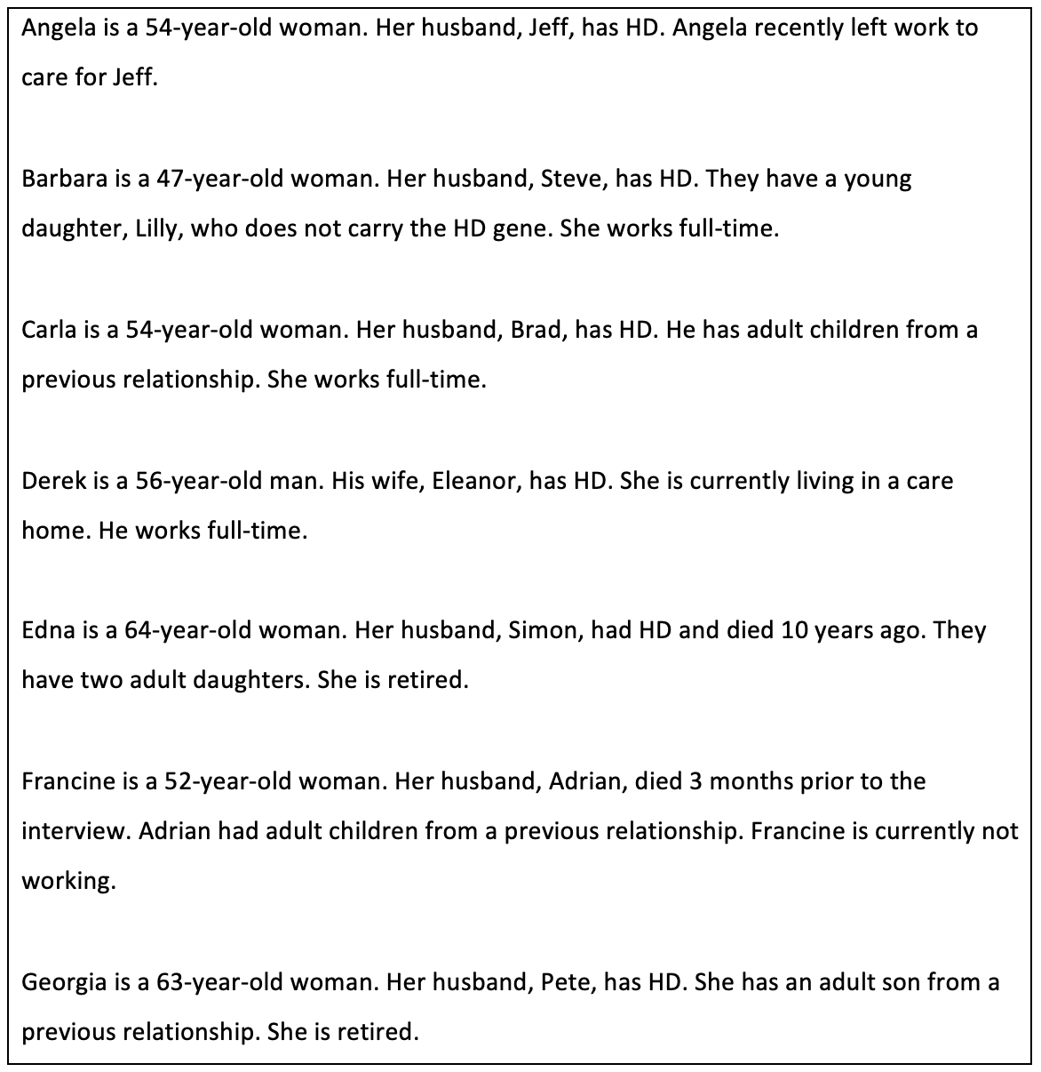

Analysis

Interviews were transcribed, and analysis followed the steps described by Smith and colleagues (2022). The process of creating each transcript, reading each transcript several times and watching the interview recording allowed the researcher to become immersed in the data. Analysis began by making exploratory notes on the transcript, recording initial observations, reflections and considering context and the use of language. Each transcript was then read again, and experiential statements were developed (Appendix H). Experiential statements are more psychological in conceptualisation than notes but remain grounded within the participant’s experience. For each participant, experiential statements were examined for connections, forming personal experiential themes (PETS) and sub-themes (Appendices I & J). The researcher then examined connections across participants, exploring both convergence and divergence (Appendix K). This led to the development of higher order group experiential themes (GETS) and lower order sub-themes, supported with quotes from the transcripts (Smith et al., 2022). This information was displayed in a table (Appendix L). A flow diagram of the analysis process was developed (Appendix M). Quotes were used within the findings section to support interpretation of participant experiences (Smith et al., 2022). Asterisks have been used to indicate emotion and behaviours displayed by participants.

Reflexivity and Epistemology

Reflexivity is an important process within qualitative analysis. Reflexivity considers the researcher’s own preconceptions and experiences and how these may impact analysis and the interpretation of participant experiences (Smith et al., 2022). Within IPA, there is a dual interpretation process (‘double hermeneutics’) in which the participants make sense of their experiences, and the researcher then attempts to make sense of the participant’s meaning making (Pietkiewicz & Smith, 2014). Throughout the research process, the researcher was aware of their own epistemological stance, taking a constructivist approach. Constructivism asserts that individuals make sense of their own experiences via shared meanings, interactions and social contexts (Creswell, 2013). This approach is suitable for research using IPA methodology, as IPA is rooted within phenomenology and social constructivism, examining how individuals have made sense of their social world (Creswell, 2013). The researcher had experience of working within mental health services, supporting individuals and families with neurological conditions, including HD, and therefore had existing knowledge relating to challenges carers can encounter. The researcher therefore approached the research with self-awareness, and utilised research supervision and IPA workshops throughout the research process in order to identify potential bias in interpretation (Smith et al., 2022). Keeping a reflective diary was helpful when identifying the influence of bias or preconceptions on the interpretative process (Appendix N).

Results

Analysis produced five group experiential themes (GETS) and 12 sub-themes. GETS were titled: Experience of identity, The transition from spouse to carer, Impact of caring role on wellbeing, Coping with caring, and Thinking of the future as shown in Table 2.

Table 2.
Group experiential themes and sub-themes
Group Experiential Theme | Sub-Themes
Experience of identity | Loss of identity to caring role
 | Rediscovering themselves
The transition from spouse to carer | Changes in roles and responsibilities
 | Intimacy, sex and affection
Impact of caring role on wellbeing | Alone and unappreciated
 | Emotional and physical burden of caregiving
 | Raising children in HD families
Coping with caring | You, me and HD
 | The importance of adapting, not stopping
 | Sources of support
Thinking of the future | Grieving for the future they had planned
 | Fears and uncertainty about the future

1. Experience of identity

All participants experienced changes in their perception of identity over time as a result of being the spouse of an individual with HD.

1.1 Loss of identity to caring role

Participants reported feeling they had lost their identity within their caring roles: “I think I’ve lost who I am” (Derek). Participants felt they had little control over this change, with this being a gradual transition in response to increasing caring responsibilities and the deterioration of their spouses’ condition: “I think you lose your own identity … I can't *exhales* … I am who I am… I think it has been gradual because Pete's condition is gradual” (Georgia). As caring responsibilities continue to increase, further restricting activities, participants described feeling that they would lose their sense of identity further: “…at the moment I’m okay, but I sometimes feel that no, that I will be his carer and that will be it. I will lose my identity because I can’t do what I want to do” (Georgia). Participants are required to navigate conflicting roles and identities (i.e. spouse and carer). Due to the progressive nature of HD, participants are aware that this will become increasingly difficult, producing feelings of hopelessness and exasperation.

Participants made conscious attempts to protect their identity but this could be challenging: “I guess I probably did get a little bit lost in it all. I was conscious to make sure that I was still me, which was really hard” (Francine). This was echoed by Angela: “I try and sort of do stuff individually as well. I’ve got to keep me as me”. Carla reflected that losing her identity within her caring role negatively impacted her mood, but engaging in personal therapy is supportive and “keeps [her] in check”.

Work provided an important identity outside of their caring role and an escape from the challenges of family life, which seemed to support overall wellbeing:

“I was really pleased I was still at work … at least that gives you that identity. During the day, I wouldn’t have to think about things because you’re so busy and then you just have to face what’s going on when you get home at night”- Edna

This was reflected by Derek: “I love the job I do … we’re busy and it’s a bit of a sanctuary … but when I get home, I’m very, very lonely … Yeah definitely, I’m not who I used to be”. Within the context of work, participants feel a cohesive sense of self and identity, creating a sense of purpose and contentment. This is a stark contrast to the emotional distress and entrenched loneliness stemming from their caregiving role and the associated loss of identity. Work also provided a sense of competence and autonomy not present in other areas of their life : “I was always a teacher, not just a wife … you could see yourself as a competent person” (Edna).

1.2 Rediscovering themselves.

Two participants had experienced the loss of their spouse and described rediscovering their identity once their caring role ended. One participant realised how much she had missed out on whilst caring for her husband after his death:

“ … certainly now … I realise … how much I missed. So you know, getting up in the morning, I can just sort myself out, I haven’t got to keep half an ear out for what Adrian’s doing … I definitely got lost in it”- Francine

Both participants reported feeling they had regained control over their lives and now had the freedom to rediscover themselves. For example, one participant felt that regaining their own identity was “liberating” (Edna) and another shared that “my life really does become mine to do what I want” (Francine).

2. The transition from spouse to carer

All participants experienced a transition in their relationship from spouse to carer. This transition was highlighted by changes in roles and responsibilities, as well as changes in intimacy, sex and affection.

2.1 Changes in roles and responsibilities

Changes in employment and finances were particularly challenging. Participants experienced a transition to becoming the household’s sole earner, triggering financial concerns. One participant described going into “panic mode” (Angela) when faced with this change. This transition also highlighted a distinct change in relationship dynamics, which could be emotionally difficult: “When we first met, my husband and I were equals … and over time, that's changed, I've become the breadwinner… and that's tough” (Carla).

Participants shared their experiences of seeking benefits, finding this complicated and confusing: “… it was really hard to sort of work out what benefits you could access and what support you were entitled to … we were really struggling” (Edna). One participant, Angela, had recently left work to care for their spouse and described further financial concerns: “… it's gonna be a lot less money coming in and that does worry me”.

Becoming the sole driver was experienced differently by participants. This transition was “natural” (Francine) for some, as their spouses’ health deteriorated, but others had to initiate this change: “… he wanted to carry on driving … I said he shouldn't be driving and so that's why I won't let him drive the car” (Edna). Again, this highlighted a change in relationship dynamics and a move away from being equal partners. For Edna, this change likely solidified her identity as a carer for her husband, as she was required to assert this change in his best interests. Others found becoming the sole driver “frustrating” (Angela).

Participants also reported changes in the division of household responsibilities, with their workload increasing as their spouse became less able:

“… things would start to change where Eleanor would do her ironing and she'd drop the iron … So then I began to take the ironing over. She'd tried to cook meals and then she'd drop the stuff on the floor… So I began to take control of everything. Eventually I took over the finances… it gradually became too much for her”- Derek

Participants described becoming the sole organiser: “we go away in this country a lot, I've got to drive, and I do all the planning again and all of that, so I do everything”(Angela). Georgia shared: “I've taken on a lot more of the roles, the jobs. I have to instigate everything. I’m the planner. The encourager”. Participants also described being an “advocate” (Carla) and “interpreter” (Francine) for their spouse, demonstrating the diversity of roles and responsibilities adopted by participants. These changes cause a shift in relationship dynamics as the division of tasks and labour is no longer equal, reciprocal or as it once was. This shift is likely to be experienced by participants as being more cohesive with their caregiver role and identity, as opposed to being a ‘spouse’.

2.2 Intimacy, sex and affection

All participants shared experiences relating to a loss of sexual intimacy as a result of their spouse having HD. This change marked the transition from intimate relationship (husband and wife) to carer and cared for: “I've definitely gone from being wife and intimate to being a carer … things like intimacy definitely dropped off” (Francine). This change in relationship dynamics was echoed by another participant, Angela: “He was in a different bedroom, so that's like had a major impact on the husband-and-wife relationship… that's difficult as well … it was more like a brother and sister relationship. Or mother and son”.

Barbara described a change in sexual intimacy with her husband due to her perception of him as disabled creating an internal conflict, stating: “I think with like the diagnosis, I feel like being intimate … is slightly wrong… Steve's got like a disability now”. This demonstrates a significant change in relationship dynamics, moving away from an intimate spousal relationship and further solidifying the role of caregiver. Navigating the conflict between identities (i.e. spouse and carer) can be seen to create feelings of uneasiness and discomfort for participants.

Participants described a loss of physical affection, with this being a particularly emotive topic, and could make them feel unloved and rejected:

“We used to be quite affectionate with each other. Now … I'm only allowed to kiss the top of his head, if I go to hug him, I get pushed away … It feels like rejection *becomes tearful* and that's the disease, not him”- Carla

Where affectionate behaviour had continued, participants wondered whether this stemmed from habit and routine. However, affection was welcomed as it provided a sense of closeness and normality:

“I think some of it was quite routine, but it was still good to do … we made a point of having a hug and kiss … we always told each other we loved each other, again, some of that is probably habit. But it was still nice to hear”- Francine

The transition from spouse to carer was also signified by changes in emotional intimacy and closeness, with Derek stating: “On paper I’m her husband, in reality I'm not really a husband … I love Eleanor, but I'm not in love with her".

3. Impact of caring role on wellbeing

Participants shared the impact of changes within their relationship and caring role on their emotional and physical wellbeing. Participants also described the emotional challenges associated with raising children in HD families.

3.1 Alone and unappreciated

Participants expressed feeling alone in their relationship, with this impacting their own wellbeing. Angela shared feeling “I'm just on my own”, making her feel “low and upset”. Participants described their spouse’s inability to support them during hardships, as would typically be expected from a spouse: “sometimes you do get resentful because I think ‘I wish I had somebody that looked after me’, a husband … usually well, you look after each other” (Angela). Derek reflected feeling “angry” when experiencing a bereavement, stating: “I had nobody to grieve with … I was trying to deal with it on my own”. Participants could feel reluctant to share feelings of loneliness with others for fear of “burdening” (Derek) them with their problems.

Additionally, participants described feeling unappreciated and unrewarded, which could lead them to feel dissatisfied within their caring role: “you didn't get any thanks for what you were doing from them … if you're caring for somebody who's appreciative … you feel it’s worth it” (Edna). Participants also stated: “it's a job really more than a relationship sometimes and you don't get any reward for it" (Angela) and that “Huntington’s is the wrong place if you want a reward” (Georgia). Participants reported that receiving appreciation for their care made it feel worthwhile: “Whenever he really appreciates anything... *becomes tearful* ... that helps me feel like I'm doing a good job” (Angela).

3.2 Emotional and physical burden of caregiving

The demands of their caring role and other commitments could cause participants to feel “exhausted” (Derek), “worn out, knackered” (Francine) and overwhelmed. Barbara stated: “I was working from home, trying to prevent him getting injured … I was home schooling as well… I'm surprised I didn't have a nervous breakdown”.

The practicalities of caregiving could feel easier to manage than the emotional impact of missing out on a ‘normal’ life and relationship: “I've missed out on … a normal relationship, arguments, holidays, cinema, restaurants … I think that's been the biggest challenge. The caring side, you just you just get on with it.” (Derek). Participants shared making sacrifices and putting their spouse’s needs “1st on the list” (Derek), above their own. Participants described the impact of this on their own quality of life, with Derek stating: “I don't live a life, I exist” and another sharing:

“There is a little bit of me that wants to be selfish … we went on the cruise, there were three or four walks that [I] could have gone on and I thought I can't leave Pete … you just grit your teeth and get on with it” – Georgia

3.3 Raising children in HD families

Due to the inheritability, having a spouse with HD can pose complex challenges for family life. Barbara shared having considered terminating her pregnancy due to the risk of HD, before deciding to undergo prenatal testing. Whilst her daughter does not have HD, this experience has deterred her from having more children: “They said it was my decision at the end of the day, but it was a big risk” … “I would have loved another one. But … I just can't go through all that again, it was quite traumatic”.

Participants described the impact of their spouse’s HD on their children. Edna shared that her children had a difficult childhood and that her youngest daughter “can't remember her dad being well properly”. Another participant shared the impact of her husband’s deterioration on their daughter: “She watched a webinar with me the other day … she said it upset her a bit … that Daddy’s brain's dying and … he won't be the same” (Barbara). Participants were emotional when sharing the experiences of their children, demonstrating the stresses they face in navigating these challenges.

There was an awareness that HD would continue to impact their children’s lives. Barbara described how her daughter will become a young carer for her father: “I've said that to her … you know when Dad is a little bit more poorly … are you gonna help Mommy? and … she goes yeah yeah that's fine”. Edna described hoping for a cure “so that if my daughters do have it, then there's something to help them”.

4. Coping with caring

Participants shared their experiences of coping within their caregiving role and the changes within their relationship. They described the importance of adapting their lives to HD and shared external sources of support.

4.1 You, me and HD.

Several participants found it useful to externalise and separate HD from their spouse as a way of coping with and managing their caring role. This shifted the blame and anger onto HD, rather than their spouse: “He tested positive and for me, it was a relief. I could now have something other than my husband himself to blame … I could be angry with the disease. I don't have to be angry with him” (Carla). Barbara used this strategy when explaining her husband’s behaviour to their daughter, stating ”daddy wasn't like this when me and him first met … but this is what the Huntington’s is doing to Daddy”. However, there was divergence across participants, with one participant stating they found it easier to be angry at their spouse, rather than the HD: “I know that you should be angry with the situation rather than the person. But I think I found it easier to protect myself by just being very angry with him” (Edna). This divergence could be due to the unique psychological predispositions of participants and variations within their social contexts.

Reminiscing and remembering who their partner was before HD was found to assist in coping with the changes in their relationship: “I'm able to look at him and still remember him … he's been so incredible at times … helping me … you know that's changed. But I still remember that… he’s still him” (Carla). This was echoed by Angela: “I'll try talk about memories a lot … I was reminiscing with him today actually about when we first met”. Recalling shared memories appeared to help participants feel connected to their spouse.

Participants were also aware that due to HD and life expectancy, they had limited time with their spouses, and described the importance of prioritising this time together: “I always knew I wouldn't get to 60 with him … we just wanted to make the most of life. Build memories, so we've done some crazy things…” (Francine). Time and shared experiences, or memory making, became very important: “We do more as a family now … knowing that he's got Huntington's … we need to pack as much in … for our memories” (Barbara). Memory making appeared to help participants cope with the awareness that time with their spouse was limited. Memory making could be seen to foster feelings of connectedness between participants and their spouses and provide a sense of normality, thus helping to reinforce their identity as a spouse rather than solely a caregiver.

4.2 The importance of adapting, not stopping.

Attempts to live life as normally as possible, whilst adapting to HD, was shared across participant’s experiences. Barbara described “living every day and adapting our life to Huntington's” as being “the easiest way” to manage and cope. This also helped to maintain their identity as a spouse rather than solely as carer: “You know people saying you're a carer … yeah, but I'm still his wife and I think that's why I want to keep life as normal as possible” (Francine).

Completing household chores together with their spouse, with adaptations, appeared to help maintain feelings of normality. One participant described their usual evening routine, but with safety adaptations: “We'll cook some dinner together … I’ve banned him from knives. So I'll do the chopping, he'll do the stirring and then we'll choose a couple of TV shows to watch” (Carla). Also, encouraging their spouse to complete chores around the home reduced their own feelings of burden: “I try and get him involved in little jobs still … because otherwise I will feel like I'm doing everything” (Angela).

Participants also shared adapting to the absence of sexual intimacy, maintaining closeness and normalcy in alternative ways. One participant shared that they “carried on” expressing physical affection, but with adjustments due to their spouse’s movements: “he held my hand rather than putting his arm around me…at least holding his hand I could let go … or readjust it easier” (Francine). Derek described operating as a couple in other ways: “we still went on holidays; we still went to functions … Your brain almost learns to adapt to it”.

4.3 Sources of support

Various sources of support were described by participants, including work colleagues, family and friends. Across these sources of support, participants shared the importance of being able to “vent” (Barbara) and share experiences. Derek stated that his colleagues, friends and family were “sounding boards”. It felt important for participants to be able to “bounce things off” (Barbara) others who were accepting and willing to listen.

Carer support groups were an important source of support, as participants had shared experiences with other group members, who were better able to understand their difficulties: “Even though my sister tries to help … unless you're going through it yourself, you don't really understand” (Angela). Carer support groups could reduce feelings of loneliness and isolation: “It was very lonely … I was on my own with the whole thing, until I found the Huntington’s Disease Association… you suddenly thought ‘Oh God it's not just me’” (Edna). Support groups were also useful sources of information, with two participants mentioning finding out information about benefits from support groups.

5. Thinking of the future

When sharing thoughts about the future, participants possessed the painful knowledge that they were now unable to have the future they had hoped for and expressed fears and uncertainty about this new reality.

5.1 Grieving for the future they had planned.

Due to their spouse’s HD, participants knew they would be unable to experience the future or retirement they had planned, causing feelings of sadness and frustration: “It gets very upsetting and frustrating sometimes because the life I thought we were going to have together … in retirement … in the future … is not going to happen” (Angela). Georgia described hopes of travelling with their spouse in retirement no longer being possible, and the difficult realisation that “our future as retired people would be very different”. Participants attempted to process this loss and its implications whilst simultaneously working to adapt to the continual changes within their caring role and relationship.

5.2 Fears and uncertainty about the future

Participants shared concerns relating to the risk of violence and aggression from their spouses, as their disease progresses: “You hear stories of … people with Huntington's that can be quite abusive to the partners … that's my only worry, I suppose in future” (Barbara). Participants shared how this could impact their ability to remain in their relationship, with this being a “clear boundary” (Carla). This was reflected by Angela: “I just hope he doesn't get too moody or physical with me … I always hear a lot about wives leaving their husbands … and I think, oh God, will I get to that stage after all?”

When thinking about the future, participants expressed concerns about being able to “keep going” and “adapt” (Georgia) to the challenges that lie ahead. Participants shared feeling concerned by the prospect of increasing caring responsibilities and how they might negotiate this: “… there's gonna be times where I won't be able to go out when he gets even worse, unless I have someone, a carer, you know coming in...” (Angela). Georgia recalled developing an end-of-life plan with their spouse, carefully considering “what [Pete] wants for the future”. Participants all appeared motivated to remain in their caring role for as long as possible, despite these difficulties.

Discussion

This is the first research to explicitly explore how spouses of individuals with HD experience changes within their identity over time. The research also provides an in-depth exploration of the spousal relationship and family life. Findings will be discussed in relation to change in identity and sense of self, the relationship, and family life.

Participants shared how being the spouse of an individual with HD had influenced their sense of self and identity over time. Consistent with caregiver identity theory, caregiver identity was dynamic and evolved over time (Montgomery & Kosloski, 2009; 2013). Participants described a gradual loss of their previous identity and sense of self, influenced by the growing demands of their caring role and responsibilities. In line with theory, this loss of identity caused distress, with participants expressing feelings of hopelessness and exasperation (Montgomery & Kosloski, 2009; 2013). Participants could feel powerless over these changes, with an awareness that the progressive nature of the disease meant that they could lose their own identity further in future.

Identity was rediscovered after their spouse’s death and their caring role ceased. Consistent with previous research, following this significant life event, identity was revaluated by participants (Cross & Markus, 1991; Eifert et al., 2015; Kroger, 2006). Participants were able to be reflective and there was a realisation of just how much they had become lost within their caring role. Participants shared having a greater sense of control over their lives and were able to engage in activities that provided fulfilment and a sense of identity. This rediscovering of identity and sense of self was viewed positively by participants and appeared to support their wellbeing. Reconstructing identity is generally considered to be an important factor in managing grief and emotional difficulties after the loss of a spouse (Haase & Johnston, 2012; Jones et al., 2019). This appears to also be the case for HD spousal carers.

In agreement with existing literature on caregiving, participants experienced a change in their relationship, describing a gradual transition from spouse to carer (Kessler, 1993; Montgomery & Kosloski, 2009; Williams et al., 2009). This change in relationship dynamics saw a shift away from being equal partners, to becoming ‘carer and cared-for’. When individuals are required to behave in ways that feel inconsistent with their role identity (e.g. providing care to your spouse), individuals can experience role conflict which may generate feelings of discomfort (Montgomery & Kosloski, 2009; 2013). Caregiver identity theory states that carers attempt to manage this discomfort through appraisal and continual reconfiguration of their identity, feeling greater cohesion with their caring identity (Montgomery & Kosloski, 2009; 2013). This was the case within the current research as whilst participants shared the challenges of navigating their conflicting roles, participants generally experienced a growing cohesion with their caring role and identity.

The transition from spouse to carer was marked, for example, by changes in sexual intimacy. This loss of sexual intimacy and physical affection could be particularly distressing, as it produced feelings of rejection and worked to solidify their identity as a carer rather than a spouse. Previous research found that spouses of individuals with HD have coped with this loss of intimacy by no longer viewing their spouse as an intimate partner (Williams et al., 2009), and whilst this was the case for some participants, others were able to maintain a sense of intimacy and physical affection. This physical affection became routine, such as holding hands when sitting together and saying ‘I love you’ when parting ways, but provided a sense of closeness and normality which was welcomed. Similar advantages of developing these habits have been found for spouses of individuals with dementia and mild cognitive impairment (Davies et al., 2010).

Participants described gradually taking over their spouse’s roles and responsibilities, including household chores, managing finances and driving, in line with previous literature (Aubeeluck & Buchanan, 2007; Hans & Koeppen, 1980; Kessler, 1993). The experience of becoming the sole earner was particularly difficult, due to both the impact on finances and the change this highlighted in the relationship i.e. moving further away from being equal partners. Participants varied in how they made sense of these changes, with some finding them to be a cause of frustration, but for others, these changes felt more expected and therefore caused less distress.

Family life could be difficult, and participants described feeling they had missed out on ‘normal’ expected experiences, such as holidays, socialising and travelling together. Participants recounted the difficulties of raising children within HD families. Parents can experience feelings of anger, guilt or concern at having potentially passed the disease on to their children (Novak & Tabrizi, 2010). Within the current research, even when children did not carry the HD gene, participants shared the emotional impact on their children of having a parent with HD and demonstrated distress related to their children’s experience of childhood being impacted by this. Participants carried additional emotional burden for their children because of the upsetting nature of watching a parent deteriorate.

Participants experienced emotional and physical difficulties similar to those identified within previous research, such as loneliness, isolation and feeling exhausted with their caring role (Aubeeluck & Buchanan, 2007). There were also feelings of being unappreciated and unrewarded within their caring role, which appeared to relate to the apathy that can present within HD (Roos, 2010). Despite the challenges experienced, participants were motivated to remain within their relationship and fulfil their caring role. Participants appeared to cope by working to generate feelings of closeness with their spouse. As participants were aware of having limited time with their spouse, they shared the importance of family time, reminiscence and memory making. Memory making and reminiscence have been found to be useful coping strategies for family carers of people with other degenerative conditions, such as dementia, supporting feelings of connectedness (Ryan et al., 2020). The current research supports these strategies as also being helpful for HD carers. Participants shared their experiences of adapting life to HD, in order to try and maintain a sense of normality. This normality appeared to help participants feel that they are a spouse and not solely a carer, supporting caregiver identity as being a dynamic process, and mitigating the distress caused by changes and transitions in these roles (Montgomery & Kosloski, 2009).

In addition to the obvious financial implications, work appeared to be an important protective factor as it provided an additional identity to that of being a spouse or carer (e.g. teacher) and a sense of normality. Previous research suggests that maintaining a balance between caregiving and work can be challenging and that the roles can be seen as conflicting, causing additional stress (Duxbury et al., 2009; Kayaalp et al., 2021; Li et al., 2015). However, this was not reflected within the current research, with work providing time away from their caring role and the challenges of home life, supporting their wellbeing. Colleagues also provided important social contact and support. It is unclear why these findings relating to work differ from the findings of previous research, but this further demonstrates the diversity and range of carer experiences.

Strengths and Limitations

The current research provided a detailed insight into how spouses of individuals with HD experience changes within their identity over time, a previously unstudied area. The research also delivered a nuanced exploration of the spousal relationship and family life. The involvement of experts by experience is a particular strength, as their experiential knowledge of caring for family members with HD enhances the credibility and meaningfulness of the research (Lindenmeyer et al., 2007; Thompson et al., 2009). The use of IPA methodology allowed for an in-depth exploration of participant experiences, generating rich data. The prior experience of the researcher was immensely valuable given their role in the co-construction of meaning and knowledge, allowing for a more intuitive interpretation and exploration of participant experiences (Smith et al., 2022).

Participants were all living in the UK, were white, and spoke English. Whilst this study focused on lived experiences and interpretations, with less emphasis placed on the findings being generalisable, it is important to consider the experiences that could be missed due to the lack of diversity within the sample. The majority of participants were female, with only one male taking part in the research. Again, this lack of diversity may impact the experiences captured. Males can be reluctant to engage in qualitative research due to the self-disclosure and openness required (Dindia & Allen, 1992; Patel et al., 2003). Males are also less likely to seek assistance for caregiver stress and can prefer to receive practical support over emotional expression (Greenwood & Smith, 2015; Velissaris, et al., 2021). The research was advertised by the HDA and within HD support groups, and it is possible that males do not utilise these organisations and support groups in the same way as females. There is also the risk of selection-bias, and it is possible that the experiences of those who opted to take part differ from those who did not wish to take part.

Clinical Implications

The research highlights the significant and complex challenges encountered by spouses of individuals with HD. It is important that services understand these difficulties, in order to offer appropriate support and provide spouses with the information needed throughout their caring role. Information regarding HD and related issues, such as planning for the future and managing finances, should be provided routinely within services following diagnosis.

In order for spouses to be able to continue within their caregiving role, it is vital that they receive formal support with the emotional difficulties they experience. For instance, services should offer therapeutic interventions that are tailored to the needs of this group. Therapeutic approaches could incorporate supportive strategies highlighted within the research, such as the use of reminiscence, memory making and establishing routines. Psychologists working within these services would be well placed to implement and facilitate the delivery of therapeutic interventions. Psychologists would also be able to support colleagues from other disciplines, providing specialist consultation, training and supervision.

Future Research

Future research should expand upon the findings of the current study and consider utilising a longitudinal approach to explore the dynamic nature of identity, within the context of the spousal relationship, over time. Whilst this would be resource intensive, it would allow participants to share their evolving journey as a HD spousal carer and enable a deeper, richer understanding of their experiences. Future research should also consider potential barriers to engaging in research amongst male spouses and partners, helping to ensure that their experiences are represented.

Conclusion

This research provided a valuable contribution to the understanding of the experiences, needs and challenges faced by this group of HD family carers. There is a need for services which effectively support spousal carers and their wellbeing, enabling them to continue their caring role. It is important that services are able to provide carers with accessible information relating to HD, along with any other concerns they may have, such as planning for the future and managing finances. Services should offer tailored therapeutic interventions to support carers with the emotional difficulties they experience throughout their caregiving role. Psychologists working within these services are well placed to support the implementation and delivery of such interventions.

References

Aubeeluck, A., & Buchanan, H. (2007). The Huntington’s disease quality of life battery for carers: reliability and validity. Clinical Genetics, 71(5), 434-445. https://doi.org/10.1111/j.1399-0004.2007.00784.x

Aubeeluck, A. V., Buchanan, H., & Stupple, E. J. (2011). ‘All the burden on all the carers’: exploring quality of life with family caregivers of Huntington’s disease patients. Quality of life Research, 21(8), 1425-1435.
https://doi.org/10.1007/s11136-011-0062-x

Bates, G., Tabrizi, S., & Jones, L. (2014). Huntington's Disease (4th ed.). Oxford University Press.

Berzonsky, M. D. (2011). A social-cognitive perspective on identity construction. In Schwartz, S., Luyckx, K., Vignoles, V. (Eds.), Handbook of identity theory and research (pp. 55-76). Springer. https://doi.org/10.1007/978-1-4419-7988-9_3

Creswell, J.W. (2013). Qualitative inquiry & research design: choosing among the five approaches. Sage.

Davies, H. D., Newkirk, L. A., Pitts, C. B., Coughlin, C. A., Sridhar, S. B., Zeiss, L. M., & Zeiss, A. M. (2010). The impact of dementia and mild memory impairment (MMI) on intimacy and sexuality in spousal relationships. International Psychogeriatrics, 22(4), 618-628. https://doi.org/10.1017/S1041610210000177

Dindia, K., & Allen, M. (1992). Sex differences in self-disclosure: a metanalysis. Psychological bulletin, 112(1), 106-124. https://doi.org/10.1037/0033-2909.112.1.106

Duxbury, L. E., Higgins, C. A., & Schroeder, B. (2009). Balancing paid work and caregiving responsibilities: A closer look at family caregivers in Canada. Canadian Policy Research Networks.

Eifert, E. K., Adams, R., Dudley, W., & Perko, M. (2015). Family caregiver identity: A literature review. American Journal of Health Education, 46(6), 357-367. http://dx.doi.org/10.1080/19325037.2015.1099482

Erikson, E. H. (1968). Identity, youth and crisis. W. W. Norton Company.

Evans, S. J., Douglas, I., Rawlins, M. D., Wexler, N. S., Tabrizi, S. J., & Smeeth, L. (2013). Prevalence of adult Huntington's disease in the UK based on diagnoses recorded in general practice records. Journal of Neurology, Neurosurgery & Psychiatry, 84(10), 1156-1160. http://dx.doi.org/10.1136/jnnp-2012-304636
Greenwood, N., & Smith, R. (2015). Barriers and facilitators for male carers in accessing formal and informal support: A systematic review. Maturitas, 82(2), 162-169. https://doi.org/10.1016/j.maturitas.2015.07.013

Gusella, J. F., Wexler, N. S., Conneally, P. M., Naylor, S. L., Anderson, M. A., Tanzi, R. E., Watkins, P. C., Ottina, K., Wallace, M. R., Sakaguchi, A. Y., Young, A. B., Shoulson, I., Bonilla, E., & Martin, J. B. (1983). A polymorphic DNA marker genetically linked to Huntington's disease. Nature, 306(5940), 234-238. https://doi.org/10.1038/306234a0

Haase, T. J., & Johnston, N. (2012). Making meaning out of loss: A story and study of young widowhood. Journal of Creativity in Mental Health, 7(3), 204-221. https://doi.org/10.1080/15401383.2012.710170

Hans, M. B., & Koeppen, A. H. (1980). Huntington's chorea: Its impact on the spouse. The Journal of nervous and mental disease, 168(4), 209-214. https://doi.org/10.1097/00005053-198004000-00003

Jones, E., Oka, M., Clark, J., Gardner, H., Hunt, R., & Dutson, S. (2019). Lived experience of young widowed individuals: A qualitative study. Death Studies, 43(3), 183-192. https://doi.org/10.1080/07481187.2018.1445137

Kayaalp, A., Page, K. J., & Rospenda, K. M. (2021). Caregiver burden, work-family conflict, family-work conflict, and mental health of caregivers: A mediational longitudinal study. Work & Stress, 35(3), 217-240. https://doi.org/10.1080/02678373.2020.1832609

Kessler, S. (1993). Forgotten person in the Huntington disease family. American journal of medical genetics, 48(3), 145-150. https://doi.org/10.1002/ajmg.1320480306

Kroger, J. (2006). Identity in late adulthood. In Kroger, J. (Ed.), Identity Development: Adolescence Through Adulthood. (2nd ed., pp. 191-216). Sage Publications.

Li, A., Shaffer, J., & Bagger, J. (2015). The psychological well-being of disability caregivers: examining the roles of family strain, family-to-work conflict, and perceived supervisor support. Journal of occupational health psychology, 20(1), 40-49. https://doi.org/10.1037/a0037878

Lindenmeyer, A., Hearnshaw, H., Sturt, J., Ormerod, R., & Aitchison, G. (2007). Assessment of the benefits of user involvement in health research from the Warwick Diabetes Care Research User Group: a qualitative case study. Health Expectations, 10(3), 268-277. https://doi.org/10.1111/j.1369-7625.2007.00451.x

Montgomery, R., & Kosloski, K. (2009). Caregiving as a process of changing identity: Implications for caregiver support. Generations, 33(1), 47-52.

Montgomery, R. J., & Kosloski, K. D. (2013). Pathways to a caregiver identity and implications for support services. In Talley, R. C., & Montgomery, R. J., (Eds.), Caregiving across the lifespan: Research, practice, policy (pp. 131-156). Springer.

Novak, M. J., & Tabrizi, S. J. (2010). Huntington’s disease. Bmj, 340(c3109), 34-40. https://doi.org/10.1136/bmj.c3109

Patel, M. X., Doku, V., & Tennakoon, L. (2003). Challenges in recruitment of research participants. Advances in Psychiatric Treatment, 9(3), 229-238. https://doi.org/10.1192/apt.9.3.229

Pietkiewicz, I., & Smith, J. A. (2014). A practical guide to using interpretative phenomenological analysis in qualitative research psychology. Psychological journal, 20(1), 7-14. https://doi.org/10.14691/CPPJ.20.1.7

Quarrell, O. (2008). Huntington’s disease: The facts (2nd ed.). Oxford University Press.

Rawlins, M. D., Wexler, N. S., Wexler, A. R., Tabrizi, S. J., Douglas, I., Evans, S. J., & Smeeth, L. (2016). The prevalence of Huntington's disease. Neuroepidemiology, 46(2), 144-153.
https://doi.org/10.1159/000443738

Roos, R. A. (2010). Huntington's disease: a clinical review. Orphanet journal of rare diseases, 5(40), 1-8. https://doi.org/10.1186/1750-1172-5-40

Ryan, A. A., McCauley, C. O., Laird, E. A., Gibson, A., Mulvenna, M. D., Bond, R., Bunting, B., Curran, K., & Ferry, F. (2020). ‘There is still so much inside’: The impact of personalised reminiscence, facilitated by a tablet device, on people living with mild to moderate dementia and their family carers. Dementia, 19(4), 1131-1150. https://doi.org/10.1177/1471301218795242

Soltysiak, B., Gardiner, P., & Skirton, H. (2008). Exploring supportive care for individuals affected by Huntington disease and their family caregivers in a community setting. Journal of Clinical Nursing, 17(7b), 226-234.
https://doi.org/10.1111/j.1365-2702.2007.02276.x

Smolina, E. (2007). Psychosocial impact of Huntington’s disease on families and spouses from the perspective of the Family Systems Theory. SURG Journal, 1(1), 51-62. https://doi.org/10.21083/surg.v1i1.338

Smith, J.A., Flowers, P., & Larkin, M. (2022). Interpretative phenomenological analysis: Theory, method and research (2nd ed.). Sage.

Thoits, P. A., & Virshup, L. K. (1997). Me’s and we’s: forms and functions of social identity. In Ashmore, R., & Jussim, L., (Eds.), Self and Identity: Fundamental issues (pp. 106-133). Oxford University Press.

Thompson, J., Barber, R., Ward, P. R., Boote, J. D., Cooper, C. L., Armitage, C. J., & Jones, G. (2009). Health researchers’ attitudes towards public involvement in health research. Health expectations, 12(2), 209-220. https://doi.org/10.1111/j.1369-7625.2009.00532.x

Turpin, G., Barley, V., Beail, N., Scaife, J., Slade, P., Smith, J. A., & Walsh, S. (1997). Standards for research projects & theses involving qualitative methods: Suggested guidelines for trainees & courses. Clinical Psychology Forum, 108, 3–7.

Velissaris, S. L., Hosken, R., & Gluyas, C. (2021). Pilot investigation into the need and feasibility of a psychoeducation and support group for male caregivers of those with Huntington’s disease. Journal of Community Genetics, 12(4), 679-684. https://doi.org/10.1007/s12687-021-00535-2

Walker, F. O. (2007). Huntington's disease. The Lancet, 369(9557), 218-228. https://doi.org/10.1016/S0140-6736(07)60111-1

Williams, J. K., Skirton, H., Paulsen, J. S., Tripp‐Reimer, T., Jarmon, L., McGonigal Kenney, M., Birrer, E., Hennig, B. L., & Honeyford, J. (2009). The emotional experiences of family carers in Huntington disease. Journal of advanced nursing, 65(4), 789-798. https://doi.org/10.1111/j.1365-2648.2008.04946.x

Appendices

Appendix A.
Author guidelines for ‘Clinical Genetics’

Guidelines available online:
https://onlinelibrary.wiley.com/page/journal/13990004/homepage/forauthors.html

Overview of author guidelines:
- Original research papers can be up to 6,000 words.*
- Abstracts are unstructured and a maximum of 200 words.
- Papers should include 4-9 keywords. Key words must be taken from the US National Library of Medicine’s Medical Subjects Headings.
- References may be submitted in any style or format but must be consistent throughout.
- Figures and tables must have legends.
- A conflict-of-interest statement must be provided.*

An asterisk (*) indicates that this will be addressed prior to submission .

Appendix B.
Ethical Approval Letter
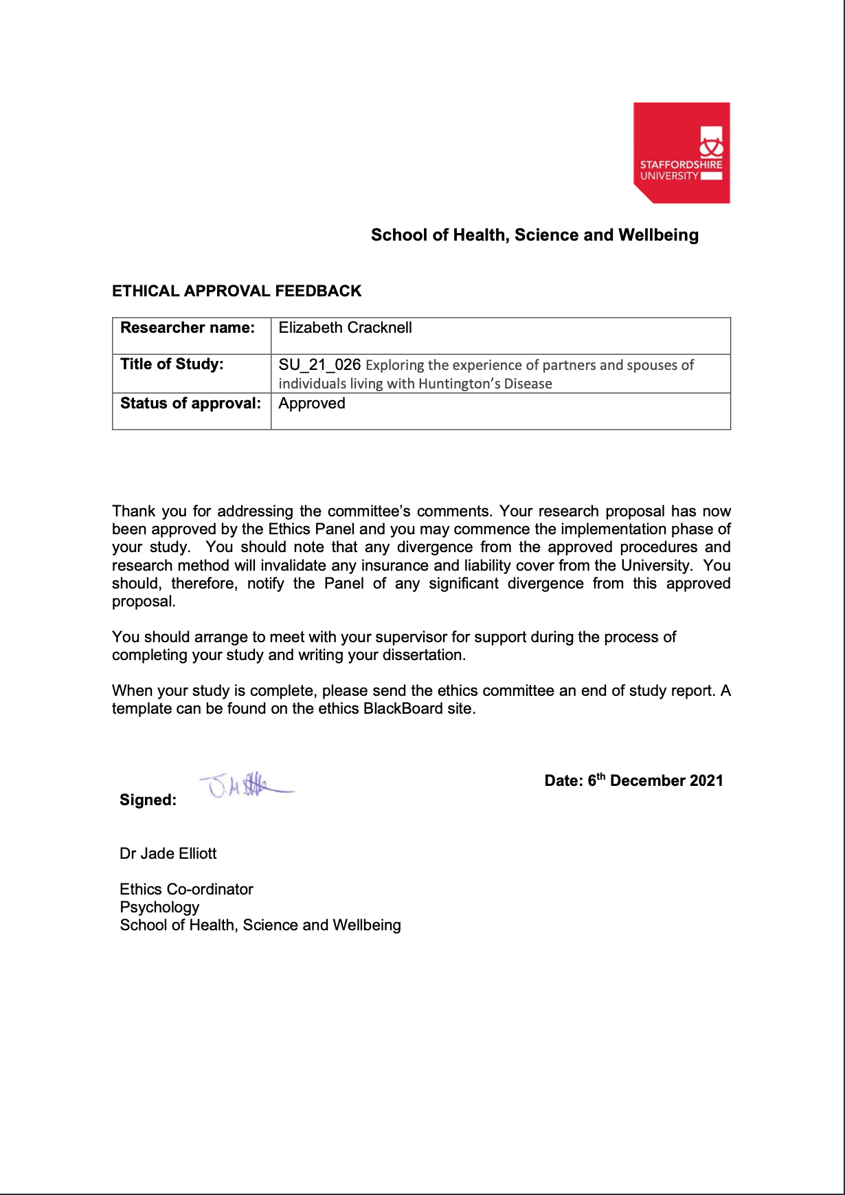
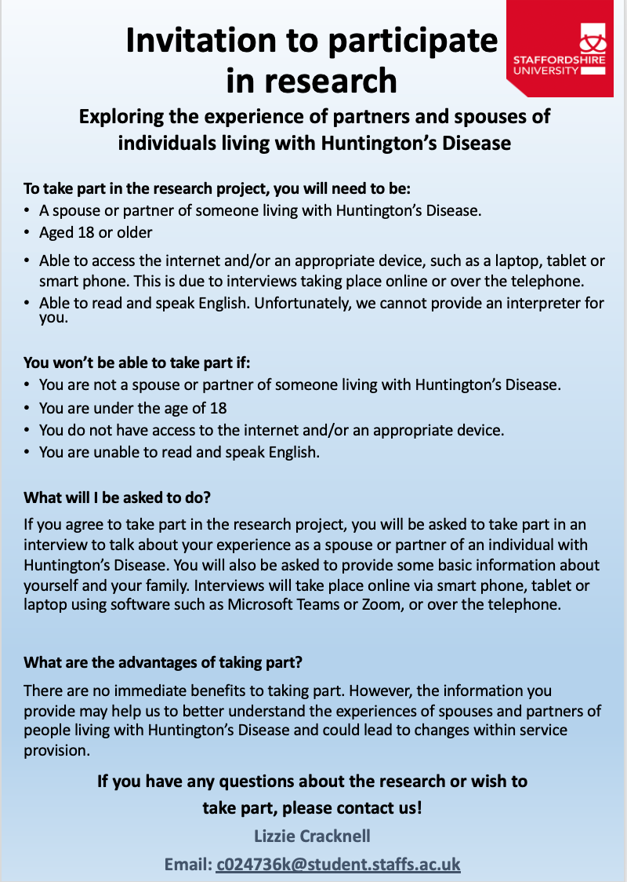
Appendix C.
Research Poster
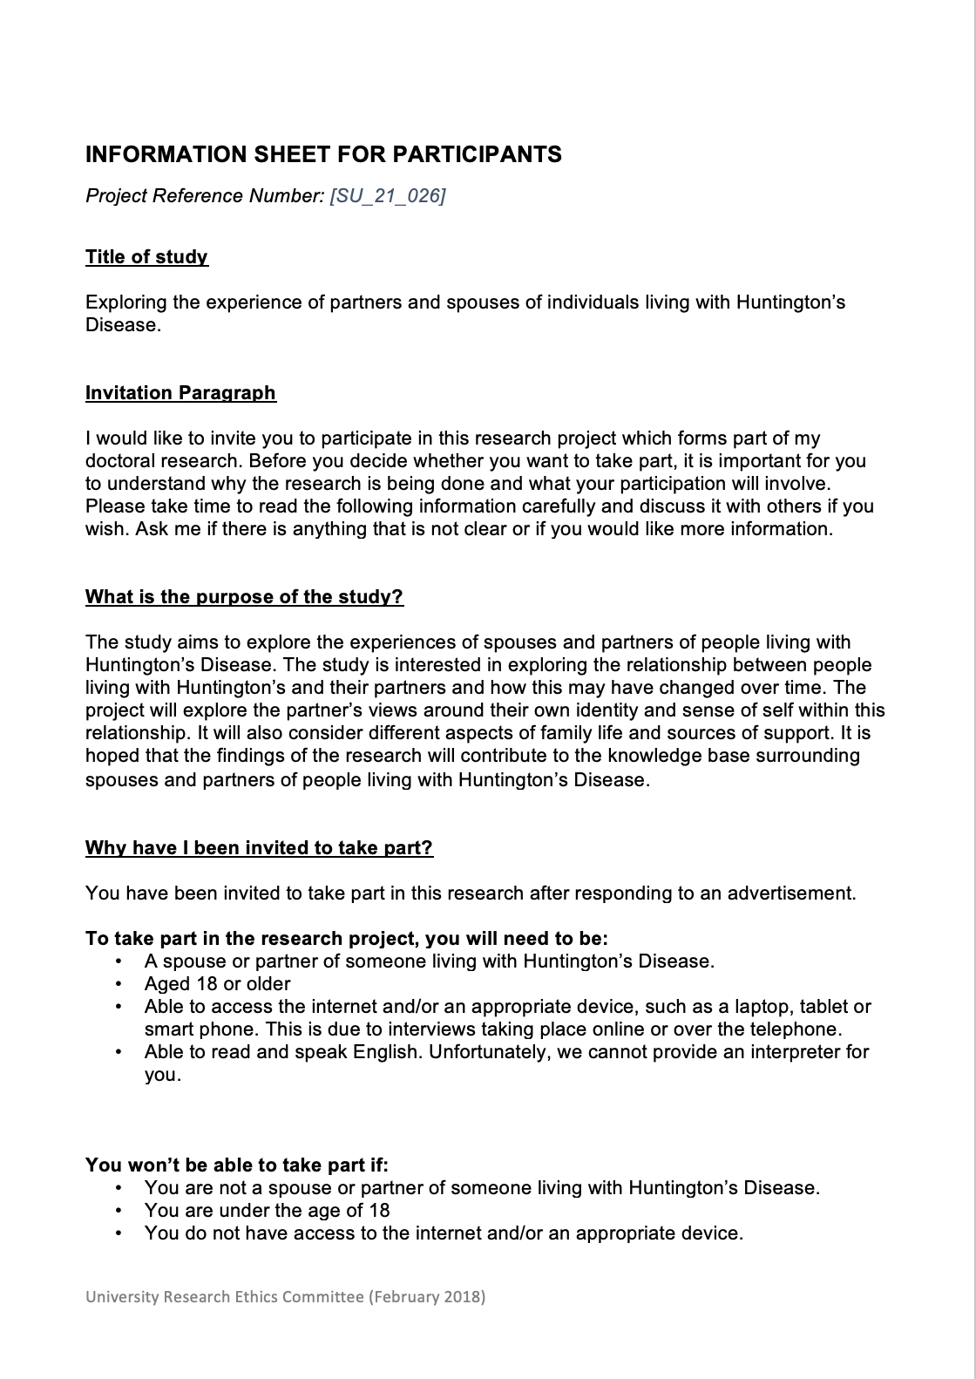
Appendix D.
Participant information sheet
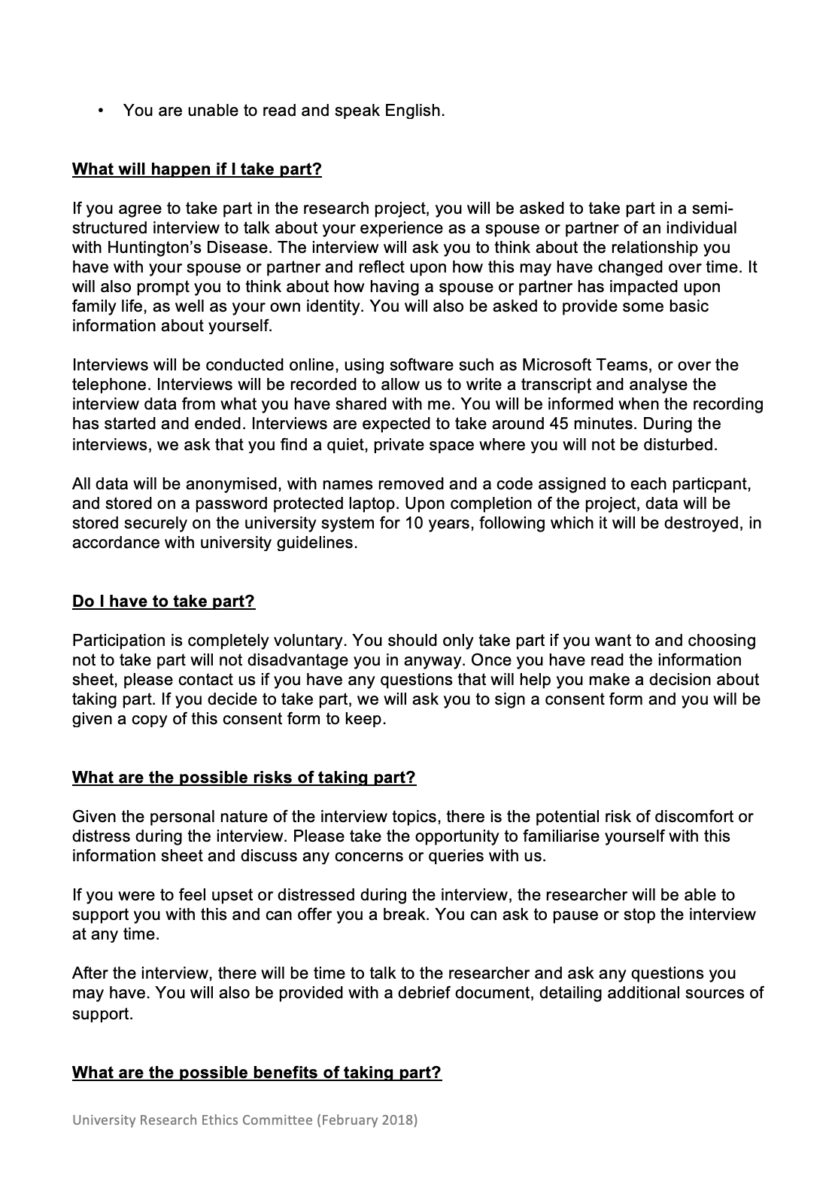
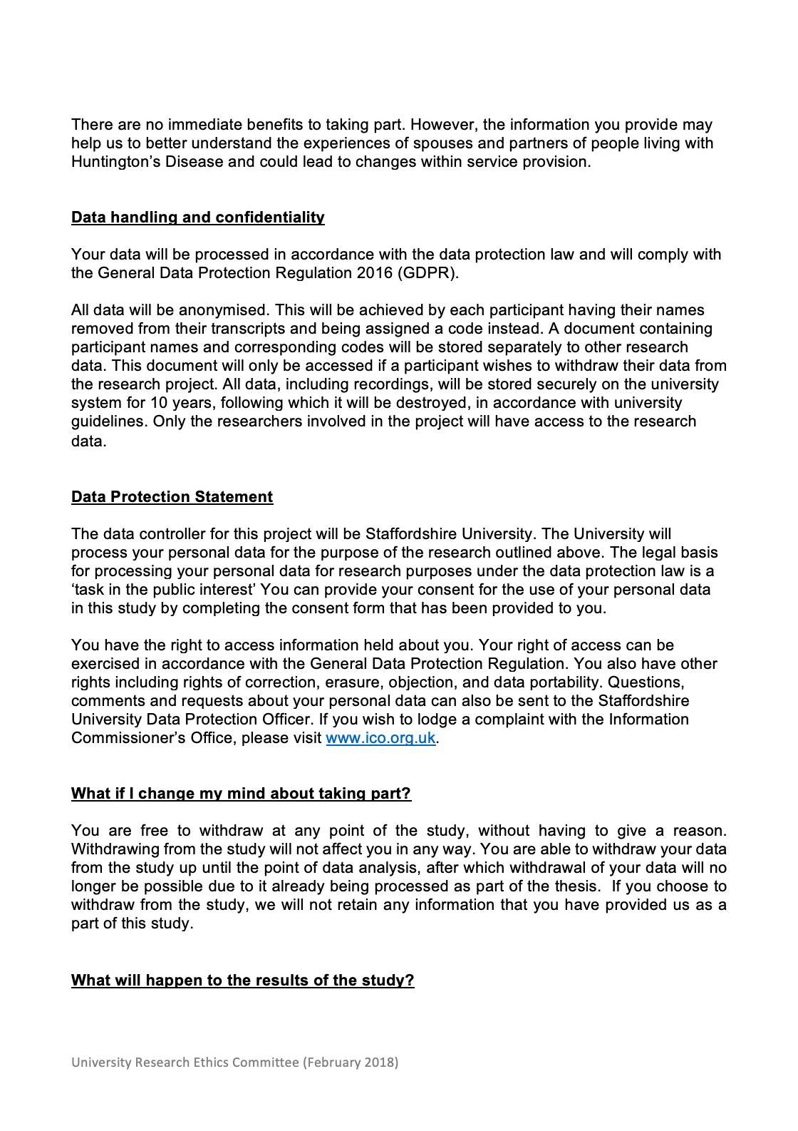

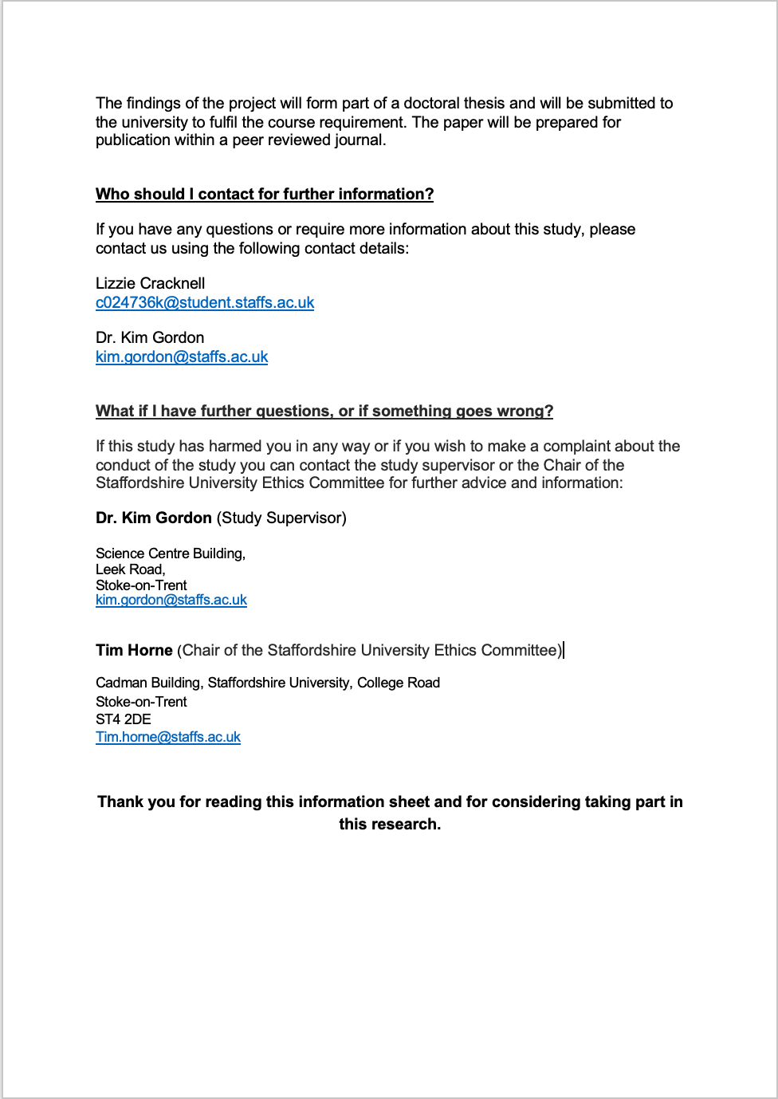
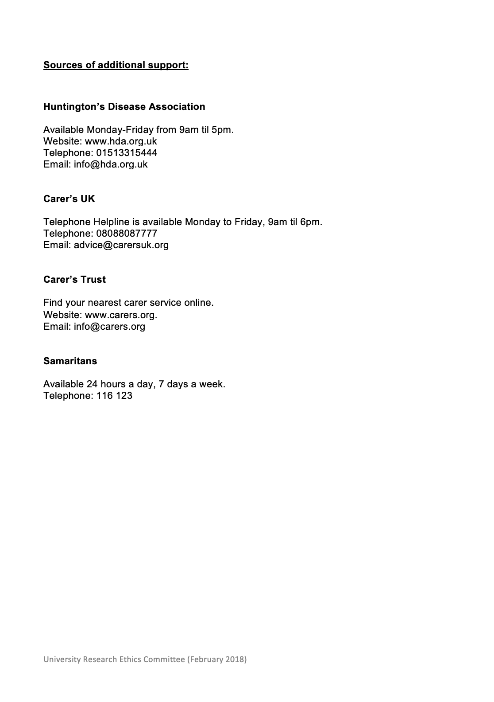
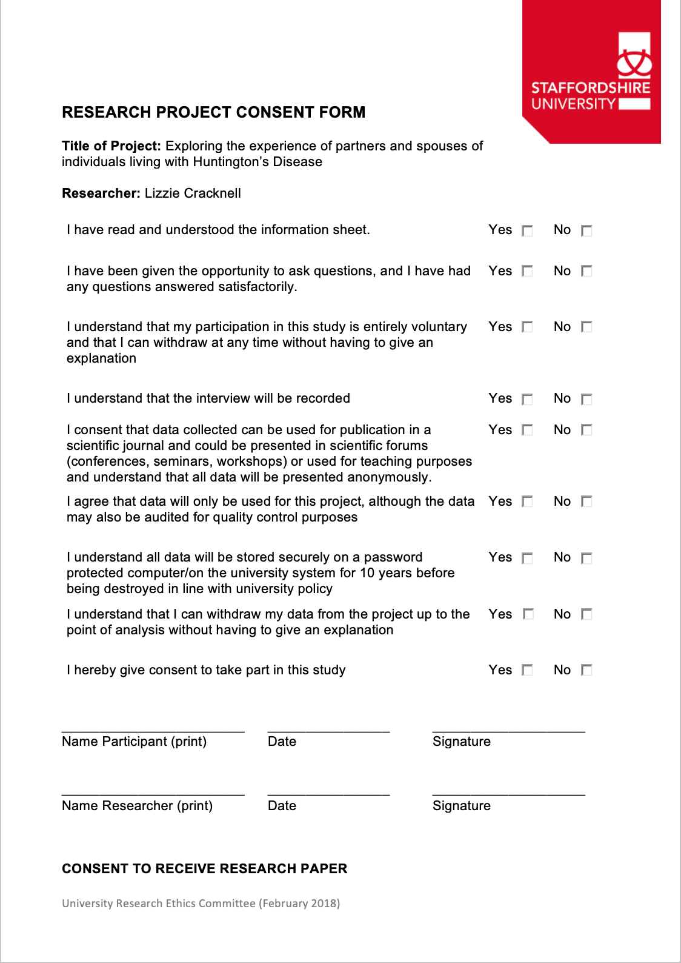
Appendix E.
Participant consent form
Appendix F.
Debriefing Document
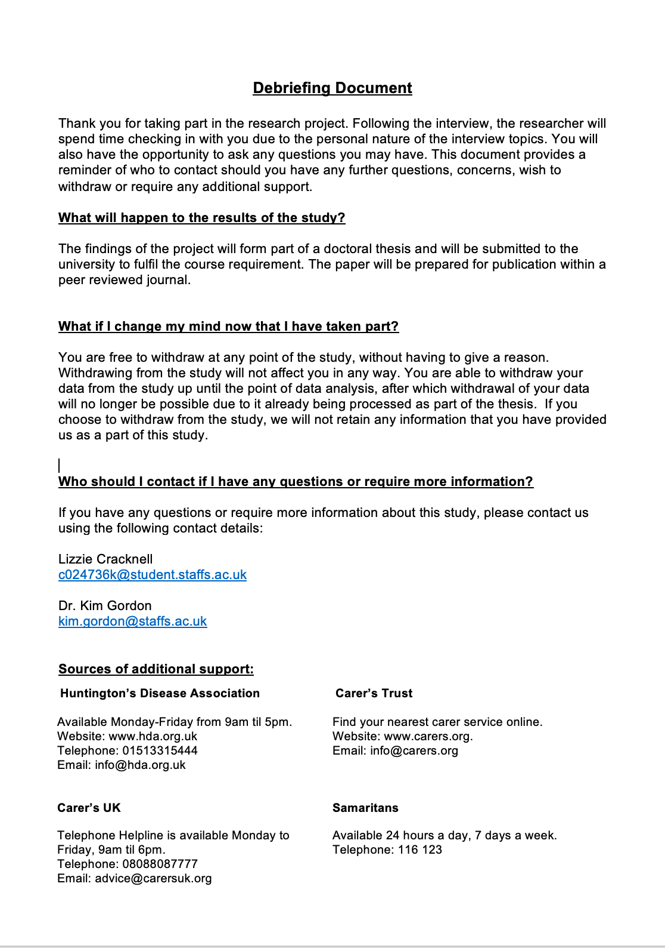

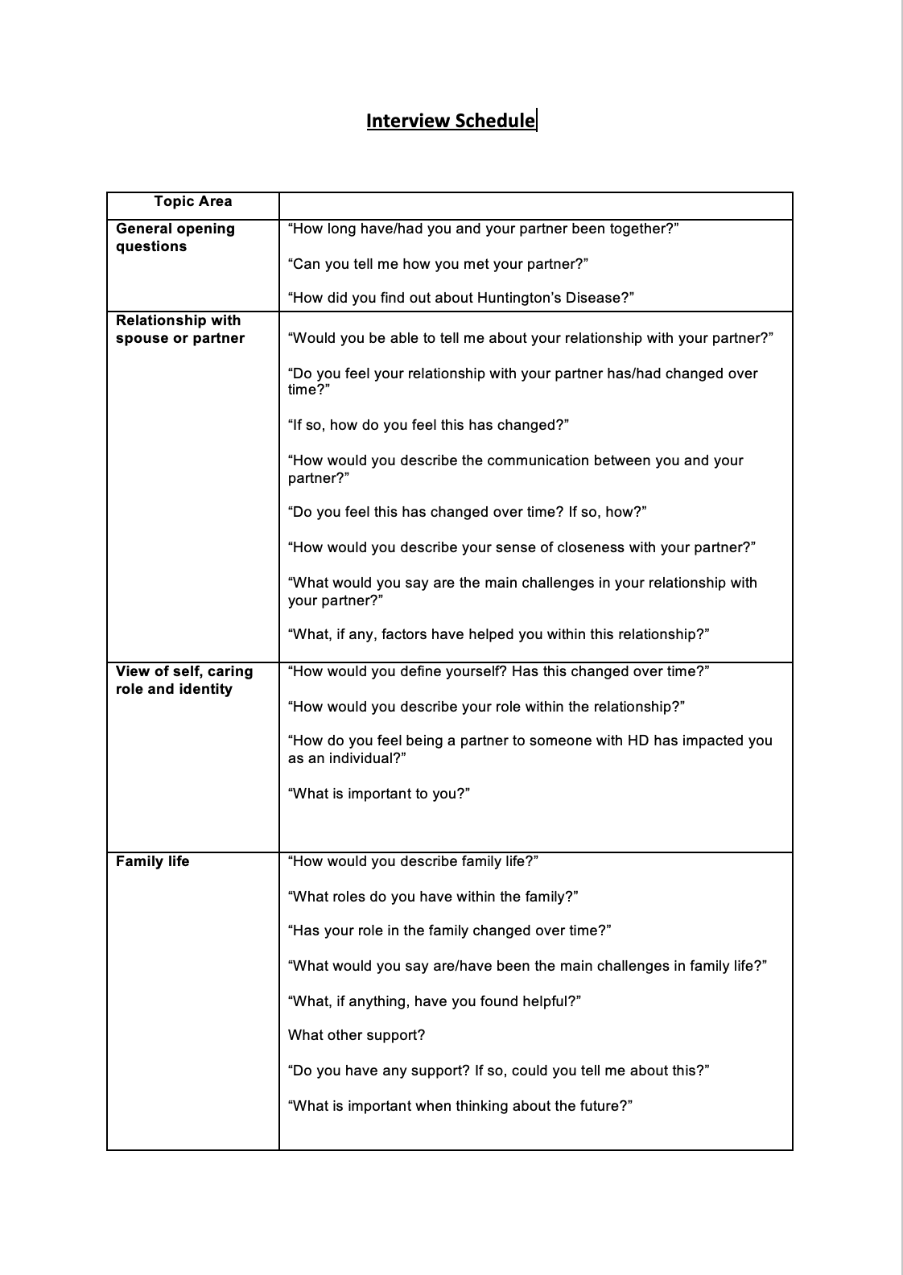
Appendix G.
Interview Schedule
Appendix H.
Exploratory notes and experiential statements (Angela)

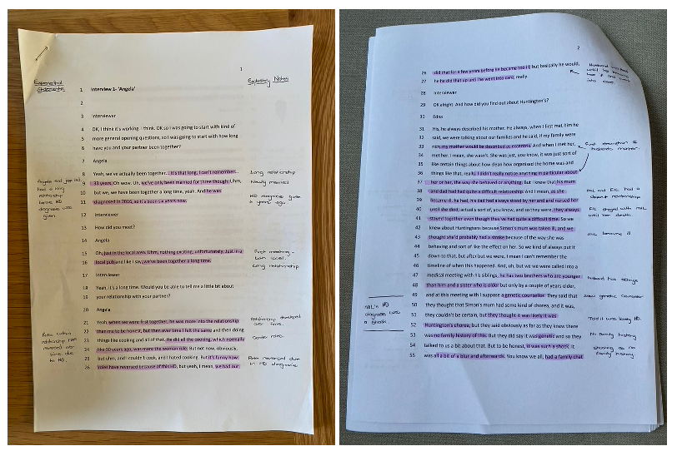

Appendix I.
Developments of PETS and sub-themes (Derek)

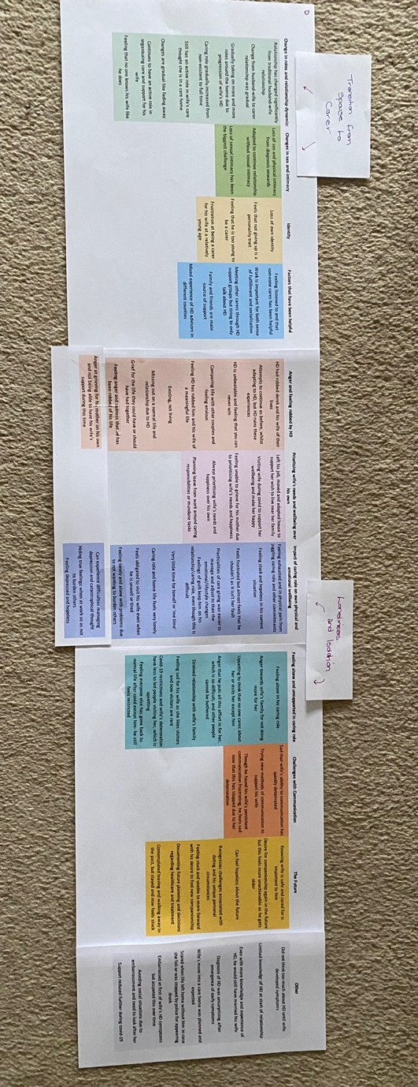

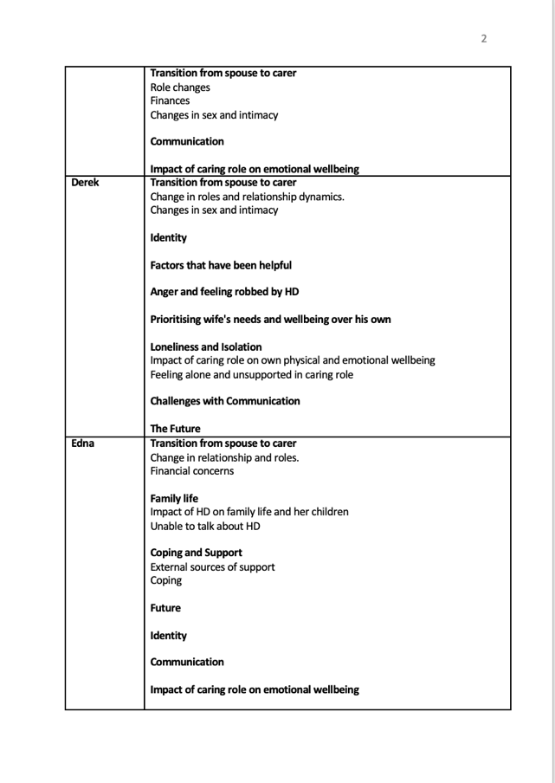
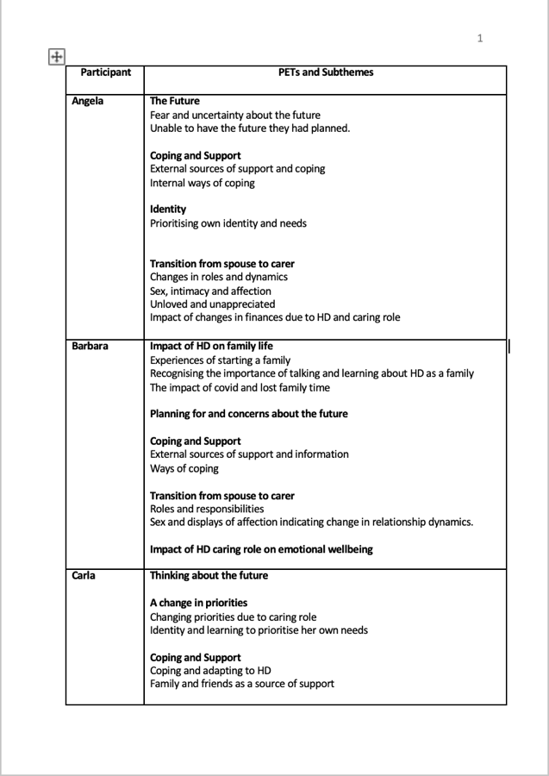
Appendix J.
PETS and Sub-themes for each case
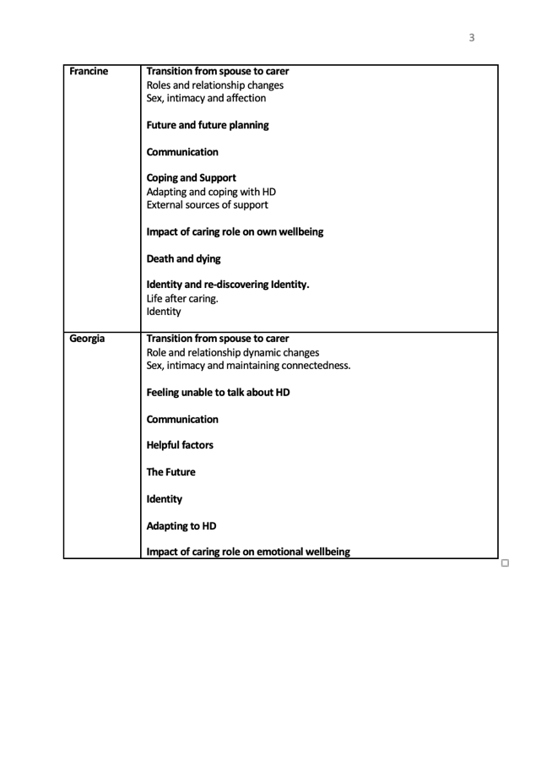

Appendix K.
Examining connections across cases using colour coding.

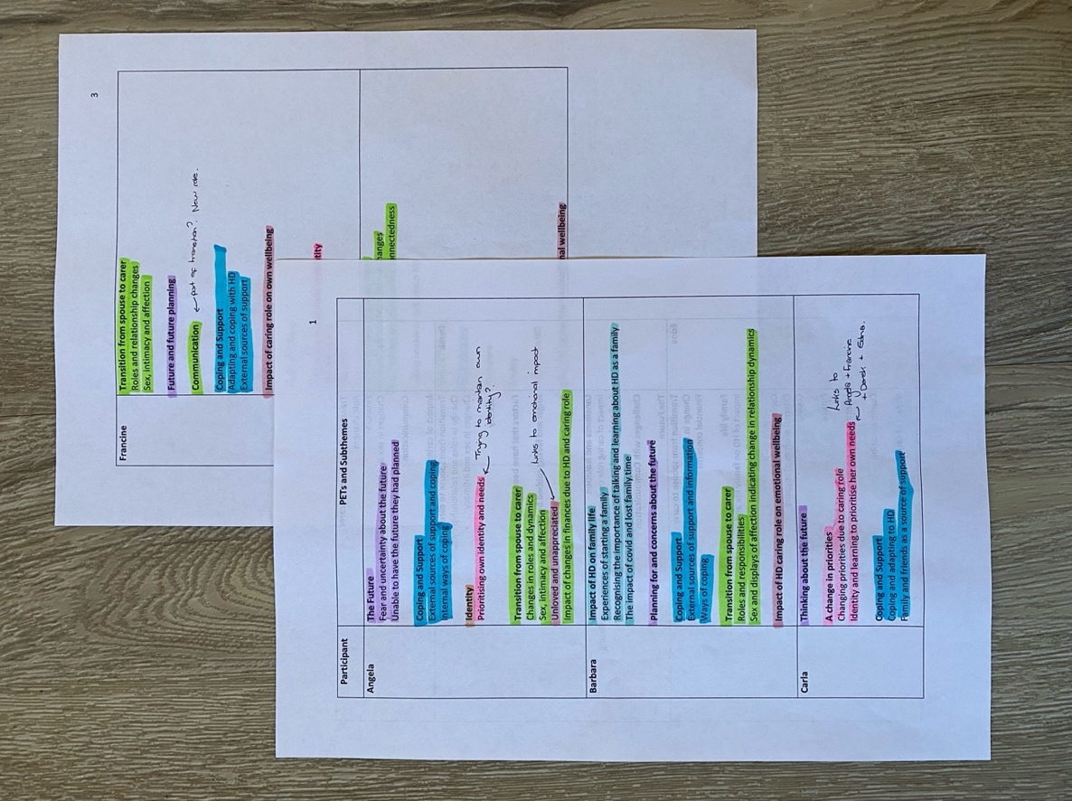
Appendix L.
Table of Group Experiential Themes and Sub-Themes

Table of Group Experiential Themes (GETS)

1. EXPERIENCE OF IDENTITY
1.1 Loss of identity to caring role
Loss of own identity.

“I think I’ve lost who I am”- Derek (p.11)

Losing own identity through caring role.

“I think you lose your own identity, I don't. I can't *exhales* I am, you know, I am who I am… I think it has been gradual because Pete's condition is gradual.”- Georgia (p.18)

Concerns about losing identity due to caring role and sacrifices associated with this.

“Being me, at the moment I’m okay, but I sometimes feel that no, that I will be his carer and that will be it. I will lose my identity because I can’t do what I want to do”- Georgia (p.19)

Making a conscious effort to maintain own identity.

“I try and sort of do stuff individually as well. And I explain that to my husband as well… I say to him, look, I’ve got to keep me as me”- Angela (p.6)

Difficulties maintaining own identity.

“I guess I probably did get a little bit lost in it all. I was conscious to make sure that I was still me, which was really hard”- Francine (p.19)

Personal therapy as an important source of support when losing own identity to caring role.

“I speak to my therapist because that’s been an important source of support for me to just, at times when I lose my identity and myself and I become overwhelmed with being a carer and I get really down about it, it’s good she keeps me in check”- Carla (p.6)

Work provided her with an identity and an escape from the challenges of family life.

“I was really pleased I was still at work, so I thought, at least that gives you that identity… during the day, I wouldn’t have to think about things because you’re so busy and then you just have to face what’s going on when you get home at night”- Edna (p.13)

Work as an escape from the challenges of being a carer:

“I love the job I do; I love what we do and you know we’re busy and it’s a bit of a sanctuary as well being away, but then when I get home, I’m very, very lonely at home… Yeah definitely, I’m not who I used to be”- Derek (p.11)

Work provided a sense of identity and a sense of competence she lacked in other areas of her life.

“I was always a teacher, not just a wife. I think that's meant it affected me less than it might have affected other people in that situation, you know, like I had a job that had a lot of responsibilities, and you could see yourself as a competent person. So even when at times I thought I was going crazy, I realised that I was being logical in other parts of my life”- Edna (p. 23)

1.2 Rediscovering themselves
Realisation about how much she had missed out on whilst caring for husband.

“But certainly now it’s like I realise how much how much of things I missed. So you know, getting up in the morning, I can just sort myself out, I haven’t got to keep half an ear out for what Adrian’s doing… You know, so it’s things like that that, I definitely got lost in it”- Francine (p.19)

Once caring role reduced, having new experiences was liberating.

“I just did loads of stuff because I hadn’t been able to do stuff before. So that was quite liberating”- Edna (p.24)

Now caring responsibility is over, feels that she has got her life back.

“My life really does become mine to do what I want and then go and live it in honour of Adrian”- Francine (p. 23)

2. THE TRANSITION FROM SPOUSE TO CARER
2.1 Changes in roles and responsibilities
Worry about finances when husband was required to stop working due to HD.

“When he left work, that's when I went into panic mode, actually, because before that the two of us were earning, and you just spend to your means, don't you? And I was, and then I went into panic mode, thinking, because he wasn't on any benefits then obviously. And I was saying how are we going to cope, how are we going to cope, but we did, so I'm hoping that's the same for now for me that we'll end up just managing”- Angela (p.19)

Financial concerns when she became the sole earner, with the benefit process being confusing.

“So basically I was paying the mortgage. He was getting a small amount of disability living allowance… it was really hard to sort of work out what benefits you could access and what support you were entitled to, and it was, we were really struggling”- Edna (p.11)

Change in work roles from being equals to her being the sole earner.

“When we first met my husband and I were equals, right here *hold hands up level to each other* and you know…and over time, that's changed, I've become the breadwinner. And rather than being equals it's not, it's not much of a true partnership anymore. Things have had to change and that's tough”- Carla (p.6)

Change in finances since becoming a full-time carer is worrying.

“…it's going to be a lot less money coming in and that does worry me”- Angela (p.18)

Taking on the role of sole driver can be frustrating.

“Well he used to drive as well, but that was another, this is another major thing. I do all the driving as he lost his license a couple of years ago now and that gets frustrating sometimes. If we go out to family do or something and I just, not that I'm a big drinker, but if I just fancy a couple, I can't because I'm driving and it's just things like that really... and then like we go away in this country a lot, if we don't get the train or anything- well I've got to drive and I do all the planning again and all of that, so I do everything”- Angela (p.14)

Responsibility for stopping husband from driving.

“I said to them, you know your dad's not well and so and he shouldn't be driving because at that point he wanted to carry on driving. You know, I said he shouldn't be driving and so that's why I won't let him drive the car”- Edna (p.16)

Transition to sole driver felt natural and expected.

“OK, yeah, I ended up doing all the driving, he gave up … we then went on holiday for 10 days without a car and he didn't go back to it once we got back. So that was a natural one, but early on in our relationship I had not been quite so well with my health, so he'd done the bulk of the driving at that point. Then we kind of split it and then it kind of, but again we knew what was gonna happen and I like driving”- Francine (p.12)

Gradually taking on more responsibilities around the home due to progression of wife's HD.

“We tried to carry on as normal from there, but then things would start to change where Eleanor would do her ironing and she'd drop the iron several times. So then I began to take the ironing over. She'd tried to cook meals and then she'd drop the stuff on the floor. So I began to do all that. So I began to take control of everything. Eventually I took over the finances, after about four or five years because Eleanor was struggled with it or she wasn't bothered with it, if that makes sense …everything was in place for Eleanor, but then it gradually became too much for her. So, I think from yeah, it was a gradual change and I always say my caring role was 0 percent on day one of her finding out, but now, I know she's in a care home but there’s still certain things I do for her, you know, prior to going into a care home, my caring role went up to 100%”- Derek (p. 4)

Taking on the role of advocate.

“And you know if I'm with him, I'm his advocate. I will. I have I have no problem advocating for him”- Carla (p.17)

Taking on the role of the planner and encourager.

“I've taken on a lot more of the roles, the jobs. I have to instigate everything. I’m the planner. The encourager.”- Georgia (p.5)

Taking on the role of her husband’s interpreter.

“… he's been non-verbal for 3 years, almost non-verbal. He could get speech out but it was very unclear and I was definitely his interpreter”- Francine (p.5)

2.2 Intimacy, sex and physical affection
Loss of sexual intimacy has changed relationship dynamics.

“He was in a different bedroom, so that's like had a major impact on the husband-and-wife relationship… that's difficult as well. But yeah, I mean times, it's more like a brother and sister relationship. Or mother and son”- Angela (p.21)

Change in sexual intimacy due to HD and her perception of her husband as disabled.

“I think with like the diagnosis, I feel like being intimate and stuff like that is slightly wrong. I don't know… I just think like you know, Steve's got like a disability now, if you get me, and it's more prominent and you know, it just feels sometimes wrong to be doing that, I don't know. And then obviously I wouldn't want to get pregnant again. So and then actually doing stuff is different with his movements and stuff, so you know”- Barbara (p.18)

Relationship changed from wife to carer most notably due to loss of sexual intimacy.

“I think particularly since I stopped work to be his full-time carer, I've definitely gone from being wife and intimate to being carer, so we've always remained in the same bed because when he was asleep he stopped moving. So it's never got to be in that dangerous in that respect, but definitely things like intimacy definitely dropped off”- Francine (p.3)

Loss of affection can feel like rejection.

“We used to be quite affectionate with each other. Now I can only, I'm only allowed to kiss the top of his head, if I go to hug him, I get pushed away. And… It feels like rejection *becomes tearful* and that's the disease, not him”- Carla (p.13)

Affectionate behaviours stemmed from habit and routine, but helped maintain a sense of closeness.

“We always had a kiss and a hug, I think some of it was quite routine, but it was still good to do, and even while he was in the hospital, you know we made a point of having a hug and kiss when we and you know, I arrived and as we left, and he'd sit and hold my hand while we were talking. So yeah, and we always told each other we loved each other, again, some of that is probably habit. But it was still nice to hear and be told despite the awful circumstances” Francine (p.14)

Relationship has changed significantly from traditional husband-wife relationship.

“I guess, if I'm honest, and I will be honest, on paper I’m her husband, in reality I'm not really a husband, you know I love Eleanor, but I'm not in love with her if that makes sense"- Derek (p.3)

3. IMPACT OF CARING ROLE ON WELLBEING
3.1 Alone and unappreciated
Feeling isolated and uncared for when unwell.

“But then that's hard on me because I'm trying to be positive and happy for him and sometimes... I found that when I've been ill twice recently… I just didn't feel 100%, that's when I feel, that's when I got quite low myself and upset because I feel like I'm just on my own”- Angela (p.6)

Anger at grieving for his mother on his own and not being able to have his wife's support during this time.

“I’m trying to make everything nice for Eleanor and grieve for my mom and I I wasn't allowed to grieve properly for my mom. I had nobody to grieve with or that will help me through that thing so you I wouldn't say I was resentful, but I was angry that I was trying to deal with it on my own”- Derek (p.18)

Feeling resentful that caring role is one sided.

“I have to sort of organize everything and then make sure he knows where he's going. Yeah, so it's not like a... and this is when if I'm being honest, sometimes you do get resentful because I think ‘I wish I had somebody that looked after me’, a husband. You know, usually well, you look after each other, don't you, but it's the fact that I'm looking after him, really”- Angela (p.5)

Hiding true feelings, so as not to burden others with problems, can result in loneliness.

“I always try and keep happy and smiley at work. You know, some people know my story and some people don't you know? Yeah, so it it is quite lonely mentally as well, because you don't want to burden people with, you know what they've heard before, really”- Derek (p.16)

Feeling unrewarded in caring role.

“It is hard to get rewarded through Huntington’s because they’re unable to really say how they, they can't do it and I thought Huntington’s is the wrong place if you want a reward”- Georgia (p.12)

Caring role can make her relationship feel like an unrewarding job.

“I do everything. And then I don't even get, like when we're away, he hardly says, like, ‘oh, this is nice’ so you know, so it's very... uhm, it's a job really more than a relationship sometimes and you don't get any reward for it”- Angela (p.14)

Efforts to help her husband were unappreciated.

“Whatever you did was wrong and you didn't get any thanks for what you were doing from them. Do you know what I mean, whereas you kind of feel if you're caring for somebody who's appreciative, at least with that you feel like it's kind of worth it *laughs*”- Edna (p.10)

Feeling appreciated makes caring role feel worthwhile.

“Whenever he really appreciates anything that's... *becomes tearful* yeah, that's... that helps me feel like I'm doing a good job.”- Angela (p.12)

Putting effort into caring role but feeling this is unappreciated.

“Because he doesn't say a lot and I'm thinking, I said to him to today actually, I said, you know, I'm always trying to do the best for you. Which I am really. I mean, I attend loads, he just, you know he doesn't really realize how much I could just not bother”- Angela (p.13)

Husband does not understand she is balancing multiple roles.

“You know, he doesn’t realize I’m trying to be a housewife you know, uh, a Mum, work and like you know, he doesn't see that”- Barbara (p.18)

3.2 Emotional and physical burden of caregiving
Feeling exhausted and in physical pain from juggling caring role and other commitments.

“So I was working 60 hour shifts, travelling down to see Eleanor, stopping at my sisters, travelling back the next day. Doing all my washing, shopping online and go to work the day after and I was I was exhausted. And then Eleanor wanted to go out as well. And I was lifting her in and out of the car at the time and I had a bad back and just yeah, it wasn't a good time for those first couple of years.”- Derek (p.6)

Caring role was overwhelming, particularly with additional caring role for mum.

“Worn out, knackered, exhausted, juggling too many.. I think it was the juggling between Adrian’s support that he needed and the nominal support I could give my mum”-Francine (p.18)

Overwhelmed by roles and responsibilities.

“I was working from home, trying to prevent him erm getting injured and us having to go to hospital with his injuries. And then also I was home schooling as well, so I'm surprised I didn't have a nervous breakdown. But also in the middle of that, I had health problems myself…I had to be admitted hospital. So yeah, it just wasn't the best couple of years we've had so. Nightmare”- Barbara (p.10)

Practicalities of caregiving role were easier to manage and adapt to than the emotional implications and lifestyle changes.

“I feel, I've missed out on, and Eleanor has as well, missed out on normal relationship, arguments, holidays, cinema, restaurants. You know, what people do normally. So I think that's been the biggest challenge. The caring side, you just you just get on with it, you know. You know, and like when I was showering Eleanor and drying her hair, getting her ready, getting her dressed… I didn't think about it, I just did it”- Derek (p.11)

Feels prioritising own wants would be selfish and harmful to her husband.

“There is a little bit of me that wants to be selfish and like, when we went on the cruise, there were three or four walks that could have gone on and I thought I can't leave Pete for 5 hours, not in an unfamiliar place… I don't wanna put him through that. So yeah… you just grit your teeth and get on with it”- Georgia (p.17)

Upsetting seeing a loved one deteriorate over time.

“Watching someone you love deteriorate. You know it's not, it's a very slow illness as well. It can be very slow without sounding horrible. If it's you know, some other illnesses can be quick and I'm not saying that's any better or worse, but you know. Yeah, it’s just a long process. Yeah, it's not just physical, it's mental, behavioural, and everything that changes”- Angela (p.23)

Feeling HD has robbed him and Eleanor of a meaningful life.

“I basically I think I exist. I don't live a life, I exist. So it's robbed Eleanor. It's robbed me, so I think that that is the biggest thing”- Derek (p.10)

Putting wife’s needs above his own.

“Knowing Eleanor is safe and cared for. That's my biggest thing I think … that that's important to me. You know I always put Eleanor 1st, I’m 2nd on the list really”- Derek (p.13)

3.3 Raising children in HD families
Potentially facing the difficult decision to continue or terminate the pregnancy.

“They said it was my decision at the end of the day, but the baby would, if it did have the grandma’s gene, would be at 50/50 risk, the same as Steve. So, uh it was a big risk, but… obviously everything went well fantastic in our favour but and I think suppose looking back on it now thinking Oh my God like you know I could have been, it could have been completely different”- Barbara (p.5)

Traumatic experience of pregnancy and conceiving daughter has deterred her from having future children.

“I would have loved another one. But I just thought, I just can't go through all that again, it was quite traumatic”- Barbara (p.5)

Daughters had a difficult childhood due to husband’s HD.

“So family life, the two girls have had a very difficult childhood, *starts crying* I would say, my youngest daughter… She says she can't remember her dad being well properly. So you know they've had a very tough time”- Edna (p.16)

Concerned about the impact her husband’s deterioration has on their daughter.

“She watched a webinar with me the other day erm about the trial that Steve’s on erm and the guy said that the brain dies and there's no like kind of reversing that and that's why they're trying to find these drugs that can help kind of thing and she just said it to me today, she said it upset her a bit that you know, Daddy’s brain's dying and that you know, he won't be the same kind of thing”- Barbara (p.36)

Talking about HD with her daughter to support her understanding.

“Is it damaging giving her too much information, I don't know, I don't know if it will. You don't know being a parent do you… I just hope that she doesn't become anxious like me and that she's more confident with all the information she knows about her dad”- Barbara (p.37)

Hopeful for a cure in future to help her daughters if they have HD.

“The future.. what is important to me? That they find a cure, so that if my my daughters do have it, then there's something to help them, because at the moment there isn't really”- Edna (p.22)

Awareness that her daughter will become a young carer for her dad.

“Just hope she becomes like a kind young carer when she's you know growing up. Because I've said that to her said like you know, you know when Dad is a little bit more poorly and you know he has to go in a wheelchair and stuff like that, are you gonna help Mommy and that and she goes yeah yeah yeah, that's fine”- Barbara (p.37)

4. COPING WITH CARING
4.1 You, Me and HD
HD diagnosis was a relief, as she could blame HD instead of her husband.

“So last summer, he tested positive and for me, it was a relief. I could now have something other than my husband himself to blame. I could say ohh, that's the disease, I could be angry with the disease. I don't have to be angry with him”- Carla (p.4)

This isn’t Daddy, this is HD.

“I just explained to Lilly like you know, Daddy hasn't always been like this… and I said, like you know, that daddy wasn't like this when me and him first met and you know, but this is what the Huntington’s is doing to Daddy so”- Barbara (p.36)

Feeling anger towards her husband, rather than HD, as a way of coping.

I mean I was I, I would say I was always fond of him, but towards the end I was also really angry and I know that you should be angry with the situation rather than the person. But I think I found it easier to protect myself by just being very angry with him. So that meant I could deal with it”- Edna (p.6)

Blaming HD, not her husband, and remembering how he used to be before HD.

“I'm able to look at him and still remember him and his, he's such a supportive character, I mean. The two of us, it's just, he's been so incredible at times, constantly, you know, pushing me forward with my career, helping me, and you know when I'm having a bad day, give me a big hug and you know that's changed. But I still remember that… he’s still him”- Carla (p.13)

Feeling connected through reminiscing and sharing happy memories.

“I'll try and uhm, talk about memories a lot because his short-term memory is not so good, but his long term is better. And I was reminiscing with him today actually about when we first met. Yeah, and I try and do that really and just think, trying to go by the past with him”- Angela (p.11)

Making the most of their time together.

“I just didn't want to see him suffering and missing out. And you know, I loved him very much despite the circumstances. You know, I always knew I wouldn't get to 60 with him. I didn't expect to be quite so close to 50, but you know, we always knew it was gonna happen so and we just wanted to make the most of life. Build memories, so we've done some crazy things…”- Francine (p.15)

Making the most of the time they have together and memory making.

“It is very difficult with the Huntington’s, like our relationships completely changed from when we first met. And I suppose we do more as a family now. Always, you know, out doing stuff as a family so. Just I suppose knowing that he's got the Huntington's, knowing that we need to pack as much into our, our, for our memories, I suppose. As much as we can really”- Barbara (p.30)

4.2 The importance of adapting, not stopping
Being both his wife and his carer.

“You know people saying you're a carer. It's like yeah, but I'm still his wife and I think that's why I want to keep life as normal as possible where we could. So I was still his wife. As much as I could be”- Francine (p.18)

Living life as normally as possible whilst adapting to HD.

“I think we're living every day and adapting our life to Huntington's always. We have to change with it I suppose I think that's probably the easiest way I can, you know, Steve still wants to do normal things while he can”- Barbara (p.27)

Trying to do things together as normal, with adjustment.

“We'll cook some dinner together. That's mostly me doing the chopping and stuff, I’ve banned him from knives. So I'll do the chopping, he'll do the stirring and then we'll choose a couple of TV shows to watch or a movie”- Carla (p.8)

Involving husband in household chores to reduce feelings of burden.

“I think I try and get him involved in a little job still, like he'll do the bins or something like that still and he hoovers a bit. Just get him involved still because otherwise I will feel like I'm doing everything”- Angela (p.15)

Adapting affection and intimacy rather than stopping.

“So you know, once he became incapable of being physically intimate, then you know we still had a cuddle in bed kind of thing. We always have done…We've always sat next to each other on the sofa, and we carried on doing so. It's just he held my hand rather than put his arm around me because *gestures strangulation and laughs* the motion was too much, whereas at least holding his hand I could let go when it was, or readjust it easier” Francine (p.14)

Adapting to a relationship without sexual intimacy.

“I think if anything, it was the, being personal, it was intimacy really, you know. Eleanor, since she was diagnosed, it was almost that was it, end of sort of thing. But you know, you move on and take it from there and you know, we still went on holidays, we still went to functions … and went from there. Your brain almost learns to adapt to it if that makes sense. It's not necessarily in the right way, but you know it does adapt”- Derek (p.3)

4.3 Sources of support
Work as a distraction from home life and a source of support.

“I mean I talk to my best friend or text every day and then yeah, I suppose being back in the office, work are really supportive and bouncing things off work, they kind of like know the situation. So, and they're really supportive erm so I kind of like vent when I'm there kind of thing. And being at work is quite a good distraction really, from home life I suppose”- Barbara (p.22)

Family and friends as sources of support .

“I've always been close to my sister, and she literally lives down the road now, we’ve like you know, always been close since kids sort of thing so she she's my sounding board. I got my mates at work. They're sounding boards”- Derek (p.7)

Felt understood and supported by other carers within support groups.

“It was very lonely for me and I felt like that I was quite, on my own with the whole thing, until I found the Huntington’s Disease Association… when I spoke to other carers they go, you know, I get all ‘my husband does blah’ they went ‘ohh God yeah that's what my wife does’ and you suddenly thought ‘Ohh God it's not just me’ and that was like that's been my main source of support”- Edna (p.8)

Other HD carers understand and have shared experiences.

“Uhm, I think my main support is people I've met through the support groups who have got the same, a family member or somebody else at risk. Uhm, there's a couple of ladies I'm in contact with via text. We meet up for a walk every so often and one, her son’s got it and then the other lady her husband’s got it. Uhm yeah. I don't think you really know. Even though my sister tries to help. It's like unless you're going through it yourself, you don't really understand what it's like”- Angela (p.15)

5. THINKING OF THE FUTURE
5.1 Grieving for the future they had planned
No longer having the future they had planned together.

“I feel more, well I am his carer really and it's not like a husband-and-wife relationship unfortunately. And I wish it was. It gets very upsetting and frustrating sometimes because the life I thought we were going to have together, in the same, in retirement for both of us in the future. Uhm, is not going to happen so yeah, that's upsetting and frustrating”- Angela (p.4)

Frustrated they are unable to have the future they had planned.

“I can feel quite frustrated. We'd hoped, when we retired that we would be able to do things, we were going to travel to India, but that's when Pete had a real meltdown, had to cancel it, and I knew that our future as retired people would be very different”- Georgia (p.14)

5.2 Fears and uncertainty about the future
Worried about husband having no quality of life in the future.

“I do not want to see Pete, laying in a bed, all shrivelled up and being fed through a tube and being kept alive. I am just so positive about assisted dying, that is really difficult thing for me to deal with. That would be really hard in the future”- Georgia (p.18)

Concerned about risk of violence and aggression from husband in future.

“You hear stories of like, especially the male people with Huntington's, that that can be quite abusive to the partners. And you know there's been incidents where there's been a sexual assault and stuff like that, and I'm just like, bit concerned of that kind of, you know, to come… that's the that's my only worry, I suppose in future”- Barbara (p.32)

Fear of violence and aggression from husband in the future from hearing other carer's experiences.

“I just hope he doesn't get too moody or physical with me or anything like that and it sounds dramatic, but that can happen and I, the thing that worries me and, this is just to do with relationships, is I always hear a lot about wives leaving their husbands, that have got there and I think, oh God, will I get to that stage well after all”- Angela (p.16)

Would only leave relationship if husband became aggressive or violent.

“I've always said to him. I will never abandon you. I will never leave you. The only caveat to that is if you are physically or mentally abusing me, or if I feel like I'm in danger. And that's a clear boundary”- Carla (p.14)

Hoping she will continue to be resilient in future.

“I think it has been gradual because Pete's condition is gradual. I'm, what I'm hoping is, it's gonna be nurture. It's gonna be that I will evolve because it's, things are happening very slowly. I'm hoping that I am going to be able to, if I cope with the last you know three years and I coped before he got his diagnosis, officially, that I will be able to, that's the only thing, positive I can get out of it, is that if things change, I will be able to adapt”- Georgia (p.19)

Feeling that she is doing all the future planning on her own.

“Me keeping going. Uhm, because it is isolated because you can't, share your own, your own thoughts about things. When I've been trying to give him, talk to him about what he wants for the future…We've got an end-of-life plan…”- Georgia (p.10)

Uncertainty about how she may cope in the future.

“… there's gonna be times where I won't be able to go out when he gets even worse, unless I have someone, a carer, you know coming in...”- Angela (p.7)

Appendix M.
Flow diagram of analysis process

Appendix N.
Extract from reflective diary

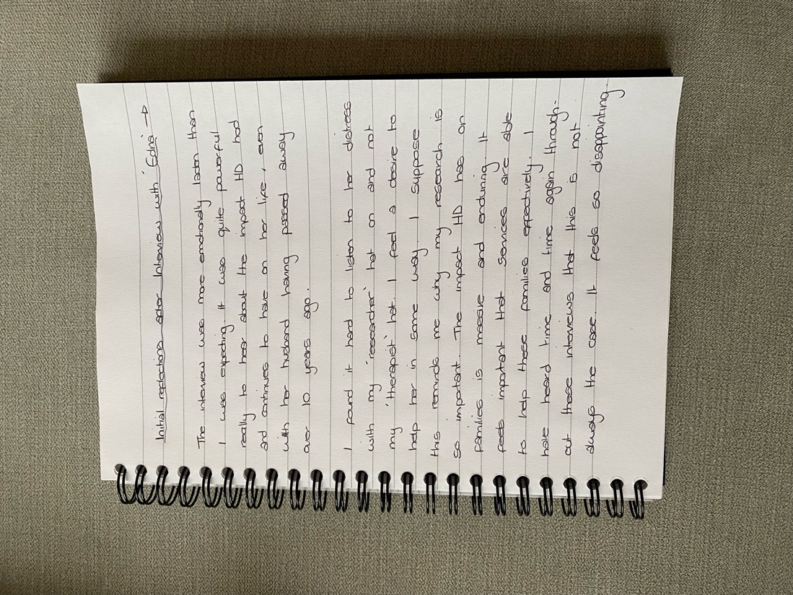

Paper 3: Exploring the experiences of partners and spouses of individuals living with Huntington’s Disease.

Executive Summary

Student ID: 20024736
Supervised by Dr Kim Gordon

Word count: 1,440

(Excluding Title Page and References)

Acknowledgments

The author would like to give special thanks to the HD family caregivers who supported the research project and aided in the development of the current paper.

Exploring the experiences of partners and spouses of individuals living with Huntington’s Disease

Executive Summary

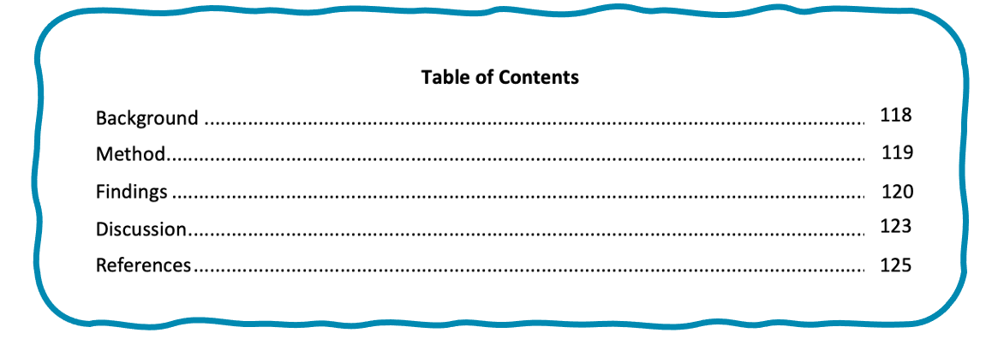
Purpose of the paper

This paper was developed for the purpose of informing spouses, partners and other adult family caregivers of people with Huntington’s of the research project. It may also be useful for staff working within health and social care services who support families with Huntington’s.

Data collection took place May-November 2022.

Carer Involvement

Members of a Huntington’s support group acted as consultants during the research project. Group members supported the development of the interview questions. They also commented on the advert, participant information sheet and the executive summary paper, to help make sure that they were accessible for readers.

Background

What is Huntington’s Disease?

Huntington’s Disease (HD) is a condition that damages cells in the brain, causing it to not function correctly. HD can cause changes with movement, thinking, behaviour and emotions. It is progressive, meaning that difficulties gradually get worse over time.

HD is caused by a faulty gene in your DNA. If a parent has HD there is a 50/50 chance of passing this faulty gene on to their child. It is usually diagnosed between the ages of 35-45 (Smolina, 2007). There is currently no cure for HD.

Impact of Huntington’s Disease on family life.

As people with HD become more unwell, they need more care and support. Family members often take on caring roles, looking after their family member with HD. Being a carer for a family member with HD can be difficult, with carers feeling that their caring role reduced their own quality of life (Aubeeluck & Buchanan, 2007).

Why is it important to think about spouses and partners?
Identity

Identity is our sense of who we are. It can be influenced by our memories, experiences, relationships, and values. It gives us a steady sense of who we are over time. New experiences and roles can become part of our identity over time.

HD is often diagnosed during a busy time in people’s lives, when people are at work and raising children. As people with HD become more unwell, they are less able to do the things that they used to do. This can mean that their spouses or partners take on these roles and responsibilities, such as cooking, cleaning, driving, and looking after any children, whilst also caring for the person with HD (Aubeeluck & Buchanan, 2007; Kessler, 1993). In this way, HD can cause many changes in family life and relationships. Within previous research, spouses and partners are often grouped with other family carers, meaning that their experiences are not explored in detail.

Becoming a carer for a person with HD can change the way a person sees themselves and their own identity. There is no previous research exploring experiences of identity amongst spouses and partners of people with HD.

Aim
The research project aimed to explore how partners and spouses of people with Huntington’s make sense of changes in their relationship, family life and their own identity.

Method

Ethical approval to carry out the research project was given by Staffordshire University Ethics Committee. Participants and their families were given different names to protect their identity. Questions were developed through talking with carers at a HD support group. This helped to make sure the questions were meaningful and useful.

Adverts were shared on social media by the Huntington’s Disease Association and were posted on Huntington’s Disease Facebook support groups. Participants were asked to contact the researcher if they wanted to take part in the project.
To be able to take part in the research, participants had to be:

- A spouse or partner of a person with HD
- Aged 18 or older
- Able to access the internet and an appropriate device (e.g. laptop, smart phone)
- Able to read and speak English

Participants

Seven participants took part in the research. All participants were living in the UK. Participants were aged between 47-64. Six participants were female, and one was male. All participants were married to a person with HD, with two participants being widows.

Procedure and Analysis
What is IPA?

IPA is a way of analysing the words people use to describe and make sense of their experiences.
Participants took part in interviews online using Microsoft Teams software. Interviews were recorded so that they could be transcribed. Transcripts of the interviews were analysed using Interpretive Phenomenological Analysis’ (IPA). The researcher interpreted the data, looking for similarities and differences across participants, and developed themes and sub-themes.

Findings

Five main themes and 12 sub-themes were found. The main themes were: Experience of identity, The transition from spouse to carer, Impact of caring role on wellbeing, Coping with caring, and Thinking of the future.

Experience of Identity

All participants experienced a change in their identity over time as a result of being the spouse of a person with HD. Participants described feeling that they had become lost within their caring role, often despite trying hard to maintain their own sense of identity. Work was helpful as it provided an additional identity (e.g. being a teacher as well as a spouse and carer). Participants also shared experiences of regaining identity and finding themselves again after the death of their spouse.

The transition from spouse to carer

All participants experienced a change in their relationship, changing from being a spouse to a carer. This change was highlighted by changes in roles and responsibilities. Participants shared being worried about finances when their spouses could no longer work. Participants also described changes in sex, affection and how connected they felt with their spouse.

Impact of caring role on wellbeing

Participants described the impact their caring role could having on their emotional and physical wellbeing. Participants described feeling lonely, unappreciated and exhausted by their caring role. Participants also spoke about the difficulties of raising children in HD families.

Coping with caring

Participants described their experiences of adapting their lives to HD. Some participants described separating their spouse and HD in their minds, in order to cope. Remembering who their spouse was before HD and talking about shared memories helped them to feel more connected to their spouse. Participants described feeling that it was important to change how they do things, and adapt their lives to HD, rather than stop doing things. Participants spoke about where they get support, such as from family, friends, work and carer support groups.

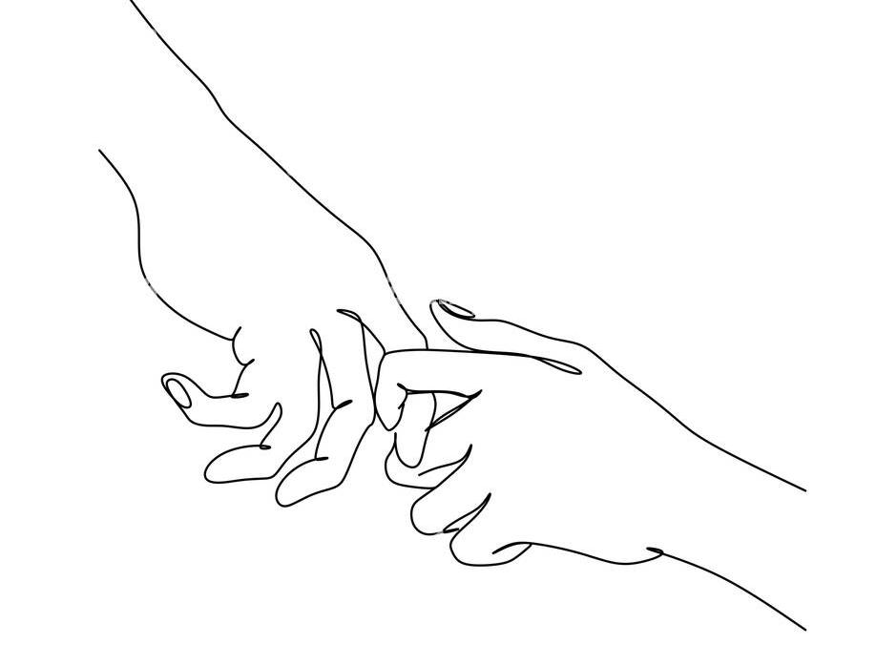
Thinking of the future

Participants described feeling frustrated and upset that they were not able to have the future they planned with their spouse. Participants shared feeling uncertain about the future and described concerns about how they may cope with the challenges that lie ahead.

Discussion

This study highlighted the experiences and challenges faced by spouses of people with HD. Participants described a change in their identity, from spouse to carer, as the disease progressed, and they became overwhelmed by their caring role. This was seen in changes in sexual intimacy, roles and responsibilities. Family life could be difficult. Participants were worried about how having a parent with HD could impact their children and whether they might develop the disease in the future. Work was important as it gave participants a sense of identity (e.g. a teacher) and time away from their caring role. By trying to adapt their lives to HD, participants were able to feel more normal and more like a spouse, rather than a carer. This supported their wellbeing and helped them to carry on caring.

What could services do to help?

It is important that services understand the challenges spouses and partners of people with HD face to make sure that they are able to give them the support they need. Services should be able to give spouses and partners the information they need about HD, along with other important topics, such as finances. Services should offer support with the emotional burden of caring, such as offering personal therapy.

What future research is needed?

As the current research only had one male participant, it would be important to include males within future research to make sure that their experiences are also heard and build upon the current findings. It may also be helpful to look at the experiences of spouses and partners over time (e.g. from diagnosis to after the person with HD has passed away). This research would be more time consuming, but it would let participants share their journey with HD over time, giving us a deeper understanding of their experiences.

References

Aubeeluck, A., & Buchanan, H. (2007). The Huntington’s disease quality of life battery for carers: reliability and validity. Clinical Genetics, 71(5), 434-445. https://doi.org/10.1111/j.1399-0004.2007.00784.x

Kessler, S. (1993). Forgotten person in the Huntington disease family. American journal of medical genetics, 48(3), 145-150. https://doi.org/10.1002/ajmg.1320480306

Smolina, E. (2007). Psychosocial impact of Huntington’s disease on families and spouses from the perspective of the Family Systems Theory. SURG Journal, 1(1), 51-62. https://doi.org/10.21083/surg.v1i1.338

