The role of Psychological Formulation in inpatient settings in supporting staff Empathy and Therapeutic Optimism for adults diagnosed with Borderline Personality Disorder: A pre-and-post vignette study.

Felicity Watkin

Thesis submitted in partial fulfilment of the requirements of Staffordshire University for the degree of Doctorate in Clinical Psychology

April 2023

Total word count: 18,772

THESIS PORTFOLIO: CANDIDATE DECLARATION
Title of degree programme | Professional Doctorate in Clinical Psychology
Candidate name | Felicity Watkin
Registration number | xxxxxxx
Initial date of registration | September 2020

Declaration and signature of candidate
I confirm that the thesis submitted is the outcome of work that I have undertaken during my programme of study, and except where explicitly stated, it is all my own work.
I confirm that the decision to submit this thesis is my own.
I confirm that except where explicitly stated, the work has not been submitted for another academic award.
I confirm that the work has been conducted ethically and that I have maintained the anonymity of research participants at all times within the thesis.

Signed: Date: 27.04.2023

Acknowledgements
To all the participants who were interested, asked about and took the time to complete the study, in the busy climate of the NHS, I am incredibly grateful! This research could not have happened without you.
I would also like to express my thanks to:
- Dr Helen Scott, for her guidance, support, and patience throughout this research project,
- Professor David Clark-Carter for sharing his expert statistical knowledge and for his kind words of reassurance and encouragement,
- Dr Ann Kilanska who repeatedly shared my research to support recruitment,
- My clinical research supervisor, Dr Ruth Richards, who has been there to guide, reassure and offer her expertise and,
- The Community Learning Disability team who kindly offered invaluable consultation and advice.
I would like to thank my family, particularly my parents for their unwavering support and my sister who inspires me every day. To my husband, Gary, I express unconditional gratitude as he, and our poodle Freda, stood by me through the long days and late nights.
Finally, I thank my friends, including the incredible cohort of trainees who I have had the privilege to share this journey with.

Contents
Thesis Abstract 9

Paper 1: Literature Review 10
Abstract 11
Introduction 12
Rationale for literature review 13
Method 14
Search strategy 14
Inclusion and Exclusion criteria 14
Critical Appraisal 17
Results 17
Overview of included studies 17
Quantitative Studies 18
Qualitative studies 20
Mixed method studies 20
Study Quality 32
Measures 32
Sampling 32
Results/Findings 33
Discussion of limitations, conflict of interest and ethical considerations 34
Findings 35
Attitudes and Empathy 35
Therapeutic relationships and interventions 36
Emotional reactions/countertransference 37
Positive experiences 38
Confounding factors 38
Discussion 39
Limitations 41
Considerations for Clinical Practice 42
Future Directions for Research 42
Conclusion 43
References 44
Appendices 51
Appendix A: Journal Guidelines for Psychology and Psychotherapy: Theory, Research and Practice 52
Appendix B: Critical Appraisal Tables 53

Paper 2: Empirical Paper 57
Abstract 58
Introduction 59
Adult mental health inpatient services 59
Borderline Personality Disorder 59
Adult mental health inpatient services and Borderline Personality Disorder (BPD) 60
The impact of organisational culture in adult mental health inpatient services 61
Empathy 62
Therapeutic optimism 62
The role of formulation 63
The current study 64
Materials and methods 65
Epistemology 65
Design 65
Participant Selection 66
Participant characteristics 67
Measures 68
Ethical approval 70
Procedure 70
Results 73
Data analysis and assumptions 73
Perspective taking 77
Empathic concern 77
Personal distress 78
Therapeutic optimism 78
Discussion 79
Clinical implications 82
Limitations 82
Future research 83
Conclusion 85
References 86
Appendices 95
Appendix A: Author guidelines for journal (Journal of Clinical Psychology) 96
Appendix B: Ethical Approval 97
Appendix C: Study advertisements 105
Appendix D: Participant information sheet 107
Appendix E: Participant consent form 112
Appendix F: Participant debrief form 113
Appendix G: Measures 115
Appendix H: Demographic questionnaire 118
Appendix I: Hypothetical case vignette (non-formulated case information) 120
Appendix J: Hypothetical case vignette (formulated case information) 121
Appendix K: Sample comparisons 122
Appendix L: Distribution of dependent variables 128
Appendix M: Distribution of covariate variables 139
Appendix N: Tests for homogeneity of regression slopes 149
Appendix O: ANCOVAS and ANCOHETs 154
Appendix P: Cronbach’s alphas for measures 164

Paper 3: Executive Summary 170
Background to the research 172
Adult mental health inpatient services 172
Borderline Personality Disorder (BPD) 172
Empathy and Therapeutic Optimism 173
Psychological Formulation 173
Why carry out this Study? 174
The use of a vignette 175
Aims and predicted outcomes of the Study 176
Method 177
How were participants recruited? 177
Who could take part? 177
What did taking part involve? 178
Who took part? 179
How was the data analysed? 180
Key findings 181
Conclusions and Recommendations 183
Limitations of this Research 184
Recommendations for Researchers 184
Who will this research be shared with? 185
References 186
Appendices 189
Appendix A: Non-formulated case vignette 190
Appendix B: Formulated case vignette 191

Thesis Abstract
The subsequent three papers aim to explore psychological practitioners’ experience of working with service users with a diagnostic label of borderline personality disorder (BPD) and investigate the role of formulation in staff empathy and therapeutic optimism towards this service user group. Paper one, for example, reports a literature review which explores what is known about the experiences of psychological practitioners who work therapeutically with adults diagnosed with BPD. In the twelve-article review, there was some evidence to suggest that practitioners were more negative about, less empathic toward and had stronger emotional responses (e.g., frustration, anxiety) to service users with a diagnosis of BPD, particularly when compared to therapeutic work with service users with other diagnostic labels. Positive experiences however, such as hope, were also identified. Limitations of the included studies and the review process, however, indicated a need for further research in this area.
Paper two details a pre-and-post vignette study investigating the role of psychological formulation on staff empathy and therapeutic optimism, toward a service user with a presentation associated with a diagnostic label of BPD. Sixty-six mental health professionals working in NHS mental health inpatient services took part in this empirical research. Following exposure to the formulated case vignette, two constructs of empathy (i.e., perspective taking and empathic concern), and therapeutic optimism significantly increased. The clinical implications and limitations of the study are discussed, and suggestions for further research are made. Paper three presents an executive summary of this empirical paper, written for NHS staff who work in mental health inpatient services. This summary may also be relevant for those who have an interest in psychological formulation, such as mental health professionals and service users.

Paper 1: Literature Review

What is known about the experiences of Psychological Practitioners who work therapeutically with adults diagnosed with Borderline Personality Disorder: a literature review

Word count: 7,881 (Excluding the title page, references, and appendices)

This literature review is intended for publication in the journal ‘Psychology and Psychotherapy: Theory, Research and Practice’. The referencing style of this paper is APA 7th edition, in line with the journal requirements. Author guidelines for the journal can be found in Appendix A. Further modifications will be made before submitting to the journal to meet these guidelines.

Abstract
Purpose: Despite a large evidence base demonstrating longstanding stigma from mental health professionals towards service users with a diagnosis of borderline personality disorder (BPD), there is currently little known about the experiences of psychological practitioners who work therapeutically with this service user group. Psychological practitioners tend to be highly involved with supporting this service user group alongside supporting the wider team involved with their care. This review, therefore, aimed to identify and appraise existing literature to investigate what is known about this therapeutic experience.
Method: A systematic review of articles published up to April 2022 was conducted. A total of 12 studies were identified, critically reviewed, and synthesised.
Results: The included articles illustrated a range of cognitive and emotional responses experienced by psychological practitioners across a range of settings. For example, psychological practitioners were more negative about and less empathetic toward service users with a diagnosis of BPD when compared to other mental health diagnoses (e.g., depression). Psychological practitioners also had strong emotional responses (e.g., frustration, anxiety) when working therapeutically with this service user group, however, they also identified positive experiences including feeling “impressed” and describing “hope”.
Conclusions: Limitations of included studies and the review process need to be considered when interpreting the results. Findings, however, indicate that psychological practitioners experience negative perceptions of, and emotional reactions towards this service user group, similar to findings reported in other reviews exploring mental health workers more broadly. Positive experiences, however, are also identified. These responses along with possible associated factors are discussed.

Introduction
Individuals who are diagnosed with borderline personality disorder (BPD) are said to present with interpersonal and emotional regulation difficulties, risk of self-harm and suicide, and an increased risk for substance misuse (Leichsenring et al., 2011; Sansone & Sansone, 2013). This service user group can require support from a range of services and high levels of support (e.g., inpatient admissions) at times of crises (Egan et al., 2014). The diagnosis of BPD, despite being helpful and validating for some service users (Lester er al., 2020), has received strong criticism due to the stigma attached to the label and lack of specificity regarding its diagnostic criteria and associated risk factors (Amad et al., 2019; Lewis & Grenyer, 2009). The diagnostic label, however, will be used throughout this review for ease of reading.
Attitudes and emotional reactions towards the diagnosis of BPD have been widely researched in healthcare settings around the world (Avriam et al., 2006). In a 2013 literature review, Sansone and Sansone reported that mental health professionals disclosed a number of negative attitudes towards service users with a diagnosis of BPD. The mental health professionals included psychiatric nurses, psychotherapists and “mixed samples of mental health clinicians” such as psychiatric nurses, healthcare assistants, psychologists, and psychiatrists. The negative attitudes reported included perceiving service users with a diagnosis of BPD as dangerous, unrelenting, time consuming and more difficult to take care of. This review also suggested that professionals experienced a range of emotional reactions when working with this service user group including feeling uncomfortable, anxious, frustrated, and manipulated. They found some evidence to suggest that these experiences (i.e., the attitudes and emotional reactions) were more negative than the experiences that mental health professionals had towards other mental health conditions, although this was not the focus of their review.
More recently, a literature review of twenty-five quantitative studies authored by McKenzie et al. (2022) was published. Their review investigated whether ‘mental health workers’ held different attitudes towards individuals with a diagnosis of BPD compared to other mental health conditions. The ‘mental health workers’ in this review included professionals from nursing, psychology, social care, and psychiatry disciplines. The findings suggested that practitioners working with this service user group rated their experiences more negatively (e.g., feeling less positive, confident, or purposeful), expressed less empathy, and showed lower levels of treatment optimism in comparison to working with service users with other mental health conditions. They also reported that professionals felt more frustrated, angry, and helpless when working with individuals diagnosed with BPD compared to other mental health conditions.
This existing evidence base, however, has illustrated that the majority of the studies’ samples have represented psychiatric nurses or “mixed samples” of different professions (McKenzie et al., 2022; Sansone & Sansone, 2013), with a paucity of research which specifically explores psychological practitioners experience of working with individuals diagnosed with BPD. The term ‘psychological practitioner’ includes any qualified practitioner working in a psychological or psychotherapeutic role (Summers et al., 2020), for example, clinical psychologists, trainee psychologists, other chartered psychologists, and psychological therapists. Psychological training programmes emphasise a person-centred approach, as opposed to a medical model emphasised in other professional training such a psychiatric nursing (Bodner et al., 2011; British Psychological Society [BPS], 2019; Liebman & Burnette, 2013), therefore it would be interesting to explore psychological practitioners more explicitly.
With this, it is also important to consider the role of a psychological practitioner, not only working directly with service users but their responsibilities within a wider multidisciplinary team. Psychological practitioners, for example, have several responsibilities regarding indirect care, such as sharing knowledge with colleagues, supervision, formulation and/or leadership roles ((BPS, 2010; British Association for Behavioural and Cognitive Psychotherapy [BABCP], 2021; British Association for Counselling and Psychotherapy [BACP], 2018; Health and Care Professionals Council [HCPC]). A psychological practitioner, therefore, needs to have an awareness of their own biases, not just for the purpose of the direct therapeutic relationship, but also for the integrated relational and systemic aspects of indirect working and how their biases may affect others or the systems they work in (Hawkins & Shohet, 2012).

Rationale for literature review
There is a strong evidence base demonstrating that a range of mental health professionals report more negative experiences of working with individuals labelled with a diagnosis of BPD than other mental health conditions. Psychological practitioners, however, may warrant more specific exploration due to their different training routes and psychological, rather than diagnostic/medical, approach. This review could provide valuable learning in regard to how psychological practitioners experience working with individuals diagnosed with BPD, which could have implications for quality of care, professional development, and personal reflection. This literature review, therefore, aims to answer the following research question: “What is known about the experiences of psychological practitioners who work therapeutically with adults diagnosed with borderline personality disorder?”.

Method

Search strategy
This literature review utilised a systematic search strategy completed in April 2022. The database host EBSCO was used to access the following relevant databases: MEDLINE, CINAHL, PschINFO and PsycARTICLES along with Scopus. Publication bias, however, is an inherent issue for psychological research, with unpublished studies being less likely to report significant findings (Fanelli, 2012), therefore, to mitigate this, grey literature was searched using OpenGrey. Hand searches and google scholar were also used to review reference lists and identify any additional articles. The following key words were used with Boolean operators to advance the search: (Psychologist* OR Psychological therapist* OR therapist* OR counsellor*) AND (Borderline Personality Disorder OR Emotionally unstable personality disorder OR BPD OR EUPD) AND (Attitudes OR Stigma* OR views OR reactions OR bias OR prejudice OR perceptions OR beliefs OR transference) AND Adult*. The databases were searched electronically for peer reviewed articles published in English, with no date limiter applied.
The initial search yielded 217 results, which reduced to 140 when duplicates were removed. Twelve studies were identified to be included within this review. The studies have been briefly described in Table 1, with Figure 1 detailing the literature search process (Liberati et al., 2009).

Inclusion and Exclusion criteria
To be included in this literature review, studies were required to:
- Be published in English due to a lack of translation resources.
- Be peer reviewed.
- Include participants’ working in mental health services as a psychological practitioner.
- Specifically refer to staff attitudes, views, or experiences of working therapeutically with service users diagnosed with BPD.
Studies which met the following criteria were excluded:
- The article was a summary or opinion piece.
- The article evaluated staff experiences of working with service users diagnosed with BPD related to or following training in a specific intervention or theoretical approach.
- The article referred to therapeutic work with children (<18) or older adults (+65) due to differences in clinical presentation (Peckham et al., 2020).

Records identified through database searching (N=217)

EBSCO host:
PsychINFO (n = 15)
PsychARTICLES (n = 4)
MEDLINE (n = 80)
CINAHL (n = 22)
Scopus (n = 96)
OpenGrey (n = 0)
Records removed before screening:

Duplicate records removed
(n = 77)

Records screened by title and abstract (n = 140)
Records excluded due to a clear lack of relevance to the review topic or clear violation of inclusion criteria
(n = 114)
Full texts assessed for eligibility
(n = 26)
Reports excluded (n = 20) due to:

- Specific intervention (n = 4)
- Commentary/Reflective article
(n = 2)
- Psychology professionals not currently working within MH services (n = 5)
- Unable to differentiate Psychology professionals’ data from sample
(n = 6)
- Does not specifically refer to “Borderline” Personality Disorder
(n = 1)
- Referred to therapeutic work with children or older adults (n = 2)
Studies included in review
(n = 12)

Identification of studies via databases and registers
Identification
Screening

Included
Hand searching of articles citations (using google scholar) and reference lists for further eligible articles (n = 6)
Figure 1
Flow Chart Demonstrating Literature Review Search Strategy

Critical Appraisal
All quantitative studies included were cross-sectional, therefore the appraisal tool for cross-sectional studies (AXIS) (Downes et al., 2016) was used to critically appraise these papers, due to its specificity to this methodology and inclusion of key issues apparent in cross-sectional studies. The critical appraisal skills programme (CASP) qualitative checklist was used to appraise the qualitative studies (CASP, 2018), as this tool is advocated by National Institute for Health and Care Excellence (NICE) review protocol guidelines (2018). The mixed methods study was assessed using both the AXIS and the CASP.
The AXIS and the CASP tool score every item out of 2. A 2 is awarded if the criterion is fully met, a one is awarded if the criterion is partially met, and a 0 is awarded if the criterion is not met or if it is not clear. Quality scores for each item within the two tools are illustrated in Tables B2 and B3 (Appendix B), with key strengths and limitations for the studies highlighted in Table 1. A summary of the quality of studies has been synthesised within the results section.

Results

Overview of included studies
Of the twelve studies included within this review, nine utilised a quantitative design, two a qualitative design and one a mixed methods approach. Psychological practitioners were identified through professional titles, which varied from psychologists (Black et al., 2011; Bodner et al., 2011; Bodner et al., 2015) clinical and trainee clinical psychologists (Bourke & Grenyer, 2010; 2013; 2017; Millar et al., 2012; Servais & Saunders, 2007), “clinicians” differentiated by their primary discipline as either psychologists or “masters level therapists” (Liebman & Burnette, 2013), psychotherapists (Putrino et al., 2020), and therapists from a range of therapy modalities including cognitive, behavioural, interpersonal, psychodynamic, systemic, eclectic and “other” (Brody & Farber, 1996; McIntyre & Schwartz, 1998). The staff recruited to participate worked across a variety of settings including primary and mental health services (Millar et al., 2012), community health teams (Bourke & Grenyer, 2010; 2013; 2017), mental health hospitals (Bodner et al., 2011; Bodner et al., 2015), academic centres (Black et al., 2011), and “institutional” and private settings (Brody & Farber, 1996). Some studies did not report where participants worked (Liebman & Burnette, 2013; McIntyre & Schwartz, 1998; Putrino et al., 2020; Servais & Saunders, 2007) but required practitioners to have experience of working therapeutically with individuals diagnosed with BPD. The included studies took place in America (Black et al., 2011; Brody & Farber, 1996; Liebman & Burnette, 2013; McIntyre & Schwartz, 1998; Servais & Saunders, 2007), Australia (Bourke & Grenyer, 2010; 2013; 2017), Israel (Bodner et al., 2011; Bodner et al., 2015), Argentina (Putrino et al., 2020) and Scotland (Millar et al., 2012).

Quantitative Studies
Seven of the quantitative studies utilised self-report, Likert scale measures (Black et al., 2011; Bodner et al., 2011; Bodner et al., 2015; Brody & Farber, 1996; Liebman & Burnette, 2013; McIntyre & Schwartz, 1998; Servais & Saunders, 2007). Some measures were created by the authors (Black et al., 2011; Bodner et al., 2011; Servais & Saunders, 2007), other used validated measures (Bourke & Grenyer, 2013; McIntyre & Schwartz, 1998) and some studies also included a case vignette (Bodner et al., 2015; Brody & Farber, 1996; Liebman & Burnette, 2013; McIntyre & Schwartz, 1998) to apply measures to.
Servais and Saunders (2007), for example, created a sematic differential scale (e.g., safe vs dangerous, worthy vs unworthy) with five “targets” to examine attitudes of 306 clinical psychologists towards these targets. These targets included ‘yourself’, a member of the public, a person diagnosed with depression, a person with “borderline features” and a person diagnosed with schizophrenia. A one-way analysis of variance (ANOVA) was then used to indicate any significant differences between the “target” ratings. Black and colleagues (2011) also created their own questionnaire, consisting of 31-items exploring sub-scales of caring attitudes, empathy, and treatment optimism. This survey was distributed to nine academic centres and completed by 706 multidisciplinary professionals of which 53 were psychologists. An analysis of covariance (ANCOVA) was used to test for differences between the subscales and professional groups, with gender, experience and site entered as covariates.
Bodner et al. (2011) explored staff attitudes towards the diagnosis of BPD in a sample of 57 clinicians’, of which 13 were psychologists. They created two inventories referring to cognitive (47 items) and emotional attitudes (20 items) and utilised multivariate analyses of variance (MANOVAs) to compare the 3 groups of clinicians (i.e., nurses, psychologists, and psychiatrists) on the factors of the cognitive and emotional inventories (e.g., antagonistic judgments, perception of suicidal tendencies, negative emotions, and empathy). Bodner et al. (2015) further developed these inventories through confirmatory factor analysis and replicated the 2011 study with a sample of 691 professionals, including 162 psychologists. This 2015 study also added a vignette element to explore implicit attitudes. MANOVAs were again used to compare the responses of the different professional groups on the factors of the inventories used.
Other studies that utilised case vignettes included Brody and Farber (1996). They designed a 25-item experience and attitude scale and 20-item vignette rating scale to explore the countertransference reactions of 336 therapists working with service users diagnosed with major depression, BPD, and schizophrenia. This study assessed therapists’ attitudes towards working with this service user group and their reactions to a clinical vignette which described the three previously mentioned diagnoses. ANOVAs were then used to explore any differences between the attitudes and responses of therapists toward the different service user groups. Liebman and Burnette (2013) also used a case vignette, which described a service user presenting with difficulties associated with BPD and then used a web-based survey to capture countertransference reactions (e.g., empathy, trust, dangerousness) of psychiatrists and psychological practitioners (psychologists and therapists N=479). MANOVAs were then used to assess differences in clinician attitudes across discipline and the surveys subscales. Experience and gender were also considered as confounding factors.
The quantitative study which applied validated questionnaires to their research question was McIntyre and Schwartz (1998). They asked 155 psychotherapists to listen to audio recordings of interview sessions with service users presenting with difficulties associated with a diagnosis of major depression or BPD and then used the Impact Message Inventory (Kiesler, 1987) to measure personal reactions to the interview and the Stress Appraisal Scale (Carpenter & Suhr, 1988) to investigate therapist anxiety. A series of ANOVAs were then computed to explore gender differences and differences in countertransference reactions to the different service user groups. Years of experience was also investigated as a possible confounding factor.
Finally, the two quantitative studies which did not utilise Likert scale measures included Bourke and Grenyer (2010; 2017). They utilised a relationship anecdotes paradigm (a semi-structured face-to-face interview procedure) to code relational patterns from interviews with 20 clinical psychologists, to examine emotional and cognitive responses to service users diagnosed with BPD or major depressive disorder (MDD). In 2010, Bourke and Grenyer utilised a core conflictual relationship theme analysis (CCRT) to analyse the interview transcripts, whereas a computerised linguistic content analysis was used in 2017. Years of experience was added as a factor to the statistical model in 2010, with the 2017 study also considering years of experience, therapist age and gender.

Qualitative studies
The included qualitative studies utilised different methodologies. For example, Millar et al. (2012) recruited 16 psychologists (including trainees and qualified) to focus groups through purposive sampling. The focus groups were “naturally occurring” meaning that participants were colleagues who already knew each other. The group transcript was then analysed using interpretive phenomenological analysis. Putrino et al. (2020), however, used semi-structured interviews with 43 therapists, from different theoretical orientations, to explore emotional and physiological reactions when working with service users diagnosed with either BPD or depression. A snowball sampling approach was used, where psychotherapists who had “previous contact” with the researchers were contacted via email. The data was analysed using a consensual qualitative research (CQR) approach which focused on developing categories to describe consistencies across cases.

Mixed method studies
Bourke and Grenyer (2013) utilised a mixed methods approach. They explored the therapists accounts of process when working with service users diagnosed with either BPD or depression, from the same sample of 20 therapists used in their other research (Bourke & Grenyer, 2010; 2017). In this study however, the interview transcripts were analysed through thematic content analysis software, and the Psychotherapy Relationship Questionnaire (Westen, 2000) was administered to measure perceived relational patterns between the service user and the therapist.
Table 1
Data Extracted from the 12 Studies Included in the Literature Review Pertaining to Study Characteristics, Participant Details, Key Findings and Strengths and Limitations
Author, Date, and Country | Sample and Setting | Methodology | Key Findings Pertaining to Psychological Practitioners | Comparison Group (if applicable) | Strengths | Limitations
Black et al. (2011)  USA | Total sample (n=706): Psychologists (n=89)  Psychology sample = 53 female; 43 male; 4 unknown.  Academic centres. | Quantitative – survey. | Psychologists were less likely to endorse medication.  Psychologists were more optimistic psychotherapies.  More contact increased positive attitudes. | Compared professional groups including nursing, psychiatry, social work, psychology and ‘other’. | Clear aims and appropriate design.  Results clearly presented.  Adequate selection process.  Conclusions justified.  Limitations discussed. | No power analysis reported.  Psychometrics not validated.  Concerns re: non-response bias
Bodner et al. (2011)  Israel | Total sample (n=57): Psychologists (n=13)  Psychiatric hospitals. | Quantitative –  Cognitive attitudes and treatment inventory.  Emotional attitudes inventory. | Psychologists had less antagonistic views and greater empathy for service users diagnosed with BPD. | Compared professional groups including nurses, psychologists, and psychiatrists. | Clear aims and appropriate design.  Results clearly presented.  Attempts to create and validate psychometric inventories.  Conclusions justified.  Limitations discussed. | No power analysis reported.  Small sample.  Concerns re: non-response bias.
Bodner et al. (2015)  Israel | Total sample (n=691):  Psychology (n=162),  Psychology; 125 female, 37 male.  Psychiatric hospitals. | Quantitative –  The cognitive attitudes inventory (Bodner et al, 2011).  The emotional attitudes inventory (Bodner er al, 2011).  Implicit attitudes inventory with a vignette around hospitalisation. | Psychologists had fewer negative attitudes and more empathy for services users diagnosed with BPD. | Compared professional groups including nurses, psychologists, and psychiatrists. | Clear aims and appropriate design.  Some validated measures.  Effect size reported.  Results presented. Conclusions justified.  Limitations discussed.  Conflict of interests/funding reported. | No power analysis reported.  Concerns re: non-response bias.
Bourke & Grenyer (2010)  Australia | 20 Clinical Psychologists  17 female; 3 male.  Community health teams. | Quantitative – Recorded interviews with core conflictual relationship theme analysis (CCRT). | Therapists were empathetic but less confident when working with diagnoses of BPD.  Years of experience = no effect. | Service user comparison group (compared experiences of a diagnostic label of BPD to experiences of a diagnostic label of major depressive disorder [MDD]). | Clear aims.  Based on real therapeutic relationships.  Included comparison group.  Results presented and conclusions justified.  Limitations discussed. | No power analysis reported.  Snowball sample may not be representative.
Bourke & Grenyer (2013)  Australia | Same as Bourke & Grenyer (2010) | Mixed methodology  Quantitative –Psychotherapy Relationship Questionnaire (Westen,  2000).  Qualitative –  Semi structured interviews analysed with computer assisted content analysis. | Therapists experience greater emotional distress when working with service users diagnosed with BPD.  Supervision was important in maintaining a positive therapeutic frame.  Years of experience = no effect. | As above | Mixed methodology – clear aims and appropriate design.  Based on real therapeutic relationships.  Included comparison group. | No power analysis reported.  Snowball sample may not be representative.  Relationship between researcher and participants not considered.
Bourke & Grenyer (2017)  Australia | Same as Bourke & Grenyer (2010) | Quantitative - Linguistic  responses  analysed  using  linguistic  inquiry &  word count. | Therapists used more words describing negative emotions (e.g., sadness/anger) working with service user diagnosed with BPD.  Years of experience = no effect. | As above | Clear aims and appropriate design.  Based on real therapeutic relationships.  Included comparison group. | No power analysis reported.  Snowball sample may not be representative.
Brody & Farber (1996)  USA | 336 therapists  “Split equally between male and female”  Private and “Institutionally-based” settings | Quantitative - survey with case vignettes | Service users diagnosed with BPD evoked the greatest degree of anger/irritation and the least degree of liking, empathy, and nurturance.  Years of experience increases comfort with emotional reactions. | Service user comparison group (compared experiences of a diagnostic label of BPD to experiences of a diagnostic label of major depression and schizophrenia). | Clear aims and appropriate design.  Adequate selection process.  Included comparison group.  Methods sufficiently described.  Results presented and conclusions justified.  Limitations discussed. | No power analysis reported.  Psychometrics not validated.  Some inconsistencies in data.  Concerns re: non-response bias.
Liebman & Burnette (2013)  USA | Total sample (n=560):  Psychology professionals (n=479) as categories were not mutually exclusive.  Setting not specified. | Quantitative – Online survey with case vignette. | Psychological practitioners endorsed more positive reactions, were more empathetic but less trusting of service users diagnosed with BPD. | Compared professional groups including psychiatry and psychology. | Clear aims and appropriate design.  Adequate selection process.  Results presented.  Conclusions justified.  Limitations discussed. | No power analysis reported.  Psychometrics not validated.  Some inconsistencies in data.  Concerns re: non-response bias.
McIntyre & Schwartz (1998)  USA | 155 licensed psychotherapists: 53 male; 102 female.  Setting not specified. | Quantitative – Questionnaires with case audio files  Impact Message Inventory (Kiesler, 1987)  Stress Appraisal Scale (Carpenter &  Suhr, 1988). | Service users with a diagnosis of BPD evoked more dominant and hostile emotional reactions.  The degree of countertransference decreases with years of experience. | Service user comparison group (compared experiences towards a diagnostic label of BPD to experiences of a diagnostic label of major depression). | Validated measures used.  Clear aims and appropriate design.  Included comparison group.  Adequate selection process.  Methods sufficiently described.  Results presented and conclusions justified. | No power analysis reported.  Concerns re: non-response bias.  Limitations not discussed.
Millar et al. (2012)  Scotland | 16 female psychologists  Primary and mental health services. | Qualitative – Focus groups  Interpretive phenomenological analysis. | Psychologists held negative perceptions of services users diagnosed with BPD.  Participants were aware of negative appraisals and took steps to manage them.  Psychologists also reported positive experiences. | Not applicable | Clear aims and appropriate methodology.  Data analysis rigorous with clear statement of findings.  Clear value of research. | Homogenous, small sample.  Participants were colleagues – possible social desirability effect.  Relationship between researcher and participants not fully considered.
Putrino et al. (2020)  Argentina | 43 Clinical Psychologists: 28 female; 15 males.  Setting not specified | Semi-structured interviews  Consensual qualitative research (CQR) approach. | Psychologists experience similar levels of negative emotions related to treating service users diagnosed with BPD and depression but reported different physiological responses. | Service user comparison group (compared experiences towards a diagnostic label of BPD to experiences towards a diagnostic label of depression). | Clear aims and statement of findings.  Included comparison group.  Clear reporting of clinical significance/value of the research. | Relationship between researcher and participants not fully considered.  Retrospective self-report data – could be impacted by recall bias and social desirability.
Servais & Saunders (2007)  USA | 306 Clinical Psychologists: 138 male; 168 female.  Setting not specified. | Quantitative – survey | A person with “borderline features” was rated as the least safe, the second least worthy and as highly undesirable. | Service user comparison group (compared experiences towards a diagnostic label of BPD to experiences of ‘yourself’, a member of the public, a person diagnosed with depression and a person diagnosed with schizophrenia). | Clear aims and appropriate design.  Results clearly presented.  Included comparison group.  Adequate selection process.  Effect size reported.  Conclusions justified. | No power analysis reported.  Psychometrics not validated.  Concerns re: non-response bias.  Limitations not discussed.

Study Quality
The quality assessment process identified a variety of strengths and weaknesses. Some common strengths shared between the studies included a clear account of their aims and employment of appropriate cross-sectional or qualitative designs (captured in the overview of the studies).

Measures
Some measures were created by the authors without formally validating the psychometric properties (Black et al., 2011; Brody & Farber, 1996; Servais & Saunders, 2007), however, others validated their measures through factor analysis, replication (Bodner et al., 2011; Bodner et al., 2015) and pilot studies (Liebman & Burnette, 2013). Two studies also applied validated questionnaires to their research question (Bourke & Grenyer, 2013; McIntyre & Schwartz, 1998). Validated measures help to provide validity, reliability and ensure that the measure is sensitive enough to capture meaningful change (Slade et al., 1999). The outcome of the studies which were unable to validate their measures, therefore, could be subject to measurement error and bias (Downes et al., 2016). Nonetheless, there does not appear to be a standardised measure consistently used within the literature which, although not uncommon in reviews, can make comparisons across studies difficult.

Sampling
All the included studies collected self-report data from practitioners who volunteered their participation. This, therefore, could have biased the findings due to the reliance on the willingness of practitioners to participate and for those who did participate to answer honestly, even if undesirable (Black et al., 2011). Samples of psychological practitioners across all included studies ranged from 13-479. Most of the quantitative studies recruited from large target population databases (Brody & Farber, 1996; McIntyre & Schwartz, 1998; Servais & Saunders, 2007) online websites (Liebman & Burnette, 2013), and academic or mental health centres (Black et al., 2011; Bodner et al., 2011; Bodner et al., 2015). None of the quantitative studies, however, justified the sample size to demonstrate that the study was adequately powered. Sample size is crucial when considering the significance of the results, as an underpowered study could lead to missed or biased results and therefore impacts the ability to draw valid conclusions from the quantitative outcomes. When considering statistical magnitude or precision estimates, only two studies reported standardised effect sizes (Bodner et al., 2015; Servais & Saunders, 2007) and all of the included studies omitted confidence intervals. An absence of these statistics can limit the interpretation of significant results (e.g., their accuracy and clinical relevance).
The sample sizes of the qualitative studies are adequate when considering clinical guidelines for qualitative research (Vasileiou et al., 2018). The samples, however, included participants who either worked together, as colleagues or had previous contact with the researchers. It is not clear, therefore, how participant relationships (e.g., with other participants or with the researchers) may have influenced or biased results. Participants, for example, may have been selective in what they shared or how they responded to questions based on the presence of others (e.g., the researcher or colleagues) (CASP, 2018).

Results/Findings
All included studies clearly reported their findings, justified their conclusions, and demonstrated the value of the research. Three of the quantitative studies, however, presented inconsistent demographic data, which meant there were discrepancies which were then not adequately described in the study. Liebman and Burnette’s (2013) demographic table, for example, did not add up to the total sample reported in the text. This may be due to categories representing different professional disciplines (e.g., psychology, psychiatry, and psychotherapy/social work) not being exclusive, therefore, it is possible that participants identified with more than one discipline, increasing the numbers in the table compared with the overall sample size reported in the text. Also, Brody and Farber (1996) and Bodner et al. (2015) did not appear to report missing data related to participants profession. This meant that the number documented in the demographic table referring to participants’ professional subgroup, when totalled, did not equal the total sample size reported in the text. It is important that any missing data (e.g., demographic data about participants) is declared and adequately documented as this can cause bias in the conclusions made from the research (Downes et al., 2016).
Additionally, none of the quantitative studies adequately detailed how they addressed non-responders, with only McIntyre and Schwartz (1998) briefly documenting “no differential characteristics between participants and non-participants were identified”. Non-response, however, in cross-sectional studies is a challenging area to address because it is difficult and sometimes impossible to gain information about the participants who did not respond (Downes et al., 2016). One way this can be addressed is through an adequate response rate. An adequate response rate, deemed to be 50% or greater, can minimise the impact of non-response bias (Fincham, 2008). Three of the quantitative studies either omitted the response rate or reported a response rate of 29% or less (Bodner et al., 2011; Brody & Farber, 1996; Liebman & Burnette, 2013) with only one study deemed to have an “acceptable” response rate between 40.91% and 70.5% (Bodner et al., 2015). The other included studies (i.e., with a low response rate) who did not attempt to address non-responders, therefore, could have been subject to non-response bias, meaning their outcomes could be less representative of the target population (Downes et al., 2016).
When considering the qualitative studies, the researchers only partially considered the relationship between the researcher and participants (Millar et al., 2012; Putrino et al., 2020), with the mixed design omitting this completely (Bourke & Grenyer, 2013). This is particularly important when considering the existing literature around negative biases towards this service user group (McKenzie et al., 2022), and how such biases may have influenced the research question, data collection and interpretation.

Discussion of limitations, conflict of interest and ethical considerations
The majority of the included studies adequately identified appropriate limitations to their research. Two studies, however, did not document any limitations to the research (McIntyre & Schwartz, 1998; Servais & Saunders, 2007). Furthermore, only one study declared no conflicts of interest or funding bodies (Bodner et al., 2015) with all other studies omitting this. Although this does not mean that conflicts of interest exist, it does make it difficult to conclude that the research has not been unconsciously biased in favour of funding agencies, employers, or individual beliefs. Finally, although all studies refer to ethical considerations, three studies did not clearly document their ethical approval, for instance, how or if they gained approval through ethical governing bodies (Brody & Farber, 1996; McIntyre & Schwartz, 1998; Servais & Saunders, 2007). Ethical approval ensures that research is conducted in a responsible and ethically accountable way and thus reference to this would be expected in a peer-reviewed paper.

Findings
The articles illustrated a range of cognitive and emotional experiences identified by psychological practitioners working therapeutically with individuals diagnosed with BPD. These included: attitudes and empathy (Black et al., 2011; Bodner et al., 2011; Bodner et al., 2015; Bourke & Grenyer, 2010; 2013; Brody & Farber, 1996; Liebman & Burnette, 2013; Millar et al., 2012; Servais & Saunders, 2007); therapeutic relationships and interventions (Black et al., 2011; Bodner et al., 2011; Bourke & Grenyer, 2010; 2013; McIntyre & Schwartz, 1998), and emotional reactions/countertransference (Bourke & Grenyer, 2010; 2013; 2017; Brody & Farber, 1996; McIntyre & Schwartz, 1998; Millar et al., 2012; Putrino et al., 2020; Servais & Saunders, 2007). There is limited reflection of the positives of working with this service user group (Brody & Farber, 1996; Liebman & Burnette, 2013; Millar et al., 2012) with some consideration for factors that may confound practitioners’ views (e.g., gender and professional experience) (Black et al., 2011; Bourke & Grenyer, 2010; 2013; 2017; Brody & Farber, 1996; Liebman & Burnette, 2013; McIntyre & Schwartz, 1998; Millar et al., 2012). These headings, (attitudes and empathy, therapeutic relationships and interventions, emotional reactions/countertransference, positive experiences, and confounding factors) have been used to structure the synthesis and for ease of reading.

Attitudes and Empathy
Bourke and Grenyer (2013) found that psychologists related words such as “difficult”, “control”, “emotional” and “destructive” to service users with a diagnosis of BPD, compared with words like “sad” and “empathetic” which were related to service users diagnosed with depression. Servais and Saunders (2007) concluded that a person with “borderline features” was perceived as the most dangerous and undesirable to be around when compared to a member of the public, and service users diagnosed with other mental health conditions. Psychologists were also found to view service users diagnosed with BPD as having “something markedly different about them”. These included descriptions of this service user group being “manipulative, attention seeking” and “over the top” (e.g., exaggerating or over-reacting) (Millar et al., 2012). Liebman and Burnette (2013) reported that psychological practitioners were more distrusting of service users diagnosed with BPD than psychiatrists and viewed their difficulties less as the individual being “ill” and more of a “conduct problem”. When compared to other health professionals, however, (e.g., nurses and psychiatrists), psychologists had significantly less antagonistic views (e.g., being manipulative, difficult and malingering) toward this service user group (Bodner et al., 2011; Bodner et al., 2015).
Millar et al. (2012) documented that empathy was evident throughout the narratives of clinical psychologists included in their study, and Bourke and Grenyer (2010) reported that psychologists held an “empathetic stance” regardless of diagnosis (i.e., whether the service user had a diagnosis of BPD or major depressive disorder). Additionally, psychological practitioners, when compared to other multidisciplinary professionals (e.g., nursing and psychiatry) endorsed more empathetic responses to individuals diagnosed with BPD (Black et al., 2011; Bodner et al., 2011; Bodner et al., 2015; Liebman & Burnette, 2013). When comparing psychological practitioner’s experience of working with service users diagnosed with BPD with other mental health conditions such as a diagnosis of schizophrenia or depression, however, individuals diagnosed with BPD evoked the least degree of empathy (Brody & Farber, 1996). Servais and Saunders (2007) reported that negative perceptions may hinder practitioners from being able to display empathy for this service user group.

Therapeutic relationships and interventions
Bourke and Grenyer (2010; 2013) suggested, based on linguistic analysis, that psychological practitioners have more harmonious (e.g., more supportive, attentive) therapeutic relationships with individuals diagnosed with depression in comparison with individuals diagnosed with BPD. They linked this to the possible “push-pull” interpersonal dynamics and reduced ability to mentalise (due to heightened emotional responses) when working with this service user group.
In regard to intervention options, psychologists were less likely than psychiatry, nursing, and social workers to endorse medication and were more optimistic about the effectiveness of psychotherapy for individuals diagnosed with BPD (Black et al., 2011). Therapists, however, also rated the salience of therapeutic interventions for service users with a diagnosis of BPD as lower than for service users diagnosed with depression (McIntyre & Schwartz, 1998). This implied that they felt intervention for service users with a diagnosis of BPD would be less beneficial with less potential for positive outcomes.

Emotional reactions/countertransference
McIntyre and Schwartz (1998) concluded that service users diagnosed with BPD evoked more extreme reactions of ‘hostility’ (i.e., tendencies to criticise, punish and doubt the intentions) and ‘dominance’ (i.e., perceptions of exhibitionism or attention seeking). Other mental health conditions, such as major depression, however, evoked stronger countertransference related to submissiveness (i.e., willingness to accept blame and helplessness) and friendliness (i.e., agreeableness and warmth). Brody and Farber (1996) also reported that therapists felt angrier and more irritated working with service users diagnosed with BPD when compared with individuals diagnosed with other mental health conditions. Service users diagnosed with schizophrenia or depression also evoked more compassion.
Putrino et al. (2020) reported similar levels of negative emotional reactions from therapists working with service users diagnosed with BPD and major depressive disorder (MDD), such as feeling annoyed, overwhelmed, and anxious. Different physiological reactions, however, were reported, such as muscular tension, exhaustion, increased heart rate and headaches when working with individuals diagnosed with BPD in comparison to reduced energy when working with service users diagnosed with MDD. It was thought that the more varied physiological responses found when working with service users diagnosed with BPD was due to the tendency for intervention with this service user group to be more challenging.
Millar et al. (2012) identified two themes of “desirable” and “undesirable feelings” in the psychologist. Desirable feelings included empathy for and interest in working with individuals diagnosed with BPD. Undesirable feelings, however, referred to a sense of feeling overwhelmed (i.e., “thrown in the deep-end”, “bombarded”), frustrated and stuck (e.g., “I’ve tried that…it doesn’t work…what else is there”). Anxiety was also evident with practitioners linking this to a perceived lack of skill or training (e.g., not “equipped”). Bourke and Grenyer (2010; 2013; 2017) refer to disharmonious responses (e.g., being dissatisfied, rejecting, or withdrawing) and increased negative affect (e.g., feeling anxious, angry, or sad) occurring more frequently when working with service users diagnosed with BPD compared with other mental health diagnoses (e.g., depression).
Nonetheless, some studies indicated that psychological practitioners had an awareness of their emotional reactions and how these could impact their practice (e.g., their empathy, therapeutic optimism, and engagement in the therapy). This insight encouraged practitioners to access support systems (i.e., supervision) to protect the therapeutic alliance, allowing them to work more effectively (Bourke & Grenyer, 2010; 2013; 2017; Millar et al., 2012; Servais & Saunders, 2007).

Positive experiences
Millar et al. (2012) described positive experiences of working with service users diagnosed with BPD, including positive perceptions of the service user and “desirable feelings in the psychologist”. Psychologists, for example, described hope and a sense of reward from working with this service user group, identifying times they felt “impressed” by the progress that individuals made. Psychological practitioners also endorsed more positive reactions, when compared to psychiatrists, towards individuals diagnosed with BPD regarding their ability to form meaningful relationships (Liebman & Burnette, 2013). Brody and Farber (1996) documented therapists were no less interested in working with this service user group and felt that this work engaged and positively challenged them, more so than working with individuals diagnosed with depression, for example.

Confounding factors
Training and experience were named factors which were thought to be influential in practitioners’ experience. Some studies indicated that increased contact/experience with this service user group was linked to more positive attitudes and less negative emotional reactions (Black et al., 2011; Liebman & Burnette, 2013; McIntyre & Schwartz, 1998; Millar et al., 2012). Training was also identified as a mechanism to increase practitioners’ comfort and confidence (Brody & Farber, 1996). It is important to note, however, that other studies reported that years of experience had no effect (Bourke & Grenyer, 2010; 2013; 2017), therefore this is not conclusive. Four studies explored the impact of gender (as a covariate to cognitive and emotional responses) and from this concluded that gender did not influence practitioners’ experience (Black et al., 2011; Bourke & Grenyer, 2017; Liebman & Burnette, 2013; McIntyre & Schwartz, 1998).
Additionally, supervision was identified as a key support mechanism. It was reported that supervision supported psychological practitioners to interpret their emotional reactions and avoid the enactment of transference, helping to maintain a positive therapeutic frame (Bourke & Grenyer, 2013; 2017; Liebman & Burnette, 2013). This was further supported with ongoing supervision being deemed essential, particularly for newly qualified practitioners, to prevent any negative feelings or perceptions from compromising the stability or value of the therapeutic relationship (Millar et al., 2012).

Discussion
This literature review examined 12 research articles exploring or measuring psychological practitioners’ experiences of working therapeutically with individuals diagnosed with BPD. Overall, these studies indicated that psychological practitioners do experience negative perceptions of, and emotional reactions towards this service user group, particularly when compared to the responses experienced when working with service users with other clinical presentations. The findings suggest that these negative experiences, however, may be less prevalent than other professional groups. Due to the paucity of research that looks at psychological practitioners specifically, and the limitations/inconsistency in the methodology used to explore this, few definitive conclusions can be drawn from this review.
Similar to earlier literature reviews (McIntyre et al., 2022; Sansone & Sansone, 2013), rather than interpreting these findings as evidence that practitioners are more judgemental towards this service user group, it is possible that the data reflects an evolutionary adaptive response (Gilbert, 1998). Evolutionary psychology, for example, proposes that as humans we seek shared goals such as forming alliances, eliciting, and providing care (Gilbert, 1998). Complex interpersonal behaviours, such as those associated with a diagnosis of BPD, would challenge these goals, and therefore trigger a threat or negative response from others, whether mental health professional or not (Gilbert, 1998; Sansone & Sansone, 2013). The review findings, therefore, may reflect a ‘human reaction’ that is a common and understandable experience for many practitioners working with complex presentations. Psychological practitioners, however, may have more access to and/or promote support systems (e.g., supervision), which aim to normalise these reactions to help maintain positive therapeutic relationships. Additionally, as psychological training programmes emphasise a person-centered approach, as opposed to a medical model emphasised in other professional training, (e.g., nursing or psychiatry) (Bodner et al., 2011; BPS, 2019; Liebman & Burnette, 2013) this training route, therefore, may also help to detach from potentially stigmatising diagnostic labels. These factors (e.g., support and professional training) may help to explain some of the differences evidenced between mental health professionals in this review.
Additionally, four of the included studies indicated that negative experiences decreased as the practitioner became more experienced, progressed through training, or increased their level of contact with this service user group (Black et al., 2011; Liebman & Burnette, 2013; McIntyre & Schwartz, 1998; Millar et al., 2012). This suggests that with experience, cognitive and emotional responses can be subject to change. It is important to note, however, that not all included studies supported this hypothesis (i.e., that negative experiences decreased with professional experience). Some research, for example, indicated that years of experience had no impact on cognitive and emotional responses (Bourke & Grenyer, 2010; 2013; 2017). Some participants within the included studies, however, recognised the importance of training and learning experiences, linking a lack of these opportunities to some of their negative responses (Black et al., 2011; Bodner et al., 2015; Brody & Farber, 1996; McIntyre & Schwartz, 1998; Millar et al., 2012). Several studies support this, demonstrating that training aimed at developing understanding and support for individuals diagnosed with BPD can reduce negative attitudes and stigma (Attwood et al., 2021; Black et al., 2011; Clarke et al., 2015; Lee at al., 2021; Treloar, 2009). This could suggest that an increase in training from the early stages of careers could potentially reduce some of the evidenced biases, particularly if the training addressed bias specifically, normalising ‘human’ responses (Servais & Saunders, 2007).
Alongside training, supervision was identified as a protective factor when working with individuals diagnosed with BPD. Although training provides an academic understanding of how to support this service user group, it may not always address the emotional experience felt by practitioners (Moore, 2012). Supervision is a space which facilitates reflection and supports practitioners with the potential impact of their work (Aiyegbusi, 2004; Schumann et al., 2020). Reflective practice, alongside supervision, may also be an important practice to consider when supporting psychological practitioners to identify and manage the emotional impact of working with complex presentations (Association of Clinical Psychology [ACP], 2022). Additionally, formulation is an advocated approach, particularly when working with complexity, which facilitates both an increase of psychological understanding around presenting difficulties and a space to reflect and challenge biases, without judgement (Division of Clinical Psychology [DCP], 2011). Formulation is a core competency of psychological practitioners (American Psychological Association, 2005; DCP, 2011) and research has demonstrated its role in supporting staff to maintain motivation, compassion, and a non-judgemental stance towards this service user group (Chapman, 2006). This could be due to formulation relying less on a diagnostic label, creating a greater awareness of an individual’s personal story, strengths, and goals (McKenzie et al., 2022). Formulation is also consistent with therapy models, such as dialectic behavioural therapy, structured clinical management, cognitive analytic therapy and mentalisation therapy, which have been evidenced for working effectively with individuals diagnosed with BPD (Bateman & Fonagy, 2009; Bateman et al., 2021; Clarke et al., 2015; Karterud, & Kongerslev, 2019; Linehan, 2018; Ryle, 2004). Formulation, therefore, has been considered a main focus of intervention for individuals diagnosed with BPD and for the practitioners working therapeutically with them (Allen, 2004).

Limitations
The limitations of the included papers, discussed within the critical appraisal should be considered when interpreting the results of this review. The current review, however, also has limitations that need to be considered. For example, the critical appraisal tools used may not have been sufficiently comprehensive to capture all areas of interest due to the different methodologies of the included studies (Crowe & Sheppard, 2011). Furthermore, the critical appraisal process was carried out independently by the author and, therefore, the absence of a second reviewer limits the reliability of the results. In an attempt to mitigate this, a clear search strategy was used to allow replication. Attempts were also made to avoid publication bias by including grey literature, however, there remains a risk of bias as only published studies were identified and included in the review. Additionally, due to a lack of translation resources, non-English literature was also excluded.

Considerations for Clinical Practice
This review highlights a need for more research in this area to replicate and further explore the findings. The review, however, did indicate a need for training and practical educational opportunities which proactively address some of the known challenges/biases of working with this service user group (Millar et al., 2012; Servais & Saunders, 2007). Supervision and reflective practice also need to be protected processes, during training and once qualified, to establish and maintain professional boundaries and attend to the needs of the staff member (e.g., safety, wellbeing, personal development) (ACP, 2022; Moore, 2012). Supervisors have an important role in reassuring practitioners regarding their personal reactions, particularly for newly qualified or less experienced practitioners (Brody & Farber, 1996; Millar et al., 2012). Compassionate leadership could be included within supervisory training to facilitate adequate modelling both within supervision and more widely through multidisciplinary teams (Gomes, 2015). Finally, psychological practitioners should reinforce the helpfulness of formulation as a way of making sense of the complexity experienced by individuals diagnosed with BPD and practitioners working alongside them (McKenzie et al., 2022).

Future Directions for Research
It would be desirable for future research to validate a measure of cognitive and emotional biases (e.g., the cognitive and emotional attitudes inventory) (Bodner et al., 2015) that could be used as a standardised measure. This would enable better comparison of findings across different studies and different population groups. When considering disparity in practices internationally, it would also be interesting to gain a better insight into the experiences of practitioners within the UK, and between the different psychological practitioners, to explore possible confounding variables such as training route, therapeutic modality, workplace setting and supervisory experiences. It may also be useful to explore how indirect contact (e.g., consultancy, supervision, and formulation) rather than direct contact with individuals diagnosed with BPD impacts practitioners’ views. Finally, future research could aim to explore factors that lead to positive experiences and desirable feelings in relation to this service user group.

Conclusion
This review is the first to our knowledge to systematically explore what is known about psychological practitioners’ experiences of working therapeutically with individuals diagnosed with borderline personality disorder (BPD). The findings provide some evidence, although limited, of negative cognitive and emotional responses of psychological practitioners working with this service user group. The limitations of the included studies and the review need to be considered when interpreting these findings. This review, however, could help to inform education and supervisory practices for psychological practitioners. Such practices, for example, should aim to normalise the experience of biases whilst attempting to minimise the impact of these experiences on therapeutic relationships and interventions. This review also highlights key areas for future research.

References
Aiyegbusi A (2004). Thinking under fire: the challenge for forensic mental health nurses working with women in secure care. In N Jeffcote & N Watson (Eds.), Working Therapeutically with Women in Secure Mental Health Settings (pp. 108–19). Jessica Kingsley Publishers.
Allen, C. (2004). Borderline personality disorder: Towards a systemic formulation. Journal of Family Therapy, 26(2), 126-141.
Amad, A., Radua, J., Vaiva, G., Williams, S. C., & Fovet, T. (2019). Similarities between borderline personality disorder and post traumatic stress disorder: Evidence from resting-state meta-analysis. Neuroscience & Biobehavioral Reviews, 105, 52-59. https://doi.org/10.1016/j.neubiorev.2019.07.018
American Psychological Association. (2005). Report of the 2005 Presidential Task Force on Evidence-Based Practice. APA.
Attwood, J., Wilkinson-Tough, M., Lambe, S., & Draper, E. (2021). Improving attitudes towards personality disorder: is training for health and social care professionals effective? Journal of personality disorders, 35(3), 409-S4. https://doi.org/10.1521/pedi_2019_33_458
Avriam, R.B., Brodsky, B.S. & Stanley, B (2006). Borderline personality disorder, stigma and treatment implications. Harvard Review of Psychiatry, 14, 249-256. https://doi.org/10.1080/10673220600975121.
Bateman, A., & Fonagy, P. (2009). Randomized controlled trial of outpatient mentalization-based treatment versus structured clinical management for borderline personality disorder. American journal of Psychiatry, 166(12), 1355-1364. https://doi.org/10.1176/appi.ajp.2009.09040539
Bateman, A., Constantinou, M. P., Fonagy, P., & Holzer, S. (2021). Eight-year prospective follow-up of mentalization-based treatment versus structured clinical management for people with borderline personality disorder. Personality Disorders: Theory, Research, and Treatment, 12(4), 291–299. https://doi.org/10.1037/per0000422
Black, D.W., Pfohl, B., Blum, N., McCormick, B., Allen, J., North, C.S., Phillips, K.A., Robins, C., Siever, L., Silk, K.R. and Williams, J.B. (2011). Attitudes toward borderline personality disorder: a survey of 706 mental health clinicians. CNS spectrums, 16(3), 67-74. https://doi.org/10.1017/S109285291200020X
Bodner, E., Cohen-Fridel, S., & Iancu, I. (2011). Staff attitudes toward patients with borderline personality disorder. Comprehensive psychiatry, 52(5), 548-555. https://doi.org/10.1016/j.comppsych.2010.10.004
Bodner, E., Cohen-Fridel, S., Mashiah, M., Segal, M., Grinshpoon, A., Fischel, T., & Iancu, I. (2015). The attitudes of psychiatric hospital staff toward hospitalization and treatment of patients with borderline personality disorder. BMC psychiatry, 15(1), 1-12. https://doi.org/10.1186/s12888-014-0380-y
Bourke, M. E., & Grenyer, B. F. (2010). Psychotherapists' response to borderline personality disorder: A core conflictual relationship theme analysis. Psychotherapy Research, 20(6), 680-691. https://doi.org/10.1080/10503307.2010.504242
Bourke, M. E., & Grenyer, B. F. (2013). Therapists' accounts of psychotherapy process associated with treating patients with borderline personality disorder. Journal of personality disorders, 27(6), 735-745.
Bourke, M. E., & Grenyer, B. F. (2017). Therapists’ metacognitive monitoring of the psychotherapeutic process with patients with borderline personality disorder. Journal of Psychiatric Practice, 23(4), 246-253. https://doi.org/10.1097/PRA.0000000000000247
British Association for Behavioural & Cognitive Psychotherapies (2021). Standards of Conduct, Performance and Ethics. Health & Care Professions Council. https://babcp.com/Portals/0/Files/About/BABCP-Standards-of-Conduct-Performance-and-Ethics%20Feb%202021.pdf?ver=2021-02-24-142904-080
British Association for Counselling and Psychotherapy (2018). Ethical Framework for the Counselling Professions. Health & Care Professions Council. https://www.bacp.co.uk/ethics-and-standards/ethical-framework-for-the-counselling-professions/
British Psychological Society (2010). Clinical Psychology Leadership Development Framework. British Psychological Society. https://www.bps.org.uk/clinical-psychology-leadership-development-framework
British Psychological Society (2019, January). Standards for the accreditation of Doctoral programmes in clinical psychology. British Psychological Society. https://www.bps.org.uk/sites/www.bps.org.uk/files/Accreditation/Clinical%20Accreditation%20Handbook%202019.pdf
Brody, E. M., & Farber, B. A. (1996). The effects of therapist experience and patient diagnosis on countertransference. Psychotherapy: Theory, Research, Practice, Training, 33(3), 372. https://doi.org/10.1037/0033-3204.33.3.372
Carpenter, B. N., & Suhr, P. (1988, August). Stress appraisal: Measurement and correlates [paper presentation]. American Psychological Association Annual meeting, Atlanta.
Chapman, A. L. (2006). Dialectical behavior therapy: Current indications and unique elements. Psychiatry (Edgmont), 3(9), 62–68.
Clarke, S., Taylor, G., Bolderston, H., Lancaster, J., & Remington, B. (2015). Ameliorating patient stigma amongst staff working with personality disorder: Randomized controlled trial of self-management versus skills training. Behavioural and Cognitive Psychotherapy, 43(6), 692-704. https://doi:10.1017/S1352465814000320
Clarke, S., Taylor, G., Bolderston, H., Lancaster, J., & Remington, B. (2015). Ameliorating patient stigma amongst staff working with personality disorder: Randomized controlled trial of self-management versus skills training. Behavioural and Cognitive Psychotherapy, 43(6), 692-704. https://doi:10.1017/S1352465814000320
Critical Appraisal Skills Programme. (2018). CASP Qualitative Checklist. https://casp-uk.net/wp-content/uploads/2018/01/CASP-Qualitative-Checklist-2018.pdf
Crowe, M., & Sheppard, L. (2011). A review of critical appraisal tools show they lack rigor: alternative tool structure is proposed. Journal of clinical epidemiology, 64(1), 79-89. https://doi.org/10.1016/j.jclinepi.2010.02.008
Division of Clinical Psychology. (2011). Good practice guidelines on the use of psychological formulation. British Psychological Society. https://www.sisdca.it/public/pdf/DCP-Guidelines-for-Formulation-2011.pdf
Downes, M. J., Brennan, M. L., Williams, H. C., & Dean, R. S. (2016). Development of a critical appraisal tool to assess the quality of cross-sectional studies (AXIS). British Medical Journal Open, 6(12). https://doi.org/10.1136/bmjopen-2016-011458
Egan, S. J., Haley, S., & Rees, C. S. (2014). Attitudes of clinical psychologists towards clients with personality disorders. Australian Journal of Psychology, 66(3), 175-180. https://doi:10.1111/ajpy.12068
Fanelli, D. (2012). Negative results are disappearing from most disciplines and countries. Scientometrics, 90(3), 891-904. https://doi.org/10.1007/s11192-011-0494-7
Fincham, J.E. (2008). Response rates and responsiveness for surveys, standards, and the Journal. America Journal of Pharmaceutical Education, 72(2), 43-45. http://doi.org/10.5688/aj720243
Gilbert, P. (1998). Evolutionary psychopathology: Why isn’t the mind designed better than it is?. British Journal of Medical Psychology, 71(4), 35-373.
Gomes, R. L. (2015). A grounded theory investigation to build a preliminary model of the transformational process of how clinical psychologists may evolve into compassionate leaders [Unpublished doctoral thesis]. Canterbury Christ Church University.
Hawkins, P., & Shohet, P. (2012). Supervision in the helping professions (4th ed.). Open University
Health and Care Professionals Council (2016). Standards of conduct, performance and ethics. Health & Care Professionals Council. https://www.hcpc-uk.org/standards/standards-of-conduct-performance-and-ethics/
Karterud, S., & Kongerslev, M. T. (2019). Case formulations in mentalization-based treatment (MBT) for patients with borderline personality disorder. In S. Karterud & M. T. Kongerslev (Eds.), Case formulation for personality disorders (pp. 41-60). Academic Press. https://doi.org/10.1016/B978-0-12-813521-1.00003-5
Kiesler, D. J. (1987). Impact Message Inventory (IMI) [Database record]. APA PsycTests. https://doi.org/10.1037/t02262-000
Lee, T., Grove, P., Garrett, C., Whitehurst, T., Kanter-Bax, O., & Bhui, K. (2021). Teaching trainee psychiatrists a Mentalization-Based Treatment approach to personality disorder: effect on attitudes. BJPsych Bulletin, 1-5. https://doi:10.1192/bjb.2021.50
Leichsenring, F., Leibing, E., Kruse, J., New, A. S., & Leweke, F. (2011). Borderline personality disorder. Lancet, 377, 74-84. https://doi.org/10.1016/S0140-6736(10)61422-5
Lester, R., Prescott, L., McCormack, M., Sampson, M., & North West Boroughs Healthcare, NHS Foundation Trust. (2020). Service users' experiences of receiving a diagnosis of borderline personality disorder: A systematic review. Personality and mental health, 14(3), 263-283. https://doi.org/10.1002/pmh.1478
Lewis, K., L., & Grenyer, B, F, S. (2009). Borderline personality or complex Posttraumatic Stress Disorder? An update on the controversy. Harvard Review of Psychiatry, 17(5), 322-328. https://10.3109/10673220903271848
Liberati, A., Altman, D.G., Tetzlaff, J., Mulrow, C., Gøtzsche, P.C., Ioannidis, J.P., Clarke, M., Devereaux, P.J., Kleijnen, J. and Moher, D. (2009). The PRISMA statement for reporting systematic reviews and meta-analyses of studies that evaluate health care interventions: explanation and elaboration. Journal of clinical epidemiology, 62(10), e1-e34. https://doi.org/10.1016/j.jclinepi.2009.06.006
Liebman, R. E., & Burnette, M. (2013). It's not you, it's me: an examination of clinician‐and client‐level influences on countertransference toward borderline personality disorder. American Journal of Orthopsychiatry, 83(1), 115-125. https://doi.org/10.1111/ajop.12002
Linehan, M. (2018). Cognitive-behavioral treatment of borderline personality disorder. Guilford Publications.
McIntyre, S. M., & Schwartz, R. C. (1998). Therapists' differential countertransference reactions toward clients with major depression or borderline personality disorder. Journal of Clinical Psychology, 54(7), 923-931. https://doi.org/10.1002/(SICI)10974679(199811)54:7<923::AIDJCLP6>3.0.CO;2-F
McKenzie, K., Gregory, J., & Hogg, L. (2022). Mental Health Workers' Attitudes Towards Individuals With a Diagnosis of Borderline Personality Disorder: A Systematic Literature Review. Journal of Personality Disorders, 36(1), 70-98. https://doi.org/10.1521/pedi_2021_35_528
Millar, H., Gillanders, D., & Saleem, J. (2012). Trying to make sense of the chaos: Clinical psychologists' experiences and perceptions of clients with ‘borderline personality disorder’. Personality and Mental Health, 6(2), 111-125. https://doi.org/10.1002/pmh.1178
Moore, E. (2012). Personality disorder: its impact on staff and the role of supervision. Advances in psychiatric treatment, 18(1), 44-55. https://doi:10.1192/apt.bp.107.004754
National Institute for Health and Care Excellence. (2018). Developing NICE guidelines: the manual. NICE Guidelines. https://www.nice.org.uk/process/pmg20/chapter/reviewing-research-evidence
Peckham, A. D., Jones, P., Snorrason, I., Wessman, I., Beard, C., & Björgvinsson, T. (2020). Age-related differences in borderline personality disorder symptom networks in a transdiagnostic sample. Journal of affective disorders, 274, 508-514. https://doi.org/10.1016/j.jad.2020.05.111
Putrino, N., Casari, L., Mesurado, B., & Etchevers, M. (2020). Psychotherapists’ emotional and physiological reactions toward patients with either borderline personality disorder or depression. Psychotherapy Research, 30(7), 912-919. https://doi.org/10.1080/10503307.2019.1690176
Ryle, A. (2004). The contribution of cognitive analytic therapy to the treatment of borderline personality disorder. Journal of personality Disorders, 18(1), 3-35.
Sansone, R. A., & Sansone, L. A. (2013). Responses of mental health clinicians to patients with borderline personality disorder. Innovations in clinical neuroscience, 10(5-6), 39–43.
Schumann, N. R., Farmer, N. M., Shreve, M. M., & Corley, A. M. (2020). Structured peer group supervision: A safe space to grow. Journal of Psychotherapy Integration, 30(1), 108–114. https://doi.org/10.1037/int0000180
Servais, L. M., & Saunders, S. M. (2007). Clinical psychologists' perceptions of persons with mental illness. Professional Psychology: Research and Practice, 38(2), 214. https://doi.org/10.1037/0735-7028.38.2.214
Slade, M., Thornicroft, G., & Glover, G. (1999). The feasibility of routine outcome measures in mental health. Social psychiatry and psychiatric epidemiology, 34(5), 243.
Summers, E. M., Morris, R. C., & Bhutani, G. E. (2020). A measure to assess the workplace well‐being of psychological practitioners. Clinical Psychology & Psychotherapy, 27(1), 11-23. https://doi.org/10.1002/cpp.2401
The Association of Clinical Psychologists UK (ACP-UK). (2022). Team formulation: Key Considerations in Mental Health Services. https://acpuk.org.uk/wp-content/uploads/2022/07/ACP-UK-Team-Formulation-Guidance-v1.pdf
Treloar, A. J. C. (2009). Effectiveness of education programs in changing clinicians' attitudes toward treating borderline personality disorder. Psychiatric Services, 60(8), 1128-1131. https://doi.org/10.1176/ps.2009.60.8.1128
Vasileiou, K., Barnett, J., Thorpe, S. & Young, T. (2018). Characterising and justifying sample size sufficiency in interview-based studies: systematic analysis of qualitative health research over a 15-year period. BMC Medical Research Methodology 18, 148. https://doi.org/10.1186/s12874-018-0594-7
Westen, D. (2000). Psychotherapy Relationship Questionnaire (PRQ) manual. Departments of Psychology and Psychiatry and Behavioral Sciences. Emory University, Atlanta.

Appendices
Appendix A: Journal Guidelines for Psychology and Psychotherapy: Theory, Research and Practice
Appendix B: Critical Appraisal Tables (Table B2 & B3)

Appendix A

Journal Guidelines for Psychology and Psychotherapy: Theory, Research and Practice
Please refer to the Journal webpage for the author submission guidelines:
https://bpspsychub.onlinelibrary.wiley.com/hub/journal/20448341/homepage/forauthors.html
- Referencing style APA 7th edition is used in the current paper, as per the journal guidelines.
- The word count for the current paper will be reduced prior to submission to the journal, as the journal word limit is 6,000.

Appendix B

Critical Appraisal Tables
Table B2
Quality scores for the included quantitative studies
AXIS questions (Downes et al, 2016). | Black et al., (2011) | Bodner et al.,  (2011) | Bodner et al., (2015) | Bourke & Greyner (2010) | Bourke & Grenyer (2013) | Bourke & Greyner (2017) | Brody & Farber (1996) | Liebman & Burnette (2013) | McIntyre & Schwartz (1998) | Servais & Saunders (2007)
Q1. Clear aims? | 2 | 2 | 2 | 2 | 2 | 2 | 2 | 2 | 2 | 2
Q2. Study design appropriate for aims? | 2 | 2 | 2 | 2 | 2 | 2 | 2 | 2 | 2 | 2
Q3. Sample size justified? | 1 | 1 | 1 | 0 | 0 | 0 | 1 | 0 | 1 | 1
Q4. Target population clearly defined? | 2 | 2 | 2 | 2 | 2 | 2 | 2 | 1 | 2 | 2
Q5. Sample representative of the target population? | 1 | 1 | 2 | 1 | 1 | 1 | 1 | 1 | 1 | 1
Q6. Adequate selection process? | 2 | 2 | 2 | 1 | 1 | 1 | 2 | 2 | 2 | 2
Q7. Measures taken to address non-responders? | 0 | 0 | 0 | 0 | 0 | 0 | 0 | 0 | 0 | 0
Q8. Variables measured appropriate to study aims? | 2 | 2 | 2 | 2 | 2 | 2 | 2 | 2 | 2 | 2
Q9. Variables measured correctly? | 1 | 2 | 2 | 1 | 2 | 2 | 1 | 1 | 2 | 1
Q10. Clear how statistical significance/precision estimates are determined? | 1 | 1 | 1 | 1 | 1 | 1 | 1 | 1 | 1 | 1
Q11. Methods sufficiently described to allow replication? | 1 | 2 | 2 | 1 | 2 | 2 | 2 | 1 | 2 | 1
Q12. Adequate descriptive data of the sample presented? | 2 | 2 | 2 | 2 | 2 | 2 | 2 | 1 | 2 | 1
Q13. Response rate raises concerns about non-response bias? | 1 | 0 | 2 | NA | NA | NA | 0 | 0 | 1 | 1
Q14. Was information about non-responders described (if appropriate)? | 0 | 0 | 0 | NA | NA | NA | 0 | 0 | 1 | 0
Q15. Results internally consistent? | 2 | 2 | 1 | 2 | 2 | 2 | 1 | 1 | 2 | 2
Q16. All results for planned analyses presented? | 2 | 2 | 2 | 2 | 2 | 2 | 2 | 2 | 2 | 2
Q17. Conclusion justified by results? | 2 | 2 | 2 | 2 | 2 | 2 | 2 | 2 | 2 | 2
Q18. Study limitations discussed? | 2 | 2 | 2 | 2 | 2 | 2 | 2 | 2 | 0 | 0
Q19. Conflicts of interest/funding? | 0 | 0 | 2 | 0 | 0 | 2 | 0 | 0 | 0 | 0
Q20. Ethical approval/consent attained? | 2 | 2 | 2 | 2 | 2 | 2 | 1 | 2 | 1 | 1
Total score out of 40 (out of 38 where non-responders are NA) | 28 | 29 | 33 | 25 | 27 | 29 | 26 | 23 | 28 | 24
Note. Question 13 scored negatively. Question 13 response rate: 50%+ score 2, 30% to 49% score 1, 29% and below score 0. Articles were awarded 2 points if a criterion was fully met, 1 point if a criterion was partially met or 0 points if a criterion was not met or ‘can’t tell’. If a question was not applicable to a research study, N/A is indicated.

Table B3
Quality scores for the included qualitative studies
Critical Appraisal Skills Programme questions  (Critical Appraisal Skills Programme, 2018) | Bourke & Grenyer (2013) | Millar et al., (2012) | Putrino et al., (2020)
Q1. Clear aims? | 2 | 2 | 2
Q2. Qualitative methodology appropriate? | 2 | 2 | 2
Q3. Research design appropriate? | 2 | 2 | 2
Q4. Recruitment strategy appropriate? | 2 | 2 | 2
Q5. Data collection appropriate? | 2 | 2 | 2
Q6. Relationship between researcher and participants considered? | 0 | 1 | 1
Q7. Ethical issues considered? | 2 | 2 | 2
Q8. Data analysis rigorous? | 2 | 2 | 2
Q9. Clear statement of findings? | 2 | 2 | 2
Q10. Value of research? | 2 | 2 | 2
Total score out of 20 | 18 | 19 | 19
Note. Articles were awarded 2 points if a criterion was fully met, 1 point if a criterion was partially met, or 0 points if a criterion was not met or “can’t tell”.

Paper 2: Empirical Paper

The role of Psychological Formulation in inpatient settings in supporting staff Empathy and Therapeutic Optimism for adults diagnosed with Borderline Personality Disorder: A pre-and-post vignette study.

Word count: 7,957 (Excluding the title page, references, and appendices)

This empirical paper is intended for publication in the ‘Journal of Clinical Psychology’. The referencing style of this paper is APA 7th edition, in line with the journal requirements. Author guidelines for the journal can be found in Appendix A. Further modifications will be made before submitting to the journal to meet these guidelines.

Abstract
Objectives: National Health Service (NHS) values, such as empathy and therapeutic optimism, are integral when supporting service users with complex mental health presentations. There is some evidence to suggest that psychological formulation can increase empathy and optimism in healthcare professionals. This study, therefore, aimed to investigate whether a psychological formulation of a hypothetical service user with a complex presentation, typically labelled with a diagnosis of borderline personality disorder (BPD), increased empathy and therapeutic optimism in professionals working in mental health inpatient services.
Method: Sixty-six mental health professionals working in NHS inpatient services took part in a pre-and-post vignette study. Participants were asked to read a case vignette about a hypothetical service user, with a diagnostic label of BPD, and complete questionnaires capturing levels of empathy and therapeutic optimism. Participants were then randomised into two conditions and either asked to read the same information again (control condition) or read a psychological formulation based on the same hypothetical service user (intervention condition). The findings were analysed using a series of ANCOVAs/ANCOHETs.
Results: Two constructs of empathy (i.e., perspective taking and empathic concern), and therapeutic optimism significantly increased following exposure to the psychological formulation when compared to the control group condition.
Conclusion: This study warrants further replication. These initial findings, however, indicate that psychological formulation can significantly increase the ability to perspective take, display empathic concern, and hold therapeutic optimism towards service users with a presentation associated with a diagnosis of BPD.

Introduction

Adult mental health inpatient services
Adult mental health inpatient services, within the National Health Service (NHS), aim to support people, typically between the ages of 18 and 65, who can no longer be supported at home and need to be admitted to hospital due to complex and acute psychological or mental health difficulties (Bowers et al., 2005; Tyler et al., 2020). These services provide multidisciplinary support, bringing together skills and knowledge from a range of professional backgrounds (e.g., psychiatry, psychology, nursing, health, and social care). Over the last few decades, there has been pressure within the NHS to increase access to community care and reduce the need for hospitalisation (Man et al., 2023). This has arguably led to an increase in acuity of the service users accessing mental health inpatient services, as inpatient admissions are only considered for service users experiencing the most acute mental health difficulties and the highest risk of harm to self and others (Bowers et al., 2005; Sealy, 2012).

Borderline Personality Disorder
Individuals who have received the diagnosis of borderline personality disorder (BPD) are considered one of the most stigmatised and complex service user groups within mental health services (Sheehan et al., 2016). BPD, also known as emotionally unstable personality disorder, is labelled as a mental health condition by the diagnostic classifications DSM-V and ICD-11 (American Psychiatric Association, 2022; World Health Organisation, 2019). Experiences associated with a diagnosis of BPD include difficulties with emotional regulation and interpersonal skills (e.g., building relationships with others), significant self-harm, and suicidal behaviours (Bodner et al., 2011). There is ongoing controversy, however, around the diagnosis of BPD due to the broad diagnostic criteria and the stigma attached to the label.
The diagnostic criteria for BPD, for example, has been labelled as descriptive and thus offers no understanding as to what underpins the difficulties associated with the diagnosis (e.g., beliefs, motives, childhood experiences) (British Psychological Society [BPS], 2006). The broad criteria may also lead to inconsistent diagnoses, for example, there may be service users with similar ‘traits’ to a service user who has been labelled with a diagnosis of BPD that do not warrant a diagnosis, as their ‘traits’ may not be seen as ‘problematic’ by the individual or those around them (BPS, 2006). This, therefore, has invited debate around how meaningful it is to label an individual with a personality disorder, such as BPD, particularly when also considering the stigma that has become synonymous with this diagnostic label (BPS, 2006). Nonetheless, whilst some service users report experiencing this label as stigmatising, it is important to capture the narrative of others who have found this diagnosis validating (Lester et al., 2020). For ease of reading however, this report will use the diagnostic label throughout.

Adult mental health inpatient services and Borderline Personality Disorder (BPD)
In the UK, a diagnosis of BPD is estimated to represent 20% of the presentations within mental health inpatient services (Chapman et al., 2019). It could be argued, however, that many service users, particularly within mental health inpatient settings, would fulfil the criteria for more than one of the personality disorder categories (BPS, 2006) due to their range, acuity, and complexity of presenting difficulties. This therefore identifies possible inaccuracies with, and further questions the meaningfulness of these diagnoses. Research, however, has indicated that staff working in mental health inpatient settings hold negative views toward service users with this diagnostic label (i.e., BPD). A literature review, for example, of eight studies comprising of 439 mental health workers (including registered mental health nurses and health care assistants) working in inpatient settings, concluded that staff were more rejecting, distant, and less optimistic about care outcomes when working with service users with a diagnosis of BPD (Westwood & Baker, 2010).
Staff working in mental health inpatient services are said to work in pressured, fast-paced, and sometimes risky environments (Currid, 2009). Alongside the argued increase of acuity within inpatient services (Bowers et al., 2005; Sealy, 2012), research has stated that such settings are also faced with increasing demands such as staff and bed shortages and an increase in administrative tasks (e.g., care planning and risk assessment documentation) (Currid, 2009; Jenkins & Elliott, 2004). These pressures of working in mental health inpatient environments are thought to exacerbate negative perceptions toward service users with a diagnosis of BPD, due to their need for high levels of support, which can subsequently increase the risk of staff burnout and negatively impact the organisational culture (Currid, 2009; Westwood & Baker, 2010; Wyder et al., 2017).

The impact of organisational culture in adult mental health inpatient services
Organisational culture refers to the values, attitudes, and beliefs shared amongst stakeholders within an organisation (Davies et al., 2007). Organisational culture within inpatient mental health services has received significant attention due to the distressing abuse reported and exposed within a series of National Health Service (NHS) hospital trusts (e.g., Winterbourne, Rampton, Ashworth, Whorlton Hall, Prestwich, Staffordshire) (Boynton, 1980; Department of Health, 2012; Francis, 2013; Granada, 2022; Murphy, 2019; Quinsey, 1999). Investigative reports, subsequent to incidences of malpractice, have documented several recommendations in an attempt to improve the way people are cared for and support NHS staff who deliver care (Francis, 2013; Independent review, 2013).
One change that has been consistently recommended has been the need to promote value-based recruitment, whereby the personal values of a potential employee are consistent with NHS values (Health Education England, 2014). Examples of these values include empathy and therapeutic optimism (National Institute for Health and Care Excellence, 2009; Patterson et al., 2014). It could be argued that these values are particularly important when considering supporting service users with a diagnosis of BPD, as research suggests that the interpersonal difficulties associated with this diagnosis can evoke strong reactions and divided opinions amongst clinicians and management (Yeandle et al., 2015). An illustrative example could include how a service user, who can be rejecting and critical of the care they receive, may elicit similar responses from staff (i.e., a pull to reject or criticise) or an opposite response of ‘over-caring’. Due to these strong reactions, some staff members may, for example, limit their time, or spend more time with the service user, leading to inconsistency and confusion for both the service user seeking care and the staff team providing care. It is, therefore, even more important that values such as empathy and therapeutic optimism are shared across staff teams, to increase an ability to understand these reactions, empathise, hold hope for recovery, and reduce a “splitting” of approaches between staff members (Mannion et al., 2008; Yeandle et al., 2015).

Empathy
There are various definitions of empathy, but this research will utilise Davis’s (1983) multidimensional approach to empathy. Davis (1983) defines empathy as the reactions of one individual to the observed experiences of another. Davis’ considers empathy through various constructs such as perspective taking (the ability to take the view of another), empathic concern (to show warmth to another), fantasy (to connect to the feelings and actions of fictitious characters) and personal distress (feelings of anxiety/unease in tense interpersonal settings).
There is a strong evidence base that links staff empathy to quality of care and care outcomes. Moudatsou et al. (2020) literature review, for example, analysed seventy-eight studies to explore the role of empathy in health and social care from a service user and professional perspective (including medical, psychological, nursing, health, and social care disciplines). Included studies from this review used qualitative and quantitative methods. The review concluded that empathy was positively correlated with a greater ability to recognise service user’s experiences and perspectives, and as a result predicted positive therapeutic relationships and better therapeutic results. Service users also reported empathy as “critical” to feeling more trusting and secure in the therapeutic relationship.
This review also identified challenges to providing empathic care such as lack of time, large numbers of service users in need of support and a lack of support for staff to process their own feelings (Moudatsou et al., 2020). When considering the identified challenges of working in mental health inpatient services (e.g., increased acuity, administrative demands and bed and staff shortages), these challenges to empathy may be particularly pertinent (Bowers et al., 2005; Currid, 2009). One of the recommendations from this review was that empathy should not be seen as a static quality but as a value that can be enhanced through personal and professional development (Moudatsou et al., 2020).

Therapeutic optimism
Therapeutic optimism has been defined as optimism or hope that a service user will benefit from a therapeutic intervention (Elsom & McCauley-Elsom, 2008). Therapeutic optimism has been described as key for promoting recovery (Perkins, 2001). Research into therapeutic optimism has demonstrated that staff optimism can increase service users’ ability to cope with stressful experiences, motivate them to work towards goals, and promote service user recovery (Gallagher et al., 2019). Theories of optimism describe the role of outside influence, such as the actions of others, in the development of an optimistic outlook (Carver et al., 2010). It is therefore possible that therapeutic optimism, displayed by staff members, can motivate service users to feel more hopeful and to work towards their goals (i.e., recovery).
Research, however, has illustrated that staff working in mental health inpatient services felt that their ability to develop and maintain therapeutic optimism was influenced by the challenges of the ward environment (e.g., caseload and administrative demands, lack of support/supervision and complexity/acuity of service users) (Bowers et al., 2005; Clearly et al., 2012a; 2012b; 2012c). It has been recommended that more research is needed to understand how to maintain optimism in mental health inpatient environments, as arguably environments characterised by cynicism (i.e., lack of optimism) could be viewed as disheartening and non-therapeutic for service users and staff members (Jackson, 2005; 2009).

The role of formulation
Formulation can be defined as the process of working with service users to construct hypotheses, based on a service user’s life story, to make sense of their strengths and difficulties in the context of their life events, relationships, and social circumstances (Johnstone, 2018). A formulation brings together psychological theory, research, clinical experience and the service user’s expertise about their life and their interpretation of this. A formulation should also provide a basis for an intervention plan which is tailored to meet service users’ needs (Johnstone, 2018). One of the possible outcomes of creating a formulation with a service user is to support an understanding of their personal difficulties, which in turn can increase staff understanding (Wilkinson et al., 2017).
Research into formulation has suggested that it can support staff to better make sense of presenting difficulties, reduce feelings of blame, increase optimism regarding treatment, increase empathy toward the service user and increase staff confidence regarding their own clinical practice (e.g., feeling like they are providing the most appropriate support) (Berry et al., 2009; 2016; 2017; Collins, 2011; Herhaus, 2014; Hewitt, 2007; Summers, 2006). Taylor and Sambrook (2012) also found that staff well-being, determined by a measure of staff burnout, improved with team formulation. This has been supported qualitatively, with staff members reporting that psychological formulation provided them with space to realise, express and validate their own feelings (Berry et al., 2017; Whitton et al., 2016). Wilkinson et al. (2017) explored the effect of presenting psychologically formulated information of a hypothetical service user on self-reported empathy in staff from medium and low secure forensic mental health services. One hundred and fifty-four staff from different disciplines (nursing, support worker, ‘other’) completed self-report questionnaires measuring empathy and burnout. This research concluded no significant difference in empathy scores between the staff in the formulation group when compared with the non-formulation (control) group. It was acknowledged by the authors, however, that the brevity of the formulation developed for this research may have reduced its potential impact on staff attitudes.

The current study
When considering the active attempts made by the NHS to recruit staff members who embody core values, such as empathy and therapeutic optimism, it is important to also consider how these values can be supported within services. This is particularly important when thinking about the links between these values and the quality of care. Some evidence has indicated that formulation can be helpful in increasing staff empathy and optimism. In view of this, this research aims to investigate whether a vignette of a psychological formulation of a service user with a complex presentation (typically labelled with a diagnosis of BPD) improves empathy and optimism in health professionals working in adult mental health inpatient services.

Hypotheses
A case vignette presented as a psychological formulation of a hypothetical service user (typically labelled with a diagnosis of BPD), when compared to a non-formulated case vignette will:
- H¹ increase participants’ empathy by increasing their ability to perspective take (i.e., ‘their ability to adopt the view of others’)
- H² increase participants’ empathy by increasing their level of empathic concern (i.e., ‘their feelings of sympathy and concern for others’)
- H³ increase participants’ empathy by reducing their level of personal distress (i.e., ‘their feelings of personal anxiety/unease in tense interpersonal situations) and
- H⁴ increase participants’ experience of therapeutic optimism (i.e., ‘their belief/hope that the service user will benefit from therapeutic intervention’).

Materials and methods

Epistemology
The researcher adopted a positivist epistemological stance, in order to objectively explore the impact of psychological formulation on staff empathy and therapeutic optimism. Statistical methodology is central to positivist research as it adheres to structured research techniques which attempt to achieve reliable, generalisable and scientific research results (Tuli, 2010).

Design
The current research used a quantitative, between-groups experimental pre-and-post survey that was conducted online. The design included one independent variable with two levels (non-formulated and formulated case vignettes) and four dependent variables (perspective taking, empathic concern, personal distress, and therapeutic optimism). Survey methodologies are said to have high external validity due to their ease and accessibility, which enables larger sample sizes to participate and subsequently increases the representativeness of the data. Survey designs, however, impact the internal validity due to the absence of experimental intervention or explanatory variables. An experimental vignette-based survey attempts to overcome these limitations by combining the traditional survey with a vignette experimental intervention (Atzmüller & Steiner, 2010).
Vignettes have been reported as useful and reliable when considering research with mental health professions (Evans et al., 2015). One reason for this could be that case vignettes reduce some of the ethical considerations associated with conducting experimental research with real service users accessing health care services (i.e., capacity, confidentiality), by creating a hypothetical service user which negates the need to address these ethical considerations. Evans et al. (2015) suggested some best practice recommendations for vignette content, examples of which include the vignette being derived from clinical experience, resembling real people, and covering all pertinent variables. In order to address these recommendations, the vignettes for this research were developed collaboratively with multidisciplinary professionals who did not meet the eligibility criteria (i.e., staff who worked in a community learning disability team) to create more holistic and accessible case vignettes (Appendices I & J). The researcher also approached the university service user consultation group for service user involvement, however, due to time constraints this involvement was not attained.
With the use of multiple dependent variables in this research, a one-way between-subjects multivariate analysis of covariance (MAN(C)OVA) was deemed the most appropriate statistical analysis. This analysis would enable baseline scores from the dependent variables (i.e., pre-measures) to be inputted as the covariate so that each participant could act as their own control. A preliminary analysis with sample demographics (i.e., age, gender, ethnicity, and years of experience) could also be conducted to ensure the intervention groups (i.e., non-formulated case vignette and formulated case vignette) were comparable across these descriptive variables, allowing any significantly different demographic to be added as an additional covariate if required.

Participant selection
Prior to the study, a power calculation was conducted using interpolation from Stevens (2009) power value tables for MAN(C)OVA, a medium effect size (Wilkinson et al., 2017) (partial η2 = 0.06), and alpha of 0.05. This power calculation indicated that to achieve power of 0.8, 32 participants would be required in each condition, therefore 64 participants in total.
Participants were NHS staff members who worked in adult inpatient mental health services recruited online via an advertisement through social media and via a local NHS Trust (Appendix C). The study advert was posted on general Trust communication channels such as organisation wide emails, the intranet, as well as open social media platforms (e.g., Facebook, Twitter, LinkedIn). Participants were included if they were (i) employed as an NHS health care professional, including Nurses, Allied Health Professionals (e.g., Occupational Therapists, Physiotherapists, Social Workers, Speech and Language Therapists), Medics (e.g., Psychiatrists, medical Doctors) and Health Care Support Workers, and (ii) if they worked in an NHS mental health inpatient setting with service users who had been diagnosed with Borderline Personality Disorder. Participants who worked in a Psychological profession were excluded due to their assumed training and experience in formulation.

Participant characteristics
A total of 138 participants clicked on the Qualtrics link to view the study information. Of these, 35 participants were screened out through the eligibility questions as they did not meet the study criteria. A further 33 participants withdrew their participation prior to completing the survey. Fifteen of the 33 participants that withdrew had not consented to participate in the study, one participant closed the survey after providing consent but prior to completing any measures, six participants closed the survey prior to completing the pre-assessments, nine closed the survey before being assigned to a condition (i.e., control or intervention), and two participants closed the survey prior to completing the post-assessments. Due to data being missing at the construct-level (i.e., entire questionnaires), and adherence to ethical values, all participants who withdrew were not included in the final analyses. This left a total of 70 completed survey datasets for the final analysis. Four participants, however, within these datasets were from a Psychological profession (i.e., Assistant Psychologist N = 2, Clinical Psychologist N = 1, Trainee Health Psychologist N = 1), who defined their profession as “other” bypassing the eligibility screening questions, then qualitatively defined their psychological profession in the text box provided, thus their data were manually removed from the final dataset.
The final sample comprised 66 participants, 33 participants in the control group and 33 participants in the intervention group, thus the sample was sufficiently powered. Table 1 summarises the demographic characteristics of the study sample.

Table 1
Demographic characteristics of the study sample
Sample demographic | N | %
Gender  Female  Male | 66  47  19 | 100  71  29
Ethnicity  White British  Asian Pakistani  Asian Chinese  Other Asian background | 66  61  3  1  1 | 100  92  5  1.5  1.5
Job role/Profession  Healthcare assistant/support worker  Nurse  Occupational therapist  Social Worker  Other | 66  32  29  3  1  1 | 100  48  44  5  1.5  1.5

Note. N = 66 (33 for each condition). Participants were on average 34.6 years old (SD = 11, range= 19-63 years), with years of experience mean of 12 (SD = 11, range= 1-45 years).

Measures
The measures (detailed below) used in the study were all validated and freely available to use.
The Interpersonal Reactivity Index (Adapted) (IRI-A; Davis, 1983)
The Interpersonal Reactivity Index (IRI) is a self-report measure of empathy. The original IRI contains four subscales; 1) perspective taking (PT), which is the ability to take the view of another, for example, “I sometimes try to understand my friends better by imagining how things look from their perspective”, 2) fantasy (FS), which measures a tendency to identify with fictional characters, 3) empathic concern (EC), which relates to the respondent’s ability to have warm feelings towards others, for example, “I often have tender, concerned feelings for people less fortunate than me” and 4) personal distress (PD), feelings of personal anxiety and unease in response to information about others, for example, “being in a tense emotional situation scares me”. The IRI measure takes an average of ten to fifteen minutes to complete.
The fantasy subscale, however, was not included in this study, as it has been challenged regarding its relevance to empathy (Baron-Cohen & Wheelwright, 2004). Additionally, it has been argued that the subscales of this measure should be used in isolation rather than totalled, as the IRI is based upon multiple dimensions of empathy (i.e., Davis’s multidimensional definition of empathy) rather than global empathy (Konrath, 2013). Each subscale, excluding the fantasy subscale, was therefore used in isolation. Each subscale is represented by seven items (subscale score range = 0-28) and rated on a five-point Likert scale asking the extent to which the participant believes the statements describe them (0 = does not describe me well, 4 = describes me well). Higher scores reflect greater empathy.
All subscale items were adapted to relate to the service user (Sam) in the case vignette (Appendix G), in keeping with such adaptations in other research in this area (Wilkinson et al., 2017). This adaptation was a small change to the language of the statements used in the questionnaire, for example, using the name ‘Sam’ from the vignette rather than more vague terms such as “people” “others”, used in the original scale. The scale has been evidenced to have moderate levels of internal consistency (α = 0.70-0.78), and moderate to high test–retest reliability over a 75-day period (r = 0.61 – 0.81; Yu & Kirk, 2009). Cronbach’s alphas, for this sample, indicated that internal consistency was acceptable for the perspective taking (α = 0.92), empathic concern (α = 0.65) and personal distress (α = 0.83) subscales, as well as for the adapted overall scale (α = 0.83) (Appendix P).
The Elsom Therapeutic Optimism Scale (ETOS; Elsom & McCauley-Elsom, 2008)
The Elsom Therapeutic Optimism Scale (ETOS) is a self-report questionnaire developed for use with mental health clinicians to measure therapeutic optimism. The ETOS is a 10-item scale measuring therapeutic optimism, using a 7-point Likert scale, (1 = strongly disagree to 7 = strongly agree). Example questions include: “Even the most challenging clients can benefit from my intervention”, “Often there is little I can do to help people with their mental illness”. Positive optimism correlates to higher scores (highest possible score is 70, and the scores range from 10-70). The ETOS takes an average of ten minutes to complete.
A study of 245 participants indicated that the ETOS had a Cronbach alpha value of 0.81 and good external validity due to statistically significant positive correlations with other clinical measures of optimism and hope (Byrne et al., 2006). Cronbach’s alpha, for this sample, indicated that internal consistency was acceptable for the overall scale (α = 0.91) (Appendix P). All items from the measure were adapted to relate to the service user (Sam) in the case vignette (Appendix G). This adaptation was again a small change to the language of the statements used in the questionnaire, for example, using the name ‘Sam’ from the vignette rather than more vague terms such as “people” and “clients” used in the original scale.

Ethical approval
The current research study was approved by Staffordshire University ethics committee, the integrated research application system (IRAS), and the NHS trust ethical board (Appendix B).

Procedure
Participants took part in the study by reading case vignettes and completing questionnaires via an electronic link generated through Qualtrics (online survey software). Participation in the research was anonymous and took approximately 30-40 minutes. Participants were provided with a unique code, randomly generated by Qualtrics, which would identify each participant so that this code could be used if participants wanted to withdraw. Interested and eligible participants were asked to read the information sheet and consent form, and then to electronically confirm consent if they wanted to participate in the study (Appendices D and E).
Following consent, participants then progressed onto the first survey section, which comprised demographic information to describe the sample, including age, gender, ethnicity, job role, and years of clinical/professional experience (Appendix H). Participants were then asked to review the non-formulated case vignette which depicts clinical information about a hypothetical service user with a diagnosis of BPD (Appendix I). This initial information was similar to information that can be provided in referral forms, namely a service user’s name, age, diagnosis, and a brief description regarding reason for referral. Following this, participants were asked to complete two self-report questionnaires measuring components of empathy (Adapted IRI) and therapeutic optimism (ETOS).
Following completion of these questionnaires, participants were randomly assigned to either the control group or the intervention group through the randomiser function within the Qualtrics software. The control group were provided with the same case vignette, and then asked to complete the same two self-report questionnaires (adapted IRI and ETOS). Participants in the intervention group were provided with, and asked to read, an additional case vignette (about the same fictitious service user) presented in the format of a psychological formulation (Appendix J). Following this, participants in the intervention group were asked to repeat the same two self-report measures on components of empathy (adapted IRI) and therapeutic optimism (ETOS). After completing the study, all participants (both control and intervention group) were presented with a debrief form (Appendix F). Participants were not provided with any incentive (financial or otherwise) to take part in the study. Figure 1 depicts a consort diagram illustrating participants’ flow through the research study.

Figure 1
Consort diagram depicting participants' flow through the research study

All participants accessed the research via an online Qualtrics link
If eligible, all participants were asked to read the information sheet
All participants were asked to read the consent form and electronically confirm consent
If consent was confirmed, all participants completed a demographic questionnaire
All participants were asked to read the unformulated case vignette
All participants completed the empathy and therapeutic optimism measures (pre-measures)
All participants were randomly allocated to the control or intervention group
Control Group
Intervention Group
Participants were asked to read the unformulated case vignette again
Participants were asked to read the formulated case vignette
Participants completed the empathy and therapeutic optimism measures (post-measures)
Participants completed the empathy and therapeutic optimism measures (post-measures)
All participants were asked to read the debrief form
All participants were asked to complete eligibility questions
If not eligible the survey closed.
If consent was not confirmed the survey closed.

Results

Data analysis and assumptions
All analyses were conducted using the IBM SPSS Statistics for Windows, Version 28.0 (IMB Corp, 2021). Initially, the sample demographics of the two groups (formulated case vignette and non-formulated case vignette) were examined, using statistical analyses, to ensure that they were comparable across gender, ethnicity, job role, age, and years of experience. Table 2 illustrates the chi-squared analysis and independent t-tests significance scores, which demonstrated no significant differences between the groups; therefore, these variables were not entered as covariates in the analysis (Appendix K).

Table 2
Significance values (p values) for the comparison of sample demographics across control and intervention groups

 | Control Group |  |  | Intervention Group
 | N | M | SD | N | M | SD | Pearson Chi-Square  P value | T-Test  P value
Gender  Male  Female  Total | 12  21  33 |  |  | 7  26  33 |  |  | .087
Ethnicity  White British  Asian Pakistani  Asian Chinese  Other Asian Background  Total | 31  1  0  1  33 |  |  | 30  2  1  0  33 |  |  | .252
Job role  Nurse  Healthcare/Support Worker  Occupational Therapist  Social Worker  Other  Total | 13  18  1  1  0  33 |  |  | 16  14  2  0  1  33 |  |  | .267
Age | 33 | 34.06 | 9.58 | 33 | 35.21 | 12.47 |  | .338
Years of experience | 33 | 10.28 | 9.78 | 33 | 12.86 | 11.98 |  | .225
Means, standard deviations and ranges for the dependent variables (perspective taking, empathic concern, personal distress, and therapeutic optimism) for the total sample at pre-and-post intervention are presented in Table 3 and are divided into control group and intervention group conditions.

Table 3
Means and standard deviations of the pre-and-post intervention scores categorised by condition
 | Control Group  N = 33 |  | Intervention Group  N = 33
 | Pre | Post | Pre | Post
Perspective Taking (PT)  M  SD  Range | 13.91  5.38  4 – 27 | 13.97  5.37  4 - 28 | 14.18  6.19  3 - 26 | 20.61  4.05  6 - 27
Empathic Concern (EC)  M  SD  Range | 11.73  3.96  5 – 21 | 12.00  3.91  4 - 21 | 12.39  4.28  5 - 19 | 17.55  3.54  10 - 25
Personal Distress (PD)  M  SD  Range | 7.30  3.70  1 – 14 | 7.18  3.37  0 - 14 | 7.21  3.70  0 - 14 | 7.03  3.92  0 - 18
Therapeutic Optimism (ETOS)  M  SD  Range | 49.30  9.35  28 – 65 | 49.27  9.29  31 - 64 | 49.12  10.22  29 - 67 | 56.64  5.71  41 - 67

The raw data were screened for outliers and the standardised residuals were computed for each dependent variable and covariate and then tested for normality. The standardised residuals for each dependent variable were normally distributed, evidenced through normally distributed histograms, skewness, and kurtosis values (+/- 2), and non-significant tests of normality including Shapiro-Wilk and Kolmogorov-Smirnov tests (i.e., p value > .05) (George & Mallery, 2010) (Appendix L). When considering outliers, however, box plots identified three outliers within two subscales of the empathy measure (perspective taking N = 2 and personal distress N = 1). A sensitivity analysis was conducted to check whether the presence of the outliers affected the results by removing the identified outliers from the analysis, yet this concluded the same results, therefore the outliers were kept in the final analysis.
Regarding the covariates (i.e., the pre-scores on the dependent variables) there were no outliers found across the different subscales, however, the personal distress subscale data were not normally distributed as tests of normality were significant, including Shapiro-Wilk (p = .025) and Kolmogorov-Smirnov (p = .03). Homogeneity of variance was assumed for all dependent variables and covariates through the rule of thumb, which assumes homogeneity when the largest variance is less than four times the smallest variance (when considering equal sample sizes) (Clark-Carter, 2009) (Appendix M). To meet the assumptions of a MANCOVA, there should be multivariate normality and no significant univariate outliers (Clark-Carter, 2009), therefore, due to these violations, the impact of formulation on perspective taking, empathic concern, personal distress and therapeutic optimism was investigated using a series of one-way univariate alternatives. Thus, the multivariate design was substituted for the alternative analysis of covariance (ANCOVA) and analysis of covariance with heterogeneity of regression (ANCOHET: an extension of ANCOVA). Despite the change in data analysis, the sample size still had adequate power for realistic/feasible effect sizes (Maxwell et al., 2017).
Each analysis was checked for homogeneity of regression slope (Appendix N). Where heterogeneity of regression slope was detected, ANCOHET was interpreted which accounted for the added interaction between the covariate and the independent variable (Clark-Carter, 2009; Maxwell et al., 2017) (Appendix O). Table 4 depicts the adjusted means, 95% confidence intervals (CIs), the ratio of explained variance to unexplained variance (F value), the statistical significance (P value) and the effect size (partial eta squared η2) for each dependent variable.

Table 4
The adjusted means, F value, P value, partial η2 and CIs for the dependent variables
 |  |  |  |  | 95% CI
Dependent variable | Adjusted means | F value | P value | Partial η2 | Lower | Upper
Perspective Taking  Control Group  Intervention Group | 14.10  20.57 | 77.464 | <.001 | .555 | 13.14 19.60 | 15.07 21.53
Empathic Concern  Control Group  Intervention Group | 12.29  17.44 | 34.296 | <.001 | .356 | 11.37  16.51 | 13.22  18.37
Personal Distress  Control Group  Intervention Group | 7.15  7.07 | 0.026 | .874 | .000 | 6.43  6.35 | 7.86  7.78
Therapeutic Optimism  Control Group  Intervention Group | 49.18  55.03 | 77.273 | <.001 | .555 | 47.83  55.03 | 50.54  58.01

Perspective taking
A significant interaction was found which indicated heterogeneity of regression slope (F (1, 62) = 32.060, p = <.001, partial η2 = .341), therefore, an ANCOHET was interpreted. The ANCOHET analysis for perspective taking revealed a significant difference between the two conditions (i.e., non-formulated case vignette vs formulated case vignette) while adjusting for pre-test scores (F (1, 62) = 77.464, p = <.001, partial η2 = .555). According to Cohen (1973), this indicates a large effect size. The adjusted means demonstrated that the perspective taking subscale post-score was greater in the intervention group (M = 20.57, 95% CI [19.60, 21.53]) than the control group (M = 14.10, 95% CI [13.14, 15.07]).

Empathic concern
A significant interaction was found which indicated heterogeneity of regression slope (F (1, 62) = 12.442, p = <.001, partial η2 = .167), therefore, an ANCOHET was interpreted. The ANCOHET indicated a significant difference between the conditions (i.e., non-formulated case vignette vs formulated case vignette) (F (1, 62) = 34.296, p = <.001, partial η2 = .356). According to Cohen (1973), this indicates a large effect size. The adjusted means demonstrated that the empathic concern subscale post-score was greater in the intervention group (M = 17.44, 95% CI [16.51, 18.37]) than the control group (M =12.29, 95% CI [11.37, 13.22]).

Personal distress
A one-way between subjects ANCOVA was conducted to compare the personal distress score of participants provided with a non-formulated case vignette vs formulated case vignette, whilst controlling for the pre-score on the personal distress subscale. Homogeneity of regression slope was checked via the interaction between the pre-score on the personal distress scale and the intervention condition. This was not significant (F (1, 62) = 0.004, p = .952, partial η2 = .000). The ANCOVA assumptions were therefore met, and it was concluded that the two conditions did not differ significantly (F (1, 63) = 0.026, p = .874, partial η2 = .000). According to Cohen (1973), this indicates a small effect size.

Therapeutic optimism
A significant interaction was found which indicated heterogeneity of regression slope (F (1, 62) = 55.286, p = <.001, partial η2 = .471), therefore, an ANCOHET was interpreted. The ANCOHET indicated a significant difference between the conditions (i.e., non-formulated case vignette vs formulated case vignette) (F (1, 62) = 77.273, p = <.001, partial η2 = .555). According to Cohen (1973), this indicates a large effect size. The adjusted means demonstrated that the therapeutic optimism scale post-score was greater in the intervention group (M = 56.66, 95% CI [55.03, 58.01]) than the control group (M = 49.18, CI [47.83, 50.54]).

Discussion
The results of the present study offer additional insight into the impact and possible application of psychological formulation, supporting the ongoing development of the current evidence base. Three of the initial hypotheses were supported, suggesting that a hypothetical formulated case vignette had a significant impact on staff empathy, when considering the ability to perspective take and demonstrate empathic concern, and a significant impact on therapeutic optimism. The null hypothesis, however, was accepted when considering the impact that formulated case vignettes had on personal distress. This indicated that feelings of personal anxiety and unease did not change in either the control or intervention condition (i.e., non-formulated or formulated case vignettes).
The results from this study extend some of the previous research in this area, which has indicated an increase in empathy following the implementation of psychological formulation (Berry et al., 2009; 2016; 2017; Collins, 2011; Herhaus, 2014; Hewitt, 2007; Summers, 2006). Participants in this research, for example, positively altered their perceptions of the hypothetical service user and reported greater empathic concern for this service user following the exposure to the formulated case vignette. As the analysis controlled for the pre-measure scores, it can be hypothesised that the exposure to the psychological formulation of the difficulties, as opposed to the diagnostic based referral information, directly influenced these changes in empathy. When considering the recognised pressures of working in mental health inpatient services, such as lack of time, increase in acuity of admissions and increase in administrative demand, it is understandable that such demands challenge the capacity for staff empathy (Moudatsou et al., 2020; Wyder et al., 2017). Psychological formulation, therefore, may offer a supportive intervention which makes sense of and validates a service users’ difficulties, increasing staff understanding and empathy. This could also help service users to feel more understood.
This research also illustrated an increase in staff optimism following the exposure to the formulated case vignette, whilst controlling for pre-measure scores. Participants in the research, for example, felt more hopeful and able to promote therapeutic change following exposure to the psychological formulation. Therapeutic optimism has been described as essential in creating an environment which promotes recovery (Perkins, 2001), and enables service users to manage stress and work towards their goals (Gallagher et al., 2019). Such optimism is also important for creating and maintaining positive organisational cultures within inpatient settings (Jackson, 2005; 2009), without which there is an increased risk of malpractice due to increased levels of burnout, conflict, and staff dissatisfaction which directly impact the quality of staff-service user interactions (Kamavarapu et al., 2017). Formulation, therefore, could offer a space to inspire hope, create person-centred intervention goals and motivate service users and staff members to work towards these shared goals for recovery. The formulation used in the research, however, comprised of more case history than a standard referral would usually comprise, therefore, it is worth considering whether a detailed case history, rather than a psychological formulation specifically, would also impact these core values of empathy and therapeutic optimism.
Personal distress is described within the IRI measure as self-orientated feelings of personal anxiety and unease in tense interpersonal situations (Davis, 1983). There has been some indication that psychological formulation has a positive impact on staff wellbeing and provides an opportunity for staff members to recognise and process their personal emotions and responses to service users they care for (Berry et al., 2017; Taylor & Sambrook, 2012; Whitton et al., 2016). A lack of support systems in place to process personal emotions has also been identified as a barrier to providing empathic care (Moudatsou et al., 2020). This research, however, did not offer further support to the hypothesis that psychological formulation would increase empathy by reducing participants level of personal distress. Methodological factors may have impacted this outcome, for example, a vignette cannot capture all aspects of the service user and/or staff experience, which therefore may have impacted participants ability to emotionally connect to the hypothetical service user. Additionally, participants in this research were recipients of the formulation, rather than collaboratively involved in the development of this psychological understanding. The methodological design of this research, therefore, may have impacted participants emotional response to, including any change to personal distress, following exposure to the formulation.
It is possible, however, that this finding offers support for the distinction between formulation and reflective practice defined within the Association of Clinical Psychologists (ACP; 2022) guidelines. These guidelines identify the overlap that team formulation can sometimes have with reflective practice yet document the need for these two processes to have clear distinctions. Team formulation, for example, aims to develop a compassionate and collaborative understanding of a service user’s history to help to make sense of their current difficulties, with the service user being central and where possible involved in this process. Reflective practice, however, provides a space for staff to reflect on challenges within care environments and in providing care for service users, therefore, may address some of the more personal distress aspects of empathy.
In reflective practice, staff are supported to reflect on and process the emotional impact of their work whilst holding in mind the needs and formulation of the service users’ they care for (ACP, 2022). Reflective practice has been evidenced as a valuable indirect intervention within inpatient mental health services as it provides a space for staff to discuss emotionally challenging events and concerns which impact their clinical practice (Moreno-Poyato et al., 2019; Raphael et al., 2020). Reflective practice aims to develop self-awareness and process personal emotions, including personal distress, in an attempt to improve the therapeutic relationship between staff and service users (Moreno-Poyato et al., 2019). This research, therefore, may suggest a need for the two distinct processes (i.e., team formulation and reflective practice) in order to support all components of empathy within inpatient services. Psychological formulation, for example, to support empathic care and perspective taking and reflective practice to address the personal impact of health care professional roles, which may be less addressed through service user formulations.
Psychological formulation in adult mental health inpatient services, therefore, is an important clinical practice to support and promote shared values, such as empathy and therapeutic optimism. These shared values, in clinical practice, could also highlight, address, and potentially minimise disagreement within teams which would help the service user to experience a more consistent team approach to intervention (Division of Clinical Psychology [DCP], 2011). An increase in key NHS values and consistency through psychological formulation, therefore, could support the provision of psychologically informed care within inpatient services, of which promotes effective care delivery (Oflaz et al., 2019).

Clinical implications
It is important that prior to devising firm conclusions about the clinical implications of this research, further research seeks to replicate this study to affirm the reliability and representativeness of the findings. Nonetheless, this research can offer initial considerations toward possible clinical implications. Psychological practitioners, for instance, have been said to offer an important and valuable skillset that can improve the quality of mental health inpatient care (Evlat et al., 2021; Man et al., 2023) with formulation being one of the core competencies of psychological practitioners (DCP, 2011). If psychological formulation offers a space for staff to develop a more empathic perspective and hopeful approach to service users, such approaches have been empirically linked to positive therapeutic change (Gallagher et al., 2019; Moudatsou et al., 2020). This research, therefore, supports the requirement for psychological input in inpatient services (Evlat et al., 2021; Man et al., 2023) as the findings support the idea that psychological formulation could indirectly impact the quality of care and care outcomes experienced by service users.
Additionally, in line with the NHS strategy aimed at recruiting staff who embody the core NHS values, this research indicates that psychological formulation warrants further exploration as a possible intervention to support and enhance these values. This could be particularly important for challenging working contexts, such as mental health inpatient services (Currid, 2009), where staff empathy and therapeutic optimism can be negatively impacted (Gallagher et al., 2019; Moudatsou et al., 2020). Lower levels of staff empathy and optimism have also been empirically linked to staff burnout (Ferri et al., 2015), which has been shown to increase rates of job turnover and stress-related absences (Morse et al., 2012). With this, future research, could build on Taylor and Sambrook’s (2012) study for example, to further explore whether psychological formulation supports staff wellbeing and whether it indirectly contributes to staff retention, for example, through reducing burnout.

Limitations
There are several limitations of the present study which should be considered when interpreting the findings. Firstly, there are limitations that come with conducting the study online, for example, there was no means of confirming that participants were in fact eligible participants, based on the inclusion criteria. Furthermore, the research was shared on personal and professional social platforms, therefore the researcher recognised their own position in working in mental health and their affiliation with psychological formulation and how this may have impacted participant recruitment. When recruiting participants, for example, on personal and professional social platforms, the research could clearly be linked to the researcher, therefore, this may have impacted who engaged, motivations for engagement and possibly increased the risk of a Hawthorne effect (i.e., where the participants alter their engagement due to recognising their role within the experiment). Nonetheless, as a positivist epistemological stance was taken in this research, methodological procedures were implemented in an attempt to reduce bias. The survey, for instance, employed randomised conditions, anonymous responses, and the researcher recruited through an NHS Trust where the researcher had no affiliation with the inpatient service. Additionally, the survey also employed the ‘prevent multiple responses’ function from Qualtrics, which aims to prevent multiple/repeat responders.
Additionally, a key limitation within this research is the use of a hypothetical case vignette and the presentation of a formulation without the expert (i.e., the service user experiencing and making sense of their difficulties). Real clinical practice involving formulation should be inclusive of the service user and when not possible, family or advocates of service users to ensure that their voices are heard, and they are consenting to this process (ACP, 2022). The experimental nature of the study also meant that the findings are only representative of empathy and optimism at one point in time in one specific context (i.e., mental health inpatient services). As formulation is an ongoing process, it is likely that this methodology neglects any longitudinal impact and may influence the generalisability to individuals working in other contexts.

Future research
It is important that future research looks to replicate and expand upon these findings. There is some conflicting research into the impact of formulation, with existing research utilising relatively small samples when considering how widely psychological formulation is used within healthcare (DCP, 2011). Additionally, formulation is a narrative representing the difficulties present for an individual at a specific time, possibly as a result of a specific or range of events that have happened and the circumstances around these (Johnstone, 2018). Research, therefore, needs to consider the longitudinal impact of formulation, as formulation is dynamic and can change, therefore, future research could explore whether the evidenced short-term benefits of formulation are maintained over time.
It is still unclear within the literature whether formulation is experienced as helpful by the service user and whether service users feel a difference in care or care outcomes when a formulation has been developed and shared (ACP, 2022). Some service users have expressed distress or harm because of their experience of psychological formulation, (both individually and through team formulation processes), due to a sense of their ‘story’ being told about them, without them (Clare, 2021; Pain et al., 2008); therefore, it is important to continue to understand when and why psychological formulation is helpful. It is possible that some of the ethical considerations around such research (e.g., consent, capacity, confidentiality) (Evans et al., 2015) and the nature of psychological formulation (e.g., person-centered, co-constructed) (Johnstone, 2018) have impacted the opportunities to operationalize this concept (i.e., formulation) and subsequently research it. There have also been recommendations from professional governing guidelines to separate the practice of team formulation and team reflective practice (ACP, 2022), yet further research is needed to explore the effectiveness of both processes regarding service user experience, clinical practice, and staff wellbeing.
An important future direction for the evidence base underpinning psychological formulation could be to explore its empirical role within real clinical settings, rather than its role in hypothetical cases. It is possible that survey-based research, or voluntary participation, elicits participants who are already motivated or value a psychological understanding of a service user’s difficulties (i.e., staff members who are more likely to engage in research, attend meetings, review psychological documentation). A key question, therefore, is how to access staff members that may not view this as an important part of a service users’ care or an active part of their professional responsibilities.

Conclusion
In conclusion, this research study found statistically significant increases in empathy (considering perspective taking and empathic concern) and therapeutic optimism following exposure to a psychological formulation about a hypothetical service user. No significant effect, however, was found when considering participants’ personal distress to this case vignette. Such findings require further replication before robust conclusions can be made and the limitations of this research should be considered when interpreting its findings. Initial clinical implications, however, can be hypothesised in terms of the potential role of psychological formulation in enhancing NHS values, such as empathy and optimism, and indirectly supporting service users’ experience of care. This could be seen as particularly important when considering care settings, such as mental health inpatient services, which can be demanding and as a result negatively impact these key care values (i.e., empathy and therapeutic optimism).

References
American Psychiatric Association. (2022). Diagnostic and statistical manual of mental disorders (5th ed., text rev.). https://doi.org/10.1176/appi.books.9780890425596
Atzmüller, C., & Steiner, P. M. (2010). Experimental vignette studies in survey research. Methodology, 6(3), 128-138. https://doi.org/10.1027/1614-2241/a000014
Baron-Cohen, S., & Wheelwright, S. (2004). The empathy quotient: an investigation of adults with Asperger syndrome or high functioning autism, and normal sex differences. Journal of Autism and Developmental Disorders, 34(2), 163-175. https://doi.org/10.1023/B:JADD.0000022607.19833.00
Berry, K., Barrowclough, C., & Wearden, A. (2009). A pilot study investigating the use of psychological formulations to modify psychiatric staff perceptions of service users with psychosis. Behavioural and Cognitive Psychotherapy, 37(1), 39. https://doi.org/10.1017/S1352465808005018
Berry, K., Haddock, G., Kellett, S., Awenat, Y., Szpak, K., & Barrowclough, C. (2017). Understanding outcomes in a randomised controlled trial of a ward-based intervention on psychiatric inpatient wards: A qualitative analysis of staff and patient experiences. Journal of Clinical Psychology, 73(10), 1211–1225. https://doi.org/10.1002/jclp.22434
Berry, K., Haddock, G., Kellett, S., Roberts, C., Drake, R., & Barrowclough, C. (2016). Feasibility of a ward-based psychological intervention to improve staff and patient relationships in psychiatric rehabilitation settings. British Journal of Clinical Psychology, 55, 236–252. https://doi.org/10.1111/bjc.12082
Bodner, E., Cohen-Fridel, S., & Iancu, I. (2011). Staff attitudes toward patients with borderline personality disorder. Comprehensive Psychiatry, 52(5), 548-555. https://doi.org/10.1016/j.comppsych.2010.10.004
Bowers, L., Simpson, A., Alexander, J., Hackney, D., Nijman, H., Grange, A., & Warren, J. (2005). The nature and purpose of acute psychiatric wards: The Tompkins Acute Ward Study. Journal of Mental Health, 14(6), 625–635. https://doi.org/10.1080/09638230500389105
Boynton, J. (1980). Report of the Review of Rampton Hospital (Cmnd 8073). HMSO.
British Psychological Society. (2006). Understanding personality disorder. British Psychological Society. https://www.bps.org.uk/psychologist/understanding-personality-disorder.
Byrne, M. K., Sullivan, N. L., & Elsom, S. J. (2006). Clinician optimism: Development and psychometric analysis of a scale for mental health clinicians. The Australian Journal of Rehabilitation Counselling, 12(1), 11-20.
Carver, C. S., Scheier, M. F., & Segerstrom, S. C. (2010). Optimism. Clinical Psychology Review, 30(7), 879–889. https://doi.org/10/1016/j.cpr/2010/01/006
Chapman, J., Jamil, R. T., & Fleisher, C. (2019). Borderline Personality Disorder. StatPearls Publishing.
Clare, C. (November, 2021). Its just a bunch of people telling your story, excluding you for the telling. The Psychologist. https://www.bps.org.uk/psychologist/its-just-bunch-people-telling-your-story-excluding-you-telling
Clark-Carter, D. (2009). Quantitative psychological research: The complete student's companion. Psychology press.
Clearly, M., Horsfall, J., O’Hara-Aarons, M., & Hunt, G.E. (2012a). Leadership, support and acknowledgement of registered nurses work in acute mental health units. International journal of mental health nursing, 21(5), 445-452. https://doi.org/10.1111/j.14470349.2011.00804.x
Cleary, M., Horsfall, J., O'Hara‐Aarons, M., & Hunt, G. E. (2012b). Mental health nurses' views on therapeutic optimism. International Journal of Mental Health Nursing, 21(6), 497-503. https://doi.org/10.1111/j.1447-0349.2011.00805.x
Clearly, M., Horsfall, J., O’Hara-Aarons, M., Jackson, D., & Hunt, G.E. (2012c). Mental health nurses’ perceptions of good work in an acute setting. International Journal of Mental Health Nursing, 21(5), 471-479. https://doi.org/10.1111/j.1447-0349.2011.00810.x
Cohen, J. (1973). Eta-Squared and partial Eta-Squared in fixed factor Anova designs. Educational and Psychological Measurement, 33(1), 107–112. https://doi.org/10.1177/001316447303300111
Collins, A. (2011). Exploring psychological processes in reflective practice groups in acute inpatient wards: A grounded theory study [Unpublished doctoral dissertation]. Canterbury Christ Church University.
Currid, T. (2009). Experiences of stress among nurses in acute mental health settings. Nursing Standard, 23(44), 40-46.
Davies, H. T. O., Mannion, R., Jacobs, R., Powell, A. E., & Marshall, M. N. (2007). Exploring the relationship between senior management team culture and hospital performance. Medical care research and review, 64(1), 46-65. https://doi.org/10.1177/1077558706296240
Davis, M. H. (1983). Measuring individual differences in empathy: Evidence for a multidimensional approach. Journal of Personality and Social Psychology, 44(1), 113.
Department of Health. (2012). Transforming care: A national response to Winterbourne View Hospital. https://assets.publishing.service.gov.uk/government/uploads/system/uploads/attachment_data/file/213215/final-report.pdf
Division of Clinical Psychology (DCP). (2011). Good practice guidelines on the use of psychological formulation. https://doi.org/10.53841/bpsrep.2011.rep100
Elsom, S. J., & McCauley-Elsom, K. M. (2008). Measuring therapeutic optimism. Australian and New Zealand Journal of Psychiatry, 42(3), 51-52.
Evans, S. C., Roberts, M. C., Keeley, J. W., Blossom, J. B., Amaro, C. M., Garcia, A. M., Stough, C.O., Canter, K.S., Robles, R., & Reed, G. M. (2015). Vignette methodologies for studying clinicians’ decision-making: Validity, utility, and application in ICD-11 field studies. International journal of clinical and health psychology, 15(2), 160-170. https://doi.org/10.1016/j.ijchp.2014.12.001
Evlat, G., Wood, L., & Glover, N. (2021). A systematic review of the implementation of psychological therapies in acute mental health inpatient settings. Clinical Psychology & Psychotherapy, 28(6), 1574-1586. https://doi.org/10.1002/cpp.2600
Ferri, P., Guerra, E., Marcheselli, L., Cunico, L., & Di Lorenzo, R. (2015). Empathy and burnout: an analytic cross-sectional study among nurses and nursing students. Acta Biomed for Health Professionals, 86, 104-115.
Francis, R. (2013). Report of Mid Staffordshire Foundation Trust Public Inquiry. The Stationary Office. https://assets.publishing.service.gov.uk/government/uploads/system/uploads/attachment_data/file/279124/0947.pdf
Gallagher, M, W., Long, L. J., & Phillips, C. A. (2019). Hope, optimism, self-efficacy, and posttraumatic stress disorder: A meta-analytic review of the protective effects of positive expectancies. Journal of clinical psychology, 76(3), 329-355. https://doi.org/10.1002/jclp.22882
George, D. & Mallery, M. (2010). SPSS for Windows Step by Step: A Simple Guide and Reference, 17.0 update (10a ed.). Pearson.
Granada. (2022). Claims of alleged mistreatment of patients at mental health unit in Greater Manchester. https://www.itv.com/news/granada/2022-09-14/claims-of-alleged-mistreatment-of-patients-at-mental-health-unit
Health Education England (2014). Values based recruitment framework. https://www.hee.nhs.uk/our-work/attracting-recruiting/values-based-recruitment
Herhaus, J. K. (2014). Constructing shared understanding: A grounded theory exploration of team case formulation from multiple perspectives [Unpublished doctoral dissertation]. University of Glasgow.
Hewitt, O. M. (2007). Using Psychological Formulation As A Means Of Intervention In A Psychiatric Rehabilitation Setting. International Journal of Psychosocial Rehabilitation, 12(2), 8-9.
IBM Corp. (2021). IBM SPSS Statistics for Windows (Version 28.0) [Computer software]. IBM Corp
Independent Review (2013). The Cavendish review: An independent review into healthcare assistants and support workers in the NHS and social care settings. Crown. https://www.gov.uk/government/uploads/system/uploads/attachment_data/file/236212 /Cavendish_Review.pdf
Jackson, C. (2005). The experience of a good day: A phenomenological study to explain a good day as experienced by a newly qualified RN. International Journal of Nursing Studies, 42, 85–95. https://doi.org/10.1016/j.ijnurstu.2004.05.015
Jackson, D. (2009). Editorial: The importance of optimism. Journal of Clinical Nursing, 18, 1377–1378.
Jenkins, R., & Elliott, P. (2004). Stressors, burnout and social support: nurses in acute mental health settings. Journal of advanced nursing, 48(6), 622-631. https://doi.org/10.1111/j.1365-2648.2004.03240.x
Johnstone, L. (2018). Psychological formulation as an alternative to psychiatric diagnosis. Journal of Humanistic Psychology, 58(1), 30-46. https://doi.org/10.1177/0022167817722230
Kamavarapu, Y. S., Ferriter, M., Morton, S., & Völlm, B. (2017). Institutional abuse–Characteristics of victims, perpetrators and organisations: A systematic review. European Psychiatry, 40, 45-54.
Konrath, S. H. (2013). Critical synthesis package: interpersonal reactivity index (IRI). MedEdPORTAL Publications, 9. https://doi.orrg/10.15766/mep_2374-8265.9596
Lester, R., Prescott, L., McCormack, M., Sampson, M., & North West Boroughs Healthcare, NHS Foundation Trust. (2020). Service users' experiences of receiving a diagnosis of borderline personality disorder: A systematic review. Personality and Mental Health, 14(3), 263-283. https://doi.org/10.1002/pmh.1478
Man, H., Wood, L., & Glover, N. (2023). A systematic review and narrative synthesis of indirect psychological intervention in acute mental health inpatient settings. Clinical Psychology & Psychotherapy, 30(1), 24-37. https://doi.org/10.1002/cpp.2780
Mannion, R., Davies, H., Scott, T., Jung, T., Bower, P., Whalley, D. and McNally, R. (2008). Measuring and Assessing Organizational Culture in the NHS (OC1). National Co-ordinating Centre for National Institute for Health Research Service Delivery and Organisation Programme. https://njl-admin/ac.uk
Maxwell, S. E., Delaney, H. D., & Kelley, K. (2017). Designing experiments and analyzing data: A model comparison perspective. Routledge.
Moreno-Poyato, A. R., Delgado-Hito, P., Leyva-Moral, J., Casanova Garrigos, G., & Montes o-Curto, P. (2019). Implementing evidence-based practices on the therapeutic relationship in inpatient psychiatric care: A participatory action research. Journal of Clinical Nursing, 28, 1614–1622. https://doi.org/10.1111/jocn.14759
Morse, G., Salyers, M. P., Rollins, A. L., Monroe-DeVita, M., & Pfahler, C. (2012). Burnout in mental health services: A review of the problem and its remediation. Administration and Policy in Mental Health and Mental Health Services Research, 39, 341-352. https://doi.org/10.1007/s10488-011-0352-1
Moudatsou, M., Stavropoulou, A., Philalithis, A., & Koukouli, S. (2020). The role of empathy in health and social care professionals. Healthcare, 26(8)1-9.https://doi.org/10.3390/healthcare8010026
Murphy, G. (2019). Whorlton Hall: a predictable tragedy?. Bmj, 366. https://doi.org/10.1136/bmj.l5293
National Institute for Health and Care Excellence. (2009). Borderline personality disorder: recognition and management. Department of Health. https://www.nice.org.uk/guidance/cg78
Oflaz, F., Ançel, G., & Arslan, F. (2019). How to achieve effective teamwork: The view of mental health professionals. Cyprus Journal of Medical Sciences, 4(3), 235–241. https://doi.org/10.5152/cjms. 2019.1009
Pain, C. M., Chadwick, P., & Abba, N. (2008). Clients' experience of case formulation in cognitive behaviour therapy for psychosis. British Journal of Clinical Psychology, 47(2), 127-138. https://doi.org/10.1348/014466507X235962
Patterson, F., Zibarras, L., & Edwards, H. (2014). Values-based recruitment for patient-centred care. In Division of Occupational Psychology (Eds), Implementing culture change within the NHS: Contributions from Occupational Psychology (pp. 10-17). The British Psychological Society.
Perkins, R. (2001). What constitutes success?: The relative priority of service users' and clinicians' views of mental health services. The British Journal of Psychiatry, 179(1), 9-10. http://doi.org/10.1192/bjp.179.1.9
Quinsey, V. L. (1999). Report of the committee of inquiry into the personality disorder unit, Ashworth special hospital, Vol. 1. The Journal of Forensic Psychiatry, 10(3), 635-648. https://doi.org/10.1080/09585189908402164
Raphael, J., Haddock, G., Edge, D., Lovell K., Bucci, S., Winter, R., Drake, R., Price, O. & Berry, K. (2020). Conducting a consensus conference to design a psychology service model for acute mental health wards. British Journal of Clinical Psychology, 59, 439-460. https://doi.org/10.1111/bjc.12260
Sealy, P. A. (2012). The impact of the process of deinstitutionalization of mental health services in Canada: An increase in accessing of health professionals for mental health concerns. Social Work in Public Health, 27(3), 229–237. https://doi.org/10.1080/19371911003748786
Sheehan, L., Nieweglowski, K., & Corrigan, P. (2016). The stigma of personality disorders. Current Psychiatry Reports, 18(1), 11-12. https://doi.org/10.1007/s11920-015-0654-1
Stevens, J. P. (2009). Applied multivariate statistics for the social sciences (5th ed.). Routledge/Taylor & Francis Group.
Summers, A. (2006). Psychological formulations in psychiatric care: staff views on their impact. Psychiatric Bulletin, 30(9), 341-343. https://doi.org/10.1192/pb.30.9.341
Taylor, K. N., & Sambrook, S. (2012). CBT for culture change: Formulating teams to improve patient care. Behavioural and Cognitive Psychotherapy, 40, 496–503. https://doi.org/10.1017/S135246581200006
The Association of Clinical Psychologists UK (ACP-UK). (2022). Team formulation: Key Considerations in Mental Health Services. https://acpuk.org.uk/wp-content/uploads/2022/07/ACP-UK-Team-Formulation-Guidance-v1.pdf
Tuli, F. (2010). The basis of distinction between qualitative and quantitative research in social science: Reflection on ontological, epistemological and methodological perspectives. Ethiopian Journal of Education and Sciences, 6(1), 97-108.
Tyler, N., Wright, N., Grundy, A., & Waring, J. (2020). Developing a core outcome set for interventions to improve discharge from mental health inpatient services: A survey, Delphi and consensus meeting with key stakeholder groups. BMJ Open, 10, e034215. https://doi.org/10.1136/bmjopen-2019-034215
Westwood, L., & Baker, J. (2010). Attitudes and perceptions of mental health nurses towards borderline personality disorder clients in acute mental health settings: a review of the literature. Journal of Psychiatric and Mental Health Nursing, 17(7), 657-662. https://doi.org/10.1111/j.1365-2850.2010.01579.x
Whitton, C., Small, M., Lyon, H., Barker, L., & Akiboh, M. (2016). The impact of case formulation meetings for teams. Advances in Mental Health and Intellectual Disabilities, 10(3), 145-157. https://doi.org/10.1108/AMHID-09-2015-0044
Wilkinson, H., Whittington, R., Perry, L., & Eames, C. (2017). Does Formulation of Service Users’ Difficulties Improve Empathy in Forensic Mental Health Services? Journal of Forensic Psychology Research and Practice, 17(3), 157-178. https://doi.org/10.1080/24732850.2017.1297758
World Health Organization. (2019). International statistical classification of diseases and related health problems (11th revision). https://icd.who.int/
Wyder, M., Ehrlich, C., Crompton, D., McArthur, L., Delaforce, C., Dziopa, F., Ramon, S., & Powell, E. (2017). Nurses experiences of delivering care in acute inpatient mental health settings: A narrative synthesis of the literature. International Journal of Mental Health Nursing, 26(6), 527-540. https://doi.org/10.1111/inm.12315
Yeandle, J., Fawkes, L., Carter, C., Gordon, C., & Challis, E. (2015). Organisational effectiveness and personality disorder. The Mental Health Review, 20(2), 84-91. https://doi.org/10.1108/MHRJ-04-2014-0012
Yu, J., & Kirk, M. (2009). Evaluation of empathy measurement tools in nursing: systematic review. Journal of Advanced Nursing, 65(9), 1790-1806. https://doi.org/10.1111/j.1365-2648.2009.05071.x

Appendices
Appendix A: Author guidelines for journal (Journal of Clinical Psychology)
Appendix B: Ethical approval
Appendix C: Study advertisements
Appendix D: Participant information sheet
Appendix E: Participant consent form
Appendix F: Participant debrief form
Appendix G: Measures
Appendix H: Demographic questionnaire
Appendix I: Hypothetical case vignette (non-formulated case information)
Appendix J: Hypothetical case vignette (formulated case information)
Appendix K: Sample comparisons
Appendix L: Distribution of dependent variables
Appendix M: Distribution of covariate variables
Appendix N: Tests for homogeneity of regression slopes
Appendix O: ANCOVAS and ANCOHETs
Appendix P: Cronbach’s alphas for measures

Appendix A

Author guidelines for journal (Journal of Clinical Psychology)
Please refer to the journal of clinical psychology webpage for the author submission guidelines:

https://onlinelibrary.wiley.com/page/journal/10974679/homepage/forauthors.html

- Referencing style APA 7th edition is used in the current paper, as per the journal guidelines
- The word count for the current paper will be reduced prior to submission to the journal, as the journal word limit is 5,000 to 6,000

Appendix B

Ethical Approval
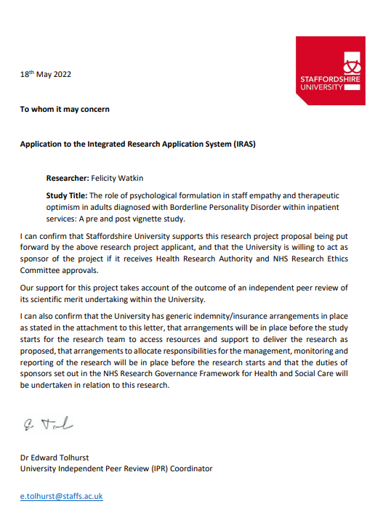

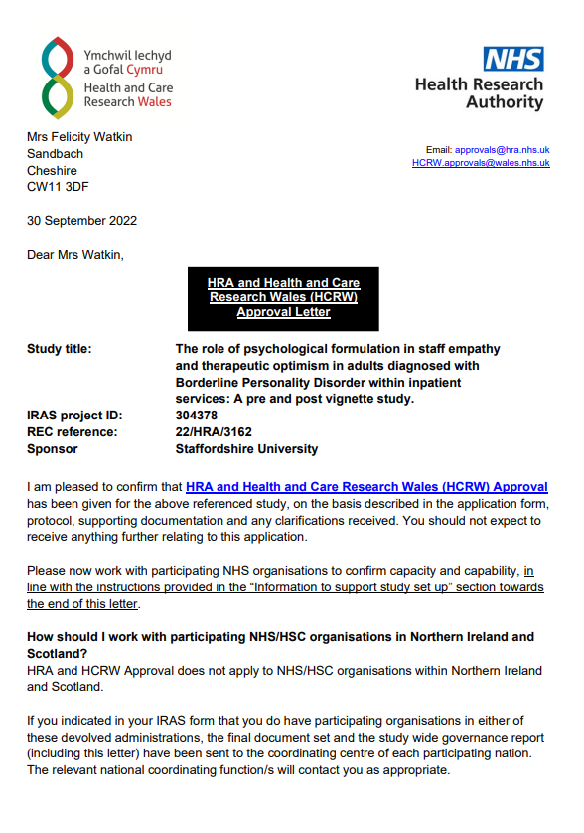
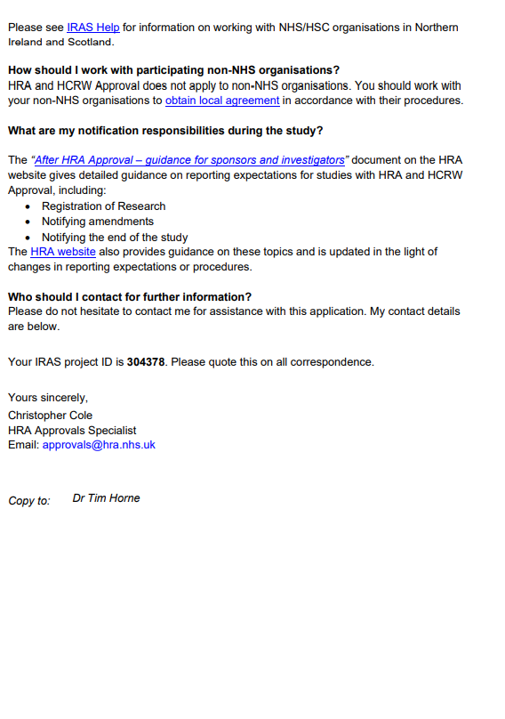
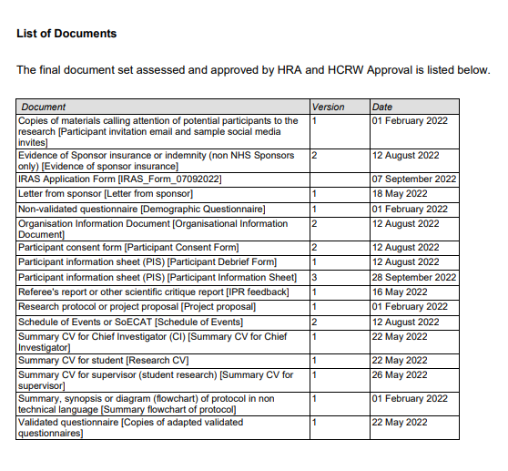

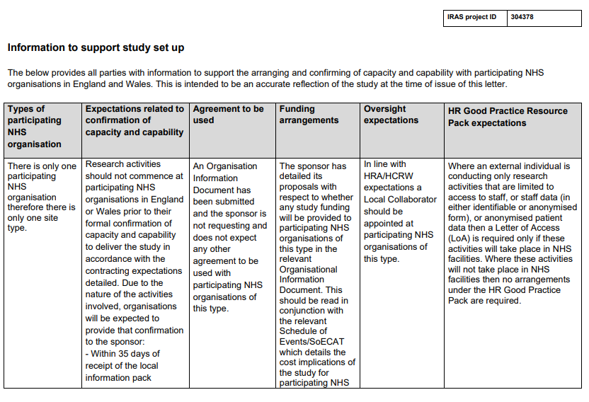
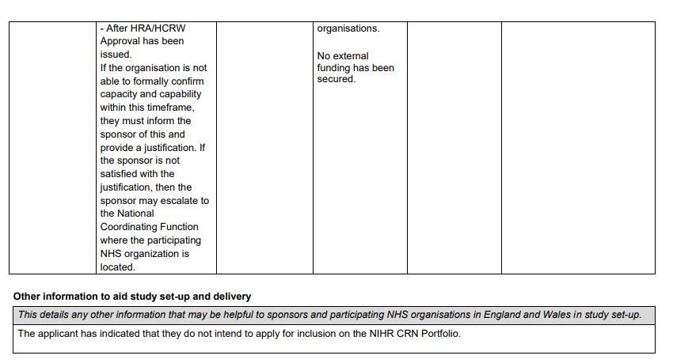

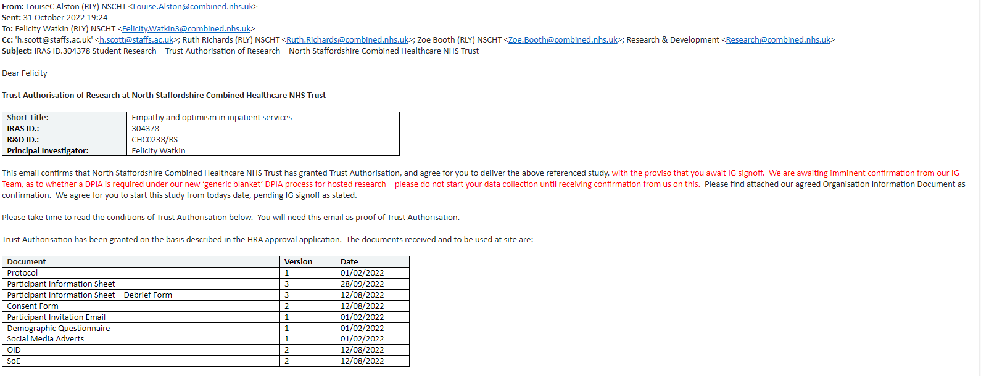

Appendix C

Study advertisements

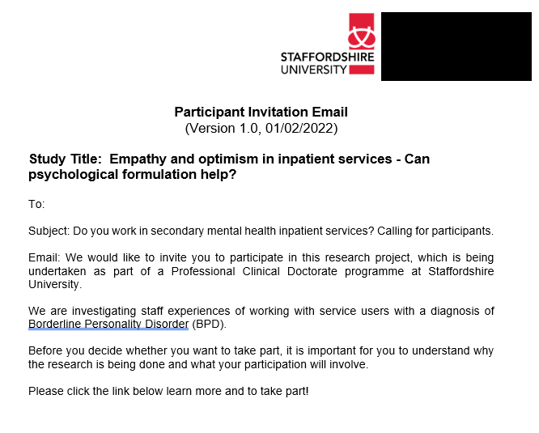

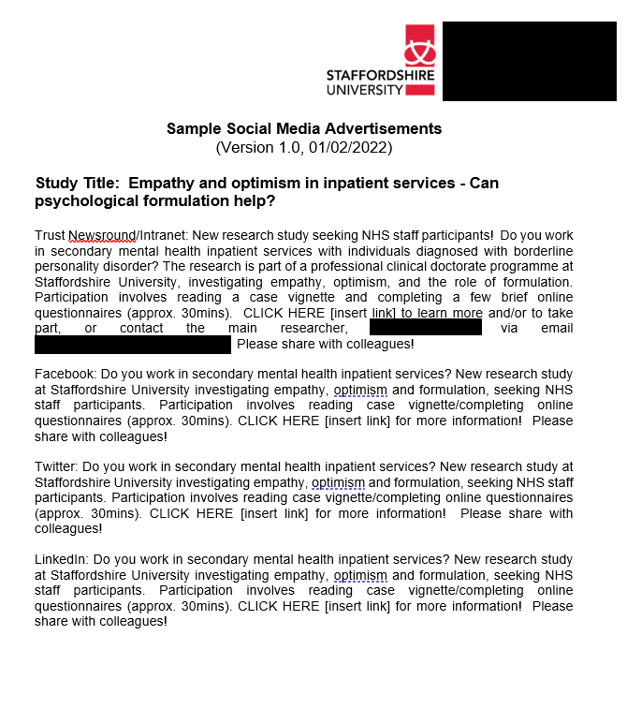

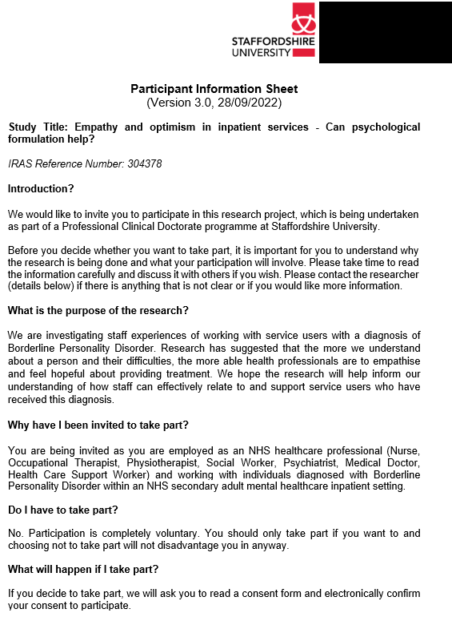
Appendix D

Participant information sheet
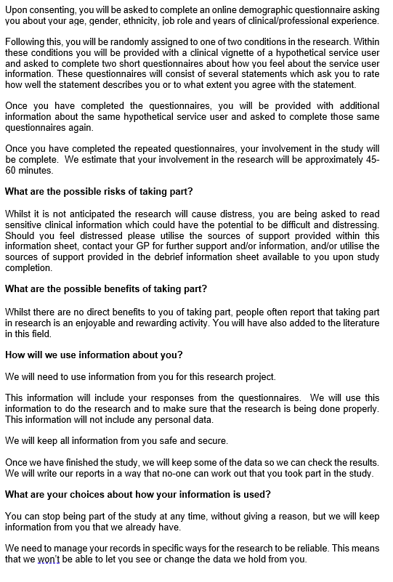
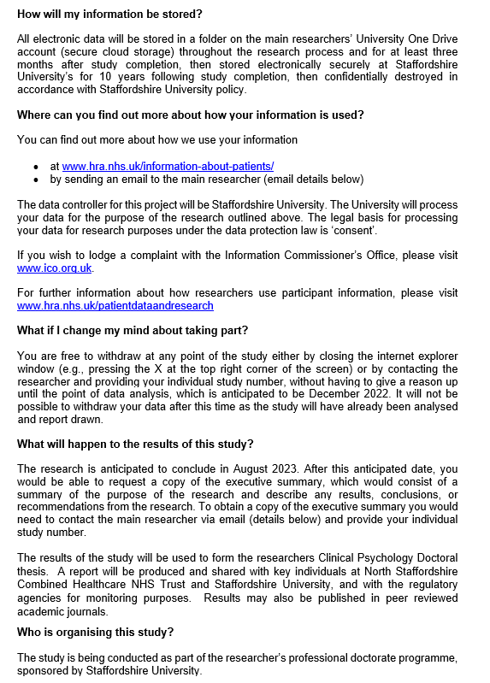
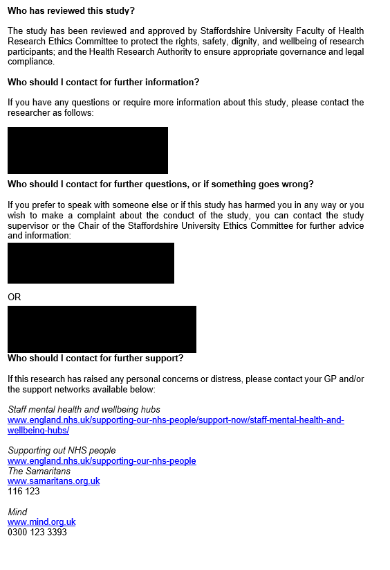

Appendix E

Participant consent form

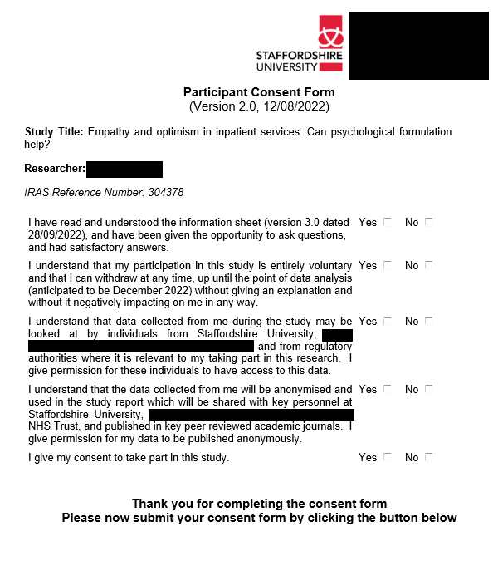

Appendix F

Participant debrief form
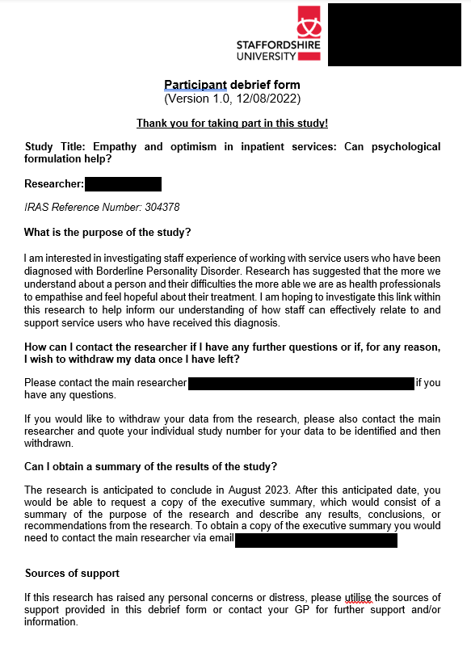
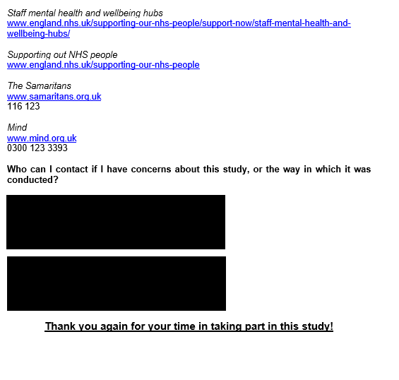

Appendix G

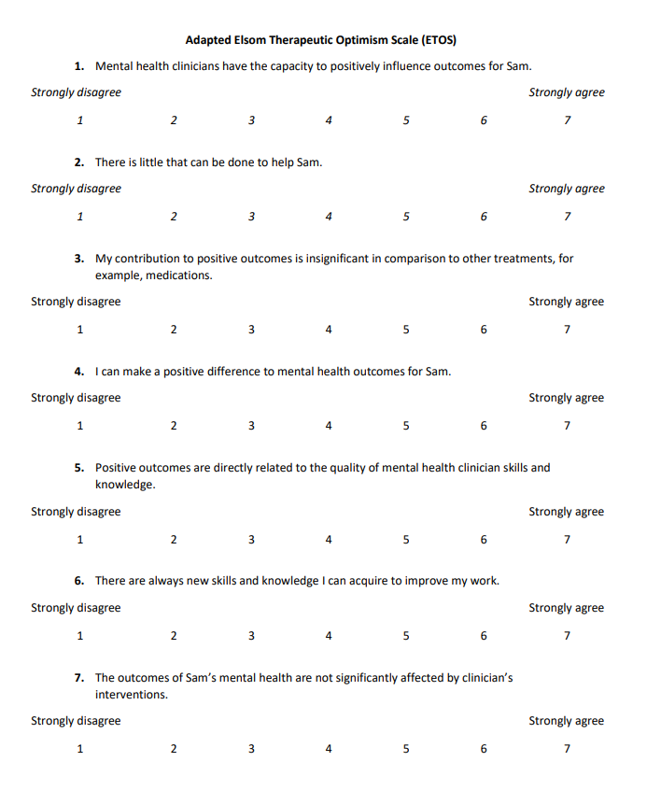
Measures
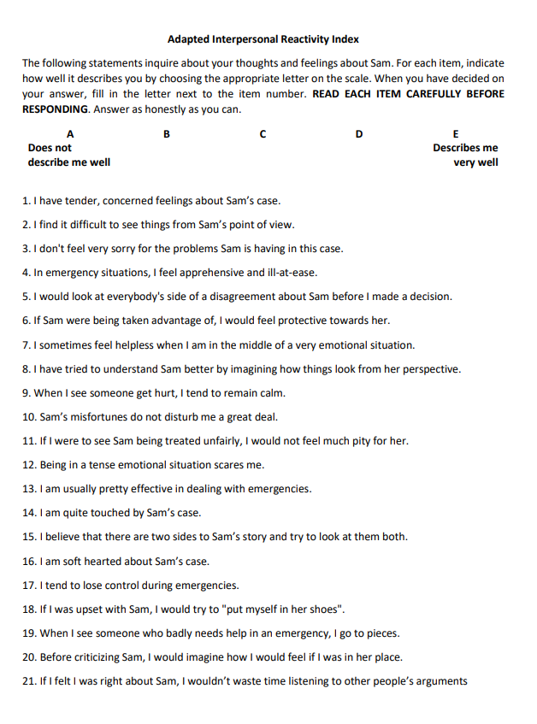

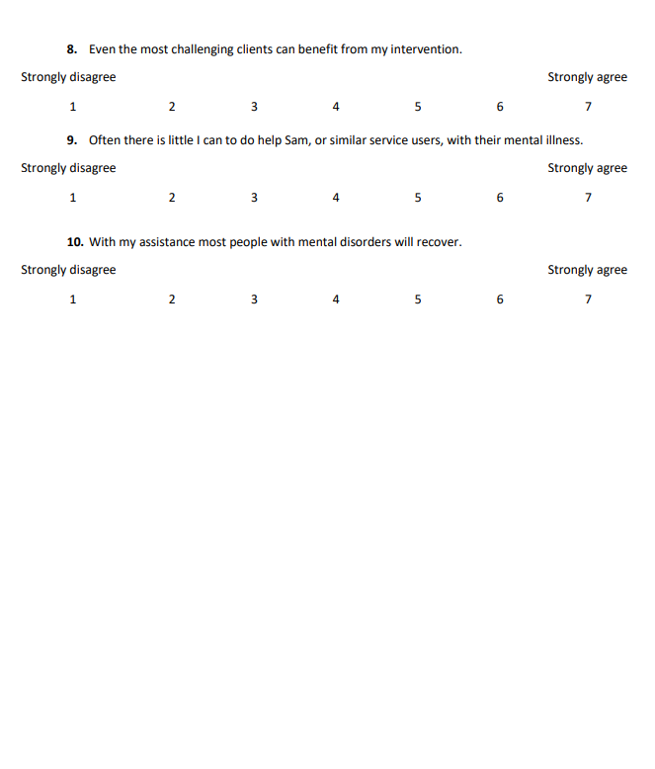

Appendix H

Demographic questionnaire
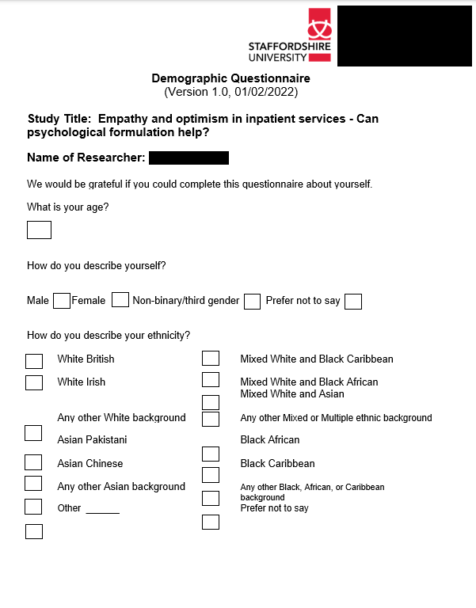

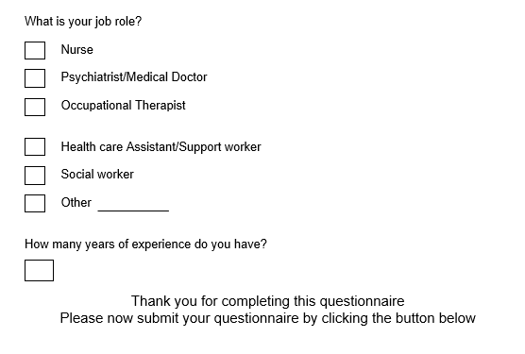

Appendix I

Hypothetical case vignette (non-formulated case information)

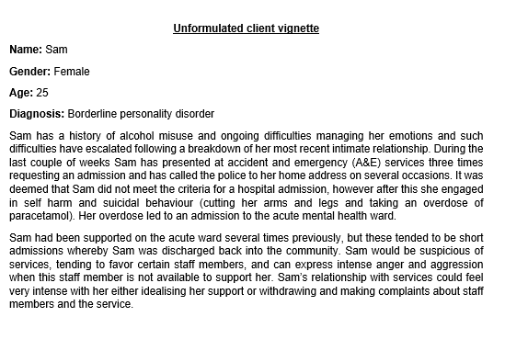

Appendix J

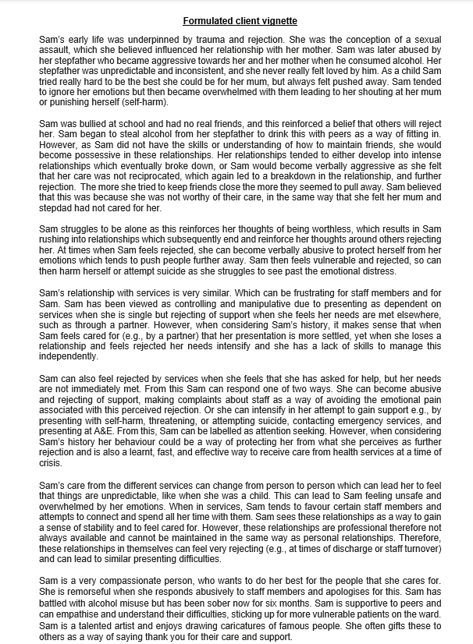
Hypothetical case vignette (formulated case information)

Appendix K

Sample comparisons

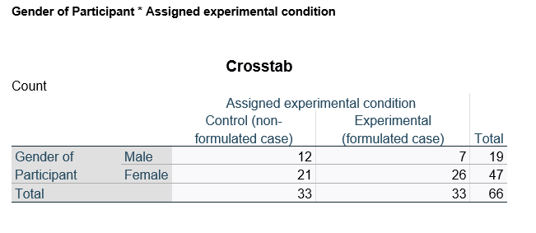

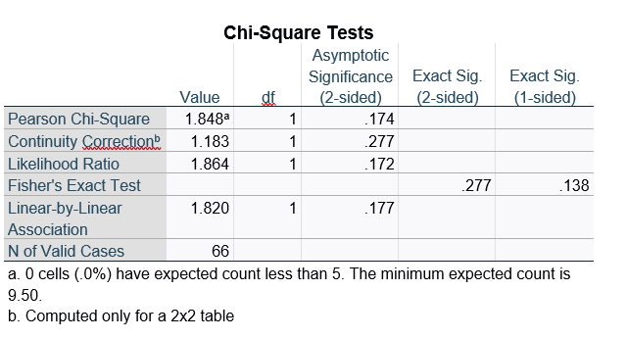

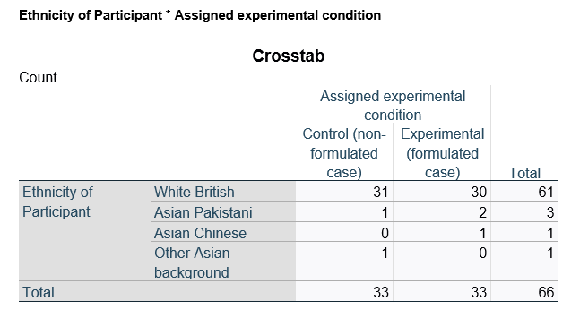
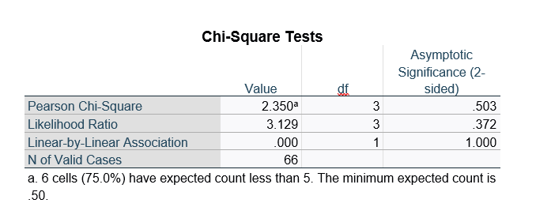

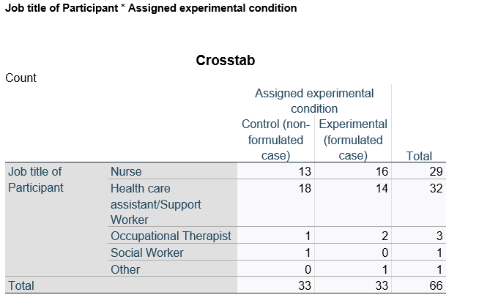

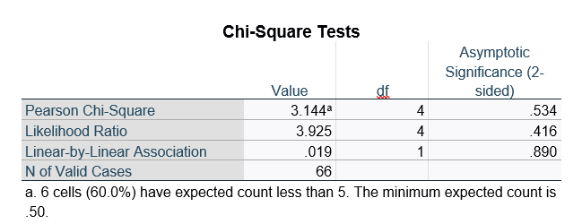

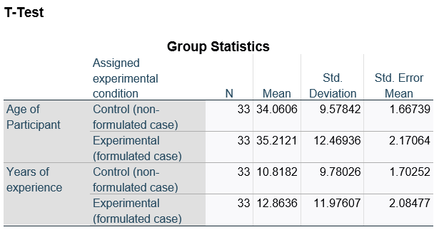
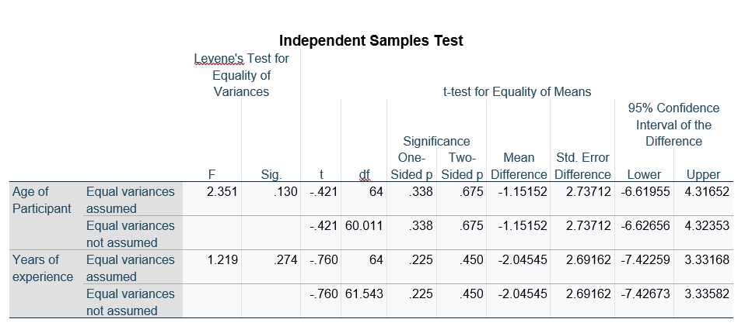

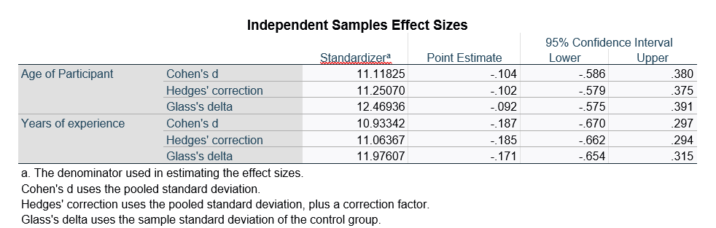

Appendix L

Distribution of dependent variables
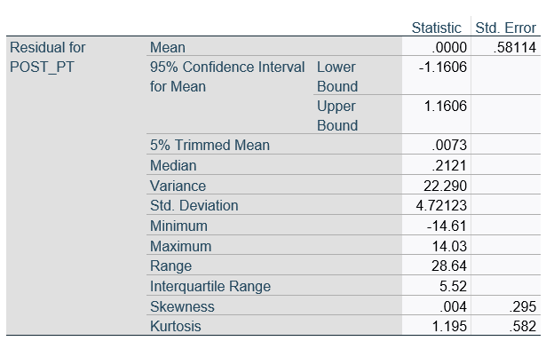
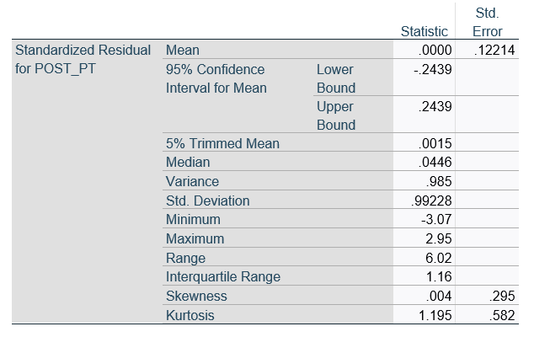

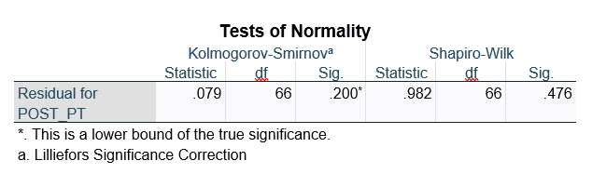

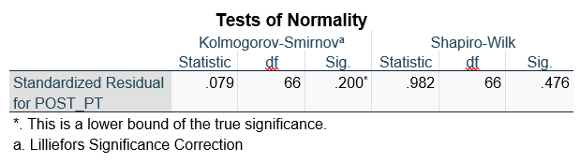

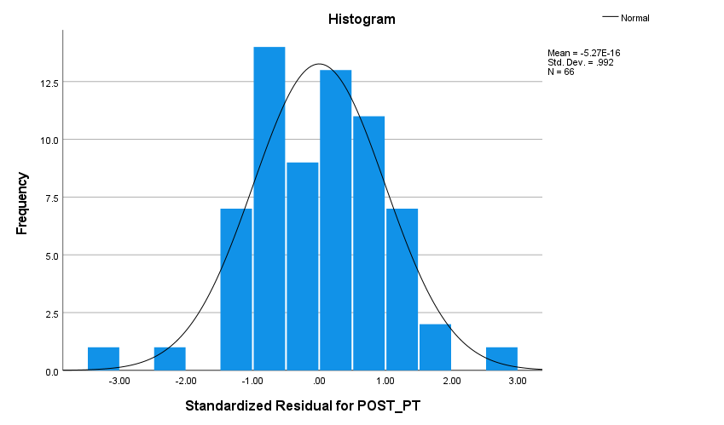

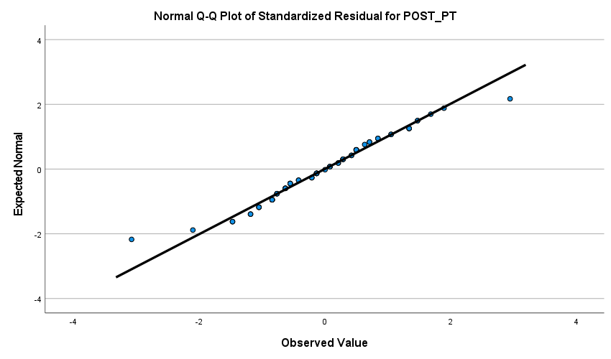

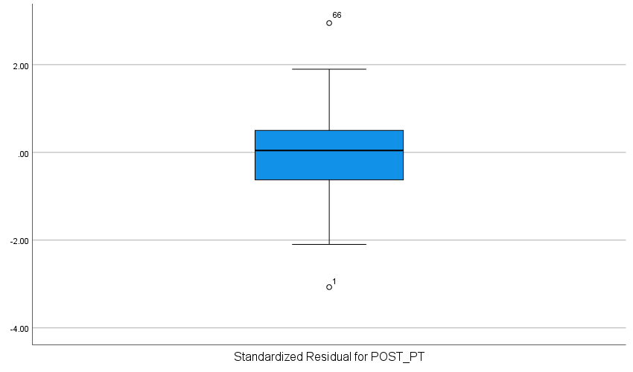

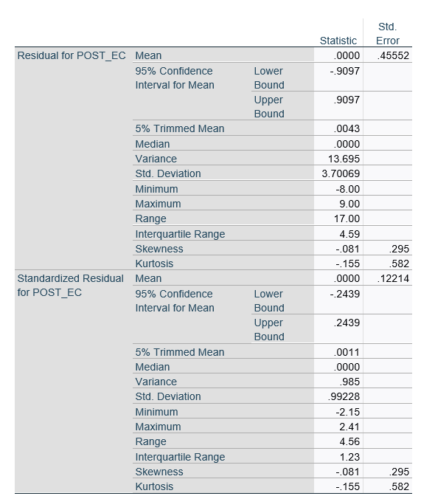
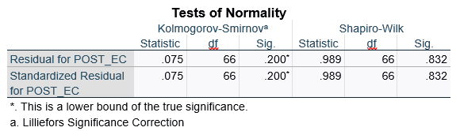

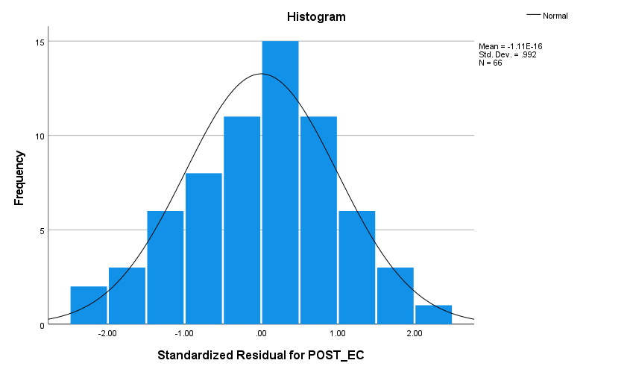

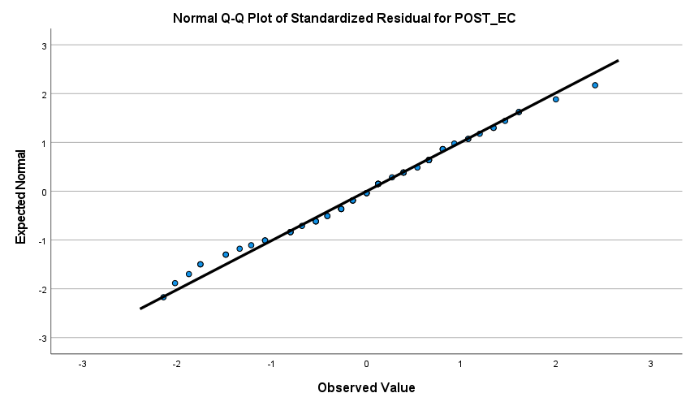

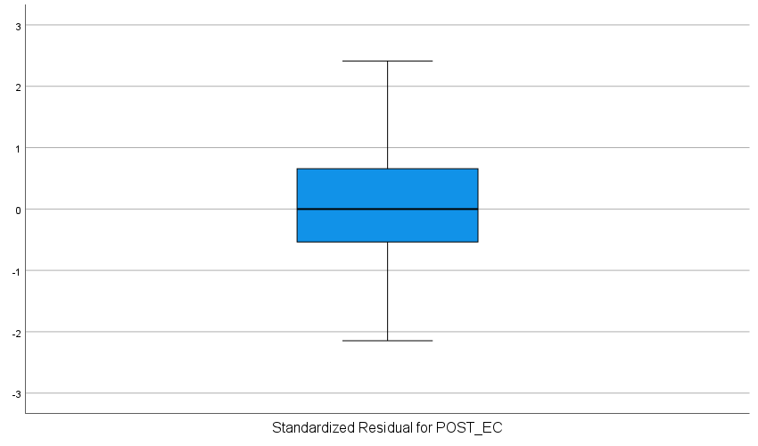
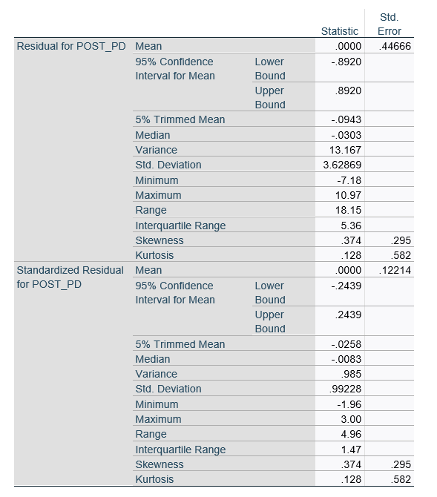
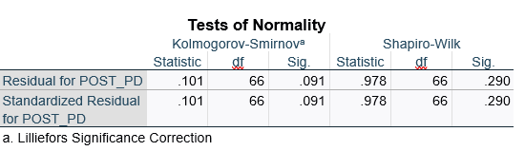

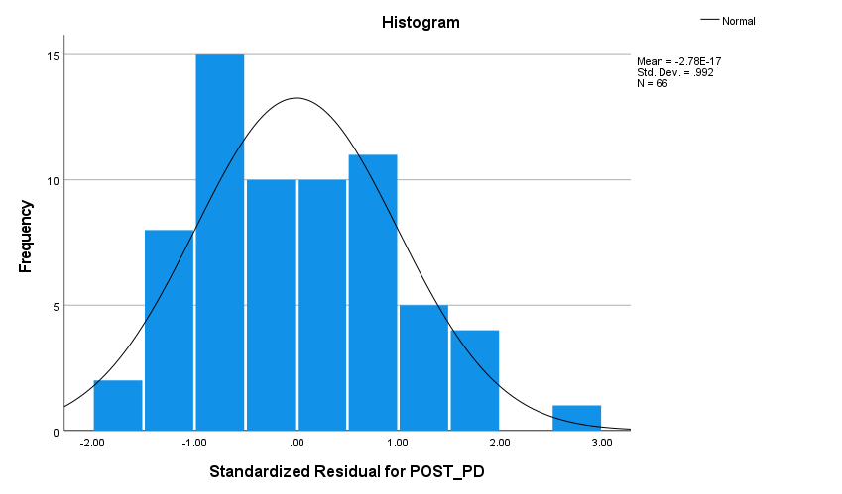

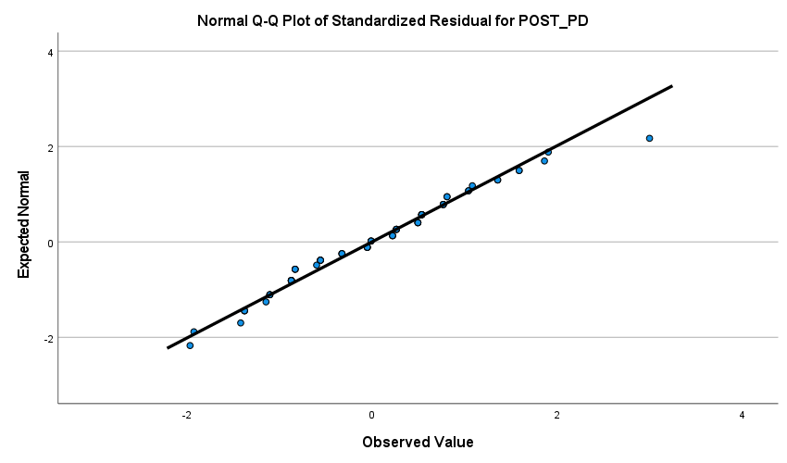

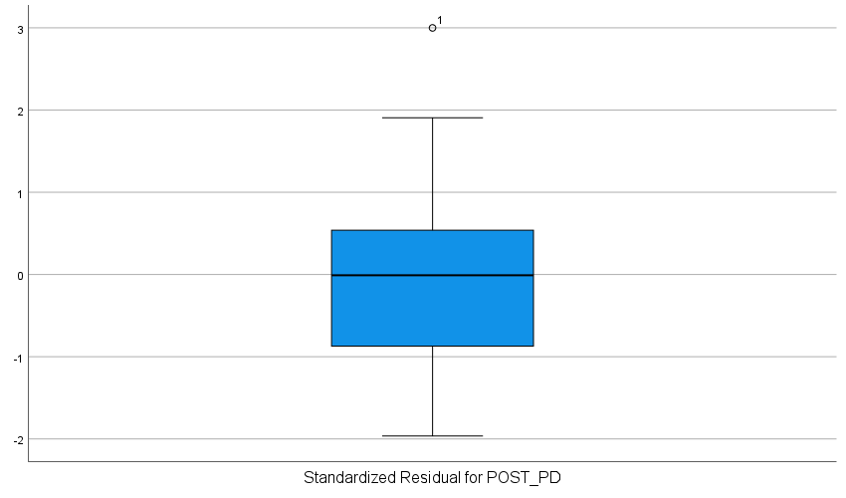

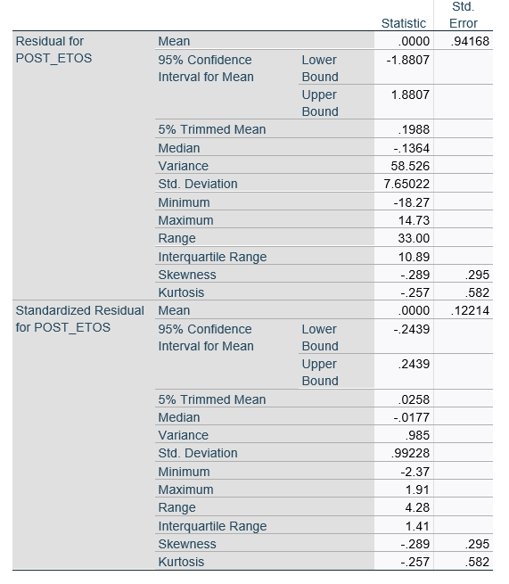
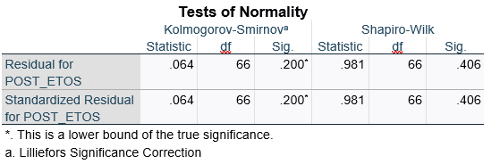
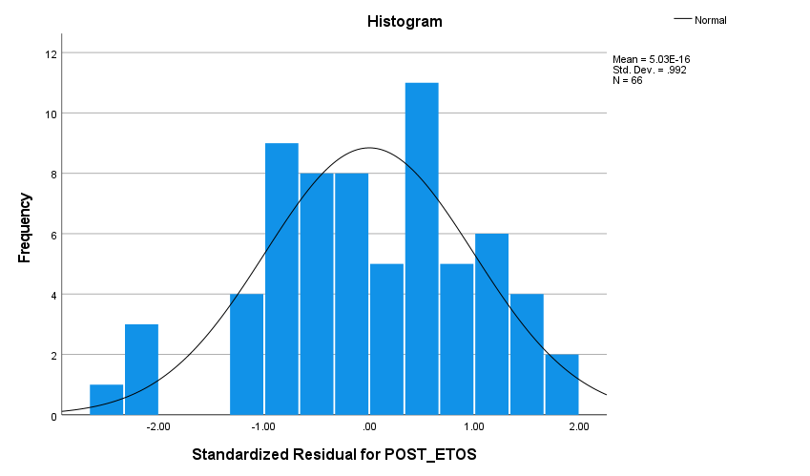

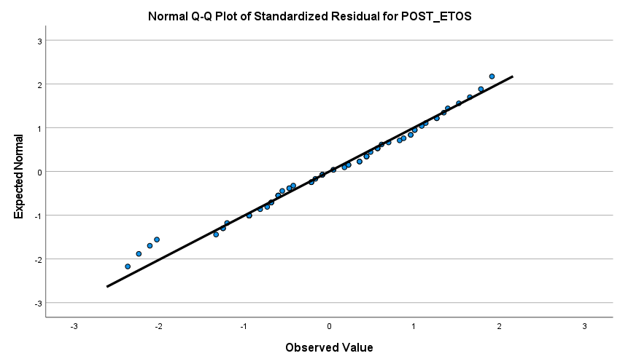

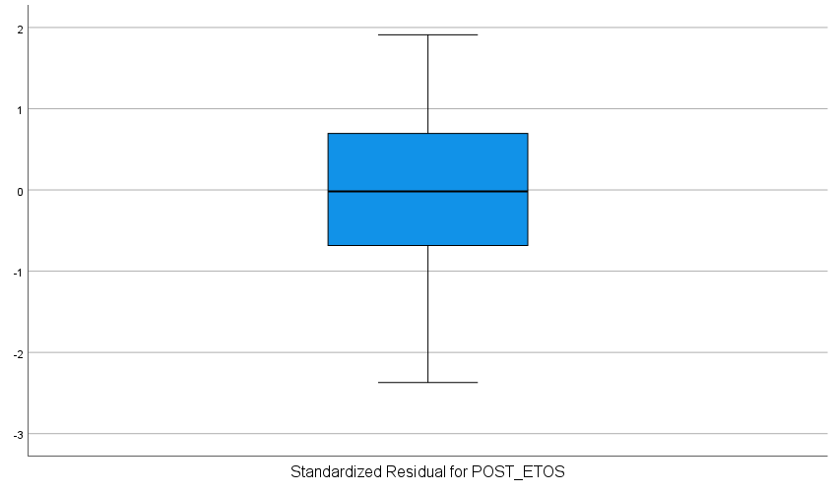

Appendix M

Distribution of covariate variables
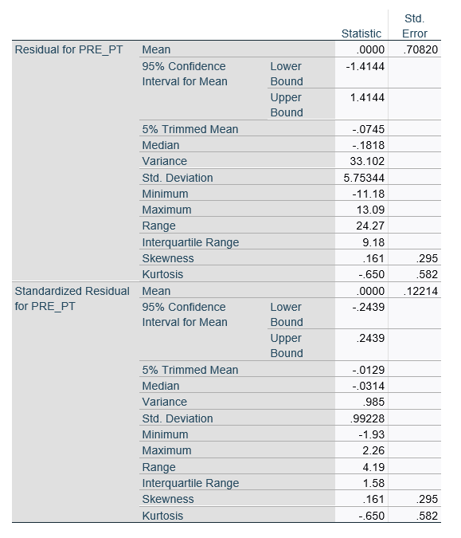
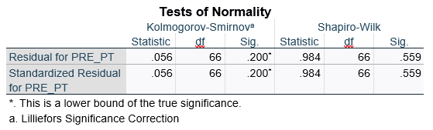
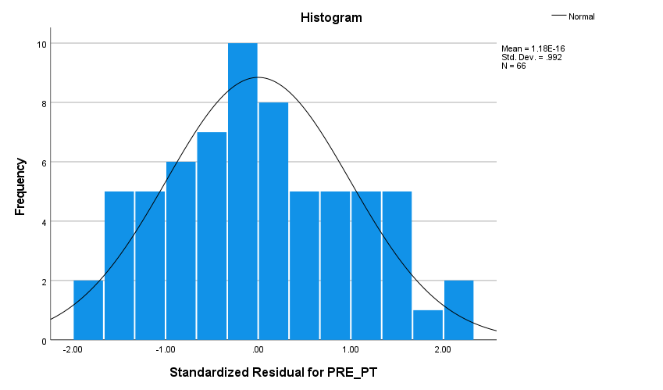

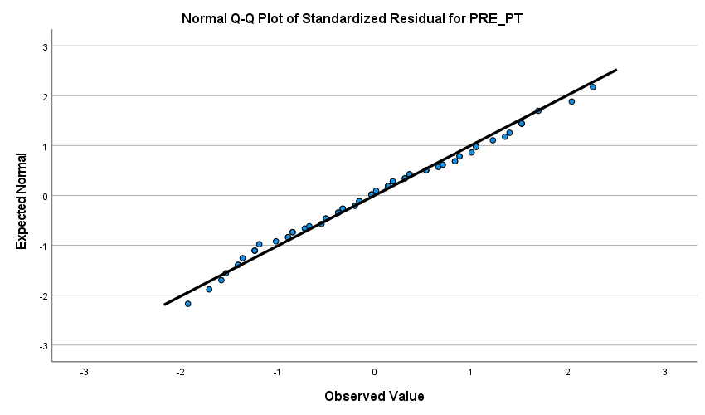

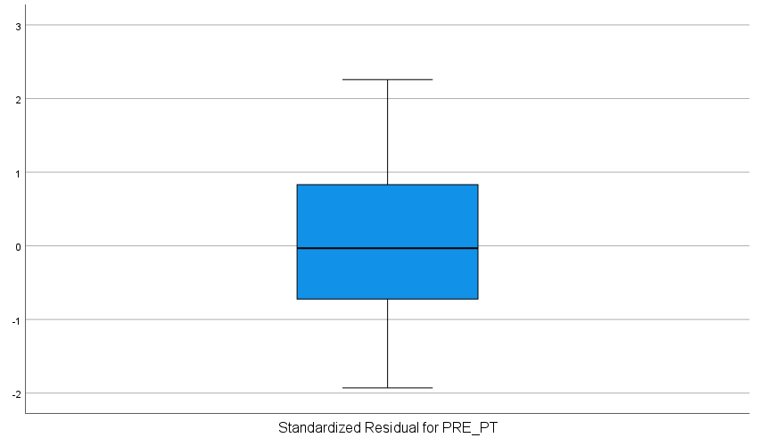

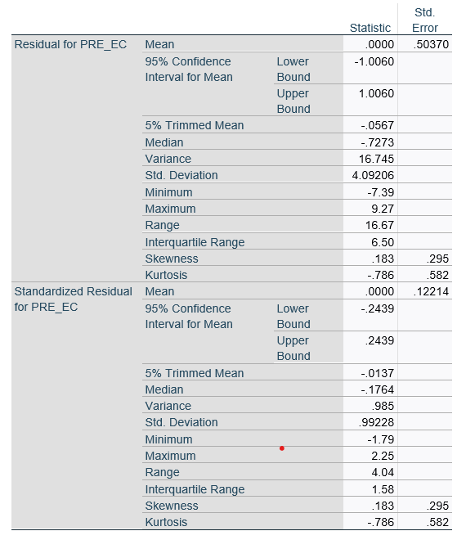

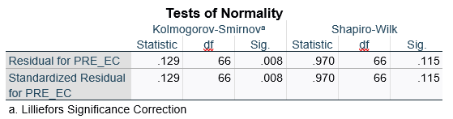
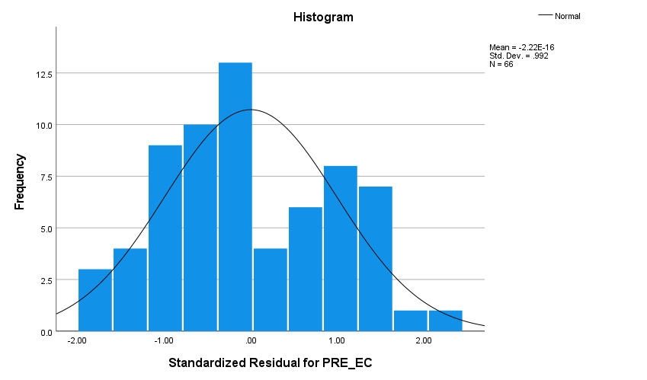

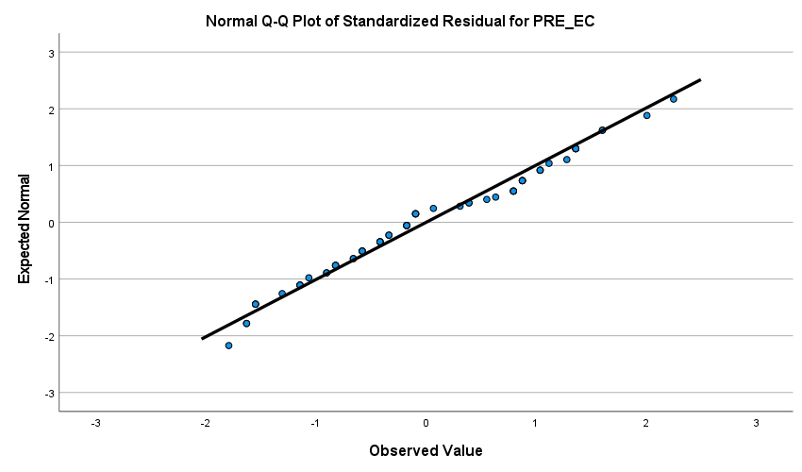

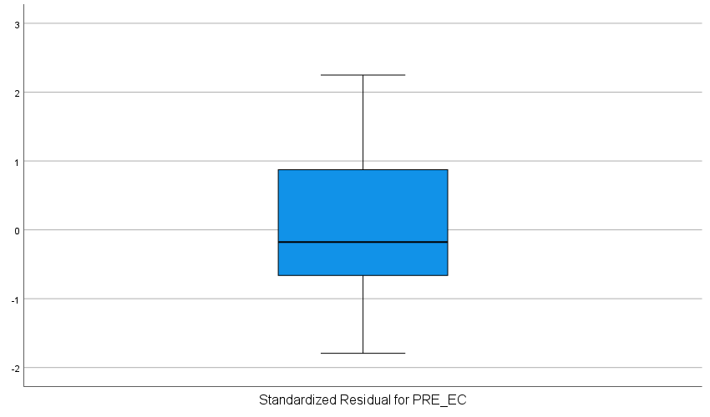

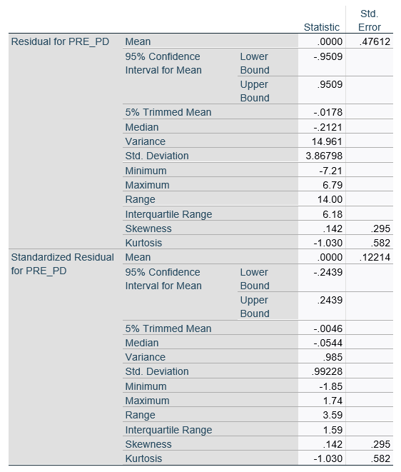
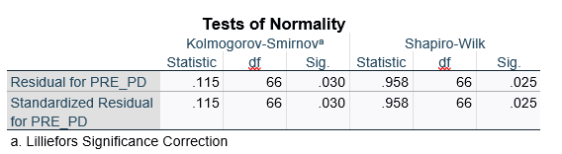
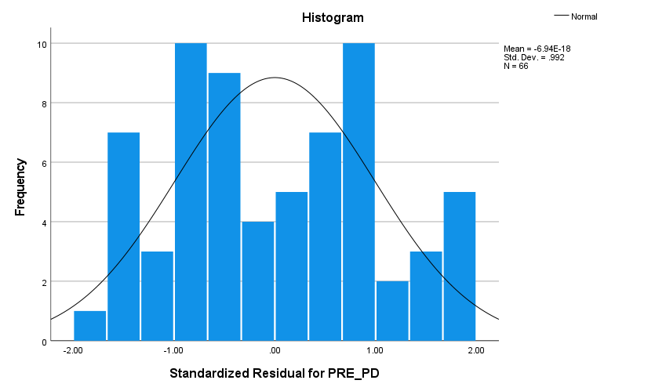

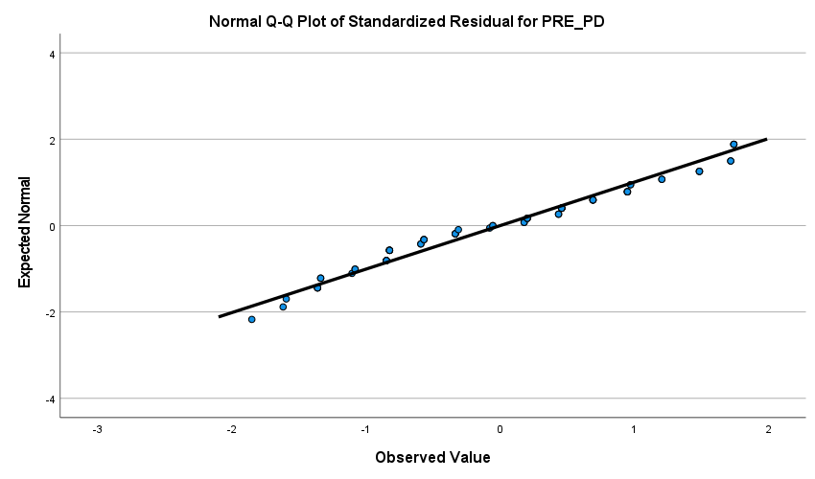

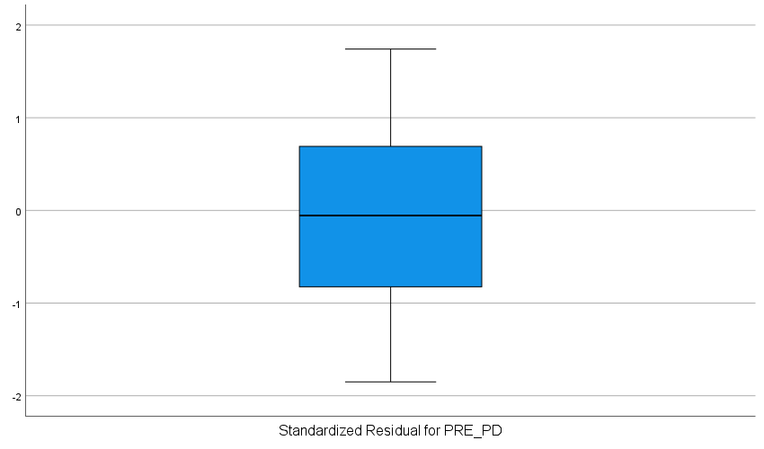

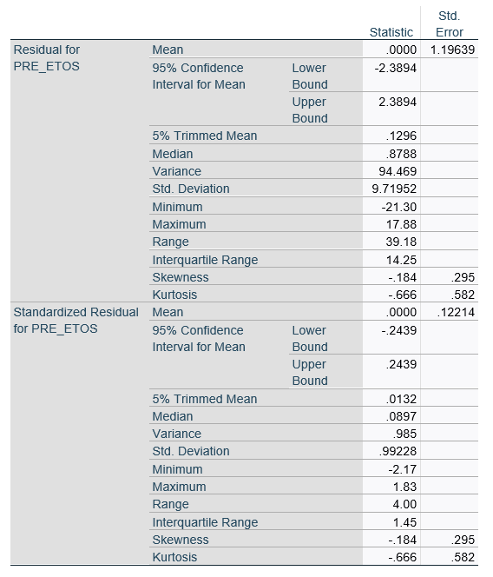
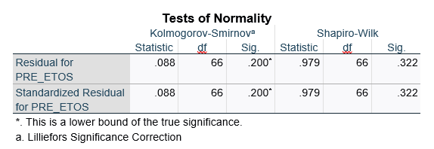
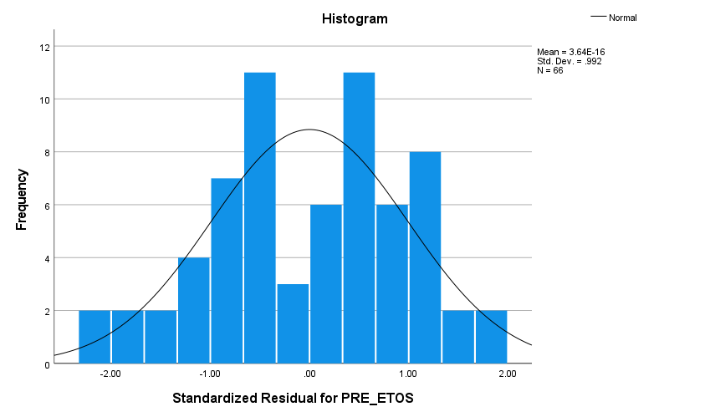

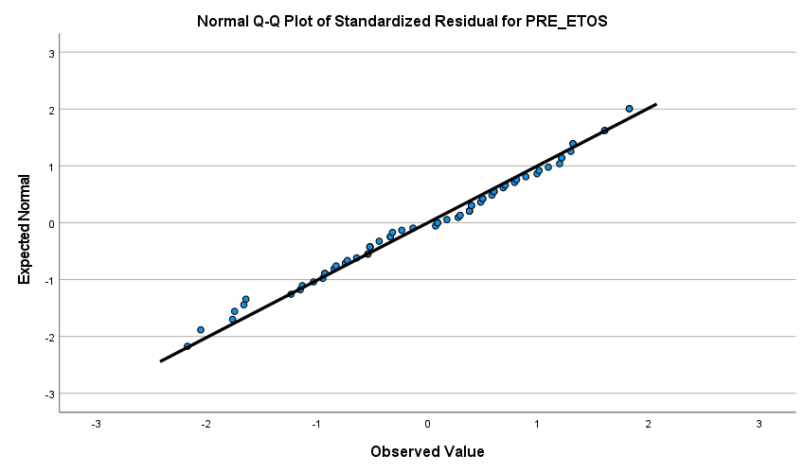

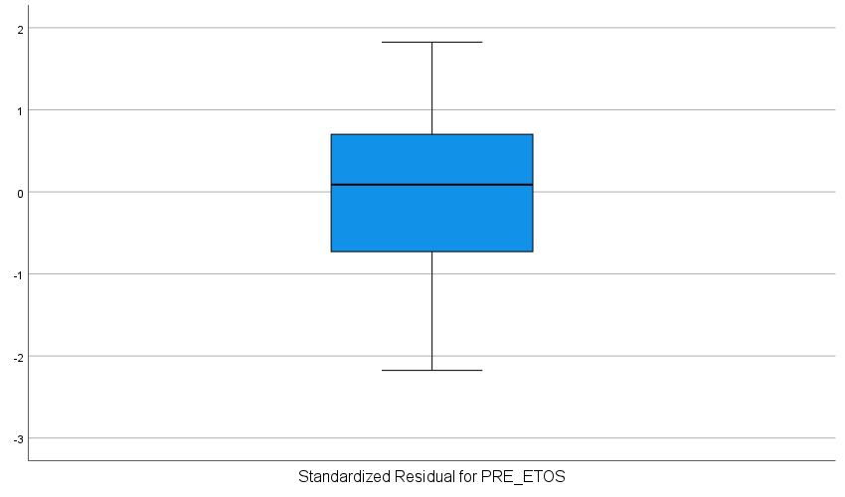

Appendix N

Tests for homogeneity of regression slopes
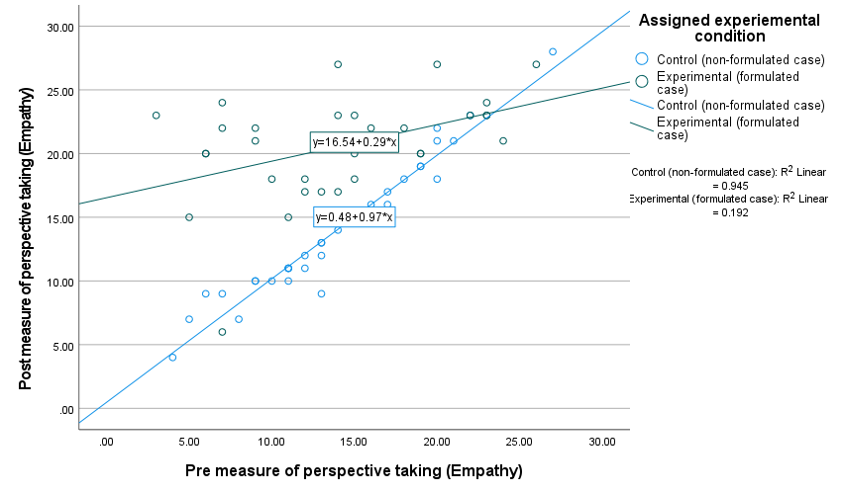

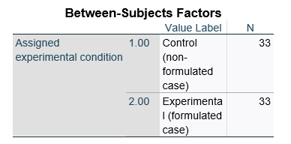
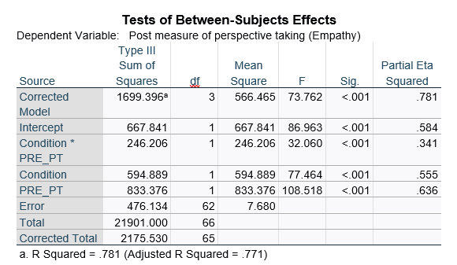

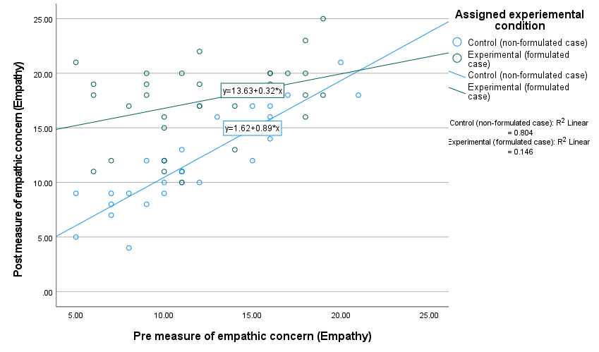

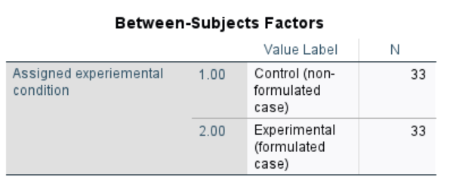

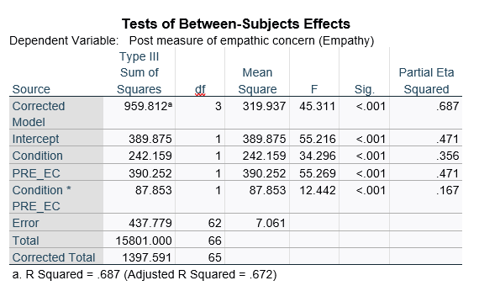

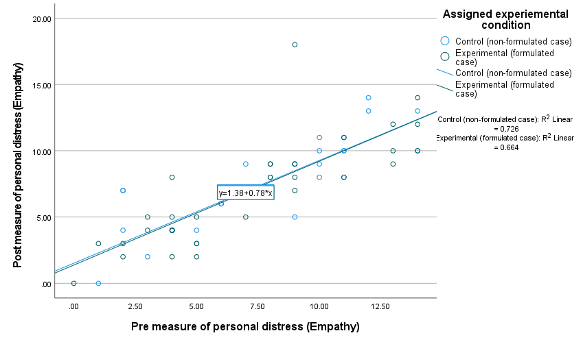

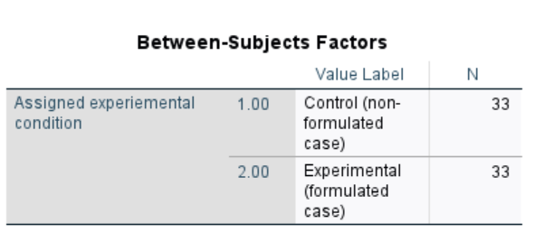

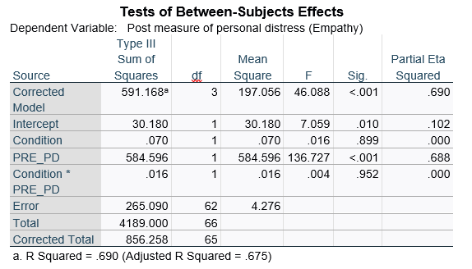
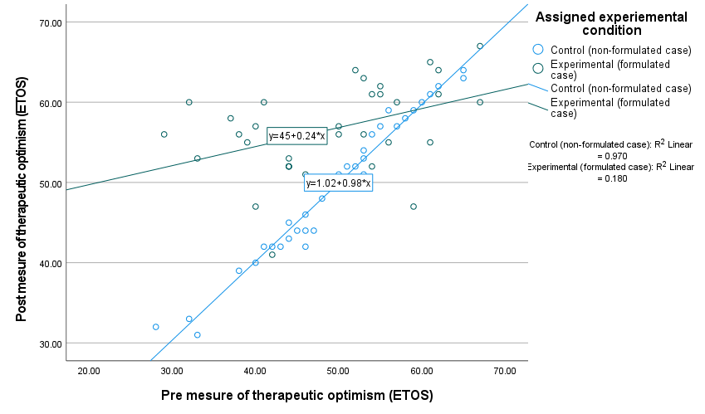

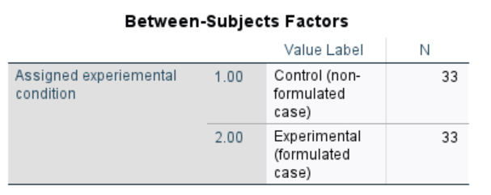

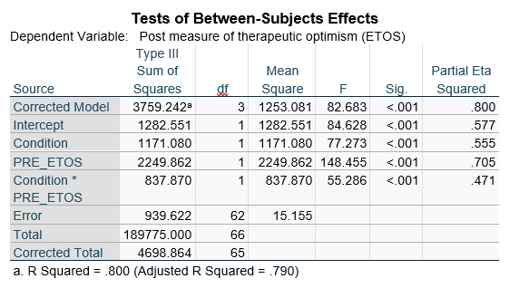

Appendix O

ANCOVAS and ANCOHETs
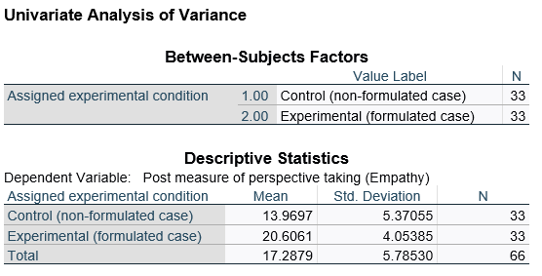

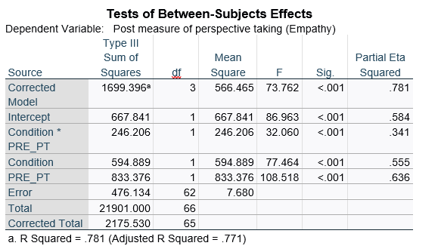

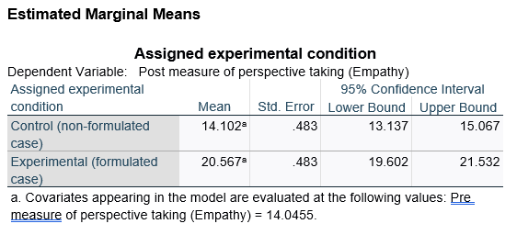
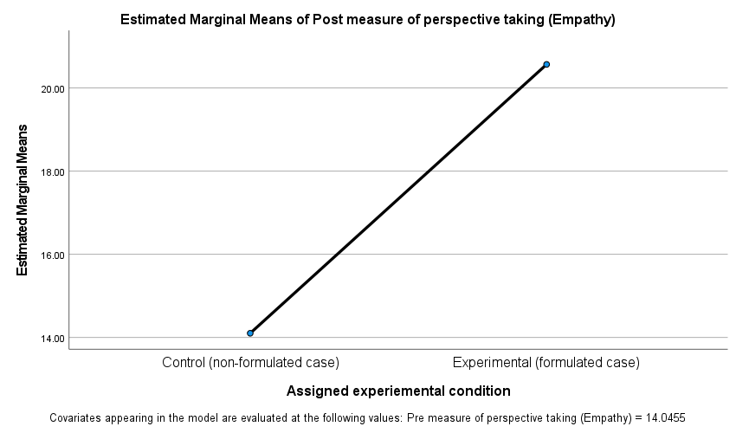

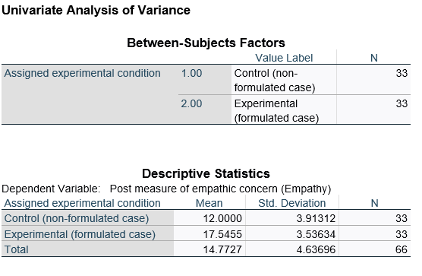

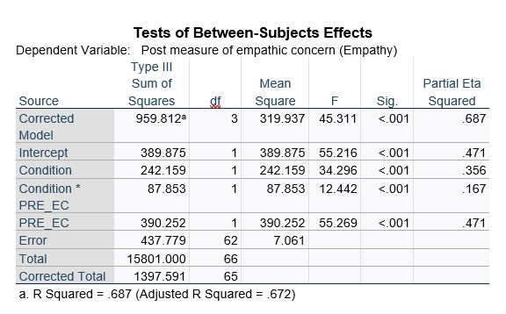

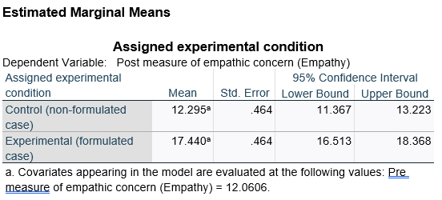
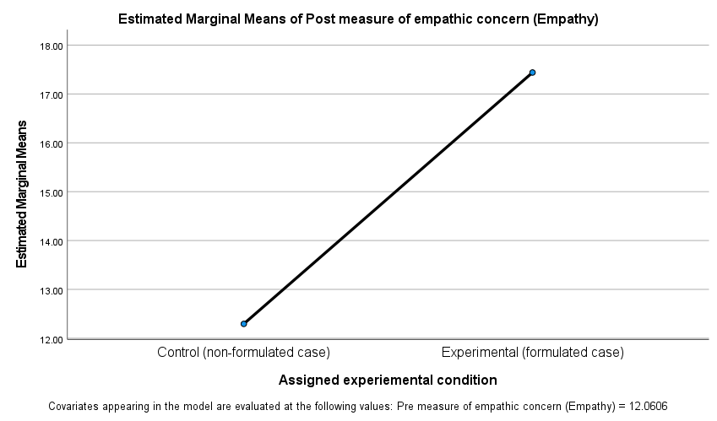

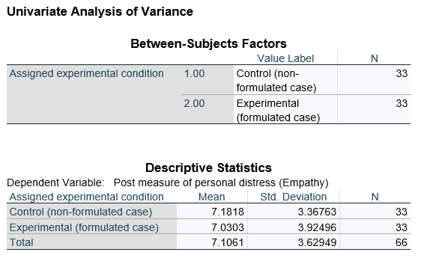

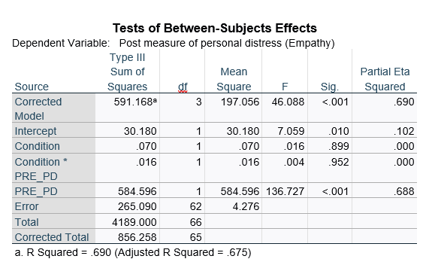

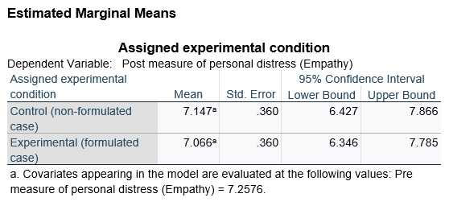
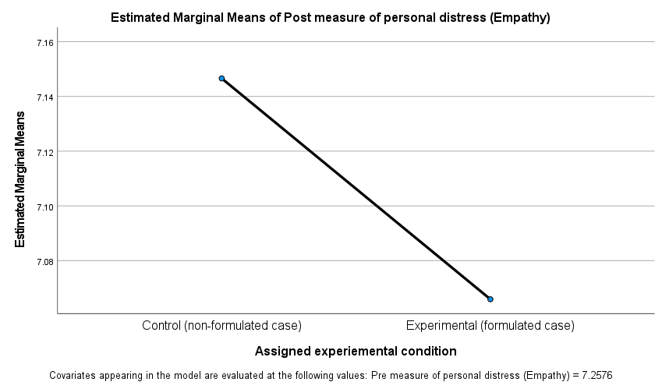

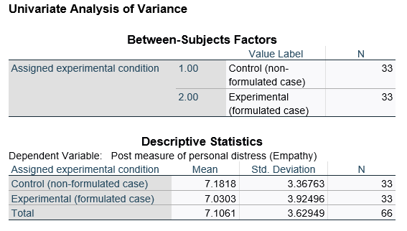
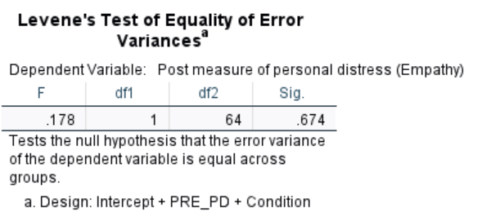
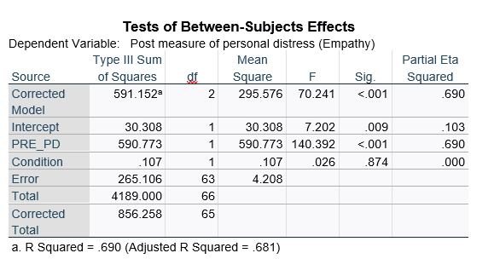
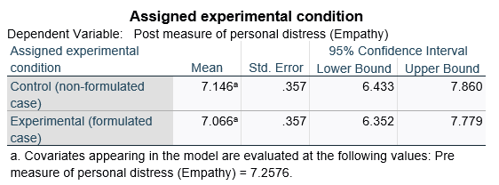

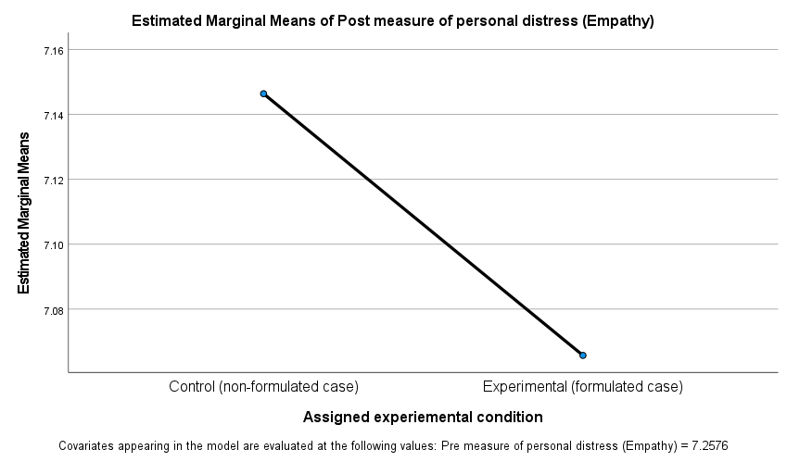

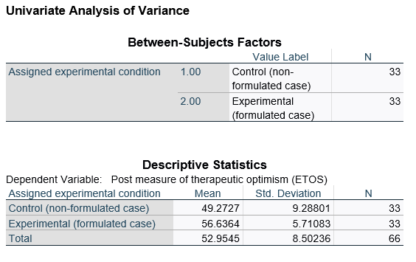
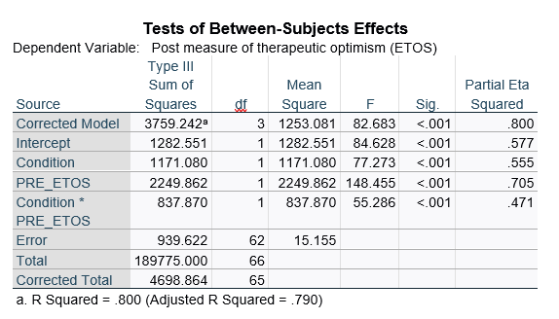

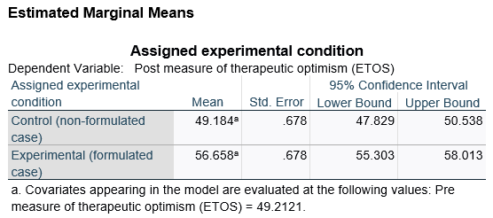
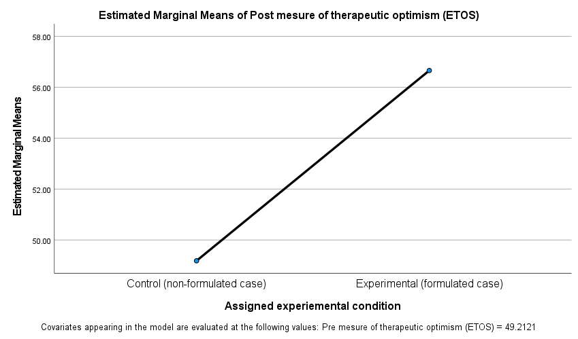

Appendix P

Cronbach’s alphas for measures
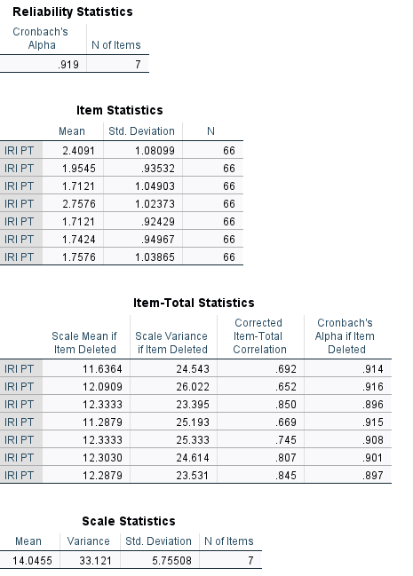

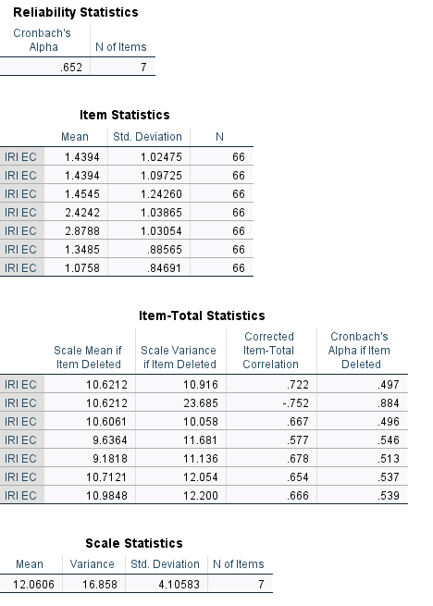

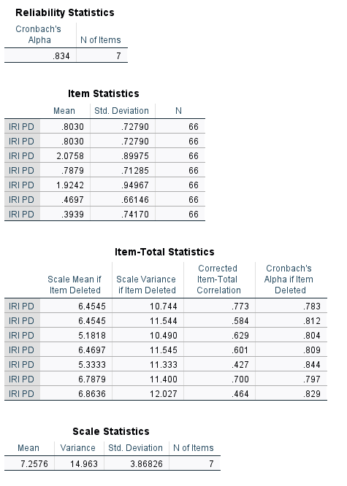

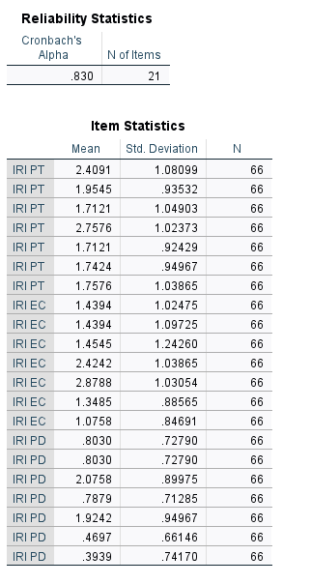

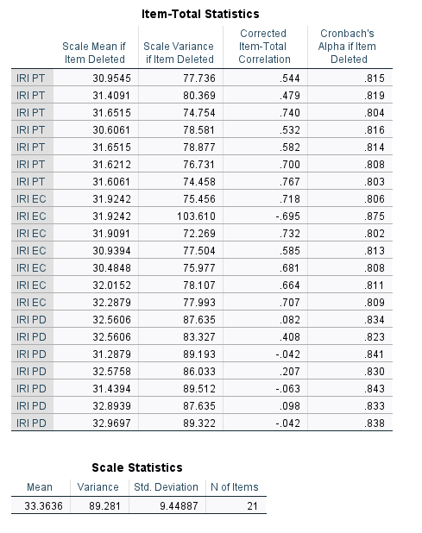

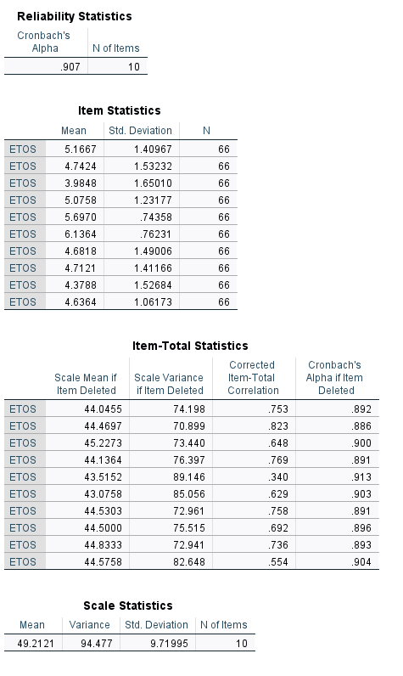

Paper 3: Executive Summary

Empathy and optimism in inpatient services: Can psychological formulation help? An Executive Summary

Word count: 2468 (Excluding the title page, references, and appendices)

Empathy and optimism in inpatient services: Can psychological formulation help?
This report is a summary of a research project investigating the role of formulation in mental health inpatient services on staff empathy and therapeutic optimism. This summary has been written for NHS staff who work in mental health inpatient services. This report, however, may also be of interest to service users who have experienced care from mental health inpatient settings and anyone else who may be interested in the topic of psychological formulation. This report was developed in consultation with staff members from a multidisciplinary team in a community service who kindly reviewed the report to provide comments on how to improve the accessibility (e.g., the wording, structure, and layout).

Background to the research

Adult mental health inpatient services
Within the National Health Service (NHS), adult mental health inpatient services are for people, aged 18-65, who can no longer be supported at home due to complex psychological or mental health conditions (Bowers et al., 2005). Examples of psychological or mental health conditions could include depression, anxiety, schizophrenia, and personality disorders. In these services, staff work within a multidisciplinary team, which brings together skills and knowledge from a range of professional backgrounds (e.g., psychiatry, psychology, nursing, health, and social care). The aim of inpatient services is to support service users to become well enough to return to living in their local community (Tyler et al., 2020). A large proportion of service users that access inpatient services are likely to meet the criteria for, or have been diagnosed with, borderline personality disorder (BPD) (Chapman et al., 2019).

Borderline Personality Disorder (BPD)
There has been a lot of research which has indicated that service users who have been diagnosed with BPD have experienced stigma from mental health services (Sheehan et al., 2016). Staff, for example, have reported feeling more critical, rejecting and less optimistic when working with this service user group (Westwood & Baker, 2010). The diagnostic label (i.e., BPD) has, therefore, received a lot of criticism, in part, due to the stigma attached to the label and due to questions around the reliability of this diagnosis (British Psychological Society, 2006). It is important, however, to recognise that for other service users, this diagnostic label has felt helpful (Lester et al., 2020). The National Institute for Health and Care Excellence (NICE) guidelines (2009) have identified the importance of developing an optimistic and trusting relationship when working with service users diagnosed with BPD. An important aspect of building such a relationship is the ability to understand and empathise with service users’ and to create an atmosphere of hope around treatment and recovery.

Empathy and Therapeutic Optimism
Empathy and therapeutic optimism are key values which are fundamental to working in the NHS (National Institute for Health and Care Excellence, 2009; Patterson et al., 2014). Empathy has been defined through various concepts (Davis, 1983) as illustrated below.
Therapeutic optimism has been defined as hope that a service user can and will benefit from support (Elsom & McCauley-Elsom, 2008).
Research has evidenced the importance of both empathy and therapeutic optimism for building relationships with service users and for service user recovery (Gallagher et al., 2019; Moudatsou et al., 2020). Studies from mental health inpatient services, however, have shown that staff can find it difficult to express empathy and optimism for service users with a diagnostic label of BPD (Currid, 2009; Westwood & Baker, 2010; Wyder et al., 2017). It is thought that this could be due to a lack of understanding around the diagnosis and strong emotive responses (e.g., frustration, exasperation) toward the diagnosis (Sheehan et al., 2016).

Psychological Formulation
Formulation is the process of bringing together the experience of health care professionals, psychological knowledge, research, and the service users’ expertise to make sense of current difficulties, in view of past and life events (Johnstone, 2018).
Experience from health care professionals
Service User expertise
Psychological knowledge
Research

A formulation can then be shared with others, for example staff members, to help to increase staff understanding, empathy and hope for recovery (Wilkinson et al., 2017). Some research has found that formulation has done just this, for example, it has increased staff empathy, hope for treatment, confidence, and consistency in staff approach (Berry et al., 2009; 2016; 2017; Hewitt, 2007; Summers, 2006). Other research has also shown that formulation can help staff members to understand their own emotions and how these emotions might impact their care for service users (Berry et al., 2017; Taylor & Sambrook, 2012; Whitton et al., 2016). Not all research, however, indicates that formulation has a significant impact on attitudes (Wilkinson et al., 2017).

Why carry out this Study?
There has been some research which has suggested that psychological formulation can help staff members to feel more empathic towards and optimistic about service users’ recovery. These values (i.e., empathy and therapeutic optimism) are important when considering forming therapeutic relationships, providing quality care and for service user recovery. This research, therefore, aimed to see whether a psychological formulation of a hypothetical service user (typically labelled with a diagnosis of BPD), increased participants’ (i.e., staff members) empathy and therapeutic optimism towards this hypothetical service user.

Empathy was broken down into three components. These included:
- Participants’ ability to perspective take
- Participants’ ability to show empathic concern
- Participants’ experience of personal distress
Therapeutic optimism was defined as participants’ belief/hope that the hypothetical service user will benefit from therapeutic intervention.

The use of a vignette
Case vignettes provide a summary of a service user’s ‘clinical information’ (Evans et al., 2015). Clinical information may include information such as age, gender, medical diagnoses, as well as information about service users’ current mental health difficulties.
Two case vignettes were used in this research to describe a hypothetical service user named ‘Sam’. One case vignette included the ‘typical’ clinical information for Sam (non-formulated case vignette). The other vignette detailed a psychological formulation of the same hypothetical service user (formulated case vignette). The formulation looked at Sam's early history and some of the difficult life experiences that she had been through.
The formulation also hypothesised based on these experiences:
- How Sam might think or feel about herself
- How Sam forms and views relationships with others
- How Sam may view staff and her experience of care
The formulation also captures Sam's strengths, things that have worked well and 'positives' about her personality, skills, and interests. The details of these vignettes are included in the appendices (Appendix A and B).

Aims and predicted outcomes of the Study
 | Aims of the Study |  | Predicted Outcomes
1. | To investigate whether psychological formulation will increase participants’ empathy by increasing their ability to perspective take. |  | A vignette of a psychological formulation will increase participants’ empathy by increasing their ability to perspective take.
2. | To investigate whether psychological formulation will increase participants’ empathy by increasing their empathic concern. |  | A vignette of a psychological formulation will increase participants’ empathy by increasing their level of empathic concern.
3. | To investigate whether psychological formulation will increase participants’ empathy by reducing their personal distress. |  | A vignette of a psychological formulation will increase participants’ empathy by reducing their level of personal distress.
4. | To investigate whether psychological formulation will increase participants’ therapeutic optimism. |  | A vignette of a psychological formulation will increase participants’ therapeutic optimism.

Method
This study was reviewed and approved by Staffordshire University Ethics Committee, the integrated research application system (IRAS), and the NHS trust ethical board.

How were participants recruited?
Participants were recruited between November 2022 and January 2023. The research was advertised online, through social media, and through a local NHS trust (e.g., through trust wide communication emails).

Who could take part?
Participants had to meet the following criteria to be eligible to take part:
To take part, participants must: | Participants could not take part if they:
- Be employed as an NHS health care professional including:  - Nurses  - Allied Health Professionals (e.g., Occupational Therapists, Social Workers, Speech and Language Therapists)  - Medics (e.g., Psychiatrists, Medical doctors)  - Health Care Support Workers.  - Work in an NHS mental health inpatient setting with service users with a diagnosis of BPD. | - Worked in other NHS services  - Worked in private mental health services  - Worked in mental health services but had no contact with service users  - Were employed in Psychology due to their experience/training in formulation  - Could not understand written English (due to no resources for translation).

What did taking part involve?
This research used an experimental design and data was collected at one point in time. All participants completed the study online through an online survey software tool, named Qualtrics, which was used for the research. Participants clicked a link on the online advertisement to access the study. This link took participants to a webpage that provided information about the study to help them to make an informed decision about taking part. If participants decided to proceed, they were asked to complete a consent form.
Participants were asked to complete several questions about themselves and their professional role, this included:
- Age
- Gender
- Ethnicity
- Job title
- Years of experience in job role

During the research, participants were asked to read the non-formulated case vignette and complete questionnaires including:

- Empathy Questionnaire (Interpersonal Reactivity Index, Adapted) (Davis, 1983) – a 21-item questionnaire measuring the different components of empathy (i.e., perspective taking, empathic concern and personal distress).
- Therapeutic Optimism Questionnaire (Elsom Therapeutic Optimism Scale) (Elsom & McCauley-Elsom, 2008) – a 10-item questionnaire measuring therapeutic optimism.
Following completion of the questionnaire’s participants were randomly allocated to one of the two groups below.

Group that did not read the formulation | Group that read the formulation
- Re-read the non-formulated case vignette.  - Completed the two questionnaires again:  - Empathy Questionnaire  - Therapeutic Optimism Questionnaire | - Read the formulated case vignette.  - Completed the two questionnaires again:  - Empathy Questionnaire  - Therapeutic Optimism Questionnaire

Who took part?
Sixty-six participants took part in the research. Most participants identified as White British (92%), female (71%), with the main profession identified as healthcare assistant/support worker (48%). Gender, ethnicity, and job role of the total sample are depicted in the pie charts below. The average age of the sample was 34.6 years with an average of 12 years’ experience in the profession.

How was the data analysed?
The data was analysed using two types of statistical analysis. These analyses determined whether the scores on the empathy and therapeutic optimism questionnaires were significantly different between the group of participants’ that read the formulation compared to the group that did not.

Key findings
- Psychological formulation increased participants’ empathy by increasing their ability to perspective take.
The results showed that participants’ ability to perspective take was significantly higher for the group of participants’ that read the formulation compared to the group that did not. This indicates that psychological formulation significantly increased participants’ empathy by increasing their ability to take a different viewpoint (i.e., perspective take).
- Psychological formulation increased participants’ empathy by increasing their level of empathic concern.
The results demonstrated that participants’ ability to show empathic concern was significantly higher for the group of participants’ that read the formulation compared to the group that did not. This indicates that psychological formulation significantly increased participants’ empathy through increasing their ability to show concern and sympathy for the service user in the vignette.

- Psychological formulation did not increase participants’ empathy by reducing their level of personal distress.
There was no difference in the scores for personal distress between the group of participants’ that read the formulation and the group that did not. This demonstrated that psychological formulation had no significant impact on participants’ experience of personal distress.

- Psychological formulation increased participants’ therapeutic optimism.
The results showed that participants’ therapeutic optimism was significantly higher for the group of participants’ that read the formulation compared to the group that did not. This indicates that psychological formulation significantly increased participants’ belief/hope that the hypothetical service user could benefit from therapeutic intervention.

Conclusions and Recommendations
The role of psychological formulation in mental health services is not new, however, there has been little research that evidences how it directly impacts staff empathy and optimism. Although more research is needed before we can make confident conclusions, this research does provide some insight into how psychological formulation could be helpful in supporting these key NHS values (e.g., empathy and therapeutic optimism). An idea to help put this into practice could include:
- Providing regular formulation meetings - It would be helpful for mental health inpatient services to offer regular (e.g., weekly, fortnightly, or monthly) formulation meetings facilitated by a psychologist, involving the service user.
This research, however, indicated that formulation did not impact participants’ personal distress, therefore, it may be that other practices (e.g., supervision, reflection) may be more helpful when considering this component to empathy.

Limitations of this Research
- Online research – Recruiting online can bias or limit who takes part.
- Voluntary participation – Voluntary participation can also bias who takes part as individuals who are already interested in psychological formulation may be more likely to take part.
- Use of a vignette – The research is based on a hypothetical service user and thus may not reflect staff responses to real service user experiences.
- Research design – The research only measures participants’ empathy and optimism at one point in time. These findings, therefore, might not be generalisable to other healthcare settings and any changes to empathy and optimism, for example, may not be maintained over time.

Recommendations for Researchers
It is important to remember that this is only one study, so there should be caution when interpreting and applying the results. Further research should be conducted to help support these results. Examples of future research might include:
- Exploring psychological formulation in a real clinical setting
It would be helpful to explore the impact of formulation in clinical practice, rather than using a hypothetical case vignette. Researchers, for example, could facilitate sessions with real service users and staff from inpatient services to develop a psychological formulation. The researcher could then measure the impact of these sessions (for example on staff empathy and optimism).
- Exploring the impact of psychological formulation for service users
It would be useful to explore and capture service user feedback. Researchers, for example, could ask service users whether they feel more understood, supported, or hopeful once a formulation has been developed with them and shared with their care team.
- Exploring the impact of psychological formulation on care outcomes
Researchers could also look to see whether formulation directly influences care outcomes (e.g., reduction in risk, reduction in psychological distress etc.).

Who will this research be shared with?
The research project has been written up and will be submitted to, and if accepted, published in a scientific journal.
This summary report will also be shared with key personnel from Staffordshire University, the clinical supervisor and the research and development team from the involved NHS Trust.

References
Berry, K., Barrowclough, C., & Wearden, A. (2009). A pilot study investigating the use of psychological formulations to modify psychiatric staff perceptions of service users with psychosis. Behavioural and Cognitive Psychotherapy, 37(1), 39. https://doi.org/10.1017/S1352465808005018
Berry, K., Haddock, G., Kellett, S., Awenat, Y., Szpak, K., & Barrowclough, C. (2017). Understanding outcomes in a randomised controlled trial of a ward-based intervention on psychiatric inpatient wards: A qualitative analysis of staff and patient experiences. Journal of Clinical Psychology, 73(10), 1211–1225. https://doi.org/10.1002/jclp.22434
Berry, K., Haddock, G., Kellett, S., Roberts, C., Drake, R., & Barrowclough, C. (2016). Feasibility of a ward-based psychological intervention to improve staff and patient relationships in psychiatric rehabilitation settings. British Journal of Clinical Psychology, 55, 236–252. https://doi.org/10.1111/bjc.12082
Bowers, L., Simpson, A., Alexander, J., Hackney, D., Nijman, H., Grange, A., & Warren, J. (2005). The nature and purpose of acute psychiatric wards: The Tompkins Acute Ward Study. Journal of Mental Health, 14(6), 625–635. https://doi.org/10.1080/09638230500389105
British Psychological Society. (2006). Understanding personality disorder. British Psychological Society. https://www.bps.org.uk/psychologist/understanding-personality-disorder.
Chapman, J., Jamil, R. T., & Fleisher, C. (2019). Borderline Personality Disorder. StatPearls Publishing.
Currid, T. (2009). Experiences of stress among nurses in acute mental health settings. Nursing Standard, 23(44), 40-46.
Davis, M. H. (1983). Measuring individual differences in empathy: Evidence for a multidimensional approach. Journal of Personality and Social Psychology, 44(1), 113.
Elsom, S. J., & McCauley-Elsom, K. M. (2008). Measuring therapeutic optimism. Australian and New Zealand Journal of Psychiatry, 42(3), 51-52.
Evans, S. C., Roberts, M. C., Keeley, J. W., Blossom, J. B., Amaro, C. M., Garcia, A. M., Stough, C.O., Canter, K.S., Robles, R., & Reed, G. M. (2015). Vignette methodologies for studying clinicians’ decision-making: Validity, utility, and application in ICD-11 field studies. International journal of clinical and health psychology, 15(2), 160-170. https://doi.org/10.1016/j.ijchp.2014.12.001
Gallagher, M, W., Long, L. J., & Phillips, C. A. (2019). Hope, optimism, self-efficacy, and posttraumatic stress disorder: A meta-analytic review of the protective effects of positive expectancies. Journal of clinical psychology, 76(3), 329-355. https://doi.org/10.1002/jclp.22882
Hewitt, O. M. (2007). Using Psychological Formulation As A Means Of Intervention In A Psychiatric Rehabilitation Setting. International Journal of Psychosocial Rehabilitation, 12(2), 8-9.
Johnstone, L. (2018). Psychological formulation as an alternative to psychiatric diagnosis. Journal of Humanistic Psychology, 58(1), 30-46. https://doi.org/10.1177/0022167817722230
Lester, R., Prescott, L., McCormack, M., Sampson, M., & North West Boroughs Healthcare, NHS Foundation Trust. (2020). Service users' experiences of receiving a diagnosis of borderline personality disorder: A systematic review. Personality and Mental Health, 14(3), 263-283. https://doi.org/10.1002/pmh.1478
Moudatsou, M., Stavropoulou, A., Philalithis, A., & Koukouli, S. (2020). The role of empathy in health and social care professionals. Healthcare, 26(8), 1-9. https://doi.org/10.3390/healthcare8010026
National Institute for Health and Care Excellence. (2009). Borderline personality disorder: recognition and management. Department of Health. https://www.nice.org.uk/guidance/cg78
Patterson, F., Zibarras, L., & Edwards, H. (2014). Values-based recruitment for patient-centred care. In Division of Occupational Psychology (Eds), Implementing culture change within the NHS: Contributions from Occupational Psychology (pp. 10-17). The British Psychological Society.
Sheehan, L., Nieweglowski, K., & Corrigan, P. (2016). The stigma of personality disorders. Current Psychiatry Reports, 18(1), 11-12. https://doi.org/10.1007/s11920-015-0654-1
Summers, A. (2006). Psychological formulations in psychiatric care: staff views on their impact. Psychiatric Bulletin, 30(9), 341-343. https://doi.org/10.1192/pb.30.9.341
Taylor, K. N., & Sambrook, S. (2012). CBT for culture change: Formulating teams to improve patient care. Behavioural and Cognitive Psychotherapy, 40, 496–503. https://doi.org/10.1017/S135246581200006
Tyler, N., Wright, N., Grundy, A., & Waring, J. (2020). Developing a core outcome set for interventions to improve discharge from mental health inpatient services: A survey, Delphi and consensus meeting with key stakeholder groups. BMJ Open, 10, e034215. https://doi.org/10.1136/bmjopen-2019-034215
Westwood, L., & Baker, J. (2010). Attitudes and perceptions of mental health nurses towards borderline personality disorder clients in acute mental health settings: a review of the literature. Journal of Psychiatric and Mental Health Nursing, 17(7), 657-662. https://doi.org/10.1111/j.1365-2850.2010.01579.x
Whitton, C., Small, M., Lyon, H., Barker, L., & Akiboh, M. (2016). The impact of case formulation meetings for teams. Advances in Mental Health and Intellectual Disabilities, 10(3), 145-157. https://doi.org/10.1108/AMHID-09-2015-0044
Wilkinson, H., Whittington, R., Perry, L., & Eames, C. (2017). Does Formulation of Service Users’ Difficulties Improve Empathy in Forensic Mental Health Services? Journal of Forensic Psychology Research and Practice, 17(3), 157-178. https://doi.org/10.1080/24732850.2017.1297758
Wyder, M., Ehrlich, C., Crompton, D., McArthur, L., Delaforce, C., Dziopa, F., Ramon, S., & Powell, E. (2017). Nurses experiences of delivering care in acute inpatient mental health settings: A narrative synthesis of the literature. International Journal of Mental Health Nursing, 26(6), 527-540. https://doi.org/10.1111/inm.12315

Appendices
Appendix A: Non-formulated case vignette
Appendix B: Formulated case vignette

Appendix A

Non-formulated case vignette
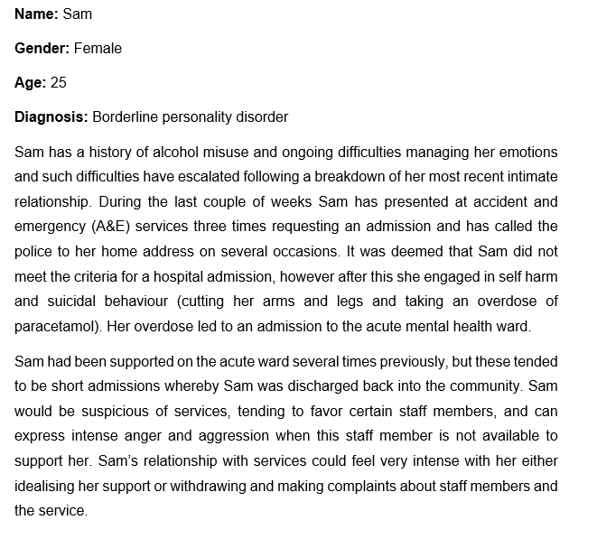

Appendix B

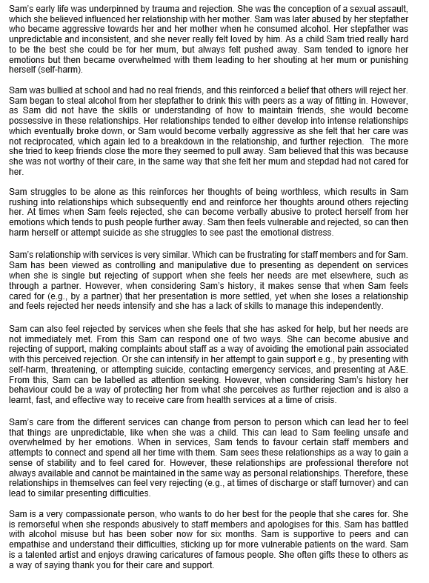
Formulated case vignette

