Why do police officers (not) seek help? Correlates and predictors of attitudes towards psychological help-seeking in the police

Imogen Grumley Traynor

Thesis submitted in partial fulfilment of the requirements of Staffordshire University for the degree of Doctorate in Clinical Psychology

April 2023

Total word count: 18,786 words

Thesis Portfolio: Candidate Declaration

Title of degree programme | Professional Doctorate in Clinical Psychology
Candidate name | Imogen Grumley Traynor
Registration number
Initial date of registration | 21st September 2020

Declaration and signature of candidate
I confirm that the thesis submitted is the outcome of work that I have undertaken during my programme of study, and except where explicitly stated, it is all my own work.
I confirm that the decision to submit this thesis is my own.
I confirm that except where explicitly stated, the work has not been submitted for another academic award.
I confirm that the work has been conducted ethically and that I have maintained the anonymity of research participants at all times within the thesis.

Signed: 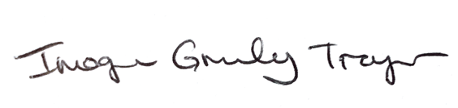 Date: 27.04.2023

Acknowledgements
Firstly, I wish to thank West Midlands Police for their collaboration on this project. I am deeply grateful to all the officers who participated, as well as to the numerous staff and officers who helped to plan and run the study.

Thanks also to Dr Leanne Savigar-Shaw, and to all those with first-hand knowledge of policing—in West Midlands Police, in other forces, and in research—who supported me from design through write-up. I am grateful for your help in making the study more meaningful to those whom it is ultimately for.

In addition, I would like to thank my supervisors, Dr Michelle Rydon-Grange and Dr Helen Scott, for their guidance and expertise throughout the research process. The countless emails, Teams calls, and meetings have been very much appreciated.

Last but certainly not least, I would like to express my gratitude to my parents, and to all my family and friends who encouraged me, assisted me, and carried me through. Thank you, in particular, to my fiancé, Tom, for first inspiring and facilitating this research, as well as for single-handedly keeping our lives running while I completed yet another thesis…

Mar a deir an seanfhocal, “Ar scáth a chéile a mhaireann na daoine.”
Table of Contents
Thesis Abstract 6
Paper 1: Literature Review 7
Abstract 8
Keywords 8
Introduction 9
Method 12
Search Strategy & Study Selection 12
Eligibility Criteria 13
Data Charting 15
Critical Appraisal 15
Results 15
Overview 15
Critical Appraisal 17
Research Question 1: Operationalising Help-Seeking Attitudes 18
Research Question 2: Correlates Studied 22
Research Question 3: Significant and Non-Significant Correlates 35
Discussion 35
Limitations 38
Conclusion 39
References 41
Appendices 48
Appendix A – Journal Submission Guidelines 48
Appendix B – Search Terms 49
Appendix C – Critical Appraisal of Included Studies 51
Appendix D – Operationalisation of Help-Seeking Attitudes 53
Paper 2: Empirical Paper 54
Abstract 55
Keywords 55
Introduction 56
Demands of Policing 56
Police Wellbeing 57
Psychological Help-Seeking 58
Current Study 59
Aims and Hypotheses 60
Method 60
Design and Procedure 60
Participants 62
Measures 62
Data Analysis 65
Results 67
Descriptive Statistics 67
Correlations 69
Regression Analyses 70
Discussion 72
Limitations and Future Research 76
Clinical Implications 78
Conclusion 80
References 81
Appendices 91
Appendix A – Journal Submission Guidelines 91
Appendix B – Study Approval 92
Appendix C – Participant Information Sheet 94
Appendix D – Participant Consent Form 97
Appendix E – Demographics Response Options 99
Appendix F – Permission to Use Measures 101
Appendix G – Details of the Multiple Imputation Model 104
Appendix H – SPSS Regression Tables (Regression Analysis with All Predictors) 107
Appendix I – SPSS Histograms and Normal Probability Plots (Regression Analysis with All Predictors) 116
Appendix J – SPSS Scatterplots and Partial Regression Plots (Regression Analysis with All Predictors) 118
Appendix K – SPSS Regression Tables (Regression Analysis with Only Significant Predictors) 124
Appendix L – Comparison of Force and Sample Demographics 132
Paper 3: Executive Summary 134
Background 135
What do we know already? 135
What is the purpose of this study? 136
Predicted findings 137
Method 138
How was the study designed? 138
How were participants recruited? 138
Who took part? 138
What did the survey involve? 139
How was the data analysed? 140
Key Findings 141
Prediction 1 141
Prediction 2 141
Prediction 3 141
Conclusions & Recommendations 142
Recommendations for Researchers 143
Recommendations for Police Forces 144
Limitations & Future Research 145
What will happen now? 146
References 146

Thesis Abstract
Through both literature review and empirical research, this thesis explores factors which may explain why police officers do not always seek psychological support when they need it. By consolidating and expanding current knowledge, it is hoped that the thesis may help to inform future efforts to ensure that all officers can access support as required.

Paper 1 is a scoping literature review of quantitative studies which have examined the relationship between attitudes towards psychological help-seeking and other variables. The review identified 102 potential correlates/predictors of help-seeking attitudes across 21 studies. Past help-seeking, perceived service availability, and having a mental health diagnosis were the most consistent facilitators of positive help-seeking attitudes. Current PTSD symptoms were the most consistent barrier. However, most variables had a weak evidence base, having been studied only once or having had contradictory findings across studies. The studies also differed substantially in their operationalisation of help-seeking attitudes. The review concluded that further high-quality research is necessary.

Paper 2 presents a cross-sectional, quantitative research study investigating the ability of five variables—current psychological distress, mental health literacy, distress disclosure, organisational stigma, and length of service—to predict psychological help-seeking in a UK police force. An online survey was completed by 97 officers. Multiple regression analyses showed that mental health literacy and distress disclosure predicted more positive help-seeking attitudes, while distress and organisational stigma predicted more negative attitudes. Length of service was not significant. Clinical implications of the findings are considered, alongside limitations and recommendations for future research.

Paper 3 is an executive summary of the empirical research, written for the research participants, police forces, and related organisations. The paper gives an overview of the study’s background, method, findings, limitations, and recommendations. A police officer, an ex-officer, and police researchers were consulted to maximise this paper’s usefulness.

Word count = 299 words

Paper 1: Literature Review

Examining correlates of police officers’ attitudes towards seeking mental health support: A scoping review

Word count: 7,992 words

This paper is intended for publication in The Police Journal: Theory, Practice and Principles. Appendix A outlines the journal’s submission guidelines. Further edits may be made before submission to the journal.

Abstract
Policing poses significant challenges to officers’ mental health. Yet police officers are not always willing to seek psychological support. While many individual studies have explored potential reasons for this, a coherent, overall picture is lacking. The current scoping review aimed to address this by investigating: how studies of police populations have operationalised help-seeking attitudes, which potential correlates of help-seeking attitudes they have studied, and which correlates they have found to be significant. Three primary databases were searched, returning 1,568 initial results. Following further manual searching and screening, 21 quantitative, observational, peer-reviewed studies remained. The studies were published between 1995 and 2022, spanned six countries, and appeared generally of moderate quality. The most consistent variables positively associated with help-seeking attitudes were past help-seeking, perceived service availability, and having a mental health diagnosis. Current PTSD symptoms was the variable most consistently negatively associated with help-seeking attitudes. However, the principal finding of the review was the heterogeneity between studies. 102 independent variables had been investigated, but 73 only in a single study, and the remaining findings were often contradictory. Similarly, the disparate operationalisations of the variables prevented a meaningful synthesis of the research. To clarify this important topic, future studies should replicate and refine current research, and address the quality limitations of existing studies.

Keywords
Help-seeking; police; mental health; correlates; predictors; scoping review

Introduction
Policing is an inherently dangerous, stressful, and traumatic job. Stress in policing is usually divided into two categories. Operational stressors relate to the nature of policing (e.g., exposure to death), whereas organisational stressors relate to how the organisation is run, such as equipment quality (Violanti et al., 2017). Unsurprisingly, both stressor types negatively impact officers’ mental health, increasing symptoms of post-traumatic stress disorder (PTSD), occupational stress, distress, and emotional exhaustion (Purba and Demou, 2019; Wagner et al., 2020). Similar evidence continues to emerge internationally (e.g., Craddock and Telesco, 2022; Houdmont et al., 2020). A recent meta-analysis, using data from 272,463 police officers from 24 countries, found concerning rates of PTSD (14.2%), anxiety (9.6%), depression (14.6%), suicidal ideation (8.5%), and alcohol misuse (25.7%), which were far higher than estimates for the general population (Syed et al., 2020). Similarly, in the 2021/2022 UK National Police Wellbeing Survey, officers reported concerning levels of fatigue, anxiety, and depression (Graham et al., 2022).

Interestingly, these findings appear to contradict a recent large-scale UK study, where rates of PTSD, anxiety, and depression were lower than in Syed et al. (2020) and considered similar to the general population (Stevelink et al., 2020). Stevelink et al. (2020) argue that their estimates are more realistic than others because their study was not advertised as focusing on mental health, which can inflate rates of mental health difficulties. However, even if police officers’ difficulties are no more common than in the general population, their occurrence remains a concern, not only for officer wellbeing, but for the economy and public safety. Mental health difficulties in police officers can have numerous negative outcomes, including “poorer quality of life, elevated risk of errors, aggression, cardiac deaths, substance misuse, absenteeism and suicide” (Syed et al., 2020: p. 737). Similarly, one fifth of sick leave taken by UK Metropolitan Police officers in 2021 was related to mental health (Metropolitan Police, no date).

Police mental health may be threatened further by the increasingly negative public perception of the police. For example, during the COVID-19 pandemic, British police have been scrutinised for both issuing (Lowbridge, 2021) and not issuing (Sandford, 2022) fines. Recent incidents of officer brutality and misdemeanour (e.g., the murders of George Floyd and Sarah Everard) may have tarnished the reputation further, even if not representative of all officers (BBC News, 2021; Bell, 2022; Hill et al., 2022). Recent research found that attitudes towards the police among US college students became more negative following George Floyd’s murder and the start of the Black Lives Matter movement (Verhaeghen and Aikman, 2022). Similarly, UK data collected by the research firm YouGov indicates that the proportion of people reporting that the police were doing a “good job” fell from 75% in July 2019 to 53% in January 2022 (Kirk, 2022). The respect and admiration of others has been shown to predict self-esteem (Mahadevan et al., 2021), which in turn predicts wellbeing (Mann et al., 2004). Therefore, negative public perception may be an additional threat to police mental health.

Given the multiple pressures on police wellbeing, and their effects on both officers and the public, it seems crucial that officers seek psychological support (i.e., assistance from a trained mental health professional; Mackenzie et al., 2004) where necessary. However, officers may not always do so. Rates of police help-seeking vary, likely based on the nature of the sample and the operationalisation of help-seeking. For example, the proportion of police samples with concerning exposure to stress or concerning levels of distress who did not access psychological support can range from 26.7% (Drew and Martin, 2021) to 83% (Jetelina et al., 2020). However, even the lower estimate suggests notable issues in service uptake, with over a quarter of officers who might need help not seeking it. Similarly, a study of police responders to the World Trade Centre attack found that a quarter of officers were experiencing at least one barrier to seeking support (DePierro et al., 2021). This figure was even higher (43.7%) among officers with concerning levels of distress (DePierro et al., 2021).

An increasing number of studies have explored why police officers—working in a job which presents multiple challenges to mental health—are nevertheless unwilling to seek psychological support. This is an important area of research. If factors affecting officers’ help-seeking attitudes can be identified, they may serve as fruitful loci of intervention to help ensure officers access the support they need. A range of help-seeking barriers have been identified in the literature, including stigma from self and others, a feared impact on career progression, and perceived lack of support from the police as an organisation (e.g., Edwards and Kotera, 2021; Johnson, 2016; Tucker, 2015). Whilst the breadth of factors examined in these studies is important for a comprehensive understanding of police help-seeking, it also makes it difficult to gain a coherent picture of the current knowledge.

Three recent reviews exploring barriers to police help-seeking have attempted to address this (Haugen et al., 2017; Richards et al., 2021; Velazquez and Hernandez, 2019). However, they each have important limitations. Haugen et al. (2017) considered first responders, not specifically police. Moreover, their aim was not to identify the correlates of help-seeking attitudes, but to explore how often officers endorsed various barriers and aspects of stigma. Similarly, Velazquez and Hernandez (2019) thematically explored stigma and barriers to help-seeking among police officers, without considering which factors were correlated with their constructs of interest. In contrast, Richards et al. (2021) systematically identified factors associated with help-seeking attitudes. However, the review omitted several relevant papers: some due to recency, others likely due to the authors’ search terms which were inconsistently applied across databases and appeared too restrictive (e.g., requiring search results to include the terms “‘occupational health’ OR ‘occupational diseases/ psychology’ OR burnout OR ‘PTS*’ OR trauma”; Richards et al., 2021: p. 352). Other limitations to the reviews included geographical restriction to North America (Richards et al., 2021; Velazquez and Hernandez, 2019), reliance on a large number of unpublished theses (Haugen et al., 2017; Richards et al., 2021), and lack of critical appraisal of the primary studies included (Richards et al., 2021; Velazquez and Hernandez, 2019).

The current review aims to address these limitations. Specifically, the review will explore the factors associated with police officers’ help-seeking attitudes by addressing the following questions:
- How have attitudes towards seeking psychological support been operationalised across studies in police populations?
- Which factors have been investigated as possible correlates of attitudes towards seeking psychological support in the police?
- Which factors have been shown to correlate with attitudes towards seeking psychological support in the police?

In accordance with guidance from Munn et al. (2018), a scoping review was deemed more appropriate than a systematic review. Police help-seeking is a rapidly developing area of research and, as explained above, the scope and focus of current literature has not been fully captured in previous reviews.

Method
This review followed the Preferred Reporting Items for Systematic Reviews and Meta-Analyses (PRISMA) guidelines for scoping reviews (Tricco et al., 2018).

Search Strategy & Study Selection
Based on the most recent pre-existing review (Richards et al., 2021), access to databases, and advice from a university librarian, three primary databases were selected: Scopus, Health Research Premium Collection (via ProQuest), and Web of Science. Table 1 indicates database selections within each primary database.

Search terms were generated for three topics: police, help-seeking, and attitudes (see Appendix B). Initial terms were tested in Scopus to maximise the precision and relevance of the results. Where known relevant papers were not returned by the search, their abstracts were scanned and the search terms refined accordingly. Additional relevant synonyms for each term were also identified from a general thesaurus and from the alternatives suggested when searching within EBSCOhost. Final searches were performed on 1st June 2022.

The search results were exported into RefWorks, which automatically identified duplicates. The author screened the results for relevance, eligibility, and further duplication, first by title/abstract and then by full text. Papers whose full text was unavailable were excluded.

The reference lists of the three previous reviews (Haugen et al., 2017; Richards et al., 2021; Velazquez and Hernandez, 2019) and of all eligible papers were manually searched for additional relevant studies. The author also included any known relevant papers which the searches did not return.
Table 1
Databases Included in the Literature Search
Primary Database  (publication years covered) | Databases Included
Scopus  (1970–present) | - Main results  - Secondary documentsª
Health Research Premium Collection  (1946–present) | - Consumer Health Database  - Health & Medical Collection  - Healthcare Administration Database  - MEDLINE®  - Nursing & Allied Health Database  - Psychology Database  - Public Health Database
Web of Science | - Web of Science Core Collection (2016–present)  - BIOSIS Citation Index (1926–present)  - Current Contents Connect (1998–present)  - Data Citation Index (1900–present)  - KCI – Korean Journal Database (1980–present)  - SciELO Citation Index (2002–present)
Note. ª “[A] secondary document is a document that has been extracted from a Scopus document reference list but is not available directly in the Scopus database since it is not indexed by Scopus” (Scopus, 2021, ‘Secondary documents’).

Eligibility Criteria

Study design and outcomes
The review selected quantitative studies which measured the association between attitudes towards help-seeking (dependent variable) and any other independent variable(s). Studies could be cross-sectional or longitudinal. Any analytical method which tested the association between variables (e.g., correlation, regression) or explored group differences (e.g., t-tests, ANOVA) was included. Qualitative studies were excluded. Barriers to help-seeking which are appropriate for intervention should be widely experienced and have a substantial impact on help-seeking—factors which cannot easily be assessed from qualitative studies.

Studies of help-seeking behaviour were also excluded because the correlation between help-seeking attitudes and behaviour is far from perfect (Mojtabai et al., 2016). Intervention studies were excluded as it can be difficult to ascertain which aspect(s) of the intervention was associated with any effect. It seems more appropriate to investigate interventions after factors that are associated with help-seeking attitudes have been identified. This study focused on original studies—reviews were only used to inform study selection.

Attitudes towards help-seeking were defined broadly to include any measure of participants’ views, intentions, or stigma towards accessing support from a mental health service or professional (e.g., psychologist, counsellor). This review focused on attitudes rather than behaviour because the decision to actually seek support may be affected by additional factors that are less amenable to intervention (e.g., negative life events), which are outside the scope of this review.

Participants
Eligible studies included currently serving or retired police officers in any country. There are substantial international differences between police forces, which could plausibly affect help-seeking attitudes (e.g., more in-duty officer deaths in the US than in the UK; Belkin, 2021). Therefore, it was considered important to ascertain the location of existing research. Participants could be any age or rank. Studies with mixed samples of multiple professionals (e.g., first responders) were not included unless results were reported separately for the police sub-sample. Studies were not included if they focused solely on police staff (e.g., call handlers), who were not sworn/warranted officers. However, studies which involved both officers and staff were included (although only the officer results were considered, if reported separately). No limits were placed on sample size.

Study characteristics
Studies conducted and published in any country were permitted. However, the reports had to have been written in English, German, or French due to the lack of capacity for translation. No restrictions were placed on year of publication. Studies were only included if the full text was accessible.
Only published, peer-reviewed studies were included in the review. Factors which are correlated with police help-seeking attitudes may serve as future intervention loci to encourage police to access support when needed. Consequently, study quality is paramount. Given the ample literature available, it was deemed most efficient to only include studies which had been pre-screened for quality through peer review.

Data Charting
A data charting form, following relevant guidance (Arksey and O’Malley, 2005; Downes et al., 2016; Peters et al., 2020; Tricco et al., 2018), was designed to extract data relevant to the research questions and study quality (e.g., design, measures). As recommended by Levac et al. (2010), the form was developed dynamically throughout data charting.

Critical Appraisal
In order to clarify the rapidly expanding evidence base on police help-seeking attitudes, it is important to determine the quality of the studies. Previous reviews (Haugen et al., 2017; Richards et al., 2021; Velazquez and Hernandez, 2019) did not always assess quality and included many unpublished dissertations, which may be held to less rigorous standards. The AXIS tool (Downes et al., 2016) was used to critically appraise all studies in this review. The AXIS was specifically designed for cross-sectional, observational studies. It involves the assessment of 20 items, such as the quality of study design, risk of biases, and reporting quality. No overall score is obtained. Rather, each item (e.g., “Were the aims/objectives of the study clear?”) was rated as true (‘Yes’), untrue (‘No’), partially true (‘Some’), or unclear (‘?’; see Appendix C).

Results

Overview
The literature search returned 1,568 initial results, with 709 duplicates subsequently removed (see Figure 1). 859 papers were screened by title/abstract. Out of the 50 papers whose full text was sought, five were inaccessible and 26 were not eligible: 12 did not measure an association between help-seeking attitudes and other variables; two had a sample incompatible with the specified criteria; two were unpublished theses; eight were

Figure 1
Flow Diagramª Illustrating Study Selection
Identification of studies via other methods
Identification of studies via databases

Records removed before screening (n=709):
Duplicate records identified by ProQuest (n=15)
Duplicate records identified by RefWorks (n=564)
Duplicate records identified manually (n=130)
Records identified from:
Citation searching (n=9)
Prior awareness of the literature (n=1)
Records identified (n=1,568):
Scopus (n=577)
Scopus Secondary Documents (n=12)
Health Research Premium Collection (n=332)
Web of Science (n=647)

Identification

Records screened (title & abstract)
(n=859)
Records excluded
(n=809)

Reports not retrieved
(n=1)
Reports sought for retrieval
(n=10)
Reports sought for retrieval
(n=50)
Reports not retrieved
(n=5)

Screening

Reports excluded (n=7):
No association between help-seeking attitudes and other variables (n=2)
Sample not meeting criteria (n=1)
Dissertation/thesis (n=2)
Studied actual help-seeking behaviour (n=2)

Reports excluded (n=26):
No association between help-seeking attitudes and other variables (n=12)
Sample not meeting criteria (n=2)
Dissertation/thesis (n=2)
Not quantitative (n=8)
Studied actual help-seeking behaviour (n=2)
Reports assessed for eligibility
(n=9)
Reports assessed for eligibility (full text)
(n=45)

Included
Studies included in review
(n=21)

Note. ªFollowing Page et al. (2021).
not quantitative; and two measured help-seeking behaviour. The remaining 19 studies were included in the review. Their reference lists were then screened and nine further relevant studies were identified. One was inaccessible but eight were screened for eligibility, with one retained. One final study, known to the first author, was added, leading to a total of 21 studies included in the review.

Table 2 summarises the included studies. The studies were published between 1995 and 2022. They spanned six countries, but were biased towards the US (n=14) over Canada (n=5), Ireland (n=2), the UK (n=2), Australia (n=1), and New Zealand (n=1). All but two focused exclusively on police. Krakauer et al. (2020) studied public safety personnel and DePierro et al. (2021) studied World Trade Centre responders, but both presented results separately for the police sub-sample. Krakauer et al. (2020) studied both sworn officers and police staff. All other studies examined sworn officers exclusively or presented results separately for sworn officers. The North American studies covered multiple agencies, including municipal, county, regional, state, federal, and university police. Agency type was not specified elsewhere. Samples were reasonably large (78–2,135 participants), although 15 studies had under 500 participants and over a third had under 200. All studies employed a quantitative, observational, cross-sectional design, and used self-report questionnaires. DePierro et al. (2021) additionally used health examinations and clinical interviews. Only two studies did not explicitly aim to investigate correlates of help-seeking attitudes. Carlan and Nored (2008) examined correlates of police stress, while Hyland et al. (2015) investigated the psychometric properties of a help-seeking measure.

Critical Appraisal
Study quality was assessed against 20 criteria (see Appendix C). Although the AXIS tool has no quantitative score, all studies appeared to be of at least moderate quality. All had clear aims, appropriate designs, and appropriate independent and dependent variables. Generally, the methods, sample, and basic measurements were detailed enough for contextualisation and replication. The target population was usually clear, and limitations considered. Results were usually presented in full, but some studies mentioned secondary analyses/data collection, which were not reported. Missing data was often, but not always, accounted for. The authors’ conclusions seemed mostly appropriate. However, the sampling frame was often too narrow. For example, Karaffa and Tochkov’s (2013) population was US police but their sample came only from Texas. Moreover, sampling was not always random. Response rates were rarely reported, and the sample size rarely justified. Additionally, several studies did not fully compare the characteristics of participants to the broader population to assess the representativeness of their sample. Other studies did compare participants to non-participants but found demographic differences, such as age or ethnicity (see e.g., Jetelina et al., 2020). Studies also frequently employed unvalidated measures and omitted statistics for non-significant results. Most studies did not explicitly declare conflicts of interests and some did not explicitly state their ethics procedure.

Research Question 1: Operationalising Help-Seeking Attitudes
‘Attitudes towards help-seeking’ were operationalised very differently across studies. Most studies (n=16) measured favourable attitudes (e.g., willingness to seek help; Tucker, 2015), but five studies studied barriers (e.g., stigma towards help-seeking; Soomro and Yanos, 2019). The terms used to refer to help-seeking attitudes varied greatly, including ‘likelihood of’, ‘interest in’, and ‘concerns about’ seeking help (see Appendix D for a complete list). Occasionally, the terminological disparity reflected a fundamental difference in the conceptualisation of the dependent and independent variables. Specifically, the dependent variable was behavioural (e.g., help-seeking intentions), while opinions on help-seeking were actually independent variables (e.g., Daniel and Treece, 2022). Similarly, in other studies, positive attitudes towards help-seeking were the dependent variable, while stigma/barriers were the independent variable (Krakauer et al., 2020; Tucker, 2015). Indeed, four measures (ATSPPH–SF; SSOSH; PSOSH; and Military Stigma Scale – see Table 2) were used to assess the dependent variable (i.e., help-seeking attitudes) in some studies, but to assess a potential correlate of help-seeking (e.g., stigma) in other studies.
Table 2
Study Characteristics
Authors & Year | Participants |  |  | Measure of Help-Seeking Attitudes  (Number of Questions; Scale) | Correlates
Authors & Year | Number | Location | Agency Type
Asen and Colón (1995) | n=82 | New Jersey, US | Municipal | Acceptance of the EAP  (12; 4-point) | - Age  - Gender  - Length of service  - Number of children |  | - EAP training  - Past help-seeking  - Having seen EAP policy
Carlan and Nored (2008) | n=1,083 | Alabama, US | Municipal | Would use counselling via department if necessary  (1; 5-point) | - Whether department offered counselling
Ceka and Ermasova (2021) | n=431 | Illinois, US | Multiple | Likelihood of using the EAP following critical incident/ stress at work  (1; 5-point) | - Gender  - Length of service  - Ethnicity  - Education |  | - Perceived effect on promotion  - Confidence in department’s assistance  - Organisational stressors
Copen-haver and Tewksbury (2018) | n=359 | US | State | Would seek professional help for depression  (1; Yes/No) | - Age  - Length of service  - Education  - Role  - Shift  - Overall health  - Depression since joining police |  |  |  | - Exercise  - Recreational sports participation  - Alcohol consumption  - Stimulant drinks per shift  - Sleep  - Fast food consumption  - Perceived control of job
Daniel and Treece (2022) | n=78 | US | Multiple | Considering seeking mental health services in the future  (1; Yes/No) | - Gender  - Length of service  - Agency size  - Past help-seeking  - Psychological openness |  |  |  | - Help-seeking propensity  - Indifference to stigma  - Compassion satisfaction  - Burnout  - Secondary traumatic stress
DePierro et al. (2021) | n=1,178 | US | 9/11 responders with mental health difficulties | Endorsing any of seven barriers to ﻿using stress-management services | - Age  - Gender  - Ethnicity  - Education  - Relationship status  - Income  - Pre-9/11 diagnosis of depression/anxiety/PTSD |  |  |  | - World Trade Centre exposures  - World Trade Centre-related medical conditions  - PTSD  - Depression  - Alcohol misuse  - Time since 9/11  - Perceived mental health service need
Heffren and Hausdorf (2016) | n=102 | Peel Regional Police, Ontario, Canada | Municipal | Likelihood of seeking help for work stress from a professional at/outside of work  (2; 5-point) | - Type A personality: achievement-striving; impatience-irritability  - Distress disclosure  - Help-seeking attitudes  - Self-stigma  - Public stigma |  |  | - Perceived organisational support  - Reciprocal relationship with supervisor  - Organisational climate of fear  - Social support  - Turnover intentions
Hyland et al. (2012) | n=259 | Ireland | Unknown | Intentions to engage in psychological counselling  (3; 7-point) | - Age  - Length of service  - Help-seeking attitudes |  |  | - Subjective norms  - Perceived behavioural control: internal control; external control
Hyland et al. (2015) | n=331 | Ireland | Unknown | Intentions to engage in psychological counselling  (3; 7-point) | - Age  - Psychological openness  - Help-seeking propensity  - Indifference to stigma |  |  | - Psychoticism  - Extraversion  - Neuroticism
Jetelina et al. (2020) | n=114 | Dallas Police Department, US | Municipal; mental health difficulties | Interest in help from mental health services  (1; Yes/No) | - Depression  - Anxiety |  |  |  | - PTSD  - Suicide/self-harm ideation
Karaffa and Tochkov (2013) | n=158 | Texas, US | Multiple | ﻿ATSPPH–SF  (10; 4-point) | - Age  - Gender  - Length of service  - Ethnicity  - Education |  | - Relationship status  - Perceived help-seeking willingness of colleagues  - Identification with police officers  - Police culture: aggression; emotional control; bravery; autonomy; secrecy; distrust of outsiders
Karaffa and Koch (2016) | n=248 | Texas & Oklahoma, US | Multiple | ﻿ATSPPH–SF  (10; 4-point) | - Public stigma  - Self-stigma  - Voluntary past help-seeking
Krakauer et al. (2020) | n=2,135 | Canada | n=1,065 municipal/ provincial;  n=1,070 Royal Canadian Mounted Police | ﻿Mental Health Service Use Questionnaire  (4; 7-point) | - Mental health knowledge  - Workplace stigma
Lane et al. (2022) | n=112 | Ontario, Canada | Municipal | Likelihood of seeking mental health treatment from a professional for current/future mental health concern  (1; 0-100) | - Age  - Gender  - Length of service  - Mental health diagnosis | - Training: Mental Health Response Officer; Mental Health First Aid  - CISM: debrief; defuse  - Current resilience  - Perceived change in resilience
Ménard et al. (2016) | n=1,286 | US, Canada, UK, Australia, & New Zealand | Multiple | Feeling they could use department’s services  (1; Yes/No) | - Age  - Gender  - Length of service  - Ethnicity  - Country  - Community size | - Relationship status  - Trauma exposure  - Alcohol misuse  - PTSD  - Military experience  - Social stressors |  |  |  | - Living with dependent children  - Perceived service availability  - Negative coping strategies
Short (2021) | n=173 | Eastern Canada | Regional | ATSPPH–SF  (10; 4-point) | - Operational stress  - Organisational stress  - Public stigma  - Self-stigma |  |  |  | - Psychological quality of life  - Social relationships quality of life  - Perpetration of microaggressions
Soomro and Yanos (2019) | n=296 | US | Multiple | SSOSH (10; 5-point)  ﻿PSOSH (5; 5-point) | - Gender  - Ethnicity  - Education | - Knowing someone with mental health difficulties  - PTSD  - Mental health training
Tucker (2015) | n=673 | Pennsylvania, US | Multiple | Willingness to use stress-intervention services following critical incident/stress  (not reported; 5-point) | - Gender  - Length of service  - Ethnicity  - Education  - Relationship status  - Active/retired  - Agency size  - Agency type  - Role | - Rank  - Military experience  - Perceived existence of police stress policies  - Perceived organisational support  - Confidentiality concerns/stigma (towards help-seeking) at work |  |  |  |  | - Family support for career choice  - Confidence in service providers  - Health  - Alcohol consumption  - Stress  - Trauma exposure  - CISM/peer-support training
Watson and Andrews (2018) | n=650 | UK | Unknown | ﻿Stigma and Barriers to Care Questionnaire (13; 4-point)  Military Stigma Scale (26; 4-point) | - Use of Trauma Risk Management
Wester et al. (2010) | n=178 | South-eastern Wisconsin, US | Multiple; men only | SSOSH (10; 5-point)  Stigma Scale for Receiving Psychological Help (5; 4-point) | - Gender role conflict: restrictive emotionality; restrictive affective behaviour between men; conflict between work & family relations; success, power & competition  - Anticipated benefit of help-seeking  - Anticipated risk of help-seeking
White et al. (2016) | n=454 | Arizona, US | Multiple | SSOSH (10; 5-point)  Adapted PSOSH﻿ (25; 5-point) | - Age  - Gender  - Length of service  - Ethnicity |  | - Agency size  - Union affiliation  - Role  - Agency type
Note. EAP=Employee Assistance Programme; PTSD=post-traumatic stress disorder; ATSPPH–SF=Attitudes Toward Seeking Professional Psychological Help–Short Form; CISM=Critical Incident Stress Management; SSOSH=Self-Stigma of Seeking Help Scale; PSOSH=Perceptions of Stigmatization by Others for Seeking Help Scale.
In addition, studies differed concerning the providers of support. Most studies (n=14) referred generically to professional/psychological help, counselling, or mental health services/providers/treatment. DePierro et al. (2021) and Tucker (2015) referenced stress counselling/management/intervention services, but did not define these. Five studies (e.g., Tucker, 2015) referred specifically to services provided by/for the police. Studies also asked about seeking help for different reasons, such as mental health difficulties (e.g., Short, 2021), work-related stress/incidents (e.g., Tucker, 2015), depression (Copenhaver and Tewksbury, 2018), or a particular traumatic scenario (Hyland et al., 2012, 2015). One study actually informed participants that they may benefit from services following their responses (Jetelina et al., 2020). However, others were vague, not providing a reason for accessing support (e.g., Asen and Colón, 1995), or asking whether officers would seek help “if needed” (Carlan and Nored, 2008), or in their current situation (e.g., Daniel and Treece, 2022).

Finally, the help-seeking measures varied significantly. Most studies (n=15) employed a Likert scale, albeit with 4, 5, 7, or 100 points. Four (Copenhaver and Tewksbury, 2018; Daniel and Treece, 2022; Jetelina et al., 2020; Ménard et al., 2016) required a binary Yes/No response. DePierro et al. (2021) and Carlan and Nored (2008) used scales but dichotomised the results for analysis. Similarly, while most measures involved multiple questions, seven studies used a single question. Moreover, most studies (n=15) used at least one help-seeking measure that had not been validated or standardised.

Research Question 2: Correlates Studied
In total, 102 distinct correlates of help-seeking attitudes were identified. The number of studies in which each correlate was examined ranged widely. For example, income was only investigated once, whereas gender was investigated in 10 studies. Table 3 summarises the correlates, grouped thematically.

Table 3
Correlates of Help-Seeking Attitudes
Correlate | Analytic Method | Finding | Study
Demographic Factors – Officers
Gender | Regression | Females > males | Ménard et al. (2016)
Gender | Correlation | Self-stigma & public stigma: Females > males | Soomro and Yanos (2019)
Gender | Regression | Self-stigma & public stigma: Females > males | Soomro and Yanos (2019)
Gender | ANOVA | Females < males | Ceka and Ermasova (2021)
Gender | Mediation model | Significant | Ceka and Ermasova (2021)
Gender | Regression | Non-significant | Daniel and Treece (2022)
Gender | Regression | Non-significant | DePierro et al. (2021)
Gender | Regression | Non-significant | Tucker (2015)
Gender | t-test | Non-significant | Lane et al. (2022)
Gender | Regression | Non-significant | Lane et al. (2022)
Gender | t-test | Non-significant | Karaffa and Tochkov (2013)
Gender | Correlation | Non-significant | Karaffa and Tochkov (2013)
Gender | Regression | Non-significant | Karaffa and Tochkov (2013)
Gender | t-test | Females > males (1 question)ª | Asen and Colón (1995)
Gender | t-test | Non-significant (11 questions)ª | Asen and Colón (1995)
Gender | Correlation | Self-stigma & public stigma: Significant | White et al. (2016)
Gender | Regression | Self-stigma & public stigma: Non-significant | White et al. (2016)
Age | Regression | Non-significant | Copenhaver and Tewskbury (2018)
Age | Regression | Non-significant | DePierro et al. (2021)
Age | Regression | Non-significant | Karaffa and Tochkov (2013)
Age | Regression | Non-significant | Ménard et al. (2016)
Age | SEM | Non-significant | Hyland et al. (2015)
Age | Correlation | Non-significant | Lane et al. (2022)
Age | Regression | Non-significant | Lane et al. (2022)
Age | Correlation | Positive (10 questions) | Asen and Colón (1995)
Age | Correlation | Non-significant (2 questions) | Asen and Colón (1995)
Age | Correlation | Non-significant | Hyland et al. (2012)
Age | SEM | Negative | Hyland et al. (2012)
Age | Correlation | Self-stigma: Positive | White et al. (2016)
Age | Correlation | Public stigma: Significant | White et al. (2016)
Age | Regression | Self-stigma & public stigma: Non-significant | White et al. (2016)
Ethnicity | Regression | Black non-Hispanic > others | DePierro et al. (2021)
Ethnicity | ANOVA | African-American > others | Ceka and Ermasova (2021)
Ethnicity | Mediation model | Significant | Ceka and Ermasova (2021)
Ethnicity | Regression | Non-significant | Ménard et al. (2016)
Ethnicity | Regression | Non-significant | Tucker (2015)
Ethnicity | Correlation | Non-significant | Karaffa and Tochkov (2013)
Ethnicity | Regression | Non-significant | Karaffa and Tochkov (2013)
Ethnicity | Correlation | Self-stigma: Non-White > White | Soomro and Yanos (2019)
Ethnicity | Correlation | Public stigma: Non-significant | Soomro and Yanos (2019)
Ethnicity | Regression | Self-stigma: Non-White > White | Soomro and Yanos (2019)
Ethnicity | Regression | Public stigma: Non-significant | Soomro and Yanos (2019)
Ethnicity | Correlation | Self-stigma & public stigma: Significant | White et al. (2016)
Ethnicity | ANOVA | Stigma from fellow officers: Non-significant | White et al. (2016)
Ethnicity | Regression | Stigma from fellow officers: Non-Caucasian-European < others | White et al. (2016)
Ethnicity | Regression | Self-stigma; stigma from friends & family, supervisors, administration, + mental healthcare providers: Non-significant | White et al. (2016)
Education | Correlation | Non-significant | Soomro and Yanos (2019)
Education | Mediation model | Non-significant | Ceka and Ermasova (2021)
Education | Regression | Non-significant | Copenhaver and Tewskbury (2018)
Education | Regression | Non-significant | DePierro et al. (2021)
Education | Regression | Non-significant | Tucker (2015)
Education | Correlation | Non-significant | Karaffa and Tochkov (2013)
Education | Regression | Non-significant | Karaffa and Tochkov (2013)
Relationship status | Regression | Married/partnered > others | DePierro et al. (2021)
Relationship status | Regression | Non-significant | Ménard et al. (2016)
Relationship status | Regression | Non-significant | Tucker (2015)
Relationship status | Correlation | Non-significant | Karaffa and Tochkov (2013)
Relationship status | Regression | Non-significant | Karaffa and Tochkov (2013)
Number of children | Correlation | Positive (10 questions) | Asen and Colón (1995)
Number of children | Correlation | Non-significant (2 questions) | Asen and Colón (1995)
Living with dependent children | Regression | Non-significant | Ménard et al. (2016)
Military experience | Regression | Non-significant | Ménard et al. (2016)
Military experience | Regression | Non-significant | Tucker (2015)
Length of service | Regression | Positive | Daniel and Treece (2022)
Length of service | Mediation model | Non-significant | Ceka and Ermasova (2021)
Length of service | Regression | Non-significant | Copenhaver and Tewskbury (2018)
Length of service | Regression | Non-significant | Ménard et al. (2016)
Length of service | Regression | Non-significant | Tucker (2015)
Length of service | Correlation | Non-significant | Karaffa and Tochkov (2013)
Length of service | Regression | Non-significant | Karaffa and Tochkov (2013)
Length of service | Correlation | Positive (10 questions) | Asen and Colón (1995)
Length of service | Correlation | Non-significant (2 questions) | Asen and Colón (1995)
Length of service | t-test | Senior > junior officers | Lane et al. (2022)
Length of service | t-test | Non-significant (11-20 years versus >20 years) | Lane et al. (2022)
Length of service | Regression | Positive | Lane et al. (2022)
Length of service | Correlation | Non-significant | Hyland et al. (2012)
Length of service | SEM | Positive | Hyland et al. (2012)
Length of service | Correlation | Self-stigma: Positive | White et al. (2016)
Length of service | Correlation | Public stigma: Significant | White et al. (2016)
Length of service | Regression | Self-stigma & public stigma: Non-significant | White et al. (2016)
Income | Regression | Non-significant | DePierro et al. (2021)
Active/retired | Regression | Non-significant | Tucker (2015)
Role | Regression | Non-significant | Copenhaver and Tewksbury (2018)
Role | Regression | Non-significant | Tucker (2015)
Role | Correlation | Self-stigma & public stigma: Significant | White et al. (2016)
Role | ANOVA | Stigma from administration: Patrol > administration | White et al. (2016)
Role | Regression | Self-stigma & public stigma: Non-significant | White et al. (2016)
Rank | Regression | Non-significant | Tucker (2015)
Shift | Regression | Non-significant | Copenhaver and Tewksbury (2018)
Union affiliation | Correlation | Self-stigma: Negative | White et al. (2016)
Union affiliation | Correlation | Public stigma: Significant | White et al. (2016)
Union affiliation | Regression | Self-stigma & public stigma: Non-significant | White et al. (2016)
Demographic Factors – Organisation
Agency size | Regression | Negative | Tucker (2015)
Agency size | Regression | Non-significant | Daniel and Treece (2022)
Agency size | Correlation | Self-stigma: Positive | White et al. (2016)
Agency size | Correlation | Public stigma: Significant | White et al. (2016)
Agency size | Regression | Self-stigma; stigma from friends & family + mental healthcare providers: Positive | White et al. (2016)
Agency size | Regression | Stigma from fellow officers, supervisors + administration: Non-significant | White et al. (2016)
Agency type | Regression | Non-significant | Tucker (2015)
Agency type | Correlation | Self-stigma & public stigma: Significant | White et al. (2016)
Agency type | Regression | Self-stigma & public stigma: Non-significant | White et al. (2016)
Community size | Regression | Non-significant | Ménard et al. (2016)
Country | Chi-squared test | Significant | Ménard et al. (2016)
Country | Regression | Australia < US; New Zealand > US | Ménard et al. (2016)
Organisational Factors
Police culture
Distrust of outsiders | Correlation | Negative | Karaffa and Tochkov (2013)
Distrust of outsiders | Regression | Negative | Karaffa and Tochkov (2013)
Aggression | Correlation | Non-significant | Karaffa and Tochkov (2013)
Aggression | Regression | Non-significant | Karaffa and Tochkov (2013)
Emotional control | Correlation | Non-significant | Karaffa and Tochkov (2013)
Emotional control | Regression | Non-significant | Karaffa and Tochkov (2013)
Bravery | Correlation | Non-significant | Karaffa and Tochkov (2013)
Bravery | Regression | Non-significant | Karaffa and Tochkov (2013)
Autonomy | Correlation | Non-significant | Karaffa and Tochkov (2013)
Autonomy | Regression | Non-significant | Karaffa and Tochkov (2013)
Secrecy | Correlation | Non-significant | Karaffa and Tochkov (2013)
Secrecy | Regression | Non-significant | Karaffa and Tochkov (2013)
Identification with police officers | Correlation | Non-significant | Karaffa and Tochkov (2013)
Identification with police officers | Regression | Non-significant | Karaffa and Tochkov (2013)
Organisational climate of fear | Regression | Non-significant | Heffren and Hausdorf (2016)
Organisational stress | Correlation | Non-significant | Ceka and Ermasova (2021)
Organisational stress | Mediation model | Non-significant | Ceka and Ermasova (2021)
Organisational stress | Correlation | Non-significant | Short (2021)
Organisational stress | Regression | Non-significant | Short (2021)
Perceived organisational support | Regression | Positive | Tucker (2015)
Perceived organisational support | Regression | Non-significant | Heffren and Hausdorf (2016)
Reciprocal relationship with supervisor | Regression | Non-significant | Heffren and Hausdorf (2016)
Perceived service availability | Chi-squared test | Positive | Carlan and Nored (2008)
Perceived service availability | Regression | Positive | Ménard et al. (2016)
Confidence in department’s assistance | Correlation | Positive | Ceka and Ermasova (2021)
Perceived existence of police stress policies | Regression | Non-significant | Tucker (2015)
Having seen EAP policy | t-test | Positive (5 questions) | Asen and Colón (1995)
Having seen EAP policy | t-test | Non-significant (7 questions) | Asen and Colón (1995)
Turnover intentions | Regression | Non-significant | Heffren and Hausdorf (2016)
Experience Factors
Operational stress | Correlation | Non-significant | Short (2021)
Operational stress | Regression | Non-significant | Short (2021)
Trauma exposure | Regression | Negative | DePierro et al. (2021)
Trauma exposure | Regression | Positive | Tucker (2015)
Trauma exposure | Regression | Non-significant | Ménard et al. (2016)
Time since trauma | Regression | Non-significant | DePierro et al. (2021)
Past help-seeking | Regression | Positive | Daniel and Treece (2022)
Past help-seeking | t-test | Positive | Karaffa and Koch (2016)
Past help-seeking | t-test | Positive (4 questions) | Asen and Colón (1995)
Past help-seeking | t-test | Non-significant (8 questions) | Asen and Colón (1995)
Use of Trauma Risk Management | t-test | Barriers to care & public stigma: Positive | Watson and Andrews (2018)
Use of Trauma Risk Management | t-test | Self-stigma: Non-significant | Watson and Andrews (2018)
Knowing someone with mental health difficulties | Correlation | Self-stigma: Positive | Soomro and Yanos (2019)
Knowing someone with mental health difficulties | Regression | Self-stigma: Positive | Soomro and Yanos (2019)
Knowing someone with mental health difficulties | Correlation | Public stigma: Non-significant | Soomro and Yanos (2019)
Knowing someone with mental health difficulties | Regression | Public stigma: Non-significant | Soomro and Yanos (2019)
Knowledge Factors
Mental health knowledge | Correlation | Positive | Krakauer et al. (2020)
Training | Correlation | Non-significant | Soomro and Yanos (2019)
Training | Regression | Non-significant | Tucker (2015)
Training | t-test | Positive (5 questions) | Asen and Colón (1995)
Training | t-test | Non-significant (7 questions) | Asen and Colón (1995)
Training | t-test | MHFA > none | Lane et al. (2022)
Training | t-test | MHRO > none | Lane et al. (2022)
Training | t-test | CISM debrief/defuse: Non-significant | Lane et al. (2022)
Training | ANOVA | Both MHFA and MHRO > none | Lane et al. (2022)
Training | Regression | MHFA: Positive | Lane et al. (2022)
Training | Regression | MHRO: Non-significant | Lane et al. (2022)
Training | Regression | CISM debrief & CISM defuse: Non-significant | Lane et al. (2022)
Attitudinal Factors
Overall help-seeking attitudes | Regression | Professional group 1^{b}: Positive | Heffren and Hausdorf (2016)
Overall help-seeking attitudes | Regression | Professional group 2^{b}: Non-significant | Heffren and Hausdorf (2016)
Overall help-seeking attitudes | Correlation | Positive | Hyland et al. (2012)
Overall help-seeking attitudes | SEM | Non-significant | Hyland et al. (2012)
Psychological openness | SEM | Positive | Hyland et al. (2015)
Psychological openness | Regression | Non-significant | Daniel and Treece (2022)
Help-seeking propensity | SEM | Positive | Hyland et al. (2015)
Help-seeking propensity | Regression | Non-significant | Daniel and Treece (2022)
Indifference to stigma | Regression | Positive | Daniel and Treece (2022)
Indifference to stigma | SEM | Non-significant | Hyland et al. (2015)
Self-stigma (towards help-seeking) | Correlation | Negative | Karaffa and Koch (2016)
Self-stigma (towards help-seeking) | Mediation model | Negative | Karaffa and Koch (2016)
Self-stigma (towards help-seeking) | Correlation | Negative | Short (2021)
Self-stigma (towards help-seeking) | Regression | Negative | Short (2021)
Self-stigma (towards help-seeking) | Regression | Non-significant | Heffren and Hausdorf (2016)
Public stigma (towards help-seeking) | Correlation | Negative | Short (2021)
Public stigma (towards help-seeking) | Regression | Negative | Short (2021)
Public stigma (towards help-seeking) | Correlation | Negative | Karaffa and Koch (2016)
Public stigma (towards help-seeking) | Mediation model | Negative, fully mediated by self-stigma | Karaffa and Koch (2016)
Public stigma (towards help-seeking) | Regression | Non-significant | Heffren and Hausdorf (2016)
Confidentiality concerns/stigma (towards help-seeking) at work | Regression | Negative | Tucker (2015)
Workplace stigma (towards people with mental health difficulties) | Correlation | Negative | Krakauer et al. (2020)
Anticipated risk of help-seeking | Correlation | Self-stigma & public stigma: Negative | Wester et al. (2010)
Anticipated risk of help-seeking | SEM | Self-stigma & public stigma: Negative | Wester et al. (2010)
Anticipated benefit of help-seeking | Correlation | Self-stigma & public stigma: Positive | Wester et al. (2010)
Anticipated benefit of help-seeking | SEM | Self-stigma & public stigma: Positive | Wester et al. (2010)
Subjective norms | Correlation | Positive | Hyland et al. (2012)
Subjective norms | SEM | Positive | Hyland et al. (2012)
Perceived help-seeking willingness of colleagues | Correlation | Positive | Karaffa and Tochkov (2013)
Perceived help-seeking willingness of colleagues | Regression | Positive | Karaffa and Tochkov (2013)
Perceived effect on promotion | Correlation | Negative | Ceka and Ermasova (2021)
Perceived effect on promotion | Mediation model | Negative, partially mediated by confidence in department’s assistance | Ceka and Ermasova (2021)
Distress disclosure | Regression | Professional group 2^{b}: Positive | Heffren and Hausdorf (2016)
Distress disclosure | Regression | Professional group 1^{b}: Non-significant | Heffren and Hausdorf (2016)
Confidence in service providers | Regression | Non-significant | Tucker (2015)
Perpetration of microaggressions | Correlation | Non-significant | Short (2021)
Perpetration of microaggressions | Regression | Non-significant | Short (2021)
Psychological Factors
Type A personality:
Achievement-striving | Regression | Non-significant | Heffren and Hausdorf (2016)
Impatience-irritability | Regression | Non-significant | Heffren and Hausdorf (2016)
Neuroticism | SEM | Positive | Hyland et al. (2015)
Psychoticism | SEM | Non-significant | Hyland et al. (2015)
Extraversion | SEM | Non-significant | Hyland et al. (2015)
Overall perceived behavioural control | Correlation | Positive | Hyland et al. (2012)
Internal control | Correlation | Positive | Hyland et al. (2012)
Internal control | SEM | Positive | Hyland et al. (2012)
External control | Correlation | Positive | Hyland et al. (2012)
External control | SEM | Non-significant | Hyland et al. (2012)
Negative coping strategies | Regression | Non-significant | Ménard et al. (2016)
Perceived control of job | Regression | Positive | Copenhaver and Tewksbury (2018)
Overall gender role conflict | Correlation | Self-stigma & public stigma: Negative | Wester et al. (2010)
Overall gender role conflict | SEM 1 | Public stigma: Negative, partially mediated by anticipated risk of help-seeking | Wester et al. (2010)
Overall gender role conflict | SEM 1 | Self-stigma: Negative, fully mediated by anticipated risk of help-seeking | Wester et al. (2010)
Overall gender role conflict | SEM 2 | Public stigma & self-stigma: Negative direct effect | Wester et al. (2010)
Restrictive emotionality | Correlation | Self-stigma & public stigma: Negative | Wester et al. (2010)
Restrictive affectionate behaviour between men | Correlation | Self-stigma & public stigma: Negative | Wester et al. (2010)
Success, power, and competition | Correlation | Self-stigma & public stigma: Negative | Wester et al. (2010)
Conflict between work and family relations | Correlation | Public stigma: Negative | Wester et al. (2010)
Conflict between work and family relations | Correlation | Self-stigma: Non-significant | Wester et al. (2010)
Wellbeing Factors
Perceived mental health service need | Regression | Negative | DePierro et al. (2021)
Mental health diagnosis | t-test | Positive | Lane et al. (2022)
Mental health diagnosis | Regression | Positive | Lane et al. (2022)
Mental health diagnosis | Regression | Positive | DePierro et al. (2021)
PTSD symptoms | Regression | Negative | DePierro et al. (2021)
PTSD symptoms | Correlation | Negative | Ménard et al. (2016)
PTSD symptoms | Regression | Negative | Ménard et al. (2016)
Likely PTSD | t-test | Negative | Soomro and Yanos (2019)
Likely PTSD | Regression | Negative | Soomro and Yanos (2019)
Likely PTSD | Regression | Non-significant | Jetelina et al. (2020)
Depression symptoms | Regression | Non-significant | DePierro et al. (2021)
Likely depression | Regression | Non-significant | Jetelina et al. (2020)
Depression since joining police | Regression | Non-significant | Copenhaver and Tewksbury (2018)
Likely anxiety | Regression | Non-significant | Jetelina et al. (2020)
Suicide/self-harm ideation | Regression | Positive | Jetelina et al. (2020)
Stress | Regression | Non-significant | Tucker (2015)
Professional quality of life:
Compassion satisfaction | Regression | Positive | Daniel and Treece (2022)
Secondary traumatic stress | Regression | Positive | Daniel and Treece (2022)
Burnout | Regression | Non-significant | Daniel and Treece (2022)
Psychological quality of life | Correlation | Non-significant | Short (2021)
Social relationships quality of life | Correlation | Non-significant | Short (2021)
Current resilience | Correlation | Non-significant | Lane et al. (2022)
Perceived change in resilience | Regression | Negative | Lane et al. (2022)
Alcohol misuse | Correlation | Negative | Ménard et al. (2016)
Alcohol misuse | Regression | Negative | Ménard et al. (2016)
Alcohol misuse | Regression | Non-significant | DePierro et al. (2021)
Alcohol consumption | Regression | Non-significant | Copenhaver and Tewksbury (2018)
Alcohol consumption | Regression | Non-significant | Tucker (2015)
Stimulant drinks per shift | Regression | Non-significant | Copenhaver and Tewksbury (2018)
Fast food consumption | Regression | Non-significant | Copenhaver and Tewksbury (2018)
General health | Regression | Non-significant | Copenhaver and Tewksbury (2018)
General health | Regression | Non-significant | Tucker (2015)
World Trade Centre-related medical conditions | Regression | Non-significant | DePierro et al. (2021)
Exercise | Regression | Non-significant | Copenhaver and Tewksbury (2018)
Recreational sports participation | Regression | Non-significant | Copenhaver and Tewksbury (2018)
Sleep | Regression | Positive | Copenhaver and Tewksbury (2018)
Social support | Regression | Non-significant | Heffren and Hausdorf (2016)
Social support | Regression | Non-significant | Ménard et al. (2016)
Family support for career choice | Regression | Positive | Tucker (2015)
Note. ªAsen and Colón (1995) calculated separate correlations for each of 12 questions used to assess help-seeking attitudes. ^{b}Heffren and Hausdorf (2016) ran separate regressions for help-seeking from professionals at work versus help-seeking from professionals outside of work, but it is unclear which groups the findings relate to. Green shading = positive association (i.e., more favourable help-seeking attitudes); blue shading = negative association; red shading = non-significant association; no shading = direction of relationship unclear or not inherently meaningful (e.g., for categorical variables). SEM=structural equation modelling; EAP=Employee Assistance Programme; CISM=Critical Incident Stress Management; MHFA=Mental Health First Aid; MHRO=Mental Health Response Officer.

Research Question 3: Significant and Non-Significant Correlates
The most consistent finding overall was education, which was not significant in any of six studies. Military experience, organisational stress, alcohol consumption, general health, and social support were all non-significant across two studies each. Past help-seeking was a positive correlate in three studies (albeit not on all help-seeking measures), perceived service availability and having a mental health diagnosis were positive correlates in two studies each, and current PTSD symptoms were a negative correlate in two studies.

Generally, however, very few correlates were consistent across multiple studies. Over two thirds (n=73) were only examined in a single study. For some of the remaining correlates, the effect was always in the same direction but not always found. For example, length of service was a positive correlate in five studies, but non-significant in nine. However, other correlates (e.g., age) demonstrated negative, positive, and non-significant relationships with attitudes towards help-seeking. Therefore, it is difficult to draw firm conclusions regarding the presence and nature of the relationship between help-seeking attitudes and most of the variables examined in the literature thus far.

Discussion
This review aimed to investigate factors which were associated with police officers’ attitudes towards seeking psychological support. In total, the review included 21 studies, spanning six countries. Although the studies date back to 1995, almost half (n=10) have been published within the past 5 years, suggesting that this is an area of recent, and continuing, research interest. Overall, 102 correlates of help-seeking attitudes were identified and grouped into eight themes (see Table 3). Past help-seeking, perceived service availability, and having a mental health diagnosis were most consistently associated with more positive help-seeking attitudes, while greater PTSD symptoms were consistently associated with more negative attitudes. However, each of these factors featured in only two or three studies. The most consistent non-significant correlate was education (in six studies). Most correlates showed inconsistent relationships with help-seeking attitudes across studies, or were only examined in one study. This limits the ability to draw clear conclusions regarding the correlates of help-seeking attitudes in police samples. Indeed, this review has highlighted the significant diversity between studies examining this topic. Causes and implications of this diversity will be considered below, alongside considerations for future research.

The first research question related to the operationalisation of help-seeking attitudes across the studies. For study findings to be meaningfully compared, they must assess the same construct. The studies in this review often operationalised help-seeking differently. For example, studies differed in whether the dependent variable was positively or negatively phrased (e.g., ‘interest’ versus ‘stigma’). Whilst it is tempting to view positive and negative views as opposite ends of a spectrum, this may ignore qualitative differences between them. Indeed, stigma and help-seeking attitudes may be associated, but this correlation is far from perfect (–0.26 ≤ r ≤ –0.72; Karaffa and Koch, 2016; Short, 2021), and occasionally non-significant (Heffren and Hausdorf, 2016). Therefore, it is unclear whether the findings from the included studies are directly comparable.

Similarly, the terminology ranged widely regarding help-seeking attitudes (e.g., ‘interest’ versus ‘intention’). These terms seem intuitively to be assessing the same construct. In fact, some authors used them interchangeably (e.g., Ceka and Ermasova, 2021). However, others explicitly distinguished between them. For example, Hyland et al. (2012) found that officers’ intentions to seek help were associated with their perceived ability to seek help but not with their appraisal of the outcome. Yet, in other studies, perceived ability (whether officers felt they could use services; Ménard et al., 2016) and appraisal of the outcome (concerns when asking for help; Watson and Andrews, 2018) were treated as dependent variables in their own right. Therefore, although all included studies assessed help-seeking attitudes, they may not have measured the same construct.

Furthermore, the provider of support and the reason for help-seeking varied considerably across studies, or were ill-defined. For example, it cannot be assumed that officers will appraise job-related and external assistance similarly. Asen and Colón (1995) found that officers generally thought that Employee Assistance Programmes should not be on site, suggesting a desired separation between work and support. In contrast, qualitative findings indicate that officers fear that mental health professionals will not understand their difficulties (Jetelina et al., 2020; Karaffa and Tochkov, 2013), in which case policing-based services may be preferred. Similarly, the likelihood of help-seeking may depend on the reason for seeking help. Indeed, some studies found that current distress (e.g., PTSD symptoms) decreased willingness to seek help (DePierro et al., 2021; Ménard et al., 2016). Yet the reason for help-seeking varied widely across the studies and was not always specified. Overall, there is substantial diversity in how help-seeking attitudes were understood, making it difficult to meaningfully compare the studies’ findings.

In this context, it is unsurprising that the third research question—which factors correlate with help-seeking attitudes—was difficult to answer definitively. There are several plausible reasons for the inconsistent findings, beyond the different operationalisations of help-seeking attitudes. First, several correlates were operationalised differently across studies. Of both empirical and ethical concern is the dichotomisation of ethnicity by Copenhaver and Tewksbury (2018; African-American versus Other) and Tucker (2015; White versus Minority), which obscures diversity within these groups. Second, confounding variables may sometimes have accounted for the results. For example, the positive association between length of service and help-seeking attitudes observed in five studies (e.g., Daniel and Treece, 2022) might have been mediated in Copenhaver and Tewksbury’s (2018) study by perceived control of one’s job. Mediation analysis could test this in future studies. However, currently it is not possible to state with certainty which factors are associated with help-seeking attitudes among police officers.

Nevertheless, in line with the second research question, it was possible to identify the correlates which have been investigated to date. The fact that the vast majority of correlates were investigated in only one study suggests that studies in this field are being conducted largely independently of one another. Indeed, nine of the included studies are not cited by any other study in the review. Instead, correlates may be chosen to suit the aims and theoretical stance of the individual researchers. This fits with concerns raised generally in psychology that study replication attempts are typically uncommon (Makel et al., 2012). However, this is concerning given evidence that replication tends to find results which are weaker and less likely to be significant than the original (Open Science Collaboration, 2015). Future research should aim to focus on refining pre-existing work in order to produce maximally interpretable findings, which lead to useful intervention targets.
In addition, future studies should address the methodological limitations in many of the existing studies. For example, the studies frequently used unstandardised measures to assess both dependent and independent variables. Moreover, the measures of help-seeking attitudes often consisted of a single question, and/or binary response options. This reduces the validity and reliability of these measures (Field, 2018). In addition, many studies relied on convenience or other non-random sampling methods, which limit the generalisability of the results. For example, Daniel and Treece (2022) advertised their study through a law enforcement Facebook page and website, creating the potential for self-selection bias (e.g., participants with positive attitudes towards help-seeking may have been more open to a study on this topic). No studies included a formal power analysis.

Moreover, there may be a more fundamental issue regarding generalisability. According to the AXIS criteria, most studies had a clearly defined population (e.g., the Dallas Police Department; Jetelina et al., 2020). However, many authors referred to ‘police officers’ generally, implying that their results had national, or even international, relevance that was not necessarily justified. Similarly, some studies used national statistics to assess the representativeness of their sample, yet only recruited participants from a narrow locality (e.g., Texas; Karafffa and Tochkov, 2013). This is problematic because different countries, states, and even agencies may involve very different policing experiences. Indeed, the only international study found significant differences between countries (Ménard et al., 2016). Future studies should be cautious that generalisations made from their findings are justified.

Limitations
This review has some limitations. First, the studies are all from Westernised, English-speaking countries. No relevant non-English-language studies were discovered during the literature search. This is likely largely because the search terms and databases were English-based. Future reviews should broaden the search terms and sources to ascertain whether there is a true lack of global research into police help-seeking attitudes. Similarly, this review only included published, peer-reviewed papers as their quality had been pre-screened through the peer-review process. Although the many non-significant results reported suggests that publication bias is not an issue (cf. Fanelli, 2012), it would be useful to also review unpublished work to ensure key findings have not been missed.

Second, statistical significance (e.g., p < 0.05) was used to identify correlates of help-seeking attitudes. Statistical significance has been heavily criticised, including for using arbitrary cut-off points, ignoring clinical relevance, and being inconsistent across studies (Halsey et al., 2015; Ranganathan et al., 2015). It was used at this scoping stage for simplicity of interpretation. However, future reviews should consider estimation methods (e.g., effect sizes, confidence intervals) for a more accurate and nuanced analysis of the relationship between help-seeking attitudes and other variables (Claridge-Chang and Assam, 2016).

Third, this study focused on attitudes towards help-seeking, rather than actual help-seeking behaviour, as attitudes were considered more amenable to direct intervention. However, it will be important in future research to investigate whether and how any influences on help-seeking attitudes translate into behavioural change. Finally, only one reviewer was involved in extracting the data and appraising study quality, which increased the chance of errors (Buscemi et al., 2006).

Conclusion
The primary aim of this scoping review was to investigate the factors which are associated with police officers’ attitudes towards seeking psychological support. Across 21 studies, 102 correlates were measured but most were only examined in individual studies. This suggests a lack of unity in the field of police help-seeking research, making it difficult to provide a succinct overview. Past help-seeking, perceived service availability, and having a mental health diagnosis (positive), and current PTSD symptoms (negative) were the most consistent correlates of help-seeking attitudes, while education, military experience, organisational stress, alcohol consumption, general health, and social support were consistently non-significant. However, there was substantial inconsistency among the remaining findings, likely due to differences in the operationalisation of the dependent and independent variables, possible confounding effects, and quality limitations. Therefore, further research is required before any factors can be identified as potential intervention loci. Instead, the overarching finding of this review is the diversity between studies and the need for future research to refine this.

References
Arksey H and O’Malley L (2005) Scoping studies: Towards a methodological framework. International Journal of Social Research Methodology: Theory and Practice 8(1): 19–32. https://doi.org/10.1080/1364557032000119616
Asen J and Colón I (1995) Acceptance and use of police department employee assistance programs. Employee Assistance Quarterly 11(1): 45–54. https://doi.org/10.1300/J022v11n01_04
BBC News (2021) Sarah Everard murder: Wayne Couzens given whole-life sentence. Available at: https://www.bbc.com/news/uk-england-london-58747614 (accessed 7 July 2022).
Belkin L (2021) Differences and similarities: Policing in the US and the UK. Available at: https://www.open.edu/openlearn/education-development/race-and-ethnicity-hub/differences-and-similarities-policing-the-us-and-the-uk# (accessed 7 July 2022).
Bell B (2022) Dame Cressida Dick: Crises and controversies of Met chief. Available at: https://www.bbc.co.uk/news/uk-england-london-58514848 (accessed 7 July 2022).
Buscemi N, Hartling L, Vandermeer B, et al. (2006) Single data extraction generated more errors than double data extraction in systematic reviews. Journal of Clinical Epidemiology 59: 697–703. https://doi.org/10.1016/j.jclinepi.2005.11.010
Carlan PE and Nored LS (2008) An examination of officer stress: Should police departments implement mandatory counseling? Journal of Police and Criminal Psychology 23: 8–15. https://doi.org/10.1007/s11896-008-9015-x
Ceka E and Ermasova N (2021) Use of employee assistance programs to manage stress in policing: The effects of perceived adequacy of assistance and opportunity for promotion. Policing: An International Journal 44(2): 291–313. https://doi.org/10.1108/PIJPSM-02-2020-0023
Claridge-Chang A and Assam PN (2016) Estimation statistics should replace significance testing. Nature Methods 13(2): 108–109. https://doi.org/10.1038/nmeth.3729
Copenhaver A and Tewksbury R (2018) Predicting state police officer willingness to seek professional help for depression. Criminology, Criminal Justice, Law and Society 19(1): 60–74.
Craddock TB and Telesco G (2022) Police stress and deleterious outcomes: Efforts towards improving police mental health. Journal of Police and Criminal Psychology 37: 173–182. https://doi.org/10.1007/s11896-021-09488-1
Daniel AM and Treece KS (2022) Law enforcement pathways to mental health: Secondary traumatic stress, social support, and social pressure. Journal of Police and Criminal Psychology 37: 132–140. https://doi.org/10.1007/s11896-021-09476-5
DePierro J, Lowe SM, Haugen PT, et al. (2021). Mental health stigma and barriers to care in World Trade Center responders: Results from a large, population-based health monitoring cohort. American Journal of Industrial Medicine 64: 208–216. https://doi.org/10.1002/ajim.23204
Downes MJ, Brennan ML, Williams HC, et al. (2016) Development of a critical appraisal tool to assess the quality of cross-sectional studies (AXIS). BMJ Open, 6: Article e011458. https://doi.org/10.1136/bmjopen-2016-011458
Drew JM and Martin S (2021) A national study of police mental health in the USA: Stigma, mental health and help-seeking behaviors. Journal of Police and Criminal Psychology 36: 295–306. https://doi.org/10.1007/s11896-020-09424-9
Edwards AM and Kotera Y (2021) Mental health in the UK police force: A qualitative investigation into the stigma with mental illness. International Journal of Mental Health and Addiction 19: 1116–1134. https://doi.org/10.1007/s11469-019-00214-x
Fanelli D (2012) Negative results are disappearing from most disciplines and countries. Scientometrics 90: 891–904. https://doi.org/10.1007/s11192-011-0494-7
Field A (2018). Discovering Statistics Using IBM SPSS Statistics (5th ed.). London: Sage Publications Ltd.
Graham L, Plater M and Brown N (2022) National policing wellbeing survey 2021-22: Summary of evidence and insights. Report, Durham University, UK, March.
Halsey LG, Curran-Everett D, Vowler SL, et al. (2015) The fickle P value generates irreproducible results. Nature Methods 12(3): 179–185. https://doi.org/10.1038/nmeth.3288
Haugen PT, McCrillis AM, Smid GE, et al. (2017) Mental health stigma and barriers to mental health care for first responders: A systematic review and meta-analysis. Journal of Psychiatric Research 94: 218–229. https://doi.org/10.1016/j.jpsychires.2017.08.001
Heffren CDJ and Hausdorf PA (2016) Post-traumatic effects in policing: Perceptions, stigmas and help seeking behaviours. Police Practice and Research 17(5): 420–433. https://doi.org/10.1080/15614263.2014.958488
Hill E, Tiefenthäler A, Triebert C, et al. (2022) How George Floyd was killed in police custody. The New York Times, 31 May 2020.
Houdmont J, Jachens L, Randall R, et al. (2020) Stress management competency framework in English policing. Occupational Medicine 70: 31–37. https://doi.org/10.1093/occmed/kqz143
Hyland P, Boduszek D, Dhingra K, et al. (2015) A test of the inventory of attitudes towards seeking mental health services. British Journal of Guidance and Counselling 43(4): 397–412. https://doi.org/10.1080/03069885.2014.963510
Hyland P, Boduszek D, Shevlin M, et al. (2012) Investigating the latent structure of the Theory of Planned Behavior and its effectiveness in explaining intentions to participate in counseling among a sample of police officers. Journal of Police and Criminal Psychology 27: 129–140. https://doi.org/10.1007/s11896-012-9103-9
Jetelina KK, Molsberry RJ, Gonzalez JR, et al. (2020) Prevalence of mental illness and mental health care use among police officers JAMA Network Open 3(10): Article e2019658. https://doi.org/10.1001/jamanetworkopen.2020.19658
Johnson SF (2016) Investigating barriers to mental health care in law enforcement officers. PhD Thesis, East Tennessee State University, US.
Karaffa KM and Koch JM (2016) Stigma, pluralistic ignorance, and attitudes toward seeking mental health services among police officers. Criminal Justice and Behavior 43(6): 759–777. https://doi.org/10.1177/0093854815613103
Karaffa KM and Tochkov K (2013) Attitudes toward seeking mental health treatment among law enforcement officers. Applied Psychology in Criminal Justice 9(2): 75–99.
Kirk I (2022) Confidence in the police sinks in two years. Available at: https://yougov.co.uk/topics/politics/articles-reports/2022/03/15/confidence-police-sinks-two-years (accessed 7 July 2022).
Krakauer RL, Stelnicki AM and Carleton RN (2020) Examining mental health knowledge, stigma, and service use intentions among public safety personnel. Frontiers in Psychology 11: Article 949. https://doi.org/10.3389/fpsyg.2020.00949
Lane J, Le M, Martin K, et al. (2022) Police attitudes toward seeking professional mental health treatment. Journal of Police and Criminal Psychology 37: 123–131. https://doi.org/10.1007/s11896-021-09467-6
Levac D, Colquhoun H and O’Brien KK (2010) Scoping studies: Advancing the methodology. Implementation Science 5: Article 69. https://doi.org/10.1186/1748-5908-5-69
Lowbridge C (2021) Covid: Women on exercise trip “surrounded by police”. Available at: https://www.bbc.co.uk/news/uk-england-derbyshire-55560814 (accessed 7 July 2022).
Mackenzie CS, Knox VJ, Gekoski WL, et al. (2004) An adaptation and extension of the attitudes toward seeking professional psychological help scale. Journal of Applied Social Psychology 34(11): 2410–2433. https://doi.org/10.1111/j.1559-1816.2004.tb01984.x
Mahadevan N, Gregg AP and Sedikides C (2021) Self-esteem as a hierometer: Sociometric status is a more potent and proximate predictor of self-esteem than socioeconomic status. Journal of Experimental Psychology: General 150(12): 2613–2635. https://doi.org/10.1037/xge0001056
Makel MC, Plucker JA and Hegarty B (2012) Replications in psychology research: How often do they really occur? Perspectives on Psychological Science 7(6): 537–542. https://doi.org/10.1177/1745691612460688
Mann M, Hosman CMH, Schaalma HP, et al. (2004) Self-esteem in a broad-spectrum approach for mental health promotion. Health Education Research 19(4): 357–372. https://doi.org/10.1093/her/cyg041
Ménard KS, Arter ML and Khan C (2016) Critical incidents, alcohol and trauma problems, and service utilization among police officers from five countries. International Journal of Comparative and Applied Criminal Justice 40(1): 25–42. https://doi.org/10.1080/01924036.2015.1028950
Metropolitan Police (no date) Sick days taken off by police officers due to mental health reasons from 2017 to 2021. Available at: https://www.met.police.uk/foi-ai/metropolitan-police/d/february-2022/sick-days-taken-off-by-police-officers-due-to-mental-health-reasons-from-2017-to-2021/ (accessed 7 July 2022).
Mojtabai R, Evans-Lacko S, Schomerus G, et al. (2016) Attitudes toward mental health help seeking as predictors of future help-seeking behavior and use of mental health treatments. Psychiatric Services 67(6): 650–657. https://doi.org/10.1176/appi.ps.201500164
Munn Z, Peters MDJ, Stern C, et al. (2018) Systematic review or scoping review? Guidance for authors when choosing between a systematic or scoping review approach. BMC Medical Research Methodology 18, Article 143. https://doi.org/10.1186/s12874-018-0611-x
Open Science Collaboration (2015) Estimating the reproducibility of psychological science. Science 349: Article aac4716. https://doi.org/10.1126/science.aac4716
Page MJ, McKenzie JE, Bossuyt PM, et al. (2021) The PRISMA 2020 statement: An updated guideline for reporting systematic reviews. The BMJ 372: Article 71. https://doi.org/10.1136/bmj.n71
Peters MDJ, Godfrey C, McInerney P, et al. (2020) Chapter 11: Scoping reviews. In: Aromataris E and Munn Z (eds) JBI manual for evidence synthesis. Available at: https://synthesismanual.jbi.global (accessed 7 July 2022).
Purba A and Demou E (2019) The relationship between organisational stressors and mental wellbeing within police officers: A systematic review. BMC Public Health 19: Article 1286. https://doi.org/10.1186/s12889-019-7609-0
Ranganathan P, Pramesh C and Buyse M (2015) Common pitfalls in statistical analysis: Clinical versus statistical significance. Perspectives in Clinical Research 6(3): 169–170. https://doi.org/10.4103/2229-3485.159943
Richards NK, Suarez EB and Arocha JF (2021) Law enforcement officers’ barriers to seeking mental health services: A scoping review. Journal of Police and Criminal Psychology 36: 351–359. https://doi.org/10.1007/s11896-021-09454-x
Sandford D (2022) Partygate: How did the Metropolitan Police decide who to fine? Available at: https://www.bbc.co.uk/news/uk-politics-61516186 (accessed 7 July 2022).
Scopus (2021) How do I work with document search results? Available at: https://service.elsevier.com/app/answers/detail/a_id/11423/supporthub/scopus/#DI (accessed 7 July 2022).
Short JL (2021) Predicting mental health quality of life in policing: Officers and civilians. Journal of Police and Criminal Psychology 36: 276–287. https://doi.org/10.1007/s11896-020-09415-w
Soomro S and Yanos PT (2019) Predictors of mental health stigma among police officers: The role of trauma and PTSD. Journal of Police and Criminal Psychology 34: 175–183. https://doi.org/10.1007/s11896-018-9285-x
Stevelink SAM, Opie E, Pernet D, et al. (2020) Probable PTSD, depression and anxiety in 40,299 UK police officers and staff: Prevalence, risk factors and associations with blood pressure. PLOS ONE 15(11): Article e0240902. https://doi.org/10.1371/journal.pone.0240902
Syed S, Ashwick R, Schlosser M, et al. (2020) Global prevalence and risk factors for mental health problems in police personnel: A systematic review and meta-analysis. Occupational and Environmental Medicine 77: 737–747. https://doi.org/10.1136/oemed-2020-106498
Tricco AC, Lillie E, Zarin W, et al. (2018) PRISMA extension for scoping reviews (PRISMA-ScR): Checklist and explanation. Annals of Internal Medicine 169(7): 467–473. https://doi.org/10.7326/M18-0850
Tucker JM (2015) Police officer willingness to use stress intervention services: The role of perceived organizational support (POS), confidentiality and stigma. International Journal of Emergency Mental Health 17(1): 304–314.
Velazquez E and Hernandez M (2019) Effects of police officer exposure to traumatic experiences and recognizing the stigma associated with police officer mental health: A state-of-the-art review. Policing 42(4): 711–724. https://doi.org/10.1108/PIJPSM-09-2018-0147
Verhaeghen P and Aikman SN (2022) Police as threat: The influence of race and the summer of Black Lives Matter on implicit and explicit attitudes towards the police. Journal of Community Psychology 50: 3354–3370. https://doi.org/10.1002/jcop.22840
Violanti JM, Charles LE, McCanlies E, et al. (2017) Police stressors and health: a state-of-the-art review. Policing 40(4): 642–656. https://doi.org/10.1108/PIJPSM-06-2016-0097
Wagner SL, White N, Fyfe T, et al. (2020) Systematic review of posttraumatic stress disorder in police officers following routine work-related critical incident exposure. American Journal of Industrial Medicine 63: 600–615. https://doi.org/10.1002/ajim.23120
Watson L and Andrews L (2018) The effect of a Trauma Risk Management (TRiM) program on stigma and barriers to help-seeking in the police. International Journal of Stress Management 25(4): 348–356. https://doi.org/10.1037/str0000071
Wester SR, Arndt D, Sedivy SK, et al. (2010) Male police officers and stigma associated with counseling: The role of anticipated risks, anticipated benefits and gender role conflict. Psychology of Men and Masculinity 11(4): 286–302. https://doi.org/10.1037/a0019108
White AK, Shrader G and Chamberlain J (2016) Perceptions of law enforcement officers in seeking mental health treatment in a right-to-work state. Journal of Police and Criminal Psychology 31: 141–154. https://doi.org/10.1007/s11896-015-9175-4

Appendices

Appendix A – Journal Submission Guidelines
Full submission guidelines for The Police Journal: Theory, Practice and Principles can be found at https://journals.sagepub.com/author-instructions/PJX.

In accordance with the journal’s guidelines, SAGE Harvard referencing style has been used throughout this paper. In line with this referencing style, a maximum of three authors are listed in the reference list, with additional authors represented by ‘et al.’ if necessary (see https://www.sagepub.com/sites/default/files/sage_harvard_reference_style_0.pdf).

The journal’s maximum word count is 6,000 words. However, this excludes references, tables, and figures. Therefore, this paper should meet this requirement in its current form.

Appendix B – Search Terms
Table B1
Search Terms, Settings and Limiters by Database
Database | Search Terms | Additional Settings or Limiters
Scopus  (Basic Search) | Abstract: ((police OR “law enforcement”) AND (officer* OR agent* OR member* OR responder* OR personnel)) OR (policeman OR “police man” OR policemen OR “police men” OR policewoman OR “police woman” OR policewomen OR “police women”)  AND  Abstract: (help OR support OR care OR “mental healthcare” OR treatment OR counselling OR counseling OR therapy OR psychotherapy OR service*) W/5 (seek* OR access* OR use* OR utilis* OR utiliz*)  AND  Abstract: attitude* OR perceive* OR perception* OR opinion* OR view* OR belief* OR believe* OR willing* OR desire* OR intend* OR intention* OR facilitat* OR barrier* OR stigma* OR hinder* OR prevent*  AND NOT  Abstract: “service user*” OR “service-user*” | None
Health Research Premium Collection  (Advanced Search) | ((police OR “law enforcement”) AND (officer* OR agent* OR member* OR responder* OR personnel)) OR (policeman OR “police man” OR policemen OR “police men” OR policewoman OR “police woman” OR policewomen OR “police women”) in Abstract  AND  (help OR support OR care OR “mental healthcare” OR treatment OR counselling OR counseling OR therapy OR psychotherapy OR service*) NEAR/5 (seek* OR access* OR use* OR utilis* OR utiliz*) in Abstract  AND  attitude* OR perceive* OR perception* OR opinion* OR view* OR belief* OR believe* OR willing* OR desire* OR intend* OR intention* OR facilitat* OR barrier* OR stigma* OR hinder* OR prevent* in Abstract  NOT  “service user*” OR “service-user*” in Abstract | Peer-reviewed articles only  Spelling and form variants for search terms included  Duplicates excluded
Web of Science  (Advanced Search) | (((AB=(((police OR “law enforcement”) AND (officer* OR agent* OR member* OR responder* OR personnel)) OR (policeman OR “police man” OR policemen OR “police men” OR policewoman OR “police woman” OR policewomen OR “police women”))) AND AB=((help OR support OR care OR “mental healthcare” OR treatment OR counselling OR counseling OR therapy OR psychotherapy OR service*) NEAR/5 (seek* OR access* OR use* OR utilis* OR utiliz*))) AND AB=(attitude* OR perceive* OR perception* OR opinion* OR view* OR belief* OR believe* OR willing* OR desire* OR intend* OR intention* OR facilitat* OR barrier* OR stigma* OR hinder* OR prevent*)) NOT AB=(“service user*” OR “service-user*”) | ‘Exact search’ turned off

Appendix C – Critical Appraisal of Included Studies
Table C1
Critical Appraisal of Included Studies
AXIS Criterion | Study
AXIS Criterion | 1 | 2 | 3 | 4 | 5 | 6 | 7 | 8 | 9 | 10 | 11 | 12 | 13 | 14 | 15 | 16 | 17 | 18 | 19 | 20 | 21
Clear aims | Yes | Yes | Yes | Yes | Yes | Yes | Yes | Yes | Yes | Yes | Yes | Yes | Yes | Yes | Yes | Yes | Yes | Yes | Yes | Yes | Yes
Appropriate design | Yes | Yes | Yes | Yes | Yes | Yes | Yes | Yes | Yes | Yes | Yes | Yes | Yes | Yes | Yes | Yes | Yes | Yes | Yes | Yes | Yes
Sample size justified | No | No | Yes | No | No | No | Yes | No | No | No | No | No | No | No | No | No | No | No | No | No | No
Population clearly defined | No | Yes | Yes | No | Yes | Yes | Yes | Yes | Yes | Yes | Yes | Yes | Yes | Yes | Yes | Yes | Yes | Yes | Yes | Yes | Yes
Representative sample frame | ? | No | Yes | Yes | No | No | Yes | No | No | Yes | No | No | Yes | Yes | No | ? | No | No | No | No | Yes
Representative sampling strategy | Yes | No | No | Yes | Yes | Yes | Yes | Yes | No | Yes | Yes | Yes | Yes | Yes | No | ? | Yes | Yes | Yes | Yes | No
Consideration of non-responders | No | Some | Yes | Yes | No | No | Some | Some | No | Yes | Yes | Yes | No | No | Yes | No | Yes | Yes | Yes | Yes | Yes
Appropriate dependent and independent variables | Yes | Yes | Yes | Yes | Yes | Yes | Yes | Yes | Yes | Yes | Yes | Yes | Yes | Yes | Yes | Yes | Yes | Yes | Yes | Yes | Yes
Robust measures | No | No | No | No | Some | Some | Some | No | Some | Some | Some | Some | Some | No | Some | Yes | Some | Some | Some | Yes | Yes
Clear indication of significance/ precision | Yes | Yes | Yes | Yes | Yes | Some | Some | Yes | Yes | Some | Yes | Yes | Some | Some | Yes | Yes | Some | Yes | Yes | Some | Some
Detailed methods | Yes | No | Yes | Yes | Yes | Yes | Some | Yes | Yes | Yes | Yes | Yes | Yes | Yes | Yes | Some | Yes | Yes | Yes | Yes | Yes
Clear basic data | Yes | Yes | Yes | Some | Some | Yes | Yes | Yes | Yes | Yes | Yes | Yes | Yes | Yes | Yes | Some | Yes | Yes | Yes | Yes | Yes
Response rate acceptable (relative to number of people invited) | Yes | Yes | ? | No | ? | ? | No | Yes | Yes | Yes | ? | ? | ? | No | ? | ? | ? | No | ? | ? | ?
Non-responders similar | ? | No | Yes | ? | ? | ? | Some | No | ? | No | No | No | ? | ? | No | ? | Yes | Yes | Some | Some | Some
Internally consistent results | Yes | No | Yes | Yes | Yes | Yes | No | Yes | Yes | Yes | Yes | No | No | Yes | Yes | Yes | No | Yes | Yes | No | Yes
All results presented | No | Yes | Yes | No | No | Yes | Yes | Yes | No | Yes | Yes | Yes | Yes | No | ? | No | Yes | Yes | Yes | Yes | Yes
Appropriate discussion/ conclusions | Some | Yes | Yes | Yes | Yes | Yes | Yes | Yes | Yes | Some | Some | Yes | Yes | Yes | Some | Some | Yes | Yes | Yes | Yes | Some
Limitations discussed | No | Some | Yes | Yes | Yes | Yes | Yes | Yes | Yes | Yes | Yes | Yes | Yes | Yes | Yes | No | Yes | Yes | Yes | Yes | Yes
Free from conflicts of interests | ? | ? | ? | ? | Yes | Yes | ? | ? | ? | Yes | ? | ? | Yes | Yes | ? | Yes | ? | ? | ? | ? | ?
Ethical approval/ participant consent | ? | ? | Yes | Yes | Yes | Yes | ? | Yes | Yes | Yes | Yes | Yes | Yes | Yes | Yes | Yes | Yes | ? | Yes | Yes | ?
Note. The critical appraisal criteria in this table are taken from the AXIS tool (Downes et al., 2016). A question mark (?) indicates that the answer was unclear or could not be determined. Only methods and findings relevant to the aims of the current review were critically appraised. 1 = Asen and Colón (1995); 2 = Carlan and Nored (2008); 3 = Ceka and Ermasova (2021); 4 = Copenhaver and Tewksbury (2018); 5 = Daniel and Treece (2022); 6 = DePierro et al. (2021); 7 = Heffren and Hausdorf (2016); 8 = Hyland et al. (2012); 9 = Hyland et al. (2015); 10 = Jetelina et al. (2020); 11 = Karaffa and Tochkov (2013); 12 = Karaffa and Koch (2016); 13 = Krakauer et al. (2020); 14 = Lane et al. (2022); 15 = Ménard et al. (2016); 16 = Short (2021); 17 = Soomro and Yanos (2019); 18 = Tucker (2015); 19 = Watson and Andrews (2018); 20 = Wester et al. (2010); 21 = White et al. (2016).

Appendix D – Operationalisation of Help-Seeking Attitudes
The terms used to operationalise help-seeking attitudes across the studies included whether officers:
- Would use/seek help (Carlan and Nored, 2008; Copenhaver and Tewksbury, 2018);
- Feel they could use services (Ménard et al., 2016);
- Are interested in seeking help (Jetelina et al., 2020);
- Are willing to seek help (Krakauer et al., 2020; Tucker, 2015);
- Are considering/planning to seek help (Daniel and Treece, 2022);
- Will try to participate in counselling (Hyland et al., 2012, 2015); or
- Have decided to participate in counselling (Hyland et al., 2012, 2015);
As well as
- How likely officers were to seek help (Ceka and Ermasova, 2021; Heffren and Hausdorf, 2016; Hyland et al., 2012, 2015; Lane et al., 2022);
- What reasons would prevent officers from using services (DePierro et al., 2021);
- Concerns when asking for help (Watson and Andrews, 2018);
- Stigma towards oneself or from others (Soomro and Yanos, 2019; Watson and Andrews, 2018; Wester et al., 2010; White et al., 2016); or
- A range of different attitudinal items (Asen and Colón, 1995; Karaffa and Koch, 2016; Karaffa and Tochkov, 2013; Short, 2021).

Paper 2: Empirical Paper

Intrapersonal and organisational predictors of psychological help-seeking in a UK police force

Word count: 7,997 words

This paper is intended for publication in the Journal of Police and Criminal Psychology. Appendix A outlines the journal’s submission guidelines. Further edits may be made before submission to the journal.

Abstract
Police officers experience multiple operational, organisational, and contextual stressors, which impact wellbeing and have significant repercussions for the economy and public safety. However, officers often feel unable to seek psychological help. Quantitative research has investigated over 100 potential correlates and predictors of police help-seeking attitudes, but most variables have been examined only once, or results are inconsistent across studies. The current cross-sectional study investigated the role of current psychological distress, mental health literacy, distress disclosure, organisational stigma, and length of service as predictors of help-seeking attitudes in one UK police force. Ninety-seven officers completed an online survey. Multiple regression analyses indicated that all variables except length of service were significant predictors of police help-seeking attitudes, with distress disclosure having the largest effect. The current findings are broadly consistent with existing literature. The high proportion of variance explained by the predictors suggests that it may be worth researching interventions which target mental health literacy, distress disclosure, and organisational stigma. Moreover, the finding that participants experiencing greater distress were less likely to seek help highlights the importance of organisational proactivity to ensure police officers access psychological support.

Keywords
Police help-seeking; distress; mental health literacy; distress disclosure; organisational stigma; length of service

Introduction

Demands of Policing
On a daily basis, police officers are exposed to potentially traumatising situations (e.g., knife crime; Miller et al., 2022). Trauma exposure has been defined as “threatening or physically or emotionally harmful events” with long-term negative impacts on wellbeing or functioning (Lynch & Lachman, 2020, p. 774). In the general population, trauma exposure is associated with numerous adverse outcomes, including poorer mental health, cognitive functioning, and physical health (Briere & Scott, 2015; Lynch & Lachman, 2020; Tursich et al., 2014). These findings have been echoed in police samples, with trauma exposure associated with difficulties including symptoms of post-traumatic stress disorder (PTSD), psychological distress (e.g., stress, depression, and anxiety), and poor sleep (Violanti et al., 2017; Wagner et al., 2020).

In addition to the operational stress inherent to the job, police officers are negatively affected by organisational stressors, such as poor supervision (Shane, 2010). For example, studies have shown that high job-related pressure among police officers increases the likelihood of anxiety, and of physical illnesses, including cardiovascular disease (Purba & Demou, 2019; Violanti et al., 2017). These professional issues are exacerbated by overarching social, political, and economic issues. For example, the under-resourcing of mental health services increases demand on the police, who must respond to individuals in mental health crisis (Her Majesty’s Chief Inspector of Constabulary, 2021; Wood et al., 2021). The COVID-19 pandemic also increased police stress (Newiss et al., 2022; Rooney & McNicholas, 2020; Tehrani, 2022; Zhu et al., 2020), with 66% of one UK police sample (N = 2,323) saying their mental health had deteriorated during this time (Mind, 2021).

Moreover, the role of the police in enforcing pandemic-related restrictions is one of many recent factors which may have negatively impacted public perception of the police (Newiss et al., 2022). Other factors include the murders of US citizen George Floyd and UK citizen Sarah Everard, as well as the police response to protests following both deaths (Newiss et al., 2022; Verhaeghen & Aikman, 2022). Even before these incidents, public perception that the local British police were “doing a good/excellent job” was falling (Office for National Statistics, 2020). While understandable, these patterns are concerning, given evidence that at least some aspects of perceived public trust in the police positively predict officer wellbeing (Rotenberg et al., 2016).

Police Wellbeing
A recent meta-analysis estimated the international prevalence of various mental health difficulties (e.g., PTSD, anxiety, and depression) to be much higher in the police than in the general population (Syed et al., 2020). However, prevalence estimates should be interpreted with caution. For example, two recent UK studies found differing rates of PTSD within the police (20.6% [Brewin, Miller, Soffia, et al., 2022] vs. 3.9% [Stevelink et al., 2020]). Differences in how the studies were advertised, the timeframe of trauma considered, and whether participants had additionally experienced childhood trauma were hypothesised to explain the results (Brewin, Miller, & Burchell, 2022; Stevelink et al., 2022).

However, recent data gathered by UK policing organisations does suggest high levels of distress among officers. The 2021/22 National Police Wellbeing Survey found concerning levels of anxiety, depression, and potential burnout (Graham et al., 2022). Similarly, the Police Federation of England and Wales (PFEW) found that 77% of officers had experienced mental health difficulties within the past year, with 90% of these officers believing their work had contributed (Elliott-Davies, 2021). Mental health difficulties are inherently detrimental, and are also associated with higher rates of cardiometabolic diseases, alcohol misuse, smoking, physical inactivity, unhealthy diet, poor sleep, and premature mortality—both in the general population (Firth et al., 2019), and among police officers (Irizar et al., 2022; Syed et al., 2020).

Furthermore, police wellbeing may have broader economic and public safety impacts, including increased sick leave, decreased productivity, and greater staff turnover. Between 2008 and 2018, the proportion of UK police personnel who were absent from work due to their mental health almost doubled (Cartwright & Roach, 2021). In addition, 66% of respondents in a PFEW survey reported attending work despite struggling with their mental health (Elliott-Davies, 2021), likely reducing productivity (Mojallal et al., 2022). In another PFEW survey, 73% of officers who were planning on resigning identified that the psychological impact of policing substantially influenced their intentions (Chandler, 2021). Therefore, poor police wellbeing has far-reaching effects beyond the individual officers.

Psychological Help-Seeking
In this study, psychological help-seeking is defined as accessing assistance from any professional trained to manage mental health difficulties, such as a psychologist, psychiatrist, or counsellor (Mackenzie et al., 2004). Despite the impact of policing on wellbeing, officers do not always seek psychological support when needed. In a study of police samples from several countries, 37.8% of UK officers reported not feeling able to use their department’s mental health services, with this figure as high as 52.5% in Australia (N = 1,286 overall, sample sizes for individual countries not given; Ménard et al., 2016). In a sample of 7,927 US police officers, almost all (90.3%) officers identified that stigma (e.g., fear of losing one’s job) hindered support-seeking (Drew & Martin, 2021).

A recent scoping review of 21 quantitative studies (Grumley Traynor & Rydon-Grange, 2023, manuscript in preparation) identified 102 potential correlates and predictors of police help-seeking attitudes. Four factors appeared consistent across two or more studies: past help-seeking, service availability, and having a mental health diagnosis were all associated with more positive attitudes, while current PTSD symptoms were associated with more negative attitudes. Of these factors, a recent theoretical model of psychological help-seeking (McLaren et al., 2023) only explicitly acknowledges past help-seeking. However, the other factors are easily incorporated. For example, the model references the importance of help-seeking self-efficacy, which may be increased by service availability and decreased by PTSD symptoms. Similarly, diagnoses may indirectly influence help-seeking by increasing individuals’ self-identification of having difficulties.

While these four factors appear promising, 73 of the 102 variables have only been examined in a single study, suggesting a weak evidence base (Grumley Traynor & Rydon-Grange, 2023, manuscript in preparation). Moreover, the findings regarding most of the remaining variables were inconsistent across the studies. For example, trauma exposure was a negative predictor of help-seeking attitudes in one study (DePierro et al., 2021), a positive predictor in another study (Tucker, 2015), and not significant in a third study (Ménard et al., 2016). Overall, the review concluded that more high-quality research is needed before firm conclusions can be drawn regarding potential intervention targets.

Current Study
The current study aimed to re-examine potential predictors of help-seeking which lack a strong evidence base. The study was conducted in the UK, where there has been very little quantitative research into police help-seeking attitudes. Naturally, one study can only examine a fraction of the 102 previously investigated factors. Three intrapersonal factors—current distress, mental health literacy, and distress disclosure—were selected as they may be easier to change than systemic issues. However, organisational factors—organisational stigma and length of service—were also included because systemic factors are predominant within help-seeking models (e.g., McLaren et al., 2023) and qualitative research (e.g., Burns & Buchanan, 2020; Edwards & Kotera, 2021).

Typically, people seek psychological support when in distress. Psychological distress is the uncomfortable emotional state induced by a stressor/demand, which causes an individual temporary or permanent harm (Ridner, 2004). However, for distress to trigger help-seeking, officers must be able to identify and manage it, an ability known as mental health literacy. Mental health literacy is the “knowledge and beliefs about mental disorders which aid their recognition, management or prevention” (Jorm et al., 1997, p. 182). Once officers recognise their distress, to receive help, they must be willing to discuss it. Distress disclosure is “one’s tendency to talk to others about [one’s] distress” (Kahn & Hessling, 2001, p. 59). Moreover, officers do not work in isolation, but may be shaped by their environment. Organisational stigma consists of prejudice in policing which may negatively affect help-seeking attitudes, such as expecting officers to suppress emotion (Edwards & Kotera, 2021). If stigma impacts help-seeking attitudes, officers may also be affected by the length of their time in the police.

While the relationships between help-seeking attitudes and each of these factors have been examined previously, the evidence is weak (Grumley Traynor & Rydon-Grange, 2023, manuscript in preparation). A positive association for mental health literacy and distress disclosure, and a negative association for organisational stigma have each been shown in only one or two studies, so replication is warranted. Overall distress has never been investigated and studies of specific distress types (e.g., PTSD, stress) have produced mixed findings. Similarly, although examined in 10 studies, length of service has returned mixed results (either positive or non-significant), which contradict the negative association hypothesised by representatives from the force being studied. Further investigation may help to resolve these discrepancies.

Aims and Hypotheses
The current study aimed to address a gap in existing research by re-examining several intrapersonal and organisational predictors of police help-seeking attitudes which are under-researched or have been inconsistently associated with help-seeking attitudes in previous studies. Specifically, current psychological distress, mental health literacy, distress disclosure, organisational stigma, and length of service were examined as predictors of attitudes towards psychological help-seeking in a sample of UK police officers. The following hypotheses were tested:
- Greater mental health literacy and greater willingness to disclose distress will predict more positive attitudes towards psychological help-seeking.
- Greater perceived organisational stigma will predict more negative attitudes towards psychological help-seeking.
- Current psychological distress and length of service will predict help-seeking attitudes. Given the discrepancy between previous studies, directional hypotheses cannot be made.

Method

Design and Procedure
This study was conducted from a positivist epistemological stance and employed a cross-sectional design. Quantitative data were collected through an online survey on the research platform Qualtrics (https://www.qualtrics.com). Participants provided demographic information and completed five self-report questionnaires, measuring help-seeking attitudes (outcome variable), as well as current distress, mental health literacy, distress disclosure, and organisational stigma (predictor variables). Force-level demographic data was obtained from the force’s Human Resources department via email to assess the representativeness of the sample.

The study was approved by the ethics committee within the School of Health, Science and Wellbeing at Staffordshire University, and the West Midlands Police (WMP) research sub-group (Appendix B). During survey development, positive feedback regarding the format and clarity was received from a non-WMP police officer, an ex-officer, and police researchers. Specific suggestions regarding the wording of the help-seeking attitudes measure could not be implemented but are discussed as limitations later in the paper.

The survey was open from 9th September 2022 until 21st October 2022. Recruitment was completed internally within WMP in the UK. The WMP Wellbeing Manager posted the link to a virtual noticeboard, as well as emailing it via distribution lists to all constables, sergeants, inspectors, and chief inspectors. An email was also sent to the Human Resources Business Managers, who are responsible for passing information on to superintendents and chief superintendents. Some senior officers additionally distributed the survey amongst their teams.

Officers who were interested in participating clicked the link to a participant information sheet (Appendix C) . Officers were reassured that participation was voluntary. Data was pseudo-anonymised as participants created their own ID numbers. However, the research team could not identify participants unless they provided their ID number (to withdraw from the study). No incentives were provided for participating. To access the survey, officers were required to provide informed consent by agreeing to seven statements online (Appendix D).

The survey took approximately 20 minutes. Participants could take breaks as needed but were encouraged to complete the survey in one sitting. For ethical reasons, and to avoid high levels of missing data, participants were assumed to have withdrawn if they did not complete all five questionnaires. Therefore, once started, the survey had to be completed within four hours or the data were deleted. As the deletion was automatic, the number of participants who withdrew in this way is unknown. Participants were also informed that they could withdraw from the study (by contacting the researcher) for up to one month after participating, and their data would be deleted. No participants chose to withdraw following participation.

Participants
The population for this study was sworn police officers of any rank or department who were actively serving in WMP. In England and Wales, sworn police officers are officers who have the legal authority to arrest and control the public (PFEW, n.d.). Given that past help-seeking is associated with help-seeking attitudes (Asen & Colón, 1995; Daniel & Treece, 2022; Karaffa & Koch, 2016), officers were excluded if they had ever sought psychological support. ‘Psychological support’ was defined as ‘talking therapy or similar help from a psychologist, counsellor, charity or similar’ and did not include ‘taking mental health medication (e.g., antidepressants) prescribed by a GP’.

In total, 97 officers completed the full survey. This exceeded the minimum a priori sample size of 91 for a multiple regression analysis with five predictors (current distress, mental health literacy, distress disclosure, organisational stigma, and length of service), a medium effect size (f² = 0.15), desired power of 80%, and an α of .05 (Soper, n.d.). The medium effect size was based on the findings of previous similar studies (Lane et al., 2022; A. K. White et al., 2016).

Measures

Demographics
Participants provided their gender, age, ethnicity, length of service, rank, and department (see Appendix E for response options). Demographic data were collected to describe the sample. Length of service was included in the main analyses. Other demographic variables were not included because of concerns that it would not be possible to recruit enough participants to maintain adequate statistical power with additional predictors.

Attitudes towards help-seeking
Help-seeking attitudes were assessed via the Inventory of Attitudes Toward Seeking Mental Health Services (IASMHS; Mackenzie et al., 2004). The IASMHS consists of 24 items, such as “Having been mentally ill carries with it a burden of shame.” Responses are rated on a Likert scale, from ‘Disagree’ (0) to ‘Agree’ (4). Total possible scores range from 0 to 96. Higher scores indicate more positive attitudes towards help-seeking (15 items are reverse scored). The IASMHS has three subscales: psychological openness, help-seeking propensity, and indifference to stigma. However, the IASMHS has also been validated using only the overall score (Mackenzie et al., 2004), which was used in the current study. The IASMHS’s internal consistency has been shown to be good (Cronbach’s alpha = .87), as has the test-retest reliability (r = .85, p < .01; Mackenzie et al., 2004). Cronbach’s alpha was also high in the current sample at .90. The IASMHS has been used successfully with police officers (Hyland et al., 2015).

Current psychological distress
Distress was measured using the 34-item Clinical Outcomes in Routine Evaluation Outcome Measure (CORE-OM; Evans et al., 2000). Participants rate the frequency of experiencing various emotions, thoughts, and behaviours during the past week (e.g., “I have felt like crying”). Response options range from ‘Not at all’ (0) to ‘Most or all the time’ (4). A participant’s overall score is based on their mean score across the items, multiplied by 10 to generate a whole number (Barkham et al., 2015). Total possible scores are 0–40, with higher scores representing greater distress (eight items are reverse scored). The CORE-OM has good internal consistency (Cronbach’s alpha ≥ .91; Barkham et al., 2005; Connell et al., 2007), test-retest reliability (Barkham et al., 2007), and discriminant validity (Evans et al., 2002). Cronbach’s alpha was high in the current sample at .95.

Mental health literacy
The Multicomponent Mental Health Literacy Measure (MMHLM; Jung et al., 2016) assessed mental health literacy. The MMHLM includes 26 statements about participants’ beliefs and knowledge of mental health and psychological support. For the 12 items assessing mental health knowledge (e.g., “Counselling is a helpful treatment for depression”), participants respond on a 5-point Likert scale from ‘Strongly disagree’ to ‘Strongly agree’, or select ‘Don’t know’. For scoring, the response options are dichotomised. ‘Agree’ and ‘Strongly agree’ score 1, indicating that participants have mental health literacy skills. ‘Neutral’, ‘Disagree’, ‘Strongly disagree,’ and ‘Don’t know’ score 0, indicating that participants lack mental health literacy skills. For the 10 items assessing mental health beliefs (e.g., “Poor parenting causes schizophrenia”), the response system is the same, with the scoring reversed (‘Disagree’/‘Strongly disagree’ = 1; ‘Neutral’/‘Agree’/‘Strongly agree’/‘Don’t know’ = 0).

For the four items measuring knowledge of mental health resources (e.g., “I know where to go to receive mental health services”), participants answer ‘Yes’ (1) or ‘No’ (0). Scores across all items are then summed (total possible scores = 0–26). Higher scores represent greater mental health literacy. The MMHLM has good internal consistency (Kuder-Richardson Formula 20 = .83), known-groups validity (i.e., it can distinguish between groups known to have different mental health literacy levels), and convergent validity (Jung et al., 2016). Cronbach’s alpha was high in the current sample at .88.

Distress disclosure
Distress disclosure was assessed via the Distress Disclosure Index (DDI; Kahn & Hessling, 2001). The scale includes 12 items (e.g., “When I feel upset, I usually confide in my friends”), rated on a Likert scale from 1 (‘Strongly disagree’) to 5 (‘Strongly agree’). Total possible scores are 12–60. Six items are reverse scored, such that higher scores indicate greater willingness to disclose distress. The DDI has been shown to have good internal consistency (Cronbach’s alpha ≥ .92), convergent validity, discriminant validity, and test-retest reliability (Kahn & Hessling, 2001). Cronbach’s alpha in the current sample was high at .95.

Organisational stigma
The Police Officer Stigma Scale (POSS; Stuart, 2017) measured organisational stigma. This 11-item scale assesses the culture around mental health within the police (e.g., “Most officers would not willingly accept a colleague with a mental illness as a partner”). Ratings are made on a Likert scale from 1 (‘Strongly disagree’) to 5 (‘Strongly agree’), with an additional ‘Don’t know’ option. Stuart (2017) gave no guidance about scoring ‘Don’t know’. No other published studies appear to have used the POSS, apart from Burzee et al. (2022), who omitted the ‘Don’t know’ option (see the limitations section later in this paper). Therefore, the current study followed Mirzaei et al.’s (2022) general guidance to treat ‘Don’t know’ as missing data in surveys. ‘Don’t know’ could be coded as 0, but this would bias the interpretation of the original response scale (Mirzaei et al., 2022) and may under-estimate the true stigma levels.
Total possible scores on the POSS are 11-55, with higher scores indicating greater perceived organisational stigma. The POSS has good internal consistency (Cronbach’s alpha = .82; Stuart, 2017). Cronbach’s alpha was also high in the current sample: .91 for the original data (n = 72), and .90–.91 for the imputed data (n = 97). There is disagreement over whether the POSS has a one-factor (Stuart, 2017) or two-factor (Burzee et al., 2022) structure, but this was not problematic for the current study because only the overall scale score was used in the analyses (following the original design; Stuart, 2017). The POSS has good face validity and was the only measure found by the current author which exclusively measures organisational stigma in the police. As such, it was employed despite the paucity of psychometric analysis.

Questionnaire permissions
Explicit permission was granted by the authors to use the CORE-OM, MMHLM, and DDI (Appendix F). No permission is required to use the IASMHS (Mackenzie et al., 2004). Permission to use the POSS was requested via email but no reply was received. However, the measure was published with no indication of restrictions on usage (Stuart, 2017).

Data Analysis
All analyses were conducted in SPSS Version 28.0 (IBM Corp, 2021a). Descriptive statistics provided an overview of the sample’s demographics and questionnaire scores. Multiple regression analyses were run to examine whether current distress, mental health literacy, distress disclosure, organisational stigma, and length of service predicted officers’ attitudes towards seeking psychological support. Bivariate correlations between all variables were produced within the regression analyses.

Missing data
Due to the ‘Don’t know’ option on the POSS (Stuart, 2017), 25 participants had between one and 10 missing answers across the POSS items. Length of service was missing for one additional participant who chose not to provide it. Little’s (1988) Missing Completely at Random (MCAR) test was not significant (χ² = 343.08, df = 335, p = .369), suggesting that the data may be MCAR. Nevertheless, Little’s test often has low power to detect MCAR violations (Enders, 2010).

Eekhout et al. (2014) used multiple imputation to replace individual item scores on a multi-item questionnaire. They found that a regression analysis using the imputed data produced an appropriate approximation of the true parameters (based on the complete data) regardless of missing data mechanism, for proportions of missing data similar to those in the current study (i.e., 25% of cases missing 25% of item scores). Therefore, multiple imputation was used to impute missing values in the current study. The Multivariate Imputation by Chained Equations (MICE) algorithm was used with Predictive Mean Matching (PMM; following Heymans & Eekhout, 2019). See Appendix G for details of the imputation model. SPSS automatically pools certain statistics (e.g., unstandardised coefficients) using Rubin’s rules (Rubin, 1987). Where pooled statistics were unavailable, the range of values across the imputations is given instead.

Statistical assumptions
The data were screened to check the statistical assumptions for regression, including multicollinearity, normality, linearity, and homoscedasticity (Field, 2018). During regression, statistics and graphs were produced for each of the 30 imputed datasets (no pooled versions were available). As recommended by Regorz (2022), regression checks were conducted across five imputations, as this is the number required to generate unbiased parameter estimates.

The variance inflation factor (VIF) values were all substantially below 10 (see Appendix H). The average VIF was close to 1, and the tolerance values were all substantially above .2, suggesting no issues with multicollinearity. The Durbin-Watson statistic was close to 2 (see Appendix H), indicating independence of errors. The residuals appeared unbiased. Over 95% of cases had standardised residual values within ±2, approximately 99% had values within ±2.5, and no cases had values greater than 3. No cases had a Cook’s distance greater than 1, suggesting no cases had an undue influence on the model.

Histograms and P-P plots of the standardised residuals showed slight deviations from normality (see Appendix I). The scatterplot of standardised predicted values against standardised residuals and the partial regression plots were screened for outliers, linearity, and homoscedasticity (see Appendix J). Some patterning was evident in the partial regression plots. In particular, the plot for mental health literacy displayed some funnelling, suggesting potential heteroscedasticity. Ideally, bootstrapping would have been used within the regression analysis to manage this (Field, 2018). However, bootstrapping is not possible in SPSS with multiply imputed datasets (IBM Corp, 2021b). As the violations of the assumptions were minor and did not affect all variables, it was deemed acceptable to proceed without bootstrapping. However, some caution is advised when interpreting the results, especially regarding mental health literacy.

Results

Descriptive Statistics
Table 1 presents the participants’ demographic characteristics. Participants were mostly male (59.8%), White (91.8%), and lower ranking (constable: 42.3%; sergeant: 34.0%), with an average age of 41.0 years and length of service of 16.1 years. Participants worked in various departments.

Table 1
Demographic Characteristics of Participants
Characteristic |  | n |  | %
Gender (n=97)  - Female  - Male  - Prefer not to say |  | 38  58  1 |  | 39.2%  59.8%  1.0%
Ethnicityª (n=97)  - Asian or Asian British  - Black, Black British, Caribbean or African  - White  - Prefer not to say |  | 3  2  89  3 |  | 3.1%  2.1%  91.8%  3.1%
Rank (n=97)  - Constable  - Sergeant  - Inspector  - Chief Inspector  - Superintendent  - Prefer not to say  - Missing |  | 41  33  13  7  1  1  1 |  | 42.3%  34.0%  13.4%  7.2%  1.0%  1.0%  1.0%
Department (n=97)  - Neighbourhood  - Criminal Investigation Department (CID)  - Response  - Firearms  - Public Protection  - Offender Management  - Custody  - Regional Organised Crime Unit  - Intelligence  - Counter-Terrorism  - Other  - Prefer not to say |  | 17  16  15  8  7  5  4  4  3  3  9  6 |  | 17.5%  16.5%  15.5%  8.2%  7.2%  5.2%  4.1%  4.1%  3.1%  3.1%  9.3%  6.2%
 | M |  | SD |  | Range
Age (n=96) | 41.0 |  | 8.4 |  | 21–58
Length of service  - Original data (n=96)  - Imputed data (n=97) | 16.1  16.2^{b} |  | 8.3  8.3^{b} |  | 0–31  —^{c}
Note. ªDue to low numbers selecting certain categories, more specific ethnicity statistics are not provided to protect confidentiality. ^{b}Pooled statistics following multiple imputation. ^{c}Range differed for each imputation.

Table 2 presents descriptive statistics for the outcome and predictor variables.

Table 2
Descriptive Statistics for All Variables in the Regression Model
Measure | M | SD | Range
Help-seeking attitudes: IASMHS (n=97) | 58.3 | 17.0 | 16–94
Current distress: CORE-OM (n=97) | 8.1 | 6.1 | 0–29
Mental health literacy: MMHLM (n=97) | 18.3 | 4.9 | 3–26
Distress disclosure: DDI (n=97) | 34.6 | 11.0 | 12–60
Organisational stigma: POSS  - Original data (n=72)  - Imputed data (n=97) | 34.2  33.4ª | 8.5  8.5ª | 18–55  —^{b}
Note. ªPooled statistics following multiple imputation. ^{b}Range differed for each imputation.

Correlations
Table 3 presents the pooled bivariate Pearson r correlations between all variables in the regression analysis. Length of service was not significantly correlated with help-seeking attitudes (r = .08, p = .225), distress (r = –.07, p = .246), mental health literacy (r = .11, p = .154), distress disclosure (r = –.01, p = .464), or organisational stigma (r = .08, p = .214).

There was a moderate to strong significant correlation between each remaining independent variable and help-seeking attitudes. Greater mental health literacy (r = .44, p < .001) and greater willingness to disclose distress (r = .76, p < .001) were associated with more positive attitudes. Conversely, greater distress (r = –.48, p < .001) and greater organisational stigma (r = –.61, p < .001) were associated with more negative attitudes.

Levels of distress were lower for participants who had greater mental health literacy
(r = –.18, p = .040) and for participants who were more willing to disclose distress
(r = –.36, p <.001), but higher for participants who perceived greater stigma (r = .43, p < .001). Participants who had greater mental health literacy were more willing to disclose distress (r = .28, p = .003) and reported lower stigma (r = –.29, p = .002). Participants who were more willing to disclose distress also perceived lower stigma (r = –.46, p < .001).

Table 3
Pooled Pearson’s r Correlations Between All Variables in the Regression Model (n=97)
 | 1 | 2 | 3 | 4 | 5 | 6
- Help-seeking attitudes (IASMHS) | –
- Length of service | .08 | –
- Current distress (CORE-OM) | –.48*** | –.07 | –
- Mental health literacy (MMHLM) | .44*** | .11 | –.18* | –
- Distress disclosure (DDI) | .76*** | –.01 | –.36*** | .28** | –
- Organisational stigma (POSS) | –.61*** | .08 | .43*** | –.29** | –.46*** | –
Note. *p < .05; **p < .01; ***p < .001.

Regression Analyses
A multiple regression analysis was run including all five predictors, using the imputed data. The mean proportion of variance in help-seeking attitudes explained across the 30 imputations was 71.8%. This proportion ranged from 71% (Imputation 30: R² = .71, F[5, 91] = 45.28, p < .001) to 72% (Imputations 21 and 22: R² = .72, F[5, 91] = 47.25, p < .001). Adjusted R² values ranged from 70% to 71%. Full statistics for each imputation are in Appendix H.

Table 4 presents the results of the initial regression analysis. In line with hypothesis 1, mental health literacy (β = 0.18—0.20; p = .002) and distress disclosure (β = 0.53—0.55; p < .001) were significant positive predictors of help-seeking attitudes. Supporting hypothesis 2, perceived organisational stigma significantly negatively predicted help-seeking attitudes (β = –0.27 — –0.24; p < .001). Hypothesis 3 was only partially supported. Current distress was a significant negative predictor (β = –0.15 — –0.13; p = .029), but length of service was not significant (β = 0.07–0.08; p = .193).

Table 4
Multiple Regression Analysis Predicting Help-Seeking Attitudes: All Predictors (n=97)
 | Bª | SE Bª | β^{b} |  | pª | 95% CIª
 |  |  | Lower | Upper |  | Lower | Upper
Constant: Help-seeking attitudes (IASMHS) | 35.04 | 7.76 |  |  | <.001 | 19.84 | 50.25
Length of service | 0.15 | 0.12 | 0.07 | 0.08 | .193 | –0.08 | 0.38
Current distress  (CORE-OM) | –0.39 | 0.18 | –0.15 | –0.13 | .029 | –0.73 | –0.04
Mental health literacy (MMHLM) | 0.65 | 0.21 | 0.18 | 0.20 | .002 | 0.25 | 1.06
Distress disclosure  (DDI) | 0.84 | 0.10 | 0.53 | 0.55 | <.001 | 0.64 | 1.03
Organisational stigma  (POSS) | –0.50 | 0.14 | –0.27 | –0.24 | <.001 | –0.77 | –0.24
Note. 95% CI = 95% confidence intervals for B. R² = 71%–72%; adjusted R² = 70%–71%. ªPooled values. ^{b}Range of values across the imputations.

The regression analysis was then re-run, including only the four significant predictors, to improve the precision of the model. The mean proportion of variance in help-seeking attitudes explained by the new model was 71.28%. The proportion ranged from 71% (Imputation 30: R² = .71, F[4, 92] = 55.74, p < .001) to 72% (Imputation 21: R² = .72, F[4, 92] = 58.14, p < .001; Imputation 22: R² = .72, F[4, 92] = 58.30, p < .001). Adjusted R² values ranged from 70% to 71%. See Appendix K for the full statistics for each imputation.

As in the original model, current distress (β = –0.16 — –0.14; p = .020), mental health literacy (β = 0.19—0.20; p < .001), distress disclosure (β = 0.53—0.55; p < .001), and perceived organisational stigma (β = –0.25 — –0.22; p < .001) all significantly predicted help-seeking attitudes.

Table 5
Multiple Regression Analysis Predicting Help-Seeking Attitudes: Significant Predictors Only (n=97)
 | Bª | SE Bª | β^{b} |  | pª | 95% CIª
 |  |  | Lower | Upper |  | Lower | Upper
Constant: Help-seeking attitudes (IASMHS) | 36.29 | 7.73 |  |  | <.001 | 21.14 | 51.44
Current distress  (CORE-OM) | –0.41 | 0.18 | –0.16 | –0.14 | .020 | –0.76 | –0.07
Mental health literacy (MMHLM) | 0.69 | 0.21 | 0.19 | 0.20 | <.001 | 0.28 | 1.09
Distress disclosure  (DDI) | 0.83 | 0.10 | 0.53 | 0.55 | <.001 | 0.64 | 1.03
Organisational stigma  (POSS) | –0.48 | 0.14 | –0.25 | –0.22 | <.001 | –0.74 | –0.21
Note. 95% CI = 95% confidence intervals for B. R² = 71%–72%; adjusted R² = 70%–71%. ªPooled values. ^{b}Range of values across the imputations.

Discussion
The current study aimed to investigate intrapersonal and organisational predictors of police officers’ attitudes towards seeking psychological support. In order to refine a broad and fragmented field of research, the study focused on factors which have previously been under-researched, or where findings have been inconsistent across studies. Specifically, current distress, mental health literacy, distress disclosure, organisational stigma, and length of service were examined as predictors of psychological help-seeking.

In terms of help-seeking attitudes, police officers’ mean IASMHS score was 58.3/96. IASMHS scores ranged from 16 to 94, suggesting substantial individual differences in officers’ openness to help-seeking. Interestingly, these scores were very similar to those of an Irish police sample (M = 54.5, range = 15–93; Hyland et al., 2015), suggesting potential international similarity in police help-seeking attitudes. Higher mean scores were reported when the IASMHS was initially developed in 2004, both among undergraduate psychology students (M = 61.4) and in a community sample (M = 69.2; Mackenzie et al., 2004). This could suggest that police officers have slightly more negative help-seeking attitudes than the general public. However, Mackenzie et al.’s (2004) study was conducted nearly 20 years ago in Canada, so is not directly comparable to the current UK sample.

In keeping with hypothesis 1, greater mental health literacy and greater distress disclosure both predicted more positive attitudes towards seeking psychological support. This finding fits with that of Krakauer et al. (2020), who found a significant positive correlation between mental health literacy and help-seeking attitudes. It is also consistent with qualitative findings that officers’ awareness of mental health and support is an important precursor to help-seeking (Burns & Buchanan, 2020).

The relationship between officers’ willingness to disclose distress and their help-seeking attitudes had only been examined once previously. Heffren and Hausdorf (2016) found that distress disclosure positively predicted help-seeking attitudes, but only for one professional group (the study was unclear as to which group). The current study did not differentiate professional groups but found, similarly, that officers who discussed their distress more were more open to accessing support. In fact, distress disclosure was the strongest predictor of help-seeking (β = 0.53—0.55). This echoes qualitative findings, such as the expectation for officers to suppress emotion (Edwards & Kotera, 2021; Burns & Buchanan, 2020). Importantly, both mental health literacy and distress disclosure made significant unique contributions to the regression model. Thus, they each independently explain variance in help-seeking attitudes when all other factors in the model are held constant.

In accordance with hypothesis 2 and with previous research (Krakauer et al., 2020; Tucker, 2015), officers who perceived greater organisational stigma had more negative help-seeking attitudes, even when all other predictors were accounted for. This also fits with Karaffa and Tochkov’s (2013) finding that perceived help-seeking willingness of colleagues positively predicted officers’ own help-seeking attitudes. Moreover, the negative impact of police culture on help-seeking is a very common theme in qualitative studies (e.g., Burns & Buchanan, 2020; Edwards & Kotera, 2021; Hofer & Savell, 2021; Ricciardelli et al., 2021). Notably, studies have not always found significant relationships between help-seeking attitudes and specific aspects of police culture, such as officers’ level of fear regarding their workplace (e.g., fear of making mistakes; Heffren & Hausdorf, 2016). Future studies may benefit from parsing out aspects of organisational stigma. For example, officers’ help-seeking attitudes may be negatively affected by organisational views of mental health, but not by general aspects of organisational culture, such as fearing work.

Hypothesis 3 was partially supported. As predicted, current distress was a significant predictor of help-seeking attitudes. Specifically, officers who were experiencing greater distress were less open to seeking help, regardless of their scores on the other variables. This counter-intuitive result is consistent with findings that perceived need for mental health services (DePierro et al., 2021), greater PTSD symptoms (DePierro et al., 2021; Ménard et al., 2016), and a probable PTSD diagnosis (Soomro & Yanos, 2019) all predicted more negative help-seeking attitudes (albeit not in every study; Jetelina et al., 2020). It may be that mental health stigma deters officers from seeking help when they most need it. Indeed, in the current study, greater distress was correlated with greater stigma (r = .43, p < .001). Future research could investigate whether stigma mediates the relationship between distress and help-seeking attitudes.

Nevertheless, this would not explain why help-seeking attitudes have been found to be positively predicted by other aspects of distress, including secondary traumatic stress (Daniel & Treece, 2022), suicide/self-harm ideation (Jetelina et al., 2020), and having a mental health diagnosis (DePierro et al., 2021; Lane et al., 2022). It may be that seeking help for certain difficulties is less shameful for police officers. For example, suicide and self-harm may represent more extreme distress, which officers may feel better justifies help. However, further aspects of distress (e.g., burnout, depression, anxiety, and stress) have not been significantly associated with help-seeking attitudes (Copenhaver & Tewksbury, 2018; Daniel & Treece, 2022; DePierro et al., 2021; Jetelina et al., 2020; Lane et al., 2022; Short, 2021; Tucker, 2015). Therefore, although overall distress may impede help-seeking willingness, different aspects of distress may relate differently to help-seeking attitudes. This could be investigated in future studies and may explain why distress was the weakest predictor in the current study (β = –0.16 — –0.14).

Finally, contrary to hypothesis 3, length of service had a very small, non-significant effect on help-seeking attitudes (β = 0.07—0.08). This is consistent with many past studies (Ceka & Ermasova, 2021; Copenhaver & Tewksbury, 2018; Karaffa & Tochkov, 2013; Ménard et al., 2016; Tucker, 2015; A. K. White et al., 2016). Interestingly, the finding contradicts WMP’s practice-based hypothesis that newer-in-service officers are more open to seeking support. Rather than a linear relationship between length of service and help-seeking attitudes, it may be that only the newest officers are more open to help-seeking. Newer-in-service officers were under-represented in the current study (e.g., 18.6% of the sample had under five years’ experience, compared to 39.9% of the force), which may have obscured any association with help-seeking attitudes.

Sample bias might also explain why some studies found a significant positive relationship between length of service and help-seeking attitudes (Asen & Colón, 1995; Daniel & Treece, 2022; Hyland et al., 2012; Lane et al., 2022). For example, the majority of Hyland et al.’s (2012) sample (79.5%, n = 206) had been in the police for two years or less. The relationship may not retain significance for a broader range of experience. There may also be differences between forces. For example, Asen and Colón (1995) suggested that longer-in-service officers likely have greater familiarity with their employee assistance programme (EAP), which may increase their openness towards support. However, this suggests that officers encounter the EAP frequently throughout their careers, which may not apply to all forces.

Overall, the findings of the current study are broadly consistent with McLaren et al.’s (2023) theoretical model of psychological help-seeking. Both mental health literacy and stigma are explicit predictors in this model. Although not currently included, distress disclosure could be added as a factor affecting help-seeking self-efficacy. Specifically, individuals who discuss their distress more may feel more capable of seeking assistance. This could be tested in future research. Interestingly, the negative relationship between distress and help-seeking attitudes in the current study appears to contradict the model, in which individuals are assumed to seek help when they sense they are struggling. Admittedly, the current study measured objective distress symptoms rather than subjectively perceived wellbeing. However, De Pierro et al. (2021) similarly found that police officers’ perceived need for mental health services negatively impacted their help-seeking attitudes. Therefore, McLaren et al.’s (2023) model may require adaptation for police populations to reflect different relationships between distress and help-seeking in police versus community samples. This should be researched further.

Limitations and Future Research
Some limitations to the current study should be considered. The study was cross-sectional, so was not intended to determine whether the predictors causally predict help-seeking attitudes. Causality could be investigated in the future through longitudinal and intervention-based research, such as by comparing officers’ help-seeking attitudes before and after an intervention which reduces organisational stigma. Moreover, the cross-sectional nature of the study necessitated a focus on officers’ views about accessing support (i.e., help-seeking attitudes) and not whether officers actually sought support (i.e., help-seeking behaviour). Mojtabai et al. (2016) found that some attitudinal factors (e.g., willingness to seek help) predicted help-seeking behaviour but others (e.g., embarrassment over help-seeking) did not. Therefore, help-seeking attitudes may not be an exact proxy for actual help-seeking.

In addition, several demographic variables (gender, ethnicity, age, rank, and department) were excluded from the regression analyses because of concerns over statistical power. However, these variables warrant inclusion in future, larger studies because they have previously returned inconsistent findings (gender, age, and ethnicity) or have not been investigated before (UK rank and department; Grumley Traynor & Rydon-Grange, 2023, manuscript in preparation). Gender is of particular interest because the general pattern of women being more open to help-seeking than men (Nam et al., 2010) is not always found in police samples (Grumley Traynor & Rydon-Grange, 2023, manuscript in preparation).

Furthermore, the ‘Don’t know’ option on the POSS (Stuart, 2017) was problematic as it led to 25 participants missing at least one response. As described above, missing data were managed via multiple imputation, but this relies on estimation (increasing the likelihood of error). Future studies using the POSS may wish to exclude the ‘Don’t know’ option. A recent study (published after the current data collection had begun) appears to have omitted ‘Don’t know’, and still reported good internal consistency for the POSS (Burzee et al., 2022). More thorough investigation of the psychometric properties of the POSS is required generally, especially as it appears to be the only measure focusing specifically on organisational stigma in the police.

Another limitation relates to the language in the IASMHS and MMHLM. During survey design, a police researcher identified that it was sometimes unclear whether IASMHS items were asking participants to consider their own experience or what others do/should do (e.g., “Keeping one’s mind on a job is a good solution for avoiding personal worries and concerns”). The meaning of other phrasing was also considered unclear (e.g., “It is probably best not to know everything about oneself”). To preserve the measure’s psychometric integrity, these items could not be changed. Nevertheless, this fits with M. M. White et al.’s (2018) conclusions that attitudinal help-seeking measures require refinement for future research. Furthermore, the MMHLM reflects a somewhat medicalised and unnuanced view of mental health. For example, it dichotomises the continuum of mental wellbeing into ‘well’ versus ‘ill’ by referring only to psychiatric diagnoses (e.g., schizophrenia). Similarly, mental health literacy itself is dichotomised, reducing the MMHLM’s sensitivity to intra- and inter-individual variability. Moreover, the MMHLM assumes as fact some statements which are debatable without qualification (e.g., “Taking prescribed medications for mental illness is effective”). The MMHLM was considered the most appropriate of all available mental health literacy measures, suggesting, again, that these measures require improvements.

Finally, there were some limitations to the current sample. Although the survey was advertised widely, the potential for self-selection bias remained. For example, stating explicitly that a survey concerns mental health can lead to a sample with higher rates of mental health difficulties (Stevelink et al., 2020). In addition, the current study only included sworn police officers (in order to maintain a manageable sample size). There are many police staff roles (e.g., digital imaging viewers) which are very similar to those of police officers, and may present similar challenges to wellbeing (Gray & Rydon-Grange, 2020; Varker et al., 2022). Where possible, future research should involve a broader range of police participants. Finally, officers who have previously sought help were excluded due to concerns over statistical power. Future, larger studies should include these officers to improve generalisability and to examine any interaction between past help-seeking and other predictors.

Clinical Implications
The current findings offer tentative suggestions for areas of intervention which may help to improve police officers’ attitudes towards seeking psychological support. Of all the predictors studied, distress disclosure had the largest unique effect on help-seeking attitudes. Therefore, it may be important to increase officers’ comfort in sharing their difficulties generally, before professional help is considered. There do not appear to be many interventions designed to encourage distress disclosure specifically. However, Jorm et al. (2020) found that Mental Health First Aid (MHFA) training significantly increased participants’ willingness to disclose distress, despite being designed to help people to support others. Therefore, general mental health training might be a useful starting point within police forces. Indeed, MHFA has, itself, been shown to positively predict officers’ help-seeking attitudes (Lane et al., 2022). This relationship could be mediated by distress disclosure.

The provision of mental health training to police officers may also improve mental health literacy, another significant unique predictor of help-seeking attitudes in the current study. Importantly, caution and further research are needed to ensure that the selected training programme is effective in practice. Knaak et al. (2019) studied the Canadian Road to Mental Readiness (R2MR) training and concluded that it was its cultural uptake (i.e., the integration of the programme into the organisation’s norms) which determined its success. Similarly, LaMontagne et al. (2021) discussed the importance of anticipating barriers such as scheduling and workload challenges when planning police mental health literacy training.

Nevertheless, when programmes such as R2MR are incorporated into organisational practice, they have good potential for creating cultural change, including more positive discussion and acceptance of mental health, greater drive for change and, notably, greater help-seeking (Knaak et al., 2019). Thus, there is an opportunity for interventions which target not only intrapersonal predictors of help-seeking attitudes (e.g., mental health literacy and distress disclosure), but also the less tractable interpersonal predictor of organisational stigma. Indeed, in the current study, organisational stigma, mental health literacy, and distress disclosure were all intercorrelated (see Table 3). Crucially, however, each of these factors uniquely explained variance in help-seeking attitudes when all other factors were held constant. Thus, an intervention which targets all three factors simultaneously could potentially lead to three increases in help-seeking attitudes.

One finding of particular concern in the current study is the fact that officers experiencing greater distress were less open to seeking psychological support, even when all other variables in the model were accounted for. This suggests that it may not be appropriate to expect officers to reach out when they are in distress. Tehrani and Hesketh (2019) recommend using a proactive surveillance process, whereby officers in high-risk roles regularly complete mental health screening measures (e.g., regarding anxiety, PTSD, etc.). If officers’ scores raise concerns, they are referred for further assessment and/or support. Where possible, psychological screening should be external to the police force, as research shows that officers under-report their mental health difficulties to their employing organisation (Marshall et al., 2021).

Finally, it is important to consider the generalisability of the current findings. Statistically, the small difference between the R² and adjusted R² values (1%) suggests that the results should generalise well. The results also seem broadly consistent with international findings, despite substantial international differences between police forces (e.g., Belkin, 2021). Demographic data for WMP police officers were provided by their Human Resources department for comparison (see Appendix L). The sample appears to be fairly representative; however, officers from an ethnic minority were under-represented (5.1% versus 13.8%), while ranks above constable were substantially over-represented (55.6% versus 19.6%). As the number of eligible participants (i.e., WMP officers who have not previously sought help) is unknown, the response rate could not be calculated. It is likely to be low given the total number of officers in WMP (7,838). Although the current study was adequately powered, it would be interesting to determine whether the results are consistent in a larger sample, more representative of WMP officers, and of British and international officers more broadly. Given that the data exhibited minor violations of the statistical assumptions for regression, it would also be prudent to verify the current findings (especially regarding mental health literacy) in future research.

Conclusion
The main aim of the current study was to investigate five potential predictors of help-seeking attitudes among UK police officers. In so doing, the study sought to help refine what is currently a broad and fragmented field of research. Ninety-seven officers from West Midlands Police, of various ranks and departments, completed an online survey. Multiple regression analysis indicated that current psychological distress, mental health literacy, distress disclosure, and organisational stigma were all significant predictors of officers’ attitudes towards seeking psychological support, whereas length of service was non-significant. Further high quality and focused research into the predictors of help-seeking attitudes—and, importantly, of actual help-seeking—is still needed. Meanwhile, the current findings suggest some key areas to consider when designing and evaluating interventions to encourage help-seeking. The current study has also highlighted the importance of organisations proactively offering help to officers, given that officers may be less open to seeking help when in distress.

References
Asen, J., & Colón, I. (1995). Employee assistance quarterly and use of police department employee assistance programs. Employee Assistance Quarterly, 11(1), 45–54. https://doi.org/10.1300/J022v11n01_04
Barkham, M., Gilbert, N., Connell, J., Marshall, C., & Wigg, E. T. (2005). Suitability and utility of the CORE-OM and CORE-A for assessing severity of presenting problems in psychological therapy services based in primary and secondary care settings. British Journal of Psychiatry, 186, 239–246. https://doi.org/10.1192/bjp.186.3.239
Barkham, M., Mellor-Clark, J., & Stiles, W. B. (2015). A CORE approach to progress monitoring and feedback: Enhancing evidence and improving practice. Psychotherapy, 52(4), 402–411. https://doi.org/10.1037/pst0000030
Barkham, M., Mullin, T., Leach, C., Stiles, W. B., & Lucock, M. (2007). Stability of the CORE-OM and the BDI-I prior to therapy: Evidence from routine practice. Psychology and Psychotherapy: Theory, Research and Practice, 80, 269–278. https://doi.org/10.1348/147608306X148048
Belkin, L. (2021, February 23). Differences and similarities: Policing in the US and the UK. Open Learn, The Open University. Retrieved March 16, 2023, from https://www.open.edu/openlearn/education-development/race-and-ethnicity-hub/differences-and-similarities-policing-the-us-and-the-uk#
Brewin, C. R., Miller, J. K., & Burchell, B. (2022). Estimating the total prevalence of PTSD among the UK police force: Formal comment on Stevelink et al. (2020). PLOS ONE, 17(5), Article e0268621. https://doi.org/10.1371/journal.pone.0268621
Brewin, C. R., Miller, J. K., Soffia, M., Peart, A., & Burchell, B. (2022). Posttraumatic stress disorder and complex posttraumatic stress disorder in UK police officers. Psychological Medicine, 52(7), 1287–1295. https://doi.org/10.1017/S0033291720003025
Briere, J., & Scott, C. (2015). Complex trauma in adolescents and adults: Effects and treatment. Psychiatric Clinics of North America, 38(3), 515–527. https://doi.org/10.1016/j.psc.2015.05.004
Burns, C., & Buchanan, M. (2020). Factors that influence the decision to seek help in a police population. International Journal of Environmental Research and Public Health, 17, Article 6891. https://doi.org/10.3390/ijerph17186891
Burzee, Z., Bowers, C., & Beidel, D. (2022). A re-evaluation of Stuart’s police officer stigma scale: Measuring mental health stigma in first responders. Frontiers in Public Health, 10, Article 951347. https://doi.org/10.3389/fpubh.2022.951347
Cartwright, A., & Roach, J. (2021). The wellbeing of UK police: A study of recorded absences from work of UK police employees due to psychological illness and stress using Freedom of Information Act data. Policing, 15(2), 1326–1338. https://doi.org/10.1093/police/paaa033
Ceka, E., & Ermasova, N. (2021). Use of employee assistance programs to manage stress in policing: The effects of perceived adequacy of assistance and opportunity for promotion. Policing: An International Journal, 44(2), 291–313. https://doi.org/10.1108/PIJPSM-02-2020-0023
Chandler, N. (2021). Pay and morale survey 2021: Headline report (Report No. R112.2021). Police Federation of England and Wales. https://www.polfed.org/media/17481/pplusm2021_headlinereport_180122_v011-2.pdf
Connell, J., Barkham, M., Stiles, W. B., Twigg, E., Singleton, N., Evans, O., & Miles, J. N. V. (2007). Distribution of CORE-OM scores in a general population, clinical cut-off points and comparison with the CIS-R. British Journal of Psychiatry, 190, 69–74. https://doi.org/10.1192/bjp.bp.105.017657
Copenhaver, A., & Tewksbury, R. (2018). Predicting state police officer willingness to seek professional help for depression. Criminology, Criminal Justice, Law and Society, 19(1), 60–74. https://ccjls.scholasticahq.com/article/3446-predicting-state-police-officer-willingness-to-seek-professional-help-for-depression
Daniel, A. M., & Treece, K. S. (2022). Law enforcement pathways to mental health: Secondary traumatic stress, social support, and social pressure. Journal of Police and Criminal Psychology, 37, 132–140. https://doi.org/10.1007/s11896-021-09476-5
DePierro, J., Lowe, S. M., Haugen, P. T., Cancelmo, L., Schaffer, J., Schechter, C. B., Dasaro, C. R., Todd, A. C., Crane, M., Luft, B. J., Moline, J. M., Harrison, D., Udasin, I. G., Feder, A., Southwick, S. M., & Pietrzak, R. H. (2021). Mental health stigma and barriers to care in World Trade Center responders: Results from a large, population-based health monitoring cohort. American Journal of Industrial Medicine, 64, 208–216. https://doi.org/10.1002/ajim.23204
Drew, J. M., & Martin, S. (2021). A national study of police mental health in the USA: Stigma, mental health and help-seeking behaviors. Journal of Police and Criminal Psychology, 36, 295–306. https://doi.org/10.1007/s11896-020-09424-9
Edwards, A. M., & Kotera, Y. (2021). Mental health in the UK police force: A qualitative investigation into the stigma with mental illness. International Journal of Mental Health and Addiction, 19, 1116–1134. https://doi.org/10.1007/s11469-019-00214-x
Eekhout, I., de Vet, H. C. W., Twisk, J. W. R., Brand, J. P. L., de Boer, M. R., & Heymans, M. W. (2014). Missing data in a multi-item instrument were best handled by multiple imputation at the item score level. Journal of Clinical Epidemiology, 67, 335–342. https://doi.org/10.1016/j.jclinepi.2013.09.009
Elliott-Davies, M. (2021). Demand capacity & welfare survey 2020: Headline report (Report No. R095/2020). Police Federation of England and Wales. https://www.polfed.org/media/16557/dcw_prrb-report-13-01-2021-v20.pdf
Enders, C. K. (2010). Applied missing data analysis. The Guilford Press.
Evans, C., Connell, J., Barkham, M., Margison, F., McGrath, G., Mellor-Clark, J., & Audin, K. (2002). Towards a standardised brief outcome measure: Psychometric properties and utility of the CORE-OM. British Journal of Psychiatry, 180, 51–60. https://doi.org/10.1192/bjp.180.1.51
Evans, C., Mellor-Clark, J., Margison, F., Barkham, M., Audin, K., Connell, J., & McGrath, G. (2000). CORE: Clinical outcomes in routine evaluation. Journal of Mental Health, 9(3), 247–255. https://doi.org/10.1080/jmh.9.3.247.255
Field, A. (2018). Discovering statistics using IBM SPSS statistics (5th ed.). Sage Publications Ltd.
Firth, J., Siddiqi, N., Koyanagi, A., Siskind, D., Rosenbaum, S., Galletly, C., Allan, S., Caneo, C., Carney, R., Carvalho, A. F., Chatterton, M.-L., Correll, C. U., Curtis, J., Gaughran, F., Heald, A., Hoare, E., Jackson, S., Kisely, S., Lovell, K., … Stubbs, B. (2019). The Lancet Psychiatry Commission: A blueprint for protecting physical health in people with mental illness. Lancet Psychiatry, 6(8), 675–712. https://doi.org/https://doi.org/10.1016/S2215-0366(19)30132-4
Graham, L., Plater, M., & Brown, N. (2022). National policing wellbeing survey 2021-22: Summary of evidence and insights. Durham University. https://www.oscarkilo.org.uk/media/2826/download?inline
Gray, C., & Rydon-Grange, M. (2020). Individual characteristics, secondary trauma and burnout in police sexual and violent offending teams. The Police Journal: Theory, Practice and Principles, 93(2), 146–161. https://doi.org/10.1177/0032258X19847499
Heffren, C. D. J., & Hausdorf, P. A. (2016). Post-traumatic effects in policing: Perceptions, stigmas and help seeking behaviours. Police Practice and Research, 17(5), 420–433. https://doi.org/10.1080/15614263.2014.958488
Her Majesty’s Chief Inspector of Constabulary. (2021). State of policing: The annual assessment of policing in England and Wales 2021. Her Majesty’s Inspectorate of Constabulary and Fire & Rescue Services. https://www.justiceinspectorates.gov.uk/hmicfrs/wp-content/uploads/State-of-policing-2021-1-double-page.pdf
Heymans, M. W., & Eekhout, I. (2019). Applied missing data analysis with SPSS and (R)Studio. Bookdown. https://bookdown.org/mwheymans/bookmi/
Hofer, M. S., & Savell, S. M. (2021). “There was no plan in place to get us help”: Strategies for improving mental health service utilization among law enforcement. Journal of Police and Criminal Psychology, 36, 543–557. https://doi.org/10.1007/s11896-021-09451-0
Hyland, P., Boduszek, D., Dhingra, K., Shevlin, M., Maguire, R., & Morley, K. (2015). A test of the inventory of attitudes towards seeking mental health services. British Journal of Guidance and Counselling, 43(4), 397–412. https://doi.org/10.1080/03069885.2014.963510
Hyland, P., Boduszek, D., Shevlin, M., & Adamson, G. (2012). Investigating the latent structure of the Theory of Planned Behavior and its effectiveness in explaining intentions to participate in counseling among a sample of police officers. Journal of Police and Criminal Psychology, 27, 129–140. https://doi.org/10.1007/s11896-012-9103-9
IBM Corp. (2021a). IBM SPSS statistics for Macintosh (28.0).
IBM Corp. (2021b, February 28). Procedures that support bootstrapping. Retrieved April 6, 2023, from https://www.ibm.com/docs/en/spss-statistics/27.0.0?topic=bootstrapping-procedures-that-support
Irizar, P., Gage, S. H., Fallon, V., & Goodwin, L. (2022). A latent class analysis of health risk behaviours in the UK police service and their associations with mental health and job strain. BMC Psychiatry, 22, Article 426. https://doi.org/10.1186/s12888-022-04054-3
Jetelina, K. K., Molsberry, R. J., Gonzalez, J. R., Beauchamp, A. M., & Hall, T. (2020). Prevalence of mental illness and mental health care use among police officers. JAMA Network Open, 3(10), Article e2019658. https://doi.org/10.1001/jamanetworkopen.2020.19658
Jorm, A. F., Korten, A. E., Jacomb, P. A., Christensen, H., Rodgers, B., & Pollitt, P. (1997). Public beliefs about causes and risk factors for depression and schizophrenia. Social Psychiatry and Psychiatric Epidemiology, 32(3), 143–148. https://doi.org/10.1007/bf00794613
Jorm, A. F., Mackinnon, A. J., Hart, L. M., Reavley, N. J., & Morgan, A. J. (2020). Effect of community members’ willingness to disclose a mental disorder on their psychiatric symptom scores: Analysis of data from two randomised controlled trials of mental health first aid training. Epidemiology and Psychiatric Sciences, 29, Article e46. https://doi.org/10.1017/S2045796019000404
Jung, H., von Sternberg, K., & Davis, K. (2016). Expanding a measure of mental health literacy: Development and validation of a multicomponent mental health literacy measure. Psychiatry Research, 243, 278–286. https://doi.org/10.1016/j.psychres.2016.06.034
Kahn, J. H., & Hessling, R. M. (2001). Measuring the tendency to conceal versus disclose psychological distress. Journal of Social and Clinical Psychology, 20(1), 41–65. https://doi.org/10.1521/jscp.20.1.41.22254
Karaffa, K. M., & Koch, J. M. (2016). Stigma, pluralistic ignorance, and attitudes toward seeking mental health services among police officers. Criminal Justice and Behavior, 43(6), 759–777. https://doi.org/10.1177/0093854815613103
Karaffa, K. M., & Tochkov, K. (2013). Attitudes toward seeking mental health treatment among law enforcement officers. Applied Psychology in Criminal Justice, 9(2), 75–99. http://dev.cjcenter.org/_files/apcj/apcjspring 2013karaffa.pdf_1383836355.pdf
Knaak, S., Luong, D., McLean, R., Szeto, A., & Dobson, K. S. (2019). Implementation, uptake, and culture change: Results of a key informant study of a workplace mental health training program in police organizations in Canada. The Canadian Journal of Psychiatry, 64(Supplement 1), 30S-38S. https://doi.org/10.1177/0706743719842565
Krakauer, R. L., Stelnicki, A. M., & Carleton, R. N. (2020). Examining mental health knowledge, stigma, and service use intentions among public safety personnel. Frontiers in Psychology, 11, Article 949. https://doi.org/10.3389/fpsyg.2020.00949
LaMontagne, A. D., Martin, A. J., Page, K. M., Papas, A., Reavley, N. J., Noblet, A. J., Milner, A. J., Keegel, T., Allisey, A., Witt, K., & Smith, P. M. (2021). A cluster RCT to improve workplace mental health in a policing context: Findings of a mixed-methods implementation evaluation. American Journal of Industrial Medicine, 64, 283–295. https://doi.org/10.1002/ajim.23217
Lane, J., Le, M., Martin, K., Bickle, K., Campbell, E., & Ricciardelli, R. (2022). Police attitudes toward seeking professional mental health treatment. Journal of Police and Criminal Psychology, 37, 123–131. https://doi.org/10.1007/s11896-021-09467-6
Little, R. J. A. (1988). A test of missing completely at random for multivariate data with missing values. Journal of the American Statistical Association, 83(404), 1198–1202.
Lynch, K. S., & Lachman, M. E. (2020). The effects of lifetime trauma exposure on cognitive functioning in midlife. Journal of Traumatic Stress, 33(5), 773–782. https://doi.org/10.1002/jts.22522
Mackenzie, C. S., Knox, V. J., Gekoski, W. L., & Macaulay, H. L. (2004). An adaptation and extension of the attitudes toward seeking professional psychological help scale. Journal of Applied Social Psychology, 34(11), 2410–2433. https://doi.org/10.1111/j.1559-1816.2004.tb01984.x
Marshall, R. E., Milligan-Saville, J., Petrie, K., Bryant, R. A., Mitchell, P. B., & Harvey, S. B. (2021). Mental health screening amongst police officers: Factors associated with under-reporting of symptoms. BMC Psychiatry, 21, Article 135. https://doi.org/https://doi.org/10.1186/s12888-021-03125-1
McLaren, T., Peter, L.-J., Tomczyk, S., Muehlan, H., Schomerus, G., & Schmidt, S. (2023). The Seeking Mental Health Care model: Prediction of help‑seeking for depressive symptoms by stigma and mental illness representations. BMC Public Health, 23, Article 69. https://doi.org/10.1186/s12889-022-14937-5
Ménard, K. S., Arter, M. L., & Khan, C. (2016). Critical incidents, alcohol and trauma problems, and service utilization among police officers from five countries. International Journal of Comparative and Applied Criminal Justice, 40(1), 25–42. https://doi.org/10.1080/01924036.2015.1028950
Miller, J. K., Brewin, C. R., Soffia, M., Elliott-Davies, M., Burchell, B. J., & Peart, A. (2022). The development of a UK police traumatic events checklist. The Police Journal: Theory, Practice and Principles, 95(1), 207–223. https://doi.org/10.1177/0032258X211002597
Mind. (2021). Blue Light: Post coronavirus research findings: Police service report. https://www.mind.org.uk/media/8587/blue-light-programme_c19_police-report-2021_final.pdf
Mirzaei, A., Carter, S. R., Patanwala, A. E., & Schneider, C. R. (2022). Missing data in surveys: Key concepts, approaches, and applications. Research in Social and Administrative Pharmacy, 18, 2308–2316. https://doi.org/10.1016/j.sapharm.2021.03.009
Mojallal, M., Simons, R. M., Quevillon, R. P., & Hatwan, M. L. (2022). Associations of experiential avoidance with burnout, wellbeing, and productivity loss among police officers: The mediating role of negative and positive affect. Journal of Clinical Psychology, 78(11), 2260–2280. https://doi.org/10.1002/jclp.23371
Mojtabai, R., Evans-Lacko, S., Schomerus, G., & Thornicroft, G. (2016). Attitudes toward mental health help seeking as predictors of future help-seeking behavior and use of mental health treatments. Psychiatric Services, 67(6), 650–657. https://doi.org/10.1176/appi.ps.201500164
Nam, S. K., Chu, H. J., Lee, M. K., Lee, J. H., Kim, N., & Lee, S. M. (2010). A meta-analysis of gender differences in attitudes toward seeking professional psychological help. Journal of American College Health, 59(2), 110-116. https://doi.org/10.1080/07448481.2010.483714
Newiss, G., Charman, S., Ilett, C., Bennett, S., Ghaemmaghami, A., Smith, P., & Inkpen, R. (2022). Taking the strain? Police well-being in the COVID-19 era. The Police Journal: Theory, Practice and Principles, 95(1), 88–108. https://doi.org/10.1177/0032258X211044702
Office for National Statistics. (2020, July 17). Crime in England and Wales: Annual supplementary tables. Retrieved March 16, 2023, from https://www.ons.gov.uk/peoplepopulationandcommunity/crimeandjustice/datasets/crimeinenglandandwalesannualsupplementarytables
Police Federation of England and Wales. (n.d.). The office of constable: The bedrock of modern day British policing. https://www.polfed.org/media/18120/the-office-of-constable.pdf
Purba, A., & Demou, E. (2019). The relationship between organisational stressors and mental wellbeing within police officers: A systematic review. BMC Public Health, 19, Article 1286. https://doi.org/10.1186/s12889-019-7609-0
Regorz, A. (2022). Checking regression assumptions when using multiple imputation for missing data. Regorz Statistics. http://www.regorz-statistik.de/en/regression_assumptions_multiple_imputation.pdf
Ricciardelli, R., Czarnuch, S. M., Kozmochka, N., & Martin, K. (2021). ‘I’m not sick!…Are you?’ Groupthink in police services as a barrier to collecting mental health data. International Journal of Police Science and Management, 23(4), 331–344. https://doi.org/10.1177/14613557211008473
Ridner, S. H. (2004). Psychological distress: Concept analysis. Journal of Advanced Nursing, 45(5), 536–545. https://doi.org/10.1046/j.1365-2648.2003.02938.x
Rooney, L., & McNicholas, F. (2020). ‘Policing’ a pandemic: Garda wellbeing and COVID-19. Irish Journal of Psychological Medicine, 37, 192–197. https://doi.org/10.1017/ipm.2020.70
Rotenberg, K. J., Harrison, A., & Reeves, C. (2016). Police officers’ trust beliefs in the police and their psychological adjustment. Policing and Society, 26(6), 627–641. https://doi.org/10.1080/10439463.2014.1000324
Rubin, D. B. (1987). Multiple imputation for nonresponse in surveys. John Wiley & Sons.
Shane, J. M. (2010). Organizational stressors and police performance. Journal of Criminal Justice, 38, 807–818. https://doi.org/10.1016/j.jcrimjus.2010.05.008
Short, J. L. (2021). Predicting mental health quality of life in policing: Officers and civilians. Journal of Police and Criminal Psychology, 36, 276–287. https://doi.org/10.1007/s11896-020-09415-w
Soomro, S., & Yanos, P. T. (2019). Predictors of mental health stigma among police officers: The role of trauma and PTSD. Journal of Police and Criminal Psychology, 34, 175–183. https://doi.org/10.1007/s11896-018-9285-x
Soper, D. (n.d.). A-priori sample size calculator for multiple regression. Daniel Soper – Free Statistics Calculators. https://www.danielsoper.com/statcalc/calculator.aspx?id=1
Stevelink, S. A. M., Opie, E., Pernet, D., Gao, H., Elliott, P., Wessely, S., Fear, N. T., Hotopf, M., & Greenberg, N. (2020). Probable PTSD, depression and anxiety in 40,299 UK police officers and staff: Prevalence, risk factors and associations with blood pressure. PLOS ONE, 15(11), Article e0240902. https://doi.org/10.1371/journal.pone.0240902
Stevelink, S. A. M., Wessely, S., Fear, N. T., Hotopf, M., & Greenberg, N. (2022). Estimating the total prevalence of PTSD among the UK police force: Formal comment on Brewin, Miller and Burchell (2022). PLOS ONE, 17(5), Article e0268400. https://doi.org/10.1371/journal.pone.0268400
Stuart, H. (2017). Mental illness stigma expressed by police to police. Israel Journal of Psychiatry and Related Sciences, 54(1), 18–23.
Syed, S., Ashwick, R., Schlosser, M., Jones, R., Rowe, S., & Billings, J. (2020). Global prevalence and risk factors for mental health problems in police personnel: A systematic review and meta-analysis. Occupational and Environmental Medicine, 77, 737–747. https://doi.org/10.1136/oemed-2020-106498
Tehrani, N. (2022). The psychological impact of COVID-19 on police officers. The Police Journal: Theory, Practice and Principles, 95(1), 73–87. https://doi.org/10.1177/0032258X211039975
Tehrani, N., & Hesketh, I. (2019). The role of psychological screening for emergency service responders. International Journal of Emergency Services, 8(1), 4–19. https://doi.org/10.1108/IJES-04-2018-0021
Tucker, J. M. (2015). Police officer willingness to use stress intervention services: The role of perceived organizational support (POS), confidentiality and stigma. International Journal of Emergency Mental Health, 17(1), 304–314. https://digitalcommons.wcupa.edu/crimjust_facpub/4
Tursich, M., Neufeld, R. W. J., Frewen, P. A., Harricharan, S., Kibler, J. L., Rhind, S. G., & Lanius, R. A. (2014). Association of trauma exposure with proinflammatory activity: A transdiagnostic meta-analysis. Translational Psychiatry, 4, Article e413. https://doi.org/10.1038/tp.2014.56
Varker, T., Dennison, M. J., Bancroft, H., Forbes, D., Nursey, J., Sadler, N., Creamer, M., Khoo, A., Metcalf, O., Putica, A., Pedder, D. J., & Phelps, A. J. (2022). Mental health, operational stress, and organizational stress among sworn and unsworn police personnel. Traumatology. Advance online publication. https://doi.org/10.1037/trm0000399
Verhaeghen, P., & Aikman, S. N. (2022). Police as threat: The influence of race and the summer of Black Lives Matter on implicit and explicit attitudes towards the police. Journal of Community Psychology, 50, 3354–3370. https://doi.org/10.1002/jcop.22840
Violanti, J. M., Charles, L. E., McCanlies, E., Hartley, T. A., Baughman, P., Andrew, M. E., Fekedulegn, D., Ma, C. C., Mnatsakanova, A., & Burchfiel, C. M. (2017). Police stressors and health: A state-of-the-art review. Policing, 40(4), 642–656. https://doi.org/10.1108/PIJPSM-06-2016-0097
Wagner, S. L., White, N., Fyfe, T., Matthews, L. R., Randall, C., Regehr, C., White, M., Alden, L. E., Buys, N., Carey, M. G., Corneil, W., Fraess-Phillips, A., Krutop, E., & Fleischmann, M. H. (2020). Systematic review of posttraumatic stress disorder in police officers following routine work-related critical incident exposure. American Journal of Industrial Medicine, 63, 600–615. https://doi.org/10.1002/ajim.23120
White, A. K., Shrader, G., & Chamberlain, J. (2016). Perceptions of law enforcement officers in seeking mental health treatment in a right-to-work state. Journal of Police and Criminal Psychology, 31, 141–154. https://doi.org/10.1007/s11896-015-9175-4
White, M. M., Clough, B. A., & Casey, L. M. (2018). What do help-seeking measures assess? Building a conceptualization framework for help-seeking intentions through a systematic review of measure content. Clinical Psychology Review, 59, 61-77. https://doi.org/10.1016/j.cpr.2017.11.001
Wood, J. D., Watson, A. C., & Barber, C. (2021). What can we expect of police in the face of deficient mental health systems? Qualitative insights from Chicago police officers. Journal of Psychiatric and Mental Health Nursing, 28, 28–42. https://doi.org/10.1111/jpm.12691
Zhu, X., Xia, M., Hu, Y., Zhang, L., Lu, Y., Zhang, Y., & Guo, X. (2020). Mental status and psychological needs of Chinese police officers in a highly impacted city during the COVID-19 pandemic. International Journal of Mental Health Promotion, 22(3), 149-157. https://doi.org/10.32604/IJMHP.2020.011097

Appendices

Appendix A – Journal Submission Guidelines
Full submission guidelines for the Journal of Police and Criminal Psychology can be found at https://www.springer.com/journal/11896/submission-guidelines.

The journal guidelines for referencing are broadly in line with APA 7th edition referencing style. Therefore, APA referencing was used in this paper except where it contradicted the journal guidelines (e.g., retrieval dates were included for all webpage references, whereas APA only requires retrieval dates for webpages which are designed to change over time). It should be noted that the Journal of Police and Criminal Psychology specifies that manuscripts which have not yet been accepted for publication, are cited in the text but not included in the reference list.

The submission guidelines do not specify an overall maximum word count for submitted papers. The curent paper adheres to the requirements that the abstract be 150–250 words and that 4–6 keywords be provided.

Some information required by the journal (e.g., author information, declarations) has been omitted for the purpose of this thesis but will be added before submission of the paper.

Appendix B – Study Approval

Ethical approval from Staffordshire University:
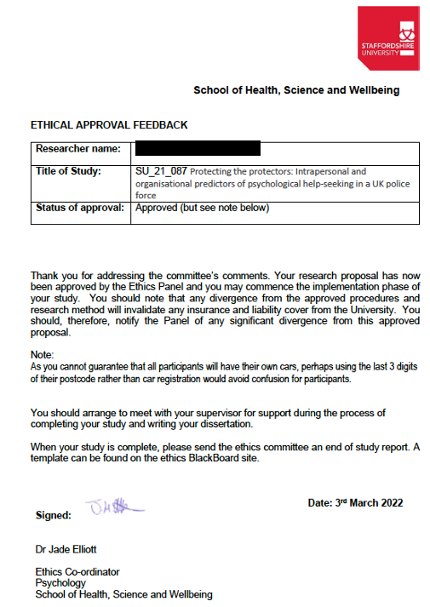

Approval from West Midlands Police:

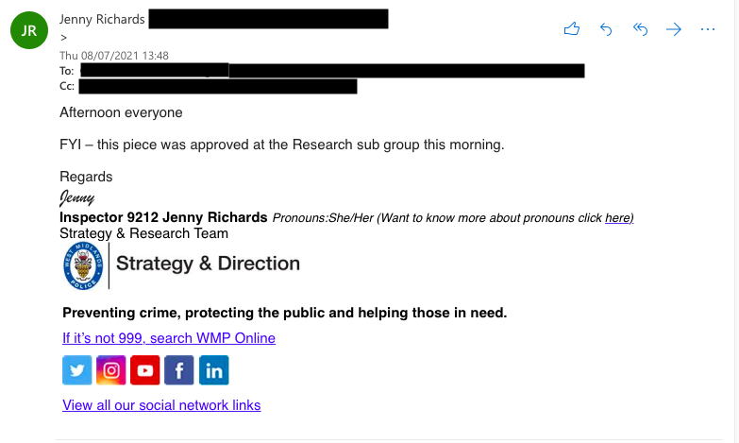

Appendix C – Participant Information Sheet

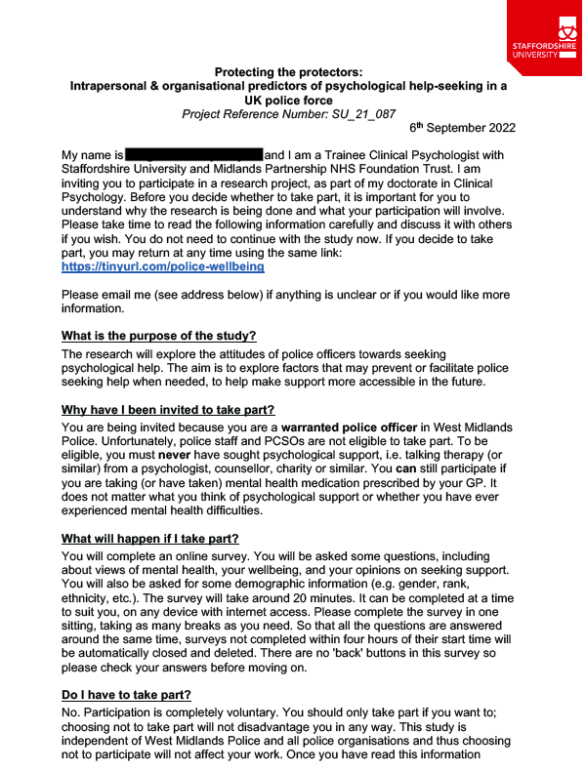
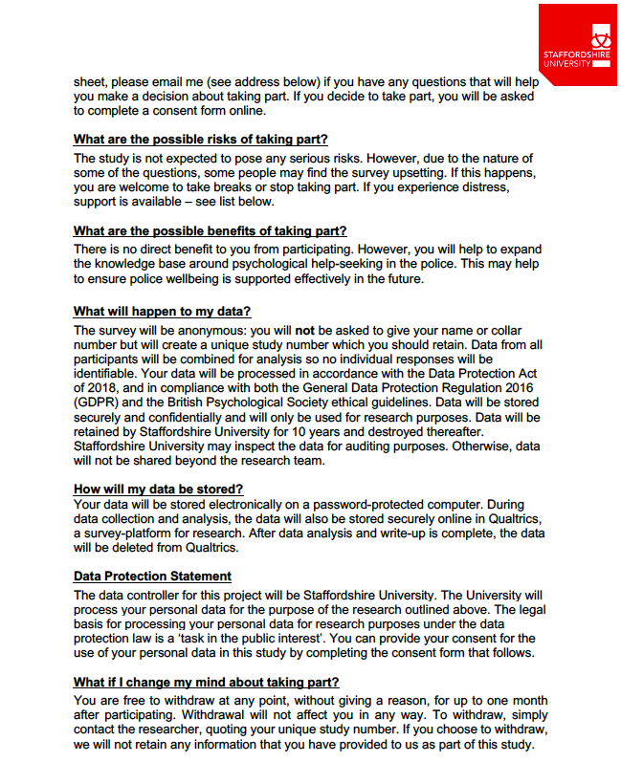

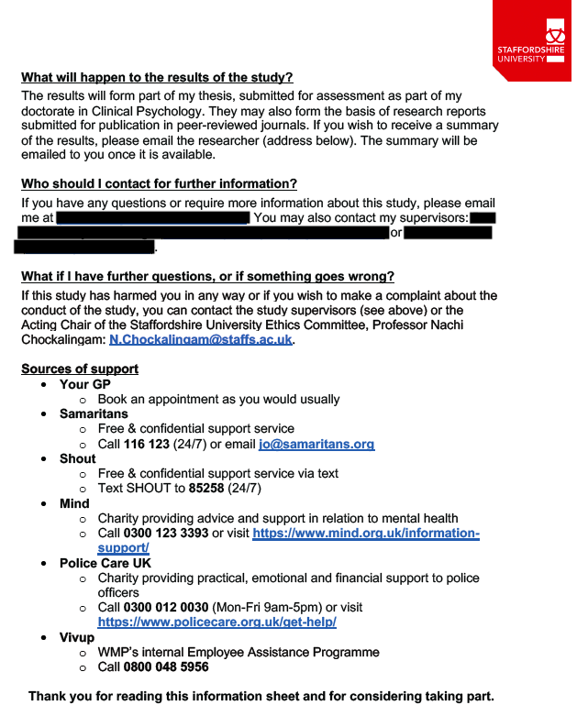

Appendix D – Participant Consent Form
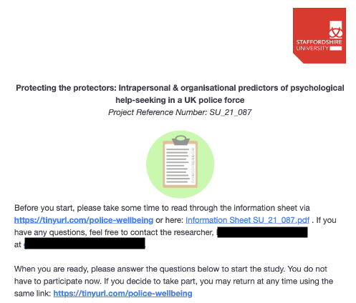
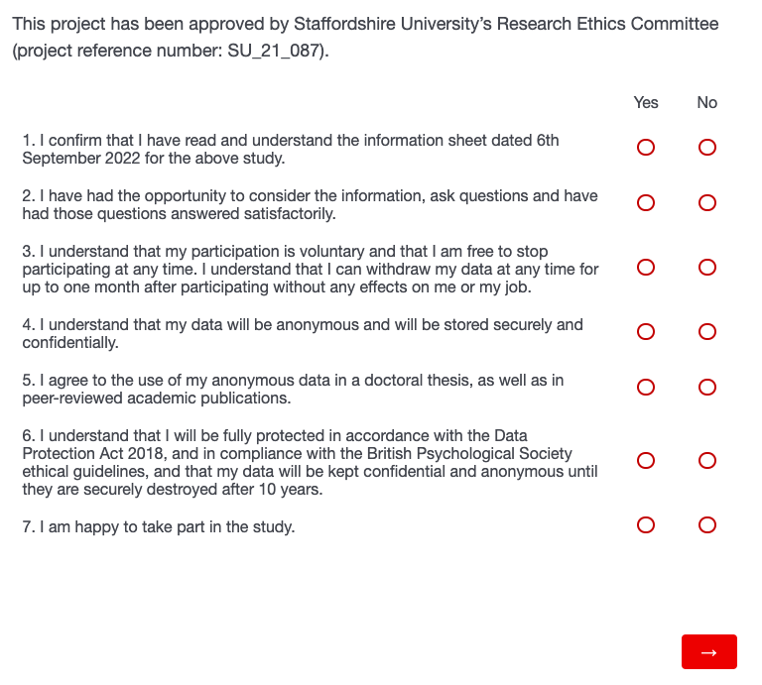

Appendix E – Demographics Response Options

Age
- Question: How old are you?
- Response options:
  - Drop-down menu, with choices from 18 to 100
  - ‘Prefer not to say’

Gender
- Question: What best describes your gender?
- Response options:
  - Female
  - Male
  - Prefer to self-describe (free text box)
  - Prefer not to say
- Following guidance from Stonewall (Pasterny et al., 2016)

Ethnicity
- Question: What is your ethnicity?
- Response options:
  - Asian or Asian British
    - Indian
    - Pakistani
    - Bangladeshi
    - Chinese
    - Any other Asian background
  - Black, Black British, Caribbean or African
    - Caribbean
    - African
    - Any other Black, Black British, Caribbean or African background
  - Mixed or multiple ethnic groups
    - White and Black Caribbean
    - White and Black African
    - White and Asian
    - Any other Mixed or multiple ethnic background
  - Other ethnic group
    - Arab
    - Any other ethnic group
  - White
    - English, Welsh, Scottish, Northern Irish or British
    - Irish
    - Gypsy or Irish Traveller
    - Roma
    - Any other White background
  - Prefer to self-describe (free text box)
  - Prefer not to say
- Categories taken from the UK government’s 2021 Census of England and Wales (GOV.UK, n.d.)

Length of service
- Question: How long have you been working as a police officer?
- Response options:
  - Sliding scale from 0 (full) years to 70 years
  - Prefer not to say

Rank
- Question: What is your rank?
- Response options:
  - Constable
  - Sergeant
  - Inspector
  - Chief inspector
  - Superintendent
  - Chief Superintendent
  - Assistant Chief Constable
  - Deputy Chief Constable
  - Chief Constable
  - Other (free text box)
  - Prefer not to say

Department
- Question: What department do you work in?
- Response options:
  - Neighbourhood
  - Response
  - Traffic
  - Criminal Investigation Department (CID)
  - Public Protection
  - Firearms
  - Operational Support Unit (OSU)
  - Force Contact/Control Room
  - Custody
  - Learning and Development
  - Other (free text box)
  - Prefer not to say

References
GOV.UK. (n.d.). List of ethnic groups. https://www.ethnicity-facts-figures.service.gov.uk/style-guide/ethnic-groups
Pasterny, L., Sanders, K., & Long, A. (2016). Do ask, do tell. Stonewall. https://www.stonewall.org.uk/sites/default/files/do_ask_do_tell_guide_2016.pdf

Appendix F – Permission to Use Measures

CORE-OM

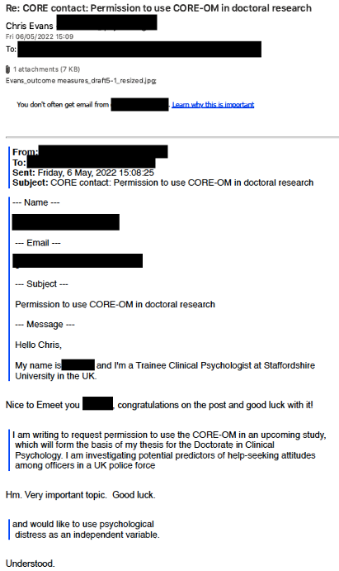
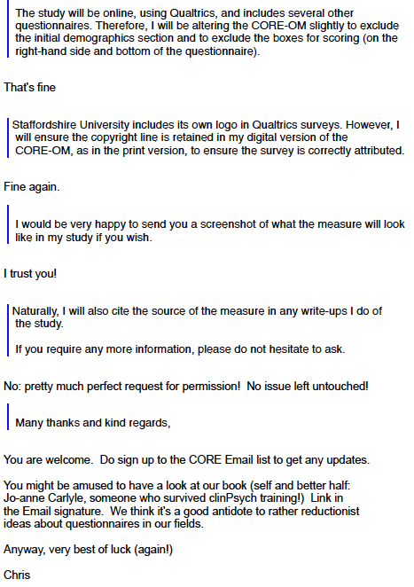
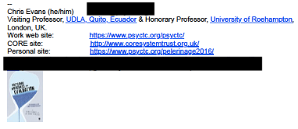

MMHLM
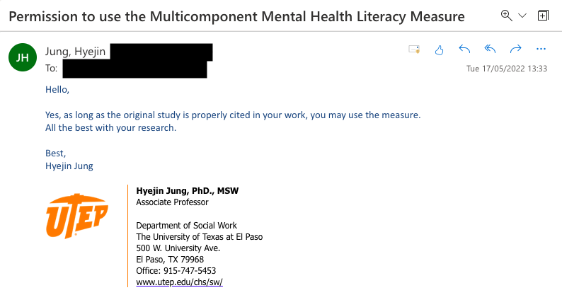

DDI
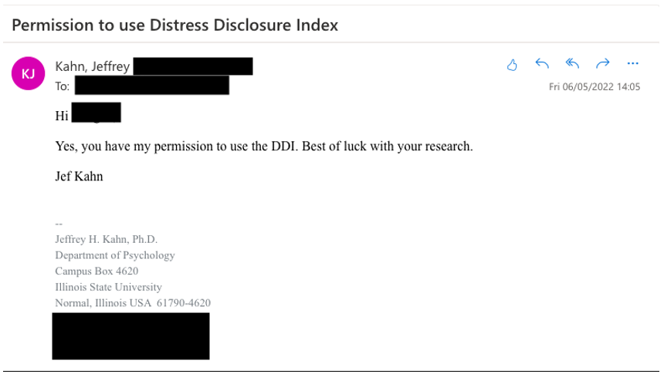

Appendix G – Details of the Multiple Imputation Model

Multiple imputation was carried out within SPSS Version 28.0 (IBM Corp, 2021). As recommended by Enders (2010), the model included all of the variables to be included in the main regression analyses (i.e., total IASMHS score, total CORE-OM score, total MMHLM score, total DDI score, length of service, and the POSS items), as well as several auxiliary variables (i.e., age, gender, ethnicity, rank, and department).

The variables were entered in the following order:
- Auxiliary variables (used for prediction only)
  - Age
  - Gender
  - Ethnicity
  - Rank
  - Department
- Analysis variables with no missing values (used for prediction only)
  - IASMHS Total
  - CORE-OM Total
  - MMHLM Total
  - DDI Total
- Analysis variables with missing values (imputed and used for prediction)
  - Length of service
  - POSS Q1
  - POSS Q2
  - POSS Q3
  - POSS Q4
  - POSS Q5
  - POSS Q6
  - POSS Q7
  - POSS Q8
  - POSS Q9
  - POSS Q10
  - POSS Q11

For the imputation analysis, the demographic variable Department was recoded to be of maximum use for imputing missing values. Specifically, departments specified under ‘Other’ which fitted at least two participants were included as a new Department category. Any departments selected by only one participant (whether in the original Department list or specified under ‘Other’) were group together as ‘Other’. The two participants who selected ‘Other’ but did not specify further were also subsumed under ‘Other’.

Current guidance on the number of imputations to calculate varies. However, a fairly conservative and commonly used estimate is to use at least as many imputations as the percentage of cases with missing values (Heymans & Eekhout, 2019; van Buuren, 2018). In the current study, this was 27% (26 cases with missing values out of 97 total cases), which was rounded up to 30 imputations.

As recommended by Heymans and Eekhout (2019), the Multivariate Imputation by Chained Equations (MICE) algorithm and Predictive Mean Matching (PMM) model were used, with the number of iterations set to 50. Convergence plots suggested adequate convergence.

Initial imputation attempts returned error messages as some of the demographic variables (especially rank and department) contained a very large number of parameters. Therefore, for the final imputation model, the number of parameters permitted was increased to 300. To permit replication of the multiple imputation procedure, the Random Number Generators in SPSS were set to 950 (Heymans & Eekhout, 2019).

References
Enders, C. K. (2010). Applied missing data analysis. The Guilford Press.
Heymans, M. W., & Eekhout, I. (2019). Applied missing data analysis with SPSS and (R)Studio. Bookdown. https://bookdown.org/mwheymans/bookmi/
IBM Corp. (2021). IBM SPSS statistics for Macintosh (28.0).
van Buuren, S. (2018). Flexible imputation of missing data (2nd ed.). Bookdown. https://stefvanbuuren.name/fimd/

Appendix H – SPSS Regression Tables (Regression Analysis with All Predictors)
ANOVAª
Imputation Number | Model |  | Sum of Squares | df | Mean Square | F | Sig.
Original data | 1 | Regression | 13553.676 | 5 | 2710.735 | 29.336 | <.001^{b}
Original data | 1 | Residual | 6006.183 | 65 | 92.403
Original data | 1 | Total | 19559.859 | 70
1 | 1 | Regression | 19733.779 | 5 | 3946.756 | 45.592 | <.001^{b}
1 | 1 | Residual | 7877.664 | 91 | 86.568
1 | 1 | Total | 27611.443 | 96
2 | 1 | Regression | 19803.064 | 5 | 3960.613 | 46.158 | <.001^{b}
2 | 1 | Residual | 7808.379 | 91 | 85.806
2 | 1 | Total | 27611.443 | 96
3 | 1 | Regression | 19779.229 | 5 | 3955.846 | 45.962 | <.001^{b}
3 | 1 | Residual | 7832.214 | 91 | 86.068
3 | 1 | Total | 27611.443 | 96
4 | 1 | Regression | 19852.282 | 5 | 3970.456 | 46.566 | <.001^{b}
4 | 1 | Residual | 7759.162 | 91 | 85.266
4 | 1 | Total | 27611.443 | 96
5 | 1 | Regression | 19769.864 | 5 | 3953.973 | 45.885 | <.001^{b}
5 | 1 | Residual | 7841.579 | 91 | 86.171
5 | 1 | Total | 27611.443 | 96
6 | 1 | Regression | 19780.488 | 5 | 3956.098 | 45.972 | <.001^{b}
6 | 1 | Residual | 7830.955 | 91 | 86.054
6 | 1 | Total | 27611.443 | 96
7 | 1 | Regression | 19794.791 | 5 | 3958.958 | 46.089 | <.001^{b}
7 | 1 | Residual | 7816.652 | 91 | 85.897
7 | 1 | Total | 27611.443 | 96
8 | 1 | Regression | 19845.780 | 5 | 3969.156 | 46.512 | <.001^{b}
8 | 1 | Residual | 7765.664 | 91 | 85.337
8 | 1 | Total | 27611.443 | 96
9 | 1 | Regression | 19837.483 | 5 | 3967.497 | 46.443 | <.001^{b}
9 | 1 | Residual | 7773.960 | 91 | 85.428
9 | 1 | Total | 27611.443 | 96
10 | 1 | Regression | 19870.708 | 5 | 3974.142 | 46.720 | <.001^{b}
10 | 1 | Residual | 7740.735 | 91 | 85.063
10 | 1 | Total | 27611.443 | 96
11 | 1 | Regression | 19879.742 | 5 | 3975.948 | 46.796 | <.001^{b}
11 | 1 | Residual | 7731.702 | 91 | 84.964
11 | 1 | Total | 27611.443 | 96
12 | 1 | Regression | 19765.864 | 5 | 3953.173 | 45.852 | <.001^{b}
12 | 1 | Residual | 7845.580 | 91 | 86.215
12 | 1 | Total | 27611.443 | 96
13 | 1 | Regression | 19820.087 | 5 | 3964.017 | 46.298 | <.001^{b}
13 | 1 | Residual | 7791.356 | 91 | 85.619
13 | 1 | Total | 27611.443 | 96
14 | 1 | Regression | 19862.520 | 5 | 3972.504 | 46.651 | <.001^{b}
14 | 1 | Residual | 7748.924 | 91 | 85.153
14 | 1 | Total | 27611.443 | 96
15 | 1 | Regression | 19870.011 | 5 | 3974.002 | 46.714 | <.001^{b}
15 | 1 | Residual | 7741.432 | 91 | 85.071
15 | 1 | Total | 27611.443 | 96
16 | 1 | Regression | 19831.533 | 5 | 3966.307 | 46.393 | <.001^{b}
16 | 1 | Residual | 7779.911 | 91 | 85.494
16 | 1 | Total | 27611.443 | 96
17 | 1 | Regression | 19847.139 | 5 | 3969.428 | 46.523 | <.001^{b}
17 | 1 | Residual | 7764.304 | 91 | 85.322
17 | 1 | Total | 27611.443 | 96
18 | 1 | Regression | 19794.540 | 5 | 3958.908 | 46.087 | <.001^{b}
18 | 1 | Residual | 7816.903 | 91 | 85.900
18 | 1 | Total | 27611.443 | 96
19 | 1 | Regression | 19799.433 | 5 | 3959.887 | 46.128 | <.001^{b}
19 | 1 | Residual | 7812.010 | 91 | 85.846
19 | 1 | Total | 27611.443 | 96
20 | 1 | Regression | 19884.899 | 5 | 3976.980 | 46.839 | <.001^{b}
20 | 1 | Residual | 7726.544 | 91 | 84.907
20 | 1 | Total | 27611.443 | 96
21 | 1 | Regression | 19933.715 | 5 | 3986.743 | 47.253 | <.001^{b}
21 | 1 | Residual | 7677.729 | 91 | 84.371
21 | 1 | Total | 27611.443 | 96
22 | 1 | Regression | 19932.907 | 5 | 3986.581 | 47.246 | <.001^{b}
22 | 1 | Residual | 7678.536 | 91 | 84.380
22 | 1 | Total | 27611.443 | 96
23 | 1 | Regression | 19905.263 | 5 | 3981.053 | 47.011 | <.001^{b}
23 | 1 | Residual | 7706.181 | 91 | 84.683
23 | 1 | Total | 27611.443 | 96
24 | 1 | Regression | 19816.994 | 5 | 3963.399 | 46.273 | <.001^{b}
24 | 1 | Residual | 7794.449 | 91 | 85.653
24 | 1 | Total | 27611.443 | 96
25 | 1 | Regression | 19754.411 | 5 | 3950.882 | 45.759 | <.001^{b}
25 | 1 | Residual | 7857.032 | 91 | 86.341
25 | 1 | Total | 27611.443 | 96
26 | 1 | Regression | 19859.694 | 5 | 3971.939 | 46.628 | <.001^{b}
26 | 1 | Residual | 7751.750 | 91 | 85.184
26 | 1 | Total | 27611.443 | 96
27 | 1 | Regression | 19858.805 | 5 | 3971.761 | 46.620 | <.001^{b}
27 | 1 | Residual | 7752.638 | 91 | 85.194
27 | 1 | Total | 27611.443 | 96
28 | 1 | Regression | 19780.527 | 5 | 3956.105 | 45.972 | <.001^{b}
28 | 1 | Residual | 7830.917 | 91 | 86.054
28 | 1 | Total | 27611.443 | 96
29 | 1 | Regression | 19811.229 | 5 | 3962.246 | 46.225 | <.001^{b}
29 | 1 | Residual | 7800.215 | 91 | 85.717
29 | 1 | Total | 27611.443 | 96
30 | 1 | Regression | 19695.379 | 5 | 3939.076 | 45.282 | <.001^{b}
30 | 1 | Residual | 7916.064 | 91 | 86.990
30 | 1 | Total | 27611.443 | 96
a. Dependent Variable: IASMHS Total score
b. Predictors: (Constant), POSS Total score, Length of service (in completed years), MMHLM Total score, Overall CORE score (personal mean x 10), DDI Total score

Appendix I – SPSS Histograms and Normal Probability Plots (Regression Analysis with All Predictors)
Histograms of the standardised residuals for each imputation:

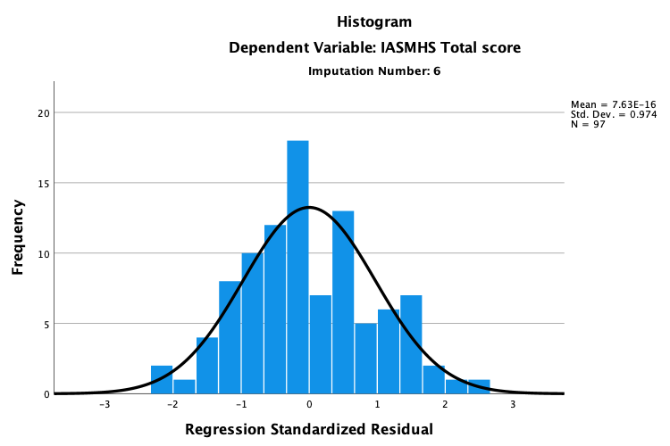 | 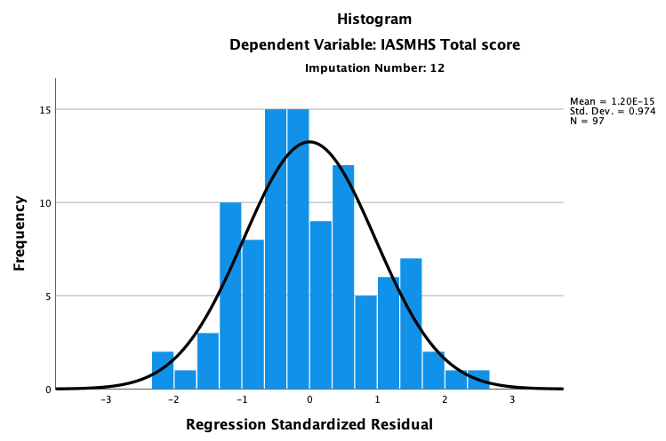
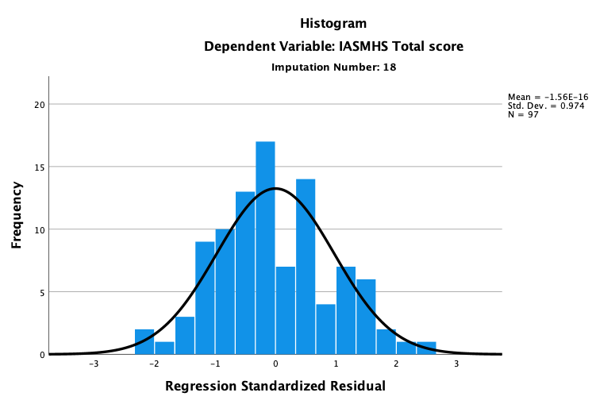 | 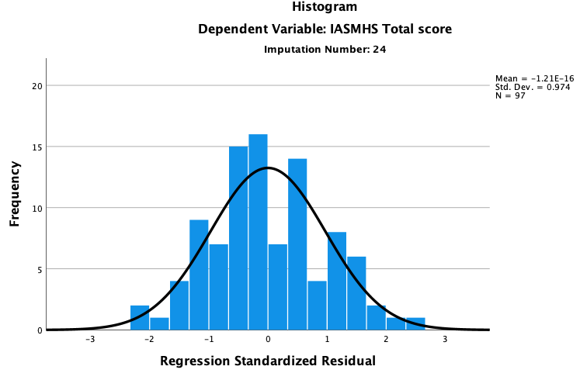
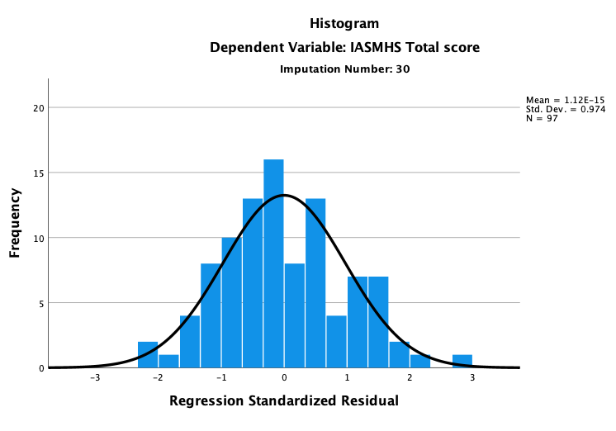

P-P plots of standardised residuals for each imputation:

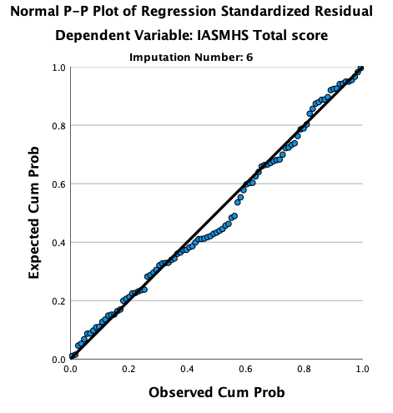 | 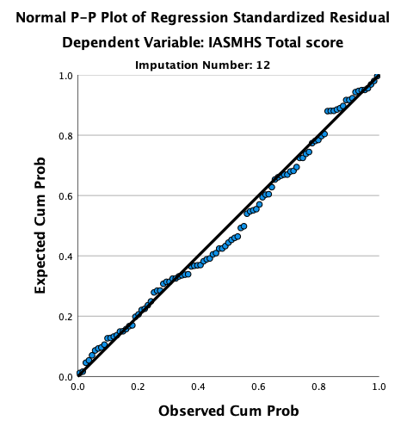
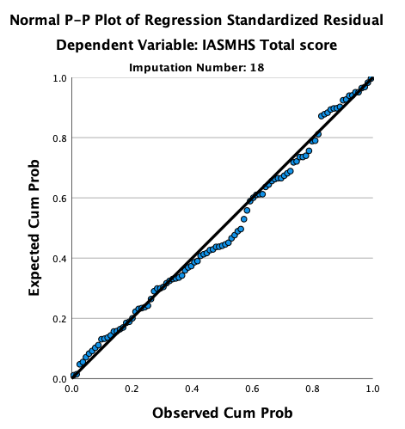 | 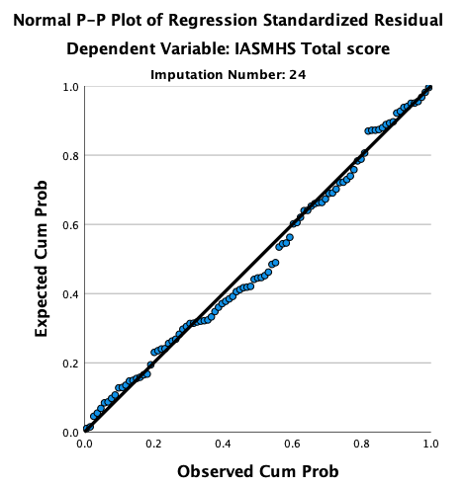
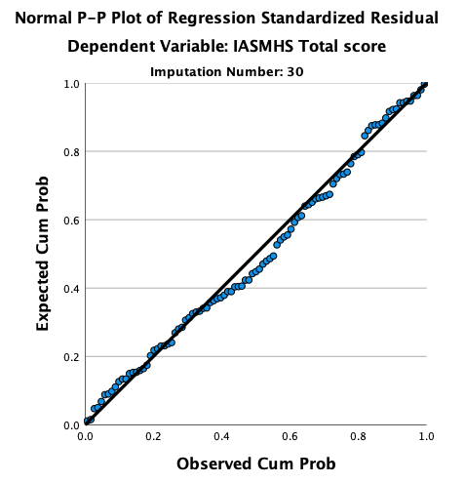

Appendix J – SPSS Scatterplots and Partial Regression Plots (Regression Analysis with All Predictors)
Scatterplots of standardised predicted values against standardised residuals for 5 imputations:

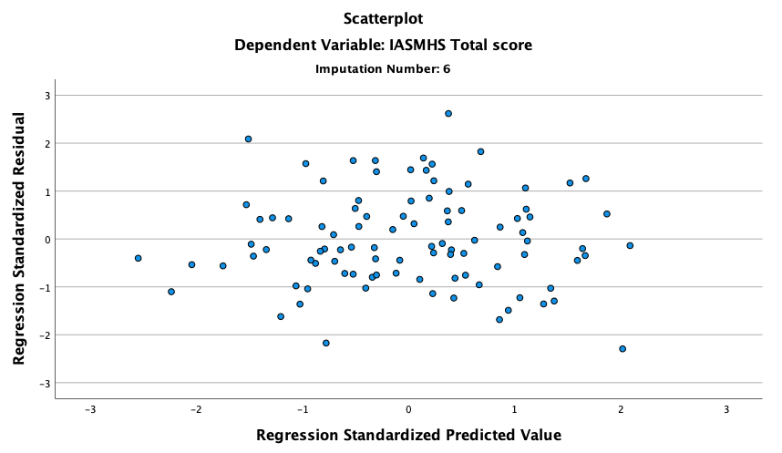 | 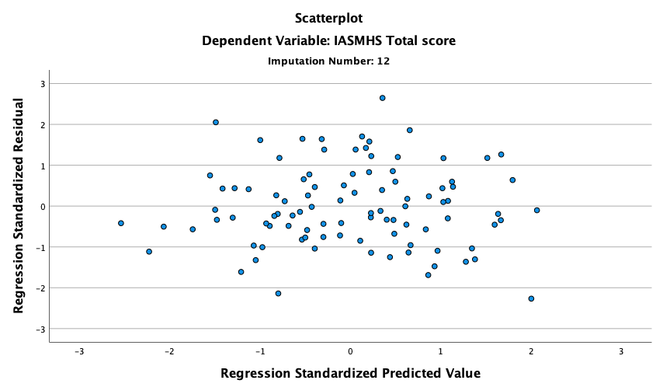
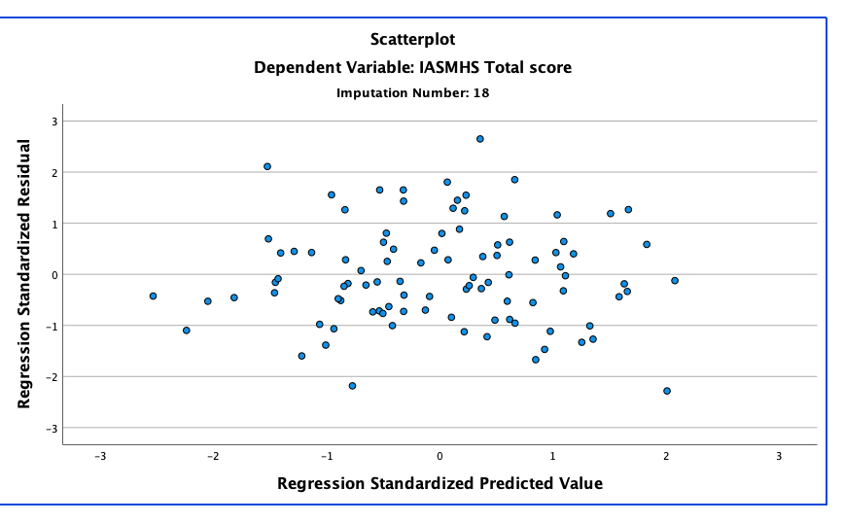 | 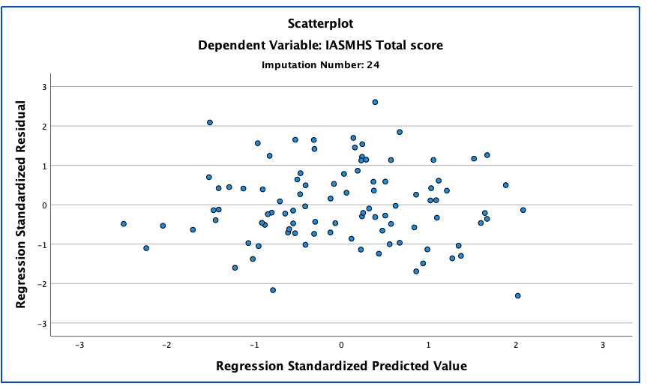
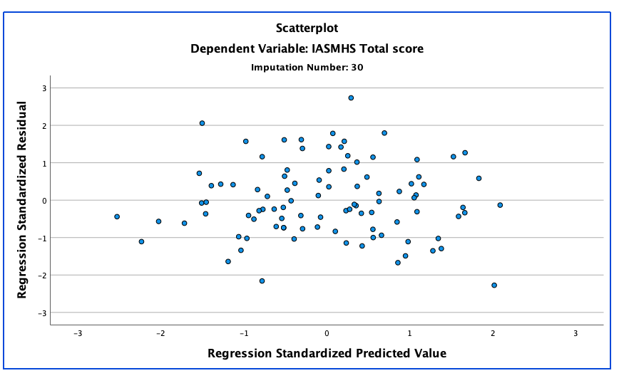

Partial regression plots for length of service:

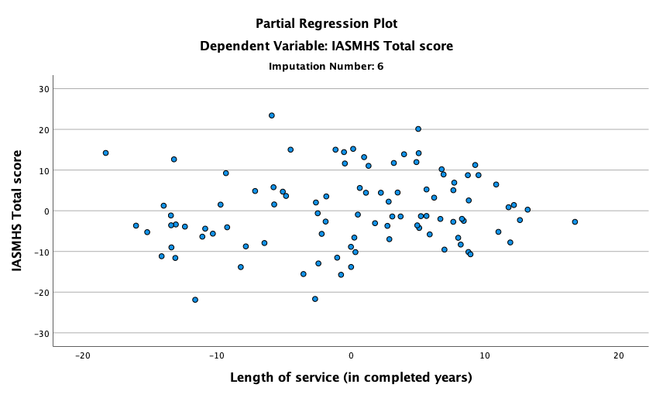 | 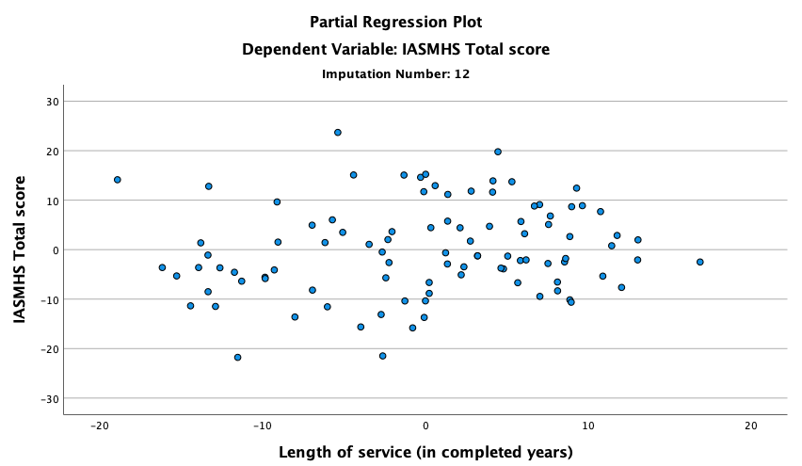
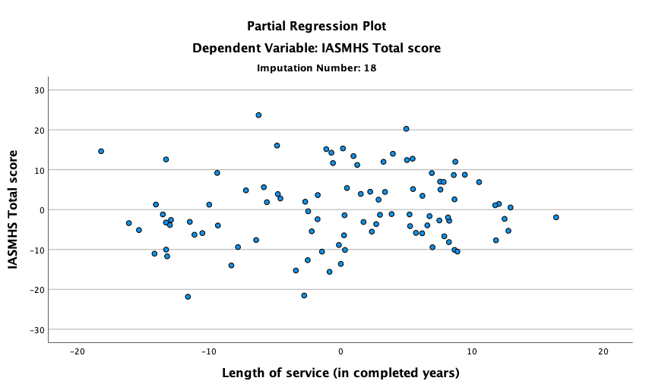 | 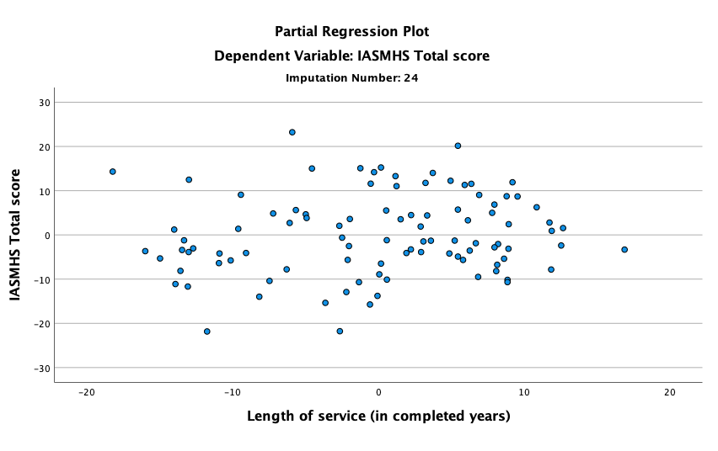
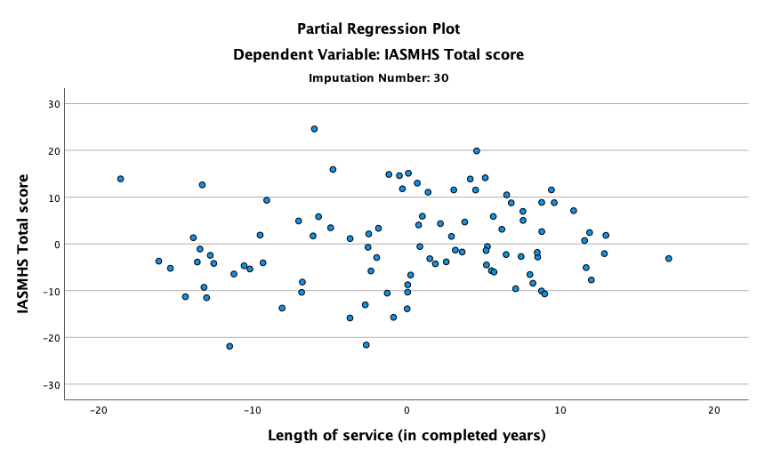

Partial regression plots for current psychological distress (CORE-OM):

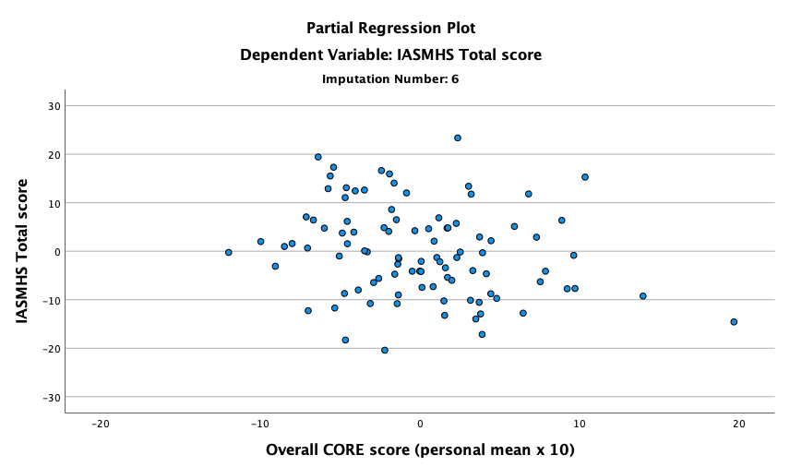 | 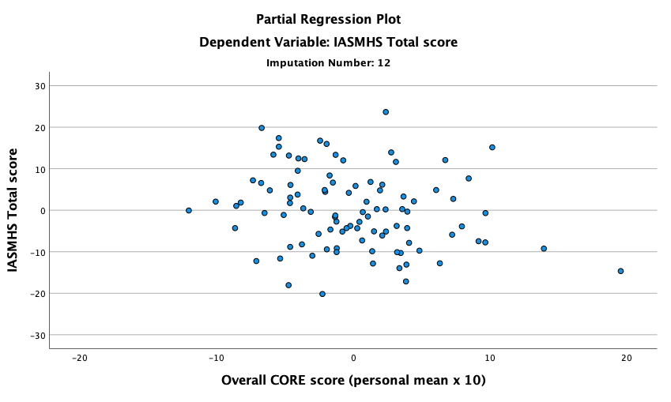
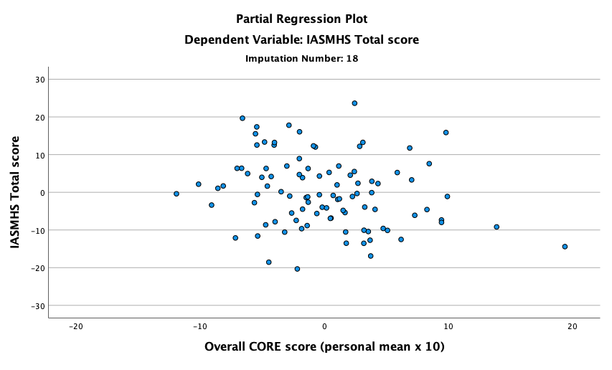 | 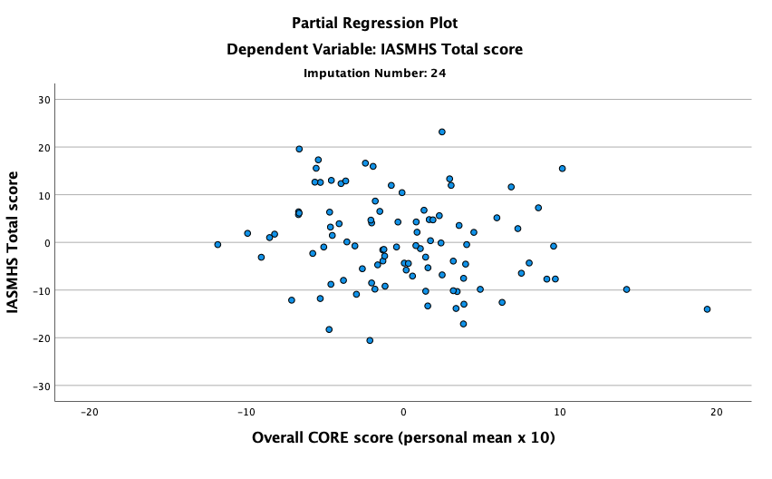
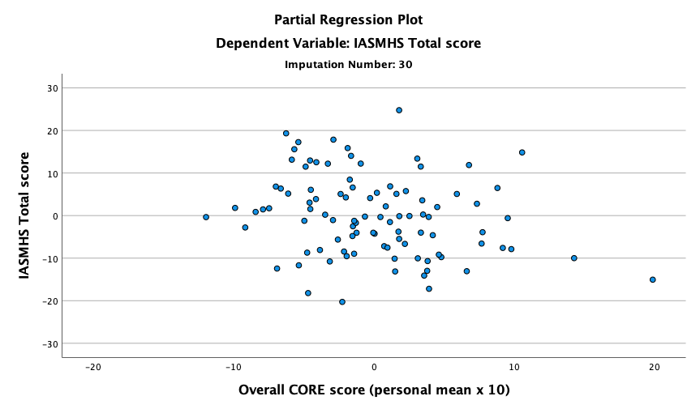

Partial regression plots for mental health literacy (MMHLM):

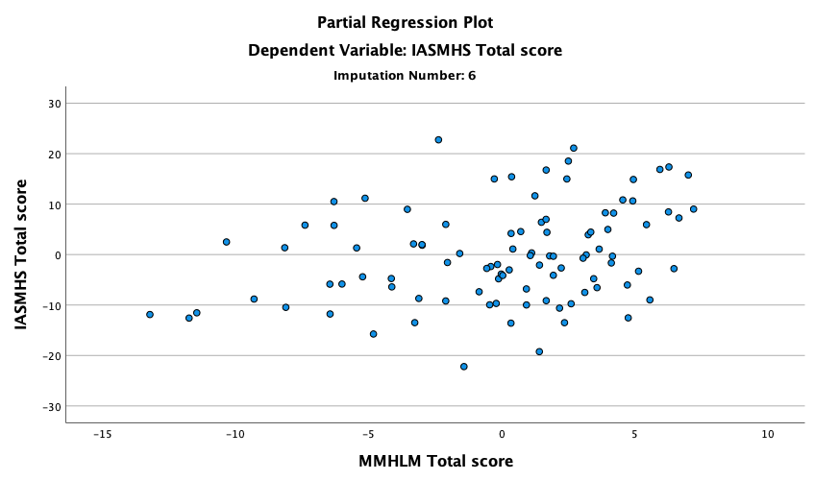 | 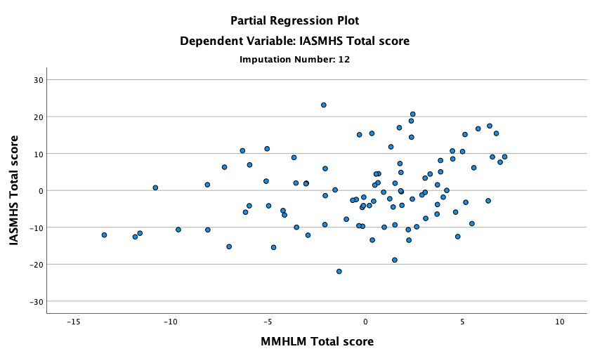
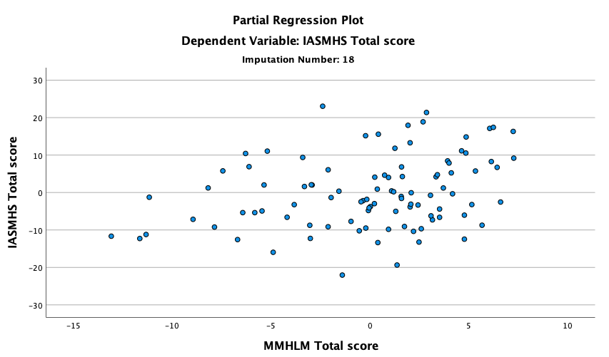 | 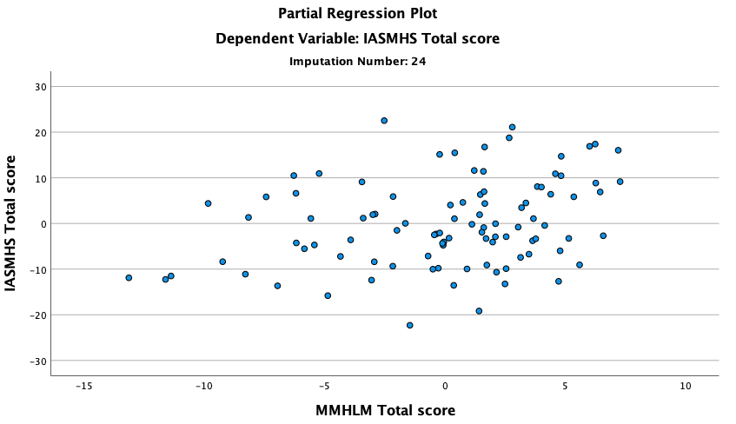
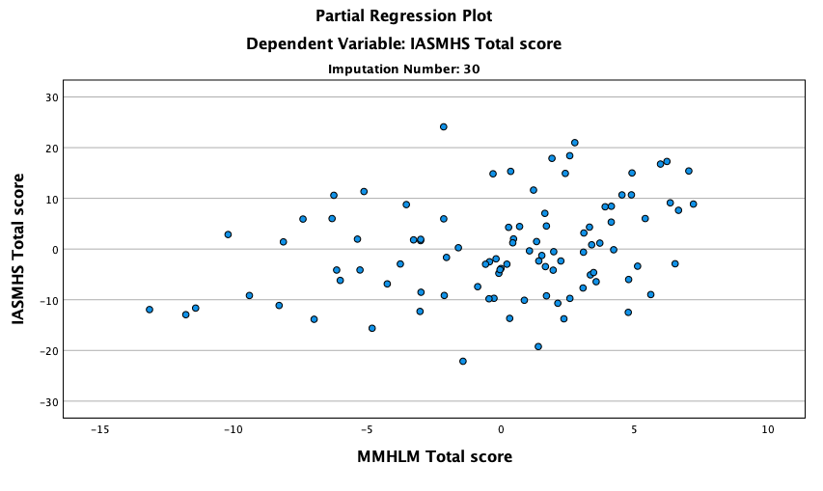

Partial regression plots for distress disclosure (DDI):

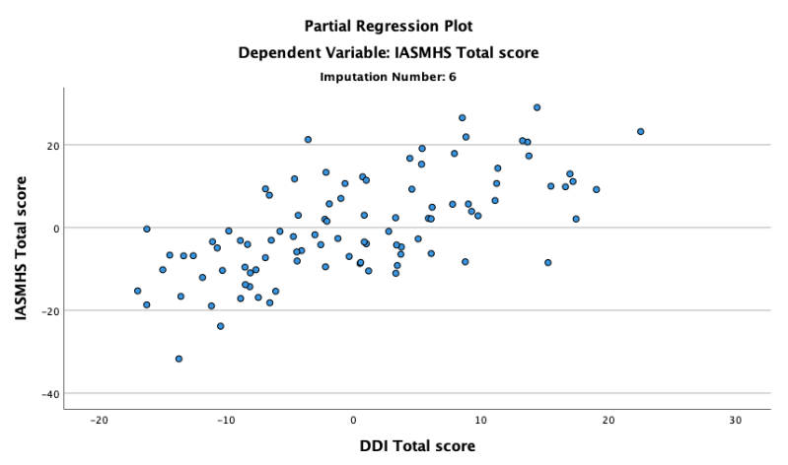 | 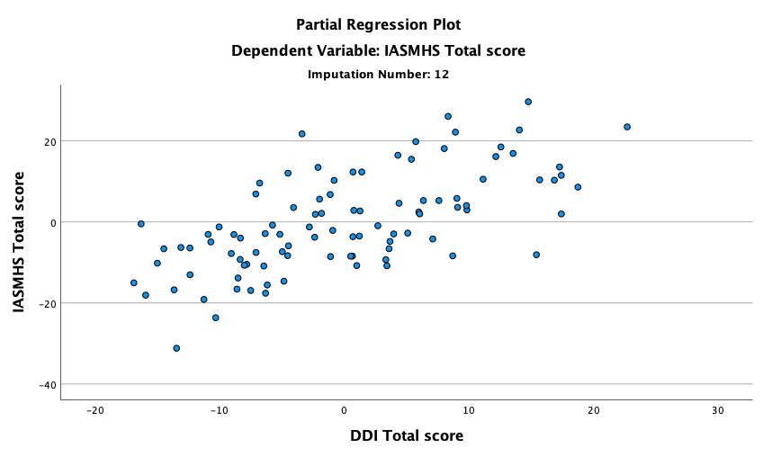
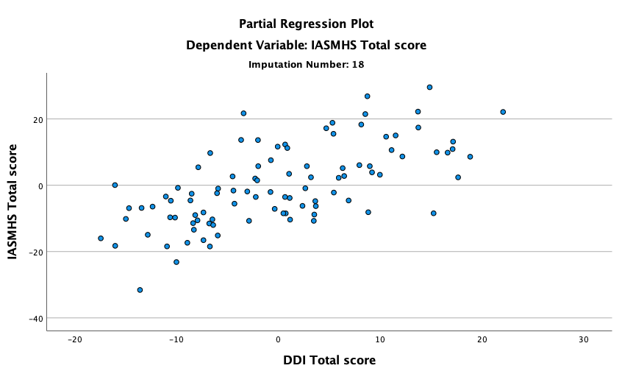 | 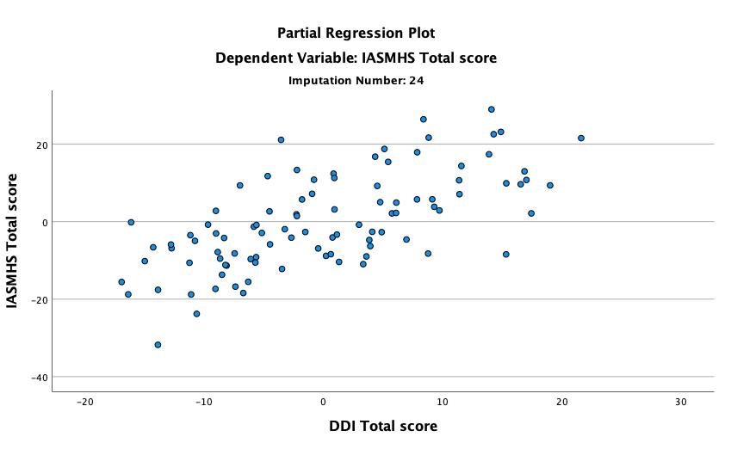
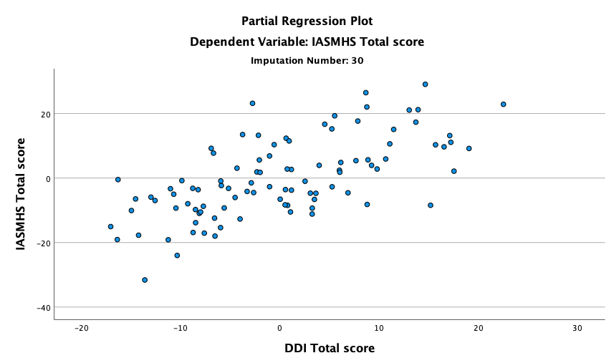

Partial regression plots for perceived organisational stigma (POSS):

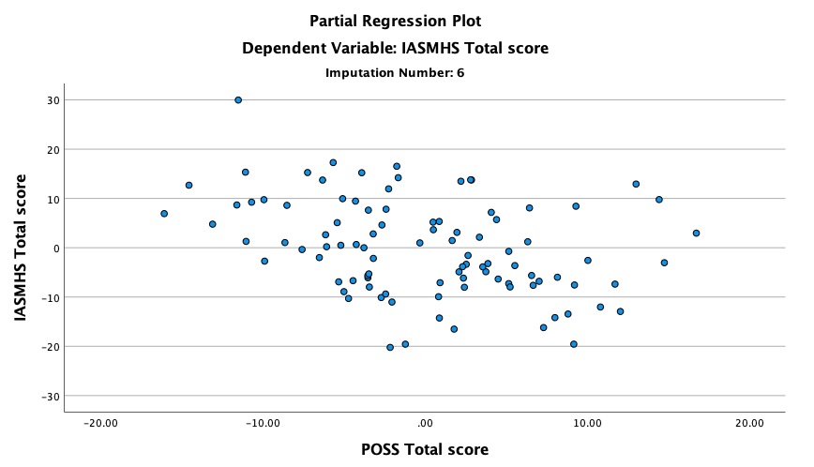 | 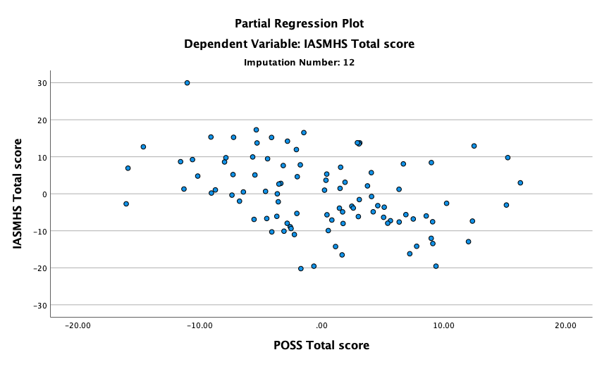
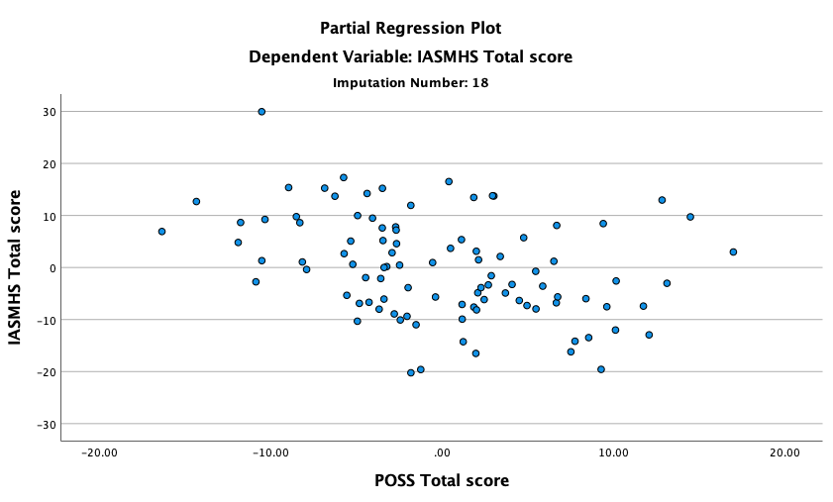 | 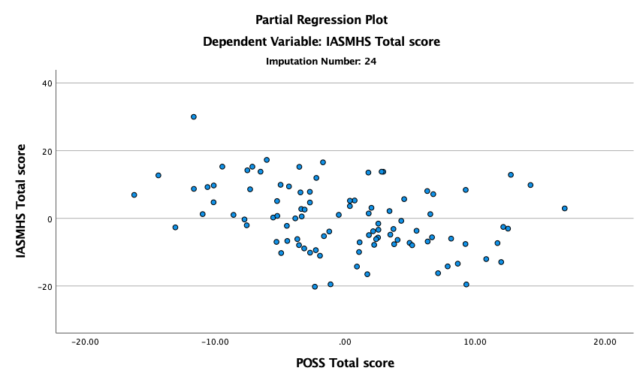
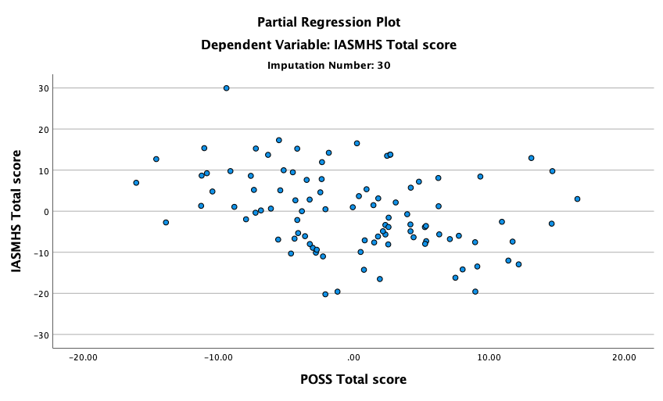

Appendix K – SPSS Regression Tables (Regression Analysis with Only Significant Predictors)

ANOVAª
Imputation Number | Model |  | Sum of Squares | df | Mean Square | F | Sig.
Original data | 1 | Regression | 13607.250 | 4 | 3401.813 | 37.106 | <.001^{b}
Original data | 1 | Residual | 6142.402 | 67 | 91.678
Original data | 1 | Total | 19749.653 | 71
1 | 1 | Regression | 19589.492 | 4 | 4897.373 | 56.166 | <.001^{b}
1 | 1 | Residual | 8021.951 | 92 | 87.195
1 | 1 | Total | 27611.443 | 96
2 | 1 | Regression | 19668.371 | 4 | 4917.093 | 56.952 | <.001^{b}
2 | 1 | Residual | 7943.073 | 92 | 86.338
2 | 1 | Total | 27611.443 | 96
3 | 1 | Regression | 19631.617 | 4 | 4907.904 | 56.584 | <.001^{b}
3 | 1 | Residual | 7979.826 | 92 | 86.737
3 | 1 | Total | 27611.443 | 96
4 | 1 | Regression | 19733.869 | 4 | 4933.467 | 57.617 | <.001^{b}
4 | 1 | Residual | 7877.574 | 92 | 85.626
4 | 1 | Total | 27611.443 | 96
5 | 1 | Regression | 19627.398 | 4 | 4906.849 | 56.542 | <.001^{b}
5 | 1 | Residual | 7984.045 | 92 | 86.783
5 | 1 | Total | 27611.443 | 96
6 | 1 | Regression | 19639.928 | 4 | 4909.982 | 56.667 | <.001^{b}
6 | 1 | Residual | 7971.515 | 92 | 86.647
6 | 1 | Total | 27611.443 | 96
7 | 1 | Regression | 19638.998 | 4 | 4909.750 | 56.657 | <.001^{b}
7 | 1 | Residual | 7972.445 | 92 | 86.657
7 | 1 | Total | 27611.443 | 96
8 | 1 | Regression | 19675.894 | 4 | 4918.974 | 57.028 | <.001^{b}
8 | 1 | Residual | 7935.549 | 92 | 86.256
8 | 1 | Total | 27611.443 | 96
9 | 1 | Regression | 19684.199 | 4 | 4921.050 | 57.111 | <.001^{b}
9 | 1 | Residual | 7927.244 | 92 | 86.166
9 | 1 | Total | 27611.443 | 96
10 | 1 | Regression | 19724.370 | 4 | 4931.092 | 57.519 | <.001^{b}
10 | 1 | Residual | 7887.073 | 92 | 85.729
10 | 1 | Total | 27611.443 | 96
11 | 1 | Regression | 19736.193 | 4 | 4934.048 | 57.640 | <.001^{b}
11 | 1 | Residual | 7875.250 | 92 | 85.601
11 | 1 | Total | 27611.443 | 96
12 | 1 | Regression | 19593.168 | 4 | 4898.292 | 56.202 | <.001^{b}
12 | 1 | Residual | 8018.275 | 92 | 87.155
12 | 1 | Total | 27611.443 | 96
13 | 1 | Regression | 19681.682 | 4 | 4920.420 | 57.086 | <.001^{b}
13 | 1 | Residual | 7929.762 | 92 | 86.193
13 | 1 | Total | 27611.443 | 96
14 | 1 | Regression | 19718.498 | 4 | 4929.625 | 57.460 | <.001^{b}
14 | 1 | Residual | 7892.945 | 92 | 85.793
14 | 1 | Total | 27611.443 | 96
15 | 1 | Regression | 19716.884 | 4 | 4929.221 | 57.443 | <.001^{b}
15 | 1 | Residual | 7894.559 | 92 | 85.810
15 | 1 | Total | 27611.443 | 96
16 | 1 | Regression | 19695.923 | 4 | 4923.981 | 57.230 | <.001^{b}
16 | 1 | Residual | 7915.521 | 92 | 86.038
16 | 1 | Total | 27611.443 | 96
17 | 1 | Regression | 19702.465 | 4 | 4925.616 | 57.296 | <.001^{b}
17 | 1 | Residual | 7908.979 | 92 | 85.967
17 | 1 | Total | 27611.443 | 96
18 | 1 | Regression | 19668.189 | 4 | 4917.047 | 56.950 | <.001^{b}
18 | 1 | Residual | 7943.255 | 92 | 86.340
18 | 1 | Total | 27611.443 | 96
19 | 1 | Regression | 19653.647 | 4 | 4913.412 | 56.804 | <.001^{b}
19 | 1 | Residual | 7957.797 | 92 | 86.498
19 | 1 | Total | 27611.443 | 96
20 | 1 | Regression | 19744.834 | 4 | 4936.208 | 57.729 | <.001^{b}
20 | 1 | Residual | 7866.610 | 92 | 85.507
20 | 1 | Total | 27611.443 | 96
21 | 1 | Regression | 19784.755 | 4 | 4946.189 | 58.141 | <.001^{b}
21 | 1 | Residual | 7826.689 | 92 | 85.073
21 | 1 | Total | 27611.443 | 96
22 | 1 | Regression | 19799.561 | 4 | 4949.890 | 58.295 | <.001^{b}
22 | 1 | Residual | 7811.882 | 92 | 84.912
22 | 1 | Total | 27611.443 | 96
23 | 1 | Regression | 19774.746 | 4 | 4943.687 | 58.037 | <.001^{b}
23 | 1 | Residual | 7836.697 | 92 | 85.181
23 | 1 | Total | 27611.443 | 96
24 | 1 | Regression | 19671.504 | 4 | 4917.876 | 56.983 | <.001^{b}
24 | 1 | Residual | 7939.939 | 92 | 86.304
24 | 1 | Total | 27611.443 | 96
25 | 1 | Regression | 19593.049 | 4 | 4898.262 | 56.201 | <.001^{b}
25 | 1 | Residual | 8018.394 | 92 | 87.156
25 | 1 | Total | 27611.443 | 96
26 | 1 | Regression | 19715.120 | 4 | 4928.780 | 57.425 | <.001^{b}
26 | 1 | Residual | 7896.324 | 92 | 85.830
26 | 1 | Total | 27611.443 | 96
27 | 1 | Regression | 19702.871 | 4 | 4925.718 | 57.301 | <.001^{b}
27 | 1 | Residual | 7908.572 | 92 | 85.963
27 | 1 | Total | 27611.443 | 96
28 | 1 | Regression | 19626.020 | 4 | 4906.505 | 56.528 | <.001^{b}
28 | 1 | Residual | 7985.423 | 92 | 86.798
28 | 1 | Total | 27611.443 | 96
29 | 1 | Regression | 19659.492 | 4 | 4914.873 | 56.863 | <.001^{b}
29 | 1 | Residual | 7951.951 | 92 | 86.434
29 | 1 | Total | 27611.443 | 96
30 | 1 | Regression | 19545.993 | 4 | 4886.498 | 55.739 | <.001^{b}
30 | 1 | Residual | 8065.450 | 92 | 87.668
30 | 1 | Total | 27611.443 | 96
a. Dependent Variable: IASMHS Total score
b. Predictors: (Constant), POSS Total score, MMHLM Total score, Overall CORE score (personal mean x 10), DDI Total score

Appendix L – Comparison of Force and Sample Demographics

Table 6
Demographic Composition of WMP Compared to the Current Sample
Characteristic | Statistics
Characteristic | WMP Police Officers (N = 7,838) | Current Sample  (N = 97)
Gender  - Female  - Male  - Prefer not to say | 35.7%  64.3%  0.0% | 39.2%  59.8%  1.0%
Age  - 18-20 years old  - 21-25 years old  - 26-30 years old  - 31-40 years old  - 41-50 years old  - 51-60 years old  - 61-65 years old  - Over 65 years old  - Prefer not to say | Mean = 38 years  1.5%  11.9%  13.9%  24.0%  28.4%  17.2%  2.6%  0.5%  0.0% | Mean = 41.03 yearsª  0.0%  5.0%  9.3%  30.0%  44.4%  10.2%  0.0%  0.0%  1.0%
Ethnicity  - White British  - White Other  - Ethnic Minority Groups  - Not stated  - Prefer not to say | 82.4%  2.9%  13.8%  0.4%  0.5% | 87.6%  4.1%  5.1%  0.0%  3.1%
Length of service  - Less than 2 years  - 2-5 years  - 6-10 years  - 11-15 years  - 16-20 years  - 21-25 years  - 26-30 years  - 30+ years  - Prefer not to say | Mean = 12 years  Range = 0-36 years  17.9%  23.0%  4.7%  14.0%  21.0%  13.3%  6.1%  0.1%  0.0% | Mean = 16.07 yearsª  Range = 0-31 yearsª  4.1%  14.5%  6.2%  16.5%  19.6%  29.8%  7.2%  1.0%  1.0%
Rank  - Constable  - Sergeant  - Inspector  - Chief Inspector  - Superintendent  - Chief Superintendent  - Chief Officers  - Prefer not to say  - Missing | 80.5%  14.0%  3.7%  0.9%  0.6%  0.3%  0.1%  0.0%  0.0% | 42.3%  34.0%  13.4%  7.2%  1.0%  0.0%  0.0%  1.0%  1.0%
Department  - Neighbourhood  - Response  - Criminal Investigation Department (CID)  - Public Protection  - Operations  - Regional Organised Crime Unit  - Counter Terrorism Unit  - Force Contact  - Motorway Policing  - Criminal Justice Services  - Intelligence  - Organisation Development and Learning  - Forensic Services  - Integrated Offender Management  - Other  - Prefer not to say | 21.7%  18.0%  17.6%  10.3%  9.3%  4.4%  3.9%  2.1%  2.1%  1.8%  1.6%  1.4%  0.3%  0.1%  5.4%  0.0% | 17.5%  15.5%  16.5%  7.2%  10.3%  4.1%  3.1%  1.0%  2.1%  4.1%  3.1%  1.0%  1.0%  5.2%  2.1%  6.2%
Note. ª Calculated based on officers who provided this information (n = 96 in both cases).

Paper 3: Executive Summary

What predicts police officers’ attitudes towards seeking psychological help? Examining individual and organisational factors

Word count: 2,498 words


What predicts police officers’ attitudes towards seeking psychological help? Examining individual and organisational factors
This is a summary of a research project undertaken with West Midlands Police (WMP) as part of the author’s Doctorate in Clinical Psychology. It has been written for the research participants, the wider police force, and related organisations. A police officer, an ex-police officer, and police researchers gave feedback on clarity and phrasing, which was incorporated into the summary.

Background



What do we know already?
Police officers are frequently exposed to traumatising situations (e.g., knife crime; Miller et al., 2022). They also experience organisational challenges, such as poor resources (Purba & Demou, 2019). Recently, there have been increased pressures on the police, including the COVID-19 pandemic (Newiss et al., 2022), gaps in mental health services (Her Majesty’s Chief Inspector of Constabulary, 2021), and public scrutiny (Verhaeghen & Aikman, 2022).

Therefore, it is unsurprising that police officers experience high levels of distress. In a recent UK survey, 77% of officers reported experiencing mental health difficulties (e.g., stress) within the past year (Elliott-Davies, 2021). 90% of these officers believed that their work had contributed. Officer wellbeing also affects public safety and the economy, through increased sick leave, lower productivity, and higher staff turnover (Cartwright & Roach, 2021; Chandler, 2021; Mojallal et al., 2022).


Nevertheless, police officers do not always seek psychological help (i.e., assistance from a trained mental health professional). In one study, 37.8% of UK officers felt unable to use their department’s mental health services (Ménard et al., 2016). Many studies have investigated why this might be. Results show that officers are more willing to seek help if they have sought help before, if they can access support through work, or if they have a mental health diagnosis (Asen & Colón, 1995; Daniel & Treece, 2022; DePierro et al., 2021; Karaffa & Koch, 2016; Lane et al., 2022). Officers are less open to help-seeking if they have more PTSD symptoms (DePierro et al., 2021; Ménard et al., 2016). These findings broadly fit with a recent theoretical model of psychological help-seeking (McLaren et al., 2023). However, a recent review of existing studies concluded that more research is needed (Grumley Traynor & Rydon-Grange, 2023).


What is the purpose of this study?
This study aimed to further explore some of the factors which affect police officers’ attitudes towards seeking psychological help.



Distress disclosure
The “tendency to talk to others about [one’s] distress” (Kahn & Hessling, 2001, p. 59).



Mental health literacy
Knowledge and beliefs which help people to recognise, manage, and prevent mental health difficulties (Jorm et al., 1997).

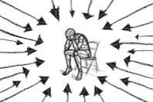


Organisational stigma
Prejudice within policing which may negatively affect help-seeking attitudes, such as expecting officers to hide emotion (Edwards & Kotera, 2021).

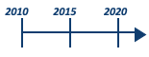

Length of service
How long officers have been in the police.

Distress
An uncomfortable emotional state which causes harm (Ridner, 2004).


Greater mental health literacy and greater distress disclosure seem to be associated with more positive help-seeking attitudes, and greater organisational stigma with more negative attitudes. However, these patterns have only been shown in one or two studies each. Distress and length of service have been studied more often but have had conflicting findings. During study design, WMP representatives predicted that newer-in-service officers would be more open to help-seeking, which further contradicts previous studies. Therefore, these factors need to be studied further (Grumley Traynor & Rydon-Grange, 2023).

Predicted findings
Table 1 shows what the researcher expected to find.

Table 1. Predicted Study Findings (Based on Previous Research)

Potential Predictor of Help-Seeking Attitudes |  |  | Predicted Finding
 | 
Greater mental health literacy | and greater distress disclosure | will predict |  | more positive help-seeking attitudes
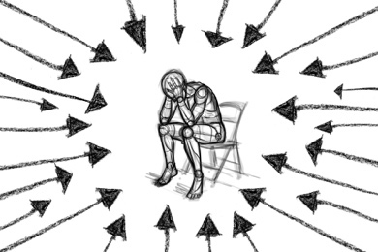
Greater organisational stigma |  | will predict |  | more negative help-seeking attitudes
 | 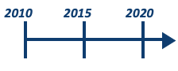 |  |  | 
Distress | and length of service | will predict |  | either more positive or more negative help-seeking attitudes

Method




How was the study designed?
The study was cross-sectional, meaning that all the data was collected at a single timepoint. The study was granted ethical approval by Staffordshire University, and was agreed with WMP’s research sub-group. A survey was conducted on the online platform Qualtrics. The survey was tested by a non-WMP police officer, an ex-officer, and police researchers. Force-level demographic data was provided by WMP’s Human Resources department.

How were participants recruited?
The survey was open from 9th September 2022 until 21st October 2022. WMP’s Wellbeing Manager posted the link on a virtual noticeboard and emailed officer distribution lists. People were eligible to take part if they were sworn police officers, who had never sought psychological help.

Who took part?
In total, 97 police officers participated. Participants were mostly White (91.8%), male (59.8%), and either constables (42.3%) or sergeants (34.0% — see Figures 1–3). Their average age was 41.0 years. The participants worked across various departments. On average, they had been a police officer for 16.1 years.



What did the survey involve?
Officers who clicked the survey link were asked to read an information sheet. If they wanted to participate, they had to complete an online consent form before they could access the survey. The survey first asked for participants’ gender, age, ethnicity, length of service, rank, and department. Participants then completed five questionnaires:
- The Inventory of Attitudes Toward Seeking Mental Health Services (Mackenzie et al., 2004) measured help-seeking attitudes. Participants rated 24 statements (e.g., “Having been mentally ill carries with it a burden of shame”) on a scale from ‘Disagree’ to ‘Agree’.
- The Clinical Outcomes in Routine Evaluation Outcome Measure (Evans et al., 2000) measured distress. Participants reported how often they had experienced 34 emotions, thoughts, and behaviours within the past week (e.g., “I have felt like crying”). Possible answers ranged from ‘Not at all’ to ‘Most or all the time’.
- The Multicomponent Mental Health Literacy Measure (Jung et al., 2016) measured mental health literacy. Participants responded to 26 statements (e.g., “Poor parenting causes schizophrenia”) on a scale from ‘Strongly disagree’ to ‘Strongly agree’ or as ‘Yes’ or ‘No’. Some answers were considered ‘correct’ and others ‘incorrect’ in relation to mental health literacy.
- The Distress Disclosure Index measured distress disclosure (Kahn & Hessling, 2001). Participants rated 12 statements (e.g., “When I feel upset, I usually confide in my friends”) on a scale from ‘Strongly disagree’ to ‘Strongly agree’.
- The Police Officer Stigma Scale (Stuart, 2017) measured organisational stigma. Participants rated 11 statements (e.g., “Most officers would not willingly accept a colleague with a mental illness as a partner”) from ‘Strongly disagree’ to ‘Strongly agree’. Alternatively, participants could skip each question by selecting ‘Don’t know’.





How was the data analysed?
A statistical method called multiple regression was used. Regression tests whether participants’ scores on one measure can predict their scores on another measure (e.g., does an officer’s level of distress predict how willing they are to seek psychological help?). Multiple regression was used to test whether officers’ scores on five different measures (i.e., distress, mental health literacy, distress disclosure, organisational stigma, and length of service) could predict their help-seeking attitudes.

Because of the ‘Don’t know’ option on the Police Officer Stigma Scale, 25 participants had some missing answers on this measure. Therefore, a statistical technique called multiple imputation was used. Multiple imputation estimates what answers the participant would have chosen (if there had been no ‘Don’t know’ option) based on how the participant answered all the other questions in the survey. Multiple imputation was also used to estimate length of service for one participant.

Due to the statistical characteristics of the data in this study, it would have been better to use a more advanced form of multiple regression analysis, called bootstrapping. However, bootstrapping cannot be used with multiple imputation. Therefore, the findings below should be interpreted with some caution, bearing this in mind. Ideally, the findings should be checked in future studies.

Key Findings

Prediction 1: Greater mental health literacy and greater distress disclosure will predict more positive help-seeking attitudes.
As predicted, officers who had greater mental health literacy had more positive attitudes towards seeking psychological support, regardless of their levels of distress, distress disclosure, or organisational stigma. Officers who talked more about their distress also had more positive help-seeking attitudes, regardless of their scores on the other measures. Of all the predictors, distress disclosure had the largest effect on help-seeking attitudes.

Prediction 2: Greater organisational stigma will predict more negative help-seeking attitudes.
As predicted, officers who reported more organisational stigma had more negative attitudes towards help-seeking, regardless of their other scores.

Prediction 3: Distress and length of service will predict either more positive or more negative help-seeking attitudes.
As expected, distress predicted help-seeking attitudes. Specifically, officers who were experiencing greater distress were less open to seeking support, regardless of their other scores. Contrary to expectations, length of service did not predict help-seeking attitudes. Officers’ willingness to seek help did not differ based on how long they had been in the police.

The findings are summarised in Table 2.

Table 2. Actual Findings in the Current Study

Potential Predictor of Help-Seeking Attitudes |  |  | Actual Finding
Greater mental health literacy | and greater distress disclosure | predicted |  | more positive help-seeking attitudes
Greater organisational stigma | and greater distress | predicted |  | more negative help-seeking attitudes
Length of service |  | did not predict |  | help-seeking attitudes

Conclusions & Recommendations

The study identified four factors which predict police officers’ attitudes towards seeking psychological help. Officers who understood more about mental health and officers who discussed their distress more both held more positive attitudes. In contrast, officers who reported more organisational stigma and officers who were in greater distress both held more negative attitudes.


Recommendations for Researchers
- In this study, greater organisational stigma predicted more negative help-seeking attitudes.
- Why did other studies find no relationship between officers’ help-seeking attitudes and particular aspects of organisational stigma?
- Perhaps different types of stigma have different effects. For example, officers may be reluctant to seek help if they believe that other officers would disagree with their decision. However, being fearful of their workplace in general may not affect officers’ help-seeking attitudes.

- In this study, officers who were experiencing more overall distress had more negative help-seeking attitudes.
- Why are officers who are more in need of help less willing to access it?
- Officers who are in greater distress may experience greater stigma.

- Why did some studies find that officers experiencing certain types of distress had more positive help-seeking attitudes? Why did some studies find no relationship between help-seeking attitudes and some types of distress?
- Perhaps different aspects of distress have different relationships with help-seeking. For example, officers may feel that thoughts of self-harm/suicide are more serious (and therefore require more help) than other types of distress.
- Why does McLaren et al.’s (2023) model of help-seeking suggest that people who feel they are struggling are more likely to seek help?
- Perhaps the relationship between help-seeking and distress is different in the police compared to the general population.

Overall, these findings are similar to what previous studies have found and to theoretical models of psychological help-seeking. There are a few differences which would be helpful to explore in future research.

- In this study, length of service did not predict help-seeking attitudes.
- Why did WMP representatives feel that newer-in-service officers seemed more open to seeking support?
- Perhaps there is a link between help-seeking attitudes and length of service, but only among the newest officers. In this study, newer-in-service officers were under-represented, so the link may not have been obvious.
- Why did some studies find that longer-in-service officers had more positive help-seeking attitudes?
- Perhaps the participants in those studies did not accurately represent all police officers. For example, 79.5% of one sample had been in the police for two years or less (Hyland et al., 2012).
- There may also be differences between police forces. Length of service might predict help-seeking in some forces but not others.


Recommendations for Police Forces
- Proactively offer psychological support to all officers, rather than waiting for officers to seek help when they are struggling. Consider using psychological surveillance and screening (see Tehrani and Hesketh, 2019).
- Consider introducing interventions which increase mental health literacy, increase distress disclosure, and decrease stigma. These factors were each independently linked to help-seeking attitudes, so targeting all three may be associated with three separate increases in help-seeking attitudes. Mental Health First Aid (Jorm et al., 2020) and the Canadian Road to Mental Readiness training (Knaak et al., 2019) are two intervention possibilities. Choose one that suits the force, and is thoroughly researched.





Limitations & Future Research
In this study, all the measures were completed at the same time. Therefore, we cannot know whether the predictors actually caused officers’ help-seeking attitudes to increase/decrease. Future studies could investigate this, such as by looking at changes in officers’ attitudes over time. Studies could also include more demographic predictors (e.g., gender). These were excluded because of concerns that there would not be enough participants for the analysis to work.

Because participants could select ‘Don’t know’ on the Police Officer Stigma Scale (POSS), 25 participants had missing answers, which had to be estimated. Future studies could leave out the ‘Don’t know’ option (as in Burzee et al., 2022). In general, more research is needed to check that the POSS is an accurate and consistent measure.

During study design, a police researcher highlighted that some of the language on the help-seeking measure was unclear. Similarly, the mental health literacy measure reflects a somewhat outdated view of mental health. For example, the answers to some statements (e.g., “Taking prescribed medications for mental illness is effective”) are debatable, but the measure treats them as either ‘right’ or ‘wrong’. As these measures are standard questionnaires, they could not be changed for this study. However, future studies should investigate how to improve the measures.

Finally, the study only included sworn police officers. Future studies could also include police staff who perform similar roles (e.g., digital imaging viewers). In addition, the participants in this study may not fully represent all WMP officers. Officers from an ethnic minority were under-represented, while ranks above constable were over-represented. Officers who had sought help previously were also excluded. It would be interesting to examine whether the results are consistent among other WMP officers, and among other UK and international police officers.

What will happen now?
This summary will be shared with representatives of WMP’s Wellbeing and Occupational Health departments, and will be emailed to research participants who requested a copy. A detailed report of the research will be submitted for publication to the Journal of Police and Criminal Psychology.

References
Asen, J., & Colón, I. (1995). Acceptance and use of police department employee assistance programs. Employee Assistance Quarterly, 11(1), 45–54. https://doi.org/10.1300/J022v11n01_04
Burzee, Z., Bowers, C., & Beidel, D. (2022). A re-evaluation of Stuart’s police officer stigma scale: Measuring mental health stigma in first responders. Frontiers in Public Health, 10, Article 951347. https://doi.org/10.3389/fpubh.2022.951347
Cartwright, A., & Roach, J. (2021). The wellbeing of UK police: A study of recorded absences from work of UK police employees due to psychological illness and stress using Freedom of Information Act data. Policing, 15(2), 1326–1338. https://doi.org/10.1093/police/paaa033
Chandler, N. (2021). Pay and morale survey 2021: Headline report (Report No. R112.2021). Police Federation of England and Wales. https://www.polfed.org/media/17481/pplusm2021_headlinereport_180122_v011-2.pdf
Daniel, A. M., & Treece, K. S. (2022). Law enforcement pathways to mental health: Secondary traumatic stress, social support, and social pressure. Journal of Police and Criminal Psychology, 37, 132–140. https://doi.org/10.1007/s11896-021-09476-5
DePierro, J., Lowe, S. M., Haugen, P. T., Cancelmo, L., Schaffer, J., Schechter, C. B., Dasaro, C. R., Todd, A. C., Crane, M., Luft, B. J., Moline, J. M., Harrison, D., Udasin, I. G., Feder, A., Southwick, S. M., & Pietrzak, R. H. (2021). Mental health stigma and barriers to care in World Trade Center responders: Results from a large, population-based health monitoring cohort. American Journal of Industrial Medicine, 64, 208–216. https://doi.org/10.1002/ajim.23204
Edwards, A. M., & Kotera, Y. (2021). Mental health in the UK police force: A qualitative investigation into the stigma with mental illness. International Journal of Mental Health and Addiction, 19, 1116–1134. https://doi.org/10.1007/s11469-019-00214-x
Elliott-Davies, M. (2021). Demand capacity & welfare survey 2020: Headline report (Report No. R095/2020). Police Federation of England and Wales. https://www.polfed.org/media/16557/dcw_prrb-report-13-01-2021-v20.pdf
Evans, C., Mellor-Clark, J., Margison, F., Barkham, M., Audin, K., Connell, J., & McGrath, G. (2000). CORE: Clinical outcomes in routine evaluation. Journal of Mental Health, 9(3), 247–255. https://doi.org/10.1080/jmh.9.3.247.255
Grumley Traynor, I., & Rydon-Grange, M. (2023). Examining correlates of police officers’ attitudes towards seeking mental health support: A scoping review [Manuscript in preparation]. Department of Psychology, Staffordshire University.
Her Majesty’s Chief Inspector of Constabulary. (2021). State of policing: The annual assessment of policing in England and Wales 2021. Her Majesty’s Inspectorate of Constabulary and Fire & Rescue Services. https://www.justiceinspectorates.gov.uk/hmicfrs/wp-content/uploads/State-of-policing-2021-1-double-page.pdf
Hyland, P., Boduszek, D., Shevlin, M., & Adamson, G. (2012). Investigating the latent structure of the Theory of Planned Behavior and its effectiveness in explaining intentions to participate in counseling among a sample of police officers. Journal of Police and Criminal Psychology, 27, 129–140. https://doi.org/10.1007/s11896-012-9103-9
Jorm, A. F., Korten, A. E., Jacomb, P. A., Christensen, H., Rodgers, B., & Pollitt, P. (1997). Public beliefs about causes and risk factors for depression and schizophrenia. Social Psychiatry and Psychiatric Epidemiology, 32(3), 143–148. https://doi.org/10.1007/bf00794613
Jorm, A. F., Mackinnon, A. J., Hart, L. M., Reavley, N. J., & Morgan, A. J. (2020). Effect of community members’ willingness to disclose a mental disorder on their psychiatric symptom scores: Analysis of data from two randomised controlled trials of mental health first aid training. Epidemiology and Psychiatric Sciences, 29, Article e46. https://doi.org/10.1017/S2045796019000404
Jung, H., von Sternberg, K., & Davis, K. (2016). Expanding a measure of mental health literacy: Development and validation of a multicomponent mental health literacy measure. Psychiatry Research, 243, 278–286. https://doi.org/10.1016/j.psychres.2016.06.034
Kahn, J. H., & Hessling, R. M. (2001). Measuring the tendency to conceal versus disclose psychological distress. Journal of Social and Clinical Psychology, 20(1), 41–65. https://doi.org/10.1521/jscp.20.1.41.22254
Karaffa, K. M., & Koch, J. M. (2016). Stigma, pluralistic ignorance, and attitudes toward seeking mental health services among police officers. Criminal Justice and Behavior, 43(6), 759–777. https://doi.org/10.1177/0093854815613103
Knaak, S., Luong, D., McLean, R., Szeto, A., & Dobson, K. S. (2019). Implementation, uptake, and culture change: Results of a key informant study of a workplace mental health training program in police organizations in Canada. The Canadian Journal of Psychiatry, 64(Supplement 1), 30S-38S. https://doi.org/10.1177/0706743719842565
Lane, J., Le, M., Martin, K., Bickle, K., Campbell, E., & Ricciardelli, R. (2022). Police attitudes toward seeking professional mental health treatment. Journal of Police and Criminal Psychology, 37, 123–131. https://doi.org/10.1007/s11896-021-09467-6
Mackenzie, C. S., Knox, V. J., Gekoski, W. L., & Macaulay, H. L. (2004). An adaptation and extension of the attitudes toward seeking professional psychological help scale. Journal of Applied Social Psychology, 34(11), 2410–2433. https://doi.org/10.1111/j.1559-1816.2004.tb01984.x
McLaren, T., Peter, L.-J., Tomczyk, S., Muehlan, H., Schomerus, G., & Schmidt, S. (2023). The Seeking Mental Health Care model: Prediction of help‑seeking for depressive symptoms by stigma and mental illness representations. BMC Public Health, 23, Article 69. https://doi.org/10.1186/s12889-022-14937-5
Ménard, K. S., Arter, M. L., & Khan, C. (2016). Critical incidents, alcohol and trauma problems, and service utilization among police officers from five countries. International Journal of Comparative and Applied Criminal Justice, 40(1), 25–42. https://doi.org/10.1080/01924036.2015.1028950
Miller, J. K., Brewin, C. R., Soffia, M., Elliott-Davies, M., Burchell, B. J., & Peart, A. (2022). The development of a UK police traumatic events checklist. The Police Journal: Theory, Practice and Principles, 95(1), 207–223. https://doi.org/10.1177/0032258X211002597
Mojallal, M., Simons, R. M., Quevillon, R. P., & Hatwan, M. L. (2022). Associations of experiential avoidance with burnout, wellbeing, and productivity loss among police officers: The mediating role of negative and positive affect. Journal of Clinical Psychology, 78(11), 2260–2280. https://doi.org/10.1002/jclp.23371
Newiss, G., Charman, S., Ilett, C., Bennett, S., Ghaemmaghami, A., Smith, P., & Inkpen, R. (2022). Taking the strain? Police well-being in the COVID-19 era. The Police Journal: Theory, Practice and Principles, 95(1), 88–108. https://doi.org/10.1177/0032258X211044702
Purba, A., & Demou, E. (2019). The relationship between organisational stressors and mental wellbeing within police officers: A systematic review. BMC Public Health, 19, Article 1286. https://doi.org/10.1186/s12889-019-7609-0
Ridner, S. H. (2004). Psychological distress: Concept analysis. Journal of Advanced Nursing, 45(5), 536–545. https://doi.org/10.1046/j.1365-2648.2003.02938.x
Stuart, H. (2017). Mental illness stigma expressed by police to police. Israel Journal of Psychiatry and Related Sciences, 54(1), 18–23.
Tehrani, N., & Hesketh, I. (2019). The role of psychological screening for emergency service responders. International Journal of Emergency Services, 8(1), 4–19. https://doi.org/10.1108/IJES-04-2018-0021
Verhaeghen, P., & Aikman, S. N. (2022). Police as threat: The influence of race and the summer of Black Lives Matter on implicit and explicit attitudes towards the police. Journal of Community Psychology, 50, 3354–3370. https://doi.org/10.1002/jcop.22840

Broad ethnicity groups were used as follows: Asian or Asian British; Black or Black British, Caribbean or African; Mixed or multiple ethnic groups; Other ethnic group; White
Regression checks were run on five imputations, as recommended by Regorz (2022).

