**Exploring the lived experience of adenomyosis and reviewing experiences of endometriosis during COVID-19.**

Sara Elizabeth Peat

Thesis submitted in partial fulfilment of the requirements of Staffordshire University for the degree of Doctorate in Clinical Psychology

August 2023

Total word count: 18236

**THESIS PORTFOLIO: CANDIDATE DECLARATION**

|  |  |
| --- | --- |
| **Title of degree programme** | **Professional Doctorate in Clinical Psychology** |
| **Candidate name** | **Sara Peat** |
| **Registration number** |  |
| **Initial date of registration** | **September 2020** |

|  |
| --- |
| **Declaration and signature of candidate** |
| I confirm that the thesis submitted is the outcome of work that I have undertaken during my programme of study, and except where explicitly stated, it is all my own work.  I confirm that the decision to submit this thesis is my own.  I confirm that except where explicitly stated, the work has not been submitted for another academic award.  I confirm that the work has been conducted ethically and that I have maintained the anonymity of research participants at all times within the thesis.  Signed:  Date: 10/08/2023 |

**Acknowledgements**

Thank you to all those who bravely shared their stories and expressed hope that change is possible.

Thank you to all who contributed to the completion of this research.

Thank you to humans and creatures dear to me who listened, laughed and screamed alongside me during this expedition.

*”For the women who persist, keep on being bloody difficult.”*

(Caroline Criado Perez, 2019)

**Contents**

Thesis Abstract7

Paper 1: Literature Review 8

Abstract9

Introduction11

Endometriosis11

Treatment and Coping Strategies12

COVID-1912

Research Question13

Method13

Search Strategy13

Search Terms14

Search Results14

Inclusion and Exclusion Criteria15

Analysis and Critical Appraisal Process17

Results17

Article Summary and Quality Rating Table 19

Critical Appraisal24

MMAT24

Additional Methodological Considerations25

Key Findings26

Stress26

Anxiety and low mood28

Changed medic-patient relationships31

Self-awareness31

Social support32

Behavioural changes33

Work life34

Discussion36

Limitations38

Clinical Implications and Future Research40

Conclusion41

References43

Appendices49

Paper 2: Empirical Paper56

Abstract57

Introduction58

What is Adenomyosis?58

Research Rationale58

Objective and Research Question60

Method60

Ethics60

Study Design………………………………………………………………………………… 61

Recruitment61

Inclusion Criteria62

Exclusion Criteria62

Participants62

Procedure63

Data Analysis64

Service User Involvement 65

Epistemological Position and Reflexivity65

Results66

Themes Overview67

Group Experiential Theme 1: Feeling dismissed, invalidated, and lost while seeking  
 support 67

Subtheme 1: “Just get on with it”67

Subtheme 2: “A fight to be listened to”69

Subtheme 3: Mixed feelings at diagnosis70

Subtheme 4: Fearfully seeking solutions ………………...………………………. 72

Group Experiential Theme 2: Ongoing struggles with symptomology and identity73

Subtheme 1: “It’s like you’re getting punched from the inside”74

Subtheme 2: Pressure to maintain roles75

Subtheme 3: “I’ve lost a little bit of myself”77

Group Experiential Theme 3: Feeling misunderstood and isolated 79

Subtheme 1: “No no no no no, you don’t understand”79

Subtheme 2: “You’re completely alone”80

Discussion81

Key Findings and Implications81

Future Research85

Strengths and Limitations86

Conclusion87

References88

Paper 3: Executive Summary 96

Appendices105

## Thesis Abstract

This thesis reviews and synthesises experiences of endometriosis during COVID-19 and explores the lived experience of adenomyosis. Chapter one is a systematic literature review of eleven studies which detail psychological impact and coping strategies of individuals experiencing endometriosis during the COVID-19 pandemic. Stress, anxiety and low mood were experienced as negative psychological impacts of COVID-19, while positively increased self-awareness developed as a result of quarantine. Findings across studies were varied yet individuals were found to face challenges to their practiced coping strategies of seeking social support, engaging in physical exercise or maintaining patient-clinician relationships during COVID-19. During future pandemics endometriosis specific health information, stress relief, social support groups and continued access to healthcare should be considered.A need to reconsider workplace adaptations for persons living with endometriosis was highlighted.

Chapter two is an empirical study which explored the experiences of nine females diagnosed with adenomyosis. Interpretative Phenomenological Analysis (IPA) was used to analyse semi-structured interviews. Three Group Experiential Themes emerged: Feeling dismissed, invalidated, and lost while seeking support; Ongoing struggles with symptomology and identity and Feeling misunderstood and isolated. Individuals with adenomyosis are experiencing physical, social and psychological challenges due to feeling dismissed, invalidated, misunderstood and lacking support. Clinical implications for gynaecological care are outlined. As this was the first study of its kind, further research is necessary to increase understanding of the challenges which accompany life with adenomyosis and to better inform individualized service provisions.   
  
Chapter three is an executive summary which has been written for individuals who are experiencing unusual menstrual symptoms or have recently been diagnosed with adenomyosis in effort to improve accessibility of information.

# Paper 1: Literature Review

**A review of the literature exploring the psychological impact upon and coping strategies of people experiencing endometriosis during the COVID-19 pandemic.**

Sara Elizabeth Peat  
Doctorate in Clinical Psychology  
Staffordshire University

Word count: 7986

Target Journal: Women’s Health  
Author guidelines can be found in Appendix B. Further modifications will be made prior to journal submission

**Abstract**

**Objective**The review will evaluate existing literature on the psychological impact and coping strategies of individuals experiencing endometriosis during the COVID-19 pandemic.

**Method**A systematic literature search was conducted between August and October 2022. CINAHL (Cumulative Index to Nursing and Allied Health), SCOPUS, Psycharticles, PubMed, PsychINFO and Medline were searched, following which a search of Google Scholar and ethos was conducted in effort to include a breadth of multidisciplinary resources. Research was limited by “English Language” and due to the timeline of COVID-19, the limit of “years 2019 – 2022” was applied. No limits were applied in relation to research methodology. Papers were appraised using the Mixed Methods Appraisal Tool (MMAT).  **Results** Initially 977 results were identified. Inclusion and exclusion criteria were applied. Following screening 11 papers were identified for review. 9 studies employed quantitative methodology and 2 used a mixed methods approach. Similar findings across studies led to salient themes being identified as; stress, anxiety and low mood, self-awareness, social support, behaviour changes, changed medic-patient relationships and work life. **Conclusion** The reviewed literature demonstrated that stress, anxiety and low mood were experienced as negative psychological impacts of COVID-19, while positively increased self-awareness developed as a result of quarantine. Although the limited number of papers leads to a lack of overall consensus, individuals experiencing endometriosis during COVID-19 were found to face challenges to their practiced coping strategies of seeking social support, engaging in physical exercise or maintaining patient-clinician relationships. The review also highlighted a need to consider the impact of cancelled medical appointments and reconsider workplace adaptations for persons living with endometriosis. During future pandemics endometriosis specific health information, stress relief, social support groups and continued access to healthcare should be considered.

**Key Words**Endometriosis, gynaecology, COVID-19, pandemic, psychological impacts, coping strategies.

**Introduction**

**Endometriosis**

Endometriosis is a complex, long-term gynaecological condition that can affect persons with a uterus at any age from the onset of their first period (menarche) and have wide ranging impacts upon their daily life.

Medically, endometriosis is defined as “a disease characterized by the presence of tissue resembling endometrium (the lining of the uterus) outside the uterus. It causes a chronic inflammatory reaction that may result in the formation of scar tissue (adhesions, fibrosis) within the pelvis and other parts of the body” (World Health Organization (WHO, Endometriosis, 2023). Biologically the development of endometriosis is thought to be related to oestrogen yet the relationship between the two is complex and not fully understood. Several other factors including; genetics, menstrual patterns, immune mechanisms and environment are purported as potential influencers on the pathogenesis of the condition (Oral and Arici, 1997). It is estimated that 10% of individuals with a uterus may be diagnosed with endometriosis, approximately 176 million people worldwide (Rowlands et al., 2022).

Primary symptoms of endometriosis include; chronic pelvic pain, painful periods, painful bowel movements and urination, pain during and/or after sexual intercourse, fatigue, bloating, nausea and infertility. Depression, anxiety and related challenges (known as secondary symptoms) can be wide-ranging and impact upon daily routines, relationships, employment, education and wellbeing. Each individual may be impacted differently as there is limited correlation between the severity or duration of symptoms and the degree of endometrial lesions (Vercellini et al., 2007). Persons may also have the condition yet experience no symptoms.

Historically, the negative psychological impacts of living with endometriosis were unexplored (Brosens & Benagiano, 2011), but the extensive health-related quality of life burden experienced in relation to the illness has been well documented (Gao et al, 2006; Della Corte et al., 2020). Research has recently cited that individual characteristics such as self-esteem and self-efficacy (Facchin et al., 2017), along with social factors such as intimate relationship status (Faccin et al., 2021) and access to medical care (Roomaney & Kagee, 2018), can impact upon the mental health of persons living with endometriosis.

**Treatment and coping strategies**

Despite the aforementioned negative psychological experiences and subsequent calls from meta-analytic researchers to expand the mental health support offered to endometriosis patients (Brasil et al., 2019), the National Institute for Health and Care Excellence (NICE) guidelines for treatment of endometriosis are limited to medical interventions and do not specifically refer to the provision of clinical psychology nor recommend a psychologically informed therapeutic treatment. Instead they state that persons with a confirmed or suspected endometriosis diagnosis should have access to a “multidisciplinary pain management service” (NICE, 2017). NHS England (2019) denotes that pain management services should comprise of psychologists alongside medical professionals and that persons living with endometriosis may benefit from contacting support groups such as Endometriosis UK (NHS England, 2022).

Literature has suggested that those who suffer with negative symptoms of endometriosis may rely heavily on their medical doctor-patient relationships (Marki et al., 2022), social support networks (Whitney, 1995) and practical (e.g. limiting physical activity) and emotional (e.g. adopting a positive attitude) self-management tactics to cope with their illness (Roomaney and Kagee, 2016).

**COVID-19**

According to the WHO (WHO, 2021) COVID-19 is a disease caused by a new coronavirus, SARSCoV-2, which resulted in a global pandemic being declared on the 11th March 2020. Globally COVID-19 has had a widespread impact upon individual’s medical, social and psychological health and wellbeing (Ciotti et al., 2020), with dramatic shifts in clinical service provisions. More pertinent to persons living with endometriosis, in relation to the enforced lockdowns, researchers have suggested that persons suffering from chronic pain conditions may be at disproportionate risk of suffering due to the changed social environment during the pandemic (Karos et al., 2020). Similarly, a prospective clinical advice report published in July 2020 proposed that persons living with endometriosis during COVID-19 may be impacted by delays in diagnosis and treatment which could contribute to a reduction in their overall quality of life (Leonardi et al., 2020).

Covid-19 has been cited to have increased levels of stress in the general population (Park et al, 2020). Given that clinical studies have indicated endometriosis to be associated with chronic stress (Brasil et al., 2019), and that a correlation between increased stress levels and pain severity / disease progression has been recorded (Reis et al., 2020), there is cause to investigate how the additional impact of COVID-19 related stress might impact upon endometriosis disease experience.

Although COVID-19 may have impacted upon the psychological wellbeing and coping strategies of persons living with endometriosis, limited research has examined this. In order to understand the interplay between the illness and the pandemic, inform future pain management service planning and direct preventative support provisions offered during similar global health emergencies, a systematic review of the literature is required.

**Review Question**

Based on current evidence, this review attempts to explore: What are the psychological impacts upon and coping strategies of persons experiencing endometriosis during the COVID-19 pandemic?

**Method**

**Search Strategy**

A literature search was conducted between August and October 2022. Stage one involved searching the following databases chosen for their appropriateness to the topic; CINAHL (Cumulative Index to Nursing and Allied Health), SCOPUS, Psycharticles, PubMed, PsychINFO and Medline. Stage two included a search of Google Scholar (chosen for its breadth of multidisciplinary resources) and EThOS in an effort to find any further literature. No limits were applied in relation to research methodology. The limiters of “English Language” and “years 2019 – 2022” (due to the timeline of the COVID-19 pandemic) were applied. To avoid publication bias, grey literature was searched.

**Search Terms**

The following search terms were used to scope the literature by title and abstract:

(“Endometriosis”) AND

(“Emotional” OR "mental health" OR “Psychological” OR "impact" OR "experiences" OR "coping")

AND

(“COVID-19” OR “COVID” OR “Coronavirus”)

**Search results**

Figure 1 depicts a flow diagram of the search process. Initially 977 papers were discovered during database searching. Inclusion and exclusion criteria were then applied to identify the most appropriate literature (detailed below and in Table 1). Results were originally screened by title at which point 672 records were excluded and 68 duplicates were removed. The remaining 237 records were screened by title and abstract (194 records were excluded). 43 records were then screened by full text (32 were excluded). The final number of studies meeting the criteria for review was 11.

**Inclusion and Exclusion Criteria**

To identify appropriate literature for review, inclusion and exclusion criteria were applied (Table 1).

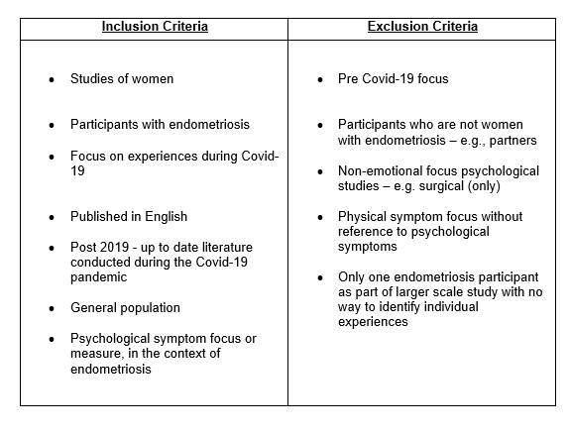**Table 1***Inclusion and Exclusion Criteria*

**Figure 1***Search Process Flow Diagram*

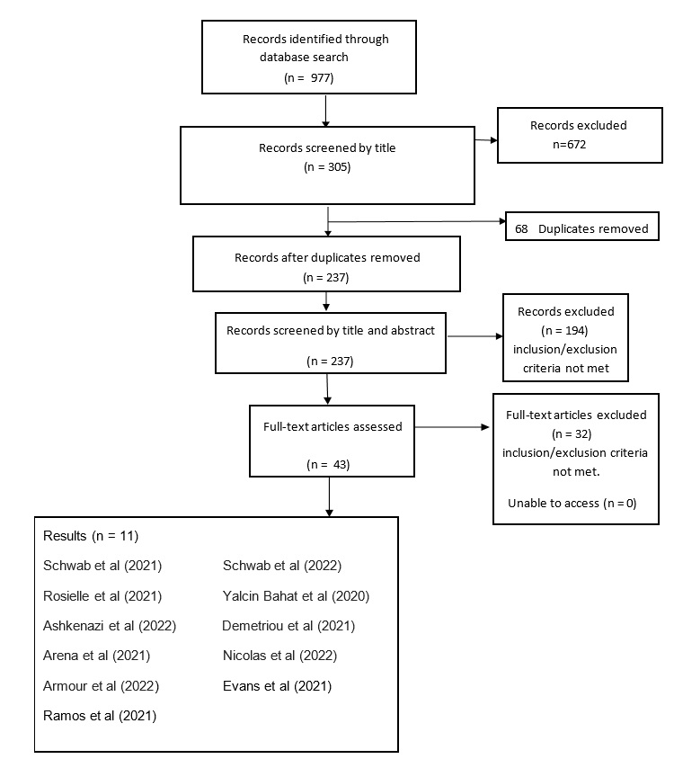

**Analysis and Critical Appraisal Process**

The papers were appraised using Hong et al.’s (2018) ‘Mixed Methods Appraisal Tool’ (MMAT) as it offers suitable assessment for studies with differing methodological approaches. As none of the studies followed a Randomised Control

Trial (RCT) methodology the MMAT was deemed more suitable than the Critical Appraisal Skills Programme (CASP).

The MMAT allows for a structured evaluation and provides some comparison across studies by requiring each paper to be rated on five methodologically relevant criteria. For enhanced sensitivity of analysis, Hong et al. (2018) discourage the calculation of an overall score and instead advise that ratings are presented by depicting the total number of each rating given (either ‘yes’, ‘no’, or ‘can’t tell’). Excluding studies with a low methodological quality is discouraged within the MMAT instructions. Table 2 provides a summary of data and methodological quality rating for each paper. For spreadsheets detailing the MMAT questions and scoring see Appendix A.

**Results**A summary of the eleven included studies is shown in Table 2. Nine studies used quantitative methodology (Schwab et al., 2021; Schwab et al., 2022; Rosielle et al., 2021; Bahat et al., 2020; Ashkenazi et al., 2022; Demetriou et al., 2021; Arena et al., 2021; Nicolas et al., 2022; Armour et al., 2022). Two studies used mixed methodology (Evans et al., 2021 and Ramos et al., 2021).  
  
All but three of the papers (Evans et al., 2021, Armour et al., 2022 and Schwab et al., 2022) focused on medical symptomology and functional impacts of restricted access to health care during COVID-19. However, they provided relevant data relating to psychological impacts by including accompanying investigations into pandemic influenced changes in anxiety, stress, mental state, social support, wellbeing and overall quality of life. Armour et al., (2022) supplied insight into fluctuations in quality of life related to workplace changes, Schwab et al., (2022) directly assessed impact upon psychological distress, while Evans et al., (2021) employed mixed methodology to investigate the holistic experience of living with endometriosis during the pandemic.   
  
Sample sizes across the papers varied from 82 to 6729 participants. Three research teams directly recruited participants using existing clinical relationships (Arena et al., 2021, Nicolas et al., 2022 and Rosielle et al., 2021). The remaining eight papers recruited anonymously via advertisements on social media platforms and endometriosis support groups.  
  
Across the papers a variety of countries were represented. However, the majority of six studies composed of exclusively European samples (Arena et al., 2021; Bahat et al., 2020; Nicolas et al., 2022; Rosielle et al., 2021; Schwab et al., 2021, Schwab et al., 2022), and two global studies (Ashkenazi et al., 2022; and Demetriou et al., 2021) also comprised of 75% and 67.13% (respectively) European individuals. Armour et al., (2022) and Evans et al., (2021) recruited Australian participants, whereas Ramos et al., (2021) involved Puerto Rican residents.   
  
All data was gathered via online surveys but Nicolas et al, (2022) also offered paper surveys. Validated measures were used exclusively by three research teams (Arena et al., 2021, Ashkenazi et al., 2022 and Schwab et al., 2022) while five teams combined validated and novel tools (Armour et al., 2022; Evans et al., 2021; Ramos et al., 2021; Rosielle et al., 2021 and Schwab et al., 2021). The remaining three did not use validated measures.

|  |  |  |  |  |  |  |
| --- | --- | --- | --- | --- | --- | --- |
| **Table 2**  *Article Summary and Quality Rating Table* | | | | | | |
| ***Title/Author/Date*** | ***Purpose*** | ***Participants*** | ***Design*** | ***Measure*** | ***Main Findings*** | ***Quality***  ***Rating***  *Frequency*  *Counts for: Yes.No.Can’t*  *tell* |
| Effects of the SARSCoV-2 pandemic on women affected by endometriosis: A large cross-sectional online survey. Arena et al., 2021 | To assess the relationship between the intensity of endometriosis related symptoms and anxiety levels and the psychological impact of the COVID-19 pandemic. | N= 468 with clinical, sonographic diagnosis of endometriosis, aged >18 years. | Questionnaire sent via email | Closed questions related to work habits, clinical and care concerns.  Endometriosis specific health experiences: The Endometriosis  Health Profile (EHP-5).  Anxiety levels: Generalised Anxiety Disorder – 7 (GAD-7) and  The Spielberg State Trait Anxiety Inventory Y6 (STAI-Y6).  Psychological impact of COVID-19: The Impact of Events Scale Revised (IES-R). | COVID-19 had a high psychological impact on women with endometriosis, putting them at significant risk of PTSD.  Age, pre-existing anxiety and unemployment were independently associated with risk of PTSD.  No association found between IES-R scores and EHP-5 or STAI-Y6 scores.  Telemedicine may reduce feelings of isolation. | 4.0.1 |
| Endometriosis and the workplace: Lessons from Australia’s response to COVID‐19. Armour et al., 2022 | To determine if the shift in working practices due to the COVID-19 pandemic resulted in changes in symptom  management and  productivity. | N= 398, with self-reported diagnosis of endometriosis from a health professional, aged 18-55 years. | Online questionnaire | Closed questions relevant to the impact of the  COVID-19 pandemic on  Endometriosis associated symptomology and employment.  Health related quality of life: Endometriosis Health Profile-30 (EHP- 30).  Fatigue Severity Scale (FSS). | COVID-19 restrictions related to changes in working arrangements improved quality of life and productivity.  Self- management of working hours and rest breaks contributed to improvements.  8 out of 10 women reported that COVID-19 workplace changes had made management of their endometriosis symptoms easier. | 3.0.2 |
| COVID-19 pandemic  and the  consequential effect on patients with endometriosis. Ashkenazi et al., 2022 | To explore the effect of the  COVID-19 pandemic on patients suffering from endometriosis and investigate the different approaches to the medical management of these patients. | N = 2964, with  self-reported diagnosis from 59 countries, aged 12-72 years. | Online questionnaire | Edited version of Endometriosis Health Profile-30 (EHP- 30).  Medical postponements: a section of “yes/no” questions.  Decision making, condition management, symptoms and changes to mental state: Likert scale responses. | A clear correlation was demonstrated between deterioration of physical and mental state and impaired medical care during COVID-19.  Almost 50% of respondents reported decline in physical or mental wellbeing or both during COVID-19.  Decline was attributed to cancelled and postponed medical appointments. | 4.0.1 |
| The COVID‐19 pandemic and patients with endometriosis: A survey‐based study conducted in Turkey.  Bahat et al., 2020 | To determine knowledge and  perceptions of the COVID-19 pandemic in endometriosis patients. | N = 261 patients with a history  of  endometriosis <1 year. | Online questionnaire | 25 questions prepared by two Gynaecologists and two Endometriosis Specialists. | The pandemic was a stress laden period for endometriosis patients.  The majority of patients were afraid of having endometriosis- related problems during the pandemic.  Patients were highly aware of the pandemic and practiced social distancing and hygiene.  Patients adapted healthier lifestyles during COVID-19. | 4.0.1 |
| The global impact of COVID-19 on the care of people with endometriosis. Demetriou et al.,  2021 | To explore the impact of COVID-19 on the care of people with endometriosis around the world. | N= 6729 global persons, self-reported surgical or radiological diagnosis of endometriosis, aged <18 years. | Online questionnaire | Closed questions relevant to the impact of the COVID-19 pandemic on endometriosis-associated symptomology, care, mental health and social support. | The pandemic affected care of the majority of people with endometriosis.  Contact with gynaecologists via telemedicine.  The provision of remote mental health support should be prioritised. | 2.1.2 |
| “I'm in iso all the time anyway”: A mixed methods study on the impact of COVID-19 on women with endometriosis. Evans et al., 2021 | To understand how COVID-19 has affected people with endometriosis. | N=162, with self-reported  endometriosis.  . | Online questionnaire (mixed methods) | Menstrual pain severity  Numerical Rating Scale  (NRS)  The Fear of COVID scale.  Open ended questions related to pandemic impacts. | Stress was reported as a negative consequence of COVID-19. Sub themes related to stress; social life, work life and health.  Positive impact was observed in work life management.  Restrictions promoted self-management. | 5.0.0 |
| Impact of SARSCOV2 Pandemic on  Patients with Endometriosis and Their Health Care.  Nicolas et al., 2022 | To analyse the impact of the COVID-19 pandemic on the perceived clinical health status and type of care received in patients with endometriosis. | N=945 premenopausal participants  (N=549, with diagnosis of endometriosis and N=396 with other benign gynaecological  diseases), aged <18 years. | Online questionnaire and paper survey by mail | Closed questions relevant to the impact of the COVID-19 pandemic on endometriosis-associated symptomology, sadness and clinical management. | Persons with endometriosis more frequently had the clinical perception of worsening and concern during COVID-19 than those without endometriosis.  Telehealth is a useful tool but face-to face visits should be considered for those with “significant” pelvic pain. | 5.0.0 |
| Impact of the early COVID-19 era on endometriosis patients: Symptoms, stress, and access to care.  Ramos et al., 2021 | To determine whether the measures implemented to mitigate COVID-19 infections had a substantial impact on risk behaviours, endometriosis symptoms, stress, and access to healthcare. | N=308, with self-reported clinical diagnosis of endometriosis, aged <18 years. | Online questionnaire (mixed methods). | 46 questioned designed to assess:  (i) Demographics and lifestyle changes, (ii) Clinical and gynaecological background, including endometriosis-related symptoms, (iii) Access to health care/medications during the pandemic, (iv) COVID-19 questions (exposures, diagnosis/symptoms, perceptions regarding the pandemic).  The intensity of experiencing  endometriosis during COVID-19: Peritraumatic Distress Inventory (PDI). | The pandemic negatively impacted the health and wellbeing of endometriosis patients while imposing substantial restrictions on access to healthcare.  Patients considered e-health modalities as acceptable alternatives to minimize negative impacts.  As many as 40% of participants experienced high levels of peritraumatic stress. | 5.0.0 |
| The impact of the  COVID-19 pandemic  on infertility patients and endometriosis patients in the Netherlands.  Rosielle et al., 2021 | How infertility patients, endometriosis patients and healthcare providers rate virtual care as an alternative to physical care during COVID-19 and how this influences quality of life and quality of care. | N =330 infertility patients, N =181 endometriosis patients with self-reported endometriosis diagnosis, aged <18 years and N=101 healthcare providers. | Online questionnaire | Questions to assess virtual care and stress developed by the research team.  ENDOCARE questionnaire (ECQ).  The Dutch Fertility-related Quality of Life Questionnaire (FertiQol). | Self-reported stress was  especially high in infertility patients during COVID-19, who did not feel that they could cope well with changes to care.  Virtual care seems to be a good alternative for all patients when physical consultations are not possible. | 4.1.0 |
| Pain experience and social support of endometriosis  patients during the COVID-19 pandemic in Germany–results of a web-based cross-sectional survey.  Schwab et al., 2021 | To assess the impact of social distancing measures on pain perception, pain intensity and  social support. | N= 285, with confirmed history of endometriosis, aged <18 years. | Online Questionnaire | Pain intensity: Visual Pain Scale  (VAS) and Pain Disability Index (PDI).  5 point Likert scale assessing perceived social support, perceived pain management and use of medication. | Physical and emotional pain experiences were differentially affected by the constraints of the pandemic.  Global physical impairment improved significantly.  Frequency of pain awareness increased while verbalization of pain experience and social support decreased. | 4.0.1 |
| Predictors of  Psychological  Distress in Women with Endometriosis during the COVID-19 Pandemic.  Schwab et al., 2022 | To evaluate the prevalence of self- reported depression and anxiety, the influence of demographic, endometriosis specific, pandemic factors, and resilience on mental health outcomes. | N=274, given a diagnosis of endometriosis during a surgical procedure, aged <18 years. | Online questionnaire | Visual Pain Scale  (VAS)  Pain Disability Index (PDI)  Patient Health  Questionnaire for Depression and Anxiety (PHQ-4)  Brief Resilience Scale (BRS) | Pain induced disability is an independent risk factor for developing major depression and anxiety.  Resilience was identified as a potential protective parameter in terms of positive psychological outcomes in women experiencing endometriosis during COVID-19. | 4.0.1 |

**Critical Appraisal**

**MMAT**

Following the MMAT screening, by providing clear research questions and data addressing these questions, every article was deemed acceptable for appraisal. Upon methodological analysis three papers received a 5/5 yes score, six attained 4/5, one achieved 3/5 and one received 2/5.

Of the nine quantitative papers (Schwab et al., 2021; Schwab et al., 2022; Rosielle et al., 2021; Bahat et al., 2020; Ashkenazi et al., 2022; Demetriou et al., 2021; Arena et al., 2021; Nicolas et al., 2022; Armour et al.,2022) only Nicolas et al. (2022) met every quality criteria, receiving “yes” on all counts for their use of adequate sampling strategy, representativeness of the sample, appropriateness of the measurements used, low risk of nonresponse bias and appropriate analysis.

Six articles (Schwab et al., 2021; Schwab et al., 2022; Rosielle et al., 2021; Bahat et al., 2020; Ashkenazi et al., 2022; Arena et al., 2021) achieved a quality criterion score of four yes’s, with all but Bahat et al. (2020) appraised as possessing an unclear risk of nonresponse bias being low. For Bahat et al., (2020), their use of a non-pre-tested or validated questionnaire caused query around the appropriateness of their measurement. In Ashkenazi et al.’s (2022) case, non-response rates or statistical compensation was not mentioned. For both Rosielle et al., (2021) and Arena et al.

(2021) response rates were recorded as potentially low due to refusal or noncontact whereas for Schwab et al., (2021) and Schwab et al., (2022) reasons for the non-response were not provided.

Armour et al., (2022) was attributed three yes’s during appraisal however their discussion of response rates was lacking which caused concern as to the bias which may have been evident in their reporting. Additionally, despite including some qualitative questioning, the results of this type of data were not clearly presented nor analysed in adherence to any discernible method.

Demetriou et al., (2021) received just two criterion yes’s as their sampling strategy and statistical analysis were deemed relevant to the research question. However, the quality of methodology was in question due to the use of a non-pre-tested nor validated questionnaire and potential in nonresponse bias. Concern about the representativeness of the sample in relation to the “global” background population that they aimed to assess was evident as recruitment was limited to support group users.

Both of the mixed methods papers (Evans et al., 2021 and Ramos et al., 2021) were estimated to have used adequate rationale, effective collection, integration, interpretation and analysis of the data and therefore received “yes” for all methodological criteria assessed.

By comparing and contrasting the MMAT results of all studies, it is clear that a non-response bias coupled with representativeness of the sample are the main methodological concerns. With the prevalence rate of 176 million people worldwide and limited recruitment resources, the majority of papers acknowledged that their population samples (often recruited via online support groups) could be generalised with caution. Likewise, non-response rates were not commented upon or investigated by a number of the studies. Although this is potentially understandable given COVID-19’s wide ranging impact, it calls bias into question as research has suggested that persons suffering from more severe symptoms may be more likely to seek support or engage in research (Fourquet et al., 2015).   
  
**Additional Methodological Considerations**   
In all studies and particularly impactful for those that were conducted by practicing clinicians, the relationship of the researchers to participants was not considered. Thus, researcher bias or demand characteristics may be questioned.

Importantly, the design of novel questionnaires devised by research teams were not explained in any detail and a lack of validated pre and post measures was commonly noted. Such methodological weaknesses could motivate scrutiny of the literatures’ validity.

**Key Findings**

Following critical appraisal, in order to synthesize findings relevant to the review’s aims, each article was read a number of times and key psychological impacts or coping strategies were drawn out and recorded. Results pertinent to psychological impacts or coping strategies are presented below.

Given that the literature on endometriosis experiences during COVID-19 is limited, all studies were included regardless of their MMAT score and irrespective of the majority of their data focusing upon healthcare provision or physical symptoms. All eleven studies identified some factor associated with changes in psychological wellbeing or coping strategies during COVID-19. The type of psychological impacts and extent to which they were reported varied greatly across studies yet, by bringing them together, this work aims to be one of the first narrative literature reviews of the data. Key themes were developed based on frequency across studies and saliency to the review question therefore themes were included despite being mentioned briefly or occasionally. Themes which will be discussed include; stress, anxiety and low mood, changed medic-patient relationships, self-awareness, social support, behaviour changes and work life.

**Stress**Although there was no consensus on prevalence of stress across studies, stress was a clear theme running through the literature and cited in all eleven discussions as impactful upon persons living with endometriosis during COVID-19.

In Ramos et al.’s (2021) cohort, quantitative findings suggested that 75.9% of participants were at risk of significant peri-traumatic stress (PDI scores). While Arena et al. (2021) found that IES-R scores for 29.9% of participants indicated a probable diagnosis of PTSD. Of those, increased levels of generalized anxiety (GAD7), older age and unemployment were associated with higher IES-R scores.

Investigating COVID-19’s impact on service provision, Rosielle et al. (2021) reported that 35.9% of the endometriosis cohort agreed with the statement: “I experience an increase in stress due to a delay in treatment”. Upon finding a higher agreement rate (and therefore higher stress levels) in response to this question in infertility patients (76.6%), the authors proposed that persons living with chronic endometriosis may perceive that they require less time-sensitive intervention and may be accustomed to delays in care therefore sustaining less stress escalation.

However, qualitative data offered some suggestion to the contrary:

“The current lockdown makes it hard, more so mentally with stress of possibly not being able to attend/being turned away” (Evans et al., 2021, p.4).

And provided insight into the intricacies of why and how stress may be present for endometriosis sufferers during COVID-19:

“The stress caused by the beginning of the pandemic made the pain more frequent and hurtful” (Ramos et al., 2021, p.118).

Or, how practical changes induced by COVID-19 may have relieved endometriosis related stressors:

“I have spent a lot of time at home which has allowed me to be less stressed and always have a heat pack” (Evans et al., 2021, p.4).  
  
Overall, the data infers that individuals had a range of stress experiences, for some stress was increased and for others it did not. The relationship between living with endometriosis during COVID-19 and stress is not straightforward. Stress was moderated by generalized anxiety, age, employment, experiences of treatment delay, pain levels and practical adjustments.

**Anxiety and Low Mood**

Reports of mood changes and anxiety associated with COVID-19 varied across seven of the eleven studies. Commonly, data indicated lack of knowledge about the interplay between the virus and endometriosis, along with healthcare access concerns and changes in help-seeking behaviour related to anxieties.

50% of participants in Demetriou et al. (2021) worried that they might be more vulnerable to COVID-19 due to a diagnosis of endometriosis. Similarly, Ramos et al. (2021) noted 76.3% of participants believed that their condition may make them more vulnerable to COVID-19, additionally finding that 23.3% did not seek medical attention due to a fear of contracting the virus.   
  
Although the majority (58.89%) of the Bahat et al. (2020) cohort stated that they did not believe themselves to be at high risk (those marked “high risk” by advising bodies were instructed to shield and faced strictest restrictions and isolation), 83.36% reported a fear of experiencing endometriosis issues during COVID-19. Similarly, Arena et al. (2021) reported that 63.5% of participants were concerned for their health during the pandemic, and on a self-reported measure of pandemic fear, 45% of individuals reported clinically concerning levels of COVID-19 related fear (Evans et al., 2021).

Impacts of pandemic related health concerns were underlined by clinically significant levels of general anxiety and low mood, measured using validated tools. PHQ-2 scores indicated that during COVID-19, “high” (46%) and “very high” (21.5%) probability of depression was evident in Schwab et al.’s (2022) cohort of 274 participants. Similarly, GAD-2 scores of “high” (48.2%) and “very high” (23.7%), indicated increased probability for anxiety. Importantly, the authors commented that these proportions were significantly higher than had been found when PHQ-2 and GAD-2 were investigated in chronic pain patients pre COVID-19.

Likewise, Arena et al. (2021) indicated that most women in their cohort would be diagnosed with a mild to moderate generalized anxiety disorder (GAD-7) with 3 out of 4 persons falling in the “severe” GAD-7 range at risk of PTSD. As Schwab et al.’s (2022) PHQ-2 scores signposted, in comparison to 44.7% of participants with other gynaecological conditions, a larger 59.7% of persons with endometriosis in Nicolas et al.’s (2022) study cited that “sadness” was a concern for them during COVID-19.

Qualitative data similarly suggested that generalized anxiety, low mood and restrictions were of concern and impacted on primary symptoms for participants living with endometriosis:

“I suffer from generalized anxiety, which has increased during the period of quarantine, and as a chain effect, all symptoms of pain and inflammation increased”

(Ramos et al., 2021, p.118).

“It has affected me a lot emotionally. I understand that the hormonal imbalance has made me more vulnerable to depression” (Ramos et al., 2021, p.118).

Incongruently, recruiting from 59 countries Ashkenazi et al. (2022) found that the majority (44%) of participants disagreed or strongly disagreed that their mental state had worsened during COVID-19, while 36.3% reported some deterioration in their mental health, and 19.7% remained unsure. Yet, further indicative of a negative relationship between restricted healthcare access and psychological wellbeing in persons suffering from endometriosis during COVID-19, for persons whose medical appointments had been cancelled the figure rose from 36.3% to 49.3%. Individuals who had no cancellations self-reported mental health decline decreased to 27.5%. Thus suggesting that maintained access to medical appointments could positively moderate mental health outcomes for this patient group during pandemics.

Of the 6729 global participants in Demetriou et al., s (2021) study 20.3% suggested that prioritising mental health support during the pandemic would be helpful, third only to improved contact with a gynaecologist (32.6%) and arrangement of procedures (20.5%). When asked to envisage post-pandemic life, participants reported that mental health support would become less important overall. However, 13.0% stated that it would continue to be their priority. Endometriosis participants’ top three post-COVID-19 priorities were equivalent worldwide, therefore mental health support was consistently cited as more valued than medicine availability or primary care appointments.

The literature suggest that, although variable, clinically significant levels of anxiety and low mood were experienced by individuals living with endometriosis during COVID-19. Mental health fluctuations were found to be of elevated concern to this group during the pandemic, and beyond. Along with access to health care and physical symptomology, variation in mental health experiences were likely influenced by individual differences such as resilience. Schwab et al (2022) reported high resilience (BRS) to be a protective factor for mental health, resulting in a decreased probability of generalized anxiety (GAD-7) and major depression (PHQ-4) during COVID-19.   
  
**Changed Medic-Patient Relationships**As mentioned previously, access to or anticipation of difficulty in accessing healthcare seemed to have some influence on participants’ experience of stress and anxiety. Two studies certainly suggested that persons struggled to access care and felt additional stress or coped less well because of this:

68.6% of respondents were quite to extremely worried about not having access to care and those who struggled to access medical care experienced higher levels of distress (Arena et al., 2021).

“I am falling through the cracks” - having not been called for a scheduled appointment (Evans et al., 2021, p.3).

However some benefits in changed healthcare services were also noted. When adapted appointments were upheld they afforded persons rest, in turn decreasing anxiety:

“I love telehealth it means I don’t need to drag myself to the doctor’s office when I’m full of pain and anxious and when I’m in the calm of my home I feel less anxious” (Evans et al., 2021, p.4).

**Self-Awareness**

Via qualitative analysis, Ramos et al. (2021) presented a positive psychological impact of COVID-19 upon persons living with endometriosis: “self-awareness”. The authors stated that “self-awareness” developed because quarantine enabled individuals to better monitor their symptoms without the distractions of everyday life:

“Thanks to quarantine I was able to be more aware of my symptoms and contact a specialist” (Ramos et al., 2021, p.118). Correspondingly, Schwab et al. (2021) reported a marked increase in pain cognition during isolation with 43.6% of respondents stating that they felt more frequently aware of pain. Although 29.3% of those who were more aware of their pain reported finding this experience “disturbing”, the discomfort was thought to be mitigated somewhat by isolation affording 43% of participants more opportunity to relax, despite increased pain awareness.

**Social Support**

In six of the reviewed studies, social isolation was clearly thought to be impactful upon persons living with endometriosis during COVID-19. Links were made between increased pain and isolation, decreased opportunity for discussion, restricted social support and the length of time persons had experienced social changes.

Social support was perceived as having decreased from family (21.9%) and friends (31.5%) during COVID-19 and pain was perceived to be taken less seriously by both social groups by 13.5% and 19.5% respectively (Schwab et al., 2021).

When Schwab et al. (2021) investigated the differences between respondents who answered questions relating to pain or social support and those who did not, they found a statistically significant difference between the length of time that persons had been in isolation. Respondents were more likely to answer these questions if they had been in isolation for a longer period.

Thinking back to the aforementioned psychological impacts of COVID-19, for persons who recounted a largely reduced social network, Schwab et al (2022) found a 2-fold increase in the likelihood of their experiencing moderate to high levels of anxiety (GAD-2) or psychological burden (PHQ-4).

Similarly, qualitative data implied there might be negative impacts upon a person’s mood and comfort when pre-existing social coping strategies were compromised due to environmental changes in access to systems or spaces for endometriosis related conversation:

“It saddens me that I cannot meet with people who I share my concerns about my condition with” (Ramos et al., 2021, p.118).

“Zoom is not the same – walls are thin and our catch ups are public to our households (so I’m not going to talk about period pain)” (Evans et al., 2021, p.4).

In the case of someone who was able to maintain these links during COVID-19, social support as coping was cited as vital:

“Between my psychologist and the catholic church I have been able to handle these situations” (Ramos et al., 2021, p.118).

Although (Ramos et al., 2021) noted that during the research process requests for links to additional support groups were made, Evans et al. (2021) posited the notion that this population might be versed in social isolation pre COVID-19 as one participant commented:

“I’m in isolation anyway all the time anyway. My life is isolation and I’m only in my

thirties” (p.4).

**Behavioural Changes**

Across three papers, discussion of pre-pandemic and ongoing behavioural coping strategies employed by persons suffering with endometriosis included talk of exercise, crafting, eating healthier and self-medicating.

In the Ramos et al. (2021) study 40% of participants who exercised regularly reported reducing this behaviour. Qualitative data provided understanding that COVID-19 restrictions may have been instrumental in this change and that it was not experienced positively:

“Took away my only source of relief by taking away sport” (Evans et al., 2021, p.4).

“Could not do Pilates classes which were to help strengthen muscles to help reduce associated pain” (Evans et al., 2021, p.3).

However, qualitative reports also suggested that this behaviour change may have been more nuanced and driven by individual factors as one respondent noted a marked increase in physical activity and positive effects of this:

“It has impacted me positively to work out more by doing online yoga and going to the gym and walks which I am proud of” (Evans et al., 2021, p.5).

Similarly, positive behaviour change was indicated in 70.63% of the Turkish cohort in Bahat et al. (2020) who reported making an effort to eat healthier during COVID-19.

During COVID-19 increased doses of unnamed analgesics (24.4%) and herbal medicines (12.2%) (Ramos et al., 2021) were reported. Along with medications, Ramos et al. (2021) found that 29.2% of participants reported increasing their alcohol intake with supporting qualitative data suggesting that the reason for this might have been to help them cope with COVID-19 changes to routine:

“I am relying on alcohol to relax every afternoon” (Ramos et al., 2021, p.118).

**Work Life**Considering more functional impacts of living with the condition, four studies found that changes to work life resulted in varying positive and negative impacts upon persons coping with endometriosis.

Ramos et al. (2021) reported that 72% of participants work life had been affected but not did not clarify exactly how. While persons who left their home to go to work were found to have lower levels of post traumatic distress (IES-R scores), which Arena et al., (2021) suggested to be linked to maintained social interaction, qualitative evidence illuminated that during COVID-19 professional social interactions were not always experienced positively. Work life was more challenging for persons suffering endometriosis during COVID-19:  
  
“The lack of empathy of co-workers” (Ramos et al., 2021, p.118).

However, overall, more positive shifts in work-related coping were reported. Prior to the pandemic 65.0% of the Amour et al. (2022) cohort indicated that they had taken unpaid leave due to endometriosis symptoms after exceeding sick leave allowances and 64.0% reported that they felt “judged” when trying to manage symptoms at work. Subsequently, the burden of “hiding” symptoms from management was mentioned in open comments along with statements such as:

“Working from home allows me to better manage my pain and be much more productive and comfortable” (Evans et al., 2021, p.4).  
  
“I have been working from home so feel much less stress and anxiety about needing to take time off and the judgement and questioning that follows” (Evans et al., 2021, p.4).

Amour et al., (2022) also reported that many of the practical changes to work life were beneficial for persons living with endometriosis as 8 out of 10 participants stated that COVID-19 had made their management of symptoms easier during work and 63.02% of the cohort reported feeling somewhat or much more productive as a result of working more flexibly. Consequently, 50% of respondents called for psychology or counselling support to be included in workplace initiatives.

**Discussion**   
Following synthesis of pertinent research findings, the themes of; stress, anxiety and low mood, changed medic-patient relationships, self-awareness, social support, behaviour changes and work life, were established. Reported experiences of these themes varied throughout the literature and individual differences, practiced coping behaviours and environmental factors were found to impact upon psychological experiences.

Wider literature has cited individual difference as impactful upon mental health presentations in persons with chronic pain conditions (Facchin et al., 2017). The review was able to support this notion, underlining the importance of individualised care and suggesting that blanket approaches to supporting endometriosis patients during pandemics could have mixed outcomes.

The review echo’s pre-pandemic research which suggested that persons with endometriosis exhibit increased pain anxiety compared to “healthy” control groups (Aken et al., 2017). Theoretically, it may have been possible to foresee that the negative repercussions of living through a pandemic while suffering from chronic pain, would lead to increased health related anxieties. However, the review also highlighted previously under-reported increased risk of developing PTSD for endometriosis sufferers who faced additional challenges such as older age or unemployment during COVID-19.

Consistent with pre-pandemic research underlining the importance of social support as a coping mechanism in persons with endometriosis (Yoon et al., 2021; Whelan, 2007; Whitney, 1995), the physical distance imposed by quarantine was shown to heighten emotional distancing, lessen social support and negatively impact upon coping. This finding, cited in the majority of studies, is of concern as historically, when persons suffering chronic pain were encouraged to support themselves, limited improvement was observed (Mistretta and Davis, 2021).

The review’s suggestion that the absence of, or restricted access to, healthcare negatively impacts upon psychological wellbeing is significant as the theme was cited consistently. In order to maintain the wellbeing of this population, this finding has implications for future endometriosis service planning during global crisis.

During COVID-19 increased addiction, poorer diet, irregular sleep and decreased exercise were evident in the general population (Shi et al., 2021). Given that health-related behaviours have been cited as the most significant and notably most modifiable risk factor impacting upon chronic pain (Van Hecke et al., 2013), unsurprisingly the review made links between inability to exercise and negative wellbeing or increased activity and improved wellbeing. Currently, although exercise is recommended for the management of chronic primary pain it is not clearly included in NICE guidance on endometriosis.

Prior to COVID-19 significant impact of living with endometriosis on work life had been reported (Culley et al., 2013). Interestingly, the review indicated that the negative impacts (sadness, fear and anger) of working from home experienced by the general population during COVID-19 (Borzoi et al., 2020) may have been less marked in persons living with endometriosis. This difference could be attributed to functional self-management possibilities that the home environment afforded (rest, heat pack, not having to interact with unsupportive colleagues). When interpreting this theme, the lack of consensus in findings should be considered.   
Research suggests that individuals who become more aware of their symptoms may be better at self-management, having gained insight into the interconnectedness of their behaviours and symptoms (Steihaug & Malterud, 2008). One of the most methodologically sound papers (Ramos et al., 2021), posited that increased self-awareness was a beneficial psychological impact of COVID-19.

**Limitations**

The review was completed by one reviewer who lacked familiarity with conducting literature reviews. The reliability of the search strategy, appraisal process and narrative synthesis might have been enhanced by a second reviewer. Efforts were made to combat lack of experience by the use of peer support groups and academic supervision.

As noted in key findings, the majority of papers focused on physical symptomology and health care provision. Although this limited the available data for review and resulted in some papers being more heavily discussed than others, the search process included all papers with some empirical research on psychological impact or coping strategy. However limited, the data correlates with literature which highlights the lack of clinical psychological understanding, provision and guidelines for endometriosis care (Schreurs et al., 2021; Kundu et al, 2015). Due to the timeline of COVID-19 and the duration research requires more psychologically relevant, reviewable data should be published in the near future. Given the magnitude of the global response (6729 persons) that Demetriou et al. (2021) received in the period of one month the importance of such research and the rationale for this review are clear.

Studies conducted earlier in the pandemic reported higher levels of COVID-19 related fear (Bahat et al, 2020) than those conducted later (Rosielle et al, 2021). As there were many more unknowns during the earlier stages of the pandemic, particularly as healthcare systems had not yet begun to adapt to dynamic needs, the time at which each study took place may have impacted the results.

Lockdown restrictions (period and strictness), COVID-19 related media messages (infodemic), care provisions and fatality rates varied greatly across regions and countries (Mheidly & Fares, 2020). As such, it could be suggested that environmental stressors may have impacted upon the lived experiences of participants and influenced wellbeing and self-reports. However, when Ramos et al. (2021) analysed stress scores between respondents whose locale had recently suffered devastating earthquakes and those who lived in safer areas, no regional difference was found. As geographical differences were not controlled for, nor directly measured by any other studies, queries around the impact of environmental factors on the lived experience of endometriosis during COVID-19 remain unanswered by this review.   
  
The Eurocentric nature of the data set implies that the reviews generalisability may be restricted. Papers published in other languages may have provided wider insight however, due to limited translation resources, a criteria of ‘English Language’ was required. When considering the reviewed global participant pool, cultural differences in interpretation of language or inaccurate translation of validated scales may have arisen. As all data was collected anonymously, using online procedures, question comprehension along with individual’s diagnostic credibility could not be confirmed. Moreover, a subset of individuals’ who do not have access to technology have not been captured.

Throughout the review a large proportion of data denoted an increase in negative physical symptomology across the course of COVID-19. This could offer important supplementary insight into the experiences of persons suffering from endometriosis during a pandemic and may be particularly important given the evidenced links between increased pain and decreased psychological wellbeing (Facchin et al., 2017) However, as the aims of this review focused on non-physical impact, pain data was not discussed.

The methodological qualities of the papers varied according to the MMAT and therefore results presented from papers with lower scores may not be deemed as reliable as those who scored highly. For the purpose of this review, all relevant data was discussed regardless of methodological limitations. In order to increase confidence in understanding, future research involving more validated measures is indicated.

Although the majority of studies are quantitative with larger sample sizes, increasing external validity and generalizability, it is clear that the qualitative data allowed for more nuanced insight into the lived experience of persons managing endometriosis during COVID-19. The review is limited in this type of rich data therefore future mixed-method designs would be recommended should researchers seek to expand upon the knowledge gained by this review.

**Clinical Implications and Future Research**

**Social Support**

To address the everyday isolation that persons living with endometriosis experience, the review underlines a need for organization of social support groups both during and outside of the COVID-19 timeline. Social groups could serve as appropriate spaces for education in positive behavioural coping strategies (including exercise), increased self-awareness and a place to seek compassionate interaction when social networks are weakened during pandemics.

**Updating Clinical Guidelines and Psychological Input**Demetriou et al. (2021) commented on their shock at the number of participants wishing to prioritise mental health care during and outside of the pandemic. As there is currently no psychology provision nor clinical guidance on comorbid mental health challenges in this population, research into comorbidity may be required, following which NICE guidelines should be reconsidered. As studies found increased stress was observed in this population during COVID-19, psychological services could aim to provide routine stress relief / emotion regulation training alongside pain management to guard against negative mental health impacts during future pandemics.

**Public Health Information**

The review gleaned that this group of persons may be at more risk of developing anxiety when faced with future pandemics. Research could endeavour to better understand the relationship between COVID-19 and chronic pain conditions to more clearly inform patients if they are at increased risk or provide information and reassurance if this is not the case.

**Clinical Management**

Options for telehealth during pandemics and beyond should be considered due to the benefits of flexible care upon rest and minimizing disruption to routines. However, in-person care should not be replaced.

**Workplace Adjustments**

The WHO or other governing bodies could include stipulation that workplaces should be more mindful of endometriosis related needs including; flexibility, options to work from home and encouragement of empathy from colleagues.   
 **Conclusion**Eleven studies of varying methodological quality, exploring the experience of individuals living with endometriosis during COVID-19 were reviewed. Psychological impacts of COVID-19 and practiced coping strategies were influenced by individual differences. During the pandemic, increases in stress, anxiety and low mood were experienced. Positive impacts of increased self-awareness and better work-life management were reported. Individuals faced challenges to their coping strategies of seeking social support, engaging in physical exercise or maintaining patient-clinician relationships. When interpreting the reviews findings, the limited number of papers, lack of overall consensus and outlined limitations should be considered.

**References**

Arena, A., Orsini, B., Degli Esposti, E., Raimondo, D., Lenzi, J., Verrelli, L., ... & Seracchioli,   
 R. (2021). Effects of the SARS-CoV-2 pandemic on women affected by   
 endometriosis: A large cross-sectional online survey. *Annals of Medicine*, *53*(1),  
 1924-1934.  
Armour, M., Sinclair, J., Cheng, J., Davis, P., Hameed, A., Meegahapola, H., ... & Leonardi,   
 M. (2022). Endometriosis and cannabis consumption during the covid-19 pandemic:   
 an international cross-sectional survey. *Cannabis and Cannabinoid Research*.   
Armour, M., Ciccia, D., Stoikos, C., & Wardle, J. (2022). Endometriosis and the workplace:   
 Lessons from Australia’s response to COVID‐19. *Australian and New Zealand   
 Journal of Obstetrics and Gynaecology*, *62*(1), 164-167.  
Ashkenazi, M. S., Huseby, O. L., Kroken, G., Soto-Mota, A., Pents, M., Loschiavo, A., ... &   
 Kwiatkowski, S. (2022). COVID-19 pandemic and the consequential effect on   
 patients with endometriosis. *Human reproduction open*, *2022*(2), hoac013.  
Bahat, P., Kaya, C., Selçuki, N. F., Polat, İ., Usta, T., & Oral, E. (2020). The COVID‐19   
 pandemic and patients with endometriosis: A survey‐based study conducted in   
 Turkey. *International Journal of Gynecology & Obstetrics*, *151*(2), 249-252.  
Brasil, D. L., Montagna, E., Trevisan, C. M., La Rosa, V. L., Lagana, A. S., Barbosa, C. P., ...   
 & Zaia, V. (2019). Psychological stress levels in women with endometriosis:   
 systematic review and meta-analysis of observational studies. *Minerva   
 Medica*, *111*(1), 90-102.  
Bourne T , Leonardi M , Kyriacou C , Al-Memar M , Landolfo C , Cibula D , Condous G ,   
 Metzger U , Fischerova D , Timmerman D et al. ISUOG Consensus Statement on   
 rationalization of gynecological ultrasound services in context of SARS-CoV-2.   
 *Ultrasound Obstet Gynecol 2020*. doi:10.1002/uog.22047.  
Brosens, I., & Benagiano, G. (2011). Endometriosis, a modern syndrome. *The Indian journal   
 of medical research*, *133*(6), 581.  
Ciotti, M., Ciccozzi, M., Terrinoni, A., Jiang, W. C., Wang, C. B., & Bernardini, S. (2020). The   
 COVID-19 pandemic. *Critical reviews in clinical laboratory sciences*, *57*(6), 365-388.  
Culley, L., Law, C., Hudson, N., Denny, E., Mitchell, H., Baumgarten, M., & Raine-Fenning,   
 N. (2013). The social and psychological impact of endometriosis on women's lives: a   
 critical narrative review. *Human reproduction update*, *19*(6), 625-639.  
Della Corte, L., Di Filippo, C., Gabrielli, O., Reppuccia, S., La Rosa, V. L., Ragusa, R., ... &   
 Giampaolino, P. (2020). The burden of endometriosis on women’s lifespan: a   
 narrative overview on quality of life and psychosocial wellbeing. *International journal   
 of environmental research and public health*, *17*(13), 4683.  
Demetriou, L., Cox, E., Lunde, C. E., Becker, C. M., Invitti, A. L., Martínez-Burgo, B., ... &   
 Vincent, K. (2021). The global impact of COVID-19 on the care of people with   
 endometriosis. *Frontiers in global women's health*, 65.  
Evans, S., Dowding, C., Druitt, M., & Mikocka-Walus, A. (2021). “I'm in iso all the time   
 anyway”: A mixed methods study on the impact of COVID-19 on women with   
 endometriosis. *Journal of psychosomatic research*, *146*, 110508.  
Facchin, F., Barbara, G., Dridi, D., Alberico, D., Buggio, L., Somigliana, E., Saita, E., &   
 Vercellini, P. (2017). Mental health in women with endometriosis: searching for   
 predictors of psychological distress. *Human Reproduction, 32*(9), 1855–1861.   
 https://doi.org/10.1093/humrep/dex249  
Fourquet, J., Sinaii, N., Stratton, P., Khayel, F., Alvarez-Garriga, C., Bayona, M., Ballweg, M.   
 L., & Flores, I. (2015). Characteristics of Women with Endometriosis from the USA   
 and Puerto Rico. *Journal of Endometriosis and Pelvic Pain Disorders, 7*(4), 129–135.   
 https://doi.org/10.5301/je.5000224  
Gao, X., Yeh, Y. C., Outley, J., Simon, J., Botteman, M., & Spalding, J. (2006). Health-  
 related quality of life burden of women with endometriosis: a literature   
 review. *Current medical research and opinion*, *22*(9), 1787-1797.   
 <https://doi.org/10.1185/030079906x121084>  
Karos, K., McParland, J. L., Bunzli, S., Devan, H., Hirsh, A., Kapos, F. P., ... & Ashton-  
 James, C. E. (2020). The social threats of COVID-19 for people with chronic   
 pain. *Pain*, *161*(10), 2229.  
Kundu, S., Wildgrube, J., Schippert, C., Hillemanns, P., & Brandes, I. (2015). Supporting and   
 Inhibiting Factors When Coping with Endometriosis From the Patientsʼ Perspective.   
 *Geburtshilfe Und Frauenheilkunde, 75*(05), 462–469. https://doi.org/10.1055/s-0035-  
 1546052  
Leonardi, M., Horne, A. W., Armour, M., Missmer, S. A., Roman, H., Rombauts, L., ... &   
 Johnson, N. P. (2020). Endometriosis and the coronavirus (COVID-19) pandemic:   
 clinical advice and future considerations. *Frontiers in Reproductive Health*, *2*, 5.  
 https://doi.org/10.3389/frph.2020.00005  
Márki, G., Vásárhelyi, D., Rigó, A., Kaló, Z., Ács, N., & Bokor, A. (2022). Challenges of and   
 possible solutions for living with endometriosis: a qualitative study. *BMC Women's   
 Health*, *22*(1), 1-11.  
Mheidly, N., & Fares, J. (2020). Leveraging media and health communication strategies to   
 overcome the COVID-19 infodemic. *Journal of Public Health Policy, 41*(4), 410–420.   
 https://doi.org/10.1057/s41271-020-00247-w.  
Mistretta, E. G., & Davis, M. C. (2021). Meta-analysis of Self-compassion Interventions for   
 Pain and Psychological Symptoms Among Adults with Chronic Illness. *Mindfulness,   
 13*(2), 267–284. https://doi.org/10.1007/s12671-021-01766-7  
Nicolás, I., Martínez-Zamora, M. Á., Gracia, M., Feixas, G., Rius, M., & Carmona, F. (2022).   
 Impact of SARS-COV2 Pandemic on Patients with Endometriosis and Their Health   
 Care. *Journal of Women's Health*, *31*(4), 480-486.  
National Institute for Health and Care Excellence. (2017). *Endometriosis: diagnosis and   
 management* [NICE Guideline NG73]. https://library.hud.ac.uk/pages/referencing-  
 niceguidelinesguidance/  
National Health Service. (2022, September 05). *Endometriosis.*   
 <https://www.nhs.uk/conditions/endometriosis/treatment/>

National Health Service. (2019, August 08). *Adult Highly Specialist Pain Management   
 Services. https://www.england.nhs.uk/publication/adult-highly-specialist-pain-  
 management-services/*  
Oral, E., & Arici, A. (1997). Pathogenesis of endometriosis. *Obstetrics and gynecology   
 clinics of North America*, *24*(2), 219-233. [https://doi.org/10.1016/S0889-  
 8545(05)70301-6](https://doi.org/10.1016/S0889-%098545(05)70301-6)  
Park, C. L., Russell, B. S., Fendrich, M., Finkelstein-Fox, L., Hutchison, M., & Becker, J.   
 (2020). Americans’ COVID-19 stress, coping, and adherence to CDC   
 guidelines. *Journal of general internal medicine*, *35*(8), 2296-2303.  
Ramos-Echevarría, P. M., Soto-Soto, D. M., Torres-Reverón, A., Appleyard, C. B., Akkawi,   
 T., Barros-Cartagena, B. D., ... & Flores-Caldera, I. (2021). Impact of the early   
 COVID-19 era on endometriosis patients: Symptoms, stress, and access to   
 care. *Journal of Endometriosis and Pelvic Pain Disorders*, *13*(2), 111-121.  
Rowlands, I. J., Mishra, G. D., & Abbott, J. A. (2022). Global Epidemiological Data on   
 Endometriosis. *Endometriosis and Adenomyosis*, 15–28. https://doi.org/10.1007/978-  
 3-030-97236-3_2  
Roomaney, R., & Kagee, A. (2016). Coping strategies employed by women with   
 endometriosis in a public health-care setting. *Journal of health psychology*, *21*(10),   
 2259-2268. <https://doi.org/10.1177/1359105315573447>  
Reis, F. M., Coutinho, L. M., Vannuccini, S., Luisi, S., & Petraglia, F. (2020). Is stress a   
 cause or a consequence of endometriosis?. *Reproductive Sciences*, *27*(1), 39-45.  
Rosielle, K., Bergwerff, J., Schreurs, A. M., Knijnenburg, J., De Bie, B., Maas, J. W., ... &   
 Mijatovic, V. (2021). The impact of the COVID-19 pandemic on infertility patients and   
 endometriosis patients in the Netherlands. *Reproductive biomedicine online*, *43*(4),   
 747-755.  
Schreurs, A. M. F., van Schaijik, C. I., De Bie, B., Maas, J. W. M., Lambalk, C., van der   
 Houwen, L. E. E., & Mijatovic, V. (2021). Improving Patient-Centredness in   
 Endometriosis Care: A Study Protocol for a Prospective Study with a Mixed-Methods   
 Approach. *Gynecologic and Obstetric Investigation, 86*(6), 542–548. Portico.   
 <https://doi.org/10.1159/000520495>  
Schwab, R., Anić, K., Stewen, K., Schmidt, M. W., Kalb, S. R., Kottmann, T., ... &   
 Hasenburg, A. (2021). Pain experience and social support of endometriosis patients   
 during the COVID-19 pandemic in Germany–results of a web-based cross-sectional   
 survey. *Plos one*, *16*(8), e0256433.  
Schwab, R., Stewen, K., Ost, L., Kottmann, T., Theis, S., Elger, T., ... & Hasenburg, A.   
 (2022). Predictors of Psychological Distress in Women with Endometriosis during the   
 COVID-19 Pandemic. *International Journal of Environmental Research and Public   
 Health*, *19*(8), 4927.  
Staal, A. H. J., Van Der Zanden, M., & Nap, A. W. (2016). Diagnostic delay of endometriosis   
 in the Netherlands. *Gynecologic and obstetric investigation, 81*(4), 321-324.  
Steihaug, S., & Malterud, K. (2008). Stories about bodies: A narrative study on self-  
 understanding and chronic pain. *Scandinavian Journal of Primary Health Care, 26*(3),   
 188–192. <https://doi.org/10.1080/02813430802177305>  
van Aken, M. A., Oosterman, J. M., Van Rijn, C. M., Ferdek, M. A., Ruigt, G. S., Peeters, B.   
 W. M. M., ... & Nap, A. W. (2017). Pain cognition versus pain intensity in patients with   
 endometriosis: toward personalized treatment. *Fertility and sterility*, *108*(4), 679-686.  
van Hecke, O., Torrance, N., & Smith, B. H. (2013). Chronic pain epidemiology – where do   
 lifestyle factors fit in? *British Journal of Pain, 7*(4), 209–217.   
 <https://doi.org/10.1177/2049463713493264>  
Vercelli, L. Fedele, G. Aimi, G. Pietropaolo, D. Consonni, P.G. Crosignani, Association   
 between endometriosis stage, lesion type, patient characteristics and severity of   
 pelvic pain symptoms: a multivariate analysis of over 1000 patients, *Human   
 Reproduction*, Volume 22, Issue 1, 1 January 2007, Pages 266–  
 271, <https://doi.org/10.1093/humrep/del339>  
Whelan, E. (2007). ‘No one agrees except for those of us who have it’: endometriosis   
 patients as an epistemological community. *Sociology of Health &amp; Illness, 29*(7),   
 957–982. https://doi.org/10.1111/j.1467-9566.2007.01024.x  
Whitney, M. L. (1995). *The social support experiences of women with   
 endometriosis* (Doctoral dissertation, Virginia Tech).  
World Health Organization. (2023, February 21). *Coronavirus disease (COVID-19).* https://www.who.int/emergencies/diseases/novel-coronavirus-2019/question-and-  
 answers-hub/q-a-detail/coronavirus-disease-covid-19  
World Health Organization. (2023, March 23). *Endometriosis.* [https://www.who.int/news-  
 room/fact-sheets/detail/endometriosis](https://www.who.int/news-%09room/fact-sheets/detail/endometriosis)  
Yoon, Y., Park, M., & Park, S. (2021). Seeking adaptation from uncertainty: Coping   
 strategies of South Korean women with endometriosis. *Research in Nursing &amp;   
 Health, 44(*6), 970–978. Portico. <https://doi.org/10.1002/nur.22186>  
Young, K., Fisher, J., & Kirkman, M. (2015). Women's experiences of endometriosis: a   
 systematic review and synthesis of qualitative research. *Journal of Family Planning   
 and Reproductive Health Care*, *41*(3), 225-234. https://doi.org/10.1136/jfprhc-2013-  
 100853

**Appendix A  
MMAT Scoring Examples**

|  |  |  |
| --- | --- | --- |
|  |  | **Answer for all 11 papers** |
| **Screening questions (for every category of study)** | S1. Are there clear research questions? | Yes |
| S2. Do the collective data allow to address the research questions? | Yes |

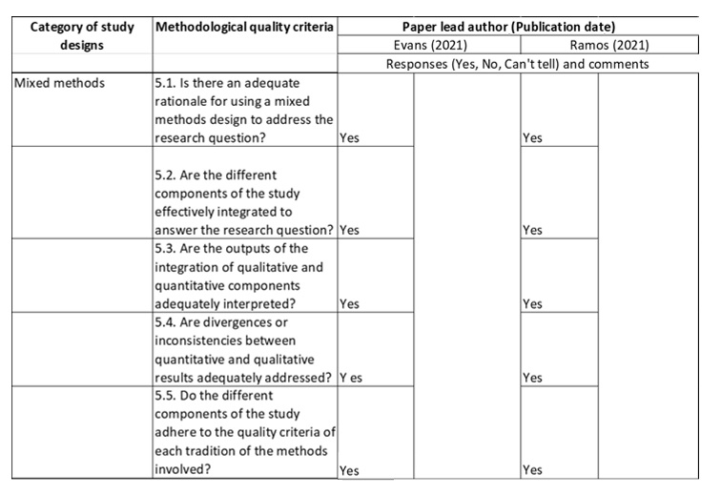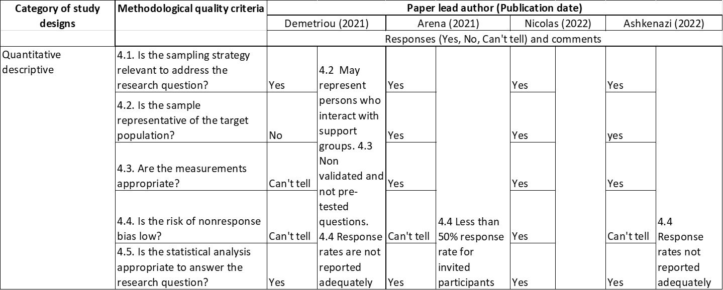

**Appendix B  
Manuscript Submission Guidelines: Women’s Health**

*This Journal is a member of the Committee on Publication Ethics.*

*This Journal recommends that authors follow the Recommendations for the*

*Conduct, Reporting, Editing, and Publication of Scholarly Work in Medical Journals formulated by the International Committee of Medical Journal Editors (ICMJE).*

*Review Articles*. These manuscripts are usually commissioned by the Editors but unsolicited reviews will be considered. The following types of high-quality review will be considered:

1. General reviews that provide a synthesis of an area that fits within the aims and scope of the journal
2. Perspective reviews – review articles that address important new areas of general interest and afford the author the opportunity to present a forward-looking perspective on the topic

* Abstract: unstructured, maximum 300 words
* Plain language summary: optional. Please check section [3.4](https://journals.sagepub.com/author-instructions/WHE#PlainLanguageSummaries) for further details.
* Word count: around 4000 – 6000 words (excluding tables, figure legends and references) is recommended. This can be flexible.
* Figures/Tables: no limit
* Declarations: please check section [5](https://journals.sagepub.com/author-instructions/WHE#Declarations) for further details.

**5. Declarations**

All submissions must include a section with the heading ‘Declarations’, including each of the sub-headings listed below. If a declaration is not applicable to your manuscript, you must still include the heading and state ‘Not applicable’ underneath. Please note that you may be asked to justify why a declaration was not applicable to your submission by the Editorial Office.

**5.2 Consent for publication**

Submissions containing any data from an individual person (including individual details, images or videos) must include a statement confirming that informed consent for publication was provided by the participant(s) or a legally authorized representative. Nonessential identifying details should be omitted. Please do not submit the participant’s actual written informed consent with your article, as this in itself breaches the patient’s confidentiality. The Journal requests that you confirm to us, in writing, that you have obtained written informed consent to publish but the written consent itself should be held by the authors/investigators themselves, for example in a patient’s hospital record. The confirmatory letter may be uploaded with your submission as a separate file in addition to the statement confirming that consent to publish was obtained within the manuscript text. If this is not applicable to your manuscript, please state ‘Not applicable’ in this section.

**5.3 Author contributions**

Papers should only be submitted for consideration once consent is given by all contributing authors. Those submitting papers should carefully check that all those whose work contributed to the paper are acknowledged as contributing authors. The list of authors should include all those who can legitimately claim authorship. This is all those who:

1. Made a substantial contribution to the concept or design of the work; or acquisition, analysis or interpretation of data,
2. Drafted the article or revised it critically for important intellectual content,
3. Approved the version to be published,
4. Each author should have participated sufficiently in the work to take public responsibility for appropriate portions of the content. Authors should meet the conditions of all of the points above. Each author should have participated sufficiently in the work to take public responsibility for appropriate portions of the content. When a large, multicentre group has conducted the work, the group should identify the individuals who accept direct responsibility for the manuscript.

These individuals should fully meet the criteria for authorship.

Acquisition of funding, collection of data, or general supervision of the research group alone does not constitute authorship, although all contributors who do not meet the criteria for authorship should be listed in the Acknowledgments section. Please refer to the [International Committee of Medical Journal Editors (ICMJE)](http://www.icmje.org/recommendations/browse/roles-and-responsibilities/defining-the-role-of-authors-and-contributors.html) authorship guidelines for more information on authorship.

***5.3.1 CRediT***

As part of our commitment to ensuring an ethical, transparent and fair peer review and publication process, [SAGE is trialling the adoption of CRediT (Contributor Roles Taxonomy) on several of our journals.](https://www.sagepub.com/credit) CRediT is a high-level taxonomy, including 14 roles, which is used to describe each author’s individual contributions to the work.

You will be asked to list the contribution of each author as part of the submission process. Please include the Author Contributions heading within your manuscript. The information you give on submission will then show under the Author Contributions heading later at the proofing stage.

**5.4 Acknowledgements**

All contributors who do not meet the criteria for authorship should be listed in this section. Examples of those who might be acknowledged include a person who provided purely technical help, or a department chair who provided only general support. If you do not have any acknowledgements to make, please state ‘Not applicable’ in this section.

***5.4.1 Third party submissions***

Where an individual who is not listed as an author submits a manuscript on behalf of the author(s), a statement must be included in the Acknowledgements section of the manuscript and in the accompanying cover letter. The statements must:

* Disclose this type of editorial assistance – including the individual’s name, company and level of input
* Identify any entities that paid for this assistance
* Confirm that the listed authors have authorized the submission of their manuscript via a third party and approved any statements or declarations, e.g. conflicting interests, funding, etc.

Where appropriate, SAGE reserves the right to deny consideration to manuscripts submitted by a third party rather than by the authors themselves.

***5.4.2 Writing assistance***

Individuals who provided writing assistance, e.g. from a specialist communications company, do not qualify as authors and so should be included in the Acknowledgements section. Authors must disclose any writing assistance – including the individual’s name, company and level of input – and identify the entity that paid for this assistance. It is not necessary to disclose use of language polishing services.

**5.5 Funding**

All authors must acknowledge their funding in a consistent fashion under a separate heading. Please visit the [Funding Acknowledgements page](https://www.sagepub.com/funding-acknowledgements?_gl=1%2Aa5i3fk%2A_ga%2AMTcwNTk2MDM5NC4xNjIwNjM2Nzk5%2A_ga_60R758KFDG%2AMTY0MjQzNjIyNS41NzQuMS4xNjQyNDM2MjYwLjA.) on the SAGE Journal Author

Gateway to confirm the format of the acknowledgment text in the event of funding, or state that: This research received no specific grant from any funding agency in the public, commercial, or not-for-profit sectors.

**5.6 Competing Interests**

All financial and non-financial competing interests must be declared in this section. If no conflict exists, please state that ‘The Author(s) declare(s) that there is no conflict of interest’. For guidance on conflict of interest statements, please see the [ICMJE recommendations.](http://www.icmje.org/recommendations/browse/roles-and-responsibilities/author-responsibilities--conflicts-of-interest.html#two)

**5.7 Availability of data and materials**

SAGE acknowledges the importance of research data availability as an integral part of the research and verification process for academic journal articles.

The Journal encourages all authors to submit any primary data used in their research articles alongside their article submissions to be published in the online version of the journal, or provide detailed information on how the data can be obtained. This information should include links to third-party data repositories or detailed contact information for third-party data sources. Data available only on an author-maintained website will need to be loaded onto either the journal’s platform or a third-party platform to ensure continuing accessibility. Examples of data types include but are not limited to statistical data files, replication code, text files, audio files, images, videos, appendices, and additional charts and graphs necessary to understand the original research. The editor may consider limited embargoes on proprietary data. The editor can also grant exceptions for data that cannot legally or ethically be released. All data submitted should comply with Institutional or Ethical Review Board requirements and applicable government regulations. If this is not applicable to your manuscript, please state ‘Not applicable’ in this section.

[Back to top](https://journals.sagepub.com/author-instructions/WHE#top)

**6. Publishing Policies**

**6.1 Publication ethics**

SAGE is committed to upholding the integrity of the academic record. We encourage authors to refer to the Committee on Publication Ethics’ [International Standards for Authors](http://publicationethics.org/files/International%20standards_authors_for%20website_11_Nov_2011.pdf) and view the Publication Ethics page on the [SAGE Author Gateway.](https://www.sagepub.com/ethics-responsibility)

***6.1.1 Plagiarism***

*Women’s Health* and SAGE take issues of copyright infringement, plagiarism or other breaches of best practice in publication very seriously. We seek to protect the rights of our authors and we always investigate claims of plagiarism or misuse of published articles. Equally, we seek to protect the reputation of the journal against malpractice. Submitted articles may be checked with duplication-checking software. Where an article, for example, is found to have plagiarised other work or included third-party copyright material without permission or with insufficient acknowledgement, or where the authorship of the article is contested, we reserve the right to take action including, but not limited to: publishing an erratum or corrigendum (correction); retracting the article; taking up the matter with the head of department or dean of the author's institution and/or relevant academic bodies or societies; or taking appropriate legal action.

***6.1.2 Prior publication***

If material has been previously published it is not generally acceptable for publication in a SAGE journal. However, there are certain circumstances where previously published material can be considered for publication. Please refer to the guidance on the [SAGE Author Gateway](https://www.sagepub.com/prior-publication) or if in doubt, contact the Editor at the address given below. **6.2 Contributor's publishing agreement**

Before publication, SAGE requires the author as the rights holder to sign a Journal Contributor’s Publishing Agreement. *Women’s Health* publishes manuscripts under [Creative Commons licenses.](http://creativecommons.org/licenses/) The standard license for the journal is Creative Commons by Attribution Non-Commercial (CC BY-NC), which allows others to re-use the work without permission as long as the work is properly referenced and the use is noncommercial. For more information, you are advised to visit [SAGE's OA licenses page.](https://www.sagepub.com/re-use-of-open-access-content) Alternative license arrangements are available, for example to meet particular funder mandates, made at the author’s request.

[Back to top](https://journals.sagepub.com/author-instructions/WHE#top)

**7. Preparing your manuscript for submission**

**7.1 Formatting**

The preferred format for your manuscript is Word. Word templates are available on the [Manuscript Submission Guidelines](https://www.sagepub.com/manuscript-submission-guidelines) page of our Author Gateway.

**7.2 Artwork, figures and other graphics**

For guidance on the preparation of illustrations, pictures and graphs in electronic format, please visit SAGE’s [Manuscript Submission Guidelines.](https://www.sagepub.com/manuscript-submission-guidelines)

**7.3 Supplementary material**

This journal is able to host additional materials online (e.g. datasets, podcasts, videos, images etc) alongside the full-text of the article. For more information please refer to our [guidelines on submitting supplementary files.](https://www.sagepub.com/supplementary-files-on-sage-journals-sj-guidelines-for-authors)

**7.4 Reference style**

*Women’s Health* adheres to the SAGE Vancouver reference style. View the [SAGE Vancouver](https://www.sagepub.com/sites/default/files/sage_vancouver_reference_style_1.pdf) guidelines to ensure your manuscript conforms to this reference style. If you use [EndNote](http://www.endnote.com/) or [Zotero](https://www.zotero.org/) to manage references, you can download the appropriate output style file to help format your references quickly.

EndNote: [here](http://endnote.com/downloads/style/sage-vancouver)

Zotero: [here](https://www.zotero.org/styles?q=id:sage-vancouver)

**7.5 English language editing services**

Authors seeking assistance with English language editing, translation, or figure and manuscript formatting to fit the journal’s specifications should consider using SAGE Language Services. Visit [SAGE Language Services](http://languageservices.sagepub.com/en/) on our Journal Author Gateway for further information.

[Back to top](https://journals.sagepub.com/author-instructions/WHE#top)

**8. Article publication enhancements**

**8.1 Infographics**

An infographic is a graphic visual representation that provides a snapshot of an article. It is a very effective means of making your article stand out, encouraging readership of your work.

Infographics must be peer-reviewed and submitted at some point during the peer review process prior to official article acceptance. We recommend creating an infographic after first decision to ensure it reflects any peer review comments received. However, please let your SAGE Editor know as soon as possible if you plan to create and include an infographic in your article.

SAGE is partnered with an external professional vendor. This service can be requested from the [Sage Author Services](https://languageservices.sagepub.com/en/services/infographics.html) prior to acceptance of your manuscript.

Please visit our [Author Guidelines for Creating and Publishing Infographics](https://www.sagepub.com/author-guidelines-for-creating-and-publishing-infographics) for further information on creating and publishing infographics.

**9. Submitting your manuscript**

*Women’s Health* is hosted on SAGE Track, a web-based online submission and peer review system powered by ScholarOne™ Manuscripts.

Visit<https://mc.manuscriptcentral.com/whe>to login and submit your article online. IMPORTANT: Please check whether you already have an account in the system before trying to create a new one. If you have reviewed or authored for the journal in the past year it is likely that you will have had an account created. For further guidance on submitting your manuscript online please visit ScholarOne [Online Help.](http://mchelp.manuscriptcentral.com/gethelpnow/)

**9.1 Information required for completing your submission**

You will be asked to provide contact details and academic affiliations for all co-authors via the submission system and identify who is to be the corresponding author. These details must match what appears on your manuscript. At this stage please ensure you have included all the required statements and declarations and uploaded any additional supplementary files (including reporting guidelines where relevant).

**9.2 ORCID iDs**

As part of our commitment to ensuring an ethical, transparent and fair peer review process SAGE is a supporting member of [ORCID, the Open Researcher and Contributor ID.](http://orcid.org/) ORCID provides a unique and persistent digital identifier that distinguishes researchers from every other researcher, even those who share the same name, and, through integration in key research workflows such as manuscript and grant submission, supports automated linkages between researchers and their professional activities, ensuring that their work is recognized.

If you already have an ORCID iD, please list this next to your name in this section. You will also be asked to link your ORCID iD to your submission during the online submission process.

We also strongly encourage all co-authors to link their ORCID iD to their accounts in our online peer review platforms. It takes seconds to do: click the link when prompted, sign into your ORCID account and our systems are automatically updated. Your ORCID iD will become part of your accepted publication’s metadata, making your work attributable to you and only you. Your ORCID iD is published with your article so that fellow researchers reading your work can link to your ORCID profile and from there link to your other publications. Please note that only ORCID iDs validated prior to article acceptance will be authorized for publication, and ORCID iDs cannot be added or amended at a later stage. If you do not already have an ORCID iD please follow this [link](https://orcid.org/register) to create one or visit our [ORCID homepage](https://www.sagepub.com/orcid) to learn more.

**9.3 Permissions**

**Please also ensure that you have obtained any necessary permission** from copyright holders for reproducing any illustrations, tables, figures or lengthy quotations previously published elsewhere. For further information including guidance on fair dealing for criticism and review, please see the Copyright and Permissions page on the [SAGE Author Gateway.](https://www.sagepub.com/copyright-and-permissions)

[Back to top](https://journals.sagepub.com/author-instructions/WHE#top)

**10. On acceptance and publication**

**10.1 SAGE Production**

Your SAGE Production Editor will keep you informed as to your article’s progress throughout the production process. Proofs will made available to the corresponding author via our editing portal SAGE Edit, or by email to the corresponding author and should be returned promptly. Authors are reminded to check their proofs carefully to confirm that all author information, including names, affiliations, sequence and contact details are correct, and that Funding and Conflict of Interest statements, if any, are accurate. Please note that if there are any changes to the author list at this stage all authors will be required to complete and sign a form authorising the change.

**10.2 Online publication**

One of the many benefits of publishing your research in an open access journal is the speed to publication. With no page count constraints, your article will be published online in a fully citable form with a DOI number as soon as it has completed the production process. At this time it will be completely free to view and download for all.

**10.3 Access to your published article**

SAGE provides authors with online access to their final article.

**10.4 Promoting your article**

Publication is not the end of the process! You can help disseminate your paper and ensure it is as widely read and cited as possible. The SAGE Author Gateway has numerous resources to help you promote your work. Visit the [Promote Your Article](https://www.sagepub.com/promote-your-article) page on the Gateway for tips and advice.

[Back to top](https://journals.sagepub.com/author-instructions/WHE#top)

**11. Further information**

Any correspondence, queries or additional requests for information on the manuscript submission process should be sent to the *Women’s Health* editorial office as follows: womenshealth@sagepub.co.uk

For all commercial sales and sponsorship enquiries, including advertising, reprints and supplements, please contact:

Commercial Sales Team, London, UK Tel: +44 20 7336 1205

Email: reprints@sagepub.co.uk

**Paper 2: Empirical Paper**

**“Just get on with it”: Exploring the lived experience of adenomyosis (an Interpretative Phenomenological Analysis)**

Sara Elizabeth Peat  
Doctorate in Clinical Psychology  
Staffordshire University

Word count: 7998

Target Journal: Women’s Health  
Author guidelines can be found in Appendix M. Further modifications will be made prior to journal submission

**Abstract**This qualitative study explores the experiences of nine females diagnosed with adenomyosis. Currently, there is a lack of literature attending to adenomyosis in any capacity. Negative psychological impacts upon wellbeing, which necessitate clinical support, have been associated with other gynaecological conditions (Della Corte et al, 2020). Therefore, research is required to gain understanding of any comparable impacts associated with adenomyosis. This study provides novel insight into individual experiences of living with the chronic gynaecological condition. Semi-structured interviews were analysed using Interpretative Phenomenological Analysis (IPA) which allowed for the meanings that participants made of their experience to be explored. Three Group Experiential Themes were identified: Feeling dismissed, invalidated, and lost while seeking support; Ongoing struggles with symptomology and identity and Feeling misunderstood and isolated. Individuals living with adenomyosis are experiencing physical, social and psychological challenges which negatively impact upon their wellbeing within personal, professional, and clinical environments. Clinical implications around the need for improved support including: information sharing; self-management education; individualized care and enhanced training for medical professionals are outlined. Further research is required to better understand causal links between effects and impacts and inform holistic interventions.

**Key words: adenomyosis, pelvic pain, menstruation, endometriosis, gynaecology**

**Introduction**

**What is Adenomyosis?**   
Adenomyosis (pronounced: ad-uh-no-my-O-sis) is a gynaecological condition which can cause severe pain and have wide ranging impacts upon a person’s everyday life. Discomfort occurs when the tissue that normally lines the uterus (endometrial tissue) grows into the muscular wall of the uterus (Litin, 2018). Primary symptoms may include menorrhagia (heavy menstrual bleeding), abnormal uterine bleeding, dysmenorrhea (lower pelvic pain), and infertility. Secondary symptoms may be far more diverse, impacting upon daily routines, sexual health, relationships and wellbeing. Persons may also have the condition yet experience no symptoms.

Adenomyosis is estimated to affect one in ten (Guy’s and St Thomas’ NHS, 2021) people born with a uterus. It can be found in persons with a uterus of all ages, including adolescents once menstruation has commenced. Rates of diagnosis and treatment are much lower than this suggested prevalence (Naftalin et al., 2012). Historically, an absence of diagnosis could be attributed to difficulties in diagnostic techniques (hysterectomy was required for retrospective diagnosis). Despite more accurate diagnosis being possible thanks to progress in imaging techniques (Campo et al., 2011), the current length of time to receive diagnosis from initial visit to a general practitioner is estimated to be approximately seven years. Thus, a potential disparity exists between population prevalence, diagnosis, and clinical service provision. Evidence of this unmet need has been highlighted in a recent population-based study (Yu et al., 2020) which described adenomyosis as ‘disabling’ and called for more research into this relatively understudied but common gynaecological condition.

**Research Rationale**Unlike other chronic pain conditions with similar prevalence rates such as endometriosis (Chaman-Ara et al., 2017), literature searches yield no existing studies exploring the impacts of living with adenomyosis. Limited specialist knowledge is accessible within National Health Services (NHS) and, at the time of study commencement, adenomyosis had no dedicated NHS webpage, consequently NICE guidelines (NICE, 2013) discussing the condition are sparse. Post-diagnosis, persons are directed to Adenomyosis Advice Association, The Pelvic Pain Support Network and Hysterectomy Association for support. Anecdotal evidence on these support network forums, online discussion boards and social media support groups, includes dialogue detailing the varied and life-long impacts of adenomyosis. Subsequently, anecdotal treatment advice shared among persons with similar symptoms seems to be the main source of support accessed by those with an adenomyosis diagnosis. Within these spaces, narratives of mistrust, discontent and lack of support from clinical professionals are common.

Literature suggests that individuals experiencing physical health issues have a greater chance of developing mental health problems and calls for clinicians to treat the mind and body as interrelated systems (Doherty & Gaughran, 2014). As there is a well-documented relationship between chronic pain conditions and changes in psychological processes (Simons et al., 2014), psychological interventions for chronic pain conditions are commonplace. Interventions adhere to a biopsychosocial model, recognising the subjective experience of the illness and focusing on symptom management using self-regulatory behaviours and cognitive change (Roditi & Roditi, 2011).

Existing literature investigating the psychological impacts of the chronic gynaecological condition, endometriosis, which is reported to have similar symptoms and often coexists with adenomyosis, is more prevalent (potentially due to the condition being more easily diagnosed) and could be used to guide studies aiming to glean equivalent experiential information about adenomyosis. Literature cites endometriosis’ negative effects upon levels of fatigue (Ramin-Wright, 2018), work and social participation (Culley et al., 2013), sexual function and quality of relationships (Pluchino, 2016), and generally speaks to a significant effect on mental and social wellbeing. Findings ultimately suggest that a ‘patient-centred approach with extensive collaboration across disciplines, such as pain specialists, psychologists, sexologists and social workers, may be a valuable strategy to improve the long-term care of women with endometriosis (De Graaff et al., 2013). Due to the lack of evidence directly investigating adenomyosis (Halvorson et al., 2020), it is not known if a similar approach would be appropriate to the treatment and management of adenomyosis. Through exploring individuals’ experiences, this study aims to contribute to the limited understanding of life with adenomyosis. Research which considers the perspectives of those with a lived experience of adenomyosis is important as it could lead to findings that more realistically reflect the realities and needs of this group (Banner et al., 2019). By using IPA to explore idiographic accounts and enhance the richness in understanding of these realities, this research could prove useful to psychological professionals in directing service provisions.   
 **Objective and Research Question**   
**Objective:** To gain insight into individual experiences of living with the chronic gynaecological condition adenomyosis.   
  
**Research question:** How do people experience life with adenomyosis?

**Method  
Ethics**Ethical approval was granted by Staffordshire University Ethics Committee (appendix A). Prior to interviews consent was obtained (appendix C) and participants were reminded of their right to withdraw from the study. During interviews, several participants expressed feeling distressed. Guidelines and ethical protocols for responding to participant distress when using video software were adhered to (Kasket, 2009a, 2009b). The researcher showed compassion, offered to engage in relaxation techniques and gave participants the option to terminate the interview. No participants decided to withdraw from the process. Participants’ rights to privacy were upheld in line with The British Psychological Society (BPS) (2017).  
  
**Study Design**The study employed a qualitative design using Interpretative Phenomenological Analysis (IPA) (Smith et al., 2021). IPA takes a cognitive analytical approach to qualitative research which combines phenomenology, hermeneutics, and idiographic approaches (Chenail, 2016), enabling researchers to examine “how people make sense of major life experiences” (Smith et al., 2009, p. 1). The “phenomenology” element involves asking questions which elicit information relating to how a person, in a given context, makes sense of a phenomenon (Davidson, 2013). Every explored experience is “idiographic” in that it relates to one person’s lived experiences as they recount them. The researcher attends to each unique narrative separately while also considering homogenous group themes (Shinebourne, 2011). In essence, IPA methodology attempts to explore individual subjective perceptions of their experiences and nuanced sense-making, while comparing and contrasting group experiences (Tuffour, 2017). “Hermeneutics” refers to the interpretative element of understanding applied to the discourse. The “double hermeneutic” layer of IPA pertains to the researcher actively engaging in interpretation and meaning-making, aiming to understand participants’ sense-making (Nizza et al., 2021). Due to the explorative nature of the research question and the complex and emotional phenomenon of living with a chronic condition, IPA was considered more suitable than other qualitative methods as it enabled the researcher to gain an in-depth understanding of the subjective, lived illness experience of adenomyosis (Peat et al., 2018; Larkin et al.,2021).   
  
**Recruitment**  
A purposive, volunteer sampling method was used. Recruitment advertisements (appendix D) were distributed via social media platforms and communications by The Pelvic Pain Support Network and The Adenomyosis Advice Association. The British Psychological Society ethics guidelines for conducting internet mediated research (Hewson, 2021) were adhered to. Participants emailed the researcher who responded with a participant information sheet (appendix B) following eligibility clarification. Following a week’s contemplation period the researcher collected consent forms and arranged interviews. Recruitment spanned January 2023 – March 2023.   
  
**Inclusion Criteria**  
Participants were eligible to take part in the study if they had received a diagnosis of adenomyosis, were above the age of eighteen years (rationale found in exclusion criteria) and possessed fluency in English due to lack of funding for an interpreter.

**Exclusion Criteria**Persons with a co-existing endometriosis diagnosis were excluded due to the inability to accurately attribute symptoms to each condition. Mixed condition presentations could be useful to include in future studies, however, as this investigation was explorative the researcher aimed to address the absence of specificity in existing literature. The decision to exclude persons under eighteen was influenced by the suggestion that coming to terms with a chronic medical illness can act as a significant risk factor for the development of an anxiety disorder (Pao & Bosk, 2010). Therefore, it seemed prudent to be mindful of the potential psychological distress that a young person might experience if they were asked to prematurely contemplate the life-long impact of this condition.   
  
**Participants**Target sample size was informed by Clarke (2010) who stipulated that 2-10 participants is suitable when using IPA methodology due to the richness of understanding provided by the depth of idiographic accounts. The emphasis on depth of experience, captured by IPA, is particularly relevant to unresearched areas, such as adenomyosis, that may be ambiguous, complex and emotionally laden thus necessitate some novel sense-making before moving towards more general understandings (Smith & Osborn, 2014). 17 individuals responded to the advertisement, 3 of whom did not meet inclusion criteria. The first 10 respondents were invited to take part in the study and 4 were advised that the study had reached capacity. 1 participant did not attend interview. The final sample size was 9. Although no specific demographic data was collected other than age and location (Table 1), during interview participants talked about: varied durations of lived experience; diverse symptomologies and different diagnosis timelines.  
  
**Table 1**  
*Participant demographics*

|  |  |  |  |
| --- | --- | --- | --- |
| **Participant No.** | **Pseudonym** | **Age** | **Location** |
| 1 | Meredith | 35 | England |
| 2 | Lily | 40 | England |
| 3 | Jane | 47 | England |
| 4 | Louise | 46 | England |
| 5 | Simran | 27 | England |
| 6 | Cara | 26 | England |
| 7 | Mo | 53 | England |
| 8 | Cath | 52 | Scotland |
| 9 | June | 28 | United States |

**Procedure**  
Interviews took place online using Microsoft Teams video platform to limit logistical challenges related to geographical location. Interviews were facilitated at a convenient time, in a private location chosen by participants where they felt safe enough to discuss sensitive topics. A continuous conversation between researcher and participant was audio recorded, transcribed, and anonymized using Microsoft Word. At completion, participants were debriefed verbally, encouraged to take time to relax and emailed a debriefing form (appendix F). In line with IPA, the interview comprised of open-ended questions (appendix E) relating to individuals’ experiences, informed by other chronic pain conditions and narratives identified on online discussion forums. During interview the researcher endeavoured to build rapport with participants by using a relaxed, conversational style and encouraging them to share their stories at a comfortable pace. Any salient or novel points made my participants were noted down and used as prompts for more in-depth discussion.

**Data Analysis**   
Data was analysed using IPA, adhering to guidelines produced by Smith et al., (2021). The process follows an idiographic pathway, exploring each participant’s sense-making individually, before considering the groups commonalities and generating generic experiential themes (Pietkiewicz & Smith, 2012). Once the researcher had repeatedly listened to the audio recordings and become familiar with them, transcripts were read several times until the researcher felt immersed in the data. As part of the meaning-making process, the researcher kept a reflective log of initial thoughts during immersion. Upon reading, narrative deemed significant or interesting due to linguistic content or non-verbal communication was noted in the right-hand margin of the page as exploratory comments. The left-hand margin was then used to document potential experiential statements (appendix H). The researcher generated a list of personal experiential statements (PES) for each interview (appendix I). PES were grouped to generate clusters of Personal Experiential Themes (PETs) (appendix J). This process was repeated for every transcript after which visible patterns between participant PETs allowed for Group Experiential Themes (GETs) to emerge (appendix K & L). The final GETs and subthemes were selected based upon salience, universality and richness of content as opposed to prevalence alone. Once themes were finalized, the researcher referred to the original transcripts to ensure that supporting quotes retained a true reflection of participant dialogue and meaning. A sample of the transcripts were reviewed by the supervisor to confirm that analysis was trustworthy.   
  
**Service User Involvement**   
The semi-structured interview questions were assessed for suitability by an independently recruited individual with a diagnosis of adenomyosis and by the Pelvic Pain Network. To strengthen the trustworthiness of researcher interpretation following analysis, resonance of final themes was checked with participants via email. No amendments were deemed necessary. To ensure that the Executive Summary (Chapter 3) was appropriately written for this group of service users, the aforementioned independently recruited individual reviewed the document.

**Epistemological Position and Reflexivity**  
A self-awareness of the epistemological position was relevant to IPA methodology due to the reflexivity involved within the double hermeneutic process (Clansy, 2013). A social constructivist epistemological position was employed by the researcher, holding the belief that there is no pure objective truth in meaning. Instead, social constructivism considers inter-subjectivity and social interactions to impact upon individual constructs (Sandu & Unguru, 2017). The social constructivist lens was deemed appropriate for research interpreting lived experiences through the collaborative process of IPA (McNamee, 2011). The researcher held an assumption that social experiences, with particular focus on gender, may influence participants sense-making. Literature has suggested that social narratives pertaining to gender impact upon how seriously clinicians appraise women in pain (Samulowitz et al., 2018). Gender stereotypes have been reported to result in underestimation of pain in female patients (Zhang et al., 2021) and lead to women feeling responsible for being unwell (Skuladottir & Halldorsdottir, 2008).   
  
Reflexivity was considered throughout the study as standard, as a means of dialectical self-critique (Dowling, 2006) and because the researcher has a diagnosis of adenomyosis and therefore possessed a special interest in the condition. Further information about the researcher can be found in a reflective statement (Appendix G). The researcher was able to utilise personal and clinical knowledge to facilitate understanding within interviews. However, the researcher noticed that their personal experiences resulted in assumptions that clinical provisions require improvement and that gender norms may negatively impact upon participants’ experiences. To manage this, the researcher utilized experience from previous research undertakings to help them to stay attuned to any possible influences upon theme interpretation. Although assumptions are an accepted element of a reflexive qualitative research (Patnaik, 2013), the researcher aimed to increase the trustworthiness of the study by utilising a reflective log and seeking peer supervision to discuss and monitor the process of theme generation and limit biases in interpretation. The researcher’s reflexive journal highlighted that completing the work was emotionally challenging thus they made use of peer reflective practice and social support to enable them to maintain perspective during analysis.  **Results**  
Table 2 shows the three GETs and nine subthemes identified during analysis. Theme descriptions are supported by participant quotes and interpreted using IPA.

**Table 2**  
*Themes*

|  |  |  |
| --- | --- | --- |
| **Group Experiential Themes (GETs)** | **Subthemes** | **Present in participant(s)** |
| **1) Feeling dismissed, invalidated, and lost while seeking support.** | *“Just get on with it”*  *“A fight to be listened to”*  *Mixed feelings at diagnosis Fearfully seeking solutions* | 1,2,3,5,6,8,9 1,2,3,5,7,8,9  1,2,3,5,6,7,9 1,2,3,4,5,6,7,8,9 |
| **2)** **Ongoing struggles with symptomology and identity.** | *“It’s like you’re getting punched from the inside”*  *Pressure to maintain roles*  *“I've lost a little bit of myself”* | 1,2,3,4,5,7,8,9 1,2,3,4,5,6,7,8,9 1,2,3,4,5,6,7,8,9 |
| **3) Feeling misunderstood and isolated.** | *“No, no, no, no, no, you don't understand”*  *“You’re completely alone”* | 1,2,3,4,5,6,7,8,9 1,2,3,4,5,7,8,9 |

**Group Experiential Theme 1: Feeling dismissed, invalidated, and lost while seeking support.**  
Participants discussed the experience of seeking clinical support and diagnosis for unusual menstrual symptoms. A lack of clinical recognition led to 8 of the 9 participants seeking private healthcare diagnoses. Pre and post diagnosis, experiences of seeking support included being dismissed, misdiagnosed, effortful self-advocacy and developing a mistrust in medical professionals which sometimes resulted in disengagement and decades of uninformed self-management. Following diagnosis, lacking information and guidance, participants found themselves in the role of self-researcher.   
  
**Subtheme 1: “Just get on with it” (Jane)** Participants reflected upon feeling invalidated, dismissed and negatively appraised when seeking support: “It's quite disheartening when you're having these symptoms and the message that you receive is, well, it is painful” (Meredith).   
  
A power imbalance in the role of ‘patient’ was expressed: “this anxiety of Oh my God! I have to go sit in this room again and be talk down to” (June). June’s wording “oh my god” and “again” implies frustration and potentially being accustomed to experiencing disempowerment.   
  
Individual characteristics (race, gender and age) were thought to be utilised as reasons for invalidation producing increased vulnerability. Simran recounted with shock:

“I've literally been told by the doctors that Asian women just have a lower pain   
 threshold. I had experienced racism since a really young age, but not from   
 somebody…that is supposed to be there to help me”.  
  
Attempting to seek care as a female teenager similarly left Jane feeling dismissed and silenced:

“I would go in with all of these symptoms, he would say oh it's you young girls. You   
 don't look after yourself. You don't eat properly. You know everybody has heavy   
 periods. Off you go. Go on the pill. It will sort everything out” (Jane).   
  
Referencing age, Cath echoed a comparable dismissal in her forties: “I was told this is what happens to women as you get older”.   
  
Sitting in the non-expert role of patient and receiving messages from clinicians in which their pain was normalised: “I think it's just your period and that's normal” (Cara) could be equated to being told: you are inaccurately appraising your symptoms and the problem is not real nor does it warrant support. Despite “knowing” something was wrong Meredith recalled how this messaging prevented sustained efforts in seeking care: “I came away thinking I don’t believe you but you certainly don't want to nag. If they're telling you that nothing is wrong, I didn't want to mither”.   
  
These experiences were described as inciting “hopelessness” by Lily, and for Jane they resulted in self-criticism and disengagement: “you start doubting yourself thinking maybe I am making all of this up. Maybe everybody goes through this. Maybe I just need to just get on with it” (Jane).   
  
**Subtheme 2: “A fight to be listened to” (Meredith)**  
Throughout all interviews, a perception that life with adenomyosis required enduring and effortful self-advocacy was evident, illustrated by Meredith likening the experience to a “fight”: “I was dismissed for years…It was just a fight to be listened to”.  
  
Jane shared: “I'm just being fobbed off. I mean it, for years and years this went on”. Reflecting on “years” of seeking help to no avail the language “fobbed off” suggests that Jane felt undermined and dismissed.   
  
Feelings of frustration, anger and being “fed up” (Louise) were conveyed as participants’ battles were compounded by medical professionals repeatedly not providing answers: “it was this constant battle of going to doctors and then being like, I don't know, here's another doctor” (June), assuming other clinical causes: “she convinced herself I had Polycystic Ovaries” (Meredith), or delivering misdiagnosis: “NHS confirmed fibroids, only to go see the specialist to be told no, you don't have any fibroids“ (Louise).

For Lily, recurrent dismissal and misdiagnosis led to spending years in pain:

“I have had it for probably 25 years…a lot of the symptoms I've experienced   
 throughout my whole life…I've been misdiagnosed with Vulvodynia… I had very, very   
 painful sex after I gave birth to my children again, which was sort of dismissed”.

Although Lily continuously sought help she expressed feeling “completely helpless” due to a perception that medical professionals were unempathetic. Lily conveyed experiences of minimization by impersonating clinicians: “Stop coming back about this, this is annoying… we've ruled things out. You should just be happy about the fact it's not cancer”, thereby underlining how participants may not only have experienced feeling unheard by professionals, but also belittled.

Suggestions were made that needing to fight had something to do with gender, a societal notion of “women’s troubles” (Cath) and inequality in medical care:  
 “It just makes you feel a bit worthless…as though my pain and my life isn't as   
 important as a male’s…every single point of this journey…I've just been made to feel   
 like, ohh. You're just a woman. You're just being dramatic.” (Simran).   
  
Alternatively, Mo wondered if the doctors’ gender explained the lack of attentiveness: “why are gynaecologists always men?...They don’t have the equipment to understand”. This may imply a belief that the embodied experience of being a female is vital to the comprehension of adenomyosis.

**Subtheme 3: Mixed feelings at diagnosis**   
Experiences during diagnosis were varied. For those who had been suffering and feeling invalidated for many years relief was evident:  
 “I was told for 13 years that it's in my head when actually, no. It justified what I was   
 feeling…like what you're feeling is what you're feeling…part of it was I was relieved.   
 Because now I know that I'm not crazy, which is how I have felt for years” (Simran).   
Sentiments of validation were echoed by Meredith: “oh, I wasn’t going mad”. For these women diagnosis seemed to provide transition towards a long-disputed peace of mind. However, their indignant tone during discussion implied that they felt a lasting sense of injustice.   
  
Along with external validation, a powerful sense-making value of diagnosis was amplified by June:   
 “It was just like this moment of Oh my God! I've been listened to and we've been able   
 to put a name to this pain, as opposed to just a feeling, it solidifies…I think it made   
 people take it more seriously, even if they didn't understand it.”

All but one individual stated that they “had never heard of adenomyosis” (Lily) when diagnosed. This lack of knowledge was recurrently unaddressed even when further information was requested: “do you have any literature you can give me on this?...she said to me, ohh, go away Google it. There's lots of stuff online…in the moment I was quite shocked.” (Jane). The “shock” described implies a disparity between an expected level of information and that received. All participants highlighted feeling a deficiency in understanding of the condition coming away from diagnosis.  
  
A collective sense of diagnosis being delivered without compassion was shared:

“all that was said to me was there's nothing we can do about it…the only options are  
hysterectomy or we stop your periods. Initially I was really upset…it was just very how it was delivered was very just casual” (Cara).

Highlighting the “casual” tone of the clinician suggests that delivery was perceived as out of sync with the personal gravity of the situation. Cara emphasised this sentiment by stating: “it’s very dismissive to say okay, you found your answer. Now go deal with it”.   
  
Interpersonal experiences aside, a shared feeling was described well by Mo: “it is good to have a name rather than say we don’t know what’s wrong with you”. This common desire for a label may speak to participants’ unmet need for validation or suggest that they held an implicit belief that diagnosis carries with it some hope for future relief. **Subtheme 4: Fearfully seeking solutions**Participants inferred that they became self-researchers due to “inadequate information” (Cara) and fears related to “incredibly limited treatment options” (Lily). Assuming this role signalled a transfer of the duty of care from professionals onto the individual. The work involved effortful “digging” (Jane) for information, using the internet to navigate challenges and making educated guesses using existing health knowledge: “I started doing the 5/2 when you fast twice a week and my symptoms did get better…it could have been totally coincidental” (Mo).   
  
Self-researching provided positive support and reassurance for June: “There's this wonderful [online] community…that teaches each other how to navigate these things.” Yet, most participants implied that blindly searching for information exacerbated distress or incited fear:

“There's nothing at the beginning to sort of say read up on this or look for this page   
 so you are just finding other women who had really negative experiences…burning   
 themselves in that much pain and you're like, wow….if you're accessing it yourself…I   
 can find things that scare me. I’m scared to potentially think that I could end up in that   
 position” (Cara).   
For Louise, the adverse impact of receiving contradictory and insufficient information about the interplay between adenomyosis and fertility was experienced as life changing following miscarriage and unsuccessful in vitro fertilisation (IVF):

“I can't deal with the fact that I've had this condition for many years. The doctors   
 didn't talk to me about it…I can't deal with the fact that this has prevented me from   
 having a child. And nobody's willing to talk about that”.

Louise conveyed anger and despondency when describing how deficient information gave way to lack of accountability and feeling ignored, emphasised by “nobody’s willing to talk about that”.   
  
A dearth of information and self-navigated care resulted in Cath making dangerous self-management decisions: “I took medication that wasn’t prescribed to me just because the pain was so bad”. There was also a sense that lacking information left individuals feeling lost and ill-equipped to make decisions around hysterectomy. Lily implied that taking on the role of self-researcher could stem from a fearful reluctance to accept that treatment options are truly so limited:

“Surgery is frightening and the possibility of going into early menopause is   
 frightening…I'm really struggling with the fact that I've got two options…it physically   
 makes me like literally just hunch over. I feel heartbroken…those two choices. I   
 don't believe that, that it really is only two choices”.   
  
Every participant asked the researcher questions, highlighting an on-going lack of understanding: “I don’t know what the normal symptoms of it are. Can you enlighten me? Does it resolve with menopause?” (Mo). Even Cath, who had suffered symptoms for decades and elected to have a hysterectomy, appeared unclear of the facts: “now I’m talking I’m realising, do we even know what causes it?”.**Group Experiential Theme 2: Ongoing struggles with symptomology and identity**Participants reflected upon day-to-day struggles involved with living with adenomyosis. Physical and emotional impacts were discussed along with lifestyle adaptations. Participants struggled to maintain “normal” life and experienced challenges to established roles. Feelings of loss, self-compassion, acceptance and power struggles accompanied shifting self-identities.

**Subtheme 1: “It’s like you’re getting punched from the inside” (Cath)**Participants described struggling with a variety of physical symptoms including but not limited to; leg pain, rectal pain, “extremely painful intercourse” (Cara), migraines, fatigue, menorrhagia, “lowered immune system” (Meredith) and bloating. Varied techniques were employed in effort to manage symptoms including; pain killers, baths, walking, stretching, avoiding intercourse, yoga, resting, heat pads, dietary adaptations and loose clothing.  
  
The severity endured was stressed by the visceral detail with which participants described symptoms, attempting to convey the “nightmare” (Mo) of the experience, as if an outsider could not accurately imagine the reality: “It’s like you’re getting punched from the inside” (Cath).   
  
“I'm crying on the toilet because I can't cope with the amount of blood…waking up two or three times during the night...I'm covered in blood” (Louise). As highlighted by Louise crying, an experiential connection between relentless physical symptoms and emotional impacts was universal. For some, low mood was connected to symptoms preventing engagement in daily activities:

“I do definitely have days where I just feel like I just don't even wanna be here. Like   
 the pain is not worth it. Like nothing is worth it. But then I have to remind myself that   
 at the end of that, sometimes I have days where I have no pain and I'm able to do so   
 much in a day.” (Simran).   
  
Inactivity due to pain also resulted in self-criticism:

“It’s preventing me from doing the things I'd like to be doing. I have to try not to get   
 too down and out about such things…you just have a couple of days of not being   
 able to do very much and feeling like you were failing yourself.” (Meredith)   
  
Jane emphasized how the unpredictable nature of symptoms makes ongoing management feel challenging: “I go through periods of feeling quite well and then my symptoms would increase quite significantly and I would feel quite unwell and it feels like this constant cycle. It becomes quite exhausting trying to manage it.” The use of “constant cycle” implies an inescapable sense of powerlessness, not being able to maintain control or feel lasting reprieve.

**Subtheme 2: Pressure to maintain roles**Mixed emotions accompanied efforts to maintain existing roles of partner, mother and employee while struggling with symptoms.  
  
A shift in relationship dynamics and challenges to self-worth were discussed as a consequence of partners assuming the role of caregiver: “it affects every part of your life, especially romantic wise… I harboured so much guilt for having someone have to take care of me” (June).   
  
Many participants discussed challenges in sexual intimacy:

“My husband is a great support; our marriage suffers from it. Bleeding constantly, has   
 affected us, our sex life. I don't feel like a sexual being anymore…That has to be   
 parked for me…he can't park his, or he can, but he does feel like a sexual person   
 because he's not going through this, so we have a significant mismatch…I want my   
 marriage to continue.” (Lily).

The emotional impact of a “mismatch” in sexual desire was evident as Lily broke into tears, sharing a belief that a shift in her role of partner may jeopardize the future of her marriage.

Meredith reflected upon internal conflict resultant from a pressure to sustain practical expectations of being a partner and stressed that she would “really suffer for it”:

“You're having to ask for a bit of compassion, that can be a difficult thing to ask for   
 when you know it's not necessarily going to be received very well, those times I   
 would sort of make myself get out of bed and drive somewhere because we needed   
 to do something…it made me feel rubbish actually.”

Conversely, Louise implied that a sense of shared duty and understanding enabled her to feel more secure in her role: “we're a team and everything's 50-50 so he'll sort stuff out. I value it…I love him to bits for understanding.”

Parental demands resulted in a pressure to “just get on with it” (Lily) regardless of pain. Inability to engage in family activities, prioritising childcare over other responsibilities or sacrificing rest were discussed: “I've still got to take care of my kids. You know?” (Lily).   
“You are losing two sometimes three days of your life…trying to explain to my son who was 13, that I couldn’t do certain things because I was in so much discomfort, it wasn’t good” (Cath).  
“I just probably won't do as much housework…obviously I have a small child, so that's so the main thing I really do” (Cara). Cara went on to share that were she not a mother she would “probably have stayed in bed”, underlining the physical toll of maintaining this role alongside managing symptoms.

Participants described themselves as “Lucky” (Louise, Lily, Cath, Meredith) if they worked from home, implying that symptoms may not feel manageable outside of the home. This signified an inherent worry about keeping up with workplace expectations. Validating the reality of this concern, Cath shared: “I would make it to work but I would be heavily medicated to get there.” Simran spoke with disappointment and frustration as she reflected:

“I've actually lost jobs because managers don't understand…they don't take it   
 seriously and they just think I'm just taking time off work just because I fancy it, not   
 because I'm actually literally in bed. Can't even get myself to the bathroom”.

Yet, she went on to express:

“I’ve now found a job with a workplace that's so understanding...I just feel a lot   
 happier. I don't feel like I'm constantly having to suppress these feelings and   
 medicate myself. If I'm having a bad day, I'm having a bad day and I need to go   
 home.”

Thus conveying the value of receiving “understanding” about the day-to-day struggles associated with managing adenomyosis in the workplace and emphasising that reduced pressure in this role can improve wellbeing.   
  
**Subtheme 3: “I've lost a little bit of myself” (Simran)** Participants’ self-identity was challenged by the ongoing changes demanded by life with adenomyosis. Reflections on a struggle for agency were conveyed with feelings of resentment, grief, hopelessness and acceptance, highlighting the psychological impact of the condition.

Participants described discomfort and grief associated with experiencing changes in their appearance: “I thought I looked ok, I put on my make-up, went out and my sister said ‘oh god you look awful’. I thought I looked good…but people could see the pain….. I thought god I must look bad” (Cath).

“This condition has taken so much away from me...I used to show so much more of   
 my personality through how I dressed... I feel like I've lost a little bit of myself with   
 that. When I look in a mirror, I don't wanna look at Sim that has adenomyosis and is   
 bloated and uncomfortable. I wanna look at Sim that's comfortable and can go about   
 her day and doesn't need to worry” (Simran).

In recounting what the condition has “taken” from her, Simran infers a loss of agency and a power struggle against the personified adenomyosis. Louise echoed this personification and efforts to assert her position of power and identity:

“Sit on the sofa under a blanket…that's not me. I'm an active exercising person but   
 for that period of time now I'm a different person...I don't like to allow it to rule me, I   
 prefer to rule it. It's not something I feel I'm gonna let get hold of me...I am a strong   
 independent woman”.

The language “different person” describes a forced change in self-identity that participants can experience.   
  
Some participants spoke with acceptance about elements of their changed identity:

“Not that I've given up, I've just given in...having to realise that it's more important to   
 take care of my body and how I'm feeling rather than necessarily how I look…it's   
 shaped me…it is my identity, but it's not necessarily what I paint myself all the time.”   
 (June).

June implies that a giving-in and acceptance of a re-shaped identity was necessary to more compassionately “care” for themselves. The notion that acceptance makes way for comfort and self-compassion was echoed by Cara: “I think body wise….that's kind of a journey…I've got more comfortable with just like looking at myself and being like, no, it's okay if you are bloated”.   
  
For Lily the physical changes endured gave way to hopelessness: “the pain that has been there for the past however long makes you carry yourself differently…I've physically been altered… that just felt inevitable…it all just is. It's all just…this has been my life since I was 15”. The language “inevitable” implies that Lily felt as if she had little agency over her future physicality. The repetition of “just” suggests a struggle to verbalize her hopelessness, later using the number of years she has felt this way to stress her powerlessness.

**Group Experiential Theme 3: Feeling misunderstood and isolated**  
An overarching relational feeling of being socially misunderstood was evident. Perceptions that social and gender norms limited other people’s ability to understand adenomyosis were considered. Participants reflected on a shared sense of isolation and self-reliance born out of feeling misunderstood.  
  
**Subtheme 1: “No, no, no, no, no, you don't understand” (June)**Gender norms and societal narratives about wellness negatively impacted on participants feeling understood. Feelings of anger and frustration accompanied the narrative that adenomyosis, not being part of public consciousness, meant that: “people don't get it because they don't understand. It's not something that people know about” (Louise).   
  
Participants reflected upon experiences of feeling misunderstood in relation to inaccurate societal perceptions about menstruation: “the perception comes down to it’s women’s troubles, oh it happens once a month” (Cath).

“I think from a social construct that a lot of times, if it's men they will just minimize   
 and say, yeah, it's just period pain…You'll be fine. I'd be angry, it would make me   
 have to explain the whole thing” (Cara).

The “minimization” described suggests that being misunderstood triggered invalidation and placed the individual in a position of having to “explain” or defend themselves. Simran echoed this sentiment:

“I’ve had people tell me my entire life…Oh she's just lazy...It's this, it's that…that's not   
 how I am at all. If you actually paid attention to what was going on, you would realise,   
 it makes me angry”.

The language “if you actually paid attention” suggests feeling unseen.   
  
This “invisibility” (Lily) of the illness was rationalized as contributing to misunderstandings: “I do get some comments... Oh you’re just being dramatic, or you look fine and I'm like, yeah, but I might look fine, but I'm still feeling what I'm feeling.” (Simran).

There was a sense that participants felt criticized as they recounted experiences of people proposing that their behavior could cause or exacerbate symptoms: “People are like, well, it must be just really simplistic, just work out harder” (Cara).

“I've had people try to tell me…Oh, you're a vegetarian. You're not getting enough   
 iron. That's why you're having all these issues. It's like. No, no, no, no, no you don't   
 understand. I know what's going on in my body.” (June).

June’s repetition of “no” communicates the frustration that accompanied a misinterpretation that they held responsibility for being unwell.  
 **Subtheme 2: “You’re completely alone” (Louise)**   
A recurrent theme of isolation was present. Reflections upon feeling alone were compounded by the shame and secrecy surrounding menstruation. Loneliness accompanied and accentuated self-reliance: “people didn’t talk about things...I’d actually feel as if I was alone in some ways...I would just go in on myself and not want to speak to anybody” (Cath).   
“there's also the element of embarrassment...it’s just quite a personal, intimate problem and the shame that you kind of go through your teens with… I’ve learnt to kind of get on with it myself” (Meredith).

Feeling unable to communicate due to embarrassment or social convention, and being forced to miss out on social events due to overwhelming symptoms, led to feelings of increased isolation:

“Talking to friends about rectal pain…it's not a pleasant set of symptoms…you   
 wouldn’t say I'm staying home because I'm having a heavy period…you're making   
 excuses, then how do your friends perceive you? You know she always lets us down”   
 (Lily).  
  
Participants who felt able to communicate found utility or compassion in doing so: “Sometimes you just need to vent and hear someone say that sucks” (June). Yet, there was a shared sense of inescapable self-reliance: “you’re bleeding you have to cope with it yourself. You get understanding, there’s nothing that other people…you know, they can bring you a cup of tea but that doesn’t do much, that’s all they can do” (Mo).  
   
Louise expressed: "nobody knows because I've never had anyone in that room with me…nobody knows, nobody ******* gets this is not normal...I'm not about to drag my husband into the toilet with me and go there look at that...you're completely alone". The swearing and repetition of ‘nobody knows’ emphasises the psychological distress, compounded by the isolation of coping alone and in secret.

**Discussion**

**Key Findings and Implications**To date, no qualitative research has been conducted into the lived experience of adenomyosis. This study provides a unique contribution to gynaecological literature.   
  
The study identified three GETs: Feeling dismissed, invalidated, and lost while seeking support; Ongoing struggles with symptomology and identity and Feeling misunderstood and isolated. During the sense-making process participants considered delayed diagnosis, inadequate support and information, societal representations of adenomyosis, gender and social roles, interpersonal support, and self-concepts as influential upon their experience of life with adenomyosis. The aforementioned themes are comparable to previous research on lived experiences of chronic conditions which have cited clinical support (Von Korff et al., 2002), self-management strategies (Barlow et al., 2002), interpersonal experiences (DeVellis et al., 2003) and self-identity (Charmanz, 1995) as influential upon psychological wellbeing.   
  
The drive for diagnosis that was exhibited (GET 1) may originate from a “sense-making” need. Persons suffering from chronic symptoms are more able to conceptualize their future post-diagnosis when supported to view the condition as a challenge rather than something unknown which dominates their life (Jacobi & MacLeod, 2011). In this way diagnosis may be viewed as treatment in itself whereby meaning-making in the patient reflects meaning conveyed by clinicians (Brody & Waters, 1980). Consequently, the hopelessness and ongoing struggle discussed by participants was likely influenced by the lack of support, limited compassion or sense-making at diagnosis. NICE guidance on the management of persistent pain (April 2021) recommend that a holistic clinical approach (including psychology) should be offered. At the point of diagnosis, clinicians are directed to provide individualized and participatory care via informative communication and shared decision making, aiming to foster collaborative, supportive, sense-making relationships which can instil hope. This study suggests that individuals living with adenomyosis have not received this level of care but that they would benefit from doing so to enable them to adjust to challenges and combat feelings of invalidation, shown to negatively impact upon the mental wellbeing of persons suffering from chronic illnesses (Kool et al., 2010).   
  
Experiences of receiving inadequate information and/or support contributed to disorganised and risky symptom management as individuals struggled to maintain “normal” lives. Overall, themes indicate that a lack of clinical guidance left individuals relying on themselves to devise coping strategies. Without effective self-management education, persons living with chronic illnesses can slip into a ‘boom and bust’ cycle of behaviours (see figure 1) in which they try to do as much as possible on ‘good days’, resulting in exhaustion and exacerbating symptoms (Birkholtz et al., 2004).

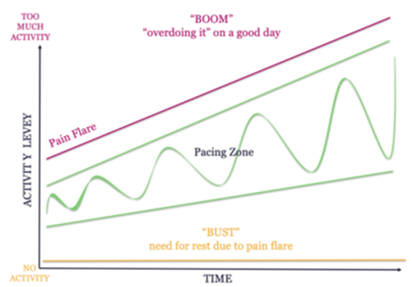**Figure 1**   
*Boom and Bust Cycle [diagram].*

*Note. From 12 Quick Tips for Introducing Pacing into Your Day, by A. Carter, n.d (https://www.northernpaincentre.com.au/wellness/chronic-pain-tools/12-quick-tips-for-introducing-pacing-into-your-day/).*

Desire to maintain self-identity and social role and/or reluctance to accept the physical demands of adenomyosis resulted in participants pushing through pain, sacrificing rest and feeling low in mood, thus enacting the ‘boom and bust’ cycle (GET 2). A resistance to make reasonable lifestyle adjustments and self-criticism have been cited as key psychological barriers to self-compassion and effective regulation (Malpus et al., 2023). Acceptance and commitment therapy (ACT) has been purported to aid adjustment to living with chronic health conditions by encouraging psychological flexibility (Graham et al., 2016), and may prove beneficial as intervention for individuals who are struggling to accept their changed reality.   
  
Participants made attempts to understand symptoms, conceptualize illness timelines and consider treatment options without appropriate information which left them feeling lost, afraid and low in mood. The Common-Sense Model of Self-Regulation (CSM) in health and illness framework (Leventhal and Burns, 2016) could contextualize the emotional challenges accompanying self-management. The CSM explains that management of health threats is contingent upon individuals’ ability to accurately interpret: illness severity; consequences; timeline and perceived control. Without sufficient knowledge of adenomyosis, individuals were seemingly unable to appraise illness threats which engendered hopelessness, hindered self-regulation and resulted in fear-driven coping strategies. Adhering to the CMS model, should individuals receive more clinical information and education in self-management practices such as rest and pacing (Kralik et al., 2004), they may feel increased levels of control and be better able to self-regulate (Schulman‐Green et al., 2012; Roditi & Roditi, 2011).

Throughout all GETs but with particular focus on GET 3, the psychological effects of experiencing invalidation, isolation and feeling misunderstood was evident. A systematic review of the literature on invalidation of chronic health conditions confirmed that invalidation by the self, family, friends, and healthcare professionals is a common experience in persons living with pain (Nicola et al., 2019). Interrelation between: loss of Identity, threats to self-image and isolation alongside not being believed, lack of compassion, lack of pain awareness and critical self-judgement, were reported. Themes developed within this study imply that individuals living with adenomyosis experience comparable interrelated psychosocial stressors. Feeling misunderstood may also put this cohort at risk of increased stress levels and perceived lower life satisfaction (Crockett at el., 2022). ‘Social isolation’ as a solitude that is unwanted as opposed to chosen (e.g. relaxation) is known to negatively impact upon anxiety levels and self-esteem as well as increasing physical health risks (Brandt et al., 2022). Living with adenomyosis can put persons at risk of social isolation. Clinicians should be mindful that individuals living with adenomyosis may require referral to mental health professionals. Group therapy could also provide a shared social space for normalization and validation (Keefe et al., 2022).   
  
Findings underline a need for improved training for medical professionals. A lack of knowledge may account for discussed delays in diagnosis, misdiagnoses and dismissive attitudes (GET 1) as clinicians have reported finding patients who present with unexplained medical symptoms difficult to manage (Reid et al, 2001), which results in poor communication (Ring et al.,2005). Education could seek to improve diagnostic pathways so that women are not suffering without clinical guidance or “fighting” against invalidating narratives. Subsequently, there may be a need to support practitioners in delivering person-centred care when working with adenomyosis as this has been reported to improve outcomes for conditions that are more ambiguous (Alamo et al., 2002).

**Future Research**This study highlights that life with adenomyosis carries substantial psychological impacts. These experiences were previously unreported. Future research could aim to decipher causal links between effects and impacts to inform ‘evidence based’ interventions. As limited research has occurred into adenomyosis, it may be possible (as participants questioned) that hormonal contraception, pain relief or hysterectomy are not the only treatment options. Further research could seek to identify if lifestyle or nutritional changes might improve the wellbeing of those living with this condition. Prior to conducting the work the researcher held the assumption that societal norms may negatively impact upon participants’ experiences. Concerningly, some individuals did speak to this explicitly in their accounts, suggesting that life with adenomyosis could entail experiences that are perceived to be more burdensome due to gender or intersectional features. Future research could aim to assess this further. Reported experiences imply that there is a need for further research to understand how individualized support and age specific information could impact upon the experience of adenomyosis. This is particularly relevant as presently services are not adhering to the NHS value ‘everyone counts’. An impact on work life was evident (GET 2), further investigation into this area may elucidate if adaptations to employment legislation are necessary to ensure that individuals with a diagnosis of adenomyosis do not face discrimination.   
  
**Strengths and Limitations**   
This study is original and clinically relevant in relation to the current “Women’s Health Strategy for England” (Women's Health Strategy: Call for Evidence - GOV.UK) which calls for evidence from women’s voices. According to IPA guidance the sample size is adequate which enabled exploration of varied experiences from different perspectives. Researcher reflexivity may have been impacted by their own lived experience of adenomyosis. However, the author utilised previous research experience to identify limitations to interpretation. Participants were recruited online using female health media platforms therefore the cohort may be representative of a certain population, that is: those who engage with these spaces may have more severe symptomology. Although, as the youngest participant did not report prolific physical or social impacts, instead citing a lack of ‘age appropriate’ care as her reason for participating, this limitation may not be valid. Findings should be conceptualized with consideration of the limitations of this participant pool: a Western sample. All were white in ethnicity, English speaking, possessing access to the internet and eight of the nine were of a socio-economic background which enabled them to seek private healthcare. Additionally, societal issues with discussing menstruation may have deterred certain persons or cultural groups from participating. However, the IPA process demonstrated the trustworthiness of the findings in that, although there was individual variance in idiographic lived experience, commonalities and parallels were evident within analysis of the first few interviews.

**Conclusion**

This was the first exploratory study to investigate the lived experience of adenomyosis. Nine participants were interviewed, transcripts were analysed using IPA methodology which resulted in the identification of three GETs: Feeling dismissed, invalidated, and lost while seeking support; Ongoing struggles with symptomology and identity and Feeling misunderstood and isolated. Findings suggest that those who live with adenomyosis experience a plethora of physical, social and psychological challenges. Subsequently, this population is experiencing negative impacts upon their wellbeing. It is recommended that further research should be undertaken so to better understand the individual challenges of persons of all ages from the onset of menstruation who experience symptoms of adenomyosis and to inform clinical provisions which are currently substantially limited.

**References**Alamo, M. M., Moral, R. R., & de Torres, L. A. P. (2002). Evaluation of a patient-centred   
 approach in generalized musculoskeletal chronic pain/fibromyalgia patients in   
 primary care. *Patient education and counseling, 48*(1), 23-31.   
 https://doi.org/10.1016/s0738-3991(02)00095-2Banner, D., Bains, M., Carroll, S., Kandola, D. K., Rolfe, D. E., Wong, C., & Graham, I. D.   
 (2019). Patient and Public Engagement in Integrated Knowledge Translation   
 Research: Are we there yet? *Research Involvement and Engagement, 5(*1).   
 https://doi.org/10.1186/s40900-019-0139-1Barlow, J., Wright, C., Sheasby, J., Turner, A., & Hainsworth, J. (2002). Self-management   
 approaches for people with chronic conditions: a review. *Patient education and   
 counseling*, *48*(2), 177-187. https://doi.org/10.1016/s0738-3991(02)00032-0  
Birkholtz, M., Aylwin, L., & Harman, R. M. (2004). Activity pacing in chronic pain   
 management: One aim, but which method? Part one: Introduction and literature   
 review. *British Journal of Occupational Therapy*, *67*(10), 447-452.   
 https://doi.org/10.1177/030802260406701005

Bird, C. C., McElin, T. W., & Manalo-Estrella, P. (1972). The elusive adenomyosis of the   
 uterus—revisited. *American Journal of Obstetrics and Gynecology, 112*(5), 583–  
 593. https://doi.org/10.1016/0002-9378(72)90781-8

Brandt, L., Liu, S., Heim, C., & Heinz, A. (2022). The effects of social isolation stress and   
 discrimination on mental health. *Translational psychiatry*, *12*(1), 398.   
 https://doi.org/10.1038/s41398-022-02178-4  
Brocki, J. M., & Wearden, A. J. (2006). A critical evaluation of the use of interpretative   
 phenomenological analysis (IPA) in health psychology*. Psychology &amp; Health,   
 21*(1), 87–108. https://doi.org/10.1080/14768320500230185  
Brody, H., & Waters, D. B. (1980). Diagnosis is treatment. *J Fam Pract*, *10*(3), 445-449.

Campo, S., Campo, V., & Benagiano, G. (2011;2012;). Adenomyosis and infertility.   
 *Reproductive Biomedicine Online, 24*(1), 35-46.   
 https://doi.org/10.1016/j.rbmo.2011.10.003  
Carter, A. (n.d). *12 Quick Tips for Introducing Pacing into Your Day* [Infographic].Northern   
 Pain Centre. https://www.northernpaincentre.com.au/wellness/chronic-pain-  
 tools/12-quick-tips.  
Chaman-Ara, K., Bahrami, M. A., & Bahrami, E. (2017). Endometriosis Psychological   
 Aspects: A Literature Review. *Journal of Endometriosis and Pelvic Pain Disorders,   
 9*(2), 105–111. doi:10.5301/jeppd.5000276  
Charmaz, K. (1995). The body, identity, and self: Adapting to impairment. *Sociological   
 quarterly*, *36*(4), 657-680. https://doi.org/10.1111/j.1533-8525.1995.tb00459.x  
Chenail, R. (2016). Making Phenomenological Inquiry Accessible: A Review of Jonathan A.   
 Smith, Paul Flowers, and Michael Larkin’s Interpretative Phenomenological   
 Analysis: Theory, Method, and Research. *The Qualitative Report.* https://doi.org/10.46743/2160-3715/2009.2841  
Clancy, M. (2013). Is reflexivity the key to minimising problems of interpretation in   
 phenomenological research? *Nurse researcher*, *20*(6), 12-16.  
 https://doi.org/10.7748/nr2013.07.6.12.c1209  
Clarke, V. (2010). Review of the book “Interpretative phenomenological analysis: Theory,   
 method and research”. *Psychology Learning & Teaching*, *9*(1), 57-56.

Crockett, E. E., Pollmann, M. M., & Olvera, A. P. (2022). You just don’t get it: The impact of   
 misunderstanding on psychological and physiological health. *Journal of Social and*   
 *Personal Relationships, 39*(9), 2847–2868.   
 https://doi.org/10.1177/02654075221089903

Culley, L., Law, C., Hudson, N., Denny, E., Mitchell, H., Baumgarten, M., & Raine-Fenning,   
 N. (2013). The social and psychological impact of endometriosis on women's   
 lives: A critical narrative review. *Human Reproduction Update, 19*(6), 625-639.   
 https://doi.org/10.1093/humupd/dmt027  
Davidsen, A. S. (2013). Phenomenological Approaches in Psychology and Health Sciences.   
 *Qualitative Research in Psychology, 10*(3), 318–339.   
 https://doi.org/10.1080/14780887.2011.608466

De Graaff, A. A., D'Hooghe, T. M., Dunselman, G. A. J., Dirksen, C. D., Hummelshoj, L.,   
 Simoens, S., & WERF EndoCost Consortium. (2013). The significant effect of   
 endometriosis on physical, mental and social wellbeing: Results from an international   
 cross-sectional survey. *Human Reproduction (Oxford), 28*(10), 2677-2685.   
 https://doi.org/10.1093/humrep/det284  
Della Corte, L., Di Filippo, C., Gabrielli, O., Reppuccia, S., La Rosa, V. L., Ragusa, R.,   
 Fichera, M., Commodari, E., Bifulco, G., & Giampaolino, P. (2020). The Burden of   
 Endometriosis on Women’s Lifespan: A Narrative Overview on Quality of Life and   
 Psychosocial Wellbeing. *International Journal of Environmental Research and Public   
 Health, 17*(13), 4683. https://doi.org/10.3390/ijerph17134683  
DeVellis, R. F., Lewis, M. A., & Sterba, K. R. (2003). Interpersonal emotional processes in   
 adjustment to chronic illness. *Social psychological foundations of health and illness*,   
 256-287. https://doi.org/10.1002/9780470753552.ch10  
Department of Health and Social Care. (2022, April 13). *Women's Health Strategy: Call for   
 Evidence***.** Women's Health Strategy: Call for Evidence - GOV.UK (www.gov.uk)   
 (Accessed: July 2023).   
Doherty, A. M., & Gaughran, F. (2014). The interface of physical and mental health. *Social   
 Psychiatry and Psychiatric Epidemiology, 49*(5), 673–682.   
 https://doi.org/10.1007/s00127-014-0847-7

Dowling, M. 92006). Approaches to reflexivity in qualitative research. *Nurse Researcher,   
 13*(3), 7-21. https://doi.org/10.7748/nr2006.04.13.3.7.c5975  
Graham, C. D., Gouick, J., Krahé, C., & Gillanders, D. (2016). A systematic review of the use   
 of Acceptance and Commitment Therapy (ACT) in chronic disease and long-term   
 conditions. *Clinical psychology review*, *46*, 46-58.   
 https://doi.org/10.1016/j.cpr.2016.04.009

Guy’s and St Thomas’. (2021). *Gynaecology Patient Information.*   
 https://www.guysandstthomas.nhs.uk/resources/patientinformation/gynaecology/a  
 denomyosis.pdf (Accessed: September 2022).   
Halvorson, L. M., Giudice, L. C., & Stewart, E. A. (2020). Eye to the Future in Adenomyosis   
 Research. *Seminars in Reproductive Medicine, 38*(02/03), 197–200.   
 doi:10.1055/s-0040-1721503  
Hewson, C. British psychological society-ethics guidelines for Internet mediated research   
 www. Bps. org. *Uk2021. nd Available: https://www. bps. org. uk/sites/www. bps.   
 org. uk/files/Policy/Policy*. https://doi.org/10.53841/bpsrep.2021.rep155  
Jacobi, S., & MacLeod, R. (2011). Making sense of chronic illness – a therapeutic approach.   
 *Journal of Primary Health Care, 3*(2), 136. https://doi.org/10.1071/hc11136  
Kasket, E. (2009a). Protocol for responding to participant distress: adapted version for   
 instant messaging. London Metropolitan University. Available from:   
 e.kasket@londonmet.ac.uk.  
Kasket, E. (2009b). Protocol for responding to participant distress: Adapted version 92 for   
 telephone or Skype. London Metropolitan University. Available from:   
 e.kasket@londonmet.ac.uk.  
Keefe, F. J., Beaupre, P. M., Gil, K. M., Rumble, M. E., & Aspnes, A. K. (2002). Group   
 therapy for patients with chronic pain. *Psychological approaches to pain   
 management: A practitioner's handbook*, 234-255.   
 https://doi.org/10.1017/cbo9780511543579.012  
Kool, M. B., Van Middendorp, H., Lumley, M. A., Schenk, Y., Jacobs, J. W. G., Bijlsma, J. W.   
 J., & Geenen, R. (2010). Lack of understanding in fibromyalgia and rheumatoid   
 arthritis: the Illness Invalidation Inventory (3* I). *Annals of the Rheumatic   
 Diseases*, *69*(11),1990-1995. https://doi.org/10.1136/ard.2009.123224  
Kralik, D., Koch, T., Price, K., & Howard, N. (2004). Chronic illness self‐management: taking   
 action to create order. *Journal of clinical nursing*, *13*(2), 259-267.   
 <https://doi.org/10.1046/j.1365-2702.2003.00826.x>  
Larkin, M., Flowers, P., & Smith, J. A. (2021). *Interpretative phenomenological analysis:   
 Theory, method and research. Interpretative phenomenological analysis*, 1-100.   
 https://doi.org/10.1002/9780470015902.a0028014  
Leventhal, H., Phillips, L. A., & Burns, E. (2016). The Common-Sense Model of Self-  
 Regulation (CSM): a dynamic framework for understanding illness self-  
 management. *Journal of Behavioral Medicine, 39*(6), 935–946.   
 https://doi.org/10.1007/s10865-016-9782-2  
Leventhal, T., & Brooks-Gunn, J. (2003). Moving to Opportunity: an Experimental Study of   
 Neighborhood Effects on Mental Health. *American Journal of Public Health, 93*(9),  
 1576–1582. https://doi.org/10.2105/ajph.93.9.1576  
Litin, S. C. (1998). *Book Reviews*. Mayo Clinic Proceedings, 73(4), 392–393.   
 https://doi.org/10.1016/s0025-6196(11)63714-2  
Malpus, Z., Nazar, Z., Smith, C., & Armitage, L. (2023). Compassion focused therapy for   
 pain management: ‘3 systems approach’ to understanding why striving and self-  
 criticism are key psychological barriers to regulating activity and improving self-  
 care for people living with persistent pain. *British Journal of Pain*, *17*(1), 87-102.   
 https://doi.org/10.1177/20494637221133630  
McNamee, S. (2011). From Social Construction to Relational Construction: Practices from   
 the Edge. *Psychological Studies, 57*(2), 150–156. https://doi.org/10.1007/s12646-  
 011-0125-7  
Naftalin, J., Hoo, W., Pateman, K., Mavrelos, D., Holland, T., & Jurkovic, D. (2012). How   
 common is adenomyosis? A prospective study of prevalence using transvaginal   
 ultrasound in a gynaecology clinic. *Human Reproduction, 27*(12), 3432–3439.   
 doi:10.1093/humrep/des332  
National Institute for Health and Care Excellence. (2013). *Heavy Menstrual Bleeding*.   
 Retrieved from https://www.nice.org.uk/Guidance/IPG473  
National Institute for Health and Care Excellence. (2021). *Chronic pain (primary and   
 secondary) in over 16s: assessment of all chronic pain and management of   
 chronic primary pain* [NICE Guideline 193].   
 https://www.nice.org.uk/guidance/ng193/chapter/recommendations#:~:text=1.2.,la  
 bel%20use%20of%20these%20antidepressants.  
Nicola, M., Correia, H., Ditchburn, G., & Drummond, P. (2019). Invalidation of chronic pain: a   
 thematic analysis of pain narratives. *Disability and Rehabilitation, 43*(6), 861–869. https://doi.org/10.1080/09638288.2019.1636888  
Nizza, I. E., Farr, J., & Smith, J. A. (2021). Achieving excellence in interpretative   
 phenomenological analysis (IPA): Four markers of high quality. *Qualitative   
 Research in Psychology, 18*(3), 369–386.   
 https://doi.org/10.1080/14780887.2020.1854404  
Pao, M., & Bosk, A. (2010). Anxiety in medically ill children/adolescents. *Depression and   
 Anxiety, 28*(1), 40–49. doi:10.1002/da.20727  
Patnaik, E. (2013). Reflexivity: Situating the researcher in qualitative research. *Humanities   
 and Social Science Studies*, *2*(2), 98-106.  
Peat, G., Rodriguez, A., & Smith, J. (2018). Interpretative phenomenological analysis applied   
 to healthcare research. *Evidence Based Nursing, 22*(1), 7–9.   
 https://doi.org/10.1136/ebnurs-2018-103017  
Perez, C. C. (2019). *Invisible women: Data bias in a world designed for men*. Abrams.  
Pietkiewicz, I. & Smith, J.A. (2012). A practical guide to interpretative phenomenological   
 analysis in qualitative research. *Psychology journal,18*(2), 361-369.

Pluchino, N., Wenger, J., Petignat, P., Tal, R., Bolmont, M., Taylor, H. S., & Bianchi-  
 Demicheli, F. (2016). Sexual function in endometriosis patients and their partners:   
 Effect of the disease and consequences of treatment. *Human Reproduction   
 Update, 22*(6), 762-774. https://doi.org/10.1093/humupd/dmw031  
Ramin-Wright, A., Schwartz, A. S. K., Geraedts, K., Rauchfuss, M., Wölfler, M. M.,   
 Haeberlin, F., von Orelli, S., Eberhard, M., Imthurn, B., Imesch, P., Fink, D., &   
 Leeners, B. (2018). Fatigue - a symptom in endometriosis. *Human Reproduction   
 (Oxford), 33*(8), 1459-1465. https://doi.org/10.1093/humrep/dey115  
Reid, S., Whooley, D., Crayford, T., & Hotopf, M. (2001). Medically unexplained symptoms   
 GPs' attitudes towards their cause and management. *Family practice*, *18*(5), 519-  
 523. https://doi.org/10.1093/fampra/18.5.519   
Ring, A., Dowrick, C. F., Humphris, G. M., Davies, J., & Salmon, P. (2005). The somatising   
 effect of clinical consultation: what patients and doctors say and do not say when   
 patients present medically unexplained physical symptoms. *Social science &   
 medicine*, *61*(7), 1505-1515. https://doi.org/10.1016/j.socscimed.2005.03.014  
Roditi, D., & Roditi, M. E. (2011). The role of psychological interventions in the management   
 of patients with chronic pain. *Psychology Research and Behavior Management*, *41*.   
 <https://doi.org/10.2147/prbm.s15375>  
Samulowitz, A., Gremyr, I., Eriksson, E., & Hensing, G. (2018). “Brave Men” and “Emotional   
 Women”: A Theory-Guided Literature Review on Gender Bias in Health Care and  
 Gendered Norms towards Patients with Chronic Pain. *Pain Research and   
 Management, 2018*, 1–14. <https://doi.org/10.1155/2018/6358624>  
Sandu, A., & Unguru, E. (2017). Several Conceptual Clarifications on the Distinction  
 between Constructivism and Social Constructivism. *Postmodern Openings, 8*(2),   
 51–61. https://doi.org/10.18662/po/2017.0802.04  
Schulman‐Green, D., Jaser, S., Martin, F., Alonzo, A., Grey, M., McCorkle, R., ... &   
 Whittemore, R. (2012). Processes of self‐management in chronic illness. *Journal   
 of nursing scholarship*, *44*(2), 136-144. https://doi.org/10.1111/j.1547-  
 5069.2012.01444.x  
Shinebourne, P. (2011). The Theoretical Underpinnings of Interpretative Phenomenological   
 Analysis (IPA). *Existential Analysis: Journal of the Society for Existential   
 Analysis*, *22*(1), 16–31.  
Simons, L. E., Elman, I., & Borsook, D. (2014). Psychological processing in chronic pain: A   
 neural systems approach. *Neuroscience &amp; Biobehavioral Reviews, 39*, 61–  
 78. https://doi.org/10.1016/j.neubiorev.2013.12.006  
Skuladottir, H., & Halldorsdottir, S. (2008). Women in Chronic Pain: Sense of Control and   
 Encounters With Health Professionals. *Qualitative Health Research, 18*(7), 891–  
 901. https://doi.org/10.1177/1049732308318036  
Smith, J. A., & Osborn, M. (2015). Interpretative phenomenological analysis as a useful   
 methodology for research on the lived experience of pain. *British Journal of Pain,   
 9*(1), 41-42. https://doi.org/10.1177/2049463714541642  
Smith, J., Flowers, P., & Larkin, M. (2009). *Interpretative phenomenological analysis.   
 Theory, method and research*. Sage  
The British Psychological Society. (2017). Ethics Guidelines for Internet-mediated Research.   
 The British Psychological Society. https://doi.org/INF206/04.2017  
Tuffour, I. (2017). A Critical Overview of Interpretative Phenomenological Analysis: A   
 Contemporary Qualitative Research Approach. *Journal of Healthcare   
 Communications*, 02(04). https://doi.org/10.4172/2472-1654.100093  
Von Korff, M., Glasgow, R. E., & Sharpe, M. (2002). Organising care for chronic   
 illness. *Bmj*, *325*(7355), 92-94. https://doi.org/10.1136/bmj.325.7355.92

Yu, O., Schulze-Rath, R., Grafton, J., Hansen, K., Scholes, D., & Reed, S. D. (2020).   
 Adenomyosis incidence, prevalence and treatment: United states population-  
 based study 2006–2015. *American Journal of Obstetrics and Gynecology, 223*(1),   
 94.e1-94.e10. https://doi.org/10.1016/j.ajog.2020.01.016  
Zhang, L., Losin, E. A. R., Ashar, Y. K., Koban, L., & Wager, T. D. (2021). Gender Biases in   
 Estimation of Others’ Pain. *The Journal of Pain, 22*(9), 1048–1059.   
 https://doi.org/10.1016/j.jpain.2021.03.001

**Paper 3: Executive Summary**

**“Just get on with it”: Exploring the lived experience of adenomyosis (using Interpretative Phenomenological Analysis)**  
Sara Elizabeth Peat  
Doctorate in Clinical Psychology  
Staffordshire University

Word Count: 1920



**“Just get on with it”: Exploring the lived experience of adenomyosis**

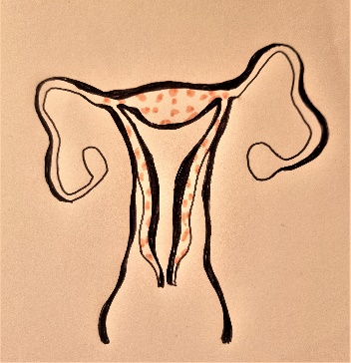

**Who is this information for?**

This executive summary has been written for anyone who has received a diagnosis of adenomyosis or is experiencing unusual menstrual symptoms and is seeking information. To ensure that this summary can be easily understood a member of the public with a diagnosis of adenomyosis has kindly reviewed the document and deemed it to be suitable.

The project explored what it is like to live with adenomyosis. The researcher talked to individuals who have been diagnosed with the condition and analysed these conversations to try and make sense of the participants experiences. This is the first study of its kind, and it was designed to provide new insight into the everyday impacts of living with adenomyosis. The work will be submitted to academic journals to share findings.  
  
The study was completed by a Trainee Clinical Psychologist   
who was studying at Staffordshire University: Sara Elizabeth Peat.

**The research project:**

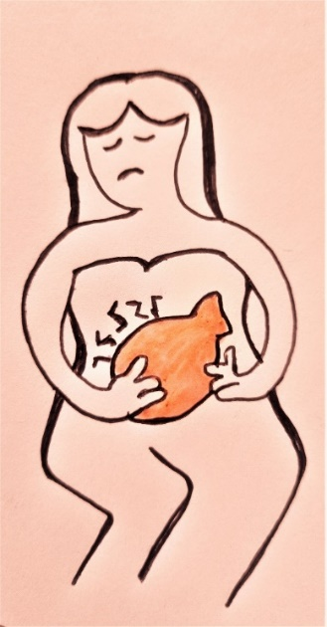

**Background information:**

Adenomyosis (pronounced: ad-uh-no-my-O-sis) is a gynaecological condition which can cause severe discomfort and have wide ranging impacts upon a person’s everyday life. Discomfort occurs when the tissue that normally lines the uterus (endometrial tissue) grows into the muscular wall of the uterus (Litin, 2018). Adenomyosis is estimated to affect one in ten women (Guy’s and St Thomas’ NHS, 2021). The National Health Service (NHS) suggests that symptoms include:

* **Painful periods**
* **Heavy bleeding during your period**
* **Pelvic pain**
* **Bloating, heaviness, or fullness in your tummy**
* **Pain during sex**

Discussion on online support groups suggests that there are a number of other symptoms and impacts which people experience such as:

* **Back and leg pain**
* **Fatigue**
* **Infertility**
* **Impacts on daily routine and work life**
* **Impacts on sexual health, relationships, and wellbeing.**

We know that people who experience other gynaecological conditions (Chaman-Ara et al., 2017) or chronic pain conditions (Simons et al., 2014) have a greater chance of developing mental health issues. As yet it is not known if this is the case for persons experiencing adenomyosis. By completing the work, the researcher hoped to contribute to psychological understanding of life with adenomyosis and consider implications for health care.

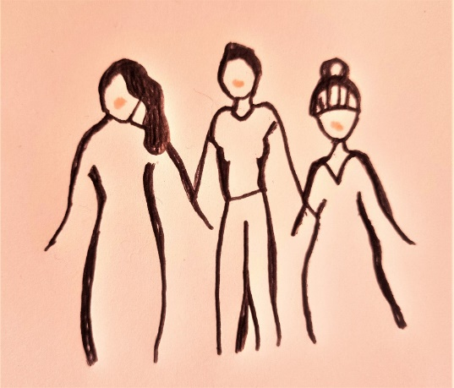

To gain insight into individual experiences of living with the chronic gynaecological condition adenomyosis.

**How do people experience life with adenomyosis?**

Ethical approval to conduct the study was received from Staffordshire University Ethics Committee. This meant that no harm should be caused to participants, that they were aware of their rights and that they were looked after properly throughout the research process.

**Research aim:**

**Research question:**

**Ethical Approval:**

**What did we find out?**

Three Group Experiential Themes (GETs) were identified: Feeling dismissed, invalidated, and lost while seeking support; Ongoing struggles with symptomology and identity and Feeling misunderstood and isolated. By discussing each theme and its subthemes we can summarise participant experiences of living with adenomyosis.

The study used a “qualitative” method. This meant that we were interested in the characteristics of life with adenomyosis rather than looking at quantities related to it. To do this the researcher used a methodology called Interpretative Phenomenological Analysis (IPA). IPA is a way of collecting and analysing information to try and make sense of and interpret the lived experiences of participants.   
  
Interviews took place online, lasted about an hour and were recorded via Microsoft Teams. The researcher transcribed and analysed each interview separately to interpret every individual’s experiences. After themes were identified in each individual’s life, group themes (including subthemes) were developed which illustrated shared participant experiences. Before finalizing the themes, the researcher checked back with all participants to make sure that the themes resonated with them. Some themes spoke more to some individual experiences than others, but all were considered relevant and important to think about so to help us to better understand life with adenomyosis.

Participants were recruited via advertisements on social media and adenomyosis support groups. There were nine participants in total, eight from the UK and one from the USA. All had received a diagnosis of adenomyosis but had no other gynaecological conditions. Participants were aged 26 - 53. Each person chose a pseudonym to protect their identity during publication.

**Study information:**

**Participants:**



Participants talked about seeking support and diagnosis because they were experiencing unusual menstrual symptoms. This process included experiencing feelings of being dismissed, misdiagnosed, effortful self-advocacy and developing a mistrust in medics. Participants described feeling helpless due to lacking information.  
  
Subtheme 1: **“Just get on with it” (Jane)**Participants reflected upon experiences of feeling disempowered and dismissed in the role of patient: ***“I would go in with all these symptoms, he would say oh it's you young girls. You don't look after yourself. You don't eat properly. You know everybody has heavy periods. Off you go. Go on the pill. It will sort everything out” (Jane).***Subtheme 2: **“A fight to be listened to” (Meredith)**Participants talked about having to repeatedly visit care services, explain their discomfort and stress that they needed help: ***“I was dismissed for years…It was just a fight to be listened to” (Meredith).***  
Experiences of feeling unheard and misdiagnosed resulted in feelings of frustration, leaving some participants feeling as if clinicians were unempathetic. Lily imitated the message she felt that she was receiving: ***“Stop coming back about this, this is annoying… we've ruled things out. You should just be happy about the fact it's not cancer”.***Subtheme 3: **Mixed feelings at diagnosis**Upon receiving a diagnosis participants suggested that they were able to make better sense of their situation. Some conveying feelings of validation: ***“It justified what I was feeling…like what you're feeling is what you're feeling…part of it was I was relieved. Because now I know that I'm not crazy, which is how I have felt for years” (Simran).*** Yet a sense of disappointment was evident when participants recounted the lack of compassion conveyed by clinicians during diagnosis delivery: ***“all that was said to me was there's nothing we can do about it… I was really upset…it was just very how it was delivered was very just casual” (Cara).***

**Group theme 1: Feeling dismissed, invalidated   
 and lost while seeking support**



Subtheme 4: **Fearfully seeking solutions**  
Participants talked about having to do their own research to try and figure out how to cope with the impacts of adenomyosis. Some experienced online support positively: “***There's this wonderful [online] community…that teaches each other how to navigate these things” (June).*** While feeling lost searching for support, others stumbled upon information about people who are in a lot of pain which resulted in fear about their future*:* ***“There's nothing at the beginning to sort of say read up on this or look for this page…I can find things that scare me. I’m scared to potentially think that I could end up in that position” (Cara).***

Participants reflected upon day-to-day struggles while living with adenomyosis. Physical and emotional impacts and lifestyle adaptations were discussed . Participants struggled to maintain “normal” life and experienced challenges to social roles and self-identities.   
Subtheme 1: **“It’s like you’re getting punched from the inside” (Cath)**Each participant shared descriptions of the physical symptoms they experience. These included: **leg pain, rectal pain, painful intercourse, migraines, fatigue, menorrhagia, lowered immune system and bloating**. To cope with symptoms participants discussed using: **pain killers, taking baths, walking, stretching, avoiding intercourse, doing yoga, resting, applying heat pads, dietary adaptations and wearing loose clothing**.  
There was a sense that physical symptoms interrupted daily life which negatively impacted on participants moods: ***“It’s preventing me from doing the things I'd like to be doing. I have to try not to get too down…you just have a couple of days of not being able to do very much and feeling like you were failing yourself or failing other people in some way” (Meredith).***  
Subtheme 2: **Pressure to maintain roles**Participants found it challenging to manage symptoms and live up to expectations of being a partner, parent or employee: ***“I would make it to work but I would be heavily medicated to get there” (Cath).***

**Group theme 2: Ongoing struggles with symptomology and identity**



Subtheme 3: **“I’ve lost a little bit of myself” (Simran)**Participants reflected upon their changing appearance and abilities, negative emotions and the journey of acceptance that accompanied this: ***“It's not something I feel I'm gonna let get hold of me...I am a strong independent woman” (Louise).*   
*“I think body wise…. that’s kind of a journey…I've got more comfortable with just like looking at myself and being like, no, it's okay if you are bloated” (Cara).***

Throughout all interviews participants discussed experiencing feeling misunderstood. Perceptions that social and gender norms limited other people’s ability to understand were considered. Participants reflected on a shared sense of isolation and self-reliance born out of feeling misunderstood.  
  
Subtheme 1: **“No, no, no, no, no, you don’t understand” (June)**There was a sense that participants felt as if the general public, medical professionals, family and friends could not understand their experience of adenomyosis: ***“People don't get it because they don't understand. It's not something that people know about” (Louise).*** Some participants wondered if the “invisibility” of the illness contributed to experiences of feeling inaccurately judged*:*  ***“I do get some comments... Oh you’re just being dramatic or you look fine and I'm like, yeah, but I might look fine, but I'm still feeling what I'm feeling” (Simran).***Subtheme 2: **“You’re completely alone” (Louise)**Participants shared experiences of having to cope in isolation, perhaps due to societal ideas about shame around menstruation: ***“There's also the element of embarrassment...it’s just quite a personal, intimate problem and the shame that you kind of go through your teens with… I’ve learnt to kind of get on with it myself” (Meredith).***

**Group theme 3: Feeling misunderstood and isolated**



**Health Care:**   
We now understand that life with adenomyosis carries with it many impacts upon wellbeing including physical, social, and psychological difficulties. The study suggests that persons suffering from adenomyosis experience similar challenges to those managing other chronic conditions. As this was previously unreported, this work highlights that there is a need for clinical provisions to adapt to support this group of individuals in similar ways to how other people with chronic conditions are supported. Providing more information (Von Korff et al., 2002), education in self-management strategies (Barlow et al., 2002) and support with interpersonal impacts could improve life satisfaction (Crockett at el., 2022) and help this group feel cared for.   
  
**Research:**  
Now that we know a little more about adenomyosis it seems clear that we don’t know enough about the cause and effect of different impacts or treatments. These novel findings imply that more research is necessary so that we can learn more and hope to understand the impacts of adenomyosis on a wider scale.

We recommend that the following changes could be made to make life with adenomyosis feel more manageable:   
  
- **Medical training and understanding should be improved** so that clinicians are aware of symptoms and supported to deliver person-centred care. This would help those seeking support to feel heard and supported instead of dismissed or misdiagnosed.   
- **Treatment should be holistic**. This would mean that individuals are offered psychological support as well as medical support to combat the negative emotional impacts that accompany experiences of isolation and changed identity due to adenomyosis.   
- **Support should be individualised** and adapted to suit each person’s preferences and life stage. This could enable people to feel understood and in turn better enable them to understand themselves and their experience of the condition.

**Recommendations:**

**What implications does this research have?**

**References**Barlow, J., Wright, C., Sheasby, J., Turner, A., & Hainsworth, J. (2002). Self-management   
 approaches for people with chronic conditions: a review. *Patient education and   
 counseling*, *48*(2), 177-187. https://doi.org/10.1016/s0738-3991(02)00032-0  
Chaman-Ara, K., Bahrami, M. A., & Bahrami, E. (2017). Endometriosis Psychological   
 Aspects: A Literature Review. *Journal of Endometriosis and Pelvic Pain Disorders*, *9*(2), 105–111. doi:10.5301/jeppd.5000276  
Crockett, E. E., Pollmann, M. M., & Olvera, A. P. (2022). You just don’t get it: The impact of   
 misunderstanding on psychological and physiological health. *Journal of Social and   
 Personal Relationships, 39*(9), 2847–2868.   
 https://doi.org/10.1177/02654075221089903  
Guy’s and St Thomas’. (2021). *Gynaecology Patient Information.*   
 https://www.guysandstthomas.nhs.uk/resources/patientinformation/gynaecology/a  
 denomyosis.pdf (Accessed: September 2022).   
Litin, S. C. (1998). *Book Reviews*. Mayo Clinic Proceedings, 73(4), 392–393.   
 https://doi.org/10.1016/s0025-6196(11)63714-2  
Simons, L. E., Elman, I., & Borsook, D. (2014). Psychological processing in chronic pain: A   
 neural systems approach. *Neuroscience &amp; Biobehavioral Reviews, 39*, 61–  
 78. https://doi.org/10.1016/j.neubiorev.2013.12.006  
Von Korff, M., Glasgow, R. E., & Sharpe, M. (2002). Organising care for chronic   
 illness. *Bmj*, *325*(7355), 92-94. https://doi.org/10.1136/bmj.325.7355.92

**Appendices**

**Appendix A: Staffordshire university ethical approval**



**School of Health, Science and Wellbeing**

**ETHICAL APPROVAL FEEDBACK**

|  |  |
| --- | --- |
| **Researcher name:** | Sara Peat |
| **Title of Study:** | **SU_21_190** ‘An Exploratory study into the lived experience of  Adenomyosis.’ |
| **Award Pathway:** | PGR |
| **Status of approval:** | Approved |

Your project ***proposal has been approved*** by the Ethics Panel and you may commence the implementation phase of your study. You should note that any divergence from the approved procedures and research method will invalidate any insurance and liability cover from the University. You should, therefore, notify the Panel of any significant divergence from this approved proposal. This approval is only valid for as long as you are registered as a student at the University.

You should arrange to meet with your supervisor for support during the process of completing your study and writing your dissertation.

When your study is complete, please send the ethics committee an end of study report. A template can be found on the ethics BlackBoard site.

The Ethics Committee wish you well with your research.

**Signed: Date: 15.11.2022**



Dr. Edward Tolhurst

Ethics Co-ordinator for Health

**Appendix B: Participant information sheet**

**UNDERSTANDING ADENOMYOSIS**

# PARTICIPANT INFORMATION SHEET

You are being invited to participate in a research study. Before you decide whether you would like to participate, it is important for you to understand why the research is being done and what it will involve. Please take time to read the following information carefully and feel free to ask the researcher if you would like more information or if there is anything that you do not understand. Please also feel free to discuss your participation with anyone you wish. You do not have to accept this invitation and should only agree to participate if you want to. Thank you for reading this.

**Purpose of the study**

This interview aims to explore your lived experience of adenomyosis along with any related psychological impacts.

**Why have I been chosen to take part?**

You have been chosen to take part, as you have disclosed that you have received a diagnosis of adenomyosis. Your participation is voluntary, and you are free to withdraw from the study at any point before analysis without explanation, and without incurring a disadvantage.

**What will happen if I take part?**

The research will be conducted in the form of an informal interview, between you and the researcher that will last up to one hour. As the interview will take place online it is recommended that you are located in a safe place that is convenient for you and where you feel comfortable talking about your experience of adenomyosis and how it makes you feel. Before the interview begins, this information will be repeated to you and you will be given the chance to ask any questions about the research and the form of the interview. The audio of the interview will be recorded on a dictaphone for data collection and transcription purposes. During the interview please feel free to express your views and ask any questions you like.

**Are there any risks in taking part?**

There are no direct risks associated with being involved in this research.

**What if I am unhappy or if there is a problem?**

If you are experiencing any discomfort or distress as a result of the research or during the course of the interview, you should let the researcher know. You are free to take a rest break, postpone the interview until a different day, or withdraw if you feel you need to.

If you are unhappy with any aspect of the study, or if there is a problem, please feel free to let us know by contacting the lead researcher and supervisor of this research project, Dr Jo Heyes (details below) and we will try to address your concerns. If you remain unhappy then you can contact the Staffordshire University Ethics Team at ethics@staffs.ac.uk. If you contact the team, please provide details of the title or description of the study (so that it can be identified).

**Will my participation be kept confidential?**

Your data (i.e. interview recording and transcription) will remain confidential and be kept separate from any identifiable information you provide (i.e email or name). The recording will be securely stored with password protection on the university’s secure server, accessible only to the research team. Data will be securely stored until the research project is completed in the form of a research thesis. In accordance with the University policy, all data will be stored for ten years before being deleted and destroyed. Due to the nature of the research, analysis will involve creating transcripts of the interview. Transcripts will include a pseudonym therefore your opinion will be completely anonymous and will remain so if any part of your interview transcript is quoted in the research thesis or any resulting paper. Participants taking part in a Staffordshire University ethically approved study are covered by a University insurance scheme.

**What will happen to the results of the study?**

The results of this study will be written up in the form of a final year doctoral thesis. We will prepare the research for publication in a psychology journal. If the research is published, the researcher will inform you and provide details about where you can access the journal article. No identifying information will be included in either the final year thesis or any resulting journal article.

**What will happen if I want to stop taking part?**

You are free to withdraw from this study at any time up to the point of data analysis, and without explanation. Results up to the period of your withdrawal may be used, if you are happy for this to be done. Otherwise you can ask us to destroy your data and no further use will be made of it.

**Who can I contact if I have any questions?**

If you have any further questions, or would like to know more about the study, please contact the researcher, Sara Peat by emailing p024987k@student.staffs.ac.uk or the supervisor, Dr Jo Heyes by emailing joanna.heyes@staffs.ac.uk.

**Note:**

Your data will be processed in accordance with the General Data Protection Regulation 2016 (GDPR).

The data controller for this project will be Staffordshire University. The university will process your personal data for the purpose of the research outlined above. The legal basis for processing your personal data for research purposes under the GDPR is a ‘task in the public interest’. You can provide your consent for the use of your personal data in this study by completing the consent form that has been provided to you.

You have the right to access information held about you. Your right of access can be exercised in accordance with the GDPR. You also have other rights including rights of correction, erasure, objection, and data portability. Questions, comments and requests about your personal data can also be sent to the Staffordshire University Data Protection Officer. If you wish to lodge a complaint with the Information Commissioner’s Office, please visit www.ico.org.uk.

# THANKYOU for taking the time to read this information ☺

**Appendix C: Consent form**

**CONSENT FORM**

Title of Project: An Exploratory Study into the Lived Experience of Adenomyosis

Name of Researcher: Sara Elizabeth Peat

Please   
 initial box

1. I confirm that I have read the information sheet dated.................... (version...........) for the  
   above study. I have had the opportunity to consider the information, ask questions and have  
   had these answered satisfactorily.
2. I understand that my participation is voluntary and that I am free to withdraw at any time  
   without giving any reason, without my medical care or legal rights being affected.
3. I understand that my anonymised data will be used within the researchers’ final research paper (thesis) and further publications.
4. I understand that the interview will be audio recorded and stored in keeping with the universities ethical guidelines.
5. I understand that I am consenting to possessing a fluency in English language.
6. I agree to take part in the above study.

Name of Participant Date Signature

Name of Person Date Signature

seeking consent

**Appendix D: Study advert**

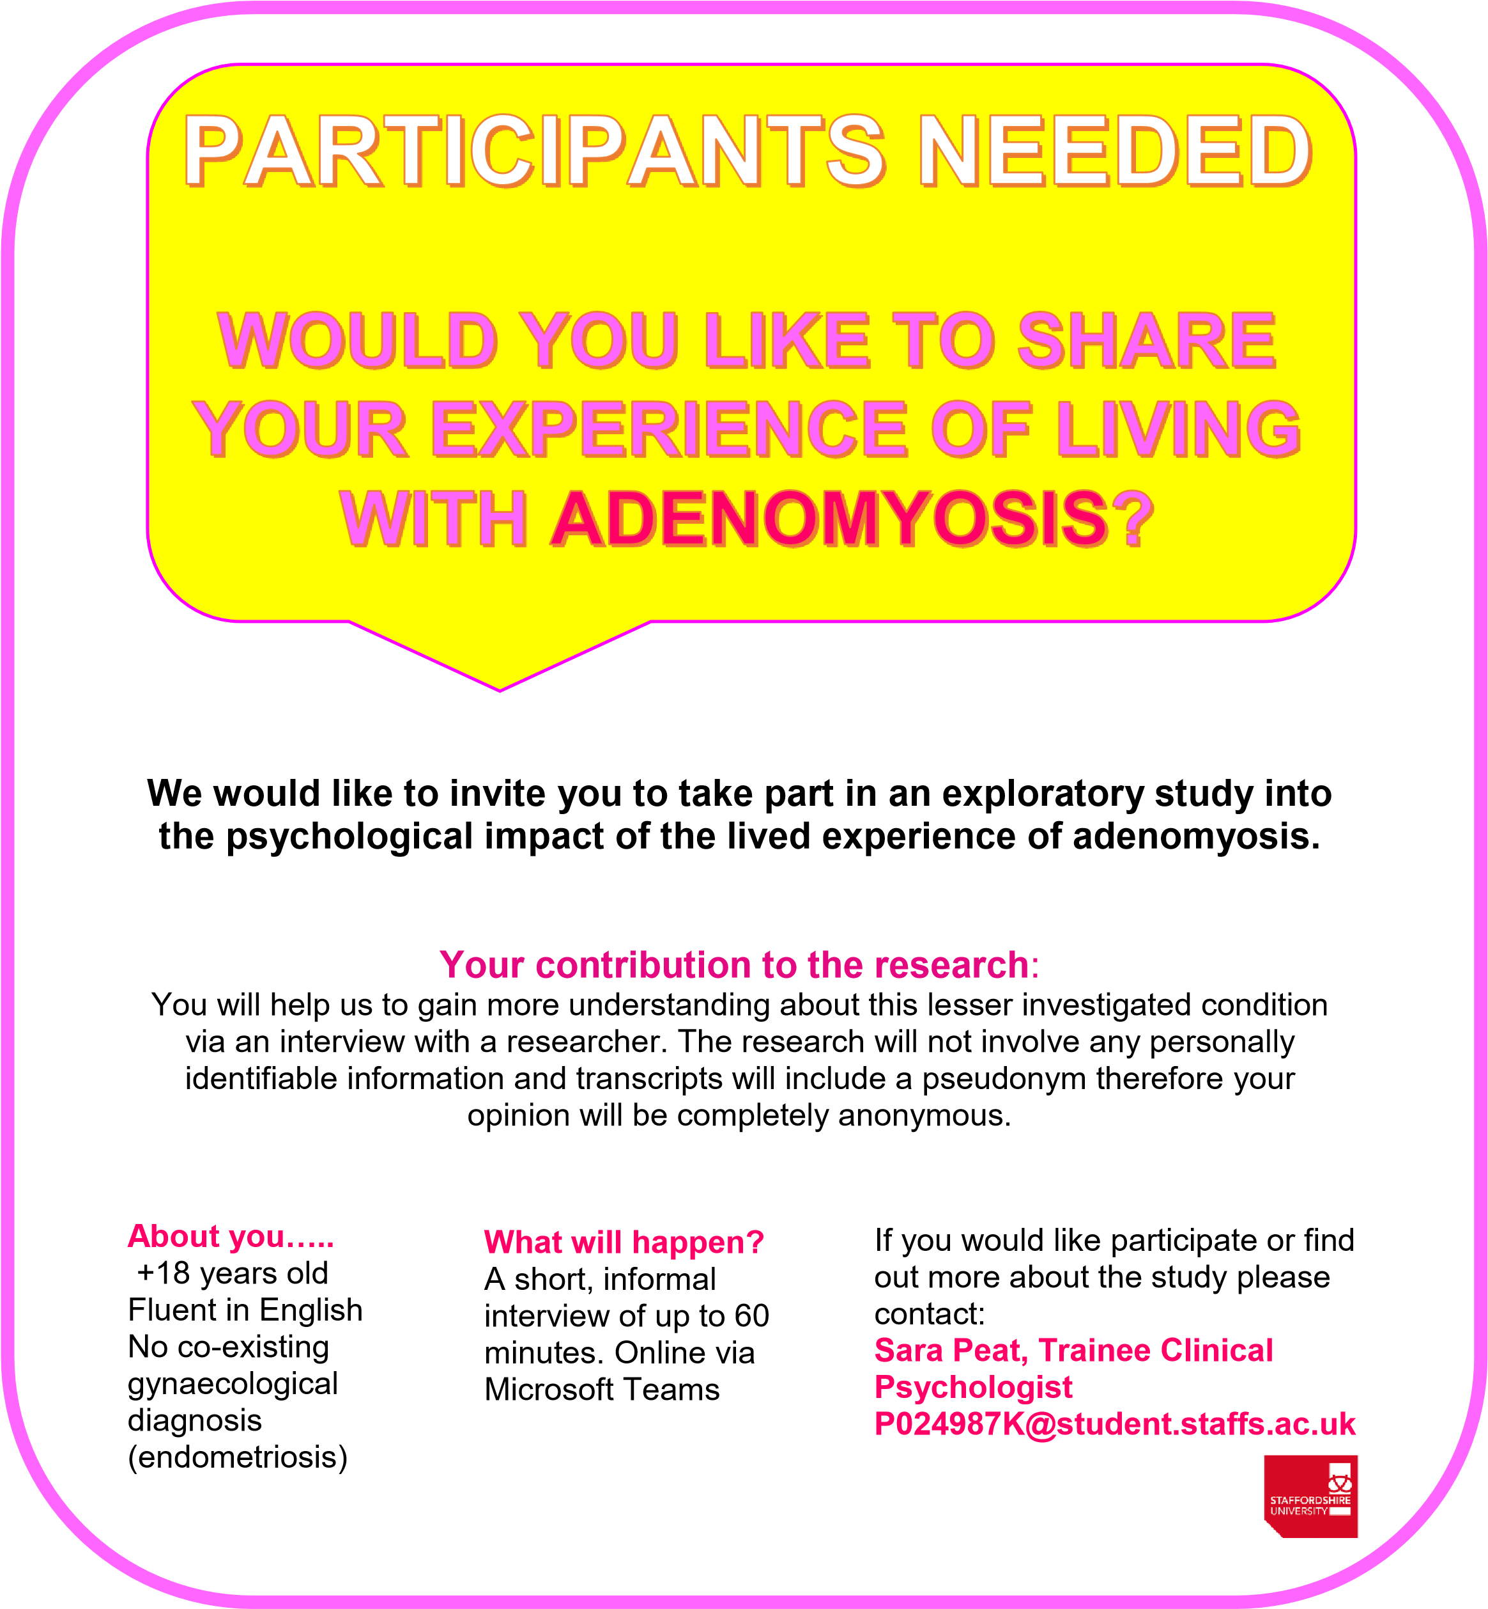

**Appendix E: Interview schedule**

  
 **UNDERSTANDING ADENOMYOSIS  
INTERVIEW SCHEDULE**  
**Introduction**“As detailed in the information sheet, we will now spend some time discussing your lived experience of Adenomyosis, the conversation will last up to one hour. Please feel free to let me know if you wish to take a break or stop the conversation at any time. The conversation will be recorded via audio recording. Do you have any questions before we begin?”

This is not a structured interview therefore the schedule is somewhat flexible. The questions asked will be open ended and relate directly to the research aim of gaining understanding of the lived experience and psychological impact of Adenomyosis.

**Diagnosis**

1 Can you tell me about your experience of receiving a prospective diagnosis of Adenomyosis?   
Prompts  
- if you experienced an emotional response at this time could you describe it?  
- if any, what thoughts went through your mind?

**Support**

2 Can you tell me a bit about your experience of support around living with your condition?  
Prompts  
- who if anyone has supported you  
- if so, in what way have they supported you?  
- have you discussed your symptoms with anyone else?  
- can you tell me about living with the condition and your relationships?

**Everyday life**

3 Can you talk to me about your experience of living with Adenomyosis day-to-day?  
Prompts  
- have you made any adaptations to your lifestyle?  
- do you experience any emotional impacts?

**Self-Perception**

4 Can you talk to me about your understanding of the relationship between living with adenomyosis and your self-image / view of yourself?   
Prompt  
- have you thought about your gender in relation to the condition?  
- if so what sort of emotions and thoughts did you experience?

**Closing questions**

* Is there anything we haven’t covered that you had in mind to discuss about your life with adenomyosis?
* May I ask why you decided to take part in this research?

**

**UNDERSTANDING ADENOMYOSIS  
DEBRIEFING FORM**

Thank you for your help by participating in this study. The study was conducted as an exploratory investigation into the experience of living with Adenomyosis. You are not restricted to refrain from talking about your participation in the experiment.

If you have found any of the interview topics distressing or sensitive in nature, you are advised to seek clinical support by contacting your general practitioner or reaching out to The Pelvic Pain Support Network at: www.pelvicpain.org.uk.

If you would like any information about the results of the study once it is completed, would like to know where to find more information regarding the research topic, or have any complaints or further questions, you should feel free to contact the researcher by emailing Sara Elizabeth Peat at p024987k@student.staffs.ac.uk. If you feel that you cannot contact the researcher with your query, please contact the supervising researcher, Dr Jo Heyes by joanna.heyes@staffs.ac.uk. If you remain unhappy or have a complaint about the research, you should contact the Staffordshire University Ethics Team at ethics@staffs.ac.uk. If you contact the team, please provide details of the title or description of the study (so that it can be identified), the researcher involved, and the details of the complaint you wish to make.

Thank you once more for your participation, it is greatly appreciated.

**Appendix G: Reflective Statement**The researcher is a 36 year old female, who received a diagnosis of adenomyosis in 2016 following years of physical discomfort. Therefore, they have a special interest in the condition and, after finding very little information about adenomyosis following diagnosis, they possess a knowledge that there is a need for information to be provided.   
  
As the researcher has strong beliefs about the need for clinical provisions to be improved they attempted to use their experience working as a Research Assistant, Research Co-ordinator and Research Associate in academic and clinical roles as a means of staying attuned to any influences in theme interpretation. Similarly, the researcher utilised peer support from the IPA research group at the university in effort to discuss and monitor the process of theme generation.   
  
The reflexive journal kept by the researcher highlighted that completing this work was emotionally challenging. Peer reflective practice and social support enabled them to maintain perspective during analysis.

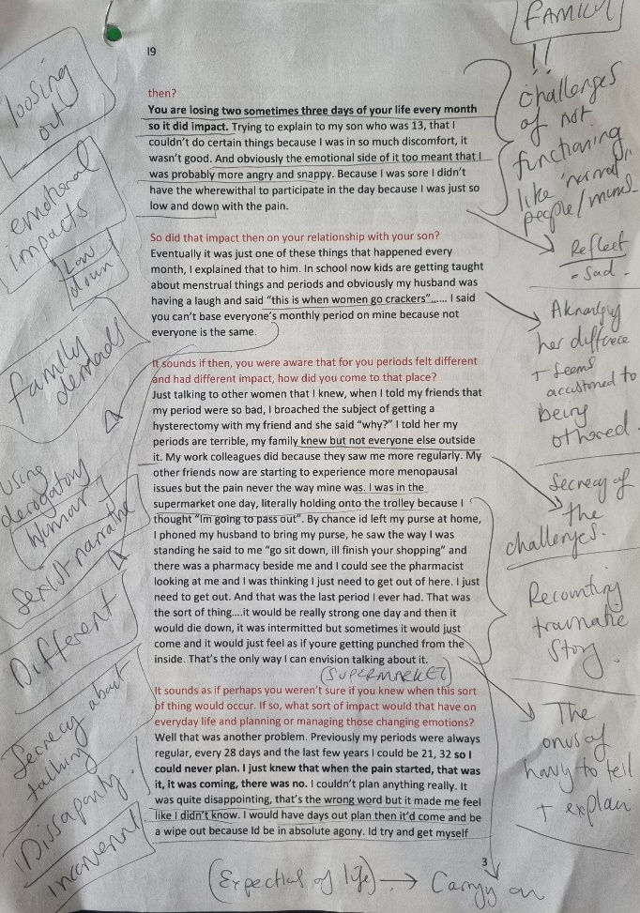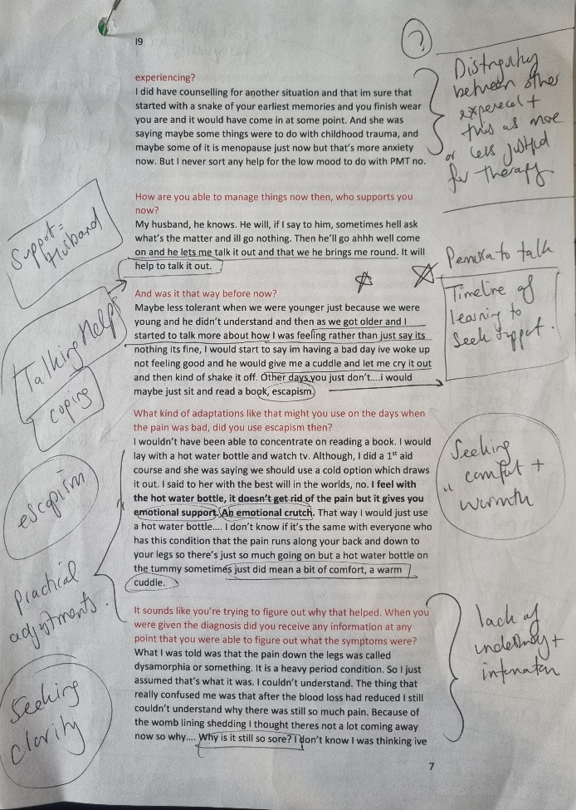**Appendix H: Examples of initial notes and themes for Cath**

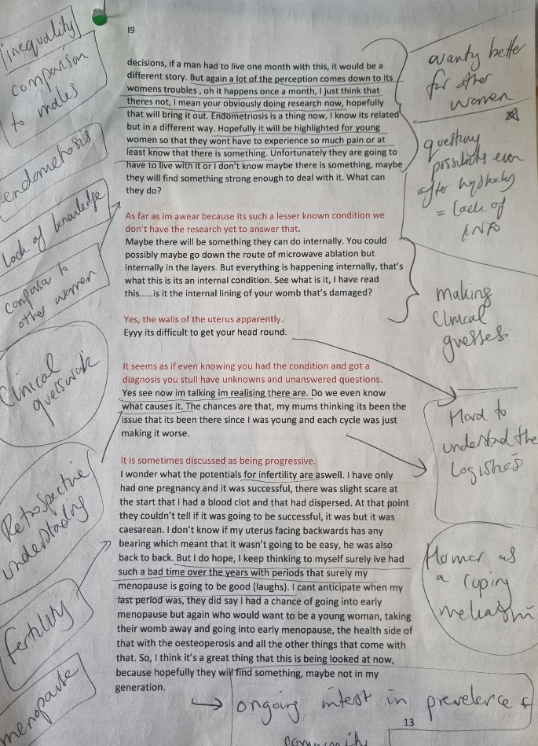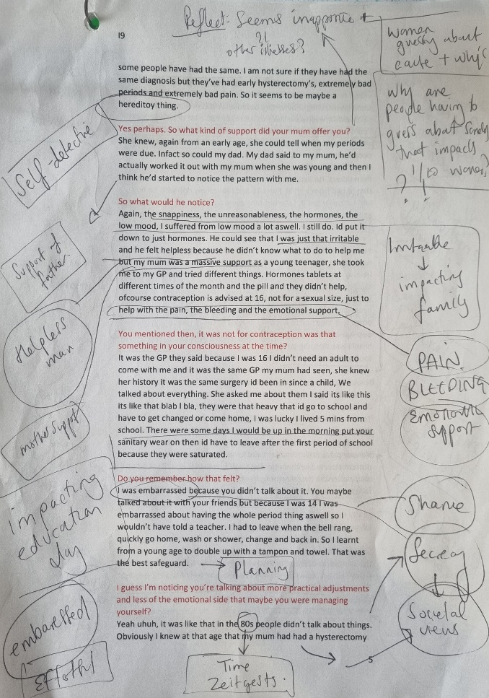

**Appendix I: Emergent theme development for Cath**a) Example of interpreting what is being said and possible personal themes

b) List of all themes

|  |  |  |  |  |
| --- | --- | --- | --- | --- |
| **a)**  **Quote** | | **What’s being said?** | | **Theme** |
| Well mine was diagnosed after a partial hysterectomy, I had many years of extreme pain with heavy bleeding. In the July I made the decision, primarily because I had private healthcare to go through with the hysterectomy. My mum came with me for the second consultation I obviously googled it and I was quite surprised to hear about it, I found it was a relative of endometriosis. | | Shock at diagnosis, conceptualized in relation to endometriosis presumably as it alone is unknown.   agreed to hysterectomy due to pain despite not knowing cause, but influence was impacted upon by private care  perhaps came away without experiencing having received enough information as used google | | **Diagnosis   private healthcare  self-researching** |
| Yeah because I don’t know ive mostly just seen male GPs in general. In my early 40s the pains were getting really bad and I was told “this is what happens to women as you get older” as if this is just a kind of part of your period. | | Had hysterectomy after years of seeking help and being dismissed. Came to the conclusion that male doctors were less empathetic and there is a societal narrative that you just get on with it   situation was normalised despite discomfort | | **Dismissed  seeking help   life stage   Normalised and dismissed** |
| Disillusioned because I thought I can’t live like this. Even after having a hysterectomy, working with the girls in my team they all could tell when my period was due because they could see the pain, and my mood start to drop. I took medication that wasn’t prescribed to me just because the pain was so bad at times. | | Pain management and mood impacted by discomfort  losing faith in medics due to lack of support? Disillusioned   There were impacts on work life and interpersonal, spoken of as if it was something others were used to noticing.   forced? Into self-medicating due to severity, no other options and feeling like she had to carry on regardless – pressures? | | **Pain   self-management   work life   others noticing   low mood** |
| **b)**  Impact on “pessimistic” outlook  Exhaustion and fatigue  Self-image  Self-critical  Feeling “sorry for self”  Feeling guilty  **Others noticing**  Length of time to diagnosis  Unanswered questions  Visual changes  **Private healthcare**  Justification at diagnosis  Lifelong struggle  Talking helps  Prevents usual activities  Impact on family relationships  Change in presentation over time  Learning coping strategies  Hopelessness “why me?” – unfair  Withdrawing  Mistrust of the NHS  **Self-management**  Not talking | Lacking support  Husband learning how to help  Fears of judgement  **Self-researching**  “Just get on with it”  Finding acceptance  Adapting day to day routine  **Pain**  Teenage shame and embarrassment  **Low mood and fed up**  Mum understanding, shared genetics?  Impact on loss of education / school  Secrecy and isolation  Loss of time  Independence and coping alone  Variable information Hysterectomy  **Diagnosis**  No one understands  Emotionally draining  Clinical guesswork  **Feeling dismissed** | | Disillusioned with healthcare  Self- medicating  “Moods” impacted  **Work life**  Conflicted about it being a “natural process”  Pretending for others  Feeling misunderstood  Loss of control  Planning  Missing out  Self-compassion  Disappointing experiences  “Normal” looking and  Gender inequality?  Compassion for other women  **Life stage**  Seeking help  Social / interpersonal awkwardness  **Seeking help**  **Normalizing and dismissing of pain**  Society not set up to support  Effortful management Escapism | |

**Appendix J: Grouping of emergent themes for Cath into subthemes / experiences**

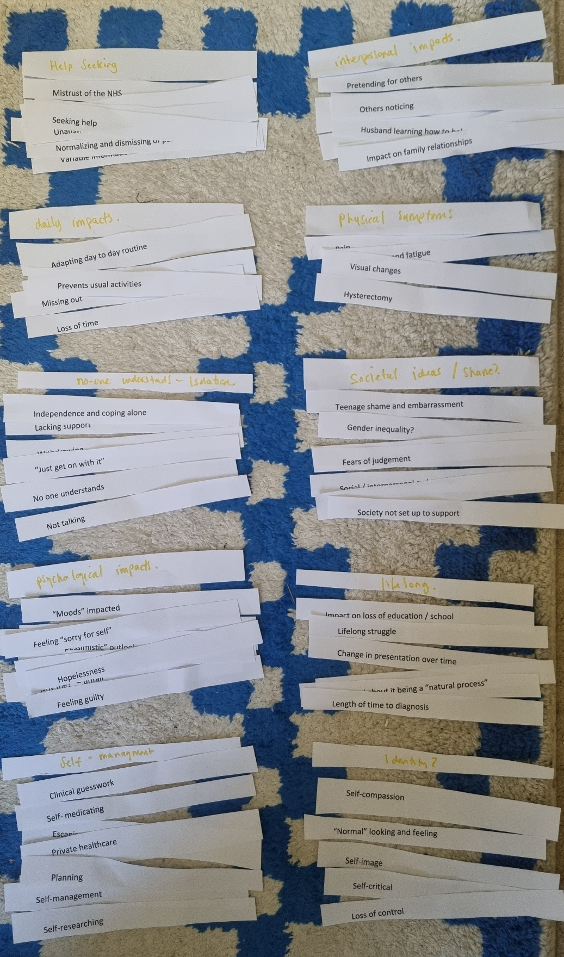

**Appendix K: Grouping of subthemes for all participants into GETS   
  
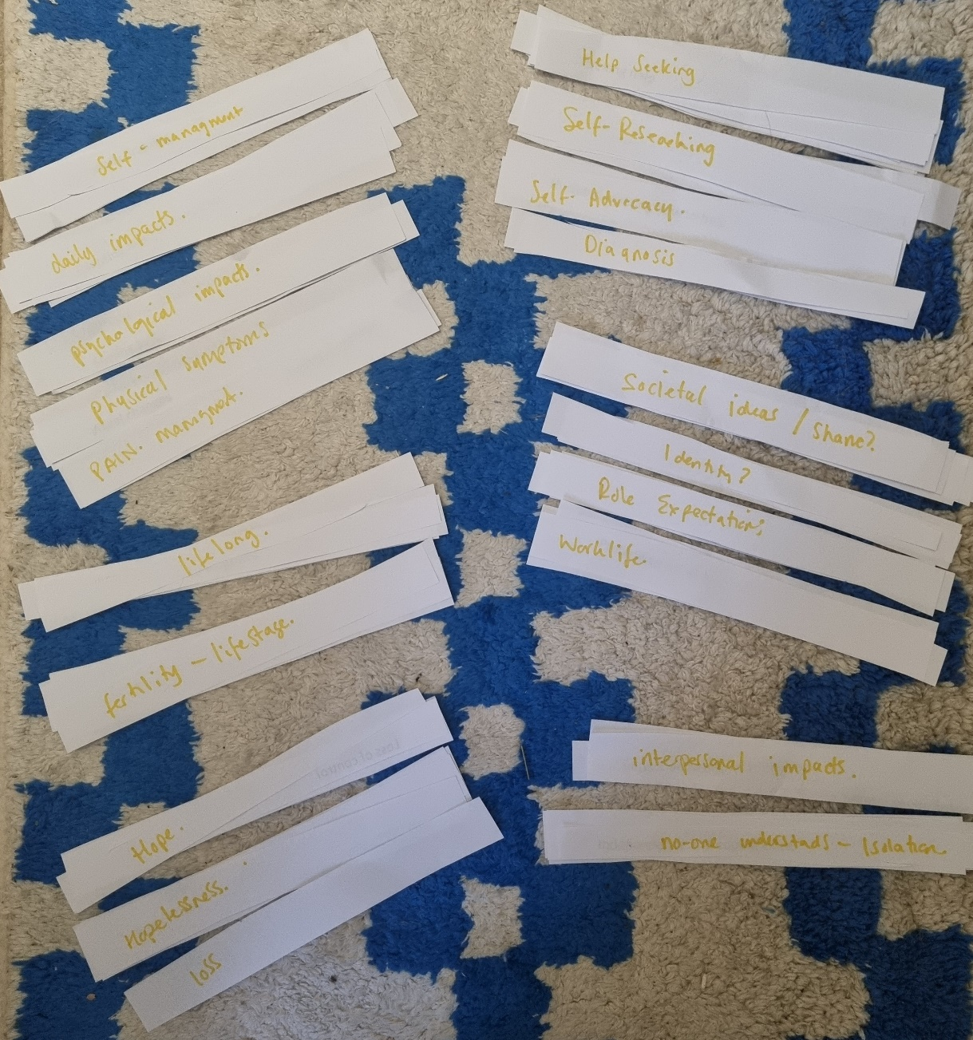**

**Appendix L: GET 2 Self-Management: Subtheme 1 “inadequate information” example with supporting quotes**

|  |  |  |  |
| --- | --- | --- | --- |
| **GET** | **Subtheme** | **Participant** | **Quote** |
| Self-management | Inadequate Information | Meredith | It's quite disheartening when you're having these symptoms and the message that you receive is, well, it is painful. |
| one doctor just said if that's just how it is, unfortunately. And I came away from that even then thinking, well, I don't really believe that to be the case. |
| Just because you are googling, you figure out what's going on with your body. You know, whatever it is, so you learned to navigate that in in different ways. |
| they told me that it was unlikely it would impact my fertility. Everything else looked healthy. It was just this adenomyosis and there were methods that they could introduce to help with that pain. |
| And I was like starting to challenge myself. Like, do I really need this operation? You know, do I need this operation? Only momentarily like that was a very fleeting thought, but I think when it is your family you do? |
| Cara | all that was said to me was there's nothing we can do about it. And the only options are hysterectomy, or we stop your periods. |
| I'm quite young and and it was sort of like well you can stop your periods or have a hysterectomy whereas in all the women they have less time to have periods to them for their users to get bigger. |
| cause I've taken the additional tablets to stop my periods on top of the contraception and it still hasn't stopped it. So, it's like, well, that's not going to work for me. just like inadequate information. |
| I was just discharged from the gynaecologist, and they said come back to us if you have any further issues. And they said, well, there's nothing we can do about it. So and then likewise, the likelihood, if I go back, they're just gonna tell me there's nothing we can do about it. So, I joined like Facebook groups and just found out information through them and then pretty much found the same information that is a hysterectomy or basically just live with the symptoms. |
| sometimes it can be a little bit scary as well. At the same time of people highlighting how much pain they're in. And then you're like, oh, is that going to be the point? |
| then then I'm like, what is my pain threshold? Different to their pain threshold and so that side of it can be a little bit scary when you look at the group's cause, some people will say ohh I haven't been able to move. I've not been able to go to work. And then you're like ohh okay. |
| there's nothing at the beginning to sort of say read up on this or look for this page so you are just finding other women who had really negative experiences like burning themselves in that much pain and you're like, wow I…if you're accessing it yourself, I think yeh I can find things that scare me. I’m scared to potentially think that I could end up in that position |
| June | Believe it or not, but there's just this wonderful community And I think I've seen a really big growth of advocacy among people for these things because we built a community that teaches each other how to navigate these things. |
| you don't really read a lot of research articles on it or things are locked behind paywalls or university sites like you can only access things in certain places plus. Not everyone wants to read along paper like I would love to read extensive research on things, but that's also time you have to take. |
| Lily | I'm just happy to help. There's not enough known about or spoken about with adenomyosis. |
| I've researched it and see what the symptoms are, I suspect actually that I have had it for probably 25 years. |
| So my symptoms have been progressed and become much worse. And I haven't received additional support. Um, you know the options are incredibly limited. |
| surgery is frightening and the possibility of going into early menopause is frightening and it really is you know, I'm really struggling with the fact that I've got two options, bleed continually or… it physically makes me like literally just hunch over. I feel heartbroken about it that those, the two choices. I don't believe that, that it really is only two choices. |
| And my local guyne department just keep discharging me. So I have to go back to my GP to try and see them again. |
| Look at it. Decide what you can cope with, and some days you just put the plaster back, you know, and and you just carry on. There’s no solutions. |
| Louise | Mentioned in you know in his paperwork he was like ohh yes and blah blah blah and I didn't. I was like, what is that? And is that the reason we failed like I just and he just kind of chucked it in quite informally? Not really explaining what it was and not believing it had anything to do with the failed fertility. I did ask him about it, and he said well, there's no need to kind of. Worry about it. |
| he tried to draw me some diagrams and basically just try to explain it to me as like endometriosis. But inside the womb, not outside. And that's essentially all I got. |
| Now apparently it had had absolutely nothing to do with it, but it just happens. Maybe the big coincidence, but I had to have a termination. And prior to this it was fine. |
| But I also, you know, quite quickly read that I couldn't do anything about it and there isn't a treatment and there's not very much known. And I was like ohh well that's that then. And you can't go down a rabbit hole. |
| They just think it's known to have potential impact. Right. See. So, you can't say it is for sure. You can't say it's not. You can't do anything about it. |
| I can't deal with the fact that I've had this condition for many years. The doctors didn't talk to me about it. I’ll take the periods; I can't deal with the fact that this has prevented me from having a child. And nobody's willing to talk about that. |
| when I was having multiple miscarriages and I was having investigations. It should have come up during all of that, but it didn't. |
| let's have a conversation around the fact that this is probably highly likely to be contributing. And there is or there isn't something you can do. I don't know. Eat less red meat and fine. Like if there's something I can do, have that conversation with me. If there's absolutely nothing I can do. Why you now giving me medications to stop blood flows and stuff when actually, is that something that I could have done? It just feels like there's no joined-up Ness around the whole thing. |
| Simran | it was helpful, but at the same time it can be kind of triggering hearing other peoples. And like experiences and things, and you realise that you've experienced this thing and they've not in. It is helpful in the sense that everyone just wants to help each other, but then hearing other people's stories like it can bring back all these like negative feelings and emotions that you've had before. |
| I've done a lot, a lot of research over the years. Um, I've spoken to other people that kind of deal with this. Some of them don't have issues with food. Some of them do. I mean, I have a lot of allergies, so I wasn't kind of surprised that a lot of the foods for me triggered. |
|  |  | Jane | the gynaecologist that I actually spoke to, I did say, do you have any literature you can give me on this? And she said to me, ohh, go away. Google it. There's lots of stuff online. I am, I think in the moment quite shocked. |
| I'd never heard of the condition before. It's. I'm really had to go digging around to try and find some information and some support outside of my medical provider, you know. |
|  | I did find, you know there are support groups out there, um, support groups through Facebook. Um finding lots of other women that were going through it or had gone through it. That's where I really found my advice from. |
| I was looking for information, they're just was very little information out there.  And even gynaecologist that I spoke to didn't even seem to be fully versed on the condition and I would go and with symptoms and they'd say ohh that's not a symptom, yeah, which is very frustrating. |
| Mo | Yeah, a bit annoyed you know if it was something that a man would have there would be reams of stuff about it. But because it’s something that women have, yeh eh. |
| I tell you what I started doing the 5/2 when you fast twice a week and my symptoms did get better when I started fasting twice a week. It could have been totally coincidental that I went through a period of lesser symptoms. |
| I remember talking to my female, private doctor who I went to see to get the HRT. She is private GP who specializes in women’s health. I can remember asking her a long time ago, she said it doesn’t or did she say it did. Her and the gynaecologist one of them said it did stop with menopause and one of them said it didn’t. I think it was the gynaecologist who thought it didn’t as that’s why he wanted to do a hysterectomy. But I always take that with a pinch of salt because that’s his job isn’t it. |
| I don’t know what the normal symptoms of it are. Can you enlighten me? Does it resolve with menopause? |
| we talk about how weather the lower back pain I get is related to this as well because everything is connected so potentially, who knows. |
| I chickened out and said it’s not worth the risks, but you know my level of symptoms wasn’t worth the risk of going through major abdominal surgery. So, I thought I will put up with it and hopefully, I hope that once I hit menopause it will settle down. So, I’m just like enduring it. |
| Cath | you just think it’s like a sore tummy, or not a sore tummy but you think it’s just something that will go away. I wasn’t realising the full impact it had on me physically and probably emotionally too. |
| I took medication that wasn’t prescribed to me just because the pain was so bad |
| My mum had terrible periods as well from a young age. She had a hysterectomy at 31. So, in my family there’s certainly a history on my mum’s maternal side. Not everyone but some people have had the same. I am not sure if they have had the same diagnosis, but they’ve had early hysterectomy’s, extremely bad periods and extremely bad pain. So, it seems to be maybe a hereditary thing. |
| I was told was that the pain down the legs was called dysamorphia or something. It is a heavy period condition. So, I just assumed that’s what it was. I couldn’t understand. The thing that really confused me was that after the blood loss had reduced, I still couldn’t understand why there was still so much pain. Because of the womb lining shedding I thought there’s not a lot coming away now so why…. Why is it still so sore? I don’t know I was thinking I’ve got another 10 years of this, and so when I had private healthcare I could choose, I didn’t have to go on an NHS waitlist. Probably to be honest if I’d gone on the waitlist for the NHS I don’t know that they would have done that pathology afterwards. |
| Eyyy its difficult to get your head round.  It seems as if even knowing you had the condition and got a diagnosis you still have unknowns and unanswered questions. now I’m talking I’m realising; do we even know what causes it? |

**Appendix M: Author submission guidelines**

***Women’s Health* *Original Articles***. The Editors will consider clinical interventional and observational studies with clearly stated aims, well-reported methodology (including main outcome measures) results, and a discussion of the results in the context of the published literature.

* Abstract: Maximum 300 words. Should be structured to include:   Background; Objectives; Design; Methods; Results; Conclusion; Registration (if applicable)
* Plain language summary: optional. Please check section [3.4](https://journals.sagepub.com/author-instructions/WHE#PlainLanguageSummaries) for further details.
* Word count: up to 6000 words (excluding tables, figure legends and references) is recommended (this can be flexible)
* Figures/Tables: no limit
* Declarations: please check section [5](https://journals.sagepub.com/author-instructions/WHE#Declarations) for further details.
* Reporting guidelines: please check section [4.3](https://journals.sagepub.com/author-instructions/WHE#ReportingGuidelines) for further details.

**5. Declarations**

All submissions must include a section with the heading ‘Declarations’, including each of the sub-headings listed below. If a declaration is not applicable to your manuscript, you must still include the heading and state ‘Not applicable’ underneath. Please note that you may be asked to justify why a declaration was not applicable to your submission by the Editorial Office.

**5.2 Consent for publication**

Submissions containing any data from an individual person (including individual details, images or videos) must include a statement confirming that informed consent for publication was provided by the participant(s) or a legally authorized representative. Nonessential identifying details should be omitted. Please do not submit the participant’s actual written informed consent with your article, as this in itself breaches the patient’s confidentiality. The Journal requests that you confirm to us, in writing, that you have obtained written informed consent to publish but the written consent itself should be held by the authors/investigators themselves, for example in a patient’s hospital record. The confirmatory letter may be uploaded with your submission as a separate file in addition to the statement confirming that consent to publish was obtained within the manuscript text. If this is not applicable to your manuscript, please state ‘Not applicable’ in this section.

**5.3 Author contributions**

Papers should only be submitted for consideration once consent is given by all contributing authors. Those submitting papers should carefully check that all those whose work contributed to the paper are acknowledged as contributing authors. The list of authors should include all those who can legitimately claim authorship. This is all those who:

1. Made a substantial contribution to the concept or design of the work; or acquisition, analysis or interpretation of data,
2. Drafted the article or revised it critically for important intellectual content,
3. Approved the version to be published,
4. Each author should have participated sufficiently in the work to take public responsibility for appropriate portions of the content. Authors should meet the conditions of all of the points above. Each author should have participated sufficiently in the work to take public responsibility for appropriate portions of the content. When a large, multicentre group has conducted the work, the group should identify the individuals who accept direct responsibility for the manuscript.

These individuals should fully meet the criteria for authorship.

Acquisition of funding, collection of data, or general supervision of the research group alone does not constitute authorship, although all contributors who do not meet the criteria for authorship should be listed in the Acknowledgments section. Please refer to the [International Committee of Medical Journal Editors (ICMJE)](http://www.icmje.org/recommendations/browse/roles-and-responsibilities/defining-the-role-of-authors-and-contributors.html) authorship guidelines for more information on authorship.

***5.3.1 CRediT***

As part of our commitment to ensuring an ethical, transparent and fair peer review and publication process, [SAGE is trialling the adoption of CRediT (Contributor Roles Taxonomy) on several of our journals.](https://www.sagepub.com/credit) CRediT is a high-level taxonomy, including 14 roles, which is used to describe each author’s individual contributions to the work.

You will be asked to list the contribution of each author as part of the submission process. Please include the Author Contributions heading within your manuscript. The information you give on submission will then show under the Author Contributions heading later at the proofing stage.

**5.4 Acknowledgements**

All contributors who do not meet the criteria for authorship should be listed in this section. Examples of those who might be acknowledged include a person who provided purely technical help, or a department chair who provided only general support. If you do not have any acknowledgements to make, please state ‘Not applicable’ in this section.

***5.4.1 Third party submissions***

Where an individual who is not listed as an author submits a manuscript on behalf of the author(s), a statement must be included in the Acknowledgements section of the manuscript and in the accompanying cover letter. The statements must:

* Disclose this type of editorial assistance – including the individual’s name, company and level of input
* Identify any entities that paid for this assistance
* Confirm that the listed authors have authorized the submission of their manuscript via a third party and approved any statements or declarations, e.g. conflicting interests, funding, etc.

Where appropriate, SAGE reserves the right to deny consideration to manuscripts submitted by a third party rather than by the authors themselves.

***5.4.2 Writing assistance***

Individuals who provided writing assistance, e.g. from a specialist communications company, do not qualify as authors and so should be included in the Acknowledgements section. Authors must disclose any writing assistance – including the individual’s name, company and level of input – and identify the entity that paid for this assistance. It is not necessary to disclose use of language polishing services.

**5.5 Funding**

All authors must acknowledge their funding in a consistent fashion under a separate heading. Please visit the [Funding Acknowledgements page](https://www.sagepub.com/funding-acknowledgements?_gl=1%2Aa5i3fk%2A_ga%2AMTcwNTk2MDM5NC4xNjIwNjM2Nzk5%2A_ga_60R758KFDG%2AMTY0MjQzNjIyNS41NzQuMS4xNjQyNDM2MjYwLjA.) on the SAGE Journal Author

Gateway to confirm the format of the acknowledgment text in the event of funding, or state that: This research received no specific grant from any funding agency in the public, commercial, or not-for-profit sectors.

**5.6 Competing Interests**

All financial and non-financial competing interests must be declared in this section. If no conflict exists, please state that ‘The Author(s) declare(s) that there is no conflict of interest’. For guidance on conflict of interest statements, please see the [ICMJE recommendations.](http://www.icmje.org/recommendations/browse/roles-and-responsibilities/author-responsibilities--conflicts-of-interest.html#two)

**5.7 Availability of data and materials**

SAGE acknowledges the importance of research data availability as an integral part of the research and verification process for academic journal articles.

The Journal encourages all authors to submit any primary data used in their research articles alongside their article submissions to be published in the online version of the journal, or provide detailed information on how the data can be obtained. This information should include links to third-party data repositories or detailed contact information for third-party data sources. Data available only on an author-maintained website will need to be loaded onto either the journal’s platform or a third-party platform to ensure continuing accessibility. Examples of data types include but are not limited to statistical data files, replication code, text files, audio files, images, videos, appendices, and additional charts and graphs necessary to understand the original research. The editor may consider limited embargoes on proprietary data. The editor can also grant exceptions for data that cannot legally or ethically be released. All data submitted should comply with Institutional or Ethical Review Board requirements and applicable government regulations. If this is not applicable to your manuscript, please state ‘Not applicable’ in this section.

[Back to top](https://journals.sagepub.com/author-instructions/WHE#top)

**6. Publishing Policies**

**6.1 Publication ethics**

SAGE is committed to upholding the integrity of the academic record. We encourage authors to refer to the Committee on Publication Ethics’ [International Standards for Authors](http://publicationethics.org/files/International%20standards_authors_for%20website_11_Nov_2011.pdf) and view the Publication Ethics page on the [SAGE Author Gateway.](https://www.sagepub.com/ethics-responsibility)

***6.1.1 Plagiarism***

*Women’s Health* and SAGE take issues of copyright infringement, plagiarism or other breaches of best practice in publication very seriously. We seek to protect the rights of our authors and we always investigate claims of plagiarism or misuse of published articles. Equally, we seek to protect the reputation of the journal against malpractice. Submitted articles may be checked with duplication-checking software. Where an article, for example, is found to have plagiarised other work or included third-party copyright material without permission or with insufficient acknowledgement, or where the authorship of the article is contested, we reserve the right to take action including, but not limited to: publishing an erratum or corrigendum (correction); retracting the article; taking up the matter with the head of department or dean of the author's institution and/or relevant academic bodies or societies; or taking appropriate legal action.

***6.1.2 Prior publication***

If material has been previously published it is not generally acceptable for publication in a SAGE journal. However, there are certain circumstances where previously published material can be considered for publication. Please refer to the guidance on the [SAGE Author Gateway](https://www.sagepub.com/prior-publication) or if in doubt, contact the Editor at the address given below. **6.2 Contributor's publishing agreement**

Before publication, SAGE requires the author as the rights holder to sign a Journal Contributor’s Publishing Agreement. *Women’s Health* publishes manuscripts under [Creative Commons licenses.](http://creativecommons.org/licenses/) The standard license for the journal is Creative Commons by Attribution Non-Commercial (CC BY-NC), which allows others to re-use the work without permission as long as the work is properly referenced and the use is noncommercial. For more information, you are advised to visit [SAGE's OA licenses page.](https://www.sagepub.com/re-use-of-open-access-content) Alternative license arrangements are available, for example to meet particular funder mandates, made at the author’s request.

[Back to top](https://journals.sagepub.com/author-instructions/WHE#top)

**7. Preparing your manuscript for submission**

**7.1 Formatting**

The preferred format for your manuscript is Word. Word templates are available on the [Manuscript Submission Guidelines](https://www.sagepub.com/manuscript-submission-guidelines) page of our Author Gateway.

**7.2 Artwork, figures and other graphics**

For guidance on the preparation of illustrations, pictures and graphs in electronic format, please visit SAGE’s [Manuscript Submission Guidelines.](https://www.sagepub.com/manuscript-submission-guidelines)

**7.3 Supplementary material**

This journal is able to host additional materials online (e.g. datasets, podcasts, videos, images etc) alongside the full-text of the article. For more information please refer to our [guidelines on submitting supplementary files.](https://www.sagepub.com/supplementary-files-on-sage-journals-sj-guidelines-for-authors)

**7.4 Reference style**

*Women’s Health* adheres to the SAGE Vancouver reference style. View the [SAGE Vancouver](https://www.sagepub.com/sites/default/files/sage_vancouver_reference_style_1.pdf) guidelines to ensure your manuscript conforms to this reference style. If you use [EndNote](http://www.endnote.com/) or [Zotero](https://www.zotero.org/) to manage references, you can download the appropriate output style file to help format your references quickly.

EndNote: [here](http://endnote.com/downloads/style/sage-vancouver)

Zotero: [here](https://www.zotero.org/styles?q=id:sage-vancouver)

**7.5 English language editing services**

Authors seeking assistance with English language editing, translation, or figure and manuscript formatting to fit the journal’s specifications should consider using SAGE Language Services. Visit [SAGE Language Services](http://languageservices.sagepub.com/en/) on our Journal Author Gateway for further information.

[Back to top](https://journals.sagepub.com/author-instructions/WHE#top)

**8. Article publication enhancements**

**8.1 Infographics**

An infographic is a graphic visual representation that provides a snapshot of an article. It is a very effective means of making your article stand out, encouraging readership of your work.

Infographics must be peer-reviewed and submitted at some point during the peer review process prior to official article acceptance. We recommend creating an infographic after first decision to ensure it reflects any peer review comments received. However, please let your SAGE Editor know as soon as possible if you plan to create and include an infographic in your article.

SAGE is partnered with an external professional vendor. This service can be requested from the [Sage Author Services](https://languageservices.sagepub.com/en/services/infographics.html) prior to acceptance of your manuscript.

Please visit our [Author Guidelines for Creating and Publishing Infographics](https://www.sagepub.com/author-guidelines-for-creating-and-publishing-infographics) for further information on creating and publishing infographics.

**9. Submitting your manuscript**

*Women’s Health* is hosted on SAGE Track, a web-based online submission and peer review system powered by ScholarOne™ Manuscripts.

Visit<https://mc.manuscriptcentral.com/whe>to login and submit your article online. IMPORTANT: Please check whether you already have an account in the system before trying to create a new one. If you have reviewed or authored for the journal in the past year it is likely that you will have had an account created. For further guidance on submitting your manuscript online please visit ScholarOne [Online Help.](http://mchelp.manuscriptcentral.com/gethelpnow/)

**9.1 Information required for completing your submission**

You will be asked to provide contact details and academic affiliations for all co-authors via the submission system and identify who is to be the corresponding author. These details must match what appears on your manuscript. At this stage please ensure you have included all the required statements and declarations and uploaded any additional supplementary files (including reporting guidelines where relevant).

**9.2 ORCID iDs**

As part of our commitment to ensuring an ethical, transparent and fair peer review process SAGE is a supporting member of [ORCID, the Open Researcher and Contributor ID.](http://orcid.org/) ORCID provides a unique and persistent digital identifier that distinguishes researchers from every other researcher, even those who share the same name, and, through integration in key research workflows such as manuscript and grant submission, supports automated linkages between researchers and their professional activities, ensuring that their work is recognized.

If you already have an ORCID iD, please list this next to your name in this section. You will also be asked to link your ORCID iD to your submission during the online submission process.

We also strongly encourage all co-authors to link their ORCID iD to their accounts in our online peer review platforms. It takes seconds to do: click the link when prompted, sign into your ORCID account and our systems are automatically updated. Your ORCID iD will become part of your accepted publication’s metadata, making your work attributable to you and only you. Your ORCID iD is published with your article so that fellow researchers reading your work can link to your ORCID profile and from there link to your other publications. Please note that only ORCID iDs validated prior to article acceptance will be authorized for publication, and ORCID iDs cannot be added or amended at a later stage. If you do not already have an ORCID iD please follow this [link](https://orcid.org/register) to create one or visit our [ORCID homepage](https://www.sagepub.com/orcid) to learn more.

**9.3 Permissions**

**Please also ensure that you have obtained any necessary permission** from copyright holders for reproducing any illustrations, tables, figures or lengthy quotations previously published elsewhere. For further information including guidance on fair dealing for criticism and review, please see the Copyright and Permissions page on the [SAGE Author Gateway.](https://www.sagepub.com/copyright-and-permissions)

[Back to top](https://journals.sagepub.com/author-instructions/WHE#top)

**10. On acceptance and publication**

**10.1 SAGE Production**

Your SAGE Production Editor will keep you informed as to your article’s progress throughout the production process. Proofs will made available to the corresponding author via our editing portal SAGE Edit, or by email to the corresponding author and should be returned promptly. Authors are reminded to check their proofs carefully to confirm that all author information, including names, affiliations, sequence and contact details are correct, and that Funding and Conflict of Interest statements, if any, are accurate. Please note that if there are any changes to the author list at this stage all authors will be required to complete and sign a form authorising the change.

**10.2 Online publication**

One of the many benefits of publishing your research in an open access journal is the speed to publication. With no page count constraints, your article will be published online in a fully citable form with a DOI number as soon as it has completed the production process. At this time it will be completely free to view and download for all.

**10.3 Access to your published article**

SAGE provides authors with online access to their final article.

**10.4 Promoting your article**

Publication is not the end of the process! You can help disseminate your paper and ensure it is as widely read and cited as possible. The SAGE Author Gateway has numerous resources to help you promote your work. Visit the [Promote Your Article](https://www.sagepub.com/promote-your-article) page on the Gateway for tips and advice.

[Back to top](https://journals.sagepub.com/author-instructions/WHE#top)

**11. Further information**

Any correspondence, queries or additional requests for information on the manuscript submission process should be sent to the *Women’s Health* editorial office as follows: womenshealth@sagepub.co.uk

For all commercial sales and sponsorship enquiries, including advertising, reprints and supplements, please contact:

Commercial Sales Team, London, UK Tel: +44 20 7336 1205

Email: reprints@sagepub.co.uk