Exploring the Intersection of Virtual Reality and Haptic Technology to Aid the Interpretation and Interaction with The Thornhill Collection of East Asian Ceramics

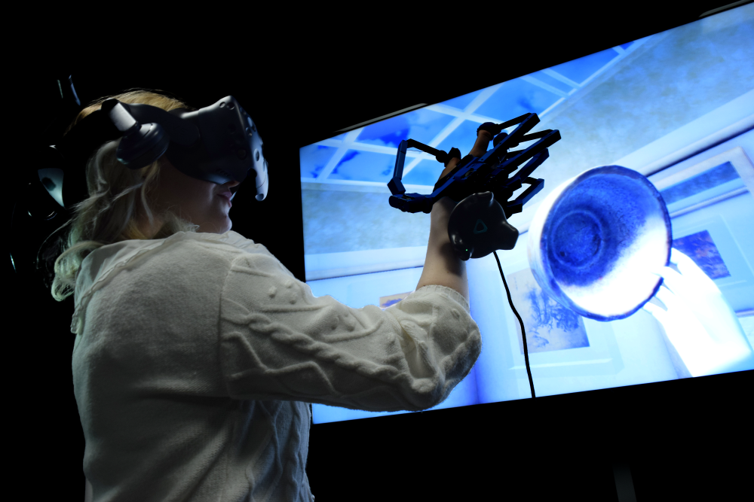

Emma Fallows

A thesis submitted in partial fulfilment of the requirement of Staffordshire University for the degree of Doctor of Philosophy

September 2024

Dedication
This thesis research is dedicated to my ever encouraging and amazing family. My exceptional and faithful parents, Kathryn Fallows and David Fallows for always doing everything they can to support my ambitions and make them possible. As well as my amazing uncle, the late Terry Skelson for his incredible knowledge in the ceramic industry and sparking my passion for this research.
Acknowledgments
I would like to thank my primary supervisor Dr David White and secondary supervisor Professor Neil Brownsword for their help and support to drive this thesis to completion. I would also like to acknowledge my previous supervisors Professor Minhua Eunice Ma and Dr Yvan Cartwright for their guidance during this PhD.
I am greatly thankful to the team at SenseGlove for their amazing opportunities for this project, the team were so helpful throughout this research journey.
A huge thank you to the Games and Visual Effects Department at Staffordshire University for providing a full scholarship and funding for this PhD degree. I am forever grateful for this opportunity.
I would like to thank my colleagues and friends who have endlessly supported me during this PhD journey:
Luke Haslett, Rich Harper, Jennifer Challenor and Debbie Cartwright.
A personal thank you to my partner, Ryan Jackson. For his continued support and guidance that strived the Thornhill Experience to new heights.
Finally, a thank you to the examiners for their time and patience in reading and reviewing my thesis.

Abstract
With a rise in the use of Virtual Reality (VR) applications in museums and exhibition displays, digital heritage has shown limitations in what a visitor can experience from the intersection of technology and history. Traditionally, historical content has been communicated through text panels which limit access to the broader context of artefacts. These modes of disseminating contextual information remain in place throughout many cultural institutions, and although they have been complimented by the installation of digital media to facilitate visitor interaction, there are very few examples which engage multisensory immersion.
Through practice-based research, this paper aims to explore haptic-enabling technologies to disseminate a greater understanding of historical objects through multi-faceted modes of interpretation. It examines new methods of communicating historical information, to provide innovative solutions to increase visitor engagement with ceramic objects.
This research digitally reconstructs selected objects from a collection of East-Asian ceramics bequeathed by Ernest Thornhill in 1944 to North Staffordshire Technical College (now Staffordshire University) to create an immersive virtual museum space that provides interactive content to acquire contextual information on a selection of Thornhill ceramics.
This VR experience has been developed to engage the viewer beyond the traditional viewing formats and utilises object analysis frameworks adapted to enhance the foundations of interpretation within a museum context. This research aims to develop an application that increases visitors’ interest with museum collections which are often neglected by a contemporary audience. Through an amalgamation of sensory experiences, it deconstructs cultural information into a range of related narratives and aims to enhance a visitor learning experience through an alternative digital exhibition that integrates haptic technology. From an evaluation of visitor satisfaction using quantitative surveys, evidence revealed a significant positive response to this application in a museum setting. Responses revealed these methods of interaction assisted in learning about ceramics and demonstrated how such methods could encourage a high likelihood of future visits.
This research contributes with a developed and tested concept to expand on existing digital heritage methodologies, with regards to introducing a consistent workflow and playable application to view artefacts virtually. This concept explores integrated methods that permit novel interactions to allow for the visual acquisition of information.
This research has revealed a gap in knowledge related to haptic-enabling devices offering sophisticated virtual interactions with ceramics to enable alternative methods of combining interaction with concealed displays. These novel interactions remain absent in many cultural institutions. This research demonstrates how Virtual Reality and haptic-enabling technologies can communicate information visually and interactively to enhance the museum visitors’ experience beyond the traditional text panel.

List Of Publications
Fallows, E., White, D., Brownsword, N. (October 2022). Design and Development Approach for an Interactive Virtual Museum with Haptic Glove Technology. [Accepted]

Contents
Contents 6
Contents of Terminology 9
Figures 11
List of Tables 13
Chapter 1: Introduction 14
1.1 Background and Rationale 14
1.2 The Thornhill Collection 18
1.3 Research Questions 22
1.4 Aims and Objectives 23
1.4.1 Aims 23
1.4.2 Objectives 23
1.5 Research Contribution 24
1.6 Significance of this Research 27
1.7 Thesis Outline 28
Chapter 2: Literature Review 30
2.1 Introduction 30
2.2 Review of Selected Museums for Current Immersive Displays 31
2.3 Virtual Reality in Museums 38
2.3.1 Definition of Virtual Reality 38
2.3.2 The History of Virtual Reality 38
2.3.3 Examples of Existing Research in Digital Heritage 41
2.3.4 Existing Virtual Reality in Museums 44
2.3.5 Summary 49
2.3.6 Haptic Technology in Museums 49
2.3.7 Summary 52
2.4 3D Digitisation of an Artefact 52
2.4.1 Photogrammetry Vs Laser Scanning 53
2.4.2 Existing workflows 53
2.4.3 Summary: Chosen Workflow 55
2.5 Review of existing Haptics 55
2.5.1 Existing Haptic Devices 55
2.5.2 Other Haptic Gloves 58
2.5.3 SenseGlove 59
2.5.4 Summary 59
2.6 Methology Structures 61
2.7 Digitising Methods 63
Chapter 3: Methodology 66
3.1 Object Analysis 66
3.2.1 Object Analysis Framework 68
3.2 Data Analysis 68
Chapter 4: Design and Development of the ‘Thornhill Experience’ 70
4.1 Introduction 70
4.2 The aim of the ‘Thornhill Experience’ 71
4.3 Workflow for decision making 71
4.3.1 List of Functions for the ‘Thornhill Experience’ 73
4.4 Digitising the Thornhill Ceramic Collection 75
4.4.1 Preparation for Photogrammetry 75
4.4.2 Choosing the Digitising Software 76
4.4.3 Visiting the Thornhill Ceramics Storage Unit 77
4.5 Digitisation 80
4.5.1 Photo Selection 80
4.5.2 The Digitising Process 81
4.5.3 Reconstruction 82
4.5.4 Retopology 83
4.5.5 Texture Baking 83
4.5.6 Polishing 84
4.6 Stage 2: Content Creation for the ‘Thornhill Experience’ 86
4.6.1 Mock Designs 86
4.6.2 Environmental Design 88
4.6.3 Additional 3D Content 95
4.6.4 Lady Dai’s Coffin 96
4.5.5 Han Dynasty Goose Lamp. 98
4.7 Stage 3: Interactions and Gaming Elements 99
4.7.1 SenseGlove Integration 99
4.7.3 The Stem Cup Study 101
4.8.1 The Proposed Concept 102
4.8.2 The Greenhalgh Method 103
4.7.2 Summary 107
Chapter 5: The Testing Phase and Data Analysis 109
5.1 Introduction 109
5.1.1 Structure for Questions 110
5.1.2 Method of observation 112
5.2 Questionnaire- Feedback 113
5.2.1 Participants Backgrounds 113
5.2.2 Participant Questionnaire Results 117
5.3 Observation Analysis 131
5.3.1 Visual Observation 131
5.3.2 Observations from Questionnaire. 134
5.3.3 Results 135
5.4 Questionnaire Analysis 135
5.5 Descriptive Analysis 138
Chapter 6: Discussion and Conclusion 143
6.1 Introduction 143
6.2 Summary of Thesis 143
6.2.1 Conclusion 144
6.3 Revisiting Research Questions 145
6.4 Significance of this Research 147
6.5 Contributions 148
6.6 Thesis Implications 149
6.7 Future Work 150
6.8 Epilogue 153
Appendices 154
Appendix 1: Haptic glove Breakdown 154
Appendix 2: Run-through of the ‘Thornhill Experience’: 154
Appendix 3: Interview for SenseGlove about the research: 155
Appendix 4: “Design and Development Approach for an Interactive Virtual Museum with Haptic Glove Technology” 156
Appendix 5: Ethics Approval 157
Appendix 6: Online Library of Thornhill Ceramics Via Sketchfab. 157
Appendix 7: Lyon & Turnbull Inventory & Evaluation for the Thornhill Collection 158
References 159

Contents of Terminology
Virtual Reality (VR)
Virtual Reality is used as a technological technical term for a simulated experience, the word virtual in this context meaning “not physically existing but made to appear by software”. ‘VR' typically has a full headset display to fully immerse the player within a 360-degree scene.
Two-Dimensional (2D)
Two-dimensional, in a mathematical context, means a geometrical shape that can be defined as a flat plane figure or a shape that has exactly two dimensions: length and width.
Three-Dimensional (3D)
Three-dimensional, in a mathematical context, is the addition of depth to a two-dimensional geometric shape.
Digitisation
Digitisation refers to a technique that converts an object from a physical form into a digital form.
Photogrammetry
Photogrammetry refers to the scientific technique of obtaining measurements of a 3D object with photographs that are processed within a digitising software to create a 3D virtual replica. The result provides a digitised version of the physical object.
Digital Heritage
Digital Heritage is a concept made up of computer-based materials that stem from physical forms to create a digital archive that supplies a preserved replicas for accessible future access.
Software Development Kit (SDK)
A Software Development Kit is a technical term used within programming to refer to a pre-made package that can be installed into an engine software and used instantly without the need for additional coding.
Human-Computer Interaction (HCI)
The study of how people interact with computers. This can relate to the technology (hardware) and UI application (software).

Figures
Fig. 1. The Xuande Ming Cup.
Fig. 2. British Museum, interactable tablet in the ceramic department.
Fig. 3. V&A, Ming dynasty vase.
Fig. 4. V&A, Tang Dynasty sculpture.
Fig. 5. Mazarin Chest reconstructed as a 3D model, V&A, Lacquer for Europe department.
Fig. 6. The Mazarin Chest digitally demonstrating techniques and material analysis, V&A, Lacquer for Europe department.
Fig. 7. Recommended technological display in the V&A
Fig. 8. The Royal Delft Museum, displaying a start to finish to finish process of creating a Delftware vase.
Fig. 9. An audio guide in The Royal Delft Museum.
Fig. 10. Van Gogh The Immersive Experience, The Immersive room, photo taken by the reseearcher.
Fig. 11. The VR suite in the Van Gogh Immersive Experience, Photo taken by the researcher.
Fig. 12. Van Gogh: The Immersive Experience, The VR setup, Photo taken by the researcher.
Fig. 13. VR headset by NASA for training simulations in the 1980's-1990's
Fig. 14. The sit-down virtuality 1000 system.
Fig. 15. The Oculus Rift Kickstarter Campaign.
Fig. 16 An Art of Attraction: The Electrotyping Process. The digitised Object. By The Met. 2011.
Fig. 17. A screenshot from ‘Curious Alice’, a VR experience created by the V&A and HTC Vive Arts, 2020.
Fig. 18. Mona Lisa: Beyond the Glass, VR Experience.
Fig. 19. Petersen Automotive Museum: HoloLens Experience.
Fig. 20. National Museum of Finland VR experience of R. W. Ekman painting.
Fig. 21. Modigliani VR Experience, Modern Tate Museum.
Fig. 22. When Sir David met Sir David in the VR experience at the Tate Modern Museum.
Fig. 23. Geomagic Touch haptic device.
Fig. 24. Manchester Museum test with the haptic interface.
Fig. 25. Roman Face Pot. Viewed in SketchFab.
Fig. 26. Phantom Omni Device.
Fig. 27. SkinHaptics device illustration.
Fig. 28. Haptx haptic glove devices.
Fig. 29. Dexmo developments from original drawing (Middle) in 2013 to the original Dexmo design (Right) to the Dexmo DK1 (Left).
Fig. 30. Set up of the SenseGlove haptic gloves with the HTC Vive headset.
Fig. 31. The Nova Glove.
Fig. 32. Photogrammetry setup example for a Cultural Heritage project
Fig. 33 Example of a handheld 3D laser scanner.
Fig. 34. Early Tests with Photogrammetry and Augmented Reality.
Fig. 35. Artist Ai Weiwei, Dropping a Han Dynasty Urn, 1995.
Fig. 36. Photograph comparison with and without a polarized filter lens.
Fig. 37. Photogrammetry setup at the location for the Thornhill Collection, featuring the Green Glazed Bowl from the collection.
Fig. 38. Breakdown of Photogrammetry equipment.
Fig. 39. Flowchart of the photographing process.
Fig. 40. Digitising process with the Stem Cup.
Fig. 41. UI Layout of Meshroom.
Fig. 42. Digitising process for the Green-Glazed Bowl.
Fig. 43. Digitising process for the Stoneware Wine Bottle.
Fig. 44. Digitising process for the Musician on Horseback.
Fig. 45. Musician on Horseback in Sketchfab.
Fig. 46. Sketchfab 3D editing UI.
Fig. 47. Storyboard of the ‘Thornhill Experience’ interactions.
Fig. 48. Tang Dynasty drum reference.
Fig. 49. Screenshot in the ‘Thornhill Experience’ of a player interacting with the drum.
Fig. 50. The ‘Thornhill Experience’, Museum room.
Fig. 51. Screenshot of the 'Rise of the Tomb Raider' game.
Fig. 52. Environment Map Design for the ‘Thornhill Experience’.
Fig. 53. Mood board of Museum environments.
Fig. 54. The ‘Thornhill Experience’, Tomb Room.
Fig. 55. Mood board for the Tomb environment.
Fig. 56. Screenshot of the puzzle room in the ‘Thornhill Experience’.
Fig. 57. Module tile texture used for the Museum floor.
Fig. 58. Module tile texture used for the Tomb floor.
Fig. 59. Interaction featuring the player dropping the Musician on Horseback to generate a replica Tang Drum.
Fig. 60. Original references of Lady Dai’s Coffin for inspiration.
Fig. 61. Renders of the 3D model coffin for the tomb environment.
Fig. 62. Original reference of Han dynasty goose oil lamp.
Fig. 63. Renders of the goose oil lamp 3D model for the tomb environment.
Fig. 64. Screenshot from the ‘Thornhill Experience’, featuring a shattered ceramic.
Fig. 65. Thornhill Stem Cup 3D model.
Fig. 66 Proposed concept Main menu.
Fig. 67. The stem cup catalogue description.
Fig. 68. Storyboard for 'The Creation'.
Fig. 69. Storyboard for 'The Role'.
Fig. 70. Storyboard for 'The Demand'.
Fig. 71. Frequencies on Age at the BCB.
Fig. 72. Frequencies on age at PM&AG.
Fig. 73. Frequencies on Gender at the BCB.
Fig. 74. Frequencies on Gender at the PM&AG.
Fig. 75. Frequencies on 'How did you find navigating around the environment?', data collected from the BCB.
Fig. 76. Frequencies on 'How did you find navigating around the environment?', data collected from the PM&AG.
Fig. 77. Frequencies on ‘Do you feel like this experience helped you learn more about the ceramics?’, data collected from the BCB.
Fig. 78. Frequencies on ‘Do you feel like this experience helped you learn more about the ceramics?’, data collected from the PM&AG.
Fig. 79. Frequencies on ‘Do you think haptic gloves provide a realistic sense of touch?’, data collected from the BCB.
Fig. 80. Frequencies on ‘Do you think haptic gloves provide a realistic sense of touch?’, data collected from the PM&AG.
Fig. 81. Frequencies on ‘Do you think a digital surrogate is an effective alternative to interact with a ceramic?’, data collected from the BCB.
Fig. 82. Frequencies on ‘Do you think a digital surrogate is an effective alternative to interact with a ceramic?’, data collected from the PM&AG.
Fig. 83. Frequencies on ‘How important do you think interaction is to understand a ceramics physical properties?’, data collected from the BCB.
Fig. 84. Frequencies on ‘How important do you think interaction is to understand a ceramics physical properties?’, data collected from the PM&AG.
Fig. 85. Frequencies on ‘What was your favourite part/s of the experience?’, data collected from the BCB.
Fig. 86. Frequencies on ‘What was your favourite part/s of the experience?’, data collected from the PM&AG.
Fig. 87. Frequencies on ‘Do you think installations like this could encourage you to visit a museum?’, data collected from the BCB.
Fig. 88. Frequencies on ‘Do you think installations like this could encourage you to visit a museum?’, data collected from the PM&AG.
Fig. 89. Frequencies on ‘Would you like to see more technology in museums in the future?’, data collected from the BCB.
Fig. 90. Frequencies on ‘Would you like to see more technology in museums in the future?’, data collected from the PM&AG.
Fig. 91. Screenshot of participant holding multiple objects using their drumstick.
Fig. 92. Screenshot of participant holding 2 ceramics with one hand.
Fig. 93. Screenshot of participant successfully balancing one ceramic on another.
Fig. 94. The V&A museum ceramic display.
Fig. 95. The researcher testing out the Nova Glove.
Fig. 96. Metaverse transformers, the roles expected by the modern-day Meta world.

List of Tables
Table 1. List of the ‘Thornhill Experience’ Functions. 73
Table 2. Participants favourite part of the experience at the BCB. 134
Table 3. Participants favourite part of the experience at PM&AG. 134
Table 4. Participants positive responses to the experience. 136
Table 5. Participants neutral responses to the experience. 137
Table 6. Participants negative responses to the experience. 137

Chapter 1: Introduction

Background and Rationale
The sense of touch has been the natural instinct used by humans to develop a physical understanding of the world around them. This desire is present in numerous opportunities for interaction, such as walking past an item of clothing and feeling the fabric. Touch is the first sense to develop in the human sensory system (Spence & Gallace, 2011) and explores the desire to acquire sensory information. Despite this, museums are limited in the ways visitors can interact with artefacts and history and in most scenarios showcase artefacts behind glass cabinet displays.
The Thornhill Collection poses an example of what complications arise with a collection of artefacts that show significant value. The ceramics are currently in confined storage with limited accessibility to ensure safety. However, this current setup creates barriers that go against Ernest Thornhill’s wishes for these pieces to benefit the education of ceramics at Staffordshire Technical College - now Staffordshire University. With a re-occurring issue to disallow handling situations to preserve the collection, alternative modes of interaction will dictate the future of fulfilling Thornhill’s bequest.
Virtual Reality (VR) comprises computer-rendered visuals in a fully immersive environment, to create an alternate, artificial reality to real life. Commonly, VR is experienced through two of the five senses: sight and sound. However, this research pushes the boundaries of adding a sense of touch to the experience to create an innovative alternative to how users can interact with a virtual scene.
The use of Virtual Reality has significantly increased in popularity, showing a steady growth in demand against other leading gaming platforms (Alsop, 2022). Whilst the preliminary stages of Virtual Reality began primarily for entertainment purposes, VR is now being explored to offer alternative educational applications, supporting the ever-growing demand to teach immersive digital content (Evans, 2017). However, the use of technological advancements is underdeveloped within museums and tourism with evidence from existing research that this could add to a visitor’s overall satisfaction and enhance their experience in order to learn about history (Trunfio, 2021).
Recent events in the form of the COVID-19 pandemic forced museums to close for over a year This showed limitations in how cultural assets and information can be accessed, and the limited scenarios by which museums implemented technology to encourage more visitors upon re-opening. Through the forced closures of the COVID-19 pandemic, virtual museums and tours hit an all-time high at providing digital walk-throughs and tours, sparking an interest in how digital heritage could be utilised to document and disseminate cultural content through an interactive virtual scene.
A blog article by Vision Direct featured eight virtual museum tours they recommended during the self-isolation period at the start of the COVID-19 pandemic in 2020 (Direct, 2020) and Deutsche Welle, an international broadcaster in media outlets posted an article on ‘Six Museum to explore virtually during lockdown’ which was also released in 2020 (Braun, 2020). These examples displayed a desire to still access museum content during a time when in-person visits were prohibited. These articles boast the accessibility of these museums being ‘one click away’, yet showed limitations in what methods could display information, due to most visuals consisting of an image of the museum room and text to accompany the displays seen.
Hassan Taher published a thesis study on the various effects of digital technology on museums and how Malmö Museum can develop new interactions for their visitors (Taher, 2020). Taher highlighted the effects of COVID-19 and the importance for museums to reach their visitors through multimedia and creating a digital presence. Through testing a Norwegian method (Tingens Metod-Method of Things) with the Malmö Museum, Taher showed that collaborative digital workshops with participating groups have led to evidence showing a new-found appreciation for historical content and participants would like to use digital tools and interactions in their exploration of museum displays (Taher, 2020).
The method works through setting up objects with interactive devices for participants to experiment and then write thoughts and observations. The participants were allowed to familiarise themselves with the different objects for between twenty to thirty minutes, followed by an open discussion to address which objects they felt were most interesting and why. This method aimed to highlight the similarities and differences in participants’ viewpoints and how they interpreted the visual characteristics. Another part of the method involved an open discussion phase where participants collectively talked through their ideas and thoughts as a stream of consciousness to see how they influenced other participants’ views.
During the COVID-19 pandemic, the Iziko Museum in South Africa partnered with the Zamani Project, a non-profit heritage documentation organisation based at the University of Cape Town (Browning, 2020), that enabled a wide range of visitors’ greater accessibility to connect with the museum, via a virtual environment. Claire Browning, a curator at Iziko Museum highlighted the usefulness of 3D scanning technologies in the preservation of history. It discussed the concerns of when exhibitions no longer reflect our current understanding of how life and Earth evolved, however, old displays can be preserved by technology to transform them into a digital version (Browning, 2020). This article highlighted the usefulness of 3D scanning technologies in the preservation of history, and this project offered valuable accessibility to connect with a wide range of visitors in a virtual environment during the COVID-19 pandemic.
By building upon the success of existing VR applications, this research aims to use VR technology within museums to provide visitors with an additional motivation, increase audience appeal and learn about history. Through direct interactive content using haptic glove technology, museums can provide information with a unique addition to pre-existing displays.
Curatorial and security protocols within museums, galleries and exhibitions have traditionally limited the visitor’s sensory experiences showing outdated displays featuring text panels and audio sources. Leeds Museums and Galleries have guidelines for text displays to offer the easiest and most comfortable reading experience. Their intention is to provide text panels that are accessible and welcoming for as many types of visitors as possible (Galleries, 2017). This text information is an effective way to explain about an artefact clearly to a visitor. However, this still limits the visitor to the interpretation of text alone.
This approach is unlikely to suit every style of learner and limits visitors to reading and contextualising imaginatively. Exploring other methods of contextualising information via the implementation of a multisensory source could be of a major benefit, helping to engage a visitor visually and enabling the retention of information more effectively (Barron, 2017).
A secondary issue involves international visitors. Text panels generally feature one language with the occasional second translation, meaning visitors outside these languages would not be able to understand the written text. Audio devices are useful in these circumstances as the technology can be set up with a multi-lingual system. However, audio relies on the visitor consistently keeping up with the recording, with a high probability of being disturbed by surrounding distractions or technological complications. An example includes the Amsterdam Museum, which introduced a solution using a QR code for multilingual visitors to access information in ten different languages (Ward, 2019). This solution still finds limitations in visitors who speak a language outside of the ten languages used in this application. Physical interaction is universal, most human beings can interact visually or physically within an interactive scene and therefore, would not find any limitations in keeping up with audio or reading text to obtain information.
Recent innovations in Virtual Reality demonstrate how immersive digital content can increase engagement and create a lasting impact. Mariapina Trunfio & Salvatore Campana (2021) found considerable evidence from testing a virtual experience in The Ara Pacis Museum in Rome. This project called “The Ara as it was” project, examined the impact of AR and VR experiences on museum service aspects and analysed the visitors’ experience and satisfaction. The experience was developed by ETT, an international digital and creative company that specialise in supplying engaging experiences using advanced technologies and innovative storytelling. Virtual reconstruction is becoming a frequently used technique to be able to see a full 360-degree view of an artefact and how it originally looked in its primary form.
The quantitative survey used in their methodology focused on four divided sections. The first collected the visitor’s socio-demographic information such as age, gender, and country. The second and third sections measured the level of expectation the visitor had for the experience, and the overall performance. The closing section focused on the visitor’s intention to revisit or recommend this experience to others to evaluate the various levels of satisfaction. These results showed a medium to high level of satisfaction from visitors. The analysis confirmed an increasingly positive impact that technological innovations have on a visitor’s cultural heritage museum experience, noting that the immersive approach of VR is highly valued by visitors (Trunfio, 2021). This evidence confirms the effectiveness and innovation of a Virtual Reality experience and how much this technology improved the overall museum experience for a visitor.
Ramy Hammady (2019) found that a Mixed Reality guide could fulfil the needs of getting knowledge and guidance in a museum. This guide called the ‘MuseumEye’ was designed and developed for the Egyptian Museum in Cairo, to overcome challenges that were uncovered from their research. These challenges included a lack of guiding methods, limited information signposting and a lack of visitor engagement resulting in less time spent in the museum compared to other museums with similar capacity and significance. This research introduced a set of guidelines when designing an immersive guide using techniques such as multimedia displays and user interface design to create interactions for exploratory purposes. Results from this research showed significant correlations between measured constructs of perceived usefulness, ease of use, enjoyment, and interactivity. Visitors preferred this designed system compared to traditional methods and concluded positively that ‘MuseumEye’ could enhance and reshape the museum experience, through a mixed reality guide of engaging interactions with a range of digital artefacts.
This project introduces an application within Virtual Reality, combined with haptic enabling technologies, which permits visitors to use their sense of touch to handle ceramic artefacts and obtain information through visual contextualisation. Introducing haptics opens new possibilities in the way museums can interoperate a ceramic’s historical context, through digital reconstruction. History can now be presented in an intimate one-to-one experience and provide unique opportunities for interactivity to educate museum visitors.
This project demonstrates innovative ways of incorporating technology to engage young and contemporary audiences, while attracting the attention of technology enthusiasts to come and experience history with an alternative incentive. According to the DCMS Taking Part Survey (Rosales, 2018), the percentage of younger visitors (5 to 15 years old) who visited a museum in the previous twelve months had declined from 63.3% in 2016/17 to 58.1% in 2017/18, showing a drop of 5% from the previous year. These figures were mainly attributed to the decline in family visits which is a first within a decade of data (Rosales, 2018). Multiple defining factors could lead to a decline in interest from younger people, such as accessibility relating to:
- Costs for museum entry and extra fees for additional displays.
- Lack of parental influence- affecting the child’s view of relevance to history.
- Poor collaboration- between local communities, schools and museums to increase relevance. (Whitaker, 2016).
These constraints make it more difficult for younger audiences to access museums and understand the benefits of gaining historical knowledge and the significance of how that influences their perception of the world in which they live. This evidence provides a strong rationale to explore how advanced technologies can attract and encourage younger audiences to pursue attending museums in the future and enhancing their experience.
A defining factor for a lack of young adults (18–30-year olds) visiting can be a lack of interpretation. Heritage sites generally do not cater to younger demographics. A survey with 2000 18–30-year olds by OnePoll in 2018 found that 19% of those surveyed had never visited a museum and 36% had never visited a gallery. However, 52% of 18-30 years olds stated that a heritage sites online presence would encourage them to visit in person (Rowland, 2018).
Every museum visitor cannot be expected to be a history enthusiast, so may need additional attractions to encourage them to visit. Additional interpretations regarding artefacts on display and their role in history and implications to the present/future, may be required. Technology offers an insightful perspective, with visual stimulation of 3D reconstructions and engaging multisensory interaction with history, to gain information visually. This concept will explore new ways museums can curate their displays to further enhance the visitor experience and increase visitor satisfaction when learning about history.

The Thornhill Collection
Although this study is underpinned by examining the broad use of advanced technology in museums and their use in enhancing visitor engagement, this research focuses on a university collection which is not currently attributed to a museum and therefore not accessible in any form. This constraint has identified an importance of developing other methods of accessing artefacts and providing a solution to installing a version of the ceramics while the originals are temporarily hidden in storage. However, once the ceramics are put on display, an experience such as this application can be used as a complimentary source of information when the ceramics are visited.
The focus of this research centres upon the Thornhill Collection currently held by Staffordshire University, which is comprised of 270 pieces of East Asian Ceramics. The collection consists of mainly Chinese wares from the Shang (c.1700 – 1028 BCE) /Zhou (1027 -221 BCE) to the late Qing dynasty (1644-1912 AD), which reveal a broad cross-section of historical styles and techniques.
Mr. Ernest Thornhill lived in Clapham, London and worked as a chemist registered with the Royal Pharmaceutical Society from 1890 until his death in 1944 at the age of seventy-six. Bluett and Son Ltd, a London dealer who helped Thornhill acquire more than thirty pieces from 1928-1936. This list suggests Thornhill paid approximately £10 per item with £42.10 being the largest sum paid for a single piece. Thornhill used accessible collections at the British Museum and Victoria and Albert Museum as his models and guidance from experts and scholars of East-Asian ceramics to become an avid collector with foresight. He bequeathed his collection to the North Staffordshire Technical College in 1944, as a handling collection with the intention of benefitting ceramic education within Stoke-on-Trent (the centre of British ceramic manufacture). Thornhill’s bequest states:
‘The undertakings that the governors are required to give are two: 1) but they will retain the collection 2) that at all reasonable times the colleges students and at the option of the governors any other person will be able and allowed to Study the pottery and porcelain pieces by handling them. I have in mind the procedure followed in the libraries with books’
The Thornhill Collection was largely forgotten until it was discovered in 1984 by Professor Flavia Swann, Head of Art and Design History at North Staffordshire Polytechnic the late 1970s. The collection was fully catalogued thanks to the funding from the Spode Trust, resulting in a scholarly paper by Shuning Sun-Bailey describing the collection published in the Transactions of the Oriental Ceramics Society (Sun-Bailey, 1983-1984).
“Wares from the last two dynasties, the Ming (AD1368-1644) and Qing (AD 1644-1912), constitute almost half of the collection as they do many collections formed in the early part of this century 40. The wares are more or less equally divided among porcelains with underglaze blue decoration, blue-and-white ware, ware with overglaze enamelled decoration and wares covered in monochrome glazes, mainly from Jingdezhen in Jiangxi province.
The earliest example of blue-and-white ware is a small stem-cup (P1 16) decorated with a pair of dragons on the outside wall and foamy waves on the stem. The base unglazed showing a very fine ivory white porcelain body. A two column six-character mark of Xuande (AD 1426-35) in a double ring is written in underglaze blue on the inside centre. It’s fine potting, delicate and confident painting in the deep blue, compact composition and minute bubble in the clear glaze showing a slight tinge of blue are qualities tending to confirm its 15th century imperial mark. It is indeed one of the gems in this collection.” (Sun-Bailey, 1983-1984)
In 1988 one public exhibition ‘Out of the Orient’ displayed 152 works at the City Museum and Art Gallery, Stoke-on-Trent (now the Potteries Museum) from which a catalogue was produced. A further five pieces were loaned for the exhibition Ceramic Cities: Dialogues in Design, again at the Potteries Museum in 2011. Since then, there has been no further public exposure of the collection.
Aware of the rarity and significance of specific items within the collection, Staffordshire University has subsequently arranged for the collection to be valued numerous times, leading to its removal from campus to offsite professionally insured storage in the 1990s. Ceramic experts Steven Moore and Anna Westin of Lyon & Turnbull advised that the Collection ‘is a rare and rich resource for students, academic researchers and professional practitioners’. It also has significance in relation to historical ceramic production in North Staffordshire and offers a narrative that complements most regional collections (e.g., Spode Museum) in terms of trade and stylistic influence. In 2016, following approval by Staffordshire University’s Board of Governors, one of its most valuable assets a Ming Xuande porcelain stem cup (1426-35) was sold for £3.6 million at auction (Turnbull, 2016).
Proceeds from the sale were intended to create a permanent home for the remainder of the Thornhill Collection on the Stoke-on-Trent campus, thereby fulfilling the wishes of Ernest Thornhill. The Deputy Vice-Chancellor at the time, Rosy Crehan stated:
‘We envisage that proceeds from the sale of the Stem Cup will enable us to comply with the original bequest and give our students full and proper access to this historically significant collection of oriental ceramics’
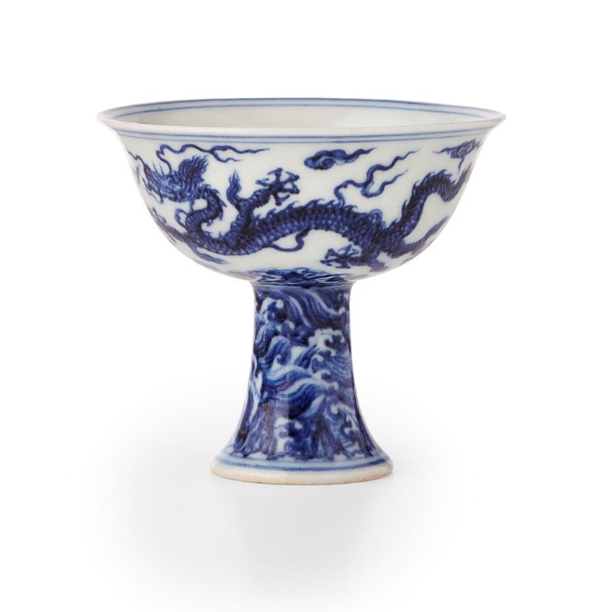
Fig. 1. The Xuande Ming Cup.
With its increased value, and geographic distribution of the collection within secure storage, Thornhills’s intention for this collection to be handled for educational purposes is no longer viable. The core rationale for this project is to develop an interactive digital application that offers alternative solutions to partially fulfil Thornhill’s bequest, by handling 3D replicas of a selection of ceramics from this collection.
Through the use of Virtual Reality and Haptic Technology, limitless interaction becomes possible and a novel context through sensory engagement is gained. Museums can now make the desired changes to traditional methods of displaying information and invite technology as a tool to communicate visually and interactively.
Museum conservation protocols can often prevent visitors from fully accessing artefacts contained in glass vitrines. Limiting understanding solely to the visual senses and factual information contained within conventional museum interpretation panels, can often disengage the visitor, with the average time being spent in the museum being around 3-4 hours according to the British Museum visiting guide (Headout, 2023) and the average time interacting with a museum piece estimated between 15 seconds and 30 seconds (Kaplan, 2017). With the exception of controlled handling sessions which can often involve a lengthy bureaucratic process to gain access, there is no other way of handling an artefact. James O. Pawelski, the director of education for the Positive Psychology Centre at the University of Pennsylvania states:
“When you go to a library, you don’t walk along the shelves looking at the spines of the books and on your way-out tweet to your friends, ‘I read 100 books today!’ Yet that’s essentially how many people experience a museum, you can’t really see a painting as you’re walking by it” (Rosenbloom, 2014)
The opportunity to hold an artefact can offer a sensory understanding of form that can communicate its material, texture, and former use. This research explores how the use of Virtual Reality and haptic glove technology can provide multisensory experiences that offer new methods of communicating the history of an artefact which could increase interest and understanding. It also considers how such an application could be a valuable tool to attract engagement from younger audiences and provide innovative methods of utilising digital heritage for public use. Virtual Reality (VR) comprises of computer-rendered visuals in a fully immersive environment, to create an alternate, artificial reality. Commonly VR is experienced through two of the five senses: sight and sound. However, this research pushes the boundaries of this experience to create an innovative alternative to how participants can interact with a virtual scene by integrating the freedom of touch through haptic glove technology.
This research explores how haptic gloves can provide multisensory experiences that offer new methods of communicating the history of an artefact and prolong the time spent understanding an artefact. These innovations may also increase the interest of attending a display with technological enhancements. The points in this chapter demonstrate the innovation of this research and the value of this tool to attract engagement of younger audiences and provide innovative methods of utilising digital heritage for public use.

Research Questions
Research questions have been developed and honed out of a preliminary review of literature associated with papers that have examined a similar use of technology in museums and tourism. Alexandra Bec (2021) introduces an alternative motive for a range of audiences to engage with history through 3D visuals. Through introducing Mixed Reality as a preservation method, Bec claims that there is a deterioration of tourism sites due to difficulties of cost expenses managing preservation and fostering meaningful visitor engagement. Technology offers vital alternatives to re-invent the way history is documented and preserved while achieving an enriching and engaging experience for visitors.
George E. Raptis (2018) used mixed reality to analyse a player’s behaviour and immersion in a cultural tourism game, as well as Daniel A. Guttentag (2010), who explored how VR can be used in tourism as a substitute for real visitation and questioned the authenticity of the experience.
The reviewed research papers have identified gaps in a demand to combine history with technology, while exploring how technology could benefit the way history is preserved, interpreted, and presented. The benefits of enriching a visitor’s experience and offering visual methods to communicate history could encourage greater visitor numbers. This research aims to increase visitor engagement with ceramic displays that often receive little attention and to increase the chances of retaining information about that ceramic through interactive experiences.
From the literature review, this research has developed a theoretical approach for how museums can benefit from interactive technologies to further enhance the visitor experience. These questions will address this theory in part through a Questionnaire User Interface Software (QUIS) to gather data based on the visitor’s response to the project created for this research. A combination of these research methods to answer the proposed questions will produce qualitative data and research outcomes.
In addition to the reviewed literature, practical developments have also helped to hone research questions through an iterative process of experimentation and reflection.
Question One: How can the visual and tactile characteristics of historical ceramic artefacts from the Thornhill Collection be recorded, displayed and experienced through innovative modes of virtual interaction?
Question Two: How can the historical context of ceramic artefacts be experienced through immersive Virtual Reality, to engage, educate and inform museum audiences?
Question Three: What innovations can the use of haptic glove technology bring to modes of interpretation of ceramics selected from the Thornhill Collection?
Question Four: How could this application be applied to a museum environment to provide opportunities for enhancement in learning for the future benefit of educating the history of collection artefacts?
Question Five: How can the design and development of this application be extended to provide opportunities for enhancement in engagement at multiple levels of complexity?

Aims and Objectives

Aims
This research aims to explore the potential of combining Virtual Reality with haptic technology to facilitate innovative forms of interaction, and potentially enrich and enhance the museum experience.
It aims to explore innovative methods of reshaping and communicating historical content, which can contribute to new ways in which collection narrative and context can be disseminated and inform more diverse audiences.
It offers an alternative to traditional museums displays using a text panel format, through its combination of virtual and haptic technologies. This research aims to attract a wider audience to a collection of historical ceramics whose contemporary relevance can often be overlooked.

Objectives
Objective 1: To evaluate the most effective methods to create digital surrogates of a ceramic artefact, whilst maintaining a sense of authenticity in visuals within the digital scene.
Objective 2: To create a fully developed Virtual Reality application that can be situated inside a museum or exhibition environment and provide various modes of digital interaction with history.
Objective 3: To explore systems of object analysis that deconstruct the Thornhill ceramics narrative into its social, cultural, historical, and geographical context thus widening the scope for contemporary analogy and interpretation.
Objective 4: To implement haptic glove technology into the Virtual Reality application, exploring design applications that could be suitable for museum environments to disseminate historical content interactively.
Objective 5: To undertake a testing phase within an exhibition and museum setting to analyse the reactions and behaviour patterns of visitors to question the practicality of implementing Virtual Reality setups into mainstream museum displays.

Research Contribution
This research contributes new knowledge to the fields of digital heritage and Human-Computer Interaction through its application of interactive technologies to engage museum collection content, and how this could potentially reshape or enhance traditional displays. Digital heritage is made up of computer-based materials that represent a physical original to be preserved for the near future (UNESCO, 2021). Therefore, this research explores the most efficient workflows to effectively create digital surrogates of physical artefacts to provide permanent replicas within digital archives. This can be seen within the researcher’s online library in ‘Appendix 6: Online Library of Thornhill Ceramics Via Sketchfab.’.
Human-Computer Interaction (HCI) refers to the study and design of how humans interact with computers and other technological systems. This encompasses understanding users’ behaviour, needs and preferences, while designing interfaces and interactions that are intuitive, efficient, and enjoyable experiences (avcontentteam, 2023). This research contributes to the field by designing an application suitable for visitors within museum settings to acquire information through interactive, engaging visuals. It focuses on how displays can be more engaging and help visitors retain information on artefacts beyond the one-dimensional traditions of museum text panels.
Through the design, development and evaluation, this research offers new intersections between Virtual Reality and haptic technology to engage a broader range of sensory interactions that go beyond a traditional visual experience of artefacts contained within the museum. This research offers an application design which can facilitate the dissemination of an artefact’s historical context to enhance learning via novel modes of multi-sensory engagements that give deeper contextual meanings that would be difficult to interpret within text alone.
Below describes the separate phases of this research journey.

Phase 1
Desk research was conducted for part of the literature review to survey what technology already exists within the cultural heritage sector and how these provide access to related content to artefacts held in museum displays. This research examines how collection interpretation can benefit from a greater implementation of innovative technology to enhance display content and concludes the desire for more technology to be used within mainstream museum and exhibition settings.
Changes of approach from AR to VR due to issues with the haptic gloves obstructing view in a real world, VR offered the ability to replace the exoskeleton design with a simple 3D hand.
Technology review to determine the most appropriate methods to digitise the ceramics. This involved researching which 3D digitising technique would be most suitable and what methods of object analysis will be used to contextualise the artefact’s information into visual interactions.
Digitisation to create 3D replicas of the Thornhill ceramics. This process involved photogrammetry techniques to capture the artefacts visual information through a series of photographs. The photographic data was processed using Meshroom, a 3D reconstruction software to link visual points together to create a digital surrogate.
Phase 2
This phase examines the various stages of the ‘Thornhill Experience’s development and elucidates the creative decision-making involved regarding the construction of its virtual environments and objects. This phase explores the narrative and planning how digital surrogates will be experienced, considering interaction, visual information and gamified application.
This interaction included the action of dropping the ceramic on to the floor. This action links to the contemporary artist Ai Weiwei who created a series of photographs showing a Han dynasty pot being smashed. This action was irreversible and shocking, which therefore acted as a political statement about the way we value history. This action was implemented into the ‘Thornhill Experience’ as a way of safely letting a player experience dropping a valuable artefact, to build a significance through uncovering information and context.
The development comprises five key stages to develop the narrative.
Stage 1: 3D reconstruction of historical artefacts to facilitate virtual interaction.
The creation of a digital surrogate was intended to provide greater accessibility for participants to hold, observe and engage with historical artefacts that would otherwise not have access to.
Stage 2: Interactive Context
The addition of interactive objects creates a layer of interpretation and understanding, as their historical/cultural significance, purpose may be obscured. It also offers an opportunity to add content that engages a range of senses, such as sound.
Stage 3: Environments and visual surroundings
To create a visual representation of a museum to familiarise the player to their surroundings, with the ability to transport them around the world and into a whole different period in time, in order to display where the ceramics were found and their potential former use.
Stage 4: Inclusion of text information
Some information is better integrated through the use of text to communicate historical data, such as the specific periods of history that the ceram8ics originate from.
Stage 5: Puzzles and quizzes
This stage was developed to allow the user to test their understanding and retainment of the information experienced via their interactions with the virtual application, performed through a simple quiz at the end to gather responsive data.
Phase 3
For seven days, the first version of this application was tested at the 2021 British Ceramics Biennial festival. Once feedback was gathered and acted upon, the final version of the application was tested for three days within the public realm in a museum context to evaluate its success and levels of user engagement.
A questionnaire was developed to offer a qualitative method of gathering data in relation to user feedback, alongside the researcher recording observations. This questionnaire was used to gauge the significance of the use of this technology during an average museum visit. It was also devised to examine how the ‘Thornhill Experience’ enhanced a visitor’s experience through the understanding they gained of the digital artefacts. Quantitative questions, such as age and gender, have been included to compare the patterns of the participants and how they responded to the experience.
Behavioural observations involved the researcher viewing the respondent’s reactions to the experience and asked additional questions relating to how the visitor felt and if they enjoyed participating in the research.
Phase 4
As technology advances, it has been important to constantly reflect upon, and acknowledge, any changes regarding any interactive digital applications museums are using, and how haptic technology is evolving in relation to this in the literature review. Due to limitations of time, the higher levels of the application have not been physically developed but are visually and conceptually mapped out for further development. This demonstrates how more complex information in relation to historical context, and greater detailed object analysis could be disseminated to inform more knowledgeable/advanced users.
Develop further versions of the application to involve more advanced levels of interaction. This would benefit the player by adding more layers of interactive content to understand the artefacts historical and societal context.
Following a final account of these phases, this thesis concludes with an overall evaluation of how the research questions have been answered by this research.

1.6 Significance of this Research
This research contributes to the growing knowledge of introducing virtual haptic technologies into public environments and discovering how these can be utilised to advance education and entertainment in museums. The purpose of this research is to better engage visitors through the use of multiple modes of interpretation to translate text panel information into visual and interactive digital content. These applications will test the ways visitors can learn about ceramics while enriching the museum experience.

The importance of the research is to expand learning content and make it appeal to a wider audience: to help visitors better retain information about the historical context of artefacts, whilst incorporating innovative technology that engages sensory interaction into traditional ceramic displays. The acquisition and expansion of knowledge is a common motivation for the average museum visitor. This research expands on this motivation, through the use of entertaining digital applications that relay information in novel ways to engage a range of museum visitors. Interaction and sense of touch is an instinct for most humans. By introducing haptic interaction into a virtual museum collection context, conventional boundaries that prevent access to traditional ceramic displays can be playfully overturned, to expand a more holistic understanding.

Ernest Thornhill expressed in this bequest that his collection donated to the university should be handled to benefit the education of ceramic history, however due to unforeseen circumstances including age, value and the ceramics condition, this bequest has not yet been fulfilled. This research offers an alternative solution that facilitate interactions with a selection of Thornhill ceramics currently secured in storage. In addition, the application allows access to the collection’s prime ceramic, the Xuande porcelain, blue and white stem cup, through the digitisation of a modern replica.

1.7 Thesis Outline
Chapter 2:
This chapter reviews current literature on existing technology in museums and how they are being utilised, to gain an insight into what is already available and what limitations are present to the visitor experience. It explores how Virtual Reality is being used, and what its primary use consists of in the museum/cultural heritage sectors. Case studies survey what is prominent in present-day museum displays to gain insights into what technology is available for the usual visitor. It examines how Virtual Reality is being used in the cultural heritage sector, alongside its use in other fields to examine how it is increasingly becoming a novel interactive tool for knowledge dissemination and learning.
Chapter two also examines current literature in the field that compares the various methods to determine the most effective processes of digitisation in relation to 3D model acquisition. Analysis of other research projects and examples in the field relating to this project have also been reviewed to reinforce this decision. It also identifies various prototypes of haptic devices used within museums and what alternative devices are available and how they compare to deliver an accurate sense of touch. A review of haptic devices is presented, detailing which are most suitable for this research and their pros and cons, in order to inform which haptic device would be best suited for this research and why it was chosen.
Chapter 3:
This chapter focuses on the methodology used to implement this research, highlighting theories and methods employed in the design, analysis, and evaluation of the ‘Thornhill Experience’. This includes methods from existing frameworks including Paul Greenhalgh’s model (2001) of ceramic analysis that has been adopted and adapted to provide a framework which interrogates the cultural and social significance of an artefact, for more advanced levels of interpretation. The research scopes out these possibilities with regard to the digital application and builds an object analysis framework for each ceramic artefact, to influence the delivery of multisensory information and interactive content.
Chapter 4:
This chapter presents the design and development of the ‘Thornhill Experience’ and reflections on the process employed to achieve the finished results. It elucidates each stage in the creation process from the initial storyboard ideas, photographing the ceramics, digitising the ceramics, content creation for the experience, adding in the gaming elements and integrating the SenseGlove playable controllers. It further illuminates the decision-making processes which have led to the development of the ‘Thornhill Experience’.
Chapter 5:
This chapter presents the testing phases and what methods were utilised during the data collecting phase, followed by a critical analysis derived from the qualitative data collected. This chapter draws conclusions from the analysis of the data gathered and discusses outcomes in relation to the initial research questions.
Chapter 6:
The chapter summarises the thesis and discusses the findings from the investigation of existing research and the results concluded from the analysis of the data collection phase. It revisits the research questions and evaluates these results in relation to the aims of this research.
Chapter 7:
The concluding chapter draws together conclusions from this thesis through a discussion of existing research findings to build on the significance this research has had within the digital heritage field. This chapter breaks down the contributions this research has made practically and within related research fields.
Final discussions include thesis implications to address issues and possible factors to consider when investigating research in a similar field or creating applications for similar audiences. Finally, a consideration is given to future work and how this research could be advanced further, both practically and theoretically, with surrounding developments that may impact this research including innovations in haptic technology and additional interest in creating content designed for the ‘metaverse’.

Chapter 2: Literature Review
This research impacts on many facets of interdisciplinary research which include Museum Studies, Digital Heritage, object analysis, and the technological evolution of VR and 3D reconstruction into ceramic digital replicas, it is important to review the relevant literature within these research areas. This aims to reveal the broad context underpinning this study alongside identifying the gaps in knowledge that this thesis aims to address. This chapter examines the decision-making that has influenced choices of technology, appropriate modes of object analysis, the layers of virtual, interactive content and methods employed to execute the digital reconstruction process central to the design and development of the ‘Thornhill Experience’.

2.1 Introduction
“A museum is a not-for-profit, permanent institution in the service of society that researches, collects, conserves, interprets and exhibits tangible and intangible heritage. Open to the public, accessible and inclusive, museums foster diversity and sustainability. They operate and communicate ethically, professionally and with the participation of communities, offering varied experiences for education, enjoyment, reflection, and knowledge sharing.” (ICOM, 2022).
As part of this role, museums have been exploring the opportunities to combine digital content with displays that can enrich, engage, entertain, and educate a visitor. Digital media has been employed in museums but restricts the visitor’s ability to interact. Displays can include digital content that consists of short texts, short films, audio guides, recorded interviews, podcasts, and web pages (White, 2008) but this limits the visitor to a flat, tablet screen for a source of interaction.
Analysts at Arts Professional confirmed in 2018 that the Tate Modern Museum received the most visits to any museum and art gallery in the United Kingdom, likely due to the building’s new extension and popular collaborative exhibitions (Romer, 2019), confirming a demand for innovative solutions and implementing digital heritage into public displays to increase visitor attendance.
This chapter derives research that explores what technology can be found in traditional museum settings and what research projects have been pursued to contribute to existing knowledge in the field. The following research reviews how museums typically communicate information to discuss the limitations found with contextualization of a ceramic artefact.

2.2 Review of Selected Museums for Current Immersive Displays
Museums have displayed an interest in implementing technology into their displays and workshops, with the desired aim to engage visitors and enrich their experience learning about history. Some
technologies are intended for enhancing a visitor experience at the museum, whereas others are intended to increase accessibility by permitting access to displays and information through numerous platforms. Museums are shaping new methods of how a visitor can engage, interact and learn about artefacts and history using advanced technologies that are familiar to a contemporary audience.
Recent developments over the last three years have shown The British Museum is interested in expanding on a digital learning platform via virtual visits on a tablet screen. The Samsung Digital Discovery Centre (SDDC) has launched a virtual visits programme that provides accessibility to 35,000 school children who are unable to physically attend the museum (Rogers, 2019). This experience includes digital interaction between a student and museum staff, as well as interacting with 3-Dimensional (3D) digital assets on a screen (Rogers, 2019). The concept of broadcasting the museum exhibit to students provides a widely accessible option for attending contextual walk-through sessions, however, the user is still reliant on a flat screen to interact with 3D content.
A case study conducted by the researcher in November 2019 was made to gain insight into what popular museums currently have regarding technology installations. These museums were selected due to their prominent ceramic displays to see first-hand how the museums display their information and highlights an artefacts significance to ceramic history.
This research aimed to show the limitations of technological advances in their standard display setups. The British Museum in the United Kingdom showed interactive tablets (See Fig. 2) that were used to source further context about an artefact using a unique code placed adjacent to their display cabinet. This proved an efficient way to gather further context that would be difficult to fit on a single text panel due to the tablet having scrolling features, but this still limits the user to reading text as a source of information. One benefit of this technology was the ability to show ceramics at multiple angles that cannot be seen in a common display setup, such as the bottom of an object seen in Fig. 2. Although this technology offers further insights, this still limits the users to a 2D image display and hinders the ability to interact with an object. Overall 2D images are less engaging than 3D visuals or gamified setups as they do not offer any additional entertainment value.
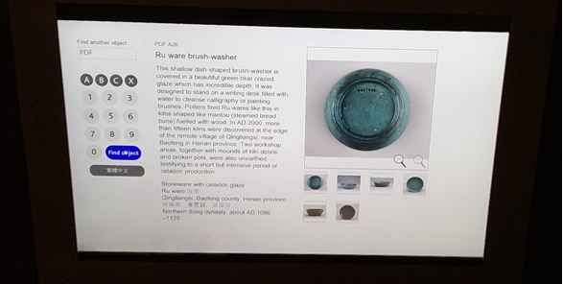
Fig. 2. British Museum, interactable tablet in the ceramic department.
The Victoria and Albert Museum (V&A) in the United Kingdom was voted the third best place to visit in the UK for ceramics and pottery collections due to its reputation of having the most comprehensive ceramic collections in the world (McNab, 2017). An exhibit was found with the ability to physically touch selected artefacts on display as shown in Fig. 3 and Fig. 4, raising the question of how valuable the pieces were and their authenticity, presenting the possibility of replicas designed for handling due to the sustainability of the experience and risk factors.
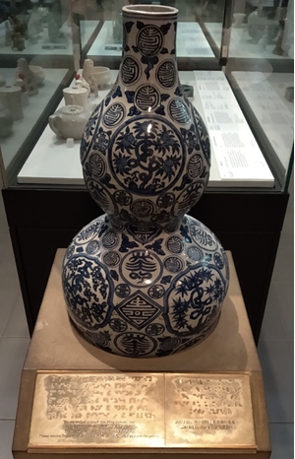
Fig. 3. V&A, Ming dynasty vase.
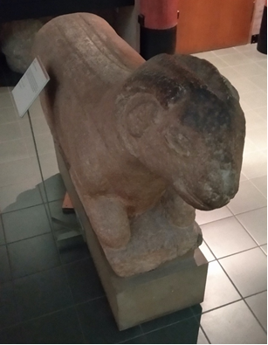
Fig. 4. V&A, Tang Dynasty sculpture.
More advanced interpretation technologies at the V&A demonstrate recent developments to educate users via greater interactivity with 3D models using a touch screen. Fig. 5 shows The Mazarin Chest from Japan (1640-43 AD) where you can access its accompanying information to explain its historical background, iconography/design features and manufacturing techniques.
Additional features included opening and closing the trunk for interesting visuals, along with the ability to zoom in on its details to view the complexities of both the crafting of the object and its visual composition (See Fig. 6).
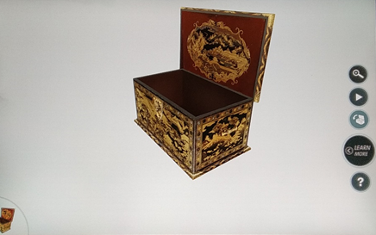
Fig. 5. Mazarin Chest reconstructed as a 3D model, V&A, Lacquer for Europe department.
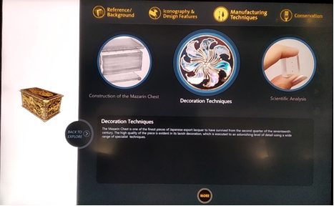
Fig. 6. The Mazarin Chest digitally demonstrating techniques and material analysis, V&A, Lacquer for Europe department.
It was clear that the V&A had started implementing some forms of technical displays, but this still limited the user to textual sources. This demonstrated the importance of this project to show innovative methods of communicating history using multisensory interactions that can add further contextualisation to the interpretation of an artefact. These included incorporating oral testimony or narratives which illuminate the artefacts context and method of creation processes, all whilst interacting within a virtual scene.
A follow-up visit was made to the V&A in June 2022 to assess any further technological advancements had been implemented into its ceramic displays. Upon requesting information at the museum’s reception desk regarding technological displays, Fig. 7. shows the display the researcher was directed to, showing a miscommunication on what is defined technological or confirming a potential lack of modern technology. Additionally, since the COVID-19 global pandemic, the museum decided to remove interactive tablets from displays to remove risks of spreading the virus. This means there is now no technology within these displays.
COVID-19 played a key role in the rising interest in how technology can successfully leverage digital content to stay relevant and maintain the attention of the public at a time when the pandemic forced 90% of museums and galleries to close worldwide in March 2020 (King, 2021). This will lead to a focus on providing digital resources remotely so museum content can be accessible, flexible, and engaging (MuseumBooster, 2021). An additional motive for exploring these technologies links to the museums’ source of income. The COVID-19 pandemic led to the immediate loss of up to 80% of heritage institutions’ incomes due to closures, creating a fear of long-term economic disruption (King, 2021). However, museums and galleries around the globe saw their position as community leaders to bring people together during a difficult time, this meant getting creative with the ways people can still interact and engage with history, such as accessing displays and interacting with museums through online applications and live streams (Cuseum, 2018). This shift in society has addressed the usefulness of technology, offering an ability to facilitate an online presence and provide for the increased consumption of cultural content online since the COVID-19 pandemic caused a global quarantine (Finnis & Kennedy, 2020).
With the situation improving and humanity finding a new normal in society, this project provides the ideal opportunity for museums to re-evaluate what technology they are funding. Furthermore, museums should consider whether more advanced setups could be more beneficial than basic technology like tablets to enhance the visitor experience and enrich the information communicated.
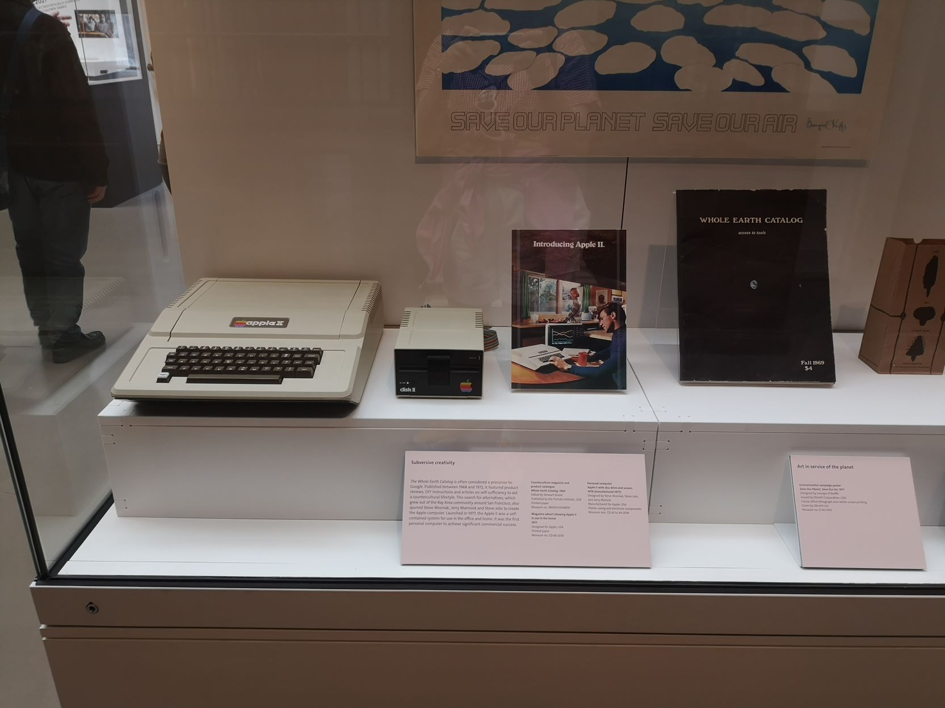
Fig. 7. Recommended technological display in the V&A
The Royal Delft Museum in the Netherlands displays the famous Delft Blue pottery. Delft Blue has been produced at the Royal Delft since 1653 and it is still being produced today using the same traditional techniques. This process consists of using plaster moulds to shape the liquid clay, followed by a tin glaze before firing. Delftware was then painted on to the glazed clay using crushed cobalt oxides, the second firing would then follow to give the pottery its famous Delft Blue colour (Solanki, 2017). See Fig. 8 for reference to this process.
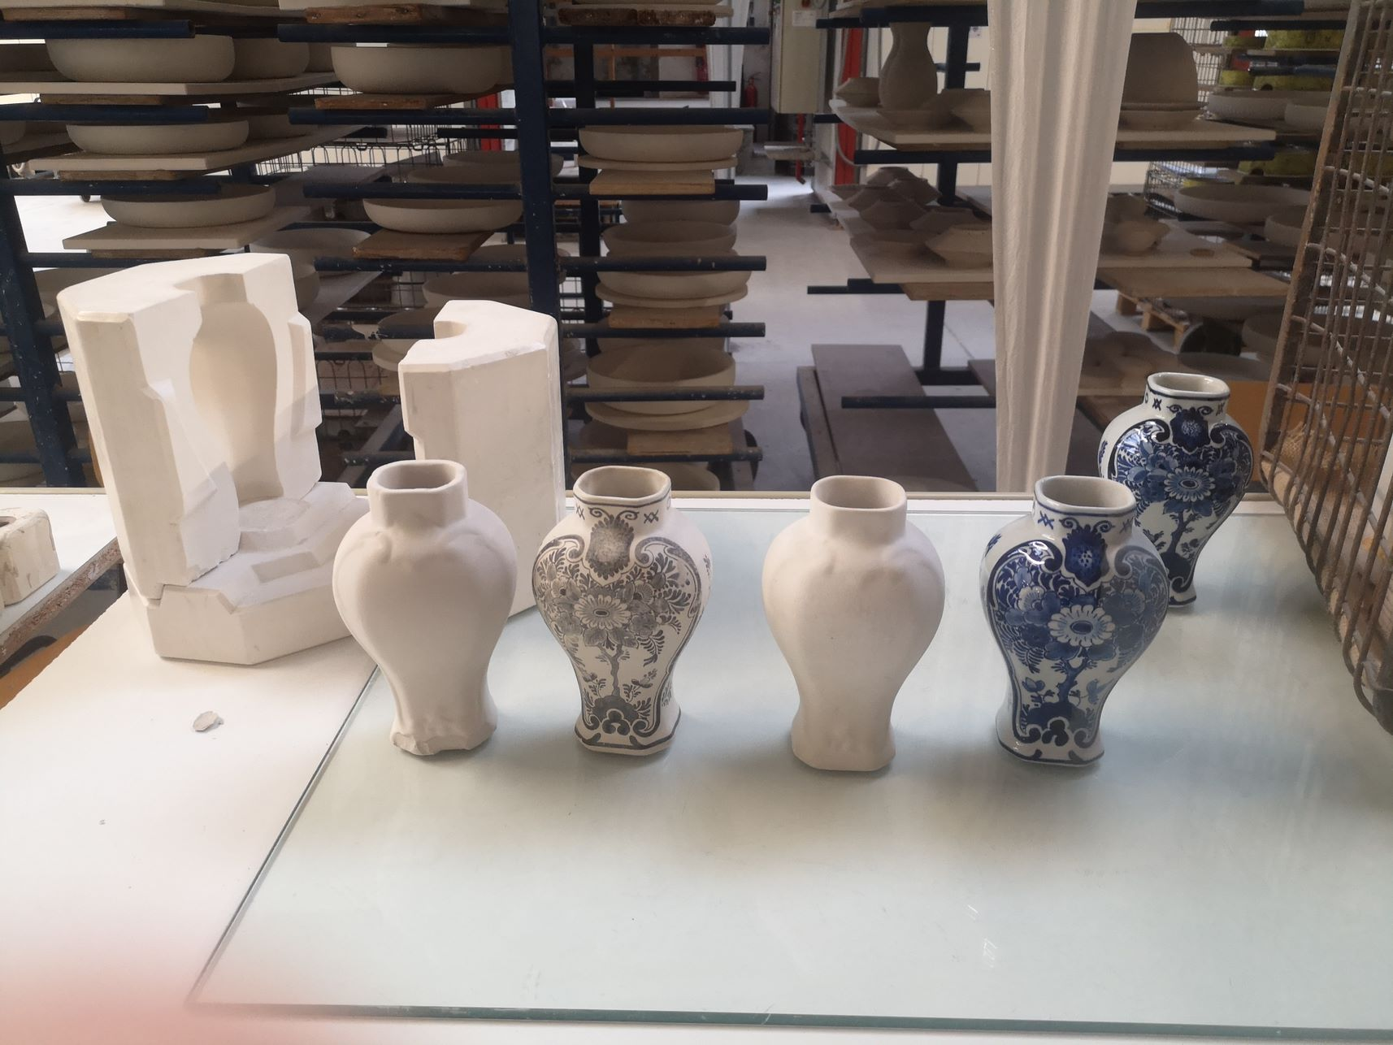
Fig. 8. The Royal Delft Museum, displaying a start to finish to finish process of creating a Delftware vase.
The museum featured a range of interactions to better engage a visitor to learn about pottery. Types of context interpretation included an audio guide (see Fig. 9) with various bases around the museum that would trigger an audio script describing what could be seen in that vicinity, such as a painter at work and informing the listener on the techniques involved in that role. A short visual display showed the start-to-end process of how Delftware products are made. They used LED screens to show people performing roles within the factory and quirky additions such as a kiln door opening to reveal a ceramic before and after firing. These visuals made explaining the process interesting and immersive due to the suspense involved with the manufacturing process. A clear aim for this project to achieve effective methods of visually contextualising information and creating an immersive experience.
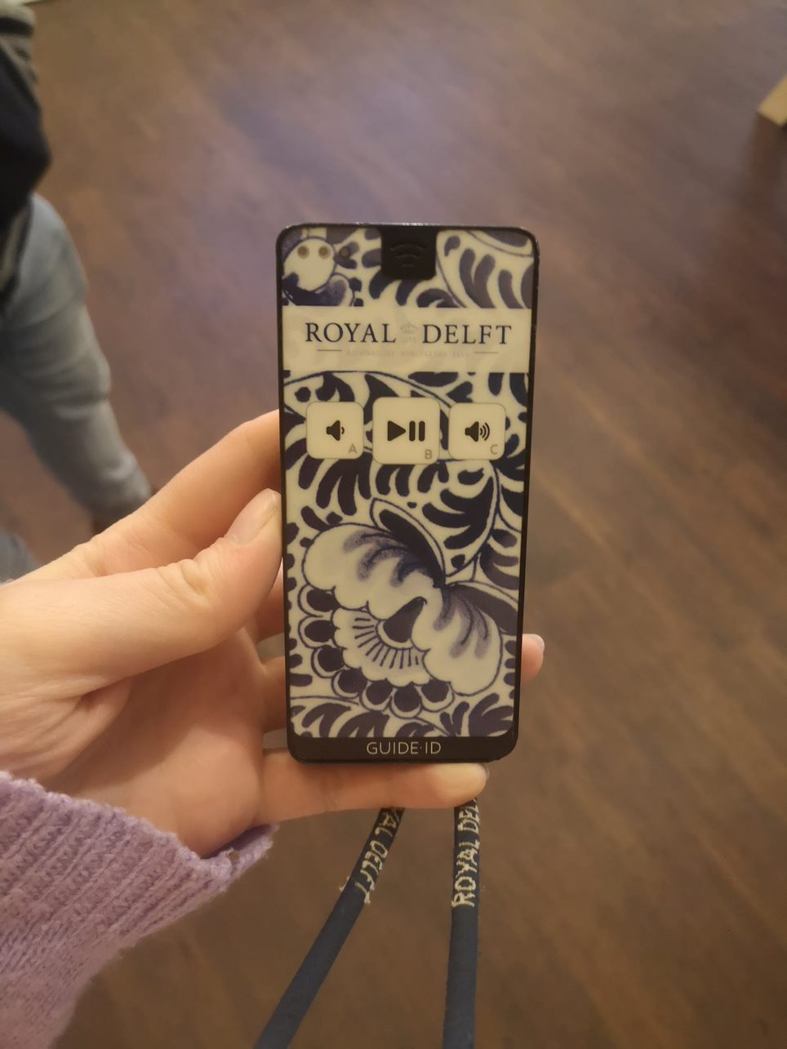
Fig. 9. An audio guide in The Royal Delft Museum.
Many studies have focused on how digital technology could provide many benefits to museums and cultural tourism, claiming this could be a ‘second chance’ for museums and introduce new conceptual frameworks for digital preservation and immersive museum experiences (Bec, 2021). It was clear from these case studies that technology is still limited in museum environments and relies heavily on text panels and auditory guides.
This research explores the novelty to intersect Virtual Reality with the traditional museum experience, to enhance the visitor experience through interactive content and visual context. The ability to engage a visitor’s sense, through a unique, immersive experience.
Recent trends have seen a rising popularity in ‘immersive’ installations. These installations have been defined by their ability to engage senses beyond a singular glance of an artefact or artwork piece, claiming you can experience the art through extended visuals, motion and/or sound.
An example of this comes from the Van Gogh London Exhibit: The Immersive Experience (2021), this exhibition uses two-storey projections of Van Gogh’s most famous artwork, with accompanying motion and sound scaping to offer a unique experience which the exhibit claims ‘brings his art to life’. This installation offers a Virtual Reality component to take the visitor on a journey with Van Gogh to show further visual narrative on the inspirations behind his most iconic works.
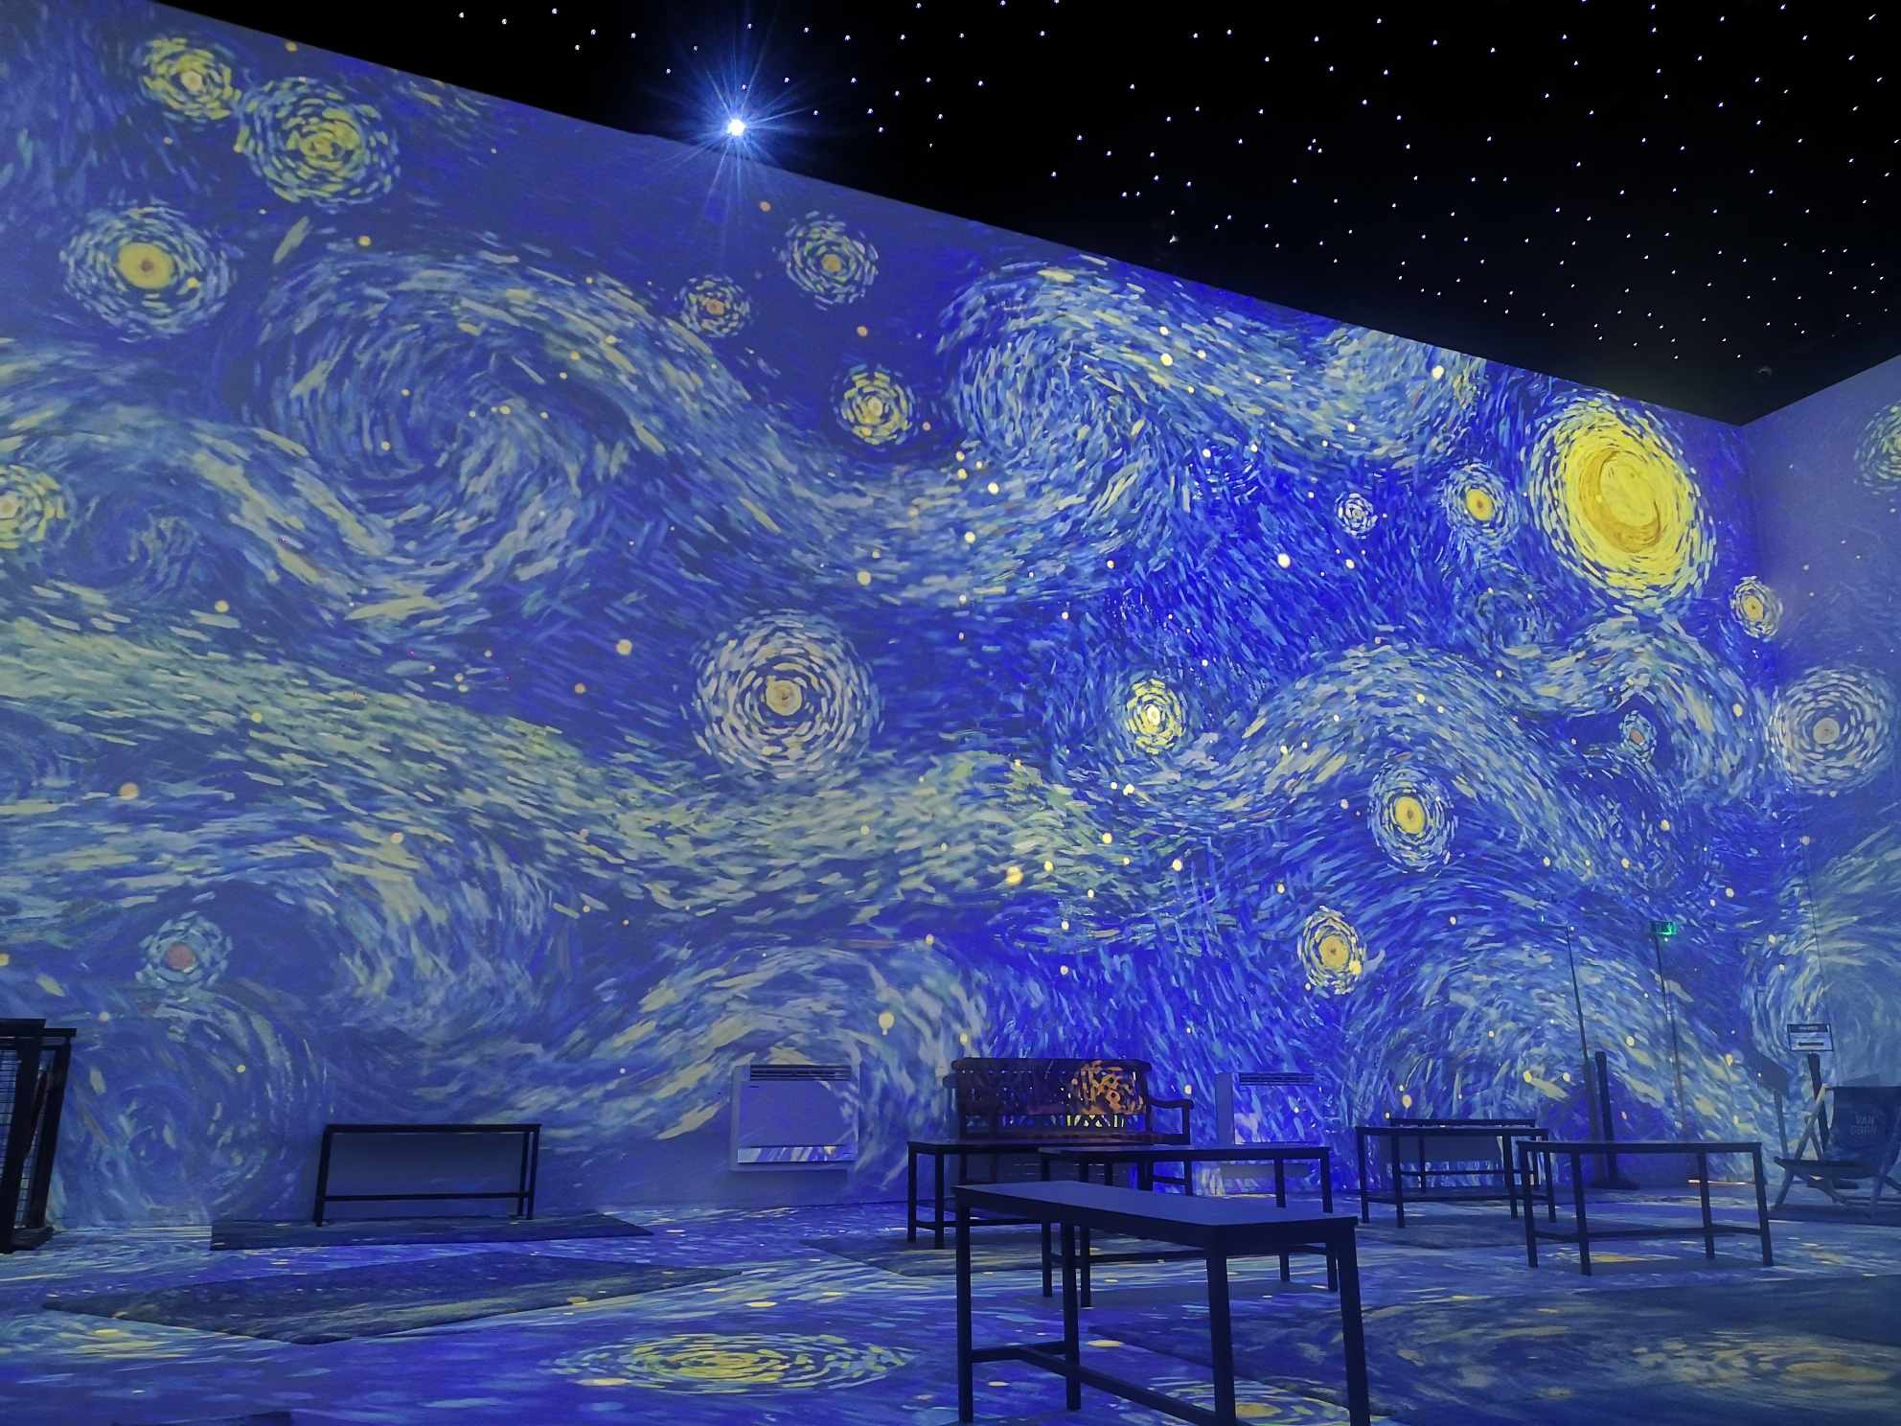
Fig. 10. Van Gogh The Immersive Experience, The Immersive room, photo taken by the reseearcher.
As of writing this in Septmber 2024, the exhibit is still successfully running and continues the use of Virtual Reality in its experience. The VR component to the Van Gogh London Exhibit has also been isolated as an additional cost, therefore demonstrating a demand in visitors for this part of the experience and highlighting the value of this technology in museum spaces.
Upon visiting this exhibition, it was clear the curators desired a ‘high-tech’ feel to the VR installation, this was done through low lighting and blue hues flooding the room. Assistance was provided to help don the headset, but a problem with a missing head strap did cause discomfort due to the headset falling down the face during the experience. However, this problem was only found on certain headsets, possibly highlighting a difficulty in maintaining the technology physically.
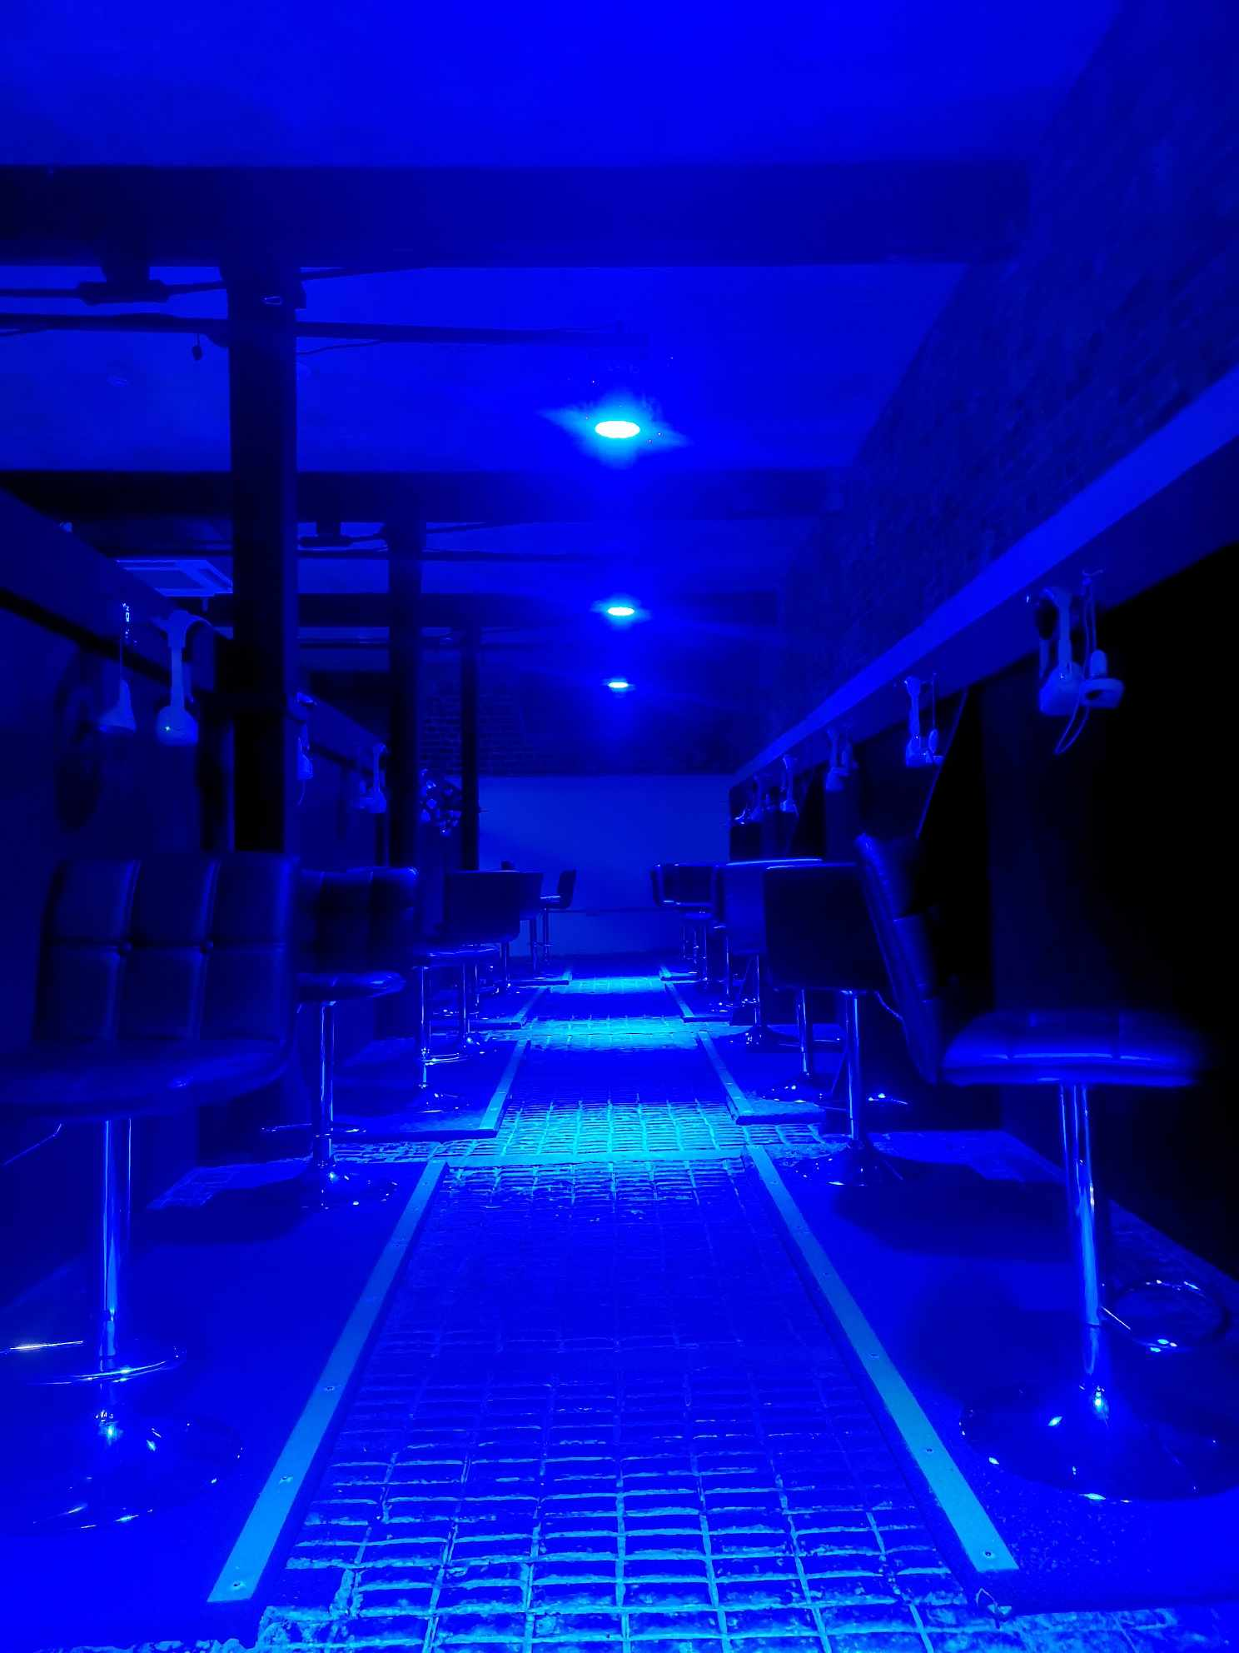
Fig. 11. The VR suite in the Van Gogh Immersive Experience, Photo taken by the researcher.
The experience moved the visitor around the scene, while the visitor stayed physically stationary. This led to minor disorientation of the physical body not matching with the surrounding visuals. Audio was used to mimic Van Goghs voice to discuss his paintings in more detail, this helped the visitor feel a more personal experience by the painter himself communicating directly.
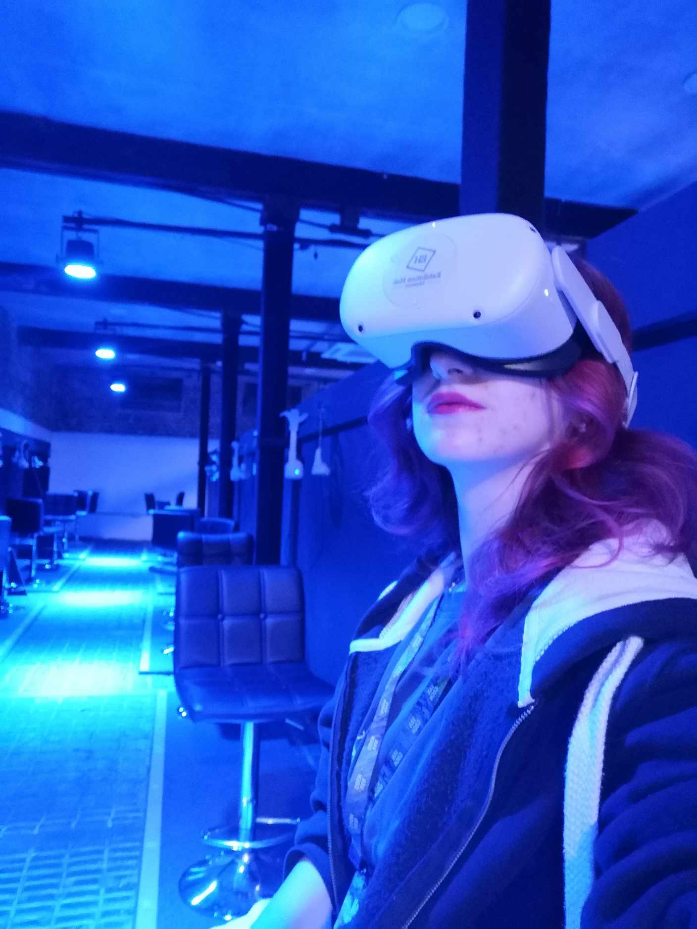
Fig. 12. Van Gogh: The Immersive Experience, The VR setup, Photo taken by the researcher.
No controllers were used during the experience, causing a disconnection of sensory engagement beyond sight and sound. Overall, this experience offered a unique insight into Van Goghs life and career, but still limited the visitor in the capabilities of interaction, therefore limiting the extent of immersion created.

2.3 Virtual Reality in Museums

2.3.1 Definition of Virtual Reality
Virtual Reality (VR) refers to the complete, 3-Dimensional (3D) environment in which a player can freely look around and explore. These computer-generated visuals can represent a virtual world which can take the player on a journey of playable scenes and interactions. To experience Virtual Reality, the player will use a VR headset such as the HTC Vive, Oculus Rift or Samsung Gear VR (Farshid, 2018). These devices need to connect to a PC or Console that will provide the VR generating application which is best viewed through the headset. VR can be used for gaming, simulations, guided tours or 3D videos.
However, discussions revolve around how close this ‘reality’ can be to the real world. The definition of virtual meaning ‘near’, while reality is what human beings experience, therefore Virtual Reality relates to emulating a ‘near-reality’ experience (Society, 2017) . To bring this reality as close as possible to the real word it can implement a multisensory extension from interactive content, such as talking to computer-generated humans or picking up objects and using them for a purpose.

2.3.2 The History of Virtual Reality
The use of Virtual Reality has significantly increased in popularity and has steadily shown a growth in becoming a top recognised gaming platform with an expanding market worldwide (Alsop, 2022). Virtual Reality is popular for entertainment purposes within the present-day. However, VR has had a significant journey to how it is seen today. NASA had developments with VR in the 1980s-1990s. Displaying a similar headset design that is recognised in the modern-day (See Fig. 10), NASA used this technology to create training simulations for astronaut training. It was through these developments that this company created real-time binaural 3D audio processing (Barnard, 2019). Binaural audio technically refers to audio captured in a way that a person would hear the sound exactly if the person had been placed in the same position at that the time of the recording (Fidelity, 2021).
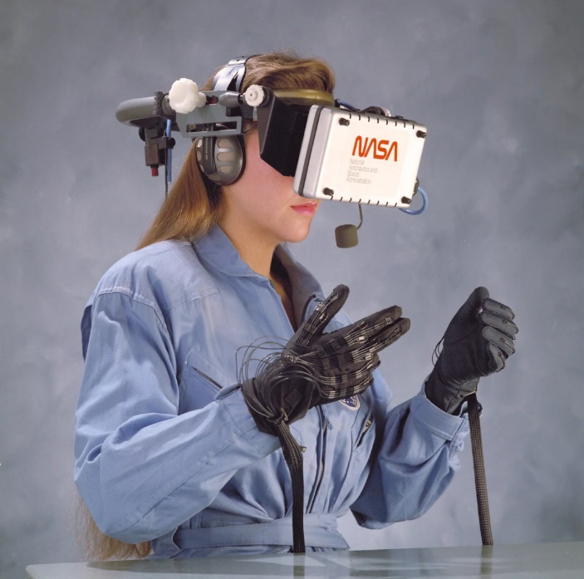
Fig. 13. VR headset by NASA for training simulations in the 1980's-1990's
In 1991 The Virtuality Group launched Virtuality; these were VR arcade machines where gamers could play in a 3D world. This was the first mass-produced VR gaming system in the public domain and could even network together for multiplayer opportunities. One example of the games used for this device was Pac-Man, which released a special VR version so the player could explore the maze in 3D (Society, 2017).
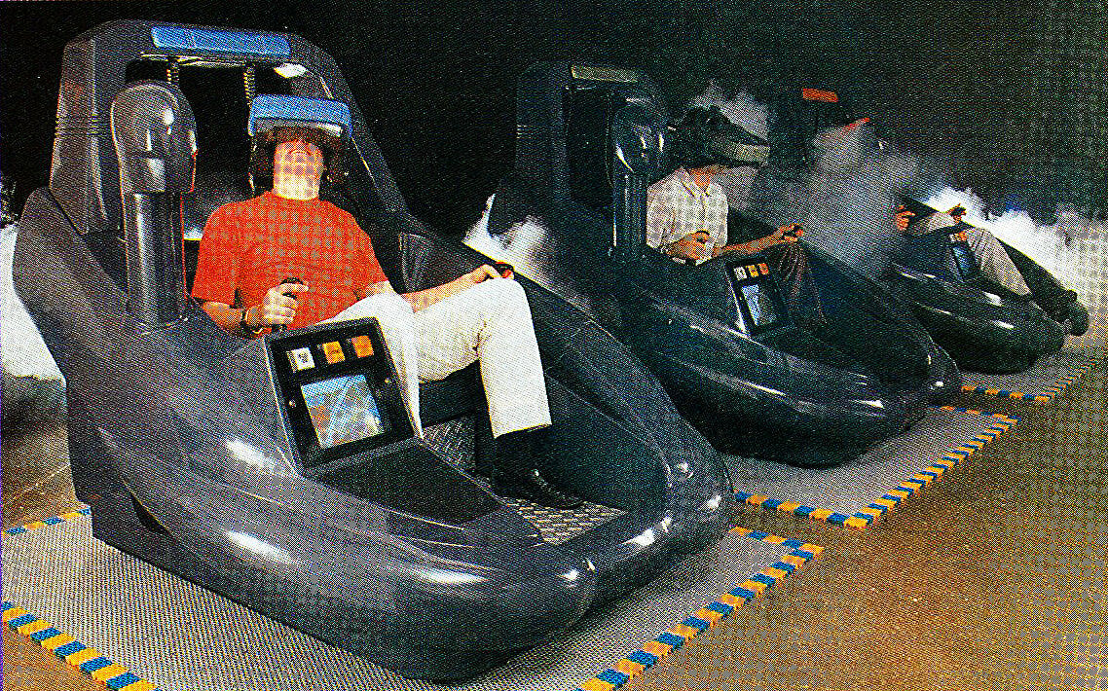
Fig. 14. The sit-down virtuality 1000 system.
SEGA announced they were developing a SEGA VR headset which would be available for the public to purchase in 1991, however, despite four games being created it was terminated due to SEGA’s concerns of people getting injured. In a statement, they expressed that the VR effect was too realistic, although this was an unlikely reason due to the limitations of processing power at that time (Barnard, 2019).
It was not until 2012 that a VR company developed a fully functioning VR headset, Oculus Rift started a Kickstarter campaign for the headset raising $2.4 million. Facebook then bought the Oculus Rift company in 2014 for $2 billion. This defining moment then gained the momentum needed to get Games companies such as Sony to develop specialised VR games that can be used with the Oculus Rift (Barnard, 2019).
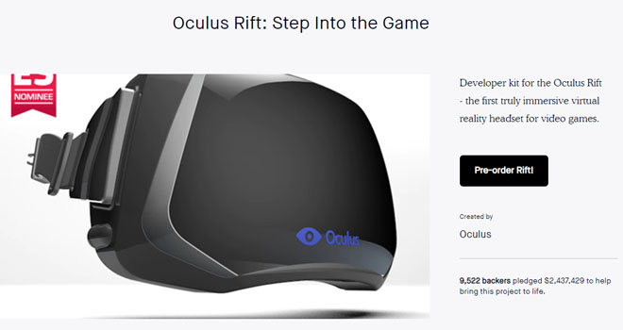
Fig. 15. The Oculus Rift Kickstarter Campaign.
Since then, VR has soared in popularity with multiple VR companies across the world developing headsets, apps and games (Help, 2022). With evidence from an article from MuseumNext (2021), it is clear there is a rise in the use of Virtual Reality and experimentation with the ways it can be utilised in museum displays. This article covers what VR applications have launched in the past four years, while expressing a rising interest to explore VR in future museum displays and incorporate more permanent versions, compared to the limited-time exhibitions that are most common.
A second article by MuseumNext (2020) covers the meaningfulness of museum interpretations using Virtual Reality. This article discusses how VR can be used as a tool to reflect and reimagine history to create new and exciting installations. In this article, the author expresses the endless potential of what VR can offer, such as breaking down the methods of painting the Mona Lisa or touring through Modigliani’s studio. This immersive experience can show visitors a whole new perspective in addition to observing the original artefact in question. Virtual Reality is evidentially versatile for many forms of applications with consistent recognition to implement into the educational settings, with more demand to teach immersive digital content to appeal to a range of learners (Evans, 2017). Therefore, this supports the decision to implement VR into a museum to add an entirely new dimension in how we can communicate history. Additionally, this will act as an attraction to any visitors who are interested in advanced technologies or intrigued by the entertainment value of learning in VR.
This fresh interest in combining VR with museum displays will also likely attract younger audiences that may alternatively not attend a museum. This sparks a new interest in what museums can offer and whether it can increase engagement with contemporary audiences.

2.3.3 Examples of Existing Research in Digital Heritage
Digital Heritage is becoming a more widely discussed topic within the research world, with an increased interest in exploring how digital technologies and media can enhance the visitor experience in museums and heritage sites. This chapter will show the existing research this thesis links to and detail what existing technology has been developed to transform the visitor experience and defend a modern agenda within a landscape of transformative display designs and museum experiences.
Hammady (2019) focuses on similar aims and objectives to this project to reinvent the way Egyptian culture is taught within museum environments. Hammady uses the Microsoft HoloLens to transport the user into a virtual world that represents an ancient temple along with a human interactive tour guide to give audio context of selected digitised artefacts and aid throughout the experience. In the discussion on usefulness, Hammady highlighted that the museum’s pre-visit agenda includes the desire for entertainment and gaining knowledge which is what both projects aim to achieve with modern technology. This project extends these concerns via exploring haptic force-feedback gloves to add another dimension to the virtual experience.
Dr. Karina Rodriguez Echavarria (2023) has demonstrated extensive use of 3D technologies for cultural heritage projects including the 3D-COFORM integrating project that occurred 2008-2012. This was established to advance 3D-digitisation and make 3D documentation available as a practical outcome for digital documentation campaigns in the cultural heritage sectors (CSIUS, 2020). This research takes place at the Centre for Secure, Intelligent and Usable Systems, with research areas surrounding the development of software systems that are secure, intelligent and usable to digitise artefacts within the cultural heritage sector.
Echavarria (2021) has also published research surrounding interactive 3D artefact puzzles to support engagement beyond the museum environment. This paper investigates the development and testing of an online 3D interactive activity to resemble a physical environment surrounding the archaeological gallery of the Brighton Museum and Art Gallery (UK). It aimed to understand what the impact of such online offerings are to better contextualise heritage collections, while enhancing cultural heritage learning and appreciation. The analysis of audiences' opinions about these interactions offered valuable insight. As such, applications have the potential to enable limitless access to cultural heritage resources regardless of the physical location of its users and transform heritage experiences in the long-term.
“while the physical experience might offer advantages as far as it concerns the familiarity with the tactile nature of the interaction, the digital counterpart has potential to allow for the experience of assembling the puzzle to achieve a wider reach of audiences” (Echavarria, 2021).
3D reconstruction offers its users an alternative experience that can enhance engagement value. For example, methods of creation can become tricky to accurately represent or explain due to the complex processes involved. However, through a 3D digital animation, the abstract language of where craft, science and technology intersect, can be communicated to impart complex knowledge in a succinct manner, the end user can gain a holistic understanding of an artefact’s conception and realisation.
A good example of this is ‘An Art of Attraction: The Electrotyping Process’, developed by The Metropolitan Museum of Art (2011) that reveals a breakdown of each stage of creation of the replication of the Bryant vase made in 1872, within a 3.06-minute digital animation. High-definition imagery and a succinct narrative structure in this example provide in-depth information on the sophistications of electrotype technology, in a creative and engaging way and educating viewers on complex aspects of cultural heritage.
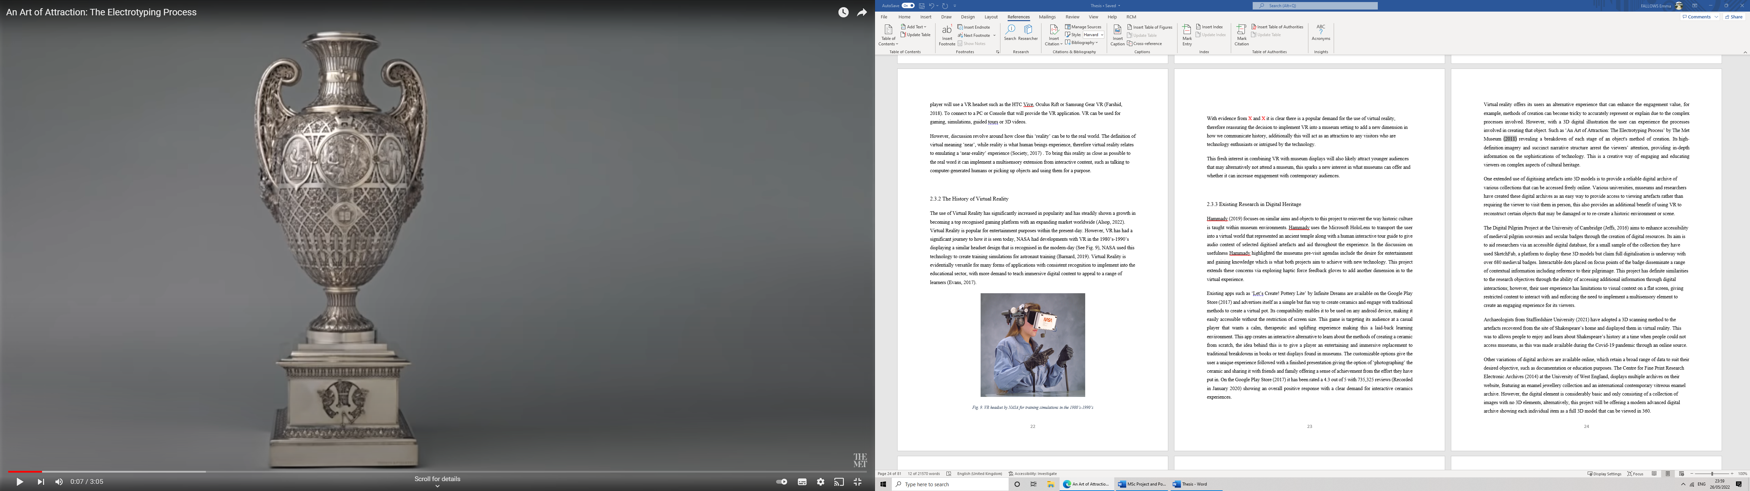
Fig. 16 An Art of Attraction: The Electrotyping Process. The digitised Object. By The Met. 2011.
One advantage of digitising artefacts into 3D models is that it can create assets that can be represented within digital collections that can be accessed freely online. Various universities, museums and researchers have created these digital archives as an effortless way to provide access to viewing artefacts, rather than requiring the viewer to visit them in person. This also supplies an additional benefit of using VR to reconstruct artefacts that may have succumb to damage or to re-build an historical scene.
The Digital Pilgrim Project at the University of Cambridge (Jeffs, 2016) aims to enhance the accessibility of medieval pilgrim souvenirs and secular badges through the creation of a digital database. For a small sample of the collection, they have used Sketchfab, a platform to display these 3D models but claim full digitalisation is underway with over 680 medieval badges. Interactable dots placed on focus points of the badge disseminate a range of contextual information including reference to their pilgrimage. The project has definite similarities to the research objectives undertaken in this research, through the ability to access additional information via digital interactions. However, their user experience has limitations to visual context on a flat screen, giving restricted content to interact with and enforcing the need to implement a multisensory element to create an engaging experience for its viewers.
Digital heritage has been found as an efficient alternative to access history, even when existing factors present themselves. Archaeologists from Staffordshire University (2021) have adopted a 3D scanning method for the artefacts recovered from the site of Shakespeare’s home and displayed them in Virtual Reality. The purpose was to allow people to enjoy and learn about Shakespeare’s history at a time when people could not access museums, as this was made available during the COVID-19 pandemic through an online source. This project offers itself as a source of information using technology, eliminating the limitation of accessibility.
Other variations of digital archives are available online, which retain a broad range of data to suit their desired objective, such as documentation or education purposes. The Centre for Fine Print Research Electronic Archives (2014) at the University of West England, displays multiple archives on their website, featuring an enamel jewellery collection and an international contemporary vitreous enamel archive. However, the digital element is considerably basic and only consists of a collection of images with no 3D elements. Alternatively, this project will be offering a modern advanced digital archive showing each item as a full 3D model that can be viewed in 360 degrees. This example demonstrates the framework of how an artefact could be presented in a digital form. Whilst also showing the benefit of 3D model replicas that can be easily preserved, accessed and contextualised with associated information.
VR has become more prominent in the research of digital preservation, with more VR user experience designs developed within the digital heritage sector. Gillian Arrighi (2021) developed a VR experience based on a research study focusing on the preservation of heritage buildings through digital reconstruction. Arrighi created a usability study pilot to recognise the challenges VR faces to some users and how the experience could be adapted. Results showed their participants found the VR generally easy to navigate but desired fewer restrictions with wires to allow more free movement. Some mentioned the implementation of touch would create more immersion and realism to the application.
Users noted they would have preferred a broader range of information to create multiple scenarios to receive history about the building. This ensured that the player stayed engaged throughout with extended usability and increased interoperability.
After a critical review of existing digital heritage projects. The research above highlights potential benefits to using technology to display history inside and outside a museum environment. While 3D reconstruction offers an efficient method of accessibility to existing artefacts, this also offers an alternative solution to reconstructing original artefacts that may have succumb to damage or decomposition. Therefore, forever preserving the artefact in a 3D form.
Projects above highlight the usefulness of similar technologies. To offer visual representation of complex manufacturing methods, which may be difficult to visualise from descriptive text alone. These capabilities demonstrate an engaging alternative to receiving information about history and enriching the user experience.

2.3.4 Existing Virtual Reality in Museums
Virtual tours within museums are not an unknown concept and these are utilised as a valuable tool to show potential visitors 3D museums and collections to entice them to visit physically. Virtual screen tours are frequently used to offer viewers an alternative to 2D images and text. This has been demonstrated by the British Museum with ‘The Museum of the World’ (BritishMuseum, 2020), which combined a digital archive of artefacts with an interactive scene, allowing the user to click on the timeline to find out about artefacts in the museum.
However, in most cases, these tours are limited to the user staring at a flat screen monitor and using a mouse to navigate around the environment, which does not offer the immersive potential of Virtual Reality. Some sources such as Sketchfab do offer VR platforms to view 3D models, but the user would not be able to interact with objects freely as it would require a controller instead of a haptic device that would mimic hands-on interaction.
A virtual tour can be found of The National Museum of Natural History (2021) located in Washington DC, USA. On their interactive website designed by Loren Ybarrondo, a self-guided navigation experience to explore different areas and rooms of the museum can be found. With the feature of high-definition panoramas on compatible devices, navigation is performed by clicking on available arrows that point in the direction the visitor may go.
The Natural History Museum (2021) claims that some of the virtual tours feature previously unseen archives and holdings which gives them a unique attraction to use this with the addition of visiting in real-life. The high-quality content makes this experience useful for viewers to see what exactly is on display and have the ability to zoom in without losing detail. However, content on signs for the intended displays can be difficult to read making it not suitable for viewers who want a reliable source of information for the object that they are viewing. With no option to access external context whilst using the virtual tour this makes its uses limited to navigation and examining the visuals of the object alone.
There has been a rise in Virtual Reality experiences within museums, usually only featuring for a limited period to encourage visitors with new attractions. The Victoria & Albert Museum (2021) in the United Kingdom featured a VR experience in 2021 called ‘Curious Alice: the VR experience’. This experience was in collaboration with the V&A and HTC Vive Arts, produced by the game’s studio PRELOADED.
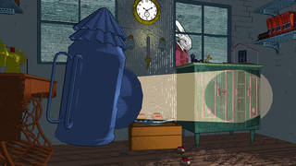
Fig. 17. A screenshot from ‘Curious Alice’, a VR experience created by the V&A and HTC Vive Arts, 2020.
The advertising boasts a fully immersive and interactive re-creation of Wonderland, with visually beautiful landscapes and effective storytelling. This exhibition is a prime example of what museums are aiming for in future exhibitions to explore the ways context can be communicated and installing more entertainment-like experiences. This experience does provide the ability to interact with the scene however this was using the HTC Vive controllers. This still limits the player to the freedom of using their hands freely, creating a potential for new knowledge to introduce full haptic glove interaction to touch objects with each fingertip.
The Louvre Museum in France launched “Mona Lisa: Beyond the Glass” in October 2019, this VR experience explores Renaissance painting as part of the Leonardo Da Vinci exhibition show in 2020. This VR experience uses design, sound and animated images to uncover details about the painting in an immersive and alternative way. Details include the wood panels texture and how the passage of time has changed the way the painting looks. This experience was available for four months at the Louvre Museum and is available to download on the VR app store on multiple platforms now that the exhibit has finished. This versatility shows how VR technology can be used outside of displays to provide accessibility to anyone who is interested in trying the experience themselves (Louvre, 2021).
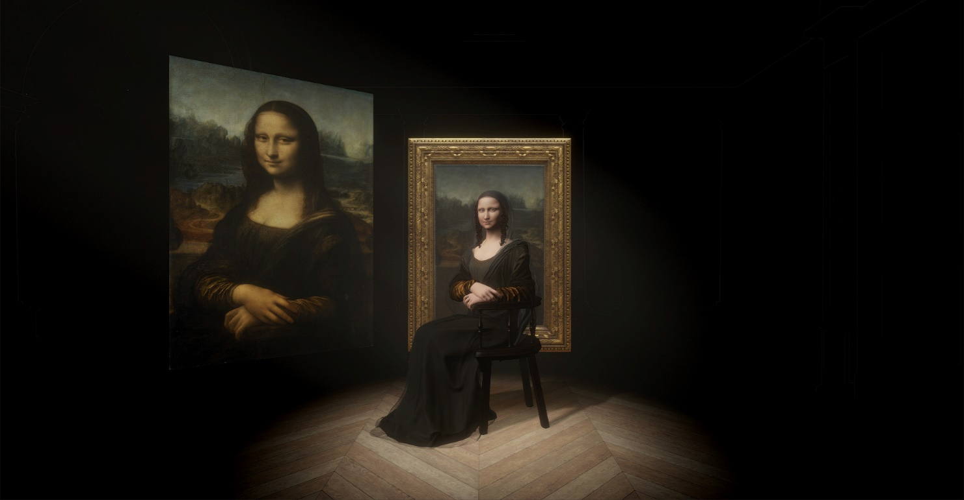
Fig. 18. Mona Lisa: Beyond the Glass, VR Experience.
An example of Mixed Reality involves the Peterson Automotive Museum in Los Angeles which worked with Microsoft HoloLens in 2017 to create an MR exhibition experience. Visitors were able to interact with a classic American sports car, the Ford GT40, a racing car well known for winning several LeMans races in the 1960s, and now available to view close up with the HoloLens headset. The main aim of this experience was storytelling, to take the visitor through the history of racing. When showing historical context in Mixed Reality, it is important to consider the foundations of relating senses that can fully immerse a player in the past. In this example, the player can hear the engine noises and sounds of tyres around the racetrack to mimic what the races would have sounded like. This exhibit is a good example of how MR can be used as a tool for effective storytelling as they can visually deconstruct components in the vehicle and show a breakdown of what makes a winning race car, followed by visual explanations of how the car performs during a race.
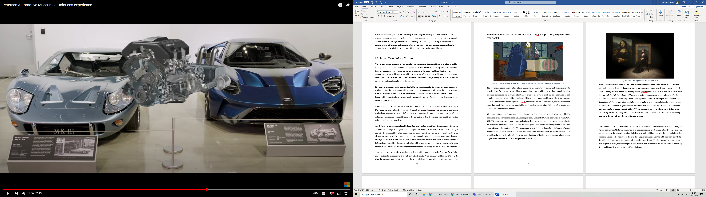
Fig. 19. Petersen Automotive Museum: HoloLens Experience.
When VR is used as a tool to communicate history, one key factor is considering if the experience offers a unique insight that pushes the limits faced in real life. The National Museum of Finland in Helsinki opened a VR exhibit in 2018, which allowed visitors to be transported back to the year 1863 to explore the painting ‘The Opening of the Diet 1863 by Alexander II’ by Robert Wilhelm Ekman, a Finnish painter in the 1800s (Hills-Duty, 2018).
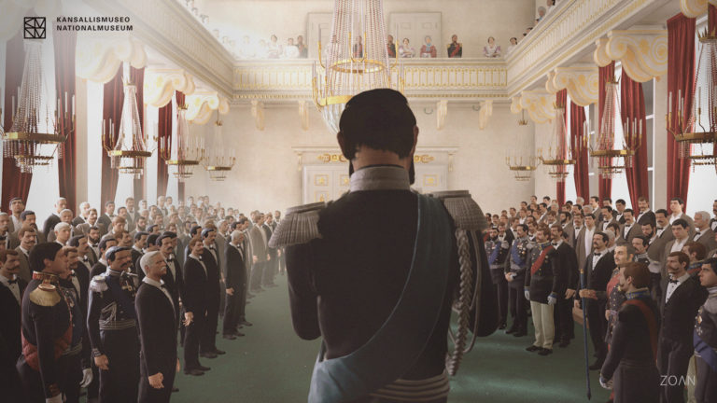
Fig. 20. National Museum of Finland VR experience of R. W. Ekman painting.
Players can speak with the emperor and various representatives of the different social classes seen in the original painting. This VR experience brings a unique twist on bringing a painting to life by visually recreating a full 3D reconstruction of how it would have looked in 1863 and fully immerses the player by playing the role of one of the attendees (Hills-Duty, 2018). This clever technique of inclusion makes the player interested in understanding their role further, therefore learning about what the painting represents.
When understanding a painting or artefact, it’s also important to understand the artist and historical and social contexts behind what has influenced the final piece. These contexts can be communicated with text and 2D images but there this would take a lot of research to build a thorough understanding. However, the Tate Modern Museum (2017) in the United Kingdom, created a VR exhibit in 2017 which takes the player through the surroundings of where Amedeo Modigliani created his artwork. The experience includes a 3D reconstruction of the artist’s studio from 1919 to get a feel for how the artist lived and implements a lot of essential historical details to see visually, and to understand fully, aspects such as how the paints looked on the painters’ palettes during the creation process.
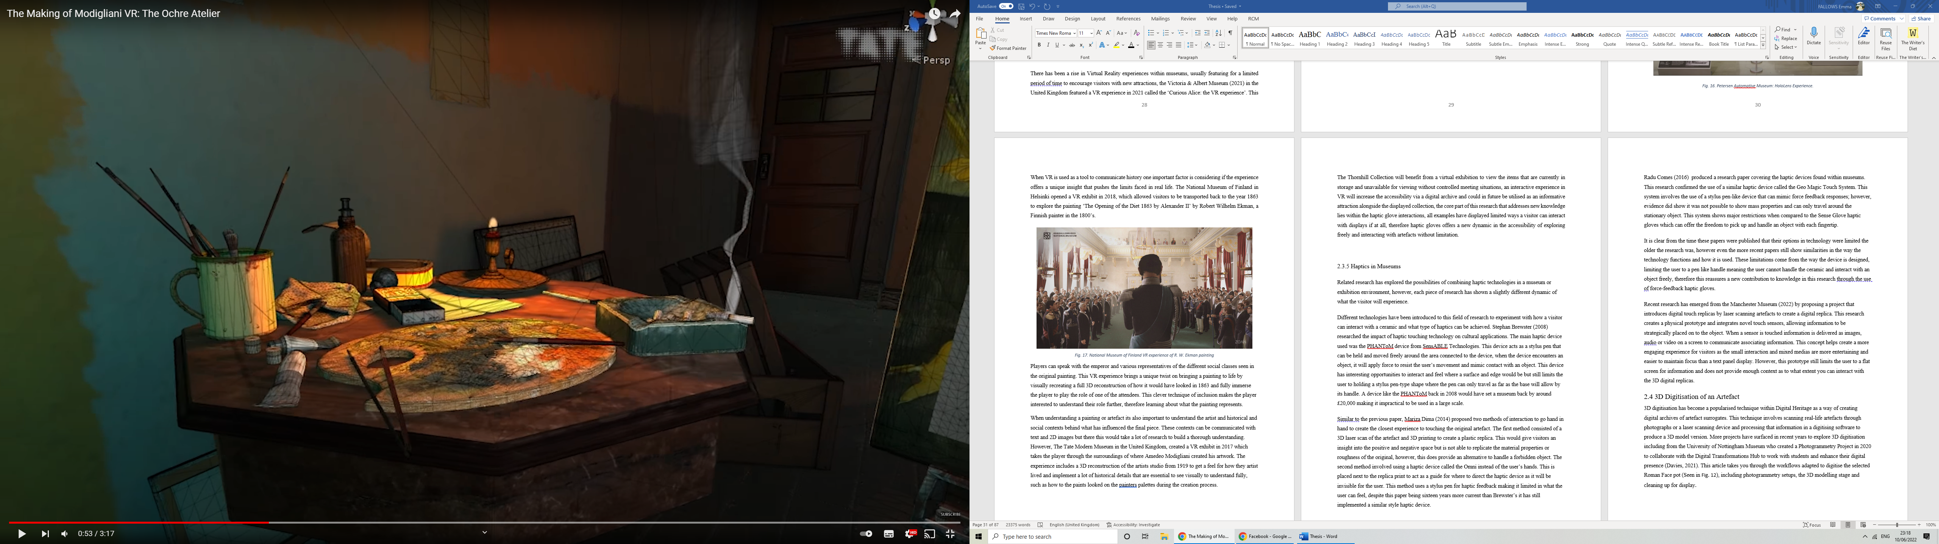
Fig. 21. Modigliani VR Experience, Modern Tate Museum.
Museum guides are a common sight to help guide a visitor around displays but often consist of audio voices. The Natural History Museum challenged this in 2018 when they partnered up with broadcaster Sky to develop a VR experience called ‘Hold the World’ (Pavid, 2018). This experience combines a 3D reconstruction of Sir David Attenborough to guide you through 3D visuals and provide information while putting the player in reach of rare specimens found in the real-life collection. VR provides the ability to bring these specimens to life to understand the way they moved visually, whilst David Attenborough acts as a guide to discuss other aspects like living conditions, diet and other interesting facts (Pavid, 2018).
Players can interact with these specimens using the HoloLens controllers to pick up, hold and enlarge with ease. This form of interaction plays on the ability to grab any object and play with it, even something that would usually be huge can be reduced and looked at from every angle with ease (Pavid, 2018).
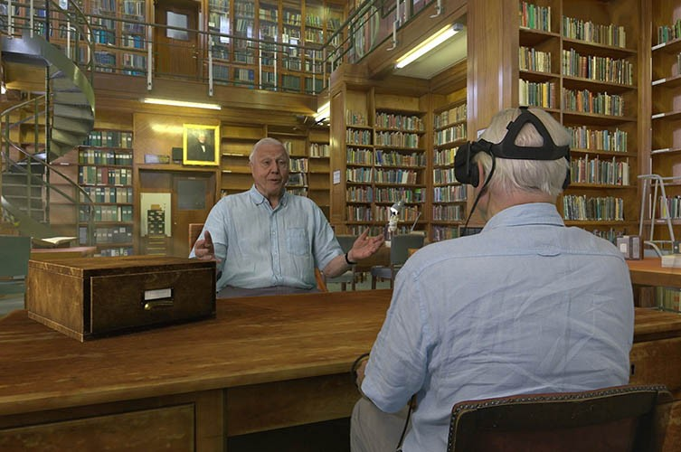
Fig. 22. When Sir David met Sir David in the VR experience at the Tate Modern Museum.

2.3.5 Summary
The Thornhill Collection will benefit from a virtual exhibition to view the items that are currently in storage and unavailable for viewing without controlled meeting situations. An interactive experience in VR will increase the accessibility via a digital archive and could in future be utilised as an informative attraction alongside the displayed collection. The core part of this research that addresses new knowledge lies within the haptic glove interactions. All examples have displayed limited ways a visitor can interact with displays, if at all, therefore haptic gloves offer a new dynamic in the accessibility of exploring freely and interacting with artefacts without limitation.

2.3.6 Haptic Technology in Museums
Related research has explored the possibilities of combining haptic technologies in a museum or exhibition environment, however, each piece of research has shown a slightly different dynamic of what the visitor will experience.
Different technologies have been introduced to this field of research to experiment with how a visitor can interact with ceramic artefacts and what type of haptics can be achieved. Stephan Brewster (2008) researched the impact of haptic touching technology on cultural applications. The main haptic device used was the PHANToM device from SensABLE Technologies (see Fig. 23). This device acts as a stylus pen that can be held and moved freely around the area connected to the device, when the device encounters an object, it will apply force to resist the user’s movement and mimic contact with an object. This device has interesting opportunities to interact and feel where a surface and edge would be but still limits the user to holding a stylus pen-type shape where the pen can only travel as far as the base will allow by its handle. A device like the PHANToM back in 2008 would have set a museum back by approximately £20,000 making it impractical to be used in any large-scale setting.
Similar to the previous research, Mariza Dima (2014) proposed two methods of interaction to go hand in hand to create the closest experience to touching the original artefact. The first method consisted of a 3D laser scan of the artefact and 3D printing to create a plastic replica. This would give visitors an insight into the positive and negative space but is not able to replicate the material properties or roughness of the original, however, this does provide an alternative to handling a precious artefact. The second method involved using a haptic device called the Omni instead of the user’s hands. This is placed next to the replica print to act as a guide for where to direct the haptic device as the object will be invisible to the user. This method uses a stylus pen for haptic feedback making it limited in what the user can feel. Despite this paper being sixteen years more current than Brewster’s, it has still implemented a similar style of haptic device.
Radu Comes (2016) produced a research paper covering the range of haptic devices found within museums. This research confirmed the use of a similar haptic device called the Geo Magic Touch System (see Fig. 20). This system involves the use of a stylus pen-like device that can mimic force-feedback responses; however, evidence did show it was not possible to show mass properties and can only travel around the stationary object. This system shows major restrictions when compared to the SenseGlove haptic gloves which can offer the freedom to pick up and handle an object with each fingertip.
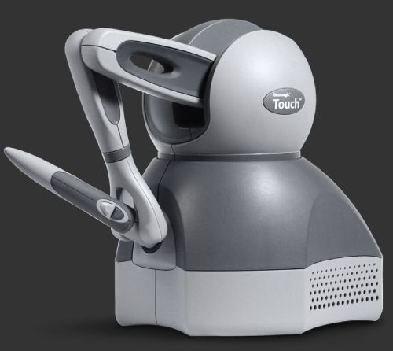
Fig. 23. Geomagic Touch haptic device.
It is clear from the time these papers were published that their options in technology were limited the older the research was, however, even the more recent papers still show similarities in the way the technology functions and how it is used. These limitations come from the way the device is designed, limiting the user to a pen-like handle meaning the user cannot handle the ceramic and interact with an object freely, therefore this assures a new contribution to knowledge in this research through the use of force-feedback haptic gloves.
Research conducted by Manchester Museum (2013) actively pursued a philosophy of making more of its collections available for visitors to handle through object handling sessions and tactile displays. This included an adaptation of sensory engagement via a ball shaped stylus between the fingers. The ball then mimics an on screen presence that causes a resistance when the ball virtually comes into contact with an artefact. This device aims to aid context of an artefacts forms and bring up additional information about the material qualities for a deeper understanding of its creation.
The experience also incorporated vocal instructions and sensory cues to indicate the objects material properties. For example, a broken ceramic gives a dull sound, whilst a high-fired ceramic can give a musical ring.
This experience pushed the levels of context achievable through multisensory components and haptic feedback. However, the haptic device posed great limitations in the extent of haptic feedback achieved. The stylus pen device created a sensory barrier between accessing the artefact directly, therefore impacting the extent of interaction.
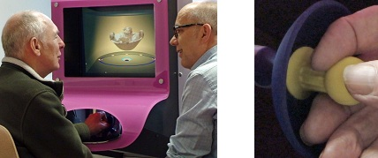
Fig. 24. Manchester Museum test with the haptic interface.
Recent research from Manchester Museum (2022) proposed a project that introduces digital touch by laser scanning artefacts to create a digital replica. This research creates a physical application and integrates novel touch sensors, allowing information to be strategically placed on to the object. When a sensor is touched, information is delivered as images, audio or video on a screen to communicate associating information. This concept helps create a more engaging experience for visitors as the small interaction and mixed use of media are more entertaining and easier to maintain focus than a text panel display. However, this application still limits the user to a flat screen for information and does not provide enough context as to what extent you can interact with the 3D digital replicas.

2.3.7 Summary
After a review of existing haptics used within museum displays, a pattern of interest can be seen with the types of devices used. Stylus pen designs were mostly used as a form of force-feedback response to understand the dexterity of an artefact. However, the device reveals restrictive interaction with an object. The pen-like design removes the opportunity for a free sense of touch that could offer a museum visitor a more comfortable interactive experience. Limitations are also presented in terms of interactive context. If the visitor if navigating around the stationary object, then actions such as, picking up the object to demonstrate its former use is not an option.

2.4 3D Digitisation of an Artefact
3D digitisation has become a popularised technique within Digital Heritage as a way of creating digital archives of artefact surrogates. This technique involves scanning real-life artefacts through photographs or a laser scanning device and processing that information within a digitising software to produce a 3D model version. More projects have surfaced in recent years to explore 3D digitisation including from the University of Nottingham Museum which created a Photogrammetry Project in 2020 to collaborate with the Digital Transformations Hub to work with students and enhance their digital presence (Davies, 2021). This article describes the workflows adapted to digitise the selected Roman Face pot (Seen in Fig. 22), including photogrammetry setups, the 3D modelling stage and cleaning up for display.
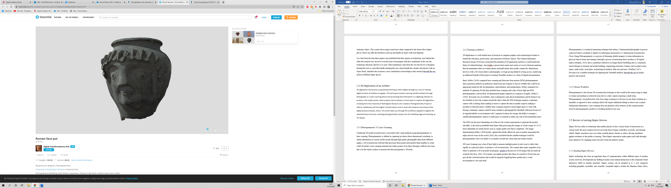
Fig. 25. Roman Face Pot. Viewed in SketchFab.

2.4.1 Photogrammetry Vs Laser Scanning
Traditional 3D model reconstruction is associated with two main methods: photogrammetry or laser scanning. Photogrammetry is defined as capturing an object’s three-dimensional coordinate, to obtain information on various surface points through high-quality photographs taken from different angles. A 3D reconstruction software then processes these points and matches them together to create a full 3D model. Laser scanning estimates the surface points of an object through a reflectorless laser line over the objects surface to measure the data and generate a 3D mesh.
Another notable method includes structured light scanning, a device that projects a striped pattern onto an object and the surface causes the pattern to distort, allowing the device to calculate the objects shape and produce a 3D digital scan (Hexagon, 2021). This device was not considered at the time this project was created due to accessibility issues and companies limiting commercial sales.

2.4.2 Existing workflows
3D digitisation is a well-studied area of research in computer graphics and archaeological studies to benefit the education, preservation, and restoration of historical artefacts. The Cultural Informatics Research Group (2010) have researched the potential of 3D digitisation and how it could benefit the future of cultural heritage. Ann Coulié, a preservation expert and curator at the Louvre Museum mentions that documentation relies on written reports and publications that usually contain few illustrations. However, with a 3D version, there is photographic coverage giving detailed viewing access, reinforcing an additional benefit of this project recreating Thornhill ceramics as a form of digital documentation.
Barry Molloy (2016) compared laser scanning and Structure From Motion (SFM) photogrammetry data acquisition methods on prehistoric metal tools and weapons to discuss whether this could be an appropriate media for the documentation, representation, and interpretation of an artefact. Molloy examined two methods of capturing 3D data that included laser scanning with a line of laser light and SFM photogrammetry sourced from 2D-dimensional images captured in a sequence of angles. Molloy’s (2016) first point was accessibility, laser scanning has some physical limitations and he found it was less feasible to move the scanner around the object when the SFM technique requires a stationary camera with a rotating object making it easier to capture the data in more restricted spaces, whilst laser scanning required a much bigger space to work with. Having a stationary camera would be more suitable to photograph the Thornhill Collection because of the unpredictable environment. With two separate locations for storage, the ability to arrange a suitable photogrammetry setup in a small space is essential to reduce any risk of environmental issues.
The SFM technique was the most demanding out of the two for system requirements to generate the models smoothly. It also had an unreliable time frame when processing the images as it had a range of two to twelve hours dependent on certain factors, including image quality and object complexity. The image demonstrating Molloy’s SFM model captured the details effectively and accurately represented the edges and use-wear on the sword (2016), it was concluded from this that the suitable technique for this research would be photogrammetry due to its ability to accurately recreate the colour data and surface texture.
3D Laser Scanning uses a line of laser light to measure multiple points in each scan to collect data rapidly on a physical object and to produce a 3D reconstruction. The scanner takes many snapshots of an object to generate a 3D scan made of polygons, similar to the process of 2D images that are made up of pixels (Kivolya, 2019). 3D scanners can rapidly produce the forms of a model in 3D but does not provide the coloured textures that would be required if placing these models inside a visual environment to view and study.
Photogrammetry is a technical measuring technique that utilises two-dimensional photographs to process a physical object coordinate, digitise its information and produce a three-dimensional reconstruction. Close-Range Photogrammetry is a process of obtaining reliable imagery to retain information on a physical object’s form and running it through a process of measuring data to produce a 3D digital replica (Murphy, 2014). This is sometimes referred to as Image-Based Modelling and is a commonly used technique to measure and model buildings, engineering structures, forensic and accident scenes, mines, earthworks, stockpiles, archaeological artefacts, film sets and more. (Walford, 2017). With similar projects and research, this review demonstrates that photogrammetry is a suitable technique for digitising the Thornhill artefacts.

2.4.3 Summary: Chosen Workflow
Photogrammetry is the chosen 3D reconstruction technique as this would be the easiest setup to adapt to certain surroundings in restricted areas due to a static camera requiring a small setup. Photogrammetry can perform best with close-range scanning as it focuses on one object rotating on a turntable, as opposed to laser scanning which will require additional editing to remove any scanned background information. Laser scanning does not generate colour textures on the scanned model, however photogrammetry produces everything needed in one scan. Additional research also revealed the setup costs between the two methods. Photogrammetry required a simple camera, tripod and light source to get started, all of which were already owned by the researcher. Laser scanning devices come at a costly price and will typically range in the thousands, such as the Leica BLK360 laser scanner starter kit listed for £25,489.20 (SunBelt, 2024).

2.5 Review of existing Haptics
Haptics refers to technology that enables players to have various forms of interaction in a virtual environment. The most common devices are in the form of game controllers, joysticks, and steering wheels. Haptic sensations can occur when a mobile phone vibrates or when a driving simulation applies resistance to the pedals or steering. These haptic experiences make games and walk-throughs more immersive by engaging senses beyond visual and auditory means.
Various forms of physical interaction can indicate a haptic experience and some studies have involved delivering physical sensations through what is known as ‘passive haptics’. This technique involves virtual visuals with a corresponding set of physical objects. This technique creates a simple, user-friendly design for users to touch objects in Virtual Reality (Insko, 2001), (Hoffman, 1998), (Tennent, et al., 2020). These objects would require a stationary position to correspond with the virtual objects accurately as there was no tracking built into the objects to provide free interaction. A secondary issue lies with the quality of the object and how realistic the texture of the material would be. However, both studies focus on the potential to use haptics as a form of freedom of senses and converging evidence reinforced the value of adding touch to a virtual object to improve a user’s sense of presence and understanding of spatial knowledge.

2.5.1 Existing Haptic Devices
Haptic technology has been an important form of communication within various parts of modern society; however, developments are shifting to mimic more natural interactions to the commonly found interactive tablet in modern museums. Haptic systems can be grouped in to three core categories: graspable, touchable, and wearable. Graspable haptics include the Phantom Omni (Seen in Fig. 24.) (Silva, 2009), designed as a tool to enhance simulation and training, along with other interactive scenarios. This device provides full force-feedback to mimic the realistic sense of touch, however, the user is still limited to holding the stylus for a sensory response.
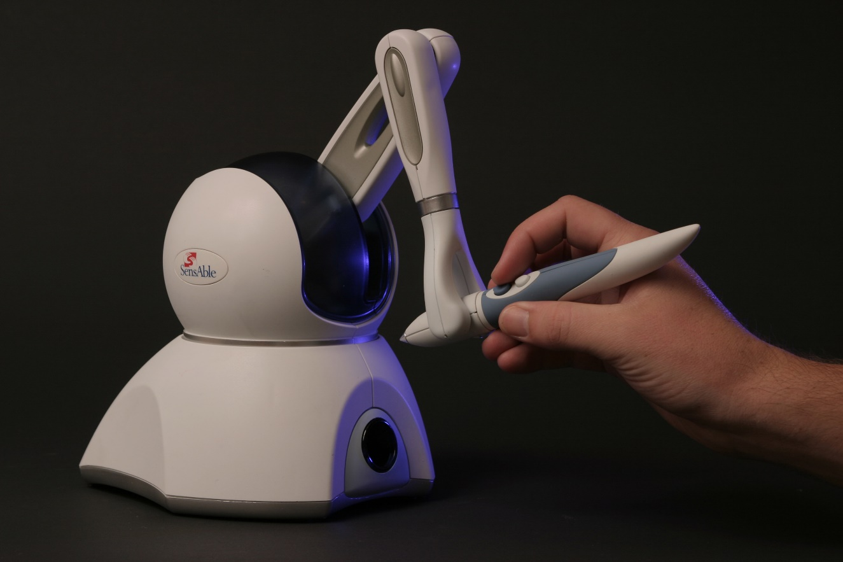
Fig. 26. Phantom Omni Device.
Another example of a haptic device is SkinHaptics (Seen in Fig. 25.) (Ackerman, 2016), a device using ultrasound vibrations to generate tactile feedback to touch objects in midair. This creates a hands-free experience. Albeit one this is limited due to the device attaching to the palm of the hand, making it the only section active for feedback. Missing out the fingertips makes it impossible to achieve a grabbing motion on an object, therefore making the player unable to pick up objects freely.
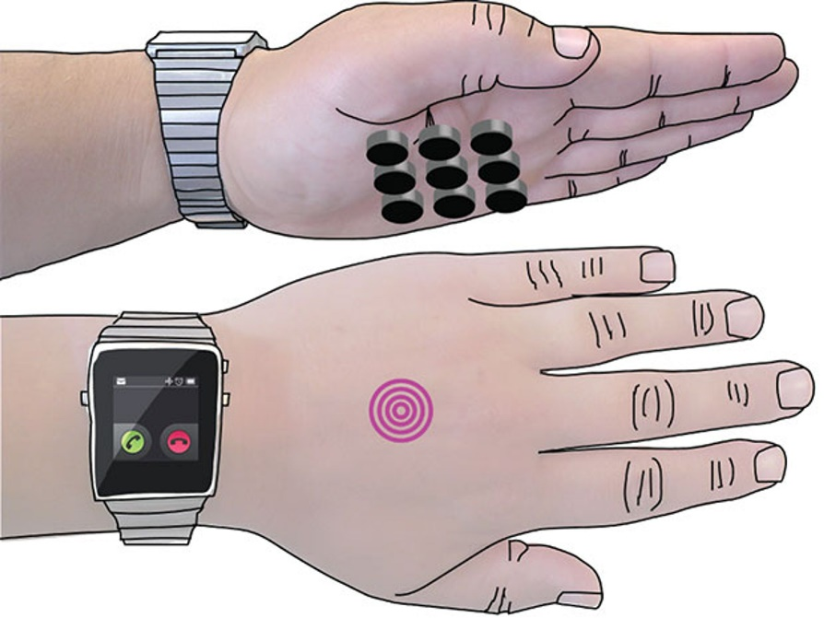
Fig. 27. SkinHaptics device illustration.
Wearable haptic gloves featuring tactile feedback are an upcoming development in the technology industry and now making their way into the mainstream market. Whilst the technology is more accessible, many companies have created their own version of the gloves focusing on diverse ways the gloves behave, a study was created to compare a selection of existing devices (See Appendix 1). Haptic gloves offer novel solutions to common problems faced with Virtual Reality and let the player use their hands to operate the user interface and interact with the scene around them naturally.
Haptic technology could be used to benefit the cultural heritage sector to educate its users on methods of creation through firsthand tactile experience. Muhammad Jamil (2018) attempts to combine haptic technologies with heritage and archaeology to compare the real object with its digital representation. One focus is to address issues with value degradation and comparing that to the potential to add value through the implementation of haptic technology while exploring an archaeological object. These points consider whether recreating historical ceramics as a digital replica could realistically compare to the original, however, could potentially increase the value of experiencing an artefact without interactive restriction, opening opportunities for contextualizing historical content in an engaging, visual alternative.
There have been previous attempts to implement haptic interactive technology into existing museums. Museum and Heritage (2013) reproduces an article about The Manchester Museum pursuing a philosophy of making more of its collection available through object handling sessions and tactile displays. They wanted to develop an experience offering visually impaired users the opportunity to interact with objects through the sense of touch. They laser-scanned their items and placed them into virtual environments. The haptic device employed was a ball shaped stylus between the fingers which mimicked the ball’s movements in the virtual scene so the user would feel resistance when the ball came into contact with the virtual object.
This shows potential in opening opportunities for various individuals who may rely primarily on their sense of touch. This project could contribute to innovative experiences that offer visitors a unique insight into how ceramics feel and how the information is displayed to develop a deeper understanding than text or audio could achieve.

2.5.2 Other Haptic Gloves
Developments in technology have shown multiple versions of the devices that resemble a haptic glove-like design, with the intention to mimic a realistic sense and freedom of touch. Appendix 1: Haptic glove Breakdown compares existing haptic gloves to decide on which glove would be most suitable and used within this research project.
Another glove-like design reviewed was the Haptx Gloves that delivers a full force-feedback experience for its users. This was essential for this project to allow visitors to feel like the interaction with artefacts is realistic, however, this glove was not available to purchase at the time this research was conducted. Haptx has since launched their haptic gloves, with intentions to continue developing the technology (Carlton, 2021).
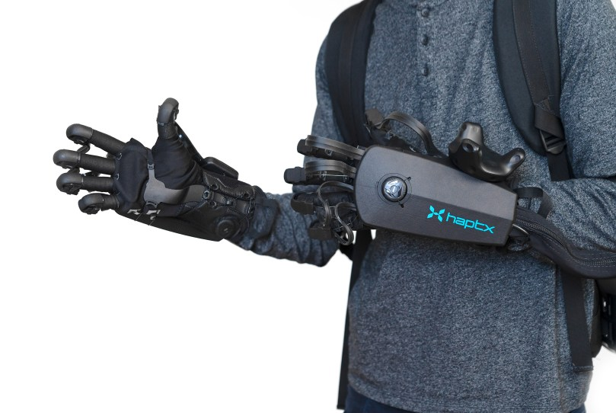
Fig. 28. Haptx haptic glove devices.
Another Haptic glove to allow full force-feedback in their technology is the Dexmo haptic gloves by Dexta Robotics. With an exoskeleton design, the Dexmo gloves offer a mixture of vibration and motors within each finger to stop motion that gives the sensation of grabbing an object (Lang, 2019) These gloves have not yet been released to consumers but offer a contactable email for business enquires to acquire for a developer or enterprise edition of the glove. This glove was not yet publicised for sale during the selection of which haptic glove would be suitable for this research, therefore, it was not a consideration.
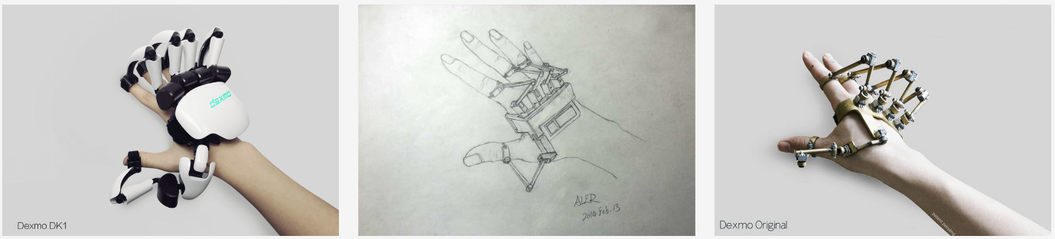
Fig. 29. Dexmo developments from original drawing (Middle) in 2013 to the original Dexmo design (Right) to the Dexmo DK1 (Left).

2.5.3 SenseGlove
Results from Appendix 1: Haptic glove Breakdown showed that a limited number of devices offered a full force-feedback in their design, and all eight devices found used motion tracking to let the player use their hands as controllers within VR and be able to see them in the scene. Most devices did not offer anything additionally with motion tracking and relied solely on the visuals of the hands for the player to use them, two devices used vibrations to alert the player they were interacting with an object and two devices offered a full force-feedback experience. This project had a strong focus on incorporating full force-feedback as that was a unique aspect of the museum experience to be able to interact with artefacts freely without limitations.
Many of the haptic devices found had a lot of information withheld when requesting to order making them difficult to access commercially at the time the research was conducted, information such as their availability, costs and delivery charges.

2.5.4 Summary
The final part of this research showed that only one device (the SenseGlove) offered VR and AR compatibility which offered the option to experiment with both instead of being limited to one platform.
The device chosen from this research was the SenseGlove haptic gloves. This was selected based on several factors: their ability to adjust to different-sized hands so being suitable for their use within the public domain, the device was available at the time of the technology evaluation phase, and it offers VR and AR compatibility with a pre-made software development kit (SDK), which makes the device simple to set up and get started with within a game engine.
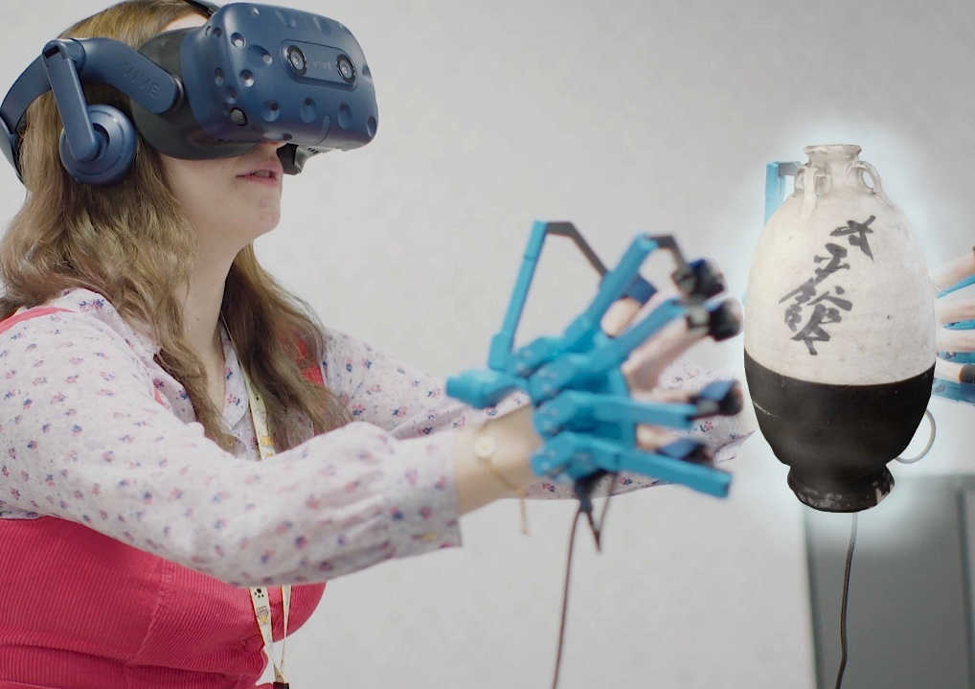
Fig. 30. Set up of the SenseGlove haptic gloves with the HTC Vive headset.
The device utilised in this study fits the forms of interaction due to the exoskeleton design (See Fig. 28) to provide full force-feedback to each fingertip. This system is designed to provide the freedom of touch to interact with visuals naturally and enhance the visitors experience through a deeper context that Virtual Reality allows compared to the physical world.
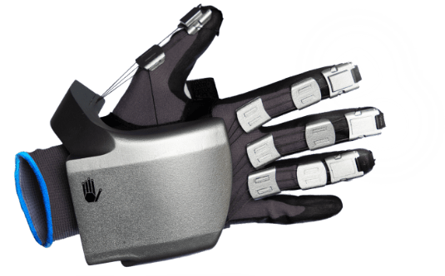
Fig. 31. The Nova Glove.
SenseGlove originates from an undergraduate graduation project by its two founders Johannes Luijten and Gijs Den Butter, at the Delft University of Technology. Within these projects the core technology of SenseGlove was developed. The company SenseGlove was founded in 2015 following the development of the first prototype glove in 2017 which was the first collaboration of haptics and Virtual Reality (SenseGlove, 2022). Since then, they have introduced a second device called the Nova Glove in 2021 which features a force-feedback glove that boasts a simplistic and easily donned design (See Fig. 29).

2.6 Methology Structures
As there exists no prescriptive procedure to conduct practice-related research in Digital Heritage, the methodological framework applied in this project has developed an individually tailored approach through trial-and-error practices. The practice-based research guide focused on in this study is by Dr Linda Candy (2006), a professor at the University of Technology in Sydney, who defines two types of practice related research: practice-based and practice-led.
Practice-based Research is defined as an original investigation undertaken in order to gain new knowledge partly by means of practice and the outcomes of that practice. In a doctoral thesis, claims of originality and contribution to knowledge may be demonstrated through creative outcomes in the form of designs, music, digital media, performances, and exhibitions. Whilst the significance and context of the claims are described in words, a full understanding can only be obtained with direct reference to the outcomes (Candy, 2006).
Practice-led Research is concerned with the nature of practice and leads to new knowledge that has operational significance for that practice. In a doctoral thesis, the results of practice-led research may be fully described in text form without the inclusion of a creative work. The primary focus of the research is to advance knowledge about practice, or to advance knowledge within practice. Such research includes practice as an integral part of its method and often falls within the general area of action research (Candy, 2006).
This research will be implementing a practice-based research method to design a practical outcome that can lead to advancements in knowledge in how the visitor’s experience can be enhanced and improve the retention of information provided.
This research has reviewed existing examples of practice-based research to inform and develop the structure and its underpinning research questions. Ramy Hammady ‘Virtual Guidance using Mixed Reality in Historical Places and Museums’ (2019) created a virtual guidance system using Mixed Reality for a museum environment to increase levels of engagement and the length of time a visitor spends in a museum. Influences come from how Hammady approaches the testing phase on the Museum Eye, including using museum participants to assess their behaviour patterns and how that data was collected and analysed. This research expands this approach by offering a virtual, interactive experience with history through incorporating haptic sensory qualities. While Museum Eyes key aim was to be used as a guide around the museum, the ‘Thornhill Experience’ will focus on what sensory interactions can be experienced to further educated visitors using advancing technologies. This will help visitors learn about ceramics in an engaging environment and increase the chance of information being retained.
Marco Mason (2021) presents a conceptual framework that features three perspectives- activity, tool mediation, and knowledge production, in order to analyse digital cultural heritage design practice. As his research supports this has not been analysed in museums, in terms of an activity system where a team of staff and partners engage in the co-creation of knowledge about how to design an experience appropriate for the museum and its audience. This research has a design in practice approach to reveal new understandings on how diverse museum teams come together in digital cultural heritage design practice.
Mason’s research was formulated from conceptual frameworks resulting from two research projects that were developed between 2012 and 2018. The first project studied American museums engaging in the production of digital technologies and media to enhance the visitor experience. This involved interviews with museum staff and external partners who were involved in the design process, as well as analysis of related project archives and documentation. These sources of data were compared to develop a shared understanding of visitor needs to translate into new digital media designs.
The second project was conceptualised as an experiment in instigating the emergence of a digital cultural heritage design practice. This involved Mason (2021) working for a period of six months as a Human-Centred Designer-in-residence at the Fitzwillian Museum in Cambridge, UK, alongside a team of educators, curators, digital specialists, visitor services staff and graphic designers, to develop a digital family guide service for a mobile device.
Mason’s (2021) project highlights the everchanging dynamic and mediating relationship with technology. Results showed that practice depends as much on their historical as on their evolving contemporary contexts, therefore analysing the systems designed it can reveal its historical evolution as it happens, while adopting new tools and have the freedom to modify the design to suit future developments. This created an awareness for this project to have the potential to be further developed, so it can be updated to maintain its relevance in the tech world.
Mason (2021) concluded their thoughts to highlight the new research agenda that refocuses attention from design outcomes to design processes. This is accomplished by gathering data to measure the impact this digital cultural heritage design made on the team involved in the creation and the network it creates with a museum audience.
Theory-research relates to the qualitative data collected by exploring a research question and pursuing the theory for the research to formulate an answer (Clark, 2021). This theoretical technique was found suitable for this research as this will drive the collection and analysis of data from a social environment to effectively analyse how technology can change the way visitors experience museums.
This research will create an interactive VR application that would serve as a suitable addition to ceramic displays to disseminate historical content deriving from the Thornhill Collection visually via 3D digital replicas and environments. The ‘Thornhill Experience’ will involve methods of creation to show 3D replicas of existing ceramics to represent themselves as a surrogate version that can be interacted with.
The experience will experiment with how implementing multisensory technology could enhance a museum visitors experience by involving methods of interaction to acquire information. Through the methods used by Hammady (2019) to collect data from participants, the testing phases in this research would highlight if the experience increased the engagement of the visitor with a ceramic and if they retained information provided in the experience. This data is gained through observing behavioural patterns of participants during the experience and will provide evidence on the museum visitors response to usability of the application, efficiency of educating information and desirability on similar installations in future museum displays.

2.7 Digitising Methods
From the research conducted within the literature review it was decided that photogrammetry would be the most suitable process of digitisation for this project. Photogrammetry is a technique used to take a physical object or environment and deconstruct it into a 3D digital model through the use of high-quality photographs (Aber, 2010). These photographs hold the essential data that record the coordinates in a 3D-reconstruction software to find links and further process these to form a 3D replica model. This method is commonly used amongst the digital heritage sector (Foundation, 2016), (Walbridge, 2018), (DigVentures, 2016), with multiple benefits to the preservation, representation, and accessibility of artefacts around the world (Knodell, 2017).
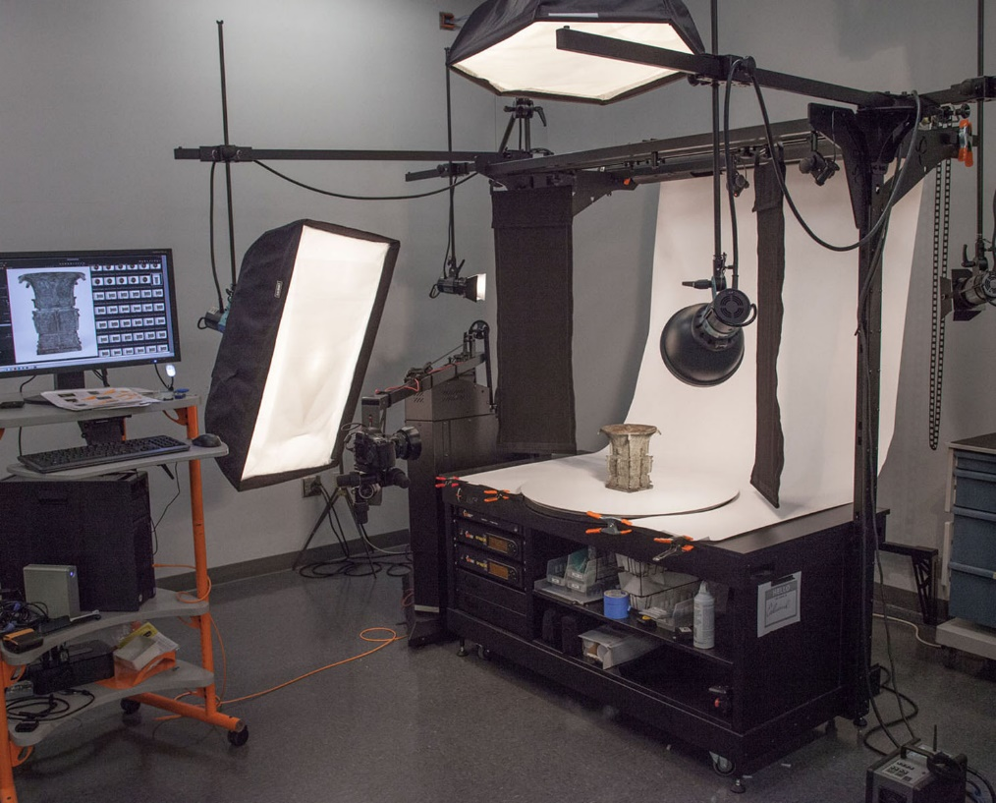
Fig. 32. Photogrammetry setup example for a Cultural Heritage project
This method was chosen over 3D laser scanning due to its adaptable setups, more suitable within the Thornhill’s storage units. 3D laser scanning involves a handheld laser device (See Fig. 31) that is guided around an object with a line of laser light to link points together and instantly create a 3D model outcome without any additional processing. Laser scanning offers precise accuracy with delicate details in a small amount of time (Parnell, 2018).
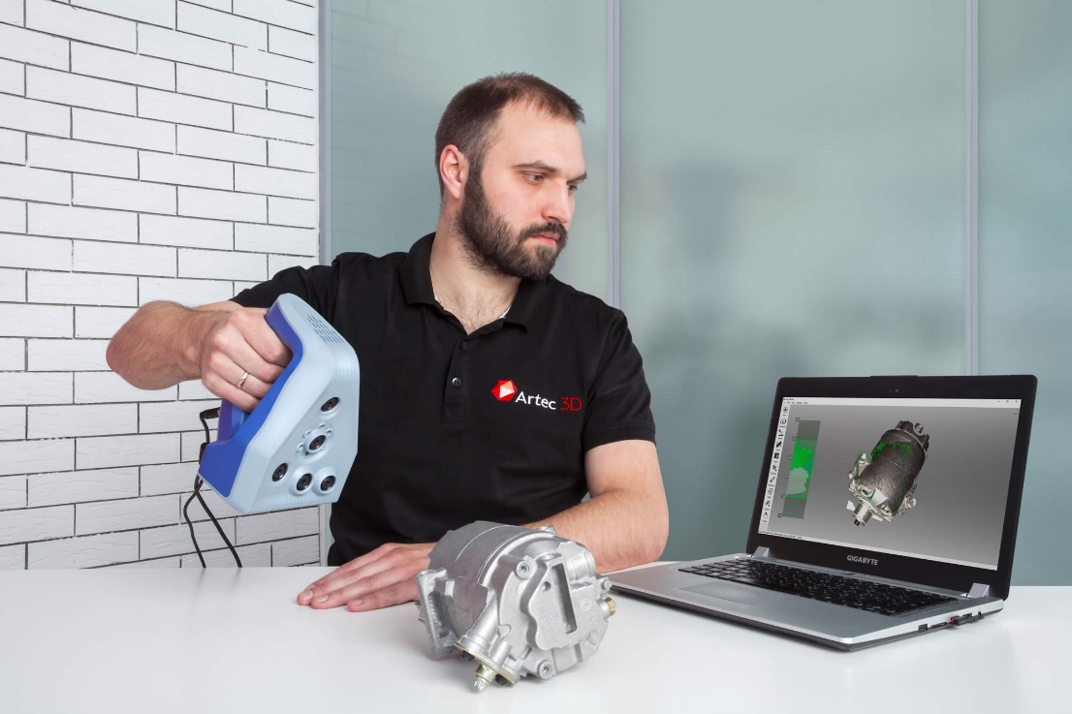
Fig. 33 Example of a handheld 3D laser scanner.
Photogrammetry was found to be more suited for close range data compared to 3D laser scanning which is commonly used for gathering substantial amounts of data, such as a surrounding environment. To use 3D laser scanning with small objects there would be an extended process to remove any of the unwanted background.
Photogrammetry was chosen as the more suitable form of gathering digital data, due to the versatility of photogrammetry. Laser scanning, however, requires a trained handler to use the technology due to the complicated nature and value of the device. Photogrammetry can therefore be achieved with little previous experience to achieve the desired results. Also, laser scanning does not create the material texture automatically when creating the 3D model, which means photogrammetry would need to be used additionally for this purpose. Given these factors, it made more sense to use photogrammetry solely.
Other research in digital heritage does support using Photogrammetry as the most suitable method to digitise artefacts. This included the VR experience for the Tate Modern Museum which worked with Factory 42, using photogrammetry to recreate the museum and hologram of Sir David Attenborough, as well as the individual artefacts (Eylott, 2018).Digitisation is the process of taking analogue information, such as documents, sounds or photographs and converting them into a digital format that can be stored and accessed on computers, mobile phones, and other digital devices (NextService, 2020). This project is specifically using photographs to reconstruct artefacts into a digital 3D version that can be accessed on the prototype experience. This is a commonly used technique by museum and heritage sites for storing history in a digital database to preserve and provide accessibility to collections (Martenstyn, 2013). Digital archives provide many internal, as well as external benefits, such as easing the workload for curator staff in museums. An article from The Guardian interviewed Richard McDonough, a sound curator at the Imperial War Museum (IWM) in England, who noted that due to the archives providing easier documentation and cataloguing: “Rather than having to dig out a cassette or draw an archive from an open reel, archives are now easier to transfer into a user-friendly format”, through a digital archive (Martenstyn, 2013). Another benefit the IWM noted was the possibility of exclusive online exhibitions for objects considered too delicate to handle, stating that some documents and objects that are invaluable culturally and monetarily cannot be in a typical display due to the materials degrading over time (Martenstyn, 2013).
This technique to digitise an object provides the ability to reconstruct the artefact and make it accessible in the ‘Thornhill Experience’, exploring ways visitors can interact with the object, while making a safe solution to artefacts that may degrade over time if left in a typical display case.

Chapter 3: Methodology

3.1 Object Analysis
As there exists no prescriptive procedure to conduct practice-based research the methodological framework applied in this project has developed via an individually tailored approach. This has derived partly from an analysis of other examples including Paul Greenhalgh (2001) who developed an object analysis framework to breakdown a ceramic’s historiography. This structure implies the pattern or form of history of a ceramic, not just the individual facts.
Object analysis is a process of breaking down the contextual information of an object’s physical properties. There are three primary areas of analysis to conduct to understand the substance of an artefact, these include the material, aesthetic, and interactive qualities, followed by sourcing information on their social and cultural contexts. This information can then aid the interpretation of displaying these objects virtually or physically and give them meaning and purpose to their history.
The Greenhalgh method assisted in defining the object analysis framework that would efficiently breakdown the contextualisation of an artefact and help explore what components can communicated through multisensory means.
The multisensory opportunities provide the ability to demonstrate a narrative from other forms of digital interpretation, such as how a drum will sound when you tap it with a hand or drumstick, a context that would alternatively be forbidden with an authentic Tang drum. This model has come from a comparative evaluation of other existing applications including, The Virtual Studilolo which aims to resemble in an immersive, 3D environment in the Palazzo Ducale of Mantua where Isabella d’Este displayed her collection of art, books, musical instruments, and antiquities (Shemek, 2016). This was created to offer accessibility to Renaissance treasures for anyone with a connection to the internet or to offer immersive experiences in a museum experience for students, educators, tourists, artists and other history enthusiasts (Shemek, 2016).
This experience extends the traditional museum environments by opening accessibility links with no need for extended mobility. This concept works by seeing the ceramic’s origin and where it would have been found. This also provides a unique 3D reconstruction of what an ancient burial would have looked like during use.
Throughout the history of material culture, there have been many theories proposed to understand the remains and creative process outputs of humankind. Ceramic production is one of the oldest forms of artistic expression that due to its fired state, survives history and has long served archaeologists in their gauge of cultural and technological sophistication.
The academic social research in this study approaches the changes in society and how we have incorporated technology into our daily lives. Evidence shown in the literature review revealed a limited use of technology in museum displays and the lack of interaction visitors have with historical artefacts. Social research is essential for generating new knowledge and expanding our understanding of contemporary social life (Clark, 2021). This was found to be an ideal research method to apply to this project, as its core aim is to incorporate innovative technologies into a traditionally outdated environment. This research is essentially a concept aiming to explain a theory, in which history can be shown in a new and exciting form that brings words to life and offers multiple layers of contextual visuals and interactions.
Theory-research relates to the qualitative data collected by exploring a research question and pursuing the theory for the research to formulate an answer (Clark, 2021). This theoretical technique was found suitable for this research as this will drive the collection and analysis of data from a social environment to effectively analyse how technology can change the way visitors experience museums.
A limitation was found within this research regarding the SenseGlove haptic device, due to the inability to provide a weighted simulation and the ability to use your fingertips to feel texture precisely. These limitations impacted the extent of interpretation that could be achieved. However, the addition of Virtual Reality provides visual context combined with interactive content. This application aims to benefit the visitors understanding of an artefact’s creation, role and present-day demand.
A selection process was made to decide which ceramics will feature in the experience. These decisions were based on the object analysis breakdown in the methodology of this research.
The chosen ceramics dated back to the Han and Tang periods to keep them within a similar timeline. This was to create consistency in the second environment the player would be teleported into. The VR tomb recreation represents the ceramics’ former use to demonstrate where they were discovered and communicates that the ceramics were offerings to the afterlife. The environment was designed to replicate a traditional Tang Dynasty tomb that would have featured ceramic offerings in their burial rituals. The murals on the walls were direct projections of murals found in an existing uncovered Tang tomb. Additional objects were created including a ceramic goose lamp and a decorative coffin that accurately represented the resting place of Lady Dai, a female aristocrat who died during the Han Dynasty.
An additional design aspect that influenced decision making for selected Thornhill pieces came from the representation regarding fake replicas. Despite Ernest Thornhill displaying an advanced knowledge on East-Asian ceramics, Thornhill made one mistake in his collection when he bought a fake Tang dynasty Musician on Horseback figurine. The modern copy was examined and found to be a close fake to the original design. Copies are a common issue in the ceramics community as close replicas can make a lot of money at auction if they remain unidentified.
Therefore, the musician on horseback was chosen to feature in the experience to show visitors how fake versions can look to the original and question the visitor on which they thought was the fake while in the virtual scene.

3.2.1 Object Analysis Framework
Expanded methods of object analysis can facilitate broader connectivity and contemporary relevance of collection artefacts. As a starting point, Paul Greenhalgh’s method of object analysis will be considered to ‘reverse engineer’ the ceramic object into its constituent parts to elucidate:
The maker (the maker’s personal/social background/the embodied knowledge/technical proficiency of the maker)
The consumer (the consumer's personal/social background, status)
The role of the object (its function – utilitarian, religious, ceremonial, visual, conceptual)
The condition of the marketplace (demand and consumption)
The history of the specific individual objects (where it has been, who bought it, how it was used)
The class of the object within the genre of ceramics (its status in relation to other ceramic idioms and objects)
The history of ceramics (its relation to historical precedents - cultural, aesthetic influences)
The material itself (geographic, geologic origin, extraction, environment, sustainability)
The technical state of the medium (technology, chemistry of ceramic)
General political and social trends (that influenced the aesthetics and demand for objects, e.g., tea drinking)
The history of other genres that relate to ceramics (metal work, textile, architecture, painting, sculpture)

3.2 Data Analysis
When deciding how to sample the data for this research it was decided that two locations would be selected to receive a secure and adequate number of participants for this research.
There are numerous ways of analysing data. This research’s focus was on evaluating the behaviour and response from participants and analysing user satisfaction to conclude if this experience was accepted and successful in the intended settings of a museum.
This research adopted an observation method that allows the researcher to assess a participant's behaviour during the experience and through feedback. This provides details on how participants responded visually to the experience. Questions in the questionnaire also address what part of the experience participants found most entertaining or memorable, in order to test what types of interactions were most efficient at engaging a user.
The questionnaire also had a general feedback option to write a personalised message to give an insight into how the participant feels after trying the experience.
This research adopted a questionnaire for User Interface Satisfaction (QUIS) method to compare responses and evaluate the software and hardware used for the user testing phase. The QUIS is a usability testing tool designed to gauge a user’s subjective satisfaction with the computer interface, or, in this case, the ‘Thornhill Experience’.
The QUIS contains a demographic questionnaire that measures users’ satisfaction based on screen factors, terminology, system feedback, learning factors and system capabilities (Harper, 1993). When applied to this research, the questionnaire is designed to target four defining factors in this research: how participants responded to navigating around the experience and how they felt using haptic enabling technologies within a virtual museum setting (usability), if the participant felt the experience helped them learn more about the ceramics and if the interaction benefited their understanding (effectiveness), if this type of installation enhanced the visitor’s overall experience and performed as an alternative method of gaining information (efficiency), and if the experience would be desired by the target audience in future displays within museums and cultural heritage sites (desirability).
The questionnaire was formed to be quick to complete and simple to understand. It includes a short set of questions to avoid it taking longer than five minutes to complete and all questions consisted of multiple-choice answers to make for a simplistic layout.
The questions were constructed using the System Usability Scale (SUS), a workflow that consists of creating positive or negatively phrased questions to assess users’ satisfaction. This is a common technique used for public questionnaires and surveys (Sauro, 2011), due to a relatable layout to represent a user’s emotional response.
For example, if a visitor is asked if they enjoyed the experience, a range of faces are displayed to acknowledge what ‘bad’ and ‘good look like and whether the individual agrees with that statement.

Chapter 4: Design and Development of the ‘Thornhill Experience’

4.1 Introduction
This chapter focuses on the process of building the ‘Thornhill Experience’, starting with the literature review to uncover and identify the most suitable workflows, then following this into a structured design process. This chapter demonstrates the creation of visual content from planning storyboards to designing interactions within the environments to contextualise the ceramics using the object analysis frameworks.
The first stage outlines the process of photogrammetry techniques to digitise the Thornhill ceramics, digitisation is a process of taking a real-life artefact and turning it into a virtual 3D model. Digitising can be achieved with multiple methods. The thesis compares and considers which method is most suitable when using it to digitise an artefact for a virtual museum.
The second stage demonstrates the process of creating the environments. This involved selecting an environment that could deliver visual information on a ceramic. The first room would consist of a classic museum that imitates the real-life perspective of where a visitor would usually see a ceramic artefact, followed by a transformative journey into a second environment to display a reconstruction of a Tang Dynasty tomb to visually communicate where some of the Thornhill ceramics were discovered and recovered from. This visual context can explain the former use of an artefact without the need for additional text, whilst creating an immersive interaction for a visitor to explore. The tomb symbolises the ability to transport a visitor out of the typical museum room and give them a unique method of engagement with an artefact’s history.
The third stage explains a breakdown of how the interactions were created and what gamification experiences were selected as the most appropriate for this experience. The interactions offer the ability to implement sources of information in an engaging alternative. These visual sources of information broke down what was achievable for the visitor to experience that would usually be difficult to replicate in the real-world museum, typically with limited resources for a breakdown of information.

The interactions included in this experience are:
- limitless interaction to hold and observe the ceramics within a close-range using
photogrammetry to digitise the original ceramics.
- Discoverable objects and interactions to keep the experience unpredictable and engaging.
- A small amount of text to give specific dates and additional context
- Transporting the visitor into another environment to take them away from the typical museum setting and show where some of the ceramics were recovered.
- A quiz for the visitor to test their knowledge and to see what information was retained from the experience.
This chapter explores the first question set through this research, on how the visual and tactile characteristics of historical ceramic artefacts from the Thornhill Collection can be recorded, displayed and experienced through innovative modes of digital dissemination. This chapter responds to this by analysing to what extent a player can experience the physical properties of ceramics when interacting with a digital surrogate. This section first considers the most suitable techniques to create the 3D digital surrogates, along with how this method was executed and concluding the results of the models. This chapter then follows with describing how the interactions were carefully selected to inform the various layers of context disseminated through the selected artefacts.

4.2 The aim of the ‘Thornhill Experience’
This project aims to enhance a visitor's experience and understanding of historical ceramics usually cased within the museum vitrine, through a Virtual Reality based application. This project provides the opportunity to enhance a visitor's experience through incorporating Virtual Reality and haptic technology to handle these ceramics that alternatively would be prohibited, whilst educating the visitor with innovative forms of interaction to visually contextualise a ceramics historical context.
Through novel forms of interaction that involve the virtual handling a digital ceramic surrogate, the application aims to engage the visitor with the historical context of an artefact beyond the traditional museum display. Museums have shown a significant rise in visitors to Museums and Galleries around the UK from 2018-2019, studies show that children have also increased in numbers to attend new initiatives and exhibitions, whilst also attracting more tourists overseas (Gov.uk, 2019), the demand for new attractions is evident and in a digital age it is important to analyse the ways we can incorporate technology to elevate education and appeal to a more contemporary audience.

4.3 Workflow for decision making
Before designing the system structure, it was important to plan out the key characteristics of this experience and develop a system workflow of how they would be executed. Identifying the core functions and requirements of this application was made to fit the aim of what the player should experience. These functions included picking up and observing a ceramic object up close, which were considered valuable interactions to enable greater insights into the historical context and origins of the ceramic artefact, by transporting the player into a different scene.
At the beginning of this project, it was decided to create this experience within an Augmented Reality environment with the concept to lead a player around a museum to find discoverable interactions that offer additional context that goes beyond a panel of text to visually stimulate and enhance the visitor experience. However, these experiments in the initial stages showed that Augmented Reality caused a few issues when implementing this effectively with a range of senses and would not be possible to include haptic devices due to a limited range of mobility from a wired setup.
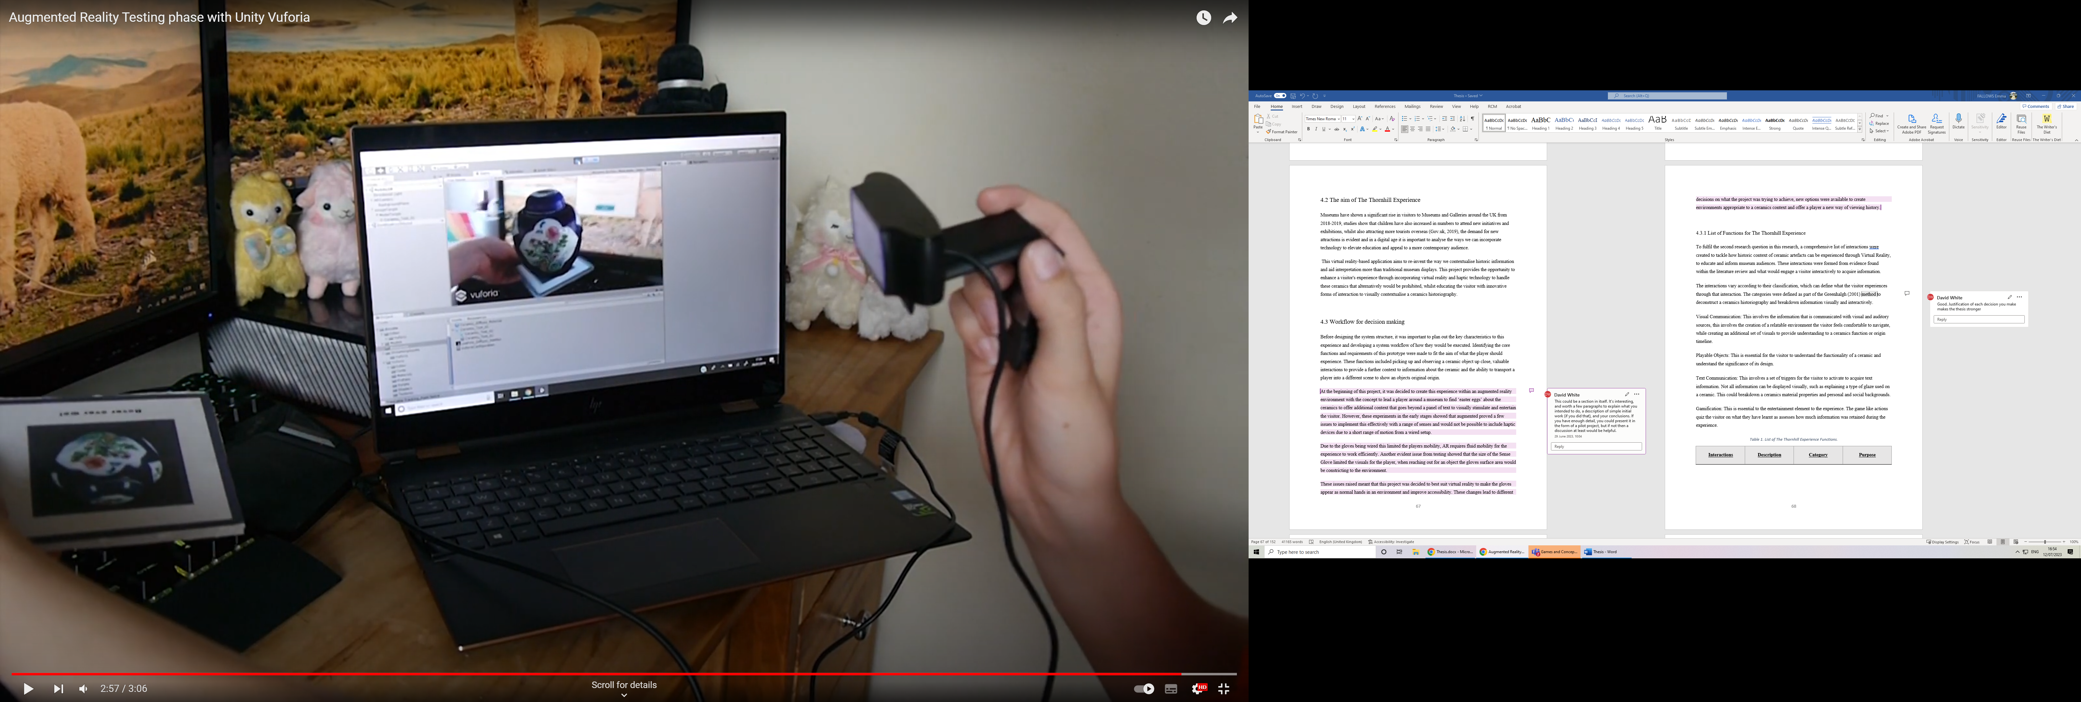
Fig. 34. Early Tests with Photogrammetry and Augmented Reality.
Fig. 32 shows the early tests for the ‘Thornhill Experience’. Photogrammetry was used to create the ceramic test seen in the experience, and this also shows the Augmented Reality prototype that included activated base stations that would load up the artefacts to be viewed in the application.
Evidence from early testing showed difficulty in implementing haptic technologies due to the requirements for a confined space and issues from the size of the SenseGlove device, limiting the visuals for the player in the virtual scene. This was especially so when reaching out for an object when the gloves’ surface area would be constricting to the environment. Virtual Reality offers the ability to hide the mass of the device and replace the hands with a more compact and realistic hand to simulate realism.
Given these issues, it was determined that Virtual Reality would best suit this research to aim for an innovative alternative reality for a visitor to experience interaction with artefacts and learn about history in a visually reconstructed context.

4.3.2 List of Functions for the ‘Thornhill Experience’
To fulfil the second research question in this research, a comprehensive list of interactions was created to tackle how the historical context of ceramic artefacts can be experienced through Virtual Reality, to both educate and inform museum audiences. These interactions were formed from evidence found within the literature review and an analysis of what would better engage a visitor interactively to acquire information.
The interactions vary according to their classification, which can define what the visitor experiences through that interaction. The categories were defined as part of the Greenhalgh (2001) method to deconstruct a ceramic’s historical context and breakdown information visually and interactively.
Visual Communication: This involves the information that is communicated with visual and auditory sources. This involves the creation of a relatable environment the visitor feels comfortable to navigate, while creating an additional set of visuals to provide understanding of a ceramic’s function or origin timeline.
Playable Objects: This is essential for the visitor to understand the functionality of a ceramic and understand the significance of its design.
Text Communication: This involves a set of triggers for the visitor to activate to acquire text information. Not all information can be displayed visually, such as explaining a type of glaze used on a ceramic. This could breakdown a ceramic’s material properties, as well as personal and social backgrounds.
Gamification: This is essential to the entertainment element of the experience. The game-like actions quiz the visitor on what they have learnt and assesses how much information was retained during the experience.
Table 1. List of the ‘Thornhill Experience’ Functions.
Interactions | Description | Category | Purpose
Museum environment | These include digital renders of the museum environment, with auditory background noise of other visitors accompanied by examples of traditional Chinese music related to the historical context of objects. | Visual Communication | To give the visitor a relatable visual environment.
Interactive virtual replicas | The main aim of this experience is to provide accessibility to the ceramics, these ceramics are 3D replicas that can be fully interacted with haptic gloves. | Playable Objects | This interaction challenges the typical limitations of ceramic collections contained within museum cases, and lets visitors freely interact with 3D replicas in the scene and examine the close up.
Interactive storytelling through 3D reconstruction | The narrative of the musician on horseback ceramic has been communicated through a 3D reconstruction of a Tang dynasty drum that the visitor can interact with audible sounds. | Playable Objects | To provide visitors with an understanding of the origin and ritual context of artefacts placed within their historical timeline.
Visual storytelling with the tomb | The ceramic’s origin is communicated through transporting the visitor into a replica Tang dynasty tomb, to show where the ceramics were recovered. | Visual Communication | To provide visitors with a visual context that enables them to better understand the artefacts origin and timeline.
Text appearing upon touching a ceramic in the tomb | This interaction was designed to show additional information that was difficult to display visually. The information would appear in the tomb when the visitor picks up one of the ceramics. | Text Communication | This was used as a method of communication for information that was difficult to display visually, while still interacting with the ceramics.
Quiz of dynasties | The last room in the experience would quiz the visitors on a certain piece of information they were given in the tomb. | Gamification | This was used to assess how much visitors retained information that was displayed throughout the experience

A key interaction was implemented as a fundamental method to acquire information or progress within the experience, this was inspired by the artist Ai WeiWei.
Ai Weiwei is an artist and activist, famous for a particular piece called ‘Dropping a Han Dynasty Urn (1995)’ (Bilbao, 2024). Consisting of a series of photographs, showing Weiwei dropping and smashing a Han Dynasty Urn. This urn was used as an impactful message to question its cultural worth. Weiwei quotes “Chairman Mao used to tell us that we can only build a new world if we destroy the old one.”, this statement refers to the widespread destruction of antiques during China’s Cultural Revolution (1966-76) (Bilbao, 2024).
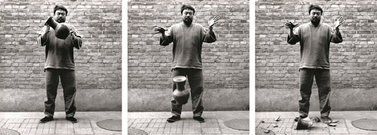
Fig. 35. Artist Ai Weiwei, Dropping a Han Dynasty Urn, 1995.
“The work captures Ai as he drops a 2,000-year-old ceremonial urn, allowing it to smash to the floor at his feet. Not only did this artifact have considerable value, it also had symbolic and cultural worth.” (Bilbao, 2024)

The Object Analysis framework in this research considers how this experience can demonstrate the physical, symbolic and cultural significance of an artefact, through visual reconstructions and interactive content. The Thornhill Experience incorporates this message at the start of experience through an explanation of Weiwei’s message, along with an indication that upon dropping an artefact, they will acquire more information or the ability to progress further through the experience.
This function plays on the message Weiwei intended through a visual representation that will not harm a physical artefact and provides further contextual information into the ceramics, potentially deepening a user’s understanding of the ceramics cultural and physical value.

4.4 Digitising the Thornhill Ceramic Collection
To create the virtual artefacts, it was important to consider the techniques applied to recreate virtual replicas to accurately reflect the physical characteristics of the original.
This method uses photogrammetry, a process of taking a physical object and creating a 3D digital version (Burkett, 2017). It is the method of gathering data of an object’s physical information, collecting that data, and processing it in within a 3D reconstruction software. This allows for the recreation of the ceramics original forms and preserving the unique texture and surface details.

4.4.1 Preparation for Photogrammetry
Extensive tests took place to decide on the most suitable equipment and software to digitise the Thornhill ceramics. This chapter covers these decisions and the testing that took place to decide on which methods and setups were the most suitable to digitise an artefact into a 3D replica.
In the preliminary stages, different setups and equipment were used to experiment with different results. Some setups showed issues with rejected photographs resulting in errors. This was sometimes a result of mistakes made with the photographing process or misuse of the software. Photogrammetry requires a lot of adjusting to find what works for a certain objective. For example, if the goal is to digitise a porcelain ceramic pot, then lighting will have to be tailored to avoid bouncing any light off the reflective surface. One way this was resolved was by using a polarizing filter (See Fig. 33) which manages reflections and suppresses any glares from a surface, overall creating cleaner results with true colouration.
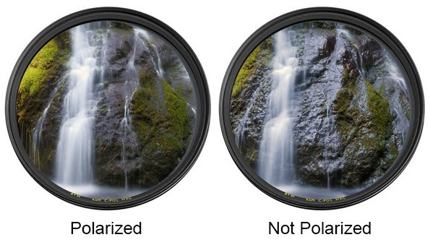
Fig. 36. Photograph comparison with and without a polarized filter lens.
When the 3D scan has been created, it will then be tweaked within the texturing and post processing stages to manually apply a suitable reflectiveness to the material of the ceramic that would match real-life. This was done to give real-time material properties so when a visitor holds the ceramic in Virtual Reality they can see the reflections bouncing off from the surrounding environment.

4.4.2 Choosing the Digitising Software
The next stage was deciding the most suitable photogrammetry software to process the data from the photographs to develop the 3D model replicas. Different software can alter the final results of a scan due to the way the data is processed and produced. A significant amount of existing research utilises 3D reconstruction software’s such as VisualSFM, released in 2011 (Fuaite, 2016) and OpenMVG, released in 2013, (Moulon, 2016). Likely due to their reliable workflow that has been refined over the last 10+ years. However, this research wanted to focus on software releases within the last 10 years and explore potential advancements that could modernise existing digitising workflows.
This resulted in an experimental stage of using various digitising softwares to determine which would be suitable specifically for the recreation of existing artefacts, important factors to include are the following:
- High resolution textures to capture ceramic details, such as paintings.
- Accuracy in capturing positive and negative spaces, such as handles.
- Reliable results, to produce multiple scans in a short time
Autodesk Recap (2023) was used first due to the attractive features that offer fast results with little difficulty to navigate due to a simple User Interface (UI), however, limited UI showed a lack of editing abilities. The results were processed enough for a full model to be created successfully but usually had a poor resolution on the texture maps causing this software to be unsuitable to represent digital replicas of existing artefacts. An important aspect of this project was allowing the player to fully interact with the ceramics to see details at a close range, however poor texture quality would have made this difficult for visitors to see the ceramics details. This is a good starter software as it is simplistic and provides quick results but was decided to be unsuitable due to limitations in UI and poor texture resolution.
Reality Capture (2023)was used due to a highly rated opinion across rating websites for photogrammetry software. Reality Capture is known for its fast results (Lewis, 2021). However, this software can become expensive as it charges for every export you make on a model. The software was complex, meaning it would take an appreciable time to understand the UI to achieve satisfactory results. The potential of this software is high due to the ability to create clean and precise results, but this was found to be unsuitable for the project due to the time constraints to train the researcher on its use.
3DF Zephyr (2023) was a close second when compared with the other software in these experiments. This software was simple to understand and could be navigated easily. This software was free but offered quite a few limitations to encourage the user to pay for a full version. These limitations impacted the results required for this project, so, therefore, was found unsuitable to produce the final scans. Many issues occurred including images often getting rejected due to it not recognising where they are in the world, resulting in errors in the final model, or the model not being created.
Meshroom (2023) was chosen as the most suitable software due to its thorough framework to flexibly adjust settings to suit certain ceramic scans. The models had a good chance of success compared to other software and, if errors occurred, there was an ability to read a breakdown of which stage failed in the process. This saved time to be able to understand the problem and fix it rather than running it repeatedly until the results were desired.
The software displays each stage of the process so you can understand what the scan goes through to produce the final 3D model. This made the UI simple to use and even automatically creates a file of the 3D model without the additional need to export it. This increased the results in a smaller time frame making it the most time-efficient out of all the other software.

4.4.3 Visiting the Thornhill Ceramics Storage Unit
The location was situated within a warehouse where the collection was in storage. A room was allocated to setup the equipment with no windows that could impact the lighting arrangements (See Fig. 34).

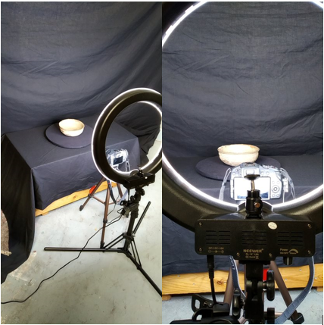
Fig. 37. Photogrammetry setup at the location for the Thornhill Collection, featuring the Green Glazed Bowl from the collection.
The setup consisted of a rotating turntable for the ceramic to sit on with the ability to rotate at a pace that suited gathering all of the data. If ceramics are more complex in form, they will require more images to capture that information. Then blackout sheets were used on the underneath and back of the object to filter out any bouncing lights. The camera was placed on a tripod which could be adjusted up or down depending on the angle needed for shooting.
The camera was generally used with standard settings, with the surrounding environment adjusted to suit the lighting requirements. Before each ceramic was photographed, the camera would be checked for suited exposure, aperture and focus to assure the images were high quality. In addition to this, a camera colour tester was used to check the clarity of colours with a test photograph.
To make the photographs easier to capture in large quantities, a device was connected to the camera that would work as an automatic timer for the shutter to trigger and take a photo, this allowed the researcher the ability to focus on the turntable to rotate each artefact.
Finally, a ring light was used to distribute even lighting across one angle the camera was shooting. This was easier than multiple cameras set up on various angles due to the mass of equipment that would have been required to acquire enough data from a set of images. Fig. 35 shows all the equipment that was used to photograph the ceramics during that visit.
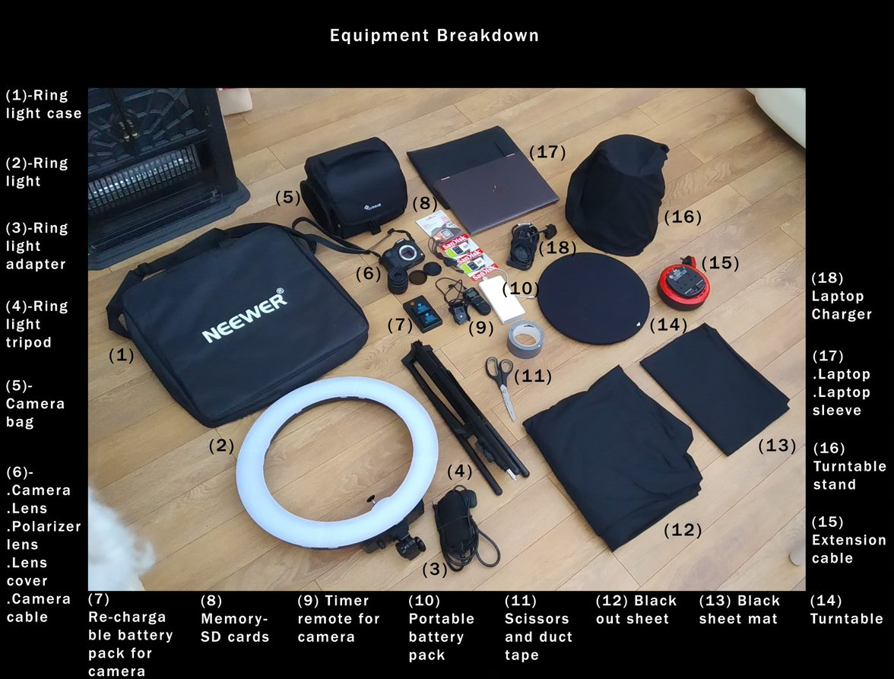
Fig. 38. Breakdown of Photogrammetry equipment.
The handling process included additional handlers to unpack the required ceramics and display them on the setup so no touching was necessary that would increase the risks of damage. The handlers wore protective gloves and had previous training on safely transporting the ceramics from the crate to the setup and how to package them back into the crate to be screwed shut.
The scans took one working day to complete, along with the setup taking roughly an hour to get right followed by quick tests to make sure the camera was working, and the images were what was needed. Camera settings usually need adjusting to ensure that the colour balance is correct and there are no unneeded sources of light that can impact the quality of the images.
Each ceramic took roughly 20-30 minutes to ensure there was no room for error to put the ceramics at risk, Fig. 36 shows a flow chart of a typical scenario photographing a Thornhill ceramic. In future, it would be considered that a second visit would have been ideal to fix any of the possible errors with the first attempt and to scan more ceramics in case any previously selected were found not to be suitable for digitising.
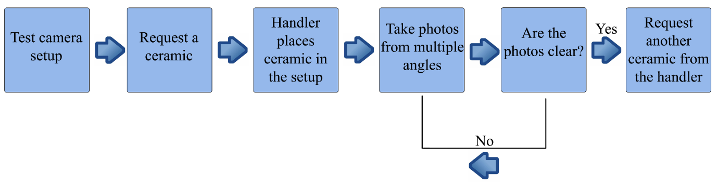
Fig. 39. Flowchart of the photographing process.

4.5 Digitisation
This process converts physical information into a digital format. This process consists of various photographs of an object at multiple angles to gather the physical information to transfer them into the photogrammetry phase. When the data is processed in a 3D re-construction software, the software uses the photographs to link matching points in the data and create a full 3D model version (Choukroun, 2022). See Fig. 37 for a visual example of this process. This 3D model is then transferred into a games engine or rendering setup, such as Sketchfab, to serve as an interactive 3D object.
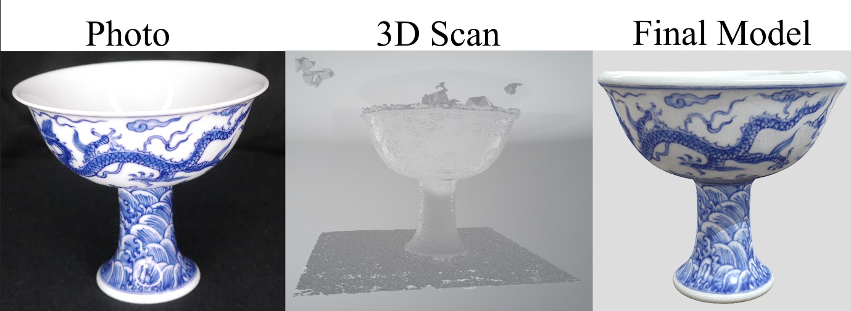
Fig. 40. Digitising process with the Stem Cup.
This technique was chosen due to its most photo-realistic results to achieve a close replica of the original artefact. Maintaining visual accuracy was important to provide the end user with an interactive experience that was close to engaging with an artefact in real life.

4.5.1 Photo Selection
The process starts with uploading the photographs from the camera to a computer device. Once the transferring process is complete, there is an elimination process to analyse if the photos are deemed suitable for photogrammetry. A few reasons for not using an image are listed below:
- Blurry or poor-quality image.
- Bad framing- The object is not centred or has poor alignment.
- Duplicates- Only need one image of the same angle.
- Unwanted additions. For example, hands are visible from adjusting the scene.

The photographs are shot in a raw format to provide the most authentic version of the ceramic with accurate colour matches; however, this means that the images must then be converted into a compatible version for photogrammetry software. For Meshroom, all the images were converted into JPG format due to their small file size and quicker upload speed (1stWebDesigner, 2016).

4.5.2 The Digitising Process
Once the photos are ready, they are uploaded to the Meshroom software to begin the digitising process. See Fig. 38 for a visual reference of the digitising software, Meshroom.
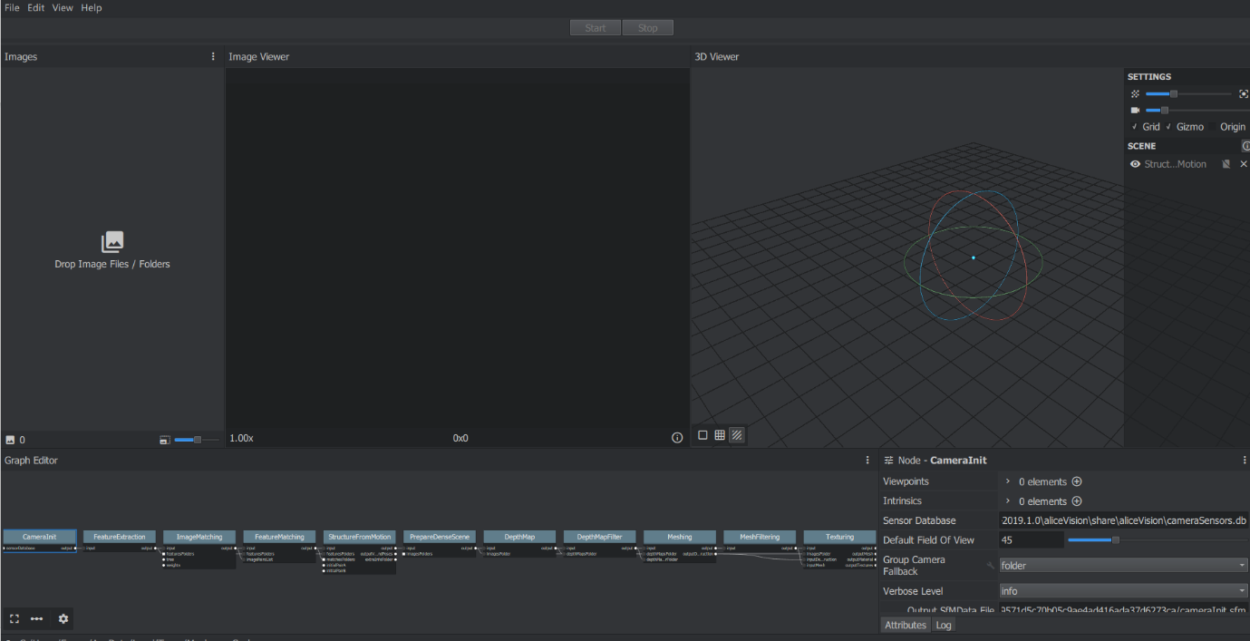
Fig. 41. UI Layout of Meshroom.
As seen in Fig. 39, Fig. 40 and Fig. 41, there is a timeline shown for each stage to get the final 3D scan. This software begins the process by extracting the feature of the object depicted in the images, followed by matching this data with coordinated points to fully reconstruct in 3D where each point would be. Once this has been created, Meshroom then creates a 3D mesh with a texture overlay and exports it as an OBJ file object. This output is then ready to be edited in an external 3D editing software.
Meshroom required roughly 30-50 images to produce a full 3D model with minimal errors. However, this would take multiple attempts of trying different angles of each ceramic to see which was most accepted by the software. If a certain angle was rejected, a new angle of photos was added with the previously accepted selection.
A fair amount of testing went into this stage due to the trial-and-error nature of this software, in order to achieve an efficient result that can be taken through into the next stages. If images were rejected, the models would finish with errors or poor results, thereby needing another attempt to get the desired base.
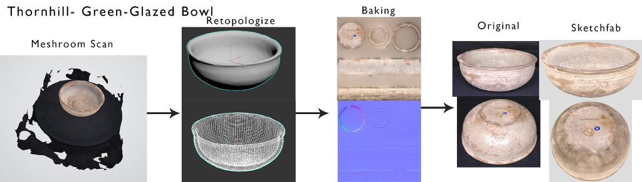
Fig. 42. Digitising process for the Green-Glazed Bowl.
Challenges were overcome by using a distinct set of images each time to see what the software most agreed with. Sometimes, a certain angle would be rejected by the software and therefore remained unused to develop a scan, resulting in poor reconstruction.
Many angles were taken of a single ceramic to allow issues with an album of photos that could be scrapped for an alternative solution.

4.5.3 Reconstruction
The two software applications used for reconstruction were 3dsMax and ZBrush, 3dsMax offers the ability to remove irrelevant meshes by quickly selecting the associated geometry to remove. ZBrush was used to edit the meshes organically to fill any unwanted holes or smooth any harsh edges.
This stage focuses on editing the mesh to fix any issues and get the model as close to the original piece as possible. The first step is to remove any unwanted background, as seen in the first image on Fig. 39, Fig. 40 and Fig. 41, so the mesh is just the object that is being reconstructed. Usually, a scan will have holes within the mesh. This is a result of lost data via the photographs and errors that happened during the scanning phase.
One of the bigger challenges of reconstructing a ceramic in 3D was how to apply a base so the object could be turned at any angle and have zero gaps. To approach this, images were taken to cover every area of the object and the base of the ceramic is then applied separately in the editing software. After the mesh is complete, the texture is then projected and combined with the rest of the texture colour map to complete the ceramic.
Additional editing can be required depending on the complexity of the design and how the scan has interpreted certain design elements. For example, Fig. 40 shows handles around the top of the pot. The photogrammetry scan closed up these holes due to them being too small to process and therefore needed further editing to make the negative spaces by hand.
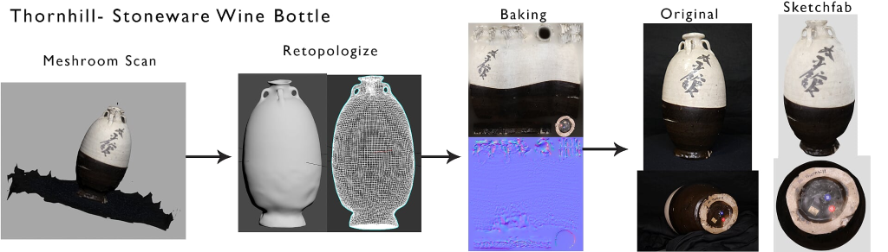
Fig. 43. Digitising process for the Stoneware Wine Bottle.

4.5.4 Retopology
Once the High Poly version of the mesh is complete, it can then be retopologized. Retopology is a process in 3D Art to create a lower resolution mesh version suitable to import into a 3D environment. Using a lower resolution means the object is more performant to render and helps the game run more smoothly as a result. It is important with retopology to retain the detailed information. This means creating a replica version that mimics the shape and forms of the original digitised model. If the low poly version is not directly matching up with the original mesh, this can cause the projection to fail or have gaps in the details.
This can also be related to the decimation phase, decimation meaning reducing the file size and therefore improving the overall optimization of the model (GoMeasure3D, 2024). However, retopology slightly differs in techniques to improve the efficiency of the topology. Whether decimation will focus on making the topology as reduced as possible. Which may lead to errors in the textures phase.

4.5.5 Texture Baking
With a reconstructed mesh created, Fig. 39, Fig. 40 and Fig. 41 show a completed, untextured model under ‘Retopologize’. The low-poly model will then be overlayed on top of the original high-poly to project the coloured texture details onto the low-poly model. This will give the low poly model a full colour map texture that can be exported into an external software.
Substance Painter is then used to do any additional details or tidying of any errors from the projection. This texturing software also can create multiple texture maps to add realistic elements. These texture maps are flat 2D layouts of a 3D object.
These models have a primary colour map for the visual information and colouration as shown in Fig. 41 under ‘Baking’, along with a normal map as shown under the colour map. A Normal map texture defines which way a light bounces off a surface. This includes how an object reacts to light, represented through RGB colours (XPlaneDeveloper, 2020). Normal maps help to identify the 3-dimensionality of a surface and will add definition within the ceramic's negative spaces.

4.5.6 Polishing
Polishing consists of last-minute touches to refine any possible flaws or additional details that could include adjusting the physical properties or reverting back to a previous stage to fix any flaws or mistakes.
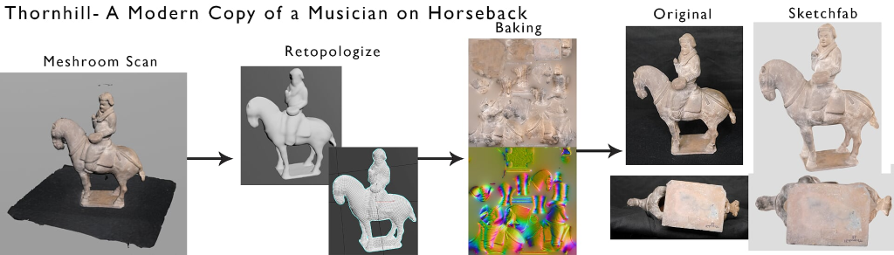
Fig. 44. Digitising process for the Musician on Horseback.
6.4.4.7 Rendering and Presenting
Once the model is completed, it is ready to present via the rendering software, so that high-quality rendered images can be taken for presentations and documentation. Sketchfab was used to import the 3D model to assess how the 3D model was behaving and checked for any unknown errors before being imported into Unity. Sketchfab is an online platform for sharing 2D, 3D and AR content (SketchFab, 2020).
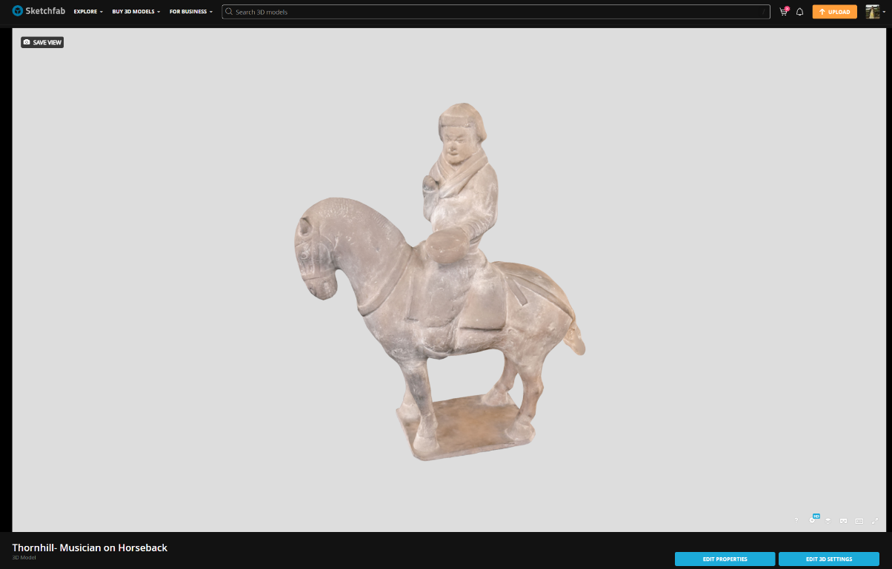
Fig. 45. Musician on Horseback in Sketchfab.
Uploading to this platform can be done quickly with many editing options to customize the way they are presented. This makes this an efficient option for an online portfolio and was especially useful during the initial stages of this project. Fig. 43 shows the 3D editing settings within Sketchfab and Fig. 42 shows how the model appears for viewing. This software was used for similar projects, such as (Davies, 2021), (VR, 2023), (Archaeology, 2015) and (Museum, 2023).
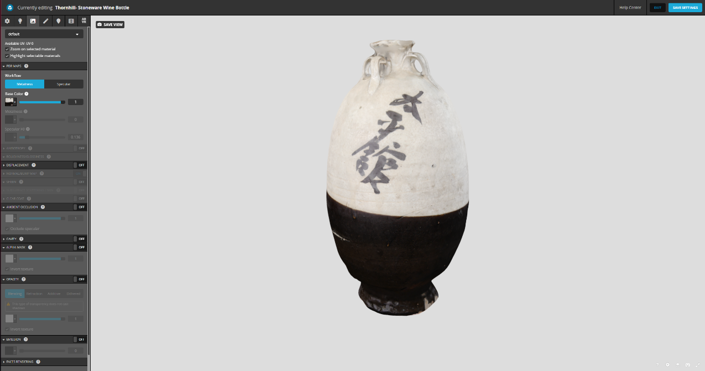
Fig. 46. Sketchfab 3D editing UI.

4.6 Stage 2: Content Creation for the ‘Thornhill Experience’

4.6.1 Mock Designs
Plans were created to explore the diverse ways hands-on interaction could be utilised to offer users ways to interact with the experience. These plans included sketches, drawings, mind maps and 3D mock visuals before deciding on the final focused interactions. An example of a story board can be seen in Fig. 44. The interactions were broken down into diverse levels that provide storytelling to the history of a Thornhill ceramic. The ceramics were framed in a museum to open the scene with a familiar setting.
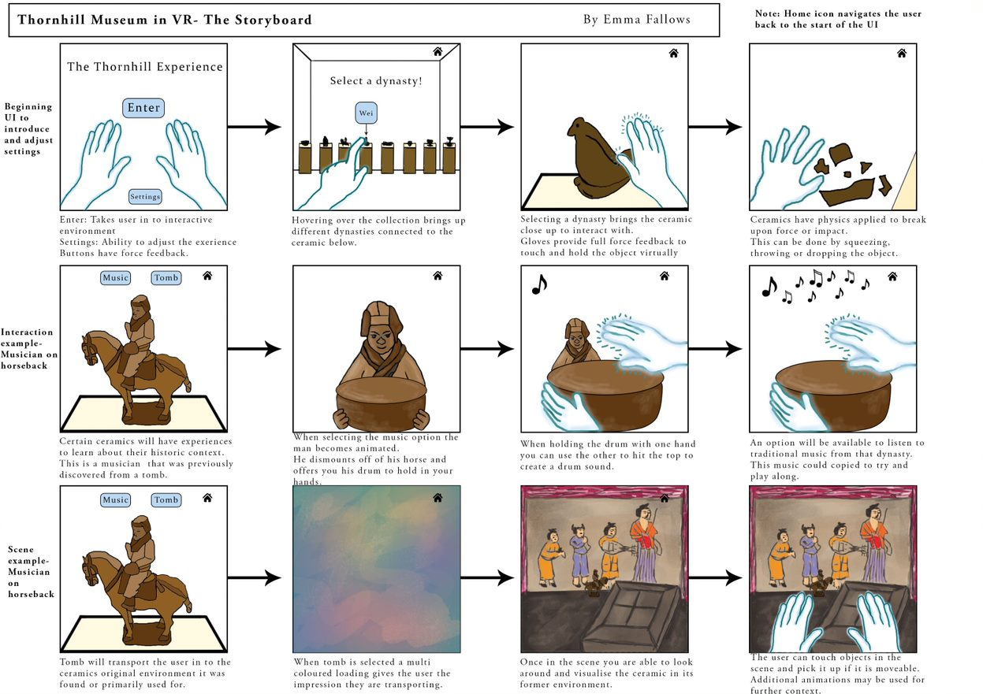
Fig. 47. Storyboard of the ‘Thornhill Experience’ interactions.
The museum was designed to show the player had no rules when to interacting with objects. The cabinets could be taken away and the objects handled to get a close-up view of a ceramic.
Some ceramics may need additional context to understand their forms, such as the musician on horseback, this was communicated by recreating the drum from the ceramic into an authentic replica of a Tang Dynasty drum (See Fig. 45 for reference). To provide a broader cultural context of the ceramic, the representation of the drum within the Tang figure on horseback, provided an additional layer of interpretation for visitors to engage with.
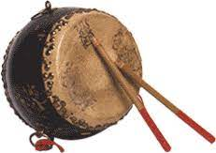
Fig. 48. Tang Dynasty drum reference.
The drum had two sides that provided two different sounds upon being hit with sticks. This sound was clipped out of a modern orchestra video recreating Tang Dynasty music. This was to provide authentic sounds to add another sense within the experience that would provide additional context to the ceramic.
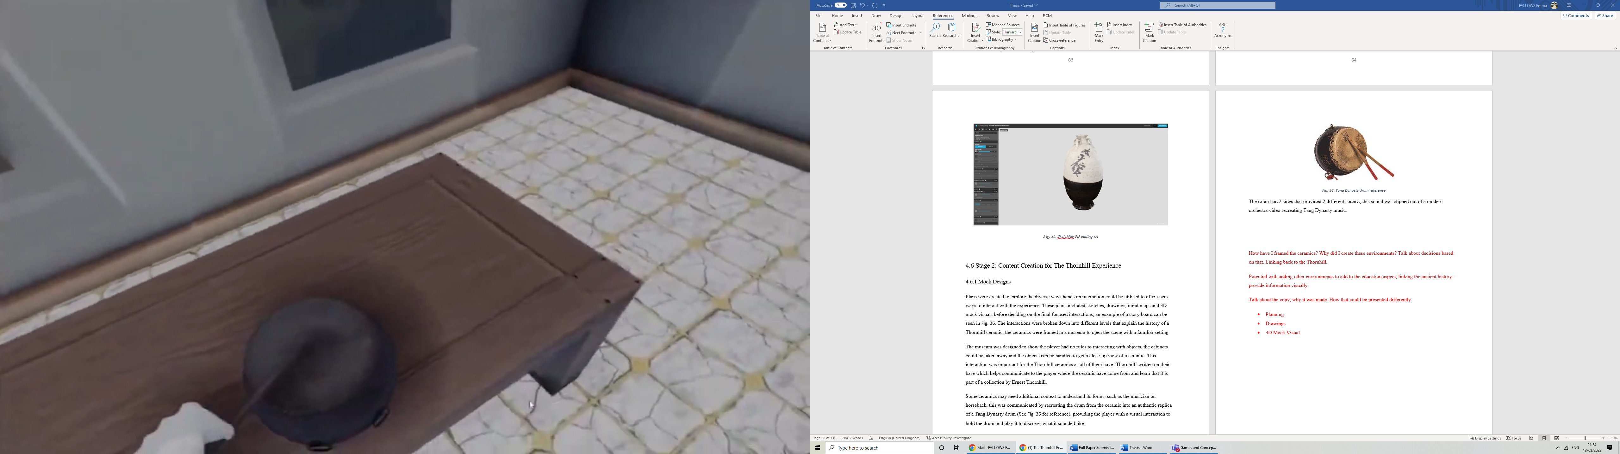
Fig. 49. Screenshot in the ‘Thornhill Experience’ of a player interacting with the drum.
The next core interaction was with a change of environment. This was to transport the player into a tomb setting to communicate where the ceramics were originally discovered. This context helped the player understand how the Thornhill Collection was formed, through ceramics of divergent backgrounds but all linked through an East Asian location. This context was intended to assist the visitors understanding the ritual significance of objects as tomb offerings and place them also with in a geographic context. Tomb offerings were a common ritual for burials in East Asia, these can be personal possessions, supplies to assist in the deceased’s journey to afterlife or as symbol of wealth or status (Rawson, 2023).
In the initial stages of production for the ‘Thornhill Experience’, it was found by the researcher that the Musician on Horseback ceramic was a fake, as recorded in the collection’s documentation confirming its authenticity (See Appendix 7: Lyon & Turnbull Inventory & Evaluation for the Thornhill Collection). This impacted plans on whether to include the ceramic in the experience. The skill of the counterfeiters remains so advanced it is incredibly difficult to distinguish the original from the fake. It is unknown if Earnest Thornhill was aware of the Musician of Horseback being a fake despite evidence of him seeking professional advice from curators and ceramic experts to avoid this mistake, but it is likely the replica remained undetected until later examinations when the collection was valued in 2015 by Lyon & Turnbull auctions (See Appendix 7). This ceramic was included in order to inform visitors of what a fake replica could look like, with the ability to handle and look at details closely to understand the ageing creation techniques that replicate the original artefact. This example indicates one of many counterfeit artefacts that are accurate enough to remain undetected and end up included in mainstream collections or museum displays.

4.6.2 Environmental Design
For the project, two core environments were made to demonstrate an element of time travel for the player to experience. The first environment shown in Fig. 47 focuses on where the ceramics would be displayed, mirroring a typical museum layout to display the selected Thornhill ceramics.
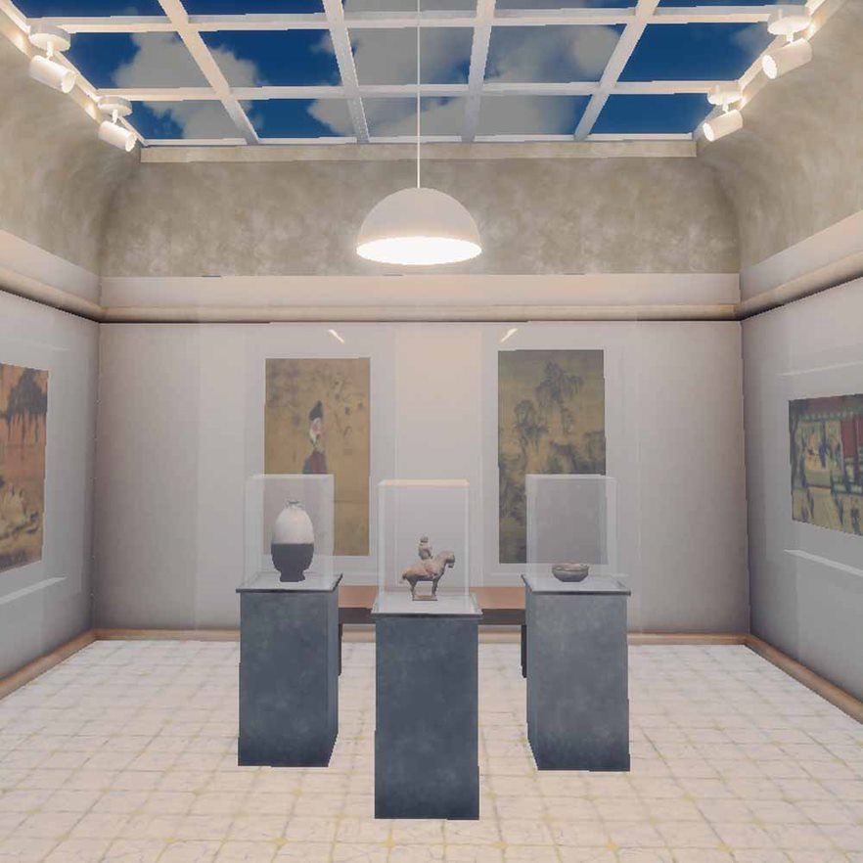
Fig. 50. The ‘Thornhill Experience’, Museum room.
For the visitor to feel fully immersed in the environment, spatial mapping was created to surround the player in an enclosed virtual environment. The museum featured a doorway that appeared to lead to another room in the museum, however, that was created to avoid the visitor feeling enclosed in a single room, the layout replicating a real museum design.
To inform the player that the second museum room was not playable it was darkened with limited lighting to disinterest the player and stay in the same room. This is a common technique used in gaming to focus a player on a certain path or guide them to desired interactions. The ceramics in the museum were lit directly above to highlight what the visitor should interact with.
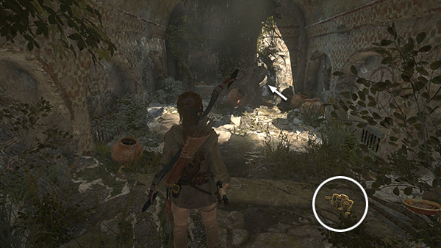
Fig. 51. Screenshot of the 'Rise of the Tomb Raider' game.
In Fig. 48, the game ‘Rise of the Tomb Raider’ shows lighting being used in a comparable way. An interactable object has been highlighted with its own light source, this has been circled for reference. The arrow shows the general light source directing the player on where to go next, with the surrounding environment dimmed in brightness to make it appear less interesting.
For the environment map design of the three rooms (see Fig. 49), the dotted line represents other rooms visible to the visitor but are not accessible. The yellow dots represent the light sources in the scene.
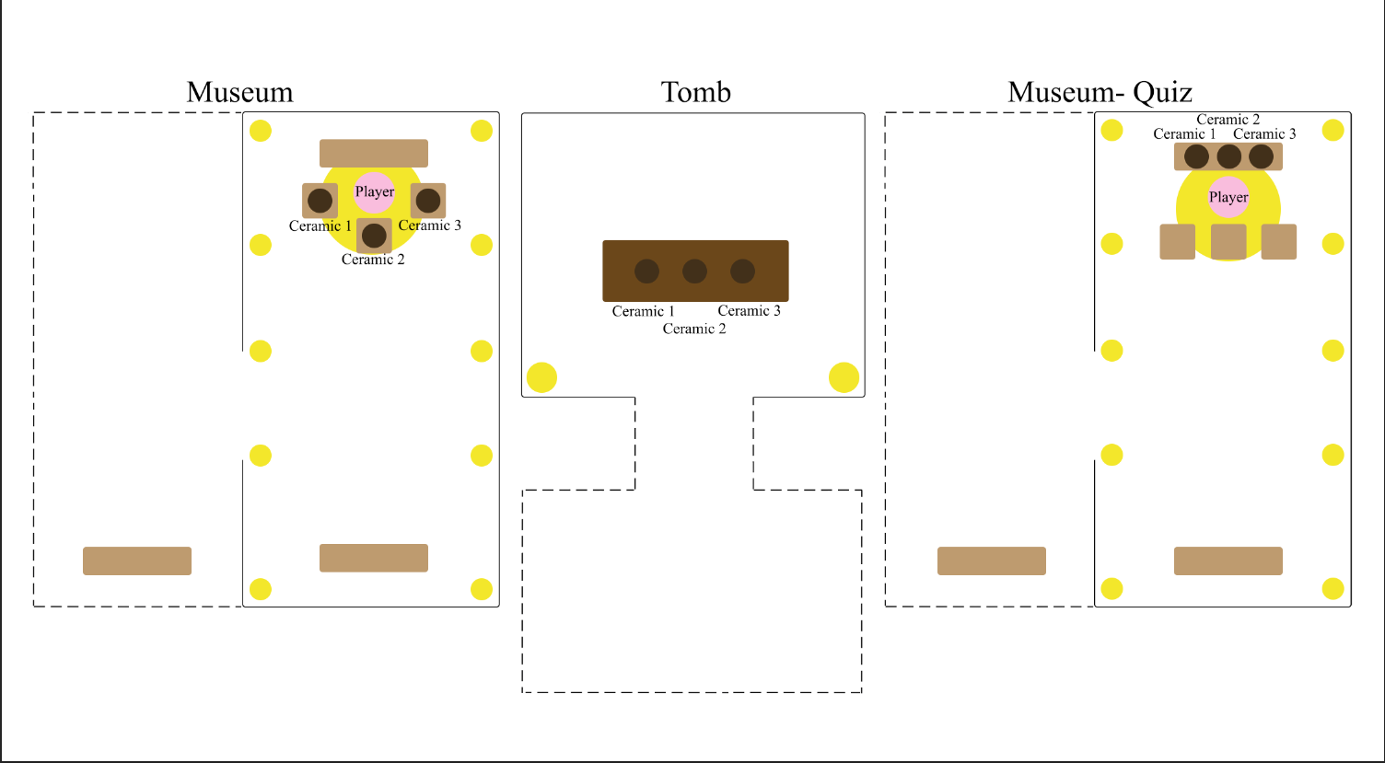
Fig. 52. Environment Map Design for the ‘Thornhill Experience’.
Additional objects are used to build a scene to replicate a traditional museum setup, such as cabinets for the artefacts and benches for visitors to sit and admire the history or art. Replica paintings and murals were featured on the walls that linked with the ceramics time periods to create additional visual interest. This included paintings and murals from the Han and Tang dynasty.
The layout was decided from gathered references featured in Fig. 50. This included deciding how light would enter the room and light up the scene. For museums to feature natural light some decided on a ceiling window to let in natural day light and illuminate the room, with additional point lights around the ceiling window or above the art work to highlight the viewing points in the room.
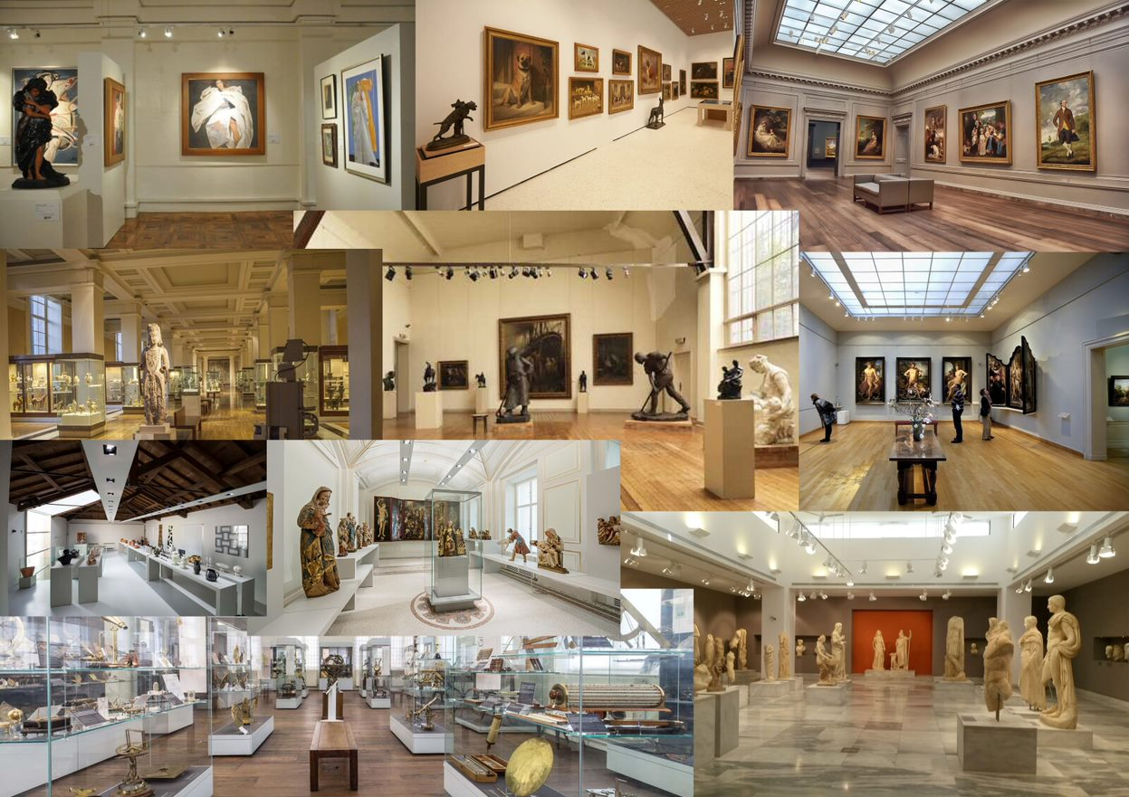
Fig. 53. Mood board of Museum environments.
The second core environment consists of a tomb reconstruction from the Tang dynasty as shown in Fig. 51 which acts as a visual context to where the ceramics were discovered. The ability to transport a visitor into the tomb offers a unique insight into the ceramic’s ritual significance and purpose of presence.
Tombs served as homes for the afterlife, so depending on status and wealth, the deceased would be accompanied with offerings that are personal possessions or supplies for the afterlife to be comfortable (Archaeology, 2023).
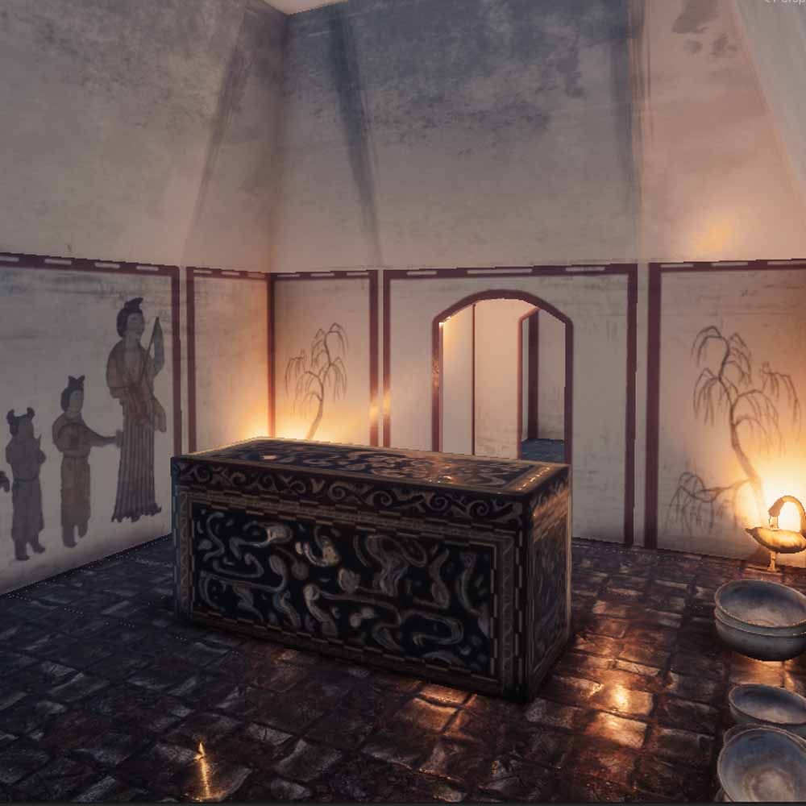
Fig. 54. The ‘Thornhill Experience’, Tomb Room.
The tomb required thorough research before the reconstruction process to understand what the defining features and characteristics would be within these burials to build up a virtual replica of a typical Chinese Tang Dynasty tomb. The references shown in Fig. 52 are photographs taken of a recovered Tang Dynasty tomb found in Taiyuan, China, beneath an elementary school undergoing renovations (Collins, 2019). This Tomb was chosen as the core reference due the preservation of wall details, structure and offerings. This tomb was highly documented, allowing for accessible imagery to assure accuracy in reconstruction.
Fig. 52’s photographs were the main inspiration for the tomb environment to decide on room shape, layout of objects and decorative features. The murals paintings on the walls were particularly important to communicating a story on the possible burial type. The references are suspected to have been someone of importance who was laid to rest, this was concluded through the intricacy of paintings, number of offerings and carvings on the tomb stone.
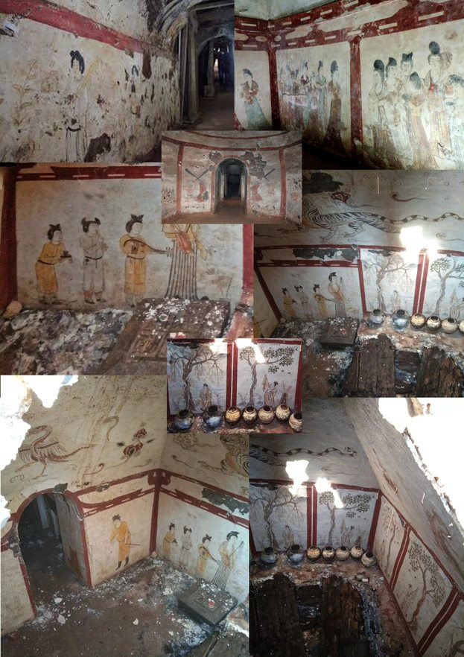
Fig. 55. Mood board for the Tomb environment.
A third room was created to have familiarity with the original museum room but with a separate function. This scene challenges the player with a simple puzzle set up to associate the right ceramic with the correct dynasty of their origin, as featured on plaques on the front of each dynastic podium. Gamification was implemented to make the podiums glow colours to communicate the results of the quiz. If a podium glowed red, it meant the ceramic was placed on the incorrect podium, whereas a green glow indicated the correct podium. This feature provided as an indicator to observe what the participants had learnt about the ceramics from the application.
This gamification was implemented in response to part of question two, ‘How can the historical context of ceramic artefacts be experienced through immersive Virtual Reality, to engage, educate and inform museum audiences?’ in this research. This element of challenge offers immersive alternatives to engage and educate museum visitors by challenging them on the information retained, which they can recall from previous parts of the experience.
This yielded a good insight into what information was retained, examining their responses as part of the data analysis phase to conclude if the application can efficiently communicate historical content, if this can help visitors effectively retain information, if the application is user-friendly and if technology similar to this is desirable in a museum-like setting.

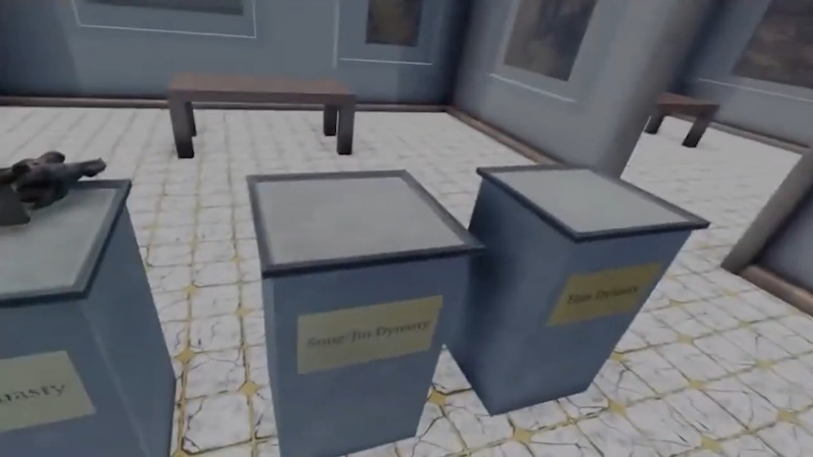
Fig. 56. Screenshot of the puzzle room in the ‘Thornhill Experience’.
Module tiling was used within all the environments to create a base for the scene. Module tiling is a process of creating a tile that can be repeated along a virtual wall and floor to create a repetitive pattern. For this project, these tiles were created with the software: Substance Designer (Adobe, 2023). The museum required marble floor tiling to mimic the typical setups used within museum rooms, and the tomb required old brick flooring that represents a traditional Tang dynasty re-creation. Fig. 54 and Fig. 55 show these floor textures in the Unity engine.
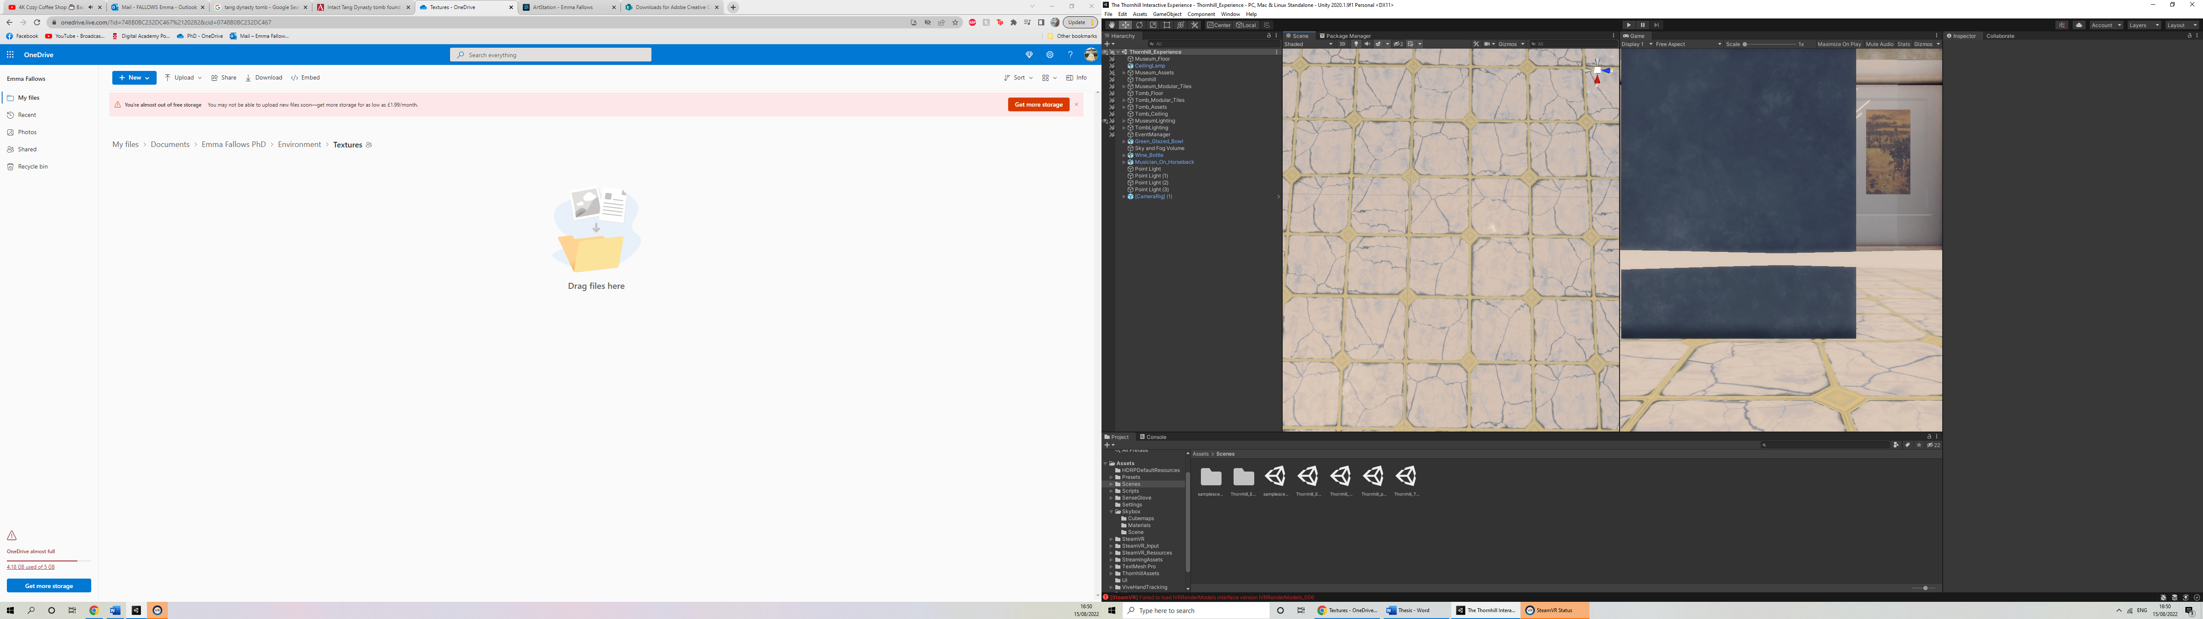
Fig. 57. Module tile texture used for the Museum floor.
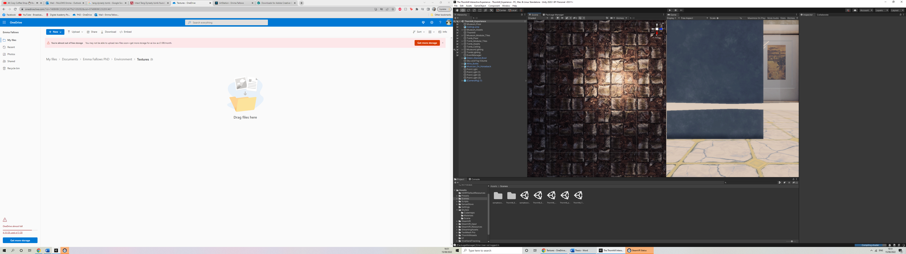
Fig. 58. Module tile texture used for the Tomb floor.

4.6.3 Additional 3D Content
The environment for both scenes had a list of suitable assets to add to the visuals around the player to increase engagement. These objects have been selected based off their relevance to the Thornhill ceramics selected and their associated timelines.
Once something is encased in a museum vitrine, it accentuates its preciousness. In the ‘Thornhill Experience’, the player can remove the case and scrutinise the object at varying degrees of proximity. Additionally, players can be irreverent, throw, or drop an artefact, without any consequence. By giving the player virtual access and permission to drop an artefact, this helps communicate cultural value systems.
This key interaction links by imitating the actions of the contemporary artist, Ai Weiwei. Weiwei created a series of photographs smashing a Han dynasty urn. Despite the considerable value and cultural worth, Weiwei wanted to question the cultural value system and challenge who creates cultural values (Beres, 2021). This links to the application by encouraging the interaction of dropping a ceramic to receive additional interactions and context. This real-life example of Chinese ceramic culture has been implemented in VR as it can provide a virtual representation without putting a ceramic at risk.
Additional interactions have been applied to make the experience more enriching in content through the use of sound. This includes a ceramic called ‘The Musician on Horseback’ and communicating to the visitor that the musician is holding a drum by generating a 3D replica drum into the scene. See Fig. 56 to see this demonstrated in a series of images. See Appendix 2: Run-through of the ‘Thornhill Experience’ to hear the drum within a demonstration of the application.
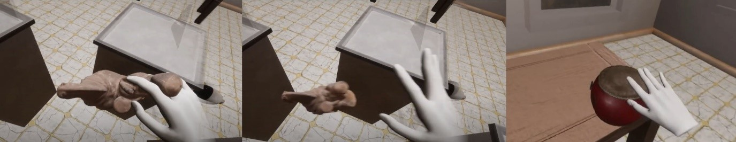
Fig. 59. Interaction featuring the player dropping the Musician on Horseback to generate a replica Tang Drum.
Whilst in the scene, you can hear traditional Tang dynasty music featuring the same drum reconstructed for the ‘Thornhill Experience’ within a group of musicians. See Appendix 2 to hear the drum sound within a demonstration of the application.

This process enriches the visitors experience by connecting the historical context of one object to another to expand cultural understanding. Through the appearance of the drum, this helps the visitor to virtually engage with the visual aesthetics, construction, materiality of a Tang Dynasty instrument, and hear its 2 varying pitches.

4.6.4 Lady Dai’s Coffin
Another key feature of the application includes the Tomb’s coffin that is inspired by that of Lady Dai’s (See Fig. 57). Lady Dai was the aristocratic wife of a Han Dynasty nobleman Li Cang in ancient China. This coffin was part of a series of four layers of nesting coffins to symbolise her extravagant wealth and the tomb was filled with luxury items such as embroidered silk garments, skirts, dainty mittens, a silk sachet filled with various spices, flowers and fragment reeds, a box of cosmetics, more than a hundred lacquer wares, musical instruments and statuettes of musicians, even prepared meals and more than a thousand other items (Patowary, 2018).
These items bestowed on her death were to offer her a luxury lifestyle even in her afterlife. This is an example of how a Han dynasty tomb was set up and the types of offerings that were made. The lacquer coffin is a beautiful representation of pure artistry and displays an elevated level of respect towards the deceased to give them a personal and valued burial.
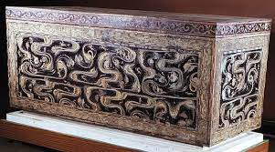
Fig. 60. Original references of Lady Dai’s Coffin for inspiration.
Fig. 58 shows the completed 3D model of the Lady Dai-inspired coffin that will be used within the 3D Tomb. The textures have been hand-painted to better reflect the authenticity of the actual hand-painted techniques used on the original Han dynasty coffin (Chaffin, 2022).
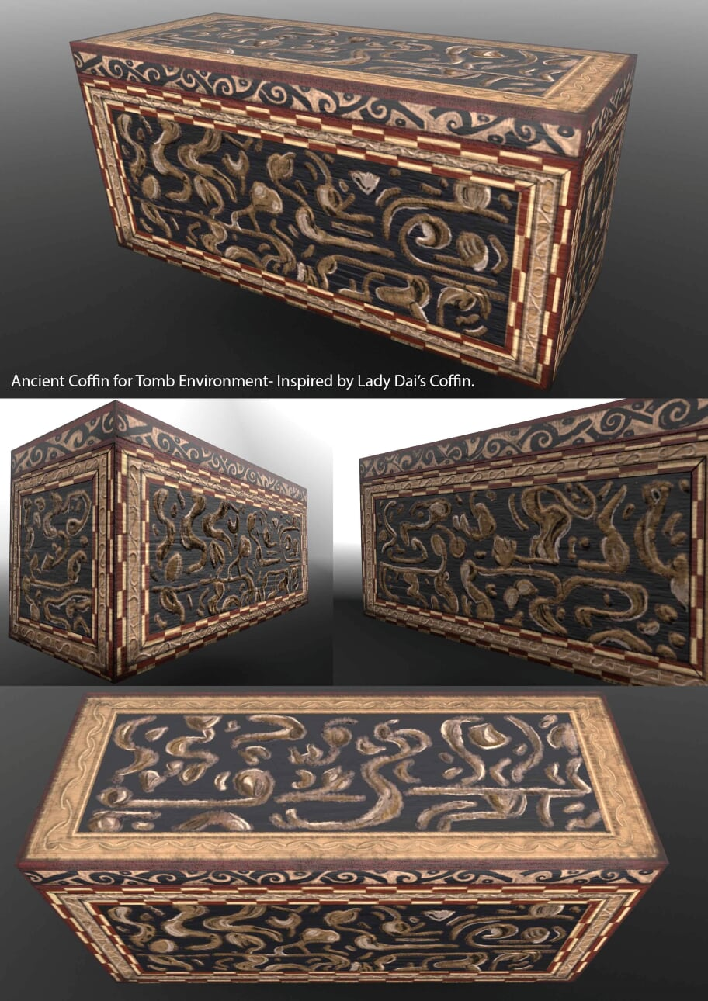
Fig. 61. Renders of the 3D model coffin for the tomb environment.
This allowed the player to gain a sense of how the aristocracy were buried, compared to the average burial in the Han Dynasty. This was to give a sense of the structures of social class that would have received offerings similar to the ceramics featured in this application.

4.5.5 Han Dynasty Goose Lamp.
An important part of the tomb environment was to consider the light sources in the scene. Research showed that lamps in the shapes of geese (See Fig. 59) were commonly found in the burial tombs of ancient China. Plant oil was used to burn and create a light source with some sources supporting animal fat that was also a common fuel for the lamps (INews, 2022). These lamps were chosen to be the source of light in the tomb to reflect a recent burial and the lamps are still burning after the body has been placed in the tomb.
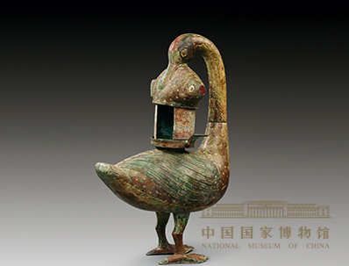
Fig. 62. Original reference of Han dynasty goose oil lamp.
Due to the fuel of the lamp being derived from animal fat, it will produce choking smoke and burning the lamp for a long time will cause the air quality within the room to drop. The invention of the wild goose lamp effectively reduced the smoke and became an environmentally friendly product popular among the aristocracy at that time. After the goose fish lamp is ignited, the smoke enters the goose’s body through the fish and the gooseneck. This sucks the smoke into the goose's belly, dissolves the water, purifies the air, and prevents oil fume from polluting the indoor air. It uses the principle of a physical "siphon". This shows that people at the time had a strong awareness of environmental protection. At the same time, the four parts of the goose fish lamp can be freely assembled and disassembled for easy cleaning. This history makes the goose lamp a recognized art treasure in ancient Chinese history, therefore, it felt important to include it inside an ancient Chinese burial tomb.

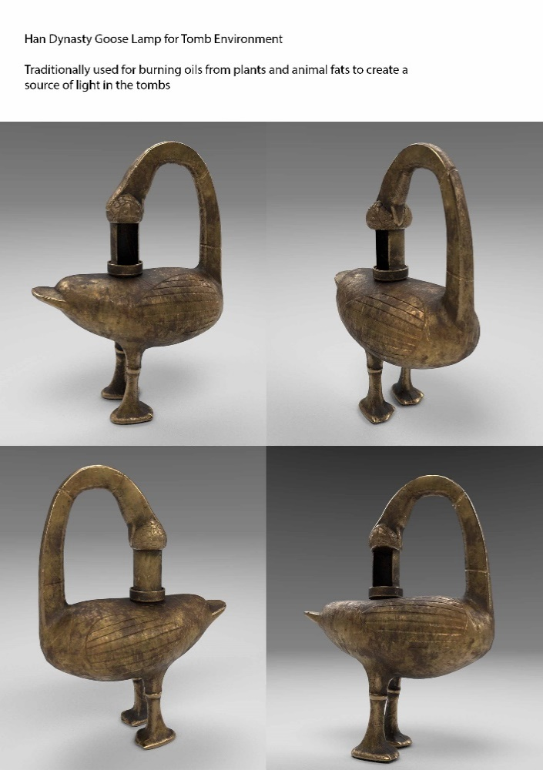
Fig. 63. Renders of the goose oil lamp 3D model for the tomb environment.
Fig. 60 shows the completed 3D model of the Han dynasty goose oil lamp. This model was created using 3dsMax using the original references to create the basic forms. This base design was taken into an organic modelling software (ZBrush) to hand-sculpt the details. The decision was made to implement hand-sculpted techniques to make the object feel organic to the real-life version. This method was used as an alternative to a digitised reconstruction due to not having access to a real-life artefact from which to scan.
This lamp provided a lit environment for individuals to pay their respects comfortably to the deceased. Once the oil or fat had ran out, the lamps would go out and leave the deceased to rest.

4.7 Stage 3: Interactions and Gaming Elements

4.7.1 SenseGlove Integration
SenseGlove has an efficient system to get a new user started in Unity. Unity is a game development platform used to create games and applications (Unity, 2022). This engine software was chosen due to its compatibility with both Augmented Reality and Virtual Reality to offer experimentation at the beginning of this research. Unity also offers compatibility with SenseGlove and their pre-made Software Development Kit (SDK) to import into a scene, SDKs are a set of tools from a third-party developer to produce certain applications in a game engine with their partnering technology (Valdellon, 2020). The SenseGlove SDK provided everything needed to understand how to perform an initial set up and to test if the gloves were working via default applications that demonstrate the different interactions the gloves can do. During the setup for the SDK, it included pre-sets of SenseGlove settings to be able to quickly setup the SenseGlove to work within Unity’s play mode. These settings gave flexibility in how the gloves behave and the properties that can be adjusted to manipulate what the player can feel. This process is performed using the pre-set options combined with mesh colliders.
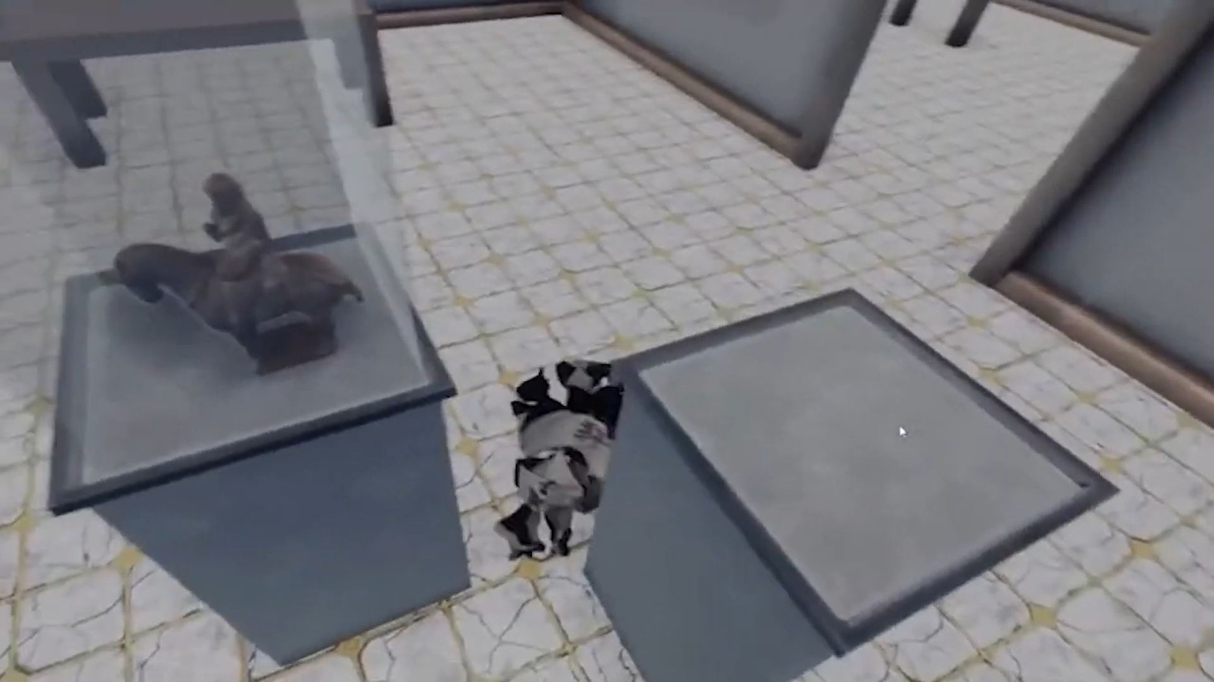
Fig. 64. Screenshot from the ‘Thornhill Experience’, featuring a shattered ceramic.
Mesh Colliders are applied to Mesh assets in a scene and given a collider allowing the technology to understand what type of material it is, such as hard or bendable. When the SenseGlove device is used to pick up an object, it can create the feel of the density properties. These properties were used on all of the objects within the scene to provide full interactivity. Further adjustments were made to the ceramic objects to try and mimic the way a ceramic would feel in real-life. These include the density of the material and applying physics so that if the object is dropped, it would fall with a similar weight to the real version and smash into various pieces when hitting a surface with any appreciable impact.

4.7.3 The Stem Cup Study
This case study uses a 3D digitised replica of the original Thornhill stem cup that sold at auction for a weighty £3.6 million. This model was created using the same process as the other Thornhill ceramics via photogrammetry. See Fig. 37 for this process.
In order to make decisions on what would be included in the ‘Thornhill Experience’, the Paul Greenhalgh method was implemented to deconstruct the historiography of a ceramic, in order to contextualise this information in to a visual or interactive format.
An image of the stem cup 3D model, presented in SketchFab can be seen below in Fig. 62.

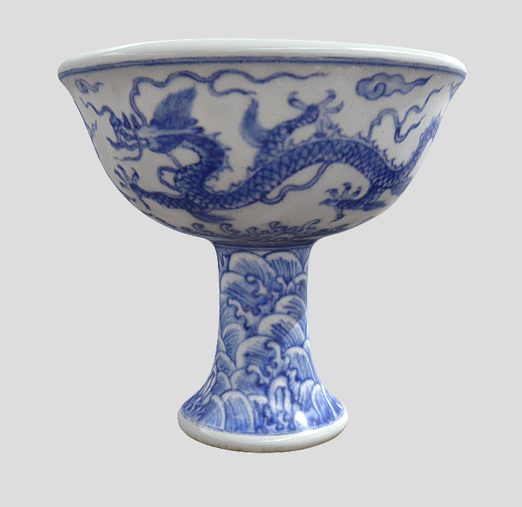
Fig. 65. Thornhill Stem Cup 3D model.
This ceramic posed a significant problem compared to the other ceramics in the Thornhill Collection, modern attitudes and implications can misconstrue the fundamentals of the ceramic’s significance. For example, at auction this stem cup sold for £3.6 million, displaying a high economic value. However, the other ceramics estimates are significantly lower with most pieces in the hundreds and occasionally in the thousands.
It is believed the high price tag was due to the cultural significance and high understanding of the buyer (An East Asian private collector based in Hong Kong) wanted to bring this ceramic back to its original country of origin, but this then raises the question of why and what makes this ceramic so special compared to the others in the collection.
According to some sources, the cup is considered rare and was thought to have been made for an emperor during the Ming dynasty in 1425 (Fricker, 2016). The cup is marked with the Xuande inscribing helping to pinpoint the exact age and which emperor this would have been made for (TheMet, 2016). It is believed that stem cups were used as a goblet style cup for drinking purposes. One design aspect was that when the drink is being consumed, the design would come in to view inside the cup, as a visual treat to the emperor using it (Glendale, 2023).
With the understanding of age, high economical value, a key social function, its hierarchy status and cultural significance. These pieces of information can be used to underpin the contextualising of visual constructions that will communicate the significance of the ceramic and the factors that contributed to history and the effects on the modern world today.

4.8.1 The Proposed Concept
Further developments could explore the methodology framework of the Greenhalgh method to demonstrate object analysis. The stem cup has been deconstructed contextually using this method and concepted to explore how this technology could preserve and educate the relevance of this ceramic.
The application within this research currently demonstrates the foundation of communication through engaging visuals and sensory information. However, due to time dictating the extent of implementation, a lot of potential contexts have had to be withheld from development. Storyboards with the stem cup have been created to show how this application could be developed to create more contextual understanding and offer visitors a deep understanding for its significant value. (See Fig. 65, Fig. 66 and Fig. 67 for these storyboards).
The concept starts in a VR scene with the stem cup located in the middle of the room and in clear view of the user. The player can then approach the stem cup to be offered multiple options on information they wish to acquire. These options breakdown the Greenhalgh method to include key information linked to that ceramic. (See Fig. 63 to see this menu concept).
The menu is designed to show a series of time lined events that breakdown the ceramic’s journey, to get a sense of where the ceramic was created, how the materials were acquired to make it, the methods used to create the ceramic, what the design aspects represent, what the ceramic was used for, where the ceramic was found during modern-day and what was the ceramics current significance and market value.
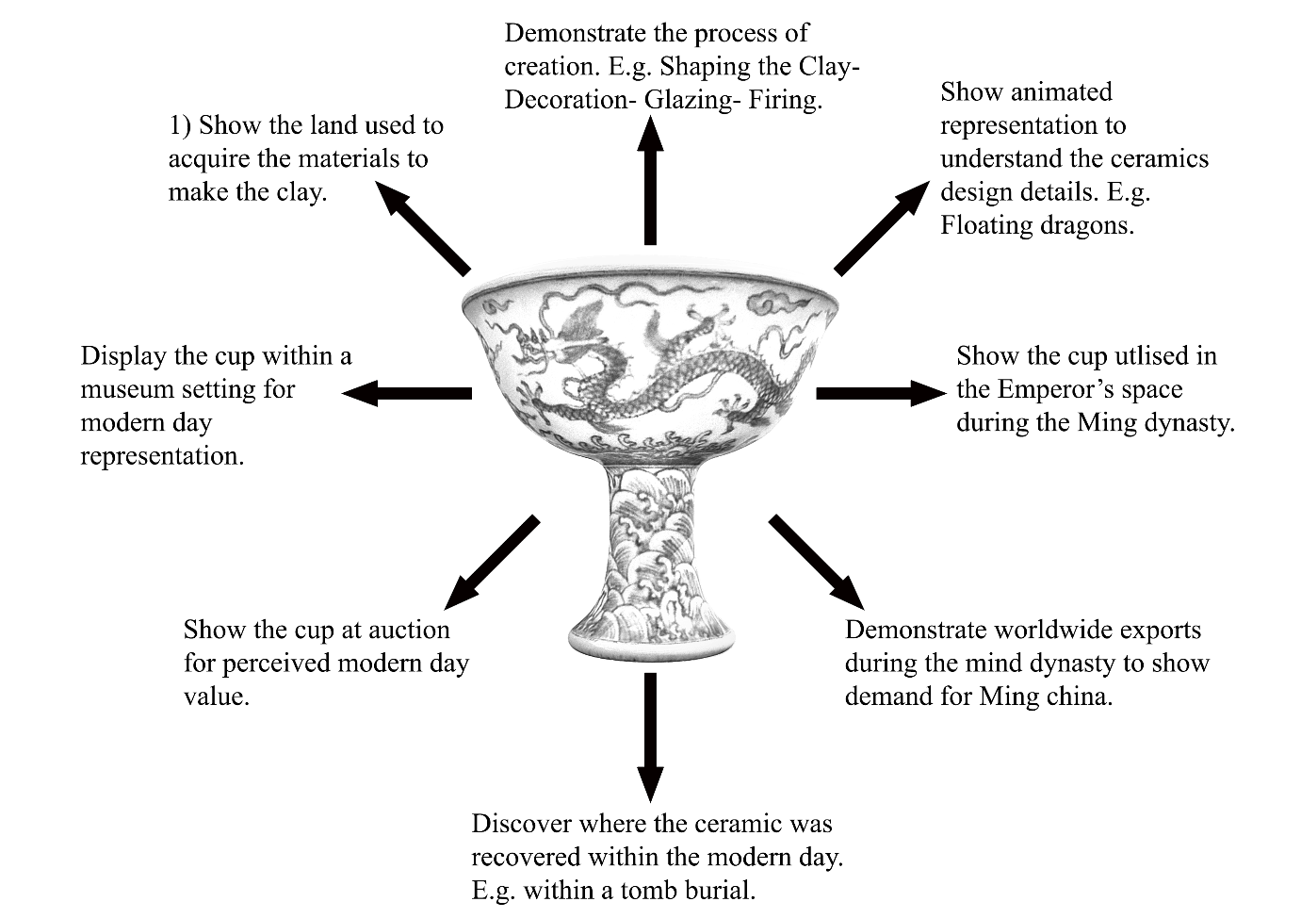
Fig. 66 Proposed concept Main menu.
Each arrow breaks down the ceramic’s historical context into absorbable experiences to help the user better understand the Stem cup.

The proposed storyboards have been broken down into three key experiences. The first offers insight into what methods were used to create the stem cup and the techniques applied to achieve the detailing. The role demonstrates the stem cup’s purpose and grows an understanding with the player about why the cup existed. This is followed by the demand to show how much this style of pottery was desired in China and around the rest of the world, finishing up with a current marketplace value to show the current demand for this artefact.

4.8.2 The Greenhalgh Method
This explores how the Stem Cup could be presented and experienced within the ‘Thornhill Experience’. This breakdown will highlight the potential developments this project could use to build a wider context of visual information.
The information below has been conceived using the Greenhalgh method to breakdown key information about the ceramic. Followed with storyboard on visualising how these can be contextualised into visual and interactive experiences for visitors.
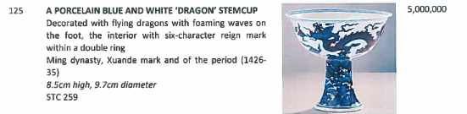
Fig. 67. The stem cup catalogue description.

The Creation
The maker- An imperial porcelain factory was created in Jingdezhen in 1368 to produce wares for the imperial court. (History, 2018)
The material itself- One of the best-loved exports of the Ming Dynasty was its porcelain. Created by grinding China-stone, mixing it with China-clay and then baking until translucent, the technique was developed during the Tang Dynasty, but perfected in the Ming era. Though an assortment of colours might be featured on a piece, the classic Ming porcelain was white and blue. (History, 2018)
The technical state of the medium- The blue and white Ming porcelain was developed by coating a design onto a Ming vase in an underglaze of cobalt-blue pigment (Qi, 2016), likely from Persia and then firing it at a very high temperature of around 1100°C. Then the Chinese vase was fired again once the remainder of the design was added in contrasted colours of overglaze enamel at a lower temperature closer to 850-900°C. (Marchant, 2021)
The history of ceramics- Aesthetic achievements were recorded during the Ming dynasty with the contrast of blue and white colouring marking a "breakthrough" for the Ming period, exemplifying the artisans' control over the cobalt pigments and refined techniques for the detailing. (Qi, 2016)
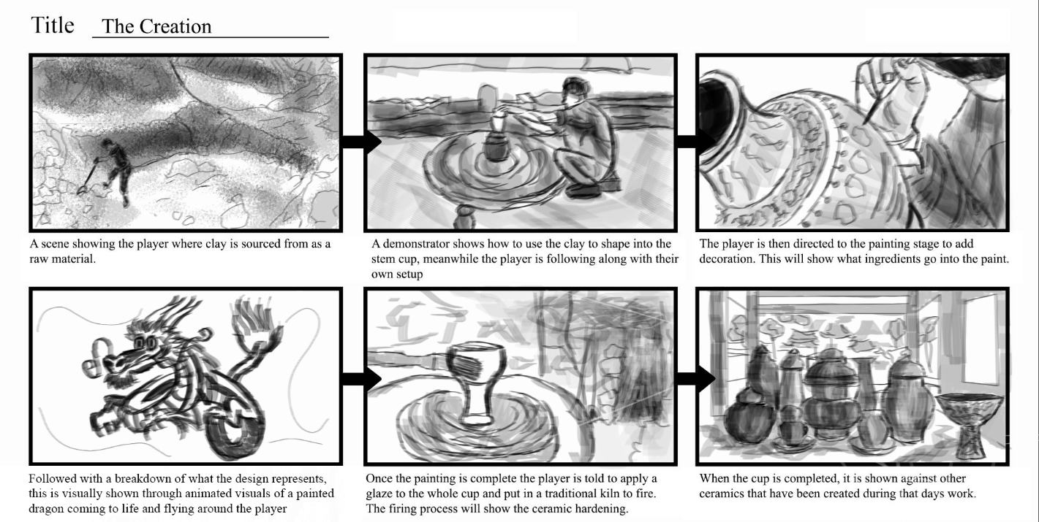
Fig. 68. Storyboard for 'The Creation'.

The Role
The consumer- The Xuande emperor of the Ming dynasty in China. (Hultengren, 2023)
The role of the object- Stem cups resemble wines vessels and were used for drinking purposes. (TheWaltersArtMuseum, 1983)
General political and social trends- Stem cups were typically used on special occasions by high profile individuals such as emperors or empresses for wine. (Caledon, 2022)
The history of the specific individual objects- The stem cup likely had one of two purposes, 1. to have been used as a goblet type vase for drinking wine or 2. A gift for the emperor to be placed within his tomb upon his death as a sacrificial offering.
The class of the object within the genre of ceramics- The stem cup features two five-clawed dragons, a symbol of imperial power, likely a reflection of its consumer (Qi, 2016).
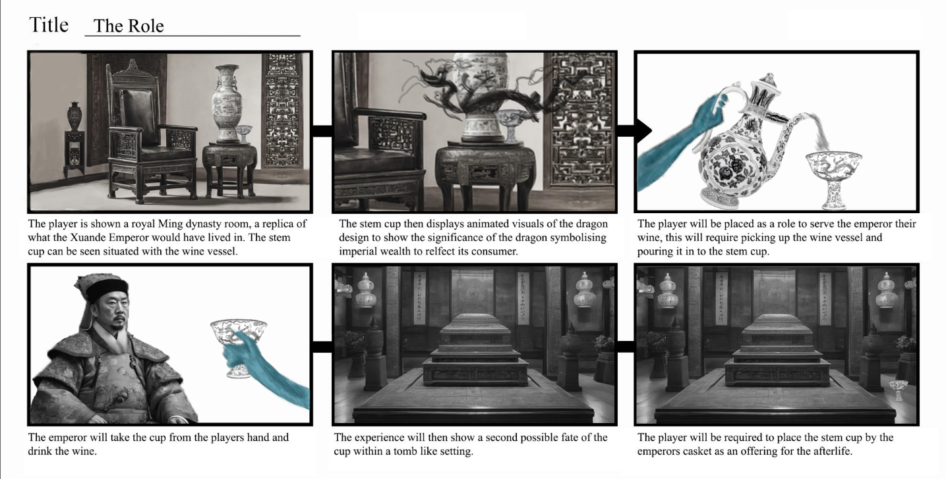
Fig. 69. Storyboard for 'The Role'.

The Demand
The history of other genres that relate to ceramics- The Jingdezhen factory became the source of porcelain exports that were extremely popular in Europe, which hoped to replicate the form. (History, 2018)
The condition of the marketplace- High demand due to rarity and cultural significance to its consumer.
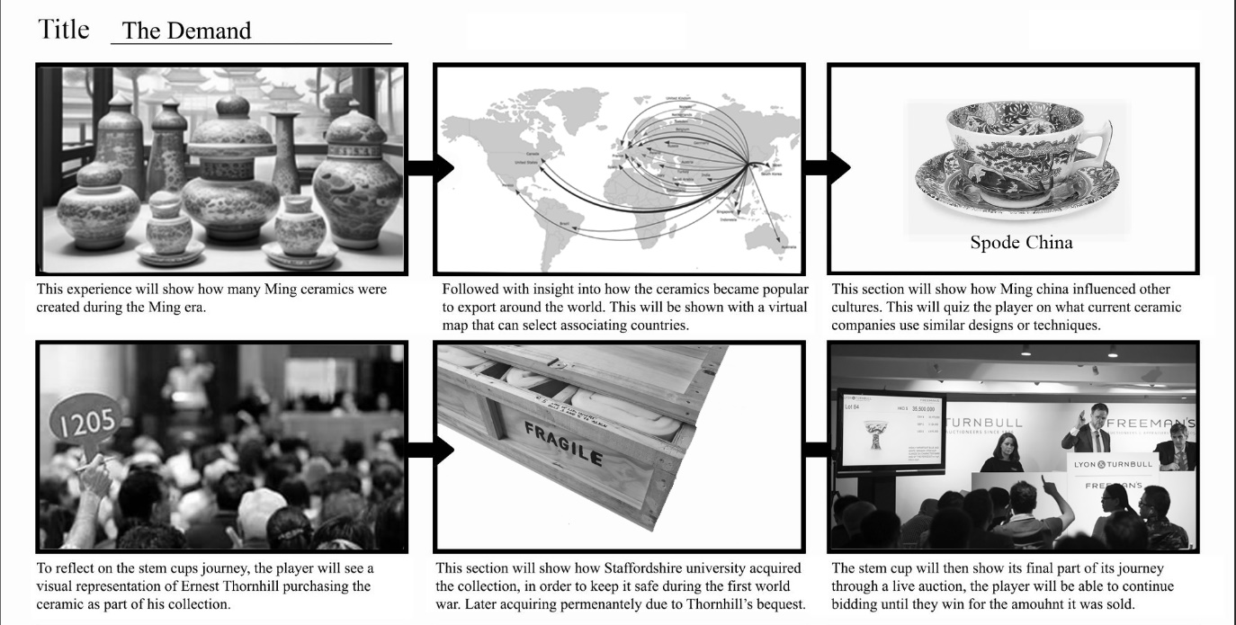
Fig. 70. Storyboard for 'The Demand'.

4.7.2 Summary
This chapter aimed to examine question one in the research questions by uncovering the most efficient methods of practically creating a museum experience virtually.
“Question One: How can the visual and tactile characteristics of historical ceramic artefacts from the Thornhill Collection be recorded, displayed, and experienced through innovative modes of digital dissemination?”
This question was examined through practical outcomes of this project to explore and solidify a structure on how to approach a Virtual Reality application that will be used to inform and educate museum visitors on ceramic artefacts and history. Below shows how visual and tactile characteristics can be recorded through this structure.
Visual characteristics can be recorded through:
- Photogrammetry to capture the ceramics’ unique characteristics and details to create an authentic texture accurate to the original. It offers the ability to re-create a ceramic’s surface texture, colours and pattern details that help to tell a story of the ceramic’s significance and origin.
- 3D documentation of the ceramics offers a method of recording the Thornhill Collection virtually
- Sketchfab offers an online platform to display ceramics with full accessibility. This website offers options to supply information in multiple locations to learn about the ceramic’s history.
Tactile characteristics can be recorded through:
- Meshroom, which offers the ability to create a 3D model from an album of photographs. This process creates a replica mesh to match the forms of the ceramic. This provides a tactile sense of an artefact’s forms.
- Haptic Touch aids the process of experiencing visually interactive context. This experience offers players the ability learns about history in an engaging alternative.
When deciding on methods that would be utilised for this project, research on similar projects showed consistency in using Photogrammetry to digitally reconstruct historical artefacts (Group, 2010), (Molloy, 2016), (Foundation, 2016), (DigVentures, 2016) and (Walbridge, 2018). Therefore, this research decided to match similar research in the field. In addition to existing research, this chapter aimed to create a repeatable workflow method to digitise an artefact. This uncovered what software would best suit the digitising process and what process would achieve results that could resemble the artefact as an accurate 3D replica. See Fig. 37, Fig. 39, Fig. 40 and Fig. 41 for a visual breakdown of this process.
Additionally, this research has utilised the SenseGlove device to implement haptic feedback into a VR scene, allowing users to interact freely with the ceramics and achieve a visual reconstruction of contextual information that would traditionally be presented in museum through text panels.
Challenges found in this application involve creating a realistic sense of touch and improving the gloves’ response to the ceramics to feel the forms more accurately. This would be addressed through trial and error periods of adjusting the physical properties of the objects and assessing how the glove responds. This issue also lies with the limitations of the gloves themselves; they can replicate touch and interaction but cannot mimic an object’s textural pattern, meaning there is potential for the gloves to develop in the future.
The results from observational data collection concluded that some participants desired the ability to feel the weight of an object, something that can only be replicated with a real-life ceramic. Currently, no haptic gloves can add the weight of an object to the interaction of holding a virtual object. This is a limitation found in the application with potential for further developments.

Chapter 5: The Testing Phase and Data Analysis

5.1 Introduction
This chapter will present the data collected and compares this against the literature review in this thesis paper. The data will be compared to the research questions to offer considerable evidence for the research aims and objectives. This chapter presents structured techniques designed to test this project within a public setting and explain how the data was gathered.
The data demonstrates qualitative results after analysing a participant’s behaviour and reactions. The virtual interactive experience in this study will be compared to traditional formats discussed in the literature review in chapter two to compare and determine if this experience felt more engaging to the visitor and helped them to retain information more easily. This research includes a questionnaire response from each participant to gather feedback and thoughts on their experience.
This data highlights how easily a participant was able to navigate around the environment and any complications they found that impacted their experience. These results show what age ranges used the experience the most and who the target demographic could be if developed further.
This research uncovers how the public felt about haptic feedback gloves, if they provided a realistic sense of interaction with virtual ceramics and whether an experience such as this one can offer new ways to effectively learn about ceramics and understand new contexts of information through visual interpretations and interactions.
Complications did arise for this chapter as the testing phase was due to take place initially in 2020, which was postponed due to the COVID-19 pandemic. During this time, the pandemic highlighted some additional points that would support the desire for this project.
Benefits included the versatility of installing this setup in any museum or exhibition setting which explores the desire for more technology to take place in museums and attract wider audiences. Additionally, experimenting with how digital heritage can benefit the education of ceramic history.
The first testing phase was conducted at the British Ceramics Biennial event, a ceramics festival celebrating and showcasing contemporary ceramics from across the world (BCB, 2021) The BCB has hosted an impressive 60,000 visitors in 2017 with 27,000 coming from outside the city, the economic impact of the BCB 2017 was estimated at £2,140,556 (BCB, 2019). This testing phase took place in September 2021 from the 10th to the 17th. The second testing phase took place at The Potteries Museum and Art Gallery in November 2021 from the 5th to the 8th. This experience was displayed within the newly opened Spitfire Gallery that opened September 18th, 2021, at the cost of £5.4 million (StokeGov, 2021)
The COVID-19 breakout meant that certain regulations had to be put in place once restrictions had been lifted to allow for testing phases to go ahead and abide by the rules set in the United Kingdom in 2021. Including disinfecting the equipment after every use and requiring the visitor to use rubber gloves and a mask when using the equipment.

5.1.1 Structure for Questions
There were two separate documents within this testing phase, consisting of a consent form before the participant could proceed and a feedback questionnaire at the end of the experience to record their response. The questionnaire is designed to target three defining factors in this research, including how participants responded to the haptic gloves and whether they felt it was realistic to reality (Usability). If the participant felt the experience helped them learn more about the ceramics (Effectiveness) and if this type of installation enhanced their overall museum experience, whilst increasing the engagement time learning about a ceramic artefact (efficiency).
This structure has been developed as part of the methodology used within this research with the QUIS framework to assess data based on what this technological instalment offers to a museum or exhibition setting. These components have been broken down in further detail within The Testing Phase and Data Analysis Chapter.
All questions were multiple choice for a simplistic layout that made it efficient to complete in less than five minutes and included ten questions in total. This questionnaire employed a User Interface Satisfaction (QUIS) method, which obtains a participants opinions based on the usability of an interface and assesses user satisfactory and acceptance of the system (Chin, 1988). There was a closing section of the questionnaire that gave an open opportunity for participants to express any opinions they may have whether positive, negative or suggestions.
The questionnaire begins with quantitative formed questions for data collection such as age and gender. The remaining questions required qualitative data to analyse the visitor’s responses to the technology, these questions included:
- How did you find navigating around the environment? (With five possible answers to gauge emotional response, ranging from Very Happy, Happy, Neutral, Sad, Very Sad)

- Do you feel like this experience helped you learn more about the ceramics? (With five possible responses ranging from Definitely Yes, Probably Yes, Might or Might Not, Probably Not and Definitely Not.)

- Do you think haptic gloves provide a realistic sense of touch? (With five possible answers with Definitely Yes, Probably Yes, Might or Might Not, Probably Not and Definitely Not)

- Do you think a digital surrogate is an effective alternative to interact with a ceramic? (With five possible responses ranging from Very Happy, Happy, Neutral, Sad and Very Sad)

- Frequencies on ‘Do you think haptic gloves provide a realistic sense of touch? (With five possible answers including Very Happy, Happy, Neutral, Sad and Very Sad)

- Do you think a digital surrogate is an effective alternative to interact with a ceramic? (With five possible responses including Definitely Yes, Probably Yes, Might or Might Not, Probably Not and Definitely Not)

- How important do you think interaction is to understand a ceramic’s physical properties? (With five possible responses including Extremely Important, Very Important, Moderately Important, Slightly Important and Not at all Important)

- What was your favourite part/s of the experience? (With five possible answers with the option for multiple choice, including Interaction with the ceramics, Playing the drum, Learning about the ceramics, Playing the quiz and Exploring the tomb)

- Do you think installations like this could encourage you to visit a museum? (With five possible responses including Definitely Yes, Probably Yes, Might or Might Not, Probably Not and Definitely Not.)

- Would you like to see more technology in museums in the future? (With five possible responses ranging from Like a great dead, Like somewhat, Neither like or dislike, dislike somewhat, Dislike a great deal.)
This questionnaire first obtained ethical permission to carry out collecting this data according to Staffordshire University guidelines (University, 2019). See Appendix 5 for ethics approval.
The questionnaire was completed primarily from guests who were attending events or visiting the museum casually, however a range of experts within the museum and heritage field including archaeologists and museum curators also took part to include a range of knowledge and understanding.
After the first testing phase was completed, the questionnaire and responses were assessed on any issues found to adjust for the second round of testing. It was found that the age ranges were not varied enough from the original 65+ as some participants were known to be 70+ and 80+ in a few cases so it felt the questionnaire was not as precise as it could be. This was changed for the second testing phase to feature more age categories.

5.1.2 Method of observation
Systematic observation has been a common technique for assessing a visitor’s behaviour within museums and exhibitions (Yoshimura, 2014). This is due to observations providing details on what exhibits get the most reported time spent and creating visual data on the relationship between the artefact and the visitor (Yoshimura, 2014). This type of data often contributes to the exploration of how the layout can impact a visitor’s behaviour but also acknowledges what displays receive the most attention (Bollo, 2005). This will be conducted through a question asked within the questionnaire asking what part of the experience the participant most enjoyed. This method was found suitable for gathering data as observing the participant provided answers on their visual reaction during the experience and analysed their view on what they felt was the most entertaining and memorable part through feedback in the questionnaire.
The questionnaire also had an option at the end to add a personalised message to observe the general reaction of every participant.
For this project, the observational process focused three core responses:
- Visual reaction to the experience
- Response within the questionnaire
- Any additional comments provided at the end of the questionnaire.
This gave the researcher a clear overview of how the experience was received by museum visitors and what needed to be adjusted to suit a wide range of audiences. An example of this came from the first testing phase at the BCB event. A vast majority of participants struggled to grab objects with the haptic glove devices. After this acknowledgement, it was clear the experience needed to be made easier to grasp objects in the scene. At the second testing phase, results from the surveys (See Fig. 76 and Fig. 77 for results) showed fewer people were dissatisfied with how realistic the haptic gloves provided a sense of touch.

5.2 Questionnaire- Feedback

5.2.1 Participants Backgrounds
Participants involved in testing phase one were visitors to the British Ceramics Biennial. This project was accepted positively due to the contemporary techniques to display ceramics virtually and offered advanced technology to create a unique exhibition for visitors. This project was installed for one week and acquired 34 participants in total.
Testing Phase 2 was conducted at The Potteries Museum and Art Gallery, a museum which showcases a technical section in their ceramic gallery illustrating the production techniques of pottery and includes multiple ceramic collections (PM&AG, 2022). The Potteries Museum has also featured more technology in recent years and shown a strong interest in experimenting with how it can be implemented into different exhibitions, including the recent developments of the Spitfire Gallery, an extension of the museum featuring an RAF Spitfire, along with virtual replicas of other Spitfire designs on small screens (PM&AG, 2021). This project was accepted to be showcased alongside the launch of the Spitfire exhibition and this attracted a total sample size of 24 participants in the duration of four days permitted for testing.
The participants who took part in this experience were adults aged between 18-65+ in the first testing phase and 18-81+ in the second testing phase. This was due to observing the first round of testing and noticing a bigger demographic of senior ages that were interested in trying this project. It was evident that the audience’s age range was wider than anticipated and needed to be adjusted accordingly.
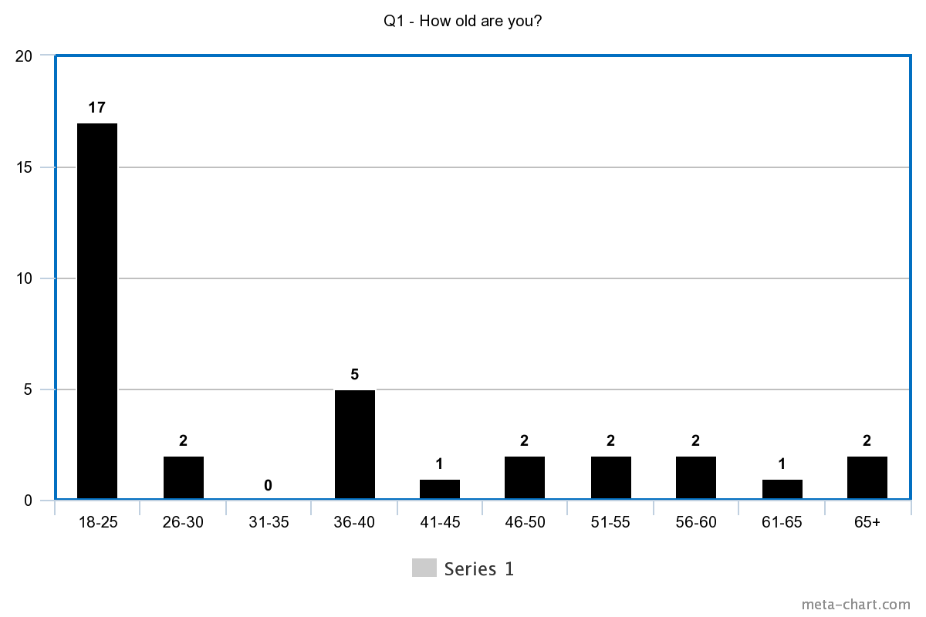
Fig. 71. Frequencies on Age at the BCB.
Results from both testing phases showed the ages were much more varied at PM&AG than at the BCB, likely due to a more tailored audience at the BCB and PM&AG from within the general public. Interestingly, at PM&AG, age did not have any defining age groups that took part, with the biggest age group at 21% consisting of 41–45-year-olds.
Results from the BCB showed a distinct interest from the youngest age group, 18–25-year-olds. This was likely due to groups of university students who attended the event and most of them falling within this bracket. 18–25-year-olds made up 71% of the total participants. From observations at the BCB it was clear the older generations felt somewhat alienated by the technology and wanted to continue looking at the ceramic displays instead. This was possibly due to a somewhat intimidating setup, requiring participants to be wired up to a few different devices at one time. This made it clear from the results that to make it most appealing to all audiences, and especially to those that a more reserved with technology, wireless alternatives would be appealing as this appears simpler visually and reduces the risks of wires getting tangled.
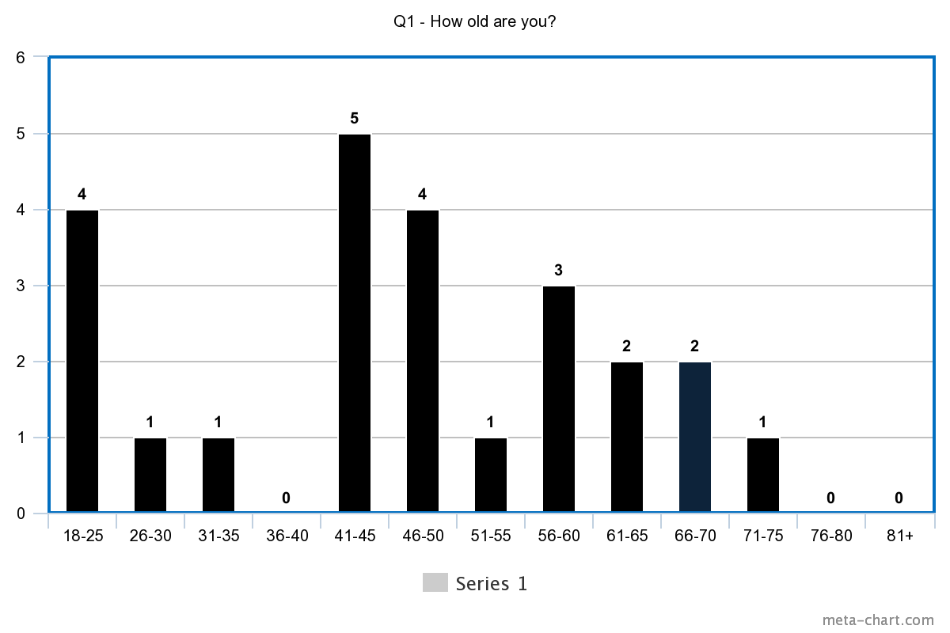
Fig. 72. Frequencies on age at PM&AG.
A range of ages took part in both testing phases showing no distinct target audience; however, it was clear from the results in Fig. 69 that youngest age grow was significantly lower than the first testing phase at a ceramic event (Fig. 68), showing a lack of younger museum visitors as expected from the research conducted in the literature review. This technology appealed to a wide range of ages and age did not limit the participant from getting involved.
Interestingly, the BCB shows a majority of participants being in the youngest age bracket which questions the motive for their attendance. From observations, this was mainly due to college and university students attending the event for their studies, showing how a younger person would be more likely to attend if they benefit from experiencing something informative and engaging to retain information.
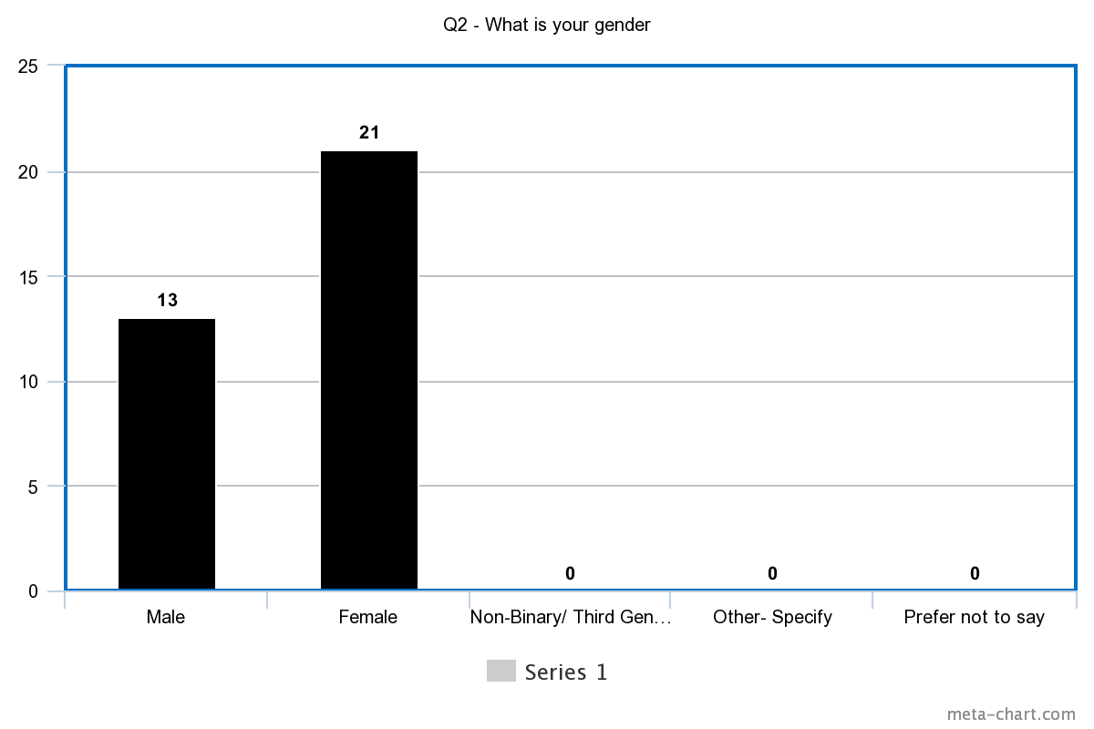
Fig. 73. Frequencies on Gender at the BCB.
The participants’ gender varied from the two sets of data. The first testing phase at the BCB revealed more women took part in the experiment, with 62% of participants recording themselves as Female.
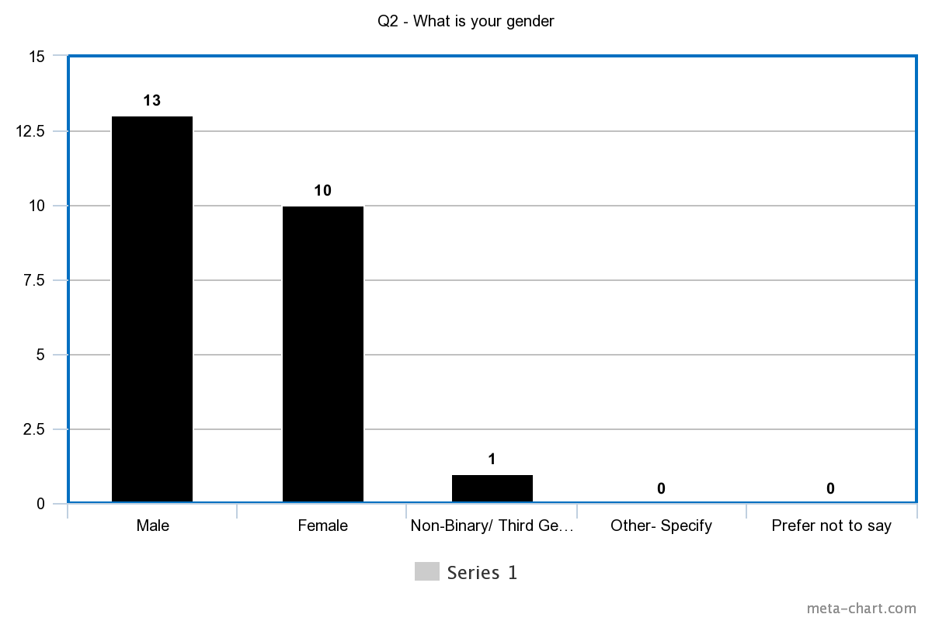
Fig. 74. Frequencies on Gender at the PM&AG.
However, the second round of testing revealed the largest group of participants were men with 54%, followed by women with 42% and then non-binary/third gender with 4%.
These results show this type of installation had no specific gender more interested than the other, but instead showed an equal participation across all genders.
Hammady’s (2019) research ‘Virtual guidance using Mixed Reality Historical Places and Museums’ showed similarities in findings. With a sample size of 171 participants displaying a fairly equal representation in terms of gender, resulting in 57.3% male and 42.7% female.

5.2.2 Participant Questionnaire Results
The following section evaluates and cross-analyses the questionnaire outcomes from the two testing phases. This data will help answer the research questions regarding increasing visitor engagement and how this experience has been received by a ceramic event’s guests and general museum visitors. These results will determine how successful the proposed framework was in creating a virtual experience suitable for learning about history through visual information and interaction.
Question three: How did you find navigating around the environment?
The results from the data collection showed that 76% of participants from the BCB were very happy navigating around the environment, giving a clear indication that they did not feel restricted or found it difficult, with the remaining responses recording they were happy to navigate around the scenes. PM&AG also showed consistency in positive responses, with 88% of participants feeling very happy navigating the experience.
This question helped show any potential limitations with the technology or the application. A positive response showed that Virtual Reality could be suitable to be used within museum displays and that participants feel comfortable using the equipment and navigating the application.

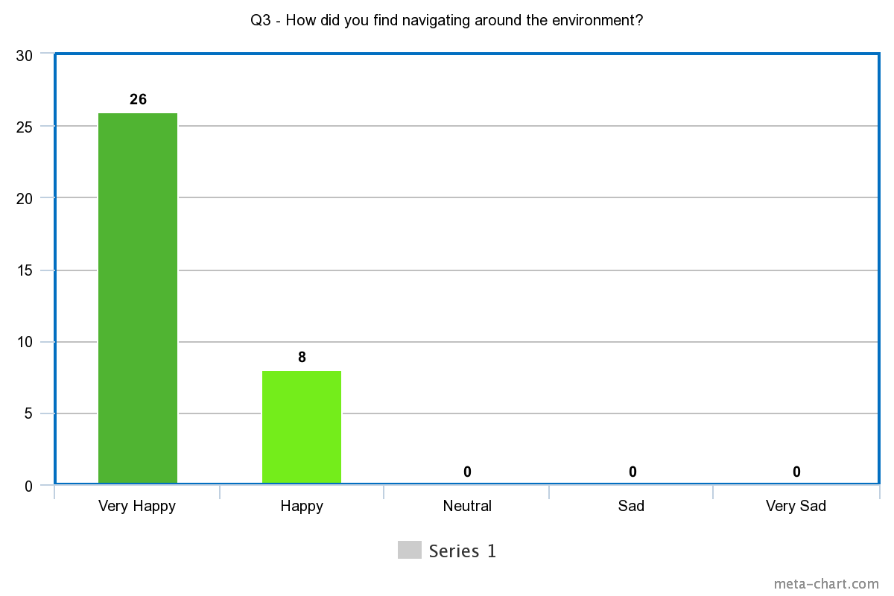
Fig. 75. Frequencies on 'How did you find navigating around the environment?', data collected from the BCB.
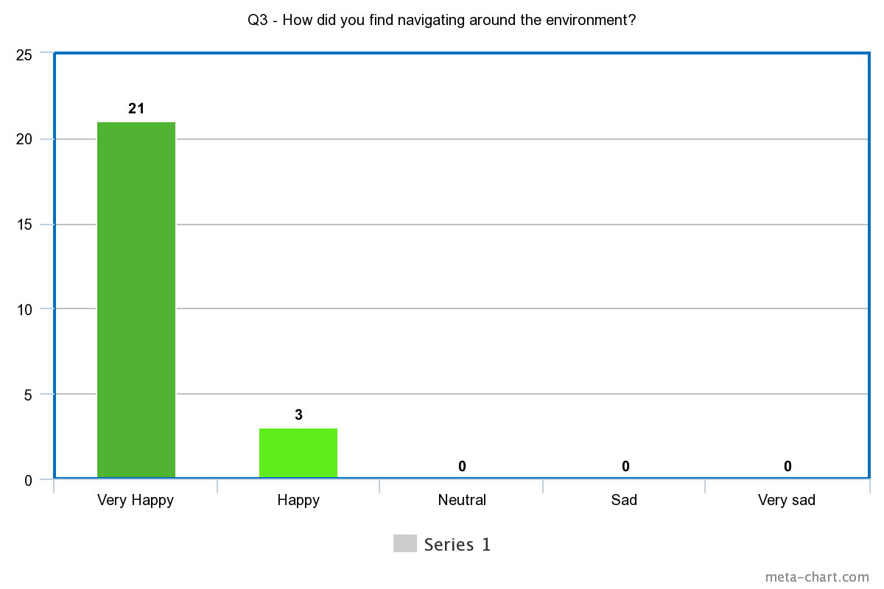
Fig. 76. Frequencies on 'How did you find navigating around the environment?', data collected from the PM&AG.
The main aim of the ‘Thornhill Experience’ was to demonstrate new and innovative methods to communicate history to help retain information through engaging content. Evidence to answer this question came from Question 4 in the questionnaire and through observation during the quiz in the experience. The observation relied on the players to select the correct answers, meaning the information was likely retained in previous interactions to know the answer in the quiz.
Question four: Do you feel like this experience helped you learn more about the ceramics?
The BCB showed 47% of participants felt they definitely learnt about ceramics from the ‘Thornhill Experience’, followed by 32% recording they probably did. The remaining 21% recorded that they might or might not have learnt more about the ceramics, suggesting a potential change that could be made to the experience to ensure the information is easily accessed and understood before progressing further.
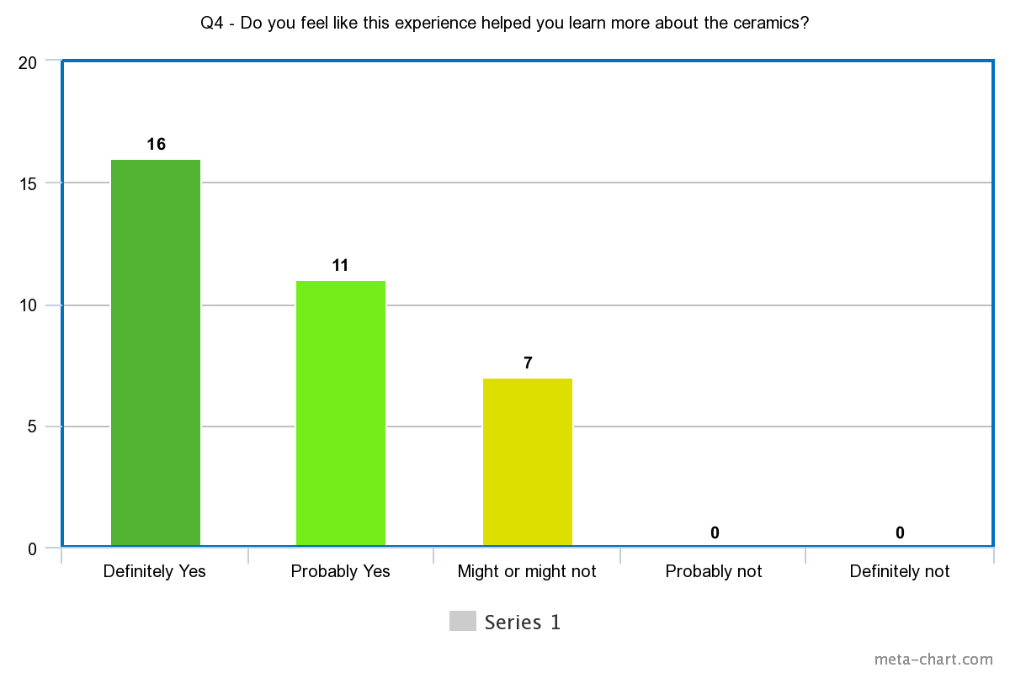
Fig. 77. Frequencies on ‘Do you feel like this experience helped you learn more about the ceramics?’, data collected from the BCB.
Comparing this data to PM&AG it was evident the results were very similar in response with 50% of participants saying they definitely learned more about the ceramics from this experience. Followed with 37.5% that probably learned more and the final 12.5% were undecided.
This experience focused on the possibility of retaining more information but without comparing directly with other sources of information. Instead, this experience questioned if this platform would be suitable as a standalone method to learn about a ceramic’s history.
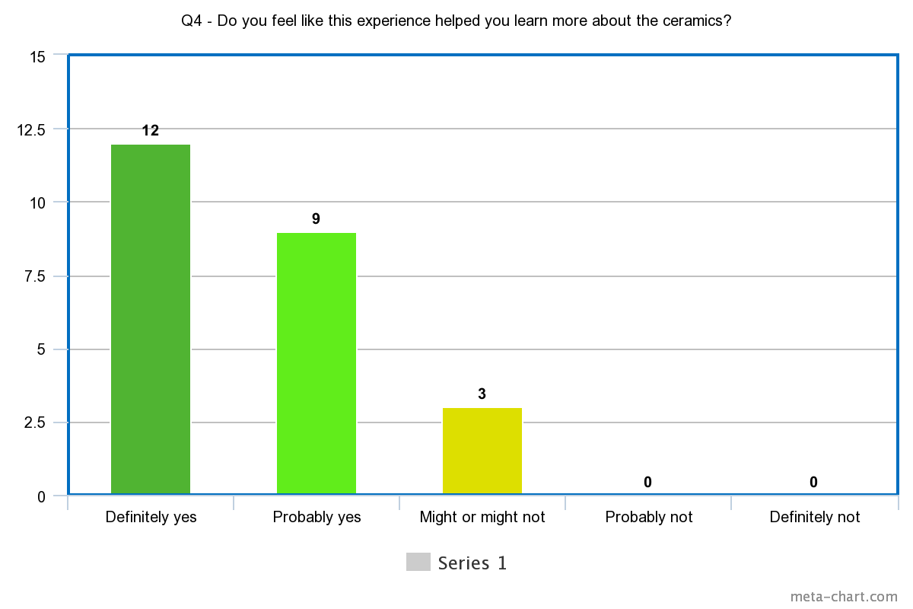
Fig. 78. Frequencies on ‘Do you feel like this experience helped you learn more about the ceramics?’, data collected from the PM&AG.
Question five: Do you think haptic Gloves Provide a realistic sense of touch?
This question was designed to receive feedback based on the chosen haptic glove in this study. These results would determine how the public responded to the gloves and if they added to the virtual experience. At the BCB, 42% of participants felt very happy with how realistic the sense of touch was with the haptic gloves in this study. Comparatively, 40% of participants felt very happy with the sense of touch at PM&AG, showing a similar result overall. At both testing phases, it was recorded that 1 participant felt very sad with how realistic the gloves felt, along will 3 sad and 10 feeling neutral overall, showing a range of responses with this technology. It was clear that not all participants felt satisfied by the implementation of haptics in VR.
However, overall, the majority of participants did record they were very happy or happy with how realistic the SenseGlove sense of touch was in the VR experience.
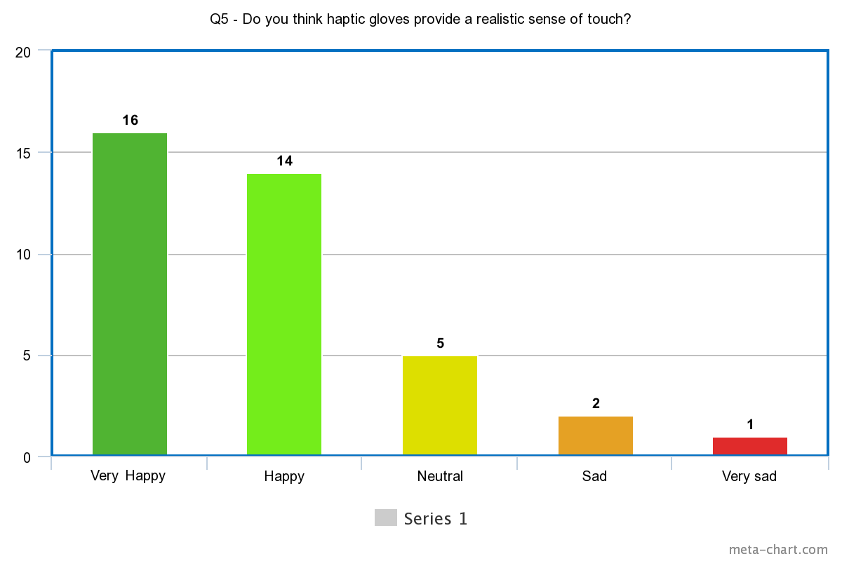
Fig. 79. Frequencies on ‘Do you think haptic gloves provide a realistic sense of touch?’, data collected from the BCB.

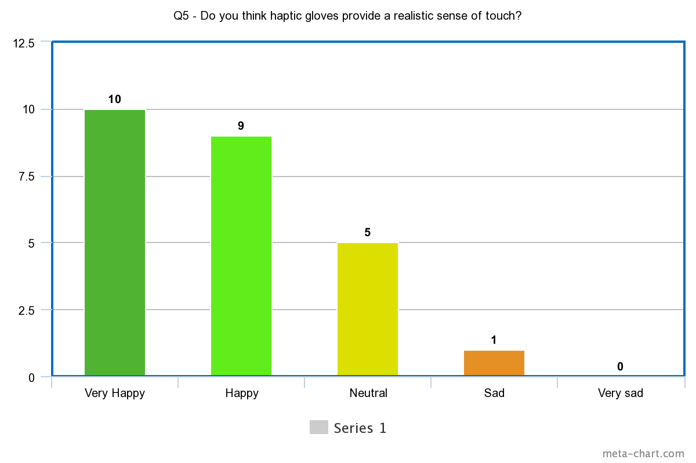
Fig. 80. Frequencies on ‘Do you think haptic gloves provide a realistic sense of touch?’, data collected from the PM&AG.
This research aimed to offer an alternative solution to the lack of accessibility to feeling an artefact. Holding an object can offer a lot of insights that visuals alone cannot offer, such as texture, forms, weight and simply seeing the underneath. The SenseGlove haptic gloves cannot offer the ability to feel the weight of an object, however, it can offer the ability to feel the artefacts dexterity freely and view from every angle, all while in a risk-free environment.
Question six: Do you think a digital surrogate is an effective alternative to interact with a ceramic?
Fig. 78 and Fig. 79 shows the majority of participants agreed that this was an effective alternative to holding a precious ceramic. However, 10 out of 59 felt it might or might not, while 3 felt this is not an effective alternative. While it is understandable that you are limited to what you can experience with touch, this experience offers the ability to interact with an artefact that is usually prohibited or, as with the Thornhill Collection, currently in storage and unavailable to view.
There are limited solutions to this limitation in museums with a strong suggestion from the literature review (See Chapter 2.2 Review of Selected Museums for Current Ceramic Displays) that in most cases you must view an artefact behind a glass cabinet, making it difficult to engage with for more than a glance. It was clear from these results that participants understood they were not going to feel like they were touching a real ceramic, although what makes the experience unique is the way you can interact and gain context visually.
Considerations for future developments could find methods to measure how much a participants felt the application felt real and to what extent the ceramics felt like the original. This could be shown through devices that measure a participant’s response or use eye tracking technology to analyse what the participant engaged with the most.
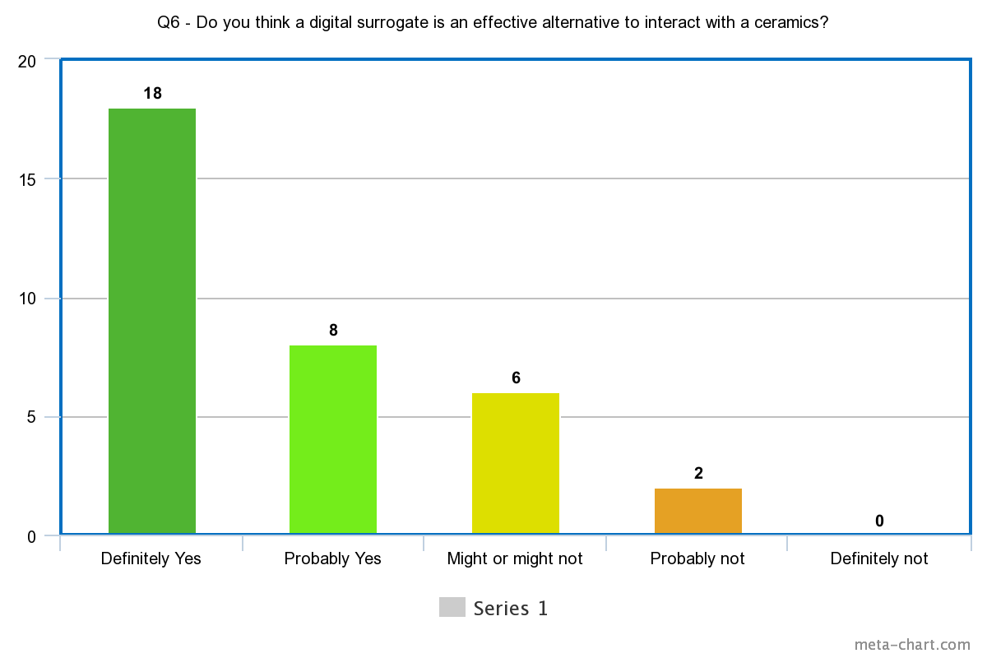
Fig. 81. Frequencies on ‘Do you think a digital surrogate is an effective alternative to interact with a ceramic?’, data collected from the BCB.
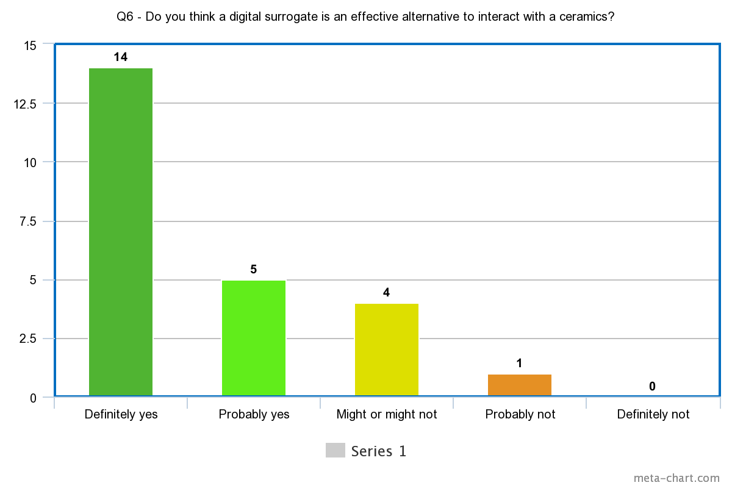
Fig. 82. Frequencies on ‘Do you think a digital surrogate is an effective alternative to interact with a ceramic?’, data collected from the PM&AG.
Question seven: How important do you think interaction is to understand a ceramics physical properties?
Results shown in Fig. 80 and Fig. 81 display a slight difference in the two testing locations. More visitors at the BCB ceramics event felt Interaction was extremely important to understand a ceramic’s physical properties, compared to the majority of participants at PM&AG responding with Very Important.
Showing a potential insight into the values of what each type of visitor wants from the experience, the ceramics event attracted ceramics enthusiasts with a passion for the craft and history. Therefore, they evidentially valued understanding a ceramic’s physical property more than general visitors attending the museum.
It was clear on the majority of votes that participants overall value the ability to interact with a ceramic in order to gain knowledge on physical properties. That may include seeing the underneath the ceramic, looking close up at details or seeing inside of negative spaces that would be difficult to see unless held.
However, with some participants in question of the effectiveness of this application as an alternative to interact with a ceramic. This questions the limitations of what Virtual Reality can offer due to the fact that VR is not a real concept and cannot replace a real artefact fully. These conclusions reaffirm this application as a potential beneficial tool to act as an addition to an original display, with the benefit of acquiring historical context visually and interactively.
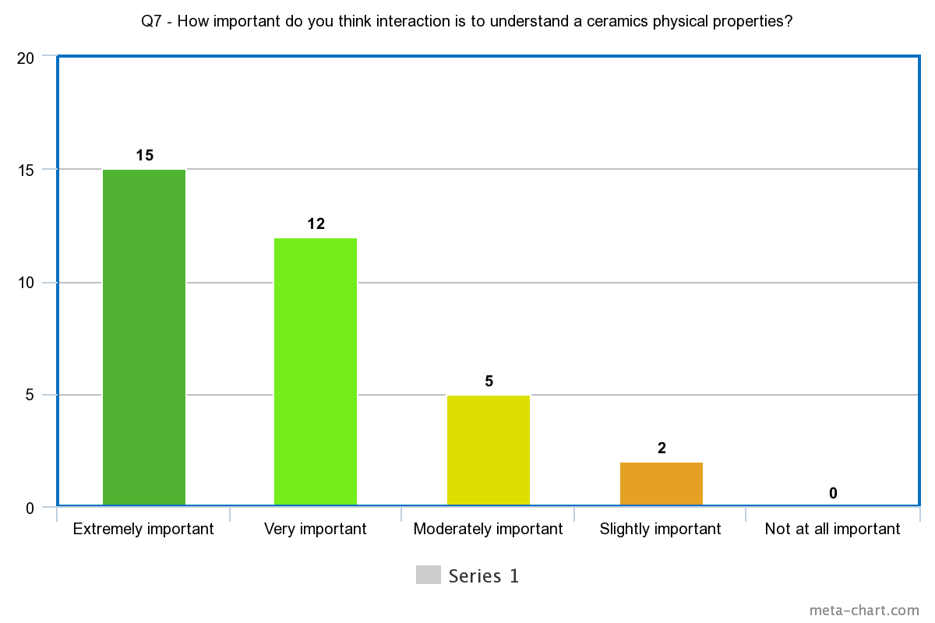
Fig. 83. Frequencies on ‘How important do you think interaction is to understand a ceramics physical properties?’, data collected from the BCB.

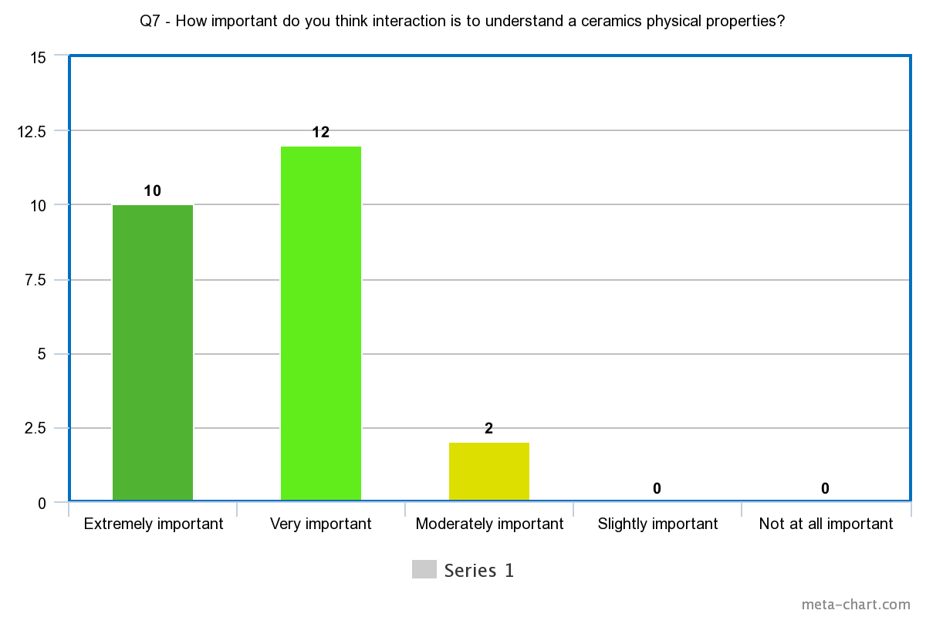
Fig. 84. Frequencies on ‘How important do you think interaction is to understand a ceramics physical properties?’, data collected from the PM&AG.
Question eight focused on user satisfaction of the experience. Participants were asked what their favourite part of the experience was. This received mixed responses, with the majority voting that their favourite was interacting one-to-one with a ceramic object, followed by exploring the tomb showing a positive response from putting the participant in multiple environments. In this case, the participant was transported into a tomb to visually demonstrate where the ceramics were found and provided with a reconstruction of what a traditional Tang Dynasty tomb looked like. The option with the least votes was playing with the drum, which was an anticipated result, as the drum was added as a surprise interaction to see if the participant could discover it upon doing a certain action.
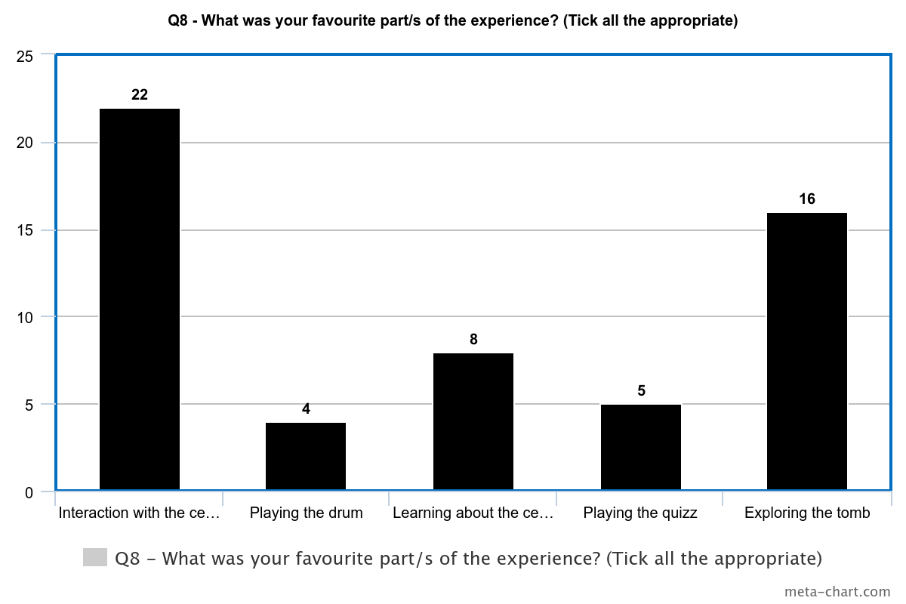
Fig. 85. Frequencies on ‘What was your favourite part/s of the experience?’, data collected from the BCB.
The action required dropping the Musician on Horseback ceramic whilst in the museum. The interaction aimed to show the musician was holding a drum by dropping a full-size Tang dynasty drum into the scene upon the ceramic smashing on to the floor. This also let the player pick up the drum and make authentic sounds upon touching the drum with a drumstick or hand.
This action acted as a discoverable source of information. This unpredictable interaction was implemented to encourage the visitor to stay engaged and maintain focus throughout the experience.
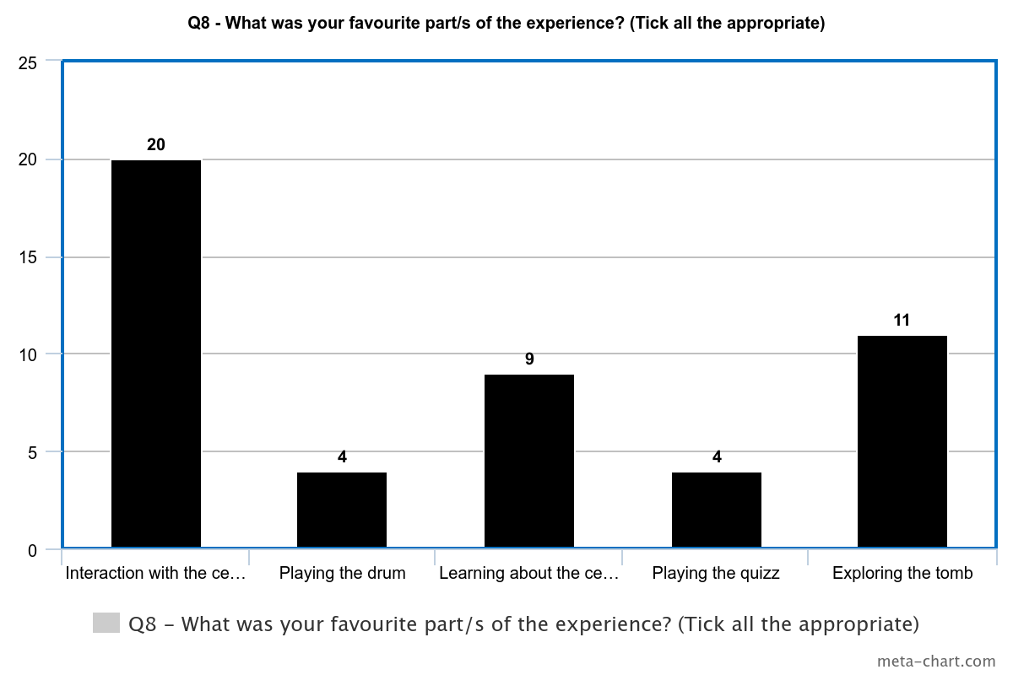
Fig. 86. Frequencies on ‘What was your favourite part/s of the experience?’, data collected from the PM&AG.
After focusing on User Satisfaction, the questionnaire then went on to find out about the desirability of this experience and if participants would want to try this again. Fig. 84 and Fig. 85 show the majority of participants would definitely feel encouraged to visit a museum if they were previously informed of installations similar to this one. With the exception of one out of the entire group of participants answering they might or might not be encouraged to visit, no participants answered that this technology installation would discourage them from visiting a museum.
It is likely the response numbers had a strong relation to the layout of the experience. When the player first enters the experience, they encounter the ceramics in front of them, so is likely to stick in a player’s mind as it is the first encounter that allows haptic touch. The exploring of the tomb is likely popular due to this being essential for the player to progress through the different levels and a change in environment is a drastic change for the player to experience. This may also remain a high interest among visitors as a recreation of an old tomb is visually interesting due to limitations in context if the tomb is described through text or shown through 2D imagery.
Learning about the ceramics is shortly behind exploring the tomb and this is likely popular due to this being a motivating factor to try the technology. A visitor attending the museum could possibly intend to learn more about history, therefore, any learning aspect about the ceramics would be favourable for the visitor to feel the experience was helpful.
The playing of the drum may have received fewer votes purely as it was a hidden feature that would not always be discovered. This was purposefully designed to make the experience feel unpredictable and exciting, while the quiz may have received fewer votes because visitors felt it was challenging mentally to recall information or physically to navigate around the room.
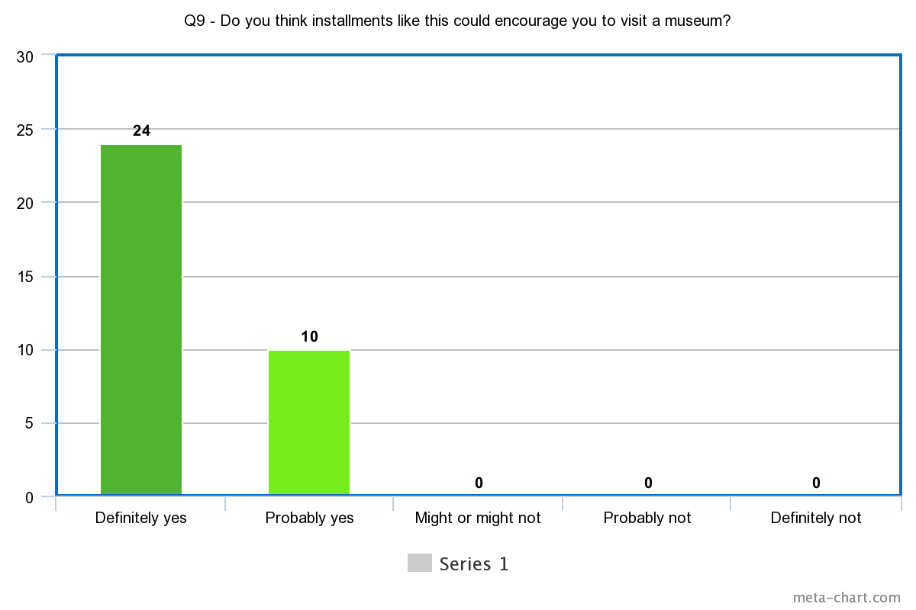
Fig. 87. Frequencies on ‘Do you think installations like this could encourage you to visit a museum?’, data collected from the BCB.
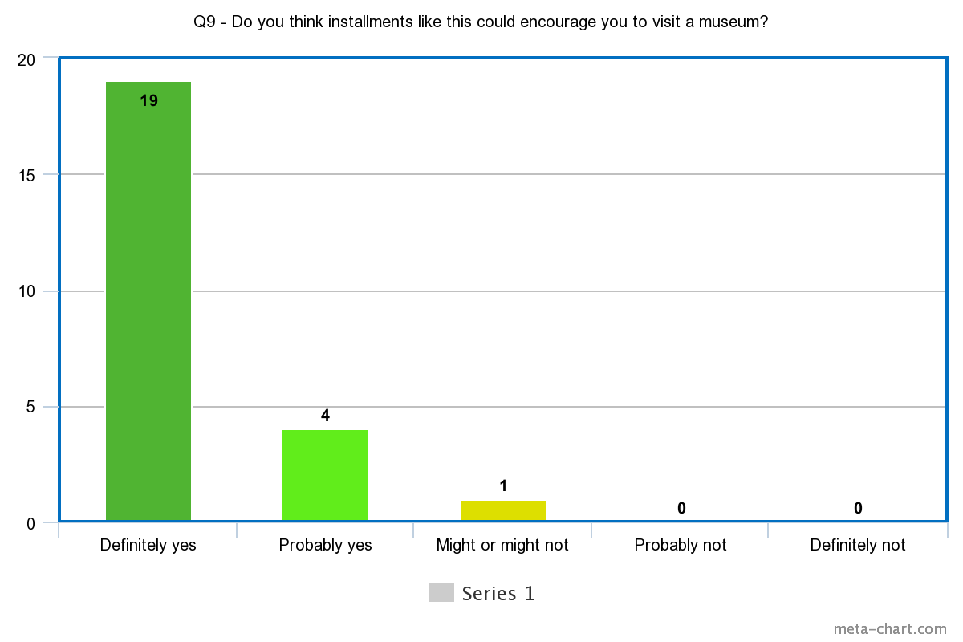
Fig. 88. Frequencies on ‘Do you think installations like this could encourage you to visit a museum?’, data collected from the PM&AG.
This research focuses on exploring the possibilities of how museums can incorporate technology into museum settings to enhance a visitor experience. With this aim, it was important to question the desirability of visitors to see technology incorporated into museums in the future. Fig. 86 and Fig. 87 show 88% of participants from the BCB and 96% from PM&AG would like to see more technology in museums in the future. This shows a distinct desirability towards this research and therefore solidifies the significance into developing suitable technology for museum installations.
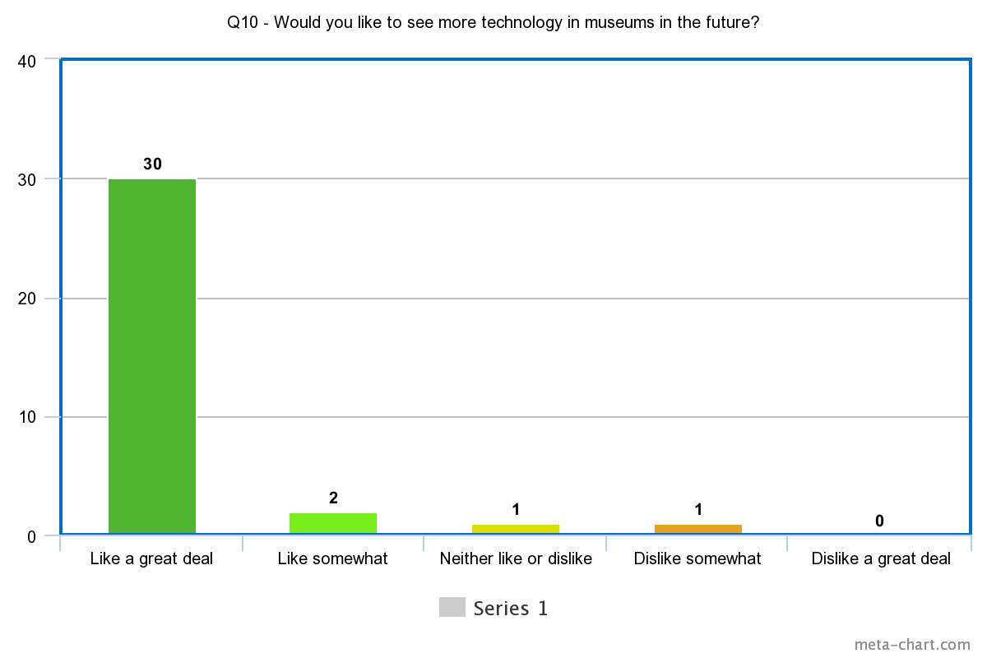
Fig. 89. Frequencies on ‘Would you like to see more technology in museums in the future?’, data collected from the BCB.
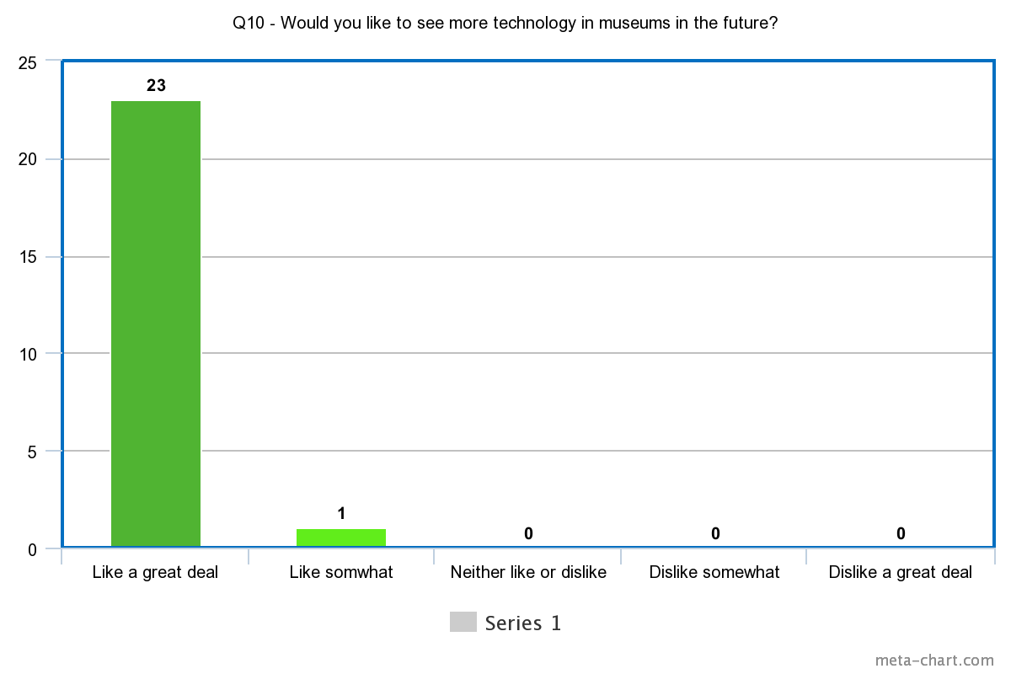
Fig. 90. Frequencies on ‘Would you like to see more technology in museums in the future?’, data collected from the PM&AG.
The method employed to analyse this data involved the User Interface Satisfaction questionnaire, also known as QUIS. This is used to compare responses and evaluate the software and hardware used in this study, therefore comparing how Virtual Reality, haptic technology and the ‘Thornhill Experience’ impacted the visitors’ experience in the museum setting. The questionnaire was structured to gauge if a visitor enjoyed the experience, if it helped them learn more about ceramics and if this was desired in current displays to encourage future visits.
Results show some complications with the haptic gloves appearing realistic enough for participants to interact freely with the ceramics. Some visitors felt dissatisfied by the limitations of what could be the sense of touch offered. However, from observations, it was found that most visitors acknowledged the limitation but felt it did not impact their experience due to the limitless access to ceramics that could not be accessed in real life. The experience focused on the playable nature of the experience as opposed to how realistic it could feel to hold a ceramic. This took the focus away from the limitations of touch and focused on the importance of acquiring information about an artefact through 3D visuals and interactivity.
It was clear participants had a mostly positive response to the experience and confirmed their interest and desire to experience other technology installations such as this one through the responses in the questionnaire. This gave clear confirmation that the majority of visitors would be more encouraged to visit museums in the future if projects such as this one was implemented.
Future work could include considerations towards visits to museums that may have not occurred if the technology had not present to encourage attendance. This work could highlight the appeal for technology through feedback on whether a participant only attended due to accessible technology-based installations. An article by Kelly Song (2017) discusses how technology is helping museum attendance and encouraging visitors that may have shown a lack of interest before technological installations. With places the Metropolitan Museum of Art in New York City with an increase in attendance with more than 7 million visitors in 2016. With recent digitisation of more than 380,000 images from its collections, making art available to view and download digitally.
“The best use of digital is to not make you aware of the technology, but to make you aware of the art.”- Jane Alexander (2017)
Data from the testing phases confirmed this experience offered an alternative method of accessibility to museum visitors that enables new interactions with ceramic displays and surrounding visuals that would be impossible or exceedingly difficult to replicate in real-life. These unique interactions confirm the usefulness into incorporating this technology to help visitors use this experience as a tool for visual information and provide a role of creating engaging installations that show an artefact in a multimode of contexts.
One missing factor in these results was creating a profile for visitors. This research would have benefited from understanding how experienced visitors were with VR to assess the experience levels of participants. This would have also been compared to age to see if this correlated with an overall positive experience and if they found it easier to retain information.
The Observation analysis does address this will general observation and any correlating factors, however this is limited due to no factual data that could be compared.

5.3 Observation Analysis
The results from the data come from two collective methods. Firstly, observations to assess the participant’s behaviour and conclude how long they engaged with ceramics compared to a traditional museum display, and secondly, testing the proposed framework to use QUIS as an effective form of analysing user satisfaction and usability within a museum setting from the questionnaire results.

5.3.1 Visual Observation
Overt observations were conducted as a qualitative insight of data that watches the participants responses during the experience and recording any common occurrences or unique interactions through screenshots and notes (CDC, 2018).
Before the experience started participants were verbally asked if they had ever used VR before and whether they had experienced any negative side effects. This was performed to conduct a small risk assessment before they read the consent form to assess if the participant, as an individual, required additional support or if the experience may not be suitable for them. It was found that the majority of participants aged 18-25 had used VR before and felt confident using the technology, however, a substantial number of participants aged 50-80 did not have experience and required additional assistance to help them navigate the experience and took them longer to get started. On average, a participant took around 10-15 minutes within the ‘Thornhill Experience’, however this differed depending on the age and previous experience with VR. The longest participant took roughly 20 minutes to complete the experience from start to finish.
Through observations, it was found that participants ages 18-30 tended to complete the experience the quickest but requested they have multiple goes to get the most from the experience and interact with everything they could find.
Through observations, it was found that audio guidance was necessary for most participants, as they would need prompts to lead them into stages and navigate fluently around the scene It was clear that an introductive scene to provide instructions would have helped the participant understand what they needed to do, alternatively prompts within the environment would be beneficial to help a participant in the moment they are struggling with. It was concluded that a supervisor would be required due to donning the equipment safely as this would be difficult to do solely.
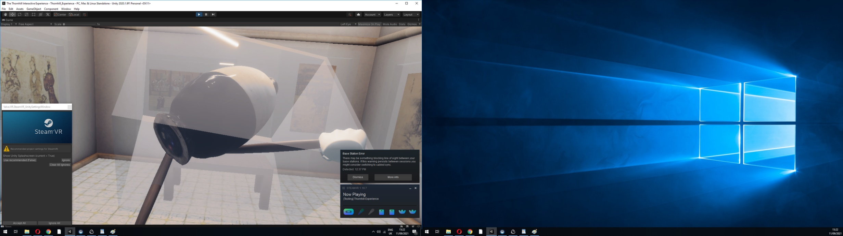
Fig. 91. Screenshot of participant holding multiple objects using their drumstick.
It was found through observation that some individuals enjoyed trying to evaluate the game’s breakability and wanted to find possible bugs within the scene that could create a unique reaction. Fig. 88 shows the drumsticks attaching onto other items in the scene, impressively not shattering the glass cabinet. Fig. 89 shows a player successfully grabbing two objects at the same time. This was a challenging task to achieve due to the realistic physical properties, however, this exception proved it is possible. Fig. 90 shows quite a skill for the player to successfully balance one ceramic on top of another and let go without them falling. This is exceedingly difficult due to the collisions being temperamental, but this showed the potential of how objects can act within a virtual scene.
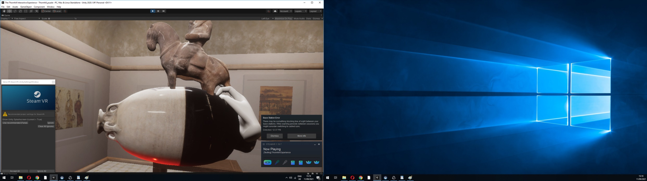
Fig. 92. Screenshot of participant holding 2 ceramics with one hand.
Participants pushed the boundaries with the physical properties of these ceramics. It was clear that the more confidence the participant gained, the higher the level of experimentation on top of the requirements to complete the game, to push the boundaries of what the VR experience can offer and added that playful element of discovery.
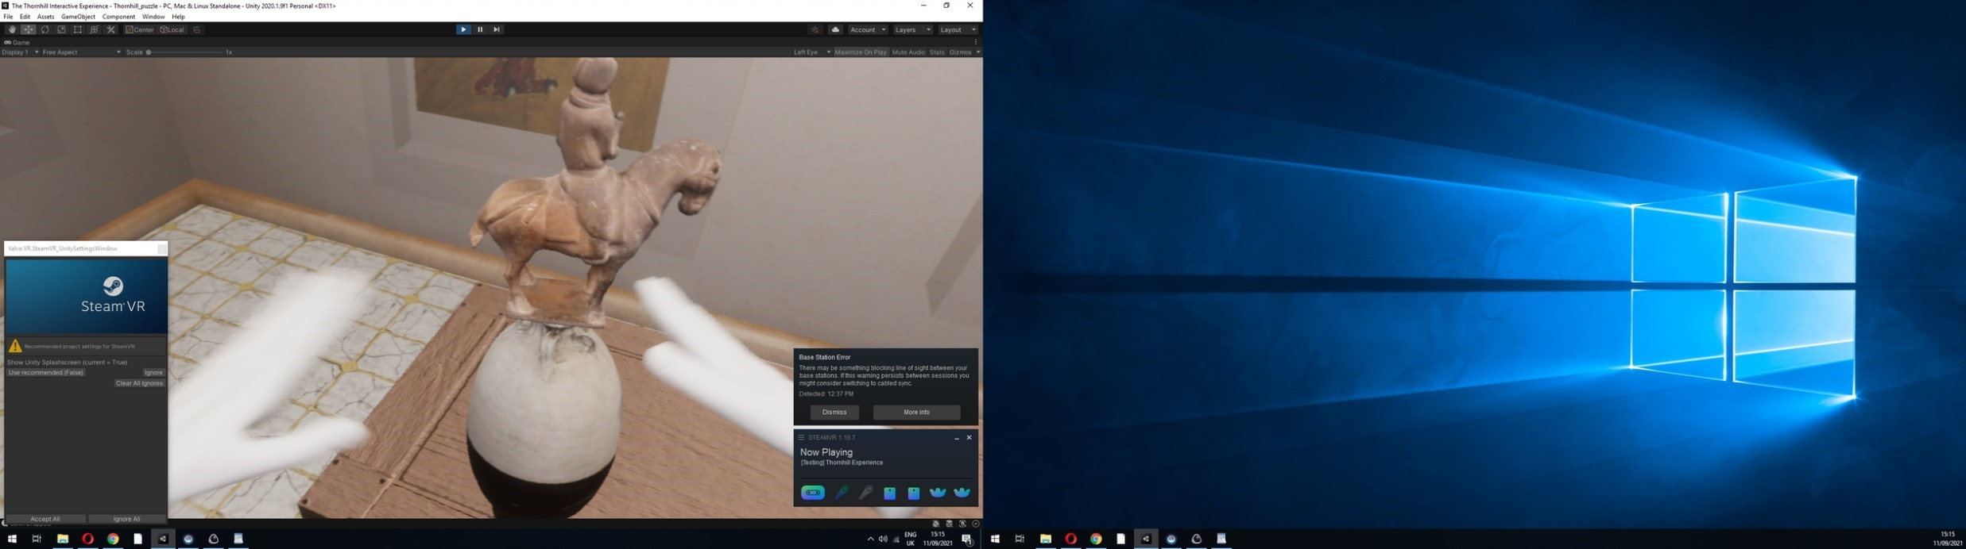
Fig. 93. Screenshot of participant successfully balancing one ceramic on another.
Regarding observing the equipment on the participants, it was clear the exoskeleton design of the SenseGlove haptic gloves showed some possible defects that could hinder a visitor experience. Firstly, donning the gloves on to a participant took roughly five minutes due to instructing the participant to sanitise, apply disposable gloves, directing how the hands will be positioned and assisting them putting the gloves on. Occasionally the fingertips on the SenseGlove would detach from the participants fingers and would require assistance from the supervisor to reconnect the fingers, as they were unable to see from the VR headset on their head. The bulky nature of the SenseGlove meant that if the finger straps came away from the finger, it would be difficult for the participant to fix without assistance from someone else.

5.3.2 Observations from Questionnaire.

Table 2. Participants favourite part of the experience at the BCB.
Participants favourite part of the experience | Frequency
“The interaction with the ceramics was one of my favourite parts” | 22
“Playing the drum was one of my favourite parts” | 4
“Learning more about ceramics was one of my favourite parts” | 8
“Playing the quiz was one of my favourite parts” | 5
“Exploring the tomb was one of my favourite parts” | 16

Table 3. Participants favourite part of the experience at PM&AG.
Participants favourite part of the experience | Frequency
“The interaction with the ceramics was one of my favourite parts” | 20
“Playing the drum was one of my favourite parts” | 4
“Learning more about ceramics was one of my favourite parts” | 9
“Playing the quiz was one of my favourite parts” | 4
“Exploring the tomb was one of my favourite parts” | 11

5.3.3 Results

Most of the participants recorded that their favourite part of the experience was interacting with the ceramic objects. (Offering a visual representation of the ceramic in high detail).
The second favourite part of the experience was exploring the tomb environment. (Providing visual information on former use and where the ceramics were originally found)
The third favourite part of the experience was the information given to the participant via text to learn about how old the ceramic is and how it was created.
The fourth favourite part of the experience was participants playing the quiz. (Likely due to the entertainment/gamification value)
The fifth favourite part of the experience was participants playing the drum. (Likely due to making this interaction an ‘easter egg’ style discovery to make the game feel unpredictable. However, this led to the drum not always being found.) This interaction was triggered upon dropping the Musician on Horseback on the floor and causing a drum to appear behind the player. The drum relates to this ceramic due to this instrument representing what the musician would have been holding in a real-life version.

5.4 Questionnaire Analysis
The questionnaire was formed to determine definitive results that provided evidence towards answering research questions three, four and five in this research. The User Interface Satisfaction Questionnaire (QUIS) was used as a designed measurement tool to assess a user’s satisfaction using the computer interface. In this case, the Virtual Reality setup of the digital museum.
The QUIS method has been used in this research to determine user satisfaction results based on three key factors:
- Effectiveness (What information was retained)
- Efficiency (Serving the desired purpose)
- Usability (Ease of use with the equipment)
- Desirability (Desired within the target audience and setting)
In order to collect the data, the System Usability Scale (SUS) method was used to create a series of questions that would be suitable for a wide audience of museum visitors whilst obtaining suitable data with valuable results.
The data was framed to allow visitors to have an emotional response to the questions by assessing their satisfaction through standardised measures that identify with ‘good’ or ‘bad’. This was portrayed through faces displaying very happy, happy, sad, neutral, angry, or very angry emotions, accompanied with colours that are often linked in standard questionnaire layouts used for the public in the United Kingdom.
A breakdown of colours and associated responses are as follows:
- Dark Green- Very happy face
- Lighter green- Happy face
- Yellow- Neutral face
- Light red- Angry face
- Dark red- Very angry face
The following results have been combined to include both happy and very happy within the positive category, with angry and very angry combined in the negative responses. This has been done to apply the SUS method that will obtain direct comparative data with the positive, neutral and negative responses.
Table 4. Participants positive responses to the experience.
Positive responses about the ‘Thornhill Experience’ | Frequency
Usability: “I felt happy navigating around the environment” | 58
Effectiveness: “I felt this experience helped me learn more about ceramics” | 48
Usability: “I think the haptic gloves provided a realistic sense of touch” | 49
Efficiency: “I think a digital surrogate is an effective alternative to interact with a ceramic” | 45
Effectiveness: “I think it is important to interact with a ceramic to understand its physical properties” | 49
Desirability: “I think instalments like this would encourage me to visit a museum” | 57
Desirability: “I would like to see more technology in museums in the future” | 56
Total | 362

Table 5. Participants neutral responses to the experience.
Neutral responses about the ‘Thornhill Experience’ | Frequency
Usability: “I felt ok navigating around the environment” | 0
Effectiveness: “I felt this experience may or may not have helped me learn more about ceramics” | 10
Usability: “I think the haptic gloves provided a realistic sense of touch” | 10
Efficiency: “I think a digital surrogate might be an effective alternative to interact with a ceramic” | 10
Effectiveness: “I think it is somewhat important to interact with a ceramic to understand its physical properties” | 7
Desirability: “I think instalments like this might encourage me to visit a museum” | 1
Desirability: “I might like to see more technology in museums in the future” | 1
Total | 39

Table 6. Participants negative responses to the experience.
Negative responses about the ‘Thornhill Experience’ | Frequency
Usability: “I struggled navigating around the environment” | 0
Effectiveness: “I felt this experience did not help me learn more about ceramics” | 0
Usability: “I think the haptic gloves provided an unrealistic sense of touch” | 4
Efficiency: “I think a digital surrogate would not be an effective alternative to interact with a ceramic” | 3
Effectiveness: “I think it is not really important to interact with a ceramic to understand its physical properties” | 2
Desirability: “I think instalments like this would discourage me to visit a museum” | 0
Desirability: “I would not like to see more technology in museums in the future” | 1
Total | 10

5.5 Descriptive Analysis

There were four forms of evaluation on the feedback provided from both testing phases. These constructs were formed to target key factors that go into a technological exhibit. This framework was constructed using the User Interface Questionnaire method to evaluate the level of user satisfaction of the software and hardware used for the ‘Thornhill Experience’.

Usability-
“How participants responded to navigating around the experience and how they felt using haptic enabling technologies within a virtual museum setting”

The useability links to the system capabilities of the experience and the implementation of haptic devices. This provides insight in to whether the experience has been constructed efficiently for a positive response. This concept analyses the system created and how it delivers as an experience. This can relate to the technology utilised in this study and how the visitor felt within the Virtual Reality experience.
Results on the ‘Usability’ by both testing phases were overall positive. 58 recorded responses felt happy navigating around the environment, with an additional 49 responses recording they felt the haptic gloves did provide a realistic sense of touch.
No recorded participants responded that they found the environment difficult to navigate, therefore confirming the experience was a success in the testing phase settings it was implemented into. This assures that a familiar museum environment with a free ability to interact with any object somewhat reflected the way they would interact with the object in real-life.
A total of four participants recorded a negative response to how to haptic provided their sense of touch and acknowledging that this did not feel realistic compared to real-life interaction. This poses some exploration to discover better ways to interact with the objects and staying open to the possibility of more sophisticated developments that imitate a more realistic sense of touch.
Effectiveness-
“If the participant felt the experience helped them learn more about the ceramics and if the interaction benefited their understanding”
The effectiveness links to the learning factors in the QUIS method and focuses on how effective the content was in helping visitors learn more about the ceramic collection.
This concept highlights what the overall attitude is from visitors that view ceramics. This shows whether they value the ability to interact with an artefact that would alternatively be forbidden to do so, as well as seeing if the visitor personally felt the experience helped them obtain information and retain it after the experience to have a better understanding of the historical context of a ceramic artefact.
Results showed 49 recorded responses valued the importance of interaction with an artefact, in order to understand the physical properties, with a further 48 confirming they felt the experience definitely helped them learn more about ceramics. 10 recorded responses felt impartial to whether the experience helped them retain information from the experience, with no recorded responses reporting the experience did not help them learn more about the ceramics.
Showing an indefinite response to the usefulness of the experience helped educate the visitors within a virtual space, all whilst increasing the chances of retaining information due to the visitors recording that they definitely thought the experience taught them valuable information that they could recall.
Efficiency-
“If this type of installation enhanced the visitors overall experience and performed as an alternative method of gaining information”
Efficiency explores the user interface satisfaction method (QUIS) through direct responses from participants on how the experience affected their museum experience in comparison to traditional displays.
This concept explores the views from visitors of using this technology as an alternative form of interaction that is forbidden from real-life displays. This feedback will allow the researcher to understand whether this virtual experience can work in typical display setups as an additional tool to acquire information.
It was evident that feedback showed 45 recorded responses expressing the importance digital representation can offer as a surrogate alternative for hands-on interaction. With a further 10 responses feeling as though this might be an effective solution to implementing interactive displays. Three responses felt as though this solution would not offer an effective alternative, likely due to the limitations in technology and what cannot be experienced with the current setup.
Desirability-
“If the experience would be desired by the target audience in future displays within museums and cultural heritage sites”
Desirability explores user satisfaction through the potential demand from the target audience of participants in this study. This concept addresses the likeliness of visitors attending museums and exhibits with the additional motive of trying the experience and gathering an opinion on whether they would like to see more technology in museum settings in the future.
It was clear from the feedback that an overwhelming number of visitors showed desirability and genuine interest in the technology installation, with 57 responses confirming that installations similar to this research would definitely encourage them to visit museums in the future and a further 56 responses confirmed that they would like to see more technology installed in museums in the future. An exceedingly small number of responses were left for the other categories, but one participant felt they might be encouraged to visit museums and one participant might like to see more technology, possibly depending on what the experience is designed for. No responses were recorded for visitors feeling discouraged to visit museums if instalments like this research were present and one recorded response would not like to see more technology in museums in the future.
This opens a discussion on what technology would not be suitable within a museum setting, perhaps being mindful to not distract away from the original artefact with technology or causing the original ceramic to lose visual value with other visual distractions.

5.5.1 Data Findings
In conclusion, this data shows a prodigiously positive response to the technology installation within a museum or exhibition setting, with clear benefits for many of the participants who took part in the ‘Thornhill Experience’.
Question four in this research asks how this application could be implemented into a museum to enhance learning for the future benefit of educating history. This question is approached through the user Interface Satisfaction Questionnaire (QUIS) method to identify how the participants responded to the experience and understand key focuses to achieve an interactive, virtual learning tool that can benefit future museum displays.
Enhancing learning has two key goals, to help retain information while making an entertaining system for the museum visitor target audience. The majority of participants confirmed positively that the experience helped them learn more about ceramics, confirming the potential for integration of similar technology being used as an alternative tool to acquire information.
The perceived usefulness from participants shows a significantly positive response expressing the importance of digital representation with artefacts to allow interactive experiences with history, with a clear desirability and genuine interest in digital heritage in museum displays in the future.
Limitations in the findings include a lack of comparable data. This would have been particularly helping into comparing how long a traditional display would have been observed, along with how long visitors interacted with the ceramics in the ‘Thornhill Experience’. The ‘Thornhill Experience’ on average took roughly 10-15 minutes to complete from observations, offering a distinct comparison with evidence from existing research showing visitors on average observed an artefact for roughly 15 – 30 seconds (Kaplan, 2017).
"The 3-Second Museum Visitor" Phenomenon: A study by J.K. Smith and L.F. Smith (2001) found that the average museum visitor spends less than 10 seconds looking at any individual artwork. This has led to the popular notion of the "3-second museum visitor". However, this is an average, and there are certainly visitors who spend much longer at individual exhibits.
Factors Influencing Viewing Time: A study by Bitgood (2009) found that several factors influence how long a visitor will spend at an exhibit. These include the visitor's interest in the topic, the complexity of the exhibit, the visitor's prior knowledge, and the presence of interactive elements or multimedia.
Interactive Exhibits: Exhibits that are interactive or that invite visitor participation do tend to hold attention longer. For example, a study by Serrell (1997) found that interactive exhibits can engage visitors for several minutes at a time.
Label Reading: The presence and length of labels or accompanying text can also influence viewing time. Some visitors read labels thoroughly, while others may skim or skip them entirely. A study by Serrell in 1995 found that the average visitor reads only about 20% of the text provided in an exhibit (Serrel, 1995).
Group Dynamics: Visitors who are part of a group or who are discussing the exhibit with others tend to spend longer at individual exhibits. This social aspect of museum visiting can significantly influence viewing behaviours.
Comparing VR and Physical Exhibits: The comparison between VR and physical exhibits is an emerging area of research. Factors such as immersion, interactivity, and the novelty of the VR experience can influence how long users spend in a virtual environment. However, the direct comparison between VR and physical exhibits in terms of viewing time would depend on the specific context and design of the study.
A second limitation found in this data includes definitive evidence of the exact information retained by visitors from this experience, where the data gathered relied on opinions from the visitors and whether they feel this experience was useful. However, this is an important aspect to consider with Objective five, which focuses on the reactions and behaviour patterns to question the potential of combining this experience with mainstream museum displays.

Chapter 6: Discussion and Conclusion

6.1 Introduction
Museum visitors have seen a significant rise in technology installations to aid context and benefit the museum experience. Through audio guides, interactive tablets, 3D generated artefacts and other robotic technology to enrich their experience over the last couple of decades. Therefore, it is time to explore what further advancements technology could offer to transform the way museum visitors learn about history, facilitating an entertaining, yet unusual solution to better engage contemporary audiences. This chapter concludes with findings, theoretical and practical contributions to highlight this research’s significant value and final views on possible directions to develop and influence future work.

6.2 Summary of Thesis
In summary, this research was undertaken within museum development and to define the purpose of using digital heritage in the public domain. It was clear from the literature that there was a significant lack of technological advancement in the museum setting, therefore negatively impacting visitor engagement with ceramic displays. The displays showed a significant lack of context that could only be provided through audio guides or flat screen displays. However, these methods still limit the user’s senses and inability to engage with an artefact. The research starts with an overview of what current museums offer to a visitor, enabling the research to identify a novel approach for developing a Virtual Reality system that introduces a limitless way of interacting and learning about the Thornhill ceramics. Studies showed that technology is being used more in recent years, but these exhibitions only remain temporary for a matter of weeks or months which limits the visitor to a time frame.
This research study followed the design and development of other Virtual Reality applications and existing methodologies within the digital heritage sector to develop an application combined with haptic enabling technology. The results of these experiments indicated a positive response from visitors and provided evidence of a high-level engagement from information retained and the increased amount of time spent interacting with an artefact when the visitor can handle the ceramics without limitations. The experience proved an efficient way to offer visitors an alternative motive to visit a museum, using an interactive application that would be educational but also entertaining. The technology could prove to be an issue given on the expense of acquiring the technology and the problems faced with the hardware causing hazardous scenarios due to a sizeable number of wires for the visitor to navigate around safely.
Evidence also showed from testing that the visitor responded well to a playable source of information. Interactions kept the visitor engaged until the experience ended. Discoverable interactions, such as the drum appearing upon dropping the musician on horseback ceramic, offered surprise motives to encourage the player to explore the experience thoroughly.

6.2.1 Conclusion
Museums have certainly seen an increase in experimentation to include technology in their installations, with the majority of museum experiences offering virtual guides around the displays and limiting the visitors’ sensory opportunities to visual and auditory technology (TheBritishMuseum, 2023).
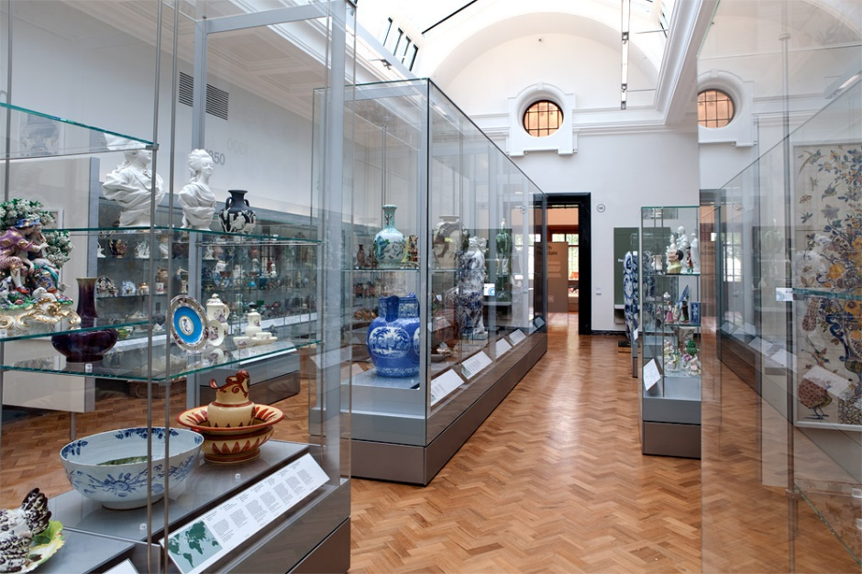
Fig. 94. The V&A museum ceramic display.
It is frequent practice to offer audio guides to visitors walking around the museums to offer an alternative source of context to the traditional text panel (Delft, 2019). This research supports the desire and intention to create exciting and new technological advancements within the history and heritage domains. Haptic technology is still in its nascent form and has a long road of potential ahead to create more vigorous and polished haptic gloves that can offer full accessibility in Virtual Reality to interact freely. This project proves the potential of haptic gloves enhance a VR experience for visitors in a museum and how the added sense of touch adds a new dimension to what the visitor can do compared to physical displays.
The research undertaken has highlighted the issue that exists in museums to be able to offer a range of experiences that avoid the traditional text panel that was proven to have become outdated to a contemporary audience. However, other factors can contribute to the limitations of haptic technology making its way into museums and galleries around the world, such as cost. Most museums will only have so much funding to budget what they spend on a display. Haptic technology ranges in price but is often in the thousands, for example SenseGlove’s Nova glove costs £3826 (SenseGlove, 2022).
Projects such as this one demonstrates the potential in making it a commitment to invest in the technology, and results show the positive response from visitors. However, museums need the ability to see how they can utilise this technology in various displays and functions to justify the potential investments of time and money.
By collecting data on desirability during the testing phase of this research, results proved the potential of how haptic gloves could be received by museum visitors with mainstream display setups. This technology shows a structure of how information can be communicated to a visitor through visual representation and immersive, interactive content.

6.3 Revisiting Research Questions
Question One: How can the visual and tactile characteristics of historical ceramic artefacts from the Thornhill Collection be recorded, displayed, and experienced through innovative modes of digital dissemination?
This question was answered through the use of existing object analysis frameworks to breakdown the historical context of a ceramic. These methods form ways for the visitor to experience contextual information in an interactive alternative to text displays. This research uncovered the most suitable methods of digitising an artefact to maintain the authentic visuals into a 3D version. This outcome provided a digital archive suitable to be used to document the Thornhill ceramics virtually.
The tested methods outlined a linear process using photogrammetry to gather visual data and reconstruct ceramics into a 3D digital replica, this process is called digitisation.
The haptic devices implemented into this application allowed for freedom of interaction with the scenes and allowed explorative methods of discovering visual information. Challenges were found to replicate realistic elements such as a ceramics’ texture or weight due to limitations in what the haptic devices could offer. This shows potential developments with future advancements in haptic technology.
Question Two: How can the historical context of ceramic artefacts be experienced through immersive Virtual Reality, to educate and inform museum audiences?
The methods employed discovered alternative methods to visually reconstruct a piece of information that can now be recreated for a deeper context of understanding, the experience allowed visitors to teleport into a Tang dynasty tomb to visually experience what a tomb would have looked like during the time it was used for a burial, a visual context that would not be possible with text alone.
The experience allowed visitors to use multiple senses which resulted in a prominent level of engagement. Visitors could see a Tang dynasty drum but also handle and hear what the drum sounds like upon impact from a hand or drumstick. This enriches the visitors through engaging with the drum’s visual aesthetics, construction, materiality and hear its 2 varying pitches.
Question Three: What innovations can the use of haptic glove technology bring to modes of interpretation of ceramics selected from the Thornhill Collection?
Haptic technologies open opportunities for visitors to interact with artefacts that would usually be concealed behind a glass case. Evidence in the results showed a demand for gaining access to the ceramics and the positive response to feeling no restrictions with interaction.
The application showed various modes of interpretation through different interactions, such as dropping the ceramic on the floor to experience a new interaction or environment. Handling the ceramics gave a simple benefit to also see every part of a ceramic. All displays will obstruct some part of the artefact because of the requirement for a stand, but this experience allowed visitors to see the underside featuring a Thornhill stamp and number.
Question Four: How could this application be applied to a museum environment to increase engagement for the future benefit of learning about history?
This application can be developed further to be applied to other displays other than ceramics. The methods used to communicate information can be reworked to any artefact with history to display. This project has created a foundation to show how a visitor can learn about an artefact without the need to read text alone.
In the future, as technology advances, this experience can be made accessible online for the public to access freely, providing they have the technology needed. This will create an online presence for museums and create links to create historical information for gamification platforms.
Question Five: How can the design and development of this application be extended to enhance engagement at multiple levels of complexity?
This application offers many areas for further development and new ways of communicating with history. The gamification could be developed to incorporate more game-like features to create various levels of complexity and entertainment, such as a win-or-lose scenario.
Ceramics would benefit from a visual reconstruction of their creation process. With more time this application planned on featuring a step-by-step walkthrough to understand how a ceramic was made in the time period of their origin. This would have helped communicate how materials were sourced, made and used to understand the significance of how methods have developed since.
This question derives from a speculative perspective, but results have shown this experience has achieved multiple levels of communicating contextual information. Gaming is a consistently growing industry, with technology developing at a similar pace. Through future advancements, experiences such as this one should be refined in sophistication and offer more realistic interaction and sensory experiences.

6.4 Significance of this Research
Museums have posed concerns about their relevance within the 21st century, arguing that the developments of digital culture would render physical collections and museum visits redundant (Khan, 2012), as well as other researchers exploring the concerns and how they could be addressed (King, 2016). This research aims to enhance cross-cultural digital interactions with museums to develop interactive exhibits and enhance the visitor experience, through multisensory experiences and modern technology.
The theoretical framework focuses on the suggestion that social interaction through advanced technologies is a significant motivating factor for visitors going to museums whilst enhancing the acquisition of knowledge (Saker, 2020). This project introduces an opportunity to combine Virtual Reality with haptic technology within a museum environment to increase the significance of ceramic history via the development of ubiquitous multisensory digital surrogates.
The topic has been widely researched with a peak found in 2020 during the COVID-19 pandemic which saw museums shut all around the world (UnitedNations, 2020). This issue sparked the interest in creating a digital presence to remain relevant to an audience while displays are not accessible. More so, museums were more inclined to experiment with technology and explore how it can be used to document, display, educate and entertain its visitors to maintain and grow its audiences.
This thesis offers a solution to the demand surrounding implementing technology into a museum setting while enabling free interaction with artefacts via haptic enabling devices which had not previously been studied.

6.5 Contributions
This research project contributes practically through the development of a reliable system to create digital replicas of ceramics that can serve as surrogate versions. This project exploits the potential of using haptic glove technology and how this can be used to enhance a museum visitor’s experience and introduce a new dynamic of multisensory experiences that would alternatively be forbidden with the original artefact. Visualisation contextualises the ways visitors can learn about a ceramic’s history and the ways this information can be constructed into innovative forms of interaction to appeal to a digital age of learners.
The innovation lies in the opportunity of how history can be interpreted into a digital alternative, and the ways visitors can learn through hands-on interaction and multisensory experiences. These forms of interpretation create new conceptual modes for visitors who wish to learn about history through an intimate, hands-on approach.
This technology has the potential to enhance engagement and increase the chances of retaining information, therefore bringing a sense of purpose and evident demand for various forms of Digital Heritage into mainstream museums and exhibitions.
The unique contribution lies with the implementation of haptic technologies to allow tactile feedback with ceramic artefacts. Therefore, allowing visitors limitless interaction while exploring an innovative approach to acquiring historical information visually and interactively.

Theoretical contributions
- This research introduces a Virtual Reality guide with haptic enabling technologies that offer engaging interactions and reshaping the traditional museum experience.
- A theoretical framework which assesses VR technology in museum spaces of their perceived Efficiency, Effectiveness, Usability and Desirability for similar future installations.
- The perceived interactive experience is the most effective factor that can stimulate visitors and add a positive addition to museum displays

Practical contributions
- Introducing the visual forms of contextualisation to enhance the museum visitor experience and improve understanding.
- A Virtual Reality educational experience was designed and developed to reshape the traditional museum text panel, to enhance the visitors’ experience and to offer visual reconstructions of information and hands-on interaction.

6.6 Thesis Implications
This research can open contradictions of technology invading museum displays and distracting visitors from the cultural history if they are too engrossed in the technology itself. The results from the data analysis chapter did show that visitors favourite parts of the experience did not necessarily relate to learning more about the ceramic itself but more so enjoying the interactive freedom the technology allows.
This technology currently does not support anyone under the age of 18 using the VR system, causing a substantial part of the museum audience to be prevented from taking part. This implication can alienate the younger audience that could arguably be more interested in the technology than an individual who did not grow up surrounded by regular technological advancements. The data also showed that the youngest age was the largest group of participants in both testing phases. This research is intended to appeal to a wide audience, while encouraging younger audiences to visit museums who may not have attended to view the ceramic display alone. However, the technology currently does not facilitate anyone younger than 18 using the equipment.
However, through adopting the technology, the awareness of technology use in museums and the ability to interact with ceramics will create an additional motive for visitors who enjoy trying similar installations and encourage a positive significance for potential visitors to learn more about history within museums and cultural heritage.
The thesis also introduces a guide for future museum display designers, developers and academics who aspire to adopt advanced technologies for the use of enhancing the visitor experience and providing a visual alternative to interact with history without the limitations of artefacts trapped behind a glass case.
This project additionally provides an initiative to preserve the heritage of ceramics inside a museum or cultural heritage site digitally, with a proposed method of digitisation to enhance visualisation and increase accessibility of their visitors via a digital archive.
The ‘Thornhill Experience’ could therefore influence the traditional museum display and increase the exploration of incorporating technology to better engage museum visitors and, correspondingly, influence new audiences to increase the number of museum visitors and positively impact the significance of museums and cultural sites.
This thesis shows similarities with existing research to enrich the communication of historical context virtually. Hammady’s (2019) thesis used Mixed Reality technology as a guide for visitors to acquire information visually, while guiding them around the physical displays. Hammady found results from testing that showed a positive response to the experience with a demand for more technological aids in museums. Arrighi (2021) also utilised Virtual Reality as a tool to reconstruct and virtually preserve heritage buildings. From the pilot study conducted in Arrighi’s research, it was concluded that the experience would have benefited from the addition of touch to increase immersion and realism to the application.

6.7 Future Work
Future work would include keeping up to date with developments in haptic technologies. The SenseGlove resulted in a few limitations, such as the size of the exoskeleton obstructing fluid movements and the ability to use AR without it dominating a scene. With time, the technology will no doubt gain flexibility in design.
This project can be explored by implementing it into other suitable learning environments such as schools and one-off events related to technology or ancient history.
In February 2021, SenseGlove released a second prototype design called the Nova Glove, featuring a simplified design consisting of donning a glove, compared to the original exoskeleton version. The researcher was invited by SenseGlove to visit their office in Delft, The Netherlands, in February 2022 (See Fig. 92) to test this version out and compare the difference with the first prototype used in this project. It was clear this glove was much quicker to put on and get started. There were no wires which made for a much smoother experience and avoided the hazard of tripping up or getting tangled. The Nova Glove offers full force-feedback and replicated the sense of interaction within the scene. However, the feedback was not as vigorous as the original design and had a limit to the amount of pressure you could receive to imitate the feeling of grabbing an object. The Nova Glove had a clever mix of feedback and a variety of interactions to trick the brain into thinking this was reality, which made the experience very immersive.
One design choice of particular note involved SenseGlove not including the fifth digit finger as they said it had truly minor impact on the experience and felt it worked just as efficiently without wiring it up.
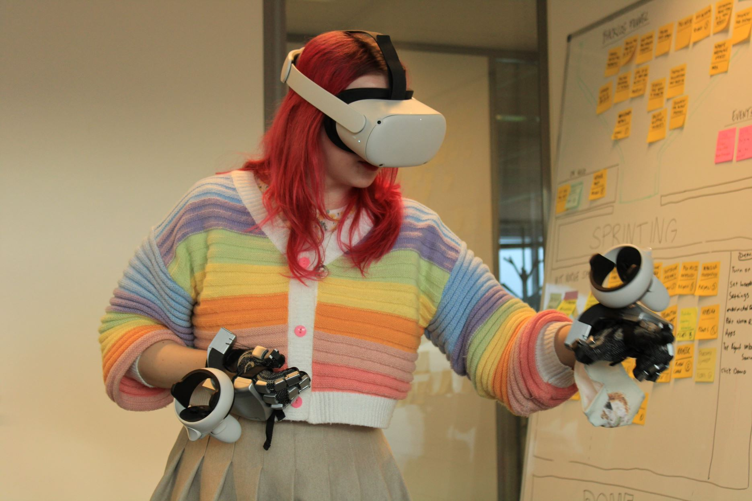
Fig. 95. The researcher testing out the Nova Glove.
From the trip, it was concluded that for this project the original device suited the requirements better than the Nova Glove, due to the level of feedback you can receive, it creates a more valuable experience for visitors who wish to get a realistic sense of touch when interacting with the ceramics, as this plays on the forbidden nature of interaction with artefacts in museums.
The created frameworks can offer the foundations of methodology for future research in digital heritage, this research performs as a potential guide to digitising real-life artefacts into a digital archive. Additionally, this research defines how object analysis can be applied artefacts to explore gamification experience to aid educational learning.
This research has a strong link towards the recent developments revolving around the Metaverse world, meaning a network of 3D virtual worlds that can be utilised by humans to live, work, shop, learn and interact with each other (Tucci, 2022). The term ‘Meta’ is a concept recently adopted by large technology companies such as Google, Microsoft, Nvidia and Qualcomm who are investing billions of pounds in the hopes of being a part of the next big technological advancement in the present day (Lawton, 2022).
The Metaverse is not a new concept, but actually a concept explored as early as 1992 when mentioned in a book called ‘Snow Crash’, depicting a dystopian future world where rich people can escape into an alternative 3D connected reality (Tucci, 2022). This concept is arguably not that far away from today where humans can invest and engage in virtual worlds through virtual enabling technologies.
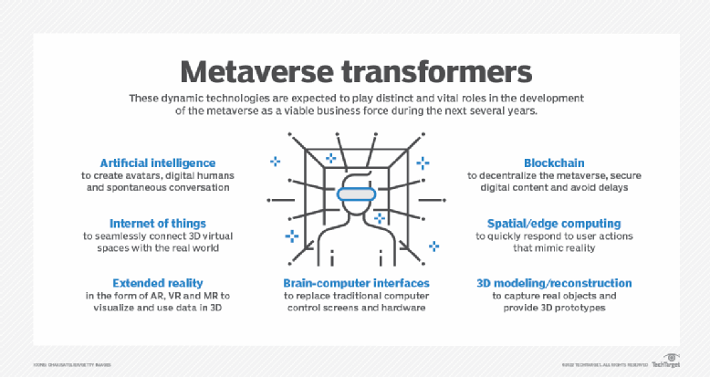
Fig. 96. Metaverse transformers, the roles expected by the modern-day Meta world.
The modern day Metaverse relates to a form of virtual surroundings, presented via either Virtual Reality or Augmented Reality experiences, which allow players to interact in an open world with other players. As shown in Fig. 93, the technology used will play distinct roles in how the Metaverse will be used, with the intention of synchronising immersive user interfaces and artificial intelligence (Shein, 2022).
This research opens an opportunity to combine the potential Metaverse system with the museum and heritage sites to develop an educational space suitable for learning about history and ceramics while in a virtual space. The potential for museums to adopt the concept of Virtual Reality could bring forth a much-desired collaboration of old and new by combining history with modern technological concepts, all while exploring how technology could be seen as a way of implementing interactive entertainment that will engage visitors beyond the traditional glass cabinet and text panel for information.
Finally, this research will continue to explore the ways history can be experienced interactively and to what extent multisensory can be used as a communicative tool to better retain information and enhance the museum experience. The Thornhill Experience will be further developed to test the limits of what interactions can be achieved, along with the potential developments of the haptic devices themselves.
This research has uncovered developing potential to explore museum spaces virtually and how technology can be perused to assist in the communication of history. This project holds the potential to frame how technology could be utilised in museum displays and re-establish the relationship between the artefact and the visitor.

6.8 Epilogue
This chapter presented the main findings of the research, summarising the theoretical and practical contributions and limitations, and it has further suggested future work for researchers and developers of immersive virtual and haptic technology for museum and heritage spaces.

Appendices

Appendix 1: Haptic glove Breakdown
This research was conducted in 2019.
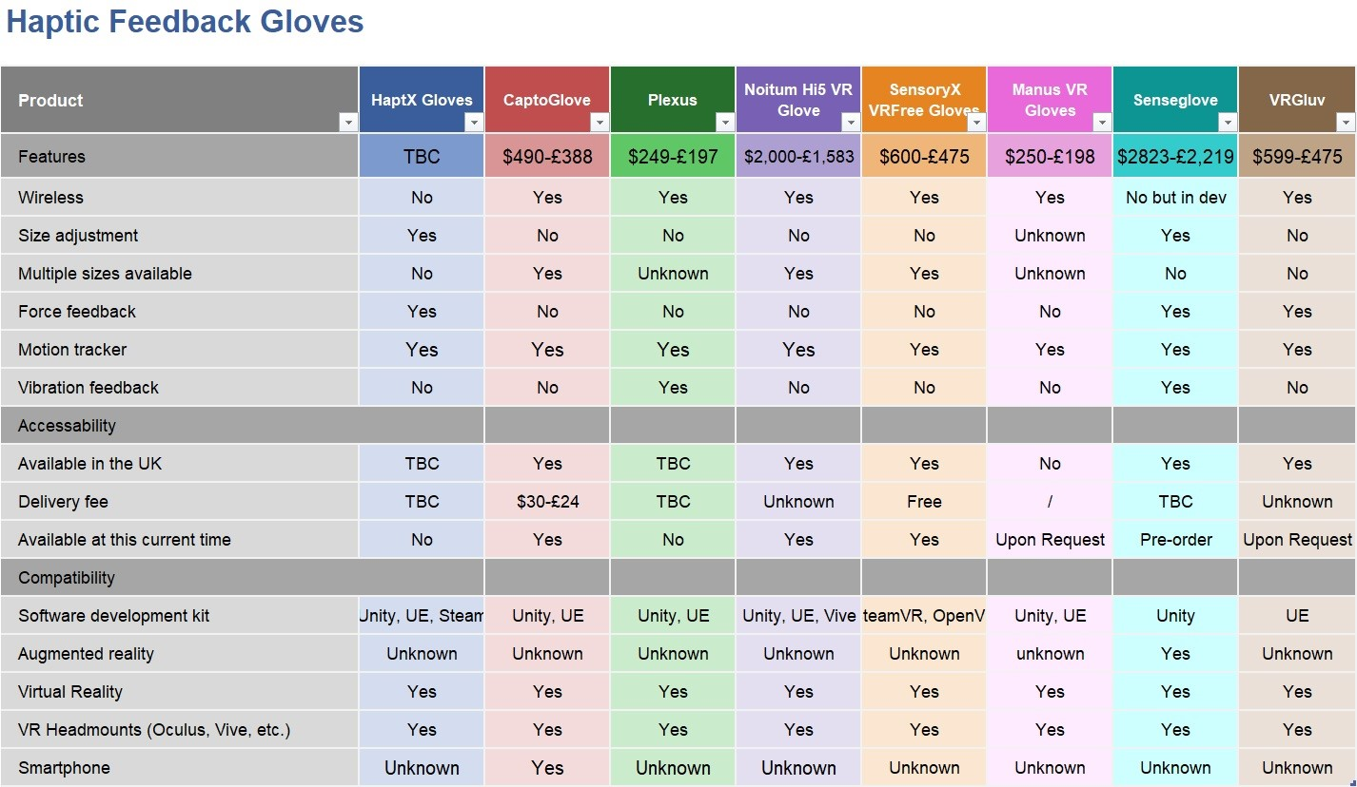

Appendix 2: Run-through of the ‘Thornhill Experience’:
Link provided via YouTube:
The Thornhill Experience- PhD Research Project
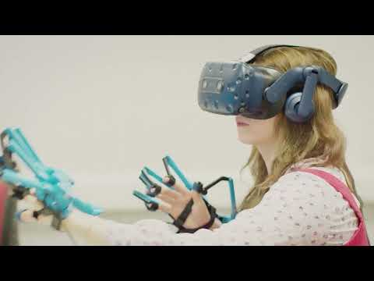

Appendix 3: Interview for SenseGlove about the research:
Link provided via YouTube:
Reinventing education with haptic feedback gloves - #1 Short series


Appendix 4: “Design and Development Approach for an Interactive Virtual Museum with Haptic Glove Technology”
This conference paper is the published paper by the researcher.
Link to the paper: https://dl.acm.org/doi/abs/10.1145/3569219.3569382

Appendix 5: Ethics Approval
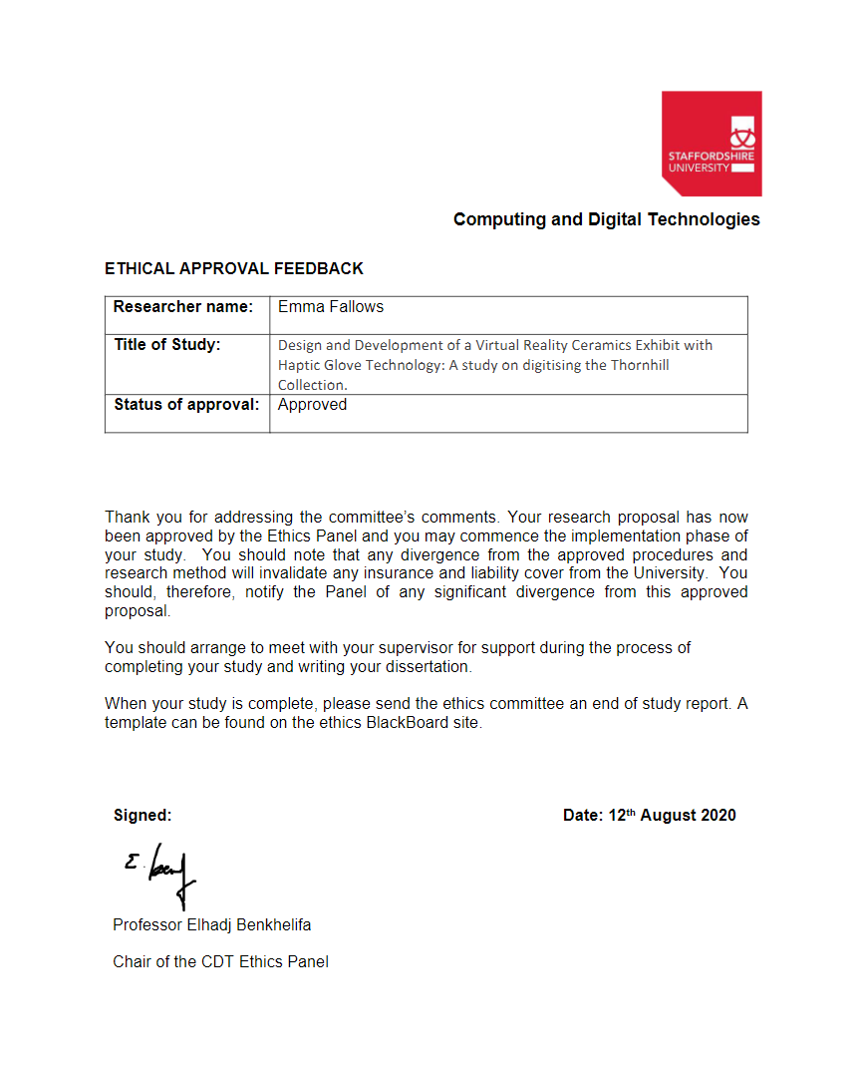

Appendix 6: Online Library of Thornhill Ceramics Via Sketchfab.
Link: https://sketchfab.com/sunnyelf

Appendix 7: Lyon & Turnbull Inventory & Evaluation for the Thornhill Collection
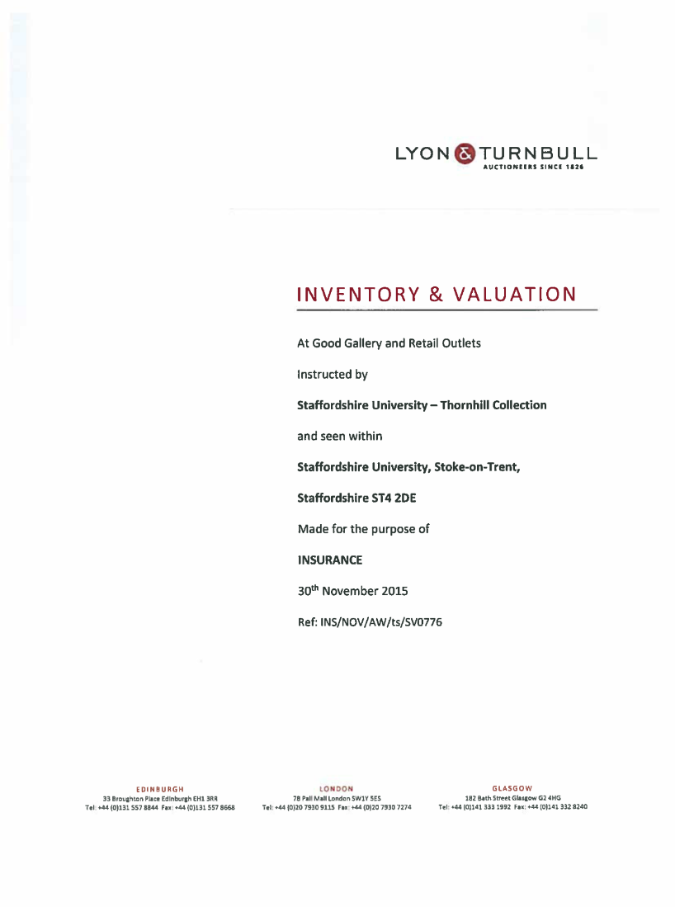

References
1stWebDesigner, 2016. Understanding the Most Popular Image File Types and Formats. [Online]
Available at: https://1stwebdesigner.com/image-file-types/
[Accessed 21 January 2021].
3DFLOW, 2023. 3DF ZEPHYR. [Online]
Available at: https://www.3dflow.net/3df-zephyr-photogrammetry-software/
[Accessed 21 12 2023].
A.Guttentag, D., 2010. Virtual reality: Applications and implications for tourism. Tourism Management, 31(5), pp. 637-651.
Aber, J. S., 2010. Small-Format Aerial Photography. Kansas: Elsevier Science.
Ackerman, E., 2016. SkinHaptics Uses Ultrasound to Generate Haptic Feedback Through Your Body. [Online]
Available at: https://spectrum.ieee.org/skinhaptics-uses-ultrasound-to-generate-haptic-feedback-inside-your-body
[Accessed 14 January 2021].
Adobe, 2023. Limitless 3D materials creation.. [Online]
Available at: https://www.adobe.com/products/substance3d-designer.html
[Accessed 22 12 2023].
AliceVision, 2023. Photogrammetric Computer Vision Framework. [Online]
Available at: https://alicevision.org/
[Accessed 21 12 2023].
Allen, C., 2021. HOW BIG IS THE UK VR AVAILABLE MARKET?. [Online]
Available at: https://www.immersivepromotion.com/understanding-the-vr-market-in-2021
[Accessed 16 October 2021].
Alsop, T., 2022. Augmented reality (AR), virtual reality (VR), and mixed reality (MR) market size worldwide in 2021 and 2028. [Online]
Available at: https://www.statista.com/statistics/591181/global-augmented-virtual-reality-market-size/#statisticContainer
[Accessed 13 October 2022].
An Art of Attraction: The Electrotyping Process. 2011. [Film] Directed by Ellenor Alcorn. United Kingdom: The Met.
Anon., 2014. Centre for Fine Print Research Electronic Archives. [Online]
Available at: https://archivescfpr.uwe.ac.uk
[Accessed 14 October 2020].
Archaeology, W., 2015. 19th-century relish dish with Napoleonic scene. [Online]
Available at: https://sketchfab.com/3d-models/19th-century-relish-dish-with-napoleonic-scene-a09c4156e3b94181861a5fff7ee9d0e8
[Accessed 21 12 2023].
Archaeology, W., 2023. China unearthed: A hidden history of tombs and offerings. [Online]
Available at: https://the-past.com/feature/china-unearthed-a-hidden-history-of-tombs-and-offerings/
[Accessed 22 12 2023].
ArcheologyExpert, 2023. Being Aware of Fake Archaeological Artefacts. [Online]
Available at: https://www.archaeologyexpert.co.uk/fakes.html
[Accessed 08 14 2023].
Arrighi, G., 2021. Victoria Theatre virtual reality: A digital heritage case study and user experience design. Digital Applications in Archaeology and Cultural Heritage.
Autodesk, 2023. Autodesk ReCap Pro: Turn the physical into digital. [Online]
Available at: https://www.autodesk.com/products/recap/overview?term=1-YEAR&tab=subscription
[Accessed 21 12 2023].
avcontentteam, 2023. Introduction to Human Computer Interaction (HCI) With Examples. [Online]
Available at: https://www.analyticsvidhya.com/blog/2023/05/human-computer-interaction/
[Accessed 19 07 2023].
Barnard, D., 2019. History of VR - Timeline of Events and Tech Development. [Online]
Available at: https://virtualspeech.com/blog/history-of-vr
[Accessed 13 September 2020].
Barron, P., 2017. Visitor engagement at museums: Generation Y and ‘Lates’ events at the National Museum of Scotland. Museum Management and Curatorship, 32(5), pp. 473-490.
BCB, 2019. Our Impact. [Online]
Available at: https://www.britishceramicsbiennial.com/about/our-impact/
[Accessed 27 06 2023].
BCB, 2021. 2021. [Online]
Available at: https://www.britishceramicsbiennial.com/festival/bcb2021/
[Accessed 21 October 2021].
Bec, A., 2021. Virtual reality and mixed reality for second chance tourism. Tourism Management, 83(104256), pp. 0261-5177.
Beres, T. W.-Y., 2021. Ai Weiwei, Dropping a Han Dynasty Urn. [Online]
Available at: https://smarthistory.org/ai-weiwei-dropping-a-han-dynasty-urn-2/
[Accessed 22 April 2022].
Bilbao, G., 2024. Ai Weiwei, Dropping a Han Dynasty Urn, 1995. [Online]
Available at: https://www.guggenheim-bilbao.eus/en/learn/schools/teachers-guides/ai-weiwei-dropping-han-dynasty-urn-1995
[Accessed 07 08 2024].
Bitgood, S., 2009. Museum fatigue: A cryitical review. Visitor Studies, 12(2), pp. 93-112.
Bollo, A., 2005. Analysis of Visitor Behaviour inside the Museum : An Empirical Study, s.l.: Unk.
Braun, S., 2020. Six museums to explore virtually during lockdown . [Online]
Available at: https://www.dw.com/en/six-museums-to-explore-virtually-during-lockdown/a-53073411
[Accessed 26 05 2022].
Brewster, S. A., 2008. The Impact of Haptic ‘Touching’ Technology on Cultural Applications. [Online]
Available at: https://www.researchgate.net/publication/29815508_The_Impact_of_Haptic_%27Touching%27_Technology_on_Cultural_Applications
[Accessed 12 September 2020].
BritishMuseum, 2020. The Museum of the World. [Online]
Available at: https://britishmuseum.withgoogle.com
[Accessed 20 February 2021].
Browning, C., 2020. Technology and planning help museums manage outdated exhibitions. [Online]
Available at: https://theconversation.com/technology-and-planning-help-museums-manage-outdated-exhibitions-143852
[Accessed 26 07 2022].
Burkett, D., 2017. Digitisation and digitalisation: What means what?. [Online]
Available at: https://workingmouse.com.au/innovation/digitisation-digitalisation-digital-transformation/
[Accessed 3 April 2021].
Caledon, J., 2022. Chinese Stemmed Cups: Ancient vs. Contemporary. [Online]
Available at: https://celadon.sg/blogs/news/chinese-stemmed-cups-ancient-vs-contemporary
[Accessed 06 07 2023].
Candy, L., 2006. Practice Based Research: A Guide, Sydney: Creativity & Cognition Studios.
Carlton, B., 2021. HaptX Launches True-Contact Haptic Gloves For VR And Robotics. [Online]
Available at: https://vrscout.com/news/haptx-true-contact-haptic-gloves-vr/#
[Accessed 19 07 2023].
CDC, 2018. Data Collection Methods for. [Online]
Available at: https://www.cdc.gov/healthyyouth/evaluation/pdf/brief16.pdf
[Accessed 14 02 2023].
Chaffin, D. C. E., 2022. The search for immortality: The Tomb of Lady Dai. [Online]
Available at: https://smarthistory.org/tomb-of-lady-dai/
[Accessed 22 April 2022].
Charr, M., 2020. How technology is bringing museums back to life. [Online]
Available at: https://www.museumnext.com/article/how-technology-is-bringing-museums-back-to-life/
[Accessed 24 12 2023].
Chin, J., 1988. Development of an Instrument Measuring User Satisfaction of the Human-Computer Interface. New York, SIGCHI Conference on Human Factors in Computing Systems.
Choukroun, T., 2022. Digitisation vs digitalisation. [Online]
Available at: https://yousign.com/blog/digitisation-vs-digitalisation
[Accessed 14 07 2022].
Clark, T., 2021. Bryman's Social Research Methods. Sixth ed. Oxford: Oxford.
Collins, T., 2019. Intact Tang Dynasty Tomb Found In China. [Online]
Available at: https://www.thehistoryblog.com/archives/56197
[Accessed 15 08 2022].
Comes, R., 2016. HAPTIC DEVICES AND TACTILE EXPERIENCES IN MUSEUM EXHIBITIONS. Journal of Ancient History and Archeology, Volume 3.
CSIUS, 2020. Centre for Secure, Intelligent and Usable Systems. [Online]
Available at: https://www.brighton.ac.uk/csius/what-we-do/index.aspx
[Accessed 17 07 2023].
Cuseum, 2018. VIDEO LIVE STREAMS AS AN ENGAGEMENT TOOL FOR MUSEUMS. [Online]
Available at: https://cuseum.com/blog/2018/7/26/video-live-streams-as-an-engagement-tool-for-museums
[Accessed 11 07 2022].
Davies, M., 2021. 3D digitisation: the University of Nottingham Museum photogrammetry project. [Online]
Available at: https://blogs.nottingham.ac.uk/digitaldialogues/2021/03/02/3d-digitisation-the-university-of-nottingham-museum-photogrammetry-project/
[Accessed 27 05 2022].
Delft, R., 2019. Royal Delft: Delftblue Factory and Museum. [Online]
Available at: https://www.getyourguide.co.uk/royal-delft-l14397/the-royal-delft-experience-t196814/?ranking_uuid=ac8443cf-fadf-40b7-b3fc-2aab6e660ce3
[Accessed 20 11 2023].
DigVentures, 2016. How To… Do Photogrammetry For Archaeology (Part 1). [Online]
Available at: https://projects.digventures.com/under-the-uplands/timeline/diary/how-to-do-photogrammetry-for-archaeology-part-1/
[Accessed 14 07 2022].
Dima, M., 2014. Touching the past: Haptic Augmented Reality for Museum Artefacts. s.l., HCI.
Direct, V., 2020. 8 best virtual museum tours during self-isolation. [Online]
Available at: https://www.visiondirect.co.uk/blog/best-virtual-museum-tours/
[Accessed 26 05 2022].
Dreams, I., 2017. Let's Create! Pottery Lite. [Online]
Available at: https://play.google.com/store/apps/details?id=pl.idreams.potterylite&hl=en_GB
[Accessed 11 January 2021].
Echavarria, K. R., 2021. Interactive 3D Artefact Puzzles to Support Engagement Beyond the Museum Environment. Brighton, The Eurographics Association.
Evans, S., 2017. Technology is bringing museums back to life. [Online]
Available at: https://www.verdict.co.uk/technology-museums-back-to-life/
[Accessed 13 October 2021].
Eylott, M.-C., 2018. Museum to star in Sky VR experience with Sir David Attenborough. [Online]
Available at: https://www.nhm.ac.uk/discover/news/2017/april/museum-to-star-in-sky-vr-experience-with-sir-david-attenborough.html
[Accessed 10 06 2022].
Farshid, M., 2018. Go boldly!: Explore augmented reality (AR), virtual reality (VR), and mixed reality (MR) for business. [Online]
Available at: https://www-sciencedirect-com.ezproxy.staffs.ac.uk/science/article/pii/S000768131830079X?via%3Dihub#!
[Accessed 11 January 2020].
Fidelity, H., 2021. The Major Differences Between Stereo Audio vs. Binaural Audio vs. Spatial Audio. [Online]
Available at: https://www.highfidelity.com/blog/binaural-audio-vs-stereo-audio-vs-spatial-audio
[Accessed 10 06 2022].
Finnis, J. & Kennedy, A., 2020. The digital transformation agenda and GLAMs - Culture24 findings and outcomes, Brighton: Culture24.
Foundation, T. L., 2016. A Simple Method for Reliable Creation of 3D Artifact Models in the Field. [Online]
Available at: https://leakeyfoundation.org/a-simple-photogrammetry-rig-for-the-reliable-creation-of-3d-artifact-models-in-the-field/
[Accessed 14 07 2022].
Fricker, M., 2016. How a dusty old pot fetched more than THREE MILLION at auction. [Online]
Available at: https://www.mirror.co.uk/news/uk-news/how-dusty-old-pot-fetched-8089303
[Accessed 15 03 2023].
Fuaite, F., 2016. Visual SfM: 3D Construction through Structure from Motion. [Online]
Available at: https://fitefuaite.com/digital-artefact/visual-sfm-3d-construction-through-structure-from-motion/
[Accessed 29 08 2024].
Galleries, L. M. a., 2017. Leeds Museums and Galleries: A practical guide for text interpretation. [Online]
Available at: https://www.museumdevelopmentyorkshire.org.uk/wp-content/uploads/2017/12/Practical-guide-for-text-interpretation-2017.pdf
[Accessed 17 November 2021].
Glendale, 2023. ART 198 - HISTORY OF WORLD CERAMICS. [Online]
Available at: http://www-01.glendale.edu/ceramics/mingstemcup.html
[Accessed 15 03 2023].
GoMeasure3D, 2024. Everything You Need To Know About Decimating 3D Scan Data. [Online]
Available at: https://gomeasure3d.com/article/everything-you-need-to-know-decimating-3d-scan-data/
[Accessed 29 08 2024].
Gov.uk, 2019. Record breaking year for museums and galleries in England. [Online]
Available at: https://www.gov.uk/government/news/record-breaking-year-for-museums-and-galleries-in-england
[Accessed 5 April 2021].
Greenhalgh, P., 2001. Social Complexity and the Historiography of Ceramic. [Online]
Available at: https://ceramicsmuseum.alfred.edu/perkins_lect_series/greenhalgh/
[Accessed 21 June 2020].
Group, C. I. R., 2010. Cultural Heritage - A New Dimension. [Online]
Available at: http://www.culturalinformatics.org.uk/node/107
[Accessed 11 January 2020].
Hammady, R., 2019. Virtual Guidance using Mixed Reality in Historical Places and Museums, Stoke-On-Trent: Staffordshire University.
Harper, B. P., 1993. Improving user satisfaction: The questionnaire for user interaction satisfaction Version 5.5. Virginia, Proceedings of the 1st Annual Mid-Atlantic Human Factors Conferen.
Headout, 2023. Discover 8 Million Works of Art & History With These British Museum Tours in London. [Online]
Available at: https://www.headout.com/blog/british-museum-london-tours/#:~:text=How%20long%20does%20it%20take,the%20entire%20day%20wandering%20around.
[Accessed 26 06 2023].
Help, S. T., 2022. 20 Biggest Virtual Reality Companies | Top VR Companies 2022. [Online]
Available at: https://www.softwaretestinghelp.com/top-virtual-reality-companies/
[Accessed 10 06 2022].
Heratige, M. a., 2013. Haptic interactive technology brings visitors closer to museum collections. [Online]
Available at: https://advisor.museumsandheritage.com/features/haptic-interactive-technology-brings-visitors-closer-to-museum-collections/
[Accessed 20 April 2020].
Hexagon, 2021. PrimeScan. [Online]
Available at: https://www.bing.com/search?q=structured+light+scanning+device+prime+scan&qs=n&form=QBRE&sp=-1&ghc=1&lq=0&pq=structured+light+scanning+device+prime+scan&sc=11-43&sk=&cvid=636CCB4118DE449CBE479C77132617D3&ghsh=0&ghacc=0&ghpl=
[Accessed 29 08 2024].
Hills-Duty, R., 2018. National Museum of Finland Offers Virtual Time Travel. [Online]
Available at: https://www.gmw3.com/2018/02/national-museum-of-finland-offers-virtual-time-travel/
[Accessed 10 06 2022].
History, 2018. Rise of the Ming Dynasty. [Online]
Available at: https://www.history.com/topics/ancient-china/ming-dynasty
[Accessed 06 07 2023].
History, T. N. M. o. N., 2021. National Museum of Natural History - Virtual Tours. [Online]
Available at: https://naturalhistory.si.edu/visit/virtual-tour
[Accessed 14 October 2021].
Hoffman, H., 1998. Physically touching virtual objects using tactile augmentation enhances the realism of virtual environments. 1998 Virtual Reality Annual International Symposium.
Hub, F. L. I. /. E., 2021. Van Gogh: The Immersive Experience. [Online]
Available at: https://vangoghexpo.com/london/
[Accessed 05 08 2024].
Hultengren, I., 2023. Zhu Zhanji - the Xuande Emperor. [Online]
Available at: https://www.mingtombs.eu/emp/05xuande/xuande.html
[Accessed 06 07 2023].
ICOM, 2022. ICOM Define Methodology (2020-2022), Prague: ICOM.
INews, 2022. Why is the Western Han Dynasty painted goose-fish bronze lamp so valuable?. [Online]
Available at: https://inf.news/en/collect/ff3b02bcbae0714ca32ada047eda11ab.html
[Accessed 22 April 2022].
Insko, B., 2001. Passive Haptics Significantly Enhances Virtual Environments, North Carolina: The University of North Carolina at Chapel Hill.
Jamil, M. H., 2018. The Role of Haptics in Digital Archaeology and Heritage Recording Processes. China, Institute of Electrical and Electronics Engineers Inc..
Jeffs, A., 2016. The Digital Pilgrim Project. [Online]
Available at: https://www.hoart.cam.ac.uk/research/the-digital-pilgrim-project
[Accessed 11 June 2020].
Kaplan, I., 2017. How Long Do You Need to Look at a Work of Art to Get It?. [Online]
Available at: https://www.artsy.net/article/artsy-editorial-long-work-art-it
[Accessed 26 06 2022].
Khan, Y., 2012. Museums in the information age: survival of the most digital?. [Online]
Available at: https://www.theguardian.com/culture-professionals-network/culture-professionals-blog/2012/dec/05/museums-adapting-digital-age
[Accessed 13 January 2022].
King, E., 2021. Digital Responses of UK Museum Exhibitions to the COVID-19 Crisis, March – June 2020. Curator: The Museum Journal 2021, 64(3), pp. 487-504.
King, L., 2016. Experiencing the Digital World: The Cultural Value of Digital Engagement with Heritage. Heratige & Society, 9(1), pp. 76-101.
Kivolya, N., 2019. What are 3D scanners used for?. [Online]
Available at: https://www.artec3d.com/learning-center/what-are-3d-scanners-used-for
[Accessed 11 April 2021].
Knodell, A., 2017. Photogrammetry for Documentation and Sharing. [Online]
Available at: https://archaeologyinthearb.com/archaeology-pine-hill-village/2017-fieldwork/artifact-analysis-2/
[Accessed 14 07 2022].
Lang, B., 2019. Hands-on: Dexmo Haptic Force-feedback Gloves are Compact and Wireless. [Online]
Available at: https://www.roadtovr.com/dexta-dexmo-vr-gloves-force-feedback-haptic-hands-on/
[Accessed 19 07 2023].
Lawton, G., 2022. Metaverse vs. multiverse vs. omniverse: Key differences. [Online]
Available at: https://www.techtarget.com/searchcio/tip/Metaverse-vs-multiverse-vs-omniverse-Key-differences
[Accessed 04 13 2023].
Lewis, A., 2021. The Top 10 Best Photogrammetry Software 2022 (4 are Free!). [Online]
Available at: https://www.3dsourced.com/3d-software/best-photogrammetry-software/
[Accessed 21 January 2022].
Lewis, A., 2021. The Top 10 Best Photogrammetry Software 2022 (4 are Free!). [Online]
Available at: https://www.3dsourced.com/3d-software/best-photogrammetry-software/
[Accessed 19 07 2022].
Louvre, 2021. The Mona Lisa in virtual reality in your own home. [Online]
Available at: https://www.louvre.fr/en/what-s-on/life-at-the-museum/the-mona-lisa-in-virtual-reality-in-your-own-home
[Accessed 10 06 2022].
Marchant, 2021. A Concise Guide to Ming Porcelain. [Online]
Available at: https://www.marchantasianart.com/guide/a-concise-guide-to-the-antique-ming-vase/#:~:text=Most%20was%20made%20in%20Jingdezhen,manufactured%20the%20famous%20Chinese%20vase.
[Accessed 06 07 2023].
Martenstyn, L., 2013. Digital archives: making museum collections available to everyone. [Online]
Available at: https://www.theguardian.com/culture-professionals-network/culture-professionals-blog/2013/may/03/museum-archives-digital-online
[Accessed 23 08 2022].
Mason, M., 2021. Digital Cultural Heritage Design Practice: A Conceptual Framework. Digital Cultural Heritage Design Practice: A Conceptual Framework., 1-27(24), pp. 405-425.
McNab, K., 2017. Britain’s best places to see: Ceramics and pottery collections. [Online]
Available at: https://museumcrush.org/britains-best-places-to-see-ceramics-and-pottery-collections/
[Accessed 14 September 2020].
Modern, T., 2017. Modigliani VR. [Online]
Available at: https://www.tate.org.uk/whats-on/tate-modern/modigliani/modigliani-vr-ochre-atelier
[Accessed 10 06 2022].
Molloy, B., 2016. 'Tracing edges: A consideration of the applications of 3D modelling for metalwork wear analysis on Bronze Age bladed artefacts. Journal of Archaeological Science, Volume 76, pp. 79-87.
Moulon, P., 2016. OpenMVG: Open Multiple View Geometry. Cancun, 1st Workshop on Reproducible Research in Pattern Recognition.
Murphy, B. L., 2014. Introduction To Environmental Forensics. 3 ed. s.l.:Academic Press 2014.
MuseumBooster, 2021. museum innovation barometer. [Online]
Available at: https://museumbooster.com/wp-content/uploads/2021/08/Museum-Innovation-Barometer-2021.pdf
[Accessed 23 08 2022].
Museum, F., 2023. Reconstructed ceramic vessel. [Online]
Available at: https://sketchfab.com/3d-models/reconstructed-ceramic-vessel-a7aacbb3437e4126a8f61cd355739f72
[Accessed 21 12 2023].
Museum, M., 2013. Haptic interactive technology brings visitors closer to museum collections. [Online]
Available at: https://museumsandheritage.com/advisor/posts/haptic-interactive-technology-brings-visitors-closer-to-museum-collections/
[Accessed 05 08 2021].
Museum, M., 2022. Digital Touch Replicas. [Online]
Available at: https://www.museum.manchester.ac.uk/about/digitaltouchreplicas/
[Accessed 08 06 2022].
MuseumNext, 2020. Meaningful museum interpretations using virtual reality. [Online]
Available at: https://www.museumnext.com/article/meaningful-museum-interpretations-using-virtual-reality/
[Accessed 10 06 2022].
MuseumNext, 2021. Virtual Reality is a big trend in museums, but what are the best examples of museums using VR?. [Online]
Available at: https://www.museumnext.com/article/how-museums-are-using-virtual-reality/
[Accessed 10 06 2022].
NextService, 2020. Digitize vs Digitalize: Why You Need to Know the Difference. [Online]
Available at: https://nextservicesoftware.com/news/digitize-vs-digitalize-know-the-difference/
[Accessed 23 08 2022].
Parnell, S., 2018. What Is 3D Laser Scanning Technology?. [Online]
Available at: https://www.duncan-parnell.com/blog/what-is-3d-laser-scanning-technology#:~:text=A%203D%20laser%20scanner%20is,of%20a%20three%2Ddimensional%20object.
[Accessed 14 07 2022].
Patowary, K., 2018. The Mystery of Lady Dai’s Preserved Mummy. [Online]
Available at: https://www.amusingplanet.com/2018/11/the-mystery-of-lady-dais-preserved-mummy.html
[Accessed 21 January 2022].
Pavid, K., 2018. Explore the Museum's collection with Sir David Attenborough. [Online]
Available at: https://www.nhm.ac.uk/discover/news/2018/march/explore-the-museum-with-sir-david-attenborough.html
[Accessed 10 06 2020].
PM&AG, 2021. The Spitfire Gallery. [Online]
Available at: https://www.stokemuseums.org.uk/pmag/exhibitions/spitfire/
[Accessed 18 September 2022].
PM&AG, 2022. Galleries. [Online]
Available at: https://www.stokemuseums.org.uk/pmag/galleries/
[Accessed 14 September 2022].
Qi, L., 2016. Rare Ming royal stem bowl to feature at Christie's auction. [Online]
Available at: https://www.chinadaily.com.cn/culture/art/2016-11/29/content_27511467.htm#:~:text=The%20bowl%20from%20the%20Ming,above%20cresting%20waves%20and%20mountains.
[Accessed 06 07 2023].
Raptis, G. E., 2018. Effects of mixed-reality on players’ behaviour and immersion in a cultural tourism game: A cognitive processing perspective. International Journal of Human-Computer Studies, 114(1071-5819), pp. 69-79.
Rawson, J., 2023. Life and Afterlife in Ancient China. Washington: University of Washington Press.
Reality, C., 2023. Create realistic 3D models from photos. [Online]
Available at: https://www.capturingreality.com/
[Accessed 21 12 2023].
Richardson, J., 2024. Virtual Reality is a big trend in museums, but what are the best examples of museums using VR?. [Online]
Available at: https://www.museumnext.com/article/how-museums-are-using-virtual-reality/
[Accessed 07 08 2024].
Rogers, C., 2019. British Museum expands digital learning programme. [Online]
Available at: https://edtechnology.co.uk/latest-news/british-museum-expands-digital-learning-programme/
[Accessed 14 September 2020].
Romer, C., 2019. Tate Modern becomes most visited attraction in the UK. [Online]
Available at: https://www.artsprofessional.co.uk/news/tate-modern-becomes-most-visited-attraction-uk
[Accessed 16 September 2020].
Rosales, M. L. G., 2018. Taking Part Survey: England Child Report, 2017/18, England: The Department for Digital, Culture, Media & Sport.
Rosenbloom, S., 2014. The Art of Slowing Down in a Museum. [Online]
Available at: https://www.nytimes.com/2014/10/12/travel/the-art-of-slowing-down-in-a-museum.html#:~:text=Most%20people%20want%20to%20enjoy,to%20make%20that%20feel%20normal.
[Accessed 26 06 2022].
Rowland, M., 2018. Museums are most popular heritage attraction among young people. [Online]
Available at: https://www.museumsassociation.org/museums-journal/news/2018/12/10122018-fifth-young-people-never-visit-museums/
[Accessed 23 06 2022].
Saker, M., 2020. Art museums and the incorporation of virtual reality: Examining the impact of VR on spatial and social norms. Convergence, 26(5-6).
Sauro, J., 2011. Measuring Usability with the System Usability Scale (SUS). [Online]
Available at: https://measuringu.com/sus/
[Accessed 16 11 2023].
SenseGlove, 2022. About Us. [Online]
Available at: https://www.senseglove.com/about-us/
[Accessed 8 February 2022].
SenseGlove, 2022. The New Sense in VR for enterprise. [Online]
Available at: https://www.senseglove.com/product/nova/
[Accessed 17 07 2022].
Serrel, B., 1995. Exhibit labels: An interpretive approach. Oxford: Alta Mira Press.
Serrel, B., 1997. Paying attention: Visitors and museum exhibitions.. American association of museums, 40(2), pp. 108-125.
Shein, E., 2022. 7 top technologies for metaverse development. [Online]
Available at: https://www.techtarget.com/searchcio/tip/7-top-technologies-for-metaverse-development
[Accessed 04 13 2023].
Shemek, D., 2016. he Virtual Studiolo – IDEA Art/e.. [Online]
Available at: https://onedrive.live.com/edit.aspx?resid=748B0BC232DC467!1776&ithint=file%2cdocx
[Accessed 12 July 2020].
Silva, A. J., 2009. PHANToM OMNI Haptic Device: Kinematic and Manipulability. Mexico , Electronics, Robotics and Automotive Mechanics Conference, pp. 193-198.
SketchFab, 2020. About Us. [Online]
Available at: https://sketchfab.com/about
[Accessed 12 June 2020].
Smith, S. a., 2001. Spending Time on Art. Experical Studies of the Arts, 19(2), pp. 229-236.
Society, V. R., 2017. Virtuality – A New Reality of Promise, Two Decades Too Soon. [Online]
Available at: https://www.vrs.org.uk/dr-jonathan-walden-virtuality-new-reality-promise-two-decades-soon/
[Accessed 10 06 2022].
Society, V. R., 2017. What is Virtual Reality?. [Online]
Available at: https://www.vrs.org.uk/virtual-reality/what-is-virtual-reality.html
[Accessed 11 December 2021].
Solanki, M., 2017. A brief history of Delft Blue a.k.a. Delfts Blauw. [Online]
Available at: https://www.iamexpat.nl/lifestyle/lifestyle-news/brief-history-delft-blue-aka-delfts-blauw
[Accessed 10 February 2022].
Song, K., 2017. Virtual reality and Van Gogh collide — technology is turning museums into a booming industry. [Online]
Available at: https://www.cnbc.com/2017/09/22/how-technology-is-turning-museums-into-a-booming-industry.html
[Accessed 24 12 2023].
Spence, C. & Gallace, A., 2011. Multisensory design: Reaching out to touch the consumer. Physcology & Marketing, 28(3), pp. 267-308.
staff, J. N., 2016. Thornhill Stem Cup could bring up to $6 million at Lyon & Turnbull. [Online]
Available at: https://news.justcollecting.com/thornhill-stem-cup-could-bring-up-to-6-million-at-lyon-turnbull/
[Accessed 13 October 2021].
StokeGov, 2021. Stoke-on-Trent's Spitfire and £5.4m new gallery to be unveiled as nation marks Battle of Britain Day. [Online]
Available at: https://www.stoke.gov.uk/news/article/936/stoke-on-trents_spitfire_and_54m_new_gallery_to_be_unveiled_as_nation_marks_battle_of_britain_day
[Accessed 17 07 2023].
StrategyWiki, 2019. Pac-Man VR. [Online]
Available at: https://strategywiki.org/wiki/Pac-Man_VR
[Accessed 10 06 2022`].
Sun-Bailey, S., 1983-1984. The E.S. Thonhill Bequest of Chinese Ceramics at the North Staffordshire Polytechnic. The Transactions of the Oriental Ceramic Society, Volume 48, pp. 63-86.
SunBelt, 2024. BLK360 Starter Pack. [Online]
Available at: https://www.sunbeltsales.co.uk/leica-blk360-starter-pack
[Accessed 29 08 2024].
Taher, H., 2020. Digitalisation at. [Online]
Available at: https://www.diva-portal.org/smash/get/diva2:1480519/FULLTEXT01.pdf
[Accessed 26 07 2022].
Tennent, P. et al., 2020. Thresholds: Embedding Virtual Reality in the Museum.
TheBritishMuseum, 2023. Take a free tour of a British Museum gallery with Samsung tablets, using augmented reality to examine the objects on display.. [Online]
Available at: https://www.britishmuseum.org/learn/schools/samsung-digital-discovery-centre/tablet-tours
[Accessed 20 11 2023].
TheMet, 2016. Small stem cup. [Online]
Available at: https://www.metmuseum.org/art/collection/search/42507
[Accessed 15 03 2023].
TheWaltersArtMuseum, 1983. Stem Cup. [Online]
Available at: https://art.thewalters.org/detail/18744/footed-cup-for-an-altar-3/#:~:text=Stemmed%20cups%20resembling%20wine%20vessels,images%20and%20filled%20with%20water.
[Accessed 06 07 2023].
Trunfio, M., 2021. Innovating the cultural heritage museum service model through virtual reality and augmented reality: the effects on the overall visitor experience and satisfaction. Journal of Heritage Tourism, 17(1), pp. 1-19.
Tucci, L., 2022. What is the metaverse? An explanation and in-depth guide. [Online]
Available at: https://www.techtarget.com/whatis/feature/The-metaverse-explained-Everything-you-need-to-know
[Accessed 07 04 2023].
Turnbull, L. &., 2016. Thornhill Stem Cup Sells for £3.6 million. [Online]
Available at: https://www.lyonandturnbull.com/news/article/thornhill-stem-cup-sells-for-36-million/
[Accessed 17 February 2021].
UNESCO, 2021. Concept of Digital Heritage. [Online]
Available at: https://en.unesco.org/themes/information-preservation/digital-heritage/concept-digital-heritage
[Accessed 18 07 2023].
UnitedNations, 2020. Covid-19 crisis closes 90 percent of museums globally, UNESCO plans for reopenings. [Online]
Available at: https://news.un.org/en/story/2020/05/1064362
[Accessed 20 11 2023].
Unity, 2022. Unity 2022.2 alpha. [Online]
Available at: https://unity3d.com/unity/alpha/
[Accessed 19 07 2022].
UniversityOfBrighton, 2021. Interactive 3D Artefact Puzzles to Support Engagement Beyond the Museum Environment. [Online]
Available at: https://research.brighton.ac.uk/en/publications/interactive-3d-artefact-puzzles-to-support-engagement-beyond-the-
[Accessed 17 07 2023].
UniversityOfBrighton, 2023. Karina Rodriguez Echavarria. [Online]
Available at: https://research.brighton.ac.uk/en/persons/karina-rodriguez-echavarria
[Accessed 17 07 2023].
University, S., 2019. Staffordshire University Research Ethical Review Policy. [Online]
Available at: https://www.staffs.ac.uk/research/docs/pdf/ethical-review-policy.pdf
[Accessed 16 1 2023].
University, S., 2021. Relics from Shakespeare’s home shared in new virtual exhibition. [Online]
Available at: https://workvivo.staffs.ac.uk/news/13826
[Accessed 21 September 2021].
V&A, 2021. Curious Alice: the VR experience. [Online]
Available at: https://www.vam.ac.uk/articles/curious-alice-the-vr-experience?site=ca
[Accessed 26 05 2022].
Valdellon, L., 2020. What is an SDK? Everything You Need to Know. [Online]
Available at: https://clevertap.com/blog/what-is-an-sdk/
[Accessed 21 August 2020].
VR, H., 2023. Minoan Pottery. [Online]
Available at: https://sketchfab.com/3d-models/minoan-pottery-5df89b953588439ea2a21e1f2739989c
[Accessed 21 12 2023].
Walbridge, C., 2018. Robot photogrammetry in Minneapolis. [Online]
Available at: https://sketchfab.com/blogs/community/robot-photogrammetry-minneapolis/
[Accessed 14 07 2022].
Walford, A., 2017. What is Photogrammetry?. [Online]
Available at: https://www.photogrammetry.com
[Accessed 18 August 2020].
Ward, L., 2019. 6 Examples of Language and Technology in Museums. [Online]
Available at: https://www.k-international.com/blog/language-and-technology-in-museums/
[Accessed 14 07 2022].
Whitaker, S., 2016. Hurdles to the participation of children, families and young people in museums: A literature review, England: Arts Council England.
White, L., 2008. Digital Desires: What Are Museums Up To?. Bulletin of the American Society for Information Science and Technology, April, 34(4), pp. 12-16.
XPlaneDeveloper, 2020. Normal Maps. [Online]
Available at: https://developer.x-plane.com/article/normal-maps/
[Accessed 14 January 2021].
Yoshimura, Y., 2014. An Analysis of Visitors' Behavior in the Louvre Museum: A Study Using Bluetooth Data. Sage Journals, 41(6), pp. 1113-1131.

