**Design of a latent heat thermal energy storage system under simultaneous charging and discharging for solar domestic hot water applications**

M. Yang1**,** M. A. Moghimi2*, R. Loillier 2, C. N. Markides3, M. Kadivar4

*1 School of Mechanical and Power Engineering, Nanjing Tech University, 30 Puzhu South Rd, Pukou, Nanjing 211816, China*

*2 Department of Engineering, Staffordshire University, Stoke-On-Trent ST4 2DE, United Kingdom.*

*3 Clean Energy Processes (CEP) Laboratory, Department of Chemical Engineering, Imperial College London, London SW7 2AZ, United Kingdom*

*4 Department of Mechanical & Manufacturing Engineering, Atlantic Technological university (ATU), Sligo F91 YW50, Ireland.*

*Corresponding Author: Mohammad.Moghimi-Ardekani@staffs.ac.uk

# **Abstract**

Latent heat thermal energy storage (LHTES) systems using phase change materials (PCMs) have appeared as promising solutions for energy storage when harnessing renewable energy sources in a wide range of engineering applications. The present study focuses on the design of horizontal shell-and-tube PCM-based LHTES systems capable of simultaneous charging and discharging in solar domestic hot water (SDHW) applications. Two scenarios are investigated: (i) initially fully charged, and (ii) initially fully discharged LHTES systems, in both cases with a 30-minute charge/discharge time interval. Configurations with key geometrical design variations are considered to identify the best radial and tangential positions of the heat transfer fluid (HTF) tubes inside the shell that enhance storage performance against the following criteria: (i) gained and released thermal power, and (ii) total gained and released energy per unit mass of PCM. The distance between the hot and cold HTF tubes was maintained constant and an LHTES with horizontally aligned HTF tubes was selected as a baseline case. The findings showed that tangential displacement had a considerable impact on the performance of the system, while the effect of radial displacement was marginal. A design with displacements of ¼ tube diameter and 90 ° in the radial and tangential positions of the HTF tubes, respectively, had promising performance in both considered scenarios. In comparison to the baseline case, which had the hot and cold tubes positioned horizontally, and symmetrically on the shell’s central plane, this configuration demonstrated a 103.02 % enhancement in energy delivery in the fully discharged and a 2 % enhancement in the fully charged scenario, respectively.

***Keywords:*** latent heat thermal energy storage (LHTES), phase change material (PCM), simultaneous charging and discharging, solar domestic hot water (SDHW)

# **Introduction**

Among renewable resources, solar energy is a promising candidate for producing thermal energy for domestic and industrial applications [1–4], which significantly contributes to the world’s total energy consumption [5]. However, there is a temporal mismatch between solar irradiation and energy demand that can be addressed by the latent heat thermal energy storage (LHTES) systems using phase change materials (PCMs) [6–8]. A PCM manages thermal energy in the form of latent heat in an isothermal phase change process, storing energy by melting and releasing energy by solidification [9–11], of which the latter presents a particular set of challenges due to the associated heat transfer deterioration [12–14].

PCMs can store up to 14 times more energy than water per unit volume [15]. Therefore, depending on the temperature difference considered for the LHTES systems, PCM can reduce the weight and required space of the LHTES system by providing higher storage capacity [16]. LHTESs can provide high energy storage capacities to adjust the mismatch between the solar energy supply and thermal energy demand [6], especially in integration with solar domestic hot water (SDHW) systems. These storage systems store energy (charge) when solar energy is available and release energy (discharges) when there is a demand for domestic hot water. Due to the irregular demand for thermal energy (discharging) and the variability of solar irradiation during the day, LHTES systems can be charged and discharged at either separate time intervals or simultaneously.

Recently, the simultaneous charging and discharging (SCD) mode of LHTES has interested researchers in developing various heat exchangers, including heat pipe-assisted [17–19], triplex tube [20–23], and shell and tube shell-and-tube [24–31]. Among various designs, triplex-tube and shell-and-tube are suitable for SDHW applications. The shell-and-tube configuration was selected for the present study due to its wide application and popularity. In a shell-and-tube LHTES system operated under SCD mode, the PCM is stored in the shell while two tubes are provided inside the shell (see Figure 1) for hot and cold heat transfer fluids (HTF) [29,30,32]. Murray and Groulx [32] experimentally studied the performance of a vertical shell-and-tube LHTES system coupled with an SDHW application in SCD mode. They found that natural convection in the molten PCM provides better heat transfer performance compared to direct heat exchange between the hot and cold heat transfer fluids (HTF); however, the low thermal conductivity of solid PCM reduces the heat transfer.

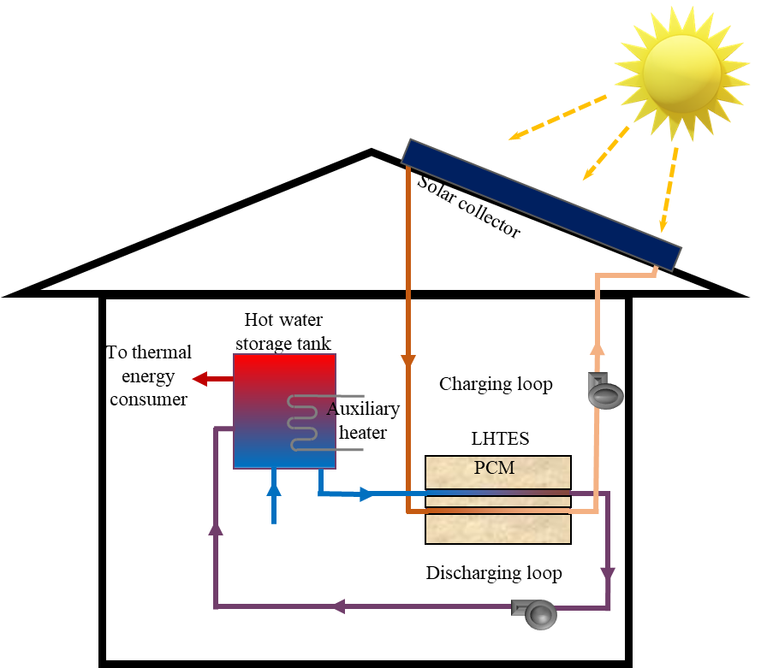

**Figure 1.** Schematic of a typical SDHW system incorporated with an LHTES system in SCD mode, reproduced from Murray and Groulx [32].

The main drawback of most PCM materials is their low thermal conductivity [33,34] (0.1-0.2 W/m.K for organic PCMs and 0.4-0.6 W/m.K for others), which hinders the heat transfer process and reduce the charging/discharging rates [35,36]. Several approaches have been adopted to enhance the heat transfer in LHTES systems, including the application of extended surfaces [37,38], roughness [39,40], PCM micro-encapsulation [41,42], porous material [43,44], dispersion of high conductivity particles in the PCM [20,45–47], metal foam inserts [48,49], high-conductivity materials [37,50], and hybrid application [35,51]. These methods are costly and sometimes impractical in large-scale or industrial LHTES systems. Fang et al. [30] employed microencapsulated PCM to enhance the heat transfer process in an LHTES system and observed a stable direct heat transfer between heating water and cooling water in the SCD mode. Mahdavi et al. [31] used a hybrid method of utilising copper fins and Cu nanoparticles to improve heat transfer in shell-and-tube LHTES systems. They observed that the impact of nanoparticle addition under the SCD condition is negligible, and that the influence of fin is limited to a short time in the initial stage of the process. In addition, there are nontrivial considerations when nanoparticles are used in real applications [52].

Apart from the PCM’s thermophysical properties, the geometry configuration and orientation of LHTES systems will impact the charging and discharging rate as the natural convection heat transfer in the molten PCM will be affected. The impact of the orientation of shell-and-tube LHTES systems on their performance has been studied by several researchers [53–57]. Khobragade and Devanuri [24] conducted energy and exergy analyses of shell-and-tube LHTES systems at different inclination angles under SCD mode. They found that the orientation of an LHTES can significantly impact the natural convection in molten PCM, hence the performance of LHTES, leading to a 27 % improvement in the maximum gained energy in the horizontal configuration compared with the vertical. The radial and tangential eccentricities of the tube within the shell can also significantly influence the performance of LHTES systems as boosts the natural convection in molten PCM [58–65]. Kadivar et al. [66] optimised the eccentric shell-and-tube LHTES system and calculated the optimum radial and tangential eccentricities, and found that the charging and discharging are more sensitive to the radial eccentricity than the tangential.

Comprehensive studies of LHTES systems in the SCD mode is challenging experimentally due to the significant costs involved in investigating a large number of geometrical configurations, and therefore, computational fluid dynamics (CFD) approaches – such as that used in the present study – are commonly employed as a cost-effective and suitable methods to study these systems [32]. According to the literature [30,31], the adoption of pin fin, encapsulation, and nanoparticle addition can marginally enhance the performance of shell-and-tube LHTES systems operated under SCD mod. However, the impact of geometric modifications such as inclination angle is typically more pronounced. Therefore, a horizontal shell-and-tube LHTES configuration was selected due to its enhanced performance under SCD mode [24]. Motivated by the early findings in Kadivar et al. [66], the present study investigates the impact of the radial and tangential positions of the HTF tubes inside the shell on the performance of such an LHTES system in SCD mode, which has not been studied thus far, to the best of the authors’ knowledge.

# **Characterisation of LHTES systems**

## **SDHW applications in SCD mode**

In a typical LHTES-incorporated SDHW system, the LHTES is charged and discharged simultaneously, in order to respond to a mismatch between energy supply and demand. During the daytime, energy is constantly supplied to the LHTES (charging) by the solar absorber, while energy extraction occurs during short time intervals (10 or 30 min domestic hot water use, for example, a shower). In order to replicate this, the response of several configurations of the LHTES system was evaluated in a fixed time interval. The selected flow rates for the cold HTF were taken from hot water end-use data for single-family dwellings collected by Aquacraft Incorporated Water Engineering and Management [67], shown in Table 1. Similar data was used by Murray and Groulx [68].

**Table 1.** Hot water usage in a single-family dwelling [67,68].

|  |  |
| --- | --- |
| **Utility** | **Average flow rate (L/min)** |
| Bath | 8.4 |
| Dishwasher | 4.7 |
| Shower | 5.7 |
| Faucets | 3.5 |
| Washing machine | 7.9 |

Since the present study is a comparative investigation of different designs of LHTES units, the simulations replicate the LHTES when only the shower is in use for 30 min (i.e., the cold HTF flow rate of 5.7 L/min), and the results can be applied to cases with higher/lower flow rates. A hot HTF flow rate of 2.8 L/min was selected to reflect the flow rate of a typical SDHW system for a single-family dwelling [32].

It is noteworthy that, the National Energy Policy Act (EPA) of 1992 (EPAct 92) set a maximum flow rate of 9.5 L/min for showerheads. The US EPA WaterSense program has considered water-efficient showerheads at a lower flow rate of 7.57 L/min. Lower flowing showerheads are definite in some green codes and use 5.7 L/min or less [69]. Based on the US EPA the average shower time is about 8 minutes; however, a longer time (30 min) was considered in this study. as illustrated in Figure 1, in order to have more control over the water temperature, the discharged hot water from LHTESs is used to heat water in a storage tank which is equipped with an auxiliary heater. In the present study, a flowrate of 5.7 L/min for a 30 min discharging time was considered that suits the slow heat transfer in LHTESs as well as green code and can respond to efficient demands.

Two scenarios can occur when an LHTES is used for SDHW application in the SCD mode: (i) LHTES initially discharged, and (ii) LHTES initially charged. For example, when the SDHW system has not absorbed enough solar energy in the early morning, the LHTES is discharged, and the PCM is solid. However, LHTES is more likely fully charged in the late evening, and the PCM is liquid. Both scenarios were investigated. It is noteworthy that, in a real system, partially-charged scenarios can also take place which is not investigated in the present study.

## **LHTES geometry**

Since the transient CFD simulations are computationally expensive and various cases were simulated in the present study, Therefore, measures were taken to reduce the computational effort. Firstly, the diameter of the shell and HTF tubes used in this study was smaller than the commercial LHTES systems. Secondly, a single unit of the LHTES system with a length of 1 mm was considered. Using a small sized single unit LHTES does not influence the performance of the cases studied in the present paper due to the small temperature difference in HTF tubes, which in turn, it allows the adoption of 2D simplified models (see section 3); however, the exchanged thermal power is smaller when compared to the commercial LHTES systems. Since higher thermal power is required in commercial applications, several units with a larger shell and HTF tubes diameter are used in parallel or series to achieve the desired performance.

Figure 2 illustrates the schematic cross-section of a horizontal LHTES unit and the position of hot and cold HTF tubes inside the shell. The inner diameter of the shell (*D* = 40 mm) and the distance between the HTF tubes (16 mm) are, respectively, 5 and 2 times of HTF tube diameter (*d* = 8 mm). Also, the thickness of the HTF tube is considered to be 1.5 mm, and the length of the unit is 1 m. Note that the tangential positions of the HTF tubes and their radial displacement are denoted by *θ* and *C* in Figure 2, respectively. Figure 3 shows various configurations of the LHTES unit and their specifications are listed in Table 2. Configurations T1 to T5 represent LHTESs with the modified tangential position and R1 to R3 show configurations with radial displacement. To promote natural convection, the hot and cold HTF tubes are always on the bottom and top half of the shell, respectively, except for the baseline case (T1) which has both tubes aligned horizontally and on the central plane of the shell. The distance between HTF tubes in all cases is constant and equal to 16 mm (2*d*).

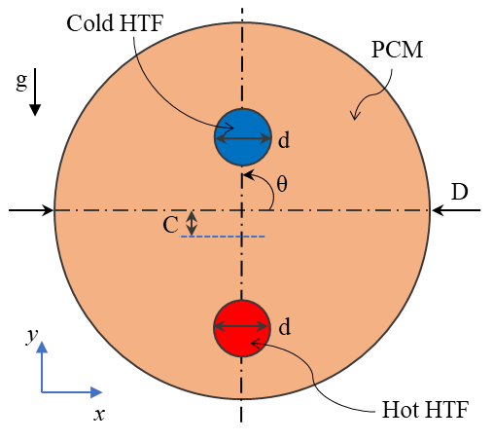

**Figure 2**. Schematic of the horizontally aligned LHTES and the position of hot and cold HTF tubes inside the shell.

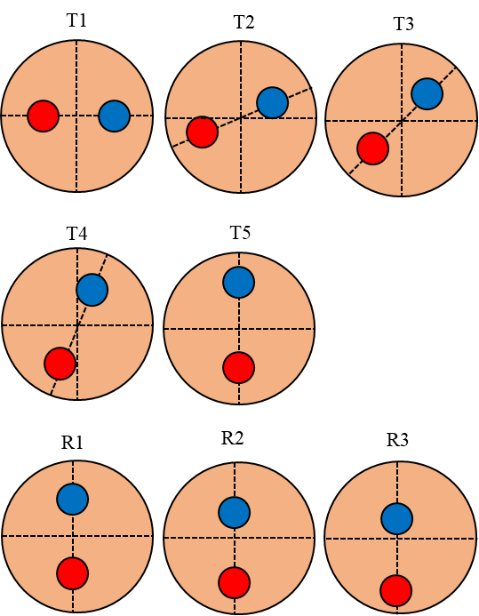

**Figure 3.** Various LHTES configurations. The baseline case is T1.

**Table 2.** Various combinations of radial and tangential positions of HTF tubes inside the shell.

|  |  |  |  |  |  |
| --- | --- | --- | --- | --- | --- |
| **Cases** | ***D* (mm)** | ***d* (mm)** | ***θ* (°)** | ***C* (mm)** | ***C/d*** |
| T1 | 40 | 8 | 0 | 0 | 0 |
| T2 | 40 | 8 | 22.5 | 0 | 0 |
| T3 | 40 | 8 | 45.0 | 0 | 0 |
| T4 | 40 | 8 | 67.5 | 0 | 0 |
| T5 | 40 | 8 | 90.0 | 0 | 0 |
| R1 | 40 | 8 | 90.0 | 2 | 0.25 |
| R2 | 40 | 8 | 90.0 | 4 | 0.5 |
| R3 | 40 | 8 | 90.0 | 6 | 0.75 |

## **2.2 PCM and thermophysical properties**

Dodecanoic (lauric) acid (CH3(CH2)10COOH) was selected as the PCM for the present study since it is safe, relatively inexpensive and has a melting temperature of 42.5 ± 0.5 °C, which suits the temperature range for an SDHW application [70]. Dodecanoic acid also has stable thermal properties during thermal cycling [71]. The thermophysical properties of dodecanoic acid [72] are listed in Table 3 and the thermophysical properties of copper (the material of the tube body) can be found in Table 4.

**Table 3.** Thermophysical properties of dodecanoic acid [72].

|  |  |  |
| --- | --- | --- |
| **Property** | **Value/relation (*T* in K)\*** | |
| Specific heat capacity (J/mol.K) | Liquid | $$50.801+2.258T-0.004966T^{2}+0.0000043771T^{3}$$ |
| Solid | $$202.564-1.1243+0.0064399T^{2}$$ |
| Density (g/mol) | Liquid | $$0.28418×{0.2655}^{\left[-{\left(1-\frac{T}{734}\right)}^{0.2933}\right]}$$ |
| Solid | 930 |
| Thermal conductivity (W/m.K) | Liquid | $$-1.4322+{0.7077}^{{\left(1-\frac{T}{734}\right)}^{(2/7)}}$$ |
| Solid | 0.15 |
| Viscosity (cP) | $$-8.6022-\frac{1871.3}{T}+0.015184T-0.000012043T^{2}$$ | |
| Molecular mass (g/mol) | 200.3 | |
| Thermal expansion coefficient (1/K) | 0.000797 | |
| Latent heat of fusion (J/kg) | 184000 | |
| Solidus temperature (K) | 314.15 | |
| Liquidus temperature (K) | 316.15 | |

* In all equations, the unit of temperature (*T*) is in Kelvin.

**Table 4.** Thermophysical properties of copper (the material of the tube body), adopted from ANSYS Fluent database.

|  |  |
| --- | --- |
| **Property** | **Value** |
| Specific heat capacity (J/kg.K) | 381 |
| Density (kg/m3) | 8980 |
| Thermal conductivity (W/m.K) | 388 |

# **Numerical methods**

The CFD model was developed based on the enthalpy-porosity formulation [73–75], including natural convection, conduction heat transfer and phase change during the charging and discharging processes. In the enthalpy-porosity method, the liquid-solid mushy zone is treated as porous where the cell porosity is equal to the liquid fraction. In the computation domain, each cell is associated with a quantity called “liquid fraction” calculated based on an enthalpy balance. The liquid fraction lies between 0 and 1, and the porosity increase from 0 to 1 as the material melts. As the material is fully solidified in a cell, the porosity and hence the velocity drop to zero.

The thermofluid behaviour of the PCM in the horizontal configurations is 2D, therefore 2D numerical approaches have been demonstrated as a rewarding capacity to model the behaviour of such systems. It is widely used by previous studies and verified against experimental data (see e.g. Ref. [53,54,76]). The main goal of the present study is to investigate the PCM behaviour in the LHTESs but not the evolution of the water/tube wall in the process. Moreover, experimental data [29,77,78] showed that the variation of the HTF during the charging and discharging process is not significant. Therefore, a 2D approach was chosen for this study to investigate the performance of PCM, and the bulk effect of the HTFs and tubes was modelled using the method developed in Appendix A.

A shell conduction approach was used to model heat conduction in copper. This approach employs an equivalent thermal resistance (based on the thermal conductivity and thickness of the copper) to model heat conduction in the solid wall.

## **Governing equations**

Following assumptions were considered:

* The flow is 2-D, laminar, incompressible, transient and Newtonian.
* Boussinesq approximation was used for buoyant force calculations [79–82].
* The gravity acceleration of 9.81 m/s2 was applied on the negative y-axis (see Figure 2).Viscous dissipation was neglected due to small velocity gradients [14].
* Linear variation of the liquid fraction with temperature was assumed [79–82].
* The bulk HTF temperature was assumed constant in the HTF tube
* The flow in HTF tubes is fully developed and approximated by convective boundary conditions on the tube’s walls.
* Convective boundary condition was used to account for convective heat transfer in HTF tubes
* Shell conduction approach was used to account for conductive heat transfer in copper

The governing equations for enthalpy-porosity can be written as follows [66]:

*Continuity equation:*

|  |  |
| --- | --- |
| $\frac{∂ρ}{∂t}+∇.\left(ρ\vec{v}\right)=0$. | (1) |

*Momentum equation:*

|  |  |
| --- | --- |
| $\frac{∂\left(ρV\right)}{∂t}+∇.\left(ρVV\right)=-∇P+∇.\left(μ∇V\right)-ρ_{0}gβ\left(T-T_{0}\right) +\frac{{\left(1-f\right)}^{2}}{f^{3}-ε}VA_{mush}$, | (2) |

where $V$ is the velocity field, *P* the pressure, $μ$ the dynamic viscosity, and $ρ$ is the PCM density, while $ρ_{0}$ and $T_{0}$ are reference density and temperature, respectively. The third and fourth terms on the right-hand side of the Eq. (2) are buoyancy force (defined based on the Boussinesq approximation) and momentum sink (due to reduced porosity in the mushy zone), respectively. The term $A_{mush}$ is a constant reflecting the mushy zone morphology that describes how steeply the velocity is reduced as the material solidifies. The constant $ε$ is a small number to prevent division by zero, and the liquid fraction $f$ is defined as:

|  |  |
| --- | --- |
| $f=\left\{\begin{matrix}0 \\ \frac{T-T_{s}}{T_{l}-T_{s}} \\ 1\end{matrix} ; \begin{matrix}T<T_{s} \\ T_{s}<T<T_{l} \\ T> T_{l}\end{matrix}\right.$, | (3) |

where $T_{s}$ and $T_{l}$ are the solidus and liquidus temperatures, respectively.

*Energy equation:*

|  |  |
| --- | --- |
| $\frac{∂}{∂t}\left(ρH\right)+∇.\left(ρVH\right)=∇.\left(k∇T\right)$, | (4) |

where $k$ the thermal conductivity and $H$ the total volumetric enthalpy, that is the sum of sensible enthalpy, $h$, and latent heat, $L$:

|  |  |
| --- | --- |
| $H=h+fL$*,* | (5) |
| $h=h_{ref}+\int_{T_{ref}}^{T}{c_{p}}dt$, | (6) |

where $h_{ref}$ is the sensible enthalpy at the reference temperature, $T_{ref}, and c_{p}$ is the specific heat. The following parameters were used in this work [66]: $A_{mush}={10}^{5}$, $ε=0.001$, and $T_{ref}=298.15$ K.

## **3.2 Initial and boundary conditions**

It is assumed that the shell’s outer surface is well insulated; therefore, an adiabatic boundary condition was used for the outer wall of the shell. The convective heat transfer boundary condition was applied to their inner surfaces. The convective boundary condition corresponds to the forced convection heat transfer from/to the HTFs [79] and is defined as:

|  |  |
| --- | --- |
|  | (7) |

where $T_{b}$ is the fluid bulk temperature, and $h$ is the convective heat transfer coefficient, which can be estimated from the method developed in “Appendix A”. The shell conduction model was used to account for the conduction heat transfer through the tube’s wall.

The cold and hot water were assumed to enter the HTF tubes at 10 °C and 58 °C, respectively [32]. As discussed in Section 2.1, the flow rate of cold and hot water was assumed to be 5.7 L/min and 2.8 L/min, respectively. The initial temperature was assumed to be 55 °C when the LHTES is initially charged (PCM is melted) and 22 °C (room temperature) when the LHTES is initially discharged (PCM is solid).

## **3.2 Data reduction**

Three terms, released, gained and stored energy, have been widely used throughout this paper which are described here for sake of clarity. The released energy implies the released thermal energy by PCM to the cold HTF which can be calculated from the heat transfer rate in cold HTF. The gained energy is the absorbed thermal energy by PCM from the hot HTF which can be calculated from the heat transfer rate in the hot HTF. The stored energy in the LHTES system is the difference between gained and released energy that is stored in the form of latent heat in the PCM.

The gained thermal power, $P_{G}$, is defined as the amount of heat delivered by hot HTF to the PCM in the LHTES unit, and the released thermal power, $P_{R}$, is the amount of heat delivered by the PCM in the LHTES unit to the cold HTF. These can be evaluated by calculating the rate of heat transfer on the surface of the hot and cold HTF tubes from:

|  |  |
| --- | --- |
| $$P_{G}(t)=h_{h}\left(\frac{πd^{2}}{4}\right)\left[T_{w,h}(t)-T_{in,h}\right]$$ | (8) |
| $$P_{R}(t)=h_{c}\left(\frac{πd^{2}}{4}\right)\left[T_{w,c}(t)-T_{in ,c}\right]$$ | (9) |

where $h_{h}$ and $h_{c}$ are the heat transfer coefficient on the internal surfaces of the hot and cold HTF tubes, respectively, $T_{in,h}$ and $T_{in,c}$ are the inlet temperature of hot and cold HTF, respectively, and $T_{w,h}$ and $T_{w,c}$ are the temperature of the inner surface of hot and cold HTF tubes, respectively. The fluid inlet temperatures are assumed to be constant; however, $T_{w,h}$ and $T_{w,c}$ vary with time due to changes in heat transfer rate in PCM.

In Eqs. 8 and 9, the bulk HTF temperature and (ii) the convective heat transfer coefficient are constant, while the surface temperature of the HTF tubes ( $T_{w,h}$ and $T_{w,c}$) varies with time. Due to the small variations in the HTF temperature [77,78], the bulk HTF temperature was approximated by the inlet temperature. Consequently, the heat transfer coefficient was calculated by the Nusselt number with the method discussed in the Appendix. The convective heat transfer coefficient remains constant since the Reynolds number of HTFs does not change during the process. The bulk HTF temperature and convective heat transfer coefficient are used as convective boundary conditions on the surface of the HTF tubes in the CFD simulations as defined by Eq. 7. During the process, the power is altered based on the surface temperature of the HTF tubes ( $T_{w,h}$ and $T_{w,c}$), which are calculated by CFD simulation in each individual timestep. This simplified method can accurately predict the transient heat transfer process in horizontal shell-and-tube LHTES systems, which was also validated against the data from the literature (see Figures 7 and 8) for calculating average PCM temperature and liquid fraction.

Since a valid converged CFD simulation must maintain the energy balance, therefore, the calculated heat transfer rate Eqs. 8 and 9 should be equal to the heat transfer rate calculated by CFD simulation in this case ANSYS Fluent simulations. Table 5 compares heat transfer rate values calculated by distinctive methods for configuration R2 at 20 min in an initially melted scenario:

Table 5. Comparing methods for calculating the heat transfer rate

|  |  |  |
| --- | --- | --- |
| **Method** | **Heat transfer rate** | |
| **Cold HTF tube** | **Hot HTF tube** |
| Eqs. 8 and 9 | 66.74 | 61.05 |
| CFD-ANSYS Fluent | 66.23 | 60.81 |
| Deviation (%) | 0.76 | 0. 39 |

The small deviations observed in Table 5 are due to the different averaging used by each method. In Eqs. 8 and 9, the averaged surface temperature was used, while in Fluent, the heat rate was averaged over the tube’s walls.

The capacity of the LHTES in gaining and releasing energy over time $t$ can be evaluated as [83]

|  |  |
| --- | --- |
| $$Q=\int_{0}^{t}{P dt}$$ | (10) |

where $P$ is the heat transfer rate to/from HTFs (Eq.s (12) and (13)).

## **3.3 Numerical procedure**

ANSYS-Fluent 19 is employed for solving the set of coupled partial differential equations using the Finite Volume Method (FVM), and the Pressure Implicit with Splitting of Operator (PISO) algorithm is used for treating the pressure-velocity coupling. The discretisation of momentum and energy equations is performed by the QUICK differencing scheme, while the PRESTO! (PREssure STaggering Option) scheme is adopted for pressure correction. The majority of the previous numerical studies (see, e.g. Ref. [66,76,80,81,84]) used convergence criteria of 10-6 for all equations, while other convergence criteria such as 10-5 for momentum equations and 10-8 for the energy equation was also used [82]. In the present study, a first-order implicit time advancing method was used and a course of 100 iterations at each time step was found satisfactory to fulfil the convergence criterion of 10-6 for momentum and 10-9 for the energy equations. The simulations were performed in double precision, and all convergence criteria were checked at each time step to ensure solution convergence.

## **3.4 Numerical convergency**

To ensure the convergency of the simulations, the convergency of the temperature was checked during the iterative simulation process. Figure 4 illustrates the variation of the average temperature on the cold and hot HTF tubes versus numerical iterations during the numerical solution. It demonstrates that the temperature changes in each time step remain constant after some iteration, proving the convergency of the temperature during the time steps. Figure 5 shows the absolute residual of the average temperature on the cold and hot HTF tubes in a typical time step during the numerical solution. It demonstrated that, after a few iterations at the initial stages of each time step, the temperature residual converges to an infinitesimal value (a value less than 10-7) at the end of time steps. Figures 4 and 5 confirm the convergency of the numerical simulations with well-defined convergence criteria.

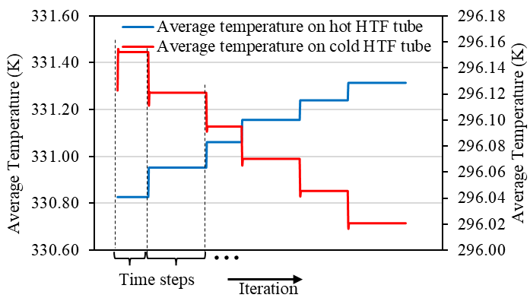

**Figure 4**. Variation of the average temperature on the cold and hot HTF tubes versus numerical iterations during the numerical solution. For brevity, only a typical section of the graph is plotted. The horizontal axis represents the iteration progress, and each step shows the time step change.

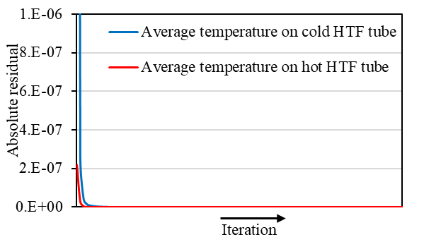

**Figure 5**. Absolute residual of the average temperature on the cold and hot HTF tubes in a typical time step during the numerical solution.

**3.5 Mesh generation**

The computational mesh was generated in ANSYS-Meshing 19.2 with structured boundary layer mesh over the tubes and unstructured in the rest of the computational domain. Face sizing was used to control the cell size inside the shell, and inflation layers were implemented to generate the boundary layer mesh, with ten layers over the HTF tubes, which can reduce the number of required cells to reach the mesh convergency. Figure 4 shows the computational mesh and the boundary layer mesh with a smooth transition.

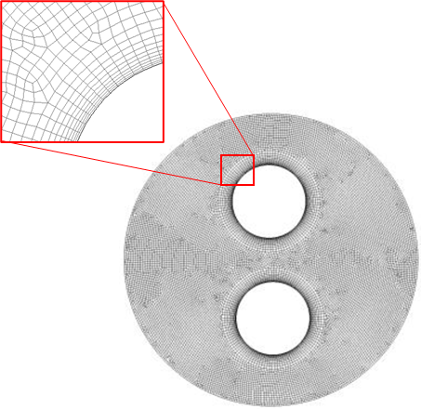

**Figure 6.** Computational mesh with the structured boundary layer mesh over the tubes and unstructured in the rest of the domain.

# **Validation and verification of CFD method**

## **4.1 Model validation**

The CFD method was validated against the experimental study of Hosseini et al. [53] and the numerical study of Seddegh et al. [79]. Both studies have been conducted to evaluate the charging and discharging behaviour of shell-and-tube LHTES systems. Hosseini et al. [53] recorded the temperature history in PCM and the variation of PCM liquid fraction with time (under the charging and discharging processes) in a heat exchanger with a 1 m long horizontal cylinder as the shell with an inner diameter of 85 mm, and a copper tube with an inner radius of 22 mm located centrally in the cylinder filled with commercial paraffin RT50 as the PCM. The outside surface of the heat exchanger was insulated by glass wool of 60 mm thickness to prevent heat losses to the surroundings. The HTF flow rate was 1 L/min, and the HTF inlet temperature was 343 K and 293 K for charging and discharging, respectively. Seddegh et al. [79] also used the same LHTES system to perform a numerical study.

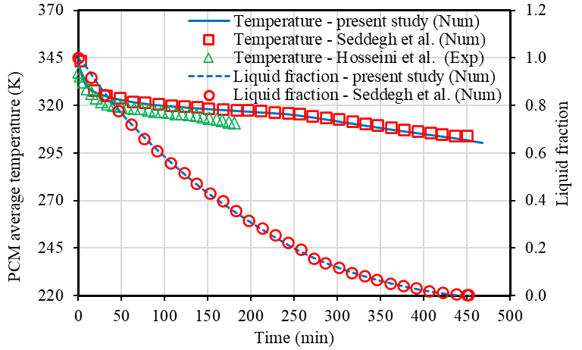

**Figure 7.** Validation of the CFD method against the results of Hosseini et al. [53] and Seddegh et al. [79] for the variations of temperature and liquid fraction during discharging (solidification).

Figure 7 compares the CFD results of the present study for variation of temperature and liquid fraction during the charging (melting) process compared with the results of Hosseini et al. [53] and Seddegh et al. [79]. Figure 8 illustrates the verification of the CFD results for discharging (solidification) process. For the discharging process, excellent agreement is observed with Seddegh et al. [79] data with a Normalised Root Mean Square Error (NRMSE) of 0.01 % and good agreement with Hosseini et al. [53] with an NRMSE of 5 %. For the charging process, excellent agreement is reflected in the experimental data of Hosseini et al. [53] with an NRMSE of 2 % and 0.07 % for temperature and liquid fraction estimations, respectively.

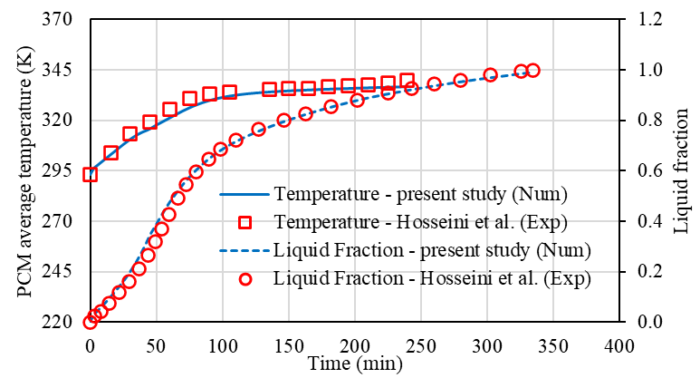

**Figure 8.** Validation of the CFD method against the results of Hosseini et al. [53] and Seddegh et al. [79] for the variations of temperature and liquid fraction during charging (melting).

## **Mesh and timestep dependency study**

A mesh convergence study was conducted to ensure the numerical simulation is independent of the mesh resolution. This procedure started with a computational mesh with 3000 cells and continued by increasing the number of cells to 20000.

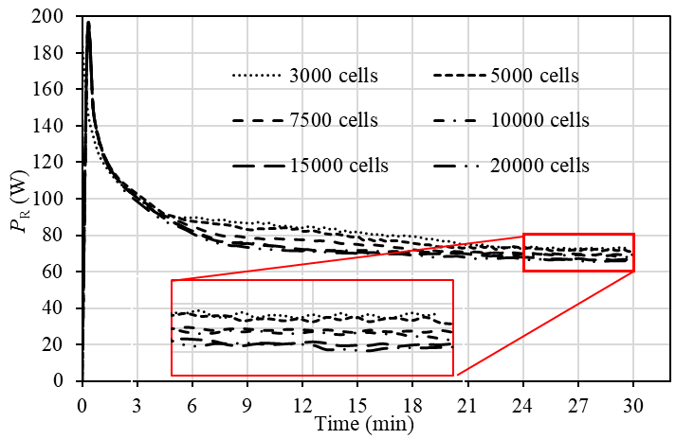

**Figure 9.** Mesh convergency study for Case T3, initially charged, with different computational cells.

Configuration T3 (listed in Table 2), with the initially charged condition, was selected for mesh convergency study, and six computational meshes with various cells were studied. The variation of gained thermal power ( $P_{R})$ with time was recorded for each computational mesh, as shown in Figure 9. A computational mesh with 15000 cells seems to be sufficient for the present study since a further increase in the cells leads to marginal changes in the gained energy.

Since PCM’s charging and discharging process is a time-dependent process, the timestep size can influence the calculated results. In order to test whether the CFD code is independent of the timestep size, a timestep dependency study for timestep sizes of 0.1, 0.08, and 0.05 s was performed. Figure 10 shows that the sensitivity of results to the variation of the tested timesteps is negligible, and a timestep size of 0.05 s was used for the present study.

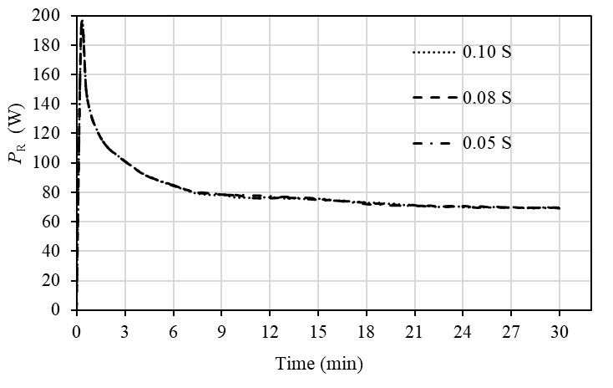

**Figure 10.** Timestep convergence study for Case T3, initially melted.

# **Results and discussion**

A range of CFD simulations was performed to investigate the SCD response of eight horizontal LHTES systems with various configurations shown in Figure 3. It was assumed that cold water enters the cold HTF tube at a temperature of 10 °C and a flow rate of 5.7 L/min to discharge the system, and at the same time, hot water – e.g., from a solar collector – enters the hot HTF tube at a temperature of 58 °C and a flowrate of 2.8 L/min to charge the system. These conditions meet the operation parameters of a typical LHTES system for SDHW applications [29,32]. The SCD response of these LHTES systems was evaluated for a duration of 30 min in two scenarios: (i) LHTES is initially discharged (PCM is solid at room temperature 22 °C), and (ii) LHTES is initially charged (PCM is melted at 55 °C).

The SDC operation of LHTES systems can be an unstable process due to the complexity and nonlinearity of the process, including simultaneous melting, solidification, natural convection, and conduction heat transfer. Figure 11(a) shows that, at the beginning of the process, the natural convection is extremely weak (t = 5 min) and the dominant heat transfer mechnisim is conduction. As the process continues, small recirculation regions are formed (t = 10 min) and the natural convection begins to influence the heat transfer. With further melting, the liquid region becomes larger and the recirculation regions become stronger due to the increased velocity of the molten PCM (t = 15, 20, and 25 min). By further extension of the molten region (t = 30 min), the recirculation regions merge and construct larger recirculation that enhances the natural convection process. Variations in the dynamics of the recirculation and hence heat transfer leads to changes in the temperature distribution during the operation, as indicated in Figure 11(b). The temperature variations in the molten PCM can result in regional solidification in the PCM that will be investigated in the following sections (See Figure 19). Since the heat transfer to/from HTF tubes can vary significantly during the process, the temperature on the HTF tubes alters during the SCD process. As numerical simulation concerns, the constant temperature boundary conditions cannot properly model the heat transfer variations on the HTF tubes, and more realistic boundary conditions are required. Therefore, the convective boundary condition, explained in section 3.2 and Appendix A, was used in the present study, allowing the temperature of the HTF tubes to vary during the simulation.

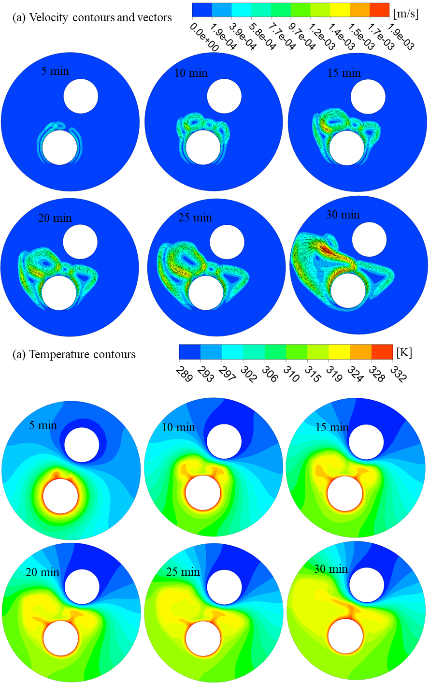

Figure 11. (a) Velocity contours and vectors; and (b) Temperatures contours for different instances during SCD operation. For brevity, only configuration T4 (for the initially discharged process) is considered.

The thermal power is sensitive to the temperature of the surfaces of the HTF tubes and small variation in the temperature leads to changes in the thermal power (See Eq.s (8) and (9)). Therefore, depending on the heat transfer, operation condition and design of the system, small or large fluctuations can be appeared in the thermal power, especially in SCD mode. These fluctuations can be observed in Figure 12 (for initially discharged) and Figure 16 (for initially charged). This is also observed in the earlier experimental studies (see, e.g. Ref.s [24,29,30]). Since the hot and cold HTF tube is surrounded by the liquid and solid PCM, respectively, the influence of the natural convection is more prominent on the hot HTF tube than that on the cold HTF tube. Therefore, the fluctuations appeared in the $P_{G}$ graphs are more than that of the $P_{R}$ graphs. For the same reason, the fluctuations are stronger when in an initially charged LHTES (see Figure16 (a)). Further discussion will be provided later in this paper.

## **LHTES initially discharged**

The SCD operation of an initially discharged LHTES system is challenging since it has low stored energy to supply and the low thermal conductivity of PCM between the HTF tubes hinders the direct conduction heat transfer between tubes.

Figure 12 illustrates the variations of the gained/released thermal power with operation time for initially discharged LHTES systems. For an initially discharged LHTES in SCD mode, the heat transfer from HTF initially occurs in the form of sensible heat to the PCM around each HTF tube. Therefore, in the initial stage, a constant decrease in the thermal power release/storage can be observed due to the reduction of PCM sensible heat transfer over time, as shown in Figure 12. As the process proceeds, the temperature of the solid PCM around the cold HTF tube reduces, and at the same time, the temperature of the solid PCM around the hot HTF tube increases until the PCM temperature in those regions reaches the melting temperature; after which further heat transfer from hot HTF to the PCM takes place in the form of latent heat by melting the solid PCM through natural convection-dominant heat transfer [56,66], and the energy is released into the cold HTF by heat conduction through solid PCM [66]. More heat is transferred in a convection-dominant than the conduction-dominant phase change process [80]; therefore, by comparing Figures 12(a) and (b), it can be seen that amount of gained power is more than the released power as the SDC process starts with initially solid PCM.

A typical SDC process is initially an energy store process and the LHTES unit undergoes a temperature increase process during the initial stage until it eventually becomes stable [32]. Figures 12 shows that, in the stable condition, no noticeable change in the gained energy occurs, while the released power requires more time to reach a stable condition. The configurations of the HTF tubes inside the shell can alter the impact of natural convection heat transfer in the molten PCM and influence the performance of the LHTES system. Since the conduction heat transfer governs the energy transfer at the initial stage, all configurations have similar performance for about 2 min, as shown in Figure 12, after which each system starts to behave differently due to the emergence of natural convection and phase-change process in the liquid PCM that is influenced by the configuration.

**Figure 12.** Variation of: (a) gained thermal power ($P_{G})$, and (b) released thermal power ( $P_{R})$ with time for initially discharged LHTES systems.

Figure 12 (a) shows that the impact of the tangential position of the HTF tubes on the gained power is greater than that of the radial position. For example, as shown in the inset of Figure 12 (time between 22 to 24 min), the gained thermal power can change from approximately 58 W for the baseline configuration (T1) to roughly 75 W for configuration T3, which corresponds to a notable increase of about 32 %. However, further increases in the tangential displacement lead to a reduction of the gained thermal power to approximately 67 W and 65 W for T4 and T5, respectively.

Figure 12 (b) shows that the impact of the tangential position on the released thermal power is greater than that of radial displacement. Increasing the radial distance (C in Figure 2) from configurations R1 to R2 slightly enhances the released thermal power, but further increases to that of configuration R3 reduces the released thermal power. Similar findings were reported by Zheng et al. [65] and Kadivar et al. [66] that increasing the radial displacement of the HTF tubes towards the bottom of the shell can increase the thermal efficiency up to a certain level, after which further increase in radial displacement reduces the thermal efficiency.

Figure 13 shows the variations of the gained and released energy with time. The gained energy is the cumulative energy supplied by the solar absorber to the LHTES system from the beginning of the operation till a certain instance. The released energy is the cumulative energy released by the LHTES system (stored in a hot water tank, see Figure 1) from the beginning of the operation till a certain instance. Figure 13 demonstrates that the graphs do not reach an asymptotic value for the duration of the SCD operation (for all configurations), meaning that the LHTES system has more capacity to be operated for a longer time under SCD mode. The performance of all configurations in gained energy is similar (Figure 13 (a)), with slightly better performance for T4 and R3. However, there is a noticeable difference between the released energy among the configurations. Figure 13 (b) shows that, since the beginning of the operation, the released energy of all configurations equally increases to about 6 kJ after 8 minutes of the operation; after which the released energy of each configuration increases with different slop. Configuration, T1 has the lowest rate of increasing the released energy with time, while configurations R1 and R2 have the highest rate of released energy.

**Figure 13**. Variation of: (a) gained energy, and (b) released energy with time for initially discharged LHTES systems.

To perform a quantitative evaluation of different LHTES configurations, the total energy is calculated and shown in Figure 14. The total released energy enhances from 22.23 kJ for T1 up to 23.68, 34.16, 40.86, and 43.97 kJ/kg for T2 to T5, respectively, showing a monotonical enhancement up to 97.74 % with increasing the tangential position from T1 to T5. Increasing the tangential position (θ) moves the cold HTF tube above the hot HTF tube leading to the improved interaction between the convective region (in liquid PCM) and conductive region (solid PCM). This leads to the reduction of the solid PCM between the cold HTF tube and the liquid PCM, as illustrated in Figure 15. Since the solid PCM is a poorly conductive material due to its low thermal conductivity, the reduction of its thickness improved the heat conduction from the convective region (liquid PCM) to the cold HTF tube.

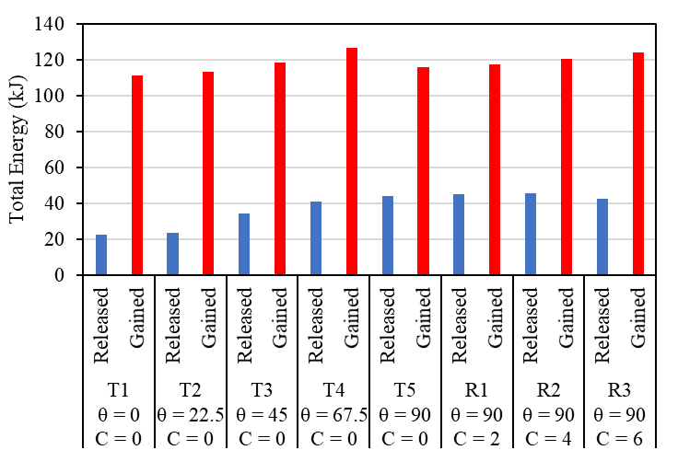

**Figure 14.** Total released/gained energy of different LHTES configurations for 30-min operation under SDC mode when the unit is initially discharged.

The total gained energy is less sensitive to the changes in tangential position, leading to a maximum 13.80 % improvement in the total gained energy for configuration T4. Increasing the tangential position improved the total gained energy from 111.33 kJ for configuration T1 up to 113.04, 118.30, and 126.70 kJ for configurations T2 to T4, respectively; however, a further increase in tangential position to configuration T5 reduced the total gained energy down to 115.90 kJ. As mentioned, increasing the tangential position (θ) enhances the heat transfer; however, at θ = 90˚ (configuration T5), the cold HTF tube is exactly positioned above the hot HTF tube (see Figure 15) and diminishes the growth of the liquid region, leading to heat transfer reduction.

Figure 14 shows that the total released energy is less sensitive to the changes in the radial position. An increase in the radial position from T5 to R1 increases the total release energy from 43.97 to 45.12 kJ, while a further increase in radial position to that of R2 does not affect the total released energy, although more increase to R3 reduced the total release energy to 42.68 kJ. Increasing the radial position monotonically enhances the total gained energy from 115.90 kJ for T5 to 117.57, 120.17, and 124.10 kJ for R1 to R3, respectively. This is due to growth in the liquid region, hence enhanced natural convection (see Figure 15).

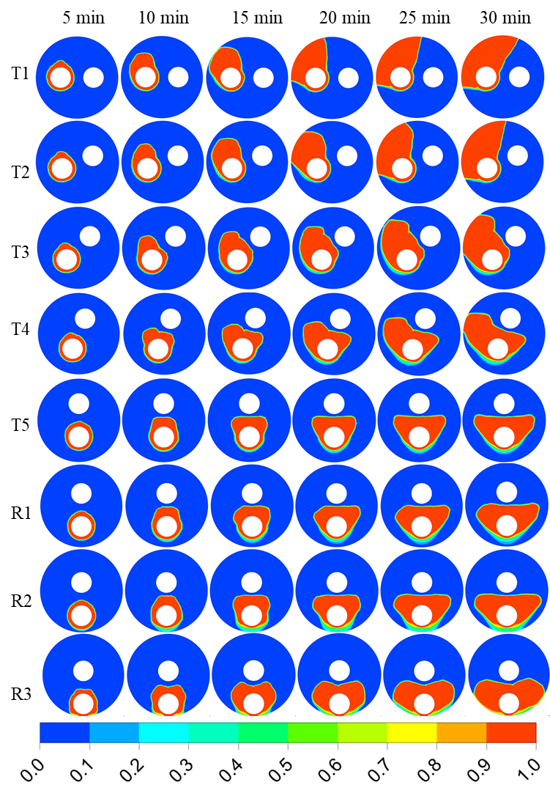

**Figure 15.** Impact of tangential displacement of the HTF tubes on the development of PCM liquid fraction for initially discharged LHTES systems; red: melted PCM, blue: sold PCM.

To achieve a better understating of the behaviour of the different LHTES configurations, the dynamic of the molten PCM is investigated in Figure 15. This figure shows the impact of the configurations of the HTF tubes on the liquid fraction development in an initially discharged LHTES under SDC mode. The red colour shows the liquid PCM, and the blue represents the solid PCM. During the SDC mode, when the PCM reaches its melting temperature, the cold HTF exchanges heat with the solid PCM around it, and the hot HTF transfers heat to the liquid PCM formed around its tube. The formation of the buoyancy-driven flow in the melted PCM enhances the phase-change heat transfer [56,66]. The heat transfer and thermal efficiency are significantly influenced by the interaction between the solid PCM and buoyancy-driven flow in liquid PCM. The more interaction between the liquid and solid PCM, the higher released and gained energy. For configuration T1, the least possible interaction occurs compared to other configurations. Increasing the tangential position causes the cold HTF tube to be placed above the hot HTF tube (through the buoyancy-driven region in melted PCM), leading to enhanced heat transfer between the hot and cold regions.

## **5.2 Initially charged**

The SCD operation of an initially charged LHTES system is less challenging since the stored energy can fully supply the energy demand, and the natural convection in the molten PCM enhances the direct heat transfer between HTF tubes. Figure 16 (a) and (b) illustrate the variations of the gained and released thermal power with time, respectively, for initially charged LHTES systems for SDC mode operation. As mentioned in the previous section, the energy storage/release is initially associated with sensible heat changes, i.e., by reducing the temperature of the PCM to the melt temperature, after which the phase change process in the form of latent heat governs the energy gained/release in a stable condition. Compared to the previous (initially discharged) case, here in the initially charged cases, a similar gained thermal power is observed, while the released energy roughly doubles during SDC. Figure 16 shows that the gained and released thermal power are in the same order, meaning that for longer operations, the process can be dominated by the direct heat transfer between the hot and cold HTFs, confirming the findings of Fang et al. [30].

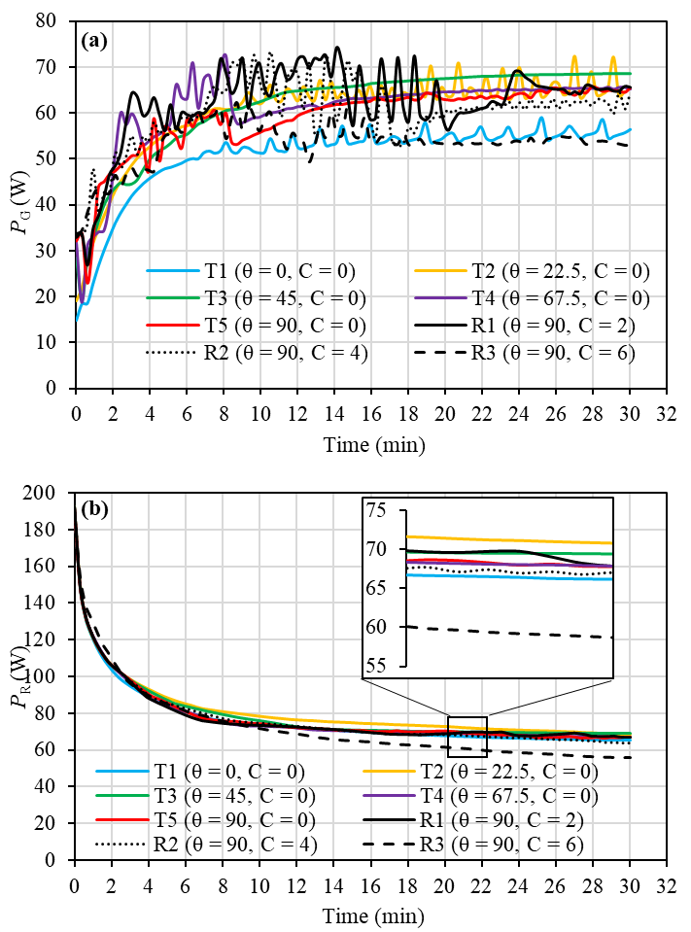

**Figure 16.** Variation of: (a) gained thermal power ($P_{G})$, and (b) released thermal power ( $P_{R})$ with time for initially charged LHTES systems.

The tangential position can influence the gained thermal power in LHTES under SDC mode, as shown in Figure 16 (a). Among all configurations, T1 has the lowest gained thermal power during the SDC process. Increasing the tangential position from that T1 to T4 enhances the performance of energy storage, after which a further increase from configuration T4 to T5 leads to a reduction in the gained thermal power. Increasing the tangential displacement seems to enhance the stability of the gained thermal power, with T3 having the most stable energy storage process.

The radial displacement of the HTF tubes can also influence the gained thermal power, as shown in Figure 16 (a). Increasing the radial displacement from 2 to 4 mm (that of R1 to R2) enhances gained thermal power for the majority of the operation time, while further increase to 8 mm (configuration R3) significantly reduces the gained thermal power. These findings are in line with those of Zheng et al. [65] and Kadivar et al. [66] that increasing the radial displacement can be effective up to a certain level, beyond that further increase in radial displacement reduce the thermal efficiency. However, it is evidenced that increasing the radial displacement seems to enhance the stability of the energy transfer.

Figure 16 (b) shows the effect of the radial and tangential positions of HTF tubes on the realised thermal power for initially charged LHTES units. All configurations provide a stable energy supply during SDC mode, and the released thermal power is less sensitive to changes in radial and tangential positions. Increasing the tangential position from configuration T1 to T2 increases the gained thermal power; however, a further increase from configuration T2 to T5 led to decreases in the released thermal power. The effect of radial displacement on released energy is more significant than that of tangential, as shown in Figure 16 (b). Increasing the radial displacement from 2 to 4 mm (from configuration R1 to R2) marginally reduces the released thermal power, and further increase to 8 mm (configuration R3) significantly reduces the energy supply. The configuration R3 supplies the lowest thermal power compared to the other configuration, and the configuration T2 provides the highest.

Figure 17 shows that the gained and released energy with time do not reach an asymptotic value for the duration of the SCD operation (for all configurations), meaning that the LHTES system has more capacity to be operated for a longer time under SCD mode. Figure 17 (a) shows that the released energy of each configuration linearly increases with different rates for each configuration. Configuration, T1 has the lowest rate of increasing the released energy with time, while configurations R1 has the highest rate of released energy. However, the performance of all configurations in released energy is similar, except for configurations T2 and R3, which have higher and lower rates, respectively.

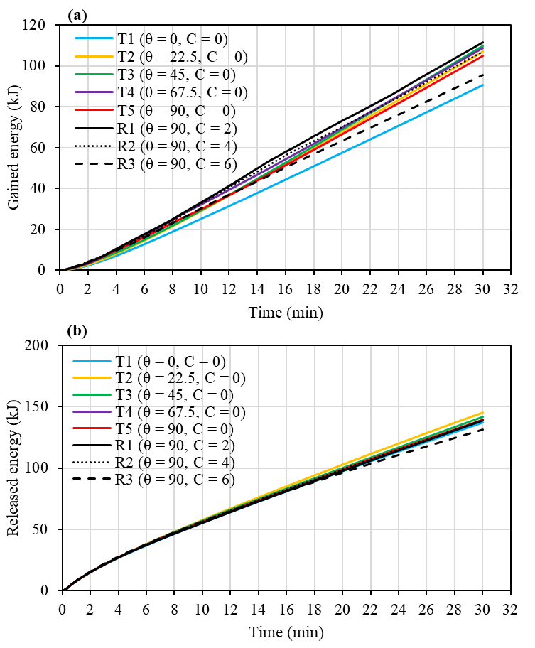

**Figure 17**. Variation of: (a) gained energy, and (b) released energy with time for initially charged LHTES systems.

Figure 18 shows the total released/gained energy of different LHTES configurations for 30 min of operation under SDC mode when the unit is initially charged. For all configurations, the total released energy is more than that of gained energy. The SDC operation of the initially charged LHTES system is less sensitive to the variations of the HTF tubes inside the shell. The reason is that the initially charged LHTES is filled with liquid PCM, hence good natural heat transfer exists in the system. Increasing the tangential position of the HTF tubes from *θ* = 0 ° to *θ* = 22.5 ° leads to an improvement in the total released energy from 137.35 kJ up to 145.11 kJ (5.65 % improvement) and total gained energy from 90.744 kJ up to 107.10 kJ (18 % improvement). The reason for this enhancement is the improved interaction between the hot and cold region that leads to the reduction of the solid PCM region around the cold HTF tube (see Figure 19), hence the growth of the liquid region (enhanced convection) and reduced thermal resistance by solid (improved conduction). A further increase in *θ* = 45 ° caused about a 2 % reduction in total released energy to a value of 141.81 kJ, although no significant change in the total gained energy. More increase in *θ* does not lead to noticeable changes in the total gained/released energies since the liquid region is already developed and the solid region reduced sufficiently, therefore, there is no further capacity in the system for heat transfer improvement.

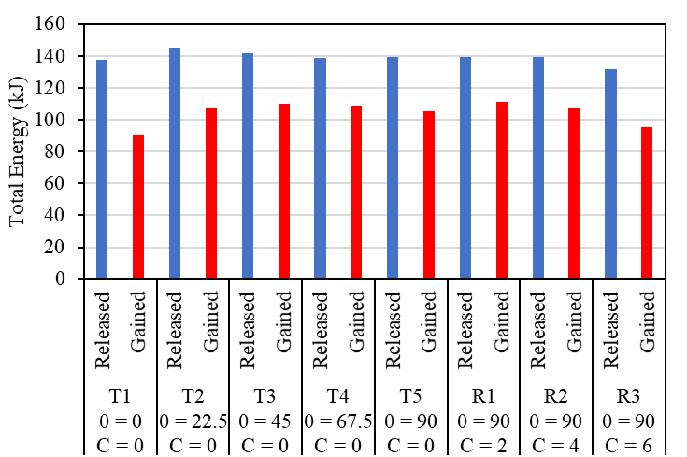

**Figure 18.** Total released/gained energy of different LHTES configurations for 30-min operation under SDC mode when the unit is initially charged.

Figure 18 shows that increasing the radial displacement enhances the total gained energy from 105.05 kJ (for T5) to 111.38 kJ for R1, due to enhanced convection. Further increase in the radial displacement reduces the total gained energy to 107.08 kJ for R2 and 95.65 KkJ for R3. Increasing the radial displacement does not affect the total released energy, except for R3 where the total realised energy reduces by 5.54 % to a value of 131.59 kJ, which is due to the increased solid region around the cold HTF tube (See Figure 19).

Figure 19 shows the impact of tangential displacement of the HTF tubes on the development of PCM liquid fraction for initially charged LHTES systems. In the majority of configurations (T1, T2, T4 and R1-R3) floating mushy regions (regions where the solid and liquid are mixed) form in the liquid PCM below the hot HTF. In the mushy region, the temperature locally varies between the solidus and liquidus temperatures, thus the liquid fraction varies between 0 and 1. The floating mushy regions can be formed due to unstable heat transfer that causes temperature variations in the liquid PCM. The region is the variation of the temperature distribution in the liquid PCM due to unstable heat transfer discussed at the beginning of this section. The Mushy region is also highly unstable, creating unstable heat transfer from hot HTF to PCM, exacerbating the fluctuations in the gained energy observed in Figure 15 (a). Modification of the HTF tube positions alters the natural convection in the liquid PCM and limits the formation of separated mushy, hence enhancing the heat transfer stability.

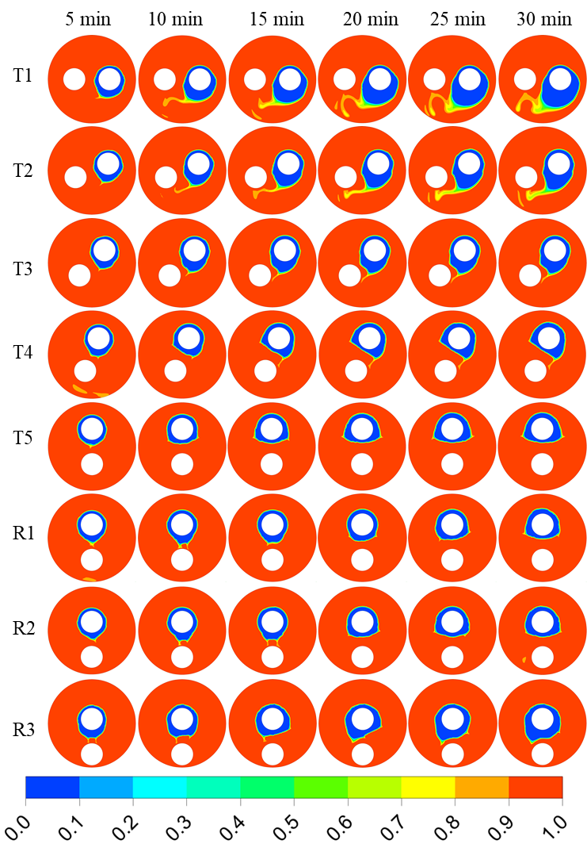

**Figure 19.** Impact of tangential displacement of the HTF tubes on the development of PCM liquid fraction for initially charged LHTES systems; red: melted PCM, blue: sold PCM.

Due to the solidification in the energy release process, solid PCM forms around the cold HTF tube, acting as a barrier against heat transfer due to the low thermal conductivity of the PCM; reducing the released energy to a certain extent lower than that of storage. Figure 19 shows that increasing the radial position from configuration reduces the size of the solid PCM formed around the cold HTF tube, leading to increased heat transfer and enhanced performance of LHTES under SDC mode. The smallest solid PCM region is observed in R1 and R2.

## **5.3 Optimised design and application**

When the SCD model of an LHTES system begins at a completely discharged unit, due to existing solid PCM in the LHTES, the rate of the released energy is very low, yet its gained energy is high (more than two times, see Figure 12). Therefore, in this condition, it is expected that the system follows two chief characteristics: (i) fast response to the demand, (ii) enhanced released energy. Considering Figures 12 and 14, it seems that, among all configurations, the LHTES with the configuration R2 outperform the others in fulfilling these two characteristics. Configuration R2 can provide a thermal power of more than 15 W after approximately 7 min from the start of the SCD operation and supply thermal powers of over 20 W (for 73 % of the time) and over 30 W (for 50 % of the time), during a 30-min SCD operation (see Figures 12). Compared to the configuration T1 (with the lowest performance), the total released energy of R2 is enhanced by 105.47 % (see Figure 12). The performance of R1 is very close to that of R2 with almost a similar response to the demand and a 103.02 % enhancement in total released energy.

On the other hand, as mentioned earlier, the SCD operation of an initially charged LHTES system is less critical than the initially discharged one. It was observed that the performance of the LHTES in both initially charged and discharged conditions gain a similar amount of energy from hot water. However, the released energy in the initially discharged LHTES systems is substantially less than in initially charged LHTES systems. Therefore, the selection of LHTES systems with enhanced performance in the initially discharged condition is the priority. Configurations R1 and R2 showed promising performance in initially discharged LHTES. These configurations also have good performance in the initially charged system with a better gained energy for R1. Therefore, among all configurations, R1 seems to have the best overall performance at both initially charged and discharged LHTES systems.

The double tube heat exchanger used in this study for SCD operation has some clear advantages over single tube managed with automatic switches one that only can contribute to consecutive charging and discharging. The followings list the pros and cons of these two designs

* Imagine, the highest solar irradiation is available whilst a demand for hot water is required, e.g. showering at noon of a sunny day. In the case of using a single-pipe LHTES with automatic switch, the demand of hot water activates the discharging mode which consequently depriving the system from utilizing the available high level of solar irradiation. To overcome this shortcoming in single-pipe LHTES applications, one of the practical step is to consider two separate outlet branches from the solar panel, one for the LHTES system and the other for the end-user; however, this idea will add more complexity to the system, design and consequently capital cost.
* Single-pipe LHTES with automatic switch systems are more complex and expensive due to demand of control switches and its associated costs. In addition, those switch systems are regularly electrical with limited lifetime span which prone the system to some technical maintenance issues. However, a double-pipe LHTES is simpler system, more durable as only mechanical devices (shell and tube) included in design and last but not the least more budget friendly as all the installation and maintenance procedure as only require a plumber technician.
* The present study showed that the design of double-pipe LHTESs can be optimised to suit both fast charging and discharging processes. However, Kadivar et al. [66] demonstrated that there is no single optimum design for both fast charging and discharging in single-pipe LHTESs.
* One of the drawbacks of the SCD is that some space in the shell is occupied with an extra tube, reducing the volume of the PCM in the shell. However, in the case of only charging/ discharging operation mode, both tubes can be served for the operation (only charging or discharging) which can enhance the heat transfer rate and increase the rate of heat transfer. Previous studies [85-86] have shown the advantage of multi-tube LHTESs in enhancing performance.

# **Conclusions**

The numerical results demonstrated that, at the beginning of the operation, heat transfer from the HTF was initially associated with changes to the sensible heat of the PCM and a stable change of released/gained energy was observed due to the temperature change. As the process proceeded, the PCM temperature approached its melting temperature and the energy transfer from hot HTF to the PCM took place in the form of latent heat.

The SCD operation mode does not suit configurations T1 (horizontally oriented HTF tubes) and T2 (no radial displacement and tangential displacement of 22.5 °), when these configurations are initially discharged. This mode of operation is challenging to the energy demand since the LHTES is discharged, and among all configurations, R1 and R2 had satisfactory performances. Compared to the configuration T1 (with the lowest performance), the total released energy of R2 is enhanced by 105.47 %. The performance of R1 is very close to that of R2 with almost a similar response to the demand and a 103.02 % enhancement in total released energy.

When the LHTES was initially charged, unlike in the initially discharged case, the gained and released thermal powers were similar, showing that, over the prolonged operation, the process can be dominated by direct (undesirable) heat transfer between the hot and cold HTFs. The SCD operation mode suits shell-and-tube LHTES systems when these are initially charged since the amount of energy released and storage are noticeable. The configuration R1 also excelled in this case with a high amount of released and gained energy, with a 22.74 % enhancement in the gained energy and about a 2 % improvement in the released energy.

In general, the impact of the tangential position of the HTF tubes on the performance of LHTES systems operated in SCD mode is more significant than that of the radial position. The selection of the most suitable configuration depends on the application, and in an SDHW application in the SCD mode, the released energy is of importance. Therefore, considering both scenarios (LHTES initially discharged/charged), the performance of configuration R1 (¼ tube diameter and 90 ° displacement in the radial and tangential positions) demonstrated the best performance compared to the configurations studied in this work.

# **Acknowledgements**

This work was supported by the UK Engineering and Physical Sciences Research Council (EPSRC) [grant numbers EP/S032622/1, and EP/R045518/1]. Data supporting this publication can be obtained on request from cep-lab@ imperial.ac.uk. For the purpose of Open Access, the authors have applied a CC BY public copyright licence to any Author Accepted Manuscript version arising from this submission.

**References**

[1] A. Kasaeian, H. Sarrafha, Solar energy systems: An approach to zero energy buildings, in: Advances in Clean Energy Technologies, Elsevier, 2021: pp. 89–170. https://doi.org/10.1016/B978-0-12-821221-9.00003-7.

[2] L. Kumar, M. Hasanuzzaman, N.A. Rahim, Global advancement of solar thermal energy technologies for industrial process heat and its future prospects: A review, Energy Convers Manag. 195 (2019) 885–908. https://doi.org/10.1016/j.enconman.2019.05.081.

[3] M.K.H. Rabaia, M.A. Abdelkareem, E.T. Sayed, K. Elsaid, K.-J. Chae, T. Wilberforce, A.G. Olabi, Environmental impacts of solar energy systems: A review, Science of The Total Environment. 754 (2021) 141989. https://doi.org/10.1016/j.scitotenv.2020.141989.

[4] M. Yang, M.A. Moghimi, Y. Zhu, R. Qiao, Y. Wang, R.A. Taylor, Optical and thermal performance analysis of a micro parabolic trough collector for building integration, Appl Energy. 260 (2020) 114234. https://doi.org/10.1016/j.apenergy.2019.114234.

[5] M. Najjar, K. Figueiredo, A.W.A. Hammad, A. Haddad, Integrated optimization with building information modeling and life cycle assessment for generating energy efficient buildings, Appl Energy. 250 (2019) 1366–1382. https://doi.org/10.1016/j.apenergy.2019.05.101.

[6] S. Zhang, D. Feng, L. Shi, L. Wang, Y. Jin, L. Tian, Z. Li, G. Wang, L. Zhao, Y. Yan, A review of phase change heat transfer in shape-stabilized phase change materials (ss-PCMs) based on porous supports for thermal energy storage, Renewable and Sustainable Energy Reviews. 135 (2021) 110127. https://doi.org/10.1016/j.rser.2020.110127.

[7] H. Zhang, J. Baeyens, G. Cáceres, J. Degrève, Y. Lv, Thermal energy storage: Recent developments and practical aspects, Prog Energy Combust Sci. 53 (2016) 1–40. https://doi.org/10.1016/j.pecs.2015.10.003.

[8] Y. Zhao, C.Y. Zhao, C.N. Markides, H. Wang, W. Li, Medium- and high-temperature latent and thermochemical heat storage using metals and metallic compounds as heat storage media: A technical review, Appl Energy. 280 (2020) 115950. https://doi.org/10.1016/j.apenergy.2020.115950.

[9] H. Bazai, M.A. Moghimi, H.I. Mohammed, R. Babaei-Mahani, P. Talebizadehsardari, Numerical study of circular-elliptical double-pipe thermal energy storage systems, J Energy Storage. 30 (2020) 101440. https://doi.org/10.1016/j.est.2020.101440.

[10] P.T. Sardari, R. Babaei-Mahani, D. Giddings, S. Yasseri, M.A. Moghimi, H. Bahai, Energy recovery from domestic radiators using a compact composite metal Foam/PCM latent heat storage, J Clean Prod. 257 (2020) 120504. https://doi.org/10.1016/j.jclepro.2020.120504.

[11] P. Talebizadehsardari, J.M. Mahdi, H.I. Mohammed, M.A. Moghimi, A. Hossein Eisapour, M. Ghalambaz, Consecutive charging and discharging of a PCM-based plate heat exchanger with zigzag configuration, Appl Therm Eng. 193 (2021) 116970. https://doi.org/10.1016/j.applthermaleng.2021.116970.

[12] A. Gupta, R. Mathie, C. Markides, An experimental and computational investigation of a thermal storage system based on a phase change material: Heat transfer and performance characterization, Computational Thermal Sciences: An International Journal. 6 (2014). https://doi.org/10.1615/.2014011117.

[13] V. Voulgaropoulos, N. Le Brun, A. Charogiannis, C.N. Markides, Transient freezing of water between two parallel plates: A combined experimental and modelling study, Int J Heat Mass Transf. 153 (2020) 119596. https://doi.org/10.1016/j.ijheatmasstransfer.2020.119596.

[14] V. Voulgaropoulos, M. Kadivar, M.A. Moghimi, M. Maher, H. Alawadi, O.K. Matar, C.N. Markides, A combined experimental and computational study of phase-change dynamics and flow inside a sessile water droplet freezing due to interfacial heat transfer, Int J Heat Mass Transf. 180 (2021) 121803. https://doi.org/10.1016/j.ijheatmasstransfer.2021.121803.

[15] A.I. Fernandez, M. Martínez, M. Segarra, I. Martorell, L.F. Cabeza, Selection of materials with potential in sensible thermal energy storage, Solar Energy Materials and Solar Cells. 94 (2010) 1723–1729. https://doi.org/10.1016/j.solmat.2010.05.035.

[16] M. Mazman, L.F. Cabeza, H. Mehling, M. Nogues, H. Evliya, H.Ö. Paksoy, Utilization of phase change materials in solar domestic hot water systems, Renew Energy. 34 (2009) 1639–1643. https://doi.org/10.1016/j.renene.2008.10.016.

[17] Z. Liu, Z. Wang, C. Ma, An experimental study on the heat transfer characteristics of a heat pipe heat exchanger with latent heat storage. Part II: Simultaneous charging/discharging modes, Energy Convers Manag. 47 (2006) 967–991. https://doi.org/10.1016/j.enconman.2005.06.007.

[18] N. Sharifi, A. Faghri, T.L. Bergman, C.E. Andraka, Simulation of heat pipe-assisted latent heat thermal energy storage with simultaneous charging and discharging, Int J Heat Mass Transf. 80 (2015) 170–179. https://doi.org/10.1016/j.ijheatmasstransfer.2014.09.013.

[19] Z. Wang, Y. Diao, Y. Zhao, C. Chen, L. Liang, T. Wang, Thermal performance investigation of an integrated collector–storage solar air heater on the basis of lap joint-type flat micro-heat pipe arrays: Simultaneous charging and discharging mode, Energy. 181 (2019) 882–896. https://doi.org/10.1016/j.energy.2019.05.197.

[20] J.M. Mahdi, S. Lohrasbi, D.D. Ganji, E.C. Nsofor, Simultaneous energy storage and recovery in the triplex-tube heat exchanger with PCM, copper fins and Al2O3 nanoparticles, Energy Convers Manag. 180 (2019) 949–961. https://doi.org/10.1016/j.enconman.2018.11.038.

[21] M.M. Joybari, F. Haghighat, S. Seddegh, A.A. Al-Abidi, Heat transfer enhancement of phase change materials by fins under simultaneous charging and discharging, Energy Convers Manag. 152 (2017) 136–156. https://doi.org/10.1016/j.enconman.2017.09.018.

[22] M. Mastani Joybari, F. Haghighat, S. Seddegh, Numerical investigation of a triplex tube heat exchanger with phase change material: Simultaneous charging and discharging, Energy Build. 139 (2017) 426–438. https://doi.org/10.1016/j.enbuild.2017.01.034.

[23] M.M. Joybari, F. Haghighat, S. Seddegh, Y. Yuan, Simultaneous charging and discharging of phase change materials: Development of correlation for liquid fraction, Solar Energy. 188 (2019) 788–798. https://doi.org/10.1016/j.solener.2019.06.051.

[24] S. Khobragade, J.K. Devanuri, Energy and Exergy Analyses of Simultaneous Charging and Discharging Latent Heat Storage System at Different Inclination Angles—An Experimental Study, J Energy Resour Technol. 143 (2021). https://doi.org/10.1115/1.4051049.

[25] P. Omojaro, C. Breitkopf, Investigating and Modeling of Simultaneous Charging and Discharging of a PCM Heat Exchanger, Energy Procedia. 48 (2014) 413–422. https://doi.org/10.1016/j.egypro.2014.02.048.

[26] A.P. Omojaro, C. Breitkopf, Study on solid liquid interface heat transfer of PCM under simultaneous charging and discharging (SCD) in horizontal cylinder annulus, Heat and Mass Transfer. 53 (2017) 2223–2240. https://doi.org/10.1007/s00231-017-1971-1.

[27] A. Maccarini, G. Hultmark, N.C. Bergsøe, A. Afshari, Free cooling potential of a PCM-based heat exchanger coupled with a novel HVAC system for simultaneous heating and cooling of buildings, Sustain Cities Soc. 42 (2018) 384–395. https://doi.org/10.1016/j.scs.2018.06.016.

[28] G.S. Sodhi, P. Muthukumar, Compound charging and discharging enhancement in multi-PCM system using non-uniform fin distribution, Renew Energy. 171 (2021) 299–314. https://doi.org/10.1016/j.renene.2021.02.084.

[29] R.E. Murray, D. Groulx, Experimental study of the phase change and energy characteristics inside a cylindrical latent heat energy storage system: Part 1 consecutive charging and discharging, Renew Energy. 62 (2014) 571–581. https://doi.org/10.1016/j.renene.2013.08.007.

[30] Y. Fang, Z.G. Qu, J.F. Zhang, H.T. Xu, G.L. Qi, Simultaneous charging and discharging performance for a latent thermal energy storage system with a microencapsulated phase change material, Appl Energy. 275 (2020) 115353. https://doi.org/10.1016/j.apenergy.2020.115353.

[31] A. Mahdavi, M.A. Erfani Moghaddam, A. Mahmoudi, Simultaneous charging and discharging of multi-tube heat storage systems using copper fins and Cu nanoparticles, Case Studies in Thermal Engineering. 27 (2021) 101343. https://doi.org/10.1016/j.csite.2021.101343.

[32] R.E. Murray, D. Groulx, Experimental study of the phase change and energy characteristics inside a cylindrical latent heat energy storage system: Part 2 simultaneous charging and discharging, Renew Energy. 63 (2014) 724–734. https://doi.org/10.1016/j.renene.2013.10.004.

[33] P. Lamberg, Approximate analytical model for two-phase solidification problem in a finned phase-change material storage, Appl Energy. 77 (2004) 131–152. https://doi.org/10.1016/S0306-2619(03)00106-5.

[34] M. KENISARIN, K. MAHKAMOV, Solar energy storage using phase change materials☆, Renewable and Sustainable Energy Reviews. 11 (2007) 1913–1965. https://doi.org/10.1016/j.rser.2006.05.005.

[35] J.M. Mahdi, S. Lohrasbi, E.C. Nsofor, Hybrid heat transfer enhancement for latent-heat thermal energy storage systems: A review, Int J Heat Mass Transf. 137 (2019) 630–649. https://doi.org/10.1016/J.IJHEATMASSTRANSFER.2019.03.111.

[36] F. Agyenim, N. Hewitt, P. Eames, M. Smyth, A review of materials, heat transfer and phase change problem formulation for latent heat thermal energy storage systems (LHTESS), Renewable and Sustainable Energy Reviews. 14 (2010) 615–628. https://doi.org/10.1016/j.rser.2009.10.015.

[37] H. Yin, X. Gao, J. Ding, Z. Zhang, Experimental research on heat transfer mechanism of heat sink with composite phase change materials, Energy Convers Manag. 49 (2008) 1740–1746. https://doi.org/10.1016/j.enconman.2007.10.022.

[38] O.K. Yagci, M. Avci, O. Aydin, Melting and solidification of PCM in a tube-in-shell unit: Effect of fin edge lengths’ ratio, J Energy Storage. 24 (2019) 100802. https://doi.org/10.1016/j.est.2019.100802.

[39] M.H. Mizan, T. Ueda, K. Matsumoto, Enhancement of the concrete-PCM interfacial bonding strength using silica fume, Constr Build Mater. 259 (2020) 119774. https://doi.org/10.1016/j.conbuildmat.2020.119774.

[40] M. Kadivar, D. Tormey, G. McGranaghan, A review on turbulent flow over rough surfaces: Fundamentals and theories, International Journal of Thermofluids. 10 (2021) 100077. https://doi.org/10.1016/j.ijft.2021.100077.

[41] A. Jamekhorshid, S.M. Sadrameli, M. Farid, A review of microencapsulation methods of phase change materials (PCMs) as a thermal energy storage (TES) medium, Renewable and Sustainable Energy Reviews. 31 (2014) 531–542. https://doi.org/10.1016/j.rser.2013.12.033.

[42] M.N.A.N.A. Hawlader, M.S.S. Uddin, M.M. Khin, Microencapsulated PCM thermal-energy storage system, Appl Energy. 74 (2003) 195–202. https://doi.org/10.1016/S0306-2619(02)00146-0.

[43] M. Esapour, A. Hamzehnezhad, A.A. Rabienataj Darzi, M. Jourabian, Melting and solidification of PCM embedded in porous metal foam in horizontal multi-tube heat storage system, Energy Convers Manag. 171 (2018) 398–410. https://doi.org/10.1016/j.enconman.2018.05.086.

[44] Z. Deng, X. Liu, C. Zhang, Y. Huang, Y. Chen, Melting behaviors of PCM in porous metal foam characterized by fractal geometry, Int J Heat Mass Transf. 113 (2017) 1031–1042. https://doi.org/10.1016/j.ijheatmasstransfer.2017.05.126.

[45] M. Al-Jethelah, S.H. Tasnim, S. Mahmud, A. Dutta, Nano-PCM filled energy storage system for solar-thermal applications, Renew Energy. 126 (2018) 137–155. https://doi.org/10.1016/j.renene.2018.02.119.

[46] L. Qiu, Y. Ouyang, Y. Feng, X. Zhang, Review on micro/nano phase change materials for solar thermal applications, Renew Energy. 140 (2019) 513–538. https://doi.org/10.1016/j.renene.2019.03.088.

[47] M. Gorzin, M.J. Hosseini, M. Rahimi, R. Bahrampoury, Nano-enhancement of phase change material in a shell and multi-PCM-tube heat exchanger, J Energy Storage. 22 (2019) 88–97. https://doi.org/10.1016/j.est.2018.12.023.

[48] W. Li, D. Zhang, T. Jing, M. Gao, P. Liu, G. He, F. Qin, Nano-encapsulated phase change material slurry (Nano-PCMS) saturated in metal foam: A new stable and efficient strategy for passive thermal management, Energy. 165 (2018) 743–751. https://doi.org/10.1016/j.energy.2018.09.147.

[49] J.M. Mahdi, E.C. Nsofor, Solidification enhancement in a triplex-tube latent heat energy storage system using nanoparticles-metal foam combination, Energy. 126 (2017) 501–512. https://doi.org/10.1016/j.energy.2017.03.060.

[50] J. Fukai, Y. Hamada, Y. Morozumi, O. Miyatake, Improvement of thermal characteristics of latent heat thermal energy storage units using carbon-fiber brushes: experiments and modeling, Int J Heat Mass Transf. 46 (2003) 4513–4525. https://doi.org/10.1016/S0017-9310(03)00290-4.

[51] J.M. Mahdi, H.I. Mohammed, E.T. Hashim, P. Talebizadehsardari, E.C. Nsofor, Solidification enhancement with multiple PCMs, cascaded metal foam and nanoparticles in the shell-and-tube energy storage system, Appl Energy. 257 (2020) 113993. https://doi.org/10.1016/j.apenergy.2019.113993.

[52] O. Mahian, E. Bellos, C.N. Markides, R.A. Taylor, A. Alagumalai, L. Yang, C. Qin, B.J. Lee, G. Ahmadi, M.R. Safaei, S. Wongwises, Recent advances in using nanofluids in renewable energy systems and the environmental implications of their uptake, Nano Energy. 86 (2021) 106069. https://doi.org/10.1016/j.nanoen.2021.106069.

[53] M.J. Hosseini, M. Rahimi, R. Bahrampoury, Experimental and computational evolution of a shell and tube heat exchanger as a PCM thermal storage system, International Communications in Heat and Mass Transfer. 50 (2014) 128–136. https://doi.org/10.1016/j.icheatmasstransfer.2013.11.008.

[54] F. Rösler, D. Brüggemann, Shell-and-tube type latent heat thermal energy storage: numerical analysis and comparison with experiments, Heat and Mass Transfer. 47 (2011) 1027–1033. https://doi.org/10.1007/s00231-011-0866-9.

[55] M. Avci, M.Y. Yazici, Experimental study of thermal energy storage characteristics of a paraffin in a horizontal tube-in-shell storage unit, Energy Convers Manag. 73 (2013) 271–277. https://doi.org/10.1016/j.enconman.2013.04.030.

[56] W.-W.W. Wang, K. Zhang, L.-B.B. Wang, Y.-L.L. He, Numerical study of the heat charging and discharging characteristics of a shell-and-tube phase change heat storage unit, Appl Therm Eng. 58 (2013) 542–553. https://doi.org/10.1016/j.applthermaleng.2013.04.063.

[57] M.A. Alnakeeb, M.A. Abdel Salam, M.A. Hassab, Eccentricity optimization of an inner flat-tube double-pipe latent-heat thermal energy storage unit, Case Studies in Thermal Engineering. 25 (2021) 100969. https://doi.org/10.1016/j.csite.2021.100969.

[58] Y. Zhang, A. Faghri, Analysis of Freezing in an Eccentric Annulus, J Sol Energy Eng. 119 (1997) 237–241. https://doi.org/10.1115/1.2888025.

[59] R. Dutta, A. Atta, T.K. Dutta, Experimental and numerical study of heat transfer in horizontal concentric annulus containing phase change material, Can J Chem Eng. 86 (2008) 700–710. https://doi.org/10.1002/cjce.20075.

[60] N.S. Dhaidan, J.M.M. Khodadadi, T.A. Al-Hattab, S.M. Al-Mashat, Experimental and numerical investigation of melting of NePCM inside an annular container under a constant heat flux including the effect of eccentricity, Int J Heat Mass Transf. 67 (2013) 455–468. https://doi.org/10.1016/j.ijheatmasstransfer.2013.08.002.

[61] A.R.A.R. Darzi, M. Farhadi, K. Sedighi, Numerical study of melting inside concentric and eccentric horizontal annulus, Appl Math Model. 36 (2012) 4080–4086. https://doi.org/10.1016/j.apm.2011.11.033.

[62] M.Y. Yazici, M. Avci, O. Aydin, M. Akgun, On the effect of eccentricity of a horizontal tube-in-shell storage unit on solidification of a PCM, Appl Therm Eng. 64 (2014) 1–9. https://doi.org/10.1016/j.applthermaleng.2013.12.005.

[63] M. Yusuf Yazici, M. Avci, O. Aydin, M. Akgun, M. Yusuf Yazıcı, M. Avcı, O. Aydın, M. Akgun, Effect of eccentricity on melting behavior of paraffin in a horizontal tube-in-shell storage unit: An experimental study, Solar Energy. 101 (2014) 291–298. https://doi.org/10.1016/j.solener.2014.01.007.

[64] Y. Pahamli, M.J. Hosseini, A.A. Ranjbar, R. Bahrampoury, Analysis of the effect of eccentricity and operational parameters in PCM-filled single-pass shell and tube heat exchangers, Renew Energy. 97 (2016) 344–357. https://doi.org/10.1016/j.renene.2016.05.090.

[65] Z.-J.J. Zheng, Y. Xu, M.-J.J. Li, Eccentricity optimization of a horizontal shell-and-tube latent-heat thermal energy storage unit based on melting and melting-solidifying performance, Appl Energy. 220 (2018) 447–454. https://doi.org/10.1016/j.apenergy.2018.03.126.

[66] M.R. Kadivar, M.A. Moghimi, P. Sapin, C.N. Markides, Annulus eccentricity optimisation of a phase-change material (PCM) horizontal double-pipe thermal energy store, J Energy Storage. 26 (2019) 101030. https://doi.org/10.1016/j.est.2019.101030.

[67] W. DeOreo, P. Mayer, The End Uses of Hot Water in Single Family Homes From Flow Trace Analysis, 2000.

[68] R.E. Murray, D. Groulx, Experimental study of the phase change and energy characteristics inside a cylindrical latent heat energy storage system: Part 2 simultaneous charging and discharging, Renew Energy. 63 (2014) 724–734. https://doi.org/10.1016/j.renene.2013.10.004.

[69] Residential Shower Use, Alliance for Water Efficiency. (2022). https://www.allianceforwaterefficiency.org/resources/topic/residential-shower-use (accessed December 22, 2022).

[70] K. Kaygusuz, A. Sari, Thermal Energy Storage System Using a Technical Grade Paraffin Wax as Latent Heat Energy Storage Material, Energy Sources. 27 (2005) 1535–1546. https://doi.org/10.1080/009083190914015.

[71] L. Desgrosseilliers, C.A. Whitman, D. Groulx, M.A. White, Dodecanoic acid as a promising phase-change material for thermal energy storage, Appl Therm Eng. 53 (2013) 37–41. https://doi.org/10.1016/j.applthermaleng.2012.12.031.

[72] C.L. Yaws, Chemical properties handbook, McGraw-Hill Education, 1999.

[73] A.D. Brent, V.R. Voller, K.J. Reid, Enthalpy-porosity technique for modeling convection-diffusion phase change: application to tthe melting of a pure metal, Numerical Heat Transfer. 13 (1988) 297–318. https://doi.org/10.1080/10407788808913615.

[74] V.R.V.R. Voller, C. Prakash, A fixed grid numerical modelling methodology for convection-diffusion mushy region phase-change problems, Int J Heat Mass Transf. 30 (1987) 1709–1719. https://doi.org/10.1016/0017-9310(87)90317-6.

[75] V.R. Voller, C.R. Swaminathan, B.G. Thomas, Fixed grid techniques for phase change problems: A review, Int J Numer Methods Eng. 30 (1990) 875–898. https://doi.org/10.1002/nme.1620300419.

[76] M.J. Hosseini, A.A. Ranjbar, K. Sedighi, M. Rahimi, A combined experimental and computational study on the melting behavior of a medium temperature phase change storage material inside shell and tube heat exchanger, International Communications in Heat and Mass Transfer. 39 (2012) 1416–1424. https://doi.org/10.1016/j.icheatmasstransfer.2012.07.028.

[77] H. Shmueli, G. Ziskind, R. Letan, Melting in a vertical cylindrical tube: Numerical investigation and comparison with experiments, Int J Heat Mass Transf. 53 (2010) 4082–4091. https://doi.org/10.1016/j.ijheatmasstransfer.2010.05.028.

[78] M.K. Rathod, J. Banerjee, Experimental Investigations on Latent Heat Storage Unit using Paraffin Wax as Phase Change Material, Experimental Heat Transfer. 27 (2014) 40–55. https://doi.org/10.1080/08916152.2012.719065.

[79] S. Seddegh, X. Wang, A.D. Henderson, A comparative study of thermal behaviour of a horizontal and vertical shell-and-tube energy storage using phase change materials, Appl Therm Eng. 93 (2016) 348–358. https://doi.org/10.1016/j.applthermaleng.2015.09.107.

[80] S. Seddegh, X. Wang, A.D. Henderson, Numerical investigation of heat transfer mechanism in a vertical shell and tube latent heat energy storage system, Appl Therm Eng. 87 (2015) 698–706. https://doi.org/10.1016/j.applthermaleng.2015.05.067.

[81] S. Seddegh, M.M. Joybari, X. Wang, F. Haghighat, Experimental and numerical characterization of natural convection in a vertical shell-and-tube latent thermal energy storage system, Sustain Cities Soc. 35 (2017) 13–24. https://doi.org/10.1016/j.scs.2017.07.024.

[82] N. Kousha, M.J.J. Hosseini, M.R.R. Aligoodarz, R. Pakrouh, R. Bahrampoury, Effect of inclination angle on the performance of a shell and tube heat storage unit – An experimental study, Appl Therm Eng. 112 (2017) 1497–1509. https://doi.org/10.1016/j.applthermaleng.2016.10.203.

[83] A. Sari, K. Kaygusuz, Thermal performance of a eutectic mixture of lauric and stearic acids as PCM encapsulated in the annulus of two concentric pipes, Solar Energy. 72 (2002) 493–504. https://doi.org/10.1016/S0038-092X(02)00026-9.

[84] D.S. Mehta, K. Solanki, M.K. Rathod, J. Banerjee, Thermal performance of shell and tube latent heat storage unit: Comparative assessment of horizontal and vertical orientation, J Energy Storage. 23 (2019) 344–362. https://doi.org/10.1016/j.est.2019.03.007.

[85] M. Esapour, M.J. Hosseini, A.A. Ranjbar, R. Bahrampoury, Numerical study on geometrical specifications and operational parameters of multi-tube heat storage systems, Appl Therm Eng. 109 (2016) 351–363. https://doi.org/10.1016/J.APPLTHERMALENG.2016.08.083.

[86] M. Esapour, M.J. Hosseini, A.A. Ranjbar, Y. Pahamli, R. Bahrampoury, Phase change in multi-tube heat exchangers, Renew Energy. 85 (2016) 1017–1025. https://doi.org/10.1016/J.RENENE.2015.07.063.

[87] F.I. Doshmanziari, M.R. Kadivar, M. Yaghoubi, D. Jalali-Vahid, M.A. Arvinfar, Experimental and Numerical Study of Turbulent Fluid Flow and Heat Transfer of Al2O3/Water Nanofluid in a Spiral-Coil Tube, Heat Transfer Engineering. 38 (2017) 611–626. https://doi.org/10.1080/01457632.2016.1200380.

[88] S.W. Churchill, H. Ozoe, Correlations for Laminar Forced Convection with Uniform Heating in Flow over a Plate and in Developing and Fully Developed Flow in a Tube, J Heat Transfer. 95 (1973) 78–84. https://doi.org/10.1115/1.3450009.

[89] Gnielinski, V., New equations for heat and mass transfer in the turbulent flow in pipes and channels, 1975.

**Appendix A**

The heat transfer in HTFs can be modelled by using convective boundary conditions by estimating the bulk temperature and convective heat transfer coefficient using empirical correlations [79,80]. Experimental data [77,78] showed that the variation of the HTF during the charging and discharging process is not significant. Therefore, the bulk temperature of the fluid can be approximated by the HTF inlet temperature. The thermophysical properties of water (HTF) can be estimated using Table 5 and the known bulk temperature of the fluid.

**Table 5.** Thermophysical properties of water (HTF) [87] and copper (HTF’s tube material).

|  |  |
| --- | --- |
| **Property** | **Value/relation (*T* in Kelvin)** |
| Specific heat capacity (J/kg.K) | $$198531.690492-2894.853934×T+17.2363068×T^{2}-0.05126994×T^{3}+7.616133×{10}^{-5}T^{4}-4.517821×{10}^{-8}T^{5}$$ |
| Density (kg/m3) |  |
| Themal conductivity (W/m.K) | $$-1.549404+0.01553952×T-3.65967×{10}^{-5}T^{2}+2.9401×{10}^{-8}T^{3}$$ |
| Viscosity (Pa.s) | $$ln\left(\frac{μ_{f}}{0.001792}\right)=-1.24- 6.44\left(\frac{273.15}{T}\right)+7.68{\left(\frac{273.15}{T}\right)}^{2}$$ |

The convective heat transfer coefficient ( $h)$ can be calculated by the Nusselt number ( $Nu)$ as

|  |  |
| --- | --- |
| $$h=Nu\frac{k}{d}$$ | (A1) |

where $d$ is the tube's inner diameter and $k$ is the fluid thermal conductivity.

In a fully developed laminar flow, the Nusselt number is constant. However, since the length of a typical HTF tube is short, the fluid is developing and the Nusselt number can be estimated by Churchill and Ozoe’s correlation [88], expressed as

|  |  |
| --- | --- |
| $$\frac{Nu}{4.364{\left[1+{\left(\frac{Gz}{29.6}\right)}^{2}\right]}^{1/6}}={\left[1+{\left(\frac{\frac{Gz}{19.04}}{{\left[1+{\left(\frac{Pr}{0.0207}\right)}^{2/3}\right]}^{1/2}{\left[1+{\left(\frac{Gz}{29.6}\right)}^{2}\right]}^{1/3}}\right)}^{3/2}\right]}^{1/3}$$ | (A1) |

where $Gz$ is the Graetz number and $Pr$ is the Prandtl number, expressed as

|  |  |  |
| --- | --- | --- |
| $$Gz=\frac{d}{L}Re Pr$$ | (A2) | |
| $$Pr=\frac{c_{p}μ}{k}$$ | | (A3) |

Where the Reynolds number $Re$ is calculated by

|  |  |
| --- | --- |
| $$Re=\frac{4\dot{m}}{πdμ}$$ | (A4) |

with $\dot{m}$ being the mass flowrate of HTF.

For transitional and turbulent flows, the Nuselt number can be calculated from the Gnielinski correlation [89]:

|  |  |
| --- | --- |
| $$Nu=\frac{\left(f/8\right)(Re-1000)Pr}{1+12.7{\left(f/8\right)}^{1/2}({Pr}^{2/3}-1)}$$ | (A5) |

The friction factor $(f)$ is calculated from:

|  |  |
| --- | --- |
| $$f={(0.79\ln{Re}-1.64)}^{-2}$$ | (A6) |