Influence of latent heat based passive cooling on the performance of EV battery under Automotive drive cycles

**R.A. Nicholls, M.A. Moghimi*, A.L. Griffiths**

Department of Engineering, Staffordshire University, Stoke-On-Trent ST4 2DE, UK

*Corresponding author: [mohammad.moghimi-ardekani@staffs.ac.uk](mailto:mohammad.moghimi-ardekani@staffs.ac.uk)

# ABSTRACT

The utilisation of passive cooling techniques involving Phase change materials (PCMs) represents a promising approach in the realm of battery thermal management systems (BTMS). Specifically, this study delves into the examination of a single cylindrical Panasonic 18650 battery cell, employing a circumferential Latent Heat (LH) jacket, under various real-world automotive drive cycles. The challenge addressed in this research revolves around understanding the impact of haphazard behaviour in the battery’s performance and thermal stability in the presence of proposed passive cooling. While drive cycle data, encompassing aggressive to casual driving scenarios, has been collected, there remains a need to evaluate how these driving behaviours affect the battery’s performance and longevity. To address this issue, this study uses conjugated thermo-chemical and electrical models of the battery. These models are informed by numerically simulated results based on real-world driving scenarios that account for varying routes, driving styles, and distances. The simulations were conducted at an ambient temperature of 25 °C and a 1C-rate to assess the impact of LH jacket usage on the battery’s performance under diverse drive cycles. The results reveal that the implementation of a LH jacket can significantly enhance the battery’s performance across multiple drive cycles. The data indicates an improvement of over 50% in the performance of the majority of drive cycles assessed. This enhancement is most remarkable in aggressive drive cycles, with battery life extending 2.2x to 2.4x times. The findings demonstrate that LH jackets maintain the battery’s thermal stability within the optimal range for more extended periods, mitigating sensible heat dominance until the PCM material reaches its full melting point. The study reports over a 45% thermal performance enhancement for all drive cycles examined, from aggressive to casual, and a life extension of more than 200% due to the delayed effect of the LH jacket. This methodological approach is of utmost importance as it significantly contributes to understanding and improving BTMS in real-world drive scenarios, especially concerning passive cooling through LH jackets.

*Keywords:*

Lithium-ion battery (LIB) cell

Passive cooling

Phase change material (PCM)

Computational fluid dynamics (CFD)

Automotive drive cycles

Liquid fraction

# **Nomenclature**

|  |  |  |  |
| --- | --- | --- | --- |
| $$A_{mush}$$ | mushy zone constant (${kg}/{m^{3}s}$) | *Greek symbols* | |
| $$C_{p}$$ | specific heat ($J/{kgK}$) | $$α$$ | thermal diffusivity |
| $$D_{i}$$ | inner diameter (mm) | $$β$$ | expansion coefficient ($1/K$) |
| $$D_{o}$$ | outer diameter (mm) | $$μ$$ | dynamic viscosity ($Pa s$) |
| $$f$$ | friction factor [-] | $$ε$$ | small number |
| $$F_{o}$$ | Fourier Number [-] | $$ρ$$ | density (${kg}/{m^{3}}$) |
| g | gravity acceleration ($m/{s^{2}}$) | $$ρ_{0}$$ | constant density (${kg}/{m^{3}}$) |
| h | sensible enthalpy $(J/{kg}$) | $$∇$$ | non dimensional term |
| $$h_{ref}$$ | reference enthalpy $(J/{kg}$) | $$σ$$ | Electrical conductivity of the passive material (S/m) |
| H | total enthalpy ($J/{kg}$) | $${\dot{q}}_{ECh}$$ | Electrochemical reaction heat due to electrochemical reactions |
| k | thermal conductivity ($W/{mK}$) | $${\dot{q}}_{short}$$ | Heat generation rate due to battery internal short-circuit |
| L | latent heat $(J/{kg}$) | $${\dot{q}}_{abuse}$$ | Heat generation due to the thermal runaway reactions under the thermal abuse condition |
| $$P$$ | Pressure $(Pa)$ |  |  |
| SOC | State of Charge |  |  |
| $$S$$ | source term |  |  |
| t | time (s) |  |  |
| T | temperature (K) |  |  |
| $$T_{liquidous}$$ | Liquid temperature (K) |  |  |
| $$T_{0}$$ | operation temperature (K) |  |  |
| $$T_{s}$$ | inner surface temperature (K) |  |  |
| $$T_{solidus}$$ | solid temperature (K) |  |  |
| $$T_{ref}$$ | reference temperature (K) |  |  |
| $$\vec{v}$$ | fluid velocity |  |  |

# **1 Introduction**

Amid the global drive to reduce carbon dioxide (CO2)emissions, green technologies, especially Electric Vehicles (EVs) and Hybrid Electric Vehicles (HEVs), are at the forefront of the transition away from fossil fuels. This shift has led to a considerable focus on Electrical Energy Storage (EES) technologies, particularly lithium-ion batteries (LIBs), to enhance energy storage capacities. Several studies stress the urgency of moving from high CO2 emitting Internal Combustion Engine (ICE) vehicles to renewable energy sources [1-3]. Despite the zero-emission nature of EVs and HEVs, some performance limitations persist, such as extended charging periods, driving range, and power output [4]. LIBs, with their superior energy density, stability, and extended lifespan, are a preferred choice for major car manufacturers due to their high-quality performance attributes [5-6]. While battery selection has been researched [7-8], improvement in thermal performance and safety for batteries meeting consumer demands and ensuring top-tier product use is crucial for overall performance.

LIBs are widely favoured for EVs and HEVs, yet they possess certain vulnerabilities, notably their susceptibility to temperature fluctuations. These batteries typically operate within an optimal temperature range of 20 °C to 40 °C [9-11]. Deviating from this range has critical consequences: overheating may result in thermal runaway, leading to battery decomposition, fire, or explosions [5], while under-cooling increases internal resistances, causes capacity fading and reduces chemical reactions [12-15]. A temperature uniformity [16] greater than 5 °C outside the optimal range significantly affects overall performance. Voltage range also plays a key role, with the power output safety range for single-cell use typically between ~2.5V to 4.2V [5]. To achieve a positive potential rating or drive relevant devices and vehicles, various batteries need to be connected in series or parallel [3]. These safety constraints often affect LIB’s performance during discharging and recharging.

An effective BTMS, as described in [15], plays a crucial role in maintaining the stability of individual battery cells, modules, or packs within their optimal temperature thresholds. When the proposed battery cell or pack generates heat, it can create substantial temperature differences and potentially lead to thermal runaway, an aspect also highlighted in [15-17]. Employing active or passive cooling, an efficient BTMS enhances battery efficiency by focusing on crucial factors such as State of Charge (SOC), temperature, and Power [5], which significantly influence battery effectiveness and its longevity. SOC represents the battery’s capacity balance between 0 and 1. Studies like [18] propose Neural Network (NN) models influenced by time delays, while deep learning, as explored by [19-20], offers insights into the advantages and disadvantages of leveraging artificial intelligence (AI), and machine learning (ML) for precise SOC estimations. This research uses numerical computational fluid dynamics (CFD) [5] to accurately predict, SOC, Power, and temperature levels.

Research studies often extensively examine the application of BTMS focusing on various designs that utilise active cooling methods like liquid/air cooling [21-23] while passive cooling techniques involve the utilisation of PCMs in applications related to LHS systems [24-26]. LHS operates on the principle of phase change, where materials transition from solid to liquid and then to gas or vapour, depending on temperature changes and thermal properties. PCMs have increasingly gained popularity in various thermal applications to maintain consistent system temperature based on specific needs [27-30]. These material-based energy storage solutions exploit phase change phenomena by absorbing heat energy [31-34]. Past studies have demonstrated that energy absorbed during battery cycling contributes to sustaining the ideal battery temperature over prolonged periods. To address challenges linked to renewable energy supply and demand, passive cooling methods like PCMs [35-37] have been explored to enhance thermal performance and selection criteria. Additionally, sustainability aspects, particularly in terms of environmental impact, are crucial. An analysis of [38] of bio-based PCM’s impact on thermal stability and control for 18650 LIBs, assessed under varying loading conditions, showed promising results with less environmental harm.

Several studies have highlighted the amalgamation of PCMs in designs of BTMS to influence overall thermal performance [39-40]. Investigations into various PCM types [41,42], have been conducted to evaluate their impact on thermal behaviour. PCM selection criteria rely on factors such as maximum temperature, temperature variation, ambient temperature, and C-rate to determine the most suitable PCM for a given application [3-5]. Paraffin-based PCMs have shown effectiveness in managing thermal aspects, and the review [21] outlines the composite nature, functions, and manufacturing details of these materials, providing valuable insights into their potential use in EES systems.

Moreover, previous studies have emphasised examining consecutive charging and discharging, pulsing, and combined heat transfer (CHT) in battery thermal modelling to assess their impact on battery performance. For instance, a study on continuous cycling in EVs [43] explored various setups, including the placement of PCM in the pack around the cells, while also considering the impact of rest time between charging and discharging cycles (ranging from 10 to 20 minutes). Findings revealed that PCM placement around the cells exhibited better results during the initial cycle, whereas PCM in the pack demonstrated limitations in maintaining optimal temperature conditions. Notably, the study suggested that longer rest times led to more consistent temperatures across consecutive cycles.

Similarly, in another investigation [40] a 3-dimensional (3D) transient electro-thermal model was employed under drive cycles characterised by high initial ambient temperature and high power demands associated with aggressive driving styles. This study recorded temperature and C-rates, adhering to safety limits during continuous charging and discharging cycles. The findings significantly shed light on the necessity for an effective BTMS to sustain the ideal operating temperature of battery cells when affected by demanding driving cycles.

The precision of battery thermal modelling is critical for effective BTMS, considering heat transfer from the core temperature of batteries. Literature offers diverse, simpler electrochemical models [44-45] with drawbacks such as lacking internal state information and side reactions during charging and discharging. However, these models can integrate seamlessly into various BTMS technologies, showing advantages in higher order modelling [46] over lower order models [47-48]. Equivalent circuit models (ECM) [31,49] have been evaluated under Worldwide Harmonised Light Vehicles Test Procedure (WLTP) conditions [50-51] across different batteries in varied numerical and experimental settings. Various notable drive cycles, like Unified Dynamometer Driving Schedule (LA92) [52], Emission test cycle (US06) [53], New European Drive cycle (NEDC) [51], Indian drive cycle and Federal Test procedure (FTP-75) [54], have been examined to study battery thermal performance aligned with the behaviour of the drive cycle. These studies have demonstrated the effectiveness of modelling battery systems through experimental and numerical validations, along with the use of PCMs for managing thermal performance during both single and continuous cycling [5]. Incorporating the modelling of dynamic vehicle driving behaviour in real-life scenarios is crucial for more efficient BTMS designs.

This research work seeks to address the field of battery modelling in which previous studies have shown success in predicted battery behaviour under different driving styles for experimental and numerical approaches. They have faced challenges in the integration of various loading conditions with BTMS using passive cooling. To bridge the discussed gap in knowledge, this work presents an approach, aiming to model dynamic battery behaviour in the presence of real-world automotive driving for a Panasonic LIB equipped (as passive cooling approach) with a LH jacket, which, to the authors’ best knowledge, not explored before. It is noteworthy that, while most existing research primarily analyses battery charging or discharging in single or continuous cycles, this study deals with the impact of unpredictable driving patterns and its associated thermal management. Thus, the novelty of this work lays one investigating the impact of passive cooling under real world automotive driving cycles at cell level. Consequently, this study shed some light on the haphazard cycling processes and its associated thermal demand in single-cell scenarios. The insights gained from this approach extend beyond individual cells, offering valuable data applicable to module and pack levels while ensuring computational efficiency and early development standardisation. Furthermore, this research assesses BTMS performance, considering SOC, power, and temperature, both with and without LH jackets. Throughout, safety considerations are paramount, with temperature and voltage limits established to prevent thermal runaway and explosions. This research highlights the importance of considering environmental conditions when selecting BTMS configurations for practical EV applications and underscores the need for further exploration of battery modules and packs to fully comprehend and implement innovative thermal management solutions in the field.

The structure of the study follows drive cycle definitions, which describes the nature of drive cycles, numerical methods detailing the models, mathematical approaches, assumptions including thermo-chemical and electrical modelling, safety controls, initial and boundary conditions, and computational model setup. This follows the results and discussion, including verification (special grid, temporal, and mushy zone independency analysis) and validation study, and the impact of the LH jacket on the battery performance under automotive drive cycles, and the impact of variation of discharging C-rates and finally suitable conclusions provided.

# **2 Drive Cycle Definitions**

Drive cycles are known to deal with the variation of the speed of the vehicle versus time. They are normally used to determine fuel consumption and emissions based on a standardised assessment to make a comparison between different vehicles. These tests are focused on the chassis dynamometer to accumulate and assess variation in emissions. Each test is based on real world driving scenarios depending on travel routes, idle times, driving behaviours (for example speed fluctuations) and distance travelled at a specific time. **Fig. 1** displays the power profile of all the drive cycles used in this study. All drive cycle testing data were collected from literature [34],[56]. In the following, a brief explanation of the drive cycles and physical conditions they are mimicking are provided. It is worth noting that numerical simulations concluded when the data reached the maximum cycle data available, but there was ample data for conducting a thorough numerical analysis and drawing meaningful conclusions. A continuous discharge power result for a single cell is also displayed for comparison purposes of the dynamic behaviour of an aggressive drive cycle compared to continuous discharge regularly seen in literature.

The figure in this study, **Fig. 1A,** illustrates the emission test cycle (US06) drive cycle, emphasising power patterns. This drive cycle represents aggressive and high-speed driving behaviour, featuring rapid speed changes and intense acceleration, typical of real-world conditions. Over a distance of 8.01 miles (12.8km), the vehicle maintains an average speed of 48.4 miles per hour (mph) (77.9 kilometres per hour (kph)) and reaches a maximum speed of 80.3 mph (129.2 kph) within 596 seconds. A closer look at the power variations during this phase reveals fluctuations, with the highest power reaching around 25 W and the lowest dropping to approximately -53 W, spanning a total time of 4,500 seconds. This cycle is replicated multiple times based on available literature data for the recorded cycles in this study.

The Urban Dynamometer Driving Schedule (UDDS) drive cycle, as depicted in **Fig. 1B**,illustrates the power profile throughout a specific time. This cycle simulates urban driving conditions, covering a route of 7.5 miles (12.07 km) characterised by frequent stops, with a maximum speed of 56.7 mph (91.25 kph) and an average speed of 19.6 mph (31.5 kph). The UDDS consists of two phases: the first phase lasts 505 seconds (equivalent to 5.78 km at an average speed of 41.2 kph), followed by the second phase, which lasts 867 seconds and begins with a cold start. Weighting factors of 0.43 and 0.53 are applied to the first and second phases, and emission are expressed in grams per mile (g/mile) or grams per kilometre (g/km). Zooming in on the power fluctuations during a 1,500-second interval within this cycle reveals peak power around 13 W and a minimum power of approximately -19 W, covering a total time span of 22,450 seconds. Multiple cycles of this UDDS are considered, and the data is collectively analysed to draw conclusions.

The Highway Fuel Economy Test (HWFT) drive cycle is presented in **Fig. 1C** and **D**, illustrating the power profile. This test is conducted twice, with a downtime period in between cycles, initially for pre-conditioning and then for the actual conditioning phase. The HWFT simulates vehicle operation to determine the fuel economy of light-duty vehicles highway fuel economy rating. This cycle involves driving a vehicle over a total distance of 10.26 miles (16.45 km) at an average speed of 48.3 mph (77.7 kph) within a duration of 765 seconds. Zooming in on power fluctuations during an 800-second interval within this cycle reveals peak power around 18 W and a minimum power of approximately -16 W, covering a total time span of 7,500 seconds. Multiple cycles of the HWFT are conducted and analysed to assess performance and draw conclusion regarding fuel economy for light-duty vehicles on highways.

The Unified Dynamometer Driving Schedule (LA92) drive cycle is depicted in **Fig. 1E**, illustrating the power profile. This cycle is designed for testing Tier 3 vehicles with weights ranging from 10,000 to 14,000 lbs. It involves aggressive driving conditions with high speeds, rapid acceleration and reduced downtime and idling. The LA92 cycle comprises several distinct phases:

1. The vehicle covers a distance of 11.04 miles (17.7 km) at an average speed of 22.92 mph (36.74 kph) in 1,735 seconds.
2. The vehicle travels for 9.8 miles (15.8 km) at an average speed of 24.8 mph (39.6 kph) in 1,435 seconds.

Phase 1 includes a 1.2-mile (1.9 km) drive completed in 300 seconds, while phase 2 covers 8.6 miles (13.8 km) in 1,135 seconds. Zooming in on power fluctuations over a 1,500-second interval within this cycle reveals peak power around 35 W and a minimum power of approximately -26 W, spanning a total time of 14,000 seconds. Multiple cycles of the LA92 are conducted and analysed to evaluate the performance of Tier 3 vehicles under these demanding driving conditions.

The Neural Network (NN) drive cycle, depicted in **Fig. 1F**, presents the power profile over a specific duration. This cycle combines elements from the US06 and LA92 drive cycles, introducing additional dynamics necessary for training neural networks. In a closer examination, a zoomed image reveals power fluctuations over a 600-second interval within this cycle. Within the total captured cycle data, the peak power reaches approximately 28 W, while the minimum power drops to around -38 W. The entire cycle spans about 11,700 seconds. The NN drive cycle is designed to provide diverse driving scenarios used for training neural networks, making it a valuable tool for assessing the performance of various vehicle systems and technologies.

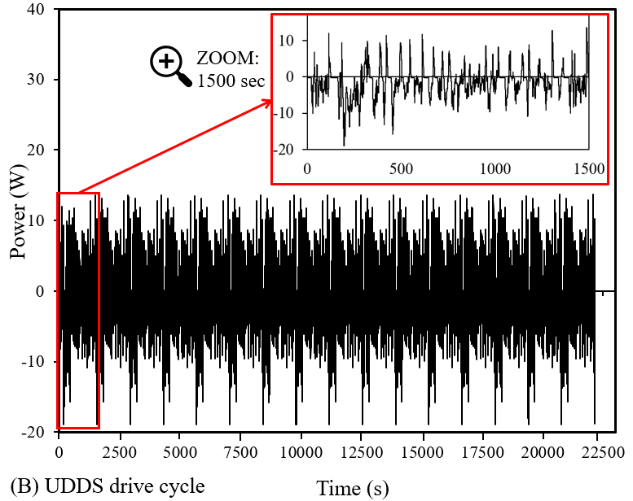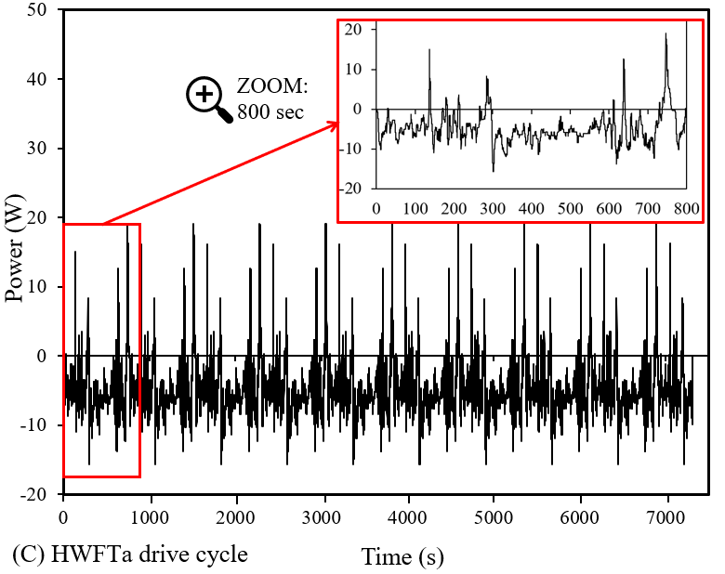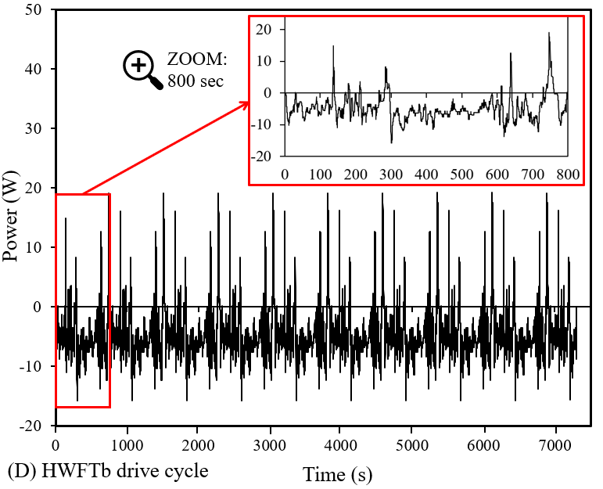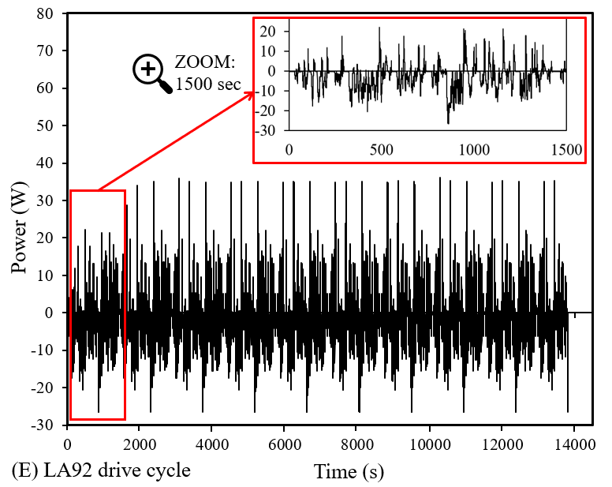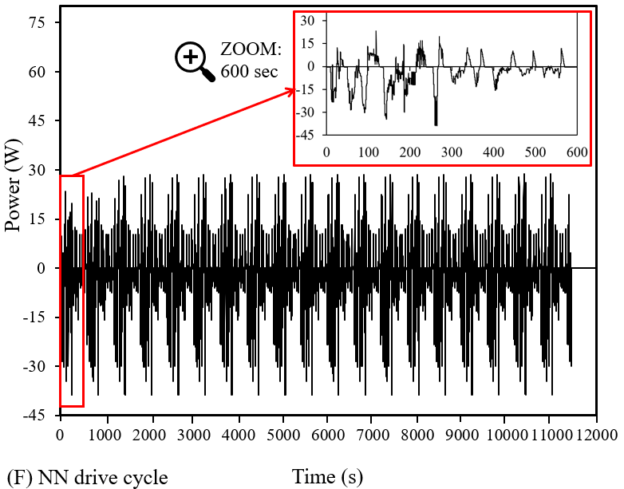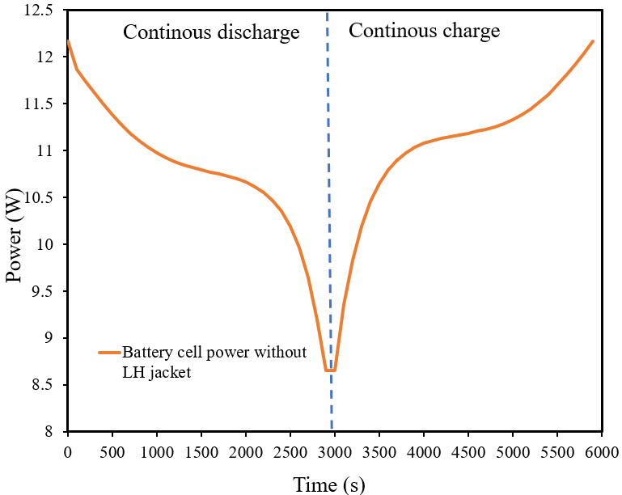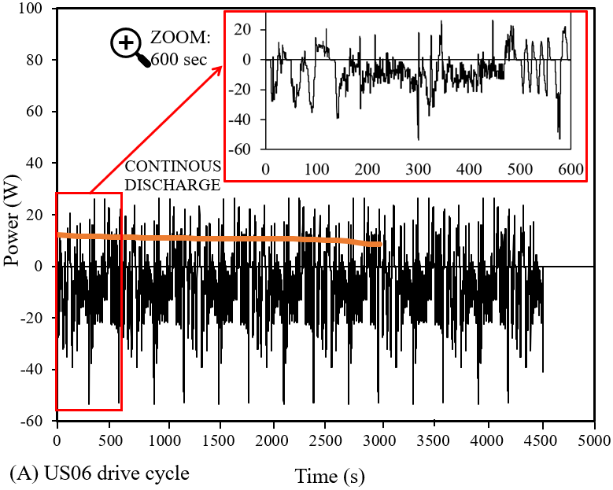

Fig. 1. Automotive drive cycles illustrating Power versus time evaluated for a single battery cell under 25 °C at

1 C-rate (A-F) and continuous discharge and recharge comparison.

Furthermore, in **Fig. 1**, a plot of power versus time for continuous discharging followed by recharging of a similar cell under the same ambient conditions and C-rate is to distinguish between the haphazard fluctuations seen in the various driving cycles and the more uniform continuous cycles. These continuous cycles are performed as step functions of uniform increments between SOC 0% to 100% or specific to the testing applications. This analysis may provide detailed insights into the application of these drive cycles on this specific Panasonic 18650 battery cell. In this case, dynamic behaviour based on driving scenarios including idle time and speed fluctuations have been shown to have different effects on the power required to drive those vehicles which are normally used to decide on fuel consumption as well as emissions in a standardised format. Due to numerical simulation performance, this eliminated potential hazards as well as added costs for experimental setups as well as procurement, labour, and costs to repeat experiments when needed. Moreover, the impact on the LH storage material or LH jacket (PCM) and its capability to reduce the maximum temperature and maintenance of more uniform temperature during these rapid fluctuations as opposed to continuous, uniform cycling is analysed. The response of the PCM is pivotal and uses its property of low thermal conductivity and slow heat transfer.

# **3 Numerical Method**

## *3.1 Models*

**Fig. 2** displays the schematic of a Panasonic LIB with an introduced 3 mm LH jacket. In a previous study, [5], the impact of PCM circumferential thickness (1mm, 3mm, 5mm, and 7mm) on the electrical and thermal performance of the battery was investigated. The previous results indicated that 3mm LH jacket was sufficient to enhance the electrical and thermal performance of the proposed LIB battery. Authors also concluded that increased thickness can extend the useful life with the penalty of increased weight and less compactness of eventual constructed module and pack; thus design engineers should have rational and applied justifications to go beyond 3mm thickness. In this study, the thermal and electrical performance of the proposed case (battery cell equipped with 3 mm PCM jacket) is compared against the same cell with no LH jacket. It should be noted that, in previous studies [5], the 3mm PCM jacket thickness was considered as sufficient thickness, which improved the thermal performance during consecutive charging and discharging cycles and was subsequently used in this study based on the results achieved previously. Increasing the volume of PCM can inherently increase the thermal performance of the battery cell for longer, but has the disadvantage of imposing additional weight and cost to the system.

Both cells are oriented horizontally and have thermally insulated outer walls to ensure no thermal effect from the ambient will impact the results of these cases. This means that all the heat generated from the battery during the cycling processes would be directly captured by the LH jacket PCM to depict the heat transfer between materials. Horizontal cases were assessed as due to the PCM charging and discharging, these systems are more effective in heat transfer during PCM melting, whereas vertical systems maintain consistent heat transfer [29],[57],[58]. Inclination angle reduces the average PCM temperature but affects the PCM melting, since convective heat transfer is dominant [59],[60]. The figure shows the active cell zone, the cell tab, and the location of the LH jacket (PCM) around the circumferential area of the battery with horizontal front and side views. Here, the battery cell is an 18650 cylindrical cell type with 18 mm and 65 mm in diameter and length, respectively.

|  |  |  |
| --- | --- | --- |
|  |  |  |
| FRONT  VIEW |  | A picture containing building, device, fan, tower  Description automatically generated  PCM  Cell tab  Active cell zone |
| SIDE VIEW | Text  Description automatically generated with medium confidence  (A) | A picture containing shoji, building  Description automatically generated  (B) |

Fig. 2. Battery cell with PCM jacket showing front and side views: A) schematic sketch and B) meshed geometry.

## *3.2 Mathematical and numerical model*

PCM melting engages an enthalpy-porosity formulation. The liquid-solid mushy zone defined as a porous zone is synonymous with the liquid fraction, including sink and momentum zones appropriately referenced for the drop-in pressure in the solid zones. These sink terms are also readily applied to the turbulence equations due to the reduced porosity expected in the solid zones. It is noted that the liquid fraction associates the states of the cell volume defined as either liquid or solid and is included in each domain cell. During every iterative solution, this value is calculated based on the enthalpy balance. To account for the change in the PCM physical state, a boundary region is set between 0 and 1 and signifies where the medium as in fully solid and liquid state, respectively. In this regard, a fully solid medium would have zero velocity and porosity.

The following section accounts for the PCM melting model, for details of the battery model, please check [5]:

Energy equation follows:

$\frac{∂ρh}{∂t}+ ∇.\left(ρ\vec{v}h\right)= ∇.\left(k∇T\right)- \frac{∂ρfL}{∂t}- ∇.\left(ρ\vec{v}fL\right)+S$ (1)

The liquid fraction, $f$, is derived as

$f=\left\{\begin{aligned}0 \\ 1 \\ \frac{T- T_{solidus}}{T_{liquidous}- T_{solidus}}\end{aligned}\right.$; $\left\{\begin{aligned} T < T_{solidus} \\ T > T_{liquidous} \\ T_{solidus} <T <{ T}_{liquidous}\end{aligned}\right.$ (2)

Natural convection flows because of buoyancy flows results from the density variation due to temperature. This phenomenon take places in the molten section of PCM in this study. The flows are encased within a closed boundary and so valid Boussinesq Approximation initialises faster convergence at constant density and temperature. The thermal expansion coefficient affects the natural convection flows induced by gravity, which would impact the density variations caused by temperature in molten PCM region. As long as these are not sizeable differences in the density of the material and temperature differences within the domain are small, then the Boussinesq approximation is accurate. As the temperature of the PCM material increases, the volume is increased per temperature change by the value (0.00091) specified in Table 1. This means that there are very small changes in volume as the material temperature increases and in melting:

The momentum follows:

$\frac{∂ρ_{0}\vec{v}}{∂t}+ ∇.\left(ρ_{0}\vec{v}\vec{v}\right)= -∇P+ ∇.\left(μ∇\vec{v}\right)+(ρ-ρ_{0})g+ \frac{{\left(1-f\right)}^{2}}{f^{3}+ ε} \vec{v}A_{mush}$ (3)

Where $ε$ is a number equal set to 0001,

$A_{mush}$ is the mushy zone constant between 104 - 107. 105 was proved to be sufficient for the melting process in this analysis, as discussed in earlier studies [5],[29].

The governing equation for continuity is as follows:

$\frac{∂(H)}{∂\frac{αt}{D^{2}}}+ ∇.\left(\vec{v}H\right)= ∇.(∇T)$ (4)

Where $H$ is derived as the sum of sensible enthalpy and the latent heat:

$H=h_{ref}+ \int_{T_{ref}}^{T}{C_{p}}dT+ fL$ (5)

ANSYS Fluent 2022 R2 is used to analyse the coupled thermal-electrical result for heat generation rate with the applied Multi-Scale Multi-Domain method (MSMD) used. This method is primarily based on a multi-domain, multi-physics approach involving atomic LIB transport for distributed temperature measured along the battery length. The thermophysical properties of the battery cell, including the active zones, tabs, PCM and insulation, can be found in a previous research study [5] in Table 1. Various engineering domains use computational fluid dynamics (CFD) software to optimise thermal solutions. This numerical method offers cost and time savings as an alternative to physical experiments, particularly when exploring diverse design variations, along with optimisation tools for enhanced efficiency. Other benefits include parametric exploration for optimal designs and configurations, insights on heat transfer, temperature distribution, and system performance under varying conditions and risk reduction, which mitigates development risks without the necessity of physical prototypes. Although there are some drawbacks which can include data dependency on material property for accurate simulations. In practice, some of those data may not be readily available and demands a reverse engineering practice to align simulation results with physical reality. Such reverse engineering practices often necessitate extensive experimental validations, adding complexity to research and oversimplifications for real-world complexities with disparities between simulated and actual performance. Employing electrochemical and thermal models in computational tools aids in modelling diverse behaviours of LIBs for longevity, analysing heat generation, dissipation, and temperature control. Despite existing models’ limitations, more detailed models are computationally demanding. SOC and state of health (SOH) estimation methods rely on data processing, and combining different battery models enhances the accuracy, particularly through an electrochemical model based on the electric circuit. In this study, the Equivalent Circuit Model (ECM) model is used to replicate the electrical behaviour of the battery, as seen in a previous study [5].

Table 1: Thermophysical properties of battery cell (active zone), PCMs and insulation walls [5].

|  |  |  |  |  |  |
| --- | --- | --- | --- | --- | --- |
|  | **18650 Battery cell(active zone)** | **Pos Tab** | **Neg Tab** | **PCM** | **Plexiglass**  **(insulation)** |
| **Density (${kg}/{m^{3}}$)** | 2092 | 2719 | 8978 | 770 | 1190 |
| **Cp (Specific Heat) ($J/{kg-K}$)** | 678 | 871 | 381 | 2196 | 1470 |
| **Thermal Conductivity ($W/{m-K}$)** | 18.2 | 202.4 | 387.6 | 0.148 | 0.19 |
| **Viscosity (${kg}/{m-s}$)** |  |  |  | 0.003 |  |
| **Thermal Expansion Coefficient ($1/K$)** |  |  |  | 0.00091 |  |
| **Latent Heat of Melting ($J/{kg}$)** |  |  |  | 243500 |  |
| **Solidus Temperature (K)** |  |  |  | 298.15 |  |
| **Liquidus Temperature (K)** |  |  |  | 302.15 |  |

In the previous study [5], the PCM chosen (N-octadecane) was deemed sufficient to maintain uniform battery temperature at ambient 25 °C due to its solidus and liquidus temperature applicable to the testing scenarios. Different ambient weather conditions were analysed, including extreme winter weather -20 °C, winter weather 0 °C, ambient weather 25 °C, hot summer weather 40 °C, and extreme hot/desert weather 55 °C. It was noted that although at higher temperatures (40 °C and 55 °C) the LH jacket was able to stabilise the battery temperature for longer; the improvement was not significant unless an appropriate PCM (different from N-octadecane) based on extreme weather conditions was introduced in the system. Nevertheless, the study indicated that the chosen PCM (N-octadecane considered in this study as well) at ambient temperature was sufficient to maintain constant/stable temperatures within the optimum temperature (20 °C to 40 °C). The selected PCM also improved the delay effect, increased the useful life of the battery cell and thermal performance enhancement extension for multiple cycles at 20% and 340%, respectively. This study does not go into detail on the effectiveness of different PCMs as the main concern of this study was checking the feasibility of utilising PCM as passive cooling under actual drive cycles, but further study on different PCMs based on the methodology of this work can be considered in the future works of researchers. PCM properties are chosen for their unique attributes, which can include thermal, mechanical, and responsive but must be selected based on the appropriate application and thermal requirements. These might include high latent heat, small phase transition temperatures, chemically stable and safe for use, as mentioned in the literature in this study.

## *3.3 Assumptions*

### *3.3.1 Thermo-chemical and electrical modelling*

The following assumptions are applied to the modelled cases:

* The initial SOC of the battery is set to 100% at the ambient temperature of 25 °C,
* A transient time analysis is used,
* Viscous fluid flow is laminar and incompressible,
* Constant physical properties are applied to the battery cell with conduction heat transfer as the main heat transfer mechanism,
* PCM thermophysical properties remain a constant discounting density due to Boussinesq approximation.

### *3.3.2 Safety Controls*

To avoid thermal runaway with uncontrolled exothermic chemical reactions from fire and potential explosion due to battery degradation, constraints on the battery temperature and voltage during charging and discharging are maintained in the analysis. These constraints also help to maintain effect from high temperatures, decomposition of electrolytes, including lithium loss and capacity fade effect and overcharging. The imposed constraints are as follows:

* Minimum and maximum cut-off voltage: 4.2V and 2.5V respectively,
* Maximum temperature during charging set to 45 °C and for discharging set to 60 °C.

### *3.3.3 Initial and boundary conditions*

The following initial and boundary conditions are applied to the modelled cases:

* Thermophysical properties of battery cell, PCM and insulations walls in Table 1,
* Outer walls insulated,
* Battery tabs set to adiabatic conditions,
* PCM initially at a solid state with liquid fraction as zero.

## *3.4 Computational model setup*

The flow model chosen involves laminar viscous flows with an applied pressure-based solver due to incompressibility consideration of PCM Transient analysis is preferred to capture changes in the solution with time and to pinpoint change in phases of the PCM. Pressure Implicit Splitting Operator (PISO) scheme is used for the pressure-velocity coupling for the transient time-based analysis. The solution method for spatial discretization for pressure is indicated PRESTO! with a second order upwind for momentum and energy equations. Under-relation factors for pressure and momentum are initially set at 0.3 and 0.7 respectively, with density, body forces and momentum and energy set to 1. The LH model solution convergence is set to 1 microsecond in order to achieve sufficient convergence. For the electro-chemical modelling of the battery, as mentioned in section 3.2, the MSMD solution method with ECM E-chemistry model is applied for the battery cell at 2.9 Ah nominal cell capacity. Since a coupled thermal-electrochemical simulation is used, the electro-chemical aspect of the battery would be solved instead of just the heat generation rate, as in other solvers. The model allows for the use of different physics applied to different solution domains in which li-ion transport occurs at the atomic length scale. The battery is deemed a homogeneous body with the electro-chemical reactions occurring within the active zone. In particular, the ECM model aims to replicate the electric circuit with resistors and capacitors as a function of SOC. The model is deemed suitable for single cell or multi-cell analysis. The solution options specified C-rate at 1, and minimum and maximum cut-off voltages at 2.5V and 4.2V, respectively, to match the manufacturer specifications for safe operation. The automotive drive cycle data is implemented as a time-scheduled profile type from **Fig. 1** into the battery model as a using profile in the solutions options. This profile provides a time-dependent input based on parameters such as C-rate, current, voltage and power, which can be effectively varied to change the electric load type and the values. It means that the numerical and experimental data captured can then be directly analysed via linear interpolation.

# **4 Results and Discussion**

## *4.1 Verification study*

Independency analyses were performed involving Mesh, Time step and Mushy zone ($A_{mush}$) to ensure the results were of sufficient accuracy. **Fig. 3A** displays the analysis of the variation of grids for both cases with and without the LH jacket, with results of temperature versus time. Three different grid sizes compared including coarse (24,911), selected (84,801) and fine (130,130) elements and coarse (40,128), selected (86,877) and fine (116,664) elements for the case without and with LH jacket (PCM) respectively. The constructed meshes in the domains were mostly structured grids, where for sake of brevity only the views of selected mesh for battery with LH jacket displayed in **Fig. 2**. As shown in **Fig. 3A**, the proposed selected meshes (for both cases in presence and absence of LH jacket) were fine enough to capture the results of this study independent of mesh sizes (less than 1% divergence recorded for the results of selected mesh versus fine and coarse cases). It is noteworthy that the Orthogonal qualities and skewness for proposed meshes were more than 95% and less than 25% respectively, which proves what promising qualities the generated meshes had.

A time-step independency study is shown in **Fig. 3B** for a single cell battery discharge at ambient temperature (25 °C) analysing four different time-step sizes (10 s, 50 s, 100 s and 150 s) without LH jacket. Results show that the chosen time-step size at 100 s was sufficient (< 0.1% deviation) to conduct the study. For the case with LH jacket, a manual adaptive time-step size beginning at 1 microsecond was used until sufficient convergence was seen. The effect on the mushy zone was highlighted in **Fig. 3C** with a study between applicable ranges of 1e4 to 1e8, to realise in the simulation of LH jacket what $A_{mush}$ value (as discussed in Eq.3) were required for accurate results. The study was performed for PCM N-octadecane with an initial solidus temperature at a discharge rate of 1C. Results indicate minimal effect on the temperature, showing less than 1% deviation from selected $A_{mush}$ value at 1e5. This was elaborated in previous results seen in [5],[29] where the volume of the circumferential diameter does not show significant change in natural convection heat transfer. This occurs when the PCM starts to melt at the top of the container. For this study, solidification of the PCM was not conducted and only the melting of the PCM during the cycles were recorded.

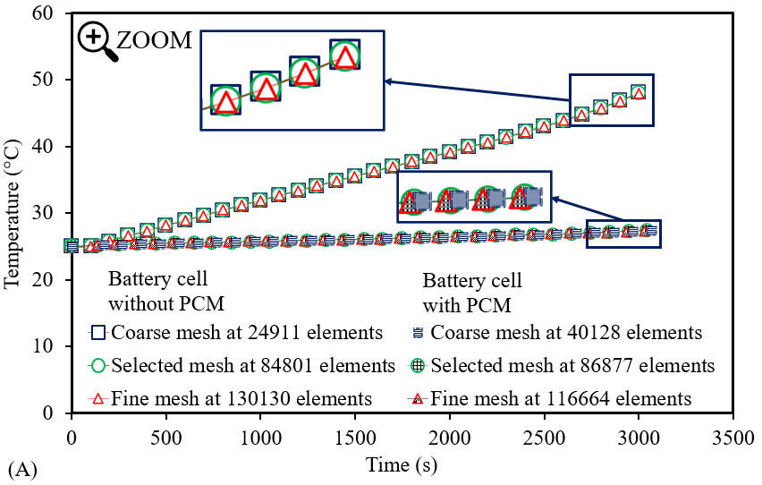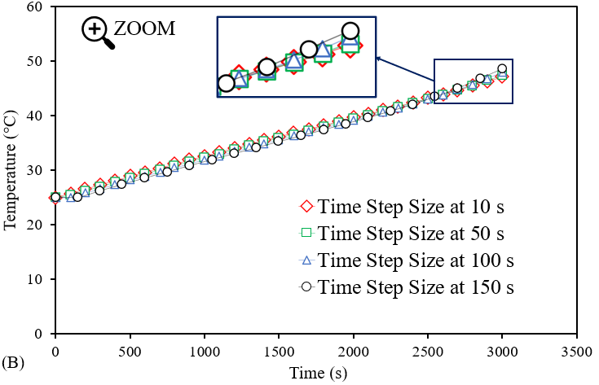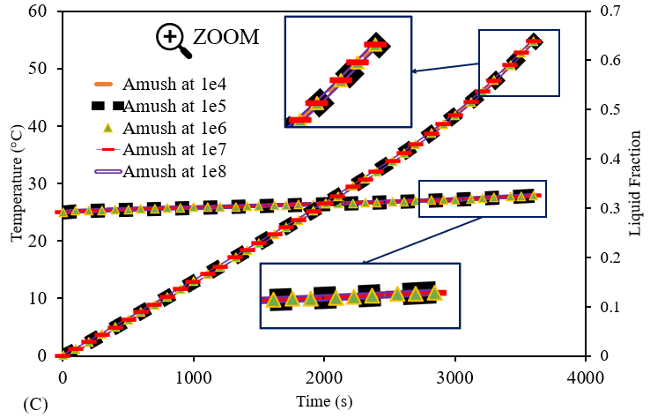

Fig. 3. Verification study showing: A) grid independence study, B) temporal independence study and C) mushy zone ($A_{mush}$) independence study.

## *4.2 Validation study*

A numerical validation study shown in **Fig. 4A**,and **B** presents the battery thermal management validation along with the PCM validation. A battery cell assessed at ambient weather condition (25 °) for a single discharge at 1C rate with heat transfer coefficient set to 7 W/m2K, compared the data from literature with the current study. A deviation of 1% was seen and deemed sufficient to conduct the variation in drive cycles outlined. In this work, a numerical approach using CFD compounded the use and the advantages, including cost saving and time bound, as well as harnessing the efficiency, safety, and risk mitigation. The gap between real-world complexity and accuracy in simulation was closed by combining the experimental data and numerical solutions captured from [34] and [18] in order to perform parametric studies and provide insights to performance in the presence of a LH jacket. Similar methods were used to show the relationship between the liquid fraction during PCM melting in an enclosed container of constant heat flux. A PCM melting validation shown in **Fig. 4B** compares the data for liquid fraction versus Fourier number of captured data from literature [5] based on N-eicosane PCM. The study showed less than 1% deviation and was sufficient to conduct the study based on N-octadecane PCM. In that study, different PCMs were analysed based on the impact of ambient weather conditions on the effectiveness for thermal management, including extreme weather conditions as mentioned in section 3.2.

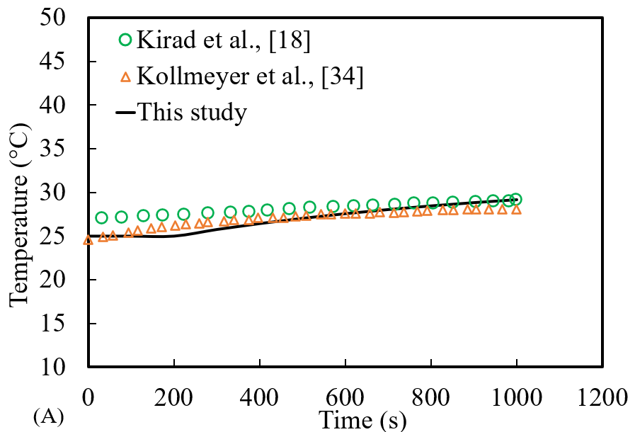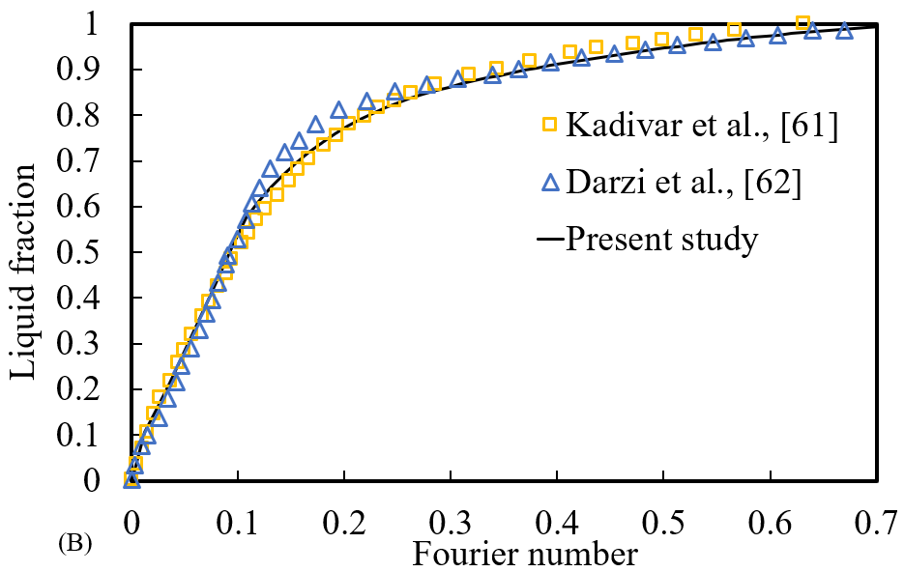

Fig. 4. Validation study: A) Single cell battery validation under ambient temperature (25 °C) for a thermal analysis of Temperature vs time (°C) versus Time (s) and B) PCM validation for liquid fraction versus Fourier number compared with literature results.

## *4.3 Impact of LH jacket on battery performance under Automotive drive cycles*

In the preceding discussions, an examination of the range of drive cycles studied each with their own characterisation behaviours and unique power profiles and applications. The US06 cycle, as seen in **Fig. 1A**, represents an aggressive driving scenario with rapid speed fluctuations and behaviours following start-up. Meanwhile, the UDDS cycle illustrated in **Fig. 1B**, mimics an urban route with frequent stops. The HWFT cycle, as displayed in **Fig. 1C** and **D**, assesses the fuel economy of light-duty vehicles for highway ratings. The LA92 in **Fig. 1E** simulates aggressive driving with high speeds and acceleration. Lastly, the NN drive cycle in **Fig. 1F** combines features from US06 and LA92 cycles for training neural networks. Thes drive cycle data captured from [39],[56] serve as valuable tools in various automotive applications. They enable the evaluation of vehicle performance and the effect on battery technologies with emissions and energy efficiency under diverse driving conditions, from aggressive and high-speed scenarios to urban routes. The variation in drive cycles and the effect on thermal performance of battery cells as well as the LH cooling jacket can play a crucial role in advancing automotive technologies and improving vehicle efficiency and sustainability.

The primary objectives of this study were to ascertain the impact of LH jacket (passive cooling) on the thermal and electrical performance of a chosen battery cell under different drive cycles. Results into this investigation were shown in **Fig. 5**. The variation of the automotive drive cycles involving US06, UDDS, HWFT, LA92 and NN drive cycles illustrated for Power profiles on an 18650 Panasonic LIB seen in **Fig. 2** andassessed under ambient weather conditions (25 °C) at 1C-rate. The Power profiles shown in **Fig. 5** displays the Power output versus time for the combined thermo-chemical and electrical results for a similar battery cell with and without a LH jacket. The full results of the automotive drive cycles seen in **Fig. 1** is implemented numerically as a time-scheduled profile. As seen in the Power profile results, there was an extension in performance of the battery cell for the cases with the LH jacket.

This behaviour is attributed to the fact that presence of the LH heat jacket can maintain the battery thermal stability at optimum range (20 °C to 40 °C) for a longer period, therefore the battery can have better performances as will be discussed in this section. These extensions were significantly seen in the aggressive cycles such as US06, LA92 and NN drive cycles as described in Section 2.

It is noteworthy that in **Fig. 5** zoomed-in images of the curves is provided to visualise the initial variation in performance as seen in **Fig. 1** between the battery cell Power with and without the LH jacket. For the automotive drive cycles, the initial referenced time were repeated until all the data was completed, and the results of the combined thermo-chemical and electrical results are presented. The provided zoomed images were captured at different time spans depending on the drive cycles nature, as follows: A) US06 – 600 s, B) UDDS – 1500 s, C) HWFTa – 800, D) HWFTb – 800 s, E) LA92 – 1500 s and F) NN – 600 s. In these initial phases, the Power profiles are similar for both cases in the presence and absence of the LH jacket up to and including for the full cycles. Each of the different drive cycles has a differing effect on the performance of the LIB because of their characteristically varied behaviours and therefore has varying effects on the thermal and electrical performance.

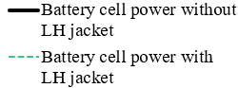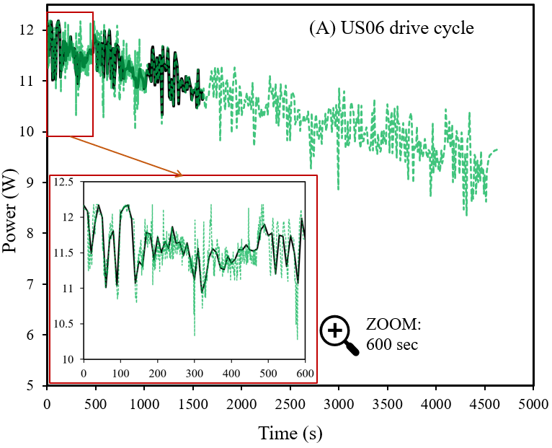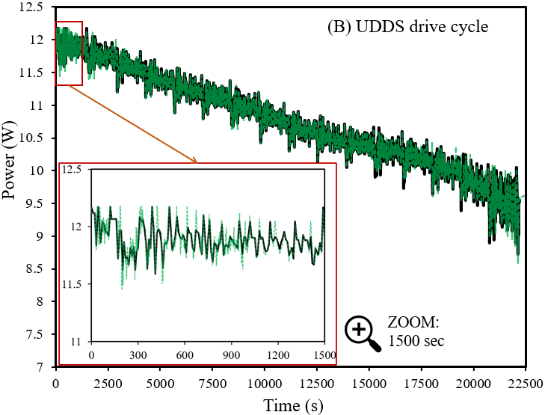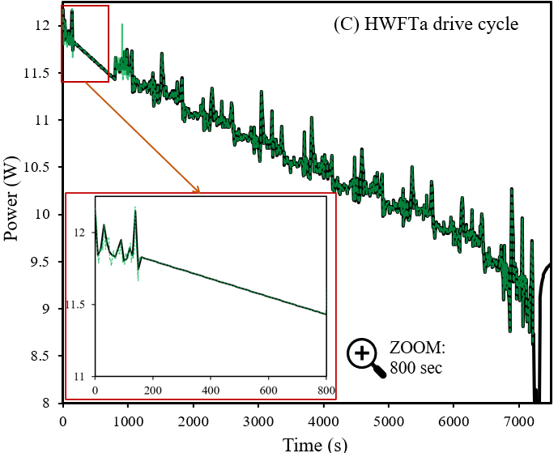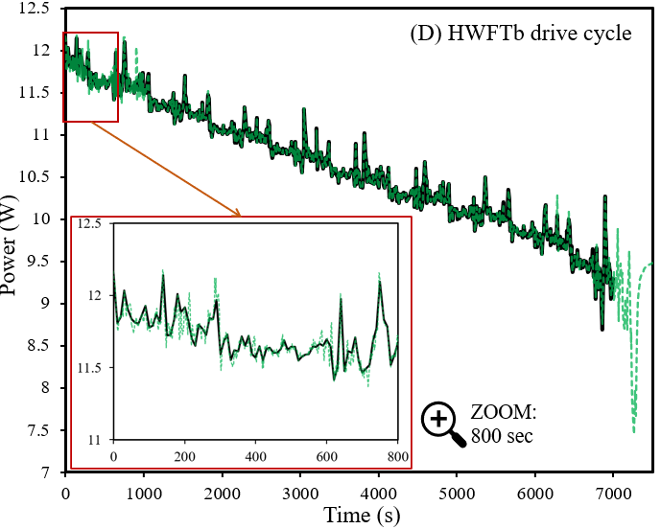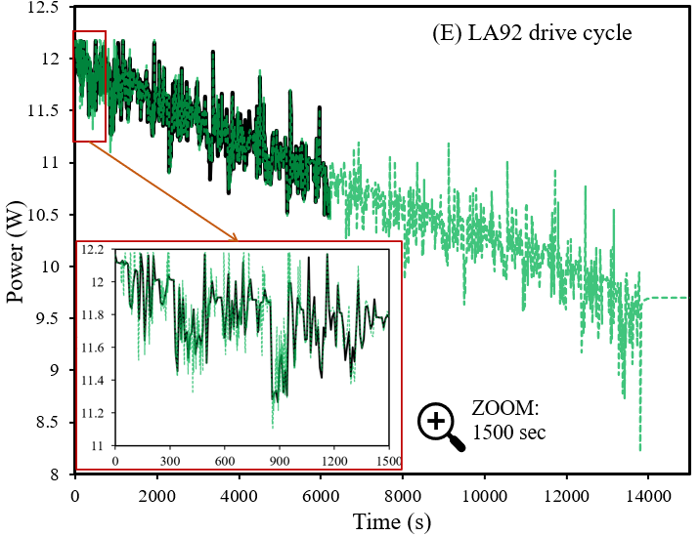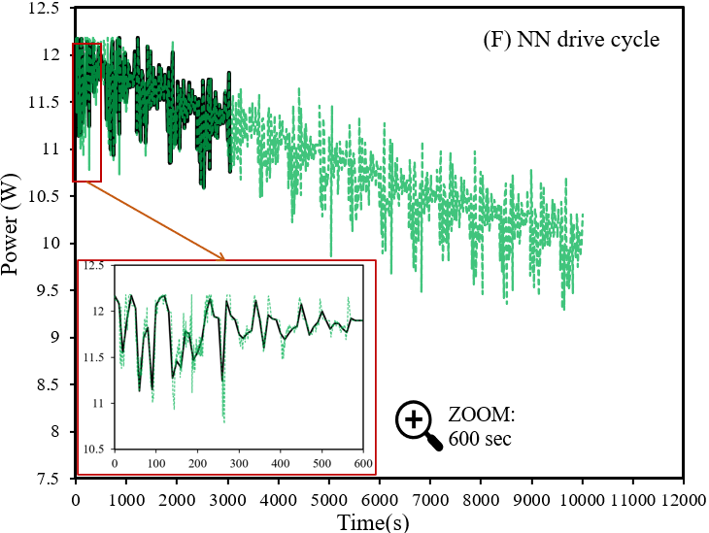

Fig. 5. Impact of automotive drive cycles on Power of battery cell with and without LH jacket as seen in legend: A) US06, B) UDDS, C), HWFTa, D) HWFTb, E) LA92 and F) NN.

To investigate the coupled effects of thermo-chemical and electrical performance in this study, temperature, SOC, and liquid fraction for both cases in presence and absence of LH jacket were recorded. The results for battery temperature distribution and SOC are shown in **Fig. 6** and **Fig. 7**, respectively, which captured when the initial battery state was at 100% SOC (fully charged battery) at an ambient temperature (25 °C) and C-rate of 1. In both figures, the harsh drive cycle comparison is illustrated in (A), and the casual drive cycle comparison is illustrated in (B).

The varied drive cycles outlined in Section 2 were applied to both cases (with and without LH jacket) with safety measures applied for discharge and charge temperature (60 °C and 45 °C respectively) including cut-off voltage between 2.5V and 4.2V. It is noteworthy that under those drive cycles with discussed safety and cut-off considerations, the LIB is discharged up to ~0% to 20% SOC and depends on the drive cycles as will be discussed in this study. It should be noted that when all the LH available from the chosen PCM (N-octadecane) was used, there was a transition to SH, which is shown by a linear rise in battery temperature. This linearised temperature increase during the SH shows a similar gradient pattern during this stage for all cases and is dependent on the battery SOC available at this stage of the drive cycle process. In this case, if the battery SOC was equal to zero or close thereof, then the cycling process would also end. Please note that in this study, as the driving cycles had been recorded over a specific period, authors could not run the cases to their ultimate limits.

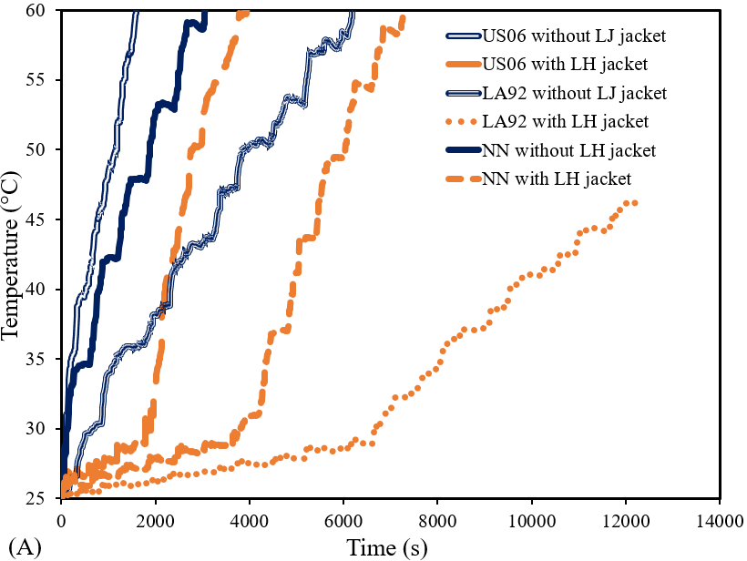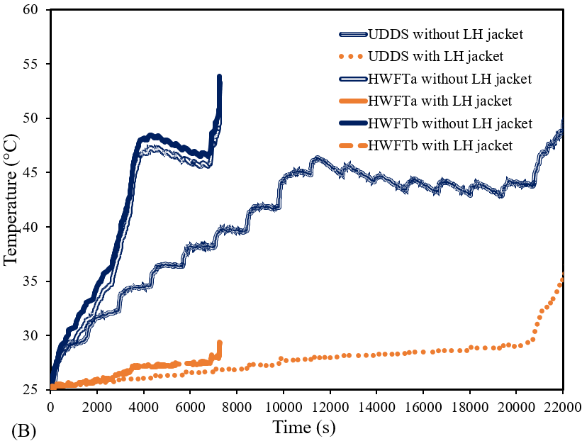

Fig. 6. Impact on battery temperature for harsh (A) and casual (B) driving cycles with and without LH jacket.

To effectively analyse the thermal performance of the LIB in presence and absence of LH jacket (PCM), the results in **Fig. 6** were analysed based on the following criteria:

1st criteria: Comparing the battery temperatures for both cases (with and without LH jacket), at the final instant which the battery without LH jacket case can reach.

2nd criteria: Comparing the time for both cases (with and without LH jacket), at the final temperature which a battery with LH Jacket can reach.

Please note that in those criteria definitions, the batteries undergo the drive cycle until the process stopped either due technical or safety considerations or termination of defined drive cycle data.

Indeed, in definition of 1st criteria as will be discussed later, under different dive cycle loads the battery in absence of LH jacket cannot undergo the entire defined cycle period (as shown in **Fig. 1**) while the case LH jacket can go through a longer period of drive cycle. This is attributed to this fact that, in the absence of LH jacket, the battery either reached the imposed safety threshold or defined cut-off voltage or reach to almost zero SOC (see **Fig. 7**). Therefore, in the 1st criteria, the temperature variation of these two cases at the instant which the battery without LH jacket reaches, are compared.

Notably, there were drive cycles which did not reach the temperature safety limit for either case (with and without LH jacket) (see **Fig. 6**) due to either the end of the drive cycles data or the battery SOC ~ 0 (see **Fig. 7**). Thus, the 2nd criteria were defined to compare how long it took for both cases to reach to the temperature of the battery with LH jacket at the end of simulation.

For the applied drive cycle US06, the case with no LH jacket reached the safety limit temperature at 60 °C as seen in **Fig. 6A** within 1,600 s, and subsequently the further cycling load could not be proceeded. At this same instance in time, the battery cell in presence of LH jacket had a temperature of ~ 29 °C (~ 52% reduction in temperature based on the 1st defined comparison criteria) and still well within the optimum temperature range of the battery (20 °C to 40 °C) with the indication that the thermal performance of the cell had been enhanced due to the impact of the LH jacket and the available LH. At around 1,940 s, the liquid fraction of the PCM had reached the upper limit of 1 and all the PCM had been melted and thus SH was the dominant mechanism. During this period (after 1,940 s), the battery cell temperature sharply rose in a linear fashion noted by the cycling effect. This resulted in a rise in temperature to 60 °C in 3,940 s at the end of the driving cycle as the safety limit temperature was reached. Thus, the battery run for further 1,340 s in the presence of the proposed jacket. I.E. Based on the 2nd defined comparison criteria, the battery with LH jacket last ~x2.5 longer period. As seen in **Fig. 7A**, from the initial state of the battery with the applied drive cycle US06, the SOC of the battery is shown to decrease from 1 to 0.07 at the end of the cycling. This shows that the battery was cycling the Power from 100% and coinciding with **Fig. 5A** as the Power profile was seen to be decreasing over time.

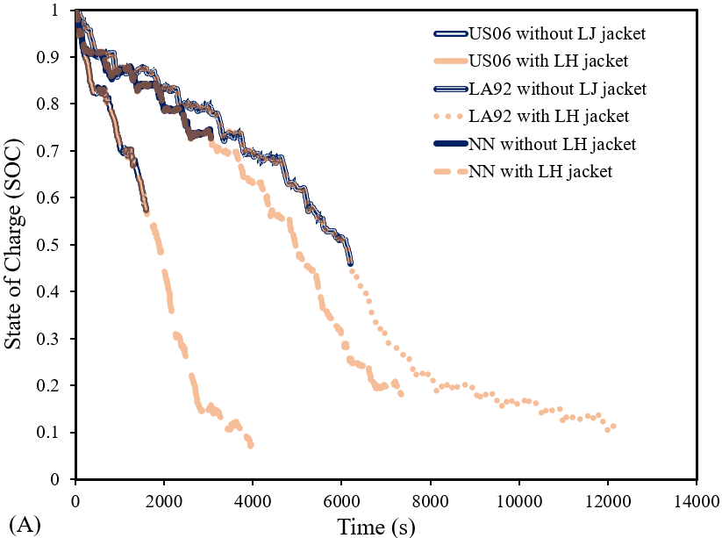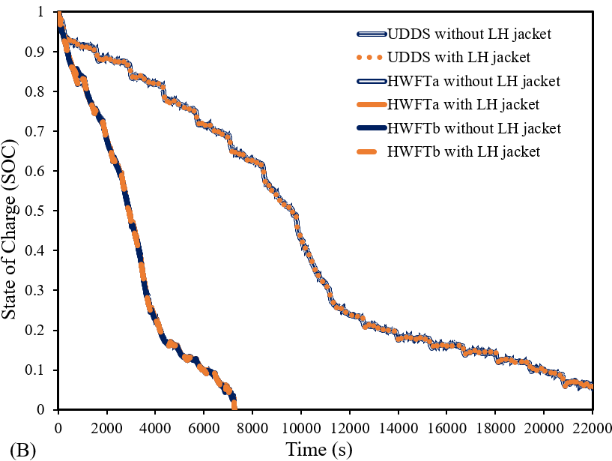

Fig. 7. Impact on battery SOC for harsh (A) and casual (B) driving cycles with and without LH jacket.

The impact of LA92 drive cycle on thermal and electrical performance of both cases (with and without LH jacket) are shown for temperature and SOC in **Fig. 6A** and **Fig. 7A,** respectively. The cycle has an aggressive style behaviour for heavy classes (>10,000 lbs) vehicles and so would have a significant impact on the battery thermal performance, as seen in the previous case. For the case without LH jacket, the SOC reduced from 1 to 0.46 (see **Fig. 7A**) with the battery temperature reaching the safety limit at 60 °C in 6,190 s (see **Fig. 6A)**, displaying a linear relationship while the battery temperature with LH jacket was at 29 °C (still within the optimum temperature range) at the same instant. This means that the LH jacket led to ~52% reduction in temperature based on the first defined comparison criteria. As the case with the LH jacket has not reached to it safety limit, it can still undergo the drive cycle. Here, the SOC reduced from 1 to 0.07 in 13,710 s at the end of the drive cycle. At this stage, the numerical simulation was concluded as the battery SOC was ~ 0 (see **Fig. 7A)**, and no further results was captured. Please note in that case (in presence of LH jacket), at 6,770 s, the PCM liquid fraction reached the maximum at 1 and all the LH was subsequently utilised. Beyond this stage, SH was dominant, and the LIB temperature sharply rose to ~53 °C in 13,710 s (end of cycle) (see **Fig. 6A**). As seen with results from the previous cycles, the battery temperature remained uniform until all the LH was used and SH become active. The change to SH as saw similar linear rise in temperature until the end of the drive cycle. According to 2nd defined comparison criteria, there was a ~2.2x extension in the available usefulness of the battery with LH compared with the battery cell without LH.

Moreover, **Fig. 6A** and **Fig. 7A** displays the results for the NN drive cycle for temperature distribution and SOC, respectively, which represents a combination of US06 and LA92 drive cycle with supplementary dynamics in the need for training neural networks. With this introduced cycle, for the case without LH jacket, the battery cell temperature rose sharply and linearly to 60 °C in 3,050 s (see **Fig. 6A)** while the SOC reduced from 1 to 0.73 (**Fig. 7A**) and since the safety limit was reached, no further cycling was performed. When the LH jacket was added, the optimum temperature was maintained for a longer period until all the LH available was used and the liquid fraction reached 1 in 3,900 s. As no LH is available, SH becomes the predominant mechanism and the battery cell temperature rose linearly in a similar fashion as without the LH jacket. The temperature subsequently reached the safety limit at 60 °C in 7,340 s with a reduced SOC to ~ 0.18. Therefore, based on the 2nd defined comparison criteria, the introduced LH jacket had prolonged the battery usefulness up to x2.4. also based on the 1st defined comparison criteria, the LH jacket reduce battery temperature by ~52%.

In the cases for the casual drive cycles, the impact of the UDDS driving cycle cases for temperature and SOC is shown in **Fig. 6B** and **Fig. 7B**, respectively.This cycle had an initial SOC of 1 and ended at 0.07 at the end of the drive cycle (see **Fig. 7B)**. For the case with no jacket, the battery cell temperature rose steadily until it reached ~ 46 °C at around 11,560 s then the temperature gradually declined down to ~ 43 °C at around 19,370 s (see **Fig. 6B**). The temperature then steadily rose again until the end of the drive cycle, around 22,200 s as the battery reached a temperature of ~ 50 °C due to the drive cycle characteristics. However, for the case which battery cell encapsulated with LH jacket, the temperature variation is more uniform until around 20,210 s when all the PCM had been fully melted (LF is equal to 1) and so the temperature rose sharply due to activation of SH. At this stage, the temperature started to rise to ~ 36 °C before the end of the drive cycle (22,200 s). In this case, the drive cycle had been completed with both cases lasting the same time (22,200 s). Thus, LH jacket reduces the battery temperature by ~28% based on the 1st defined comparison criteria. In addition, the presence of LH jacket makes the battery temperature rise much more uniformly for a much longer time until the end of the drive cycle and maintained stability until SH became dominant. In other words, based on 2nd defined comparison criteria, the battery with LH jacket last ~x5 longer.

**Fig. 6B** and **Fig. 7B** display similar patterns with the drive cycle HWFT applied with similar thermal performance improvement over both phases. In the absence of LH jacket, the SOC decreased from 1 to 0 within ~7,270 s (see **Fig. 7B**)as the battery cell temperature rose to ~ 53 °C (see **Fig. 6B**). Please note that, in this case, the thermal behaviour of the battery is not linear. Indeed, the temperature rose steadily until ~ 48 °C (around 4300 s) before decreasing gradually to ~ 45 °C (around 6,800 s) with a sharp rise in temperature to ~ 53 °C at the end of the cycle. In this case, the battery SOC had reached null, and the numerical solution is concluded. In contrast, the case equipped with LH storage maintained uniform battery temperature throughout the entire cycle until the battery SOC was at 0. So, based on the 1st defined comparison criteria, the LH jacket reduces the temperature of battery by about 45% and 46% for HWFTa and HWFTb, respectively. Please note that at the end of the introduced cycle, the liquid fraction of LH storage was around 75%. This meant that the battery temperature with the LH jacket not only experienced steady temperature throughout the introduced drive cycle with an end temperature of ~ 29 °C but also it still has 25% LH jacket which can be used for a longer period of drive cycles. With the LH jacket, the battery temperature was uniform for a significant amount of time until the end of the drive cycle. According to 2nd defined comparison criteria, the battery with the LH jacket lasted more than 10 times (x10) for HWFTa and 16 times (x16) for HWFTb. These cycles were less harsh than the previously noted US06 drive cycle and so the thermal impact on the battery was less severe.

The results of battery performance improvement based on the above-discussed criteria summarise as follows:

1. Based on the 1st comparison criteria definition, the temperature of battery in presence of LH jacket reduced by 52%, 28%, 45%, 46%, 52%, and 52% as the battery undergoes the following drive cycles US06, UDDS, HWFTa, HWFTb, LA92, and NN, respectively,
2. Based on the 2nd comparison criteria definition, the battery can last longer in presence of LH jacket by x2.5 x5, x10, x16, x2.2 and x2.4 as it undergoes the following drive cycles US06, UDDS, HWFTa, HWFTb, LA92, and NN, respectively.

From the highlighted summary, and results shown in **Fig. 6** and **Fig. 7**, the most aggressive behaviour drive cycles (US06, LA92, and NN) had significant thermal improvement (over 52% reduction in battery temperature) with a notable extension in the battery useful life more than 2.2x times and up to 2.4x times. The least reduction in battery temperature was seen for the UDDS drive cycle due to its characteristic behaviour as discussed in Section 2. In particular, the UDDS drive cycle, even with the lengthiest time out of all the drive cycles in this study, showed the least increase in thermal performance due to the drive cycle behaviour and the least increase in temperature during the cycling process. The most apparent result was the thermal stability that the LH jacket afforded the LIB during the cycle. This must be taken into consideration, as indeed with this type of battery cell and for other larger battery cell types, divergent temperature uniformity throughout the battery would be kept to a minimum. Similarly, for the HWFT (a and b) drive cycle, the temperature stability and prolonged battery usefulness were the most apparent improvement, as those cases did manage to stay within the optimum battery temperature during cycling and can significantly increase the range an EV can go through with a single charge.

To further highlight the thermal impact of LH jacket on the battery, isometric temperature contours displayed in **Fig. 8** illustrate the battery cell temperature with and without the LH jacket for all the drive cycles studied. The contours were based on a specified range between 25 °C up to the safety limit at 60 °C, as seen by the colour legend. As a quick overview, as seen by the colour legend, the temperature safety limit is from blue up to the green colour band (25 °C to 40 °C). Above the green-coloured band, towards the yellow and red, the battery temperature is beyond the optimum temperature and moving up to the maximum at the safety limit. Each of the drive cycles outlined in this study are shown with the effect on temperature with and without the LH jacket at specific instances in time (0 s, 1,000 s, 2,000 s, 3,000 s, 4,000 s and 5,000 s) that would effectively capture the changes in temperature during the cycling processes and show the gradual change in temperature as per the colour legend. If the battery temperature reached the safety limit, no significant change in the coloured contour is seen.

In **Fig. 8**, a sample localised temperature contour displays the NN drive cycle at time 5,000 s with and without the LH jacket to highlight the difference between the pre-defined global range (25 °C to 60 °C) with the majority of contours in **Fig. 8** captured based on the localised temperature. Since the temperature variation in the local range is small compared with the pre-defined global range, the variation of temperature in a pre-defined global range is not visible (the batteries are displayed in mono-colour format in **Fig. 8**). Indeed, the localised battery temperature without the PCM corresponds to the colour bar between 76.7 °C to 77 °C and reveals where the maximum temperature amassed near the centre of the battery with decreasing temperature towards the tabs. Since the highest temperature is near this region, the PCM enveloped in that region to capture the heat energy generated and so does not cover the tab region as seen in **Fig. 2**. For the same drive cycle (NN) at 5,000 s with the specified temperature range, there was no variation in the colour contour beyond the temperature safety limit (60 °C), however, the change seen in the localised temperature range was almost non-detectable (minimal) for a majority period. For this reason, a specified temperature range was useful to show the variation in battery temperature at different time intervals during the cycling process. With the LH jacket, the battery cell with PCM at the same period shows 41 °C and the highest temperature of the jacketed PCM near the hot zone region and decreasing in temperature towards the tabs, which corresponds to the localised temperature contour.

|  |  |  |  |  |  |  |  |  |
| --- | --- | --- | --- | --- | --- | --- | --- | --- |
|  |  | **LH**  **(⁂)** | **Time (s)** | | | | | |
| **0** | **1,000**  48°C | **2,000**  60°C | **3,000**  60°C | **4,000** | **5,000** |
| **US06** |  | Shape, arrow  Description automatically generated  25°C  25°C | A picture containing lighter, marker, battery  Description automatically generated  28°C | A picture containing lighter  Description automatically generated  33°C | Shape, arrow  Description automatically generated  53°C | Shape, arrow  Description automatically generated  60°C  60°C |  |
|  | ⁂ |  | Shape, arrow  Description automatically generated  29°C | A picture containing lighter  Description automatically generated  32°C | A picture containing lighter, marker, battery  Description automatically generated  34°C | A picture containing lighter  Description automatically generated  34°C |  |
| **UDDS** |  | Shape, arrow  Description automatically generated  25°C | A picture containing lighter  Description automatically generated  25°C | A picture containing lighter  Description automatically generated  26°C | A picture containing lighter  Description automatically generated  26°C | A picture containing lighter  Description automatically generated  26°C | A picture containing lighter  Description automatically generated  37°C  26°C |
| ⁂ | Shape, arrow  Description automatically generated  25°C |  |  |  |  |  |
| **Drive cycles** | **HWFTa** |  | Shape, arrow  Description automatically generated  25°C  25°C | A picture containing lighter  Description automatically generated  29°C  25°C | A picture containing lighter  Description automatically generated  33°C  26°C | A picture containing lighter  Description automatically generated  39°C  26°C | A picture containing marker, lighter, battery  Description automatically generated  47°C  27°C | A picture containing lighter, marker, battery  Description automatically generated  47°C  27°C |
| ⁂ | Shape, arrow  Description automatically generated  25°C | Shape, arrow  Description automatically generated  31°C | Shape, arrow  Description automatically generated  35°C | Shape, arrow  Description automatically generated  40°C | Shape, arrow  Description automatically generated  48°C | A picture containing lighter  Description automatically generated  48°C |
| **HWFTb** |  |  | A picture containing lighter  Description automatically generated  26°C | A picture containing lighter  Description automatically generated  26°C | A picture containing lighter  Description automatically generated  26°C | A picture containing marker, lighter, battery  Description automatically generated  27°C | A picture containing lighter, marker, battery  Description automatically generated  27°C |
| ⁂ | Shape, arrow  Description automatically generated  25°C  25°C | Shape, arrow  Description automatically generated  34°C | Shape, arrow  Description automatically generated  38°C | Shape, arrow  Description automatically generated  43°C | Shape, arrow  Description automatically generated  50°C | A picture containing lighter  Description automatically generated  54°C |
| **LA92** |  | A picture containing lighter  Description automatically generated  25°C |  |  |  |  |  |
| ⁂ | Shape, arrow  Description automatically generated  25°C | Shape, arrow  Description automatically generated  26°C | Shape, arrow  Description automatically generated  26°C | Shape, arrow  Description automatically generated  27°C | Shape, arrow  Description automatically generated  27°C | Shape, arrow  Description automatically generated  60°C  28°C |
| **NN** |  |  | A picture containing lighter  Description automatically generated  27°C  42°C | A picture containing marker, lighter, battery  Description automatically generated  53°C  28°C | A picture containing lighter  Description automatically generated  59°C | A picture containing lighter  Description automatically generated  30°C  60°C | A picture containing lighter  Description automatically generated  41°C |
| ⁂ | Shape, arrow  Description automatically generated  25°C |  |  | Shape, arrow  Description automatically generated  28°C |  |  |
| Local temperature contours for NN at 5000 s | Chart  Description automatically generated  77°C | |  | ⁂  41°C | |  |

Fig. 8. Battery cell temperature contours with (⁂) and without LH jacket as seen in colour legend based on drive cycles: A) US06, B) UDDS, C) HWFTa, D) HWFTb, E) LA92 and F) NN at selected time instances.

In **Fig. 8**, for all the drive cycles, the initial ambient temperature of 25 °C was seen for the initial time at 0 s corresponding to the colour contour with the lowest temperature. At 1,000 s, the temperature rose based on the actions of the drive cycle, with the highest temperature seen for US06, followed by NN and LA92 drive cycles, respectively. The other drive cycles (UDDS, HWFTa and HWFTb) were still within 29 °C to 31 °C, when the temperature rose steadily. At this stage (1,000 s), the LIB with LH jacket maintained low temperatures closer to the ambient, visualised by the temperature contours for all cases.

As noted in **Fig. 6A**, in the case of US06 drive cycle, the battery cell temperature reached the temperature safety limit before 2,000 s and as shown in **Fig. 8,** according to colour legend, the red contour indicates the highest temperature reached and so the contour was majority red from 2,000 s. There was no colour change seen beyond this range as the temperature safety limit was reached. However, with the LH jacket, the temperature contour was still in the blue range since the temperature was only ~ 33 °C as compared to without at 60 °C.

As shown in **Fig. 8**, at 2,000 s, there was an increase in temperature for all cases without LH jacket showing US06 (60 °C) followed by NN (53 °C) and LA92 (38 °C) respectively. The lowest temperature was shown to be the UDDS drive cycle (32 °C) since it was the longest drive cycle out of all and had the lowest impact on the thermal performance at this stage. HWFT (a and b) had similar temperatures, showing 33 °C and 35 °C, respectively. As before, similar temperature contours were seen for the LH jacket case with a noticeable rise in temperature seen for US06 drive cycle as it reached the temperature safety limit at 60 °C. Beyond this temperature range, at 3,000 s and 4,000 s, the temperature contour did not change as it reached the limit. However, the temperature was at 53 °C and 60 °C at 3,000 s and 4,000 s, respectively. Albeit it was the harshest drive cycle on the battery, the PCM jacket kept the temperature stable for longer, with the safety limit reached at 4,000 s. The cases with the addition of the LH jacket had temperatures below 26 °C (UDDS, HWFTa and b and LA92) with the highest seen for the NN drive cycle (28 °C).

Also, at 3,000 s based on **Fig. 8**, the most noticeable temperature change was seen for the NN drive cycle, as it too entails harsh driving characteristics with a temperature rise to 59 °C and consequently reaching the temperature safety limit at 4,000 s. The same-coloured contour was shown at 5,000 s since there was no change in the colour at the safety limit. The temperature rose significantly at this point, as seen from the localised temperature contour at 77 °C at 5,000 s. The contour is shown here to make a comparison between the case with the introduced LH jacket. For the case with the LH jacket, the battery temperature was kept at 28 °C, 30 °C, and 41 °C at 3,000 s, 4,000 s and 5,000 s respectively under the NN drive cycle. For this driving cycle, the battery temperature remained within the optimum temperature shown by the coloured contour.

The UDDS drive cycle at 3,000 s and 4,000 s was the same at 34°C with the highest temperature shown at 37 °C at 5,000 s and was still within the optimum battery temperature at this time due to the nature of the drive cycle. As seen in this figure (**Fig. 8**), the addition of the LH jacket showed a constant temperature at 26 °C at the indicated times which corresponded to **Fig. 6** for being the least harsh cycle in this study. HWFTa and b had similar temperature contours with 1 °C higher seen for the HWFTb cycle. When compared with the case with LH jacket, the temperature remained much more uniform between 26 °C and 27 °C, showing the thermal stability during these drive cycles.

Eventually as shown in **Fig. 8**, under the LA92 drive cycle, the battery reached 43 °C at 3,000 s, 50 °C at 4,000 s and 54 °C at 5,000 s showing a steady rise in temperature during these periods shown by the colour contour. With the LH added, the maximum temperature at 5,000 s was at 28 °C showing a more uniform and stable variation in temperature. In all discussed cases, the addition of the LH jacket kept the divergent temperature variation lower than 5 °C except for the US06 and NN drive cycles, which were significantly more severe on the battery thermal condition.

Another important piece of information that can be reported is the liquid fraction. Indeed, as proven in an earlier investigation [61], the PCM liquid fraction can be almost equal or equal to the thermal energy storage rate ($η= {Q_{s}}/{Q_{m}}$). This thermal energy storage rate is a ratio of the heat energy stored in the PCM jacket, Qs ,(which is also equivalent to the amount of heat generated in the battery cell to that instance), to the maximum value of the heat energy which can be stored in the PCM jacket, Qm. It is noteworthy that Qm can be calculated based on multiplication of volume of PCM, density of PCM (given in Table 1) and Latent heat of melting for PCM (given in Table 1). Thus, liquid fraction is a good representative of both thermal energy storage rate, and the total amount of thermal energy stored in the process ( $Q_{s}=ηQ_{m} ).$ By having this in mind, **Fig. 9** displays a plot of the liquid fraction versus time for a comparison of all the drive cycles assessed. The impact of the drive cycle behaviour on the battery thermal performance is indicated by PCM melting in the least time from the harshest (US06, NN, and LA92) to casual (HWFTa, HWFTb, and UDDS) drive cycle. The figure also shows that the HWFTa and b drive cycles did not reach the full melting fraction of 1 because it marked the end of the available drive cycle data.

Fig. 9. PCM liquid fraction versus time with the applied drive cycles: US06, UDDS, HWFTa, HWFTb, LA92 and NN.

The results show the disparities between the PCM melting performance when compared to the different drive cycles assessed (US06, UDDS, HWFTa, HWFTb, LA92 and NN). It is noted that increased heat generation from the drive cycle behaviour had a significant effect on the battery cell temperature. This was shown in **Fig. 6A** for the aggressive driving cycles and **Fig. 7A** for the casual driving cycles. Due to the behaviour of the drive cycle and the haphazard nature, particularly for the aggressive driving cycles like US06, the PCM fully melted in the shortest time (1950 s or 3.4x, 1.95x and 10.3x times faster than LA92, NN and UDDS, respectively) as compared to the other aggressive cycles (LA92 – 6,710 s and NN – 3,810 s) as well as the casual drive cycle which fully melted (UDDS – 20,240 s) (see **Fig. 9)**.

|  |  |  |  |  |  |  |  |
| --- | --- | --- | --- | --- | --- | --- | --- |
| **Drive cycles** |  | **Time (s)** | | | | | |
| **1000** | **2000** | **3000** | **4000** | **5000** | **6000** |
| **US06** | **56%** | **100%** | **100%** | **100%** |  | |
|
| **UDDS** | **8%** | **16%** | **20%** | **25%** | **32%** | **37%** |
| **HWFTa** | **9%** | **17%** | **28%** | **49%** | **54%** | **57%** |
| **HWFTb** | **12%** | **20%** | **32%** |  |  | **60%** |
| **LA92** | **17%** | **28%** | **42%** | **58%**  **53%** | **70%**  **58%** | **87%** |
| **NN** | **36%** | **60%** | **80%** | **100%** | **100%** | **100%** |

Fig. 10. PCM liquid fraction contours showing percentage melted displayed as isometric views as seen in colour legend with the applied drive cycles: A) US06, B) UDDS, C) HWFTa, D) HWFTb, E) LA92 and F) NN at selected time instances.

The circumferential PCM contours with results for liquid fraction are shown in **Fig. 10** for all drive cycles highlighted with isometric views. The contours show the change in liquid fraction between the lower and upper limits of 0 and 1 respectively, as shown by the colour legend. The liquid fraction contours correspond to the temperature contours as shown in **Fig. 8** with a similar outlook on the results. It should be noted that only a specific range of times were captured as contours for illustration purposes to view the changes in liquid fraction. The main action of the PCM jacket is to absorb the heat energy generated from the battery during cycling by conduction heat transfer, which increases the internal energy and heat energy of the PCM, raising the temperature above its solidus state (25 °C). Due to the orientation (horizontal) of the battery, the PCM starts to melt from the top section, changing the state from solid to liquid as the liquidus temperature (29 °C) is reached in this region. As the PCM melts, natural convection heat transfer becomes the dominant heat transfer mechanism as the convection currents or vortices are increased. This is attributed to the PCM temperature rise, creating a temperature gradient and subsequent buoyancy forces from the changes in density. This causes the highest temperature fluid regions to rise, creating a circulation effect of Bernard cells. Due to the small circumferential LH jacket thickness and the specified liquid fraction contour range, variation in the mushy region is not highly detailed but the changes can be seen in the **Fig. 10**.

For all the cycles, an at initial condition at 0 s, liquid fraction was at 0 and show the lowest colour contour as per legend. The PCM solidus temperature is the same as ambient temperature (25 °C) and so the liquid fraction would be at 0. As recalled, this value designates that the material is in the solid state at the minimum and 1 for a liquid state at the maximum. As seen in this figure, for US06 drive cycle and all the other drive cycles assessed, the initial time was shown at 1,000 s up to 6,000 s with 1,000 s increments to illustrate the most dramatic changes in PCM melting. At higher times, with the cycles more evolved and the battery temperature increased, the liquid fraction was closer to maximum or fully melted.

At 1,000 s, the liquid fraction was at 56% for US06 drive cycle followed by 8%, 9%, 12%, 17%, and 36%, for UDDS, HWFTa, HWFTb, LA92 and NN drive cycles, respectively. Since the battery cell was well insulated, it meant that the heat generated from the battery as a direct result of the drive cycle influenced the temperature of the battery, which translated into the LH jacket due to heat conduction. The rate at which the PCM melted was based on the geometry, heat transfer and temperature of the battery cell. These factors were affected by the behaviour of the drive cycles, including the distance travelled and time. In the initial cases, the most severe cycles would cause the highest thermal impact on the battery cell, which was translated into the PCM.

Displayed results in **Fig. 10** showed at 2,000 s, the liquid fraction for US06 drive cycle was at 100% and thus all the LH was used, displaying a very high temperature contour. NN drive cycle had the next highest liquid fraction value at 60% with higher temperature contours shown on the inside of the LH jacket from the heat conduction in the battery cell, but still had LH available to continue capturing the heat given off by the battery. The other drive cycles UDDS, HWFTa, HWFTb, and LA92 drive cycles had 16%, 17%, 20% and 28% respectively, which meant they all had a significant amount of accessible LHS to continue to manage the thermal response of the battery.

For the time at 3,000 s shown in **Fig. 10**, the liquid fraction was at 80% for NN, 20%, 28%, 32%, and 42% for UDDS, HWFTa, HWFTb, and LA92 drive cycles, respectively. Even at this time, apart from US06 drive cycle, there was still accessible LHS and so the temperature remained stable even up to this point. The effect of buoyancy driven flows is highlighted for the LH jacket liquid fraction for the NN drive cycle and the indication of heat accumulation more to the centre of the cell showing a curved melted feature. A closer look near the tabs shows less PCM melting compared to the inside of the jacket and at its centre.

At 4,000 s, the liquid fraction for the NN drive cycle was at 100%, so LH turned to SH and the battery temperature started to rise sharply after this stage. The other drive cycles, UDDS, HWFTa, HWFTb, and LA92 drive cycles had 25%, 49%, 53% and 58% liquid fraction and even at 5,000 s they had 32%, 54%, 58% and 70%, respectively. Results showed that at the times displayed for liquid fraction, these drive cycles had remaining LH and kept the battery temperature more uniform and stable to remain within optimum operating temperature for longer comparable to the results shown (see **Fig. 6** and **Fig. 7**).

At 6,000 s, the liquid fraction of the PCM under the remaining drive cycles which had not been fully melted was at 37%, 57%, 60% and 87% for UDDS, HWFTa, HWFTb, and LA92, respectively. More of the PCM had become melted within the inner side of the LH jacket as opposed to the outside due to the direct contact from the battery and essential conduction heat transfer. A transition to natural convection heat transfer is either imminent or on track to increase the heat transfer rate as opposed to the slower conduction. Results indicate a positive outlook for the PCM under dramatic battery temperature changes, as a direct effect from real-driving cycles displayed the stable nature of PCM melting and low thermal conductivity to transition smoothly from one physical state to another.

## *4.4 Impact of variation of discharging C-rate*

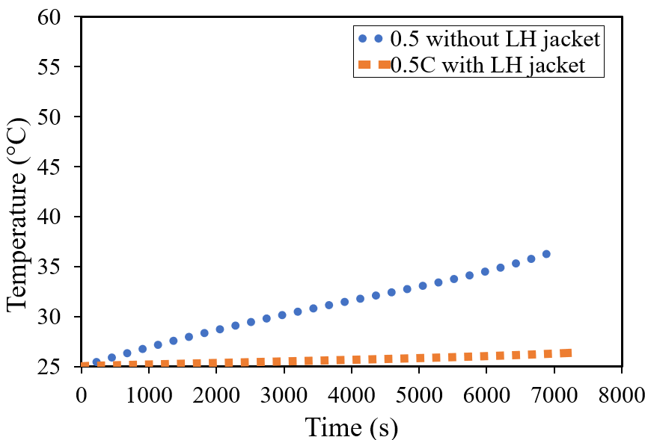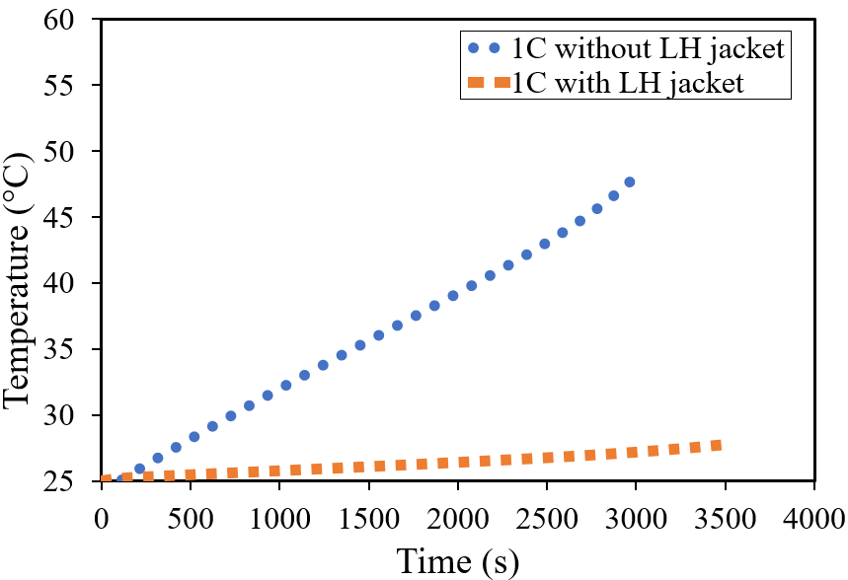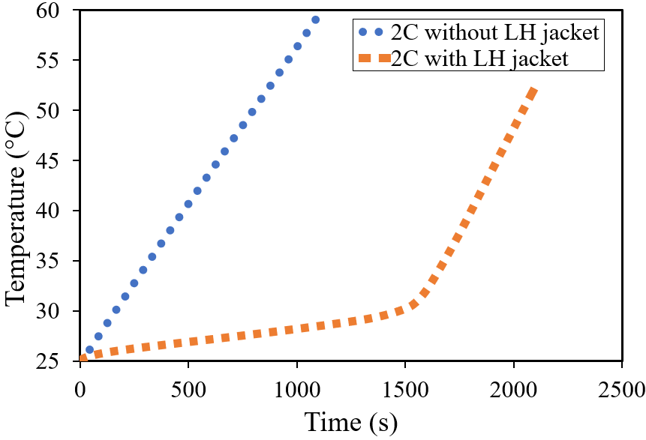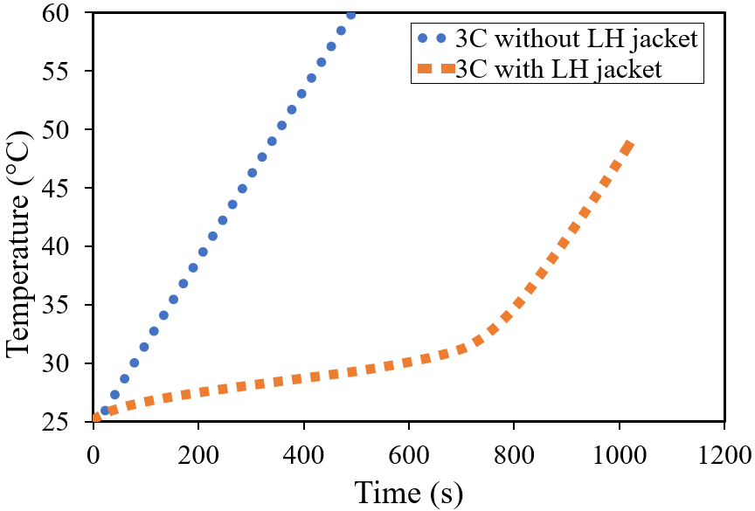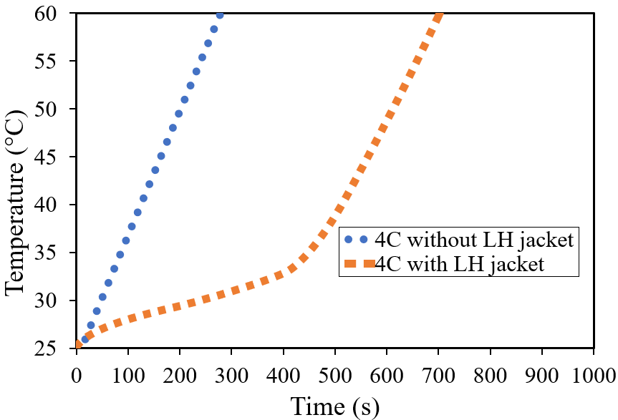

Fig. 11. Battery cell temperature distribution with and without LH jacket for discharging rates at 0.5C, 1C, 2C, 3C and 4C.

**Fig. 11** displays the comparison of the temperature distributions for the battery cell with and without the LH jacket at 0.5C, 1C, 2C, 3C, and 4C discharge rates. For all the discharge rates, the initial battery temperature was at 25 °C. Each test was performed for a single discharge from an initial SOC at 100% until 0% with the time taken for the battery cell to fully discharge reduced as the C-rates were increased. It is seen that the temperature increased to the safety limit at 60 °C faster with increasing C-rates. This increase in temperature can be attributed to the internal heat generation. In comparison, for all the cases where the LH jacket was introduced, the temperature remained within the optimum temperature (20 °C to 40 °C) excluding for 0.5C where the limit had not been exceeded in either case. It is also shown that compared to the sharp rise in temperature for the cases without a LH jacket, the ones with LH jacket rose more steadily and uniformly until all the LH was inaccessible. After this stage, a sharp rise can be seen for all the cases with LH jackets, as SH transfer became dominant. In other words, when the PCM got fully melted, as seen for 2C, 3C, and 4C discharge rates, the system temperature rose in proportion to the cases where no LH was present.

The temperature increased to 11.5 °C and 23.1 °C higher than the ambient temperature for 0.5C and 1C, respectively. For the other cases at 2C, 3C, and 4C there was an increase to 35 °C without a LH jacket, however, there was an increase to 27 °C, 23.8 °C and 35 °C above the ambient temperature, respectively, for the cases with a LH jacket. It is noteworthy that although there was a temperature rise above the optimum working temperatures, there was a delay effect and extension in useful life with the introduced passive cooling. In comparison to the final temperatures at these stages at 2C, 3C, and 4C, there was an extension in useful life by 294%, 300% and 250%, respectively.

# **5 Conclusions**

This study delves into the impact of varying drive cycles, such as US06, UDDS, HWFTa, HWFTb, LA92 and NN, on the thermal and electrical performance of a single 18650 battery cell, both independently and when equipped with a LH storage PCM jacket. The research harnesses an accurate MSMD ECM model to represent the battery cell’s electrical parameters, using real-world automotive drive cycles validated under ambient conditions 25 °C. The validated model precisely predicts the thermal and electrical performance, complying with manufacturer’s recommended safety limits. Through a combined thermo-chemical and electrical model, it explores power, temperature, SOC, and liquid fraction across different drive cycles, highlighting the need for effective thermal management techniques for aggressive driving scenarios, yielding performance enhancements across all cycles examined. The introduction of the LH jacket significantly extends the battery’s optimum operating temperature (20 °C – 40 °C) duration, with notable reductions in temperature (up to 52%) and remarkable increases in battery life (2.2x to 2.4x) during demanding driving cycles (US06, LA92, and NN). It ensures stable and uniform battery temperatures throughout all cycles when LH is accessible, notably beneficial for UDDS and HWFTa and b, where the battery temperature remains within the optimal range, effectively minimising temperature variations, except for the US06 and NN drive cycles, where divergence remains below 5 °C.

**CRediT author statement**

**R. A. Nicholls:** Conceptualization, Methodology, Software, Validation, Formal analysis, Investigation, Writing – Original Draft. **M.A. Moghimi:** Methodology, Software, Validation, Formal analysis, Investigation, Writing – Original Draft, Writing – Review & Editing, Supervision, Project administration, Funding acquisition, management. **A. L. Griffiths:** Writing – Original Draft, Writing – Review & Editing, Supervision.

### **Acknowledgements**

The authors gratefully acknowledge the support received from Staffordshire Advanced Manufacturing, Prototyping, and Innovation Demonstrator (SAMPID) that is part funded through the European Regional Development Fund 2014-2020, project reference No: 32R19P03142.

### **References**

1. Ghaeminezhad, N., Wang, Z. and Ouyang, Q. (2022) 'A Review on lithium-ion battery thermal management system techniques: A control-oriented analysis', *Applied Thermal Engineering,*, pp. 119497. <https://doi.org/10.1016/j.applthermaleng.2022.119497.>
2. Subramanian, M., Hoang, A.T., B, K., Nižetić, S., Solomon, J.M., Balasubramanian, D., C, S., G, T., Metghalchi, H. and Nguyen, X.P. (2021) 'A technical review on composite phase change material based secondary assisted battery thermal management system for electric vehicles', *Journal of Cleaner Production,*322, pp. 129079. <https://doi.org/10.1016/j.jclepro.2021.129079.>
3. Kumar, P., Chaudhary, D., Varshney, P., Varshney, U., Yahya, S.M. and Rafat, Y. (2020) 'Critical review on battery thermal management and role of nanomaterial in heat transfer enhancement for electrical vehicle application', *Journal of Energy Storage,*32, pp. 102003. <https://doi.org/10.1016/j.est.2020.102003.>
4. Tete, P.R., Gupta, M.M. and Joshi, S.S. (2021) 'Developments in battery thermal management systems for electric vehicles: A technical review', *Journal of Energy Storage,*35, pp. 102255. <https://doi.org/10.1016/j.est.2021.102255.>
5. Yang, M., Nicholls, R.A., Moghimi, M.A., and Griffiths, A.L. (2023) ‘Performance management of EV battery coupled with latent heat jacket at cell level’, *Journal of Power Sources,* 558, pp. 232618. <https://doi.org/10.1016/j.jpowsour.2022.232618>.
6. Jaguemont, J., Boulon, L. and Dubé, Y. (2016) 'A comprehensive review of lithium-ion batteries used in hybrid and electric vehicles at cold temperatures', *Applied Energy,*164, pp. 99-114. <https://doi.org/10.1016/j.apenergy.2015.11.034.>
7. Arora, S. (2018) 'Selection of thermal management system for modular battery packs of electric vehicles: A review of existing and emerging technologies', *Journal of power sources,*400, pp. 621-640. <https://doi.org/10.1016/j.jpowsour.2018.08.020>.
8. Kim, J., Oh, J. and Lee, H. (2019) 'Review on battery thermal management system for electric vehicles', *Applied thermal engineering,*149, pp. 192-212. <https://doi.org/10.1016/j.applthermaleng.2018.12.020>.
9. Muenzel, V., Hollenkamp, A.F., Bhatt, A.I., de Hoog, J., Brazil, M., Thomas, D.A. and Mareels, I., A, Comparative Testing Study of Commercial 18650-Format Lithium-Ion Battery Cells, *Journal of the Electrochemical Society,*162(8), 2015, pp. A1592-A1600. <https://doi.org/10.1149/2.0721508jes>.
10. Landini, S., Leworthy, J. and O’Donovan, T.S., A Review of Phase Change Materials for the Thermal Management and Isothermalisation of Lithium-Ion Cells, *Journal of Energy Storage,*25, 2019, pp. 100887. <https://doi.org/10.1016/j.est.2019.100887>.
11. Jilte, R.D., Kumar, R., Ahmadi, M.H. and Chen, L., Battery thermal management system employing phase change material with cell-to-cell air cooling, *Applied thermal engineering,*161, 2019, pp. 114199. <https://doi.org/10.1016/j.applthermaleng.2019.114199>.
12. Wang, Q., Ping, P., Zhao, X., Chu, G., Sun, J. and Chen, C. (2012) 'Thermal runaway caused fire and explosion of lithium-ion battery', *Journal of Power Sources,*208, pp. 210-224. <https://doi.org/10.1016/j.jpowsour.2012.02.038.>
13. Ibrahim, A. and Jiang, F. (2021) 'The electric vehicle energy management: An overview of the energy system and related modeling and simulation', *Renewable and Sustainable Energy Reviews,*144, pp. 111049. <https://doi.org/10.1016/j.rser.2021.111049.>
14. Ostanek, J.K., Li, W., Mukherjee, P.P., Crompton, K.R. and Hacker, C. (2020) 'Simulating onset and evolution of thermal runaway in Li-ion cells using a coupled thermal and venting model', *Applied Energy,*268, pp. 114972. <https://doi.org/10.1016/j.apenergy.2020.114972>.
15. Raijmakers, L.H.J., Danilov, D.L., Eichel, R.-. and Notten, P.H.L. (2019) 'A review on various temperature-indication methods for Li-ion batteries', *Applied Energy,*240, pp. 918-945. <https://doi.org/10.1016/j.apenergy.2019.02.078>.
16. Choudhari, V.G., Dhoble, D.A.S. and Sathe, T.M. (2020) 'A review on effect of heat generation and various thermal management systems for lithium ion battery used for electric vehicle', *Journal of energy storage,*32, pp. 101729. <https://doi.org/10.1016/j.est.2020.101729>.
17. Wu, W., Wang, S., Wu, W., Chen, K., Hong, S. and Lai, Y. (2019) 'A critical review of battery thermal performance and liquid-based battery thermal management', *Energy conversion and management,*182, pp. 262-281. <https://doi.org/10.1016/j.enconman.2018.12.051>.
18. Kirad, K. and Chaudhari, M. (2021) 'Design of cell spacing in lithium-ion battery module for improvement in cooling performance of the battery thermal management system', *Journal of power sources,*481, pp. 229016. <https://doi.org/10.1016/j.jpowsour.2020.229016>.
19. Xi, Z., Wang, R., Fu, Y. and Mi, C. (2022) 'Accurate and reliable state-of-charge estimation of lithium ion batteries using time-delayed recurrent neural networks through the identification of overexcited neurons', *Applied Energy,*305, pp. 117962. <https://doi.org/10.1016/j.apenergy.2021.117962>.
20. Guo, S. and Ma, L. (2023) 'A comparative study of different deep learning algorithms for lithium-ion batteries on state-of-charge estimation', *Energy (Oxford),*263, pp. 125872. <https://doi.org/10.1016/j.energy.2022.125872>.
21. Gulfam, R., Zhang, P. and Meng, Z. (2019) 'Advanced thermal systems driven by paraffin-based phase change materials – A review', *Applied Energy,*238, pp. 582-611. <https://doi.org/10.1016/j.apenergy.2019.01.114>.
22. Worwood, D., Kellner, Q., Wojtala, M., Widanage, W.D., MGlen, R., Greenwood, D. and Marco, J. (2017) 'A new approach to the internal thermal management of cylindrical battery cells for automotive applications', *Journal of Power Sources,*346, pp. 151-166. <https://doi.org/10.1016/j.jpowsour.2017.02.023>.
23. Al-Zareer, M., Dincer, I. and Rosen, M.A. (2018) 'Performance assessment of a new hydrogen cooled prismatic battery pack arrangement for hydrogen hybrid electric vehicles', *Energy Conversion and Management,*173, pp. 303-319. <https://doi.org/10.1016/j.enconman.2018.07.072>.
24. Jilte, R.D., Kumar, R., Ahmadi, M.H. and Chen, L., Battery thermal management system employing phase change material with cell-to-cell air cooling, *Applied thermal engineering,*161, 2019, pp. 114199. <https://doi.org/10.1016/j.applthermaleng.2019.114199>.
25. Sardari, P.T., Babaei-Mahani, R., Giddings, D., Yasseri, S., Moghimi, M.A. and Bahai, H. Energy recovery from domestic radiators using a compact composite metal Foam/PCM Latent Heat Storage, *Journal of cleaner production,*257, 2020, pp. 120504. <https://doi.org/10.1016/j.jclepro.2020.120504>.
26. Talebizadehsardari, P., Mahdi, J.M., Mohammed, H.I., Moghimi, M.A., Hossein Eisapour, A. and Ghalambaz, M., Consecutive charging and discharging of a PCM-based plate heat exchanger with zigzag configuration, *Applied thermal engineering,*193, 2021, pp. 116970. <https://doi.org/10.1016/j.applthermaleng.2021.116970>.
27. Rao, Z. and Wang, S. (2011) 'A review of power battery thermal energy management', *Renewable and Sustainable Energy Reviews,*15(9), pp. 4554-4571. <https://doi.org/10.1016/j.rser.2011.07.096>.
28. Cao, J., Ling, Z., Fang, X. and Zhang, Z. (2020) 'Delayed liquid cooling strategy with phase change material to achieve high temperature uniformity of Li-ion battery under high-rate discharge', *Journal of Power Sources,*450, pp. 227673. <https://doi.org/10.1016/j.jpowsour.2019.227673.>
29. Nicholls, R.A, Moghimi, M.A., and Griffiths, A.L., Impact of fin type and orientation on performance of phase change material-based double pipe thermal energy storage, *Journal of Energy storage*, 50, 2022, pp 104671. <https://doi.org/10.1016/j.est.2022.104671>.
30. Du, K., Calautit, J.K., Wang, Z., Wu, Y. and Liu, H. (2018) 'A review of the applications of phase change materials in cooling, heating and power generation in different temperature ranges', *Applied Energy,*220. <https://doi.org/10.1016/j.apenergy.2018.03.005>.
31. Nicholls, R.A, Moghimi, M.A., and Griffiths, A.L., Can passive cooling be a practical solution for the thermal management of battery in electric vehicles, *Proceedings of the 16th International Conference on Heat Transfer, Fluid Mechanics and Thermodynamics and Editorial Board of Applied Thermal Engineering*, Amsterdam, Netherlands, August 2022.
32. Chen, J., Kang, S., E, J., Huang, Z., Wei, K., Zhang, B., Zhu, H., Deng, Y., Zhang, F. and Liao, G. (2019) 'Effects of different phase change material thermal management strategies on the cooling performance of the power lithium ion batteries: A review', *Journal of power sources,*442, pp. 227228. <https://doi.org/10.1016/j.jpowsour.2019.227228>.
33. Damiano, A., Musio, C. and Marongiu, I. (Nov 2015) *Experimental validation of a dynamic energy model of a battery electric vehicle.*IEEE, pp. 803.
34. Kollmeyer, P., Hackl, A. and Emadi, A. (Jun 2017) *Li-ion battery model performance for automotive drive cycles with current pulse and EIS parameterization.*IEEE, pp. 486.
35. Nazir, H., Batool, M., Bolivar Osorio, F.J., Isaza-Ruiz, M., Xu, X., Vignarooban, K., Phelan, P., Inamuddin and Kannan, A.M. (2019) 'Recent developments in phase change materials for energy storage applications: A review', *International Journal of Heat and Mass Transfer,*129, pp. 491-523. <https://doi.org/10.1016/j.ijheatmasstransfer.2018.09.126>.
36. Alami, A.H., Maghrabie, H.M., Abdelkareem, M.A., Sayed, E.T., Yasser, Z., Salameh, T., Rahman, S.M.A., Rezk, H. and Olabi, A.G. (2022) 'Potential applications of phase change materials for batteries' thermal management systems in electric vehicles', *Journal of Energy Storage,*54, pp. 105204. <https://doi.org/10.1016/j.est.2022.105204>.
37. Huang, Y., Cheng, W. and Zhao, R. (2019) 'Thermal management of Li-ion battery pack with the application of flexible form-stable composite phase change materials', *Energy Conversion and Management,*182, pp. 9-20. <https://doi.org/10.1016/j.enconman.2018.12.064>.
38. Abdulmunem, A.R., Hamed, H.M., Samin, P.M., Mazali, I.I. and Sopian, K. (2023) 'Thermal management of lithium-ion batteries using palm fatty acid distillate as a sustainable bio-phase change material', *Journal of Energy Storage,*73, pp. 109187. <https://doi.org/10.1016/j.est.2023.109187>.
39. Siddique, A.R.M., Mahmud, S. and Heyst, B.V. (2018) 'A comprehensive review on a passive (phase change materials) and an active (thermoelectric cooler) battery thermal management system and their limitations', *Journal of Power Sources,*401, pp. 224-237. <https://doi.org/10.1016/j.jpowsour.2018.08.094>.
40. Patel, J.R. and Rathod, M.K. (2020) 'Recent developments in the passive and hybrid thermal management techniques of lithium-ion batteries', *Journal of Power Sources,*480, pp. 228820 Available at: <https://doi.org/10.1016/j.jpowsour.2020.228820>.
41. Chacko, S., and Chung, Y.M. (2012) 'Thermal modelling of Li-ion polymer battery for electric vehicle drive cycles', *Journal of power sources,*213, pp. 296-303. <https://doi.org/10.1016/j.jpowsour.2012.04.015>.
42. Patel, J.R. and Rathod, M.K. (2022) 'Phase change material selection using simulation-oriented optimization to improve the thermal performance of lithium-ion battery', *Journal of Energy Storage,*49, pp. 103974 Available at: <https://doi.org/10.1016/j.est.2022.103974>.
43. Najafi Khaboshan, H., Jaliliantabar, F., Adam Abdullah, A. and Panchal, S. (2023) 'Improving the cooling performance of cylindrical lithium-ion battery using three passive methods in a battery thermal management system', *Applied Thermal Engineering,*227, pp. 120320. <https://doi.org/10.1016/j.applthermaleng.2023.120320>.
44. Jiang, J., Liu, Q., Zhang, C. and Zhang, W. (2014) 'Evaluation of Acceptable Charging Current of Power Li-ion Batteries Based on Polarization Characteristics', *IEEE transactions on industrial electronics (1982),*61(12), pp. 6844-6851. https://doi.org/10.1109/TIE.2014.2320219.
45. Xiaopeng, C., Weixiang, S., Zhenwei, C., and Kapoor, A. (2014) 'Adaptive gain sliding mode observer for state of charge estimation based on combined battery equivalent circuit model', *Computers &amp; chemical engineering,*64, pp. 114-123. <https://doi.org/10.1016/j.compchemeng.2014.02.015>.
46. Khamar, M. and Askari, J. (May 2014) ‘A charging method for Lithium-ion battery using Min-max optimal control’*.*IEEE, pp. 1239.
47. Parvini, Y. and Vahidi, A. (Jul 01, 2015) ‘Maximizing charging efficiency of lithium-ion and lead-acid batteries using optimal control theory’*.*American Automatic Control Council, pp. 317.
48. Zheng Chen, Bing Xia, Mi, C.C., and Rui Xiong (2015) 'Loss-Minimization-Based Charging Strategy for Lithium-Ion Battery', *IEEE transactions on industry applications,*51(5), pp. 4121-4129. <https://doi.org/10.1109/TIA.2015.2417118>.
49. Freudiger, D., D’Arpino, M. and Canova, M. (2019) 'A Generalized Equivalent Circuit Model for Design Exploration of Li-Ion Battery Packs Using Data Analytics', *IFAC-PapersOnLine,*52(5), pp. 568-573. <https://doi.org/10.1016/j.ifacol.2019.09.090>.
50. Ghoulam, Y., Mesbahi, T., Wilson, P., Durand, S., Lewis, A., Lallement, C. and Vagg, C. (2022) 'Lithium-Ion Battery Parameter Identification for Hybrid and Electric Vehicles Using Drive Cycle Data', *Energies (Basel),*15(11), pp. 4005. <https://doi.org/10.3390/en15114005>.
51. Micari, S., Foti, S., Testa, A., De Caro, S., Sergi, F., Andaloro, L., Aloisio, D., Leonardi, S.G. and Napoli, G. (2022) 'Effect of WLTP CLASS 3B Driving Cycle on Lithium-Ion Battery for Electric Vehicles', *Energies (Basel),*15(18), pp. 6703. <https://doi.org/10.3390/en15186703>.
52. Khalfi, J., Boumaaz, N., Soulmani, A. and Laadissi, E.M. (2021a) 'Box–Jenkins Black-Box Modeling of a Lithium-Ion Battery Cell Based on Automotive Drive Cycle Data', *World electric vehicle journal,*12(3), pp. 102. <https://doi.org/10.3390/wevj12030102>.
53. Bhavsar, S., Kant, K. and Pitchumani, R. (2023) 'Robust Model-Predictive Thermal Control of Lithium-Ion Batteries under Drive Cycle Uncertainty', *Journal of power sources,*557, pp. 232496. <https://doi.org/10.1016/j.jpowsour.2022.232496>.
54. Shah, R.M.R.A., McGordon, A., Rahman, M.M., Amor-Segan, M. and Jennings, P. (2021) 'Characterisation of micro turbine generator as a range extender using an automotive drive cycle for series hybrid electric vehicle application', *Applied thermal engineering,*184, pp. 116302. <https://doi.org/10.1016/j.applthermaleng.2020.116302>.
55. Vikram, S., Vashisht, S. and Rakshit, D. (2022) 'Performance analysis of liquid-based battery thermal management system for Electric Vehicles during discharge under drive cycles', *Journal of energy storage,*55, pp. 105737. <https://doi.org/10.1016/j.est.2022.105737>.
56. DieselNet, *Emission Test Cycles,* 1997/2013, <https://dieselnet.com/standards/cycles/index.php> [accessed 15 December 2022].
57. Gürel, B. (2020) 'A numerical investigation of the melting heat transfer characteristics of phase change materials in different plate heat exchanger (latent heat thermal energy storage) systems', *International Journal of Heat and Mass Transfer,*148, pp. 119117. <https://doi.org/10.1016/j.ijheatmasstransfer.2019.119117>.
58. Adine, H.A. and El Qarnia, H. (2009) 'Numerical analysis of the thermal behaviour of a shell-and-tube heat storage unit using phase change materials', *Applied Mathematical Modelling,*33(4), pp. 2132-2144 Available at: <https://doi.org/10.1016/j.apm.2008.05.016>.
59. Seddegh, S., Wang, X. and Henderson, A.D. (2016) 'A comparative study of thermal behaviour of a horizontal and vertical shell-and-tube energy storage using phase change materials', *Applied Thermal Engineering,*93, pp. 348-358. <https://doi.org/10.1016/j.applthermaleng.2015.09.107>.
60. Kousha, N., Hosseini, M.J., Aligoodarz, M.R., Pakrouh, R. and Bahrampoury, R. (2017) 'Effect of inclination angle on the performance of a shell and tube heat storage unit – An experimental study', *Applied Thermal Engineering,*112, pp. 1497-1509. <https://doi.org/10.1016/j.applthermaleng.2016.10.203>.
61. Kadivar, M.R., Moghimi, M.A., Sapin, P. and Markides, C.N., Annulus eccentricity optimisation of a phase-change material (PCM) horizontal double-pipe thermal energy store, *Journal of energy storage,*26, 2019, pp. 101030. <https://doi.org/10.1016/j.est.2019.101030>.
62. Darzi, A.R., Farhadi, M. and Sedighi, K., Numerical study of melting inside concentric and eccentric horizontal annulus, *Applied mathematical modelling,*36(9), 2012, pp. 4080-4086. <https://doi.org/10.1016/j.apm.2011.11.033>.