Thermal performance analysis of battery modules with passive cooling under different cycling loads in electric vehicles
R.A. Nicholls, M.A. Moghimi*, S. Sehhat

Department of Engineering, Staffordshire University, Stoke-On-Trent ST4 2DE, UK
*Corresponding author: mohammad.moghimi-ardekani@staffs.ac.uk

ABSTRACT

This study investigates the impact of passive cooling for battery thermal management systems (BTMS) for various configurations of modules under different load scenarios (e.g., continuous cycling and five automotive drive cycles). Numerical computational fluid dynamics (CFD) is used to analyse the effect of passive cooling in the form of circumferential phase change material (PCM) jackets for each cell. The three-dimensional (3D) modules of a 24-battery cell arranged in 24S, 2P12S and 3P8S in the presence and absence of latent heat (LH)/PCM jackets were constructed (in combined 6 different modules considered). The constructed modules were simulated under 1C continuous cycling (as a theoretical cycling) and five actual drive cycles (from a harsh one to a casual one including US06, LA92, NN, UDDS, HWFTa). The performance of the proposed modules under the discussed loads is investigated against battery module temperature, PCM liquid fraction, state-of-charge (SOC) and passive zone potentials. The study concludes the effectiveness of passive cooling (in the forms of latent heat jackets) to stabilise the system temperature as well as individual cells under normal and harsh Cases. Results indicated that the natural convection cooling LH jackets maintained stable and uniform temperatures for all cycles with a reduction in module temperature on average by 20 °C and less than a 5 °C temperature difference. There was on average over 200 % improvement in battery useful life under all drive cycles assessed regardless of module arrangements.

Keywords:
Lithium-ion battery (LIB) module
Latent heat cooling
Battery thermal management
Coupled thermo-chemical and electrical modelling
Theoretical cycling (continuous cycling)
Real-world drive cycles (US06, LA92, NN, UDDS, HWFTa)
Battery electrical cycling

Nomenclature
$$A_{mush}$$ | mushy zone constant (${kg}/{m^{3}s}$) | Greek symbols
$$C_{p}$$ | specific heat ($J/{kgK}$) | $$α$$ | thermal diffusivity
$$D_{i}$$ | inner diameter (mm) | $$β$$ | expansion coefficient ($1/K$)
$$D_{o}$$ | outer diameter (mm) | $$μ$$ | dynamic viscosity ($Pa s$)
$$f$$ | friction factor [-] | $$ε$$ | small number
$$F_{o}$$ | Fourier Number [-] | $$ρ$$ | density (${kg}/{m^{3}}$)
g | gravity acceleration ($m/{s^{2}}$) | $$ρ_{0}$$ | constant density (${kg}/{m^{3}}$)
h | sensible enthalpy $(J/{kg}$) | $$∇$$ | non dimensional term
$$h_{ref}$$ | reference enthalpy $(J/{kg}$) | $$σ$$ | Electrical conductivity of the passive material (S/m)
H | total enthalpy ($J/{kg}$) | $${\dot{q}}_{ECh}$$ | Electrochemical reaction heat due to electrochemical reactions
k | thermal conductivity ($W/{mK}$)
L | latent heat $(J/{kg}$)
$$P$$ | Pressure $(Pa)$
SOC | State of Charge
$$S$$ | source term
t | time (s)
T | temperature (K)
$$T_{liquidous}$$ | Liquid temperature (K)
$$T_{0}$$ | operation temperature (K)
$$T_{s}$$ | inner surface temperature (K)
$$T_{solidus}$$ | solid temperature (K)
$$T_{ref}$$ | reference temperature (K)
$$\vec{v}$$ | fluid velocity

1 Introduction

The transportation sector’s shift towards reducing carbon dioxide (CO2) emissions via electric and hybrid electric vehicles (EVs and HEVs) reflects concerns over the energy crisis and environmental pollution. Lithium-ion (Li-ion) batteries, a key renewable energy resource for EVs and HEVs [1], offer high specific energy power, and long cycling [2]. However, challenges persist regarding overheating during charging and discharging cycles, impacting battery performance [3] and posing safety hazards [4,5]. To mitigate these risks, effective battery thermal management systems (BTMS) are crucial [7]. Maintaining battery temperature within optimal ranges (recommended between 25 °C to 40 °C) and minimising temperature differences between cells in a module or pack (not exceeding 5°C ) [9-11] enhances safety and performance. Various cooling methods, classified as active or passive [8, 10, 12, 13], aim to dissipate excess heat. While active cooling systems may enhance thermal management, they introduce complexities and reduce overall efficiency [12, 13]. Addressing overheating challenges is critical for wider EV adoption and sustainable transportation solutions [14, 15]. Innovative BTMS solutions are essential to manage temperature, improve cycle life, and promote clean energy vehicles’ growth [15, 16]. This study analyses passive thermal cooling [17, 18] combined with EES to address and manage battery module overheating, contributing to sustainable transportation solutions.
EV adoption offers benefits like reduced fossil fuel consumption and emissions. HEVs combine battery technology with internal combustion engines, partially reducing fossil fuel reliance. Battery electric vehicles (BEVs) solely recharge from the grid, with advantages like reduced noise pollution and lower maintenance costs [19]. However, optimising battery performance remains crucial due to lifespan and weight concerns. An effective BTMS [20] ensures safe and efficient Li-ion battery operation, as temperature profoundly impacts electrochemical reactions and materials [21]. Managing heat generation inside batteries is crucial [22], affecting ionic conductivities and performance. Controlling temperature within safety limits is essential, with passive thermal management solutions offering benefits over traditional methods. Phase Change Materials (PCMs), particularly show promise in improving thermal management by absorbing and storing heat during temperature rise. This maintains uniform pack temperature, enhancing battery performance. PCMs store energy as Latent Heat (LH), reducing maximum temperature and temperature differences when combined with batteries. Addressing challenges like local temperature increases during high-rate charging and discharging is essential for effective thermal management.
Even at low temperatures, chemical reactions and the rate of electrochemical reactions are affected, leading to lower ionic conductivities of the electrodes and electrolytes compounding to lower battery performance. On the other hand, higher temperatures have a more complex effect than lower temperatures. The heat that is generated within the cells is associated with charge transfer and chemical reactions during battery cycling of charging and discharging [23]. This heat can be reversible (entropic heat) or irreversible from entropy change during electrochemical reactions or polarisation, ohmic heating and leading to unrecoverable heat, respectively.
Managing thermal effects involves controlling temperatures within operational ranges and safety limits, crucial depending on cell type. Traditional BTMS often require bulky additions [23, 24], prompting interest in passive thermal management solutions. Passive cooling, adept at absorbing and storing thermal energy during temperature spikes and releasing it during cooling, suits Li-ion batteries well. PCMs [25] offer a promising approach to enhance thermal management. By integrating PCMS, a low-maintenance thermal management system is created. PCMs readily absorb battery-generated heat [26-27], storing it during solid-liquid transitions. This maintains pack temperature uniformity, curbing temperature irregularities detrimental to battery performance [28]. PCMs, regardless of being organic, inorganic, or eutectic-based, store significant energy as LH [29], reducing maximum temperature and temperature differences when combined with batteries [30, 31]. However, addressing challenges such as local temperature spikes, especially during high-rate charging and discharging, remains crucial [32].
Recent studies have examined the integration of battery cells with PCM to assess cell efficiency and performance. One study [33] explored PCM thickness effects on battery pack outer walls, suggesting a 3mm thickness effectively absorbed battery-generated heat. Another study [34] evaluated different PCM jacket thicknesses (1mm, 3mm, 5mm, and 7mm) on a Panasonic Li-ion battery under various ambient conditions. Results showed that the selected PCM thickness at 3nn and melting temperature closer to ambient temperature allows for a delayed effect, aiding heat dissipation. A simplified physical battery model [35] proposed thermal output prediction, using a lumped thermal model, offering reasonably accurate operation predictions. Another study, [36] compared paraffin wax and RT-18 PCMs for thermal management effectiveness, finding lower melting point PCMs more effective due to faster melting and extended thermal resistive layer formation. Studies also explored variations in C-rate [37-39], PCM thickness, and thermal properties for analytical modelling of typical cell temperature and heating, including natural convection heat transfer [40]. Results indicated PCM thickness dependence on melting temperature and thermal conductivity, with lower melting temperatures and higher conductivity requiring less thickness. Consideration of PCM density is crucial for overall system weight.
Research by [41] and [42] compared cell spacing configurations within battery packs, assessing thermal performance under constant spacing, including transverse and longitudinal arrangements, Thermal performance of one cell directly affected by neighbouring cells was observed. For this study, cells were thermal isolated to eliminate adjacent cell impacts. Different battery modelling approaches, including the multi-scale multi-domain method, have been explored to accurately measure BTMS with PCM [43-45]. Numerical modelling assigns distributed temperatures along the length scale using an equivalent circuit model (ECM) [46, 47], representing electrical cell behaviour. This modelling is suitable for battery discharge, recharge, and sudden electricity fluctuations from drive cycling, applicable to this study. Analysing continuous discharge, charge, or combined cycles compares energy storage performance under constant conditions over time. Dynamic modelling via real-world drive cycles is essential to fully understand passive cooling’s impact on battery module thermal behaviour within acceptable limits. Studies assessing battery cell performance [48-52] observed significant temperature increases under harsh conditions, highlighting the necessity of effective BTMS to prevent fire and explosion risks.
To the best authors’ knowledge, the impact of passive cooling on battery performance under theoretical (continuous charging and discharging) and five actual (real-world drive cycles; from a harsh driving cycle to a casual one) loads at the module level have not been addressed, which shed light on the effectiveness of this approach for BTMS in EV world. Thus, the novelty of this research study lies in evaluating the impact of passive cooling/LH jackets on the thermal management of various configurations of battery modules under different loads (discharging and charging cycling modes as well as drive cycling scenarios, including harsh and casual). In this regard, three configurations were analysed for a total of 24-18650 Panasonic Li-ion cells with 278.4 W of power connected in series and parallel. The arrangement and capacity of the three configurations were as follows: Case 1 (2.9Ah case): 24 series cells (24S), Case 2 (5.9 Ah case): 2 parallel cells with 12 series (2P12S) and Case 3 (8.7 Ah case): 3 parallel cells with 8 series (3P8S). The LH jackets around the individual cells in the module were thermally isolated from neighbouring cells and the heat generated during the operational conditions of either discharging and charging or driving cycles was directly captured by LH jackets. A numerical heat transfer analysis for combined thermo-chemical and electrical modelling was performed using a chosen thickness of PCM. The transient thermal and electrical performance analysis was conducted to prove the concept of using LH jackets as an effective thermal management system for ambient weather conditions.
Understandably, the study outlines the numerical method including models, initial and boundary conditions, assumptions, mathematical and numerical models, and computational model setup. Subsequently, the results and discussion comprise the independency and validation study as well as the outcomes of the study culminating with the conclusions.

2 Numerical Method

2.1 Models

The battery module characteristics and configurations for the three distinct types of module arrangements are displayed in Fig. 1. The modules assessed in this study include three different arrangements (24S, 2P12S and 3P8S) consisting of 24 18650 PF Panasonic lithium-ion batteries, with individual 3 mm circumferential LH jackets (for better understanding of module configuration, components were colour coded in Fig. 1). The primary aim of this feasibility study was performance assessments of the considered module configuration in presence and absence of LH jacket for cells, under different cycling loads (continuous cycling as well as dynamic drive cycling), to evaluate the impact of passive cooling (proposed latent heat jacket, as shown in Fig. 1) at module level. Please note that in Fig. 1, only 3 configurations with LH jackets are displayed for the sake of brevity. Therefore, in this study performance of 6 different modules under 2 various cycling loads (continuous and real-world drive cycles) were assessed and compared against each other. The specifications of the considered module in this study against single cell specification were listed in Table 1.

Table 1: Single cell and module specifications for 18650PF Panasonic battery.
Specifications | Battery cell/Module
 | Single Cell | Case 1 (24S) | Case 2 (2P12S) | Case 3 (3P8S)
Specified C-rate | 1 | 1 | 1 | 1
Nominal Cell-capacity (ah) | 2.9 | 2.9 | 5.8 | 8.7
Specified system voltage (V) | 4 | 96 | 48 | 24
Specified system power (W) | 11.6 | 278.4 | 278.4 | 278.4
Maximum cut-off voltage (V) | 4.2
Minimum cut-off voltage (V) | 2.5

The individual cells of the module were considered as homogenous bodies, in other words, the cathode, anode and current collectors were not solved explicitly. The cells, tabs, and busbars were designed as separate zones for the sake of this study. The outer surface of cells (regardless of being jacketed or not) was insulated to eliminate the effect of the environment. Thus, only the generated heat by the battery was conducted directly to the PCM LH jacket, which better showed the effectiveness of the LH jacket for battery thermal management purposes. The cell-to-cell spacing remained constant at 30 mm between cells (both horizontally in series orientation and vertically in parallel orientation, see Fig. 1 for further clarification) as they were thermally isolated from one another. All the cells were the same type and format of 18650 Li-ion batteries. As shown in Fig. 1, busbar connections were assigned accordingly allowing tab-tab connections from the positive tab of one cell to the negative tab of the next battery cell in series arrangement and positive to positive tabs and negative to negative tabs for parallel arrangement to create the different modules. Fig. 1, also displayed zoomed-in images for a better understanding of the arrangement. The external connectors indicate the areas of the electrical contacts (positive and negative tabs not connected to a busbar). In this regard, the positive phase potential of the first battery was similar to the negative phase potential of the second battery. Subsequently, the same domain was used to resolve both the positive and negative phase potentials of the first and second batteries. The electrochemical reactions occurred within the active zone (battery cell) and both potential equations were computationally solved whereas in the passive zones (tabs/busbar), only a single potential equation was available. The batteries in the modules were connected via real connections (busbars) and were physically resolved including meshed as opposed to virtual connections (absence of busbars) in this study. Such detailed modelling highlighted a visual representation of the heat transfer between tab-busbar connections as well as between different cells in the module, which determined the areas of hot spots (hot temperature zones) concerning additional computational time for the passive zone volumes to be resolved. Each of the cells that made up the battery module consisted of different domains, notable active or e-material zones with positive and negative tabs connected to a busbar. It must be noted that in all cases studied, a horizontal orientation of the cells within the module was adopted for more effective heat transfer as seen in previous studies [34,51].

Table 2: Value parameters of the thermophysical properties of the PCM and li-ion cells [34,51].
Parameters | Materials
 | PCM  (N-octadecane) | Battery cell (active zone) | Positive Tab  (Tab_p) | Negative Tab (Tab_n) | Insulation
Specific heat, Cp (J/kg.K) | 2196 | 678 | 871 | 381 | 1470
Density (kg/m³) | 770 | 2092 | 2719 | 8978 | 1190
Thermal Conductivity (W/m.K) | 0.148 | 18.2 | 202.4 | 387.6
Solidus Temperature (K) | 298.15
Liquidus Temperature (K) | 302.15
Thermal expansion coefficient (1/K) | 0.00091
Latent heat (J/Kg) | 243500
Dynamic Viscosity (kg/m.s) | 0.003

This study was performed at an ambient temperature of 25 °C for all Cases (24S, 2P12S and 3P8S) to analyse the effect on thermal performance on this single ambient temperature. The selected PCM (N-octadecane) was based upon the optimum operating conditions of the Li-ion 18650 battery cell (20 °C – 40 °C) and as determined in a previous study [34], would be sufficient to conduct the analysis on all test Cases. The thermal properties of the PCM, module and insulation material can be found in Table 2. N-octadecane has a high latent heat, cost-effective and suitable for the temperature range to conduct sufficient analysis on the impact of LHS on the thermal performance of the test Cases. The chosen PCM demonstrated its capability to uphold consistent battery temperatures under the ambient temperature of 25 °C. An extended analysis, shown in the previous study [34], analysed the impact of PCMs under various ambient weather conditions from extreme cold (-20 °C) to hot desert conditions (55 °C) for battery performance at the cell level.

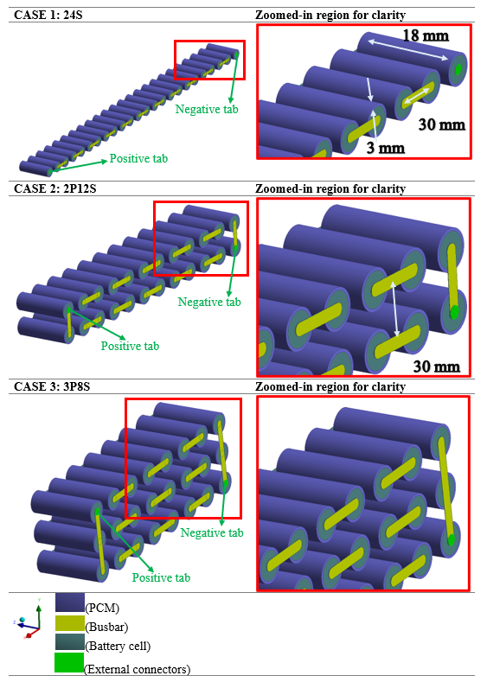
Fig. 1. Isometric and zoomed-in view of the considered battery module configurations (Case 1, 2, and 3) in the presence of individual PCM jackets.

2.2 Initial and boundary conditions

The numerical models depicted in Fig. 1 were analysed for the following initial and boundary conditions:
For all Cases (1, 2 and 3),
- Insulated outer walls around the LH jackets provided an adiabatic environment independent of adjacent cells and loss of heat to the environment,
- Adiabatic (zero heat flux) walls for battery tabs and coupled walls for busbar connections,
- The solidus temperature represented the PCM’s initial state,
- The module temperature was set to ambient 25 °C,
- Conductive battery walls to the PCM and busbar were set to ambient module temperature with heat transfer coefficient set to 7 W/mK.

2.3 Assumptions

In the modelling of all Cases (1-3), the following assumptions were considered,
- Battery modules were 100 % charged and ready to be discharged based on a reference capacity equivalent to the nominal module capacity (ah),
- Due to ECM model characteristics at the cell level, homogenous physical battery properties were sustained throughout the analysis with all cells the same in the module and under the same initial conditions,
- Molten PCM was considered compressible and viscous flows laminarly,
- Conduction heat transfer applied and continuous from battery cells to PCM and from tabs to busbars,
- Cells in the module were arranged horizontally (see Fig. 1) with gravity at 9.81 m/s² for LH-based cooling Cases,
- The positive and negative tabs were continuous surfaces,
- Real tabs/busbar conductive volumes formed connections to positive and negative tabs,
- Natural convection heat transfer calculated based on Boussinesq approximation for density approximation in molten PCM.

Essential safety limits were considered for all Cases during charging, discharging and drive cycling as a preventative measure to ensure the system remains within optimum working conditions and free from overheating effects and thermal runaway effects. Beyond these limits were not in the scope of this study and testing was only considered between the recommended manufacturer recommendations.
- For discharging: 60°C,
- For charging: 45 °C,
- For drive cycle modelling: 60°C,
- Between single cells, the minimum and maximum cut-off voltage was at 2.5 V and 4.2 V, respectively.

2.4 Mathematical and numerical model

In this study, the combined thermo-chemical and electrical models were used in ANSYS Fluent 2022 R2. An enthalpy-porosity method was used to track the movement of the liquid-solid front or in other words, the “mushy zone” region during phase change. This method eliminates the need to track the movement explicitly. An equal porous zone to the liquid fraction was dedicated to the liquid-solid mushy zone. The liquid fraction in this case was known as the specific cell volumes which were in liquid form corresponding to every cell in the PCM domain. To identify the phase change during melting, the liquid fraction was valued between 0 and 1 which represented lower and upper bounds for solid to liquid. The values were calculated for every iteration corresponding to the enthalpy balance. In the solid state, the null porosity had an equal effect on the velocity. Sink term equations were applied to the momentum equations to represent the pressure drop due to solid regions. These sink terms were also employed in the turbulence equations where there could be reduced porosity indicated by solid regions. For conducting the thermal analysis of the battery model, the heat generated by the system must be accurately performed to fully understand the thermal behaviour during regular operation. There were different methods to perform the coupling, but this study focused on the Multi-Scale Multi Domain (MSMD) solution method which directly solves the electrochemical aspect of the battery. The model addressed the issue with different length scales with distinct physical phenomena and so the distribution of temperature was along the scale of the battery. Based on the assumptions and boundary conditions, the following governing equations were used.

The energy equation for the battery [58] is
$\frac{∂ρC_{p}T}{∂t} = ∇.\left(k∇T\right)+ σ_{+}{\left|∇∅_{+}\right|}^{2}+σ_{-}{\left|∇∅_{-}\right|}^{2}+{\dot{q}}_{ECh}$ (1)
where ${\dot{q}}_{ECh}=I \frac{Q_{nominal}}{Q_{ref} Vol}[V_{OCV}-V-T\frac{dU}{dT }]$
I is the current and $V_{OCV}$ is the open circuit voltage
In this case, the heat generation [46] for the battery is noted as
${\dot{q}}_{total = }{\dot{q}}_{Joule }+ {\dot{q}}_{entropy }$ (2)
where ${\dot{q}}_{Joule }$is the irreversible heat and ${\dot{q}}_{entropy }$is the reversible heat.The energy equation for the busbar is
$\frac{∂ρC_{p}T}{∂t} = ∇.\left(k∇T\right)$ (3)
The energy equation for melting [34] is
$\frac{∂}{∂t}\left(ρH\right)+ ∇.\left(ρ\vec{v}H\right)= ∇.\left(k∇T\right)$ (4)
$H=h+ ∆H$ (5)
$h= h_{ref}+ \int_{T_{ref}}^{T}{C_{p}}dT$ (6)
$∆H= fL$ (7)
$f=\left\{\begin{aligned}0 \\ 1 \\ \frac{T- T_{solidus}}{T_{liquidous}- T_{solidus}}\end{aligned}\right.$; $\left\{\begin{aligned} T < T_{solidus} \\ T > T_{liquidous} \\ T_{solidus} <T <{ T}_{liquidous}\end{aligned}\right.$ (8)
Momentum sink term for reduced porosity in the mushy zone,
$S= \frac{{(1- f)}^{2}}{(f^{3}+ ε)} A_{mush}$ (9)
The value of the $A_{mush}$ constant is generally between 10⁴ - 10⁷. For this analysis, 10⁵ [34,51] was proven to be adequate for PCM melting based on the individual PCM volumes around each cell (see Fig. 1).
The continuity equation for the PCM is
$\frac{∂ρ}{∂t}+ ∇.\left(ρ\vec{v}\right)=0$ (10)
The momentum equation for the PCM is
$\frac{∂ρ\vec{v}}{∂t}+ ∇.\left(ρ\vec{v}\vec{v}\right)= -∇P+ ∇.\left(μ∇\vec{v}\right)+ ρg+ \frac{{\left(1-f\right)}^{2}}{f^{3}+ ε} \vec{v}A_{mush}$ (11)
$F_{o}= \frac{αt}{D^{2}}$ (12)
The Reynold’s number is based on laminar fluid flow
$R_{e}= \frac{ρvD}{µ}$ (13)
Furthermore, in the context of the MSMD model, the ECM was used to resolve the electrical behaviour of the module using an electric circuit initially modelled in their study [55,56] which involves a six-parameter approach comprising three resistors and two capacitors. This model involves the charging and discharging of individual cells and packs.
Natural convection, driven by buoyancy resulting from density changes due to temperature fluctuations, was observed within the molten phase of the studied PCM. Enclosed within a boundary, the flows adhere to the Boussinesq approximation, facilitating faster convergence under constant density and temperature conditions. As seen in the previous studies [34,51], the gravity-induced natural convection was influenced by the thermal expansion coefficient and directly impacted the density shifts in the molten PCM region, in response to temperature changes. If the temperature fluctuations remained minimal, and the density differences were negligible, then the Boussinesq approximation would be valid. The subtle changes in volume during temperature increases and the melting process were because of the thermal expansion coefficient as mentioned in Table 2.

The relationship between the voltage and current is determined by solving the electric circuit equations which are highly dependent on the battery SOC and temperature.
$V= V_{OC}\left(SOC\right)-V_{1}-V_{2}-R_{s}\left(SOC\right)I\left(t\right)$ (14)

$\frac{dV_{1}}{dt}=-\frac{1}{R_{1}\left(SOC\right)C_{1}\left(SOC\right)}V_{1}-\frac{1}{C_{1}\left(SOC\right)} I\left(t\right)$ (15)

$\frac{dV_{2}}{dt}=-\frac{1}{R_{2}\left(SOC\right)C_{2}\left(SOC\right)}V_{2}-\frac{1}{C_{2}\left(SOC\right)} I\left(t\right)$ (16)

$\frac{d(SOC)}{dt}={I(t)}/{3600Q_{ref}}$ (17)
The fifth-order polynomial form for different coefficients of charging and discharging are explicitly resolved as functions based on the following equations:
$R_{s}=a_{0}+a_{1}\left(soc\right)+a_{2}{\left(soc\right)}^{2}+ a_{3}{\left(soc\right)}^{3}+a_{4}{\left(soc\right)}^{4} +a_{5}{\left(soc\right)}^{5}$ (18)

$R_{1}=b_{0}+b_{1}\left(soc\right)+b_{2}{\left(soc\right)}^{2}+ b_{3}{\left(soc\right)}^{3}+b_{4}{\left(soc\right)}^{4}+ b_{5}{\left(soc\right)}^{5}$ (19)

$C_{1}=c_{0}+c_{1}\left(soc\right)+c_{2}{\left(soc\right)}^{2}+ c_{3}{\left(soc\right)}^{3}+c_{4}{\left(soc\right)}^{4}+ +c_{5}{\left(soc\right)}^{5}$ (20)

$R_{2}=d_{0}+d_{1}\left(soc\right)+d_{2}{\left(soc\right)}^{2}+ d_{3}{\left(soc\right)}^{3}+d_{4}{\left(soc\right)}^{4}+ d_{5}{\left(soc\right)}^{5}$ (21)

$C_{2}=e_{0}+e_{1}\left(soc\right)+e_{2}{\left(soc\right)}^{2}+ e_{3}{\left(soc\right)}^{3}+e_{4}{\left(soc\right)}^{4}+e_{5}{\left(soc\right)}^{5}$ (22)

$V_{OCV}=f_{0}+f_{1}\left(soc\right)+f_{2}{\left(soc\right)}^{2}+ f_{3}{\left(soc\right)}^{3}+f_{4}{\left(soc\right)}^{4}+ f_{5}{\left(soc\right)}^{5}$ (23)

2.5 Computational model setup

A pressure-based solver used for incompressible laminar fluid flow was evaluated in the action of fully discharging and re-charging all Cases for transient time analysis which involved 3D modelling. Fluid flow was viscous with solidification and melting activated for mushy zone values between ${10}^{4}-{10}^{7}$; [34,51] in which ${10}^{5}$ was sufficient for the volume of LH jacket around each cell in the module. PRESTO! was used for spatial discretisation under pressure whilst momentum and energy were set to Second Order Upwind. The under-relaxation factors for Pressure, Momentum, Energy, Density, and liquid fraction were as follows: 0.3, 0.7, 1, 1 and 0.9. Convergence criteria were set at 10⁻³ for continuity and momentum and 10⁻⁶ for energy. This was not checked for the Cases without PCM.
For solution convergence, the transient analysis was set to 100s for time step size during discharging and charging cycling. The LH jacket models’ solution convergence was adjusted to 1 microsecond for satisfactory results. The value was adjusted in an adaptive time advancement through to fixed once convergence was achieved and to increase simulation speed. For an MSMD solution method, the ECM E-chemistry model was used to perform the coupled thermal-electrochemical simulation to address the electrochemical aspect of the battery. Minimum and maximum voltage cut-off limits were set to 2.5 V and 4.2 V, respectively. The reduced order method (ROM) under the MSMD approach was initialised to reduce computational time after 3 timesteps were first completed. A time-scheduled using profile solution option was selected to input selected drive cycle profiles based on the electric load type. This approach allowed for a controlled time-dependent variation of load type and value reliant on requirements including sudden changes in profiles accurately.

2.6 Grid and Temporal Independence Study

A grid independence analysis was performed to analyse the effects on the grid sizes for the solution accuracy. For a single-cell approach, the meshing was performed using specific sizing based on edges and bias towards the areas which require a higher number of elements to be effectively resolved. In these cases, three different grid sizes were compared including fine, selected, and coarse with fewer than 1 % deviation for a number of elements at 86877 and 84801 without and with the LH jacket, respectively. Orthogonal quality and skewness showed more than 0.95 and less than 0.25 for increased accuracy of results. In the case of the modules, conventional meshing (considered and displayed in earlier studies, [34]) was compared with the accuracy of watertight meshing (shown in Fig. 2) which provides a more robust and high-quality meshing. Results compared for single cell 18650 Li-ion battery with 84801 conventional elements versus 5110 watertight meshing, showed less than 1 % deviation in the accuracy of results with and without the LH jacket, resulting in reduced time for meshing. This watertight meshing method was then selected for modelling the modules, which reduced the time taken to mesh each cell, but with similar accuracy of results. In this case, a grid independence analysis was performed for the watertight meshing for fine (238557), coarse (144530) and selected (181188) number of elements for the 24S Case. Results showed fewer than 1 % deviation of results, which indicated that the selected number of grids was sufficient to conduct the study. The same meshing controls were used to generate the grids for the other two Cases (Case 2: 185110 and 243874 without and with LH jacket respectively, and Case 3: 181397 and 243512 without and with LH jacket respectively). The watertight grid images without LH jackets are therefore illustrated in Fig. 3 with zoomed-in areas of interest at a different orientation to show the applied watertight meshing.
Additionally, a temporal independence study showed that a fixed 100s time-step size was sufficient for the case without LH jackets as opposed to 10, 50, and 150, with fewer than 0.1 % deviation. In the other Cases with LH jackets, an adaptive type of time-step size was used to achieve accurate results with an indication of convergence. This was also significant due to the slow melting of the PCM and to accurately capture the transition from solid to liquid during the initial stages of conduction heat transfer and the onset of buoyancy-driven convection flows in the tracking of the melting front. Moreover, a mushy zone constant study as seen in their work [34,51] showed that A_{mush} values between 10⁴ and 10⁹ were less significant during the conduction phase in the initial PCM melting and increased in the natural convection phase where buoyancy-driven flows and Bernard cells formation were more prevalent. It was also noted that the volume of PCM had a direct impact on the convection phase, as greater-sized vortices can be fully developed. Due to the small circumferential diameter (3 mm) surrounding each of the cells in the module, the variation of the A_{mush} values did not have a substantial impact on the solution results so A_{mush} = 10⁵ was chosen.

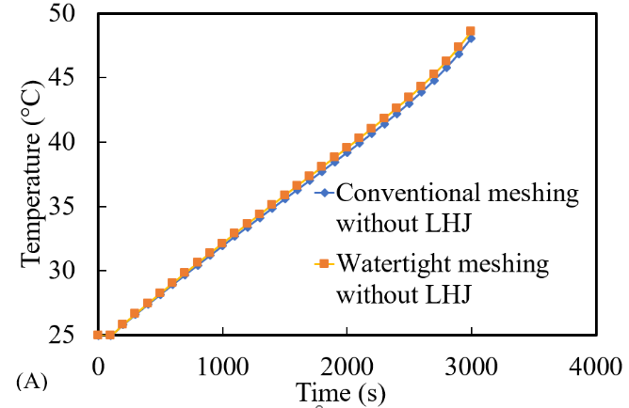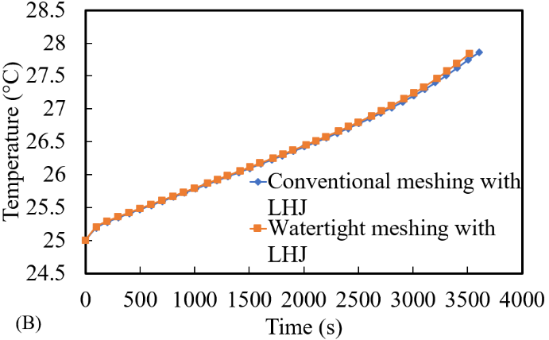
Fig. 2. Comparison of Temperature (°C) vs Time (s) for conventional meshing approach vs watertight automated meshing for a single 18650 Li-ion cell: A) without LH jacket and B) with LH jacket.

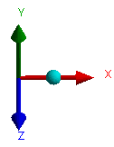
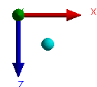

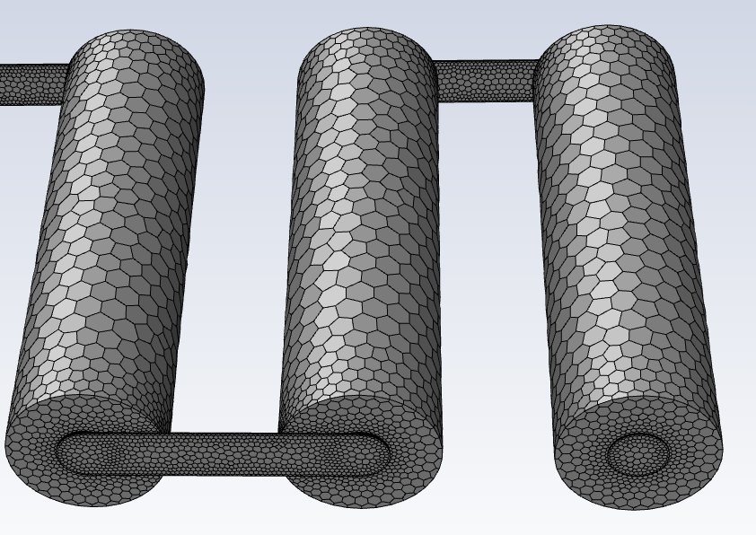
Zoomed-in image orientation
Full image orientation
CASE 1: 24S
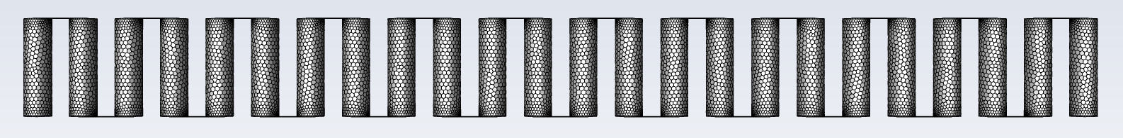
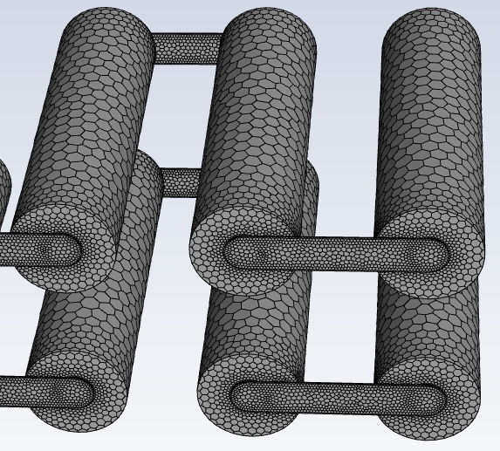
ZOOM
CASE 2 : 2P12S
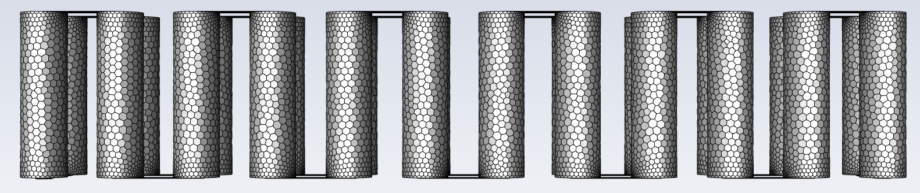
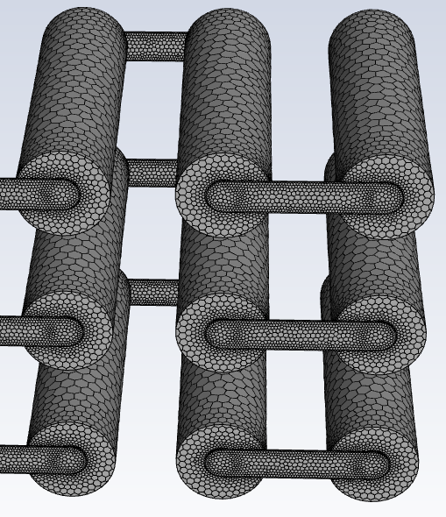
ZOOM
CASE 3: 3P8S
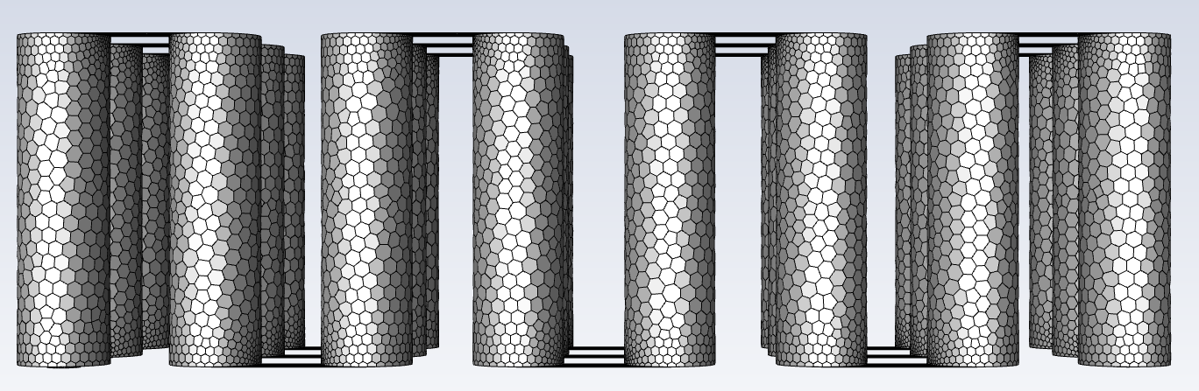
Fig. 3. Watertight grid images of all three Cases without LH jackets and zoomed-in partial images at selected areas.
ZOOM

2.7 Validation study

In a previous study [34], a battery cell thermal performance analysis was compared with the literature [46,55] for numerical and experimental data for a 18650 Li-ion Panasonic battery cell at ambient 25 °C for 1C-rate. The heat transfer coefficient at the walls was at 7 W/mK, with less than 1 % difference in results for a single discharge as seen in Fig. 4A. Additionally, a validation study [52,56] on sub-cooled PCM (N-eicosane) melting for a double pipe heat exchanger within the cylindrical annulus, at A_{mush} = 10⁵ with inner cylinder set to 329.15 K and thermal conductivity at 400 W/mK, was analysed for the effects of charging and discharging. Results shown in Fig. 4B indicate less than 1 % difference from the study to numerical data.

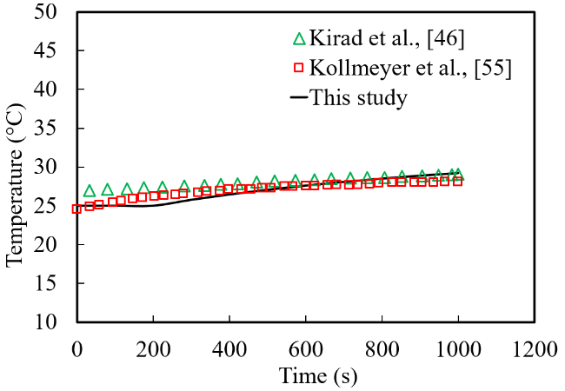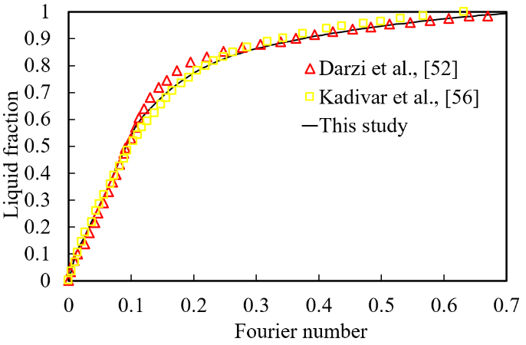
Fig. 4. Validation study: A) Cell thermal study for Temperature (°C) versus Time (s) data from literature [46,55] compared with present study at 25 °C B) study of liquid fraction versus Fourier Number ($F_{O}$) data from literature compared with present study [52,56].

2.8 Technical Discussion

Before analysing the effects of the proposed passive cooling system under different cycling loads, there are a few technical points that need to be discussed for further clarification for readers.

- The choice of PCM was important with high LH capacity and selected based on the ambient and operating conditions of the system/battery module. The solid-to-liquid phase change reduces the volume change and is highly manageable as opposed to liquid-to-gas type PCMs and is deemed more appropriate to this study. In this study, the selected solid PCM N-octadecane (Table 2) was jacketed around each cell and in direct contact with the circumferential diameter along the battery length (Shown in Fig. 1) and eventually a module was constructed with the proposed battery configuration.

- As the battery temperature rose due to discharging, the solidified PCM (LH source) absorbed the heat as the conduction heat transfer mechanism was dominant until PCM was melted and natural convection heat transfer became dominant in molten PCM. This process continued until the entire PCM volume was liquified, then the available LH would expire and there was a transition to Sensible Heat (SH), where the temperature of the system did not remain constant and started to rise sharply.

- The heat generated from the battery module was absorbed by the PCM making use of the LH capacity of phase change at liquidous temperature and functioned as a cooling agent with the capacity to store a large volume of LH, whilst maintaining a constant temperature. It was therefore essential that the volume of PCM should be of sufficient amount to be able to absorb the amount of heat generated. Generally, as seen in literature [19,25,28,36], the PCM surrounded the cells in a container by which neighbouring cell temperatures influenced each other and so cell spacing was integral to optimising the design. The module Cases seen in Fig. 1, can be treated as individual systems with no thermal impact since each cell was thermally isolated. This forgoes the need for design with cell-to-cell spacing and a reduction of SH. Moreover, all the volume of available PCM would be accessible, which would not be the case if the cells were far apart and dependent on the container design, if not cylindrical. In those cases, a percentage of PCM would not be integral to the cooling process and would then be less efficient for additional weight not used. Although adding PCM volume around each cell can be advantageous to absorb additional heat and increase the delay time for PCM melting, the energy consumed will not outweigh the benefits since the increased weight will reduce the overall EV thermal performance. In this instance, the 3 mm jackets proved sufficient to evaluate the effect on the performance.

- In this study, various drive cycle characteristics and parametrisation were assessed for the same proposed module Cases (24S, 2P12S and 3P8S). They were implemented based on voltage profiles. These dynamic profiles were specifically used in section 3.1.2 where the real-world drive cycles were assessed. All the test cycles were based on a validation study [50] for a single cell and then scaled up based on the number of cells in the module. In the literature study, the battery pack was initially scaled down from 3680 cells to a single cell to reduce computational time. Each of the drive cycles would present a unique dynamic change and therefore erratic temperature changes were expected but still follow a distinguishable pattern which was identified.

- As seen in literature [9,10,34], the battery's optimal working temperature range is between 20 °C to 40 °C and manufacture specifications state that the safety limits for use are bounded between -20 °C to 60 °C during discharging mode and not greater than 45 °C during charging mode. Beyond these ranges, the battery safety-critical conditions were met, whereby thermal runaway and potentially severe degradation of the battery can occur. Thus, in these simulations to prevent undercooling and overcharging, the following restrictions were imposed; voltage cut-off limits at cell level (2.5 V to 4.2 V), SOC limits (between 0 to 1), and module temperature restricted to below the safety limits. This will present the desired outcome where the safety and risk assessments are managed accordingly. Disastrous effects can occur from the operation of the cells outside of these limits and so these stop conditions were initialised. This approach was seen in the cycling phases, where an accurate estimation of the predicted time it would take to reach just before the maximum and/or minimum SOC value and voltages, was achieved. Homogeneous temperature between cells was also analysed to ensure the disparity of temperature between cells in the module was kept to a minimum. In this regard, individual LH jackets were modelled around the cells which were placed at an equal distance from one another for an effective comparison.

3 Results and Discussion

3.1 Discussion on the effectiveness of the proposed passive cooling system

To analyse the effectiveness of the proposed passive cooling system, three different arrangements of modules (24S, 2P12S and 3P8S) were made up of 24 series and/or parallel 18650 Li-ion Panasonic cells discharged at a constant 1 C-rate, until the SOC was approximately 0 or the temperature/voltage safety limits were reached. The proposed arrangements had different voltage/passive zone potential and current which can better assess the effectiveness of the proposed passive cooling design. Indeed, the specified system power for all the Cases (24S, 2P12S and 3P8S) remained the same at 278.4 W, and the capacities (between 2900 Ah to 8700 Ah) of each of the modules varied based on the cell arrangements comprising of series and parallel cells. The test of arrangements also provides an insight into the thermal uniformity between cells in the module, whereas the C-rate gives an indication of the current value, which would be dissipated within 1 hour if the cells were to be discharged from the fully charged position.
In addition, to better check the effectiveness of the proposed cooling system, the discussed modules were assessed in the presence and absence of the LH jackets, which gave an insight into the effectiveness of the proposed system. Thus, for this study, in combined 6 modules were considered three of those Cases (24S, 2P12S and 3P8S) equipped with LH jackets and 3 of them (24S, 2P12S and 3P8S) without jackets. Finally, in this study, all 6 cases were imposed to two different cycling loads: 1- A theoretical scenario (a continuous cycling), and 2- haphazard variations of electrical boundary conditions (five actual driving loads). These scenarios were imposed on the proposed battery modules to capture the following results: the module temperature, SOC, passive zone potential/voltage and the liquid fraction of the PCM. The following subsection of the article reports the results of those loads on the 6 discussed modules.

3.1.1 Study on the impact of theoretical load scenario (a continuous cycling)

In this section, the impact of the proposed passive cooling system on thermal management for three discussed modules (24S, 2P12S and 3P8S) in the presence and absence of LH jackets under continuous 1C cycling is discussed. This work builds upon a previous study [57], in which an investigation was conducted using a passive cooling LH jacket with PCM to manage the thermal performance of a single Panasonic Li-on 18650 battery cell under real-world drive cycles. The study addressed the impact of driving behaviours on a single-cell model validated from the literature [46,55] when compared to continuous battery cycling. In continuous cycling, the cell was discharged and then recharged without resting phases between the different cycling modes. Thus, the impact of heat dissipation on maximum temperature, SOC, power, and liquid fraction was effectively analysed. The conjugated models based on distinct driving scenarios, demonstrated that LH jackets significantly enhance battery performance by 50 %, especially in aggressive driving cycles. This becomes necessary for validation and optimisation including detailed electrochemical modelling that must be verified to simulate and understand these complex processes under varying stress/loading levels. This allows for crucial benchmarking and calibrating models to ensure alignment with real-world cell behaviour and at the same time, save computational time for more complex models with higher grid element sizes in those cases of modules/pack level. The validation of the material used permits an understanding of combining individual cells arranged together to investigate how they interact with one another. The thermal management including electrical connectors, busbars and overall system integration provides insights into scaling effects where factors like heat dissipation and electrical connection become more pronounced. In this scaling, management of the cells becomes crucial with additional challenges arising including uniform performance across cells in a module and managing the energy distribution.
In that regard, contours of battery temperature in the presence and absence of the LH jackets for Case 1 (24S) are shown in Fig. 5. Fig. 5A displays a 2D top view comparison of these two cases at 6 instances within 1 hour and Fig. 5B displays 3D Isometric views of those cases at only one instance (3500s) which were picked for the sake of brevity. The global temperature of the cells as well as temperature differences can be seen in Fig. 5B at the same time as 3500s, to clearly show the temperature differences within a closer colour bar range. Zoomed-in areas of the cells provide more apparent contours as well as PCM temperature. For clarity, in this figure, the zoomed-in areas show the cells (4 different snapshots) at the ends of the module case (24S) including the locations of the positive (Tab_p) and negative (Tab_n) tab connection cells (far ends). These snapshots will provide a better picture of understanding the temperature variation in the ending cells and corresponding busbar connections as opposed to the cells within the middle of the module
As shown in Fig. 5A, in the presence of LH, the temperature of the module was low at all the selected different time instances (depicted by the dark blue contours) and only varied within 3.5K (the temperature range of 298.15K to 301.65K). However, in the absence of an LH jacket, for Case 1 (24S), the temperature rise was more obvious with increased temperature illustrated by the colour bar legend, especially when Fig. 5B is considered as well, where global temperature contours are displayed. These global temperature contours show a closer range of temperature (the minimum, 303.2K to the maximum, 322.5K) to include both cases with and without LH jackets. They definitively indicate the temperature differences within various connections of the domain (module) including busbar, cells, and tabs. In the absence of LH jackets for the 24S case, the temperature rose from the initial ambient (25 °C) to the safety limit temperature (60 °C) (coloured contours from blue, 298.15K, to red, 333.15K) for Fig. 5A and between coloured contours from blue, 303.2K, to red, 322.5K in Fig. 5B. It is noteworthy that in this case (24S - without LH jacket), the higher temperature cells captured at the far ends of the module displays where the negative and positive tab external connections are located. These cells (far-end cells) were within the temperature range of 322.65K to 326.15K as shown in Fig. 5A in the colour bar, whereas the central cells in the module ranged between 319.15K to 322.65K at 3500s. The colour band in Fig. 5B has a maximum temperature range of up to 322.5K as this shows the global temperature range to indicate more vividly the high temperatures as opposed to the user-specified case for minimum and maximum temperature limits in kelvin (298.15K to 333.15K). A much clearer depiction of the comparison between the case with and without LH jackets is therefore shown. Compared to the case with LH jackets at 3500s, the temperature of the module remained between 298.15K to 301.65K, which represents a decrease in maximum temperature by 24.5K with the proposed passive cooling approach.

Time (s) | (A) CASE 1: 24S 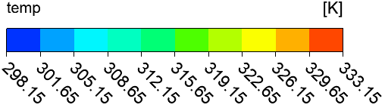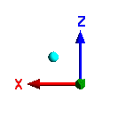
 | Without LH jackets | With LH jackets
1000 | 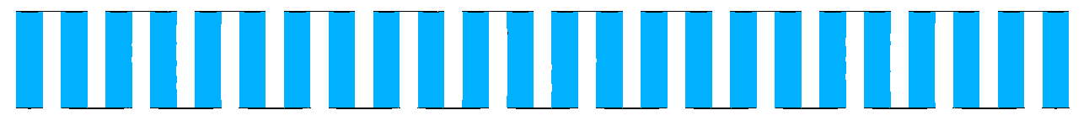 | 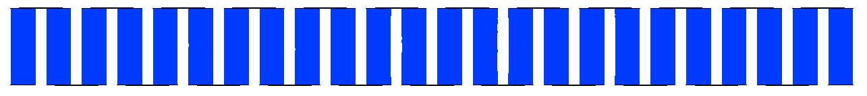
1500 | 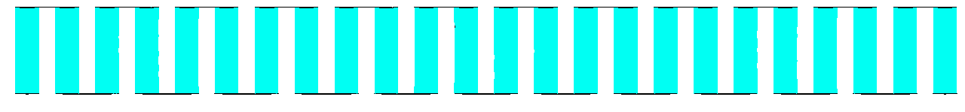 | 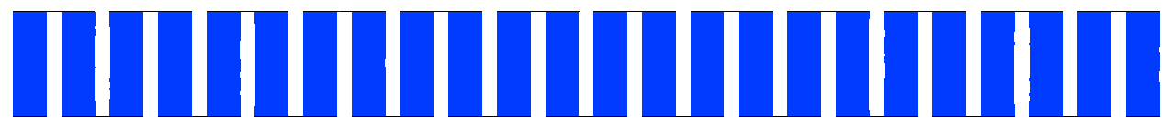
2000 | 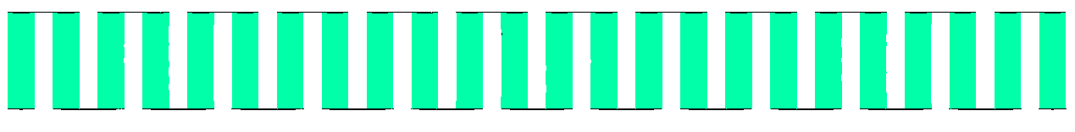 | 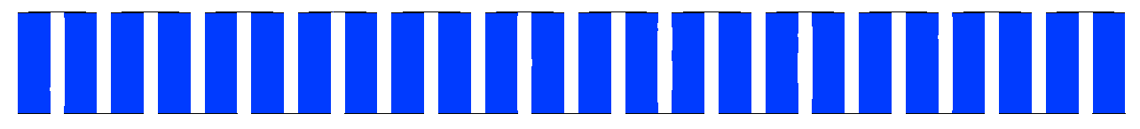
2500 | 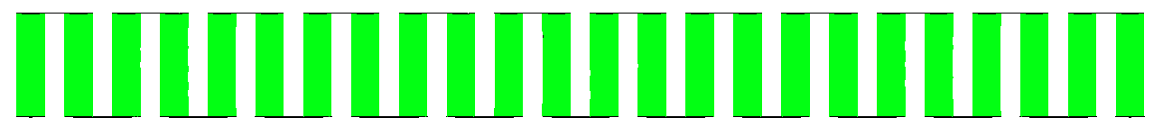 | 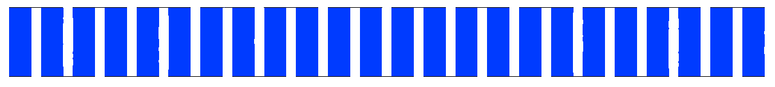
3000 | 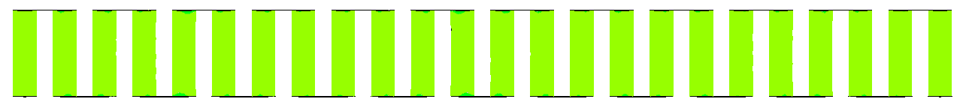 | 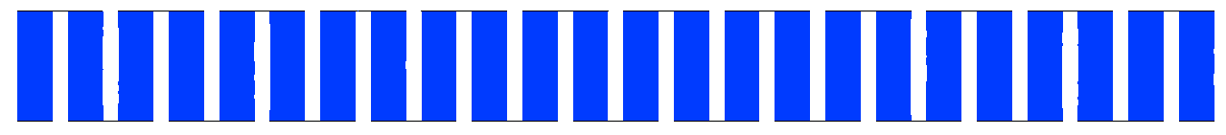
3500 | 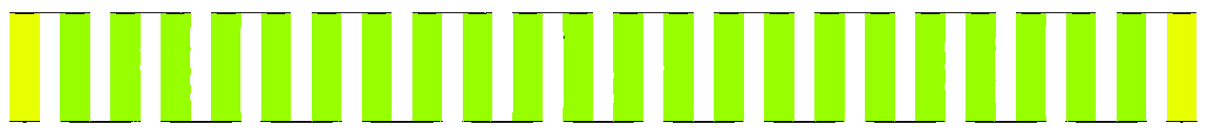 | 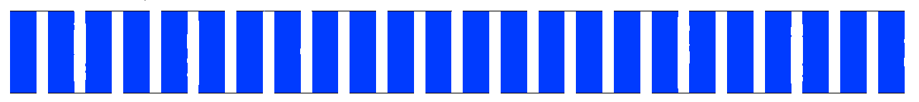

 | (B) CASE 1: 24S 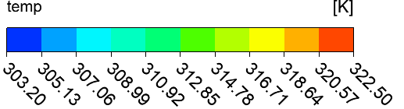 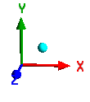
Without LH jackets | Tab_n connector  Tab_p connector  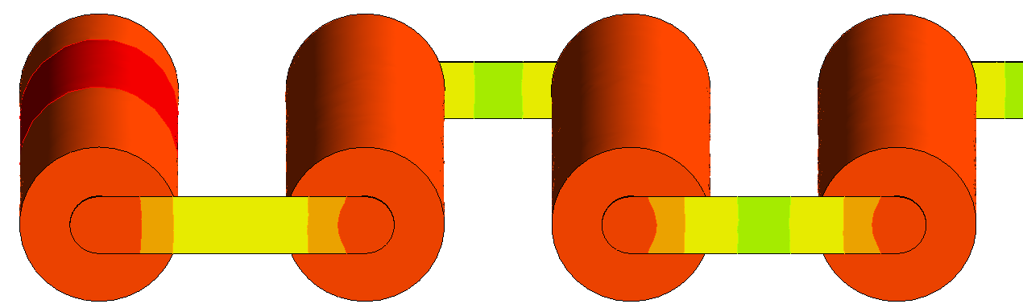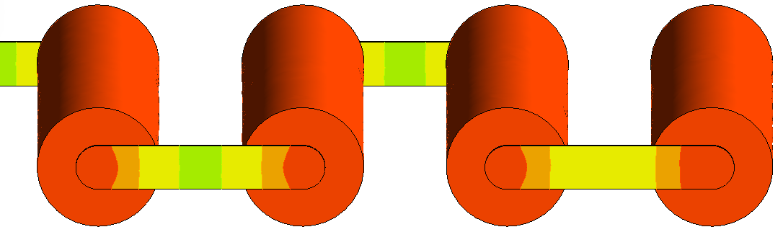
With LH jackets | Tab_n connector  Tab_p connector  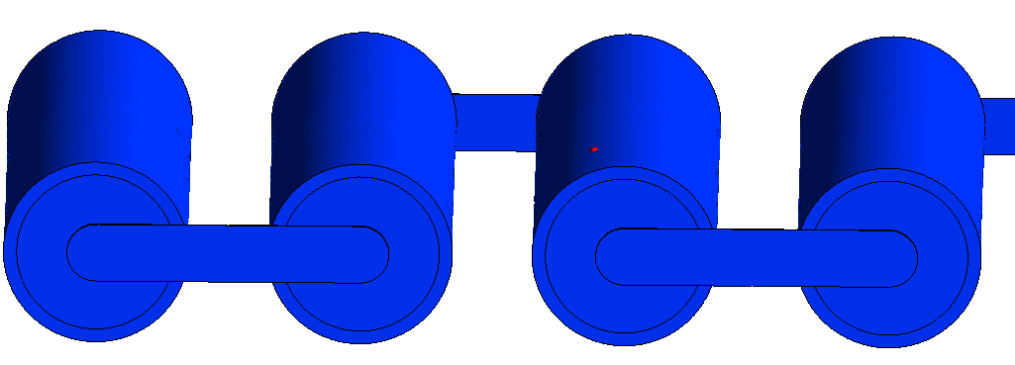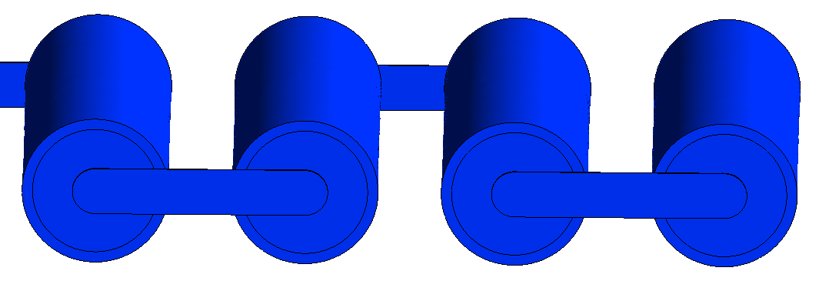
Fig. 5. Case 1 (24S) Temperature contours at indicated times for module discharging: A) 2D midplane plan top view at indicated times and B) 3D Isometric view with zoomed-in images of the external connected cells showing higher temperatures at 3500s.
Therefore, in this case, one can conclude that higher temperatures are seen for the ending cells and corresponding busbar connections as opposed to the cells within the middle of the module, which was better depicted in Fig. 6. Indeed, in Fig. 6 the 3D isometric view of the case without LH jacket was displayed with different localised temperature approach to better illustrate the busbar temperature variations and temperature at the ending cells. As shown in this picture, during the module discharge at 3500s in the absence of LH jacket, the module localised temperature range was between 316.41K to 322.52K and represents a significant temperature difference (~6.11K) for continuous discharging, resulting in a clear need of heat dissipation from the module to reduce the effects of overheating. This could be achieved by using passive cooling LH jackets as its impact was clearly shown in Fig. 5B even with the busbar connections.

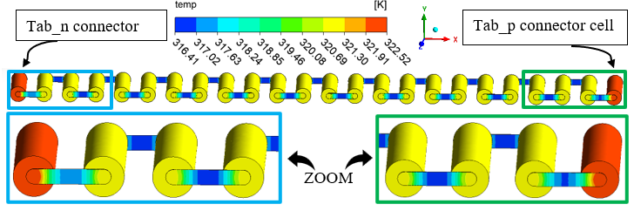

Fig. 6. 3D Isometric view with zoomed-in images of the externally connected cells (far ends), for Case 1 (24S) without LH jackets at 3500s with Localised Temperature contours.

Fig. 7A displayed the temperature contours at selected instances during discharge for Case 2 (2P12S) in the presence and absence of passive cooling. Similarly, in Fig. 7A, a 2D top view comparison of the two cases for the module (with and without LH jackets) showed 12 cells in series at 6 instances in time within 1 hour. Fig. 7B displayed a 3D Isometric view at one instance (3500s) to maintain conciseness. As seen in Fig. 7A, with the introduced LH jackets, the module temperature remained low at selected time instances as seen similarly with the first case (see Fig. 5A). The coloured contours remained dark blue and within the temperature range displayed by the colour band (298.15K to 301.65K) and still within 3.5K. Contrastingly, without the introduced LH jackets, for Case 2 (2P12S), the module temperature, and indeed individual cell temperature increase shown by the colour bar legend, was more distinct, particularly when considering the contours shown in Fig. 7B. The contours shown in Fig. 7B illustrate a global temperature legend with the colour band between 303.2K (minimum) and 322.5K (maximum) for both with and without LH jackets. Similarly, the temperature rise shown in Fig. 7A was between 298.15K to 333.15K and represents the initial temperature (25 °C) and safety temperature limit (60 °C), respectively. The temperature of the cells without LH jackets at 3500s lies within the range of 319.15K to 322.65K as displayed by the colour band. The contours indicated uniform temperature between them and did not clearly show the variation in hot temperature at the external connector cells due to the top view displayed, as well as all the cells were not shown in that view. However, Fig. 7B clearly shows the higher temperature cells near the external connectors, in particular, the positive tab connector (Tab_p). These cells were within the range of 318.64K to 320.57K without LH jackets indicated by the colour band (see Fig. 7B). All the other cells in the module were between 316.71K to 318.64K at 3500s. When analysed for the case with LH jackets at 3500s, Fig. 7A shows the module temperature within the range of 298.15K to 301.65K and a reduction in maximum temperature by 21K. Fig. 7B indicates that the introduction of the LH jackets can maintain thermal stability between all the cells in the module whilst reducing the maximum temperature limit achieved within the time.

Time (s) | - CASE 2: 2P12S
 | Without LH jackets | With LH jackets
1000 | 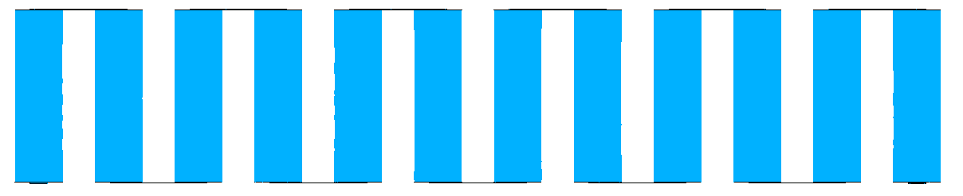 | 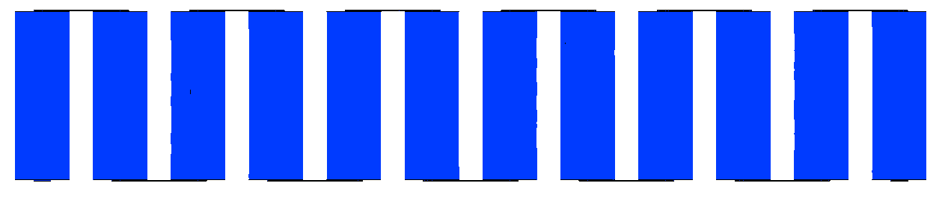
1500 | 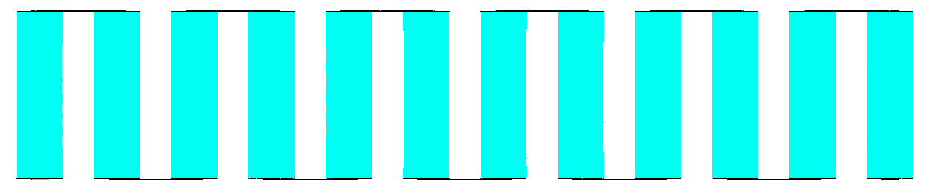 | 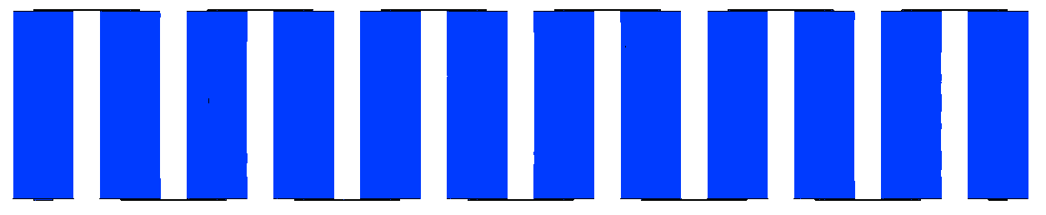
2000 | 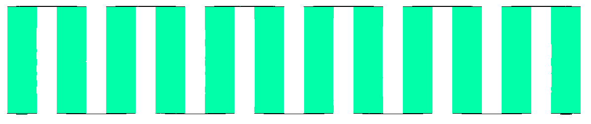 | 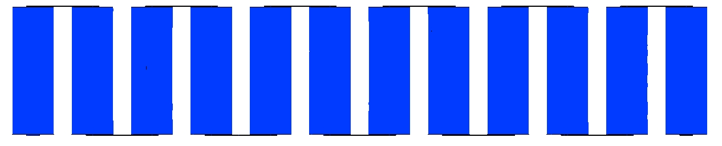
2500 | 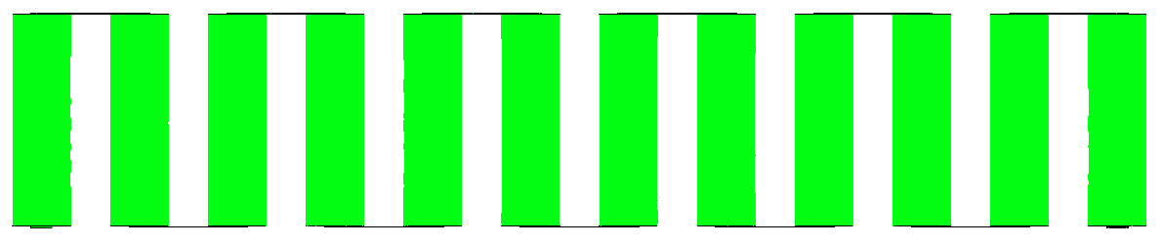 | 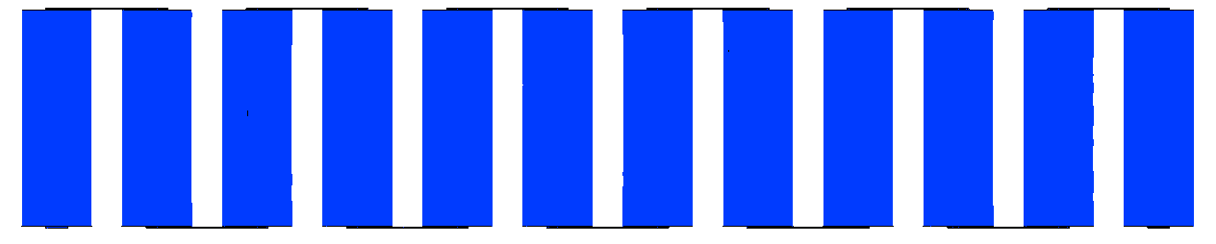
3000 | 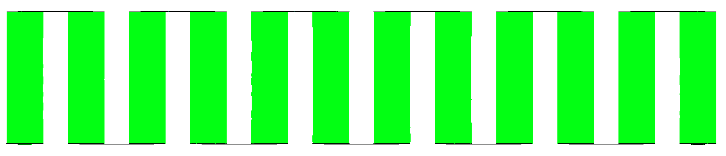 | 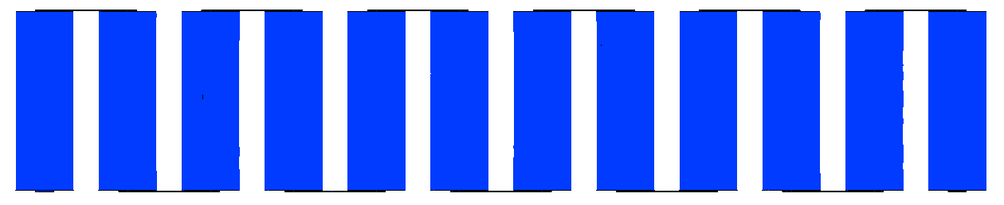
3500 | 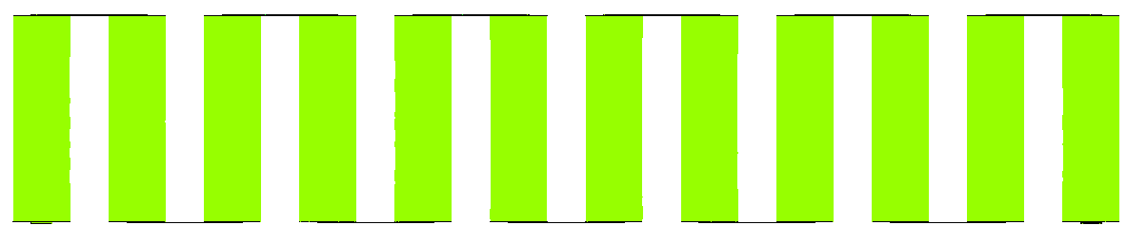 | 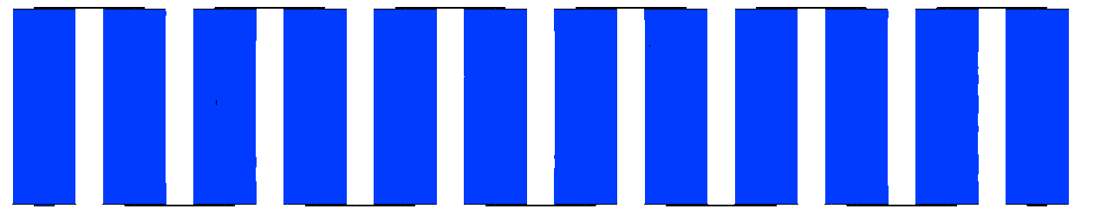

 | (B) CASE 2: 2P12S
Without LH jackets | 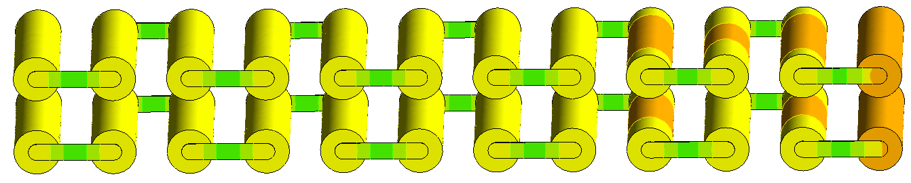  Tab_p connector  Tab_n connector  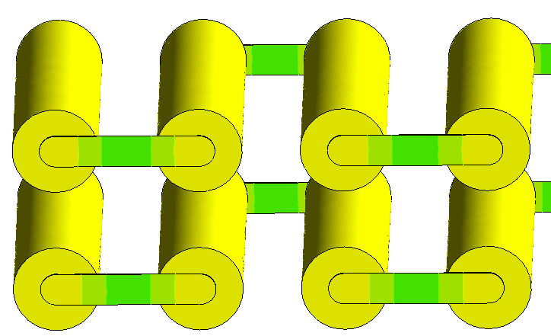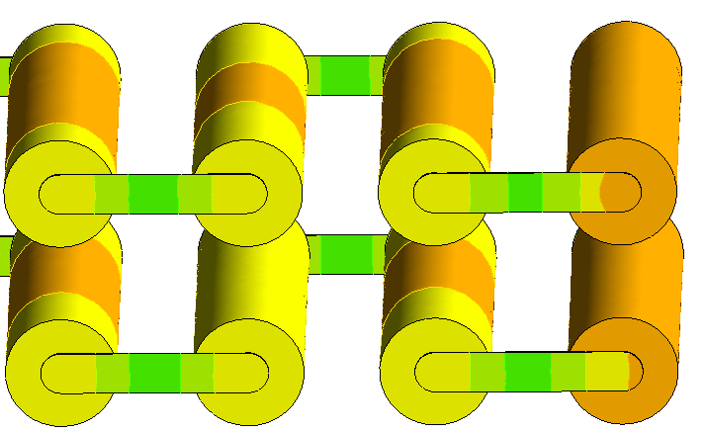
With LH jackets | 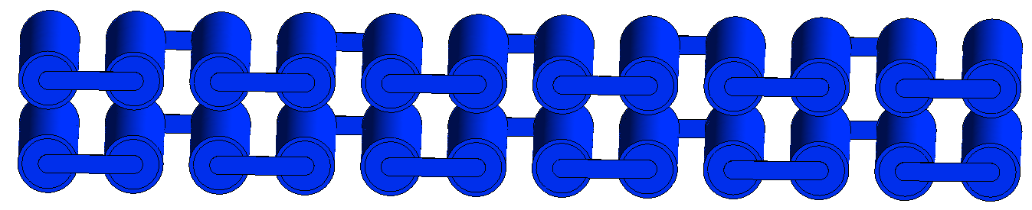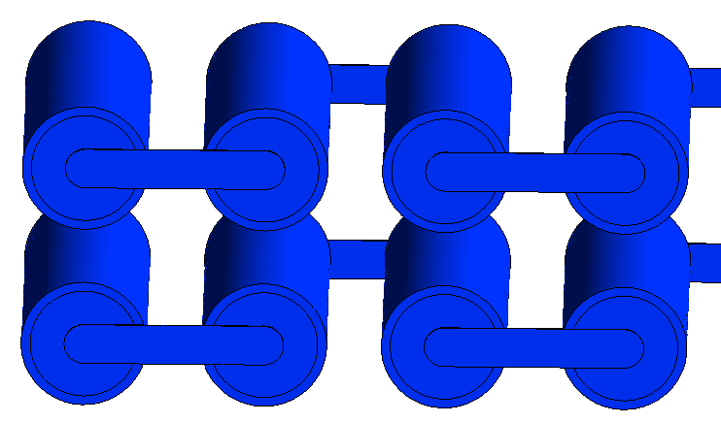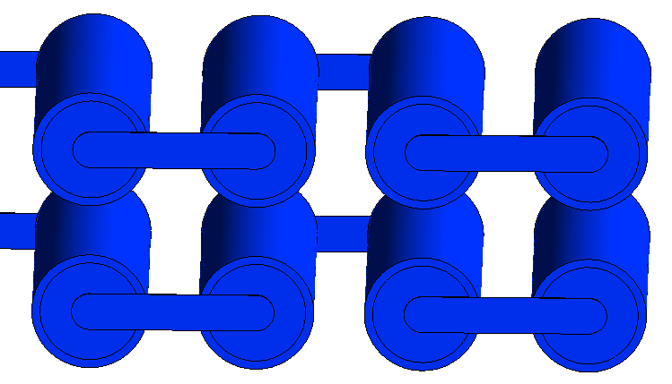  Tab_p connector  Tab_n connector
Fig. 7. Case 2 (2P12S) Temperature contours at indicated times for module discharging: A) 2D midplane top view at indicated times B) 3D Isometric view with zoomed-in images of the external connected cells showing higher temperatures at 3500s.
Fig. 8 displays the Isometric view of localised temperature contours for Case 2 (2P12S) without LH jackets at 3500s to further illustrate the differences in temperature between the external connector cells as well as all the cells in the module arrangement including busbar temperature. The temperature range had been further reduced to indicate the locations of the lowest temperature (blue) to the highest temperature (red). It was quite clear that the highest temperature cells were in the vicinity of the positive tab external connector cell and then propagated throughout the rest of the module. It was interesting that the negative tab external connector cell in this case, had one of the lowest temperature regions as seen by the colour bar legend, with the lowest temperature cell being the furthest away from the positive external connector (Tab_p). In this case, during the discharging cycle, the module temperature ranged between a minimum and maximum temperature of 314.10K to 319.22K, respectively, with a temperature difference of 5.12K at 3500s. This meant that an appropriate BTMS strategy was required to prevent overheating which can be achieved with the proposed passive cooling as shown in Fig. 7.
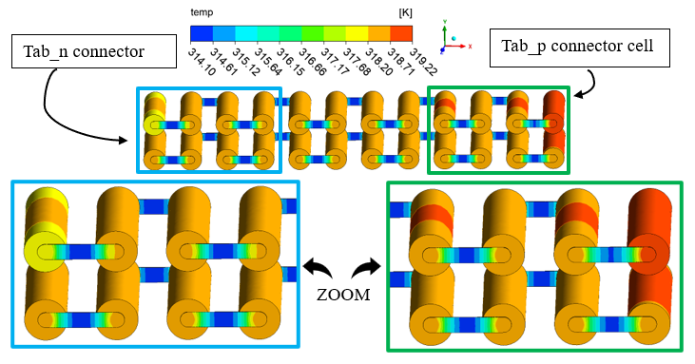
Fig. 8. 3D Isometric view with zoomed-in images of the externally connected cells (far ends), for Case 2 (2P12S) without LH jackets at 3500s with Localised Temperature contour.

Furthermore, Fig. 9 shows the temperature contours for Case 3 (3P8S) at 6 different time intervals during discharge in the presence and absence of LH jackets. Fig. 9A displays the top view in 2D for 8 cells in series within 6-time intervals from 1000s to 3500s with 500s increments. The passive cooling LH-based BTMS displayed low temperatures even up to the 3500s period within 1 hour as indicated by the colour contours which showed dark blue. This behaviour was similar to previous cases (Case 1: 24S and Case 2: 2P12S) which demonstrates the effectiveness of passive cooling in reducing maximum battery temperature during continuous discharging/charging (a continuous cycling load). This was confirmed in Fig. 9B for an Isometric 3D view showing global temperature contours with and without LH jackets at 3500s. In the previous 2 Cases (Case 1: 24S and Case 2: 2P12S), when passive cooling was available, the temperature of the cells remained within a low-temperature range of 298.15K to 301.65K, likewise, Case 3: 3P8S also remained within that temperature range even for all the times shown. This low temperature range well below the temperature safety limit, suggested that the heat was readily absorbed even in this arrangement of cells and certainly as seen for the other two cases studied. The temperature difference was still within 3.5K as seen by the colour band (see Fig. 9A).
However, compared to the case without LH jackets, the temperature rise was more apparent, as indeed, there was a definitive change in the colour contour even from the initial time at 1000s, with a maximum temperature range between 305.15K to 308.65K. This certainly indicated that an increase in current/nominal capacity (Case 1: 2.9Ah to Case 3: 8.7Ah) influenced the thermal performance of the module, impacting the heat dissipated within the cells in the module. The higher temperature cell was at the positive external connector (Tab_p), with distributed heat throughout the module decreasing as it moved towards the other cells during the cycling process. This was displayed (see Fig. 9A) as the time was increased from 1000s to 3500s. The highest temperature at 3500s for the case without LH jackets was shown to be the positive external connector tab cell which ranged between 322.65K to 326.15K. This meant that there was a drop in maximum temperature of 24.5K when the LH jackets were introduced, and passive cooling was available. The downside of the presented view in Fig. 9A is only the top level row of 8 cells in the module is visible and does not clearly show the heat transfer within all the cells. Thus Fig. 9B presented to show an Isometric view for a global and more narrow temperature range. The highest temperature (range between 320.57K to 322.50K) cell was seen to be the positive tab external connector cell (Tab_p) and the heat was dissipated throughout the rest of the module via the connecting busbars. Even the busbar connections near the Tab_p for the external connector cell have a higher temperature distribution than the other busbars as seen by the colour legend. These cells exhibit higher temperatures than the rest of the cells because of the higher voltage as opposed to the anode (negative tab external connector Tab_n). This behaviour was seen for all the time intervals showing higher temperature cells on the left and decreased as it moved to the right because of the orientation of the module (see Fig. 9A).

Time (s) | - CASE 3: 3P8S
 | Without LH jackets |  | With LH jackets
1000 | 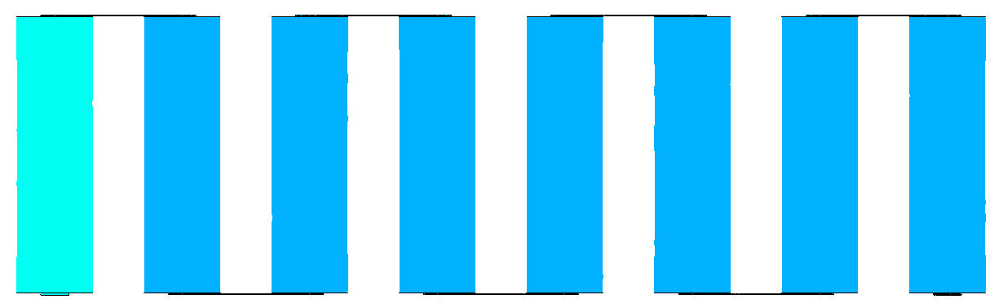 |  | 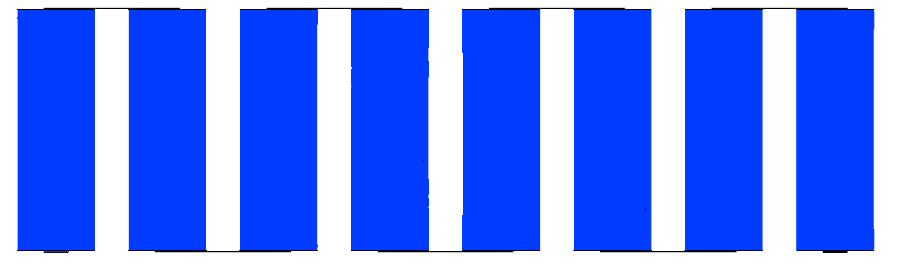
1500 | 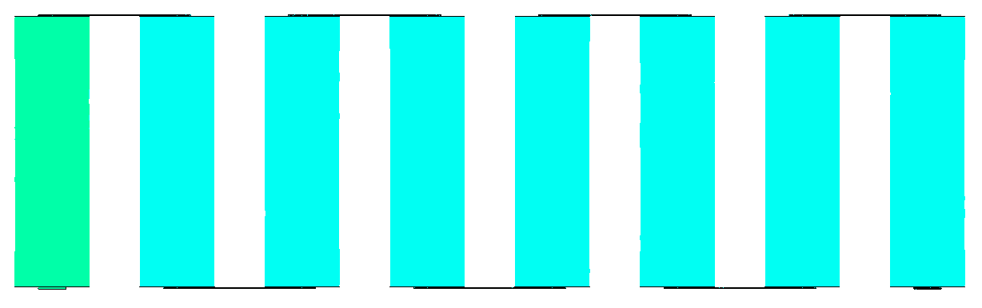 |  | 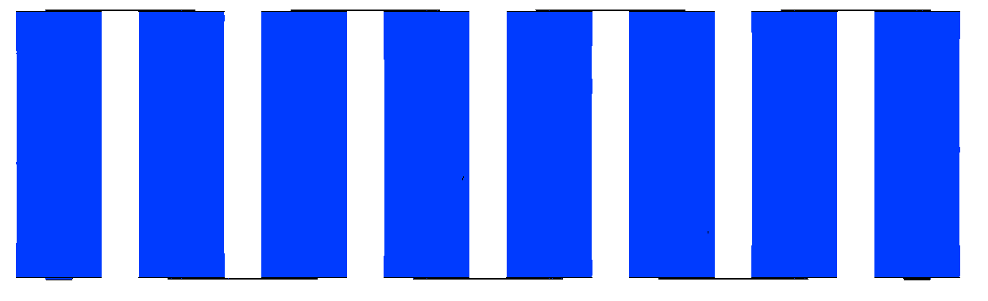
2000 | 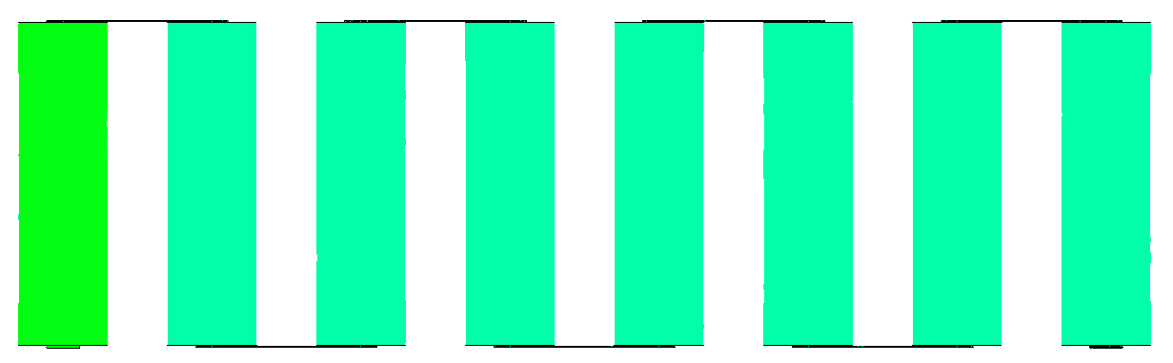 |  | 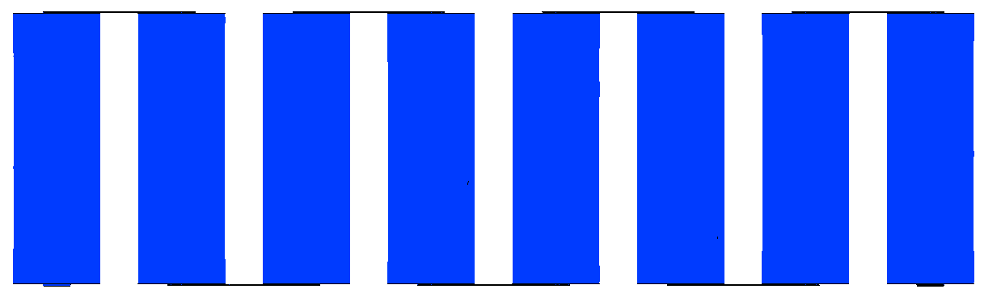
2500 | 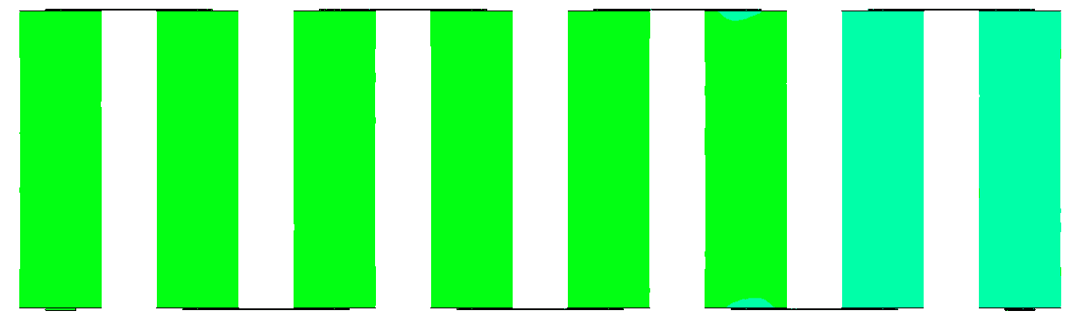 |  | 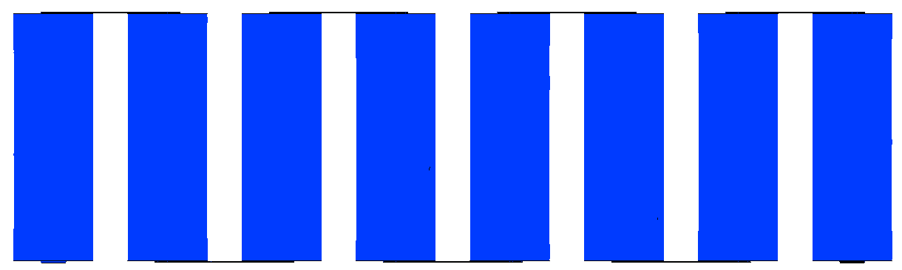
3000 | 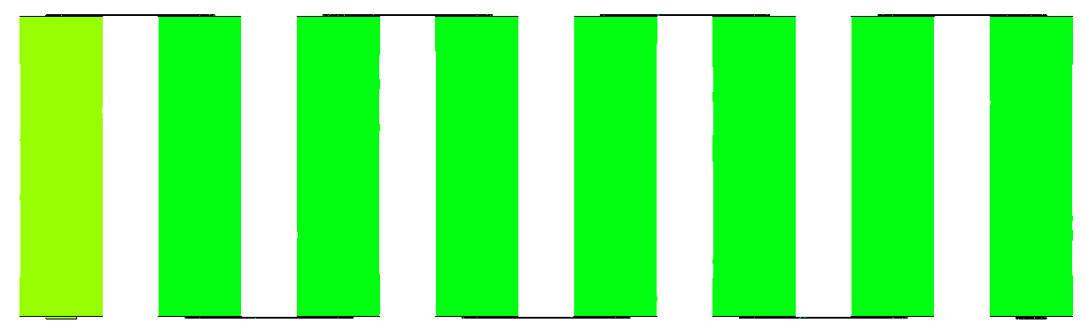 |  | 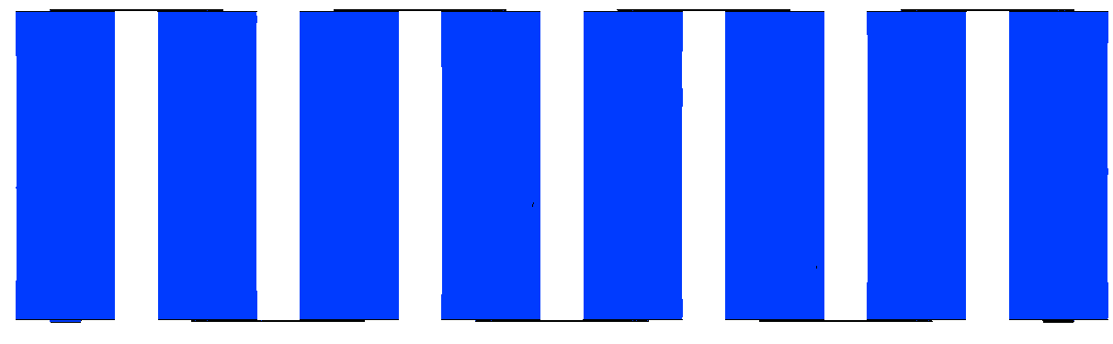
3500 | 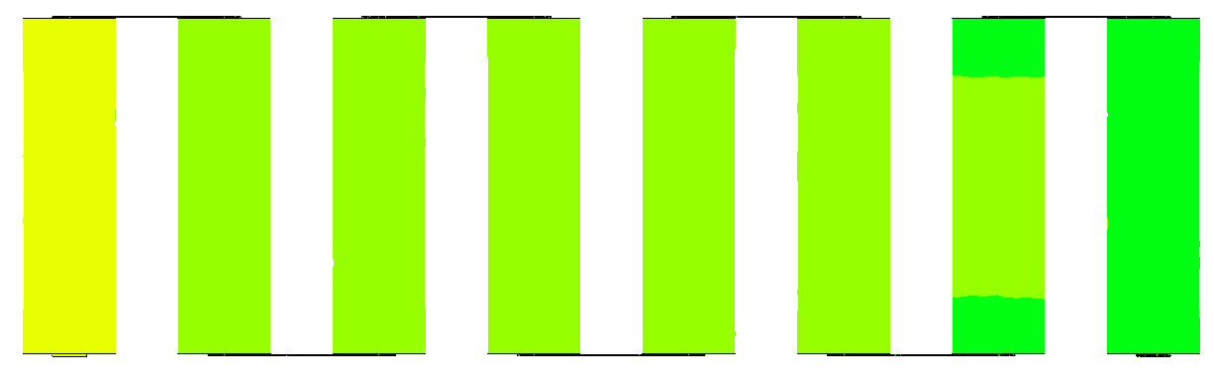
 |  | (B) CASE 3: 3P8S
Without LH jackets |  | 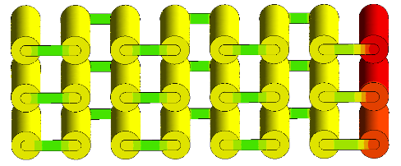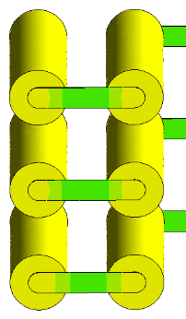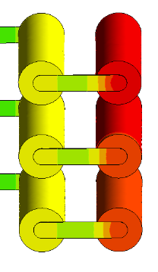  Tab_p connector  Tab_n connector
With LH jackets |  | 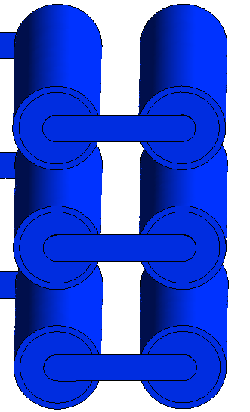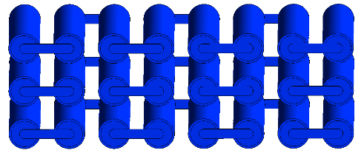  Tab_n connector  Tab_p connector
Fig. 9. Case 3 (3P8S) Temperature contours at indicated times for module discharging: A) 2D midplane top view at indicated times and B) 3D Isometric view with zoomed-in images of the external connected cells showing higher temperatures at 3500s.
To further illustrate the variation in temperature differences as described similarly with the two Cases before (Case 1 and 2), Fig. 10 illustrates an Isometric view of localised temperatures without LH jackets at 3500s showing a minimum to a maximum temperature range between 313.26K to 325.15K, respectively. The positive external connecter (Tab_p) showed the highest temperature (range between 322.77K to 323.96K) and followed the cells in the busbar connections nearby. The other cells in the middle of the module showed similar temperature ranges as the heat was propagated throughout the rest of the module. During the discharging cycle, the module temperature ranged between 313.26K to 325.15K as per the localised temperature colour band at 3500s, representing a temperature difference of 11.89K. Thus, an effective BTMS was required to prevent large temperature differences and eventually overheating which can be fulfilled with the proposed passive cooling design.
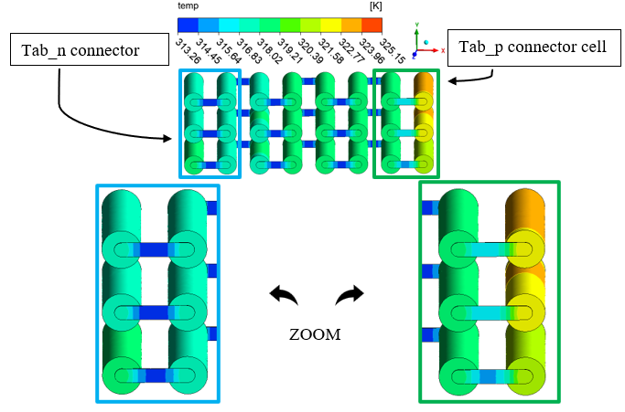

Fig. 10. 3D Isometric view with zoomed-in images of the externally connected cells (far ends), for Case 2 (3P8S) without LH jackets at 3500s with Localised Temperature contour.

Eventually, the effectiveness of the proposed passive cooling for all the modules under continuous cycling load was assessed in Fig. 11. Fig. 11 displayed the plots of continuous cycling of temperature and SOC versus time as well as the passive zone potential and PCM liquid fraction versus time for all the aforementioned cases. In all cases, the results were reported until whichever of the following criteria was met earlier: 1) the battery temperature reached to safety limit, or 2) the module had been completely discharged. It is worth noting that the total time for continuous discharging varied between the different Cases as indeed this attributed to the configuration and specification of the considered module arrangements. Due to this variation, the nominal cell capacity (Ah) and the voltages (V) were different in each case, however, as discussed earlier, for accurate modelling and comparison, the number and type of cells in each module remained the same. The Power (W) was the same across all modules assessed (see Table 1). When the nominal cell capacity was amplified from the change in series to parallel configurations, the time for complete discharge was also increased. The full results were displayed in Fig. 11 for all cases as opposed to certain time intervals for the contours which were chosen for brevity.
Fig. 11A presented results for Case 1 (24S). As seen in the graph of temperature versus time, the introduced LH jackets allowed a more uniform, slow, and steady rise from an initial ambient at 25 °C as opposed to the sharp increase in temperature in the absence of LH jackets for the same discharge period. At the end of the discharging cycle, the module temperature was approximately 28 °C with the LH jackets when compared to (~) 48 °C without the LH jackets. This represented a drop in maximum temperature by 42 % (20 °C in about 48 °C). The results demonstrated that if there was available LH, the heat dissipated by the module would be readily absorbed by the PCM jacket and increase the useful life or delay time. The passive zone potential was as expected with a smooth decrease followed by a sharp decrease in voltage when more than 95 % of the SOC was released, and the PCM was approximately 80 % liquified. This meant that there was still available LH to follow consecutive charging for the case with LH jackets since the module temperature was below the charging safety limit (45 °C).
Fig. 11B shows the results of Case 2 (2P12S). As shown in this figure, introducing LH jackets led to a marginal increase in temperature (reaching 29 °C) in the 5500s, right before all the PCM had been melted as observed from the liquid fraction curve. Due to unavailable LH after this time, the module temperature rose sharply as SH became active until the module had less than 10 % SOC. At this time (6600s), the module temperature with LH jackets had reached its maximum at 42 °C. In contrast, the module case without LH jackets in the same period had reached close to the discharging safety limit at 60 °C. This meant passive cooling could effectively control the maximum temperature of the module in this case as well (equates to an 18 °C drop in maximum temperature in 6600s). Importantly, the presence of the available LH maintained stable and uniform temperature up to around 5500s as iterated previously while the module without LH jackets had reached ~ 54 °C in 5500s. In addition, the proposed passive cooling could effectively control the maximum temperature of the module without reaching to safety limit of the module. This result highlighted the impact and effectiveness of the proposed passive thermal management strategy for this module.
The results of Case 3 (3P8S) were shown in Fig. 11C. As shown for this case, the temperature curve rose sharply at the beginning during the first 100s, which was attributed to initial SH storage before the equilibrium of heat caused a slow rise until the LH storage was activated and finally consumed at 31 °C in 5900s. This (consumption of LH) was displayed in the liquid fraction curve which reached its maximum of 1 or 100 % at 5900s. Beyond this time, for the module in the presence of the LH jackets, the temperature started to rise similarly to without the LH jackets until the safety limit temperature was reached (10780s). When compared to the case without LH jackets, the module temperature reached 60 °C at 5270s. In this case, the numerical analysis was stopped due to the temperature safety limit reached and so the other results of SOC and passive zone potential (V) were also stopped. When both cases (with and without LH jackets) were compared right before all PCM was melted, there was a drop in temperature of 29 °C by the introduction of the proposed system. Also, due to the delay effect, there was a significant extension in useful time resulting in ~200 % module useful life before the temperature safety limit was reached. It was also worth noting that the temperature difference between cells was kept below 5K for all Cases with LH cooling jackets and indicated improved thermal equilibrium between cells as compared without LH cooling. As mentioned previously, an even greater increase in the capacity (8.7 Ah) from Case 1 (2.9Ah) was displayed and did cause an increase in the delay time for the module to reach the safety limit of 60 °C but less than Case 2. This was attributed to distinct factors including differences in voltage and current distribution but was a clear indication that the arrangement of cells in a module has a differing effect on the capacity and temperature disseminated.
Regardless of the arrangement, these studies showed that the proposed thermal management system was effective for various modules under theoretical cycling load.

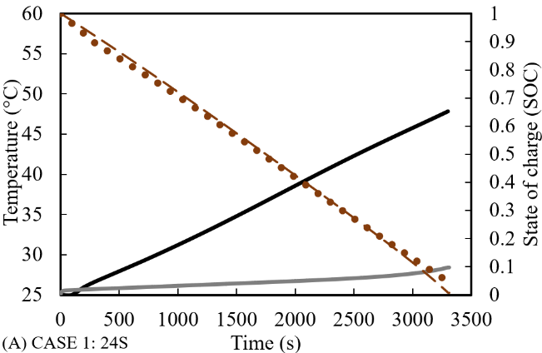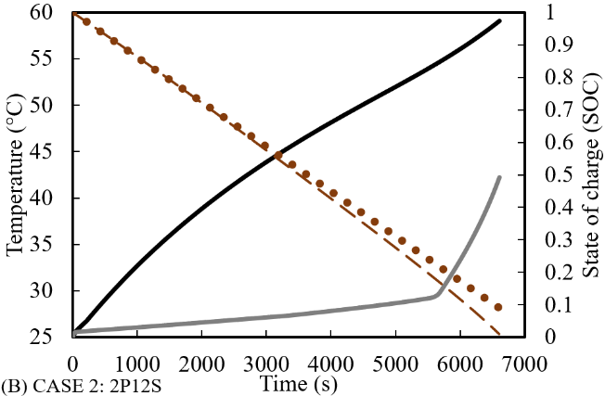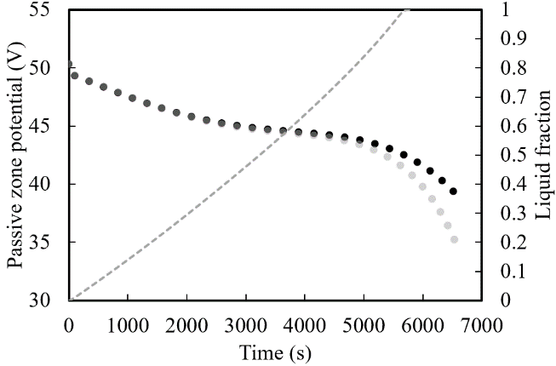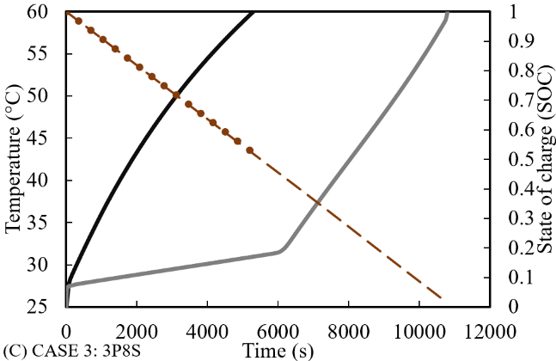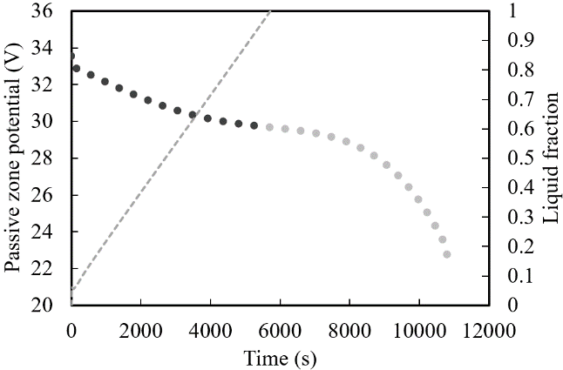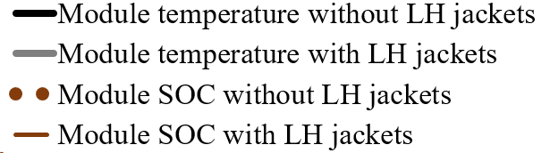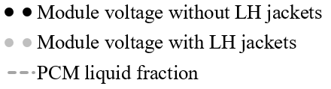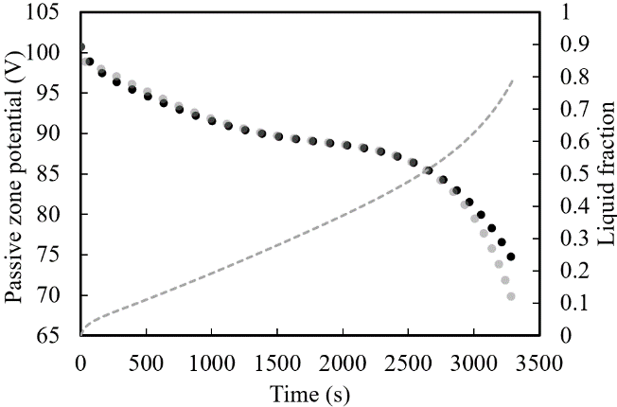

Fig. 11. Continuous cycling (Discharging) results of all Cases (24S, 2P12S and 3P85).

3.1.2 Study on the impact of real-world drive cycling

The previous analysis 3.1.1 was conducted as the researchers wanted to investigate fundamentally how the battery would behave under an ideal environment for profiles such as the voltage, power, and SOC during discharging/charging cycling. In those scenarios, the modules were discharged continuously at a constant C-rate with the option of continuous charging afterwards without resting if the safety limits were not breached. This testing assessed the system's durability and reliability for continuous cycling, but a more dynamic approach is necessary where idealistic conditions are not likely. Therefore, in this section, 3.1.2, a shift from continuous cycling (discharging/charging) to more dynamic battery modelling was considered to assess the effect of the proposed passive thermal management system on battery module temperature, SOC, passive zone potential and liquid fraction under realistic loads.
Thus, the following five different driving cycles were considered, Supplemental Federal Test Procedure (SFTP) (US06), Unified Cycle Driving Schedule or Unified LA92 (LA92), Neural Network (NN) combination cycle, Urban Dynamometer Driving Schedule (UDDS) and Highway Fuel Economy Test (HWFTa). These dynamic drive cycling replicated conditions on which vehicles are driven on different roads and environmental terrains which drivers may encounter and can include hills, flat roads, winding, or straight roads and of differing pitch that may include a variety of appropriate driving styles. In particular, the US06 (highest power requirement), LA92 and NN drive cycles consist of more harsh or aggressive driving. These include light vehicles driven at rapid velocity and acceleration with reduced stopping and idling within a 10-mile distance. On the other hand, the UDDS and HWFTa, for light-duty vehicles, represent more casual driving in Urban areas which can include very frequent idling and stopping as well as long distances. A full description of the drive cycle definitions used in the previous study [57] was outlined more in detail including power fluctuations within a specified time extracted from previous literary work published [46,55].
The results of the effects of the drive cycles on the proposed module configurations are presented in Fig. 12 to 14 for Case 1 (24S), Case 2 (2P12S) and Case 3 (3P8S), respectively. All the captured results for the dynamic cycle loads on the proposed modules displayed rapid serrations from the power variation in contrast with smooth lines and curves from continuous cycling (results of section 3.1.1) captured at constant C-rate (1C), power (278.4 W), and ambient temperature (25 °C). Please note that for these drive cycle cases, only a specific range of time was available for reference and so the analysis was concluded when the limits of the available data were reached, or the temperature/voltage limits were hit. This was also reliant on the SOC available which would have been fully expired or near the end of the module capacity.
Results of Case 1 (24S) are shown in Fig. 12, for all the considered cycles. As presented, the presence of LH jackets improved the thermal performance of the module for all the drive cycles with either expansion in useful life or maintenance of stable temperature. For the aggressive cycle US06 module (shown in Fig. 12-A), the thermal performance improved by 223 % with more than a 2000s extension in the useful life of the module until the temperature safety limit was reached. This behaviour was displayed in the temperature curves of the cases without and with LH jackets reaching the temperature safety limit (60 °C) at the 1640s and 3710s, respectively. In addition, the SOC, initially set at 1 or 100 %, was reduced to ~50 % without LH jackets and more than ~90 % of the module discharged in the presence of the LH jackets before reaching to safety limit. The passive zone potentials displayed in Fig.12-A (US06), the sporadic changes from the dynamic drive cycle behaviour and vary between ~70 V to 100 V, with a clear distinction shown between the cases in the presence and absence of LH jackets. For the cases with introduced LH jackets, there was an increase in the voltage profile corresponding to the temperature curves. Even though there was available SOC for the case without LH jackets, due to the temperature limit hit, all the other results were stopped and captured accordingly.

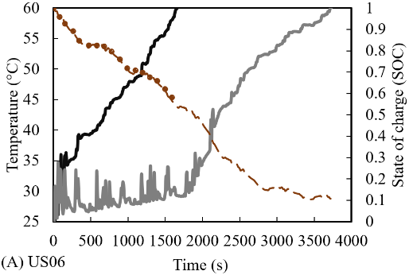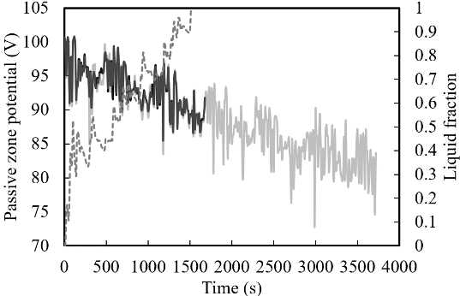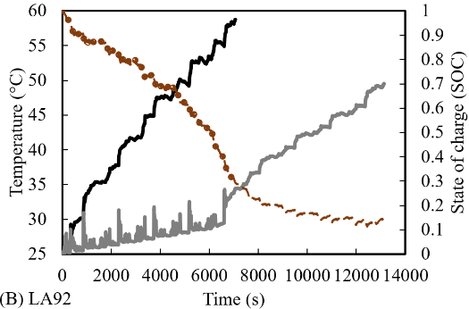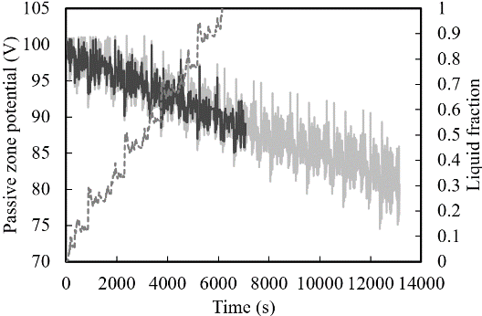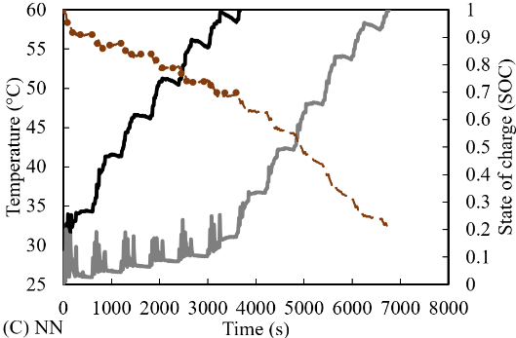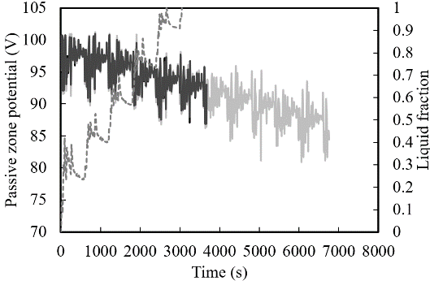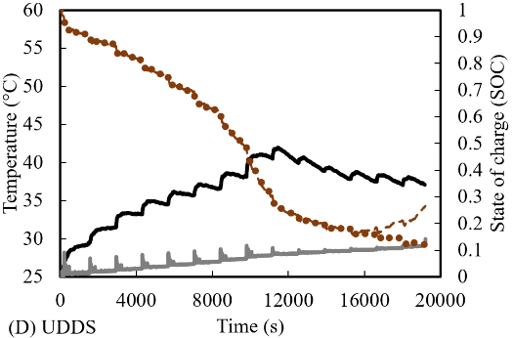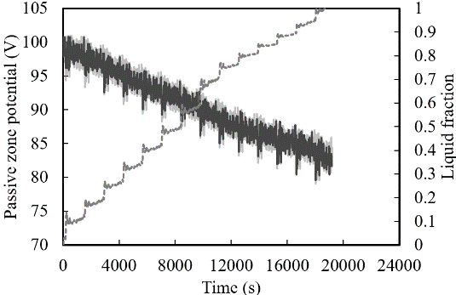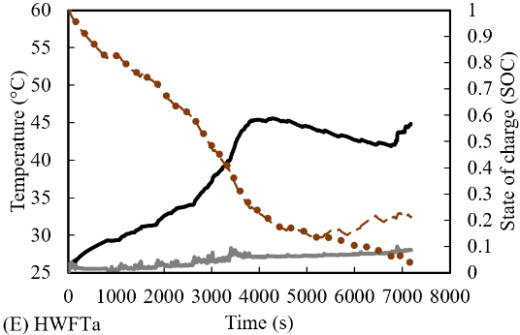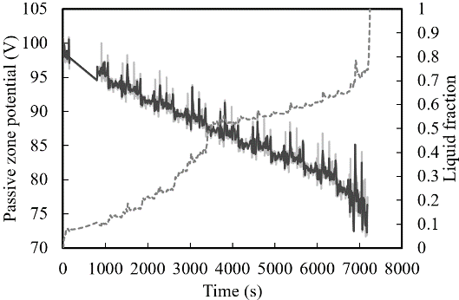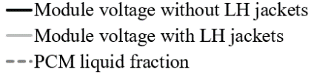

Fig. 12. Case 1 (24S) Temperature (°C) versus Time (s) analysis of Cases without LH jackets compared with LH jackets during different drive cycling modes.
Similar improvements in thermal performance can be seen with the other harsh drive cycles. LA92 drive cycle on the thermal performance of the module (24S) is shown in Fig. 12-B and represents another aggressive driving cycle with improved thermal performance at 186 % when compared at the end of the cycle. For the case without LH jackets, the temperature was close to 58.7 °C (7060s) while the case with LH jackets was around 49 °C (13130s). At these end levels, the SOC had reached ~30 % and ~14 %, in the absence and presence of the proposed passive cooling approach, respectively from an initial state of 100 %. At the same time, the passive zone potential varied between 75 V to 100 V with the results showing almost double the life for the case with LH jackets as opposed to without the LH jackets.
The third aggressive cycle (NN drive cycle) is displayed in Fig. 12-C. In this case, there was also a reduction in temperature for the introduced passive cooling case with 184 % extended time to reach the temperature safety limit (60 °C) in the 6760s as opposed to the 3670s for the case without the LH jackets. The SOC was reduced to 20 % and 70 % for the 24S module with and without the LH jackets, respectively. Due to the specific safety limits as identified previously, the study was concluded at these indicators. It was noted that the range for this drive cycle for Case 1 cycled between maximum 100 V and minimum 80 V, with the liquid fraction for the harsh cycles also following the same gradient as the modules without the LH jackets, to illustrate that the heat energy was absorbed.
For the casual Cases, UDDS and HWFTa shown in Fig. 12-D and E, more than 90 % of the module state was discharged but the battery module temperature did not rise above 45 °C. Furthermore, the battery module temperature with the proposed LH jackets was kept well below 30 °C throughout the cycling and was deemed sufficient to maintain the thermal performance for longer. Compared to the more aggressive drive cycles, however, the liquid fraction continued to rise towards the end of the cycling. This meant that the volume of LH was just enough to support the data before the temperature rise would be seen in the case without LH jackets. As seen for all the cases with LH jackets, before the liquid fraction was at 1, the module temperature did not rise higher than 35 °C and represents an optimum working temperature for the modules assessed. Only when the LH was consumed and SH was prevalent, then the temperature increase follow the same characteristics as in the cases without passive cooling.
Moreover, Fig. 13 shows the results of different drive cycles on the performance of Case 2 (2P12S). As can be concluded from this figure, regardless of the change in the arrangement of the cells, which would have a different capacity and voltage (see Table 1), the LH jackets enhanced the battery module thermal performance and the efficiency of the system. The same results were captured in the previous section 3.1.1 as well.
Concerning the most aggressive driving cycle, US06 (shown in Fig.13-A), there was approximately 200 % improvement in the useful life with the remaining 80 % of the SOC in the presence of the LH jackets as opposed to the lack of those jackets. Indeed, the Cases with and without LH jackets reached the temperature safety limit within the 1970s and 990s, respectively. When compared with Case 1 (24S), the time to reach 60 °C was shortened by 165 % (Case 1: 1640s; Case 2: 990s) which was attributed to the change in arrangement of the module to include parallel cells with double the nominal capacity (see Table 1). This meant that increased current was discharged from the module during the same total time to discharge (within 1 hour) and hence, an increase in overall module temperature was seen. The passive zone potential saw an increase in cycling time as seen in the passive zone potential curves with the liquid fraction shown at 1 in 1500s. Beyond this point (1500s), the module temperature rose in the same gradient as with the case with LH jackets like the case without LH jackets.

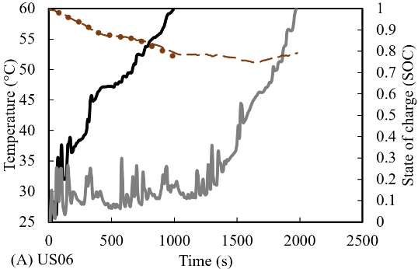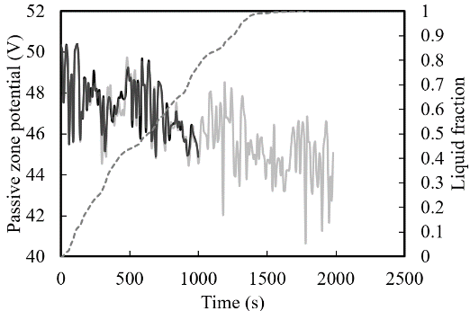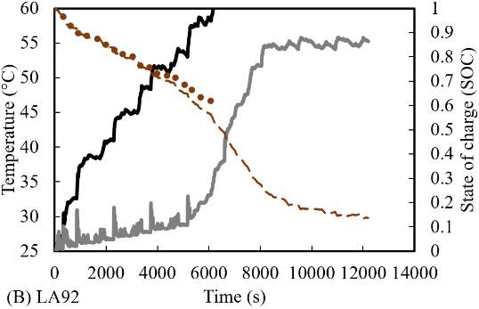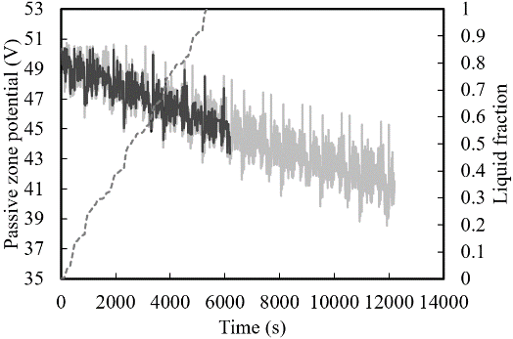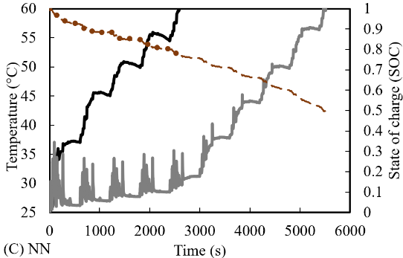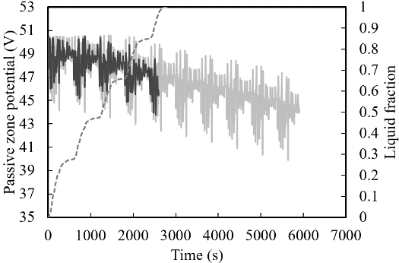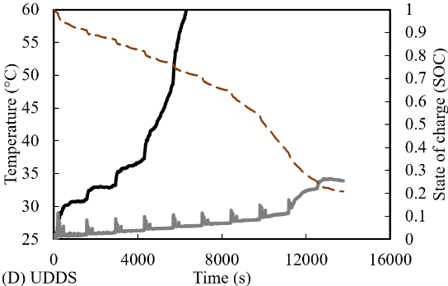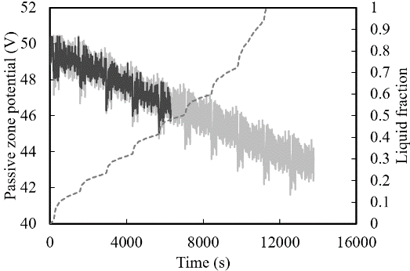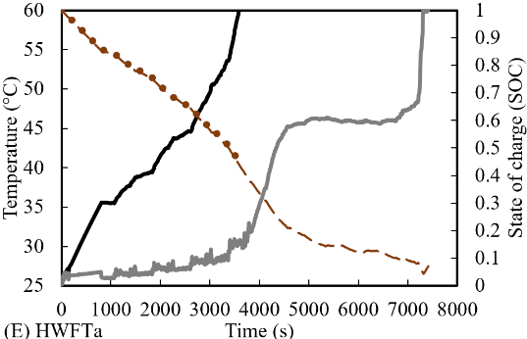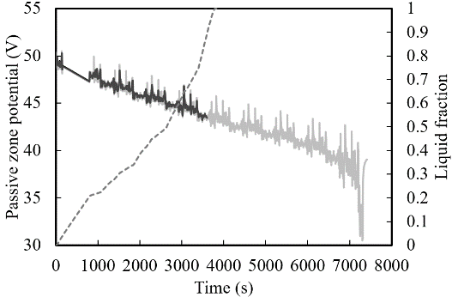
Fig. 13. Performance behaviour of Case 2 (2P12S module) in the presence and absence of LH jacket under different drive cycles.

Comparable results were captured for the harsh drive cycles LA92 (shown in Fig.13-B) and NN (shown in Fig.13-C) as well, where under those drive cycles approximately 200 % extension in useful life of the module with introduced passive cooling (LA92: 12197s at 55 °C and NN: 5513s at 60 °C) compared to the module without LH jackets (LA92: 6170s at 60 °C and NN: 2580s at 60 °C). For Case 2, the maximum and minimum voltages for passive zone potentials were between maximum 50 V and minimum 30 V, respectively. Likewise, the liquid fraction followed the same gradient as the modules without the LH jackets. Results illustrated, that compared to the casual drive cycles, UDDS (shown in Fig. 13-D) and HWFTa (shown in Fig. 13-E), displayed 218 % and 203 % extension in useful life, respectively, when the LH jackets were introduced (UDDS: 13752s at 34 °C and HWFTa: 7300s at 60 °C) as opposed to without (UDDS: 6270s at 60 °C and HWFTa: 3580s at 60 °C). After the cycle or the safety limit was reached, as shown by the SOC and the passive zone potential, indeed, only the UDDS drive cycle with LH jackets remained below 35 °C. For both Case 1 and Case 2, while LH was still available, the battery modules were maintained below 35 °C - 40 °C and only rose sharply when the LH was depleted.
Finally, the performance results of the third Case (3P8S) under various drive loads are displayed in Fig. 14. As shown in this figure, the LH jackets improved the thermal performance of the module for all drive cycles which were displayed in the temperature profiles. Distinctly, the battery module temperature without LH jackets was discharged to the safety limit of 60 °C in less time than it took for Case 2, and then Case 1. This was because of the increased current in the module due to the parallel arrangement of cells. This was also conferred from the lowered passive zone potentials, which cycled between the maximum of 34 V and to minimum of 27 V. In this test Case as well, there was an intensification in the haphazard nature of the module temperature rise compared to the other Cases (24S and 2P12S), but when the LH jackets were employed, greater thermal stability was also attained by the module.
The most aggressive drive cycle, US06 (shown in Fig. 14-A) had a significant effect on Case 3, with up to 580 % increase in battery useful life in the presence of LH jackets compared to their absences. The corresponding time as shown by the temperature profiles were 310s without LH jackets and 1820s with LH jackets at 60 °C. Correspondingly, results from the other aggressive cycles, LA92 (shown in Fig. 14-B) and NN (shown in Fig. 14-C) had 146 % and 400 % increases in thermal performance enhancements with LH jacket cooling (LA92: 3370s at 60 °C and NN: 5230s at 58 °C) in contrast without (LA92: 2310s at 60 °C and NN: 1280s at 58 °C). The life extension was illustrated similarly for the passive zone potential profiles. The liquid fraction increased comparably to the battery module temperature without LH jackets and the absorption of heat was directly captured and illustrated. Beyond consumption of the LH, the temperature sharply increased by SH.
For the casual drive cycles, UDDS (shown in Fig. 14-D) and HWFTa (shown in Fig. 14-E), improvements in thermal performance of 289 % and 197 %, respectively in the presence of LH jackets were illustrated in contrast to the cases without LH jackets. The time shown in the results of the temperature profiles at 60 °C were at the 2960s and 8570s without and with LH jackets, respectively for the UDDS drive cycle, whilst for the HWFTa drive cycle, it was presented as 1870s without LH jackets and 3690s with LH jackets. The SOC for the modules were all above 50 % but safe discharge of battery cells was the main priority, so the cycling was ceased once the temperature safety limit was reached. It was found that the effect of different intensities of drive cycles has had a significant effect on the module thermal performance depending on the arrangement of cells. The increased current and lowered voltage including locomotive behaviour can cause an intensification of module temperature to reach safety limits much faster as seen in the results. In comparison to the harshest drive cycle US06 applied to Case 1 without LH jackets, the Case 3 module temperature reached the safety temperature limit (60 °C) in 1/5th of the time even though it had 3x the capacity in Ah (see Table 1). This was also seen for the transition to the casual drive cycles where the temperature safety limit was not reached in Case 1 but hit in Case 2 and Case 3. This meant that low current modules under causal drive cycles were not severely impacted thermally, however, the opposite was true for high current modules under both aggressive and even casual drive cycles based on the test Cases in this study.
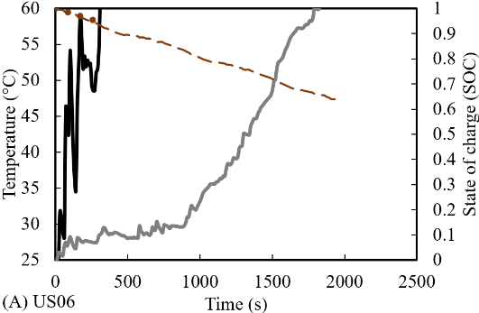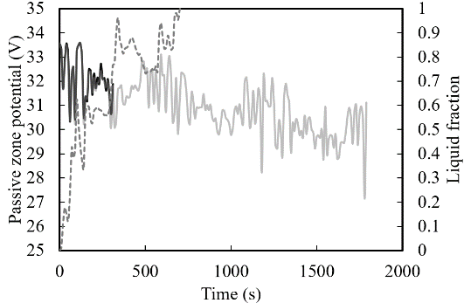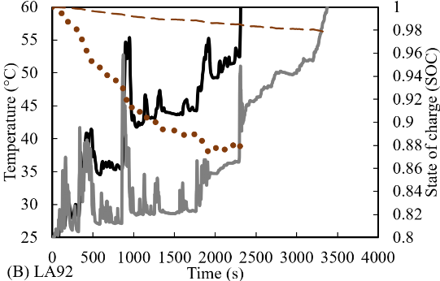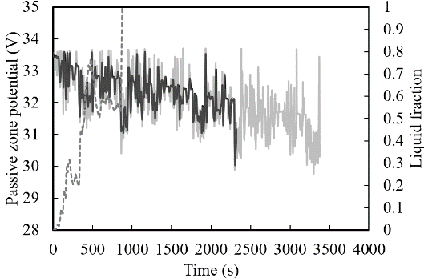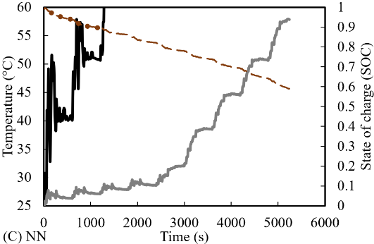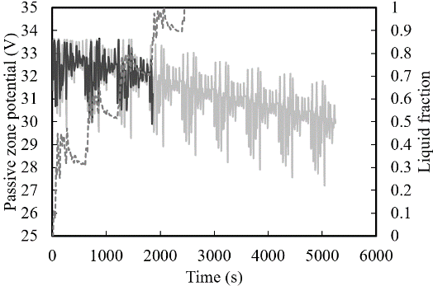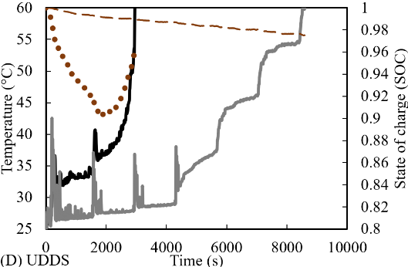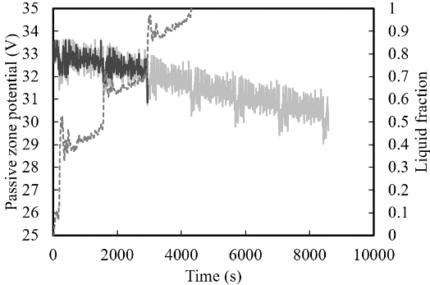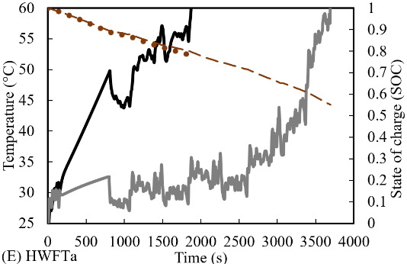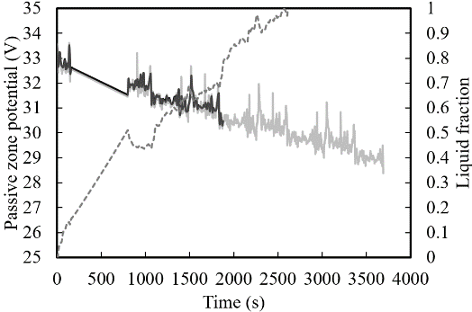

Fig. 14. Performance behaviour of Case 3 (3P8S module) in the presence and absence of LH jacket under different drive cycles.

4 Conclusions

In the present study, battery modules with natural cooling LH jackets function as thermal heat sinks to form a BTMS. The 3D thermo-chemical and electrical modelling using the MSMD ECM approach presents energy equations for combined models including PCM and busbars with all the heat energy absorbed by the PCM. Modelling of phase change takes into consideration the mushy zone parameters which are dependent on the temperature. The models for liquid fraction melting and battery cycling were validated from literature results which included numerically and experimentally assessed data with less than 1 % variation in errors. This validated model underwent verification in grid and temporal dependency tests with a 1 % relative error. Scaled models were used to assess different parameters and the effect of thermal performance including ambient temperature, SOC, passive zone potential and liquid fraction. Three models were analysed which involved different arrangements of 24 cells li-ion battery modules which included Case 1 (24S), Case 2 (2P12S) and Case 3 (3P8S) at a constant discharging C-rate of 1 for both continuous module cycling and under the impact of real-world drive cycles which varied from aggressive to casual. The main conclusions were as follows:

- Regardless of arrangement the module requires a cooling method to be able to disperse the generated heat and reduce overheating from multiple cycling,
- The sharp increase in cell temperature mimicked by the liquid fraction indicated that the heat had been sufficiently absorbed by the LH cooling jackets and successfully functioned as thermal heat sinks and managed the battery module temperature for different arrangements and capacities,
- Introduced natural convection cooling to maintain uniform and stable temperature based on indicated circumferential diameter during continuous and even under drive cycle scenarios,
- During continuous cycling, the BTMS based on LH jackets reduced the maximum module temperature by 20 °C for all Cases assessed,
- The temperature difference between cells was kept below 5 °C for all Cases with LH cooling jackets and indicates improved thermal equilibrium between cells as compared without LH cooling,
- Under all the test drive cycles, the thermal performance was improved with the introduced LH jackets resulting on average over 200 % extension in useful battery life.

CRediT author statement

R. A. Nicholls: Conceptualization, Methodology, Software, Validation, Formal Analysis, Investigation, Writing – Original Draft. M.A. Moghimi: Methodology, Software, Validation, Formal analysis, Investigation, Writing – Original Draft, Writing – Review & Editing, Supervision, Project administration, Funding acquisition, management.

Acknowledgements

The authors gratefully acknowledge the support received from Staffordshire Advanced Manufacturing, Prototyping, and Innovation Demonstrator (SAMPID) that is part funded through the European Regional Development Fund 2014-2020, project reference No: 32R19P03142.

References
- Wen, J., Zhao, D. and Zhang, C. (2020) 'An overview of electricity powered vehicles: Lithium-ion battery energy storage density and energy conversion efficiency', Renewable energy, 162, pp. 1629-1648 https://doi.org/10.1016/j.renene.2020.09.055

- Malik, M., Dincer, I., Rosen, M. and Fowler, M. (2017) 'Experimental Investigation of a New Passive Thermal Management System for a Li-Ion Battery Pack Using Phase Change Composite Material', Electrochimica acta, 257, pp. 345-355 https://doi.org/10.1016/j.electacta.2017.10.051
- Javani, N., Dincer, I., Naterer, G.F. and Yilbas, B.S. (2014) 'Heat transfer and thermal management with PCMs in a Li-ion battery cell for electric vehicles', International journal of heat and mass transfer, 72, pp. 690-703 https://doi.org/10.1016/j.ijheatmasstransfer.2013.12.076
- Nazir, H., Batool, M., Bolivar Osorio, F.J., Isaza-Ruiz, M., Xu, X., Vignarooban, K., Phelan, P., Inamuddin and Kannan, A.M. (2019) 'Recent developments in phase change materials for energy storage applications: A review', International journal of heat and mass transfer, 129, pp. 491-523 https://doi.org/10.1016/j.ijheatmasstransfer.2018.09.126
- Fan, R., Zheng, N. and Sun, Z. (2021) 'Evaluation of fin intensified phase change material systems for thermal management of Li-ion battery modules', International journal of heat and mass transfer, 166, pp. 120753 https://doi.org/10.1016/j.ijheatmasstransfer.2020.120753
- Zhang, X., Li, Z., Luo, L., Fan, Y. and Du, Z. (2022) 'A review on thermal management of lithium-ion batteries for electric vehicles', Energy (Oxford), 238, pp. 121652 https://doi.org/10.1016/j.energy.2021.121652
- Kim, J., Oh, J. and Lee, H. (2019) 'Review on battery thermal management system for electric vehicles', Applied thermal engineering, 149, pp. 192-212 https://doi.org/10.1016/j.applthermaleng.2018.12.020
- Liu, H., Wei, Z., He, W. and Zhao, J. (2017) 'Thermal issues about Li-ion batteries and recent progress in battery thermal management systems: A review', Energy conversion and management, 150, pp. 304-330 Available at: 10.1016/j.enconman.2017.08.016.
- Ling, Z., Chen, J., Fang, X., Zhang, Z., Xu, T., Gao, X. and Wang, S. (2014) 'Experimental and numerical investigation of the application of phase change materials in a simulative power batteries thermal management system', Applied Energy, 121, pp. 104-113 https://doi.org/10.1016/j.apenergy.2014.01.075
- Yang, Y., Chen, L., Yang, L. and Du, X. (2021) 'Numerical study of combined air and phase change cooling for lithium-ion battery during dynamic cycles', International journal of thermal sciences, 165, pp. 106968 https://doi.org/10.1016/j.ijthermalsci.2021.106968
- Perez Estevez, M.A., Calligaro, S., Bottesi, O., Caligiuri, C. and Renzi, M. (2021) 'An electro-thermal model and its electrical parameters estimation procedure in a lithium-ion battery cell', Energy (Oxford), 234, pp. 121296 https://doi.org/10.1016/j.energy.2021.121296
- Sabbah, R., Kizilel, R., Selman, J.R. and Al-Hallaj, S. (2008) 'Active (air-cooled) vs. passive (phase change material) thermal management of high power lithium-ion packs: Limitation of temperature rise and uniformity of temperature distribution', Journal of power sources, 182(2), pp. 630-638 https://doi.org/10.1016/j.jpowsour.2008.03.082
- Safdari, M., Ahmadi, R. and Sadeghzadeh, S. (2020) 'Numerical investigation on PCM encapsulation shape used in the passive-active battery thermal management', Energy (Oxford), 193, pp. 116840 https://doi.org/10.1016/j.energy.2019.116840
- Akula, R. and Balaji, C. (2022) 'Thermal management of 18650 Li-ion battery using novel fins–PCM–EG composite heat sinks', Applied Energy, 316, pp. 119048 https://doi.org/10.1016/j.apenergy.2022.119048
- Menale, C., D&#39;Annibale, F., Mazzarotta, B. and Bubbico, R. (2019) 'Thermal management of lithium-ion batteries: An experimental investigation', Energy (Oxford), 182, pp. 57-71 https://doi.org/10.1016/j.energy.2019.06.017
- Qaderi, A. and Veysi, F. (2022) 'Investigation of a water-NEPCM cooling thermal management system for cylindrical 18650 Li-ion batteries', Energy (Oxford), 244, pp. 122570 https://doi.org/10.1016/j.energy.2021.122570
- Alva, G., Lin, Y. and Fang, G. (2018) 'An overview of thermal energy storage systems', Energy (Oxford), 144, pp. 341-378 https://doi.org/10.1016/j.energy.2017.12.037
- Gulfam, R., Zhang, P. and Meng, Z. (2019) 'Advanced thermal systems driven by paraffin-based phase change materials – A review', Applied Energy, 238, pp. 582-611 https://doi.org/10.1016/j.apenergy.2019.01.114
- Alami, A.H., Maghrabie, H.M., Abdelkareem, M.A., Sayed, E.T., Yasser, Z., Salameh, T., Rahman, S.M.A., Rezk, H. and Olabi, A.G. (2022) 'Potential applications of phase change materials for batteries' thermal management systems in electric vehicles, Journal of energy storage, 54, pp. 105204 https://doi.org/10.1016/j.est.2022.105204
- Ma, S., Jiang, M., Tao, P., Song, C., Wu, J., Wang, J., Deng, T. and Shang, W. (2018) 'Temperature effect and thermal impact in lithium-ion batteries: A review', Progress in Natural Science: Materials International, 28(6), pp. 653-666 https://doi.org/10.1016/j.pnsc.2018.11.002
- Ibrahim, A. and Jiang, F. (2021) 'The electric vehicle energy management: An overview of the energy system and related modelling and simulation', Renewable &amp; sustainable energy reviews, 144, pp. 111049 https://doi.org/10.1016/j.rser.2021.111049
- Kim, J., Oh, J. and Lee, H. (2019) 'Review on battery thermal management system for electric vehicles', Applied Thermal Engineering, 149, pp. 192-212 https://doi.org/10.1016/j.applthermaleng.2018.12.020
- Xia, G., Cao, L. and Bi, G. (2017) 'A review on battery thermal management in electric vehicle application', Journal of power sources, 367, pp. 90-105 https://doi.org/10.1016/j.jpowsour.2017.09.046.
- Ianniciello, L., Biwolé, P.H. and Achard, P. (2018) 'Electric vehicles batteries thermal management systems employing phase change materials', Journal of power sources, 378, pp. 383-403 https://doi.org/10.1016/j.jpowsour.2017.12.071.
- Kizilel, R., Lateef, A., Sabbah, R., Farid, M.M., Selman, J.R. and Al-Hallaj, S. (2008) 'Passive control of temperature excursion and uniformity in high-energy Li-ion battery packs at high current and ambient temperature', Journal of power sources, 183(1), pp. 370-375 https://doi.org/10.1016/j.jpowsour.2008.04.050
- Nasajpour-Esfahani, N., Garmestani, H., Rozati, M. and Smaisim, G.F. (2023) 'The role of phase change materials in lithium-ion batteries: A brief review on current materials, thermal management systems, numerical methods, and experimental models', Journal of energy storage, 63, pp. 107061 https://doi.org/10.1016/j.est.2023.107061
- Arora, S. (2018) 'Selection of thermal management system for modular battery packs of electric vehicles: A review of existing and emerging technologies', Journal of power sources, 400, pp. 621-640 https://doi.org/10.1016/j.jpowsour.2018.08.020
- Mohammed, A.G., Elfeky, K.E. and Wang, Q. (2022) 'Recent advancement and enhanced battery performance using phase change materials based hybrid battery thermal management for electric vehicles', Renewable &amp; sustainable energy reviews, 154, pp. 111759 https://doi.org/10.1016/j.rser.2021.111759
- Tete, P.R., Gupta, M.M. and Joshi, S.S. (2021) 'Developments in battery thermal management systems for electric vehicles: A technical review', Journal of Energy Storage, 35, pp. 102255 https://doi.org/10.1016/j.est.2021.102255
- Chen, J., Kang, S., E, J., Huang, Z., Wei, K., Zhang, B., Zhu, H., Deng, Y., Zhang, F. and Liao, G. (2019) 'Effects of different phase change material thermal management strategies on the cooling performance of the power lithium-ion batteries: A review', Journal of power sources, 442, pp. 227228 https://doi.org/10.1016/j.jpowsour.2019.227228.
- Siddique, A.R.M., Mahmud, S. and Heyst, B.V. (2018) 'A comprehensive review on a passive (phase change materials) and an active (thermoelectric cooler) battery thermal management system and their limitations', Journal of power sources, 401, pp. 224-237 https://doi.org/10.1016/j.jpowsour.2018.08.094
- Luo, J., Zou, D., Wang, Y., Wang, S. and Huang, L. (2022) 'Battery thermal management systems (BTMs) based on phase change material (PCM): A comprehensive review', Chemical engineering journal (Lausanne, Switzerland : 1996), 430, pp. 132741 https://doi.org/10.1016/j.cej.2021.132741
- Verma, A., Shashidhara, S. and Rakshit, D. (2019) 'A comparative study on battery thermal management using phase change material (PCM)', Thermal science and engineering progress, 11, pp. 74-83 https://doi.org/10.1016/j.tsep.2019.03.003
- Yang, M., Nicholls, R.A., Moghimi, M.A., and Griffiths, A.L. (2023) 'Performance management of EV battery coupled with latent heat jacket at cell level', Journal of power sources, 558, pp. 232618 https://doi.org/10.1016/j.jpowsour.2022.232618
- Lamrani, B., Lebrouhi, B.E., Khattari, Y. and Kousksou, T. (2021) 'A simplified thermal model for a lithium-ion battery pack with phase change material thermal management system', Journal of energy storage, 44, pp. 103377 https://doi.org/10.1016/j.est.2021.103377
- Talele, V., Thorat, P., Gokhale, Y.P. and VK, M. (2021) 'Phase change material based passive battery thermal management system to predict delay effect', Journal of energy storage, 44, pp. 103482 https://doi.org/10.1016/j.est.2021.103482
- Panchal, S., Mathew, M., Fraser, R. and Fowler, M. (2018) 'Electrochemical thermal modelling and experimental measurements of 18650 cylindrical lithium-ion battery during discharge cycle for an EV', Applied thermal engineering, 135, pp. 123-132 https://doi.org/10.1016/j.applthermaleng.2018.02.046
- Ranjbar Kermani, J., Mahlouji Taheri, M., Shafii, M.B. and Moosavi, A. (2023) 'Analytical solution, optimization and design of a phase change cooling pack for cylindrical lithium-ion batteries', Applied thermal engineering, 232, pp. 120963 https://doi.org/10.1016/j.applthermaleng.2023.120963
- Najafi Khaboshan, H., Jaliliantabar, F., Adam Abdullah, A. and Panchal, S. (2023) 'Improving the cooling performance of cylindrical lithium-ion battery using three passive methods in a battery thermal management system', Applied thermal engineering, 227, pp. 120320 https://doi.org/10.1016/j.applthermaleng.2023.120320
- Gan, Y., Wang, J., Liang, J., Huang, Z. and Hu, M. (2020) 'Development of thermal equivalent circuit model of heat pipe-based thermal management system for a battery module with cylindrical cells', Applied thermal engineering, 164, pp. 114523 https://doi.org/10.1016/j.applthermaleng.2019.114523
- Padalkar, A.B., Chaudhari, M.B. and Funde, A.M. (2023) 'Computational investigation for reduction in auxiliary energy consumption with different cell spacing in battery pack', Journal of energy storage, 65, pp. 107265 https://doi.org/10.1016/j.est.2023.107265
- Ji, C., Wang, B., Wang, S., Pan, S., Wang, D., Qi, P. and Zhang, K. (2019) 'Optimization on uniformity of lithium-ion cylindrical battery module by different arrangement strategy', Applied thermal engineering, 157, pp. 113683 https://doi.org/10.1016/j.applthermaleng.2019.04.093
- Hussain, M., Khan, M.K. and Pathak, M. (2023) 'Thermal analysis of phase change material encapsulated li-ion battery pack using multi-scale multi-dimensional framework', Journal of energy storage, 65, pp. 107290 https://doi.org/10.1016/j.est.2023.107290
- Vyroubal, P. and Kazda, T. (2018) 'Equivalent circuit model parameters extraction for lithium-ion batteries using electrochemical impedance spectroscopy', Journal of Energy Storage, 15, pp. 23-31 https://doi.org/10.1016/j.est.2017.10.019
- Li, C., Ding, Y., Zhou, Z., Jin, Y., Ren, X., Cao, C. and Hu, H. (2023) 'Parameter optimization and sensitivity analysis of a Lithium-ion battery thermal management system integrated with composite phase change material', Applied thermal engineering, 228, pp. 120530 https://doi.org/10.1016/j.applthermaleng.2023.120530
- Kirad, K. and Chaudhari, M. (2021) 'Design of cell spacing in lithium-ion battery module for improvement in cooling performance of the battery thermal management system', Journal of power sources, 481, pp. 229016 https://doi.org/10.1016/j.jpowsour.2020.229016
- Chacko, S., and Chung, Y.M. (2012) 'Thermal modelling of Li-ion polymer battery for electric vehicle drive cycles', Journal of Power Sources, 213, pp. 296-303 https://doi.org/10.1016/j.jpowsour.2012.04.015
- Bhavsar, S., Kant, K. and Pitchumani, R. (2023) 'Robust model-predictive thermal control of lithium-ion batteries under drive cycle uncertainty', Journal of power sources, 557, pp. 232496 https://doi.org/10.1016/j.jpowsour.2022.232496
- Panchal, S., Mathew, M., Dincer, I., Agelin-Chaab, M., Fraser, R. and Fowler, M. (2018) 'Thermal and electrical performance assessments of lithium-ion battery modules for an electric vehicle under actual drive cycles', Electric power systems research, 163, pp. 18-27 https://doi.org/10.1016/j.epsr.2018.05.020
- Vikram, S., Vashisht, S. and Rakshit, D. (2022) 'Performance analysis of liquid-based battery thermal management system for Electric Vehicles during discharge under drive cycles', Journal of energy storage, 55, pp. 105737 https://doi.org/10.1016/j.est.2022.105737
- Nicholls, R.A, Moghimi, M.A., and Griffiths, A.L., (2022) ‘Impact of fin type and orientation on performance of phase change material-based double pipe thermal energy storage’, Journal of Energy Storage, 50, pp 104671. https://doi.org/10.1016/j.est.2022.104671.
- Darzi, A.R., Farhadi, M. and Sedighi, K., (2012) ‘Numerical study of melting inside concentric and eccentric horizontal annulus’, Applied mathematical modelling, 36 (9), pp. 4080-4086. https://doi.org/10.1016/j.apm.2011.11.033.

- Voller, V. R. and Prakash, C. (1987) ‘A Fixed-Grid Numerical Modelling Methodology for Convection-Diffusion Mushy Region Phase-Change Problems’. Int. J. Heat Mass Transfer. 30. 1709–1720.

- Chen, H., Cong, T.N., Yang, W., Tan, C., Li, Y. and Ding, Y. (2009) 'Progress in electrical energy storage system: A critical review', Progress in Natural Science, 19(3), pp. 291-312. https://doi.org/10.1016/j.pnsc.2008.07.014.

- Kollmeyer, P., Hackl, A. and Emadi, A. (Jun 2017) Li-ion battery model performance for automotive drive cycles with current pulse and EIS parameterization. IEEE, pp. 486.
- Kadivar, M.R., Moghimi, M.A., Sapin, P. and Markides, C.N., (2019) ‘Annulus eccentricity optimisation of a phase-change material (PCM) horizontal double-pipe thermal energy store’, Journal of energy storage, 26, pp. 101030. https://doi.org/10.1016/j.est.2019.101030.

- Nicholls, R.A., Moghimi, M.A., and Griffiths, A.L. (2024) 'Influence of latent heat based passive cooling on the performance of EV battery under automotive drive cycles', Journal of Energy Storage, 77, pp. 109924 https://doi.org/.1016/j.est.2023.109924.

- G-H. Kim (2011) ‘Multi-Domain Modeling of Lithium-Ion Batteries Encompassing Multi-Physics in Varied Length Scales. J. of Electrochemical Soc. 158 (8). A955-A969.

