Using a Multimodal Cognitive Behavioral 1-2-1 Intervention to Target Irrational Beliefs, Perceived Performance, and Stress Mindset with Elite Youth Football Players

Author Note
The author reported no potential conflict of interest. This research received no specific grant from funding agencies in the public, commercial, or not-for-profit sectors. Data is available upon request from the lead author. Ethical approval was received from University of Staffordshire.

Abstract
Academy football players operating in the highest echelons of youth football must navigate multiple sources of stress. The present study investigated whether a multimodal cognitive-behavioural intervention could enhance academy football players’ stress mindset and perceived performance, and reduce irrational beliefs. The sample was four male elite young athletes (Mage = 16.25 years, SD = .50). The intervention was delivered on a 1-2-1 basis and included a range of strategies within the REBT framework (i.e., education about stress, the ABC thinking framework, self-compassion, and imagery). It was hypothesised that stress mindset and perceived performance would increase, and irrational beliefs would decrease. Four elite male football players completed measures in stress mindset, perceived performance, and irrational beliefs as part of an AB single-case research design. Results revealed substantial increases in stress mindset in all four athletes, reductions in irrational beliefs in three athletes, but minimal changes in perceived performance.

Keywords: cognitive-behavioural intervention, young football players, imagery, ABC thinking.

Using a Multimodal Cognitive Behavioural 1-2-1 Intervention to Target Trait Beliefs with Elite Youth Football players
Being an academy football (i.e. soccer) player is a privileged position that can bring many opportunities, such as access to the best coaching and excellent facilities. In the UK alone, an estimated 12500 youth academy football players are attached to professional clubs, with thousands more participating at the grassroots level (Sothern & O’Gorman, 2021). The stakes are high in elite academy football as athletes compete against the best sides in their country, and football players at this level may be selected to play for their youth national sides. Despite the prestige and opportunity that being involved in an elite football academy provides, young athletes operating at such levels will undoubtedly experience stressful situations. In addition to the challenges posed by adolescence that all young people must navigate (Thrower et al., 2023), academy football players must also contend with stressors such as the looming spectre of potential deselection and injury or not reaching their career expectations (i.e., playing in the Premier League context; Wilkinson, 2021). For an academy football player, social evaluation from coaches, teammates, and parents is a feature of daily life, meaning that a fear of making mistakes may be evident (Reeves et al., 2009). Although most football academy research is concentrated in the UK, Portuguese academies are noted for their ability to consistently produce football players of a high calibre and thus generate finances that allow their clubs to compete on the European stage (Barros, 2006).
Consequently, academy football is highly competitive in football in Portugal, and players at the Under-17 level can consider competition as a notable stressor (Gomes et al., 2022). As a result of this cocktail of high demands and stressors, they may experience psychological distress (Kelly et al., 2022). Academy football players are unlikely to refer themselves for psychological support, and, accordingly, there is a need to employ interventions in academy football clubs as a proactive measure to aid stress management and facilitate mental well-being (Sothern & O’Gorman, 2021). The World Health Organization (WHO) highlights the importance of maintaining effective functioning in physical, mental, and social domains related to performance (WHO, 2022). At the same time, the International Society of Sport Psychology (ISSP) has been considering mental health as a key dimension in international sports, highlighting some examples of negative stress factors experienced within team contexts (i.e., bullying, abusive situations; Schinke et al., 2024). Given the known stress-related constructs that can influence young athletes’ mental health, it is important to continue to explore suitable modalities that practitioners could employ to support them psychologically.
Young players’ experience of stress in academy football does not always have to be maladaptive. Indeed, stress mindset theory posits that the extent to which an individual considers stress to have facilitative consequences for health, well-being, performance, productivity, learning, and growth may determine a range of stress-related outcomes (Crum et al., 2013). Evidence is growing that supports the associations between a ‘stress-is-enhancing’ mindset (SEM) and adaptive outcomes such as performance and mental health. In athletes specifically, SEM is associated positively with challenge appraisal tendencies and negatively with threat appraisal tendencies (Mansell, 2021), while in a sample of Navy SEALs, Smith et al. (2020) reported that a SEM was associated with adaptive performance markers. Other studies demonstrate positive relationships between a SEM and adaptive physiological responses to stress (Crum et al., 2013) and psychological well-being (Keech et al., 2018). Research into the effect of stress mindset interventions in athletes is scarce, although two studies have demonstrated the malleability of stress mindset in athletes with adaptive outcomes in wellbeing (Mansell et al., 2023) and performance (Cnossen et al., 2023). However, neither study investigated whether a SEM could be developed on a 1-2-1 approach with a trained sport psychologist. This is important given the frequency of 1-2-1 work that sport psychologists conduct. On a broader scale, a recent meta-analysis concluded that stress mindset interventions are a low-cost and effective approach to enhance performance (Bosshard & Gomez, 2024). Based upon the findings of previous studies, aiming to enhance stress mindset appears to be a worthwhile strategy to enhance trait beliefs that can determine performance. Indeed, given the prevalence of stress in athletes’ lives and the importance of adopting a SEM, further exploring how a SEM can be cultivated in athletes warrants further attention.
When individuals feel they can exert control over their thinking rather than their responses emanating directly from an event, this can facilitate a SEM (Mansell et al., 2023). This notion of controllability is captured with the (G)ABC thinking framework posited within Rational Emotive Behaviour Therapy (REBT; Ellis, 1957). An adverse situation or activating event (A) in response to a goal that an athlete has (G) will elicit cognitive, emotional, and behavioural consequences (C), and in REBT, it is proposed that an individual’s beliefs (B) mediate the relationship between A and C (Ellis & Dryden, 2007). According to REBT, beliefs can be helpful (or rational) or unhelpful (irrational) towards well-being and performance. Irrational beliefs are fixed, unflexible, and illogical and are categorized into a primary irrational belief of demandingness and three secondary beliefs of awfulizing, frustration intolerance, and depreciation (Turner, 2022). To illustrate, in response to being left out of the starting lineup (A), holding the primary irrational belief (B) that ‘I must be selected for the team…’ (demandingness) may be accompanied by secondary irrational beliefs of ‘…and it is awful that I have not been selected’ (awfulizing), ‘…and I cannot stand being on the bench’ (frustration intolerance) or ‘…and this means that I am a failure’ (depreciation). The endorsement of such beliefs will likely lead to unhealthy negative thoughts, feelings and behaviours (e.g., anger; Turner, 2022) and provide a significant risk to athletes’ mental health (Turner, 2016). Indeed, representing an elite football academy comes with an expectation of winning in every game, and by reducing demandingness, athletes can realise that they can be highly motivated to win without possessing the belief that they ‘must,’ ‘should,’ or ‘have to’ (Phelps-Naqvi & Katz, 2017). Consequently, interventions that have targeted reductions in irrational beliefs in academy football have demonstrated effectiveness (Turner et al., 2014), such as enhancing performance and reducing social anxiety (Nejati et al., 2022) and competitive anxiety (Jordana et al., 2020). However, little is known about whether irrational beliefs can successfully be reduced as part of a multimodal intervention. This is important given that such approaches have the potential to alter a range of theoretically linked stress-related outcomes simultaneously and offer appeal to athletes given the variety of content within this type of intervention (Mansell et al., 2023). Given the prevalence of irrational beliefs in academy football players and the known associations with poor mental health, aiming to reduce the intensity of such beliefs and promote rational alternatives is important (Jordana et al., 2020).
Most cognitive-behavioural interventions in academy football to enhance well-being and performance have been delivered at a group level (see King et al., 2024). Despite the reported efficacy of such interventions, other authors have called for empirical investigations into the utility of interventions delivered through a 1-2-1 modality as there is greater potential for establishing more effective and longer-lasting benefits through such an approach (e.g., Phelps-Naqvi & Katz, 2017). Indeed, the 1-2-1 modality may offer a more personal approach, such as exploring individual differences in irrational beliefs, and may complement existing group-level provisions (Barker et al., 2020). Assessment of such interventions is particularly pertinent at the elite level, given the dearth of single-case research with such athletes (Barker et al., 2020), which is somewhat surprising given the importance of psychological skills training at this level. Using the (G)ABC framework is an effective part of both group and individual approaches. However, given the flexibility of REBT, the addition of theoretically linked other strategies may complement psycho-educational approaches framed around the (G)ABC framework. As such, multimodal designs may appeal to athletes because of their variety and are, therefore, worthy of research (Barker et al., 2011). This approach was utilised by Mansell et al. (2023) using the program ‘Mindset: Performing Under Pressure’ (M: PUP) with four groups of athletes. Results revealed that stress mindset significantly increased and negative affect significantly decreased as a result of the intervention. Strategies including education about stress and the (G)ABC thinking framework were utilised in conjunction with self-compassion (e.g., Mosewich et al., 2013) and imagery (e.g., Keech et al., 2021a), and social validation results indicated that the athletes felt that the intervention was beneficial to their mental health and performance. Despite this, no significant changes were detected in irrational beliefs and perceived performance. Irrational beliefs can be engrained and there may be some resistance to change (Turner, 2022), while a single-item perceived performance measure was used which may not have been sufficient to detect any changes in that construct. Although M: PUP showed validity in the past (Mansell et al., 2023), there is lack of evidence in how it can aid performance and therefore, there is a need for replication to validate this method.
Accordingly, adopting a similar approach on a 1-2-1 basis may allow more specific work to be conducted with athletes and, therefore, may be more effective in reducing deeply held cognitions such as irrational beliefs (Bowman & Turner, 2022). Indeed, the present study provides the opportunity to further explore Mansell et al.’s (2023) multimodal approach and, therefore, may contribute to the literature by offering a transferrable approach to enhance elite young athletes’ trait beliefs and performance that is delivered in an ecologically valid manner. This is important given that sport psychology provision is often conducted on an individual level, and no known research has examined the effectiveness of targeting stress mindset using a 1-2-1 approach as part of a multimodal intervention.
Our present study aims to investigate whether the multimodal cognitive behavioural intervention ‘Mindset: Performing Under Pressure’ (M: PUP) could enhance stress mindset and perceived performance and reduce irrational beliefs in a sample of elite academy football players. Using a single-case A-B research design, it is hypothesized that stress mindset and perceived performance would increase, and irrational beliefs would decrease as a result of the intervention. Exploring such aims offers the chance to extend the research by being the first known study to manipulate stress mindset in athletes delivered via an ecologically valid 1-2-1 modality, and to address the lack of single-case cognitive behavioural research that has been reported in elite athletes (Barker et al., 2020). A social validation component will also assess the acceptability of the intervention and how it was delivered.
Method
Participants and Design
A single-subject A-B design was used to collect at least three measures per participant at baseline, and the collection of further measures immediately after each session and a post-intervention measure immediately after the final session. This provided a platform for visual inspection of the data between the baseline phase (A) and the intervention phase (B), while also meaning that it is possible to observe any trends within those phases, and, therefore, this is accepted as a standard method of presenting data in single-case designs (Barker et al., 2011). Four male participants (Mage = 16.25 years, SD = .5) took part in this study, and all participants may be categorized as elite athletes due to the level at which they were currently competing (Swann et al., 2015). The participants had been part of the academy for 6.75 years on average (SD = .96). All participants were fluent in Portuguese, and no exclusion criteria were stated to make the intervention as inclusive as possible. All participants were competing at a national team level. Football players were recruited through snowball sampling by the psychologist of the team. The psychologist of the team had worked with the participating athletes since the beginning of the season before conducting the intervention. This allowed them to feel supported and confident when accepting to participate since rapport was well established. They were then given an information sheet and consent form before participating in the intervention. No participants declined to participate.
Measures
Stress Mindset
Stress mindset was assessed using the 8-item Stress Mindset Measure – General (SMM-G; Crum et al., 2013) translated into Portuguese by the first author. Despite the strength of other stress mindset measures (e.g., Stress Control Mindset Measure; Keech et al., 2021b), the SMM-G was adopted due to its shorter length. Containing around half the items compared with Keech et al.’s measure, we felt this was important given the measure was administered on up to ten occasions during the study. The statements included a focus on stress in general (e.g., “The effects of stress are negative and should be avoided”) as well as statements regarding the more specific domains of stress mindset (e.g., “Experiencing stress improves performance and productivity”). Participants rated the extent to which they agreed with each statement on a 5-point Likert scale ranging from 0 (strongly disagree) to 4 (strongly agree). Four negatively worded items were reverse scored before a mean score is generated, with a higher value representing a greater ‘stress-is-enhancing’ mindset. The SMM-G has been reported to produce valid and reliable stress mindset scores within athletes (Mansell, 2021). In past research with larger samples of adolescents, estimates of this scale’s internal reliability consistency were good, at α > .80 (Hubschmann & Sheets, 2020). In this study, test-retest reliability of the scale across baseline measurements was moderate, with a single-measurement, absolute-agreement, 2-way mixed effects ICC of .51.
Irrational Beliefs
Using back translation, the Irrational Performance Beliefs Inventory (iPBI; Turner et al., 2016) was translated into Portuguese to assess irrational beliefs (Morais et al., in preparation). The 28-item questionnaire assessed four subscales including Demandingness (DEM; e.g., “I need my coach to react respectfully towards me”), Low Frustration Tolerance (LFT; e.g., “I can't stand failing in things that are important to me”), Awfulizing (AWF; e.g., “It is awful if others do not approve of me”) and Depreciation (DEP; e.g., “If I face setbacks, it goes to show how stupid I am”). Participants rate the extent to which they agree/disagree with each statement on a 5-point Likert scale ranging from 1 (strongly disagree) to 5 (strongly agree). A mean score is calculated from all the items to produce an overall score, with higher scores indicating greater irrational beliefs. The scale has previously demonstrated excellent validity and reliability (α = .91) in a sample of adolescent athletes (Mansell et al., 2023). In this study, test-retest reliability of the scale across baseline measurements was moderate (single case ICC = .58).
Perceived Performance
The Perceived Performance Questionnaire (PPQ; Gomes et al., 2019) was used to assess participants’ perceptions of their current performance. The 5-item subscale assessing perceived individual performance was utilised in this case. Participants recorded their responses on a 5-point Likert scale ranging from 1 (strongly disagree) to 5 (strongly agree). After the prefix “Until now, in games/competitions I…”, items included asking participants how much they agreed with statements such as “…performed as I expected”. In a study of 708 adult referees in Portugal, this scale was shown to have excellent internal reliability consistency (α = .89; Noguiera et al., 2022). In this study, test-retest reliability of the scale across baseline measurements was moderate (single case ICC = .53).
Manipulation Checks
Responding on a 7-point Likert scale (1 = none of the time, 7 = all the time), participants were asked to reflect on how easy they found it to image in the imagery tasks in session five and how engaged they were in the project’s tasks more broadly.
Social Validation
An essential part of single-case research (Barker et al., 2011), data was gathered to assess the participants’ views about its acceptability and usability by drawing upon Mellalieu et al.’s (2009) response to social validation in single-case research. Responding to five questions on a 7-point Likert scale (see Supplementary Material), participants were asked to reflect on the extent to which they believed the project had been beneficial for their well-being and performance (1 = not at all, 7 = very much so). Participants were also asked to reflect on the extent to which they would recommend the project to a friend (1 = not at all, 7 = very likely) while also having the opportunity to provide their thoughts on the number of sessions in the intervention and the length of the sessions (1 = not enough, 7 = too many; and 1 = too short, 7 = too long respectively). A follow-up focus group session three months after the culmination of the intervention was planned, but this was unfortunately cancelled due to a change in circumstances at the club.
Data Collection
A single-subject AB design was utilised with each player to assess any changes in the targeted variables from baseline to post-intervention (Barker et al., 2011). This consisted of a baseline phase where four measures of stress mindset, irrational beliefs, and perceived performance were sought during a two-week period. Baseline lengths are not necessarily standardized, although it is generally considered that a greater number of baseline measures provide greater reliability (Barker et al., 2020). In this case, it was felt that taking up to four measures in a two-week period during the season would be sufficient to provide a relatively stable baseline measure compared with one single cross-sectional measure. Without a control group to compare any changes to, this extended baseline phase allows each player to act as their own control, with graphical representations of mean scores from the different phases allowing for clear identification of any changes in the variables (Barker et al., 2011). During the intervention phase, each player completed the SMM-G and PPQ immediately after sessions 1-5, and in the final session, they also completed the iPBI. The iPBI was not deployed during the intervention as it was felt that irrational beliefs can be deeply held and therefore may take longer to change (Turner, 2022), hence, to avoid unnecessary repetition of the scale, the iPBI was only deployed at baseline and after the final session. Overall, this provided a total of up to ten data points across the baseline, post-session and post-intervention phases.
Procedures
Ethical approval was obtained from the fourth listed author’s university ethics board. Data collection took place between February 2024 – May 2024 with each participant beginning the intervention on a different day in the same week. This is different to previous studies that have used this intervention (Mansell et al., 2023). This period was deliberately chosen as it tends to coincide with the most demanding fixtures of the season, such as the knockout phases of national cups, as well as deadlines regarding retention for the following season. Hence, it was felt that the intervention may support the participants through this challenging period.
Intervention
The intervention consisted of 6 X 30-minute face-to-face sessions that the team’s sports psychologist delivered on a 1-2-1 basis at the academy’s training ground. To enhance procedural reliability (Barker et al., 2020), the practitioner used the same PowerPoint presentation to guide each player through the six sessions, and players completed activities in a standardized workbook. Hence, although the intervention was delivered to one player at a time, clear efforts were made to ensure that they all experienced the same content in the same order. Usually, one session was delivered per week, although there were occasions where a participant was not able to be present due to their international football commitments, and in such instances, the next session was delivered as proximally as possible. The intervention was based on the M: PUP (see Table 2) approach developed by Mansell et al. (2023). United by the principles of the ABC thinking framework put forth in REBT, in short, the intervention aims to change the way individuals think (B) about adverse situations (A). As a result, changes in cognitions, emotions and behaviour (C) should follow. Beliefs about stress (i.e., stress mindset) is one area that is targeted, as are cognitive appraisals, irrational beliefs, and self-compassion. Stress mindset and irrational beliefs are considered to be trait beliefs, so in this iteration of the intervention, we were interested in understanding whether M: PUP would elicit changes in those variables. The authors worked together to refine M: PUP to this specific context of elite youth football. This included offering contextual insights into the club and its associated demands to enhance the specificity of the project to this cohort and was able to translate PowerPoints and other supporting materials into Portuguese. In short, united by the principles of REBT, the intervention aimed to use a combination of education about stress and the ABC thinking framework, self-compassion, and imagery to enhance stress mindset and performance and reduce irrational beliefs. The intervention materials could be consulted by contacting the corresponding author or other members of the research team.
Results
Data were analyzed using visual inspection – a common method for assessing changes in single-case research with athletes (e.g., Barker & Jones, 2008) that allows for clear judgment regarding differences at each phase (Kinugasa et al., 2004). Each participant was missing data at one-time point, such as one baseline measure or one post-session measure, but a full data set was obtained post-intervention. Using visual inspection allows conclusions to be drawn regarding the extent to which any changes may have occurred, the trend of the data, when changes may have occurred, and whether there are any patterns between different participants within the same study (Bowman & Turner, 2022). To demonstrate practical significance and in-line with theoretical recommendations (e.g., Pustejovksy, 2018) and previous studies (e.g., Turner et al., 2018), an effect size of percentage changes between baseline and post-intervention is also provided in Table 1.
Results of the intervention in relation to changes in stress mindset, irrational beliefs, and perceived performance are presented in Figure 1, with the descriptive statistics reported in Table 1.
Figure 1
Changes in Stress Mindset and Irrational Beliefs in Participant E, F, G and X
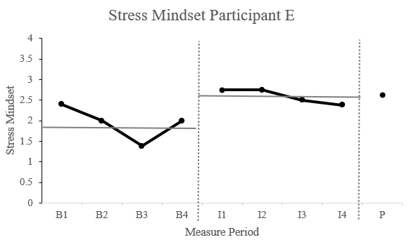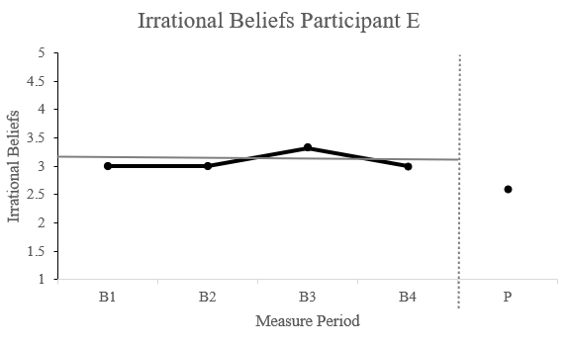
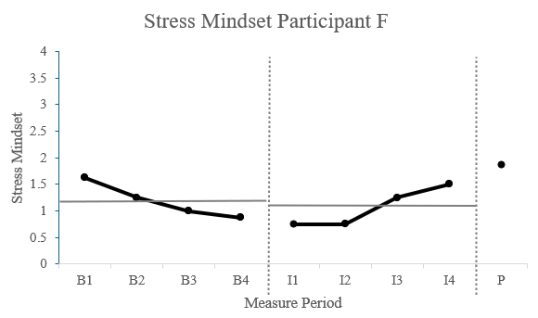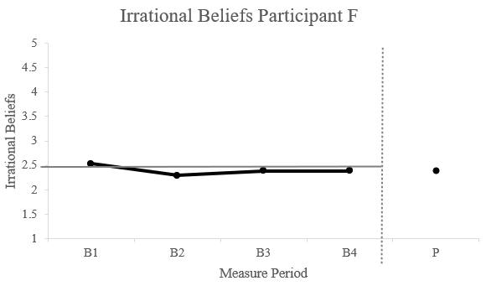
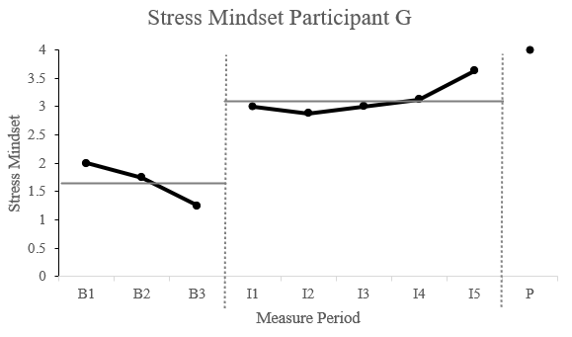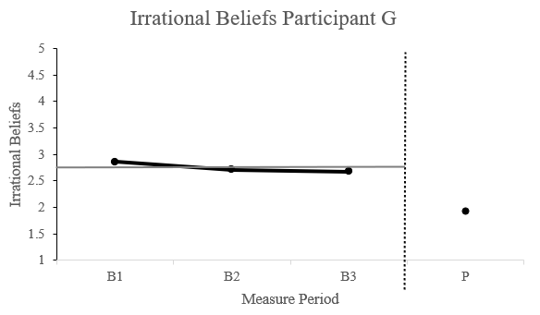

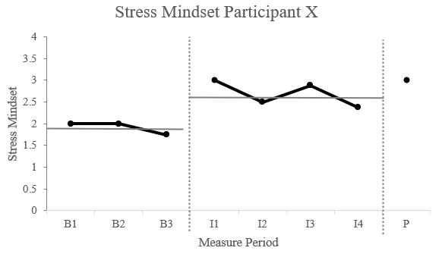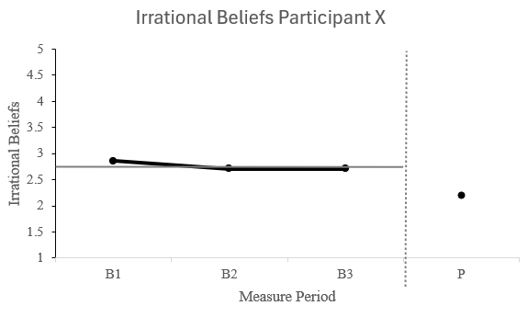

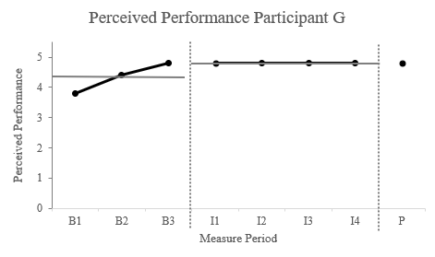
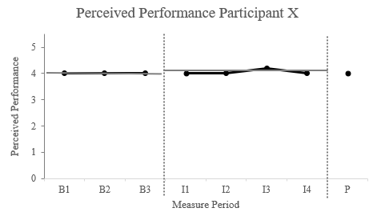
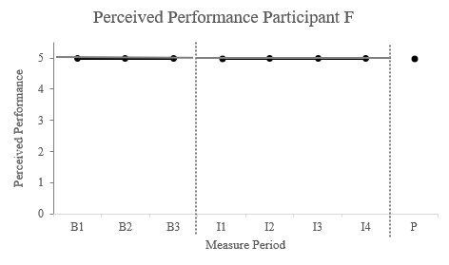
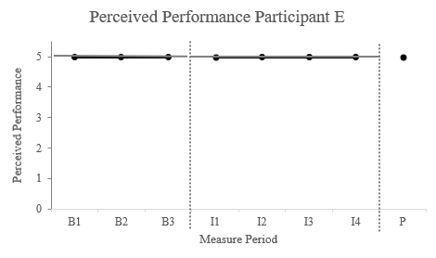

Note. B1-B4 refers to baseline measures, I1–I4 refers to measures taken during the intervention, while P refers to the post-intervention measure.
Manipulation Checks
Participants were asked to consider how easy they found it to image in session five and how engaged they were in the tasks throughout the project. Mean scores suggest that the participants felt they could image very well (6.25, SD = .83) and engaged in the tasks during the 1-2-1 sessions (6.00, SD = 1.22).
Social Validation
Social validation results revealed that the participants found the intervention to be highly beneficial for their well-being (M = 6.50) and performance (M = 6.00). This was further supported by a clear agreement that they would recommend the intervention to a friend (M = 6.50). In terms of the sessions' duration and the intervention's length overall, participants indicated that they felt both were suitable (M = 4.00).
Discussion
Utilizing a single-case approach, the aim of our study was to investigate whether a multimodal cognitive behavioural intervention could enhance stress mindset and perceived performance while also reducing irrational beliefs of elite academy football players. This is the first-known research that has aimed to enhance a stress mindset through a 1-2-1 approach with athletes, and through applying an REBT approach, and the results offer support for this type of intervention as a suitable strategy. Our study builds on previous research, which has demonstrated the effectiveness of stress mindset interventions (i.e., Crum et al., 2023; Mansell et al., 2023) in organizational and athlete samples, respectively. In our study, stress mindset increased for all participants from baseline to post-intervention, and more rapid changes were observed in three of the four participants. Stress mindset was the focus of session one, so it is unsurprising to see immediate changes in this construct (Journault et al., 2023). All participants began the intervention with a stress mindset below the mid-point on the SMM-G, and despite starting from different beliefs about stress, all participants demonstrated improvements at post-intervention. Given the known utility of education about stress (e.g., Crum et al., 2013), it is likely that presenting balanced information about the physiological and psychological responses to stress were responsible for increases in stress mindset. Although stress mindset did decrease slightly beyond session one for half of the participants, perhaps the reinforcement of stress mindset content as part of the imagery task acted as a reminder of the utility of a SEM (Keech et al., 2021). Cultivating a SEM is important, given its known associations with challenge appraisals (i.e., evaluating a situation as an opportunity to perform well; Mansell, 2021), performance (Smith et al., 2020), and mental health (Grünenwald et al., 2023). Considered as a proactive strategy when it is not possible to change the stressor (Mansell & Turner, 2023), a SEM may, therefore, be useful for academy football players given the imminent transition from academy to senior football (Stambulova et al., 2009) and may help them to avoid burnout (Zhou et al., 2024), and to perceive a higher standard of performance (Pété et al., 2023). Although we do not measure mental health specifically in this study, we suggest that including content to develop a SEM could be part of the psychological provision included within elite football settings that could support young athletes’ mental health.
In support of the hypothesis, visual inspection indicates that the intervention was responsible for reductions in irrational beliefs in all four participants (albeit only very marginally in one). These findings support the work of Bowman and Turner (2022) and Chrysidis et al. (2020) but contrast with the same style of intervention delivered in a group context to adolescent athletes by Mansell et al. (2023). Although other studies have demonstrated that REBT is effective in reducing irrational beliefs when delivered at group-level (e.g., Nejati et al., 2022), perhaps the 1-2-1 delivery within the present study enabled deeper and more specific discussions about the participant’s beliefs, such as their beliefs about being left out of the team. Participant G experienced a substantial reduction in irrational beliefs, and this may be due to a greater established working alliance between him and the sport psychologist compared with the other participants. This modality is therefore important as irrational beliefs are often deeply engrained and reinforced by socialisation and thus may be resistant to change initially (King et al., 2022), and for some there may be a lack of willingness to examine their beliefs about adversity (Turner, 2022). In session three, education about the ABC thinking framework (Ellis & Dryden, 2007) may have allowed the participants to possess a greater degree of controllability about their beliefs (B) towards activating events (A) as they recognized the benefits this might have on their thoughts, emotions, and behaviours (C) (Jordana et al., 2022). Adopting the pragmatic mode of disputation suggested by Dryden and Branch (2008), the participants were asked to consider how helpful the irrational belief examples would be towards their performance. This may have also had an adaptive influence on any debilitating beliefs about stress, given their similarity as fixed, illogical, and unhelpful (Mansell, 2021). As in Turner et al. (2014), participants reported a high degree of satisfaction with this style of intervention and would recommend participating to a friend. Overall, this adds to the literature in demonstrating that irrational beliefs may be reduced in elite young football players as part of a multimodal cognitive behavioural intervention.
Perceived performance was captured using the individual subscale of the PPQ. At the beginning of the intervention, two of the players rated their performance at the highest possible level (M = 5.00). Perhaps some participants rated their current performance as so high because they are considered to be some of the best in their country, which may lead to feelings of high confidence in their abilities (Jordana et al., 2022). A third participant experienced a negligible increase in perceived performance during the intervention, but this reverted back to the baseline mean score at the end. However, perceived performance did increase by 26.3% for Participant G, albeit from a more inconsistent baseline mean score. Interestingly, this participant also experienced the largest decrease in irrational beliefs, suggesting that this may be a factor in feeling a greater degree of confidence in his performance (Chrysidis et al., 2020). It may be also worthwhile assess the efficacy of the intervention in a similar way in other sports and to collect coach-rated performance data in the future to understand whether changes in stress mindset and irrational beliefs also translate into better athletic performance. Conducting interviews with players after the intervention may also help us to understand if they have experienced any changes in their performance resulting from the intervention. Alternatively, future research may wish to capture thriving as a construct that includes subjective performance, positive affect, and vitality (Brown et al., 2017). This may offer a wider perspective on the combination of performance and wellbeing that aligns with the purpose of this intervention.
Results from the social validation questions offer high support for the intervention. Participants unanimously felt that the intervention benefited their well-being and performance. Although measured as a self-report single-item response, this supports the findings of previous studies that have found that enhancing stress mindset and irrational beliefs may lead to better well-being and performance (e.g., Mansell et al., 2023). Encouraging as these social validation responses may be, future research may wish to include additional markers of mental health to understand whether targeting stress mindset and irrational beliefs can bring about greater mental health when delivered through a 1-2-1 approach. Recording more favourable scores in terms of session length and intervention duration than Mansell et al. (2023), the participants appear to find the 30-minute sessions more appealing than the one-hour-long group sessions.
The study's ecological validity was a strength, as the intervention was delivered in the participants’ academy by their sport psychologist. Procedural reliability was reinforced through the same practitioner’s consistent delivery of the intervention (e.g., standardised PowerPoints and player workbooks). The design of the study may also be considered as a strength due to the multiple baseline measures, at least four post-session measures, and a post-intervention measure, although future research could seek to collect up to eight baseline measures to enhance the reliability of the baseline period (Barker et al., 2020), albeit the practical challenges of doing so for sport psychologists is noted (Barker et al., 2011). Future research may wish to build on this relatively straightforward A-B research design by adopting a more complex single-case methodology, such as a withdrawal method ABA or a reintroduction approach ABAB (Barker et al., 2020). Although a useful starting point for future research of 1-2-1 psychological interventions, the small male-only sample size of this study limits the generalisability of the findings (e.g., Pété et al., 2023). Triangulation may have added a useful dimension to the study, such as collecting data from parents and coaches about their perceptions of their son’s response to the intervention (Barker & Jones, 2008). Unfortunately, a planned follow-up focus group was not conducted three months after the intervention to assess whether any changes had remained. Due to the unpredictable nature of elite sports, such challenges were often evident. However, future research should still aim to include follow-up measures as a core component of their studies.
Considering avenues for future researchers, although other studies have demonstrated that REBT effectively reduces irrational beliefs of academy football players, future research may wish to employ a longitudinal study to assess whether long-term changes are evident (Turner et al., 2014). The likelihood of long-term reductions in irrational beliefs may be supported by providing coaches with information on how they can reinforce important messages from the intervention, such as adopting rational language in half-time team talks (Evans et al., 2018). Assessing the efficacy of such an intervention in girls’ academy football should also be a priority for future research.
In conclusion, our study assessed the feasibility of a multimodal cognitive behavioural intervention in altering stress mindset, irrational beliefs and perceived performance in elite adolescent football players. Using visual inspection due to the single-case research design, results demonstrated that all four athletes experienced an increased stress mindset because of the intervention. Three of the four athletes also reported reductions in irrational beliefs from baseline to post-intervention. There were minimal changes in perceived performance. The intervention was delivered on a 1-2-1 basis by the club’s sport psychologist, and social validation results indicate a high degree of acceptability in the style and duration of the intervention and that it was beneficial to their wellbeing and performance. Despite these adaptive changes, caution should be urged, given the small sample size and the specific context.

References
Barker, J. B., & Jones, M. V. (2008). The effects of hypnosis on self-efficacy, affect, and soccer performance: A case study. Journal of Clinical Sport Psychology, 2, 127-147. DOI: https://doi.org/10.1123/jcsp.2.2.127
Barker, J., McCarthy, P., Jones, M., & Moran, A. (2011). Single case research methods in sport and exercise. Routledge.
Barros, C. P. (2006). Portuguese Football. Journal of Sports Economics, 7, 96–104. https://doi.org/10.1177/1527002505282870
Bosshard, M., Gomez, P. (2024). Effectiveness of stress arousal reappraisal and stress-is-enhancing mindset interventions on task performance outcomes: a meta-analysis of randomized controlled trials. Scientific Reports, 14, 7923. https://doi.org/10.1038/s41598-024-58408-w
Bowman, A. W., & Turner, M. J. (2022). When time is of the essence: The use of rational emotive behavior therapy (REBT) informed single-session therapy (SST) to alleviate social and golf-specific anxiety, and improve wellbeing and performance, in amateur golfers. Psychology of Sport and Exercise, 60, 102167. https://doi.org/10.1016/j.psychsport.2022.102167
Brown, D. J., Arnold, R., Standage, M., & Fletcher, D. (2017). Thriving on pressure: A factor mixture analysis of sport performers’ responses to competitive encounters. Journal of Sport and Exercise Psychology, 39, 423-437. https://doi.org/10.1016/j.jsams.2020.09.019
Cnossen, A. R. M., Maarsingh, B. M., Jerčić, P., & Rosier, I. (2023). The effects of stress mindset, manipulated through serious game intervention, on performance and situation awareness of elite female football players in the context of a match: An experimental study. Games for Health Journal, 12, 158-167. https://doi.org/10.1089/g4h.2022.0209
Crum, A. J., Salovey, P., & Achor, S. (2013). Rethinking stress: the role of mindsets in determining the stress response. Journal of personality and social psychology, 104, 716. https://doi.org/10.1037/a0031201
Evans, A. L., Turner, M. J., Pickering, R., & Powditch, R. (2018). The effects of rational and irrational coach team talks on the cognitive appraisal and achievement goal orientation of varsity football athletes. International Journal of Sports Science & Coaching, 13, 431-438. doi:10.1177/1747954118771183
Gomes, A. R., Simães, C., Morais, C., & Cunha, R. (2022). Adaptation to stress in football athletes: The importance of cognitive appraisal, Frontiers in Psychology, 13, 939840–939840. https://doi.org/10.3389/fpsyg.2022.939840.
Grünenwald, I., Kaluza, A. J., Schultze, M., & van Dick, R. (2023). Stress Mindset and Social Identification in Chronic Pain Patients and Their Relationship to Coping, Well-Being & Depression. Journal of Clinical Psychology in Medical Settings, 30, 153-168. https://doi.org/10.1007/s10880-022-09883-8
Jordana, A., Ramis, Y., Chamorro, J.L., Pons, J., Borrueco, M., De Brandt, K., & Torregrossa, M. (2022).. Ready for Failure? Irrational Beliefs, Perfectionism and Mental Health in Male Soccer Academy Players. Journal of Rational-Emotive Cognitive-Behavior Therapy, 41, 454–477. https://doi.org/10.1007/s10942-022-00491-x
Journault, A. A., Cernik, R., Charbonneau, S., Sauvageau, C., Giguère, C. É., Jamieson, J. P., & Lupien, S. J. (2023). Learning to embrace one’s stress: the selective effects of short videos on youth’s stress mindsets. Anxiety, Stress, & Coping, 1-16. https://doi.org/10.1080/10615806.2023.2234309
Keech, J. J., Hagger, M. S., & Hamilton, K. (2021a). Changing stress mindsets with a novel imagery intervention: A randomized controlled trial. Emotion, 21, 123. https://doi.org/10.1037/emo0000678
Keech, J. J., Hagger, M. S., O’Callaghan, F. V., & Hamilton, K. (2018). The influence of university students’ stress mindsets on health and performance outcomes. Annals of Behavioral Medicine : a Publication of the Society of Behavioral Medicine, 52, 1046–1059. https://doi.org/10.1093/abm/kay008
Keech, J. J., Orbell, S., Hagger, M. S., O’Callaghan, F. V., & Hamilton, K. (2021b). Psychometric properties of the stress control mindset measure in university students from Australia and the UK. Brain and Behavior, 11, e01963. https://doi.org/10.1002/brb3.1963
King, A. M., Plateau, C. R., Turner, M. J., Young, P., & Barker, J. B. (2024). A systematic review of the nature and efficacy of Rational Emotive Behaviour Therapy interventions. Plos One, 19, e0306835. https://doi.org/10.1371/journal.pone.0306835
Lang, P. J. (1979). A bio‐informational theory of emotional imagery. Psychophysiology, 16, 495-512. https://doi.org/10.1111/j.1469-8986.1979.tb01511.x
Mansell, P. C. (2021). Stress mindset in athletes: Investigating the relationships between beliefs, challenge and threat with psychological wellbeing. Psychology of Sport and Exercise, 57, 102020. https://doi.org/10.1016/j.psychsport.2021.102020
Mansell, P., Sparks, K., Wright, J., Roe, L., Carrington, S., Lock, J., & Slater, M. (2023). “Mindset: performing under pressure”–a multimodal cognitive-behavioural intervention to enhance the well-being and performance of young athletes. Journal of Applied Sport Psychology, 1-20. https://doi.org/10.1080/10413200.2023.2296900
Meijen, C., Turner, M., Jones, M. V., Sheffield, D., & McCarthy, P. (2020). A theory of challenge and threat states in athletes: A revised conceptualization. Frontiers in Psychology, 11, 126. https://doi.org/10.3389/fpsyg.2020.00126
Mellalieu, S. D., Hanton, S., & Thomas, O. (2009). The effects of a motivational general-arousal imagery intervention upon preperformance symptoms in male rugby union players. Psychology of Sport and Exercise, 10, 175-185. https://doi.org/10.1016/j.psychsport.2008.07.003
Neff, K. (2003). Self-compassion: An alternative conceptualization of a healthy attitude toward oneself. Self and Identity, 2, 85–101. https://doi.org/10.1080/15298860309032
Nogueira, D., Fontes, L., Gomes, A. R., & Resende, R. (2022). Referees’ emotions and performance perception: The importance of stress and cognitive appraisal. Cuadernos de Psicologia del Deporte, 22, 156-170. https://doi.org/10.6018/cpd.468751
Pustejovsky, J. E. (2018). Using response ratios for meta-analyzing single-case designs with behavioral outcomes. Journal of School Psychology, 68, 99-112. https://doi.org/10.1016/j.jsp.2018.02.003
Schinke, R. J., Henriksen, K., Moore, Z. E., Stambulova, N., Bartley, J., Cosh, S., ... & Wong, R. (2024). International society of sport psychology position stand: elite athlete mental health revisited. International Journal of Sport and Exercise Psychology, 1. https://doi.org/10.1080/1612197X.2024.2359872
Smith, E. N., Young, M. D., & Crum, A. J. (2020). Stress, mindsets, and success in Navy SEALs Special Warfare Training. Frontiers in Psychology, 10, 2962. https://doi.org/10.3389/fpsyg.2019.02962
Stambulova, N., Alfermann, D., Statler, T., & CôTé, J. E. A. N. (2009). ISSP position stand: Career development and transitions of athletes. International Journal of Sport and Exercise Psychology, 7, 395-412. DOI: 10.1080/1612197X.2009.9671916
Turner, M. (2022). The rational practitioner: The sport and performance psychologist’s guide to practicing rational emotive behaviour therapy. Routledge.
Turner, M. J., Ewen, D., & Barker, J. B. (2018a). An Idiographic Single-Case Study Examining the Use of Rational Emotive Behavior Therapy (REBT) with Three Amateur Golfers to Alleviate Social Anxiety. Journal of Applied Sport Psychology, 32, 186–204. https://doi.org/10.1080/10413200.2018.1496186
Turner, M. J., Kirkham, L., & Wood, A. G. (2018b). Teeing up for success: The effects of rational and irrational self-talk on the putting performance of amateur golfers. Psychology of Sport and Exercise, 38, 148-153. https://doi.org/10.1016/j.psychsport.2018.06.012
Watson, D. R., Hill, A. P., & Madigan, D. J. (2023). Psychological skills training and perfectionism: A single-subject multiple baseline study. Journal of Applied Sport Psychology, 35, 854-873. https://doi.org/10.1080/10413200.2022.2137597
World Health Organization. (2022). https://www.who.int/data/gho/data/major-themes/health-and-well-being
Zhou, Y., Jin, T., & Zhang, L. (2024). Can the stress be managed? Stress mindset as a mitigating factor in the influence of job demands on burnout. Nursing Open, 11, e70028. https://doi.org/10.1002/nop2.70028
Table 1
Participant Characteristics in Stress Mindset, Irrational Beliefs, and Perceived Performance.
Measure | Participant | Baseline  Mean (SD) | During-intervention  Mean (SD) | Post-intervention | Effect Size  (% change)
Stress mindset | E | 1.95 (0.36) | 2.60 (0.16) | 2.63 | +34.9%
 | F | 1.19 (0.29) | 1.06 (0.32) | 1.88 | +56.0%
 | G | 1.67 (0.31) | 3.13 (0.26) | 4.00 | +139.5%
 | X | 1.92 (0.12) | 2.69 (0.26) | 3.00 | +58.0%
Irrational beliefs | E | 3.08 (0.14) | - | 2.60 | -15.6%
 | F | 2.4 (0.09) | - | 2.39 | -0.4%
 | G | 2.75 (0.08) | - | 1.93 | -42.5%
 | X | 2.76 (0.07) | - | 2.21 | -20.0%
Perceived performance | E | 5.00 (0.00) | 5.00 (0.00) | 5.00 | 0%
 | F | 5.00 (0.00) | 5.00 (0.00) | 5.00 | 0%
 | G | 4.33 (0.50) | 4.80 (0.00) | 4.80 | +26.3%
 | X | 4.00 (0.00) | 4.05 (0.10) | 4.00 | 0%

Table 2
Structure of the Multi-Modal Cognitive Behavioural Intervention (M:PUP).
Session Topic | Session Content | Theory | Example Activities
- Stress mindset | Introduction of intervention (aims, practicalities). Explore understanding of stress. Introduction of stress-mindset | Stress Mindset (Crum et al., 2013) | Production of mind map of associated words with stress.  Video: Rethinking stress.  The ‘Stress Piggy Bank’
- Stress mindset,  challenge and threat | Understand how to apply stress mindset theory. Introduction of seeing a stressful situation as a challenge or threat | The Theory of Challenge and Threat in Athletes-Revised (Meijen et al., 2020) | Control Map: Acknowledging what an individual can/cannot control
- Irrational beliefs | Introduction of the ABC framework poised within REBT to help players think more adaptively prior to stressful situations | Rational Emotive Behaviour Therapy (REBT; Ellis & Dryden, 2007) | The ‘Badness Scale’ to dispute players’ beliefs.  Demonstration of a credo and assist players to create their own
- Self-compassion | Understand how players might think prior to a competitive match and which strategies’ players can use to approach competition more helpfully | Self-compassion (self-kindness, common humanity, and mindfulness (Neff, 2003) | ‘Fear Wall’ activity to promote common humanity. Role play of ‘good vs bad wolf’ to promote self-kindness
- Imagery | Introduction to imagery, practice imagery underpinned by the Bioinformational Theory of Imagery (Lang, 1979) | Enhancing stress mindset through imagery (Keech et al., 2021a) | Depiction of the importance of imagery. Co-write imagery script for future use
- Recap of all topics | Recap and reflect on how athletes’ thoughts and feelings about stressful situations may have changed over the course of the intervention | All the above | Athletes were provided with an overview of strategies they had learned on the intervention which was referred to as their toolkit

