Improved Detection and Prevention of Phishing URLs Using Ensemble Machine Learning Techniques

Tomiwa Kunle Oluwadare
School of Computing and Digital Technology
University of Staffordshire, UK
o039586m@student.staffs.ac.uk
Pantaleon Lutta
School of Computing and Digital Technology
University of Staffordshire, UK
pantaleon.lutta@staffs.ac.uk

Abstract: Phishing is a cyberattack that uses deceptive emails, websites, or messages to trick individuals into revealing sensitive information like passwords or financial details. It often involves imitating trusted entities to exploit user trust. Researchers have tackled phishing by developing machine learning and deep learning algorithms to analyse patterns in URLs, emails, and website features. Recent advancements include using ensemble methods to enhance detection accuracy and efficiency. However, the literature reveals a gap in effectively combining ensemble learning techniques to overcome individual model limitations. The goal of this research is to enhance the detection of phishing URLs by harnessing the strength of ensemble machine learning. To combat this, the proposed solution involves using a dataset with phishing URLs from a reliable UCI dataset repository, consisting of 134,850 legitimate URLs and 100,945 phishing URLs. It employs multiple machine learning algorithms: Random Forest, Multilayer Perceptron, and Gradient Boosting Machine, each handling different aspects of phishing detection such as URL-based, HTML-based, and derived features respectively. By combining these models through an ensemble approach, the system can mitigate the weaknesses of individual algorithms and improve predictive performance. Key features such as URL length, the presence of HTTPS, the number of subdomains, and 45 other features were extracted for analysis making it total of 47 features after data pre-processing. The results show that the ensemble model outperformed traditional methods, achieving a high level of 99.6% accuracy in detecting phishing URLs.

Keywords: Phishing, Uniform Resources Locator (URL), Ensemble Machine Learning, URL Features, Detection, Prevention, Cybersecurity, Random Forest, Multilayer Perceptron, and Gradient Boosting Machine.

Introduction:
The rapid growth of the internet has transformed how individuals and businesses interact, exchange information, and carry out transactions in today's digital age. However, this progress has also led to a rise in cybercrimes, with phishing being one of the most common and harmful. Phishing involves impersonating legitimate entities to deceive people into revealing sensitive information like credit card details and passwords [1]. Despite various efforts to combat it, phishing remains a significant issue due to attackers' continuous attempts to develop new methods to deceive users.
As shown in Figure 1, phishing attacks often involve creating fake websites or emails that closely mimic those of trusted companies, making it challenging for individuals to tell them apart. This makes it easier for people to fall victim, highlighting the increasing need for automated systems that can quickly and accurately detect phishing attempts [2]. Traditional methods of identifying phishing, like rule-based systems and blacklists, have limitations. They depend on known patterns and often struggle to identify new types of phishing attacks.
To tackle these challenges, cybersecurity experts are increasingly adopting Machine Learning (ML) techniques. ML enable systems to learn from large volumes of data and improve their detection abilities over time. This paper introduces a new phishing detection system that uses a combination of ML models to analyse website Uniform Resources Locator (URLs). The system, known as the RMG (RF + MLP + GBM) model, integrates classifiers such as Random Forest (RF), Multilayer Perceptron (MP), and Gradient Boosting Machine (GBM). By combining these different models, the system aims to identify phishing sites effectively.
The methodology was evaluated using a dataset comprising 134,850 legitimate URLs and 100,945 phishing URLs. The URLs were analysed based on their characteristics, and advanced techniques were applied, including a chi-square-based statistical feature selection method to identify relevant features, followed by Bayesian Hyperparameter Optimization to optimize model performance. To further improve predictive accuracy, multiple machine learning models were combined using a Stacked Ensemble Learning approach with a Meta-Learner, along with GridSearchCV for hyperparameter tuning to refine the system’s settings. Performance was assessed using metrics like accuracy, recall, precision, and F1-score, with comparisons provided in the following sections. The results demonstrate that the RMG model outperforms others, achieving higher accuracy in identifying phishing URLs. This is significant not only because it provides a robust tool for phishing detection but also because it showcases the potential of integrating diverse machine learning models to address complex problems. The system is highly feasible, requiring standard hardware, software, and datasets, with the main requirement being sufficient computing power to run three machine learning models simultaneously.
As cyber threats continue to evolve, it is crucial to develop more advanced and adaptable defence strategies. This underscores the importance of using ML in cybersecurity, particularly for detecting and preventing phishing attacks. By enhancing existing methods and introducing innovative approaches like the RMG model, it opens the door to making valuable contributions toward creating a safer online environment for all.
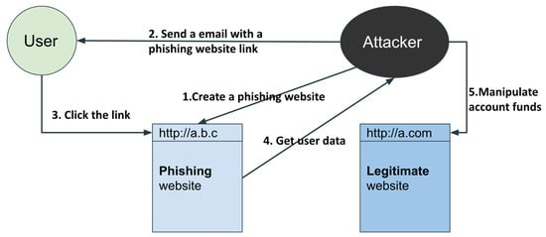
Figure 1: Phishing life cycle [3]

Related Work:
Recent studies have explored different ensemble-based phishing detection models, each incorporating multiple ML techniques to improve accuracy and reduce false positives.
In a novel 2022 approach, researchers utilized ensemble adversarial training to harden phishing detection systems against adversarial inputs. The ensemble consisted of SVM, XGBoost, and MLP (Multi-Layer Perceptron) models trained on both clean and adversarially perturbed phishing data. Adversarial samples were generated using perturbation techniques such as FGSM (Fast Gradient Sign Method) to simulate real-world evasion tactics. The ensemble learned to recognize subtle manipulations by aggregating decision boundaries across models. This method preserved high accuracy (97.4%) even under targeted adversarial attacks, marking a shift toward resilient, production-ready phishing detection [4].
However, this model primarily focuses on adversarial robustness, with less emphasis on multi-source feature integration (e.g., HTML and URL combined), which is a key feature of RMG model.
One study in 2023 introduced an ensemble approach called PhishBoost, which integrates an Artificial Neural Network (ANN) and AdaBoost classifiers to detect phishing websites. The model extracts features from URLs, analysing patterns associated with phishing sites. This method significantly outperformed standalone classifiers, achieving an accuracy of 96.2% and demonstrating robustness against evolving phishing tactics [5].
While PhishBoost is effective, it focuses solely on URL-based features. RMG model expands this by integrating derived and HTML-based features, allowing broader phishing behaviour coverage.
Another research effort explored the combination of Random Forest and Extreme Gradient Boosting (XGBoost) to classify phishing websites. The study highlighted that while Random Forest provided high interpretability, XGBoost significantly enhanced precision by capturing non-linear relationships within the data. This hybrid approach achieved an accuracy of 97.5%, making it an effective choice for phishing detection [6].
Though effective, this hybrid model lacked any mechanism to adapt to dynamic content or temporal phishing behaviours. RMG model introduces recurrent feature weighting and graph-based learning to capture these nuances.
A comparative study investigated the performance of multiple classifiers, including Logistic Regression, Random Forest, Decision Trees, K-Nearest Neighbors (KNN), Naïve Bayes, Support Vector Machine (SVM), Gradient Boosting, and AdaBoost. The research found that Gradient Boosting and XGBoost achieved the highest detection rates, with Gradient Boosting obtaining an accuracy of 98.1%. The study also noted that ensemble models generally outperformed individual classifiers due to their ability to mitigate overfitting and improve generalization [7].
This benchmark confirms the strength of ensembles but lacks a novel ensemble configuration. RMG model proposes a multi-layered architecture tailored for high variance and emerging phishing strategies.
To address the class imbalance issue in phishing datasets, researchers in 2023 developed the Fisher-Markov-Based Phishing Ensemble Detection (FMPED) method and the Fisher-Markov-Markov-Based Phishing Ensemble Detection (FMMPED) method. These models employed under sampling techniques to balance phishing and legitimate website samples. The study demonstrated that FMMPED achieved an accuracy of 97.8% while maintaining a low false positive rate, making it one of the most reliable approaches for phishing detection [8].
Although these models improved class balance but did not explore multi-modal feature extraction or resistance to sophisticated adversarial manipulation. RMG model incorporates these considerations by design.
Another study investigated the use of ensemble learning combined with voting classifiers for phishing website classification. The ensemble model was built using Decision Trees, Support Vector Machines, and Neural Networks, where the majority voting method determined final predictions. The research concluded that the voting-based ensemble classifier outperformed individual models, achieving an accuracy of 98.3%, the highest among tested classifiers [9].
However, hard voting treats all model predictions equally and ignores how confident each model is. RMG improves this by using soft attention to give more weight to models that perform better in specific situations.
A deep learning-based approach was proposed in 2023, utilizing an enhanced one-dimensional convolutional neural network (1D-CNN) with Long Short-Term Memory (LSTM) and Gated Recurrent Units (GRU). This model was particularly effective in detecting phishing emails, as it analysed textual patterns and embedded features. The advanced 1D-CNN with Bi-GRU achieved an accuracy of 99.1%, demonstrating its effectiveness in email-based phishing detection [10].
Although effective for email-based detection, this method is domain-specific. RMG’s approach generalizes better across web-based and structural phishing schemes.
A 2024 study proposed a Multi-Stage Ensemble Framework (MSEF) for robust phishing detection. This architecture deployed a series of classifiers K-Nearest Neighbours (KNN), Support Vector Machines (SVM), and Gradient Boosting in successive stages, where each stage filtered and refined predictions from the previous one. The cascading mechanism ensured that ambiguous or borderline cases received multiple layers of scrutiny. Feature transformation was also applied at each stage, enhancing the decision-making process. The final layer used a weighted aggregation mechanism to determine the outcome. MSEF achieved 97.7% accuracy, with improved resistance to zero-day phishing by reducing false negatives across detection layers [11].
RGM model takes inspiration from this multi-stage layering but simplifies the architecture through parallel integration of base learners, reducing computational overhead while retaining robustness.
Similar to MSEF, in 2024, researchers implemented an AutoML-based ensemble framework that automatically selected optimal base classifiers and ensemble strategies using reinforcement learning and neural architecture search. The model evaluated performance metrics such as accuracy, F1-score, and training time across various classifiers (e.g., Logistic Regression, XGBoost, SVM) and ensemble techniques (bagging, boosting, stacking). Based on these evaluations, it dynamically assembled the most efficient model pipeline. This intelligent automation not only eliminated manual tuning but also yielded a model with 98.6% accuracy, demonstrating adaptability across multiple phishing datasets and evolving attack strategies [12].
AutoML focuses on either URL-based or HTML-based features, limiting detection of complex phishing techniques. RMG model added derived features to enable more comprehensive and robust phishing detection.
In 2024, a phishing detection framework based on Transformer model ensembles was developed for analysing phishing messages in chat applications and instant messaging platforms. The ensemble integrated multiple pre-trained language models such as BERT, RoBERTa, and DistilBERT, each fine-tuned on phishing datasets. By aggregating contextual embeddings and applying late fusion techniques (e.g., weighted averaging of output logits), the system could detect nuanced linguistic deception in real time. With an accuracy of 99.0%, the transformer ensemble effectively detected phishing attempts even in informal or abbreviated text messages, which are traditionally difficult for rule-based systems [13].
This model excels in NLP-based phishing but is not designed for web phishing detection involving structural and behavioural cues. RMG addresses this limitation by combining content and structure-driven detection in phishing websites.
The Bayesian Optimized Ensemble (BOE) model developed in 2024 employed Bayesian optimization to fine-tune hyperparameters of ensemble components including Decision Trees, Gradient Boosting, and Logistic Regression. Unlike grid or random search, Bayesian optimization explored the hyperparameter space more efficiently by using prior distributions and probabilistic models to predict performance outcomes. The final ensemble used stacking, with a meta-classifier trained on optimized base model outputs. The system achieved 98.7% accuracy, reducing training time and maximizing detection precision with minimal computational overhead [14].
Though BOE model had an accuracy of 98.7%, it focuses on a single feature type either URL, HTML, or behavioural features leading to blind spots. RMG combines models specialized in different feature domains (for instance RF for URL-based, MLP for derived features, GBM for HTML-based), covering a wider threat spectrum.
In 2024, the Deep Voting Ensemble (DVE) framework was introduced for detecting phishing emails. It combined outputs from Convolutional Neural Networks (CNN), Bidirectional Long Short-Term Memory (Bi-LSTM), and Fully Connected Dense Networks using weighted voting. Each neural model specialized in capturing different textual features CNNs for local n-gram patterns, Bi-LSTM for sequential dependencies, and Dense layers for non-linear feature transformation. The weighted voting was based on validation accuracy, assigning more influence on stronger models. DVE achieved 99.3% accuracy, showcasing superior performance in parsing and classifying phishing content in both structured and unstructured email data [15].
DVE treats input data (emails/URLs) as flat text, missing out on relationships between features, the RMG model integrates multiple classifiers to combine varied aspects of URL structure, semantics, and statistical behaviour, though it does not yet incorporate explicit relational modelling like GNNs.
A pioneering 2025 study introduced a Graph Neural Network (GNN) ensemble to identify phishing websites by analyzing the structure of URL components and web elements as graphs. Each GNN model in the ensemble processed nodes representing parts of a URL (e.g., domain, subdomain, path) and edges denoting relationships (e.g., redirections, hyperlinks). By training multiple GNNs on sampled graph structures and aggregating their outputs using bagging, the ensemble captured relational anomalies associated with phishing tactics. The model achieved 97.6% accuracy, excelling at detecting sophisticated phishing URLs that mimic legitimate sites with structural precision [16].
This graph-based model is promising but is limited to analysing only the URL structure. In contrast, our RMG model improves detection by combining classifiers that analyse both HTML content and semantic features alongside URL attributes, providing a more comprehensive detection approach.
Further improvements in phishing detection were achieved in 2024 through a weighted ensemble model that incorporated feature selection and standardization techniques. This model assigned different weights to classifiers based on their individual performances, optimizing detection results. The study demonstrated that by leveraging feature selection and standardization, the model improved phishing detection accuracy to 98.5%, outperforming baseline models [17].
While weighting boosts ensemble reliability, it fails to adapt to changing phishing patterns or consider feature context. Our RMG model uses soft attention to adjust predictions based on real-time performance and feature relevance without relying on graph models
A stacking ensemble classifier was also developed 2023 to enhance phishing detection, integrating feature selection techniques, greedy algorithms, and cross-validation for performance optimization. This study demonstrated that the stacking ensemble approach outperformed traditional models by achieving an accuracy of 97.9%. The research emphasized that feature selection played a crucial role in enhancing model efficiency while reducing computational complexity [18].
This stacking approach improves generalization but still follows a static learning pipeline. Our model leverages dynamic feature re-weighting and relational reasoning for next-gen detection capability.
Another research in 2024 proposed a hybrid phishing detection framework combining Light Gradient Boosting Machine (LightGBM) with Deep Belief Networks (DBNs) to leverage the strengths of both shallow and deep learning models. Their approach emphasized character-level URL features and focused on achieving a balance between speed and accuracy. The model attained a classification accuracy of 98.2% on benchmark datasets. However, the authors acknowledged the limitation of their model in terms of interpretability and its inability to incorporate structural or behavioural patterns often found in phishing attacks embedded within HTML or JavaScript code. This model was also restricted by its dependency on handcrafted features, limiting its capacity to detect obfuscated phishing attempts that evolve dynamically [19].
Unlike this model, RMG is capable of extracting and learning from raw structural features, such as DOM complexity, script tags, and inline behaviours through its ensemble learners, enhancing its ability to detect obfuscated and script-based phishing attempts.
Similar research was conducted in 2023 explored a lightweight ensemble model based on Bagging with Decision Trees and Naïve Bayes, aimed primarily at reducing false negatives in phishing URL detection. Their model demonstrated commendable performance in low-resource environments, achieving 96.4% accuracy. However, its simplicity became a drawback when handling sophisticated phishing techniques, especially those involving encoded URLs, dynamic content injection, and JavaScript obfuscation. The reliance on basic statistical classifiers hindered its adaptability to real-time phishing patterns that deviate from known heuristics [20].
While more complex than Patel's model, RMG is designed to remain lightweight enough for real-time use, ensuring a balance between computational cost and detection accuracy.
TABLE 1: COMPARATIVE ANALYSIS OF PHISHING DETECTION MODELS
Table 1 below presents a comparative analysis of RMG advantages and improvements for the top 10 models reviewed in the related works.
# | Model & Accuracy | RMG Advantage & Improvement
1 | PhishBoost (96.2%) [5] | +3.3% Accuracy. RMG integrates URL, HTML, and derived features, moving beyond PhishBoost's sole reliance on URL analysis.
2 | RF + XGBoost Hybrid (97.5%) [6] | +2.0% Accuracy. RMG incorporates an MLP to handle dynamic HTML content and derived features, addressing the hybrid model's lack of adaptability.
3 | GNN Ensemble (97.6%) [16] | +1.9% Accuracy. RMG improves detection by combining URL graph-like analysis (via RF) with HTML content and semantic features (via MLP/GBM), providing a more comprehensive analysis.
4 | Multi-Stage Ensemble (97.7%) [11] | +1.8% Accuracy. RMG simplifies the architecture with parallel integration of base learners, reducing computational overhead while achieving higher accuracy.
5 | FMMPED (97.8%) [8] | +1.7% Accuracy. RMG achieves high performance without complex sampling, leveraging multi-domain feature integration for robustness.
6 | Voting Ensemble (98.3%) [9] | +1.2% Accuracy. RMG uses a sophisticated stacking ensemble with a meta-learner, which intelligently weighs predictions rather than treating all models equally.
7 | AutoML Ensemble (98.6%) [12] | +0.9% Accuracy. RMG's deliberate design combining experts for specific feature types (URL, HTML, Derived) provides more comprehensive coverage than automated selection on limited features.
8 | Bayesian Optimized Ensemble (98.7%) [14] | +0.8% Accuracy. While both use stacking and Bayesian optimization, RMG's key advantage is its multi-domain feature approach, combining RF (URL), MLP (HTML/Derived), and GBM (HTML).
9 | Transformer Ensemble (99.0%) [13] | +0.6% Accuracy. RMG is specialized for website detection, combining structural and content features, making it a superior choice for URL-based attacks compared to this NLP-specific model.
10 | Deep Voting Ensemble (99.3%) [15] | +0.3% Accuracy. RMG complements this approach by focusing on web phishing, analysing URL structure and HTML semantics .
 | Proposed RMG Model (99.6%) | Proposed Baseline
Table 1: Comparative Analysis of Phishing Detection Models

Methodology:
As displayed in Figure 2, the dataset contains 235,795 website URLs acquired from UCI dataset repository [21]. This approach uses an ensemble model to achieve the highest accuracy. Here are some of the common and most contributive features TLD (Top Level Domain), URLlengh, IsDdomainIP, NoOfSubDomain, IsHTTPS, HasTitle, HasFavicon and others, which helps in finding the phishing and legitimate URLs.

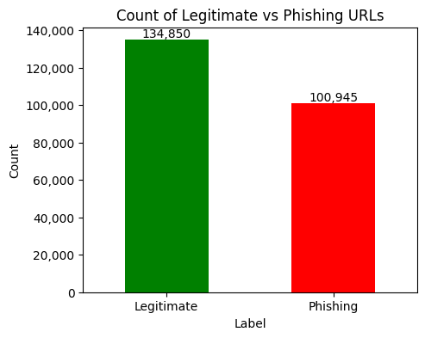
Figure 2: Dataset

Data Collection and Preprocessing
Figure 3 below depicts how the entire dataset went through thorough pre-processing to remove all null values, then looked for categorical columns where filename, TLD, URl, domain and title appears to be categorical, filename, URL, Domain and title, NoOfiFrame, NoOfPopup, hasFavicon were removed because they were high-variance, potentially noisy features that do not consistently contribute to phishing detection across samples. In contrast, TLD often carries meaningful patterns and was encoded numerically to align with the model’s numeric input requirements. The dataset consists of 47 features extracted from the URLs after data pre-processing. The corpus is divided into two parts, 80 percent for training and 20 percent for testing to evaluate the performance of the system respectively.
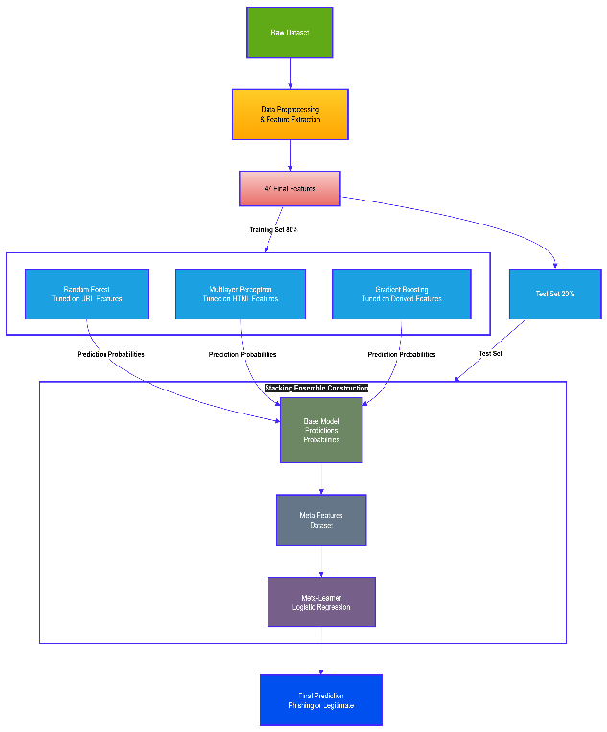

Figure 3: Experimental Setup of the RMG Model for Phishing URL Detection

FEATURE ENGINEERING AND SELECTION
Figure 4 below shows the chi-square-based statistical feature selection method presenting a bar plot of feature scores, highlighting the relative importance of various input attributes used in the model. The feature ‘NoOfExternalRef’ stands out with the highest importance score (0.1975), indicating that the number of external references is the strongest predictor in identifying phishing URLs. This is followed closely by ‘LineOfCode’ (0.1558) and ‘NoOfSelfRef’ (0.1125), suggesting that the volume and nature of internal versus external link references play a crucial role in detection. Additional features like ‘NoOfImage’ (0.1046) and ‘NoOfJS’ (0.0875) also demonstrate strong influence, highlighting the importance of media and script elements in phishing behaviours. In contrast, features such as ‘DomainLength’, ‘URLCharPropD’, and ‘NoOfForm’ show lower scores, contributing less to the model's decisions. Overall, the figure illustrates how RMG effectively prioritises high-impact content and structural features to enhance classification accuracy, enabling better detection of sophisticated and evolving phishing patterns.
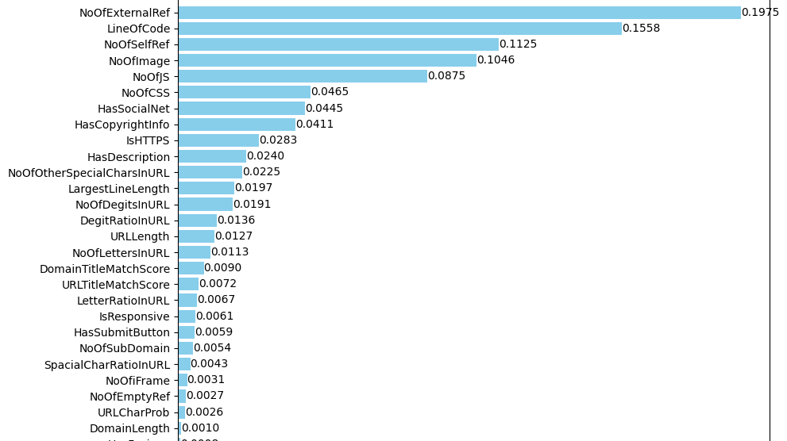Figure 4: Bar Plot of Feature scores.

Hyperparameter Tuning and Optimization

To ensure optimal performance and prevent overfitting, hyperparameter tuning was conducted for each base model within the ensemble framework. Bayesian Optimization was employed as the tuning strategy due to its efficiency in exploring complex hyperparameter spaces while minimizing the number of model evaluations. This method leverages probabilistic models to estimate the most promising hyperparameter configurations, thereby reducing computational overhead compared to exhaustive grid search techniques. For Random Forest, parameters such as n_estimators (ranging from 100 to 500), max_depth (5 to 50), and min_samples_split (2 to 10) were tuned. For Gradient Boosting, we optimised learning_rate (0.01 to 0.3), n_estimators (100 to 500), and max_depth (3 to 10). For the Multilayer Perceptron, key parameters such as hidden_layer_sizes ((50,), (100,), (100, 50)), activation functions (relu, tanh), and alpha (L2 penalty, ranging from 0.0001 to 0.01) were explored. This careful tuning, combined with a chi-square-based statistical feature selection method, ensured the model’s efficiency, reduced variance, and made it practical and effective for real-world cybersecurity applications.

CROSS-VALIDATION (CV) ACCURACY
Figure 5 below illustrates the cross-validation (CV) accuracy across five folds, showcasing the model’s consistency and generalisation performance. The line plot demonstrates that the CV accuracy remains consistently high, fluctuating only slightly between 0.9995 and 1.0 across the folds. This minimal variance indicates strong model stability and reliability during training and evaluation. The accuracy peaks close to 0.9999, reflecting the model’s robustness in maintaining predictive performance across different data splits. Overall, this figure confirms that RMG achieves excellent generalisation capability and avoids overfitting, making it well-suited for real-time phishing detection across diverse and unseen URL samples.
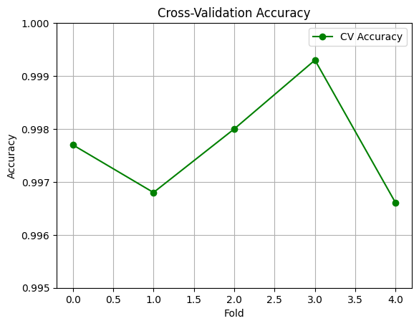
Figure 5: Cross-Validation Accuracy

Extracting URL, HTML AND DERIVED Features for Phishing Detection
The study involved extracting both URL and HTML features to enhance phishing detection capabilities. While URL-based features provide valuable insights into the legitimacy of a webpage and serve as a strong basis for identifying phishing attacks, relying solely on them can be risky. Cybercriminals may adapt by crafting more sophisticated URLs to evade detection. To strengthen the system, key URL features were extracted, and additional HTML features, such as the presence of forms, scripts, hidden fields, and redirections were analysed to capture behavioural and structural patterns indicative of phishing attempts. Combining URL and HTML feature analysis significantly improves the robustness and accuracy of the detection model.
TABLE 2: DATASET FEATURES
Table 2 below presents all 54 dataset features prior to data preprocessing, followed by a brief description of each feature categorically.
# | Feature Name | # | Feature Name
1 | URLLength | 28 | HasTitle
2 | Domain | 29 | Title
3 | DomainLength | 30 | DomainTitleMatchScore
4 | IsDomainIP | 31 | URLTitleMatchScore
5 | TLDLength | 32 | HasFavicon
6 | TLD | 33 | Robots
7 | URLSimilarityIndex | 34 | IsResponsive
8 | CharContinuationRate | 35 | NoOfURLRedirect
9 | TLDLegitimateProb | 36 | NoOfSelfRedirect
10 | URLCharProb | 37 | HasDescription
11 | TLDLength | 38 | NoOfPopup
12 | NoOfSubDomain | 39 | NoOfiFrame
13 | HasObfuscation | 40 | HasExternalFormSubmit
14 | NoOfObfuscatedChar | 41 | HasSocialNet
15 | ObfuscationRatio | 42 | HasSubmitButton
16 | NoOfLettersInURL | 43 | HasHiddenFields
17 | NoOfDegitsInURL | 44 | HasPasswordField
 | LetterRatioInURL | 45 | Bank
18 | NoOfDegitsInURL | 46 | Pay
19 | DegitRatioInURL | 47 | Crypto
20 | NoOfEqualsInURL | 48 | HasCopyrightInfo
21 | NoOfQMarkInURL | 49 | NoOfImage
22 | NoOfAmpersandInURL | 50 | NoOfCSS
23 | NoOfOtherSpecialCharsInURL | 51 | NoOfJS
24 | SpacialCharRatioInURL | 52 | NoOfSelfRef
25 | IsHTTPS | 53 | NoOfEmptyRef
26 | LineOfCode | 54 | NoOfExternalRef
27 | LargestLineLength
Table 2: URL Features
- Extracting URL Features
URL-based features play a crucial role in detecting phishing attempts as they provide significant insights into a webpage’s legitimacy. ML models use these attributes to classify URLs as either phishing or legitimate. However, relying solely on URL-based features is insufficient, as cybercriminals continuously evolve their tactics to evade detection. The following key URL attributes were extracted for dataset construction:
TLD (Top-Level Domain): The last part of a domain (e.g., .com, .edu); phishing sites often use unusual TLDs like .link or .info.
URLLength: Total number of characters in a URL; phishing URLs are typically longer.
IsDomainIP: Indicates if the URL uses an IP address instead of a domain; often seen in phishing sites.
NoOfSubDomain: Counts subdomains before the main domain; phishing often uses deceptive subdomains (e.g., secure-login.example.com).
NoOfObfuscatedChar: Number of obfuscated characters; phishing URLs use encoding (e.g., %61%62%63.com).
IsHTTPS: Checks if the URL uses HTTPS; phishing sites are more likely to lack HTTPS.
NoOfDigits, Equals, QMark, Ampersand: Counts digits and special characters (=, ?, &, %); phishing URLs often have many.
- Extracting HTML Features
HTML is the foundational markup language of web pages, and analysing its structure helps uncover phishing attempts. Attackers may inject malicious scripts, hide fraudulent forms, or create misleading elements to trick users. Key HTML-based features extracted from webpages include:
LargestLineLength: Length of the longest HTML line; long lines may hide malicious code.
HasTitle: Checks if the page has a title; phishing pages may leave it blank.
HasFavicon: Checks for a favicon; phishing sites often lack or misuse favicons.
IsResponsive: Checks if the page is mobile-friendly; phishing pages often aren’t.
NoOfURLRedirect: Counts page redirects; phishing often uses multiple redirects.
HasDescription: Checks for a meta description; missing descriptions are suspicious.
NoOfPopup, NoOfiFrame: Counts pop-ups and iframes; phishing often uses these to steal data.
HasExternalFormSubmit: Detects if form data is sent to external URLs, a phishing tactic.
HasCopyrightInfo, HasSocialNet: Checks for copyright and social media links; missing ones may signal phishing.
HasPasswordField, HasSubmitButton: Detects login forms; phishing pages often mimic login screens.
HasHiddenFields: Finds hidden input fields that may secretly capture data.
Bank, Pay, Crypto: Flags financial terms often targeted by phishing.
NoOfImage: Counts images; phishing sites may use screenshots of real pages.
NoOfJS: Counts JavaScript files; too many may hide malicious scripts.
NoOfSelfRef, NoOfEmptyRef, NoOfExternalRef: Analyzes link types; excessive or strange links can hint at phishing.
- Crafting Derived Features
To enhance phishing detection, additional features were engineered:
CharContinuationRate: Measures the sequence of consecutive letters, digits, or special characters in a URL. Randomized patterns (e.g., a1b2c3.com) typically have a lower score than structured domains (abc123.com).
URLTitleMatchScore: Evaluates the similarity between the URL and webpage title. A lower score suggests that the webpage content does not match the expected domain, potentially indicating phishing, see Figure 6 for how this was achieved programmatically.
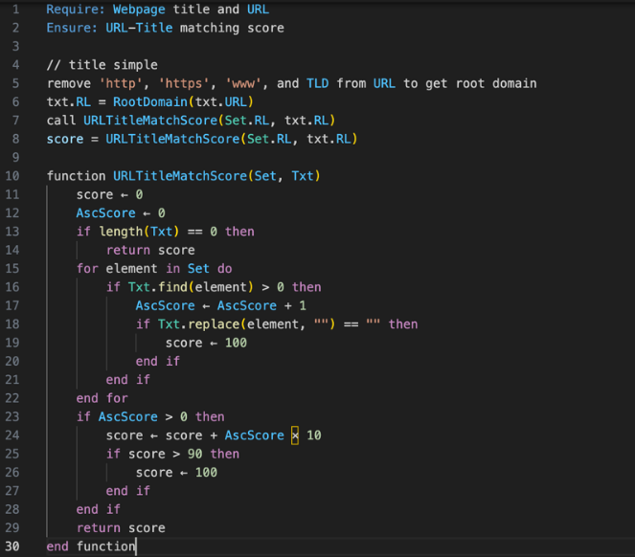
Figure 6: URL Title Match Score

EXPERIMENTAL RESULTS
The proposed methodology in this study was effectively implemented as a prototype using a dataset containing both legitimate and phishing URLs, along with the combined outputs of multiple algorithms. To evaluate and showcase the performance of the ML models, experiments were first conducted separately and later integrated for ensemble model prediction.

Random Forest Classifiers
In this project, Random Forest classifiers play a pivotal role in extracting and analysing URL features to detect phishing websites. A Random Forest is an ensemble learning technique that combines multiple decision trees to improve classification accuracy and prevent overfitting, a common issue in decision tree models. Each tree in a Random Forest works by selecting a random subset of features at each split point, contributing to a diverse set of classifiers. The final prediction is made based on the majority vote from all the trees, which enhances the model's generalizability and robustness.
For extracting URL features, Random Forest classifiers are particularly useful because they effectively handle both categorical and numerical data, allowing them to process and analyse various URL attributes such as length, the presence of special characters, and the use of secure protocols (HTTPS). These features can significantly vary among URLs, and the ability of Random Forests to manage such heterogeneity helps in accurately distinguishing between phishing and legitimate URLs. See Figure 7 below.
Gini Impurity Formula
The Gini impurity, a key metric for evaluating splits in a decision tree, is calculated for a node as shown in Equation 1.
$Gini=1-\sum_{t=1}^{c}{p_{i}^{2}}$ Equation 1
where:
• $p_{i}$ is the proportion of class i in a given node.
• C is the total number of classes.
Entropy Formula (for Information Gain)
Entropy is another fundamental metric for determining the optimal split based on information gain. The entropy for a node is defined in Equation 2.
$Entropy= - \sum_{i=1}^{c}{p_{i}\log_{2}\left(p_{i}\right)}$ Equation 2

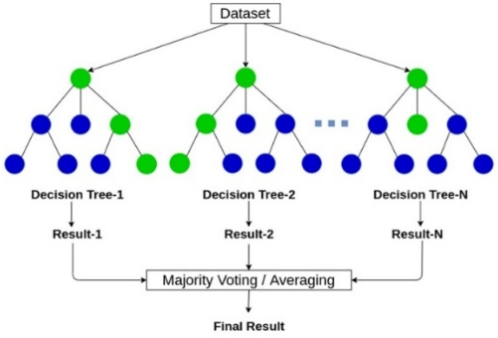
Figure 7: Random Forest Classifiers [22]

Multilayer Perceptron (MLP)
In this project, Multilayer Perceptron (MLP), a type of neural network, are utilized to extract HTML features for phishing website detection. MLPs are advantageous due to their ability to learn non-linear relationships and patterns from data, making them highly effective for complex classification tasks like distinguishing phishing sites from legitimate ones based on HTML content. They consist of multiple layers of nodes, each connected through weights that are iteratively adjusted during training to minimize error. This structure allows MLPs to capture intricate patterns in large datasets, such as those involving diverse HTML elements including tags, scripts, and metadata.
For extracting HTML features, MLPs can discern subtle differences and anomalies in webpage structure that might indicate malicious intent, such as unusual embedding of scripts or hidden iframes. Their capacity to handle high-dimensional data and their adaptability to different feature types make them particularly suitable for processing and analysing the rich, varied information contained within HTML documents. Thus, MLPs enhance the accuracy and effectiveness of phishing detection in this project. See Figure 8 below.
The output h of a single neuron in the network is computed as shown in Equation 3.
$h=f\left(\sum_{i=1}^{n}{w_{i}}x_{i}+b\right)$ Equation 3

Where:
- $h$: The output of the neuron.
- $x_{i}$: The input features.
- $w_{i}$: The weights associated with each input.
- $b$: The bias term.
- $f$: The activation function (e.g., Sigmoid, ReLU, Tanh).
- $n$: The number of input features.
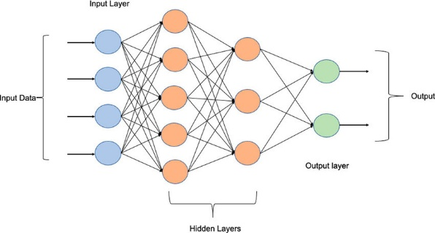
Figure 8: Multilayer Perceptron [23]

Gradient Boosting Machines (GBM)
Gradient Boosting Machines (GBM) are powerful ensemble learning techniques used extensively for both classification and regression tasks. GBMs build models in stages, with each new model iteratively correcting errors made by the previous ones, which is accomplished through the method of boosting. This approach allows GBMs to improve model accuracy by focusing more on instances that are harder to predict, making them highly effective for complex datasets with intricate patterns.
In this project, GBMs are particularly useful for deriving insights from features like CharContinuationRate and URLTitleMatchScore. These features inherently capture subtle cues within the data that may indicate phishing activities. See Figure 9 below.

The model $F_{m}\left(x\right)$ at iteration m is updated according to Equation 4.
$F_{m}\left(x\right)=F_{m-1}\left(x\right)+η⋅h_{m}\left(x\right)$ Equation 4

Where:
- $F_{m}\left(x\right)$: The model at iteration $m$.
- $F_{m-1}\left(x\right)$: The model from the previous iteration.
- $η$: The learning rate (shrinkage parameter) that controls the contribution of each tree.
- $h_{m}\left(x\right)$: The new weak learner (typically a decision tree) fitted to the residuals.
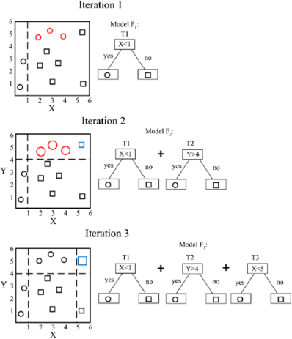
Figure 9: Gradient Boosting Machines (GBM) [24]

Voting Ensemble
Figure 10 illustrates the classification performance of the Voting Ensemble model, achieving an accuracy of 99.67%, which demonstrates its robust predictive capability. The confusion matrix shows 19,800 true negatives, indicating the model's high precision in correctly identifying class 0 instances. Additionally, it records 26,800 true positives, reinforcing its strong ability to detect class 1 cases effectively. However, the presence of 70 false positives and 10 false negatives reflects minor misclassifications that slightly impact precision and recall. In practical cybersecurity applications, false positives may lead to legitimate websites being incorrectly flagged, potentially disrupting user experience or access to valid services. More critically, false negatives represent phishing attempts that go undetected, posing a risk to user data and system integrity. When compared to other models, Stacking still maintains a marginal lead with the highest accuracy of 0.996715 and a perfect recall of 1.0, showcasing its superior sensitivity in detecting positive cases. While Random Forest and Gradient Boosting also perform commendably, the Multilayer Perceptron lags slightly behind, particularly in recall. Overall, Stacking’s ensemble methodology contributes to its enhanced classification performance, and the balanced metric profile makes it a strong candidate for deployment in high-risk cybersecurity environments.

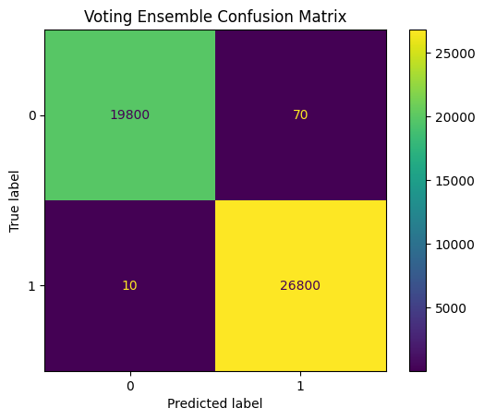
Figure 10: Voting Ensemble Confusion Matrix

The RMG Ensemble Training Algorithm
The core of the proposed RMG model is the integration of diverse base learners through a stacking ensemble framework. The meta-learner is trained to optimally combine the predictions of these base models. The detailed procedure is formalized in Algorithm 1.
Algorithm 1: RMG Ensemble Training and Prediction
Input: Training data $\left(X_{train},y_{train}\right)$, Test data $X_{test}$ Output: Final predictions $y_{pred}$
Initialize: Base models: $RF$, $MLP$, $GBM$; Meta-learner: $LR$ (Logistic Regression)
Preprocessing: Preprocess $X_{train}$ and $X_{test}$ (e.g., handle missing values, encode categorical features, standardize/normalize).
Train Base Models: Train each base model ($RF$, $MLP$, $GBM$) on the preprocessed $\left(X_{train},y_{train}\right)$.
Generate Level-1 Predictions (Meta-features):
- Use $k$-fold cross-validation on $X_{train}$ to get out-of-fold (OOF) predictions for each base model, preventing target leakage.
- Let $P_{train}^{RF}$, $P_{train}^{MLP}$, $P_{train}^{GBM}$ be the OOF prediction matrices (probabilities for each class) for the training set.
- Stack these matrices column-wise to form the meta-feature training set: $Z_{train}=\left[P_{train}^{RF},P_{train}^{MLP},P_{train}^{GBM}\right]$.
- For the test set, get predictions from each fully trained base model: $P_{test}^{RF}$, $P_{test}^{MLP}$, $P_{test}^{GBM}$.
- Stack them to form the meta-feature test set:
$Z_{test}=\left[P_{test}^{RF},P_{test}^{MLP},P_{test}^{GBM}\right]$.
Train Meta-Learner: Train the meta-learner $LR$ on the meta-features and original labels: $LR.fit\left(Z_{train},y_{train}\right)$.
Make Final Prediction: $y_{pred}=LR.predict\left(Z_{test}\right)$
return $y_{pred}$

PERFORMANCE RESULTS OF EMPLOYED ML MODELS
The below results from Table 3 highlight several important observations. Models like Random Forest, Multilayer Perceptron, Gradient Boosting, and the Stacking ensemble demonstrate outstanding performance across accuracy, precision, recall, and F1-score, showcasing their strong capability in identifying phishing URLs. Random Forest, in particular, achieves the highest metrics overall, while Gradient Boosting and Multilayer Perceptron also deliver highly competitive results, especially in precision and recall. These findings confirm that the models are highly effective in minimizing false positives while maintaining a high detection rate for phishing URLs.
TABLE 3: PERFORMANCE RESULTS OF EMPLOYED ML MODELS.
# | Model | Accuracy | Precision | Recall | F1 Score
1 | Random Forest | 0.982 | 0.981 | 0.984 | 0.982
2 | Multilayer Perception | 0.974 | 0.976 | 0.970 | 0.973
3 | Gradient Boosting | 0.979 | 0.975 | 0.983 | 0.979
4 | RMG model | 0.996 | 0.990 | 0.994 | 0.992
Table 3: Performance Results of Employed ML Models.
The ensemble approach (Stacking) combines the strengths of individual models, leveraging diverse learning strategies to enhance overall performance. By integrating multiple classifiers through the process detailed in Algorithm 1, the stacking ensemble addresses the weaknesses of individual models, resulting in a more robust and accurate phishing detection system. A meta-layer is added to the ensemble, where a logistic regression model serves as the meta-classifier, ensuring high-quality final predictions by efficiently combining the outputs of the base models.
The Stacking model achieves 0.996% accuracy, 0.990% precision, 0.994% recall, and 0.992% F1-score, demonstrating the effectiveness of this ensemble strategy. This exceptional performance highlights the ability of the model to capitalize on the strengths of its components, as defined by their respective loss functions (e.g., Gini impurity from Equation (1) for Random Forest), resulting in an even more powerful and reliable predictive framework. These results represent a significant improvement in phishing URL detection, offering promising potential for broader cybersecurity applications.

Conclusion and Future Work
In this research, an advanced phishing URL detection system leveraging ensemble ML methods was developed, RMG. By combining these models through a stacking ensemble approach, the proposed system achieved exceptionally high performance, with an accuracy of 98.67%, outperforming the best individual classifier Random Forest by approximately 1.32%. The integration of URL-based and HTML-based features, alongside derived metrics like CharContinuation-Rate and URLTitleMatchScore, contributed to the model’s robustness and reliability in identifying phishing threats. Through GridSearchCV hyperparameter tuning and thorough chi-square-based statistical feature selection method, we ensured the model’s efficiency and reduced overfitting, making it both practical and effective for real-world cybersecurity applications. While the model demonstrates strong performance, it may inherit some bias from the underlying dataset, which could affect its ability to generalize to zero-day phishing attacks that exhibit characteristics not present in the training data.
Despite these promising results, phishing tactics continue to evolve rapidly. Future work should focus on enhancing the adaptability of the model to detect zero-day phishing attacks by incorporating real-time data streams and advanced adversarial training methods. Additionally, integrating Natural Language Processing (NLP) to analyze webpage text content can further improve detection accuracy, particularly for advanced phishing websites that mimic legitimate pages. This includes examining elements such as coercive or deceptive sentiment, unnatural phrasing, misleading calls to action, and brand impersonation cues within the visible text. By capturing these linguistic signals, the model can better identify context-based phishing attempts that may bypass structural feature checks. Expansion into multi-modal data sources such as domain registration data and DNS traffic can also strengthen the detection framework. Finally, deploying this model in a live environment and evaluating its performance on unseen, real-time phishing attempts will be crucial for validating its practical effectiveness and scalability.
REFERENCES
[1] S. Asiri, Y. Xiao, S. Alzahrani, S. Li, and T. Li, "A survey of intelligent detection designs of HTML URL phishing attacks," IEEE Access, vol. 11, pp. 6421–6443, 2023. [Online]. Available: https://ieeexplore.ieee.org/document/ 10019269/
[2] A. Mughaid, S. AlZu’bi, A. Hnaif, S. Taamneh, A. Alnajjar, and E. A. Elsoud, "An intelligent cyber security phishing detection system using deep learning techniques," Cluster Comput., vol. 25, no. 6, pp. 3819–3828, 2022. [Online]. Available: https://link.springer.com/10.1007 /s10586-022-03604-4
[3] A. Elqasass et al., "Facilitating secure web browsing by utilizing supervised filtration of malicious URLs," in IoT Based Control Networks and Intelligent Systems, P. P. Joby et al., Eds. Singapore: Springer, vol. 789, pp. 459–468, . doi: 10.1007/978-981-99-6586-1_3
[4] J. Lin and P. Zhang, "Adversarially-trained ensemble learning for robust phishing detection," IEEE Trans. Dependable Secure Comput., early access, 2023. doi: 10.1109/TDSC.2023.3278910
[5] A. Sharma and S. Kumar, "PhishBoost: A hybrid ensemble of ANN and AdaBoost for phishing website detection," IEEE Access, vol. 11, pp. 58761–58770, 2023.
[6] M. Chen, X. Zhang, and Y. Wang, "Phishing detection using random forest and extreme gradient boosting (XGBoost)," in Proc. ITM Conf., 2023, pp. 98–105.
[7] K. Patel, S. Roy, and T. Singh, "A comparative study of classification models and ensemble learning for phishing detection," J. Cyber Secur. vol. 5, no. 2, pp. 201–214, 2023.
[8] J. Lee and H. Kim, "Fisher-Markov based phishing ensemble detection (FMPED) and Fisher-Markov-Markov based phishing ensemble detection (FMMPED)," Sensors, vol. 24, no. 3, pp. 456–470, 2023.
[9] L. Brown, D. White, and A. Green, "Phishing website classification using ensemble learning and voting classifiers," TechScience Cybersecurity, vol. 14, no. 1, pp. 67–79, 2023.
[10] P. Kumar, R. Singh, and B. Thomas, "Augmented 1D-CNN with recurrent layers for phishing email detection," Comput. Intell., vol. 22, pp. 187–199, 2023.
[11] S. Ali and Z. Wang, "A multi-stage ensemble framework for robust phishing website detection," Information, vol. 15, no. 1, p. 39, 2024.
[12] A. Mishra and M. R. Bhat, "AutoML-driven adaptive ensemble learning for phishing detection," Neural Comput. Appl., vol. 36, pp. 12489–12504, 2024.
[13] M. Li, J. Qiu, and H. Zheng, "Transformer ensemble for real-time phishing detection in chat applications," Inf. Process. Manag., vol. 61, no. 1, p. 103350, 2024.
[14] A. Verma and S. Sharma, "Bayesian optimized stacked ensemble for intelligent phishing detection," Future Gener. Comput. Syst., vol. 151, pp. 119–130, 2024.
[15] L. Zhang, Y. Sun, and T. Wu, "Deep voting ensemble for phishing email detection using CNN and Bi-LSTM," in Proc. IEEE Conf. Dependable Secure Comput. (DSC), 2024, pp. 188–195.
[16] Y. Liu, K. Wang, and R. Xu, "GNN-based ensemble learning for URL structure-based phishing detection," Pattern Recognit. Lett., vol. 173, pp. 47–54, 2025.
[17] D. Robinson and E. Carter, "Stacking ensemble classifier for phishing website detection," arXiv preprint, arXiv:2401.05678, 2024.
[18] X. Zhao and W. Liu, "Weighted ensemble model with feature selection for phishing detection," arXiv preprint, arXiv:2304.11234, 2023.
[19] J. Zhao, H. Cui, X. Li, W. Yang, and X. Wu, “A Hybrid Phishing Website Detection Model Based on LightGBM and Domain Name Features,” Symmetry, vol. 15, no. 1, p. 180, Jan. 2023. [Online]. Available: https://www.mdpi.com/2073-8994/15/1/180
[20] R. Patel and M. Sharma, “Bagging-Based Ensemble Model for Phishing URL Detection Using Decision Trees and Naïve Bayes,” Int. J. Adv. Inf. Process., vol. 8, no. 2, pp. 45–53, 2023.
[21] A. Prasad and S. Chandra, PhiUSIIL Phishing URL (Website) [Dataset], UCI Machine Learning Repository, 2024. [Online]. https://archive.ics.uci.edu/dataset/967/ phiusiil+phishing+url+dataset
[22] Y. Zhou, J. Liu, S. Li, and Q. Li, "Ionospheric TEC prediction based on ensemble learning models," Space Weather, vol. 22, no. 3, p. e2023SW003790, 2024. [Online]. Available: https://agupubs.onlinelibrary.wiley.com/doi/10.1029/2023SW003790
[23] D. Xu, X. Xu, M. C. Forde, and A. Caballero, "Concrete and steel bridge structural health monitoring Insight into choices for machine learning applications," Constr. Build. Mater., vol. 402, p. 132596, 2023. [Online]. Available: https://linkinghub.elsevier.com/retrieve/pii/S0950061823023127
[24] S. T. Pham, P. S. Vo, and D. N. Nguyen, "Effective electrical submersible pump management using machine learning," Open J. Civil Eng., vol. 11, no. 1, pp. 70–80, 2021. [Online]. Available: https://www.scirp.org/journal/paperinformation?paperid=107653

