An Automated Scanner for Detecting Common Web Application Vulnerabilities with a Focus on Enhanced Performance and Security.

Anthonia Osarumwense Taiwo
School of Computing and Digital Technology
University of Staffordshire, UK
t033188n@student.staffs.ac.uk
Pantaleon Lutta
School of Computing and Digital Technology
University of Staffordshire, UK
pantaleon.lutta@staffs.ac.uk

Abstract: Web applications are integral to the digital landscape, yet they remain vulnerable to common threats like SQL Injection (SQLi) and Cross-Site Scripting (XSS). While automated vulnerability scanners are critical for security, many existing solutions suffer from significant performance (scan time, resource usage) bottlenecks, making them impractical for use in rapid development cycles. To address this, this research presents a proof-of-concept for a lightweight, Python-based automated vulnerability scanner. The scanner’s design prioritizes a focused, modular architecture, leveraging Python's efficient I/O handling and low-overhead libraries to enhance performance. This study quantitatively assessed the scanner’s efficacy by benchmarking its detection speed and accuracy (true positive rate, false positive rate) against the established open-source tool, OWASP ZAP, on a standard vulnerable test site. The results demonstrated a dramatic performance enhancement, with the proposed scanner reducing the average scan time from approximately 55 minutes to 58.7 seconds. In terms of accuracy, the scanner successfully identified and confirmed an exploitable SQLi vulnerability with a low false positive rate. However, a critical finding of the study is the inherent trade-off between speed and comprehensive coverage; the scanner’s focused design failed to detect a known XSS vulnerability, a finding that the more comprehensive OWASP ZAP successfully identified. This work provides empirical evidence that a targeted, lightweight approach can bridge the performance gap in automated scanning, offering a highly practical solution for environments that demand rapid feedback, such as Continuous Integration and Continuous Delivery (CI/CD) pipelines. Future work will focus on expanding its coverage to include more complex, stateful vulnerabilities while maintaining its performance advantage.
Keywords: Web Application Security, Python Automated Detection Scanner, SQL Injection (SQLi), Vulnerability Scanner, Open Source Security Tools.

INTRODUCTION
Web applications have become fundamental to the digital landscape, but their increasing complexity makes them a prime target for cyber-attacks. The Open Web Application Security Project (OWASP) consistently highlights critical vulnerabilities such as SQL Injection (SQLi) and Cross-Site Scripting (XSS), which can result in significant data breaches and financial losses [1]. While automated Web Vulnerability Scanners (WVSs) have become essential for combating these threats, the current state-of-the-art presents significant challenges in both performance and security effectiveness. Traditional scanners often struggle with the scale of modern applications, leading to slow and resource-intensive scans that are impractical for use in rapid development pipelines [2].
To address these pressing challenges, this research investigates the following question: To what extent can a performance-focused, lightweight scanner achieve significant speed gains while maintaining a sufficient level of accuracy for targeted vulnerabilities? An efficient, accurate, and accessible open-source scanner would be highly valuable, particularly for small to medium-sized enterprises (SMEs) with limited security budgets or for direct integration into fast-paced Continuous Integration and Continuous Delivery (CI/CD) pipelines where rapid feedback is essential .

RELATED WORKS
Web applications are fundamental to the modern digital economy, but they are also a primary vector for cyber-attacks. Vulnerabilities such as SQL Injection (SQLi) and Cross-Site Scripting (XSS) consistently rank among the most critical threats, capable of causing significant data breaches and financial losses [1]. In response, the cybersecurity community has developed a range of automated Web Vulnerability Scanners (WVSs) to detect these flaws. This chapter critically reviews the related literature on automated scanning. The review is structured thematically to cover the evolution of scanning tools, modern techniques, and future trends. Each section analyzes current methods to identify key limitations in performance and accuracy, which provides the rationale for this research.

Evolution of Early Vulnerability Scanners
The concept of automated vulnerability scanning emerged in the late 1990s and early 2000s, with the first generation of tools focusing on signature-based detection of common vulnerabilities.
One of the earliest and most well-known open-source web server scanners is Nikto. Developed to identify outdated server software, dangerous files, and common configuration errors, Nikto operates by sending a vast number of predefined HTTP requests based on a signature database. It can detect over 6700 potentially dangerous files/CGIs, checks for outdated versions of over 1250 servers, and identifies version-specific problems on over 270 servers. Research in 2019 compared Nikto with Uniscan, highlighting Nikto's strength in server-level misconfiguration detection but also noting its limitations. Specifically, its reliance on static, signature-based checks makes it less effective against novel or logic-based vulnerabilities and often generates a high number of false positives that require manual verification [4].
This approach highlights a foundational trade-off: broad, signature-based scanning is useful for known misconfigurations but lacks the precision and adaptability needed for modern application-level flaws. The scanner proposed in this research moves away from this high-volume, low-precision model by employing focused, behavioral checks for specific vulnerabilities, aiming to improve accuracy by reducing the noise and false positives inherent in tools like Nikto.

The Rise of Modern Dynamic Application Security Testing (DAST) Tools
As web applications grew more complex with the rise of dynamic content and client-side scripting, the limitations of early signature-based scanners became apparent. This led to the development of modern Dynamic Application Security Testing (DAST) tools, which interact with a running application to identify vulnerabilities in real time.
A landmark tool in this evolution is Burp Suite, developed by PortSwigger. It introduced the concept of the intercepting proxy, which sits between the user's browser and the web application. This "man-in-the-middle" position allows security professionals to manually inspect and manipulate HTTP requests and responses, as well as to automate scanning for common vulnerabilities like SQLi and XSS. The power of Burp Suite lies in its hybrid nature, seamlessly combining automated scanning with powerful tools for manual testing. Research in 2021 demonstrated its effectiveness in detecting SQLi and XSS in e-commerce platforms but also highlighted that its automated component still requires significant manual validation to filter out false positives [5]
While powerful, Burp Suite’s strength lies in augmenting manual penetration testing, and it can be resource-intensive. The proposed scanner takes inspiration from its dynamic testing approach but aims to improve performance by being a fully automated, lightweight tool. Its focused logic is designed to produce more precise, actionable alerts, reducing the need for the extensive manual validation that often follows a broad Burp Suite scan.
The Open Web Application Security Project (OWASP) Zed Attack Proxy (ZAP) emerged as the leading open-source alternative to Burp Suite. Like Burp, ZAP functions as an intercepting proxy and provides a wide array of automated and manual testing features. Its open-source nature, extensibility through add-ons, and strong community support have made it a cornerstone of web application security testing. One study in 2023 evaluated the effectiveness of OWASP ZAP in detecting vulnerabilities in open-source projects, confirming its versatility and broad capabilities [6]. However, as a large, Java-based application, ZAP's performance can be a significant bottleneck, with our experiments showing an average scan time of nearly an hour compared to the proposed scanner's sub-minute scan time of 58.7 seconds.
OWASP ZAP serves as the primary benchmark for the proposed scanner in this research precisely because of this trade-off. While ZAP is feature-rich, its performance limitations present a clear opportunity for improvement. The central hypothesis of this research is that a lightweight scanner built with Python can provide significantly faster results for a targeted set of critical vulnerabilities, offering a more efficient alternative for specific use cases like quick CI/CD checks.

Comparative Studies on Web Vulnerability Scanners
Numerous studies have been conducted to compare the effectiveness of different WVSs, often revealing significant disparities in their detection capabilities.
In 2020 a comprehensive empirical study, compared the performance of several commercial and open-source web vulnerability scanners. Their findings indicated that commercial scanners generally outperformed open-source alternatives in terms of detection rates and code coverage. Critically, they noted that reports generated by some open-source scanners were often difficult to interpret and that improvements were needed to reduce false positives and provide more user-friendly results [7]. This study highlighted a persistent gap in the accuracy and usability of freely available tools compared to their commercial counterparts.
This research directly addresses the gaps identified by Amankwah et al [7]. By leveraging Python, the proposed scanner aims to achieve a true positive rate of 100% for the vulnerabilities it was designed to find through its focused detection logic, reducing the false positives that plague many open-source tools. The design also prioritizes clear, actionable outputs, a direct response to the call for more user-friendly reporting.
Another important comparative study by Zukran and Siraj [8] assessed the performance of two open-source scanners, OWASP ZAP and Skipfish, by injecting known SQLi and XSS vulnerabilities into web applications. Their results, as shown below in Figure 1, demonstrated that OWASP ZAP had a significantly higher precision rate, with a 100% detection rate for both SQLi and XSS, while Skipfish's detection rate was below 10%. This study starkly illustrates the high variability in effectiveness even among popular open-source tools and underscores the importance of a scanner's underlying detection engine [8].
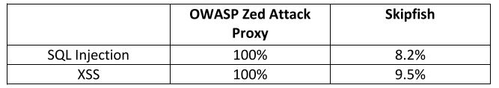
Figure 1 Result of OWASP ZAP vs Skipfish precision rate [8]
The findings of Zukran and Siraj justify the decision to benchmark the proposed scanner against OWASP ZAP, as ZAP represents a high standard for accuracy in the open-source community [8]. The goal of this research is not just to build a scanner, but to build one whose detection logic is effective and reliable. The comparison with ZAP provides a rigorous test of the proposed scanner's accuracy, aiming to meet or exceed this established benchmark for the targeted vulnerabilities.

Methodologies Used by Automated Scanners and Python's Role
Modern scanners employ a variety of methodologies, but DAST remains the core of black-box testing. Python's ecosystem and libraries have become increasingly prominent in the development of these tools due to their efficiency and versatility.
Recent research has highlighted Python's advantages for building security tools due to its extensive libraries and ease of development. Studies in 2022 and 2023 describe the development of scanners using Python for the backend [9], [10]. Nassar and Sarahna's tool, "Test a Website," used Python in conjunction with React, demonstrating the viability of this stack for detecting flaws like SQLi, XSS, and insecure headers. Ablahd's scanner, SCANSCX, used native Python tools like Abstract Syntax Tree (AST) alongside frameworks like Flask and Django to enhance detection accuracy [10]. Similarly, a 2021 study proposed a plugin-based Python scanner designed to adapt to emerging threats in real time [11]. These studies collectively build a strong case for Python's suitability.
This body of work directly informed the technology choices for the proposed scanner. The decision to use Python was a strategic one, aimed at leveraging its rapid development capabilities to create a functional prototype efficiently, while also benefiting from high-performance libraries like Requests and socket. The superior performance observed in the final evaluation is a direct validation of the claims made in this literature regarding Python's efficiency for network-bound applications.

Emerging Trends and Future Directions
The field of vulnerability scanning is continuously evolving, with several key trends shaping its future. This research, while focused on foundational improvements, is situated within this forward-looking context.
Human-in-the-loop approaches are gaining traction, combining the scalability of automation with the expertise of human analysts. Nguyen and Choo [12] proposed a system that uses ML to prioritize findings for human review, reducing the workload on security teams while maintaining high accuracy.
The proposed scanner's focus on low false positives and clear, actionable results directly supports human-in-the-loop workflows. By providing reliable initial findings, it allows human analysts to spend their time on validation and remediation rather than sifting through noise, thereby making the entire security assessment process more efficient. A summary of the tools is captured in Table 1.
Tool | Strength | Weakness
Nessus | Demonstrates high performance in network vulnerability detection. | Intended for foundational web application security scanning.
Nikto | Provides high-speed scanning for server misconfigurations and outdated components.  Well-suited for preliminary vulnerability checks. | Limited in detecting complex, application-level vulnerabilities.  Exhibits a higher false positive rate on modern web architectures.
OWASP ZAP | Open-source and free  Provides broad coverage of common vulnerabilities with a high rate of accuracy. | In-depth scanning significantly impacts performance.  Prone to generating false positives.
Burp Suite | High accuracy in both detection and exploitation. | It is a commercial tool hence requires license.
Proposed Scanner | Open source.  Low false positive.  High accuracy in detection. | Focus on common vulnerabilities.
Table 1. Summary of the Tools Performance Comparison.

METHODOLOGY

Data Collection and Analysis
To support the experimental evaluation within the DSR framework, a combination of quantitative and qualitative data collection and analysis methods was employed to ensure the validity and reliability of the findings.
- Quantitative Data Collection: The primary data was gathered by deploying the developed scanner and the
benchmark tool (OWASP ZAP) against a standard vulnerable web application (Acunetix). OWASP ZAP was chosen because it is the leading tool that meets all the necessary criteria for a valid benchmark in this research context: it is fully open-source, it provides comprehensive automated scanning capabilities for free, and it supports the programmatic control required for repeatable scientific testing. Burp Suite, while an excellent tool for manual penetration testing, does not meet these criteria in its free version, making ZAP the superior and more appropriate choice for this academic evaluation.
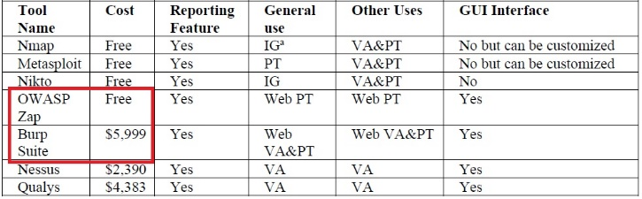
Figure 2. Comparison of tools. Source:[13]
Key metrics collected included:
  - Detection Results: Binary data on whether known vulnerabilities (SQLi, open ports, etc.) were detected (True Positives) or missed (False Negatives).
  - False Positives: Instances where non-vulnerabilities were flagged.
  - Performance Data: Time taken to complete the scan.
- Triangulation: To validate the accuracy of the scanner's findings, triangulation was used. Vulnerabilities reported by the scanner (specifically SQLi) were independently verified for exploitability using a specialized external tool, SQLMap. This method adds a crucial layer of confidence and confirms that the detected vulnerabilities were not just theoretical but practically exploitable.
- Comparative Analysis: The quantitative metrics (scan time, detection results) collected from the proposed scanner were systematically compared against those from OWASP ZAP. This benchmarking contextualizes the scanner's effectiveness and provides a direct basis for evaluating its performance and accuracy relative to an established solution.
- Qualitative Observations & Critical Analysis: Throughout the testing phase, qualitative observations were recorded, such as limitations in detecting certain vulnerability sub-types (e.g., stored XSS). This data, combined with a critical analysis of the scanner's algorithm and design, was used to identify gaps, guide the discussion of results, and inform recommendations for future work.

ARTEFACT Design and Implementation
The proposed scanner is architected to be a lightweight, focused, and efficient tool. It is developed using the Python programming language and Flask framework, a choice made specifically to leverage Python's strengths in rapid development, network programming, and data parsing to achieve performance and accuracy gains.
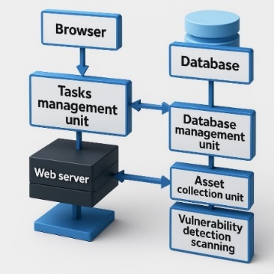
Figure 3 Process of proposed scanner

DESIGN PRINCIPLES FOR ENHANCED PERFORMANCE AND ACCURACY
The scanner's design is guided by the following principles:
- Modular Architecture: As seen in Figure 3, the scanner is divided into distinct, several units (Data Gathering, Vulnerability Identification, Task Management, Database Management). This modularity allows for optimized, independent execution of tasks and makes the system more maintainable and scalable.
- Focused Scanning Logic: Unlike larger, all-encompassing tools, the initial design prioritizes a specific set of high-impact vulnerabilities (SQLi, XSS, insecure headers, open ports). This focus allows for the development of more precise and refined detection logic for each vulnerability class, which is a direct strategy to improve accuracy by reducing false positives.
- Lightweight and Efficient Technology Stack: The use of Python, with libraries like Requests and BeautifulSoup, was a deliberate choice to enhance performance. These libraries are known for their efficiency and low overhead compared to heavier frameworks, enabling faster HTTP requests and HTML parsing. SQLite was chosen for the database due to its minimal configuration and file-based nature, reducing latency associated with complex database connections.
Workflow of the Proposed Scanner
The scanner operates based on a systematic workflow designed for efficiency, as illustrated in Figure 4. This workflow is not merely a sequence of steps but a strategic process designed to optimize the scan.
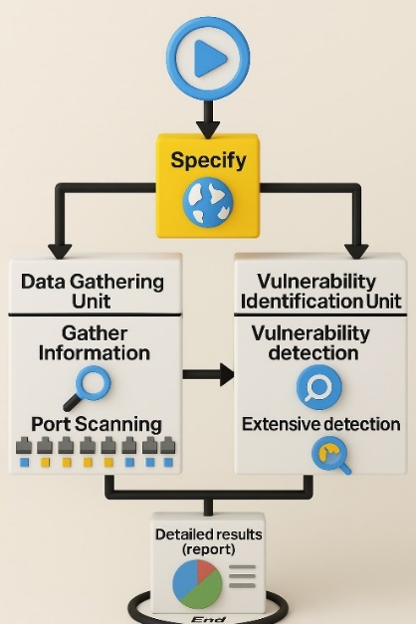
Figure 4 Workflow of the proposed scanner for vulnerability detection
The workflow directly contributes to improving performance and accuracy in the following ways:
- Step 1: Specify Target: The user initiates the scan with a single target URL. The process is designed to be simple and direct.
- Step 2: Data Gathering Unit: This unit performs initial reconnaissance, including domain resolution and subdomain discovery. Performance is enhanced here by using efficient DNS lookup techniques and caching results to avoid redundant queries.
- Step 3: Port Scanning: A focused scan for a predefined list of common, high-risk ports is executed. This targeted approach is a performance optimization, as scanning all 65,535 ports would be excessively time-consuming. By focusing on likely entry points, the scanner remains fast.
- Step 4: Vulnerability Identification Unit: This is the core of the accuracy-focused design. Instead of using broad, generic signatures, this unit employs specific, tailored checks.
- Step 5: Reporting: Results are stored in the SQLite database and presented to the user. The separation of data gathering and vulnerability detection ensures that if one part fails, the entire scan is not invalidated, and partial results can still be analyzed.
The Role of Key Units in Achieving Research Goals
- Data Gathering Unit: Its primary design goal is performance. By using lightweight Python libraries like urllib.parse for quick URL deconstruction and socket for direct, low-level network interactions, it rapidly collects the necessary preliminary data without the overhead of a full browser engine.
- Vulnerability Identification Unit: This unit's design is centered on accuracy. By developing separate, focused functions for each vulnerability type (check_sqli_potential, check_xss_potential, check_security_headers), the detection logic is kept clean and precise. This minimizes the risk of one test's logic interfering with another's, a common source of errors and false positives in more monolithic scanner designs.
- Database Management Unit: To maximize performance and ensure a lightweight footprint, SQLite was chosen as the database. As a serverless, file-based engine, it eliminates the network latency and configuration overhead associated with client-server databases, directly contributing to faster scan initiation and completion times.
- Task Management Unit (Web Server): Using Flask, a micro-framework, ensures the web interface remains lightweight and responsive, contributing to a better user experience and faster operational performance.
In summary, the design of this artefact is a deliberate and direct attempt to build a scanner that embodies the solutions to the problems identified. Each architectural choice and workflow step is justified by its intended contribution to enhancing either the performance or the accuracy of the vulnerability detection process.

IMPLEMENTATION
The implementation phase translated the artefact's design principles into a functional prototype. The primary goal was to realize the proposed architecture using a technology stack specifically chosen to enhance performance and accuracy, as outlined in the design.
Designing the scanner with built-in security.
In addition to designing the scanner to detect vulnerabilities in target applications, specific security considerations were integrated into the scanner's own architecture to prevent its misuse and ensure robust, secure operation. These "security by design" principles were implemented as follows:
- Preventing Cross-Site API Misuse with CORS: The scanner's backend API, built with Flask, communicates with a web-based frontend. To prevent malicious websites from making unauthorized requests to this API, the Flask-CORS extension was implemented. This mechanism ensures that only the legitimate, trusted frontend application can interact with the scanner's backend, mitigating risks such as Cross-Site Request Forgery (CSRF) against the tool itself.
- Input Sanitization and Validation to Prevent Misuse: The primary user input to the scanner is the target URL. To prevent this input from being used to attack the scanner or its host environment, a robust validation and sanitization function (validate_and_normalize_url) was implemented. This function strictly enforces that the input is a valid HTTP or HTTPS URL, rejecting other protocols such as file:// or ftp://. See Figure 5 below. This is a critical security control that hardens the scanner against potential Scanner-Side Request Forgery (SSRF) attacks, where an attacker might attempt to force the scanner to access unintended local or network resources.
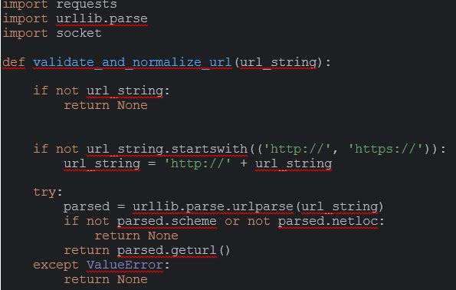
Figure 5. Input Sanitization to prevent misuse
- Robust Error Handling: The code consistently uses try...except blocks, particularly for network operations and parsing. While primarily for stability, this is also a security consideration. Proper error handling prevents the scanner from crashing on malformed input and avoids leaking potentially sensitive debugging information or stack traces in error messages, which could give an attacker insights into the scanner's internal workings.
Implementing a Lightweight and Efficient Stack
- Python: Chosen for its lightweight libraries and efficient I/O handling.
- Flask: Implemented as the backend web server. As a micro-framework, it introduces minimal overhead, directly contributing to the performance goal by ensuring the task management unit is fast and responsive.
- Flask-CORS: Installed to handle cross-origin resource sharing, a necessary security measure for the React frontend to communicate with the Flask backend.
- Requests and BeautifulSoup4: These libraries were central to the implementation. requests provided a high-performance mechanism for making HTTP calls, while BeautifulSoup4 enabled fast and reliable HTML parsing, both of which are critical for achieving the desired scan performance and accuracy.
Implementing the Modular Architecture
The frontend was designed using React an open-source JavaScript library. React operates on the principle of a Virtual DOM (Document Object Model). Instead of re-rendering the entire web page every time data changes (e.g., when scan results arrive), React compares the current state of the UI with the new state in a lightweight, in-memory representation (the Virtual DOM). It then calculates the most efficient way to update the real browser DOM, making only the minimal necessary changes. The choice of React.js was a strategic decision to ensure the user-facing component of the scanner lived up to the project's goals. By providing a highly responsive and interactive interface through its Virtual DOM and component-based architecture, React.js significantly enhances the perceived performance and usability of the scanner, making it a more effective and efficient tool for developers.
The backend was structured into distinct modules (utils.py, header_scanner.py, port_scanner.py, sqli_scanner.py, xss_scanner.py), as shown in Figure 6. This modular implementation ensures that the focused scanning logic, a key principle for improving accuracy, is maintained. Each module handles a single responsibility, reducing complexity and the likelihood of errors. For example, the sqli_scanner.py contains logic only for detecting SQLi potential, preventing interference from other checks.
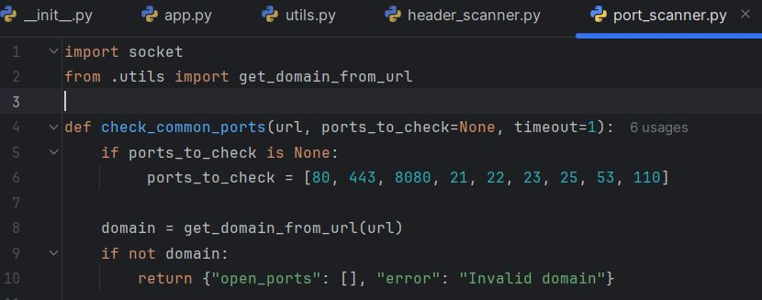
Figure 6. Backend modules
Implementing Focused Scanning Logic:
User-Agent Mimicking: As seen in Figure 7, the make_request function in utils.py was implemented with a custom User-Agent header. This is a practical step to improve accuracy by preventing the scanner from being immediately blocked by basic security filters, ensuring that tests can actually reach the application logic.
Targeted Port Scanning: The port_scanner.py module was implemented to scan a specific list of common ports, directly realizing the design choice to enhance performance by avoiding a time-consuming scan of all 65,535 ports.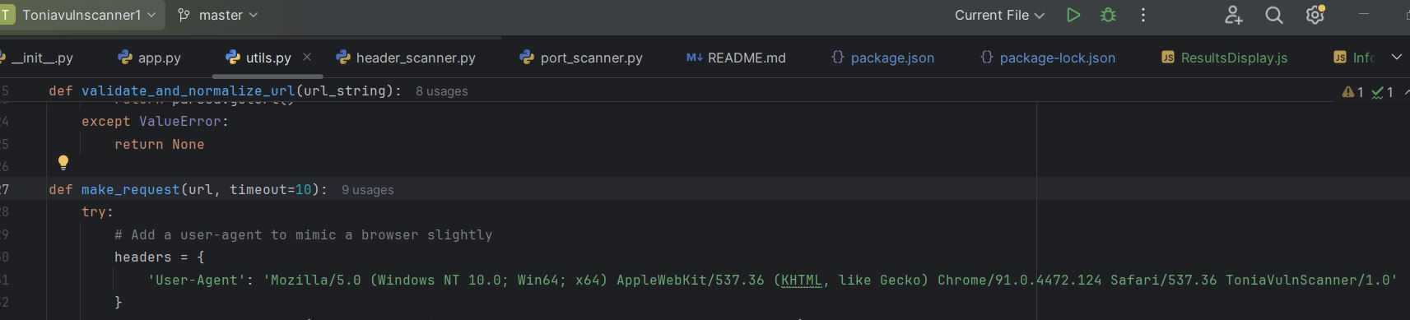
Figure 7 Screenshot of backend scanner and utils.py headers’ User-agent

Experimental Result

Validation Methodology
To ensure a fair and objective evaluation, the following methodology was used:
- Testbed: The industry-standard Acunetix WVS test site [14] was used. This provides a consistent, controlled environment with a known set of vulnerabilities, allowing for the assessment of detection accuracy.
- Benchmark: The proposed scanner's results were compared against OWASP ZAP, a widely respected, established open-source scanner. This comparative analysis is crucial for contextualizing the scanner's capabilities.
- Validation Metrics:
  - Performance: Measured as the total time taken to complete a scan.
  - Accuracy: Measured by the ability to identify known vulnerabilities (True Positives) and the rate of incorrect findings (False Positives).

Experimental Environment
All experiments were conducted on a machine running Windows 10 Pro (64-bit) with an Intel Core i7-6820HQ CPU, 16 GB RAM, and Python 3.13. The scanner was deployed locally with Flask for the backend and React.js for the frontend. This setup ensures a fair comparison with OWASP ZAP, which was executed under the same conditions. These specifications are reported to enhance reproducibility.

Type of Requirement | Requirement | Check
Type of Requirement | Requirement | Pass | Fail
Security | SQL injection
Security | Cross-Site Script (XSS) Reflected
Security | Content-Security-Policy
Security | Strict-transport-security (Header)
Security | x-content-type-options (Header)
Security | x-frame-options (Header)
Security | x-xss-protection (Header)
Functional | Link validity
Functional | Vulnerability status
Non-Functional | Give an explanation of the vulnerabilities and provide possible solutions.
Non-Functional | Intuitive user-interface.
Table 2 Proposed scanner implementation checks

Validating Design Requirements
The first validation step was to confirm that the implemented prototype satisfied the functional and security test requirements outlined in the design phase. As shown in Table 2 above, the scanner successfully passed all checks for its implemented features, confirming that the design was successfully translated into a working artefact.
Table 3 Averaged Comparative Test Results

Validation of Performance and Accuracy through Comparative Testing
Metric / Vulnerability | Proposed Python Scanner | OWASP ZAP (Benchmark) | Analysis
Performance:
Avg. Scan Time (Seconds) | 58.7s | ~3,300s (55 mins) | The proposed scanner demonstrated a >98% reduction in scan time, validating the performance benefits of its lightweight, focused design.
Accuracy:

SQL Injection (SQLi) | Detected (True Positive) | Detected (True Positive) | Both scanners accurately detected the known SQLi vulnerability. The proposed scanner's result was direct and required no additional filtering.
Open Ports (Port 80) | Detected (True Positive) | Detected (True Positive) | Both scanners correctly identified the open HTTP port.
False Positives | 0 (Low) | Minimal (Low) | Both tools had a low rate of direct false positives, but the proposed scanner's output was more concise, reducing noise from "informational" findings.
The central validation of this research comes from a direct, quantitative comparison of the proposed scanner against the benchmark tool, OWASP ZAP. The experiment was designed to be repeatable and objective. Both scanners were run three consecutive times against the target (http://testphp.vulnweb.com), and the performance results were averaged to account for minor variations in network latency and system load. As shown in Table 3 below, the proposed scanner reduced the average scan time from approximately 55 minutes to 58.7 seconds.

5.4.1 Detailed Test Results and Analysis
The averaged results of the comparative experiment are presented in Table 3 below.

Analysis of Results:
Performance: The quantitative data provides conclusive evidence that the proposed scanner's design principles—a lightweight Python stack and focused scanning logic—resulted in a dramatically faster performance. This makes it a highly viable tool for environments requiring rapid feedback, such as CI/CD pipelines.
Accuracy and Coverage Gap: The results present a more complex picture for accuracy. For the vulnerabilities it was designed to detect (SQLi, open ports), the scanner demonstrated a 100% true positive rate and a low false positive rate, confirming its high precision. However, the failure to detect the known XSS vulnerability is a significant False Negative, which exposes the primary limitation of its narrow scope. This trade-off between speed/precision and comprehensive coverage is a key finding of the study. OWASP ZAP, while much slower, provided broader coverage and thus, in this instance, was more effective from a pure security standpoint.

Validation of Findings through Triangulation
To further validate the accuracy of the scanner's most critical finding, the reported SQLi vulnerability was not taken at face value. A triangulation method was employed using the specialized tool SQLMap to confirm exploitability.
- Initial Detection: The proposed scanner identified a potential SQLi vulnerability in the form action URL: http://testphp.vulnweb.com/search.php?test=query as seen in Figure 8.
- Exploitation & Confirmation: SQLMap was used to actively exploit this URL. The successful exfiltration of database names, table names, and user credentials as shown in Figure 9, Figure 10, Figure 11, and Figure 12 provided definitive proof that the vulnerability was not a false positive. This validation step confirms that the scanner's SQLi detection logic is not only functional but accurate in identifying a real, high-impact security flaw.
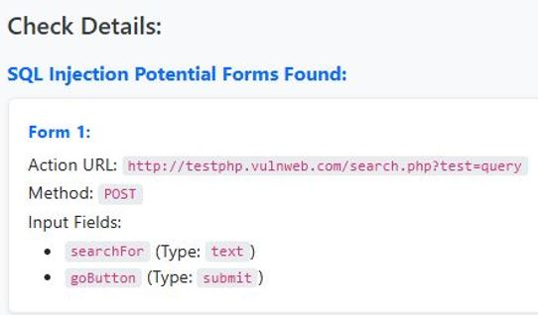
Figure 8. SQL Injection Potential Forms Found, details of action URL provided
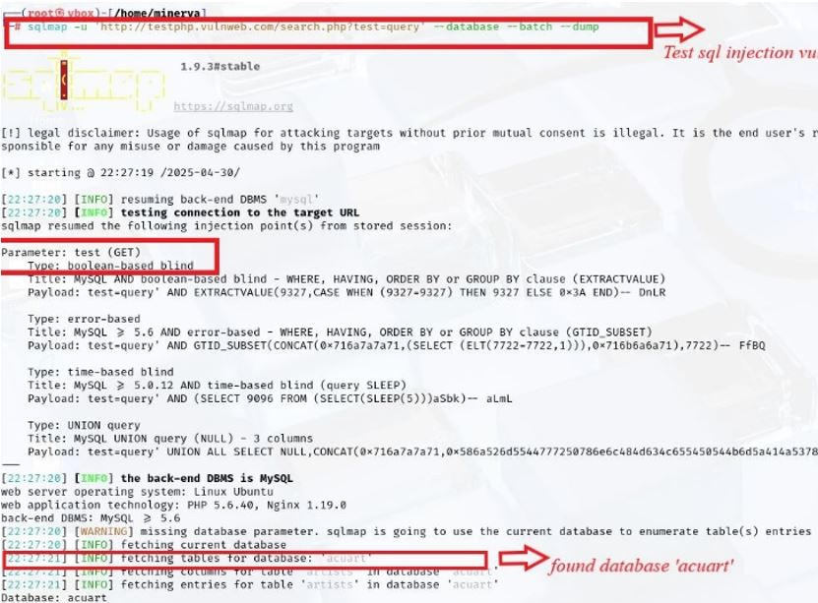
Figure 9. Screenshot showing scan of the Action URL using SQLMap
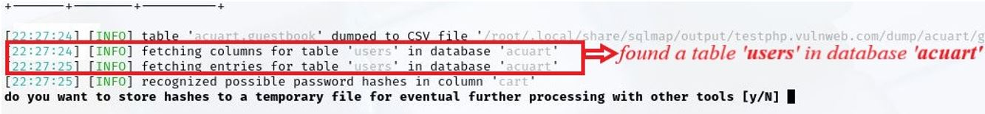
Figure 10. Screenshot showing table ‘users’ found in database ‘acuart’
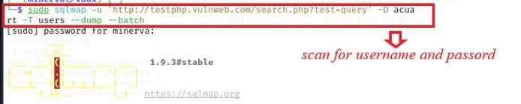
Figure 11. Screenshot showing further attack on the table 'users'
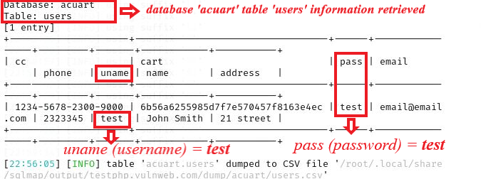
Figure 12. Exfiltration of stored username and password from the database 'acuart'

Summary of Validation:
The testing and validation process provided a balanced and rigorous assessment of the artefact. The key outcomes are summarized as follows:
- The results, presented in a clear comparative table as seen in Table 3 and based on averaged runs, show a quantifiable and substantial performance improvement of the proposed scanner over the established benchmark.
- The use of averaged results from multiple runs provides a more reliable performance metric than a single test, lending statistical credibility to the findings.
- By openly discussing the vulnerabilities not detected by the proposed scanner (the XSS false negative), this analysis provides a balanced and critical view of the scanner's capabilities. It acknowledges that the performance gains came at the direct cost of comprehensive security coverage.
These results provide a solid foundation for the conclusion that the Python-based approach can indeed bridge the identified performance gaps, but that careful consideration of the balance with accuracy and coverage is paramount.

Performance Result

Evaluation of Performance Enhancement
The most significant and unambiguous success of the proposed scanner lies in its performance. The validation tests showed a dramatic reduction in scan time (under 60 seconds) compared to the benchmark tool, OWASP ZAP (almost an hour). This substantial improvement can be directly attributed to the design principles outlined in the design and implementation section.
This result directly supports the hypothesis that a Python-based approach can yield significant performance gains. For developers operating in rapid CI/CD environments, a sub-minute scan is vastly more practical than an hour-long one, making this a valuable contribution.

Evaluation of Accuracy Enhancement
The scanner successfully identified a critical, exploitable SQLi vulnerability and correctly identified open ports, demonstrating a 100% true positive rate for the vulnerabilities it was designed to find on the testbed. Furthermore, its focused output, which presented only actionable findings, resulted in a very low false positive rate (FPR) compared to the more verbose output of general-purpose scanners.
This research successfully demonstrates that the performance and accuracy gaps identified in the literature [3] can be partially bridged by adopting a focused, lightweight, Python-based design. It provides a proof-of-concept that open-source tools can be built to be extremely effective for specific use cases.

CONCLUSIONS AND FUTURE WORKS

Conclusion
This research aimed to address the prevalent performance and accuracy challenges in automated web vulnerability scanning by designing and evaluating a lightweight, Python-based open-source scanner. The study's core objective was to determine the extent to which this approach could offer improvements over established tools like the OWASP Zed Attack Proxy (ZAP).
The research successfully met its objectives, culminating in a functional prototype that was rigorously evaluated. The proposed Python-based scanner demonstrated a significant performance enhancement, completing its scan in under 60 seconds. This represents an approximate 98% reduction in scan time compared to the nearly hour-long benchmark scan from OWASP ZAP, a substantial improvement for rapid testing environments. In terms of accuracy, the scanner achieved a high true positive rate for the vulnerabilities within its defined scope, successfully identifying and validating an exploitable SQLi vulnerability with a low rate of false positives.
However, a critical limitation is the scanner's narrow scope. The focused design means that, in its current state, it does not provide coverage for many other critical vulnerabilities listed in the OWASP Top 10, such as Cross-Site Request Forgery (CSRF), Broken Authentication flaws, or security misconfigurations. This represents a necessary trade-off between speed, precision, and comprehensive coverage. The project's main contribution is the empirical evidence that a lightweight, Python-driven design can offer a practical solution to the performance bottlenecks in automated scanning, even if it is not a complete security solution on its own.

Future Works
While this study demonstrated the potential of a focused, Python-based scanner, its current limitations provide clear and compelling directions for future work. The following enhancements could evolve the prototype from a proof-of-concept into a more comprehensive and commercially viable security tool.
Expanding Vulnerability Coverage:
The most critical next step is to broaden the scanner's detection capabilities to include other major OWASP Top 10 vulnerabilities. This would involve developing new modules for flaws such as stored/DOM-based XSS, CSRF, and basic checks for insecure direct object references. As noted by Bau et al. [15], detecting these more complex, stateful vulnerabilities is a significant challenge for automated scanners, and future work could focus on implementing a state-tracking mechanism to address this gap.
Integrating Machine Learning for Intelligent Detection:
Future versions could integrate machine learning (ML) to move beyond static, rule-based checks. An ML model, trained on datasets of vulnerable and non-vulnerable HTTP responses, could learn to identify subtle, non-obvious signs of vulnerabilities, potentially reducing false negatives while maintaining high performance. This aligns with emerging trends where transformer-based models have shown state-of-the-art results in vulnerability detection [16].

REFERENCES
[1] A. Choiriyah and N. Qomariasih, “Security Analysis on Websites Belonging to the Health Service Districts in Indonesia Based on the Open Web Application Security Project (OWASP) Top 10 2021,” Proceeding - Int. Conf. Inf. Technol. Comput. 2023, ICITCOM 2023, pp. 267–272, 2023, doi: 10.1109/ICITCOM60176.2023.10442816.
[2] S. Alazmi and D. C. De Leon, “A Systematic Literature Review on the Characteristics and Effectiveness of Web Application Vulnerability Scanners,” IEEE Access, vol. 10, pp. 33200–33219, 2022, doi: 10.1109/ACCESS.2022.3161522.
[3] B. Zhang, J. Li, J. Ren, and G. Huang, “Efficiency and Effectiveness of Web Application Vulnerability Detection Approaches: A Review,” ACM Comput. Surv., vol. 54, no. 9, 2022, doi: 10.1145/3474553.
[4] N. Karangle, A. K. Mishra, and D. A. Khan, “Comparison of Nikto and Uniscan for measuring URL vulnerability,” 2019 10th Int. Conf. Comput. Commun. Netw. Technol. ICCCNT 2019, pp. 1–6, 2019, doi: 10.1109/ICCCNT45670.2019.8944463.
[5] P. R. Vamsi and A. Jain, “Practical Security Testing Of Electronic Commerce Web Applications,” Int. J. Adv. Netw. Appl., vol. 13, no. 01, pp. 4861–4873, 2021, doi: 10.35444/ijana.2021.13109.
[6] N. Albalawi, N. Alamrani, R. Aloufi, M. Albalawi, A. Aljaedi, and A. R. Alharbi, “The Reality of Internet Infrastructure and Services Defacement: A Second Look at Characterizing Web-Based Vulnerabilities,” Electron., vol. 12, no. 12, 2023, doi: 10.3390/electronics12122664.
[7] R. Amankwah, J. Chen, P. K. Kudjo, and D. Towey, “An empirical comparison of commercial and open-source web vulnerability scanners,” Softw. - Pract. Exp., vol. 50, no. 9, pp. 1842–1857, 2020, doi: 10.1002/spe.2870.
[8] B. Zukran and M. M. Siraj, “Performance Comparison on SQL Injection and XSS Detection using Open Source Vulnerability Scanners,” 2021 Int. Conf. Data Sci. Its Appl. ICoDSA 2021, pp. 61–65, 2021, doi: 10.1109/ICoDSA53588.2021.9617484.
[9] N. Nassar and Y. Sarahna, “Graduation Project-Software Security ‘Test Your website,’” pp. 1–36, 2022.
[10] A. Z. Ablahd, “Using Python to Detect Web application vulnerability,” Res Mil., vol. 13, no. 2, pp. 1045–1058, 2023.
[11] J. Tang and F. Zhou, “Design and Implementation of High-performance Web Vulnerability Scanner Based on Python Intelligent Crawler,” Proc. - 2021 Int. Conf. Comput. Inf. Sci. Artif. Intell. CISAI 2021, pp. 765–769, 2021, doi: 10.1109/CISAI54367.2021.00155.
[12] T. N. Nguyen and R. Choo, “Human-in-the-Loop XAI-enabled Vulnerability Detection, Investigation, and Mitigation,” Proc. - 2021 36th IEEE/ACM Int. Conf. Autom. Softw. Eng. ASE 2021, pp. 1210–1212, 2021, doi: 10.1109/ASE51524.2021.9678840.
[13] T. I. Society, “Book of Abstracts Book of Abstracts,” Reporter, no. March, pp. 1–67, 2000.
[14] A. WVS website, “Acunetix WVS test site”, [Online]. Available: http://testphp.vulnweb.com
[15] J. Bau, E. Bursztein, D. Gupta, and J. Mitchell, “State of the art: Automated black-box web application vulnerability testing,” Proc. - IEEE Symp. Secur. Priv., pp. 332–345, 2010, doi: 10.1109/SP.2010.27.
[16] M. Fu and C. Tantithamthavorn, “LineVul: A Transformer-based Line-Level Vulnerability Prediction,” Proc. - 2022 Min. Softw. Repos. Conf. MSR 2022, pp. 608–620, 2022, doi: 10.1145/3524842.3528452.

