Processing and property relationships in material extrusion additive manufacturing of PLA using a hybrid predictive model for tensile strength optimization
Abstract
Material-extrusion additive manufacturing produces polymer components with region-dependent mechanical behaviour arising from raster orientation, shell geometry, and layer-wise deposition. This study develops a region-based hybrid model for predicting the tensile strength of PLA specimens by separating the cross-section into top-and-bottom layers, perimeter shells, and an infill core. Response Surface Methodology was used to model the effects of layer thickness, print speed, and shell count within the relevant structural regions, while the Tsai–Hill criterion was used to represent orientation-dependent strength in the infill core. The segmented Design of Experiments reduced the calibration matrix from 252 to 72 configurations and the required specimens from 756 to 216, corresponding to a 71.4% reduction in experimental burden. Within the investigated range, tensile strength varied from 28.85 to 50.39 MPa. The standalone Tsai–Hill model produced errors of up to 11.52% at intermediate raster angles, whereas the calibrated hybrid model reduced the maximum error below 0.6%. Independent validation using 12 previously unused parameter combinations tested in triplicate produced a maximum absolute error of 0.69%. Further validation using non-standard specimen dimensions produced a maximum absolute error of 0.78%. Uncertainty propagation based on raw triplicate data produced a final propagated uncertainty of 0.144–0.159 MPa, corresponding to 0.38–0.42%, while a complete-specimen global RSM benchmark produced a maximum relative error of 5.13%, further supporting the benefit of the region-based decomposition strategy. Optical fracture-surface images supported the interpretation of raster-gap effects, although detailed polymer-interface phenomena were not directly measured. The framework is therefore presented as a validated engineering-scale predictive method for PLA within the investigated processing domain.
Keywords: Material Extrusion (MEX); Additive Manufacturing (AM); Polymer Processing; Engineering-scale predictive modelling; Polylactic Acid (PLA); Tensile Strength; Process Optimization; Hybrid Modelling; Response Surface Methodology; Tsai–Hill Criterion; Mechanical Performance Prediction.

Asif Hasan¹, Muhammad Fahad^{2*}, Maqsood Ahmed Khan¹, Tahir Sharif³
¹ Department of Industrial and Manufacturing, NED University of Engineering and Technology, Pakistan
² Department of Engineering, University of Staffordshire, United Kingdom
³ College of Science and Engineering, University of Derby, United Kingdom
* Email address of corresponding author: Muhammad.fahad@Staffs.ac.uk

Introduction
Additive Manufacturing (AM), particularly Material Extrusion (MEX), has transformed modern fabrication by enabling rapid prototyping, design flexibility, and mass customization. Unlike conventional subtractive processes, MEX constructs components layer-by-layer directly from computer-aided design (CAD) models, allowing the efficient production of geometrically complex structures with reduced material waste (Gibson et al., 2021). This capability is especially advantageous for manufacturing intricate geometries and processing materials that are otherwise difficult to machine, while also promoting sustainability through minimized raw material consumption (Yao et al., 2019). Among various AM techniques, MEX—commonly referred to as Fused Deposition Modeling (FDM)—is widely adopted due to its cost-effectiveness, operational simplicity, and scalability (Berman, 2012). Despite these advantages, its broader application in functional and load-bearing components is often constrained by the anisotropic mechanical properties inherent to the layer-wise fabrication process (Zhao, Chen and Zhou, 2019).
The mechanical performance of MEX-fabricated parts, particularly tensile strength, is highly sensitive to processing parameters (Popescu et al., 2018). Key factors include layer thickness, raster (print) angle, print speed, and the number of perimeter shells. However, the literature presents inconsistent and sometimes contradictory findings regarding their individual and combined effects. Several studies report that reducing layer thickness enhances tensile strength by minimizing void formation and improving interlayer adhesion (Farashi and Vafaee, 2022; Marșavina et al., 2022; Hasan, Fahad and Khan, 2024), whereas others observe a directly proportional relationship between layer thickness and strength (Bembenek, Kowalski and Kosoń-Schab, 2022; Ambade et al., 2023). Additionally, non-linear dependencies have been identified, suggesting more complex interactions among parameters (Fountas et al., 2023; Singh and Bharti, 2023).
Similarly, tensile strength generally improves when the raster angle is aligned with the loading direction, owing to enhanced load transfer along filament paths (Rajpurohit and Dave, 2020). However, this relationship is often influenced by interactions with other parameters, complicating its predictability. The effect of print speed is also debated: higher speeds may degrade interlayer bonding due to insufficient thermal diffusion (Huynh et al., 2019; Yilan et al., 2023), although some studies report negligible strength reduction under optimized conditions (Torres et al., 2016; Alafaghani et al., 2017). Increasing the number of perimeter shells is typically associated with improved tensile performance due to enhanced structural reinforcement (Griffiths et al., 2016; Torres et al., 2016), yet its statistical significance is not universally supported (Hikmat, Rostam and Ahmed, 2021).
Collectively, these studies highlight that layer thickness, raster angle, print speed, and shell count are critical determinants of tensile strength in MEX-printed components. A comprehensive understanding of these parameters is essential for optimizing process conditions, reducing reliance on trial-and-error experimentation, minimizing material waste, and ensuring structural reliability—particularly in load-bearing applications. For example, meta-analyses indicate that increasing layer thickness can reduce tensile strength by up to 20%, while misalignment of print orientation may result in an additional reduction of approximately 12% (Farashi and Vafaee, 2022). In the absence of predictive insights, component performance remains uncertain and inefficient. Moreover, exhaustive experimental evaluation across all parameter combinations is impractical. Therefore, the development of robust predictive models capable of estimating tensile strength from known process parameters is essential. Recent advances demonstrate the potential of hybrid approaches, such as Taguchi-based optimization integrated with neural networks (Enzi, Ali and F. Huayier, 2023), as well as machine learning and Response Surface Methodology (RSM) techniques (Jayasudha et al., 2022; Panico et al., 2025), to significantly reduce experimental effort while maintaining predictive accuracy. These developments underscore the need for systematic experimental frameworks that can reliably characterize process–property relationships and support model development.
Structured Design of Experiments (DoE) approaches are particularly valuable in MEX research because they enable multiple process parameters and their interactions to be investigated systematically while controlling the required experimental workload, as demonstrated through reduced Taguchi and response-surface-based designs in recent studies (Alzyod, Borbas and Ficzere, 2023; Alzyod, Ficzere and Borbas, 2024).
Despite these advances, existing modelling approaches exhibit notable limitations. Statistical methods such as linear regression (Singh and Bharti, 2023; Yilan et al., 2023), polynomial regression (Giri et al., 2021; Fountas et al., 2023), and RSM (Srinivasan et al., 2020; Samykano, 2021) often assume material homogeneity, thereby oversimplifying the inherently heterogeneous and anisotropic structure of MEX-fabricated parts. Analytical models, including the Tsai–Hill failure criterion, offer improved representation of anisotropic behavior (Nali and Carrera, 2012), but their applicability is limited when addressing complex parameter interactions or generalizing across varying build configurations. Notably, most existing models do not explicitly differentiate between the mechanical contributions of distinct structural regions—such as top and bottom layers, perimeter shells, and infill core—leading to reduced prediction accuracy under varying process conditions. As a result, these models often fall short of the precision required for reliable mechanical design in functional applications.
Previous area-based modelling studies have demonstrated the usefulness of cross-sectional representations in additively manufactured components. For continuous carbon-fibre-reinforced nylon, tensile properties were related to the cross-sectional fractions of nylon and carbon fibre using a rule-of-mixtures formulation (Deng et al., 2019). For PLA, polynomial and section-area models were developed using the proportions of top-and-bottom and side-surface regions, together with infill-related parameters (Homrani et al., 2024). The contribution of the present study is not the cross-sectional decomposition concept in isolation. Rather, it lies in the integration of sequential regional-strength isolation, region-specific Response Surface Methodology models, and Tsai–Hill-based raster-orientation interpolation for the infill core. This segmented strategy also reduces the calibration matrix while retaining independent validation using previously unused parameter combinations and additional non-standard specimen geometries.
To address these limitations, this study develops a region-based hybrid predictive framework for MEX-printed PLA components. The printed specimen is decomposed into three structural regions: (i) the top-and-bottom layers, (ii) the perimeter shells, and (iii) the infill core. The contribution of the present framework lies not in cross-sectional decomposition alone, but in the sequential experimental isolation of regional tensile-strength contributions, the development of region-specific Response Surface Methodology (RSM) models, and the integration of the Tsai–Hill criterion to represent raster-orientation-dependent behaviour in the infill core. This segmented approach also reduces the calibration matrix while retaining the ability to validate predictions using previously unused parameter combinations.
The primary contributions of this work are fivefold: (i) the introduction of a systematic region-based decomposition strategy to isolate and quantify the tensile-strength contributions of the top-and-bottom layers, perimeter shells, and infill core; (ii) the development of region-specific Response Surface Methodology (RSM) equations for the relevant process parameters; (iii) the integration of these regional models with the Tsai–Hill criterion to capture and interpolate raster-orientation-dependent behaviour within the infill core, resulting in a hybrid statistical–analytical predictive framework; (iv) the reduction of the calibration matrix from 252 to 72 experimental configurations, significantly decreasing the experimental burden; and (v) comprehensive validation using previously unused parameter combinations and additional non-standard specimen geometries, demonstrating high prediction accuracy across the investigated parameter space.
While RSM effectively captures complex multi-factor interactions, it typically requires extensive experimental data. Conversely, the Tsai–Hill criterion provides a robust treatment of anisotropic behaviour but lacks the capability to represent intricate process-parameter couplings. By combining these complementary approaches, the proposed framework achieves enhanced predictive capability while substantially reducing experimental requirements. The resulting model facilitates design optimization, minimizes material waste, and improves confidence in the structural performance of MEX-fabricated components, particularly for load-bearing applications. The framework provides a validated engineering-scale basis for comparable MEX scenarios that closely match the experimental conditions and parameter set used during model development. Related applications should be supported by targeted recalibration using representative local data.

Materials and Methods

Material
Specimens for this research were fabricated using Poly Lactic Acid (PLA) material, supplied by eSun Industrial Co. Ltd., based in Shenzhen, China. Table 1 details the characteristics of the PLA filament that was utilized in printing these components.
Table 1 Material Specifications of PLA (provided by manufacturer)
Sr # | Characteristic (Unit) | Specification
1 | Material Density (g/cm³) | 1.25
2 | Optimal Printing Temperature (°C) | 190 - 220
3 | Recommended Bed Temperature (°C) | 60 - 80
4 | Elongation at Break (%) | 8
5 | Tensile Strength (MPa) | 65
6 | Bending Modulus (MPa) | 3600
7 | Melt Flow Rate (g/10 min at 190°C/2.16kg) | 5
8 | Temperature for Heat Distortion (°C) | 56 (at 0.45 MPa pressure)
9 | Standard Filament Thickness (mm) | 1.75
10 | Impact Resistance (IZOD) (kJ/m²) | 4
11 | Bending Strength (MPa) | 97

Printing Methodology
The 3D printer used is a single nozzle printer with specifications expressed in Table 2.
Table 2 Primary specifications of 3D printer
Sr # | Feature | Specification
1 | Maximum Print Size (mm³) [XYZ] | 220 x 220 x 250
2 | Layer Height (mm) | 0.1
3 | Nozzle Size (mm) | 0.4
4 | Filament diameter (mm) | 1.75
5 | Number of Extruders | 1
All tensile specimens were printed with a Flat orientation and followed the ISO 527-2:2012 Type 1A ( British Standards Institution, 2012) profile with a 4 mm thickness and 10 mm width at the gauge section of 50 mm (Figure 1). CAD models were sliced in Ultimaker Cura with default settings. Conditioning was done as per ISO 291 standard.
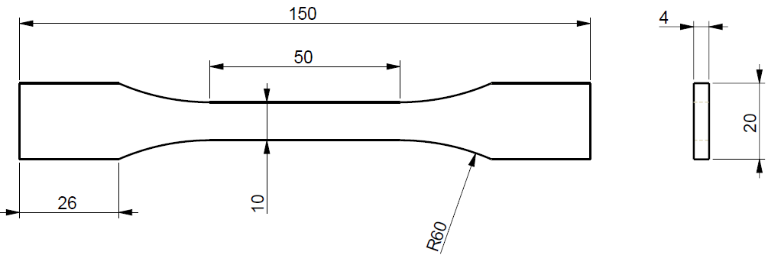
Figure 1 ISO 527-2 sample shape & size (All dimensions are in mm)
Four key process parameters were varied, as outlined in Table 3. The print angle was defined relative to the Y-axis, with force applied along the X-axis—thus, 90° aligns infill rasters with the load, while 0° orients them perpendicularly. Parameter ranges were selected based on a thorough literature review to ensure consistency with prior studies, enabling meaningful comparison. All other print settings were held constant to maintain uniform print quality across samples (see Table 4).
Table 3 Variable printing parameters
S # | Printing Parameters | Variations
1 | Layer Thickness (mm) | 0.1, 0.2 & 0.3
2 | Print Speeds (mm/s) | 40, 60, 80 & 100
3 | Print angles (˚) | 0, 15, 30, 45, 60, 75 & 90
4 | No. of Shell perimeters | 2, 3, & 4

Table 4 Constant printing parameters
S # | Printing parameter | Value
1 | Bead Width (mm) | 0.4
2 | Print density (%) | 100
3 | Infill pattern | Line
4 | Bed Temperature (°C) | 60
5 | Extrusion Temperature (°C) | 200
6 | Part Built Orientation | Flat

Experimental Design
Response Surface Methodology (RSM) was implemented within a structured Design of Experiments (DoE) framework. DoE provides a systematic basis for varying multiple input factors, evaluating their individual and interacting effects, and supporting process optimization while maintaining a manageable experimental workload. Reduced DoE strategies have been used effectively in MEX research, including Taguchi orthogonal-array designs for efficient factor screening and response-surface-based designs for examining interactions and quadratic effects with fewer trials than a direct full-factorial design (Alzyod, Borbas and Ficzere, 2023; Alzyod, Ficzere and Borbas, 2024). Based on the parameter levels listed in Table 3, a direct full-factorial design would require 252 treatment combinations. With three replicates per combination, this would result in 756 specimens. To reduce the experimental burden while retaining the ability to model the relevant process effects, a segmented DoE strategy was adopted. The tensile-specimen cross-section was divided into three functionally distinct regions: the top-and-bottom layers, the perimeter shells, and the infill core (Figure 2 and Figure 3). Each region was evaluated using only the parameters considered relevant to its mechanical behaviour.
The top-and-bottom layers, represented by regions A1 and A2 in Figure 3, were printed with the default raster orientation of ±45°. Because the raster orientation remained fixed, these layers were modelled as a function of layer thickness, print speed, and shell count. The resulting design space comprised 36 treatment combinations, which were used to develop the corresponding RSM model.
The perimeter-shell regions, represented by B1 and B2 in Figure 3, were analysed separately with the rasters fixed at 90°, ensuring alignment with the tensile loading direction. Their regional tensile strength was modelled as a function of layer thickness and print speed. Shell count was not included as an independent variable in the regional strength model because its influence was incorporated through the corresponding cross-sectional area in the area-weighted equations. This produced 12 treatment combinations for the perimeter-shell analysis.
The infill core, represented by region C in Figure 3, exhibits the most pronounced anisotropic behaviour. It was therefore evaluated as a function of raster angle, layer thickness, and print speed. Shell count was excluded because it does not directly apply to the infill-core region. A total of 24 treatment combinations were tested, comprising 12 combinations for each of the two reference raster orientations, 0° and 45°. The resulting RSM models were subsequently integrated with the Tsai–Hill criterion to account for the influence of raster orientation across the broader angular range.
Through this segmented DoE strategy, the calibration matrix was reduced from 252 to 72 unique configurations. Each configuration was tested in triplicate, resulting in a total of 216 specimens. This corresponds to a 71.4% reduction in experimental burden while allowing each structural region to be modelled using an approach suited to its specific behaviour.
It should be noted that the segmented hybrid-model dataset was not a conventional complete-specimen factorial dataset. Instead, different subsets of experiments were designed for different structural regions. The top-and-bottom-layer model used layer thickness, print speed, and shell count; the perimeter-shell model used layer thickness and print speed; and the infill-core model used layer thickness, print speed, and selected raster orientations. Therefore, the hybrid-model calibration dataset was not suitable for constructing a single global RSM model using one common set of input variables and one common complete-specimen tensile-strength response. In particular, the regional hybrid dataset did not include complete-specimen tests across all raster angles, but only used the angular conditions required for regional isolation and Tsai–Hill-based interpolation.
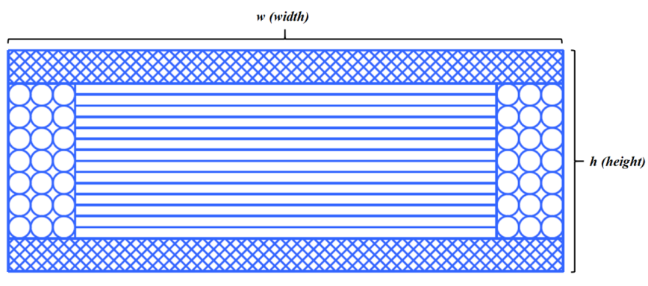
Figure 2 Cross-section of 3D printed specimen.
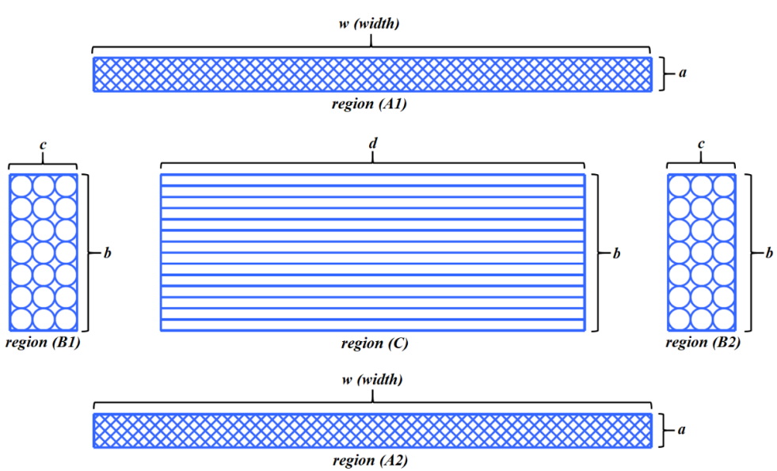
Figure 3 Exploded view of cross-section of 3D printed specimen
Here,
‘w’ is the width of the specimen,
‘a’ is the thickness of top/bottom layers,
‘b’ is the height of the perimeter shell region and the infill core region,
‘c’ is the width of each (left/right) region of perimeter shells, and
‘d’ is the width of the infill core.
Such that,
2a+b=h (total height of the specimen), and
2c+d=w (total width of the specimen).
Alternative empirical or statistical models (e.g., linear regression or machine learning) were not used because they either oversimplify nonlinear parameter interactions or require much larger datasets to train reliably (Sood, Ohdar and Mahapatra, 2010; Montgomery, 2017). Similarly, other composite failure criteria, such as Tsai–Wu or Hashin (Tsai and Hahn, 1980), involve additional material constants that are difficult to obtain experimentally for MEX parts and often require extensive characterization beyond the scope of this study. In contrast, the Tsai–Hill criterion balances simplicity with predictive capability (Gurrala and Regalla, 2014), as it requires only three strength constants and raster orientation, making it well suited for modelling anisotropic behaviour in printed specimens. Combined with RSM for process parameter interactions, this approach offered both practicality and accuracy without excessive experimental burden.
RSM model fitting and analysis of variance (ANOVA) were performed at a 95% confidence level (α=0.05). Model terms with p<0.05 were considered statistically significant. Lack-of-fit tests were also evaluated at the 95% confidence level, where a non-significant lack-of-fit result (p>0.05) was interpreted as evidence that the fitted model was adequate within the investigated parameter range. Model adequacy was assessed using R², adjusted R², predicted R², F-values, p-values, and lack-of-fit results. Residual diagnostic plots, including normal probability plots, residuals versus fitted values, residual histograms, and residuals versus observation order, were examined for each regional RSM model. The Anderson–Darling test was used to assess normality of the tensile-strength data, consistent with recent DoE/RSM-based MEX optimization studies (Alzyod, Konya and Ficzere, 2025). Detailed ANOVA outputs, residual diagnostic plots, and Anderson–Darling normality-test plots are provided in the Supplementary Information.

Mechanical Testing
Tensile testing was performed according to ISO 527-2:2012 standard using a LLOYD LR10K Plus Universal Testing Machine at 1 mm/min crosshead speed and ambient conditions (23°C). Extensometers were used for accurate strain measurements (Figure 4). Quasi-static testing was performed where the load at a slow and controlled rate is applied. This approach allows for the detailed observation and analysis of the material's behaviour under tension, including its tensile strength, elongation, yield point, and modulus of elasticity (Volkov and Smirnov, 2022).
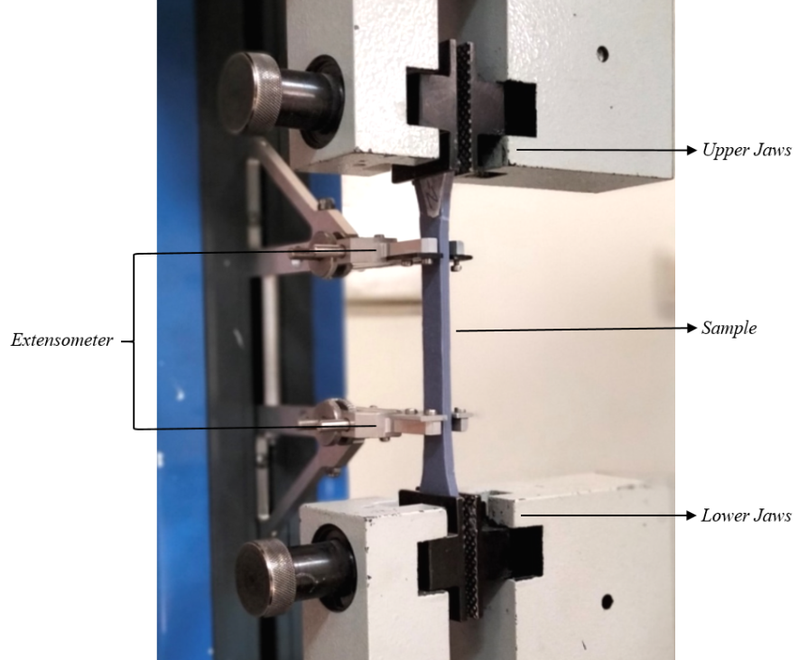
Figure 4 Uniaxial tensile testing setup

Optical stereomicroscopy
Fracture-surface images were acquired using a Motic DM 143 stereo microscope. The default 5× objective lens was replaced with a 15× lens, and the built-in 4× zoom setting was used, resulting in an overall magnification of 60×. Images were captured and annotated using Motic Images Plus software supplied with the microscope. The images were examined qualitatively to compare visible raster arrangement and inter-raster gaps across specimens fabricated at different layer thicknesses. Quantitative void-fraction analysis was not performed.

Analytical Modelling Using the Tsai-Hill Criterion
The Tsai–Hill failure criterion is widely used to predict strength in anisotropic materials, particularly fibre-reinforced composites. In the context of rasterized material extrusion (MEX) printed parts, it provides a practical means of approximating orientation-dependent strength using experimentally determined directional tensile and shear-related properties. Previous studies, including those by (Zhao, Chen and Zhou, 2019) and (Yao et al., 2019), successfully applied the Tsai–Hill criterion to specimens fabricated in upright and on-edge build orientations (Figure 5).
In the present study, the applicability of the same criterion is evaluated for a flat build orientation, where the specimens are printed in the XY plane and the raster angle varies from 0° to 90° relative to the applied tensile load (Figure 6). Although MEX-printed PLA does not possess the continuous-fibre architecture of classical composite laminates, its rasterized structure produces pronounced anisotropic behaviour. Filaments aligned with the loading direction generally carry tensile loads more effectively than those oriented transversely, resulting in orientation-dependent mechanical performance.
Accordingly, the Tsai–Hill criterion is employed here as an engineering approximation for raster-induced anisotropy rather than as a rigorous constitutive representation of the printed material. The model does not explicitly capture bead-scale voids, imperfect interfacial bonding, thermal-history effects, residual stresses, or localized crack initiation mechanisms. Instead, within the proposed hybrid framework, the role of the Tsai–Hill criterion is restricted to providing orientation-dependent strength interpolation after the regional strength parameters have been identified through the hierarchical strength isolation process.

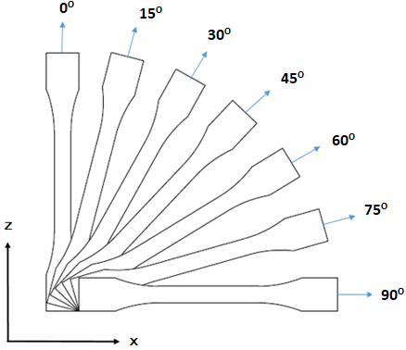
Figure 5 “On-edge to Upright” type build orientation for tensile specimen
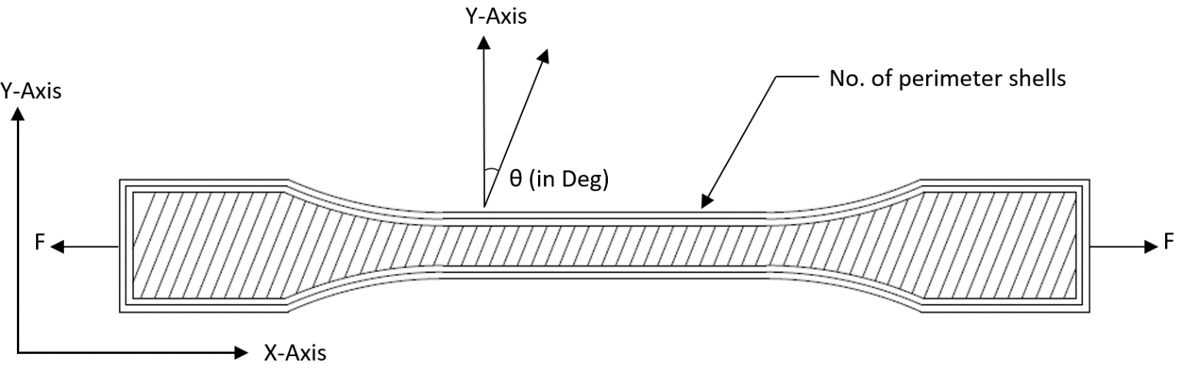
Figure 6 “Flat” type build orientation of the tensile specimen

Model Formulation and Calculation
The tensile strength σ_{x} ​at any raster angle θ is estimated using the Tsai-Hill equation:
$σ_{x}={\left[\frac{\cos^{4}θ}{T_{1}^{2}}+\left(\frac{1}{S_{2}^{2}}-\frac{1}{T_{1}^{2}}\right)\sin^{2}θ.\cos^{2}θ+\frac{\sin^{4}θ}{T_{2}^{2}}\right]}^{-1/2}$ … Eqn. (1)
$S_{2}=\frac{F_{45}}{2.w.h}$ ……………………………………………… Eqn. (2)

Where;
‘σ_{x}’ is tensile strength of the printed component (MPa).
‘θ’ is the print angle of the specimen.
‘T₁’ is the strength of the component in direction perpendicular to fiber (MPa).
‘T₂’ is the strength of the component in fiber direction (MPa).
‘S₂’ is the shear strength of the component (MPa).
‘F₄₅’ is max load borne by sample printed at 45° print angle (MPa).
‘w’ is the width of the gauge length.
‘h’ is the thickness of the specimen.
Values for T₁​, T₂​, and S₂​ were extracted experimentally. T₂​ and T₁​ represent the tensile strengths at 90° and 0° print angles, where rasters are aligned parallel and perpendicular to the load, respectively. The tensile strength (σ_{x}) values for angles between 90° and 0° is calculated using Equation (1). Whereas, S₂ denotes shear strength, derived from 45° tensile specimens using Equation (2).
To assess the model’s reliability, specimens were printed at raster angles ranging from 0° to 90° in 15° increments, for each of three layer-thicknesses: 0.1 mm, 0.2 mm, and 0.3 mm. Print speed and shell count were held constant at 60 mm/s and 4 shells, respectively. A total of 21 unique configurations were tested.
Table 5 Mean Experimental Tensile Strength (MPa), Calculated Tensile Strength (MPa) and their Relative Error (%)
Sample type | Layer thickness (mm) | Print Angle (˚) | Experimental - Mean Tensile Strength (MPa) | Std. Dev. | Calculated Tensile Strength (MPa) | Relative Error (RE)
1 | 0.1 | 0˚ | 32.94 | 0.083 | 32.94 | 0.00%
2 | 0.1 | 15˚ | 33.29 | 0.120 | 33.02 | 0.83%
3 | 0.1 | 30˚ | 35.07 | 0.257 | 33.67 | 4.17%
4 | 0.1 | 45˚ | 38.28 | 0.110 | 35.79 | 6.97%
5 | 0.1 | 60˚ | 43.65 | 0.223 | 40.22 | 8.52%
6 | 0.1 | 75˚ | 49.17 | 0.199 | 46.63 | 5.44%
7 | 0.1 | 90˚ | 50.39 | 0.127 | 50.39 | 0.00%
8 | 0.2 | 0˚ | 31.18 | 0.074 | 31.18 | 0.00%
9 | 0.2 | 15˚ | 31.79 | 0.186 | 31.26 | 1.68%
10 | 0.2 | 30˚ | 33.21 | 0.255 | 31.91 | 4.07%
11 | 0.2 | 45˚ | 36.28 | 0.100 | 33.98 | 6.76%
12 | 0.2 | 60˚ | 42.02 | 0.236 | 38.34 | 9.60%
13 | 0.2 | 75˚ | 47.37 | 0.184 | 44.71 | 5.95%
14 | 0.2 | 90˚ | 48.51 | 0.123 | 48.51 | 0.00%
15 | 0.3 | 0˚ | 28.85 | 0.064 | 28.85 | 0.00%
16 | 0.3 | 15˚ | 29.45 | 0.204 | 28.97 | 1.67%
17 | 0.3 | 30˚ | 30.44 | 0.132 | 29.65 | 2.65%
18 | 0.3 | 45˚ | 33.83 | 0.095 | 31.65 | 6.87%
19 | 0.3 | 60˚ | 39.81 | 0.255 | 35.70 | 11.52%
20 | 0.3 | 75˚ | 44.56 | 0.085 | 41.48 | 7.44%
21 | 0.3 | 90˚ | 44.86 | 0.099 | 44.86 | 0.00%

Results and Interpretation
Across all layer thicknesses, the tensile strength increased as the raster angle approached 90°, reflecting the alignment of filament rasters with the load direction. The highest tensile strength was 50.39 MPa at 0.1 mm layer thickness and 90°, while the lowest was 28.85 MPa at 0.3 mm and 0°.
However, the Tsai-Hill model systematically underestimated tensile strength at intermediate angles (15°–75°). The relative errors at these angles were notably high, reaching 8.52% for specimens printed with a 0.1 mm layer thickness, 9.60% for those with a 0.2 mm layer thickness, and 11.52% for a 0.3 mm layer thickness. Only at 0° and 90°, where T₁​ and T₂​ were directly measured from experimental data, the model produced zero error. Figure plots (Figure 7 and Figure 8) clearly show divergence between predicted and experimental values, especially at mid-angles.

Figure 7 Graphical plot for Mean Experimental Data (MED) and Calculated Data (CD)

Figure 8 Relative error plot for Mean Experimental Data (MED) vs Calculated Data (CD)

The Tsai-Hill approach proved insufficient for flat-oriented specimens due to three key limitations:
- Single-variable dependence: The model only accounts for raster angle (θ) and not for other influential parameters such as layer thickness or print speed.
- Dependency on extensive experimental input: Each configuration change (e.g., new thickness or print speed etc.) requires new test data to recalculate T₁, T₂, and S₂​, limiting scalability.
- Inadequate regional modelling: The Tsai-Hill criterion does not differentiate the contributions from top-and-bottom layers or perimeter shells, which have been shown to significantly affect tensile strength.

Hybrid Modelling Approach
As discussed earlier in section 2.3, a segmented approach is used not only to reduce the number of specimens but also to overcome the limitations of the standalone Tsai-Hill model (section 3.2). Therefore, a hybrid modelling approach was developed. It divides the tensile specimen into three distinct regions—top-and-bottom layers, perimeter shells, and the infill core—each governed by different sets of printing parameters (Figure 2 and Figure 3). The tensile strength for each region is modelled independently using either Response Surface Methodology (RSM) or the Tsai-Hill criterion, and then combined through an area-weighted average to estimate the total tensile strength TS_{S}.

Region Definitions and Parameter Mapping
Each region responds to specific parameters as follows:
- Top-and-Bottom Layers (TS_{TB}): Affected by print speed, layer thickness, and shell count; print angle fixed at ±45° due to slicer defaults.
- Perimeter Shells (TS_{PS} or T₂): Affected by print speed, layer thickness, and shell count; print angle fixed at 90°.
- Infill Core (TS_{IC}): Influenced by print speed, layer thickness, and print angle; shell count not applicable.
The total tensile strength is calculated using the area-weighted formula:
${TS}_{S}=\frac{{TS}_{TB}\left(A_{TB}\right) + {TS}_{PS}\left(A_{PS}\right)+ {TS}_{IC}(A_{IC})}{A_{TB }+ A_{PS}+ A_{IC} }$……………… Eqn. (3)
Where:
‘TS_{TB}’ represents tensile strength of top-and-bottom layers (MPa).
‘TS_{PS}’ represents tensile strength of perimeter shell region (MPa).
‘TS_{IC}’ represents tensile strength of infill core region (MPa).
‘A_{TB}’ represents the cross-sectional area of top-and-bottom layers (mm²).
‘A_{PS}’ represents the cross-sectional area of perimeter shell region (mm²).
‘A_{IC}’ represents the cross-sectional area of infill core region (mm²).

The area-weighted formulation is based on a first-order parallel-load approximation. Under uniaxial tensile loading, the total axial force is approximated as the sum of the forces carried by the top-and-bottom layers, perimeter shells, and infill core as given in Equation (4).
$F≈ {TS}_{TB}\left(A_{TB}\right)+{TS}_{PS}\left(A_{PS}\right)+{TS}_{IC}\left(A_{IC}\right)$ ……………… Eqn. (4)
Dividing by the total cross-sectional area gives Equation (3). This treatment assumes that the regions remain mechanically connected and undergo approximately compatible axial deformation up to the maximum load. It does not explicitly resolve local stress concentrations, imperfect bonding, void topology, interface debonding, crack initiation, or post-yield load redistribution. The model should therefore be interpreted as an engineering-scale approximation within the investigated parameter domain rather than as a local fracture-mechanics model.

Modelling the Top-and-Bottom Layers (TS_{TB})
The top-and-bottom layers were the first region for tensile strength modelling. They were printed with a fixed raster angle of ±45°, as configured by default in the slicing software. Their contribution to tensile strength is independent of the main infill angle and therefore modelled separately. It is important to note that the perimeter shells within the top-and-bottom layers are inherent part of the layer and were not analysed separately. Therefore, the effect of perimeter shells was incorporated as a parameter in the strength equation for this region. To measure this region’s response, dedicated specimens were printed comprising only the top and bottom sections, omitting infill and perimeter shells (Figure 9). The printing parameters varied in this phase included layer thickness (0.1–0.3 mm), print speed (40–100 mm/s), and number of perimeter shells (3–5) instead of (2–4), as the slicer adds one extra shell to these layers automatically. The mean experimental tensile strength and calculated tensile strength are presented in Table 6.
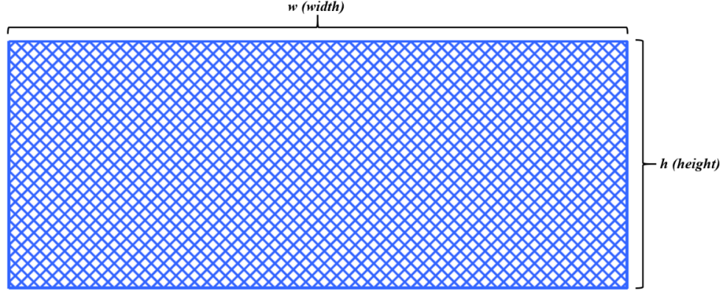
Figure 9 Cross-section area of specimen printed to examine the contribution of top and bottom layers
Table 6 Mean Experimental Tensile Strength TS_{TB} (MPa), Calculated Tensile Strength (MPa) and their Relative error (%)
S # | Print Speed (mm/s) x₁ | Layer thickness (mm) x₂ | No of Shells  x₃ | Mean Exp. Tensile Strength (Top/Bottom Layers) TS_{TB} (MPa) | Calculated Tensile Strength (Top/Bottom Layers) TS_{TB} (MPa) | Relative Error % (Test data vs Cal. data)
1 | 40 | 0.1 | 3 | 49.81 | 50.00 | 0.37%
2 | 60 | 0.1 | 3 | 47.06 | 47.30 | 0.52%
3 | 80 | 0.1 | 3 | 45.10 | 45.54 | 0.98%
4 | 100 | 0.1 | 3 | 44.17 | 44.71 | 1.23%
5 | 40 | 0.2 | 3 | 47.05 | 47.27 | 0.46%
6 | 60 | 0.2 | 3 | 44.40 | 44.68 | 0.62%
7 | 80 | 0.2 | 3 | 42.61 | 43.03 | 0.95%
8 | 100 | 0.2 | 3 | 41.75 | 42.30 | 1.32%
9 | 40 | 0.3 | 3 | 44.31 | 44.54 | 0.50%
10 | 60 | 0.3 | 3 | 41.84 | 42.06 | 0.50%
11 | 80 | 0.3 | 3 | 40.14 | 40.51 | 0.89%
12 | 100 | 0.3 | 3 | 39.31 | 39.90 | 1.46%
13 | 40 | 0.1 | 4 | 51.83 | 51.96 | 0.24%
14 | 60 | 0.1 | 4 | 48.80 | 49.22 | 0.86%
15 | 80 | 0.1 | 4 | 46.94 | 47.41 | 1.00%
16 | 100 | 0.1 | 4 | 45.97 | 46.54 | 1.24%
17 | 40 | 0.2 | 4 | 48.98 | 49.16 | 0.35%
18 | 60 | 0.2 | 4 | 46.26 | 46.52 | 0.56%
19 | 80 | 0.2 | 4 | 44.36 | 44.82 | 1.03%
20 | 100 | 0.2 | 4 | 43.44 | 44.06 | 1.42%
21 | 40 | 0.3 | 4 | 46.13 | 46.36 | 0.45%
22 | 60 | 0.3 | 4 | 43.55 | 43.83 | 0.62%
23 | 80 | 0.3 | 4 | 41.78 | 42.24 | 1.06%
24 | 100 | 0.3 | 4 | 40.91 | 41.58 | 1.60%
25 | 40 | 0.1 | 5 | 52.79 | 52.99 | 0.37%
26 | 60 | 0.1 | 5 | 49.83 | 50.20 | 0.74%
27 | 80 | 0.1 | 5 | 47.81 | 48.35 | 1.13%
28 | 100 | 0.1 | 5 | 46.82 | 47.43 | 1.31%
29 | 40 | 0.2 | 5 | 49.88 | 50.11 | 0.44%
30 | 60 | 0.2 | 5 | 47.04 | 47.43 | 0.82%
31 | 80 | 0.2 | 5 | 45.19 | 45.69 | 1.08%
32 | 100 | 0.2 | 5 | 44.24 | 44.88 | 1.43%
33 | 40 | 0.3 | 5 | 46.98 | 47.24 | 0.52%
34 | 60 | 0.3 | 5 | 44.34 | 44.67 | 0.69%
35 | 80 | 0.3 | 5 | 42.55 | 43.03 | 1.09%
36 | 100 | 0.3 | 5 | 41.66 | 42.33 | 1.55%

${TS}_{TB}= 49.162 -0.252x_{1}-27.268x_{2}+5.383x_{3}+0.0011x_{1}^{2}-0.467x_{3}^{2}+0.0534x_{1}x_{2}-0.0026x_{1}x_{3}-0.74x_{2}x_{3}$……… Eqn. (5)
Response Surface Methodology (RSM) was applied to model the relationship between these parameters and the observed tensile strength (presented in Equation 5). The analysis revealed that tensile strength in this region increases with a decrease in layer thickness and print speed, and with an increase in the number of shells (Figure 10). The maximum strength recorded was 52.79 MPa for the combination of 0.1 mm thickness, 40 mm/s speed, and five shells. The RSM model achieved an excellent fit with an R² value of 99.57%, and the maximum prediction error across all data points remained below 1.6% (Figure 11). This model was then used to predict the top-and-bottom layer strength in all subsequent calculations, effectively locking its contribution for the next stages. Detailed ANOVA results, residual diagnostics, and the Anderson–Darling normality-test plot for the TS_{TB}​ model are provided in the Supplementary Information.

Figure 10 Average Experimental Tensile Strength of Top & Bottom Layers (TS_{TB})

Figure 11 Error (%) b/w Mean Experimental Data (MED) and Calculated Data (CD) for top & bottom tensile strength (TS_{TB})

Modelling the Perimeter Shell Region (TS_{PS})
Once the contribution of the top-and-bottom layers was determined, the next step involved isolating the tensile strength of the perimeter shell region. Specimens were printed with the full geometry, including top/bottom layers, perimeter shells, and a solid infill (Figure 12). However, the infill and shell rasters were both printed at 90° to align the tensile load direction in this phase. By maintaining alignment at 90°, the strength contribution of the midsection could be assumed to come uniformly from both shells and infill.
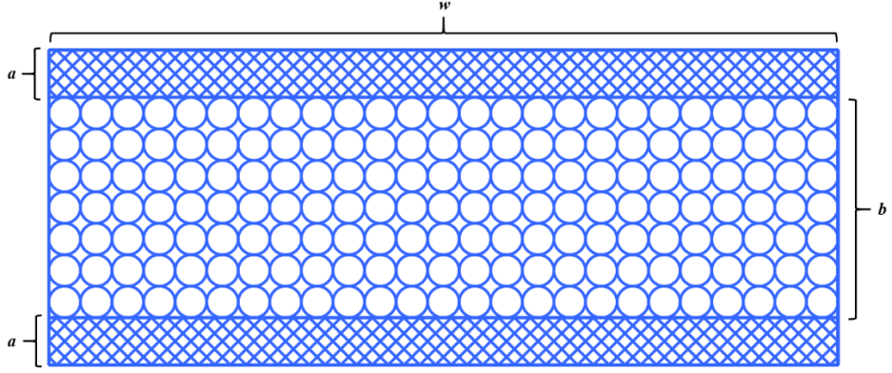
Figure 12 Cross-section of specimen printed for the calculation of tensile strength of Perimeter Shells
To isolate the midsection’s tensile strength (denoted as TS_{M}), the tensile contribution from the already-modelled top-and-bottom layers was subtracted using an area-weighted method. The formula applied was:
${TS}_{M}=\frac{{TS}_{S}\left(A_{S}\right)-{TS}_{TB}(A_{TB})}{A_{M}}$ ..………………… Eqn. (6)
Here,
‘TS_{S}’ is the total tensile strength of the specimen obtained by conducting experiments,
‘A_{S}’ is the total cross-sectional area of the specimen obtain by multiplying width of specimen by height of specimen (A_{S} = w x h),
‘TS_{TB}’ is the tensile strength of the specimen (Table 6),
‘A_{TB}’ is the cross-sectional area of the specimen obtained by formula (A_{TB} = 2a x w),
‘TS_{M}’ is the tensile strength of the midsection of the specimen,
‘A_{M}’ is the cross-sectional area of the midsection of the specimen obtained by formula (A_{M} = b x w),
The values of these regional cross-sectional areas are calculated in Table 7. and the values for mean experimental tensile strength of specimen, mean isolated tensile strength of mid-section and calculated tensile strength along with their error are presented in Table 8.
Table 7 Measurements of cross-sectional area for modelling perimeter shell
Symbol | Specification | Measurements | Unit
h | Total height of sample | 4 | mm
w | Total width of the part | 10 | mm
a | Total height of top or bottom layers | 0.6 | mm
b | Thickness of midsection Layers (b = h-2a) | 2.8 | mm
A_{S} | Total cross-sectional area of sample (A_{s} = w x h) | 40 | mm²
A_{TB} | Area of top and bottom layers (A_{TB} = 2a x w) | 12 | mm²
A_{M} | Area of midsection layers (A_{M} = A_{S} – A_{TB}) | 28 | mm²

Table 8 Mean tensile strength of the specimen, mean tensile strength of the midsection and relative error for experimental and calculated TS_{M} or TS_{PS}
S # | Print Speed (mm/s) x₁ | Layer thickness (mm) x₂ | Mean Exp. Tensile Strength TS_{S} (specimen) (MPa) | Mean Tensile Strength (Midsection) TS_{M} or TS_{PS} (MPa) | Calculated Tensile Strength (Midsection)  TS_{M} or TS_{PS} (MPa) | Relative Error % (MED vs CD)
1 | 40 | 0.1 | 53.77 | 54.19 | 54.14 | -0.10%
2 | 60 | 0.1 | 50.39 | 50.63 | 50.92 | 0.57%
3 | 80 | 0.1 | 48.38 | 48.62 | 49.03 | 0.84%
4 | 100 | 0.1 | 47.37 | 47.60 | 48.48 | 1.85%
5 | 40 | 0.2 | 51.76 | 52.56 | 52.46 | -0.20%
6 | 60 | 0.2 | 48.51 | 49.14 | 49.36 | 0.44%
7 | 80 | 0.2 | 46.56 | 47.15 | 47.59 | 0.92%
8 | 100 | 0.2 | 45.60 | 46.18 | 47.15 | 2.10%
9 | 40 | 0.3 | 47.87 | 48.25 | 48.27 | 0.04%
10 | 60 | 0.3 | 44.86 | 45.09 | 45.28 | 0.43%
11 | 80 | 0.3 | 43.06 | 43.27 | 43.63 | 0.82%
12 | 100 | 0.3 | 42.15 | 42.36 | 43.31 | 2.23%

The Response Surface Methodology (RSM) was applied to the midsection tensile strength values to develop a predictive mathematical model, as shown in Equation (7). The model results are presented in Table 8, with comparison plot shown in Figure 13. These results show close alignment between experimental and predicted tensile strengths, demonstrating high accuracy. The maximum relative error observed for the midsection’s tensile strength is 2.23%, confirming the reliability of the RSM model. Detailed ANOVA results, residual diagnostics, and the Anderson–Darling normality-test plot for the TS_{PS}​ model are provided in the Supplementary Information.
Notably, the midsection tensile strength values, denoted as TS_{M} (MPa), are equivalent to the perimeter shell strength (TS_{PS}, MPa) and corresponds to the experimental T₂​ value measured at a 90° print angle in section 3.1. Therefore, TS_{M}, TS_{PS}, and T₂​ are interchangeable terms representing the same tensile strength measurement.
${TS}_{PS}=63.99-0.3337x_{1}+18.52x_{2}+0.00167x_{1}^{2}-125.456x_{2}^{2}+0.0578x_{1}x_{2}$ …… Eqn. (7)

Figure 13 Comparison plot for Mean Experimental Data (MED) and Calculated Data (CD) for TS_{M} or TS_{PS} or T₂

Modelling the Infill Core (TS_{IC})
Specimen with complete cross-section including top-and-bottom layers, perimeter shells and infill core was printed for the modelling of TS_{IC} (Figure 14). Unlike the perimeter shell region, the infill core exhibits strong anisotropic behaviour due to the variation in raster angle relative to the loading direction. To isolate and model this region’s strength, a two-step subtraction process was followed.
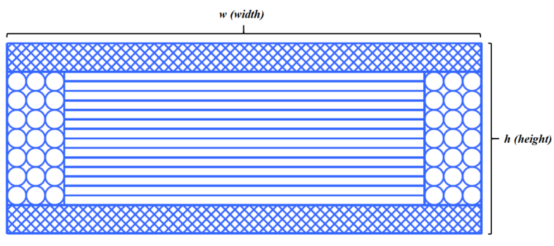
Figure 14 Cross-section of 3D printed specimen.
First, tensile specimens were printed with the infill at 0° and 45°, while perimeter shells remained at 90°, and top/bottom layers were consistent with previous phases. The total tensile strength of the specimen was measured, and the midsection strength (TS_{M}) was computed as before by subtracting the contribution of the top-and-bottom layers using Equation (6).
Next, the known strength of the perimeter shell region (TS_{PS}) was used to isolate the contribution of the infill region. The following expression (Equation 8) was used:
${TS}_{IC}=\frac{{TS}_{M}\left(A_{M}\right)-{TS}_{PS}(A_{PS})}{A_{IC}}$ ………………………… Eqn. (8)
Here,
‘TS_{M}’ is the total tensile strength of the midsection of the specimen obtained from equation (6),
‘A_{M}’ is the cross-sectional area of the midsection of the specimen obtained by formula (A_{M} = b x w),
‘TS_{PS}’ is the tensile strength of the specimen (Table 8),
‘A_{PS}’ is the cross-sectional area of the perimeter shells obtained by formula (A_{PS} = 2b x c, where c = nos x bw),
‘TS_{IC}’ is the tensile strength of the infill core of the specimen at 0° & 45° print angles,
‘A_{IC}’ is the cross-sectional area of the infill core obtained by formula (A_{IC} = b x d, where d = w - 2c),
Table 9 Measurements of cross-sectional area for modelling infill core
Symbol | Specification | Measurements | Unit
h | Total height of sample | 4 | mm
w | Total width of the part | 10 | mm
bw | Bead width (Nozzle width – can be changed by changing nozzle) | 0.4 | mm
nos | Number of perimeter shells | 4 | no
a | Total height of top or bottom layers | 0.6 | mm
b | Thickness of midsection Layers (b = h-2a) | 2.8 | mm
c | Width of the perimeter shell region (c = bw x nos) | 1.6 | mm
d | Width of the infill core region (d = w – 2c) | 6.8 | mm
A_{S} | Total cross-section area of the specimen (A_{S} = w x h) | 40 | mm²
A_{M} | Area of midsection layers (A_{M} = b x w) | 28 | mm²
A_{PS} | Total cross-section area of perimeter shell regions (A_{PS} = 2b x c) | 8.96 | mm²
A_{IC} | Area of infill core region (A_{IC} = b x d) | 19.04 | mm²
Using Equation (8) and values in Table 9, we first calculated TS_{IC0} with 0° specimens and then TS_{IC45} with 45° specimens. The mean tensile strength values for specimen, midsection & infill core and calculated tensile strength values for infill core (for both variables TS_{IC0} and TS_{IC45}) are presented in Table 10 and Table 11 respectively.
Table 10 Mean tensile strength of the specimen, mean tensile strength of the midsection, mean tensile strength of the infill region at 0°, calculated tensile strength of the infill region at 0° and relative error for experimental and calculated TS_{IC0}
S # | Print Speed (mm/s) x₁ | Layer thickness (mm) x₂ | Mean Exp. Tensile Strength TS_{S} (specimen) (MPa) | Mean Exp. Tensile Strength (midsection) TS_{M} (MPa) | Mean Exp. Tensile strength (infill region at 0°) TS_{IC0} (MPa) | Calculated Tensile Strength (infill region at 0°) TS_{IC0} (MPa) | Relative Error % (MED vs CD)
1 | 40 | 0.1 | 35.09 | 27.50 | 14.91 | 14.86 | -0.34%
2 | 60 | 0.1 | 32.94 | 25.70 | 13.93 | 13.91 | -0.12%
3 | 80 | 0.1 | 31.62 | 24.68 | 13.38 | 13.28 | -0.79%
4 | 100 | 0.1 | 30.96 | 24.16 | 13.10 | 12.95 | -1.12%
5 | 40 | 0.2 | 33.22 | 26.07 | 13.63 | 13.59 | -0.31%
6 | 60 | 0.2 | 31.18 | 24.38 | 12.75 | 12.70 | -0.40%
7 | 80 | 0.2 | 29.93 | 23.38 | 12.22 | 12.11 | -0.86%
8 | 100 | 0.2 | 29.30 | 22.90 | 11.97 | 11.84 | -1.02%
9 | 40 | 0.3 | 30.74 | 23.78 | 12.26 | 12.24 | -0.18%
10 | 60 | 0.3 | 28.85 | 22.21 | 11.45 | 11.40 | -0.41%
11 | 80 | 0.3 | 27.69 | 21.33 | 11.01 | 10.88 | -1.20%
12 | 100 | 0.3 | 27.12 | 20.88 | 10.78 | 10.66 | -1.11%

Table 11 Mean tensile strength of the specimen, mean tensile strength of the midsection, mean tensile strength of the infill region at 45°, calculated tensile strength of the infill region at 45° and relative error for experimental and calculated TS_{IC45}
S # | Print Speed (mm/s) x₁ | Layer thickness (mm) x₂ | Mean Exp. Tensile Strength TS_{S} (specimen) (MPa) | Mean Tensile Strength (Midsection) TS_{M} (MPa) | Mean Exp. Tensile strength (infill region at 45°)  TS_{IC45} (MPa) | Calculated Tensile Strength (infill region at 45°) TS_{IC45} (MPa) | Relative Error % (MED vs CD)
1 | 40 | 0.1 | 40.81 | 35.68 | 26.96 | 26.93 | -0.12%
2 | 60 | 0.1 | 38.28 | 33.33 | 25.19 | 25.22 | 0.15%
3 | 80 | 0.1 | 36.74 | 32.00 | 24.18 | 24.10 | -0.34%
4 | 100 | 0.1 | 35.98 | 31.34 | 23.69 | 23.55 | -0.59%
5 | 40 | 0.2 | 38.68 | 33.87 | 25.08 | 25.08 | -0.01%
6 | 60 | 0.2 | 36.28 | 31.66 | 23.44 | 23.44 | 0.02%
7 | 80 | 0.2 | 34.82 | 30.38 | 22.49 | 22.39 | -0.43%
8 | 100 | 0.2 | 34.10 | 29.76 | 22.03 | 21.91 | -0.54%
9 | 40 | 0.3 | 36.06 | 31.38 | 23.45 | 23.46 | 0.05%
10 | 60 | 0.3 | 33.83 | 29.32 | 21.90 | 21.90 | 0.00%
11 | 80 | 0.3 | 32.47 | 28.15 | 21.04 | 20.92 | -0.58%
12 | 100 | 0.3 | 31.80 | 27.57 | 20.61 | 20.52 | -0.47%
Using RSM, models were developed for both TS_{IC0}​ and TS_{IC45}​ across layer thicknesses and print speeds (Equation 9 & 10, respectively). The values showed that tensile strength in the infill core improved with thinner layers and slower print speeds. The maximum TS_{IC0} (0°) value observed was 14.91 MPa, and maximum TS_{IC45} (45°) was 26.96 MPa. Both models achieved excellent fits with R² values of 98.91% (for TS_{IC0}) and 98.99% (for TS_{IC45}), and maximum prediction errors of 1.2% (for TS_{IC0}) and 0.59% (for TS_{IC45}). Detailed ANOVA results, residual diagnostics, and Anderson–Darling normality-test plots for the TS_{IC0}​ and TS_{IC45}​ models are provided in the Supplementary Information. Later TS_{IC45} was used to calculate S₂ using Equation (11).
${TS}_{IC0}=18.991-0.089x_{1}-12.6624x_{2}+0.0004x_{1}^{2}-3.809x_{2}^{2}+0.0272x_{1}x_{2}$ …….… Eqn. (9)
${TS}_{IC45}=34.3114-0.1613x_{1}-23.518x_{2}+0.00072x_{1}^{2}+11.734x_{2}^{2}+0.0367x_{1}x_{2}$ …… Eqn. (10)
$S_{2}=\frac{{TS}_{IC45}}{2}$ …………………………… Eqn. (11)
Table 12 Summary of statistical validation for the regional RSM models
Regional model | R² (%) | Adjusted R² (%) | Predicted R² (%) | Model p-value | Lack-of-fit p-value | AD p-value | Maximum fitting error (%)
TS_{TB} | 99.57 | 99.53 | 99.48 | <0.001 | 1.000 | 0.252 | 1.60
TS_{PS} | 99.79 | 99.76 | 99.71 | <0.001 | 0.467 | 0.485 | 2.23
TS_{IC0} | 98.91 | 98.72 | 98.39 | <0.001 | 0.995 | 0.783 | 1.20
TS_{IC45} | 98.99 | 98.83 | 98.53 | <0.001 | 0.992 | 0.593 | 0.59
The statistical summary in Table 12 shows that all four regional RSM models were significant at the 95% confidence level (α=0.05), with model p-values below 0.05. The lack-of-fit tests were non-significant for all models (p>0.05), indicating that the fitted equations were adequate within the investigated parameter ranges. The Anderson–Darling tests also produced p>0.05 for all four regional datasets, indicating that the normality assumption was not rejected at the 95% confidence level. Residual diagnostic plots were examined for normal probability behaviour, residuals versus fitted values, residual histograms, and residuals versus observation order. The detailed ANOVA outputs and diagnostic plots are provided in the Supplementary Information.
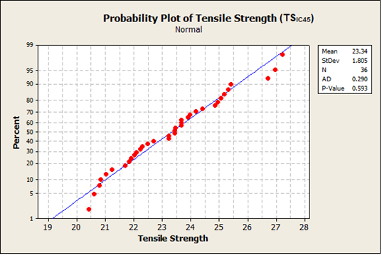
Figure 15 Anderson–Darling normality test for the TS_{IC45} tensile-strength data.

The Figure 15 presents the Anderson–Darling normality-test plot for the TS_{IC45}​ dataset, which showed the lowest fitting error among the regional RSM models. The Anderson–Darling statistic was 0.29 and the corresponding p-value was 0.593. Because the p-value was greater than 0.05, the normality assumption was not rejected at the 95% confidence level. This result supports the adequacy of the TS_{IC45}​ RSM model and is consistent with the statistical summary reported in Table 12. The remaining Anderson–Darling plots and residual diagnostic plots are retained in the Supplementary Information.

Final Calculation of Infill Strength (TS_{IC})
With the three principal strengths (T₁ = TS_{IC0}​, T₂ = TS_{PS}​, and S₂ = TS_{IC45}/2) now available as functions of layer thickness and print speed, the Tsai-Hill criterion was used to calculate the tensile strength of the infill core (TS_{IC}) at various raster angles. Raster angles were varied from 0° to 90° in 15° increments, and TS_{IC} was calculated for each layer thickness at a constant print speed of 60 mm/s and shell count of 4, using Equation (12). The constant value of print speed and no. of shell was kept such that the result can be correlated with the result of analytical model in section 3.1. Table 13 shows the principal strengths values at different layer thickness obtained using RSM models instead of experimentation. Mean tensile strength values of infill core TS_{IC} calculated using data from Table 13 are presented in Table 14.
${TS}_{IC}={\left[\frac{\cos^{4}θ}{T_{1}^{2}}+\left(\frac{1}{S_{2}^{2}}-\frac{1}{T_{1}^{2}}\right)\sin^{2}θ.\cos^{2}θ+\frac{\sin^{4}θ}{T_{2}^{2}}\right]}^{-1/2}$ …………………………… Eqn. (12)

Table 13 Region-wise Tensile Strengths at different Layer thicknesses (mm)
Regional Tensile Strengths (MPa) | Layer Thickness (mm)
Regional Tensile Strengths (MPa) | 0.1 | 0.2 | 0.3
T₁ (TS_{IC0}) | 13.91 | 12.7 | 11.4
T₂ / TS_{PS} | 50.92 | 49.36 | 45.28
S₂ (TS_{IC45}/2) | 12.61 | 11.72 | 10.95
TS_{TB} | 50.08 | 47.31 | 44.53

Table 14 Tensile strength of infill core TS_{IC} (MPa) calculated using hybrid technique
Serial # | Layer thickness (mm) | Print angle (°) | Tensile Strength of infill core TS_{IC} (MPa)
1 | 0.1 | 0 | 13.91
2 | 0.1 | 15 | 14.79
3 | 0.1 | 30 | 17.84
4 | 0.1 | 45 | 24.48
5 | 0.1 | 60 | 36.52
6 | 0.1 | 75 | 48.28
7 | 0.1 | 90 | 50.92
8 | 0.2 | 0 | 12.70
9 | 0.2 | 15 | 13.52
10 | 0.2 | 30 | 16.40
11 | 0.2 | 45 | 22.81
12 | 0.2 | 60 | 34.92
13 | 0.2 | 75 | 47.02
14 | 0.2 | 90 | 49.36
15 | 0.3 | 0 | 11.40
16 | 0.3 | 15 | 12.18
17 | 0.3 | 30 | 14.94
18 | 0.3 | 45 | 21.29
19 | 0.3 | 60 | 33.77
20 | 0.3 | 75 | 44.74
21 | 0.3 | 90 | 45.28
The results showed a clear trend: TS_{IC} increased significantly with raster angle, with maximum strength consistently observed at 90°. For instance, at 0.1 mm thickness, TS_{IC} ranged from 13.91 MPa at 0° to 50.92 MPa at 90°. The hybrid model captured this nonlinear behaviour accurately across all tested parameters. Finally, the overall tensile strength of the full specimen (TS_{S}) was calculated using an area-weighted average of all three regions (Equation 3). The computed values of the specimen's tensile strength (TS_{S}) are detailed in Table 15, alongside the mean tensile values derived from the experiments conducted in section 3.1 along their respective errors. This allows for evaluation of the hybrid model's performance under same parameter conditions, facilitating a detailed comparison with previous analytical modelling outcomes.

Table 15 Mean Experimental Tensile Strength TS_{S} of the complete specimen (MPa), Calculated Tensile Strength of infill core TS_{IC} (MPa) and their Relative Error (%)
Sample type | Layer thickness (mm) | Print Angle | Mean Tensile Strength Experimented TS_{S} (MPa) | Tensile Strength  Calculated using Hybrid Model TS_{S} (MPa) | Error (%)  MED vs CD for TS_{S}
1 | 0.1 | 0˚ | 32.94 | 33.05 | 0.34%
2 | 0.1 | 15˚ | 33.29 | 33.47 | 0.53%
3 | 0.1 | 30˚ | 35.07 | 34.93 | -0.41%
4 | 0.1 | 45˚ | 38.28 | 38.09 | -0.50%
5 | 0.1 | 60˚ | 43.65 | 43.81 | 0.37%
6 | 0.1 | 75˚ | 49.17 | 49.41 | 0.49%
7 | 0.1 | 90˚ | 50.39 | 50.67 | 0.55%
8 | 0.2 | 0˚ | 31.18 | 31.29 | 0.36%
9 | 0.2 | 15˚ | 31.79 | 31.68 | -0.34%
10 | 0.2 | 30˚ | 33.21 | 33.06 | -0.44%
11 | 0.2 | 45˚ | 36.28 | 36.11 | -0.46%
12 | 0.2 | 60˚ | 42.02 | 41.87 | -0.36%
13 | 0.2 | 75˚ | 47.37 | 47.63 | 0.54%
14 | 0.2 | 90˚ | 48.51 | 48.74 | 0.47%
15 | 0.3 | 0˚ | 28.85 | 28.93 | 0.29%
16 | 0.3 | 15˚ | 29.45 | 29.3 | -0.51%
17 | 0.3 | 30˚ | 30.44 | 30.62 | 0.59%
18 | 0.3 | 45˚ | 33.83 | 33.64 | -0.55%
19 | 0.3 | 60˚ | 39.81 | 39.58 | -0.58%
20 | 0.3 | 75˚ | 44.56 | 44.8 | 0.53%
21 | 0.3 | 90˚ | 44.86 | 45.06 | 0.44%
Comparison with the calibration dataset showed a maximum absolute relative error below 0.6% (Figure 16). Independent predictive performance was evaluated separately using parameter combinations not included in model calibration, as described in the following section.

Figure 16 Error (%) b/w Mean Experimental Data (MED) & Calculated Data (CD) for TS_{S}

Uncertainty propagation through the sequential regional-isolation procedure
Because the proposed hybrid framework isolates regional tensile-strength contributions sequentially, uncertainty from one stage can propagate into subsequent calculations. To quantify this effect, uncertainty propagation was evaluated using the raw triplicate tensile-strength data before regional isolation. The standard deviation of each triplicate set was first calculated, and pooled within-condition standard uncertainties were then obtained for the relevant datasets. Cross-sectional areas were treated as deterministic because they were defined by the CAD geometry, nozzle/bead width, and fixed slicing parameters.
The pooled standard uncertainty was calculated from the triplicate data as:
$u=\sqrt{\frac{\sum_{j=1}^{m}{(n_{j}-1)}s_{j}^{2}}{\sum_{j=1}^{m}{(n_{j}-1)}}}$..………………………………………………………………..…Eqn. (13)
where s_{j}​ is the standard deviation of the j^{th} triplicate condition, m is the number of conditions, and n_{j}=3 for all conditions.
For the perimeter-shell or midsection strength obtained from Equation (6), the propagated uncertainty was calculated as:
${u(TS}_{M})= {u(TS}_{PS})=\sqrt{{\left(\frac{A_{S}}{A_{M}}{u(TS}_{S})\right)}^{2}+{\left(\frac{A_{TB}}{A_{M}}{u(TS}_{TB})\right)}^{2}}$………………...…… Eqn. (14)
For the infill-core strength obtained from Equation (8), the propagated uncertainty was calculated as:
${u(TS}_{IC})=\sqrt{{\left(\frac{A_{M}}{A_{IC}}{u(TS}_{M})\right)}^{2}+{\left(\frac{A_{PS}}{A_{IC}}{u(TS}_{PS})\right)}^{2}}$……………………………...…… Eqn. (15)
Finally, for the complete-specimen tensile strength calculated using Equation (3), the propagated uncertainty was calculated as:
${u(TS}_{S})=\sqrt{{\left(\frac{A_{TB}}{A}{u(TS}_{TB})\right)}^{2}+{\left(\frac{A_{PS}}{A}{u(TS}_{PS})\right)}^{2}+{\left(\frac{A_{IC}}{A}{u(TS}_{IC})\right)}^{2}}$ …………....… Eqn. (16)
where A=A_{TB}+A_{PS}+A_{IC​}. The area values used were A_{TB}=12 mm², A_{PS}​=8.96 mm², A_{IC}=19.04 mm², and A=40 mm². The uncertainty-propagation results are summarized in Table 16.
Table 16 Propagation of experimental uncertainty through the sequential regional-isolation procedure.
Quantity | Mean tensile strength (MPa) | Experimental standard uncertainty (MPa) | Relative uncertainty (%)
Top-and-bottom layers, (TS_{TB}) | 46.60 | 0.247 | 0.53
Perimeter shell / midsection, (TS_{PS}) or (TS_{M}) | 47.92 | 0.197 | 0.41
Infill core at 0°, (TS_{IC0}) | 12.62 | 0.241 | 1.91
Infill core at 45°, (TS_{IC45}) | 23.34 | 0.281 | 1.20
Complete specimen, (TS_{S}) | 38.33 | 0.144–0.159 | 0.38–0.42

The propagated uncertainties were calculated from the raw triplicate tensile-strength data before regional isolation. The TS_{TB​} uncertainty corresponds to the matching top-and-bottom-layer data used in the sequential subtraction procedure. The uncertainty in TS_{PS}​ was obtained by propagating the raw complete-specimen 90° data and the TS_{TB}​ uncertainty through Equation (14). The uncertainties in TS_{IC0}​ and TS_{IC45}​ were then obtained by propagating the corresponding raw complete-specimen 0° and 45° data through Equations (14) and (15). Finally, the uncertainty in the complete-specimen tensile-strength prediction was obtained using Equation (16). The final propagated uncertainty was 0.144–0.159 MPa, corresponding to only 0.38–0.42% of the mean complete-specimen tensile strength. Although uncertainty increased through the sequential subtraction steps, the final propagated uncertainty remained below 0.5%, indicating that the regional-isolation procedure did not introduce substantial uncertainty amplification.

Independent Validation of the Hybrid Model
The agreement reported in Table 15 represents calibration accuracy because the experimental values were obtained from conditions used during model development. To evaluate predictive performance independently, an additional validation programme was conducted using parameter combinations that were not included in model calibration.
Twelve new treatment combinations were tested using layer thicknesses of 0.15 and 0.25 mm, raster angles of 25°, 35°, and 65°, print speeds of 70 and 90 mm/s, and five perimeter shells. Each treatment combination was tested in triplicate, resulting in 36 additional specimens. The maximum absolute difference between the experimental and predicted tensile strengths was 0.69% (Table 17).
Table 17 Experimental Tensile Strength (MPa), Calculated Tensile Strength (MPa) and Error percentage (%).
Run | Layer thickness (mm) | Print Angle (˚) | Print Speed (mm/s) | Number of perimeter shell | Experimental Tensile Strength (MPa) | Calculated Tensile Strength (MPa) | Error (%)
1 | 0.15 | 25˚ | 70 | 5 | 34.40 | 34.59 | -0.55%
2 | 0.25 | 25˚ | 70 | 5 | 32.56 | 32.41 | 0.46%
3 | 0.15 | 35˚ | 70 | 5 | 36.05 | 35.8 | 0.69%
4 | 0.25 | 35˚ | 70 | 5 | 33.45 | 33.57 | -0.36%
5 | 0.15 | 65˚ | 70 | 5 | 44.45 | 44.71 | -0.58%
6 | 0.25 | 65˚ | 70 | 5 | 42.29 | 42.56 | -0.64%
7 | 0.15 | 25˚ | 90 | 5 | 33.75 | 33.62 | 0.39%
8 | 0.25 | 25˚ | 90 | 5 | 31.45 | 31.52 | -0.22%
9 | 0.15 | 35˚ | 90 | 5 | 34.99 | 34.79 | 0.57%
10 | 0.25 | 35˚ | 90 | 5 | 32.83 | 32.65 | 0.55%
11 | 0.15 | 65˚ | 90 | 5 | 43.60 | 43.49 | 0.25%
12 | 0.25 | 65˚ | 90 | 5 | 41.25 | 41.44 | -0.46%

A second validation exercise examined the applicability of the model to specimens with non-standard cross-sectional dimensions (Table 18). Three additional specimen geometries were printed and tested at raster angles of 0° and 90°. The maximum absolute prediction error was 0.78%. These results (as shown in Table 19) indicate that the model retains good predictive agreement for parameter combinations outside the calibration dataset and for the additional geometries examined in this study.
Table 18 Dimensions for Cross-section Area of Specimen and Values for Print Parameter for Validation of Tensile strength model.
Symbol | Specification | Measurements |  |  | Unit
 |  | NSS₁ | NSS₂ | NSS₃
h | Total height of sample | 6 | 10 | 6 | mm
w | Total width of the part | 15 | 10 | 10 | mm
n | Nozzle Dia | 0.4 | 0.4 | 0.4 | mm
nos | Number of perimeter shells | 6 | 6 | 5 | no
a | Total height of top or bottom layers | 1.2 | 1.2 | 1.2 | mm
b | Thickness of midsection Layers (b = h-2a) | 3.6 | 7.6 | 3.6 | mm
c | Width of the perimeter shell region (c = n x nos) | 2.4 | 2.4 | 2 | mm
d | Width of the infill core region (d = w – 2c) | 10.2 | 5.2 | 6 | mm
A_{S} | Total cross-section area of the specimen (A_{S} = w x h) | 90 | 100 | 60 | mm²
A_{TB} | Area of top-and-bottom layers (A_{TB} = 2 x a x w) | 36 | 24 | 24 | mm²
A_{PS} | Total cross-section area of perimeter shell regions (A_{PS} = 2 x b x c) | 17.28 | 36.48 | 14.4 | mm²
A_{IC} | Area of infill core region (A_{IC} = b x d) | 36.72 | 39.52 | 21.6 | mm²

Table 19 Mean experimental tensile strength (MPa), Calculated tensile strength (MPa) and their error for non-standard samples
Run | Specimen | Print angle (˚) | Mean Experimental Tensile Strength (MPa) | Calculated Tensile Strength (MPa) | Error Percentage (%)
1 | NSS1 | 0˚ | 35.24 | 35.13 | 0.31%
2 | NSS2 | 0˚ | 35.69 | 35.88 | -0.53%
3 | NSS3 | 0˚ | 37.56 | 37.27 | 0.77%
4 | NSS1 | 90˚ | 50.56 | 50.23 | 0.65%
5 | NSS2 | 90˚ | 50.33 | 50.51 | -0.36%
6 | NSS3 | 90˚ | 50.21 | 50.6 | -0.78%

Discussion
The present study develops a region-based hybrid modelling framework for predicting the tensile strength of PLA components fabricated by Material Extrusion (MEX). Rather than treating the printed specimen as a homogeneous continuum, the framework represents the cross-section through three structural regions: the top-and-bottom layers, the perimeter shells, and the infill core. This segmentation reflects the heterogeneous architecture produced by layer-wise deposition and provides a structured basis for modelling the effects of raster angle, layer thickness, print speed, and shell count.
Several studies have highlighted the difficulty of describing MEX-fabricated components using a single global relationship, particularly when multiple process parameters interact and the printed structure exhibits direction-dependent behaviour (Fountas et al., 2023; Singh and Bharti, 2023; Panico et al., 2025). Area-based and region-aware representations have also been used previously for additively manufactured components. For reinforced printed materials, rule-of-mixtures formulations have been applied using constituent area fractions (Deng et al., 2019), while section-area models have been developed for unreinforced PLA components using the proportions of surface and infill regions (Homrani et al., 2024). The contribution of the present study therefore does not lie in cross-sectional decomposition alone. Rather, it lies in the integration of sequential regional-strength isolation, region-specific Response Surface Methodology (RSM) models, Tsai–Hill-based interpolation of raster-orientation effects within the infill core, and a segmented Design of Experiments strategy that reduces the required calibration matrix.

Strength-Isolation Strategy and Engineering Interpretation
The strength-isolation strategy provides an engineering-scale means of distinguishing the contributions of mechanically different regions within the printed cross-section. This approach addresses a critical limitation identified in previous studies, where parameter interactions are often conflated due to the exclusive use of full-geometry specimens. By isolating the strength contributions of individual regions, the model enables more reliable engineering-scale predictions. The top-and-bottom layers contain slicer-defined ±45° paths, the perimeter shells are predominantly aligned with the specimen axis, and the infill core exhibits the strongest dependence on raster orientation. A single global equation may blend these regional effects and obscure the separate influence of shell reinforcement and raster-induced anisotropy. The segmented framework instead estimates each regional contribution using the parameters most relevant to that region and combines the estimates at the nominal cross-sectional level.
The modelling sequence begins with the top-and-bottom layers, denoted as TS_{TB}​. These layers are printed with a fixed ±45° raster orientation and are modelled as a function of layer thickness, print speed, and shell count. Because the raster orientation remains fixed, the contribution of this region can be estimated without introducing the orientation-dependent behaviour associated with the infill core. RSM is used at this stage to capture the individual and interacting effects of the relevant process parameters. Previous studies have shown that RSM is suitable for representing nonlinear relationships among MEX processing parameters and tensile properties (Srinivasan et al., 2020; Samykano, 2021). In the present framework, however, RSM is applied at the regional level rather than through a single full-specimen equation.
The perimeter-shell contribution, denoted as TS_{PS}​, is subsequently estimated using specimens printed with rasters aligned at 90° relative to the tensile loading direction. The previously modelled top-and-bottom-layer contribution is removed through an area-weighted calculation. The resulting value is treated as an effective aligned midsection-strength parameter for representing the perimeter-shell region within the hybrid model. Previous studies have reported the reinforcing influence of perimeter shells on the tensile performance of MEX-fabricated components (Griffiths et al., 2016; Torres et al., 2016). The present framework extends this interpretation by estimating the shell-related contribution separately within the sequential modelling procedure.
The infill-core contribution, denoted as TS_{IC}​, is then estimated through a second-stage subtraction using specimens printed at the reference raster orientations. The extracted regional parameters are integrated with the Tsai–Hill criterion to interpolate raster-orientation-dependent behaviour within the infill core. Tsai–Hill was originally developed for anisotropic composite materials and is widely used for orientation-sensitive strength prediction (Nali and Carrera, 2012). However, MEX-printed PLA is not a conventional continuous-fibre laminate. In this study, Tsai–Hill is therefore used as an engineering approximation for raster-induced anisotropy rather than as a complete constitutive or fracture-mechanics description of the printed polymer.
The regional decomposition should not be interpreted as evidence that the three regions behave independently. The extracted values are effective engineering parameters that incorporate unresolved local effects within the investigated domain. The area-weighted formulation assumes that the top-and-bottom layers, perimeter shells, and infill core remain mechanically connected and undergo approximately compatible axial deformation before peak load. It does not explicitly resolve local stress concentrations, imperfect interfaces, detailed void topology, interface debonding, crack initiation, residual stresses, or post-yield load redistribution. The sequential isolation framework provides three practical advantages. First, it improves physical interpretability by modelling each region according to its dominant structural characteristics. Second, it reduces parameter coupling by separating contributions that would otherwise be combined within a single global response. Third, once regional relationships have been established, the framework permits predictions across the investigated parameter space without requiring repeated full-specimen experimentation.

Experimental-Effort Reduction Through the Segmented DoE Strategy
Response Surface Methodology was implemented within a structured Design of Experiments framework. A direct full-factorial evaluation of the selected process parameters would require 252 treatment combinations and 756 specimens with triplicate testing. By varying the parameters considered relevant to each structural region only, the segmented strategy reduced the calibration matrix to 72 configurations and the required number of specimens to 216. This corresponds to a 71.4% reduction in experimental burden. This reduction is consistent with the broader role of DoE in MEX research, where structured reduced designs are used to investigate multiple factors and their interactions while maintaining a practical experimental workload (Alzyod, Borbas and Ficzere, 2023; Alzyod, Ficzere and Borbas, 2024).
The reduction was achieved through 36 configurations for the top-and-bottom layers, 12 configurations for the perimeter-shell region, and 24 configurations for the anisotropic infill core. The strategy should be interpreted as an engineering simplification supported by regional assumptions and predictive validation, rather than as a complete substitute for an unrestricted full-factorial investigation. Nevertheless, it provides a practical route for studying multiple parameters without requiring every possible full-geometry configuration to be fabricated and tested.

Comparative Model Behaviour and Predictive Validation
The standalone Tsai–Hill model provides a useful analytical baseline for examining raster-orientation effects. However, its applicability is limited when other process parameters vary. First, its directional strength parameters must be recalibrated when the relevant printing conditions change. Second, the formulation primarily expresses tensile strength as a function of raster orientation and does not directly represent the effects of layer thickness, print speed, or shell count. These parameters have been shown to influence the tensile performance of MEX-fabricated components (Yilan et al., 2023; Hasan, Fahad and Khan, 2024). Third, the standalone model does not distinguish the contributions of the top-and-bottom layers, perimeter shells, and infill core.
The improvement arises because the hybrid framework combines region-specific modelling of structural heterogeneity with process-parameter sensitivity and raster-orientation interpolation. Unlike the standalone Tsai–Hill formulation, which represents tensile strength primarily as a function of raster angle, the hybrid framework simultaneously incorporates layer thickness, print speed, shell count, and regional area contributions. Within the investigated range, the standalone Tsai–Hill model produced errors of up to 11.52%, with the largest deviations occurring at intermediate raster angles. By contrast, the calibrated hybrid framework achieved a maximum fitting error below 0.6%. This comparison demonstrates the practical value of combining region-specific parameter modelling with raster-angle interpolation.
The comparison should nevertheless be interpreted carefully. The standalone Tsai–Hill model relies on a limited number of directional strength inputs, whereas the hybrid framework incorporates a larger regional calibration dataset and additional process parameters. The observed improvement therefore supports the practical adequacy of the calibrated hybrid framework relative to an angle-only analytical baseline, but it does not isolate the individual contribution of regional decomposition from the effect of the larger calibration dataset.
To further assess whether the improved performance of the proposed framework resulted only from regression fitting, a separate complete-specimen global RSM model was developed using the dataset originally generated for the standalone Tsai–Hill comparison in Table 5. This dataset contains complete-specimen tensile-strength values across raster angles from 0° to 90° at three different layer thicknesses, with print speed, infill density, build orientation, and shell count fixed at 60 mm/s, 100%, flat orientation, and four shells, respectively. This dataset was selected for the global benchmark because it provides a consistent complete-specimen response over the full raster-angle range.
The segmented hybrid-model calibration dataset was not used for the global RSM benchmark because it is region-specific rather than a single complete-specimen factorial dataset. Each regional model was calibrated using the parameters relevant to that region, and the hybrid dataset did not contain complete-specimen tensile-strength measurements for all raster angles and all parameter combinations. Developing a global RSM from these regional responses would therefore mix different physical response quantities and would not provide a valid conventional global model. The global RSM benchmark should therefore be interpreted as a direct non-regional benchmark based on the complete-specimen angular dataset in Table 5, rather than as part of the regional hybrid-model calibration procedure.
The coded variables were defined as x₁=(t−0.2)/0.1 and x₂=(θ−45)/45, where ‘t’ is layer thickness and ‘θ’ is print angle.
The resulting global RSM benchmark equation was:
${TS}_{Global}=37.392-{2.214x}_{1}+{9.726x}_{2}-{0.436x}_{1}^{2}+{2.768x}_{2}^{2}-{0.270x}_{1}x_{2}$… Eqn. (17)
The global RSM benchmark achieved R2=96.23%, adjusted R2=94.98%, and a PRESS-based predicted R2 of approximately 91.50%. The corresponding RMSE, MAE, and MAPE were 1.35 MPa, 1.21 MPa, and 3.25%, respectively, with a maximum relative error of 5.13%. Although the global RSM model captured the general tensile-strength trend, its maximum error remained higher than that of the proposed region-based hybrid framework. This supports the benefit of the regional decomposition strategy, while also clarifying that the global benchmark was developed only from the complete-specimen angular dataset rather than from the region-specific hybrid calibration dataset. The ANOVA results for the global RSM benchmark are presented in Table 20, and the model was statistically significant (p<0.001). The four-in-one residual diagnostic plots are presented in Figure 17.

Table 20 ANOVA results for the complete-specimen global RSM benchmark based on the Table 5 dataset
Source | DF | Adj. SS | Adj. MS | F-value | p-value
Model | 5 | 976.63 | 195.33 | 76.73 | <0.001
Layer thickness, ($x_{1}$) | 1 | 68.61 | 68.61 | 26.95 | <0.001
Raster angle, ($x_{2}$) | 1 | 882.84 | 882.84 | 346.81 | <0.001
Layer thickness², ($x_{1}^{2}$) | 1 | 0.89 | 0.89 | 0.35 | 0.563
Raster angle², ($x_{2}^{2}$) | 1 | 23.83 | 23.83 | 9.36 | 0.008
Layer thickness × raster angle, ($x_{1} ,$ $x_{2}$) | 1 | 0.45 | 0.45 | 0.18 | 0.678
Error | 15 | 38.19 | 2.55 | — | —
Total | 20 | 1014.82 | — | — | —

The ANOVA results indicate that the complete-specimen global RSM benchmark was statistically significant (p<0.001). Raster angle was the dominant factor, followed by layer thickness. The quadratic raster-angle term was also significant (p=0.008), confirming curvature in the tensile-strength response with respect to raster orientation. In contrast, the layer-thickness quadratic term and the layer-thickness & raster-angle interaction were not statistically significant at the 95% confidence level. Although the global RSM benchmark provided a statistically significant fit, its maximum relative error remained higher than that of the proposed region-based hybrid framework.

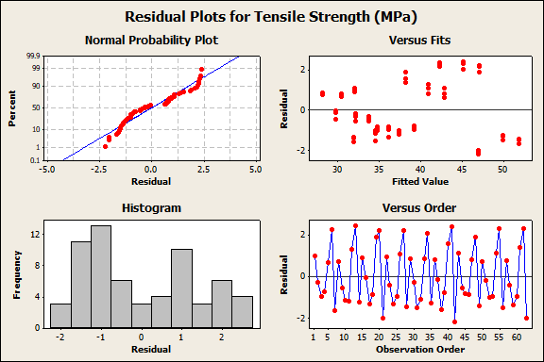
Figure 17 Residual Plot for Global RSM Model

Table 21 Comparison between standalone Tsai–Hill, complete-specimen global RSM benchmark, and proposed region-based hybrid model.
Model | Modelling approach | Maximum fitting error | Validation / prediction assessment | Main limitation
Standalone Tsai–Hill | Raster-angle-based analytical interpolation | 11.52% | Not independently validated | Does not include layer thickness, print speed, shell count, or regional effects
Global RSM benchmark | Direct complete-specimen quadratic RSM | 5.13% | (R²=96.23%), adjusted  (R²=94.98%), predicted  (R² approx. 91.50%) | Does not isolate regional mechanical contributions
Proposed region-based hybrid RSM–Tsai–Hill model | Regional RSM models + Tsai–Hill infill-core interpolation | <0.6% | 0.69% independent-validation error;  0.78% geometry-validation error | Requires regional calibration and area-weighted assumptions

The reported fitting accuracy was evaluated separately from predictive performance. The independent validation exercise used 12 previously unused parameter combinations tested in triplicate, resulting in 36 additional specimens. This dataset produced a maximum absolute prediction error of 0.69%. An additional geometry-based validation using non-standard specimen dimensions resulted in a maximum absolute error of 0.78%. These results support the predictive adequacy of the proposed framework for scenarios that remain sufficiently close to the model-development domain.
The statistical validation summary further supports the regional RSM models, as all models were significant at the 95% confidence level, exhibited non-significant lack-of-fit results, and satisfied the Anderson–Darling normality criterion (p>0.05).

Interpretation of Process-Parameter Effects
Within the investigated range, layer thickness, print speed, shell count, and raster angle influenced tensile strength through different regional pathways. Raster angle exerted its most direct effect within the infill core, where alignment with the loading direction increased the effective tensile-strength contribution. The importance of filament alignment in improving tensile performance has been reported in earlier studies of MEX-fabricated parts (Rajpurohit and Dave, 2020). Shell count affected the relative contribution of the perimeter region, while layer thickness and print speed influenced the fitted regional responses.
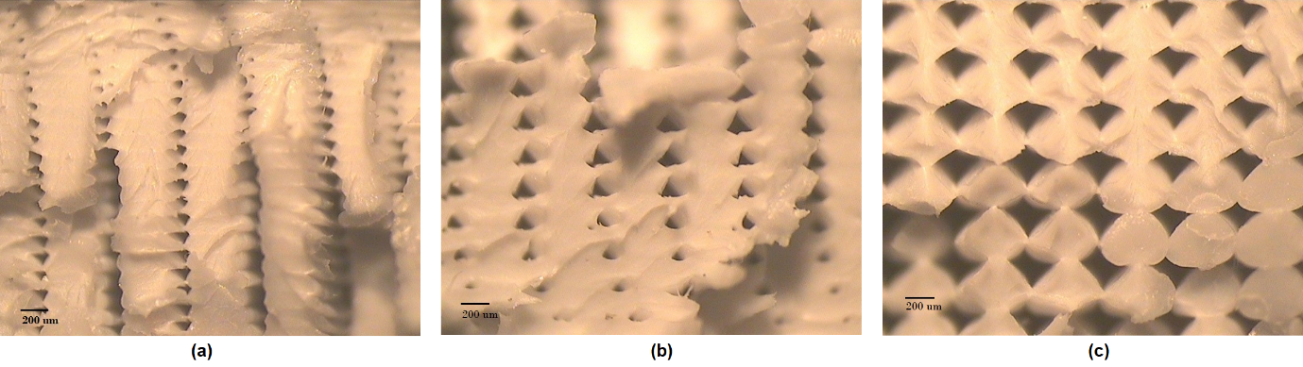
Figure 18 Representative optical stereomicrographs of fracture surfaces of MEX-printed PLA specimens fabricated at different layer thicknesses: (a) 0.1 mm, (b) 0.2 mm, and (c) 0.3 mm at 60x magnification.

The observed trends should also be interpreted at the engineering scale. Earlier studies have associated changes in layer thickness and print speed with differences in bonding quality, deposited-bead continuity, and internal gaps (Huynh et al., 2019; Farashi and Vafaee, 2022; Marșavina et al., 2022; Yilan et al., 2023). Optical fracture-surface images (Figure 18) indicate smaller visible gaps between deposited rasters at lower layer thicknesses. These observations are consistent with improved load-bearing continuity; however, they should not be interpreted as direct evidence of polymer-chain diffusion, interfacial fusion, or other bead-scale bonding mechanisms.

Limitations and Scope of Applicability
The proposed framework is an engineering-scale predictive model developed within the practical constraints of the available equipment, supporting resources, and a confined experimental dataset. The experimental programme was conducted using PLA specimens fabricated with a single material-extrusion printer under a flat build orientation, with a 0.4 mm nozzle, line infill, fixed extrusion and bed temperatures, and the investigated ranges of layer thickness, raster angle, print speed, and shell count. The print-speed range of 40–100 mm/s represents the actual machine settings used throughout the experimental programme. Accordingly, the framework is most directly applicable to comparable scenarios that closely match the experimental conditions and parameter set used during model development. Related applications should be supported by targeted recalibration using representative local data.
The regional area-weighted formulation assumes that the specimen cross-section can be partitioned into mechanically meaningful regions that remain connected and undergo approximately compatible axial deformation before peak load. This assumption enables practical tensile-strength prediction at the engineering scale. However, the model does not explicitly resolve local stress concentrations, interfacial debonding, detailed void topology, crack initiation and propagation, residual stresses, crystallinity variations, thermal-history effects, or post-yield load redistribution. Its predictive capability may therefore be reduced for complex geometries or components that cannot be readily decomposed into quantifiable structural regions.
The sequential regional-isolation procedure also introduces the potential for measurement uncertainty to propagate from the top-and-bottom-layer model into the perimeter-shell estimate and subsequently into the infill-core estimate. Triplicate testing, standard deviations, and independent validation provide an empirical assessment of repeatability and predictive performance. The present uncertainty propagation analysis quantified the effect of experimental variability from triplicate tensile testing on the sequential regional-isolation procedure. However, it did not include additional uncertainty sources such as geometric tolerances, filament-diameter variation, material-batch variability, environmental effects, or machine-to-machine differences.
The interpretation of raster-gap effects is supported by optical fracture-surface observations. However, advanced microstructural and thermal characterization techniques, including scanning electron microscopy (SEM), X-ray computed tomography (XCT), differential scanning calorimetry (DSC), X-ray diffraction (XRD), rheological analysis, and detailed thermal-history characterization, were not performed. Incorporating these techniques in future investigations would provide deeper insight into the underlying material behaviour and strengthen the physical interpretation of the proposed framework.

Conclusions
This study presents a region-based hybrid modelling framework for predicting the tensile strength of PLA components fabricated by Material Extrusion (MEX). Building on established area-based and region-aware representations of additively manufactured components, the framework separates the specimen cross-section into top-and-bottom layers, perimeter shells, and an infill core. The contribution of the present study does not lie in cross-sectional decomposition alone, but in the integration of sequential regional-strength isolation, region-specific Response Surface Methodology (RSM) models, and Tsai–Hill-based interpolation of raster-orientation effects within the infill core. This combination allows the effects of print speed, layer thickness, shell count, and raster angle to be incorporated within a unified predictive framework.
The segmented Design of Experiments strategy reduced the calibration matrix from 252 to 72 configurations and the required number of specimens from 756 to 216, representing a 71.4% reduction in experimental burden. Within the investigated processing range, the standalone Tsai–Hill model produced errors of up to 11.52% at intermediate raster angles, whereas the calibrated hybrid framework achieved a maximum fitting error below 0.6%. Predictive performance was assessed separately using 12 previously unused parameter combinations tested in triplicate, producing a maximum absolute prediction error of 0.69%. An additional geometry-based validation using non-standard specimen dimensions resulted in a maximum absolute error of 0.78%. These results indicate that the proposed framework provides accurate engineering-scale tensile-strength predictions within the tested domain.
The framework was developed within the practical constraints of the available equipment, supporting resources, and a confined experimental dataset. Accordingly, the present results establish a validated basis for tensile-strength prediction in comparable MEX scenarios that closely match the experimental conditions and parameter set used during model development. Related applications may be addressed through targeted recalibration using representative local data. The area-weighted formulation should be interpreted as a first-order engineering approximation rather than as a local fracture-mechanics model, as it does not explicitly resolve stress concentrations, detailed void morphology, interface debonding, thermal-history effects, or crack-initiation mechanisms.
Within these limits, the proposed framework offers a practical method for reducing experimental effort while improving tensile-strength prediction for MEX-printed PLA components under controlled conditions. Future work should extend the calibration domain to additional materials, nozzle diameters, extrusion temperatures, infill densities, and build orientations. Although the present revision quantified measurement-based uncertainty propagation and added a global RSM benchmark, further work should incorporate additional uncertainty sources such as geometric tolerances, filament-diameter variation, material-batch variability, environmental effects, and machine-to-machine differences.

Supplementary Information
This Supplementary Information provides additional statistical validation results for the regional Response Surface Methodology (RSM) models developed in the main manuscript. The supplementary material includes ANOVA tables for the top-and-bottom-layer tensile strength (TSTB), perimeter-shell tensile strength (TSPS), infill-core tensile strength at 0° (TSIC0), and infill-core tensile strength at 45° (TSIC45). These tables report model significance, p-values, lack-of-fit results, and model-fit statistics at a 95% confidence level (α=0.05). Residual diagnostic plots are also provided for each regional model, including normal probability plots, residuals versus fitted values, residual histograms, and residuals versus observation order. In addition, Anderson–Darling normality-test plots are included to assess the distribution of the tensile-strength data for each regional dataset. The Anderson–Darling test results showed p>0.05 for all four datasets, indicating that the normality assumption was not rejected at the 95% confidence level.
Table 22 Analysis of Variance for Tensile Strength top/bottom layers (TS_{TB}) versus Print Speed (mm/s), Layer thickness (mm) and No. of Perimeter Shells.
Source | DF | Seq SS | Adj SS | Adj MS | F | P
Regression | 9 | 1111.31 | 1111.31 | 123.479 | 2521.89 | 0.0
Linear | 3 | 1082.05 | 57.42 | 19.140 | 390.91 | 0.0
Print Speed (mm/s) [x₁] | 1 | 454.58 | 37.06 | 37.058 | 756.85 | 0.0
Layer Thickness (mm) [x₂] | 1 | 502.66 | 6.47 | 6.465 | 132.05 | 0.0
No. of perimeter Shells [x₃] | 1 | 124.82 | 9.99 | 9.991 | 204.04 | 0.0
Square | 3 | 27.72 | 27.72 | 9.241 | 188.73 | 0.0
Print Speed (mm/s) * Print Speed (mm/s) | 1 | 22.50 | 22.50 | 22.495 | 459.44 | 0.0
Layer Thickness (mm) * Layer Thickness (mm) | 1 | 0.00 | 0.00 | 0.000 | 0.00 | 0.971
No. of perimeter Shells * No. of perimeter Shells | 1 | 5.23 | 5.23 | 5.227 | 106.75 | 0.0
Interactions | 3 | 1.54 | 1.54 | 0.513 | 10.48 | 0.0
Print Speed (mm/s) * Layer Thickness (mm) | 1 | 1.03 | 1.03 | 1.026 | 20.96 | 0.0
Print Speed (mm/s) * No. of perimeter Shells | 1 | 0.25 | 0.25 | 0.251 | 5.12 | 0.026
Layer Thickness (mm) * No. of perimeter Shells | 1 | 0.26 | 0.26 | 0.263 | 5.36 | 0.023
Residual Error | 98 | 4.80 | 4.80 | 0.049 |  | 0.0
Lack-of-Fit | 26 | 0.15 | 0.15 | 0.006 | 0.09 | 1.0
Pure Error | 72 | 4.64 | 4.64 | 0.065 |  | 0.0
Total | 107 | 1116.11 |  |  |  | 0.0

ANOVA was evaluated at a 95% confidence level (α=0.05). Terms with p<0.05 were considered statistically significant. R-Sq = 99.57%, R-Sq (Pred.) = 99.48%, and R-Sq (adj) = 99.53%.

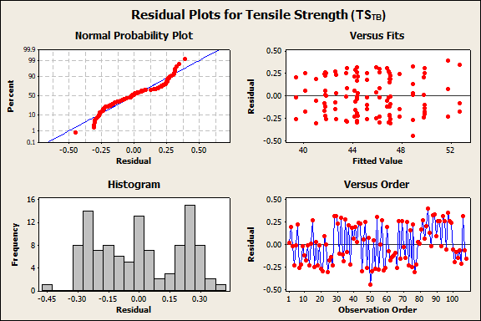
Figure 19 Residual diagnostic plots for the TS_{TB}​ RSM model, including normal probability, residuals versus fits, histogram, and residuals versus order plots.

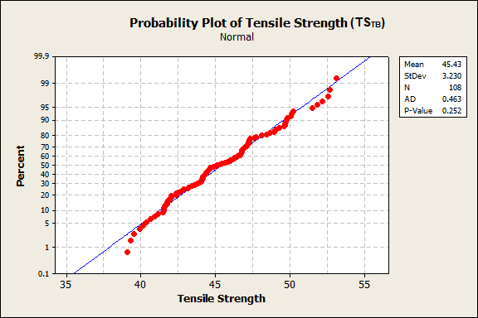
Figure 20 Anderson–Darling normality test for the TSTB tensile-strength data.

Table 23 Analysis of Variance (ANOVA) for Tensile Strength (TS_{M} / TS_{PS}) of midsection of specimen vs Print speed and Layer thickness.
Source | DF | Seq SS | Adj SS | Adj MS | F | P
Regression | 5 | 403.724 | 403.724 | 80.7447 | 2915.92 | 0.0
Linear | 2 | 377.614 | 31.563 | 15.7817 | 569.92 | 0.0
Print Speed (mm/s) [x₁] | 1 | 194.792 | 28.178 | 28.1783 | 1017.60 | 0.0
Layer Thickness (mm) [x₂] | 1 | 182.822 | 1.401 | 1.4014 | 50.61 | 0.0
Square | 2 | 25.707 | 25.707 | 12.8536 | 464.18 | 0.0
Print Speed (mm/s) * Print Speed (mm/s) | 1 | 13.116 | 13.116 | 13.1165 | 473.67 | 0.0
Layer Thickness (mm) * Layer Thickness (mm) | 1 | 12.591 | 12.591 | 12.5906 | 454.68 | 0.0
Interactions | 1 | 0.402 | 0.402 | 0.4020 | 14.52 | 0.001
Print Speed (mm/s) * Layer Thickness (mm) | 1 | 0.402 | 0.402 | 0.4020 | 14.52 | 0.001
Residual Error | 30 | 0.831 | 0.831 | 0.0277
Lack-of-Fit | 6 | 0.162 | 0.162 | 0.0270 | 0.97 | 0.467
Pure Error | 24 | 0.669 | 0.669 | 0.0279
Total | 35 | 404.554

ANOVA was evaluated at a 95% confidence level (α=0.05). Terms with p<0.05 were considered statistically significant. R² = 99.79%, R² (Pred.) = 99.71%, and R² (adj) = 99.76%

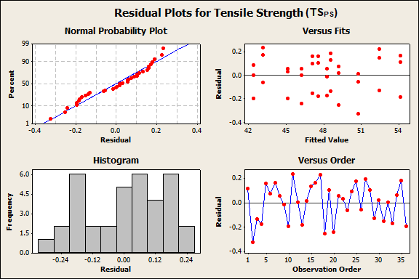
Figure 21 Residual diagnostic plots for the TS_{PS} RSM model, including normal probability, residuals versus fits, histogram, and residuals versus order plots.

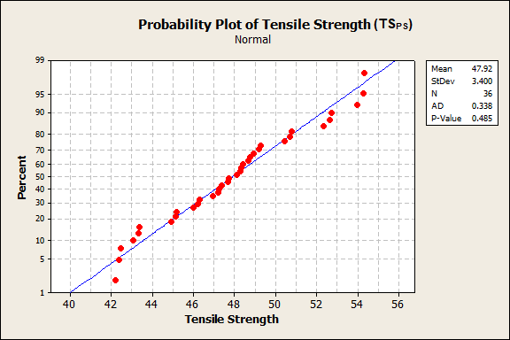
Figure 22 Anderson–Darling normality test for the TS_{PS} tensile-strength data.

Table 24 Analysis of Variance for Tensile Strength of infill core at 0° (TS_{IC0}).
Source | DF | Seq SS | Adj SS | Adj MS | F | P
Regression | 5 | 50.6251 | 50.6251 | 10.1250 | 542.31 | 0.0
Linear | 2 | 49.6067 | 2.4804 | 1.2402 | 66.43 | 0.0
Print Speed (mm/s) [x₁] | 1 | 13.4091 | 2.0715 | 2.0715 | 110.95 | 0.0
Layer Thickness (mm) [x₂] | 1 | 36.1976 | 0.6544 | 0.6544 | 35.05 | 0.0
Square | 2 | 0.9296 | 0.9296 | 0.4648 | 24.90 | 0.0
Print Speed (mm/s) * Print Speed (mm/s) | 1 | 0.9180 | 0.9180 | 0.9180 | 49.17 | 0.0
Layer Thickness (mm) * Layer Thickness (mm) | 1 | 0.0116 | 0.0116 | 0.0116 | 0.62 | 0.437
Interactions | 1 | 0.0888 | 0.0888 | 0.0888 | 4.76 | 0.037
Print Speed (mm/s) * Layer Thickness (mm) | 1 | 0.0888 | 0.0888 | 0.0888 | 4.76 | 0.037
Residual Error | 30 | 0.5601 | 0.5601 | 0.0187
Lack-of-Fit | 6 | 0.0148 | 0.0148 | 0.0025 | 0.11 | 0.995
Pure Error | 24 | 0.5453 | 0.5453 | 0.0227
Total | 35 | 51.1852

ANOVA was evaluated at a 95% confidence level (α=0.05). Terms with p<0.05 were considered statistically significant. R² = 98.91%, R² (pred.) = 98.39%, and R² (adj) = 98.72%

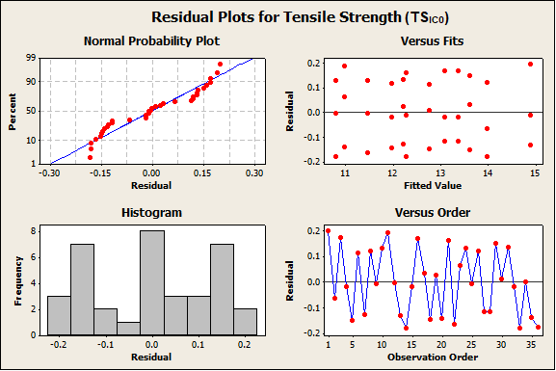
Figure 23 Residual diagnostic plots for the TS_{IC0} RSM model, including normal probability, residuals versus fits, histogram, and residuals versus order plots.

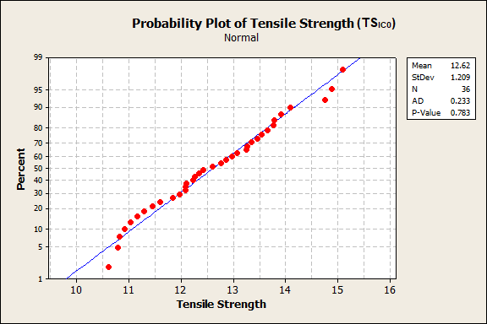
Figure 24 Anderson–Darling normality test for the TS_{IC0} tensile-strength data.

Table 25 Analysis of Variance for Tensile Strength of infill core at 45° (TS_{IC45}).
Source | DF | Seq SS | Adj SS | Adj MS | F | P
Regression | 5 | 112.843 | 112.843 | 22.569 | 590.57 | 0.0
Linear | 2 | 109.354 | 8.382 | 4.191 | 109.67 | 0.0
Print Speed (mm/s) [x₁] | 1 | 45.868 | 6.961 | 6.961 | 182.16 | 0.0
Layer Thickness (mm) [x₂] | 1 | 63.486 | 2.258 | 2.258 | 59.08 | 0.0
Square | 2 | 3.328 | 3.328 | 1.664 | 43.54 | 0.0
Print Speed (mm/s) * Print Speed (mm/s) | 1 | 3.218 | 3.218 | 3.218 | 84.21 | 0.0
Layer Thickness (mm) * Layer Thickness (mm) | 1 | 0.110 | 0.110 | 0.110 | 2.87 | 0.100
Interactions | 1 | 0.162 | 0.162 | 0.162 | 4.23 | 0.049
Print Speed (mm/s) * Layer Thickness (mm) | 1 | 0.162 | 0.162 | 0.162 | 4.23 | 0.049
Residual Error | 30 | 1.146 | 1.146 | 0.0382
Lack-of-Fit | 6 | 0.034 | 0.034 | 0.0057 | 0.12 | 0.992
Pure Error | 24 | 1.112 | 1.112 | 0.0463
Total | 35 | 113.990

ANOVA was evaluated at a 95% confidence level (α=0.05). Terms with p<0.05 were considered statistically significant. R² = 98.99%, R² (pred.) = 98.53% and R² (adj) = 98.83%

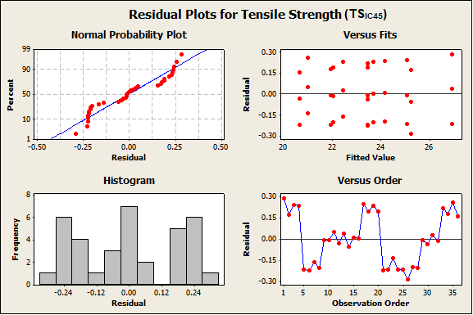
Figure 25 Residual diagnostic plots for the TS_{IC45} RSM model, including normal probability, residuals versus fits, histogram, and residuals versus order plots.

References
Alafaghani, A. et al. (2017) ‘Experimental Optimization of Fused Deposition Modelling Processing Parameters: A Design-for-Manufacturing Approach’, Procedia Manufacturing, 10, pp. 791–803. Available at: https://doi.org/10.1016/j.promfg.2017.07.079.
Alzyod, H., Borbas, L. and Ficzere, P. (2023) ‘Rapid prediction and optimization of the impact of printing parameters on the residual stress of FDM-ABS parts using L27 orthogonal array design and FEA’, Materials Today: Proceedings, 93, pp. 583–588. Available at: https://doi.org/10.1016/j.matpr.2023.02.213.
Alzyod, H., Ficzere, P. and Borbas, L. (2024) ‘Optimizing ironing parameters in material extrusion (MEX) technology: enhancing efficiency and performance’, Discover Applied Sciences, 6(11), p. 578. Available at: https://doi.org/10.1007/s42452-024-06249-7.
Alzyod, H., Konya, G. and Ficzere, P. (2025) ‘Maximizing material removal rate and surface smoothness in MEX parts through turning process optimization using BBD’, Progress in Additive Manufacturing, 10(11), pp. 10295–10309. Available at: https://doi.org/10.1007/s40964-025-01241-y.
Ambade, V. et al. (2023) ‘Influence of FDM process parameters on tensile strength of parts printed by PLA material’, International Journal on Interactive Design and Manufacturing (IJIDeM) [Preprint]. Available at: https://doi.org/10.1007/s12008-023-01490-7.
Bembenek, M., Kowalski, Ł. and Kosoń-Schab, A. (2022) ‘Research on the Influence of Processing Parameters on the Specific Tensile Strength of FDM Additive Manufactured PET-G and PLA Materials’, Polymers, 14(12), p. 2446. Available at: https://doi.org/10.3390/polym14122446.
Berman, B. (2012) ‘3-D printing: The new industrial revolution’, Business Horizons, 55(2), pp. 155–162. Available at: https://doi.org/10.1016/j.bushor.2011.11.003.
Deng, K. et al. (2019) ‘Rule of Mixtures Model to Determine Elastic Modulus and Tensile Strength of 3D Printed Carbon Fiber Reinforced Nylon’, Volume 2A: 45th Design Automation Conference. ASME 2019 International Design Engineering Technical Conferences and Computers and Information in Engineering Conference, Anaheim, California, USA: American Society of Mechanical Engineers, p. V02AT03A039. Available at: https://doi.org/10.1115/DETC2019-98024.
Enzi, A., Ali, D. and F. Huayier, A. (2023) ‘Parametric Prediction of FDM Process to Improve Tensile Properties Using Taguchi Method and Artificial Neural Network’, Advances in Science and Technology Research Journal, 17(4), pp. 130–138. Available at: https://doi.org/10.12913/22998624/169572.
Farashi, S. and Vafaee, F. (2022) ‘Effect of printing parameters on the tensile strength of FDM 3D samples: a meta-analysis focusing on layer thickness and sample orientation’, Progress in Additive Manufacturing, 7(4), pp. 565–582. Available at: https://doi.org/10.1007/s40964-021-00247-6.
Fountas, N.A. et al. (2023) ‘Statistical modelling and optimization of mechanical properties for PLA and PLA/Wood FDM materials’, Materials Today: Proceedings, p. S2214785323045467. Available at: https://doi.org/10.1016/j.matpr.2023.08.276.
Gibson, I. et al. (2021) Additive Manufacturing Technologies. Cham: Springer International Publishing. Available at: https://doi.org/10.1007/978-3-030-56127-7.
Giri, J. et al. (2021) ‘Effect of process parameters on mechanical properties of 3d printed samples using FDM process’, Materials Today: Proceedings, 47, pp. 5856–5861. Available at: https://doi.org/10.1016/j.matpr.2021.04.283.
Griffiths, C.A. et al. (2016) ‘Effect of Build Parameters on Processing Efficiency and Material Performance in Fused Deposition Modelling’, Procedia CIRP, 49, pp. 28–32. Available at: https://doi.org/10.1016/j.procir.2015.07.024.
Gurrala, P.K. and Regalla, S.P. (2014) ‘Part strength evolution with bonding between filaments in fused deposition modelling: This paper studies how coalescence of filaments contributes to the strength of final FDM part’, Virtual and Physical Prototyping, 9(3), pp. 141–149. Available at: https://doi.org/10.1080/17452759.2014.913400.
Hasan, A., Fahad, M. and Khan, M.A. (2024) ‘Effect of print parameters on the tensile strength and built time of FDM-printed PLA parts’, The International Journal of Advanced Manufacturing Technology [Preprint]. Available at: https://doi.org/10.1007/s00170-024-13506-x.
Hikmat, M., Rostam, S. and Ahmed, Y.M. (2021) ‘Investigation of tensile property-based Taguchi method of PLA parts fabricated by FDM 3D printing technology’, Results in Engineering, 11, p. 100264. Available at: https://doi.org/10.1016/j.rineng.2021.100264.
Homrani, K. et al. (2024) ‘Investigation into Influence of Tensile Properties When Varying Print Settings of 3D-Printed Polylactic Acid Parts: Numerical Model and Validation’, Polymers, 16(16), p. 2253. Available at: https://doi.org/10.3390/polym16162253.
Huynh, L.P.T. et al. (2019) ‘Effect of Process Parameters on Mechanical Strength of Fabricated Parts using the Fused Deposition Modelling Method’, Journal of the Korean Society for Precision Engineering, 36(8), pp. 705–712. Available at: https://doi.org/10.7736/KSPE.2019.36.8.705.
Jayasudha, M. et al. (2022) ‘Accurate Estimation of Tensile Strength of 3D Printed Parts Using Machine Learning Algorithms’, Processes, 10(6), p. 1158. Available at: https://doi.org/10.3390/pr10061158.
Marșavina, L. et al. (2022) ‘Effect of the manufacturing parameters on the tensile and fracture properties of FDM 3D-printed PLA specimens’, Engineering Fracture Mechanics, 274, p. 108766. Available at: https://doi.org/10.1016/j.engfracmech.2022.108766.
Montgomery, D.C. (2017) Design and analysis of experiments. Ninth edition. Hoboken, NJ: John Wiley & Sons, Inc.
Nali, P. and Carrera, E. (2012) ‘A numerical assessment on two-dimensional failure criteria for composite layered structures’, Composites Part B: Engineering, 43(2), pp. 280–289. Available at: https://doi.org/10.1016/j.compositesb.2011.06.018.
Panico, A. et al. (2025) ‘Multi objective optimization of FDM 3D printing parameters set via design of experiments and machine learning algorithms’, Scientific Reports, 15(1), p. 16753. Available at: https://doi.org/10.1038/s41598-025-01016-z.
‘Plastics. Determination of tensile properties Test conditions for moulding and extrusion plastics’ (2012). BSI British Standards. Available at: https://doi.org/10.3403/30216860.
Popescu, D. et al. (2018) ‘FDM process parameters influence over the mechanical properties of polymer specimens: A review’, Polymer Testing, 69, pp. 157–166. Available at: https://doi.org/10.1016/j.polymertesting.2018.05.020.
Rajpurohit, S.R. and Dave, H.K. (2020) ‘Prediction and Optimization of Tensile Strength in FDM Based 3D Printing Using ANFIS’, in K. Gupta and M.K. Gupta (eds) Optimization of Manufacturing Processes. Cham: Springer International Publishing (Springer Series in Advanced Manufacturing), pp. 111–128. Available at: https://doi.org/10.1007/978-3-030-19638-7_5.
Samykano, M. (2021) ‘Mechanical Property and Prediction Model for FDM-3D Printed Polylactic Acid (PLA)’, Arabian Journal for Science and Engineering, 46(8), pp. 7875–7892. Available at: https://doi.org/10.1007/s13369-021-05617-4.
Singh, M. and Bharti, P.S. (2023) ‘Identification of Process Parameter Combination for Maximum Tensile Strength in 3D Printed Polylactic Acid Specimens Using Regression and ANOVA’, in S. Yadav et al. (eds) Advances in Mechanical and Energy Technology. Singapore: Springer Nature Singapore (Lecture Notes in Mechanical Engineering), pp. 217–225. Available at: https://doi.org/10.1007/978-981-19-1618-2_21.
Sood, A.K., Ohdar, R.K. and Mahapatra, S.S. (2010) ‘Parametric appraisal of mechanical property of fused deposition modelling processed parts’, Materials & Design, 31(1), pp. 287–295. Available at: https://doi.org/10.1016/j.matdes.2009.06.016.
Srinivasan, R. et al. (2020) ‘Prediction of tensile strength in FDM printed ABS parts using response surface methodology (RSM)’, Materials Today: Proceedings, 27, pp. 1827–1832. Available at: https://doi.org/10.1016/j.matpr.2020.03.788.
Torres, J. et al. (2016) ‘An approach for mechanical property optimization of fused deposition modeling with polylactic acid via design of experiments’, Rapid Prototyping Journal, 22(2), pp. 387–404. Available at: https://doi.org/10.1108/RPJ-07-2014-0083.
Tsai, S.W. and Hahn, H.T. (1980) Introduction to composite materials. Westport, Conn: Technomic Pub.
Volkov, G. and Smirnov, I. (2022) ‘A probabilistic approach to evaluate dynamic and static strength of quasi-brittle materials through high-rate testing’, International Journal of Mechanical Sciences, 216, p. 106960. Available at: https://doi.org/10.1016/j.ijmecsci.2021.106960.
Yao, T. et al. (2019) ‘A method to predict the ultimate tensile strength of 3D printing polylactic acid (PLA) materials with different printing orientations’, Composites Part B: Engineering, 163, pp. 393–402. Available at: https://doi.org/10.1016/j.compositesb.2019.01.025.
Yilan, F. et al. (2023) ‘The Effects of Different Process Parameters of PLA+ on Tensile Strengths in 3D Printer Produced by Fused Deposition Modeling’, El-Cezeri Fen ve Mühendislik Dergisi [Preprint]. Available at: https://doi.org/10.31202/ecjse.1179492.
Zhao, Y., Chen, Y. and Zhou, Y. (2019) ‘Novel mechanical models of tensile strength and elastic property of FDM AM PLA materials: Experimental and theoretical analyses’, Materials & Design, 181, p. 108089. Available at: https://doi.org/10.1016/j.matdes.2019.108089.
Statements and Declarations
Authors’ Declaration: The authors declare that they have no known competing financial interests or personal relationships that could have appeared to influence the work reported in this paper. All authors contributed to the study conception, design and execution.
Data Availability Statement: The datasets generated during and/or analysed during the current study are available from the corresponding author on reasonable request.
Funding Declaration: The project was funded by NED University of Engineering and Technology (Pakistan).
Ethics, Consent to Participate, and Consent to Publish declarations: Not applicable.

